**FINAL REPORT (EXTRACTION)**

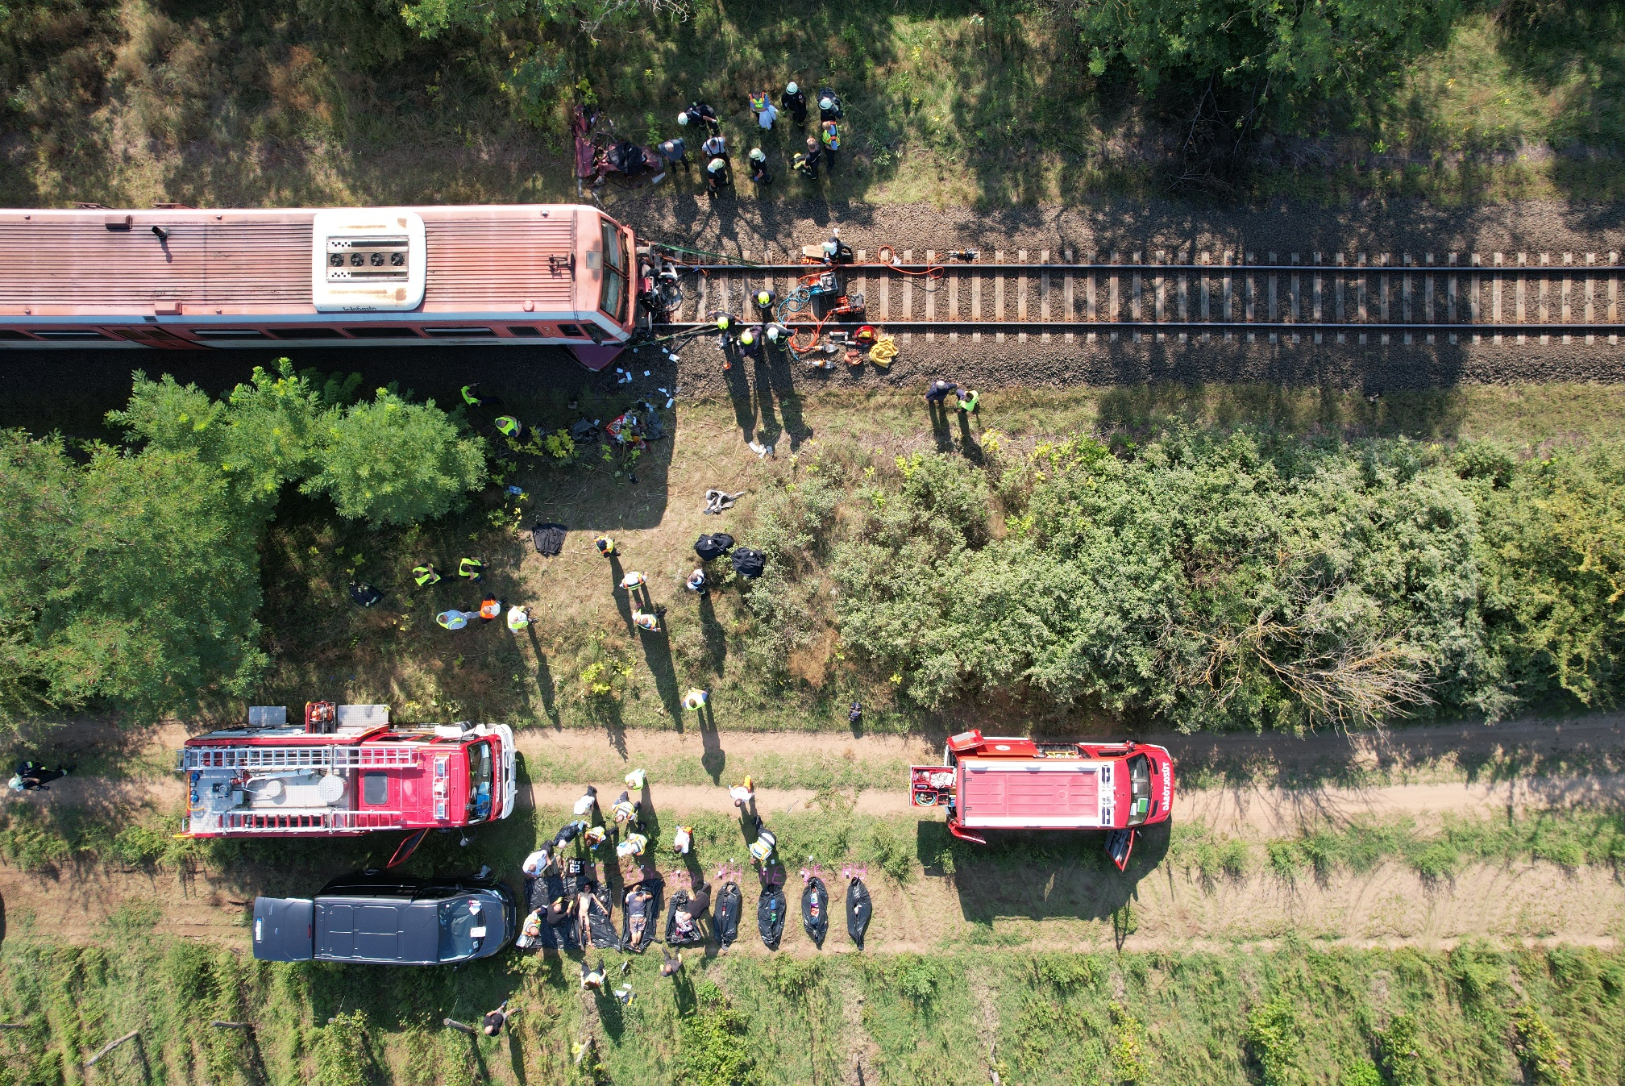

2022-0960-5

(HU-10310)

**Railway accident / Level crossing accident**

Kunfehértó - Kiskunhalas (SN 94), 5th September 2022

# Translation

This document is the translation of Points 1, 5 and 6 of Hungarian version of the Final Report. Although efforts have been made to translate the mentioned parts of the Final Report as accurately as possible, discrepancies may occur. In this case, the Hungarian Final Report is the authentic, official version.

# Basic principles of the safety investigation

The purpose of the safety investigation fulfilled by Transportation Safety Bureau (TSB) as National Investigation Body of Hungary is to reveal the causes and circumstances of serious railway accidents, railway accidents and railway incidents and propose recommendations in order to prevent similar incidents. The safety investigation is not intended to examine and determine fault, blame or liability in any form.

The findings of the safety investigation are based on an assessment of the evidence available and obtained by TSB in the course of the investigation, taking into account the principles of a fair and impartial procedure. In the Final Report, the persons involved in the occurrence shall be referred to by the positions and duties they had at the time of the occurrence.

The Final Report shall not have binding force and no appeal proceedings may be initiated against it.

This safety investigation has been carried out by TSB pursuant to relevant provisions of

1. Act CLXXXIV of 2005 on the safety investigation of aviation, railway and marine accidents and incidents;
2. Commission Implementing Regulation (EU) 2020/572 of 24 April 2020 on the reporting structure to be followed for railway accident and incident investigation reports;
3. in the absence of other related regulation of the Act CLXXXIV of 2005, the TSB conducts the investigation in accordance with Act CL of 2016 on General Public Administration Procedures.

Act CLXXXIV of 2005 is to serve compliance with Directive (EU) 2016/798 of the European Parliament and of the Council of 11 May 2016 on railway safety.

The competence of the TSB is based on Government Regulation № 230/2016. (VII.29.) on the assignment of a transportation safety body and on the dissolution of Transportation Safety Bureau with legal succession.

The safety investigation is independent of other investigations, administrative infringement or criminal proceedings, as well as proceedings initiated by employers in connection with the accident or incident.

# Copyright Notice

The original Final Report and this extraction of it were issued by:

**Transportation Safety Bureau, Ministry of Construction and Transport**

2/A. Kőér str. Budapest H-1103, Hungary

[www.kbsz.hu](http://www.kbsz.hu)

[kbszvasut@ekm.gov.hu](mailto:kbszvasut@ekm.gov.hu)

The Final Report or any part of thereof may be used in any form, taking into account the exceptions specified by law, provided that consistency of the contents of such parts is maintained and clear references are made to the source.

# SUMMARY

On 5 September 2022, at 6:43 a.m., between Kunfehértó and Kiskunhalas stations, at the level crossing without technical protection, in railway section 94+13, the passenger train № 7809 collided with an automobile. All of the seven occupants of the car deceased and the locomotive driver was slightly injured.

The investigation found that at the time of the incident, the reduced visibility triangle was ensured in all areas of the level crossing, and therefore the Investigating Committee identified the cause of the accident as a human factor related to the driver of the automobile, who entered the level crossing while a train was approaching.

In addition to the safety investigation of the level crossing involved in the accident, the Investigating Committee extended the technical investigation to the investigation of the level crossings between Kunfehértó and Kiskunhalas stations and the one branching off from the Road 5412, which are of a similar design to the one involved in the accident.

The Investigating Committee repeatedly found deficiencies in the design of level crossings, the existence of the necessary traffic signs, the visibility of the crossings, and the obstructions in the areas of visibility at the level crossing involved in the accident, as well as at other level crossings between Kunfehértó and Kiskunhalas.

Therefore, during the investigation, the TSB issued an immediate safety recommendation to the Bács-Kiskun County Government Office to eliminate the situations that endanger traffic safety.

# CONCLUSIONS

## Summary

### Direct causes

Acts, mistakes, events or conditions or a combination thereof the elimination or avoiding of which could probably have prevented the accident or incident:

1. the driver of the automobile drove his vehicle into the level crossing when a train was approaching.

### Indirect causes

The IC identified no acts or errors that influenced the event by increasing the likelihood of occurrence, accelerating the effects, or increasing the severity of the consequences, but whose elimination in itself would not have prevented the event from occurring.

### Systemic factors

The IC identified no causal or contributing factors of an organisational, managerial, societal or regulatory nature that are likely to affect similar and related events in the future, in particular including the regulatory framework conditions, the design and implementation of the safety management system, staff skills, procedures and maintenance.

## Actions taken

Following the immediate safety recommendation issued in response to the incident (6.1), the relevant government agency took action.

## Additional notes

Factors that are not related to the occurrence of the event but increase risk:

1. during the investigation, the IC found deficiencies in the design of level crossings, the existence of the necessary traffic signs, the visibility of the crossings, and the presence of obstacles in the areas of visibility at the level crossing involved in the accident, as well as at several other level crossings between Kunfehértó and Kiskunhalas.

## Proven procedures, good practices

No factor to reduce the consequences of the incident and avoid a more serious outcome has been identified by the IC.

# SAFETY RECOMMENDATION

Safety recommendations, together with the findings and conclusions in the final investigation report, represent important information for the further improvement of railway safety. Accordingly,

The addressees of safety recommendations can be the rail transport authority (ÉKM VHF), other agencies and authorities, the European Union Railway Agency (ERA), or another EU Member State. The organisations responsible for implementation (implementers of the safety recommendations) are, within their respective areas of responsibility, the contracting railway undertakings, infrastructure managers, maintenance organisations and other actors in the railway industry. Accordingly,

1. The authorities responsible for safety shall take action as necessary to ensure that safety recommendations are duly taken into consideration and applied where appropriate.
2. The organisations responsible for introducing such safety recommendations shall start, with no delay, the risk assessment and risk management activities related to the contents of such safety recommendation within the procedural framework of their safety management system.

Within 90 days of the issue of the safety recommendation, they shall report back to the IC on the actions taken or planned or on their non-acceptance (with justification) of such safety recommendation.

During the investigation, TSB’s investigating committee found deficiencies in the design of the level crossings, the existence of the necessary traffic signs, the visibility of the crossings and the obstructions in the areas of visibility at the level crossing involved in the accident, as well as at several other level crossings near Kunfehértó - Kiskunhalas station. In addition, the Investigating Committee found that, of the level crossings between the two stations, the level crossings involving dirt roads are not pre-indicated by road signs on Road 5412. Chapter II, 9.9.1 bb) of the Technical Regulation “Requirements for the design, application and installation of road signs” (published as an annex to GKM Decree № 83/2004 (VI. 4.) on the requirements for the design, application and installation of road signs) only requires, in the case of a paved road crossing a standard gauge railway track, that *if the road is crossed by another solid road outside a built-up area within 150 m of the level crossing, the level crossing shall be preceded by a "Road direction sign" on this road, indicating the way of protection of the crossing.* However, in view of the seriousness of the accident that occurred, the Investigating Committee considers that, in order to prevent similar accidents in the future, it may be appropriate to include the danger signs also on Road 5412 for the level crossings involving dirt roads. For these reasons, the TSB issued an immediate safety recommendation during the investigation:

Number: **BA2022-0960-5-01A**

Date of release: **3 October 2022**

Addressed to: **Bács-Kiskun County Government Office**

Responsible for introduction: **Bács-Kiskun County Government Office**

**The TSB recommends to the Road Department of the Transport, Technical Licensing and Consumer Protection Department of Bács-Kiskun County Government Office that in accordance with the provisions of the Government Decree 382/2016 (XII. 2.) on the designation of the bodies performing official tasks related to traffic administration,**

* **consider ordering the road operator to review the traffic regulations at the level crossings concerned and to make the necessary changes to eliminate the situation that is detrimental or dangerous to traffic safety, pursuant to Section 34(2) of Act I of 1988 on Road Traffic; and**
* **order the felling of trees or other vegetation in the area of the sight triangle of level crossings in accordance with Chapter VIII, point 26.4(d) of the Technical Regulation on Traffic Regulation, issued as an annex to KM Decree 20/1984 (XII. 21.) on the regulation of traffic on roads and the installation of road signs.**

If adopted and implemented, this recommendation will reduce the risk of similar accidents, thereby improving road safety.