**FINAL REPORT (EXTRACTION)**

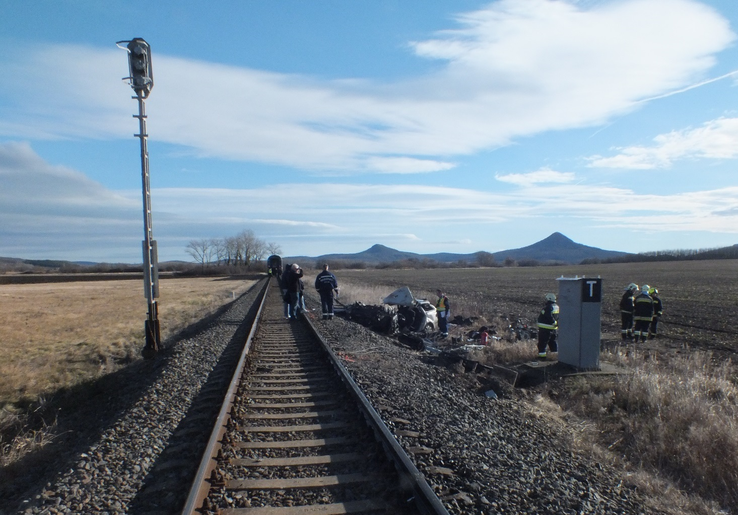

2022-0002-5

(HU-10240)

**Railway accident / Level crossing accident**

Badacsonytördemic-Szigliget - Tapolca, 1st January 2022

# Translation

This document is the translation of Points 1, 5 and 6 of Hungarian version of the Final Report. Although efforts have been made to translate the mentioned parts of the Final Report as accurately as possible, discrepancies may occur. In this case, the Hungarian Final Report is the authentic, official version.

# Basic principles of the safety investigation

The purpose of the safety investigation fulfilled by Transportation Safety Bureau (TSB) as National Investigation Body of Hungary is to reveal the causes and circumstances of serious railway accidents, railway accidents and railway incidents and propose recommendations in order to prevent similar incidents. The safety investigation is not intended to examine and determine fault, blame or liability in any form.

The findings of the safety investigation are based on an assessment of the evidence available and obtained by TSB in the course of the investigation, taking into account the principles of a fair and impartial procedure. In the Final Report, the persons involved in the occurrence shall be referred to by the positions and duties they had at the time of the occurrence.

The Final Report shall not have binding force and no appeal proceedings may be initiated against it.

This safety investigation has been carried out by TSB pursuant to relevant provisions of

1. Act CLXXXIV of 2005 on the safety investigation of aviation, railway and marine accidents and incidents;
2. Commission Implementing Regulation (EU) 2020/572 of 24 April 2020 on the reporting structure to be followed for railway accident and incident investigation reports;
3. in the absence of other related regulation of the Act CLXXXIV of 2005, the TSB conducts the investigation in accordance with Act CL of 2016 on General Public Administration Procedures.

Act CLXXXIV of 2005 is to serve compliance with Directive (EU) 2016/798 of the European Parliament and of the Council of 11 May 2016 on railway safety.

The competence of the TSB is based on Government Regulation № 230/2016. (VII.29.) on the assignment of a transportation safety body and on the dissolution of Transportation Safety Bureau with legal succession.

The safety investigation is independent of other investigations, administrative infringement or criminal proceedings, as well as proceedings initiated by employers in connection with the accident or incident.

# Copyright Notice

The original Final Report and this extraction of it were issued by:

**Transportation Safety Bureau, Ministry for Technology and Industry**

2/A. Kőér str. Budapest H-1103, Hungary

[www.kbsz.hu](http://www.kbsz.hu)

[kbszvasut@tim.gov.hu](mailto:kbszvasut@itm.gov.hu)

The Final Report or any part of thereof may be used in any form, taking into account the exceptions specified by law, provided that consistency of the contents of such parts is maintained and clear references are made to the source.

# SUMMARY

Between Badacsonytördemic-Szigliget and Tapolca stations, the train № 9797 collided with an automobile at 9:50 a.m. on 1 January 2022 in the level crossing with warning lights № AS1159. The collision resulted in the death of four of the five people in the automobile and serious injuries to one.

The investigation found that the design of the crossing complied with the legislation in force. At the time of the accident, the warning lights were functioning well, flashing red alternately towards the road, and the lights were clearly visible from the road. The relevant road and railway rules are adequate to prevent such incidents from occurring, and the IC identified no systemic deficiencies.

The accident was caused by a human error on the part of the driver of the road vehicle, who entered the level crossing despite the signal from the traffic lights.

As the level crossing signalling system was functioning well during the incident and the accident could have been avoided by following the rules of the Highway Code, the IC does not issue a safety recommendation.

# CONCLUSIONS

## Summary

### Direct causes

Acts, mistakes, events or conditions or a combination thereof the elimination or avoiding of which could probably have prevented the accident or incident:

1. the driver of the road vehicle failed to stop at the “Start of level crossing” sign, ignoring the red flashing warning light, and ran into the crossing when the train arrived.

### Indirect causes

The IC identified no acts or errors that influenced the event by increasing the likelihood of occurrence, accelerating the effects, or increasing the severity of the consequences, but whose elimination in itself would not have prevented the event from occurring.

### Systemic factors

The IC identified no causal or contributing factors of an organisational or regulatory nature that are likely to affect similar and related events in the future.

## Actions taken

Despite the reduced visibility triangle already provided, the infrastructure manager has carried out additional tree and bush clearing in the forested section of the road crossing towards Tapolca, thus increasing the visibility of the track.

## Additional notes

The IC identified no risk-increasing factors that could not be linked to the occurrence of the incident.

## Proven procedures, good practices

The IC identified no good practices or procedures that would help reduce the consequences of the incident and avoid more serious outcomes.

## Lessons learnt

The IC is of the opinion that there are no lessons to be learned from the incident other than the need to drive carefully on the roads.

# SAFETY RECOMMENDATION

Similar occurrences can be avoided by following the rules of the Highway Code and therefore the IC does not consider it justified to issue a safety recommendation.