**FINAL REPORT (EXTRACTION)**

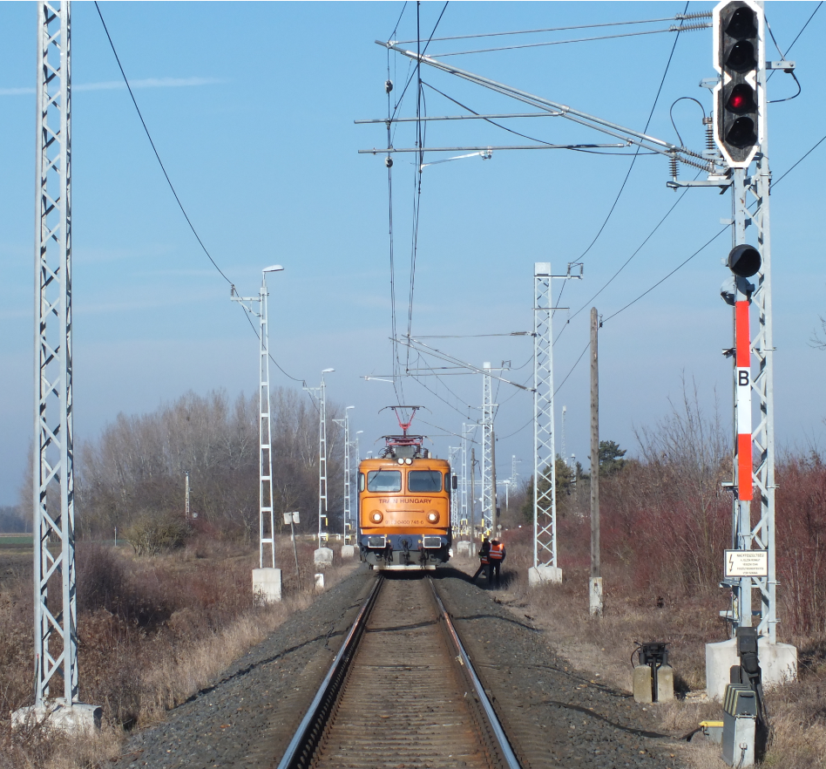

2022-0075-5

(HU-10184)

**Railway incident / SPAD**

Bősárkány, 16th January 2022

# Translation

This document is the translation of Points 1, 5 and 6 of Hungarian version of the Final Report. Although efforts have been made to translate the mentioned parts of the Final Report as accurately as possible, discrepancies may occur. In this case, the Hungarian Final Report is the authentic, official version.

# Basic principles of the safety investigation

The purpose of the safety investigation fulfilled by Transportation Safety Bureau (TSB) as National Investigation Body of Hungary is to reveal the causes and circumstances of serious railway accidents, railway accidents and railway incidents and propose recommendations in order to prevent similar incidents. The safety investigation is not intended to examine and determine fault, blame or liability in any form.

The findings of the safety investigation are based on an assessment of the evidence available and obtained by TSB in the course of the investigation, taking into account the principles of a fair and impartial procedure. In the Final Report, the persons involved in the occurrence shall be referred to by the positions and duties they had at the time of the occurrence.

The Final Report shall not have binding force and no appeal proceedings may be initiated against it.

This safety investigation has been carried out by TSB pursuant to relevant provisions of

1. Act CLXXXIV of 2005 on the safety investigation of aviation, railway and marine accidents and incidents;
2. Commission Implementing Regulation (EU) 2020/572 of 24 April 2020 on the reporting structure to be followed for railway accident and incident investigation reports;
3. in the absence of other related regulation of the Act CLXXXIV of 2005, the TSB conducts the investigation in accordance with Act CL of 2016 on General Public Administration Procedures.

Act CLXXXIV of 2005 is to serve compliance with Directive (EU) 2016/798 of the European Parliament and of the Council of 11 May 2016 on railway safety.

The competence of the TSB is based on Government Regulation № 230/2016. (VII.29.) on the assignment of a transportation safety body and on the dissolution of Transportation Safety Bureau with legal succession.

The safety investigation is independent of other investigations, administrative infringement or criminal proceedings, as well as proceedings initiated by employers in connection with the accident or incident.

# Copyright Notice

The original Final Report and this extraction of it were issued by:

**Transportation Safety Bureau, Ministry of Construction and Transport**

2/A. Kőér str. Budapest H-1103, Hungary

[www.kbsz.hu](http://www.kbsz.hu)

[kbszvasut@ekm.gov.hu](mailto:kbszvasut@ekm.gov.hu)

The Final Report or any part of thereof may be used in any form, taking into account the exceptions specified by law, provided that consistency of the contents of such parts is maintained and clear references are made to the source.

# SUMMARY

On 16 January 2022, at 9.09 a.m., the light engine № 39880, travelling from Hegyeshalom station to Szil-Sopronnémeti station, was to be diverted to track II of Bősárkány station by the KÖFI controller, who was controlling the traffic on line 16, in order to avoid the traffic load at Csorna station and to wait for the open-line shunter.

The driver of a light engine entering Bősárkány station under proper signalling control unsuccessfully attempted to reset the locomotive’s gear selector and thereby eliminate tractive power. Even when the automatic brake was applied, the traction was not interrupted and the vehicle continued to tow with the brakes on. The driver continued his attempts to stop the locomotive on track II, but in the process, he passed the exit sign V2, which was in the position prohibiting further movement, burst the № 1 switch open, crossed the open level crossing SR1, through which the № 8514 2x1-lane road passes, and there is regular bus traffic on the road. Then, after the step switch ran down, he stopped in front of the entrance sign “B” in the opposite direction at the down-side end of the station.

During the investigation, the IC reviewed the locomotive wiring diagrams and available descriptions, reviewed the logbook entries made prior to the incident and the post-incident repair documentation, and conducted a post-incident vehicle inspection with a running test. On this basis, it was found that a control panel in the IAG unit controlling the locomotive’s step switch and 3 additional control relays in the auxiliary circuits had failed. These failures resulted in the step switch not operating as commanded by the driver and other attempts to interrupt the traction circuit (switching off the vents) were also unsuccessful. The technical investigation also revealed that, although the driver could have had other options to interrupt the traction circuit (switching off the main circuit breaker with the ‘main circuit breaker off/current collector down’ pushbutton or the emergency switch), these options were not considered due to the reduced state of consciousness caused by the emergency.

In relation to the incident, the IC did not consider it necessary to issue a safety recommendation, as the incident could have been avoided if the instructions in E.1 had been followed, given that the driver was aware of the fault in the step switch when he left Hegyeshalom, but decided to start the train.

# CONCLUSIONS

## Summary

### Direct causes

Acts, mistakes, events or conditions or a combination thereof the elimination or avoiding of which could probably have prevented the accident or incident:

1. the IAG device that operates the servo motor for the step switch failed, so the locomotive continued to tow while the driver applied the brakes;
2. the locomotive driver had previously started his train despite having information about the unsafe operation of the step switch.

### Indirect causes

Acts, mistakes, events or conditions which influenced the occurrence by increasing its probability, accelerating the effects or the severity of the consequences, but the elimination of which would not have prevented the occurrence:

1. the driver did not realise that there were other options available to him to stop the traction, such as the emergency stop switch, the main circuit breaker switch and the current collector switch;
2. the locomotive does not have a main line pressure switch to prevent traction in the event of inadequate main brake line pressure.

### Systemic factors

Causal or contributing factors of organisational, management, social or regulatory nature which are likely to have an effect on similar or related occurrences, particularly including regulatory framework conditions, the design and use of the safety management systems, the skills of the personnel, the procedures and maintenance:

1. Drivers’ current knowledge of the type and their decades of driving experience do not necessarily reflect their confidence in handling vehicles, and knowledge is not always at a skill level.

## Actions taken

The IC is not aware of any action taken in relation to this case.

## Proven procedures, good practices

No factor to reduce the consequences of the incident and avoid a more serious outcome has been identified by the IC.

## Lessons learnt

The event highlighted the need for more emphasis in the practical training of drivers in vehicle skills on emergency procedures and control of vehicles in emergency.

# SAFETY RECOMMENDATION

Such incidents can be avoided by following the rules, i.e. by following the listed points of instruction E.1 presented in Annex 3, and by exercising due care and attention by the staff, and therefore the IC does not consider it justified to issue a safety recommendation.