**FINAL REPORT (EXTRACTION)**

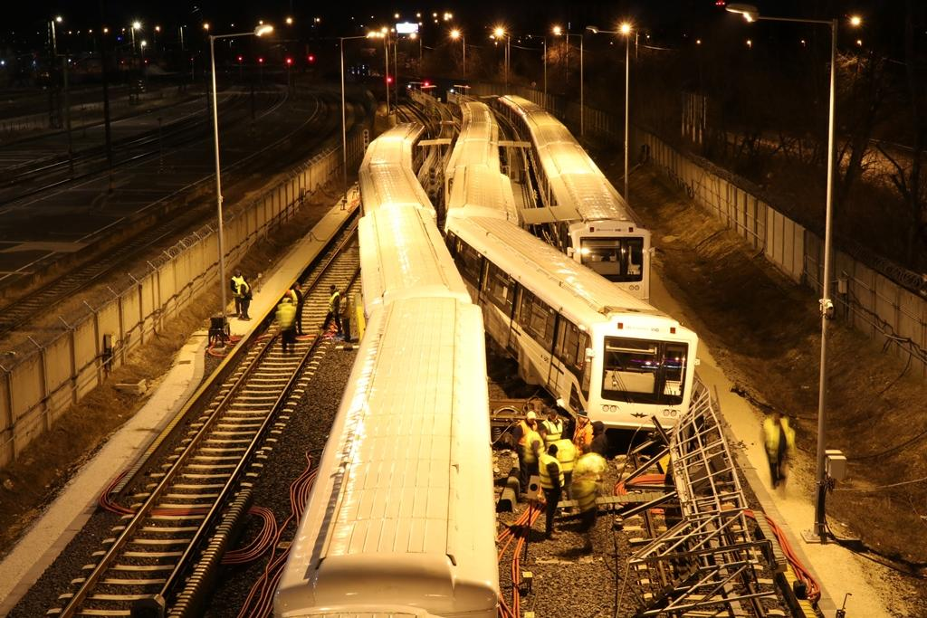

2022-0107-5

(HU-10183)

**Railway Accident / Collision**

(Kőbánya-Kispest), 21st January 2022

# Translation

This document is the translation of Points 1, 5 and 6 of Hungarian version of the Final Report. Although efforts have been made to translate the mentioned parts of the Final Report as accurately as possible, discrepancies may occur. In this case, the Hungarian Final Report is the authentic, official version.

# Basic principles of the safety investigation

The purpose of the safety investigation fulfilled by Transportation Safety Bureau (TSB) as National Investigation Body of Hungary is to reveal the causes and circumstances of serious railway accidents, railway accidents and railway incidents and propose recommendations in order to prevent similar incidents. The safety investigation is not intended to examine and determine fault, blame or liability in any form.

The findings of the safety investigation are based on an assessment of the evidence available and obtained by TSB in the course of the investigation, taking into account the principles of a fair and impartial procedure. In the Final Report, the persons involved in the occurrence shall be referred to by the positions and duties they had at the time of the occurrence.

The Final Report shall not have binding force and no appeal proceedings may be initiated against it.

This safety investigation has been carried out by TSB pursuant to relevant provisions of

1. Act CLXXXIV of 2005 on the safety investigation of aviation, railway and marine accidents and incidents;
2. Commission Implementing Regulation (EU) 2020/572 of 24 April 2020 on the reporting structure to be followed for railway accident and incident investigation reports;
3. in the absence of other related regulation of the Act CLXXXIV of 2005, the TSB conducts the investigation in accordance with Act CL of 2016 on General Public Administration Procedures.

Act CLXXXIV of 2005 is to serve compliance with Directive (EU) 2016/798 of the European Parliament and of the Council of 11 May 2016 on railway safety.

The competence of the TSB is based on Government Regulation № 230/2016. (VII.29.) on the assignment of a transportation safety body and on the dissolution of Transportation Safety Bureau with legal succession.

The safety investigation is independent of other investigations, administrative infringement or criminal proceedings, as well as proceedings initiated by employers in connection with the accident or incident.

# Copyright Notice

The original Final Report and this extraction of it were issued by:

**Transportation Safety Bureau, Ministry of Construction and Transport**

2/A. Kőér str. Budapest H-1103, Hungary

[www.kbsz.hu](http://www.kbsz.hu)

[kbszvasut@ekm.gov.hu](mailto:kbszvasut@ekm.gov.hu)

The Final Report or any part of thereof may be used in any form, taking into account the exceptions specified by law, provided that consistency of the contents of such parts is maintained and clear references are made to the source.

# SUMMARY

On 21 January 2022, at 23:27, the train № E05 departing from Kőbánya-Kispest metro station on Turnout Track II collided with the train № E07 departing and exiting from Track III at the same time. Both vehicles derailed and the sidewalk between Tracks I and II was pushed against the train № E18 on Track I. There were no personal injuries, but there was considerable damage to the vehicles and infrastructure.

The investigation found that the track route was set for the train № E07 from Track III, and the signal DKK, signalling for the train № E05 on Track II, was accordingly at danger.

The accident occurred due to a human factor related to the driver of the train № E05, who started his train despite the signal at danger. It contributed to the SPAD event that he was in a self-induced time pressure at the moment of departure and was anxious to leave as soon as possible, so he left in response to the signal that was most similar to what he expected in his own mental image.

A major contributing factor to the significant material damage was the fact that neither the train control equipment nor the driver applied emergency braking on the train № E07 after the collision. This happened because the AVR programme mat on Track III was not installed and the driver misinterpreted the signs indicating that an event had occurred.

The accident has shown that the Autostop system on the M3 metro line does not sufficiently reduce the risk of accidents when trackside elements are not correctly positioned. An accident in 2007 had already highlighted this problem, but the railway company’s safety management system did not adequately address the risk.

# CONCLUSIONS

## Summary

### Direct causes

Acts, mistakes, events or conditions or a combination thereof the elimination or avoiding of which could probably have prevented the accident or incident:

1. the driver of the train № E05 started his train from Track II despite the signal at danger, while the train № E07 was moving out, after responding to the signal, from Track III on a closed track route;
2. the AVR was disabled by the driver on the train № E05;
3. the Autostop system did not stop the train before the the shunting limit signal when the train passed the signal at danger.

### Indirect causes

Acts, mistakes, events or conditions which influenced the occurrence by increasing its probability, accelerating the effects or the severity of the consequences, but the elimination of which would not have prevented the occurrence:

1. the driver of the train № E05 was pressed for time by the fact that the order of the trains had been reversed earlier at his own request (in order to finish his work earlier), and therefore he was in a rush;
2. the driver of the train № E07 did not use the brake after the collision, and the AVR programme mat was not installed on Turnout Track III and therefore no emergency braking occurred, which would have reduced the damage.

### Systemic factors

Causal or contributing factors of organisational, management, social or regulatory nature which are likely to have an effect on similar or related occurrences, particularly including regulatory framework conditions, the design and use of the safety management systems, the skills of the personnel, the procedures and maintenance:

1. during the complex reconstruction of the M3 metro line, which is still ongoing at the time of the accident, the relocation problem (known since 2007) of the track-side elements of the Autostop system installed at the Kőbánya-Kispest turnout area had not been solved.

## Actions taken

Following the accident, on 27 January 2022, the Metro Operations Director issued an order restricting the use of Turnout Tracks II and III.

The relocation of the Autostop stop lever installed on Turnout Track II of Kőbánya-Kispest is in progress at the time of issuing this final report, and will be placed 7.75 m away from the shunting limit signal. According to BKV Zrt., the relocation will be completed by 30 June 2023.

## Additional notes

No risk-increasing factor was identified by the IC that could not be linked to the occurrence of the incident.

## Proven procedures, good practices

No factor to reduce the consequences of the occurrence and avoid a more serious outcome has been identified by the IC.

## Lessons learnt

The occurrence of the accident under investigation shows that, in general, when investigating accidents, the lessons learned should be incorporated into risk management procedures on the basis of systematic, well-developed procedures, and that the safety management system should pay particular attention to identifying the underlying, so-called root causes of accidents, so that appropriate measures can be taken to prevent future accidents. In this case, the lessons learned from a similar accident 15 years ago were only an informal part of organisational knowledge and were not systematically taken processed, so it is doubtful that they were taken into account to the extent necessary when planning the reconstruction works.

It also serves as a lesson that actions taken for personal benefit, but which also affect operational safety, require careful consideration.

The accident investigation revealed that the electronic data recording and camera systems of metro trains of type 81-717/714 2K on the M3 metro line, although meeting the conditions of general use, do not always meet the requirements for accident investigation.

# SAFETY RECOMMENDATION

As such incidents can be avoided by following the rules and with due care and attention from the staff, and as the process of modifying the train-stopping safety device (Autostop) to prevent such incidents has started, the IC does not consider it justified to issue a safety recommendation.