**FINAL REPORT (EXTRACTION)**

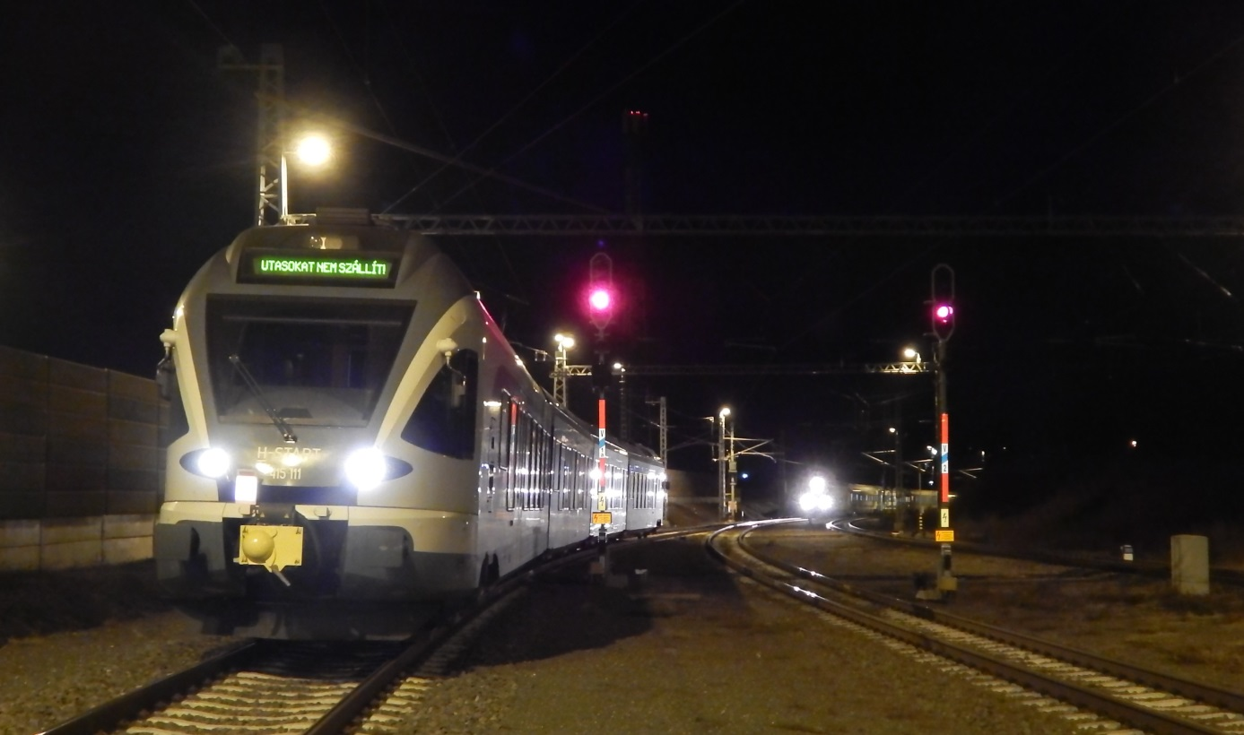

2022-0048-5

(HU-10178)

**Railway incident / SPAD**

Gödöllő, 10th January 2022

# Translation

This document is the translation of Points 1, 5 and 6 of Hungarian version of the Final Report. Although efforts have been made to translate the mentioned parts of the Final Report as accurately as possible, discrepancies may occur. In this case, the Hungarian Final Report is the authentic, official version.

# Basic principles of the safety investigation

The purpose of the safety investigation fulfilled by Transportation Safety Bureau (TSB) as National Investigation Body of Hungary is to reveal the causes and circumstances of serious railway accidents, railway accidents and railway incidents and propose recommendations in order to prevent similar incidents. The safety investigation is not intended to examine and determine fault, blame or liability in any form.

The findings of the safety investigation are based on an assessment of the evidence available and obtained by TSB in the course of the investigation, taking into account the principles of a fair and impartial procedure. In the Final Report, the persons involved in the occurrence shall be referred to by the positions and duties they had at the time of the occurrence.

The Final Report shall not have binding force and no appeal proceedings may be initiated against it.

This safety investigation has been carried out by TSB pursuant to relevant provisions of

1. Act CLXXXIV of 2005 on the safety investigation of aviation, railway and marine accidents and incidents;
2. Commission Implementing Regulation (EU) 2020/572 of 24 April 2020 on the reporting structure to be followed for railway accident and incident investigation reports;
3. in the absence of other related regulation of the Act CLXXXIV of 2005, the TSB conducts the investigation in accordance with Act CL of 2016 on General Public Administration Procedures.

Act CLXXXIV of 2005 is to serve compliance with Directive (EU) 2016/798 of the European Parliament and of the Council of 11 May 2016 on railway safety.

The competence of the TSB is based on Government Regulation № 230/2016. (VII.29.) on the assignment of a transportation safety body and on the dissolution of Transportation Safety Bureau with legal succession.

The safety investigation is independent of other investigations, administrative infringement or criminal proceedings, as well as proceedings initiated by employers in connection with the accident or incident.

# Copyright Notice

The original Final Report and this extraction of it were issued by:

**Transportation Safety Bureau, Ministry of Construction and Transport**

2/A. Kőér str. Budapest H-1103, Hungary

[www.kbsz.hu](http://www.kbsz.hu)

[kbszvasut@ekm.gov.hu](mailto:kbszvasut@ekm.gov.hu)

The Final Report or any part of thereof may be used in any form, taking into account the exceptions specified by law, provided that consistency of the contents of such parts is maintained and clear references are made to the source.

# SUMMARY

On 10 January 2022, at 20:03, the train № 23028 exiting from track I, Gödöllő station passed the exit signal “V1a” at danger without authorisation by about 50 metres and stopped in line with the shunting limit signal between tracks I and II. The train № IC658-1, which was entering track II of the station, stopped in front of the switch № 9, 125 metres from the train № 23028.

The investigation found that the KÖFI controller had set a through track for the train № IC658-1 on track II, while at the same time - taking advantage of the convenience of the safety device - blocked the exit route for train 23028 on track I. As a result, the first section of the exit route of train № 23028 between signals V1 and V1a was immediately constructed and the signal V1 was switched to allow the train to proceed, as there was no obstacle to the train on that section, while the signal V1a would have switched to allow the train to proceed after the passing of train № IC658-1. The locomotive driver of the train № 23028 started his train before the scheduled departure time, as soon as the clear aspect appeared on the ‘V1’ exit signal, but misinterpreted - at least partially - the first aspect of the ‘V1’ exit signal, and did not prepare the train to stop at ‘V1a’ within half the actual braking distance. The driver was not aware that he had passed the main signal at danger when the train control device initiated emergency braking, so after stopping, he restarted the train after the main brake line had been filled up, and stopped the train by applying the service brakes intensively after looking up from the instruments and seeing the train № IC658-1 coming from the opposite direction. The locomotive driver of the train № IC658-1 observed the signal aspect from the approaching entrance signal until his train passed the signal, so he detected the change in the signal image (reversion) and stopped his train.

The cause of the incident was due to a human factor related to the locomotive driver of the train № 23028, who, when approaching the second exit signal V1a, did not detect it or, if he did, he was not aware of the meaning of its aspect and did not stop at the signal at danger.

A contributing factor to the occurrence of the incident was that the driver of the train № 23028 may have been temporarily below the critical level of alertness at the time of the incident, as evidenced by the fact that his psychological state was not at a stable level of fitness and only partially met the requirements of the psychological fitness test ordered on an exceptional basis after the incident. The locomotive driver’s misjudgement of the situation in his presumed state of distraction may have been contributed to certain environmental factors, such as the layout of the station track network and the line of the track.

In the course of the investigation, the IC identified as a systemic factor that psychological testing is not a compulsory part of the periodic medical fitness evaluation of locomotive drivers, therefore any age-related mental performance decrease of the employees may remain hidden. To address this, the TSB already made a safety recommendation to the drafters of the legislation in 2016, but no comments were received in response to the recommendation and, although the relevant regulation has been amended several times since then, there has been no change in the wording of the regulation in relation to the part in question.

For this reason, the IC reiterated the safety recommendation previously issued by the TSB under number BA2014-720-5-1 and proposed under number 2022-0048-5-01 that psychological examinations should be included in the periodic medical evaluations of train drivers (locomotive drivers) at a specified frequency.

# CONCLUSIONS

# Summary

# Direct causes

Acts, mistakes, events or conditions or a combination thereof the elimination or avoiding of which could probably have prevented the accident or incident:

1. the driver of the train № 23028 did not stop at the second exit signal V1a indicating “Danger”, because he did not detect it when approaching it or, if he did, he was not aware of its meaning.

# Indirect causes

Acts, mistakes, events or conditions which influenced the occurrence by increasing its probability, accelerating the effects or the severity of the consequences, but the elimination of which would not have prevented the occurrence:

1. the locomotive driver of the train № 3028 misinterpreted, at least in part, the first aspect on the first exit signal V1 and failed to prepare to stop the train within half the actual stopping distance;
2. when the train was forced to brake by the train control device, the driver of the train № 23028 was not aware that he had passed a main signal indicating “Danger”, so he started again after the main brake line had been filled up;
3. the locomotive driver of the train № 23028 was presumably temporarily below the critical alertness level at the time of the incident, as evidenced by the fact that his psychological state at the exceptional psychological fitness examination ordered after the incident was not stable along age-related factors of fitness for work and he only partially met the specified requirements;
4. the locomotive driver of the train № 23028 may have been misjudged in his presumed distracted state by environmental factors such as the layout of the station track network and the line of the track.

# Systemic factors

Causal or contributing factors of organisational, management, social or regulatory nature which are likely to have an effect on similar or related occurrences, particularly including regulatory framework conditions, the design and use of the safety management systems, the skills of the personnel, the procedures and maintenance:

1. psychological testing is not a compulsory part of the periodic medical fitness tests for drivers, therefore any age-related mental performance deterioration of workers can be hidden.

# Actions taken

The IC is not aware of any measures taken to improve rail safety in general.

# Additional notes

No risk factor was identified that could not be linked to the occurrence of the incident.

# Proven procedures, good practices

In order to reduce the consequences of the incident and avoid a more serious outcome,

1. the locomotive driver of the train № IC658-1 was watching the signal of the approaching entrance signal until his train passed the signal, so he detected the change (reversion) in the signal aspect and stopped his train.

# Lessons learnt

The occurrence has served as a lesson that the obligation to observe the instructions to *“keep a constant watch on the signal given while the train is moving or reversing, because the signal may change in the meantime for an exceptional reason or to avoid danger”* must be complied with, and thus to observe the signals of fixed signals until the signal has been passed, because in an emergency situation it may happen that the train control system is no longer able to react, but only the locomotive driver.

# SAFETY RECOMMENDATION

In the course of the investigation, the IC does not consider it justified to issue a safety recommendation to transport companies, transport infrastructure operators, vehicle operators, the transport authority or other authorities involved in the procedure, but it will make a proposal to the drafters of the legislation on the basis of Section 7 e) of Act CLXXXIV of 2005 on the technical investigation of aviation, railway and marine accidents and incidents.

Based on data and experience gained during the technical investigation, the proposal, together with the Final Report and its conclusions, is intended solely to improve rail safety with a view to preventing future railway accidents and incidents.

# Proposal № 2022-0048-5-01

*During the professional examination, the Investigating Committee of the TSB found that, according to Government Decree 203/2009 (IX.18.) on the health requirements for workers performing railway transport safety-related work and the order of health evaluation, psychological examination is not a mandatory element in the periodic medical examination of train drivers, and the necessity of it is left to the decision of the examining doctor. As the doctor performing periodic evaluation only meets the person examined during the periodic evaluations, the need for psychological examinations may not always be revealed during the periodic evaluation, although the mental state of individuals may change significantly over time due to changes in the circumstances affecting it. In this way, changes in the psychological state of locomotive drivers, which may also affect their work, are not always detected. Therefore, the TSB reiterates its Safety Recommendation previously issued under number BA2014-720-5-1 and makes the following proposal:*

addressed to: **Ministry of Construction and Transport,**

**Deputy State Secretariat for Transport Strategy**

**The TSB recommends that the Deputy State Secretariat for Transport Strategy, Ministry of Transport, as the technical preparatory body for transport legislation, to consider proposing an amendment to Government Decree 203/2009 (IX.18.) on the health requirements and medical evaluation procedure for workers performing railway transport safety-related tasks, so that psychological examinations are included in the periodic medical evaluations of railway vehicle drivers (locomotive drivers) at a specified frequency.**

*If the proposal is adopted and implemented, locomotive drivers will also undergo psychological examination as part of their periodic medical evaluation, in line with European transport psychology practice, at a frequency laid down by law. This will enable changes in their psychological state to be detected, and the medical examiner to identify and treat any negative trends, thus improving the overall safety of rail transport.*