HU-6150
2019-1026-5 Miskolc-Tiszai (Railway accident / Derailment)

Overview of the accident
On 18 September 2019, at 14:30, the freight train № 45233 was approaching Miskolc-Tiszai station on a locked route, with signal handling. The train would have travelled on a crossing turnout from a main track to a main track, but its locomotive derailed with its two front axles on the turnout and was guided to a secondary track. The leading wagon derailed with 4 axles and was dragged crosswise relative to the track axis. No one was injured.
The IC found at the scene that, at the ‘a’ end of the crossing turnout, the securing of the pin was missing from the connection of the left switch tongue attachment, the stretcher bar and the control rod. As a result, the pin slipped out, and the switch tongue got critically close to the stock rail, which led to derailment of the train. The IC’s position is that the occurrence was due to technical malfunction which may be attributed to human factors.
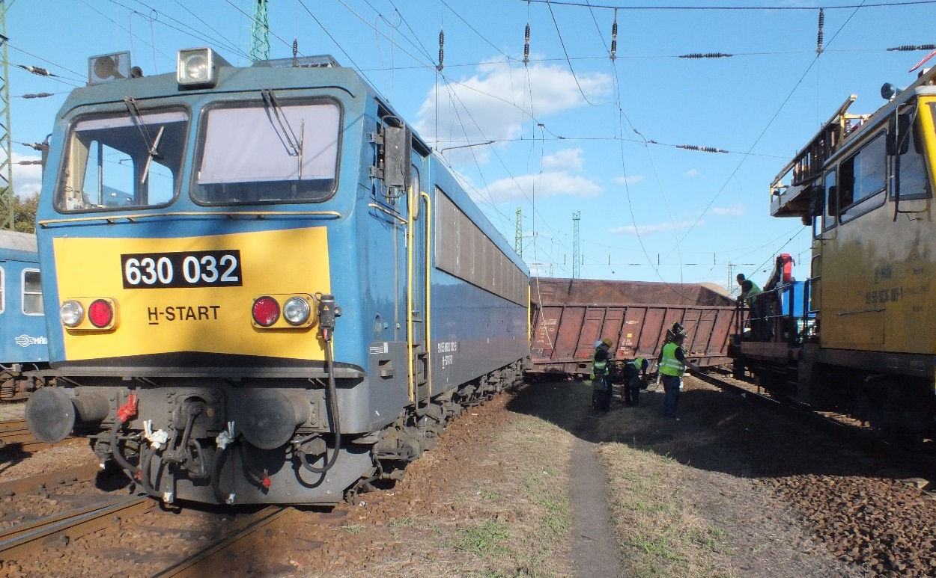

CONCLUSIONS

Direct causes
The factors which had direct effect on the occurrence were as follows:
- the connection between the arched switch tongue attachment, the stretcher bar and the control bar was disconnected because the pin had slipped out,
- the pin was not properly secured after the removal and re-installation of the control rod the night before the occurrence.

Indirect causes
Those findings relating to competences, procedures and maintenance which are related to the factors enumerated above:
- the safety installation did not detect the malfunction,
- the personnel putting the switch into operation did not realise that the pin of the control rod had not been secured,
- neither the locomotive drivers nor the track maintenance professional who detected the anomaly of the switch did recognise the hazardous nature of the defect therefore they did not intervene immediately but only reported the problem, and the action taken subsequently was too late.
- after being notified of the defect, the traffic management personnel maintained traffic on the switch concerned, not waiting until the related inspection.

Root causes
Causes that are distant in time and space from one another but which are related to system operation within the regulatory environment and in the safety management system:
- the design of the safety installation does not provide for detection of the displacement of the switch tongue in the case of similar defects until the switch position needs to be changed.

Other risk factors
The IC identified no other risk factor which could be related to the occurrence.

Lessons learnt
It was known prior to the derailment that something was wrong with the track, but it was not clear whether the defect was hazardous.
Safe action in similar situations would be to suspend or limit traffic after receiving relevant information until the track is checked (and return to normal operation after favourable feedback only), and not to maintain traffic until the inspection and negative feedback as if there is no problem, thus taking the risk of a potential accident.

