The translation from bulgarian
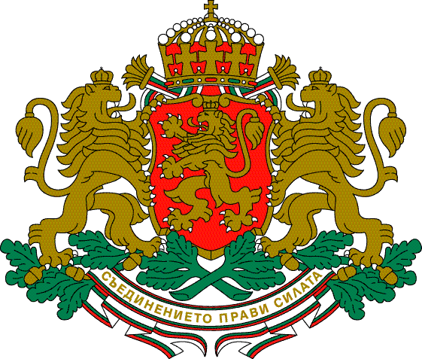REPUBLIC OF BULGARIA
MINISTRY OF TRANSPORTATION,
INFORMATION TECHNOLOGIES AND TELECOMMUNICATION

9 Dyakon Ignatiy Str., Sofia 1000 mail@mt.government.bg
Tel..: (+359 2) 940 9771 www.mt.government.bg
Fax:(+359 2) 988 5094

"AIRCRAFT, MARITIME AND RAILWAY ACCIDENT INVESTIGATION" DIRECTORATE (AMRAI)

FINAL REPORT

from

technical investigation of a railway accident, occurred on 26.06.2013 at 07:46 h at Ohrid stop – fire ignition in electric locomotive № 44074.3 of passenger train № 70200

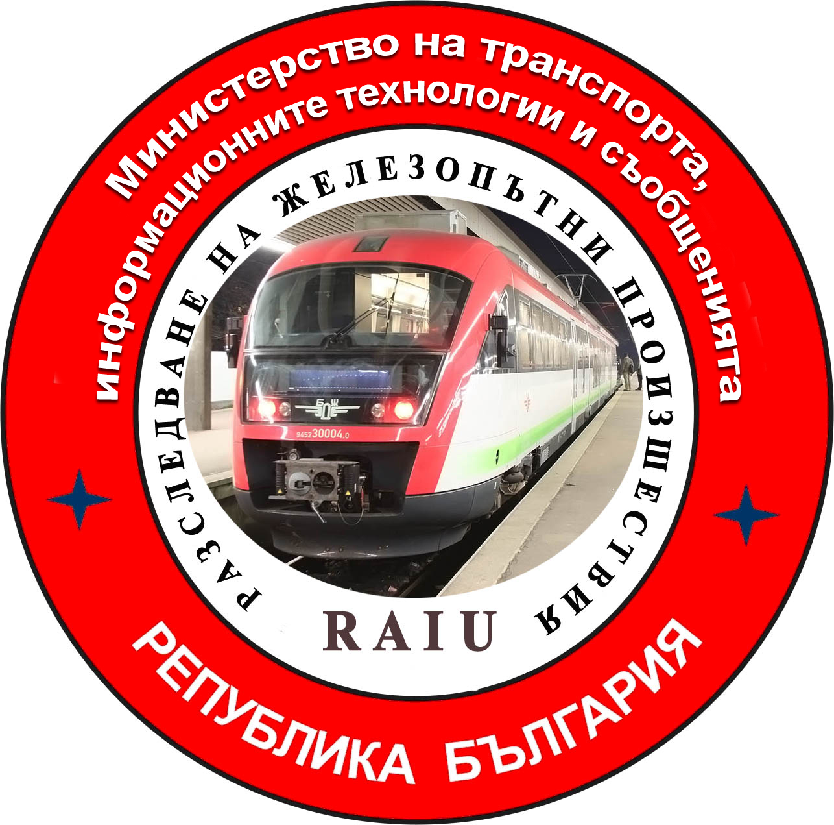

November 2013
I APPROVE:
TO
MR. DANAIL PAPAZOV
MINISTER OF TRANSPORT,
INFORMATION TECHNOLOGY AND COMMUNICATIONS

FINAL REPORT

Regarding: Technical investigation of railway accident, occurred on 26.06.2013 at 07:46 h at Ohrid stop – fire ignition of electric locomotive № 44074.3, servicing passenger train № 70200 in direction Mezdra-Montana.

DEAR MR. PAPAZOV

The Commission for the investigation has performed an inspection of the accident site, which was continued in Train car maintenance shed Mezdra and conducted personal interviews with the locomotive and transport crew and collected additional explanations from all officials involved in the accident; two outside experts were included in the Commission. In the course of investigation the report presented by the Operational group was analyzed, together with the requested additional documents, two technical expert reports was prepared and the opinions of the outside experts were discussed and accepted for the purpose of clarifying and establishing the facts and circumstances of the accident.

- 1. Established facts and circumstances in the course of the investigation.
On 26.06.2013 passenger train (PT) № 70200 comprising two cars type В₄ with mass of 91 tons is serviced by electric locomotive № 44074.3 operated from booth II by locomotive crew - locomotive driver and assistant locomotive driver from Locomotive depot Mezdra with “BDZ – Passenger Transport” EOOD and transport crew – trainmaster and train conductor from Passenger centre Mezdra with “BDZ – Passenger Transport” EOOD. The train is moving according to the Trainmovement schedule in direction Mezdra-Montana. At departure at 7:43 h from Palilula stop, the train accelerates until reaching the section-appropriate speed. The main air circuit breaker of the electric locomotive switches off at selected position 28, with indication on the control board “Н ₈₁₂”-„Land control”, “Н₈₀₆”-„Stop”. The locomotive driver lowers the positions to 0 with the position controller (341₂₁). Before passenger train № 70200 arrival at Ohrid stop, the locomotive driver sends the assistant locomotive driver the first command booth to determine the reasons for switching off at the above indication. When opening the door to the passageway, the assistant locomotive engineer feels the smell of heated isolation material, and immediately informs the locomotive engineer. Realizing the severity of the situation, the locomotive engineer leaves the assistant locomotive engineer in charge of operation and heads to the engine room for inspection and establishing the reason for the activation of signal lamp “Н₈₀₆”-“Stop”. He does a visual inspection of the engine room from the passageway side and after observing nothing unusual, he continues on to control booth I. He inspects protective cabinet 830, establishes the switched off blinker relay for maximum current protection "025В1” for motive engine one and blinker relay "860В”-„Land control”, first group (according to the initial statement given by the locomotive engineer at the site of the accident on 26.06.2013). He disconnects from the power grid protective cabinet 830 through safety switch 440 and resets the mechanically blocked blinker ,,860В”, and returns to the engine room for a second inspection; he does not find any smoke, only the smell of heated isolation material. He enters II control booth and warns the assistant locomotive engineer not to switch on the locomotive until the train stops at Ohrid stop, where he intends to perform a more detailed inspection of the locomotive. The train coasts on and stops at Ohrid stop at 07:46. After the train stops, the assistant locomotive engineer informs the trainmaster about the problem occurred.
According to the decoding and the prepared technical expert report of the speedometer tape of the electric locomotive the passenger train arrives at Palilula stop at 07:42 hrs. and departs at 07:43 h. It accelerates lightly to 42 km/h, after 200 m follows a decrease to 40 km/h, an increase to 48 km/h, a decrease to 43 km/h, an increase to 51 km/h and decrease to 0 km/h, whereby a quick braking at Ohrid stop was not undertaken at 07:46 hrs. at km 52+872, and the distance between the two stops is 2,9 km.
After the assistant locomotive driver leaves the locomotive, only the locomotive driver remains inside. At this point thick, black, acrid smoke rushes through the open door of the passageway into booth II, and the locomotive driver leaves the locomotive, carrying only the personal baggage of the locomotive crew, without activating the stationary fire extinguishing system and without activating the manual brake to secure the train against movement.
At the same time, the assistant locomotive driver disconnects the cable for the train heating system and returns to the platform, where he opens the accumulator battery cabinet, removes the fuse 876 from the 36 V DC operating circuit (according to the initial statement of the assistant locomotive driver given on the day of the accident - 26.06.2013) and together with the trainmaster commences the evacuation of the train. The locomotive driver sees that the black, thick smoke is turning into a fire and returns to booth I, where he secures the manual brake, removes the automatic tri-pole switch 832 of the accumulator battery, activates the fire extinguishing system and leaves the locomotive. At 07:57 h he calls 112 for help via his mobile telephone and then contacts the electric power controller with a request to shut down the contact network, which happens at 08:12 hrs. The trainmaster takes action to disconnect the locomotive from the rest of the train and with the help of the passengers moves the cars to a distance of 10-15 m away from the burning locomotive. After about 15-20 minutes a flame erupts under the body of the locomotive, between the cooling fans.
At 07:58 hrs. one fire truck heads towards the accident site and at 8:10 hrs. 4 more trucks head over. In 8:20 hrs. arrives the first fire truck of Regional department “Fire safety and civil protection” – Montana and at 08:21 they commence putting out the fire. At 08:30 the fire is located and at 10:30 it is completely extinguished. The investigating police officer starts a preliminary investigation at the site of the accident. For the extinguishing of the fire 46 100 liters of water were used.
After the fire occurs, the train traffic between Rakevo-Boychinovtsi railway stations was halted at 07:50 hrs. At 08:58 hrs. from Rakevo station leaves diesel locomotive № 55155.6 in order to move passenger train № 70200 from Ohrid stop to Rakevo station. The diesel locomotive arrives at Ohrid stop and attaches the passenger train; afterwards it departs for Rakevo station. At 10:02 hrs. in Rakevo station electric locomotive № 45199.7 arrives for train № 70200. Said train departs at 10:15 hrs. from Rakevo station for Mezdra station as train № 70101. Diesel locomotive № 55155.6 returns to Ohrid stop at 10:18 hrs., where he moves electric locomotive № 44074.3 to Boychinovtsi station. At 11:10 hrs. both locomotives arrive at track V of Boychinovtsi station. At 11:45 hrs. from Boychinovtsi station rail specialized self-propelled vehicle № 695 departs in order to check the working condition of the power contact network on Ohrid stop, and after the inspection returns to Boychinovtsi station at 12:20 hrs. At 12:25 hrs. the traffic between Rakevo and Boychninovtsi was restored with speed limit 25 km/h from km 52+940 to km 52+980. At 16:45 the train traffic is allowed to continue according to the schedule.
The passengers of fast train № 7621 waiting at Boychinovtsi station were transported by bus to Kurilo station, and the passengers of fast train № 7620, waiting at Kurilo station, were transported by bus to Boychinovtsi station.
At 15:17 hrs. diesel locomotive № 55155.6 removes electric locomotive № 44074.3 to Mezdra station, where it is submitted to locomotive repair facility for inspection by the Commission for the investigation.

2. Officials, involved in the case
2.1. Locomotive crew:
2.1.1. “locomotive driver” of electric locomotive № 44074.3 from locomotive depot Mezdra, “BDZ – Passenger services” EOOD – 24 years of service;
2.1.2. “assistant locomotive driver” of electric locomotive № 44074.3 from locomotive depot Mezdra, “BDZ – Passenger services” EOOD – 7 years of service.

2.2. Transport crew:
2.2.1. “trainmaster” from Passenger center Mezdra, “BDZ – Passenger services” EOOD, 22 years of service;
2.2.2. “train conductor” from Passenger center Mezdra, , “BDZ – Passenger services” EOOD, 28 years of service;
2.3. Train station staff:
2.3.1. “traffic director” Rakevo station, - employee in TTSAM Sofia, National Railway Infrastructure Company – 26 years of service
2.3.2. “traffic director” Boychinovtsi station – employee in TTSAM Sofia, National Railway Infrastructure Company – 23 years of service

3. Physical status of the officials involved in the case.
All officials involved in the case were provided with the necessary duration of rest before starting work, according to the provisions of the Labor code and Ordinance № 50 of 28.12.2001 for the work hours of managerial and operational staff, employed in the service of transporting passengers and freight in the railway transportation system (renewed in SG, issue 4 of 2002, amended in SG, issue 46 of 2004, amended and supplemented in SG, issue 99 of 2006.
All officials involved in the case have been given a pre-shift instruction and have declared that are alert, well-rested and are not under the influence of alcohol or other intoxicating substances.
The officials involved in the case have valid psychological examination certificates, which have not expired.
Before the locomotive crew started working, no checks for alcohol use were made, as must be done in accordance with the provisions of Article 24 and 28 of Ordinance № 54 of 02.06.2003 of the Minister of Transport and Communications (renewed., SG, issue 55 of 17.06.2003) for the medical and psychological requirements for personnel, employed in the service of railway transportation of passengers and freight and the accompanying activities for conducting pre-shift medical examinations. In the course of investigation in Locomotive repair shed Mezdra a widespread practice was found for allowing locomotive crew to work with only a signed declaration that they are “alert, well-rested and are not under the influence of alcohol or other intoxicating substances”, without measuring their blood alcohol content with the proper equipment. The violation established in the locomotive sheds is a proof that safety recommendation 1.5 has not been fulfilled in relation to the requirements of Article 94, paragraph 3 of Ordinance № 59 / 5.12.2006 for safety management in railway transportation:
,,1.5 The executive director of Executive agency “Railway administration” to organize and perform control checkups regarding the observation of the requirements of Article 24, paragraph 4 and Article 28, paragraph 2 and paragraph 3 of Ordinance № 54 of 02.06.2003 of the Minister of Transport and Communications (renewed, SG, issue 55 from 17.06.2003) for the medical and psychological requirements for personnel employed in the service of railway transportation of passengers and freight and the accompanying activities for conducting pre-shift medical examinations.”.
to Holding Bulgarian State Railways EAD with deadline for implementation 28.06.2013, still has not been implemented.

4. Competence and qualification documents.
All officials involved in the case possess the necessary documents for competence, professional qualification for their respective position and a certificate for holding said position.

- Actions of the officials before and during the accident.
Immediately before the accident all officials were acting in accordance with the established regulations and internal rules governing the safety in implementation of passenger transport by rail.

Despite the setting of the strong burst of smoke and toxic substances, threatening human health, as well as the circumstances that contributed to the growth of the fire, the locomotive and transport crews did not act in accordance with the established regulations and internal rules, governing the safety rail transport.
Said persons did not take the necessary measures to extinguish the fire with the fire-extinguishing equipment available in the locomotive and in the passenger cars:
- the locomotive crew did not activate immediately the stationary fire extinguishing system in the locomotive;
- the locomotive and transport crews did not take any measures for initial localization and extinguishing of the fire with the fire-equipment available in the locomotive and in the passenger cars – portable fire extinguishers with СО₂ and powder-based fire extinguishers type “Yatrus 12”;
- after passing through the passageway of the engine room the locomotive driver left the door open, which facilitated air circulation and the growth of the fire;
- the locomotive crew did not remove from the command booth the logbook and the train documents, they took care only of their personal baggage;
The locomotive and transport crews did report the fire to telephone 112 in a timely manner and contacted the energy dispatcher requesting to shut down the overhead line.

6. The circumstances that have influenced the accident, in regard to railroad, safety equipment, contact network, rolling stock.
The meteorological data about the weather influencing the visibility of the signals: during the daylight hours, air temperature: 17,6 °C, eastern wind, speed: 1 m/s and cloudiness 9/10.
Railroad: in good working order and is irrelevant to the railway accident.
Safety equipment at the station and in between the stations and its condition before the accident:
The section between the stations, equipped with semi-automatic blocking for a single-track section has been in proper condition and is irrelevant to the railway accident.
Contact network: in proper condition and does not have relation to the railroad accident.
Train-composing station: Mezdra.
Communication equipment and telecommunication connections: technically intact.
Profiles, geometry and situation of the road: The train had stopped in front of the reception building, Ohrid stop, in a straight section, 0 ⁰/₀₀ slope.
Rolling stock:
The electrical locomotive No. 44074.3, servicing Passenger train (PT) No. 70200 had been technically intact, including the undercarriage, braking system, light and sound signaling means, in accordance with the technical norms and requirements, which is evidenced by entries in the respective logbooks, copies of which are presented in the report of the Task Force.
The electrical locomotive has been equipped with the following firefighting equipment:
- portable fire extinguishers, Type “Yarus-12” in the control cabins – 2 pieces, marked with stickers for technical verification by September 2013 – both of are used during the fire;
- СО₂ containing portable fire extinguishers in the machine compartment – 2 pieces, marked with stickers for technical verification by September 2013 – not used during the fire;
- stationary dry powder extinguishing system – activated with a delay.
Wagons: 2 wagons, В₄ type, number of axles – 8 in the corridors – 2 portable fire extinguishers, marked with stickers for technical verification by October 2013, not used during the fire.

7. Compliance with the procedures and work techniques at the State enterprise “National Railway Infrastructure Company” before and during the accident. The procedures and the work techniques in the Department of “Train Traffic and Station Activity Management” – Sofia, which is in the structure of State enterprise “National Railway Infrastructure Company” before, and at the time of the occurrence, as is evident from the report of the Task Force and the annexes thereto, the additionally claimed materials and the meetings with the individuals involved in the accident, held by the Commission for the investigation.
8. Compliance with the procedures and the technologies for maintenance of rolling stock in the system of the transport operator before and during the accident.
Passenger train No. 70200 had been secured with the necessary braking mass and has been equipped with the necessary train documentation. The locomotive and the transport crews have been provided with business mobile phones.
Electrical locomotive No. 44074.3 was manufactured in 1976 and assigned in the Park of the locomotive Depot “Nikola Vaptsarov” – Sofia, and was put into exploitation on 20.12.1977
The value of the electrical locomotive as balanced to 30.10.2013 is 164 029,24 BGN.
Up to the moment of the accident, the run results of the electrical locomotive from the last repair works are shown in the following table:

type of repair works | date of Release after repair works | run at repair works
General repair works (GRW) | 08.05.1996 | 2 160 142 km
Moderate repair works (MRW) | 28.05.2004 | 1 091 000 km
Elevatory repair works (ERW) | 27.01.2010 | 433 084 km
Large scale periodic works (LSPW) | 29.09.2012 | 128 276 km
Small scale periodic works ( | 13.03.2013 | 51 397 km
Technical inspection (TI) | 13.06.2013 | 6 795 km
Exploitation inspection (EI) | 25.06.2013 | 1 100 km

During the review of the technical documentation in was found that in accordance to ПП_ПЛС 100/11 „Recommendation for runs between repair works and the cyclic recurrence of the planned inspections and repair works of the electrical locomotives and the Electric Train Buses (ETB) of BDZ – Passenger Services (PS)” EAD, from the execution of the General repair works (GRW) on 29.09.2012 up until the accident, all inspections and repair works have been performed in accordance with the established repair works cycle.
The inspection of the “Technical Passport of the locomotive No. 44074.3” (ЛС 005-1) and “Logbook for the repair works upon demand regarding the traction rolling stock” (Form. ЛП – 9), established that no violations were found or registered of the active rules for factory repair works, or maintenance shed works, of the rules for the maintenance of the organization’s electrical locomotives as well as of the procedures of the repair works, that may have any relation to the occurrence of the fire.

9. Condition of the railway infrastructure and of the rolling stock before, during and after the accident.
It was found that the railway infrastructure before, during and after the accident had been functioning properly.
Before the accident, electric locomotive No. 44074.3 and the wagons of passenger train No. 70200 were functioning properly.
As a result of the accident, multiple damages to the electric locomotive were found, which are detailed in item 10 “Consequences of the accident”.
10. Consequences of the accident
10.1. Casualties – none;
10.2. Injured with traumas – none.
10.3. Failures and damages caused to the rolling stock:
10.3.1. Wagons:
Passenger wagons No 51522150077.7 and No. 50522133023.4 – base station Mezdra – proper functioning, no damages.
10.3.2. Electric locomotive:
Electric locomotive No. 44074.3 – property of “BDZ – Passenger Services” EOOD, locomotive depot Sofia. Upon examination, the Commission for the investigation concluded the following:
- the logbook of the locomotive and the train documents have burned in the fire, for which a report is enclosed;
- the second cabin of the locomotive is fully burned down, along with the control equipment and hardware cabinets in it;
- smoked first cabin of the locomotive;
- deformed sides of the locomotive body;
- burned out air filters;
- melted accumulator batteries and power cables of the operative circuits of 36Vand 48V DC;
- burned out isolation of the power cables of IInd and IIIrd traction motors;
- melted terminal board of IIIrd traction motor;
- burned out bellows of IInd, IIIrd and IVth traction motors;
- completely burned out centrifugal fan under the body for group I;
- burned out insulation of power cords and terminal board of IInd centrifugal fan under the body;
- burned out floor in the transitional and non-transitional corridor in the machine compartment;
- burned out cabinet with reverse-emergency switches of Ist and IInd group;
- burned out main rectifier and auxiliary rectifier in Ist group, electronic control block “Recdin”, R-C groups, panel with auxiliary and signal relays;
- burned out main rectifier and auxiliary rectifier in IInd group, electronic control block “Recdin”, R-C groups, panel with auxiliary and signal relays;
- damaged insulation of the smoothing reactor of Ist and IInd traction motors, caused by the continuous effect of high temperature;
- damaged insulation of the smoothing reactor of IIIrd and IVth traction motors, caused by the continuous effect of high temperature;
- burned out smoothing reactor of the power circuit of Ist centrifugal fan under the body;
- burned out brake-traction (J-B) switch 075;
- damaged insulation of the supplying power cables and the cables circuits for control and signalization of Ist motor-compressor;
- damaged insulation of the power supply cables and the cables circuits for control and signalization of IInd motor-compressor;
- burned out motor-fan of the brake resistors for Ist and IInd group;
- burned out bellows in the brake resistance cabinets;
- burned out pump engine;
- damaged insulation of the power cables of the charging device;
- burned out switch 201 and panel 202 for charging of the auxiliary machines by an external source (in maintenance shed);
- burned out servomotor with electrical pneumatic valves /EPV/ and programming switch 015₇ of the autotransformer switch /ATS/;
- burned out bars 1000V and 1500V, as well as power cables from a circuit closer – train heating (TH) to the distributor boxes in both ends of the locomotive;
- deformed current buses between traction rectifying group 020, recessive-emergency switches cabinet of Ist group and traction transformer;
- burned out valve arresters with counters;
- burned out middle roof with the main air circuit breaker, partition insulator and collector breakers of the collectors;
- the stationary fire extinguishing system of the locomotive had been activated but did not perform its function.
After the accident and pursuant to § 18 and Annex No 3 of the “Regulations for repair works at a maintenance shed and maintenance of the electric locomotives of BDZ” – signature No. лс 0103, a Statement of Findings was prepared, dated 19.11.2013 for evaluation of the material damages, that amounts to 123 022 BGN.
10.4. Failures and damages caused to the railway infrastructure:
10.4.1. Rail road and facilities:
- two rails defected, type S 49 length 25 m – 857,50 BGN., no VAT included;
- 25 rubber traverse pads burned out – 7.75 BGN, no VAT included.
10.4.2. Security equipment and communications, radio connections, power supply: none.
10.4.3. Contact network: none.
10.4.4. Other failures and damages: none.
10.5. Accidents and spilling of cargo, baggage and mail packets: none.
10.6. Blocking of traffic: As a consequence to the fire ignition in electrical locomotive No. 44074.3 on 26.06.2013 the traffic has been blocked between the stations of Rakevo – Boychinovtsi is interrupted from 08:45 hrs. to 12:25 hrs. At 16:45 hrs. the train movement is restored, with speed as per book-schedule.
10.7. Train delay caused:
10.7.1 Cancelled trains:
- train No 70200, transport operator „BDZ - PS” EOOD – section Rakevo - Montana
- train No. 71222, transport operator BDZ PS” EOOD – section Montana – Boychinovtsi.
10.7.2. Delayed trains:
- train No. 7620, transport operator „BDZ - PS” EOOD - + 178';
- train No. 7621, transport operator „BDZ - PS” EOOD - + 210';
- train No. 70101, transport operator „BDZ - PS” EOOD - + 30';
- train No. 70202, transport operator „BDZ - PS” EOOD - + 70';
- train No. 70201, transport operator „BDZ - PS” EOOD - + 20';
- train No. 70105, transport operator „BDZ - PS” EOOD - + 128';
- train No. 70106, transport operator „BDZ - PS” EOOD - + 77';
- train No. 70206, transport operator „BDZ - PS” EOOD - + 14';
- train No. 71203, transport operator „BDZ - PS” EOOD - + 100';
- train No. 71204, transport operator „BDZ - PS” EOOD - + 60';
- train No. 72201, transport operator „BDZ - PS” EOOD - + 15';
- train No. 72202, transport operator „BDZ - PS” EOOD - + 157';
- train No. 72203, transport operator „BDZ - PS” EOOD - + 10';
- train No. 72204, transport operator „BDZ - PS” EOOD - + 13';
- train No. 72205, transport operator „BDZ - PS” EOOD - + 5';
- train No. 70230, transport operator „BDZ - PS” EOOD - + 20';
- train No. 20232, transport operator „BDZ - PS” EOOD - + 10';
- train No. 20233, transport operator „BDZ - PS” EOOD - + 15
10.7.3 Transbordering of passenger trains:
- train No. 7620, transport operator „BDZ - PS” EOOD - section Kurilo - Boychinovtsi
- train No. 7621, transport operator „BDZ - PS” EOOD - section Buychinovtsi – Kurilo;
The losses suffered by „BDZ – Passenger Services” EOOD, caused by the delayed trains amount to 49 451 BGN, no VAT included.
10.8. Running of restoration means:
10.8.1. Restoration train: none.
10.8.2. Other restoration means: none.

11. Analysis of the causes which led to the railway accident.
From the inspections performed and the materials provided, it is obvious that:
- The fire has broken out at 07:46 hrs. when passenger train No. 70200 pulled in at Ohrid Station;
- The electric locomotive has burnt mostly on the right side (in the direction of movement of the train);
- The second cabin of the electric locomotive is completely burnt, the control panel and all conductors, cables and contactors are heavily burnt;
- Second cabin – smoked up;
- There are white spots on the locomotive body above the right cabinet of the accumulator battery (AB);
- There are significant deformations of the right cabinet of the accumulator battery and its lid;
- The corpuses of the separate accumulator batteries are burnt and the lead cells in the right cabinet are melted;
- The high-power blade fuse in the right part of the cabinet is present;
- The insulation of the high-power electric conductors, which are connected to the accumulator batteries in the right cabinet, is completely burnt;
- A single-core multi-wire copper conductor (conductor 853), one end of which is connected to the plus terminal of the accumulator battery in the right cabinet of the accumulator battery, is found weld to the back side of the metal cabinet. The same has been cut due to the weld and traces of melts, which occurred as the result of an electrical short circuit, can be seen at the place of short circuit occurred. The rest of this high-power conductor after the place of welding goes through an armored metal tube towards the accumulator batteries cabinet, which is located on the left side of the locomotive. An X-ray structural analysis for determining the type of short circuit has been performed of the same;
- Under the place of welding of the electric conductor to the corpus of the right cabinet of the accumulator battery, the presence of molten copper on the bottom was found, which shows that an extremely high temperature has been reached, because the melting temperature of copper and its alloys is from 900 °С to 1100 °С;
- Melts on the armored metal tube (leading the electric conductors to the accumulator battery located in the left cabinet) were found present;
- It was found that 4 (four) units from the accumulator battery set have been replaced when performing Technical Inspection 3 (TI 3) on 13.06.2013 due to 1 (one) defective accumulator battery. A Statement of Findings No. 127 of 13.06.2013 has been composed for this purpose, as 4 new tubular accumulator batteries, type PzS (classic), lot No. 134144015, have been installed and 3 (three) units of the old good-working accumulator battery remain as a reserve.
Electrical short circuits are random and unpredictable events, resulting from defects in the insulation of electricity-carrying cables and conductors. A characteristic sign of the emergence of electrical short circuits is the melting of the wires due to emerging electric arc, the temperature of which may reach 1500 ° to 4000 ° C by which typical "frozen drops, pearls" of molten metal are produced. The current of the electrical short circuit in the initial time was comparable to the nominal operating current in operative circuits, thus not triggering any electrical protection. Subsequently, the excessive heat and melting of the insulation of the operative conductors caused a permanent electrical short circuit, which led to electric arc emergence and inflammation of the electric conductors combustible insulation of the electric locomotive. The single-core multi-wire copper conductor (conductor 853) taken from the right cabinet of the accumulator battery for an X-ray structural analysis has its insulation completely burned at one end, at which melt, characteristic of melting resulting from a short circuit, can be observed.
The comprehensive fire-technical investigation implemented by the Research and Investigation Centre of the Fire Safety and Civil Protection Chief Directorate at MoI and the radiographic structural analysis done using URS2.0 radiographic equipment has unequivocally shown that the short circuit has been “primary”. Seized evidence materials (materials and conductors from the electric locomotive) used for the fire-technical investigation have provided data for a rapid development of the fire suggesting the presence of a high power ignition source.
According to the evidence materials gathered the occurrence of the flame burning has been preceded by a long period of strong smoldering and smoke production. Burning has spread from the battery cabinet – through the conductors connected to other combustible materials in all directions in the locomotive in a form of a sphere.
From the nature of the damage and the traces of the fire effect in the burning area, the thermal influence area and the smoke production area, the place where the fire has occurred was determined. In the place of fire occurrence, as a result of continued burning and fire-impact maximum depth of burn and char marks and considerable damage are observed, which was found in the cabinet of a rechargeable battery. Traces of high thermal impact on the materials as well as deformations of the metal parts and structures have been found at the outbreak of the fire.
The products formed in the combustion zone into the metal cabinet are a multicomponent mixture which forms an elevated pressure. Under the influence of this pressure, the combustion products have spread outside the combustion zone in the cabinet of the accumulator battery. As a result of the temperature differences in height in the first zone and in the area at some distance from it, the heated hydrocarbon particles have cooled down and deposited in the vertical and horizontal structures thus forming a coating coloring the surfaces in black and dark brown. This coating has been retained on the surface only at a certain critical temperature which is in the range 600-630 °C. In the places in the combustion zone where the temperature has been higher, the deposited hydrocarbon particles have burned and formed white spots and areas and around them where the temperature has been about 600 °C, the surfaces have remained black or dark brown. In the performed initial and additional inspections, the typical signs of an outbreak of the fire have been established and clearly identified in the cabinet of the accumulator battery located on the right side of the electric locomotive in the direction of its movement.
Under the influence of the radiant heat flow and thermal conductivity, high temperature which was reached in the cabinet of the accumulator battery has spread to the car body of the electric locomotive vertically upwards where it increased the temperature of the electrical conductors and cables and the wooden elements of the floor in the engine compartment of the locomotive (cable channels) above the cabinet of the accumulator battery. The burning in the cabinet of the accumulator battery has been initially partial due to lack of oxygen. Upon reaching a temperature of the wooden elements exceeding 200 °C, the typical for the wood irreversible processes of thermal degradation and subsequent flameless combustion (smoldering) had begun, which are determined by its structure and the presence of oxygen in the basic elements of which it is built. The smoldering process is relatively slow and can last from minutes to hours. Upon reaching a temperature above 350 °C, the wood is on fire, the burning in the engine compartment of the locomotive has spread over combustible insulations of the electrical conductors and the other combustible materials – wood, plastic and others, vertically downwards under the influence of the melting materials and horizontally in all directions mainly under the influence of the radiant heat flow and the thermal conductivity in the form of a sphere.
The rapid expansion of the fire and its spread to the oil cooling system oil cooler, pump, oil lines) of the traction transformer and the subsequent melting and burning of rubber gaskets and seals caused an oil leak. The ignition of the oil, the rubber gaskets, the insulation of the cables and the insulation boards in the rectifier in the conditions of a strong air exchange caused intense increase in the temperature in the engine room and smoke production.
The smoke through the open door of the through corridor fills the 2nd control room, formed by the burning insulation and electrolyte in the accumulation batteries.
With the expansion of the fire in the electric locomotive by the action of the thermal conductivity, the convective and radiative heat flows (radiant heat exchange) and the thermal conductivity of the materials, the burning has spread faster to the front cabin under the influence of the east wind at the time of the accident and more slowly to the rear cabin. There was a real danger of the fire spreading to the passenger coaches behind the electric locomotive.
The circumstances which contributed to the emergence and spread of the fire are:
- the presence of a large volume of combustible materials in the electric locomotive – combustible insulations of electric conductors and cables, wooden elements , the presence of layering of powders, oils, plastics, etc.;
- the delayed activation of the fire extinguishing system of the electric locomotive by the locomotive crew;
- the non-performed initial extinguishing with the handheld fire extinguishers available in the locomotive and the coaches by the locomotive and transport crews;
- constructively, no Fire Alarm System (FAS) sensors are provided in the cabinets of the accumulator battery, or sensors for the presence of smoke connected to the existing FAS;
- the remoteness of the accident site from FSCP RD – Montana;
- the presence of the east wind.
- the non-equipment of the electric locomotive with gas masks, as required by Art. 427, paragraph 1, i. 7 of Ordinance № 13 from 30.12.2005 on the provision of healthy and safe working conditions in the rail transport as a consequence of the strong burst of smoke from the smoldering parts, the locomotive crew was not able to take the necessary measures for extinguishing.
With a final report approved by the Minister of Transport, Information Technology and Communications, № 14-00-1191/17.05.2013, of the technical investigation of a railway accident that occurred on 19.12.2012 at the Shumen station – ignition of electric locomotive № 42081.0 of passenger train № 90101, safety recommendation 2 was given:
"2. Pursuant to Art. 427, paragraph 1, i. 7 of Ordinance № 13 of 30.12.2005 on the provision of healthy and safe working conditions in the railway transport, the Executive Director of Holding Bulgarian State Railways EAD to undertake measures for compliance and enforcement of the Ordinance requirements".
The deadline for implementation of the recommendation given is 31.07.2013 and to the moment it still has not been implemented performed by Holding Bulgarian State Railways EAD.
Upon further investigation conducted by the Commission for investigation, the following inconsistencies with initial explanations given by officials directly involved in the accident were established and proven:
- in the written explanation given on 26.06.2013, the locomotive driver claims that "in the protection cabinet, first group ground and the first engine blinker were triggered". It was subsequently established in the Locomotive Depot in Mezdra that protection of the third traction motor and the "second group ground" were triggered;
- in the written explanation given on 26.06.2013, the assistant locomotive driver argues that he "took steps to remove the train cable, the safety device of the AB". It was subsequently established in the Locomotive Depot in Mezdra the blade high power fuse is located on the right side of the right cabinet (in the direction of movement of the locomotive) of the accumulator battery.

12. Reason for the accident.
As a result of the inspections on the site and in the locomotive depot in Mezdra by the Commission for the investigation of the railway accident and after reading the collected protocols for planned repairs and inspections, protocols for performed measurements and other technical documentation of the case, the report of the Task Force, the further taken written and oral explanations of the locomotive and transport crews and the staff involved in the accident, the results of comprehensive fire investigation expert report required by the Commission for the investigation, the additional technical expertise prepared, the opinions of external experts and the performed analysis, the Commission thinks that:
The direct technical cause of the accident – fire ignition of electric locomotive № 44074.3 on Ohrid stop is a disruption of the isolation and occurrence of primary electrical short circuit between operational conductors 850, 851, 853 of the accumulator battery mounted in the metal cabinet and passing under the frame of the electric locomotive in an armored metal flexible tube and its body (conductor 999).
The insulation of cables and conductors is subject to aging, loss of insulating qualities and properties as a result of repeated bending, vibration, moisture, loose connections or excessive heating of the insulation.
The electrical short circuit occurred when creating conditions for an electrical contact at the touch of the conductors connected to the accumulator battery of the locomotive with different polarity through very small resistance which is not envisaged for the operating conditions of the operating electric circuits.

13. Recommendations and suggestions for actions preventing other accidents of similar nature.
In order to prevent future accidents of similar nature, in connection with the requirements of Art. 94, paragraph 1 of the Ordinance № 59 of 5.12.2006 on the safety management in railway transport by the Minister of Transport, the "Railway Administration" Executive Agency should order Holding Bulgarian State Railways EAD to enforce the safety recommendations given:
1. Holding Bulgarian State Railways EAD should perform extraordinary instructions and conduct a specialized training by the Fire Safety and Civil Protection General Department (FSCP GD) with the Ministry of Interior (MoI) for the staff directly involved in the operation of traction rolling stock and train servicing on actions in the event of emergencies (a fire in rolling stock) so that they can effectively deal with fire safety installations and equipment fitted;
2. To carry out an inspection of all electric locomotives of 44000 and 45000 series operated in Holding Bulgarian State Railways EAD under the requirements of Art. 664, Art. 667, Art. 680 and Art. 681 of the Prescription for Locomotive Holding (PLH-127/05) "Regulations for factory repair of electric locomotives series 44000 and 45000" and the results of the inspection to be presented in a statement of findings;
3. Holding Bulgarian State Railways EAD should explore the possibility and to put extra temperature sensors or optical smoke detectors for the Fire Alarm System (FAS) in the cabinets of the accumulator battery which should be connected to the existing FAS of the electric locomotives;
4. Holding Bulgarian State Railways EAD should explore the possibility to install a system for monitoring of the insulation resistance of power and auxiliary control circuits allowing continuous monitoring and signaling with an indicating light signaling on the control panel in real time;
5. Holding Bulgarian State Railways EAD to introduce by the performance of every Small Periodic Repair (SPR) diagnostics of the temperature of the contact connections of electric locomotives with thermal imaging cameras;
6. The Safety Departments in Holding Bulgarian State Railways EAD should perform continuous control of the compliance with the requirements of Art. 24 and Art. 28 of Ordinance № 54 of 02.06.2003 on the medical and psychological status of the staff operating railway passenger and freight transport and associated activities and for the conduction of pre-travel (pre-shift) medical examinations.
In connection with the requirements of Art. 94, paragraph 3 of Ordinance № 59 of 5.12.2006 on the safety management in railway safety by the Minister of Transport, by 17.10.2014, the "Railway Administration" Executive Agency and Holding Bulgarian State Railways EAD should notify in writing the AMRAI Directorate in MTITC of the appropriate actions taken for the implementation of the above recommendations.

Appendix: 1. Photographs – 7.

Chairperson:
……………………………….…... (Boycho Skrobanski)
State Inspector in AMRAI Directorate in the MTITC
Members:
1. ............................................................ (Boyko Stoilov)
Chief Inspector in AMRAI Directorate in the MTITC

2. ……………………………………..... (Dimitar Iotov)
Inspector in AMRAI Directorate in the MTITC

3. ……………………………………...... (Ivan Petrov)
Independent external expert RRS

4. …………….………………………..… (Velko Danailov)
Independent external expert RRS

I, the undersigned Nadezhda Boshnyashka, certify that this is a true and accurate translation done by me from Bulgarian into English of the attached document.
The translation consists of 12 pages.

Translator: Nadezhda Boshnyashka

