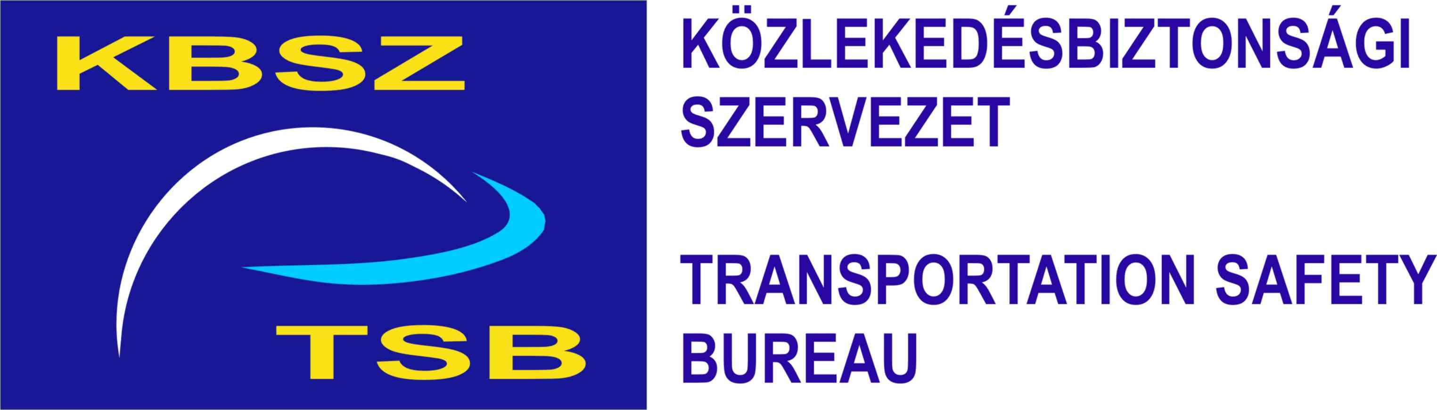
FINAL REPORT
2006- 0151-5
RAILWAY ACCIDENT
Between Ebes and Debrecen stations
7 December 2006
The sole objective of the technical investigation is to reveal the causes and circumstances of serious railway accidents, accidents and incidents and to initiate the necessary technical measures and make recommendations in order to prevent similar cases in the future. It is not the purpose of this activity to apportion blame or liability.
This present investigation was conducted on the basis of
- Act CLXXXIV of 2005 on the technical investigation of aviation, railway and marine accidents and incidents (hereinafter referred to as Kbvt.),
- MET Decree 7/2006. (II. 27.) on the regulations of the technical investigation of serious railway accidents, railway accidents and incidents.
- In absence of other related regulation of the Kbvt., the Transportation Safety Bureau of Hungary conducted the investigation in accordance with Act CXL of 2004 on the general rules of administrative authority procedure and service,
- Kbvt. and MET Decree 7/2006. (II. 27.) jointly serve the compliance with the following EU acts:
Directive 2004/49/EC of the European Parliament and of the Council of 29 April 2004 on safety on the Community's railways and amending Council Directive 95/18/EC on the licensing of railway undertakings and Directive 2001/14/EC on the allocation of railway infrastructure capacity and the levying of charges for the use of railway infrastructure and safety certification (Railway Safety Directive)
- The competence of the Transportation Safety Bureau of Hungary is based on the Kbvt. until 31st December 2006 and on Government Decree 278/2006 (XII. 23.) from 1st January 2007 respectively.

Under the aforementioned regulations
- The Transportation Safety Bureau of Hungary shall investigate serious railway accidents.
- The Transportation Safety Bureau of Hungary may investigate railway accidents and incidents which - in its judgement - would have resulted in serious accidents in other circumstances.
- The technical investigation is independent of any administrative, infringement or criminal procedures.
- This present final report shall not be binding, nor shall an appeal be lodged against it.
Incompatibility did not stand against the members of the IC. Persons participating in the technical investigation did not act as experts in other procedures concerning the same case and shall not do so in the future.

The IC shall safe keep the data having come to their knowledge in the course of the technical investigation. Furthermore, the IC shall not be obliged to make the data – regarding which the owner of the data could have refused the disclosure of the data pursuant to the relevant act – available to other authorities.

This present final report
was based on the Draft Report prepared by the IC and accepted by the Director-General of TSB. The Draft Report was sent to the relevant parties - defined by law - for reflections. At the same time, the relevant parties and organisations were also informed and invited to the closing discussion of the Draft report.
The following organisations were represented at the closing discussion which was held on 5th August 2008:
- National Transport Authority,
- MÁV Zrt.
- MÁV-Wagongo Zrt.
- MÁV-Gépészet Zrt. (Mechanical engineering)

ABBREVIATIONS
ÁVU | Station Instructions
BIG | Safety Directorate (of Máv Zrt.)
CFR | Romanian State Railways
D55 | Domino 55 type signal box
EÉVB | Unified Train Control Installation and Vigilance Warning Device
E brake test | Simplified brake test
MET | Ministry of Economy and Transport
TSB | Transportation Safety Bureau
Kbvt. | Act CLXXXIV of 2005 on the technical investigation of aviation, railway and marine accidents and incidents
KE-GP | Knorr-type brake – freight-passenger train brake
MÁV WAGONGO Zrt. | Hungarian State Railways Wagongo Plc.  Magyar Államvasutak Wagongo Zártkörűen működő Részvénytársaság
MÁV Zrt. | Hungarian State Railways Plc.  (Magyar Államvasutak Zártkörűen működő Részvénytársaság)
REV | Overhaul
SZIR | Freight Train Pool Database
IC | Investigating Committee
VBO | The competent Regional Railway Safety Department of BIG MÁV Zrt.
SUMMARY
Reports and notifications
The head of traffic operations control of MÁV Zrt. reported the occurrence to the TSB duty services at 3 hours 10 minutes on 7th December 2006.
The on duty personnel of TSB reported the occurrence to TSB’s head of department on duty at 3 hours 12 minutes on 7th December 2006.
The appointment of the Investigating Committee
The Director-General of TSB appointed the following Investigating Committee (hereinafter referred to as IC) to investigate the railway accident:
Investigator-in-Charge | András Mihály | accident investigator
IC member | Ferenc Pataki | field investigator technician
IC member | Róbert Karosi | (substituting Árpád Vincze Dr.)
Since Árpád Vincze Dr. is no longer the civil servant of TSB, the Director-General of TSB appointed Róbert Karosi on 1st May 2007 as a member of the IC.
Legal basis of the investigation: | 7. § (1) b) of Act CLXXXIV of 2005 (Kbvt.)  3. § (1) b) of 7/2006. (II. 27.) MET Decree  19. § (2) c) of Directive 2004/49/EC
Type of railway system: | national
Type of main occurrence: | railway accident
Character: | derailment
Type of secondary occurrence: | -
Type of movement: | freight train
Location: | open track + station
Injuries:
   | Fatal | Serious | Minor | None
  Passengers
  Railway staff
  LC users
  Trespassers
  Others
Infrastructure manager | MÁV Zrt.
Operator: | MÁV Wagongo Zrt.
Time of the accident
2 hours 18 minutes on 7th December 2006.
Overview of the course of the investigation
This present Final Report was compiled on the basis of the following:
- site survey,
- official records and notes made at the site,
- evaluation of the photographs taken and the video recorded at the site,
- evaluation of data from the obtained documents,
- evaluation of the strip chart recorder,
- review of technical documents and manuals, and
- interviews.
Location of the occurrence
Main line no.100 Ebes-Debrecen left track, section no. 2177+40
Competent investigating authority (according to the location of the accident)
Transportation Safety Bureau
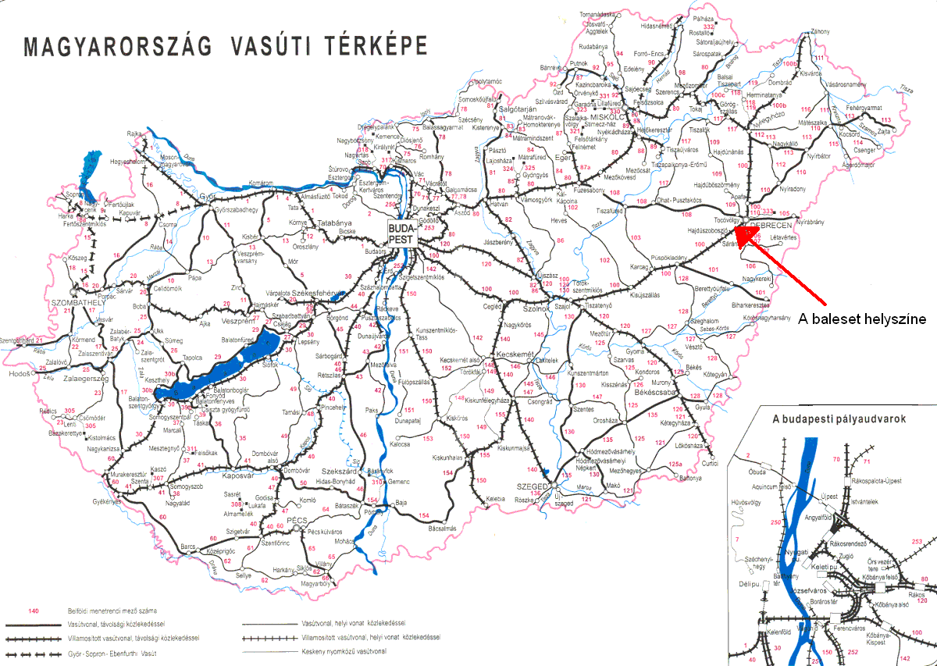
Figure 1: The railway map of Hungary
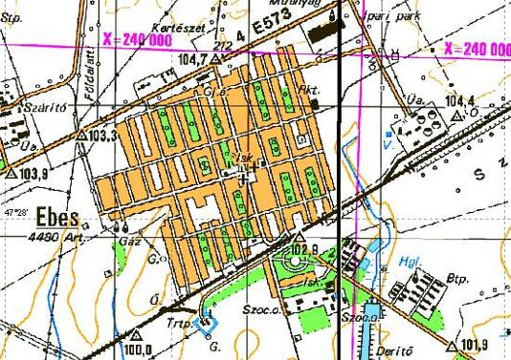
Figure 2: The map of Ebes

1. Factual information

1.1 Course of the event
According to the occurrence report, at 2 hours 18 minutes on 7th December 2006, the 24th wagon (registration number: 31 53 933 9666-0) of train no. 63203 running from Záhony marshalling yard to Budapest Ferencváros station derailed between Debrecen and Ebes stations on the open track, in railway section no. 2177+40. Train no. 63203 was running with the wheels of its 24th wagon (no. 31 53 933 9666-0) running beside the rails on the concrete sleeper on an approximately 7-kilometre-distance until Ebes station. When running through the left (transit) main track of Ebes station - track IV - the derailed axle of the arriving train tore the trackage of point no. 3 which lay in the train’s path. Subsequently, it broke the BODÁN plate of level crossing SR 1 in railway section no. 2102+10. As a consequence, the derailed pair of wheels was running towards track V, and the train separated between the 23rd and the 24th wagons. Four more wagons derailed and two toppled onto their side. When the train separated, it stopped with emergency braking. Afterwards, the general train service continued on track III at Ebes station and on the right track between Debrecen and Ebes stations.
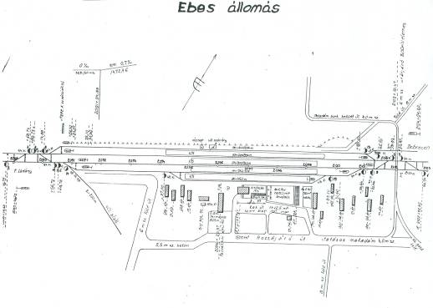
Figure 3: The layout of Ebes station; the site where the derailed wagons were found
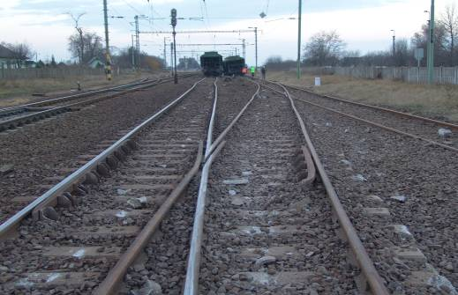
Figure 4: Derailed wagons at Ebes station

1.2 Injuries to persons
There was no injury.

1.3 Damage to railway vehicles
The rear bogie of the 22nd (no. 31 53 933 3162-5) wagon derailed with two axles.
Both bogies of the 23rd wagon (no. 31 53 933 9013-5) derailed with 2-2 axles and the wagon toppled onto its side. It suffered substantial damage and cannot be repaired economically.
Both bogies of the 24th wagon (no. 31 53 933 9666-0) derailed with 2-2 axles and toppled onto its side. It suffered substantial damage and could not be repaired economically.
Both bogies of the 25th wagon (no. 31 53 933 4307-6) derailed with 2-2 axles.
Both bogies of the 26th wagon (no. 31 53 933 4117-9) derailed with 2-2 axles. One of the bogies sustained substantial damage.
Both bogies of the 27th wagon (no. 31 53 933 5752-2) derailed with 2-2 axles.
The front bogie (running direction) of the 28th wagon (no. 31 53 933 9781-7) derailed with 2 axles.
MÁV WAGONGO Zrt. was unable to provide information on the damage to the rolling stock by the completion of the investigation as it did not receive any information regarding the damages from the owner of the wagons.

1.4 Damage to infrastructure
When the accident occurred, the toppled wagons dragged along the V5 exit signal of Ebes station and carried off the point mechanisms of points no. 3, 5 and 7 which lay on the left main track of Ebes station. The point connecting rods of point no. 13 lying on track V of Ebes station as well as the catenary support between points no. 5 and 7 sustained damage.
According to the data given by VBO, the repair of the track cost 100 million HUF which included the costs of the repair of the track at Ebes station and that of the open track. The repair of the signal box cost 10 million HUF and that of the catenary cost 1 million HUF.

1.5 Personnel information
Engine driver of train of train no. 63203
Age and gender | 28-year-old man
Issue of driving licence | 16 October 2003
Driving licence valid | 5 November 2008
Licence valid for the following type of vehicles: | electric locomotive,  electric shunting locomotive,  diesel locomotive  diesel shunting locomotive
  - Train information
Train no. 63203
Departure station | Záhony-Rendező (marshalling yard)
Destination station | Budapest Ferencváros
Registration number of locomotive | V43-1088
Number of wagons | 28
Length of train | 525 m
Full weight of train | 1077 t
Tonnage | 997 t
Prescribed braked weight percentage | 64
Actual braked weight percentage | 92

1.7 Meteorological information
At the time of the accident, the weather was windy and overcast with approximately 5 ⁰C outside temperature and normal visibility (normal night light conditions).

1.8 Description of rail track
The structure of the rail track is of 54 kg per linear metre rail fitted on reinforced-concrete sleepers in ballast chips.
The target speed for the line is 120 km/h. The permitted speed on the rail track was 120 km/h at the time of the accident.
The rail track runs straight from the location of the accident - from section no. 2177+40 - to Ebes station. There was no outdoor source of light where the derailment occurred. An automatic block signal operates between Debrecen and Ebes stations, which had no effect on the occurrence, therefore its detailed analysis is not required.

1.9 Station information
There is a D55 type signal box at Ebes station, which had no effect on the course of the occurrence, therefore its detailed analysis is not required.

1.10 Data recorders of railway vehicles
The locomotive (reg. no. V43-1088) was equipped with a TELOC system, RT 9 type strip chart recorder whose measuring limit is 150 km/h. At the time of the accident, a 102 mm wide standard strip was used. The speed of the train was 75-90 km/h. The time recording line on the strip differed - approximately 0.5 mm to the right – from the speed recording line. The unified train control installation and vigilance warning device (EÉVB) of the locomotive worked normally. Following the accident, the IC removed the strip, collated the exact time with the recordings of the time recording line and found a one minute difference. Thus the strip chart recorder recorded one minute less from the course of the events.
Prior to the accident, the train (no. 63203) last stopped at Debrecen station where 10 grain-carrier wagons were attached to its rear and then the train continued its way at 2 hours 07 minutes. According to the strip chart recorder, the train accelerated to 72 km/h then due to the line brake test, it decelerated to 52 km/h and accelerated again to 72 km/h. The train derailed at approximately 2 hours 11 minutes on 7th December 2006. The speed of the train from the location of the derailment to Ebes station alternated between 68 and 72 km/h. At the moment of the separation of the wagons at Ebes station, the speed of the train was 71 km/h. The train then slowed down and stopped at 2 hours 18 minutes, 280 metres from the point of separation.

1.11 Tests and research
Following the accident, the IC conducted a site survey on the open track between Debrecen and Ebes stations from LC no. AS 2179 in the direction of Ebes station. The IC found one of the covers of the hopper opening in section no. 2177+60, which had fallen off the 23rd wagon (reg. no. 31 53 933 9013-5). Right next to it, the mark of the flange of the pair of wheels was visible on the surface of the rail. The IC found two more hopper covers between the two stations, which had also fallen off the 23rd wagon but did not cause derailment.
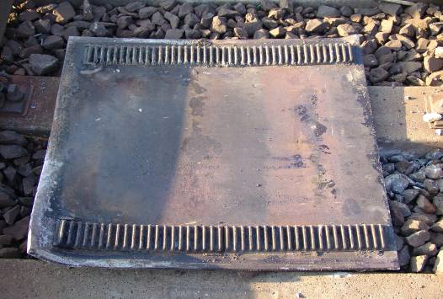
Figure 5: Hopper part found on the open track

1.12 Additional information
General details of the derailed wagons
Owner: | CFR
Serial mark: | Uagps
Brake system: | KE-GP (The 22nd wagon was deactivated from the brake system)
Type number: | 933
Number of axles: | 4
Distance between axles: | 10,47 m
Net weight: | 23 t
Length between buffers: | 15,51 m
Loading limit: | 60 000 kg
Minimal turning radius: | 50 m
Characteristics of the derailed wagons
These types of wagons are suitable for transporting cereals, grains, crops or alum earth. The wagons are usually filled from silos through an opening (‘mouth’) on the top of the wagon and are emptied - by way of gravitation - through the hopper openings on the bottom of the wagons.
Registration numbers and general overhauls of the derailed wagons
22nd wagon | 31 53 933 3162-6
Overhaul: | 6 REV SIM 25.06.05
23rd wagon | 31 53 933 9013-5
Overhaul: | 4 REV PVC 12.05.04
24th wagon | 31 53 933 9666-0
Overhaul: | 4 REV PMS 13.10.04
25th wagon | 31 53 933 4307-6
Overhaul: | 4 REV PL 22.04.03
26th wagon | 31 53 933 4117-9
Overhaul: | 6 REV SIM 15.11.04
27th wagon | 31 53 933 5752-2
Overhaul: | 6 REV PL 10.10.05
28th wagon | 31 53 933 9781-7
Overhaul: | 4 REV RV 31.10.03.
Interpretation of abbreviations and marks
4 | REV | RV | 31.10.03
Cycles of overhaul  (duration of overhaul certificate validity in years) | Overhaul | Place of overhaul (abbreviation) | Date of last overhaul (day/month/year)
Based on the above data, it can be established that all wagons had a valid overhaul certificate at the time of the accident.
2. Analysis
Train no. 63203 arrived at Debrecen station, platform XII at 0 hours 50 minutes on 7th December. At approximately 00.00 hours, reserve shunting locomotive III. moved ten empty self-discharging Uagps wagons – among them the later damaged wagons – from the private siding to track XIII, which were attached to the rear of train no. 63203 upon its arrival. The ten wagons on private sidings no. B8 had been received personally by the storeman of MÁV Wagongo Zrt. at 16.20 on 6th December. The wagons had arrived earlier at Debrecen station loaded with sunflower grains. When receiving the wagons, both sides of the wagons were inspected. One hopper was found open, which the personnel then closed. No irregularities or deficiencies were found on the other wagons. The receipt of the ten wagons was registered in the so called ‘wagon handover’ log.
The wagon examiner of Debrecen station conducted the inspection and the brake test of the wagons approximately between 1 hours 10 minutes and 1 hour 50 minutes. No deficiency or irregularity was found during the inspection which involved both sides of the train. The work area was well-lit. According to communication no. SZIR R 212, the destination of the last three wagons was Berettyóújfalú and that of the other seven wagons was Kunmadaras station. Subsequently, the “E” brake test was conducted and everything was found normal. The “E” brake test was registered into the travelling warrant of the locomotive. The data of train no. 63203 can be found in the loading report.
After departure, the 24th wagon (registration number: 31 53 933 9666-0) of train no. 63203 derailed between Debrecen and Ebes stations on the open track, in railway section no. 2177+40. One of the hopper covers of the 23rd wagon (reg. no. 31 53 933 9013-5) fell and got stuck under the wheels of the 24th wagon and pushed it off the rails. Consequently the 24th wagon derailed. Subsequently, two more hopper covers fell due to the increased vibration; however, they did not cause derailment.
Train no. 63203 was running with the wheels of its 24th wagon (no. 31 53 933 9666-0) running beside the rails on the concrete sleeper on an approximately 7-kilometre-distance, whose marks were visible where the train derailed. When running through the left (transit) main track of Ebes station - track IV - the derailed axle of the arriving train tore the trackage of point no. 3 which lay in the train’s path. Subsequently, it broke the BODÁN plate of level crossing SR 1 in railway section no. 2102+10. As a consequence, the derailed pair of wheels was running towards track V, and the train separated between the 23rd and the 24th wagons. Four more wagons derailed and two toppled onto their side. When the train separated, it stopped with emergency braking. There was no defect in the rail track which could have contributed to the accident.
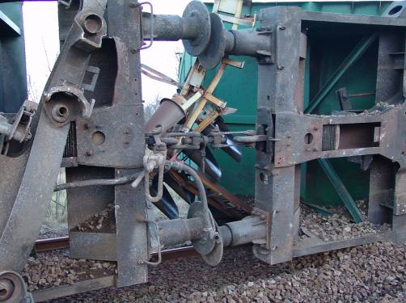
Figure 6: The toppled wagons dragged along the exit signal
Following the accident, the toppled wagons dragged along the V5 exit signal of Ebes station, they also carried away the mechanisms of points no. 3, 5 and 7 which lie on the left (transit) main track of Ebes station. The lock-bars of point no. 13 lying on track V was well as the catenary support between points no. 5 and 7 were damaged. When the IC arrived at the site, the wagons were untouched at the location where they had stopped after the derailment.
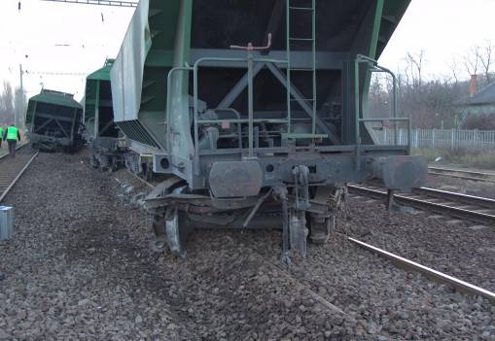
Figure 7: The derailed wagons

3. Conclusions
Based on the site survey, the obtained documents, photographs, the analysis and evaluation of technical documentations as well as on the interviews conducted by the VBO, the IC establishes the following:
Figure 8: The drawing of the derailed wagon, the hopper covers indicated with red arrows
The 24th wagon (reg. no. 31 53 933 9666-0) derailed first. The first bogie of this wagon broke off from the underframe and such damage was visible on the flange of one of the pair of wheels that is characteristic for (previous) derailments. The IC found the hopper cover of the 23rd wagon (reg. no. 31 53 933 9013-5) of train no. 62302 in section no. 2177+60. The mark of the wheel flange was visible on the surface of the rail and marks of the derailment were also visible on the concrete sleepers as well as on the geo-screws.
Wagons carrying grains have specially designed closed chassis and can be emptied manually by a rack-and-pinion mechanism.
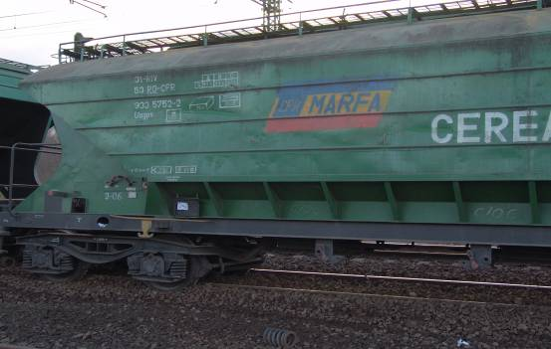
Figure 9: Opening and closing of the wagon from the outside
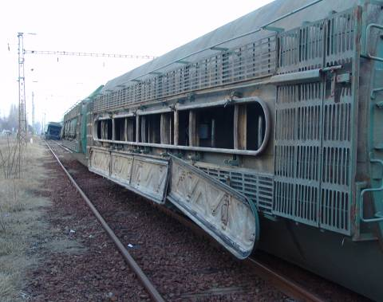
Figure 10: Filling openings of the toppled wagon
The hopper cover is a 800 x 900 x 10 mm steel plate to which two 30 mm racks are welded on either side. Furthermore, two 2 mm iron plates are welded onto the end of each rack in order to avoid ‘over-opening’. The function of this iron plate is to ensure that the hopper cover does not fall in case it is not closed back properly. The welding seam of the iron plate was dirty and covered with rust, which leads to the conclusion that it is a result of a previous fracture. When the hopper cover fell, the 2-2 welded racks got torn off and the cover got stuck between the 2nd pair of wheels of the first bogie of the 24th wagon and the sleeper. As a consequence, the wheel flange was lifted up towards the upper surface of the rail and the wagon derailed. The marks of the derailment were visible all the way from section no. 2177+40 to Ebes station. The IC found two more hopper covers in the section which fell down as the train was running on derailed course, however, they did not cause further derailment.
The IC examined the positions of the hopper covers of the 10 bottom-discharging wagons (10 grain carrier wagons, altogether 30 covers), these were as follows:
Missing: 5
Found in closed position: 2
Found half-open: 3
Found in open position: 20
The IC found all the missing hopper covers between the site of the derailment and where the train stopped (3 was found at the railway line and 2 at the station). Some of the above mentioned iron plates were missing from the examined hopper covers. The testimonies of the personnel conducting the inspection of the wagons are not in concordance with the above findings.
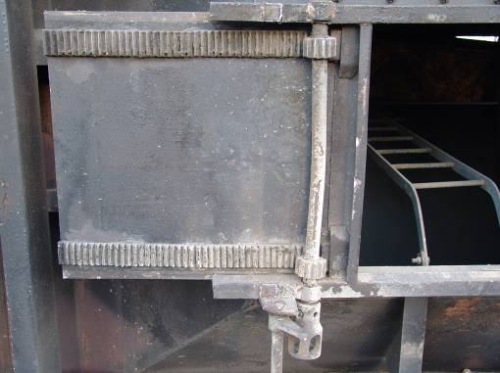
Iron plate securing the hopper cover
Figure 11: The hopper cover of the wagon in open position
The IC examined the operation of the opening mechanisms which could not be moved by hand, however, they were movable (open-close) with a rod or a wooden stick.
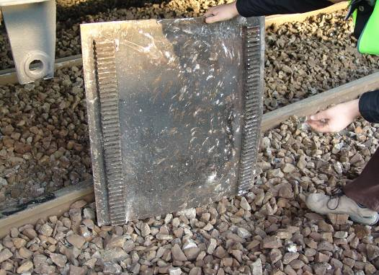
Figure 12: The unsecured plate found at Ebes station
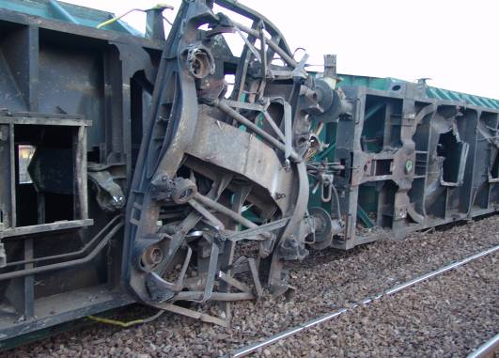
Figure 13: The hopper openings of the toppled wagons without the hopper covers

Undoubtedly, the cause of the derailment was the fact that the train ran through the fallen hopper cover as a result of which the wheels were lifted off the rails. The hopper covers fell because the securing plates were missing from the end of the racks. Furthermore, the hopper cover was presumably in open position at the departure at Debrecen station, which might also have contributed to its falling. The shifting and displacement of the covers were caused by the vibration and longitudinal swings while the train was running.

4. Safety recommendations

4.1 Safety recommendation

BA2006-0151-5_01: The IC recommends the Romanian investigating body to draw the attention of the owner and the maintenance and repair personnel of the concerned vehicles to the dangers of the missing securing plates as well as to the importance of their replacement.
BA2006-0151-5_02: The IC recommends MÁV Wagongo Zrt. that during the inspection of wagons, particular attention should be paid to checking the closed position of the hopper opening covers.
BA2006-0151-5_03: The IC recommends MÁV Gépészet Zrt. that during the maintenance work of such wagons, particular attention should be paid to the checking of securing plates and their replacement as required.
4.1.1 Measures taken, observations and opinions
BA2006-0151-5_02: MÁV Wagongo Zrt. agreed with the contents of the safety recommendations and has taken measures to implement them. It has published a Study Reference Book in which the relations of cause-and-effect of the accident and the actions to be taken in case of similar accidents are described and illustrated with photographs (inspection of the wagons, closing of hopper covers, etc). The Study Reference Book has been introduced at professional trainings in which all concerned employees (storemen, wagon inspectors, personnel receiving the trains, etc) have participated.
BA2006-0151-5_03: MÁV-Gépészet Zrt. agreed with the contents of the Draft Report and made the following reflections: the Technical Appendix of the Maintenance Contract between MÁV-Gépészet Zrt. and MÁV Wagongo Zrt. for the maintenance of wagons in 2008 includes – among the obligatory tasks – the examination of filling-emptying installations of the vehicles as well as the checking of their operability and repair as required. In all cases, particular attention is paid to the condition of filling-emptying installations of similar (primarily grain carrier) wagons in the repair workshops of A MÁV-Gépészet Zrt.
The IC agrees with the observations and suggestions of MÁV Zrt. regarding the Draft Report and took them into consideration when compiling the Final Report.
The National Transport Authority agreed with the Draft Report and did not make any reflections.
Budapest, “…” November 2008.
________________ | _______________
Ferenc Pataki  IC member | Róbert Karosi  IC member

________________
András Mihály
Investigator-in-charge

