Kamila Mestická

Project Coordinator

OLTIS Group, a.s.

Dr. M. Horákové 1200/27A

779 00 Olomouc

Czech Republic

Valenciennes, 24th October 2018

**TAF TSI Compliance Results – CEF Grant Agreement INEA/CEF/TRAN/M2016/1361703**

To whom it may concern,

I confirm and certify herewith that the TAF TSI functionalities implemented by the company OLTIS Group (Czech Republic) within the Action *“Implementation of the TAF TSI at Hungarian private railway undertakings”*, co-financed by the Connecting Europe Facility Fund, are compliant with the appropriate provisions of the TAF-TSI Regulation No. 1305/2014 and its Technical Documents.

Details of the Action:

|  |  |
| --- | --- |
| **Name of the Action:** | Implementation of the TAF TSI at Hungarian private railway undertakings |
| **No. of the Action:** | 2016-EU-TMC-0134-W |
| **No. of the Grant Agreement:** | INEA/CEF/TRAN/M2016/1361703 |
| **Duration of the Action:** | 2018-2020 |
| **Verified Activity:** | TAF TSI Implementation – Phase 1 (Activity 1) |
| **Verified TAF TSI Functionalities:** | Common Interface, Reference Files, Rolling Stock Reference Databases |

The results of the verification process are concluded as follows:

OLTIS Group has sent to the European Union Agency for Railway on 14 Sep 2018 follofing deliverable datasets for verification:

|  |  |  |  |  |  |  |
| --- | --- | --- | --- | --- | --- | --- |
| **Product** | **IS for**  **RU / IM Freight/Pass.** | **Functionality** | **Input / Output** | **Message** | **Phase of the verification and the date** | **Attachment (name of the document)** |
| **OLTIS LWP**  **L**ogistic **W**eb **P**ortal  (CEF Projec) | RU Freight | Common Interface | Input/ Output | --- | Phase 1 – September2018 | OLTIS_CEF-HU_ERA_Verification_ Phase-1.pdf |
| Reference Files | Input | Company codes | Phase 1 – September2018 | 1_countryCSVFiles.csv  2_companyCSVFiles.csv |
| Input | Primary Locations | 3_primaryLocationCSVFiles.csv  4_subsidiaryLocationCSVFiles.csv |
| Rolling Stock Reference Database | Output | RollingStockDatasetMessage | Phase 1 – September2018 | 5_RollingStockDatasetMessage NoCeZuX.XML |
| Input | RollingStockDatasetQueryMessage | 6_RollingStockDatasetQueryMessage SaNaTaXu.XML |

1)

It is visible from above PDF document that OLTIS uses the Common Interface (CI) as hosted at RNE (screenshots, list of users / countries / … , etc). This CI is compliant with TAF TSI as already attested in the CI compliance report at <https://www.era.europa.eu/node/641/6> („compliance_report_-_ccg_now_rne_common_interface_reference_implementation_v1.1.pdf“).

2)

The CSV files (generated from the Common Reference Data set hosted at RailNetEurope and containing company/country/location codes) have the content needed to operate the CI and to send TAF compliant XML messages (such as your “RollingStockDatasetMessage” and “RollingStockDatasetQueryMessage”).

3)

The TAF XML messages “RollingStockDatasetMessage” and “RollingStockDatasetQueryMessage” OLTIS group deploys in its OLTIS LWP for Hungary (CEF Project) are valid against the TAF data catalogue version baseline 2.2 (checked with Altova XML Spy 2017 in October 2018) – see https://www.era.europa.eu/node/641/6 ("taf_cat_complete_v2.2.2.xsd", "taf_cat_codelists_v2.2.2.xsd" and "TAP_TSI_codelist_v1.3.5.xsd").

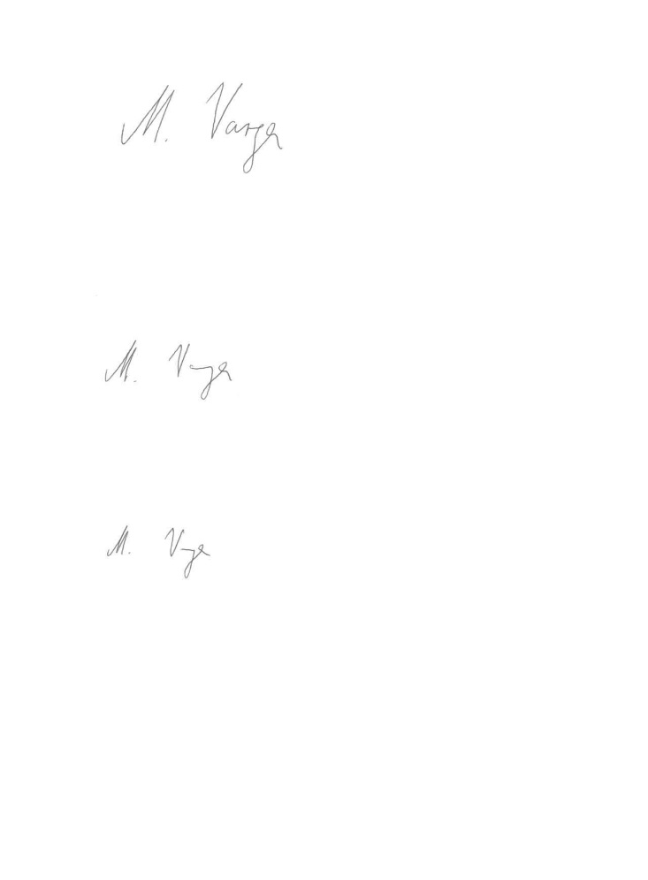

Mickael Varga

Interoperability Unit

Project Officer

Tel: +33 327096 508

Mobile: +33 664300237

Email: [mickael.varga@era.europa.eu](mailto:mickael.varga@era.europa.eu)