Full Impact Assessment
  - TSI OPE Revision

 | Elaborated by | Validated by | Approved by
Name | W. Malfait  K. Davies  I. Pagand  G. Kouparousos | F. Ferrari  O. Gherghinescu | P. Guido
Position | Project Officers | Head of Sectors | Head of Unit
Date | 20/03/2018 | 24/10/2018 | 24/10/2018
Signature

  - Contents
0. Glossary 3
1. Context and problem definition 4
1.1. Problem and problem drivers 4
1.2. Main assumptions 4
1.3. Stakeholders affected 5
1.4. Evidence and magnitude of the problem 5
1.5. Baseline scenario 8
1.6. Subsidiarity and proportionality 10
2. Objectives 11
2.1. Strategic and specific objectives 11
2.2. Link with Railway Indicators 13
3. Options 14
3.1. List of options 14
3.2. Description of options 14
3.3. Uncertainties/risks 15
4. Impacts of the options 19
4.1. Impacts of the options (qualitative analysis) 19
4.2. Impacts of the options (quantitative analysis) 22
5. Comparison of options and preferred option 24
5.1. Effectiveness criterion (options’ response to specific objectives) 24
5.2. Efficiency (NPV and B/C ratio) criterion 25
5.3. Coherence 26
5.4. Summary of the comparison 27
5.5. Preferred option(s) 27
5.6. Further work required 27
6. Monitoring and evaluation 28
6.1. Monitoring indicators 28
6.2. Future evaluations 28
Annex 1 - Estimation of economic impact 29
Annex 2 – Case study on different operational rules for cross-border sections between Germany, Denmark and Sweden 33
Annex 3 - EU harmonized communication for cross-border operating train staff 42

Glossary

Abbreviation | Description
B/C | Benefit/Cost ratio
CSM | Common Safety Methods
G/P | G/P braking mode meaning loco in G-mode and all wagons in P-mode;
IM | Infrastructure Manager
LL | Long Locomotive braking mode (meaning loco and first 5 wagons in G-mode; other wagons in P-mode)
NIP | National Implementation Plan
NPV | Net Present Value
NSA | National Safety Authority
P/P | P/P braking mode meaning loco in P-mode and all wagons in P-mode;
RA | Risk Assessment
RFC | Rail Freight Corridor
RU | Railway Undertaking
SMS | Safety Management System
SO | Specific Objective
TMS | Traffic Management System
TSI OPE | Technical Specification for Interoperability relating to the ‘operation and traffic management’ subsystem of the rail system in the European Union

Context and problem definition
Problem and problem drivers | <What is the main problem which this initiative will address?>  The main problems related to the TSI OPE for the removing operational barriers for cross-border operating trains in Europe are:  - Problem 1a: Limited possibilities to improve efficiency/innovate operational rules at railway system level due to existence of national operating rules at NSA-level or MS-level (problemdriver 1: no implementation of current TSI OPE).  - Problem 1b: As a direct consequence of problem 1a, time losses at cross-border sections due to different national/IM-operational rules (problemdriver 1 due to no implementation of current TSI OPE,) or due to other factors (problemdrivers outside the scope of the TSI OPE (e.g. custom barriers, inefficient train path schedule at cross borders, different data exchanges procedures at cross-borders or different technical infrastructure characteristics); Examples of different national operating rules linked to problemdriver 1 are listed in section 1.4.  - Problem 2: Additional training costs for cross-border operating staff due to non-EU harmonized operational processes (problemdriver 2) and due to non-EU harmonized communications (problemdriver 3);  - Problem 3: Safety incidents or accidents due to human errors of cross-border operating train staff linked to non-EU harmonized operational processes (problemdriver 2) and due to non-EU harmonized communications (problemdriver 3);  This initiative will address the implementation requirements for the current TSI OPE (incl. migration requirements for the amendments within the revision of the TSI OPE) as currently the implementation requirements within chapter 7 for the TSI OPE are limited to the requirement of establishing an implementation plan to be drawn up by each Member State. This could lead to different implementations (timing, scope) within Member States with the risk of partially removing the main operational problems. In addition, since the TSI became a Regulation directly applicable, it is important to have a European structured approach to how implementation should be taken forward to help the sector achieve their goals.
Main assumptions | //

Stakeholders affected | <Who is affected by the problem? Please refer to the relevant stakeholders, as appropriate, from this list.> <Rank the relevance of the problem for each of the categories selected from 1-low to 5-very high. The Agency itself can be considered in the list.>  Category of stakeholder Importance of the problem  IM 2 - Medium  RU 5 – Very high (in particular cross-border operating RUs)  NSA 3 – High (change in methodology of some NSAs> risk based versus rule based approach).
Evidence and magnitude of the problem | <What is the evidence and magnitude of the problem and problem drivers?>  Problem 1: Limited possibilities to improve efficiency/innovate operational rules at railway system level due to existence of national operating rules at NSA-level.  Problemdriver 1: no implementation of TSI OPE framework  Some Member States already implemented a coherent operational framework (based on the fundamental operating principles) leading to a significant reduction of national rules (e.g. : UK, FI, DK) and the development of operational risk control through the SMS and associated company rules. The return of experience on implementing a coherent fundamental operational principle framework had a positive effect on:  - NSA-level: increase in efficiency to maintain a more coherent limited set of national rules (one interview estimated a 30% efficiency increase in maintaining national operational framework/rules);  - RU&IM-level: better application of operational rules as fundamental operating principles gives a coherent framework (which is easier to remember by staff than a numerous set of operational rules without clear link to fundamental operating principles);  - RU&IM-level: more innovation as national rules could hinder a pro-active approach on improving company rules. Following example has been reported: the removal of a national rule for speed reduction in case of broken window has led to more innovative company rules. The purchase of a new type of window in which broken outer window does not require anymore a speed reduction to guarantee safety of passengers.  As a consequence (problem 1b): time losses at cross-border sections due to different operational rules to be used on the infrastructure networks;  Problemdriver 1: no implementation of current TSI OPE  The main reported operational rules causing time losses are linked to different national, IM or sector operational rules linked to train braking (point 4.2.2.6 in TSI OPE), train composition (point 4.2.2.5 in TSI OPE), train rear end device (4.2.2.1.3 in TSI OPE), checks and tests before departure (4.2.3.3.1 in TSI OPE).  Other important causes are related to different train data exchange requirements (TAP/TAF TSI) or non coordinated scheduling of train-paths at cross-border sections.  Estimated magnitude of the problem 1b:  - Estimated percentual decrease of total RU railway costs for international railway freight company of 1.5%;  - Estimated recurrent additional potential benefit between 10 [MEUR/year] and 75 [MEUR/year]; The model can be found in annex 1 and the figures above are based on 2 independent calculation methods.  Following examples have been reported by RUs /Rail Freight Corridor (see annex 2 – case study):  - RFC3: different train braking rules between Germany, Denmark and Sweden leading to time losses of 30 minutes for freight trains above 1200 tonnes;  - RFC7: checks and tests before departure allocated to IM, leading to time losses of freight trains up to 25 hours; national rules for checks and tests before departure (braking tests);  Problem 2: Additional training costs for cross-border operating staff (incl. closed national market for domestic traindrivers)  due to non-EU harmonized operational processes (problemdriver 2):  - Scope of Appendix A and B: estimated at representing in average 10% of additional training costs for cross-border operating traindrivers;  - Estimated percentual decrease of total RU railway costs for international railway freight company of 0.1%;  - Assumption: it is assumed that the percentual decrease of total RU railway costs for international railway passengers company are similar;  - Estimated recurrent additional potential benefit of 10 to 15 [MEUR/year];  - Note: The harmonization of processes/operational rules for Appendix A (ERTMS) will create additional significant benefits as it creates a more competitive/open market for technical trackside CCS-systems which are currently based on multiple different IM-based engineering guidelines. These potential benefits and the associated migration costs are not quantified within this impact assessment as it goes beyond the scope of the operational interoperability benefits.  due to non-EU harmonized communication (problemdriver 3):  - Estimated at representing in average 50% of additional training costs for cross-border operating traindrivers mainly linked to language training costs;  - Estimated percentual decrease of total RU railway costs for international railway freight company of 0.5%;  Assumption: it is assumed that the percentual decrease of total RU railway costs for international railway passengers company are similar;  - Estimated recurrent additional costs of 42 [MEUR/year] to 60 [MEUR/year];  The model can be found in annex 1 and the figures above are based on 2 independent calculation methods.  Note: The reported additional one-off training costs for cross-border operating staff are in a wide spectrum, ranging from 5 [kEUR/train-driver] up to 60 [kEUR/train-driver].  The average values used in the model are 20 [kEUR/train-driver] additional one-off training costs (in case of no additional language training required – problemdriver 1) and 40 [kEUR/train-driver] (in case of additional language training required – problemdriver 2).  Language costs represent in average 50% of additional training costs. The costs vary substantially depending on the area, e.g. between Sweden and Norway, the language training costs for cross-border operating traindrivers are limited (< 10 [kEUR/traindriver]), while e.g. in Switzerland and neighbouring areas the reported language training costs for cross-border operating traindrivers are significant due to the number of additional languages to be learnt and due to the nature of the languages to be learnt.  Problem 3: Safety incidents or accidents due to human errors of cross-border operating train staff linked to different operational processes for the neighbouring networks (problemdriver 2: non EU harmonized operational processes – see Appendix A & B of the TSI OPE) or linked to the use of different communications (problemdriver 3: non EU harmonized communication - see Appendix C of the TSI OPE);  Following examples have been reported:  - SPADs due to different operational rules (adjacent networks between NL and BE) linked to  > different train departure procedure  > different position of signals along the track (left & right side)  Both incidents are linked to the signalling equipment and as such depends on more than only operational rules.  - SPADs (and inefficiencies) due to insufficient Dutch language competences of some traindrivers operating in the Netherlands.
Baseline scenario | <What is the likelihood that the problem would persist if no action is taken?> <How will the problem evolve in the absence of additional action?>  Problemdriver 1: no implementation of current TSI OPE  Summary of National Implementation Plansof Member States : Most Member States having submitted the National Implementaion Plan indicate the implementation of the TSI OPE or plan to implement the current TSI OPE within a short timeframe (before 2020) leading to a significant reduction of national rules (e.g. UK, DK). However, they are some Member States which have not yet indicated when they will implement the TSI OPE and remove national operational rules according to the TSI OPE (see report on analysis of national implementation plans with reference ERA-REC-125-REP-03 published on 26th March 2018):  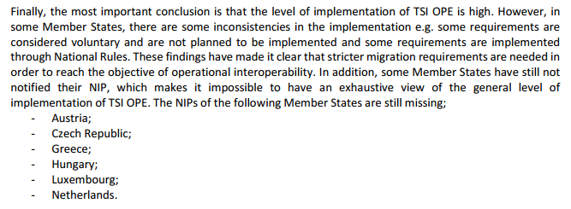  6 Member States have not yet provided the NIP (status: 15th March 2018) for which there is a significant risk that the implementation of TSI OPE will not occur. From the received NIPs, at least 2 Member States indicated not to fully implement the TSI OPE (e.g. maintaining specific national rules on braking performance, train composition and checks and tests before departure). So, without migration requirements, there is also a variation on how the TSI has been implemented with some adopting the full European approach and assessing how the TSI OPE is implemented into the SMS using national rules where appropriate and company rules. Whereas other Member States wish to retain national rules and have limited links to the SMS. This is a crucial problem for cross border operation where MSs have different approaches which will cause additional complexities (costs) for the RUs (to develop and maintain their SMS) and for assessing the single safety certificate (under the 4th Railway Package).  Case study: some NSAs reported that the issue is not effectively solved by implementation of the TSI OPE. E.g. in the case of braking performance (which is considered as part of the responsibility of the SMS of the RU), previous national rules will be required by some NSAs as being part of the SMS of the RU (only label of operational rule has changed from national rule to company rule) and therefore, RUs will not be able to merge different national rules into 1 efficient company rule. The change of operational rules might require the knowledge and origin of the existing national rules. In order to investigate the effectiveness of the TSI OPE, it has been proposed to elaborate 1 case study with Germany, Sweden and Denmark to understand the underlying issues of implementation of the TSI OPE (case study covering 2 reported priorities of time losses, being train braking performance and train composition). The results of this case study are added in annex 2.  Probemdriver 2: Non EU harmonized processes  Without adding migration requirements in the TSI OPE, there remains a risk that the implementation of harmonized processes defined in the TSI OPE will only be partially implemented and thereby hinder smooth and effective development of the single European operational railway area.  Problemdriver 3: Non EU harmonized communications  Stakeholders report that the language barrier is the main issue linked to problemdriver 3 and will even increase due to centralization of the traffic management systems. Today, local traffic management systems at cross-border sections allow in most cases that train drivers can use 1 of the 2 languages as local signallers/dispatchers manage the 2 languages. After centralization of the TMS, the use of 1 language might be no longer allowed (e.g. DE-NL; DE-PL) although a signalmen/dispatcher responsible for a specific border crossing could continue speaking a second language. In annex 3, some examples of Member States which indicate measures on reducing the language barrier are reported. An estimation of the ratio of EU cross-border operating train drivers versus number of signallers/dispatchers (before and after centralization of the traffic management systems) have been made to demonstrate the economic case of reducing the language barrier for cross-border operating train drivers compared to migration costs for training of signallers/dispatchers in a second language. There has also to be a common language defined for safety critical communication between signalmen, independent if they are working locally or in a centralized operating center (IM– IM interface).  Although this language issue is of high political sensitiveness, an EU political framework could support those Member States which are willing to reduce the language barrier in particular at those places where the language barrier is estimated to be the highest priority/remaining barrier.
Subsidiarity and proportionality | Subsidiarity: The problemdrivers 1, 2 and 3 are part of the TSI OPE framework, respectively chapter 7 of the TSI OPE is linked to problemdriver 1, Appendix A and B are linked to problemdriver 2 and Appendix C is linked to problemdriver 3.  Proportionality: the problems are of significant magnitude to be solved as part of creating a Single European Railway Area (see section 1.4).

Objectives
Strategic and specific objectives | <Mark, as appropriate, the strategic objective(s) of the Agency with which this initiative is coherent.>  ☒ Europe becoming the world leader in railway safety  ☒ Promoting rail transport to enhance its market share  ☒ Improving the efficiency and coherence of the railway legal framework  ☐ Optimising the Agency’s capabilities  ☐ Transparency, monitoring and evaluation  ☒ Improve economic efficiency and societal benefits in railways  ☐ Fostering the Agency’s reputation in the world  <What are the specific objectives of this initiative? (The objectives should be as S.M.A.R.T. as possible.)>  - Specific Objective 1 (linked to problemdriver 1):  Implement and allocate operational responsibilities to the appropriate railway actors as defined in the TSI OPE in line with the Railway Safety Directive  This TSI OPE Revision creates mainly an operational framework in line with the objectives states in the Safety Directive 2016/798:  Recital (7) The main actors in the Union Rail System, infrastructure managers and railway undertakings should bear full responsibility for the safety of the system, each for their own part. Whenever appropriate, they should cooperate in implementing risk control measures.  Recital (12) … In order to eliminate the obstacles for interoperability, the volume of national rules, including operational rules, should be reduced as a consequence of extending the scope of the TSIs to the whole of the Union Rail System and of closing open points in the TSIs. For that purpose, Member States should keep their system of national rules updated, delete obsolete rules and inform the Commission and the Agency thereof without delay.  Recital (15)… The safety management system is the recognized tool for controlling risks, whereas infrastructure managers and railway undertakings are responsible for taking immediate corrective action to prevent recurrence of accidents. Member States should avoid establishing new national rules immediately after an accident, unless such new rules are required as an urgent preventive measure.  Recitals are reflected in Article (4) Role of actors in the Union Rail system in developing and improving railway safety.  This TSI OPE revision amends the overall operational framework with:  - implementation requirements;  - the list of operational processes and instructions for which national rules are allowed (see Appendix I of TSI OPE, e.g. Class B-related);  - Specific Objective 2: Optimised set of EU harmonized operational processes for operating train staff (linked to problemdriver 2)  2.1 Appendix A of TSI OPE (ERTMS-part)  Optimal end target: full harmonized ERTMS rule book allowing single ERTMS license for train-drivers;  Main changes in TSI OPE revision: 3 additional harmonized ERTMS processes (points 6.30, 6.44.1 and 6.44.2) in draft 4.06 (date: 10/08/2017) without the need for reference to national rules;  Remaining open points of Appendix A (see annex C): 50 points in charge of IM and 8 in charge of RU. The total number of operational processes in Appendix A is estimated at 98 points.  Status of TSI OPE – App A: estimated at 60% of all rules listed in Appendix A (harmonized and non harmonized)  Further work is required to achieve optimal end target: The scope of Appendix A (and closure of open points in Annex C) might not be sufficient to reach a full harmonized ERTMS rule book allowing single ERTMS licensing for train-drivers.  Therefore, the ERA with the ERTMS operational harmonization group shall develop after this TSI OPE revision a project plan in order to progress towards the optimal end target including elaborating an ERTMS driver’s handbook which will facilitate single training and licensing for driving under ERTMS. The elaboration of this ERTMS drivers’ handbook will be as much as possible exhaustive and harmonized.  2.2 Appendix B of TSI OPE - Overall operational processes (excluding ERTMS-part):  Main changes in TSI OPE revision: clarification of required set of national rules (see Appendix B + Appendix I with open points)  Appendix B contains 6 fundamental operational principles linked to approximately 20 harmonized operational processes and rules. Appendix I contains approximately 15 operational processes for which national rules are still allowed. Some of these operational processes are not meant to be harmonised (e.g. shunting for class B system). Appendix I is built based on the feedback from the TSI OPE National Implementation Plans, and as such estimated as an exhaustive list.  Comment by WP OPE (07th December 2017): Some WP OPE members requested to make an analysis of the completeness/exhaustivity of Appendix I. In case a valid additional operational rule would be detected to be included in the Appendix I of the TSI OPE, Article 6 of the EU directive 2016/797 ‘deficiencies in TSIs’ will be applied.  Status of TSI OPE – App B: estimated at 66.66% of all processes listed in Appendix B (harmonized) and Appendix I (non harmonized) of the TSI OPE  Further work is required to achieve end target: After this TSI OPE revision, the main focus will be the facilitation and monitoring of the implementation of the TSI OPE, in particular how the know-how of existing national operating rules can be transferred to the SMS of RU and SMS IM, including the facilitation of publication of industry standards as voluntary acceptable means of compliance.  - Specific Objective 3: Optimised set of EU harmonized communications for operating train staff (linked to problemdriver 3)  Main changes in current TSI OPE revision: see 9 harmonized operational instructions within Appendix C. Remaining number of harmonized operational instructions is estimated at 5.  Status of TSI OPE – App C: estimated at 65% of identified scope within Appendix I (see remaining open points, mainly related to operational instructions in Appendix I)  Further work is required to achieve end target: The current scope of Appendix C will not lead to the reduction of the B1 language requirement for train staff which is reported as highest cost driver/operational barrier for training and free movement of traindrivers. Therefore, the overall effectiveness of the scope within this TSI OPE revision is evaluated as low compared to this end target (see section 5.1).  Therefore, an overall framework should be established to consider if and which additional EU-actions are required and estimated feasible in order to facilitate the further reduction of this operational barrier. Some examples are elaborated in Annex 3 based on practices under development/deployed within some Member States (e.g. measure 1: the Netherlands with the use of standard railway terminology, e.g. measure 2: Denmark with the introduction of a second language (English and Danish) and as such providing the choice between these 2 languages to be used as communication between train drivers and signallers/dispatchers).  The scope of this impact assessment will focus on the analysis of migration requirements (TSI OPE chapter 7) taken into account their contribution to specific objective 1, 2 and 3 and taken into account that the end targets are only partially reached.
Link with Railway Indicators | <Clarify the link with the RIs (if the case).>  Number of national (operational) rules not compliant with TSI OPE

Options
List of options | <List the options proposed, including the baseline (Option 0).>  Baseline scenario: Member States are requested to update the national implementation plan by a certain date (voluntary migration);  Option 1: Mandatory implementation of TSI OPE within 5 years;  Option 2: Mandatory implementation of TSI OPE within 2 years with the exception of following points for which a 5 years implementation period is provided to IMs and RUs:  - amendments made in Appendix A and B  - appendix C
Description of options | <Describe each of the options, including the main changes that their implementation would generate.>  Baseline scenario:  Chapter 7 of TSI OPE:  Member States are requested to update the national implementation plan by a certain date (voluntary migration);  Option 1: Mandatory implementation of TSI OPE within 5 years;  Article (main body of legal text):  The Member States shall remove all national operating rules (type 3 national safety rules) which are not listed within Appendix I of this TSI OPE within 5 years after entry into force of this TSI OPE.  Chapter 7 of TSI OPE:  TSI OPE shall be implemented by RUs and IMs within 5 years after entry into force of the TSI OPE as part of updating the SMS or as part of renewing the safety certificate/authorization.  The NSA or the European Union Agency for Railways shall verify the implementation of the TSI OPE during the certification or authorisation process.  Option 2: Mandatory implementation of TSI OPE within 2 years  Article (main body of legal text):  The Member States shall remove all national operating rules (type 3 national safety rules) which are not listed within Appendix I of this TSI OPE within 2 years after entry into force of this TSI OPE.  Chapter 7 of TSI OPE:  TSI OPE requirements shall be implemented by RUs and IMs within 2 years after entry into force of the TSI OPE as part of the CSM-process (updating the SMS) or as part of renewing the safety certificate/authorization with the exception of following points which shall be implemented within 5 years after entry into force of this TSI OPE:  - the amendments made in Appendix A and B;  - appendix C of this TSI OPE revision;  The NSA or the European Union Agency for Railways shall verify the implementation of the TSI OPE during the certification or authorisation process.
Uncertainties/risks | <What are the main uncertainties (risks) of each of the options?>  <Which aspects may require more evidence?>  <Which stakeholders may not support (some of) the options?>  Baseline scenario:  Implementation risk 1: legal ambiguity of point 4 of Annex II of the railway safety directive 2016/798.  National safety rules notified in accordance with point (a) of Article 8 (1) include:  4. rules laying down requirements in respect of additional internal operating rules (company rules) that must be established by infrastructure managers and railway undertakings.  Some Member States might use point 4 to maintain some national rules causing time losses at cross-border sections.  Implementation risk 2:  Member States could also indicate that the Appendix I is a new clarification of operational rules for which a national rule can be introduced, and as such the migration requirements within Article 8 of the EU railway safety directive 2016/798 are not applicable. Some might claim that the national operational rules are not redundant, however complementary (see point above) and as such the migration requirements do not apply at all.  Therefore, an article addressed to Member States should clarify the scope for which national operational rules remain acceptable, meaning only for the operational items listed in Appendix I of the TSI OPE.  Option 1 and 2:  The main reported risks for the fast mandatory implementation of the changes within the TSI OPE are linked to following items:  - Impact on existing technical systems (supporting IT tools for harmonized operational instructions in Appendix C) requires sufficient implementation time; During the WP-OPE meeting held on 07th December 2017, CER and EIM members requested to allow flexibility in case IT-changes are required which are linked to a TSI OPE requirement. NSA SE gave an example of IT-changes linked to the requirement of train composition rules (TSI OPE 4.2.2.5) for which the Swedish NIP included to migrate before 01/01/2023.  To be discussed/analysed if specific cases are required for some Member States  - Necessity to perform individual risk assessment for each change (which is valid for each update of the SMS);  - Availability of budget and resources to update rules (training material, train the trainer, train the staff).  These risks are addressed by increasing the required migration timeframe for amendments in Appendix A and B and for Appendix C from initially 2 years towards 5 years.  Answers from questionnaires on potential specific cases:  - NSA Finland, Germany: implementation of particular aspects in Appendix C – part on describing individual words (over-specification);  Answer: the impact of the existing part of Appendix C is addressed in a previous study made by Interfleet (see http://www.era.europa.eu/Document-Register/Pages/Study-into-safety-related-communications-methodology.aspx) and positively assessed in terms of contribution to safety (in particular avoiding human errors). In relation to the potential contribution of reducing the number of incidents & accidents linked to language issues, there were no reported cases linked to the current scope of Appendix C.  From an economic point of view, the Appendix C is evaluated as having no or limited contribution to the specific objective of decreasing language or operational training costs for cross-border operating trainstaff.  - NSA Germany: Maintain rules on train- and brake preparation, as long as no harmonised understanding of the background and underlying reasons of the national rules have been assessed.  Answer: This case is analysed in annex 2.  The results of this case study on some concrete examples demonstrate (see annex 2):  - Train braking (RFC 3): the partial effectiveness of the TSI OPE to remove existing operational issues linked to currently existing national train braking rules (see green indicated text for LL-freight trains for weights between 1201t and 2500t after the removal of the national rules). The future removal of the operational barrier for weights above 2500t would require to elaborate a CSM on RA (using an optimized benchmark value for maximum longitudinal compressive forces for 4 axle-wagons).  Weight Germany Denmark Sweden  <= 800 t P/P P/P P/P  801 t- 1200 t G/P G/P G/P  1201t – 1600t LL G/P or LL G/P or LL  1601t – 2500t LL or G G/P or LL G/P or LL  >2500t G³ or G/P with restrictions G/P G/P  - After the removal of national rules on train braking, the RU is responsible for calculating the braking capability according to the TSI OPE. The analysis has demonstrated that for the weight categories 1201t-1600t and 1601t-2500t (see green fields), the Class B-system in Denmark does function normally with LL-mode and the impact of a lower train braking performance in LL-mode (compared to G/P-mode) would only lead in 2 of 14 cases to a speed reduction. As the train length is in Sweden the most restrictive parameter, the adoption of the TSI OPE for train braking rules leads directly to 57% of trains not being stopped within the Padborg station.  - ERTMS implementation in Denmark will remove the train braking barrier between Germany and Denmark. The ERTMS implementation is scheduled in the medium term (around 2021). Therefore, the updating of the national rule for Class B-systems accepting LL-mode will only be implemented before the ERTMS implementation if this update does not require any significant administrative or additional workload to demonstrate the feasibility.  - A preliminary CSM on RA has been established to accept G/P-mode in Germany with potential restrictions on the use of particular wagons (2 axle wagons and articulated wagons) including potentially some restrictions in train composition (light vehicles at rear end of the train). UIC leaflet 412 uses currently a recommended value of 300 kN as the value for calculation of the maximum longitudinal compressive forces. According to DBCargo Scandinavia, existing measurements on currently used wagons demonstrate that this value of 300 kN has been defined in the past for all wagons (incl. 2 axle wagons) while field measurements on the currently used 4 axle-wagons could demonstrate that this value could be significantly higher. Therefore, the demonstration of safe operation of G/P-mode for weights above 2500t is estimated to be feasible.  - Checks and tests before departure (RFC7): the effectiveness of application of the TSI OPE to resolve existing operational issues at cross-border sections by shifting responsibilities to the RUs (instead of IM);  - Train composition (RFC7): the effectiveness of the TSI OPE with publication of acceptable means of compliance to remove some detailed existing national rules.

Impacts of the options
Impacts of the options (qualitative analysis) | <Describe qualitatively all different categories of impacts for each of the analyzed options. Distinguish the impacts between positive and negative, as well as per category of stakeholder.>  Category of stakeholder Option 1 & Option 2  NSA / Member State Positive impacts Less national operational rules to be maintained/upgraded at NSA/Member State level. Remark: during the WP OPE meeting of 28th February 2018, NSA CH and NSA DE explained that today deviations from the existing national operational rules are allowed if a risk assessment can demonstrate that the safety level can be maintained. ERA answer: this interpretation of national rules is in the spirit of the TSI OPE implementation, however these national operational rules should be labeled ‘acceptable means of compliance’ in order to clarify the legal status of those operational rules.  Negative impacts Migration costs : NSAs have to build up a supervision strategy based on operational risks and deliver targeted and prioritised plan based on the strategy. Training: the inspectors have to be trained towards checking compliance with the Safety Management Systems of the IMs and RUs (risk based approach) instead of checking compliance towards existing national operational rules.  RU Positive impacts SO1: The implementation of the fundamental operating principles linked to the SMS will help the RU develop a more operationally risk focused approach and make it easier to implement the requirements in the TSI OPE. In addition, National rules shifting towards company rules, allow for more innovation and flexibility to improve/optimize existing operational rules and take up their operational responsibility; As a consequence, it can avoid unnecessary time losses at cross-border sections. Implementation of fundamental operating principles allow for more efficient training of RU-staff (easier to maintain compared to high number of individual rules).  Negative impacts RUs must create transparency on the reasons and background of existing national rules in case they want to change the particular operational rule. For small RUs, there is an interest to have a reference system available to facilitate the entering into the railway market or maintaining the fixed costs for developing and maintaining operational rules at a competitive level (acceptable means of compliance - e.g. developed in Germany by VDV). Risk assessment for operational rules in Appendix A, B and C. This also includes re-training for operational staff (200k train drivers) if existing rules deviate from the defined rules within Appendix A, B or C; A questionnaire indicated that all IMs regulary (yearly) update their operational rulebooks. Therefore, potential changes due to implementation of Appendix A, B and C can be efficiently introduced as part of these regular updates of the rulebook to minimize the migration costs.  IM Positive impacts SO1: National rules shifted towards company rules allow for more innovation and flexibility to improve/optimize existing operational rules and take up their responsibility;  Negative impacts IMs must create transparency on the reasons and background of previous existing national rules in case they want to change the particular operational rule. IMs must perform risk assessment for the potential changes of existing operational rules in Appendix A, B and C in order to be compliant to the TSI OPE rules. This also includes associated re-training costs for operational staff if existing rules deviate from the defined rules within Appendix A, B or C. A questionnaire indicated that all IMs regulary update their operational rulebooks (in average once a year, at least once every 2 years. Therefore, potential changes due to implementation of Appendix A, B and C can be efficiently introduced as part of these regular updates of the rulebook to minimize the migration costs.  Overall assessment (input for section 5.1) Positive impacts Effective implementation of SMS at RU/IM-level, making it more operationally focused, will allow for overall efficient (fast) optimization of operational framework within IMs/RUs leading to direct benefits of reducing time losses at specific cross-border sections. This will lead to a cost decrease mainly for international operating freight operators and contribute to a modal shift from road to rail.  Negative impacts Migration costs mainly linked to re-training for the different actors. Limited changes to existing IT-systems which support the railway staff in operational processes/instructions.  SO1: Main difference between option 1 and option 2:  The main difference between option 1 and option 2 is that in option 2 a faster implementation of the general framework of the TSI OPE is envisaged, in particular including those rules which cause significant time losses at cross-border sections. The removal of these time losses at cross-border sections has been reported in a questionnaire by several stakeholders as the priority problem within the removal of operational barriers program for which a fast migration is feasible without any link to line infrastructure characteristics.SO2 & SO3: in order to significantly contribute to the defined end targets, additional actions are required (see section 5.1).
Impacts of the options (quantitative analysis) | <If possible, and especially in the case of a FIA, quantify the benefits and costs for each of the analyzed options per category of stakeholder and overall. Feel free to include in an annex all the relevant parameters, assumptions and calculations taken into consideration the quantitative estimates.>  SO1:  Detailed quantifications are listed in annex 1. Only the relevant part related to time losses at cross-border sections has been taken into account within this table.  A conservative value of 20 [MEUR/year] has been used as financial benefits at RU-side (derived from the case study). The potential efficiency increase at IM and NSA-side has not been calculated. The assumption is made that the potential efficiency increase within IM and NSA-side could lead to a change of tasks for the impacted staff within their organization.  The one-off migration cost to the implementation of the specific points causing time losses has been estimated at 20 MEUR (of which 5 MEUR linked to Agency activities in the upcoming years to facilitate and monitor the implementation within Member States for these specific points).  Category of stakeholder Option 0 (baseline) Option 1 Option 2  RU Benefits (euro) From 2023: 20 [MEUR/year] From 2020: 20 [MEUR/year]  IM/RU/NSA Costs (euro) One-off cost: 20 [MEUR] in period 2019-2022 One-off cost: 20 [MEUR] in period 2018-2020  Overall Benefits (euro) 300 [MEUR] 360 [MEUR]  Costs (euro) 20 [MEUR] 20 [MEUR]  <Based on the quantification above, calculate the Net Present Value (NPV) and the Benefit/Cost (B/C) ratio for a 20 year forecast. Feel free to add the detailed calculations in an annex.>  Option 0 (baseline) Option 1 Option 2 & 3  NPV (input for section 5.2) 280 MEUR 340 MEUR  B/C ratio (input for section 5.2) 15 18  SO2 and SO3: the amendments in Appendix A, B and C cannot be individually assessed as the safety contributions are not quantifiable. The contribution of a decrease in training costs is also limited. The migration requirements are set in order to allow a cost efficient migration by giving a sufficient long migration period of 5 years to incorporate the changes in the IM and RU rulebooks (which are regularly/yearly updated) for the amendments in Appendix A and B and to modify the IT-tools which support the harmonized operational instructions defined in Appendix C.

Comparison of options and preferred option

Effectiveness criterion (options’ response to specific objectives) | <Based on the findings from section 4.1, assess the extent to which the various options respond to the specific objectives, from 1-very low response to 5-very high response and calculate the average score (effectiveness).>  Option 0 (baseline) Option 1 Option 2  SO 1: Allocate responsibilities to the appropriate railway actors according to the TSI OPE; 2 4 4  SO 2: EU harmonized operational processes for train staff (in particular for cross-border train staff and opening the market for domestic train staff); 2 3 (60% of listed rules in Appendix A, B and I). 3 (60% of end target for Appendix A, B and I).  SO3: EU harmonized communications for train staff (in particular for cross-border train staff and opening the market for domestic train staff); 1.5 2 2  Effectiveness (average score) 1.83 3.33 3.33  Additional actions required to achieve full effectiveness related to defined specific objectives (to be considered within future ERA Single Progamming Document):  SO1: further actions are required to facilitate and monitor the correct implementation of the TSI OPE (e.g. removal of national rules not coherent with TSI OPE, monitoring fulfillment of conditions to refuse reflecive plates as train rear end device, reviewing and publication of industry standards).  SO2: further actions are required for  a) Appendix A - ERTMS: Elaborating an ERTMS driver’s handbook which will facilitate single training and licensing for driving under ERTMS. The elaboration of this ERTMS drivers’ handbook will be as much as possible exhaustive and harmonize further the open points in Appendix A;  b) Appendix B and I: Verify the completeness of Appendix B and Appendix I and harmonise remaining open points in Appendix I;  SO3: further actions are required to identify the options and necessary actions to potentially reduce the main operational barrier linked to language requirements (unified language and/or standardized phrases and/or digitalized translation incl. migration scenarios and potential incentive mechanisms).
Efficiency (NPV and B/C ratio) criterion | <Based on the findings from section 4.2, rate the overall efficiency of the various options as follows:  - 1 if B/C ratio <1 or NPV <=0  - 5 if B/C ratio >1 and NPV >0  Option 0 (baseline) Option 1 Option 2  Efficiency 2 4 5  The main benefits are expected for specific objective 1 as migration costs for removing remaining national rules are estimated less significant based on the received information of the national implementation plans (less than 1 MEUR per Member State).  The main difference between option 1 and 2 is a targeted fast implementation for the priority points causing time losses. This leads to an increased B/C and NPV-ratio in option 2.  The increased railway efficiency might further contribute to the modal shift from road to rail. A railway cost decrease of 1.5% for international freight traffic, this would lead to a 2.1% increase in cross-border operating railway freight traffic (which represents 412 [MEUR/year] external benefits - see model in Annex 1.4).  Amendments in Appendix A, B and C:  Although a high number of traindrivers (180k) and signallers/dispatchers (+/- 100k) could be impacted by potential changes in their rulebooks (by the changes in Appendix A, B and C), the migration costs are minimized as the rulebooks are already regularly (yearly) updated. During an interview, operational experts indicated to prefer not to have too many operational changes at once in an operational rulebook to facilitate a smooth migration to traindrivers, signallers and dispatchers. During some interviews, some operational experts indicated that most processes introduced in Appendix A or B have no impact on the national rulebooks, a sufficient long migration period (option 2) is preferred as precaution measure in case the operational managers prefer to split up the changes over multiple years in order to provide a smooth assimiliation of changes for operational staff.  These changes do not require a significant impact on technical systems. A questionnaire indicated that some limited changes could be required for IT-systems which support the operational processes or instructions. Following example has been reported:  “If there is a modification of “harmonized operational instructions” – means written orders, we have to change our system for semi-automatic production and administration of written orders, named xxx. This system has a SIL-level, so we estimate depending on the size of the changes needed, costs from € 300 000.- up to € 400 000.-;”  Based on this information, option 2 (migration within 5 years) is estimated as a more efficient migration period compared to option 1 (fast migration for Appendix A, B and C).
Coherence | Coherence with Member States/IMs/RUs responsibilities:  Option 0 is not coherent to request for an updated National Implementation Plan to Member States as responsibilities witin the TSI OPE are directly allocated to IMs and RUs.  Coherence with Railway Safety Directive 2016/798:  The timeframe in option 0, 1 and 2 could be interpreted as contradictory and not coherent with the dates stipulated in Article 8 of the Railway Safety Directive (before 16th June 2018, national safety rules made redundant by Union law, in particular TSIs, CSTs and CSMs shall be repealed).  Appendix I of TSI OPE avoids any legal ambuiguity for which national rules can be notified as today the remaining risk is that Member States could interprete some national operational rules as safety rules under the rules indicated in point 4 of Annex II (Notification of national rules).  “4. rules laying down requirements in respect of additional internal operating rules (company rules) that must be established by infrastructure managers and railway undertakings”.  Coherence with Train Drivers Directive 2007/59/EC:  It is written in annex VI.8 that drivers “must be able to use the messages and communication method specified in the OPE TSI”. The deadline to fully implement this Directive is October 2018 (see article 37: 7 years after October 2009, being the date of decision on the register for certificates and licences) which means that all train drivers in the EU will have to have their licence and complementary certificate according to EU legislation. In order to get these documents, they need to be able to use the messages of TSI OPE (so Appendix C). In order to be coherent with the TDD-requirements, the implementation requirements within TSI OPE will only refer to amendments made in Appendix C. In the application guide of the TSI OPE, it will be explained that Appendix C shall be implemented as ‘toolbox’ within the SMS taking into account the intermediate state of Appendix C (more predefined messages have to be defined in order to reduce the language barrier) in order to facilitate an efficient migration of the requirements in Appendix C.  Option 0 (baseline) Option 1 Option 2  Coherence 1 3 4
Summary of the comparison | <Use the next table to summarize the outcomes of sections 5.1 and 5.2.>  Option 0 (baseline) Option 1 Option 2  Effectiveness 1.83 3.33 3.33  Efficiency 2 4 5  Coherence 1 3 4  Overall rating 1.6 3.4 4.1
Preferred option(s) | <Based on the overall rating, indicate if possible the preferred option. If no quantification of impacts was possible, conclusions may be drawn based on the effectiveness criterion.>  <If no preferred option, indicate the remaining options to be considered further and the discarded options.>  Option 2 is the preferred option.
Further work required | <Indicate further work and consultation which could impact the conclusion. Are there uncertainties related to the preferred option(s)?>  Most uncertainties are related to the additional actions required to fully achieve the specific objectives 2 and 3 (see section 5.1 – effectiveness criterion).

Monitoring and evaluation
Monitoring indicators | <What are the possible indicators to monitor the implementation of the selected option? Make reference to the railway indicators and any other relevant indicators.>  <What is the frequency for the measurement and what are the possible data sources?>  Number of national (operational) rules not compliant with TSI OPE
Future evaluations | <Are future ex post evaluations of this initiative envisaged?>  <When and under which trigger?>  SO1: 3 years after entry into force of the TSI OPE, the Agency should contact the RUs who reported time losses at cross-border sections due to different national operational rules and evaluate if these operational issues have been removed.

Annex 1 - Estimation of economic impact
  - Economic impact of time losses at cross-border sections

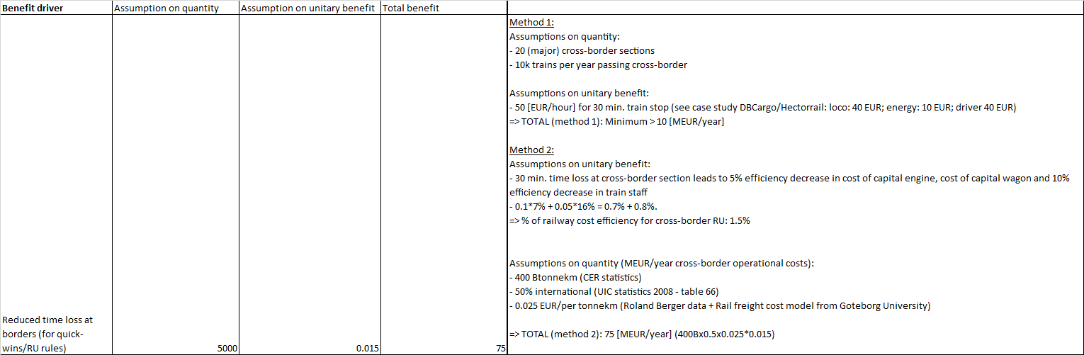

  - Economic impact of harmonised operational processes for railway staff

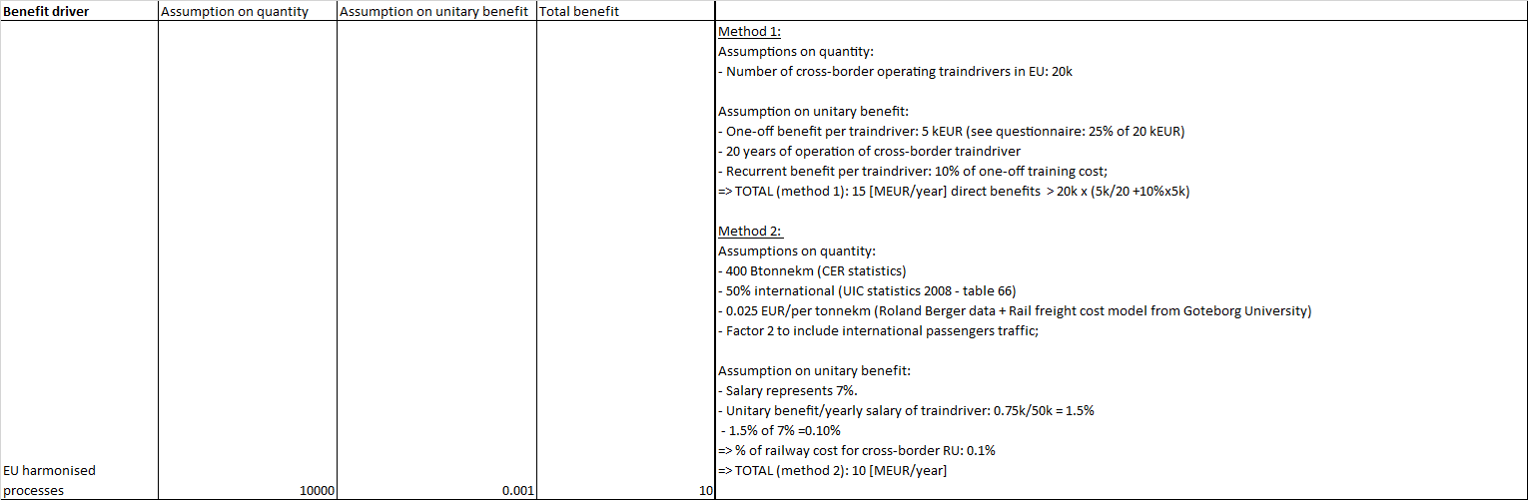

  - Economic impact of harmonised communications for railway staff

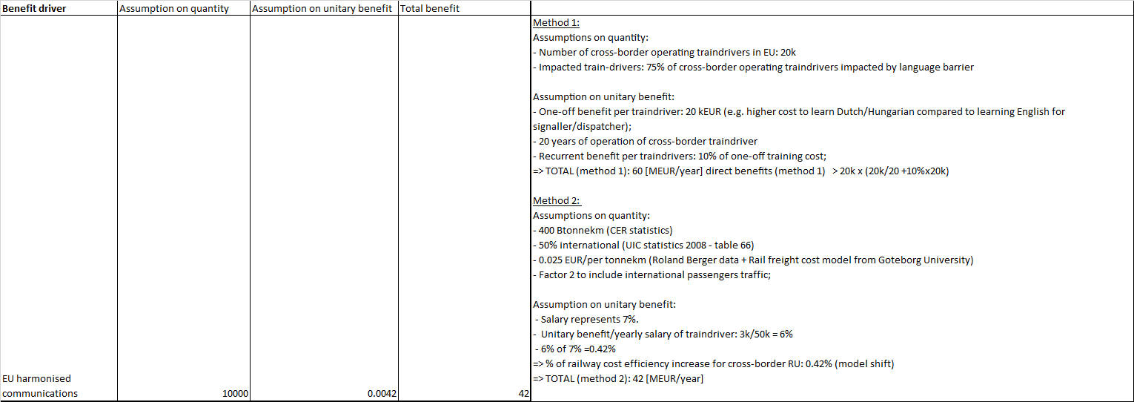

  - External benefits: Modal shift due to railway cost efficicency increase

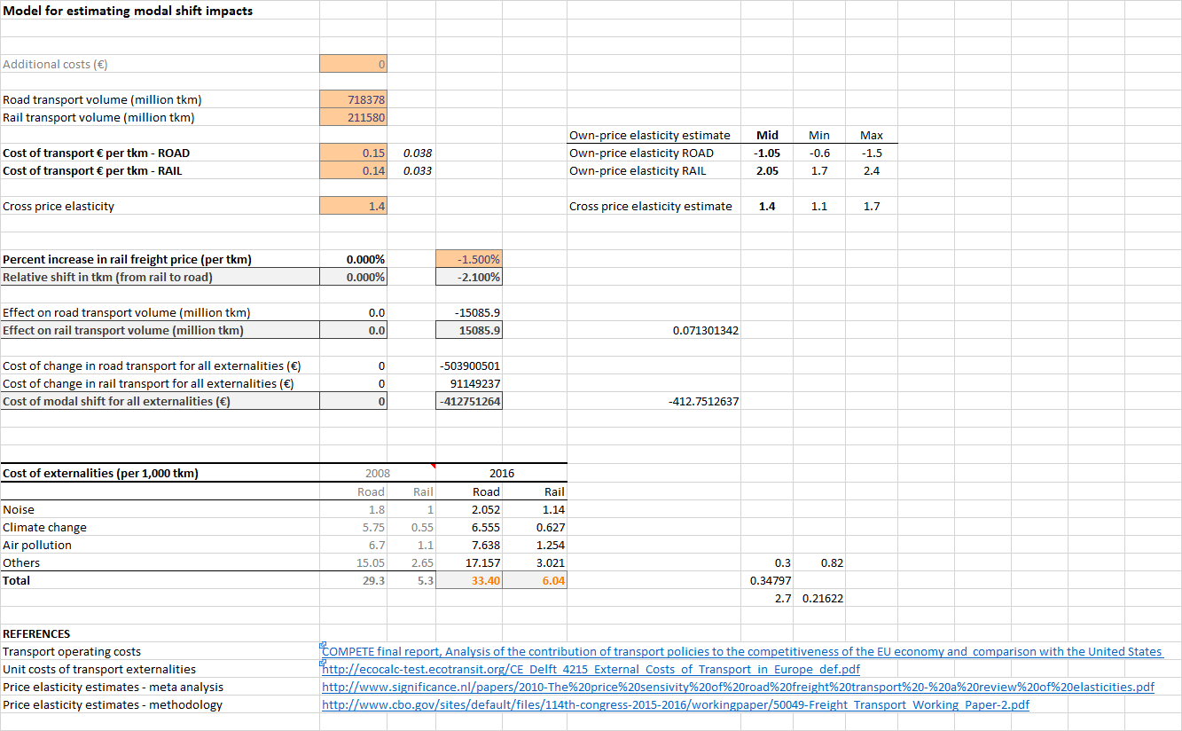

  - Simplified NPV-calculation for option 1
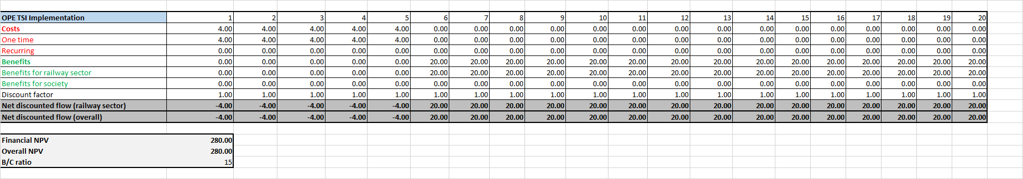

  - Simplified NPV-calculation for option 2
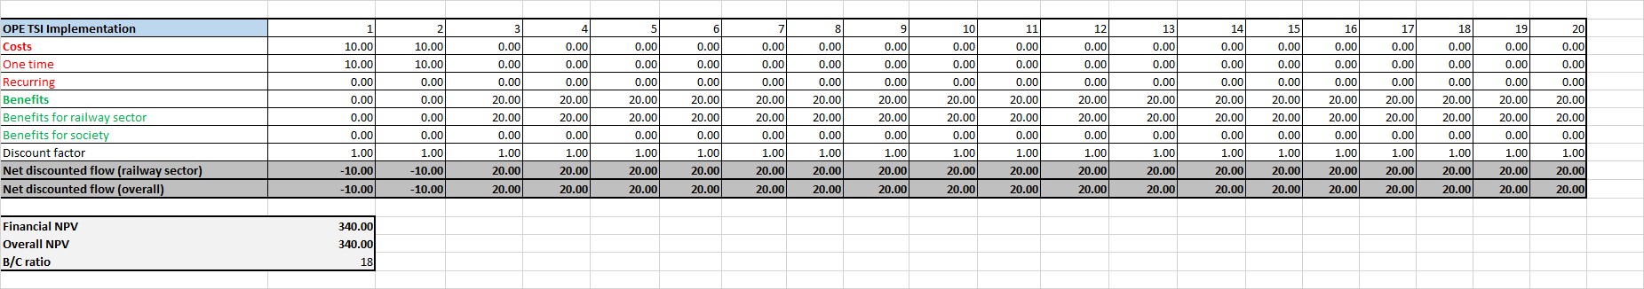

Annex 2 – Case study on different operational rules for cross-border sections between Germany, Denmark and Sweden

2.1 Introduction
Objective: clarification of the effectiveness of TSI OPE in removing remaining existing operational barriers.

Background: according to a questionnaire, the most important operational rules within the scope of the TSI OPE causing time losses at cross-border sections are related to different national train braking rules, different national train composition rules, additional checks and tests before departure at cross-border sections and changes of train rear end devices.
The freight railway operation between Germany, Denmark and Sweden is evaluated as a positive example with optimized rail freight operation with the exception of remaining different train braking rules. The case study will analyse the reasons and background of the remaining different train braking rules and the effectiveness of the TSI OPE implementation. The case study will also identify differences of train composition rules which do not cause any issues at this cross-border section, however remains an important operational barrier at other cross-border sections.
The overall aim is to clarify the effectiveness of implementation of the TSI OPE framework and potential additional actions required for removing the operational barriers.

2.2 Describe operational problem and evaluate its importance;
2.2.1 Example 1 - Train braking rules on RFC3
Following table summarises the currently applied train braking rules within the 3 Member States. In red, the main barriers between the cross-border sections are highlighted which cause significant time loss and economic impact.
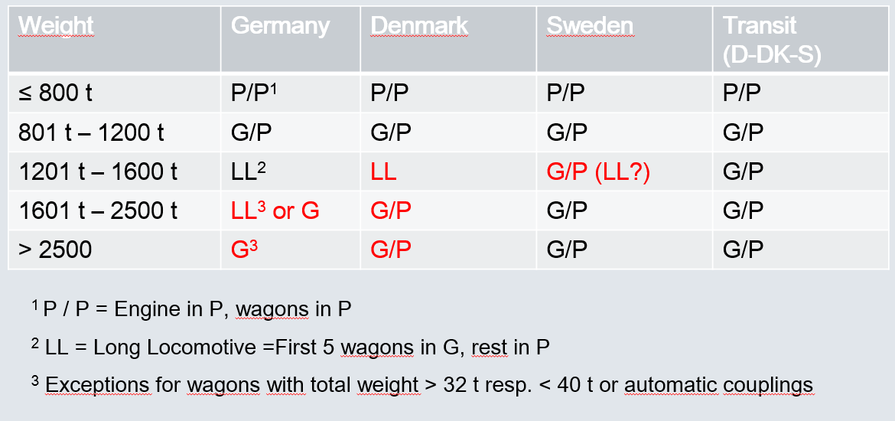

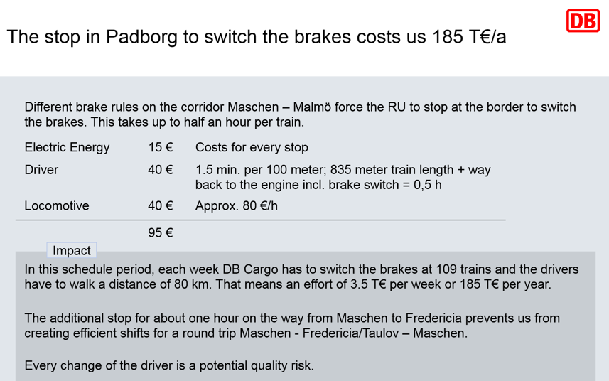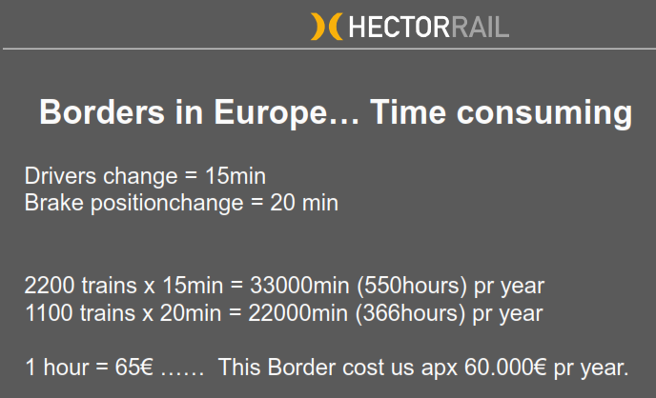
- RU 1: 1100 impacted trains per year with average time loss of 20 minutes;
- RU 2: 5668 impacted trains per year with average time loss of 30 minutes;
At the cross-border section between Germany, Denmark and Sweden, the cost impact is estimated at 500 [kEUR/year] as only operational barriers are reported due to different train braking rules for freight trains with a weight above 1200 tonnes and as no other major operational barriers exist.
DB cargo indicated that this time loss leads to an additional shift of a train driver from Maschen to Fredericia. This additional shift represents an estimated cost of 240 [EUR/train operation] (40 hours x 6 driving hours) instead of 50 [EUR] direct cost impact, so the overall economic loss could be 5 times higher than the direct economic loss.

2.2.2. Example RFC7 - Checks and tests before departure/Train composition rules
On RFC7, significant time losses are reported at the cross-border stations Curtici and Ruse, leading to time losses up to 25 hours.
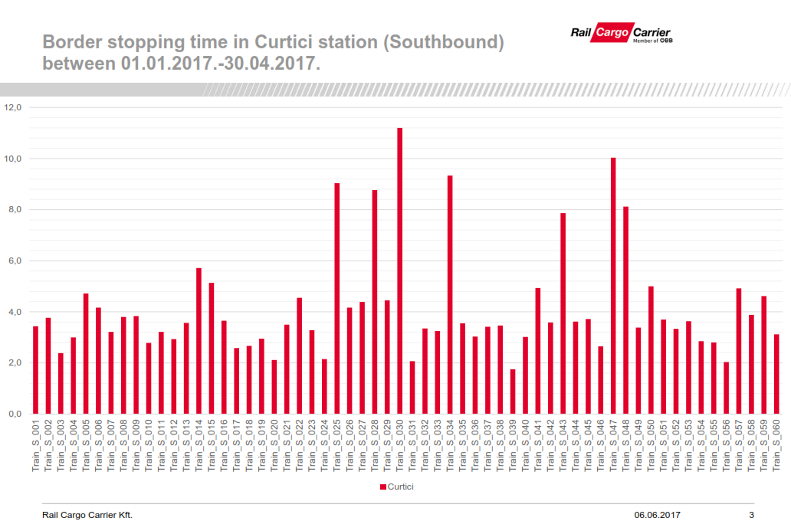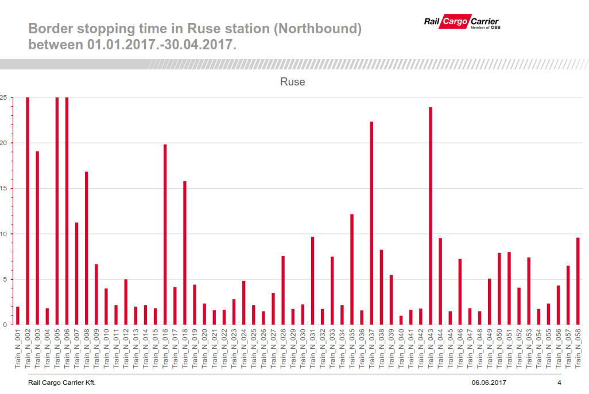

2.2.3. Estimated economic impact based on cost structure of railway freight company
The extrapolation of the data from the example of RFC3 (Padborg/Flensborg cross-border station), the overall minimum estimated impact at European level could be estimated at:
- 20 major cross-border sections;
- 10k impacted trains;
- 50 EUR impacted train (for 30 minutes time loss);
- Total minimum estimated impact: 10 [MEUR/year]

Assumptions on potential benefits:
- 30 min. time loss at a cross-border section leads to 5% efficiency decrease in cost of capital of engine/wagons (30 min./average 600 min. driving per cross-border section) and 10% efficiency decrease in train staff (30 min./5 hours effective driving time per shift). The cost of capital engine, cost of capital wagon represents 16% of operational costs and train staff costs represents 7% of operational costs in a standard freight cost structure.
% of railway cost decrease for cross-border RU: 0.10*7% + 0.05*16% = 1.5%;

Assumptions on quantity:
- Cost per tonnekm: 0.025 EUR/per tonnekm (source: Roland Berger data + Rail freight cost model from Goteborg University > see https://gupea.ub.gu.se/bitstream/2077/25877/1/gupea_2077_25877_1.pdf )
- 400 Btonnekm in Europe (CER statistics)
- 50% international (UIC statistics - table 66)
5 B [EUR/year] operational costs for international railway freight companies
TOTAL (method 2): 75 [MEUR/year]
Conclusion: the overall cost impact of remaining operational rules is estimated to be around 75 [MEUR/year].

2.3 Identify problemdrivers - reasons and background of (different) national operational rules related to train braking rules and/or train composition rules
2.3.1 Example RFC3 - Train braking rules
The main problemdrivers linked to different national rules between Germany, Denmark and Sweden are:
- Longitudinal compressive forces: In Germany, following recommendation is used to define acceptable train braking rules: “absolute limit value of allowed longitudinal compressive forces is 300kN (benchmark)”.
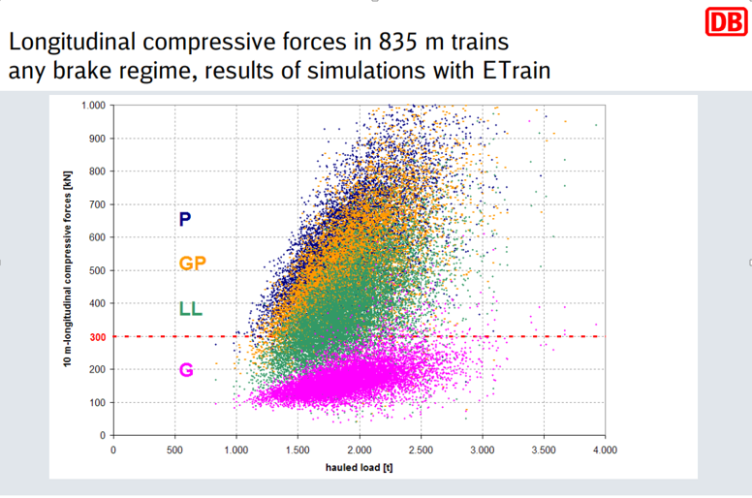

This recommendation has led to following train braking rules applied by the German railway sector:
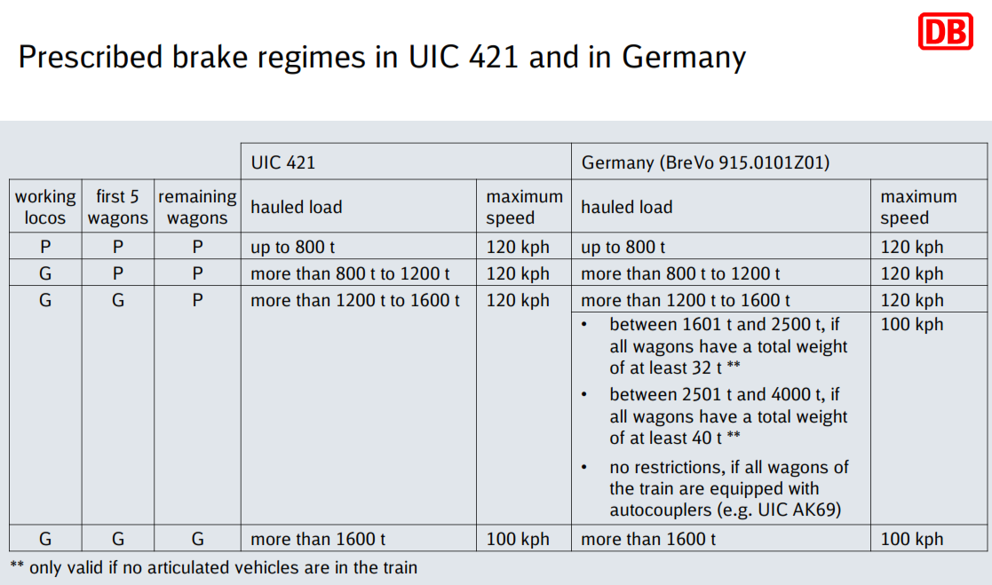
In Germany, some derailments due to excessive longitudinal compressive forces have been reported in specific conditions (during emergency braking, in curves, at low speed, in rainy weather conditions).

- Braking capability requirements:
- In Denmark/Sweden: no derailments have been reported in Denmark/Sweden in a long period (> more than 10 years) which are linked to excessive longitudinal compressive forces. The national train braking rules are mainly defined to provide sufficient braking capability in order to respect the timetable and as such, G/P-mode for heavy trains is accepted.
- In Denmark, the Class B-system is designed to operate with G/P-brake modes. According to an investigation report, the Class B-system design does not allow to operate in G-mode in order to respect the speed restrictions imposed by the Class B-system.

2.3.2. Example RFC7 - Checks and tests before departure/Train composition rules
The main problemdrivers reported by RailCargo Carrier are:
- Train composition (oversized shipments) - Instruction 328:
CFR (IM) has to check all the oversized shipments in the field (working time: Monday to Friday between 8 am – 4 pm). Some stipulations are in contradiction with Appendix 2 RIV and with UIC leaflets (rails longer than 36 meters are considered normal transports by Appendix 2 RIV, but, according with instruction 328 are considered extraordinary shipments (art.3.e).

- Checks and tests before departure - Instruction 250 (Technical inspections of trains):
The carrier has to perform a full technical inspection in cross border station (taking minimum 90 minutes). Also after a train split, a full technical inspection has to be redone. The braking system of all wagons has to be checked separately requiring to disconnect the air pipe of each wagon.
These national instructions are part of national legislation under the responsibility of the Ministry of Transport.

2.4 Develop common understanding and identify potential options and actions linked to operational barrier (e.g. accept merging of different operational rules into 1 set of operational rules as part of SMS of RU).
2.4.1 Example RFC3 - Train braking rules
Following options are considered to avoid time losses at the cross-border section Padborg/Flensborg related to train braking:
Option 1: Develop CSM on RA to accept G/P-mode in Germany:
The results of the task force indicate that the assumption of “absolute limit value of allowed longitudinal compressive forces is 300kN (benchmark)” could be rechecked. Measurement reports of maximum longitudinal compressive forces of the most currently used wagons (4 axle wagons) could be used in order to redefine the appropriate limit value for handling the risk of derailment. These measurements reports might exist already and could be used as part of the CSM on RA. As a consequence, this would exclude the use of certain categories of wagons (e.g. 2 axle wagons; articulated wagons) which is no operational constraint for the involved RUs (DBCargo and Hectorrail). If the risk would not yet been mitigated sufficiently, an additional measure could be to restrict further the train composition rules (e.g. by putting the empty 4-axle wagons at the rear end of the train).

Option 2: Use G-mode or LL-mode in Denmark/Sweden:
Although no braking tables are provided by the IM for G-mode in Denmark and Sweden, the RUs could emulate the G-braked vehicles (and trains) as P-braked vehicles (respectively trains), by introducing a reduction factor to the existing braking percentage (solution adopted in Switerland; reduction of 0.75 according to UIC leaflet 544-1).
According to TSI OPE 4.2.2.6.2, RUs are responsible to calculate the braking capability, so this solution is acceptable from a theoretical point of view. The (significant) reduction in braking percentage could however practically lead that no timeslot/path allocations are given to the RU (commercial feasibility). Therefore, following option has been evaluated as the option with highest feasibility and with potential commercial added value: “Accept LL-brake mode in Denmark/Sweden for freight trains also in the train category between 1600 tonnes and 2500 tonnes.”

This would lead to following braking table:
Weight | Germany | Denmark | Sweden
<= 800 t | P/P | P/P | P/P
801 t- 1200 t | G/P | G/P | G/P
1201 t – 1600 t | LL | G/P or LL (option 2) | G/P or LL (option 2)
1601 – 2500 t | LL or G | G/P or LL (option 2) | G/P or LL (option 2)
>2500t | G | G/P | G/P

This option has been analysed by DBCargo with positive results. The braking percentage has been investigated for 14 use cases. In only 2 of the 14 use cases, the lower braking percentage in LL-mode would lead to a lower maximum speed in Denmark or Sweden (see table below – blue boxes). The max. train length will remain only in Sweden the main issue for 8 out of 14 cases (potential stops between Denmark-Sweden). DBCargo estimated that in 57% (8 of 14 cases) they would not require in future a brake position change in the cross-border station of Padborg (Germany/Denmark) as the operational consequences are limited (in the other 43% of cases, they would require an update as G-mode is still required in Germany for train weight above 2500 tonnes).
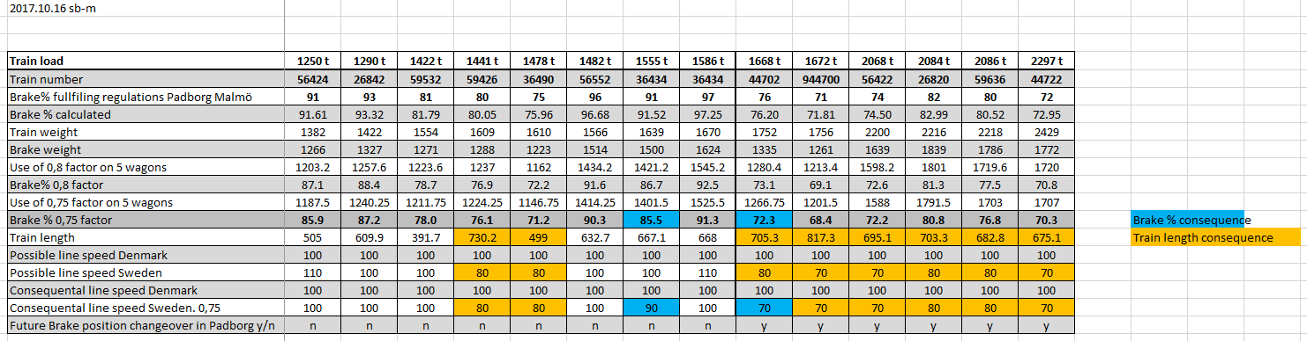

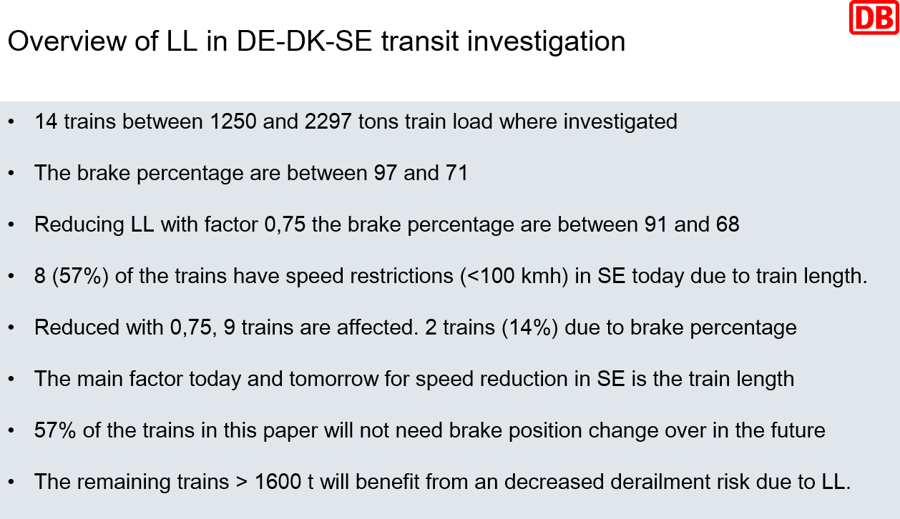

2.4.2. Example RFC7 - Checks and tests before departure/Train composition rules
TSI OPE text:
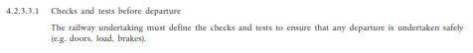
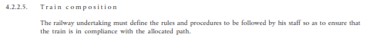
The participants confirm that in Germany, Denmark and Sweden the checks and tests before departure and the train composition rules are within the responsibility of the RUs as defined in the TSI OPE. Therefore, the reported problems by RCG at RFC7 do not appear at the cross-border sections between Germany, Denmark and Sweden.
This type of national rules originate from the time where poor maintenance was done (e.g. lack of spare parts/maintenance budget). Therefore, it should be checked with Member States having such national rules what is currently the number of maintenance issues detected at these cross-border sections and if these rules of the past are still relevant.

2.4.3. Effectiveness of TSI OPE implementation
- Checks and tests before departure – RFC7:
The implementation of the TSI OPE rules within the Member States would be effective to solve the operational barrier on checks and tests before departure and train composition rules (allocating the responsibilities towards RUs). Also the publication of existing industry standards for braking tests as acceptable means of compliance would solve the issue and remove the mandatory application of national technical instruction 250 (e.g. checking separately the braking system of all wagons).
- Train Braking – RFC3:
For the national train braking rules (see action 1 and 2), publication of UIC421 as acceptable means of compliance would not solve the reported operational issue between Germany, Denmark and Sweden as UIC 421 is more restrictive compared to Danish/Swedish rules (accepting P-mode) and also compared to German rules (for heavy freight trains in which LL-mode is accepted under certain conditions). UIC 421 could be reviewed by differentiation of the appropriate value for maximum longitudinal compressive forces in function of the type of wagons (2-axle wagons; 4-axle wagons). The experts from this task force evaluate this option to have a high probability to succeed.
During the case study, DBCargo Scandinavia investigated the possibility to use LL-mode in Denmark and Sweden. In only 2 out of 14 cases, the lower train braking performance in LL-mode (compared to G/P-mode) would lead to a lower maximum speed, however in 8 out of 14 cases, speed restrictions are introduced due to the maximum train length requirements in Sweden.
DBCargo considered that in 8 out of 14 cases (57%), there will be in future no change of braking positions in Padborg after updating of the Danish train braking rules for LL-mode linked to the Class B-system. Therefore, overall removal of national train braking rules of the TSI OPE is considered to be partially effective. Note: as ERTMS is implemented in Denmark all over the country (in Padborg-Flensborg cross-border section estimated in the year 2022), the implementation of the updated Danish train braking rules could be considered at the same time of ETCS implementation in case the update of the train braking rules only for the Class B-system requires more efforts than initially planned.

  - Processes & migration requirements within TSI OPE

    - Why did RUs not act before?
The TSI OPE is recently implemented or under implementation according to information received from OPE National Implementation Plans.

    - National rules versus industry standards (sector rules) versus company rules:
Most RUs use industry standards (sector rules) as part of their SMS. In the feedback on the NIP, it has also been reported as an effective way to proceed. Small entrants can use the industry standards to enter the market. The reported examples show the long lifetime of national rules being kept for many years. On the other hand, shifting national rules towards the SMS of the RU is changing the label of the operational rule and putting it under the full RU’s responsibility. It does not allow RUs to ‘experiment’ with changing of operational rules. The example of train braking rules demonstrate that it requires the background of existing national rules and that only in the case where a business case exist and where there is a high probability of demonstrating the safety level at a reasonable cost, an individual company would take the opportunity to modify an existing operational rule. Therefore, it is expected that the number of individual company rules deviating from industry standards will remain low, especially in case of complex topics like e.g. risks related to longitudinal compressive forces.

    - Migration requirements
Checks and tests before departure/Train composition: The reported issues are not linked to different line characteristics. The implementation of the TSI OPE would resolve the reported issues at RFC3 related to checks and tests before departure/train composition rules.
Although the TSI OPE is directly applicable to IMs and RUs, there is the risk as reported on RFC7 of remaining national rules under the responsibility of the Member State. Therefore, an article in the legal text should be addressed to remove these remaining national rules.
“The Member States shall remove all national operating rules (type 3 national safety rules) which are not listed within Appendix I of this TSI OPE within x years after entry into force of this TSI OPE.”

Annex 3 - EU harmonized communication for cross-border operating train staff

3.1 Number of cross-border train drivers versus number of signallers/dispatchers
With the centralization of traffic management systems, the ratio of number of signallers & dispatchers versus number of train drivers will decrease further. Based on a questionnaire, the estimated staff productivity increase at IM-side for signallers & dispatchers is a factor 2 to 4 higher after centralization of the TMS compared to before centralization.
Taking average numbers, for the EU-wide network, following forecast is made before and after centralization:
- Number of trainkm in Europe: 4000 Mtrainkm/year
- EU wide network : 240k linekm;
- Core network : 60 k linekm;

- Estimated range of number of trainkm per signallers & dispatchers after full centralisation: from 100 to 300 ktrainkm/year;
- Estimated range of number of trainkm per signallers & dispatchers before centralisation: from 33,33 to 100 ktrainkm/year;

- Estimated number of signallers before centralization on EU wide network : between 40k and 120 k
- Estimated number of signallers after centralization on EU wide network : between 13.33k and 40k

- Estimated number of train drivers: 180k
- Estimated number of cross-border operating train drivers: (10%) 18k
Some experts raised the concern that the centralization of traffic management systems introduced a language barrier at cross-border sections, in which cross-border operating train drivers are no longer allowed to communicate in their national language for the last mile.
The above ratio demonstrates that the specific objective of moving towards a EU harmonized single language is becoming economically more interesting taking into account the centralization of traffic management systems and the reduced number of staff required to be trained at IM-side for a single additional language compared to the number of (mainly cross-border) operating train drivers to be trained for one or multiple additional languages. This could also reduce the barriers for the opening of the market for national operating traindrivers.

3.2 Examples of reducing language barrier in Denmark and the Netherlands
Feedback from interviews on removing operational barriers demonstrate that some Infrastructure Managers are investigating or supporting the planning of allowing a second language intended for cross-border operating traindrivers, and as such reduce the language training costs.
In particular in Denmark, Banedanmark will allow train drivers to communicate in Danish or in English as part of the overall signalling programme. It is interesting to follow up the results of this implementation in Denmark.
In the Netherlands, Prorail supported such measure as long as this is an EU-wide implementation with a sufficiently migration period for training signallers and dispatchers in a second language. According to some experts, the overall B1 language requirement for train drivers could be reduced if Appendix C of the TSI OPE would introduce a common railway operational language/terminology. An example of such table has been developed by Prorail for cross-border operating train drivers between Netherlands and German based on a list of approximately 400 railway specific terms. Although this list of railway specific terms facilitate normal operation, some experts raise the concern that such list might not be sufficient to cover emergency situations and would as such not reduce the overall level B1 language requirement. The development of standard phrases could also lead to digitalization/translation of phrases.

See https://www.rssb.co.uk/rgs/casdocs/RSSB-GBMR-OC%20Iss%202.pdf
Appendix I of TSI OPE contains a list where national operational rules are still possible.
P/P= Engine in P/Wagons in P
LL = Long Locomotive = First 5 wagons in G, rest in P
Exceptions for wagons with total weight >32t and < 40 t or automatic couplings

