Report
  - TSI OPERATION AND TRAFFIC MANAGEMENT
Final report on the further development of the TSI OPE

 | Drafted by | Validated by | Approved by
Name | Karen Davies  Idriss Pagand | Felice Ferrari | Anna Gigantino
Position | Project officers | Head of Sector | Head of Unit
Date | Enter a date. | Enter a date. | Enter a date.
Signature

Document History
Version | Date | Comments
0.6 | 4 October 2017
0.7 | 24 October 2017
0.8 | 09 January 2018
0.9 | 23 March 2018
0.91 | 12 June 2018
0.92 | 28 June 2018
0.95 | 13 July 2018

  - Contents
1. Introduction 2
2. Reference documents 2
3. Abbreviations 3
4. Working methods 4
4.1. Working Party 4
4.2. Working procedures 4
4.3. Cooperation between TSI OPE Working Party and ERTMS Operational Harmonisation Working group 4
5. Modifications to Appendix A “ERTMS/ETCS operational principles and rules” to the TSI OPE (draft version 5) 6
6. Appendix B – Common operational rules 6
6.1. Fundamental Operational Principles 9
6.2. Common operational rules 12
6.3. Methodology for harmonising operational rules 12
6.4. Speeds in degraded mode 14
6.5. Failure of ATP 14
6.6. Failure of on-board equipment 15
6.7. Running with caution 16
6.8. End of authority passed without permission 16
6.9. Principles of checks and tests before departure 17
6.10. Emergency evacuation 19
6.11. Train composition and Appendix D on the elements the IM has to provide to the RU for the Route Book and for the train compatibility over the route intended for operation 19
6.12. Safety of loading 9
6.13. Failure of trackside equipment including catenary 9
6.14. Exceptional transport 10
6.15. Low adhesion/Sanding 12
6.16. Platform gap procedures 13
6.17. Safe operation of test trains 13
6.18. Unscheduled stop 13
6.19. Procedure for arrival 14
6.20. Effect of cross-wind 14
6.21. Extension of scope of rule n°8.2 on failure of voice radio communication 14
7. Appendix I – List of open points 16
7.1. Bilateral meetings 16
7.2. National implementation plans 17
7.3. National rules 29
8. Chapter 7 of TSI OPE on implementation 32
9. Appendix C – Safety related communications methodology 33
9.1. Oral communication 33
9.2. European instructions 37
10. Other topics treated 56
10.1. Two drivers 56
10.2. TSI OPE and links with the SMS 56
10.3. Rear-end signal for freight trains in international traffic (4.2.2.1.3.2) 57
10.4. Applicability of TSI OPE to existing vehicles and infrastructure (2.2.3) 57
10.5. Tram-train 58
10.6. Interfaces with TSI NOISE 58
Annex 1 Working programme 63
Annex 2 – Guidance on TSI OPE and National rules 65
Annex 3 Examples of template 70

Introduction
The Commission Decision C(2010)2576 of 29.04.2010 on the extension of scope of TSIs mandated the European Union Agency for Railways to revise the TSI OPE, focussing on the harmonisation of operational rules. Supplementing this mandate, the Commission delegated Decision (EU) 2017/1474 of 8 June 2017 set specific objectives for the drafting, the adoption and the review of TSIs. For TSI OPE, it particularly emphasized the need:
- to develop fundamental operational principles and common operational rules in order to allow for the reduction of the number of national rules;
- to include provisions to ensure compatibility between trains and routes over which they are operated;
- to take into account the development of standardized communication methods and protocols;
- to define the scope of the open points for operations and to distinguish between national applicable rules and rules requiring harmonization;
- to provide coherent links between the operational requirements and the SMS;
- where appropriate, to define skills and qualifications for all staff performing safety-critical tasks that are not covered in other relevant legislation.

The following document has been produced by the European Union Agency for Railways as final report on further developing the TSI OPE and will – after completion - serve as Annex 1 to the recommendation for the development of TSI Operation and Traffic Management.

It gives an overview about the work done by the working party, the process and final conclusions of the revision at the time of delivery to the European Commission.

Reference documents
Ref. N° | Document Reference | Official Journal | Last amendment
[1] | Directive (EU) 2016/797 on the interoperability of the rail system in the European Union | L138, 26.05.2016
[2] | Directive (EU) 2016/798 on railway safety | L138, 26.05.2016
[3] | Comission Regulation (EU) 2015/995/ concerning the technical specification for interoperability relating to the ‘operation and traffic management’ | L165, 30.06.2015
[4] | Directive 2012/34/EU establishing a single European railway area | L343, 14.12.2012
[5] | Directive 2008/68/EC (inland transport of dangerous goods) | L260, 30.09.2008 | Decision 2012/188/EU
[6] | Regulation (EU) 2016/796 on the European Union Agency for Railways | L138, 26.05.2016
[7] | Commission delegated Decision (EU) 2017/1474 on specific objectives for the drafting, adoption and review of technical specifications for interoperability | L210, 15.08.2017

Abbreviations
Abbreviation | Definition
ATP | Automatic Train Protection
CCS | Control Command and Signalling
COR | Common Operational Rules
CSI | Common Safety Indicator
The Agency | European Union Agency for Railways
ERTMS | European Rail Traffic Management System
ETCS | European Train Control System
FOP | Fundamental Operational Principles
IM | Infrastructure Manager
MS | Member State
NIP | National Implementation Plan
NSA | National Safety Authority
NSR | National Safety Rule
OH | Operational Harmonisation
RFC | Rail Freight Corridor
RSSB | Rail Safety and Standartds Board
RU | Railway Undertaking
SMS | Safety Management System
SPAD | Signal Passed At Danger
TSI | Technical Specification for Interoperability
WG | Working Group
WP | Working Party

Working methods

Working Party
The Agency is mandated to revise the TSI Operation and Traffic Management, focusing on the harmonisation of operational rules.

The Agency set up a provisional Working Programme (Annex 1) validated by its management in September 2015. The Working Programme has been set up according to the following principles:
- The revision is based on the text of TSI OPE (EU) 2015/995;
- The revision is focused on the harmonisation of operational rules as required by the European Commission’s mandate to the Agency and the Commission delegated Decision.
- The revision takes into account the aspects that have been identified in previous revision but could not be treated on the necessary level of detail.

This Working Programme is regularly updated following the input of the members of the WP and the results of the bilateral meetings with MS.

The Agency sent the call for expert in November 2015, the following organisations were represented: CER, EIM, ETF, ERFA, NB-Rail, OTIF, UITP, UNIFE and NSAs AT, BE, CH, DE, DK, ES, FI, FR, IT, LT, NO, PL, PT, RO, SE, SI, UK.

Between January 2016 and July 2018, 17 WP meetings have been held. In addition, 14 bilateral meetings (Germany, Lithuania, Belgium, Portugal, France, Italy, Austria, Poland, Finland, Romania, Bulgaria, Luxembourg, Spain, Channel Tunnel) have been organized. The strategy for the bilateral meetings has been elaborated in the second half of 2015 and is annexed to this final report under the title “Guidance on TSI OPE and National Rules” (Annex 2).

The Agency’s internal coordination of works is done by the Agency’s project officers.

Working procedures
All the subjects treated in this final report were discussed in the WP. The findings of the WP were usually also discussed in the Sector Organisations’ and NSAs’ mirror groups. Each subject was finalised after the agreement of all the members of the WP unless stated otherwise in the final report.
For each topic, the Agency prepared templates to be filled in by the members of the WP. Examples of template are given in Annex 3 of this final report. The analysis of these essential contributions was giving the basis to initiate the experts’ discussions and finalise proposals and conclusions.

Cooperation between TSI OPE Working Party and ERTMS Operational Harmonisation Working group
In the course of TSI OPE work, it was realised that a certain overlap exists between Appendix A and other parts of the TSI OPE, notably certain other Appendices like B and C. Some examples on this include the way to deal with a failed ATP, with passing a failed level crossing, with using written orders, with passing an end of authority etc. In all of these cases, as well as in several more, there exist different operational principles and rules for the ERTMS cases and for the generic (non-ERTMS) ones. Some of these rules have been found to address the same issues in diverging ways, thereby complicating the operational harmonization effort and ultimately the interoperability cause.

As soon as this overlap was detected, a joint effort of both workgroups (OH and TSI OPE) got under way to identify such cases and channel them to be processed by the more competent of the two WGs on a case-by-case basis. Such processing aimed at eventually eliminating some rules from one of the Appendices in favour of more generic harmonized rules sustained in another. Conclusions were always shared between the two groups. The fact that the coordinators of both groups participated to each other’s workgroup meetings, along with several of the members of these workgroups who attend both, was an important facilitator to this work.

The benefits from pursuing this joint harmonization effort are multiple:
- Increased overall safety when applying common operational rules;
- Less training needed for drivers crossing borders.
Other positive side effects are:
- Fewer national rules and more harmonized rules at EU level, resulting in more direct and uniform transcription of TSI OPE into national law;
- Training for staff involved in operations can also be streamlined when common operational rules are in place;
- Improved interoperability and market opening conditions;
- An indirect effect would be a reduced heterogeneity in ERTMS trackside engineering rules and implementations.

EIM, ETF and NSA FR consider that these positive effects are not certain as the harmonised rules are not as detailed as in the national legislation and there is a risk of losing some important features in the modification of national rules and company rules. The training of drivers or signallers will be based on the company rules derived from the harmonised rules, the national rules, and from the already existing company rules. It is likely that the changes to the training will be minimal. .

However, the National Safety Rules Task Force Report in 2012 states that:
‘Good practice would be to avoid issuing detailed prescriptive rules in favor of more general rules defining the objectives to be achieved in a way open to more than one solution. The level of details in the OPE TSI should serve for orientation: these TSIs support the optimal coordination between RU and IM aiming at safe and uninterrupted train traffic. Careful reflection on the level of details in NSR reduces the chance of mixing the authorities’ responsibility for safety regulatory framework and checks with the direct responsibility for managing safety and risk control which the RSD allocates to RUs and IMs’.
Work on the harmonization of ERTMS rules has adhered to these principles.

This process had borne fruit already in the previous iteration of TSI OPE: Former Appendix A rules 6.5 (running on sight), 6.6 (departure of train) and 7.5 (Emergency Call) had been made generic and replaced by Appendix B rules 9, 2 and 13, respectively. It was the same case with App. A principles 5.1.4 and 5.1.5, which had been transferred to Appendices C and B respectively.

In the current revision cycle, more Appendix A rules have been merged or cross-referenced with Appendix B rules (numbering refers to current version of documents):
- Appendix A rule 6.44 on passing a non-protected level crossing has been reworded to eventually refer to harmonized Appendix B rule 7.
- Appendix A rule 7.6 on managing a failure of self-test has been reworded to refer to harmonized Appendix B rule 8;
- Appendix A rule 7.7 on managing a lack of GSM-R network after the train has entered service has been reworded to refer to harmonized Appendix B rule 8.2;
- Appendix A rule 7.8 on onboard GSM-R failure has been eliminated, as it is covered by harmonized App. B rule 8.2;

One more example of the two workgroups joining forces towards more harmonization are the written orders– in the proposed revised Appendix C, called European instructions. Originally raised in the TSI OPE, a proposal for merging the ERTMS written order forms was taken forward to the OH, where a draft for a single form was produced. This was then put up for discussion in the TSI OPE taking into account the Appendix C provisions.It was subsequently decided to create a dedicated subgroup to deal with the harmonization of written orders by potentially extending the scope of ERTMS written orders to also cover other more generic cases (e.g. ERTMS written order 1 on passing an ETCS End of Authority could be extended to cover other similar cases, irrespective of how the EoA is communicated to the driver). The progress on this topic is reported in section 9.2 of this final report. The resulting European Instructions form Appendix C.2 to the overall TSI OPE; the ETCS written orders have been consequently removed from Appendix A.

Modifications to Appendix A “ERTMS/ETCS operational principles and rules” to the TSI OPE (draft version 5)
Current version 4 of the ERTMS Operational Rulebook (Appendix A to the current TSI OPE, i.e. Commission Regulation (EU) 2015/995) reflects the first ERTMS Baseline 3 release, featuring System Requirements Specification-SRS ver. 3.3.0, introduced under Commission Decision 2012/696. Under the following iteration of Annex A to the TSI Control-Command and Signaling (included in Commission Decision 2015/14 introducing Baseline 3 Maintenance Release 1-B3MR1 built around SRS ver. 3.4.0), the first Baseline 3 release was replaced by B3MR1. There was no effect identified for Appendix A by the introduction of B3MR1.
The most recent TSI CCS (Commission Regulation 2016/919) introduced one additional legal baseline, namely the so-called Baseline 3 Release 2 (B3R2-SRS 3.6.0). Version 4 of the ERTMS Operational Rulebook does not cover that specification either. The effect to Appendix A of the changes introduced by B3R2 has been found to be minimal, given the high-level structure of the rules and principles within Appendix A. Several DMI features are affected by the new specifications, yet these features are not covered by the current structure of Appendix A (e.g. the use of the planning area at the right-hand side of the Driver-Machine Interface-DMI).
Baseline 2 (2.3.0d) implementations are still considered, since these were already covered by version 2 of the ERTMS Operational Rulebook (Appendix A to Commission Decision 2012/757/EU).
It should however be stressed that the ERTMS Operational Rulebook is only applicable to B2 onboards to the extent that these comply with the Driver-Machine Interface specification (document ERA_ERTMS_015560), which was not mandatory for B2 implementations. Many B2 onboards indeed comply with these specifications, thereby making Appendix A largely applicable to them as well. Still, even for those B2 onboards that do comply, the applicable operational rules depend, although to less extent, on the document version to which they comply (3.3.0, 3.4.0 or 3.6.0).
A further differentiation has also been considered and ultimately rejected for the cases of different combinations of ETCS onboard / trackside system versions, which define the so-called “operated system version”. The rule of thumb to be followed is that the driver is always expected to react in the same way if confronted with the same DMI indication, regardless of the onboard/trackside system configuration. This makes Appendix A generally applicable without having to consider the actual configuration.
The validation of the resulting updated version of Appendix A will be done alongside the next edition of the TSI OPE.
The progress made in the scope and content of Appendix A has been significant.
As a starting point, the OH group agreed on a process for harmonizing rules that are currently non-harmonized. The existing non-harmonized rules that apply in the operational cases of Appendix A are grouped in Annex C thereof. There are several more non-harmonized rules that apply to ERTMS operational cases beyond the scope of the current Appendix A. These are generally national rules (see further below) and have also been considered for harmonisation when the cases to which they apply are generic ones (i.e. not network-specific).
This process applies a step-by-step approach, summarized below:
1 Appendix A is reviewed in search of rules with harmonization potential.
2 A short list of such rules is established based on consensus among OH members.
3 For each of the cases in this short list, the workgroup is asked to collect the rules which are applicable by their respective members.
4 These rules are checked against Notif-IT to see whether they have been notified as National Rules.
5 A first draft of a harmonized approach is drawn up for each case based on the common denominator of most individual rules which are applicable for that case. This draft is checked against agreed high-level fundamental operational principles (FOPs) for consistency.
6 A consultation phase follows, if OH members need an authorization to decide on replacing an existing rule by a harmonized one.
7 ERA will encourage and support Member States and NSAs in this direction.
8 Depending on the outcome of the consultation, the OH decides on discarding or keeping (in the original or amended form) the harmonized rule.
9 The new rule is included in the future Appendix A or B (depending on the rule’s scope), before replacing all relevant national ones.
10 The TSI OPE workgroup may assist the OH in the cleaning-up process of national rules becoming obsolete once a harmonized rule is put in place.
Following a poll among the members’ organizations, a priority list was established and the rules to get through this process in this revision cycle have been identified.
In this context, it has been possible to harmonize, either entirely or partially, ETCS rules which were not harmonized in the current version 4 of Appendix A:
- Rule 6.28 on sounding the audible warning device
- Rule 6.30 on passing a radio hole
- Rule 6.44 on managing a level crossing not protected
- Rule 6.53 on managing a NTC failure

The principles of the ETCS stop marker and the ETCS location marker have also been inserted in the document, along with their operational effect. Concerning the other marker boards which have been harmonized under EN 16494 “Railway applications – Requirements for ERTMS trackside boards”, the proposal was to include this norm in the list of reference documents under Appendix A, while also transferring the operational effect of these boards into the relevant rules of Appendix A. This will enable a consistent implementation of these marker boards on the trackside.
The use of GSM-R has also been further harmonized in the new edition of Appendix A. GSM-R roaming in other GSM-R and public GSM networks are covered as well.
- Rule 7.6 on managing a failure of self test (on the cab radio)
- Rule 7.7 on managing a lack of GSM-R network after the train has entered service
- Rule 7.11 on taking measures in case the (GSM-R) functional number is already used
- Rule 7.13 on changing over between GSM-R and GSM-Public as primary communication
- Rule 7.14 on changing over between GSM-R and GSM-Public as fall-back communication
NSA Italy raised a point on the risk encountered when starting a mission in Staff Responsible mode. The proposed mitigation measures have been discussed extensively in the group without reaching an agreement, as the risk is considered to be minimal.
Several other rules were examined by the OH in search of harmonization possibility, yet the group has concluded that no harmonization was possible, usually due to the association of the non-harmonized part of the rule with some legacy Class B system, for which purely national rules apply.
Further ad-hoc members’ queries have also been taken into consideration and put up for discussion in OH meetings, provided they meet certain criteria (e.g. they need to concern more than one interested party either directly or indirectly). In that way, Appendix A has gradually expanded to accommodate new, currently non-existing, operational rules (e.g. the rules 7.13 and 7.14 on GSM-R roaming in public GSM networks).
Another task which has been undertaken consisted in collecting the Appendix A “transpositions” into national law across EU. This has allowed the Agency to form an understanding of how the ERTMS Operational Rulebook has been transferred in different member states and draw useful conclusions on possible misinterpretations, best practices etc. This will further facilitate future harmonization efforts.

The OH group has been also involved in the processing of the Change Requests on the ERTMS specifications which have an operational impact. Such CRs have been identified and brought to the OH for consideration under the responsibility of the ERTMS Unit.

The OH group values the active participation of train drivers (representing ALE and ETF) and appreciates their input concerning the driver’s viewpoint when driving under ETCS.
On the other hand, the OH group regrets the lack of representation of freight operators and loco leasing companies, given the valuable experience these undertakings should normally have accumulated in working with ERTMS in cross-border and corridor traffic.
Operational harmonization activities at the level of the Rail Freight Corridors of Reg. 913/2010 have also been followed for synergies and compatibility issues. The OH group has liaised with a dedicated workgroup established under RFC2 (North Sea-Med), to follow-up an operational harmonization effort initiated by this group at the level of RFC2. The OH group has also supported the OPE WP on corridor issues of operational context related to ERTMS, as reported by the various stakeholders and compiled under the “RFC Issues Log”.
Last, some further OH activities are paving the way for future TSI OPE evolution, in areas such as:
- ATO: the OH group has participated in the validation of the operating principles and the DMI features of a future ATO over ETCS system. Once the system is technically defined, the relevant operational rules will be developed to cover automatic driving along with all degraded situations.
- ETCS Level 3: the OH group will process the necessary amendments to the operational rulebook to accommodate the rules relevant for driving in Level 3 and in particular its purest form, the so-called “moving block”. In view of this, the OH follows the development made in the relevant work package of Shift to Rail.
- FRMCS (Future Railway Mobile Communication System): the OH group has actively participated in a survey initiated by the Agency, aiming at mapping the operational experience gained by using GSM-R for over 15 years already. This return of experience has proven valuable in the definition of the user requirements for the successor of GSM-R, provisionally known as “FRMCS”. Once the new system is fully defined, the OH will elaborate the necessary operational rules adapted to the enhanced features of the new system.
- ETCS driver’s handbook: the Agency is planning to launch a tender for the drafting of a harmonized manual on how to drive a (standard) ETCS train. The OH group will assist in this activity, the outcome of which may form an additional document for TSI OPE or TSI CCS.

Appendix B – Common operational rules

As part of this revision cycle, the WP has developed and produced a hierarchy of rules for Appendix B. The process started with the 2012 revision and has now been further developed with this revision. The WP felt that there needed to be a framework for how the harmonised rules could be structured in a more coherent way, as a result the Fundamental operational principles were developed.

CER and EIM summarized the view on the common operational rules and how they link with the fundamental operational principles into a pyramid:
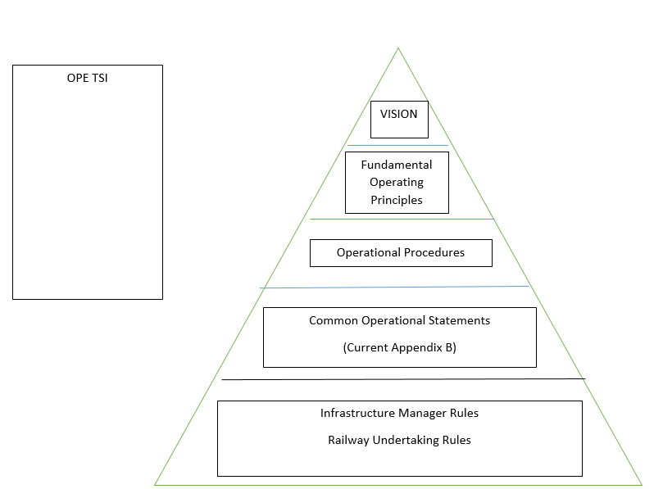
Figure 1 : CER/EIM’s pyramid of the rules

The operational vision statement is correlated to the Safety Directive where it is stated in its article 4.1 that “railway safety is generally maintained and, where reasonably practicable, continuously improved”. On a second layer comes the fundamental operational principles which gives the ovarching principles for a safe railway system. An agreed set of operational processes for each of the fundamental operational principles are included in the application guide of TSI OPE in order to make clear the scope of those principles. Appendix B on common operational rules are more detailed rules referring to specific situations. Finally, the IM and RU’s rules are developed within the SMS in order to cope with the specific needs of those companies.

Fundamental Operational Principles
The inclusion of Fundamental Operational Principles was a proposal put forward by NSA IT at the end of last revision cycle. The FOP have been given the highest priority by the member of the WP for two main reasons. Firstly, the FOP should be the overarching principles that should be reflected in all the common operational rules. They should serve as the reference to develop and improve the common operational rules. Secondly, the FOP gives a common framework of the operational concepts for safe, interoperable and modern railways.
NSA UK provided the operational concept for the mainline railway defined in a document drafted by RSSB. This document served as basis to develop the FOP in TSI OPE. One of the first conclusions was that responsibilities and technology should not be aspects of the FOP in order to keep them at a strategic level. It was also very clear from the start of the discussion that guidance would be needed along the FOP in order to explain in details what is intended by the different FOP. Some members initially questioned their benefit in relation to interoperability but it was clear that the FOP would help in scoping and mapping rules that have a relevance and if they do not match with the FOP, the rule should not exist or be developed.

Following the discussion within the WP, the results on the FOP are the following:
Fundamental Operational Principle N°1:
“The method of authorising a train movement must maintain a safe interval between trains”.

Fundamental Operational Principle N°2:
“A train must only operate over a portion of line if the train composition is compatible with the infrastructure”.

Fundamental Operational Principle N°3:
“Before a train begins or continues its journey, it must be ensured that passengers, staff and goods are carried safely”.

Fundamental Operational Principle N°4:
“Before a train is allowed to start or continue its movement, it must have an authority to move and all necessary information to define the conditions of that authority”.

Fundamental Operational Principle N°5:
“A train must be prevented from proceeding onto a portion of line if it is known or suspected that it would not be safe for the train to pass until measures have been taken to allow the train to continue safely”.

Fundamental Operational Principle N°6:
“A train must not continue to operate after it has been found to be unsafe in any respect, until measures have been taken to allow the train to continue safely”.

These new fundamental operational principles are included in TSI OPE, Appendix B.

The list of operational processes that are relevant to each fundamental operational principles are in the application guide but they cannot be considered exhaustive and can be complemented.

NSA IT agreed with the fundamental operational principles developed by the WP. However, NSA IT would like TSI OPE to describe all the principles, rules and procedure necessary to operate the lines compliant with the TSIs. NSA IT thinks that it is useless and potentially dangerous developing the current TSI OPE if the rules are not written in a coherent and complete document applicable on all of the European Union. NSA IT believes that it is only possible to adopt common rules on lines technically compliant with the other TSIs.

NSA IT proposes the following steps for theTSI OPE implementation strategy:
- TSI OPE issues the Fundamental Operational Principles (FOPs), to be applied on the whole European railway system, and the Common Operational Rules (CORs), strictly mandatory only on TSIs fully compliant lines;
- Different steps are required if the line is fully TSIs compliant or not:
  - on fully TSIs compliant lines all the relevant FOPs and CORs (written in the TSI OPE) apply and there is no need of any additional common rule, national or whatever else;
  - on the other lines, not fully TSIs compliant, the IMs have to perform a specific detailed gap analysis between the FOPs and CORs described in the TSI OPE and the rules in use on the concerned lines and is responsible for issuing the interface procedures to be applied to achieve the same level of safety that are in the TSIs compliant lines and to adopt, if necessary, the mitigation measures.;
- IMs and RUs internal rules are to be added.

Then, at the end of this process, on TSIs fully compliant lines there are no more national rules; on other lines only the national rules which cannot be removed for safety operational reasons will remain in force.
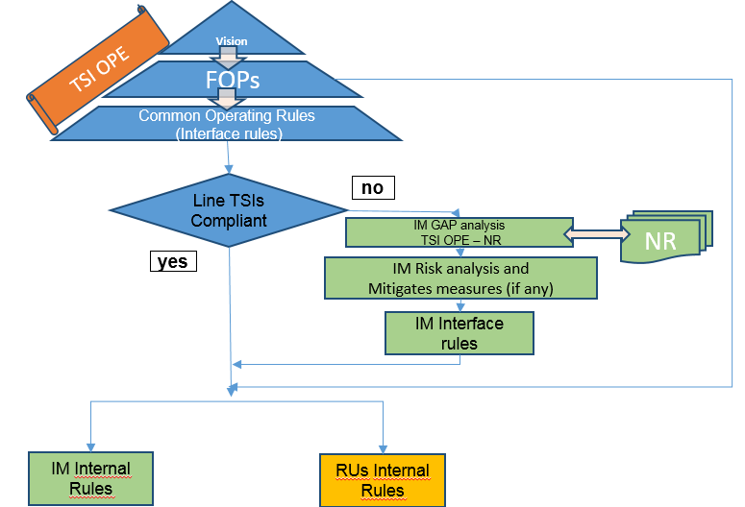
Figure 2 : NSA IT’s implementation strategy for TSI OPE

However, NSA IT proposed the Brennero tunnel as a “trial site” for applying FOPs and the consequent rules and procedures under the supervision of ERA or of TSI OPE WP for demonstrating an operational possibility to achieve the aim of a real interoperable TSI OPE. ERA is now participating to the meetings on the development of operational rules for the Brenner Base Tunnel as a support.

Moreover, NSA IT considers that the harmonisation of operational rules can be achieved only if the underlying safety principles are clearly defined in OPE TSI. In particular, among those principles, the ones regarding the safety functions of trackside systems (interlocking, block and train protection systems) should be defined and harmonised. In fact, for example, it is impossible to fully harmonise the operational rules between two networks, one with telephone block and the other with automatic block, even if ETCS is implemented on both, because the first network requires additional rules to mitigate the risks of human errors affecting the telephone block.

Whilst the WP had some sympathy for this, everyone agreed that the TSI OPE was extended to all lines and the FOPs and the CORs should reflect this plus the level of detail required to achieve this could not be done within the current revision timetable.

Common operational rules

The main objective of this WP is to continue the harmonisation of operational rules. Currently, the TSI OPE has approximately covered a small percentage of common operational rules. The objective for harmonizing operational rules is to provide clear consistent information, to reduce operational human errors (increase safety performance) and to reduce training costs, especially for cross-border operating train drivers.

The topics include ones that were originally proposed for the 2015 revision but were not covered (due to them not being the highest priority) and new ones suggested by Members and the Agency from the bilaterals with MSs during the meetings on the clean up of National Rules.

The operational rules that are intended to be harmonised in Appendix B of TSI OPE are generic in that they can be used with both the class A and B systems. It is appropriate to focus on operational rules for degraded mode and emergency situations because:
- They apply in situations that are more stressful for the driver and the signaller with a higher risk of negative consequences;
- They are often less dependent on technical solutions (track side and rolling stock side).

Methodology for harmonising operational rules

Firstly, the WP used generally a template provided by the Agency to identify the appropriate level of detail for the TSI OPE:
- A short description of the topic to be analysed;
- The existing link with TSI OPE (or other TSIs), if any;
- Relevance for interoperability;
- The potential benefits in terms of safety, capacity and interoperability;
- The potential risks to be managed (not quantified);
- The actions to be performed to manage the risks.

Based on the analysis performed at the WP level, CER and EIM provided a proposal for a common operational rule to be discussed in the WP.

Secondly, to match the requirements from the template to the proposal from the sector, the WP is asked to consider their own national Rules and the extent to which the risks can be closed out by the rule. The Agency would like to highlight that the envisaged content of Appendix B is not the detailed operational rule, but a harmonised functional requirement on operational rules (“What needs to be done?”). The procedure itself shall be set out by IM and/or RU in application of the requirements in TSI OPE via the operational procedures in the SMS (“How is it done?”). These functional requirements (sometimes called “rules”) will not reach such level of detail that they can be copied into the IM’s and RU’s set of rules. This is partly due to the fact that the landscape of operational rules is different on the various networks – following different technical solutions, different structure and different approaches to the creation of rules.

The basic question when writing an operational rule shall always be: What has to be done?
The question of how it should be done is then part of the implementation by IMs and RUs within their SMS.

Priorities

In order to define the priorities of the WP, a specific voting tool has been used. After the first vote organized during the kick-off meeting, the results (based on 29 persons voting without the Agency’s staff) are the following:
- Fundamental operational principles: 58.6%
- Speeds in degraded mode: 58.6%
- Failure of ATP: 58.6%
- Failure of driver vigilance: 55.2%
- Running with caution: 51.7%
- Written order: 51.7%
- Procedure following a SPAD: 37.9%
- Emergency evacuation: 31%
- Train composition: 27.6%
- Low adhesion: 17.2%
- Unforeseen stops: 17.2%
- Exceptional transport: 13.8%
- Procedure for arrival: 10.3%
- Effect of cross-wind: 0%

The Agency tackled all the topics over 50% and organize a second vote with the new topics included following some inputs from members of the WP and as a result from the first bilateral meetings. During the third meeting of the WP, another vote has been organized with the following results:
- Fundamental operational principles
- Speeds in degraded mode
- Failure of ATP
- Failure of driver vigilance
- Running with caution
- Written order
- Procedure following a SPAD: 95.8%
- Principles of checks and tests before departure: 83.3%
- Emergency evacuation (including in tunnels) + use of 112: 70.8%
- Train composition: 70.8%
- Safety of loading: 54.2%
- Low adhesion: 37.5%
- Unforeseen stops: 33.3%
- Exceptional transport: 33.3%
- Platform gap procedures: 25%
- Procedure for arrival: 16.7%
- Effect of cross-wind: 4.2%

Apart from train composition, all the topics over 50% have been tackled in 2016. In 2017 and 2018, after a final vote, ERA has covered the following topics:
- Failure of trackside equipment: 6.4
- Exceptional transport: 5.8
- Failure of catenary: 5.7
- Low adhesion: 5.7
- Platform gap procedures: 5.4
- Safe operation of test trains: 5.0
- Unforeseen stops: 4.9
- Procedure for arrival: 3.6
- Effect of cross wind: 3.2

NSA IT has not proposed to put forward new topics for harmonization in Appendix B, decided not to participate to the vote during the 7th meeting (and the following) as it is considered not the correct method to decide on priorities because it is not considered a structured approach

Speeds in degraded mode
The initial main questions that have been raised were ‘Do we really want to harmonise speed value’ or ‘do we want to define degraded mode’?. It was also possible to differentiate between a technical and a procedural reason for a speed restriction. If the speed restriction is due to a technical failure, this should not be covered in TSI OPE but for speed restrictions due to procedural reason like running on sight, it could be. To start the analysis, the Agency collected from the members of the WP the most typical examples which set out requirements for speeds in different degraded modes.

After the first analysis of the different degraded modes with speed restrictions, it has been found very difficult to harmonise speeds for each particular degraded situation at EU level. Instead, it has been decided to focus the work on identifying which degraded situations could be harmonised. The speed value would be given at each MS level (or at IM level). In itself, the speeds in degraded mode cannot be considered as a separate topic and cannot be treated as such because it depends upon the different circumstances of the situation and the operational conditions. However, this topic should be included as a issue that needs to be considered by the RU/IM under the relevant FOP. In addition, although it is very difficult to harmonise speed restrictions for class B system, for ERTMS/ETCS it should be harmonized as much as possible. As a general rule, in degraded mode that leads to a speed restriction, the information has to be delivered to the train driver independently of the reason and the speed restriction itself.

Failure of ATP
ERA proposed to consider this topic under :
- ERTMS Operational harmonization (OH) working group for the failure of ERTMS ATP – once this is agreed;
- TSI OPE WP consider the topic of failure of non ERTMS ATP – once this is agreed.
- Consider extending to all Train Protection System.
CER expressed caution on non ERTMS ATP that are linked to class B signaling system and entering into an area where the group accepted that national rule can exist.

The OH WG processed the rules under Appendix A relating to a failure of the ETCS (the ATP constituent of ERTMS) in search of possible harmonization. It turned out that only a few of them could be harmonized (see ch. 5), the reason being that each network deals with ETCS failures in a different way, which is largely dependent on which type of underlying Class B system exists on the line. Since in most cases an ETCS failure is managed by reverting to the Class B system, it is obvious that the steps to be followed depend on the specificities of that Class B system as well as on the associated operational rules, which are rarely harmonized.
Bullet 2 could not be processed any further, given that no harmonization could be achieved in bullet 1. The Agency believes that the proliferation of ERTMS followed by the decommissioning of Class B systems will gradually allow more harmonization of the topic in question.

Failure of on-board equipment
Initially, the topic to be covered was failure of the driver vigilance. However, after the initial discussion during the kick-off meeting, it has been acknowledged that a more generic approach should be taken and that there was the need to extend the scope of this topic to any failure of an on-board equipment. After a quite exhaustive analysis of the different possible failure of an on-board equipment, CER and EIM put forward a proposal that is covering in generic terms the different possible failures.

ERA made an initial proposal “Failure of on-board devices should be considered as part of the risk assessment of the RUs SMS. Suitable control measures should be put in place including particular procedures and or IM/RU’s rules that the driver should follow. If the train can continue it should do so based on the RUs procedures or rules. If the train cannot continue it should follow the procedure for ‘Assistance to a failed train’”. CER accepted that on-board equipment is the responsibility of the RU but expressed an issue when RU puts on safety control measures that impact capacity. The RU must then inform the IM to make sure that the IM agrees for the train to move. EIM proposed to add “as far as accepted by the IM” in order to indeed include the responsibility of the IM to keep the timetable.

NSA FR explained that they want to keep national rules on that subject because NSA FR believes that the IM knows better what is needed on its network and what it can accept. NSA FR wants to have the possibility to maintain a National rule concerning the class B systems. NSA FR also has a general concern in the operational management of a failure of an on-board equipment, when the signaler is not aware of what to do in relation to a particular failure. NSA FR considers that before choosing whether there should be a NR or not, a risk analysis (integrating human factors) should be done.

Following the discussion within the WP, the results on the failure of on-board equipments are currently the following:
“The RU shall determine the cases in which a failure of an on-board equipment affects the running of the train.
The RU shall give the necessary information to the driver and/or train crew of what action to take in the case of on-board failures that affect the running of the train.
If the driver becomes aware of a failure of any on-board equipment that affects the running of the train, the driver shall:
- Inform the signaler of the situation and the restrictions on the train should the train be allowed to continue its mission,
- The driver shall not commence or recommence the mission until permission to do so has been granted by the signaler,
- If the signaler gives permission for the train to start or continue its mission then the driver shall proceed in accordance with the restrictions placed upon the train,
- If the signaler does not give permission for the train to commence or recommence its mission then the driver shall follow the instructions given by the signaler”.

This change will be included in TSI OPE.

CER explained that point 4.2.3.3.2. on informing the IM of the train’s operational status covers the process while the appendix B rule is about the driver and the signaler explaining the problem.

ERA explained that whilst there are similarities with other rules currently existing in Appendix B, some of the nuances would be lost if all on-board failures would be into one rule. ERA proposed to add an introductory paragraph to the application guide on the failure topics and to explain why they are separate.

Running with caution

In a limited number of MS, the operational concept of running with caution exists. It is to be distinguished from running on sight as there are two different ‘types’ of drivers behaviour, depending on the type of obstacle for which the driver must be able to stop. For running on sight, the focus will be on another train, railway vehicle or stop aspect linked to the signaling system (e.g a red flag).For running with caution, the focus will be on every other ‘obstacle’ (whatever that could be). The speed used will be different as well as the drivers responsibility. With the actual definition of running on sight, the train driver has to be able to stop in front of any obstacle. From this analysis, it was proposed that it was necessary to define “obstacle”. CER explained that “an obstacle is something immobile that is on the track” and not falling down from somewhere. In that way, cattle, person or a rock falling are not to be considered in this definition. It has also been pointed out that the important element is the stopping distance that depends on the speed chosen by the train driver. NSA IT informed that the speed will also be adapted in relation to the visibility. Running with caution was not considered a concept clear enough. In conclusion, it was agreed that there was not an unanimous agreement on the use of running with caution.

Following the discussion within the WP, the results on the running with caution are currently the following:
Rule n°9 on running on sight could be amended and a bullet point added:
“This does not apply to unexpected obstacle entering the track zone within the stopping distance”.

This change will be included in TSI OPE.

As a consequence, running with caution can still exist as a national rule. However, because there might be a risk of confusion between running on sight and running with caution, especially for cross-border operations, while running on sight is harmonized at EU level, the Agency advices the Member States to review this national rule in the future and to deal with this operational concept as part of the SMS.

NSA FR pointed out that running with caution is not linked only to obstacles. In France, they are distinguished as follows:
- Running on sight = linked predominantly to the spacing systems ;
- Running with caution = linked to the operational environment and its impact on operation of the trains. The reasons to run with caution are diverse like people on the track, failure of the catenary/pantograph, open level crossing while it should be closed, etc.

End of authority passed without permission

Initially, this topic has been introduced as “procedure following a SPAD”. However, following discussions within the WP, it has been acknowledged that the term “end of authority passed without permission” was more appropriate.

While driving, especially on cross border services, the measure following a SPAD or an end of authority passed without permission should be the same in order to let the train driver to know about the implications of such an event in a consistent way. From an interoperability point of view, harmonizing this procedure was considered as highly beneficial. In general, it was acknowledged that following such an event, the train driver shall stop immediately and report to the signaler and wait for instructions. However, the procedure if the train driver is taken out of service might depend on the situation and should be considered as out of scope. NSA UK indicated that SPADs are categorized in four categories.

The Agency indicated that in the CSI, Signal Passed at Danger (SPAD) means any occasion when any part of a train proceeds beyond its authorised movement and travels beyond the danger point; Danger point is a point at which the train will be in a danger of an accident (collision, level-crossing accident, accident to person caused by rolling stock in motion or derailment).
It is usually defined in the specifications of the Train Protection System.
A failure to stop a train at a station where prescribed in the timetable does not itself qualify for a SPAD, since it does not constitute an obstacle for an authorized movement of a train.

Following the discussion within the WP, the results on the “end of authority passed without permission” are currently the following:
A definition could be included in the glossary as follows:
“An End of Authority passed without permission is any occasion when a train proceeds beyond the end of authority in the following circumstances:
- A trackside signal at danger, or an order to STOP where an ATP is not operational,
- The end of a movement authority provided in an ATP,
- A point communicated by verbal or written authorisation laid down in regulations,
- Stop boards,
- Hand signals.
This covers movement authority as described in ETCS and authority to move covered by instructions/written orders/signalling.
Any case in which a vehicle without any traction unit attached or a train that is unattended runs away is not included”.

An additional rule could be included in Appendix B:
- “If the driver becomes aware that the train has passed an end of authority without permission, the driver shall stop the train immediately.
- If the train is stopped by an ATP, the driver shall take action to support the emergency brake.
- The driver shall inform the signaler.
- If the signaler becomes aware that a train has passed a end of authority without permission, then the signaler shall take any necessary action to stop the train immediately.
- The driver and signaler shall take any necessary action to protect all movements.
- When the train is able to continue, the driver shall inform the signaler. The signaler shall set or check the route for the train to continue its journey and issue all necessary instructions”.

These changes will be included in TSI OPE.

Principles of checks and tests before departure

Despite TSI OPE which specifies in point 4.2.3.3.1 that “the RU must define the checks and tests to ensure that any departure is undertaken safely”, it appears that most Member States have national rules related to the checks and tests before departure a RU must perform. After an initial evaluation, the most common checks that are mandated at national level are the following:
- Brake tests of different type;
- Visual inspection of wagon and loading;
- Test of on-board safety device;
- Checking that the doors are closed.

Following the first meeting that was held on this topic, it was mostly agreed by the members of the WP that it was not needed to further harmonise this topic in the TSI and that there should not be possibility for national rules to be developed. However, following the issue being raised by some of the Rail Freight Corridors, where it has been proposed to harmonise these operational rules at corridor level because of some Member States continuing to have national rules on this topic; thereby potentially creating a risk of either duplication of work and/or inconsistencies between the rules, it was necessary to discuss this topic again in the WP.

NSA DE explained that because it was important that the safety levels are maintained, there were clear links to the discussions on the rail freight corridors. NSA CH explained that the CH IM has problem to share information with the RU linked to TAF TSI and there would be a need of standardization for the checks. NSA BE explained that the existing rules should be kept for RUs not mature enough to create their own rules as a support. UNIFE explained that the braking performance has to be recalculated at the borders because of the different rules for checks before departure and supports the harmonization in whatever form. ETF explained that the know-how should not disappear to ensure that safety levels are maintained.

CER explained that this is an issue for the RUs under their responsibilities in the Safety Directive. CER did not see the reason to develop further this topic in TSI OPE nor in national rules. This is something that can be based on IM/RU’s rules taking into account the specifics of the operation. To harmonise to this level would not increase the safety benefits but could cost the sector more. NSA IT explained that if the safety principles are well described in TSI OPE then this task is for the RU and therefore part of its responsibility to make the checks before departure. Only the RU has the competence and knowledge to understand the operational requirements of its RST. NSA DK took part in the steering committees of the RFCs 1 and 3. From NSA DK’s point of view, this is the role of the RU to perform this task and there should not be additional rules at TSI OPE or national level. EIM agreed with CER and explained that, in the principles of the Safety Directive, this is an RU responsibility. UITP supported CER in that it is an issue of the RUs, if they use subcontractors, this should have to be managed in the contracts. If something is developed at corridors level, it would be solely to facilitate the approach between IM or to set common standards but not a rule. In this respect, UITP supported CER. The Agency explained that TSI OPE is applicable also for corridors.
NSA NO suggested that a subgroup could agree on a guidance on the checks and tests to be performed. NSA AT, although they have no official position at this stage, explained that there were 3 key issues. The first is that this topic is a RU issue. The second is there are a lot of national rules and company rules already in existence that deal with checks and tests before departure. A lot of these rules are developed based on accidents and incidents that happened. It is very difficult to distinguish between rules caused by accidents and incidents and therefore necessary for safety reasons; or rules possibly being obsolete (or obsolete under certain circumstances).Transferring the responsibility for these rules to the RU may mean, that safety related aims get lost, which must not happen. The third is, that one goal of interoperability is also making it easier for staff to change the company. If every RU has different rules for tests before departure, this concept of mobility may not work or bear the risk of failures (esp. by “human factor”) Lack of harmonization will also make the working procedures between RUs more difficult.
All other members of the WP agreed that this should be a requirement at RU level based on individual operational requirements and risks and that it should not be mandated at OPE nor national level, even if some standards can be developed. Finally, it is linked to the FOPs n°2 and 3.

The Agency, as a reply to NSAs NO and FR, considered the idea to develop the equivalent of “acceptable means of conformity” against the TSI in the application guide. These means could be a kind of reference system, not mandatory, that could be a support for the RUs and the NSAs to comply with TSI OPE requirements. It would also provide them with the flexibility to decide their own requirements based on the operational risks if they decided to take a different approach. ERA also stressed the important role that the NSAs have in supervising that the checks and tests set out in the SMS and IM/RU’s rules are sufficient. It was for the RUs to prove to the NSA, using their processes and procedures resulting from the risk assessments, that how they undertake the tests and checks was sufficient in controlling the risks. If the NSA is not satisfied, they should take the appropriate action.

A further important point is that imposing any rule on an RU is not a risk based approach. It may be that either it is not suitable for their operation or they have better procedures developed through continuous improvement of their processes. Therefore imposing a certain rule could lead to an increase of risk to the RUs operation as it may not be suitable, up to date or effective and efficient in controlling their risks.

Emergency evacuation

After the initial discussion, it was concluded that it was possible to understand in several ways emergency evacuation. It was then decided to first define what was meant. A first proposal of definition was “Passengers being evacuated from the train at a controlled point under a controlled process as fast as possible because of imminent danger”. CER explained that under controlled emergency situation, someone has to decide that the evacuation is needed. In all operational procedures, only controlled emergency evacuation can be managed. In case of uncontrolled emergency evacuation, it is about informing the signaller that there are people on the track. NSAs UK and IT preferred to distinguish controlled and uncontrolled evacuation. ERA concluded that the term “emergency” evacuation is maybe not the most appropriate. It was also added that a national rule for the obligation to contact certain authorities in case of emergency could still exist and is listed as possible national rule in Appendix I. The proposal has been changed to the following: “Evacuation of a train is when passengers leave and go on to the infrastructure under the supervision of on-board staff. On-board staff having agreed with the signaler or other responsible IM staff, that it is safe to leave the train.”

UITP considered that in case passengers leave the train for commercial purpose, the definition matches as well. CER explained that the on-board staff will not contact the IM where the train is at the station. ETF considered that it should be explained in more details in the application guide.

After the discussions in the WP, it has been agreed to add the definition of evacuation in the glossary of TSI OPE:
“Evacuation of a train is when all passengers are instructed to leave the train and go on to the infrastructure under the supervision of on-board staff. On-board staff having agreed with the signaler or other responsible IM staff, that it is safe to do so”.

This change will be included in TSI OPE.

It was also agreed that in the application guide, ERA should explain in more details the differences between evacuation which is a controlled process and the emergency procedures where the situation of passengers escaping the train in an uncontrolled way is explained.

Train composition and Appendix D on the elements for the Route Book and for the train compatibility over the route intended for operation

According to article 23 on checks before the use of authorised vehicles of Directive (EU) 2016/797 on the interoperability of the rail system, 3 actions are foreseen to be performed by the RU before using a vehicle in the area of use specified in the authorisation for placing on the market of the vehicle:
- Verification that the vehicle is authorised and duly registered;
- Verification that the vehicle is compatible with the route on the basis of the RINF, the relevant TSIs or any relevant information provided by the IM (when the register does not exist or is incomplete);
- Verification that the vehicle is properly integrated in the composition of the train where it is intended to operate taking into account its SMS and TSI OPE.

The new elements introduced in the Interoperability Directive in relation to route compatibility needed to be also integrated in TSI OPE. Two parts of TSI OPE have been modified to take into account this legal evolution: 4.2.2.5 on train composition and Appendix D on the elements the IM has to deliver to the RU for the train compatibility over the route intended for operation. Due to the complexity of the topic and the effect of it on different pieces of legislation (on top of TSI OPE, TSI LOC&PAS, TSI WAG, TSI CCS together with Decisions on RINF and ERATV are also affected), a dedicated WP has been created to specifically deal with this issue.
The changes necessary are explained in the final report accompanying the recommendation linked to the revision of TSI LOC&PAS.

The following changes to 4.2.2.5 on train composition have been introduced:

“4.2.2.5 Route compatibility and train composition
4.2.2.5.1 Route compatibility

The railway undertaking is responsible for ensuring that the train is compatible with the intended route(s) and must have an operational process in the SMS to perform this check. The elements that must be used in order to ensure the train’s compatibility with the route are set out in Appendix D1.

The infrastructure manager must inform the railway undertaking of the changes on characteristics of the route as soon as practicable.
The railway undertaking must define the rules and procedures to be followed by his staff so as to ensure that the train is compatible with the route.
Train composition requirements must take into account the following elements:
      - the vehicles
- all vehicles in the train must be compatible with all the requirements applicable on the routes over which the train will run;
- all vehicles on the train must be fit to run at the maximum speed at which the train is scheduled to run;
      - all vehicles on the train must be currently within their specified maintenance interval and will remain so for the duration (in terms of both time and distance) of the journey being undertaken;
      - the train
- the composition of vehicles forming a train must comply with the technical and operational constraints of the route concerned and be within the maximum length permissible for forwarding and receiving terminals.
      - the railway undertaking is responsible for ensuring that the train is technically fit for the journey to be undertaken and remains so throughout the journey.

Additional constraints may be required or imposed due to the type of braking regime or traction type on a particular train.”
Most of the members of the WP expressed their discontent on the late involvement of TSI OPE WP in the process of revision of Appendix D of TSI OPE.

NSA FR, CER and EIM wondered why a process linked to authorization process of a vehicle is to be incorporated in TSI OPE which is a functional TSI. ERA explained that at the end of the authorization, the complete characteristics of the vehicle are used for the compatibility check. If a network is fully homogeneous, it could be done at authorization level but this is not the case. Appendix D1 gives the vehicle data that needs to be compared with infrastructure data. There is a clear distinction between technical compatibility and check of route compatibility.

CER also considered that there was a mix between train preparation processes and route compatibility process. In addition, NSA FR considered that this process should be managed though the SMS of the operators. In relation to this point, NSA IT explained that in the supervision activities, it could be requested the evidences of the different checks and the NSA IT wondered how this could be checked in fact.

NSA UK considered that the new Appendix D1 was too technical and not operational while TSI OPE is supposed to be a document on the modus operandi of a system without going into the technical details.

UNIFE informed that EN standards for the compatibility with bridges were to be double checked because there is an inconsistency between EN 15528 and EN 15663.

CER informed that they would not object to the existing parameters neither the details if it is a guidance and would like to focus on the additional parameters.

Appendix D shall be split in two parts: one related to route compatibility and one to the route book. It shall be read now as follows:

“Appendix D
Elements for the train compatibility over the route intended for operation and for the Route Book
Appendix D.1
Elements for the train compatibility over the route intended for operation

Notes:
- The vehicle information concerning the parameters indicated with * on the table below are also to be taken into account by the railway undertaking for the train composition, as defined in the section 4.2.2.5.2

Route compatibility check interface | Vehicle information available in the full accompanying file of the application for authorisation | Route information available in Register of Infrastructure (RINF) or provided by Infrastructure Manager
Traffic loads and load carrying capacity of infrastructure* | Design mass:  - in working order;  - under normal payload;  - under exceptional payload;  Maximum design speed;  Static axle load :  - in working order;  - under normal payload;  - under exceptional payload;  Vehicle length;  The position of the axles along the unit (axle spacing).  Static compatibility check for Wagons:  Permissible payload for different line categories according to TSI WAG. | - Load capability  1.1.1.1.2.4.1 National classification for load capability
 | Note: The static and dynamic compatibility checks shall be performed according to the procedures provided by the infrastructure manager.
Gauging * | Vehicle gauge :  - Reference profiles for which the vehicle was authorised;  - other gauges assessed. | 1.1.1.1.3.1.1 gauging  1.2.1.0.3.4 gauging
 | Note. It is expected that geometry of particular points (e.g. section of tunnel, bridges) is covered by the reference profile declared in RINF. In duly justified cases, discussion between Infrastructure Manager and Railway Undertaking might be needed for checking these specific points.
Vertical radius | Minimum vertical:  - convex curve radius capability  - concave curve radius capability | 1.2.2.0.3.3 Minimum radius of vertical curve (Concern siding)
Train detection systems * | Type of train detection systems for which the vehicle has been designed and assessed | 1.1.1.3.7.1 Type of train detection system
 | Note. In duly-justified cases, tests and/or checks could be done after authorisation, involving Railway Undertaking and Infrastructure Manager.
Hot axle box detection | Axle bearing condition monitoring (hot axles box detection)  Identification of trackside hot axle box detection when applicable  Generation of trackside hot axle box detection when applicable | 1.1.1.1.7.4 Existence of trackside Hot axle box detection  1.1.1.1.7.5 Trackside Hot axle box detection TSI compliant: Y/N,  If No:  - 1.1.1.1.7.6 Identification of trackside hot axle box detection;  - 1.1.1.1.7.7 Generation of trackside hot axle box detection;  - 1.1.1.1.7.8 Localization of trackside hot axle box detection  - 1.1.1.1.7.9 Direction of measurement of trackside hot axle box detection
 | Note: If the network(s) of the area of use is composed by only one type of trackside hot axle box detector, no route compatibility check is needed.
Running characteristics | Combination(s) of maximum speed and maximum cant deficiency to which the vehicle was authorised (operational envelope that the vehicle has been assessed for);  Rail inclination. | 1.1.1.1.4.2 Cant deficiency  1.1.1.1.2.5 Maximum permitted speed  1.1.1.1.4.3 Rail inclination
Wheelset | Wheel set gauge | 1.1.1.1.4.1 Nominal track gauge  1.2.1.0.4.1 Nominal track gauge
Wheelset | Minimum in-service wheel diameter | 1.1.1.1.5.2 Minimum wheel diameter for fixed obtuse crossings
Wheelset | Type of changeover facilities to which the vehicle is designed for | 1.2.0.0.0.5 Geographical location of Operational Point  1.2.0.0.0.4.1 Type(s) of track gauge changeover facility (ies).
Minimum curve* | Minimum horizontal curve radius capability | 1.1.1.1.3.7 Minimum radius of horizontal curve  1.2.2.0.3.2 Minimum radius of horizontal curve
Braking* | At maximum service brake: Stopping distance, Maximum deceleration, for the load condition ‘design mass under normal payload’ at the design maximum speed.  For general operation, in addition to the above data: brake weight percentage (lambda), | 1.1.1.3.11.1 Maximum braking distance requested  1.1.1.1.3.6 Gradient profile  1.1.1.1.2.5 Maximum permitted speed  1.1.1.1.6.1Maximum train deceleration  1.1.1.3.11.2 Availability by the IM of additional information mentioned in the section 4.2.2.6.2.(2) is available or not (Y/N)  If yes:  1.1.1.3.11.3 Reference of the document(s) to be indicated in RINF.
For General operation: covered by Railway Undertaking safety management system using the CSM on risk assessment. See clause 4.2.2.6 and TSI OPE application guide clause 6.
For pre-defined formation:
Comparison of the declared stopping distance and maximum train deceleration between Rolling Stock and the intended route for each load condition per design maximum speed.

Braking | Thermal capacity:  - Reference case of TSI;  - if no reference case is indicated, thermal capacity expressed in terms of:  - Speed;  - Gradient;  - Distance;  - Time (if distance is not indicated) | 1.1.1.1.3.6 Gradient profile  1.1.1.1.2.5 Maximum permitted speed
Braking * | Maximum gradient on which the unit is kept stationary by the parking brake alone (if the vehicle is fitted with it) | 1.1.1.1.3.6 Gradient profile  1.2.2.0.3.1 Gradient for stabling tracks
Magnetic track brake | Possibility of preventing the use of the magnetic brake (only if fitted with magnetic brake) | 1.1.1.1.6.3 Use of magnetic brakes
 | Note: where magnetic brake is allowed, the infrastructure manager shall provide the conditions of its use.
Eddy current track brake | Possibility of preventing the use of the eddy current brake (only if fitted with eddy current brake) | 1.1.1.1.6.2 Use of eddy current brakes
 | Note: where Eddy current track brake is allowed, the infrastructure manager shall provide the conditions of its use.
Weather conditions | Temperature range | 1.1.1.1.2.6 Temperature range
Weather conditions | Snow, ice and hail condition | 1.1.1.1.2.8 Existence of severe climatic conditions
Acceleration allowed at level crossing | Acceleration profile (acceleration=f (speed)) | 1.1.1.1.7.2 Existence of level crossings  1.1.1.1.7.3 Acceleration allowed at level crossing
Voltages and frequencies | Energy supply system :  - Nominal voltage and frequency;  - Type of contact line system  - Umin2,  - Umax2 | 1.1.1.2.2.1.1 Type of contact line system  1.1.1.2.2.1.2 Energy supply system (Voltage and frequency)  - 1.1.2.2.1.2.1 Energy supply system TSI compliant (Y/N)  - if No  - 1.1.1.2.2.1.3 Umin2 (lowest non permanent voltage) according to EN 50163  - 1.1.1.2.2.1.4 Umax2 (highest non permanent voltage) according to EN50163
Regenerative brake | Possibility of preventing the use of the regenerative brake (only if fitted with regenerative brake) | 1.1.1.2.2.4 Permission for regenerative braking
Current limitation | Electric units equipped with power or current limitation function. | 1.1.1.2.5.1 Current or power limitation on board
 | Note: TSI-compliant Rolling Stock with a maximum power higher than 2MW are equipped with current or power limitation.
Pantograph* | Maximum current at standstill per pantograph for each DC systems the vehicle is equipped for | 1.1.1.2.2.3 Maximum current at standstill per pantograph
Pantograph | Height of interaction of pantograph with contact wires (over top of rail) for each energy supply system the vehicle is equipped for | 1.1.1.2.2.5 Maximum contact wire height  1.1.1.2.2.6 Minimum contact wire height
Pantograph | Pantograph head for each energy supply system the vehicle is equipped for | 1.1.1.2.3.1 Accepted TSI compliant pantograph heads  1.1.1.2.3.2 Accepted other pantograph heads
Pantograph | Material of pantograph contact strip the vehicle may be equipped with for each energy supply system the vehicle is equipped for | 1.1.1.2.3.4 Permitted contact strip material
Pantograph* | Mean contact force curve | 1.1.1.2.5.2 Contact force permitted
Pantograph* | Number of pantographs in contact with the overhead contact line (OCL) ( for each energy supply system the vehicle is equipped for);  Shortest distance between two pantographs in contact with the OCL ( for each energy supply system the vehicle is equipped for; for single and, if applicable, multiple operation) (only if number of raised pantographs is more than 1);  Type of OCL used for the test of current collection performance (for each energy supply system the vehicle is equipped for) (only if number of raised pantographs is more than 1). | 1.1.1.2.3.3 Requirements for number of raised pantographs and spacing between them, at the given speed
Pantograph | Automatic dropping device (ADD) fitted (for each energy supply system the vehicle is equipped for) | 1.1.1.2.5.3 Automatic dropping device required
Tunnel | Fire safety category | 1.1.1.1.8.10 Fire category of rolling stock required  1.1.1.1.8.11 National fire category of rolling stock required  1.2.1.0.5.7 Fire category of rolling stock required  1.2.1.0.5.8 National fire category of rolling stock required
Vehicle length* | Vehicle length | 1.2.2.0.2.1 Usable length of siding  1.2.1.0.6.4 Usable length of platform
Platform height and  Access and egress | Platform heights for which the vehicle is designed | 1.2.0.6.4 Height of platform
ETCS | ETCS System Compatibility | 1.1.1.3.2.9 ETCS System Compatibility
ETCS | Cryptographic keys used for the protection of data transmitted via radio. | Provided by IM (Not in RINF)
ETCS* | Train Integrity | 1.1.1.3.2.8 Train integrity confirmation from on-board necessary for line access
GSM-R | Radio System Compatibility Voice | 1.1.1.3.3.9 Radio System Compatibility Voice
GSM-R | Radio System Compatibility Data | 1.1.1.3.3.10 Radio System Compatibility data
GSM-R | SIM Card GSM-R Home Network | 1.1.1.3.3.5 GSM-R networks covered by a roaming agreement
GSM-R | Support of public frequencies  SIM Card GSM-R Home Network | 1.1.1.3.3.6 Existence of Roaming to public networks  1.1.1.3.3.7 Details on Roaming to public networks  1.1.1.3.3.8 No GSM-R coverage
GSM-R | Use of Group ID 555 | 1.1.1.3.3.4 Need of Group 555
Class B | Class B train protection legacy system | 1.1.1.3.5.3 Train protection legacy systems
Class B | Class B radio legacy system | 1.1.1.3.6.1 Radio legacy system
“

Appendix D.2
Elements the Infrastructure Manager has to provide to the Railway Undertaking for the Route Book

Number | Route Book
1 | Generic information regarding the IM
1.1 | IM’s Name
2 | Maps and Diagrams
2.1 | Map: schematic overview including
2.1.1 | Line sections
2.1.2 | Principal locations (stations, yards, junctions, freight terminals)
2.2 | Line diagram
2.2.1 | Indication of running lines, loops catch/trap points and access to sidings
2.2.2 | Principal locations (stations, yards, junctions, freight terminals) and their position relative to the line
2.2.3 | Location, type and name of all fixed signals relevant for trains
2.3 | Station/Yard/Depot diagrams
2.3.1 | Name of location
2.3.2 | Type of location passenger terminal, freight terminal, yard, depot
2.3.3 | Location, type and identification of fixed signals that protect danger points
2.3.4 | Identification and plan of tracks, including switches
2.3.5 | Identification of platforms
2.3.6 | Length of platforms
2.3.7 | Height of platforms
2.3.8 | Curvature of platforms
2.3.9 | Identification of loops
3 | Specific Line Segment information
3.1 | General Characteristics
3.1.1 | Line segment extremity 1
3.1.2 | Line segment extremity 2
3.1.3 | Lineside indications of distance (frequency, appearance and positioning)
3.1.4 | Maximum permissible speed(s)/Speeds according to allocated path timetable
3.1.5 | Any other information the driver shall be aware of
3.1.6 | Specific geographical information required on the local infrastructure
3.1.7 | Means of Communication with the traffic management/control centre in normal, degraded and emergency situation
3.2 | Specific Technical Characteristics
3.2.1 | Gradient percentage
3.2.2 | Gradient location
3.2.3 | Tunnels: fire safety categorisation and tunnel-related data in clause 4.2.1.2.2.1c
3.2.4 | Non-stopping areas: identification, location, type
3.2.5 | Industrial risks – locations where it is dangerous for the driver to step out
3.2.6 | Locations of areas designated for testing the sanding device (if existing)
3.3 | Energy subsystem
3.3.1 | Energy supply system (voltage and frequency)
3.3.2 | Maximum train current
3.3.3 | Restriction related to power consumption of specific electric traction unit(s)
3.3.4 | Restriction related to the position of Multiple Traction unit(s) to comply with contact line separation (position of pantograph)
3.3.5 | Location of neutral sections
3.3.6 | Location of areas that must be passed with lowered pantographs.
3.3.7 | Conditions applying with regard to regenerative braking
3.3.8 | Maximum current at standstill per pantograph
3.4 | Control-Command and Signalling subsystem
3.4.1 | Need for more than one system active simultaneously
3.4.2 | Special conditions to switch over between different class B train protection, control and warning systems
3.4.3 | Special technical conditions required to switch over between ERTMS/ETCS and Class B systems
3.4.4 | Special instructions (location) to switch over between different radio systems
3.4.5 | Permissibility to use Eddy-current brake
3.4.6 | Permissibility to use magnetic brake
3.5 | Operation and Traffic Management subsystem
3.5.1 | Operating language
“

Safety of loading

Similarly to what was discussed for checks and tests before departure, the idea to have the equivalent of “acceptable means of conformity” against the TSI in the application guide could be developed further e.g. the UIC guidelines could be included in the guidance as a reference system. However, as for checks and tests before departure, no National Rule should be developed or kept on this topic and this topic should not be further harmonised in TSI OPE as far as according to its point 4.2.2.4.1 on safety of load: « The railway undertaking must make sure that freight vehicles are safely and securely loaded and remain so throughout the journey ». The safe loading of trains is down to the RU except for dangerous goods where this is covered by RID. Only the RU knows what it is required to carry, and how this should be safely loaded, based on what wagon and the nature of what is being carried. There will also be a lot of different ways to safely load a vehicle carrying the same goods. As a NSA, it is necessary to check that RUs are doing what they said they would do within their SMS. NSAs would ensure that they have the necessary documentation and expertise to safely load their vehicles with goods and would check the training and competence/training regime for their loading experts.

NSA DE explained that for dangerous goods, in order to ensure a degree of trust amongst the sector, the same rules are applied and considered that the same approach should be taken for other loads than dangerous goods. NSA DE considered that the minimum should be described to ensure that safety levels are maintained. NSAs AT, BE and CH supported this approach.

NSA IT explained that in the past, the manual for loading were written by the IM in charge of writing the rules. Now the RU is in charge of the safety of loading, it is an internal rule of the RU but when a newcomer creates a new rule, it can use the reference system.

All other members of the WP agreed that this should be a requirement at RU level based on individual operational requirements and risks and that it should not be mandated at OPE nor national level, even if some standards can be developed.

Failure of trackside equipment including catenary

Initially, the topic to be covered was failure of the catenary. However, after the initial discussion and similarly to the topic on failure of on-board equipment, it has been acknowledged that a more generic approach should be taken and that there was the need to extend the scope of this topic to any failure of trackside equipment. After a quite exhaustive analysis of the different possible failure of trackside equipment, ERA put forward a first proposal that is covering in generic terms the different possible failures. This proposal was:
- The IM shall determine the cases in which a failure of trackside and catenary affects the safe and/or effective operation of the train.
- The IM shall give the necessary information to the RU and Driver of what action * to take in the case of such failures that affect the running of the train.
- If the Driver becomes aware of a failure of any trackside equipment and/or catenary on-board equipment that affects the running of the train, the Driver shall inform the signaller of the circumstances and follow the instructions given by the signaller.

CER/EIM modified slightly the proposal from ERA with the following:
- The IM shall determine whether the failure of trackside and catenary affects the safe and/or effective operation of the train.
- The necessary instructions to the driver of what action to take in the case of such a failure as referenced in OPE TSI 4.2.1.2.2.2 and 4.2.1.2.2.3.
- If the driver becomes aware of a failure of any trackside equipment and/or catenary that affects the running of trains, the driver shall inform the signaller of the circumstances as soon as possible and follow the instructions given by the signaller.

NSA FR considered that some examples to illustrate this rule should be given in the guidance.

Following the discussion within the WP, the results on the failure of on-board equipments are the following:
- “The IM shall determine whether the failure of trackside equipment (including catenary) affects the safe and/or effective operation of trains.
- The IM shall provide the necessary instructions to the driver of what action to take in the case of such a failure as referenced in OPE TSI 4.2.1.2.2.3.
- If the driver becomes aware of a failure of any trackside equipment (including catenary) that affects the safe and/or effective operation of trains, the driver shall inform the signaller of the situation as soon as possible and follow the instructions given by the signaller”.
This change will be included in TSI OPE.

Exceptional transport

After the initial discussion in the WP, it was decided first to define what was meant by exceptional transport. ERA made a first proposal which was “a load carried on a train, where the size, structure and load is outside the normal parameters of the route compatibility and requires special authority for the movement and/or the application of special conditions of travel for all or part of the route to be used”.
CER also made a first proposal which was “an exceptional transport is a vehicle which is outside the normal parameters because of its size, structure and/or load”. As the vehicle and not only the load can be outside the normal parameters. NSA BE explained that the definition that currently exists in Belgium on ordinary transport and exceptional transport was: “Ordinary transport is a transport for which the rolling stock is conform to the rules and respect the gauge and the maximum loading limit authorised”. "Exceptional transport is a transport which derogates to the rules, to the respect of the gauge/ maximum loading limit authorise and/or maximum length authorised. An exceptional transport can only be under specific technical or operational conditions on a part or all the route to be taken”. Finally, the definition of exceptional transport in Denmark has also been shared “exceptional transport is railway transports exceeding weight, dimensions, usage of wagons, loading method etc. that must only be transported according to a special permission. This permission is called a ”transport permission”. Restrictions applying to the transport are stated in the transport permission”. The restrictions will ensure that infrastructure is not damaged by limiting the use of specific tracks or placing restrictions on speed. Restrictions will be handled in co-operation between the Signaller and the Driver.

UITP explained that handling of the operation was also different. The special conditions could be developed and explained in more details. EIM explained that a special train path will have to be delivered to the RU so there is not necessarily the need to have a rule. CER explained that the RU is responsible that the vehicles are inside the parameters, if some are detected to be outside then there will be a request for special paths. EIM explained that in any case, the IM will have to know it.

ERFA explained that some special transport, especially in combined transport with gauges of containers that do not fit with each conventional line, when ordering the train path, the special loading gauge is included. It is considered exceptional transport because for specific part of the route, a special authorisation is needed. Sometimes there is only a need of a check but no special authorisation. NSA UK considered that this is still an exceptional transport but the conditions are pre-set and part of regular planning basis. Every time that train runs, there is no need for special authorities because the conditions are always the same. EIM confirmed the explanation of NSA UK, the conditions are still to be met. ERA considered that this could be clarified in the guidance.

Following the discussions in the WP, the definition of exceptional transport has been put forward to be included in the glossary:
“A vehicle and/or the load carried which because of construction/design, dimensions or weight does not meet the parameters of the route and requires special authority for the movement and may require special conditions over part or its entire journey”.

As a consequence, the definition of exceptional load should be deleted from the glossary as it might create confusion. NSA SE was not in favor of this deletion as the term was used in the chapter 4.6 on professional competences.

Finally, it was not possible to agree on a harmonised rule for exceptional transport at this stage. Exceptional transport has been thus listed as an open point in Appendix I.

Low adhesion/Sanding

Concerning low adhesion, UITP explained that in Germany there is an information flow between the train driver and the signaller when the sand has been used in high quantity and with a speed of 25 km/h. NSA FR explained that when a train driver detects a problem of adhesion, the train driver informs the IM that will provide written order to the other train drivers affected. The same situation happens in Italy. From the contributions, in most of the Member States, the train driver is responsible to adapt the speed at his own authority. CER explained that if the IM knows about factor of low adhesion, the IM has to take some actions and, if there are consequences to the running of the train, the train drivers must be informed. CER considered that low adhesion is not clear as a content. It was then concluded that the key issue was sanding and the existing rule on sanding in appendix B should be reassessed. In addition, it was necessary to cover the flow of information from train driver to signaller on the use of sanding in bigger quantities at a lower speed should be considered.

CER proposed to define low adhesion as there is more to low adhesion than just the topic of sanding. ERA proposed to complement the rule on sanding with the following sentence:
“When a train driver has activated the sanding device at a lower speed than 20 km/h, the train driver must inform the signaller of the location where the sanding device has been activated”.
ETF wondered if the benefit is large enough to include this rule explaining that it was focused on manually activated sanding device. NSA UK explained that the risk is the same if the device is automatically or manually activated so either both need to be covered or not. ETF supported the fact that both should be covered as the problem will appear either way. However, with automatic sanding device, it is difficult for the driver to know and therefore to inform the signaller.

Eventually, ERA submitted a questionnaire to members of the WP in order to verify the existence of rules on sanding. The main conclusions were the following:
- Most of this topic is already covered in Appendix B;
- Problem with DE – speeds less than 25km/h;
- It is a key risk management issue and this should be pointed out in the Guidance under FOP n°3;
- The question on the flow of information between train driver and signaler if there is excessive wheel slip with the exact location of the incident is still open.
- There should be no room for national rules.

CER considered that rule n°14.2 should cover the situation where the train driver has to report the location of the incident if there is excessive wheel slip. In addition, the application guide should explain that this situation should be covered by rule 14.2. ERA agreed with this approach.
The topic “Sanding – automatic sanding device and report in case of use of the sanding device” has been listed as an open point in Appendix I.

Platform gap procedures

Following the bilateral meeting with Germany, NSA DE put this topic on the agenda. Many NSAs explained that no specific regulation exists on this topic. UITP explained that in most cases, not everything is TSI compliant. 20 cm in straight track and 29 cm in curves, platform gap is up to 40 cm for existing RST and platform. There might be a procedure on how the RUs identify the gap. However, UITP did not see any need to put this topic at European level. ERA explained that DE and AT have a specific case in PRM TSI with an additional requirement on maximum gap both vertical and horizontal. NSA ES proposed to include the curvature of the platform in Appendix D. NSA IT explained that this was important and supported NSA ES.

After the discussion in the WP, it was concluded that it is up to the RU to identify the specific risks and manage them. As such, there should be no national rule on platform gap procedure. However, several NSAs specified that the information on the curvature of the platforms should be added in Appendix D of TSI OPE. ERA verified and confirmed that this information is not specified in RINF. ERA proposed then to add this information on curvature of the platforms to be delivered from IM to RU in point 2.3 of Appendix D.

This change will be included in TSI OPE.

Safe operation of test trains

Apart from NSA SE which considered that test trains run under special conditions and restrictions developed in cooperation between RU and IM and that this topic has to be handled by the RU/IM SMS, most of other members of the WP suggested this topic to be handled under Appendix I of TSI OPE and as such potentially regulated by national rule. This conclusion was accepted by ERA and this topic was included in the list of points for Appendix I.

Unscheduled stop

In the intial discussions of the WP, it was very difficult to find a common understanding on this topic. It was proposed by CER to rename the topic additional commercial stop and to include it as a potential topic for European instruction. EIM explained that any deviation to the timetable has to be reported by the RU to the IM and this is currently detailed enough in TSI OPE. ETF explained that train drivers and the IM can deal with the situations and TSI OPE is enough on this point at this stage.

However, eventually and after broader discussions, ERA conluded that point 4.2.3.4.1. of TSI OPE could cover unscheduled stop. In addition, NSA FR considered that the change in the path is dealt with via company rules. So this topic should be cover under company rule and a process should be defined on what to communicate. As such, there is no room for national rules on this topic.

Procedure for arrival

Very early in the discussions, it was considered that this topic should be dealt with at RU’s level under their SMS. ERA explained that if this was something for the RU under their SMS then there should be no room for national rules on this topic.

Effect of cross-wind

Very early in the discussions, it was considered that speed restrictions would be likely to be defined in order to protect the catenary or the specific loading due to cross-wind effect. As a result, the need for specific rules in the TSI OPE was not clear as it is covered either by IM or RU SMS and risk assessment. ETF explained that all weather conditions need to be taken into account not only the cross-wind.

ERA concluded that the effect of cross-wind is to be considered as part of extreme weather conditions. The IM has a role to protect the catenary which can be done by speed restrictions. It should therefore be considered as a company rule and, as such, there is no room for national rules on this topic.

Extension of scope of rule n°8.2 on failure of voice radio communication

Following discussions within ERTMS OH WG, ERA presented a proposal on failure of voice radio communication in the form of the following rules under Appendix A:
    - 7.6 MANAGING A FAILURE OF SELF TEST
When the following message is displayed:
“self test failed”
the driver shall inform the signaler about the situation
Driver and signaler shall apply rule 8 of Appendix B.
    - 7.7 MANAGING A LACK OF GSM-R NETWORK AFTER THE TRAIN HAS ENTERED SERVICE
When the following message is displayed:
“no network”
Driver and signaler shall apply rule 8.2 of Appendix B.

In parallel, Appendix B rule 8.2 needs to be extended in scope:
    - 8.2 Failure of train radio or detection of lack of voice radio network when the train has entered service
When the driver becomes aware that the voice radio communication is failed, the driver shall inform the signaler as soon as practicable. The driver shall then carry out the instructions given by the signaller concerning the further movement of the train. A train with a failed train radio or having detected a lack of voice radio network may continue the service :
    - As long as another means of emergency communication is provided between the driver and the signaler, or
    - To the nearest location where the radio can be repaired or the affected vehicle replaced if the cause for the loss of communication is the failure of the train radio, as long as another means of communication is provided between the driver and the signaler.

CER explained that there should be a distinction between lack of network connection and network failure. A problem on the on-board or a problem on the infrastructure. Appendix B 8.2 should be failure of train radio or failure of detection of voice radio network by on-board unit in order to be fully clear. ERA considered that more information is needed in the application guide. NSA DK explained that the heading of 7.7 should be modified as it could be understand that the network is down. Finally, NSA FR raised an issue with 8.1 and the scope of train preparation. The definition of train preparation should be modified from train pathway to train paths. CER considered that the title of 8.1 should be failure of train radio detected before entering into service.

ETF indicated that the term “nearest location” is considered too vague as it could be interpreted differently by the different RUs.

In order to answer the request from NSA FR, it has been agreed to amend the definition of train preparation in the glossary as follows:
“Ensuring that a train is in a fit condition to enter service and that the train composition matches the train’s designated path(s). Train preparation also includes technical inspections carried out prior to the train entering service”.

Following the discussions in the WP, it was proposed to amend rule n°8.2 as follows:
“8.2 Failure of voice radio communication when the train has entered service
All failure types
If the driver becomes aware that the primary voice radio communication is failed, the driver shall inform the signaller as soon as practicable using any available means.
The driver shall then apply the instructions by the signaller concerning the further movement of the train.
On-board Failure
A train with a failed voice radio communication may:
- continue its service if another means of communication is provided between the train driver and the signaller; or
proceed to the nearest location where the radio can be repaired or the affected vehicle replaced if another means of voice communication is not provided between the driver and the signaller.”

This change will be included in TSI OPE.

Appendix I – List of open points

Bilateral meetings

The objective of the bilateral meeting is double:
- Assessing the NSR type 3 common operational rules (ex-type 4) that are currently notified in NOTIF-IT and discussing the cleaning-up strategy of the MS. This assessment is also an opportunity to level up at European level some rules currently at national level when it is perceived as beneficial for interoperability.
- Supporting MS in the elaboration of their National implementation plan.

Due to its resources, the Agency had to sample the MS that would be subject to a bilateral meeting. The sampling has been based on three main criteria: number of NSR type 3 notified, the higher the number was, the higher the priority was given, number of international links and geographical dispersion. Based on these criteria, the Agency selected the following MS:
- Germany on the 2nd February 2016;
- Lithuania on the 7th April 2016;
- Belgium on the 14th April 2016;
- Portugal on the 9th June 2016;
- France on the 26th September 2016;
- Italy on the 12th October 2016;
- Slovakia on the 25th November 2016;
- Austria on the 14th December 2016;
- Poland on the 1st March 2017;
- Finland on the 2nd March 2017;
- Romania on the 16th May 2017;
- Bulgaria on the 17th May 2017;
- Luxembourg on the 31st May 2017;
- Spain on the 5th May 2017;
- Channel Tunnel on the 8th June 2017.

During those bilateral meetings, a certain number of topics have been put forward to be harmonized at European level like, for instance, principles for checks and tests before departure or the use of the number 1-1-2 during emergency evacuation.

Those bilateral meetings were also an opportunity to agree on key principles for the cleaning-up of national rules’ process and the boundaries between what should be regulated at European level and what should be regulated at national level. As a results of those discussions, Appendix I of TSI OPE, which is currently the list of open points, should be modified in order to become a table that will clearly establish in which area national rules can exist in relation to operational issues.

NSA BE would like the legal base for the Network Statement and the RINF to be examined, not only to guarantee that certain current national safety rules can be deleted, but that the information that was given in the rule can be covered.

NSA FR expressed a generic issue on the fact that as Member State, there is the obligation to analyse the national rules and clean them up when the national rule is considered not essential (i.e. does not meet the criteria stated in the guidance on TSI OPE and National rules), whereas for several subject the Agency stated that “there should not be a NR on the subject”. Those two approaches are considered inconsistent. Maybe it would be necessary to add a sentence like “there should not be a NR on the subject except if the Member State finds out that it is necessary to have one according to its cleaning up plan”. The Agency explained that if a Member State feels a national rule is necessary, it is possible to go through the process of analysis via NOTIF-IT.

National implementation plans

According to article 3d of Commission Regulation (EU) 2015/995 of 8 June 2015 “Member States shall prepare a national implementation plan, describing the actions they plan to take to comply with this Decision, in accordance with Section 7 of Annex I. Member States shall notify their national implementation plans to the Commission by 1 July 2017 at the latest”.
The Commission has delegated the task of analysing the national implementation plans (NIP) to ERA in order to provide information on the level of implementation of TSI OPE.
The Commission has received 21 NIPs: Belgium, Bulgaria, Channel Tunnel, Croatia, Denmark, Estonia, Finland, France, Germany, Ireland, Italy, Latvia, Lithuania, Poland, Portugal, Romania, Slovakia, Slovenia, Spain, Sweden and United Kingdom.
The following analysis is based on the NIPs received.
Background information
The development of the National Implementation Plans as set out in paragraph 7 of the TSI OPE was to determine the extent to which Member States had implemented previous provisions of the TSI (there were no fundamental changes to the main body of the text) and the new provisions contained in paragraph 4.2.2.6 (on train braking) and Appendices B, C and D.
Although this had been a requirement of all past TSIs, the number of NIP received was always low and the format was not always clear. As a result ERA and the Commission developed a table requiring Member States to specify:
- when a specific TSI OPE requirement had been implemented or was planned to be;
- whether there was a need for a national rule attached to TSI OPE requirement;
- if there was a rule whether it could be removed and, if not, the justifications for the national rule; and
- whether there was a need for a specific case, harmonised rule or if there was a deficiency.
There was also a link to the review and cleaning-up of type 4 and 5 operational rules for two reasons. The first to encourage Member States to undertake a thorough review of the relevant national rules that related to operations so that their relevance in controlling operational risks was checked to see if they remained, relevant, valid and useful. This was in line with the EU Transport Commissioner Violeta Bulc request that ERA accelerated the work to improve the functioning of the European railway area and this included the issue of national rules.
Secondly, it was necessary in order to ascertain the extent of potential inconsistencies in national rules that were (or could be) causing problems, particularly for cross border operations. Often these rules were deemed to create a risk in relation to the lack of transparency and a disguised discrimination of foreign operators, particularly small ones. It was also necessary to establish how Member States, NSAs and the sector dealt with issues that should primarily be within the responsibility of the RUs/IMs’ Safety Management System and risk controls rather than a blanket rule that had to be applied irrespective of the operational risk. Therefore the NIPs would also be useful in assessing the maturity of the operational safety approach in Member States and can be used to target in the future more information on TSI OPE/SMS implementation where this may be necessary.
Finally, the Fourth railway Package and the requirements for the Single Safety Certificate, whether issued by the Agency or the NSAs, means that a more consistent approach to the national element (which is often based on NRs) and particularly for cross border operations, is needed.
State of implementation of TSI OPE
Most of the Member States are already largely compliant with the requirements of TSI OPE. According to the NIPs received, TSI OPE should be fully implemented by the end of 2019 in most of the Member States with the notable exception of Appendix C. It is important to notice that for several requirements of TSI OPE, Member States have defined voluntary means of compliance which are described in their NIP. For instance, in one Member State, an industry standard has been developed in relation to the rule book.

In Belgium, TSI OPE should be fully implemented by the 31st December 2019. However, there is still the need identified to maintain a national rule for 8 requirements of TSI OPE. It concerns among other the front end lights for existing rolling stock, the rear end signals, running with caution and running on sight and the authorization to pass a signal showing a stop aspect/indication for which more information is needed in national rule in order to cover the diversity of the class B system. The following NR will be withdrawn on the 31st Dec 2019: running on sight, if the proposed change/precision of the future definition of running on sight in de TSI OPE will be approved.

In Bulgaria, TSI OPE is already largely implemented. Only two national rules are referred to: one on freight trains rear end signal at national level and one on the examination for safety critical staff. However, several other rules are implementing TSI OPE like ordinances 58, 41 or 45. In relation to point 4.2.3.5 of TSI OPE on data recording, the data are currently recorded on paper or are inserted by employees in electronic data base. It is foreseen to do it through a data-recording device with the deployment of GSM-R. For the data to be recorded outside the train as per requirement of point 4.2.3.5.1. of TSI OPE, it is foreseen to be implemented in 2023. In relation to requirement contained in 4.8.2., the RU provide the information concerning the length of the vehicles but not the information relative to the use of dangerous materials used in the conception of the vehicles. It is foreseen to implement this obligation by 30/06/2018 together with 4.7.2.2.3 on additional medical examination, Appendix A and Appendix B1, B3-B8.

In Croatia, TSI OPE is implemented through several national rules and internal rules of the RUs and IM. In addition, all trains should fulfil the visibility requirements of TSI OPE by 1st of December 2020. Finally, Appendix C should be applicable by the end of 2022 apart from its point 4 that is already applied.

In Channel Tunnel, TSI OPE should be fully implemented by September 2018. It is foreseen to withdraw from service those vehicles which do not fully comply with the visibility requirements of TSI OPE by June 2019.

In Denmark, TSI OPE is already fully implemented and there is no national rule associated to TSI OPE. All the requirements of TSI OPE are integrated in the SMS of the IM or the RU or both. So the primary approach to ensure that the provisions of TSI OPE are implemented is with the periodic approval of the safety certificate/authorization. RUs and IMs should be able to demonstrate how they comply with the requirements of TSI OPE and, if this is not the case, they should state the reasons why they deviate from it. The implementation of TSI OPE is done thus in parallel to the process of safety certification and safety authorization and also to the deployment plan of ERTMS. The Danish authorities have established for each of the requirements of TSI OPE the elements that are to be checked in order to be in compliance with TSI OPE.

In Estonia, TSI OPE is fully implemented apart from Appendices A and C that should be conform to TSI OPE by June 2019. In addition, Estonia has some specific cases in relation to visibility requirements and does not need to comply with Appendix H as the possibility is given directly in the Interoperability Directive.

In Finland, TSI OPE is fully implemented apart from Appendix C that should be implemented by the 1st January 2020. Some national rules need to be maintained to cover certain situations such as front end lights and recording data on-board the train for existing vehicles, vehicle identification of historical vehicles and the driver vigilance.

In France, TSI OPE is largely implemented but many national rules are deemed necessary in order to ensure a transition to the TSI OPE or to cover in more details a requirement of TSI OPE. For instance, more communication messages and written orders are defined that what is currently defined in appendix C of TSI OPE. This is also the case for topics such as train composition, use of eddy-current brake, defective level-crossing, assistance to a failed train or authorization to pass a signal showing a stop aspect/indication. When a certain level of flexibility is given in the TSI, it is compensated with a national rule as is the case, for example, for maximum speed when the audible warning device is defective, the speed in running on sight mode, the staff competence or the reference to national rules in Appendix A. As it is the case in many Member States, existing rolling stock are covered by national rules in the case of rear end signals and data recording on-board the train.

In Germany, TSI OPE is largely implemented. Due to the operational restrictions that need to be complemented, the requirement on vehicle identification will be implemented only in 2018. The requirement related to the recording of supervision data on board the train will be fully implemented by 2020. The information on operation of the audible warning device; the operation of door controls (release, closure), if fitted; and the detection by on-board alarm systems related to the safe operation of the train, if fitted are not yet mandated. Finally, Appendix C is foreseen to be implemented by 2024. Finally, some requirements in TSI OPE are implemented but exceptions are set up at national level. On train composition, a vehicle can also be set up in trains if the maintenance interval is exceeded if a proper running test is carried out. On data required for train position reporting, this requirement is considered to be linked to TAF/TAP TSI and that there should be the introduction of an obligation to submit a regular train position report on computer systems with full compliance with the TSI OPE data content.

In Ireland, many requirements of the TSI are already implemented but the most of the TSI will be implemented between July 2018 and July 2019. The only exceptions to that is the chapter 4.7 on Health and safety conditions for which an action plan is to be established in order to comply with TSI OPE by 2020 and the format of train running number for which Ireland has a temporary specific case until 2024. In addition, for those elements that are not yet implemented, a gap analysis will be performed. Implementation will take into account of operating and safety elements, including human factors issues, associated with the operation of each line. Depending on feasibility, the scope of implementation of particular elements may be restricted to certain trains or certain lines. Finally, some national rules are still necessary in order to cover existing rolling stock for the requirements related to rear end signals. Some national rules are covering in more details requirements of TSI OPE such managing an emergency situation, the minimum requirements of the braking system and the system in place to check staff for alcohol and drugs.

In Italy, TSI OPE is considered as not applicable before the demonstration of coherence and self-consistency of the TSI OPE referring to the technological systems in use (see point 6.1 of this report). Within the coherent Italian system, TSI OPE is implemented on the basis of national rules and company rules apart from: the rule book which is not mandatory, the driver vigilance which is not used on certain cabin running on certain lines because of safety prescriptions from health and safety authority; and the appendix C. Finally, considering the Italian position, there are still many national rules linked to requirements of TSI OPE

In Latvia, TSI OPE is fully implemented apart from the documentation for the train drivers and for RU staff other than train driver and the information on the rolling stock to be provided by the RU to the IM that is foreseen to be implemented by March 2019.

In Lithuania, TSI OPE is fully implemented in Lithuania apart from:
- Documentation for train drivers : route book and informing the train driver in real time; and
- Data recording on-board the train.
Both requirements are foreseen to be implemented in 2020.

In Poland, it is considered that a period of transition of between 6 to 12 months from the date of implementation of TSI OPE is necessary in order to adapt internal procedures of RUs and IMs to the requirements of TSI OPE. It was also explained that for the employees who, due to their age, will not be trained according to the requirements of TSI OPE, it is necessary to determine the appropriate conditions under which they could work until retirement age. Messages according to Appendix C of TSI OPE should be mandatory for all employees regardless of their age. It was estimated that the total cost for the training of staff that railway undertakings will have to incur to implement TSI OPE will fall within the range from 8.5 to PLN 11 million. For the IM, the total cost is estimated to be in the range of PLN 9.0 to 10.8 million.
It was indicated in the Polish NIP that the entire implementation process of TSI OPE in Polish law (without covered issues a request for special cases) should end by 31 December 2019. Taking into account the transition period, the process of implementing TSI OPE by rail infrastructure managers and railway undertakings should end by 31st of December 2020.
In developing their NIP, Polish authorities have clustered the requirements of TSI OPE into three categories:
- Polish law compatible with TSI OPE;
- Polish does not take into account the requirement of TSI OPE and there is a gap;
- Polish law is incompatible with TSI OPE.
When a gap is identified, the requirement of TSI OPE will be implemented into national law without change and unnecessary delay. Where a non-compliance between Polish Law and TSI OPE is identified, Polish authorities would like to analyse first whether a specific case is possible and legitimate and, if so, to make the request to the European Commission.
The requirements from TSI OPE that are not foreseen in Poland are the following:
- Driver’s rule book;
- Documentation for RU’s staff other than train drivers;
- Documentation for IM’s staff authorizing train movements: partially compatible;
- Safety-related communication between train crew, other RU staff and staff authorizing train movements;
- Control of train audibility;
- On train composition, there is no reference to the kinematic gauge of each vehicle;
- Train identification;
- Train reporting;
- Data recording;
- Aid to train crew in the event of an incident or of a major rolling stock malfunction;
- Appendix A;
- Appendix C.
It should be thus implemented without change and unnecessary delay.
The requirements from TSI OPE that are incompatible with Polish rules are the following:
- Preparation of the route book: in Poland, the train driver must have route knowledge but there is no route book;
- Timetables: in Poland, there is no detail on the information contained in the timetable and the responsible organisation for its preparation;
- Train visibility: multiple and diverse requirements at national level but rear end signals as indicated in TSI OPE are accepted;
- Braking performance is partially compatible.
Finally, there are some national rules. On train composition, there is a rule that the length of passenger trains should not be greater than the length of platforms at which the train stops according to the train schedule. There is also a national rule for the checks and tests before departure and to determine the procedures for the traffic management.

In Portugal, TSI OPE has almost fully implemented between 2015 and 2017. The rule on assistance to a failed train and the book of forms are foreseen to be implemented by December 2018. There are 5 national rules associated to TSI OPE related to the signaling system, the fundamental operational principles, operational regimes, traffic management and complementary safety systems.

In Romania, TSI OPE is foreseen to be implemented in December 2018 with the exception of Appendix C which will be implemented in conjunction with the installation of GSM-R and Appendix D which will be implemented in conjunction with RINF. Many national rules are still in place as, for instance, train composition or train braking. For some of them, they will be maintained e.g. national rule for front end signals for vehicles that are not TSI compliant. For others, a gap analysis will be made between TSI OPE and the national rule.

In Slovakia, the implementation of TSI is based on three visions i.e. balance between transport supply and demand, balance between infrastructure supply and demand and creation of proper conditions for the functioning of the railways. TSI OPE is implemented through national rules. However, Slovakian authorities acknowledged that some national rules need to be reviewed in order to comply with TSI OPE.

In Slovenia, some few requirements like Appendices A, F and G are foreseen to be implemented in 2019. All the other requirements are foreseen either to be implemented in June 2020 or in 2022 with no real explanation of the reason for such delay.

In Spain, TSI OPE is fully implemented. One particularity in Spain is that the requirement on front end lights will also have to be applied to existing vehicles by July 2023. There is one main national rule associated to TSI OPE in the NIP which is the RCF (Reglamento de circulación ferroviaria). This rule has been analysed by ERA in 2015 and is conform to TSI OPE. Finally, in relation to the staff competence, Spain has one national rule.

In Sweden, most of the requirements of TSI OPE are already implemented or will be implemented by January 2019. The exceptions to this are the written orders that are planned to implemented in July 2021 and the route book, train composition and Appendix D that are planned to be implemented by January 2023. In addition, Sweden has still some national rules on the following topics: medical requirements, train planning, vehicle identification and documentation.

In the United Kingdom, most of the requirements are already implemented through the industry standards produced by RSSB. Appendix H on vehicle identification and 4.8.2 on rolling stock register are currently not implemented in the UK but proposal 12/030 is addressing those issues. In addition, some terms of Appendix C.5 are not currently in use in the UK but project T1078 on safety communications should result in the incorporation of the missing terms. Other elements like age limits to justify the frequency of medical examinations or the book of forms are partially aligned with the requirements of TSI OPE. However, studies are currently performed to check the possibility to integrate those requirements.

Table 1 : Timeline of the implementation of TSI OPE

Member State | 06/18 | 12/18 | 06/19 | 12/19 | 06/20 | 12/20 | 2021 | 2022 | 2023 | 2024
Belgium
Bulgaria
4.2.3.5.1
Croatia
Appendix C
Channel Tunnel
Denmark
Estonia
Appendices A & C
Finland
Appendix C
France
Germany
Appendix H
4.2.3.5.2
Appendix C
Ireland
4.7
Italy (NR)
4.2.1.2.1
4.2.2.9
Appendix C
Latvia
4.2.1.2
Lithuania
4.2.1.2
4.2.3.5.2
Poland
Portugal
Appendix B.10
Romania
Appendices C
& D
Slovakia (NR)
Slovenia
Spain
Sweden
Written orders
4.2.1.2.2.1
4.2.2.5
Appendix D
UnitedKingdom
Appendix H
4.8.2
Appendix C.5

Specific requirements for TSI OPE
Correction of errors
Denmark has pointed out two errors in the translation of TSI OPE into Danish. One relates to Appendix B.2, last indent and requires in the Danish translation that “a formal departure approval shall be given”, which is not in line with the original English wording. The second relates to Appendix B.8.1 where the word used in the Danish version “togmonterede radioudstyr” is not equal to the English term “on board radio”. Togmonterede radioudstyr means a radio, which is mounted/fixed manually in the train. These two errors have been processed and a correction should be brought to the Danish version of TSI OPE.

Denmark considered that in point 4.2.3.5.2 last indent, the text is read as follows: “Further technical specifications concerning the recording device are set out in the TSI Loc & Pas”. In order to clarify, it would be necessary to add at the end of this sentence the following “for which the rolling stock is approved by”. In TSI OPE WP, it was explained that this clarification is not necessary as the point 2.2.3 of TSI OPE refers to this situation.

Ireland considered that in point 4.2.2.9 of TSI OPE on Drivers vigilance device the word ‘react’ should be changed to ‘act’. This was due to the fact that in point 4.2.9.3.1 of TSI LOC PAS ‘time range for a lack of driver’s activity’ was specified. This point has been discussed in the WP and it was concluded that actually the key requirement of the TSI OPE was a reaction from the driver rather than an action. It was also proposed that in TSI LOC&PAS “lack of driver activity” should be changed to “lack of driver reaction”.

Proposals for amendments
Driver’s rule book (4.2.1.2.1): Italy has proposed to work on the harmonization of the format of the rule book. In TSI OPE WP, it was considered that, at this stage, RUs must have some flexibility in the way they develop their rule book.

Modification to information contained within the route book (4.2.1.2.2.2): Italy proposed that for the delivery of information concerning modification of the infrastructure having an impact on the route book, it would be necessary to define the minimum time to communicate otherwise it becomes real time information.

In TSI OPE WP, it was explained that the delivery of such information depends on the process in the IM and a large diversity in the timeline between IMs exists. The only obligation that should is the obligation to communicate but not the harmonised timeframe of it.

Front end (4.2.2.1.2): Italy considers that it should be fully transferred to TSI LOC&PAS.

In TSI OPE WP, it was concluded that there should be a discussion among Project officers in charge of TSI OPE and in charge of TSI LOC&PAS to discuss this possibility.

Safety of load (4.2.2.4.1): Romania uses Annex II of RIV as national rule for the safety of load. This annex should be referenced in the application guide of TSI OPE otherwise the national rule will be kept in Romania. France explained that in the application guide of TSI OPE there should be a reference to the UIC fiche on safety of loading.

In TSI OPE WP, it was agreed that the application guide should contain a reference to the UIC loading guidelines and to the European Standard EN 16860 that should enter into force in the course of 2018 and which contain a reference to these same guidelines.

Train braking (4.2.2.6): Italy proposed to add the following principles:
- Command of the braking system device in the front end cab;
- Graduality during the braking and in the brake release phases;
- The braking system has to be efficient after many braking and braking release.

In TSI OPE WP, it was considered that these proposals are technical values and not necessarily operational. In addition, it was pointed out that it was the role of the RU to define those elements.

France proposed to develop a unique braking bulletin.
There was no formal conclusion expressed on this point in TSI OPE WP. However, the inclusion in the application guide of the harmonised braking sheet developed by UIC is considered.

Ensuring that the train is in running order (4.2.2.7): Romania has proposed to include a rule on how to make sure that the train remains in running order.

This was not discussed in TSI OPE WP at this stage.

Train planning (4.2.3.1): Italy considers that this rule should be deleted in TSI OPE as it is relevant to the train path allocation.

In TSI OPE WP, it was agreed that this requirement was a key part of train operation and that it should remain.

Identification of trains (4.2.3.2): Italy proposed to add that the train is identified not only by the train running number but also by the train running day. So the number must be unique per day.

In TSI OPE WP, the proposal was not supported because it could mean that a train running number is changed after a certain hour.

Professional competences (4.6): Italy proposed to define the categories of staff performing safety critical tasks and France proposed harmonization of their professional competences.

In TSI OPE WP, it was explained that it was more a political debate and that ERA, in the delegated act on TSIs, should reflect upon defining categories of staff performing safety critical tasks.

Appendix B: Italy has proposed to include the automatic sanding into the scope of rule n°1.

Belgium has proposed to cover in rule n°7 the situation when the train cannot be stopped because when the failure is discovered, the train has passed a point of non-return too close to the level crossing.

Belgium has proposed to add in Appendix B.9 on running on sight the definition of obstacle: “this does not apply to obstacles entering the track zone within the stopping distance”.

Italy has proposed to add in the rule n°10 that the train driver of the failed train must put a stop marker in order to help the assisting train to locate the failed train.

Romania has proposed to define in more particular terms the nature and regime of the particular failures.

In addition to the elements referred to in TSI OPE, France proposed to extend the scope of Appendix B in order to harmonise the rule for the alert signal (head of train).

Finally, France made the particular request to include a table with the summary of the amendments to the TSI in the report.

In TSI OPE WP, this request was approved and it was explained that it is now a common practice.

Request for specific case
United Kingdom wants to retain its specific case on train running number.

This request was agreed in TSI OPE WP.

Romania wants a specific case on train composition so that a train cannot be longer than a platform in a station.

In TSI OPE WP, it was considered that there should not be a specific case on this requirement. However, such a requirement should be incorporated into the network statement.

Italy wants a specific case on the use of the driver vigilance. The possibility to switch it off (dissociation) should be given based on health and safety requirements from the national H&S authority.

In TSI OPE WP, it was considered that such a specific case could be an obstruction to safety. Indeed, the driver vigilance is perceived as a support for the safety of the train driver and the train. A detailed justification should be given by Italy particularly covering how risks deriving from dissociation are to be managed.

Belgium wants a specific case for running with caution.

In TSI OPE WP, it was explained that there would be no need for such a specific case as this requirement can be treated under national rule.

Belgium wants a specific case for rear end signal (4.2.2.1.3).

In TSI OPE WP, it was explained that the two conditions are fulfilled in BE so the reflective plates should be accepted. NSA BE explained that at least 40% of the RST has no good visibility conditions. A study is currently undertaken in Belgium to study the effect of introducing the reflective places. ERA indicated that when the study will be finalised, it should be reported to ERA and if a specific case is still considered needed, a temporary non-application of the TSI could be envisaged.

Poland wants a specific case on front end lights (4.2.2.1.2).

In TSI OPE WP, NSA BE explained that this is the role of the IM to make sure that the situation described in the request for specific case made by Poland does not happen. CER explained that, in most MS, the track should be protected in both directions. With the PL proposal, the train driver has a responsibility to protect trains against a failure made by the IM even if there is process to be developed by the IM to mitigate this risk, thereby if this is not done the driver will be at fault. It is also not dealing with the main causes of the risk, meaning that the same issue could happen again as the root cause was not being investigated and/or prevented through the SMS. Finally, there is a risk introduced if the train driver forgets to switch the red light on or off. With this rule, the train driver has a co-responsibility. ETF agreed with CER. EIM explained that if two trains are on the same track going in front of each other, the IM has made some failure and the problem that needs to be treated. Additionnally, this would have as effect to modify the requirements on the rolling stock. As a conclusion, it was considered that there should not be a specific case on this requirement.

Sweden applied for temporary specific cases in accordance with Article 5(5) of Directive 2008/57/EC, to be included in the TSI OPE due to enter into force 2019. The specific case concerns a postponement until January 1 2023 for the implementation of
- section 4.2.1.2.2
- section 4.2.2.5
- section 4.8
- section 4.8.1
- appendix D.

In TSI OPE WP, it was explained that the objective of the TSI was mostly met with the current system applied in Sweden. However, if the objective of the TSI was not met in 2021 when TSI OPE will have to be in force, Sweden should contact again ERA and EC to verify if a temporary non-application of the TSI would still be necessary.
Conclusion
The analysis of the NIPs together with the bilateral meetings, on one hand, and the impact assessment on the other hand has made it possible to:
- Define more clearly the areas for national rules in Appendix I of TSI OPE;
- Refine the list of open points in Appendix I of TSI OPE; and
- Establish migration requirements and the timing needed to ensure compliance in chapter 7 of TSI OPE.

Finally, the most important conclusion is that the level of implementation of TSI OPE is high. However, in some Member States, there are some inconsistencies in the implementation e.g. some requirements are considered voluntary and are not planned to be implemented and some requirements are implemented through National Rules. These findings have made it clear that stricter migration requirements are needed in order to reach the objective of operational interoperability. In addition, some Member States have still not notified their NIP, which makes it impossible to have an exhaustive view of the general level of implementation of TSI OPE. The NIPs of the following Member States are still missing;
- Austria;
- Czech Republic;
- Greece;
- Hungary;
- Luxembourg;
- Netherlands.

National rules

Member States through the National Implementation plan had the opportunity to reflect their national rules in relation to requirements of TSI OPE. This work is linked to the cleaning-up of national rules. Indeed, in order to facilitate the implementation of TSI OPE, the Agency has developed a strategy to review their national rules in relation to operation. The final objectives of this review were to:
- Propose the topics for which harmonization would be possible and beneficial for interoperability and/or safety; and
- Clean-up the unnecessary rules and to get an idea of the topics for which national rules were still necessary.
During a series of bilaterals with Member States held between February 2016 and June 2017, the implementation of TSI OPE, the NIP and the clean-up of national rules linked to operation have been discussed. These meetings were an opportunity to discuss the first inputs in order to revise Appendix I of TSI OPE.

Currently, the Appendix I of TSI OPE contains one open point linked to point 4.4 and Appendix B on Common operational principles and rules. Although the fact that TSI OPE contains only one point provides flexibility, this open point is so broad that it could lead to operational barriers due to a large number of very diverse national rules existing in relation to it. The aim of the revision of Appendix I with the inputs of the bilateral meetings and the NIPs is to define more open points in relation to operation but with a limited scope. This would in fact reduce the possibility to keep or adopt national rules compared to the current situation and thus would improve operational interoperability.

In relation to chapters 4.6 and 4.7, the railway staff not yet covered by European legal framework (principally by TSI OPE and Train drivers Directive) will potentially be covered by European legal framework in the future.

Some national rules mentioned in the NIP have been discussed in the TSI OPE WP (e.g. checks and tests before departure). When the conclusions for those rules was that they should be managed at SMS level then they have not been included in this analysis and therefore not part of the new Appendix I. Taking into consideration this aspect and following the feedback from the bilateral meetings and the analysis of the NIPs, the following topics have been idenfitied as topics for which national rules can still exist in relation to operation and that should be included in the list of open points in TSI OPE:
“Appendix I

List of areas for which national rules are permitted according to article 8 of Directive (EU) 2016/798

In accordance with Article 8.4. of Directive (EU) 2016/798 and the Agency Regulation Articles 13 (5) and 25, Member States shall submit the draft of a new national rule to the Agency and the Commission before the expected introduction into the national legal system of the proposed new rule and providing justification for its introduction.

- Areas for national rules

Shunting

Signalling rules
Rules related to the operational use of the national signalling system

Maximum speeds in degraded mode including running on sight

Running at caution

Local operational rule
Relating to specific local conditions where additional information may be needed – this is limited to requirements not covered by the TSI

Operation during works

Safe operation of test train

Train visibility – Front end (see 4.2.2.1.2)
Existing vehicles

Train visibility – Rear end (see 4.2.2.1.3)
System in use steady red lights or reflective plates
Existing vehicles

Managing an emergency situation (see point 4.2.3.7)
Role of local/national authorities and emergency services

Safety-related communications terminology (see Appendix C)
National operational instructions

- List of open points

Exceptional transport

Timetable (see 4.2.1.2.3)
Additional information

Recording of supervision data outside the train (see 4.2.3.5.1)
Additional information

Recording of supervision data on-board the train (see 4.2.3.5.2)
Additional information

Professional competences (see point 4.6)
- Staff with safety critical tasks other than train drivers;
- Additional information for staff undertaking the safety critical tasks associated with accompanying a train other than train driver;
- Additional information for staff undertaking the safety critical tasks associated with the last preparation of a train before it is scheduled to cross a border and work beyond any location(s) designated as the “frontier” in the network statement of an infrastructure manager and included in his safety authorization.

Health and safety conditions (see point 4.7)
- Staff with safety critical tasks other than train drivers;
- Additional information for staff undertaking the safety critical tasks associated with accompanying a train other than train driver;
- Alcohol limits (see 4.7.1).

Rules under Annex C (see Appendix A)

Common operational principles and rules (See 4.4 and Appendix B)
- Sanding – automatic sanding device and report in case of use of the sanding device;
- Failure of level crossing – additional information;

Safety-related communications terminology (see Appendix C)
Additional terms”

In addition, a paragraph should be added at the end of section 4.4 on operating rules in order to be consistent:
“Operational principles and rules, which are not common across the European Union rail system and therefore may be subject to national rules, are listed in Appendix I”.

These changes will be included in TSI OPE.

Chapter 7 of TSI OPE on implementation

The number of NIPs received for the implementation of TSI OPE 2015/995 is the highest since the first version of TSI OPE. This is certainly due to the proactive measures taken by the Agency and the Commission to develop a template for the national implementation plan; and to hold a series of bilateral meetings the Agency held where this template was discussed. A direct correlation between the MS visited and the MS who submitted their NIP can be established. However, despite this encouraging number of NIP, it is still not exhaustive which makes it, at this stage, not possible to provide a full vision on the way TSI OPE is implemented.
Taking this aspect into consideration together with the fact that TSI OPE, since 2015, is a Regulation and the role the Agency will have in the certification of railway undertakings, it is considered now necessary to revise chapter 7 of TSI OPE. Indeed, TSI OPE should be really directly applicable to RUs and IMs therefore making the need for further national implementation plans unncessary. Plus national implementations can be seen to provide too much flexibility in allowing MSs to delay implementation of certain aspects of the TSI.
This new approach in the implementation of TSI OPE has been confirmed in the impact assessment where transition periods are defined. This would allow RUs and IMs to be treated in a harmonised manner wherever they operate. In addition, while delivering a safety certificate, the Agency would not be dependent on the national implementation plans of several Member States with deadlines which might vary. This new approach would thus ensure the same level playing field for all the RUs applying for a safety certificate.
In its impact assessment of the recommendation for the revision of TSI OPE, it was proposed the following:
- To insert an article in the main body of the legal text that would oblige the Member States to remove all national operational rules (type 3 according to the Safety Directive) which are not listed within Appendix I if TSI OPE within 2 years after the entry into force of this TSI.
- To revise Chapter 7 of TSI OPE in order to make it directly applicable to RUs and IMs with a transition period of 2 years except for the amendments made in Appendices A, B and C for which a transition period of 5 years would be established. The RUs and IMs would have to implement the new requirements of TSI OPE as part of the updating process of their SMS or as part of the renewal of their safety certificate/authorization.
The measures proposed would ensure a more coherent system and would be a step forward in the process of creating a single European operational railway area.
EIM and NSA FR are not supporting this change as Appendix I does not take into account the need of complementary rules at national level to give more details to the high level harmonised principles of Appendix B on the one hand and, on the other hand, the duration of 2 years to change national rules and company rules is not in all cases realistic. However, the issue of national rules and their continued relevance has been highlighted in the Commisions’s National Safety Rules Task Force Report of 2012. However, it would seem that many MSs have not taken this into account and the plethora of national rules continues thereby inhibiting interoperability. Therefore the Agency believes that having a European managed rather than national managed migration is necessary in the cirucmstances.

Appendix C – Safety related communications methodology

Oral communication

During the last revision cycle, the Agency saw the need to perform a study on safety related communications focusing specifically on the use of predefined terminology. The study is available on the Agency’s website following this link:
http://www.era.europa.eu/Document-Register/Pages/Study-into-safety-related-communications-methodology.aspx

Following the results of the study, it has been acknowledged that predefined messages are extremely important, especially in a multilingual context. After the initial discussions, it has been agreed that a predefined message should be developed for the emergency situation. Two options were discussed: “danger” as it is used in many MS and in other sectors and “mayday, mayday, mayday” used in other modes of transport i.e. aviation and maritime which would avoid a new term specific to railways.

Following the discussions in the WP, the following items have been on the agenda for discussions for Appendix C:
- The term ‘over’.
- Make clearer that sections 5 and 7 are of mandatory effect.
- Establish a clear connection between sections 2 and 3.
- Verify the consistent use of ‘to repeat’, ‘to repeat back’ and ‘to read back’.
- Innovative solution should be determined for the translation of Appendix C.
- Develop a glossary of terms.
- Provide list of key words and more specifically develop a harmonized and uniform term for alert message in Europe.

CER explained that the term ‘over’ is linked to simplex communication and the use of a kind of technology and should be deleted from Appendix C. This statement was supported by UITP and NSAs DE, NO, SE and CH. The Agency supported by other members of the WP explained that the use of ‘over’ was proven beneficial in the study, especially as it turns the conversation between two persons having safety related tasks into a formal one. A certain level of formalism is necessary in safety related communications. The Agency agreed that some guidance should be developed to better explain the way the term ‘over’ shall be used.

NSA FI considered that instead of defining the terms in the TSI and trying to translate them to match with the terms currently used in MSs, it would be better to define only the situations and leave the determination of terms to IMs (or MSs).

Following the discussion within the WP, the results on Appendix C – oral communication part are the following:
“Appendix C
Safety related communications methodology

1 Scope and Purpose

This Appendix sets out the rules for safety-related communications, between train crew, mainly the train driver, and signaller, in particular to define its structure, methodology and content. Safety related communication has priority over all other communication.

2 Safety related communications

2.1 Communication structure

The transmission of safety-related messages shall be short and clear and, as far as possible, without abbreviation. In order to ensure a message is understood and the necessary action can be undertaken, whoever is giving the message shall cover at least the following points:
- indicate their exact location.
- state the function they are carrying out and information on the action that is needed.
Drivers shall identify themselves by the train running number and the location.
Signallers shall identify themselves by the control area or the location of the signal box.

2.2 Communication methodology

Whoever is giving the message shall:
- check that the message is received and repeated back as required. As emergency messages are intended to give urgent operational instructions that are directly linked with the safety of the railway, the repetition of these messages can be omitted.
- if necessary, correct a mistake that has been made in the message.
- if necessary, let the person know how they can be contacted.
For communication between signallers and drivers it is the signallers' responsibility to ensure that they are talking to the driver within their control area. This is critical when communication is taking place in areas where communications boundaries overlap. This principle shall apply even after an interruption during transmission.

2.3 Communication content

The following messages shall be used for identification by the different parties.
- by the signaller:
Train ……………… [running number]
this is …......…….[control area/location of the signal box]
- by the driver:
this is train …......……. [running number] at ……….[location]

Terminology shall be used in the communication procedure by all the parties:
Situation | Terminology
Term transferring the opportunity to speak to the opposite party | ‘Over’
Term confirming that the sent message has been received | ‘Received’
Term used to have the message repeated in the event of poor reception or misunderstanding | ‘Say again’
Term used to ascertain whether a read-back message exactly matches the sent message | ‘Correct’
Term used to indicate that a read-back message does not match the sent message | ‘Error (+ I say again)’
Term used to keep the other party waiting when there is a temporary break in the communication and the connection is not broken | ‘Wait’
Term used to tell the other party that the communication might be broken but should be resumed later on | ‘I call again’
Term used to indicate that the message has ended | ‘Out’

Standard terminology shall be used in the communication procedure by all the parties without translation:
Situation | Standard terminology
Term used to indicate that there is an emergency situation | ‘Mayday, mayday, mayday’
This term shall not be translated and does not have to be used in case emergency call functionality is available on the train (e.g. GSM-R).

3 Communication rules

In order that safety related communication is correctly understood, whatever the communication mean is used, the following rules shall be used:

3.1 International Phonetic Alphabet

The International Phonetic Alphabet shall be used:
- to identify letters of the alphabet;
- to spell words and location names that are difficult to say, or may be misunderstood;
- when quoting the identity of signals or points.
A Alpha  B Bravo  C Charlie  D Delta  E Echo  F Foxtrot | G Golf  H Hotel  I India  J Juliet  K Kilo | L Lima  M Mike  N November  O Oscar  P Papa | Q Quebec  R Romeo  S Sierra  T Tango  U Uniform | V Victor  W Whisky  X X-ray  Y Yankee  Z Zulu

3.2 Numbers

The Numbers shall be spoken digit by digit:
0 = Zero
1 = One
2 = Two
3 = Three
4 = Four
5 = Five
6 = Six
7 = Seven
8 = Eight
9 = Nine
“

European instructions

A subgroup was set up to develop a communication framework for written orders. This subgroup has discussed the main criteria and principles to develop European instructions, initially named harmonised operational instructions, and to define the main content. ERA presented then the results of the subgroup to the rest of the WP.

It was agreed that the term written orders should not be used in order to ensure that it was clear that these instructions could be in the form of electronic, verbal or written to reflect and allow for the increased use of technology in train operations. It was agreed that for the current rule for issuing a written order only at standstill, if the instructions needed to be written down by the driver then this must be done at a standstill to ensure that it is safe to undertake these tasks. It was also outlined that the proposed content of the instructions can be complemented by additional instructions if required providing that they do not contradict with the European instruction. In addition the SMS of both the RU and IM should set out their policy and procedure for how these are used. It should be linked to the outcomes from the risk assessment and reflect either national rules and/or company rules. The numbering of the European instructions will be the same across Europe. The subgroup has suggested that numbers 1 to 20 be reserved for these and any additional instructions needed by the RU/IM should use the numbers from 21 onwards. CER explained that the backbone for this numbering exists for ERTMS and the number gives the idea of the content of the order is. The scope of this numbering has been extended and it gives a first indication to the train driver of the content of the instructions independently of the language and the format of the instructions.

ERA presented the structure of each instructions: who (train running number, Date, ID (issuer of the instructions) and optional position (depends on the circumstance), time (depends on the circumstance and verification (signature or electronic confirmation that the instructions has been received); where (start/end with operational point, track, signal, level crossing, km or miles), technical instructions (these will be relevant to the circumstances).

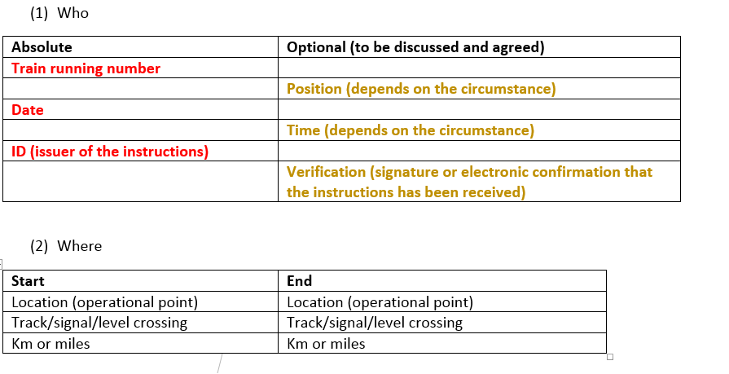

Initially, 11 possible topics for which European instructions could apply have been identified:
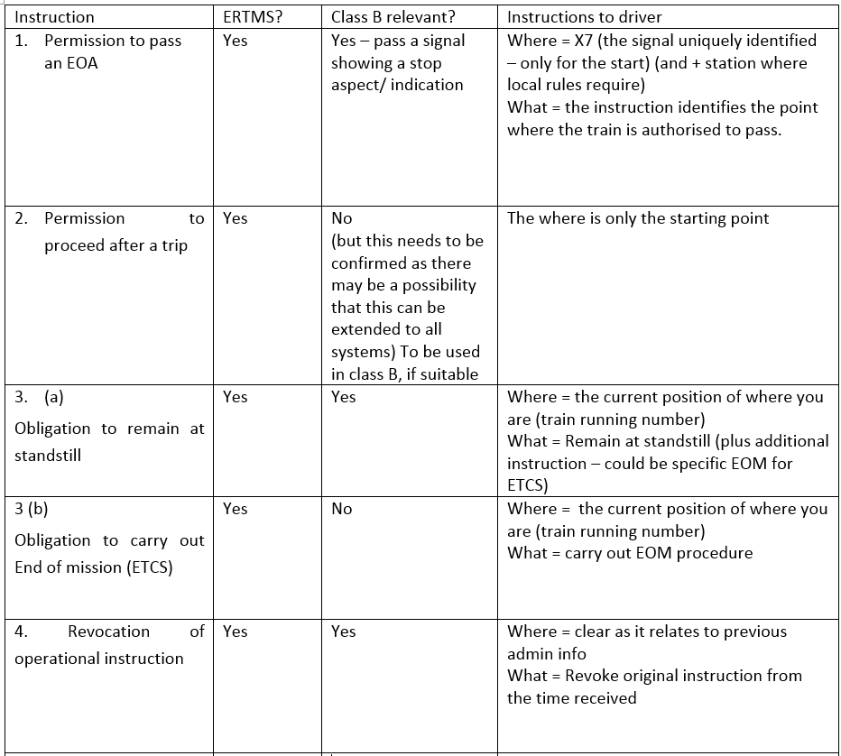

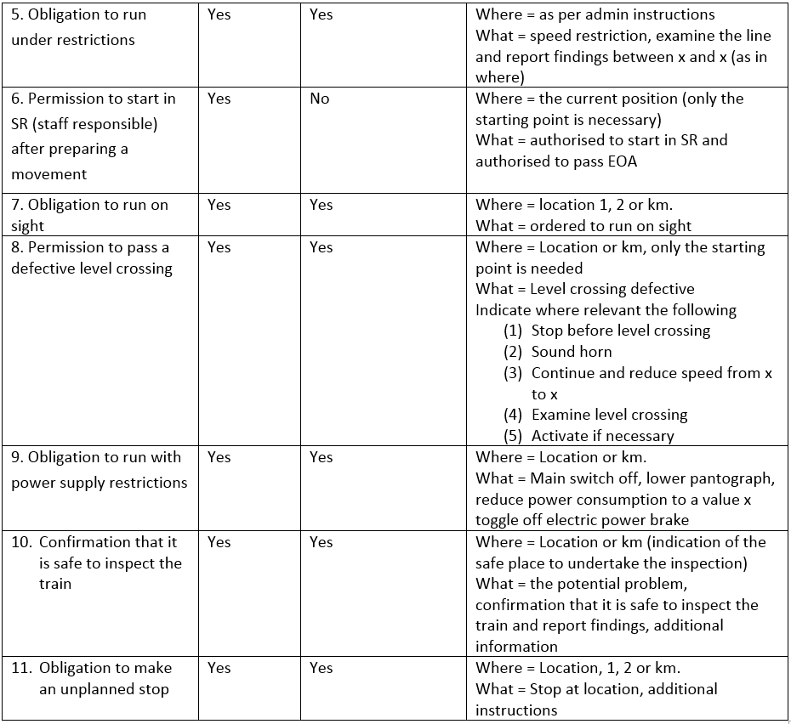

NSA PL has a problem with the word instructions because in Poland instructions are the internal rules of the RU and IM under the SMS and it could create confusion. NSA PL considered that it would be better to use the term order. UITP supported this proposal as the translation will have an effect on the understanding. In PL, it could be translated as company rule and it could create indeed confusion.

It was then agreed that the following two topics should not be included in the list as not enough representative:
- Confirmation that it is safe to inspect the train is very limited to certain Member States so propose to have it as national operational instruction.
- Obligation to make an additional unscheduled stop needs to be defined before there is a harmonised operational instructions.

NSA UK explained that the instruction on confirmation that it is safe to inspect the train should still be considered. As there is no harmonised rule, it is important to have this instruction. NSA IT agreed with this approach. CER estimated that, with the 9 HOIs, between 70 to 80% of scenarios will be covered and therefore there will be limited application to national instructions. As such, it is already a very positive development. It was reminded that the ETCS numbering and orders will remain the same but they allow for non ETCS to be used.

On the general requirements, ERA adapted the first proposal in order to take into account the following inputs:
- The list of the European instructions was numbered;
- The discrepancy between the list and the European instructions number has been eliminated;
- European instructions 10 and 11 have been deleted;
- Improved wording for the introduction of the numbering;
- Information on instructions apply to both the European and national;
- Still to consider the title of harmonised operational instruction n°8 as a working title;
- Clarification on the idea that the driver can keep the written instructions;
- Electronic transmission must not be overused – if it is safety related it should made at a standstill – this question should still be considered;
- As close as practicable – ERA would welcome any better proposal;
- A sentence has been introduced to explain that the content of European instruction is mandatory while the format is not.

NSA DE proposed to add a principle on the awareness of operational instruction. No objection has been expressed by the members of the WP and the proposal has been integrated in the draft with some editorial modifications.

NSA DE proposed to add a principle on the storage of processed operational instructions. CER considered that this was not possible as these are not always stored and that this is more for the IM. It is more important to have an agreement on the process for monitoring the delivery of the instruction. The proposed change is to add a principle that IM and RU shall agree on a process for monitoring the use of the instructions. EIM explained that the aim of this monitoring is purely to improve the traffic management or investigation purpose.

For the remaining questions related to the delivery of electronic instructions when the train is at standstill, the benefits/disadvantages of merging several instructions and the use of unique identifiers, the Human Factor Network managed by ERA has been consulted. ERA has raised 9 questions to the Human Factor Network:
TSI OPE WP has repeatedly asked for human factors contribution on this draft. ERA has thus decided to raise the topic to the Human Factor Network. ERA would like to have the opinion of the Human Factor Network on the draft and specifically on the following questions:
- Do you think the European Instructions as a harmonised communication method will be useful in ensuring effective and safe train operation at the driver/signaler interface level?
- Will they help to prevent errors in communication? If not, what else needs to be considered?
- Do they cover key human interaction risk scenarii? Are there other scenarii that we should consider in the future?
- Is the time frame sufficient in order to ensure acceptable integration into the SMS of the RU and IM?
- What is the difference on acknowledging an electronic or a verbal instruction? Would this make a difference in relation to understanding the information in a safe way?
- When an instruction is delivered electronically, how should the train driver react if he is asked to acknowledge the instruction?
- What scenarios are important for the train driver to be at standstill?
- From a human factor point of view, what could be the benefits/disadvantages of merging different instructions?
- From a human factor point of view, what could be the benefits/disadvantages of unique identifiers for each field of an instruction?

ERA received the contribution from the Human factor experts and presented the results of the consultation to TSI OPE WP. NSA FR considered that the benefit was only for cross-border traffic and not for domestic traffic. In addition, NSA FR explained that after a return of experience, it was judged necessary to have many specific written orders. In France, there is one order for one situation. NSA IT pointed out that the final users should test the instructions. On question 1, many stakeholders expressed the views that the benefits are limited to the international train drivers. ETF considered that it is a good tool. UITP pointed out that technical transmission will be easier with the proposal which is an important positive impact.
NSAs SE and FI considered that it was unnecessary to be at standstill when receiving an operational instruction to be written down by the train driver. According to these NSAs, the requirement to write down the verbal instructions only when train is at standstill should be removed from TSI OPE. There is no need for harmonization of these points as there is no direct interface between RU and IM. These are issues that RUs can deal within their SMS. If trains must stop each time when an operational instruction is given, it could easily disturb the traffic with very little safety benefit. If this strict rule is written in TSI like this then drivers have to stop the train no matter if the stop is really needed or not. Even if there would not be such a rule in TSI of course in all circumstances driver shall be allowed to stop or decrease the speed of the train if he/she needs to focus more detail on any information sent by signaler (this could be written in TSI).
The last remaining blocking point was the scope of the European instructions. It was considered necessary to distinguish what is mandatory for ERTMS and what is not.

Following the discussion within the WP, the results on Appendix C – European instructions are the following:
“Appendix C2 – Operational instructions

1. Introduction

Railway undertakings and Infrastructure managers shall use European instructions in the communication procedure in the following cases:
- Permission to pass an End of Authority - signal showing a stop aspect/stop indication;
- Permission to proceed after a trip (ETCS);
- Obligation to remain at standstill, obligation to carry out end of mission (ETCS);
- Revocation of an operational instruction;
- Obligation to run under restrictions;
- Obligation to run on sight;
- Permission to start in Staff Responsible (ETCS) after preparing a movement ;
- Permission to pass a defective level crossing;
- Obligation to run with power supply restrictions;
10-20. RESERVED
The numbers 1 to 20 are reserved for European instructions, numbers 1-5 and 7 are mandatory for ETCS. If an operational instruction related to class B system requires more information than the European instructions, the national instruction can be used instead. In such case, the Infrastructure Manager may define these requirements in its national instructions. If numbered, the national instructions defined by the individual Infrastructure Managers must start from 21 onwards. The national instructions must contain at least the same content of that for a European instruction.

2. Content

An operational instruction must state the following as a minimum:
- from where it was issued (location of signaller),
- at what date it was issued (not for verbal instruction),
- to which train / shunting movement it refers,
- clear, precise, unambiguous instructions,
- unique identification provided by the signaller.

In addition, depending on the circumstances, an operational instruction might also state:
- at what time it was issued,
- where that train / shunting movement is located, at which location it applies,
- ID of train driver;
- ID of issuer;
- verification (signature or electronic confirmation) that the instruction has been received.

Any operational instruction that has been issued can only be revoked by a European instruction n°4 explicitly referring to the unique identification of the instruction to be revoked.

3. Delivery of the operational instruction

A European instruction includes information delivered electronically, verbally, physically on paper or as verbal instructions to be written down by the train driver or by other safe methods of communication with the same level of information.

When an operational instruction is required to be written down by the train driver, the train must be at a standstill.

An operational instruction shall be delivered as close as practicable to the affected area.

An operational instruction takes precedence over the related indications provided by trackside signals and/or the DMI. When a permitted speed or a release speed lower than the maximum speed prescribed in the operational instruction is applicable, the lowest speed must be applied.

An operational instruction must only be issued by the signaller when the train running number has been identified and, if necessary, the location of the train/shunting movement. Before applying the operational instruction, the train driver must check that this operational instruction refers to his train / shunting movement and its current or identified location.

4. Awareness of the operational instruction

The RU has to define a procedure to ensure that the train driver is aware of an operational instruction until the train has reached the location where it has to be processed.

When the operational instruction does not need to be performed immediately after its delivery, it must be possible for the train driver to see the operational instruction again.

5. Monitoring of processed operational instruction

As part of the compliance with Safety Directive (EU) 2016/798, the IM and RU shall monitor the processes of delivery and use of the operational instructions.

6. European instructions

Each field of information contained in a European instruction must be given its own identifier.

While the content and the single identifiers must be used, the format itself is indicative.

On one hand, if a specific field is not to be used in a Member State or on the network of an IM, there is no obligation to display this field in the European instruction. On the other hand, there shall be no field added.

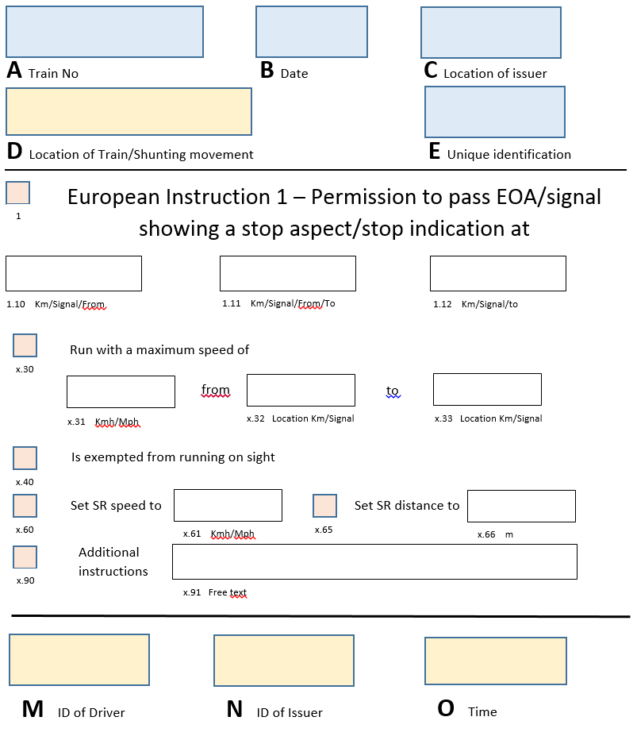
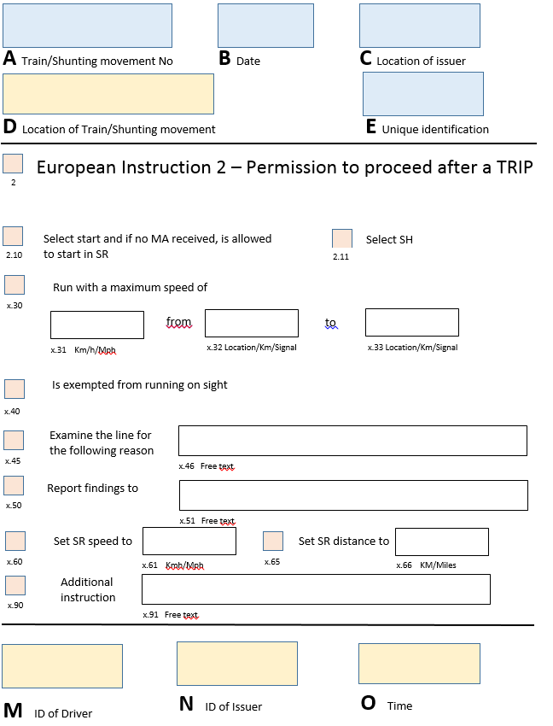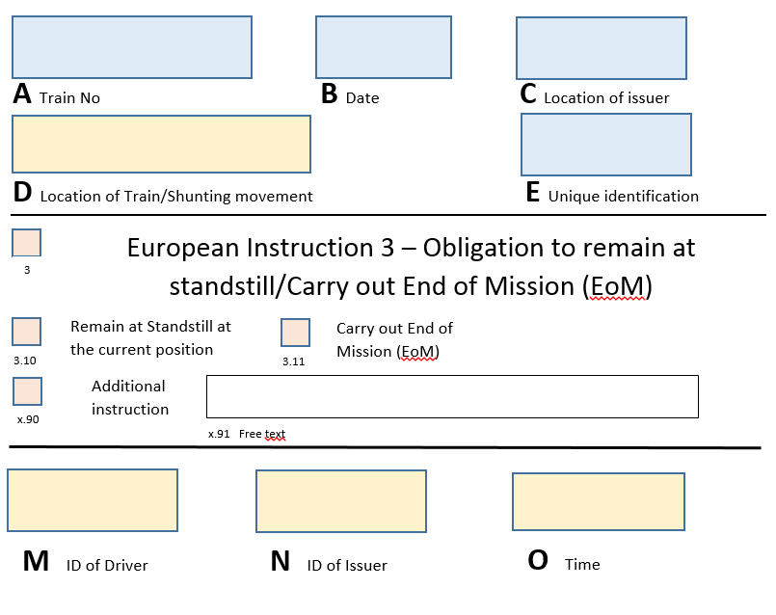
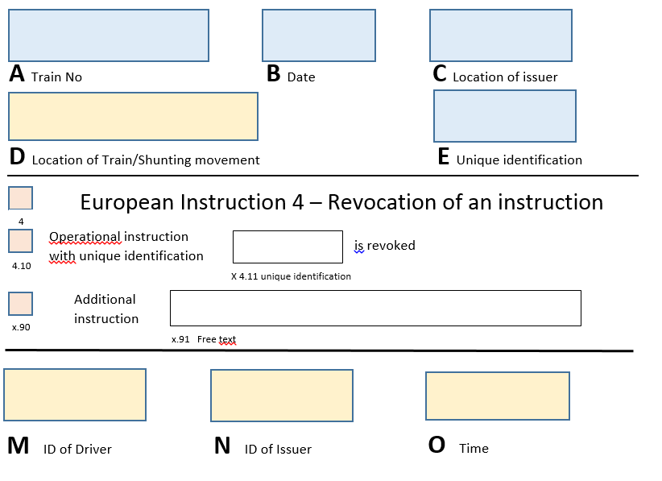
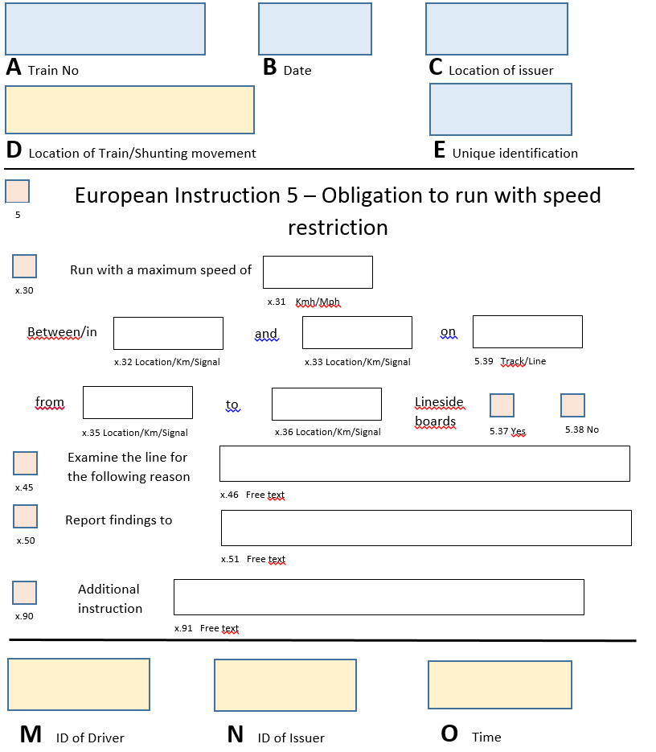
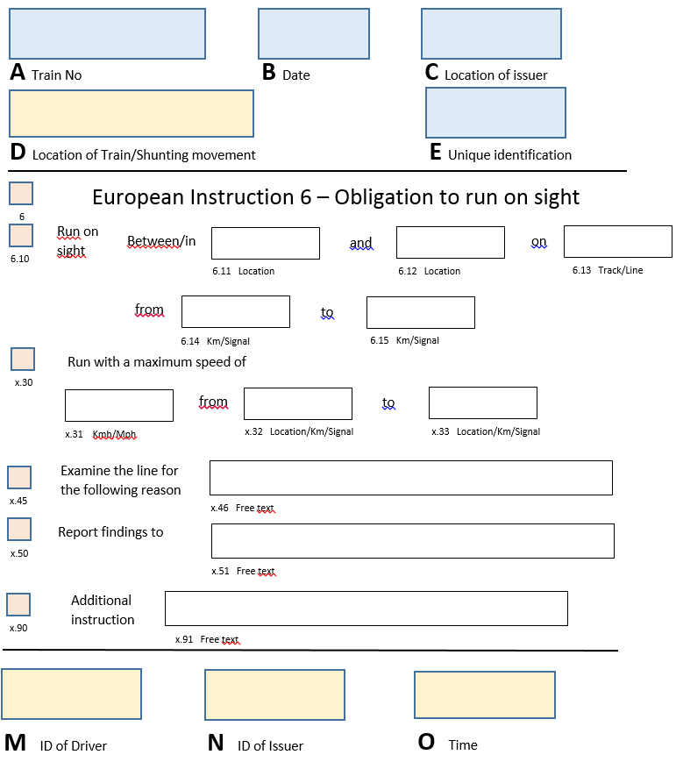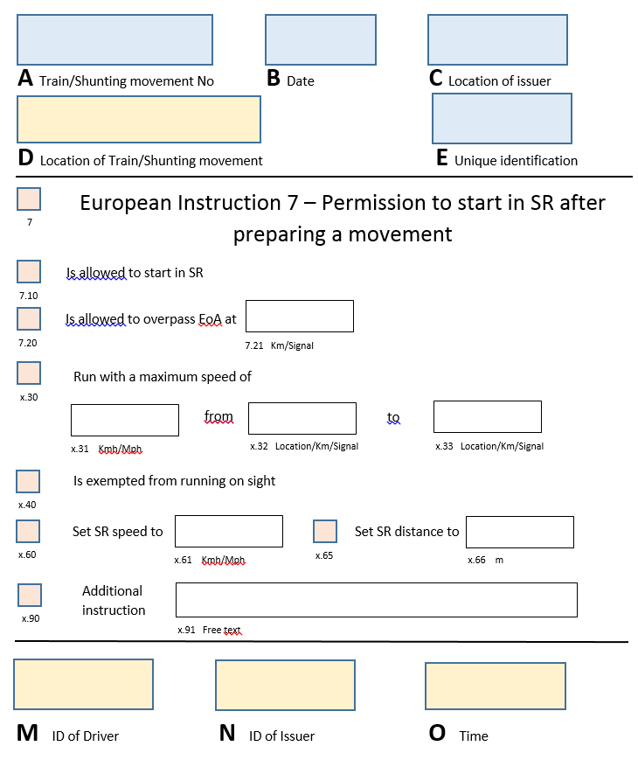
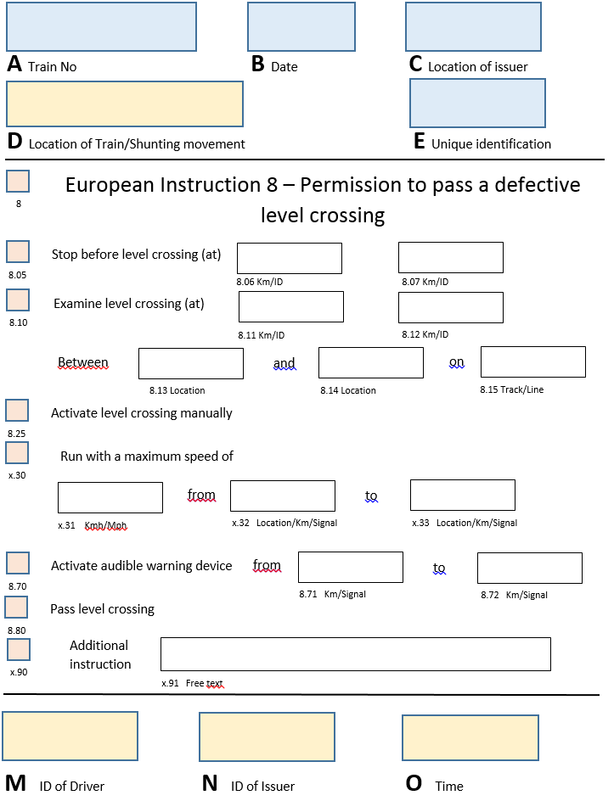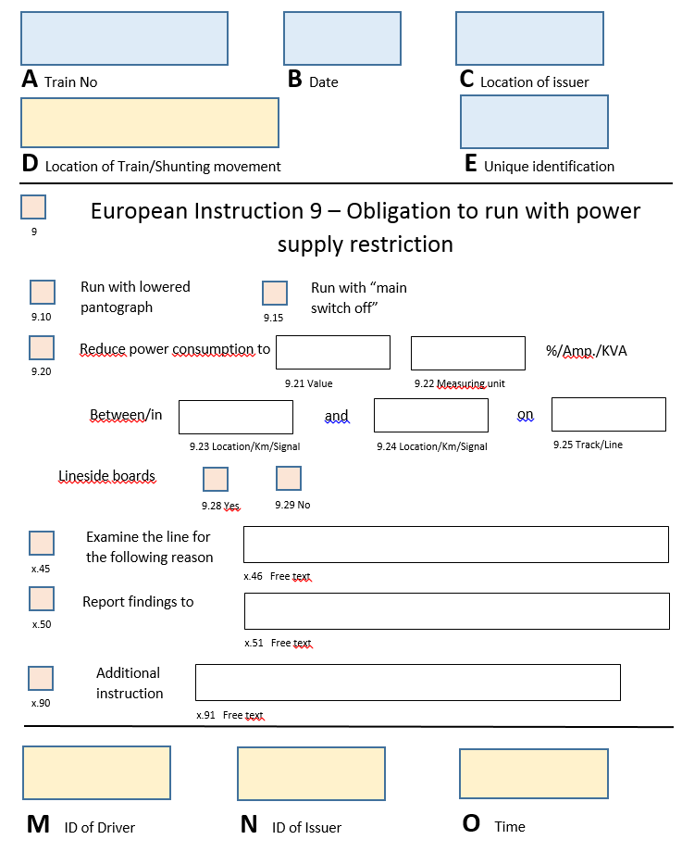
7. Communication of an operational instruction
Terminology shall be used in the communication procedure by all the parties:
Situation | Terminology
Cancelling an operational instruction | ‘Cancel procedure’
If the message is then subsequently to be resumed, the procedure shall be repeated from the start | ‘Error during transmission’
When a transmission error is discovered by the sender, the sender must request cancellation | ‘Error (+ prepare new form)’  Or  ‘Error (+ I say again)’
Error during read back | ‘Error (+ I say again)’
Misunderstanding: if one of the parties does not fully understand a message, the message must be repeated | ‘Say again (+speak slowly)

8. Book of Forms
The Infrastructure Manager is responsible for drawing up the Book of Forms and the forms themselves in its operating language.
All the forms to be used shall be assembled in a document or a computer medium called the Book of Forms.
This Book of Forms shall be used by both the driver and the staff authorising the movement of trains. The Book used by the driver and the Book used by the staff authorising the movement of trains shall be structured and numbered in the same way.

The Book of Forms shall comprise two parts.
The first part contains at least the following items:
- an index of written order Forms;
- a list of situations to which each Form applies;
- the table containing the international phonetic alphabet.
The second part contains the Forms themselves. These must be collected by the RU and given to the driver.

9. Glossary of Railway Terminology
The Railway Undertaking shall produce a glossary of railway terminology for each network over which its trains operate. It shall supply the terms in regular use in the language chosen by the Railway Undertaking and in the ‘operating’ language of the Infrastructure Manager(s) whose infrastructure the Railway Undertaking operates on.
The glossary shall be composed of two parts:
- a listing of terms by subject matter;
- a listing of the terms in alphabetical order.”

In addition, the following terms should be added to the glossary:
“Operational instruction: Formal information exchanged between signaller and train driver so as to ensure/continue railway operation in specific situations. The operational instruction exists at both national and European levels.

European instruction: An harmonised operational instruction giving a similar content to train drivers across the European Union in order for them to answer in a similar manner to similar situation.

National instruction: An instruction defined at national level or by an Infrastructure Manager which covers situations specific to a Class B system or the transition between class A and class B systems.”

These changes will be included in TSI OPE.

Other topics treated

Two drivers

Under Appendix I, there is no room for national rule related to the issue of two drivers:
  - If companies decide to require it that is their choice;
  - But if an RU operating in a MS which regularly uses one driver using the risk assessment and controls in their SMS, they cannot be required to have two;
  - An additional trainee driver (assistant or apprentice) can continue to be allowed but this should be part of the procedures in the SMS.

These elements have been included in the application guide.

TSI OPE and links with the SMS

Some discussion have been held in the WP about National Rules and the revised requirements for Safety Management Systems. The Agency gave a presentation on the links between the revised provisions in the draft Common Safety Method for Conformity Assessment, TSI OPE and SMS. CER proposed that with justification following risk assessment, there should be a possibility to deviate from legal requirements because of a specific situation. As part of the development of the Application Guide, the Agency proposed to review the content of the TSI OPE against the new requirements and proposed a way forward including how the FOPs will fit in to the operation elements in the new SMS. The option to develop specific operational guidance which covers the revised SMS elements has been finally chosen.

Rear-end signal for freight trains in international traffic (4.2.2.1.3.2)

Following an informal opinion requested to the Agency on the interpretation of “on the whole network” in the chapter related to train rear end signal, the Agency has consulted the WP to check whether this terminology is still appropriate.

Since some EIM members use “permissive driving” on some of their lines, this change is not supported by EIM. For other members of EIM this is not a problem, but since it creates difficulties for the countries with said “permissive driving” EIM cannot support changing this terminology. NSA FR supported this remark.

Considering the possible restrictive understanding of the terminology of “on the whole network”, it has been proposed to add a possible derogation to the use of the steady red lights under certain conditions.

Following the discussions in the WP, it has been proposed to add at the end of 4.2.2.1.3.2 the following sentences:
“In case a Member State requires 2 steady red lights and does not accept 2 reflective plates in its entire network, the Member State may accept the use of reflective plates in one or more section of lines of the network. The concerned Member State specifies in its notification the generic conditions of acceptance of reflective plates.
To ensure that all railway undertakings are given efficient information about the implementation of these conditions, the infrastructure manager shall publish the sections of lines concerned and the related conditions. The specific conditions defined by the infrastructure manager shall include an assessment of the risks and operational requirements.”
ES NSA still had problems with the term ‘entire network as it is very restrictive and wanted a more flexible approach. They believed it to be a barrier for interoperability and the against philosophy of the 4th package. The proposal of NSA FR allows a Member State to take a discretionary decision. FR NSA explained that they wanted to solve the issue on a national level hence the revised wording. They believed it was important to have a clear process based on analysis of risk and not for it to be a discrectionay issue. It was agreed to add to the Application Guide that the IM should provide a prompt response to individual requests to access the network with clear information on the risk analysis. If the request was refused or an RU had problems with gaining access to a network or part of a network, the NSA concerned should be contacted for further assistance.

Applicability of TSI OPE to existing vehicles and infrastructure (2.2.3)

During the bilateral meetings, it was often asked how to apply TSI OPE to existing vehicles especially in relation to rear-end signals. Although this is regulated within TSI OPE in point 2.2.3, it seems that this requirement is not clear enough.

Following the discussions in the WP, it has been proposed to reformulate point 2.2.3 of TSI OPE as follow:
“While the majority of the requirements contained in this TSI relate to processes and procedures, a number also relate to physical elements of vehicles and infrastructure that are important for their operational function in the context of TSI OPE.
Those physical elements are specified in structural TSIs covering other subsystems than operation and traffic management. They have to be assessed according to the procedures defined in those TSIs and TSI OPE might not be applicable under certain conditions to those vehicles and infrastructure.
None of the provisions of this TSI shall be used to justify a national technical rule under a structural TSI.”

Tram-train

NSA FR wondered whether TSI OPE is applicable to tram-train. NSA AT considered that the infrastructure can be excluded but not necessarily the rolling stock. NSA FR wondered also how to treat the transition. Interoperability Directive gives the possibility to exclude from the scope tram-train and it is, as such, a Member State issue.

Interfaces with TSI NOISE

The CER OPE SG has expressed several concerns regarding the imposition of quieter routes through the retrospective revision of the TSI Noise.

Concern n°1 – The TSI Noise takes no account of national actions taken to decrease the impact of noise on railway neighbours.

When new lines have been built, individual member states in partnership with the infrastructure manager have gone to great lengths to reduce the effects of noise on its railway neighbours. These measures include extensive use of tunnels, large embankments and noise barriers. This has greatly increased the cost of such lines. The equation for determining for quieter routes takes no account of such measures.

Operational Impact
The operational impact of this is that noisy trains will not be able to use the routes that best protect the public from the environmental impact of such trains. These routes fall in three categories:
- New routes specially designed for the purpose with noise mitigation in place;
- Routes that have been upgraded to deal with the flow of large numbers of freight trains that have environmental mitigations in place;
- Freight only routes that were designed with heavy freight flows in mind.
Instead these noisy trains will be pathed onto lines where no such environmental protection is in place causing upset and hardship to railway neighbours or not be allowed access to freight only lines causing more congestion on passenger lines. This will increase the number of complaints to the railways. The infrastructure may also need to be upgraded to deal with these new (to these routes) freight flows. The trains will invariably have to run at a slower speed and be costlier to run; although this may create a good business case for changing braking equipment, in the context of a poor economic outlook it should not be counted on as delivering the investment necessary in time.

Consideration for TSI Noise Working Party
TSI Noise Working Party should consider incorporating existing noise mitigations measures within the text of the TSI as these mitigation measures contribute to the environmental benefit for railway neighbours.

Concern n°2 – The equation for determining quieter routes is too simplistic and does not relate to the impact on the public.

The Agency have defined a simple methodology using the traffic (number of trains), establishing a limit during the night. If the number of trains on a route exceed an average of 12 trains in the night, then this route should be considered as a quieter route. This approach does not gauge the environmental impact upon railway neighbours as many kilometres of the route could be in open countryside, for example. It would be better if the centres of population were included in the calculation in some way and that lines, or sections of lines, that have negligible impact on railway neighbours were excluded within the TSI.

Operational Impact
Such an arbitrary method of determining the quieter routes maximises the disruption to the flexibility of the railway system. It specifically targets the routes with the largest freight flows whether they have the largest impact on the noise environment of railway neighbours or not. It will result in the following possibilities:
- It will all work perfectly, and the private wagon owners will invest in time and deliver the new braking systems so that compliance with TSI Noise is assured.
- Noisy trains will be diverted onto alternative routes, as set out in concern 1, and the net result will be an increase in noise.
- A mixture of 1) and 2) will take place and the overall effect on noise pollution by rail vehicles will be marginal.
A question worth asking at this point is what is the effect on noise if a train consisting of say 30 vehicles included one, two or even three noisy vehicles? Does it make the whole train noisy? If trains could be of such a composition, it would ease some of the logistical challenges resulting from the quieter route initiative.
It is our view that there should be more science behind the measure of determining quieter routes. There are many other scientific measurements mentioned in TSI Noise that it is difficult to understand why the number of trains in a preceding night was chosen as a measure as well as why the number 12 was chosen as the limit. There is no evidence to support the figure of 12 as a maximum. A target noise measure should be determined by TSI Noise Working Party above which a route section should not exceed. These targets, set at an EU level, could then be reached by a mix of infrastructure mitigations and train source measures. This would have the added benefit of incorporating existing noise mitigation measures into the TSI.
This would also decrease noise in the centres of population which is the outcome that we all want.

Consideration for TSI Noise Working Party
TSI Noise Working Party should use a more scientific approach to specifying maximum noise level in areas of significant railway neighbours.
TSI Noise Working Party should consider whether a proportion of noisy vehicles within the composition of freight trains could be acceptable to run on a quieter route.

Concern n°3 – The draft Noise TSI contains many specific cases that will constrain interoperability especially regarding the Nordic countries.

To address some of the issues covered by concerns 1 and 2, the draft TSI Noise contains many specific cases.
In the Nordic countries there are safety concerns regarding the fitment of composite brakes and until those concerns are satisfied the wagons on trains operated within those countries will be fitted with cast iron brakes. Due to the specific case approach, it will mean that if the safety concerns are not addressed, trains originating from the Nordic countries will not be interoperable with neighbouring member states. It is our understanding that recent tests undertaken in Finland have demonstrated that a number of safety concerns do exist with composite brakes when operated in low temperatures.

Operational Implications
Specific cases of this nature can course operational inflexibility – acting as a kind of brick wall for those trains that originate within them! Smarter wording within the TSI Noise should allow for parts of a route with few or no railway neighbours to be excluded from definition of a quieter route.

Consideration for TSI Noise Working Party
TSI Noise Working Party should introduce high level requirements in the TSI to reduce the need for so many specific cases.
TSI Noise Working Party should consider that routes with few or no railway neighbours should be excluded from the definition of a quieter route.

Concern n°4 – Train Preparation staff will have to understand which wagons can go on which routes.

It is expected that for many trains, the route to be taken will be determined well in advance as part of the planning process. However, a substantial proportion of freight trains are subject to short and very short-term planning processes as well as single wagon consignments. These trains will have to rely on a train preparer to understand which wagons can go on the quieter routes. However, there is no standard format for the production of the quieter route maps.

Operational Implications
A train preparer when preparing a train must understand the many restrictions that affects the route or routes a fully composed train can travel upon. Providing for an additional train characteristic that affects the available routes a train can travel upon is not a challenge. The challenge comes in the shape of how to provide the information to the train preparer that a vehicle has a characteristic or not. The easiest way of providing this information would be to have each vehicle marked as either loud or quiet in some way. This would be best harmonised at an EU level but would result in every freight wagon requiring such a mark. A second challenge is to the use of single wagon consignments where a train preparer in one country may have no idea of the destination of a wagon but be preparing the train to travel from one marshalling yard to the next. An example of this can be seen by the maps as there can be no direct route for a louder vehicle to travel directly between Austria and Italy.

Consideration for TSI Noise Working Party
TSI Noise Working Party should consider introducing formatting requirements for the maps to be submitted by Member States.
TSI Noise Working Party should consider how the train preparer should be supported in identifying quieter (or louder) wagons.

Concern n°5 – The effect of quieter routes on traffic from third countries.
Many freight trains enter the European Union from third countries such as Turkey and Serbia, what measures are required on borders to make sure that these trains are compliant with quieter routes?

Operational Implications
The major implication is that trains from third countries such as Serbia and Turkey will have to be stopped at the borders and have their braking systems checked to identify whether the vehicles are loud or quiet. This process will have to be enacted until these third countries are able to mark the vehicles, following bilateral negotiations. This will obviously cause delay and cost to the wagon owners.

Consideration for Noise TSI Working Party
TSI Noise representatives should request the Agency to assure itself and us that these third countries are able to comply with the revised TSI Noise.

Finally, CER explained that there is a harmonised solution to be found when a loud wagon is to be operated on a quieter route (speed reduction, fine, etc.).

Specific cases

United Kingdom has a specific case mentioned in section 7.3.2.2 of TSI OPE. This reference might need to be reviewed depending on the results of the negotiations on the Brexit.

Results from social consultation

Annex 1 Working programme
The tasks described in the working programme have been identified by the Agency as potential improvement to be brought to TSI OPE. They might be further refined thanks to the expertise of the selected members of the WP
A/ Appendix B – Common operational principles and rules
One of the key priorities for the TSI OPE is the further development of Appendix B. During the last WP discussions, 13 new common operational principles and rules were developed with a considerable input from CER and EIM. Three topics were postponed from the last 2012 revision and might be considered in the next phase of the development of the TSI:
- running with caution,
- procedure for arrival,
- speeds in degraded mode.

In addition, the WP is asked to consider additional topics, which can be discussed for inclusion in the next revision.
Initial ideas include:
- failure of ATP,
- failure of driver vigilance device,
- exceptional transport,
- emergency evacuation,
- low adhesion,
- defective on-board equipment,
- procedure following a SPAD,
- unforeseen stops.
The following issues also need to be considered:
- As part of the implementation phase of the TSI OPE 2015/995, the Commission and the Agency have developed a format for a National Implementation Plan which needs to be completed and sent to the Commission by 1 July 2017. The WP members are encouraged to discuss this with their MS and actively consider what existing NSRs they have that need to be harmonised at EU level and included in the revised TSI Appendix B.

The Agency will be undertaking a series of bilaterals with key MS in 2016/2017. Some Member States have been prioritised due to the size of their network and the percentage of international traffic: Germany, Poland, Czech Republic, Austria, France, Belgium, Hungary, Italy. The aim of which is to discuss implementation of the National Implementation Plan and the clean-up of National Safety Rules type 3 common operational rules. They will be encouraged to consider existing National Safety Rules they have that need to be harmonised at EU level and included in the revised TSI Appendix B. The WP will be used as a reference to agree whether the proposed rules should be harmonised.
- Links to Appendix A – The team will work closely with the Project Officer responsible for the development of Appendix A and as previously achieved, will transfer those rules which are appropriate, generic and applicable to all operations. This will ease the transition to ERTMS solutions.

- Review of the methodology for the situation protocols, which was used as a basis for developing the common operational principles and rules, to ensure that it is sufficiently robust for developing new principles and rules.

B/ Appendix C – Safety related communications methodology

Communication procedures – what is needed?

Deciding what safety related communication should be included.

Review of structured and unstructured messages and their use in emergency, degraded and normal operation.

Review of the use of predefined messages and agreeing those that should be included.

The use of written orders.

Additional topics will be discussed like the use of two drivers and more formal topics related to chapter 7 on implementation of TSI OPE and the format of the TSI itself.

Annex 2 – Guidance on TSI OPE and National rules

Agency’s three staged approach for the TSI OPE notification
Stage 1: Initial information to the Commission on the open operational points against Appendix B by January 2016.
Stage 2: Bilaterals with some Member States to help them with the NIP – between February 2016 and June 2017
Stage 3: Submission by all MS of their NIPs by July 2017

(Stage 1) Member States have been asked to inform the Commission of all their operational rules (NSRs) which may be open points against Appendix B. The Agency has stressed that it is important not to make a blanket notification and to consider those rules which are needed for normal or degraded operation where there is no harmonisation. MSs need to consider whether the type 4 NSR remain relevant, particularly if they are effective in controlling a safety risk and if they cannot be linked to a safety risk then they should be withdrawn. The Agency has asked the MSs to involve the sector in the discussions, as they through their SMS should have information from the SMS, risk assessment and work processes that should be relevant to the application of the national rules. MSs should also consider whether the national rules are now covered by EU legislation and requirements i.e. RINF and TSI OPE Appendices C and D.

(Stage 2) The Agency will then be undertaking a series of bilaterals with key MS (including the NSAs and the sector) in from February 2016 until June 2017. Some MS have been prioritised due to the size of their network and the percentage of international traffic and the number of rules. The aim of the bilaterals is to discuss implementation of the NIP and the clean-up of NSRs type 4 operational rules. The Agency strongly recommends that the sector is involved in these meetings as they will have firsthand knowledge and experience of working with the type 4/5 NSRs and how they link to the risks of their operation. Before the meeting, the MSs will be encouraged to consider existing NSRs they believe need to be harmonized at EU level and included in the revised TSI Appendix B. This will involve undertaking a review using the flowchart and instructions in the attached Annex 2. At the meeting the MS will give a presentation on a summary of each of the type 4 national rule and the results of the analysis they undertook using Annex 2.
Please note that it is not for the Agency at the bilateral to go through every type 4 notified rule, this is the responsibility of the MS. What the Agency will do before the meeting is to review some rules as examples and this can then be used as a basis for the discussion on the cleaning-up and prioritization for harmonization. If it is agreed that some rules may be needed to harmonised as principles, then the working party will be used as a reference to agree whether the proposed rules should be harmonised. Annex 3 sets out the proposed agenda of the bilateral meetings. For those Member States who will not be part of the bilaterals, the Agency will be providing support and advice on request. In addition, they should use the flowchart and instructions in Annex 2 to help them undertake their analysis for the NIPs.

(Stage 3) The final NIPs (Annex 4) should be sent to the Commission by 1st July 2017 and will be analysed by the Commission in cooperation with the Agency.
Annex 2
Flow chart work instructions for the notification to the Commission against Appendix B and the completion of the NIP

MS should review all the current type 4 operational rules and consider the following (this flow chart is in support of the requirements set out in Article 8.7 of the RSD (Article 8.1 in the new RSD) and designed to help MSs to establish the continuing need of the NRs:

- Additional written instructions

- The primary question that should be asked is whether the rule is linked to controlling a safety risk or not. If not, the rule should not be considered as a type 4 NSR.
- Does the rule concern interfaces between the RU and the IM? If not, the rule should not be a type 4 NSR unless more specifications are needed compared to TSI OPE (IM/RU interface or company internal only)
- If they are – to what extent are they covered by the current (2015) EU requirements:
  - SMS requirements and existing work procedures of the RU
  - TSI OPE requirements, CSMs and other relevant EU legislation
  - TSI OPE Appendix D – information that the IM should provide on the characteristics of the infrastructure
- If they are covered by the above in the same level of detail as the rule in question – the issue should not be a type 4 NSR. If more detail is needed in relation to compliance with a requirement this should be taken forward through the RU/IMs SMS or the justifications for more detail described in the NIP and this will be considered in the TSI OPE.
- If they are not covered by the above, the rule is classified as NSR.
- The following activity would be to evaluate the remaining NSR and discuss it in TSI OPE WP.
  - Is there a need identified for harmonisation because of a safety risk and benefits for interoperability? If so, what is that risk and what are the benefits for interoperability? If yes, the issue should be put forward as an open point for discussion with the TSI OPE for harmonisation and cleaned-up/removed as a type 4 NSR when the harmonisation work is finalised and published.
  - Is the rule still relevant and up to date at controlling the safety risk? Can the issue be managed through the SMS of the RU/IM? If yes, it should go through the clean-up/removal process.
  - Otherwise, the NSR will remain.
- The issue identified will then be prioritised and a decision made on harmonisation by the Working Party.
- NRs that need to be cleaned-up/removed should be done within two years after coming into force of the new RSD (Article 8.2).

NOTE:
- In case of missing requirements, the first priority should be to discuss them at EU level via the TSI OPE Working party. Only after this has been considered by the MS, should the MS propose that an additional rule may be needed. In such cases it should be notified as a draft rule. If a rule needs to be amended this should be notified according to RSD Article 8(7) in Notif-IT. For the guidance on the process see NSR Task Force Final Report on ERA website and Notif-IT User Guides for public and registered users.
- For those rules that concern dangerous goods, MS should consider the operational requirements under the relevant parameters in the NIP and the paragraph 4.2.3.4.3 of the TSI OPE is reserved for other TDG issues not covered by the relevant parameters.
- NSAs and MSs should note that just because there is a rule in place, it may not always be followed by the RU during their operation, particularly if wrongly allocates responsibilities, it is out of date or not relevant. The compliance with rules does not provide assurance of safety performance. This can only be done through the SMS and the RUs effective management of the risks through its processes and work procedures (i.e. the implementation of relevant rules). Confirmation of this is done by the NSAs through their supervision strategy, plans and subsequent audits and inspections.

Annex 3 Examples of template
Appendix C – Safety-related communications methodology
Name of organisation:
Topic | Proposal
Coded words | Coded word | Comment
Glossary of terms | Term | Comments

Topic for analysis – Principles for checks and tests before departure
Name of organisation:
TSI OPE in point 4.2.3.3.1 specifies that “the RU must define the checks and tests to ensure that any departure is undertaken safely”.
- Are there any national rules in your Member State related to the checks and tests before departure a RU must perform?
(YES/NO)
- If yes, can you indicate in the second column the name of the test and/or check and a brief explanation of its purpose?

N° | Name of checks and / or tests | Is this check and/or test related to passenger or freight traffic?  (Passenger/freight) | Purpose and brief explanation of the check and/or test | Comments
1
2
3
4
5
6

Topic for analysis – Emergency evacuation
Name of organisation :
Initial question: is the use of 1-1-2 number mandatory in the situation where an emergency evacuation is to be done? (YES/NO)
Description | TSI link (if any) | Relevance for Interoperability | Benefits (safety, capacity, interoperability) | Potential risks to be managed (not quantified) | Actions
Procedure for an emergency evacuation
Procedure for an emergency evacuation in a tunnel

Appendix A to the TSI OPE (ERTMS operational principles and rules) groups all operational principles and rules related to ERTMS. Appendix A is curated by a dedicated Agency working group, under the name of ERTMS Operational Harmonization (OH in short). Members come from CER, EIM, Drivers’ associations, NSAs and other representative bodies. This workgroup constitutes the single point of reference at EU level for processing the operational issues around the use of ERTMS.
This could be provided by e.g. a booklet or by a phone number for technical assistance.
This may be the existing driver or a substitute driver according to RU rules.
The boxes in light orange are future-oriented. They are not relevant at this stage to decide if a rule is currently a NSR but are important to feed the discussions within TSI OPE WP.

