ANNEX
COMMISSION REGULATION
[…]

TABLE OF CONTENTS
1. Introduction 6
1.1. Technical scope 6
1.2. Geographical scope 6
1.3. Content of this TSI 6
2. Description of subsystem/scope 7
2.1. Subsystem 7
2.2. Scope 7
2.2.1. Staff and trains 7
2.2.2. Principles 8
2.2.3. Applicability to existing vehicles and infrastructure 8
3. Essential requirements 8
3.1. Compliance with the essential requirements 8
3.2. Essential requirements - overview 8
4. Characteristics of the sub-system 11
4.1. Introduction 11
4.2. Functional and technical specifications of the sub-system 12
4.2.1. Specifications relating to staff 12
4.2.1.1. General requirements………………… 12
4.2.1.2. Documentation for drivers 12
4.2.1.2.1 Driver’s Rule Book 12
4.2.1.2.2 Description of the line and the relevant line-side equipment associated with the lines worked over 13
4.2.1.2.2.1 Preparation of the Route Book 14
4.2.1.2.2.2 Modifications to Information contained within the Route book 15
4.2.1.2.2.3 Informing the driver in real time 15
4.2.1.2.3 Timetables 15
4.2.1.2.4 Rolling stock 15
4.2.1.3. Documentation for Railway Undertaking staff other than drivers 15
4.2.1.4. Documentation for Infrastructure Manager’s staff authorising train movements 16
4.2.1.5. Safety-related communications between train crew, other Railway Undertaking staff and staff authorising train movements 16
4.2.2. Specifications relating to trains 16
4.2.2.1. Train visibility 16
4.2.2.1.1 General requirement 16
4.2.2.1.2 Front end 16
4.2.2.1.3 Rear end 17
4.2.2.2. Train audibility 19
4.2.2.2.1 General requirement 19
4.2.2.2.2 Control 19
4.2.2.3. Vehicle identification 19
4.2.2.4. Safety of passengers and load 19
4.2.2.4.1 Safety of load 19
4.2.2.4.2 Safety of passengers 19
4.2.2.5. Route compatibility and train composition 19
4.2.2.5.1 Route compatibility…………………………………………………………………18
4.2.2.5.2 Train composition…………………………………………………………………..18
4.2.2.6. Train braking 20
4.2.2.6.1 Minimum requirements of the braking system 21
4.2.2.6.2 Braking performance and maximum speed allowed 21
4.2.2.7. Ensuring that the train is in running order 22
4.2.2.7.1 General requirement 22
4.2.2.7.2 Data required 22
4.2.2.8. Requirements for signal and lineside marker sighting 22
4.2.2.9. Driver vigilance 23
4.2.3. Specifications relating to train operations 23
4.2.3.1. Train planning 23
4.2.3.2. Identification of trains 23
4.2.3.2.1 Format of train running number 23
4.2.3.3. Train departure 23
4.2.3.3.1 Checks and tests before departure 23
4.2.3.3.2 Informing the Infrastructure Manager of the train's operational status 23
4.2.3.4. Traffic management 24
4.2.3.4.1 General requirements 24
4.2.3.4.2 Train reporting 24
4.2.3.4.2.1 Data required for train position reporting 24
4.2.3.4.2.2 Predicted hand over time 24
4.2.3.4.3 Dangerous goods 25
4.2.3.4.4 Operational quality 25
4.2.3.5. Data recording 25
4.2.3.5.1 Recording of supervision data outside the train 26
4.2.3.5.2 Recording of supervision data on-board the train 26
4.2.3.6. Degraded operation 26
4.2.3.6.1 Advice to other users 26
4.2.3.6.2 Advice to train drivers 27
4.2.3.6.3 Contingency arrangements 27
4.2.3.7. Managing an emergency situation 27
4.2.3.8. Aid to train crew in the event of an incident or of a major rolling stock malfunction 28
4.3. Functional and technical specifications of the interfaces 28
4.3.1. Interfaces with the Infrastructure TSI 28
4.3.2. Interfaces with the Control/Command and Signalling TSI 28
4.3.3. Interfaces with the Rolling Stock TSI 29
4.3.3.1. Interfaces with TSI LOC&PAS 29
4.3.3.2. Interfaces with TSI WAG 30
4.3.4. Interfaces with the TSI Energy 30
4.3.5. Interfaces with the TSI SRT…………………………………………………………29
4.3.6. Interfaces with the TSI Noise……………………………………………………….29
4.3.7. Interfaces with the TSI PRM………………………………………………………..29
4.4. Operating rules 31
4.5. Maintenance rules 32
4.6. Professional competences 32
4.6.1. Professional competence 32
4.6.2. Linguistic competency 33
4.6.2.1. Principles 33
4.6.2.2. Level of knowledge 33
4.6.3. Initial and ongoing assessment of staff 33
4.6.3.1. Basic elements 33
4.6.3.2. Analysis and update of training needs 33
4.6.4. Auxiliary staff 34
4.7. Health and safety conditions 34
4.7.1. Introduction……………………………………………………………….. 32
4.7.2. Medical examinations and psychological assessments 34
4.7.2.1. Before appointment 34
4.7.2.1.1 Minimum content of the medical examination 34
4.7.2.1.2 Psychological assessment 35
4.7.2.2. After appointment 32
4.7.2.2.1 Periodicity of periodic medical examinations 35
4.7.2.2.2 Minimum content of the periodic medical examination 36
4.7.2.2.3 Additional medical examinations and / or psychological assessments 36
4.7.3. Medical requirements 36
4.7.3.1. General requirements 36
4.7.3.2. Vision requirements 36
4.7.3.3. Hearing requirements 37
4.8. Registers of infrastructure and vehicles 37
4.8.1. Infrastructure 37
4.8.2. Rolling stock 37
5. Interoperability constituents 38
5.1. Definition 38
5.2. List of constituents 38
6. Assessment of conformity and/or suitability for use of the constituents and verification of the subsystem 38
6.1. Interoperability constituents 38
6.2. Operation and Traffic Management Subsystem 38
6.2.1. Principles 38
7. Implementation 38
7.1. Principles 38
7.2. Implementation guidelines 39
7.3. Specific cases 40
7.3.1. Introduction 40
7.3.2. List of specific cases 40
7.3.2.1. Temporary specific case (T1) Estonia, Latvia and Lithuania 40
7.3.2.2. Temporary specific case (T1) Ireland and United Kingdom………………………...36
7.3.2.3. Temporary specific case (T2) Finland……………………………………………….36
7.3.2.4. Permanent specific case Finland……………………………………………………..36
Appendix A: ERTMS/ETCS operating rules 41
Appendix B: Common operational principles and rules 38
Appendix C: Safety related communications methodology 48
Appendix D: Elements the Infrastructure Manager has to provide to the Railway Undertaking for the Route Book and for the train compatibility over the route intended for operation.. 59
Appendix E: Language and communication level 68
Appendix F: Minimum elements relevant to professional qualification for the tasks associated with “accompanying trains” 69
Appendix G: Minimum elements relevant to professional qualification for the task of preparing trains 72
Appendix H: Vehicle identification 74
Appendix I: List of open points 77
Appendix J: Glossary 79

Introduction

Technical scope
This Technical Specification for Interoperability (‘TSI’) concerns the 'operation and traffic management' subsystem shown in the list contained in point 1 of Annex II to Directive (EU) 2016/797. Further information on this subsystem is provided in Chapter 2.
Where necessary the TSI distinguishes between requirements for conventional and high-speed rail.

Geographical scope
The geographical scope of this TSI is the Union’s network as specified in section 1.1 to Annex I of Directive (EU) 2016/797

and excludes the cases referred to in Article 1(3) and 1(4) of Directive (EU) 2016/797.

Content of this TSI
In accordance with Article 4(3) of Directive (EU) 2016/797, this TSI:
(a) indicates its intended scope for the 'operation and traffic management' subsystem – Chapter 2;
(b) lays down essential requirements for the subsystem concerned and its interfaces vis-à-vis other subsystems – Chapter 3;
(c) establishes the functional and technical specifications to be met by the target subsystem and its interfaces vis-à-vis other subsystems. If necessary, these specifications may vary according to the use of the subsystem– Chapter 4;
(d) determines the interoperability constituents and interfaces covered by European specifications, including European standards, which are necessary to achieve interoperability within the European rail system – Chapter 5;
(e) states, in each case under consideration, which procedures are to be used in order to assess the conformity or suitability for use of the interoperability constituents – Chapter 6;
(f) indicates the strategy for implementing the TSI. In particular, it is necessary to specify the stages to be completed and the elements that can be applied in order to make a gradual transition from the existing situation to the final situation in which compliance with the TSI must be the norm – Chapter 7;
(g) indicates, for the staff concerned, the professional qualifications and health and safety conditions at work required for the operation and maintenance of the subsystem concerned, as well as for the implementation of the TSI – Chapter 4.
(h) indicates the provisions applicable to the existing subsystems and vehicles, in particular in the event of upgrading and renewal and, in such cases, the modification work which requires an application for a new authorisation;
(i) indicates the parameters of the vehicles and fixed subsystems to be checked by the railway undertaking and the procedures to be applied to check those parameters after the delivery of the vehicle authorisation for placing on the market and before the first use of the vehicle to ensure compatibility between vehicles and the routes on which they are to be operated.
Moreover, in accordance with Article 4(5) of Directive (EU)2016/797, provision may be made for specific cases for each TSI. These are indicated in Chapter 7.

Description of subsystem/scope

Subsystem
The 'operation and traffic management' subsystem is described in point 2.5 of Annex II to Directive (EU) 2016/797 as:
“The procedures and related equipment permitting coherent operation of the various structural subsystems, during both normal and degraded operation, including in particular train composition and train driving, traffic planning and management.
The professional qualifications which may be required for carrying out any type of railway service.”

Scope
This TSI applies to the 'operation and traffic management' subsystem of infrastructure managers (hereinafter referred to as ‘IM’) and railway undertakings (hereinafter referred to as ‘RU’) related to the operation of trains within the geographical scope defined in chapter 1.2.

Staff and trains
Points 4.6 and 4.7 apply to those staff undertaking the safety-critical tasks associated with accompanying a train.
Point 4.6.2 applies to train drivers as provided for in point 8 of Annex VI to Directive 2007/59/EC.
For those staff undertaking the safety-critical tasks associated with despatching trains and authorising train movements, mutual recognition of professional qualifications and health and safety conditions between Member States will apply.
For those staff undertaking the safety-critical tasks associated with the last preparation of a train before it is scheduled to cross a border(s) and work beyond any location(s) designated as the ‘frontier’ in the network statement of an infrastructure manager and included in his safety authorisation, point 4.6 shall apply while mutual recognition between Member States shall apply for point 4.7. A train will not be considered to be a cross border service, if all the vehicles of the train crossing the state border cross it only to the ‘frontier’ location(s) .

Principles
This TSI covers those elements (as set out in Chapter 4) of the rail 'operation and traffic management' subsystem, where principally there are operational interfaces between RU and IM and where there is a particular benefit to interoperability.
RU and IM must ensure that all requirements concerning rules and procedures as well as documentation are met by the establishment of the appropriate processes. The set up of these processes is a relevant part of RU’s and IM’s safety management system (hereinafter referred to as ‘SMS’) as required by Directive (EU) 2016/798. The SMS itself is assessed by the relevant national safety authority (hereinafter referred to as ‘NSA’) before granting safety authorisation and by the relevant NSA or the European Union Agency for Railways before granting safety certificate.

Applicability to existing vehicles and infrastructure
While the majority of the requirements contained in this TSI relates to processes and procedures, a number also relates to physical elements of vehicles and infrastructure that are important for their operational function in the context of TSI OPE.
Those physical elements are specified in structural TSIs covering other subsystems than operation and traffic management. They have to be assessed according to the procedures defined in those TSIs and TSI OPE might not be applicable under certain conditions to those vehicles and infrastructure.
None of the provisions of this TSI shall be used to justify a national technical rule under a structural TSI.

Essential requirements

Compliance with the essential requirements
In accordance with Article 3 of Directive (EU) 2016/797, the Union rail system, its subsystems and their interoperability constituents must meet the essential requirements set out in general terms in Annex III to that Directive.

Essential requirements - overview
The essential requirements cover:
- safety,
- reliability and availability,
- health,
- environmental protection,
- technical compatibility,
- accessibility.
According to Directive (EU) 2016/797, the essential requirements may be generally applicable to the whole Union rail system or be specific to each subsystem and its constituents.
The following table summarises the correspondence between the essential requirements set out in Annex III to Directive (EU) 2016/797 and this TSI.
Clause | Clause Title | Safety |  |  |  |  | Reliability &Availability | Health |  | Environmental protection |  |  |  |  | Technical compatibility | Accessibility |  | Essential requirements specific to operation and traffic management
Clause | Clause Title | 1.1.1 | 1.1.2 | 1.1.3 | 1.1.4 | 1.1.5 | 1.2 | 1.3.1 | 1.3.2 | 1.4.1 | 1.4.2 | 1.4.3 | 1.4.4 | 1.4.5 | 1.5 | 1.6.1 | 1.6.2 | 2.6.1 | 2.6.2 | 2.6.3 | 2.6.4
4.2.1.2 | Documentation for drivers |  |  |  |  |  | X |  |  |  |  |  |  |  |  |  |  | X |  | X
4.2.1.2.1 | Rule book |  |  |  |  |  |  |  |  |  |  |  | X |  |  |  |  | X |  | X
4.2.1.2.2 | Route book |  |  |  |  |  |  |  |  |  |  |  |  |  |  |  |  | X |  | X
4.2.1.2.2.1 | Preparation of the Route book |  |  |  |  |  |  |  |  |  |  |  |  |  |  |  |  | X
4.2.1.2.2.2 | Modification to Information contained within the route book |  |  |  |  |  |  |  |  |  |  |  |  |  |  |  |  | X |  | X
4.2.1.2.2.3 | Informing the driver in real time |  |  |  |  |  |  |  |  |  |  |  |  |  |  |  |  | X | X | X
4.2.1.2.3 | Time tables |  |  |  |  |  |  |  |  |  |  |  |  |  |  |  |  | X | X | X
4.2.1.2.4 | Rolling stock |  |  |  |  |  | X |  |  |  |  |  |  |  |  |  |  | X |  | X
4.2.1.3 | Documentation for railway undertaking staff other than drivers |  |  |  |  |  | X |  |  |  |  |  |  |  |  |  |  | X |  | X
4.2.1.4 | Documentation for infrastructure manager’s staff authorising train movements |  |  |  |  |  | X |  |  |  |  |  |  |  |  |  |  | X | X
4.2.1.5 | Safety-related communications between train crew, other railway undertaking staff and staff authorising train movements |  |  |  |  |  | X |  |  |  |  |  |  |  |  |  |  | X | X | X
4.2.2.1 | Train visibility | X |  |  |  |  |  |  |  |  |  |  |  |  |  |  |  | X |  | X
4.2.2.1.1 | General requirement | X |  |  |  |  |  |  |  |  |  |  |  |  |  |  |  | X |  | X
4.2.2.1.2 | Front end | X |  |  |  |  |  |  |  |  |  |  |  |  |  |  |  | X |  | X
4.2.2.1.3 | Rear end | X |  |  |  |  |  |  |  |  |  |  |  |  |  |  |  | X |  | X
4.2.2.2 | Train audibility | X |  |  |  |  |  |  |  |  |  |  | X |  |  |  |  | X |  | X
4.2.2.2.1 | General requirement | X |  |  |  |  |  |  |  |  |  |  |  |  |  |  |  | X |  | X
4.2.2.2.2 | Control | X |  |  |  |  |  |  |  |  |  |  |  |  |  |  |  |  |  | X
4.2.2.3 | Vehicle identification |  |  |  |  |  | X |  |  |  |  |  |  |  |  |  |  | X |  | X
4.2.2.4 | Safety of passengers and load |  |  |  |  |  |  |  |  |  |  |  |  |  |  |  |  | X
4.2.2.5 | Train composition |  |  |  |  |  |  |  |  |  |  |  |  |  |  |  |  | X
4.2.2.6 | Train braking |  | X |  |  |  |  |  |  |  |  |  |  |  |  |  |  | X |  | X
4.2.2.6.1 | Minimum requirements of the braking system |  | X |  |  |  |  |  |  |  |  |  |  |  |  |  |  | X |  | X
4.2.2.6.2 | Braking performance |  | X |  |  |  |  |  |  |  |  |  |  |  |  |  |  | X |  | X
4.2.2.7 | Ensuring that the train is in running order |  | X |  |  |  |  |  |  |  |  |  |  |  |  |  |  | X |  | X
4.2.2.7.1 | General requirement |  |  |  |  |  |  |  |  |  |  |  |  |  |  |  |  | X |  | X
4.2.2.7.2 | Data required |  |  |  |  |  |  |  |  |  |  |  |  |  |  |  |  | X |  | X
4.2.2.8 | Requirements for Signal and lineside marker sighting |  |  |  |  |  |  |  |  |  |  |  |  |  | X |  |  | X
4.2.2.9 | Driver vigilance |  |  |  |  |  |  |  |  |  |  |  |  |  |  |  |  | X
4.2.3.1 | Train planning |  | X |  |  |  |  |  |  |  |  |  |  |  |  |  |  |  | X | X
4.2.3.2 | Identification of trains |  |  |  |  |  |  |  |  |  |  |  |  |  |  |  |  | X | X | X
4.2.3.3 | Train departure |  |  |  |  |  |  |  |  |  |  |  |  |  |  |  |  | X |  | X
4.2.3.3.1 | Checks and tests before departure |  | X |  |  |  | X |  |  |  |  |  |  |  |  |  |  | X |  | X
4.2.3.3.2 | Informing the Infrastructure Manager of the train's operational status |  | X |  |  |  | X |  |  |  |  |  |  |  |  |  |  |  | X | X
4.2.3.4 | Traffic management |  |  |  |  |  |  |  |  |  |  |  |  |  |  |  |  | X | X | X
4.2.3.4.1 | General requirements |  |  |  |  |  |  |  |  |  |  |  |  |  |  |  |  | X | X | X
4.2.3.4.2 | Train reporting |  |  |  |  |  |  |  |  |  |  |  |  |  |  |  |  | X | X | X
4.2.3.4.2.1 | Data required for train position reporting |  |  |  |  |  |  |  |  |  |  |  |  |  |  |  |  | X |  | X
4.2.3.4.2.2 | Predicted hand over time |  |  |  |  |  |  |  |  |  |  |  |  |  |  |  |  | X |  | X
4.2.3.4.3 | Dangerous goods |  |  |  |  |  |  |  |  |  |  |  |  |  |  |  |  | X | X
4.2.3.4.4 | Operational quality |  |  |  |  |  |  |  |  |  |  |  |  |  |  |  |  |  | X | X
4.2.3.5 | Data recording |  |  |  |  |  | X |  |  |  |  |  |  |  |  |  |  |  | X
4.2.3.5.1 | Recording of supervision data outside the train |  |  |  |  |  | X |  |  |  |  |  |  |  |  |  |  |  | X
4.2.3.5.2 | Recording of supervision data on-board the train |  |  |  |  |  | X |  |  |  |  |  |  |  |  |  |  |  | X
4.2.3.6 | Degraded operation |  |  |  |  |  |  |  |  |  |  |  |  |  |  |  |  | X | X | X
4.2.3.6.1 | Advice to other users |  |  |  |  |  |  |  |  |  |  |  |  |  |  |  |  | X |  | X
4.2.3.6.2 | Advice to train drivers |  |  |  |  |  |  |  |  |  |  |  |  |  |  |  |  | X
4.2.3.6.3 | Contingency arrangements |  |  |  |  |  |  |  |  |  |  |  |  |  |  |  |  | X | X | X
4.2.3.7 | Managing an emergency situation |  |  |  |  |  |  |  |  |  |  |  |  |  |  |  |  | X | X | X
4.2.3.8 | Aid to train crew in the event of an incident or of a major rolling stock malfunction |  |  |  |  |  |  |  |  |  |  |  |  |  |  |  |  |  |  | X
4.4 | ERTMS operating rules |  |  |  |  |  |  |  |  |  |  |  |  |  |  |  |  | X | X
4.6 | Professional qualifications |  |  |  |  |  |  |  |  |  |  |  |  |  |  |  |  | X | X | X
4.7 | Health and safety conditions |  |  |  |  |  |  |  |  |  |  |  |  |  |  |  |  | X

Characteristics of the subsystem

Introduction
Taking into account all the relevant essential requirements, the 'operation and traffic management' subsystem, as described in point 2.2, covers only the elements specified in this Chapter.
In accordance with Directive 2012/34/EU, it is the overall responsibility of the infrastructure manager to provide all the appropriate requirements which must be met by trains permitted to run on his network, taking into account the geographic particularities of individual lines and the functional or technical specifications set out in this Chapter.

Functional and technical specifications of the subsystem
The functional and technical specifications of the 'operation and traffic management' subsystem comprise of the following:
- specifications relating to staff,
- specifications relating to trains,
- specifications relating to train operations.

Specifications relating to staff

General requirements
This point deals with staff who contributes to the operation of the subsystem by performing safety-critical tasks involving a direct interface between a railway undertaking and an infrastructure manager.
    - Railway undertaking staff:
          - undertaking the task of driving trains (‘driver’) and forming part of the “train crew”,
          - undertaking tasks on-board (other than driving) and forming part of the “train crew”,
          - undertaking the task of preparing trains.
    - Infrastructure manager’s staff undertaking the task of authorising the movement of trains
The areas covered are:
- Documentation
- Communication
In addition, for the staff as defined in point 2.2.1., this TSI sets out requirements on:
- Qualifications (see point 4.6 and Appendix G)
- Health and safety conditions (see point 4.7)

Documentation for drivers
The railway undertaking operating the train must supply the driver with all the necessary information and documentation required to carry out his duties.
This information must take into account the necessary elements for operation in normal, degraded and emergency situations for the routes to be worked over and the rolling stock used on those routes.

4.2.1.2.1 Driver’s Rule Book
All the necessary procedures for the driver must be included in a document or a computer medium called the “Driver’s Rule Book”.
The Driver's Rule Book must state the requirements for all the routes worked and the rolling stock used on those routes according to the situations of normal operation, degraded operation and in emergency situations which the driver may encounter.
The Driver’s Rule Book must cover two distinct aspects:
- one which describes the set of common rules and procedures (taking into account the contents of Appendices A, B and C),
- another which sets out any necessary rules and procedures specific to each infrastructure manager.
It must include procedures covering, as a minimum, the following aspects:
- Staff safety and security,
- Signalling and control command,
- Train operation including degraded mode,
- Traction and rolling stock,
- Incidents and accidents.
The railway undertaking is responsible for compiling the Driver’s Rule Book.
The railway undertaking must present the Driver's Rule Book in a clear format for the entire infrastructure over which their drivers will work.
The railway undertaking must compile the Driver’s Rule Book in such a way that the driver’s application of all operational rules is enabled.
It must have two appendices:
- Appendix 1 : Manual of communication procedures;
- Appendix 2: Book of Forms.
Predefined messages and forms must remain in the ‘operating’ language of infrastructure manager(s).
The process for preparing and updating the Driver's Rule Book must include the following steps:
- the infrastructure manager (or the organisation responsible for the preparation of the operating rules) must provide the railway undertaking with the appropriate information in the infrastructure manager’s operating language,
- the railway undertaking must draw up the initial or updated document;
- if the language chosen by the railway undertaking for the Driver’s Rule Book is not the language in which the appropriate information was originally supplied, it is the responsibility of the railway undertaking to arrange for any necessary translation and/or provide explanatory notes in another language.
The infrastructure manager must ensure that the content of the documentation provided to the railway undertaking(s) is complete and accurate.
The railway undertaking must ensure that the content of the Driver’s Rule Book is complete and accurate.

4.2.1.2.2 Description of the line and the relevant line-side equipment associated with the lines worked over
Drivers must be provided with a description of the lines and the associated line-side equipment for the lines over which they will operate and relevant to the driving task. Such information must be set out in a single document called the “Route Book” (which can either be a traditional document or computer based).
The following is a list of information which must, as a minimum, be provided:
- the general operating characteristics,
- indication of rising and falling gradients,
- detailed line diagram.

4.2.1.2.2.1 Preparation of the Route Book
The format of the Route Book must be prepared in the same manner for all the infrastructures worked over by the trains of an individual railway undertaking.
The railway undertaking is responsible for the complete and correct compilation of the Route book, using the information supplied by the infrastructure manager(s).
The infrastructure manager must provide the railway undertaking with at least the information for the route book as defined in Appendix D2.
As a minimum, the following information must be included:
          - the general operating characteristics:
              - type of signalling system and corresponding operational regime (double track, reversible working, left or right hand running, etc.),
              - type of power supply,
              - type of track to train radio equipment.
          - indication of rising and falling gradients with their gradient values and location;
          - detailed line diagram:
- names of stations on the line and key locations and their location;
- tunnels, including location, name, length, specific information such as the existence of walkways and points of safe egress as well as the location of safe areas where evacuation of passengers can take place;
- essential locations such as neutral sections;
- permissible speed limits for each track, including, if necessary, differential speeds relating to certain types of train;
- the responsible infrastructure manager;
- means of communication with the traffic management / control centre in normal and degraded mode.
The infrastructure manager must ensure that the content of the documentation
provided to the railway undertaking(s) is complete and accurate.
The railway undertaking must ensure that the content of the Route Book is complete and accurate.

4.2.1.2.2.2 Modifications to information contained within the Route Book
The infrastructure manager must advise the railway undertaking of any permanent or temporary modifications to information supplied in accordance with point 4.2.1.2.2.1.
These changes must be grouped by the railway undertaking into a dedicated document or computer medium whose format must be the same for all the infrastructures worked over by the trains of an individual railway undertaking.
The infrastructure manager must ensure that the content of the documentation provided to the railway undertaking(s) is complete and accurate.
The railway undertaking must ensure that the content of the document grouping the modifications to information contained within the Route book is complete and accurate.

4.2.1.2.2.3 Informing the driver in real time
The infrastructure manager must inform drivers of any changes to the line or relevant lineside equipment that have not been advised as modifications to information for the Route Book as set out in point 4.2.1.2.2.2.

4.2.1.2.3 Timetables
The provision of train schedule information facilitates the punctual running of trains and assists in service performance.
The railway undertaking must provide drivers with the information necessary for the normal running of the train and as a minimum include:
- the train identification;
- the train running days (if necessary);
- the stopping points and the activities associated with them
- other timing points;
- the arrival/departure/passing times at each of those points.
Such train running information, which must be based on information supplied by the infrastructure manager, may be provided either electronically or in a paper format.
Presentation to the driver must be consistent across all the lines over which the railway undertaking operates.

4.2.1.2.4 Rolling stock
The railway undertaking must provide the driver with all information relevant to the working of the rolling stock during degraded situations (such as trains requiring assistance). Such documentation must also focus on the specific interface with the infrastructure manager’s staff in these cases.

Documentation for railway undertaking staff other than drivers
The railway undertaking must provide all members of his staff (whether on train or otherwise) who undertake safety-critical tasks involving a direct interface with the staff, equipment or systems of the infrastructure manager with the rules, procedures, rolling stock and route specific information it deems appropriate to such tasks. Such information shall be applicable in both normal and degraded operation.
For staff on-board trains, the structure, format, content and process for preparation and updating of such information must be based on the specification set out in Subsection 4.2.1.2.

Documentation for infrastructure manager’s staff authorising train movements
All the information necessary to ensure safety-related communication between staff authorising the movement of trains and train crews must be set out in:
- documents describing the Communications Principles (Appendix C);
- the document entitled Book of forms.
The infrastructure manager must draw up these documents in his operating language.

Safety-related communications between train crew, other railway undertaking staff and staff authorising train movements
The language used for safety-related communication between train crew, other railway undertaking staff (as defined in Appendix G) and the staff authorising train movements is the operating language (as defined in Appendix J) used by the infrastructure manager on the route concerned.
The principles for safety-related communication between train crew and staff responsible for authorising the movement of trains are to be found in Appendix C.
In accordance with Directive 2012/34/EU, the infrastructure manager is responsible for publishing the “operating” language used by his personnel in daily operational use.
Where, however, local practice requires that a second language is also provided for, it is the responsibility of the infrastructure manager to determine the geographic boundaries for its use.

Specifications relating to trains

Train visibility

4.2.2.1.1 General requirement
The railway undertaking must ensure that trains are fitted with means of indicating the front and rear of the train.

4.2.2.1.2 Front-end
The railway undertaking must ensure that an approaching train is clearly visible and recognisable as such, by the presence and layout of its lit white front-end lights.
The forward facing front-end of the leading vehicle of a train must be fitted with three lights in an isosceles triangle, as shown below. These lights must always be lit when the train is being driven from that end.

The front-end lights must optimise train detectability (marker lights), provide sufficient visibility for the train driver (head lights) by night and during low light conditions and must not dazzle the drivers of oncoming trains.
The spacing, the height above rails, the diameter, the intensity of the lights, the dimensions and shape of the emitted beam in both day and night time operation are defined in the 'rolling stock - locomotives and passenger rolling stock' TSI (‘LOC&PAS TSI') .

4.2.2.1.3 Rear end
The railway undertaking must provide the required means of indicating the rear of a train. The rear end signal must only be exhibited on the rear of the last vehicle of the train. It must be displayed as shown below.
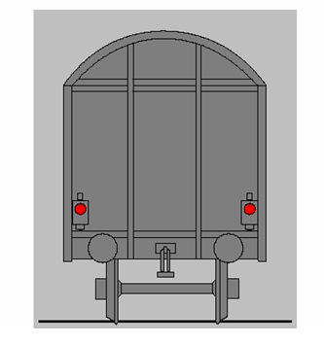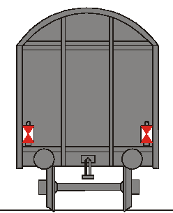

4.2.2.1.3.1 Passenger trains
The rear end indication of a passenger train must consist of 2 steady red lights at the same height above buffer on the transversal axis.

4.2.2.1.3.2 Freight trains in international traffic
The Member State must notify the Commission which of the following rules will apply on the network of its Member State for trains that cross a border between Member States:
Either
- 2 steady red lights, or
- 2 reflective plates of the following shape with white side triangles and red top and bottom triangle:

The lamps or plates must be on the same height above buffer on the transversal axis.
Member States that require 2 reflective plates must also accept 2 steady red lights as train rear end indication.
Member States that require 2 steady red lights must also accept 2 reflective plates as train rear end indication if the following 2 conditions are fulfilled in the whole network:
- the operational rule for entering a possible occupied block section states that the train drivers shall be able to stop in front of any obstacle
And
- There is no requirement that signallers must visually check the presence of a train rear end device to verify that the train is complete.
In case a Member State requires 2 steady red lights and does not accept 2 reflective plates on its entire network, the Member State may accept the use of reflective plates in one or more section of lines of the network. The concerned Member State specifies in its notification the generic conditions of acceptance of reflective plates.
To ensure that all railway undertakings are given efficient information about the implementation of these conditions, the infrastructure manager shall publish the sections of lines concerned and the related conditions. The specific conditions defined by the infrastructure manager shall include an assessment of the risks and operational requirements.

- 4.2.2.1.3.3 Freight trains not crossing a border between Member States
The Member State must notify the Commission which rules will apply on its network for trains not crossing a border.
In addition, the notified rules for freight trains in international traffic described in 4.2.2.1.3.2 shall also be accepted for trains not crossing a border.

Train audibility

4.2.2.2.1 General requirement
The railway undertaking must ensure that trains are fitted with an audible warning device to indicate the approach of a train.

4.2.2.2.2 Control
The activation of the audible warning device must be possible from all driving positions.

Vehicle identification
Each vehicle must have a number to uniquely identify it from any other rail vehicle. This number must be prominently displayed at least on each longitudinal side of the vehicle.
It must also be possible to identify operational restrictions applicable to the vehicle.
Further requirements are specified in Appendix H.

Safety of passengers and load

4.2.2.4.1 Safety of load
The railway undertaking must make sure that freight vehicles are safely and securely loaded and remain so throughout the journey.

4.2.2.4.2 Safety of passengers
The railway undertaking must ensure that passenger transport is undertaken safely at the departure and during the journey.

Route compatibility and train composition
4.2.2.5.1 Route compatibility

The railway undertaking is responsible for ensuring that the train is compatible with the intended route(s) and must have an operational process in the SMS to perform this check. The elements that must be used in order to ensure the train’s compatibility with the route are set out in Appendix D1.
The infrastructure manager must inform the railway undertaking of the changes on characteristics of the route as soon as practicable.
The railway undertaking must define the rules and procedures to be followed by his staff so as to ensure that the train is compatible with the route.
4.2.2.5.2 Train composition
Train composition requirements must take into account the following elements:
      - the vehicles
- all vehicles in the train must be compatible with all the requirements applicable on the routes over which the train will run;
- all vehicles on the train must be fit to run at the maximum speed at which the train is scheduled to run;
      - all vehicles on the train must be currently within their specified maintenance interval and will remain so for the duration (in terms of both time and distance) of the journey being undertaken;
      - the train
- the composition of vehicles forming a train must comply with the technical and operational constraints of the route concerned and be within the maximum length permissible for forwarding and receiving terminals.
      - the railway undertaking is responsible for ensuring that the train is technically fit for the journey to be undertaken and remains so throughout the journey.

      - Additional constraints may be required or imposed due to the type of braking regime or traction type on a particular train.

Train braking

4.2.2.6.1 Minimum requirements of the braking system
All vehicles in a train must be connected to the continuous automatic braking system as defined in the RST TSI.
The first and last vehicles (including any traction units) in any train must have the automatic brake operative.
In the case of a train becoming accidentally divided into two parts, both sets of detached vehicles must come automatically to a stand as a result of a maximum application of the brake.

4.2.2.6.2 Braking performance and maximum speed allowed
(1) The infrastructure manager shall provide the railway undertaking with all relevant line characteristics for each route:
• Signalling distances (warning, stopping) containing their inherent safety margins,
• gradients,
• maximum permitted speeds and
• conditions of use of braking systems possibly affecting the infrastructure such as magnetic, regenerative and eddy-current brake.

(2) Additionally, the infrastructure manager may provide the following information:
(i) For trains able to run at a maximum speed higher than 200 km/h, deceleration profile and equivalent response time on level track;
(ii) For trainsets or for fixed train compositions, unable to run at a maximum speed higher than 200 km/h, deceleration (as above in (i)) or brake weight percentage;
(iii) For other trains (variable compositions of trains unable to run at a maximum speed higher than 200 km/h): brake weight percentage.
If the infrastructure manager provides the above mentioned information, it shall be made available to all RUs who intend to operate trains on its network. The braking tables already in use and accepted for the existing lines at the date of entry into force of the present regulation shall also be made available.

(3) The railway undertaking shall, in the planning stage, determine the braking capability of the train and corresponding maximum speed taking into account:
• the relevant line characteristics as expressed in point (1) above and, if available, the information provided by the infrastructure manager in accordance to point (2) above. If the infrastructure manager has provided the information of point (2), the railway undertaking has to express the braking capability by using the same information; and
• the rolling stock-related margins derived from reliability and availability of the braking system.
Furthermore, the railway undertaking shall ensure that during operation each train achieves at least the necessary braking performance. The railway undertaking shall set up and implement corresponding rules and shall manage them within its safety management system.
In particular the railway undertaking has to set up rules to be used if a train does not reach the necessary braking performance during operation. In this case, the railway undertaking must immediately inform the infrastructure manager. The infrastructure manager may take appropriate measures to reduce the impact on the overall traffic on its network.

Ensuring that the train is in running order

4.2.2.7.1 General requirement
The railway undertaking must define the process to ensure that all safety-related on-train equipment is in a fully functional state and that the train is safe to run.
The railway undertaking must inform the infrastructure manager of any modification to the characteristics of the train affecting its performance or any modification that might affect the ability to accommodate the train in its allocated path.
The infrastructure manager and the railway undertaking must define and keep up to date conditions and procedures for train running in degraded mode.

4.2.2.7.2 Data required
The data required for safe and efficient operation and the process by which this data must be forwarded must comprise:
- the train identification
- the identity of the railway undertaking responsible for the train
- the actual length of the train
- if a train carries passengers or animals when it is not scheduled to do so
- any operational restrictions with an indication of the vehicle(s) concerned (gauge, speed restrictions, etc.)
- information the infrastructure manager requires for the transport of dangerous goods.
The railway undertaking must ensure that this data is made available to the infrastructure manager(s) prior to the departure of the train.
The railway undertaking must advise the infrastructure manager(s) if a train will not occupy its allocated path or is cancelled.

Requirements for signal and lineside marker sighting
The driver must be able to observe signals and lineside markers, and they must be observable by the driver whenever applicable. The same applies for other types of lineside signs if they are safety related.
Therefore, signals, lineside markers, signs and information boards must be designed and positioned in such a consistent way to facilitate this. Issues that must be taken into account include:
- that they are suitably sited so that train headlights allow the driver to read the information,
- suitability and intensity of lighting, where required to illuminate the information,
- where retro-reflectivity is employed, the reflective properties of the material used are in compliance with appropriate specifications and the signs are fabricated so that train headlights easily allow the driver to read the information.
Driving cabs must be designed in such a consistent way that the driver is able to easily see the information displayed to him.

Driver vigilance
A means of onboard monitoring of driver vigilance is necessary. This shall intervene to bring the train to a stand if the driver does not react within a certain time; the time range is specified in the rolling stock TSIs.

Specifications relating to train operations

Train planning
In accordance with Directive 2012/34/EU the infrastructure manager must advise what data is required when a train path is requested.

Identification of trains
Each train must be identified by a train running number. The train running number is given by the infrastructure manager when allocating a train path and must be known by the railway undertaking and all infrastructure managers operating the train. The train running number must be unique per network. Changes of train running number during a train journey should be avoided.

4.2.3.2.1 Format of train running number
The train running number format is defined in the control-command and signalling TSI (hereinafter referred to as ‘CCS TSI', Commission Regulation (EU) 2016/919 as amended)

Train departure

4.2.3.3.1 Checks and tests before departure
The railway undertaking must define the checks and tests to ensure that any departure is undertaken safely (e.g. doors, load, brakes).

4.2.3.3.2 Informing the infrastructure manager of the train's operational status
The railway undertaking shall inform the infrastructure manager when a train is ready for access to the network.
The railway undertaking must inform the infrastructure manager of any anomaly affecting the train or its operation having possible repercussions on the train's running prior to departure and during the journey.

Traffic management

4.2.3.4.1 General requirements
Traffic management must ensure the safe, efficient and punctual operation of the railway, including effective recovery from service disruption.
The infrastructure manager must determine procedures and means for:
- the real time management of trains,
- operational measures to maintain the highest possible performance of the infrastructure in case of delays or incidents, whether actual or anticipated, and
- the provision of information to the railway undertaking(s) in such cases.
Any additional processes required by the railway undertaking and which affect the interface with the infrastructure manager(s) can be introduced after being agreed with the infrastructure manager.

4.2.3.4.2 Train reporting

4.2.3.4.2.1 Data required for train position reporting
The infrastructure manager must:
          - provide a means of real time recording of the times at which trains depart from, arrive at or pass appropriate pre-defined reporting points on their networks and the delta-time value;
          - provide the specific data required in relation to train position reporting. Such information must include:
- Train identification
- Identity of reporting point
- Line on which the train is running
- Scheduled time at reporting point
- Actual time at reporting point (and whether depart, arrive or pass - separate arrival and departure times must be provided in respect of intermediate reporting points at which the train calls)
- Number of minutes early or late at the reporting point
- Initial explanation of any single delay exceeding 10 minutes or as otherwise required by the performance monitoring regime
- Indication that a report for a train is overdue and the number of minutes by which it is overdue
- Former train identification(s), if any
- Train cancelled for a whole or a part of its journey.

4.2.3.4.2.2 Predicted hand over time
The infrastructure manager must have a process, which enables an indication of the estimated number of minutes of deviation from the scheduled time a train is scheduled to be handed over from one infrastructure manager to another.
This must include information on service disruption (description and location of problem).

4.2.3.4.3 Dangerous goods
The railway undertaking must define the procedures to supervise the transport of dangerous goods.
These procedures must include:
- the provisions as specified in Directive 2008/68/EC of the European Parliament and of the Council
- advice to the driver of the presence and position of dangerous goods on the train
- information the infrastructure manager requires for transport of dangerous goods
- determination, in conjunction with the infrastructure manager, of lines of communication and planning of specific measures in case of emergency situations involving the goods.

4.2.3.4.4 Operational quality
The infrastructure manager and the railway undertaking must have processes in place to monitor the efficient operation of all the services concerned.
Monitoring processes must be designed to analyse data and detect underlying trends, both in terms of human error and system error. The results of this analysis must be used to generate improvement actions, designed to eliminate or mitigate against events which could compromise the efficient operation of the network.
Where such improvement actions would have network-wide benefits, involving other infrastructure managers and railway undertakings, they must, subject to commercial confidentiality, be communicated accordingly.
Events that have significantly disrupted operations must be analysed as soon as possible by the infrastructure manager. Where appropriate, and in particular where one of their staff is concerned, the infrastructure manager must invite those railway undertaking(s) involved in the event concerned to participate in the analysis. Where the result of such analysis leads to network improvement recommendations designed to eliminate or mitigate against causes of accidents/incidents, these must be communicated to all relevant infrastructure managers and railway undertakings concerned.
These processes shall be documented and subject to internal audit.

Data recording
Data pertaining to the running of a train must be recorded and retained for the purposes of:
- Supporting systematic safety monitoring as a means of preventing incidents and accidents.
- Identification of driver, train and infrastructure performance in the period leading up to and, if appropriate, immediately after an incident or accident, in order to enable the identification of causes, and supporting the case for new or changed measures to prevent recurrence.
- Recording information relating to the performance of both the locomotive/traction unit and the person driving.
It must be possible to match recorded data to:
- the date and time of the recording;
- the precise geographic location of the event being recorded ;
- the train identification;
- the identity of the driver.
Data to be recorded for ETCS/GSM-R are those defined in the TSI CCS and that are relevant considering the requirements in point 4.2.3.5 of this TSI.
The data must be securely sealed and stored and accessible to authorised bodies including Investigating Bodies in carrying out their role pursuant to Article 22 of Directive (EU) 2016/798.

4.2.3.5.1 Recording of supervision data outside the train
As a minimum, the infrastructure manager must record the following data:
- the failure of lineside equipment associated with the movement of trains (signalling, points etc.);
- the detection of an overheating axle bearing, if fitted;
- safety related communication between the train driver and signaller.

4.2.3.5.2 Recording of supervision data on-board the train
As a minimum, the railway undertaking must record the following data:
- the detection of passing of signals at danger or ‘end of movement authority’ ;
- application of the emergency brake;
- speed at which the train is running;
- any isolation or overriding of the on-board train control (signalling) systems;
- operation of the audible warning device;
- operation of door controls (release, closure), if fitted;
- detection by on-board alarm systems related to the safe operation of the train, if fitted;
- identity of the cab for which data is being recorded to be checked.
Further technical specifications concerning the recording device are set out in the TSI Loc & Pas.

Degraded operation

4.2.3.6.1 Advice to other users
The infrastructure manager in conjunction with the railway undertaking(s) must define a process to immediately inform each other of any situation that impedes the safety, performance and/or the availability of the rail network or rolling stock.

4.2.3.6.2 Advice to train drivers
In any case of degraded operation associated with the infrastructure manager’s area of responsibility, the infrastructure manager must give formal instructions to drivers on what measures to take in order to safely overcome the degradation.

4.2.3.6.3 Contingency arrangements
The infrastructure manager in conjunction with all the railway undertakings operating over his infrastructure, and neighbouring infrastructure managers as appropriate, must define, publish and make available appropriate contingency measures and assign responsibilities based on the requirement to reduce any negative impact as a result of degraded operation.
The planning requirements and the response to such events must be proportional to the nature and potential severity of the degradation.
These measures, which must as a minimum include plans for recovering the network to ‘normal’ status, may also address:
- rolling stock failures (for example, those which could result in substantial traffic disruption, the procedures for rescuing failed trains);
- infrastructure failures (for example, when there has been a failure of the electric power or the conditions under which trains may be diverted from the booked route);
- extreme weather conditions.
The infrastructure manager must establish and keep updated contact information for key infrastructure manager and railway undertaking staff who may be contacted in the event of service disruption leading to degraded operation. This information must include contact details both during and outside office hours.
The railway undertaking must submit this information to the infrastructure manager and advise the infrastructure manager of any changes to these contact details.
The infrastructure manager must advise all the railway undertaking(s) of any changes to his details.

Managing an emergency situation
The infrastructure manager must, in consultation with:
- all railway undertakings operating over his infrastructure, or, where appropriate, representative bodies of railway undertakings operating over his infrastructure,
- neighbouring infrastructure managers, as appropriate,
- local authorities, representative bodies of the emergency services (including fire fighting and rescue) at either local or national level, as appropriate.
define, publish and make available appropriate measures to manage emergency situations and restore the line to normal operation.
Such measures shall typically cover:
- collisions,
- fires on train,
- evacuation of trains,
- accidents in tunnels,
- incidents involving dangerous goods
- derailments
The railway undertaking must provide the infrastructure manager with any specific information in respect to these circumstances, especially in respect to the recovery or re-railing of their trains.
Additionally, the railway undertaking must have processes to inform passengers about onboard emergency and safety procedures.

Aid to train crew in the event of an incident or of a major rolling stock malfunction
The railway undertaking must define appropriate procedures to assist the train crew in degraded situations in order to avoid or decrease delays caused by technical or other failures of the rolling stock (for example, lines of communication, measures to be taken in case of evacuation of a train).

Functional and technical specifications of the interfaces
In the light of the essential requirements set out in Chapter 3 of this TSI, the functional and technical specifications of the interfaces are as follows:

Interfaces with the infrastructure TSI
Reference operation TSI |  | Reference infrastructure TSI
Parameter | Point | Parameter | Point
Braking performance and maximum speed allowed | 4.2.2.6.2 | Longitudinal track resistance | 4.2.6.2
Modifications to information contained in the route book  Degraded operation | 4.2.1.2.2.2  4.2.3.6 | Operating rules | 4.4

Interfaces with the control-command and signalling TSI
Reference operation TSI |  | Reference control-command and signalling TSI
Parameter | Point | Parameter | Point
Rule book  Operating rules | 4.2.1.2.1  4.4 | Operating rules | 4.4
Requirements for lineside signal and marker sighting | 4.2.2.8 | Visibility of track-side control-command objects | 4.2.15
Train braking | 4.2.2.6 | Train braking performance and characteristics | 4.3.2.3
Rule Book | 4.2.1.2.1 | Use of sanding equipment | 4.2.10
Train running number | 4.2.3.2.1 | ETCS DMI  GSM-R DMI | 4.2.12  4.2.13
Data recording onboard | 4.2.3.5 | Interface to data recording for regulatory purposes | 4.2.14

Interfaces with the rolling stock TSIs

Interfaces with TSI on locomotives and passenger rolling stock
Reference OPE TSI |  | Reference LOC&PAS TSI
Parameter | Point | Parameter | Point
Contingency arrangements | 4.2.3.6.3 | Rescue coupling  End coupling | 4.2.2.2.4  4.2.2.2.3
Train composition | 4.2.2.5 | axle load parameter | 4.2.3.2
Train braking | 4.2.2.6 | Braking performance | 4.2.4.5
Train visibility | 4.2.2.1 | External front and rear lights | 4.2.7.1
Train audibility | 4.2.2.2 | Horn | 4.2.7.2
Requirements for lineside signal and marker sighting | 4.2.2.8 | External visibility  Optical characteristics of the windscreen  Internal lighting | 4.2.9.1.3  4.2.9.2.2  4.2.9.1.8
Driver vigilance | 4.2.2.9 | Driver's activity control function | 4.2.9.3.1
Recording of supervision data on-board the train | 4.2.3.5.2 | Recording device | 4.2.9.6
Managing an emergency situation | 4.2.3.7 | Lifting diagram and instructions  Rescue related descriptions | 4.2.12.5  4.2.12.6
Train composition  Minimum elements relevant to professional qualification for the tasks associated with ‘accompanying trains’ | 4.2.2.5  Appendix F | Operating documentation | 4.2.12.4
Sanding | Appendix B | Isolating emissions | 4.2.3.3.1.1

Interfaces with TSI on freight wagons
Reference OPE TSI |  | Reference WAG TSI
Parameter | Point | Parameter | Point
Rear end | 4.2.2.1.3.2 | Attachment devices for rear-end signal  Rear-end signal | 4.2.6.3  Appendix E
Train composition | 4.2.2.5 | Gauging | 4.2.3.1
Train composition | 4.2.2.5 | Compatibility with load carrying capacity of lines | 4.2.3. 2
Contingency arrangements | 4.2.3.6.3 | Strength of unit - Lifting and jacking | 4.2.2.2
Train braking | 4.2.2.6 | Brake | 4.2.4

Interfaces with the Energy TSI
Reference OPE TSI |  | Reference ENE TSI
Parameter | Point | Parameter | Point
Train composition  Preparation of the Route Book | 4.2.2.5  4.2.1.2.2.1 | Maximum train current | 4.2.4.1
Train composition  Preparation of the Route Book | 4.2.2.5  4.2.1.2.2.1 | Separation sections:  Phase  System | 4.2.15  4.2.16

Interfaces with TSI on Safety in Railway Tunnels
Reference OPE TSI |  | Reference SRT TSI
Parameter | Point | Parameter | Point
Ensuring that the train is in running order  Train departure  Degraded operation | 4.2.2.7  4.2.3.3  4.2.3.6 | Emergency rule | 4.4.1
Managing an emergency situation | 4.2.3.7 | Tunnels emergency plan  Exercises  Provision of on-train safety and emergency information to passengers | 4.4.2  4.4.3  4.4.5
Professional competence | 4.6.1 | Tunnel specific competence of the train crew and other staff | 4.6.1

Interfaces with TSI Noise
Reference OPE TSI |  | Reference NOI TSI
Parameter | Point | Parameter | Point
Route compatibility and train composition | 4.2.2.5 | Additional provisions for the application of this TSI to existing wagons | 7.2.2
Train planning | 4.2.3.1 | Quieter routes | Appendix D
Contingency arrangements | 4.2.3.6.3 | Specific rules for the operation of wagons on quieter routes in case of degraded operation | 4.4.1

Interfaces with TSI Person with Reduced Mobility
Reference OPE TSI |  | Reference PRM TSI
Parameter | Point | Parameter | Point
Professional Competence  Minimum elements relevant to professional qualification for the tasks associated with “accompanying trains” | 4.6.1  Appendix F | Infrastructure subsytem | 4.4.1
Professional Competence  Minimum elements relevant to professional qualification for the tasks associated with “accompanying trains” | 4.6.1  Appendix F | Rolling stock subsytem | 4.4.2
Train composition | 4.2.2.5 | Rolling stock subsytem | 4.4.2

Operating rules
The rules and procedures enabling coherent operation of new and different structural subsystems intended to be used in the European Union rail system, and in particular those that are linked directly to the operation of a new control and signalling system, must be identical where identical situations exist.
The operational principles and rules specific to the European Rail Traffic Management System (ERTMS/ETCS) and for ERTMS/GSM-R radio system are specified in Appendix A.
Operational principles and rules, which are common across the European Union rail system, are specified in Appendices A and B.
Operational principles and rules, which are not common across the European Union rail system and therefore may be subject to national rules, are listed in Appendix I.

Maintenance rules
Not applicable

Professional competences

Professional competence
Staff of the railway undertaking and the infrastructure manager must have attained appropriate professional competence to undertake all necessary safety-critical tasks in normal, degraded and emergency situations. Such competence comprises professional knowledge and the ability to put this knowledge into practice.
Minimum elements relevant to professional qualification for individual tasks can be found in Appendices F and G.

Language competence

Principles
The infrastructure manager and the railway undertaking are required to ensure that their relevant staff are competent in the use of the communication protocols and principles set out in Appendix C.
Where the operating language used by the infrastructure manager differs from that habitually used by the railway undertaking’s staff, such linguistic and communications training must form a critical part of the railway undertaking’s overall competence management system.
Railway undertaking staff whose duties require them to communicate with staff of the infrastructure manager in connection with safety-critical matters, whether in normal, degraded or emergency situations, must have a sufficient level of knowledge in the operating language of the infrastructure manager.

Level of knowledge
The level of knowledge in the infrastructure manager’s operating language must be sufficient for safety purposes.
      - As a minimum this must comprise of the driver being able to:
- send and understand all the messages specified in Appendix C;
- effectively communicate in routine, degraded and emergency situations;
- complete the forms associated with the use of the Book of Forms;
      - Other members of the train crew whose duties require them to communicate with the infrastructure manager on safety-critical matters, must as a minimum, be able to send and understand information describing the train and its operational status.
The level of knowledge for staff accompanying trains other than train drivers must be at least level 2 as described in Appendix E.

Initial and ongoing assessment of staff

Basic elements
Railway undertakings and infrastructure managers are required to define the assessment process for their staff in order to meet the requirements specified in Commission Delegated Regulation (EU) 2018/762.

Analysis and update of training needs
Railway undertakings and infrastructure managers must undertake an analysis of training needs for their relevant staff and define a process for reviewing and updating their individual training needs in order to meet the requirements specified in Commission Delegated Regulation (EU) 2018/762.
This analysis must set out both scope and complexity and take into account the risks associated with the operation of trains, traction and rolling stock. The railway undertaking must define the process by which knowledge of on board staff of the routes worked over is acquired and maintained. This process must be:
- based upon the route information provided by the infrastructure manager; and
- in accordance with the process described in point 4.2.1.
For the tasks associated with ‘accompanying trains’ and ‘preparing trains’, the elements that shall be considered can be found in respectively the appendices F and G. As appropriate, these elements must be put in place as part of the training for staff.
It is possible that due to the type of operation envisaged by a railway undertaking or the nature of the network being run by an infrastructure manager, some of the elements in the appendices F and G will not be appropriate. The analysis of training needs must document those not deemed appropriate and the reasons why.

Auxiliary staff
The railway undertaking must make sure that the auxiliary staff (for example, catering and cleaning) not forming part of the train crew is, in addition to their basic instruction, trained to respond to the instructions of the fully trained members of the train crew.

Health and safety conditions

Introduction
Staff specified in point 4.2.1 as staff performing safety-critical tasks in accordance with point 2.2 must have appropriate fitness to ensure that overall operational and safety standards are met.
Railway undertakings and infrastructure managers must set up and document the process they put in place to meet the medical, psychological and health requirements for their staff within their safety management system.
Medical examinations as specified in point 4.7.2 and any associated decisions on the individual fitness of staff must be conducted by a medical doctor.
Staff must not perform safety-critical tasks whilst vigilance is impaired by substances such as alcohol, drugs or psychotropic medication. Therefore, the railway undertaking and the infrastructure manager must have in place procedures to control the risk that staff attend for work under the influence of such substances, or consume such substances at work.
National rules of the Member State where a train service is operated apply with regard to defined limits of the above mentioned substances.

Medical examinations and psychological assessments

Before appointment

4.7.2.1.1 Minimum content of the medical examination
Medical examinations must cover:
- General medical examination;
- Examinations of sensory functions (vision, hearing, colour perception);
- Urine or blood analysis for the detection of diabetes mellitus and other conditions as indicated by the clinical examination;
- Screening for abuse of drugs.

4.7.2.1.2 Psychological assessment
The aim of the psychological assessment is to support the railway undertaking in the appointment and management of staff who have the cognitive, psychomotor, behavioural and personality capabilities to perform their roles safely.
In determining the content of the psychological assessment, as a minimum, the following criteria relevant to the requirements of each safety function must be taken into account:
          - Cognitive:
- Attention and concentration,
- Memory,
- Perceptive capability,
- Reasoning,
- Communication.
          - Psychomotor:
- Speed of reaction,
- Gestured co-ordination.
          - Behavioural and personality
- Emotional self control,
- Behavioural reliability,
- Autonomy,
- Conscientiousness.
If any of those elements is omitted, the respective decision must be justified and documented by a psychologist.
Applicants shall demonstrate their psychological fitness by passing an examination conducted by, or under the supervision of – to be decided by the Member State – a psychologist or a medical doctor.

After appointment

4.7.2.2.1 Frequency of periodic medical examinations
At least one systematic medical examination must be performed:
- Every 5 years for staff aged up to 40;
- Every 3 years for staff aged between 41 and 62;
- Every year for staff aged over 62.
Increased frequency of examination must be set by the medical doctor if the state of health of the member of the staff requires so.

4.7.2.2.2 Minimum content of the periodic medical examination
If the worker complies with the criteria required at the examination, which is carried out before practising an occupation, the periodic specialised examinations must include as a minimum:
- General medical examination;
- Examination of sensory functions (vision, hearing, colour perception);
- Urine or blood analysis for the detection of diabetes mellitus and other conditions as indicated by the clinical examination;
- Screening for abuse of drugs where clinically indicated.

4.7.2.2.3 Additional medical examinations and/or psychological assessments
Besides the periodic medical examination, an additional specific medical examination and/or psychological assessment must be performed where there is reasonable ground for doubting the medical or psychological fitness of a member of staff or reasonable suspicion of use of drugs or use of alcohol over the limits allowed. This would be the case especially after an incident or accident caused by human error on the part of the individual.
The railway undertaking and the infrastructure manager must put systems in place to ensure that such additional examinations and assessments are undertaken as appropriate.

Medical requirements

General requirements
Staff must not suffer from medical conditions or take medical treatment likely to cause:
- Sudden loss of consciousness;
- Impairment of awareness or concentration;
- Sudden incapacity;
- Impairment of balance or co-ordination;
- Significant limitation of mobility.
The following vision and hearing requirements must be met:

Vision requirements
- Aided or unaided distance visual acuity: 0.8 (right eye + left eye – measured separately); minimum of 0.3 for the worse eye;
- Maximum corrective lenses: hypermetropia +5 / myopia – 8. The medical doctor may allow values outside this range in exceptional cases and after having sought the opinion of an eye specialist;
- Intermediate and near vision: sufficient whether aided or unaided;
- Contact lenses are allowed;
- Normal colour vision: using a recognised test, such as the Ishihara, completed by another recognised test if required;
- Vision field: normal (absence of any abnormality affecting the task to be performed);
- Vision for both eyes: effective;
- Binocular vision: effective;
- Contrast sensitivity: good;
- Absence of progressive eye disease;
- Lens implants, keratotomies and keratectomies are allowed only on condition that they are checked on a yearly basis or according to a frequency set by the medical doctor.

Hearing requirements
Sufficient hearing confirmed with tone audiogram, that is:
- Hearing good enough to hold a phone conversation going and be able to hear alert tones and radio messages.
- The use of hearing aids is allowed.

Registers of infrastructure and vehicles
Due to the characteristics of the registers of infrastructure and vehicles, as defined in Articles 47, 48 and 49 of Directive (EU) 2016/797, these registers are not suitable for the particular requirements of the operation and traffic management subsystem. Therefore this TSI specifies nothing in respect of these registers.
However, there is an operational requirement for certain infrastructure related data items to be made available to a railway undertaking and conversely for certain rolling stock related items to be made available to an infrastructure manager, as specified in point 4.8.1 and point 4.8.2. In both cases the data concerned must be complete and accurate.

Infrastructure
The requirements for the rail infrastructure related data items with regard to the operation and traffic management subsystem, and which must be made available to railway undertakings, are specified in Appendix D. The infrastructure manager is responsible for the correctness of the data.

Rolling stock
The following rolling stock related data items must be available to infrastructure managers. The keeper is responsible for the correctness of the data:
- whether the vehicle is constructed from materials which can be hazardous in case of accidents or fire (for example, asbestos);
- total length of the vehicle, including buffers if existing.

Interoperability constituents

Definition
As defined in Article 2.7 of Directive (EU) 2016/797, 'interoperability constituents' means “any elementary component, group of components, subassembly or complete assembly of equipment incorporated or intended to be incorporated into a subsystem, upon which the interoperability of the rail system depends directly or indirectly, including both tangible objects and intangible objects”.

List of constituents
In respect to the operation and traffic management subsystem, there is no interoperability constituent.

Assessment of conformity and/or suitability for use of the constituents and verification of the subsystem

Interoperability constituents
As this TSI does not yet specify any interoperability constituents, no assessment arrangements are discussed.

Operation and traffic management subsystem

Principles
The operation and traffic management subsystem is a functional subsystem according to Annex II to Directive (EU) 2016/797.
In accordance with Articles 9 and 10 of Directive (EU) 2016/798, railway undertakings and infrastructure managers must demonstrate compliance with the requirements of this TSI within their safety management system when applying for any new or amended safety certificate or safety authorisation.
The common safety methods on conformity assessment require national safety authorities to set up an inspection regime to supervise and monitor the day to day compliance with the safety management system including all TSIs. It should be noted that none of the elements contained within this TSI require separate assessment by a Notified Body.
Requirements in this TSI that refer to structural subsystems and are listed in the interfaces (point 4.3) are assessed under the relevant structural TSIs.

Implementation

Principles
TSI OPE shall be implemented by RUs and IMs within 2 years after entry into force of the TSI OPE as part of updating the SMS or as part of renewing the safety certificate/authorization. The exceptions are the amendments made in Appendices A, B and C to Commission Regulation (EU) 2015/995 of this TSI OPE revision which shall be implemented within 5 years after entry into force of this TSI OPE.

Specific cases

Introduction
The following special provisions are permitted in the specific cases below.
These specific cases belong to two categories:
          - the provisions apply either permanently (case "P"), or temporarily (case "T").
          - In temporary cases Member States shall conform with the relevant subsystem either by 2030 (case "T1") or by 2024 (case “T2”).

List of specific cases

Temporary specific case (T1) Estonia, Latvia and Lithuania
For the implementation of point 4.2.2.1.3.2 and 4.2.2.1.3.3, trains which are operated solely on the 1520 mm gauge network of Estonia, Latvia and Lithuania may use another specified train rear end signal.

Temporary specific case (T2) Ireland and United Kingdom
For the implementation of point 4.2.3.2.1, Ireland and United Kingdom are using alphanumeric number in the existing systems. The MS set out the requirements and time schedule for the transition from alphanumeric train running numbers to numeric train running numbers in the target system.

Permanent specific case (P1) Finland
For the implementation of point 4.2.2.1.3.3 and the implementation of common operational rule 5 of Appendix B, Finland is not using any rear end signal device for freight trains. The means to indicate the train rear end signal for freight trains as stated in point 4.2.2.1.3.2 are also accepted in Finland.
Appendix A
ERTMS/ETCS operating rules
The operating rules for ERTMS/ETCS and ERTMS/GSM-R are specified in the Technical Document "ETCS and GSM-R rules and principles – version 5" published on the ERA website (www.era.europa.eu).
Appendix B
Common operational principles and rules
B1. Fundamental operational principles

1. The method of authorising a train movement must maintain a safe interval between trains.
2. A train must only operate over a portion of line if the train composition is compatible with the infrastructure.
3. Before a train begins or continues its journey, it must be ensured that passengers, staff and goods are carried safely.
4. Before a train is allowed to start or continue its movement, it must have an authority to move and all necessary information to define the conditions of that authority.
5. A train must be prevented from proceeding onto a portion of line if it is known or suspected that it would not be safe for the train to pass until measures have been taken to allow the train to continue safely.
6. A train must not continue to operate after it has been found to be unsafe in any respect, until measures have been taken to allow the train to continue safely.

B2. Common operational rules
In case of degraded operation, the contingency arrangements set out in point 4.2.3.6.3 shall also be considered.

Sanding
If the train is equipped with manually activated sanding device, the driver shall always be allowed to apply sand but shall avoid it wherever possible:
- in the area of points and crossings,
- during braking at speeds less than 20 km/h,
- when at standstill.
The exceptions to this are:
- if there is a risk of SPAD (Signal Passed At Danger), or other serious incident and the application of sand would assist adhesion,
- when starting away,
- when required to test the sanding equipment on the traction unit.

Departure of the train
At the initial station or after a scheduled stop the driver is allowed to depart when the following conditions are fulfilled:
- after the driver has received an authorisation for train movement;
- after train service conditions are fulfilled;
- when it is time to depart, except when allowed to start before the scheduled time.

No authorisation for train movement at the expected time
If the driver has not received an authorisation for train movement at the expected time, and has no information as to the reason, the driver shall inform the signaller.

Complete failure of front end lights
If the driver is not able to display any front end light:

During good visibility
The driver shall inform the signaller about the failure. The train shall proceed at the maximum permitted speed to the nearest location where the front end light can be repaired/replaced or the affected vehicle replaced. When proceeding, the driver shall use the train audible warning device as necessary or as instructed by the signaller.

During darkness or poor visibility
The driver shall inform the signaller about the failure. As long as a portable front end light displaying a white light is fitted on the front of the train, the train shall proceed at the maximum allowable speed for that failure to the nearest location where the front end light can be repaired/replaced or the affected vehicle replaced.
If a portable front end light is not available, the train shall not proceed, unless formal instructions are given by the signaller to continue to the nearest suitable location to where the line can be cleared.
When proceeding, the driver shall use the train audible warning device as necessary or as instructed by the signaller.

Complete failure of a rear end signal
- If the signaller becomes aware of the complete failure of the train rear end signal, the signaller shall make arrangements to stop the train in an appropriate location and inform the driver.
- The driver shall then check the completeness of the train and if necessary repair/replace the train rear end signal.
- The driver shall report to the signaller that the train is ready to proceed. Otherwise, if the repair is not possible, the train may not proceed, unless special arrangements are made between signaller and driver.

Failure of the audible warning device of a train
If the audible warning device fails, the driver shall inform the signaller about the failure. The train shall not exceed the permitted speed for the failure of an audible warning device to the nearest location where the audible warning device can be repaired or the affected vehicle replaced. The driver shall be able to stop before passing over any level crossing where the audible warning device must be sounded and then proceed over the level crossing only when it is safe to do so. If a multi-tone audible warning device is defective but at least one tone is functioning, the train may proceed normally.

Failure of level crossing

Stopping trains passing over a defective level crossing
When a technical failure affecting safety of running trains over a level crossing has been detected and as long as the safe operation has not been restored, the normal passing of trains over the level crossing must be prevented.

Passing trains over the defective level crossing (if authorised)
- Where the nature of the failure permits train movements to continue, the driver of each train shall be authorised to continue and to pass over the level crossing.
- After being instructed to pass over the level crossing with a failure, the driver shall pass the level crossing as instructed. If the level crossing becomes obstructed the driver shall take all possible measures necessary to stop.
- When approaching the level crossing, the driver shall use the audible warning device when necessary or when formal instructions have been given by the signaller. If the level crossing is clear, the driver shall proceed and accelerate the train as soon as the front of the train has passed clear the level crossing.

Failure of voice radio communication

Failure of train radio detected during train preparation
In case of on board radio failure a train shall not be permitted to start a service on lines where a radio is required.

Failure of voice radio communication when the train has entered service
All failure types
If the driver becomes aware that the primary voice radio communication is failed, the driver shall inform the signaller as soon as practicable using any available means.
The driver shall then apply the instructions by the signaller concerning the further movement of the train.
On-board Failure
A train with a failed voice radio communication may:
- continue its service if another means of communication is provided between the train driver and the signaller; or
- proceed to the nearest location where the radio can be repaired or the affected vehicle replaced if another means of voice communication is not provided between the driver and the signaller.

Running on sight
When a driver has to run on sight, the driver shall:
- Proceed with caution, controlling the speed, taking into account the line visible in advance, such that it is possible to stop short of any vehicle, stop aspect or obstacle; and
- Not exceed the maximum speed for running on sight.
- This does not apply to unexpected obstacle entering the track zone within the stopping distance.

Assistance to a failed train
- If a train is stopped by failure, the driver must immediately inform the signaller about the failure and the circumstances of the failure.
- When an assisting train is needed, the driver and signaller must agree at least all of the following:
- the type of assisting train needed
- if a specific direction is required (front or rear)
- the location of the failed train.
After the driver has asked for assistance, the train must not be moved even if the defect is rectified until:
- the assisting train has arrived, or
- the driver and signaller have agreed alternative arrangements.
- The signaller must not allow the assisting train to enter the section occupied by the failed train unless confirmation has been received that the failed train will not be moved.
When the assisting train is ready to enter the section occupied by the failed train, the signaller shall inform the driver of the assisting train at least the following:
- the location of the failed train
- the location where the failed train is to be taken to
- The driver of the combined train must make sure that:
- the assisting train is coupled to the failed train, and
- the brake performance of the train is checked, the automatic brake, if compatible, is connected and a brake test has been carried out.
- When the combined train is ready to continue, the driver in control must contact the signaller and inform the signaller of any restrictions and move the train in accordance with any instructions given by the signaller.

Authorisation to pass a signal showing a stop aspect/indication
The driver of the train concerned must have authorisation to pass a signal showing stop aspect/indication.
When giving authorisation, the signaller must give the driver any instructions concerning the movement.
The driver must apply the instructions and must not exceed any speed restriction, where one is imposed, until reaching the location where the normal operation can be resumed.

Anomalies in lineside signalling
If any of the following anomalies are observed:
- no signal aspect is shown where there should be one;
- an irregular aspect is shown at the signal;
- an irregular signal aspect sequence is received on the approach to the signal;
- the aspect of the signal is not clearly visible.
The driver shall act according to the most restrictive aspect that could be presented by the signal.
In all cases the driver must report to the signaller the abnormal signalling aspect when observed.

Emergency call
When receiving an emergency call the driver shall assume that there is a dangerous situation and perform all actions necessary in order to avoid or reduce the effect of this situation.
In addition, the driver shall:
- immediately reduce the speed of the train to the appropriate speed for running on sight; and
- run on sight unless otherwise instructed by the signaller; and
- obey the instructions given by the signaller.
Drivers that have been ordered to stop shall not restart without authorisation from the signaller. Other drivers shall continue running on sight until the signaller informs them that running on sight is no longer necessary.

Immediate actions to prevent danger to trains
    - Any RU/IM staff who become aware of a danger to trains must take immediate action to stop any trains which may be affected and take any other action as necessary to avoid harm or loss.
    - Any driver made aware of a danger to their train must stop and alert the signaller immediately to the danger.

Failure of on-board equipment
The RU shall determine the cases in which a failure of an on-board equipment affects the running of the train.
The RU shall give the necessary information to the driver and/or train crew of what action to take in the case of on-board failures that affect the running of the train.
If the driver becomes aware of a failure of any on-board equipment that affects the running of the train, the driver shall:
- Inform the signaller of the situation and the restrictions on the train should the train be allowed to continue its mission,
- The driver shall not commence or recommence the mission until permission to do so has been granted by the signaller,
- If the signaller gives permission for the train to start or continue its mission then the driver shall proceed in accordance with the restrictions placed upon the train,
If the signaller does not give permission for the train to commence or recommence its mission then the driver shall follow the instructions given by the signaller.

End of authority passed without permission
- If the driver becomes aware that the train has passed an end of authority without permission, the driver shall stop the train immediately.
- If the train is stopped by ATP/TPS, the driver shall take action to support the emergency brake.
- The driver shall inform the signaller.

- If the signaller becomes aware that a train has passed an end of authority without permission, then the signaller shall take any necessary action to stop the train immediately.
- The driver and signaller shall take any necessary action to protect all movements.
When the train is able to continue, the driver shall inform the signaller. The signaller shall set or check the route for the train to continue its journey and issue all necessary instructions

Failure of trackside equipment including catenary
- The IM shall determine whether the failure of trackside equipment (including catenary) affects the safe and/or effective operation of trains.
- The IM shall provide the necessary instructions to the driver of what action to take in the case of such a failure as referenced in OPE TSI 4.2.1.2.2.3.
- If the driver becomes aware of a failure of any trackside equipment (including catenary) that affects the safe and/or effective operation of trains, the driver shall inform the signaller of the situation as soon as possible and follow the instructions given by the signaller.

Appendix C
Safety related communications methodology

C1. Oral communication

1. Scope and Purpose
This Appendix sets out the rules for safety-related communications, between train crew, mainly the train driver, and signaller, in particular to define its structure, methodology and content. Safety related communication has priority over all other communication.

2. Safety related communications
2.1 Communication structure
The transmission of safety-related messages shall be short and clear and, as far as possible, without abbreviation. In order to ensure a message is understood and the necessary action can be undertaken, whoever is giving the message shall cover at least the following points:
- indicate their exact location.
- state the function they are carrying out and information on the action that is needed.
Drivers shall identify themselves by the train running number and the location.
Signallers shall identify themselves by the control area or the location of the signal box.

2.2 Communication methodology
Whoever is giving the message shall:
- check that the message is received and repeated back as required. As emergency messages are intended to give urgent operational instructions that are directly linked with the safety of the railway, the repetition of these messages can be omitted.
- if necessary, correct a mistake that has been made in the message.
- if necessary, let the person know how they can be contacted.
For communication between signallers and drivers it is the signallers' responsibility to ensure that they are talking to the driver within their control area. This is critical when communication is taking place in areas where communications boundaries overlap. This principle shall apply even after an interruption during transmission.

2.3 Communication content
The following messages shall be used for identification by the different parties.
- by the signaller:
Train ……………… [running number]
this is …......…….[control area/location of the signal box]

- by the driver:
this is train …......……. [running number] at ……….[location]

Terminology shall be used in the communication procedure by all the parties:
Situation | Terminology
Term transferring the opportunity to speak to the opposite party | ‘Over’
Term confirming that the sent message has been received | ‘Received’
Term used to have the message repeated in the event of poor reception or misunderstanding | ‘Say again’
Term used to ascertain whether a read-back message exactly matches the sent message | ‘Correct’
Term used to indicate that a read-back message does not match the sent message | ‘Error (+ I say again)’
Term used to keep the other party waiting when there is a temporary break in the communication and the connection is not broken | ‘Wait’
Term used to tell the other party that the communication might be broken but should be resumed later on | ‘I call again’
Term used to indicate that the message has ended | ‘Out’

Standard terminology shall be used in the communication procedure by all the parties without translation:
Situation | Standard terminology
Term used to indicate that there is an emergency situation | ‘Mayday, mayday, mayday’
This term shall not be translated and does not have to be used in case emergency call functionality is available on the train (e.g. GSM-R).

3 Communication rules
In order that safety related communication is correctly understood, whatever the communication mean is used, the following rules shall be used:

3.1 International Phonetic Alphabet
The International Phonetic Alphabet shall be used:
- to identify letters of the alphabet;
- to spell words and location names that are difficult to say, or may be misunderstood;
- when quoting the identity of signals or points.
A Alpha  B Bravo  C Charlie  D Delta  E Echo  F Foxtrot | G Golf  H Hotel  I India  J Juliet  K Kilo | L Lima  M Mike  N November  O Oscar  P Papa | Q Quebec  R Romeo  S Sierra  T Tango  U Uniform | V Victor  W Whisky  X X-ray  Y Yankee  Z Zulu

3.2 Numbers
The Numbers shall be spoken digit by digit:
0 = Zero
1 = One
2 = Two
3 = Three
4 = Four
5 = Five
6 = Six
7 = Seven
8 = Eight
9 = Nine

- by the signaller:
- by the driver:

C2. Operational instructions

1. Introduction
Railway undertakings and Infrastructure managers shall use European instructions in the communication procedure in the following cases:
- Permission to pass an End of Authority - signal showing a stop aspect/stop indication;
- Permission to proceed after a trip (ETCS);
- Obligation to remain at standstill, obligation to carry out end of mission (ETCS);
- Revocation of an operational instruction;
- Obligation to run under restrictions;
- Obligation to run on sight;
- Permission to start in Staff Responsible (ETCS) after preparing a movement ;
- Permission to pass a defective level crossing;
- Obligation to run with power supply restrictions;
10-20. RESERVED
The numbers 1 to 20 are reserved for European instructions, numbers 1-5 and 7 are mandatory for ETCS. If an operational instruction related to class B system requires more information than the European instructions, the national instruction can be used instead. In such case, the Infrastructure Manager may define these requirements in its national instructions. If numbered, the national instructions defined by the individual Infrastructure Managers must start from 21 onwards. The national instructions must contain at least the same content of that for a European instruction.
2. Content
An operational instruction must state the following as a minimum:
- from where it was issued (location of signaller),
- at what date it was issued (not for verbal instruction),
- to which train / shunting movement it refers,
- clear, precise, unambiguous instructions,
- unique identification provided by the signaller.

In addition, depending on the circumstances, an operational instruction might also state:
- at what time it was issued,
- where that train / shunting movement is located, at which location it applies,
- ID of train driver;
- ID of issuer;
- verification (signature or electronic confirmation) that the instruction has been received.

Any operational instruction that has been issued to be written down can only be revoked by a European instruction n°4 explicitly referring to the unique identification of the instruction to be revoked.

3. Delivery of the operational instruction
A European instruction includes information delivered electronically, verbally, physically on paper or as verbal instructions to be written down by the train driver or by other safe methods of communication with the same level of information.

When an operational instruction is required to be written down by the train driver, the train must be at a standstill.

An operational instruction shall be delivered as close as practicable to the affected area.

An operational instruction takes precedence over the related indications provided by trackside signals and/or the DMI. When a permitted speed or a release speed lower than the maximum speed prescribed in the operational instruction is applicable, the lowest speed must be applied.

An operational instruction must only be issued by the signaller when the train running number has been identified and, if necessary, the location of the train/shunting movement. Before applying the operational instruction, the train driver must check that this operational instruction refers to his train / shunting movement and its current or identified location.

4. Awareness of the operational instruction
The RU has to define a procedure to ensure that the train driver is aware of an operational instruction until the train has reached the location where it has to be processed.

When the operational instruction does not need to be performed immediately after its delivery, it must be possible for the train driver to retrieve the operational instruction.
5. Monitoring of processed operational instruction
As part of the compliance with Safety Directive (EU) 2016/798, the IM and RU shall monitor the processes of delivery and use of the operational instructions.
6. European instructions

Each field of information contained in a European instruction must be given its own identifier.
While the content and the identifiers must be used, the format itself is indicative.
On one hand, if a specific field is not to be used in a Member State or on the network of an IM, there is no obligation to display this field in the European instruction. On the other hand, there shall be no field added.
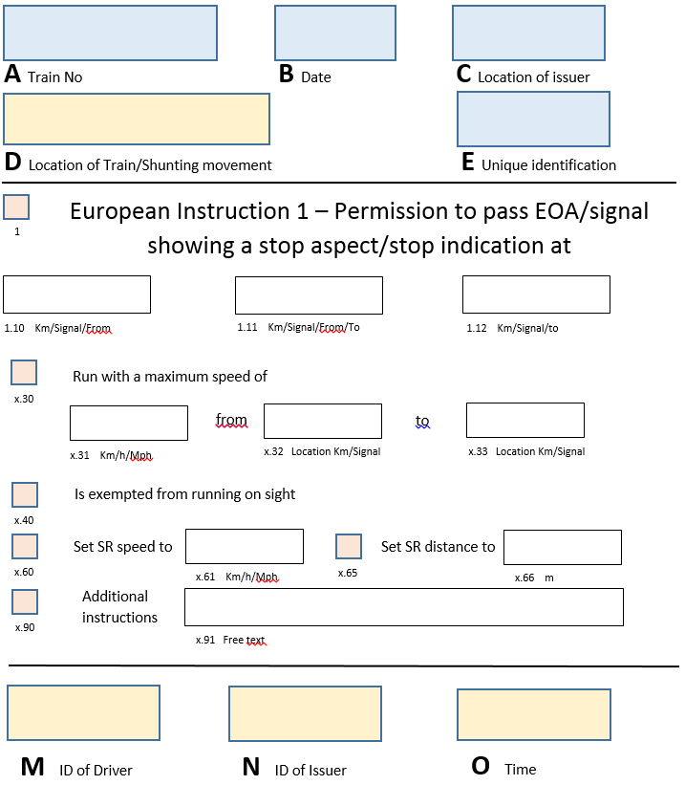
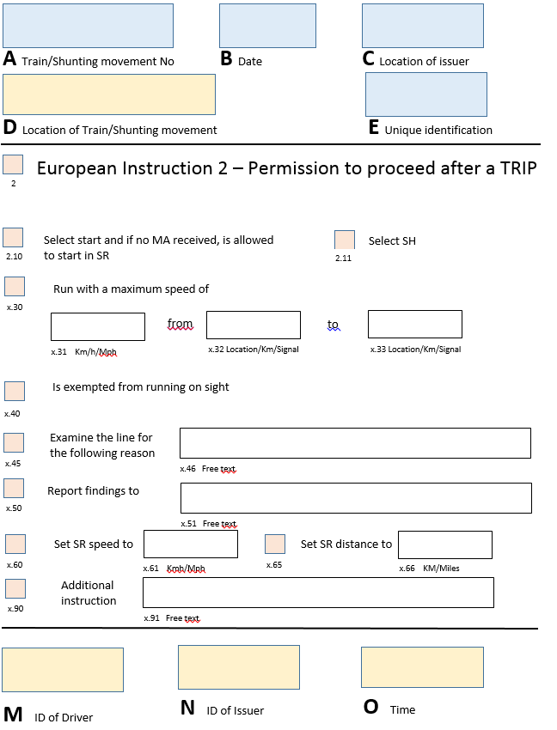
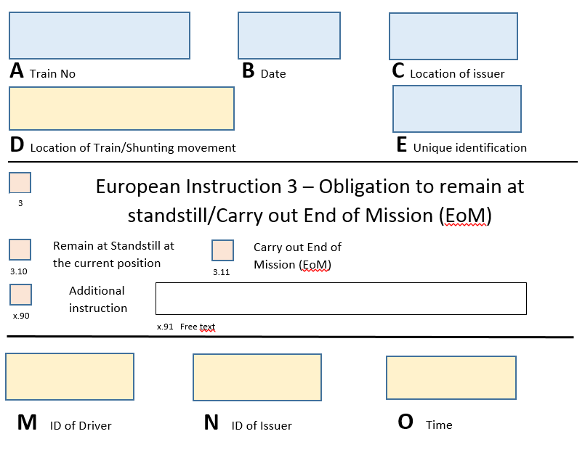
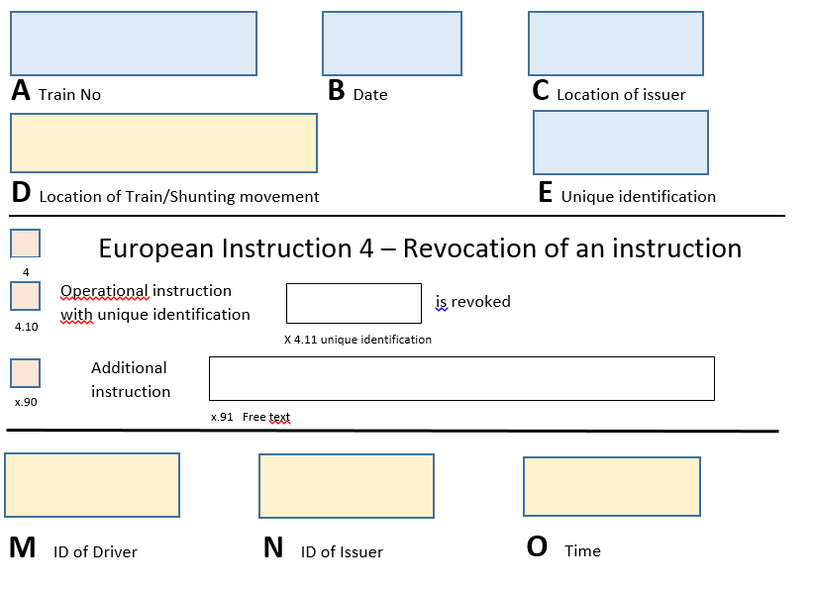
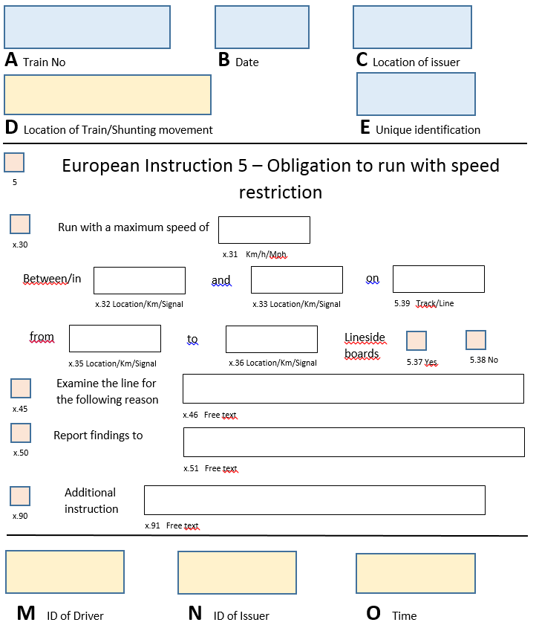
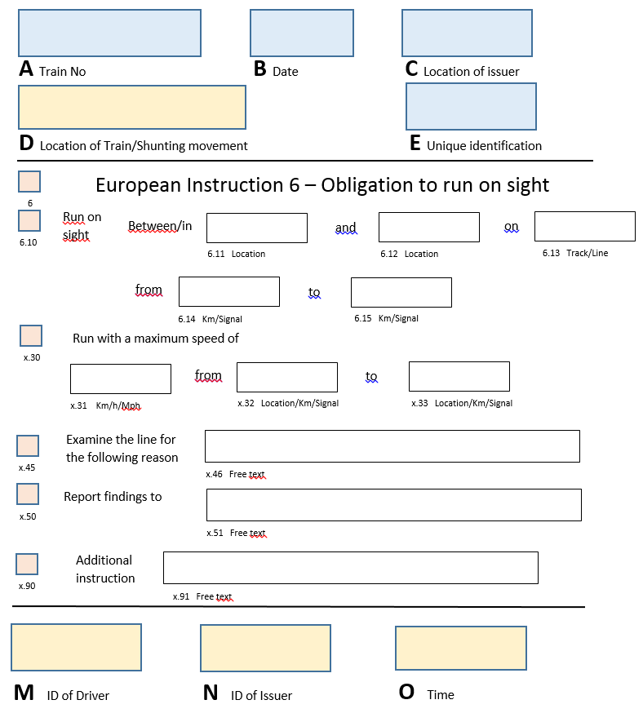
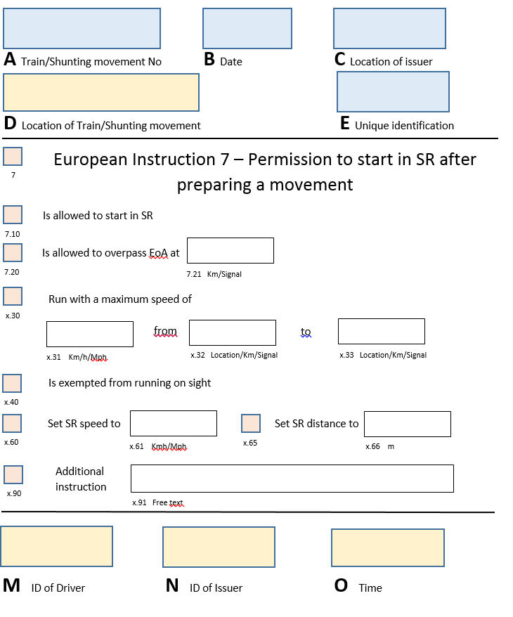
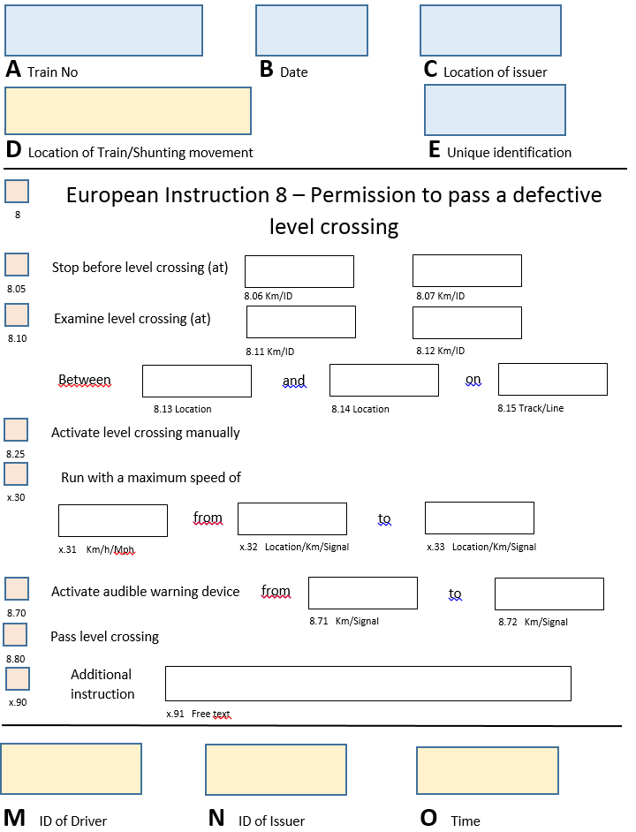
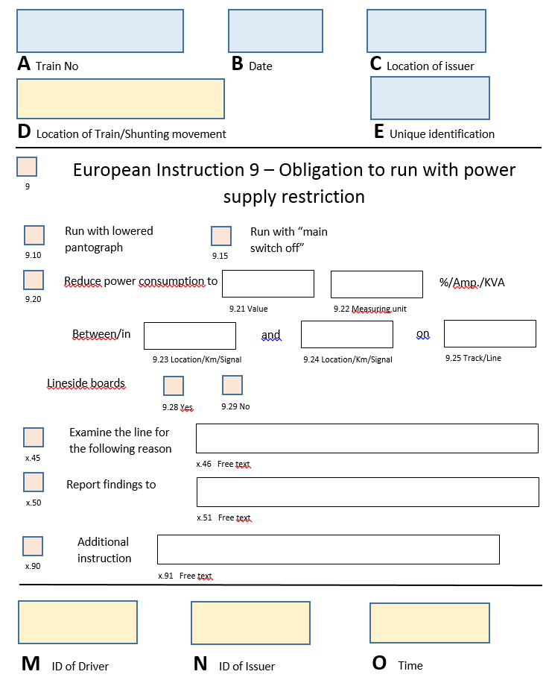

7. Communication of an operational instruction
Terminology shall be used in the communication procedure by all the parties:
Situation | Terminology
Cancelling an operational instruction | ‘Cancel procedure’
If the message is then subsequently to be resumed, the procedure shall be repeated from the start | ‘Error during transmission’
When a transmission error is discovered by the sender, the sender must request cancellation | ‘Error (+ prepare new form)’  Or  ‘Error (+ I say again)’
Error during read back | ‘Error (+ I say again)’
Misunderstanding: if one of the parties does not fully understand a message, the message must be repeated | ‘Say again (+speak slowly)

8. Book of Forms
The Infrastructure Manager is responsible for drawing up the Book of Forms and the forms themselves in its operating language.
All the forms to be used shall be assembled in a document or a computer medium called the Book of Forms.
This Book of Forms shall be used by both the driver and the staff authorising the movement of trains. The Book used by the driver and the Book used by the staff authorising the movement of trains shall be structured and numbered in the same way.

The Book of Forms shall comprise two parts.
The first part contains at least the following items:
- an index of written order Forms;
- a list of situations to which each Form applies;
- the table containing the international phonetic alphabet.
The second part contains the Forms themselves. These must be collected by the RU and given to the driver.

9. Glossary of Railway Terminology
The Railway Undertaking shall produce a glossary of railway terminology for each network over which its trains operate. It shall supply the terms in regular use in the language chosen by the Railway Undertaking and in the ‘operating’ language of the Infrastructure Manager(s) whose infrastructure the Railway Undertaking operates on.
The glossary shall be composed of two parts:
- a listing of terms by subject matter;
- a listing of the terms in alphabetical order.

Appendix D
Elements for the train compatibility over the route intended for operation and for the Route Book
Appendix D.1
Elements for the train compatibility over the route intended for operation

Notes:
- The vehicle information concerning the parameters indicated with * on the table below are also to be taken into account by the railway undertaking for the train composition, as defined in the section 4.2.2.5.2

Route compatibility check interface | Vehicle information available in the full accompanying file of the application for authorisation | Route information available in Register of Infrastructure (RINF) or provided by Infrastructure Manager
Traffic loads and load carrying capacity of infrastructure* | Design mass:  - in working order;  - under normal payload;  - under exceptional payload;  Maximum design speed;  Static axle load :  - in working order;  - under normal payload;  - under exceptional payload;  Vehicle length;  The position of the axles along the unit (axle spacing).  Static compatibility check for Wagons:  Permissible payload for different line categories according to TSI WAG. | - Load capability  1.1.1.1.2.4.1 National classification for load capability
Traffic loads and load carrying capacity of infrastructure* | Note: The static and dynamic compatibility checks shall be performed according to the procedures provided by the infrastructure manager.
Gauging * | Vehicle gauge :  - Reference profiles for which the vehicle was authorised;  - other gauges assessed. | 1.1.1.1.3.1.1 gauging  1.2.1.0.3.4 gauging
Gauging * | Note. It is expected that geometry of particular points (e.g. section of tunnel, bridges) is covered by the reference profile declared in RINF. In duly justified cases, discussion between Infrastructure Manager and Railway Undertaking might be needed for checking these specific points.
Vertical radius | Minimum vertical:  - convex curve radius capability  - concave curve radius capability | 1.2.2.0.3.3 Minimum radius of vertical curve (Concern siding)
Train detection systems * | Type of train detection systems for which the vehicle has been designed and assessed | 1.1.1.3.7.1 Type of train detection system
Train detection systems * | Note. In duly-justified cases, tests and/or checks could be done after authorisation, involving Railway Undertaking and Infrastructure Manager.
Hot axle box detection | Axle bearing condition monitoring (hot axles box detection)  Identification of trackside hot axle box detection when applicable  Generation of trackside hot axle box detection when applicable | 1.1.1.1.7.4 Existence of trackside Hot axle box detection  1.1.1.1.7.5 Trackside Hot axle box detection TSI compliant: Y/N,  If No:  - 1.1.1.1.7.6 Identification of trackside hot axle box detection;  - 1.1.1.1.7.7 Generation of trackside hot axle box detection;  - 1.1.1.1.7.8 Localization of trackside hot axle box detection  - 1.1.1.1.7.9 Direction of measurement of trackside hot axle box detection
Hot axle box detection | Note: If the network(s) of the area of use is composed by only one type of trackside hot axle box detector, no route compatibility check is needed.
Running characteristics | Combination(s) of maximum speed and maximum cant deficiency to which the vehicle was authorised (operational envelope that the vehicle has been assessed for);  Rail inclination. | 1.1.1.1.4.2 Cant deficiency  1.1.1.1.2.5 Maximum permitted speed  1.1.1.1.4.3 Rail inclination
Wheelset | Wheel set gauge | 1.1.1.1.4.1 Nominal track gauge  1.2.1.0.4.1 Nominal track gauge
Wheelset | Minimum in-service wheel diameter | 1.1.1.1.5.2 Minimum wheel diameter for fixed obtuse crossings
Wheelset | Type of changeover facilities to which the vehicle is designed for | 1.2.0.0.0.5 Geographical location of Operational Point  1.2.0.0.0.4.1 Type(s) of track gauge changeover facility (ies).
Minimum curve* | Minimum horizontal curve radius capability | 1.1.1.1.3.7 Minimum radius of horizontal curve  1.2.2.0.3.2 Minimum radius of horizontal curve
Braking* | At maximum service brake: Stopping distance, Maximum deceleration, for the load condition ‘design mass under normal payload’ at the design maximum speed.  For general operation, in addition to the above data: brake weight percentage (lambda), | 1.1.1.3.11.1 Maximum braking distance requested  1.1.1.1.3.6 Gradient profile  1.1.1.1.2.5 Maximum permitted speed  1.1.1.1.6.1Maximum train deceleration  1.1.1.3.11.2 Availability by the IM of additional information mentioned in the section 4.2.2.6.2.(2) is available or not (Y/N)  If yes:  1.1.1.3.11.3 Reference of the document(s) to be indicated in RINF.
Braking* | For General operation: covered by Railway Undertaking safety management system using the CSM on risk assessment. See clause 4.2.2.6 and TSI OPE application guide clause 6.  For pre-defined formation:  Comparison of the declared stopping distance and maximum train deceleration between Rolling Stock and the intended route for each load condition per design maximum speed.
Braking | Thermal capacity:  - Reference case of TSI;  - if no reference case is indicated, thermal capacity expressed in terms of:  - Speed;  - Gradient;  - Distance;  - Time (if distance is not indicated) | 1.1.1.1.3.6 Gradient profile  1.1.1.1.2.5 Maximum permitted speed
Braking * | Maximum gradient on which the unit is kept stationary by the parking brake alone (if the vehicle is fitted with it) | 1.1.1.1.3.6 Gradient profile  1.2.2.0.3.1 Gradient for stabling tracks
Magnetic track brake | Possibility of preventing the use of the magnetic brake (only if fitted with magnetic brake) | 1.1.1.1.6.3 Use of magnetic brakes
Magnetic track brake | Note: where magnetic brake is allowed, the infrastructure manager shall provide the conditions of its use.
Eddy current track brake | Possibility of preventing the use of the eddy current brake (only if fitted with eddy current brake) | 1.1.1.1.6.2 Use of eddy current brakes
Eddy current track brake | Note: where Eddy current track brake is allowed, the infrastructure manager shall provide the conditions of its use.
Weather conditions | Temperature range | 1.1.1.1.2.6 Temperature range
Weather conditions | Snow, ice and hail condition | 1.1.1.1.2.8 Existence of severe climatic conditions
Acceleration allowed at level crossing | Acceleration profile (acceleration=f (speed)) | 1.1.1.1.7.2 Existence of level crossings  1.1.1.1.7.3 Acceleration allowed at level crossing
Voltages and frequencies | Energy supply system :  - Nominal voltage and frequency;  - Type of contact line system  - Umin2,  - Umax2 | 1.1.1.2.2.1.1 Type of contact line system  1.1.1.2.2.1.2 Energy supply system (Voltage and frequency)  - 1.1.2.2.1.2.1 Energy supply system TSI compliant (Y/N)  - if No  - 1.1.1.2.2.1.3 Umin2 (lowest non permanent voltage) according to EN 50163  - 1.1.1.2.2.1.4 Umax2 (highest non permanent voltage) according to EN50163
Regenerative brake | Possibility of preventing the use of the regenerative brake (only if fitted with regenerative brake) | 1.1.1.2.2.4 Permission for regenerative braking
Current limitation | Electric units equipped with power or current limitation function. | 1.1.1.2.5.1 Current or power limitation on board
Current limitation | Note: TSI-compliant Rolling Stock with a maximum power higher than 2MW are equipped with current or power limitation.
Pantograph* | Maximum current at standstill per pantograph for each DC systems the vehicle is equipped for | 1.1.1.2.2.3 Maximum current at standstill per pantograph
Pantograph | Height of interaction of pantograph with contact wires (over top of rail) for each energy supply system the vehicle is equipped for | 1.1.1.2.2.5 Maximum contact wire height  1.1.1.2.2.6 Minimum contact wire height
Pantograph | Pantograph head for each energy supply system the vehicle is equipped for | 1.1.1.2.3.1 Accepted TSI compliant pantograph heads  1.1.1.2.3.2 Accepted other pantograph heads
Pantograph | Material of pantograph contact strip the vehicle may be equipped with for each energy supply system the vehicle is equipped for | 1.1.1.2.3.4 Permitted contact strip material
Pantograph* | Mean contact force curve | 1.1.1.2.5.2 Contact force permitted
Pantograph* | Number of pantographs in contact with the overhead contact line (OCL) ( for each energy supply system the vehicle is equipped for);  Shortest distance between two pantographs in contact with the OCL ( for each energy supply system the vehicle is equipped for; for single and, if applicable, multiple operation) (only if number of raised pantographs is more than 1);  Type of OCL used for the test of current collection performance (for each energy supply system the vehicle is equipped for) (only if number of raised pantographs is more than 1). | 1.1.1.2.3.3 Requirements for number of raised pantographs and spacing between them, at the given speed
Pantograph | Automatic dropping device (ADD) fitted (for each energy supply system the vehicle is equipped for) | 1.1.1.2.5.3 Automatic dropping device required
Tunnel | Fire safety category | 1.1.1.1.8.10 Fire category of rolling stock required  1.1.1.1.8.11 National fire category of rolling stock required  1.2.1.0.5.7 Fire category of rolling stock required  1.2.1.0.5.8 National fire category of rolling stock required
Vehicle length* | Vehicle length | 1.2.2.0.2.1 Usable length of siding  1.2.1.0.6.4 Usable length of platform
Platform height and  Access and egress | Platform heights for which the vehicle is designed | 1.2.0.6.4 Height of platform
ETCS | ETCS System Compatibility | 1.1.1.3.2.9 ETCS System Compatibility
ETCS | Cryptographic keys used for the protection of data transmitted via radio. | Provided by IM (Not in RINF)
ETCS* | Train Integrity | 1.1.1.3.2.8 Train integrity confirmation from on-board necessary for line access
GSM-R | Radio System Compatibility Voice | 1.1.1.3.3.9 Radio System Compatibility Voice
GSM-R | Radio System Compatibility Data | 1.1.1.3.3.10 Radio System Compatibility data
GSM-R | SIM Card GSM-R Home Network | 1.1.1.3.3.5 GSM-R networks covered by a roaming agreement
GSM-R | Support of public frequencies  SIM Card GSM-R Home Network | 1.1.1.3.3.6 Existence of Roaming to public networks  1.1.1.3.3.7 Details on Roaming to public networks  1.1.1.3.3.8 No GSM-R coverage
GSM-R | Use of Group ID 555 | 1.1.1.3.3.4 Need of Group 555
Class B | Class B train protection legacy system | 1.1.1.3.5.3 Train protection legacy systems
Class B | Class B radio legacy system | 1.1.1.3.6.1 Radio legacy system

Appendix D.2
Elements the Infrastructure Manager has to provide to the Railway Undertaking for the Route Book

Number | Route Book
1 | Generic information regarding the IM
1.1 | IM’s Name
2 | Maps and Diagrams
2.1 | Map: schematic overview including
2.1.1 | Line sections
2.1.2 | Principal locations (stations, yards, junctions, freight terminals)
2.2 | Line diagram
2.2.1 | Indication of running lines, loops catch/trap points and access to sidings
2.2.2 | Principal locations (stations, yards, junctions, freight terminals) and their position relative to the line
2.2.3 | Location, type and name of all fixed signals relevant for trains
2.3 | Station/Yard/Depot diagrams
2.3.1 | Name of location
2.3.2 | Type of location passenger terminal, freight terminal, yard, depot
2.3.3 | Location, type and identification of fixed signals that protect danger points
2.3.4 | Identification and plan of tracks, including switches
2.3.5 | Identification of platforms
2.3.6 | Length of platforms
2.3.7 | Height of platforms
2.3.8 | Curvature of platforms
2.3.9 | Identification of loops
3 | Specific Line Segment information
3.1 | General Characteristics
3.1.1 | Line segment extremity 1
3.1.2 | Line segment extremity 2
3.1.3 | Lineside indications of distance (frequency, appearance and positioning)
3.1.4 | Maximum permissible speed(s)/Speeds according to allocated path timetable
3.1.5 | Any other information the driver shall be aware of
3.1.6 | Specific geographical information required on the local infrastructure
3.1.7 | Means of Communication with the traffic management/control centre in normal, degraded and emergency situation
3.2 | Specific Technical Characteristics
3.2.1 | Gradient percentage
3.2.2 | Gradient location
3.2.3 | Tunnels: fire safety categorisation and tunnel-related data in clause 4.2.1.2.2.1c
3.2.4 | Non-stopping areas: identification, location, type
3.2.5 | Industrial risks – locations where it is dangerous for the driver to step out
3.2.6 | Locations of areas designated for testing the sanding device (if existing)
3.3 | Energy subsystem
3.3.1 | Energy supply system (voltage and frequency)
3.3.2 | Maximum train current
3.3.3 | Restriction related to power consumption of specific electric traction unit(s)
3.3.4 | Restriction related to the position of Multiple Traction unit(s) to comply with contact line separation (position of pantograph)
3.3.5 | Location of neutral sections
3.3.6 | Location of areas that must be passed with lowered pantographs.
3.3.7 | Conditions applying with regard to regenerative braking
3.3.8 | Maximum current at standstill per pantograph
3.4 | Control-Command and Signalling subsystem
3.4.1 | Need for more than one system active simultaneously
3.4.2 | Special conditions to switch over between different class B train protection, control and warning systems
3.4.3 | Special technical conditions required to switch over between ERTMS/ETCS and Class B systems
3.4.4 | Special instructions (location) to switch over between different radio systems
3.4.5 | Permissibility to use Eddy-current brake
3.4.6 | Permissibility to use magnetic brake
3.5 | Operation and Traffic Management subsystem
3.5.1 | Operating language
Appendix E
Language and communication level

The oral qualification in a language can be subdivided into five levels:
Level | Description
5 | - can adapt the way he/she speaks to any interlocutor  - can put forward an opinion  - can negotiate  - can persuade  - can give advice
4 | - can cope with totally unforeseen situations  - can make assumptions  - can express an argued opinion
3 | - can cope with practical situations involving an unforeseen element  - can describe  - can keep a simple conversation going
2 | - can cope with simple practical situations  - can ask questions  - can answer questions
1 | - can talk using memorised sentences
Appendix F:
Minimum elements relevant to professional qualification for the tasks associated with “accompanying trains”

General requirements
      - This Appendix, which must be read in conjunction with points 4.6 and 4.7 is a list of the elements that are deemed to be relevant to the tasks associated with accompanying a train on the network.
      - The expression “professional qualification”, when taken within the context of this TSI, refers to those elements that are important to ensure that operational staff are trained and able to understand and discharge the tasks.
      - Rules and procedures apply to the tasks being performed and to the person carrying out the tasks. These tasks may be carried out by any authorised qualified person irrespective of any name, job title or grade used in rules or procedures or by the individual company.

Professional knowledge
Any authorisation requires a successfully passed initial examination and provisions for ongoing assessment and training as described in point 4.6.

General professional knowledge
      - Principles of organisation’s safety management system, relevant to the tasks.
      - Roles and responsibilities of the key players involved in operations.
      - General conditions relevant to the safety of passengers or cargo and persons on or about the railway track.
      - Conditions of health and safety at work.
      - General principles of security of the railway system.
      - Personal safety including when leaving the train on the running line.

Knowledge of operational procedures and safety systems relevant to the tasks
      - Operational procedures and safety rules.
      - Relevant aspects of control command and signalling system.
      - Formalised messaging procedure including use of communication equipment.

Knowledge of rolling stock
      - Passenger vehicle interior equipment.
      - Appropriate knowledge of safety-critical tasks in respect to procedures and interfaces for rolling stock.

Knowledge of the route
      - Relevant operational arrangements (such as the method of train despatch) at individual locations (station equipment and signalling etc.).
      - Stations at which passengers may alight or board the train.
      - Local operating and emergency arrangements specific to the line(s) of route.

Knowledge on passenger safety
The training on passenger safety shall cover at least the following:
  - Principles to ensure the safety of passengers:
- Support Passengers with Reduced Mobility;
- Identify the hazards;
- Procedures applicable to accidents involving persons;
- Events of a fire and/or smoke;
- Evacuation of passengers.
  - Principles of communication:
- Identify who needs to be contacted and understand communication methods, especially with the signaller during an evacuation incident;
- Identify causes/situations and requests to initiate communication
- Communication methods for informing passengers;
- Communication methods in degraded operations/emergency situations.
  - Behavioural skills:
- Situational awareness;
- Conscientiousness;
- Communication;
- Decision making and action.

Ability to put the knowledge into practice
The ability to apply this knowledge in normal, degraded and emergency situations will require staff to be fully acquainted with:
- Methods and principles for applying the rules and procedures;
- Process for the use of line-side equipment and rolling stock, as well as any specific safety-related equipment;
In particular with:
      - Checks before departure, including brake tests if necessary and correct closure of the doors.
      - Departure procedure.
      - Degraded operation.
      - Assess the potential of a defect within the passenger areas and react according to rules and procedures.
      - Protection and warning measures as required by the rules and regulations or in assistance to the driver.
      - Communicate with the Infrastructure Manager’s staff when assisting the driver.
      - Report any unusual occurrences concerning the operation of the train, the condition of the rolling stock and the safety of passengers. If required these reports must be made in writing, in the language chosen by the Railway Undertaking.
Appendix G
Minimum elements relevant to professional qualification for the task of preparing trains

General requirements
  - This Appendix, which must be read in conjunction with point 4.6, gives a list of the elements that are deemed to be relevant to the task of preparing a train on the network.
  - The expression “professional qualification”, when taken within the context of this TSI, refers to those elements that are important to ensure that operational staff are trained and able to understand and discharge the elements of the task.
  - Rules and procedures apply to the task being performed and to the person carrying out the task. These tasks may be carried out by any authorised qualified person irrespective of any name, job title or grade used in rules or procedures or by the individual company.

Professional knowledge
Any authorisation requires a successfully passed initial examination and provisions for ongoing assessment and training as described in point 4.6.

General professional knowledge
  - Principles of organisation’s safety management system, relevant to the task.
  - Roles and responsibilities of the key players involved in operations.
  - General conditions relevant to the safety of passengers and/or cargo including the carriage of dangerous goods and exceptional loads.
  - Appreciation of hazards, especially in relation to the risks involving railway operation and electric traction supply.
  - Conditions of health and safety at work.
  - General principles of security of the railway system.
  - Personal safety when on or in the vicinity of rail lines.
  - Communications principles and formalised messaging procedure including use of communication equipment.

Knowledge of operational procedures and safety systems relevant to the task
  - Working of trains in normal, degraded and emergency situations.
  - Operational procedures at individual locations (signalling, station/depot/yard equipment) and safety rules.
  - Local operating arrangements.

Knowledge of train equipment
  - Purpose and use of wagon and vehicle equipment.
  - Identification of and arranging for technical inspections.
  - Appropriate knowledge of safety-critical tasks in respect to procedures and interfaces for rolling stock.

Ability to put the knowledge into practice
The ability to apply this knowledge in normal, degraded and emergency situations will require staff to be fully acquainted with:
- Methods and principles for applying the rules and procedures;
- Process for the use of line-side equipment and rolling stock, as well as any specific safety-related equipment;
In particular:
      - Application of train composition rules, train braking rules, train loading rules etc. to ensure the train is in running order.
      - Understanding of marking and labels on vehicles.
      - Process for determining and making train data available.
      - Communication with train crew.
      - Communication with staff responsible for controlling the movement of trains.
      - Degraded operations especially as it affects the preparation of trains.
      - Protection and warning measures as required by the rules and regulations or local arrangements at the location in question.
      - Actions to be taken in respect to incidents involving the carriage of dangerous goods (where relevant).
Appendix H
European Vehicle Number and linked alphabetical marking on the bodywork

GENERAL PROVISIONS ON THE EUROPEAN VEHICLE NUMBER
The European Vehicle Number is assigned according to the codes defined in Decision 2007/756/EC, Appendix 6.
The European Vehicle Number shall be changed when it does not reflect the interoperability capability or technical characteristics according to this Appendix due to technical modifications of the vehicle. Such technical modifications may require a new placing on the market according to Article 21 of Directive (EU) 2016/797.

GENERAL ARRANGEMENTS FOR EXTERNAL MARKINGS
The capital letters and figures making up the marking inscriptions shall be at least 80 mm in height, in a sans serif font type of correspondence quality. A smaller height may only be used where there is no option but to place the marking on the sole bars.
The marking is put not higher than 2 metres above rail level.
The keeper can add, in letters of larger size than the European Vehicle Number, an own number marking (consisting generally of digits of the serial number supplemented by alphabetical coding) useful in operations. The place where the own number is marked is left to the choice of the keeper, however it must be always be possible to distinguish easily the European Vehicle Number from the keeper’s own number marking.

WAGONS
The marking shall be inscribed on the wagon bodywork in the following manner:
23. TEN  80 D-RFC  7369 553-4  Zcs | 31. TEN  80 D-DB  0691 235-2  Tanoos | 33. TEN  84 NL-ACTS  4796 100-8  Slpss
Where in the examples
D and NL stand for the registering Member State as set out in NVR-decision 2007/756/EC, Appendix 6, part 4.
RFC, DB and ACTS stand for the keeper marking as set out in NVR-decision 2007/756/EC, Appendix 6, part 1.
For wagons whose bodywork does not offer a large enough area for this type of arrangement, particularly in the case of flat wagons, the marking shall be arranged as follows:
01 87 3320 644-7
TEN F-SNCF Ks
When one or more index letters of national significance are inscribed on a wagon, this national marking must be shown after the international letter marking and separated from it by a hyphen as follows:
01 87 3320 644-7
TEN F-SNCF Ks-xy

COACHES AND HAULED PASSENGER STOCK
The number shall be applied to each sidewall of the vehicle in the following manner:
F-SNCF 61 87 20 - 72 021 - 7
B¹⁰ tu
The marking of the country in which the vehicle is registered and of the technical characteristics are printed directly in front of, behind or under the twelve digits of the vehicle number.
In case of coaches with driver’s cabin, the European Vehicle Number is also written inside the cabin.

LOCOMOTIVES, POWER CARS AND SPECIAL VEHICLES
The European Vehicle Number must be marked on each sidewall of the tractive stock in the following manner:
92 10 1108 062-6
The European Vehicle Number is also written inside each cabin of the tractive rolling stock.

ALPHABETICAL MARKING OF THE INTEROPERABILITY CAPABILITY
‘TEN’: Vehicle which is provided with an authorisation valid for an area of use covering all Member States.

  - ‘PPV/PPW’: Vehicle which complies with PPV/PPW or PGW agreement (inside OSJD States). (original: PPV/PPW: ППВ (Правила пользования вагонами в международном сообщении); PGW: Правила Пользования Грузовыми Вагонами)
Vehicles which are provided with an authorisation valid for an area of use which does not cover all Member States need a marking indicating the Member States where the vehicle is authorised to be placed in service. This marking shall be according to one of the following drawings, where D stands for the Member State who has granted the first authorisation (in the given example, Germany) and F stands for the second authorising MS (in the given example, France). The MS are codified in accordance with Decision 2007/756/EC, Appendix 6, part 4.
Appendix I

List of areas for which national rules are permitted according to article 8 of Directive (EU) 2016/798

In accordance with Article 8.4. of Directive (EU) 2016/798 and the Agency Regulation Articles 13 (5) and 25, Member States shall submit the draft of a new national rule to the Agency and the Commission before the expected introduction into the national legal system of the proposed new rule and providing justification for its introduction.

- Areas for national rules

Shunting

Signalling rules
Rules related to the operational use of the national signalling system

Maximum speeds in degraded mode including running on sight

Running at caution

Local operational rule
Relating to specific local conditions where additional information may be needed – this is limited to requirements not covered by the TSI

Operation during works

Safe operation of test train

Train visibility – Front end (see 4.2.2.1.2)
Existing vehicles

Train visibility – Rear end (see 4.2.2.1.3)
System in use steady red lights or reflective plates
Existing vehicles

Managing an emergency situation (see point 4.2.3.7)
Role of local/national authorities and emergency services

Safety-related communications terminology (see Appendix C)
National operational instructions

- List of open points

Exceptional transport

Timetable (see 4.2.1.2.3)
Additional information

Recording of supervision data outside the train (see 4.2.3.5.1)
Additional information

Recording of supervision data on-board the train (see 4.2.3.5.2)
Additional information

Professional competences (see point 4.6)
- Staff with safety critical tasks other than train drivers;
- Additional information for staff undertaking the safety critical tasks associated with accompanying a train other than train driver;
- Additional information for staff undertaking the safety critical tasks associated with the last preparation of a train before it is scheduled to cross a border and work beyond any location(s) designated as the “frontier” in the network statement of an infrastructure manager and included in his safety authorization.

Health and safety conditions (see point 4.7)
- Staff with safety critical tasks other than train drivers;
- Additional information for staff undertaking the safety critical tasks associated with accompanying a train other than train driver;
- Alcohol limits (see 4.7.1).

Rules under Annex C (see Appendix A)

Common operational principles and rules (See 4.4 and Appendix B)
- Sanding – automatic sanding device and report in case of use of the sanding device;
- Failure of level crossing – additional information;

Safety-related communications terminology (see Appendix C)
Additional terms

Appendix J
Glossary
The definitions in this glossary refer to the use of terms in this TSI OPE.
Term | Definition
Accident | As defined in Article 3 of Directive (EU) 2016/798.
Authorising train movements | The operation of equipment in signalling centres, electric traction current supply control rooms and traffic control centres that permits train movement. This does not include those staff employed by a Railway Undertaking who are responsible for management of resources such as train crew or rolling stock.
Competence | The qualification and experience necessary to safely and reliably undertake the task being performed. Experience can be gained as part of the training process.
Dangerous goods | As covered by Directive 2008/68/EC of 24 September 2008 on the inland transport of dangerous goods
Degraded operation | Operation resulting from an unplanned event that prevents the normal delivery of train services.
Despatch (= dispatch) | See Train despatch
Driver | As defined in Article 3 of Directive 2007/59/EC.
Emergency call | Call set up in some dangerous situations to warn all trains / shunting movements in a defined area.
End of authority passed without permission | An end of authority passed without permission is any occasion when a train proceeds beyond the end of authority in the following circumstances:  - A trackside signal at danger, or an order to STOP where an ATP is not operational,  - The end of a movement authority provided in an ATP,  - A point communicated by verbal or written authorisation laid down in regulations,  - Stop boards,  - Hand signals.  This covers movement authority as described in ETCS and authority to move covered by instructions/written orders/signalling.  Any case in which a vehicle without any traction unit attached or a train that is unattended runs away is not included.
European instruction | An harmonised operational instruction giving a similar content to train drivers across the European Union in order for them to answer in a similar manner to similar situation.
Evacuation | Evacuation of a train is when all passengers are instructed to leave the train and go on to the infrastructure under the supervision of on-board staff. On-board staff having agreed with the signaller or other responsible IM staff, that it is safe to do so.
Exceptional transport | A vehicle and/or the load carried which because of construction/design, dimensions or weight does not meet the parameters of the route and requires special authority for the movement and may require special conditions over part or its entire journey.
Health and Safety Conditions | In the context of this TSI, this refers only to the medical and psychological qualifications required to operate the relevant elements of the subsystem.
Hot axle box | An axle box and bearing that has exceeded its maximum designed operating temperature.
Incident | As defined in Article 3 of Directive (EU) 2016/798.
Length of train | Total length of all vehicles over buffers including locomotive(s)
Loop | Track, connected to the main track, used for passing, crossing and stabling.
National instruction | An instruction defined at national level or by an Infrastructure Manager which covers situations specific to a Class B system or the transition between class A and class B systems.
Operating Language | The language or languages used in daily operation an Infrastructure Manager and published in his Network Statement, for the communication of operational or safety related messages between the staff of the Infrastructure Manager and the Railway Undertaking.
Operational instruction | Formal information exchanged between signaller and train driver so as to ensure/continue railway operation in specific situations. The operational instruction exists at both national and European levels.
Passenger | Person (other than an employee with specific duties on the train) travelling by train or on railway property before or after a train journey.
Performance monitoring | The systematic observation and recording of the performance of the train service and the infrastructure for the purpose of bringing about improvements in the performance of both.
Qualification | The physical and psychological suitability for the task together with the required knowledge.
Real time | The ability to exchange or process information on specified events (such as arrival at a station, passing a station or departure from a station) on the trains journey as they occur.
Reporting point | A point on the trains schedule where reporting of the arrival, departure or passing time is required.
Route | The particular section or sections of line
Safety-critical task | Task performed by staff when they control or affect the movement of a train, which could affect railway safety.
Scheduled stop | Planned stop for commercial or operational reasons.
Siding | Any track(s) within an operational point which is used only for movement other than train movement.
Signaller | Performer in charge of the route setting of trains / shunting movements and of issuing instructions to drivers.
Staff | Employees working for a Railway Undertaking or an Infrastructure Manager, or their contractors, undertaking tasks as specified in this TSI.
Stop aspect | Any signal aspect that does not allow the driver to pass the signal.
Stopping point | A location identified in the schedule of a train where the train is planned to stop, usually to carry out a specific activity such as allowing passengers to join and leave the train.
Timetable | Document or system that gives details of a train(s) schedule over a particular route.
Timing point | A location identified in the schedule of a train where a specific time is identified. This time may be an arrival time, departure time or in the case of a train not scheduled to stop at that location the passing time.
Traction unit | A powered vehicle able to move itself and other vehicles to which it may be coupled.
Train | A train is defined as (a) traction unit(s) with or without coupled railway vehicles with train data available operating between two or more defined points.
Train despatch | The indication to the person driving the train that all station or depot activities are completed and that, as far as the staff responsible are concerned, movement authority has been granted for the train.
Train crew | Members of the on-board staff of a train, who are certified as competent and appointed by a Railway Undertaking to carry out specific, designated safety related tasks on the train, for example the driver or the guard.
Train preparation | Ensuring that a train is in a fit condition to enter service, that the train equipment is correctly deployed and the train composition matches the train’s designated route(s). Train preparation also includes technical inspections carried out prior to the train entering service.

Abbreviation | Explanation
AC | Alternating current
ATP | Automatic Train Protection
CCS | Control-Command and Signalling
CEN | European Committee for Standardisation (Comité Européen de Normalisation)
COTIF | Convention Concerning International Carriage by Rail (COnvention relative aux Transports Internationaux Ferroviaires)
dB | Decibels
DC | Direct Current
DMI | Driver Machine Interface
EC | European Community
ECG | Electro Cardiogram
EIRENE | European Integrated Railway Radio Enhanced Network
EN | Euro-norm
ENE | Energy
ERA | European Union Agency for Railways
ERTMS | European Rail Traffic Management System
ETCS | European Train Control System
EU | European Union
FRS | Functional Requirement Specification
GSM-R | Global System for Mobile Communications - Rail
IM | Infrastructure Manager
INF | Infrastructure
OPE | Operation and Traffic Management
OSJD | Organisation for Co-operation of Railways
PPV /  PPW | Russian abbreviation for Prawila Polzowaniia Wagonami w mejdunarodnom soobqenii = Rules for use of railway vehicles in international traffic
RST | Rolling Stock
RU | Railway Undertaking
SMS | Safety Management System
SPAD | Signal Passed at Danger
SRS | System Requirement Specification
TAF | Telematic Applications for Freight
TEN | Trans-European Network
TPS | Train Protection System
TSI | Technical Specification for Interoperability
UIC | International Union of Railways (Union Internationale des Chemins de fer)

uropean Parliament and of the Council of 21 November 2012 establishing a single European railway area (recast) (OJ L 343, 14.12.2012, p.32)
2018 establishing common safety methods on safety managemCommission Regulation (EU) No 1169/2010 of 10 December 2010 on a common safety method for assessing conformity with the requirements for obtaining a railway safety authorisation (OJ L 327, 11.12.2010, p. 13).

