MINISTRY OF SUSTAINABLE DEVELOPMENT
AND INFRASTRUCTURE
Department of Transport
Technical Investigation Administration (Administration des Enquêtes Techniques)

Activity Report 2015

November 2016

Railway Sector

TECHNICAL INVESTIGATION ADMINISTRATION
CIVIL AVIATION – MARITIME – INLAND WATERWAYS – RAILWAYS

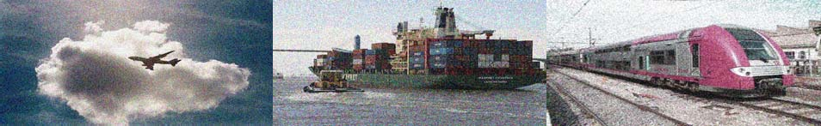

Foreword

This activity report summarises the activities of the Technical Investigation Administration (Administration des enquêtes techniques – AET) in the railway sector in 2015, as well as the accidents and incidents that occurred on the Luxembourg rail network and that were notified by the infrastructure manager or railway undertakings in the same year.

In 2015, the AET did not carry out any safety investigations in the railway sector, given that the circumstances of events did not meet the conditions for an investigation, in accordance with Article 19 of Directive 2004/49/EC of 29 April 2004 on safety on the Community’s railways.

This document has been prepared in accordance with Article 10(2) of the Grand-Ducal Regulation of 7 November 2008 laying down additional specifications for accidents and incidents occurring in the railway sector, and also in accordance with Article 23(3) of Directive 2004/49/EC.

Technical Investigation Administration (Administration des Enquêtes Techniques – AET) General context
The Technical Investigation Administration was set up in 2008 following implementation of the Law of 30 April 2008 (a) creating the Technical Inspection Administration, (b) amending the amended Law of 22 June 1963 laying down the salaries system for civil servants, and (c) repealing the Law of 8 March 2002 on technical investigation bodies for serious accidents and incidents occurring in the civil aviation, maritime transport and railway sectors.

Its aim is to improve safety in the civil aviation, maritime and inland waterway transport, and railway sectors.

There were no major accidents involving Luxembourg in the railway sector in 2015. Some of the AET’s time was spent on ensuring good relations and cooperation with other stakeholders in its areas of activity, at both the national and international levels.

Functional context

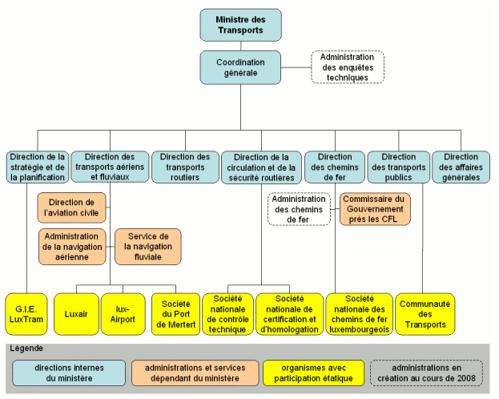

Ministre des Transports | Minister for Transport
Coordination générale | General Coordination Unit
Administration des enquêtes techniques | Technical Investigation Administration
Direction de la stratégie et de la planification | Strategy and Planning Directorate
Direction des transports aériens et fluviaux | Air and Inland Waterway Transport Directorate
Direction des transports routiers | Road Transport Directorate
Direction de la circulation et de la sécurité routières | Road Safety and Traffic Directorate
Direction des chemins de fer | Railway Directorate
Direction des transports publics | Public Transport Directorate
Direction des affaires générales | General Affairs Directorate
Direction de l’aviation civile | Civil Aviation Directorate
Administration de la navigation aérienne | Air Traffic Authority
Service de la navigation fluviale | Inland Waterway Traffic Service
Administration des chemins de fer | Railway Authority
Commissaire du Gouvernement près les CFL | Government Commissioner to the SNCFL (Luxembourg National Railway Company)
G.I.E. Lux Tram | G.I.E. Luxtram
Luxair | Luxair
lux-Airport | lux-Airport
Société du Port de Mertert | Société du Port de Mertert (Mertert Port Company)
Société nationale du contrôle technique | Société nationale du contrôle technique (National Technical Inspection Company)
Société nationale des chemins de fer luxembourgeois | Société nationale des chemins de fer luxembourgeois (Luxembourg National Railway Company)
Communauté des Transport | Communauté des Transports (Transport Community)
Légende | Key
directions internes du ministère | Ministry’s internal directorates
administrations et services dépendant du ministère | Authorities and services answerable to the Ministry
organismes avec participation étatique | Bodies with government involvement
administrations en création au cours de 2008 | Authorities being created during 2008

The AET is an independent body, which comes under the responsibility of the Minister for Transport.

Internal structure of the AET up to 31 December 2015:
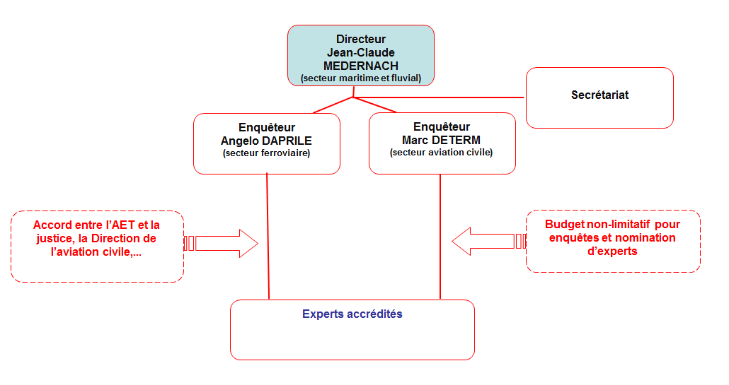

Directeur  Jean-Clauce MEDERNACH  (secteur maritime et fluvial) | Director  Jean-Claude MEDERNACH  (Maritime and Inland Waterway Sector)
Secrétariat | Secretariat
Enquêteur  Angelo DAPRILE  (secteur ferroviaire) | Investigator  Angelo DAPRILE  (Railway Sector)
Enquêteur  Marc DETERM  (secteur aviation civile) | Investigator  Marc DETERM  (Civil Aviation Sector)
Accord entre l’AET et la justice, la Direction de l’aviation civile, … | Agreement between the AET and the Luxembourg courts, the Civil Aviation Directorate, etc.
Budget non-limitatif pour enquêtes et nomination d’experts | Open-ended budget for investigations and appointment of experts
Experts accrédités | Accredited experts

There were no staffing changes during 2015. The AET has a director, two investigators and an administrator.

After more than seven years at the helm of the AET – indeed since its creation in April 2008 – the director has decided to retire. His retirement was announced with effect from 1 January 2016. The recruitment process started in December 2015 with a call for applications for the vacant post.

However, it should be noted that, if necessary for a safety investigation, the Law of 30 April 2008 creating the Technical Investigation Administration allows expert assistance from outside the AET to be procured.

With regard to its status, it should be noted that the AET’s independence in both organisational and operational terms is vital to the functioning of a safety investigation body in accordance with EU and international requirements. That is why it has an open-ended budget for investigations and appointment of experts.

Legislative context

The Luxembourg legislative framework with regard to technical investigations in the railway sector currently consists of the following:

- Law of 30 April 2008 (a) creating the Technical Inspection Administration,
(b) amending the amended Law of 22 June 1963 laying down the salaries system for civil servants, and (c) repealing the Law of 8 March 2002 on technical investigation bodies for serious accidents and incidents occurring in the civil aviation, maritime transport and railway sectors.

- Grand-Ducal Regulation of 7 November 2008 on additional specifications with regard to accidents and incidents in the railway sector.

- Directive 2004/49/EC of the European Parliament and of the Council of 29 April 2004 on safety on the Community's railways.

- Grand-Ducal Regulation of 21 September 2011 laying down the terms of issue, use and withdrawal of identity cards for staff of the Technical Investigation Administration appointed to act as investigator, for investigators appointed from outside said Administration and for experts involved in technical investigations into serious accidents and incidents in the civil aviation, maritime transport and railway sectors.

European cooperation

As it is responsible for several forms of transport, the AET is invited to take part in numerous meetings and other activities at both the European and international levels. The contacts and information obtained at these events are particularly important as they enable investigators, if necessary and in the absence of the requisite skills in-house, to quickly procure expert assistance and knowledge from foreign authorities and organisations.

Cooperation between investigating bodies is also encouraged by the international organisations (ICAO, IMO) and the European organisations and bodies (ENCASIA, ECAC, EMSA, ERA) for each form of transport.

Safety events in 2015

In 2015, 47 safety events were notified to the AET by the infrastructure manager or by the railway undertakings involved.
It should be noted that the number of events was more than double the number in 2014 (20 events in 2014). Even though there were no serious accidents meeting the criteria for a safety investigation to be carried out by the AET, these figures reveal a considerable increase in the number of potentially dangerous events. Of the 47 safety events in 2015, 27 involved a signal being passed at danger where the train driver inadvertently failed to observe the signals, meaning that the train did not stop at a signal at danger.
Added to this is the fact that traffic is constantly increasing on the Luxembourg rail network, thus increasing the risk of accidents.

The following table summarises the events on the Luxembourg network that were notified to the AET in 2015.

Statistics for 2015 in the railway sector

 | category | accidents | serious incidents | incidents | Total per category
A | Damage to installations or equipment | -- | -- | -- | --
B | Disruption to installations | -- | -- | -- | --
C | Shunting incidents and accidents | -- | -- | 19 | 19
D | Incidents and accidents in the movement of trains | -- | -- | 22 | 22
E | Incidents and accidents involving road vehicles on level crossings and on the operating service’s premises | -- | -- | 2 | 2
F | Accidents at work | -- | -- | -- | --
G | Accidents involving people (including suicides) | -- | -- | 4 | 4
H | Fires, explosions | -- | -- | -- | --
J | Criminal offences | -- | -- | -- | --
K | Natural events | -- | -- | -- | --
L | Demonstrations, strikes, etc. | -- | -- | -- | --
M | Other extraordinary events | -- | -- | -- | --
 | Total per classification | -- | -- | 47 | 47
 |  |  |  |  | Total
(Source: Notifications received by the AET)

