CP SERVICE QUALITY AND CUSTOMER SATISFACTION REPORT - 2019

JUNE 2020

technical specifications

CP – Comboios de Portugal, E.P.E.
Calçada do Duque, nº 20
1249 – 109 Lisbon
Corporate body no.: 500 498 601
Registered in the Commercial Registry Office of Lisbon under the no. 109
Statutory Capital € 3,404,000,000.00 (as at December 31, 2017)
Design and Coordination:
- QA - Quality, Environment and Safety
Collaboration:
- OC - Operations and Commercial
- ME - Maintenance and Engineering
- PE - Strategic Planning

Contacts: webmaster@cp.pt

index
technical specifications 2
index 3
executive summary 5
1-introduction 8
2-about cp 11
3-service quality performance 15
3.1 – information and tickets 15
3.2 - service punctuality 23
3.3 – service cancellation 25
3.4 - hygiene and cleaning of rolling stock (air quality in carriages, cleanliness of sanitary facilities, etc.) 27
3.5 - customer satisfaction survey 29
3.6 handling of customer complaints, refunds and compensation for non-compliance with service quality standards 32
3.6.1 - handling of customer complaints 32
3.6.2 - refunds and compensation for delay or cancellation 34
3.7 - assistance to disabled persons and persons with reduced mobility 35
attachment - indicators BI 40
illustrations index 41
graphics index 41
tables index 41


SERVICE QUALITY REPORT
EXECUTIVE SUMMARY

executive summary

The report on CP's quality of service and customer satisfaction to be published annually aims to characterize the quality of service provided by CP to its clients and the assessment made by clients of the service provided by CP.
This report covers the period from January 1, 2019 to December 31, 2019.
When analysing the performance values of the various service attributes, it is clear that CP shows high levels of performance in all of them, with the exception of:
- customer care line, calls answered up to 30” / calls answered (77% for a target >85%).
- train punctuality on the following services (punctuality <90%): Alfa Pendular (65%), Intercidades (61%), Interrregional (63%), Regional (81%), Lisbon Urban Trains (85%) and Oporto Urban Trains (85%).
- CP/IP Customer satisfaction study in the "customer care", "quality of service" and "comfort” departments.
- complaints from customers where "sales channels" (36%), "circulation" (26%) and "regulation and pricing" (16%) appear as the main reason for discontent. The “average customer response time” exceeds the target set (target <30 days).
- accessibility of carriages for people with reduced mobility (performance: 46%).
CP has not yet found an expeditious and economical methodology to monitor some service attributes, in particular:
- information provided to passengers in a disrupted situation, and
- measurement of the air quality inside the carriages when performing commercial service.

SERVICE QUALITY REPORT
- INTRODUCTION

1-introduction
We have added to the public service that we have always been obliged to provide, sustainability for the company.
Illustration 1 - Customer
Over the past few years we have successively achieved positive EBITDA (earnings before interest, taxes, depreciation and amortization). This document is in line with the CP strategy and aims to achieve
"Quality is our best guarantee of customer loyalty, our strongest defence against competition and the only path to growth and profits"
(Jack Welch)
the following objectives:
- Align the real performance of the company with customer expectations, inducing clear, transparent and understandable communication;
- Improve the company’s image;
- Raise awareness on company's employees in order to provide a quality service.
- Comply with art. 28 and its Annex III, of Regulation (EC) No. 1371/2007 on "rail passengers' rights and obligations".
Also according to the aforementioned art. 28 it should be noted that in 2000 CP began, in stages, the implementation of the quality management system (QMS). All the activities developed by CP are certified in the quality area according to ISO 9001:2015.
This means that every year all processes are subject to an internal and external audit. External audits are developed by an independent external entity accredited by APAC - Portuguese Accreditation Association.
The certification confirms that CP has policies, objectives, processes, methodologies, standards, resources, competencies and systems oriented to satisfy the clients' needs.
This certification also bears witness to the change in attitudes, behaviour and management style, leading to the implementation of systematic and integrated cycles of improvement that can be sacrificed from time to time when the economic situation of the company or its shareholder does not allow it.

QA

SERVICE QUALITY REPORT
- ABOUT CP

2-about cp

On October 28, 1856, the first train journey in Portugal took place.
After a period in which several public and private companies coexisted, the integration arose in 1951 with the constitution of the Companhia dos Caminhos de Ferro Portugueses. CP - Caminhos de Ferro Portugueses, E.P. was created in 1975 as a public company responsible for the management of the railways in Portugal and became a public company in June 2009 (Decree-Law no. 137-A/2009 of June 12th), responsible for providing national and international rail passenger transport services.
In the railway sector, CP - Comboios de Portugal, E.P.E., articulates with IP - Infraestruturas de Portugal, S.A. - entity responsible, among others, for the management of the railway infrastructure and with IMT- Instituto da Mobilidade e dos Transportes [Institute for Mobility and Transport] - entity responsible, among others, for the regulation, promotion and defence of competition in the mobility sector and in the scope of land transport.
In March 2014, with the creation of the former Directorate General for Production and Business (DGP), the management of operational resources became centralised, allowing the development of an efficient production model and creating synergies between urban, regional and long distance services, through an integrated management, boosting the increase in productivity, cost reduction and network effect.
The business, on the commercial side, is now managed by three distinct areas, namely “Lisbon urban", “Oporto urban" and “regional and long distance", which should work the respective business segments, aiming to create competitive services in the passenger transport market, with high quality, either through the supply model or through the price policy practiced, seeking its commercialization and aiming at the profitability and consequent sustainability of the business.
In 2017, with the creation of the "operating management", centralised management was strengthened, with the integration of complaints management and sales channels into a single body.
The company ended the year 2019 with 2 669 employees, 14 less than at the end of the previous year.
In 2019 more than 144 million passengers were transported by CP, corresponding to an increase of 14.7% in relation to 2018 and representing, in absolute terms, an increase of approximately 19 million passengers transported.
The extension of the railway network operated by CP has evolved as follows:
 | Dec. 2016 | Dec. 2017 | Dec. 2018
 | 2,145 | 2,179 | 2,241
Table 1- Extension of the railway network operated by CP

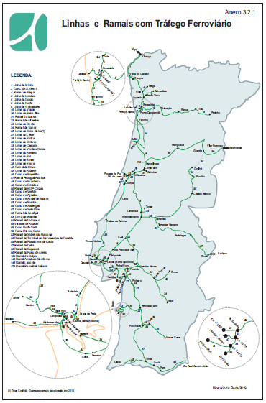
Illustration 2 - Network operated by CP (Source: IP - Network Directory)
QA

SERVICE QUALITY REPORT
- SERVICE QUALITY PERFORMANCE

3-service quality performance

3.1 – information and tickets

Information before travelling
The conditions governing rail passenger transport are defined in a document approved by the regulatory institute and are available to customers at the station ticket offices, customer assistance offices, on the customer care line (707 210 220) or on the internet at cp.pt. This document, general conditions of transport, defines the rules for the transport of passengers, luggage, portable luggage, pets and velocipedes by rail.
Train schedules and ticket prices are available at the stations, on the customer care line (707 210 220) and on the internet at cp.pt.
Regarding the conditions of access for persons with reduced mobility the information is obtained through the SIM service (707 210 746) and also on the internet at cp.pt.
Information on incidents causing significant disturbance to train movements can be obtained from station teleindicators and audible warnings, from the customer care line (707 210 220) and from employees in service at stations and Customer Assistant Offices.
Information concerning profound changes in train supply, for example due to strikes, is usually conveyed in major media - TV, radio, in addition to the means mentioned in the previous paragraphs.
If the service is delayed, the customer is informed at the ticket office when the ticket is purchased and, if the customer still wishes to purchase the service, a stamp is placed on the ticket stating that the customer was previously informed of the delay.
Information during and after the journey
On board the trains, where technically possible, information on the next stop or on delays in running is disseminated using the sound system or indicators. When delays are significant (especially in situations where the train has been stopped for more than 10 minutes on the urban service and 15 minutes on the other services) sound information is provided at regular intervals.
In addition to verbal or written information, pictograms are displayed inside the trains indicating, among other information, the class of carriage and seat number, toilet facilities and bar.
The stations broadcast information to the public of a non-commercial nature by IP, as stipulated in regulation 630/2011 of December 12th and Decree-Law no. 2017/2015.
CP shall provide the passenger, if he so requests, with a document, validated by the regulatory body, certifying the occurrence and duration of the delay, passed in the presence of the valid ticket for the said journey and train. That document shall be issued at a station or customer service office or by the inspector officer in service on the train within two hours of disembarkation or within two hours of cancellation of the journey.

Purchase of tickets
Customers can purchase the tickets in advance or on the same day at the stations ticket offices and, in the case of the Lisbon and Oporto Urban Trains, also at the ticket vending machines. Some monthly passes, from Lisbon's urban area, can be loaded onto the "Portal Viva" and the ATM. The sale of tickets for "alfa pendular" and IC is also available at ATMs, Internet CP, customer care line, travel agencies and CP app.
At the Online Ticket Office and at the Customer Care Line it is also possible to purchase tickets for journeys in the Regional, InterRegional and Urban services of Oporto and Coimbra, as a complement to long distance journeys.
If the boarding station has no ticket office or other sales method available, Customers may purchase the ticket on board the train, at no additional charge, provided that immediately after boarding they report to the ticket inspector.

Performance

Average waiting times at the ticket offices:
Service | No. audits | Waiting time
Global | 1397 | 1.79 min.
Lisbon Urban | 543 | 1.67 min.
Oporto Urban | 269 | 1.97 min.
Long Distance | 585 | 1.62 min.
Table 2 - Average waiting times at the ticket offices

SLA’s of the customer care line:
SLA’s of the customer care line | Performance | Target
Calls answered/calls received | 91 % | >90 %
Calls answered up to 30”/ calls answered | 77 % | >85 %
Chats answered / chats received | 98 % | >90 %
Chats answered up to 30” / chats answered | 96 % | >85 %
E-mails answered / received | 100 % | 100 %
E-mails answered up to 6 hours / answered | 100 % | 100 %
Table 3 - SLA’s of the customer care line

Sound information on trains in traffic disturbance situations:
In situations of traffic disturbance our standard is to broadcast sound information at regular time intervals every 10 minutes for the urban service, and every 15 minutes for the other services, especially when the delays are significant.

CP Website:
The CP website had 13,475,946 visitors in 2019, 5% more
comparing to 2018.
The CP website had 31,061,797 visits and 131,585,230 views
which represented a 10% and 8% growth, respectively, comparing to 2018.
On May 24, 2018, “MyCP” database had 1,018,464 members. With the entry into force of the GDPR (General Data Protection Regulation) the database had 833,663 members at the end of 2019.

Graphic 1 - CP Website

Social networks - Facebook:
Sustained increase of 9,331 fans (4.24 %) evolving from the 220,070 fans that the page registered at the beginning of the year.
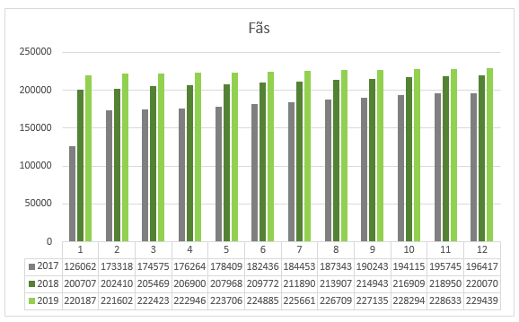
Graphic 2 - Social networks (Facebook)

Increase of the average organic (9.88 %) and paid range (46.66%), evolving from 10,406 and 128,537 people in the homologous period, to 11,434 and 188,506 people, respectively.
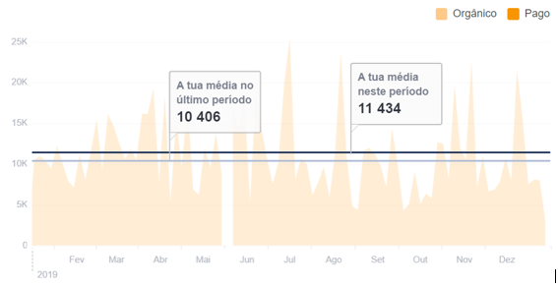
Graphic 3 - Social networks

Social networks - Instagram:
In 2019 we had 25,591 followers, an increase of 6,656 followers (35.15%) from the 18,935 followers registered at the beginning of the year. The largest number of likes in a post was hit - 1,559 likes.
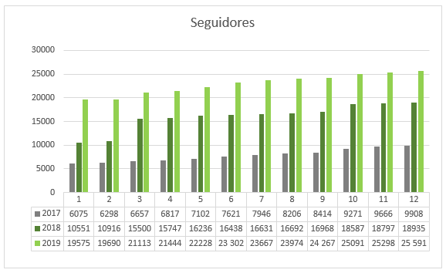
Graphic 4Social networks (Instagram)

Social networks - YouTube
In 2019 we had 1,648 subscribers, which corresponds to an increase of 360 followers (27.95 %) from the 1,288 followers registered at the beginning of the year.
We had 429,366 views and 3,463.4 hours of videos were played.

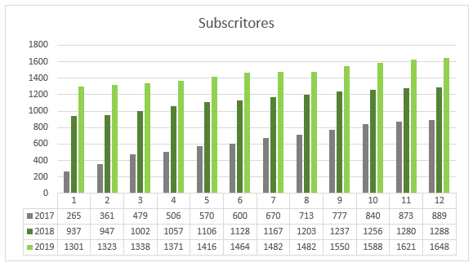
Graphic 5 - Social networks - YouTube

3.2 - service punctuality

In 2019, the Global IP registered an increase of 1 p.p. in relation to the previous year, with greater emphasis on the recovery of the Beira Alta axis, Sud-Express/Lusitania International, Intercidades and Regional traffic. Nonetheless, the 44 p.p. decrease in the IP of the Beira Baixa IC compared to the previous year is worth noting, essentially due to the Speed Limitations imposed on the Beira Baixa Line and passenger service. The main causes of penalty resulted from the speed limitations implemented in the RFN, transversal to various traffic, reflected in the crossings and links of passengers and motor material. Passenger service, engine faults and signalling malfunctions also conditioned punctuality.
Performance
The punctuality average of our services registered during the course of 2019 was of:
Services | IP  (≤3 min.) | IP  (≤5 min.) | IP  (<60 min.) | IP  (60 to 119 min.) | IP  (≥120 min.)
Alfa Pendular | - | 65.2% | 99.0% | 0.7% | 0.2%
Intercidades | - | 60.9% | 99.0% | 0.8% | 0.3%
InterRegional | - | 62.9% | 99.3% | 0.5% | 0.2%
Regional | - | 81.4% | 99.7% | 0.2% | 0.1%
Lisbon Urban | 85.5% | - | 100.0% | 0.0% | 0.0%
Oporto Urban | 84.6% | - | 99.9% | 0.1% | 0.0%
Table 4 - Punctuality average 2019 / service

Illustration 3 - Train punctuality
¹We considered the IP at 5 minutes and in the urban IP at 3 minutes in Long Distance and Regional trains.
Source: Data available at Data Warehouse on 29.01.2019 (special trains not included)

3.3 – service cancellation

Overall, the "regularity of trains" of CP in 2019 was of 99.18%, with an improvement in all traffic compared to the previous year (3,597 trains were withdrawn – 2,447 total and 1,150 partial). The main reason for this variation was the absence of cancellations due to labour disputes.
The main reason for the registered cancellations were motor material breakdowns/anomalies, which had a greater impact on the regularity of the Inter-regional/Regional Douro, Oeste and Algarve service and the Sintra/Azambuja and Cascais Urban. The secondary cause is the adverse weather conditions, which had a greater impact on the regularity of the Long Distance, Inter-regional Oeste, Regional do Norte and Coimbra/Figueira da Foz Urban services.

Performance

Illustration 4 - Train regularity
Source: Data recorded in consolidated CP systems with traffic regulation information from IP systems

3.4 - hygiene and cleaning of rolling stock (air quality in carriages, cleanliness of sanitary facilities, etc.)

Train cleaning is carried out by external suppliers whose contracts specify service quality standards, including penalties, bonuses and cleanliness assessment mechanisms (specific cleaning audits).
The air conditioning systems on rolling stock comply with the terms set out in the UIC leaflet 533, which sets out the air renewal rates. Approved maintenance plans also establish periods to be observed.
The cleaning of railway stations is the responsibility of the infrastructure manager, IP, S.A.

Performance and quality standard (target)
In 2019, 11023 audits of rolling stock were carried out and the evaluation of the state of cleanliness in accordance with the quality requirements demanded of service providers under an outsourcing regime was translated as follows:

Indicator | Performance | Target
Audits to trains with assessment in accordance | 10 095 | n/a
Annual assessment average according to the trains cleaning state | 91.6% | => 85%
Table 5 - Train cleaning

3.5 - customer satisfaction survey

In summary, in the "CP/IP 2019 Customer Satisfaction Study", there was a weighted global satisfaction figure of 7.0 (scale from 0 to 10), higher than the values for 2016 (6.9) and 2014 (6.3).
In terms of global satisfaction by product, we highlight the Oporto Urbans, which obtain the highest average among all the services analysed, with a satisfaction index of 7.7, followed by the Alfa Pendular service - 7.6; Intercidades - 7.5; International - 7.4; Regional - 7.3 and Lisbon Urbans, with a satisfaction index of 6.7.
Of the most relevant positive aspects for the Customers, the elements related to Trust, Security and Contact with the Customer stand out. This results in a considerable increase in the perceived value of the service compared to previous years. On the other hand, the aspects of Customer care, quality (of service) and comfort are the main departments and vectors for improvement.
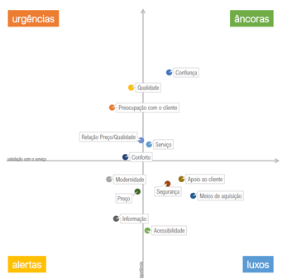

Graphic 6 - Customer satisfaction study - global result 2014/2016
Source: CP/IP Customer Satisfaction Study 2016 - Qmetrics

In turn, the ECSI (European Customer Satisfaction Index) project, in 2019, scores down several parameters in evaluation relating to the Lisbon metropolitan public transport area and in particular the complaints process.

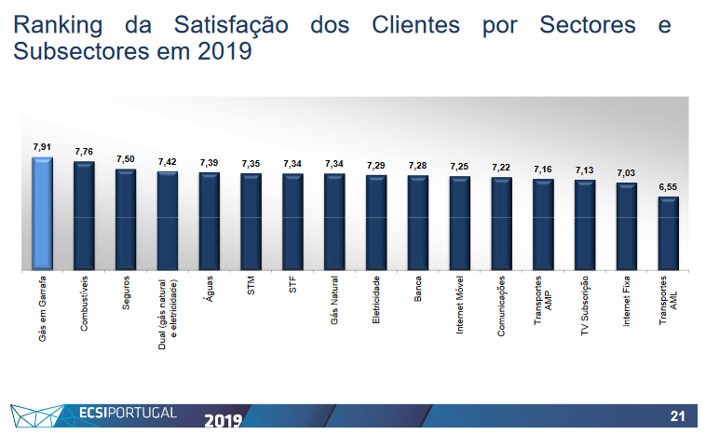
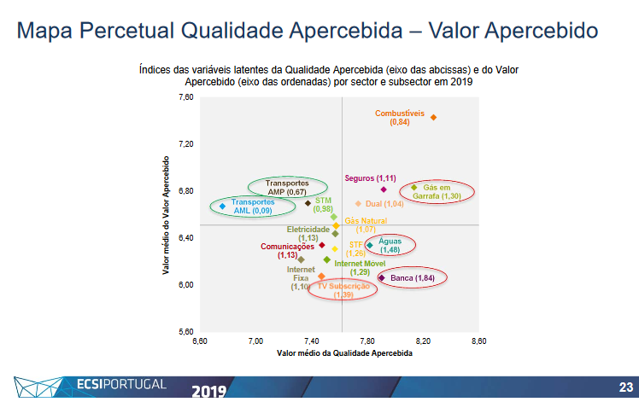
Graphic 7 - ECSI study results

3.6 handling of customer complaints, refunds and compensation for non-compliance with service quality standards

3.6.1 - handling of customer complaints

Main findings of customer complaints in 2019.
1. CP registered 20,080 complaints in the SGRS [Complaints and Suggestions Management System], between January and December 2019;
2. Decrease in the number of complaints by 34% compared to the same period last year;
3. When analysing the indicator "No. of Complaints per million passengers", the Long Distance Services are the ones with the highest number of complaints:

Service | Year 2019 | Year 2018 | Variation  2018/2019
Alfa Pendular | 1 320 | 2 753 | -52 %
Intercidades | 1 053 | 1 974 | -47 %
International | 682 | 1 105 | -38 %
Regional | 85 | 149 | -43 %
Lisbon Urban | 85 | 117 | -27 %
Oporto Urban | 101 | 171 | -41 %
Total | 139 | 239 | -42 %
Table 6 - Number of complaints per million P's
4. The Sales Channels are the main reason for complaint in this period. They total 7,151 complaints, representing 36% of the total. Compared with the same period of 2018, they show a decrease of 20%;
- The 4,300 complaints due to problems with ticket vending machines weigh 60% of the total, with an impact on Lisbon and Oporto's Urban Customers.
5. The Circulation typology with 5,290 complaints, represent 26% of the total, registering a decrease of 55%, in comparison with the same period of the previous year;
- The reason Punctuality, although with a decrease of 32% in relation to the same period in 2018, is the one that has the greatest relative importance in this typology, representing 46% of all these complaints;
6. The Regulatory and Tariff typology comes in 3rd place, with 3,297 complaints, representing 16% of the total and registering a decrease of 15% compared to the same period last year;
- The reason Reimbursements and Reissuances assumes a weight of 54% of this typology, representing an increase of 2% over the same period in 2018.
7. The Forms and the Website continue to be the channels most used by customers to complain. In this period, 75% of complaints came through these two channels.
8. Of the 20,080 complaints registered in this period, CP replied to 8,926 (44%), with an average response time of 56 days. The system recorded 11.154 unanswered complaints (56%).

3.6.2 - refunds and compensation for delay or cancellation

In all services there is a right to reimbursement of the ticket for reasons attributable to the operator, as well as a right to compensation for damages due to delays or cancellation of services, provided that the legally prescribed assumptions are met.
The conditions governing the reimbursement of tickets and compensation for damages due to delays or cancellation of services are set out in a document approved by the Regulatory Institute and are available to customers at the station ticket offices, customer assistance offices, on the customer care line (707 210 220) or on the internet at www.cp.pt. This document, “General Conditions of Transport”, defines the rules for the transport of passengers, luggage, portable luggage, pets and velocipedes by rail.

3.7 - assistance to disabled persons and persons with reduced mobility

SIM - Integrated Mobility Service is a service oriented to serve Customers with Special Needs (CNE).
The Customer with Special Needs, can obtain information by phone (+351) 707 210 746 *(707 210 SIM), which is available 24 hours a day, every day of the year, about:
- Accessibility to CP network trains;
- Accessibility to equipment such as ticket vending machines and points of sale available for ticket purchases;
- Specific commercial conditions for disabled persons;
- Advisor for the Customer with Special Needs;
- Other channels available to obtain information or send suggestions;
- Help to plan the journey in the best conditions of comfort and safety, suggesting the origin/destination and the trains with accessibility;
- How to request assistance on boarding, during the trip and on disembarkation;
- Register the request for the SIM.
To request assistance on boarding and disembarkation, you must request the Service. This request can be made through the Customer Care Line or through the Form available at cp.pt:
- By phone (+351) 707 210 746 *(707 210 SIM), has a cost of 0.10 €/min – land line| 0.25 €/min - mobile network + VAT. Calls from abroad at international rates.
- By SIM Request Form
The request by Form will be received and analysed by CP's services, which will then contact the Customer informing whether or not to provide the SIM. Any request always needs analysis and confirmation, without which CP does not guarantee the provision of the Service.

Discount - Customers with Special Needs

This is an agreement between CP - Comboios de Portugal and the INR - Instituto Nacional para a Reabilitação, I.P. (National Rehabilitation Institute) with the objective of minimising the mobility difficulties of passengers with limited autonomy. This agreement allows disabled people, with a disability of 80% or more, to enjoy a 75% discount on the full fare when purchasing transport tickets. These Customers will also be able to enjoy a ticket for a companion, issued at 25% the full fare, valid for the same train, class and route.
It also allows the purchase of tickets with 20% discount, for people with disability of 60% or more, but less than 80%, on journeys to be made on any route.
The agreement is valid for any route, in Turística/2nd class on Alfa Pendular and Intercidades, Regional, InterRegional and Urban trains.
Proof of ownership of the ticket and of the right to a discount is provided by presenting an official identification document and the "Medical Multiuse Disability Certificate" or the "Armed Forces Disability Card”.
For the purpose of purchasing a ticket with a 25% discount, any citizen who does not have any type and degree of disability that limits his/her mobility is considered as a companion of the disabled person.

Performance
In 2019, 3016 requests for SIM assistance were received, representing an increase of 39% compared to 2018.

Illustration 5 - SIM Service

In 2019 the number of journeys under the CP_INR protocol grew by 24% compared to 2018.
In the year 2019, under the protocol signed between CP and compared to the same period of the previous year, it is clear that:
- The overall value of the journeys made was 969,088€, an increase of 35%.
- Of the discount granted, CP incurred in 386,419€. This value suffered an increase of 24%.
- Of the discount granted, INR incurred in 128,806€. This value suffered an increase of 24%.
- Most of the journeys, 77%, were made in the urban, regional and interregional services.
- In the Long Distance, Alfa Pendular and Intercidades services, only 23% of the journeys were made, which corresponds however to 70% of its value, that is, 316,665€.

For rolling stock adapted for passengers with reduced mobility we have:

Performance and quality standard (target)
Indicator | Performance | Target
% multiple units prepared for access (boarding and disembarking) of passenger seats with reduced mobility | 79.8% | Undefined
% carriages prepared for access (boarding and disembarking) of passenger seats with reduced mobility | 46.4%* | Undefined
Table 7 - Rolling stock adapted for passengers with reduced mobility
* Using station lifts and transshipment wheelchairs

attachment - indicators BI

Description of the indicator 'punctuality', 'average delay in destination' and 'regularity index':
Table 8 - Description of the indicator 'punctuality', 'average delay in destination' and 'regularity index':

Description of the indicator “hygiene”:
No. of audits whose results exceeded 75% / Total number of audits carried out.

illustrations index
Ilustração 1 - Cliente 5
Ilustração 2 - Rede explorada pela CP (Fonte: IP - Diretório da Rede) 10
Ilustração 3 - Pontualidade dos comboios 21
Ilustração 4 - Regularidade dos comboios 23
Ilustração 5 - Serviço SIM 35

graphics index
Gráfico 1 - Site CP 16
Gráfico 2 - Redes sociais (facebook) 17
Gráfico 3 – Redes sociais 17
Gráfico 4 - Redes sociais (Instagram) 18
Gráfico 5 - Redes socias - You Tube 19
Gráfico 6 – Estudo de satisfação dos clientes – resultado global 2014/2016 27
Gráfico 7 - Resultados do estudo ECSI 28

tables index
Tabela 1 - Extensão da rede ferroviária explorada pela CP 9
Tabela 2 - Tempos médios de espera de atendimento nas bilheteiras 15
Tabela 3 - SLA's da linha de atendimento telefónico 15
Tabela 4 - Média da pontualidade 2019 / serviço 20
Tabela 5 - Limpeza dos comboios 25
Tabela 6 - Quantidade de reclamações por milhão de P's 29
Tabela 7 - Material circulante adaptado aos passageiros com mobilidade reduzida 36
Tabela 8 – Descrição do indicador "pontualidade", “atraso médio no destino” e “índice de regularidade” 37

