Annual report

of the national
safety authority
for 2015
Federal Ministry of Transport, Innovation and Technology
bmvit, Department IV, Rail Group, Section Sch 5


in accordance with Article 18 of Directive 2004/49/EC

on safety on the Community’s railways

transposed by Article 13a of the Railways Act 1957 – EisbG [Eisenbahngesetz 1957 – EisbG]

Federal Ministry of Transport, Innovation and Technology

Contents:

A.1. Scope of the report 2
A.2. Summary 2
B. Introduction 4
C. Organisation 7
D. The development of railway safety 11
F. The development of safety certification and authorisation 12
G. Supervision of railway undertakings and infrastructure managers 17
H. The application of CSM to risk evaluation and assessment 18
I. Sources of information 19
J. Annexes 20
ANNEX A: Railway structure information 21
Annex B: Organisation chart 25
ANNEX C: CSI data – definitions applied 32
ANNEX D: Important changes to legislation and regulation 42
ANNEX E: The development of safety certification and authorisation – numerical data 44

A.1. Scope of the report

This annual report has been drawn up in accordance with Article 13a of the Federal Act on Railways, rail vehicles on railways and traffic on railways (Railways Act 1957 – EisbG) [Bundesgesetz über Eisenbahnen, Schienenfahrzeuge auf Eisenbahnen und den Verkehr auf Eisenbahnen (Eisenbahngeset 1957 (EisbG)], Federal Law Gazette [Bundesgesetzblatt], BGBl. No 60/1957, as last amended by the BGBl. I No
137/2015 pursuant to Directive 2004/49/EC of 29 April 2004 on safety on the Community's railways, OJ L 64, 30.4.2004, as amended (on 11 May 2016 a recast directive on railway safety was announced, which repeals Directive 2004/49/EC as of 16 June 2020). The report covers the activities of the national safety authority in respect of the operation of main line railways and the secondary railways connected to them, the operation of rail vehicles on such railways and traffic on such railways in Austria in the year 2015.

A.2. Summary

In Austria general duties for railway undertakings and infrastructure managers are laid down in the Austrian Railway Act: “Eisenbahngesetz 1957”, published in “Bundesgesetzblatt BGBl No. 60/1957”, as last amended by “BGBl. I No 137/2015”. The detailed regulations of railway undertakings concerning the training, behaviour of staff concerned with safety critical tasks are subject of authorisation by the Railway Authority.

Beginning from 01.01.2006 the National Investigation Body – “Sicherheits- untersuchungsstelle (SUB)” according to the regulations in the “Bundesgesetz über die unabhängige Sicherheitsuntersuchung von Unfällen und Störungen (Unfalluntersuchungsgesetz – UUG 2005)”, published in “Bundesgesetzblatt BGBl I No.
123/2005” as last amended by “BGBl. I No 89/2014” started its work as an independent body according to Article 21 of the Safety Directive concerned with the investigation of accidents/incidents.

Safety indicators relating to accidents, incidents and near-misses, to technical safety of infrastructure and its implementation are collected by the SUB.

Safety performance on member state level is controlled on different levels e.g. by approval process of subsystems, maintenance rules, by accident and incident investigation. Railway undertakings and infrastructure managers have to fulfil obligations for periodical checking, reviewing and inspections. Furthermore safety performance is individually checked on the occasion of certain incidents.

Authorisation of subsystems for bringing into service, control of operation of railway undertakings and infrastructure managers, supervising of compliance of technical equipments, authorisation for placing into service of new or substantially altered rolling stock and monitoring, promoting and developing the safety regulatory framework are carried out by Federal Ministry of Transport, Innovation and Technology as NSA, notwithstanding the general responsibility of the railway undertakings and infrastructure managers themselves.

Publication of existing, new or updated national safety rules is managed on the website of the Federal Ministry of Transport, Innovation and Technology (www.bmvit.gv.at/en/verkehr/railway/notifications.html).

The annual report of the safety authority in Austria concerns its activities in the year

2015 according to the Directive on Safety on the Community’s railways (2004/49/EC, “Safety Directive”).

The report contains global information on the railway system in Austria shown in Parts A, B and C and also shown in the related annexes.

Safety recommendations as a result of investigation accidents, incidents and near- misses during the reporting year are enumerated in Part D.

The Part E reports important changes in legislation and regulation concerning railway safety in the year 2015.

The development of safety certification and safety authorisation is shown in Part F.

A description of results of and experience relating to the supervision of infrastructure managers and railway undertakings is given in chapter G.

Part H shows comments on the application of the CSM on risk evaluation and assessment.

- Introduction

            - Introduction to the report

Article 18 of Directive 2004/49/EC, transposed by Article 13a EisbG, provides the statutory basis for drawing up the annual report:

‘Annual Report

§ 13a. (1) (1) The Federal Minister for Transport, Innovation and Technology shall prepare a report every year on his activities during the previous year in respect of the operation of main line railways and the secondary railways connected to them, the operation of rail vehicles on such railways and traffic on such railways. The annual report shall be published on the internet on the website of the Federal Minister for Transport, Innovation and Technology at the latest by 30 September of the calendar year following the year to which the report refers and shall also be submitted to the European Union Agency for Railways.
(2) (2) The annual report shall contain the following information:
- an aggregation of the common safety indicators in accordance with Annex I to
Directive 2004/49/EC
- important changes in federal legislation and regulations made on the basis of federal law which relate to the construction or operation of the railways listed in paragraph 1, the operation of rail vehicles on such railways and traffic on railways;
- the development of safety certification and safety authorisation;
- results of and experience relating to the supervision of
Infrastructure Manager and Railway Undertaking

In addition, in accordance with Article 9 of Regulation (EC) No 352/2009 of 24 April 2009 on the common safety method for risk evaluation and assessment, the national safety authority is to report on the experience of proposers with the application of the common safety method (CSM) on risk evaluation and assessment, and, where appropriate, its own experience.
common safety method (CSM) on risk evaluation and assessment, and, where appropriate, its own experiences. Note: Commission Implementing Regulation (EU) No 402/2013 of 30 April 2013 on the common safety method for risk evaluation and assessment, as last amended by Implementing Regulation (EU) No 2015/1136, entered into force on 21 May 2015 and in doing so repealed Regulation (EC) No 352/2009 as of that day.

The annual report pursuant to the directive is based on an evaluation of the Federal Safety Investigation Authority’s data in accordance with Article 13a (3) EisbG:

§ 13a (3) (3) The Federal Safety Investigation Authority (Section 3 of the Accident Investigation Act [Unfalluntersuchungsgesetz], BGBl. I No 123/2005) shall make available the data necessary for aggregating the common safety indicators for the year to the Federal Minister for Transport, Innovation and Technology at the latest by 30 June of the calendar year following the year to which the report refers in an electronic form.’

together with the safety reports of the railway undertakings in accordance with Article 39d EisbG:

Safety report

Article 39d. Railway undertakings which have their registered office in Austria and infrastructure managers which have their registered office in Austria shall submit a safety report every year for the previous calendar year to the authorities before 30 June which shall contain the following:
- information on how the organisation's corporate safety targets are met;
- the Austrian and common safety indicators in so far as they
- are relevant to the railway undertaking in question;
- the results of internal safety auditing;
- observations on deficiencies and malfunctions which have compromised the safety of railway operations, the operation of rail vehicles on the railway or traffic on the railway.

The annual report is to be prepared in accordance with documents issued by the European

Railway Agency:

- Template – Structure for the content of the NSA Annual safety Report

- Guideline for the use of the template – Structure for the content of the NSA Annual safety Report

            - Railway structure information

- A map of the rail network (see Annex A.1.);

- A list of the railway undertakings (RU) and infrastructure managers (IM) (see Annex A.2.).

            - Summary – general trend analysis

The following paragraphs summarise the development of the common safety indicators during 2015.

77 major accidents within the scope of the Railway Safety Directive were reported in 2015. Compared to the previous reporting year (61 major accidents), there is a growing number of major accidents. The following accident types presented in the annual report show an upward trend compared to 2014: collision of trains, accidents at level crossings, derailment of trains and other accidents. The number of major collisions in the reference year 2015 increased from 1 in 2014 to 7, while the number of major accidents at level crossings rose from 27 to 33. The category fires in rolling stock shows a tendency to stagnation, while the category accidents to persons caused by rolling stock in motion followed a decreasing trend.

Overall, the two accident types, accidents at level crossings (at about 43%) and accidents to persons caused by rolling stock in motion (at about 35%), account for about 78% of the total number of major accidents.

The total number of fatalities in the year in question was 35, and the number seriously injured was 45. The figures for 2014 were 25 fatalities and 36 seriously injured.

Altogether, the total number of the seriously injured and fatalities shows a growing tendency compared to the reporting year 2014 (There were two serious individual events in 2015: a train collision with 2 fatalities and 4 seriously injured persons and a level crossing accident with 5 fatalities).

As regards the categorisation of the seriously injured and fatalities depending on the type of persons involved, level crossing users account for about 57% of the fatalities and about 51% of the seriously injured, and thus for the largest share of the total number of casualties. A further breakdown of fatalities shows that about 23% are unauthorised persons,
14% employees or contractors, as well as 3% passengers and other persons in each case. In terms of the seriously injured, passenger with about 20%, employees or contractors with about 18% and unauthorised persons with about 11% account for the remaining number.

Data on the individual CSIs for 2015 together with notes referring to the various common safety indicators is provided in Annex C.1.

- Organisation

            - Introduction to the organisation

National safety authority for safety authorisation and safety certification:
(for infrastructure managers of main line railways and railway undertakings which are authorised to operate on main line railways and the secondary railways connected to them):

Federal Minister for Transport, Innovation and Technology [Bundesministerin für Verkehr, Innovation und Technologie] (bmvit) Radetzkystraße 2
A-1030 Wien
Tel.: (+43) -1 -71162 -65 -0
Fax: +43-1-71162-652298
Email: iv-sl@bmvit.gv.at
Website: www.bmvit.gv.at/verkehr/eisenbahn

Article 12(3) EisbG contains the provisions defining the competence of the Federal Minister of Transport, Innovation and Technology as a safety authority.

Other safety authorities:
(in every case, the Governor [Landeshauptmann] of the relevant one of the nine Federal Provinces is the railway safety authority for infrastructure managers who only manage secondary railways which are connected):

Governor of Burgenland [Landeshauptmann von Burgenland]
Europaplatz 1
A-7000 Eisenstadt

Governor of Carinthia [Landeshauptmann von Kärnten]
Arnulfplatz 1
A- 9020 Klagenfurt

Governor of Lower Austria [Landeshauptmann von Niederösterreich]
Landhausplatz 1
A-3109 St. Pölten

Governor of Upper Austria [Landeshauptmann von Oberösterreich]
Landhausplatz 1
A- 4021 Linz

Governor of Salzburg [Landeshauptmann von Salzburg]
Chiemseehof
A-5010 Salzburg

Governor of Styria [Landeshauptmann der Steiermark]
Hofgasse 15
A-8010 Graz

Governor of the Tyrol [Landeshauptmann von Tirol]
Eduard-Wallnöfer-Platz 3
A-6020 Innsbruck

Governor of Vorarlberg [Landeshauptmann von Vorarlberg]
Landhaus
A-6900 Bregenz

Governor of Vienna [Landeshauptmann von Wien]
Lichtenfelsgasse 2
A-1030 Wien

Article 12(2) EisbG contains the provisions defining the competence of governors as authorities.

Labour inspectorate:

Federal Ministry of Labour, Social Affairs and Consumer Protection [Bundesministerium für Arbeit, Soziales und Konsumentenschutz] (bmask) Department VII – Labour Law and Central Labour Inspectorate Competence Centre Labour Inspectorate for Transport
Stubenring 1
A-1030 Wien
Tel.: +43-1-71100-0
Fax: +43-1-7158258
Email: post@sozialministerium.at
Website: www.sozialministerium.at

Federal Safety Investigation Authority:

Accident investigating body pursuant to Directive 2004/49/EC on the investigation of
railway accidents and incidents:

Federal Office for Transport, Federal Safety Investigation Authority, Schiene Trauzlgasse 1
A-1210 Wien
Tel.: +43-1-71162-659150
Fax: +43-1-71162-659298
Email: peter.urbanek@bmvit.gv.at
Website: versa.bmvit.gv.at

The Accident Investigation Act (BGBl. I No 123/2005, as last amended by BGBl. I No 89/2014) and the Rail Accident Reporting Regulation 2006 (MeldeVO-Eisb 2006) (BGBl. II No 279/2006) define the statutory powers for the work.

The Reporting Regulation governs:

§ 1. … the scope and form of reports of accidents and incidents which arise during the operation of a main line or secondary railway (Article 4 EisbG 1957, BGBl. No 60), a connecting railway (Article 7 EisbG 1957, BGBl. No 60) or a tramway which operates exclusively on its own formation, such as underground railways (Article 5 para. 1 point 2, EisbG 1957, BGBl. No 60), and the operation of rail vehicles on such railways.

Rail Regulator:

Rail Control Commission [Schienen-Control Kommission] (SCK) Rail Control
[Österreichische Gesellschaft für Schienenmarktregulierung mit beschränkter Haftung]

(Schienen-Control GmbH) Praterstraße 62-64
A-1020 Wien
Tel.: +43-1-5050707-0
Fax: +43-1-5050707-180
Email: office@schienencontrol.gv.at
Website: www.schienencontrol.gv.at

The SCK is the Austrian railway regulator in accordance with Article 20 Directive 2001/14/EC. It was established by the Railways Act in 1999.

            - Organisation chart

The organisation chart for the Federal Ministry of Transport, Innovation and Technology national safety authority is attached as Annex B.1.

The organisation chart for the Federal Safety Investigation Authority – Federal Traffic Agency [Bundesanstalt für Verkehr] is attached as Annex B.2.

- The development of railway safety

            - Initiatives to maintain and improve safety

The following section lists the most important safety recommendations¹ made in accident investigation reports in 2015:

Safety measures triggered by accidents and precursors to accidents:

Date of the event | Description of the event | Safety recommendations¹⁾
12.02.2014 | Train-car collision at level crossing | A-2014/051: The training content for obtaining a driving licence should be examined and, where necessary, appropriate changes should be made.  - Launching of discussions with the professional association of driving schools in the Chamber of Commerce.  A-2014/052: Launching of information campaigns on railway level crossings (LC) in general  and correct behaviour of road users in particular (e.g. by the media, public authorities, and automobile clubs).  A-2014/053: Holding special information events on LC in  general and correct behaviour of road users  in particular on-the-spot (e.g. in local communities, in schools, and directly at LC).  A-2014/054: Conducting targeted campaigns by the executive power directly  on the ground at LC in cooperation with the competent infrastructure manager.
24.10.2012 | Trail derailment following wheel breakage | A-2015/15: It is recommended that the visual inspection (Visual Testing) of a wheel-set after each underfloor handling be made mandatory in the maintenance plans of the ECM.  A-2015/16: The RU ÖBB-Produktion GmbH must ensure that  cases of broken wheels or tyres, as well as broken axles are reported to  the SUB according to Melde-VO-Eisb 2006.
24.04.2014 | Fires on train | A-2015/003: Ensure vehicle access by emergency services to stopping points as defined according to the matrix (fire department access road).  Note: In the incident in question the fire truck had to cross over a  company site and break through a locked gate.  A-2015/004: Check whether the locking device of spare brushes can be  improved e.g. through safety bolts with thread, nut and lock. Note: Upon request of the Austrian Transport Association [VK], a locking device with thread, nut and lock, as well as an additional safety chain has already been incorporated by the vehicle manufacturer in a newly ordered scrap collecting unit, to be delivered in 2015.  A-2015/005: Check whether the marking of small railcars (SR) and motorised trolleys (MT) with the  indications ‘STABLED READY FOR SHUNTING’ [VERSCHUBBEREIT ABGESTELLT] and ‘CHECK HANDBRAKES’ [AUF HANDBREMSE ACHTEN] must be included in the guidelines of the IM.
08.04.2015 | Collision of a train with  a buggy | 15.2.1: It must be checked whether the coverage area of the security cameras can be optimized or if additional security cameras should be installed.

1) These safety recommendations were made by the Safety Investigation Authority (SUB) for the reporting period, and they do not yet represent commitments to take action on safety measures however.

Safety recommendations and accident investigation reports from European Union Member States are also to be found on the ERAIL (European Railway Accident Information Links) database maintained by the European Union Agency for Railways.
Website: http://erail.era.europa.eu

            - Detailed data trend analysis

This section contains an analysis of the data in respect of all the CSI categories:

  - Indicators relating to accidents

  - Indicators relating to dangerous goods

  - Indicators relating to suicides

  - Indicators relating to the precursors of accidents

  - Indicators to calculate the economic impact of accidents

  - Indicators relating to technical safety of infrastructure and its implementation

Details of the coverage of the statistics, the definitions applied and data on the Common Safety Indicators (CSI) are listed in Annex C.

            - Results of safety recommendations

As a rule the safety recommendations made by the Safety Investigation Authority were implemented as recommended. Additional recommendations made by the national safety authority which have a more general application, i.e. are addressed to a whole group (such as for example, all infrastructure managers, all railway undertakings) can be found on the website: www.bmvit.gv.at/verkehr/eisenbahn/sicherheit/verfuegungen/index.html

- Changes to statutes and regulations

A list of the most important amendments to statutes and rules made in the year 2015 is provided in the table in Annex G.

- The development of safety certification and authorisation

            - Availability of national safety rules and other national legislation to railway undertakings and infrastructure managers:

Federal Ministry of Transport, Innovation and Technology [Bundesministerium für Verkehr, Innovation und Technologie] (bmvit) Department IV
Radetzkystraße 2
A-1030 Wien
Tel.: (+43) -1 -71162 -65 -0
Fax: +43-1-71162-652298
Websites: www.bmvit.gv.at/verkehr/eisenbahn/recht/eu/normen/index.html www.bmvit.gv.at/verkehr/eisenbahn/recht/downloads/notifizierung

National statutes and regulations can be found on the
Federal Safety Investigation Authority: Website: www.ris.bka.gv.at

A guidebook, the ‘Guide to applying for a safety certificate’ [Guide to applying for a safety certificate] [in German], has been drawn up to assist in the preparation of supporting papers for applications for safety certification pursuant to Article 12 of the Railway Safety Directive.
This may be found on the website:
www.bmvit.gv.at/verkehr/eisenbahn/sicherheit/leitfaden_bescheinigung.html

A guidebook, the ‘Guide to applying for safety authorisation’ [Guide to applying for a safety certificate] [in German], has been drawn up to assist in the preparation of supporting papers for applications for safety authorisation pursuant to Article 11 of the Railway Safety Directive:
Website:
www.bmvit.gv.at/verkehr/eisenbahn/sicherheit/leitfaden_genehmigung.html

(different font)

            - Numerical data

Numerical data on the development of safety certificates and licences are provided in Annex E.

            - Procedural aspects

  - Safety certificates – part A

    - Reasons for updating and amending part A certificates: One reason for updating safety certificates was the expiry of their validity.

    - The main reasons for the average issuing time for part A certificates (restricted to those mentioned in Annex E and after having received all the information necessary) required more than the four months provided for in Article 12(1) of the Railway Safety Directive

Not applicable in 2015.

    - Overview of requests from other national safety authorities to verify or access information relating to the part A certificate of a railway undertaking which has been certified in your state, but which applies for a part B certificate in another Member State:

No enquiries were made by other national safety authorities on this subject in the year 2015.

    - Summary of problems with the mutual recognition of the part A certificate which is valid in the whole European Community:

No problems with mutual recognition arose in 2015.

    - Fees charged by the national safety authority for issuing
a part A certificate (yes/no – fees charged):

Fees are charged in accordance with the Fees Act 1957 [Gebührengesetz 1957]
(BGBl. No 267/1957, as amended) for the submission of application documentation. These are based on the volume of the documents submitted with the application.

    - Summary of the problems with using harmonised formats for part A certificates, specifically in relation to the categories for type and extent of service:

No major problems arose in connection with the use of the harmonised document.

    - Summary of the common problems and difficulties for the national safety authority in application procedures for part A certificates:

No particular problems with the application procedures for part A certificates arose in the year 2015.

    - Summary of the problems reported by railway undertakings when applying for a part A certificate. No particular problems were reported in the year 2015.

    - Feedback procedure (e.g. questionnaires) that allows railway undertakings to express their opinion on issuing procedures and practices or to make complaints:

There was no formal feedback procedure in the year 2015.

  - Safety certificates – part B

    - Reasons for updating and amending part B certificates:

One reason for updating safety certificates part B was the expiry of their validity.

    - The main reasons for the average issuing time for part B certificates (restricted to those mentioned in Annex E and after having received all the information necessary) required more than the four months provided for in Article 12(1) of the Railway Safety Directive

Did not apply in 2015.

    - Fees charged by the national safety authority for issuing a part B certificate (yes/no – fees charged):

Fees are charged in accordance with the Fees Act 1957 [Gebührengesetz 1957] (BGBl. No 267/1957, as amended) for the submission of application documentation. These are based on the volume of the
documents submitted with the application.

    - Summary of the problems with using harmonised formats for part B certificates, specifically in relation to the categories for type and extent of service:

No major problems arose in connection with the use of the harmonised document.

    - Summary of the common problems and difficulties for the national safety authority in application procedures for part B certificates:

No particular problems with the application procedures for part B certificates arose in the year 2015.

    - Summary of the problems reported by railway undertakings when applying for a part B certificate:

No major problems with applications for part B certification were reported in the year in question.

    - Feedback procedure (e.g. questionnaires) that allows railway undertakings to express their opinion on issuing procedures and practices or to make complaints:

There was no formal feedback procedure in the year 2015.

  - Safety authorisations

    - Reasons for updating and amending safety authorisations:

Not applicable in 2015.

    - The main reasons for the average issuing time for safety authorisations (restricted to those mentioned in Annex E and after having received all the information necessary) required more than the four months provided for in Article 12(1) of the Railway Safety Directive:

Not applicable in 2015.

    - Summary of the problems and difficulties which arose regularly when applying for a safety authorisation:

Not applicable in 2015.

    - Summary of the problems reported by infrastructure managers when applying for a safety authorisation:

Not applicable in 2015.

    - Feedback procedure (e.g. questionnaires) that allows infrastructure managers to express their opinion on issuing procedures and practices or to make complaints:

There was no formal feedback procedure in the year 2015.

    - Fees charged by the national safety authority for issuing safety authorisation (yes/no – fees charged):

Fees are charged in accordance with the Fees Act 1957 [Gebührengesetz 1957]
(BGBl. No 267/1957, as amended) for the submission of application documentation. These are based on the volume of the
documents submitted with the application.

- Supervision of railway undertakings and infrastructure managers

            - Description of the means used to supervise railway undertakings and infrastructure managers

The general tasks of railway authorities and means they use for supervision are laid down comprehensively in Article 13 EisbG. The Railways Act, as amended, places firm responsibility on railway organisations to supervise their own construction and operation over the long term.

Amongst other methods, railway undertakings and infrastructure managers are supervised following exceptional events (see also point D.1.) e.g. by the authorities making sample inspections of operating documentation on railway undertakings’ sites followed by documentation of the results and specifying measures to correct deficiencies (on-site supervisory activity).

As part of the supervisory process, sample on-site inspections using checklists were carried out on behalf of the national safety authority in connection with the issue of safety certificates in 2015.

            - Submission of all annual safety reports produced by infrastructure managers and railway undertakings in accordance with Article 9(4) of the Railway Safety Directive within the statutory time limits

The reports listed below were submitted to the national safety authority (bmvit) for the year 2015. Bmvit also called for further statistical data:

9 safety reports from infrastructure managers;

27 safety reports from railway undertakings, data from the Federal Office for Transport (Federal Safety Investigation Authority), along with supplementary data from railway undertakings;

            - Number of inspections (on-site inspections) of RU/IM in 2015

Inspections (on-site inspections) |  | Part A safety certificates issued | Part B safety certificates issued | Safety certificates – notifications | other  activities
Number of audits (on-site inspections)  Number of audits of RU/IM in 2015 | planned | *) | 4
 | unplanned | *)
 | carried out | *) | 4

*) The certification bodies audit the

underlying management system periodically.

            - Summary of the relevant corrective measures/actions (e.g. amendment, revocation, suspension, serious warning) related to safety aspects following these audits/inspections

No relevant corrective measures in the year in question.

            - Complaints from IMs about RUs related to conditions in their part A or part B certificates

No known complaints in 2015.

            - Complaints from RUs about IMs related to conditions in their safety authorisation

No known complaints in 2015.

- The application of CSM to risk evaluation and assessment

As an aid to help and support users of the ‘Common Safety Method on Risk Evaluation and Assessment’ and so that the use of these common safety methods should be to a single national standard, the Federal Ministry of Transport, Innovation and Technology (bmvit) drew up a ‘Guide to Regulation (EC) No 352/2009’ [Guide to Regulation (EC) No 352/2009]. The entry into force of Commission Implementing Regulation (EU) No 402/2013 of 30 April 2013 on the common safety method for risk evaluation and assessment (as last amended by Commission Implementing Regulation (EU) No 2015/1136) on 21 May 2015 repealed Regulation (EC) No 352/2009. More details may be found on the website:
Website: www.bmvit.gv.at/verkehr/eisenbahn/sicherheit/gmethoden/index.html

            - Description of the most important changes which were not regarded as significant by the proposers

In the year in question, railway organisations reported 98 changes which they did not regard as significant in their safety reports.

In making their assessment, railway organisations used the criteria of Article 4(2) of Commission Regulation (EC) No 402/2013 on common safety methods for risk evaluation and assessment supplemented by criteria internal to the organisation (for example, a comparison with internal safety targets).

            - Description of the most important changes

In the course of drafting safety reports, three changes considered to be significant were reported. The independent assessment bodies were internal, as well as external bodies, relying on subcontractors or not.

            - Short description of the audits undertaken by the proposers on the effectiveness of the risk management process

The railway organisations' risk management procedure is subject to a continuous audit programme as an integral part of the safety management system. As yet there are no meaningful insights into the effectiveness of the risk management procedure.

            - Reports from proposers and ultimately from their subcontractor(s) and assessment body/bodies on the application of Commission Regulation (EC) No 402/2013 on common safety methods for risk assessment

Amongst other issues, the costs of introducing a risk management procedure and the documentation (particularly to take account of changes that were not significant) were mentioned by railway organisations.

- Sources of information

Federal Office for Transport, Federal Safety Investigation Authorit: accident statistics, safety recommendations, various publications

ERAIL, the European Union Agency for Railways’s database: calculation templates, charts and table excerpts

The European Union Agency for Railways: various publications (particularly guides and templates for drawing up annual reports, ‘Implementation Guidance for CSIs, Annex 1 of Directive 2004/49/EC, as amended by Directive 2014/88/EC, V4’)

Federal Act on the Independent Safety Investigation of Accidents and Incidents (Accident Investigation Act) [Bundesgesetz über die unabhängige Sicherheitsuntersuchung von Unfällen und Störungen (Unfalluntersuchungsgesetz)] (UUG 2005) BGBl. I No 123/2005, as last amended by BGBl. I No 89/2014

Federal Act on High Capacity Railway Lines (High Capacity Line Act) [Bundesgesetz über Eisenbahn-Hochleistungsstrecken (Hochleistungsstreckengesetz)] – HlG, BGBl. No 135/1989, as last amended by BGBl. I No 154/2004

Federal Act on Railways, Railway Rolling Stock on Railways and Traffic on Railways (Railways Act) [Bundesgesetz über Eisenbahnen, Schienenfahrzeuge auf Eisenbahnen und den Verkehr auf Eisenbahnen (Eisenbahngesetz)] 1957 (EisbG), BGBl. No 60/1957, as last amended by BGBl. I No 137/2015

Eurostat: various publications

Austrian railway organisations within the scope of the Railway Safety Directive, safety reports, various publications (for example, annual reports, network use conditions)

ÖBB-Infrastruktur AG: network map

Directive 2004/49/EC of the European Parliament and of the Council of 29 April
2004 on safety on the Community's railways in its current version.

Schienen-Control GmbH, Annual Report 2015

Austrian Statistics Office [Statistik Austria]: various publications

Regulation of the Federal Minister for Transport, Innovation and Technology on the scope and form of reports of accidents and incidents involving railway organisations to the Federal Safety Investigation Authority (Rail Accident Reporting Regulation 2006 [MeldeVO-Eisb 2006]), BGBl. II No 279/2006

- Annexes

ANNEX A: Railway structure information

  - Network map

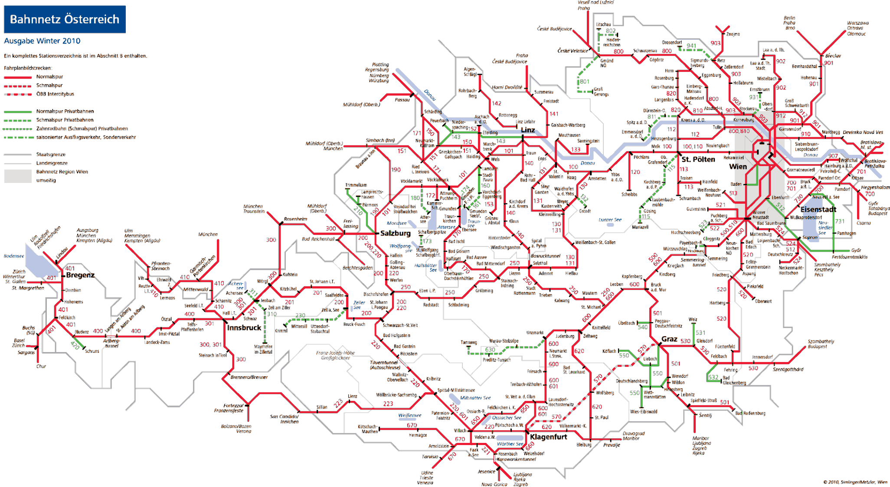—— ÖBB Infrastruktur AG network
—— Other infrastructure managers’ networks
A network map of the ÖBB Infrastruktur AG network may be viewed at: http://www.oebb.at/infrastruktur/de/_p_3_0_fuer_Kunden_Partner/3_2_Schienennutzung/3_3_Schieneninfrastruktur/3_3_6_Karten/02_DMS_Dateien/Infrastrukturnetzuebersichtskarte.jsp

  - List of railway organisations and infrastructure managers

    - Infrastructure managers with safety authorisations in accordance with Article 38 EisbG (infrastructure managers on main lines and the secondary lines connected to them as of 31 December 2015)

Name | Address | Website | Link to network statements [in German]
Aktiengesellschaft der Wiener Lokalbahnen | Eichenstraße 1  1120 Vienna | www.wlb.at | www.wlb.at/eportal/ep/channelView.do/pageTypeId/11  128/channelId/-22413
Cargo-Center-Graz Betriebsgesellschft m.b.H. & Co KG | Terminal 1  8402 Werndorf | www.cargo-center-graz.at | www.stlb.at/terminal-graz-sued/
Graz-Köflacher Bahn und Busbetrieb GmbH | Köflacher Gasse 35-41  8020 Graz | www.gkb.at | www.gkb.at/index.php/infrastruktur-zugang
Land Steiermark/Steiermärkische Landesbahnen | Eggenberger Str. 20  8020 Graz | www.stlb.at | http://www.stlb.at/impressum-snnb/schienennetz-nutzungsbedingungen
Lokalbahn Lambach- Vorchdorf- Eggenberg AG (Betriebsführung: Stern & Hafferl Verkehrsgesellschaft mbH) | Kuferzeile 32  4810 Gmunden | www.stern-verkehr.at | www.lb-lve.at/index.php/infrastruktur
Linzer Lokalbahn AG  (managed by: Stern & Hafferl Verkehrsgesellschaft mbH) | Rathaus  4041 Linz | www.stern-verkehr.at | www.linzer-lokalbahn.at/index.php/infrastruktur
Montafonerbahn Aktiengesellschaft | Bahnhofstraße 15 a+b  6780 Schruns | www.montafonerbahn.at | www.montafonerbahn.at/verkehr/start.htm
Neusiedler Seebahn Gesellschaft mbH  (managed by: Raab-Oedenburg-Ebenfurter Eisenbahn AG) | Bahnhofplatz 5  7041 Wulkaprodersdorf | www.neusiedlerseebahn.at | www.neusiedlerseebahn.at/de/netzzugang/network- statement
ÖBB-Infrastruktur Aktiengesellschaft | Praterstern 3  1020 Vienna | www.oebb.at/infrastruktur | www.oebb.at/infrastruktur/de/_p_3_0_fuer_Kunden_P  artner/3_2_Schienennutzung/3_2_2_SNNB/index.jsp
Raab-Oedenburg-Ebenfurter Eisenbahn AG (Raaberbahn AG) | Bahnhofplatz 5  7041 Wulkaprodersdorf | www.raaberbahn.at | www.raaberbahn.at/schienennetznutzung.html
Salzburg AG für Energie, Verkehr und Telekommunikation | Plainstraße 70  5020 Salzburg | www.salzburg-ag.at | www.salzburg-ag.at/agb-schlichtungsstellen/
Stern & Hafferl Verkehrsgesellschaft mbH)  (as operating railway undertaking) | Kuferzeile 32  4810 Gmunden | www.stern-verkehr.at

    - Railway undertakings with a safety certificate part B in accordance with Article 37 EisbG (as of 31 December 2015)

Name | Address | Website
Aktiengesellschaft der Wiener Lokalbahnen | Eichenstraße 1, 1120 Wien | www.wlb.at
Bayerische Oberlandbahn GmbH | Bahnhofplatz 9, DE-83607 Holzkirchen | www.bayerischeoberlandbahn.de/
Cargo Service GmbH | Lunzer Straße 41, 4031 Linz | www.cargoserv.at
City Air Terminal Betriebsg.m.b.H. | Office Park, 1300 Wien Flughafen | www.cityairporttrain.com
DB Cargo Aktiengesellschaft | Rheinstraße 2, DE-55116 Mainz | www.dbcargo.com
DB Regio Aktiengesellschaft | Stephensonstraße 1, DE-60326 Frankfurt am Main | www.deutschebahn.com
ecco-rail GmbH | Haizingergasse 47/3, 1180 Wien | www.ecco-rail.at
ERS Railways B.V. | Waalhaven Zuidzijde 2, NL-3088 HH Rotterdam | www.ersrail.com
FLOYD Szolgáltató Zártkörűen Működő Részvénytársaság (FLOYD ZRt.) | Madarász Viktor u. 47-49, HU-1138 Budapest, | www.floyd.hu
GEVD Gesellschaft für Eisenbahnverkehrsdienstleistungen mbH | Brunner Straße 33, 2700 Wiener Neustadt
Grampetcargo Austria GmbH | Ignaz-Köck-Straße 10 Top 4111, 1210 Wien | www.grampetcargo.at
Graz-Köflacher Bahn und Busbetrieb GmbH | Köflacher Gasse 35 – 41, 8020 Graz | www.gkb.at
Land Steiermark/Steiermärkische Landesbahnen | Eggenberger Str. 20, 8020 Graz | www.stlb.at
Lokomotion- Gesellschaft für Schienentraktion mbH | Kastenbauerstraße 2, DE-81677 München | www.lokomotion-rail.de
LTE-Logistik- und Transport GmbH | Karlauer Gürtel 1, 8020 Graz | www.lte.at
METRANS Railprofi Austria GmbH | Karl Mierka Staße 7-9, 3500 Krems | www.railprofi.at
MEV Independent Railway Services GmbH | Hütteldorfer Straße 343-345, 1140 Wien | www.m-e-v.at
MMV Magyar Magánvasút Zártkörűen Működő Részvénytársaság MMV ZRt. | Kerék utca 80, HU-1035 Budapest | www.mmv.hu
Montafonerbahn AG | Bahnhofstraße 15 a+b, 6780 Schruns | www.montafonerbahn.at
ÖBB Personenverkehr AG | Am Hauptbahnhof 2, 1100 Wien | www.oebb.at/pv
ÖBB Produktion GmbH | Am Hauptbahnhof 2, 1100 Wien | produktion.oebb.at
ÖBB Technische Services GmbH | Grillgasse 48, 1110 Wien | www.oebb.at/ts
PKP CARGO SPÓŁKA AKCYJNA | ul. Grojecka 17, PL-02-021 Warszawa | www.pkp-cargo.pl
Raab-Oedenburg-Ebenfurter Eisenbahn AG) | Bahnhofplatz 5, 7041 Wulkaprodersdorf | www.raaberbahn.at
Raaberbahn Cargo GmbH | Bahnhofplatz 5, 7041 Wulkaprodersdorf | www.raaberbahncargo.at
Rail Cargo Austria AG | Am Hauptbahnhof 2, 1100 Wien | www.railcargo.com

Name | Address | Website
Rhomberg Bahntechnik GmbH | Mariahilferstraße 29, 6900 Bregenz | www.rhombergrail.com
RTS Rail Transport Service GmbH | Puchstraße 184 b, 8055 Graz | www.rts-austria.at
Safety4you Baustellenlogistik GmbH | Bahnhofplatz 1, 4600 Wels | www.s4you.at
Salzburg AG für Energie, Verkehr und Telekommunikation | Plainstraße 70, 5020 Salzburg | www.salzburg-ag.at
Steiermarkbahn Transport und Logistik GmbH | Eggenberger Str. 20, 8020 Graz | www.steiermarkbahn.at
Stern & Hafferl Verkehrsgesellschaft mbH) | Kuferzeile 32, 4810 Gmunden | www.stern-verkehr.at
SŽ Tovorni promet d.o.o. | Kolodvorska 11, SI-1000 Ljubljana | www.slo-zeleznice.si/en/freight/
Transalpin Eisenbahn AG | Steinengraben 42, CH-4051 Basel
Trenitalia S.p.A. | Piazza della Croce Rossa 1, IT-00161 Roma | www.trenitalia.com
TX Logistik Austria GmbH | Am Concorde-Park E/13, 2320 Schwechat | www.txlogistik.eu
WESTbahn Management GmbH | Europaplatz 3/Stiege 5, 1150 Wien | www.westbahn.at
Wiener Lokalbahnen Cargo GmbH | Freudenauer Hafenstraße 8-10, 1020 Wien | www.wlb-cargo.at

25

Annex B: Organisation chart

  - Organisation chart for the Federal Ministry of Transport, Innovation and Technology national safety authority

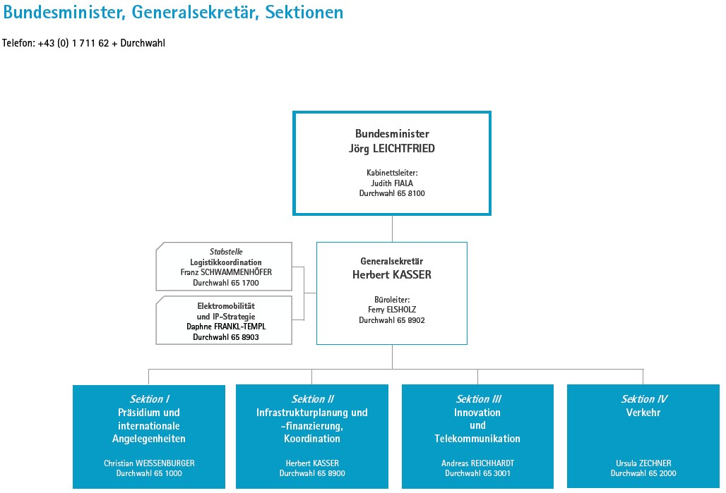
Bundesminister, Generalsekretär, Sektionen | Federal Minister, General Secretary, Departments
Telefon: +43 (0) 1 1711 62 + Durchwahl | Tel.: +43 (0) 1 1711 62 + Extension
Bundesminister | Federal Minister
Jörg LEICHTFRIED | Jörg LEICHTFRIED
Kabinettstleiter: Judith FIALA | Ministry Office Head: Judith FIALA
Durchwahl 65 8100 | Extension 65 8100
Stabstelle | Staff unit
Logistikkoordination | Logistics coordination
Franz SCHWAMMENHÖFER | Franz SCHWAMMENHÖFER
Durchwahl 65 1700 | Extension 65 1700
Elektromobilität und IP-Strategie | Electromobility and IP strategy
Daphne FRANKL-TEMPL | Daphne FRANKL-TEMPL
Durchwahl 65 8903 | Extension 65 8903
Generalsekretär | General Secretary
Herbert KASSER | Herbert KASSER
Büroleiter: Ferry ELSHOLZ | Office Manager Ferry ELSHOLZ
Durchwahl 65 8902 | Extension 65 8902
Sektion I | Department I
Präsidium und international Angelegenheiten | Steering committee and international affairs
Christian WEISSENBURGER | Christian WEISSENBURGER
Durchwahl 65100 | Extension 65100
Sektion II | Department II
Infrastrukturplanung und Finanzierung, Koordination | Infrastructure planning and financing, coordination
Herbert KASSER | Herbert KASSER
Durchwahl 65 8900 | Extension 65 8900
Sektion III | Department III
Innovation und Telekommunikation | Innovation and telecommunications
Andreas REICHHARDT | Andreas REICHHARDT
Durchwahl 65 3001 | Extension 65 3001
Sektion IV | Section IV
Verkehr | Transport
Ursula ZECHNER | Ursula ZECHNER
Durchwahl 65 2000 | Extension 65 2000
(Situation as of 1 August 2016, Source: Website of bmvit)

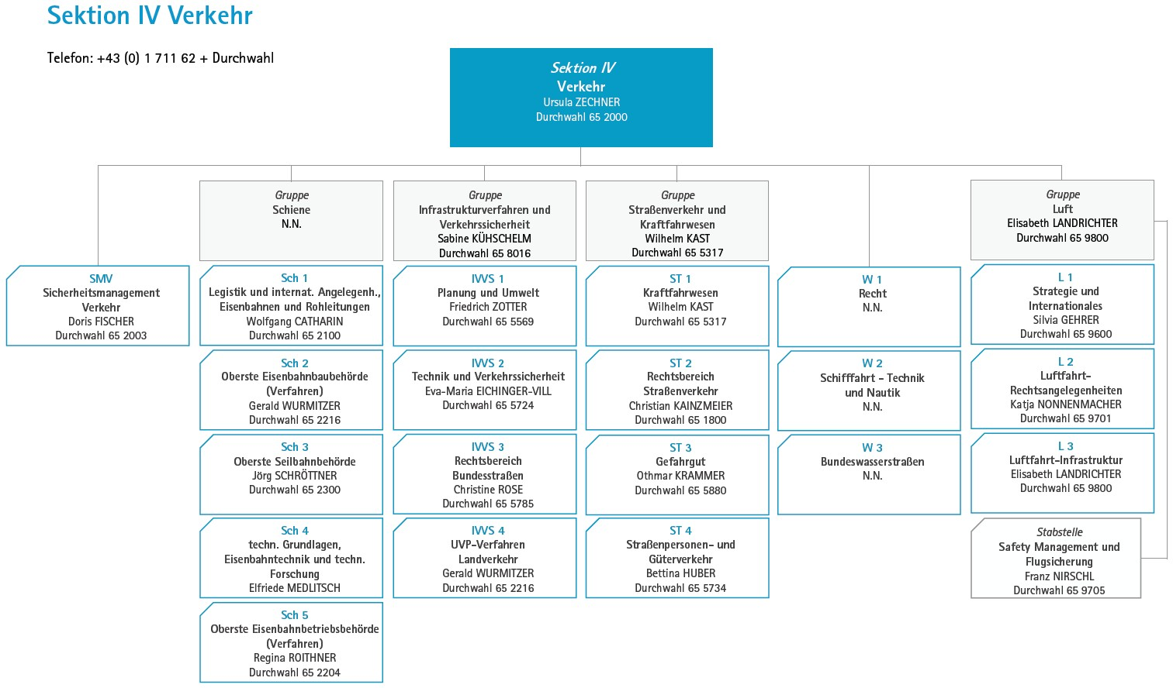

(Situation as of 1 August 2016, Source: Website of bmvit)

Sektion IV Verkehr | Department IV Transport
Telefon: +43 (0) 1 711 62 + Durchwahl | Phone: +43 (0) 1 711 62 + Extension
Sektion IV | Section IV
Verkehr | Transport
Ursula ZECHNER | Ursula ZECHNER
Durchwahl 65 2000 | Extension 65 2000
SMO | SMO
Sicherheitsmanagement | Safety Management
Verkehr | Transport
Doris FISCHER | Doris FISCHER
Durchwahl 65 2003 | Extension 65 2003
Gruppe | Group
Schiene | Rail
N.N. | Vacancy
Sch 1 | Sch
Logistik und internat. Angelegenh., | Logistics and international affairs
Eisenbahnen und Rohleitungen | railways and pipelines
Wolfgang CATHARIN | Wolfgang CATHARIN
Durchwahl 65 2100 | Extension 65 2100
Sch 2 | Sch 2
Oberste Eisenbahnbaubehörde | Supreme railway construction authority
(Verfahren) | (Procedure)
Gerald WURMITZER | Gerald WURMITZER
Durchwahl 65 2300 | Extension 65 2300
Sch 3 | Sch 3
Oberste Seilbahnbehörde | Supreme cableway authority
Jörg SCHRÖTTNER | Jörg SCHRÖTTNER
Durchwahl 65 2300 | Extension 65 2300
Sch 4 | Sch 4
Techn. Grundlagen, Eisenbahntechnik und techn. Forschung | Technical principles & technology, technical railway research
Elfriede MEDLITSCH | Elfriede MEDLITSCH
Sch 5 | Sch 5
Oberste Eisenbahnbetriebsbehörde | Supreme railway operation authority
(Verfahren) | (Procedure)
Regina ROITHNER | Regina ROITHNER
Durchwahl 65 2204 | Extension 65 2204
Gruppe | Group
Infrastrukturverfahren und Verkehrssicherheit | Infrastructure procedure and traffic safety
Sabine KÜHSCHELM | Sabine KÜHSCHELM
Durchwahl 65 8016 | Extension 65 8016
IVVS 1 | IVVS 1
Planung und Umwelt | Planning and environment
Friedrich ZOTTER | Friedrich ZOTTER
Durchwahl 65 5569 | Extension 65 5569
IVVS 2 | IVVS 2
Technik und Verkehrssicherheit | Technology and Traffic Safety
Eva-Maria EICHINGER-VILL | Eva-Maria EICHINGER-VILL
Durchwahl 65 5724 | Extension 65 5724
IVVS 3 | IVVS 3
Rechtsbereich Bundesstraßen Christine ROSE | Legal field federal roads Christine ROSE
Durchwahl 65 5785 | Extension 65 5785
IVVS 4 | IVVS 4
UVP-Verfahren | EIA procedures
Landverkehr | Overland transport
Gerald WURMITZER | Gerald WURMITZER
Durchwahl 65 2216 | Extension 65 2216
Gruppe | Group
Straßenverkehr und Kraftfahrwesen | Road transport and road vehicles
Wilhelm KAST | Wilhelm KAST
Durchwahl 65 5317 | Extension 65 5317
ST 1 | ST 1
Kraftfahrwesen | Road vehicles
Wilhelm KAST | Wilhelm KAST
Durchwahl 65 5317 | Extension 65 5317
ST 2 | ST 2
Rechtsbereich | Legal field
Straßenverkehr | Road transport
Christian KAINZMEIER | Christian KAINZMEIER
Durchwahl 65 1800 | Extension 65 1800
ST 3 | ST 3
Gefahrgut | Dangerous goods
Othmar KRAMMER | Othmar KRAMMER
Durchwahl 65 5880 | Extension 65 5880
ST 4 | ST 4
Straßen Personen und Güterverkehr | Road, passenger and freight transport
Bettina HUBER | Bettina HUBER
Durchwahl 65 5734 | Extension 65 5734
W 1 | W 1
Recht N.N. | Legal Vacancy
W 2 | W 2
Schifffahrt – Technik und Nautik | Shipping, technology and navigation
N.N. | Vacancy
W 3 | W 3
Bundeswasserstrassen | Federal waterways
N.N. | Vacancy
Gruppe | Group
Luft | Air
Elisabeth LANDRICHTER | Elisabeth LANDRICHTER
Durchwahl 65 9800 | Extension 65 9800
L 1 | L 1
Strategie und Internationales | Strategy and International
Silvia GEHRER | Silvia GEHRER
Durchwahl 65 9600 | Extension 65 9600
L 2 | L 2
Luftfahrt Rechtsangelegenheiten | Aviation legal affairs
Katja NONNENMACHER | Katja NONNENMACHER
Durchwahl 65 9701 | Extension 65 9800
L 3 | L 3
Luftfahrt-Infrastruktur | Air – Infrastructure
Elisabeth LANDRICHTER | Elisabeth LANDRICHTER
Durchwahl 9800 | Extension 9800
Stabsteile | Staff
Safety Management und Flugsicherung | Safety Management and Flight Safety Unit
Franz NIRSCHL | Franz NIRSCHL
Durchwahl 659705 | Extension 659705

Extract from the organisation chart (with particular reference to the Railway Safety Directive):

Department IV – Transport

Authorities, technical and legal field rail/road/cableway/pipeline as well as
issues in the area of water and air.

SMV Department – Safety Management Transport [Sicherheitsmanagement Verkehr]

Coordination and strategic management of safety-critical tasks of all Austrian road safety authorities within bmvit; Standardisation and quality management (including the monitoring the implementation) with regard to compliance by road safety authorities; processing of administrative files assigned to bmvit according to the Act on the Transport of Dangerous Goods [Gefahrgutbeförderungsgesetz] (GGBG)]; verification of financial capacity of transport companies during the authorisation procedure and supervisory activity; affairs of the traffic safety advisory council according to Article 23 of the Accident Investigation Act 2005, including management, risk and crisis management.

Section Sch 1 – Parliamentary drafting and international affairs railways and
pipelines

Participation in the creation and implementation of Union law and of bilateral agreements in the area of railways and pipelines,including the representation of the matters in question within EU bodies and other international and national bodies; national law-making including general secondary legislation, as well as coordination of legal regulations in the area of railways and pipelines; basic legal matters with regard to the rail reform and railway market regulation, as well as affairs of the state commissaries; implementation of Pipeline Act [Rohrleitungsgesetz].

Section Sch 2 – Supreme railway construction authority [Oberste Eisenbahnbaubehörde] (railway procedures)

Exercising rail construction authority powers for railways, in particular procedures for construction approval, type approval including approval for operation, level crossings; lineside property procedures; preliminary rulings; preliminary questions decisions; handling of complaints; legal and administrative issues relating to training and examining of railway staff; management of the lists and official monitoring of the Railway Infrastructure Services Company [Schieneninfrastruktur- Dienstleistungsgesellschaft mbH] (SCHiG) in implementing the Railways Act; in all these matters drafting of secondary legislation; deciding appeals and representing these matters in international and national technical bodies.

Section Sch 4 – Railway technical principles and technology, technical railway research

General technical matters relating to construction, safety, telecommunications engineering, electrical engineering and machinery for railways including the technical aspects of equipment to ensure railway safety and rolling stock of all types; domestic and international technical rules and specifications and other sets of regulations on the state of the art; matters relating to technical standards for railways in domestic and international bodies, in particular in RISC, ERA and CEN working groups; involvement in accreditation; evaluation and publication of the results of relevant research in the railway field including involvement in research projects and external publications.

Section Sch 5 – Supreme railway operating authority (Procedures concerned with
railways)

Exercising administrative processes for mainline and secondary railways from the legal, operational and (in so far as involved) technical design aspects; implementing and checking the access conditions set by railway safety authorities together with drafting strategic principles for concessions, traffic authorisations, safety authorisations and safety certification; evaluating and drafting
the annual reports including monitoring that safety levels are maintained; evaluating, implementing and checking safety recommendations of the safety investigation authority; approval of staff regulations; approval of the appointment of local operations supervisors; closure of railways; matters relating to other safety authority related supervisory activities including administrative circulars and decrees including evaluating and monitoring of these measures; coordination and representing these matters in domestic and international bodies including in the development of EU statutory bases in the RISC and ERA.

  - Organisation chart for the Federal Office for Transport as the federal accident investigation institution:

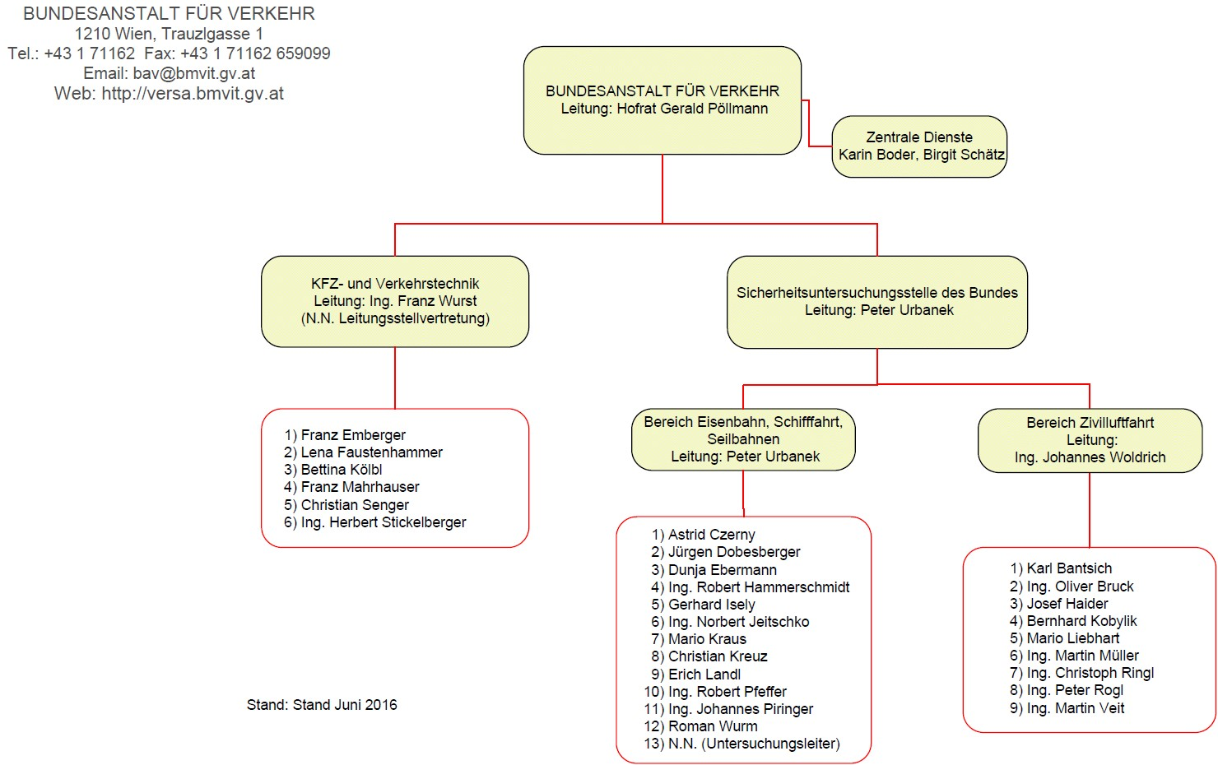
BUNDESANSTALT FÜR VERKEHR | FEDERAL OFFICE FOR TRANSPORT [BUNDESANSTALT FÜR VERKEHR]
1210 Wien, Trauzlgasse 1 | 1210 Vienna, Trauzlgasse 1
Tel.: +43 1 71162 Fax: +43 1 71162 659099 | Tel.: +43 1 71162 Fax: +43 1 71162 659099
Email: bav@bmvit.gv.at | Email: bav@bmvit.gv.at
Web: http://versa.bmvit.gv.at | Web: http://versa.bmvit.gv.at
BUNDESANSTALT FÜR VERKEHR | FEDERAL OFFICE FOR TRANSPORT [BUNDESANSTALT FÜR VERKEHR]
Leitung: Hofrat Gerald Pöllmann | Director Hofrat Gerald Pöllmann
Zentrale Dienste Karin Boder, Birgit Schätz | Central Service Karin Boder, Birgit Schätz
KFZ und Verkehrtechnik | Motor vehicles and traffic technology
Leitung: Ing. Franz Wurst | Director Eng. Franz Wurst
(N.N. Leitungsstelvertretung) | (Vacancy Vice-chair)
Sicherheitsuchungsstelle des Bundes | Federal Safety Investigation Authority
Leitung: Peter Urbanek | Director Peter Urbanek
Bereich Eisenbahn, Schifffahrt, Seilbahnen | Rail, navigation, cableways
Leitung: Peter Urbanek | Director Peter Urbanek
Bereich Zivilluftfahrt | Civil aviation
Leitung: Ing. Johannes Woldrich | Director Eng. Johannes Woldrich

(Source: Website Bundesanstalt für Verkehr) Federal Office for Transport’s website

ANNEX C: CSI data – definitions applied

The CSI data evaluated relates to the operation of main lines and the secondary lines connected to them, the operation of rolling stock on such railways and traffic on such railways on Austrian sovereign territory in 2015.

- CSI Data

  - Accident-related indicators (including the years 2011 – 2014)

Graphical presentation of accident-related indicators: Significant accidents by type of accident:
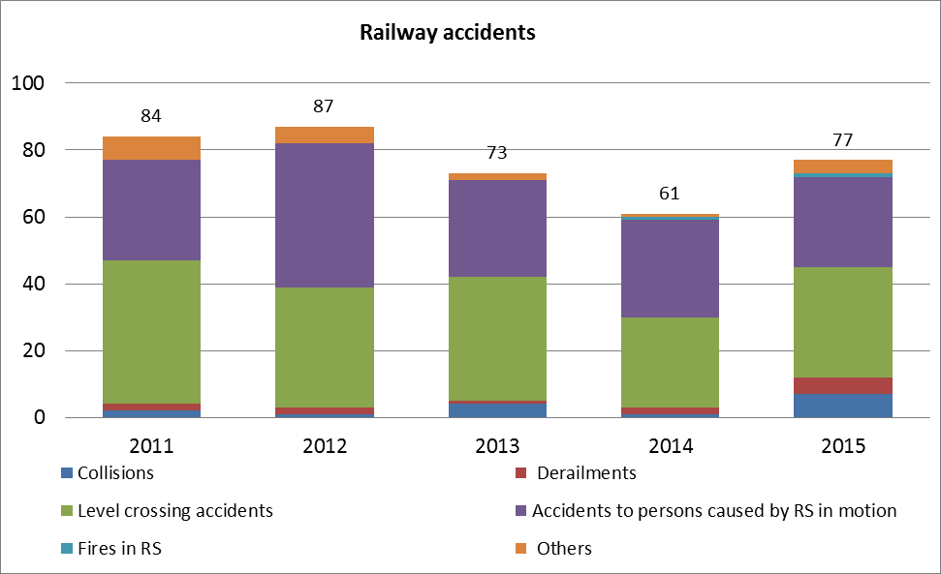

Fatalities by type of accident:

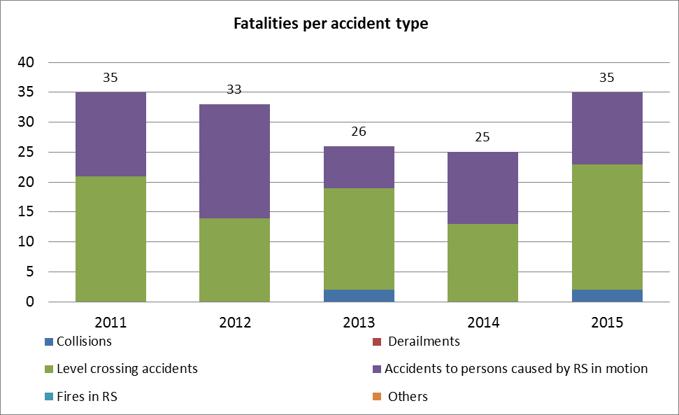

Serious injuries by type of accident:

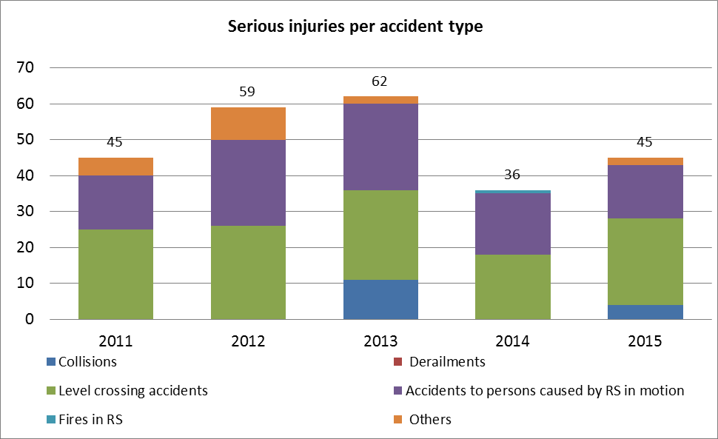

Fatalities by category of people involved:

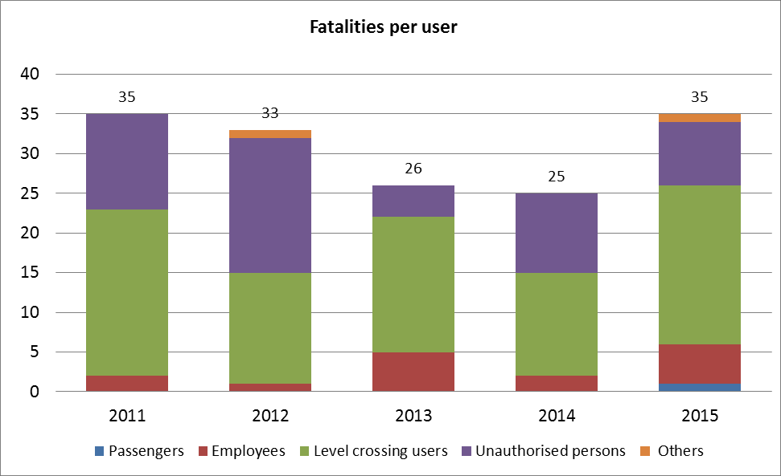

Serious injuries by category of people involved:

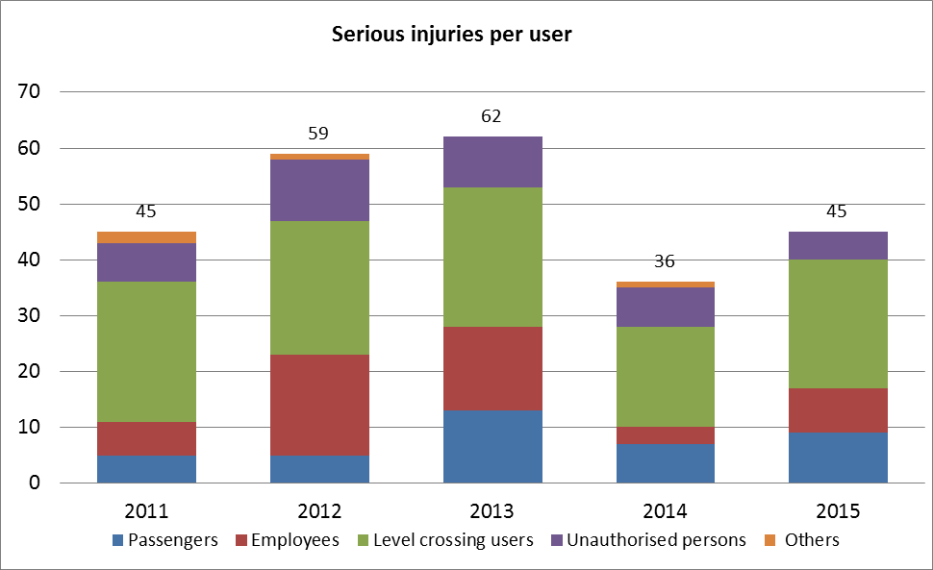

Tabular presentation of accident-related indicators: Significant accidents by type of accident:
Year | Collisions | Derailments | Level crossing accidents | Accidents to persons caused by RS  in motion | Fires in RS | Others | Total
2011 | 2 | 2 | 43 | 30 | 0 | 7 | 84
2012 | 1 | 2 | 36 | 43 | 0 | 5 | 87
2013 | 4 | 1 | 37 | 29 | 0 | 2 | 73
2014 | 1 | 2 | 27 | 29 | 1 | 1 | 61
2015 | 7 | 5 | 33 | 27 | 1 | 4 | 77

Fatalities by type of accident:

Year | Collisions | Derailments | Level crossing accidents | Accidents to persons caused by RS  in motion | Fires in RS | Others | Total
2011 | 0 | 0 | 21 | 14 | 0 | 0 | 35
2012 | 0 | 0 | 14 | 19 | 0 | 0 | 33
2013 | 2 | 0 | 17 | 7 | 0 | 0 | 26
2014 | 0 | 0 | 13 | 12 | 0 | 0 | 25
2015 | 2 | 0 | 21 | 12 | 0 | 0 | 35

Serious injuries by type of accident:

Year | Collisions | Derailments | Level crossing accidents | Accidents to persons caused by RS  in motion | Fires in RS | Others | Total
2011 | 0 | 0 | 25 | 15 | 0 | 5 | 45
2012 | 0 | 0 | 26 | 24 | 0 | 9 | 59
2013 | 11 | 0 | 25 | 24 | 0 | 2 | 62
2014 | 0 | 0 | 18 | 17 | 1 | 0 | 36
2015 | 4 | 0 | 24 | 15 | 0 | 2 | 45

Fatalities by category of people involved:

Year | Passengers | Employees | Level crossing users | Unauthorised persons | Others | Total
2011 | 0 | 2 | 21 | 12 | 0 | 35
2012 | 0 | 1 | 14 | 17 | 1 | 33
2013 | 0 | 5 | 17 | 4 | 0 | 26
2014 | 0 | 2 | 13 | 10 | 0 | 25
2015 | 1 | 5 | 20 | 8 | 1 | 35

Serious injuries by category of people involved:

Year | Passengers | Employees | Level crossing users | Unauthorised persons | Others | Total
2011 | 5 | 6 | 25 | 7 | 2 | 45
2012 | 5 | 18 | 24 | 11 | 1 | 59
2013 | 13 | 15 | 25 | 9 | 0 | 62
2014 | 7 | 3 | 18 | 7 | 1 | 36
2015 | 9 | 8 | 23 | 5 | 0 | 45

  - Indicators relating to dangerous goods

 | Total | Relative number (per million train km)
Accidents in which at least one rail vehicle carrying dangerous goods was involved (in accordance with the definition in the Annex to Directive 2014/88/EC) | 0 | 0
Number of this type of accidents in which dangerous goods are released. | 0 | 0

  - Indicators relating to suicides

 | Total | Relative number (per million train km)
Suicide | 95 | 0.62
Suicide attempt | 12 | 0.08

  - Indicators relating to the precursors of accidents

 | Total | Relative number (per million train km)
Broken rails | 79 | 0.52
Track buckles or other track geometry defects | 182 | 1.19
Wrong-side signalling failures | 11 | 0.07
Signal Passed at Danger reaching the danger point | 10 | 0.07
Signal Passed at Danger without reaching the danger point | 29 | 0.19
Broken wheels on vehicles in service | 0 | 0.00
Broken wheels and broken axles on a moving vehicle | 0 | 0.00

  - Indicators to calculate the economic impact of major accidents

 | Total amount | Relative amount (per million train km)
Total cost of all major accidents: | EUR 132 840 670 | EUR 869 945
Number of deaths and serious injuries multiplied by the value of preventing a  casualty (VPC) | EUR 98 142 838 | EUR 642 717
Costs of damage to the environment | EUR 235 000 | EUR 1 539
Costs of damage to rolling stock and infrastructure | EUR 31 276 828 | EUR 204 825
Costs of delay caused by accidents | EUR 3 186 004 | - EUR

  - Indicators relating to technical safety of infrastructure and its implementation

Percentage of lines operated with control-command systems (TPS) which include
the following:
warning | 0%
Warning and automatic stopping2) | 76%
Warning and automatic stopping as well as section-by-section speed supervision2) | 3%
Warning and automatic stopping as well as continuous speed supervision | 10%

Percentage of train kilometres using on-board TPS. These systems are
the following:
warning | 0%
Warning and automatic stopping2) | 69%
Warning and automatic stopping as well as section-by-section speed supervision2) | 8%
Warning and automatic stopping as well as continuous speed supervision | 19%

 | Total | Number per route kilometre | Number per track kilometre
Total number of level crossings by type: | 4419 | 0.846 | 0.600
active level crossing | 1903 | 0.364 | 0.258
manual | 156 | 0.030 | 0.021
automatic with user-side warning | 849 | 0.163 | 0.115
automatic with user-side protection | 898 | 0.172 | 0.122
with rail-side protection 0.000 | 0 | 0.000 | 0.000
passive level crossing | 2516 | 0.482 | 0.342

The common safety indicators (CSI) as from the reference year 2006 can be found on the

ERAIL (European Railway Accident Information Links) database of the European Union Agency for Railways.

Website: http://erail.era.europa.eu/safety-indicators.aspx

The common safety indicators of the European Union Member States are published on that site.

2 clear attribution to ‘warning and automatic stopping‘ or ‘warning and automatic stopping’ as well as section-by-section speed supervision’ is not available from all managers

- Definitions used in the annual report

  - Definitions to be adopted

The common definitions for the common safety indicators laid down in Directive 2014/88/EU of 9 July 2014 amending Directive 2004/49/EC are to be used with effect from 2015.

Further details on the various common safety indicators are provided in the guide entitled Implementation Guidance for CSIs, and produced by the European Union Agency for Railways.

Website: http://www.era.europa.eu/Document- Register/Pages/Implementation_Guidance_for_use_of_Common_Safety_Indicators.aspx

  - National definitions

Further national definitions which have a particular relevance to the application of the Railway Safety Directive are set out below:

Main and secondary lines in accordance with Article 4 EisbG, BGBl. No 60/1957, as amended:

§ 4. (1) Main lines are specific railway lines of greater traffic importance open
for public traffic. Amongst them are those railway lines
which have been declared to be high capacity lines in accordance with Article 1 of the High Capacity Line Act (Hochleistungsstreckengesetz), BGBl. No 135/1989 as amended;
2. which the Federal Minister of Transport, Innovation and Technology has declared by means of a regulation
to be main lines because a particular importance is attributed to them for high performance traffic or because they should be upgraded for such traffic – in particular for international services or for regional traffic.
(2) Secondary lines are railway lines open for public traffic
provided they are not main lines or tramways.

connected main and secondary lines in accordance with Article 1a EisbG, BGBl. No 60/1957, as amended:

Main and secondary lines are connected if an exchange of vehicles can just take place over a local connection without a change of gauge and without technical aids (transporter wagon, for example). Main and secondary lines are also considered as connected if they are connected across a frontier with another railway of the same type in a neighbouring state.

Hochleistungsstrecken in accordance with Hochleistungsstreckengesetz, BGBl. No 135/1989, as amended:

Article 1. (1) The Federal Government may declare existing or planned railways (sections of lines or parts of sections of lines including the installations necessary) to be high capacity lines by regulation (High Capacity Line Regulation (Hochleistungsstreckenverordnung)). A precondition for this is that the line is considered to have a special importance for high performance with international connections or for local traffic.
(2) Existing or planned railways may be declared to be part of high capacity lines even if the characteristics outlined in Article 1 do not apply to them, but they are
directly connected to high capacity lines and are necessary for a rational management
of railway operation or rail transport on high capacity lines.

Infrastructure Managers (IM) in accordance with Article 1a EisbG, BGBl. No 60/1957, as amended:

Article 1a. An infrastructure manager is a railway organisation which covers the construction and operation of main line and secondary railways excluding those secondary railways which are not connected to main lines or other secondary lines and is authorised to make them available.

Infrastructure manages (IM) in accordance with Article 1b Railways Act 1957, BGBl. No 60/1957, as amended:

Article 1b. A infrastructure manager is a railway undertaking which operates railway services on the railway infrastructure of main lines or connected secondary lines as well as provides traction; this also includes undertakings
which provide traction only, and who hold an operating authorisation, an operating concession or an authorisation or approval equivalent to an operating authorisation in accordance with Article 41.

- Abbreviations

bmvit | Federal Ministry of Transport, Innovation and Technology [Bundesministerium für Verkehr, Innovation und Technologie]
CSI | Common Safety Indicators
CSM | Common Safety Methods
ECM | Entity in Charge of Maintenance
EisbG | Railways Act 1957 [Eisenbahngesetz 1957]
EIM | European Rail Infrastructure Manager
LC | Level Crossing
ERA | European Union Agency for Railways
ERAIL | European Railway Accident Information Links
EU | European Union
RU | Railway Undertaking
IM | Infrastructure Manager
SR | Small Railcar
km | kilometre
MeldeVO | Rail Accident Reporting Regulation 2006 [Meldeverordnung Eisenbahn – Eisb 2006]
NSA | National Safety Authority
ÖBB | Austrian Federal Railways [Österreichische Bundesbahnen]
PKW | Passenger cars
RISC | Railway Interoperability and Safety Committee
RU | Railway Undertaking
MT | Motorised Trolley
SUB | Federal Safety Investigation Authority [Sicherheitsuntersuchungsstelle des Bundes]
VO | Regulation [Verordnung]
VT | Visual Testing

ANNEX D: Important changes to legislation and regulation

 | Statutory reference | Date legislation comes into force | Reason for introduction | Description
General national railway safety legislation
Legislation relating to the national
safety authority (Sicherheitsbehörde)
Legislation relating to notified bodies, assessors, third party bodies for registration, examination, etc. | Federal Act on Railways, Railway Rolling Stock on Railways and Traffic on Railways (Railways Act 1957 – EisbG) [Bundesgesetz über Eisenbahnen, Schienenfahrzeuge auf Eisenbahnen und den Verkehr auf Eisenbahnen (Eisenbahngesetz 1957 – EisbG)], BGBl. I No 137/2015 | 27 November  2015 | Amendment of the Railways Act  1957 for the implementation of Directive 2012/34/EU and Regulation (EU) No 402/2013 | In the context of the national implementation of Directive 2012/34/EU, Regulation No 402/2013 was also implemented for the purpose of determining who must carry out the activity of an assessment body pursuant to this regulation.
National rules on
railway safety
Rules on national safety targets and
methods
Rules on requirements for safety management systems and safety certification of railway undertakings
Rules on requirements for safety management systems and safety authorisation of infrastructure managers
Rules on requirements for
wagon keepers
Rules on requirements for
maintenance organisations

40

 | Statutory reference | Date legislation comes into force | Reason for introduction | Description
Rules on requirements for the authorisation of placing in service and maintenance of new and substantially altered rolling stock, including rules for exchange of rolling stock between railway undertakings, registration systems and requirements on testing procedures
Common operating rules for the railway network, including rules relating to signalling and traffic procedures
Rules laying down requirements for additional internal operating rules
that must be established by the infrastructure managers and railway undertakings
Rules on requirements for staff executing safety critical tasks, including selection criteria, medical fitness and vocational training and certification
Rules on the investigation of accidents and incidents including recommendations
Rules on requirements for national safety indicators including how to collect and analyse the indicators
Rules on requirements for the
approval to put
Infrastructure (track, bridges, tunnels, power supplies, ATC, radio, signals, interlocking, level crossings, platforms, etc.) into service

41

ANNEX E: The development of safety certification and authorisation – numerical data

- Safety certificates in accordance with Directive 2004/49/EC

 | Number of certificates
- Number of valid safety certificates Part A issued in the reporting year and previous years | 26

 |  | Number of certificates
- Number of safety certificates Part B issued in the reporting year and previous years that remain valid | Number of certificates part B, for which the part  A has been issued in your Member State | 26
 | Number of certificates part B, for which the part  A has been issued in another Member State | 12

 |  | A | R | P
- Number of new applications for safety certificates Part A submitted by railway undertakings in 2015 | New certificates | 1 | - | 2
 | Updated/amended certificates | - | - | -
 | Renewed certificates | 12 | - | 3

 |  |  | A | R | P
E.1.4. Number of new applications for safety certificates part B submitted by railway undertakings in 2015 | Where the part A has been issued in your Member State | New certificates | 1 | - | 2
 |  | Updated/amended certificates | - | - | -
 |  | Renewed certificates | 12 | - | 3
 | Where the part A has been issued in another Member State | New certificates | 1 | - | 1
 |  | Updated/amended certificates | - | - | -
 |  | Renewed certificates | 1 | - | -

A = accepted: application accepted; certificate has already been issued
R = rejected: application rejected; no certificate has been issued
P = pending: case is still pending; no certificate has been issued in the reporting year

 | Number of certificates
- Number of certificates Part A revoked in the reporting year | -
- Number of certificates Part B revoked in the reporting year | -

E.1.5. List of states from which railway undertakings applying for a safety certificate part B in your Member State have obtained their safety certificate part A:

- Germany

- Italy

- Netherlands

- Poland

- Switzerland

- Slovenia

- Czech Republic

- Hungary

- Safety authorisations in accordance with Directive 2004/49/EC

 | Number of authorisations
- Number of valid safety authorisations issued to infrastructure managers in the reporting year and previous years | 9

 |  | A | R | P
- Number of applications for safety authorisations submitted by infrastructure managers in 2015 | New authorisations | - | - | -
 | Updated/amended authorisations | - | - | -
 | Renewed authorisations | - | - | -

A = accepted: application accepted; authorisation has already been issued
R = rejected: application rejected; no authorisation has been issued
P = pending: case is still pending; no authorisation has been issued in the reporting year

  - Number of safety authorisations revoked in the reporting year

