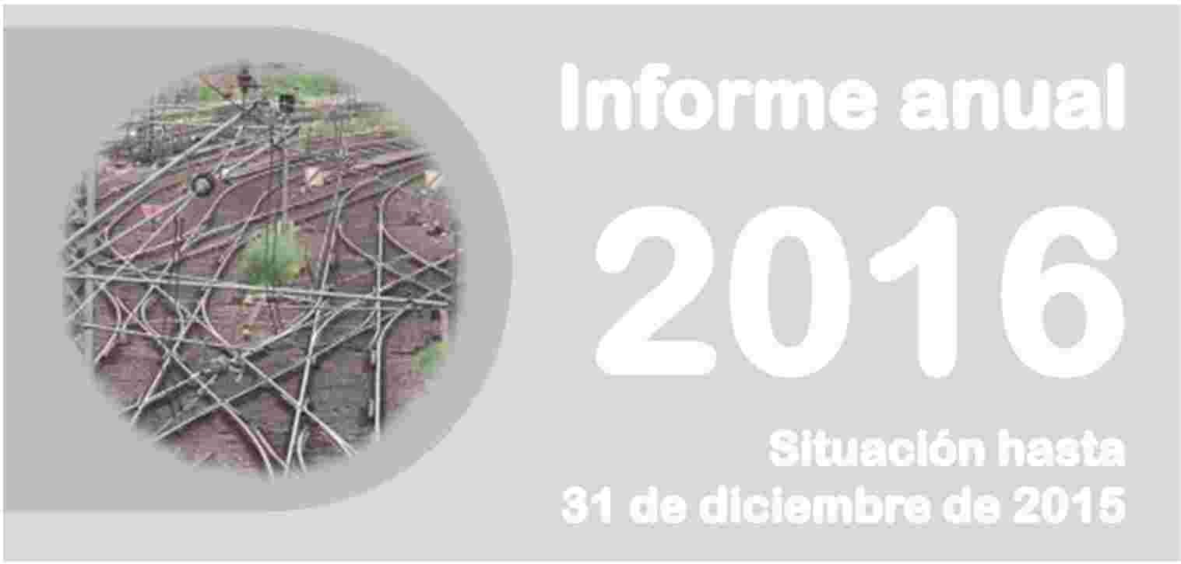

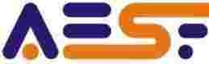






 | GOVERNMENT OF SPAIN | MINISTRY OF PUBLIC WORKS AND TRANSPORT

 | NATIONAL RAILWAY SAFETY AGENCY

Annual Report
2016
Situation as at
31 December 2015
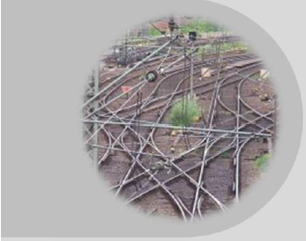

NATIONAL RAILWAY SAFETY AGENCY
 | GOVERNMENT OF SPAIN | MINISTRY OF PUBLIC WORKS AND TRANSPORT

National Railway Safety Agency

Annual Report
(Article 18, Directive 2004/49)

2016

(Actions to
31 December 2015)

Contents

A. Introduction 4
B. The National Railway Safety Agency 7
C. Policies and action lines regarding railway safety 11
D. Safety 23
E. Safety certificates and authorisations 38
F. Certification of entities in charge of maintenance 40
G. Supervision of the rail system 43
H. Modifications to railway safety legislation 50
I. Application of Regulation 402/2013 on risk evaluation and assessment 54
J. ANNEXES 58

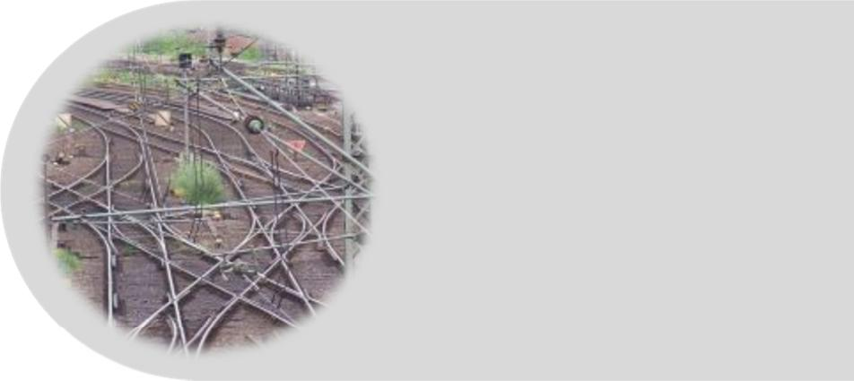

A. Introduction

Article 18 of Directive 2004/49/EC on railway safety, states:
‘Each year the safety authority shall publish an annual report concerning its activities in the preceding year and send it to the Agency by 30 September at the latest. The report shall contain information on:
- the development of railway safety, including an aggregation at Member State level of the CSIs laid down in Annex I;
- important changes in legislation and regulation concerning railway safety;
- the development of safety certification and safety authorisation;
- results of and experience relating to the supervision of infrastructure managers and railway undertakings’.
This report complies with this requirement. The information contained in the report reflects the situation at the end of 2015, i.e. up to 31 December 2015.
This report has been prepared by the National Railway Safety Agency (Agencia Estatal de Seguridad Ferroviaria – AESF) to be forwarded to the European Union Agency for Railways (ERA), in accordance with the guidelines of this body, for the purposes of:
- providing the Agency with basic information for drafting the biannual safety report.
- publication by the Agency on its website.
The report is therefore directed at agents in the railway sector and at the general public, both through dissemination by the European Union Agency for Railways and by the AESF to national agents (railway undertakings and managers, entities in charge of maintenance, certification entities and the accident investigation committee).
For the preparation of this report, the Directive states that:
‘Each year all infrastructure managers and railway undertakings shall submit to the safety authority before 30 June an annual safety report concerning the preceding calendar year.’
Therefore, the agents of the national railway system must submit the information requested in Directive 2004/49/EC through these reports. As in previous years, to facilitate the compilation of data for the preparation of this report, a template of the annual report has been provided to undertakings, and the annual safety reports received from railway undertakings and infrastructure managers have been assessed to identify possible improvements for the preparation of subsequent reports.
This report includes information on the Public Railway Network (RFIG) administered in 2015 by the Railway Infrastructure Manager (Adif), by Adif-Alta Velocidad and by TP Ferro, as well as information on the services and activities that are provided on the infrastructure. The following are excluded from the scope of application of this report, as permitted by Directive 2004/49:
- metros, trams and other light rail systems,
- networks that are functionally separate from the rest of the rail system and intended only for the operation of local, urban or suburban passenger services, as well as railway undertakings operating solely on these networks,
- privately owned railway infrastructure that exists solely for use by the infrastructure owner for their own freight operations,
- historical vehicles that travel on the RFIG, as long as they comply with specific safety rules to guarantee the safety of such vehicles,
- historical, museum and tourist railways that operate on their own networks, including workshops, vehicles and personnel.
This report covers the services and activities provided on the RFIG by railway undertakings that provided commercial passenger services (Renfe Viajeros) and freight services (Acciona Rail Services, S.A, Comsa Rail Transport, S.A., Continental Rail, S.A.U., Ferrovial Railway, S.A., Logitren Ferroviaria, S.A., Renfe Mercancías, Tracción Rail, S.A., Transfesa Rail, S.A.U. and Transitia Rail, S.A.) on this date.

B. The National Railway Safety Agency

Powers of the Agency
One of the main new developments in the sector during 2015 was the entry into operation of the National Railway Safety Agency (AESF). The AESF is a public body regulated by Law 28/2006 of 18 July, on state Agencies for the improvement of public services, and is attached to the Ministry of Public Works and Transport through the General Secretariat of Infrastructure.
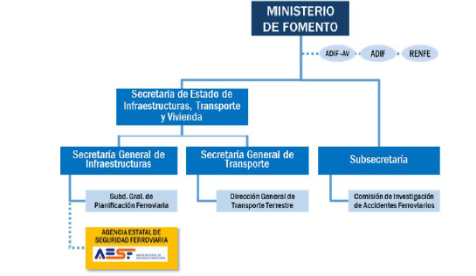
MINISTERIO DE FOMENTO | MINISTRY OF PUBLIC WORKS AND TRANSPORT
ADIF-AV | ADIF-AV
ADIF | ADIF
RENFE | RENFE
Secretaria de Estado de Infraestructuras, Transporte y Vivienda | State Secretariat of Infrastructure, Transport and Housing
Secretaria General de Infraestructuras | General Secretariat of Infrastructure
Secretaria General de Transporte | General Secretariat of Transport
Subsecretaria | Under-secretariat
Subd. Gral. De Planificación Ferroviaria | General Under-secretariat of Railway Planning
Dirección General de Transporte Terrestre | Directorate-General of Land Transport
Comisión de investigación de Accidentes Ferroviarios | Railway Accidents Investigation Commission
AGENCIA ESTATAL DE SEGURIDAD FERROVIARIA | NATIONAL RAILWAY SAFETY AGENCY

Its by-laws were approved by Royal Decree 1072/2014 of 19 December, which established 1 April 2015 as the start date for its activities.
Within the scope of the Agency’s jurisdiction (the RFIG), it is the authority responsible for railway safety, as set out in Law 38/2015 of 29 September, on the Railway Sector, organising and supervising the safety of all parts of the railway system: infrastructure, rolling stock, railway personnel and railway operations.
It carries out duties related to the interoperability of the railway system for which the state is responsible, and is likewise responsible for granting, suspending and revoking the licenses of railway undertakings.
The Agency continues the powers on these matters that, prior to the start of its activities, were exercised by the Directorate-General of Railways of the Ministry of Public Works and Transport.
For more information about the Agency, visit its website: www.seguridadferroviaria.es

The Agency’s action principles
The Agency is guided by the following action principles:
- Independence in its actions with respect to the functions that it has been assigned regarding the safety of railway transport.
- Authority and responsibility for the development and application of national and international railway standards, and the control of procedures.
- Promotion and dissemination of a culture of railway safety in all areas of action.
- Quality, efficacy, efficiency and transparency in the exercise of its functions.

Governing bodies, executive bodies and structure of the Agency
The Presidency and the Governing Council are the Governing Bodies of the Agency.
The Director of the Agency is the chief executive and is responsible for its direction and ordinary management. The Director is appointed by the Governing Council at the proposal of the President.
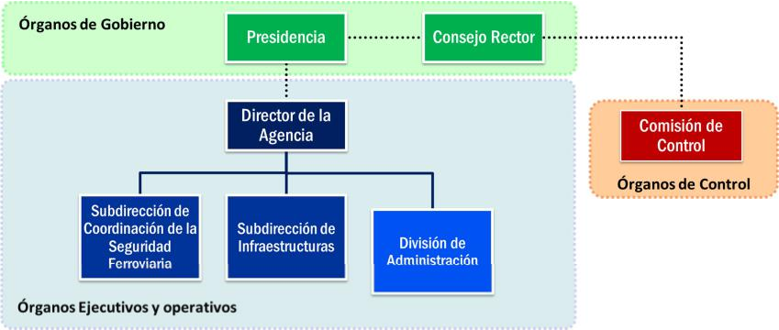
Órganos de Gobierno | Governing Bodies
Presidencia | Presidency
Consejo Rector | Governing Council
Director de la Agencia | Director of the Agency
Subdirección de Coordinación de la Seguridad Ferroviaria | Sub-directorate of Coordination of Railway Safety
Subdirección de Infraestructuras | Sub-directorate of Infrastructure
División de Administración | Administrative Division
Comisión de Control | Control Commission
Órganos de Control | Control Bodies
Órganos Ejecutivos y operativos | Executive and operational bodies

The Agency is composed of the following units:

■ Sub-directorate General of Infrastructure
Responsible for exercising functions related to issuing safety authorisations for infrastructure managers and the subsequent supervision thereof, as well as all aspects related to infrastructure and fixed equipment.

■ General Sub-directorate of Coordination of Railway Safety
Responsible for exercising functions related to issuing licences and safety certificates for railway undertakings and the subsequent supervision thereof, including authorisations for candidates other than railway undertakings and everything related to rolling stock, the maintenance thereof, railway personnel and associated centres.
Likewise, it is responsible for overall monitoring of the safety of the railway system, and coordinating the development of its technical operating procedures, as well as external representation of the Agency.

■ Administrative Division
Reporting directly to the Director of the Agency, it carries out support tasks for management and the Governing Council, as well as the management functions entrusted to it.

C. Policies and action lines regarding railway safety

Strategic action lines of the AESF
As previously mentioned, the National Railway Safety Authority (AESF) came into operation on 1 April 2015. Aside from its ordinary actions in the exercise of the powers assigned to national safety authorities by legislation (issuing authorisations for lines and vehicles, certificates, official approvals, etc.), its main lines of action in the year were those set out in its Action Plan 2015.
This plan was based around the following strategic lines:
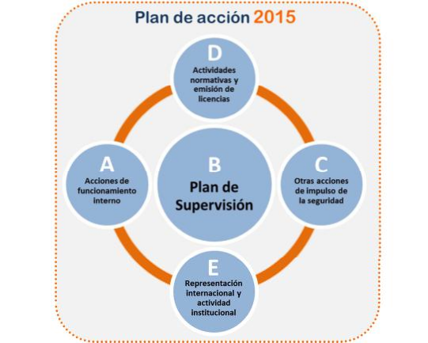
Plan de Acción 2015 | Action Plan 2015
Acciones de funcionamiento interno | Internal operating actions
Plan de Supervisión | Supervision Plan
Otras acciones de impulso de la seguridad | Other actions for promoting safety
Actividades normativas y emisión de licencias | Regulatory activities and the issuance of licences

- Internal operating actions:
As 2015 was the initial year of the AESF, the majority of efforts during the first few months were directed at starting up the Agency and equipping it with the tools to perform its tasks.
- Supervision plan:
In accordance with the Railway Sector Act, traffic safety on the Public Railway Network is the responsibility of the infrastructure managers and the railway undertakings that operate on the network.
In turn, the authority that is responsible for safety must ensure compliance with the regulatory framework by system agents and ensure that they use an adequate safety management system.
Further details of the supervisory activities of the AESF are set out in Chapter G of this report.
- Other actions for promoting safety:
The AESF is responsible for monitoring and coordinating the agents involved, and for the majority of the initiatives established by the Ministry of Public Works and Transport for the improvement of railway safety.
In particular, the AESF was involved in monitoring the measures described in greater detail in section C.2.2 of this report.
One particularly notable aspect was its work on developing the Railway Traffic Regulation (RCF), which was approved in 2015 and represents a milestone in national railway rules and regulations. Even though its entry into force will not be complete until January 2017, this transitional period involves major efforts to adapt facilities and equipment, review the internal procedures of all system agents and to train railway personnel. The AESF is responsible for supervision of this process.
Actions targeted at human factors were also notable during 2015. These related to improvements of training in the sector and incorporating medical and psychological conditions in assessments of aptitude for performing particular professions.
- Regulatory activities and the issuance of licences:
During 2015, the AESF was intensely active in regulatory activities, as set out in Chapter H of this report.
- International representation and institutional activity:
The AESF’s involvement in the international forums in which regulations are defined – European Commission, European Union Agency for Railways, Intergovernmental Organisation for International Carriage by Rail (OTIF), etc. – is considered fundamental.
This has led to intensive representation activities: approximately 80 meetings of bodies and work groups were attended in 2015, and further meetings were coordinated with the national authorities of other countries, whilst seminars were organised with the European Union Agency for Railways.

Safety strategies, programmes and initiatives of the Ministry of Public Works and Transport
- general policies to improve safety
The current policies of the Ministry of Public Works and Transport are included in the Infrastructure, Transport and Housing Plan (PITVI). This Plan arises from the need for a new framework for the strategic planning of infrastructures, with a time horizon ranging from 2012 to 2024.
The main action points for railway transport in this Plan are the following:
- Rearranging the current organisational model of railway management in order to overcome existing inefficiencies and ensure effective coordination of the roles of the agents involved.
- Giving a new boost to complete the deregulation of the sector, in line with European approaches, in order to ensure the development and improvement of the efficiency of railway transport.
- Fostering the opening-up of the Spanish network to new railway passenger operators under a competitive structure.
- Improving efficiency and competitiveness in freight transport by rail, as well as the effective integration thereof into logistics chains.
- Integrating the high-speed and conventional networks, as well as links with the networks of other countries.
All these action points revolve around the basic focus of maintaining and improving the safety of railway transport. Thus, all of the action programmes include action lines on safety. For example, the regulation, control and supervision programme includes the action line, ‘Improvement of railway safety and passenger protection’.
In addition, the investment action programme includes investment to reduce the accident rate of the network through maintenance of the conventional network, investment to continue with the elimination of level crossings and investment in updating safety installations.
- Improvement measures for the railway system
Since August 2013, the Ministry of Public Works and Transport has been pursuing a series of measures covering various aspects of the railway sector to improve the sector and establish future action lines. Most of these measures, which are far-reaching and therefore medium term, continued to be developed in 2015.
The announced measures relate to the improvement of infrastructure (signalling), personnel (hiring, evaluation and training), rolling stock, passengers and regulations. They cover the entire national railway sector, therefore including the Ministry itself, the AESF and infrastructure managers and railway undertakings.
The following actions related to these measures were carried out in 2015:
- Review of the maximum speed tables for all lines, with an analysis of speed scaling. Review of track signalling for significant speed changes and protection using beacons, if applicable.
This measure was almost entirely implemented in 2014 and was completed at the beginning of 2015. It included a review of significant speed changes in temporary speed limits. Moreover, the General Traffic Regulation approved in 2015 introduced new speed signalling criteria for routes.
- Promotion of greater development of the digital ASFA, enhancing the capacity for information transmission between the track and the train.
This measure endeavours to improve the features of the ASFA system, by increasing the number of system frequencies.
The testing process for track equipment prototypes was concluded in 2015 and the technical specifications for on-board equipment were drawn up. These were also independently evaluated and consultations were carried out with the sector.
Likewise, an implementation plan for the new versions was also rolled out, and the tender process for the installation of on-board and track equipment was initiated during 2015.
- Installation of a satellite system for trains as reinforcement for signalling systems.
This is a pilot project for the use of navigators as an aid for driving. After Renfe had prepared the functional specifications for the equipment and conducted prototype testing, a tender process was launched in 2015 for the installation of equipment in a ‘pilot test’. The railway undertaking and the infrastructure manager have signed a cooperation agreement for the exchange of information on track references.
- Review of requirements for entrance to railway sector professions and assessment of the appropriateness of designing ad hoc academic training.
2015 saw the approval of ‘Order FOM/679/2015 of 9 April, modifying Order FOM/2872/2010 of 5 November, which sets out the conditions for obtaining the qualifying certificates that allow railway personnel to perform duties related to rail traffic safety, setting forth the system of accredited training centres and the medical examination of the personnel’ and the AESF Resolution of 23 December 2015 on training pathways, which develops the Order.
In addition, work in cooperation with the Ministries responsible for education and employment was carried out in order to gradually incorporate railway professions into official, approved vocational education.
- Review of the protocol for psycho-physical medical examinations, analysing locations and requirements.
The aforementioned Order, FOM/679/2015, of 9 April, included clearer and more precise criteria for the physical assessment of railway professionals, addressing certain issues, such as taking medications that could hinder the performance of particular tasks. These criteria were defined jointly with medical specialists.
- Enhancement of the analysis of psychological aspects of driving to guide the continuous training of drivers.
Order FOM/679/2015 also includes psychological evaluation criteria prepared jointly with the General Council of Psychologist Associations, which has analysed the most important psychological variables to be considered in relation to the profession of train driving.
- Assessment of the possibility of improving the recording of professional activity of trains.
Recordings are extremely useful for investigating events. Therefore, in 2015 Renfe conducted phase I of the installation as a pilot phase, and initiated the tender process for phase II for a large part of its fleet.
- Implementation of a single, integrated communications systems in the cab using a hands-free system.
Renfe initiated the tender process to implement integrated equipment for train-ground and GSM-R systems, with hands-free capabilities, throughout its entire fleet.
Actions have also been taken to enable drivers’ mobile phones to interconnect with on-board GSM-R communications equipment in future.
- Increased checks on mandatory recording devices (safety), with systematic analysis of their information to foster improvement measures.
In 2015, Renfe implemented an automated computer analysis system that has allowed a considerable increase in the number of checks of readings from mandatory recording devices.
At the same time, it approved a modernisation plan for the mandatory recording devices of its fleet, with gradual replacement by more modern equipment that allows better application of automated analysis systems.
- Improvement of the location and protection of luggage inside coaches.
During 2015, modifications were made to the luggage racks of several trains as a pilot project. The results were satisfactory. These measures have therefore been extended to the specifications for future contracts for vehicle maintenance and the supply of new trains.
- Updating of the General Traffic Regulation (RCF) and other implementing standards.
This is perhaps one of the most far-reaching measures, given that it represents a complete overhaul of the regulations relating to railway operations that have traditionally been applied in Spain.
The drafting of the new RCF seeks the following objectives:
- The grouping and unification of previously dispersed regulations:
- The General Traffic Regulation applicable to the Conventional Network, as well as successive modifications to its drafting since its publication in 1992.
- The Specific Traffic Standards (NEC) and the Technical-Operational Traffic and Safety Specifications (PTO) applied to High Speed.
- The Train Traffic Regulation (RCT) applicable to the narrow gauge network, in force since 1972.
- The Traffic Manual and some specific instructions.
- Adaptation of the content thereof to the Technical Specifications for Interoperability (TSIs – European reference standards).
- The incorporation of content from the Traffic Manual and from some Specific Instructions.
- Improved adaptation to the legal framework, with the separation of jurisdiction and responsibilities between infrastructure managers and railway undertakings.
- The transfer of specific procedures to the safety management systems of railway undertakings.
- The improvement and modernisation of railway signalling and installations, therefore incorporating new technologies and more up-to-date work procedures.
Work on drafting the RCF ended with its approval in 2015, through Royal Decree 664/2015 of 17 July, approving the Railway Traffic Regulation.
- Creation of the National Railway Safety Agency.
As stated, the Agency was created through Royal Decree 1072/2014 of 19 December, and it entered into effective operation on 1 April 2015.

Other actions to improve the safety of other agents in the system.
During 2015, all of the other agents in the system carried out the specific actions set out in their safety plans, which focused on resolving specific problems derived from their accident rates and from investigations of events that occurred.
- Actions carried out by the railway infrastructure managers Adif and Adif Alta Velocidad
The planning of the safety actions of companies for 2015 was coordinated through the 2015 Annual Safety Plan (PASC), which sets down the elements and mechanisms indicated below to achieve the Plan’s objectives:
- Involve the entire organisation of the company in progressively reducing the accident rate and incident rate.
- Establish annual accident rate indicators, thereby contributing to the continuous improvement of safety levels.
- Monitor the aforementioned indicators to try to establish appropriate measures and actions for correcting and eliminating any deviations detected.
- Establish a Follow-up Plan on Accident Precursors related to the main activity of Adif and Adif AV, such as track buckling and broken rails, linking them to inspection procedures and conducting follow-up with the corresponding area.
- Achieve the established objectives through quantifiable and verifiable annual targets that allow monitoring of the level of compliance, oriented at continuously improving traffic safety and adapted to the characteristics of the network.
- Promote detection, communication and identification tasks in order to correct regulatory breaches, violations, bad practices and deficiencies in the conditions of installations in order to prevent and mitigate, if applicable, traffic accidents and incidents and correct possible deviations in the established indicators.
- Annually regulate and take the actions needed to achieve the objectives of Adif’s Strategic Plan.
- Promote inspection, supervision and control actions to detect and correct regulatory violations, incorrect actions, improper practices and deficiencies in the conditions of installations in order to prevent and mitigate, if applicable, traffic accidents and incidents and correct possible deviations in the indicators.
To achieve this, PASC actions take place at various levels.
- First of all, detection actions, based on detecting and correcting regulatory violations or bad practices and deficiencies in the state of installations.
- Scheduled: inspections, operational audits, workshops.
- Unscheduled: samples.
- Proactive and preventive safety actions are also carried out.
- Risk detectors installed on the track: over-heated axles and wheels, axle impact and overload, and fallen objects on the track.
- Proactive safety actions by traffic personnel (weighing of wagons on dynamic scales, visual inspections).
- Preventive safety actions (acoustic monitoring, safety visits).
- In addition, the following support and assistance actions were also performed, as in previous years:
- Training actions, reflected in the Annual Training Plan.
- Communication actions to promote the culture of safety, including:
- information dissemination and awareness actions,
- methodology for the study and raising awareness of lessons learnt,
- forums for sharing experiences and lessons learnt,
- actions focused on human factors.
- With regard to improvement actions for installations, Adif’s areas of activity with jurisdiction for traffic safety (including those that provide services to Adif AV) allocate a significant part of their annual budgets to improving infrastructure and installations and the equipment of lines, stations, command posts and regulation and control centres, in order to maintain and improve their reliability.
In 2015 these included:
- Adaptation of level crossing installations to eliminate temporary speed limits put in place after the publication of a new maximum speed table in 2010 for the Barcelona - Ripoll - Puigcerdá line.
- Adaptation of the Barcelona - Gerona - Figueras and Castellbisbal - Mollet interlocks to the track numbering standard.
- Design and construction of the automatic blocking installation for the Murcia Cargas - Lorca line.
- Improvement of flank protections on the junctions of the Barcelona suburban trains hub (Sagrera junction, Barcelona Marina, Aragón junction).
- Installation of ASFA warning beacons on exit signals at various points of the network.
- Actions related to the Specific Track Works Plan, which continued along the lines developed in the previous financial year. A Specific Plan has been established to consolidate the actions carried out and ensure the continuity of the measures put in place, and to continue analysing the adoption of other actions deemed appropriate to prevent incidents and accidents. These include:
- The development and entry into force of a new version of Specific Instruction No 58, in line with the provisions set out in the Railway Traffic Regulation.
- Preparation and dissemination of case studies on track works of various types and for various reasons.
- Increased inspections of track works.
- Increased site visits by activity areas.
- Actions carried out by the railway infrastructure manager of TP Ferro
The Internal Safety Committee of TP Ferro held 18 meetings during 2015. It is in charge of handling the internal safety issues of TP Ferro, as well as safety issues that could involve operators of adjacent infrastructure or railway undertakings. All the actions in the Safety Actions Plan were regularly checked by the Committee.
The Safety Actions Plan was implemented in full in 2015, including the control actions indicated in its Safety Management System and the actions defined after external and internal audits and the decisions of the Internal Safety Committee.
- Actions carried out by railway undertakings
In general, railway undertakings in Spain coordinate safety through:
- The preparation of annual safety plans setting out safety indicators and objectives on the following, among others:
- Accident rates / incident rates.
- Management of personnel training.
- Internal monitoring plan (inspections of various types and audits to be conducted during the year).
- Approved safety policy, endorsed by the undertaking’s management bodies.
- A strategic plan for traffic safety, designed to continuously reduce risk levels.
More specifically, the 2015 Safety Plan of the main operator in Spain – the Renfe Group (currently formed, among other segments, by the railway undertakings Renfe Viajeros and Renfe Mercancías) – established, in addition to its general and specific quantitative targets related to actual or potential accident rates, a set of Operational Objectives, which differ for each of the railway undertakings that form part of the Renfe Group.
In the case of Renfe Viajeros, a series of actions for achieving the objectives were planned:
- Reduction of risk.
- Study of the viability of developing IT supports for avoiding risks.
- SGS documentation for obtaining the Safety Certificate and inclusion of IT media as a part of the SGS.
- Documenting the SGS and preparing the technical specifications of the IT media for the Safety Action Plan as a system tool.
- Monitoring and management of human error (lessons learnt) for the improvement thereof.
- Development of the management of risks due to human error.
- Delving deeper into the culture of safety through lessons learnt.
- Establishing two-way communication actions and defining the lessons-learnt module for communication in refresher training for qualifications.
- Evolutionary adaptation of Narrow Gauge Services to the culture of safety.
- Extension of the SGS by applying the criteria of the action plan, compliance with procedures, lessons learnt, etc.
- Management and monitoring of new international traffic.
- Incorporation into the SGS by applying Action Plan criteria and complying with the established procedures.
Renfe Mercancías established the following actions to be implemented in 2015 to foster compliance with the strategic lines of the annual safety objectives:
- Prevention of human error.
- Accompaniment of driving personnel in the cab.
- Analysis of ‘mandatory recording devices’.
- Preventive checks for alcohol and drugs, Safety only.
- Inspections prior to train departure.
- Switching inspections.
- Inspections of driving bases and management centres.
- Audits of driving bases and management centres.
- Audits of refresher and simulator courses.
- Support equipment, according to the procedure.
- Train operations personnel.
- Safety workshops with operations personnel, depending on accident rates.
- Prevention of technical failure of rolling stock.
- Technical inspections of rolling stock in service.
- In UIC gauge traffic: Application of the Quality Management System.
- Prevention of cargo decomposition.
- Cargo inspections. Performed at loading/unloading points.
- Increased number and toughness of inspections depending on the difficulty of the traffic and/or the loader.
- Inspections prior to train departure.
In 2015, the Renfe group implemented an Internal Audit Plan for the Safety Management System, as part of its monitoring and supervision processes. The objective of this Audit Plan for the System was to verify implementation of the current procedures and forecasts for its development, within the context of Renfe’s corporate changes and the publication of sector legislation.
This enabled verification that the basic elements of the system are being applied at Renfe Viajeros and at Renfe Mercancías with respect to the functions and information return mechanisms set down in the procedures in their respective SGSs.

Areas of priority attention for the future
The following will be areas of priority attention for the National Railway Safety Agency over the coming years:
- Consolidating the Agency’s position in the sector, therefore reinforcing its actions and visibility.
- In the medium term, the Agency must be ready for the in-depth change that application of the Fourth Railway Package will represent for the sector in the future, overhauling relationships between national agencies and the European Union Agency for Railways.
- Regarding the AESF’s actions, it must continue the work that has been developed to date, in conjunction with the sector as a whole, such as implementing the improvement measures for the railway sector indicated in the preceding sections.
- One noteworthy challenge in 2016 was the supervision of the transition process to the new framework established in the Railway Traffic Regulation. This will require a major effort in terms of training and in preparing new procedures throughout the entire national sector.

D. Safety

This report includes statistics on the significant accidents that took place on the Public Railway Network managed by the infrastructure managers Adif and Adif Alta Velocidad in 2015. No accidents or precursors of accidents occurred on the network managed by TP Ferro.
The charts below show two different geographic scopes of application: one for the RFIG managed by Adif, Adif AV and TP Ferro, and one also including the Narrow Gauge Network (RAM), which was managed by the extinct company, FEVE.
Up until 1 January 2013, when the narrow gauge network was integrated into Adif with the disappearance of FEVE, the criteria for quantifying the accident rate on the RAM were not entirely comparable with those for the rest of the network. Therefore, it was deemed that the information should be separated into two series: a shorter series, from 2013, with information on the entire network to which Railway Safety Directive 2004/49/EC is applicable (including the RAM), and another, longer series excluding the RAM, in order to provide historical continuity.
In addition to the information included in this section, a series of charts have been prepared on the trend for each of the Common Safety Indicators, according to the criteria and the templates provided by the European Union Agency for Railways. The details of these statistics are included in Article A.

Detailed analysis of the latest recorded trends
As a general summary, during 2015 there were 130 accidents on the RFIG, which represents a drop with respect to the preceding year and a historical low for this series. The accident-frequency index (number of accidents per million train-kilometres travelled) was 0.647.
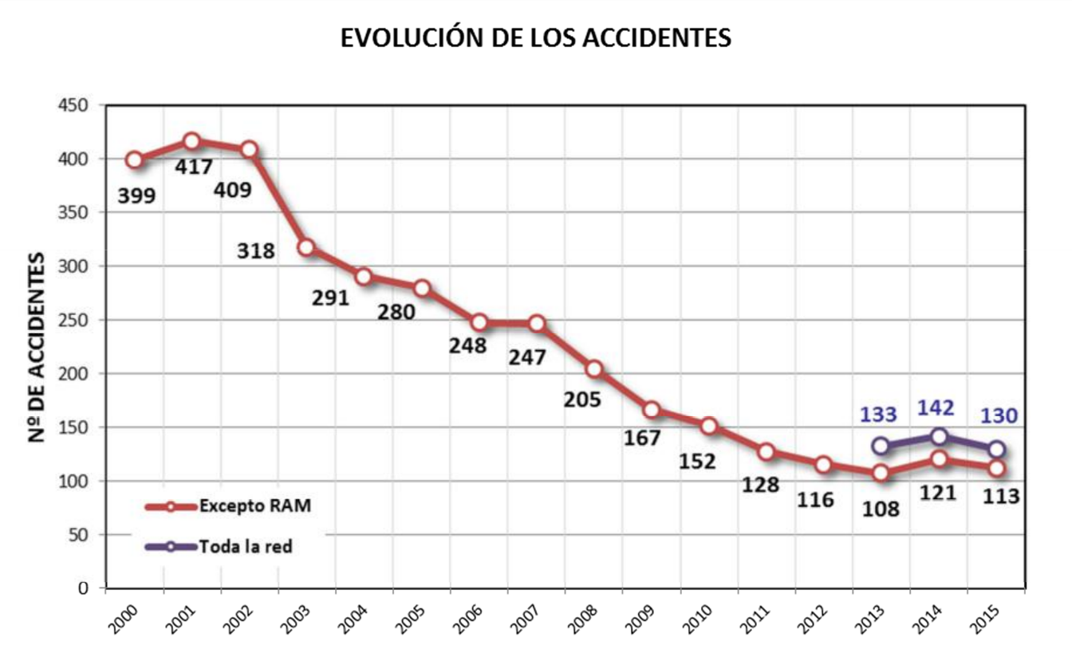
EVOLUCIÓN DE LOS ACCIDENTES | ACCIDENTS
No DE ACCIDENTES | NUMBER OF ACCIDENTS
Excepto RAM | Excluding the RAM
Toda la red | Entire network
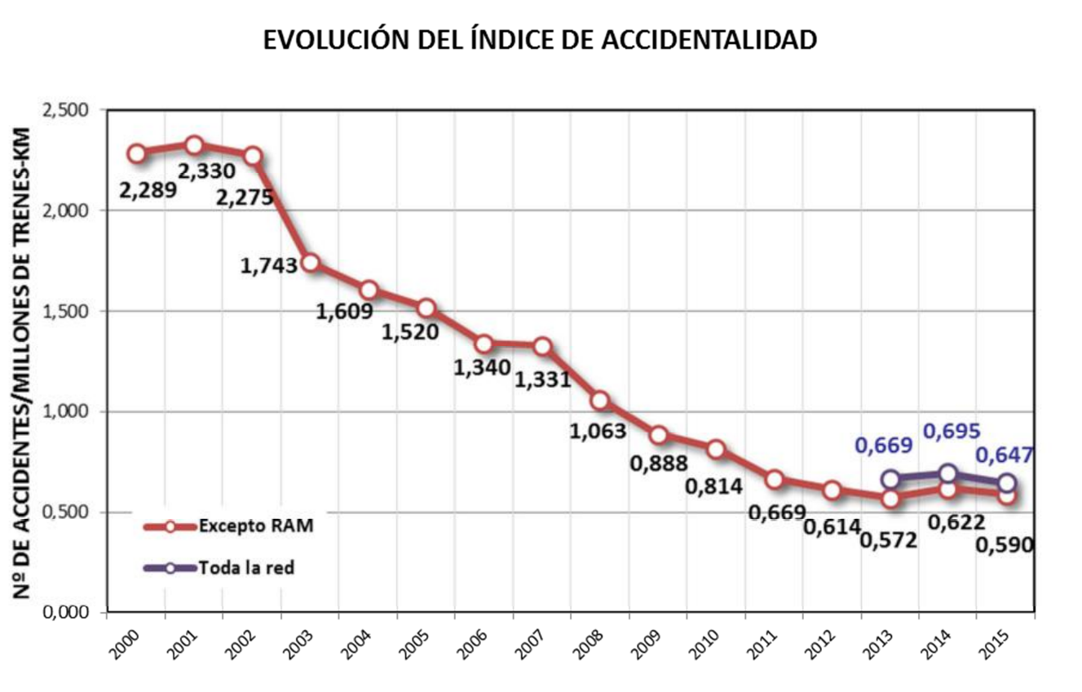
EVOLUCIÓN DEL ÍNDICE DE ACCIDENTALIDAD | ACCIDENT RATE INDEX
No DE ACCIDENTES/MILLONES DE TRENES-KM | NUMBER OF ACCIDENTS PER MILLION TRAIN-KM
Excepto RAM | Excluding the RAM
Toda la red | Entire network

The following chart shows that the slight upturn in the total number of accidents that occurred in 2014 was reversed in 2015, with an on-going downward trend in the total number of significant accidents and serious accidents, and new lows for the time series.
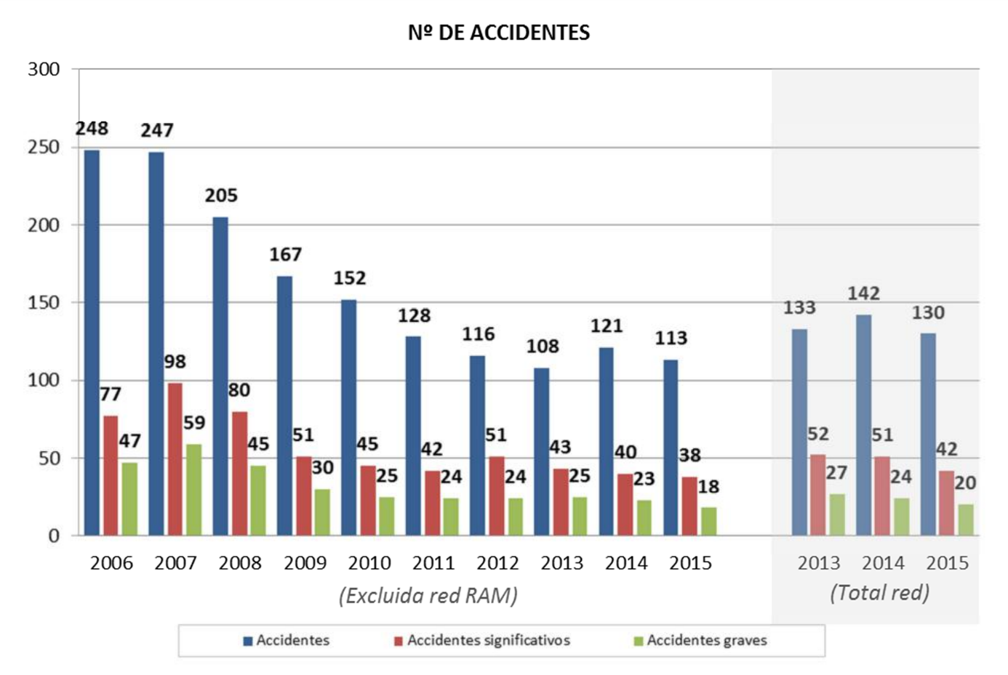
No DE ACCIDENTES | NUMBER OF ACCIDENTS
Excluida red RAM | Excluding the RAM network
Total red | Total network
Accidentes | Accidents
Accidentes significativos | Significant accidents
Accidentes graves | Serious accidents
By type of accident, there was a decrease in the number of accidents of various types compared to the previous year: collisions (down from 31 to 24); accidents affecting people, except for those happening at level crossings (down from 40 to 39); accidents at level crossings (down from 24 to 17); and fires (down from 2 to 1).
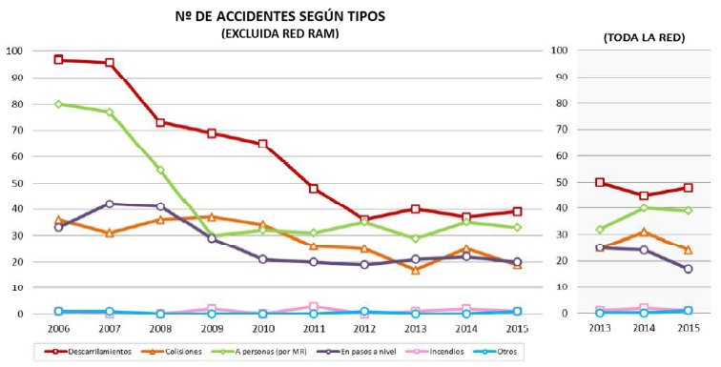
№ DE ACCIDENTES SEGÚN TIPOS (EXCLUIDA RED RAM) | NUMBER OF ACCIDENTS BY TYPE (EXCLUDING THE RAM NETWORK)
(TODA LA RED) | (ENTIRE NETWORK)
Descarrilamientos | Derailments
Colisiones | Collisions
A personas (por MR) | Involving people (by rolling stock)
En pasos a nivel | At level crossings
Incendios | Fires
Otros | Others

 | RFIG (INCLUDING THE RAM NETWORK) |  |  |  |  |  |  |  |  |  |  | TOTAL NETWORK
Accidents | 2006 | 2007 | 2008 | 2009 | 2010 | 2011 | 2012 | 2013 | 2014 | 2015 |  | 2013 | 2014 | 2015
Derailments | 97 | 96 | 73 | 69 | 65 | 48 | 36 | 40 | 37 | 39 |  | 50 | 45 | 48
Collisions | 36 | 31 | 36 | 37 | 34 | 26 | 25 | 17 | 25 | 19 |  | 25 | 31 | 24
Involving people (by rolling stock) | 80 | 77 | 55 | 30 | 32 | 31 | 35 | 29 | 35 | 33 |  | 32 | 40 | 39
At level crossings | 33 | 42 | 41 | 29 | 21 | 20 | 19 | 21 | 22 | 20 |  | 25 | 24 | 17
Fires | 1 | 0 | 0 | 2 | 0 | 3 | 0 | 1 | 2 | 1 |  | 1 | 2 | 1
Others | 1 | 1 | 0 | 0 | 0 | 0 | 1 | 0 | 0 | 1 |  | 0 | 0 | 1
TOTAL | 248 | 247 | 205 | 167 | 152 | 128 | 116 | 108 | 121 | 113 |  | 133 | 142 | 130

Significant accidents reached a peak in 2007, since when the number has decreased significantly, with an on-going stable, slightly downward trend, even when the network as a whole is considered. All time lows for the statistical series were recorded in 2015.
The following graph shows the trends in significant accidents by type. As a general conclusion, we can say that the various types of accidents show a relatively stable or downward trend.
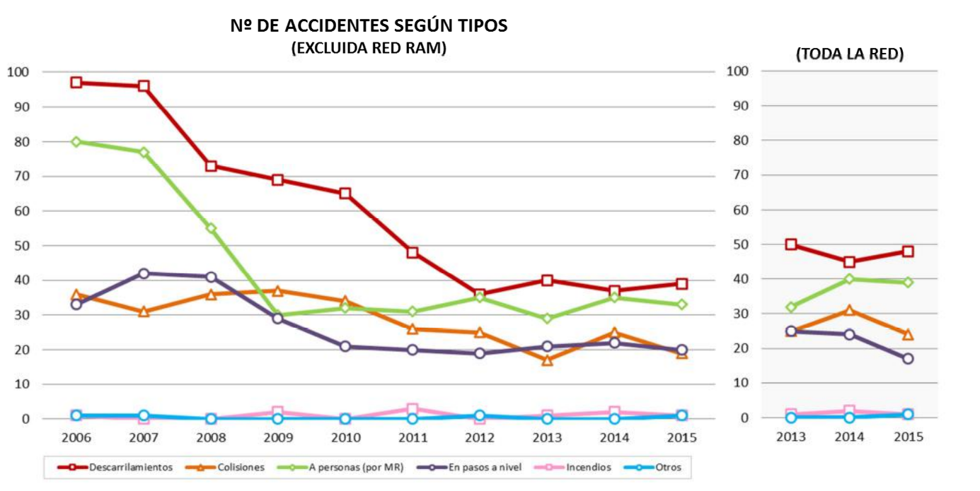
№ DE ACCIDENTES SIGNIFICATIVOS SEGÚN TIPOS (EXCLUIDA RED RAM) | NUMBER OF SIGNIFICANT ACCIDENTS BY TYPE (EXCLUDING THE RAM NETWORK)
(TODA LA RED) | (ENTIRE NETWORK)
Descarrilamientos | Derailments
Colisiones | Collisions
A personas (por MR) | Involving people (by rolling stock)
En pasos a nivel | At level crossings
Incendios | Fires
Otros | Others
 |  | RFIG (INCLUDING THE RAM NETWORK) |  |  |  |  |  |  |  |  |  | TOTAL NETWORK
Significant accidents | 2006 | 2007 | 2008 | 2009 | 2010 | 2011 | 2012 | 2013 | 2014 | 2015 |  | 2013 | 2014 | 2015
Derailments | 9 | 12 | 15 | 7 | 7 | 7 | 10 | 9 | 3 | 5 |  | 11 | 6 | 6
Collisions | 4 | 4 | 4 | 3 | 3 | 4 | 3 | 1 | 4 | 2 |  | 5 | 7 | 3
Involving people (by rolling stock) | 51 | 63 | 43 | 22 | 24 | 23 | 29 | 23 | 24 | 23 |  | 25 | 27 | 24
At level crossings | 13 | 19 | 18 | 19 | 11 | 8 | 8 | 10 | 8 | 7 |  | 11 | 10 | 8
Fires | 0 | 0 | 0 | 0 | 0 | 0 | 0 | 0 | 1 | 0 |  | 0 | 1 | 0
Others | 0 | 0 | 0 | 0 | 0 | 0 | 1 | 0 | 0 | 1 |  | 0 | 0 | 1
TOTAL | 77 | 98 | 80 | 51 | 45 | 42 | 51 | 43 | 40 | 38 |  | 52 | 51 | 42

The trend in the number of serious accidents has remained stable over recent years, even considering the network as a whole, with the statistical series hitting a low in 2015.
The following chart shows accidents over recent years that could be classified as serious due to their consequences (at least one fatality, five or more serious injuries or major damage). It can be seen that the accident rate for the network is influenced considerably by accidents related to the activity of third parties: accidents involving people or at level crossings. In 2015, there were no serious accidents involving a derailment or collision, types of accidents that depend almost exclusively on the railway system.
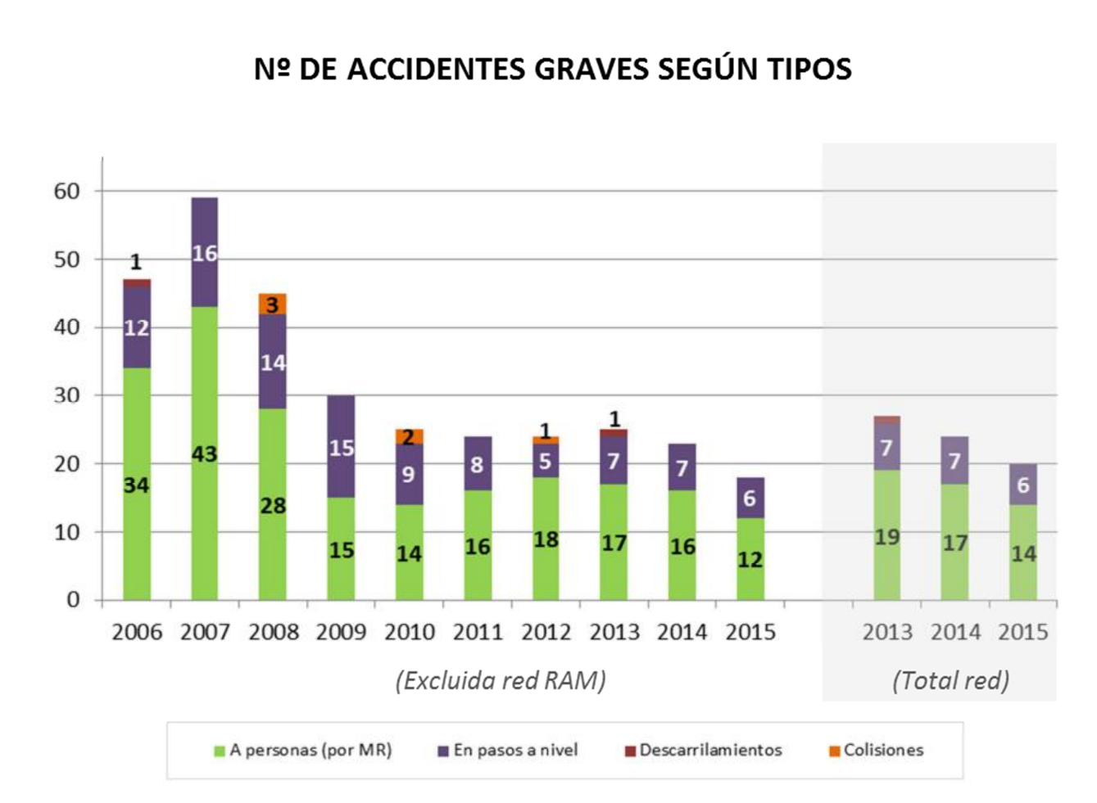
№ DE ACCIDENTES GRAVES SEGÚN TIPOS | NUMBER OF SERIOUS ACCIDENTS BY TYPE
Excluida red RAM | Excluding the RAM network
Total red | Total network
A personas (por MR) | Involving people (by rolling stock)
En pasos a nivel | At level crossings
Descarrilamientos | Derailments
Colisiones | Collisions

 | RFIG (INCLUDING THE RAM NETWORK) |  |  |  |  |  |  |  |  |  |  | TOTAL NETWORK
Serious accidents | 2006 | 2007 | 2008 | 2009 | 2010 | 2011 | 2012 | 2013 | 2014 | 2015 |  | 2013 | 2014 | 2015
Derailments | 1 | 0 | 0 | 0 | 0 | 0 | 0 | 1 | 0 | 0 |  | 1 | 0 | 0
Collisions | 0 | 0 | 3 | 0 | 2 | 0 | 1 | 0 | 0 | 0 |  | 0 | 0 | 0
Involving people (by rolling stock) | 34 | 43 | 28 | 15 | 14 | 16 | 18 | 17 | 16 | 12 |  | 19 | 17 | 14
At level crossings | 12 | 16 | 14 | 15 | 9 | 8 | 5 | 7 | 7 | 6 |  | 7 | 7 | 6
TOTAL | 47 | 59 | 45 | 30 | 25 | 24 | 24 | 25 | 23 | 18 |  | 27 | 24 | 20

Considering the severity of the accidents in this assessment, the number of deaths in 2015 was the lowest in the historical series. Moreover, all of those victims once again resulted from accidents involving people or at level crossings, in which elements unrelated to the railway system itself play a greater part.
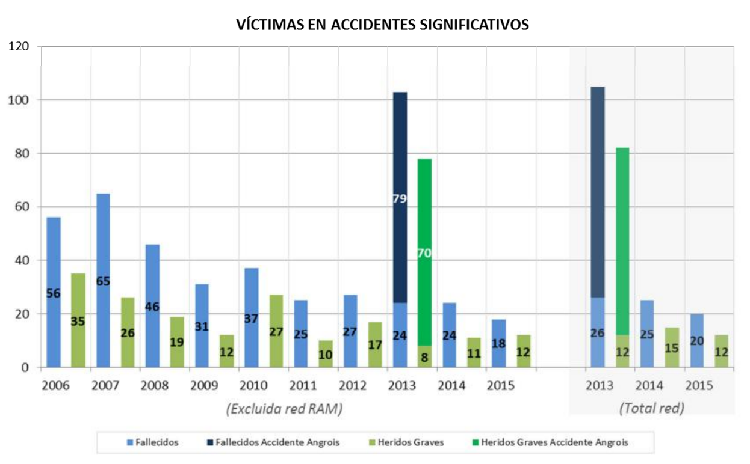
VÍCTIMAS EN ACCIDENTES SIGNIFICATIVOS | VICTIMS IN SIGNIFICANT ACCIDENTS
(Excluida red RAM) | (Excluding the RAM network)
(Total red) | (Total network)
Fallecidos | Deaths
Fallecidos Accidente Angrois | Deaths in the Angrois accident
Heridos Graves | Serious Injuries
Heridos Graves Accidente Angrois | Serious injuries in the Angrois accident
The number of fatalities is broken down below by types of accidents.
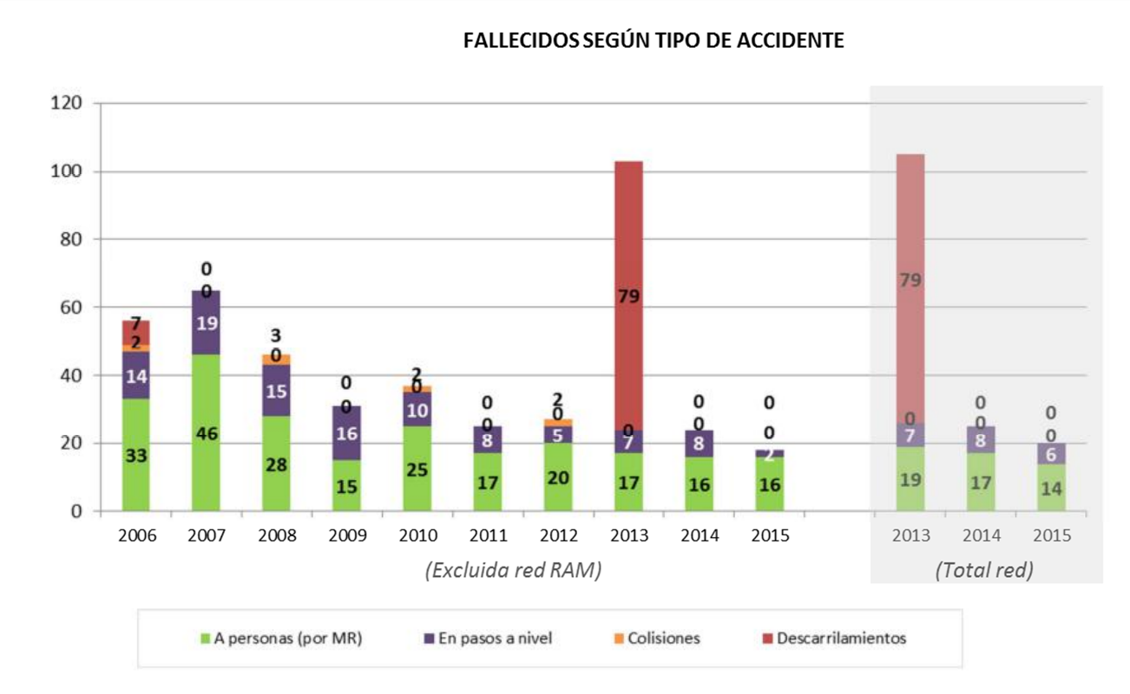
FALLECIDOS SEGÚN TIPO DE ACCIDENTE | DEATHS BY TYPE OF ACCIDENT
Excluida red RAM | Excluding the RAM network
Total red | Total network
A personas (por MR) | Involving people (by rolling stock)
En pasos a nivel | At level crossings
Colisiones | Collisions
Descarrilamientos | Derailments
This final chart shows the precursors of accidentsrecorded in recent years.
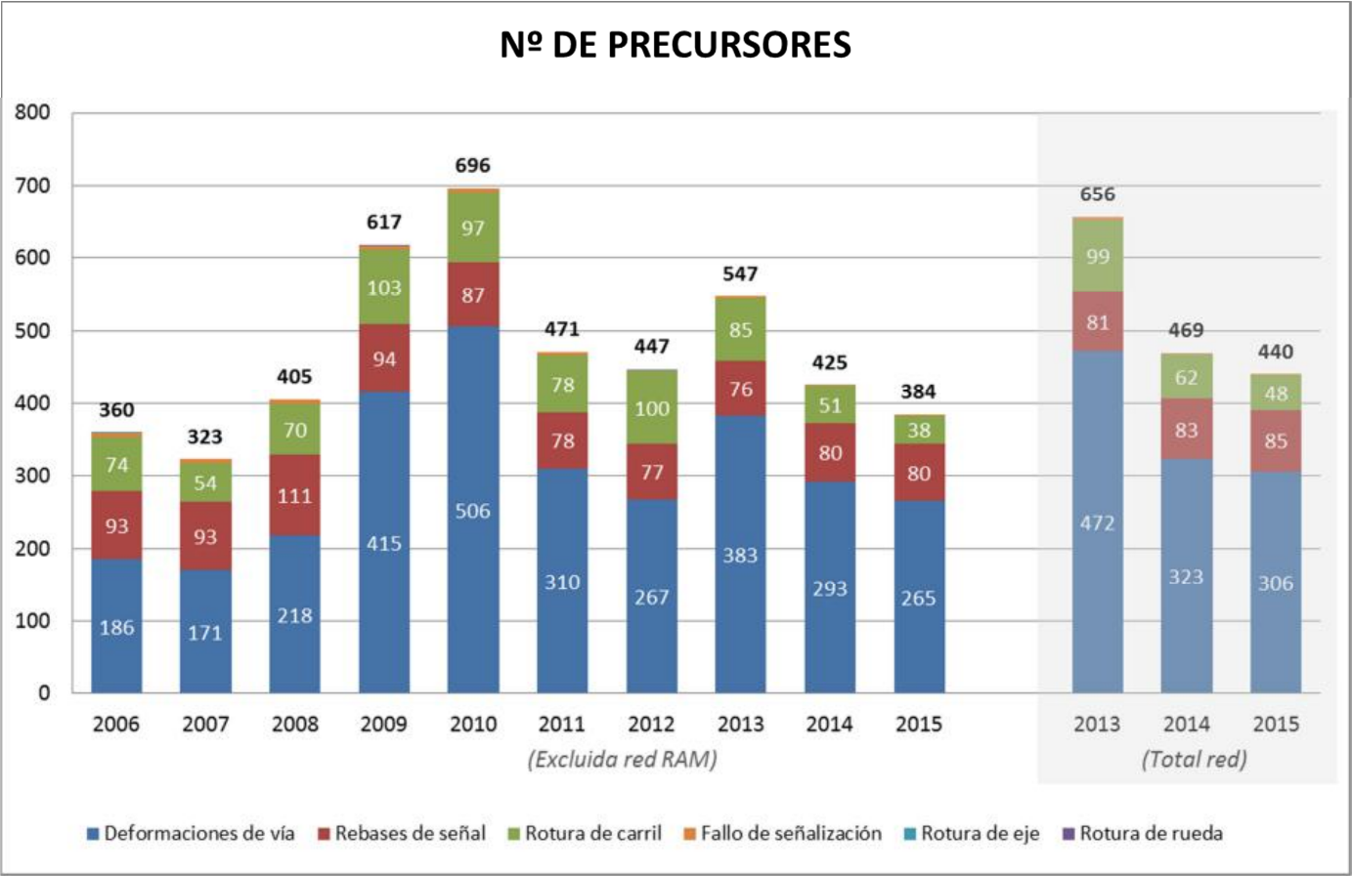
№ DE PRECURSORES | NUMBER OF PRECURSORS
Excluida red RAM | Excluding the RAM network
Total red | Total network
Deformaciones de via | Track buckling
Rebases de señal | Signal overrun
Rotura de carril | Broken rails
Fallo de señalización | Signalling failure
Rotura de eje | Broken axle
Rotura de rueda | Broken wheel
This chart shows a trend towards stabilisation in signal overruns (the danger point was exceeded in only 6 of the 85 cases). There were also no cases of broken axles and/or wheels, with only three such incidents between 2006 and 2014.
Regarding infrastructure precursors, the actions implemented in 2014 have enabled a further reduction in track buckling and broken rails compared to the previous year.
Therefore, the general conclusions we can draw from an analysis of the railway accident rate data for 2015 are that there were new lows in the accident rate for the historical series with a consolidation of the stable downward trend seen in recent years.

Safety recommendations
Investigating the accidents and incidents that occur on the network is a fundamental tool for detecting and preventing risks. This type of investigation must include all accidents and precursors of accidents with certain characteristics – such as repetition and when or where they occur, or where the causes can be attributed to railway management – irrespective of whether they have serious personal or financial repercussions.
Therefore, a report is prepared by an entity that is independent of the Agency for every accident investigated. These reports set out the causes identified and any recommendations for improving the railway installations, searching for patterns of behaviour in the people involved so as to prevent recurrence.
During 2015, the Railway Accidents Investigation Commission (CIAF) opened a total of 59 dossiers, of which a total of 9 accidents and 6 incidents were finally investigated. These involved 4 derailments, 4 collisions (one rear-end collision), 1 fire, 5 near collisions (after the same number of signal overruns) and 1 regulatory violation.
As a summary, the most important safety recommendations in CIAF reports into events in 2015 where investigations have concluded and implementation is already in progress by the appropriate bodies are shown below.
- Recipients: National Railway Safety Agency
- Require railway undertakings and infrastructure managers to include a procedure in their safety management systems (SGS) that makes it possible to trace training initiatives, especially those of a practical nature, specifying the activity models to be established by the managers responsible for each of the training activities.
- Specify a maximum period for railway undertakings and infrastructure managers to incorporate the provisions contained in the AESF Resolution of 23 December 2015 (BOE of 27 January 2016), on the training pathways of railway personnel, into their safety management systems, (SGS) and for these to be fully operational.
- Recipients: Infrastructure managers
- Study the possibility of changing the position of a signal in a specific station to improve its visibility and fit a warning beacon, if applicable.
- Review a specific procedure from the Safety Management System in order to detail and specify how non-conformities detected in the inspection and monitoring of the infrastructure by maintenance personnel are treated and managed in order to improve the operation of that procedure and ensure compliance therewith. After being reviewed, check that the system is operational and ensure that it is understood by the personnel involved.
- Analyse the viability of replacing wooden sleepers in track sections with concrete sleepers or, if this is not feasible, replacing those that are in poor condition with others of the same material. Comply with the frequency and quality of on-site visits established for the line, and reconsider the traffic conditions of the line in light of the control sheets and any issues identified, and ensure these are resolved.
- Modify the specific procedure for inspection of the infrastructure and track in order to include checks on the geometry of crossovers. Prepare an inspection plan for the geometry of crossovers located on main lines. In the event of safety deficiencies, act to re-establish conditions for safe travel.
- Recipients: Infrastructure managers (Port Authorities)
- Improve the implementation of safety management systems, according to the provisions set out in additional provision three of RD 810/2007, approving the Regulation on traffic safety for the Public Railway Network.
- Analyse the viability of implementing measures to prevent uncontrolled movements of rolling stock (coasting) from the interior port network reaching the physical connection point with the general network.
- Check compliance with the maintenance plan for rolling stock used in port facilities.
- Train signalling personnel, in accordance with the Adif-Port Authority Agreement.
- Recipients: Railway undertakings.
- Ensure compliance with the maintenance cycles for owned rolling stock, and ensure periodic verification by responsible personnel that the ‘Deadman’s’ device has not been by-passed on its rolling stock.
- Insist on refresher training courses for drivers on the acceleration and braking behaviours of rolling stock under the various conditions in which they might operate.
- Improve the safety management system procedures for the suspension, revocation and recovery of authorisations after a human error, depending on the severity thereof.
The National Railway Safety Agency monitors compliance with these recommendations by the parties involved. It therefore makes periodic requests for information on the level of compliance from the body to which the recommendation is addressed. When it is deemed that a sufficient level of implementation of the recommendation has been reached, the Railway Accidents Investigation Commission is notified so that the issue may be closed.
The most noteworthy actions taken by the agents responsible for complying with such recommendations are set out below. This list is not comprehensive. It only details the most significant actions, as it is working to achieve compliance with all of the recommendations issued by the CIAF.
EVENT: Derailment due to a technical failure of the installations or of the infrastructure.
Actions: | - The control document for maintenance operations on clamp locks has been updated to reinforce verification of the status of the pins. A systematic review plan for all the existing pins at turnouts with clamp locks has been established. The double pin solution is proposed for new turnouts.  - An internal audit has been conducted on corrective maintenance actions in the failure zone of the infrastructure to verify correct application of the regulation.  - Inspections have been scheduled for turnouts that provide access to railway facilities. A replacement plan has been drafted for turnouts with type C welding, for a specific turnout and two adjacent crossovers.
EVENT: near collision due to signal overrun.
Actions: | - Testing has been conducted to reduce the quantity of sand ejected by specific units during emergency braking, therefore implementing a shut-off of sanding at 12 km/h on units in the affected series.
EVENT: Incident due to technical failure of the infrastructure
Actions: | - A monitoring plan has been established, with weekly inspections and water pumping when there is rain, whilst emergency work continues to reinforce drainage and restore the superstructure on a section of track.
EVENT: Derailment due to signal overrun
Actions: | - A new signal indicating exit S1/1 at the station was put into service.
EVENT: Derailment due to incorrect stowage of cargo
Actions: | - The application of General Instruction No 66 ‘Loading Regulations’ is regulated within the scope of the RAM.  - Training needs have been detected, and training courses have been scheduled for people responsible for loading on the RAM network or who are qualified as loaders. The certifications conferred in Renfe’s ‘Habilita’ computer application are being included.
EVENT: collision due to human error by driving personnel under poor conditions
Actions: | - Technical Recommendation 2/2015 of the National Railway Safety Agency has been prepared, on training for driving personnel under abnormal conditions or with degraded rolling stock.
EVENT: Derailment due to technical failure of the rolling stock related to grease boxes
Actions: | - The working group established to analyse the existing problem with respect to managing the alarms that occur on axle-overheating detector equipment has concluded its analysis, with a modification to the existing regulations. Specifically, certain types of alarms have been defined in the Railway Traffic Regulation, thereby regulating control and follow-up actions for these.
EVENT: Derailment due to excess speed
Actions: | - A review of the maximum speed tables and of the signalling and beaconing of significant speed changes, both fixed and temporary, has been completed.  - In addition, the new Railway Traffic Regulation approved in 2015 includes a comprehensive review of regulations, including signalling criteria, thereby establishing the on-track signalling obligation for all speed changes, as compared to traditional practice.  - An improvement in the Digital ASFA is being developed, which will allow the establishment of more steps in speed control. Plans for the complete roll out of this on all equipment have been speeded up.  - Within the process of bringing new railway lines or by-passes into service, or providing new commercial services, there has been reinforcement of the specific risk analyses that record the identification and management of possible hazards derived from the interaction of various subsystems, under both normal and poor operating conditions.  - The viability of the implementation of this in the various phases of construction is being analysed.
Actions: | - Technical Recommendation 1/2015 of the National Railway Safety Agency has been prepared, concerning processes prior to the start-up of new lines or before beginning new types of services.  - The procedures of the SGSs have been reviewed and reinforced so that notifications of safety-related deficiencies detected at any stage are redirected towards the functionally established channels for analysis and consideration, thereby assuring efficient preventive management.  - Systems that provide greater recording capacity in cabins are being installed to facilitate the investigation of events.

E. Safety certificates and authorisations

Reference Framework For Issuing Certificates And Authorisations
Commission Regulation (EU) No 1158/2010 of 9 December 2010 has been used as the reference for the evaluation process prior to issuing safety certificates for railway companies. This Directive sets out a common safety method for assessing conformity with the requirements for obtaining railway safety certificates.
The AESF considers it essential that safety management systems be conceived from the outset taking into account Regulations 1158/2010 and 1169/2010, as well as Regulation 402/2013 on risk assessment, Regulation 445/2011 on a certification system for entities in charge of maintenance of freight wagons, and Regulation 1078/2012 on internal monitoring.
Therefore, and in order to facilitate the process of obtaining certificates, the AESF is carrying out advisory work directly with railway undertakings, or consultant companies that provide such undertakings with support, during the drafting phase of their SGSs, and even prior to submission of a formal application. This work procedure is facilitating subsequent assessment.
The annual safety reports that undertakings and managers submit offers an opportunity to express opinions about the procedures and practices for issuing safety certificates/authorisations, and other possible improvements to the system.

Certificates and authorisations issued during 2015
- Part A safety certificates
In 2015, seven part A safety certificates were issued:
Railway Undertaking | Type of Certificate | Issue Date
AISA TREN | New | 03/03/2015
CONTINENTAL RAIL | Update | 17/06/2015
FERROVIAL RAILWAY | Update | 23/06/2015
AVANZA TREN | New | 14/07/2015
RENFE MERCANCÍAS | New | 28/07/2015
ARRAMELE SIGLO XXI | New | 30/07/2015
LOGITREN FERROVIARIA | Renewal | 14/12/2015
- Part B safety certificates
The part B safety certificates issued during 2015 are indicated below:
Railway Undertaking | Type of Certificate | Issue Date | Reasons for the update
Aisa Tren | New | 03/03/2015 | -
Continental Rail | Update | 17/06/2015 | Expansion of passenger traffic (including high-speed services)
Ferrovial Railway | Update | 23/06/2015 | Expansion of passenger traffic (including high-speed services)
Avanzatren | New | 14/07/2015 | -
Renfe Mercancías | New | 28/07/2015 | -
Arramele Siglo XXI | New | 30/07/2015 | -
Logitren | Renewal | 14/12/2015 | -
Ferroviária
- Safety authorisations
During 2015, the AESF continued with the assessments of the safety management systems of Adif AV (as a new entity) and of Adif (due to the modification caused by the split of the network management activities assigned to Adif AV).
In November 2015, the AESF granted the corresponding safety authorisations to Adif and Adif AV, which are valid for five years.
Meanwhile, the safety authorisation of the railway infrastructure manager, TP-FERRO, was renewed at the end of September, valid until 25 September 2020.
Therefore, in 2015 there was a complete review of the safety authorisations of the managers of the RFIG.

F. Certification of entities in charge of maintenance

Reference framework for issuing certificates for entities in charge of maintenance
The National Railway Safety Agency is responsible for certifying entities in charge of maintenance (EEMs) for freight wagons registered in Spain, thereby complying with the provisions set out in the Railway Safety Directive and in Commission Regulation (EU) No 445/2011 of 10 May 2011, on a system of certification of entities in charge of maintenance of freight wagons.

Certificates issued during 2015
In 2015, two entities in charge of maintenance were certified:
Entity in charge of maintenance | Type of company | Issue date | Includes rail tankers for dangerous goods | Includes other special wagons for dangerous goods
RAILSIDER | Keeper | 23/03/2015 | No | No
RENFE FABRICACIÓN Y MANTENIMIENTO | Maintenance, manufacturing and transformation of rolling stock | 09/06/2015 | Yes | Yes
In addition to the aforementioned certificates, in 2015 the AESF also certified some of the functions of Entities in Charge of Maintenance (EEMs) separately for the first time. This is highlighted in the following table.
Business | Type of company | Issue date | Includes rail tankers for dangerous goods | Includes other special wagons for dangerous goods | Certified function of the EEM
SIDERÚRGICA REQUENA | Maintenance provider | 18/06/2015 | No | No | Execution of maintenance
RENFE FABRICACIÓN Y MANTENIMIENTO | Maintenance, manufacturing and transformation of rolling stock | 24/06/2015 | Yes | Yes | Execution of maintenance
RENFE FABRICACIÓN Y MANTENIMIENTO | Maintenance, manufacturing and transformation of rolling stock | 02/07/2015 | Yes | Yes | Management of fleet maintenance
RENFE FABRICACIÓN Y MANTENIMIENTO | Maintenance, manufacturing and transformation of rolling stock | 28/07/2015 | Yes | Yes | Performance of maintenance

During the remainder of 2015, work continued to process new applications from organisations that aspire to obtain the EEM certificate.
It must be kept in mind that, in accordance with the provisions set out in Article 12.5 of Commission Regulation (EU) No 445/2011, maintenance centres that are officially approved and qualified to perform maintenance on freight wagons in accordance with national laws are directly recognised as having an equivalent certificate for performing maintenance functions.
Finally, in 2015 the AESF did not issue any derogations based on Article 14.a, point 8, of Directive 2004/49/EC, in accordance with the modification introduced by Directive 2008/110/EC to certify alternative cases.

G. Supervision of the rail system

General lines of supervision
As in previous years, supervision of correct application of the regulatory framework regarding safety by responsible agents is carried out at various levels:
- In general, the most important variables are monitored using the overall accident rate for the system through activities already described in this report, such as:
- Continuous monitoring of accident rate statistics and indicators to detect significant deviations.
- Review of the annual reports of railway undertakings and infrastructure managers.
- Follow-up on the safety recommendations issued by the CIAF to ensure compliance therewith.
- It is also carried out through the certification and supervision of railway companies and infrastructure managers, as well as other agents involved in the railway sector and that provide services, such as entities in charge of wagon maintenance, rolling stock maintenance centres, railway personnel training centres and medical examination centres.
- Through audits and inspections of the undertakings and managers themselves, especially for verifying application of the internal follow-up procedures of undertakings.
- By issuing technical recommendations to sector entities regarding procedures for facilitating the implementation of requirements.
- Through training measures and the dissemination of information to undertakings and managers, thereby assuring that they have adequate knowledge of the regulations they must apply.
- Finally, by advising entities on specific subjects on request and through the coordination of work groups and information-sharing meetings.

Supervision of railway system agents
The various agents of the system are subject to having previously obtained a certificate, authorisation or official approval from the national authority, thereby allowing them to exercise their activities. Once this qualifying certificate has been issued, the objectives of supervision actions change:
- Periodic supervision, whether total or partial, of the conditions for granting the certificate/authorisation/approval.
- Verification of implementation of the actions committed to when the certificate/authorisation/approval was granted (non-inhibiting qualifications or non-conformities).
- Verification in the event of a change in the conditions for having granted the certificate/authorisation/approval.
- Supervision derived from observation of a possible ‘abnormal’ situation that could be due to inadequate application of safety rules.
- A revision or update, if applicable, of the safety management system in the event that circumstances arise that may represent added risks that must be adequately considered in procedures.
Specific supervision activities are planned considering the following aspects:
- General supervision objectives and criteria.
- All types of activities of the supervised agent and the size of the assessed undertaking.
- Findings of the assessment process prior to obtaining the certificate/authorisation/approval.
- Activities that are considered capable of generating more serious risks.
- Other data and information available to the AESF, such as: the results of previous supervisions, the annual safety report prepared by the undertaking/manager, accident rate reports, etc.

Railway undertakings and Infrastructure managers
The most notable supervision actions conducted on undertakings and infrastructure managers are:
- In relation to railway undertakings, audits of the application of the safety management systems of five of the operating undertakings were conducted in 2015. These audits sought evidence of compliance with the undertakings’ own procedures, and they concluded with reports being issued, in which the AESF made proposals for improvement and requested, where applicable, the presentation of action plans for implementing these improvements.
Some of the points that received special attention in these audits were the process of loading freight wagons and checks on maximum driving times.
In addition, compliance with requirements or the closing of points left open by the AESF when the safety certificates were issued or renewed was also monitored.
- In relation to infrastructure managers, a programme of accompaniment and visits of various kinds was implemented in 2015:
- Accompaniment visits on the internal monitoring actions of Adif itself, to verify compliance with its internal monitoring actions, in accordance with European Regulation 1078/2012. Such visits also serve as training for AESF technicians for other, independent inspection actions.
- Informative inspection visits for an overall examination or for examining particular aspects of one or several facilities of the RFIG, of its functioning and/or of its operation.
- Informative visits for authorisations to bring lines into service, carrying out an overall examination or an examination of particular aspects of facilities before they come on stream.
It must be kept in mind that a complete review of the safety management systems of all network managers – Adif, Adif-AV and TP Ferro – was conducted during the year. During 2015, there was follow-up work on the development of these systems. Supervision actions for the application of these will be planned in future years.
Moreover, there was continuing follow-up on the processes of starting up lines and new infrastructures through the verification of adequate application of Adif’s internal procedures for start-up and for managing changes in safety installations. In 2015, this activity was significant, affecting approximately 500 km of new lines.
- Another field of supervision was monitoring compliance with recommendations issued by the Railway Accidents Investigation Commission as a result of its investigations of accidents or incidents. This took place through systematic requests for information from the body to which the recommendation was addressed relating to the level of compliance, until it is considered that implementation of the recommendation has been sufficiently achieved.

Entities related to rolling stock maintenance.
As stated, a priority line at the AESF is adequate control of the maintenance of railway vehicles, in accordance with the provisions set out in Spanish legislation. To do this, maintenance centres must be officially approved by the AESF, in accordance with the provisions set out in Order FOM/233/2006 for exercising such roles.
- Total number of approved maintenance centres: 57
- Number of maintenance centres approved in 2015: 2
- Number of approved facilities: 185
The AESF conducts controls and inspections at least annually whenever there may be reasonable doubts about possible breaches of requirements. It may also do so randomly at any moment to verify that compliance with the requirements for official approval is maintained.
There were 106 inspections of various facilities in 2015, covering all of the approved maintenance centres.
These inspections were, as a general rule, satisfactory, although recommendations were issued in some cases. Compliance with such recommendations is monitored in subsequent inspections.
Turning to the supervision of entities in charge of wagon maintenance, which is entrusted to the AESF as the EEM certification body. Work continued to monitor execution of the improvement plans established for each of the EEMs already certified, to verify that any deficiencies detected in the auditing and inspection processes prior to issuing the certificates were corrected. This action was complemented by the annual monitoring activities of the EEMs, the certification of which is issued for a period of 5 years, and by conducting audits and
inspections for renewal of the certificate of EEMs classified as ‘new’, in accordance with the provisions set out in Commission Regulation (EU) No 445/2011.
In addition to the two initial audits conducted during the certification process, eight renewal audits were conducted and one follow-up audit was conducted during 2015 to close non-conformities and recommendations.
Four initial audits were conducted of undertakings that applied for certification for some of the functions defined in Commission Regulation (EU) No 445/2011.

Centres related to railway personnel
Another, complementary activity of vital importance to the sector is training of personnel. Controlling the centres that conduct such activities is, therefore, also a priority for the AESF.
Officially approved centres for the training of railway personnel are inspected in accordance with the provisions set out in Article 53 of Order FOM 2872/2010, Title IX, Chapter I, with respect to the inspection scheme for officially approved centres for railway personnel and the functioning of all operations linked to the training of railway personnel for the various certificates established in that Order. Eight inspections of officially approved training centres were conducted in 2015.
As of 31 December 2015, there were 10 officially approved training centres for railway personnel.
Similarly, inspection activities were also carried out on psycho-physical examination centres for railway personnel, which are also regulated under Order 2872/2010. 16 inspection activities were conducted in 2015, and as of 31 December 2015, there were 20 officially approved psycho-physical examination centres.
The aforementioned data exclude the visits made to the training centres for railway personnel and psycho-physical examination centres conducted due to new approvals or the renewal of existing approvals.
The AESF’s objective is to conduct at least one annual inspection of these centres, as indicated in Article 58 of Order FOM/679/2015 of 9 April. In addition, when a training centre submits an application to expand its facilities, the AESF visits the centre before issuing its decision.

Activities for the dissemination of information and lessons learnt
From the AESF’s point of view, the dissemination of information to the sector is a support task that complements its supervision role. Its activities in this area include:
- Issuing technical recommendations, which are an effective means of disseminating information and ensuring the spread of best practices in the sector.
During 2015, the following recommendations were issued, which generally include criteria for facilitating incorporation into safety management systems:
- 1/2015 (of the Directorate-General of Railways). Responsibilities of entities in charge of vehicle maintenance within the framework of the Railway Safety Directive, and in particular regarding maintenance plans.
- 2/2015 (of the Directorate-General of Railways). Responsibility of railway undertakings in relation to the maintenance of freight wagons.
- 1/2015 (of the AESF). Processes prior to the entry into service of new lines or the beginning of new types of services.
- 2/2015 (of the AESF). Training for driving personnel under abnormal conditions or degraded situations related to rolling stock.
- Dissemination of safety alerts notified by the safety alerts system of the European Union Agency for Railways.

Internal follow-up by undertakings and managers
During 2015, railway undertakings (RU) and infrastructure managers (IM) carried out the procedures provided for in their safety plans, with satisfactory levels of compliance with such plans.
INSPECTIONS |  | RAILWAY UNDERTAKINGS:
Number of RU/IM inspections in 2015 | Inspection of loads | 2,526
Number of RU/IM inspections in 2015 | Technical Inspection of Rolling Stock in Service (ITMS) | 839
Number of RU/IM inspections in 2015 | Accompaniment of trains and switching | 17,415
Number of RU/IM inspections in 2015 | Train inspections before running | 2,691
Number of RU/IM inspections in 2015 | Switching inspections | 708
Number of RU/IM inspections in 2015 | Alcohol and drug testing | 9,898
Number of RU/IM inspections in 2015 | Visits to driving bases, residences, production and management centres | 441
Number of RU/IM inspections in 2015 | Control of driving times | 545
Number of RU/IM inspections in 2015 | Control of train safety records | 4,128
Number of RU/IM inspections in 2015 | INFRASTRUCTURE MANAGERS:
Number of RU/IM inspections in 2015 | A total of 5,392 safety inspections were conducted, 65 of which identified serious anomalies.

H. Modifications to railway safety legislation

2015 was a significant year for modifications to the railway safety framework:
- The new Railway Sector Act was published, the main reference standard for the sector. One new development in this is a specific chapter on railway safety, as befits the importance of this standard for railway transport.
- A number of national standards related to all elements of the system were approved, introducing certain very significant changes:
- Authorisation processes for vehicles and subsystems
- Requirements for railway personnel.
- Operating standards, with the publication of the Railway Traffic Regulation. This Regulation compiles the regulatory documents affecting the railway sector into a single text. It replaces the General Traffic Regulation, a document that has been the main reference for the sector for decades, but needed to be updated and adapted for the new reality and new agents.

Transposition of European legislation regarding railway safety
The basic document from the point of view of European legislation on railway safety, the Railway Safety Directive 2004/49 (RSD), was incorporated into the Spanish legal system through Royal Decree 810/2007 of 22 June, thereby approving the Regulation on traffic safety in the Public Railway Network.
Subsequently, given the importance of railway safety in the system, it was deemed appropriate to elevate the main concepts of the RSD to the level of a regulation. These concepts were then incorporated into the Railway Sector Act, which is the highest standard on the subject.
Thus, Law 38/2015 of 29 September, on the railway sector, incorporates the main concepts of the RSD, such as the definitions of the safety authority, safety authorisation and certificates and management systems.
The RSD was updated three times between in publication in April 2004 and the end of the period covered by this report. Each of these modifications is described in greater detail below, as well as the status of transposition into the national legislative framework.
- Directive 2008/57/EC of the European Parliament and of the Council of 17 June 2008 on the interoperability of the rail system within the Community (recast), states the following in Article 40: ‘Article 14 of Directive 2004/49/EC shall be repealed with effect from 19 July 2008’, as the scheme of vehicle authorisations is incorporated into the Interoperability Directive.
The Interoperability Directive (2008/57/EC) was transposed into national legislation through Royal Decree 1434/2010 of 5 November.
- Directive 2008/110/EC of the European Parliament and of the Council of 16 December 2008, amending Directive 2004/49/EC on safety on the Community’s railways in certain aspects, including, inter alia, those relating to its scope of application and to safety certificates.
As a consequence of the publication of this Directive, Royal Decree 641/2011 of 9 May was drafted and published, amending the Regulation on traffic safety in the Public Railway Network approved by Royal Decree 810/2007 of 22 June.
- Commission Directive 2009/149/EC of 27 November 2009, amending Directive 2004/49/EC of the European Parliament and of the Council as regards Common Safety Indicators and common methods to calculate accident costs.
Through the publication of Royal Decree 918/2010 of 16 July, the amendment implemented by Directive 2009/149/EC was introduced into Article I of the Regulation on Traffic Safety approved by Royal Decree 810/2007 of 22 July, therefore including in the same the Common Safety Indicators and common methods for calculating the costs of actions aimed at improving traffic safety.
- Commission Directive 2014/88/EU of 9 July 2014, amending Directive 2004/49/EC of the European Parliament and of the Council as regards Common Safety Indicators and common methods to calculate accident costs.
In 2015, Royal Decree 1006/2015 of 6 November was published, amending the Regulation on traffic safety in the Public Railway Network approved by Royal Decree 810/2007 of 22 June, which represents the incorporation of Directive 2014/88/EU into the internal legal system.
Table 1 of Article B of this document shows the transposition status of the legislation indicated in this section, as of 31 December 2015.

Amendments of laws and regulations
In 2015, the work of revising various elements of railway regulations and legislation was concluded, ending in publication of the following legislation:
- Order FOM/22/2015 of 19 January, amending Article III of Royal Decree 1434/2010 of 5 November, on interoperability on the rail system of the Public Railway Network. The publication of this legislation represents incorporation of the amendment of Directive 2008/57/EC into the Spanish legal scheme, regarding the noise emitted by rolling stock.
- Order FOM/167/2015 of 6 February, thereby regulating the conditions for the entry into service of railway structural subsystems, lines and vehicles, thus completing the transposition of Directive 2008/57 into national legislation.
- Order FOM/679/2015 of 9 April, amending Order FOM/2872/2010 on railway personnel, which sets out the conditions for obtaining the qualifying certificates that allow railway personnel to perform their duties with respect to rail traffic safety, as well as the system of officially approved training centres and the medical examination centres of said personnel.
- Royal Decree 664/2015 of 17 July, approving the Railway Traffic Regulation. This document brings together and updates the various applicable regulatory documents (RGC, NECs, PTO, etc.). It is therefore a fundamental document in the railway sector, and the approval thereof represents a milestone. Its definitive entry into force will occur in January 2017. However, major efforts are required during 2015 and 2016 for its implementation in the railway sector, adapting the regulatory documents derived from the Regulation and the safety management systems, and providing training for all personnel to whom it applies.
- Order FOM/1630/2015 of 14 July, approving the ‘Railway gauges instruction’.
- Order FOM/1631/2015 of 14 July, approving the instruction for the design and construction of railway works, IF-3. Track on ballast. Calculation of the layer thickness of the transversal cross-section.
- Decision of 23 December 2015 of the National Railway Safety Agency, establishing the basic training requirements and minimum educational content of training programmes for qualifying railway personnel, to be given at approved training centres for railway personnel.
In addition, Law 38/2015 of 29 September, on the railway sector, was also published in the year covered by this report. Despite this law maintaining a large number of the precepts of Law 39/2003 of 17 November, it was decided to unify and concentrate the whole general structure of railway transport in a new law that entirely replaces Law 39/2003 of 17 November, for reasons of certainty and clarity, and to provide a more accurate interpretation of its mandates.
The purpose of this law is, within the scope of state jurisdiction, to regulate railway infrastructures, rail traffic safety and the provision of passenger and freight railway services and other services provided to railway undertakings at service facilities, including complementary and auxiliary services.

I. Application of Regulation 402/2013 on risk evaluation and assessment

This section responds to the requirement of Article 18.2 of Commission Implementing Regulation 402/2013 of 30 April 2013 on the common safety method for risk evaluation and assessment, which states that ‘each national safety authority must, in its annual safety report referred to in Article 18 of Directive 2004/49/EC, report on the experience of the proposers with the application of this Regulation and, where appropriate, its own experience’.
The generalised application of the methodology of Regulation 402/2013 continued for changes in rolling stock throughout 2015.
In 2015, 74 dossiers were opened for modifications (46, of which 2 were begun in 2016) and applications for authorisation for entry into service (28). Including dossiers initiated in preceding years, 75 modification dossiers were worked on in 2014.
There has been a steady increase in temporary modification dossiers for herbicide work.
The examples listed below correspond to practical applications of the legislation in the period covered by this report:
- Adaptation of national vehicles for international traffic
- Modification of self-propelled vehicle for operation in traffic between Portugal and Spain.
- Modifications relating to the modernisation and installation of communications equipment:
- Installation of ERTMS/ETCS equipment for levels 0, 0 + ASFA and level 1 on self-propelled vehicles.
- Installation of GSM-R equipment on electric locomotives and self-propelled vehicles.
- Installation of on-board communications platforms on conventional and high-speed self-propelled vehicles.
- Installation of ASFA reinforcements on locomotives.
- Updating of STM-LZB equipment on self-propelled vehicles.
- Technical modifications for improving the operation of mechanical elements of vehicles.
- Replacement of traction engines due to ageing of narrow gauge, electric self-propelled vehicles.
- Installation of additional perimeter safety protection on wagons.
- Mechanisation of wheel bearing lubricators on high-speed trains.
- Modification of brake resistors on high-speed trains.
- Substitution of Y-25 bogies for Y-21 bogies on wagons for running on Iberian gauge.
- Implementation of overflow valves on the brake distributor on diesel self-propelled vehicles.
- Replacement of rimmed wheels by monoblock wheels.
- Improved activation of the parking brake.
- Modifications that have significantly affected the structure of the vehicle:
- Replacement of the integral body on wagons with high sides.
- Replacement of the hazardous goods hoppers with the same or greater capacity and replacement of the bogie for loads of 22.5 tons/axle.
- Modification of the hopper loading openings, subject to an experimentation phase.
- Adaptation of narrow-gauge auxiliary vehicles to the network gauge by reducing the frame.
- Modifications to improve accessibility of trains for persons with reduced mobility:
- Installation of a hoist platform, WC module and PRM area on self-propelled vehicles.
- Modification of self-propelled vehicles to adapt them for transporting persons with reduced mobility.
- Modifications relating to the improvement of train processes.
- Improvements relating to the management system for temperatures, acceleration, clamping locks, integration of the CESIS and the management of dead zones on self-propelled vehicles.
- Implementation of the alert device for exit signals (DASS) on electric self-propelled vehicles.
- Standard installation of the PMGE system on high-speed trains.
- Modification of the exterior doors isolation system on high-speed trains and coaches.
- Installation of autoreset on the BCU of electric self-propelled vehicles.
- Update of the train control and monitoring unit on electric self-propelled vehicles.
- Integral action on vehicles.
- Installation of the ‘Timbler’ blocking stability system for access doors.
- On-board hot box detection.
- Modifications of software on vehicles of different types, such as:
- Improvements in the automatic train control system (ATC) and the traction control unit (TCU) on high-speed trains.
- Improvements in the vehicle control equipment (ECV) system on high-speed trains and locomotives.
- Update of Cosmos software on high-speed trains and diesel self-propelled vehicles.
- Modification of the On-board Computer System (SIE) on high-speed trains.
- Modification of the traction motors idle software on diesel self-propelled vehicles.
- Modification of Siemens Digital ASFA software.
- Modification of the software of the BCU and EPM hardware on high-speed trains.
- Software change for microMICEF cards on high-speed trains.
- Temporary modifications and a permanent modification for adaptation to herbicide compositions.
- Remodelling of the interior design in electric self-propelled units and in coaches.
In 2015 the railway infrastructure managers ADIF and ADIF AV advanced in applying the common safety method for assessing risk when making improvements or changes to safety installations. Risk analysis forms a part of the dossier required for approval - in particular - of the entry into service of lines and sections. This includes the safety demonstration dossiers for infrastructure, energy and command/control and signalling subsystems.
One of the objectives of the AESF’s actions in this area is to promote new internal practices in the management of shared risks among the various agents involved during the entry into service of new lines and services. For the AESF, it is vitally important to set up mechanisms for the exchange of information between the infrastructure managers, railway undertakings and other agents, suppliers and service providers, in order to jointly determine and manage hazards and the associated safety measures.
Therefore, the AESF issued Technical Recommendation 1/2015, on processes prior to the entry into service of new lines or the start of operation of new types of services, making recommendations about the management process for shared risks.
In addition, within the guidelines for issuing the annual reports, the AESF is calling for information from railway undertakings about the application of Regulation 402/2013 in other areas, within the risk management procedures of their safety management systems. Some representative examples of how the regulation’s methodology is being applied to other organisational or operational changes include:
- Expansion of the Safety Management Systems of freight undertakings for application to passengers.
- The effects of organisational changes on Safety Management Systems, such as the separation of Renfe Operadora into various business units.
- Analysis of the repercussions of expansion of the scope of operation, due to the start of operation of new lines or the bringing of new trains into operation.
- The assessment of risks emanating from human factors.
- The assessment of changes in vehicle maintenance plans.
Finally, in relation to the recognition of assessment bodies, the accreditation and recognition scheme established by Regulation 402/2013 entered into force definitively on 25 May 2015. In Spain, it was decided that undertakings recognised up to that point as safety assessment bodies, in accordance with the provisions set out in Article II of Commission Regulation (EC) No 352/2009, must pass an accreditation process before the ENAC as inspection bodies pursuant to standard 17020. Therefore, assessment bodies that wanted to retain this capacity undertook the corresponding accreditation process during 2015.

J. ANNEXES

ANNEX A: Common Safety Indicators

ANNEX B: Status of transposition of Directive 2004/49

ANNEX A: Common Safety Indicators
■ General Summary

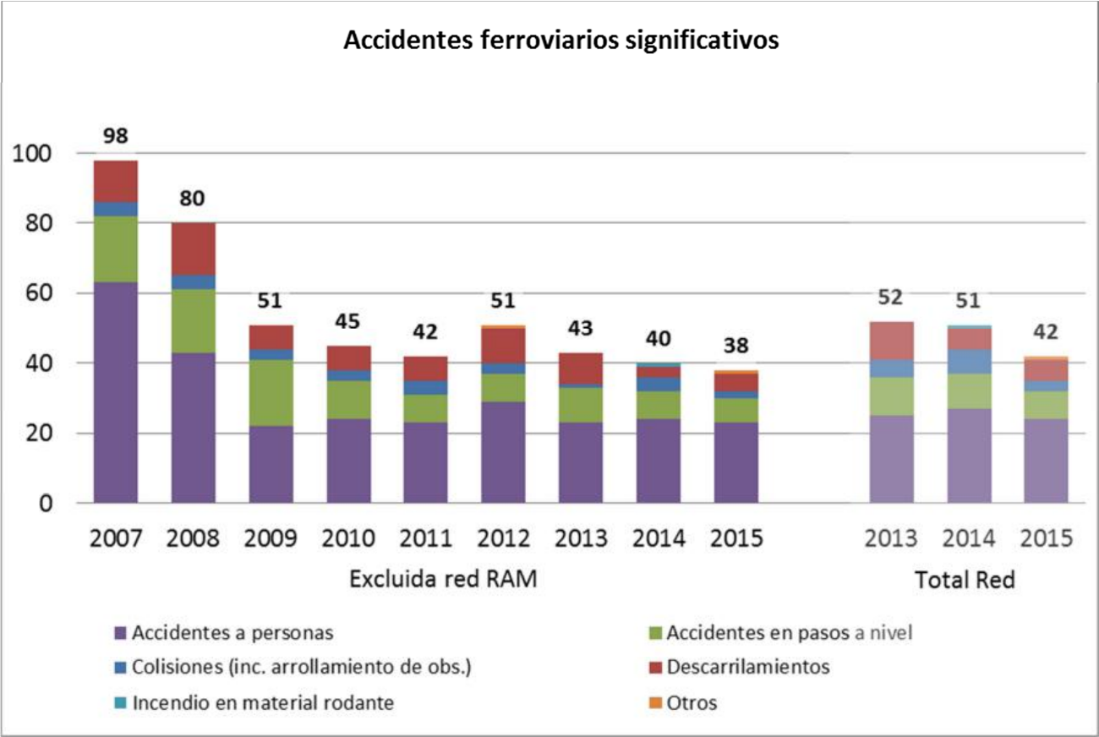
Accidentes ferroviarios significativos TIPOS | Significant railway accidents TYPES
Excluida red RAM | Excluding the RAM network
Total Red | Total network
Accidentes a personas | Accidents involving people
Colisiones (inc. arrollamiento de obs.) | Collisions (including running over obstacles)
Incedio en material rodante | Fire involving rolling stock
Accidentes en pasos a nivel | Accidents at level crossings
Descarrilamientos | Derailments
Otros | Others

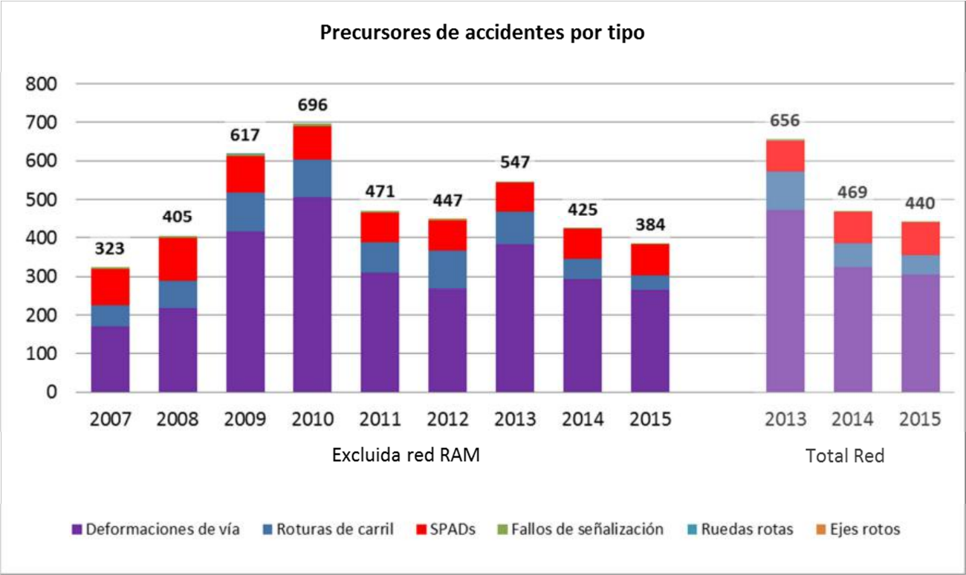
Precursores de accidentes por tipo | Precursors of accidents by type
Excluida red RAM | Excluding the RAM network
Total red | Total network
Deformaciones de via | Track buckling
Rotura de carril | Broken rails
SPADs | SPADs
Fallo de señalización | Signalling failure
Ruedas rotas | Broken wheels
Ejes rotos | Broken axles
■ Fatalities
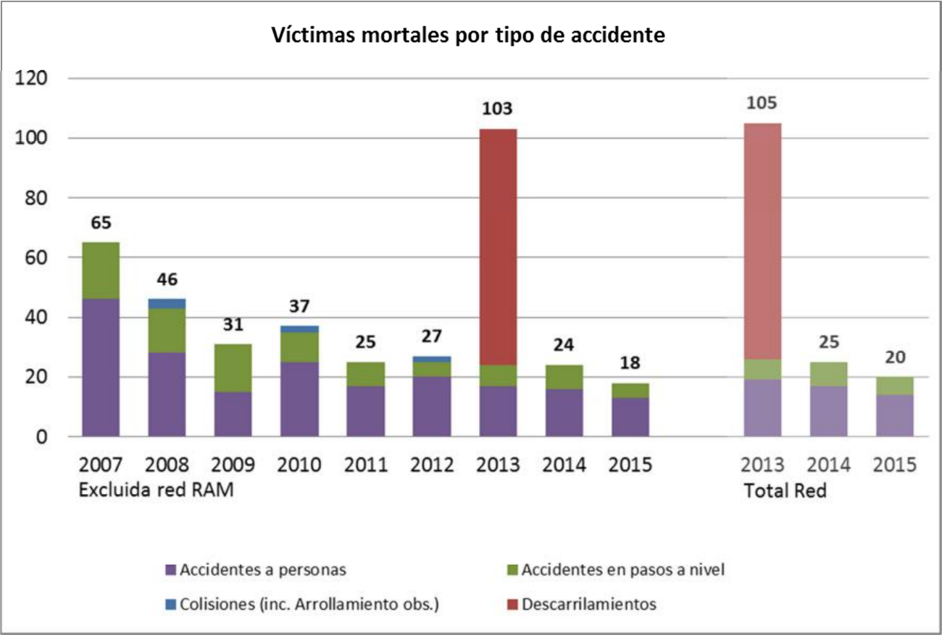
Víctimas mortales por tipo de accidente | Fatalities by type of accident
Excluida red RAM | Excluding the RAM network
Total Red | Total network
Accidentes a personas | Accidents involving people
Colisiones (inc. Arrollamiento obs.) | Collisions (including running over obstacles)
Accidentes en pasos a nivel | Accidents at level crossings
Descarrilamientos | Derailments

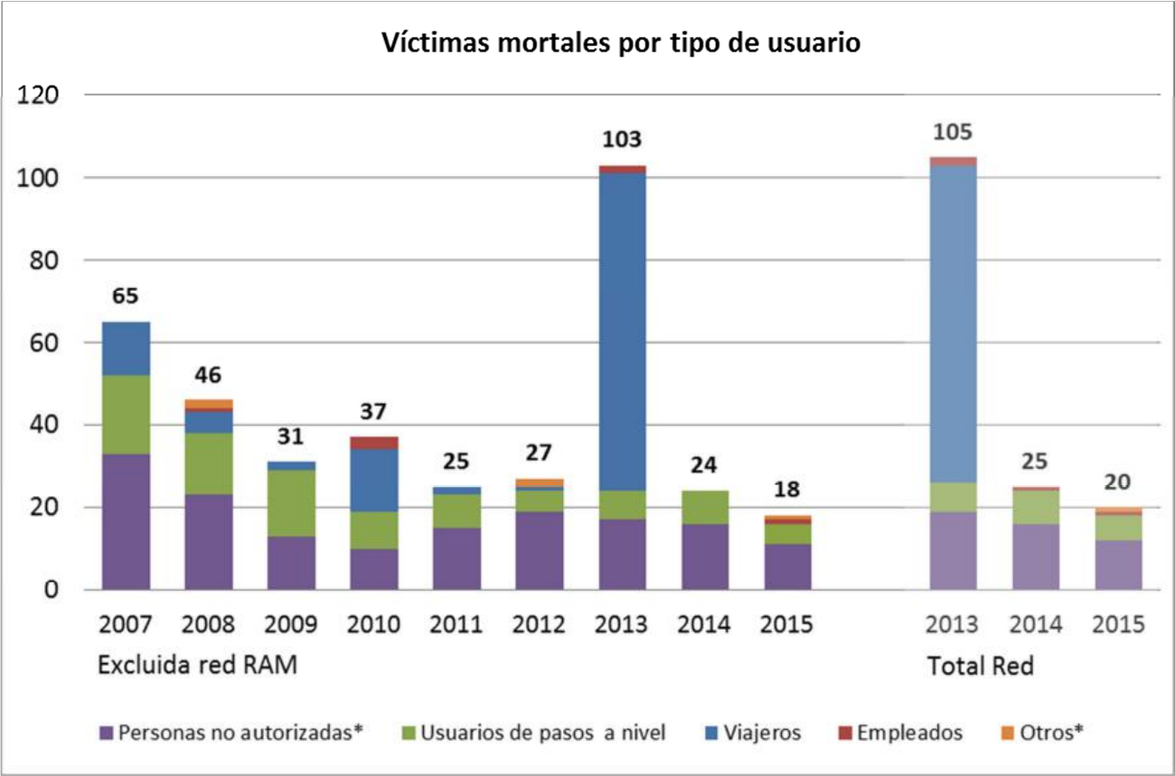
Accidentes ferroviarios significativos TIPOS | Fatalities by type of user
Excluida red RAM | Excluding the RAM network
Total Red | Total network
Personas no autorizadas | Unauthorised persons
Usuarios a pasos a nivel | Level crossing users
Viajeros | Passengers
Empleados | Employees
Otros | Others

(*) To maintain the consistency of the historical series, and considering the modifications introduced in order to adapt to Directive 2014/88, in Article I of the Railway Traffic Safety Regulation in the RFIG approved by Royal Decree 810/2007, in the 2015 figures:
- The ‘Unauthorised persons’ category includes fatalities from the ‘Trespasser’ and ‘Other person at a platform’ categories, in accordance with the definitions in Directive 2014/88.
- The ‘Others’ category includes the fatalities from the ‘Other person not at a platform’ category, in accordance with the definitions in Directive 2014/88.

■ Serious injuries
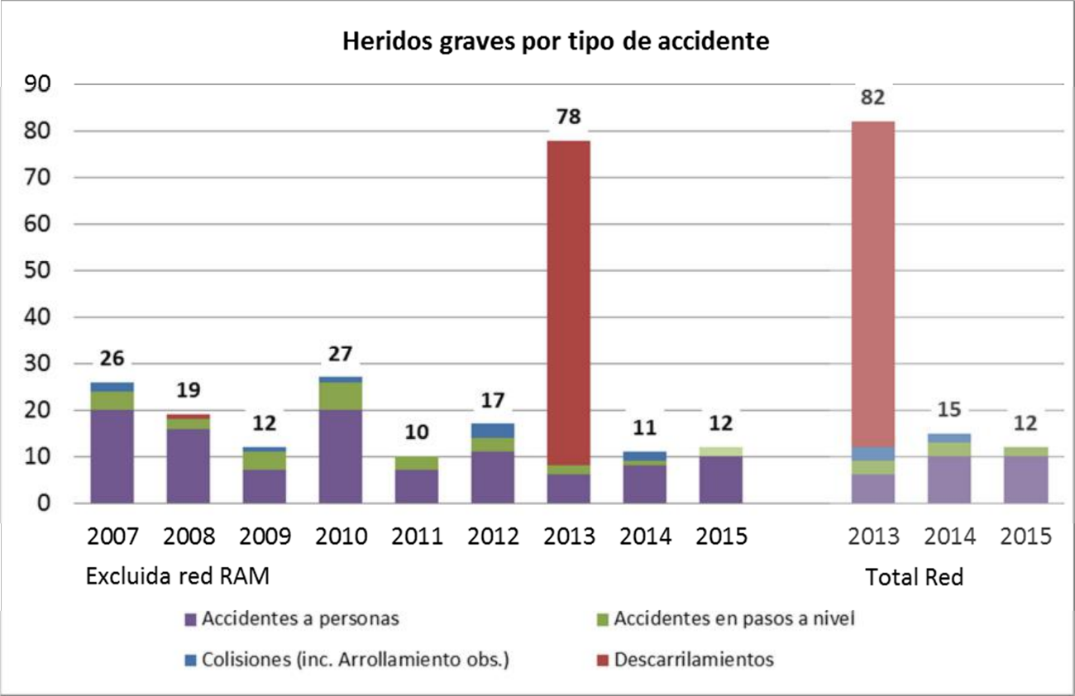
Heridos graves por tipo de accidente | Serious injuries by type of accident
Excluida red RAM | Excluding the RAM network
Total Red | Total network
Accidentes a personas | Accidents involving people
Colisiones (inc. Arrollamiento obs.) | Collisions (including running over obstacles)
Accidentes en pasos a nivel | Accidents at level crossings
Descarrilamientos | Derailments

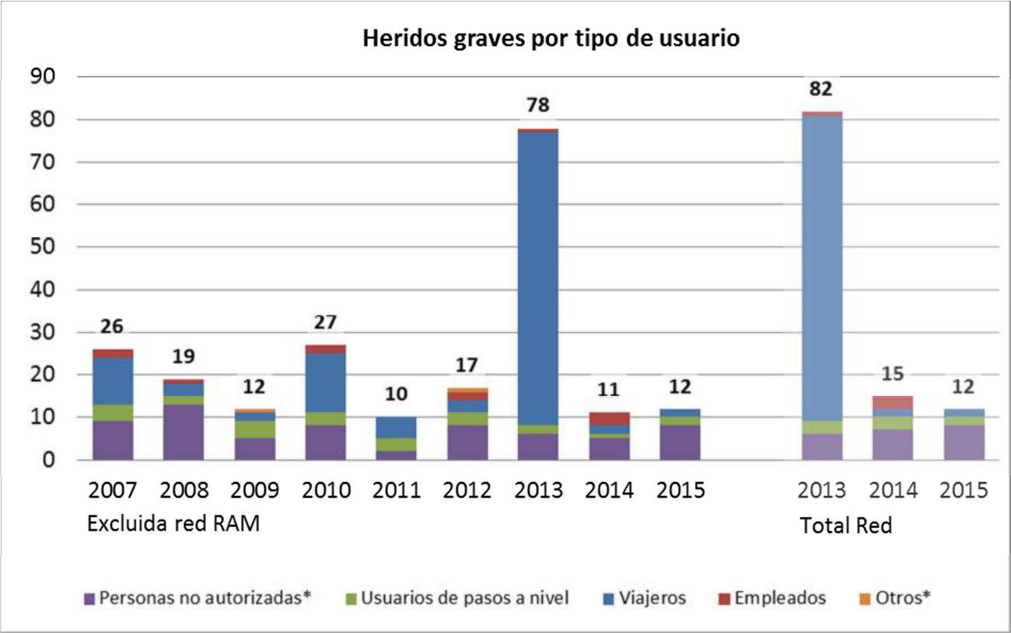
Heridos graves por tipo de usuario | Serious injuries by type of user
Excluida red RAM | Excluding the RAM network
Total Red | Total network
Personas no autorizadas | Unauthorised persons
Usuarios a pasos a nivel | Level crossing users
Viajeros | Passengers
Empleados | Employees
Otros | Others

(*) To maintain the consistency of the historical series, and considering the modifications introduced in order to adapt to Directive 2014/88, in Article I of the Railway Traffic Safety Regulation in the RFIG approved by Royal Decree 810/2007, in the 2015 figures:
- The ‘Unauthorised persons’ category includes serious injuries from the ‘Trespasser’ and ‘Other person at a platform’ categories, in accordance with the definitions in Directive 2014/88.
- The ‘Others’ category includes serious injuries from the ‘Other person not at a platform’ category, in accordance with the definitions in Directive 2014/88.

■ Reference data:
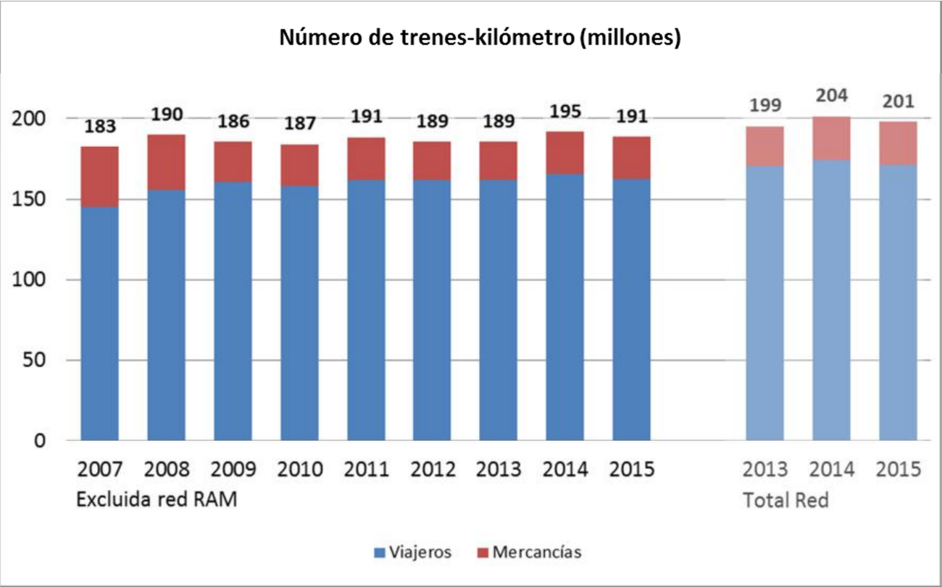
Número de trenes-kilormetro (millones) | Number of train-kilometres (million)
Excluida red RAM | Excluding the RAM network
Total Red | Total network
Viajeros | Passengers
Mercancías | Freight

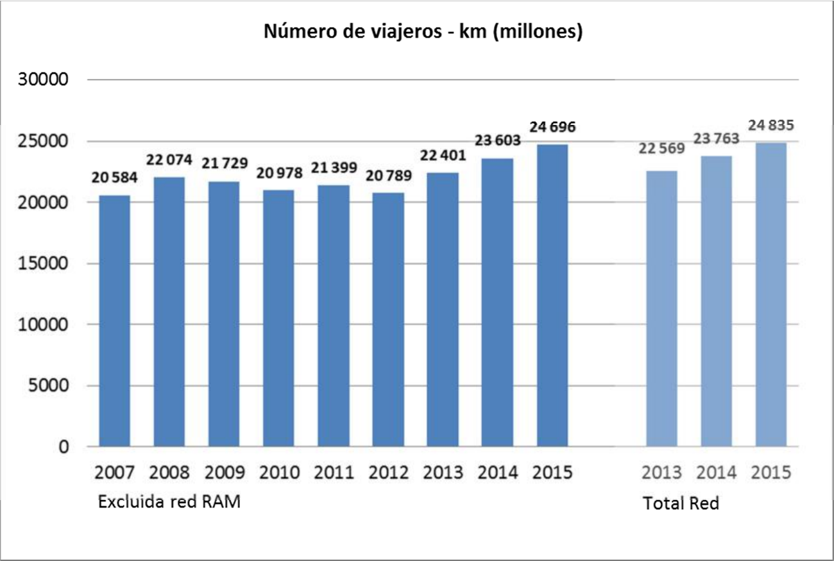
Número de viajeros | Number of passengers
Excluida red RAM | Excluding the RAM network
Total Red | Total network

■ Risk indicators by category of persons involved
■ Total: all categories of persons involved:

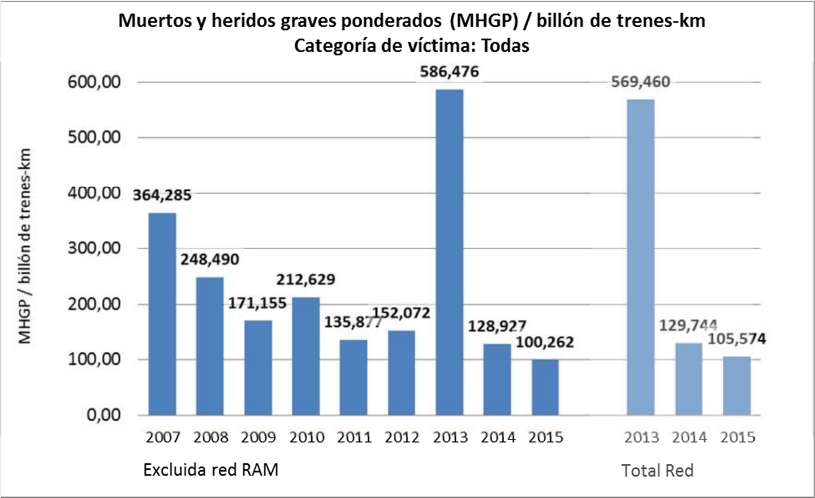
Muertos y heridos graves ponderados (MHGP) / billón de trenes-km | Accidental fatalities and weighted injuries (FWI) / billion train-kilometres
Categoría de víctima: Todas | Victim category: All
MHGP / billón de trenes-km | FWI / billion train-km
Excluida red RAM | Excluding the RAM network
Total Red | Total network

■ Employees
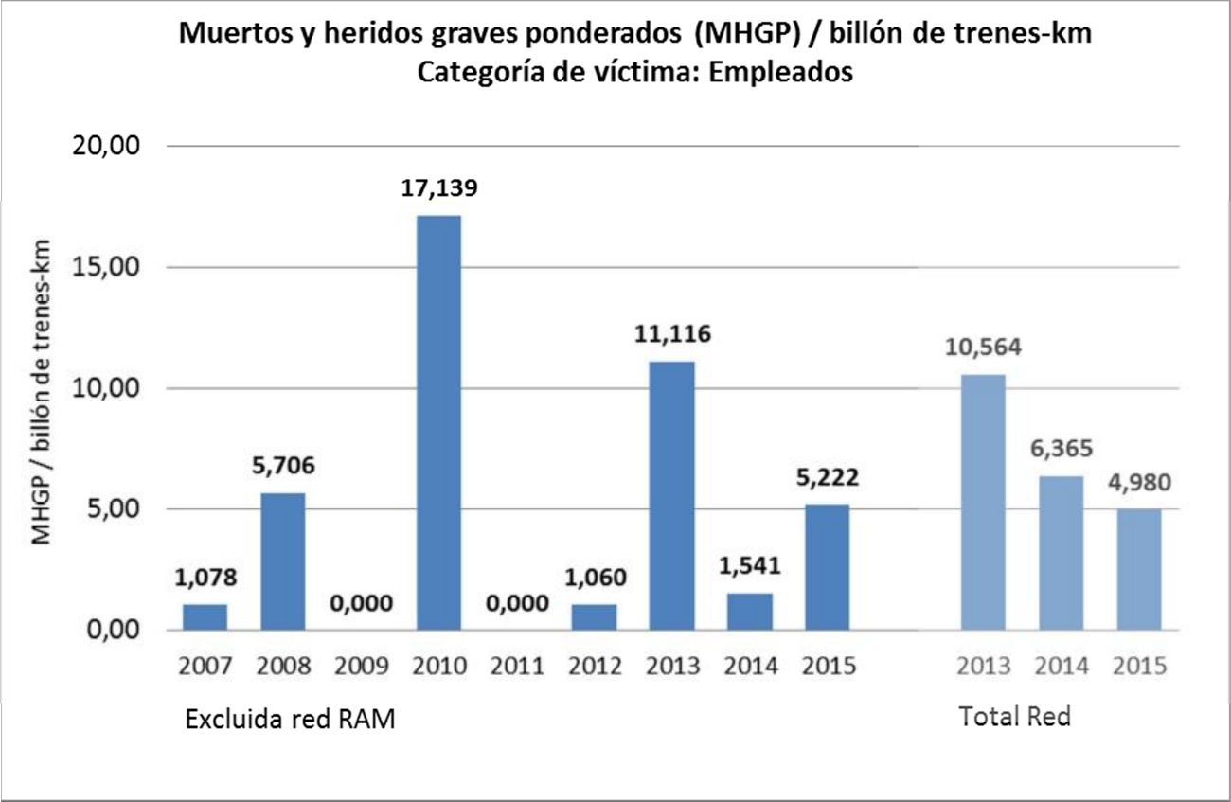
Muertos y heridos graves ponderados (MHGP) / billón de trenes-km | Accidental fatalities and weighted injuries (FWI) / billion train-kilometres
Categoría de víctima: Empleados | Victim category: Employees
MHGP / billón de trenes-km | FWI / billion train-km
Excluida red RAM | Excluding the RAM network
Total Red | Total network

■ Passengers
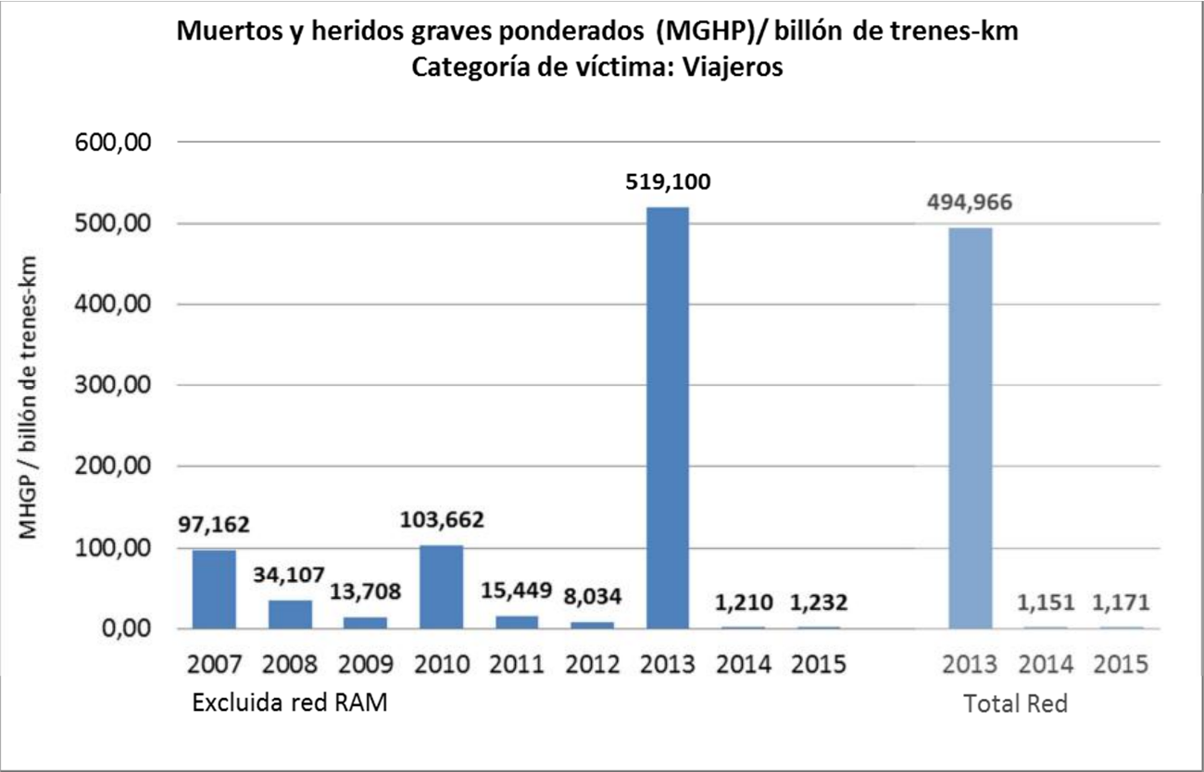
Muertos y heridos graves ponderados (MHGP) / billón de trenes-km | Accidental fatalities and weighted injuries (FWI) / billion train-kilometres
Categoría de víctima: Viajeros | Victim category: Passengers
MHGP / billón de trenes-km | FWI / billion train-km
Excluida red RAM | Excluding the RAM network
Total Red | Total network

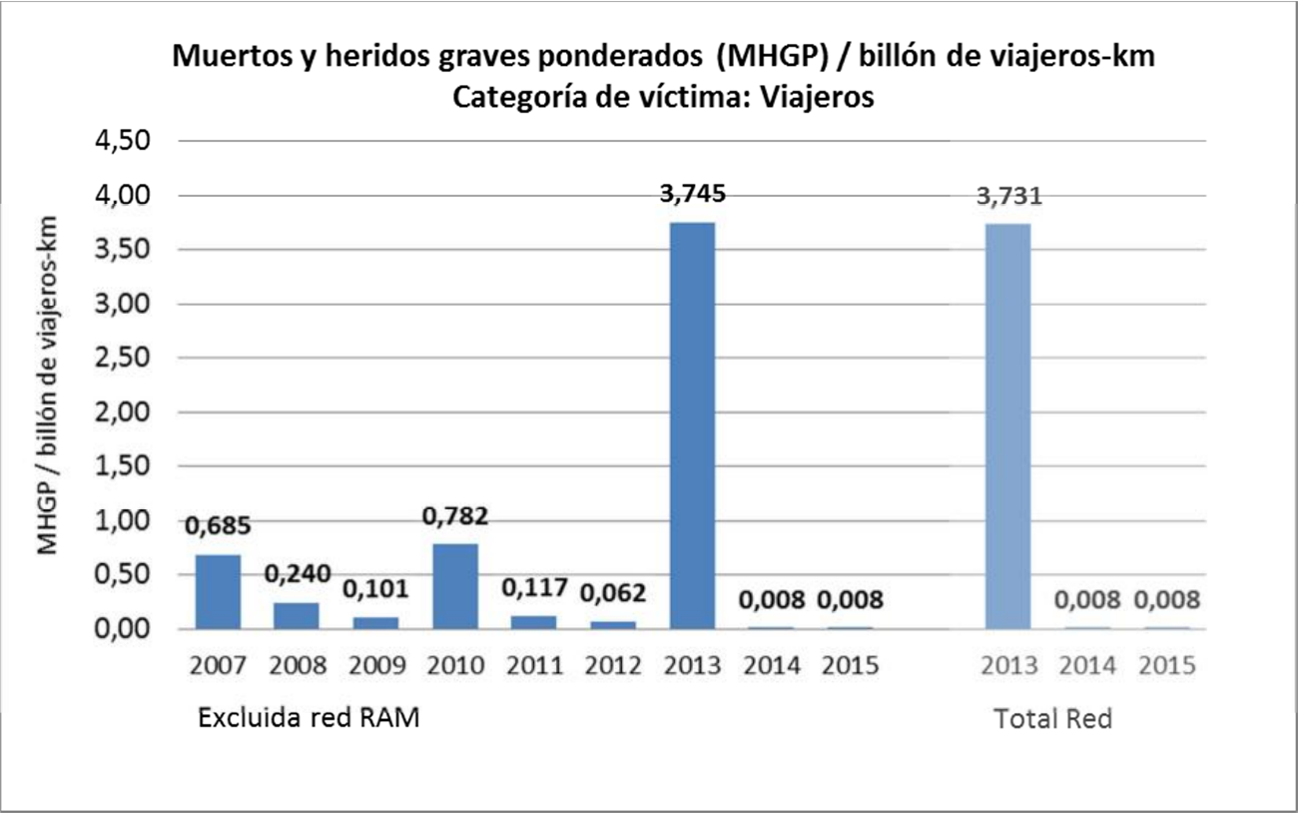
Muertos y heridos graves ponderados (MHGP) / billón de trenes-km | Accidental fatalities and weighted injuries (FWI) / billion train-kilometres
Categoría de víctima: Viajeros | Victim category: Passengers
MHGP / billón de trenes-km | FWI / billion train-km
Excluida red RAM | Excluding the RAM network
Total Red | Total network

■ Level crossing users
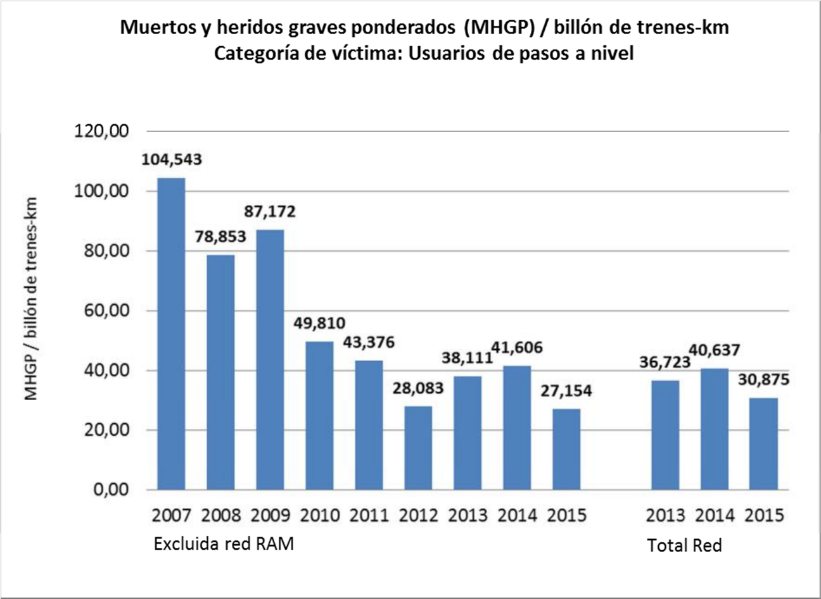
Muertos y heridos graves ponderados (MHGP) / billón de trenes-km | Accidental fatalities and weighted injuries (FWI) / billion train-kilometres
Categoría de víctima: Usuarios de pasos a nivel | Victim category: Level crossing users
MHGP / billón de trenes-km | FWI / billion train-km
Excluida red RAM | Excluding the RAM network
Total Red | Total network

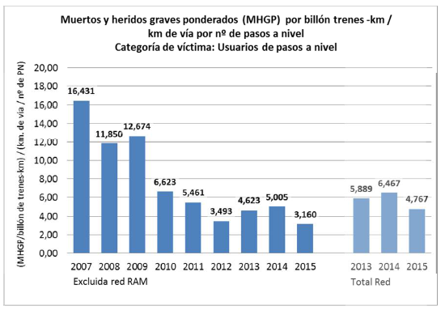
Muertos y heridos graves ponderados (MHGP) por billón de trenes-km / km de vía por no de pasos a nivel | Accidental fatalities and weighted injuries (FWI) per billion train-kilometres / km of track per no. of level crossings
Categoría de víctima: Usuarios de pasos a nivel | Victim category: Level crossing users
(MHGP / billón de trenes-km) (km. de via / no de PN) | (FWI / billion train-kilometres) (km of track / no. level crossings)
Excluida red RAM | Excluding the RAM network
Total Red | Total network

■ Unauthorised persons
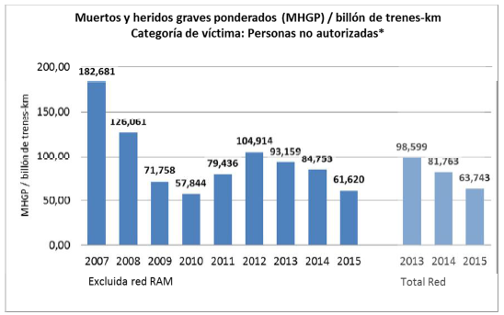

Muertos y heridos graves ponderados (MHGP) / billón de trenes-km | Accidental fatalities and weighted injuries (FWI) / billion train-kilometres
Categoría de víctima: Personas no autorizadas | Victim category: Unauthorised persons
MHGP / billón de trenes-km | FWI / billion train-km
Excluida red RAM | Excluding the RAM network
Total Red | Total network

(*) To maintain the consistency of the historical series, the 2015 values for the ‘Unauthorised persons’ category include victims from the ‘Trespasser’ and ‘Other person at a platform’ categories, in accordance with the definitions in Directive 2014/88.
■ Others
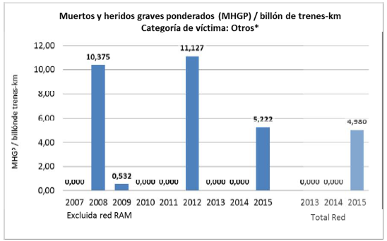

Muertos y heridos graves ponderados (MHGP) / billón de trenes-km | Accidental fatalities and weighted injuries (FWI) / billion train-kilometres
Categoría de víctima: Otros | Victim category: Others
Excluida red RAM | Excluding the RAM network
Total Red | Total network

ANNEX B: Status of transposition of Directive 2004/49

Rail directives and amendments | Transposed (YES/NO) | Legislative reference | Date of entry into force
Directive 2004/49/EC | YES | Royal Decree 810/2007 | 22/08/2007
Directive 2008/57/EC | YES | Royal Decree 1434/2010 | 07/11/2010
Directive 2008/110/EC | YES | Royal Decree 641/2011 | 11/05/2011
Directive 2009/149/EC | YES | Royal Decree 918/2010 | 06/08/2010
Directive 2014/88/EU | YES | Royal Decree 1006/2015 | 08/11/2015

Transposed into national legislation through Royal Decree 810/2007 of 22 June, approving the Regulation on traffic safety in the Public Railway Network.
The International Section in Spanish territory between Figueras and Perpignan.
For these purposes, this network is hardly significant, given that since its activity began in 2010, there has only been one significant accident, which occurred in 2012.
Significant accident: according to Article I of the Safety Regulations on railway traffic, approved by Royal Decree 810/2007 of 22 June: ‘any accident involving at least one railway vehicle in motion, with at least one fatality or serious injury or serious damage to the rolling stock, track, other installations or environments, or prolonged traffic disruptions. Accidents at workshops, warehouses and depots are excluded’. ‘Serious damage to the rolling stock, track, other installations or environments’ is understood as damage with a value equivalent to or greater than EUR 150,000, and ‘prolonged traffic disruptions’ are understood as railway services on a main railway line that are suspended for a minimum period of six hours. Serious accident: according to Article 2 of the Safety Regulations on railway traffic, approved by Royal Decree 810/2007 of 22 June: ‘any collision or derailment of trains with the result of at least one fatality or five or more serious injuries, or major damage to the rolling stock, to the infrastructure or to the environment, and any other, similar accident, with an evident effect on railway safety or on safety management. Major damage is understood as damage that can be immediately assessed by the investigation body to be worth at least two million euros in total’. For consistency with the criteria used in the past, serious accidents (regardless of the type of accident) are considered to include all accidents in which there is at least one fatality or five or more serious injuries or major damage.
According to the definitions of types of accidents included in Article I of the Safety Regulations on railway traffic, approved by Royal Decree 810/2007 of 22 June.
Includes the following types of accidents: ‘Collision of train with rail vehicle’ and ‘Collision of train with obstacle within the clearance gauge’.
Accidents involving people due to rolling stock in movement, not including suicides or suicide attempts.
Accidents at level crossings, including accidents involving pedestrians.
To give continuity to the statistical series, the following types of accidents are grouped together: ‘Collision of train with rail vehicle’ and ‘Collision of train with obstacle within the clearance gauge’. There were no train collisions with a rail vehicle in 2015.
To give continuity to the statistical series, the following types of accidents are grouped together: ‘Collision of train with rail vehicle’ and ‘Collision of train with obstacle within the clearance gauge’. There were no train collisions with a rail vehicle in 2015.
The statistical series is strongly influenced by the accident of 24 July 2013 in Angrois (Santiago de Compostela), as it significantly distorts the statistical series due to being an extraordinary event.
As from 2009, more restrictive criteria for quantifying track buckling began to be used, meaning the statistical series is not uniform.
Recommendations in final reports issued before the publication of this Annual Report (September 2016). Therefore, this report does not include any recommendations from reports on accidents in 2015 issued by the CIAF subsequent to its publication (between September and December 2016).
The actions relate to recommendations considered to be closed in 2015, as the AESF deemed compliance to be satisfactory. These originated from events in 2015 or earlier.
Order FOM 233/2006 of 31 January, regulating the conditions for the approval of railway rolling stock and maintenance centres and establishing the fees for the certification of such rolling stock.
‘Member States may decide to fulfil the obligations to identify the entity in charge of maintenance and to certify it through alternative measures, in the following cases: - Vehicles registered in a third country and maintained according to the law of that country; - Vehicles which are used on networks or lines the track gauge of which is different from that of the main rail network within the Community and for which fulfilment of the requirements referred to in paragraph 3 is ensured by international agreements with third countries; - Vehicles identified in Article 2(2) and military equipment and special transport requiring an ad hoc national safety authority permit prior to their entry into service. In this case derogations shall be granted for periods not longer than five years. Such alternative measures shall be implemented through derogations to be granted by the relevant national safety authority: - When registering vehicles pursuant to Article 33 of the Railway Interoperability Directive, as far as the identification of the entity in charge of maintenance is concerned; - When delivering safety certificates and authorisations to railway undertakings and infrastructure managers pursuant to Articles 10 and 11 of this Directive, as far as the identification or certification of the entity in charge of maintenance is concerned. Such derogations shall be identified and justified in the annual safety report referred to in Article 18 of this Directive. Where it appears that undue safety risks are being taken on the Community rail system, the Agency shall immediately inform the Commission thereof. The Commission shall make contact with the parties involved and, where appropriate, request the Member State to withdraw its derogation decision.’
Order FOM 233/2006 of 31 January, regulating the conditions for the approval of railway rolling stock and maintenance centres and establishing the fees for the certification of such rolling stock.
Order FOM/2872/2010 of 5 November, which sets out the conditions for obtaining the qualifying certificates that allow railway personnel to perform their duties with respect to rail traffic safety, as well as the system of officially approved training centres and the medical examination centres of said personnel. This rule was amended by Order FOM 679/2015 of 9 April.
Serious anomalies are defined as those that prevent any type of traffic if they involve infrastructure or rolling stock.
Modification dossiers processed, but not opened, during 2015.

