Railway accident investigation

2007 2007 2007 2007

This document is translated from the original German and is for information only. The original document should be used as the reference source.

PUBLISHED BY:

Bundesministerium für Verkehr, Bau und Stadtentwicklung (German Federal Ministry of Transport, Building and Urban Affairs)
Leitung der Eisenbahn-Unfalluntersuchungsstelle des Bundes (Management of the Federal Railway Accident Investigation Office)
Referat (Department) E 15
Robert-Schuman-Platz 1
53175 Bonn
Germany
www.bmvbs.bund.de
1 Summary
With the 5th Law for Changing Regulations under Railway Law, the Federal Republic of Germany transposed Directive 2004/49/EC (Safety Directive) into national law on 21 April 2007. A further transposition of the Safety Directive occurred with the Eisenbahn-Unfalluntersuchungsverordnung (Railway Accident Investigation Regulation) (EUV) of 5 July 2007.
In its capacity as the tutelary authority of the independent Eisenbahn-Unfalluntersuchungsstelle des Bundes (EUB) (Federal Railway Accident Investigation Office) the Federal Ministry of Transport, Building and Urban Affairs, in accordance with Section 5(1)(f) of the Allgemeines Eisenbahngesetz (General Railways Act) (AEG) obtained the statutory task of investigating accidents pursuant to Chapter V of the Safety Directive.
The reorganisation of the EUB has been completed, with the organisation of the management of the EUB and of the Central Investigation Office of the EUB, but the staffing of the investigation regions is still outstanding. Until the investigation regions are fully ready for work, employees of the railway supervision office of the Eisenbahn-Bundesamt (EBA) (Federal Railway Authority) conduct accident investigations under the supervision of the Central Investigation Office of the EUB.
In the reporting year, the EUB investigated 6 accidents pursuant to Article 19 of the Safety Directive. Investigations of 2 accidents from 2006 have now been completed.
In 2007, 2 safety recommendations were addressed to the Safety Authority.
In the course of accident investigations, in particular by analysis of the accident database, 3 series of dangerous events were recognised, to which the Safety Authority responded with safety measures.
1 Introduction
1.1 Introduction to the annual report
This annual report provides information about the activities of the EUB as the German accident investigation office for the railway sector, in accordance with the Safety Directive. The target group of this report is primarily the railway sector in Germany and Europe; however, it is also directed at representatives of politics, business and the press from other sectors, and at the whole interested public.
The 2007 annual report of the EUB, in accordance with Article 23(3) of the Safety Directive, gives information about the following:
- Transposition of Chapter V of the Safety Directive into national law
- setting up the EUB
- what was learned from the investigations which were carried out
- series of dangerous events
- safety recommendations.
1.2 Overview of the last 12 months
In the reporting year, the instruction "notify about dangerous events in railway operation, investigate them and report on them" was still applicable. Accident-related safety indicators according to CSIs were not yet taken into account.
Within the existing notification procedure, about 8 500 dangerous events were notified. Of these, notification of about 250 dangerous events was given immediately. These events include accidents and other events in railway operation which might have resulted in accidents.
In the reporting year, the EUB investigated 6 accidents in pursuant to Article 19 of the Safety Directive. Investigations of 2 accidents from 2006 have now been completed.
In 2007, safety recommendations with respect to 2 dangerous events were addressed to the Safety Authority.
During accident investigations, in particular by analysis of the accident database, 3 series of dangerous events were recognised, to which the Safety Authority responded with safety measures.
1.3 Aim and purpose of accident investigation
The purpose of the investigation of dangerous events in railway operations is prevention, i.e. preventing accidents and improving railway safety. The aim of every investigation is to gain knowledge by determining the causes, so that suitable measures to avoid future such events can be enacted.
Investigation includes collection and analysis of information, drawing conclusions including establishing the causes, and if appropriate, giving safety recommendations.
Suggestions of the Investigation Office for avoiding accidents and improving safety in railway transport are made to the responsible bodies in the form of safety recommendations.
It is not the purpose of an investigation to establish blame or settle questions of liability, or to prepare or make it possible to penalise individual offences.
Any investigation is carried out independently of any judicial inquiry.
1.4 Safety Directive – state of transposition into national law
In its capacity as the tutelary authority of the independent Eisenbahn-Unfalluntersuchungsstelle des Bundes (EUB) (Federal Railway Accident Investigation Office) the Federal Ministry of Transport, Building and Urban Affairs, in accordance with Section 5(1)(f) of the Allgemeines Eisenbahngesetz (General Railways Act) (AEG) obtained the statutory task of investigating accidents pursuant to Chapter V of the Safety Directive. Accordingly, the Federal Government is responsible for railway accident investigation on railway infrastructures for the supervision of which it is responsible.
A further transposition of the Safety Directive occurred with the Eisenbahn-Unfalluntersuchungsverordnung (Railway Accident Investigation Regulation) (EUV) of 5 July 2007. The EUV concerns the following fields:
Section 1 Field of application
Section 2 Investigation and notification obligation
Section 3 Co-operation with other Member States, the agency and the federal states
Section 4 Actions at an accident site
Section 5 Investigation report
Section 6 Safety recommendations
Section 7 Annual report
Section 8 Retention periods
Section 9 Administrative offences
The EUB was set up by an organisational decree. This provides, among other things:
- The EUB is managed by the Federal Ministry of Transport, Building and Urban Affairs as the tutelary authority.
- To carry out railway accident investigations, a Central Investigation Office of the EUB is set up at the EBA. The Central Investigation Office is made up of the management of the Central Investigation Office and 4 investigation regions (Berlin, Essen, Karlsruhe and Munich).
- Those employees of the EUB at the EBA who are responsible for accident investigation perform accident investigation tasks exclusively. Professionally, they are subordinate exclusively and directly to the Head of the EUB.
With the EUB, an independent investigation office was set up in the Federal Republic of Germany, thus accomplishing the requirements of Chapter V of the Safety Directive.
2 Organisation
2.1 Introduction to the organisation
By setting up the EUB, the Federal Republic of Germany has created an independent accident investigation office.
The EUB is managed by the Federal Ministry of Transport, Building and Urban Affairs. Its address is:
Bundesministerium für Verkehr, Bau und Stadtentwicklung
Leitung der Eisenbahn-Unfalluntersuchungsstelle des Bundes
Robert-Schuman-Platz 1
53175 Bonn
Germany
To carry out investigations, the Central Investigation Office of the EUB was set up at the EBA. The Central Investigation Office of the EUB consists of the management of the Central Investigation Office and four investigation regions. The Central Investigation Office of the EUB operates from the following address:
Eisenbahn-Bundesamt (EBA)
Untersuchungszentrale der Eisenbahn-Unfalluntersuchungsstelle des Bundes [Central Investigation Office of the Federal Railway Accident Investigation Office]
Vorgebirgsstrasse 49
53119 Bonn
Germany
2.2 Organisation of the EUB
Federal Ministry of Transport, Building and Urban Affairs

Management of the EUB; Department E 15
Central Investigation Office

Federal Railway Authority
Berlin investigation region
Essen investigation region
Karlsruhe investigation region
Munich investigation region

3 Investigation process
3.1 Independence of the accident investigation
Based on national legislation and regulations, the EUB is independent of all persons and parties whose interests could conflict with the tasks of the EUB.
3.2 Institutions which are involved in accident investigation
To establish causes, in addition to its own investigations, the support of the following institutions can be requested as required:
- Federal Police and rescue services
- EBA
- external experts (e.g. an institute for materials research)
- railway transport companies (Eisenbahnverkehrsunternehmen (EVU)) and railway infrastructure companies (Eisenbahninfrastrukturunternehmen (EIU))
3.3 Investigation process
The EIUs must notify the EUB of all dangerous events occurring in railway operations. The reporting process is regulated separately in an instruction to the railway companies. Immediate notification and daily notification are distinguished. Immediate notification must take place immediately in the case of accidents with at least one dead or seriously injured person or more than five slightly injured persons; daily notification by 7:30 on the next working day.
On the basis of incoming notifications, dangerous events are categorised according to the following table:

A "Serious accident" (AEG Section 5(1)( f)(1) and (2)
1. Train collisions or train derailments with
- at least one fatality
- at least 5 seriously injured
- considerable damage to vehicles, infrastructure or the environment
(considerable damage: costs can be immediately assessed by the investigation office at EUR 2 000 000)
2. if there are sufficient indications that a dangerous event other than those mentioned in 1. above could have caused a serious accident.

B "Other dangerous events requiring investigation"
- events requiring immediate notification, but not included in Category A
- events requiring daily notification, but where the cause is unclear or there is suspicion of systematic faults of any kind

C. "Other dangerous events"
- events requiring daily notification, not included in Category A or B

The Central Investigation Office with its 4 investigation regions receives the notifications and takes over the determination of the facts as far as necessary.
Further procedures depend on the accident category.
In the case of serious accidents (Category A), the Central Investigation Office informs the management of the EUB immediately. The latter decides in each individual case on the further procedure, in particular how the accident investigation should be carried out.
In the case of other events requiring investigation (Category B), the Central Investigation Office of the EUB carries out its own investigation.
In the case of events in Category C, no investigation by the EUB takes place.
Further details of the investigation procedure are laid down in a manual.
4 Investigations
4.1 General
EIUs are required to notify the Central Investigation Office of the EUB of all dangerous events in railway operations.
6 accidents were assigned to Category A.
About 250 events requiring immediate notification were assigned to Category B and considered in more detail within the accident investigation. For this purpose, investigation reports from the railway companies were requested, considered, checked for plausibility and evaluated.
By analysing the accident database, the EUB has identified trends and informed the Safety Authority about them in the case of the following event types:
- boarding accidents in the case of Series 423 vehicles
- alighting accidents in the absence of side-selective door control
- wheelset axle breaks in the case of goods wagons.
4.2 Investigations in accordance with Article 19 of the Safety Directive
4.2.1 Derailment on 23 January 2007 between Elmshorn and Tornesch

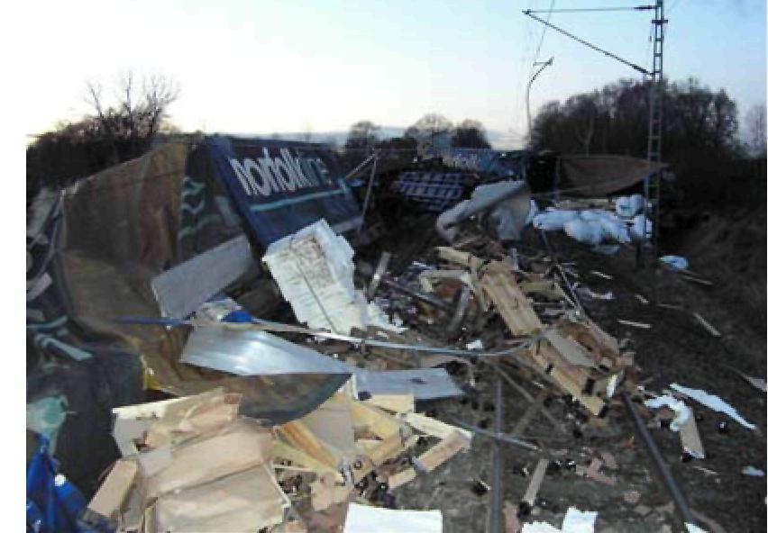
On 23 January 2007, at about 3:19, on the Kiel – Hamburg line between Elmshorn and Tornesch stations, goods train TEC 40013 suffered a loss of load from a container which was being transported on the first goods wagon and was loaded with two steel coils.

Consequences:
12 of the 21 goods wagons of the train were derailed; some of the wagons overturned. A tank container loaded with chloroacetic acid (at the 4th position in the train) sprang a leak at the derailment, so that considerable quantities dangerous material escaped.
Railway vehicles, their loads, the track and the overhead line equipment were seriously damaged.
Cause:
- The faulty loading of the steel coils, which was not in accordance with the relevant regulations.
- The load was insufficiently distributed.
- The knife-edge load of the container was clearly exceeded because it was loaded in the wrong way.
- The state of the container, in particular around the floor cross-beams, showed considerable faults.
Actions to ensure operational safety:
22 containers of this type were in circulation. As soon as the role of the coil in the accident was known, the shipper immediately stopped further transport of coils in the interchangeable containers.

4.2.2 Derailment on 28 February 2007 in Rottenburg Wümme

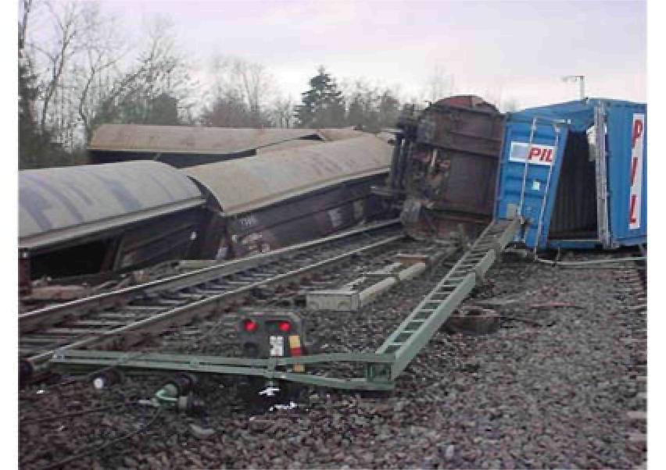
On 28 February 2007, goods train FIR 51284 was derailed on the journey from Seelze to Maschen, on leaving Rotenburg / Wümme station. The 23rd wagon and then all the wagons of the goods train thereafter were derailed.

Consequences:
Because of the derailment, considerable damage to the track and severe damage to signalling equipment and overhead line equipment occurred.
Cause:
The immediate cause of the derailment was undoubtedly a wheelset axle break because of a hot box.
Safety recommendation:
Regarding line-side equipment with hot box location systems, and taking account of the conclusions, consideration should be given by specialists to whether and to what extent the distance between hot box location systems can or must be optimised, to deal more effectively with the case of relatively quickly developing hot boxes.

4.2.3 Collision on 24 July 2007 between Munich-Lochhausen and Olching

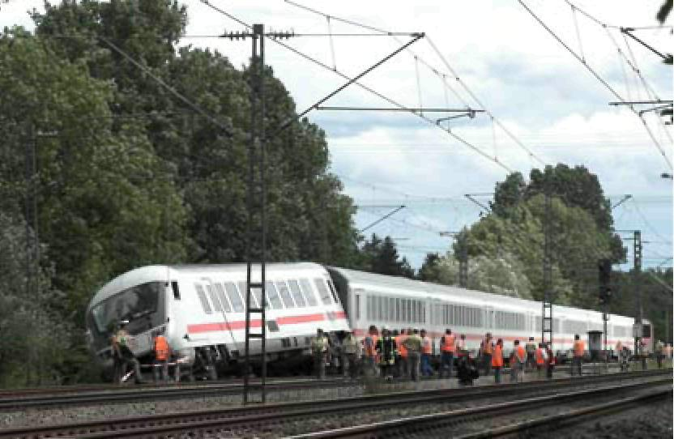 | On 24 July 2007, at about 12:10, on the journey from Munich Central Station to Frankfurt Central Station, between Munich-Lochhausen and Olching at about km 13.3, IC 2298 collided with an old rail which extended onto the track on the right in the direction of travel, and was derailed with 4 axles.
Old rails which were stacked on the long-distance track between Munich-Pasing and Olching were supposed to be loaded onto a container by a company with a loading vehicle. While this work was being carried out, during turning, a rail slipped out of the claw, and extended into the clearance of the track.
Consequences:
The train driver and 8 passengers were slightly injured.
Cause:
The collision with the old rail, which was within the regulated clearance of the track, was the result of the deficient safety planning of the company which was supposed to transport the rails away. The rules of BGV D 33 were not observed. These regulate what the safety precautions against the dangers of railway operation during work in or on the track area must be. The subcontractor failed to contact the office which is responsible for railway operation, and to ensure that the safety precautions against the dangers of railway operation were introduced.

4.2.4 Collision on 26 July 2007 in Wuppertal Barmen

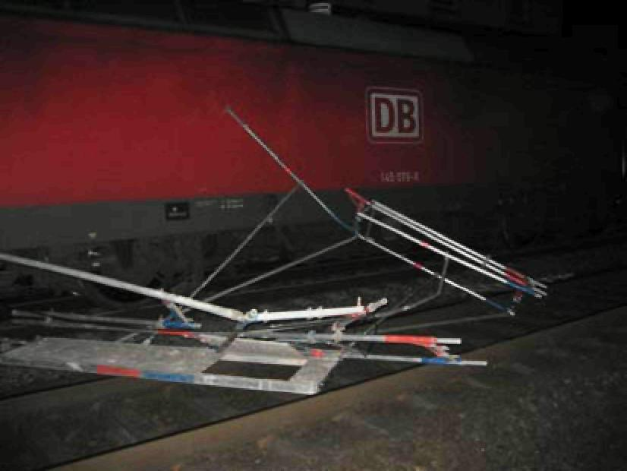 | On 26 July 2007, at 02:37, goods train FIR 51104 collided with scaffolding on the long-distance track from Wuppertal-Oberbarmen to Wuppertal central station.  In the area of responsibility of the Wuppertal-Oberbarmen traffic manager, work was being done on the long-distance tracks in both directions between Wuppertal central station and Wuppertal-Oberbarmen, according to Advice of Work in Progress 26286.
Among other things, the overhead line was supposed to be switched off here for bridge work.
In parallel, work was being done on Track 6 in Wuppertal-Oberbarmen station, according to Advice of Work in Progress 26317.
Consequences:
Three building workers were slightly injured and one was seriously injured.
Cause:
- The technically authorised switching requester designated in Advice of Work in Progress 26286 (for the long-distance track) documented the switch-off properly, but did not inform the traffic manager.
- The traffic manager had agreed to the switch-off. However, he did not receive the information that the switch-off had actually occurred. He therefore did not document the switch-off of the overhead line.
- The intended interruption of possession at 00:50 did not occur. Work on the long-distance track continued by tacit agreement.
- The traffic manager confused the technically authorised person of Advice of Work in Progress 26317 with the technically authorised person of Advice of Work in Progress 26286, and treated the departure of the permanent way gang in Oberbarmen station as equivalent to notification that the Wuppertal-Oberbarmen – Wuppertal central station track was fit for traffic. He therefore cancelled the possession of the long-distance tracks. The traffic manager did not expect notification that the overhead line was switched on again because he had not been informed when it was switched off.
- Because of the presumption that the work had ended, the traffic manager allowed FIR 51104 to move on the long-distance tracks.

4.2.5 Collision on 12 November 2007 in Schlüchtern

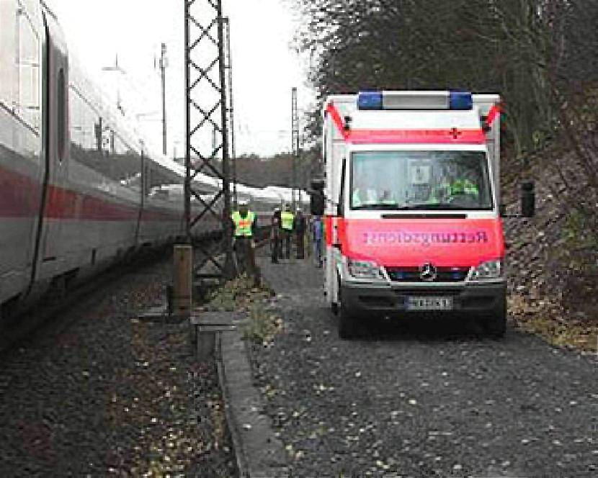 | On 12 November 2007, at 13:23, ICE 75 (Hamburg-Altona – Zürich), while travelling on Track 204 in Schlüchtern station, collided with one of 3 employees who were working on Points 227 (km 75.200). The affected employee was fatally injured. Welding work was taking place at Points 227.
Consequences:
1 employee (welder) was fatally injured; 2 further employees were slightly injured.
Cause:
The traffic manager had not properly ensured that the track was safe. The preconditions for movement were thus not fulfilled.
The traffic manager consented to the movement of ICE 75 although Points 227 were still in possession.

4.2.6 Derailment on 19 December 2007 on the Brannenburg - Raubling line

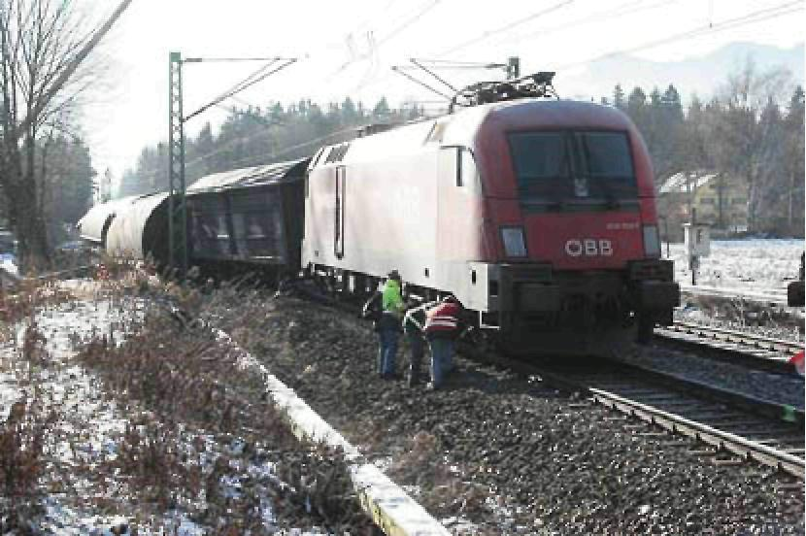 | On 19 December 2007, goods train DGS 45861 (route: Kufstein – Salzburg) was derailed between Kufstein and Rosenheim with all wagons. The accident occurred on a bridge over a motorway. At the time of the accident, there was a heavy frost.
Consequences:
No-one was injured in the accident. The material damage to vehicles, track and overhead line amounted to about EUR 900 000.
Cause:
The cause of the derailment was a rail break in the right-hand rail. This evidently occurred before the movement of goods train 45861.
In materials testing, a crack, which because of its large fatigue fracture area and the adjacent forced fracture area must have initiated the rail break as an initial break when the train moved over it, was identified in the rail segments which had been removed for examination. This was made more likely because of the low outside temperature.

4.3 Series of dangerous events
During accident investigations, in particular by analysis of the accident database, the following series of dangerous events were recognised to which the Safety Authority responded with safety measures.
4.3.1 Boarding accidents in the case of vehicles of Series 423
In several cases, boarding passengers had jammed their arms in the closing door of a vehicle of Series 423.
Safety measures of the Safety Authority:
Instruction to the affected railway transport company:
For reliable detection of persons in the closing area and to avoid the danger of injury, the boarding doors of Series 423 vehicles must be retrofitted with light grids.
If Series 423 trains which are used to convey passengers consist wholly or partly of vehicles with boarding doors which are not equipped with light grids, when readiness to depart is established an employee must establish by a visual check that the outer doors are closed and no persons are jammed in.
4.3.2 Alighting accidents in the absence of side-selective door control
Because of alighting on the unintended side of the train at a station or halt, several accidents have occurred in the past, some of them fatal.
Safety measures of the Safety Authority:
Instruction to the affected railway transport company:
In passenger trains where the coaches do not have effective equipment for side-selective door control, before the platform is reached the alighting side must be announced by the train driver.

Before the train driver or conductor establish that passenger trains where the coaches do not have side-selective door controls are ready to depart, they must take care that the passengers are only boarding and alighting on the intended side of the vehicles.
4.3.3 Wheelset axle breaks in the case of goods wagons
Seven goods train derailments which were the result of wheelset axle breaks, in Germany, the Netherlands, Austria and Switzerland, were known to the EUB. It could be deduced from the investigation results that long-term vibration fractures were caused by corrosion damage or other surface damage, and resulted in spontaneous forced fracture of the rest.
Safety measures of the Safety Authority:
General instruction to all railway companies and holders which are subject to supervision by the EBA:
In this general instruction, the railway companies and holders were instructed to have available maintenance programmes for goods train wheelsets, taking account of the operating limit criteria according to E-Din 27204-1, to develop them further as required and to apply them.
Additionally, periodic testing of the wheelset axles for maintaining an operationally safe state must be planned, among other things by suitable methods of non-destructive testing.

5 Safety recommendations
In the reporting year, two safety recommendations have been addressed to the Safety Authority. Both safety recommendations were adopted by the Safety Authority to the required extent.
One safety recommendation concerned the railway accident on 20 November 2006 in Berlin Südkreuz. In this case a city train passed a signal at stop. Although emergency braking was initiated, the city train did not come to a stop in time before the rail surveying train which was stopped at the platform.
Safety recommendation:
- Send the expert opinion to S-Bahn Berlin GmbH [the Berlin urban railway company].
- Issue a decision to S-Bahn Berlin GmbH containing instructions to ensure that the sand spreading equipment of the city trains of BR 480 and 481 work reliably and always have sufficient fuel.
- Check the design of the brake system of the vehicles of BR 480/481, in co-operation with the manufacturer and operator and taking account of the expert's indications.
- Produce a risk analysis, with the aim of preventively combating the combination of "dirty rail head and slight moistening" which probably caused the accident, or limiting its effect by suitable operational actions.
Implementation of the Safety Directive:
The Safety Authority, with the support of an external expert, carried out a technical investigation of the brakes. The retrofitting of the brake system as required by the Safety Authority for the affected vehicle series is not yet complete. Vehicles which have not yet been retrofitted are running with operational restrictions, on the basis of a voluntary commitment by the affected railway company.

A further safety recommendation resulted from the investigation of the goods train derailment on 28 February 2007 in Rotenburg / Wümme (see Section 4.2.2)
Safety recommendation:
Taking account of the conclusions in the accident investigation and the findings of the expert opinion of the metallurgical investigation, consideration should be given by specialists to whether and to what extent the distance between hot box location systems can or must be optimised, to deal more effectively with the case of relatively quickly developing hot boxes.
Implementation of the safety recommendation:
The safety recommendation refers to the use of hot box location systems. The Safety Authority has discussed possible improvements with the infrastructure operator (required distances, possible detection methods, basic assumptions about the progress of heating). A risk study regarding the hot box location system was initiated. An update of the rules and requirement specification for the hot box location system by the operator, with the participation of the EBA, is intended. The procedure has not yet been concluded.

