|  |  |  |  |
| --- | --- | --- | --- |
|  |  | **Austria** | |
| **Annual Report** | | | |
| **of the  National Safety Authority**  **for the year 2014** | | | bmvit, Department IV, Rail Group, Section Sch 5 |
|  | | | |
| in accordance with Article 18 of Directive 2004/49/EC  ‘Directive on safety on the Community’s railways’  transposed by Article 13a Railways Act 1957 (EisbG) | | | |

Contents:

A.1. Scope of the report 1

A.2 Summary 1

B Introduction 3

C Organisation 6

D The development of railway safety 10

E Changes to statutes and regulations 17

F The development of safety certification and authorisation 17

G Supervision of railway undertakings and infrastructure managers 22

H The application of CSM to risk evaluation and assessment 24

I Sources of information 26

J Annexes 28

ANHANG A: Railway structure information 29

ANHANG B: Organisation chart 33

ANHANG C: CSI data – definitions applied 39

ANHANG D: Important changes to legislation and regulation 49

ANHANG E: The development of safety certification and authorisation – numerical data 51

A.1. Scope of the report

This annual report has been drawn up in accordance with Article 13a Railways Act 1957, the Federal Act concerning railways, rail vehicles on railways and traffic on railways [Bundesgesetz über Eisenbahnen, Schienenfahrzeuge auf Eisenbahnen und den Verkehr auf Eisenbahnen (Eisenbahngesetz)] (EisbG), Federal Law Gazette [Bundesgesetzblatt (BGBl.)] No 60/1957 as most recently amended by BGBl. No 205/2013. It falls within the meaning of Directive 2004/49/EC of 29 April 2004 (OJEU L164 of 30 April 2004) ‘Directive on safety on the Community's railways’ as most recently amended by 2014/88/EU of 9 July 2014 (OJEU L201 of 10 July 2014). The report covers the activities of the national safety authority in respect of the operation of main line railways and the secondary railways connected to them, the operation of rail vehicles on such railways and traffic on such railways in Austria in the year 2014.

A.2 Summary

In Austria general duties for railway undertakings and infrastructure managers are laid down in the Austrian Railway Act: “Eisenbahngesetz 1957”, published in “Bundesgesetzblatt BGBl No. 60/1957”, as last amended by “BGBl. I No 61/2015”. The detailed regulations of railway undertakings concerning the training, behaviour of staff concerned with safety critical tasks are subject of authorisation by the Railway Authority.

Beginning from 01.01.2006 the National Investigation Body – “Sicherheits- untersuchungsstelle (SUB)” according to the regulations in the “Bundesgesetz über die unabhängige Sicherheitsuntersuchung von Unfällen und Störungen (Unfalluntersuchungsgesetz – UUG 2005)”, published in “Bundesgesetzblatt BGBl I No.

123/2005” as last amended by “BGBl. I No 89/2014” started its work as an independent body according to Article 21 of the Safety Directive concerned with the investigation of accidents/incidents.

Safety indicators relating to accidents, incidents and near-misses, to technical safety of infrastructure and its implementation are collected by the SUB.

Safety performance on member state level is controlled on different levels e.g. by approval process of subsystems, maintenance rules, by accident and incident investigation. Railway undertakings and infrastructure managers have to fulfil obligations for periodical checking, reviewing and inspections. Furthermore safety performance is individually checked on the occasion of certain incidents.

Authorisation of subsystems for bringing into service, control of operation of railway undertakings and infrastructure managers, supervising of compliance of technical equipments, authorisation for placing into service of new or substantially altered rolling stock and monitoring, promoting and developing the safety regulatory framework are carried out by Federal Ministry of Transport, Innovation and Technology as NSA, notwithstanding the general responsibility of the railway undertakings and infrastructure managers themselves.

Publication of existing, new or updated national safety rules is managed on the website of the Federal Ministry of Transport, Innovation and Technology

(www.bmvit.gv.at/en/verkehr/railway/notifications.html).

The annual report of the safety authority in Austria concerns its activities in the year

2014 according to the Directive on Safety on the Community’s railways (2004/49/EC, “Safety Directive”).

The report contains global information on the railway system in Austria shown in Parts A, B and C and also shown in the related annexes.

Safety recommendations as a result of investigation accidents, incidents and near- misses during the reporting year are enumerated in Part D.

The Part E reports important changes in legislation and regulation concerning railway safety in the year 2014.

The development of safety certification and safety authorisation is shown in Part F.

A description of results of and experience relating to the supervision of infrastructure managers and railway undertakings is given in chapter G.

Part H shows comments on the application of the CSM on risk evaluation and assessment.

1. Introduction
2. Introduction to the report

Article 18 of Directive 2004/49/EC, transposed by Article 13a Railways Act 1957, provides the statutory basis for drawing up the annual report:

‘Annual Report

*Article 13a (1) The Federal Minister for Transport, Innovation and Technology shall prepare a report every year on his activities during the previous year in respect of the operation of main line railways and the secondary railways connected to them, the operation of rail vehicles on such railways and traffic on such railways. The annual report shall be published on the internet on the website of the Federal Minister for Transport, Innovation and Technology at the latest by 30 September of the calendar year following the year to which the report refers and shall also be submitted to the European Railway Agency.*

*(2) The annual report shall contain the following information:*

*an aggregation of the common safety indicators in accordance with Annex I to Directive 2004/49/EC;*

*important changes in federal legislation and regulations made on the basis of federal law which relate to the construction or operation of the railways listed in paragraph 1, the operation of rail vehicles on such railways and traffic on railways;*

*the development of safety certification and safety authorisation;*

*results of and experience relating to the supervision of infrastructure managers and railway undertakings.’*

In addition, in accordance with Article 9 of Regulation (EC) No 352/2009 of 24 April 2009 on the common safety method for risk evaluation and assessment, the national safety authority is to report on the experience of proposers with the application of the common safety method (CSM) on risk evaluation and assessment, and, where appropriate, its own experience. Note: Commission Implementing Regulation (EU) No 402/2013 of 30 April 2013 on the common safety method for risk evaluation and assessment entered into force on 21 May 2015 and in doing so repealed Regulation (EC) No 352/2009.

The annual report within the meaning of the directive is based on an evaluation of the Federal Safety Investigation Authority’s data in accordance with Article 13a (3) Railways Act:

‘***Article 13a*** (3) The Federal Safety Investigation Authority (Article 3 Investigation Bureau Act, BGBl.. *I No 123/2005) shall make available the data necessary for aggregating the common safety indicators for the year to the Federal Minister for Transport, Innovation and Technology at the latest by 30 June of the calendar year following the year to which the report refers in an electronic form.’*

together with the safety reports of the railway undertakings in accordance with Article 39d Railways Act:

Safety report

***Article 39d.*** *Railway undertakings which have their registered office in Austria and infrastructure managers which have their registered office in Austria shall submit a safety report every year for the previous calendar year to the authorities before 30 June which shall contain the following:*

* + 1. information on how the organisation's corporate safety targets are met;
    2. the Austrian and common safety indicators in so far as they are relevant to the railway undertaking in question;
    3. the results of internal safety auditing;
    4. observations on deficiencies and malfunctions which have compromised the safety of railway operations, the operation of rail vehicles on the railway or traffic on the railway.

The annual report is to be prepared in accordance with documents issued by the European Railway Agency:

* Template - Structure for the content of the NSA Annual safety Report
* Guideline for the use of the template - Structure for the content of the NSA Annual safety Report

1. Railway structure information

* Annex A.1. shows the rail network map;
* Annex A.2. shows a list of the railway undertakings (RU) and infrastructure managers (IM).

1. Summary – general trend analysis

The following paragraphs summarise the development of the common safety indicators during 2014.

Sixty-one significant accidents within the scope of the Railway Safety Directive were reported in 2014. This compares with seventy-three in the previous year (2013). Within these totals, accidents involving personal injuries caused by moving rail vehicles (some 48 %) and accidents at level crossings (some 44 %) formed some 92 % of the total number of significant accidents.

The total number of fatalities in the year in question was twenty-five and the number seriously injured was thirty-six. The figures for 2013 were twenty-six fatalities and sixty-two seriously injured.

In total, the overall figures for significant accidents demonstrated a falling trend compared with 2013. The collisions between trains and accidents on level crossings categories demonstrated a falling trend compared with 2013. The accident indicators for other categories (train derailments, accidents in which moving rail vehicles cause personal injury, train fires together with other accidents) show scatter compared with the previous year.

Level crossing users (some 51 % of the total number of victims) formed the largest category of persons seriously injured and killed.

Annex C.1. contains data on the individual CSIs for 2014 together with notes referring to the various common safety indicators.

1. Organisation
2. Introduction to the organisation

**National safety authority for safety authorisation and safety certification:**

(for railway infrastructure managers of main line railways and railway undertakings which are authorised to operate on main line railways and the secondary railways connected to them):

Federal Minister of Transport, Innovation and Technology [Bundesministerin für   
Verkehr, Innovation und Technologie] (bmvit)

Radetzkystraße 2

A-1030 Wien

Tel.: (+43) -1 -71162 -65 -0

Fax: (+43) -1 25 -71162 -652298

E-mail: [iv-sl@bmvit.gv.at](mailto:iv-sl@bmvit.gv.at)

Web: [www.bmvit.gv.at/verkehr/eisenbahn](http://www.bmvit.gv.at/verkehr/eisenbahn)

Article 12(3) of the Railways Act contains the provisions defining the competence of the Federal Minister of Transport, Innovation and Technology as a safety authority.

**Other safety authorities:**

(in every case, the Governor (Landeshauptmann) of the relevant one of the nine Federal Provinces is the railway safety authority for infrastructure managers who only manage secondary railways which are connected):

Governor of Burgenland [Landeshauptmann von Burgenland]

Europaplatz 1

A-7000 Eisenstadt

Governor of Carinthia [Landeshauptmann von Kärnten]

Arnulfplatz 1

A- 9020 Klagenfurt

Governor of Lower Austria [Landeshauptmann von Niederösterreich]

Landhausplatz 1

A-3109 St. Pölten

Governor of Upper Austria [Landeshauptmann von Oberösterreich]

Landhausplatz 1

A- 4021 Linz

Governor of Salzburg [Landeshauptmann von Salzburg]

Chiemseehof

A-5010 Salzburg

Governor of Styria [Landeshauptmann der Steiermark]

Hofgasse 15

A-8010 Graz

Governor of the Tyrol [Landeshauptmann von Tirol]

Eduard-Wallnöfer-Platz 3

A-6020 Innsbruck

Governor of Vorarlberg [Landeshauptmann von Vorarlberg]

Landhaus

A-6900 Bregenz

Governor of Vienna [Landeshauptmann von Wien]

Lichtenfelsgasse 2

A-1010 Wien

Article 12(2) Railways Act contains the provisions defining the competence of governors as authorities.

**Labour inspectorate:**

Federal Ministry of Labour, Social Affairs and Consumer Protection   
[Bundesministerium für Arbeit, Soziales und Konsumentenschutz] (bmask)

Labour Law and Central Labour Inspectorate Section VII [Arbeitsrecht und Zentral-   
Arbeitsinspektorat, Sektion VII]

Transport Labour Inspectorate [Verkehrs-Arbeitsinspektorat]

Stubenring 1

A-1010 Wien

Tel.: (+43) -1 25 -71100 -0

Fax: (+43) -1 25 -71100 -2190

E-mail: [post@bmask.gv.at](mailto:post@bmask.gv.at)

Web: [www.bmask.gv.at](http://www.bmask.gv.at/)

Federal Safety Investigation Authority:

Accident investigating body within the meaning of Directive 2004/49/EC for the investigation of railway operating accidents and incidents:

Federal Office for Transport [Bundesanstalt für Verkehr]

Federal Safety Investigation Authority, Rail Section [Sicherheitsuntersuchungsstelle des Bundes, Schiene]

Trauzlgasse 1

A-1210 Wien

Tel.: (+43) -1 25 -71162 -659150

Fax: (+43) -1 25 -71162 -659298

E-mail: uus-schiene@bmvit.gv.at

Web: [versa.bmvit.gv.at](http://versa.bmvit.gv.at/)

The Accident Investigation Act (BGBl. I No 123/2005 as most recently amended by BGBl. I No 89/2014) and the Rail Accident Reporting Regulation 2006 (MeldeVO-Eisb 2006) (BGBl. II No 279/2006) define the statutory powers for the work.

The Reporting Regulation governs:

Article 1: *… the scope and form of reports of accidents and incidents which arise during the operation of a main line or secondary railway (Article 4 Railways Act 1957, BGBl. No 60), a connecting railway (Article 7 Railways Act 1957, BGBl. No 60) or a tramway which operates exclusively on its own formation, such as underground railways (Article 5 para. 1 point 2, Railways Act 1957, BGBl. No 60), and the operation of rail vehicles on such railways.*

**Rail Regulator:**

Rail Control Commission [Schienen-Control Kommission] (SCK)

Rail Control, Austrian Company for Rail Market Regulation [Schienen-Control

Österreichische Gesellschaft für Schienenmarktregulierung mit beschränkter Haftung]

(Schienen-Control GmbH)

Praterstraße 62-64

A-1020 Wien

Tel.: (+43) -1 25 -5050707 -0

Fax: (+43) -1 25 -5050707 -180

E-mail: [office@schienencontrol.gv.at](mailto:office@schienencontrol.gv.at)

Web: [www.schienencontrol.gv.at](http://www.schienencontrol.gv.at/)

The SCK is the Austrian railway regulator in accordance with Article 20 Directive 2001/14/EC. It was established by the Railways Act in 1999.

1. Organisation chart

Annex B.1. shows the organisation chart for the Federal Ministry of Transport, Innovation and Technology as the national safety authority.

Annex B.2. shows the organisation chart for the Federal Office for Transport’s Federal Safety Investigation Authority.

1. The development of railway safety
2. Initiatives to maintain and improve safety

The following section lists the most important safety recommendations[1]  made in accident investigation reports in 2014:

Safety measures triggered by accidents and precursors to accidents:

| **Date of the event** | **Description of the event** | **Safety recommendation1)** |
| --- | --- | --- |
| 27 Mar 2013 | Collision of a train with a stationary track examination vehicle | **A-2014/010**: investigate whether stations with similar technical installations must be double manned in similar operational situations (Betra ...).  **A-2014/011**: investigate whether sections of line that are not linked to an operations centre should be monitored by empowered monitoring offices (operations controller) in respect of operating matters (including engineering work). |
| 11 Jun 2013 | Collision of a train with a shunting movement | **A-2014/017**: investigate whether the checklists defining the scope of the examination of every item to be checked during the regular visual checks of the general track section in accordance with regulation 06.01.01 ‘maintenance of superstructure’ must necessarily be drawn up and applied to take account of the location and season. |
| 21 Feb 2013 | Collision of a train with an infrastructure component and derailment of the train after a collision with part of a vehicle | **A-2014/029**: investigate whether a phrase such as ‘DANGER FOR OPERATIONS ...’ used in a regulation is adequate to make all the staff aware of the situation.  **A-2014/030**: investigate whether checking the gauge at points where trains are examined would allow open doors and other irregularities in loading to be detected in good time.  **A-2014/031**: ensure that rolling stock examination staff check labelled and apparently locked doors before departure in accordance with Article 38 EisbEPV  **A-2014/032**: ensure that unauthorised persons’ access to unserviceable coaches is prevented.  **A-2014/033**: ensure that train managers watch out for obvious tampering with locked doors during the journey. |
| 19 Jun 2013 | Train hitting a group of people | **A-2014/018**: ensure that safety measures to protect staff active in the danger zone on the track are drawn up to reflect the type of work the staff are engaged in. Activities are to be planned thoroughly to ensure that the safety measures within the meaning of the stipulations of EisbAV are only to be applied when absolutely necessary.  **A-2014/019**: ensure that all the technical equipment used for operations communications provides for recording messages and that these are regularly checked to ensure that message protocols and particularly phraseology are maintained.  **A-2014/020**: railway undertakings are to ensure by means of mandatory instructions and constant supervision that safety measures for work done in the area around the track are laid down and implemented in accordance with legal requirements and that in that way the clear ranking of safety measures is adhered to (organisational safety measures accepting the ‘human factor’ can only be permitted when there is no access to the danger area, no movements, technical means of protection only when it can be demonstrated that no other measures are possible).  SUB comment: source: Transport Labour Inspectorate  **A-2014/021**: Railway undertakings are to take organisational precautions (general instructions, supervision) in order that the documentation necessary to prepare for and carry out works is simplified and standardised to avoid mistakes in planning and execution. SUB comment: source: Transport Labour Inspectorate  **A-2014/022:** railway undertakings must take organisational precautions (general instructions, supervision) in order that the functions and tasks necessary for carrying out work in the danger area around the track are simplified and standardised. In doing so they are to ensure that all the functions defined in the legal provisions as required are in fact staffed (for example, engineering coordinator, supervisor in accordance with Article 4 BauV, safety supervisor). At the same time the ‘additional functions’ which the legal provisions do not insist on are to be investigated thoroughly to check if they actually contribute to higher levels of safety on the work site or if they possibly have a contrary effect. SUB comment: source: Transport Labour Inspectorate  **A-2014/023**: Railway undertakings are to take organisational precautions (general instructions, supervision) in order that the measures necessary are clearly specified before the start of works and followed without exception (for example, briefing on the dangers of railway operation).  SUB comment: source: Transport Labour Inspectorate  **A-2014/024**: Railway undertakings are to take organisational precautions (general instructions, supervision) to ensure engineering work is only started after all the preparatory measures necessary have been completed properly (for example, briefing on places of safety, briefing of lookouts, hearing tests, coordination of arrangements for starting the work).  SUB comment: source: Transport Labour Inspectorate  **A-2014/025**: in addition, further fundamental structural measures for safety on track work sites within the scope of railway supervision (railway authorities) are necessary to avoid similar accidents during engineering work in the danger area around the track:   * 1. Immediate audit of the non-standard regulations for safety measures on railway work sites then existing. As part of this investigation general instructions not conforming with law, contradictory duplicate regulations and unnecessary detailed regulations for individual topics are to be thinned out rigorously.   2. Immediate review of the staffing of the coordination function on work sites. The process should ensure that the coordination of protection and safety tasks on worksites in the danger area around the track is only undertaken by employees who have adequate theoretical knowledge and practical experience of the dangers of railway operation.   3. Reduction in the number of interfaces in the danger area around the track and review of the activities of ‘railway undertakings’ which have been formed just for this purpose.   SUB comment: source: Transport Labour Inspectorate |
| 2 Jul 2013 | Train derailment | **A-2014/026**: investigate whether a phrase such as ‘DANGER FOR OPERATIONS ...’ used in a regulation is adequate to make all the staff aware of the situation.  **A-2014/027**: investigate whether the installation of long welded rail must take account of the influence of temperature caused by the microclimate close to noise barriers.  **A-2014/028**: investigate whether all the infrastructure manager’s current instructions should be collected together in a consolidated set of regulations  (until being included in another set of regulations or withdrawn). |
| 30 May 2013 | Collision of a train with a rail mounted crane | **A-2014/037**: railway undertakings are to ensure by means of mandatory instructions and constant supervision that safety measures for work done in the area around the track are laid down and implemented in accordance with legal requirements and that in that way the clear ranking of safety measures is adhered to (organisational safety measures accepting the ‘human factor’ can only be permitted when there is no access to the danger area, no movements, technical means of protection only when it can be demonstrated that no other measures are possible). .  SUB comment: source: Transport Labour Inspectorate  **A-2014/038**: railway undertakings are to take organisational precautions (general instructions, supervision) in order that the documentation necessary to prepare for and carry out works is simplified and standardised to avoid mistakes in planning and execution. SUB comment: source: Transport Labour Inspectorate  **A-2014/039**: railway undertakings are to take organisational precautions (general instructions, supervision in order that the functions and tasks necessary for carrying out work in the danger area around the track are simplified and standardised. In doing so they are to ensure that all the functions defined in the legal provisions as required are in fact staffed (for example, engineering coordinator, supervisor in accordance with Article 4 BauV, safety supervisor). At the same time the ‘additional functions’ which the legal provisions do not insist on are to be investigated thoroughly to check if they actually contribute to higher levels of safety on the work site or if they possibly have a contrary effect.  SUB comment: source: Transport Labour Inspectorate  **A-2014/040**: railway undertakings are to take organisational precautions (general instructions, supervision) in order that the measures necessary are clearly specified before the start of works and followed without exception (for example, briefing on the dangers of railway operation).  SUB comment: source: Transport Labour Inspectorate  **A-2014/041**: railway undertakings are to take organisational precautions (general instructions, supervision) to ensure engineering work is only started after all the preparatory measures necessary have been completed properly (for example, briefing on places of safety, briefing of lookouts, hearing tests, coordination of arrangements for starting the work).  SUB comment: source: Transport Labour Inspectorate  **A-2014/042**: in addition, further fundamental structural measures for safety on track work sites within the scope of railway supervision (railway authorities) are necessary to avoid similar accidents during engineering work in the danger area around the track:   1. Immediate audit of the non-standard regulations for safety measures on railway work sites then existing. As part of this investigation general instructions not conforming with law, contradictory duplicate regulations and unnecessary detailed regulations for individual topics are to be thinned out rigorously. 2. Immediate review of the staffing of the coordination function on work sites. The process should ensure that the coordination of protection and safety tasks on worksites in the danger area around the track is only undertaken by employees who have adequate theoretical knowledge and practical experience of the dangers of railway operation. 3. Reduction in the number of interfaces in the danger area around the track and review of the activities of ‘railway undertakings’ which have been formed just for this purpose.   SUB comment: source: Transport Labour Inspectorate  **A-2014/043**: ensure that when compiling the Betra all the relevant activities and the measures that flow from them are specifically included. The process must ensure that these are described clearly and unmistakeably. |
| 8 Jan 2014 | Collision of a trip working with a staff member | **A-2014/044**: railway undertakings are to ensure by means of mandatory instructions and constant supervision that safety measures for work done in the area around the track are laid down and implemented in accordance with legal requirements and that that in that way the clear ranking of safety measures is adhered to (organisational safety measures accepting the ‘human factor’ can only be permitted when there is no access to the danger area, no movements, technical means of protection only when it can be demonstrated that no other measures are possible).  SUB comment: source: Transport Labour Inspectorate  **A-2014/045**: railway undertakings are to take organisational precautions (general instructions, supervision) in order that the documentation necessary to prepare for and carry out works is simplified and standardised to avoid mistakes in planning and execution. SUB comment: source: Transport Labour Inspectorate  **A-2014/046**: railway undertakings are to take organisational precautions (general instructions, supervision in order that the functions and tasks necessary for carrying out work in the danger area around the track are simplified and standardised. In doing so they are to ensure that all the functions defined in the legal provisions as required are in fact staffed (for example, engineering coordinator, supervisor in accordance with Article 4 BauV, safety supervisor). At the same time the ‘additional functions’ which the legal provisions do not insist on are to be investigated thoroughly to check if they actually contribute to higher levels of safety on the work site or if they possibly have a contrary effect.  SUB comment: source: Transport Labour Inspectorate  **A-2014/047:** railway undertakings are to take organisational precautions (general instructions, supervision) in order that the measures necessary are clearly specified before the start of works and followed without exception (for example, briefing on the dangers of railway operation).  SUB comment: source: Transport Labour Inspectorate  **A-2014/048**: railway undertakings are to take organisational precautions (general instructions, supervision) to ensure engineering work is only started after all the preparatory measures necessary have been completed properly (for example, briefing on places of safety, briefing of lookouts, hearing tests, coordination of arrangements for starting the work).  SUB comment: source: Transport Labour Inspectorate  **A-2014/049**: in addition, further fundamental structural measures for safety on track work sites within the scope of railway supervision (railway authorities) are necessary to avoid similar accidents during engineering work in the danger area around the track:   1. Immediate audit of the non-standard regulations for safety measures on railway work sites then existing. As part of this investigation general instructions not conforming with law, contradictory duplicate regulations and unnecessary detailed regulations for individual topics are to be thinned out rigorously. 2. Immediate review of the staffing of the coordination function on work sites. The process should ensure that the coordination of protection and safety tasks on worksites in the danger area around the track is only undertaken by employees who have adequate theoretical knowledge and practical experience of the dangers of railway operation. 3. Reduction in the number of interfaces in the danger area around the track and review of the activities of ‘railway undertakings’ which have been formed just for this purpose.   SUB comment: source: Transport Labour Inspectorate |
| 28 Sep 2013 | Collision of a train with a track construction crane | **A-2014/037**: railway undertakings are to ensure by means of mandatory instructions and constant supervision that safety measures for work done in the area around the track are laid down and implemented in accordance with legal requirements and that in that way the clear ranking of safety measures is adhered to (organisational safety measures accepting the ‘human factor’ can only be permitted when there is no access to the danger area, no movements, technical means of protection only when it can be demonstrated that no other measures are possible). .  SUB comment: source: Transport Labour Inspectorate  **A-2014/038:** railway undertakings are to take organisational precautions (general instructions, supervision) in order that the documentation necessary to prepare for and carry out works is simplified and standardised to avoid mistakes in planning and execution. SUB comment: source: Transport Labour Inspectorate  **A-2014/039**: railway undertakings are to take organisational precautions (general instructions, supervision) in order that the functions and tasks necessary for carrying out work in the danger area around the track are simplified and standardised. In doing so they are to ensure that all the functions defined in the legal provisions as required are in fact staffed (for example, engineering coordinator, supervisor in accordance with Article 4 BauV, safety supervisor). At the same time the ‘additional functions’ which the legal provisions do not insist on are to be investigated thoroughly to check if they actually contribute to higher levels of safety on the work site or if they possibly have a contrary effect. SUB comment: source: Transport Labour Inspectorate  **A-2014/040**: railway undertakings are to take organisational precautions (general instructions, supervision) in order that the measures necessary are clearly specified before the start of works and followed without exception (for example, briefing on the dangers of railway operation).  SUB comment: source: Transport Labour Inspectorate  **A-2014/041**: railway undertakings are to take organisational precautions (general instructions, supervision) to ensure engineering work is only started after all the preparatory measures necessary have been completed properly (for example, briefing on places of safety, briefing of lookouts, hearing tests, coordination of arrangements for starting the work).  SUB comment: source: Transport Labour Inspectorate  **A-2014/042**: in addition, further fundamental structural measures for safety on track work sites within the scope of railway supervision (railway authorities) are necessary to avoid similar accidents during engineering work in the danger area around the track:   1. Immediate audit of the non-standard regulations for safety measures on railway work sites then existing; As part of this investigation general instructions not conforming with law, contradictory duplicate regulations and unnecessary detailed regulations for individual topics are to be thinned out rigorously. 2. Immediate review of of the staffing of the coordination function on work sites. The process should ensure that the coordination of protection and safety tasks on worksites in the danger area around the track is only undertaken by employees who have adequate theoretical knowledge and practical experience of the dangers of railway operation. 3. Reduction in the number of interfaces in the danger area around the track and review of the activities of ‘railway undertakings’ which have been formed just for this purpose.   SUB comment: source: Transport Labour Inspectorate  **A-2014/043**: ensure that when compiling the Betra all the relevant activities and the operational measures that necessarily flow from them are specifically included. The process must ensure that this is described clearly and unmistakeably. |

Safety recommendations and accident investigation reports from European Union Member States are also to be found on the ERAIL (European Railway Accident Information Links) database maintained by the European Railway Agency.

Website: [http://erail.era.europa.eu](http://erail.era.europa.eu/)

1. Detailed data trend analysis

This section contains an analysis of the data in respect of all the CSI categories:

* + Indicators relating to accidents
  + Indicators relating to dangerous goods
  + Indicators relating to suicides
  + Indicators relating to the precursors of accidents
  + Indicators to calculate the economic impact of accidents
  + Indicators relating to technical safety of infrastructure and its implementation
  + Indicators relating to the management of safety

Annex C gives details of the coverage of the statistics, the definitions adopted and data on the common indicators for dangerous goods in the context of safety indicators for dangerous goods (common safety indicators) (CSI).

1. Results of safety recommendations

As a rule the safety recommendations made by the Safety Investigation Authority were implemented as recommended. Additional recommendations made by the national safety authority which have a more general application, i.e. are addressed to a whole group (such as for example, all infrastructure managers, all railway undertakings) are shown on the website: www.bmvit.gv.at/verkehr/eisenbahn/sicherheit/verfuegungen/index.html

1. Changes to statutes and regulations

The table in Annex G contains a list of the most important amendments to statutes and rules made in the year 2014.

1. The development of safety certification and authorisation
2. Availability of national safety rules and other national legislation to railway undertakings and infrastructure managers:

Federal Ministry of Transport, Innovation and Technology [Bundesministerium für   
Verkehr, Innovation und Technologie] (bmvit)

Section IV [Sektion IV]

Radetzkystraße 2

A-1030 Wien

Tel.: (+43) -1 -71162 -65 -0

Fax: (+43) -1 25 -71162 -652298

Websites:

[www.bmvit.gv.at/verkehr/eisenbahn/recht/eu/normen/index.html](http://www.bmvit.gv.at/verkehr/eisenbahn/recht/eu/normen/index.html)

[www.bmvit.gv.at/verkehr/eisenbahn/recht/downloads/notifizierung](http://www.bmvit.gv.at/verkehr/eisenbahn/recht/downloads/notifizierung_tsi2008.pdf)

The general federal legal information system provides details of national statutes and regulations:

Website: [www.ris.bka.gv.at](http://www.ris.bka.gv.at/)

A guidebook, the ‘Guide to Applying for a Safety Certificate’ [[Leitfaden zum Antrag auf Ausstellung einer Sicherheitsbescheinigung](http://www.bmvit.gv.at/verkehr/eisenbahn/sicherheit/bescheinigung/downloads/leitfaden_2014.pdf)] [only available in German], has been drawn up to assist in the preparation of supporting papers for applications for safety certification within the meaning of Article 12 of the ‘Directive on safety on the Community’s railways’.

This may be found on the website: [www.bmvit.gv.at/verkehr/eisenbahn/sicherheit/leitfaden_bescheinigung.html](http://www.bmvit.gv.at/verkehr/eisenbahn/sicherheit/leitfaden_bescheinigung.html)

A guidebook, the ‘Guide to Applying for Safety Authorisation’ [[Leitfaden zum Antrag auf Ausstellung einer Sicherheitsgenehmigung](http://www.bmvit.gv.at/verkehr/eisenbahn/sicherheit/downloads/genleitfaden.pdf)] [only available in German]), has been drawn up to assist in the preparation of supporting papers for applications for safety authorisation within the meaning of Article 11 of the ‘Directive on safety on the Community’s railways’:

Website: [www.bmvit.gv.at/verkehr/eisenbahn/sicherheit/leitfaden_genehmigung.html](http://www.bmvit.gv.at/verkehr/eisenbahn/sicherheit/leitfaden_genehmigung.html)

1. Numerical data

Annex E contains numerical data on the development of safety certification and authorisation.

1. Procedural aspects
   1. **Safety certificates - part A**
      1. Reasons for updating and amending part A certificates:

One reason for updating safety certificates was the expiry of their validity.

* + 1. Main reasons for the mean issuing time for part A certificates (restricted to those mentioned in Annex E and after having received all the information necessary) being more than the four months provided for in Article 12(1) of the Railway Safety Directive

Did not apply in 2014.

* + 1. Overview of requests from other national safety authorities to verify or access information relating to the part A certificate of a railway undertaking which has been certified in your state, but which applies for a part B certificate in the other Member State:

No enquiries were made by other national safety authorities on this subject in the year 2014.

* + 1. Summary of problems with the mutual recognition of the part A certificate which is valid in the whole European Community:

No problems with mutual recognition arose in 2014.

* + 1. Fees charged by the national safety authority for issuing a part A certificate (yes/no – fees charged):

Fees are charged in accordance with the Fees Act [Gebührengesetz] 1957 (BGBl. No 267/1957 as subsequently amended) for the submission of application documentation. These are based on the volume of the documents submitted with the application.

* + 1. Summary of the problems with using harmonised formats for part A certificates, specifically in relation to the categories for type and extent of service:

No major problems arose in connection with the use of the harmonised document.

* + 1. Summary of the common problems and difficulties for the national safety authority in application procedures for part A certificates:

No particular problems with the application procedures for part A certificates arose in the year 2014.

* + 1. Summary of the problems reported by railway undertakings when applying for a part A certificate:

No significant problems were reported in 2014.

* + 1. Feedback procedure (e.g. questionnaires) that allows railway undertakings to express their opinion on issuing procedures and practices or to make complaints:

There was no formal feedback procedure in the year 2014.

* 1. **Safety certificates - part B**
     1. Reasons for updating and amending part B certificates:

One reason for updating safety certificates part B was the expiry of their validity.

* + 1. Main reasons for the mean issuing time for part B certificates (restricted to those mentioned in Annex E and after having received all the information necessary) being more than the four months provided for in Article 12(1) of the Railway Safety Directive

Did not apply in 2014.

* + 1. Fees charged by the national safety authority for issuing a part B certificate (yes/no – fees charged):

Fees are charged in accordance with the Fees Act [Gebührengesetz] 1957 (BGBl. No 267/1957 as subsequently amended) for the submission of application documentation. These are based on the volume of the documents submitted with the application.

* + 1. Summary of the problems with using harmonised formats for part B certificates, specifically in relation to the categories for type and extent of service:

No major problems arose in connection with the use of the harmonised document.

* + 1. Summary of the common problems and difficulties for the national safety authority in application procedures for part B certificates:

No particular problems with the application procedures for part B certificates arose in the year 2014.

* + 1. Summary of the problems reported by railway undertakings when applying for a part B certificate:

No major problems with applications for part B certification were reported in the year in question.

* + 1. Feedback procedure (e.g. questionnaires) that allows railway undertakings to express their opinion on issuing procedures and practices or to make complaints:

There was no formal feedback procedure in the year 2014.

* 1. Safety authorisations
     1. Reasons for updating and amending safety authorisations:

Did not apply in 2014.

* + 1. Main reasons for the mean issuing time for safety authorisations (restricted to those mentioned in Annex E and after having received all the information necessary) being more than the four months provided for in Article 12(1) of the Railway Safety Directive:

Did not apply in 2014.

* + 1. Summary of the problems and difficulties which arose regularly when applying for a safety authorisation:

Did not apply in 2014.

* + 1. Summary of the problems reported by infrastructure managers when applying for a safety authorisation:

Did not apply in 2014.

* + 1. Feedback procedure (e.g. questionnaires) that allows infrastructure managers to express their opinion on issuing procedures and practices or to make complaints:

There was no formal feedback procedure in the year 2014.

* + 1. Fees charged by the national safety authority for issuing safety authorisation (yes/no – fees charged):

Fees are charged in accordance with the Fees Act [Gebührengesetz] 1957 (BGBl. No 267/1957 as subsequently amended) for the submission of application documentation. These are based on the volume of the documents submitted with the application.

1. Supervision of railway undertakings and infrastructure managers
2. Description of the means used to supervise railway undertakings and infrastructure managers

The general tasks of railway authorities and means they use for supervision are laid down comprehensively in Article13 Railways Act. The Railways Act, as amended, places significant responsibility on railway organisations to supervise their own construction and operation over the long term.

Amongst other methods, railway undertakings and infrastructure managers are supervised following exceptional events (see also point D.1.) e.g. by the authorities making sample inspections of operating documentation on railway undertakings’ sites followed by documentation of the results and specifying measures to correct deficiencies (on-site supervisory activity).

As part of the supervisory process, sample on-site inspections using checklists were carried out on behalf of the national safety authority in connection with the issue of safety certificates in 2014.

1. Submission of all annual safety reports produced by infrastructure managers and railway undertakings in accordance with Article 9(4) of the Railway Safety Directive within the statutory time limits

The reports listed below were submitted to the national safety authority (bmvit) for the year 2014. Bmvit also called for further statistical data:

ten safety reports from infrastructure managers;

twenty-six safety reports from railway undertakings;

data from the Federal Office for Transport (Federal Safety Investigation Authority),   
together with supplementary data from railway undertakings;

1. Number of inspections (on-site inspections) of RU/IM in 2014

|  |  |  |  |  |  |
| --- | --- | --- | --- | --- | --- |
| **Inspections (on-site inspections)** |  | Safety certificates part A issued | Safety certificates part B issued | Safety authorisations issued | Other activities |
| **Number of inspections (on-site inspections) of RU/IM in 2014** | planned | *) | 6 | 1 |  |
| unplanned | *) |  |  |  |
| carried out | *) | 4 | 1 |  |

*) The certification bodies audit the underlying management system periodically.

1. Number of audits of RU/IM in 2014

The number of internal audits which were carried out by railway organisations as set out in the documentation for their safety management systems in 2014 was:

infrastructure managers 143 and by

railway undertakings 231.

1. Summary of the relevant corrective measures/actions (e.g. amendment, revocation, suspension, serious warning) related to safety aspects following these audits/inspections

No relevant corrective measures in the year in question.

1. Complaints from IMs about RUs related to conditions in their part A or part B certificates

No known complaints in 2013.

1. Complaints from RUs about IMs related to conditions in their safety authorisation

No known complaints in 2013.

1. The application of CSM to risk evaluation and assessment

As an aid to help and support users of the ‘Common Safety Method on Risk Evaluation and Assessment’ and so that the use of these common safety methods should be to a single national standard, the Federal Ministry of Transport, Innovation and Technology (bmvit) drew up a ‘Guide to Regulation (EC) No 352/2009’ [Leitfaden zur Verordnung (EG) Nr. 352/2009]. The entry of Commission Implementing Regulation (EU) No 402/2013 of 30 April 2013 on the common safety method for risk evaluation and assessment into force on 21 May 2015 repealed Regulation (EC) No 352/2009. More details may be found on the website: [www.bmvit.gv.at/verkehr/eisenbahn/sicherheit/gmethoden/index.html](http://www.bmvit.gv.at/verkehr/eisenbahn/sicherheit/gmethoden/index.html)

1. Description of the most important changes which were not regarded as significant by the proposers

In the year in question, railway organisations reported eighty-seven changes which they did not regard as significant in their safety reports.

In making their assessment, railway organisations used the criteria of Article 4(2) of Commission Regulation (EC) No 352/2009 on risk evaluation and assessment supplemented by criteria internal to the organisation (for example, a comparison with internal safety targets).

1. Description of the most important changes

In the course of drafting safety reports, three changes considered to be significant were reported. The independent assessment bodies which made the evaluation were sometimes based within the undertakings. Subcontractors were not involved.

1. Short description of the audits undertaken by the proposers on the effectiveness of the risk management process

The railway organisations' risk management procedure is subject to a continuous audit programme as an integral part of the safety management system. As yet there are no meaningful insights into the effectiveness of the risk management procedure.

1. Reports from proposers and ultimately from their subcontractor(s) and assessment body/bodies on the application of Commission Regulation (EC) No 352/2009 on common safety methods for risk assessment

Amongst other issues, the costs of introducing a risk management procedure and the documentation (particularly to take account of changes that were not significant) were mentioned by railway organisations.

1. Sources of information

Federal Office for Transport, Federal Safety Investigation Authority, accident statistics, safety recommendations, various publications

ERAIL European Railway Agency’s database, calculation templates, charts and table excerpts

European Railway Agency, various publications (particularly guides and templates for drawing up annual reports, ‘Implementation Guidance for CSIs, Annex 1 of Directive 2004/49/EC as amended by Directive 2009/149/EC, V2.3’)

Federal Act concerning the Independent Safety Investigation of Accidents and Incidents (Accident Investigation Act) [Bundesgesetz über die unabhängige Sicherheitsuntersuchung von Unfällen und Störungen (Unfalluntersuchungsgesetz)] (UUG 2005) BGBl. I No 123/2005 as most recently amended by BGBl. I No 89/2014

Federal Act concerning High Capacity Railway Lines (High Capacity Line Act) [Bundesgesetz über Eisenbahn-Hochleistungsstrecken (Hochleistungsstreckengesetz)] – (HlG) BGBl. No 135/1989 as most recently amended by BGBl. I No 154/2004

Federal Act concerning Railways, Railway Rolling Stock on Railways and Traffic on Railways (Railways Act 1957) [Bundesgesetz über Eisenbahnen, Schienenfahrzeuge auf Eisenbahnen und den Verkehr auf Eisenbahnen (Eisenbahngesetz 1957)] – (EisbG) BGBl. No 60/1957 as most recently amended by BGBl. I No 61/2015

Eurostat, various publications

Austrian railway organisations within the scope of the Railway Safety Directive, safety reports, various publications (for example, annual reports, network use conditions)

ÖBB-Infrastruktur AG, network map

‘Directive 2004/49/EC of the European Parliament and of the Council of 29 April 2004 on safety on the Community’s railways’ as most recently amended by Commission Directive 2014/88/EU of 9 July 2014

Schienen-Control GmbH, Annual Report 2014

Austrian Statistics Office [Statistik Austria], various publications

Regulation of the Federal Minister for Transport, Innovation and Technology on the scope and form of reports of accidents and incidents involving railway organisations to the Federal Safety Investigation Authority (Rail Accident Reporting Regulation [MeldeVO-Eisb] 2006), BGBl. II No 279/2006

1. Annexes
2. Railway structure information

**A.1. Network map**

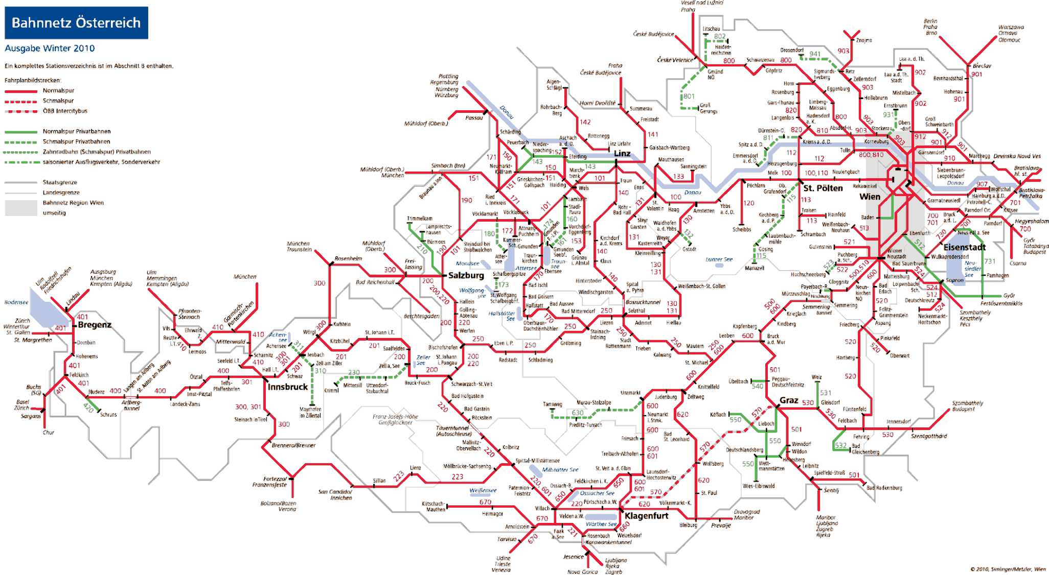

ÖBB Infrastruktur AG network

Other infrastructure managers’ networks

A network map for the ÖBB Infrastruktur AG network may be viewed on:

www.oebb.at/infrastruktur/de/_p_3_0_fuer_Kunden_Partner/3_3_Schieneninfrastruktur/3_3_6_Karten/index.jsp

A.2. List of railway organisations and infrastructure managers

A.2.1. Infrastructure managers with safety authorisations in accordance with Article 38 Railways Act (infrastructure managers on main lines and the secondary lines connected to them as at 31 December 2014)

|  |  |  |  |
| --- | --- | --- | --- |
| Name | Address | Website | Link to network statements [in German] |
| Aktiengesellschaft der Wiener Lokalbahnen | Eichenstraße 1  1120 Wien [Vienna] | [www.wlb.at](http://www.wlb.at/) | www.wlb.at/eportal/ep/channelView.do/pageTypeId/11128/channelId/-22413 |
| Cargo-Center-Graz Betriebsgesellschft m.b.H. & Co KG | Terminal 1  8402 Werndorf | [www.cargo-center-graz.at](http://www.cargo-center-graz.at/) | [www.stlb.at/terminal-graz-sued/](http://www.stlb.at/terminal-graz-sued/) |
| Graz-Köflacher Bahn und Busbetrieb GmbH | Köflacher Gasse 35 – 41  8020 Graz | [www.gkb.at](http://www.gkb.at/) | [www.gkb.at/infrastruktur-zugang.html](http://www.gkb.at/infrastruktur-zugang.html) |
| Land Steiermark/Steiermärkische Landesbahnen | Eggenberger Str. 20  8020 Graz | [www.stlb.at](http://www.stlb.at/) | [www.stlb.at/impressum-snnb/schienennetz-nutzungsbedingungen](http://www.stlb.at/impressum-snnb/schienennetz-nutzungsbedingungen) |
| Lokalbahn Lambach- Vorchdorf- Eggenberg AG  (Betriebsführung: Stern & Hafferl Verkehrsgesellschaft mbH) | Kuferzeile 32  4810 Gmunden | [www.stern-verkehr.at](http://www.stern-verkehr.at/) | [www.lb-lve.at](http://www.lb-lve.at/) |
| Linzer Lokalbahn AG  (Betriebsführung: Stern & Hafferl Verkehrsgesellschaft mbH) | Rathaus  4041 Linz | [www.stern-verkehr.at](http://www.stern-verkehr.at/) | [www.linzer-lokalbahn.at](http://www.linzer-lokalbahn.at/) |
| Montafonerbahn Aktiengesellschaft | Bahnhofstraße 15 a+b  6780 Schruns | [www.montafonerbahn.at](http://www.montafonerbahn.at/) | [www.montafonerbahn.at/verkehr/start.htm](http://www.montafonerbahn.at/verkehr/start.htm) |
| Neusiedler Seebahn Gesellschaft mbH  (Betriebsführung: Raab-Oedenburg-Ebenfurter Eisenbahn AG) | Bahnhofplatz 5  7041 Wulkaprodersdorf | [www.nsb-ag.at](http://www.nsb-ag.at/) | [www.neusiedlerseebahn.at/de/netzzugang/network-statement](http://www.neusiedlerseebahn.at/de/netzzugang/network-statement) |
| ÖBB-Infrastruktur Aktiengesellschaft | Praterstern 3  1020 Wien | [www.oebb.at/infrastruktur](http://www.oebb.at/infrastruktur) | [www.oebb.at/infrastruktur/de/_p_3_0_fuer_Kunden_Partner/3_2_Schienennutzung/3_2_2_SNNB/index.jsp](http://www.oebb.at/infrastruktur/de/_p_3_0_fuer_Kunden_Partner/3_2_Schienennutzung/3_2_2_SNNB/index.jsp) |
| Raab-Oedenburg-Ebenfurter Eisenbahn AG) | Bahnhofplatz 5  7041 Wulkaprodersdorf | [www.raaberbahn.at](http://www.raaberbahn.at/) | [www.gysev.hu/gysev/?p_h=5&t=1795709](https://www.gysev.hu/gysev/?p_h=5&t=1795709) |
| Salzburg AG für Energie, Verkehr und Telekommunikation | Plainstraße 70  5020 Salzburg | [www.salzburg-ag.at](http://www.salzburg-ag.at/) | [www.salzburg-ag.at/agb](http://www.salzburg-ag.at/agb) |
| Stern & Hafferl Verkehrsgesellschaft mbH  (as the railway organisation managing operations) | Kuferzeile 32  4810 Gmunden | [www.stern-verkehr.at](http://www.stern-verkehr.at/) |  |

A.2.2. Railway undertakings with a safety certificate part B in accordance with Article 37 Railways Act (as at 31 December 2014)

|  |  |  |
| --- | --- | --- |
| **Name** | **Address** | **Website** |
| Aktiengesellschaft der Wiener Lokalbahnen | Eichenstraße 1, 1120 Wien [Vienna] | [www.wlb.at](http://www.wlb.at/) |
| Bayerische Oberlandbahn GmbH | Bahnhofplatz 9, DE-83607 Holzkirchen | [www.bayerischeoberlandbahn.de/](http://www.bayerischeoberlandbahn.de/) |
| Cargo Service GmbH | Lunzer Straße 41, 4031 Linz | [www.cargoserv.at](http://www.cargoserv.at/) |
| City Air Terminal Betriebsg.m.b.H. | Office Park, 1300 Wien Flughafen | [www.cityairporttrain.com](http://www.cityairporttrain.com/) |
| DB Regio Aktiengesellschaft | Stephensonstraße 1, DE-60326 Frankfurt am Main | [www.deutschebahn.com](http://www.deutschebahn.com/) |
| ecco-rail GmbH | Haizingergasse 47/3, 1180 Wien | [www.ecco-rail.at](http://www.ecco-rail.at/) |
| ERS Railways B.V. | Waalhaven Zuidzijde 2, NL-3088 HH Rotterdam | [www.ersrail.com](http://www.ersrail.com/) |
| FLOYD Szolgáltató Zártkörűen Működő Részvénytársaság (FLOYD ZRt.) | Madarász Viktor u. 47-49, HU-1138 Budapest, | [www.floyd.hu](http://www.floyd.hu/) |
| GEVD Gesellschaft für Eisenbahnverkehrsdienstleistungen mbH | Brunner Straße 33, 2700 Wiener Neustadt |  |
| Graz-Köflacher Bahn und Busbetrieb GmbH | Köflacher Gasse 35 – 41, 8020 Graz | [www.gkb.at](http://www.gkb.at/) |
| Land Steiermark/Steiermärkische Landesbahnen | Eggenberger Str. 20, 8020 Graz | [www.stlb.at](http://www.stlb.at/) |
| Lokomotion- Gesellschaft für Schienentraktion mbH | Kastenbauerstraße 2, DE-81677 München | [www.lokomotion-rail.de](http://www.lokomotion-rail.de/) |
| LTE-Logistik- und Transport GmbH | Karlauer Gürtel 1, 8020 Graz | [www.lte.at](http://www.lte.at/) |
| METRANS Railprofi Austria GmbH | Karl Mierka Staße 7-9, 3500 Krems | [www.railprofi.at](http://www.railprofi.at/) |
| MEV Independent Railway Services GmbH | Hütteldorfer Straße 343-345, 1140 Wien | [www.m-e-v.at](http://www.m-e-v.at/) |
| MMV Magyar Magánvasút Zártkörűen Működő Részvénytársaság MMV ZRt. | Kerék utca 80, HU-1035 Budapest | [www.mmv.hu](http://www.mmv.hu/) |
| Montafonerbahn AG | Bahnhofstraße 15 a+b, 6780 Schruns | [www.montafonerbahn.at](http://www.montafonerbahn.at/) |
| ÖBB Personenverkehr AG | Am Hauptbahnhof 2, 1100 Wien | [www.oebb.at/pv](http://www.oebb.at/pv) |
| ÖBB Technische Services GmbH | Grillgasse 48, 1110 Wien | [www.oebb.at/ts](http://www.oebb.at/ts) |
| ÖBB Produktion GmbH | Am Hauptbahnhof 2, 1100 Wien | [www.oebb-produktion.at](http://www.oebb-produktion.at/) |
| PKP CARGO SPÓŁKA AKCYJNA | ul. Grojecka 17, PL-02-021 Warszawa [Warsaw] | [www.pkp-cargo.pl](http://www.pkp-cargo.pl/) |
| Raab-Oedenburg-Ebenfurter Eisenbahn AG) | Bahnhofplatz 5, 7041 Wulkaprodersdorf | [www.raaberbahn.at](http://www.raaberbahn.at/) |
| Raaberbahn Cargo GmbH | Bahnhofplatz 5, 7041 Wulkaprodersdorf | [www.raaberbahncargo.at](http://www.raaberbahncargo.at/) |
| Rail Cargo Austria AG | Am Hauptbahnhof 2, 1100 Wien | [www.railcargo.at](http://www.railcargo.at/) |

|  |  |  |
| --- | --- | --- |
| **Name** | **Address** | **Website** |
| Rhomberg Bahntechnik GmbH | Mariahilferstraße 29, 6900 Bregenz | [www.rhombergrail.com](http://www.rhombergrail.com/) |
| RTS Rail Transport Service GmbH | Puchstraße 184 b, 8055 Graz | [www.rts-austria.at](http://www.rts-austria.at/) |
| Safety4you Baustellenlogistik GmbH | Bahnhofplatz 1, 4600 Wels | [www.s4you.at](http://www.s4you.at/) |
| Salzburg AG für Energie, Verkehr und Telekommunikation | Plainstraße 70, 5020 Salzburg | [www.salzburg-ag.at](http://www.salzburg-ag.at/) |
| Steiermarkbahn Transport und Logistik GmbH | Eggenberger Str. 20, 8020 Graz | [www.steiermarkbahn.at](http://www.steiermarkbahn.at/) |
| Stern & Hafferl Verkehrsgesellschaft mbH) | Kuferzeile 32, 4810 Gmunden | [www.stern-verkehr.at](http://www.stern-verkehr.at/) |
| SŽ Tovorni promet d.o.o. | Kolodvorska 11, SI-1000 Ljubljana | [www.slo-zeleznice.si/en/freight/](http://www.slo-zeleznice.si/en/freight/) |
| TX Logistik Austria GmbH | Am Concorde-Park E/13, 2320 Schwechat | [www.txlogistic.eu](http://www.txlogistic.eu/) |
| WESTbahn Management GmbH | Europaplatz 3/Stiege 5, 1150 Wien | [www.westbahn.at](http://www.westbahn.at/) |
| Wiener Lokalbahnen Cargo GmbH | Freudenauer Hafenstraße 8-10, 1020 Wien | [www.wlb-cargo.at](http://www.wlb-cargo.at/) |

1. Organisation chart

B.1. Organisation chart for the Federal Ministry of Transport, Innovation and Technology as the national safety authority

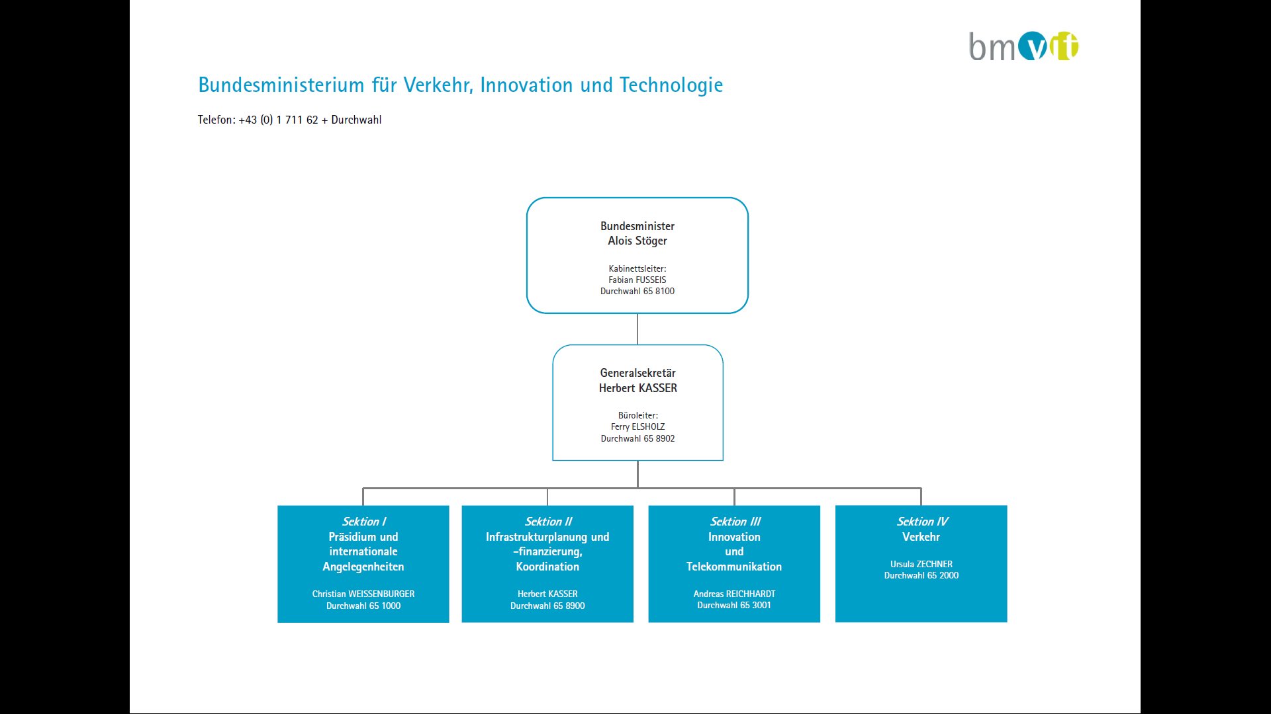

|  |  |
| --- | --- |
| Bundesministerium für Verkehr, Innovation und Technologie | Federal Ministry of Transport, Innovation and Technology |
| telefon: +43(0)171162+Durchwahl | Telephone +43/0/171162 + extension |
| Bundesministerin Alois Stöger  Kabinettsleiter: Fabian FUSSEIS Durchwahl 658100 | Federal Minister Alois Stöger  Head of Chancellery: Fabian FUSSEIS extension 65 8100 |
| Generalsekretär Herbert KASSER  Büroleiter: Ferry ELSHOLZ Durchwahl 658902 | General Secretary Herbert KASSER  Office Manager Ferry ELSHOLZ extension 65 8900 |
| Sektion I Präsident und inernationale Angelegeheiten  Christian Weissenburger Durchwahl 65 1000 | Department I Executive Committee and International Affairs  Christian WEISSENBURGER extension 65 1000 |
| Sektion II Infrastrukturplanung und-finanzierung Koordination  Herbert KASSER Durchwahl 658900 | Department II Infrastructure Planning and Financing, Coordination  Herbert KASSER extension 65 8900 |
| Sektion III Innovation und Telekomunikation  Andreas REICHHARDT Durchwahl 65 3001 | Department III Innovation and Telecommunications  Andreas REICHHARDT extension 65 3001 |
| Sektion IV Verkehr  Usula ZECHNER Durchwahl 652000 | Department IV Transport  Ursula ZECHNER extension 65 2000 |

(As at February 2015, source: [Website bmvit)](http://www.bmvit.gv.at/ministerium/organisation/downloads/orgmehrseitig_20110901.pdf)

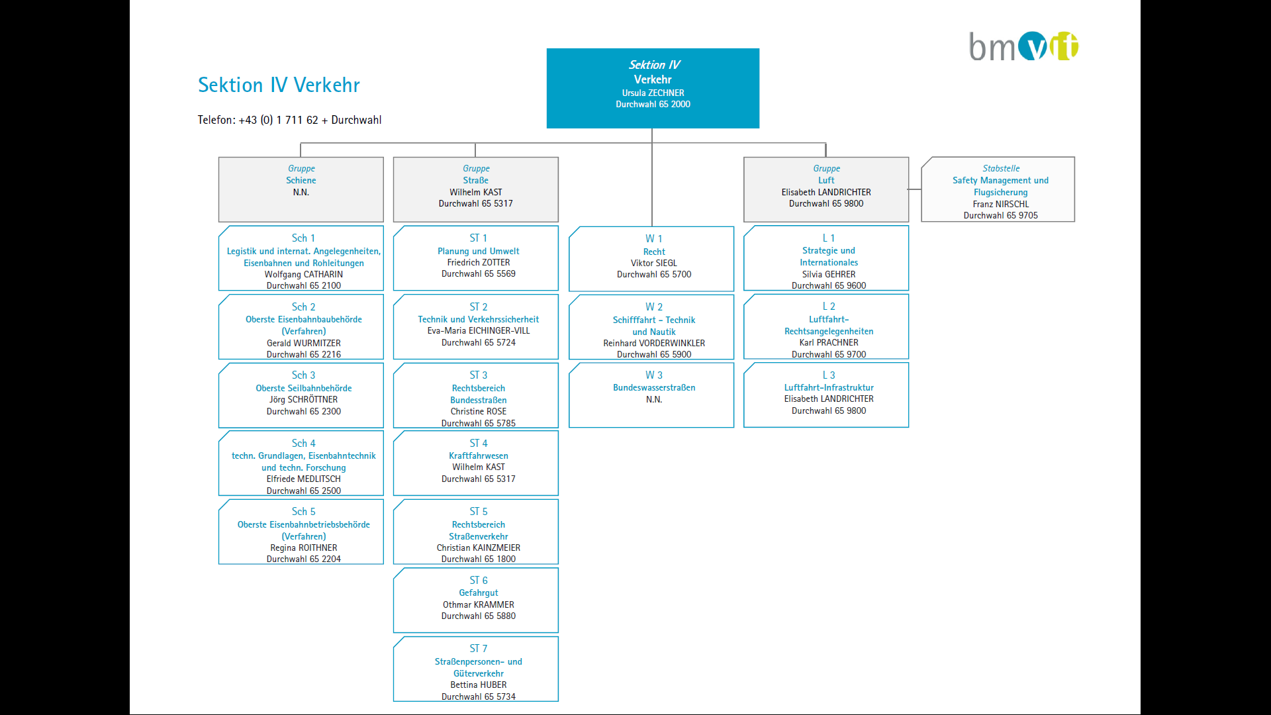

(As at February 2015, source: [Website bmvit)](http://www.bmvit.gv.at/ministerium/organisation/downloads/orgmehrseitig_20110901.pdf)

|  |  |  |  |  |  |
| --- | --- | --- | --- | --- | --- |
| Section IV  Transport  Ursula ZECHNER extension 65 2000 | | | | | |
| Group  Rail  Vacancy | Road Group  Wihelm KAST  Extension 65317 |  | | Air Group  Elisabeth LANDRICHTER  Extension 65 9800 | Safety Management and flight safety unit  Franz NIRSCHL  Extension 65 9705 |
| Sch 1  Parliamentary drafting & international affairs railways and pipelines | S71  Planning and environment | W1  Law | | Lf  Strategy and International |  |
| Sch 2  Supreme railway construction authority (procedures) | S72  Technology and Traffic Safety | W2  Shipping, technology and navigation | | L2  Air – legal issues |  |
| Sch3  Supreme cableway authority | S73  Legal area – Federal roads | W3  Federal inland waterways | | L3  Air – Infrastructure |  |
| Sch4  Technical principles & technology, technical railway research | | | S74  Road vehicles | | |
| Sch5  Supreme railway operating authority (procedures) | | | S75  Legal area – road traffic | | |
| ST6 Dangerous goods | | | | | |
| S77 Passenger and freight traffic by road | | | | | |

Extract from the organisation (with particular reference to the ‘Railway Safety Directive’):

**Department IV - Transport**

Authorities, technology and legal areas for rail, road, cableway and pipeline together with issues from the waterway and air areas. Matters concerning the Transport Security Advisory Board in accordance with Article 23 of the Federal Act concerning Independent Safety Investigation of Accidents and Incidents [Unfalluntersuchungsgesetz 2005] including managing the board.

**Section Sch 1 - Parliamentary drafting & international affairs, railways and pipelines**

Involvement in drawing up and transposing EU law and intergovernmental treaties concerning rail and pipelines; domestic parliamentary drafting including all general secondary parliamentary drafting and coordination of statutory regulations for railways and pipelines; fundamental legal issues for rail reform and for the regulation of the market for rail services together with matters concerning state commissioners; enforcement of the Pipeline Act.

**Section Sch 2 – Supreme railway construction authority (Procedures concerned with railways)**

Exercising rail construction authority powers for railways, in particular procedures for construction approval, type approval including approval for operation, environmental impact assessment and train path approval, level crossings; lineside property procedures; preliminary rulings; compulsory purchase procedures; handling of complaints; legal and administrative issues concerning training and examining of railway staff; management of the lists and official monitoring of the Railway Infrastructure Services Company [Schieneninfrastruktur-Dienstleistungsgesellschaft mbH] SCHiG in its role to facilitate the implementation of the Railways Act; in all these matters drafting of secondary legislation; deciding appeals and representing these matters in international and national technical bodies.

**Section Sch 4 - Railway technical principles and technology, technical railway research**

General technical matters concerning construction, safety, telecommunications engineering, electrical engineering and machinery for railways including the technical aspects of equipment to ensure railway safety and rolling stock of all types; domestic and international technical standards and specifications and other sets of regulations on the state of the art; matters concerning railway technical fundamentals in domestic and international bodies, in particular in RISC, ERA and CEN working groups; involvement in accreditation; evaluation and publication of the results of relevant research in the railway field including involvement in research projects and external publications.

**Section Sch 5 – Supreme railway operating authority (Procedures concerned with railways)**

Exercising administrative processes for mainline and secondary railways from the legal, operational and (in so far as involved) technical design aspects; implementing and checking the access conditions set by railway safety authorities together with assembling strategic principles for concessions, traffic authorisations, safety authorisations and safety certification; evaluating and drafting the annual reports including monitoring that safety levels are maintained; evaluating, implementing and checking safety recommendations of the safety investigation authority; approval of staff regulations; approval of the appointment of local operations supervisors; closure of railways; matters concerning other safety authority related supervisory activity matters including administrative circulars and decrees including evaluating, monitoring and representing these matters in domestic and international bodies including the development of EU statutory bases in the RISC and ERA.

**B.2** **Organisation chart for the Federal Office for Transport as the federal accident investigation institution:**

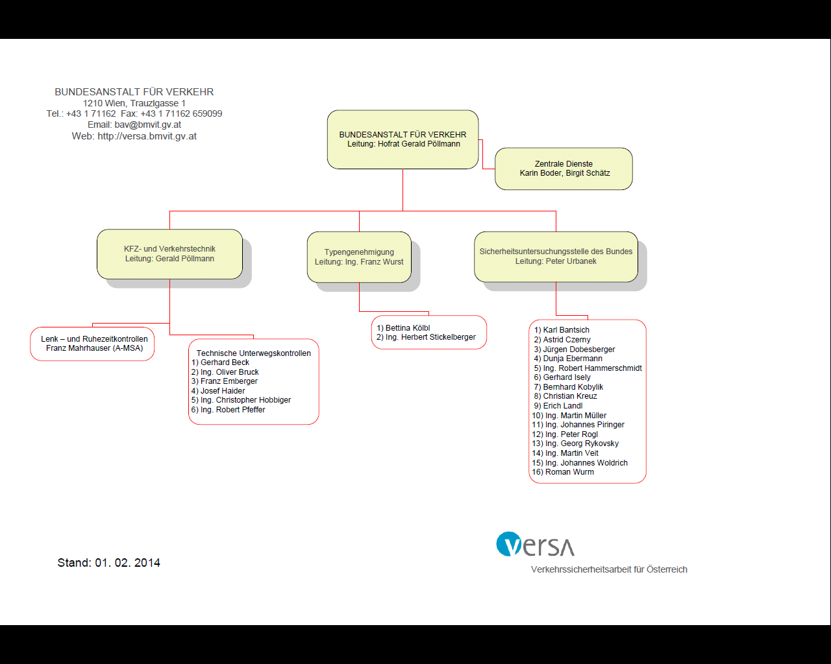

(Source: Federal Office for Transport’s website

|  |  |
| --- | --- |
| BUNDESANSTALL FÛR VERKEHR  Leitung | FEDERAL OFFICE FOR TRANSPORT  Director |
| Zentrale Dienste | Central services |
| KFZ und Verkehrstechnik  Leitung | Motor vehicles and traffic technology  Manager |
| Typengenehmigung  Leitung | Type approval  Manager |
| Sicherheitsuntersuchungsstelle des Bundes  Leitung | Federal Safety Investigation Authority  Manager |
| Lenk – und Ruhezeikontrollen | Driving and rest-time checks |
| Technische unterwegskontrollen | Technical checks on vehicles en route |
| Verkehrssicherheitsarbeit für Österreich | Transport safety tasks for Austria |
| Stand: 01.02.2014 | As at: 1 Feb 2014 |

1. CSI data – definitions applied

The CSI data evaluated relates to the operation of main lines and the secondary lines connected to them, the operation of rolling stock on such railways and traffic on such railways on Austrian sovereign territory in 2014.

C.1. CSI Data

C.1.1. Accident-related indicators (including the years 2010 – 2013)

Graphical presentation of accident-related indicators:

Significant accidents by type of accident:

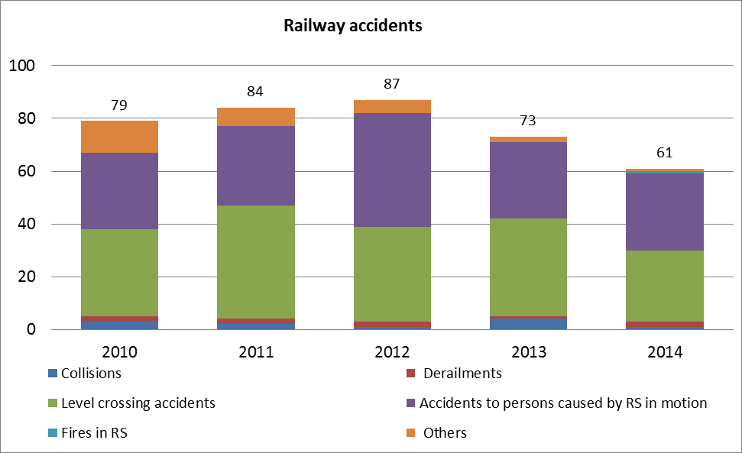

Fatalities by type of accident:

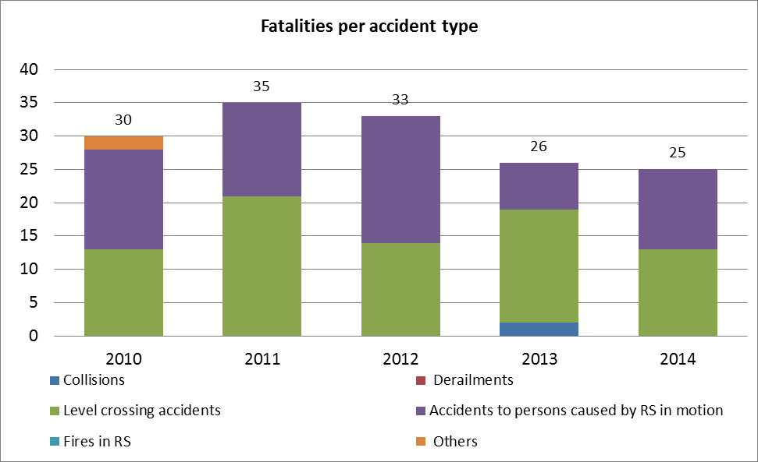

Serious injuries by type of accident:

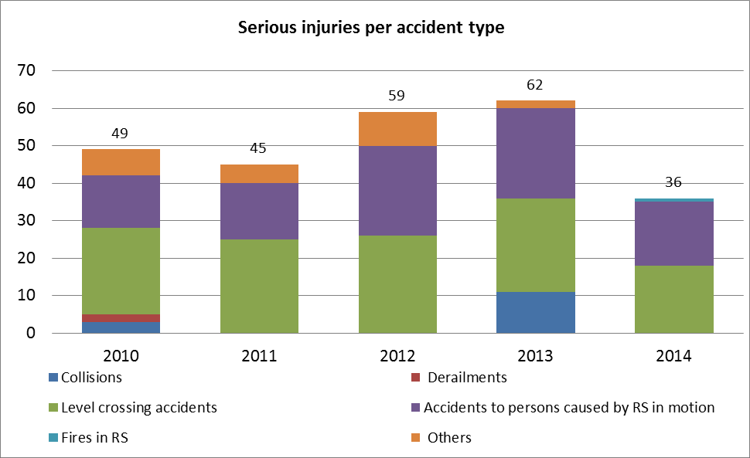

Fatalities by category of people involved:

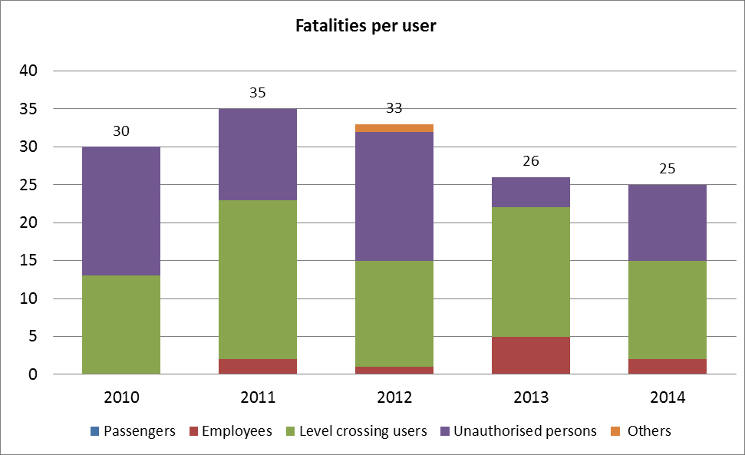

Serious injuries by category of people involved:

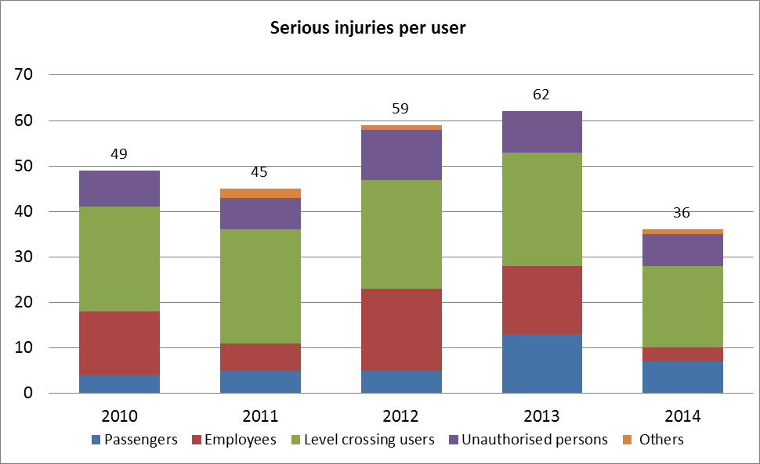

Tabular presentation of accident-related indicators:

Significant accidents by type of accident:

|  |  |  |  |  |  |  |  |
| --- | --- | --- | --- | --- | --- | --- | --- |
| Year | *Collisions* | *Derailments* | *Level crossing accidents* | *Accidents to persons caused by RS in motion* | *Fires in RS* | *Others* | *Total* |
| 2010 | 3 | 2 | 33 | 29 | 0 | 12 | 79 |
| 2011 | 2 | 2 | 43 | 30 | 0 | 7 | 84 |
| 2012 | 1 | 2 | 36 | 43 | 0 | 5 | 87 |
| 2013 | 4 | 1 | 37 | 29 | 0 | 2 | 73 |
| 2014 | 1 | 2 | 27 | 29 | 1 | 1 | 61 |

Fatalities by type of accident:

|  |  |  |  |  |  |  |  |
| --- | --- | --- | --- | --- | --- | --- | --- |
| Year | *Collisions* | *Derailments* | *Level crossing accidents* | *Accidents to persons caused by RS in motion* | *Fires in RS* | *Others* | Total |
| 2010 | 0 | 0 | 13 | 15 | 0 | 2 | 30 |
| 2011 | 0 | 0 | 21 | 14 | 0 | 0 | 35 |
| 2012 | 0 | 0 | 14 | 19 | 0 | 0 | 33 |
| 2013 | 2 | 0 | 17 | 7 | 0 | 0 | 26 |
| 2014 | 0 | 0 | 13 | 12 | 0 | 0 | 25 |

Serious injuries by type of accident:

|  |  |  |  |  |  |  |  |
| --- | --- | --- | --- | --- | --- | --- | --- |
| Year | *Collisions* | *Derailments* | *Level crossing accidents* | *Accidents to persons caused by RS in motion* | *Fires in RS* | *Others* | Total |
| 2010 | 3 | 2 | 23 | 14 | 0 | 7 | 49 |
| 2011 | 0 | 0 | 25 | 15 | 0 | 5 | 45 |
| 2012 | 0 | 0 | 26 | 24 | 0 | 9 | 59 |
| 2013 | 11 | 0 | 25 | 24 | 0 | 2 | 62 |
| 2014 | 0 | 0 | 18 | 17 | 1 | 0 | 36 |

Fatalities by category of people involved:

|  |  |  |  |  |  |  |
| --- | --- | --- | --- | --- | --- | --- |
| Year | Passengers | Employees | Level crossing users | Unauthorised persons | Others | Total |
| 2010 | 0 | 0 | 13 | 17 | 0 | 30 |
| 2011 | 0 | 2 | 21 | 12 | 0 | 35 |
| 2012 | 0 | 1 | 14 | 17 | 1 | 33 |
| 2013 | 0 | 5 | 17 | 4 | 0 | 26 |
| 2014 | 0 | 2 | 13 | 10 | 0 | 25 |

Serious injuries by category of people involved:

|  |  |  |  |  |  |  |
| --- | --- | --- | --- | --- | --- | --- |
| Year | Passengers | Employees | Level crossing users | Unauthorised persons | Others | Total |
| 2010 | 4 | 14 | 23 | 8 | 0 | 49 |
| 2011 | 5 | 6 | 25 | 7 | 2 | 45 |
| 2012 | 5 | 18 | 24 | 11 | 1 | 59 |
| 2013 | 13 | 15 | 25 | 9 | 0 | 62 |
| 2014 | 7 | 3 | 18 | 7 | 1 | 36 |

**C.1.2. Indicators relating to dangerous goods**

|  |  |  |
| --- | --- | --- |
|  | Total | Relative number (per million train km) |
| Accidents in which at least one rail vehicle carrying dangerous goods was involved (in accordance with the definition in Directive 2009/149/EC) | 0 | 0 |
| Number of such accidents in which dangerous goods were released | 0 | 0 |

**C1.3. Indicators relating to suicides**

|  |  |  |
| --- | --- | --- |
|  | Total | Relative number (per million train km) |
| Suicides | 92 | 0.60 |

**C.1.4. Indicators relating to the precursors of accidents**

|  |  |  |
| --- | --- | --- |
|  | Total | Relative number (per million train km) |
| Broken rails | 66 | 0.43 |
| Buckled rails | 137 | 0.90 |
| Wrong-side signalling failures | 0 | 0.00 |
| Signals passed at danger | 11 | 0.07 |
| Broken wheels on vehicles in service | 0 | 0.00 |
| Broken axles on vehicles in service | 0 | 0.00 |

**C.1.5. Indicators to calculate the economic impact of significant accidents**

|  |  |  |
| --- | --- | --- |
|  | Total amount | Relative amount (per million train km) |
| Total cost of all significant accidents: | €94,361,065 | €619,167 |
| Number of deaths and serious injuries multiplied by the value of preventing a casualty (VPC) | €71,358,227 | €468,230 |
| Costs of damage to the environment | €191,800 | €1,259 |
| Costs of damage to rolling stock and infrastructure | €19,786,308 | €129,831 |
| Costs of delay caused by accidents | €3,024,730 | €19,847 |

**C.1.6. Indicators relating to technical safety of infrastructure and its implementation**

|  |  |
| --- | --- |
| Percentage of tracks with automatic train protection (ATP) in operation | 78.1 % |
| Percentage of train kilometres operated using ATP systems | 86.1 % |

|  |  |  |  |
| --- | --- | --- | --- |
|  | Total | Number per route kilometre | Number per track kilometre |
| **Total number of level crossings** | **4509** | 0.863 | 0.614 |
| **Total number of actively protected level crossings** | **1881** | 0.360 | 0.256 |
| With automatic user-side warning | 801 | 0.153 | 0.109 |
| With automatic user-side protection | 0 | 0.000 | 0.000 |
| With automatic user-side protection and  warning | 917 | 0.176 | 0.125 |
| With automatic user-side protection and  rail-side protection | 4 | 0.001 | 0.001 |
| With user-side manual warning | 151 | 0.029 | 0.021 |
| With user-side manual protection | 8 | 0.002 | 0.001 |
| With user-side manual protection and warning | 0 | 0.000 | 0.000 |
| **Total number of passivvely protected level crossings** | **2628** | 0.503 | 0.358 |

**C.1.7. Indicators relating to the management of safety**

|  |  |
| --- | --- |
| Number of audits carried out | 374 |
| Percentage of audits carried out to the number of audits planned | 100 % |

Common safety indicators (CSI) from 2006 are also to be found on the   
ERAIL (European Railway Accident Information Links) database maintained by the European Railway Agency.

Website: <http://erail.era.europa.eu/safety-indicators.aspx>

The common safety indicators of European Union Member States are published on that site.

C.2. Definitions used in the annual report

**C.2.1. Definitions to be adopted**

The common definitions for the common safety indicators laid down in Directive 2009/149/EC of 27 November 2009 amending Directive 2004/49/EC are to be used with effect from 2010.

Further details on the various common safety indicators are to be found in the guide entitled ‘Guidance for the use of CSIs’ and produced by the European Railway Agency (ERA).

Website: [www.era.europa.eu/Document-Register/Pages/guidance-for-use-of-common-safety-indicators.aspx](http://www.era.europa.eu/Document-Register/Pages/guidance-for-use-of-common-safety-indicators.aspx)

**C.2.2.** **National definitions**

Further national definitions which have a particular relevance to the application of the Safety Directive are shown below:

**Main lines, secondary lines**

In accordance with Article 4 Railways Act 1957, BGBl. No 60/1957, as amended:

Article 4: *(1) Main lines are specific railway lines of greater traffic importance open for public traffic. Amongst them are those railway lines*

*which have been declared to be high capacity lines in accordance with Article 1 of the High Capacity Line Act (Hochleistungsstreckengesetz), BGBl. No 135/1989 as amended;*

*which the Federal Minister of Transport, Innovation and Technology has declared by means of a regulation to be main lines because a particular importance is attributed to them for high performance traffic or because they should be upgraded for such traffic – in particular for international services or for regional traffic.*

*(2) Secondary lines are railway lines open for public traffic provided they are not main lines or tramways.*

**Connected main and secondary lines**

In accordance with Article 1a Railways Act 1957, BGBl. No 60/1957, as amended:

*Main and secondary lines are connected if an exchange of vehicles can just take place over a local connection without a change of gauge and without technical aids (transporter wagon, for example). Main and secondary lines are also considered as connected if they are connected across a frontier with another railway of the same type in a neighbouring state.*

**High capacity lines**

in accordance with the High Capacity Line Act [,](http://www.ris.bka.gv.at/taweb-cgi/taweb?x=d&o=d&v=bnd&d=BND&i=105246&p=5&q=%20%20%20%20%20%20%20%20and%20(20071022%3e=IDAT%20and%2020071022%3c=ADAT)%20and%20(Hochleistungsstreckengesetz)#hit1) BGBl. No 135/1989, as amended:

***Article 1.*** *(1) The Federal Government may declare existing or planned railways (sections of lines or parts of sections of lines including the installations necessary) to be high capacity lines by regulation (High Capacity Line Regulation (Hochleistungsstreckenverordnung)). A precondition for this is that the line is considered to have a special importance for high performance with international connections or for local traffic.*

*(2) Existing or planned railways may also be declared to be parts of high capacity lines if the characteristics in paragraph 1 do not apply to them but they have a direct relationship with high capacity lines and are required for rational railway operation or rail traffic on high capacity lines.*

**Infrastructure manager**

In accordance with Article 1a Railways Act 1957, BGBl. No 60/1957, as amended:

*Article 1a. An infrastructure manager is a railway organisation which covers the construction and operation of main line and secondary railways excluding those secondary railways which are not connected to main lines or other secondary lines and is authorised to make them available.*

**Railway undertaking**

In accordance with Article 1b Railways Act 1957, BGBl. No 60/1957, as amended:

*Article 1b. A railway undertaking is a railway organisation which provides rail traffic services on main line or connected secondary line rail infrastructure and provides the traction, this also includes those which only provide traction, and to which a traffic authorisation, a traffic concession or an authorisation or approval which is equivalent to a traffic approval in accordance with Article 41 has been granted.*

C.3. Abbreviations

|  |  |  |  |
| --- | --- | --- | --- |
| BauV BETRA Bf  bmvit | Bauarbeiterschutzverordnung Betriebs- und Bauanweisung Bahnhof  Federal Ministry of Transport, Innovation and Technology | EU EVU Fzg  IM | Europäische Union Eisenbahnverkehrsunternehmen Fahrzeug  Infrastructure Manager |
| CSI | Common safety indicators  (Gemeinsame Sicherheitsindikatoren) | km | kilometer |
| CSM | Common safety method | MeldeVO | Rail Accident Reporting Regulation 2006 [Meldeverordnung Eisenbahn -Eisb 2006] |
| EisbAV | Railway Employee Protection Regulation [Eisenbahn- ArbeitnehmerInnenschutzverordnung] | NSA | National safety authority |
| EisbBBV | Railway Construction and Operation Regulations [Eisenbahnbau- und -betriebsverordnung] | ÖBB | Austrian Federal Railways [Österreichische Bundesbahnen] |
| EisbEPV | Railway Suitability and Testing Regulation [Eisenbahn-Eignungs- und Prüfungsverordnung] | RISC | Railway Interoperability and Safety Committee |
| EisbG | Railways Act 1957 [Eisenbahngesetz 1957] | RU | Railway undertaking  [Eisenbahnunternehmen] |
| IM | infrastructure manager | SUB | Federal Safety Investigation Authority |
| ERA | European Railway Agency  [Europäische Eisenbahnagentur] | VO | Regulation [Verordnung] |
| ERAIL | European Railway Accident Information Links | Z | train |

1. Important changes to legislation and regulation

|  |  |  |  |  |
| --- | --- | --- | --- | --- |
|  | **Statutory reference** | **Date legislation comes into force** | **Reason for introduction** | **Description** |
| **General national railway safety legislation** |  |  |  |  |
| Legislation concerning the national safety authority |  |  |  |  |
| Legislation concerning notified bodies, assessors, third party bodies for registration, examination, etc. |  |  |  |  |
|  |  |  |  |  |
| **National rules concerning railway safety** |  |  |  |  |
| Rules concerning national safety targets and methods |  |  |  |  |
| Rules concerning requirements for safety management systems and safety certification of railway undertakings |  |  |  |  |
| Rules concerning requirements for safety management systems and safety authorisation of infrastructure managers |  |  |  |  |
| Rules concerning requirements for wagon keepers |  |  |  |  |
| Rules concerning requirements for maintenance workshops |  |  |  |  |

|  |  |  |  |  |
| --- | --- | --- | --- | --- |
|  | **Statutory reference** | **Date legislation comes into force** | **Reason for introduction** | **Description** |
| Rules concerning requirements for the authorisation of placing in service and maintenance of new and substantially altered rolling stock, including rules for exchange of rolling stock between railway undertakings, registration systems and requirements on testing procedures |  |  |  |  |
| Common operating rules for the railway network, including rules relating to signalling and traffic procedures | Railway Construction and Operation Regulations [Eisenbahnbau- und -betriebsverordnung] (EisBBV)  BGBl. II No 156/2014 | 1 October 2014 | Amendment of the Railway Construction and Operation Regulations [Eisenbahnbau- und -betriebsverordnung] (EisBBV) | specifies safety standards across the industry based on the requirements of European and Austrian railway law The emphasis in this process is on the interface between infrastructure managers and railway undertakings and the creation of a link between technical rules and the conduct of railway operations. |
| Rules laying down requirements for additional internal operating rules  that must be established by the infrastructure managers and railway undertakings | Railway Construction and Operation Regulations [Eisenbahnbau- und -betriebsverordnung] (EisBBV)  BGBl. II No 156/2014 | 1 October 2014 | Amendment of the Railway Construction and Operation Regulations [Eisenbahnbau- und -betriebsverordnung] (EisBBV) | specifies safety standards across the industry based on the requirements of European and Austrian railway law The emphasis in this process is on the interface between infrastructure managers and railway undertakings and the creation of a link between technical rules and the conduct of railway operations. |
| Rules concerning requirements for staff executing safety critical tasks, including selection criteria, medical fitness and vocational training and certification |  |  |  |  |
| Rules concerning the investigation of accidents and incidents including recommendations |  |  |  |  |
| Rules concerning requirements for national safety indicators including how to collect and analyse the indicators |  |  |  |  |
| Rules concerning requirements for the  approval to put  Infrastructure (track, bridges, tunnels, power supplies, ATC, radio, signals, interlocking, level crossings, platforms, etc) into service | Railway Construction and Operation Regulations [Eisenbahnbau- und -betriebsverordnung] (EisBBV)  BGBl. II No 156/2014 | 1 October 2014 | Amendment of the Railway Construction and Operation Regulations [Eisenbahnbau- und -betriebsverordnung] (EisBBV) | specifies safety standards across the industry based on the requirements of European and Austrian railway law The emphasis in this process is on the interface between infrastructure managers and railway undertakings and the creation of a link between technical rules and the conduct of railway operations. |

1. The development of safety certification and authorisation – numerical data

E.1. Safety certificates in accordance with Directive 2004/49/EC

|  |  |
| --- | --- |
|  | Number of certificates |
| E.1.1. Number of safety certificates part A issued in the reporting year  and previous years that remain valid | *26* |

|  |  |  |
| --- | --- | --- |
|  | | Number of certificates |
| E.1.2. Number of safety certificates part B issued in the reporting year and previous years that remain valid | Number of certificates part B, for which the part  A has been issued in your Member State | *26* |
| Number of certificates part B, for which the part  A has been issued in another Member State | *8* |

|  |  |  |  |  |
| --- | --- | --- | --- | --- |
|  | | A | R | P |
| E.1.3. Number of new applications for safety certificates part A submitted by railway undertakings in 2014 | New certificates | *-* | *-* | *-* |
| Updated/amended certificates | *-* | *-* | *-* |
| Renewed certificates | *3* | *-* | *2* |

|  |  |  |  |  |  |
| --- | --- | --- | --- | --- | --- |
|  | | | A | R | P |
| E.1.4. Number of new applications for safety certificates part B submitted by railway undertakings in 2014 | Where the part A has been issued in your Member State | New certificates | *-* | *-* | *-* |
| Updated/amended certificates | *-* | *-* | *-* |
| Renewed certificates | *3* | *-* | *2* |
| Where the part A has been issued in another Member State | New certificates | *1* | *-* | *1* |
| Updated/amended certificates | *-* | *-* | *-* |
| Renewed certificates | *2* | *-* | *-* |

A = accepted: application accepted; certificate has already been issued

R = rejected: application rejected; no certificate has been issued

P = *pending*: case is still pending; no certificate has been issued in the reporting year

|  |  |
| --- | --- |
|  | Number of certificates |
| Number of certificates part A revoked in the reporting year | *-* |
| Number of certificates part B revoked in the reporting year | *-* |

E.1.5. List of states from which railway undertakings applying for a safety certificate part B in your Member State have obtained their safety certificate part A:

* Germany
* Hungary
* Poland
* Netherlands
* Slovenia
* Czech Republic
* Switzerland

E.2. Safety authorisations in accordance with Directive 2004/49/EC

|  |  |
| --- | --- |
|  | Number of authorisations |
| E.2.1. Number of valid safety authorisations issued to infrastructure managers in the reporting year and previous years | *9* |

|  |  |  |  |  |
| --- | --- | --- | --- | --- |
|  |  | A | R | P |
| E.2.2. Number of applications for safety authorisations submitted by infrastructure managers in 2014 | New authorisations | *-* | *-* | *-* |
| Updated/amended authorisations | *-* | *-* | *-* |
| Renewed authorisations | *-* | *-* | *-* |

A = accepted: application accepted; authorisation has already been issued

R = rejected: application rejected; no authorisation has been issued

P = pending: case is still pending; no authorisation has been issued in the reporting year

|  |  |
| --- | --- |
| E.2.3 Number of safety authorisations revoked in the reporting year | *-* |

1. Safety recommendations which the Safety Investigation Authority (SUB) had made at the time the report went to press are shown, they do not yet represent commitments to take action on safety measures however.