|  |  |
| --- | --- |
| Federal Office of Transport  Federal Accident Investigation Bureau  Lohnergasse 1  1210 Vienna  Austria  Tel.: +43/664/818 90 96  [E-mail: peter.urbanek@bmvit.gv.at](mailto:peter.urbanek@bmvit.gv.at)  Web: <http://versa.bmvit.gv.at> | **VERSA**  ***Working for traffic safety for Austria***  **BUNDESANSTALT FÜR VERKEHR (*FEDERAL OFFICE OF TRANSPORT*)**  **Unfalluntersuchungsstelle des Bundes (*Federal Accident Investigation Bureau*) Bereich Schienenverkehr (*Rail Transport Section*)**  **ANNUAL REPORT 2008** |

**1. General**



The Austrian Accident Investigation Bureau has a multi-modal structure and has separate sections devoted to aviation, rail transport, shipping and cable cars.

From an organisational point of view, the Austrian Accident Investigation Bureau is part of the Federal Office of Transport. The Federal Office of Transport is an agency within the Austrian Federal Ministry for Transport, Innovation and Technology.

**2. Legal framework (Rail Transport Section)**

The legal framework for the investigation of occurrences in the Rail Transport Section is as follows:

1. Directive 2004/49/EC (‘European Railway Safety Directive’)
2. Unfalluntersuchungsgesetz (accident investigation law) BGBl. (Bundesgesetzblatt = Federal Gazette) I, No 123, 2005
3. Railway notification ordinance (BGBl. II, No 279, 2006)
4. Eisenbahngesetz (Railway Act) (version contained in BGBl. I, No 125, 2006)

**3. Remit of the Austrian Accident Investigation Bureau**

The central remit is to investigate occurrences by conducting an expert enquiry, determine the cause and, if necessary, draw up safety recommendations in the form of suggestions for improving railway safety. These investigations are not intended to establish guilt or liability.

**4. Characteristics of investigations of occurrences**

**Reporting**

The railway companies concerned have an obligation to report occurrences. The occurrences to be reported and the timing and form of the report are set out in the notification ordinance.

**Initiation of an investigation**

An investigation always begins with the report of an occurrence; however, it should be noted that an investigation is not initiated for every report. The decision as to whether to initiate an investigation depends on the extent to which the cause of the occurrence is clear. Where an investigation is initiated, it is necessary to specify whether on-site fact-finding will be required for this investigation.

**Investigation**

All investigations have to be carried out immediately, and in a straightforward and appropriate manner. In this connection it should be noted that the investigation process is not public and the personnel conducting the investigation have a duty of confidentiality. The powers of the investigation personnel in relation to on-site investigations are set out in the Accident Investigation Act.

**Investigation report**

Every investigation is concluded with an investigation report, which is distributed to the appropriate parties for comment prior to publication. The final investigation report has to be published and must contain, among other items, details of the occurrence, the modes of transportation involved, the circumstances that contributed to the accident, the investigations carried out and their results, and conclusions as to the cause. The final investigation reports are published on the website of the Federal Office of Transport (<http://versa.bmvit.gv.at>).

**Safety recommendations**

Safety recommendations are drawn up on the basis of the results of the investigation and take the form of suggestions as to how to improve transport safety. These are directed at those offices able to implement the recommendations in the form of suitable measures. Whether and to what extent safety recommendations once issued are implemented falls within the responsibility of those directly concerned.

**5. Activities in 2008**

**General**

In 2008, the Rail Transport Section of the Austrian Accident Investigation Bureau was occupied with an increase in the number of occurrences compared with the year 2007.

|  |  |  |
| --- | --- | --- |
|  | 2007 | 2008 |
| Total number of occurrences | 1527 | 1589 |
| Of which, accidents | 1173 | 1177 |
| Of which, incidents | 354 | 412 |

This increase is partly due to improved reporting by the railway companies but it is also partly a reflection of the steady increase in transport services.

In the past year, **21 on-site investigations** (including **6 investigations of occurrences on railway crossings**) and **17 further investigations** were carried out. On top of this, a number of core themes were set, and these are being continued in 2009 on the basis of developing trends. These core themes include, in particular, occurrences involving shunting (marshalling activities), occurrences relating to rail vehicles (wheel sets, loading), occurrences on railway crossings and occurrences connected with construction work in danger areas on the tracks.

In connection with the capture of statistical data on the reported occurrences, the existing statistical database was updated for completeness. This revision was carried out in close collaboration with the Federal Ministry of Transport, Innovation and Technology and Statistics Austria, taking national and international statistical requirements as the basis. Following the update, a better quality of data is now available for various analyses.

**On-site investigations**

|  |  |
| --- | --- |
| Date | Occurrence |
| 24.03.2008 | **Derailment of Z47490 in Leoben Donawitz station**  Cause: lack of grip between track and sleepers as a result of damaged rail fastenings. |
| 11.04.2008 | **Collision between Z44925 and Z47926 in Neumarkt-Kallham station**  Cause: Z47926 passed a signal without stopping. |
| 27.06.2008 | **Derailment of Z197 on the Vienna suburban railway after Schedifkaplatz train stop**  Cause: wheel shaft fracture. |
| 16.08.2008 | **Derailment of Z94435 in Neulengbach station**  Cause: investigation report not yet completed. |
| 02.09.2008 | **Derailment of Z68270 in Vienna central shunting station**  Cause: lop-sided load. |
| 06.09.2008 | **Derailment of Z40667 in Rosenbach station**  Cause: investigation report not yet completed. |
| 12.09.2008 | **Derailment of Z66969 in Linz shunting station**  Cause: investigation report not yet completed. |
| 16.09.2008 | **Derailment of Z2134 on the Vienna branch line in Inzersdorf passenger station**  Cause: shunted backwards without being instructed to do so after passing a signal without stopping. |
| 18.10.2008 | **Derailment of Z54091 in Pöchlarn station**  Cause: investigation report not yet completed. |
| 22.10.2008 | **Derailment of Z47321 in Vienna central shunting station**  Cause: investigation report not yet completed. |

|  |  |  |
| --- | --- | --- |
| Date | Occurrence | |
| 31.10.2008 | **Derailment of Z45818 between Gummern 2 fork and Gummern station**  Cause: investigation report not yet completed. |
| 17.11.2008 | **Derailment of Z47107 in Unter Purkersdorf station**  Cause: lop-sided load. |
| 07.11.2008 | **Death of a young passenger in Kuchl train stop**  Cause: unauthorised entry into railway property |
| 23.11.2008 | **Collision of Z1614 with construction vehicle between Rekawinkel and Hutten stations**  Cause: investigation report not yet completed. |
| 20.12.2008 | **Derailment of Z44852 between Seekirchen am Wallersee and Hallwang-Elixhausen stations**  Cause: investigation report not yet completed. |

**On-site investigations (occurrences on railway crossings)**

|  |  |
| --- | --- |
| Date | Occurrence |
| 10.01.2008 | **Collision between Z8428 and passenger car in Söding-Mooskirchen station**  Cause: inattentiveness of car driver |
| 05.02.2008 | **Collision of Z6619 with lorry between Spratzern station and Wilhelmsburg a.d. Traisen station**  Cause: inattentiveness of lorry driver |
| 07.02.2008 | **Endangerment of persons by train running in Klagenfurt station**  Cause: irregularities in the safety equipment |
| 09.07.2008 | **Collision of Z6581 with lorry in Feuerwerksanstalt station**  Cause: inattentiveness of lorry driver |
| 15.07.2008 | **Collision of Z7822 with mobile home between Purbach am Neusiedlersee station and Breitenbrunn station**  Cause: inattentiveness of motor vehicle driver |
| 01.12.2008 | **Collision of Z149 with passenger car in Viennaer Neudorf station**  Cause: inattentiveness of car driver |

**Further investigations**

|  |  |
| --- | --- |
| Date | Occurrence |
| 08.02.2008 | **Derailment of locomotive vehicle 1063.031 in Vienna Süd locomotive depot**  Cause: defective monitoring of shunting path. |
| 21.03.2008 | **Derailment of Z44863 in Hall station in Tirol**  Cause: failure to remove wagon safety device. |
| 07.04.2008 | **Death of a shunting operator in Amstetten station**  Cause: own inattentiveness. |
| 12.04.2008 | **Serious injury to a locomotive vehicle driver in Vienna Süd station**  Cause: own inattentiveness. |
| 17.06.2008 | **Derailment of Z74650 in Kapfenberg station**  Cause: wheel load exceeded on one side as a result of load (steel coil) shifting due to defective or incorrect securing of the load. |
| 23.06.2008 | **Z92918 driven without testing the brakes in Bruck a.d. Mur freight depot**  Cause: failure to follow correct procedures for establishing train ready to depart. |
| 26.06.2008 | **Collision of Z52436 with construction machine near Zell am See 1 shunt during construction work**  Cause: failure to take correct safety measures. |
| 08.07.2008 | **Collision of Z611 with construction machine near Salzburg Aigen station during construction work**  Cause: failure to take correct safety measures. |

|  |  |
| --- | --- |
| 10.07.2008 | **Serious injury to an employee of a third-party company in Feldkirch station during construction work**  Cause: failure to take correct safety measures. |
| 06.08.2008 | **Unauthorised entry of Lz88013 into an occupied section of track through Szentgotthard station (Hungary)**  Cause: irregularities in communications in Szentgotthard station. |
| 06.09.2008 | **Collision of Z1953 with small, heavy wagon between Semmering and Breitenstein stations**  Cause: irregularities in track spacing. |
| 13.10.2008 | **Collision of Z47021 with shunt run in Stadlau station**  Cause: unauthorised passing of the shunt signal, which was showing STOP. |
| 16.10.2008 | **Death of a person by touching the catenary in Wels traction support point**  Cause: own inattentiveness. |
| 13.11.2008 | **Derailment of Z54666 in St. Michael station**  Cause: failure to remove wagon safety device. |
| 13.11.2008 | **Collision of Z54009 with passenger vehicle on the track in the vicinity of Traismauer station**  Cause: car was coming out of the road next to the track. |
| 24.11.2008 | **Unauthorised cancellation of a train route in Krift station**  Cause: incorrect operation of the safety installations. |
| 25.11.2008 | **Collision of Z57100 with construction vehicle in Vienna Matzleinsdorf station**  Cause: failure to take correct safety measures. |

**Safety recommendations**

In 2008 a total of 66 safety recommendations were issued.

**Reported occurrences (all railways)**

|  |  |  |
| --- | --- | --- |
| Reported occurrences | Number | Of which, serious accidents |
| Reported occurrences (accidents and incidents) | 1589 | - |
| Of which, reported accidents | 1177 | 110 |
| Of which, reported incidents | 412 | - |

**Reported accidents by accident type (all railways)**

|  |  |  |
| --- | --- | --- |
| Accident type | Number | Of which, serious accidents |
| Train collision | 177 | 2 |
| Collision during shunting / running on branch lines | 148 | 1 |
| Train derailment | 18 | 7 |
| Derailment during shunting / running on branch lines | 159 | - |
| Accidents at railway crossings | 150 | 38 |
| Damage during the transportation of hazardous goods | 35 |  |
| Injury / death of persons caused by rail vehicles | 55 | 39 |
| Injury / death of persons caused by other accidents | 145 | 22 |
| Fires / explosions, vehicles | 36 | - |
| Fires / explosions, infrastructure | 134 | 1 |
| Suicide / attempted suicide | 120 | - |

**Reported incidents by incident type (all railways)**

|  |  |
| --- | --- |
| Incidents | Number |
| Unauthorised passing of a signal by a train | 29 |
| Unauthorised passing of a signal during shunting / running on branch lines | 31 |
| Unauthorised entry into occupied sections of track | 3 |
| Driving without being instructed to do so or without authorisation | 21 |
| Rail vehicles rolling away | 5 |
| Technical defects on installations and rail vehicles | 31 |
| Train breaking loose | 159 |
| Incorrect loading / securing of load | 39 |
| Impairment of safe operation as a result of the violation of railway regulations | 37 |
| Endangerment of persons during work in the track area by running train | 7 |
| Failure to secure railway crossings | 44 |
| Road vehicles entering railway crossings in the process of closing | 6 |

|  |  |  |  |
| --- | --- | --- | --- |
| **Accidents to persons, including suicide (all railways)** | | | |
|  | Deaths | Serious injuries | Minor injuries |
| Networked railways | 132 | 60 | 173 |
| Non-networked railways | 1 | - | 6 |
| Connecting railways | 1 | 2 | 5 |
| Inner-city local transport | 8 | 12 | 19 |
| **Total** | **142** | **74** | **203** |

|  |  |  |  |  |
| --- | --- | --- | --- | --- |
| **Accidents to persons by category of person (all railways)** | | | |  |
|  | Deaths | Serious injuries | | Minor injuries |
| Passengers | 2 | | 11 | 91 |
| Employees | 2 | | 13 | 50 |
| Users of railway crossings | 18 | | 25 | 41 |
| Other persons | 3 | | 5 | 5 |
| Unauthorised persons | 17 | | 10 | 15 |
| Suicide / attempted suicide | 100 | | 10 | 1 |
| **Total** | **142** | | **74** | **203** |

**Reported occurrences (networked railways)**

|  |  |  |
| --- | --- | --- |
| Reported occurrences | Number | Of which, serious accidents |
| Reported occurrences (accidents and incidents) | 1367 | - |
| Of which, reported accidents | 989 | 97 |
| Of which, reported incidents | 378 | - |

**Reported accidents by accident type (networked railways)**

|  |  |  |
| --- | --- | --- |
| Accident type | Number | Of which, serious accidents |
| Train collision | 176 | 2 |
| Collision during shunting / running on branch lines | 125 | 1 |
| Train derailment | 15 | 7 |
| Derailment during shunting / running on branch lines | 107 | - |
| Accidents at railway crossings | 128 | 36 |
| Damage during the transportation of hazardous goods | 33 | - |
| Injury / death of persons caused by rail vehicles | 46 | 35 |
| Injury / death of persons caused by other accidents | 117 | 16 |
| Fires / explosions, vehicles | 22 | - |
| Fires / explosions, infrastructure | 113 | - |
| Suicide / attempted suicide | 107 | - |

**Reported incidents by incident type (all railways)**

|  |  |
| --- | --- |
| Incidents | Number |
| Unauthorised passing of a signal by a train | 25 |
| Unauthorised passing of a signal during shunting / running on branch lines | 29 |
| Unauthorised entry into occupied sections of track | 3 |
| Driving without being instructed to do so or without authorisation | 19 |
| Rail vehicles rolling away | 4 |
| Technical defects on installations and rail vehicles | 31 |
| Train breaking loose | 156 |
| Incorrect loading / securing of load | 39 |
| Impairment of safe operation as a result of the violation of railway regulations | 16 |
| Endangerment of persons during work in the track area by running train | 6 |
| Failure to secure railway crossings | 44 |
| Road vehicles entering railway crossings in the process of closing | 6 |

|  |  |  |  |  |  |
| --- | --- | --- | --- | --- | --- |
| **Accidents to persons, including suicide, by accident type (networked railways)** | | | | | |
| Deaths | | Serious injuries | | | Minor injuries | |
| Train collision | 1 | | - | 3 | |
| Accidents at railway crossings | 17 | | 23 | 52 | |
| Injury / death of persons caused by rail vehicles | 20 | | 15 | 9 | |
| Injury / death of persons caused by other accidents | 1 | | 15 | 107 | |
| Suicide / attempted suicide | 93 | | 7 | 2 | |
| **Total** | **132** | | **60** | **173** | |

|  |  |  |  |
| --- | --- | --- | --- |
| **Accidents to persons by category of person (networked railways)** | | |  |
| Deaths | | Serious injuries | Minor injuries |
| Passengers | 2 | 6 | 77 |
| Employees | 2 | 12 | 49 |
| Users of railway crossings | 17 | 23 | 34 |
| Other persons | 2 | 3 | 4 |
| Unauthorised persons | 16 | 9 | 8 |
| Suicide / attempted suicide | 93 | 7 | 1 |
| **Total** | **132** | **60** | **173** |

**Reported occurrences (non-networked railways)**

|  |  |  |
| --- | --- | --- |
| Reported occurrences | Number | Of which, serious accidents |
| Reported occurrences (accidents and incidents) | 30 | - |
| Of which, reported accidents | 28 | 1 |
| Of which, reported incidents | 2 | - |

**Reported accidents by accident type (non-networked railways)**

|  |  |  |
| --- | --- | --- |
| Accident type | Number | Of which, serious accidents |
| Train derailment | 2 | - |
| Derailment during shunting / running on branch lines | 1 | - |
| Accidents at railway crossings | 18 | 1 |
| Injury / death of persons caused by other accidents | 2 | - |
| Fires / explosions, vehicles | 2 | - |
| Fires / explosions, infrastructure | 3 | - |

**Reported incidents by incident type (non-networked railways)**

|  |  |
| --- | --- |
| Incidents | Number |
| Driving without being instructed to do so or without authorisation | 1 |
| Impairment of safe operation as a result of the violation of railway regulations | 1 |

**Accidents to persons, including suicide, by accident type (non-networked railways)**

|  |  |  |  |
| --- | --- | --- | --- |
|  | Deaths | Serious injuries | Minor injuries |
| Accidents at railway crossings | 1 | - | 4 |
| Injury / death of persons caused by other accidents | - | - | 2 |
| **Total** | **1** | **-** | **6** |

**Accidents to persons by category of person (non-networked railways)**

|  |  |  |  |  |
| --- | --- | --- | --- | --- |
|  | Deaths | Serious injuries | | Minor injuries |
| Passengers | - | | - | 2 |
| Users of railway crossings | 1 | | - | 4 |
| **Total** | **1** | | **-** | **6** |

**Reported occurrences (connecting railways)**

|  |  |  |
| --- | --- | --- |
| Reported occurrences | Number | Of which, serious accidents |
| Reported occurrences (accidents and incidents) | 87 | - |
| Of which, reported accidents | 83 | 2 |
| Of which, reported incidents | 4 | - |

**Reported accidents by accident type (connecting railways)**

|  |  |  |
| --- | --- | --- |
| Accident type | Number | Of which, serious accidents |
| Derailment during shunting | 49 | - |
| Collision during shunting / running on branch lines | 23 | - |
| Accidents at railway crossings | 4 | 1 |
| Damage during the transportation of hazardous goods | 2 | - |
| Injury / death of persons caused by rail vehicles | 2 | - |
| Injury / death of persons caused by other accidents | 1 | 1 |
| Fires / explosions, vehicles | 2 | - |

**Reported incidents by incident type (connecting railways)**

|  |  |
| --- | --- |
| Incidents | Number |
| Unauthorised passing of a signal during shunting / running on branch lines | 2 |
| Rail vehicles rolling away | 1 |
| Train breaking loose | 1 |

|  |  |  |  |
| --- | --- | --- | --- |
| **Accidents to persons, including suicide, by accident type (connecting railways)** | | | |
|  | Deaths | Serious injuries | Minor injuries |
| Accidents at railway crossings | - | 2 | 3 |
| Injury / death of persons caused by rail vehicles | - | - | 2 |
| Injury / death of persons caused by other accidents | 1 | - | - |
| **Total** | **1** | **2** | **5** |

|  |  |  |  |  |  |  |
| --- | --- | --- | --- | --- | --- | --- |
| **Accidents to persons by category of person (connecting railways)** | | | | | |  |
|  | | Deaths | Serious injuries | | Minor injuries | |
| Employees | - | | | - | | 1 |
| Users of railway crossings | - | | | 2 | | 3 |
| Other persons | 1 | | | - | | 1 |
| **Total** | **1** | | | **2** | | **5** |

**Reported occurrences (inner-city local transport)**

|  |  |  |
| --- | --- | --- |
| Reported occurrences | Number | Of which, serious accidents |
| Reported occurrences (accidents and incidents) | 105 | - |
| Of which, reported accidents | 77 | 10 |
| Of which, reported incidents | 28 | - |

**Reported accidents by accident type (inner-city local transport)**

|  |  |  |
| --- | --- | --- |
| Accident type | Number | Of which, serious accidents |
| Train collision | 1 | - |
| Train derailment | 1 | - |
| Derailment during shunting / running on branch lines | 2 | - |
| Injury / death of persons caused by rail vehicles | 7 | 4 |
| Injury / death of persons caused by other accidents | 25 | 5 |
| Fires / explosions, vehicles | 10 | - |
| Fires / explosions, infrastructure | 18 | 1 |
| Suicide / attempted suicide | 13 | - |

**Reported incidents by incident type (inner-city local transport)**

|  |  |
| --- | --- |
| Incidents | Number |
| Unauthorised passing of a signal by a train | 4 |
| Driving without being instructed to do so or without authorisation | 1 |
| Train breaking loose | 2 |
| Impairment of safe operation as a result of the violation of railway regulations | 20 |
| Endangerment of persons during work in the track area by running train | 1 |

**Accidents to persons, including suicide, by accident type (inner-city local transport)**

|  |  |  |  |
| --- | --- | --- | --- |
|  | Deaths | Serious injuries | Minor injuries |
| Injury / death of persons caused by rail vehicles | 1 | 3 | 3 |
| Injury / death of persons caused by other accidents | - | 6 | 16 |
| Suicide / attempted suicide | 7 | 3 | - |
| **Total** | **8** | **12** | **19** |

|  |  |  |  |  |  |  |
| --- | --- | --- | --- | --- | --- | --- |
| **Accidents to persons by category of person (inner-city local transport)** | | | | | | |
|  | Deaths | Serious injuries | | Minor injuries | |
| Passengers | - | | 5 | | 12 | |
| Employees | - | | 1 | | - | |
| Other persons | - | | 2 | | - | |
| Unauthorised persons | 1 | | 1 | | 7 | |
| Suicide / attempted suicide | 7 | | 3 | | - | |
| **Total** | **8** | | **12** | | **19** | |

**6. Analysis**

The data sets contained in the statistics database of the Austrian Accident Investigation Bureau make it possible to perform some immediate analyses using different criteria.

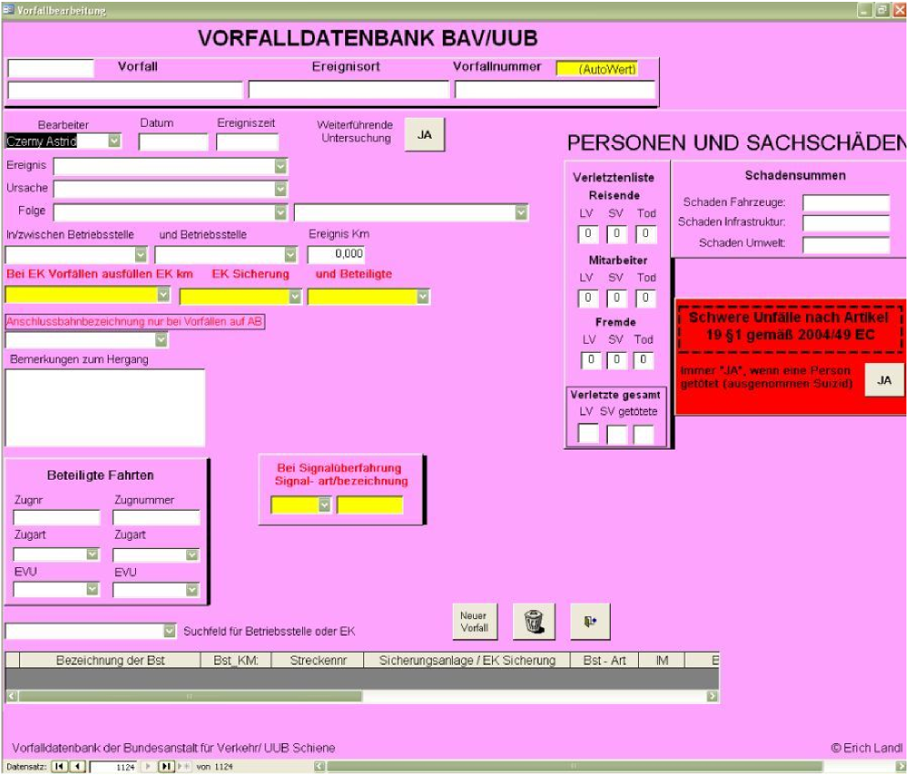

However, every analysis requires precise definition of the data that ultimately should be presented. Thus, for example, a query for the event ‘Passing a signal showing STOP’ only produces those events that are contained in the ‘Ereignis’ (‘Event’) field as the main event. It is perfectly possible that, in a given event, the passing of a signal showing STOP is only contained in the database as the cause of the relevant occurrence.

As a general rule, the highest value occurrence is always shown; there may be occurrences contained in the data input fields ‘Folgen’ (‘Consequences’) and ‘Ursache’ (‘Cause’) that have a causal relationship to the main event, and a query can be conducted on this basis:

|  |  |  |
| --- | --- | --- |
| **Main event**  Seite 14 / 14 U ntersuchu ngsbericht Jahresbericht 2008 | Consequential events | Cause |
| Train-train collision | Train derailment | Unauthorised passing of a signal |
|  | Vehicle fire |  |
|  | Hazardous goods |  |

It is possible to analyse the data both in tabular and graphical form.

**Accidents on Railway Crossings - ÖBB**

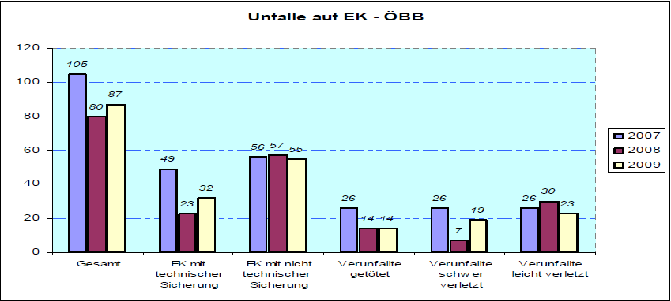

|  |  |  |  |  |  |  |  |
| --- | --- | --- | --- | --- | --- | --- | --- |
|  | Gesamt | EK mit technischer Sicherung | EK mit nicht technischer Sicherung | Verunfällte getötet | Verunfällte schwer verletzt | Verunfällte leicht verletzt |  |
| Insert translation | Total | Railway crossings with technical safety measures | Railway crossings with non-technical safety measures | Accidents to persons involving fatalities | Accidents to persons involving severe injuries | Accidents to persons involving slight injuries |  |

**List of abbreviations**

|  |  |  |  |
| --- | --- | --- | --- |
| Abzw | Fork | Bf | Station |
| BGBl | Österreichisches Bundesgesetzblatt (*Austrian Federal Gazette*) | EK | Railway crossing |
| Hst | Train stop | LKW | Lorry |
| Lz | Locomotive not coupled to a train | PKW | Passenger car |
| ÖBB | Österreichische Bundesbahnen (*Austrian Federal Railways*) | Tfz | Locomotive vehicle |
| SKl | Small, heavy wagon (construction service vehicle) | Tfzf | Locomotive vehicle driver |
| Üst | Shunt | Z | Train |

Vienna, 17 November 2009

Federal Office of Transport

Head of the Federal Accident Investigation Bureau

Peter Urbanek [signed on original]