Railway Administration
Executive Agency

2015 Annual
Safety
Report
of the National Safety Authority
of the Republic of Bulgaria
September 2016

TABLE OF CONTENTS
ABBREVIATIONS USED IN THE REPORT 4
A. INTRODUCTION 5
A.1. Objective, Scope and Addressees of the Report 5
A.2. Significant Organisational Changes affecting the NSA 5
B. OVERALL SAFETY PERFORMANCE AND STRATEGY 6
B.1. Main Conclusions from the Reporting Year 6
B.2. B.2. National Safety Strategy, Programmes and Initiatives 11
B.3. Review of the Previous Year 14
B.4. Focus Areas for the Next Year 15
C. DEVELOPMENTS IN SAFETY PERFORMANCE 15
C.1. Detailed Analysis of the Latest Recorded Trends 15
C.2. Results of Safety Recommendations 18
C.3. Measures implemented not in relation to safety recommendations. 21
D. SUPERVISION 22
D.1. Strategy and Plan(s) 22
D.2. Human Resources 23
D.3. Competence 25
D.4. Decision–making 25
D.5. Coordination and Cooperation 26
D.6. Findings from Measures Taken 26
E. ISSUING OF SAFETY CERTIFICATION AND SAFETY AUTHORISATION 26
E.1. Guidance 26
E.2. Contacts with Other NSAs 27
E.3. Procedural Issues 28
E.4. Feedback 28
F. CHANGES IN LEGISLATION 29
F.1. Railway Safety Directive (RSD) 29
F.2. Changes in legislation and regulation: 29
G. APPLICATION OF THE CSM ON RISK EVALUATION AND ASSESSMENT 30
G.1. Experience of the NSA and of the Railway Sector in Bulgaria. 31
G.2. Feedback from Stakeholders. 32
G.3. Revised National Safety Rules (NSRs) as a Result of the Implementation of the EU Provisions regarding Risk Evaluation and Assessment. 33

H. DEROGATIONS IN CONNECTION WITH THE SCHEME FOR THE CERTIFICATION OF ENTITIES IN CHARGE OF MAINTENANCE OF VEHICLES IN COMPLIANCE WITH ARTICLE 14a (8) of DIRECTIVE 2008/110/EC 33
ANNEX A – COMMON SAFETY INDICATORS (CSI) 34
C. CHANGES IN LEGISLATION 44

ABBREVIATIONS USED IN THE REPORT
EUAR | European Union Agency for Railways, former European Railway Agency (ERA)
BDZ | Bulgarian State Railways
ASR | Annual Safety Report
DGRI | Directorate General ‘Railway Inspectorate’ at the RAEA
RSD | Railway Safety Directive 2004/49/EC
IOD | Railway Interoperability Directive 2008/57/EC
SE NRIC | State Enterprise ‘National Railway Infrastructure  Company’
EC | European Commission
ERADIS | ERA Database of Interoperability and Safety
ERAIL | Register for safety and accidents in the railway transport of the European Union (European Railway Accident Information Links)
EU | European Union
RI | Railway Infrastructure
RU | Railway Undertaking
RTA | Railway Transport Act of the Republic of Bulgaria
RAEA | Railway Administration Executive Agency
ED | Executive Director
MTITC | Ministry of Transport, Information Technology and Communications
NRV | National Reference Value
NoBo | Notified Body
NSA | National Safety Authority
NIB | National Investigation Body
NSR | National Safety Rule
NVR | National Vehicle Register
CST | Common Safety Targets
CSM | Common Safety Methods
CSI | Common Safety Indicators
DeBo | Designated Body
AsBo | Assessment Body
RS | Rolling Stock
SC | Safety Certificate
ECM | Entity in Charge of Maintenance of Vehicles
SMS | Safety Management System
QMS | Quality Management System
TSI | Technical Specification for Interoperability
SA | Safety Authorisation
RU | Infrastructure Manager


INTRODUCTION

Objective, Scope and Addressees of the Report
1. This report aims to assess the achievement of Common Safety Indicators and Common Safety Targets in 2015 and to present the overall development of railway safety in the Republic of Bulgaria in compliance with Article 5 of Directive 2004/49/EO of 29 April 2004 on safety on the Community's railways (RSD).
2. The scope of the report satisfies the requirements of Article 18 of RSD. It contains information on: the development of safety and Common Safety Indicators (CSIs) in railway transport in Bulgaria in 2015; the activity of issuing, renewal, amendment or revocation of safety certificates and safety authorisations; the experience gained from supervising the infrastructure managers (IMs) and railway undertakings (RUs), including the number and results from inspections and audits; the important changes in legislation and safety regulation; derogations that have been decided in compliance with Article 14(8) of RSD; RUs and IMs experience gained from the application of the relevant Common Safety Methods (CSM).
This report was prepared using the model of the annual safety reports (ASR) of the National Safety Authorities (NSA), approved in 2013 by the Network of NSAs of the European Union (EU) Member States (MS), which is in effect for the 2015 ASR.
3. The Railway Administration Executive Agency (RAEA) is the National Safety Authority for railway transport in Bulgaria pursuant to Article 6(3) of the Railway Transport Act (RTA). The registered office of the RAEA is in Sofia, and of its regional structures – in Sofia, Plovdiv and Gorna Oryahovitsa.
The CSIs information has been prepared on the basis of data received from the ASR of the IM in Bulgaria (SE NRIC) and the RUs holding SCs for the carriage of freight or passengers in Bulgaria, as well as from the registers of railway accidents and incidents kept by the RAEA (AISKAO) and SE NRIC (Smart Safety 2.1).
4. Except for the European Union Agency for Railways (EUAR), this report is also intended for: MTITC, the National Investigation Body (NIB) of the Republic of Bulgaria (Railway Accident Investigation Unit (RAIU)), railway infrastructure managers, railway undertakings (including rail operators and entities in charge of maintenance of vehicles), Notified Bodies (NoBo), Designated Bodies (DeBo), Assessment Bodies (AsBo), specialised training institutions
(universities, institutes, schools, colleges and vocational and training centres, vocational schools, etc.), professional associations, unions, domestic and foreign legal entities and natural entities performing or intending to perform railway activities on the territory of the Republic of Bulgaria.
This report is published online in the ERADIS database of EUAR in the NSA & NIB reports section, and on the RAEA website – in the National Safety Authority section, in the Annual Safety Reports category. The data with the CSIs for Bulgaria for the previous year, as well as for the period 2006 – 2015, are published and are publicly available in the ERAIL register via this link.

Significant Organisational Changes affecting the NSA
In 2015, no significant organisational changes were made, and there were no significant legislative or external organisational changes that affected the RAEA's responsibilities as the NSA of Bulgaria.

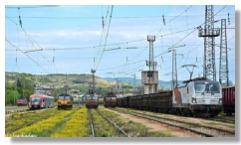
OVERALL SAFETY PERFORMANCE AND STRATEGY

Main Conclusions from the Reporting Year
Common Safety Indicators (see also Annex A to the report):
1. Safety indicators related to railway accidents:
In 2015, there is a tendency towards an improvement in the values of the basic Common Safety Indicators (CSIs) relating to accidents, namely: total number of significant accidents (48 compared to 58 in 2014), total number of persons killed (fatalities) (20 compared to 23 in 2014) and total number of seriously injured persons (24 compared to 45 in 2014). The total number of accidents in 2015 was almost identical to the registered ones in 2014, respectively: 305 in 2015 compared to 304 in 2014.
1.1. As mentioned above, the value of the indicator (N00) of the total number of significant accidents in 2015 decreased to 48. Over the past five years, the values of this indicator are respectively: 58 (2014), 33 (2013), 48 (2012), 74 (2011) and 39 (2010). Accidents to persons involving rolling stock in motion (RSM), with the exception of suicides and attempted suicides, by tradition account for the largest share of the significant accidents registered in 2015, namely: 33. The next most serious significant accidents are 6 accidents at level crossings and also 6 derailments. The smallest number are collisions of trains, including collision of a train with an obstacle within the clearance gauge, respectively 3. In 2015, there were 15 fires in rolling stock (RS), of which none was classified as a significant accident. For more information, see Table 2 and Table 3 on page 14 of the report.
1.2. The CSIs regarding the total number of persons killed (ТК00) and seriously injured (TS00) in 2015 decreased in comparison with 2014. In 2015, persons killed numbered 20, while in the previous five years they numbered: 23 (2014), 12 (2013), 21 (2012), 37 (2011) and 16 (2010). In 2015 the persons seriously injured numbered 24, while in the previous five years they numbered: 45 (2014), 21 (2013), 32 (2012), 42 (2011) and 22 (2010).
1.3. In 2015, the significant accidents with the greatest number of persons killed and seriously injured for the individual risk categories set out in letters (a) and (b) of Article 7(4) of Directive 2004/49/EC are as follows:
- For risk category (RC) ‘Passengers’ :
In 2015, the most serious accidents to persons of the RC ‘Passengers’ numbered two, with one passenger killed in each of them. The first one was registered on 26 October 2015 at railway station Chirpan, where one passenger aged 84 was run over by passenger train No 10113, operated by BDZ - Passenger Services Ltd. The second one was registered on 11 November 2015 at railway station Iskar, where one passenger was run over by passenger train No 10125 of BDZ - Passenger Services Ltd. For these two cases, the value of the FWSIindicator = 1.0 for persons of RC ‘Passengers’.
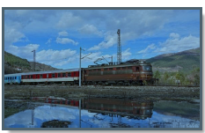
- For risk category ‘Employees’:
On 26 August 2015, at 03:48 a.m., at marshalling yard Gorna Oryahovitsa, while performing a shunting operation with locomotive No 55-169 of BDZ - Freight Services Ltd., in the movement of wagons to a wagon-repair workshop (WRW), one railway employee was hit and severely injured (shunting switchman aged 58), who later died. For this case, the value of the indicator FWSI = 1.0.
- For risk category ‘Level Crossing Users’:
On 3 April 2015, at the level crossing at km 10+ 147, in the section between the railway stations Karnobat – Lozarevo, passenger train No 9632 of BDZ - Passenger Services Ltd., hauled by locomotive No 44-125 collided with a car. As a result, 2 level crossing users were killed, and 2 other level crossing users were seriously injured (all persons killed and injured were travelling in the car). For this accident to persons of RC ‘Level Crossing Users’, the indicator for killed and seriously injured persons is FWSI = 2.2.
This value of the FWSI indicator is equal to the value of the most serious single incident at level crossings registered in the period 2006 – 2014. This incident happened on 4 January 2014 at the level crossing at km 29+415 in the section between the railway stations Dolna Mahala – Banya between passenger train No 82206 and a car, as a result of which 2 people were killed and two other persons of RC ‘Level Crossing Users’ were injured. The value of the FWSI indicator for this accident is also equal to 2.2.
- For risk category ‘Trespassers’:
In 2015, in 15 individual accidents 15 persons of RC ‘Trespassers’ were killed. For all these cases for persons from RC ‘Trespassers’, the value of the indicator FWSI = 1.0. In another 10 individual accidents, another 10 seriously injured ‘Trespassers’ were registered.
- For risk category ‘Other persons at a platform’:
In 2015, no significant accidents were registered with people from RC ‘Other persons at a platform’.
- For risk category ‘Other persons not at a platform’:
In 2015, one significant accident was registered, in which 1 person from RC ‘Other persons not at a platform’ was severely injured. The accident occurred on 11 April 2015, at 9:16 a.m., at the departure of passenger train No 8611 from the first track of railway station Plovdiv. A man aged 66 from Plovdiv, who had been seeing off his relatives, jumped off the train while it was moving at a speed of about 23 km/h, after which he fell between the track and the platform of the first track and hurt himself. The victim was taken to hospital by an of EMC car.
1.4. Details regarding the persons killed and seriously injured during the significant accidents registered in 2015, broken down by risk categories of persons.
- For risk category ‘Passengers’:
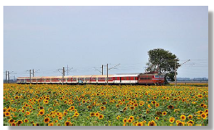
In 2015, in 2 individual accidents 2 persons of the RC ‘Passengers’ were killed. In another 5 individual accidents, 6 persons from RC ‘Passengers’ were seriously injured. Four of them were injured after jumping off a moving train, and two others were injured on 9 August 2015 at railway station Plovdiv at the collision of shunting locomotive No 07-032.6 into standing international passenger train No 493.
- For risk category ‘Employees’:
In 2015, one significant accident was registered with a person of RC ‘Employees’, as a result of which one railway employee was killed (the accident is described above).
- For risk category ‘Level Crossing Users’:
In 2015, in a total of six significant individual accidents, 2 persons from RC ‘Level Crossing Users’ were killed and 7 other people from RC ‘Level Crossing Users’ were seriously injured.
- For risk category ‘Trespassers’:
In 2015, a total of 25 significant individual accidents, 15 people were killed and 10 other people were severely injured from RC ‘Trespassers’.
- For risk category ‘Other persons not at a platform’:
In 2015, one seriously injured person (accompanying) from RC ‘Other persons not at a platform’ was registered in an accident that occurred on 11 April 2015 in railway station Plovdiv (details of the accident are shown on the previous page).
- For risk category ‘Other persons’:
In 2015, no significant accidents, killed or seriously injured persons from RC ‘Other persons’ were registered.
- For risk category ‘Other persons at a platform’:
In 2015, no significant accidents, killed or seriously injured persons from RC ‘Other persons not at a platform’ were registered.
2. Safety indicators relating to dangerous goods:
In 2015, in Bulgaria, one accident during dangerous goods transport was registered. The accident took place on 16 September 2015, in the section between the railway stations Klissura – Stryama, with freight train No 82590, hauled by locomotive No 40-0534.4 of BRC S.A. The primary accident in this case was derailment of a wagon tank No 33527868283-6 (Z4) with sulphuric acid, owned by KCM S.A. Plovdiv, the 11th car in the train composition after the locomotive. The secondary accident in this case involved at least one railway vehicle transporting dangerous goods. The accident did not lead to the release of dangerous goods (sulphuric acid). After an inspection of the track had been made, it was found that the location of the derailment (ascension) was km 113+980 at the beginning of tunnel No 11. The train travelled 4 580 meters after the derailment and stopped at km 109+400.
3. Safety Indicators relating to suicides:
In 2015, there were 21 suicides and one suicide attempt. In the previous five years, the number of suicides were as follows: 29 (2014), 17 (2013), 33 (2012), 27 (2011) and 18 (2010). Statistical data on suicide attempts before 2015 were not collected.
4. Safety indicators relating to precursors to accidents:
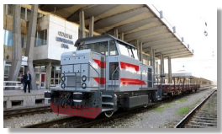
In 2015, under the indicator ‘Total number of precursors to accidents’ with code I00 there was an increase of about 7% compared with 2014. The value of indicator I00 for 2015 was 133, while for 2014 it was 124.
In recent years, in the indicators: I05 ‘Broken wheel on rolling stock in service’ and I06 ‘Broken axle on rolling stock in service’, there has been a tendency to their reduction, which is due to the increased attention paid by owners, keepers and entities in charge of maintenance of vehicles in Bulgaria for these two key indicators. In 2015, the parameters of indicators I05 and I06 were equal to 0, while in 2014 they were 1 and 4, respectively.
There was an increase in the value of the indicator I02 ‘Track buckle and other track misalignment’. For 2015, the value of I02 was 14, whereas for 2014 it was 1, and for 2012 and 2013 it was 0.
For the indicator I01 ‘Broken rail’, the value for 2015 was 104, while in the previous 4 years it was: 2014 – 102, 2013 – 83, 2012 – 82 and 2011 – 71. For indicator I04 ‘Total number of Signals Passed at Danger’, the value for 2015 was 13, while in the previous four years it was as follows: in 2014 and 2013 – 16, in 2012 and 2011 – 4.
5. Indicators for calculation of the economic impact of accidents:
In 2015, under the indicator ‘Cost of material damage to rolling stock or infrastructure from significant accidents’ (C13), there was an increase of nearly 80% compared to 2014, respectively BGN 136,180.33 for 2015 and BGN 27,191.00 for 2014.
There is an ongoing trend to an increase in the parameters of the indicators C15 ‘Minutes of delay of passenger trains’ and C16 ‘Minutes of delay of freight trains’ due to the significant increase in damage to traction rolling stock of both companies in the ‘Holding BDZ’ EAD (BDZ - Passenger Services Ltd. and ‘BDZ - Freight services’ Ltd.). The values of indicator C15 in recent years are as follows: In 2015, a total of 12,833 minutes, in 2014 – 10,882 minutes, in 2013 – 5,157 minutes and in 2012 – 7,583 minutes. The values of indicator C16 over recent years are as follows: In 2015, – a total of 7,058 minutes of delays, in 2014 – 4,842 minutes, in 2013 – 7,012 minutes and in 2012 – 3,159 minutes.
The 2015 annual safety report of the state railway infrastructure manager in Bulgaria – SE NRIC graphically presents an analysis of damage to equipment calculating the greatest delay of trains in minutes, which is shown below (Figure 1).

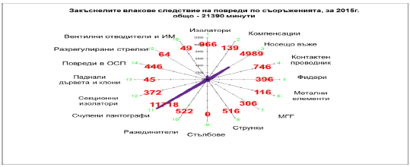
Figure 1. Data on delayed trains due to damage to facilities in the railway infrastructure and RS in 2015.

Закъснелите влакове следствие на повреди по съоръженията, за 2015 г. общо ‒ 21 390 минути | Delayed trains due to damage to facilities, for 2015, a total of 21,390 minutes
Изолатори | Isolators
Компенсации | Offsetting devices
Носещо въже | Messenger wire
Контактен проводник | Contact wire
Фидери | Feeders
Метални елементи | Metal elements
МГГ | Gas generator MGG
Струнки | Cable dropper
Стълбове | Poles
Разединители | Disconnectors
Счупени пантографи | Broken pantographs
Секционни изолатори | Section insulators
Паднали дървета и клони | Fallen trees and branches
Повреди в ОСП | Damage to main section posts
Разрегулирани стрелки | Disordered switches
Вентилни отводители и ИМ | Surge arresters and impedance

The chart shows that the damage causing the greatest time delay of trains in 2015 is the breaking of pantographs.
In 2015, there is a tendency to a reduction in the time delay of trains due to broken pantographs (Figure 2).
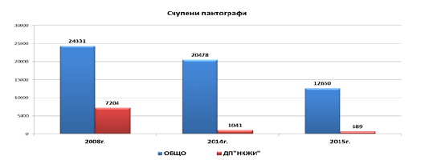
Figure 2. Data on the total delay of trains due to broken pantographs in 2008, 2014 and 2015.
Счупени пантографи | Broken pantographs
ОБЩО | TOTAL
ДП „НКЖИ“ | SE NRIC

6. Safety indicators relating to the technical safety of infrastructure and its implementation.
During the reporting year 2015, in indicator T01 ‘Percentage of tracks with Train Protection Systems (TPSs)’ there is a decrease of nearly 50% compared to 2014, caused by isolation of the effect of 507.63 km of railway track due to construction works. For this reason, the values of indicator T02 ‘Percentage of train-kilometres using on-board TPSs’ decreased by more than 45 percent.
In indicator T06, referring to the total number of ‘active level crossings’ in Bulgaria, there is a decrease of about 1% compared with 2014. In 2015, T06 is 626, while in the previous four years it is: In 2014 – 632, in 2013 – 648, in 2012 – 646 and in 2011 – 654.
In indicator T14 concerning the total number of ‘passive level crossings’, there is also a decrease of about 1% compared with 2014. In 2015, T14 is equal to 140, while in the previous four years it is as follows: In 2014 – 142, in 2012 – 137, in 2012 – 137 and in 2011 – 134.
7. Indicators relating to safety management.
In 2015, there was no increase in the number of conducted internal audits on the Safety Management Systems (SMS) of the IM (SE NRIC) and RUs pursuant to the requirements of Regulation (EC) No 1078/2012. The observations of the NSA of Bulgaria show that the IM and the ‘old’ RUs plan and carry out audits of their SMS once per year. Most of them use the services of trained internal auditors and only one RU (Bulmarket Rail Cargo Ltd.) uses external auditors. In 2015, the internal audit of the SMS, planned by Bulmarket DM Ltd., was not conducted due to the closure of the RU and the transfer of its activities to the newly created subsidiary – Bulmarket Rail Cargo Ltd., to which on 7 August 2015 the NSA of Bulgaria issued SC Part A and Part B.

B.2. National Safety Strategy, Programmes and Initiatives
The National Safety Strategy of the Republic of Bulgaria is included in the Strategy for Development of the transport system of the Republic of Bulgaria until 2020, issued by MTITC in 2010. It describes the obligations of the state regarding the development, coordination and implementation of a policy to increase safety and security in all modes of transport and of the transport system as a whole. The strategy emphasises the important role of the determination and the control of the application of technical standards for planning, design, construction, maintenance and operation of the transport infrastructure in order to ensure the safety of consumers, uniformity and technical compatibility of the networks.

Operational Programme ‘Transport’ (OPT) 2007–2013 and Operational Programme ‘Transport and Transport Infrastructure’ (OPTTI) 2014–2020.
One of the main development programs of the Trans-European Transport Network for achievement of sustainability of the Bulgarian transport system, part of which the railway system is, is OPT 2007–2013, continued with OPTTI 2014–2020. It is one of the seven operational programmes of the Republic of Bulgaria, financed from the EU Structural Funds and the Cohesion Fund. OPT is the Operational Programme with the largest budget in Bulgaria – over 2 billion EUR.
The Strategy of OPTTI 2014–2020 ensures the continuity and logical continuation of investments from the 2007–2013 programming period, thus ensuring the completion of the routes in which investments have already been made. The following priority axes are formulated in the programme:
- ‘Development of railway infrastructure along the “core” Trans-European Transport Network’.
- ‘Development of road infrastructure along the “core” and “comprehensive” Trans-European Transport Network’.
- ‘Improvement of intermodal transport services for passengers and freights and development of sustainable urban transport’.
- ‘Innovations in management and services – establishment of modern infrastructure for traffic management and transport safety improvement’.
- Technical Assistance.

The Strategy of OPTTI 2014–2020 is developed based on a number of relevant documents in line with the applicable Community and National Strategies and Policies. It is based on the needs defined in the analysis of the current situation in the transport sector, developed for the purposes of the Programme. The Strategy of OPTTI 2014–2020 envisages the completion of core national and Pan-European transport routes on the territory of Bulgaria. The main investments are targeted at routes at an advanced stage of implementation, mainly financed under OPT 2007–2013, thus aiming at the utmost finalisation of their modernisation or their completion.
The National Concept for Spatial Development for the period 2013–2025 includes a set of priorities, one of which aims at developing the national transport infrastructure as part of the Trans–European transport network. – ‘Strategy for Development of the Transport System of the Republic of Bulgaria until 2020’ defines the following objectives of the national transport policy: 1) Achieving cost-effectiveness; 2) Development of a sustainable transport sector; 3) Improvement of regional and social development and commitment. The overall objective of OPTTI 2014–2020q as well as of OPT 2007–2013 is ‘Development of a sustainable transport system‘, which corresponds to the above-mentioned thematic objectives.
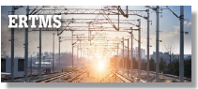
‘National Deployment Plan of the European Rail Traffic Management System (ERTMS)’
In 2013, the Minister of Transport, Information Technology and Communications of Bulgaria endorsed the ‘Strategy for Implementation of the TSIs for the Conventional Railway System in the Republic of Bulgaria (2013–2030)’, financed under OPT 2007–2013, priority axis 5 ‘Technical Assistance’. Before that, in 2012, he endorsed the updated national implementation plans of the individual TSIs, as well as the ‘National Deployment Plan of the European Rail Traffic Management System (ERTMS)’.
The deployment of a European Rail Traffic Management System (ERTMS) in Bulgaria will result in raising the safety and security level in railway transport; in connection with this, the National Plan and Strategy of the Republic of Bulgaria for ERTMS Deployment has been developed and implemented.
‘Strategy for the implementation of technical specifications for interoperability for conventional rail in the Republic of Bulgaria 2013 – 2030’ containing 11 strategies for the different sub-systems, as well as one overall strategy approved by the Minister of Transport, Information Technology and Communications in 2013. It covers both TSIs for the conventional rail system and functional TSIs that apply mandatorily for conventional and for high-speed lines.
Updated national plans have been developed and approved for each strategy. The ‘Strategy for Deployment of the European Rail Traffic Management System (ERTMS) in the Republic of Bulgaria’ and the ‘National Deployment Plan of the European Rail Traffic Management System (ERTMS)’ were approved by the Minister for Transport, Information Technology and Communications in 2012. Considering that the geographical scope of applicability of the TSIs has been expanded, their implementation should cover not only the corridors along the ‘core’ and ‘comprehensive’ network, but also the entire territory of Bulgaria, i.e., the entire railway network.
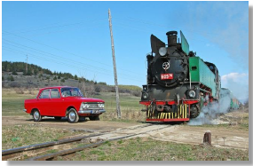
Initiative of MTITC in Connection with the International Level Crossing Awareness Day (ILCAD) – 3 June
In 2015, for the seventh consecutive year, the infrastructure manager SE NRIC participated in the large-scale initiative of the International Level Crossing Awareness Day (ILCAD), which is held on the initiative of the International Union of Railways (UIC) jointly with the railway and the automobile sector in more than 50 countries around the world. The first International Level Crossing Awareness Day (ILCAD) was held on 25 June 2009 in 27 countries.
The main purpose of the initiative is to show that accidents can be avoided by complying with traffic rules and by reducing the dangerous behaviour of traffic participants when crossing railway level crossings and the area around them.
At the end of 2015, the total wrap length of the railway network of the Republic of Bulgaria was 6,474 km. There are 766 level crossings in the territory of the country, managed by SE NRIC, of which: ‘passive level crossings’ – 140 and ‘active level crossings’ – 626. (Including level crossings with manual barriers – 108, with ALCS – 280, with automatic barriers (Automatic level-crossing devices with alarm and barrier and with Electric barrier) – 238. Apart from these, walkways number 116. Industrial level crossings, located in industrial railway branches, number 163.
One of the main priorities, as part of the overall activity of SE NRIC in Bulgaria, is ensuring security and safety when crossing railway level crossings.
Last year there was a tendency towards a reduction in accidents registered at railway level crossings. In 2015, accidents at level crossings totalled 20, of which 6 were significant, whereas in 2014 they were 21, of which 11 significant. The main reason for their occurrence is the gross violation of safety rules by drivers of motor vehicles and disregard of the signals prohibiting passage through the level crossing due to an approaching train.
The data regarding level-crossing accidents, registered in Bulgaria during the 5-year period 2011–2015, are presented in tabular format below:
Year | Total number of accidents at level crossings | Total number of significant accidents at level crossings | Persons killed | Persons seriously injured | Total number of persons killed and seriously injured
2011 | 15 | 7 | 2 | 9 | 11
2012 | 36 | 15 | 7 | 15 | 22
2013 | 32 | 11 | 3 | 12 | 15
2014 | 21 | 11 | 6 | 16 | 22
2015 | 20 | 6 | 2 | 7 | 9
Table 1. Data for accidents at level crossings registered in Bulgaria in the period 2011 – 2015 (incl.)
The main objective of the implementation of the investment programme of NRIC SE for installing all required modern technical devices at level crossings is to reduce fatalities and serious injuries at railway level crossings. The financial strategy, implemented by the company in this respect, is based on the funds supplied both by the national budget of the Republic of Bulgaria and by the European funds – OPT 2007–2013 and OPTTI 2014–2020.
SE NRIC makes efforts to reduce incidents at railway level crossings in the country by intensively replacing level-crossing devices and building elastic level-crossing pavements ensuring smooth and comfortable passage of motor vehicles in the area of the level crossings.

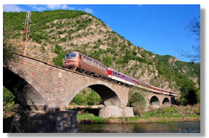
Review of the Previous Year
In 2015, as a whole, no lowering of the level of safety of the railway infrastructure was accounted for compared to 2014, based on the statutory criteria and safety indicators.
The safety management structures of the IM and the RUs provide full assistance to the RAEA in the monitoring and control of the overall development and improvement of safety. By the 10th day of each month they collect and process statistical information regarding the CSIs for the previous month and make it available to the RAEA and to the specialised unit for investigation of accidents and incidents in railway transport at the Ministry of Transport, Information Technology and Communications. The orders and prescriptions issued for this period and relating to the safety of transportation are enclosed with this information.
The efforts of the NSA Bulgaria in 2015 were in the following directions:
- Maintenance of the safety level of movement of trains and railway infrastructure and enhancing their efficiency.
- Control over the construction, repairs, maintenance and operation of railway infrastructure, traffic and transportation safety and the technical condition and serviceability of rolling stock.
- Supervision of the SMS of the IM and RUs in compliance with Regulation (EC) No 1077/2012.
- Controls and checks of the activities of persons authorised to assess and verify conformity of the constituents and subsystems with the Technical Specifications for Interoperability (TSI) (NoBo) and with the national safety regulations or technical rules (DeBo);
- Successful implementation of the cross-audit of the NSA of Bulgaria, which took place from December 2014 to March 2016 under the NSA Cross-Audit Program. The scope of the audit covered the following three processes: 1) Issuance of safety certificates and safety authorisations; 2) Safety supervision and 3) Authorisations for placing into service of rolling stock.
- Revision and cleaning up of the National Safety Rules (NSR) and the National Technical Rules (NTR).
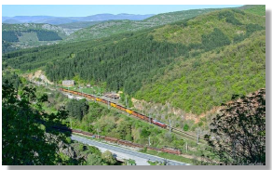
In 2015, the NSA of Bulgaria, applying the CSM for assessing conformity with the requirements for obtaining railway safety certificates established by Regulation (EU) No 1158/2010, issued new SCs to the following three RU for the rail carriage of goods: Bulmarket Rail Cargo Ltd., Rail Cargo Carrier Bulgaria Ltd. and TBD - Freight Services Ltd. In 2015, the SC of DB Schenker Rail Bulgaria Ltd. was renewed and the SC (Part A and B) of Bulmarket DM Ltd. was revoked due to cessation of the activity of the RU and its transfer to the newly created RU Bulmarket Rail Cargo Ltd. No SAs were issued/renewed to the IM during the reporting year. Further details regarding the safety certificates and safety authorisations issued by the NSA to the IM and RUs are presented in section F of the report.

Focus Areas for the Next Year
The key areas in the field of railway safety in 2016 of the NSA of Bulgaria in compliance with the requirements of Art (16)(2) of RSD are as follows:
- Issuance, renewal, amendment or revocation of safety certificates and safety authorisations of the RUs and the IM;
- The exercise of supervisory activity in compliance with the requirement of Regulation (EC) No 1077/2012 and checks of whether the formulated terms and conditions in the issued safety certificates and safety authorizations have been complied with and whether the IM and RU operate according to the Community requirements or the national legislation;
- Issuing permits for commissioning the structural subsystems constituting the railway system and checking whether they are operated and maintained in compliance with the relevant essential requirements;
- Issuing permits for commissioning new and substantially altered rolling stock (RS);
- Control, support and development of the safety regulatory framework, including the system of National Safety Rules (NSRs);
- Registration of vehicles in the National Vehicle Register (NVR) and timely update of the information in the register.
- Control over repairs, maintenance and operation of the railway infrastructure, traffic and transportation safety and the technical condition and serviceability of rolling stock.
- Controls and checks of the activities of persons authorised to assess and verify conformity of the constituents and subsystems with the TSIs (NoBo) and with the national safety regulations or technical rules (DeBo);
- Successful completion of the NSA of Bulgaria cross-audit, conducted under the NSA Cross-Audit Program during the period from December 2014 to March 2016.

DEVELOPMENTS IN SAFETY PERFORMANCE

Detailed Analysis of the Latest Recorded Trends
Analysis of the data of the Common Safety Indicators (see Annex A).
- Safety indicators relating to the total number of accidents, the total number of significant accidents, the total number of persons killed and the total number of seriously injured persons:
As was mentioned in item C.1 of this report, in 2015 the following values of safety indicators were registered related to the total number of accidents, total number of significant accidents, killed and seriously injured persons, which during the period 2011 – 2015 are shown in the table below:
Year | Total number of accidents | Total number of significant accidents | Total number of persons killed | Total number of seriously injured persons
2011 | 189 | 74 | 37 | 42
2012 | 274 | 48 | 21 | 32
2013 | 266 | 33 | 12 | 21
2014 | 304 | 58 | 23 | 45
2015 | 305 | 48 | 20 | 24
Table 2. Data on the main CSIs for Bulgaria for the period 2011 – 2015
The total number of accidents registered in 2015, including significant accidents, is shown in Table 3 below:
Type of event | Region Sofia | Region Plovdiv | Region Gorna Oryahovitsa | Total number of accidents | Significant accidents
Collision of train with railway vehicle | 1 | 1 | 0 | 2 | 1
Collision of a train with obstacle within the clearance gauge | 62 | 47 | 40 | 149 | 2
Derailment of railway rolling stock | 21 | 16 | 12 | 49 | 6
Level-crossing accident | 6 | 8 | 6 | 20 | 6
Accidents to persons involving rolling stock in motion | 25 | 21 | 20 | 66 | 33
Fires in rolling stock | 5 | 6 | 4 | 15 | 0
Other | 2 | 2 | 0 | 4 | 0
TOTAL | 122 | 101 | 82 | 305 | 48
Table 3. Data on the total number of registered incidents in 2015, including significant accidents
- Safety indicators relating to precursors to accidents:
The values of the indicators relating to precursors to accidents for the last five years are presented in the table above:
Year | Number of broken rails | Number of track buckles and other track misalignments | Number of wrong side signalling failures leading to dangerous situations | Number of signals passed at danger | Number of broken wheels on rolling stock in service | Number of broken axles on rolling stock in service | TOTAL
CSI code | I01 | I02 | I03 | I04 | I05 | I06 | I00
2011 | 71 | 1 | 0 | 4 | 2 | 16 | 94
2012 | 82 | 0 | 0 | 4 | 27 | 14 | 127
2013 | 83 | 0 | 0 | 16 | 76 | 5 | 180
2014 | 102 | 1 | 0 | 16 | 1 | 4 | 124
2015 | 104 | 14 | 2 | 13 | 0 | 0 | 133
Table 4. Data on the CSIs related to precursors to accidents for the period 2011 – 2015 (incl.)
- Indicators for calculation of the economic impact of accidents:
For 2015, the value of the indicator C10 ‘Economic impact of significant accidents only’ is equal to 15.081 million EUR. For 2015, the value of the indicator С01 on 'Economic impact of deaths only from significant accidents’ is 12.859 million EUR and of C02 ‘Economic impact of serious injuries only from significant accidents’ is 2.086 million EUR. In 2015, indicator C17 for damage to the environment is equal to 0 and indicator C13 for damage to RS and to the railway infrastructure is 0.136 million EUR.
Compared with 2014, in 2015, there was an increase of 15% in indicator C15 ‘Minutes of delay of passenger trains only from significant accidents’ (2015 – 12,833 minutes, 2014 – 10,882 minutes). In indicator C16 ‘Minutes of delay of freight trains only from significant accidents’, the increase is over 30% (2015 – 7,058 minutes, 2014 – 4,842 min.).
- Safety indicators relating to the technical safety of infrastructure.
In 2015, in indicator T01 ‘Percentage of tracks with Train Protection Systems (TPSs) in operation’ there was a decrease of nearly 50% compared to 2014 due to isolation of the effect of 507.63 km of railway track due to construction works. For this reason, the value of indicator T02 ‘Percentage of train-kilometres using on-board TPSs in operation’ decreased by more than 45 %.
In indicator T06, referring to the total number of ‘active level crossings’ in Bulgaria, there was a decrease of about 1% compared to 2014. In indicator T14 concerning the total number of ‘passive level crossings’, there was also a decrease of about 1% as compared to 2014.
Year | Percentage of tracks with Train Protection Systems (TPSs) in operation | Percentage of train–km with Train Protection Systems (TPSs) in operation | Total number of active and passive railway level crossings | Total number of active railway level crossings (with automatic user-side protection and warning and automatic rail-side protection) | Total number of active railway level crossings (with automatic user-side warning) | Total number of active railway level crossings (with automatic user-side protection and warning and automatic rail-side protection) | Total number of active railway level crossings with manual user-side warning | Total number of passive railway level crossings
Code | Т01/ТР03 | Т02/ТТ03 | T03 | T06 | Т08/Т09 | T10 | T12 | T14
2010 | 11% | 21% | 815 | 669 | 131 | 354 | 184 | 146
2011 | 11% | 21% | 788 | 654 | 161 | 315 | 178 | 134
2012 | 11% | 22% | 783 | 646 | 172 | 303 | 171 | 137
2013 | 16% | 24% | 785 | 648 | 187 | 322 | 139 | 137
2014 | 13% | 22% | 771 | 632 | 120 | 386 | 126 | 142
2015 | 6.7% | 10.2% | 766 | 626 | 238 | 108 | 108 | 140
Table 5. CSIs related to technical safety of the railway infrastructure in Bulgaria for the period 2010 – 2015 (incl.)
- Indicators relating to safety management.
In 2015, the value of the conducted internal audits and monitoring of the Safety Management Systems (SMS) of the RUs licensed for freight and passengers transport was the same as in 2014, respectively 7. The internal audit of the SMS of Bulmarket DM Ltd., planned for 2015, was not conducted due to the cessation of railway operations of the RU and its transfer to the newly-created RU Bulmarket Rail Cargo Ltd.
The observations of the NSA of Bulgaria show that SE NRIC (state railway infrastructure manager) and the ‘old’ RUs conduct internal audits of their SMS annually. In the ‘new’ RUs, such traditions have not been established yet. Until 2011, there is no data that the Bulgarian IM and RUs conducted any internal SMS audits.

Year | Total number of conducted audits of IM and RUs | Performed audits as a percentage of planned audits (%)
2012 | 4 | 100
2013 | 5 | 100
2014 | 7 | 100
2015 | 7 | 87.5*
Table 6. Conducted internal audits of the SMS of the RU and IM holding SC and SA, issued by the NSA of Bulgaria
* The internal audit of the SMS of Bulmarket DM Ltd., planned for 2015, was not conducted due to the cessation of railway operations of the RU and the creation of a new subsidiary RU.

Results of Safety Recommendations
The National Investigation Body (NIB) in Bulgaria is the Railway Accident Investigation Unit (RAIU) at the Directorate ‘Unit for Investigation of Accidents in Air, Water and Rail transport’ at the Ministry of Transport, Information Technology and Communications (MTITC).
In 2015, safety recommendations from the NIB of Bulgaria (RAIU) were received in connection with the following four railway accidents:
- On 23 December 2014, during the departure from railway station Zimnica, freight train No 30561 derailed, served by locomotive staff and two electric locomotives No 92–034 and No 92–027 of DB Schenker Rail Bulgaria Ltd.(DBSRBG).
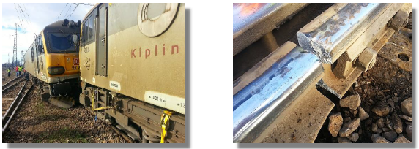
Photos from the site of derailment of freight train No 30 561 on 23 December 2014 at railway station Zimnica.
- On 1 February 2015, during its entry to railway station Stryama, passenger train No 30111 served by train staff and electric locomotive No 44–179 of BDZ - Passenger Services Ltd. moving in the direction Sofia – Karlovo, derailed.

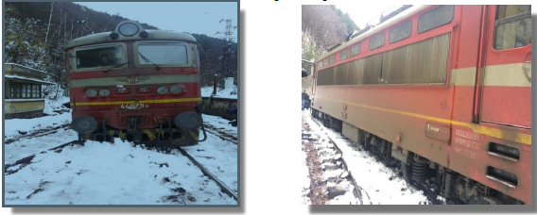
Photos from the site of derailment of passenger train No 30111 on 1 February 2015 at railway station Stryama
- On 9 August 2015, at railway station Plovdiv, diesel locomotive No 07–032.6 collided into international passenger train No 493, operated by BDZ - Passenger Services Ltd.
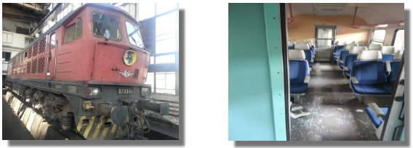

Photos of locomotive No 07–032.6 and passenger car B4 after the accident on 9 August 2015 at railway station Plovdiv
- On 13 October 2015, in the section between railway stations Elin Pelin – Vakarel, a fire occurred in locomotive No 44–169.1, serving passenger train No 1621 of BDZ - Passenger Services Ltd.
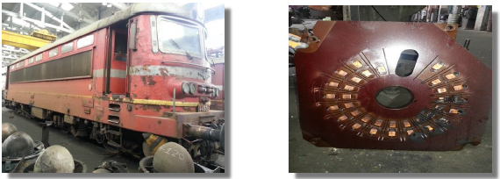
Photos of train No 44–169.1 and its 33-position disk selector of the degrees after the fire in the locomotive, occurring on 13 October 2015 in the section between railway stations Elin Pelin – Vakarel

Safety recommendations received from the NIB of Bulgaria | Safety recommendations received from the NIB of Bulgaria | Status of implementation
After the derailment of freight train No 30561 of
DB Schenker Rail Bulgaria Ltd. at railway station Zimnica on 23 December 2014 г.
1. SE NRIC shall study the possibility and deliver equipment for non-destructive testing with capabilities for the accurate detection of defects on the profile of the switch components and the elements of the railway tracks. | SE NRIC studied the possibilities for delivery of automated equipment for control of the rail tracks, of a specialised vehicle hand-car for automatic ultrasound control of rail tracks. After such a mobile measuring unit, the control will be carried out on both tracks simultaneously during motion. Data from the control will be evaluated and archived automatically.  Spare parts for defectoscopic devices were purchased and an organisation was created for maintaining the latter in good technical order. The control of the work of officials involved in non-destructive testing of rails, railway switches and welded joints of the track, which is strictly carried out, was increased. | In progress
After the derailment of passenger train No 30111 of
BDZ - Freight Services Ltd. at railway station Stryama on 1 February 2015.
1. In connection with Article 7(1) and 7(2) of Ordinance No 56, the RAEA shall conduct an extraordinary examination of the persons occupying the positions of station masters, traffic managers and post switchmen working in the railway stations Koprivshtica and Stryama.  2. The Director General of SE NRIC, pursuant to Article 22(3)(13) of Ordinance No 59, shall organise and develop programs guaranteeing the technical competence of staff, including work in the conditions of damaged interlocking equipment for railway stations and for the sections between railway stations on the third major railway line from railway station Pirdop to railway station Sopot, including the persons occupying the positions of: station master, traffic manager and post switchman or switchmen – level-crossing guard | 1. On 21, 27 and 28 May 2015, the RAEA organised and conducted extraordinary examinations of the persons occupying the positions of: station masters, traffic managers and post switchmen in railway stations Koprivshtica and Stryama.  The employees successfully passed the extraordinary exam on the safety rules of transportation and technical operation, and in compliance with Article 25(1) of Ordinance No 56 protocols were drawn up for the results of the exam.  2. With telegram No 196 of 9 February 2015, the Director of the UDVK Division of SE NRIC describes the reasons that led to the derailment of passenger train No 30111 at railway station Stryama as an alarm bulletin and ordered staff briefings to review the alarm bulletin, to organise and conduct additional training of staff in the area Iliyantsi – Karlovo on the work in the railway station on damaged interlocking equipment (IE), as for the conducted additional training protocols of all present employees are prepared against signature. The staff was notified in case of handling damaged IE to act carefully, without any hasty actions, to require from the operational staff reports for the proper preparation of the train path for the safety of movement of the trains and shunting activity in railway transport in order to prevent cases of a similar character.  The requirements of the heads of the UDVGD Divisions in Sofia, Plovdiv and Gorna Oryahovitsa of SE NRIC for all employees associated with monitoring the performance of transport safety in rail transport were increased.  To improve the staff training with the competence ‘traffic manager’ in April 2015, a new curriculum and program was prepared and approved, which increased the tuition hours of theory and practice to ensure the technical competence of staff in the execution of their professional duties. | Fulfilled
After the collision of locomotive No 07-032.6 into passenger train No 493 on 9 August 2015, at railway station Plovdiv
1. BDZ Passenger Services Ltd. shall organise the training of locomotive staff operating international passenger trains in the section Plovdiv–Kapikule–Plovdiv and shall hold an extraordinary examination in compliance with Article 7, paragraph 1 of Ordinance No 56.  2. The RAEA shall carry out control of full and proper implementation of the regulations. | 1. On 7 December 2015, the RAEA organised and held at RRI Plovdiv a verification examination of the locomotive crew that had admitted the serious railway accident, for which according to Article 25(1) of Ordinance No 56, Protocol No XI -20-49/07.12.2015 was prepared.  2. By Order No 101/12.11.2015 of the head of Locomotive Depot Plovdiv at BDZ Passenger Services Ltd., a list of locomotive staff operating international passenger trains in the section Plovdiv – Kapikule – Plovdiv and a training program, comprising mainly indications of the entry and outgoing traffic lights, automatic brakes tests and speeds in carrying out shunting, were prepared. The locomotive staff training was conducted on 19 and 20 November 2015. | Fulfilled
After the fire that occurred on 13 October 2015, in the section between railway stations Elin Pelin-Vakarel
in electric locomotive No 44-169.1, serving passenger train No 1621
1. Holding BDZ Ltd. and the railway carriers operating electric locomotives with an autotransformer switch (ATP) in the course of conducting 48-hour operational checks shall conduct a visual inspection of the collector unit of the ATP.  2. After having performed an inspection and possible repairs, a mandatorily angular diagram shall be prepared and taken by respecting the norms for large periodic repairs.  3. Technical requirements for the supply of contact bodies of material with parameters according to the technical requirements of the manufacturing plant shall be drafted. | 1. The final report was sent to all divisions for familiarization against the signatures of the repair and operations staff.  2. The ‘RRS’ and ‘Operations’ Directorates of BDZ-PS received orders from the divisions of the organization created to implement the recommendations.  3. Preparations are underway for a public contract for the supply of ATP contacts of electric locomotives series 44 and 45, which sets the requirements for the material from which the contacts are made, corresponding to the original drawing issued by the manufacturing plant. | The first two recommendations are fulfilled.  The implementation of recommendation 3 is in progress.
Table 7. Measures taken in response to safety recommendations made by the NIB of Bulgaria in 2015

Measures implemented not in relation to safety recommendations.
Safety measures implemented as a result of railway accidents and incidents investigated by the NSA
In 2015, employees of the Regional Rail Inspectorates (RRIs) at the RAEA participated in the meetings of the regional investigation committee, which investigated 305 accidents and 36 incidents (precursors to accidents) in accordance with Ordinance No 59 of 5 December 2006 on safety management in railway transport. For the individual RRIs, the data are as follows: 1) RRI Sofia – 135 accidents and 18 incidents, 2) RRI Plovdiv – 108 accidents and 10 incidents and 3) RRI Gorna Oryahovitsa – 82 accidents and 8 incidents. For all accidents and incidents, final reports were made, in which, if necessary, recommendations were given in order to avoid any repetition of the admitted violations or searching for liability of employees for violations they had allowed on the safety of train movement.
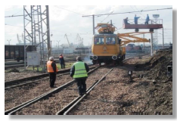
On 10 February 2015, the Executive Director of the RAEA issued Prescription No 2015/001/10 after a technical investigation into the causes of a railway accident, in which on 16 November 2014, at railway station Tserkovski, passenger train No 8601 was accepted onto the sixth track, occupied by train No 80122 instead of the fifth unoccupied track, as a result of a subjective error of the duty post switchman when preparing the path for adopting train No 8601. The prescription includes several safety recommendations related to:
- Assignment of individual work of newly hired workers in a certain railway station and training of employees to work with the IE (interlocking equipment) at the railway stations;
- Working time of the persons occupying positions related to safety of transport;
- Technology of the work at the railway station; 4) Developing a panel board for temporary control of the entry traffic lights near the railway stations.
In 2015, employees of the Regional Railway inspectorates (RRIs) at the RAEA prepared a total of 21 acts for violations of employees, including RRI Plovdiv – 9 and RRI Gorna Oryahovitsa – 12.
Safety measures taken by the NSA of Bulgaria as a result of inspections of IM and RU carried out in 2015:
In 2015, employees of the NSA of Bulgaria checked more than 1000 objects of the IM (SE NRIC), RUs and ECMs, including: Railway stations, railway sections, railway level crossings, sub-regions for maintenance of the catenary, EDC, sections for IE, WRS, passenger and freight centres, locomotive depots, trains, locomotives, DMU/EMU, motor handcars, train and locomotive crews, train fleet managers of the IM and fleet managers of the RUs, construction firms carrying out repair of the railway infrastructure, licensed carriers, etc. When during the checks irregularities were established regarding compliance with the RTA, Ordinance No 58, Ordinance No 56, TOR, RMTSA etc. for which the following number of total acts were drawn up: 66 prescriptions (including of: the Executive Director (ED) of the RAEA – 6, RRI Sofia – 11, RRI Plovdiv – 25 and RRI Gorna Oryahovitsa – 24.). The prescriptions were addressed to: SE NRIC (46), RUs for the carriage of passengers or freight (15) and owners of IRB (5). In 2015, RAEA employees also issued: 9 revision sheets and telegrams; 73 letters of an instructive nature, 7 orders for interim speed reductions on tracks in railway stations and between railway stations and 3 orders for the suspension of operation of railway switches.
In 2015, employees of the Regional Railway Inspectorates of the RAEA inspected a total number of 1,459 train employees for use of alcohol.
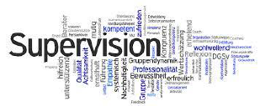
In fulfilment of the requirements of Ordinance No 58, in 2015, RAEA employees from the RRI(s) conducted verification examinations on the employees of the IM and RUs holding positions related to the safety of transport, as they examined a total number of 1,372 employees of SE NRIC and RUs, including: RRI Sofia – 467, RRI Plovdiv – 550 and RRI Gorna Oryahovitsa – 355

SUPERVISION

Strategy and Plan(s)
The essential safety requirements are specified in the Railway Transport Act and in the secondary legislative acts. The requirements of the RSD (Safety Directive 2004/49/EC) are implemented mainly through Ordinance No 59 on safety management of railway transport, issued by the Minister for Transport, Information Technology and Communications. It introduces the principles of the CSM on supervision performed by the NSA after the issuance of the SC and SA and ECM certificates, stipulated in the provisions of Regulation (EU) No 1077/2012.
When defining the supervision strategy and supervision plans of the NSA of Bulgaria, at least the following sources of information are used:
- Monthly and annual information on the status of safety, presented by the railway undertakings and the infrastructure manager;
- Daily information from the bulletin about irregularities in the railway network, drawn up by the infrastructure manager;
- Examination of documentation and records relating to the SMS;
- Review of the performance results of the safety management system, established during inspections or related activities;
- Results of the investigation of accidents, incidents and NM;
- Received signals and complaints from IM, RU and others.
Based on the analysis of the incoming information, the following types of checks are carried out:
- On-site inspections – in the presence of information raising concerns about safety;
- Official checks (ex–officio) initiated by the NSA;
- Thematic targeted checks in case of a reported breach of safety.
Monthly supervision plans are developed and amended based on aggregate information from:
- Daily analysis of the information on irregularities from the previous day;
- Signals and complaints received from companies and individuals;
- Analysis of the accidents, incidents and NMs investigated during the previous month
- The monthly information submitted by the railway undertakings and the infrastructure manager about the state of safety.
The monthly control schedule is drafted by the Head of the RRI department and is approved by the Director General of DG ‘Railway Inspectorate’. The schedule is subject to changes, as additional tasks or emergency situations may arise in the course of control.
Monthly supervision plans are developed and amended based on aggregate information from:
- The results of the performed monthly checks and inspections by RRI;
- The accumulated information from the annual reports of the railway undertakings and the infrastructure manager;
- Analysis of investigated accidents and incidents in the preceding year.
The plans for the annual inspection may be revised based on the input information from the monthly analyses, checks and inspections. Major changes in revisions are related to the scope and purpose of the inspection in the presence of alarming information on safety. They are approved by the Executive Director of the RAEA and are sent for information to the respective railway undertakings and the infrastructure manager. The annual supervision schedule is developed by the Director General of DG ‘Railway Inspectorate’.


Human Resources
The RAEA, through its Directorate General ‘Railway inspectorate’, performs its functions of the National Safety Authority for the railway transport of the Republic of Bulgaria. Some of its main features are related to the performance of supervision of the Safety Management (SMS) of the RU and IM, as well as control over the management of ECM of wagons and other railway vehicles.
As of 31 December 2015, DG ‘Railway Inspectorate’ consisted of 31 employees, including 15 inspectors in the territorial units – Regional Railway Inspectorates (RRIs) in Sofia, Plovdiv and Gorna Oryahovitsa. The administrative, legal and financial services for the DG ‘Railway Inspectorate’ are delivered within the RAEA by the ‘Administrative-legal and Financial-economic Management’ Directorate, comprising 8 members of staff.
In 2015, the NSA of Bulgaria conducted a total of 8 audits of the SMS of 1 RU operating passenger services and of 7 RUs operating freight services as follows:
1. BDZ - Passenger Services Ltd., 2. DB Cargo Bulgaria Ltd., 3. State Enterprise ‘Transport Construction and Rehabilitation’ (SE TCR), 4. Port Rail Ltd., 5. Gastrade S.A., 6. Cargo Trans Wagon Bulgaria S.A.; 7. Express Service Ltd. and 8. TBD-Cargo Ltd.
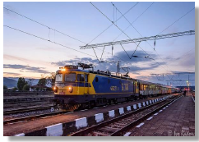
Audits of BDZ - Passenger Services Ltd., SE TCR, Port Rail Ltd., Gastrade S.A. Cargo Trans Wagon Bulgaria S.A. and Express Service Ltd. were carried out in the implementation of the annual supervision plan of the RAEA as NSA, and those of DB Cargo Bulgaria Ltd. and TBD-Cargo Ltd. for assessment of the submitted applications for SC renewal (Please refer to section E.1 of the report for more information). An average of 9 – 10 auditors (employees from the DG ‘Railway Inspectorate’) participated in the audits and were engaged in this activity for a total of about 640 hours. So far, the NSA of Bulgaria has not used the services of external auditors for performing its supervisory functions.
In 2015, the NSA of Bulgaria as a certification body of entities in charge of the maintenance (ECM) of freight wagons and railway vehicles performed 22 audits.
Of these, for initial certification a total number of 9 audits were performed, including entities certified to perform maintenance functions – 4, and certified entities in charge of maintenance – 5.
For renewal of the certificates, a total of 7 audits were performed, including for renewal of certificates for the performance of maintenance functions – 3 and for renewal of certificates of entities in charge of maintenance – 4 audits.
For updating certificates – 3 audits, of which 2 were of entities performing maintenance functions and 1 audit of entities in charge of maintenance.
Supervisory annual audits of the implementation of the annual supervision plan of the NSA – 3 audits of entities in charge of maintenance.
An average of 5 to 10 auditors (officials from the DG ’Railway Inspectorate’) participated in these audits and were engaged in this activity for a total of about 1,000 hours – 7 - 8 hours per person on average.
So far, the NSA of Bulgaria has not used the services of external auditors for performing its supervisory functions on ECM.
In 2015, checks and inspections of railway undertakings and the infrastructure manager related to their activities concerning the safety of transportation were carried out, and 15 inspectors from the Regional Railway Inspectorates spent a total of 6,000 hours conducting them.

Competence

Employees of the NSA of Bulgaria carrying out activities for the control and supervision of railway undertakings, shall have the competence, connected with the safety activities of transportation by railway transport in compliance with the requirements of Ordinance No 56 of 14 February 2003 on the requirements, conditions and procedure for the training of candidates for the acquisition of competence required by staff responsible for the safety of transportation by railway transport, or recognition of such a capacity, and the procedure for conducting examinations of persons of the staff responsible for the safety of transportation.
In 2015, no trainings of the employees of NSA of Bulgaria aimed at raising their competence and skills in the supervision activity were conducted.

Decision–making
1. Ordinance No 59 introduces the principles of supervision provided for in Regulation (EU) No 1078/2012, which are as follows:
- Proportionality

- Coherence
- Targeting
- Transparency
- Priorities in the effective use of resources
- Management responsibility
- Cooperation
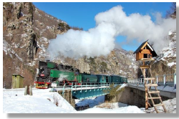
The audits performed were targeted at checking the operation of the Safety Management Systems of the railway undertakings and the infrastructure manager, as well as the systems for the maintenance of vehicles of the ECMs. In case of established irregularities, recommendations shall be prepared by the appropriate deadlines.
In the conducted checks/inspections of the railway infrastructure and railway undertakings, the NSA has made prescriptions and actions have been undertaken to bring objects of the railway infrastructure and rolling stock into compliance with the safety requirements. Upon finding deficiencies that threaten the safety of carriages, the inspectors of the NSA stop the service of elements of the railway infrastructure or rolling stock until such deficiencies are eliminated. The IM and the RUs are required to comply with the prescriptions within the specified time limit. Implementation of prescriptions and elimination of non-compliance with safety requirements are subject to follow-up control by the NSA.
For established violations relating to the safety of carriages, the employees of the NSA compile acts of administrative violation, in compliance with the provisions of the Railway Transport Act. In 2015, 96 penal decrees were issued by the Executive Director of the RAEA, based on acts of violations of the RTA, drawn up by inspectors of the Railway Administration Executive Agency and employees of the Ministry of Interior.
2. During the reporting year, there were no complaints filed by the RUs and the IM against decisions made by the NSA of Bulgaria in the course of supervisory activities.

Coordination and Cooperation
During the reporting year, there were no agreements concluded between the NSA of Bulgaria with NSAs from other EU Member States for the common implementation of supervisory activities on RUs and the IM.

Findings from Measures Taken
As a result of the audits carried out in 2015 on RUs and the IM, the conclusion can be made that they comply with the requirements of the European and the national legislation relating to the Common Safety Methods and Common Safety Targets and maintain functioning SMS. Gaps in the implementation of Regulation (EU) No 1078/2012 and Regulation (EU) No 402/2013 were established. As a result of the recommendations and prescriptions of the NSA, railway undertakings take timely action to correct the discrepancies established in the implementation of SMSs.


ISSUING OF SAFETY CERTIFICATION AND SAFETY AUTHORISATION

Guidance
The RAEA holds a quality management certificate issued under ISO 9001:2008. As part of the QMS of the RAEA, internal procedures (working instructions) are prepared regulating the procedure and method for the assessment of applications for the issuance of safety authorisations to the IM and safety certificates to RUs for the carriage of passengers and/or freight. The procedures are published on the intranet page of the RAEA and are used by employees of the NSA of Bulgaria involved in the assessment of the submitted applications, and are issued based on the requirements of the applicable European and national legislation, as follows:
- Railway Transport Act (RTA);
- Ordinance No 59 of 5 December 2006 on safety management in railway transport;
- Ordinance No 58 of 2 August 2006 on the rules for technical operation, movement of trains and railway signalling;
- Ordinance No 56 of 14 February 2003 on the requirements, conditions and procedure for the training of candidates for the acquisition of competence required by staff responsible for the safety of transportation by railway transport, or recognition of such a capacity, and the procedure for conducting examinations of persons of the staff responsible for the safety of transportation;
- Rules of Procedure of the RAEA;
- Commission Regulation (EC) No 653/2007 of 13 June 2007 on the use of a common European format for safety certificates and application documents in accordance with Article 10 of Directive 2004/49/EC of the European Parliament and of the Council, and on the validity of safety certificates delivered under Directive 2001/14/EC;
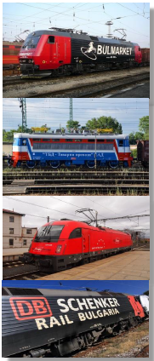
- Commission Regulation (EU) No 1158/2010 of 9 December 2010 on a common safety method for assessing conformity with the requirements for obtaining railway safety certificates;
- Commission Regulation (EU) No 1169/2010 of 10 December 2010 on a common safety method for assessing conformity with the requirements for obtaining a railway safety authorisation;
- Commission Regulation (EU) No 1077/2012 of 16 November 2012 on a common safety method for supervision by national safety authorities after issuing a safety certificate or safety authorisation.
The regulations above are published on the website of the RAEA.
In 2015, three applications were deposited in the NSA of Bulgaria for the issuance of 3 new safety certificates (SC) Part A and Part B of newly established RUs for freight transport (Bulmarket Rail Cargo Ltd., Rail Cargo Carrier Bulgaria Ltd. and TBD-Cargo Ltd.) and two applications for amendment/updating of the SC for freight transport of TBD-Cargo Ltd. After submitting all the necessary and additionally requested information, all requests were met within the time specified in Article 12 of RSD, respectively in Article 29(3) of Ordinance No 59.
Submitted on 28 November 2014, the application for the renewal of safety certificates Part A and Part B of DB Schenker Rail Bulgaria Ltd. was granted on 22 May 2015.
Details about the safety certificates and safety authorisations issued in 2015 to RUs and the IM are presented in Table 7 below:
 | Submitting entity / Name of the RU |  | Date of submission of the application |  | Date of issuance of SC/SA |  | Type of SC/SA |  |  | Validity
 |  |  |  |  |  |  | Certificate | Certificate | Certificate | From | To
 |  |  |  |  |  |  |  | Part A | Part B | From | To
 | DB Schenker Rail Bulgaria Ltd. |  | 28.11.2014 |  | 22.5.2015 |  | - | Yes | Yes | 27.5.2015 | 26.5.2020
Bulmarket Rail Cargo Ltd. |  | 30.3.2015 |  | 6.8.2015 |  | - |  | Yes | Yes | 6.8.2015 | 5.8.2020
Rail Cargo  Carrier Bulgaria Ltd. |  | 5.3.2015 |  | 7.8.2015 |  | - |  | Yes | Yes | 7.8.2015 | 6.8.2020
TBD-Cargo Ltd. |  | 1.4.2015 |  | 27.8.2015 |  | - |  | Yes | Yes | 27. 8.2015 | 26.8.2020
TBD-Cargo Ltd. |  | 1.10.2015 |  | 1.12.2015 |  | - |  | Yes | Yes | 1.12.2015 | 26.8.2020
TBD-Cargo Ltd. |  | 30.12.2015 |  | 25.1.2015 |  | - |  | Yes | Yes | 26.1.2016 | 26.8.2020
Table 8. SC to RUs and SA to IM issued by the NSA of Bulgaria in 2015
In 2015, by Order No 14-00-116/26 October 2015 of the ED of the RAEA, the safety certificates (Part A and Part B) of Bulmarket DM Ltd. were confiscated and the rights arising from them were terminated due to termination of the activity of the company and the creation of a new subsidiary RU.
In 2015, no applications for the issuance of safety certificates to IM were submitted to the RAEA, and no such certificates were issued.

Contacts with Other NSAs
During the reporting period, there are no inquiries from other NSAs for the provision of information regarding safety certificates Part A of railway undertakings certified by the NSA of Bulgaria applying for a safety certificate Part B in another Member State.
In 2015, the NSA of Bulgaria did not make any requests for the provision of information for Safety Certificates Part A issued in other EU Member States.


Procedural Issues
The observations of the NSA of Bulgaria in the implementation in 2015 of the CSMs for assessing conformity with the requirements for obtaining railway safety certificates (Regulation (EU) No 1158/2010/EU) and safety authorisations (Regulation (EU) No 1169/2010/EU) show that SE NRIC and the railway undertakings (RUs) have adapted their safety management systems (SMS) to these requirements.
A main area for improvement of operations in the railway sector in Bulgaria in the field of safety is the implementation of the CSM on risk evaluation and assessment in compliance with the requirements of Regulation No 352/2009/EC, repealed by Regulation No 402/2013.
Another major area to improve the performance of the railway sector in the field of safety is to improve the criteria on behalf of the railway undertakings in the application of the CSM for monitoring pursuant to the requirements of Regulation (EC) No 1078/2012/EU.


Feedback
The NSA of Bulgaria works in continuous interaction and cooperation with the RUs and the IM. Regular meetings and meetings of working groups are held, where various issues relating to problems in the implementation of the safety of transportation by rail, the implementation of the TSIs and national rules, changes to existing National Technical Rules and safety rules, etc., are discussed.
The RAEA obtains from businesses and citizens feedback on the quality of the services it offers in the following ways: 1) through its website and by e-mail; 2) on the spot – at the front office or via a post box located at the entrance of the RAEA, and 3) by ordinary mail.
The instrument which the RAEA has created for measurement of the satisfaction of citizens and businesses is completing a feedback questionnaire by consumers by electronic means or on the spot (at the front office). The feedback questionnaire contains questions relating to overall assessment of the performance and competence of RAEA employees, their interaction with citizens and the existence of corruption practices.
The data obtained through various communication channels are analysed and used to divide the consumers into target groups. Consumers, non-governmental organisations of citizens and businesses and the general public are informed of the action taken and the outcome via the RAEA website and through hard copies through the front office of the Railway Administration Executive Agency.
The information in which citizens are interested can be obtained from the information board at the entrance of the MTITC, at ‘Kuzman Shapkarev’ No 7, Customer Charter and the RAEA website.
Since 2011, there has been an operating telephone number (+359 2 940 9400) on a special internet website (www.transportinfo.bg</2356><2357>), where citizens and businesses can report irregularities in transport, including railway transport.


CHANGES IN LEGISLATION

Railway Safety Directive (RSD)
In 2015, Directive 2014/88/ЕС was transposed in Annex No 1 of Ordinance No 59 of 5 December 2006 on safety management in railway transport.
Table 1 to Annex C of this report presents details about the changes made in the Bulgarian legislation in connection with the RSD.

Changes in legislation and regulation:
In the period from 1 January 2015 to 31 December 2015 in the ‘State Gazette’ (SG) of the Republic of Bulgaria, the following changes in the Bulgarian railway legislation were published:
- ‘Railway Transport Act’ (RTA) in 2015 was changed two times: 1) as amended in issue SG 17 of 6 March 2015 and 2) as amended and supplemented in issue SG 47 of 26 June 2015. The first amendment provided more precise RTA provisions regarding a received reasoned opinion on infringement proceeding No 2013/2076 on the docket of the European Commission in relation to the incorrect transposition and application of RSD (Directive 2004/49/EC), and the second one introduces the provisions of Directive 2012/34/EC.
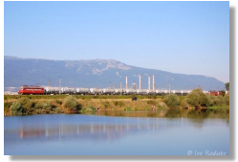
- Ordinance No 43 of 11 September 2001 on the carriage of passengers, luggage and parcels by rail is complemented in issue SG 40 from 2 June 2015, in connection with a request by the Bulgarian side and approved by the EC derogation of Articles 4, 5, 6(1), 8, 10, 13, 1518, 20(2), 21-25 regarding transportations under Article (2)(4)-(2)(6 ) of Regulation (EC) No 1371/2007. – The changes are not related to railway safety.
- Ordinance No 46 of 30 November 2001 for railway transport of dangerous goods is amended and supplemented in issue SG 24 from 31 March 2015, in connection with the transposition of Directive 2014/103/EC.
- ‘Ordinance No 54 of 2 June 2003 on the medical and psychological requirements for staff who carry rail passengers and cargo and their accompanying activities and for the conduct of pre-travel (pre-shift) medical examinations’ is amended in issue SG 76 of 02/10/2015, in connection with the transposition of Directive 2014/82/EC.
- Ordinance No 56 of 14/02/2003 on the requirements, conditions and procedure for the training of candidates for the acquisition of competence required by staff responsible for the safety of transportation by railway transport, or recognition of such a capacity, and the procedure for conducting examinations of persons of the staff responsible for the safety of transportation is amended and supplemented in issue SG 76 of 2 October 2015, in connection with: 1) transposition of Directive 2014/82/EC, 2) clarification of the provisions relating to the organization of the verification examinations on National Safety Rules in rail transport in relation to the experience gained by the examining campaign in 2014 and 3) refinement of the order and manner of recognition of professional qualifications acquired in other EU Member States or in third countries to gain access and exercise regulated professions in the field of railway transport in Bulgaria.
- Ordinance No 57 of 9 June 2004 on the conditions and essential requirements for the railway infrastructure and rolling stock aimed at achieving interoperability of the national rail system with the rail system within the European Union is amended in issue. SG 4 of 16 January 2015, in connection with introducing into the Bulgarian legislation the provisions of Directive 2014/106/EU.
- Ordinance No 59 of 5 December 2006 on safety management in railway transport is amended in issue SG 58 of 31 July 2015, in connection with the clarification of provisions relating to: 1) received reasoned opinion under infringement procedure No 2013/2076 on the docket of the European Commission in relation to the incorrect transposition and application of Directive 2004/49/EC; 2) implementing Directive 2014/88/EC by replacing Annex 1 of Ordinance No 59 and 3) Refining the system of certification of entities in charge of the maintenance of railway vehicles (ECM) regarding the validity of the ECM certificate in compliance with Regulation (EU) No 445/2011.
- Ordinance for the categorization of railway lines in Bulgaria included in the railway infrastructure and closing of separate lines or sections of linesis amended in issue SG 40 of 2 June 2015, as a requirement has been introduced so that upon the closure of railway lines, category III, their owners shall notify not only the Minister of Transport, Information Technologies and Communications, but also the Minister of Economy.
Further details regarding the amendments to the Bulgarian legislation relating to the safety of railway transport in Bulgaria which entered into force in 2015 are presented in Table 2 of Annex B of this report.

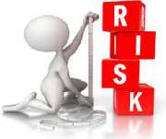
APPLICATION OF THE CSM ON RISK EVALUATION AND ASSESSMENT
Regulation (EC) No 352/2009 and Regulation (ЕС) No 402/2013 are introduced in the procedures on the IM and RUs SMS, and the NSA controls the application of the relevant procedures for risk assessment, including the assessment of significant operational or organisational changes.

Experience of the NSA and of the Railway Sector in Bulgaria.
1. Decisions taken by persons submitting proposals in 2015 on the degree of importance of the change.
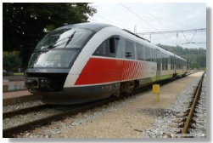
In calendar 2015, there were no significant changes in the organization of work of railway undertakings and the types of rolling stock they use within the meaning of Regulation (EC) No 402/2013.
- In 2015, BDZ - Passenger Services Ltd. applied the CSM on risk assessment and evaluation in the preparation of expert evaluation in order to determine the significance and extent of impact on the safety of the operational process in the company of the following proposed change:
‘Service train composed of a diesel multiple unit series 10 of the train crew composed of the head of the train, instead of head of the train and a conductor‘, as the conclusion of the expert assessment carried out on the grounds and in compliance with Regulation (EU) No 402/2013 was that the change was insignificant and as such it had no impact on the safety of the operational process in the company. Subsequently, the proposal for the respective amendment was not accepted, as one employee cannot serve an entire train, and due to the danger of terrorist attacks.
The methodology was also used to analyse safety at BDZ – Passenger Services Ltd., including for evaluation and assessment of the risk to the safety of transport in BDZ–Passenger Services Ltd., carried out in response to order No 789 of 27 November 2014 of the manager of BDZ–Passenger Services Ltd. in order to obtain clarity about what the safety risks are, what the identified potential hazards are and whether they are acceptable. Consequently, the head of the ‘Safety’ Department at the Headquarters of BDZ–Passenger Services Ltd. produced a report, which presents an assessment of the risks to the transport of passengers made by BDZ–Passenger Services Ltd., based on data from accidents, incidents and near misses in the last three years – i.e., since the creation of the ‘Safety’ Department in the company. After carrying out a risk assessment of first category hazards (accidents and incidents) and the second category hazards (failures and damage to RS) and the risk assessment in different directions, it was concluded that the multiple unit trains from the 10th series give the largest number of failures, while with trains from the 32nd series the failures are few, but they are the most serious.
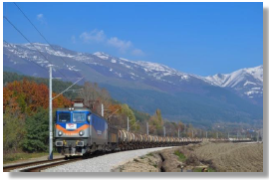
- In the period from 10.03.2015 until 30.05.2015, BRC S.A., in the implementation of its safety procedure (SP 9.1.2) for the implementation of a common safety method for monitoring the effectiveness of the SMS, conducted monitoring of the processes and activities in the servicing of trains, resulting in damage to the electrical equipment of operated locomotives. Within the conducted monitoring, an assessment was made of the degree of risk of damage to the electrical equipment of locomotives during the service of trains. Procedure SP 5.1.3 ‘Procedures and method for determining the risk level’ was applied and it was found that the event falls within the zone of negligible (totally acceptable) risk.
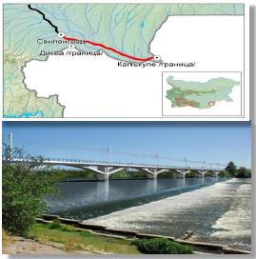
- In 2015, SE NRIC made an assessment of the risk and significance of the change for the project: ‘Electrification and Reconstruction of Railway Line Svilengrad – Turkish Border - Phase 5’.
With Order No 2701 of 12 December 2015 of the Director General of SE NRIC, in compliance with the internal safety procedure ‘SP 2.09. Methodology for identification and assessment of risk ’and in compliance with the requirements of Regulation (EC) No 402/2023, a task was assigned to the permanent expert panel on risk assessment in SE NRIC to conduct an independent evaluation of the risk assessment of the Project Management and Implementation Unit ‘Parvomai – Svilengrad’ for the project ‘Electrification and reconstruction of the railway line Svilengrad – Turkish border – phase 3’ in connection with submitting an application for authorisation for placing in service by the NSA of Bulgaria. The panel approved the following documents: 1) Description of the system; 2) Safety Plan; 3) Risk Analysis; 4) Specifications of safety requirements; 5) Hazard log.
- In compliance with the adopted ‘Risk Management Strategy at SE NRIC 2014–2016‘, the ‘Signalling and Telecommunications’ Division (STD) of SE NRIC developed and implements a plan for the mitigation and control of risks for 2015 – 2016. All risks are covered in the implementation of the set goals and their good management is ensured within the risk appetite of SE NRIC and STD.
Real measures have been taken for the implementation of risk management as part of the decision–making process. The established organizational structure of the ‘Signalling and Telecommunications’ Division to SE NRIC in terms of risk management and liability is associated with risk management at all levels.
Construction site ‘Rehabilitation of the equipment and devices of interlocking equipment between railway stations Pirdop – Karlovo’ was rated as risky as it was executed in operating conditions. After analysing the potential threats, the ‘Signalling and Telecommunications’ Division developed guidelines for creating a plan to manage the risks applied in the execution on the site.
A risk register was established for the reporting year 2015 and the implementation of the actions and mitigation measures and controls set out therein is regularly monitored, as the required records are kept.

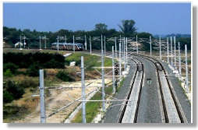
Feedback from Stakeholders.
The NSA of Bulgaria receives information about the application of the CSM on risk evaluation and assessment by RUs, IM and ECMs of vehicles through supervision carried out on them in compliance with Regulation (EC) 1077/2012 and their annual reports received annually by 30 June according to Article 12 and 12a of Ordinance No 59 on safety management in railway transport in Bulgaria.
Stakeholders can express their opinions, comments, proposals, complaints, etc., on all matters relating to RAEA activities, including on matters relating to the CSM on risk evaluation and assessment, by electronic means (by e-mail or on the RAEA website), by regular mail or in person – in the front office or the mailbox located at the entrance of the RAEA and MTITC.

Revised National Safety Rules (NSRs) as a Result of the Implementation of the EU Provisions regarding Risk Evaluation and Assessment.
In 2015, no National Safety Rules were revised as a result of the implementation of the EU provisions regarding risk evaluation and assessment.
In pursuance of Commission Regulation (EU) No 402/2013 of 30 April 2013 on the common safety method for risk evaluation and assessment, the Republic of Bulgaria adopted the idea that a risk assessment body pursuant to Article 9 of the Regulation will be a recognised body. The recognition authority is the NSA of Bulgaria, and EUAR was notified about it in a timely manner in compliance with Article 13 of the Regulation.
On 5 November 2015, the RAEA, as a recognising body for Bulgaria, pursuant to Article 7(b), in conjunction with Article 9(1)(d) of Regulation (EU) No 402/2013, issued to the Bulgarian company ‘TINSA’ Ltd. certificate No BG/36/0015/0001 of the Assessment Body (AsBo) to carry out an independent evaluation of the implementation of the procedure for risk management and the results thereto.

DEROGATIONS IN CONNECTION WITH THE SCHEME FOR THE CERTIFICATION OF ENTITIES IN CHARGE OF MAINTENANCE OF VEHICLES IN COMPLIANCE WITH ARTICLE 14a (8) of DIRECTIVE 2008/110/EC
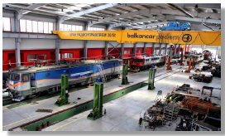
In 2015, the NSA of Bulgaria, in its capacity as certification body of entities in charge of the maintenance of vehicles, did not apply derogations or alternative measures for their certification in compliance with Article 14a(8) of Directive 2008/110/EC of the European Parliament and of the Council of 16 December 2008 amending Directive 2004/49/EC.

ANNEX A – COMMON SAFETY INDICATORS (CSI)
Data/diagrams for the fulfilment of the main CSIs for the period 2011–2015.
Data regarding significant accidents and precursors to accidents:

Significant accidents
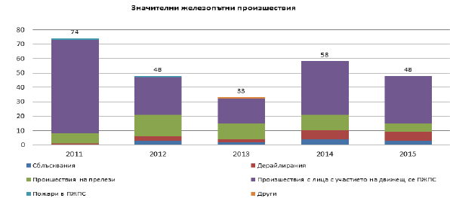
Сблъсквания | Collision
Произшествия на прелези | Level-crossing accident
Пожари в ПЖПС | Fires in rolling stock
Дерайлирания | Derailment
Произшествия с лица с участието на движещ се ПЖПС | Accident to persons involving rolling stock in motion
Други | Other

Year | Collision | Derailment | Level-crossing accident | Accident to persons involving rolling stock in motion | Fires in rolling stock | Other | Total
2011 | 0 | 1 | 7 | 65 | 1 | 0 | 74
2012 | 3 | 3 | 15 | 26 | 1 | 0 | 48
2013 | 2 | 2 | 11 | 17 | 0 | 1 | 33
2014 | 4 | 6 | 11 | 37 | 0 | 0 | 58
2015 | 3 | 6 | 6 | 33 | 0 | 0 | 48

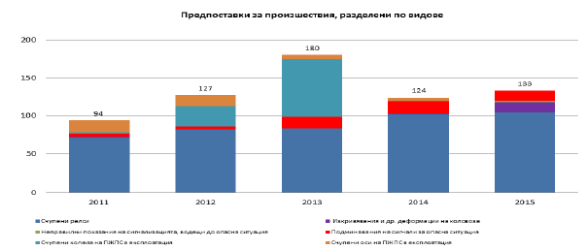

Предпоставки за произшествия, разделени по видове | Precursors to accidents and a breakdown of the following types
Счупени релси | Broken rail
Неправилни показания на сигнализацията, водещи до опасна ситуация | Wrong-side signalling failure
Счупени колела на ПЖПС в експлоатация | Broken wheel on rolling stock in service
Изкривявания и др деформации на коловоза | Track buckle and other track misalignment
Подминавания на сигнали за опасна ситуация | Signals passed at danger when passing a danger point
Счупени оси на ПЖПС в експлоатация | Broken axle on rolling stock in service

Year | Broken rail | Track buckle and other track misalignment | Wrong-side signalling failure | Signals passed at danger when passing a danger point | Broken wheel on rolling stock in service | Broken axle on rolling stock in service | Total
2011 | 71 | 1 | 0 | 4 | 2 | 16 | 94
2012 | 82 | 0 | 0 | 4 | 27 | 14 | 127
2013 | 83 | 0 | 0 | 16 | 76 | 5 | 180
2014 | 102 | 1 | 0 | 16 | 1 | 4 | 124
2015 | 104 | 14 | 2 | 13 | 0 | 0 | 133

Total number of persons killed by type of accident and risk categories of persons:
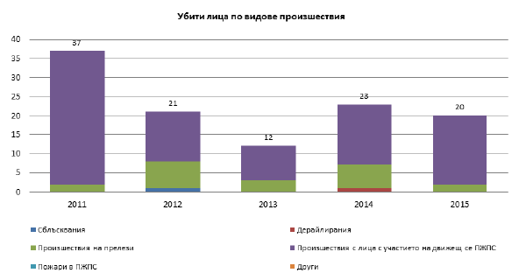
Убити лица по видове произшествия | Persons killed by types of accidents
Сблъсквания | Collision
Произшествия на прелези | Level-crossing accident
Пожари в ПЖПС | Fires in rolling stock
Дерайлирания | Derailment
Произшествия с лица с участието на движещ се ПЖПС | Accident to persons involving rolling stock in motion
Други | Other

Year | Collision | Derailment | Level-crossing accident | Accident to persons involving rolling stock in motion | Fires in rolling stock | Other | Total
2011 | 0 | 0 | 2 | 35 | 0 | 0 | 37
2012 | 1 | 0 | 7 | 13 | 0 | 0 | 21
2013 | 0 | 0 | 3 | 9 | 0 | 0 | 12
2014 | 0 | 1 | S | 16 | 0 | 0 | 23
2015 | 0 | 0 | 2 | 18 | 0 | 0 | 20

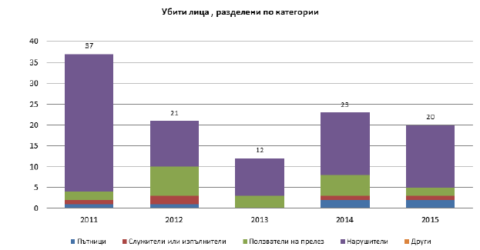
Убити лица, разделени по категории | Killed persons broken down by categories
Пътници | Passengers
Служители или изпълнители | Employees or contractors
Ползватели на прелез | Level crossing users
Нарушители | Trespassers
Други | Other

Year | Passengers | Employees or contractors | Level crossing users | Trespassers | Other | Total
2011 | 1 | 1 | 2 | 33 | 0 | 37
2012 | 1 | 2 | 7 | 11 | 0 | 21
2013 | 0 | 0 | 3 | 9 | 0 | 12
2014 | 2 | 1 | 5 | 15 | 0 | 23
2015 | 2 | 1 | 2 | 15 | 0 | 20

Total number of persons severely injured, according to the type of accident and the risk categories of persons
Seriously injured persons by type of accident
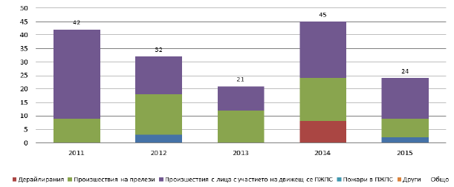
Дерайлирания | Derailment
Произшествия на прелези | Level-crossing accident
Произшествия с лица с участието на движещ се ПЖПС | Accident to persons involving rolling stock in motion
Пожари в ПЖПС | Fires in rolling stock
Други | Other
Общо | Total

Year | Collision Derailment |  | Level-crossing accident | Accident to persons involving rolling stock in motion | Fires in rolling stock | Other | Total
2011 | 0 | 0 | 9 | 33 | 0 | 0 | 42
2012 | 3 | 0 | 15 | 14 | 0 | 0 | 32
2013 | 0 | 0 | 12 | 9 | 0 | 0 | 21
2014 | 0 | 8 | 16 | 21 | 0 | 0 | 45
2015 | 2 | 0 | 7 | 15 | 0 | 0 | 24

Seriously injured persons broken down by categories
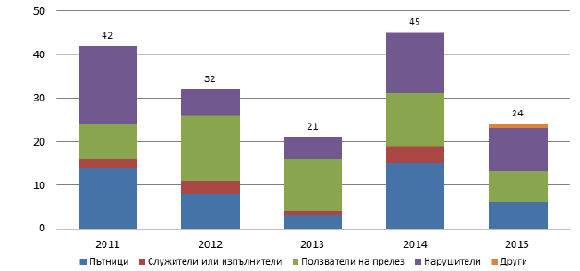
Пътници | Passengers
Служители или изпълнители | Employees or contractors
Ползватели на прелез | Level crossing users
Нарушители | Trespassers
Други | Other

Year | Passengers | Employees or contractors | Level crossing users | Trespassers | Other | Total
2011 | 14 | 2 | 8 | 18 | 0 | 42
2012 | 8 | 3 | 15 | 6 | 0 | 32
2013 | 3 | 1 | 12 | 5 | 0 | 21
2014 | 15 | 4 | 12 | 14 | 0 | 45
2015 | 6 | 0 | 7 | 10 | 1 | 24

Information regarding the traffic
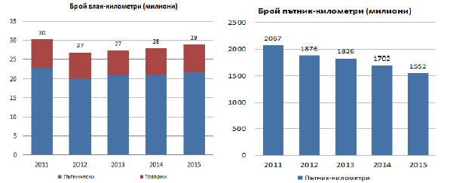
Брой влак-километри (милиони) | Number of train-kilometres (millions)
Пътнически | Passenger
Товарни | Cargo
Брой пътник-километри (милиони) | Number of passenger–kilometres (millions)
Passenger–kilometres | Passenger–kilometres

Year | Passenger | Cargo | Total |  | Year | Passenger–kilometres
2011 | 23 | 7 | 30 |  | 2011 | 2067
2012 | 20 | 7 | 27 |  | 2012 | 1876
2013 | 21 | 6 | 27 |  | 2013 | 1826
2014 | 21 | 7 | 28 |  | 2014 | 1702
2015 | 22 | 7 | 29 |  | 2015 | 1552

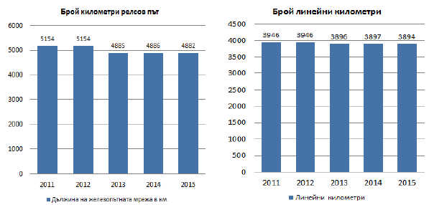
Брой километри релсов път | Number of track km
Дължина на железопътната мрежа в км. | Length of the railway network in km
Брой линейни колометри | Number of line km
Линейни километри | Line km

Year | Length of the railway network in km |  | Year | Line km
2011 | 5154 |  | 2011 | 3946
2012 | 5154 |  | 2012 | 3946
2013 | 4885 |  | 2013 | 3896
2014 | 4886 |  | 2014 | 3897
2015 | 4882 |  | 2015 | 3894

Data on technical safety of the railway infrastructure:
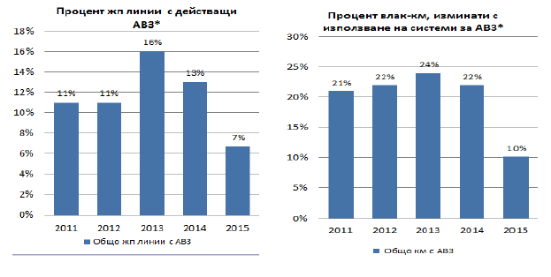
Процент жп линии с действащи АВЗ* | Percentage of tracks with Train Protection Systems (TPSs) in operation*
Общо жп линии с АВЗ | Total number of railway lines with TPS
Процент влак-км, изминати с използване на система за АВЗ* | Percentage of train-kilometres using on-board TPSs*
Общо км с АВЗ | Total km with TPS

Year | Total number of railway lines with TPS |  | Year | Total km with TPS
2011 | 0.11 |  | 2011 | 0.21
2012 | 0.11 |  | 2012 | 0.22
2013 | 0.16 |  | 2013 | 0.24
2014 | 0.13 |  | 2014 | 0.22
2015 | 0.067 |  | 2015 | 0.10

Data on the total number of level crossings (including ‘passive’ and ‘active‘) in Bulgaria
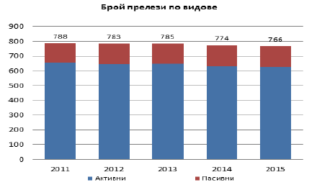
Брой прелези по видове | Number of railway level crossings by types
Активни | Active
Пасивни | Passive

Year | Active | Passive | Total
2011 | 654 | 134 | 788
2012 | 646 | 137 | 783
2013 | 648 | 137 | 785
2014 | 632 | 142 | 774
2015 | 626 | 140 | 766

Fatalities and weighted serious injuries (FWSI) of the risk categories: ‘Passengers‘, ‘Employees’ and ‘Level Crossing Users’ from 2011 to 2015:
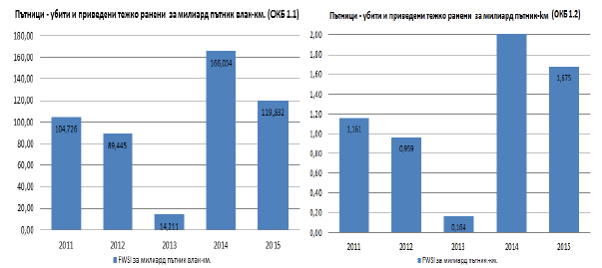
Пътници – убити и приведени тежко ранени за милиард пътник влак-км. (ОКЕ 1.1) | Passengers – fatalities and weighted serious injuries per billion passenger train–km (CST 1.1)
FWSI за милиард пътник влак-км | FWSI per billion passenger train–km
Пътници - убити и приведени тежко ранени за милиард пътник-км (ОКE 1.2) | Passengers – fatalities and weighted serious injuries per billion passenger–km (CST 1.2)
FWSI за милиард пътник-км | FWSI per billion passenger–km

Year | Passengers killed | Passengers seriously injured | Number of train kilometres (In millions) | FWSI for billion passenger train-km. |  | Year | Passengers killed | Passengers seriously injured | Number of passenger–km (In millions) | FWSI per billion passenger-km
2011 | 1 | 14 | 22.917 | 104.726 |  | 2011 | 1 | 14 | 2067.000 | 1.161
2012 | 1 | 8 | 20.124 | 89.445 |  | 2012 | 1 | 8 | 1876.000 | 0.959
2013 | 0 | 3 | 21.110 | 14.211 |  | 2013 | 0 | 3 | 1826.000 | 0.164
2014 | 2 | 15 | 21.080 | 186.034 |  | 2014 | 2 | 15 | 1702.000 | 2.056
2015 | 2 | б | 21.697 | 119.832 |  | 2015 | 2 | 6 | 1552.158 | 1.675

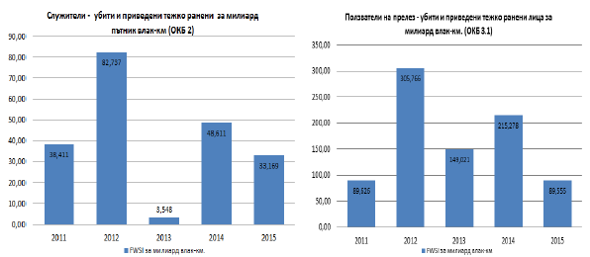
Служители - убити и приведени тежко ранени за милиард пътник влак-км (ОКБ 2) | Employees – fatalities and weighted serious injuries per billion passenger train–km (CST 2)
FWSI за милиард влак-км. | FWSI per billion train-km
Ползватели на прелез-убити и приведени тежко ранени лица за милиард влак-км. (ОКБ 3.1) | Level Crossing Users - FWSIs per billion train–km (CST 3.1)
FWSI за милиард влак-км. | FWSI per billion train-km

Year | Employees killed | Employees seriously injured | Number of train–km (In millions) | FWSI per billion train-km |  | Year | Level crossing users killed | Level crossing users injured | Number of train–km (In millions) | FWSI per billion train-km
2011 | 1 | 2 | 31.241 | 38.411 |  | 2011 | 2 | 8 | 31.241 | 89.625
2012 | 2 | 3 | 27.799 | 82.737 |  | 2012 | 7 | 15 | 27.799 | 305.766
2013 | 0 | 1 | 28.184 | 3.548 |  | 2013 | 3 | 12 | 28.184 | 149.021
2014 | 1 | 4 | 28.800 | 48.611 |  | 2014 | 5 | 12 | 28.800 | 215.278
2015 | 1 | 0 | 30.149 | 33.169 |  | 2015 | 2 | 7 | 30.149 | 89.555

Fatalities and weighted serious injuries (FWSI) of the risk categories: ‘Level Crossing Users’, ‘Trespassers‘, ‘Other’ and ‘All’ 2011 – 2015:
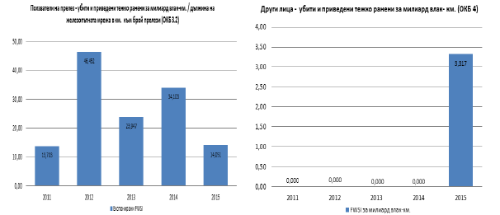
Ползватели на прелез - убити и приведени тежко ранени за милиард влак-км./дължина на железопътната мрежа в км. към брой прелези (ОКБ 3.2) | Level-crossing user - FWSIs per billion train-km /Length of the railway network in km × number of level crossings (CST 3.2)
Експонирани FWSI | Exposed FWSIs
Други лица - убити и приведени тежко ранени за милиард влак-км. (ОКБ 4) | Other persons – fatalities and weighted serious injuries per billion train–km (OKB 4)
FWSI за милиард влак-км. | FWSI per billion train-km

Year | Level crossing users killed | Level crossing users injured | Number of train–km  (In millions) | Length of the railway network in km | Total number of active and passive level crossings | Exposed FWSIs |  | Year | Number of injured – other persons | Number of seriously injured – train–km | Number of train–km (In millions) | FWSIs for billion train-km
2011 | 2 | 8 | 31.241 | 5154.000 | 788 | 13.703 |  | 2011 | 0 | 0 | 31.241 | 0.000
2012 | 7 | 15 | 27.799 | 5154.000 | 783 | 46.452 |  | 2012 | 0 | 0 | 27.799 | 0.000
2013 | 3 | 12 | 25.184 | 4885.000 | 785 | 23.947 |  | 2013 | 0 | 0 | 25.184 | 0.000
2014 | 5 | 12 | 28.800 | 4886.000 | 774 | 34.103 |  | 2014 | 0 | 0 | 28.800 | 0.000
2015 | 2 | 7 | 30.149 | 4882.000 | 766 | 14.051 |  | 2015 | 0 | 1 | 30.149 | 3.317

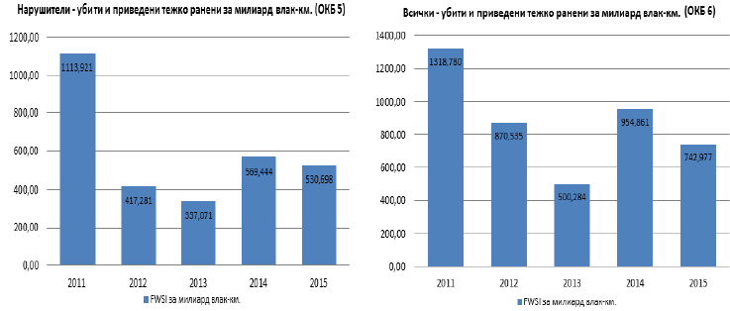
Нарушители - убити и приведени тежко ранени за милиард влак-км. (OKБ 5) | Trespassers – fatalities and weighted serious injuries per billion train–km (OKB 5)
FWSI за милиард влак-км. | FWSI per billion train-km
Всички - убити и приведени тежко ранени за милиард влак-км. (OKБ 6) | Total number of FWSIs per year arising from significant accidents per billion train–km (OKB 6)
FWSI за милиард влак-км. | FWSI per billion train-km

Year | Trespassers – killed | Trespassers – seriously injured | Number of train–km (In millions) | FWSI per billion train-km |  | Year | All – killed |  | All – seriously injured |  | Number of train–km (In millions) |  | FWSI per billion train-km
2011 | 33 | 18 | 31.241 | 1113.921 |  | 2011 |  | 37 |  | 42 |  | 31.241 |  | 1318.780
2012 | 11 | 6 | 27.799 | 417.281 |  | 2012 |  | 21 |  | 32 |  | 27.799 |  | 870.535
2013 | 9 | 5 | 28.184 | 337.071 |  | 2013 |  | 12 |  | 21 |  | 28.184 |  | 500.284
2014 | 15 | 14 | 28.800 | 589.444 |  | 2014 |  | 23 |  | 45 |  | 28.800 |  | 954.881
2015 | 15 | 10 | 30.149 | 530.898 |  | 2015 |  | 20 |  | 24 |  | 30.149 |  | 742.977


C. CHANGES IN LEGISLATION
(Annex to Section F of this report)
Table 9.
Status of transposition of the amendments to Directive 2004/49/EC as of 31/12/2015 in Bulgaria.
(Annex to Section F.1 of this report)
Amendments of Directive 2004/49/EC | Transposed (Yes/No) | Legal references | Date of entry into force
Directive 2008/57/EC | ^{Yes} | Ordinance No 57 of 09/06/2004 on the conditions and essential requirements for railway infrastructure and rolling stock aimed at achieving interoperability of the national railway system with the railway system within the European Union, Chapter V, Section IV ‘Authorisation for placing into service of a vehicle’. | 26/10/2010
Directive 2008/57/EC | ^{Yes} | Ordinance No 59 of 05/12/2006 on safety management in railway transport | 28/12/2010
Directive 2009/149/EC | ^{Yes} | Ordinance No 59, Annex 1 | 22/06/2010
Directive 2014/88/EU | ^{Yes} | Ordinance No 59, Annex 1 | 31/07/2015


Table 10
Legislative and regulatory changes in the field of railway transport of Bulgaria, published in the State Gazette and entering into force in the period from 1 January 2015 to 31 December 2015 (Annex to Section F.2 of this report).
LEGISLATION AND REGULATION | Legal references | Entry into force, date | Description of the change | Reasons for the change
Concerning the NSA | Ordinance No 59 of 05/12/2006 on safety management in railway transport | the State Gazette (SG), No 58 of 31/07/2015 | Annex No 1 of Ordinance No 59 was replaced by the new Annex of Directive 2014/88/EC. | The Bulgarian legislation has transposed Directive 2014/88/ЕС.
Concerning NoBos, DeBos, Assessment bodies, third parties of registration, examination, etc. | Ordinance No 57 of 9 June 2004. Article 13(2) of Ordinance No 57 transposes the texts in Bulgarian legislation for achieving interoperability from Directive 2014/38/ЕС. Article 60a(1)(3) is supplemented by the transposed Directive 2014/106/EU and compatibility of the national one in effect of the ‘National Technical Rules’ explaining the process and Directive 2014/38/EC. | the State Gazette (SG), No 4 of 16 January 2015, effective as of 1 January 2015. | Article 13(2) of Ordinance No 57 transposes texts of Directive 2014/38/EC. Article 60a(1)(3) is complemented by the ‘National Technical Rules’ explaining the process and the scope of control over the activities of the entities for conformity assessment (NoBo and DeBo) regarding compliance with the requirements of the RTA.  For transposition of the texts of Directive 2014/106/EU, in Ordinance No 57 Annex No 1a (EC declaration of verification of subsystems) and Annex No 1b (EC procedure for verification of subsystems) are created. Annex No 8 to Article 56e(3) is also amended. |  | The Bulgarian legislation transposes Directive 2014/106/EU and Directive 2014/38/EC.
Concerning the RU/IM/ECM | Railway Transport Act (RTA); | the State Gazette (SG), No 17 of 6 March 2015 | 1. Item 3a in § 1 of the Supplementary Provisions of Ordinance No 59 provides a more advanced concept of the definition of ‘railway undertaking’ pursuant to Directive 2004/49/EC, rather than the definition of ‘rail carrier’ existing at the moment in RTA and in Ordinance No 59. Under the Bulgarian legislation so far, so that an entity can have access to the railway infrastructure, besides a license, it needs to have a safety certificate.  2. The system for certification of entities in charge of maintenance (ECM) of railway vehicles has been refined with regard to the period of validity of the ECM Certificate in compliance with Regulation (EU) No 445/2011. Article 62b(5) of Ordinance No 59 is amended, as required by Article 7(4) of Regulation (EU) No 445/2011, so that the ECM certificate shall be valid for a period of 5 years. So far, in the current text of the Ordinance, the deadline is specified as five years. | There are clarified provisions of RTA in connection with receiving a reasoned opinion under Infringement Procedure No 2013/2076 on the docket of the European Commission on the incorrect transposition and application of Directive 2004/49/EC concerning the extension of the term ‘railway undertaking’, which includes both companies licensed to operate railway carriages, also such without a license, but which shall mandatorily possess SC. RUs without a license will have access only to the first railway station of the railway infrastructure.
 | Ordinance No 59 of 05/12/2006 on safety management in railway transport. | the State Gazette (SG), No 58 of 31/07/2015 | 1. Item 3a and in § 1 of the Supplementary Provisions of Ordinance No 59 provide a more advanced concept of the definition of ‘railway undertaking’ under Directive 2004/49/EC, rather than the definition of ‘rail carrier’ existing at the moment in RTA and in Ordinance No 59. Under the Bulgarian legislation so far, so that an entity can have access to the railway infrastructure, besides a license, it needs to have a safety certificate.  2. The system for certifying entities in charge of maintenance (ECM) of railway vehicles is refined with regard to the period of validity of the ECM Certificate in compliance with Regulation (EU) No 445/2011. Article 62b(5) of Ordinance No 59 is amended as required by Article 7 (4) of Regulation (EU) No 445/2011, so that the ECM certificate shall be valid for a period of 5 years. So far, in the previous text of the Ordinance, a five-year period was specified. | There are clarified provisions of RTA in connection with receiving a reasoned opinion under Infringement Procedure No 2013/2076 on the docket of the European Commission on the incorrect transposition and application of Directive 2004/49/EC concerning the extension of the term ‘railway undertaking’, which includes both companies licensed to operate railway carriages, also such without a license, but which shall mandatorily possess SC. RUs without a license will have access only to the first railway station of the railway infrastructure.
Application of other requirements of the EU (relating to railway safety) | Ordinance No 46 of 30 November 2001 for the transport of dangerous goods | amended and supplemented the State Gazette (SG), No 24 of 31/03/2015 | Paragraph 2 of the Final Provisions of Ordinance No 46 is amended and supplemented. | Directive 2014/103/EU adapting for the third time the Annexes to Directive 2008/68/EC on the inland transport of dangerous goods to scientific and technical progress is transposed.
 | Ordinance No 54 of 02.06.2003 on the medical and psychological requirements for staff who carry rail passengers and cargo and their accompanying activities and for the conduct of pre-travel (pre-shift) medical examinations | amended the State Gazette (SG), No 76 of 02/10/2015 | The proposed amendments and supplements to Ordinance No 54 (in Appendix No 2a to Article 8a ‘Medical requirements’, item 1.2 ‘Eyesight’) are connected with the change of medical requirements for the eyesight of loco drivers | Transposition of Directive 2014/82/ЕС
 | Ordinance No 56 of 14 February 2003 on the requirements, conditions and procedure for training of candidates for the acquisition of competence required by staff responsible for the safety of transportation by railway transport, or recognition of such a capacity, and the procedure for conducting examinations of persons of the staff responsible for the safety of transportation | amended and supplemented the State Gazette (SG), No 76 of 02/10/2015 | 1. In order to transpose Directive 2014/82/EC, Annex No 5 and No 8 of Ordinance No 56 were revised in connection with the need for a consistent interpretation of the tasks that shall be met during the training of applicants for train drivers in Member States. This aligns the requirements to the trainees and the possibility of not allowing any misunderstanding of the rules.  2. The procedure and method for the recognition of professional qualifications acquired in other Member States of the EU or in third countries for the exercise of regulated professions in the field of railway transport in Bulgaria was clarified according to RPQA, VETA and Decision No 619 of the CM of 20 July 2009 on the adoption of the List of regulated professions in Bulgaria. | Transposition of Directive 2014/82/EC relating to the amendment of Annex IV on general professional knowledge and requirements in connection with the driving license and Annex VI, item 8, on language skills related to the additional certificate of loco drivers.
 | Ordinance No 58 | the State Gazette (SG), No 68 of 15/08/2014 | 5. In the heading of Chapter Sixteen, the words ‘Operating Management’ are replaced with ‘Operations’. | The amendment is related to the implementation of Decision 2011/314/EU concerning the TSI OPE of 1 January 2012.

This report used photos from the following sources:
- http://flickrhivemind.net/ – three of the pictures on the front page 1 and the photos on pages 5, 6, 7, 12, 13, 21, 22, 29 and 30 (above) – all are with author Ivo Radoev;
- http://www.railpictures.net/ – the photos on p. 2 (content), p. 11 and p. 24 – all are with author Ivo Radoev;
- http://www.railwaymodeling.com - the photos on p. 1 (bottom) and of the DMU ‘Siemens Desiro’ series 10.00, p. 30;
- http://lz1866.com/ the official site of Express Service Ltd.) - two of the photos on p. 1, and the photos on p. 8 and p. 31 (below);
- http://www.rail-infra.bg/ (Official site of SE NRIC) - the top photo on p. 1, as well as the map and photo of the bridge below on p. 31;
- http://www.tsv-bg.com/ (Official site of the State Enterprise ‘Transport Construction and Rehabilitation") - the photo at the bottom of p. 1;
- http://lokomotiv.bg/ (Bulgarian locomotive forum) – the 4 photos of the locomotives shown on page 25;
- https://www.mtitc.government.bg/page.php?category=390&id=9040 - the 8 photos on p. 16 and p. 17 are of the final reports of the NIB of Bulgaria (RAIU).

AISKAO - Administrative Information System for Integrated Administrative Services
NSA & NIB reports https://eradis.era.europa.eu/safety_docs/AnnualReport/default.aspx
https://erail.era.europa.eu/safety-indicators.aspx
“Significant accident” means any accident involving at least one rail vehicle in motion, resulting in at least one killed or seriously injured person, or in significant damage to stock, track, other installations or the environment, or extensive disruptions to traffic, excluding accidents in workshops, warehouses and depots (item 1.1 of the Addendum to Annex I of the RSD).
Passenger’ means any person, excluding a member of the train crew, who makes a trip by rail, including passengers trying to embark onto or disembark from a moving train for accident statistics only (item 1.12 of the Addendum to Annex I of RSD).
FWSI (‘Fatalities and weighted serious injuries’) means such a measurement of the consequences of significant accidents combining fatalities and serious injuries, where 1 serious injury is considered statistically equivalent to 0.1 fatalities (See letter (d) of Article 3 of Decision 2009/460/EC).
‘Employee or contractor’ means any person whose employment is in connection with a railway and who is at work at the time of the accident, including the staff of contractors, self-employed contractors, the crew of the train and persons handling rolling stock and infrastructure installations (item 1.13 of the Addendum to Annex I of the RSD).
‘Level crossing user’ means any person using a level crossing to cross the railway line by any means of transport or by foot (item 1.14 of the Addendum to Annex I of the RSD).
‘Trespasser’ means any person present on railway premises where such presence is forbidden, with the exception of a level crossing user.
‘Other persons at a platform’ means any person at a railway platform who is not defined as ‘passenger’, ‘employee or contractor’, ‘level crossing user’, ‘trespasser’ or‘other person not at a platform’;.
‘Other persons not at a platform’ means any person not at a railway platform who is not defined as ‘passenger’, ‘employee or contractor’, ‘level crossing user’, ‘trespasser’ or‘other person at a platform’.
EMC – Emergency medical care.
Commission Regulation (EU) No 1078/2012 of 16 November 2012 on a common safety method for monitoring to be applied by railway undertakings, infrastructure managers after receiving a safety certificate or safety authorisation and by entities in charge of maintenance.
ALCS – Automatic level-crossing signalling
ALCDAB – Automatic level-crossing device with alarm and barrier
EB – Electric barrier
MV – Motor vehicle
Ordinance No 56 of 14 February 2003 on the requirements, conditions and procedure for training of candidates for the acquisition of competence required by personnel responsible for the safety of transportation by railway transport, or recognition of such a capacity, and the procedure for conducting examinations of persons of the staff responsible for the safety of transportation
UDVK – Train Movement and Capacity Management
UDVGD - Train Movement and Station Activity
RRI – Regional Railway Inspectorate at the Railway Administration Executive Agency
EDC – Electrical Distribution Company at SE NRIC
IE – Interlocking equipment
WRS – Wagon-revising section
DMU – Diesel multiple units
EMU – Electric multiple units
Ordinance No 58 of 2006 on the rules for technical operation, movement of trains and railway signalling;
TOR – Technical operation rules of the railway infrastructure, issued by the Director General of NRIC in 2006
RMTSA – Rules on the movement of trains and shunting activity in railways issued by the Director General of NRIC in 2006
IRB – Industrial railway branch
NM– near misses
Commission Directive 2014/88/EU of 9 July 2014 amending Directive 2004/49/EC of the European Parliament and of the Council as regards common safety indicators and common methods of calculating accident costs.
Directive 2012/34/EC of the European Parliament and of the Council of 21 November 2012 establishing a single European railway area
Regulation (EC) No 1371/2007 of the European Parliament and of the Council of 23 October 2007 on rail passengers’ rights and obligations
Commission Directive 2014/103/EU of 21 November 2014 adapting for the third time the Annexes to Directive 2008/68/EC of the European Parliament and of the Council on the inland transport of dangerous goods to scientific and technical progress.
Commission Directive 2014/82/EU of 24 June 2014 amending Directive 2007/59/EC of the European Parliament and of the Council as regards general professional knowledge and medical and licence requirements.
Directive 2014/106/EU of the Commission of 5 December 2014 amending Annexes V and VI to Directive 2008/57/EC of the European Parliament and the Council on the interoperability of the rail system within the Community.
Regulation (EU) No 445/2011 of the Commission of 10 May 2011 on a system of certification of entities in charge of the maintenance for freight wagons and amending Regulation (EC) No 653/2007.
Commission Regulation (EC) No 352/2009 of 24 April 2009 on the adoption of a common safety method of risk evaluation and assessment as referred to in Article 6(3)(a) of Directive 2004/49/EC of the European Parliament and of the Council.
Commission Implementing Regulation (EU) No 402/2013 of 30 April 2013 on the common safety method for risk evaluation and assessment and repealing Regulation (EC) No 352/2009.
Commission Regulation (EU) No 1077/2012 of 16 November 2012 on a common safety method for supervision by national safety authorities after issuing a safety certificate or safety authorisation.
‘significant accident’ means any accident involving at least one rail vehicle in motion, resulting in at least one killed or seriously injured person, or in significant damage to stock, track, other installations or the environment, or extensive disruptions to traffic. Accidents in workshops, warehouses and depots are excluded; ‘significant damage to stock, track, other installations or the environment’ means damage that is equivalent to EUR 150,000 or more; ‘extensive disruptions to traffic’ means that train services on a main railway line are suspended for six hours or more;
‘train-km’ means the unit of measure representing the movement of a train over one kilometre. The distance used is the distance actually run, if available, otherwise the standard network distance between the origin and destination shall be used. Only the distance on the national territory of the reporting country shall be taken into account (definitions from Directive 2014/88/EU amending Directive 2004/49/EC); ‘passenger-km’ means the unit of measure representing the transport of one passenger by rail over a distance of one kilometre. Only the distance on the national territory of the reporting country shall be taken into account; * ‘line km’ means the length measured in kilometres of the railway network in Member States, whose scope is laid down in Article 2. For multiple–track railway lines, only the distance between the origin and destination is to be counted. ** ‘track km’ means the length measured in kilometres of the railway network in Member States, whose scope is laid down in Article 2. Each track of a multiple-track railway line is to be counted’. 10 July 2014, L 201/17 Official Journal of the European Union BG --- symbol showing lack of data for the respective year
‘Automatic Train protection (ATP)’ is a system which requires compliance with signals and speed limits through supervision of the speed limits, including automatic braking on signal submitted for this;
‘Passive level crossing’ means a level crossing without any form of warning system or protection activated when it is unsafe for the user to traverse the crossing. ‘Active level crossing’ means a level crossing where the crossing users are protected from or warned of the approaching train by devices activated when it is unsafe for the user to traverse the crossing.
‘Fatalities and weighted serious injuries (FWSI)’ means a measurement of the consequences of significant accidents combining fatalities and serious injuries, where 1 serious injury is considered statistically equivalent to 0.1 fatalities (letter (d) of Article 3 of Decision 2009/460/EC) ‘Level crossing’ means any level intersection between a road or passage and a railway, as recognised by the infrastructure manager and open to public or private users. Passages between platforms within the railway stations are excluded, as well as passages over tracks for the sole use of employees (definitions from Directive 2004/49/EC);
Commission Directive 2014/88/EU of 9 July 2014 amending Directive 2004/49/EC of the European Parliament and of the Council as regards common safety indicators and common methods of calculating accident costs.
Directive 2014/38/EC of 10 March 2014 amending Annex III to Directive 2008/57/EC of the European Parliament and of the Council as regards the level of permissible noise pollution.
Commission Directive 2014/106/EU of 5 December 2014 amending Annexes V and VI to Directive 2008/57/EC of the European Parliament and of the Council on the interoperability of the rail system within the Community
Directive 2014/103/EU of 21 November 2014 adapting for the third time the Annexes to Directive 2008/68/EC to scientific and technical progress.
Commission Directive 2014/82/EU of 24 June 2014 amending Directive 2007/59/EC of the European Parliament and of the Council as regards general professional knowledge and medical and licence requirements.
RPQA – Recognition of Professional Qualifications Act of the Republic of Bulgaria.
VETA – Vocational Education and Training Act of the Republic of Bulgaria.
CM – Council of Ministers of the Republic of Bulgaria.

