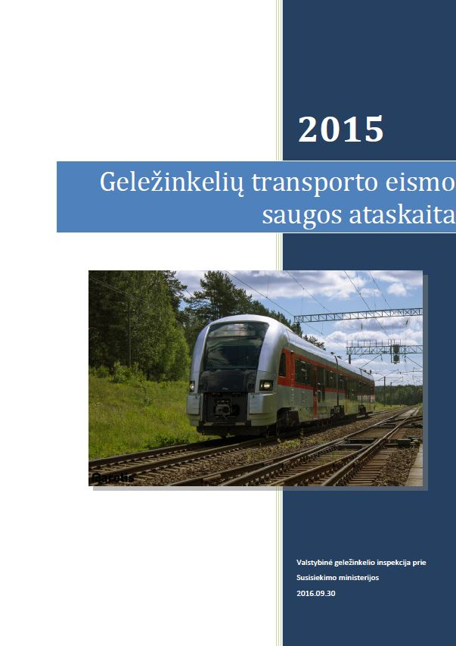

**Railway Traffic Safety Report**

State Railway Inspectorate under

the Ministry of Transport and Communications

30/09/2016

**Table of contents**

A. INTRODUCTION 1

A.1. Objectives and scope of the Railway Traffic Safety Report 1

B. General safety level in 2015 2

B.1. General conclusions about 2015 2

B.2. National safety strategies, programmes and initiatives 2

B.3. General information on 2015 3

B.4. Priorities for the next year 4

C. Development of Safety 5

C.1. Trend Analysis 5

C.2. Results of traffic safety measures (recommendations) 6

C.3. Measures unrelated to the traffic safety recommendations 6

D. Supervision of railway undertakings (carriers) and railway infrastructure managers 7

D.1. Strategy and plans 7

D.2. Human Resources 7

D.3. Competences 7

D.4. Decision making 8

D.5. Cooperation 8

D.6. Implementation of measures 8

E. Issuance of safety certificates and railway traffic safety authorisations 9

E.1. Information on the procedure for the issue of safety certificates and railway traffic safety authorisations 9

E.2. Use of non-certified interoperability constituents 9

E.3. Communication with other States’ national safety authorities regarding issuance of safety certificates 9

E.4. Issues relating to the procedural aspects of granting certificates or authorisations 9

E.5. Feedback 9

F. Changes in the traffic safety legislation in 2015 11

F.1. Railway Safety Directive 11

F.2. Changes in legislation in 2015 11

G. Application of the common safety method (CSM) on risk evaluation and assessment 12

G.1. NSA’s experience 12

G.2. Communication and feedback 12

G.3. Review of national rules 13

A. Appendix. Common safety indicators 15

B. Appendix. Changes in the legislation. 22

C. Appendix. Significant traffic accidents in Lithuania in 2015 37

# **INTRODUCTION**

## Objectives and scope of the Railway Traffic Safety Report

Pursuant to the provisions of Article 23 Directive No 2004/49/EC of the European Parliament and of the Council on safety on the Community's railways[1],

The European Union’s national safety authorities must, by September 30 each year, prepare an annual railway traffic safety report (hereinafter referred to as the ‘Traffic Safety Report’).

The objectives of the annual Traffic Safety Report are as follows:

1. to present summary information on the status of the Lithuanian railway system in 2015 and to compare it with the 2007-2014 data;
2. to present the railway traffic safety improvement trends in 2015;
3. to review the problems encountered by the State Railway Inspectorate under the Ministry of Transport and Communications (‘the Inspectorate’) in ensuring railway traffic safety.

The annual railway Traffic Safety Report contains information on:

1. improvement of traffic safety and the general traffic safety indicators set by the Minister for Transport and Communications of the Republic of Lithuania;
2. amendments to legal acts related to traffic safety;
3. improvement of the procedures for the issue of safety certificates to railway undertakings (carriers) and safety authorisations to railway infrastructure managers;
4. results of traffic safety audits of railway infrastructure managers and railway undertakings (carriers) and their experience related to traffic safety;
5. maintenance of freight wagons used in the 1 520 mm gauge railway network.

Pursuant to Article 6(18) of the Law of the Republic of Lithuania on Railway Traffic Safety, the Inspectorate is to publish the annual Traffic Safety Report on its website [2] and submit it to the European Union Agency for Railways[3] (‘ERA’).

This report includes information on traffic safety throughout the Lithuanian railway network.

The annual Traffic Safety Report, having been drawn up for a ninth year already, has been prepared in accordance with the recommendations laid down in the ERA guide for the pattern and use of tables in annual traffic safety reports of national safety authorities.

The annual railway Traffic Safety Report has been drafted on the basis of the statistical data gathered and systematised by the Inspectorate as well as the findings of the 2015 traffic safety reports of railway infrastructure managers and railway undertakings (carriers).

# **General safety level in 2015**

## General conclusions about 2015

The data on the safety of the Lithuanian railway transport system for 2015 suggest that the level of traffic safety has remained high compared to previous years. Moreover the numbers of both significant traffic accidents and fatalities in the railway environment have declined:

* in 2015, the total number of accidents decreased from 59 to 42, compared to 2014;
* in 2015, the number of significant traffic accidents went down by 28.8 %, compared to 2014;
* in 2015, the number of fatalities decreased by 27.3 %, compared to 2014.

It should also be noted that this positive trend is further corroborated by the National Reference Values (‘NRV’) at the end of 2015:

* The risk to passengers NRV is 100 % lower than the permissible NRV laid down in European Commission (‘EC’) Decision 2012/226/EU;
* The NRV of danger to employees is 10 % lower than the permissible NRV laid down in Commission Decision 2012/226/EU.
* The NRV of danger to level crossing users is 72 % below the permissible NRV established by Commission Decision 2012/226/EU;
* The NRV of danger to unauthorised persons on railway premises is 77 % lower than the permissible NRV laid down by Commission Decision 2012/226/EU;
* The NRV of danger to persons classified as ‘Others’ is 100 % lower than the permissible NRV laid down by Commission Decision 2012/226/EU.

The above data illustrates that the level of safety of the Lithuanian railway transport system complies with the European Union standards and long-term goals.

**Table 1. Overall NRV after Q4, 2015**

|  |  |  |  |
| --- | --- | --- | --- |
| National  reference values | Tolerable value under  2012/226/EU  NRV X 109 | Yearly NRV X 109 | Change |
| Passengers | 97.20 | 0.00 | -100 % |
| Employees | 41.00 | 0 | -100 % |
| Level-crossing  users | 522.00 | 148.54 | -72% |
| Unauthorised persons | 2050.00 | 466.83 | -77% |
| Others | 11.60 | 0.00 | -100% |
| Society | 2590.00 | 615.37 | -76% |

15 significant and 27 insignificant traffic accidents took place in Lithuania in 2015. A detailed list of major traffic accidents is given in Annex C.

## National safety strategies, programmes and initiatives

In 2015, development of the Lithuanian transport policy was carried out in accordance with the 2014-2022 National Programme for Transport Development, approved by the Government on 18 December 2013. The strategic goal of the Programme is to develop a sustainable, environment-friendly, competitive and high value-added transport system in Lithuania.

Other objectives of the programme:

1. to increase freight and passenger mobility by improving the main grid corridors of the EU Trans-European transportation grid and their connections with the national and local transportation grids and by enhancing the efficiency of the interoperability between different transport modes.
2. to improve the transport sector's competitiveness through an active transport policy;

to enhance the quality of transport and logistical services;

1. to promote the sustainability of the local (urban and suburban) transport system;
2. to improve energy efficiency in transport and to mitigate the negative environmental impact of transport;
3. to improve the safety and interoperability of traffic, including railway traffic.

In 2014, the Inspectorate elaborated its safety strategy, which was approved in 2015. Based on the good practices of Sweden, the ‘zero’ vision was adopted: “a safe society and safe railway transport without traffic accidents, fatalities, or injuries”. The Inspectorate’s safety strategy, based on this zero version, was developed using the X-Matrix under the LEAN Government management methodology. This means that the above document linked the goals of individual members of the Inspectorate’s staff with the institution’s long-term objective of ensuring zero fatalities, injuries and accidents on Lithuanian railways. Accordingly, the strategy is made up of three parts, setting out measures for the prevention of fatalities, injuries and traffic accidents.

In September 2015, the Inspectorate completed the implementation of a project for the creation of public electronic services for railway transport risk management and monitoring (Lith. *Geležinkelių transporto rizikos valdymo ir priežiūros viešųjų elektroninių paslaugų sukūrimas*) to transfer to the electronic environment the service of electronic monitoring of the Lithuanian public railway infrastructure as well as the electronic service of managing the risk of railway system changes.

The Inspectorate envisages the implementation of a range of projects in 2015-2020 to improve the safety and interoperability of the Lithuanian railway transport system. Projects in preparation:

1. Safety improvement on level crossings. An intelligent transport system will be developed to reduce the number of traffic accidents and violations of road traffic regulations on level crossings (‘ITS’). The ITS will consist of an information system and acquired equipment which will monitor the status of level crossings in real time, provide the drivers and pedestrians with information on traffic conditions and record a range of violations committed on level crossings.
2. Transfer of the Inspectorate’s services and the public electronic services of risk management and monitoring to the electronic environment, and upgrading thereof The Inspectorate will carry out a project to upgrade and expand the following services: traffic risk management, noise control, structure technical control and railway infrastructure monitoring modules, and introduce electronic testing of persons, rolling-stock registration, railway traffic accident investigations as well as other services.
3. The most effective instruments for informing and educating the public The Inspectorate intends to implement a project to identify the most effective instruments for informing and educating the public in order to reduce the risk of injuries and fatalities to different social groups in railway protection zones. Based on the findings of an investigation, the Inspectorate will implement a public awareness programme on safe behaviour in the railway protection zone.

The railway infrastructure manager (AB Lietuvos geležinkeliai) obtained a renewal of authorisations in the traffic safety area in 2015.

## General information on 2015

In 2015, the Inspectorate issued and renewed two safety certificates - Part A and two safety certificates - Part B. 75 undertakings were granted railway traffic safety authorisations.

In carrying out the supervision of railway undertakings (carriers) and railway infrastructure managers, the Inspectorate inspected 74 railway undertakings (carriers) and railway infrastructure managers in 2015.

21 inspections of railway undertakings (carriers) and railway infrastructure managers detected violations of railway transport safety regulations.

The Inspectorate’s internal audits were launched in 2014 using the methodologies of the European Union Agency for Railways (‘ERA’): the Cross-audit and the Matrix assessment. Upon completion of the internal audits in 2015, recommendations were issued for the enhancement of legal and organisational processes in the Inspectorate.

A customer satisfaction survey was conducted towards the end of 2015 among the Inspectorate’s customers. After summarising the data collected, a conclusion was drawn that the Inspectorate’s services are viewed positively by customers. The customer satisfaction index was 73 %.

The Inspectorate developed a vision for zero-based strategy, which was recognised as the best innovative example of public administration in Lithuania in the selection of the public administration quality initiative, organised by the Lithuanian Ministry of the Interior. In 2015, the Strategy was included by the Ministry of Public Service and Administrative Reform of Luxembourg and the European Institute of Public Administration into the agenda of the 8th European Quality Conference, as a recognised good practice.

## Priorities for the next year

In implementing the functions entrusted to it, in 2015

the Inspectorate envisages the following:

* To seek compliance with the Lithuanian NRV, as laid down by European Commission Decision 2012/226/EU[4];
* To control the supply of railway system interoperability components to the market and to ensure that only those interoperability components that meet the core requirements are used in the implementation of the Rail Baltica project;
* By way of cooperation between the Inspectorate’s specialists and infrastructure managers, to introduce typical safety management systems with a view to enhancing the safety of railway undertakings and reducing the number of traffic accidents in the railway transport area;
* To partake in the priority countries programme of the European Agency for Railways and its sub-elements: Cross-audit and Matrix assessment.
* To assist ERA auditors by providing necessary information and relevant documents and to implement the assessment recommendations.
* In order to implement the projects for improving level crossing safety (Lith. *Saugumo didinimas geležinkelių pervažose*) and for the transfer of Inspectorate’s services and the public electronic services of risk management andmonitoring to the electronic environment, and upgrading thereof (Lith. *VGI teikiamų paslaugų, rizikos valdymo ir priežiūros viešųjų elektroninių paslaugų perkėlimas į elektroninę erdvę bei jų atnaujinimas*), the following activities are envisaged in 2016:
* Preparation of an investment project;
* Submission of project applications to obtain funding;
* Preparation of contract documents for the projects;
* Implementation of public procurement for the projects.

# **Development of Safety**

## Trend Analysis

**Table 2. 2015 accident statistics and losses as well as working time spent as a result of accidents**

|  |  |  |  |  |  |  |  |  |  |
| --- | --- | --- | --- | --- | --- | --- | --- | --- | --- |
| Serious accidents | Major traffic accidents | | Other traffic accidents | Incidents | Injuries | | Fatalities | | Losses and working time spent (in Euro and hours) |
| Total | In train kilometres | Total | In train kilometres | Total | In train kilometres |
| 0 | 13 | 928x10-9 | 40 | 5 | 5 | 353x10-9 | 8 | 565X10-9 | EUR 134 475.33 / 84 hrs. 24 mins. |

In 2015, 40 accidents occurred, including 13 significant accidents: 0 train collisions; 0 derailments; 3 accidents on level crossings; 10 accidents attributable to unauthorised persons; 0 rolling-stock fires; 5 incidents.

As with the number of accidents, the number of fatalities on level crossings has remained stable since 2012, averaging around three fatalities per year.

The number of significant accidents in Lithuania decreased in 2009-2014. This trend continued in 2015. The year 2014 saw a reduction in the number of accidents compared to the previous year (-3). For the past six years, train collisions causing major losses have been avoided. Similarly, there have been no derailments for five consecutive years. Fires resulting in major losses or fatalities have also been avoided for six consecutive years.

The number of fatalities in railway accidents has been on the decline since 2009. 2015 has been no exception, as the number of fatalities went down by 3 compared to 2014

The number of unauthorised person fatalities, as well as the total number of fatalities, have been declining for as long as such records have been kept. The change on the 2014 figure is not significant: a decrease of 14 % (-1).

A downward trend in the number of accidents involving unauthorised persons was observed in 2010-2014, yet in 2015 the reduction in this type of accidents was insignificant (-1). Compared with 2013, the decline remains significant, as the number of accidents caused by unauthorised persons dropped by 50 % (-10).

The number of accidents on level crossings also showed a downward trend from 2009. Since 2012, this number has stabilised, totalling around four accidents per year.

The number of injuries on level crossings remained constant from 2009 to 2015, despite an increase in 2014 due to one very serious accident.

Charts representing the above and other relevant indicators are given in Annex A.

In 2015, as in previous years, the main causes of traffic accidents are as follows:

* Unauthorised persons do not know how to conduct themselves safely by the railway and how to cross the tracks safely and fail to appreciate the danger; they often cross the track at the wrong places to save time or out of curiosity (the former violation is mainly typical of children) or because they have no other choice due to the underdeveloped pedestrian infrastructure.
* Users of level crossings and pedestrian crossings fail to respect the Level Crossing Construction and Use Rules and the Traffic Rules, in particular:
* they enter the level crossing/pedestrian crossing despite a prohibitive traffic light or signal by the signalman, while the barrier is down or is descending;
* they go around other vehicles that have stopped before the level crossing to let the train pass;
* they lift the barrier or go around it without permission;
* they enter a railway pedestrian or level crossing despite there being an obstacle behind it that necessitates stopping on the level crossing or pedestrian crossing;
* they fail to stop at the road sign ‘STOP’;

Other traffic accidents occur due to deficient railway infrastructure or rolling-stock as well as traffic organisation and management.

## Results of traffic safety measures (recommendations)

The Inspectorate received no safety recommendations from the Head of Accident Investigation. In the course of the above period, the Inspectorate did not issue any...

## Measures unrelated to the traffic safety recommendations

In 2015, the inspectorate did not submit any measures unrelated to the traffic safety recommendations.

A detailed list of significant accidents in 2015 and findings is presented in Annex C.

# Supervision of railway undertakings (carriers) and railway infrastructure managers

## Strategy and plans

The Inspectorate’s priorities and targeted activities in supervising railway undertakings (carriers) and railway infrastructure managers are determined by

1. Legal acts of the Republic of Lithuania. Order No V-604 of the Head of the Inspectorate of 27 December 2010 approving the Rules for the scheduled and unscheduled checks carried out by the State Railways Inspectorate under the Ministry of Transport and Communications sets out the types of checks carried out by the Inspectorate. The legislation governing the activities of economic operators specifies the inspection intervals.
2. The available information on the activities of legal entities that might violate the legal provisions and therefore pose a risk to the public.

The strategy and inspection schedules for supervising legal entities shall be developed:

* With regard to the Lithuanian legislation specifying the intervals for inspection of activities by legal entities;
* With regard to a request from an economic operator to perform an activity check/consultation;
* In order to determine whether the economic operator has fulfilled the requirements issued during previous inspections;
* With regard to reports and complaints received from persons concerning infringements committed by economic operators;
* With regard to data on traffic accidents (investigation findings, recommendations and report results);
* With regard to the information collected during the assessment of the railway traffic safety management systems of railway undertakings (carriers) and railway infrastructure managers;
* With regard to the reports submitted by the economic operator to the Inspectorate.

The Inspection Schedule may be amended:

* in the event of a change in the legal status or area of activities of the economic entity;
* in the event of a change in the regulatory requirements governing the inspections.

Based on the experience acquired in the performance of supervisory functions, the Inspectorate revises the inspection plan on a monthly basis in order to ascertain whether the initially established targeted activities, use of data and/or information from various sources, results of supervision, and distribution of resources are appropriate and, where necessary, changes the priorities and makes the necessary amendments thereto.

## Human Resources

In 2015, the Inspectorate carried out five types of inspections:

1. Inspections of hazardous objects;
2. Supervisory inspections of the use of structures;
3. Certified activity inspections;
4. Licensed activity inspections;
5. Other railway transport activity inspections.

Inspections in detail: an inspection of hazardous objects (including completion of the inspection report) takes about five hours. In total, approximately 40 hours were spent on the inspection of hazardous objects in 2015. Around 172 hours were spent on supervisory verifications of the use of structures. A total of 212 hours were spent on inspections in 2015.

Five employees of the Inspectorate were involved in inspections in 2015. Each employee spent an average of 42 hours on inspections.

In 2015, there were a total of 252 working days in Lithuania (2,016 working hours). On average, each employee spent 2.1 % of his/her working time on inspections/audits.

## Competences

To conduct the supervision of legal entities, each employee must have the required competences. These are listed in the job description of each employee and verified at the time of recruitment and annual employee assessment.

Each inspection shall be performed by at least two employees. The more experienced employee shall be assigned the manager of the inspection. The less experienced employee shall learn from the manager of the inspection by performing the tasks assigned to them and observing the actions of the manager of the inspection.

Prior to starting the inspection, the employees must be familiar with the Rules for Inspections and the legal acts regulating the activities of the legal entity being inspected, and to be aware of the rights and obligations of legal entities.

Before carrying out an inspection, the employee must identify the objective thereof and specify the documents to be inspected.

## Decision making

Legal compliance is monitored and assured by inspecting legal entities and providing them with consultations. If a violation is identified the Inspectorate evaluates its scale, potential effect on society and other circumstances of the violation and makes a decision regarding the measures to be applied.

The goal is to expand the consulting practice as widely as possible and to help legal entities understand and comply with the regulatory requirements. If violations are identified, the Inspectorate orders the legal entity to prepare and implement a plan for correcting the legal violations identified. The goal is a collaboration, based on goodwill with the undertakings and to minimise any penalties imposed on the legal entities.

It is noteworthy that in 2015 the Inspectorate received no observations or complaints from railway undertakings (carriers) and railway infrastructure managers concerning the inspections performed and the decisions taken.

## Cooperation

In implementing the provisions of Article 8 of Commission Regulation (EU) No 1077/2012 on a common safety method for supervision by national safety authorities after issuing a safety certificate or safety authorisation, the Inspectorate signed a cooperation agreement with the Latvian NSA on 10 December 2014 and with the Polish NSA on 21 July 2015.

Both agreements were drafted in line with the ERA Guide for the implementation of Article 8 of Commission Regulation (EU) No 1077/2012 on a common safety method for supervision by national safety authorities after issuing a safety certificate or safety authorisation[5].

## Implementation of measures

The Inspectorate oversees the implementation of traffic safety measures. All the traffic safety measures introduced in 2015 either have already been implemented or are presently being implemented by legal entities.

# Issuance of safety certificates and railway traffic safety authorisations

## Information on the procedure for the issue of safety certificates and railway traffic safety authorisations

Safety certificates and railway traffic safety authorisations (hereinafter referred to as ‘authorisations’) are issued in accordance with the Rules on safety certification of railway undertakings (carriers) and of railway infrastructure managers, approved by Order No 3-37 of the Minister for Transport and Communications of the Republic of Lithuania of 23 January 2003. Interested persons can find the legislation governing the issue of safety certificates and authorisations on the public database of the Seimas of the Republic of Lithuania[6] and on the website of the Inspectorate.[7] Information on the issuance of safety certificates and railway traffic safety authorisations (legal basis, guides, application forms etc.) is published on the Inspectorate’s website[8], which also lists all the companies that hold safety certificates and/or authorisations.

## Use of non-certified interoperability constituents

Non-certified interoperability constituents were not used.

## Communication with other States’ national safety authorities regarding issuance of safety certificates

No inquiries were received in 2015 from the NSAs of other States relating to Part A of the safety certificate issued in Lithuania where a railway undertaking/carrier applies for Part B of the safety certificate in another State.

In 2015, the Inspectorate did not submit any inquiries to other States’ NSAs for information on Part A of the safety certificate issued in another State, where a railway undertaking/carrier of another State has applied to the Inspectorate in order to obtain Part B of the safety certificate in Lithuania.

## Issues relating to the procedural aspects of granting certificates or authorisations

In 2015, there were no issues relating to the granting of certificates or authorisations.

## Feedback

Pursuant to Resolution No 511 of the Government of the Republic of Lithuania of 4 May 2010 regarding the optimisation of supervisory functions performed by institutions, the Inspectorate conducted a survey to measure the following:

1. the percentage of economic entities stating that the supervisory authority’s consulting was useful and helped them to understand and comply with legal acts (92 %);
2. the percentage of economic entities stating that the check-lists helped them to understand the legal provisions and implement them better (94 %);
3. the percentage of economic entities stating that they received useful consulting in the first year of operations and no sanctions were imposed on them, except in cases where they were necessary and unavoidable in order to prevent significant damage or threat to the public, other persons’ interests or the environment (97 %).

In order to ensure the high quality of customer consultation by telephone, a survey for the evaluation of the telephone consultations provided was carried out in each quarter. The survey focused on the quality of telephone services, on the service level, and on the number of calls answered. The general telephone consultation quality was 90 % in the first quarter, 90 % in the second quarter, 96 % in the third quarter, and 92 % in the fourth quarter of 2015. Railway undertakings (carriers) have the opportunity to file complains concerning the activities of the Inspectorate both directly at the Inspectorate as well as by electronically evaluating the administrative services provided[9].

In 2015, the Inspectorate did not receive any complaints about inadequate provision of services.

# Changes in the traffic safety legislation in 2015

## Railway Safety Directive

In 2015, 35 legal acts transposing the provisions of Directive 2004/49/EC on safety on the Community’s railways were in force in Lithuania.

A definitive list of these legal acts is presented in Annex B, Table 1.

Table 2, Annex B, contains information on the status of transposition of the amendments to the Railway Safety Directive at the end of 2015.

## Changes in legislation in 2015

Table 2, Annex B, lists the essential changes of the legislation along with relevant details (the title of the legal act, date of adoption, the content of adoption or amendment of the legal act and the reasons for adopting or amending the legal act).

# Application of the common safety method (CSM) on risk evaluation and assessment

## NSA’s experience

The common safety method on risk evaluation and assessment is applied in accordance with the requirements laid down in Commission Implementing Regulation (EU) No 402/2013 of 30 April 2013 on the common safety method for risk evaluation and assessment and repealing Regulation (EC) No 352/2009

(‘Regulation No 402/2013’). Under the second paragraph of Article 20 of Regulation No 402/2013, the regulation is binding in its entirety as of 21 May 2015, however, even before that date, it was applicable:

1. to any significant technical modifications having an impact on vehicles within the meaning of Article 2(c) of Directive 2008/57/EC of the European Parliament and of the Council of 17 June 2008 on the interoperability of the rail system within the Community (‘the Directive’);
2. to all significant changes to the structural subsystems necessary under Article 15(1) of the Directive or the technical specifications for interoperability (TSIs).

Pursuant to Article 6(4) of Regulation No 402/2013, the Inspectorate did not take part, as an independent assessment body, in the risk management processes in the event of changes to the railway system, conducted by railway undertakings (carriers) and infrastructure managers.

Standard stages in CSM application:

1. In accordance with Article 4(1) of Regulation No 402/2013, railway undertakings (carriers) and infrastructure managers (hereinafter referred to as ‘the proposers’) conduct a preliminary evaluation on the potential impact of a particular change on the safety of the railway system. The proposers provide reasoning for any decision finding the existence of impact.
2. In accordance with the criteria set out in Article 4(2) of Regulation No 402/2013, the proposers decide on the significance of the change having an impact on the safety of the railway system. Relevant criteria:
   * the consequences of failure of the railway system change;
   * the novelty used in implementing the change;
   * the complexity of the change.
3. With regard to the decisions adopted by the proposers:
4. a decision that the railway system change in question is not significant is adopted – the Inspectorate familiarises itself with the decision and evaluates the decision and the supporting documents;
5. a decision that the railway system change in question is significant is adopted and a risk management process is initiated in line with the requirements of Annex I of Regulation No 402/2013. In accordance with the requirements of Article 6 of the Regulation, an independent assessment body conducts an independent process evaluation and delivers the safety assessment report.

In 2015, there were no separate independent assessment bodies compliant with the requirements of Annex II of Regulation No 402/2013 and delivering safety assessment reports in Lithuania.

## Communication and feedback

With the entry into force of Regulation No 402/2013, the legal entities concerned were informed that the Inspectorate would no longer perform the AsBo functions and the source of information on the bodies performing assessment was indicated.

After the Inspectorate completed the implementation of the Project for the creation of public electronic services for railway transport risk management and monitoring, the proposers were also offered training introducing the consumer interface of the GERVIS electronic service for railway transport risk management.

Additionally, a publicity campaign for the service was implemented and the message on the service was spread through internet news portals.

## Review of national rules

On 7 May 2015, amendments were made to Law No VII-1688 adding Article 151 to Law No IX-1905 of the Republic of Lithuania on Railway Traffic Safety and amending the Annex to Law No  IX-1905. According to the amendments, the activities of an assessment body (AsBo under Regulation (EU) No 402/2013) may be carried out by persons holding valid accreditation.

Alternative measures when certifying entities responsible for supervision

In view of the fact that the Lithuanian railway infrastructure for the most part consists of a 1 520 mm gauge, Lithuania has made use of the exception provided for in

Article 14a(8)(b) of Directive 2008/110/EC.

Pursuant to Paragraph 2 of the Rules for the Certification of Entities in Charge of Technical Maintenance approved by Order No 3-431 of 11 July 2011 of the Minister of Transport and Communications of the Republic of Lithuania, technical maintenance entities in charge of the technical maintenance of freight wagons used within the 1,435mm gauge railway network shall be certified in accordance with Commission Regulation (EU) No 445/2011 of 10 May 2011 on a system of certification of entities in charge of maintenance for freight wagons and amending Regulation (EU) No 653/2007 (OJ 2011 L 122, p. 22).

Technical maintenance entities in charge of freight wagons used within the 1,520mm gauge railway network (the `technical maintenance entity') shall be certified in accordance with the aforementioned rules.

If the entity in charge of maintenance is an infrastructure manager or railway undertaking (carrier), compliance of freight wagons with the applicable requirements is verified by the national safety authority, which grants infrastructure managers authorisations in the traffic safety area and issues railway undertakings (carriers) with safety certificates.

Railway rolling stock managers may obtain a technical maintenance entity certificate when registering rolling stock in the Register of Railway Rolling Stock of the Republic of Lithuania.

Technical maintenance entities willing to obtain a technical maintenance entity certificate shall establish a freight wagon technical maintenance system which should include technical maintenance organisational measures, assurance measures, control measures and technical maintenance performance measures. This system of certification makes sure that the entity responsible for maintenance creates its own maintenance system and complies with the regulatory requirements. This is intended to ensure the safe operational condition of freight wagons.

Five entities in charge of maintenance for 1 1520 mm gauge freight wagons were registered before 31 December 2015:

1. AB Lietuvos geležinkeliai (the certificate of an entity in charge of maintenance issued on 16 November 2011);
2. UAB Skinest Baltija (the certificate of an entity in charge of maintenance issued on 7 November 2013);
3. UAB Railana (the certificate of an entity in charge of maintenance issued on 20 July 2015);
4. UAB Klaipėdos jūrų krovinių kompanija Bega (the certificate of an entity in charge of maintenance issued on 30 November 2015).
5. UAB Autorail (the certificate of an entity in charge of maintenance issued on 29 December 2015);

**ANNEXES**

# **Appendix. Common safety indicators**

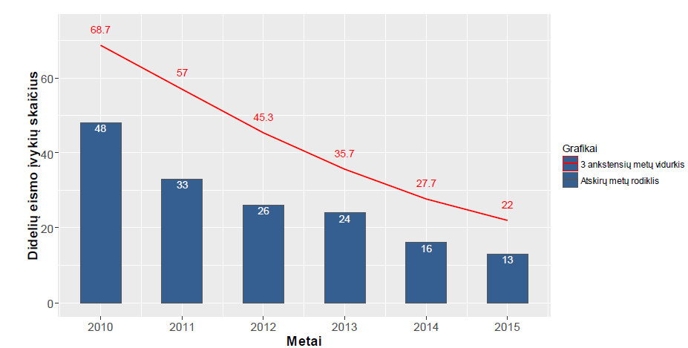

|  |  |
| --- | --- |
| Didelių eismo įvykių skaičius | Number of significant accidents |
| Grafikai | Legend |
| 3 ankstensių metų vidurkis | Average for 3 previous years |
| Atskirų metų rodiklis | Indicator for separate years |
| Metai | Year |

**Fig. 1. Number of major traffic accidents in 2009-2014**

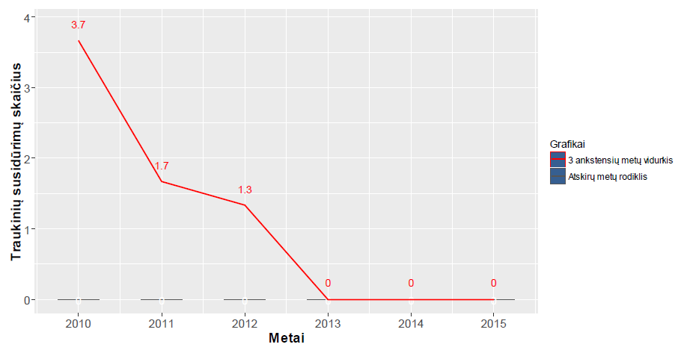

|  |  |
| --- | --- |
| Traukinių susidūrimų skaičius | Number of train collisions |
| Grafikai | Legend |
| 3 ankstensių metų vidurkis | Average for 3 previous years |
| Atskirų metų rodiklis | Indicator of separate years |
| Metai | Year |

**Fig. 2. Number of train collisions from 2009-2014**

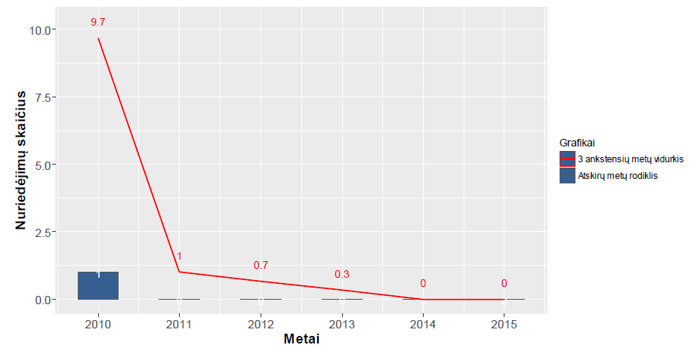

|  |  |
| --- | --- |
| Nuriedėjimų skaičius | Number of derailments |
| Grafikai | Legend |
| 3 ankstensių metų vidurkis | Average for 3 previous years |
| Atskirų metų rodiklis | Indicator of separate years |
| Metai | Year |

**Fig. 3. Number of derailments from 2009-2014**

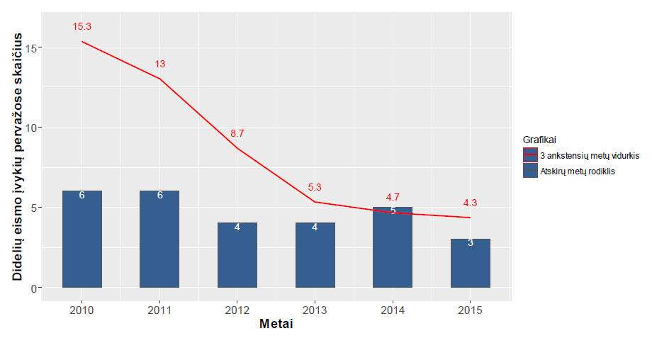

|  |  |
| --- | --- |
| Didelių eismo įvykių pervažose skaičius | Number of significant accidents at level crossings |
| Grafikai | Legend |
| 3 ankstensių metų vidurkis | Average for 3 previous years |
| Atskirų metų rodiklis | Indicator of separate years |
| Metai | Year |

Fig. 4. Number of major traffic accidents at level crossings from 2009-2014

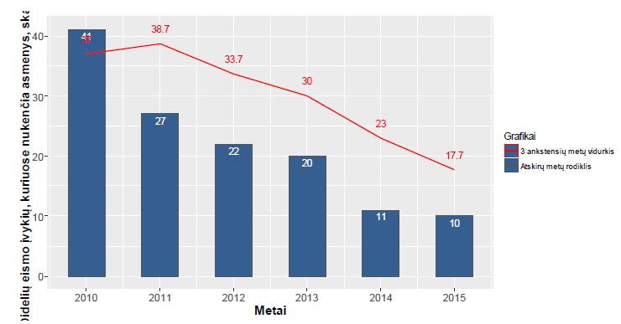

|  |  |
| --- | --- |
| Didelių eismo įvykių, kuriuose nukenčia asmenys, skaičius | Number of significant accidents with casualties |
| Grafikai | Legend |
| 3 ankstensių metų vidurkis | Average for 3 previous years |
| Atskirų metų rodiklis | Indicator of separate years |
| Metai | Year |

**Fig. 5. Number of major traffic accidents caused by unauthorised persons from 2009-2014**

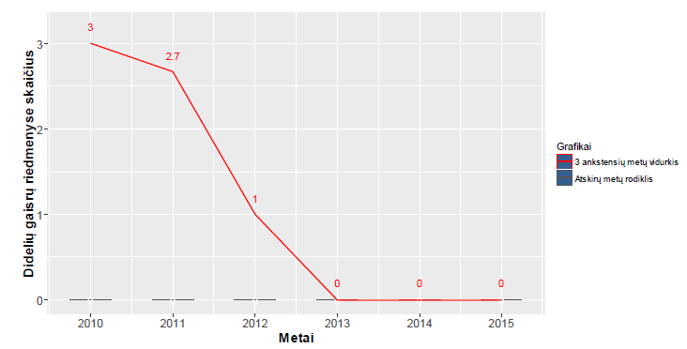

|  |  |
| --- | --- |
| Didelių gaisrų riedmenyse skaičius | Number of major fires in rolling-stock |
| Grafikai | Legend |
| 3 ankstensių metų vidurkis | Average for 3 previous years |
| Atskirų metų rodiklis | Indicator of separate years |
| Metai | Year |

Fig. 6. Number of major fires from 2009-2014

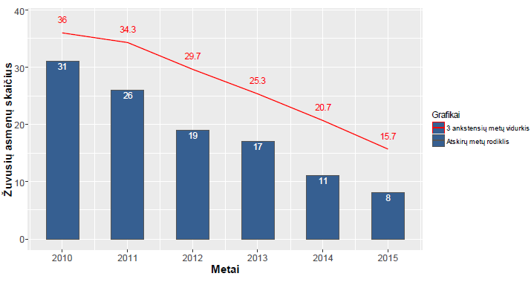

|  |  |
| --- | --- |
| Žuvusių asmenų skaičius | Number of fatalities |
| Grafikai | Legend |
| 3 ankstensių metų vidurkis | Average for 3 previous years |
| Atskirų metų rodiklis | Indicator of separate years |
| Metai | Year |

**Fig. 7. Number of fatalities from 2009-2014**

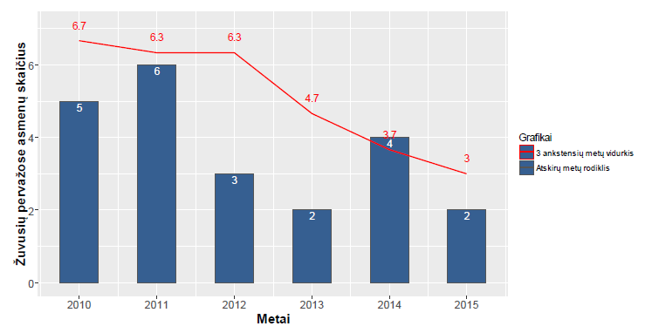

|  |  |
| --- | --- |
| Žuvusių pervažose asmenų skaičius | Number of fatalities at level crossings |
| Grafikai | Legend |
| 3 ankstensių metų vidurkis | Average for 3 previous years |
| Atskirų metų rodiklis | Indicator of separate years |
| Metai | Year |

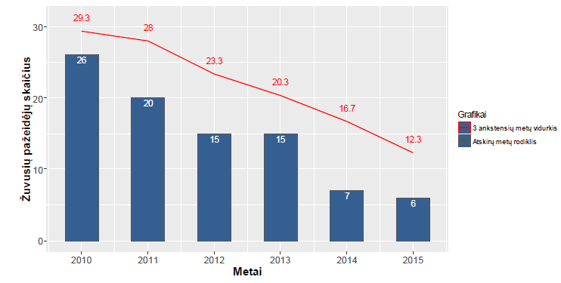

|  |  |
| --- | --- |
| Žuvusių pažeidėjų skaičius | Number of fatalities |
| Grafikai | Legend |
| 3 ankstensių metų vidurkis | Average for 3 previous years |
| Atskirų metų rodiklis | Indicator of separate years |
| Metai | Year |

Fig. 9. Number of fatalities among unauthorised persons from 2009-2014

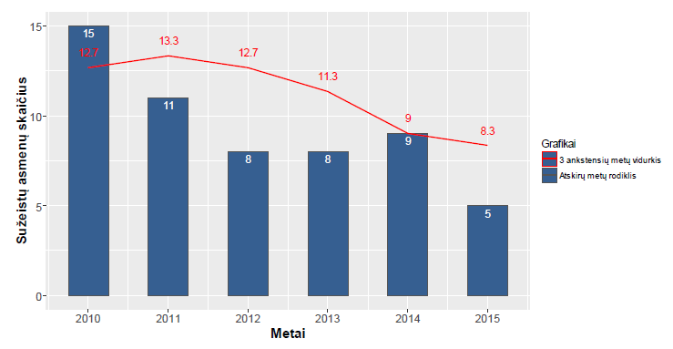

|  |  |
| --- | --- |
| Sužeistų asmenų skaičius | Number of injured persons |
| Grafikai | Legend |
| 3 ankstensių metų vidurkis | Average for 3 previous years |
| Atskirų metų rodiklis | Indicator of separate years |
| Metai | Year |

Fig. 10. Number of injuries from 2009-2014

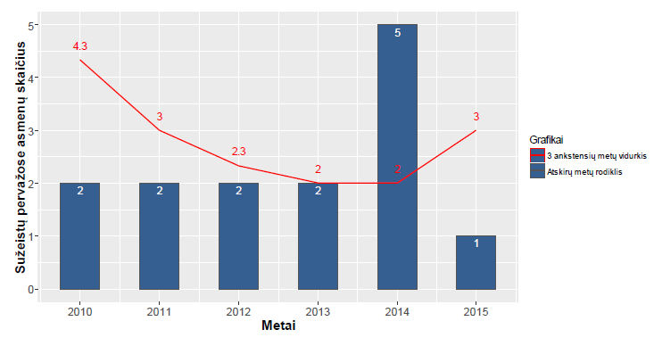

|  |  |
| --- | --- |
| Sužeistų pervažose asmenų skaičius | Number of persons injured at level crossings |
| Grafikai | Legend |
| 3 ankstensių metų vidurkis | Average for 3 previous years |
| Atskirų metų rodiklis | Indicator of separate years |
| Metai | Year |

Fig. 11. Number of injuries in level-crossing accidents from 2009-2014

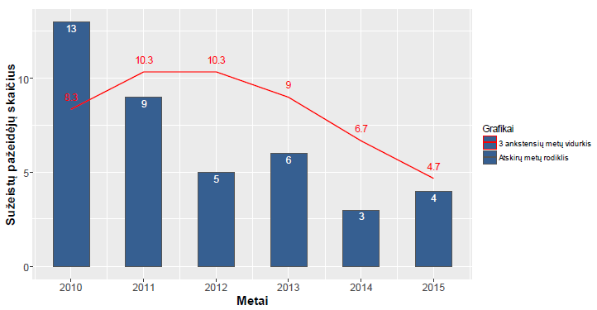

|  |  |
| --- | --- |
| Sužeistų pažeidėjų skaičius | Number of injured unauthorised persons |
| Grafikai | Legend |
| 3 ankstensių metų vidurkis | Average for 3 previous years |
| Atskirų metų rodiklis | Indicator of separate years |
| Metai | Year |

**Fig. 12. Number of injuries to unauthorised persons from 2009-2014**

**Fig. 13. Other traffic accidents from 2012-2014**

# **Appendix. Changes in the legislation.**

|  |  |  |  |
| --- | --- | --- | --- |
| Table 1. Information on the status of transposition of the amendments to the Railway Safety Directive at the end of 2015. | | | |
| **Amendments to Railway Safety Directive** | Transposed? (Y/N) | Legal reference | Date of entry into force |
| Directive 2004/49/EC | Yes | Law No XI-642 amending the Law on Railway Traffic Safety of the Republic of Lithuania | 30/01/2010 |
| Law amending Articles 2, 5, 6, 9, 12 and 22 and the Annex of the Law on Railway Traffic Safety of the Republic of Lithuania | 03/05/2011 |
| Law amending Articles 3, 7, 10, 11, 13, 16, 21, 22, 23, 24, 25, 26, 28 and 31 and repealing Articles 6, 30 and 301 of the Code of Railway Transport of the Republic of Lithuania and adding Articles 101and 231 to the Code | 01/07/2013 |
| Law on Administrative Proceedings | 14/01/1999 |
| Law on Standardisation of the Republic of Lithuania; | 28/04/2000 |
| Resolution No 1468 of the Government of the Republic of Lithuania of 22 November 2004 on the establishment of a Register of Rolling Stock and Containers of the Republic of Lithuania, approval of its regulations and launching of its operations | 26/11/2004 |
| Resolution No 743 of the Government of the Republic of Lithuania of 16 June 2010 amending Resolution No 1468 of the Government of the Republic of Lithuania of 22 November 2004 on the establishment of a Register of Rolling Stock and Containers of the Republic of Lithuania, approval of its regulations and launching of its operations | 23/06/2010 |
| Resolution No 674 of the Government of the Republic of Lithuania of 4 July 2006 on the approval of the Rules for designation and notification of testing laboratories and certification and inspection bodies | 15/07/2006 |
| Order No 3-382 of the Minister for Transport and Communications of the Republic of Lithuania of 4 October 2006 on the amendment of the Regulations of the Register of Railway Infrastructure of the Republic of Lithuania | 13/10/2006 |
| Order No 3-437 of the Minister for Transport and Communications of the Republic of Lithuania of 13 July 2010 approving the Procedure for drafting and adoption of subsystem technical rules | 18/07/2010 |
| Order No 3-467 of the Minister for Transport and Communications of the Republic of Lithuania of 3 September 2013 amending Order No 3-509 of the Minister for Transport and Communications of the Republic of Lithuania of 27 December 2006 on the approval of the Regulations of the State Railway Inspectorate under the Ministry of Transport and Communications | 08/09/2013 |
| Order No 3-659 of the Minister for Transport and Communications of the Republic of Lithuania of 31 December 2013 amending Order No 3-586 of the Minister for Transport and Communications of the Republic of Lithuania of 23 December 2004 on the approval of the Rules for the establishment and application of requirements for the interoperability of the trans-European rail system | 01/01/2014 |
| Order No 3-658 of the Minister for Transport and Communications of 31 December 2013 amending Order No 3-507 of the Minister for Transport and Communications of the Republic of Lithuania of 22 December 2006 approving the Rules on the issuance of permits to begin the use of the structural subsystems and rolling-stock of the trans-European rail system in the Republic of Lithuania | 01/01/2014 |
| Order No 3-660 of the Minister for Transport and Communications of the Republic of Lithuania of 31 December 2013 on the approval of the Rules for supplying the market with the interoperability constituents of the railway system (‘Order No 3-660’) | 01/01/2014 |
| Directive 2008/110/EC | Yes | Law No XI-642 amending the Law of the Republic of Lithuania Law on Railway Traffic Safety | 30/01/2010 |
| Law No XI-1807 of the Republic of Lithuania on Management of State Information Resources | 01/01/2012 |
| Regulations of the Register of Rolling Stock and Containers of the Republic of Lithuania, approved by Resolution No 1468 of the Government of the Republic of Lithuania of 22 November 2004 | 26/11/2004 |
| Resolution No 743 of the Government of the Republic of Lithuania of 16 June 2010 amending Resolution No 1468 of the Government of the Republic of Lithuania of 22 November 2004 on the establishment of a Register of Rolling Stock and Containers of the Republic of Lithuania, approval of its regulations and launching of its operations | 23/06/2010 |
| Law No XI-1334 amending Articles 2, 5, 6, 9, 12 and 22 and the Annex of the Law on Railway Traffic Safety of the Republic of Lithuania | 01/05/2011 |
| Law No X-653 amending Article 4 of the Law on Approval, Entry into Force and Application of the Railway Transport Code, amending Articles 3, 4, 6, 7, 10, 11, 12, 13, 16, 19, 28, 30 and 48 and the Annex of the Railway Transport Code, and adding Article 30(1) to the Code | 28/06/2006 |
| Law No XI-1595 amending Articles 1, 3, 4, 7, 11, 12, 13, 16, 23, 24, 25, 29 and 33 and the Annex of the Code of Railway Transport of the Republic of Lithuania, adding Articles 4-1, 25-1 and 33-1 to the Code and repealing Articles 8 and 27 of the Code | 08/10/2011 |
| Law XII-235 amending Articles 3, 7, 10,11, 13, 16, 22, 23, 24, 25, 26, 28, 28 and 31 and repealing Articles 6, 30 and 30-1 of the Code of Railway Transport of the Republic of Lithuania and adding Articles 10-1 and 23-1 to the Code | 01/07/2013 |
| Order No 3-444 of the Minister for Transport and Communications of the Republic of Lithuania of 22 July 2011 amending Order No 3-37 of the Minister for Transport and Communications of the Republic of Lithuania of 23 January 2003 on the approval of the Rules for safety certification of railway undertakings (carriers) and railway infrastructure managers | 29/07/2011 |
| Order No 3-421 of the Minister for Transport and Communications of the Republic of Lithuania of 11 June 2012 amending Order No 3-37 of the Minister for Transport and Communications of the Republic of Lithuania of 23 January 2003 on the approval of the Rules for safety certification of railway undertakings (carriers) and railway infrastructure managers | 20/06/2012 |
| Order No 3-514 of the Minister for Transport and Communications of the Republic of Lithuania of 1 October 2013 amending Order No 3-37 of the Minister for Transport and Communications of the Republic of Lithuania of 23 January 2003 on the approval of the Rules for safety certification of railway undertakings (carriers) and railway infrastructure managers | 11/10/2013 |
| Order No 3-431 of the Minister for Transport and Communications of the Republic of Lithuania of 19 July 2011 on the approval of Certification Rules for entities in charge of maintenance | 21/12/2013 |
| Order No 3-634 of the Minister for Transport and Communications of 13 December 2013 [amending](http://www.infolex.lt/ta/292522?nr=12) [Order No 3-431 of the Minister for Transport and Communications of the Republic of Lithuania of 19 July 2011 on the approval of Certification Rules for entities in charge of maintenance](http://www.infolex.lt/ta/292522?nr=12) | 21/12/2013 |
| Order No 3-359 of the Minister for Transport and Communications of the Republic of Lithuania of 13 June 2011 amending Order No 3-238 of the Minister for Transport and Communications of the Republic of Lithuania of 12 June 2006 on the approval of the Description of the establishment of common traffic safety indicators | 19/06/2011 |
| Order No V-441 of the Head of the State Railway Inspectorate under the Ministry of Transport and Communications of 20 July 2011 on the approval of the Procedure for the evaluation of applications from entities in charge of maintenance for the certificate of an entity in charge of maintenance for freight wagons used in the 1 520 mm gauge railway network | 24/07/2011 |
| Commission Directive 2009/149/EC | Yes | Law No XI-642 amending the Law of the Republic of Lithuania Law on Railway Traffic Safety | 03/05/2011 |
| Order No 3-424 of the Minister for Transport and Communications of the Republic of Lithuania of 7 July 2010 amending Order No 3-238 of the Minister for Transport and Communications of the Republic of Lithuania of 12 June 2006 on the establishment of common traffic safety indicators | 15/07/2010 |
| Order No 3-483 of the Minister for Transport and Communications of the Republic of Lithuania of 9 August 2010 amending Order No 3-238 of the Minister for Transport and Communications of the Republic of Lithuania of 12 June 2006 on the establishment of common traffic safety indicators | 13/08/2010 |
| Order No 3-359 of the Minister for Transport and Communications of the Republic of Lithuania of 13 June 2011 amending Order No 3-238 of the Minister for Transport and Communications of the Republic of Lithuania of 12 June 2006 on the approval of the Description of the establishment of common traffic safety indicators | 19/06/2011 |
| Order No 3-685 of the Minister for Transport and Communications of the Republic of Lithuania of 23 October 2012 amending Order No 3-238 of the Minister for Transport and Communications of the Republic of Lithuania of 12 June 2006 on the approval of the Description of the establishment of common traffic safety indicators | 28/10/2012 |
| 2014/88/EU | Yes | Order No 3-177(1.55) of the Minister for Transport and Communications of the Republic of Lithuania of 7 May 2015 amending Order No 3-238 of the Minister for Transport and Communications of the Republic of Lithuania of 12 June 2006 on the approval of the Description of the establishment of common traffic safety indicators | 08/05/2015 |

*N.B.: Information on the implementation of European Commission Directive 2014/88/EU and Directive 2012/64/EU will be provided in the 2015 Lithuanian Railway Traffic Safety Report.*

|  |  |  |  |  |
| --- | --- | --- | --- | --- |
| Table 2. Information on changes in the traffic safety legislation in 2015 | | | | |
| Legislation | Reference to legal act | Date of entry into force | Amendments: | Reasons for amendment |
| Implementation of other EU requirements | Law No VII-1688 adding Article 151 to Law No IX-1905 of the Republic of Lithuania on Railway Traffic Safety and amending the Annex to Law No  IX-1905 | 21/05/2015  (amendment) | According to the amendments, the activities of an assessment body (AsBo under Regulation (EU) No 402/2013) may be carried out by persons holding a valid accreditation. | Implementation of Regulation (EU) No 402/2013 |
| Implementation of other EU requirements  Regarding railway undertakings, railway infrastructure managers and certified entities in charge of maintenance  Related to NSA | Law No XII-1793 of 16 June 2015 amending Law No IX-1905 of the Republic of Lithuania on Railway Traffic Safety | 01/09/2015  (recast) | The provisions governing economic operator activities in the area of railway transport, previously contained in subordinate legislation, have been transferred to the Law. | Modification of legal regulation in view of the fact that, under national law, restrictions on economic operators as well as the main provisions regulating their activities should be laid down by |
|  |  | Implementation of Regulation (EU) No 445/2011 According to the amendments, safety certificates are required not only for railway undertakings (carriers) but also other undertakings that manoeuvre and/or to enter or exit the site of construction, repair and/or maintenance of railway infrastructure facilities and that must obtain the safety certificate in accordance with the procedure prescribed by the legislation.  The terminology has been unified and the legal regulation enhanced. | law, rather than by subordinate legislation. Implementation of Regulation (EU) No 445/2011 Modification of legal regulation |
| Related to NSA  Licensing of railway undertakings (carriers) | Resolution No 976 of the Government of the Republic of Lithuania of 16 September 2015 amending Resolution No 783 of the Government of the Republic of Lithuania of 17 June 2003 approving the Licensing Rules for railway undertakings (carriers) | 01/11/2015  (amendment) | The majority of the provisions governing the conditions of granting a licence have been transferred to the Law (Railway Transport Code). The procedural provisions of granting licences have been amended. | Modification of legal regulation in view of the fact that, under national law, restrictions on economic operators as well as the main provisions regulating their activities should be laid down by law, rather than by subordinate legislation. |
| Related to NSA  Licensing of railway undertakings (carriers) | Resolution No 1031 of the Government of the Republic of Lithuania of 30 September 2015 amending Resolution No 1052 of the Government of the Republic of Lithuania of 13 November 2013 on the approval of the Rules on mandatory third-party liability insurance of railway undertakings (carriers) and undertakings using public railway infrastructure | 01/11/2015  (amendment) | The majority of the provisions concerning civil liability requirements have been transferred to the Law (Railway Transport Code). | Modification of legal regulation in view of the fact that, under national law, restrictions on economic operators as well as the main provisions regulating their activities should be laid down by law, rather than by subordinate legislation. |
| **Requirements for for train drivers**  **Safety management systems (SMSs)** | Order No 3-358(1.5 E) of the Minister for Transport and Communications of the Republic of Lithuania of 24 August 2015 amending Order No 3-297 of the Minister for Transport and Communications of the Republic of Lithuania of 17 July 2006 on the approval of the Requirements for railway traffic safety management systems | 01/09/2015  (amendment) | It has been established that the above Order must be observed when conducting medical examinations as well as theoretical and practical testing of professional knowledge and skills for train drivers that were issued with documents authorising them to operate rolling-stock prior to 1 September 2011 | Modification of legal regulation |
|  |  |  | Requirements for SMS components relating to the requirements for train drivers have been amended. |  |
| **Requirements for train drivers** | Order No 3-258(1.5E) of the Minister for Transport and Communications of the Republic of Lithuania of 18 June 2015 amending Order No 3-297 of the Minister for Transport and Communications of the Republic of Lithuania of 17 July 2006 on the approval of the Requirements for railway traffic safety management systems | 01/01/2016  (amendment) | It has been established that the train drivers’ comprehension (listening and reading) and communication (oral and written) skills in the language specified by the railway infrastructure manager must be of level B1 or above. | Implementation of Decision No 2012/88/EC. |
| **Requirements for train drivers** | Order No 3-433(1.5 E) of the Minister for Transport and Communications of the Republic of Lithuania of 20 October 2015 amending Order No 3-297 of the Minister for Transport and Communications of the Republic of Lithuania of 17 July 2006 on the approval of the Requirements for railway traffic safety management systems | 01/01/2016  (amendment) | It has been established that the health as well as theoretical and practical professional knowledge and skills of train drivers that were issued with documents authorising them to operate rolling-stock prior to 1 September 2011 correspond to the requirements applicable to train drivers as of 1 January 2016. | Modification of legal regulation |
| **Signalling requirements** | Order No 3-509(1.5 E) of the Minister for Transport and Communications of the Republic of Lithuania of 21 December 2015 amending Order No 483 of the Minister for Transport and Communications of the Republic of Lithuania of 30 December 1997 on the approval of the Rules on railway traffic signalling | 01/01/2016  (amendment) | Modifications have been made to the sending light signals of the double-track automatic block, allowing exit from the station to the side track in an irregular direction | Modification of legal regulation |
| **Provision of training facilities** | Order No 3-368(1.5 E) of the Minister for Transport and Communications of the Republic of Lithuania of 31 August 2015 amending Order No 3-237 of the Minister for Transport and Communications of the Republic of Lithuania of 12 June 2006 on the approval of the Rules for providing railway undertakings (carriers) with training capacities | 01/09/2015  (recast) | Provisions have been transferred to the Law on Railway Traffic Safety (‘LRTS’) | Modification of legal regulation in view of the fact that, under national law, restrictions on economic operators as well as the main provisions regulating their activities should be laid down by law, rather than by subordinate legislation. |
| **Requirements for train drivers** | Order No 3-335(1.5 E) of the Minister for Transport and Communications of the Republic of Lithuania of 13 August 2015 amending Order No 3-163 of the Minister for Transport and Communications of the Republic of Lithuania of 16 March 2010 on the approval of requirements for train driver professional training programmes | 01/09/2015  (recast) | Changes were made to the requirements for train driver training programmes and some provisions were transferred to the law (LRTS) | Modification of legal regulation in view of the fact that, under national law, restrictions on economic operators as well as the main provisions regulating their activities should be laid down by law, rather than by subordinate legislation. |
| **Requirements for train drivers** | Order No 3-434(1.5 E) of the Minister for Transport and Communications of the Republic of Lithuania of 20 October 2015 amending Order No 3-163 of the Minister for Transport and Communications of the Republic of Lithuania of 16 March 2010 on the approval of requirements for train driver professional training programmes | 21/10/2015  (recast) | Transposition of Council Directive 2014/82/EU | Implementation of Directive 2014/82/EEC |
| **Requirements for train drivers** | I hereby repeal Order No 3-126(1.5E) of the Minister for Transport and Communications of the Republic of Lithuania of 31 March 2015 amending Order No 3-301 of the Minister for Transport and Communications of the Republic of Lithuania of 7 May 2010 approving the procedure for acquiring the right to operate rolling stock. | 01/04/2015  (amendment) | It has been established that the documents authorising the operation of rolling-stock that were issued prior to 1 September 2011 are valid until 31 August 2018 | Modification of legal regulation |
| **Requirements for train drivers** | Order No 3-363(1.5 E) of the Minister for Transport and Communications of the Republic of Lithuania of 26 August 2015 amending Order No 3-301 of the Minister for Transport and Communications of the Republic of Lithuania of 7 May 2010 approving the procedure for acquiring the right to operate rolling stock | 01/09/2015  (recast) | Excessive requirements already covered by the legislation laying down requirements for SMSs have been lifted | Modification of legal regulation |
| **National safety rules** | Order No 3-332(1.5 E) of the Minister for Transport and Communications of the Republic of Lithuania of 12 August 2015 amending Order No 3-506 of the Minister for Transport and Communications of the Republic of Lithuania of 16 August 2010 on the approval of the List of national traffic safety rules | 01/09/2015  (recast) | The List of national safety rules was reduced in accordance with the ERA recommendations (NSR tool) | Modification of legal regulation |
| **Safety requirements for level crossings and pedestrian crossings** | Order No 3-276(1.5E) of the Minister for Transport and Communications of the Republic of Lithuania of 30 June 2015 amending Order No 3-431-(E) of the Minister for Transport and Communications of the Republic of Lithuania of 14 November 2014 on the approval of Order No 3-36 of the Minister for Transport and Communications of 27 January 2005 approving the Level Crossing Construction and Use Rules | 01/07/2015  (amendment) | The minimum technical requirements for pedestrian crossings have been established | Introduction of additional safety measures at the NSA's initiative |
| **Regarding railway undertakings, railway infrastructure managers and certified entities in charge of maintenance** | Order No 3-344(1.5 E) of the Minister for Transport and Communications of 14 August 2015 amending Order No 3-431 of the Minister for Transport and Communications of the Republic of Lithuania of 19 July 2011 on the approval of Certification Rules for entities in charge of maintenance | 01/09/2015  (recast) | The main provisions have been transferred to the law (‘LRTS’) | Modification of legal regulation in view of the fact that, under national law, restrictions on economic operators as well as the main provisions regulating their activities should be laid down by law, rather than by subordinate legislation. |
| **Requirements in the railway protection zone** | Order No 3-485(1.5 E) of the Minister for Transport and Communications of the Republic of Lithuania of 27 November 2015 amending Order No 3-507 of the Minister for Transport and Communications of the Republic of Lithuania of 23 December 2008 on the approval of the Procedure for trimming and cutting the trees and shrubs that grow in the protection zone of railway tracks and facilities thereof and in the right of way of roads of national significance and pose a danger to traffic safety | 01/09/2015  (recast) | Requirements concerning the trimming of trees and shrubs in the railway protection zone have been updated | Modification of legal regulation |
| **Requirements for train drivers** | Order No  3-350(1.5E) of the Minister for Transport and Communications of the Republic of Lithuania of 18 August 2015 approving the Procedure for obtaining the right to operate rolling-stock and for the recognition of documents attesting the right to operate rolling-stock issued in other States | 01/09/2015  (new legislation) | A procedure for the recognition of train driver’s licences issued in third countries has been established.  Border railway lines have been identified where rolling-stock may be operated based on the recognition in the Republic of Lithuania of documents attesting the right to operate rolling-stock issued in other states. | Implementation of Directive 2007/59/EC on train drivers |
| **Regarding designated bodies, notified bodies, assessment bodies and third persons**  **Implementation of other EU requirements** | Order No 3-315(1.5E) of the Minister for Transport and Communications of the Republic of Lithuania of 27 July 2015 amending Order No 3-507 of the Minister for Transport and Communications of the Republic of Lithuania of 22 December 2006 on the approval of the Rules on the issuance of permits to begin the use of structural subsystems and rolling-stock in the Republic of Lithuania | 01/08/2015  (amendment) | The Inspectorate has been granted the right to approve the Lithuanian inspection procedure. | Modification of legal regulation |
| Order No 3-303(1.5E) of the Minister for Transport and Communications of the Republic of Lithuania of 28 July 2015 amending Order No 3-507 of the Minister for Transport and Communications of the Republic of Lithuania of 22 December 2006 on the approval of the Rules on the issuance of permits to begin the use of structural subsystems and rolling-stock in the Republic of Lithuania | 01/09/2015  (amendment) | Annex 10 (requirements for economic operators wishing to perform the functions of a notified body) and a number of definitions have been deleted – the provisions have been transferred to the LRTS | Modification of legal regulation in view of the fact that, under national law, restrictions on economic operators as well as the main provisions regulating their activities should be laid down by law, rather than by subordinate legislation. |
| **Regarding railway undertakings, railway infrastructure managers and certified entities in charge of maintenance** | Order No 3-446-(1.5E) of 28 October 2015 of the Minister for Transport and Communications of the Republic of Lithuania amending Order No 3-37 of the Minister for Transport and Communications of the Republic of Lithuania of 23 January 2003 on the approval of the Rules for safety certification of railway undertakings (carriers) and railway infrastructure managers | 01/11/2015  (recast) | Railway undertakings (carriers) are now obliged to inform the Inspectorate on the implemented changes to the certified activities. The cases of amendment and renewal of the safety certificate and railway traffic safety authorisations have been re-defined and the cases of supplementing the safety certificate and railway traffic safety authorisations have been specified. | Adaptation of subordinate legislation in accordance with the amended clauses of the Railway Transport Code of the Republic of Lithuania and modification of legal regulation |
| **Implementation of other EU requirements** | Order No 3-304(1.5E) of the Minister for Transport and Communications of the Republic of Lithuania of 28 July 2015 amending Order No 3-586 of the Minister for Transport and Communications of the Republic of Lithuania of 23 December 2004 on the approval of the Rules for the establishment and application of requirements for the interoperability of the trans-European rail system | 29/07/2015  (amendment) | Amendments have been made to the procedure for applying to the Ministry of Transport and Communications by an applicant that finds the application of the relevant TSI requirements to the projects of structural subsystems or rolling-stock projects implemented by it unacceptable due to legal, contractual, economic, financial, social or environmental reasons and seeks recognition of the projects of structural subsystems or rolling stock as projects at an advanced stage of development (‘request for recognition of a project’s advanced stage of development’) | Modification of legal regulation |
| **Related to NSA** | Order No 3-531-(1.5E) of the Minister for Transport and Communications of the Republic of Lithuania of 23 December 2015 amending Order No 3-79 of the Minister for Transport and Communications of the Republic of Lithuania of 23 December 2015 on the approval of the Regulations for the investigation and response to railway traffic accidents, serious accidents and incidents | 01/01/2016  (recast) | The provisions on the serious accident investigator have been deleted (it falls within the competence of the Ministry of Justice and, thus, the investigation procedure was approved by the Minister for Justice) | Modification of legal regulation by amendment of the Law on Railway Traffic Safety |
| **Related to the serious accident investigator** | Order No 1R-385 of the Minister for Justice of the Republic of Lithuania of 30 December 2015 approving the Procedure for the investigation of serious accidents, accidents and incidents in railway transport and for the drafting and delivery of investigation reports and railway traffic safety recommendations | 01/01/2016  (new legislation) | The procedure for the investigation of serious accidents, accidents and incidents in railway transport by the serious accident investigator and the procedure for submitting safety recommendations and reports have been established | Modification of legal regulation by amendment of the Law on Railway Traffic Safety |
| **Implementation of other EU requirements** | Order No 3-496(1.5E) of the Minister for Transport and Communications of the Republic of Lithuania of December 2015 amending Order No 3-317 of the Minister for Transport and Communications of the Republic of Lithuania of 28 May 2004 establishing of the Register of Railway Infrastructure of the Republic of Lithuania and approving its Regulations | 09/12/2015  (amendment) | The preamble has been amended, specifying the legislation which is the basis for Register management and describing the terms used in this legal act. | Modification of legal regulation |
| **Related to NSA** | Order No V-171 of the Head of the State Railway Inspectorate under the Ministry of Transport and Communications of 28 August 2015 amending Order No V-196 of the Head of the State Railway Inspectorate under the Ministry of Transport and Communications of 29 June 2010 approving the procedure for the recognition of the examiners of train drivers, requirements for examiners and examinations and requirements for the examination procedure | 01/09/2015  (recast) | Essential provisions have been transferred to the LRTS and definitions have been amended | Modification of legal regulation in view of the fact that, under national law, restrictions on economic operators as well as the main provisions regulating their activities should be laid down by law, rather than by subordinate legislation. |
| **Related to NSA** | Order No V-169 of the Head of the State Railway Inspectorate under the Ministry of Transport and Communications of 28 August 2015 amending Order V-153 of the Head of the State Railway Inspectorate under the Ministry of Transport and Communications of 17 May 2010 on the approval of the Procedure for the recognition of train driver training centres | 01/09/2015  (recast) | Essential provisions have been transferred to the LRTS and definitions have been amended | Modification of legal regulation in view of the fact that, under national law, restrictions on economic operators as well as the main provisions regulating their activities should be laid down by law, rather than by subordinate legislation. |
| **Related to NSA** | Order No V-170 of the Head of the State Railway Inspectorate under the Ministry of Transport and Communications of 28 August 2015 amending Order No V-449 of the Head of the State Railway Inspectorate under the Ministry of Transport and Communications of 29 July 2013 approving the Procedure for granting authorisations to examination centres | 01/09/2015  (recast) | Essential provisions have been transferred to the LRTS and definitions have been amended | Modification of legal regulation in view of the fact that, under national law, restrictions on economic operators as well as the main provisions regulating their activities should be laid down by law, rather than by subordinate legislation. |
| **Related to NSA** | Order No V-189 of the Head of the State Railway Inspectorate under the Ministry of Transport and Communications of 4 September 2015 amending Order No V-29 of the Head of the State Railway Inspectorate under the Ministry of Transport and Communications of 14 October 2004 approving the Procedure for testing the knowledge of employees whose work is related to railway traffic | 01/11/2015  (recast) | Essential provisions have been transferred to the LRTS and definitions have been amended | Modification of legal regulation in view of the fact that, under national law, restrictions on economic operators as well as the main provisions regulating their activities should be laid down by law, rather than by subordinate legislation. |
| **Related to NSA** | Order No V-181 of the Head of the State Railway Inspectorate under the Ministry of Transport and Communications of 2 September 2015 amending Order No V-30 of the Head of the State Railway Inspectorate under the Ministry of Transport and Communications of 14 October 2004 approving the Procedure for testing the knowledge of persons who are in charge of loading and fixing of freight in train cars (work managers); | 01/11/2015  (recast) | Essential provisions have been transferred to the LRTS and definitions have been amended. | Modification of legal regulation in view of the fact that, under national law, restrictions on economic operators as well as the main provisions regulating their activities should be laid down by law, rather than by subordinate legislation. |
| **Related to NSA**  **Regarding railway undertakings, railway infrastructure managers and certified entities in charge of maintenance** | Order No V-139 of the Head of the State Railway Inspectorate under the Ministry of Transport and Communications of 16 July 2015 repealing Order No V-7 of the Head of the State Railway Inspectorate under the Ministry of Transport and Communications of 10 January 2011 on the approval of the form of an administrative infringement report and the form of an administrative infringement decision and Order No V-727 of the Head of the State Railway Inspectorate under the Ministry of Transport and Communications of 9 October 2012 approving the form of an administrative infringement report | 18/07/2015  repealed | The Government of the Republic of Lithuania approved common standard forms of documents (administrative offence report, decision in an administrative offence case, decision on an administrative offence where the report is not issued) for the institutions authorised to resolve administrative offence cases in accordance with the procedure prescribed by the Code of Administrative Offences of the Republic of Lithuania. | Modification of legal regulation |
| Order No V-61 of the Head of the State Railway Inspectorate under the Ministry of Transport and Communications of 23 March 2015 amending Order No V-5 of the Head of the State Railway Inspectorate under the Ministry of Transport and Communications of 7 January 2014 on the approval of the Procedure for the examination of the applications and accompanying documentation received from railway undertakings (carriers) and other undertakings applying for part A and/or part B of the safety certificate and railway infrastructure managers applying for part A and/or part B of the traffic safety authorisation | 24/03/2015  (amendment) | The composition of the commission has been changed (by specifying who may be members of the commission (the Inspectorate’s civil servants and staff under employment contracts) and stipulating that the commission must include at least one member from the Inspectorate’s Legal Division); the procedure for the evaluation of the model safety management system’s description and for issuing part A and/or part B of the traffic safety authorisation has been established. | Modification of legal regulation |
| Order No V-142 of the Head of the State Railway Inspectorate under the Ministry of Transport and Communications of 27 July 2015 amending Order No V-5 of the Head of the State Railway Inspectorate under the Ministry of Transport and Communications of 7 January 2014 on the approval of the Procedure for the examination of the applications and accompanying documentation received from railway undertakings (carriers) and other undertakings applying for part A and/or part B of the safety certificate and railway infrastructure managers applying for part A and/or part B of the traffic safety authorisation | 28/07/2015  (recast) | Changes have been made to the commission’s composition (from four members previously to at least four members now; the option of forming a commission of a different composition has been eliminated) and its working principles (assessment of the commission members and/or voting through the Inspectorate’s information system is valid where it is performed by more than a half of its members (previously, at least three members) | Modification of legal regulation |
|  |
|  | Order No V-191 of the Head of the State Railway Inspectorate under the Ministry of Transport and Communications of 9 September 2015 amending Order No V-5 of the Head of the State Railway Inspectorate under the Ministry of Transport and Communications of 7 January 2014 on the approval of the Procedure for the examination of the applications and accompanying documentation received from railway undertakings (carriers) and other undertakings applying for part A and/or part B of the safety certificate and railway infrastructure managers applying for part A and/or part B of the traffic safety authorisation | 10/09/2015  (amendment) | The procedure for the evaluation of applications for changes to part A and/or part B of the safety certificate and part A and/or part B of the traffic safety authorisation has been modified. | Modification of legal regulation |
| **Traffic safety report** | Order No V-133 of the Head of the State Railway Inspectorate under the Ministry of Transport and Communications of 7 July 2015 amending Order No V-24 of the Head of the State Railway Inspectorate under the Ministry of Transport and Communications of 28 March 2007 on traffic safety reporting by railway infrastructure managers and railway undertakings (carriers) | 08/07/2015  (recast) | A more user-friendly form of the traffic safety report has been prepared. | Modification of legal regulation and reduction of the administrative burden |
| **Requirements for train drivers** | Order No V-9 of the Head of the State Railway Inspectorate under the Ministry of Transport and Communications of 23 January 2015 amending Order No V-284 of the Head of the State Railway Inspectorate under the Ministry of Transport and Communications of 13 August 2010 on the approval of the Procedure for the recognition of psychologists carrying out psychological assessment of persons applying for the train driver‘s licence | 27/01/2015  (recast) | Amendments have been made to the provisions laying down requirements for psychologists carrying out psychological assessment of persons applying for the train driver‘s licence. | Modification of legal regulation |
| **Requirements for train drivers** | Order No V-175 of the Head of the State Railway Inspectorate under the Ministry of Transport and Communications of 31 August 2015 amending Order No V-284 of the Head of the State Railway Inspectorate under the Ministry of Transport and Communications of 13 August 2010 on the approval of the Procedure for the recognition of psychologists carrying out psychological assessment of persons applying for the train driver‘s licence | 01/09/2015  (recast) | Essential provisions have been transferred to the LRTS and definitions have been amended. | Modification of legal regulation in view of the fact that, under national law, restrictions on economic operators as well as the main provisions regulating their activities should be laid down by law, rather than by subordinate legislation. |
| **Regarding railway undertakings, railway infrastructure managers and certified entities in charge of maintenance** | Order No V-167 of the Head of the State Railway Inspectorate under the Ministry of Transport and Communications of 28 August 2015 amending Order No V-441 of the Head of the State Railway Inspectorate under the Ministry of Transport and Communications of 20 July 2011 on the approval of the Procedure for the evaluation of applications from entities in charge of maintenance for the certificate of an entity in charge of maintenance for freight wagons used in the 1 520 mm gauge railway network | 01/09/2015  (recast) | Essential provisions have been transferred to the LRTS and definitions have been amended. | Modification of legal regulation in view of the fact that, under national law, restrictions on economic operators as well as the main provisions regulating their activities should be laid down by law, rather than by subordinate legislation. |
| **Regarding railway undertakings, railway infrastructure managers and certified entities in charge of maintenance** | Order No V-238 of the Head of the State Railway Inspectorate under the Ministry of Transport and Communications of 17 December 2015 approving the model description of the safety management system of undertakings whose rolling-stock manoeuvre and/or enter or exit the site of construction, repair and/or maintenance of railway infrastructure facilities | 18/12/2015  (new) | A model description of the SMS of undertakings whose rolling-stock manoeuvre and/or enter or exit the site of construction, repair and/or maintenance of railway infrastructure facilities has been approved – small businesses (manoeuvring entities) receive assistance in SMS implementation and benefit from a simplified procedure. | Reduction of administrative burdens on economic operators; modification of legal regulation |

# **Appendix. Significant traffic accidents in Lithuania in 2015**

|  |  |  |  |  |
| --- | --- | --- | --- | --- |
| No | Date/time | Location | Circumstances | Conclusions |
|  | 26/01/2015  17:59 | Kūlupėnai - Kretinga  353 km 10 pickets | Person fatally injured by a train. | The victim failed to observe the requirements of safe conduct on the railway and breached Article 10(3) of the Lithuanian LRTS. |
|  | 09/02/2015  22:51 | Kazlų Rūda - Mauručiai  72 km 4 pickets | Person fatally injured by a train. | The accident was caused by the victim’s conduct on the railway: while lying between the rails, he/she ignored the sound signal of the driver. Violation of Article 10(3) of the Lithuanian LRTS. |
|  | 20/02/2015  14:23 | Baisogala | Train collided with a car. | The accident was caused by the driver of the car, who entered the level crossing on a prohibitive traffic lights signal, failing to give way to a rail vehicle. Violation of the Lithuanian Road Traffic Regulations, paragraphs 173–175. |
|  | 21/02/2015  23:20 | Lieplaukė | Person fatally injured by a train. | The accident was caused by the actions of the victim on the railway: he tried to touch a passing train. |
|  | 18/03/2015  20:45 | Vievis | Person fatally injured by a train. | The accident was caused by the conduct of the victim on the railway: he was crossing the track despite the prohibitive sign and the warning sound signal given by the approaching train driver, thus infringing Article 10(3) of the Lithuanian LRTS. |
|  | 20/03/2015  20:15 | Radviliškis | Person injured by a train. | The accident was caused by the injured person’s conduct on the railway: he was crossing the level crossing on a prohibitive traffic light signal and ignored the sound signal given by the train. Violation of paragraph 168 of the Lithuanian Road Traffic Regulations |
|  | 02/10/2015  02:19 | Kyviškės - Valčiūnai  19 km 9 pickets | Person injured by a train. | The accident was caused by the injured person's conduct on the railway: she was walking by the track with headphones and suddenly, as the train approached, turned across the track to cross to the other side. Violation of Article 11 of the Lithuanian LRTS. |
|  | 08/10/2015  23:13 | Zokniai - Šilėnai  208 km 5 pickets | Person fatally injured by a train. | The accident was caused by the victim’s conduct on the railway: he approached the track and, despite the approaching train, sat down on the rails. Violation of Article 11 of the Lithuanian LRTS. (investigation pending) |
|  | 26/10/2015  12:05 | Šateikiai - Plungė  324 km 3 pickets | Person injured by a train. | The accident was caused by the injured persons’ conduct on the railway: he emerged from the bushes and lay down on the track in front of an approaching train. Violation of Article 11 of the Lithuanian LRTS. (investigation pending) |
|  | 30/10/2015  22:10 | Tytuvėnai - Viduklė  67 km 6 pickets | Person injured by a train. | The accident was caused by the injured persons’ conduct on the railway: he lay down on the rails to commit suicide. Violation of Article 11 of the Lithuanian LRTS.  (investigation pending) |
|  | 07/12/2015  17:25 | Kaunas - Palemonas  32 km 3 pickets | Person fatally injured by a train. | The accident was caused by the victim’s conduct on the railway. Violation of Article 11 of the Lithuanian LRTS. (investigation pending) |
|  | 08/12/2015  14:15 | Klaipėda - Rimkai  6 km 1 pickets | Person fatally injured by a train. | The accident was caused by the injured persons’ conduct on the railway. Violation of Article 11 of the Lithuanian LRTS. (investigation pending) |
|  | 21/12/2015  12:45 | Radviliškis | Person fatally injured by a train. | The accident was caused by the victim’s conduct on the railway. He walked across the level crossing despite a prohibitive traffic light signal and in disregard of the sound signal by the train. Violation of paragraph 168 of the Lithuanian Road Traffic Regulations (investigation pending) |

1. Directive 2004/49/EC of the European Parliament and of the Council of 29 April 2004 on safety on the Community's railways (OJ L 220, 2004.6.21,

   p. 16)
2. <http://www.vgi.lt/lt/veikla/saugos-ataskaita>
3. Regulation (EC) No 881/2004 of the European Parliament and of the Council of 29 April 2004 establishing a European railway agency (Agency Regulation)
4. Commission Decision 2012/226 on the second set of common safety targets as regards the rail system.

   ([OL L 115, 2012 p. 27](http://eur-lex.europa.eu/legal-content/LT/TXT/?qid=1412053954359&amp;uri=CELEX:02012D0226-20131213http://eur-lex.europa.eu/legal-content/LT/TXT/?qid=1412053954359&amp;uri=CELEX:02012D0226-20131213))
5. A guide for national safety authorities in applying Article 8 of Commission Regulation on a common safety method for supervision by national safety authorities after issuing a safety certificate or safety authorization.
6. <https://www.e-tar.lt/portal/lt/index>
7. <http://vgi.lrv.lt/lt/teisine-informacija/teises-aktai> i
8. http://vgi.lrv.lt/lt/paslaugos/saugos-sertifikavimas
9. [http://www.vgi.lt/lt/paslaugos/administracins- paslaugos](http://www.vgi.lt/lt/paslaugos/administracins-paslaugos)