Railway Safety 2016
NSA Annual Report for the Netherlands

Railway Safety 2016
NSA Annual Report for the Netherlands

Date | October 2017
Status | Final

Publisher’s details

Published by | The Human Environment and Transport Inspectorate
 | ILT/ | Rail and Road Transport
 | PO Box 16191| 2500 AA The Hague
 | www.ilent.nl
 | @inspectieLenT

Contents
Summary
1 About this Annual Report
2 How safe were the railways in 2016?
5 Initiatives to maintain or improve safety performance
6 Important amendments to laws and regulations
7 The development of safety certificates and safety authorisation National legislation - starting dates - availability
8 Supervision of railway undertakings and infrastructure managers
9 Report on the application of the common safety methods (CSM) for risk evaluation and assessment
9 Exceptions with regard to the ECM certification system
Appendix A Main Railway Network
Appendix B NSA (ILT and DGB) and Dutch Safety Board Organisational Structure
Appendix C The railways at a glance
Appendix D Level crossing protection and railway deviations
Appendix E Accident, injury and suicide figures
Appendix F Indicators set out in the Policy Impetus for Railway Safety
Appendix G Analysis of SPAD events
Appendix H European indicators

Summary
How safe were the railways in 2016? This Annual Report provides details about railway safety performance in the Netherlands. In this document, the Human Environment and Transport Inspectorate (ILT) presents the figures for accidents, seriously injured persons (including at level crossings), railway suicides, signals passed at danger (SPAD events), railway platform accidents and near-accidents.

The figures show that railway safety in the Netherlands is high: the country ranks among the top five in Europe in terms of railway network safety.
In 2016 the number of level crossing fatalities was the lowest recorded in the past 15 years. The number of suicide events remained virtually unchanged from 2015.

Nevertheless, less favourable developments were also evident in 2016. The risk figure has risen as a result of SPAD events. In one incident a train driver and a track worker were killed. The number of people who sustained minor injuries in railway platform accidents is increasing, particularly in escalator and stairway fall accidents.

Continuing attention is required to be paid to areas with a relatively large number of passive (unprotected) level crossings, the majority of which are located in the north-east and southern regions of the Netherlands.

- About this Annual Report

How safe were the railways in 2016?

This Annual Report provides an account of the development of railway safety performance on the main railway network. It contains the figures for all transport categories: passenger and freight transport as well as transport for contractors and service providers. With the exception of transfer accidents, all accidents and injuries involve moving trains.

What is the Annual Report used for?
The information in this Annual Report is used to monitor the objectives of the Ministry of Infrastructure and Water Management in the Policy Impetus for Railway Safety, in which the ministry has set out the following priorities for railway safety until 2020: safer level crossings, fewer SPAD events, increased passenger safety and fewer suicides. The information is also used for mandatory reporting on the European Common Safety Targets (http://www.era.europa.eu/Pages/Home.aspx).

Where does the information come from?
This Annual Report contains both quantitative and qualitative information. The quantitative information relates to the number of seriously injured persons and serious accidents, and the indicators calculated on the basis of those numbers. The quantitative information has been sourced from the annual reports and incident databases of railway undertakings. The Human Environment and Transport Inspectorate has verified all the data and information.

What about Europe?
As the European Union Agency for Railways (hereinafter the 'ERA') has not yet published the Railway Safety Performance Report for 2017, this Annual Report does not yet contain an update on comparative railway safety performance between the Netherlands and other European Member States. The Netherlands' position in Europe is therefore still based on the 2016 ERA Performance Report.
- How safe were the railways in 2016?

In 2016 trains in the Netherlands operated a total of 158 million kilometres, representing a 1 % increase over 2015. This chapter explains what this means for railway safety.

Level crossing accidents
A passenger train collided with a crane in Dalfsen on 23 February 2016. The accident was caused by an error of judgement on the part of the crane driver, who was unable to cross the level crossing in time. The train driver was killed in this serious accident.
Looking at the full-year 2016, a decline is evident in the number of persons seriously injured in level crossing accidents. Whereas a total of 13 fatalities occurred in 2015, in 2016 only three people died on a level crossing (Appendix D) while one person sustained serious injuries. One fatality was due to the reckless behaviour of a motorist who ignored the closed barriers and crossed a level crossing. Furthermore, in 2016 the number of vulnerable road users among the fatalities declined to just one pedestrian.

Highest number of accidents outside the Randstad conurbation
The majority of level crossings are located outside the Randstad conurbation. The north-east and southern regions of the Netherlands again recorded the highest number of level crossing incidents in 2016. These regions have the most publicly accessible passive (unprotected) level crossings.

Also note that the number of accidents registered in 2016 does not reflect the same break in the trend as that of seriously injured persons. Thirty-seven accidents were registered, only four fewer than the previous year.

Safe level crossings
Safer level crossings should help reduce the number of seriously injured persons, accidents and suicides. The installation of automatic protection on passive (unprotected) level crossings continued throughout 2016. Of the 2,241 level crossings, 1,744 were equipped with an active protection system (Appendix C).
In the years ahead, government programmes such as the National Level Crossing Improvement Programme (LVO), the Programme for Passive Level Crossings and the National Suicide Prevention Agenda should make level crossings safer. The measures under these programmes include making physical modifications to level crossings, reducing the closure time of barriers and providing information to schools.

Railway suicides
In 2016, 221 people committed suicide on the railways. This is almost on par with the 2015 figure of 223 suicides. In addition, there were 30 attempted suicides (Appendix D). A total of 1 894 people committed suicide in the Netherlands in 2016, a slight increase of 23 cases compared with 2015. Railway suicides account for around 10 % of all suicides recorded in the past five years.

Although the number of railway suicides remains virtually unchanged, the number of unsuccessful or abandoned attempts is rising. Thirty attempted suicides were recorded in 2016. Suicides are not regarded as accidents, but the Inspectorate does consider the prevention of suicide as an important factor in raising the level of railway safety.

Trains passing signals at danger
On 14 October 2016, a freight train travelling on the Betuwe Line towards Arnhem passed a signal at danger. The train continued to travel on for some time and only came to a standstill 500 metres past the signal. The Human Environment and Transport Inspectorate suspended the train driver's licence following this violation.

In 2016 a total of 100 trains passed a signal at danger (SPAD), the same as the number recorded in 2015 (Appendix G). SPADs are regarded as particularly high-risk events in view of the far higher probability of an accident with serious consequences.

What is the cause?
SPADs are usually caused by a human error of judgement. In 2016, 'expectation' was stated as the cause of 21 % of SPADs. This means that the train driver had expected a different signal aspect. During the 2012–2016 period, the on-board procedure was the primary cause.

Greater risk
In 2016, the risk figure was around 25 % higher than the 25 % maximum limit set in the policy objective. The risk figure is a measure that expresses the severity level of the potential consequences of an SPAD, such as a train colliding with an oncoming passenger train. Another determinant underlying the risk figure is whether a train reaches a danger point after passing a signal at danger. An example of a danger point is a point switch or an open level crossing. The number of times a danger point was reached rose by 44 %, from 27 times in 2015 to 39 in 2016, which has also brought about an increase in the number of high-risk SPADs.

Improvement measures
At the request of the Ministry of Infrastructure and Water Management, the railway undertakings and ProRail joined forces in the SPAD Steering Committee, which discusses and agrees on improvement measures. One important measure is equipping the signals with Automatic Train Control - improved version (ATB Vv). This system intervenes by braking when a train approaches a stop signal at high speed. In the Netherlands over 2,600 signals were equipped with ATB Vv in 2016. ProRail will additionally equip several hundred signals with ATB Vv in the years ahead.

ERTMS

The colour-light signalling system will be replaced by the European Rail Traffic Management System (ERTMS) in due course. This will reduce the influence of the human factor and is expected to lead to fewer SPADs. Nonetheless, it has emerged that trains have passed signals at danger even under ERTMS. In 2016, ProRail reported 19 SPADs in ERTMS-protected railway yard areas. One of the causes is driving in shunting mode when the active protection system is switched off and the train driver is required to respond to signals at danger in on-sight mode, consequently increasing the probability of a collision or derailment. Trains cannot reach the main railway line from the railway yard without an activated ERTMS, but even so the Human Environment and Transport Inspectorate will closely monitor the development of ERTMS in 2017.

Delays
In its review of ‘Signals passed at danger' of 11 November 2015, the Human Environment and Transport Inspectorate stated that the proposed measures would further reduce the number of SPADs as well as the risk. However, much to its regret the Inspectorate has established that various measures, including the ORBIT warning system, have been delayed.

Other railway accidents
As agreed with Human Environment and Transport in the Policy Impetus for Railway Safety issued by the Ministry of Infrastructure and Water Management, the Inspectorate will report on specific indicators. These indicators will provide, among other things, a long-term perspective of the trend in accidents and injuries relative to the number of train-kilometres operated. The accidents are classified into various categories: train passengers, staff, level crossing users, accidents involving trains, collisions and derailments (Appendix E).

Casualties and serious injuries
The indicator methodology is based on the Common Safety Methods used by the Agency to determine railway safety performance in the various Member States. Railway safety performance is determined according to the ‘Fatalities and Weighted Serious Injuries’ method (FWSI; Appendix F), in which the number of fatalities and seriously injured persons are related to each other, with 10 seriously injured persons weighted as the equivalent of 1 fatality. The FWSI is also linked to the number of train-kilometres operated. The higher the FWSI, the less favourable the development of safety is.
The development of the FWSI is predominantly positive for the various categories. In 2016, the value of the number of weighted injuries for staff rose. This is attributable to the fact that no staff fatalities have occurred for several years and the number of train-kilometres operated has risen marginally. Although the assessment of the five-year moving average for staff is shifting towards a negative development, it remains well below the National Reference Value set by the European Union for the Netherlands.

Transfer accidents
The number of injuries in transfer accidents increased in 2016. Transfer accidents are accidents involving passengers who have sustained injuries not caused by a moving train. Most transfer accidents result in minor injuries. Given that the number of serious injuries remains limited, the Human Environment and Transport Inspectorate assumes that an improved registration system accounts not only for the higher number of minor injuries, but also for the rise in the number of vulnerable travellers. An assessment of transfer accidents over the past five years shows that vulnerable groups such as the elderly are more frequently involved in the transfer accidents registered.

The most common accidents are a fall from an escalator or stairway, falling on the platform and falling between the platform and a train. Remarkably, the number of escalator or stairway fall accidents has almost doubled since 2011 to around 300. The number of injuries caused by a fall on the platform has dropped by 50 % to around 100.

Most transfer accidents occur at Utrecht Central Station and at Amsterdam Central Station, where 633 and over 400 have occurred respectively since 2011. All stations report a rise in the total number of casualties and weighted serious injuries for the year 2016. The exact cause of the higher risk cannot be identified because the necessary information is unavailable. However, it is plausible that the growing number of passengers will also increase the probability of an accident causing injury in the future.

Near accidents
The number of near-accidents registered in 2016 has hardly changed compared with 2015. The number of unauthorised persons on or alongside the railway has fallen slightly. The registrations combined with the information on level-crossing accidents reinforce the impression that the measures aimed at preventing unauthorised third parties from entering the railway area are becoming more and more effective.

Finally, the number of level crossing incidents among the total number of near-accidents registered remains high. This is consistent with the view that level crossings continue to see a comparatively large number of accidents.

Accident precursors
Precursors are incidents that can lead to an accident. One example of a precursor is a broken rail. In 2016 the number of broken rails rose to 77, from 54 in 2015.

Dangerous goods and freight transport
In 2016, the Dutch Safety Board published its report on a collision in Tilburg in the previous year between a passenger train and a train carrying dangerous goods. Due to a combination of circumstances, in which a passenger train passed a signal at danger and the length of a parked freight train had been incorrectly communicated, the passenger train ran into the rear of a tank wagon filled with butadiene. A leak occurred in the tank wagon as a result of the collision but this did not lead to the loss of its contents. Nevertheless, this accident illustrates the potential consequences of inattentiveness and carelessness.

The Dutch Safety Board recommends that dangerous goods should no longer be transported in the rear wagon and that all types of tank wagons should be equipped with buffer overriding protection devices. NS no longer operates the older train type that was involved in this collision. The Human Environment and Transport Inspectorate has a statutory duty to monitor the implementation of the Dutch Safety Board's recommendations.

Apart from the accident in Tilburg, no accidents occurred in which hazardous substances were released, although an incident occurred with this train type. On 27 May 2016 the brakes of a freight train operating between Roosendaal and Breda jammed. The hot brakes damaged the rail vehicle and the train was unable to continue its journey. The train was carrying tank wagons filled with LPG.

Other developments

Reporting an unusual rail incident
Safety incidents or safety-related disruptions on the railways are required to be reported to the Human Environment and Transport Inspectorate. The reports are essential for obtaining insight into incidents or disruptions that can cause accidents. The Inspectorate has found that reporting does not always proceed in the proper manner, which can be attributed to a variety of causes. In principle, all rail disruptions and incidents that adversely affect safety must be reported. However, this would lead to hundreds of reports a day. To avoid this situation, the Inspectorate has specified which incidents should be reported in any event, but this still leaves situations where it is not entirely clear whether they are worth reporting. The reporting form and the procedure are due for revision. The Inspectorate has a need for other information, and the amount of information on some aspects could be reduced. In addition, the procedure should be adjusted to improve communication with the person reporting the incident on the action taken in response to the report.

Quality of annual safety reports
In recent years the Human Environment and Transport Inspectorate has taken action to harmonise the safety reports of railway undertakings. This should make the information in the reports more accessible and comparability should be improved. For example, it is essential for all undertakings to use the same European definitions.

Most railway undertakings have been using the guidelines issued by the Inspectorate for the preparation of the annual safety report since 2015. The timely submission of the reports has also improved significantly. Regrettably, the Inspectorate has found that the figures submitted are still of inadequate quality and require comprehensive double-checking by the Inspectorate before they can be used.

The figures as well as the improvement objectives are key components of
railway undertakings' safety management systems. The safety management system constitutes the basis for the safe conduct of railway operations by the undertakings. What is striking in this context is that although the majority of railway undertakings have set objectives, they do not state how these objectives translate into safety effects. Another striking aspect is that while incident registration has improved considerably, one railway undertaking registers dozens of near-accidents on level crossings whereas another similar undertaking has hardly made any such reports. This may relate to the interpretation of 'near-accident' or the registration method (for example, on camera or visual observation). Finally, the mutual exchange of information on accidents and near-accidents was found to be lacking. This reduces insight into the causes of accidents and consequently thwarts the learning effect and measures within the rail sector.

3 The Netherlands compared to Europe

How safe is the rail network in the Netherlands compared to that of other European countries?

Position in Europe
The Netherlands is expected to remain one of the top five EU Member States with the safest rail networks. As the ERA Annual Report containing the latest data has not yet been published, the exact position of the Netherlands in the ranking is not yet known.

Reporting
As the National Safety Authority (NSA), the Human Environment and Transport Inspectorate submits the mandatory annual report on the development of safety to the Agency, which, in turn, uses the report to publish the Railway Safety Performance Report. The report outlines safety developments in Europe and compares safety performance among the Member States.

Accidents
Only significant accidents, i.e. accidents with serious consequences, are reported to the Agency. In 2016, 28 significant accidents occurred, four fewer than in 2015 but nine more than in 2014. In the various ERA accident categories, only level-crossing accidents reflect a downward trend; the other categories reflect either a stable or upward trend. The increase is visible for 'staff' and is attributable to two fatalities in 2016. In the category ‘others’ the trend has been higher than the National Reference Value (Appendix F) for the third consecutive year.

In 2016 significant accidents again were difficult to identify on the basis of the costs of damage or obstruction. As previously stated in the 2015 Annual Report, there is no clear and unambiguous method for recording the costs of damage. This can be explained by the lack of an accurate estimate of the costs after the accident, or failure to register the costs on account of liability issues. This means that in 2016, again, the actual number of significant accidents may have been higher than stated.

Point requiring attention
All EU Member States use the methods and indicators stipulated by the Agency; however, in the opinion of the Human Environment and Transport Inspectorate, they are less appropriate for the Netherlands. The low numbers of accidents and injuries are difficult to use as a basis for establishing trends and make it exceedingly difficult, if not impossible, to demonstrate the causality between measures and the trend in significant accidents. The Inspectorate wishes to repeat its call for different or additional indicators, such as risk-based indicators. The Inspectorate believes that the National Reference Value should also be evaluated. The Agency is currently in the process of reviewing its approach, the results of which are expected to become available in 2018.

4 Conclusions

The main railway network in the Netherlands reflect a high level of safety in 2016. Many objectives for improving railway safety have been achieved.

Points requiring attention
One point that should be addressed is that the safety trend is not consistent across the various categories. For example, the number of people injured at level crossings has fallen sharply, but the risk figure due to trains passing a signal at danger has risen. Measures must be taken to reverse this trend. The reduction of level crossing accidents is another area requiring continued attention.
Particularly in view of the growing passenger numbers, passenger safety at stations will become a focus area that requires careful monitoring by the Human Environment and Transport Inspectorate. Escalator and stairway falls constitute a heightened risk, especially for vulnerable passengers.

What about the future?
The rail sector expects railway traffic to grow further in the years ahead. Planned safety measures such as ORBIT have been delayed. New transport concepts will be launched, including high-frequency rail. It will be a challenge for the railway undertakings and the infrastructure manager to maintain or improve the current level of safety.

5 Initiatives to maintain or improve safety performance
A variety of situations may result in measures or actions to improve safety. The ILT has various instruments for stimulating the improvement of safety, including investigations and/or enforcement. The tables below show the most important events after which investigations were conducted and the measures that resulted from them as well as a number of interventions during enforcement.

Table 5: Measures resulting from accidents or near-accidents
Safety measure implemented
Town/city | Description of the incident | Measure
Tilburg | Passenger train involved in SPAD and crashed into a stabled freight train. The freight train was transporting hazardous substances and turned out to be longer than the siding. | Re-instruction of train drivers for departure on yellow.  Better forwarding of the actual length of freight trains.  Advice for installing vehicle creep protection.
Kijfhoek | Ore wagons derailed as a consequence of incorrect loading. Because a loader was defective, a decision was taken to load using a digger. As a result, the load was not distributed correctly and the vehicles were unbalanced. | Better control of loading and no more loading with a digger.

Table 6: Safety measures or voluntary measures resulting from reasons other than accidents or near-accident.
Interventions
Legislation | Description of reason for the measure | The following safety measure was implemented:
 | SPAD event | Suspension of train driver's licence
 | SPAD event | Suspension of train driver's licence

- Important amendments to laws and regulations

As a result of new European legislation, Dutch railway legislation is being amended. The development in the European Commission is that they want to see more uniform legislation in international traffic, for the acceptance of freight rolling stock for instance. In addition, evaluation of the Railways Act in 2008 revealed a number of points for improvement. The Coordination of Implementation of Regulations Evaluation of Railway Legislation (Coördinatie Implementatie Regelgeving Evaluatie Spoorwetgeving, CIRES) directs that the points for improvement should be translated into amendments to legislation. The table below shows the total of legislation that was published in 2015.

Table 9: Total of legislation published in 2016
Publication | Title | Regulation/Policy Rule
Bulletin of Acts and Decrees  2016  No. 232  Published on 23 June 2016 9.00 a.m. | Decree of 15 June 2016, laying down the time that Section I, subsections Oa, Ob, K, L, M and N of the Act of 19 November 2014 to amend the Railways Act and the Passenger Transport Act 2000 (Wet personenvervoer 2000) enters into force in connection with the second tranche of implementation measures for the government position on Rail in Movement (Spoor in beweging), including regulations relating to special railways and simplification of the main railway lines authorisations regime, and in relation to the introduction of a ban on entry and stay for public transport facilities (Dutch Government Gazette 2015, 9) and of Sections 20 and 22 of the Special Railways Decree (Besluit bijzondere spoorwegen) (Bulletin of Acts and Decrees 2015, 267).
Dutch Government Gazette  2016  No. 43266  Published on 16 August 2016 9.00 a.m. | Opinion of the Council of State on the Bill to amend the Railways Act for the further implementation of Directives 2004/49/EC, 2008/57/EC and 2012/34/EU.
- The development of safety certificates and safety authorisation National legislation - starting dates - availability
Starting date for the issue of safety certificates in accordance with Article 10 of Directive 2004/49/EC (Part A and Part B)

Act on the Operational Safety of Railways of 13 May 2011, (Bulletin of Acts and Decrees 2011, No. 218).

Starting date for the issue of safety authorisations in accordance with Article 11 of Directive 2004/49/EC

Act on the Operational Safety of Railways of 1 January 2015 (Railways Act 2005).

Making it possible for railway undertakings and infrastructure managers to consult on the national safety regulations or other relevant legislation.

Publication in the Dutch Government Gazette. Prior consultation on request from the legislator and/or via www.wetten.overheid.nl

Table 10: Certificates
 |  | Total number of certificates | Number of Part A certificates in ERADIS^{[1]}
Number of valid Part A safety certificates issued in and prior to 2016, valid in 2016 |  | 32 | 32
Number of valid Part B safety certificates issued in and prior to 2016, valid in 2016 | Number of Part B certificates where Part A was issued in the Netherlands | 32 | 32
 | Number of Part B certificates where Part A was issued outside of the Netherlands | 11 | 11

 |  |  | A | R | P
Number of valid Part A safety certificates issued in and prior to 2015, valid in 2015 |  | New certificates
 |  | Amended certificates
 |  | Re-issued certificates
Number of newly issued Part B safety certificates for railway undertakings issued in and prior to 2015, valid in 2015 | Of which Part A was issued in the Netherlands | New certificates
 | Of which Part A was issued in the Netherlands | Amended certificates
 | Of which Part A was issued in the Netherlands | Re-issued certificates
 | Of which Part A was issued outside of the Netherlands | New certificates
 | Of which Part A was issued outside of the Netherlands | Amended certificates
 | Of which Part A was issued outside of the Netherlands | Re-issued certificates

Procedural aspects

There are three types of operating licence in the Netherlands:
- the EU operating licence, for general passenger and freight transport;
- the restricted A operating licence for shunting, for undertaking own transport and for participation in rail traffic without transport activities;
- the restricted B operating licence for driving within a station and for self-propelled equipment on non-operational lines.

The EU licence is valid in all EU countries; a railway undertaking applies for and is issued with it in the country where it is established. The category A and B operating licences only apply within the Netherlands.

The safety certificate is issued by the Inspectorate to a railway undertaking if it has set up a proper and functioning safety management system.

Part A of the safety certificate is issued in the country where the railway undertaking began its operations. Part B is issued in all other countries to which the undertaking has access.

Part A safety certificates
Reasons for amending/changing Part A certificates (e.g. change in the type of service provision, scale of the traffic, size of the business)

Not applicable

Main reasons if the average time for issuing Part A certificates (limited to those mentioned in Appendix E and after receipt of the necessary information) took longer than the four months stipulated in Article 12(1) of the Railway Safety Directive

Lack of staff capacity or incompleteness of the documents supplied with the application for Part A.

Summary of requests from other National Safety Authorities to check/obtain information concerning the Part A certificate for a railway undertaking that is certified in their country but is applying for a Part B certificate in another Member State

Not applicable

Summary of problems with the mutual acceptance of Part A certificates that are valid throughout the entire Community

Not applicable.

Fees when applying for a Part A certificate

- Article 6 Railways Act Fees Regulations 2012
- A fee, as shown below, is payable for processing an application for a safety certificate as referred to in Article 32 of the Act:
Table 11: Certificate fees
Safety certificate | Part A | Part B
Safety certificate for a railway undertaking with fewer than  300 members of staff employed in a safety role. | EUR 12 885– | EUR 8 589–
Safety certificate for a railway undertaking with 300 members of staff or more employed in a safety role. | EUR 27 381– | EUR 18 254–
Safety certificate for a railway undertaking that uses the main rail network at a single location for transferring railway vehicles or which performs activities on or near the main rail network using self-propelled equipment or equivalent vehicles on a part of the mainline rail network that has been taken out of service for this purpose. | EUR 4 919– | -
- A fee as shown in the table below is payable for processing an application to re-award a safety certificate as referred to in Section 32 of the Act:
Table 12: Fees for renewing certificate
Renewed safety certificate | Part A | Part B
Renewed safety certificate for a railway undertaking with fewer than 300 members of staff employed in a safety role | EUR 10 099– | EUR 6 443–
Renewed safety certificate for a railway undertaking with 300 members of staff or more employed in a safety role. | EUR 13 818– | EUR 7 623–
Renewed safety certificate for a railway undertaking that uses the main rail network at a single location for transferring railway vehicles or which performs activities on or near the main rail network using self-propelled equipment or equivalent vehicles on a part of the main rail network that has been taken out of service for this purpose. | EUR 4 919– | -

- Section 7, Railways Act Fees Regulations 2011
A fee as shown in the table below is payable for processing an amendment to a safety certificate as referred to in Section 33(6) of the Act:
Table 13: Fees for amending a certificate
Amendment to a safety certificate | Part A | Part B
Amendment to a safety certificate for a railway undertaking with fewer than 300 members of staff employed in a safety role. | EUR 6 443– | EUR 4 295–
Amendment to a safety certificate for a railway undertaking with 300 members of staff or more employed in a safety role. | EUR 9 664– | EUR 6 443
Amendment to a safety certificate for a railway undertaking that uses the main rail network at a single location for transferring railway vehicles or which performs activities on or near the main railway line using self-propelled equipment or equivalent vehicles on a part of the main rail network that has been taken out of service for this purpose. | EUR 1 639– | -

Summary of the problems associated with using the harmonised formats for Part A certificates, in relation to the categories for type and scale of the service in particular

Not applicable.

Summary of the common problems/difficulties experienced by the ITL with application procedures for Part A certificates

Not applicable.

Summary of the problems reported by railway undertakings when applying for a Part A certificate

Not applicable.

Feedback procedure (e.g. Questionnaire) allowing the railway undertakings to express their opinions on the issue procedures/practical aspects or to register their complaints

Not applicable.

Part B safety certificates
Reasons for amending/changing Part B certificates (e.g. change in type of services, scale of the traffic, lines to be operated, type of rolling stock, crew category, etc.)

Not applicable.

Main reasons if the average time for issuing Part B certificates (limited to those mentioned in Appendix E and after receipt of the necessary information) took longer than the four months stipulated in Article 12(1) of the Railway Safety Directive

Not applicable.

Fees when applying for a Part B certificate

See Tables 11 and 12.

Summary of the problems associated with using the harmonised formats for Part B certificates, in relation to the categories for type and scale of the service in particular

Not applicable.

Summary of the common problems/difficulties experienced by the ITL with application procedures for Part B certificates

Not applicable.

Summary of the problems reported by railway undertakings when applying for a Part B certificate

Not applicable.

Feedback procedure (e.g. Questionnaire) allowing the railway undertakings to express their opinions on the issue procedures/practical aspects or to register their complaints

Not applicable.

Safety authorisations

The safety authorisations related to the infrastructure managed by ProRail. The safety authorisation was renewed in 2011 for a term of three years. It is an authorisation that is issued under national regulations. The following questions are therefore not applicable.

Reasons for updating or amending the safety authorisations

Not applicable.

The main reasons for delays in issuing safety authorisations (only those mentioned in Appendix E and after receipt of all necessary information) exceeding the four months provided under Article 12(1) of the Railway Safety Directive.

Not applicable.

A summary of the problems or difficulties that regularly occur within the framework of the safety authorisations request procedures

Not applicable.

Summary of problems identified by infrastructure managers when applying for a safety authorisation

Not applicable.

Feedback procedure (e.g. Questionnaire) allowing the infrastructure manager to express their opinion on the procedures/practical aspects of issuing certificates or to register complaints

Not applicable.

Does the NSA charge a fee for issuing an infrastructure safety authorisation? (Yes/No – fee)

No
- Supervision of railway undertakings and infrastructure managers
  - Audits/inspections/check-lists

In the Netherlands, the ‘railways’ are supervised by the ILT. Supervision focuses on the safe and sustainable use of the railways. Supervision activities include:
- acceptance and certification (granting of authorisation) of undertakings, businesses, vehicles and infrastructure;
- the enforcement of laws and regulations (Railways Act, Working Conditions Act, relevant European legislation) in relation to infrastructure, staff, rolling stock and safety processes.

Supervision of rail transport is a type of system supervision. This involves supervision exercised based on the safety management system, supplemented with reality checks (enforcement audits on the shop floor and in the field) and object inspections (inspections of rolling stock and infrastructure).

This supervision comprises:
- the rail infrastructure;
- the manager of the rail infrastructure;
- the businesses that provide transport on the rail infrastructure;
- certain officers who are employed on the rail infrastructure;
- the vehicles that run on the rail infrastructure;
- businesses that conduct tests on the infrastructure, vehicles or people;
- businesses that provide training and are authorised to hold examinations.

The ILT's complete long-term plan and its justification can be found in the ILT Long-term Plan and ILT Annual Report, which are published annually (www.ilent.nl)
  - Granting authorisation and passengers’ rights

Various authorisations were awarded and renewed in 2016. There was a catch-up action on the driver authorisations. The table below shows the total number of authorisations issued.

Table 14: Number of authorisations issued

Number of rail transport | 2016
authorisations | 801
% within quality norm | 84

Since 4 October 2011, the Inspectorate has been designated as the authority that protects the interests of passengers in train traffic and advises them of their obligations. Since 2011, passengers have therefore been able to report incidents to the Inspectorate’s Reporting and Information Centre (Meld- en Informatiecentrum, MIC).
Most complaints concern insufficient compensation, or refusal to pay compensation, for delays incurred or cancellations, or for missing connections to follow-on transport as a result of a delay or cancellation.

Table 15: Passengers’ rights complaints 2016
Rail transport passengers’ rights | 2016
Number of complaints | 50
% within norm | 95

  - Points requiring attention for railway safety in the Netherlands

The priorities in enforcement supervision carried out by the Inspectorate are decided based on risks, politico-social issues, policy objectives of the Ministry of Infrastructure and the Environment and the European Commission as well as the outcomes of inspections.

Enforcement audits ensure that the safety management system (on component level) actually works in practice. The object inspections examine whether infrastructure, operations (incl. rail traffic control, departure procedures, staff) and vehicles comply with laws and regulations. The ILT also inspects activities on the railways under the Working Conditions Act. Enforcement action is taken in the event of infringements.

In 2015, important points for attention in the supervision included:
- internal policy with regard to route familiarity (including recording);
- granting shunting authority to train drivers;
- automatic train protection brake criteria (train event recorder data) in relation to driving style (supervision of train drivers);
- SPAD events;
- more stringent supervision of railway undertakings and the infrastructure manager.

In 2016, 2 000 inspections and 170 enforcement audits were carried out. These include inspections on behalf of the Inspectorate of Social Affairs and Employment (safety at work) incl. workplace safety and safety instructions.

Table 16: Numbers of enforcement audits and inspections
Type of instrument | 2016
Inspections (incl. 111 Inspectorate of Social Affairs and Employment) | 2000
Enforcement audit | 170

In most cases, a notification was issued or a warning was given when infringements and/or shortcomings were detected. In these cases, the infringement or shortcoming concerned the inability to produce the necessary documents, such as the train driver's authorisation, for example.

Table 17: Number of interventions
Type of instrument | 2015
Provide information | 50
Warning | 105
Periodic penalty payments | 4
Administrative measure of constraint | 1
More stringent supervision | 1
Administrative fine | 3

  - Assessment of annual reports from infrastructure managers and railway undertakings

Infrastructure managers, railway businesses and contractors for railway works submit their safety reports to the Minister of Infrastructure and the Environment (in accordance with Article 9(4) of the Railway Safety Directive) before 30 June of the current year. The obligation applies to all holders of a Part A safety certificate. Undertakings that are not registered in the Netherlands are not under an obligation to report; they provide data on a voluntary basis. All holders of a Part A safety certificate submitted their annual report in 2014. Of the foreign undertakings, four submitted a report voluntarily.

The annual reports for the A certificate holders were used when compiling this annual report. The differences between the individual reports are notable with regard to structure, content and the reporting and interpreting of the various incidents and accidents. There is no easy way to compare the reports with each other and to compare the certificate holders with each other on this basis. Additional information from other sources, such as Promise and the railway undertakings’ Unusual Incident Reports to the ILT, is required to do this.
  - Complaints

Summary of complaints from the infrastructure manager about railway undertakings that relate to the conditions stated on their Part A/B certificate:

The infrastructure manager claimed his rights from a railway undertaking and forwarded an invoice for the use of the infrastructure based on this. The invoice amount was too high.

Summary of complaints from the railway undertakings about the infrastructure manager that relate to the conditions stated on their authorisation:

We know of no complaints in 2015.
- Report on the application of the common safety methods (CSM) for risk evaluation and assessment
CSM on Supervision highlights the legislator's intention in consideration 6 and Article 1(3) of Directive 2004/49/EC: state where the responsibilities lie. The risk analysis and assessment should be based on our supervision activities and be addressed to the Minister. The ILT has a system of bimonthly policy alerting, which, among other things, concerns the adequacy and/or applicability of policy, laws and regulations.

European Directive 2009/352/EC applies in full in the Netherlands. It sets out a common safety method for risk evaluation and assessment as referred to under a in Article 6(3) of Directive 2004/49/EC of the European Parliament and of the Council.

No experience of interface management has been gained in the application of the CSM regarding risk analysis and assessment.

The NSA does not have any ongoing experiments for risk evaluation and assessments. During the inspections the undertakings were notified of the importance of conducting risk analyses and evaluations on important changes in the organisation.

There is no procedure, a questionnaire for instance, that provides railway undertakings and infrastructure managers with the opportunity to show their experience with the European regulations on CSM for risk management.

There is no revision of national regulations that introduces the European regulations for CSM on risk management. European Regulation 2009/352/EC applies in the Netherlands without revision.

EU Regulation 1077/2012 was published at the end of 2012 and came into force from 7 June 2013. In it, a common safety method came into force for the supervision by the national safety authorities, following the issue of a safety certificate or safety authorisation (CSM on Supervision).

      - Exceptions with regard to the ECM certification system

Not applicable.

Appendices
Appendix A Main Railway Network
Appendix B NSA (ILT and DGB) and Dutch Safety Board Organisational Structure
Appendix C The railways at a glance
Appendix D Level crossing protection and railway deviations
Appendix E Accident, injury and suicide figures
Appendix F Indicators set out in the Policy Impetus for Railway Safety
Appendix G Analysis of SPAD events
Appendix H European indicators

Appendix A: Main Railway Network
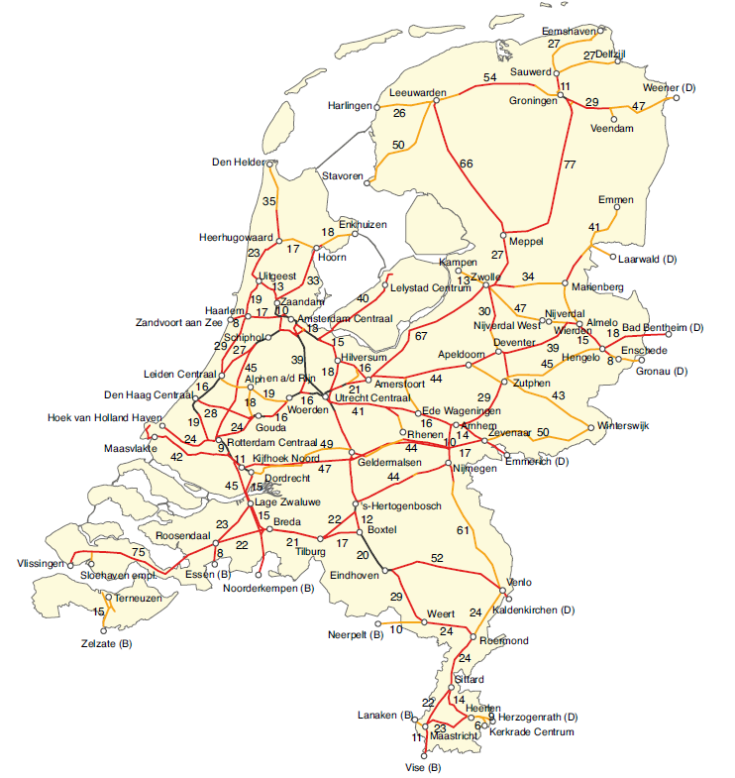
Source: ProRail

Key
1 track
2 tracks
3 or more tracks
O Station/hub
75 Distance in kilometres
Appendix B: NSA (ILT and DGB) and Dutch Safety Board Organisational Structure

Ministry of Infrastructure and the Environment
Directorate General for
Accessibility
Directorate of Public Transport and Railways
The Human Environment and
Transport Inspectorate
Rail and Road Transport Domain
Dutch Safety Board
Appendix C: The railways at a glance
There were very few changes in 2016. The number of train-kilometres rose slightly. A number of railway undertakings discontinued their operations and a number of new entrants commenced operations, due to which the total number remained stable.

 | 2016 | 2015
Railway network (kilometres) | 3434 | 3058
Train-kilometres (m) | 158 | 156
Number of passenger transport railway undertakings | 5 | 8
Passenger train-kilometres (m) | 147 | 146
Passenger-kilometres (bn) | 19 | 19
Number of freight transport railway undertakings | 29 | 29
Freight train-kilometres (m) | 11 | 10

Table 1: Kilometres operated and length of railway network. Sources: ProRail and ILT.

Appendix D: Level crossing protection and railway deviations.

This appendix contains an overview of the numbers and types of level crossings. The policy is to make level crossings safer; this means that the number of passive (unprotected) and publicly accessible level crossings will be reduced.

An overview of 'precursors' is also included. These mandatory ERA categories are regarded as important indicators of imminent accidents.

Number of level crossings (as at 1 July 2017 – ProRail statement) | Passenger network | Freight network | Total
All level crossings | 1 916 | 530 | 2 446
Barrow crossings | 60 | 24 | 84
Active level crossings (excl.  barrow crossings) | 1 526 | 199 | 1 725
Passive level crossings (excl. barrow crossings) | 330 | 307 | 637
Publicly accessible passive level crossings | 116 | 274 | 390
Private passive level crossings (excl. barrow crossings) | 214 | 33 | 247
Table 2: Breakdown of level crossing types

Precursor | 2016 | 2015
Broken rails | 77 | 54
Thermally reduced track alignment | 4 | 5
Signalling errors | 30 | 37
Broken wheels | 0 | 0
Broken axles | 0 | 0

Table 3: Precursors

Precursors are irregularities on the railway track that can cause an accident. The number of broken rails has risen. This may be due to maintenance or maintenance standards. The ILT will conduct the regular five-year inspection in 2018 as required by the Kuiken Committee. This may also provide insight into the development of the number of precursors.
Appendix E: Accident, injury and suicide figures

This appendix contains the total figures for all categories of accidents, near-accidents and injuries. The classification is in accordance with the ERA definitions and those of the objective set out in the Policy Impetus.

 | Accidents  (including significant) |  |  | Significant ERA
 | 2016 | 2015 | 2014 | 2016 | 2015 | 2014
Train-train collisions | 9 | 8 | 14 | 2 | 1 | 2
Train-obstacle collisions | 415 | 374 | 293 | 5 | 7 | 1
Derailment | 24 | 22 | 10 | 0 | 1 | 1
Level crossing accidents/collisions | 37 | 41 | 28 | 7 | 12 | 13
Accidents to persons caused by rolling stock | 13 | 7 | 1 | 11 | 7 | 1
Fire in rolling stock | 52 | 46 | 46 | 1 | 2 | 0
Other types of accident | 2 | 1 | 1 | 2 | 1 | 1
Total (excl. train-obstacle collisions) | 137 | 125 | 100 | 23 | 24 | 18
Total | 552 | 499 | 393 | 28 | 31 | 19

Table 4: Accidents and significant accidents

An accident is significant if there is at least one fatality, one seriously injured person, if the damaged incurred amounts to at least EUR 150 000 or if the track section is obstructed for six hours or more.

 | FWSI |  |  | Fatal injury |  |  |  | Serious injury |  |  | Minor injury
 | 2016 | 2015 | 2014 |  | 2016 | 2015 | 2014 | 2016 | 2015 | 2014 | 2016 | 2015 | 2014
Passengers | 0 | 0.2 | 0 |  | 0 | 0 | 0 | 0 | 2 | 0 | 23 | 25 | 25
Railway staff | 2.3 | 0.2 | 0 |  | 2 | 0 | 0 | 3 | 2 | 0 | 4 | 4 | 2
Level crossing users | 3.1 | 13.2 | 7.4 |  | 3 | 13 | 7 | 1 | 2 | 4 | 0 | 5
Unauthorised persons on the railway | 1.4 | 3.1 | 1 |  | 1 | 3 | 1 | 4 | 1 | 0 | 0
Others | 2.3 | 2 | 1 |  | 2 | 2 | 1 | 3 | 0 | 0 | 0 | 0 | 9
Total | 9.1 | 18.7 | 9.4 |  | 8 | 18 | 9 | 11 | 7 | 4 | 27 | 34 | 36
Table 5: Development of FWSI

A quantification of the consequences of serious accidents resulting in fatalities and serious injuries, where 1 seriously injured person is statistically equivalent to 0.1 fatality. See, among other documents, Commission Decision 2009/460/EC on the adoption of a common safety method for assessment of achievement of safety targets.

Number of suicides | 2012 | 2013 | 2014 | 2015 | 2016
Rail suicides | 202 | 199 | 192 | 223 | 221
National suicides | 1753 | 1857 | 1839 | 1871 | 1894
Rail suicides in Europe | 2890 | 2982 | 2859 | nb | nb

Table 6: Development of the number of suicides

For ILT purposes, suicides must have been confirmed by the police. This explains potential discrepancies between these figures and those stated in other suicide overviews.

Transfer accident | Number registered | Serious injury | Minor injury
Due to personal condition | 50 (57) | 2(0) | 17(2)
Due to work-related activities | 11 (10) |  | 7(5)
Falls when boarding/alighting from trains | 54(39) |  | 29(9)
Falls in halls, tunnels, passageways | 57(52) |  | 30(7)
Falls on platforms | 105(113) | (1) | 55(18)
Falls between a train and a platform | 35(34) | (2) | 16(3)
Falls from escalators | 177(129) | (1) | 107(22)
Falls from stairways | 117(137) |  | 62(12)
Departure procedures/stuck | 18(22) |  | 3(1)
Injuries due to objects | 37(23) |  | 21(5)
Falls from platforms | 11(11) |  | 6(0)
Other | 70(92) |  | 33(0)
Total | 742(719) | 2(4) | 353(84)

Table 7: Transfer accidents. The 2015 figures are stated between brackets.

The table showing transfer accidents is indicative; the registration of persons with minor injuries in particular is incomplete. The actual number is probably higher. Transfer accidents involve people who are intending to travel by train or those who have deboarded a train. Transfer accidents are an important category because the European definitions only take injuries caused by a moving train into account.
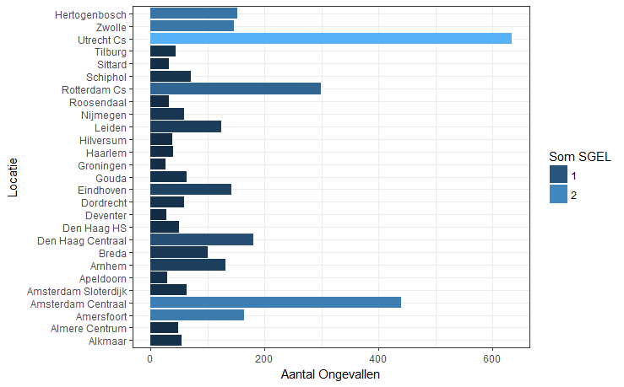
Hertogenbosch | 's-Hertogenbosch
Zwolle | Zwolle
Utrecht Cs | Utrecht Cs
Tilburg | Tilburg
Sittard | Sittard
Schiphol | Schiphol
Rotterdam Cs | Rotterdam Cs
Roosendaal | Roosendaal
Nijmegen | Nijmegen
Leiden | Leiden
Hilversum | Hilversum
Haarlem | Haarlem
Groningen | Groningen
Gouda | Gouda
Eindhoven | Eindhoven
Dordrecht | Dordrecht
Deventer | Deventer
Den Haag HS | Den Haag HS
Den Haag Centraal | Den Haag Centraal
Breda | Breda
Arnhem | Arnhem
Apeldoorn | Apeldoorn
Amsterdam Sloterdijk | Amsterdam Sloterdijk
Amsterdam Centraal | Amsterdam Centraal
Amersfoort | Amersfoort
Almere Centrum | Almere Centrum
Alkmaar | Alkmaar
Aantal Ongevallen | Number of Accidents  Total FWSI  Location

Figure 1: Breakdown of transfer accidents across the different stations, with accident severity expressed in FWSI. The lighter the colour, the higher the FWSI. The calculation of FWSI includes persons with minor injuries, where 1 person with a minor injury is counted as 0.01 fatalities.

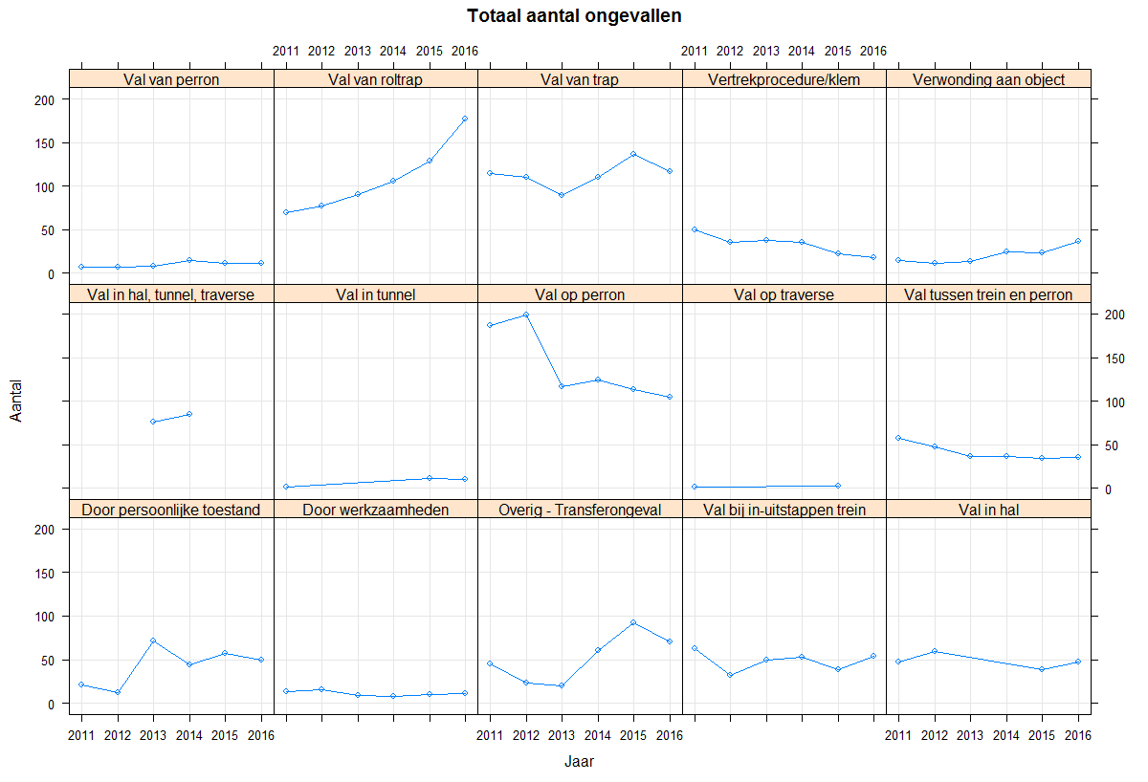
Totaal aantal ongevallen | Total number of accidents
Val van perron | Falls from platforms
Val van roltrap | Falls from escalators
Val van trap | Falls from stairways
Vertrekprocedure/klem | Departure procedures/stuck
Verwonding aan object | Injuries due to objects
Val in hal, tunnel, traverse | Falls in halls, tunnels, passageways
Val in tunnel | Falls in tunnels
Val op perron | Falls on platforms
Val op traverse | Falls on passageways
Val tussen trein en perron | Falls between a train and a platform
Door persoonlijke toestand | Due to personal condition
Door werkzaamheden | Due to work-related activities
Overig - Transferongeval | Other - Transfer accident
Val bij in-uitstappen trein | Falls when boarding/alighting from trains
Val in hal | Falls in halls
Jaar | Year
Figure 2: Breakdown of the number of transfer accidents across the categories since 2011

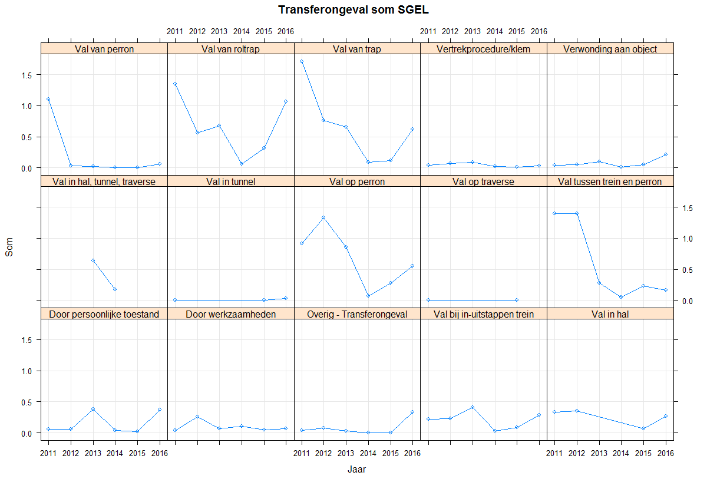
Transferongeval som SGEL | Total FWSI for transfer accidents
Val van perron | Falls from platforms
Val van roltrap | Falls from escalators
Val van trap | Falls from stairways
Vertrekprocedure/klem | Departure procedures/stuck
Verwonding aan object | Injuries due to objects
Val in hal, tunnel, traverse | Falls in halls, tunnels, passageways
Val in tunnel | Falls in tunnels
Val op perron | Falls on platforms
Val op traverse | Falls on passageways
Val tussen trein en perron | Falls between a train and a platform
Door persoonlijke toestand | Due to personal condition
Door werkzaamheden | Due to work-related activities
Overig - Transferongeval | Other - Transfer accident
Val bij in-uitstappen trein | Falls when boarding/alighting from trains
Val in hal | Falls in halls
Jaar | Year

Figure 3: FWSI transfer accidents across the categories since 2011

Registered near-accidents category | 2016 | 2015 | 2014
Near-suicide | 30 | 16 | 18
Third parties | 70 | 133 | 157
Staff | 1 | 1 | 1
Staff - Contractor | 1 | 5 | 8
Staff - Public service | 0 | 1 | 3
Staff - Transport operator | 4 | 1 | 1
Train | 0 | 1 | 1
Installation/infrastructure | 0 | 1 | 1
Machine/equipment - machine unrelated to railway | 1 | 1 | 4
Machine/equipment - railway-related machine | 0 | 0 | 2
Obstacle | 1 | 2 | 1
Obstacle - Vegetation | 0 | 0 | 1
Obstacle - Animal | 8 | 5 | 11
Train - Train | 2 | 9 | 10
Level crossing train - person | 87 | 90 | 93
Level crossing train - road traffic | 72 | 63 | 80
Level crossing - near-suicide | 5 | 3 | 1
Total | 282 | 332 | 393

Table 8: Near accidents

The table showing transfer accidents is indicative. The ILT has noted that even though registration has improved, the actual number is probably higher than the number registered. The number of incidents on level crossings in particular remains high. As a result the potential to actually cause an accident is fairly high. Notable trends are the decline in the number of third parties (unauthorised persons) and the increase in suicides in near-accidents.

Appendix F: Indicators according to the Policy Impetus for Railway Safety

In the Policy Impetus for Railway Safety the Ministry of Infrastructure and Water Management has defined specific indicators, which the ILT monitors and reports on in the Annual Report. This appendix presents the year-on-year figures and the trend-based developments.

Subject | Indicator | Value in 2016 | Value in 2015
Safety risk  train passengers | FWSI among passengers/year/bn  passenger-km | 0 | 0.01
(Potential) accidents  involving trains | Number of significant accidents/m train-km | 0.18 | 0.20
(Potential) accidents  involving trains | Number of significant train collisions/m train-km | 0.01 | 0.01
(Potential) accidents  involving trains | Number of significant derailments/m train-km | 0 | 0.01
(Potential) accidents  involving trains | Number of SPAD events | 100 | 100
Safety risk  railway staff | FWSI among railway staff/year/bn  train-km | 13.96 | 1.28
Safety risk  level crossing users | FWSI among level crossing users/year,  bn train-km | 19.68 | 84.70
Suicides | Number of railway suicides | 221 | 223
Table 9: Indicators according to the Policy Impetus for Railway Safety

FWSI stands for 'Fatalities and Weighted Serious Injuries': this is a quantification of the consequences of serious accidents resulting in fatalities and serious injuries, where 1 seriously injured person is statistically equivalent to 0.1 fatality. See, among other documents, 2009/460/EC: Commission Decision on the adoption of a common safety method for assessment of achievement of safety targets.

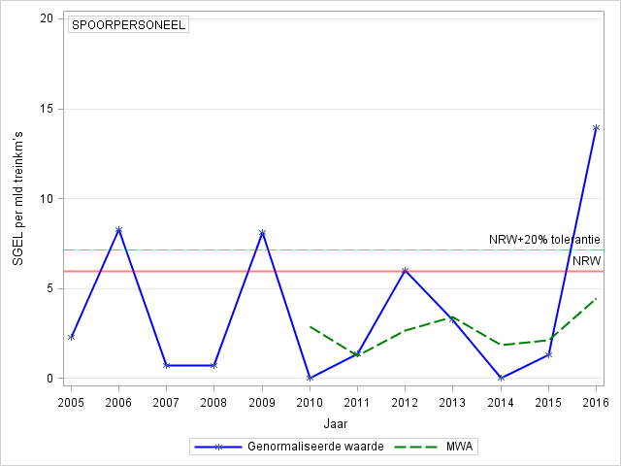 | Staff safety  The National Reference Value (NRV) for staff safety relates to injuries (FWSI) for significant train accidents and other accidents involving a moving train. If the green dotted line, the dynamic five-year moving weighted average (MWA), is below the red dotted line (the NRV plus a 20 % tolerance limit), the Agency qualifies the development as acceptable safety performance. For the purpose of the Framework Policy Document, the MWA should be below the NRV (red line) and reflect a downward trend, in accordance with the basic principle of permanent improvement. Only the values and the MWA are shown for the indicators that have no NRV.
  SPOORPERSONEEL | RAILWAY STAFF
  SGEL per mld treinkm’s | FWSI per bn train-km
  NRW+20% tolerantie | NRV +20% tolerance
  NRW | NRV
  Genormaliseerde waarde | Normalised value
  MWA | MWA
  Jaar | Year
Figure 4: Explanation of the graphs with trends.

Figure 4 above is provided as a reference for the following graphs.

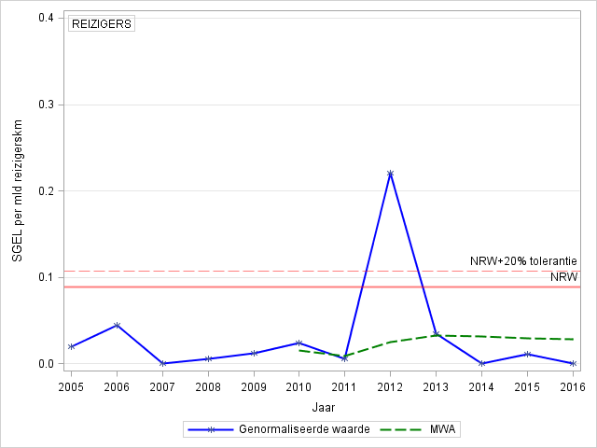

REIZIGERS | PASSENGERS
SGEL per mld reizigerskm | FWSI per bn passenger-km
NRW+20% tolerantie | NRV +20% tolerance
NRW | NRV
Genormaliseerde waarde | Normalised value
MWA | MWA
Jaar | Year

Graph 1: Injury trend among passengers per billion passenger-kilometres

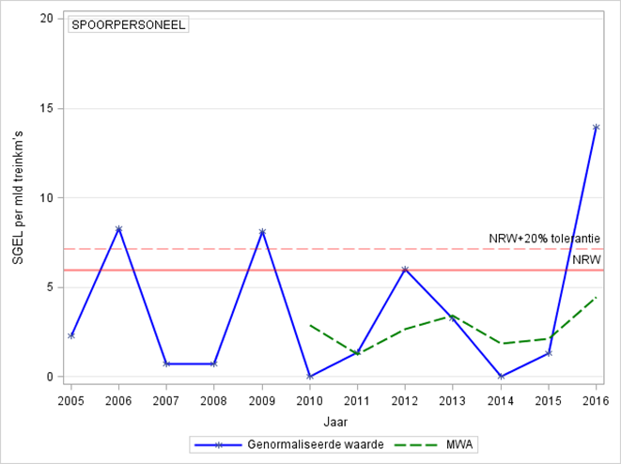

SPOORPERSONEEL | RAILWAY STAFF
SGEL per mld treinkm’s | FWSI per bn train-km
NRW+20% tolerantie | NRV +20% tolerance
NRW | NRV
Genormaliseerde waarde | Normalised value
MWA | MWA
Jaar | Year

Graph 2: Injury trend among railway staff per billion train-kilometres

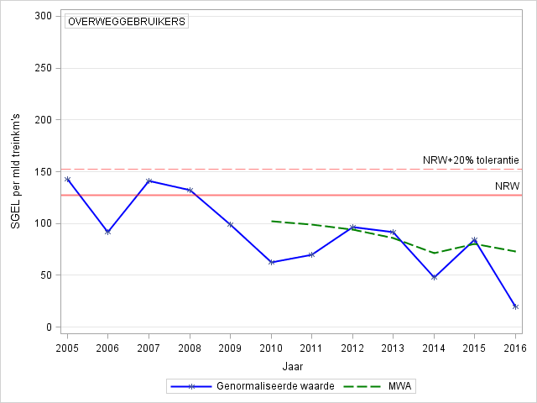

OVERWEGGEBRUIKERS | LEVEL CROSSING USERS
SGEL per mld reizigerskm | FWSI per bn passenger-km
NRW+20% tolerantie | NRV +20% tolerance
NRW | NRV
Genormaliseerde waarde | Normalised value
MWA | MWA
Jaar | Year

Graph 3: Injury trend among level crossing users per billion passenger-kilometres

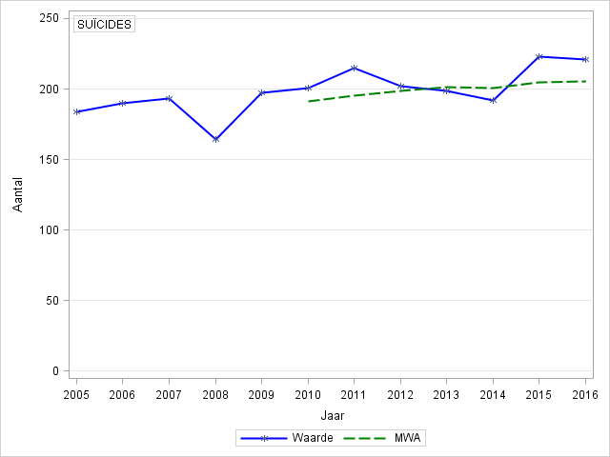

SUÏCIDES | SUICIDES
Aantal | Number
Waarde | Value
MWA | MWA
Jaar | Year

Graph 4: Suicide trend

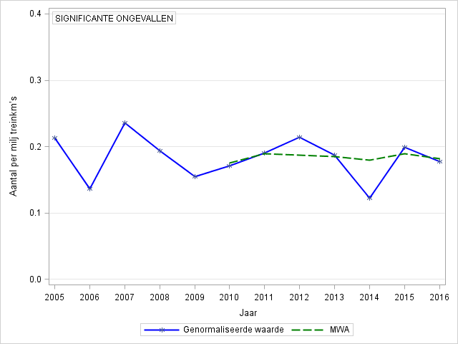

SIGNIFICANTE ONGEVALLEN | SIGNIFICANT ACCIDENTS
Aantal per milj treinkm’s | Number per billion train-km
Genormaliseerde waarde | Normalised value
MWA | MWA
Jaar | Year

Graph 5: Trend in significant accidents per billion train-kilometres

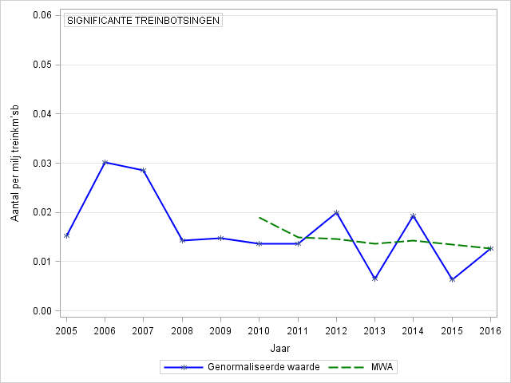

SIGNIFICANTE TREINBOTSINGEN | SIGNIFICANT TRAIN COLLISIONS
Aantal per milj treinkm’sb | Number per billion train-km
Genormaliseerde waarde | Normalised value
MWA | MWA
Jaar | Year

Graph 6: Trend in significant train collisions per billion train-kilometres

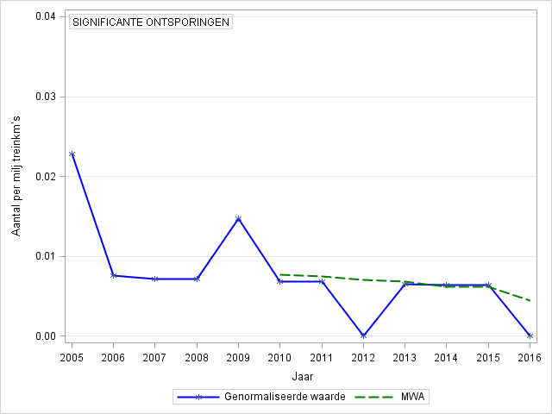

SIGNIFICANTE ONTSPORINGEN | SIGNIFICANT DERAILMENTS
Aantal per milj treinkm’s | Number per billion train-km
Genormaliseerde waarde | Normalised value
MWA | MWA
Jaar | Year

Graph 7: Trend in significant derailments per billion train-kilometres

Appendix G: Analysis of SPAD events

The figure below shows the trend in the number of SPADs. A steady
downward trend is evident after 2009, with the number of SPADs falling to 100 from 2015. The number remains unchanged in 2016.
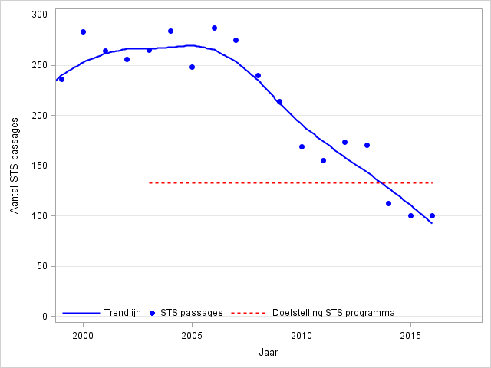

Aantal STS-passages | Number of SPAD events
Trendlijn | Trend line
STS passages | SPAD events
Doelstelling STS programma | SPAD programme target
Jaar | Year

Graph 8: Trend in the number of SPAD events

Another parameter is the development of the risk figure, which provides an indication of the potential risk of an accident due to an SPAD.
In addition to the objective of reducing the number of SPAD events, the risk figure should be reduced by 75 % against the 2003 reference year. The figure below shows the development based on a two-year moving total.

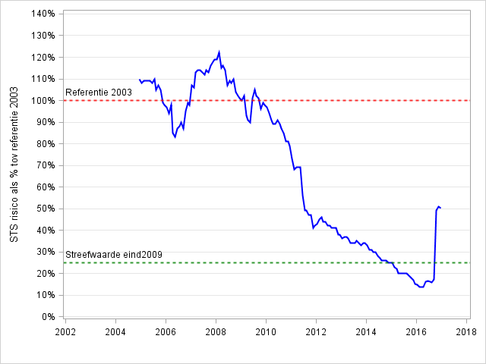

STS risico als % tov referentie 2003 | SPAD risk % against 2003 reference
Referentie 2003 | 2003 reference
Streefwaarde eind2009 | Target value end of 2009

Graph 9: Trend in the SPAD risk figure

In 2016 the risk figure was approximately 50 % due to a high-risk situation on 14 October 2016 (to which a risk figure of 27 was assigned).

The target risk figure set for 2010 was achieved for the first time in 2014. Following a further decline into 2015, the figure rose sharply in 2016 due to an SPAD event with an extremely high potential risk involving an HSL
freight train that was unable to brake sufficiently (connection, Elst, 14 October). The train driver made an emergency call so that the rail traffic controller could halt all rail traffic. Because the train had been delayed, an immediate collision with a passenger train was avoided (three trains had run over point switch 421 at the following times: 18.07, 18.12 and 18.18). The train drove 550 metres past signal 422. The danger point, the point switch, was located at 145 metres, which means that the train came to a standstill 405 metres after the danger point.

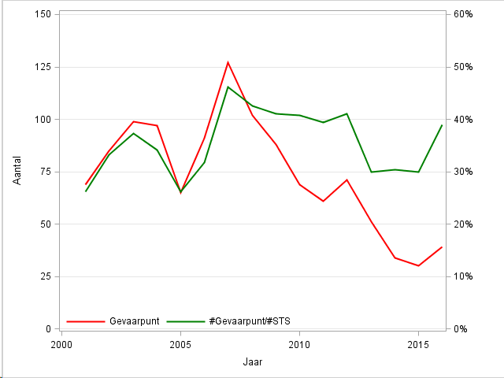
The number of times trains pass a danger point (red line) has decreased since 2007, as shown in the figure below. The ratio between the number of times trains pass a danger point and the number of SPADs (green line) likewise decreased after 2007, but rose again in 2016. The same pattern is evident in the development of the risk score.

Aantal | Number
Gevaarpunt | Danger point
#Gevaarpunt/#STS | #Danger point/#SPAD
Jaar | Year

Graph 10: Development of reaching danger point and ratio to the number of SPADs.

Primary cause | % of total 2012-2016 | % of total number of SPADs 2015 | % of total number of SPADs 2016
On-board  procedure | 25% | 18% | 16%
Technical  circumstances | 16% | 8% | 11%
Distraction | 16% | 17% | 12%
Observation | 9% | 5% | 14%
Off-board  procedure | 8% | 10% | 1%
Expectation | 15% | 22% | 21%
Total | 89% | 80% | 75%
Table 10: Causes of SPADs

The percentage shares of the primary causes of SPADs assigned by the ILT and ProRail. In 2016, the on-board procedure and expectation show high scores compared to the other primary causes. Scores for the other three causes are similar and the off-board procedure has fallen sharply compared to 2015. ‘Rail traffic controller operations’ is a new factor in the list, with a 4 % share in the total from 2012-2016, but accounting for 13 % of all primary causes for the full-year 2016.

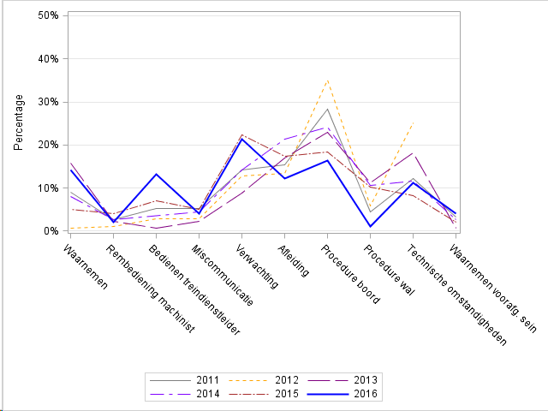

Percentage | Percentage
Waarnemen | Observation
Rembediening machinist | Train driver braking operations
Bedienen treindienstleider | Rail traffic controller operations
Miscommunicatie | Miscommunication
Verwachting | Expectation
Afleiding | Distraction
Procedure boord | On-board procedure
Procedure wal | Off-board procedure
Technische omstandigheden | Technical circumstances
Waarnemen voorafg. sein | Observation of advance signal

Graph 11: Breakdown of causes of SPADs since 2011

The relative share of the on-board procedure and the other causes has declined since 2011, except for:
train driver braking operations and expectation, which remain unchanged. Rail traffic controller operations and expectation both show a notable increase.

 |  | Total 2012-2016 | SPAD  per million train-km |  | 2016 SPAD |  | 2015  SPAD
Breakdown of total |  |  |  |  | 100 |  | 100
 | Passengers | 377 | 0.34 |  | 49 |  | 58
 | Freight | 148 | 2.63 |  | 27 |  | 22
 | Contractors and service providers | 55 | 137.39 |  | 9 |  | 9
 | Revoked signals | 75 |  |  | 15 |  | 11
Risk
 | Danger point reached | 213 |  |  | 39 |  | 27
 | Danger point not reached | 429 |  |  | 61 |  | 73
Severity
 | SPAD with potential risk | 189 |  |  | 32 |  | 27
 | SPAD with potential serious risk | 91 |  |  | 15 |  | 7
 | Seriously injured persons | 18 |  |  | 0 |  | 0
 | Fatal injury | 1 |  |  | 0 |  | 0
General information |  | Total  million train-km  2012-2016 |  | 2016 million train-km |  | 2015  million train-km
Transport type
 | Passengers | 726 |  | 147 |  | 146
 | Freight | 51 |  | 11 |  | 10
 | Contractors and service providers | <2 |  | <1 |  | <1
Number of signals equipped with ATB Vv |  |  |  | 2633 |  | 2616
Railway with train protection |  |  |  | 100% |  | 100%*
Signals with a recent history of repeated SPADs |  |  |  | 9 |  | 4
*0.8 % of cross-border railway sections are equipped with the Krokodil or Indusi signalling systems.
Table 12: Overview of SPADs and risk

Signals where repeated SPADs began occurring in 2016: Bilthoven 857 (3), Blerick 294 (3), ’s-Hertogenbosch 2162 (3), Leiden 1010 (3), Liempde 1238 (3), Maastricht 168 (3), Rotterdam Waalhaven Zuid 208 (3), Rotterdam Waalhaven Zuid 4, (4) and Utrecht Cartesiusweg 1472 (4).

Appendix H: European indicators

Decision 2009/460/EC, adopted on 5 June 2009, describes the Common Safety Indicators method (CSI). The indicators are used to determine whether safety performance is acceptable and/or whether there is a continuous improvement in the categories of passenger safety, staff safety, safety of level crossing users, safety of unauthorised persons on railway premises, safety of others and overall safety.

Subject | indicator | ERA NRV 2004-2009 | Value 2016 | Value 2015 | ERA NRV +20% | MWA 2012-2016
Safety risk  train passengers | FWSI among passengers/year/bn  passenger-km | 0.089 | 0 | 0.011 | 0.107 | 0.028
 | FWSI among passengers/year/bn  passenger train-km | 7.430 | 0 | 1.374 | 8.916 | 3.454
Safety risk  railway staff | FWSI among railway staff/year/bn  train-km | 5,970 | 13,965 | 1,283 | 7,164 | 4,418
Safety risk  level-crossing users | FWSI among level crossing users/year,  bn train-km | 127,000 | 19,678 | 84,704 | 152,400 | 72,923
Safety risk  others | FWSI among others (third parties)/year/bn train-km | 4,700 | 14,600 | 12,834 | 5,640 | 8,113
Safety risk unauthorised persons | FWSI among unauthorised persons on railway premises/year/bn train-km | 15,900 | 8,887 | 19,893 | 19,080 | 10,623
Overall safety | Total FWSI/year/bn train-km | 148,000 | 57,129 | 119,998 | 177,600 | 103,786
positive development
negative development

Table 13: Overview of FWSI for the various ERA indicators

REIZIGERS | PASSENGERS
SGEL per mld reizigerskm | FWSI per bn passenger-km
NRW+20% tolerantie | NRV +20% tolerance
NRW | NRV
Genormaliseerde waarde | Normalised value
MWA | MWA
Jaar | Year

Graph 12: Injury trend among passengers per billion passenger-kilometres

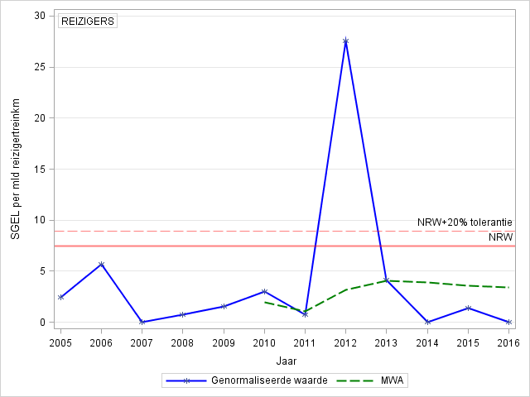

REIZIGERS | PASSENGERS
SGEL per mld reizigertreinskm | FWSI per bn passenger train-kilometres
NRW+20% tolerantie | NRV +20% tolerance
NRW | NRV
Genormaliseerde waarde | Normalised value
MWA | MWA
Jaar | Year

Graph 13: Injury trend among passengers per billion passenger-train kilometres

SPOORPERSONEEL | RAILWAY STAFF
SGEL per mld treinkm’s | FWSI per bn train-km
NRW+20% tolerantie | NRV +20% tolerance
NRW | NRV
Genormaliseerde waarde | Normalised value
MWA | MWA
Jaar | Year

Graph 14: Injury trend among railway staff per billion train-kilometres

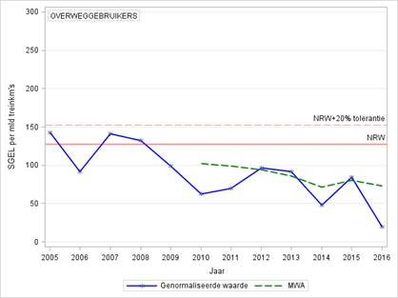

OVERWEGGEBRUIKERS | LEVEL-CROSSING USERS
SGEL per mld treinkm’s | FWSI per bn train-km
NRW+20% tolerantie | NRV +20% tolerance
NRW | NRV
Genormaliseerde waarde | Normalised value
MWA | MWA
Jaar | Year

Graph 15: Injury trend among level crossing users per billion train-kilometres

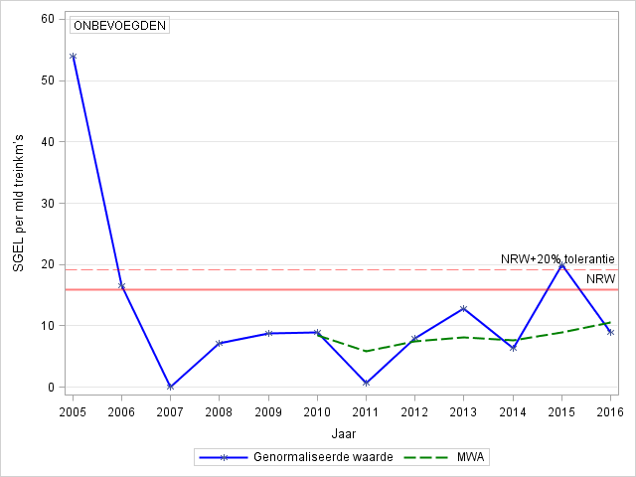

ONBEVOEGDEN | UNAUTHORISED PERSONS
SGEL per mld treinkm’s | FWSI per bn train-km
NRW+20% tolerantie | NRV +20% tolerance
NRW | NRV
Genormaliseerde waarde | Normalised value
MWA | MWA
Jaar | Year

Graph 16: Injury trend among unauthorised persons per billion train-kilometres

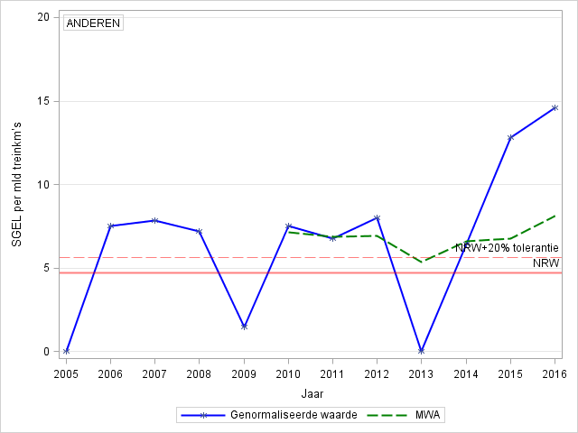

ANDEREN | OTHERS
SGEL per mld treinkm’s | FWSI per bn train-km
NRW+20% tolerantie | NRV +20% tolerance
NRW | NRV
Genormaliseerde waarde | Normalised value
MWA | MWA
Jaar | Year

Graph 17: Injury trend others per billion train-kilometres

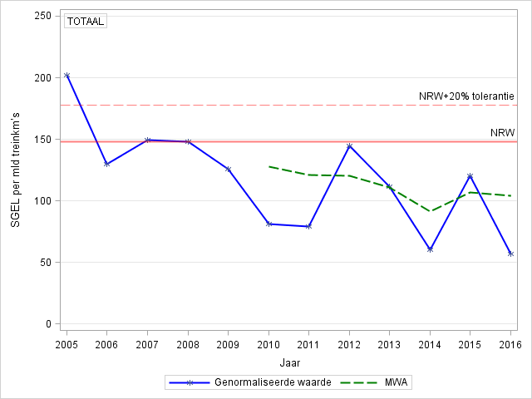

TOTAAL | TOTAL
SGEL per mld treinkm’s | FWSI per bn train-km
NRW+20% tolerantie | NRV +20% tolerance
NRW | NRV
Genormaliseerde waarde | Normalised value
MWA | MWA
Jaar | Year

Graph 18: Overall safety trend per billion train-kilometres

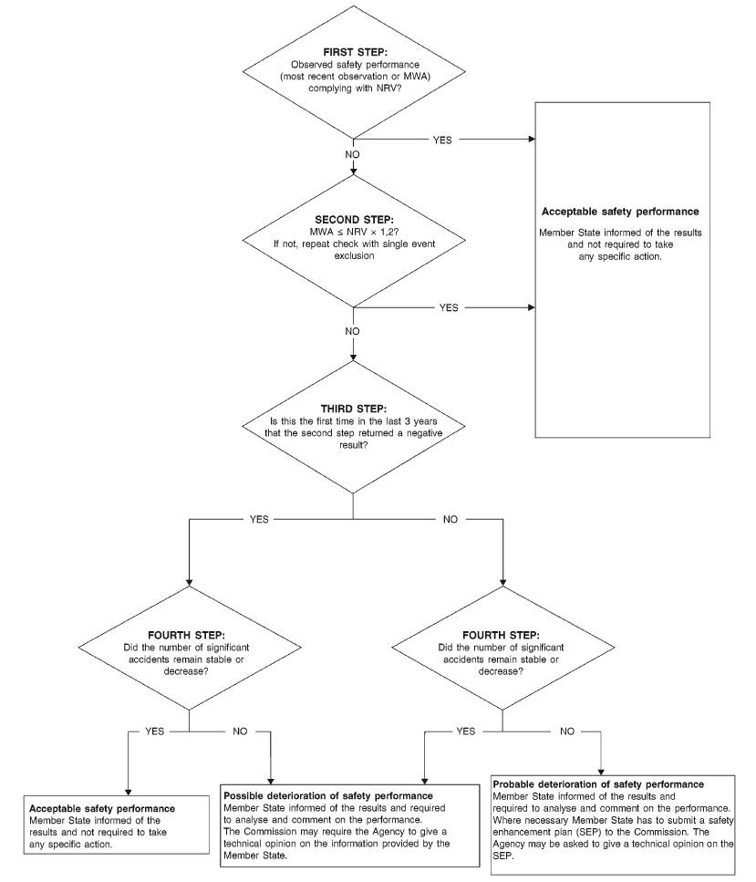Figure 5: Decision tree that is used to assess the development of safety performance based on trends, the National Reference Value and the moving weighted average.

Appendix: CSI data and Associated Definitions

C.1. CSI Data

Safety indicators according to Annex I of the Railway Safety Directive (Directive 2004/49/EC)
- Indicators relating to accidents

  - Total number of significant accidents and average number of significant accidents (per million train kilometres), broken down into the following types of accident

 | All types of accident | Collisions of trains including collisions with obstacles within the clearance gauge | Derailments of trains | Level crossing accidents including accidents involving pedestrians at level crossings | Accidents leading to personal injury caused by moving railway vehicles, excluding suicides | Vehicle fires | Other accidents
Total | 28 | 7 | 0 | 7 | 11 | 1 | 2
Average number | 0.178 | 0.044 | 0.000 | 0.044 | 0.070 | 0.006 | 0.013

  - Total number and average number (per million train kilometres) of serious injuries and fatalities by type of accident, broken down into the following categories

    - Person seriously injured

 | All types of accident | Collisions of trains including collisions with obstacles within the clearance gauge | Derailments of trains | Level crossing accidents including accidents involving pedestrians at level  crossings | Accidents leading to personal injury caused by moving railway vehicles,  excluding suicides | Vehicle fires | Other accidents
Total seriously injured | 11 | 2 | 0 | 1 | 7 | 0 | 1
Average number seriously injured | 0.070 | 0.013 | 0.000 | 0.006 | 0.044 | 0.000 | 0.006
Of whom:

Passengers | 0 | 0 | 0 | 0 | 0 | 0 | 0
Average number of seriously injured passengers | 0.000 | 0.000 | 0.000 | 0.000 | 0.000 | 0.000 | 0.000
Average number of seriously injured passengers per billion passenger kilome- tres | 0.000 | 0.000 | 0.000 | 0.000 | 0.000 | 0.000 | 0.000
Average number of seriously injured passengers per million passenger train kilometres | 0.000 | 0.000 | 0.000 | 0.000 | 0.000 | 0.000 | 0.000
Employees, including the staff of contrac- tors | 3 | 0 | 0 | 0 | 2 | 0 | 1
Average number of seriously injured employees, including contractors | 0.019 | 0.000 | 0.000 | 0.000 | 0.013 | 0.000 | 0.006
Level crossing users | 1 | 0 | 0 | 1 | 0 | 0 | 0
Average number of seriously injured level crossing users | 0.006 | 0.000 | 0.000 | 0.006 | 0.000 | 0.000 | 0.000
Unauthorised persons on railway premises | 4 | 2 | 0 | 0 | 2 | 0 | 0
Average number of seriously injured unauthorised persons on railway premises | 0.025 | 0.013 | 0.000 | 0.000 | 0.013 | 0.000 | 0.000
Others | 3 | 0 | 0 | 0 | 3 | 0 | 0
Average number of others seriously injured | 0.019 | 0.000 | 0.000 | 0.000 | 0.019 | 0.000 | 0.000

    - Person killed

 | All types of accident | Collisions of trains including collisions with obstacles within the clearance gauge | Derailments of trains | Level crossing accidents including accidents involving pedestrians at level crossings | Accidents leading to personal injury caused by moving railway  vehicles, excluding  suicides | Vehicle fires | Other accidents
Total number of fatalities | 8 | 0 | 0 | 4 | 4 | 0 | 0
Average number of fatalities | 0.051 | 0.000 | 0.000 | 0.025 | 0.025 | 0.000 | 0.000
Of whom:

Passengers | 0 | 0 | 0 | 0 | 0 | 0 | 0
Average number of passengers killed | 0.000 | 0.000 | 0.000 | 0.000 | 0.000 | 0.000 | 0.000
Average number of passengers killed per billion passenger kilometres | 0.000 | 0.000 | 0.000 | 0.000 | 0.000 | 0.000 | 0.000
Average number of passengers killed per million passenger train kilometres | 0.000 | 0.000 | 0.000 | 0.000 | 0.000 | 0.000 | 0.000
Employees, including the staff of contrac- tors | 2 | 0 | 0 | 1 | 1 | 0 | 0
Average number of employees, including the staff of contractors killed | 0.013 | 0.000 | 0.000 | 0.006 | 0.006 | 0.000 | 0.000
Level crossing users | 3 | 0 | 0 | 3 | 0 | 0 | 0
Average number of level crossing users killed | 0.019 | 0.000 | 0.000 | 0.019 | 0.000 | 0.000 | 0.000
Unauthorised persons on railway premises | 1 | 0 | 0 | 0 | 1 | 0 | 0
Average number of unauthorised persons on railway premises killed | 0.006 | 0.000 | 0.000 | 0.000 | 0.006 | 0.000 | 0.000
Others | 2 | 0 | 0 | 0 | 2 | 0 | 0
Average number of others killed | 0.013 | 0.000 | 0.000 | 0.000 | 0.013 | 0.000 | 0.000

- Indicators relating to dangerous goods

Total and average numbers (per million train kilometres) of accidents in connection with the carriage of dan- gerous goods, broken down into the following categories

 | Accidents in which at least one rail vehicle carrying dangerous goods was involved | Accidents in which dangerous goods were released
Total | 0 | 0
Average number | 0.000 | 0.000

- Indicators relating to suicides

Total and average numbers (per million train kilometres) of suicides

 | Suicides | Attempted suicides
Total | 221 | 10
Average number | 1.403 | 0.063

- Indicators relating to incidents and near misses

Total number and average number (per million train kilometres) of incidents and near misses, broken down into the following categories

 | All incidents and near misses | Broken rails (EIUs only) | Buckled rails (EIUs only) | Signalling errors (EIUs only) | Signals passed at danger | Broken wheels | Broken axles
Total | 211 | 77 | 4 | 30 | 100 | 0 | 0
Average number | 1.339 | 0.489 | 0.025 | 0.190 | 0.635 | 0.000 | 0.000
 |  |  |  | Resulting in an accident |  | 0 | 0
 |  |  |  | Found in service |  | 0 | 0
 |  |  |  | Found during regular maintenance |  | 0 | 0

- Indicators relating to the consequences of significant accidents

Total amount in Euro and average values (per million train kilometres) for

 | Number of deaths and serious injuries multiplied by the value  of avoiding accident  victims | Costs of damage to rolling stock and infrastructure | Costs of environmen- tal damage* | Costs of delays caused by accidents
Total costs | 21014713 | 11393050 | 142550 | 221,348
Average costs | 133394 | 72319 | 905 | 14602

- Indicators relating to technical safety of infrastructure and its implementation

  - Automatic train protection

Percentage of tracks with automatic train protection (EIUs only) | 100%
Percentage of train kilometres run using operational train protection systems | 100%

  - Number of level crossings (in total, per line kilometre and per track kilometre), broken down into the follow- ing eight types:

 | With user-side automatic warning | With user-side automatic protection | With user-side automatic protection and automatic warning | With user-side automatic protection and automatic warning and with rail- side protection | With user-side manual warning | With user-side manual protection | With user-side manual protection and manual warning
Actively protected level crossings | 60 | 0 | 1472 | 0 | 212 | 0 | 0
Average number per line kilometre | 0.017 | 0.000 | 0.429 | 0.000 | 0.062 | 0.000 | 0.000
Average number per track kilometre | 0.008 | 0.000 | 0.204 | 0.000 | 0.029 | 0.000 | 0.000

 | Total
Passively protected level crossings | 497
Average number per line kilometre | 0.145
Average number per track kilometre | 0.069

- Indicators relating to the safety management system

Total number of internal checks (audits) carried out
Percentage of internal checks (audits) carried out in relation to the number of checks stipulat- ed or planned | Not available

Annual Railway Safety Performance in the European Union 2016, European Union Railway Agency, Valenciennes. France. Please note that the figures in this report end in 2015.
Source: ProRail.
Source: Statistics Netherlands (CBS).
Decree Designating Main Railway Lines, dated 20 December 2004.
A railway vehicle with a fixed destination from A to B and an assigned train number.
Policy Impetus for Railway Safety (Beleidsimpuls Railveiligheid), parliamentary paper 29893, No. 204, 21 June 2016, Safety of Rail Transport.
The Annual Report on Railway Safety constitutes the basis for the mandatory report on railway safety which the ILT, as the National Railway Safety Authority (NSA), submits to the European Union Agency for Railways each year.
Fatalities or seriously injured persons.
The train driver in the Dalfsen accident and two road users.
Pedestrians, cyclists, moped riders, the elderly.
An 80-year-old woman who was trapped behind closed barriers.
Regions based on the areas under the management of ProRail.
Significant accidents declined by 50% but this is because the significance of level-crossing accidents is primarily determined by serious injuries.
Recorded suicide attempts.
Source: Statistics Netherlands (CBS).
Unless in the event of signal revocation/drop to stop, or a technical signal deviation. In that case the train driver cannot be reproached for an SPAD.
The maximum risk figure is 25 % of the 2003 reference year.
Seriously injured persons and damage.
Such as a point switch or an open level crossing.
Multiple seriously injured casualties and/or considerable damage.
Railway Undertakings and ProRail Steering Committee, established by the State Secretary for Infrastructure and the Environment in the late 1990s.
ERTMS setting for shunting. The train driver drives the train to another location based on a signal aspect.
Warning in the train driver's cabin when the train is approaching a signal at danger.
The definitions of the Agency always assume that a moving train is involved.
This is a quantification of the consequences of serious accidents resulting in fatalities and serious injuries, where 1 seriously injured person is statistically equivalent to 0.1 fatality.
Risk management for the transport of dangerous goods by rail, 6 March 2016, Dutch Safety Board.
Colourless, flammable gas.
An accident involving a moving train causing at least one fatality or one seriously injured person, or damage totalling EUR 150,000, or the obstruction of a track section for six hours.
Annual Report on Railway Safety 2014, the development of railway safety performance, ILT, The Hague, p 38.
^{[1]} ERADIS is an ERA data information system with certificates issued by the national railway safety authorities.
Including cableways.
Excluding shunting process and revoked signals.
Amsterdam signal 494 on 21 May 2012.
Sources: ProRail and NS.
Repeated SPADs = five-year period with three or more SPADs.

