|  |
| --- |
|  |
|  |
| Safety report for the railways 2017 |
|  |

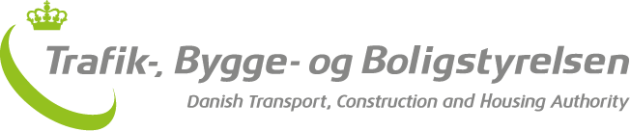

September 2018

Foreword

Each year, the Danish Transport, Construction and Housing Authority’s safety report for the railways presents an overview of the development in the number of accidents and incidents on the Danish railways as well as a review of the Authority’s safety-related activities. The report thus provides a status report on railway safety in Denmark. The report’s target group is the Danish rail sector, politicians and press, as well as the other EU countries and the European Union Agency for Railways (ERA).

2017 shows that the safety level on the railways in Denmark is still very high, with the lowest level of people killed and seriously injured since 1999, which is as far as the data go back. Denmark is in the top 5 among the EU countries with the highest railway safety measured by the number of people killed and seriously injured per train-km travelled.

In total, six people died and six were seriously injured in 2017. The majority were struck after having gained unauthorised access to the railway. Two people were struck and killed at a platform crossing and one person on a level crossing. In addition, three people were seriously injured when they touched the overhead contact line after having crawled onto the roof of a train that had stopped.

2017 was also the year in which Denmark’s first light rail, the Aarhus Letbane, was safety-approved. The purpose of the approval is to ensure that the safety of the light rail is at a high level. Approval of a new track type is an extensive task that requires coordinated handling of interdependent relationships, such as infrastructure, trains, the undertakings that run the light rail and the safety rules by which the undertakings will run the rail. The progress towards approval has given the Authority a valuable experience base, which we expect will benefit both applicants and the Authority, not least when it comes to the safety approval of the Odense Letbane, the Hovedstadens Letbane and the completion of the Aarhus Letbane. The Authority also looks forward to taking advantage of the learning and improvement potentials expected to be presented to the Ministry of Transport, Construction and Housing, during October 2018, as a result of the ongoing external evaluation of the authorisation process of the Aarhus Letbane.

Happy reading!

Lise Aaen Kobberholm  
Deputy Director

|  |
| --- |
| **THE DATA IN THE REPORT:**  The data in the safety report are for 2017. The reason for the relatively late release date is that the Authority only receives the latest reports from undertakings in the spring and summer of 2018, after which they must be validated and analysed.  The Danish Transport, Construction and Housing Authority is required to publish the safety report and submit it to the European Union Agency for Railways (ERA), but the Authority has chosen to design the report to also make it relevant for Danish infrastructure managers, railway undertakings, the Accident Investigation Board Denmark, politicians and the press.  The report therefore also includes data on urban networks such as the metro and local railways, which would otherwise not be covered by the European reporting requirements. Data in this report are therefore different from data reported for use only for European statistics. |

Contents

Summary 5

Summary 7

Chapter 1: Railway safety in Denmark in 2017 9

Reporting of data for the safety report 9

Data and incident categories 10

Incidents on the railways in 2017 11

Significant accidents 12

Significant accidents involving people 14

Minor accidents 22

Precursors to accidents 24

Suicides on the railway 26

Chapter 2: Follow-up of recommendations from the Accident Investigation Board Denmark 31

Person’s hand became trapped in the doors of an IC3 train, Vejle 32

Person struck on platform crossing, Kværndrup 33

Station official (trainee) killed during derailment, Høje Taastrup 35

Chapter 3: Safety certificates and safety approvals 36

New executive order with requirements for safety certificates and safety authorisations 36

Safety certificates and safety authorisations in Denmark 37

The Authority’s guidance for undertakings 39

Other matters 39

Chapter 4: Experiences with supervision 41

Supervision planning and prioritisation 41

Results of supervision in 2017 41

Cooperation with other countries’ authorities 43

Chapter 5: Experiences with approvals 45

General information about the Authority’s work with authorisations in 2017 45

Experiences in the area of infrastructure 48

Experiences in the area of vehicles 48

Experiences from the undertakings 49

Chapter 6: Experiences with regulation 51

Harmonisation of regulations 51

The Executive Order on safety authorisations and safety certificates in the railways sector 51

Executive Order on the rules governing travelling on railway infrastructure with train control BJ 5-1-2017 52

Executive Order on the certification of train drivers 53

Executive Order on requirements for the accreditation of assessors in the rail sector. 53

Executive Order on the authorisation of assessors and experts in connection with the authorisation of railway infrastructure and vehicles. 54

Executive Order on authorisation for the training of train drivers in the rail sector 55

Annex A: The railways in figures 2017 59

Annex B: Safety indicators for 2017 61

Annex C: Definitions used 67

# Summary

**Still a very high level of safety on the Danish railways in 2017**The safety level on the railways in Denmark is still very high.  The number of people killed and seriously injured is at its lowest since 1999, which is as far as the data go back. Denmark is therefore in the top five in the EU measured by the number of people killed and seriously injured per train-km.

In the period 2013-2017, an average of 0.2 people were killed or seriously injured per million train-km.

The overall safety target for the railways in Denmark is that there must be no more than 0.3 people killed or seriously injured per million train-km. In 2017, the safety target corresponds to 24 people killed or seriously injured.

In fact, in 2017 6 people were killed, while 6 people were seriously injured. The majority of these were struck after having gained unauthorised access to the railway. Two people were struck and killed at a platform crossing and one person was killed on a level crossing. In addition, three people were seriously injured when they touched the overhead contact line after having crawled onto the roof of a train that had stopped.

**Improved reporting culture**

The number of reports of precursors to accidents rose again this year. This is probably due to an ever-improving reporting culture, and to the fact that the new Executive Order on reporting[1], which came into force in 2016, introduced new and more accurate event categories.

**The Authority’s work with the Accident Investigation Board Denmark’s recommendations**In 2017, the Accident Investigation Board Denmark published three reports with recommendations. In 2017 and 2018 the Authority followed up on the recommendations in the report on an accident at a platform crossing at Kværndrup Station in 2016. The follow-up is considered complete. In 2017, the Authority followed up on the recommendations of a report on an accident in which a person’s hand became trapped in the train doors at Vejle Station. The Authority considers the recommendations to have been met in 2017. At the end of 2017 a report was published regarding a trainee station official who died during a derailment at Høje Taastrup Station. The Authority is currently following up on the recommendations in the report.

**Experiences with supervision**Safety on the railways is high. At the same time, the Danish Transport, Construction and Housing Authority notes that several undertakings are facing challenges implementing the system-based rather than person-based approach to safety that are a consequence of common EU regulations for the railways. The Authority finds that these challenges can not immediately be seen to represent an increased safety risk here and now. This is because the undertakings’ challenges in developing system-backed safety do not seem to reflect a decrease in the ability to implement known, safety-bearing functions and activities here and now. However, to maintain the high level of safety on the railways over time and increase undertakings’ self-management, it is important that undertakings increase their focus on maintaining and developing their safety management skills.

**Experiences with approvals**

The Authority sees a need to increase the guidance efforts for approvals. Therefore, in 2017 the Authority visited smaller infrastructure managers, created a CSM-RA[2] panel and released two new guides. In 2017, the Authority also carried out a check of neighbours in the UK, the Netherlands, Sweden and Norway on the use of CSM-RA in the authorisation process. The check among neighbours showed that all countries operate by adapting authorisations of release to service nationally, as it is recognised that the EU approval regime cannot blindly be transferred to the infrastructure area. There is a very different approach to the use of CSM-RA in the countries investigated. A common feature of the countries that use CSM-RA actively is that they are experiencing a certain lack of guidance and that they themselves have to a very large extent had to advise and guide the industry about the use of CSM-RA.

**Experiences with regulation**  
The Railway Safety Directive is the European legislation that provides the framework for the harmonisation of safety regulation in Europe. In 2017, the Authority continued to work on implementing the Directive, inter alia by drafting seven new executive orders. The executive orders deal with, among other things safety approval and certification, train driver training, approval of assessors, as well as fees and charges in connection with the railways.

# Summary

**Denmark continues to have a high level of railway safety**

In Denmark, the rail safety level continues to be very high. The number of significant accidents causing fatalities or serious injuries is in 2017 at the lowest level since 1999, which is as far as the data go back. Denmark is in the top five of the EU Member States measured as the number of fatalities or serious injuries per train kilometre.

In the period 2013-2017, the average number of fatalities or seriously injured people is 0.2 per million train-km.

Denmark’s safety target is determined to a maximum of 0.3 fatalities or severely injured (weighted 1/10) persons per million train-km. In 2017, this is the equivalent of 24 killed or 240 serious injured persons.

In total, six persons were killed and six were seriously injured on the Danish railway in 2017. The majority of significant accidents continues to involve unauthorised persons. Two persons were killed while crossing the tracks between platforms and one person was killed in a level crossing. In addition, three persons were seriously injured when they came in contact with the catenary system after having climbed up on top of a train which was not in motion.

**Improved safety reporting culture**

The number of reported precursors to accidents increased again in 2017. This is most likely due to an improvement in the safety reporting culture and a new executive order[3] on safety reporting, which became effective in 2016, and which introduces new and more precise safety indicators.

**The Authority’s follow-up on recommendations by the National Investigation Body**The Danish National Investigation Body published three reports with recommendations in 2017. In 2017 and 2018, the Authority followed up on the recommendations from a report concerning an accident at a passenger crossing at Kværndrup Station. The follow-up by the Authority is completed. Additionally, the Authority has followed up on the recommendations from a report concerning an accident at Vejle Station. The Authority considers the recommendations fulfilled. In December 2017, a report was published concerning an accident where an employee was killed at Høje Taastrup Station. The Authority will follow up on the recommendations in 2018.

**Supervision**

The Danish rail safety level is high. At the same time, it continues to be a challenge for several railway companies to fully implement and manage a safety management system. However, the challenges with the safety management system do not seem to represent an increasing safety risk at present. Thus, the ability of the companies to produce a system-based approach to safety does not necessarily reflect a decreasing in their ability to carry out known safety functions and activities at present. Nevertheless, it is important that the companies increase their focus on maintaining their safety management systems so that the systems match their activities. A well-functioning safety management is the foundation of increasing self-management and a continuing high safety level over time.

**Authorisation**The Authority is working on increasing the guidance effort regarding the authorisation process. For this purpose, the Authority introduced a number of new initiatives in 2017. For example, the Authority visited a number of smaller infrastructure managers to learn more about their experiences and needs, set up a CSM-RA Panel and published two new guides. The Authority also made a study of how the National Safety Authorities in the UK, the Netherlands, Sweden and Norway make use of CSM-RA as a part of the authorisation process. The study showed that the countries employ CSM-RA very differently, if at all. The countries which do employ CSM-RA felt a lack of guidance. Consequently, they have to guide the industry in how to use CSM-RA on their own.

**Regulation**

The Railway Safety Directive is the European legislation, which constitutes the framework within which the harmonisation of the safety regulation in Europe takes place. In 2017, the Authority continued the work on implementing the Directive. This includes issuing seven new executive orders. The executive orders regulates the approval of assessors, training of locomotive drivers, safety certificates and safety authorisations.

# Chapter 1: Railway safety in Denmark in 2017

Denmark still has a very high level of railway safety. The number of people killed and seriously injured is at its lowest since 1999, which is as far as the data go back, and Denmark is in the top five in the EU. In total, six people died and six were seriously injured in 2017. The majority of these were struck after having gained unauthorised access to the railway.

## Reporting of data for the safety report

There are approximately 300 railway accidents a year in Denmark. The vast majority of these accidents have few, if any, harmful consequences. For example, a collision between a train and a deer or a collision with a shopping trolley left on the track has only minor consequences for rolling stock and rarely any consequences for passengers.

Railway undertakings and infrastructure managers are responsible for following up on incidents that have occurred in their areas. In serious cases, the Accident Investigation Board Denmark helps establish the chain of events and possible causes of the incidents (see Chapter 2).

Each year, infrastructure managers and railway undertakings report all safety-related incidents to the Danish Transport, Construction and Housing Authority. Based on the data reported, the Authority analyses the development of railway safety and presents the results in this chapter of the annual safety report[4].

|  |
| --- |
| **Summary: Railway safety in 2017**  **Historically low number of people killed and seriously injured:** The number of people killed and seriously injured is at its lowest since 1999, which is as far as the data go back.  **Six killed:** Five were struck and killed after having gained unauthorised access to the railway. Two of these were struck at a platform crossing. One died in a level-crossing accident.  **Six serious injuries:** Six were seriously injured after having gained unauthorised access to the railway. Three of these were struck and three came into contact with the overhead contact line after having crawled onto the roof of a train.  **Denmark in the top 5 in the EU:** Measured by the number of people killed and seriously injured per train-km, Denmark is in the top five across the EU countries with the highest rail safety.  **Denmark’s safety targets met:** On average, 0.10 people were killed or severely injured (weighted 1/10) per year per million train-km in the period 2012-2016. This is significantly below the safety target for the railways in Denmark, which states that this figure must not exceed 0.30 per million train-km – corresponding in 2017 to 24 people killed or 240 people seriously injured. |

## Data and incident categories

Due to the low number of incidents per year, there is some statistical uncertainty in the calculations. For this reason, the actual figures for 2017 are compared with the five-year average for 2013-2017, which is based on a larger amount of data.

In order to find the five-year average, it has been necessary to compile incident data from 2017 and 2016 using the broader incident categories that were used prior to Executive Order on reporting No 1340/2015 coming into force on 1 January 2016.

In addition, the chapter also contains calculations made on the basis of the new and narrower categories that were introduced with Executive Order on reporting No 1340/2015, and where there are only data from 2016 and 2017[5].

|  |
| --- |
| **Categorisation of incidents**  Incidents on the railways are divided up into *accidents* and *precursors to accidents*. In order to distinguish between accidents that do and do not have major consequences, accidents are divided into two groups: *significant* accidents and *minor* accidents.Data relating to significant accidents *involving people* are also collected and evaluated for significant accidents[6].  **Significant accidents:** *Significant accident* should be understood as meaning any accident that results in at least one of the following:   * At least one person killed or seriously injured * Destruction of stock, track, other parts of the infrastructure and/or the environment amounting to at least DKK 1.2 million. * Disruption to train traffic such that it is at a standstill for 6 hours or more on a main line   **Significant accidents *involving people*:** While *significant accidents* designates accidents with major consequences, *significant accidents involving people* designates accidents involving serious personal injury. There is often incomplete information regarding the financial consequences of accidents, so information about significant accidents involving people is considered to be the best safety indicator. Significant accidents involving people are the total number of people killed and the weighted number of people seriously injured (weighted 1/10) per million train-km on the railways over the year[7].  **Minor accidents:** An accident is regarded as ‘minor’ if it has *not* resulted in death, serious injury, significant material damage or major delays that exceed DKK 1.2 million or delays of more than 6 hours.  **Precursors to accidents:** Precursors to accidents are events in the railways sector that have not resulted in an accident but which could have been significant for railway safety.  **Executive Order on reporting No 1340/2015** also breaks down *accidents* (both significant and minor accidents) into 14 types of incident and *precursors to accidents* into 19 types of incident. Please see Annex C for a description of the definitions used.  **Suicides on the railways** are not included in these categories, as they are not considered to be railway accidents. You can read more about suicides on the railways later on in this chapter. |

## Incidents on the railways in 2017

Figure 1.1 below shows that only a small proportion of incidents reported in 2017 were *accidents*, and very few of them were *serious accidents*. The majority of reported incidents were *precursors to accidents*.

*Figure 1.1: Number of incidents reported in 2017 according to incident type*

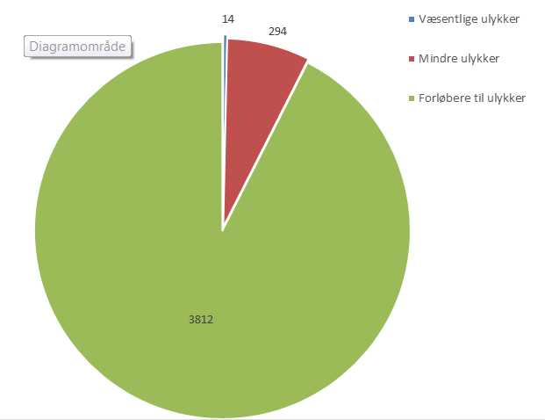

*Note: Suicides are not included*

*Source: Danish Transport, Construction and Housing Authority incident database*

|  |  |
| --- | --- |
| Væsentlige ulykker | Significant accidents |
| Mindre ulykker | Minor accidents |
| Forløbere til ulykker | Precursors to accidents |
| 3812 | 3 812 |

The incident database shows an increase of reported incidents from around 3 500 in the years up to 2015 to 4 002 in 2016 and 4 120 in 2017[8]. It is particularly incidents in the category *precursors to accidents* that have seen an increase in both 2016 and 2017 compared with previous years.

The larger number of incident categories that have been introduced by Executive Order on reporting No 1340/2015 may be a contributory factor for this increase. Nevertheless, the most probable cause for the increase is an improved reporting culture within certain undertakings.

## Significant accidents

14 *significant accidents* on the Danish railways were reported in 2017. In the period 1999-2017, only in the years 2017 and 2013 were so few *major accidents* reported. By way of comparison, there were 20 *significant accidents* in 2016.

The 14 *significant accidents* in 2017 correspond to 0.17 significant accidents per million train-km. The five-year average for the period 2013-2017 is 0.20 significant accidents per million train-km, which is the lowest level in the period 1999-2017 (see Figure 1.2 on the next page).

*Figure 1.2: Significant accidents 1999 – 2017 (per million train-km)*

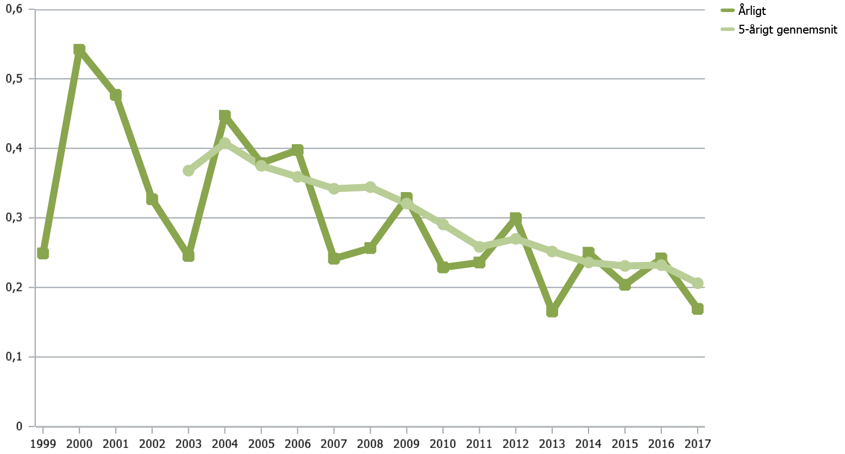

*Note: Suicides are not included.*

*Source: Danish Transport, Construction and Housing Authority incident database*

|  |  |
| --- | --- |
| Årligt | Annually |
| 5-arigt gennemsnit | 5-year average |
| 0,1 | 0.1 |
| 0,2 | 0.2 |
| 0,3 | 0.3 |
| 0,4 | 0.4 |
| 0,5 | 0.5 |
| 0,6 | 0.6 |

Figure 1.3 shows that most *significant accidents* on the railways in Denmark still involve *personal injuries involving rolling stock in motion* (0.097 per million train-km in 2017). Figure 1.4 on the next page shows that the figure covers over 8 *collisions involving people* and no accidents with *personal injuries aboard the train in motion*. There were also two *significant accidents* in 2017 at a level crossing and two *significant accidents involving traction current* (categorised as *other significant accidents* in Figure 1.3). Accidents involving serious injuries and deaths are described in more detail below under *significant accidents involving people*.

*Figure 1.3: Significant accidents broken down by type of accident (per million train-km).*

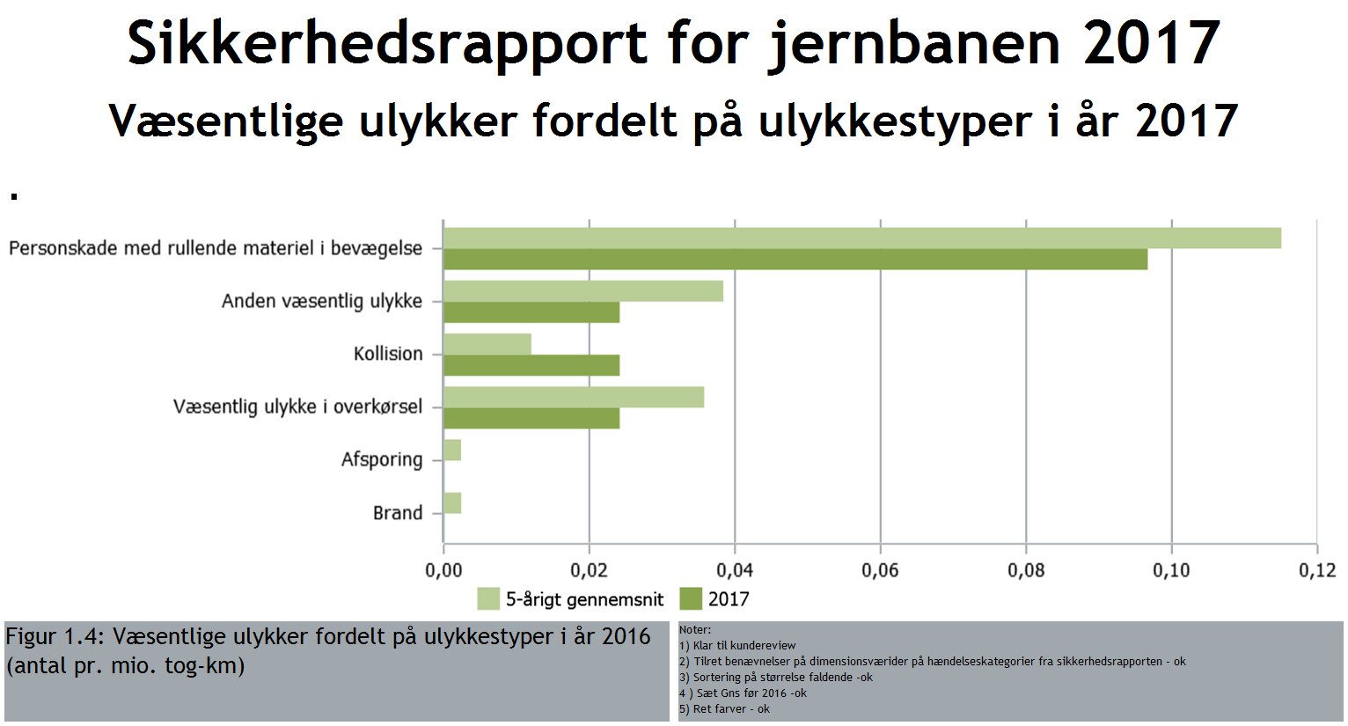

*Note: Suicides are not included. The category of ‘personal injuries involving rolling stock in motion’ has been designated as ‘collisions involving people’ in the safety reports for previous years.*

*Source: Danish Transport, Construction and Housing Authority incident database*

|  |  |
| --- | --- |
| Personskade med rullende materiel i bevægelse | Personal injuries involving rolling stock in motion |
| Anden væsentlig ulykke | Other significant accidents |
| Kollision | Collision |
| Væsentlig ulykke i overkørsel | Significant accidents at level crossings |
| Afsporing | Derailment |
| Brand | Fire |
| 5-årigt gennemsnit | 5-year average |
| 0,00 | 0.00 |
| 0,02 | 0.02 |
| 0,04 | 0.04 |
| 0,06 | 0.06 |
| 0,08 | 0.08 |
| 0,10 | 0.10 |
| 0,12 | 0.12 |

*Figure 1.4: Number of significant accidents in 2016 and 2017, broken down by the categories in Executive Order on reporting No 1340/2015*

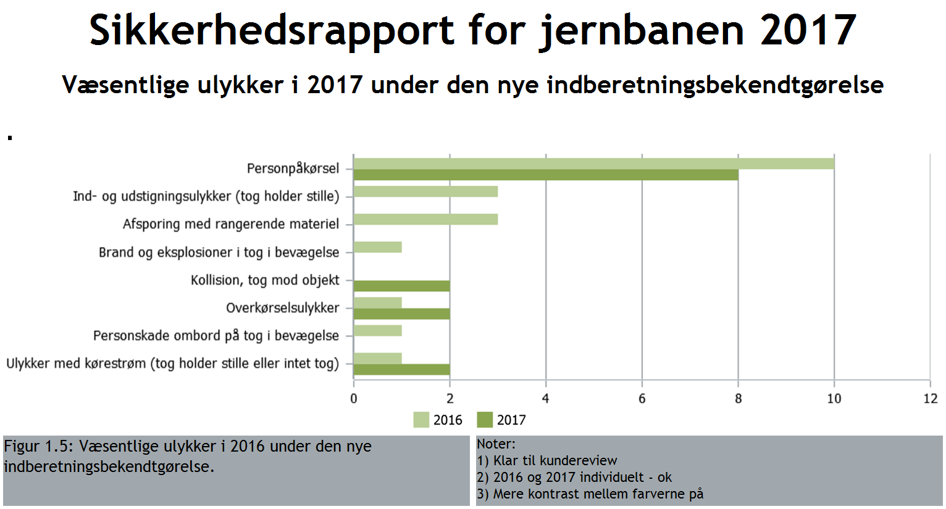

*Note: Suicides are not included. Incident categories for which no incidents were reported in 2016 and 2017 have not been included.*

*Source: Danish Transport, Construction and Housing Authority incident database*

|  |  |
| --- | --- |
| Personpåkørsel | Collisions involving people |
| Ind-og udstigningsulykker (tog holder stille) | Boarding and alighting accidents (train stationary) |
| Afsporing med rangerende materiel | Derailment involving slow-moving rolling stock |
| Brand og eksplosioner i tog i bevægelse | Fires and explosions on a train in motion |
| Kollision, tog mod objekt | Collision, train and object |
| Overkørselsulykker | Accidents at level crossings |
| Personskade ombord på tog i bevægelse | Personal injury on board a train in motion |
| Ulykker med kørestrøm (tog holder stille eller intet tog) | Accidents involving traction current (train stationary or no train) |

Collisions, fire or derailments, which are the accidents with the greatest potential for causing multiple injuries, are rare in Denmark. There were also no significant accidents caused by derailment or fire in 2017, but there were two major collisions, which is above the five-year average (see Figure 1.3).

One collision took place when a train hit a tree that had fallen onto the track. No personal injuries were reported as a result of the accident, but material damage was caused that amount to more than DKK 1.2 million. The second collision occurred when a train hit an excavator that was on the track. A slight injury was reported, along with material damage of over DKK 1.2 million as a result of the accident.

There was also a significant accident in which a tractor was struck on a level crossing. As a result of the accident, reports were filed of a slight injury, major disruptions to train movements and material damage of over DKK 1.2 million.

Incidents involving dangerous goods

No accidents involving dangerous goods were reported in 2017.

## Significant accidents involving people

Figure 1.5 on the next page shows *significant accidents involving people* per million train-km from 1999 up to and including 2017. *Significant accidents involving people* for 2017 and for the five-year average for 2013-2017 respectively are at their lowest level for the whole period 1999-2017. Specifically, the level of significant accidents involving people per million train-km was 0.080 in 2017 and the average in the period 2013-2018 was 0.128.

The Danish safety target

Denmark’s target is to maintain the high level of safety (measured with 2004 as the reference year)[9]. The Danish safety target is that the number of significant accidents involving people on the railways in Denmark calculated using the five-year average should be less than 0.30 per million train-km (shown with a red line in Figure 1.5) – corresponding in 2017 to 24 people killed or 240 seriously injured. As shown in Figure 1.5, significant accidents involving people for the period 2013-2017 are well below the Danish safety target.

*Figure 1.5: Significant accidents involving people 1999-2017 (deaths/injuries per million train-km). The red line indicates the Danish safety target.*

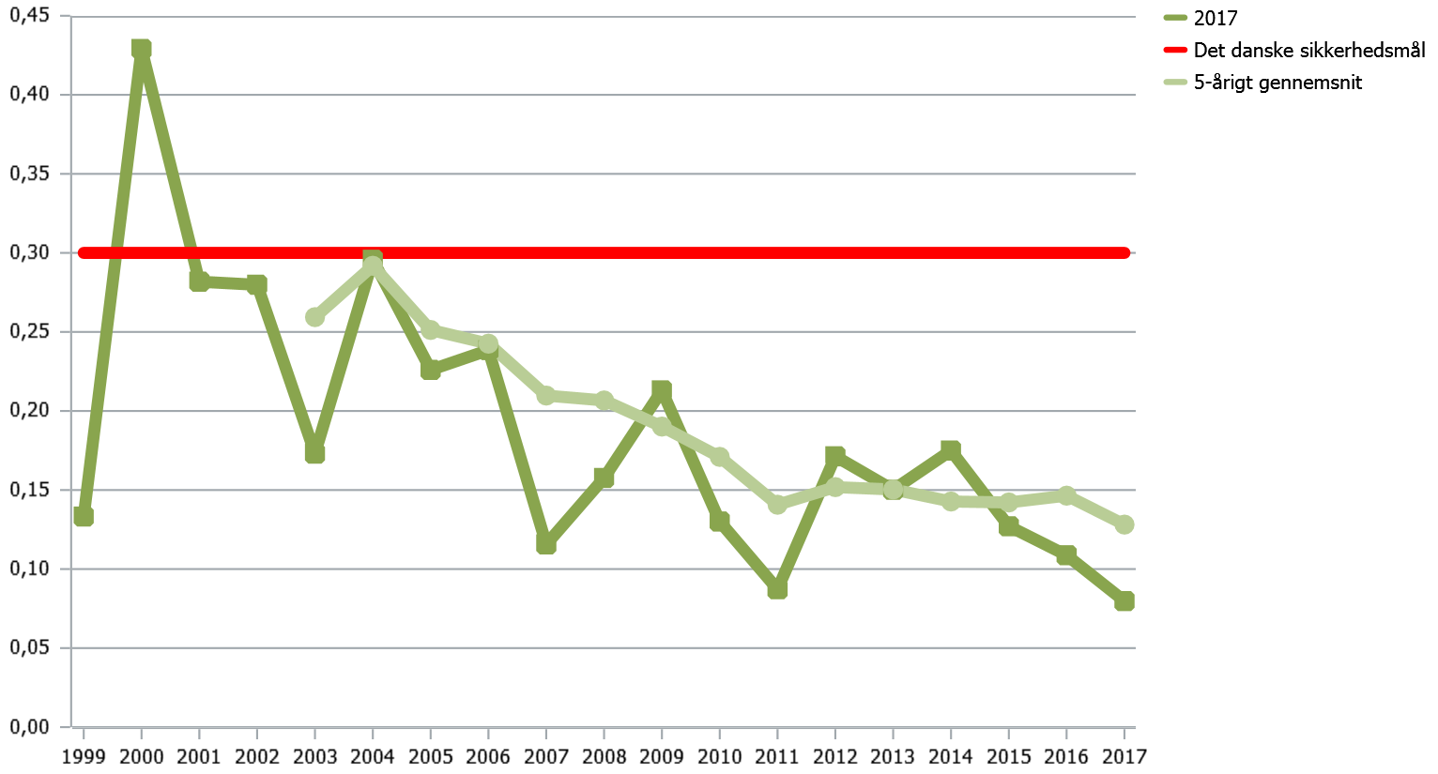

*Note: Suicides are not included. Significant accidents involving people are the total number of people killed and the number of people seriously injured (weighted 1/10) per million train kilometres on the railways.*

*Source: Danish Transport, Construction and Housing Authority incident database*

|  |  |
| --- | --- |
| Det danske sikkerhedsmål | The Danish safety target |
| 5-arigt gennemsnit | 5-year average |
| 0,00 | 0.00 |
| 0,05 | 0.05 |
| 0,10 | 0.10 |
| 0,15 | 0.15 |
| 0,20 | 0.20 |
| 0,25 | 0.25 |
| 0,30 | 0.30 |
| 0,35 | 0.35 |
| 0,40 | 0.40 |
| 0,45 | 0.45 |

**The safety level in the EU – Denmark in the top five**

A comparison of EU countries shows that Denmark is one of the European countries with the highest levels of railway safety. Figure 1.6 on the next page shows *significant accidents involving people* in the EU in the period 2012-2016[10]. The figure shows that the safety level for the Danish railway network for *significant accidents involving people* (excluding the metro and suburban railways) is 0.10 fatalities and weighted serious injuries per million train-km in 2012-2016. The European average for the same period is 0.23 significant accidents involving people per million train-km.

Both in Denmark and in the rest of the EU there has been a decline in *significant accidents involving people* in recent years. For example, in the period 2007-2011 the Danish average was 0.18 and the European average 0.35 for *significant accidents involving people* per million train-km[11].

*Figure 1.6: Significant accidents involving people per million train-km in the EU for 2012-2016*

*Note: Suicides are not included. Significant accidents involving people are the five-year average of the number of people killed and the number of people seriously injured (weighted 1/10) per million train-km on the railways.*

*By way of comparison, the Danish safety target is 0.3.*

*Source: The figures are based on calculations based on data from ERAIL (erail.era.europa.eu).*

|  |  |
| --- | --- |
| Irland | Ireland |
| Storbritannien | UK |
| Luxemborg | Luxembourg |
| Holland | Netherlands |
| Danmark | Denmark |
| Sverige | Sweden |
| Tyskland | Germany |
| Finland | Finland |
| Frankrig | France |
| Belgien | Belgium |
| Tjekkiet | Czech Republic |
| Italien | Italy |
| Ostrig | Austria |
| Spanien | Spain |
| Slovenien | Slovenia |
| EU gennemsnit | EU average |
| Portugal | Portugal |
| Estland | Estonia |
| Kroatien | Croatia |
| Bulgarien | Bulgaria |
| Ungarn | Hungary |
| Letland | Latvia |
| Polen | Poland |
| Grækenland | Greece |
| Litauen | Lithuania |
| Rumænien | Romania |
| Slovakiet | Slovakia |
| Antal pr. mio. tog-km | Number per million train-km |
| 0.04 | 0.04 |
| 0.05 | 0.05 |
| 0.07 | 0.07 |
| 0.08 | 0.08 |
| 0.10 | 0.10 |
| 0.12 | 0.12 |
| 0.13 | 0.13 |
| 0.16 | 0.16 |
| 0.17 | 0.17 |
| 0.18 | 0.18 |
| 0.20 | 0.20 |
| 0.21 | 0.21 |
| 0.23 | 0.23 |
| 0.54 | 0.54 |
| 0.62 | 0.62 |
| 0.63 | 0.63 |
| 0.64 | 0.64 |
| 0.73 | 0.73 |
| 0.83 | 0.83 |
| 0.88 | 0.88 |
| 0.93 | 0.93 |
| 0.97 | 0.97 |
| 1.02 | 1.02 |
| 0.00 | 0.00 |
| 0.20 | 0.20 |
| 0.40 | 0.40 |
| 0.60 | 0.60 |
| 0.80 | 0.80 |
| 1.00 | 1.00 |
| 1.20 | 1.20 |

Deaths and serious injuries

In 2017, six people were killed and six were seriously injured on railways in Denmark. The number of people killed and seriously injured fell in 2017 compared with 2016.

|  |
| --- |
| **Denmark's safety target**  The safety target[12] for the Danish railways, corresponding in 2017 to a maximum of 24 people killed or 240 seriously injured. In total, six people were killed and six were seriously injured in 2017. |

Table 1.2 shows that five of the six people killed and all six people seriously injured in 2017 were on railway land without permission – in other words, they are on railway land where it is not permitted to be. Of these, five unauthorised people were killed and three seriously injured when they were struck by a train.

*Table 1.2: Number of fatalities and serious injuries in 2016 and 2017 broken down into categories of people*

|  |  |  |  |  |  |
| --- | --- | --- | --- | --- | --- |
| Persons killed | 2016 | 2017 | Serious injuries | 2016 | 2017 |
| **Passengers** | 0 | 0 | Passengers | 4 | 0 |
| **Staff** | 1 | 0 | Staff | 0 | 0 |
| **Level-crossing users** | 1 | 1 | Level-crossing users | 0 | 0 |
| **Trespassers** | 5 | 5 | Trespassers | 3 | 6 |
| **Other fatalities** | 1 | 0 | Other serious injuries | 3 | 0 |
| Total persons killed | **8** | **6** | **Total serious injuries** | **10** | **6** |

*Note: Suicides are not included.*

*Source: Danish Transport, Construction and Housing Authority incident database*

On 28 July 2017 a person was struck and killed on a platform crossing at Bred Station. The platform crossing was equipped with a warning system. The Accident Investigation Board Denmark’s report subsequently stated that the early warning system was working correctly. On 10 August 2017 a person was struck and killed on a platform crossing at Tjæreborg Station. This platform crossing was also equipped with a warning system, and the Accident Investigation Board Denmark’s report subsequently stated that the warning system was working correctly. The two accidents at Bred and Tjæreborg together with the platform crossing accident at Kværndrup Station in 2016 meant that there has been extra focus on safety at platform crossings (see more on this in Chapter 2).

Statistics from previous years show that many significant accidents involving people happen on level crossings. In 2017 one pedestrian died on a level crossing. According to the Accident Investigation Board Denmark’s report, the barriers were down, the crossing equipment was working, and the driver had slowed and sounded his horn when the accident happened.

In addition, three people who were on railway land without permission were seriously hurt in 2017 in accidents involving traction current. This involved two different accidents, in which the people came into contact with the overhead contact line after they had crawled onto the top of a train that had stopped.

Figure 1.7 shows the number of people killed in railway accidents in the EU in 2015 and 2016. This shows that there is a relatively low number of deaths on Danish railways compared with other European countries. Please note that the figure does not take into account the number of train-km in each country, and that the figures are from European statistics, which do not include the metro and urban networks, including local railways.

*Figure 1.7: Number of fatalities in railway accidents in Europe in 2015 and 2016[13]* [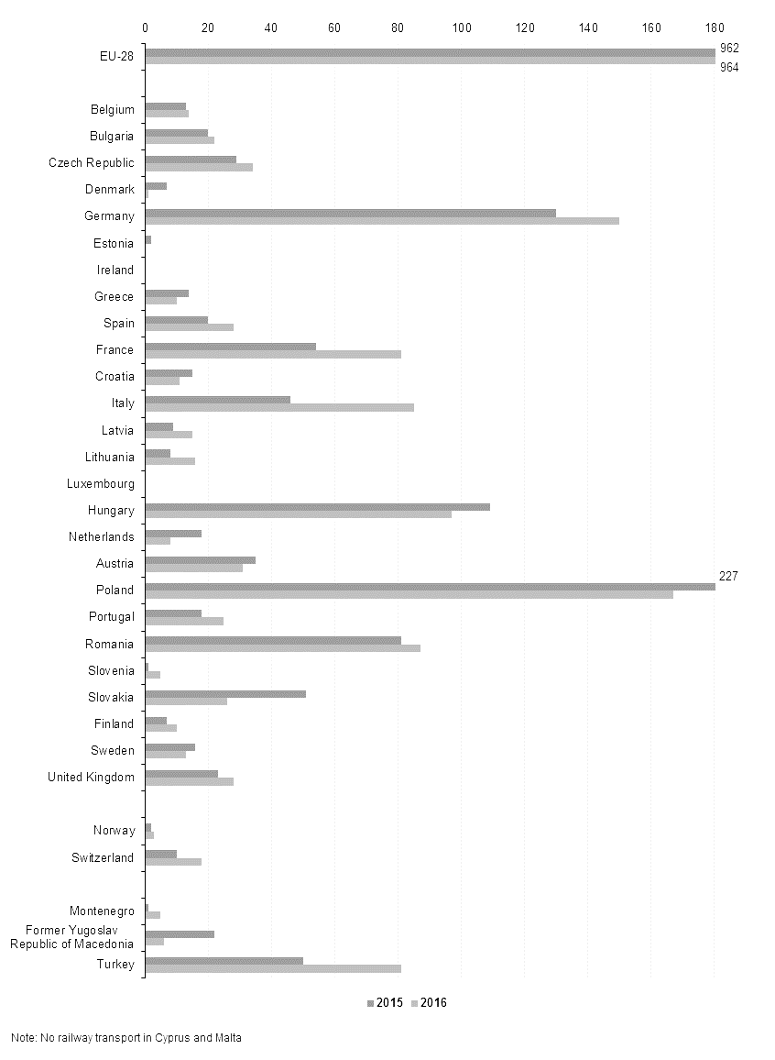](http://ec.europa.eu/eurostat/statistics-explained/index.php?title=File:Number_of_persons_killed_in_railway_accidents,_2015-2016.png)

*Source:* [*http://ec.europa.eu/eurostat/statistics-explained/index.php/Railway_safety_statistics*](http://ec.europa.eu/eurostat/statistics-explained/index.php/Railway_safety_statistics)

## Minor accidents

In 2017, 294 *minor accidents* were recorded, which is on a par with recent years. Some 357 *minor accidents* were recorded in 2016.

Figure 1.8 shows the number of *minor accidents* per million train-km, broken down according to accident type for 2017 and the five-year average for 2013-2017. The figure shows a slight increase in the number of *other minor accidents*, a small decrease in the number of *collisions*, and a major decrease in the number of *fires*[14]in 2017 compared with the five-year average. For the other types of accidents, the number of incidents in 2017 is virtually on a par with the five-year average.

*Figure 1.8: Minor accidents broken down according to accident type for 2017 and the five-year average for 2013-2017 (number per million train-km).*

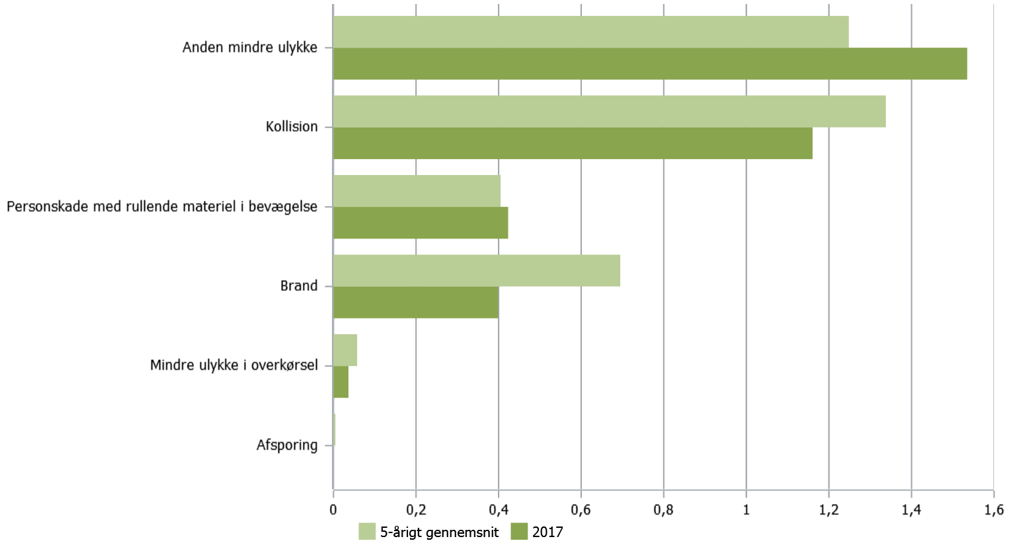

*Note: Suicides are not included. Where possible, the names of the categories have been modified so that they are comparable with previous years’ safety reports and the categories in Executive Order on reporting No 1340/2015 (please see Figure 1.10).*

*Source: Danish Transport, Construction and Housing Authority incident database*

|  |  |
| --- | --- |
| Anden mindre ulykke | Other minor accidents |
| Kollision | Collision |
| Personskade med rullende materiel i bevægelse | Personal injuries involving rolling stock in motion |
| Brand | Fire |
| Mindre ulykke i overkørsel | Minor accidents at level crossings |
| Afsporing | Derailment |
| 5-årigt gennemsnit | 5-year average |
| 0,2 | 0.2 |
| 0,4 | 0.4 |
| 0,6 | 0.6 |
| 0,8 | 0.8 |
| 1,2 | 1.2 |
| 1,4 | 1.4 |
| 1,6 | 1.6 |

Figure 1.9 below shows *minor accidents* in 2016 and 2017, broken down by the categories in Executive Order on reporting No 1340/2015. The 127 incidents involving *other minor accidents* in Figure 1.8 include the following types of incident in Figure 1.9:

* Boarding and alighting accidents (train stationary)
* Derailment involving slow-moving rolling stock
* Collision (slow-moving rolling stock and object)
* Collision (slow-moving rolling stock and other slow-moving rolling stock)
* Other minor accidents

Please also note that the 35 incidents of *personal injuries involving rolling stock in motion* in Figure 1.8 include the following types of incident in Figure 1.9:

* Personal injury on board a train in motion
* Collisions involving people
* Boarding and alighting accidents (train in motion)

*Figure 1.9: Minor accidents in 2016 and 2017, broken down by the categories in Executive Order on reporting No 1340/2015*

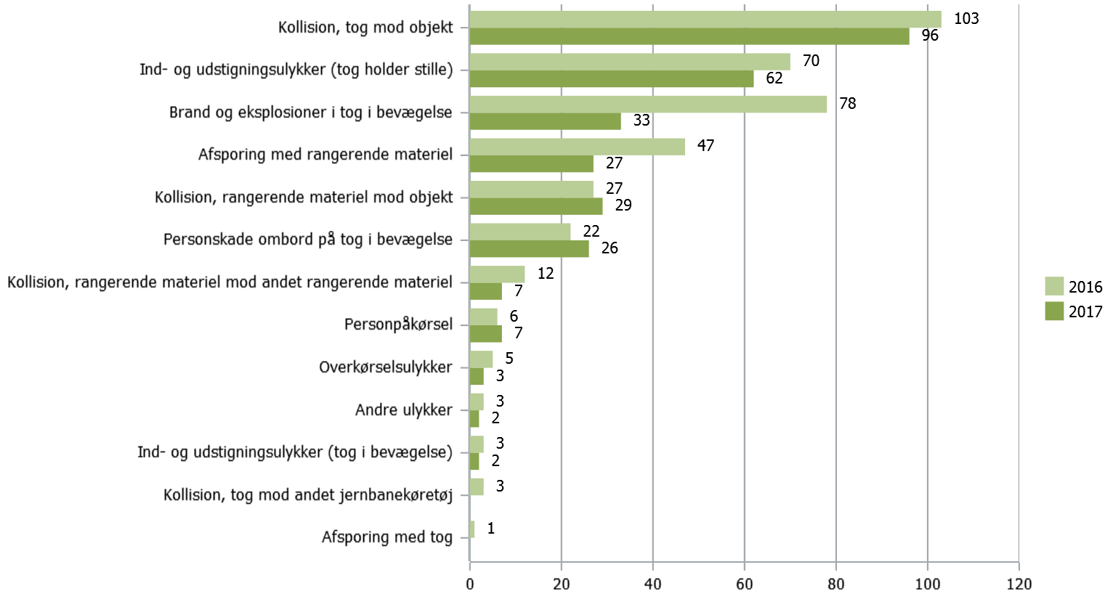

*Note: Suicides are not included. Incident categories for which no incidents were reported in 2016 and 2017 have not been included.*

*Source: Danish Transport, Construction and Housing Authority incident database*

|  |  |
| --- | --- |
| Kollision, tog mod objekt | Collision, train and object |
| Ind-og udstigningsulykker (tog holder stille) | Boarding and alighting accidents (train stationary) |
| Brand og eksplosioner i tog i bevægelse | Fires and explosions on a train in motion |
| Afsporing med rangerende materiel | Derailment involving slow-moving rolling stock |
| Kollision, rangerende materiel mod objekt | Collision, slow-moving rolling stock and object |
| Personskade ombord på tog i bevægelse | Personal injury on board a train in motion |
| Kollision, rangerende materiel mod andet rangerende materiel | Collision, slow-moving rolling stock and other slow-moving rolling stock |
| Personpåkørsel | Collisions involving people |
| Overkørselsulykker | Accidents at level crossings |
| Andre ulykker | Other accidents |
| Ind- og udstigningsulykker (tog i bevægelse) | Boarding and alighting accidents (train in motion) |
| Kollision, tog mod andet jernbanekøretøj | Collision, train and other railway vehicle |
| Afsporing med tog | Derailment of train |

## Precursors to accidents

There has been an increase in the number of reported *precursors to accidents* in recent years. Some 3 812 precursors to accidents were reported in 2017. This is an increase of 199 incidents in relation to 2016, equivalent to approximately 5%.

As mentioned above, one contributory factor to the increase could be the increased number of incident categories introduced by Executive Order on reporting No 1340/2015. Nevertheless, the most probable cause for the increase is an improved reporting culture within certain undertakings.

In 2017 there was an increased number of reports of the *risk of collision with person* type compared with the five-year average (see Figure 1.10 on the next page). However, Figure 1.11 on the next page shows that the number reported in 2017 is on a par with the number in 2016.

Figure 1.10 shows that the number of *errors by station manager/traffic controller* in 2017 is on a par with the five-year average. At the same time, Figure 1.11 shows that there was a drop in the number of *errors by station manager/traffic controller* from 374 incidents in 2016 to 294 in 2017.

In 2017, the number of signals passed at danger fell compared with both 2016 and the five-year average. On the other hand, the number of *other precursors to accidents* increased in 2017 compared with both 2016 and the five-year average for 2013-2017.

*Figure 1.10: Precursors to accidents broken down according to incident type for 2017 and the five-year average for 2013-2017 (number per million train-km).*

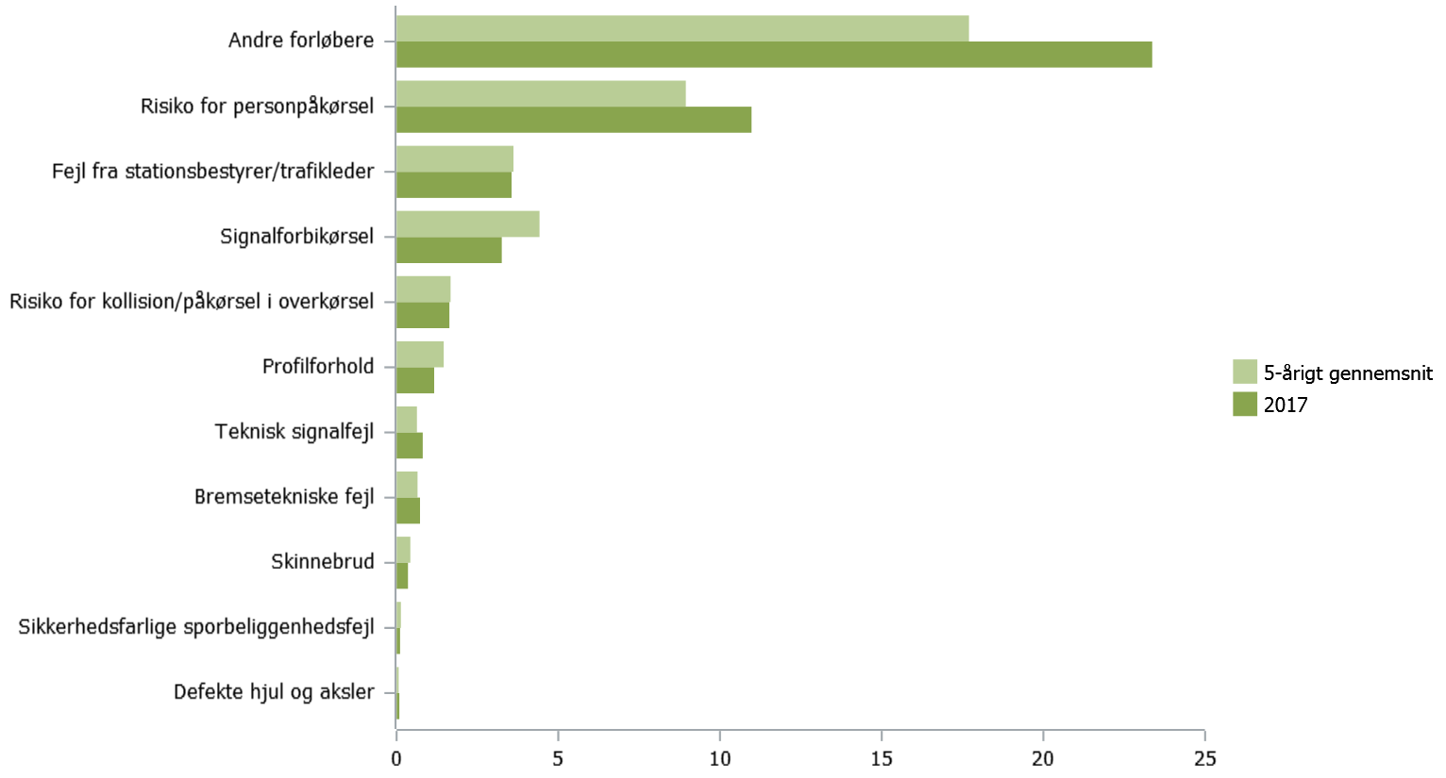

*Note: Suicides are not included. Where possible, the names of the categories have been modified so that they are comparable with previous years’ safety reports and the categories in Executive Order on reporting No 1340/2015 (see Figure 1.11).*

*Source: Danish Transport, Construction and Housing Authority incident database*

*Figure 1.11: Precursors to accidents in 2016 and 2017, broken down by the categories in Executive Order on reporting No 1340/2015*

|  |  |
| --- | --- |
| Andre forløbere | Other precursors |
| Risiko for personpåkørsel | Risk of collision with person |
| Fejl fra stationsbestyrer/trafikleder | Error by station manager/traffic controller |
| Signalforbikørsel | Signal passed at danger |
| Risiko for kollision/påkørsel i overkørsel | Risk of collision/hitting someone at a level crossing |
| Profilforhold | Profiling |
| Teknisk signalfejl | Technical signalling fault |
| Bremsetekniske fejl | Braking-technology fault |
| Skinnebrud | Broken rails |
| Sikkerhedsfarlige sporbeliggenhedsfejl | Track-bed faults hazardous for safety |
| Defekte hjul og aksler | Broken wheels and axles |
| 5-årigt gennemsnit | 5-year average |

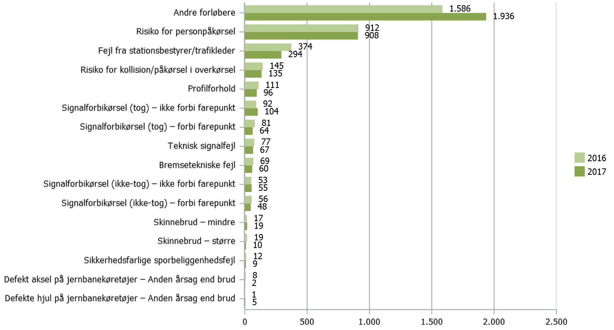

*Note: Suicides are not included. Incident categories for which no incidents were reported in 2016 and 2017 have not been included. For the categories relating to passing a signal at danger, 'train' is understood to mean a train movement with a train number (i.e. scheduled) on the through track and on an open line. ‘No train’ means moving slowly on or onto a through track with empty rolling stock that does not have a train number, and moving slowly in a secured shunting area (signals are controlled by a signal box).*

*Source: Danish Transport, Construction and Housing Authority incident database*

|  |  |
| --- | --- |
| Andre forløbere | Other precursors |
| Risiko for personpåkørsel | Risk of collision with person |
| Fejl fra stationsbestyrer/trafikleder | Error by station manager/traffic controller |
| Risiko for kollision/påkørsel i overkørsel | Risk of collision/hitting someone at a level crossing |
| Profilforhold | Profiling |
| Signalforbikørsel (tog) – ikke forbi farepunkt | Passing a signal at danger (train) - not passing a hazard |
| Signalforbikørsel (tog) –forbi farepunkt | Passing a signal at danger (train) – passing a hazard |
| Teknisk signalfejl | Technical signalling fault |
| Bremsetekniske fejl | Braking-technology fault |
| Signalforbikørsel (ikke-tog) – ikke forbi farepunkt | Passing a signal at danger (no train) – not passing a hazard |
| Signalforbikørsel (ikke-tog) –forbi farepunkt | Passing a signal at danger (no train) – passing a hazard |
| Skinnebrud – mindre | Broken rail – minor |
| Skinnebrud – større | Broken rail – major |
| Sikkerhedsfarlige sporbeliggenhedsfejl | Track-bed faults hazardous for safety |
| Defekt aksel på jernbanekøretøjer - Anden årsag end brud | Defective axles on railway vehicles - Reasons other than a break |
| Defekt hjul på jernbanekøretøjer - Anden årsag end brud | Defective wheels on railway vehicles - Reasons other than a break |
| 1.586 | 1 586 |
| 1.936 | 1 936 |
| 1.000 | 1 000 |
| 1.500 | 1 500 |
| 2.000 | 2 000 |
| 2.500 | 2 500 |

## Suicides on the railway

Figure 1.12 shows the number of suicides on the railways in the period 1999-2017. In 2017, 25 suicides on the railways in Denmark were reported. This is the same number as in 2016, which was the lowest in 10 years. By way of comparison, 12 suicides were reported on the railways in Norway in 2016, and 69 in Sweden. In the EU, the number of suicides on the railways has been around 3 000 a year since 2010. This was also the case in 2016, when the number of reported suicides was 3 006[15].

Figure 1.13 on the next page shows the total number of suicides in Denmark compared with the number of suicides on the railways in Denmark since 1999. The figure shows that the five-year average for the number of suicides in Denmark has been relatively stable in recent years. The figure also shows that only a small proportion of suicides in Denmark take place on the railways.

*Figure 1.12: Number of suicides on the railways in Denmark in the period 1999-2017*

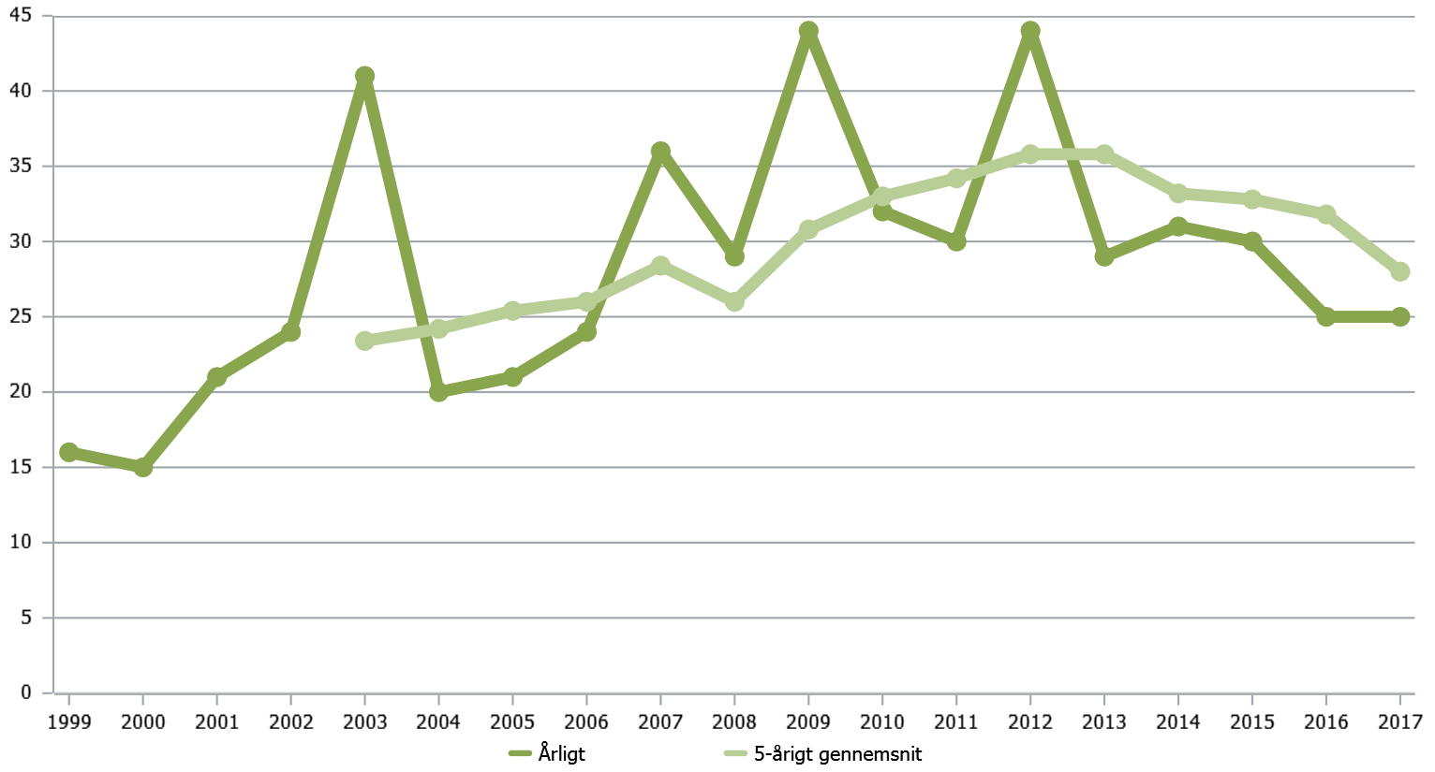

*Note: The figure shows the number of suicides resulting in a fatality. Source: Danish Transport, Construction and Housing Authority incident database*

|  |  |
| --- | --- |
| Årligt | Annually |
| 5-årigt gennemsnit | 5-year average |

|  |
| --- |
| **Suicides on the railway**  Suicide is not viewed as a railway accident in the traditional sense, because the causes of suicide are not directly related to the railway. The number of suicides and suicide attempts is therefore not included in the statistics on which the previous section is based. Suicides on the railways should be considered and prevented on the same basis as suicides and suicide attempts in general.  However, it is important to monitor and try to prevent the number of suicides and suicide attempts on the railways, in the interests of the person concerned and his/her dependants, the train driver and any witnesses to the suicide.  Suicides and suicide attempts are recorded on the basis of witness statements and police decisions. |

*Figure 1.13: Number of suicides in Denmark compared with the number of suicides on the Danish railways in the period 1999-2017*

*Source:* *The Danish Transport, Construction and Housing Authority’s incident database and Statistics Denmark’s table DOD1*

|  |  |
| --- | --- |
| Den danske jernbane – årligt | The Danish railways – annually |
| Den danske jernbane – 5-årigt gennemsnit | The Danish railways – 5-year average |
| Danmark – årligt | Denmark – annually |
| Danmark – 5-årigt gennemsnit | Denmark – 5-year average |

# Chapter 2: Follow-up of recommendations from the Accident Investigation Board Denmark

In 2017 the Accident Investigation Board Denmark (HCLJ) published three reports and records with recommendations. In addition, at the beginning of 2017 a report was published that the Authority followed up on in 2017. This chapter presents the Authority’s treatment and the status of the treatment of the recommendations.

In 2017 the HCLJ published three reports and records with recommendations (see Table 2.1), two of which contained recommendations for the Danish Transport*,* Construction and Housing Authority.

**The Accident Investigation Board Denmark and the Authority’s cooperation on incidents**

The Accident Investigation Board Denmark (HCLJ) is an investigative authority. Based on unbiased investigations of incidents, the HCLJ makes recommendations to prevent accidents and incidents and improve rail safety. The HCLJ does not attribute blame and responsibility.

As the primary recipient of the recommendations, the Danish Transport*,* Construction and Housing Authority must ensure the appropriate follow-up. Any action takes place in cooperation with the responsible actors concerned.

Furthermore, every year there are incidents on the railways that require particular attention and need following up by the Authority. This may involve concrete recommendations from the HCLJ or incidents that have not yet been investigated by the HCLJ, or are not being investigated by the HCLJ.

The third report contains recommendations directly to the railway undertaking concerned (DSB), and the report is therefore not discussed here (the report is from 25 October 2017). The Danish Transport*,* Construction and Housing Authority will follow up on the DSB’s handling of the recommendations in connection with the Authority’s follow-up supervision.

In addition, this chapter describes a report published at the beginning of 2017, which the Authority followed up on in 2017.

The reports and records discussed in this chapter are listed in Table 2.2 on the next page.

*Table 2.1: Reports/records from the Accident Investigation Board Denmark published in 2017.*

|  |  |  |
| --- | --- | --- |
| **Report date** | **Incident** | **Incident date** |
| 22/05/2017 | Person struck on platform crossing, Kværndrup | 23/05/2016 |
| 25/10/2017 | Train derailed while leaving Lundby station | 26/10/2016 |
| 06/12/2017 | Station official (trainee) killed during derailment, Høje Taastrup | 12/12/2016 |

*Table 2.2: Reports/records from the Accident Investigation Board Denmark discussed in this chapter.*

|  |  |  |
| --- | --- | --- |
| **Report date** | **Incident** | **Incident date** |
| 29/12/2016 | Person’s hand became trapped in the doors of an IC3 train, Vejle | 23/02/2013 |
| 22/05/2017 | Person struck on platform crossing, Kværndrup | 23/05/2016 |
| 06/12/2017 | Station official (trainee) killed during derailment, Høje Taastrup | 12/12/2016 |

## Person’s hand became trapped in the doors of an IC3 train, Vejle

The accident occurred on 23 February 2013 early in the morning at Vejle station. A group of young women wanted to take the train after a city tour, but they did not all reach the train door in time before departure. Members of the group prevented the doors from closing by blocking them. One of the women ended up with her hand trapped in the doors when the train departed. She was dragged along by the train, pulled her hand free after about 10 metres, then fell between the train and the platform. The train was a one-man-operated IC3 train.

The Accident Investigation Board Denmark assessed that the incident was caused by passengers making active attempts to prevent the doors from closing, combined with the fact that the doors were not checked and rechecked before the train departed in this situation or, if they were checked, the checks did not work as assumed. The Accident Investigation Board Denmark also concluded that the DSB had not taken sufficient account in advance of the incident of the already known safety risks posed by the introduction of one-man operation on letter MF (IC3), including ensuring that the staff had the necessary knowledge of the door closure system’s weaknesses.

**Recommendations**

The Accident Investigation Board Denmark recommends that the Danish Transport, Construction and Housing Authority ensure that a passenger safety analysis is carried out in connection with the departure procedure for one-man operation of an MF trainset and trainset with corresponding doors, including that:

* the staff have sufficient knowledge of how the door system works
* the safety measures are adequate when the doors close and a one-man-operated trainset with same type of doors departs.

In addition, the report listed a number of observations.

**Follow-up by the Danish Transport, Construction and Housing Authority**

The Danish Transport, Construction and Housing Authority has followed up with the DSB both the recommendations made by the Accident Investigation Board Denmark and other measures that the DSB has taken on its own initiative. The follow-up took place by means of supervision of the DSB and examination of the material submitted by the DSB.

On the basis of the report by the Accident Investigation Board Denmark and the supervisory process, the DSB decided on or implemented a number of corrective actions:

* Implemented in-service training of train drivers with a focus on door closing and anti-trapping systems.
* Affixed yellow warning pictograms designed to warn passengers against blocking the doors on departure.
* Prepared an updated analysis note (as a result of the recommendations), which has resulted in a series of actions.
* Decided on clear marking of emergency brake and emergency door opening, initially on letter MF.
* Decided to implement corrected in-service training in the anti-trapping system for train crews and platform managers.

The DSB decided that in 2018 it wanted to clarify the marking of the emergency brake and emergency door opening, initially on letter MF. As of September 2018 the Authority has not yet checked by supervision whether this has been implemented. As of September 2018 the Authority believes that the DSB has implemented all the other actions.

The Authority believes that the DSB has undertaken a thorough analysis of the situation regarding boarding and alighting accidents for both one-man-operated operation and operation with conductors. The analysis has shown that boarding and alighting accidents are not a problem that relates specifically to one-man operation.

The Authority believes that with the above measures, the DSB has taken the Accident Investigation Board Denmark’s recommendation and observations into account. The Authority considers that the recommendations have been met.

The HCLJ’s report is available (in Danish) [here](http://www.havarikommissionen.dk/index.php?option=com_contentbuilder&title=s%C3%B8g-jernbane-hclj611-2013-127-rapport&controller=details&id=1&record_id=93&Itemid=163&limitstart=0&filter_order=&lang=da).

## Person struck on platform crossing, Kværndrup

On 23 May 2016 a person was struck and killed on a platform crossing at Kværndrup Station. The person was struck by a scheduled through train on track 1. The driver managed to sound the horn and begin braking around 30 metres before the platform crossing. A mobile phone and a book were later found on the ground next to the person.

At the time of the accident, the platform on track 1 at Kværndrup Station was closed due to damage to the foundations and a risk of collapse. Therefore, all passenger-transferring trains were scheduled to transfer passengers at the island platform on track 2. In other words, all alighting and boarding passengers had to use the platform crossing across track 1.

At the time of the accident, no crossing had taken place at Kværndrup Station. The through trains passed over the platform crossing twice per hour, 10 minutes before and 10 minutes after the train on track 2 transferred its passengers. The speed was 75 km/h during the passage.

The Accident Investigation Board Denmark concludes that the collision was caused in particular by:

* ‘the fact that the young woman did not pay the necessary attention when she needed to use the crossing
* inadequate safety and warning measures at the platform crossing in relation to track use, speed and operation (through train).’

The Accident Investigation Board Denmark also concludes that Banedanmark did not immediately implement a risk assessment of the changing safety conditions in relation to, among other things, through trains over the platform crossing.

**Recommendations**

The Accident Investigation Board Denmark recommends that the Danish Transport, Construction and Housing Authority ensure that a risk analysis is carried out into passenger safety at Kværndrup and Stenstrup stations, including whether the applicable rules have been complied with since 1999 (due to changed traffic, increased line speed, etc.), and ensure that the necessary safety measures are implemented.

The Accident Investigation Board Denmark recommends that the Danish Transport, Construction and Housing Authority ensure that a risk analysis is carried out of personal safety at platform crossings, where there is no established warning system or any other similar protection, including whether the existing rules are sufficient. The risk analysis must also include other crossings between platforms that might be thought of by passengers as platform crossings.

The Accident Investigation Board Denmark recommends that the Danish Transport, Construction and Housing Authority ensure that clear and relevant rules are established for the use of warning systems and signage at platform crossings.

**Follow-up by the Danish Transport, Construction and Housing Authority**

The Danish Transport, Construction and Housing Authority asked Banedanmark to follow up on the recommendations of the Accident Investigation Board Denmark. Banedanmark has implemented the following corrective actions:

* Developed a method of risk assessment (risk number) and implemented this for all platform crossings on Banedanmark’s infrastructure.
* Taken a decision on the use of the method of risk assessment of the significance of working timetable changes for safety at platform crossings.
* Diverted traffic at Kværndrup Station so that through trains no longer use track 1 but track 2, where there is no platform crossing.
* Taken a decision to establish warning systems at Kværndrup Station and Stenstrup Station.
* Identified the need for an overall organisational safety responsibility for platform crossings and decided to collect this responsibility in one place in the organisation.

In addition, Banedanmark has begun identifying the need for changes in the overall regulatory framework for safety at platform crossings. This work is still in progress and will be followed up by the Authority as part of the follow-up of the Accident Investigation Board Denmark’s recommendations from the platform crossing accidents in Bred and Tjæreborg (the two accidents are described in Chapter 1).

Banedanmark’s follow-up work has thus far shown that:

* there are no rules that guarantee uniform and sufficient signs for warning users of platform crossings.
* the highest risk is generally associated with platform crossings on the railway network’s main lines and platform crossings that also serve as neighbourhood connections.

As of September 2018, the Authority believes that Banedanmark’s follow-up of the report’s recommendations is complete, since Banedanmark’s ongoing work to develop rules will be followed up as part of the Authority’s follow-up of the Accident Investigation Board Denmark’s recommendations from the platform crossing accidents in Bred and Tjæreborg (as mentioned above).

The HCLJ’s report is available (in Danish) [here](http://www.havarikommissionen.dk/index.php?option=com_contentbuilder&title=s%20g-jernbane-hclj611-2016-242-redeg%20relse&controller=details&id=1&record_id=97&Itemid=163&limitstart=0&filter_order=&lang=da&contentbuilder_downl).

## Station official (trainee) killed during derailment, Høje Taastrup

On 12 December 2016 a trainee station official was killed during shunting of a goods train at Høje Taastrup Station. The accident was due partly to a derailment and partly to the fact that the trainee was working alone without his instructor.

The derailment was caused, among other things, by the fact that the train was set in motion without permission and then passed a signal showing ‘do not pass’. During the derailment the trainee, who was alone without his instructor, was trapped by the derailed wagon, as a result of which he died.

The derailment occurred against the adjacent track, where a passenger train had passed immediately beforehand.

**Recommendations**

The Accident Investigation Board Denmark recommends that the Danish Transport, Construction and Housing Authority:

* ‘ensure that for all trainees there are guidelines in rail safety training on trainees’ areas of responsibility, i.e. whether and, where appropriate, the conditions under which trainees must perform safety work completely or partially unsupervised.
* ensure, together with Banedanmark, that potentially safety-critical usages are intercepted by and corrected through safety management systems.
* ensure, together with Banedanmark and relevant operators that the ATC instructions’ provisions for resuming travel after an ATC emergency braking are observed.’

**Follow-up by the Danish Transport, Construction and Housing Authority**

The Accident Investigation Board Denmark’s report was published at the end of 2017. The Authority therefore first had the opportunity to follow up on the report’s recommendations in 2018.

In April 2018 the Authority held a meeting with The Accident Investigation Board Denmark to obtain further details about the above recommendations. The Authority will meet the recommendations in connection with Banedanmark’s renewal of its safety authorisation, since the processes that should address the situation are part of the renewal.

The HCLJ’s report is available (in Danish) [here](http://www.havarikommissionen.dk/index.php?option=com_contentbuilder&view=list&Itemid=163&lang=da&contentbuilder_download_file=52d43267a00a5b84c9ead2f9de268f2157094265).

# Chapter 3: Safety certificates and safety approvals

On 31 December 2017, three undertakings were approved to operate infrastructure, and seven undertakings were approved to run trains. In addition, five undertakings were approved both to operate infrastructure and to run trains. During the year two new undertakings were approved - one for the operation of a light rail infrastructure, and one to run light rail trains. In 2017, the rules for safety certificates and authorisations[16] became more manageable, because the Authority combined the four existing executive orders in this area into one.

## New executive order with requirements for safety certificates and safety authorisations

In 2017 the Danish Transport, Construction and Housing Authority issued a new executive order on safety authorisations and safety certificates on the railways, Executive Order No 147 of 30 January 2017.

The new executive order constitutes one single set of rules and replaces the four different executive orders that previously applied to safety authorisation and certification on the railways. The executive order thus lays down requirements for infrastructure managers, railway undertakings and undertakings that operate services at their own risk on the railways in connection with work for other undertakings.

The requirements in the new executive order are adapted to the practice for safety management systems, which has evolved over the past years.

Similarly, the forthcoming common European requirements, which are expected to be introduced in the context of the implementation of the fourth railway package in 2019/2020, have been incorporated into the new executive order as far as possible.

The executive order came into force on 1 March 2017. As a transitional arrangement until the end of 2017, it was still possible to apply for approval or certification under the four old executive orders.

## Safety certificates and safety authorisations in Denmark

In Denmark, a total of 15 undertakings had a safety certificate and/or safety authorisation as of 31 December 2017. Three undertakings were approved to operate infrastructure and seven undertakings were approved to run trains. In addition, five undertakings were approved both to operate infrastructure and to run trains. The 15 undertakings can be broken down as shown in Tables 3.1 and 3.2 on the next page.

*Table 3.1: Railway undertakings as of 31 December 2017*

|  |  |
| --- | --- |
| **Category** | **No** |
| Railway undertakings with safety certificates A and B[17]   * Arriva Tog A/S * Captrain Denmark Aps * CFL Cargo Aps * DB Cargo Scandinavia A/S * DSB * Keolis Aarhus Letbane A/S * Lokaltog A/S * Metro Service A/S * Midtjyske Jernbaner A/S * Nordjyske Jernbaner A/S | 10 |
| Railway undertakings with safety certificate B in Denmark only   * Hector Rail AB * SJ AB | 2 |

The 12 railway undertakings are divided into 8 companies solely for passengers and 4 companies solely for freight.

*Table 3.2: Infrastructure managers as of 31 December 2017*

|  |  |
| --- | --- |
| Category | No |
| Undertakings with safety authorisation   * Arriva Tog A/S * Banedanmark * Lokaltog A/S * Metro Service A/S * Midtjyske Jernbaner A/S * Nordjyske Jernbaner A/S * Øresundsbro Konsortiet I/S Vester * Aarhus Letbane I/S | 8 |

Table 3.3 gives an overview of the changes to safety certificates and safety authorisations that have been implemented in 2017.

*Table 3.3: Changes to safety certificates and authorisations in 2017*

|  |  |  |
| --- | --- | --- |
| Changes | Number of safety certificates | Number of safety authorisations |
| New safety certificates/authorisations issued | 1 | 1 |
| Renewals of safety certificates/authorisations | 2 | 0 |
| Amendments to safety certificates/authorisations | 3 | 2 |
| Applications for new safety certificates/authorisations currently being processed | 7 | 0 |
| Revoked or expired (without renewal) safety certificates/authorisations | 0 | 0 |
| Total | **13** | **3** |

The Authority issued a new safety certificate (A and B) and a new safety authorisation in connection with the establishment of a new light rail, which began operation in December 2017. This certification and approval are carried out in accordance with the new executive order on safety authorisations and safety certificates on the railways.

In addition, two railway undertakings received renewed safety certificates (A and B) in connection with the expiry of the period of validity of the existing safety certificates. The renewals were made pursuant to the old executive order on safety certificates for railway undertakings.

The changes to safety certificates and safety authorisations in 2017 were made mainly on the basis of changes in the specific sections.

Finally, the Danish Transport, Construction and Housing Authority received applications from five construction companies and two railway undertakings applying for a safety certificate part B in Denmark. All these applications were being processed at the end of the year.

## The Authority’s guidance for undertakings

When issuing the new executive order on safety authorisations and certificates in 2017, the Authority issued two guides. The first concerns requirements placed on undertakings’ safety management systems. The second concerns requirements placed on the overall process for obtaining and amending safety authorisations and certificates. The guides can be accessed via the Authority’s website. Here you can also find forms for applying for safety certificates and authorisations.

A number of guidance meetings were held in 2017 with undertakings that are currently carrying out major audits of their safety management systems, as well as undertakings that have not previously had their own safety certificate. At these meetings, information was provided on the Authority’s requirements for a safety management system and the Authority offered guidance on how the undertaking can build a safety management system based on its activities and risks.

## Other matters

Complaints and rights of appeal

Undertakings cannot refer decisions of the Danish Transport, Construction and Housing Authority to the transport, construction and housing minister or any other administrative authority. However, undertakings may refer a decision to the courts within 8 weeks of its notification.

In addition, undertakings may always ask the Danish Transport, Construction and Housing Authority to re-assess the case.

**Declarations to the police**

The Danish Transport, Construction and Housing Authority may make declarations to the police. This is made possible by a number of provisions in the Railways Act and in executive orders issued by the Danish Transport, Construction and Housing Authority, if defined provisions are not respected.

The Danish Transport, Construction and Housing Authority did not make any declarations to the police in 2017.

# Chapter 4: Experiences with supervision

The Danish Transport, Construction and Housing Authority supervises the railway undertakings and railway infrastructure managers’ safety management systems to ensure that the undertakings are assuming their share of responsibility for railway safety.

## Supervision planning and prioritisation

The supervision plan shows what supervisory activities the Authority planned to carry out in 2017. The supervision is aimed at existing safety certificates and safety authorisations, but also new issues and renewals of safety certificates and safety authorisations.

Since 2010, the Authority’s annual supervision planning has been based on a comprehensive and systematic assessment of the undertakings’ circumstances, so that efforts can be concentrated where the risks are deemed to be most prevalent and greatest. The method is described in the Authority’s supervision strategy. Both the supervision strategy and supervision plan can be found on the Authority’s website.

In 2017, the Authority focused on:

* Undertakings’ implementation of cause analyses,
* Choice of activities as a follow-up to cause analyses,
* Establishment of safety targets with associated action plans,
* Undertakings’ methods for assessing and guaranteeing professional competencies for employees and subcontractors.

## Results of supervision in 2017

Safety on the railways is high. At the same time, the Danish Transport, Construction and Housing Authority notes that several undertakings are facing challenges implementing the system-based rather than person-based approach to safety that are a consequence of common EU regulations for the railways. The Authority finds that these challenges can not immediately be seen to represent an increased safety risk here and now. This is because the undertakings’ challenges in developing system-backed safety do not seem to reflect a decrease in the ability to implement known, safety-bearing functions and activities here and now.

However, to maintain the high level of safety on the railways and increase undertakings’ self-management, it is important that undertakings increase their focus on maintaining and developing their safety management skills. Below are described a number of general observations from the supervision of undertakings in 2017, including the situations undertakings could benefit from focusing on to maintain railway safety over time.

Focus area: cause analysis and corrective actions

Undertakings must continuously monitor safety. This is done by, among other things, monitoring reports, observations, registrations, incidents and more, identifying the causes of unwanted situations, and then taking action to remedy and correct these situations.

In 2017 the Authority notes that undertakings are generally good at detecting problems and carrying out *remedial actions*, i.e. correcting the immediate error. However, they are generally less good at investigating *why* the problem arose, to reduce the likelihood of the same problem occurring again. This is not a direct criticism of safety, but simply pointing out what undertakings could focus their efforts on to maintain high railway safety over time.

Safety targets and action plans

To maintain safety, the undertaking must establish safety targets, which preferably address specific risks or trends that can challenge the safety level the undertaking has set for itself.

Safety targets help undertakings focus their resources on those areas of action the undertaking feels are of the greatest significance in terms of safety. This is done by drawing up action plans with appropriate activities and corresponding methods of measurement, which aim to verify whether the desired effect is reached.

Undertakings are generally good at setting targets, but could benefit from focusing more on action plans and systematically following them up.

**Organisation and competence management**

Undertakings should ensure that their safety management system provides clear descriptions of the responsibilities and powers and competence requirements linked to the functions that the undertaking considers necessary. The purpose is to ensure that the undertaking’s activities that are relevant to railway safety are carried out on time and are of the right quality.

A number of undertakings are focusing on competence management systems. At the same time, however, the Authority notes that the majority of undertakings have difficulty distinguishing between the competence requirements for the individual function and the competencies that employees possess. Consequently, undertakings often have a problem being able to present evidence of the competence of their own and subcontractors’ employees.

An approach to organisation and competence management that is not always systematic is not directly critical in terms of safety. But it is a situation to which undertakings should devote more attention going forward if the high safety on the railways is to be maintained over time.

**Other matters**

Undertakings generally have difficulty showing that their safety management system is an integral part of everyday life for the employees, and covers the activities of the undertaking, which has an impact on railway safety. In addition, undertakings are continually struggling to apply the risk-based approach that follows from the mandatory common European methodology for risk assessment, CSM-RA. (Read more about CSM-RA in Chapter 5).

Accordingly, in the Authority’s experience, the safety management system is not always regularly updated or fully implemented in the organisation.

However, a number of undertakings are working on a root-and-branch review of their safety management systems. Several undertakings have chosen to start from scratch with a new IT platform and a new way of describing the system, which makes it more useful in practice. This, together with the fact that most undertakings are working constructively to complete their risk profile, are important indicators that there is understanding that over time safety will have to be supported by systems, not individuals.

The undertakings’ management of transportation of dangerous goods

As in previous years, the Authority has supervised goods operators’ transportation of dangerous goods. Thus, physical checks were carried out to ascertain whether the wagon composition and signage were in accordance with the transport documents. Interviews were also conducted with train drivers from the relevant goods operators, and the drivers’ certificates and licences, among other things, were checked as part of this.

On the basis of this supervision, the Authority is of the view that the difficulties encountered by the operators in previous years in relation to deficient train driver certificates have generally been resolved. No new challenges were identified in 2017.

## Cooperation with other countries’ authorities

In 2017, Denmark entered into a written agreement with the Swedish national safety authority, the Swedish Transport Agency (Transportstyrelsen). The agreement requires the countries to exchange critical information and information about supervisory activities relating to railway undertakings and infrastructure managers operating in the two countries.

**Nordic cooperation**

The Authority exchanges ongoing experiences with the authorities in both Norway and Sweden with a focus on the safety management systems, safety culture and competencies of the undertakings. In addition, experience from completed supervision is generally shared, but especially for undertakings that have safety certificates in several of the Nordic countries.

The Authority has entered into agreements with the other Nordic countries on the implementation of common supervisory activities. In 2017 this resulted in the Authority participating as an observer in some of the Swedish Transport Agency’s renewal supervision with a railway undertaking that has a B-certificate for freight transport in Denmark. In addition, the Authority also participated as an observer in a follow-up supervision with a railway undertaking that has a B-certificate for passenger transport in Denmark.

The Authority is also discussing the implementation of the fourth railway package and guidelines for requests for changes to a safety certificate or authorisation.

# Chapter 5: Experiences with approvals

In 2017, the Danish Transport, Construction and Housing Authority continued to focus on dialogue with the industry regarding approvals. Through the year, among other things the Authority visited smaller infrastructure managers, created a CSM-RA panel and released two new guides in the area. In 2017, the Authority also carried out a check of neighbours’ authorisation processes in the UK, the Netherlands, Sweden and Norway.

## General information about the Authority’s work with authorisations in 2017

Undertakings’ use of CSM-RA in the approval of construction projects has been challenged by a large turnover of employees in the industry in general, coupled with an increasing workload. This is reflected in varying maturity in the use of CSM-RA in the application process. That is why in 2017 the Authority focused on guiding the use of CSM-RA and targeting this guidance according to the specific needs and challenges in the industry.

The need for guidance also stems from the fact that CSM-RA was largely developed for handling authorisations and changes to rail vehicles. This means that the individual countries themselves have had to adapt the authorisation process for infrastructure, which in turn has resulted in variations in the extent to which the respective EU countries use CSM-RA as an integral part of the basis for authorising a project. In this context, the Authority carried out a check among neighbours in order to find out more about the differences in the use of CSM-RA.

**Check of neighbours’ authorisation processes**

In 2017, the Authority carried out a check of neighbours’ authorisation processes for infrastructure in the UK, the Netherlands, Sweden and Norway. The purpose of the check of neighbours was to investigate how other comparable countries have chosen to utilise the European regulations in this area in order to consider the appropriateness of the Danish approach, but also to find out whether the other countries are facing similar challenges in the use of the European regulations.

The check of neighbours showed that there are differences in the individual countries in the basis for authorisations and thus the issuing of authorisations of release to service. There is a recognition that the EU authorisation regime cannot blindly be transferred to the infrastructure area. This is due in particular to the need to release the infrastructure to service immediately after the change has been completed. This implies that the countries allow release to service based on preliminary documentation, with the condition that final documentation will be submitted at a later date. The Danish authorisation method is just one of the existing variants.

A different approach to the use of CSM-RA was identified in the countries investigated. The use of CSM-RA as proof of safety varies from being the determining factor for whether a new authorisation of release to service is needed, to undertakings themselves having to deal with CSM-RA without regulatory involvement.

In Denmark, for example, there is a greater degree of self-management, where the need for a new authorisation of release to service is based on whether a given change is significant according to CSM-RA. In other countries, any changes must be notified to the authority, which subsequently determines whether a new authorisation from the authority is required. There is also a different approach to the use of TSIs. TSIs must be used in all countries, even though the criteria for using TSIs are different: Whereas some countries (such as Denmark) take as a starting point an assessment of whether the change is a major task, the need for an authorisation of release to service may automatically trigger a requirement for the use of TSIs in other countries. Table 5.1 on the next page gives an overview of the five countries’ authorisation processes.

*Table 5.1: Authorisation processes in Denmark, the UK, the Netherlands, Sweden and Norway*

|  |  |  |  |  |  |
| --- | --- | --- | --- | --- | --- |
|  | **Denmark** | **Norway** | **Sweden** | **Netherlands** | **UK** |
| **How is it decided whether an authorisation of release to service is necessary?** | The undertaking’s significance assessment (CSM-RA) | All changes are notified to the NSA[18], which determines the need for an authorisation of release to service | All changes are notified to the NSA, which determines the need for an authorisation of release to service. An indicative list of changes that should/should not have an authorisation of release to service | All changes are notified to the NSA, which determines the need for an authorisation of release to service | The infrastructure manager’s definition of change is checked by their acceptance panel; the NSA is a member. Must be justified to the NSA if no need for an authorisation of release to service |
| **Use of CSM-RA** | CSM-RA is used to determine the need for an authorisation of release to service | CSM-RA is only used to determine the need for an AsBo | CSM-RA is not used in the authorisation of release to service process | CSM-RA and budget are used by the NSA to determine the need for an authorisation of release to service | CSM-RA one of the criteria for determining the need for an authorisation of release to service |
| **Use of TSIs** | TSIs must be used for major changes (NSA decision) | TSIs must be used for major changes (NSA decision) | TSIs must be used for all changes (irrespective of size) | TSIs must be used if there is a need for an authorisation of release to service (NSA decision) | The use of TSIs is determined by the infrastructure manager. All changes are within the scope of the use of TSIs unless agreed otherwise with the NSA |
| **When is the authorisation of release to service issued (time)?** | Prior to release to service, with conditions for final documentation | Close to release to service, sometimes time-limited and with conditions for final documentation | Time-limited authorisations with conditions first, authorisation of release to service is issued when final documentation is received | Exception with conditions close to release to service, authorisation of release to service after final documentation is received | Before infrastructure is released to service, mostly with conditions |

In those countries where CSM-RA and the assessors’ work will be used actively in connection with an application for authorisation of release to service, it is the Authority’s opinion that the time the authority spends on authorisation work is substantially less than in those countries that have not involved CSM-RA documentation in their work in the same way. Table 5.2 shows how processing times vary in the five countries.

*Table 5.2:* Processing times in Denmark, the UK, the Netherlands, Sweden and Norway

|  |  |  |  |  |
| --- | --- | --- | --- | --- |
| **DK** | **NO** | **SE** | **NL** | **UK** |
| 3 weeks | 4 weeks (notification)  4 months (authorisation of release to service) | 4 months | 8 weeks (information file)  8 weeks (authorisation of release to service) | 4 weeks |

A common feature of the countries that use CSM-RA actively is that they are experiencing a certain lack of guidance from the EU, and that they themselves have to a very large extent had to advise and guide the industry about the use of the common European set of rules, CSM-RA. The Authority believes that this is to the detriment of a uniform implementation of CSM-RA, and thus a common understanding of, and approach to, sets of rules across the Member States.

**Visits to smaller infrastructure managers**

At the end of 2016 and early in 2017, the Authority visited several of the country’s smaller infrastructure managers. The purpose of the visits was to target the Authority’s guidance on the specific needs of smaller infrastructure managers. During the visits, the overall challenges of infrastructure managers in relation to applications for authorisations of release to service, including the particular understanding and use of CSM-RA, were discussed.

**Guidance on the use of CENELEC standards in relation to CSM-RA**

European standards EN 50126, 50128 and 50129 have been used for the management of rail control risks for a long time. This applies to light rail and to conventional railways. In particular, EN 50126 largely corresponds to CSM-RA and the introduction of CSM-RA has therefore raised a large number of questions as to when the standards are applied and what the connection is to CSM-RA.

The topic was also the theme for a session at the Authority’s safety conference in 2017. The Authority has since seen a marked decrease in questions on this topic. The issue was extensively discussed with the Danish signal programme in 2016, and at the start of 2017 the Authority issued a guide on the authorisation of urban network trains.

**Guidance on the use of CSM-RA during line electrification**

In 2017 the Authority worked to clarify the interface with the Danish Safety Technology Authority in connection with line electrification. In December 2017 this led to the publication of a new guide, which clarifies the degree to which the scope of CSM-RA extends to line electrification. The guide can be accessed via the Authority’s website.

In the light of the European definition of the traction current system, the Authority advises that the traction current system up to and including the line transformer is part of the railway system. Therefore, this section also falls within the scope of CSM-RA. This implies that the applicant must comply with both the Authority’s and the Danish Safety Technology Authority’s requirements as there may be hazards linked to both electrical and railway safety in connection with the establishment of line electrification.

**CSM-RA panel – focus on specific challenges and their solutions**

At the end of 2017 the Authority established a CSM-RA panel with the participation of people from the industry with specific competence in CSM-RA. The panel will meet a total of approximately 6 times over three quarters of a year. The panel arose as a consequence of continuous requests from the industry on clarification of essential concepts and processes when using CSM-RA in connection with applications. It is the Authority’s desire that the panel be broad-based and thus reflect the industry’s professional composition. The purpose of the panel is to discuss and clarify some of the challenges involved in the use of CSM-RA in Denmark. The aim is for clarifications from the panel to either be included directly in the Authority’s guidance or in the industry as Best Practice.

## Experiences in the area of infrastructure

It is the Authority’s opinion that there are many people in the industry with experience and competence in the use of CSM-RA when applying for authorisations for infrastructure. However, it is also the perception that the growing number of projects means that resources must play a part in many projects at the same time.

In other words, a need has been identified for the new powers in infrastructure to quickly acquire a basic understanding of the CSM-RA process. The Authority has been in discussions with the industry about this in particular, and also wanted to support this with visits to smaller infrastructure managers.

In 2017, the European Union Agency for Railways issued a guide on CSM-RA, and at the end of 2017 established a panel of accredited CSM-RA assessors. It is the Authority’s expectation that the increased guidance from the ERA will help to support a European assessor market.

## Experiences in the area of vehicles

It is the Authority’s assessment that in 2017 there was a positive development in the quality of the safety documentation on which the authorisation of vehicles is based. This can be attributed to the fact that companies have to a greater extent prepared templates and procedures to ensure a consistent approach and better quality. Overall, this development helps reduce the time taken from an undertaking planning an amendment to a vehicle for the change to be authorised and released to service.

One of the things undertakings can benefit from improving is the safeguarding of the documentation that will be used to assess the significance and risk-control identified hazards, so that it follows the common European methodology for risk assessment, CSM-RA.

The quality of undertakings’ significance assessments varies, but is generally considered to be improving. This has included a clear improvement in terms of when in the change process an undertaking assesses whether the change is significant. However, some undertakings still feel that the significance criteria[19] come ‘too late’ in the process, usually *after* the change in question is ready for implementation. This is out of line with the change management process, which requires an assessment of whether or not the change in question is significant *before* the change is set in motion. The undertakings therefore do not always apply the CSM-RA process as intended.

In 2017, several railway undertakings had a condition in their safety certificate requiring them to submit all changes to the Authority and not only significant changes. During 2017, the Authority tried to give these undertakings more detailed feedback on their significance assessment, so that on the one hand undertakings receive feedback that consists of general comments on the material submitted, and on the other hand receive feedback on actual deviations from the principles of the CSM-RA Regulation.

**Test and transport**

In 2017 the Authority dealt with a wide range of applications for test and transport permits, where the applicant explained whether the test and/or transport is a significant modification of the existing railway system. The majority of these applications relate to tests in connection with the signal programme, and here clear improvements can be seen with regard to the understanding of the fact that it is the railway system under test and transport that must be described and assessed.

## Experiences from the undertakings

In 2017, there were 15 railway undertakings and infrastructure managers with activities in Denmark. All of these submitted a safety report for 2017 to the Danish Transport, Construction and Housing Authority. 13 undertakings made changes during the year that were significant in terms of railway safety, and they therefore described their experience of using the CSM-RA methods in their safety report from 2017.

Most of the undertakings report that their learning process has been positive, and that they have had good experiences with the use of CSM-RA methods. The undertakings have continued to focus on the implementation and development of processes for CSM-RA as well as on the development of internal competencies within CSM-RA.

Five undertakings report that in 2017 they worked to strengthen and develop their processes in the safety management system related to changes. A single undertaking reports that it is working on a process for the management of assessors because, in 2017, it incurred significant costs for projects that involved an assessor.

Several undertakings have been working to implement and embed the processes for CSM-RA in their organisation. One undertaking reports that it has optimised the internal process for implementing changes by implementing discussion meetings.

Several companies made fewer than five changes in 2017, and five companies did not use CSM-RA in 2017. Naturally enough, there have only been a limited number of changes for small undertakings in the industry. This means that the small undertakings have not had particularly great opportunities for reinforcing their skills through practical experience of using the CSM-RA methods. At the same time, two undertakings first became operational at the end of 2017.

It is clear from the safety reports that undertakings generally are working to strengthen and develop competencies within CSM-RA. For example, in 2017 several undertakings carried out training activities. They plan to continue these in 2018. One undertaking also reports that competencies within CSM-RA are strongest in the technical and administrative areas of the organisation, but that competence in production departments is improving slowly, although it still requires action.

Only one undertaking used external skills to perform significance assessments in 2017. This is regarded as an expression of the fact that many undertakings now consider their internal skills for performing significance assessments to be sufficient for ensuring that the risks associated with changes are managed in an acceptable way.

Overall, the undertakings’ safety reports for 2017 show that undertakings’ use of CSM-RA during the year has yielded good experiences and thus contributed to the development of processes. The experience that has been gained and the training and implementation activities that are being carried out are supporting the undertakings’ work to reinforce their skills in the use of the CSM-RA methods.

As a starting point, it is the undertakings themselves that are in charge of their handling of changes. However, some undertakings are experiencing challenges in terms of ensuring consistency and documentation. The Authority is focusing on this and is assisting undertakings through increased supervision. The extended supervision will be withdrawn when the undertakings have demonstrated that they have ensured consistency and documentation with adequate risk management.

# Chapter 6: Experiences with regulation

The Railway Safety Directive is the European legislation that provides a framework for the harmonisation of safety regulations in Europe. The Danish Transport, Construction and Housing Authority continued its work on implementing the Railway Safety Directive in 2017. This chapter reviews the rules issued by the Authority in 2017 as part of its implementation of the Railway Safety Directive.

## Harmonisation of regulations

The purpose of the Railway Safety Directive[20] is to ensure the development and improvement of safety on the EU’s railways and improved access to the market. The Safety Directive provides a framework for the harmonisation of national safety regulations, safety certificates for railway undertakings, tasks and roles for the national safety authority and the national investigation authority. The purpose of harmonising these regulations is to alleviate the administrative burden for undertakings and make it easier and cheaper to travel across Europe by train.

|  |
| --- |
| **The Danish Transport, Construction and Housing Authority issued the following rules in 2017 as part of its implementation of the Railway Safety Directive:**  *Legal acts supplementing the implementation of the Railway Safety Directive:*   * Executive Order No 147 of 30 January 2017 on safety authorisations and safety certificates in the railways sector.   *National safety rules[21]:*   * Executive Order No 9556 of 29 March 2017 on the rules governing travelling on railway infrastructure with train control BJ 5-1-2017. * Executive Order No 1212 of 20 November 2017 on the certification of train drivers.   *New rules aimed at railway undertakings:*   * Executive Order No 542 of 24 May 2017 on requirements for the accreditation of assessors in the rail sector. * Executive Order No 543 of 24 May 2017 on the authorisation of assessors and experts in connection with the authorisation of railway infrastructure and vehicles. * Executive Order No 1213 of 20 November 2017 on authorisation for the training of train drivers in the rail sector * Executive Order No 1216 of 6 November 2017 on fees and charges levied by the Danish Transport, Construction and Housing Authority in the railways sector. |

## The Executive Order on safety authorisations and safety certificates in the railways sector

This executive order updates and simplifies the regulatory structure for safety authorisations and safety certificates in the railways sector so that the rules are easier to understand and thus easier to comply with. At the same time, the current practices concerning safety management systems, which are widely followed by the undertakings, have been written into the rules.

The new executive order is more consistent with the practices that have developed in recent years, not only in the railways sector but also in relation to all safety management systems. The new rules therefore reflect to a great extent the understanding of safety management that certified undertakings now have. The new rules are also more transparent for new undertakings that have to establish a safety management system.

To date, the rules governing safety certificates and safety authorisations have been regulated by four different executive orders. The rules have now been combined in one executive order, so that they are more manageable.

There have not been any significant changes to the content in relation to the requirements hitherto in force.

|  |
| --- |
| **The new Executive Order contains the following changes:**   * The rules concerning the issuing of safety authorisations and certificates, and the conditions for obtaining them, have been updated; * The requirements for safety management systems have been updated and adapted to the trend in management standards, including the trend seen in the area of EU law. Please see the requirements in Annex 1 to the Executive Order. * Modernisation of the rules governing applications for safety authorisations and certificates, including the addition of new annexes concerning application forms. * Clarification of the provisions concerning amendments to safety authorisations and certificates. * The deadline for submitting the undertaking’s safety report has been changed from 30 June to 31 May. |

It should be noted that the executive order was also mentioned in the safety report for 2016, because the majority of the work on the executive order was in 2016. Since the regulation was issued in 2017, it is also mentioned in this year’s report.

Executive Order No 147/2017 is available (in Danish) [here](https://www.retsinformation.dk/Forms/R0710.aspx?id=186463).

## Executive Order on the rules governing travelling on railway infrastructure with train control BJ 5-1-2017

The BJ regulates travelling on railway infrastructure that is equipped with an authorised train control system. With the new BJ, the provision governing railway undertakings’ use of a driver to travel from a stretch without train control onto a stretch with train control (and vice versa) is deleted. The change is due to the fact that the provision is no longer up to date.

Background to the change

In connection with the roll-out of the ATC (automatic train control) system, for several years vehicles of the same letter type existed where some were equipped with mobile train control systems and others were not. The provision should prevent misunderstandings as to whether a train without train control is monitored by ATC in the context of a connecting journey.

The former provision provided for a limitation in relation to the use of train drivers in the context of a connecting journey:

‘*Railway undertakings may not use a driver who has driven traction units with effective train control systems for connecting journeys with traction that have not been fitted with effective train control systems in the last 3 months if the cab layout is equivalent to that used for the operation of effective train control systems*.’

The European Union Agency for Railways (ERA) questioned the need for the provision. In the spring of 2016, the Danish Transport, Construction and Housing Authority therefore asked railway undertakings and infrastructure managers whether the provision was still relevant. None of the answers gave this impression. The Authority therefore felt that the provision was no longer up to date, and therefore issued a new BJ in which the provision was deleted.

BJ No 5-1-2017 is available (in Danish) [here](https://www.retsinformation.dk/Forms/R0710.aspx?id=192007).

## Executive Order on the certification of train drivers

The Executive Order on train drivers[22] was amended at the same time as the Executive Order on training centres[23]. To clarify what requirements are placed on the authorisation of driving instructors and examiners, the requirements were removed from the Executive Order on train drivers and instead gathered together in the Executive Order on training centres. At the same time, a number of minor adjustments were made to ensure that the requirements of the Executive Order are consistent with current practice.

|  |
| --- |
| **The new Executive Order contains the following changes:**   * The requirements relating to authorisation as driving instructor and examiner were removed from the Executive Order on train drivers and transferred to the Executive Order on training centres. * The requirements for the organisation of tests were updated, so that the Executive Order on train drivers now includes the requirements of Commission Decision No 2011/765/EU * Several linguistic updates were made. |

Executive Order No 1212/2017 is available (in Danish) [here](https://www.retsinformation.dk/Forms/R0710.aspx?id=194727).

## Executive Order on requirements for the accreditation of assessors in the rail sector.

The executive order regulates requirements for undertakings wishing to be accredited as assessors in connection with CSM-RA Regulation No 402/2013[24]. On the whole, the executive order perpetuates the earlier executive order[25] in the area. The main reason for amending the earlier executive order is to make it possible for the inspection bodies type B and C to also achieve accreditation as an assessor in accordance with international standard DS/EN ISO/IEC 17020.

Requirement of accreditation as type A, B or C inspection body

The CSM-RA Regulation does not specify what type of inspection body an assessor undertaking should be accredited as.

Executive Order No 359/2014[26] specified that undertakings, or parts of undertakings, wishing to exercise the independent assessment of suitability as accredited inspection in accordance with ISO/IEC 17020 and the CSM-RA Regulation must satisfy the requirements of Annex II of the CSM-RA Regulation or Annex 2 of the Executive Order and be accredited as a type A inspection body by the national accreditation body of a Member State.

This requirement is continued in Executive Order No 542/2017, but such that the requirement for accreditation is no longer solely as type A, but rather as either a type A inspection body, type B inspection body or type C inspection body according to ISO/IEC 17020.

In addition, several linguistic updates were made with the amendment of the executive order.

Executive Order No 542/2017 is available (in Danish) [here](https://www.retsinformation.dk/Forms/R0710.aspx?id=191301).

## Executive Order on the authorisation of assessors and experts in connection with the authorisation of railway infrastructure and vehicles.

The executive order applies to undertakings, or parts thereof, which will act as assessors in accordance with the CSM-RA Regulation[27] and in areas where there are no requirements on the use of accredited assessors. It also applies to experts in connection with the authorisation of vehicles.

The new executive order amends the requirements placed on independence and application materials when applying for authorisation. A few linguistic clarifications were also made. The executive order was modified at the same time as Executive Order No 542/2017 was amended (as described above).

Requirement of independence

The requirements set out in the executive order have been eased, as assessors no longer have to comply with Annex A, section A.1 of international standard DS/EN ISO/IEC 17020:2012 on conformity assessment – requirements for different types of inspection bodies. It therefore follows from Section 2(2) that assessors must comply with either section A.1, A.2 or A.3 of Annex A in the standard in question.

Application materials when applying for authorisation

The executive order specifies what materials the Danish Transport, Construction and Housing Authority should receive with applications for authorisation as either an assessor of a specific change or an expert.

The new executive order introduces a requirement of a completed application form. This was not a requirement in the earlier executive order, but application forms prepared by the Authority were submitted by applicants in the majority of cases. An application form is considered easier to handle for both the undertakings and the Authority. The form is available via the Danish Transport, Construction and Housing Authority’s website.

When applying for authorisation of assessors for a specific change, a declaration should be submitted from the assessor that the assessor meets and complies with the requirements in Sections 2-3 and Sections 6-8 of the executive order. The aim is to make it administratively simpler. This is also applicable when applying for authorisation of experts for a specific change. A text template for the declaration is available via the Danish Transport, Construction and Housing Authority’s website.

In addition, a declaration should be submitted from the assessor that the interim system definition is sufficient to start the assessment. This was already the practice for applications for the authorisation of assessors in connection with vehicles.

Executive Order No 543/2017 is available (in Danish) [here](https://www.retsinformation.dk/Forms/R0710.aspx?id=191308).

## Executive Order on authorisation for the training of train drivers in the rail sector

In the earlier executive order[28] in the area, the Commission’s decision of 22 November 2011[29] was annexed to the executive order. To increase ease of use, the requirements have been incorporated into the new executive order. In addition, the new executive order brings together requirements for specialist teachers, driving instructors and examiners and clarifies the linguistic requirements and penalty provisions. Finally, there have been some linguistic adjustments based on current Danish practice.

Requirements in the Commission Decision incorporated

The requirements laid down in the Commission decision have been incorporated into the provisions and annexes. This is done in order to make it clear to the user what the requirements are for obtaining authorisation as a training centre and teacher, as well as what documentation is to be sent to the Danish Transport, Construction and Housing Authority in order to obtain authorisation.

Transfer of requirements

All requirements for specialist teachers, driving instructors and examiners are collected in this executive order. Previously, some of the requirements were to be found in the Executive Order on train drivers (as described above). In addition, the requirements for teachers, driving instructors and examiners have been clarified to comply with the requirements of the Commission’s decision.

Linguistic requirements

According to the Commission’s decision, driving instructors, specialist teachers and examiners should be able to understand and speak the test language corresponding to level B2. The linguistic requirements have been incorporated into the annex to the executive order. This should make it easier for the user to find and understand which linguistic requirements apply.

Penalty provisions

Penalty provisions have been inserted into the executive order. The penalty provisions are taken from Sections 117 and 119 of the Railways Act[30], which state that in regulations adopted in accordance with the Railways Act, a penalty of fine or imprisonment of up to 4 years may be imposed, and that legal persons may be subject to criminal liability under Chapter 5 of the Criminal Code.

The determination of the penalty provisions in the executive order is a precision that should clarify what sanctions may be imposed on the user if the requirements of the executive order are not observed.

Executive Order No 1213/2017 is available (in Danish) [here](https://www.retsinformation.dk/Forms/R0710.aspx?id=194733).

**Executive Order on fees and charges levied by the Danish Transport, Construction and Housing Authority in the railways sector**

This Executive Order regulates fees and charges levied by the Authority and by the Danish Rail Regulatory Body in the railways sector. To be specific, the following fees and charges have been regulated:

* Charges in the railways sector; please see Section 109 of the Railways Act[31];
* Charges for the Danish Rail Regulatory Body; please see Section 111 of the Railways Act;
* Invoiced fees and fixed fees; please see Section 110 of the Railways Act.

In the new executive order the rates have been set for 2018 (see Table 6.1). The rates for most fees will fall in 2018 compared with 2017. This is because, inter alia, the Authority’s overhead costs per hour have fallen in comparison with previous years owing to a number of economies of scale at the Authority resulting from reallocations of jurisdictional scope.

A single clarifying amendment was also made in the executive order. The provision in Section 2(1)(8) was changed from ‘assessment’ to ‘authorisation of bodies and third parties, including assessors, designated bodies (DeBo), experts, etc.’

*Table 6.1: Fees and charges in the railway sector in 2017 and 2018, in Danish kroner*

|  |  |  |
| --- | --- | --- |
|  | **Rate 2017** | **Rate 2018** |
| Invoiced fees (hourly rate) | 850 | 800 |
| Registration of foreign licences (set-up/amendment) in the national vehicle register (NVR) | 850 | 800 |
| Entering and amending records in the NVR | 30 | 30 |
| Setting up access to the central virtual vehicle register (VVR) | 850 | 800 |
| Medical certificate | 500 | 500 |
| Train drivers’ licence | 800 | 800 |
| Issuing of replacement train drivers’ licence | 400 | 250 |
| Basic amount (charge) | 51 511 | 52 902 |
| Activity-related charge, rate per km | 0.0450 | 0.0463 |
| Charge for the Danish Rail Regulatory Body, rate per km | 0.0897 | 0.0921 |
| Danish Rail Regulatory Body, fee for lodging an appeal | 4 000 | 4 000 |

**Fees**

Invoiced fees

Invoiced fees cover the costs of the time that the Authority spends on the task described in Section 2(1) of the Executive Order. The invoiced fee was reduced in 2018 to DKK 800 per hour, because the Authority expects a balance in the area financed by invoiced fees at the end of 2019 with the rate at this level.

Fees for registering foreign licences in the NVR

The fee has been set at DKK 800. This fee has not been collected in recent years, since no foreign licences have been registered in the NVR. The fee is set so as to correspond to one hour's time spent processing cases. This amendment is not considered to be of significant importance for the industry.

Fees for entering and amending records in the NVR

This fee has been maintained at DKK 30 in 2018, because the Authority expects a balance in the area at the end of 2019 with the rate at this level.

Fees for setting up access to the VVR

The fee has been set at DKK 800. This fee has not been collected in recent years, since no access to the VVR has been set up. The fee was set so as to correspond to one hour's time spent processing cases. This amendment is not considered to be of significant importance for the industry.

Fee for issuing a health certificate and acknowledgement of receipt of a status declaration

This fee has been maintained at DKK 500 in 2018. The Authority expects a balance in the area at the end of 2019 by retaining the fee. In addition, the introduction of a new procedure in connection with the submission of status declarations, which in the future will only be acknowledged for receipt.

Fees for issuing train drivers’ licences

This fee has been maintained at DKK 800 in 2018. The Finance Act provides grounds for a ten-year balance on this fee, because these licences are issued en masse every ten years. The next mass issue is expected in 2023. There are expected to be major fluctuations in fee rates in the intervening years, as a result of the low annual number of issues. To create stability for users, the aim is therefore to maintain the fee at DKK 800.

Fees for issuing replacement train drivers’ licences

This fee was reduced to DKK 250 in 2018 from DKK 400 in 2017, since the Authority’s overhead costs for casework are lower than at the last setting, as a result of an improvement in the efficiency of administrative procedures.

In addition, there will be a proportionate refund of the portion of the rate for fees paid in the period 2015-2017 that was too high in relation to the Authority’s costs in this area. Upon repayment, the area is expected to be in balance at the end of 2019.

Fees for lodging an appeal with the Danish Rail Regulatory Body

This fee has been maintained at DKK 4 000, see Section 111(8) of the Railways Act. This fee is only regulated by amendment to the legislation governing it.

**Charges**

Basic amounts and activity-related charges

In 2017, the basic amount was DKK 51 511 for each safety certificate or safety authorisation, and the activity-related charge was DKK 0.0450 for every train-km run. These amounts are regulated using the rate for the general price and wage index, which was 2.7% in the draft Finance Act for 2018. On this basis, the basic amount and activity-related charges have been amended to DKK 52 902 for the basic amount and DKK 0.0463 for activity-related charges.

The Danish Rail Regulatory Body

In 2017, the charge was DKK 0.0897 for every train-km run. These amounts are regulated using the rate for the general price and wage index, which was 2.7% in the draft Finance Act for 2018. On this basis, the charge has been amended to DKK 0.0921.

Executive Order No 1216/2017 is available (in Danish) [here](https://www.retsinformation.dk/Forms/R0710.aspx?id=194782).

# Annex A: The railways in figures 2017

Table A.1. Information on infrastructure managers

| **Infrastructure managers** | **2017** |
| --- | --- |
| Number of infrastructure managers** | 8 |
| Total length of lines (km)* | 2 560 |
| Total length of track (km)*** | 4 240 |
| Length of electrified lines (km)* | 642 |
| Lines with ATC, ATC train stopping/ACT equipment (km) *** | 1 379 |
| Total number of level crossings | 1 255 |
| * Automatic level crossing with warning signal system | 158 |
| * Automatic level crossing with warning signal system and half or full barriers | 607 |
| * Automatic level crossing with warning signal system, half or full barriers and track-side protection in the form of detection in the road or similar | 173 |
| * Manually operated level crossing with warning signal system | 2 |
| * Manually operated level crossing with barrier system | 1 |
| * Level crossing without protection | 314 |

*Source: Danish Transport, Construction and Housing Authority’s database. However, data marked * are from table BANE41 from Statistics Denmark.*

*Note: ** This figure includes metros and light rails.* *** The variation in this number between the safety reports for 2016 and 2017 is due to an improvement in the reported data.

Table A.2. Information on railway undertakings

| **Urban network and railway undertakings** | **2017** |
| --- | --- |
| Number of railway undertakings** | 12 |
| Number of locomotives* | 130 |
| Number of trainsets* | 630 |
| Number of train drivers | 2 306 |
| Volume of passenger transport (million passenger-km)* | 6 622 |
| Volume of freight transport (million tonne-km)* | 2 653 |
| Volume of passenger transport (million train-km)* | 78 317 |
| Volume of freight transport (million train-km)* | 3 789 |
| Total number of kilometres travelled (million train-km)* | 82 106 |

*Source: Danish Transport, Construction and Housing Authority’s database. However, data marked with * are from tables BANE1, BANE21, BANE31 and BANE51 from Statistics Denmark.*

*Note: ** this figure includes metros and light rails.*

# Annex B: Safety indicators for 2017

**Data**[32]

The statistical data in the annex were recorded by railway undertakings and railway infrastructure managers in the period 2013-2017. Some of the figures in the report are based on data that go back to 1999, but data for private and local lines are only available to a limited extent before 2003.

Data are reported in accordance with the Reporting Executive Order[33]. Executive Order No 1340 of 26 November 2015 concerning the reporting of data on accidents and precursors to accidents etc. in the railways sector to the Danish Transport and Construction Agency entered into force on 1 January 2016.

The definitions used can be found in Annex C and are described in greater detail in the guidelines on Executive Order on reporting No 1340 of 26 November 2015, which can be found on the Danish Transport, Construction and Housing Authority’s website.

Some categories of data contain relatively small quantities of data, and can give rise to big fluctuations in the statistics from year to year. This is why 5-year cumulative averages are calculated for comparison with annual figures.

In order to find the five-year average, it has been necessary to compile incident data from 2016 and 2017 using the broader incident categories that were used before the new Executive Order on reporting came into force in 2016. Nevertheless, the Annex does also contain data for the new, smaller categories for which there is only data in relation to 2016 and 2017.

**Overview of national safety indicators**

*Table B.1. Safety indicators for 2017*

| **Indicators** | **Total in 2017** |
| --- | --- |
| Significant accidents | 14 |
| Minor accidents | 294 |
| Precursors to accidents | 3 812 |
| Persons killed* | 6 |
| Serious injuries | 6 |
| Suicides (deaths) | 25 |

*Note: *The figures for ‘persons killed’ exclude suicides, as these are given separately.*

*Table B.2. Indicators relating to significant accidents*

| **Significant accidents** | **Total in 2017/million train-km** | **5-year average/million train-km** |
| --- | --- | --- |
| Collision | 0.02 | 0.01 |
| Derailment | 0.00 | 0.00 |
| Significant accidents at level crossings | 0.02 | 0.04 |
| Fire | 0.00 | 0.00 |
| Personal injuries involving rolling stock in motion | 0.10 | 0.12 |
| Other significant accidents | 0.02 | 0.04 |
| Dangerous goods | 0.00 | 0.01 |
| **Total significant accidents** |  |  |

*Note: The figures for number of significant accidents do not include suicides. Zero indicates that the 5-year average is extremely small (value < 0.01).*

*Table B.3. Indicators concerning significant accidents divided up into incident categories according to Executive Order on reporting No 1340/2015*

|  |  |  |
| --- | --- | --- |
| Significant accidents | Total in 2016 | Total in 2017 |
| **Collisions involving people** | 10 | 8 |
| **Derailment involving slow-moving rolling stock** | 3 | 0 |
| **Boarding and alighting accidents (train stationary)** | 3 | 0 |
| **Accidents at level crossings** | 1 | 2 |
| **Personal injury on board a train in motion** | 1 | 0 |
| **Fires and explosions on a train in motion** | 1 | 0 |
| **Accidents involving traction current (train stationary or no train)** | 1 | 2 |
| **Collision, train and other railway vehicle** | 0 | 0 |
| **Collision, train and object** | 0 | 2 |
| **Collision, slow-moving rolling stock and other slow-moving rolling stock** | 0 | 0 |
| **Collision, slow-moving rolling stock and object** | 0 | 0 |
| **Derailment of train** | 0 | 0 |
| **Boarding and alighting accidents (train in motion)** | 0 | 0 |
| **Accidents involving traction current (train in motion)** | 0 | 0 |
| Total significant accidents | **20** | **14** |

*Note: The figures for number of significant accidents do not include suicides.*

*Table B.4. Indicators relating to persons killed*

| **Persons killed** | **Total in 2016** | **Total in 2017** |
| --- | --- | --- |
| Passengers | 0 | 0 |
| Staff | 1 | 0 |
| Level-crossing users | 1 | 1 |
| Persons on railway property without permission | 5 | 5 |
| Other | 1 | 0 |
| **Total persons killed** | **8** | **6** |

*Note: The figures for persons killed do not include suicides.*

*Table B.5. Indicators relating to serious injuries*

| **Serious injuries** | **Total in 2016** | **Total in 2017** |
| --- | --- | --- |
| Passengers | 4 | 0 |
| Staff | 0 | 0 |
| Level-crossing users | 0 | 0 |
| Persons on railway property without permission | 3 | 6 |
| Other | 3 | 0 |
| **Total serious injuries** | **10** | **6** |

*Note: The figures for serious injuries do not include attempted suicides.*

*Table B.6. Indicators relating to minor accidents*

| **Minor accidents** | **Total in 2017/million train-km** | **5-year average/million train-km** |
| --- | --- | --- |
| Collision | 1.17 | 1.34 |
| Derailment | 0.00 | 0.00 |
| Level-crossing accidents | 0.04 | 0.06 |
| Collisions involving people | 0.43 | 0.41 |
| Fire | 0.40 | 0.70 |
| Other minor accidents | 1.55 | 1.25 |
| **Total minor accidents** |  | |

*Note: The figures for serious injuries do not include attempted suicides.*

*Table B.7. Indicators concerning minor accidents divided up into incident categories according to Executive Order on reporting No 1340/2015*

|  |  |  |
| --- | --- | --- |
| Minor accidents | Total in 2016 | Total in 2017 |
| **Collision, train and object** | 103 | 96 |
| **Fires and explosions on a train in motion** | 78 | 33 |
| **Boarding and alighting accidents (train stationary)** | 48 | 62 |
| **Derailment involving slow-moving rolling stock** | 47 | 27 |
| **Collision, slow-moving rolling stock and object** | 27 | 29 |
| **Personal injury on board a train in motion** | 22 | 26 |
| **Collision, slow-moving rolling stock and other slow-moving rolling stock** | 12 | 7 |
| **Collisions involving people** | 6 | 7 |
| **Accidents at level crossings** | 5 | 3 |
| **Collision, train and other railway vehicle** | 3 | 0 |
| **Other minor accidents** | 3 | 2 |
| **Boarding and alighting accidents (train in motion)** | 2 | 2 |
| **Derailment of train** | 1 | 0 |
| **Accidents involving traction current (train in motion)** | 0 | 0 |
| **Accidents involving traction current (train stationary or no train)** | 0 | 0 |
| Total minor accidents | **357** | **294** |

*Note: The figures for serious injuries do not include attempted suicides.*

*Table B.8. Accidents and incidents involving dangerous goods*

| **Accidents and incidents involving dangerous goods** | **Total in 2016** | **Total in 2017** |
| --- | --- | --- |
| Accidents involving dangerous goods | 0 | 0 |
| Incidents involving dangerous goods | 1 | 0 |

*Table B.9. Indicators relating to precursors to accidents*

| **Precursors to accidents** | **Total in 2017/million train-km** | **5-year average/million train-km** |
| --- | --- | --- |
| Broken rails | 0.35 | 0.42 |
| Track-bed faults hazardous for safety | 0.11 | 0.13 |
| Technical signalling fault | 0.82 | 0.63 |
| Signals passed at danger | 3.28 | 4.43 |
| Broken wheels and axles | 0.09 | 0.06 |
| Risk of collision with person | 11.06 | 8.96 |
| Braking-technology fault | 0.73 | 0.65 |
| Risk of collision/hitting someone at a level crossing | 1.64 | 1.67 |
| Error by station manager/traffic controller | 3.58 | 3.62 |
| Profiling | 1.17 | 1.46 |
| Other precursors to accidents | 23.54 | 17.73 |

*Table B.10. Indicators concerning precursors to accidents divided up into incident categories according to Executive Order on reporting No 1340/2015*

|  |  |  |
| --- | --- | --- |
| Precursors to accidents | Total in 2016 | Total in 2017 |
| **Other precursors** | 1 586 | 1 936 |
| **Risk of collision with person** | 912 | 908 |
| **Error by station manager/traffic controller** | 374 | 294 |
| **Risk of collision/hitting someone at a level crossing** | 145 | 135 |
| **Profiling** | 111 | 96 |
| **Passing a signal at danger (train) - not passing a hazard** | 92 | 104 |
| **Passing a signal at danger (train) – passing a hazard** | 81 | 64 |
| **Technical signalling fault** | 77 | 67 |
| **Braking-technology fault** | 69 | 60 |
| **Passing a signal at danger (no train) – passing a hazard** | 56 | 48 |
| **Passing a signal at danger (no train) – not passing a hazard** | 53 | 55 |
| **Broken rail – major** | 19 | 10 |
| **Broken rail – minor** | 17 | 19 |
| **Track-bed faults hazardous for safety** | 12 | 9 |
| **Defective axles on railway vehicles – reasons other than a break** | 8 | 2 |
| **Defective axles on railway vehicles – break** | 0 | 0 |
| **Defective wheels on railway vehicles – reasons other than a break** | 0 | 0 |
| **Defective wheels on railway vehicles – break** | 1 | 5 |
| Total precursors to accidents | **3 613** | **3 812** |

# Annex C: Definitions used

**Accidents**[34]

- *Collision, train and other railway vehicle:* Frontal collision between two trains or between the front and rear of two trains or a lateral collision between one part of a train and one part of another train or a railway vehicle or slow-moving rolling stock.

- *Collision, train and object:* Collision between one part of a train and an object permanently installed or temporarily located on or near the track, with the exception of level crossings, if the objects are lost by passing vehicles or users. This definition also covers collisions with overhead power lines.

- *Collision, slow-moving rolling stock and other slow-moving rolling stock:* Frontal collision between two pieces of slow-moving rolling stock or collision between the front and rear of two pieces of slow-moving rolling stock or a lateral collision between one part of a piece of slow-moving rolling stock and one part of another piece of slow-moving rolling stock.

- *Collision, slow-moving rolling stock and object:* Collision between one part of a piece of slow-moving rolling stock and an object permanently installed or temporarily located on or near the track. This definition also covers collisions with overhead power-line installations.

- *Derailment of train:* Any incident in which at least one of the train’s wheels comes off the rails.

- *Derailment involving slow-moving rolling stock:* Any incident in which at least one of the wheels of a slow-moving vehicle comes off the rails.

- *Accidents at level crossings:* These involve at least one railway vehicle and one or more crossing vehicles, other crossing users, such as pedestrians, or objects temporarily on or near the track if these have been lost by crossing vehicles or users.

- *Collisions involving people:* Injury to one or more people who are either hit by a railway vehicle, part of a railway vehicle or an object attached to or detached from the vehicle.

- *Personal injury on board a train in motion:* Injury to one or more people who fall or are hit by loose objects during carriage on the train, as a result of the train’s movement.

- *Fires and explosions on a train in motion:* Fires and explosions in railway vehicles, including their cargo, en route between the departure station and the destination - including where such vehicles are stationary at the departure station, have stopped, or are at the destination, as well as during shunting.

- *Boarding and alighting accidents (train in motion):* Accidents whereby a person falls while boarding or alighting a train, while the train is in motion.

- *Boarding and alighting accidents (train stationary):* Accidents whereby a person falls while boarding or alighting a train, while the train is stationary.

- *Accidents involving traction current (train in motion):* Accidents where a person comes into contact with traction current and where a train in motion is involved.

- *Accidents involving traction current (train stationary or no train):* Accidents where a person comes into contact with traction current but where no train in motion is involved in the accident.

**Significant accidents**

**-** *Significant accidents* is understood to mean any accident involving at least one moving railway vehicle and which results in at least one person being killed or seriously injured, or in the extensive destruction of rolling stock, track, other parts of the infrastructure (installations), the environment, or in extensive disruption to traffic.

- *Extensive destruction of rolling stock, track, other parts of the infrastructure (installations) or the environment* is understood to mean destruction/damage valued as at least DKK 1.2 million.

- *Extensive disruption to traffic* is understood to mean that train traffic is at a standstill for 6 hours or more on a main line.

**Suicide**

*- Suicide:* An act whereby a person deliberately takes his or her own life, and which is recorded as such if it is known to be so.

*- Suicide attempt:* An act whereby a person deliberately attempts to take his or her own life, and which is recorded as such if it is known to be so or is recorded as such by the competent authorities.

**Dangerous goods**

**-** *Dangerous goods:* Substances and objects that may not be transported under the Regulation concerning the International Carriage of Dangerous Goods by Rail (RID), or may only be transported under conditions defined in the RID.

- *Accidents in connection with the transportation of dangerous goods:* Any accident or incident that must be reported under Chapter 1.8.5 of the RID/ADR.

- *Accidents in connection with the transportation of dangerous goods with spillage:* Any accident or incident that must be reported under Chapter 1.8.5 of the RID/ADR and where there has been a spillage of dangerous goods.

**Precursors to accidents**

*Precursors to accidents* means an event in the railways sector that has not resulted in an accident but which could have been significant for railway safety.

- *Broken rail – major:* Any rail that has broken into two or more pieces, or any rail from which a piece of metal has broken away, leaving a hole more than 50 mm long and more than 10 mm deep on the running surface.

- *Broken rail – minor:* Any rail that constitutes a hazard and the hazardous periods of which can clearly be measured, for example by closing the track or reducing the speed.

- *Track-bed faults hazardous for safety:* Faults in the track layout and track geometry associated with sun kinks, track deformities and isolated defects in the height of the rails and track bed, which require immediate restrictions on operating conditions for safety reasons.

- *Technical signalling fault:* Any technical fault in the signalling system that results in a less restrictive signal than is required.

- *Defective wheels on railway vehicles – Break:* A break affecting the wheel and thus creating a risk of accidents in the form of derailments or collisions. The break must result in the railway vehicle in question being taken out of operation immediately.

- *Defective axles on railway vehicles – Break:* A break affecting the axle and thus creating a risk of accidents in the form of derailments or collisions. The break must result in the railway vehicle in question being taken out of operation immediately.

- *Defective wheels on railway vehicles – Reasons other than a break:* Reasons other than a break affecting the wheel and thus creating a risk of accidents in the form of derailments or collisions. The defect must result in the railway vehicle in question being taken out of operation immediately.

- *Defective axles on railway vehicles – Reasons other than a break:* Reasons other than a break affecting the axle and thus creating a risk of accidents in the form of derailments or collisions. The defect must result in the railway vehicle in question being taken out of operation immediately.

- *Passing a signal at danger (train) – passing a hazard:* Driving farther forward than permitted/driving past a given point without permission, so that the train will pose a danger of being involved in a railway accident. The hazard is often defined in the train-control system.

- *Passing a signal at danger (train) – not passing a hazard:* Driving farther forward than permitted/driving past a given point without permission, but where the hazard is not passed.

- *Passing a signal at danger (no train) – passing a danger signal:* Driving farther forward than permitted/driving past a given point without permission, so that the railway vehicle will pose a danger of being involved in a railway accident. The point in question is often defined in the train-control system.

- *Passing a signal at danger (no train) – not passing a hazard:* Driving farther forward than permitted/driving past a given point without permission, but where the hazard is not passed.

- *Risk of collision with person:* Any risk of one or more people being hit by railway vehicles in motion or by an object associated with the railway vehicle.

- *Braking-technology fault:* Any fault of the brakes that results in reduced braking power, including dragging brakes.

- *Risk of collision/hitting someone at a level crossing:* Any danger of users of level crossings or objects temporarily located on or near the track, if they are lost from passing vehicles or users are hit by rolling stock in motion.

- *Error by station manager/traffic controller:* An error connected to signal operation resulting in the erroneous dispatching of a train, including errors in uncovering a work site in the context of work on the track.

- *Profiling:* Loose parts of the train, or loss of parts of the rolling stock or goods, lost or displaced cargo.

- *Other:* Other precursors to accidents not covered by the other categories, such as serious maintenance errors or faults with railway vehicles above and beyond the categories mentioned above.

**Personal injury**

- *Passengers:* Anyone who undertakes a journey by railway, excluding train staff. In accident statistics this also includes persons who attempt to board or alight from a moving train.

- *Staff – including contractor staff:* Any person employed in connection with a railway and who is at work at the time of the accident. This definition covers contractors’ staff, independent contractors, train personnel, and staff who operate railway vehicles and infrastructure installations.

- *Level-crossing users:* Anyone who uses a level crossing to cross the railway with the help of a vehicle or on foot.

- People on railway premises unlawfully (trespassers): Anyone who remains in a railway area where prohibited.

- *People on the platform:* Anyone not covered by the definition of passengers, staff, level-crossing users, or people on railway premises unlawfully, and who are on the platform.

- *Other people:* Anyone not covered by the definition of passengers, staff, level-crossing users, people on railway premises unlawfully, and people on the platform.

**Injury types**

- *People killed:* One or more people who are killed immediately or die within 30 days as a result of an accident.

- *Serious injuries:* One or more people who have been admitted to hospital for 24 hours or longer as a result of an accident.

- *Minor injuries:* People who have sustained injuries requiring treatment. Deaths and serious injuries are not included.

**Costs**

- *Material damage to rolling stock or infrastructure:* The costs of purchasing new rolling stock or constructing new infrastructure with the same functionality and technical parameters as the rolling stock or infrastructure damaged in the accident, as well as the costs of returning rolling stock or infrastructure that can be repaired to its condition prior to the accident. Both parts must be estimated by the railway undertakings and infrastructure managers on the basis of their experience. Costs of leasing rolling stock to replace damaged railway vehicles that are not available are also covered by this definition.

- *Environmental damage:* Costs that must be defrayed by the railway undertakings and infrastructure managers and other holders of safety certificates, estimated on the basis of their experience in restoring a damaged area to its condition prior to the railway accident.

**Types of level crossing**

- *Unsecured level crossing*: A level crossing without any safeguards, only a crossing sign and potentially a component or manual barrier operated by a pedestrian.

- *Manually operated level crossing:* A level crossing with warning equipment and/or barrier equipment activated by railway staff.

- *Automatically secured level crossing with warning signal system:* A level crossing with warning equipment, flashing light and audible signal that are activated automatically by the train or by a route-locking system.

- *Automatically secured level crossing with half barrier but no clearance detection:* A level crossing with a half barrier, flashing light, audible signal and barrier over the right-hand side of the road, possibly supplemented by a path barrier that is automatically activated by the train or by a route-locking system.

- *Automatically secured level crossing with half barrier and clearance detection:* A level crossing with a half barrier, a system to ensure the line is clear, flashing light, audible signal and barrier over the right-hand side of the road, possibly supplemented by a path barrier that is automatically activated by the train or by a route-locking system. When the barrier closes, a check is performed to see if there are any cars on the level crossing, for example by roadside poles.

- *Automatically secured level crossing with full barrier but no clearance detection:* A level crossing with a full barrier, flashing light, audible signal and barrier over whole road, that is automatically activated by the train or by a route-locking system.

- *Automatically secured level crossing with full barrier and clearance detection:* A level crossing with a full barrier, a system to ensure the line is clear, flashing light, audible signal and barrier over the whole road, that is automatically activated by the train or by a route-locking system. When the barrier closes, a check is performed to see if there are any cars on the level crossing, for example using roadside poles.

|  |
| --- |
|  |
|  |

The Danish Transport, Construction and Housing Authority

Edvard Thomsens Vej 14

DK-2300 Copenhagen S

info@tbst.dk

www.tbst.dk

**Safety report for the railways 2017**

*ISBN*

1. Executive Order No 1340 of 26 November 2015 on the reporting of railway data relating to accidents and precursors to accidents, etc. to the Danish Transport and Construction Agency came into force on 1 January 2016.
2. Commission Implementing Regulation (EU) No 402/2013 of 30 April 2013 on the common safety method for risk evaluation and assessment, as amended.
3. Executive Order No 1340 of 26 November 2015 concerning the reporting of data on accidents and precursors to accidents etc. in the railways sector to the Danish Transport and Construction Agency.
4. Please see Executive Order No 1340 of 26 November 2015 concerning the reporting of data on accidents and precursors to accidents, etc. in the railways sector to the Danish Transport and Construction Agency.

   This chapter does not deal with the light rail area.

   There may be small variations in data relating to 2016 and earlier years in this report compared with previous years’ safety reports due to further quality assurance of data from these years.
5. Incident categories for which no incidents were reported have not been included. All incident categories can be seen in Annex C. Some of the figures from before 2017 may be adjusted compared with previous years’ safety reports as a result of further quality assurance of data.
6. See Annex C for definitions of terms used in this report.
7. The unit number of deaths and weighted serious injuries is abbreviated to FWSI: *fatalities and weighted serious injuries*.
8. Please note that suicides are not included in these figures. You can read more about suicides on the railways later on in this chapter.
9. The Danish safety target and the definition of significant accidents involving people are laid down in [The common European railway - A strategy for high safety levels and smooth implementation in Denmark. February 2009](http://www.trafikstyrelsen.dk/da/jernbanesikkerhed/~/media/115e88c51b234068a092cb1b9dd46ad4.ashx).
10. Please note that Figure 1.6 only contains data up to and including 2016, as the European figures will only be updated when the European countries have submitted their safety reports (this report) in September for the previous year. Please also note that where the figures in the rest of this chapter concern the entire Danish rail network, those given in figure 1.6 relate to the Danish rail network excluding the metro and local railways. This is because metros and railways that are functionally distinct from the rest of the rail network, and that can only be used to transport passengers in local, urban or suburban areas, are not included in the official European statistics. The total safety level for the Danish railway (including the metro and suburban railways) in respect of the number of *significant accidents involving people* in 2012-2016 stood at 0.14 fatalities and weighted serious injuries per million train-km.
11. See Safety report for the railways 2012.
12. The Danish safety target is for the number of significant accidents involving people on the railways in Denmark, calculated using the five-year average, to be under 0.30 per million train-km. This means that for every million km travelled by trains in Denmark, there must be a maximum of 0.3 people killed (or 3 seriously injured). The safety target expresses the actual safety level in 2004 (5-year rolling average). The level is shown by a red line in Figure 1.5 above. The Danish safety target and the definition of significant accidents involving people are laid down in [The common European railway - A strategy for high safety levels and smooth implementation in Denmark. February 2009](http://www.trafikstyrelsen.dk/da/jernbanesikkerhed/~/media/115e88c51b234068a092cb1b9dd46ad4.ashx).
13. Please note that Figure 1.8 contains the figures for 2015 and 2016, while the figures in this report are from 2016 and 2017. This is because the European figures will only be updated when the European countries have submitted their reports (including this report). Please also note that the Danish figures reported to the European statistics do not include figures from the metro or the local railways, as they are not part of the European railway network and are thus not to be reported to ERA. Figure 1.7 is included here to show how Denmark compares with other European countries with regard to the number of fatalities on the railways.
14. Please note that the category *fire* contains incidents with fire or smoke. *Fire* while shunting is categorised under *other minor accidents*.
15. The number of suicides on the railways in the EU in 2017 will be published after this report. See more on *ERAIL (erail.era.europa.eu).* Please note that in the above section, the figures from Denmark include the entire railway network in Denmark (including the metro and suburban railways), while the figures from the other EU countries cover only the European rail network (excluding the metro and urban networks).
16. A safety certificate is issued to railway undertakings, and a safety authorisation is issued to infrastructure managers. A list of all undertakings that have been issued safety certificates and safety authorisations may be found on the Danish Transport, Construction and Housing Authority website.
17. A safety certificate is divided into part A and part B which cover a railway undertaking’s safety-related activities. The safety certificate part A places overall requirements on the undertaking. The undertaking must have a part A safety certificate in the country in which it has its main activities. Part B covers the specific infrastructure used by the undertaking in a given country. The undertaking must obtain a part B safety certificate for each country in which it wishes to carry out railway transport.
18. National Safety Authority
19. The six criteria are: (a) the impact of failure, (b) innovation, (c) complexity, (d) monitoring, (e) reversibility and (f) accumulation. See also Article 4 of the Regulation.
20. Directive 2004/49/EC, as amended by Directives 2008/110/EC, 2009/149/EC, 2012/34/EU and 2014/88/EU 2014.
21. In accordance with Article 8, Article 16(2)(f) and Article 18(b) of the Railway Safety Directive. These do not implement or supplement the Railway Safety Directive.
22. Executive Order No 1212 of 20 November 2017 on the certification of train drivers.
23. Executive Order No 1213 of 20 November 2017 on authorisation for the training of train drivers in the rail sector.
24. Commission Implementing Regulation No 402/2013 on the common safety method for risk evaluation and assessment and repealing Regulation (EC) No 352/2009, as amended by Commission Implementing Regulation (EU) No 2015/1136 of 13 July 2015 amending Implementing Regulation (EU) No 402/2013 on the common safety method for risk evaluation and assessment.
25. Executive Order No 359 of 8 April 2014 on requirements for the accreditation of assessors in the rail sector
26. As amended by Executive Order No 644 of 8 May 2015 on the amendment of the requirements for the accreditation of assessors in the rail sector.
27. Commission Implementing Regulation No 402/2013 on the common safety method for risk evaluation and assessment and repealing Regulation (EC) No 352/2009, as amended by Commission Implementing Regulation (EU) No 2015/1136 of 13 July 2015 amending Implementing Regulation (EU) No 402/2013 on the common safety method for risk evaluation and assessment.
28. Executive Order No 1029 of 15 November 2012 on the authorisation of training centres, examiners, etc. for the training of train drivers in the rail sector
29. The Commission’s decision of 22 November 2011 on the criteria for the recognition of training centres involved in the training of train drivers, on the criteria for the recognition of examiners for drivers and on criteria for the holding of examinations in accordance with European Parliament and Council Directive 2007/59/EC.
30. The Railways Act, Act No 686 of 27 May 2015.
31. Act No 686 of 27 May 2015
32. Please see Executive Order No 1340 of 26 November 2015 concerning the reporting of data on accidents and precursors to accidents, etc. in the railways sector to the Danish Transport and Construction Agency.

    This chapter does not deal with the light rail area.

    There may be small variations in data relating to 2016 and earlier years in this report compared with previous years’ safety reports due to further quality assurance of data from these years.
33. Executive Order No 1343 of 26 November 2015 concerning the reporting of data on accidents and precursors to accidents etc. to the Danish Transport and Construction Agency
34. The definitions that have been used and which are listed in this Annex C have their legal basis in Annex 1 to Executive Order No 1340 of 26 November 2015 concerning the reporting of data on accidents and precursors to accidents etc. in the railways sector to the Danish Transport and Construction Agency, which entered into force on 1 January 2016.