MINISTRY OF TRANSPORTS
ROMANIAN RAILWAY AUTHORITY – AFER

ROMANIAN RAILWAY SAFETY AUTHORITY - ASFR



Address: Bucureşti, 393 Calea Griviţei, sector 1, postal code 010719, România
Phone: +4021/316.02.65, Fax:+40 21/316.19.60, Web: www.afer.ro

Annual report
of Romanian Railway Safety Authority
- 2017 -

1. Objectives of the ASFR annual report

In order to improve safety in the rail system of the Member States, the European Union Agency for Railways should understand how the whole railway system works and other issues with an impact on the safety performance of railways. Each actor plays a role in ensuring the operation of the railway system and, in this respect, one of the essential roles that ASFR performs is that it acts with "eyes and ears" in the field.

The annual report is based on the model submitted by the European Union Agency for Railways and contains the elements referred to in Art. 18 of Directive 2004/49 / EC on safety on the Community's railways, as amended by Directive 2014/88 / EU on:
- development of railway safety, including a Romanian national inventory of the common safety indicators (I.S.C);
- important changes in legislation and regulations on rail safety;
- development of safety certification and safety authorization;
- results and experiences on controlling the administrator/infrastructure managers and railway undertakings..

The Romanian Railway Safety Authority – ASFR has drawn up the present annual report with its activities of 2017 in order to transmit it to the European Union Agency for Railways until September 30th, according to article 18 of Law 55/2006 on railway safety, and also to publish it on AFER’s Bulletin and website.

The railway system in Romania is organized and operates in accordance with the provisions of GEO no. 12/1998 on the Romanian railway transport and the reorganization of the Romanian National Railway, as amended and supplemented.

In this system, the following entities work and interact:

State through the Ministry of Transport.

Railway Infrastructure Manager, CFR SA.
Railway Infrastructure Managers, legal entities to whom CFR SA has sold or leased non-interoperable railway infrastructure sections under the conditions laid down by law.

Rail freight undertakings,
Railway passenger undertakings,
Rail shunting undertakings,
Keepers renting their rolling stock,
Entities in charge of maintenance for rolling stock, railway lines and installations.

The Romanian Railway Authority, - AFER, in which three independent bodies operate:
- Romanian Railway Safety Authority - ASFR,
- Romanian Railway Notified Body - ONFR,
- Romanian Railway Licensing Body - OLFR.

Romanian Railway Investigating Agency - AGIFER.

National Railway Qualification and Training Center - CENAFER.
Railway Reform Authority.

Railway Supervision Council, structure within the Competition Council.

One of the objectives of the Annual Report is to help the Agency understand how NSAs run the rail industry in the Member States to improve safety and how the requirements of EU Directive No. 798/2016, for example the promotion of the European railway regulatory framework in accordance with Article 16 (2) (to monitor, promote and, where appropriate, apply and update the safety regulatory framework, including the national rules system) are met.

Romanian Railway Safety Authority - ASFR is the national safety authority set up on the basis of the provisions of the article 16 of Law no.55/2006 on railway safety with subsequent amendments, which transposed the Directive 2004/49/EC on safety on the Community’s railways into national law, as amended and supplemented.

ASFR has the necessary internal and external organizational capacity in terms of human and material resources. ASFR is independent of the organization, legal structure and decision-making process of any railway undertaking, infrastructure manager, applicant or contracting entity and any entity awarding public service contracts.

According to the Government Decision no. 606/2015 for amending and supplementing the Government Decision no. 626/1998 on the organization and functioning of the Romanian Railway Authority - AFER, as well as for amending the annex no. 2 of the Government Decision no. 21/2015 regarding the Ministry of Transport’s organization and functioning, the Romanian Railway Safety Authority – ASFR fulfills, mainly, the following duties:
- authorize the placing in service of the structural subsystems of the railway system, according to the provisions of article no. 15 of the Government Decision no. 877/2010 on the railway system interoperability, with subsequent amendments and check the compliance of the relevant essential requirements in operation and maintenance;
- authorize the placing in service and the introduction in running of a new or substantially modified rolling stock that is not under TSI (Technical Specification for Interoperability);
- authorize the placing in service of the new – build, upgraded or renewed vehicles, according to the articles no. 22 and 24 of Government Decision no. 877/2010, with subsequent amendments and check the compliance of the relvant requirements in their operation and maintenance;
- grant additional authorization for the vehicles initially authorized in other EU member state;
- supervise the conformity of the interoperability constituents with the esential requirements, according to the Government Decision no. 877/2010, with subsequent amendments;
- supervise the appropriate registration of vehicles in the National Vehicle Register and ensure that its safety informations are accurate and updated;
- issue and renew the railway undertaking’s safety certificates, ammend and revok its relevant parts;
- issue and renew the safety authorizations for Romanian’s railway infrastructure managers, modify and revoke its relevant parts;
- certify the safety management system of the Romanian’s railway infrastructure managers and railway undertakings;
- certify the acceptance of the provisions adopted by the railway infrastructure managers in order to fulfill the specific requirements necessary to guarantee the railway infrastructure safety at the level of its design, maintenance and operation, including the maintenance and the operation of the signalling and traffic control system, if any;
- certify the provisions adopted by the railway undertakings to fulfill the specific requirements necessary to provide in safety their services on the appropriate network;
- perform the independent assessment of the proper risk management system implementation, as well as of its result and draw up the safety assessment report for the applicant;
- monitor, promote and, if appropriate, apply and develop the regulatory framework in the field of railway safety, including the national safety rules. In this sense, mainly draw up and/or endorse, by case, and submit for approval to the Ministry of Transports:
- specific regulations designed to ensure the compatibility of the national railway transport system with the European one;
- specific regulations on subway and railway safety, as well as on multimodal and combined transport;
- take part to the draw up of the specific regulations regarding the transport of dangerous goods;
- specific regulations for the metro and railway staff’s authorization, certification and attestation;
- oversee through safety audits, control and state inspection the economic entities from the railway transport system, according to the national and European legislation in force;
- supervise the railway suppliers in safety terms;
- certify the entities in charge of maintenance for railway vehicles;
- approve the technical specifications used in railway vehicle maintenance;
- certify the economic entities who take over one or more functions of railway vehicles maintenance;
- supervise through audits and inspections the entities in charge of maintenance for railway vehicles and the economic entities who perform the maintenance functions, during the certificate validity;
- ensure the functioning of a permanent monitoring office in charge with reception and handling of emergency calls received through the unique centre for emergency calls - 112, according to the laws in force;
- notify the Ministry of Transport’s management about the accidents and incidents on the rail and metro network;
- draw up, periodically, records and statistics regarding the accidents and incidents on the railways and metro network and provide statistical data to the National Statistics Institute;
- authorize the railway stations and issue the operating authorizations;
- authorize the opening to the traffic of new built or upgraded industrial branches and issue the authorizations;
- authorize the operation of the industrial branches and issue the authorizations;
- approve the technical operating regulations of the industrial branches;
- organize the exams and issue the authorizations, attestations and certificates for railway and subway staff;
- grant, renew, update and modify the train drivers’ licenses (according to the specific regulations regarding the certification of train drivers)
- grant, renew, update and modify the recognition statements of the trainning centres that ensure the training tasks regarding the general knowledge about rolling stock and railway infrastructure for engine drivers;
- grant, renew, update and modify the recognition statements of the examiners that perform the assessment of general vocational knowledges about rolling stock and railway infrastructure for the train drivers;
- ensure the vocational training and the certification for the dangerous good advisers and issue the certificates;
- performe training courses for staff responsible with the railway safety management system and grant attestations;
- authorize the public subway transport and issue the authorizations/licenses for subway undertakings;
- draw up an annual report on its activities in the previous year and then publish it in Romanian Railway Authority Bulletin and on the website www.afer.ro/asfr and forward it to the European Union Agency for Railways by 30 September;
- ensure guidance to the applicants on the requirements for authorization, certification and attestation activities;
- ensure representation to the plenary, committees and working groups of the Railway European Agency or to other similar meetings of the European bodies, as well as to other international actions;
- provide specialised advise according to the specific activity object.

The provisions of art. 16 (2), letter. i from (EU) Directive 2016/798 regarding the railway safety (to monitor, promote and, where appropriate, apply and update the safety regulatory framework including the national rules system) are also included in the current tasks of ASFR (letter. m).

By transposing the Directives included in the Fourth Railway Package into the national legislation, the provisions specified in Article 16 (2) of Railway Safety (EU) Directive 2016/798 will be fully assigned to ASFR.

In order to fulfill one of the essential roles, namely to act with "eyes and ears" in the railway system, ASFR needs objectives, a clear policy in the field, as well as a strategy to supervise the railway transport activities.

- ASFR objectives

The objectives of the ASFR are closely linked to the European Union's strategy for the development of the trans-European conventional and high-speed rail system.
Being part of the Network of National Safety Authorities in Europe, the role of ASFR is to ensure the coherence of an integrated European rail transport policy and its correlation with national legislation. This policy must lead to the liberalization of the rail transport market and to the commercial efficiency of this activity by removing the technical, administrative and legal obstacles in Romania which slow down the entry of new economic operators on the European railway market.
In the above context, the main objective of ASFR is to supervise the way the railway network in Romania is harmonized and technically integrated with the European railway network under the conditions of a common railway safety regime.
By performing its duties, ASFR must ensure that:
- there is an optimal level of railway safety that will be continuously improved if financially reasonable and technically feasible;
- the safety rules are applied in a transparent and non-discriminatory manner to all actors involved in the rail transport activity;
- the responsible assurance of safety conditions in railway operation and the control of related risks lay in the duty of railway undertakings and infrastructure manager.
The Railway Safety Management System is not part of a TSI, but compliance with the TSI is part of the SMS.
In view of the above considerations, ASFR has five basic functions with regard to its role in the national and European rail transport system, namely:
- authorization of placing into service of structural subsystems and railway vehicles;
- safety certification and authorization;
- monitoring and developing the regulatory framework;
- supervision of railway transport actors;
- certification of entities in charge of maintenance.

- ASFR policy

The notions related to the policy of the Romanian Railway Safety Authority - ASFR in its field of activity must be associated with the elements stipulated in the European and national normative acts on the basis of which the institution was established and carries out its activity.
This includes both the main tasks conferred by the current legislative framework and the railway safety strategy lines. Much of the policy elements of national safety authorities coordinated at Community level are initiated by the European Union Agency for Railways as the coordinator of the "National Security Authorities Network (NSA)", of which ASFR is part as NSA in Romania.
The ASFR policy is based on the main EU and national concerns regarding:
- maintaining and improving the level of safety in the European rail transport system;
- monitoring, developing and harmonizing the legal framework and safety rules;
- ensuring the interoperability of the rail transport system, interoperability which is designed to remove as far as possible the legislative, technical and operational barriers between some Member States whose rail transport systems have inherited different safety cultures and operating principles.
There are multiple correlations and dependencies between the three above mentioned lines, especially in the field of regulation and safety rules. Therefore, any of the approaches ASFR deal with at national level, separately or concurrently, should not be individually tackled but integrated into a global policy vision of the field of activity.
The main elements of ASFR policy, in terms of its attributions in the field of railway transport, are listed below.
Policy regarding the development of the railway transport system in Romania
- system management to operational excellence in general and more specifically to a European market in a sustainable way to improve safety;
- supporting and monitoring under the conditions and limitations imposed by the legislation in force on safety and interoperability, of all national or regional rail-related community projects;
- encouraging the system in addressing specific weaknesses about the regime risks;
- proactive monitoring of critical and vulnerable parts of railway system as against the safety indicators in order to identify the deviations from the targets to be achieved in the field of safety;
- reviewing and improving the supervision process using a risk-based approach and guiding the rail sector to achieve the desired behavior;
- an increased and continouesly provided focus, to make possible, both at legislative and technical level, to create added value for railway safety;
- systematically identification of tasks and responsibilities of stakeholders in the railway sector, and establishment of a system to ensure compliance with the EU requirements;
- implementing the policies to mitigate the impact of migration to the 4th Railway Package.

Policy on collaboration with the Ministry of Transport
- establishment of common rules between the Ministry of Transport and ASFR, as parties in the notification of national and technical rules in Romania, on sending them to Database of ERA (NOTIF - IT) to be published;
- development with MT of strategies for implementing TSI in the transition period;
- conducting joint review between MT - ASFR - AGIFER - railway system, for adopting measures leading to the fulfillment of safety targets and the continuous improvement of safety.

Policy elements under Community legislation and national regulations
- participate in the prompt and correct transposition at national level of the european legislation in the field of railway safety;
- applying the European regulations and decisions related to the Technical Specifications for Interoperability (TSI) and thus harmonizing the national safety rules and the national reference technical with the TSI;
- cleaning up the national safety rules subject to railway safety management system (SMS), which are redundant or obsolete;
- analysis of national safety rules and reference rules in order to eliminate issues that contradict the requirements of TSI;
- development of an optimal program for gradual migration from the national reference technical rules to the TSI requirements;
- redefinition, adaptation and respect of any new tasks and responsibilities of the actors involved in the application and enforcement of national and European rules, incurred as a result of changes to legislation related items;
- integration and application of regulatory regimes of common safety methods for risk assessment;
- using the information from surveillance, certification, monitoring, accident investigation in order to review the risk assessment procedures;
- establish informal channels of communication leading to more efficient work to harmonize national legislation with the European one and remove bureaucratic barriers.

Communication policy and decision making
- common analysis between European Union Agency for Railways and ASFR, conducted in order to clarify and identify possible inconsistencies arising between the national safety and technical rules and the requirements laid down in TSI, in view of gradual sanitation of the redundant requirements or of those that are not subject to national rules;
- make available under conditions and limits in existing in the legislation in force, of all information, data and guidance for actors in the railway sector;
- establishment and continuous improvement of a management tool for national safety and technical rules in order to ensure optimal transparency and harmonisation of these rules with the TSIs and European legislation;
- bidirectional communication between ASFR and the railway system to jointly improve the safety culture;
- active communication with the railway system to collect data and to guide the rail system to the fulfillment of general policies of rail transport;
- tracking in a proactive way the sharing of information across borders and establishing bilateral relations with other national safety authorities.

Cooperation policy with the European Union Agency for Railways (EUAR) and other national safety authorities
- participation of ASFR specialists and representatives at meetings and activities of the working groups established by Interoperability Unit and Safety Unit of the Agency to develop, complete and review the EU legislation (Directives, TSIs, Regulations, Decisions etc.);
- develop activity reports submitted to EUAR;
- organizing and participating in meetings on topics of common interest for the railway sector, meetings initiated by the Agency and other European institutions to disseminate the practices of national safety authorities.

Policy for the development and improvement of ASFR activity
- the establishment and development of a system to analyse the organization performance and collect the safety data;
- developing a solid management framework through which to provide evidences that staff at all levels proactively assumes the responsibility for its own activities;
- raising the level of competence, involvement and responsibility of ASFR employees;
- adopt in the ASFR activity, the modern concepts in order to increase the efficiency and create a work environment focused exclusively on results;
- setting up a professional stimulation process at all levels, recognized by all staff as an important tool in achieving the objectives;
- efficient management of resources and setting targets in terms of own activities and railway transport system as well.

c. The ASFR strategy for the supervision of railway transport activities

The basic principles of supervision are as follows:
- non-discrimination principle – by ensuring the same conditions of supervision to any economic operator;
- equal treatment principle – namely the establishment and application in all stages of supervision, of some rules, requirements and criteria, equal for all economic operators;
- principle of transparency – disclosure to all interested parties the relevant information about the surpervision;
- principle of proportionality – the correlation between the objective necessity of the supervision, proposed objective and requirements in the context of the assignment procedure;
- principle of assuming responsibility – clear determination of tasks and responsibilities of persons involved in supervision, while aiming to ensure the professionalism and independence of decisions made during the actions.

To assess the maturity of the risk management system and the safety culture of the main actors involved in the rail transport activities as well, ASFR aims to focus its concerns on the Safety Management System.
The supervision mission is to observe the safety performances after a safety certificate/authorization was granted and, where reasonable, to improve them.

The objectives of the ASFR surveillance activity are listed below.
Maximizing the overall impact of supervision actions through:
- optimal selection and design of ASFR supervision actions;
- targeting supervision activities to be deployed to high risk areas;
- the establishment of appropriate measures proportionate to the severity of non-conformities so that the ASFR can ensure that the supervised entity is able to take immediate measures to keep under control the serious risks;
- the implementation of information systems to track and manage the information gathered through supervision actions so that the risk control measures to be effectively tracked.

Increasing the effectiveness of supervision actions by optimizing the use of resources through:
- maintaining a structured and auditable competence management system to ensure that the necessary organizational capacity and professional competence are in place, according to the requirements of the UE Regulation no. 1077/2012 on a common safety method for supervision by national safety authorities after issuing a safety certificate or safety authorisation;
- developing relationships with other railway safety authorities in order to identify good practice and, if appropriate, to improve the time spent on preparing the supervision;
- improvement of IT tools - implementation and use of an IT platform for the exchange of information, in particular of its own legislation, and of the findings made, so as to make more efficient the time spent in preparation of supervison actions.

Increase by 10% of the number of safety audit supervision actions using additional auditors from other ASFR compartments.

Supervision of ASFR aimes mainly the activities exposed to most serious risks or where associated risks are controlled in the most unsatisfactory way.
On this line, ASFR sets the following technics for performing the supervision actions:
- state control actions which are performed at the administrator/ railway infrastructure managers and railway transport operators, on the bases of quarterly state control program approved by the Minister of Transports;
- state inspection actions which are performed at the administrator/railway infrastructure managers, railway transport operators, entities in charge of maintenance of the freight wagons, holders of industrial railway lines, METROREX, based on monthly program approved by the ASFR Director;
- audit actions which are performed at the administrator/ railway infrastructure manager, railway transport operators, entities in charge of maintenance of the freight wagons, based on monthly program approved by ASFR Director, ASFR ensures that the audited entity on:
  - effectiveness of the safety management system;
  - individual items or partial effectiveness of safety management systems, including
operational activities.

Follow-up actions are carried out in four stages, as follows:
Stage 1 - collecting information and synthesizing them;
Stage 2 – supervision of the supervision plan;
Stage 3 - tracking the non-compliance and corrective action plan, timing, forwarding relevant information to other compartments within the ASFR;
Stage 4 - monitoring the effectiveness of measures that control the risks in their own business, as well as the interface risks.

Romanian Railway Safety Authority - ASFR, through the supervision strategy, identifies and establishes areas for specific supervision activities and develops a supervision framework plan, indicating how to implement the strategy during the lifetime of a certificate of safety/ safety authorization.
For documenting supervision actions, ASFR uses data/ information from various sources as follows:
- information collected during the assessment of safety management systems;
- results of previous supervision activities;
- accident investigation information or recommendations issued by the Romanian Railway Investigation Agency - AGIFER;
- other reports or data on railway accidents/ incidents;
- annual reports of the Railway Infrastructure Manager (s), Railway Undertaking (s) and of the entities in charge of maintenance;
- complaints from citizens and other relevant sources.

As a result of supervision, ASFR has both an overview of safety performance in general and at the level of each economic operator, and will publish and communicate to stakeholders the points of view related to overall performance and effectiveness regulatory framework in the field of safety.

ASFR performs its duties under current legislation, providing evidence of its efforts to improve safety performance in the Romanian rail system within a wider context.
It is also opportune for ASFR to communicate the main safety messages and goals, to publish what it does and why and to comment on what is happening well and less well when appropriate.

2. Annex

Annex - The definitions used in this report are in accordance with the provisions of Commission Directive 2014/88/EU of 9 July 2014 amending Directive 2004/49/EC of the European Parliament and of the Council as regards common safety indicators and common methods of calculating accident costs, as well as numerical data on safety indicators in 2017.

3. Content

1. Objectives of the NSA annual report …………………………………………………………….... 2

2. Annex… …………………………………………………………………………………….………. 11

3. Content. …………………………………………………………………………………………….. 12

3.1. Introduction.……………………………………………………………........................................ 13

3.2. Summary in English ………...........……………………………………………………………... 16

3.3 ASFR safety strategy, programs, initiatives (organizational changes only if major changes have taken place) ………………………………………………......................………………………. 17

3.4 Safety performance...........……………………………………………………………………….. 19

3.5. Certification and Authorization…………………………........................................................... 30

3.6. Supervision.......….…………………………………………………………….............................. 30

3.7. Implementing major EU projects …...............…………………………………………………. 34

3.8. European legislation and regulations …………………………………………...……………... 37

3.9. Safety culture ……………............………………………………………………………………. 37

3.10. Optional chapter ……………………………………………………………………………..... 37

3.1. Introduction

1. Purpose, scope and address of the report

Romanian Railway Safety Authority - ASFR has drawn up this annual report with its activities in 2017 for the purpose of its submission to the European Union Agency for Railways by 30th of September, in accordance with Art. 18 of Law no. 55/2006 regarding the railway safety, as well as the publication in the AFER Bulletin and on the website of the Romanian Railway Authority - AFER.
The target audience of this report is:
- railway infrastructure manager: CNCF "CFR" SA;
- non-interoperable rail infrastructure managers: RC-CF TRANS SRL, TRANSFEROVIAR GRUP S.A., VIROMET S.A., VIATERRA SPEDITION S.R.L., INTERNATIONAL RAIL TRANSPORT SI CONSTRUCTII CAI FERATE S.R.L., GRUP FEROVIAR ROMÂN S.A., APRIA S.R.L., VEST TRANS RAIL S.R.L.;
- rail transport operators: SNTFM ”CFR MARFĂ” S.A., SNTFC ”CFR CĂLĂTORI” S.A., UNICOM TRANZIT S.A, SERVTRANS INVEST S.A., GRUP FEROVIAR ROMÂN S.A., VIA TERRA SPEDITION SRL, TRANSFEROVIAR GRUP S.A., SOFTRANS S.R.L., DEUTSCHE BAHN CARGO RAIL ROMÂNIA S.R.L., CARGO TRANS VAGON S.A., TRANS EXPEDITION FEROVIAR S.R.L., CONSTANTIN GRUP S.R.L., REGIOTRANS S.R.L., TRANSBLUE S.R.L., RAIL FORCE S.R.L., VEST TRANS RAIL S.R.L., RAIL CARGO CARRIER ROMÂNIA S.R.L., LTE – RAIL ROMÂNIA S.R.L., CAPTRAIN ROMÂNIA S.R.L., TRANSFEROVIAR CĂLĂTORI S.R.L., CER – FERSPED S.A., TRANS RAIL S.R.L., COLAS RAIL Ltd., INTERREGIONAL CĂLĂTORI S.R.L., TIM RAIL CARGO S.R.L., INTERNAŢIONAL RAIL TANSPORT S.R.L., TEHNOTRANS FEROVIAR S.R.L, MMV RAIL ROMÂNIA S.A., TRADE TRANS COMBI S.R.L., EXPRESS FORWARDING SRL, ASTRA TRANS CARPATIC S.R.L., MIRO CARGO SRL.
- other bodies and economic operators in the railway system.
2. Main conclusion on the reporting year

a) In 2017, the activity of investigating accidents and incidents was carried out in accordance with the provisions of the Regulation for investigating accidents and railway incidents, for the development and improvement of railway safety in the Romanian railways, approved by the Government Decision no. 117 / 17.02.2010, regulation elaborated for the unitary application of the provisions of Law no. 55/2006 by all economic operators carrying out railway transport operations on Romanian railways.
The investigation of the accidents was carried out by the Romanian Railway Investigation Agency - AGIFER, and the investigation of incidents was carried out according to the activity in which they occurred, by committees composed of representatives of AGIFER and/or the infrastructure manager/infrastructure managers , the economic operators involved in rail transport operations, respectively only representatives of the Infrastructure Manager / Infrastructure Managers, the economic operators involved in rail transport operations. The investigation reports drawn up by AGIFER, in addition to describing the objectives of the investigations carried out, included, where appropriate, safety recommendations.
In 2017, railway accidents and incidents occurred in the railway network in Romania, classified according to the provisions of the Regulation for the investigation of accidents and railway incidents, for the development and improvement of railway safety on the Romanian railways, approved by the Government Decision no. 117 / 17.02.2010 as follows:
- no collision between 2 trains;
- a total of 73 collisions of obstacle trains within the railway crossing gauge (unattended animals, vehicles in the railway crossing gauge, rocks, trees, carriages, etc.);
- 20 train derailments classified as accidents in accordance with the provisions of the Regulation for the investigation of accidents and railway incidents, for development and improvement of railway safety in the Romanian railways, approved by the Government Decision no. 117 / 17.02.2010, art. 7 (1), lit. b), and the investigation was carried out by AGIFER, which issued, where appropriate, safety recommendations. A train derailment has been classified as a significant accident;
- 169 level-crossing accidents (out of which 43 significant accidents resulted in 43 serious injuries and 16 deceased persons);
- 103 cases of people affected by inoperative railway vehicles, except in the case of suicide, for which no investigation has been carried out, resulting in the serious injury of 60 persons and the death of 41 persons;
- 3 fires for rolling stock classified as accidents in accordance with the provisions of the Regulation for investigation of accidents and railway incidents, development and improvement of rail safety on the Romanian railways, approved by the Government Decision no. 117 / 17.02.2010, art. 7 (1), lit. e), and the investigation was carried out by AGIFER. No fire case was classified as a significant accident.
The acts committed by third parties, natural or legal persons, which have endangered railway safety and which have resulted in the disruption of the railway activity, the destruction and / or the removal of parts or materials from the railway vehicles or infrastructure have been endorsed by the personnel railway, according to the provisions of the Regulation for investigating accidents and railway incidents, for the development and improvement of railway safety in the Romanian railways, approved by the Government Decision no. 117 / 17.02.2010, art. 34 (2), the police authorities, together with other authorized state institutions, identified the guilty persons in order to recover the damages caused to the railway vehicles or to the railway infrastructure.
b) A serious accident occurred during 2017.
On 08.04.2017, at 14:35, within the activity area of ​​the CF Timisoara Regional Branch, the Petroşani - Simeria (double electrified) traffic section between the railway station Băniţa and the Merişor railway station, on the 1st line of traffic, at km. 62 + 890, there was the derailment of the traction locomotive and 14 wagons from the freight train composition no. 50457 (belonging to the railway carrier UNICOM TRANZIT SA).
The train was towed with EA 759 locomotive, mechanic Garcea Alexandru, mechanic Milotin Eugen, composed of 16 wagons, 52 loaded axles / 12 bare axles, 1033/683 tons, 249 meters. As a result of the railway accident, the driver and the mechanic were injured.
The EA 759 derailed all axles at a distance of about 1 meter between thread I and thread II.
For the first 14 wagons of the train after the train, the following occurred:
- wagons no. 31535494448-2, 33515373861-2 and no. 31535928542-7 empty, they derailed, overturned and fell from the backfill at a distance of about 15 meters;
- wagon no. 33535300220-7 loaded, derailed, overturned and fell from the embankment to about 15 meters;
- wagons no. 33535363557-9, 33565423333-7, 33535303447-0, 33565423334-5, 33565423379-0, 33565423287-5, 33535421205-2, 33535303598-3, 33565423357-6 and nr. Loaded 31555330294-6 derailed and overturned.
The current traffic line Băniţa - Merişor was closed for the railway traffic on both roads, the line was damaged at a distance of about 110 meters, two poles of the contact line were damaged and two inclined.
For the activity of releasing the damaged area and the recovery of the derailed rolling stock, the EDK 1000 - 125 Tf crane, from the L5 Deva section, the EDK 2000 - 250 Tf crane train from the L6 Craiova section and the EDK 2000 - 250 crane train Tf, from the L1 Section of Brasov. On April 13, 2017, at 5:45 pm, the affected area was released from the derailed rolling stock, and on 14.04.2017, at 11:25, the first line of traffic, Băniţa - Merişor, was reopened for the circulation of trains. speed restriction of 30 km / h between km 60 + 350 - 63 + 000.
The Single National Emergency Call Service - 112, TF Petrosani Police and the Prosecutor's Office were approved. The organs of AFER, ASFR, AGIFER were presented at the scene.
The direct cause of the railway accident is the strong increase of the lateral forces acting on the locomotive wheels, which led to the overcoming of the derailment stability limit. This was due to the fact that the speed of the train (92 km / h) exceeded by 130% the maximum speed allowed on the traffic area (40 km / h) when traveling on an area in the curve. The increase in train speed was due to human errors, errors that made the air cock from the first wagon on the train to be "closed", the general air duct being interrupted, and the automatic train brakes not providing braking it.

3.2. Summary in English

The annual report is based on the model submitted by the European Union Agency for Railways and contains the elements referred to in Art. 18 of Directive 2004/49 / EC on safety on the Community's railways, as amended by Directive 2014/88 / EU on:
e) development of railway safety, including a Romanian inventory of common safety indicators (CSIs);
f) important changes in railway safety legislation and regulations;
g) development of safety certification and safety authorization;
h) the results and experience of controlling the infrastructure manager / managers and the rail transport operators.

Romanian Railway Safety Authority - ASFR has drawn up this annual report with its activities in 2017 for the purpose of its submission to the European Union Agency for Railways by 30 September, in accordance with Art. 18 of Law no. 55/2006 regarding the railway safety, as well as the publication in the AFER Bulletin and on the website of the Romanian Railway Authority - AFER.
In 2017, accident and incident investigation activity was carried out in accordance with the provisions of the Regulation for the investigation of accidents and railway incidents, for development and improvement of railway safety in the romanian railways, approved by the Government Decision no. 117 / 17.02.2010, regulation elaborated for the unitary application of the provisions of Law no. 55/2006 by all economic operators carrying out railway transport operations on Romanian railways.
The investigation of the accidents was carried out by the Romanian Railway Investigation Agency - AGIFER, and the investigation of incidents was carried out according to the activity in which they occurred, by committees composed of representatives of AGIFER and / or the infrastructure manager / infrastructure managers , the economic operators involved in rail transport operations, respectively only representatives of the Infrastructure Manager / Infrastructure Managers, the economic operators involved in rail transport operations. The investigation reports drawn up by AGIFER, in addition to describing the objectives of the investigations carried out, included, where appropriate, safety recommendations.
The report presents:
- ASFR security strategy, programs, initiatives;
- statistics and analysis of the overall trends of common safety indicators for 2017 comparing the 5-year average (2013-2017) for each indicator,
- strategy of surveillance actions;
- implementation of major EU projects;
- changes in legislation;
- safety culture.

Safety indicators are listed in the Annex.

3.3 ASFR Security Strategy, Programs, Initiatives (organizational changes only if major changes have taken place)
After issuing a safety certificate, safety authorization or an ERI Certification, the Romanian Railway Safety Authority - ASFR must implement all the provisions to verify that the results described in the application for a safety certificate, a safety authorizations or an ERI certificate are obtained during the operation and if all the necessary requirements are met at all times in accordance with Article 16 (2) (e) and Article 17 (2) of Directive 2004/49 / EC on the Safety of Community Railways. In order to be able to carry out its tasks in accordance with Article 16 (2) (f) of Directive 2004/49 / EC on the safety of the Community's railways, ASFR must also assess, on the basis of its oversight activities , the effectiveness of the regulatory framework in the field of safety.
Due to the fact that the Community railway legislation is undergoing a continuous review process, determined first of all by the profound changes in the Fourth Railway Package, the ASFR having the role of the National Security Authority (NSA) for Romania, to revise, improve and follow a supervisory strategy that is consistent with that at European level, taking into account the need for a minimum economic and social impact to open up the market and protect actors at national level, namely rail transport operators, infrastructure managers and entities in charge of maintenance. It is structured on objectives grouped according to the priorities and the main tasks of the ASFR. Through this strategy, the ASFR has to meet mainly five objectives that can be considered as priorities but whose validity we can meet in the medium and long term.
The ASFR strategy is structured on objectives grouped in the general (medium and long term) and those related to the main tasks assigned to it by the European and national legislative framework.

Since the adoption and implementation of the Railway Infrastructure Surveillance Strategy in 2017, significant progress has been made in the rail sector, with success being recorded in terms of imposing the main principles on which surveillance is based:
- the principle of non-discrimination - by ensuring the same conditions for the supervision of any economic operator;
- the principle of equal treatment - namely the establishment and application, at all stages of the supervision procedure, of rules, requirements and criteria, identical for all economic operators;
- transparency principle - ie to inform all interested parties of the relevant information regarding the supervisory actions;
- the principle of proportionality - ie ensuring the correlation between the objective need for the supervisory action, the proposed objective and the requirements formulated in the context of the application of the award procedure,
- the principle of assuming responsibility - ie the clear determination of the tasks and responsibilities of the persons involved in the supervision activity, while ensuring the professionalism and independence of the decisions taken during the course of the actions.

In order to assess the maturity of the risk management system, as well as the safety culture of the main actors involved in the activities of the railway system, ASFR aims to place the Safety Management System at the heart of its concerns.

The Railway Infrastructure Surveillance Strategy will continue the ASFR's mission to serve the public interest by promoting a safe, efficient, and responsive transport system that responds to customer requirements.
The mission of the surveillance activity is to keep track of safety performance after having issued an ERI certificate / authorization or an ERI certificate and, if reasonable, to improve it.

In addition to the principles outlined above, ASFR promotes, through its supervisory actions, representative values ​​for the organization and its staff:

Respect we respect and respect our colleagues, the actors in the railway system, but also our partners
Implementing our own procedures to eliminate discriminatory attitudes and fair attitudes that improve our ability to be in the service of transport users. Let's be open, fair and honest in our relationship with our partners.
Professionalism We make the professionalism of our team a title of glory
Implementing skills management procedures to ensure a high level of preparedness to respond to changes in the applicable regulatory framework so that teams involved in supervisory activities can respond to all the challenges that may arise and respond to requests properly and efficiently.
Teamwork relies on the whole strategy on teamwork
The entire surveillance activity is based on teamwork, thus maximizing efficiency and effectiveness of our work. We seek to involve all inspectors so that we encourage proactive approaches, supporting collective decisions, disseminating information, collective management of the problems identified in railway activity to implement the most effective corrective measures.
Review of the previous year
In order to control the supervision of the non-interoperable railway infrastructure manager / managers and the railway transport operators by the ASFR departments, internal audits were carried out during 2017 on the basis of the audit objectives drawn up and measures were taken to improve the activity.

Areas where attention will focus next year
It is necessary to continuously improve the level of professional knowledge, ASFR proposing to look for new ways to achieve this goal.

During the reporting year there were no significant organizational changes.

3.4 Safety performance

1. Statistics and analysis of the general trends of common safety indicators for 2017 compare the 5-year average (2013-2017) for each indicator

Detailed analysis of the latest registered trends
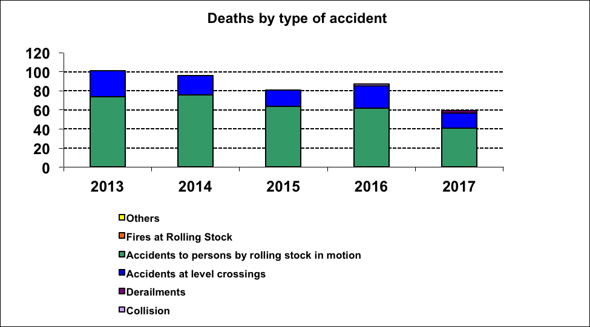

Year | Collisions | Derailments | Accidents at level crossing | Accidents to persons by rolling stock in motion | Fires at rolling stock | Ohers | Year
2013 | 0 | 0 | 27 | 74 | 0 | 0 | 101
2014 | 0 | 0 | 20 | 76 | 0 | 0 | 96
2015 | 0 | 0 | 17 | 64 | 0 | 0 | 81
2016 | 2 | 0 | 23 | 62 | 0 | 0 | 87
2017 | 0 | 2 | 16 | 41 | 0 | 0 | 59
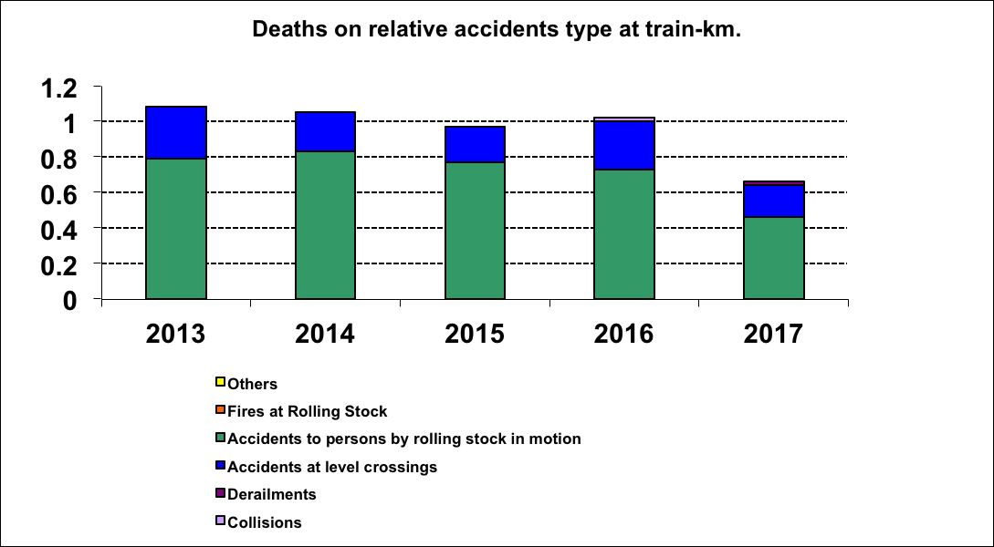

Year | Collisions | Derailments | Accidents at level crossing | Accidents to persons by rolling stock in motion | Fires at rolling stock | Ohers
2013 | 0 | 0 | 0.29 | 0.79 | 0 | 0
2014 | 0 | 0 | 0.22 | 0.83 | 0 | 0
2015 | 0 | 0 | 0.20 | 0,77 | 0 | 0
2016 | 0.02 | 0 | 0.27 | 0.73 | 0 | 0
2017 | 0 | 0.02 | 0.18 | 0.46 | 0 | 0

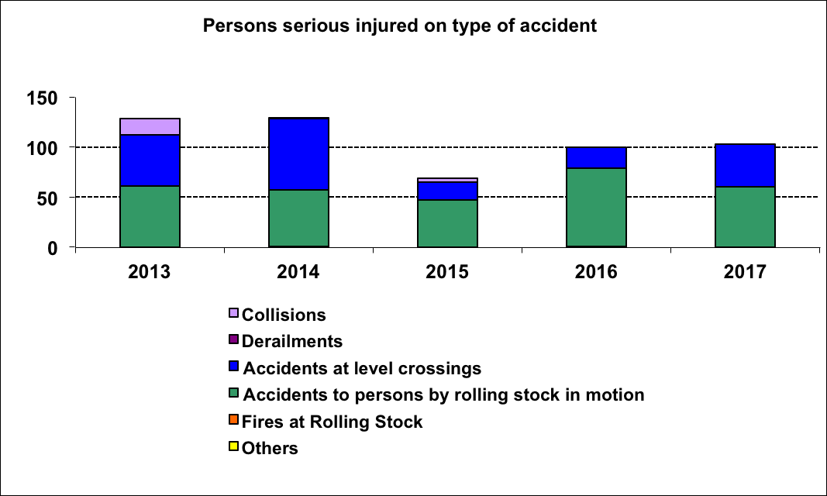
Year | Collisions | Derailments | Accidents at level crossing | Accidents to persons by rolling stock in motion | Fires at rolling stock | Ohers | Year
2013 | 16 | 0 | 51 | 61 | 0 | 0 | 128
2014 | 1 | 0 | 71 | 56 | 1 | 0 | 129
2015 | 4 | 0 | 18 | 47 | 0 | 0 | 69
2016 | 0 | 0 | 21 | 78 | 1 | 0 | 100
2017 | 0 | 0 | 43 | 60 | 0 | 0 | 103
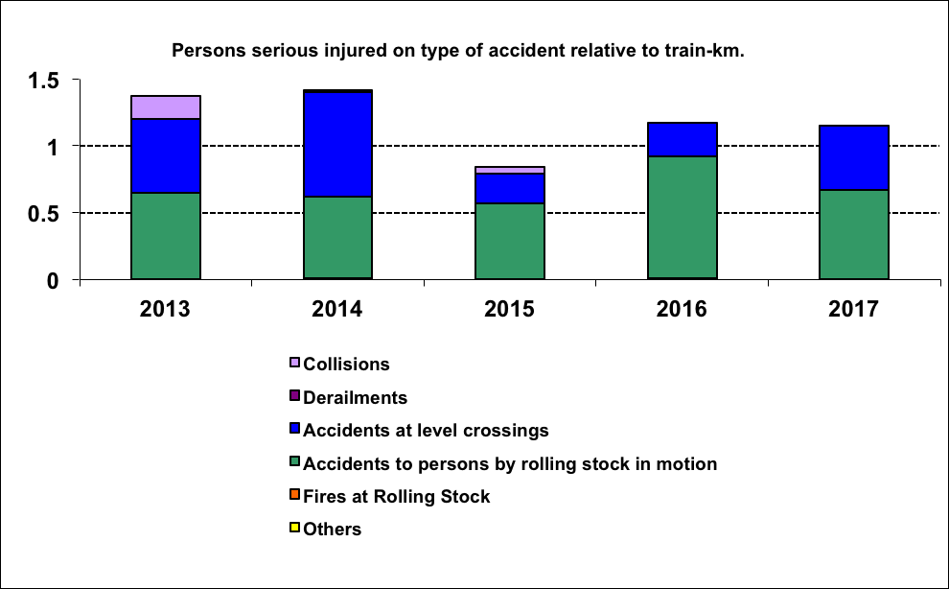
Year | Collisions | Derailments | Accidents at level crossings | Accidents to persons caused by the rolling stock in motion | Fires at rolling stock | Others
2013 | 0.17 | 0 | 0.55 | 0.65 | 0 | 0
2014 | 0.011 | 0 | 0.78 | 0.61 | 0.011 | 0
2015 | 0.05 | 0 | 0,22 | 0,57 | 0 | 0
2016 | 0 | 0 | 0.25 | 0.91 | 0.011 | 0
2017 | 0 | 0 | 0.48 | 0.67 | 0 | 0

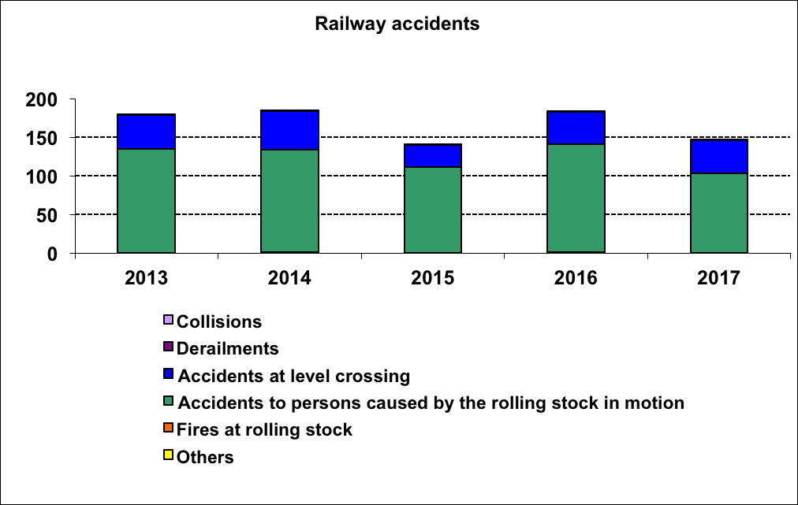
Year | Collisions | Derailments | Accidents at level crossing | Accidents to persons caused by the rolling stock in motion | Fires at rolling stock | Others | Total
2013 | 1 | 0 | 44 | 135 | 0 | 0 | 180
2014 | 1 | 0 | 50 | 133 | 1 | 0 | 185
2015 | 1 | 0 | 29 | 111 | 0 | 0 | 141
2016 | 1 | 0 | 42 | 140 | 1 | 0 | 184
2017 | 0 | 1 | 43 | 103 | 0 | 0 | 147

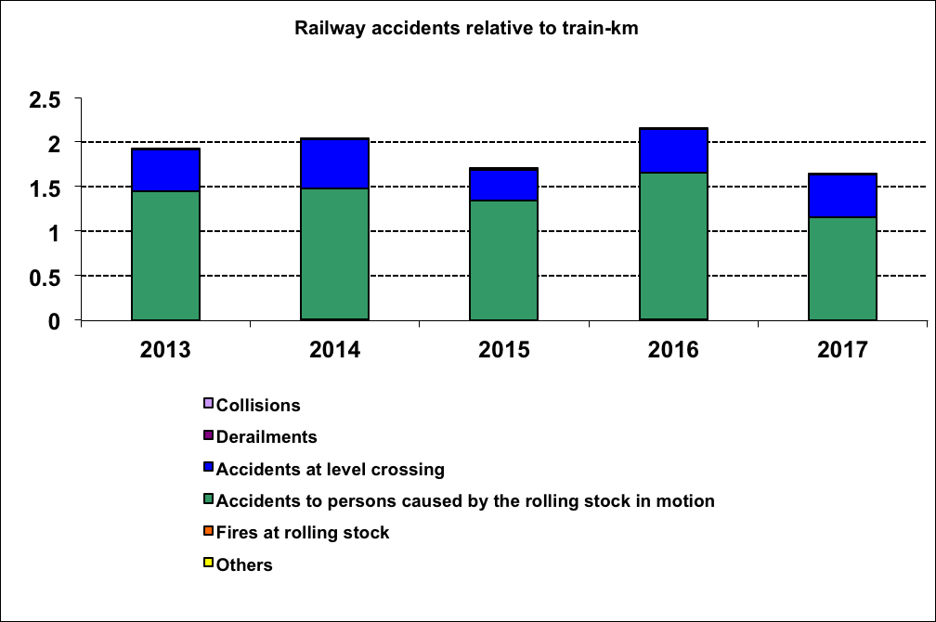
Year | Collisions | Derailments | Accidents at level crossing | Accidents to persons caused by the rolling stock in motion | Fires at rolling stock | Others
2013 | 0.011 | 0 | 0.47 | 1.45 | 0 | 0
2014 | 0.011 | 0 | 0.55 | 1.47 | 0.011 | 0
2015 | 0,012 | 0 | 0,35 | 1,34 | 0 | 0
2016 | 0.011 | 0 | 0.49 | 1.64 | 0.011 | 0
2017 | 0 | 0.01 | 0.48 | 1.15 | 0 | 0

Year | Broken rails | Track kinks | Signalling failure leading to a dangerous condition of the signal | Passing the signals on dangerous position | Cracked wheels at railway vehicles in service | Broken axles at rolling stock in service | Total
2013 | 484 | 0 | 0 | 405 | 2 | 1 | 892
2014 | 593 | 3 | 0 | 288 | 0 | 1 | 885
2015 | 349 | 0 | 0 | 444 | 0 | 1 | 794
2016 | 912 | 0 | 1 | 391 | 0 | 0 | 1304
2017 | 891 | 1 | 0 | 306 | 0 | 0 | 1198

2. Effect of intervention programs on statistics and indicators

a) Status of rehabilitation and modernization works on corridor IV (works completed in 2017, ongoing works, works under preparation for rehabilitation and modernization):

Work in progress
No. | Project | Contract object | The physical status of the work on 31.12.2017 | Delivery on completion
1 | Rehabilitation of the Border Rail Line - Curtici - Simeria part of the Pan-European Corridor IV for the movement of trains with a speed of max. 160 km / h, section 1: Border - Curtici - Arad - km 614 | Rehabilitation of the Border Rail Line - Curtici - Simerie part of the Pan-European Corridor IV for the movement of trains with a maximum speed of 160 km / h, section 1: Border - Curtici - Arad – km 614 | 97,00% | September  2018
2 | Rehabilitation of the Curtici Border Line Curtici - Simerie Part of the Pan-European Corridor IV for the movement of trains with a maximum speed of 160 km / h, Section 2: km 614-Gurasada and Section 3: Gurasada - Simeria | "Rehabilitation of the Border Rail Line - Curtici - Simeria, a part of the Pan European Corridor IV for the movement of trains with a maximum speed of 160 km / h, section 2: Km 614 - Gurasada, sub-division 2a: Km 614 - Cap Y Bârzava. | 1,00% | July  2020
2 |  | "Rehabilitation of the Border Railroad Line - Curtici - Simeria, part of the Pan European Corridor IV for the movement of trains with a maximum speed of 160 km / h, section 2: Km 614 - Gurasada, substring 2b: Cap Y Bârzava - Cap Y Ilteu | 1,00% | July  2020
2 |  | "Rehabilitation of the Border Railroad Line - Curtici - Simeria, part of the Pan European Corridor IV for the movement of trains with a maximum speed of 160 km / h, section 2: Km 614 - Gurasada, Subcategory 2c: Cap Y Ilteu - Cap Y Gurasada. | 0,00% | October  2020
2 |  | "Rehabilitation of the Border Line - Curtici - Simeria, part of the Pan European Corridor IV for the movement of trains with a maximum speed of 160 km / h, section 3: Gurasada - Simeria. | 0,10% | October  2020
3 | Rehabilitation of CF Braşov - Simeria line component of Pan-European Corridor IV for the movement of trains with a speed of up to 160 km / h, the section: Simeria - Coșlariu | Execution of construction and installation works (excluding ERTMS, GSM-R, electronic centralization), Section 3: Coslariu-Simeria, Section: Vintu de Jos - Coşlariu | 84,37% | May  2019
3 |  | Execution of construction and installation works (excluding ERTMS, GSM-R, electronic centralization), Section 3: Coslariu-Simeria, Section: Vinţu de Jos - Simeria | 88,25% | Quarter IV 2019
3 |  | Work wiring signaling ERTMS, GSM-R, centralized electronic and Control Center Operations Simeria the projects "Rehabilitation of the Simeria – Brasov rail line, part of Pan European Corridor IV train traffic with maximum speed of 160 km / h ' section Coşlariu - Simeria | 61,00% | December  2018
4 | Rehabilitation of Braşov Rail Line - Simeria part of the Pan-European Corridor IV for the movement of trains with a maximum speed of 160 km/h, the section: Coşlariu - Sighişoara | Execution of construction works and installations (excluding ERTMS, GSM-R, electronic centralization) Section 2: Coşlariu-Sighişoara, the Coşlariu-Micasaasa-LOT 3 | 98,90% | July  2018
4 |  | Execution of construction works and installations (excluding ERTMS, GSM-R, electronic centralization) Section 2: Coşlariu-Sighişoara, Micasasa-Aţel-LOT 2 | 96,20% | November  2018
4 |  | Execution of construction works and installations (excluding ERTMS, GSM-R, electronic centralization) Section 2: Coşlariu-Sighisoara, the Aţel-Sighişoara-LOT 1 | 88,20% | December  2018
4 |  | ERTMS, GSM-R, electronic centralization and Simeria Operational Control Center related to the projects: "Rehabilitation of the Simeria - Braşov railway line, part of the Pan European Corridor IV for the movement of trains with a maximum speed of 160 km / h Coşlariu – Simeria section and "Rehabilitation of the Simeria-Braşov railway line, part of the Pan European Corridor IV for the movement of trains with the maximum speed of 160 km / h" Coşlariu-Sighisoara section. | 71,00% | December  2018
4 |  | Additional works (road bridge construction DN 14 km 75 + 650 pr) | 99,00% | June  2018
5 | Rehabilitation of railway bridges located at km 152 + 149 and km 165 + 817 on the railway section Bucharest - Constanta | Construction works and installations related to the objective "Rehabilitation works of railway bridges across the Danube - km 152 + 149 and km 165 + 817, CF Bucharest - Constanta line, SRCF Constanta" | 98,23% | April  2018

Works under preparation for rehabilitation
No. | Project | Objective | Current status
1 | Rehabilitation of the Brasov - Simeria railway line, part of the PanEuropean IV corridor, for the movement of trains with a maximum speed of 160 km / h, section Brasov - Sighisoara, subsections 1: Braşov - Apăţa and 3. Căţa - Sighişoara | In the rehabilitation of the Brasov-Sighisoara section (112.63 km) the rehabilitation of 85 km of railway line according to the pan-European corridor technical parameters provided in the AGC, AGTC, TER  Subsection 1: Braşov- Apăţa (km 170 + 285 - km 208 + 090) - 39 km at present, 38 km after rehabilitation. Subsection 3: Sighişoara (km 236 + 290 - km 282 + 842) - 47 km at present, 47 km after rehabilitation. | Acquisition procedure in progress.
1 | Rehabilitation of Brasov - Simeria railway line, component of the PanEuropean IV corridor, for the movement of trains with a maximum speed of 160 km / h, section Brasov - Sighisoara, subsection 2: Apaţa - Căţa | In the rehabilitation of the Brasov-Sighisoara section (112.63 km) the rehabilitation of 28.2 km of railway line according to the pan-European corridor technical parameters provided in the AGC, AGTC, TER  Subsection 2: Apaţa - Căţă (km 208 + 090 - km 236 + 290) - 43,95 km now, 28,2 km after rehabilitation | Acquisition procedure in progress.

b) Railway stations rehabilitated and upgraded during the year 2017 (railway stations received in 2017, railway stations at which works are underway, railway stations in preparation for rehabilitation and modernization):

Received CF stations 2017
No. | Project | Contract object | The physical status of the work on 31.12.2017 | Delivery on completion
2 | Modernization of some railway stations in Romania - Târgu Mureş railway station | Modernization works of the Târgu Mureş railway station | 100,00% | 11.04.2017
Railway Stations in preparation for rehabilitation and modernization
1 | Modernization of 47 railway stations in Romania (Târgoviște, Ploiești Vest, Sinaia, Bușteni, Videle, Târgu Jiu, Alexandria, Caracal, Filiași, Roșiori Nord, Piatra Olt, Timișoara Nord, Simeria, Băile Herculane, Petroșani, Orșova, Caransebeș, Satu Mare, Baia Mare, Jibou, Dej Călători, Beclean pe Someș, Valea lui Mihai, Carei, Salonta, Miercurea Ciuc, Făgăraș, Sebeș Alba, Gheorghieni, Reghin, Aiud, Teiuș, Războieni, Suceava Nord, Pașcani, Vatra Dornei, Verești, Dolhasca, Rm. Sărat, Comănești, Făurei, Tecuci, Mărășești, Adjud, Neptun, Costinești Tabără, Ciulnița)

c) Railways centrally electronically controlled during 2017 (electronic centralization works completed in 2017, electronic centralization works in progress):

Concentrating work in progress
No. | Project | Contract object | The physical status of the work on 31.12.2017
1 | Overheated axle box and brake system detection system - DCOS | Design and execution work related to the lens: Overheated axle box and close braking detection system | 27,00%
2 | Modernization of electromechanical centralization installations on the Ilia - Lugoj traffic section - CEM - CF 4 | Project design and execution related to the objective: "Modernization of electromechanical centralization installations on the Ilia-Lugoj traffic section" | 91,60%
3 | Electronic centralization at Videle railway station | Design and execution works related to the "Electronic centralization in the Videle railway " | 99,99%
4 | Project design and execution related to the objective: "Modernization of electromechanical centralization installations on the Siculeni-Adjud circulation section - 2 lots | Design and execution works related to the objective "Modernization of electromechanical centralization installations on the Siculeni - Adjud traffic section" - Lot 1 | 76%
4 |  | Design and execution works related to the objective "Modernization of electromechanical centralization installations on the Siculeni - Adjud circulation section" - Lot 2 | 68%

In order to reduce the number of accidents occurring at railway level crossings, a legislative initiative was made in 2017 which materialized with the adoption by the Romanian Parliament of Law no. 154/2018 for completing the Government Ordinance no. 43/1997 on the road regime, which came into force on July 2, 2018.

In 2017, the number of cross-border accidents has fallen since previous years.

3.5. Certification and Authorization

1. Situation of the number of certificates and authorizations. Information about news or changes in certification and licensing processes

The state of the authorizations for placing in service railway vehicles, issued in 2017 is the following:
- APS for type - 1;
- APS conforming to the originally authorized type - 82;
- Additional APS - 12.

2. Results of discussions on the results of oversight with other NSAs in the context of certification authorization, as appropriate.

It was not the case.

3. Change strategy and procedure (only if relevant).

No significant changes have been made to the strategy and procedures for the granting of authorizations for placing in service of railway vehicles.

4. There is a regular exchange of information between Romanian Railway Safety Authority and RU/IM.

It was not the case.

3.6. Supervision

1. Changes in the supervision strategy, procedure and team.

It was not the case.

2. Supervision plan including changes to the plan including changes to the plan during the year.

The mission of the supervision activity is to keep track of safety performance after having granted a safety certificate or authorization and, if reasonable, to improve it. The objectives of the Romanian Railway Safety Authority supervision activity are listed below.
Maximizing the overall impact of oversight by:
- selecting and designing optimally and effectively the supervisory actions;
- directing supervision activities to be carried out to high risk areas;
- establishing appropriate measures proportionate to the severity of non-conformities so that Romanian Railway Safety Authority can ensure that the supervised entity is able to take immediate action to control unacceptable risks;
- implementation of IT systems to track and manage the information gathered from supervision actions so that risk control measures can be effectively tracked.

Increasing the effectiveness of supervisory actions by optimizing resources, by:
- maintaining a structured and auditable competence management system to ensure that the necessary organizational capacity and professional competence are in place, as required by Regulation (EU) No. 1077/2012 on a common safety method for oversight by national safety authorities;
- developing relations with other railway safety authorities in order to identify good practices and, if appropriate, to improve the time spent on preparing supervision actions;
- improvement of IT tools - Implementation and use of an information exchange platform, in particular of its own legislation, and of the findings made so as to make the time spent preparing the supervision actions more efficient.

The supervision plan has not changed and has not changed in 2017.

3. Supervision results.
The results of the supervision carried out by Romanian Railway Safety Authority contributed to the success of the SMS in the control of risks in the railway system in Romania. There were also problems with how the risk control in the Romanian railway system was carried out, but these were overcome.
With a view to eliminate non-compliance and control the risks, the Romanian Railway Safety Authority has taken timely and accountable measures as a result of oversight activities and the supervised entities have drawn up their own action plans.

As a result of the supervisory actions through state control and inspection, in order to eliminate the nonconformities, the Romanian Railway Safety Authority has disposed measures with terms and responsibilities and the supervised entities have drawn up their own plans of measures, such as:

• The Public Railway Infrastructure Manager:

CNCF "CFR" SA
- Updating company strategy, priorities and plans;
- Collecting, documenting and analyzing all information in accordance with the strategy and priorities set out in this respect;
- Develop action plans for unacceptable cases of non-compliance with the requirements of the risk management system;
- Evaluating the effectiveness of the actions included in the action plans through actions to verify the relevance of their implementation, achievement of the expected results or whether other risk control measures are also needed;
- Making repairs and technical revisions according to the planned schedules and deadlines.

• Non-interoperable railway infrastructure managers:

RCCF TRANS SRL Braşov
- Steps will be taken to prioritize the technically authorizing of stations and walkways;
- All the personnel with control duties from the provisions of the operational procedure code PS - 91, regarding the organization and development of controlling documents at RC-CF TRANS SRL, were re-trained;
- Addressing the Infrastructure Manager to conclude cooperation agreements for the mutual recognition of the railway safety risks identified by both parties;
- The necessary steps in order to technically approve the stations and stops, depending on the economic and financial situation of the company, phased in;
- Ultrasonic inspection of track rails.

TRANSFEROVIAR GRUP SA Cluj Napoca
- In the educational materials to be drawn up for safety analyzes, it will also be noted the way of applying the measures established following the control actions that have focused on their own activity;
- Updating the job descriptions of senior management personnel and staff with training and control duties, in accordance with the organization chart and internal regulations;
- All the staff with control duties were reinstated from the provisions of the Operational Procedure Code PO - 8.3-03, ed. 4, rev. 0, in order to comply with it by all sub-units in the structure of Transferoviar Grup SA;
- When drawing up specific training plans, the deadline of December 15 will be met;
- Filling in the job description of the safety adviser for the transport of dangerous goods by rail with all the duties specified in the specific regulations in force;
- Reprocessing the relevant information from the PTE datasheets of the stations where Transferoviar Grup SA performs shunting operations with all interested personnel.

• Rail transport operators:

SNTFC "CFR Călători" SA
- Scheduled repair vehicles will be replaced as other vehicles will be out of repair;
- The Rail Safety General Inspectorate has notified the central Directorates and the eight regional branches on the update of the job description for management, training and control staff;
- The request of the Regional Railway Branches subordinated to CNCF "CFR" SA, the copy of the specific PTEs in force, respectively the regulations regarding the exploitation of LFI belonging to SNTFC "CFR Călători" SA, which will be distributed to subordinated stations, in order to update the bases data;
- The General Safety Traffic Safety Supervisor has taken measures to complete the process of identifying the risks associated with railway safety;
- SNTFC "CFR Călători" SA will draw up an operational procedure for handling defects within the warranty period.

SNTFM „CFR Marfă” SA
- Identifcation, together with the Railway Infrastructure Manager and Infrastructure Managers, Hazards and Interface Risk Assessment;
- Assessing safety performance against the organization's safety objectives at quarterly safety analyzes;
- Branches belonging to SNTFM "CFR Marfă" SA, whose incidents of activity have occurred, will convene the risk assessment commissions to reassess the risks associated with them;
- SNTFM "CFR Marfă" SA has drawn up the strategy for monitoring the railway safety management system and the action plan for the implementation of the strategy;
- Performing second-party audits on critical rail service providers as part of the SMS monitoring program;
- CNCF "CFR" SA was requested to conclude the contracts for Exploitation and Housing of industrial railway lines owned by SNTFM "CFR Marfă" SA.

GRUP FEROVIAR ROMÂN SA
- As a result of the control activity carried out at the level of the Romanian Railways SA, the SCCI Service will bring to the knowledge of the company all the deviations from the established codes of practice, which will be analyzed and evaluated;
- Establishment of a program to control the interface risks with infrastructure managers, while concluding bilateral conventions on ensuring the status of personnel with responsibilities in the safety of movement upon entry into service;
- A monitoring plan has been drawn up to determine whether the risk control measures are effective and their expected results are achieved;
- GRUP FEROVIAR ROMÂN SA took steps to program the staff with training responsibilities, in order to carry out compulsory training courses.

REGIOTRANS SRL Braşov
- The steps will be taken to the Regional Railway Passenger Transport Brasov to support the finalization of the necessary documentation for the approval of the two Drainage Technical Regulations for the Drainage of Sfântu Gheorghe, following the commencement of the necessary actions for obtaining the Exploitation Authorization;
- Establishment together with the police authorities within the Road Police, the road manager and the infrastructure manager, media representatives, joint actions for the supervision of the identified passages, in order to raise the awareness of the drivers of the risks they face by not complying with the road legislation at the level crossings railway;
- Carrying out a risk analysis of the interface risks with the companies with which REGIOTRANS SRL has contractual relations;
- Revision of PO-82 Operational Procedure Code, "Conformity Assessment" to comply with the safety monitoring requirement according to Regulation (EU) No. 1078/2012;
- Launching a processing / reprocessing action for all PTEs of the stations on the traffic sections of which REGIOTRANS SRL carries out railway passenger transport operations.

4. Results of discussions on the results of supervision with other NSAs, if applicable.

It was not the case.

5. Dialogue with Operations on Specific Topics.

As part of the oversight activity, in addition to the oversight audit activity (as part of the safety audit) to economic operators who have obtained safety certificates or safety authorizations (railway transport operators and railway infrastructure manager/manager), as well as to their service providers and railway products in the operation and maintenance of infrastructure and railway vehicles, Romanian Railway Safety Authority invited economic operators to participate in various meetings where specific themes were discussed, such as controlling all risks associated with the activities of operators rail transport and infrastructure manager/managers, including maintenance, supply of materials and recourse to contractors, reduction of national rules that are redundant with European directives, regulations and decisions, and debate on the Fourth Railway Package - guidelines, objectives, challenges and the impact of the implementation of the technical pillar IV of the Railway Package on safety certification/authorization processes, vehicle registration and railway safety supervision.
Given that Community legislation is undergoing a continuous review process, the Romanian Railway Safety Authority has continued to organize dialogues by maintaining active communication with railway undertakings in order to collect data and to guide them on specific topics such as the series of changes in relation to the tasks and responsibilities of the Agency and of the national safety authorities (NSAs) in the Member States of the European Union and the issue of the single safety certificate by implementing the 4th Railway Package, as well as addressing the issue of the placing on the market of vehicles.

6. Romanian Railway Safety Authority checks the correct application and effectiveness of all processes and procedures in the management system in accordance with EU Regulation no. No 1078/2012 on a common safety method for monitoring to be applied by railway undertakings and infrastructure managers upon receipt of a safety certificate or safety authorization and entities in charge of maintenance.
Investigation of the causes of accidents will be done in accordance with EU Directive no. 798/2016 on railway safety after it has been transposed into national law.
At present EU Directive no. 798/2016 on railway safety is being transposed into national law.

3.7. Implementing major EU projects

1. Implementing major EU projects
- European IV Package (for 2020):
In the context of the issuance of the IVth Railway Package, the Agency started in 2015 the "National Technical Standards Program - NNTR and NNS Safety" in order to accelerate the activity to improve the functioning of the European railway area. This program aims at significantly reducing the national technical and safety standards which refer to the conditions for the issue of safety certificates and authorizations for the placing in service of vehicles which are redundant with the requirements of Regulation (EU) No 1158/2010 on a common safety method for assessing conformity with the requirements for obtaining railway safety certificates and the technical specifications for interoperability.
The targets for NNTR and NNS reduction under this program are:
- the removal/reduction of notified NNTRs in accordance with Directive 2008/57/EC on the interoperability of the rail system in the Community, for the transfer of a vehicle registration and the abolition of additional authorizations;
- the NOTIF-IT removal / reduction of NNS notified in accordance with Directive 2004/49/EC on Community Rail Safety following a joint analysis with the Agency and a decision whether or not to be assigned to NNS;
- the drafting of the National Implementation Plan in accordance with Commission Regulation (EU) 2015/995 of 8 June 2015 amending Decision 2012/757 / EU on the technical specification for interoperability relating to the subsystem "operation and traffic management" of the Union rail system European Union with a deadline of 2017-2018.
In this context, the Romanian Railway Safety Authority organized a series of debates with the railway sector for the elaboration of the National Implementation Plan, where the issues related to the action to reduce the national safety standards of type 1, 2, 4, 5 and 7 were presented and discussed, (EC) 2015/995 of 8 June 2015 amending Decision 2012/757/ EU concerning the technical specification for interoperability relating to the subsystem "operation and traffic management" of the system railways in the European Union.
The final form of the National Implementation Plan for Romania was elaborated and finalized by Romanian Railway Safety Authority at the beginning of June 2017 and was forwarded to the Ministry of Transport, which sent it to the Romanian representative to the European Commission, respecting the deadline set in Regulation (EU) 2015 / 995 of 8 June 2015 amending Decision 2012/757 / EU on the technical specification for interoperability relating to the subsystem "operation and traffic management" of the rail system in the European Union, being set as a phase-in implementation deadline of December 2018.
In order to ensure the efficient development and functioning of the national railway system and its integration into the European railway area, as well as for the enforcement of the regulatory framework, the Romanian Railway Safety Authority - Romanian Railway Safety Authority, has drafted and submitted the drafts of normative acts transposing the directives in the Package IV Railway to the Ministry of Transport as Railway Regulatory Authority for notification to the European Commission.

- CSM on RA (Common Safety Method on Risk Assessment):
Starting with 04.12.2014, Romanian Railway Safety Authority was designated by the Ministry of Transport, through OMT no. 1501/2014 concerning certain measures for the implementation of Implementing Regulation (EU) No. Commission Regulation (EU) No 402/2013 of 30 April 2013 on a common safety method for risk assessment and amending Regulation (EC) (EC) No 352/2009 to carry out the tasks of a nationally recognized assessment body for all areas of competence within the rail system in accordance with Implementing Regulation (EU) No. Commission Regulation (EU) No 402/2013 of 30 April 2013 on a common safety method for the assessment and appraisal of risks and amending Council Regulation (EC) 352/2009.
On September 15, 2015 Romanian Railway Safety Authority set up the "Risk Assessment System Evaluation Service", under the direct subordination of the Romanian Railway Safety Authority Director, with the attributions of the assessment body.
Romanian Railway Safety Authority, decided that the documentation referred to in art. 4 par. (3) of Implementing Regulation (EU) No. Commission Regulation (EU) No 402/2013 of 30 April 2013 on a common safety method for the assessment and appraisal of risks and amending Council Regulation (EC) 352/2009 and justifying the decision taken by the proposing party to be evaluated for all changes in the rail system in order to reduce the risk of significant changes being treated as insignificant.
Since there are no notified national rules in Romania to define whether a change is significant or not, the criteria specified in Art. 4 par. (2) of the Regulation. In most cases, the decisions made by proponents on the importance of changes in the rail system were that they have an impact on the system and are significant.
Romanian Railway Safety Authority checks the compliance of documents submitted by the proposer with the process described in Annex I to the Regulation. When identifying an issue requiring additional clarification, it makes concrete remarks and helps the applicant understand the level of detail that must characterize the response he has been asked for. Upon receipt of all the information and documents requested, it shall without delay, but not later than four months, issue the safety assessment report, which shall be submitted for approval to the Romanian Railway Safety Authority Director, and then forward to the applicant a copy.
The Safety Assessment Report shall be drawn up in accordance with the provisions of Annex III to the Regulation. In this document, any cases identified as non-compliance with the provisions of the Regulation, respectively the recommendations of the assessment body, are also communicated.
The proposing party is responsible for accepting change within the evaluated system.

During the period 01.01-31.12.2017, 83 requests were made for the analysis of some changes in the railway system, of which 80 related to the introduction / decommissioning of motor railway vehicles or the extension / restriction of the traffic sections / maneuvering areas passenger and / or freight operations, respectively railway maneuver, to update / modify the Safety Certificates held by the railway operators or the Safety Authorizations held by the Infrastructure Managers / Administrators. One request was to add the type of passenger transport (type A) to the existing type of freight (OTF - IRTCCF) and two requests related to the takeover of some sections by the infrastructure managers (OTF - TFG and RC- CF Trans). Of the 83 requests, 6 were urgently requested.
During this period, 79 safety assessment reports were issued, 2 requests were refused due to documentation not in accordance with the procedure described in Annex I of the Regulation, and 2 requests were waived by the operator.
The very small number of rejected applications compared to 2016 (3% in 2017 compared to 25% in 2016) indicates that the efforts of the staff of this service to clarify in detail the requirements of Implementing Regulation (EU) no. (EU) No 402/2013 of 30 April 2013 on a common safety method for risk assessment and amending Regulation (EC) No 352/2009, have made the rail management operators / infrastructure managers adequately apply the risk management process described in Annex I the Regulation.
In 2018, SESMR will continue to work towards a better understanding of the risk management process described in Annex I to Regulation (EU) No. 402/2013 by all actors in the railway market, as well as their awareness of the risk-based approach to management.

The Romanian Railway Safety Authority has published on the website http://www.afer.ro/Romanian Railway Safety Authority/ghiduri/metodogii-ro.html and a methodology that details both the elements that the expert team evaluating the documentation submitted by the submitting party focus its attention as well as the procedural elements necessary for drawing up the files by the proposer. At http://www.afer.ro/Romanian Railway Safety Authority/guiduri/guiduri-ro.html published ERA / GUI / 01-2008 / SAF and the set of examples ERA / GUI / 02-2008 / SAF and at http: // www.afer.ro/Romanian Railway Safety Authority/ghiduri/proceduri-en.html the procedure "Independent evaluation of the application of the risk management process".
The Romanian Railway Safety Authority also regularly publishes disseminations, debates and other forms of dialogue with actors in the railway system, based on the applicable European regulatory framework.

Romanian Railway Safety Authority assesses stakeholder feedback during the audit audits and the rail safety oversight audits.
Also at http://www.afer.ro/documents/sesizari-en.html stakeholders can formulate any problem, suggestion, referral to AFER.

In order to implement and implement the Implementing Regulation (EU) No. 402/2013 on a common safety method for risk assessment and evaluation and amending Regulation (EC) No 352/2009, Romanian Railway Safety Authority also conducted a dissemination on the application of common safety methods for risk assessment in the railway industry in Romania on the transition to a safety management system - SMS that focuses on methods of controlling risks.

- CSM on monitoring:
Supervision activity primarily targets activities that are exposed to the greatest risks or where the associated dangers are controlled in the most unsatisfactory manner.
During the last stage of the monitoring actions the monitoring of the effectiveness of the measures by which the risks from the own activity are controlled, as well as the interface risks.

2. Status of process implementation, including strategy changes and newly introduced initiatives;

With the implementation and application of the transition to a unique safety certificate adopted at European level, provided by the Railway Safety Directive (UE) 2016/798 within the technical pillar IV of the Railway Fourth Railway Safety Authority, the Romanian Railway Safety Authority - Romanian Railway Safety Authority started the review process of the procedures relating to safety certification processes and authorization to put into service structural subsystems and vehicles.
3. Outcome of previous initiatives on safety.
Previous safety initiatives have reached their goal and have increased safety in the rail system.

3.8. European legislation and regulations

1. Changes in legislation and regulation on the Safety Directive;
Modification of MTO no. 535/2007 regarding the approval of the rules for the granting of the railway transport license and of the safety certificates for the railway transport services on the Romanian railways following the issuance of Law no. 202/2016 on the integration of the railway system in Romania into the single European railway area transposing Directive 2012/34 / EU on the Single European Railway Area as the part related to the railway transport licenses will be the subject of a new normative act (already regulated at dated 24.05.2018, the Government approved the Government Decision no.361 / 2018 on the approval of the procedures for granting licenses in the field of railway transport, published in the Official Gazette of Romania, Part I, No. 482 / 12.06.2018, in accordance with the requirement of Article 25 of the Law No 202/2016 on the integration of the Romanian railway system into the single European railway area).
2. Review of the operational companies use of new EU legislation and regulations, including rolling stock, infrastructure training and personal, derogations decided in accordance with Article 15.
It was not the case.

3.9. Safety culture

As a national safety authority, the Romanian Railway Safety Authority promotes and manages a Just Culture and mutual learning culture, encouraging economic operators to involve and empower all categories of staff, to contribute to the development of safety while confidentiality is ensured.
This safety culture is continuously promoted, developed and improved in normal surveillance activities and through all meetings, disseminations and discussions organized by the Romanian Railway Safety Authority emphasizing the idea of ​​"performance" obtained by refining the methodologies and tools, through interoperability through the implementation of the SMS based on risk control as well as awareness of the wide-ranging implications of the actions of system operators in order to achieve a secure railway system.

3.10. Optional chapter

In order to reduce the accidents caused by rail crossings, the Romanian Parliament adopted Law no. 154/2018 for completing the Government Ordinance no. 43/1997 on the road regime, which entered into force on July 2, 2018. In this law, the following obligations are stipulated for the railroad administrator:
"Transitions on the same level as the railways of all international" E "roads, as well as national roads with a high risk of road accidents, will be provided with barriers or semi-barriers made by the railways administrator, with the approval of the administrator road and road police.
The Rail Administrator is required to ensure the visibility of crossings along the track by clearing the vegetation within a 150-meter radius from the intersection. "

Director of ASFR
Dan Marcel BĂRBUŢ

