Railway Safety 2017

Annual Report on Railway Safety 2017

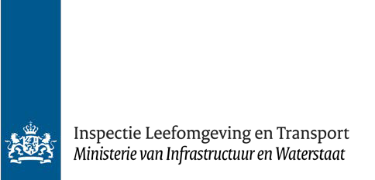
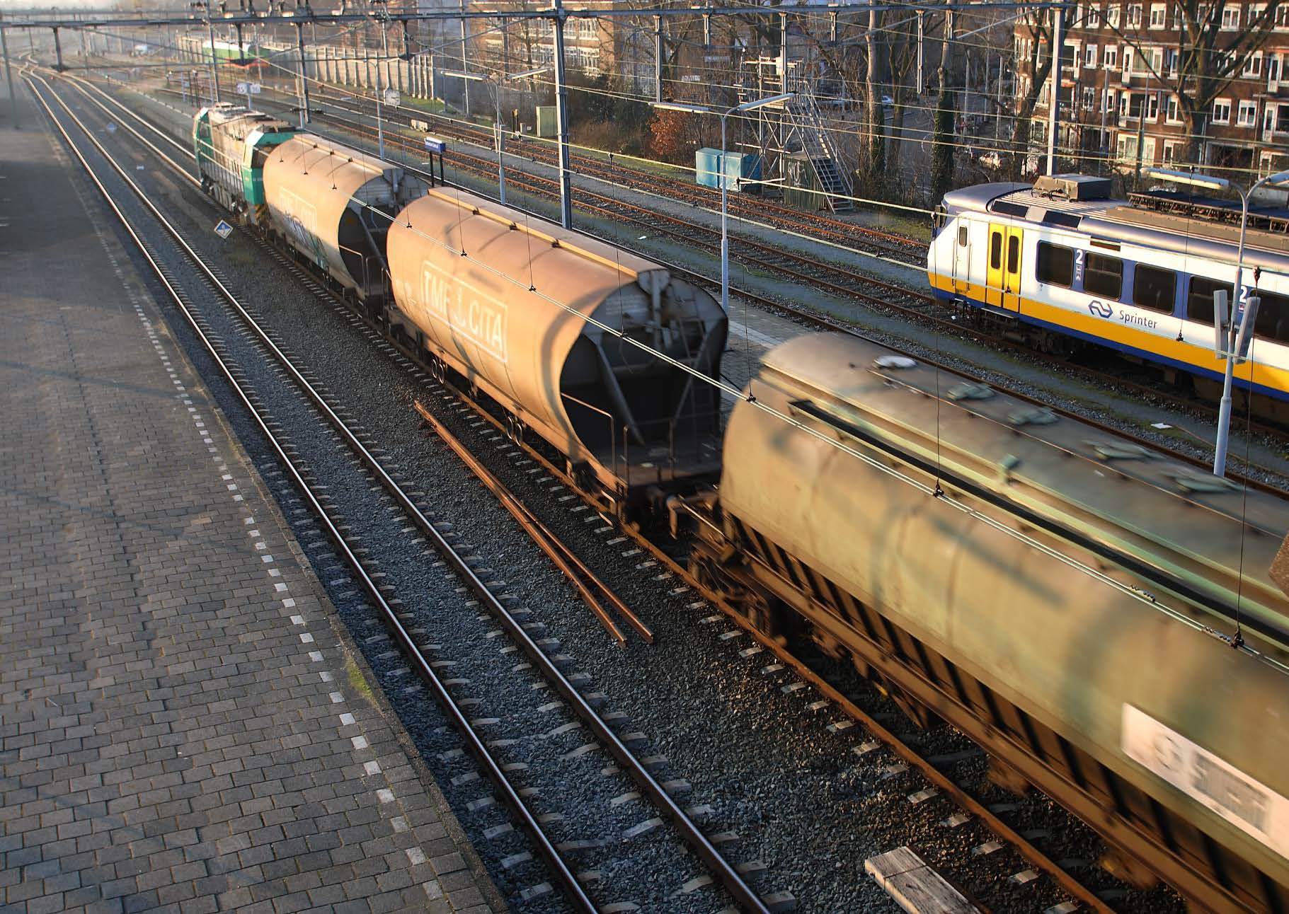

Railway Safety 2017

Annual Report on Railway Safety 2017

Date | October 2018

Publisher’s details

Published by | The Human Environment and Transport Inspectorate
 | Information and Programming
 | Analysis
 | PO Box 16191| 2500 BD The Hague
 | 088 489 00 00
 | www.ilent.nl

Contents

Summary 9
1 About this Annual Report 11
1.1 Objectives 11
1.2 Indicators 11
1.3 Sources 11
1.4 Ranking of the Netherlands compared to Europe 11
2 Accidents involving a rail vehicle in motion 12
2.1 Collisions and derailments 12
2.2 Accidents and collisions at a level crossing 13
2.4 Fire in rolling stock 15
2.5 Other accidents 15
2.6 Casualties of railway accidents involving a rail vehicle in motion 15
2.7 Indicators from the Policy Impetus for Railway Safety 15
3 Other railway accidents 17
3.1 Railway suicides 17
3.2 Accidents involving track employees 17
3.3 Transfer accidents 18
3.4 Environmental accidents 18
4 Near railway accidents 20
4.1 Rail vehicles passing a stop signal 20
4.2 The risk and causes of SPAD events 21
4.3 Technical support for reducing the number of SPAD events 21
4.4 SPAD events according to railway undertaking 22
4.5 Deviations in infrastructure and rolling stock 24
4.6 Near accidents involving a rail vehicle in motion 24
4.7 Common Safety Method for Risk Evaluation and Assessment (CSM REA) 25
5 The Netherlands compared to Europe 26
5.1 Accident reporting 26
5.2 Position in Europe 26
6 Conclusions 27
6.1 Level crossings 27
6.2 SPAD events 27
Definitions and abbreviations 28
Appendix A Infrastructure: size and use 33
Appendix B Figures for accidents involving rail vehicles in motion 35
Appendix A Figures for other railway accidents 38
Appendix D Numbers of near railway accidents 41
Appendix E Indicators set out in the Policy Impetus for Railway Safety 47

Summary

In this Annual Report on Railway Safety 2017, the Human Environment and Transport Inspectorate (ILT) presents an account of safety on the main railway network in 2017. It describes accidents, near accidents and casualties involving passenger trains, freight trains and work trains.

In 2017, there were 12 fatalities on the main railway network. Half (6) of them happened at a level crossing as a result of an accident. Most of the other fatalities (3) resulted from a collision between a train and an unauthorised person on the track. In 2017, 17 of the 2 446 remaining level crossings were removed. Railway safety is the subject of continuous improvement. One of the ways of achieving this is by removing level crossings, even though 2017 saw the lowest number of level crossings removed over the last 5 years. Reducing the number of level crossings provides the most safety gains.

In 2017, there were 105 ‘signal passed at danger’ events. That represents 5 more than in 2016. However, the number of dangerous SPAD events decreased slightly. The calculated probability of injury resulting from an SPAD event was on a par with the 2016 figure.

In 2017, there were 75 inspections at locations where work was being carried out on the track. Shortcomings were found in 28 cases (37 %). There were also 39 reports about the work situations of track employees. These reports mainly dealt with workplace safety (19) and driving into or out of a non-operational area with maintenance equipment (11).

Hazardous substances pose a risk to persons and the environment, whether that is on the track or during shunting operations. In 2017, an inspection of 700 tank wagons revealed drip leaks in 22 of them.

Accidents involving a train 2017
Occurrences | Numbers | Details (significant)
Collision between trains | Significant – 1  Insignificant – 6 | Seriously injured shunter
Collision between train and obstacle | Significant – 2  Insignificant – 672 | Damage and obstruction
Derailment of a train | Significant – 1  Insignificant – 14 | Damage
Accidents and collisions at a level crossing | Significant – 11  Insignificant – 23 | 6 fatalities and 2 seriously injured persons
Accidents to persons caused by rolling stock | Significant – 7  Insignificant – 1 | 5 fatalities and 3 seriously injured persons
Fire in rolling stock | Significant – 3  Insignificant – 62 | Locomotive, no casualties
Other | Significant – 1  Insignificant – 0 | 1 fatality, cause not clear
Other railway accidents 2017
Subject | Details
Suicide | 215 suicides and 79 attempted suicides
Track employees | 3 seriously injured persons, 39 persons with minor injuries
Transfer accident | 743 of which 1 seriously injured person and 392 persons with minor injuries
Environment | 68 reports of which 48 on actual leakages
Near railway accidents 2017
Occurrences | Details
Signal passed at danger | 105 of which 36 passed the danger point
Due to a deviation in the infrastructure or rolling stock | 100 of which 61 broken rails, 3 track buckles and 36 wrong-side signalling failures
With a train (excluding attempted suicides/track employees) | 249 of which 21 between trains, 88 with track-side passengers, 140 at level crossings
About this Annual Report

This annual report provides an account of safety on the main railway network. Safety has been mapped out according to the number of railway accidents, the number of railway casualties and the number of near accidents. The figures cover all users of the main railway network, namely passenger transport, freight transfer and work trains.

Objectives
The aim of the report is to enable the Minister for Infrastructure and Water Management (I&W) to monitor the railway safety objectives as laid down in the Third Framework Memorandum on Safety and the Policy Impetus for Railway Safety. The Ministry has set the following priorities for railway safety up to 2020: safer level crossings, fewer SPAD events, improved safety for passengers and fewer suicides on the railways. The annual report also forms the basis for the report on railway safety to the European Union Agency for Railways (ERA).

Indicators
In order to make railway safety measurable, use is made of FWSIs (= fatalities and weighted serious injuries). The number of fatalities and seriously injured persons are combined together, whereby 10 seriously injured persons are weighted as the equivalent of 1 fatality. The FWSI figure is then compared with the total number of train-kilometres or passenger-kilometres travelled in 2017. This normalised FWSI figure is the number of casualties per kilometre travelled. The lower the normalised FWSI figure, the higher the safety performance. In order to arrive at a more stable indicator, this normalised FWSI figure is averaged over the last 5 years. This average is referred to as the moving weighted average (MWA).

Sources
This report reports both quantitative and qualitative information. The quantitative information relates to the number of accidents, casualties and near accidents and the indicators that can be calculated from these figures. This information originates from the Human Environment and Transport Inspectorate (ILT), ProRail and Statistics Netherlands (CBS). The qualitative information has been sourced from the annual reports and incident databases of railway undertakings. All information has been verified by the ILT.

Ranking of the Netherlands compared to Europe
This annual report also compares railway safety within the Netherlands with that of the EU Member States. However, this comparison is not based on the 2017 data, as ERA is not expected to publish this information before the end of 2019. The Railway Safety Performance Report 2018 – based on data up to and including 2016 – is not expected until the last quarter of 2018. The position of the Netherlands in Europe has therefore been based on the 2017 Interim Report, which is based on data from the EU Member States up to and including 2015.
Accidents involving a rail vehicle in motion

ERA classifies accidents involving a rail vehicle in motion into seven categories: collisions of trains with rail vehicles; collisions of trains with obstacles; derailment; level crossing accidents; accidents to persons caused by rolling stock; fire in rolling stock; other types of accident.

The severity of this category of accidents is measured according to its consequences. An accident involving a rail vehicle in motion is significant if it results in the following:
- one or more fatalities or seriously injured persons; or
- a total loss of EUR 150 000 or more; or
- obstruction of a main track section for 6 hours or more.

Collisions and derailments
On 21 November, during a shunting movement, a freight train with containers collided with a fence that had a mountain of construction sand behind it. The shunter had forgotten to set a points switch, with the result that a freight train travelled on a closed section of track. The collision caused the locomotive and four wagons to derail. Two containers fell on the adjoining track. Nobody was hurt, but there was a lot of damage.

When registering collisions and derailments, ERA limits itself to these types of accidents with trains. A train is defined as at least one locomotive running under a given number from an initial fixed point to a terminal fixed point. This definition often excludes collisions and derailments during the shunting movements of trains or work trains. However, collisions and derailments of these other rail vehicles are still reported for information purposes. In order not to deviate from ERA's definition, they are grouped under ‘Other accidents’ in Table 4 of Appendix B. In the remainder of this report, the term ‘train’ is used according to this strict definition from ERA. If this limitation is not important, the more generic term ‘rail vehicle’ is used.

Collisions between rail vehicles
In total, there were 7 collisions between rail vehicles in 2017. One collision involved an empty passenger train. Shortly after taking the brake test, the train rolled slightly backwards and collided slightly with another trainset. No one was injured and there was no damage. Of the 6 collisions with other rail vehicles, 5 occurred during shunting. One of these was a significant accident as a shunter was seriously injured. There was also a rear-end collision between two work trains, which was insignificant. Compared to 2016, the number of significant as well as insignificant collisions between rail vehicles decreased (in 2016, 2 and 7 respectively). This is the lowest number of collisions over the last 5 years.

Collisions between rail vehicles and an obstacle
In total, there were 674 collisions between a rail vehicle and an obstacle. Of these, 2 collisions were significant due to the amount of damage and obstruction. Both collisions related to a train. Of the 672 insignificant collisions, 62 related to a train and 610 related to another rail vehicle in motion. Compared to 2016, there were fewer significant, but more insignificant, collisions with an obstacle (in 2016, 5 and 410 respectively).

It is striking that the total number of insignificant collisions of a rail vehicle with an obstacle has increased over the past 4 years (2014: 292; 2015: 367).
This increase is attributed to a greater degree of willingness to report. If there were actually more collisions, there would also be more delays. The increased willingness to report is in line with further improvements in the way the railway undertakings are implementing the safety management system. What is certain is that over time, the number of categories has expanded. This is another way of encouraging greater accuracy of registration.

Derailments of rail vehicles
In 2017, there were a total of 15 derailments. One derailment occurred in an area put out of service and a tamping machine derailed on a points switch due to human error. The remaining 14 derailments occurred in a non-centrally operated area.
One derailment can be attributed to rolling stock (broken drive shaft), one to the infrastructure (defective sleeper) and ten to the faulty operation of a points switch. The cause of two derailments remains unclear after investigation; one of these was significant due to the amount of damage. In 2016, there were no significant derailments. However, there were 24 insignificant derailments that year. Over the previous 5 years, the only year that saw a lower number of total derailments (namely nine) was 2014 .

Accidents and collisions at a level crossing
On 28 April, a train collided with a low loader in Wouw. The accident was the result of an error of judgement on the part of the lorry driver. There was a sharp bend immediately after a level crossing. The driver entered the curve, but was unable to take the bend because of a lamp post and the size of his trailer and as a result, he got stuck in the curve. The whole of the low loader was still stuck over both tracks as a passenger train approached. The train collided with the low loader and derailed. In this accident, the conductor sustained a serious head injury and three passengers sustained minor injuries.

In 2017, there were 34 accidents in total at level crossings, 11 of which were significant accidents. There were 6 fatalities and 2 seriously injured persons. Of the 34 accidents, there were 7 (21 %) accidents involving crossing slow traffic (3 fatalities and 1 seriously injured person), 23 (68 %) accidents involving intersecting fast traffic (3 fatalities and 1 seriously injured person) and 4 (12 %) collisions with objects that had been left behind (stones, etc.). Of the 30 accidents with intersecting road traffic, 7 (23 %) occurred at a passive level crossing, 4 (13 %) at an actively protected level crossing without barriers, and 19 (63 %) at an actively protected level crossing with barriers (see Appendix B, Table 5). In 4 accidents, barrier protection had been ignored. Compared to 2016, the number of significant level crossing accidents was higher (11 compared to 7 in 2016).

Dutch Safety Board report
The aforementioned collision with the low loader was one of the reasons for the Dutch Safety Board to launch an investigation into the safety of level crossings. In its report, the Dutch Safety Board noted that the current level crossing policy, namely the ‘no-unless’ principle, had not formulated any specific objectives. Using data up to and including 2016, it was shown that the original fall in the curve of level crossing casualties has levelled out. The Dutch Safety Board also underlines the fact that the Netherlands has an intensively used railway network with many level crossings: ‘a combination that does not go together well’ (p. 6). The Dutch Safety Board considers the main reason for this to be administrative deadlocks between national and local authorities regarding the desired solution and financing. The Minister for Infrastructure and Water Management aims for continuous improvement of railway safety. The overall railway safety objective is to be ranked structurally in the top five of the European Union. This shows a high level of ambition, precisely because the Netherlands has a combination of an intensively used railway network with numerous level crossings. In addition to implementing the ‘no-unless’ principle, the number of level crossings has been reduced. In 2017, 17 level crossings were removed (see Appendix A, Table 3). However, the question arises whether this is sufficient to achieve this objective, as there have been relatively many casualties at level crossings.

Nevertheless, the MWA of level crossing users continues to fall, after the increase in 2015. At the moment, this trend has not levelled out. Nevertheless, a critical examination of the figures shows that the MWA of level crossing users has fallen not only because of a decrease in the number of casualties, but also because of an increase in the number of train-km. This increase is mainly due to more intensive use of the high-speed line (HSL) and the Amsterdam-Utrecht-Eindhoven route as part of the ‘Every-Ten-Minutes-A-Train’ scheme. There are no level crossings on the HSL and the Amsterdam-Utrecht section. From this perspective, the decline in the MWA – a measure prescribed by ERA – may give an overly rosy picture, even though the safety of level crossing users has remained unchanged.

  - Accidents to persons caused by rolling stock in motion
On 11 December, a man was running towards a train at Voorschoten station. The train door closed as soon as he got to it. As he ran alongside the departing train, he pressed the button to reopen the door. He fell and ended up between the train and the platform. Passengers on the train saw what happened and pulled the emergency brake. The train stopped and the conductor, together with the train driver, brought the man to safety. He broke his leg and ankle.

In 2017, there were 7 significant accidents and 1 insignificant accident caused by rolling stock (see Appendix B, Table 4). There were 5 fatalities, 3 seriously injured persons and 1 person with minor injuries. A total of 3 persons were seriously injured as a result of being hit by a moving train at a station. Moreover, 5 persons who went on the track without authorisation were killed. In one accident, 2 persons were killed. Compared to 2016, the number of significant as well as insignificant accidents caused by rolling stock decreased (in 2016, 11 and 2 respectively).

Track walkers
ProRail is committed to reducing the number of persons who enter the track without authorisation (‘track walkers’). These incidents are startling to train drivers, who put the brakes on and are instructed to drive at a walking pace in order to prevent accidents. But delays are not the only consequence of track walking. In 2017, 5 track walkers were killed. ProRail employs 50 special investigating officers to investigate incidents. Using a prediction model based on the weather and events, efforts have been targeted at increasing the likelihood of catching offenders.

Fire in rolling stock
In 2017, there were 3 significant fire accidents. In all cases, the fire started in the locomotive. On one occasion, this was caused by a malfunction in a substation. This resulted in the incorrect voltage being applied to the overhead contact line. In one locomotive, the fire was caused by a short circuit. The cause of the other significant fire accident was unknown. There were no casualties. There were also 62 insignificant fire accidents. Compared to 2016, the number of significant as well as insignificant fire accidents increased (in 2016, 1 and 51 respectively).

Other accidents
A dead person was found along the track. It was assumed that the person had been hit, but the facts remain unclear. Therefore, this accident has been classified as a significant accident under Other accidents in Table 4 of Appendix B.

Casualties of railway accidents involving a rail vehicle in motion
Another way of mapping railway safety is to report the number of casualties of railway accidents involving a rail vehicle in motion. ERA classifies casualties into five categories: passengers, employees, level crossing users, unauthorised persons and other persons.

In 2017, railway accidents accounted for 12 fatalities, 6 seriously injured persons and 14 persons with minor injuries (see Appendix B, Table 6). The FWSI figure was therefore 12.6, which was more than in 2016 (9.1). level crossing users had the highest number of fatalities (6 fatalities, 1 seriously injured person and 7 minor injuries, FWSIs: 6.1). Unauthorised persons accounted for 5 fatalities and 1 person with minor injuries (FWSIs: 5.0). In the ‘Other persons’ category, there was 1 fatality and 2 seriously injured persons (FWSIs: 1.2). Finally, there were 2 employees who were seriously injured (FWSIs: 0.2) and 1 passenger who was seriously injured (FWSIs: 0.1).

Classifying accidents according to location shows that most fatalities in 2017 occurred at level crossings (6 fatalities, 2 seriously injured persons and 13 persons with minor injuries; Appendix B, Table 7). On the open track, there were 3 fatalities and 1 person with minor injuries. Accidents at a station were responsible for 2 fatalities and 3 seriously injured persons. On a marshalling yard, there was 1 seriously injured person as a result of an accident. The location of one fatality was unknown.

Indicators from the Policy Impetus for Railway Safety
The evaluation of the objectives taken from the Policy Impetus for Railway Safety requires a trend-based comparison. For this purpose, indicators have also been defined in the Policy Impetus for Railway Safety. These indicators are discussed here.

In 2017, the railways were used more intensively (159 million train-kilometres) than in 2016 (158 million train-kilometres; Appendix A, Table 1). This increase potentially entails an increase in the number of accidents or casualties. For a valid trend-based comparison, the number of accidents or the FWSI figure is divided by the number of train-kilometres travelled in the relevant year. This normalised number or normalised FWSI figure can be interpreted as the expected number of accidents per million train-km or the expected FWSIs per billion train-km in the long term if the railway safety situation remains unchanged.

The indicators taken from the Policy Impetus for Railway Safety are as follows:
    - the safety risk of passengers,
    - actual and potential accidents involving trains,
    - the safety risk of employees,
    - the safety risk of users of level crossings.

In 2017, 1 passenger was seriously injured; in 2016, the only injuries sustained by passengers were minor injuries. This increases the normalised FWSI (0.01 compared to 0.00; see Appendix E, Table 21) and decreases the safety of rail passengers compared to 2016. However, the 5-year moving weighted average has decreased, representing an improvement (see Appendix E, Figures 5 and 6). The most recent fatality dates back to 2012 and was therefore no longer included when calculating the MWA. Since 2010 (with the exception of 2012) the MWA has remained relatively stable at close to absolute zero. The safety of passengers was high.

The total number of significant accidents decreased in 2017 compared to 2016 (26 compared to 28), as well as the normalised total number of significant accidents (0.16 compared to 0.18; see Appendix E, Table 20). This also applies to the absolute and normalised number of collisions (0 and 0.00 compared to 2 and 0.01). However, the absolute and normalised number of derailments increased (1 and 0.01 compared to 0 and 0.00). The 5-year moving weighted average of the total number of significant accidents shows a slight improvement (see Appendix E, Figure 12). However, taking into account the trend since 2010, this represents more of a status quo than an improvement. Given the total of 26 in 2017, there is certainly room to reduce this number further.

Unlike 2016, there were no fatalities among employees in 2017. As a result, there was a drop in the normalised FWSI figure compared to 2016 (1.26 compared to 13.96; see Appendix E, Table 21). This decrease also caused a decrease in the MWA (see Appendix E, Figure 7). However, since 2010, there has not been a clear trend-based decline in the number of employees either. Although the MWA was not as close to absolute zero for employees as it was for passengers, the safety of employees has continued to remain stable at a high level.

The number of fatalities amongst level crossing users increased from 3 in 2016 to 6 in 2017, thus also increasing the normalised FWSI figure (38.38 compared to 19.68; see Appendix E, Table 21). Despite this increase, the MWA decreased (see Appendix E, Figure 8). According to the interpretation above, this decrease paints a partly rosy picture. Indeed, normalisation is based on all train-kilometres travelled, whereas the increase in train-kilometres in 2017 is largely based on an intensification of journeys that do not use level crossings.

No indicator is laid down in the Policy Impetus for Railway Safety; however, a cause of concern is the number of casualties among unauthorised persons. At 5.0, the FWSI figure for unauthorised persons reached the highest point in 2017 over the last 5 years. The normalised FWSI figure has not been so high since 2005. The MWA has been rising steadily over the past 4 years and threatens to exceed the NRV next year (see Appendix E, Figure 9).
Other railway accidents

The other railway accidents were all railway accidents that have not been explained in the previous chapter. This chapter discusses the following types of railway accident: railway suicides, accidents of track employees, transfer accidents and environmental accidents.

Railway suicides
In 2017, there were 215 suicides on the railways. This was almost on a par with the 2016 figure of 221 suicides. There were 79 attempted suicides, 18 of which resulted in serious injuries and 5 of which resulted in minor injuries (see Appendix C, Table 8). In 2017, a total of 1 917 persons committed suicide in the Netherlands. Over the past 5 years, railway suicides have accounted for around 11 % of all suicides. Of all 294 suicides and attempted suicides, 63 (21 %) took place at a train station, 84 (29 %) at a railway crossing and 147 (50 %) on the open track (see Appendix C, Table 9).

Accidents involving track employees
Track employees carry out maintenance on the track. Track employees are at higher risk of an accident compared to other occupations. In 2017, there were no fatal accidents amongst track employees due to electrocution. Likewise, there were no fatal accidents amongst track employees due to collisions. Despite this, 3 track employees were seriously injured and 39 track employees sustained minor injuries. The persons who were seriously injured sustained these injuries as a result of falling from a height of 3 metres, a sleeper falling on someone’s heel and electrification.

There were 6 occasions when a track employee was electrified: twice when work was being carried out at a substation, twice when work was being carried out on signals, once during welding and once due to a faulty plug. There was no electrification during works carried out on overhead contact lines. As a result of a concerted effort on the part of the Social Affairs and Employment Inspectorate (ISZW), ProRail and contractors, from 15 September 2017 onwards, any work carried out on the overhead contact lines will be voltage-free.

In order to limit the risks to track employees, other safety regulations apply, which have been laid down in the Netherlands Railways Act and the Netherlands Working Conditions Act. The ILT checks for compliance with these rules on behalf of the ISZW. In 2017, there were 75 inspections. Additionally, 28 inspections (37 %) revealed shortcomings. On 3 occasions, the shortcomings were serious in the sense that employees were subjected to a risk of being hit.

ILT also received 39 reports of unsafe situations. The ILT has investigated these reports. In 19 cases, there was incorrect workplace protection. There were 9 reports of a near collision between a train and a track employee. On 11 occasions, there was unauthorised driving into or out of a non-operational area. In order to prevent this from happening in the future, the boundaries of non-operational areas will be marked with out-of-service signs.

Transfer accidents
Transfer accidents are passenger accidents at a station, without the involvement of a rail vehicle in motion. In 2017, there were 743 transfer accidents involving 392 minor injuries and 1 seriously injured person (see Appendix C, Table 10). The seriously injured person sustained their injuries by falling on a broken beer bottle. The number of transfer accidents and the number of injured persons remained virtually unchanged (in 2016, 742 and 388 respectively).

The largest accident category is formed by escalator falls, accounting for 172 accidents; this category also accounted for the most minor injuries, namely 104. These numbers were comparable to those of the previous year (in 2016, 177 and 107 respectively). Compared to 2016, there were fewer accidents and minor injuries due to stairway falls (107 and 52 compared to 177 and 107 respectively in 2016) and due to works (1 and 1 compared to 11 and 7 respectively). On the other hand, there was an increase in accidents and minor injuries resulting from a fall on the platform (127 and 67, compared to 105 and 55 respectively) and resulting from personal condition, such as drunkenness (69 and 25 respectively, compared to 50, of whom 17 persons with minor injuries and 2 seriously injured persons).

Once the transfer accidents for 2011-2017 are added up, it becomes clear that Utrecht Centraal, Amsterdam Centraal and Rotterdam Centraal are the stations with the highest number of transfer accidents (728, 540 and 347 respectively; see Appendix C, Figure 1). This is not surprising, as these were also the stations with the most transfers. In the middle segment, it was noticeable that Amersfoort, Zwolle and ’s-Hertogenbosch stations have a high normalised FWSI figure (1.82, 1.92 and 1.75 respectively) compared to comparable stations such as Arnhem Centraal, Den Haag Centraal or Eindhoven (0.66, 1.10 and 0.87 respectively). It appears that over the last 7 years, a fatal transfer accident has occurred at all three stations.

Environmental accidents
On 27 November, two LPG wagons derailed in a shunting yard and a third LPG wagon was damaged. This did not result in any leakage, personal injury or obstruction and there was no damage to the environment; however, there was considerable damage to the infrastructure and rolling stock. This was the only accident in 2017 involving a rail vehicle in motion transporting hazardous substances.

Hazardous substances are harmful to persons and the environment. Even a few drops can cause health problems, such as dizziness, irritation of the respiratory tract or burns on the skin. Other scenarios are conceivable for flammable goods in combination with an ignition source.

In 2017, ILT received 68 reports of leakages of hazardous substances. These reports relate to all railways in the Netherlands and not just to the railways managed by ProRail. In 40 cases (58.8 %), there was a drip leakage of a hazardous substance. In 8 cases (11.8 %), there was leakage of a gaseous hazardous substance. Of the remaining 20 notifications (29.4 %), it appears that no hazardous substance was released.

Moreover, there were 29 incidents in which fuel or oil (lubrication/hydraulics) leaked into the ballast bed. This was due to damage to pipes or problems with the seals on the rolling stock. ProRail cleaned up these contaminants.

Inspections of hazardous substances
In order to guarantee railway safety, the ILT carries out inspections of hazardous substances, focusing on the following areas:
    - drip leaks
    - through trains
    - provision of information
    - Chlorine transports

In 2017, the ILT inspected 700 tank wagons carrying hazardous substances for drip leaks at the marshalling yards at Amsterdam Westhaven, Botlek, Europoort, Kijfhoek, Maasvlakte, Oss, Venlo and Waalhaven. Of these tank wagons, 22 (3.1 %) were found to have leakages. These infringements have been dealt with.

In 2017, the ILT inspected 100 through trains. In this context, 15 infringements were detected. These were mainly administrative offences, such as an incorrect wagon list.

Since the Kijfhoek fire in 2011, the ILT has carried out additional checks on the manner of providing information regarding stationary wagons or trains carrying hazardous substances at the various marshalling yards. In 2017, the ILT inspected 314 tracks. In 70 cases (22 %), the information provided did not correspond with the actual situation. Criminal as well as civil proceedings have been taken against these infringements.

There were chlorine transports only between 10 March and 21 April (11 in total). The ILT carried out an inspection of all 75 wagons of these 11 transports. No irregularities were found during these inspections.
Near railway accidents

A near railway accident is any preventable situation resulting in an increased risk of a railway accident, without the accident occurring. That means there are no casualties. However, for safety reasons, it is important to prevent these situations from re-occurring. Near railway accidents are subdivided into three categories: (a) rail vehicles passing a stop signal, (b) deviations of infrastructure and rolling stock, and (c) near accidents involving a rail vehicle in motion.

Rail vehicles passing a stop signal
On 27 October, the driver of a freight train failed to connect the locomotive’s brake line correctly. As the driver approached a red signal, the braking force was insufficient. The train passed the red signal, passed through a points switch and continued into the path of an oncoming train. They came to a stop 100 metres apart. The ILT suspended the train driver’s permit after this incident.

There are several signal aspects indicating the necessity of stopping. The collective name for this category of signals is ‘signal passed at danger’ (SPAD). An incident in which a rail vehicle passes this type of signal is therefore referred to as a SPAD event. The above incident shows that SPAD events increase the risk of a railway accident.

In 2017, there were 105 SPAD events, which was 5 more than in 2016. Despite this increase, the number has remained below 130 since 2014 (see Appendix D, Table 11 and Figure 2). This is the standard set by the SPAD programme.

One SPAD event was due to a right-side signalling failure due to a non-technical cause. This has not happened in the last 5 years. A total of 11 SPAD events occurred as a result of a signal returned to danger. Once this figure is normalised in relation to the number of train-km, this represents the lowest number over the last 5 years (see Appendix D, Table 12). The other SPAD events fell within the train driver’s sphere of influence. It should be noted that in the freight transport sector, there was a decrease in SPAD events, both absolute and normalised (16 and 1 568 respectively compared to 27 and 2 508 in 2016). On the other hand, there was an increase in the volume of passenger transport (69 and 0.464 respectively compared to 49 and 0.334 in 2016). Although passenger transport had relatively fewer SPAD events than freight transport, the slight increase compared to 2016 can be attributed to passenger transport.

Passenger transport
One of the elements of importance in preventing SPAD events is the competence of train drivers. In 2017, the ILT carried out an exploratory study into the recruitment, training and professionalism of train drivers at Arriva. The ILT concluded that the transport operator had insufficient insight into the knowledge and skills of its train drivers. Arriva immediately took action to improve this. A recent investigation into SPAD events experienced by another transport operator (Keolis) has revealed the same problem. Market forces can put pressure on railway safety. The ILT will therefore shortly make specific recommendations aimed at reducing potential safety risks related to the transition period between two concessionaires.

Freight transport
In 2017, freight transport operators had very few SPAD events. However, there were a few serious security incidents, resulting in HSL Logistik Benelux BV being placed under stricter supervision by the ILT in mid-February. Audits showed that the safety management system did not meet the legal requirements. Moreover, the safety management system was not applied by personnel. The shortcomings are so serious that the transport operator poses a threat to railway safety. The ILT revoked the safety certificate – a measure never previously taken in the Netherlands – thereby eliminating the transport operator from the railways.

The risk and causes of SPAD events
Of the 105 SPAD events, on 36 occasions (34 %) the danger point was passed (see Appendix D, Table 13). This was less common than in 2016 (39 occasions, 39 %). Figure 3 (Appendix D) shows in a stacked bar chart showing a decrease over time in the number of SPAD events where the danger point was passed (compared to the left axis), but that the percentage of SPAD events where the danger point was passed remained more or less stable at around 40 % (drawn line chart compared to the right axis).

The ILT also assesses for each SPAD event whether there was a risk of casualties. Based on this assessment, there was no risk of a casualty being involved in 71 SPAD events in 2017. There was, however, a risk of one casualty in the case of 24 SPAD events and a risk of multiple casualties in the case of 10 SPAD events (see Appendix D, Table 14). This was a better result than in 2016 (53, 32 and 15 respectively). However, the 2-year moving weighted average remained at the same level (see Appendix D, Figure 4). As in 2016, this means that the target value (25 % of the level in 2003) was exceeded.

In addition, the ILT analyses the cause of each SPAD event. Altogether 10 main primary causes were identified (see Appendix D, Table 15). In 2017, the most common primary causes were: On-board procedure (25, 24 %), Expectation (23, 22 %), Distraction (13, 12 %) and Off-board procedure (13, 12 %; see Appendix D, Table 16). Together, these four causes were responsible for 74 SPAD events (70 %). In 2016, the off-board procedure occurred once (1 %) as the primary cause, but in that year the figure was extremely low. The number in 2017 fits into the series of previous years.

Technical support for reducing the number of SPAD events
Within the framework of the SPAD improvement programme, work has been carried out for a considerable number of years on further reducing SPAD events and the associated risks. Important elements of the SPAD improvement programme are as follows: (a) further implementation of Automatische TreinBeïnvloeding, Verbeterde versie (ATB-Vv) [Automatic Train Influencing] and (b) the Oogst Remcurve Bewaking In Trein (ORBIT) system. Alongside these improvements, the value of the European Rail Traffic Management System (ERTMS) compared to the Dutch ATB system has been investigated.

ATB-Vv
By the end of 2017, all of the approximately 400 additional ATB-Vv installations on the A2 corridor and the Brabant route had been put into operation. In harmony with the action points set out in the Policy Impetus for Railway Safety, the State Secretary for Infrastructure and the Environment decided in 2017 to equip the following categories of signals with ATB-Vv:
    - signals where there was a risk of a side impact on journeys involving the transport of hazardous substances (20 signals)
    - signals giving access to movable bridges (115 signals).
The latter category was included in the programme on the advice of the ILT, following its findings from an investigation into an incident at the Zaanbrug between Zaandam and Zaandam Kogerveld. It is expected that these signals will be equipped with ATB-Vv by the end of 2020.

ORBIT
ORBIT is a system that warns the train driver of an approaching SPAD. The aim is to prevent SPAD events. The implementation of ORBIT has been delayed. At the end of 2017, the trial operation was evaluated and an application made to the ILT for a permit (which was granted in 2018). The inspection tracked the introduction of ORBIT and its effectiveness.

ERTMS
The further introduction of ERTMS in the Netherlands is driven by a partnership between the Ministry of Infrastructure and Water Management, ProRail and NS. The plans are still in the preparatory phase. A decision on whether and how to implement the programme is expected to be taken in 2019. The ILT is preparing for the roll-out of ERTMS and will support the preparatory phase by providing advice, whether or not requested. The ILT also monitors and analyses the number of SPAD events in the ERTMS protected area. In 2017 there were 12 events, representing a decrease from 19 in 2016.

SPAD events according to railway undertaking
During the General Consultation between the State Secretary and the lower house of Parliament on railway safety which took place on 28 June 2018, an overview was requested of the number of SPAD events over the past 5 years, broken down according to railway undertaking. A request was made to normalise the data according to the number of train-kilometres travelled. This section provides an overview of the number of SPAD events per railway undertaking, but without the required normalisation. First of all, an explanation is provided for why the ILT is unable to carry out normalisation.

The number of train-km travelled per railway undertaking is incomplete
The ILT does not have data on the number of train-km travelled per railway undertaking. The Inspectorate did not find this to be the case, at least not for all undertakings, over this 5-year period. If a railway undertaking complies with the legal requirements, ILT issues a safety certificate. These types of safety certificate consist of two parts, namely part A and part B. Part A of the safety certificate is issued by the country of origin of the railway undertaking. Part B is issued in the country or countries in which the undertaking operates. According to ERA, only the railway undertakings to which the ILT provides Part A are obliged to report the number of train-km travelled per year. That is why ILT does not hold all the information on the number of train-km per railway undertaking.

Nevertheless, the Inspectorate is able to provide a breakdown in the annual report of the number of passenger train-km as well as freight train-km. These data were based on ProRail’s anonymised invoicing data. ProRail is classed as a monopolist under competition law. The Netherlands Railways Act requires ProRail to provide access to the railway system on a non-discriminatory basis. If ProRail were to disclose train-kilometres for each railway undertaking, this could result in an undertaking feeling discriminated against. In the past, ProRail has been criticised for this by the Netherlands Authority for Consumers and Markets, at the time still referred to as the Netherlands Competition Authority. That is the reason for ProRail’s data being anonymous.

The number of SPAD events per railway undertaking does not provide any new insights
Fortunately, SPAD events are relatively rare. Approximately 100 SPAD events a year occur and 5 000 train drivers work on the Dutch rail network. This means that, on average, a driver passes an SPAD once every 50 years. As a result, the number of SPAD events per railway undertaking is difficult to interpret. In 2017, NS and Arriva were accountable for 77 of the 105 SPAD events. The remaining 28 SPAD events were divided among 27 other railway undertakings. The rarity of the event means that public perception is largely shaped by the random nature of such events.

The latter statement deserves a brief explanation. A bad impression is very quickly gained of any railway undertaking that has three SPAD events, even though it is highly likely that not all SPAD events are attributable to the undertaking. Table 16 shows that 28 (27 %) of the 105 SPAD events in 2017 were primarily attributable to operation of the system by the rail traffic controller, to off-board procedures and regulations and to technical circumstances. These were causes beyond the control of the train driver or railway undertaking. Based on these figures, there was a 61 % chance of at least one in three SPAD events being attributable to such a cause. The risk and cause analyses are therefore important for interpreting SPAD events.

SPAD events according to railway undertaking
Table 17 shows the number of SPAD events per railway undertaking for 2013 to 2017. Not included are any railway undertakings that never experienced an SPAD event during this period. The table therefore presents a list of railway undertakings that have experienced at least one SPAD over the last 5 years.

Table 17 lists six passenger transport operators, namely: Arriva, Connexxion, Keolis, NS Internationaal, NS Reiziger and Veolia Transport. Veolia Transport ceased operating in the Netherlands in 2016. Table 16 consequently lists freight transport operators, as follows: Captrain, DB Cargo, ERS Railway, HSL Logistik Benelux, Husa Transportation – Railway Services (HTRS), KombiRail, Locon, LTE Netherlands, Rheincargo, Rotterdam Rail Feeding, RTB Cargo, SBB Cargo, TaTa, Traingroup, Trainservices and TX Logistik. Of these, HTRS and Traingroup stopped operating in 2014 and Trainservices, HSL Logistik Benelux and Locon stopped operating in 2017. The list includes six railway undertakings whose main activity is track construction: BAM Rail, Dura Vermeer, Spitzke, Strukton, VolkerRail and Swietelsky. Finally, Eurailscout uses inspection trains to carry out rail track inspections, NedTrain manages NS rolling stock and ProRail uses incident response vehicles.

Where a cell is empty and does not contain a figure, this means that the relevant undertaking did not operate on the Dutch main railway network in that year. It was striking that three quarters of all SPAD events from 2013 to 2017 occurred during transport by NS, Arriva and DB Cargo (314 + 18 + 52 + 56) / 587 = 0.75. This is not surprising, because they are the largest railway undertakings in the Netherlands.

In 2017, Arriva experienced an increase in SPAD events. Section 4.1 discusses the action taken by the ILT and Arriva in this regard. Keolis had 4 SPAD events, 3 of which occurred after Keolis started operating the Zwolle-Kampen and Zwolle-Enschede routes on 10 December. Further to these SPAD events, the ILT has started an investigation. This is also discussed in discussed in section 4.1.

The number of SPAD events experienced by the other railway undertakings is low. There were no indications that any undertaking was still underperforming. Amongst the rail construction companies, two SPAD events were categorised under ‘Other’. In 2015 during works to the overhead contact line at Utrecht Centraal, a crane driver exited a non-operational area without permission. The crane driver then ended up on track that was in operation. This SPAD event was not caused by a well-known contractor. In 2016, a track crane passed a signal at danger in Eindhoven. The track crane was being operated by the construction company Safelines.

Deviations in infrastructure and rolling stock
Deviations in infrastructure and rolling stock, such as a broken rail, can result in accidents. These types of deviation are called ‘precursors to accidents’ by ERA. In 2017, there were 61 broken rails, 3 thermally reduced track alignments and 36 wrong-side signalling failures (see Appendix D, Table 18). There were no occurrences of broken wheels or axles. Compared to the numbers in 2016, the number of broken rails and thermally reduced track alignment declined; the number of wrong-side signalling failures increased.

Near accidents involving a rail vehicle in motion
In 2017, there were 249 near accidents involving a rail vehicle in motion (see Appendix D, Table 19). The classification used for near accidents is the same classification used for accidents involving a rail vehicle in motion. There were no near derailments or near fires in rolling stock. When reporting near collisions, the strict distinction between trains and other rail vehicles is not made.

Near collisions
There were 6 near collisions between rail vehicles. On 3 occasions this was caused by an SPAD event, on 2 occasions by an incorrect instruction from the staff authorising train movements, and on 1 occasion by an incorrect route setting. In 5 cases, the collision was prevented by human intervention and in 1 case by ATB intervention. There were also 15 near collisions with an obstacle. Tools were involved in 1 case; 3 cases related to material; and in 11 cases, a large animal was almost hit.

Near accidents to person caused by rolling stock
In 2017, there were 88 near collisions with persons along the track. In 10 cases, these were employees (9 track employees and 1 train driver). The remaining 78 near collisions involved unauthorised persons, both on open track and – due to risky behaviour – at stations.

Near accidents at level crossings
In 2017, there were 140 near accidents at level crossings, 86 times with slow traffic (60 pedestrians, 20 cyclists and 6 mopeds/scooters) and 54 with fast traffic (22 cars, 5 vans, 14 lorries and 13 other vehicles; see Appendix D, Table 20). From the description of the incident it can sometimes be deduced whether the protection was ignored or if there was another cause. The protection was ignored on 32 occasions and on 25 occasions, there was a different cause; the cause of 83 incidents remains unclear. Of the 140 near accidents at level crossings, the level crossing protection was not activated on 2 occasions: once due to an SPAD event and once due to a technical fault in the system that signals the approaching train.

Common Safety Method for Risk Evaluation and Assessment (CSM REA)
The ILT monitors compliance with the CSM REA. Pursuant to this EU regulation, in the event of ‘significant’ changes, railway undertakings must identify the risks involved and limit them where possible. When supervising compliance with this regulation, the Inspectorate has previously noted that knowledge of this regulation in the rail sector has been poor. For this reason, the ILT has provided a great deal of information in recent years. Audits into application of the regulation have subsequently been launched. The Inspectorate is dissatisfied with the results of the audits. Although some undertakings do apply the regulation seriously, the overall picture is that the rail sector is not making a sufficient effort in this regard.

A number of factors play a role. The rail sector fails to see sufficient added value in this, because it believes that the safety requirements are already at an adequate level, even without the regulation. Knowledge of the regulation remains poor. Furthermore, the industry considers the costs of the independent risk assessment required by the regulation as excessively high. Enforcement of the regulation is difficult because the criteria determining the circumstances in which the CSM REA applies are open to multiple interpretations. This has not been conducive to understanding and support. So far there have been no success stories.

The Inspectorate continues to draw attention to the CSM REA, but has been reticent in sanctioning it. The Inspectorate is now putting this issue on the agenda of ERA and is consulting supervisory bodies from other Member States on their experiences. In consultation with ERA, it is the Inspectorate’s aim to formulate an effective approach.
The Netherlands compared to Europe

As the National Safety Authority (NSA), the Human Environment and Transport Inspectorate reports annually to ERA on trends in railway safety in the Netherlands. It collects these data from all 28 EU Member States plus Norway and Switzerland. On this basis, ERA publishes the Railway Safety Performance Report every 2 years. The report outlines safety developments in Europe and compares safety performance among the Member States. The 2018 report has not yet been published. However, a Safety Interim Report was published in 2017. This is shorter and uses data available up until 2015.

Accident reporting
Only significant accidents are reported to ERA. In 2017, there were 26 significant accidents. This represents 2 less than in 2016, meaning a corresponding slight fall in the MWA. The MWA of collisions decreased, but that of derailments increased. This was a bottom-up effect: there were no significant derailments in 2016 and 1 in 2017. None of ERA's accident categories reflect a unvarying downward or upward trend over the past 5 years.

Position in Europe
The Netherlands comes in at 6th place when its ranking is based on the MWA of casualties from railway accidents per million train-kilometres from 2011-2015. This is on a par with last year’s position based on the MWA for 2010-2014. However, if we compare only 2015, the Netherlands falls to 11th place. This decrease is due to the fact that in 2015 a total of 18 persons were killed. The Netherlands has more than likely dropped one position in the forthcoming Railway Safety Performance Report 2018 because another country has achieved a further decline in its MWA (over the years 2012-2016).
Conclusions

Railway safety was at a high level in the Netherlands in 2017. There are two important points to consider. Firstly, as a result of level crossing accidents, there were relatively many casualties. In 2017, 6 of the 12 fatalities occurred on a level crossing. Secondly, the number of SPAD events seems to have stabilised at around 100 per year.

Level crossings
As the Dutch Safety Board has pointed out, the Netherlands has a combination of an intensively used railway network with many level crossings. If the Netherlands has the ambition of being among the top 5 in Europe in terms of railway safety, it must tackle this infrastructural backlog. Other countries have relatively fewer level crossings, meaning fewer dangerous situations. The Minister’s ambition to continuously improve railway safety has been partly met by removing level crossings. In 2017, there were 17 significant accidents. This was the lowest number in 5 years (see Annex A, Table 3). The ‘low-hanging fruit’ has been picked. Greater efforts are now needed to reach a place in the top 5.

The industry needs to be more deeply involved in safety at and around level crossings. The ILT also launches initiatives to achieve this. When there is an accident, the Inspectorate not only investigates the design and equipment requirements, but also takes into account the background and behaviour of level crossing users. A more pro-active approach which takes into account all stakeholders (municipalities, local residents, users, associations, etc.) is needed.

Nevertheless, reducing the number of level crossings results in the greatest safety gain. This is because level crossings pose a risk not only to the level crossing user, but also to the entirety of rail transport. Additionally, level crossings provide unauthorised persons with easy access to the open track. Reducing the number of level crossings is the most promising way of achieving the objectives of the Policy Impetus for Railway Safety: to structurally reduce the total number of accidents and to improve safety for rail passengers, employees and level crossing users.

SPAD events
The number of SPAD events and the risk of SPAD events remained constant compared to 2016. An important point for attention is the competence of train drivers, partly due to changes in concessions and a sudden increase in demand for freight transport. The Inspectorate will shortly be making recommendations to improve safety management during the transition from one concession to another. It will also monitor the effectiveness of the measures taken by the rail sector to reduce the number of SPAD events and their risks. Examples include ORBIT and ATB-Vv, as well as Routelint. An important indicator is the number of SPAD events and the additional risk assessment and cause analysis. By following this methodology, the Inspectorate will continue to monitor safety on the railways.

Definitions and abbreviations

Protected crossing
Protected level crossing with lights and/or bells, often also equipped with barriers.

Right-side signalling failure
A right-side signalling failure is a signal that reverts to the stop position when a technical failure occurs (e.g. a switch points failure), as part of the fail-safe design of the railway safety system. A right-side signalling failure can also occur due to a non-technical cause if a part of the track behind the signal is inadvertently occupied by another train.

Other persons (third parties)
All persons not defined as passengers, employees, level crossing users or unauthorised persons (according to definition 1.15 in the Appendix to Directive 2009/149/EC).

Automatic Train Influencing, Improved Version (ATB-Vv)
Automatic Train Influencing, Improved version is a system to stop trains automatically in front of a stop signal if the driver does not do this themselves and the standard safety device has not intervened. The improvement means that the system also intervenes at train speeds below 40 km/h.

Near accident
A near accident is a situation that could potentially have resulted in an accident, but in which this accident was prevented or did not occur.

Collision of train with rail vehicle
A collision of train with rail vehicle is a front to front, front to end or a side collision between a part of a train and a part of another train or rail vehicle, or with shunting rolling stock (according to definition 1.5 in the Appendix to Directive 2014/88/EU).

Collision between a train and an obstacle
Collision of train with obstacle within the clearance gauge means a collision between a part of a train and objects fixed or temporarily present on or near the track (except at level crossings if lost by a crossing vehicle or user), including collision with overhead contact lines (in accordance with definition 1.6 in the Appendix to Directive 2014/88/EU).

Non-operational area
Part of the railway network which is closed off to transport traffic so that works can be carried out on the track or to allow work trains to run on the track.

Centrally operated area
Part of the railway network where the relationship between route setting and track occupation is monitored from a single system and the operation of individual infrastructural objects and route setting takes place from a single central point.

Common safety indicators (CSIs)
The common safety indicators set out in Annex I to the Railway Safety Directive as last amended on 9 July 2014 (Directive 2014/88/EU).

Common Safety Method for Risk Evaluation and Assessment (CSM REA)
European Implementing Regulation (EU) No 402/2013: Common Safety Method (CSM) for Risk Evaluation and Assessment (CSM REA) is intended to harmonise risk assessment and evaluation processes when there are changes. Applying a common process makes it easier to accept an assessment carried out in one EU Member State in another EU Member State.

Common safety targets (CSTs)
The safety levels that must at least be reached by different parts of the rail system (such as the conventional rail system, the high speed rail system, long railway tunnels or lines solely used for freight transport) and by the system as a whole, expressed in risk acceptance criteria (definition (e) from Article 3 of Directive 2004/49/EC).

Killed person/fatality
Any person killed immediately or dying within 30 days as a result of an accident, excluding suicides (according to definition 1.16 in the Appendix to Directive 2009/149/EC).

European Union Agency for Railways (ERA)
The European Union Agency for Railways (formerly the European Railway Agency) advises the European Commission on technical specifications for interoperability and railway safety standards and reports on railway safety.

Danger point
Physical point on the track where a train that has passed an SPAD could potentially have an incident because it no longer has a safe route. This may be a set of points (possibility of colliding with another train), a level crossing (possibility of colliding with road traffic) or a movable bridge (possibility of the train falling into the water).

Signal returned to danger
A signal showing a safe signal aspect but still reverting to the stop position, because the rail traffic controller has made this decision.

Person with minor injuries
Someone who has sustained injuries requiring hospitalisation for up to 24 hours.

Moving weighted average (MWA)
The moving weighted average is an average with a weighting over the last 5 years according to Decision 2009/460/EC.

National reference value (NRV)
This was a reference value set at EU level based on the average FWSI figure for the years 2004 to 2009. The NRV is often expressed per billion train-km (or passenger-km). This makes it easier to carry out a like-for-like comparison of countries with a lot of track/rail transport and countries with less track/rail transport.

National Safety Authority (NSA)
Dutch safety authority.

Unprotected crossings
Unprotected level crossing without barriers, bells or lights.

Non-centrally operated area
Part of the railway network in which individual infrastructural objects and route settings are operated locally. Passenger transport does not take place in these areas.

Trespasser
Any person present on railway premises where such presence is forbidden, with the exception of a level crossing user (as defined in definition 1.15 in the Appendix to Directive 2014/88/EU).

Substation
A substation is a connection point on the high-voltage network with an installation to supply the overhead contact line with the correct power supply.

Onderzoeksraad voor Veiligheid (Dutch Safety Board)
The Dutch Safety Board investigates the causes of an accident or disaster. The issues of fault or liability are not dealt with. The goal is to learn lessons.

Derailment
Any case in which at least one wheel of a train leaves the rails (according to definition 1.7 in the Appendix to Directive 2014/88/EU).

Oogst Remcurve Bewaking In Trein (ORBIT)
ORBIT is a system that warns the train driver of an approaching SPAD.

Level crossing
Any level intersection between a road or passage and a railway, as recognised by the infrastructure manager and open to public or private users.
Passages between platforms within stations are excluded, as well as passages over tracks for the sole use of employees (according to definition 6.3 in the Appendix to Directive 2014/88/EU).

Level crossing user
Any person any person using a level crossing to cross the railway line by any means of transport or by foot (according to definition 1.14 in the Appendix to Directive 2014/88/EU).

Accidents to persons caused by rolling stock in motion
Accidents to one or more persons who were hit either by a rail vehicle or by an object attached to, or detached from, the vehicle. Persons who fall from rail vehicles are included, as well as persons who fall or are hit by loose objects when travelling on board vehicles.

Passenger
Any person, excluding a member of the train crew, who makes a trip by rail, including a passenger trying to embark onto or disembark from a moving train for accident statistics only (according to definition 1.12 in the Appendix to Directive 2014/88/EU).

Passenger-kilometre
Unit of measure representing the transport of one passenger over a distance of one kilometre. Only the distance travelled on the national territory of the reporting country is counted.

Passenger train-kilometre
Train-kilometres based only on the kilometres travelled by passenger trains.

Risk category
One of the railway risk categories: passengers, staff including the staff of contractors, level crossing users, other and unauthorised persons on railway premises and societal risks (as specified in Article 7(4)(a) and (b) of Directive 2004/49/EC).

Routelint
An application that provides train drivers with real-time information about tracks, switch points and signals, allowing them to respond more effectively to what is coming their way.

FWSIs
Fatalities and weighted serious injuries (FWSIs) means a measurement of the consequences of significant accidents combining fatalities and serious injuries, where 1 serious injury is considered statistically equivalent to 0.1 fatalities (as defined in Article 3 of Decision 2009/460/EC).

Significant accident
Accident involving at least one rail vehicle in motion with at least one of the following characteristics:
    - at least one killed or seriously injured person, or
    - the damage to stock, track, other installations or the environment is at least EUR 150 000, or;
    - extensive disruption to traffic where the train service was suspended for at least 6 consecutive hours.
Accidents in workshops, warehouses and depots are excluded (according to definition 1.1 in the Appendix to Directive 2014/88/EU).

Track length
Network length means the length, measured in kilometres, of a Member State’s railway network and falls within the scope of Article 2 of Directive 2004/49/EC. For multi-track lines, the distance between the starting point and the end point is counted, multiplied by the number of tracks.

Network length
Network length means the length, measured in kilometres, of a Member State’s railway network and falls within the scope of Article 2 of Directive 2004/49/EC. In the case of multiple track railway lines, only the distance between the start and end is counted.

Thermally reduced track alignment
Thermally reduced track alignment is a track buckle, requiring closure of the track or immediate reduction of permitted speed in order to maintain safety.

Signal passed at danger (SPAD)
A signal passed at danger is a signal that indicates that the driver must stop.

Suicide
An act to deliberately injure oneself resulting in death, as recorded and classified by the competent national authority.

Transfer accident
Accident involving a passenger at the station.

Train
One or more railway vehicles hauled by one or more locomotives or railcars, or one railcar travelling alone, running under a given number or specific designation from an initial fixed point to a terminal fixed point, including a locomotive travelling on its own.

Train-kilometre
Unit of measure representing the movement of a train over a distance of one kilometre. The distance used is the distance actually travelled, if available, otherwise the standard network distance between the origin and destination is used. Only the distance on the national territory of the reporting country is counted.

Open track
The free track is any piece of track not located at a station, a level crossing or a marshalling yard.

Employee
Any person whose employment is in connection with a railway and is at work at the time of the accident, including the staff of contractors, self-employed contractors, the crew of the train and persons handling rolling stock and infrastructure installations (as defined in definition 1.13 in the Appendix to Directive 2014/88/EU).

Seriously injured person
Someone who has sustained injuries requiring hospitalisation for more than 24 hours.

Appendix A Infrastructure: size and use

Changes to the infrastructure of the railways are moderate. It is remarkable that compared to 2016, the network length (3 049 km) increased by 15 km, while the total railway length (7 146 km) decreased by 73 km. Since the length of single track remained constant, this was in line with a reduction in the number of tracks forming part of the network of more than two tracks. Simplification of the track goes hand in hand with a further reduction in the number of points switches. This trend can be traced back to as early as 2013. The number of signals was also reduced by more than 200, which was the figure 4 years previously. This is in line with the first-line approach taken by the SPAD improvement programme: reducing the probability of a red signal. After all, this entails fewer signals that can show red.

 | 2017 | 2016 | 2015 | 2014 | 2013
Infrastructure
total track network length (km) | 3049 | 3034 | 3058 | 3057 | 3061
of which single-track (km) | 950 | 950 | 950 | 950 | 955
of which multi-track (km) | 2099 | 2084 | 2108 | 2107 | 2106
total track length (km) | 7146 | 7219 | 7021 | 7030 | 7028
points switches | 6922 | 7006 | 7071 | 7151 | 7172
signals | 11890 | 12093 | 12036 | 11944 | 11843
stations | 404 | 404 | 404 | 403 | 402
Use of track for passenger transport
railway undertaking | 9 | 9 | 10 | 9 | 9
passenger train-kilometres (in millions) | 149 | 147 | 146 | 145 | 144
passenger-kilometres (in billions) | 17.9 | 19.0 | 18.7 | 18.7 | 17.5
average number of passengers per train | 120 | 130 | 128 | 129 | 122
Use of track for freight transport
railway undertaking | 21 | 20 | 20 | 19 | 20
freight train-kilometres (in millions) | 10 | 11 | 11 | 10 | 10
net freight tonne-km (in billions) | 7 | 7 | 7 | 6 | 6
average tonnes per train | 700 | 636 | 636 | 600 | 600
Total use of track
railway undertaking | 31 | 29 | 30 | 28 | 29
train-kilometres (in millions) | 159 | 158 | 156 | 155 | 154
average number of trains per day† | 61 | 60 | 61 | 60 | 60
Table 1: Size and use of the railway 2017 to 2013 inclusive. Source: ProRail.

Since 2013, there has been a steady growth in the number of train-kilometres in passenger transport. However, fewer people are using the train. In 2017, the Zuid-Limburgse Stoomtrein Maatschappij and Veolia ceased operating on the Dutch main railway network and the companies Abellio and Railexperts started. Syntus was renamed Keolis. For freight transport, the amount of freight remained the same. The Polish freight transport undertaking PKP Cargo did not use the Dutch railway network in 2017; Rail Force One and Rail2U started. The Belgian freight forwarder SNCB Logistics was renamed Lineas Group.

Level crossings
The number of level crossings reported in this appendix is the status as at 1 July 2017. Level crossings are subdivided into four different types: (a) Barrow crossing: intersection between track and bicycle path or footpath; (b) private passive level crossing (= not actively protected level crossing): crossing between rail and private road (e.g. agricultural road), usually without warning fences or St Andrew’s cross; (c) unprotected crossing public: junction between rail and public road, equipped with warning fences and St Andrew’s cross; (c) protected crossing (= actively protected level crossing), crossing between track and road which in addition is equipped as a minimum with a flashing light and/or ringing signal system, but usually also with half barriers.

Type of crossing | Passenger network |  | Freight network |  | Total
Barrow crossing |  | 60 |  | 24 |  | 84
Unprotected crossing, private | 214 |  | 33 |  | 247
Unprotected crossing, public | 116 |  | 274 |  | 390
Unprotected crossings, total: | 330 | 330 | 307 | 307 | 637 | 637
Protected crossing |  | 1526 |  | 199 |  | 1725
Total |  | 1916 |  | 530 |  | 2446
Table 2: Number of level crossings (status as at 1 July 2017). Source: ProRail.

The policy is to stop building new level crossings and to make existing level crossings safer or replace them with a grade-separated solution. ProRail aims as standard to remove 20 level crossings per year.

 | 2017 | 2016 | 2015 | 2014 | 2013
Number of level crossings removed | 17 | 22 | 27 | 46 | 27
Table 3: Level crossings removed in the years 2017 to 2013. Source: ProRail.

Appendix B Figures for accidents involving rail vehicles in motion

This appendix contains all figures for accidents and injuries relating to accidents involving a rail vehicle in motion. The classification is in accordance with the definitions of ERA and the Policy Impetus. For accidents, a distinction is made between significant and insignificant accidents. Significant accidents are accidents involving a rail vehicle in motion in which at least one person is seriously injured or killed, the damage amounts to at least EUR 150 000, or there has been an obstruction on the railway line for at least 6 consecutive hours.

Type of accident | Class |  |  | Year
Type of accident | Class | 2017 | 2016 | 2015 | 2014 | 2013*
Collision of train with rail vehicle† | significant | 0 | 2 | 1 | 2 | 1
Collision of train with rail vehicle† | insignificant | 2 | 7 | 7 | 12 | 21
Collision of train with rail vehicle† | subtotal | 2 | 9 | 8 | 14 | 22
Collision of train with obstacle† | significant | 2 | 5 | 7 | 1 | 0
Collision of train with obstacle† | insignificant | 62 | 410 | 367 | 292 | —
Collision of train with obstacle† | subtotal | 64 | 415 | 374 | 293 | —
Derailment | significant | 1 | 0 | 1 | 1 | 1
Derailment | insignificant | 14 | 24 | 21 | 9 | 21
Derailment | subtotal | 15 | 24 | 22 | 10 | 22
Level crossing accidents | significant | 11 | 7 | 12 | 13 | 17
Level crossing accidents | insignificant | 23 | 30 | 29 | 15 | 25
Level crossing accidents | subtotal | 34 | 37 | 41 | 28 | 42
Accidents to person caused by rolling stock | significant | 7 | 11 | 7 | 1 | 9
Accidents to person caused by rolling stock | insignificant | 1 | 2 | 0 | 0 | —
Accidents to person caused by rolling stock | subtotal | 8 | 13 | 7 | 1 | —
Fire in rolling stock | significant | 3 | 1 | 2 | 0 | 0
Fire in rolling stock | insignificant | 62 | 51 | 44 | 46 | —
Fire in rolling stock | subtotal | 65 | 52 | 46 | 46 | —
Other accidents†
Collision of other rail vehicle with rail vehicle
 | significant | 1
 | insignificant | 4
Collision of other rail vehicle with obstacle | significant | 0
Collision of other rail vehicle with obstacle | insignificant | 610
Cause of accident unknown | significant | 1
Cause of accident unknown | insignificant | 0
Subtotal Other accidents | significant | 2 | 2 | 1 | 1 | 1
Subtotal Other accidents | insignificant | 614
Subtotal Other accidents | subtotal | 616
Total | significant | 26 | 28 | 31 | 19 | 29
Total | insignificant | 778 | 524 | 468 | 374 | —
Total | subtotal | 804 | 552 | 499 | 393 | —
Table 4: Railway accidents involving a rail vehicle in motion 2017 to 2013 inclusive. (*) In 2013, the number of insignificant accidents was not registered within all accident categories. (†) From 2016 to 2013 inclusive, the distinction between ‘train’ and ‘other rail vehicle’ was only made for significant accidents; both significant types of collisions with other rail vehicles were classified without distinction under ‘Other accidents’. Source: ProRail.
Level crossing user | unprotected | Protected crossing without barriers |  | Protected crossing with barriers |  | Total
Level crossing user |  | Ignored | Other | Ignored | Other
Pedestrian |  |  |  | 1 |  | 1
Cyclist |  |  |  | 3 |  | 3
Moped/scooter |  |  |  |  | 1 | 1
Other slow | 1 |  |  |  | 1 | 2
Car | 3 |  | 3 |  | 8 | 14
Van | 1 |  | 1 |  | 1 | 3
Lorry | 2 |  |  |  | 3 | 5
Other fast |  |  |  |  | 1 | 1
Total | 7 | 0 | 4 | 4 | 15 | 30
Table 5: Number of level crossing accidents in 2017 according to type of traffic, type of level crossing and – for accidents at protected level crossings – whether the protection was ignored. Source: ProRail.

Group | Type of injury | Year
Group | Type of injury | 2017 | 2016 | 2015* | 2014* | 2013*
Passengers | minor injury | 4 | 23 | 25 | 14 | 37
Passengers | serious injury | 1 | 0 | 2 | 0 | 6
Passengers | fatal injury | 0 | 0 | 0 | 0 | 0
Passengers | FWSI | 0.1 | 0.0 | 0.2 | 0.0 | 0.6
Employees | minor injury | 2 | 4 | 4 | 2 | –
Employees | serious injury | 2 | 2 | 2 | 0 | 5
Employees | fatal injury | 0 | 2 | 0 | 0 | 0
Employees | FWSI | 0.2 | 2.2 | 0.2 | 0.0 | 0.5
Level crossing users | minor injury | 7 | 0 | 5 | – | –
Level crossing users | serious injury | 1 | 1 | 2 | 4 | 2
Level crossing users | fatal injury | 6 | 3 | 13 | 7 | 14
Level crossing users | FWSI | 6.1 | 3.1 | 13.2 | 7.4 | 14.2
Unauthorised persons | minor injury | 1 | 0 | – | – | –
Unauthorised persons | serious injury | 0 | 4 | 1 | 0 | 0
Unauthorised persons | fatal injury | 5 | 1 | 3 | 1 | 2
Unauthorised persons | FWSI | 5.0 | 1.4 | 3.1 | 1.0 | 2.0
Others | minor injury | 0 | 0 | 0 | 9 | –
Others | serious injury | 2 | 3 | 0 | 0 | 0
Others | fatal injury | 1 | 2 | 2 | 1 | 2
Others | FWSI | 1.2 | 2.3 | 2.0 | 1.0 | 2.0
Total | minor injury | 14 | 27 | 34 | 25 | –
Total | serious injury | 6 | 10 | 7 | 4 | 13
Total | fatal injury | 12 | 8 | 18 | 9 | 16
Total | FWSI | 12.6 | 9.0 | 18.7 | 9.4 | 17.3
Table 6: Injuries caused by railway accidents involving a rail vehicle in motion 2017 to 2013 inclusive. (*) Between 2013 and 2015, not all categories of casualties included the figure for persons with minor injuries. Source: ProRail.
Group | Type of injury | Accident location
Group | Type of injury | station | level crossing | marshalling yard | Open track | unknown
Passengers | minor injury |  | 4
Passengers | serious injury | 1
Passengers | fatal injury
Employees | minor injury |  | 2
Employees | serious injury |  | 1 | 1
Employees | fatal injury
Level crossing users | minor injury |  | 7
Level crossing users | serious injury |  | 1
Level crossing users | fatal injury |  | 6
Unauthorised persons | minor injury |  |  |  | 1
Unauthorised persons | serious injury
Unauthorised persons | fatal injury | 2 |  |  | 3
Others | minor injury
Others | serious injury | 2
Others | fatal injury |  |  |  |  | 1
Total | minor injury |  | 13 |  | 1
Total | serious injury | 3 | 2 | 1
Total | fatal injury | 2 | 6 |  | 3 | 1
Total | FWSI | 2.3 | 6.2 | 0.1 | 3.0 | 1.0
Table 7: Injuries caused by railway accidents involving rail vehicles in motion towards the location of the accident in 2017. Source: ProRail.
Appendix A Figures for other railway accidents

This appendix contains the figures for suicides and transfer accidents.

Suicides

Severity of injury |  | Location |  |  | Total
 | station | level crossing | open track
No injury | 10 | 12 | 34 |  | 56
Minor injury | 2 | 2 | 1 |  | 5
Serious injury | 8 | 5 | 5 |  | 18
Fatal injury | 43 | 65 | 107 |  | 215
Total | 63 | 84 | 147 |  | 294
Table 8: Suicides and attempted suicides on the track in 2017 according to severity of injury and location. Source: ILT and ProRail.

 |  | 2017 | 2016 | 2015 | 2014 | 2013
NL track | Attempted suicide – serious injuries | 18 | 10 | 20 | 11 | 15
NL track | Rail suicides* | 215 | 221 | 223 | 192 | 197
NL total | Suicide total† | 1917 | 1893 | 1871 | 1839 | 1857
NL track | Suicide percentage | 11.2 | 11.7 | 11.9 | 10.4 | 10.7
EU track | Suicide‡ |  |  | 2762 | 2895 | 2819
Table 9: Suicides and serious injuries due to suicide attempt on the track 2017 to 2013 inclusive compared to figures for the Netherlands and for the EU. N.B. For the ILT, the suicide must be confirmed by the police. This may cause the table to differ from other overviews showing suicides. Sources: (*) ProRail; (†) CBS Fatalities; major causes of fatalities (brief list), age, gender; (‡) European Union Agency for Railways. Railway safety in the European Union, figure 12, p. 22, 2017);

Transfer accidents

Type of accident | Severity of injury |  |  | Year
Type of accident | Severity of injury | 2017 | 2016 | 2015 | 2014 | 2013
Personal condition | no injury | 44 | 32 | 56 | 36 | 34
Personal condition | minor injury | 25 | 16 | 1 | 4 | 37
Personal condition | serious injury | 0 | 2 | 0 | 0 | 0
Personal condition | total | 69 | 50 | 57 | 44 | 71
Activities | no injury | 0 | 4 | 6 | 6 | 2
Activities | minor injury | 1 | 7 | 5 | 1 | 7
Activities | serious injury | 0 | 0 | 0 | 1 | 0
Activities | total | 1 | 11 | 11 | 8 | 9
Falls when boarding/alighting from trains | no injury | 27 | 25 | 30 | 50 | 17
Falls when boarding/alighting from trains | minor injury | 30 | 29 | 9 | 3 | 31
Falls when boarding/alighting from trains | serious injury | 0 | 0 | 0 | 0 | 1
Falls when boarding/alighting from trains | total | 57 | 54 | 39 | 53 | 49
Falls in halls, tunnels, passageways | no injury | 21 | 27 | 43 | 68 | 21
Falls in halls, tunnels, passageways | minor injury | 47 | 30 | 9 | 17 | 54
Falls in halls, tunnels, passageways | serious injury | 0 | 0 | 0 | 0 | 1
Falls in halls, tunnels, passageways | total | 68 | 57 | 52 | 85 | 76
Falls on platforms | no injury | 59 | 50 | 92 | 117 | 31
Falls on platforms | minor injury | 67 | 55 | 19 | 7 | 86
Falls on platforms | serious injury | 1 | 0 | 1 | 0 | 0
Falls on platforms | total | 127 | 105 | 112 | 124 | 117
Type of accident | Severity of injury |  |  | Year
Type of accident | Severity of injury | 2017 | 2016 | 2015 | 2014 | 2013
Falls between a train and a platform | no injury | 21 | 20 | 29 | 31 | 18
Falls between a train and a platform | minor injury | 16 | 15 | 3 | 4 | 18
Falls between a train and a platform | serious injury | 0 | 0 | 2 | 0 | 1
Falls between a train and a platform | total | 37 | 35 | 34 | 35 | 37
Falls from escalators | no injury | 68 | 65 | 104 | 100 | 22
Falls from escalators | minor injury | 104 | 112 | 24 | 6 | 68
Falls from escalators | serious injury | 0 | 0 | 1 | 0 | 0
Falls from escalators | total | 172 | 177 | 129 | 106 | 90
Falls from stairways | no injury | 55 | 54 | 120 | 101 | 23
Falls from stairways | minor injury | 52 | 63 | 17 | 9 | 66
Falls from stairways | serious injury | 0 | 0 | 0 | 0 | 0
Falls from stairways | total | 107 | 117 | 137 | 110 | 89
Departure procedure/stuck | no injury | 15 | 15 | 21 | 33 | 29
Departure procedure/stuck | minor injury | 4 | 3 | 1 | 2 | 9
Departure procedure/stuck | serious injury | 0 | 0 | 0 | 0 | 0
Departure procedure/stuck | total | 19 | 18 | 22 | 35 | 38
Injuries due to objects | no injury | 19 | 16 | 18 | 23 | 4
Injuries due to objects | minor injury | 14 | 21 | 5 | 1 | 9
Injuries due to objects | serious injury | 0 | 0 | 0 | 0 | 0
Injuries due to objects | total | 33 | 37 | 23 | 24 | 13
Falls from platforms | no injury | 8 | 5 | 10 | 15 | 6
Falls from platforms | minor injury | 9 | 6 | 1 | 0 | 2
Falls from platforms | serious injury | 0 | 0 | 0 | 0 | 0
Falls from platforms | total | 17 | 11 | 11 | 15 | 8
Other | no injury | 13 | 37 | 92 | 60 | 173
Other | minor injury | 23 | 33 | 0 | 0 | 3
Other | serious injury | 0 | 0 | 0 | 0 | 0
Other | total | 36 | 70 | 92 | 60 | 176
Total | no injury | 350 | 350 | 621 | 645 | 223
Total | minor injury | 392 | 390 | 94 | 54 | 391
Total | serious injury | 1 | 2 | 4 | 1 | 3
Total | total | 743 | 742 | 719 | 700 | 617
Table 10: Transfer accidents 2017-2013 according to type of accident and severity of injury. Source: ProRail.

Figure 1: Bar chart of the total number of transfer accidents at the 30 stations with the most transfer accidents over the period 2011-2017. The severity of the accident is expressed in adjusted FWSIs, where one minor injury counts as a 0.01 fatality. The higher the number of FWSIs, the lighter the colour.

Appendix D Numbers of near railway accidents

This appendix contains the tables and graphs of the near accidents: the number of SPAD events, the number of deviations in infrastructure and rolling stock and the number of near accidents involving a rail vehicle in motion.

SPAD events
SPAD events are an important indicator of railway safety. The SPAD events were therefore mapped out in various ways: number according to type of rail traffic, number per million train-km according to type of rail traffic, number according to danger point event, number according to risk class and according to primary cause.

Traffic |  |  | Year
 | 2017 | 2016 | 2015 | 2014 | 2013
Passenger traffic | 69 | 49 | 58 | 59 | 104
Freight traffic | 16 | 27 | 22 | 31 | 38
Work/Test rides | 6 | 6 | 6 | 5 | 3
Other | 1 | 3 | 3 | 5 | 4
Signal returned to danger | 11 | 15 | 11 | 12 | 21
Right-side signalling failure – non-technical | 1 | 0 | 0 | 0 | 0
Total | 105 | 100 | 100 | 112 | 170
Table 11: Number of SPAD events with a breakdown according to type of rail traffic + signal returned to danger and right-side signalling failures for non-technical reasons 2017 to 2013 inclusive. Source: ILT.

Traffic |  |  | Year
 | 2017 | 2016 | 2015 | 2014 | 2013
Passenger traffic | 0.464 | 0.334 | 0.399 | 0.408 | 0.722
Freight traffic | 1.568 | 2.508 | 2.146 | 3.103 | 3.800
Work/Test rides | 138.193 | 91.593 | 122.210 | 6.413 | 3.000
Other | 0.007 | 0.019 | 0.019 | 0.032 | 0.026
Signal returned to danger | 0.069 | 0.095 | 0.071 | 0.077 | 0.135
Right-side signalling failure – non-technical | 0.006 | 0.000 | 0.000 | 0.000 | 0.000
Total | 0.661 | 0.635 | 0.642 | 0.720 | 1.097
Table 12: Number of SPAD events per million train-kilometres according to type of rail traffic 2017 to 2013 inclusive. N.B. 1. For Passengers, Goods and Work Traffic/Test Rides, the number of SPAD events was compared with the number of train-km within each category; the categories Other, Signal returned to danger, Right-side signalling failure – non-technical and Total were compared with the total number of train-km. N.B. 2. From 2015, the train-km figures will not include journeys that are less than 5 km or journeys excluded on ProRail’s instructions. As a result, the normalised SPAD events for Work/Test Rides are seriously skewed. N.B. 3. The Total is not the sum of the rows, but the total number of SPAD events per million train-km. Source: ILT.

SPAD danger point |  |  | Year
 | 2017 | 2016 | 2015 | 2014 | 2013
SPAD without danger point | 69 | 61 | 73 | 79 | 119
SPAD with danger point | 36 | 39 | 27 | 33 | 51
Total | 105 | 100 | 100 | 112 | 170
Table 13: Number of SPAD events broken down by whether the danger point was reached or not 2017 to 2013 inclusive. Source: ILT.

SPAD risk class | Risk |  |  | Year
 | score | 2017 | 2016 | 2015 | 2014 | 2013
No risk | 0-14 | 71 | 53 | 66 | 71 | 98
Risk of being a casualty | 15-19 | 24 | 32 | 27 | 25 | 51
Risk of more casualties | 20-28 | 10 | 15 | 7 | 16 | 21
Total |  | 105 | 100 | 100 | 112 | 170
Table 14: Number of SPAD events according to risk class for the years 2017 to 2013. Source: ILT.

Observation | The driver has problems with the visual observation of the SPAD. Example: the driver’s view was obstructed because the signal was located in a curve or the driver was looking at the wrong signal.
Observation of a preceding signal | The driver has problems with the visual observation of the preceding signal (showing yellow), as a result of which they do not anticipate the subsequent SPAD or anticipate it too late. Example: due to bad weather, the train driver has not seen that the previous signal was yellow.
Train driver braking operations | Driver operation of the braking system: the driver has problems bringing the rolling stock to a halt or keeping it stationery. Example: the train driver brakes too late or with insufficient braking power.
Rail traffic controller operations | The cause of the SPAD can be traced back to operation of the system by the rail traffic controller. This is especially the case where signals and routes are returned to danger.
Miscommunication | Miscommunication between off-board and on-board (of the train) resulted in the SPAD event. Example: due to poor conversation discipline, the train driver understood that they were allowed to continue the journey.
Expectation | The driver does not expect the SPAD. Example: the driver thinks that the signal for track 4 is for them (because this is always their route), whereas at the last moment it appears that the signal for track 5 is for them.
Distraction | SPAD events can occur if the attention of the rail traffic controller or driver is distracted. Example: due to a technical malfunction of the rolling stock, due to other trains that are passing or due to the driver being called when approaching an SPAD, the driver may be distracted and therefore brake too late.
On-board procedure | On-board procedures and regulations: the actions on board the train are contrary to procedures or regulations. This includes all processes, with the exception of communication. This concerns the actions of the train crew (train driver and (senior) conductor). Examples: lack of familiarity with the routes on the driver’s part or the incorrect issuing of a departure order by the senior conductor.
Off-board procedure | Off-board procedures and regulations: the actions of, for example, the rail traffic controller or the work planner are in breach of procedures or regulations. For example, they may designate an SPAD incorrectly, plan work incorrectly, or have insufficient working documentation.
Technical circumstances | Technical circumstances were the cause of the SPAD event. Examples: a failing brake system, slippery track, incorrect signal positioning, defective communication system.
Table 15: Definitions of the primary root causes of an SPAD event.

Primary cause |  |  | Year
 | 2017 | 2016 | 2015 | 2014 | 2013
Observation | 8 | 14 | 5 | 9 | 27
Observation of advance signal | 2 | 4 | 2 | 3 | 1
Train driver braking operations | 3 | 2 | 4 | 3 | 4
Rail traffic controller operations | 8 | 13 | 7 | 0 | 1
Miscommunication | 1 | 4 | 5 | 5 | 4
Expectation | 23 | 21 | 22 | 16 | 15
Distraction | 13 | 12 | 17 | 24 | 29
On-board procedure | 25 | 16 | 18 | 27 | 39
Off-board procedure | 13 | 1 | 10 | 12 | 19
Technical circumstances | 7 | 11 | 8 | 13 | 31
Unknown | 2 | 2 | 2 | 0 | 0
Total | 105 | 100 | 100 | 112 | 170
Table 16: Primary root causes for the SPAD events 2017 to 2013 inclusive. Source: ILT.

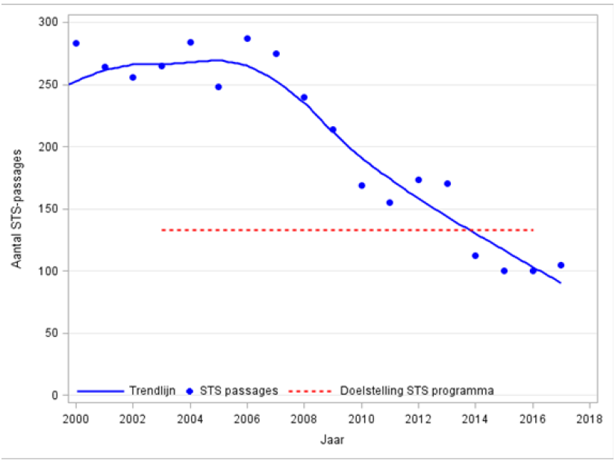
Figure 2: Development in the number of SPAD events 2000 to 2017 inclusive. Source: ILT.

Aantal STS-passages | Number of SPAD events
STS passages | SPAD events
Doelstelling STS programma | SPAD programme target
Trendlijn | Trend line

 |  |  | Year |  |  | Total
 | 2013 | 2014 | 2015 | 2016 | 2017
Passenger transporter
Arriva | 12 | 7 | 8 | 4 | 21 | 52
Connexxion | 0 | 0 | 1 | 1 | 0 | 2
Keolis | 1 | 1 | 2 | 0 | 4 | 8
NS Internationaal | 5 | 1 | 4 | 4 | 4 | 18
NS Reiziger | 102 | 59 | 49 | 52 | 52 | 314
Veolia Transport | 5 | 3 | 1 | 1 |  | 10
Subtotal | 125 | 71 | 65 | 62 | 81 | 404
Freight transporter
Captrain | 2 | 0 | 1 | 2 | 3 | 8
DB Cargo | 16 | 10 | 15 | 12 | 3 | 56
ERS Railway | 3 | 2 | 1 | 0 | 1 | 7
HSL Logistik Benelux | 0 | 0 | 0 | 2 | 2 | 4
HTRS | 1 | 0 |  |  |  | 1
KombiRail | 1 | 0 | 0 | 0 | 0 | 1
Locon | 4 | 3 | 1 | 5 | 0 | 13
LTE Netherlands | 2 | 0 | 3 | 1 | 0 | 6
Rheincargo | 3 | 2 | 0 | 1 | 0 | 6
Rotterdam Rail Feeding | 1 | 5 | 2 | 5 | 2 | 15
RTB Cargo | 3 | 6 | 2 | 0 | 3 | 14
SBB Cargo | 0 | 0 | 1 | 1 | 1 | 3
TaTa | 0 | 1 | 0 | 0 | 0 | 1
Traingroup | 1 | 3 |  |  |  | 4
Trainservices |  |  | 1 | 1 | 1 | 3
TX Logistik | 1 | 0 | 1 | 0 | 1 | 3
Subtotal | 38 | 32 | 28 | 30 | 17 | 145
Track construction traffic
BAM-rail | 0 | 2 | 0 | 0 | 0 | 2
Dura Vermeer | 0 | 0 | 0 | 0 | 1 | 1
Spitzke | 0 | 1 | 0 | 0 | 0 | 1
Strukton | 2 | 1 | 4 | 3 | 4 | 14
Swietelsky | 0 | 0 | 0 | 1 | 0 | 1
VolkerRail | 1 | 0 | 1 | 1 | 0 | 3
Other |  |  | 1 | 1 |  | 2
Subtotal | 3 | 4 | 6 | 6 | 5 | 24
Other traffic
Eurailscout | 2 | 0 | 1 | 0 | 1 | 4
NedTrain | 2 | 5 | 0 | 1 | 1 | 9
ProRail | 0 | 0 | 0 | 1 | 0 | 1
Subtotal | 4 | 5 | 1 | 2 | 2 | 14
Total | 170 | 112 | 100 | 100 | 105 | 587
Table 17: SPAD events according to railway undertaking 2017 to 2013 inclusive. Source: ILT.

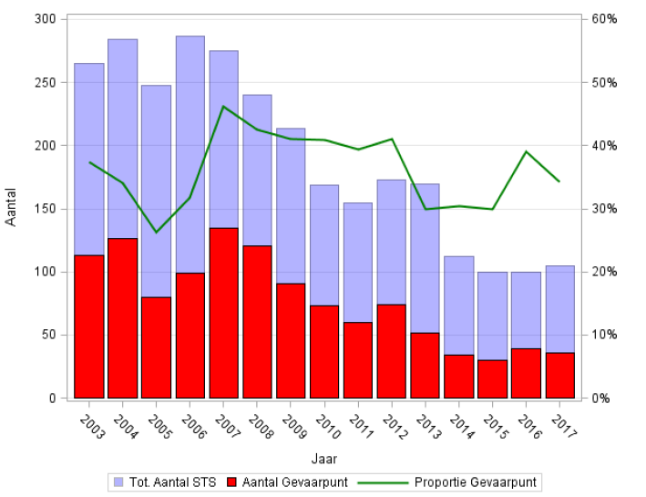
Figure 3: Trend in SPAD events with danger point. Source: ILT

Aantal | Number
Aantal Gevaarpunt | Number of danger points
Tot. Aaantal STS | Total number of SPAD events
Proportie Gevaarpunt | Percentage of danger points
Jaar | Year

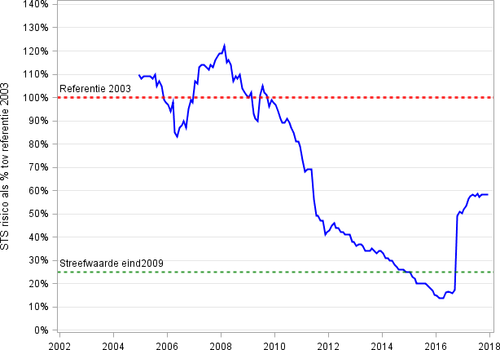
Figure 4: Trend in the MWA of the SPAD risk assessment. Source: ILT.

STS risico als % tov referentie 2003 | SPAD risk as % compared to 2003 reference
Referentie 2003 | 2003 reference
Streefwarde eind2009 | Target value end of 2009

Deviations in infrastructure & rolling stock

Precursors to accidents |  |  | Year
 | 2017 | 2016 | 2015 | 2014 | 2013
Broken rails | 61 | 77 | 54 | 63 | 54
Thermally reduced track alignment | 3 | 4 | 5 | 0 | 6
Wrong-side signalling failure | 36 | 30 | 37 | 39 | 23
Broken wheels | 0 | 0 | 0 | 0 | 1
Broken axles | 0 | 0 | 0 | 0 | 0
Table 18: Precursors to accidents 2017 to 2013 inclusive. Source: ProRail.

Near accidents involving a rail vehicle in motion

Category of registered near accident | 2017 | 2016 | 2015 | 2014
Near collision of rail vehicle with rail vehicle | 6 | 2 | 9 | 10
Near collision of rail vehicle with obstacle | 15 | 10 | 10 | 21
Near accident at level crossing – slow traffic | 86 | 87 | 90 | 93
Near accident at level crossing – fast traffic | 54 | 72 | 63 | 80
Near accident to person – unauthorised persons | 78 | 70 | 133 | 157
Near accident to person – employees | 10 | 6 | 8 | 13
Track employee | 9 | 1 | 5 | 8
Railway staff | 1 | 4 | 1 | 1
Public service employee | 0 | 0 | 1 | 3
Unknown employee | 0 | 1 | 1 | 1
Total | 249 | 247 | 313 | 374
Table 19: Near accidents involving a rail vehicle in motion 2017 to 2014 inclusive. Source: ProRail.

Level crossing user |  | Cause |  | Total
 | Ignored | Other | Unknown
Pedestrian | 16 | 10 | 34 | 60
Cyclist | 8 | 0 | 12 | 20
Moped/scooter | 1 | 0 | 5 | 6
Car | 6 | 7 | 9 | 22
Van | 0 | 1 | 4 | 5
Lorry | 0 | 4 | 10 | 14
Other vehicle | 1 | 3 | 9 | 13
Total | 32 | 25 | 83 | 140
Table 20: Near accidents on level crossings according to cause in 2017. Source: ProRail.

Appendix E Indicators set out in the Policy Impetus for Railway Safety

This appendix sets out the specific indicators that are specified in the Policy Impetus for Railway Safety.

Subject | Indicator |  | Year
 |  | 2017 | 2016 | 2015
Safety risk for passengers | FWSIs among passengers/year/billion passenger-km | 0.01 | 0.00 | 0.01
Actual and potential accidents involving trains | Number of significant accidents/million train-km | 0.16 | 0.18 | 0.20
 | Number of significant collisions/million train-km | 0.00 | 0.01 | 0.01
 | Number of significant derailments/million train-km | 0.01 | 0.00 | 0.01
 | Number of SPAD events | 105 | 100 | 100
Safety risk for railway staff | FWSIs among track personnel/year/billion train-km | 1.26 | 13.96 | 1.28
Safety risk for level crossing users | FWSIs among level crossing users/year/billion train-km | 38.38 | 19.68 | 84.70
Suicides | Number of railway suicides | 215 | 221 | 223
Table 21: Indicators from the Policy Impetus for Railway Safety 2017 to 2015 inclusive. Source: ProRail and ILT.
Results | ✓ | ✓ | ✓ | ✓ | ✗ | ✗ | ✓
MWA 2013-2017 | 0.01 | 1.15 | 4.42 | 72.92 | 7.87 | 14.80 | 82.34 | Table 22: Indicators of ERA in 2017 compared to 2016. Source: ProRail and ILT.
ERA NRV +20 % | 0.11 | 8.92 | 7.16 | 152.40 | 5.64 | 19.08 | 177.60
2016 | 0.00 | 0.00 | 13.97 | 19.68 | 14.60 | 8.89 | 57.13
2017 | 0.01 | 0.67 | 1.26 | 38.38 | 7.55 | 31.46 | 79.27
ERA NRV 2004-2009 | 0.09 | 7.43 | 5.97 | 127.00 | 4.70 | 15.90 | 148.00
Indicator | FWSIs among passengers/year/billion passenger-km | FWSIs among passengers/year/billion passenger train-km | FWSIs among railway staff/year/billion train-km | FWSIs among level crossing users/year/billion train-km | FWSIs among others (third parties)/year/billion train-km | FWSIs among unauthorised users/year/billion train-km | FWSIs total/year/billion train-km
Subject | Safety risk for passengers |  | Safety risk for railway staff | Safety risk for level crossing users | Safety risk for others | Safety risk for unauthorised persons | Overall safety
Railway Safety | October 2018

Trends in the normalised FWSI figure and the MWA of casualties

Explanation of the interpretation of the figures
Figure 5 below shows the trend in blue of the normalised passenger FWSI figures 2005 to 2017 inclusive. The green dotted line shows the trend in the 5-year moving weighted average (MWA). From 2010 onwards, this average will be calculated on an annual basis over the previous 5 years. In 2010, for example, this was calculated for 2006 to 2010. The red continuous line marks the national reference value (NRV). This was a limit value set by ERA based on the average normalised FWSI figure for the years 2004 to 2009. The red dotted line indicates the NRV plus 20 % tolerance. Where the MWA (green dotted line) falls below the NRV plus 20 % (red dotted line), the trend is considered by ERA as an acceptable safety performance. For the Policy Impetus for Railway Safety, the MWA (green dotted line) must have a downward trend to meet the criterion of permanent improvement. The other figures can be interpreted similarly.

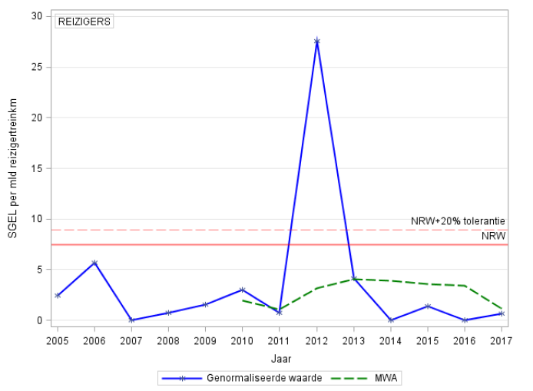

Figure 5: Trend in the normalised FWSI figure (based on billion passenger train-km) and the MWA of passengers 2005-2017.

SGEL per mld reizigertreinkm | FWSIs per billion passenger train-km
REIZIGERS | PASSENGERS
Jaar | Year
Genormaliseerde waarde | Normalised value
MWA | MWA
NRW +20% tolerantie | NRV +20 % tolerance
NRW | NRV
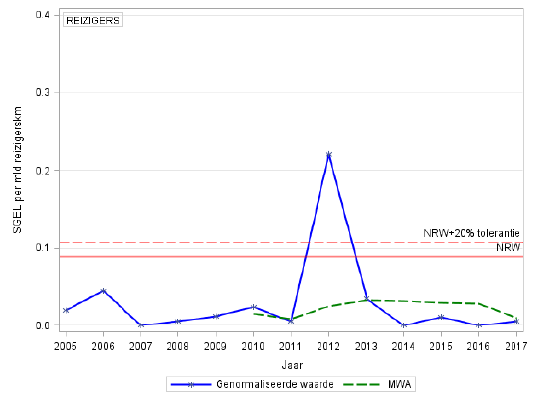
Figure 6: Trend in the normalised FWSI figure (based on billion passenger-km) and the MWA of passengers 2005-2017.

SGEL per mld reizigerskm | FWSIs per billion passenger-km
Jaar | Year
Genormaliseerde waarde | Normalised value
MWA | MWA
NRW +20% tolerantie | NRV +20 % tolerance
NRW | NRV

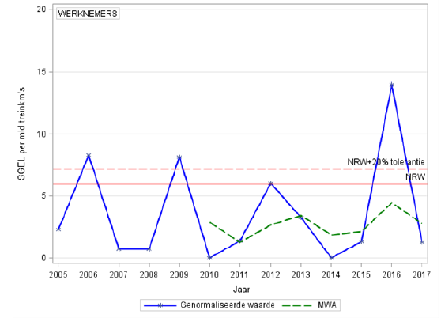
Figure 7: Trend in the normalised FWSI figure (based on billion train-km) and the MWA of employees 2005-2017.

SGEL per mld reizigerskm | FWSIs per billion passenger-km
WERKNEMERS | EMPLOYEES
Jaar | Year
Genormaliseerde waarde | Normalised value
MWA | MWA
NRW +20% tolerantie | NRV +20 % tolerance
NRW | NRV

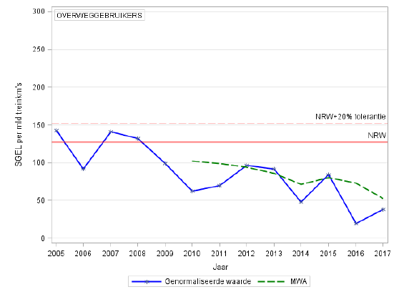
Figure 8: Trend in the normalised FWSI figure (based on billion train-km) and the MWA of level crossing users 2005-2017.

SGEL per mld reizigerskm | FWSIs per billion passenger-km
OVERWEGGEBRUIKERS | LEVEL CROSSING USERS
Jaar | Year
Genormaliseerde waarde | Normalised value
MWA | MWA
NRW +20% tolerantie | NRV +20 % tolerance
NRW | NRV

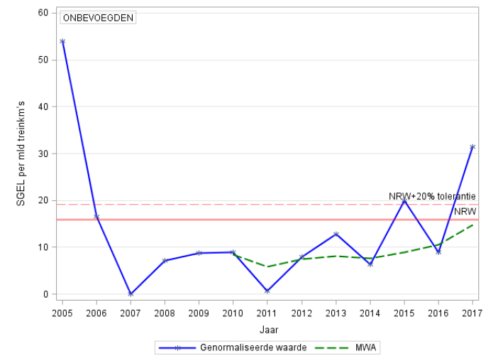
Figure 9: Trend in the normalised FWSI figure (based on billion train-km) and the MWA of unauthorised persons 2005-2017.

SGEL per mld reizigerskm | FWSIs per billion passenger-km
ONBEVOEGDEN | UNAUTHORISED PERSONS
Jaar | Year
Genormaliseerde waarde | Normalised value
MWA | MWA
NRW +20% tolerantie | NRV +20 % tolerance
NRW | NRV

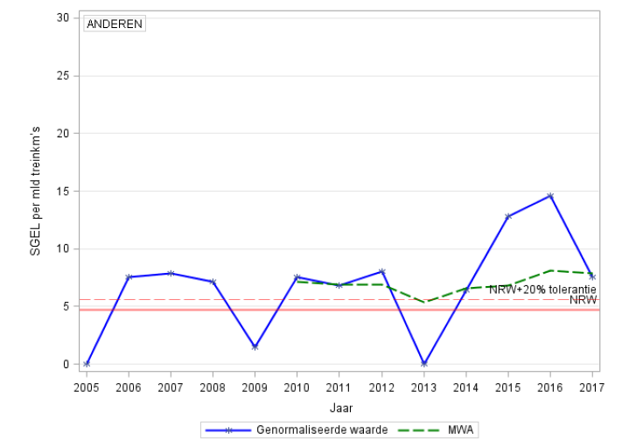
Figure 10: Trend in the normalised FWSI figure (based on billion train-km) and the MWA in the category of ‘others’ 2005-2017.

SGEL per mld reizigertreinkm’s | FWSIs per billion passenger train-km
ANDEREN | OTHERS
Jaar | Year
Genormaliseerde waarde | Normalised value
MWA | MWA
NRW +20% tolerantie | NRV +20 % tolerance
NRW | NRV

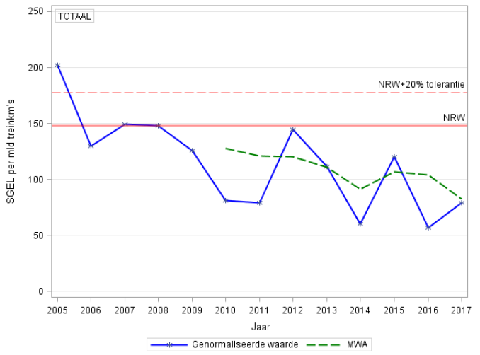
Figure 11: Trend in the normalised FWSI figure (based on billion train-km) and the MWA of the total number of casualties 2005-2017.

SGEL per mld reizigertreinkm’s | FWSIs per billion passenger train-km
ANDEREN | OTHERS
Jaar | Year
Genormaliseerde waarde | Normalised value
MWA | MWA
NRW +20% tolerantie | NRV +20 % tolerance
NRW | NRV

Trends in the normalised number and the MWA of accidents

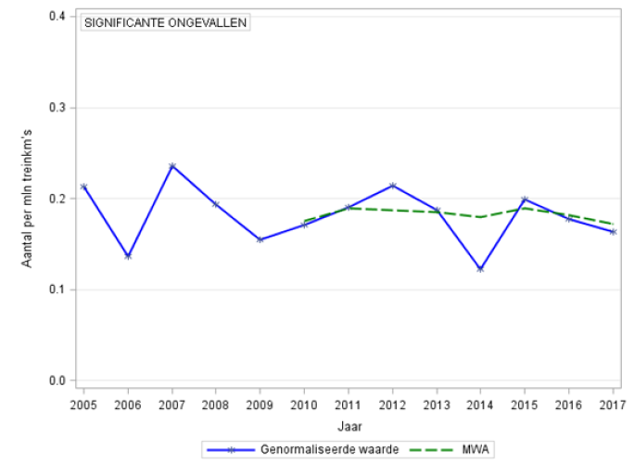
Figure 12: Trend in the normalised number (based on million train-km) and the MWA of the total number of significant accidents 2005-2017.

Aantal per mld treinkm’s | Number per billion train-km
SIGNIFICANTE ONGEVALLEN | SIGNIFICANT ACCIDENTS
Jaar | Year
Genormaliseerde waarde | Normalised value
MWA | MWA

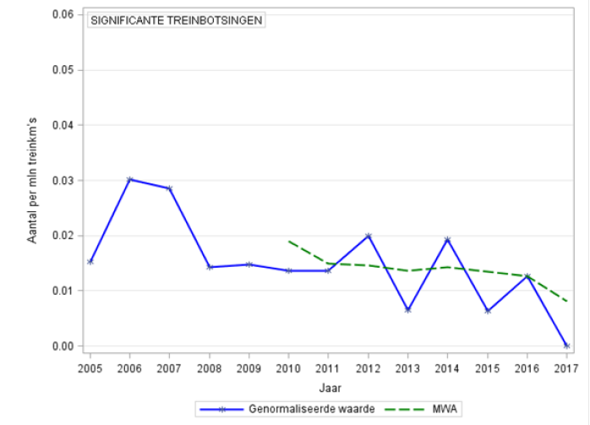
Figure 13: Trend in the normalised number (based on million train-km) and the MWA of the number of significant train collisions 2005-2017.

Aantal per mld treinkm’s | Number per billion train-km
SIGNIFICANTE TREINBOTSINGEN | SIGNIFICANT TRAIN COLLISIONS
Jaar | Year
Genormaliseerde waarde | Normalised value
MWA | MWA

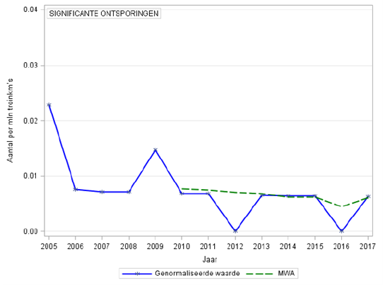
Figure 14: Trend in the normalised number (based on million train-km) and the MWA of significant derailments 2005-2017.
Aantal per mld treinkm’s | Number per billion train-km
SIGNIFICANTE ONTSPORINGEN | SIGNIFICANT DERAILMENTS
Jaar | Year
Genormaliseerde waarde | Normalised value
MWA | MWA

Trends in the normalised number and the MWA of precursors to accidents

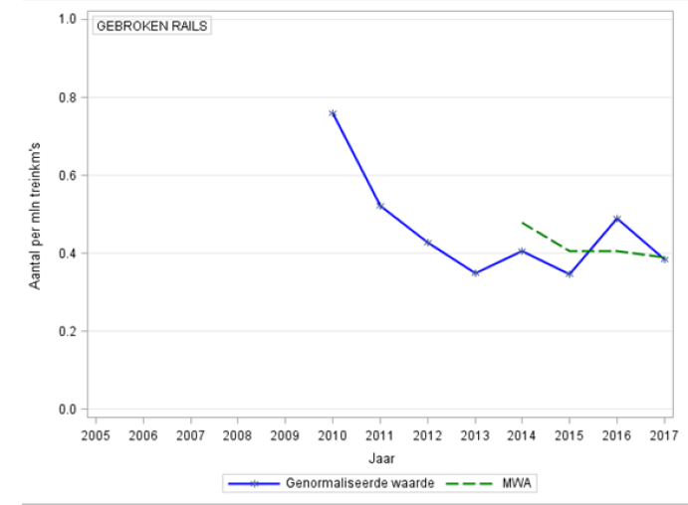
Figure 15: Trend in the normalised number (based on million train-km) and the MWA of the number of broken rails 2005-2017.

Aantal per mld treinkm’s | Number per billion train-km
GEBROKEN RAILS | BROKEN RAILS
Jaar | Year
Genormaliseerde waarde | Normalised value
MWA | MWA

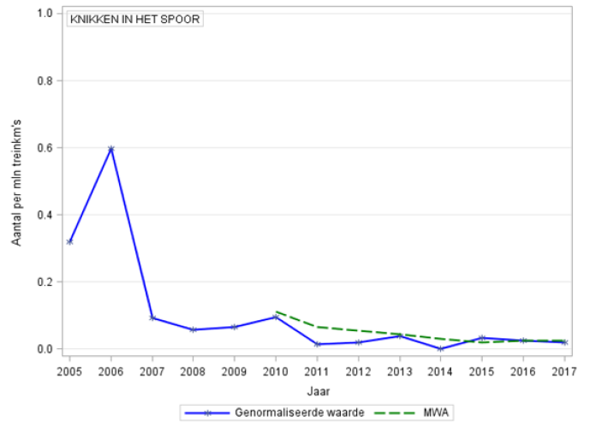
Figure 16: Trend in the normalised number (based on million train-km) and the MWA of the number of track estimates (track buckles) 2005-2017.

Aantal per mld treinkm’s | Number per billion train-km
KNIKKEN IN HET SPOOR | TRACK BUCKLES
Jaar | Year
Genormaliseerde waarde | Normalised value
MWA | MWA

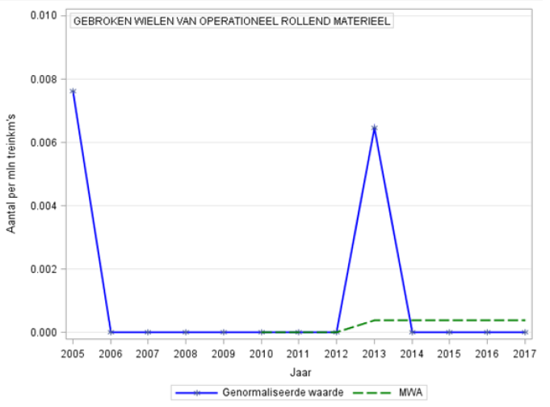
Figure 17: Trend in the normalised number (based on million train-km) and the MWA of the number of broken wheels 2005-2017.

Aantal per mld treinkm’s | Number per billion train-km
GEBROKEM WIELEN VAN OPERATIONEEL ROLLEND MATERIEEL | BROKEN WHEELS ON ROLLING STOCK IN SERVICE
Jaar | Year
Genormaliseerde waarde | Normalised value
MWA | MWA

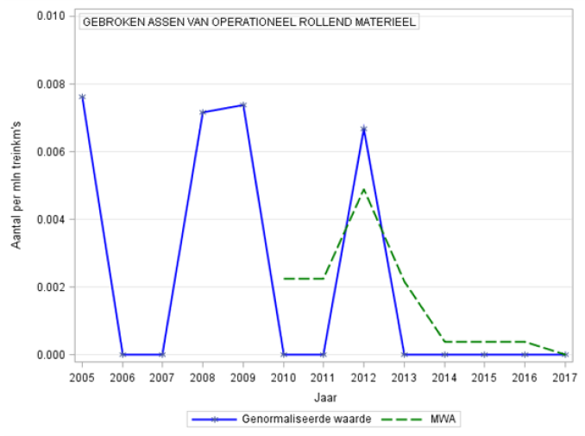

Figure 18: Trend in the normalised number (based on million train-km) and the MWA of the number of broken axles 2005-2017.

Aantal per mld treinkm’s | Number per billion train-km
GEBROKEN ASSEN VAN OPERATIONEEL ROLLEND MATERIEEL | BROKEN AXLES ON ROLLING STOCK IN SERVICE
Jaar | Year
Genormaliseerde waarde | Normalised value
MWA | MWA

Trends in the number and the MWA of types of casualty
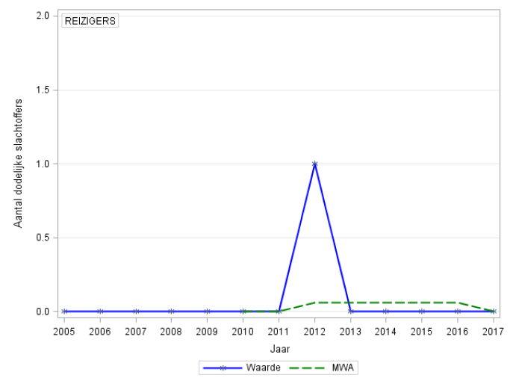
Figure 19: Trend in the number and the MWA of the number of passenger fatalities 2005-2017.

Aantal dodelijke slachtoffers | Number of fatalities
REIZIGERS | PASSENGERS
Jaar | Year
Genormaliseerde waarde | Normalised value
MWA | MWA

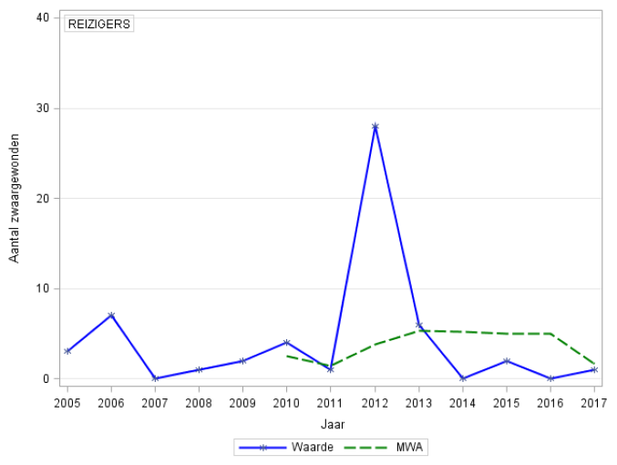
Figure 20: Trend in the number and the MWA of the number of passengers with serious injuries 2005-2017.

Aantal zwaargewonden | Number of seriously injured persons
REIZIGERS | PASSENGERS
Jaar | Year
Genormaliseerde waarde | Normalised value
MWA | MWA

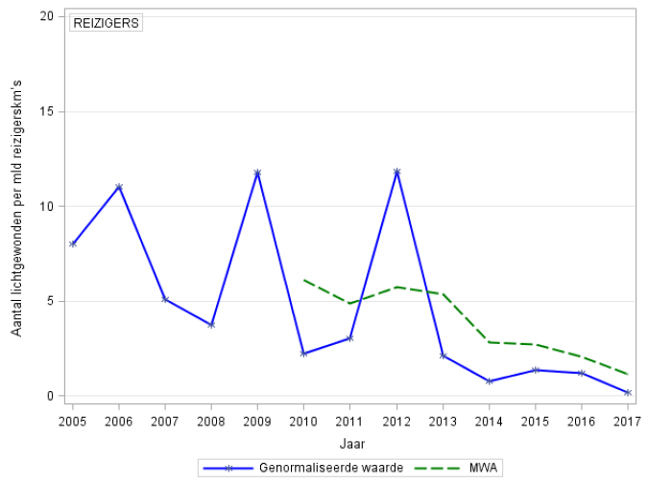
Figure 21: Trend in the normalised number (based on million train-km) and the MWA of the number of passengers with minor injuries 2005-2017.

Aantal lichgewonden per mld reizigerskm’s | Number of passengers with minor injuries per billion passenger-km
REIZIGERS | PASSENGERS
Genormaliseerde waarde | Normalised value
MWA | MWA
Jaar | Year

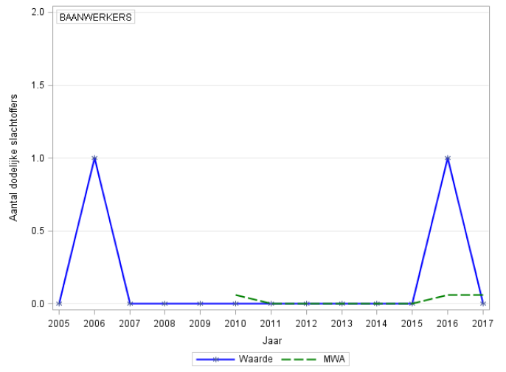
Figure 22: Trend in the number and the MWA of the number of fatalities amongst track employees 2005-2017.

Aantal dodelijke slachtoffers | Number of fatalities
BAANWERKERS | TRACK EMPLOYEES
Jaar | Year
Waarde | Value
MWA | MWA

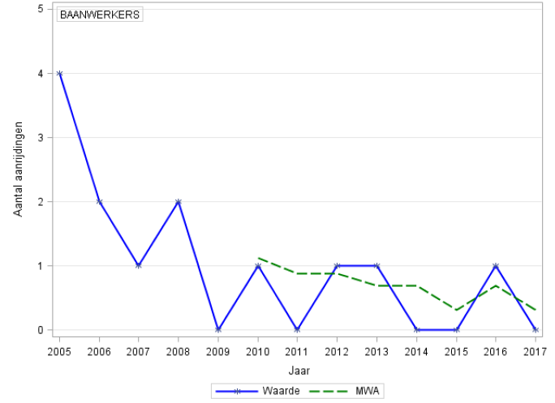
Figure 23: Trend in the number and the MWA of the number of collisions involving track employees 2005-2017.

Aantal aanrijdingen | Number of collisions
BAANWERKERS | TRACK EMPLOYEES
Waarde | Value
MWA | MWA
Jaar | Year

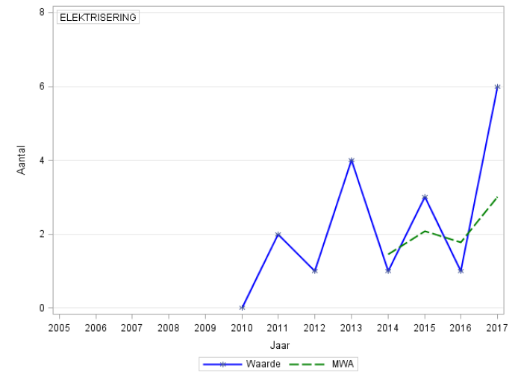
Figure 24: Trend in the number and the MWA of the number of electrifications of track employees 2005-2017.

ELEKTRISERING | ELECTRIFICATION
Aantal | Number
Jaar | Year
Waarde MWA | Value MWA

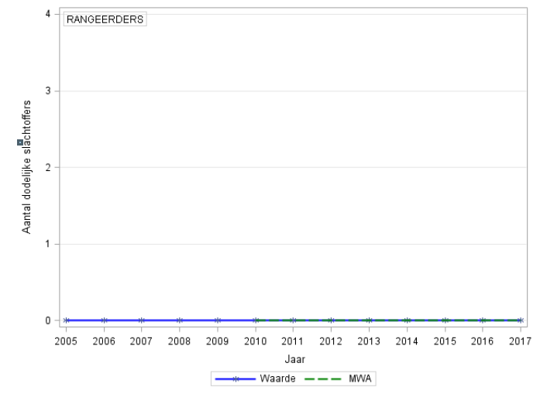
Figure 25: Trend in the number and the MWA of the number of fatalities among shunters 2005-2017.

Aantal dodelijke slachtoffers | Number of fatalities
RANGEERDERS | SHUNTERS
Jaar | Year
Waarde | Value
MWA | MWA

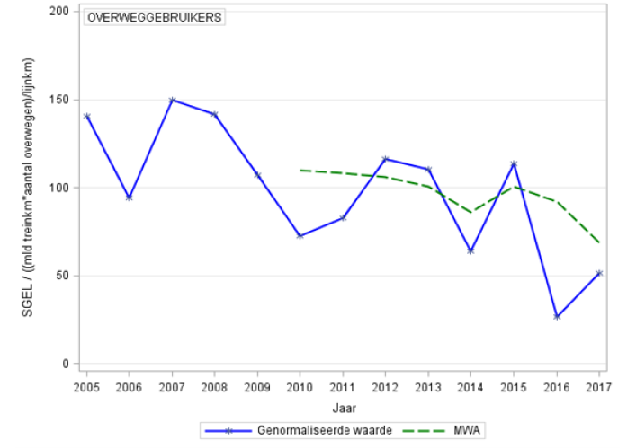
Figure 26: Trend in the normalised FWSI figure (based on billion train-km and the number of level crossings per kilometre of network length) and the MWA of level crossing users 2005-2017.
OVERWEGGEBRUIKERS | LEVEL CROSSING USERS
SGEL / ((mld treinkm*aantal overwegen)/lijnkm) | FWSIs / (billion train-km * number of level crossings)/line-km)
Jaar | Year
Genormaliseerde waarde | Normalised value
MWA | MWA

SPAD events

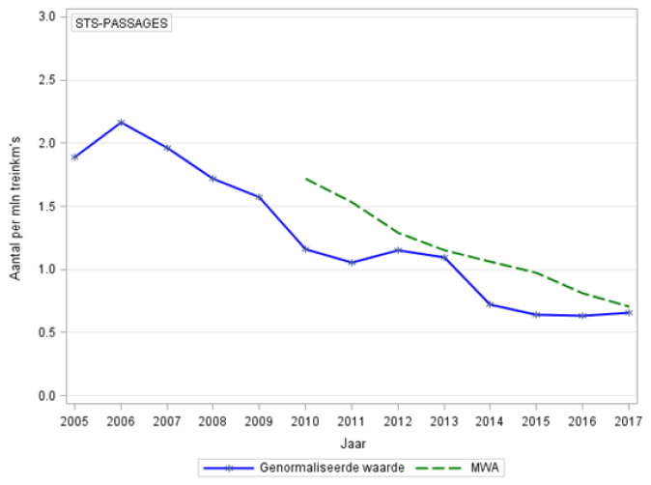
Figure 27: Trend in the normalised number (based on million train-km) and the MWA of SPAD events 2005-2017.

STS-PASSAGES | SPAD EVENTS
Aantal per mln treinkm's | Number per million train-km
Jaar | Year
Waarde | Value
MWA | MWA

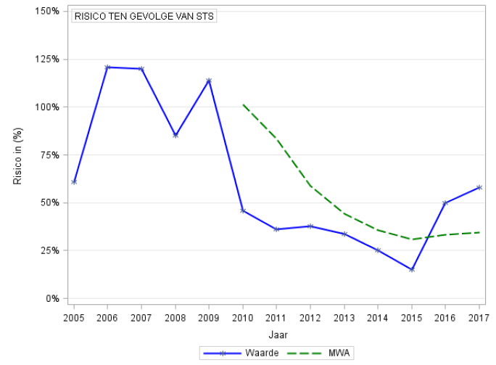
Figure 28: Trend in risk compared to 2003 and the MWA of SPAD events 2005-2017.
Risico in (%) | Risk in (%)
RISICO TEN GEVOLGE VAN STS | RISK DUE TO SPAD
Jaar | Year
Waarde | Value
MWA | MWA

Suicides

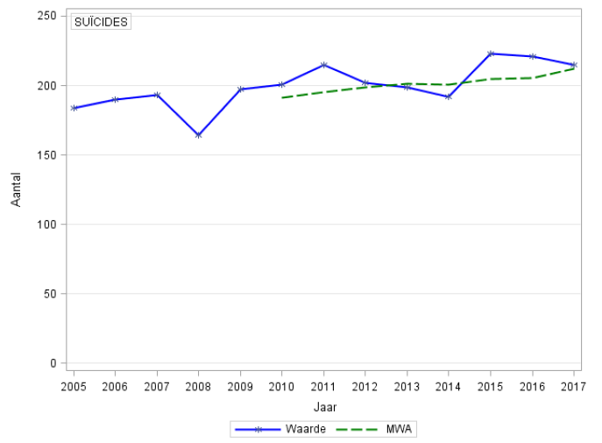
Figure 29: Trend in the number and the MWA of suicides 2005-2017.
Aantal | Number
Suïcides | SUICIDES
Jaar | Year
Waarde | Value
MWA | MWA
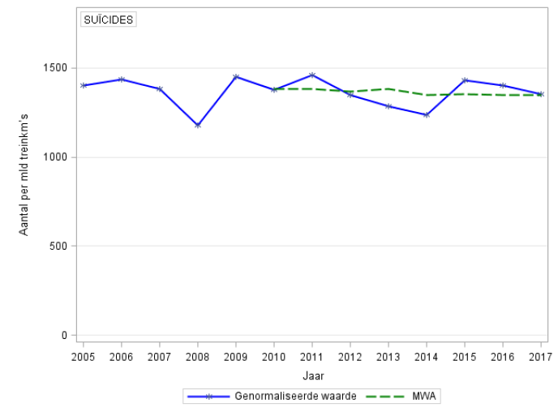

Figure 30: Trend in the normalised number (based on billion train-km) and the MWA of suicides 2005-2017.

Aantal per mld treinkm’s | Number per billion train-km
Suïcides | SUICIDES
Jaar | Year
Genormaliseerde waarde | Normalised value
MWA | MWA

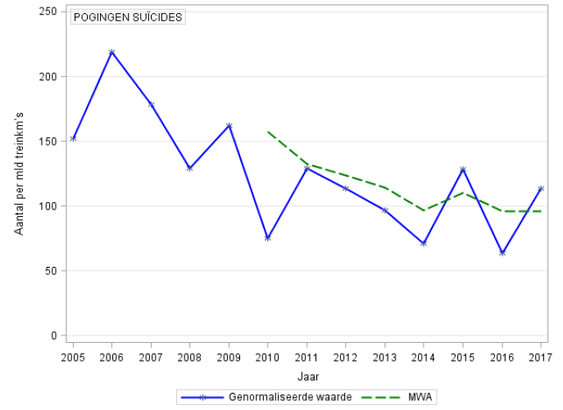
Figure 31: Trend in the normalised number (based on billion train-km) and the MWA of persons seriously injured due to attempted suicides 2005-2017.

Aantal per mld treinkm’s | Number per billion train-km
POGINGEN SUÏCIDES | ATTEMPTED SUICIDES
Jaar | Year
Genormaliseerde waarde | Normalised value
MWA | MWA

Accidents involving hazardous substances

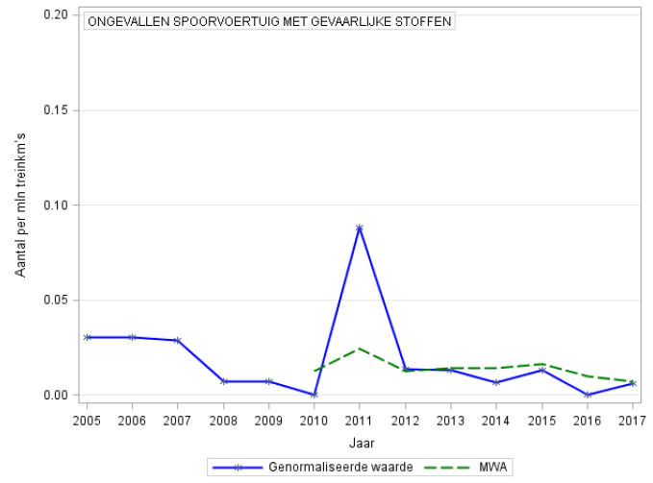
Figure 32: Trend in the normalised number (based on million train-km) and the MWA of accidents involving rail vehicles with hazardous substances 2005-2017.

ONGEVALLEN SPOORVOERTOIG MET GEVAARLIJKE STOFFEN | ACCIDENTS INVOLVING A RAIL VEHICLE CARRYING HAZARDOUS SUBSTANCES
Aantal per mld treinkm's | Number per billion train-km
Jaar | Year
Genormaliseerde waarde | Normalised value
MWA | MWA

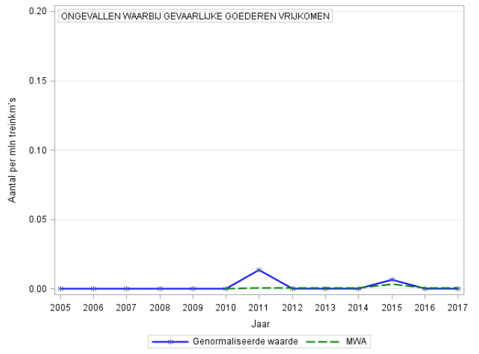
Figure 33: Trend in the normalised number (based on million train-km) and the MWA of accidents involving the release of hazardous substances 2005-2017.
ONGEVALLEN WAARBIJ GEVAARLIJKE GOEDEREN VRIJKOMEN | ACCIDENTS INVOLVING THE RELEASE OF HAZARDOUS SUBSTANCES
Aantal per mld treinkm's | Number per billion train-km
Jaar | Year
Genormaliseerde waarde | Normalised value
MWA | MWA

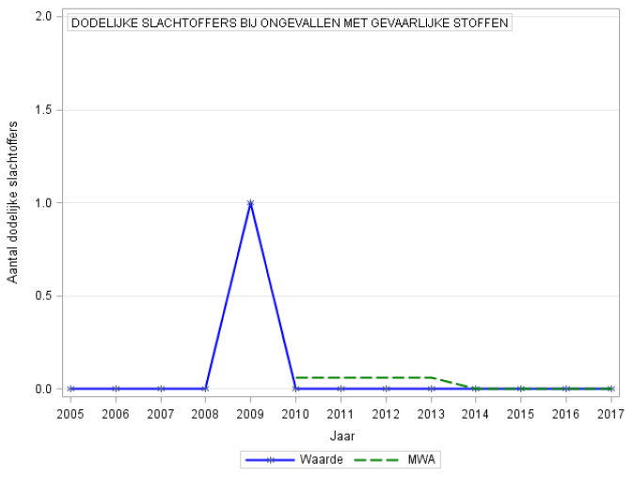
Figure 34: Trend in the number and the MWA of fatalities in accidents involving hazardous substances 2005-2017.

DODELIJKE SLACHTOFFERS BIJ ONGEVALLEN MET GEVAARLIKE STOFFEN | FATALITIES IN ACCIDENTS INVOLVING HAZARDOUS SUBSTANCES
Aantal per mld treinkm's | Number per billion train-km
Jaar | Year
Waarde | Value
MWA | MWA


This is a publication of

The Human Environment and Transport Inspectorate

PO Box 16191| 2500 BD The Hague
088 489 00 00

www.ilent.nl

October 2018

This summary does not deal with suicides. Suicides are dealt with separately in section 3.1 and Appendix C, Tables 8 and 9.
For an explanation of technical terms, see the list of definitions and abbreviations at the end of the document.
Decree of 20 December 2004 designating main railway lines; under the management of ProRail. See Appendix A for a general description of the size and use of the main railway network.
Ministry of Transport and Water Management, Veilig vervoeren, veilig werken, veilig leven met spoor: Derde kadernota railveiligheid [Safely transporting, safely working and safely living with the railways; Third Framework Memorandum on Railway Safety], June 2010.
Ministry of Infrastructure and the Environment, Beleidsimpuls Railveiligheid [Policy Impetus for Railway Safety], June 2016.
European Union Agency for Railways. Railway safety in the European Union, 2017.
Suicide is excluded from this category of accidents and will be explained in the next chapter.
A tamping machine is a track maintenance machine that is used to lift the track and move it sideways.
Dutch Safety Board (Onderzoeksraad voor Veiligheid) Overwegveiligheid: Een risicovolle kruising van belangen [Crossing protection: A hazardous intersection of interests], July 2018.
Ministry of Transport, Public Works and Water Management, Veilig vervoeren, veilig werken, veilig leven met het spoor: Derde Kadernota Railveiligheid [Safely transporting, safely working and safely living with the railways; Third Framework Memorandum on Railway Safety], p. 43, June 2010.
This was the fatality mentioned in section 2.5.
For passengers, the normalised FWSI figure is based on the number of passenger train-kilometres.
Source: ProRail.
Source: Statistics Netherlands (CBS): Fatalities; leading causes of fatalities (brief list), age, gender.
When a person dies due to the flow of electric current, this is referred to as ‘electrocution’; if the outcome is not fatal, this is called ‘electrification’.
All of these marshalling yards are managed by ProRail, with the exception of company-connecting tracks.
See the reports: Transport and Water Management Inspectorate. Weten wat er staat [Know what it says]. 15 June 2011, The Human Environment and Transport Inspectorate. Weten we nú wat er staat? [Do we know now what it says?] 28 April 2015.
A right-side signalling failure due to a technical failure of the infrastructure is not considered to be an SPAD event. Transport and Water Management Inspectorate. Onterechte passage stoptonend sein. [Signal Passed at Danger without authority.] 15 June 2009.
Another rail vehicle occupied the section of track by running through a points switch, resulting in a near collision.
Human Environment and Transport Inspectorate Verkennend onderzoek naar de aanname, opleiding en begeleiding van machinisten van Arriva [Exploratory investigation into the recruitment, training and supervision of Arriva train drivers]. 05 May 2017.
Human Environment and Transport Inspectorate Status STS-passages Keolis op routes Zwolle-Kampen en Zwolle-Enschede [Status of the Keolis SPAD events on the Zwolle-Kampen and Zwolle-Enschede routes]. 22 June 2018.
Ministry of Infrastructure and the Environment Beleidsimpuls Railveiligheid [Policy Impetus for Railway Safety], p. 5, June 2016.
The lower house of the Dutch Parliament, 2017-2018 session, 29893, number 218, page 11, 28 June 2018.
Up until 9 October 2017, Keolis was called Syntus.
Up until 15 June 2014, NS International was called NS Hispeed.
Veolia Transport stopped operating on 10 December 2016.
Captrain refers to both Captrain Netherlands BV and Captrain Belgium NV. These two subsidiaries of SNCF Fret are included in this table.
Up until 1 April 2016, DB Cargo was called DB Schenker Rail.
Trainservices started on 13 November 2014 and stopped operating on 5 April 2017.
HTRS stopped operating on 1 February 2014, Traingroup on 26 November 2014, HSL Logistik Benelux on 10 April 2017 and Locon on 14 July 2017.
As Cyprus and Malta do not have a railway system, and the Channel Tunnel railway is mentioned separately, there are 29 registrations.
European Union Agency for Railways. Railway safety in the European Union, 2017.
European Union Agency for Railways. Railway safety performance in the European Union 2016: Biennial Report, 2016.
Ministry of Transport and Water Management, Veilig vervoeren, veilig werken, veilig leven met het spoor: Derde Kadernota Railveiligheid [Safely transporting, safely working and safely living with the railways; Third Framework Memorandum on Railway Safety], p. 77, June 2010.
Ministry of Infrastructure and the Environment, Beleidsimpuls Railveiligheid [Policy Impetus for Railway Safety], June 2016, p. 5.

