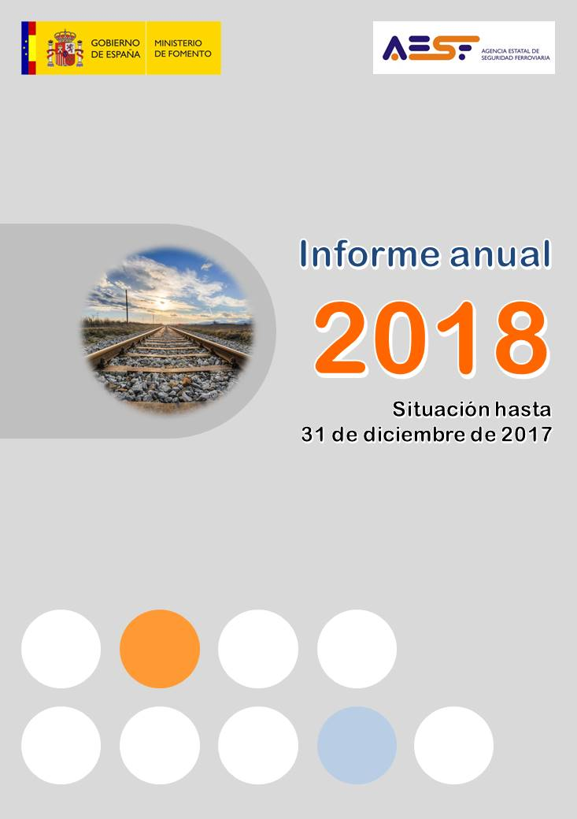

**Annual Report**

**Status up to 31 December 2017**



***National Railway Safety Agency***

**Annual Report**

(Article 18, Directive 2004/49)

2018

(Actions to 31 December 2017)

Contents

A. Introduction 5

B. English summary 8

C. The National Railway Safety Agency 10

D. Safety strategies, programmes and initiatives 14

E. Safety 21

F. Safety certificates and authorisations 34

G. Supervision of the railway system 39

H. Implementation of safety legislation 51

I. Safety Culture 58

ANNEX: Common Safety Indicators 61

Abbreviations

**AES** Authorisation of placing in service

**AESF** National Railway Safety Agency

**AI**  Infrastructure manager

**AsBo** Safety assessment body

**CIAF** Railway Accident Investigation Commission

**RSD**  Railway Safety Directive

**ECM** Entity in charge of maintenance

**EF**  Railway undertaking

**TSI** Technical specification for interoperability

**OPE TSI** Operation and traffic management technical specification for interoperability

**EUAR** European Union Agency for Railways

**CSI** Common safety indicator

**IF** Railway instruction

**LFP** Figueres-Perpignan line

**LSF** Railway Sector Act

**MHGP** Weighted fatalities and serious injuries (No of fatalities + 0.1 x No of serious injuries)

**OTIF** Intergovernmental Organisation for International Carriage by Rail

**RAM** Metre-gauge network

**RFIG**  Public Railway Network

**RCF**  Rail Traffic Regulations

**RIV** Regolamento Internazionale Veicoli

**SMS**  Safety management system

**EU** European Union

|  |  |
| --- | --- |
|  | |
|  | 1. Introduction |

Article 18 of Directive 2004/49/EC on railway safety[1], states:

*‘Each year the safety authority shall publish an annual report concerning its activities in the preceding year and send it to the Agency by 30 September at the latest. The report shall contain information on:*

*a) the development of railway safety, including, for each Member State, an inventory of the common safety indicators (CSIs) laid down in Annex I;*

*b) important changes in legislation and regulation concerning railway safety;*

*c) the development of safety certification and safety authorisation;*

*d) results of and experience relating to the supervision of infrastructure managers and railway undertakings.’*

This report complies with that requirement. The information contained in the report reflects the situation as at the end of the 2017 financial year, that is, up to 31 December 2017.

This report has been prepared by the National Railway Safety Agency (Agencia Estatal de Seguridad Ferroviaria: AESF) to be sent to the European Union Agency for Railways (EUAR), in accordance with the guidelines of that body, for the purposes of:

* providing the EUAR with basic information for drafting the biannual safety report.
* publication by the EUAR on its website.

The report is, therefore, directed at the different actors in the railway sector and at the general public, both through dissemination by the EUAR and distribution by the AESF to national actors (railway undertakings and managers, entities in charge of maintenance, certification entities and the accident investigation body).

For the preparation of this report, the Directive states that:

*‘Each year all infrastructure managers and railway undertakings shall submit to the safety authority before 30 June an annual safety report concerning the preceding calendar year.’*

Therefore, the agents of the national railway system must submit the information requested in Directive 2004/49/EC through these reports. As in previous years, to facilitate the compilation of data for the preparation of this report, a template of the annual report has been provided to undertakings, and the annual safety reports received from railway undertakings and infrastructure managers have been assessed to identify possible improvements for the preparation of subsequent reports.

This report includes information on the Public Railway Network (Red Ferroviaria de Interés General: RFIG) administered in 2017 by the railway infrastructure manager Administrador de Infraestructuras Ferroviarias (Adif), by Adif-Alta Velocidad and by the company Línea Figueras Perpignan (LFP Perthus), as well as information on the services and activities that are provided on it. The following are excluded from the scope of application of this report, as permitted by Directive 2004/49:

1. metros, trams and other light rail systems,
2. networks that are functionally separate from the rest of the railway system and intended only for the operation of local, urban or suburban passenger services, as well as railway undertakings operating solely on these networks,
3. privately owned railway infrastructure that exists solely for use by the infrastructure owner for their own freight operations,
4. historical vehicles that travel on the RFIG, as long as they comply with specific safety rules to guarantee the safety of such vehicles,
5. historical, museum and tourist railways that operate on their own networks, including workshops, vehicles and personnel.

This report covers the services and activities provided on the RFIG by railway undertakings that, on that date, were providing commercial passenger services (Renfe Viajeros, SNCF, FGC Rail and Alsa Ferrocarriles) and freight services (Acciona Rail Services, Comsa Rail Transport, Continental Rail, Ferrovial Railway, Logitren Ferroviaria, Low Cost Rail, Renfe Mercancías, Tracción Rail, Transfesa Rail and Transitia Rail).

2017 was a year of the beginning the transition towards the 4th Railway Package, which will be implemented from June 2019, when its technical pillar enters into force, and which will culminate from 2020 with the opening of the internal passenger market. Therefore, in 2017, the AESF continued with its objective of consolidating itself as benchmark in the sector, improving its procedures and working methods, to enable it to be adequately prepared for that moment of change.

|  |  |  |  |  |
| --- | --- | --- | --- | --- |
| |  |  | | --- | --- | |  | | |  | 1. English summary | |

The present report has been drafted by the Agencia Estatal de Seguridad Ferroviaria, in its role as Safety Autority of the Spanish network, in order to comply with Article 18 of the Railway Safety Directive 2004/49/EC.

The information contained in it reflects the situation at the end of the year 2017, that is to say, until the 31st of December 2017. It includes information related to Railway Network of General Interest (Red Ferroviaria de Interés General - RFIG) managed by the infrastructure managers ADIF, ADIF-Alta Velocidad and the company ‘LFP Perthus’, as well as all services and activities provided over this network.

This report will be sent to the European Union Agency for Railways (EUAR), in accordance with Agency’s guidelines, with the aim to be disseminated among the different stakeholders from railway sector.

From the AESF’s point of view, 2017 is a year for the beginning of the transition towards the Fourth Railway Package, which will be materialised from June 2019 with the entry into force of its Technical Pillar and it will be completed from 2020 on with the opening of domestic market of passengers. Therefore, during 2017 AESF has continued with the objective of consolidating as a reference within the sector, improving its procedures and working methods, in order to be properly prepared at this time of change.

In 2017 improvement strategies have been initiated involving the whole national sector that shall continue in successive years. Some of the established actions are the follow up of the modification of the Regulation of Railway Operation (Reglamento de Circulación Ferroviaria – RCF), the improvement of safety equipments and network communications and improvement of protection in level crossings and crossing boards.

In relation to safety performance, 2017 has been a year without singular accidents, in which level-crossing accidents have had more weight due to their consequences. However, some trends show an increase in precursors (SPADs or broken rails) or an increase in the total number of significant accidents, issues that shall be under surveillance in the coming years, to confirm that 2017 results do not entail trend changes and they are only on-time data within a series of a certain stability.

Regarding the European regulation implementation (safety management systems, risk approach, internal monitoring…), AESF notes a progressive improvement of the understanding and application by the entities from national sector, though there is still room for improvement in certain aspects which are subject to particular attention to be paid by AESF during its assessment and supervision activities.

|  |  |
| --- | --- |
|  | 1. The National Railway Safety Agency |

1. Powers of the Agency

The AESF is a public body regulated by Law 28/2006, of 18 July, on state agencies for the improvement of public services, and is attached to the Ministry of Public Works through the Secretariat-General for Infrastructure.

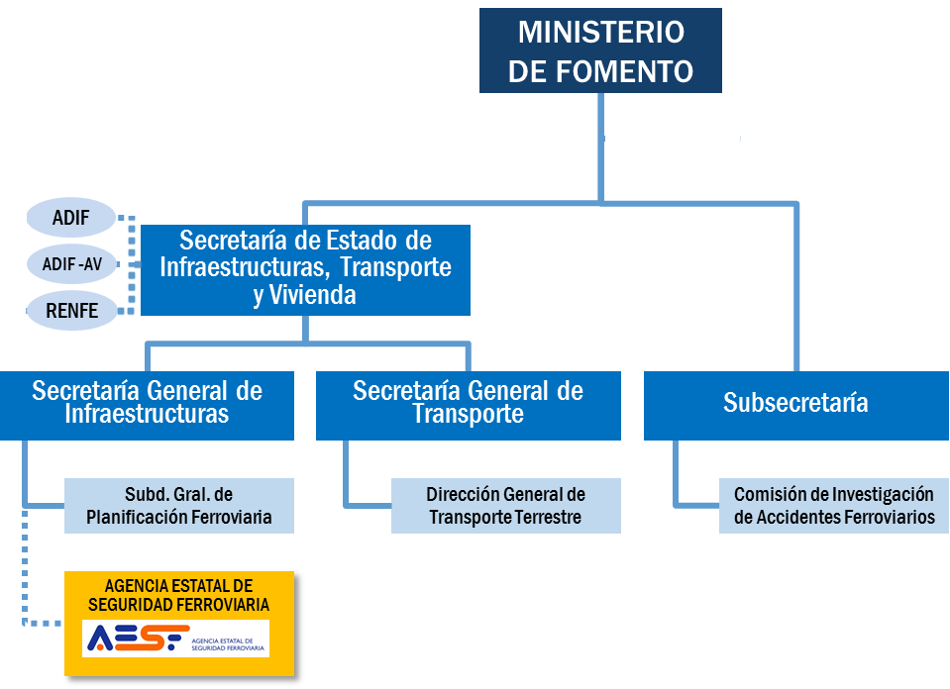

Figure 1. Organisational position of the AESF

|  |  |
| --- | --- |
| MINISTERIO DE FOMENTO | MINISTRY OF PUBLIC WORKS |
| ADIF | ADIF |
| ADIF – AV | ADIF – AV |
| RENFE | RENFE |
| Secretaría de Estado de Infraestructuras, Transport y Vivienda | State Secretariat for Infrastructure, Transport and Housing |
| Secretaría General de Infraestructuras | Secretariat-General for Infrastructure |
| Secretaría General de Transporte | Secretariat-General for Transport |
| Subsecretaría | Undersecretariat |
| Subd. Gral. De Planificación Ferroviaria | Subdirectorate- General for Railway Planning |
| Dirección General de Transporte Terrestre | Directorate-General of Land Transport |
| Comisión de Investigación de Accidentes Ferroviarios | Railway Accident Investigation Commission |
| AGENCIA ESTATAL DE SEGURIDAD FERROVIARIA | NATIONAL RAILWAY SAFETY AGENCY |

Its articles of association were approved by [Royal Decree 1072/2014, of 19 December](http://www.seguridadferroviaria.es/NR/rdonlyres/8C71789C-115A-4DF1-BD1D-86727C6021AF/129275/RD_10722014.pdf), which established 1 April 2015 as the date on which it commenced its activity.

Within the scope of the Agency's competences (the RFIG), it is the authority responsible for railway safety, as set out in Law 38/2015, of 29 September, on the Railway Sector, regulating and supervising the safety of all parts of the railway system: infrastructure, rolling stock, railway personnel and railway operations.

It also carries out those functions related to the interoperability of the railway system for which the state is responsible, and is likewise responsible for granting, suspending and revoking the licences of railway undertakings.

For more information about the Agency, visit its website: [www.seguridadferroviaria.es](http://www.seguridadferroviaria.es)

1. The Agency's action principles

The Agency is guided by the following action principles:

1. Independence in its actions with respect to the functions that it has been assigned regarding the safety of railway transport.
2. Authority and responsibility for the development and application of national and international railway standards, and the control of procedures.
3. Promotion and dissemination of a culture of railway safety in all areas of action.
4. Quality, efficacy, efficiency and transparency in the exercise of its functions.
5. Governing bodies, executive bodies and structure of the Agency

The Chairman’s Office and the Governing Board are the governing bodies of the AESF.

The Director of the Agency is the chief executive and is responsible for its direction and ordinary management. The Director is appointed by the Governing Board at the proposal of the President.

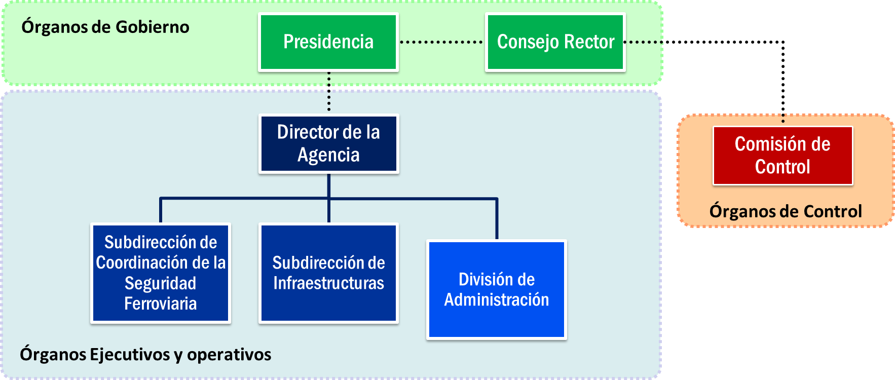

Figure 2. AESF organigram

|  |  |
| --- | --- |
| Órganos de Gobierno | Governing Bodies |
| Presidencia | Presidency |
| Consejo Rector | Governing Board |
| Director de la Agencia | Director of the Agency |
| Subdirección de Coordinación de la Seguridad Ferroviaria | Sub-directorate of Coordination of Railway Safety |
| Subdirección de Infraestructuras | Sub-directorate of Infrastructure |
| División de Administración | Administrative Division |
| Comisión de Control | Control Commission |
| Órganos de Control | Control Bodies |

The Agency is composed of the following units:

* Sub-directorate General of Infrastructure

Responsible for exercising functions related to issuing safety authorisations for infrastructure managers and the subsequent supervision thereof, as well as all aspects related to infrastructure and fixed equipment.

* General Sub-directorate of Coordination of Railway Safety

Responsible for exercising functions related to issuing licences and safety certificates for railway undertakings and the subsequent supervision thereof, including authorisations for candidates other than railway undertakings and everything related to rolling stock, the maintenance thereof, railway personnel and associated centres.

Likewise, it is responsible for overall monitoring of the safety of the railway system, and coordinating the development of its technical operating procedures, as well as external representation of the Agency.

* Administrative Division

Reporting directly to the Director of the Agency, it carries out support tasks for management and the Governing Board, as well as the management functions entrusted to it.

|  |  |
| --- | --- |
|  | 1. Safety strategies, programmes and initiatives |

1. Strategic action lines of the AESF

The AESF carries out many activities directly derived from its competences as a safety authority, especially regarding the issuance of licences, certificates, authorisations or approvals required by the system’s entities or elements in order to access the market, such as the following:

* Issuing railway undertakings’ licences.
* Issuing safety certificates to railway undertakings (new certificates, extensions or renewals), after assessment of their safety management systems.
* Issuing infrastructure manager safety authorisations (new authorisations, extensions or renewals).
* Certifying entities in charge of the maintenance of carriages.
* Approving rolling stock maintenance centres.
* Approving railway staff centres: training and psychophysical examination centres.
* Authorising the placing in service of lines.
* Authorising the placing in service of vehicles and managing modification files.
* Authorising train driver training courses and examinations.
* Activities relating to the issuance of train drivers’ licences.
* Carrying out safety adviser examinations for the transport of dangerous goods by rail.

In addition to these ordinary activities as required by the sector, the actions of the AESF in the period covered by this report, for which significant emphasis has been placed on continuity with the actions set in motion in the preceding years, appear in its Action Plan**[2]**

That plan is organised around the following strategic lines and objectives:

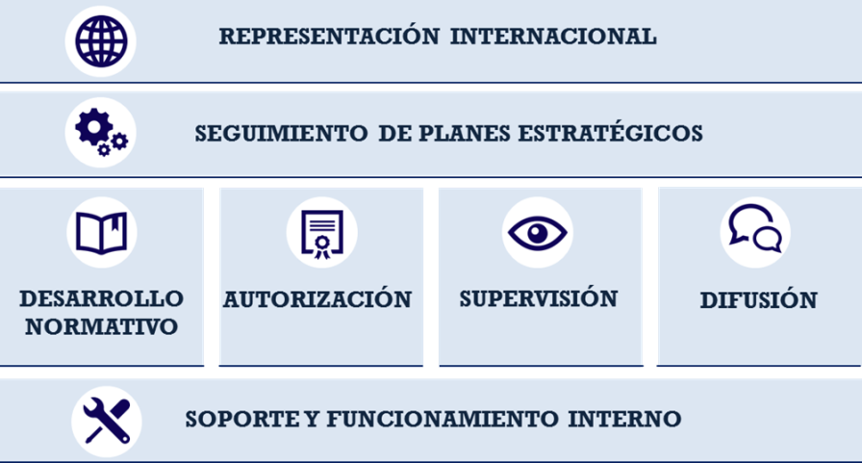

Figure 3: Strategic lines of the AESF’s 2017 Action Plan

|  |  |
| --- | --- |
| REPRESENTACIÓN INTERNACIONAL | INTERNATIONAL REPRESENTATION |
| SEGUIMIENTO DE PLANES ESTRATÉGICOS | FOLLOW-UP OF STRATEGIC PLANS |
| DESARROLLO NORMATIVO | LEGISLATIVE DEVELOPMENT |
| AUTORIZACIÓN | AUTHORISATION |
| SUPERVISIÓN | SUPERVISION |
| DIFUSIÓN | COMMUNICATION |
| SOPORTE Y FUNCIONAMIENTO INTERNO | SUPPORT AND INTERNAL FUNCTIONING |

* Actions in support of all other AESF actions, aimed at improving the Agency's internal functioning and providing the organisation with tools to facilitate its performance.
* Operational actions, relating to the AESF's particular competences, which are carried out on the basis of four key concepts:
  + Legislative development and regulation with regard to safety and interoperability, from both a technical and a legal perspective.

The regulatory activities carried out in 2017 are described in chapter H of this report.

* + The issuance of licences, authorisations, certificates or approvals required by the various elements and organisations of the railway sector in order to join the sector.
  + Supervision of the sector, which must form a highly significant subset of the 2017 Action Plan.

In accordance with the Railway Sector Act, traffic safety on the Public Railway Network is the responsibility of the infrastructure managers and the railway undertakings that operate on the network.

In turn, the authority that is responsible for safety must ensure compliance with the regulatory framework by system agents and ensure that they use an adequate safety management system.

Further details of the supervisory activities of the AESF are set out in Chapter G of this report.

* + Dissemination, as a fundamental tool for improving knowledge in the sector (see chapter I of this report).
* Strategic actions, at a higher level and over the medium term:
  + Follow-up of strategic safety improvement actions in the sector, the importance of which requires continuing action over time. With those actions, the AESF can act as a catalyst and coordinate other actors' actions.
  + The AESF attaches strategic importance to medium-term preparation for the changes introduced by the 4th Railway Package adopted in 2016, which in the coming years will bring about a new scenario in the Single European Railway Area, involving a significant change in relations between the European Union Agency for Railways and national safety authorities.
* International representation and participation in a range of organisations that will shape future policy and legislation on safety and interoperability.

The AESF takes part in European working groups within different organisations, such as the European Union Agency for Railways (EUAR), the European Commission Shift2Rail and the Intergovernmental Organisation for International Carriage by Rail (OTIF). This has meant attending more than 90 meetings.

1. Global strategies, programmes and initiatives in the railway sector

In 2017, the sector as a whole, in cooperation with the AESF, worked on different strategic lines to improve railway safety:

* **Monitoring the entry into force of the Rail Traffic Regulations**

The Rail Traffic Regulations (reglamento de circulación ferroviaria: RCF) entered into force in January 2017, after a transitional period following their approval in July 2015[3]. The RCF are the notified national legislation regulating railway management and operation. They are in keeping with the content of the operation and traffic management technical specification for interoperability (OPE TSI) and have involved a complete review of the regulations governing the national railway sector. During that transitional period, numerous actions were necessary for their full implementation.

However, their entry into force does not mean that work in this area is now at an end. In 2017, it was necessary to continue with the tasks resulting from the RCF:

1. *Analysis of proposals for amendment and improvement of the RCF and, where applicable, processing of regulatory changes.*

Once the RCF had entered into full force, in the first few months the sector conveyed the need to improve, or even correct, certain aspects of its wording. To that end, the AESF proposed the approval of a royal decree amending the RCF, correcting errors and clarifying certain aspects, which was processed during the course of 2017 and published in 2018[4].

1. *Auditing of the implementation of the RCF in the SMSs of the different system actors.*

In 2017, the AESF also assessed the implementation of the RCF, making use of the renewal, extension and assessment processes for new safety certificates, or during the audits of their safety management systems.

1. *Assessment of regulatory documents issued in implementation of the RCF.*

The AESF has occasionally reviewed documents created in implementation of the RCF by the infrastructure manager (orders, internal rules, etc.), making suggestions for improvement or requests for the correction of aspects which were not deemed to be entirely compliant with the RCF.

1. *Implementation of supplementary technical specifications (e.g. Braking TS).*

During the course of 2017, work was done on the wording of technical specification on braking, in implementation of the RCF.

1. *Issuance of documents to facilitate the application of the RCF (guidance sheets).*

To facilitate the application of the RCF, the AESF, by means of Decision 1/2017, created guidance sheets regarding the application of the RCF and has issued two of them this year.

1. *Dealing with queries.*

A considerable number of the queries received in 2017 were to do with the application of the RCF and they were resolved by email, with specific documents, by the publication of guidance sheets or even by including them in the royal decree amending the RCF.

* **Updating the ASFA system**

The national sector is in the process of updating the ASFA driver assistance system, which has largely been introduced on the national network. The aim is to eliminate its older versions (‘ASFA analogue’) completely and replace them with ‘ASFA digital’, with improved safety features.

In 2017, the AESF worked with the sector principally on monitoring the plans to eliminate ASFA analogue from the equipment concerned, processing the relevant vehicle modification files.

* **Improving the network’s safety equipment, eliminating telephonic blocks**

With a view to progressively minimising the risks resulting from the human factor in driving processes, it was deemed advisable to work on eliminating telephonic blocks from those lines on which there is still no other kind of blocking and providing equipment with regard to train protection systems.

In 2017, the AESF processed legislative amendments[5] establishing the obligation for infrastructure managers to have a medium-term strategy for improving safety equipment.

* **Improving communications on the rail network**

With a view to improving communications on the rail network on those significant sections which do not have their own means of communication (radio telephony, GSM-R, etc.) between the train and the operations centre, a medium-term strategy for their improvement has also been judged necessary.

In 2017, the AESF processed legislative amendments[6] establishing the obligation for infrastructure managers to have a medium-term strategy for improving communications.

* **Reviewing rail loading and unloading processes**

In 2017, the AESF coordinated a working group with representatives of loading companies and railway undertakings in order to assess possible improvements in the national legal regime and in company/customer contractual relationships for operations of this kind, which have a major impact on the number of freight traffic events and incidents.

1. Specific plans relating to particular accidents and incidents

In 2017, after observing certain events and trends in the accident/incident rate, the AESF began specific actions with regard to:

* **Protection of track crossings between platforms at stations and unmanned stations**

The AESF has deemed it advisable to work on improving the safety of elements of this kind, which, up to now, where not specifically regulated.

To that end, it has begun actions of various kinds:

1. Issuing a technical recommendation establishing possible safety and protection measures for such crossings, as well as criteria for deciding on the equipment required.
2. Commissioning an inventory of existing level crossings on the national network in order to assess their level of risk.
3. Starting on the drafting of specific legal rules for crossings between platforms, which would be incorporated into the legislation.

As a result of these actions, Adif has set in motion a specific programme for protecting crossings between platforms.

* **Improving the protection of type A level crossings[7]**

As can be seen in section E of this report, in 2017 there was an increase in the number of accidents at level crossings, above all at crossings in rural areas on lines with low traffic levels and without active protection.

For that reason, and given the need to give new impetus to the policies of protecting and removing level crossings which have produced such good results in reducing the accident rate in recent years, the AESF has begun other actions:

1. Commissioning an inventory of type A level crossings on the network.
2. Beginning a review of the current legal rules regarding the protection and removal of level crossings, with a view to updating and incorporating new requirements in the future.

For its part, Adif is continuing with its programmes for the removal and protection of level crossings.

* **Collisions with buffer stops**

In 2017, two accidents occurred with similar characteristics (pending the final outcome of the investigation report), involving the collision of suburban (Cercanías) passenger trains with buffer stops:

* Collision of 28 July in Barcelona, França Station, Rodalies de Catalunya train (3 people seriously injured).
* Collision of 22 December in Alcalá de Henares, Cercanías Madrid train (2 people seriously injured).

At the end of 2017, the AESF asked Renfe Viajeros and Adif to present an action plan for events of this kind.

* **Signal overruns**

Examining the analysis of the occurrence of signal overruns over time reveals an increase in the number of events of this kind.

In view of that fact, the AESF has begun medium-term actions of various kinds:

* Requesting specific action plans from the companies with the highest numbers of overruns.
* Requesting information from the sector regarding signals with low visibility.
* At the end of 2017, information was requested from the sector regarding the different signal overrun events, with the intention of beginning a more detailed study of the possible causes of this increase, taking into account the characteristics of the infrastructure (looking for black spots with repeated overruns) or the human factor (staff repeatedly involved, patterns of staff profiles more prone to overruns, etc.).

For their part, the railway undertakings most affected (Renfe, in particular) have begun analysis and specific programmes, with actions of various kinds in an attempt to reverse this negative trend.

* **Broken rails**

Examining the analysis of the occurrence of broken rails over time reveals that, after reaching an all-time low in 2015, the number of events of this kind increased in 2016 and 2017.

In view of that fact, the AESF has begun actions of various kinds, notably requesting specific action plans from the infrastructure manager and carrying out partial audits of maintenance procedures.

|  |  |
| --- | --- |
|  | |
|  | 1. Safety |

This report includes statistics on the significant accidents that took place on the Public Railway Network managed by the infrastructure managers Adif and Adif Alta Velocidad in 2017, since no accidents or precursors to accidents occurred on the network managed by LFP Perthus.

The charts below show two different geographic scopes of application: one for the RFIG managed by Adif and Adif AV, and one also including the metre-gauge network (RAM), which was managed by the defunct company FEVE.

Until 1 January 2013, when the metre-gauge network was integrated into Adif with the disappearance of FEVE, the criteria for quantifying the accident rate on the RAM were not entirely comparable with those for the rest of the network. Therefore, it was deemed that the information should be separated, in some charts, into two series: a shorter series, from 2013, with information on the entire network to which Railway Safety Directive 2004/49/EC is applicable (including the RAM), and another, more extensive series, excluding the RAM, in order to provide historical continuity.

In addition to the information included in this section, a series of charts have been prepared showing the trend for each of the common safety indicators, according to the criteria and the templates provided by the European Union Agency for Railways. The details of these statistics are included in the Annex to this report.

In 2017, the number of significant accidents[8] was somewhat higher than that recorded in the immediately preceding years.



Figure 1. The number of significant accidents each year and comparison with the moving average for the last 4 years.

|  |  |
| --- | --- |
| Nº DE ACCIDENTES SIGNIFICATIVOS Y EVOLUCIÓN MEDIA MÓVIL | NUMBER OF SIGNIFICANT ACCIDENTS AND ITS MOVING AVERAGE |
| Excluida red RAM | Excluding the RAM network |
| Total red | Total network |
| Accidentes significativos | Significant accidents |
| Media móvil 4 años | 4-year moving average |

By accident type, the distribution is similar to that for other years, although, a certain rising trend may be observed in the number of derailments and accidents at level crossings, with a falling trend in relation to accidents to persons.



Figure 2. Significant accidents by type in the period 2013-2017

|  |  |
| --- | --- |
| Núm accidentes significativos | Number of significant accidents |
| Otros | Others |
| Incendios | Fires |
| En pasos a nivel | At level crossings |
| A personas (por MR) | To persons (by rolling stock) |
| Colisiones | Collisions |
| Descarrilamientos | Derailments |



Figure 3. Trends in the different types of significant accident

|  |  |
| --- | --- |
| A personas (por MR) | To persons (by rolling stock) |
| En pasos a nivel | At level crossings |
| Descarrilamientos | Derailments |
| Colisiones | Collisions |
| Incendios | Fires |
| Otros | Others |

In 2017, the number of serious accidents[9] was similar to the figures for 2013 and 2014, although somewhat higher than that for the previous year.

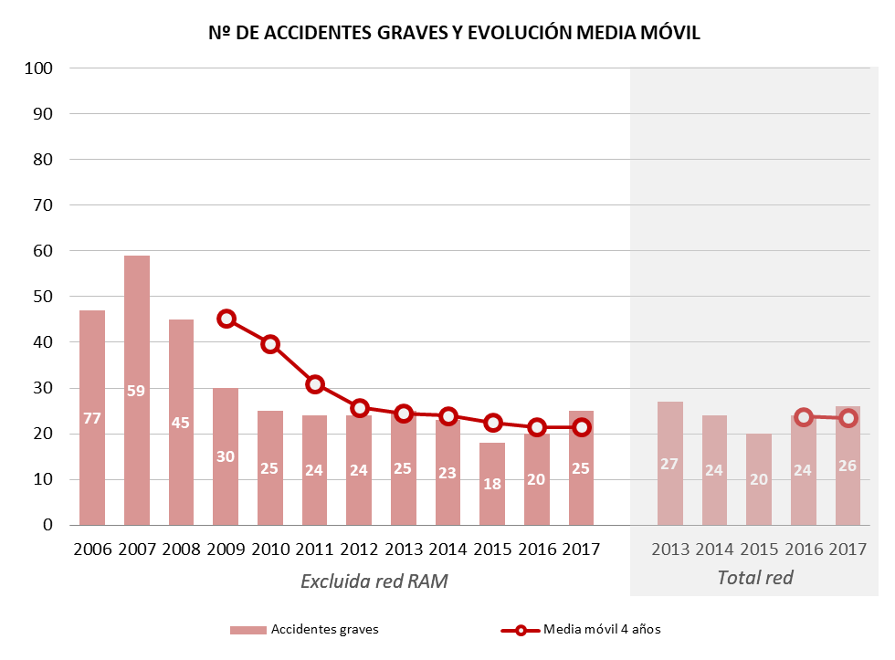

Figure 4. The number of serious accidents each year and comparison with the moving average for the last 4 years.

|  |  |
| --- | --- |
| Nº DE ACCIDENTES GRAVES Y EVOLUCIÓN MEDIA MÓVIL | NUMBER OF SERIOUS ACCIDENTS AND ITS MOVING AVERAGE |
| Excluida red RAM | Excluding the RAM network |
| Total red | Total network |
| Accidentes graves | Serious accidents |
| Media móvil 4 años | 4-year moving average |

The consequences of the accidents in 2017 are similar to those for the previous year. In particular, in relation to the victims, the MHGP[10] figure is practically the same as that for the previous year. However, the proportion of MHGP per number of significant accidents in 2017 is lower than in 2016, with the figure for 2017 equating to the average value for the whole of the EU in 2016[11].



Figure 5. Number of significant accidents and their consequences

|  |  |
| --- | --- |
| Núm de fallecidos, heridos graves, accidentes significativos, M € impacto económico | No of fatalities, serious injuries, significant accidents, € M economic impact |
| Núm. fallecidos | No of fatalities |
| Núm. heridos graves | No of serious injuries |
| Núm. accidentes significativos | No of significant accidents |
| Impacto económico estimado (M €) | Estimated economic impact (m €) |



Figure 6. Yearly MHGP and the MHGP per significant accident relationship

|  |  |
| --- | --- |
| MHGP | MHGP |
| MHGP / Acc. SIGNIF. | MHGP / SIGNIF. Acc. |
| MHGP / Accidentes Significativos | MHGP / Significant Accident |

Given the variation in the MHGP figure, there is an appreciable reduction in the rate of significant accidents with victims per million train-km in the category of accidents to persons, as well as in their consequences. Conversely, in 2017 there was an increase in the number of victims in accidents at level crossings, compared to the lows achieved in 2015, and an increase in the frequency. The number of victims in other types of accidents was very small.

Figure 7. Significant accidents with victims: MHGP and number of accidents per million train-km

|  |  |
| --- | --- |
| Accidentes con víctimas / millón tren.km | Accidents with victims / million train-km |
| MHGP Acc. de personas | MHGP Acc. to persons |
| MHGP Acc. en paso a nivel | MHGP Acc. at level crossings |
| MHGP Resto de accidentes | MHGP Other accidents |
| Acc. personas / Mill tr.km | Acc. persons / m train-km |
| MHGP | MHGP |
| Acc en paso a nivel / Mill tr.km | Acc. Level crossings / m train-km |
| Resto de accidentes signif. Con víctimas / Mill tr.km | Other signif. accidents with victims / m train-km |

All fatalities in 2017, excluding suicides, occurred in accidents to persons and accidents at level crossings. These results are similar to the proportions for the period 2013-2017 (eliminating the influence of an event as unusual as the Angrois accident, which occurred on 24 July 2013).

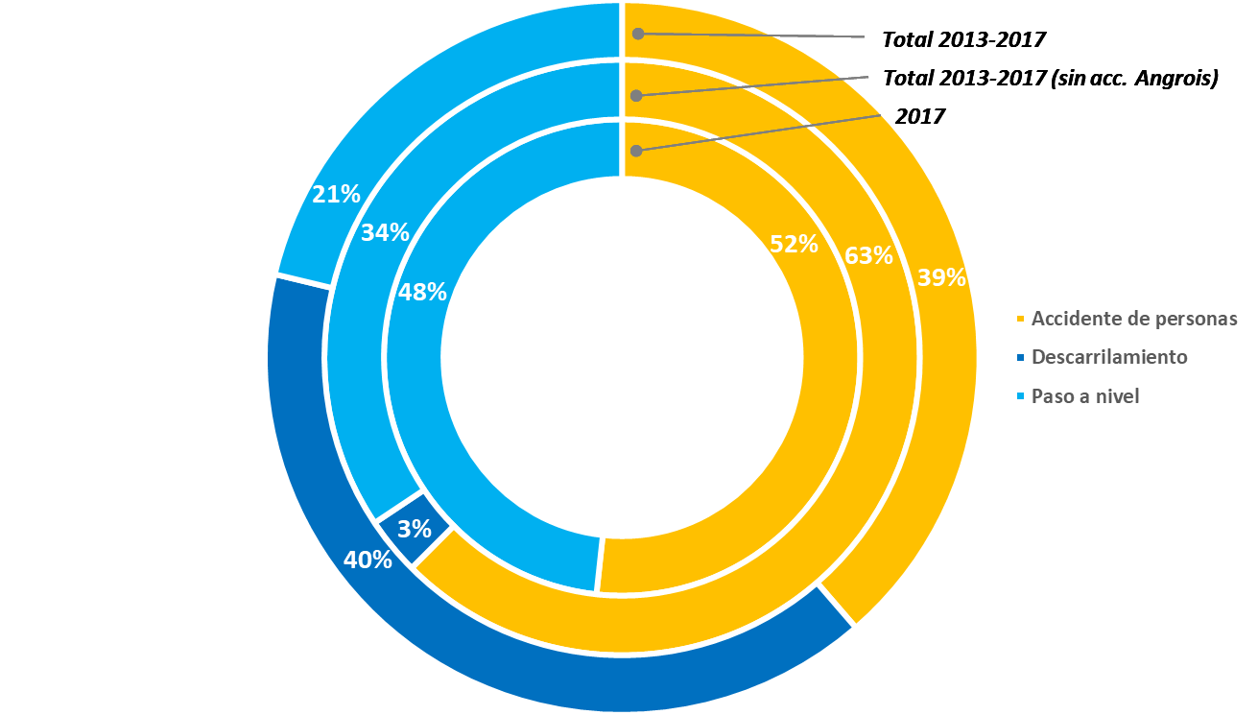

Figure 8. Proportion of fatalities according to the type of accident

|  |  |
| --- | --- |
| Total 2013-2017 | Total 2013-2017 |
| Total 2013-2017 (sin acc. Angrois) | Total 2013-2017 (without Angrois acc.) |
| Accidente de personas | Accidents to persons |
| Descarrilamiento | Derailment |
| Paso a nivel | Level crossings |

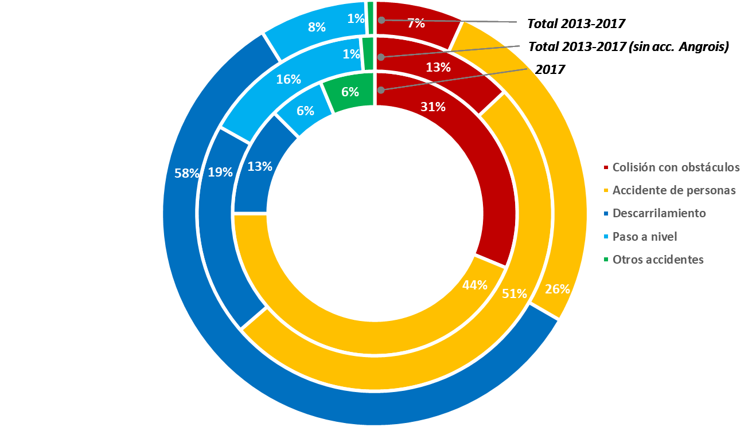

Figure 9. Figure 9. Proportion of serious injuries according to the type of accident

|  |  |
| --- | --- |
| Total 2013-2017 | Total 2013-2017 |
| Total 2013-2017 (sin acc. Angrois) | Total 2013-2017 (without Angrois acc.) |
| Colisión con obstáculos | Collision with an obstacle |
| Descarrilamiento | Derailment |
| Paso a nivel | Level crossings |
| Otros accidentes | Other accidents |

Taking into account the classification of victims, in 2017, taking the period 2013-2017 as a reference, a falling trend may be observed in the number of victims in the category ‘Trespassers’. Conversely, in 2017 there was an increase in the number of fatalities in accidents at level crossings. The levels for other categories of victims are relatively stable.

In 2017, the most serious accidents as regards MGHP were four accidents at level crossings, each involving two fatalities:

* Accident at type-C level crossing (protection with SBE semi-barriers). Collision with a road vehicle passing through the barriers when closed, occurred on 07/02/2017 in Monzón de Campos, km 308+906 of line 160, Santander to Palencia.
* Accident at type-A level crossing. Collision with road vehicle, occurred on 14/08/2017 in Almagro, km 237+810 of line 522, Manzanares to Ciudad Real.
* Accident at type-A level crossing. Collision with road vehicle, occurred on 22/10/2017 in Huéneja, km 169+528 of line 410, Linares to Baeza.
* Accident at type-A level crossing. Collision with road vehicle, occurred on 16/11/2017 in Almagro, km 237+810 of line 522, Manzanares to Ciudad Real.



Figure 10. Number of fatalities (excluding suicides) according to type of user

|  |  |
| --- | --- |
| Fallecidos | Fatalities |
| Empleados | Employees |
| Viajeros | Passengers |
| Usuarios pasos a nivel | Level crossing users |
| Intrusos | Trespassers |
| Otros en andén | Others on platform |
| Otros fuera de andén | Others away from platform |
| Total | Total |



Figure 11. Number of serious injuries (excluding suicide attempts) according to type of user

|  |  |
| --- | --- |
| Heridos graves | Serious injuries |
| Empleados | Employees |
| Viajeros | Passengers |
| Usuarios pasos a nivel | Level crossing users |
| Intrusos | Trespassers |
| Otros en andén | Others on platform |
| Otros fuera de andén | Others away from platform |
| Total | Total |

The number of deaths of trespassers and as a result of suicide shows a falling trend for the period from 2007 to 2017. Given that events of this kind are among the most common on the Spanish network, the actions to improve enclosures, remove uncontrolled points from lines and [protect] crossings between platforms may have succeeded, although the data seem to show that new measures are needed to give continued impetus to the positive trend.



Figure 12. Death of trespassers and on account of suicide in the period 2007-2017

|  |  |
| --- | --- |
| Intrusos | Trespassers |
| Suicidios | Suicides |
| Polinómica (intrusos) | Polynomial (trespassers) |
| Polinómica (suicidios) | Polynomial (suicides) |
| Número de fallecidos | Number of deaths |



Figure 13. Death of trespassers and as a result of suicide in the period 2007-2017 per million train-km

|  |  |
| --- | --- |
| Suicidios / Millones de tren.km | Suicides / million train-km |
| Intrusos / Millones de tren.km | Trespassers / million train-km |

Finally, with regard to precursors to accidents, in 2017 there was an upturn in the number of precursors of various kinds, especially broken rails, followed by signal overruns, with increases compared to the previous year of 57 % and 24 % respectively. Of the 115 signal overruns recorded in 2017, 6 were near misses, 1 less than in 2016.

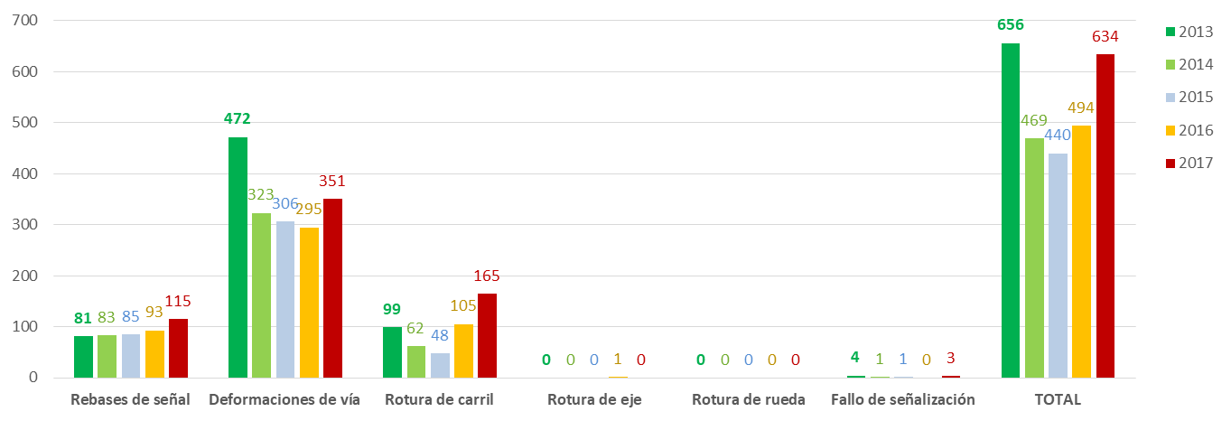

Figure 14. Precursors to accidents between 2013 and 2017

|  |  |
| --- | --- |
| Rebases de señal | Signal overruns |
| Deformaciones de vía | Warped track |
| Rotura de carril | Broken rails |
| Rotura de eje | Broken axle |
| Rotura de rueda | Broken wheel |
| Fallo de señalización | Signalling failure |
| TOTAL | TOTAL |

These trends emphasise the need to keep watch on the occurrence of two kinds of precursor: signal overruns (which may be more linked to the human factor) and broken rails (more related to the state of the infrastructure).

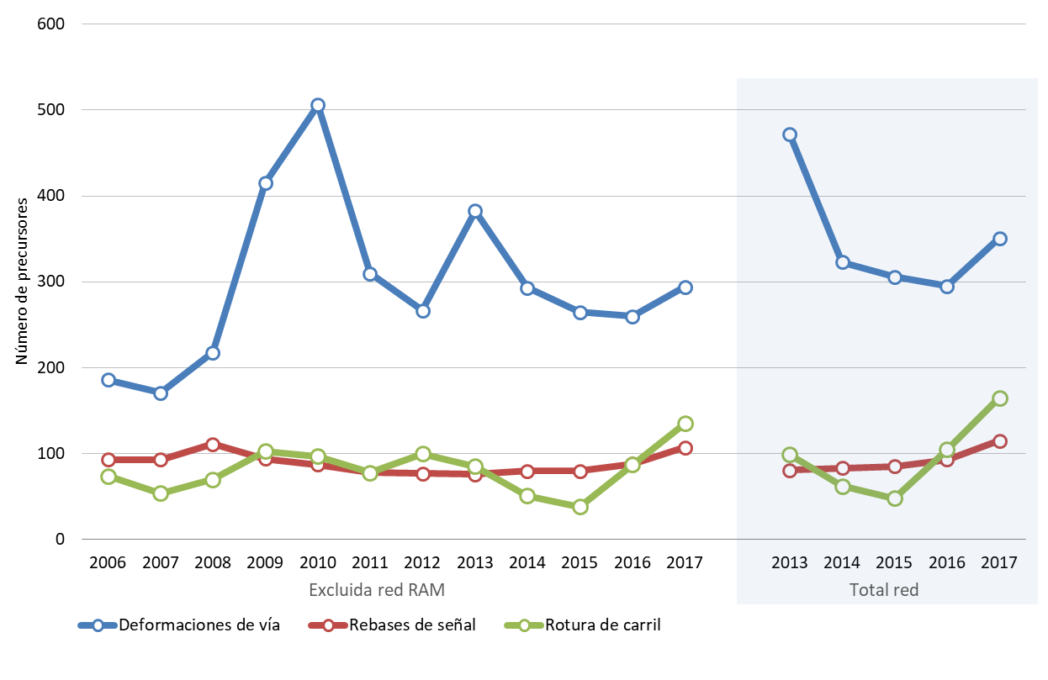

Figure 15. Occurrence of the main precursors from 2006 to 2017 by network

|  |  |
| --- | --- |
| Número de precursores | Number of passengers |
| Excluida red RAM | Excluding the RAM network |
| Total red | Total network |
| Deformaciones de vía | Warped track |
| Rebases de señal | Signal overruns |
| Rotura de carril | Broken rails |

As a general conclusion, 2017 was a year without remarkable accidents and one in which accidents at level crossings (especially crossings on lines with low traffic levels and crossings without protection) have been particularly significant on account of their consequences, breaking the improving trend of the last few years. Nevertheless, certain rising trends in the number of precursors and in the total number of significant accidents show signs which will have to be monitored in the coming years, to confirm that the 2017 results do not represent changes in trends and are only isolated data in a fairly stable series.

|  |  |
| --- | --- |
|  | |
|  | 1. Safety certificates and authorisations |

1. Reference framework for issuing certificates and authorisations

Commission Regulation (EU) No 1158/2010 of 9 December 2010, on a common safety method for assessing conformity with the requirements for obtaining railway safety certificates, has been used as a reference for the assessment process prior to issuing safety certificates to railway undertakings.

The AESF considers it essential that safety management systems be conceived from the outset taking into account Regulations 1158/2010 and 1169/2010, as well as Regulation 402/2013 on risk assessment, Regulation 445/2011 on a certification system for entities in charge of maintenance of freight wagons, and Regulation 1078/2012 on internal monitoring.

The background documents for processing safety certificates / authorisations are contained in the AESF application guides, available on its website[12].

Therefore, and in order to facilitate the process of obtaining certificates, the AESF is carrying out advisory work – directly with railway undertakings, or consultant companies that provide such undertakings with support – during the drafting phase of their SMSs, and even prior to submission of a formal application. This work procedure is facilitating subsequent assessment.

Throughout the process of obtaining their certificates and at any point within the annual safety reports submitted by undertakings and managers, there is the opportunity to express opinions regarding the procedures and practices for issuing safety certificates/authorisations, and other possible improvements to the system.

1. Certificates and authorisations issued during 2017
   1. **Part A safety certificates**

In 2017, six part A safety certificates were issued:

|  |  |  |
| --- | --- | --- |
| **Railway Undertaking** | **Type of Certificate** | **Issue Date** |
| **LOW COST RAIL** | New | 23/03/2017 |
| **ALSA FERROCARRILES** | Renewal | 26/06/2017 |
| **SOCIBUS** | New | 28/07/2017 |
| **FERROVIAL RAILWAY** | Renewal | 18/10/2017 |
| **SAGALÉS RAIL** | New | 06/11/2017 |
| **CONTINENTAL RAIL** | Renewal | 23/11/2017 |

As at 31 December 2017, there were a further six safety certificate files being processed.

* 1. **Part B safety certificates**

The part B safety certificates issued in 2017 are shown below:

| **Railway Undertaking** | **Type of Certificate** | **Issue Date** |
| --- | --- | --- |
| **LOW COST RAIL** | New | 23/03/2017 |
| **SNCF Mobilités** | Renewal | 25/05/2017 |
| **ALSA FERROCARRILES** | Renewal | 26/06/2017 |
| **SOCIBUS** | New | 28/07/2017 |
| **FERROVIAL RAILWAY** | Renewal | 18/10/2017 |
| **SAGALÉS RAIL** | New | 06/11/2017 |
| **CONTINENTAL RAIL** | Renewal | 23/11/2017 |

* 1. **Safety authorisations**

In 2017, no new safety authorisations were issued, following the renewal of the authorisations of Adif, Adif Alta Velocidad and the company managing the Figueres-Perpignan Line in previous years.

* 1. **Relations with other safety authorities**

In order to issue these certificates in 2017 it was not necessary to make contact with national authorities in other EU Member States.

1. Results and conclusions from 2017

The AESF’s experience in this area in 2017 yielded the following notable conclusions:

* Some of the points on which the AESF has been placing the most emphasis in its assessments in 2017 – and which will continue to be key points in coming years – are as follows:
  + The application of Regulation 402/2013, including aspects such as the management of hazard records.
  + The application of internal surveillance processes and their relationship with indicators and objectives.
  + The establishment of systems for managing staff skills, especially those of staff which are not authorised and, therefore, are not expressly identified in national legislation.
  + The manner in which operating procedures derived from national legislation or from the operation and traffic management technical specification for interoperability (OPE TSI) are implemented in the SMSs, such as, for example, those relating to train driver rule books and checks prior to setting off.
* The instances of collaboration between railway undertakings to establish synergies making it possible to develop common procedures, such as that for a ‘unified safety management system’ set in motion by various freight companies of the Association of Private Railway Companies (Asociación de Empresas Ferroviarias Privadas) are, from the point of view of the AESF, very positive.

While always respecting companies’ freedom to have their own documents, these procedures, developed through cooperation between various undertakings and in direct consultation with the AESF, make it possible to incorporate and exchange experiences and best practice within the sector, provided that they are properly adapted to the particular situation of each company.

The AESF encourages the sector to continue working on similar experiences, showing its willingness to collaborate, as it has done up to now.

* Notwithstanding what is set out in the preceding point, the AESF continues to perceive certain deficiencies in the adaptation of the SMSs to the scope and type of operation and to the size of the undertaking. At times, companies are equipped with management systems more in keeping with larger companies and which may require higher levels of use than an SMS adapted to the real size of the company may require. As the AESF has been insisting, it is essential that companies properly assess such aspects when designing and reviewing their SMSs.
* The AESF also wishes to emphasise the importance, after a certificate/authorisation has been issued, of entities resolving those matters which, while they did not prevent it being issued, may still be outstanding, providing action plans and documentary evidence to show that the relevant actions are being taken in the agreed time frame.

The AESF understands that there may be points which are not regarded as preventing certificates/authorisations being issued. That is necessary to avoid imposing unnecessary limitations on the market. Nevertheless, for the supervision functions of the AESF, it is necessary for the entities concerned to show that they are resolving those matters, complying with the conditions of the certificates/authorisations.

The same occurs with those documents which undertakings must review and send to the AESF just as commercial operation begins, which finalise certain matters which still may not have been settled at the time when the certificate was issued.

* In any event, the AESF urges companies which are new entrants to the sector to think about the appropriate time to apply for the safety certificate, if they do not expect to begin operating immediately. Such companies need to consider realistically the timescales required for the operation and for obtaining the certificate, as well as their business plans.

In the experience of the AESF, obtaining the certificate is considered a necessary milestone in the business process. That means an additional workload for the AESF – which has to process and assess the management systems of companies which are not sufficiently mature – and for the companies themselves, which develop management systems containing major uncertainties which will have to be checked in great detail before the start of the operation, or which may even be revoked if the operation does not begin within the established time frame.

* Another point which the AESF has observed in some specific cases is a certain instability in the documents for the SMSs, which are comprehensively and very frequently revised, which does not allow for their full implementation and the return of experience.

Such revisions may be carried out for different reasons, such as the renewal of the certificate, extensions or changes to scope, action plans following AESF audits or the incorporation of new national legislation. In such cases, some companies take advantage of the need to revise certain procedures of the SMSs to make changes to the model of the SMS. Such changes, which go beyond the revision required by the return of experience, changes in the company or continuous improvement, are usually the result of changes in the criteria of the drafters or managers of the SMSs.

In the opinion of the AESF, very frequent and drastic changes to procedural models are not positive, as it makes them difficult to apply and it makes it difficult for the AESF to subsequently supervise them.

* Finally, the AESF also wishes to emphasise the importance of the phase prior to the formal application for companies which are in operation and decide to renew their certificate. Experience shows us that it is advisable to begin that process sufficiently far in advance (8 to 10 months would be advisable), to avoid any delay jeopardising the continuity of the railway operation. It should be borne in mind that such renewals are usually used as an opportunity to carry out a comprehensive and more in-depth review of the SMSs.

|  |  |
| --- | --- |
|  | |
|  | 1. Supervision of the railway system |

1. General lines of supervision

As in previous years, supervision of correct application of the regulatory framework regarding safety by responsible agents is carried out at various levels:

1. In general, the most important variables are monitored using the overall accident rate for the system, through activities such as:

* Continuous monitoring of accident rate statistics and indicators to detect significant deviations.
* Preparation of the AESF annual report.
* Review of the annual safety reports of railway undertakings.
* Development of an incident / accident geographic information system as an internal working tool within the AESF, for the purposes of statistical monitoring and to help with defining supervision plans.

1. It is also carried out through the certification and supervision of railway companies and infrastructure managers, as well as other agents involved in the railway sector and that provide services, such as entities in charge of wagon maintenance, rolling stock maintenance centres, railway personnel training centres and medical examination centres.
2. Through audits and inspections of the undertakings and managers themselves, especially for verifying application of the internal follow-up procedures of undertakings.
3. By issuing technical recommendations to sector entities regarding procedures for facilitating the implementation of requirements.
4. Through training measures and the dissemination of information to undertakings and managers, thereby assuring that they have adequate knowledge of the regulations they must apply.
5. Another area of supervision which has received attention is monitoring compliance with recommendations issued by the Railway Accident Investigation Commission as a result of its investigations of accidents or incidents. This is done through systematic requests for information from the body to which the recommendation was addressed, relating to the level of compliance, until it is considered that implementation of the recommendation has been sufficiently achieved.
6. Following-up complaints received regarding safety.
7. Finally, by advising entities on specific subjects on request and through the coordination of work groups and information-sharing meetings.
8. Supervision of railway system agents

The various agents of the system are subject to having previously obtained a certificate, authorisation or official approval from the national authority, thereby allowing them to exercise their activities. Once this qualifying certificate has been issued, the objectives of supervision actions change:

* Periodic supervision, whether total or partial, of the conditions for granting the certificate/authorisation/approval.
* Verification of implementation of the actions committed to when the certificate/authorisation/approval was granted (non-inhibiting qualifications or non-conformities).
* Verification in the event of a change in the conditions for having granted the certificate/authorisation/approval.
* Supervision derived from observation of a possible 'anomalous' situation that could be due to inadequate application of safety rules.
* A revision or update, if applicable, of the safety management system in the event that circumstances arise that may represent added risks that must be adequately considered in procedures.

Specific supervision activities are planned considering the following aspects:

* General supervision objectives and criteria.
* All types of activities of the supervised agent and the size of the assessed undertaking.
* Findings of the assessment process prior to obtaining the certificate/authorisation/approval.
* Activities that are considered capable of generating more serious risks.
* Other data and information available to the AESF, such as, for example: the results of previous supervisions, the annual safety report prepared by the undertaking/manager, accident rate reports, etc.

The criteria used by the AESF to define its supervision activities are set out in greater detail in its Supervision Strategy, available on its website[13].

* 1. **Infrastructure managers**

With regard to **infrastructure managers**, a **programme of accompaniment and visits** was initiated in 2017, with some 80 different visits and inspections of different kinds being carried out:

* Accompaniment visits on the internal monitoring actions of Adif itself, to verify compliance with its internal monitoring actions, in accordance with European Regulation 1078/2012. Such visits also serve as training for AESF technicians for other, independent inspection actions.
* Informative inspection visits for an overall examination or for examining particular aspects of one or several facilities of the RFIG, of its functioning and/or of its operation.
* Informative visits for authorisations to bring lines into service, carrying out an overall examination or an examination of particular aspects of facilities before they come on stream.
* Visits to port railway networks.

Furthermore, ten partial audits on the application of certain processes of the management systems of infrastructure managers or specific activities were worked on in 2017.

There was continuing follow-up on the processes of commissioning lines and new infrastructures and of changes in the operating conditions by verifying the adequate application of Adif's internal procedures for start-up and for managing changes in safety installations.

* 1. **Railway undertakings**

With regard to **railway undertakings**, **audits of the application of the safety management systems** of six of the companies in operation were carried out in 2017. These audits sought evidence of compliance with the undertakings' own procedures, and they concluded with reports being issued, in which the AESF made proposals for improvement and requested, where applicable, the presentation of action plans for implementing these improvements.

One of the above audits also included aspects relating to dangerous goods within its scope.

Furthermore, compliance with requirements or the closing of points left open and highlighted by the AESF when the safety certificates were issued or renewed was also monitored.

As a result of anomalies detected, certain railway undertakings have been requested to prepare specific action plans to deal with recurrent failures (breakdowns of a certain type of equipment, certain events or loading failures).

Another important supervision element developed in 2017 was the existence of joint coordination mechanisms between AESF and Adif to exchange information between the AESF’s supervision activities and the inspection activities carried out by Adif on the ground, in implementation of the policing competences relating to activities which may cause damage to infrastructure or traffic, which the railway legislation confers on the manager. Under these mechanisms, the following inspections were managed in 2017:

|  |  |  |  |  |
| --- | --- | --- | --- | --- |
| ***TYPE OF INSPECTION*** | ***CARRIED OUT*** | ***% OF PLANNED INSPECTIONS CARRIED OUT*** | ***INSPECTIONS WITH ANOMALIES*** | ***ANOMALIES*** |
| ***Wagons*** | *1299* | *105 %* | *177* | *232* |
| ***Blood alcohol level*** | *157* | *102 %* | *2* | *2* |
| ***Dangerous goods*** | *95* | *103 %* | *18* | *57* |
| ***Freight*** | *274* | *100 %* | *38* | *272* |
| ***Cab inspection*** | *295* | *101 %* | *40* | *74* |
| ***Speed records*** | *281* | *131 %* | *37* | *37* |
| ***Total*** | ***2402*** | ***106 %*** | ***313*** | ***685*** |

Likewise, the results obtained from using Adif’s weighing systems (over 30,000 per year) were also taken into account to detect the origin of overloads.

In some cases, the results of the supervision involved imposing fines in accordance with the provisions of Law 38/2015 on the railway sector.

* 1. **Entities related to rolling stock maintenance**

Adequate control of the maintenance of railway vehicles, as set out in Spanish legislation, is still considered a priority line of action. For that, **maintenance centres** must be officially approved by the AESF, in accordance with the provisions of Order FOM/233/2006[14] for carrying out such tasks.

* Total number of approved maintenance centres: 57
* Number of maintenance centres approved in 2017: 3
* Number of approved facilities: 193

It must be borne in mind that, as of 31 May 2017, Article 12(5) of Commission Regulation (EU) No 445/2011, regarding the fact that maintenance centres that are approved and authorised to perform maintenance on freight wagons in accordance with national laws have, directly, an equivalent certificate for performing the maintenance delivery function, does not apply. Due to the above, the number of approved maintenance centres fell in 2017.

The AESF carries out checks and inspections at those centres at least annually whenever there are well-founded doubts regarding possible breaches of requirements. It may also do so randomly, at any moment, to verify that compliance with the requirements for approval is being maintained.

Specifically, during 2017 a total of 62 inspections were carried out at the various facilities.

With regard to **entities in charge of the maintenance of wagons**, certification have continued to be processed, with 14 certifications having been issued in Spain in 2017 among the four certifiable functions, of which 7 were new certifications and 7 were renewals.

As regards the task of supervising the ECMs, execution of the improvement plan established for each already certified ECM has been monitored, in order to check that deficiencies detected in audit and inspection processes prior to the issuance of certificates have been rectified. This action was complemented by the annual monitoring activities for ECMs whose certification was issued for a period of 5 years and by conducting audits and inspections for renewal of the certificates of ECMs classified as ‘new’, in accordance with the provisions of Commission Regulation (EU) No 445/2011.

In 2017, 19 audits were audits with carried out on entities in charge of maintenance. Of those, 7 were for renewal and 12 were to monitor entities which already had the certificate for an entity in charge of maintenance. A further 6 audits were carried out on entities for their initial certification.

* 1. **Centres related to railway personnel**

Another, complementary activity of vital importance to the sector is training of personnel. Controlling the centres that conduct such activities is, therefore, also a priority for the AESF.

Approved centres for the training of railway personnel are inspected in accordance with the provisions of article 53 of Order FOM 2872/2010[15], Title IX, Chapter I, regarding the inspection scheme for approved centres for railway personnel and the functioning of all operations linked to the training of railway personnel for the various certificates established in that Order.

Six approved training centres were inspected in 2017 and, as at 31 December 2017, there were a total of ten approved training centres. Four of those centres renewed their approval in 2017 and, therefore, it was not necessary to carry out inspections.

Similarly, inspection activities were also carried out at medical examination centres for railway personnel, which are also regulated under Order FOM/2872/2010. In 2017, 14 inspection activities were carried out (8 inspections and 6 visits) and, as at 31 December 2017, there were 18 approved medical examination centres. The purpose of the visits is to inform medical examination centres for railway personnel about the amendment to Order FOM/2872/2010 regarding the psychological tests which railway personnel must undergo in the medical examinations, with a view to making them aware of the importance of its application.

The AESF’s objective with regard to inspecting the centres is to conduct at least one annual inspection, as indicated in articles 58(3) and 71(3) of Order FOM/2872/2010, of 5 November.

Furthermore, when a training centre or medical examination centre submits an application to expand its facilities, the AESF visits the centre before issuing its decision.

1. Dissemination and return of experience activities

From the AESF's point of view, the dissemination of information to the sector is a support task that complements its supervision role. Its activities in this area include:

* Issuing technical recommendations, which are an effective means of disseminating information and spreading best practice in the sector.

In 2017, the following recommendations aimed at different railway sector actors were issued:

* + 1/2017. Back-to-back gauge of metre-gauge vehicles.
  + 2/2017. Driver communications in the event of accidents or incidents.
  + 3/2017. Authorisation of placing in service of vehicles not in accordance with the TSIs for rolling stock and the use of uncertified interoperability components.
  + 4/2017. Juridical recording units.
  + 5/2017. Line crossings between platforms for passengers.
  + 6/2017. Psychophysical examinations of railway personnel with a result of ‘temporarily unfit’.
  + 7/2017. Communicating safety improvement proposals and information about possible risks within railway undertakings.
* Dissemination of safety alerts notified by the alerts system of the European Union Agency for Railways.
* Communication activities, providing the sector with training on legislation and aspects of safety, such as the application of Regulation 402/2013 on risk assessment, internal monitoring methods, the new framework resulting from the new 4th Railway Package directives, or the application of the TSIs for telematics applications for passengers or freight. In particular, collaboration with the training programmes for new professionals in the sector is considered essential (involvement in master's degrees, university courses, selection courses, etc.).

1. Safety recommendations

Investigating the accidents and incidents that occur on the network is a fundamental tool for detecting and preventing risks. This type of investigation must include all accidents and precursors of accidents with certain characteristics – such as repetition and when or where they occur, or where the causes can be attributed to railway management – irrespective of whether they have serious personal or financial repercussions.

A report is, therefore, prepared by an entity independent of the AESF for every accident investigated. These reports determine the causes and make particular recommendations with a view to improving the railway installations, searching for patterns of behaviour in the people involved and, in short, seeking to prevent recurrence.

By way of summary, the following are the most important safety recommendations resulting from CIAF's reports on the files relating to events in 2017 (and including 2016) where investigations have been concluded[16] and implementation is already in progress by the different bodies responsible.

* Recipients: National Railway Safety Agency
* Promote institutional action which, with the participation of provincial councils, autonomous regions or even central government, provides resources for the improvement of municipally owned level crossings, as regards the state of the roads leading to them and their repair.
* Recipients: Infrastructure Managers
* Reconsider a major action to renew the features of the infrastructure (drainage) and superstructure of a section with high levels of freight traffic and a high accident rate.
* Comply rigorously, on the line concerned, with the provisions of the SMS as regards the frequency of track testing and monitoring visits on foot and in the cab, acting accordingly, at least until a major action to improve the section is not required.
* In refresher courses given to staff involved with operating trains, insist on the need to verify reliably the release of the electrical circuits on tracks which are little used. Also insist on verifying the length of sidings and of the trains when stabled on them.
* Establish a plan for inspecting the rust on railway network turnouts providing access from general track to diverging track, checking, where necessary, the correct shunting of track circuits and cleaning them, where appropriate, in order to restore conditions allowing traffic to pass safely. And also include excess rust in the SMS procedures as another element to be checked and dealt with, in order to prevent potential shunting faults.
* Include a procedure in the SMS for monitoring and maintaining track circuits, to enable shunting problems to be detected, both when the circuit is unoccupied and when it is occupied (with train shunt applied).
* In training and refresher courses for traffic managers, insist on the need to know exactly the manoeuvres to be carried out by the rolling stock they are responsible for and not to allow any which could give rise to unsafe situations.
* Adapt the content of operating procedures such that there are no discrepancies between them.
* Update and unify the operating and safety rules for electrical and electronic interlocking and blocking, taking into account new operating functionalities and incidents detected in the current systems.
* Review the functionality of any electronic interlocking installed which uses technology similar to that affected by a specific accident, in particular artificial route cancellation (Disolución Artificial de Itinerarios: DAI)
* In the training given to traffic managers, stress the importance of carrying out correctly (according to the regulations) actions relating to the setting and cancellation of routes.
* Take the necessary measures with regard to procedures, technology, equipment and human resources, when carrying out ultrasonic testing of rails and track apparatus, in order to establish their internal condition and detect, in an efficient manner, any faults which could later result in a broken rail.
* Reinforce the traceability of records relating to maintenance actions and of communications between the track sub-directorate and maintenance management.
* Take the measures necessary for ultrasonic testing to be carried out within the time frames established in the relevant operating procedure, including complementary actions or measures to be taken in order to operate safely in the event that the means of testing are unavailable.
* Amend specific procedures relating to maintenance, such that the records resulting from maintenance operations are kept for at least as long as the rails are in service.
* Recipients: Railway Undertakings
* In training and refresher courses given to driving staff, especially in those relating to knowledge about the infrastructure, stress the importance of adjusting the speed to what is required by the regulations and paying constant attention to track signalling instructions and indications, in particular to signals indicating an approaching stop, which instruct the driver to prepare to stop before the next signal, and also to the fact that reverse signals may instruct the driver to stop.
* In training and refresher courses given to drivers, insist on the need to comply with the speed limits established for carrying out manoeuvres at stations.
* In the training of drivers, insist on the need to inform the relevant control centre of any anomaly detected in the equipment, in compliance with the railway undertaking’s procedures.
* Carry out an in-depth analysis of anomalies causing losses of fuel in 592 rolling stock.
* Recipients: Municipal Bodies
* Adaptation of the signalling for approach roads leading to existing level crossings to the provisions of article 9.2 of Order FOM of 2 August 2001, on the removal and protection of level crossings.

The AESF monitors compliance with those recommendations by the parties involved. It therefore makes periodic requests for information on the level of compliance from the body to which the recommendation is addressed. When it is deemed that a sufficient level of implementation of the recommendation has been achieved, the Railway Accident Investigation Commission is notified so that the matter may be closed.

The most noteworthy actions[17] taken by the agents responsible for complying with such recommendations are set out below. This list is not comprehensive. It only details the most significant actions, as it is working to achieve compliance with all of the recommendations issued by the CIAF.

| ***EVENT: Derailment due to a technical failure of the infrastructure*** | |
| --- | --- |
| ***Actions:*** | * The AESF has prepared a Technical Recommendation containing the aspects which infrastructure managers have to consider in managing the safety of track work and in verifying track conditions after such work has been completed. * Comprehensive repair of the EV de Tarragona Clasificación track, removing the temporary speed restriction which was introduced. |

|  |  |
| --- | --- |
| ***EVENT: Derailment due to signal overrun*** | |
| ***Actions:*** | * All existing interlocks in the third rail have been analysed and directional slips are being introduced, in areas with sets of points that distinguish gauge, and interlocking the necessary switches and crossings. Moreover, the operating regulations for installations with third rail are being amended. |

|  |  |
| --- | --- |
| ***EVENT: Derailment due to human error by driving staff*** | |
| ***Actions:*** | * The training actions necessary to make driving staff aware of the risks inherent in any failure to comply with the regulations have been included in refresher courses. |

|  |  |
| --- | --- |
| ***EVENT: Near miss due to signal overrun*** | |
| ***Actions:*** | * A transverse screen was installed between the signals, reducing the risk of confusion on the part of the driving staff. |

|  |  |
| --- | --- |
| ***EVENT: Accidents at level crossings*** | |
| ***Actions:*** | * A change in the current regulations relating to signalling and the protection of level crossings is being prepared. In parallel, an inventory is being conducted of level crossings on the RFIG, with one of the objectives being to review the signalling for existing type-A level crossings. |

|  |  |
| --- | --- |
| ***EVENT: Collisions at crossings between platforms*** | |
| ***Actions:*** | * Technical regulations are being prepared to regulate crossings between platforms. In parallel, an inventory is being conducted of the stations and unmanned stations on the RFIG, which will include different parameters in order to carry out a risk analysis of how dangerous they are. Based on the results, a plan of measures to be taken will be prepared in order to improve safety. |

|  |  |
| --- | --- |
| ***EVENT: Collision due to human error by driving staff*** | |
| ***Actions:*** | * At certain unmanned stations where advanced signals show as permissive they have been changed to absolute. Furthermore, a working group has been set up to analyse the situation in the particular setting. * Compliance with traffic conditions with ‘running on sight’ has been included in refresher courses for driving staff. |

|  |  |
| --- | --- |
| ***EVENT: Collision due to a failure of the infrastructure*** | |
| ***Actions:*** | * Work is being carried out to stabilise the trench concerned. |

|  |  |
| --- | --- |
| ***EVENT: Near miss due to human error by driving staff*** | |
| ***Actions:*** | * Audits have been started by the AESF to analyse the application by the EFs of the procedures of their safety management systems relating to the suspension, revocation and restoration of authorisations after an instance of human error, according to its seriousness. |

|  |  |
| --- | --- |
| ***EVENT: Failure of the rolling stock*** | |
| ***Actions:*** | * The maintenance plans for the 252 locomotives have been updated to include verification of the tightness of the Q1 system switch connectors and a visual inspection to verify the absence of oil leaks in the area of the main transformer connections. |

|  |  |
| --- | --- |
| ***EVENT: Outbreak of fire due a failure of the rolling stock*** | |
| ***Actions:*** | * The maintenance plan for the 599 vehicles has been modified to include the immediate of removal of bearings and repair of the axle box components when the ingress of water is suspected. * Maintenance best practice has been strengthened as regards checking, when changing an axle of a 599 vehicle, that the kilometres travelled since the last complete servicing of the axle and its bearings are less than or equal to those of the train it is mounted on, as of the last R1 or R2 intervention carried out on it. |

|  |  |
| --- | --- |
| ***EVENT: Runaway rolling stock due to human error by the operator of manoeuvring vehicles at a port*** | |
| ***Actions:*** | * Implementation of the Port Authority’s safety management systems is being improved, as laid down in the third additional provision of RD 810/2007, approving the Regulations on traffic safety on the Public Railway Network. * The viability of introducing measures to prevent uncontrolled movements of rolling stock (coasting) from the internal port network reaching the physical connection point with the general network is being analysed. * Compliance with the maintenance plan for rolling stock used at port facilities has been assured. * Traffic managers are being authorised, in accordance with the Adif-Port Authority Agreement. |

|  |  |
| --- | --- |
| ***EVENT: Passing directly through a station without stopping due to human error by the driving staff*** | |
| ***Actions:*** | * The content of refresher courses aimed at driving staff has been strengthened with regard to degraded or unusual situations, as in the case of additional telephonic blocking, taking account of the return of experience from recorded events. * Appropriate mechanisms have been developed and implemented through subcommittees to ensure that, before carrying out their duties, train drivers receive the notices that concerns them from those responsible for documentation in the different organisational areas. Middle managers advise train drivers on an ongoing basis, reminding them of the application of the traffic conditions contained in those documents before performing their duties. |

|  |  |
| --- | --- |
| ***EVENT: Derailment due to excess speed*** | |
| ***Actions:*** | * Technical Recommendation 2/2017 of the National Railway Safety Agency, on driver communications in the event of accidents or incidents, has been drawn up. * Technical Recommendation 4/2017 of the National Railway Safety Agency, on juridical recording units, has been drawn up. * Technical Recommendation 7/2017 of the National Railway Safety Agency, on communicating safety improvement proposals and information about possible risks within railway undertakings, has been drawn up. |

|  |  |
| --- | --- |
|  | |
|  | 1. Implementation of safety legislation |

1. Transposition of European legislation regarding railway safety

From the point of view of European legislation, the basic document on railway safety, the Railway Safety Directive 2004/49 (RSD), is incorporated into the Spanish legal system by means of Law 38/2015, of 29 September, on the railway sector, and Royal Decree 810/2007 of 22 June, approving the Regulations on traffic safety on the Public Railway Network.

With the publication of the Technical Pillar of the 4th Package, which includes the new Directives (EU) 2016/798 of 11 May 2016, on railway safety, and (EU) 2016/797 of 11 May 2016, on interoperability, the process of comprehensively reviewing all of the relevant Spanish legislation was initiated in 2016 and continued in 2017. It will conclude with the publication of the royal decrees enabling its incorporation into national law in the following months.

Taking advantage of this transposition process, a general review is being carried out of all legislation relating to railway safety, with a view to consolidating it in a single legal text.

2. Amendments of laws and regulations

In accordance with its competences, the AESF is responsible for the support and development of the regulatory framework for safety and interoperability, in both technical and legal respects.

In 2017, the AESF continued to perform an important regulatory role, in accordance with Article 9.1.g) of its articles of association. That involved the processing and publication of several rules on railway safety and interoperability during the year covered by this report:

* Royal Decree 1011/2017, of 1 December, amending Royal Decree 664/2015, of 17 July, approving the Rail Traffic Regulations.

In 2017, an order was published which as processed and authorised in 2016:

* Order FOM/2015/2016, of 30 December, approving the Official Catalogue of Railway Traffic Signals on the Public Railway Network.

The translation and processing of RID 2017 (Regulations concerning the International Carriage of Dangerous Goods by Rail) was also completed in 2017 and it was finally published on 9 June 2017.

Work also began or continued on the drafting of other regulations in 2017, which are currently in different stages of preparation and processing:

1. Continuing with the transposition of the new Safety Directive (2016/796/EU) and Interoperability Directive (2016/797/EU).
2. Beginning the drafting of a royal decree for sections of the RFIG with light rail characteristics.
3. Giving impetus to the amendment of Royal Decree 412/2001, regulating matters relating to the carriage and movement of dangerous goods by rail.
4. Continuing with the processing of the order for the maintenance rail vehicles, replacing the current part of Order FOM/233/2006, of 31 January, which determines the approval system for rolling stock centres and their operating conditions.
5. Continuing to process the Railway Instructions on Infrastructure (IF-I), Energy (IF-E) and Rolling Stock (IF-MR), which are the national regulations complementing the applicable TSIs, in accordance with Order FOM/167/2015.
6. A review of the regulations on the road and rail transport of dangerous goods (ADR and RID, respectively) was initiated with a view to alignment.
7. Drafting of the Braking Technical Specification.

Lastly, in 2017 the AESF issued various circular decisions which support the interpretation and application of the legislation:

* Decision of 10 May 2017 of the Management of the AESF, approving the update of the current version of ASFA Digital in Annex C, References to Legislation, of the Decision of 10 July 2009, of the Directorate-General for Railway Infrastructure, approving the ‘Technical Specification on the Approval of Railway Rolling Stock: Locomotives’.
* Decision of 10 May 2017 of the Management of the AESF, approving the update of the current version of ASFA Digital in Annex C, References to Legislation, of the Decision of 10 July 2009, of the Directorate-General for Railway Infrastructure, approving the ‘Technical Specification on the Approval of Railway Rolling Stock: Self-propelled Units’.
* Decision 1/2017 of the AESF, creating the guidance sheets to assist with the application of the Rail Traffic Regulations.
* Decision 2/2017 of the AESF, on national technical regulations relating to the Infrastructure, Energy, Persons with Reduced Mobility and Control, Command and Signalling TSIs and the bodies in charge of their verification.
* Decision 3/2017 of the AESF, explaining the tools and works machinery referred to in section 1.1 of the Technical Specification on the Approval of Auxiliary Rolling Stock.
* Decision 4/2017 of the AESF, establishing the annual calendar of examinations for the driver’s licence and diploma and the criteria for requesting other examination dates.
* Decision 5/2017 of the AESF, announcing round-table meetings to coordinate and exchange experiences with regard to railway safety.

3. Application of the regulatory framework by railway undertakings

National undertakings are progressively achieving a better understanding of the European regulations, its concepts and obligations.

* As regards the use of management systems, railway undertakings and managers understand that they must be the basic elements which determine their way of acting and that they must reduce the differences between the procedures of their management systems and their actual actions.

Currently, the management systems already meet the criteria of Regulation (EU) No 1158/2010 of 9 December 2010, on a common safety method for assessing conformity with the requirements for obtaining railway safety certificates, and Regulation (EU) No 1169/2010 of 10 December, on a common safety method for assessing conformity with the requirements for obtaining a railway safety authorisation.

* Regarding the application of the operation and traffic management technical specification for interoperability (OPE TSI), the approval of the Rail Traffic Regulations and the adaptation by undertakings and managers of their documents and procedures have paved the way for complying with it.
* For the application of Regulation (EU) No 1078/2012 of 16 November 2012, on a common safety method for monitoring to be applied by railway undertakings, infrastructure managers after receiving a safety certificate or safety authorisation and by entities in charge of maintenance, national undertakings have a long tradition of implementing safety plans, including inspection actions, accompaniment, checks, etc., especially with regard to operating processes.

Nevertheless, there is still some room for improvement so that those plans better respond to the strategies formalised. The development of the objectives of each undertaking could also be improved, as the indicators used are not always appropriate to the size and activity of each company.

* With regard to Regulation (EU) No 402/2013 of 30 April 2013, on the common safety method for risk evaluation and assessment and repealing Regulation (EC) No 352/2009, and the approach to risk, see the following section.

The AESF pays particular attention to all of these points in its supervision and assessment activities relating to safety management systems.

4. Application of Regulation (EU) No 402/2013 on risk evaluation and assessment

This section responds to the requirement of Article 18(2) of Commission Implementing Regulation (EU) No 402/2013 of 30 April 2013, on the common safety method for risk evaluation and assessment, which states: 'Each national safety authority shall, in its annual safety report referred to in Article 18 of Directive 2004/49/EC, report on the experience of the proposers with the application of this Regulation and, where appropriate, its own experience.’

The generalised application of the methodology of Regulation No 402/2013 continued for **changes in rolling stock** in 2017.

As data of interest, in 2017, 64 rolling stock files were created, comprising modifications not requiring authorisation of placing in service (43) and requests for authorisation of placing in service and modifications requiring authorisation of placing service (21). Including the files initialised in previous years, more than 100 modification files without authorisation of placing in service were worked on in 2017.

There was a notable increase in the number of files for the adaptation of foreign wagons to the Iberian gauge both in the context of the RIV and in the context of the TSI.

The examples[18] listed below relate to practical applications of the legislation in the period covered by this report:

* Adaptation of national vehicles for international traffic and vice versa:
* Modification of axle and bogie platform wagons, rollers and hopper wagons for Iberian gauge.
* Adaptation of locomotives to the UIC gauge
* Modifications relating to the modernisation and installation of communications equipment:
* Renewal of the ERTMS-ETCS equipment software of the control and signalling subsystem. Unisig 2.3.0d functionality and national functions.
* Update of Asfa Digital equipment.
* Modification of Asfa Digital display.
* Introduction of Wi-Fi system in series 102 and 112.
* Installation of GPS module.
* Technical modifications for improving the operation of mechanical elements of vehicles:
* Mechanisation of grease guns for wheel bearings.
* Fitting of the electrical supply installation for Reefer containers in wagons.
* Modification of the wagon suspension mounting.
* Knorr compressor alternative replacement.
* Replacement of coupling hatch.
* Fitting of type P51 AXLE OGI variable gauge axle with 920mm wheels.
* Modifications that have significantly affected the structure of the vehicle:
* Comprehensive action.
* Replacement of the hazardous goods hoppers with the same or greater capacity and replacement of the bogie for loads of 22.5 tons/axle.
* Modification of Hins and tank wagons for herbicide trains.
* Increase in the number of train seats with plugs in standard class.
* Modifications to improve accessibility of trains for persons with reduced mobility:
* Modification to adapt medium-range vehicles to transport persons with reduced mobility.
* Modification to make vehicles accessible.
* Modifications relating to the improvement of train processes.
* Redundancy of UC-40 auxiliary contacts in BL contactors in traction equipment.
* Mitigation of the effect of isolating inverters.
* Improvement of traction equipment.
* Introduction of the audio and video recording system.
* On-board hot box detection.
* Modification of the introduction of the remote control system for resetting the alarm equipment.
* Functionality of the brake override button following operation of passenger alarm handles.
* Modifications of software on vehicles of different types, such as:
* Modification of the SIE 5.2 boarding computer system.
* Change of software in ECV, GW, WSP and PS equipment.
* Modification of the 0.2.1.9 vehicle control software.
* Modification of the passenger announcement system software.
* Improvements relating to the metre-gauge diagnosis in series system.
* Modification of the ATESS V 3.2 software.

Furthermore, in 2017 the railway infrastructure managers **Adif and Adif AV** continued with **training actions on methodology in the identification and development of risks** (Regulation (EU) No 402/2013), contributing general guidelines to be followed in the different areas of activity. These training actions will continue in 2018 with the aim of supporting the staff whose responsibility and function it is to apply the procedures.

Notable in 2017 was the application of the risk analysis, by infrastructure managers, in the **processes for new lines or changes to the installations**. Infrastructure managers thus continue to incorporate internal practices to identify and assess the impact of changes introduced in the works. Some of the applications in 2017 were:

* Placing in service of new lines.
* Placing in service of the energy subsystem for the electrification of lines.
* Analysis of changes in the operating conditions of lines.
* Analysis of changes in the lateral signalling as a result of its adaptation to the RCF.

At the same time, within the process of applying Regulation (EU) No 402/2013, the managers are coordinating the mechanisms for exchanging information with other actors, such as railway undertakings, in order to determine and manage jointly the hazards and safety measures associated with the changes made.

Within the guidelines for issuing the annual reports, the AESF is calling for information from railway undertakings and railway managers about the application of Regulation (EU) No 402/2013 in other areas, as a result of the application of the risk management procedures of their safety management systems.

Through the annual reports or the documents provided in different procedures or during supervision, the railway undertakings have informed the AESF about the application of the Regulation’s methodology to other **organisational and operational changes**, such as the following:

* The extension of the safety management systems of undertakings to operate in other areas.
* How safety management systems are affected by organisational changes.
* Analysis of the impact of expanding the scope of operation, due to new lines going into operation or new trains being brought into operation.
* The impact of changes on the operating regulations resulting from the Rail Traffic Regulations.
* The introduction of new electronic devices for use when driving.
* The assessment of changes in vehicle maintenance plans.

As regards entities in charge of maintenance, the AESF, as the certification body for such entities, has been able to assess compliance with Regulation (EU) No 402/2013 in its audits. As a general rule, its application in most of the certified ECM could be verified, although it was mainly focused on the management of technical changes. Progressively there has been an improvement in the application in the management of other types of changes, such as those of procedures, organisation, personnel or interfaces. There is also room for improvement in the information included about their experiences in the annual maintenance reports.

In Spain, the safety assessment bodies (AsBos) require accreditation by the National Accreditation Body (Entidad Nacional de Acreditación: ENAC) as inspection bodies (ISO 17020), including Regulation (EU) No 402/2013 in the scope of their accreditation. The AsBos market in Spain has developed significantly such that Spain is one of the countries in which the greatest number companies have decided to seek accreditation. ENAC and AESF collaborate in the exercise of the respective competences in relation to AsBos, such that there is a flow of information between the two bodies.

In conclusion, based on the experience of the AESF, the application of Regulation (EU) No 402/2013 continues to progress in the national sector, with examples of its application to other areas and new examples of changes gradually increasing in number. Nevertheless, there is still room for improvement and there are certain doubts in the sector regarding its interpretation, conveyed by the different bodies which have to apply it and by the assessment bodies themselves, such as, for example, the application of the common safety method to organisational or operational changes (which generates doubts regarding the AsBo’s scope of accreditation) and the fact that the criteria for significance under Article 4 allow for a certain degree of subjectivity.

5. Exceptions to the certification system for entities in charge of maintenance

As in previous years, in 2017 the AESF did not issue any derogations based on Article 14 bis, paragraph 8, of Directive 2004/49/EC, in accordance with the amendment introduced by Directive 2008/110/EC , in order to certify alternative cases of entities in charge of maintenance.

|  |  |
| --- | --- |
|  | |
|  | 1. Safety Culture |

Communication is one of the most effective tools to encourage a culture of safety across the sector. The AESF believes that communication is one of the most effective mechanisms for achieving compliance, over the medium term, with regulations and authorisation and supervision processes. To that end, during the course of 2017, the following activities, among others, were carried out:

* AESF communication and visibility actions: press releases, regular bulletins and forums for the distribution of newsletters.
* Participation in forums hosted by various organisations where the Agency's work and the importance of railway safety can be communicated and presented.
* Giving impetus to agreements with other sector organisations for the exchange of training actions (CEDEX, Adif, Renfe, etc.).
* Updating and improving the website, developing internal procedures for writing and reviewing its content.
* Communication activities, giving training to the sector regarding legislation and aspects of safety.
* Dealing with the general public and sector organisations: dealing with queries, questions and complaints received either in writing or over the website.

Within those communication actions, return of experience meetings, between railway undertakings, infrastructure managers and the AESF, where initiated in 2017. In particular, one such meeting was called in September 2017. Given its result, the AESF decided that the scope of the meetings should be extended even further and, to that end, in November 2017, it issued Decision 5/2017 of the AESF, announcing round-table meetings to coordinate and exchange experiences with regard to railway safety. That decision provides for the creation of a round table including workers’ representatives as well as companies and managers[19].

The principal railway undertaking, Renfe Viajeros, includes promoting cultural change in relation to safety and fostering and implementing the necessary processes among its objectives. To that end, in 2017 the following actions were carried out:

* Safety and self-protection seminars.
* Traffic safety seminars: organised and given jointly with Portuguese and French railways, under the collaboration and partnership agreements entered into with both institutions.
* Training ‘Safety Officers’.
* Development of driver information sheets (practical, technical, data and premises).
* Coordination meetings. ‘Safety / Operation / Production’
* Territories / services coordination meetings.
* Inspection / auditing conferences. ‘Requirements and Media: Traffic Safety Inspections and Audits.’
* Training days on the extraction and analysis of records.
* Training days for management teams.
* Training days on the regulatory distribution, filing and custody of safety records. Application development.

Furthermore, the railway infrastructure manager Adif carried out various actions focused on promoting a positive and fair safety culture, such as:

* Approval of the ‘Guidelines for Rail Traffic Safety Policy and Management at Adif’, establishing the principles applied by the entity and the criteria for assigning functions, responsibilities and internal governance, and promoting a safety culture based on prevention.
* In the human aspect, the number of programmes and actions related to people’s competences, training and motivation increased. In that regard, being committed to a positive and fair safety culture, backed up by open and transparent communication, an atmosphere of trust, in which people can provide information essential for learning and continuous improvement, is fostered. The actions carried out in 2017 were:
  + Forum to promote the exchange and return of experience (FIRE).
  + Human factor workshops.
  + Conference on the Traffic Safety Management System.
  + Human factor conference – Traffic Safety.
  + ESM conference – Confidential reporting of events, near misses, hazards and human errors in the context of a fair culture.
  + Conference to acknowledge the protagonists of human factor videos.

|  |  |
| --- | --- |
|  | |
|  | ANNEX: Common Safety Indicators |

* General Summary



|  |  |
| --- | --- |
| Accidentes ferroviarios significativos | Significant railway accidents |
| Excluida red RAM | Excluding the RAM network |
| Total red | Total network |
| A personas (por MR) | Involving people (by rolling stock) |
| En pasos a nivel | At level crossings |
| Colisiones | Collisions |
| Descarrilamientos | Derailments |
| Incendios | Fires |
| Otros | Others |

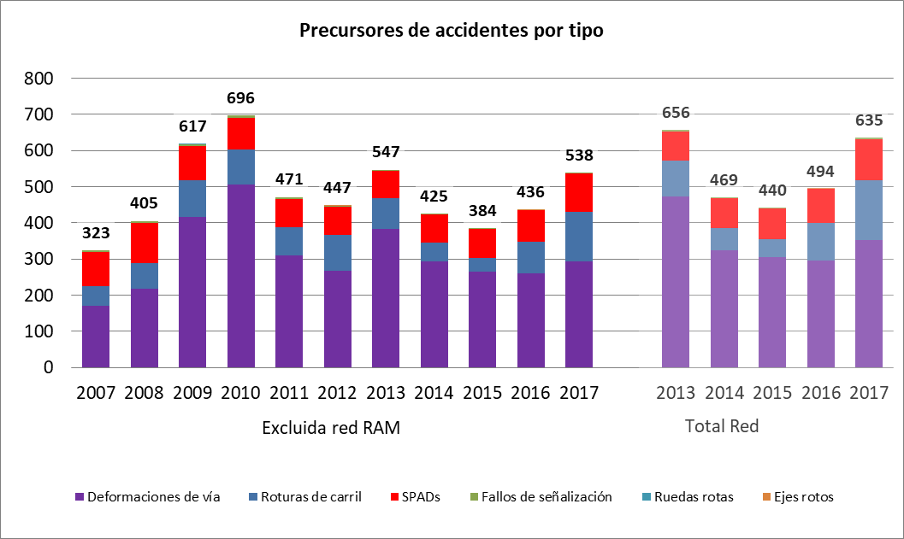

|  |  |
| --- | --- |
| Precursores de accidentes por tipo | Precursors of accidents by type |
| Excluida red RAM | Excluding the RAM network |
| Deformaciones de vía | Warped track |
| Roturas de carril | Broken rails |
| SPADs | SPADs |
| Fallos de señalización | Signal failures |
| Ruedas rotas | Broken wheels |
| Ejes rotos | Broken axles |

* Fatalities



|  |  |
| --- | --- |
| Víctimas mortales por tipo de accidente | Fatalities by type of accident |
| Accidentes a personas | Accidents involving people |
| Accidentes en paso a nivel | Accidents at level crossings |
| Colisiones (inc. Arrollamiento obs.) | Collisions (including running over obstacles) |
| Descarrilamientos | Derailments |



|  |  |
| --- | --- |
| Víctimas mortales por tipo de usuario | Fatalities by type of user |
| Excluida red RAM | Excluding the RAM network |
| Total red | Total network |
| Personas no autorizadas* | Unauthorised persons* |
| Usuarios de pasos a nivel | Level crossing users |
| Viajeros | Passengers |
| Empleados | Employees |
| Otros* | Others* |

* In 2017, in order to maintain the historical series, various categories of victims (defined according to Royal Decree 1006/2005) have been considered within the definitions used in previous years. Specifically:

Unauthorised persons: includes fatalities where the individual concerned is a 'Trespasser' or 'Another type of person present on the platform'.

Others: includes fatalities where the individual concerned is 'Another type of person present on the platform'.

* Serious injuries

|  |
| --- |
|  |



|  |  |
| --- | --- |
| Heridos graves por tipo de accidente | Serious injuries by type of accident |
| Excluida red RAM | Excluding the RAM network |
| Total Red | Total network |
| Accidentes a personas | Accidents involving people |
| Accidentes en pasos a nivel | Accidents at level crossings |
| Colisiones | Collisions |
| Descarrilamientos | Derailments |



|  |  |
| --- | --- |
| Heridos graves por tipo de usuario | Serious injuries by type of user |
| Personas no autorizadas* | Unauthorised persons* |
| Usuarios de pasos a nivel | Level crossing users |
| Viajeros | Passengers |
| Empleados | Employees |
| Otros* | Others* |

* In 2017, in order to maintain the historical series, various categories of victims (defined according to Royal Decree 1006/2005) have been considered within the definitions used in previous years. Specifically:

Unauthorised persons: includes fatalities where the individual concerned is a 'Trespasser' or 'Another type of person present on the platform'.

Others: includes fatalities where the individual concerned is 'Another type of person present on the platform'.

* Reference Data:

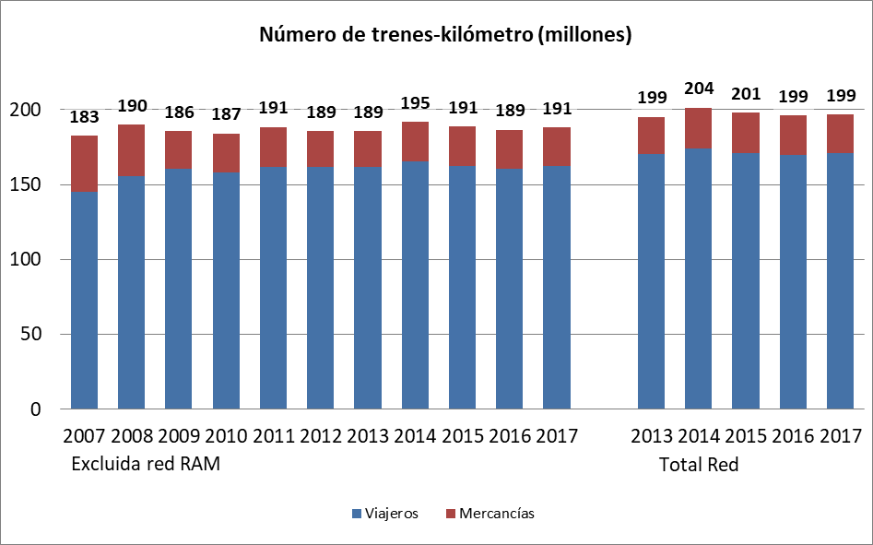

|  |  |
| --- | --- |
| Nñumero de trenes-kilómetro (millones) | Number of train-kilometres (million) |
| Excluida red RAM | Excluding the RAM network |
| Total Red | Total network |
| Viajeros | Passengers |
| Mercancías | Freight |

a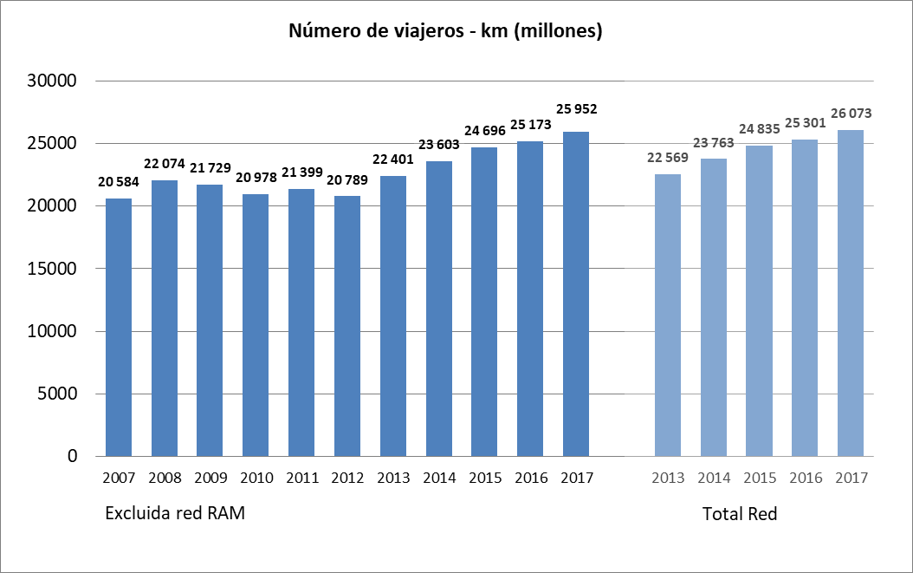

|  |  |
| --- | --- |
| Número de viajeros - km (millones) | Number of passenger-kilometres (millions) |
| Excluida red RAM | Excluding the RAM network |
| Total Red | Total network |

* Risk indicators by category of persons involved
* Total: all categories of persons involved:



|  |  |
| --- | --- |
| Muertos y heridos graves ponderados (MGHP) / mil millones de trenes-km | Weighted fatalities and serious injuries (MGHP) / billion train-kilometres |
| Categoría de víctima: Todas | Victim category: All |
| Excluida red RAM | Excluding the RAM network |
| Total Red | Total network |
| MHGP / mil millones de trenes-km | MHGP / billion train-km |

* Employees



|  |  |
| --- | --- |
| Muertos y heridos graves ponderados (MGHP) / mil millones de trenes-km | Weighted fatalities and serious injuries (MGHP) / billion train-km |
| Categoría de víctima: Empleados | Victim category: Employees |
| Excluida red RAM | Excluding the RAM network |
| Total Red | Total network |
| MHGP / mil millones de trenes-km | MHGP / billion train-km |

* Passengers



|  |  |
| --- | --- |
| Muertos y heridos graves ponderados (MGHP) / mil millones de trenes-km | Weighted fatalities and serious injuries (MGHP) / billion train-km |
| Categoría de vícitma: Viajeros | Victim category: Passengers |
| Excluida red RAM | Excluding the RAM network |
| Total Red | Total network |
| MHGP / mil millones de trenes-km | MHGP / billion train-km |



|  |  |
| --- | --- |
| Muertos y heridos graves ponderados (MGHP) / mil millones de viajeros-km | Weighted fatalities and serious injuries (MGHP) / billion passenger-km |
| Categoría de víctima: Viajeros | Victim category: Passengers |
| Excluida red RAM | Excluding the RAM network |
| Total Red | Total network |
| MHGP / mil millones de trenes-km | MHGP / billion train-km |

* Level crossing users



|  |  |
| --- | --- |
| Muertos y heridos graves ponderados (MGHP) / mil millones de trenes-km | Weighted fatalities and serious injuries (MGHP) / billion train-km |
| Categoría de víctima: Usuarios de pasos a nivel | Victim category: Level crossing users |
| Excluida red RAM | Excluding the RAM network |
| Total Red | Total network |
| MHGP / mil millones de trenes-km | MHGP / billion train-km |



|  |  |
| --- | --- |
| Muertos y heridos graves ponderados (MGHP) por mil millones de trenes-km / km de vía por nº de pasos a nivel | Weighted fatalities and serious injuries (MGHP) per billion train-km / km of track per no. of level crossings |
| Categoría de víctima: Usuarios de pasos a nivel | Victim category: Level crossing users |
| Excluida red RAM | Excluding the RAM network |
| Total Red | Total network |
| (MHGP / mil millones de trenes-km / km. de vía / nº de PN) | (MGHP / billion train-km) / (track km / no. LCs) |

* Unauthorised persons



|  |  |
| --- | --- |
| Muertos y heridos graves ponderados (MGHP) / mil millones de trenes-km | Weighted fatalities and serious injuries (MGHP) / billion train-km |
| Categoría de víctima: Personas no autorizadas* | Victim category: Unauthorised persons* |
| Excluida red RAM | Excluding the RAM network |
| Total Red | Total network |
| (MHGP / mil millones de trenes-km | (MHGP / billion train-km |

(*) In 2017, in order to maintain the historical series, various categories of victims (defined according to Royal Decree 1006/2005) have been considered within the definitions used in previous years. Specifically: Unauthorised persons: includes fatalities where the individual concerned is a 'Trespasser' or 'Another type of person present on the platform'.

* Others



|  |  |
| --- | --- |
| Muertos y heridos graves ponderados (MGHP) / mil millones de trenes-km | Weighted fatalities and serious injuries (MGHP) / billion train-km |
| Categoría de víctima: Otros* | Victim category: Others* |
| Excluida red RAM | Excluding the RAM network |
| Total Red | Total network |
| (MHGP / mil millones de trenes-km | (MHGP / billion train-km |

(*) In 2017, in order to maintain the historical series, various categories of victims (defined according to Royal Decree 1006/2005) have been considered within the definitions used in previous years. Specifically:

Others: includes fatalities where the individual concerned is 'Another type of person present on the platform'.



1. Transposed into national legislation through Royal Decree 810/2007, of 22 June, approving the Regulation on traffic safety on the Public Railway Network.
2. The AESF’s annual action plans may be consulted on its website: <http://www.seguridadferroviaria.es/quienes-somos/plan-de-accion>
3. Royal Decree 664/2015, of 17 July, approving the Rail Traffic Regulations.
4. Royal Decree 1011/2017, of 1 July, to amend Royal Decree 664/2015, of 17 July, approving the Rail Traffic Regulations.
5. Approved by means of Royal Decree 1011/2017, of 1 December, amending Royal Decree 664/2015, of 17 July, approving the Rail Traffic Regulations.
6. Approved by means of Royal Decree 1011/2017, of 1 December, amending Royal Decree 664/2015, of 17 July, approving the Rail Traffic Regulations.
7. In accordance with the Order of 2 August 2001, implementing article 235 of the Regulations of the Land Transport Act (Ley de Ordenación de los Transportes Terrestres), regarding the removal and protection of level crossings, a level crossing with type A protection has protection with exclusively fixed signals.
8. **Significant accident:** According to Annex I of the Rail Traffic Safety Regulations, approved by means of Royal Decree 810/2007, of 22 June: *‘any accident involving at least one railway vehicle in motion, with at least one fatality or serious injury or serious damage to the rolling stock, track, other installations or environments, or prolonged traffic disruptions. Accidents at workshops, warehouses and depots are excluded.’*

   'Serious damage to the rolling stock, track, other installations or environments' is understood to mean damage with a value equivalent to or greater than €150,000, and 'prolonged traffic disruptions' are understood to mean railway services on a main railway line that are suspended for a minimum period of six hours.
9. **Serious accident:** According to article 2 of the Rail Traffic Safety Regulations, approved by means of Royal Decree 810/2007, of 22 June: *‘any collision or derailment of trains with the result of at least one fatality or five or more serious injuries, or major damage to the rolling stock, to the infrastructure or to the environment, and any other, similar accident, with an evident effect on railway safety or on safety management; major damage is understood to mean damage that can be immediately assessed by the investigation body to cost at least two million euros in total'.*

   For consistency with the criteria used in the past, serious accidents (regardless of the type of accident) are considered to include all accidents in which there is at least one fatality or five or more serious injuries or major damage.
10. MHGP: Weighted fatalities and serious injuries (No of fatalities + 0.1 x No of serious injuries)
11. Source: Report on Railway Safety and Interoperability in the EU – 2018. Figure 2
12. <http://www.seguridadferroviaria.es/recursos_aesf/o030201gu01guiasolicitudcertificados.pdf>

    <http://www.seguridadferroviaria.es/recursos_aesf/o030101gu01guiasolicitudautorizaciones.pdf>
13. www.seguridadferroviaria.es/recursos_aesf/estrategia20supervisic3b3n.pdf
14. Order FOM 233/2006, of 31 January, regulating the conditions for the approval of railway rolling stock and maintenance centres and establishing the fees for the certification of such rolling stock.
15. Order FOM/2872/2010 of 5 November, which sets out the conditions for obtaining the qualifying certificates that allow railway personnel to perform their duties with respect to rail traffic safety, as well as the system of officially approved training centres and the medical examination centres of said personnel. This rule was amended by Order FOM 679/2015 of 9 April.
16. Recommendations included in final reports issued before the closing date for this Annual Report (September 2018). This report does not, therefore, include any recommendations relating to accidents occurring in 2017 where the reports were issued by the CIAF after its preparation (period between September and December 2018).
17. The actions appearing relate to recommendations regarded as closed in 2017, as the AESF deemed the level of compliance to be satisfactory. They stem from events occurring in 2017 or earlier.
18. Modification files managed in 2017 regardless of the year in which the processing of the file was started.
19. The first such round-table meeting took place in 2018.