**2018**

**CDT**

9/28/2018

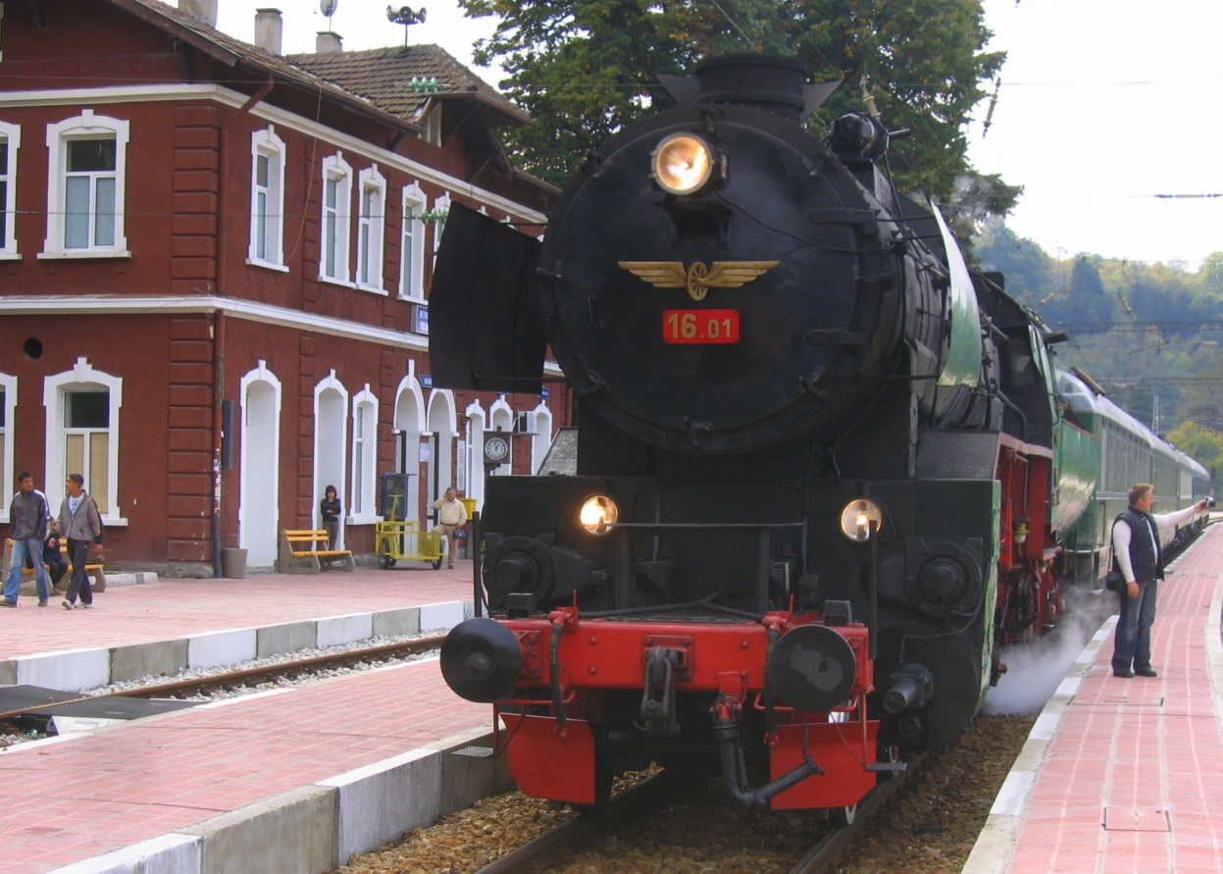

Annual safety report of the National Safety Authority of the Republic of Bulgaria 2017

**CONTENTS**

Abbreviations used in the report 2

A. INTRODUCTION 3

A.1. Objective, Scope and Addressees of the Report 3

A.2. Significant Organisational Changes Affecting the NSA 4

B. Overall Safety Performance and Strategy 4

B.1. Main Conclusions from the Reporting Year 4

B.2. National Safety Strategy, Programmes and Initiatives 12

B.3. Review of the Previous Year 14

B.4. Focus Areas for the Next Year 14

C. Development of Safety 15

C.1. Detailed Analysis of the Latest Recorded Trends15

C.2. Results of Safety Recommendations 17

C.3. Measures Taken not in Relation to NIB’s Recommendations 23

D. SUPERVISION 25

D.1. Strategy and Plan(s) 25

D.2. Human Resources 25

D.3. Competence 27

D.4. Decision-making 27

D.5. Coordination and Cooperation 28

D.6. Findings from Measures Taken 28

E. ISSUANCE OF SAFETY CERTIFICATES AND AUTHORISATIONS 28

E.1. Guidance 28

E.2. Contacts with Other NSAs 29

E.3. Procedural Issues 29

E.4. Feedback 30

F. CHANGES IN LEGISLATION 30

F.1. Railway Safety Directive (RSD) 30

F.2. Legislative and Regulatory Amendments: 30

G. APPLICATION OF THE CSM RELATED TO REA (RISK EVALUATION AND ASSESSMENT) 31

G.1. NSA Experience 32

G.2. Feedback from Stakeholders 32

G.3. Revised National Safety Rules (NSR) as a Result of the Implementation of the EU Provisions regarding Risk Evaluation and Assessment 32

H. DEROGATIONS IN CONNECTION WITH THE SCHEME FOR THE CERTIFICATION OF ENTITIES (PERSONS) IN CHARGE OF MAINTENANCE OF VEHICLES IN ACCORDANCE WITH ARTICLE 14a(8) of DIRECTIVE 2008/110/EC 32

ANNEX A. COMMON SAFETY INDICATORS (CSI) 30

Data/charts on the performance of the main CSI in the 2013–2017 period 33

ANNEX C. CHANGES IN LEGISLATION 40

Table: Legislative and regulatory changes in the field of railway transport of Bulgaria, published in the State Gazette and entering into force in the period between 1 January 2017 and 31 December 2017 *(Annex to Section F.2 of this report)* 40

Acronyms Used in the Report

|  |  |
| --- | --- |
| **ERA** | European Union Agency for Railways (ERA) |
| **AsBo** | Assessment Body |
| **BDZ** | Bulgarian State Railways |
| **ASR** | Annual Safety Report |
| **DGRI** | Directorate General Railway Inspection at the RAEA |
| **DeBo** | Designated Body |
| **RSD** | Railway Safety Directive 2004/49/EC |
| **IOD** | Railway Interoperability Directive 2008/57/EC |
| **NRIC SE** | National Railway Infrastructure Company State Enterprise |
| **EC** | European Commission |
| **ERADIS** | ERA Database of Interoperability and Safety (*ERADIS*) |
| **ERAIL** | *European Railway Accident Information Links* register |
| **EU** | European Union |
| **RI** | Railway Infrastructure |
| **RU** | Railway Undertaking |
| **RTA** | Railway Transport Act of the Republic of Bulgaria |
| **RAEA** | Railway Administration Executive Agency |
| **ED** | Executive Director |
| **PRM** | Persons with Reduced Mobility |
| **MTITC** | Ministry of Transport, Information Technology and Communications |
| **NRV** | National Reference Value |
| **NRSD** | New Railway Safety Directive 2016/798 |
| **NIOD** | New Interoperability Directive 2016/797 |
| **NoBo** | Notified Body |
| **NSA** | National Safety Authority |
| **NIB** | National Investigation Body |
| **NSR** | National Safety Rule |
| **NVR** | National Vehicle Register |
| **CST** | Common Safety Targets |
| **CSM** | Common Safety Methods |
| **CSI** | Common Safety Indicators |
| **RS** | Rolling Stock |
| **RD** | Reference Document of the Network |
| **SC** | Safety Certificate |
| **PCM/ECM** | Person (Entity) in Charge of Maintenance of Vehicles |
| **SMS** | Safety Management System |
| **QMS** | Quality Management System |
| **TSI** | Technical Specification for Interoperability |
| **SA** | Safety Authorisation |
| **IM** | Railway Infrastructure Manager |

## Introduction

# Objective, Scope and Addressees of the Report

1. This report aims to assess the achievement of Common Safety Indicators in 2017 and to present the overall development of railway safety in the Republic of Bulgaria in accordance with Article 5 of Directive 2004/49/EC of 29 April 2004 on safety on the Community’s railways (RSD).
2. The scope of the report complies with the requirements of Article 18 of the RSD.

It contains information on:

* the development of safety and Common Safety Indicators (CSI) for the railway transport of Bulgaria, in 2017;
* the activities relating to the issuance, renewal, amendment or revocation of safety certificates and authorisations;
* the experience gathered from the supervision over the infrastructure managers (IMs) and the railway undertakings (RUs), including the number and results of checks and audits;
* important changes in safety legislation and regulation; derogations whereon a decision was made pursuant to [Article 14a(8)](apis://Base=APEV&CELEX=02004L0049&ToPar=Art14а_Par8&Type=203/) of the RSD;
* the experience of the RUs and the IM from the application of the respective Common Safety Methods (CSM).

This report was prepared using the model of the annual safety reports (ASR) of the National Safety Authorities (NSA), approved in 2013 by the Network of NSAs of the European Union (EU) Member States (MS), which is also applicable to the 2017 ASR.

1. The Railway Administration Executive Agency (RAEA) is the National Safety Authority for railway transport pursuant to Article 6(3) of the Railway Transport Act (RTA). The RAEA is headquartered in Sofia and has regional units in Sofia, Plovdiv and Gorna Oryahovitsa.

The CSI information was created based on the data received from the ASR of the IM in Bulgaria (NRIC SE) and the RUs holding passenger or freight transport SCs in Bulgaria, as well as from the registers of railway accidents and incidents maintained by the RAEA (AISIAS[1]) and the NRIC SE (SmartSafety 2.1).

1. In addition to the European Union Agency for Railways (ERA), this report is also intended for: the MTITC, the National Investigation Body (NIB) of the Republic of Bulgaria (RAISIU), railway infrastructure managers, railway undertakings, entities in charge of maintenance of vehicles, notified bodies (NoBos), designated bodies (DeBos), assessment bodies (AsBos), specialised training institutions (universities, institutes, high schools, colleges, professional and qualification centres, schools, etc.), professional associations, unions and all legal entities and natural persons in the country and abroad, performing or intending to perform railway activities on the territory of the Republic of Bulgaria.

This report is published online and is publicly available both in ERA’s ERADIS database, in the *NSA & NIB reports*[2] section, and on the RAEA website—in the *National Safety Authority* section, *Annual Safety Reports* category. The CSI data for Bulgaria, both for 2017 and for the period between 2007 and 2017, are published and are publicly available in European Union’s ERAIL register on the link below[3].

# Significant Organisational Changes Affecting the NSA

In 2017, no organisational changes were made, and there were no significant legislative or external organisational changes affecting RAEA’s responsibilities as a NSA for the railway transport of Bulgaria.

## Overall Safety Performance and Strategy

# Main Conclusions from the Reporting Year

**Common Safety Indicators** (see also **Annex A** to the report):

1. **Common safety indicators data related to railway accidents:**

The total number of significant accidents in Bulgaria, in 2017, broke the positive trend for improvement of the common safety indicator (CSI) for railway accidents, namely: total number of ‘*significant accidents*[4]’—47 in 2017, compared to 40 in 2016 and 48 in 2015. The total number of railway accidents registered in Bulgaria in 2017 was 351, compared to 327 in 2016 and 305 in 2015.

1. The value of the total number of ‘significant accidents’ indicator (N00) for 2017 was 47 accidents. The values of this indicator for the previous five years were as follows: 40 (2016), 48 (2015), 58 (2014), 33 (2013) and 48 (2012). The trend for the share of ‘*accidents to persons involving RS in motion*’[5] to be the highest continued in 2017. For 2017, they were: 29 (indicator code N04). The next most serious significant accidents were: ‘*level-crossing accidents, including level-crossing accidents involving pedestrians*’ (indicator N03)—11; ‘*derailments of trains*’—5. (indicator N02); ‘*collisions of train with obstacle within the clearance gauge*’—1. (indicator N012) and ‘*Fires in rolling stock*’—1. (indicator N05). In 2017, there were no registered ‘*significant accidents*’ of the types ‘*collisions of train with rail vehicle*’ (indicator N011), ‘*level-crossing accidents on rail-side protected LCs*’ (indicator N035) and ‘*level-crossing accidents on passive LCs*’ (indicator N031).
2. In 2017, there was an improvement in the *‘total number of persons killed in all accidents’*[6](TK00) indicator, compared to 2016. In 2017, a total of 16 persons were killed in railway accidents, while in the previous five years they were: 22 (2016), 20 (2015), 23 (2014), 12 (2013) and 21 (2012).
3. In 2017, there was also an improvement in the ‘*total number of persons seriously injured in all accidents*’[7] (TS00) indicator, compared to 2016. In 2017, seriously injured were 28 persons, while in the previous five years they were: 32 (2016), 24 (2015), 45 (2014), 21 (2013) and 32 (2012).
4. Details of separate railway accidents registered in 2017, in Bulgaria, with the highest number of dead (killed) and seriously injured persons for each of the risk categories referred to in Article 7(4)(a) and (b) of the RSD and Decision 2009/460/EC[8]:
   * Of the ‘*Passengers*[9]’ risk category (RC):

In 2017, there were no killed persons of the ‘*Passengers*’ RC.

* + Of the ‘*Employees or subcontractors*[10]’ RC:

In 2017, there were no killed persons of the ‘Employees or subcontractors’ RC.

* + Of the ‘*Level crossing users*[11]’ RC:

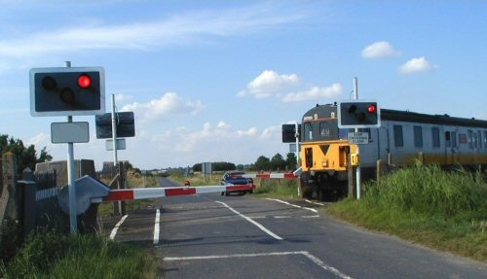 On 3 March 2017, at a level crossing at km 107+750 within the Pazardzhik–Septemvri station-adjacent section, with the crossing barriers closed, a car drove around the gates attempting to traverse the track and was hit by train No 10392. As a result of the collision, one of the passengers in the car was killed and the driver and the other passenger in the car were taken to hospital with injuries.

* + Of the ‘*Unauthorised persons*[12]’ RC:

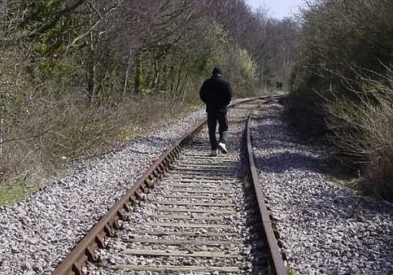On 21 October 2017, within the Gorna banya–Zaharna fabrika station-adjacent section, between the warning and entry signals at the Zaharna fabrika station, exiting left curve in the direction of travel, at km 3+950, the train driver saw, to the left of the direction of travel, two individuals, one of whom had stepped on the railroad track. The train driver immediately proceeded with emergency braking and gave the “warning” audible signal with the train whistle of the EMU. One of the individuals managed to cross the railroad track, while the other, trying to cross, stumbled and fell across the rails. Seeing this, the individual who crossed the track returned and tried to help the fallen individual. The distance between the moving train and the individuals on the railroad track was too short to avoid collision. Both individuals died on impact.

* + Of the ‘*Other persons on platform*[13]’ RC:

In 2017, there were no killed persons of the ‘*Other persons on platform*’ RC.

* + Of the ‘*Other persons not on platform*[14]’ RC:

In 2017, in Bulgaria, 2 separate accidents of the ‘*Other persons not on platform*’ RC were registered, with two persons killed. Both cases involved similar attempts to cross the railroad track outside a platform and hits by a train in transit.

1. Total number of killed and seriously injured persons in all significant accidents registered in 2017 divided into individual risk categories of persons as defined in Article 7(4)(a) and (b) of the RSD and Decision 2009/460/EC.
   * Of the ‘*Passengers*’ RC:

In 2017, there were no killed persons of the ‘*Passengers*’ RC. In 12 separate accidents, 12 persons of the ‘*Passengers*’ RC were injured. All of them were injured when trying to get off a passenger train moving off after a regular stay at the station.

* + Of the ‘*Employees or contractors*’ RC:

In 2017, one significant accident of the ‘*Employees or contractors*’ risk category was registered, where, on 3 July 2017, while traversing at an automated level-crossing device (ALCD), at km 61+089, with barriers closed, within the Borovo–Morunitsa station-adjacent section, one employee (truck driver) was seriously injured.

* + Of the ‘*Level crossing users*’ RC:

In 2017, in 10 separate significant level-crossing accidents, 8 persons of the ‘*Level crossing users*’ RC were seriously injured and 5 were killed.

* + Of the ‘*Unauthorised persons*’ RC:

In 2017, in 15 ‘significant’ separate accidents, 9 persons of the ‘*Unauthorised persons*’ RC were killed and 6 were severely injured.

* + Of the ‘*Other persons not on platform*’ RC:

In 2017, two serious accidents with persons of the *‘Other persons not on platform’* RC were registered, wherein 2 persons were killed. No seriously injured persons of the ‘*Other persons not on platform*’ RC were identified*.*

* + Of the ‘*Other persons on platform*’ RC:

In 2017, there were no killed or injured persons of the *‘Other persons on platform*’ RC.

1. Safety indicators relating to *dangerous goods* (DG)

In Bulgaria, in 2017, only one serious (including ‘significant’) railway accident[15] involving transport of dangerous goods was registered. On 9 February 2017, around 00:38, direct freight train No 30582, in transit within the Dalgopol–Komunari station-adjacent section, on road No 2, at km 88+350, the first bogie in the direction of travel of wagon No 84537915420-4 (Z 4), full, 22nd within the train composition, derailed. As the train entered the Komunari station, at switch No 5, the derailed bogie of wagon No 84537915420-4 rerailed. At 01:31, at the Zavet station, the train was stopped for an emergency inspection by the train crew, but nothing was found. At 02:20, train traffic was suspended within the Dalgopol–Komunari station-adjacent section, on road No 2, switches No 103, 3, 5 and Komunari station track three, by Section Manager Nenov from the NRIC’s railway section, due to damages caused to the railway infrastructure. At the Karnobat station, after the train arrival, damages to wagon No 84537915420-4 were identified. The tank wagon had a centre of mass visibly shifted sidewise, as a result of the gaps found on both sides in the side bearers of both bogies and the body, as well as of the loosening of the wheel-axle press assembly, which had upset the distances between the tyres of the first leading wheelset of the wagon and, subsequently, decreased the ability of the bogie to follow the track curve.

1. **Safety indicators relating to *suicides*[16]:**

In 2017, 23 suicides were registered in the railway transport of Bulgaria. In the past five years, the number of suicides committed on the railways was: 15 (2016), 21 (2015), 29 (2014), 17 (2013) and 33 (2012).

In 2017, two attempted suicides were registered. In 2016, one attempted suicide was registered. In 2015, only one attempted suicide was registered, as well. Prior to 2015, no statistical data on the attempted suicides, as indicators, were collected.

1. **Safety indicators relating to ‘*precursors of accidents[17]*’:**

In 2017, the indicator *‘Total number of precursors of accidents’*, code I00, decreased by 24%, compared to the previous year 2016. The value of the I00 indicator was 91 in 2017, 120 in 2016, 133 in 2015 and 124 in 2014.

The last four years saw the continuing positive trend for the precursors of accidents related to technical malfunctions of the RS, of the types: *‘Broken wheel on rolling stock in service’* (*I05*) and *‘Broken axle on rolling stock in service’* (*I06*) to be zero or near zero. The value of the *I05* indicator was 0 in 2017, 2 in 2016, 0 in 2015 and 1 in 2014. In 2017, 2016 and 2015, the value of the *I06* indicator was 0, while, in 2014, it was 4.

In recent years, the number of precursors of accidents related to technical failures of the track, respectively: *‘Broken rail’* (*I01*) and *‘Track buckle or other track misalignment’* (*I02*) was almost the same. In 2017, 68 cases of ‘broken rails’ were registered, while, in the previous five years, they were, respectively: 83 (2016), 104 (2015), 102 (2014), 83 (2013) and 82 (2012). In 2017, there were no registered and investigated cases of ‘*Track buckle or other track misalignment*’ (I02), while, in 2016, there were, respectively, 15 and, in 2015, there were 14.

For yet another year, there were no registered cases of ‘*Wrong-side signalling failure*’ (indicator code I03). The last 2 such cases were registered in 2015.

In 2017, the total number of registered *‘Signals Passed at Danger’ (when and without passing a danger point)* (I041 and I042 indicators) was 22, 20 in 2016, 13 in 2015 and 16 each year in both 2014 and 2013.

1. **Indicators for calculation of the economic impact of accidents:**

In 2017, the value of the C10 indicator *(Economic impact of significant accidents ONLY)* was BGN 27,67 million (EUR 14,146 million), while, in 2016, it was BGN 38,6 million (EUR 14,736 million). The decrease in 2017 was attributable mainly to the lack of serious railway accidents.

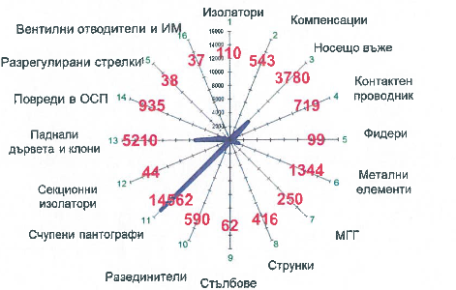In 2017, the economic impact of the 16 railway accident fatalities (C01 indicator) was BGN 21,770 million (EUR 11,13 million) and that of the 28 serious injuries (C02 indicator) was BGN 5,149 million (EUR 2,632 million). The ‘*Cost of material damages to rolling stock or infrastructure for significant accidents*’ (C13 indicator), in 2017, was BGN 750 947 (EUR 383 920 ), while, in 2016, it was BGN 2,783 million (EUR 1,423 million).

The ‘Minutes of delays of passenger trains of significant accidents’ (indicator C15), in 2017, were, respectively, 5219. The values of the C15 indicator, for the previous years, were as follows: 6166 minutes (2016); 12 833 (2015); 10 882 (2014) and 5157 (2013).

Figure 1: Train delays caused by damages to facilities

Figure 1 shows a chart of the damages to railway facilities in Bulgaria with the longest train delays in minutes, taken from the 2017 ASR of the NRIC SE. It becomes evident from the chart that the type of damage causing the longest train delays, in 2017, in Bulgaria, was pantograph breakage, which, in Bulgaria, is classified as accident of type ‘*Train collision with an obstacle within the clearance gauge’*[18]*.* The causes of the pantograph breakage(s) are highly disputed and, quite often, are the bone of contention between the RUs and the IM*,* since the damages to the contact system (25 kV, 50 Hz) and the RS are significant in most cases. The next longest train delays were caused by damages to: 1) SP (section posts) and TPS (traction substations); 2) messenger wires and contact wires/cable droppers/; 3) disconnectors; 4) metal elements; 5) messenger wire, etc.

In 2017, the total duration of train delays caused by pantograph breakages, in Bulgaria, was 16 846 minutes, while, in 2016, it was 17 302 minutes, making it difficult to keep the train schedule and causing delays for passengers and freight.

1. **Safety indicators relating to the technical safety of the railway infrastructure and its use.**

In 2017, the T03 indicator (*Total number of active and passive level crossings*), in Bulgaria, saw a 0,5% decrease, compared to 2016. The values of T03 for the last five years were as follows: 757 (2017), 761 (2016), 766 (2015), 774 (2014), 785 (2013). The values ​​of the T06 indicator (*Total number of ‘active’ level crossings*), for the last five years, were as follows: 609 (2017), 622 (2016), 626 (2015), 632 (2014), 648 (2013). The values ​​of the T14 indicator (*Total number of ‘passive’ level crossings*), for the last five years, were as follows: 139 (2016), 140 (2015), 142 (2014), 137 (2013) and 137 (2012).

1. **Indicators relating to safety management.**

In 2017, there was an increase in the number of conducted internal audits of the Safety Management Systems (SMSs) of the IM (NRIC SE) and RUs implementing the requirements of Regulation (EC) No 1078/2012[19]. The audits and monitoring of the IM and the RUs conducted by the NSA of Bulgaria found that the former are planning and conducting audits of their SMSs once a year. The internal audit process is being documented.

# National Safety Strategy, Programmes and Initiatives.

The National Safety Strategy of the Republic of Bulgaria is included in the Strategy for Development of the transport system of the Republic of Bulgaria until 2020, issued by the MTITC in 2010. It describes the obligations of the state regarding the development, coordination and implementation of a policy to increase safety and security in all modes of transport and of the transport system as a whole. The strategy emphasises the important role of the determination and the control of the application of technical standards for planning, design, construction, maintenance and operation of the transport infrastructure in order to ensure safety of consumers, uniformity and technical compatibility of the networks.

**Operational Programme ‘Transport’ (OPT) 2007–2013 and Operational Programme ‘Transport and Transport Infrastructure’ (OPTTI) 2014–2020.**

One of the main programmes for development of the Trans-European Transport Network to achieve sustainability of the Bulgarian transport system, part of which is the railway system, is **OPT 2007–2013, continued with OPTTI 2014–2020**. It is one of the seven operational programmes of the Republic of Bulgaria, financed from the EU Structural Funds and the Cohesion Fund. OPT is the Operational Programme with the largest budget in Bulgaria—over EUR 2 billion.

**OPTTI 2014–2020** ensures continuity and logical continuation of investments from the 2007–2013 programming period, thus ensuring the completion of the routes in which investments have already been made. The following priority axes are formulated in the programme: 1) ‘Development of the railway infrastructure along the ‘core’ Trans-European Transport Network’; 2) ‘Development of the road infrastructure along the ‘core’ and the ‘comprehensive’ Trans-European Transport Network’; 3) ‘Improvement of intermodal transport services for passengers and freights and development of sustainable urban transport’; 4) ‘Innovations in management and services—establishment of modern infrastructure for traffic management and transport safety improvement’ and 5) ‘Technical assistance’.

# Connecting Europe Facility (CEF)

CEF was created by Regulation (EU) No 1316/2013 of the European Parliament and of the Council of 11 December 2013 and covers the transport, telecommunications and energy sectors.

# The beneficiaries of CEF, in Bulgaria, in the area of railway transport, are:

* **the National Railway Infrastructure Company**

Railway projects valued at more than EUR 350 million were agreed upon.

- The first design and construction contract for the Sofia–Elin Pelin section was signed. The route will be completed in 4 years;

- ‘Development of the Sofia Junction: Sofia–Voluyak Section’—total project value: more than EUR 104 million; EU grant: more than EUR 76 million (73%);

- ‘Development of the Plovdiv Junction’—total project value: EUR 72 million, CEF funds: 85%, in the amount of EUR 61 million;

- ‘Upgrade of the Sofia–Elin Pelin Railway Sub-Section’—total project value: approximately EUR 68 million; EU grant: approximately EUR 58 million (85%);

- ‘Upgrade of the Kostenets–Septemvri Railway Section’—total project value: more than EUR 178 million; EU grant: more than EUR 151 million (85%).

* **Railway Administration Executive Agency**

ERTMS HIPPOPS project approved for funding under the ‘general envelope’ of the 2014 CEF Transport Multi-Annual Work Programme; the project value, in its RAEA part, is EUR 100 000 with 50% co-financing. The main purpose of ERTMS HIPPOPS is to simplify and harmonise authorisation processes and procedures for the placing of the European Railway Traffic Management System into operation/service. The project is implemented with the joint involvement of the National Safety Authorities and Conformity Assessment Bodies of Italy, Bulgaria, France and Belgium.

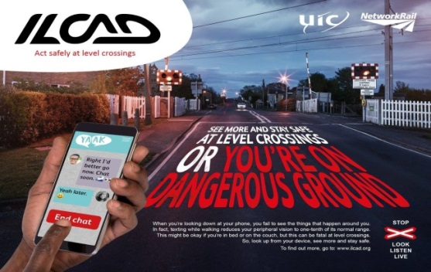 **ILCAD (International Level Crossing Awareness Day—3 June) Initiative**

In 2017, for the ninth consecutive year, the infrastructure manager NRIC SE participated in the large-scale initiative of the *International Level Crossing Awareness Day (ILCAD)*, which is held on the initiative of the International Union of Railways (UIC), jointly with the railway and automotive sectors, in more than 50 countries around the world. The first International Level Crossing Awareness Day (ILCAD) was held on 25 June 2009 in 27 countries.

The main purpose of the initiative is to show that accidents can be avoided by complying with the traffic rules and by reducing the dangerous behaviour of the traffic participants when traversing railway level crossings and the surrounding areas.

Figure 2: International Level Crossing Awareness Day

 At the end of 2017, the total length of the railway network in Bulgaria was 6458 *‘track kilometres’*[20] and 4030 *‘line kilometres’*[21]. At the end of 2017, in Bulgaria, there were 757 level crossings, operated by the NRIC SE, of which 148 were ‘*passive’*[22]and 609 were ‘*active’*[23]*.* Out of all 757 level crossings, 519 were equipped with automatic devices ensuring safe train crossing. 306 devices were equipped with road traffic lights with a third slowly flashing white light.

**One of the main priorities, as part of the overall activity of NRIC SE in Bulgaria, is ensuring security and safety when traversing railway level crossings.**

In 2017, the number of level-crossing accidents was 23 in total, of which 11 were ‘significant’. In 2016, they were 18, of which 5 were ‘significant.’ In 2015, they were 20, of which 6 were ‘significant.’ In 2014, they were 21, of which 11 were ‘significant’. The main reason for the accidents was the violation of the safety rules by drivers of motor vehicles and disregard of the signals prohibiting passage through the level crossing due to an approaching train.

The data on the level-crossing accidents, registered in Bulgaria during the five-year period between 2013 and 2017, are presented in tabular format below:

Table 1: Data on the level-crossing accidents registered in Bulgaria in the 2013–2017 period

|  |  |  |  |  |  |
| --- | --- | --- | --- | --- | --- |
| Year | Total number of level-crossing accidents | Total number of significant level-crossing accidents | Died (killed) persons | Seriously injured persons | Total  Killed and seriously injured persons |
| 2013 | 32 | 11 | 3 | 12 | 15 |
| 2014 | 21 | 11 | 6 | 16 | 22 |
| 2015 | 20 | 6 | 2 | 7 | 9 |
| 2016 | 18 | 5 | 5 | 5 | 10 |
| 2017 | 23 | 11 | 5 | 9 | 14 |

Analyses show that the main reason for the accidents is the violation of the safety rules by drivers of motor vehicles and disregard of the signals prohibiting passage through the level crossing due to an approaching train.

The main objective of the implementation of NRIC SE’s investment programme to equip the level crossings with all necessary state-of-the-art hardware is to reduce the fatalities and serious injuries at the railway level crossings. The financial strategy, implemented by the company in this respect, is based on the funds supplied both by the national budget of the Republic of Bulgaria and by the European funds—OPT 2007‑2013 and OPTTI 2014–2020.

The NRIC SE makes efforts to reduce the incidents at the railway level crossings in the country by intensively replacing the level-crossing devices and building elastic level-crossing pavements ensuring smooth and comfortable passage of motor vehicles in the area of the level crossings.

In 2017, invested for rehabilitation and ongoing maintenance of railway crossings and facilities were: BGN 3 373 306 or EUR 1 724 946.

Over the last 4 years, the NRIC SE made investments in state-of-the-art automatic level-crossing devices in the amount of BGN 16 million (EUR 8,181 million).

The new level-crossing devices are automated and, unlike the manual barriers (raised and lowered by a crossing guard), they are triggered automatically by the passing train.  All new level-crossing devices are equipped with an additional third slowly flashing white light indicating that the device is not faulty and it is safe to traverse. Cameras are additionally installed for control and prevention purposes.

For the 2018–2020 period, another BGN 8 000 000 are allocated to equip 22 level crossings with new automatic level-crossing devices.

For the 10th edition of the ILCAD, at the level crossing near the Beli izvor village, Vratsa, a car wrecked in a level-crossing violation accident was put on display. The intention was to make the drivers of motor vehicles see what could happen when the rules are violated. The level crossing is located at the Vratsa ring road, towards Vidin, where the truck traffic is extremely heavy.

In 2017, the NRIC SE registered 273 cases of broken barriers caused by vehicle collisions or vandalism, of which 73 occurred at this particular level crossing. Since the beginning of 2018, there were 23 cases of intentional barrier beam damage near the Beli izvor village.

Despite the fact that our railway infrastructure has one of the highest percentages of level-crossing signalling automation and hardware, the NRIC SE’s statistics show that, only in the past 3 years (2015, 2016, 2017), 25 people were injured and 11 people were killed in level-crossing incidents. By 1 June 2018, there were 13 level-crossing incidents, with 6 people injured and 2 people killed.

**Educational safety campaign among children**

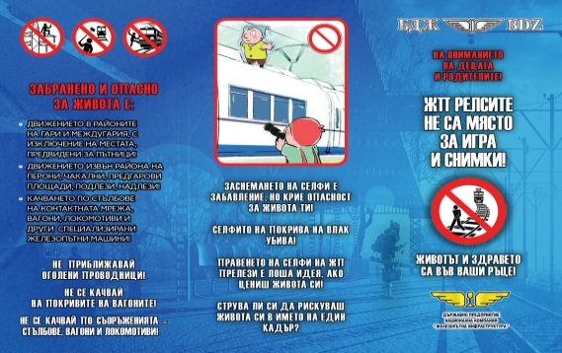In 2017, continuing its last year’s campaign, the NRIC SE, jointly with the State Agency for Child Protection, BDZ Holding EAD and the RAEA, took part in a large-scale educational campaign to explain the dangers of the recent trend among the teenagers to take ‘selfies’ and hang out in the ​​station and station-adjacent section areas. The campaign was launched in early 2016, after the school holidays. The initiative was launched to prevent accidents involving children. It was targeted at the teenage students focusing on the leading role of the parents in their upbringing.

**‘*The railroad track is no place to play and take pictures*’ and ‘*Is a shot worth risking your life?*’ campaigns**

With regard to the summer holidays and Children’s Day—1 June, the NRIC SE and BDZ Holding EAD distributed hundreds of thousands of information brochures at the big stations in the country, as part of the ***‘The railroad track is no place to play and take pictures’*** campaign. The initiative was carried out under the auspices of the State Agency for Child Protection, together with the Ombudsman of the Republic of Bulgaria, the Ministry of Interior (MoI) and other institutions dealing with cases of children injured by electric arc, as a consequence of unauthorised presence at the railway sections.

Figure 3: Promotional brochure for ‘The railroad track is no place to play’ campaign (front)

The information brochures of the NRIC and BDZ were designed to increase the safety of children in the areas of the railway infrastructure, as well as to act as deterrent for the latest teenage trend of ‘taking selfies in dangerous places’.

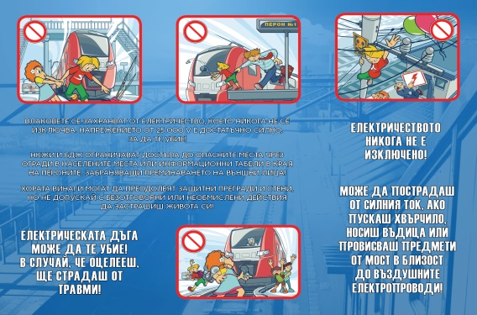Despite all the initiatives implemented over the years, their results related to the safety of the railway infrastructure were generally unsatisfactory. Besides the problems with the unauthorised traversing at the level crossings, the extreme selfies and dangerous behaviour in the RI areas, there is also the serious problem with the violations of the crossing rules at the newly built sections—the new facilities (underpasses, overpasses, lifts) are not used, holes are made in soundproofing walls as ‘doors’ to take ‘shortcuts’ across the tracks. Given the high speeds in these sections, this behaviour poses an extreme danger to human life and health.

Figure 4: Promotional brochure for ‘The railroad track is no place to play’ campaign (back).

# Review of the Previous Year

In 2017, as a whole, no lowering of the level of safety of the RI[24] and RS was reported, compared to 2016, based on the statutory criteria and safety indicators.

The safety management structures at the IM and the RUs provide full assistance to the RAEA in the monitoring and control of the overall development and improvement of safety. By the 10th day of each month, they collect and process statistical information regarding the CSI for the previous month and make it available to the RAEA and to the Railway Accident and Incident Special Investigation Unit at the Ministry of Transport, Information Technology and Communications. The orders and instructions relating to the transport safety issued for this period are also attached to this information.

In 2017, the NSA of Bulgaria, applying the CSM for assessing conformity with the requirements for obtaining railway safety certificates, introduced by Regulation (EU) No 1158/2010, issued a total of 9 SCs to the following RUs for freight transport:

* CARGO TRANS VAGON BULGARIA (SC Part A and B renewed on 11 April 2017 with a validity term of 5 years);
* Mini Maritsa Iztok EAD (new SC Part A and B issued on 19 April 2017 with a validity term of 2 years);
* TBD–TOVARNI PREVOZI JSC (SC Part A and B updated, issued on 20 April 2017);
* Port Rail Ltd. (renewed SC Part A and B issued on 26 May 2017 with a validity term of 5 years);
* DMV CARGO RAIL LTD (new SC Part A and B issued on 3 July 2017 with a validity term of 3 years);
* TBD–TOVARNI PREVOZI JSC (SC Part A and B updated, issued on 16 November 2017);
* BDZ Freight Services (renewed SC Part A and B issued on 21 December 2017 with a validity term of 5 years).

In 2017, the Safety Certificates Part A and B of TBD–TOVARNI PREVOZI JSC were updated twice, in relation to the PCM/ECM certificates[25] issued to the same RU with the following numbers: BG/31/0016/0002 for freight wagons in accordance with Regulation (EU) No 445/2011[26] and BGRA/2017/0003 for rail vehicles in accordance with Ordinance No 59[27].

In 2017, for the first time, an application for the issuance of a Safety Certificate was received for a company not holding a licence. On 5 December 2017, a Safety Certificate was issued to Traktsia JSC for ‘shunting’ within the Samuil railway station with a validity term of 2 years.

In 2017, for passenger railway transport (in Bulgaria, to date, only by BDZ Passenger Services Ltd.), SCs Part A and B were renewed on 21 December 2017 with a validity term of 5 years. See ***section E*** of this report for further details on the Safety Certificates issued by the NSA of Bulgaria to RUs in 2017.

# Focus Areas for the Next Year

The key action areas of the NSA of Bulgaria in the field of railway safety in the following year (2018) according to the requirements of Article 16(2) of the RSD are the following:

* Control over the RUs and the IM for the strict compliance with the statutory requirements for the transport of dangerous goods, RID Regulations and Ordinance No 46 after the serious accident with the release of dangerous goods, which occurred on 10 December 2016 at the Hitrino station in Bulgaria.
* Placing RI and RS into service;
* Preparatory activities related to the transposition into Bulgarian legislation of the RSD and the other legal acts of the Fourth Rail Package (4RP);
* Issuance, renewal, amendment or revocation of safety certificates and safety authorisations of the RUs and the IM;
* Exercise of supervision as required by Regulation (EU) No 1077/2012;
* Issuance of an authorisation for placing into service of the structural subsystems of which the railway system is built and verification whether they are operated and maintained in accordance with the respective essential requirements;
* Issuing authorisations for placing new and substantially modified rolling stock (RS) into service;
* Control, support and development of the safety regulatory framework, including the system of national safety rules (NSR);
* Registration of the vehicles in the National Vehicle Register (NVR) and timely update of the information in the register;
* Control over the repair, maintenance and operation of the railway infrastructure, traffic and transport safety and the operating condition of the RS;
* Controls and checks of the activities of persons authorised to assess and verify the conformity of the components and subsystems to the TSIs (NoBo) and to the national safety regulations or technical rules (DeBo).

## Development of safety

# Detailed Analysis of the Latest Recorded Trends

**Analysis of the data of the Common Safety Indicators** (*see also****Annex A***).

1. Safety indicators related to accidents, persons killed and seriously injured:

The values of the safety indicators related to railway accidents, persons killed and seriously injured are provided in the table below, for the 2013–2017 period:

Table 2: Data on the common safety indicators for Bulgaria, in the 2013–2017 period

|  |  |  |  |  |
| --- | --- | --- | --- | --- |
| Year | Total number of accidents | Total number of ‘significant’ accidents | Total number of  killed persons | Total number of seriously injured persons |
| 2013 | 266 | 33 | 12 | 21 |
| 2014 | 304 | 58 | 26 | 45 |
| 2015 | 305 | 48 | 20 | 24 |
| 2016 | 327 | 40 | 22 | 32 |
| 2017 | 351 | 47 | 16 | 28 |

Table 3 below shows the total number of railway, including ‘significant’, accidents registered in 2017, in Bulgaria:

Table 3: Data on the railway accidents registered in Bulgaria, in 2017 (by region and total)

|  |  |  |  |  |  |
| --- | --- | --- | --- | --- | --- |
| Type of accident | Region  Sofia | Region Plovdiv | Region Gorna Oryahovitsa | Total number of accidents  in 2017 | Significant accidents  in 2017 |
| Collision of train with rail vehicle | 1 | 0 | 2 | 3 | 0 |
| Collision of train with obstacle within the clearance gauge | 85 | 69 | 48 | 202 | 1 |
| Derailment of RS | 17 | 8 | 18 | 43 | 5 |
| Level-crossing accident | 6 | 9 | 8 | 23 | 11 |
| Accidents to persons involving rolling stock in motion | 23 | 22 | 9 | 54 | 29 |
| Fire in RS | 4 | 5 | 1 | 10 | 1 |
| Other | 3 | 4 | 1 | 8 | - |
| TOTAL | **144** | **119** | **88** | **351** | **47** |

1. Safety indicators relating to precursors of accidents:

The values of the indicators related to precursors of accidents, for the last five years, are provided in Table 4 below:

Table 4: Data on the CSI related to precursors of accidents, for the 2013–2017 period

|  |  |  |  |  |  |  |  |
| --- | --- | --- | --- | --- | --- | --- | --- |
| Year | Number of broken rails | Number of track buckles or other track misalignments | Number of wrong side signalling failures leading to dangerous situations | Number of signals passed at danger | Number of broken wheels on rolling stock in service | Number of broken axles on rolling stock in service | TOTAL |
| CSI code | I01 | I02 | I03 | I041+I042 | I05 | I06 | I00 |
| 2013 | 83 | 0 | 0 | 16 | 76 | 5 | 180 |
| 2014 | 102 | 1 | 0 | 16 | 1 | 4 | 124 |
| 2015 | 104 | 14 | 2 | 13 | 0 | 0 | 133 |
| 2016 | 83 | 11 | 0 | 20 | 2 | 0 | 116 |
| 2017 | 68 | 0 | 0 | 23 | 0 | 0 | 91 |

1. Indicators for calculation of the economic impact of accidents:

In 2017, in Bulgaria, there was a 15% decrease in the C15, ‘*Minutes of delays of passenger trains of significant accidents*’ indicator, compared to 2016 (2017: 5219 minutes; 2016: 6166 minutes; 2015: 12 833 minutes; 2014: 10 882 minutes).

1. Safety indicators related to the technical safety of the RI:

Data on some of the safety indicators related to the technical safety of the infrastructure and its use (‘*Train Protection Systems (TPS)*’[28] and ‘*Level crossings*’[29]) are provided in Table 5 below:

Table 5: CSI related to the technical safety of the RI in Bulgaria, for the 2013–2017 period

|  |  |  |  |  |  |  |  |  |  |
| --- | --- | --- | --- | --- | --- | --- | --- | --- | --- |
| Year | Percentage of railways in Bulgaria with active TPSs  [ % ] | Percentage of train–km with Train Protection Systems (TPSs) in operation  [ % ] | Total number of active and passive level crossings*  [ number ] | Total number of active level crossings  [ number ] | Number of active level crossings—automatic, with a warning from the user side  [ number ] | Number of active level crossings—automatic with user-side protection  [ number ] | Total number of active level crossings—automatic with user-side protection and warning, and rail-side protected  [ number ] | Total number of active railway level crossings with manual user-side warning  [ number ] | Total number of passive level crossings  [ number ] |
| CSI | Т01 | Т02 | T03 | T06 | Т07 | Т081 | T10 | T12 | T14 |
| 2013 | 10,7 | 24 | 785 | 648 | - | - | - | 139 | 137 |
| 2014 | 11,4 | 22 | 775 | 632 | - | - | - | 126 | 142 |
| 2015 | 6,5 | 10,2 | 766 | 626 | 280 | 238 | 108 | 108 | 140 |
| 2016 | 6,5 | - | 761 | 622 | 278 | 172 | 64 | 108 | 139 |
| 2017 | - | - | 757 | 609 | 265 | 254 | 0 | 80 | 148 |

1. Indicators relating to safety management.

In 2017, there was an increase in the number of the internal audits (IAs) of SMSs conducted in Bulgaria by RUs certified for freight or passenger transport and supervision, as required by Regulation (EC) No 1078/2012. In 2017, they conducted a total of 11 internal audits on their SMSs, while in 2015 and 2014, they conducted 7 IAs each year.

The observations by the NSA of Bulgaria indicate that the State Railway Infrastructure Manager (NRIC SE), the ‘large’ and the ‘medium’ RUs conduct an IA of their SMSs once a year. Of these, in 2017, only the Bulgarian Railway Company AD (a large RU) conducted 3 IAs, on certain topics, of the SMS (1 overall IA, 1 IA of the shunting and transport activity and 1 IA of the RS maintenance). Of all 15 RUs holding SCs for freight or passenger transport in Bulgaria, by 31 December 2017, four still were not conducting internal audits and monitoring their SMS as required by Regulation (EC) No 1078/2012 (GASTRADE S.A., Port Rail Ltd., PIMK Rail PLS and CARGO TRANS VAGON BULGARIA).

Table 6: Total number of internal audits conducted in Bulgaria by RUs and the IM, in the 2013–2017 period

|  |  |  |
| --- | --- | --- |
| Year | Total number of audits conducted by the IM and RUs | Performed audits as a percentage of planned audits (%) |
| 2013 | 5 | 100 |
| 2014 | 7 | 100 |
| 2015 | 7 | 87,5 |
| 2016 | 11 | 100 |
| 2017 | 17 | 100 |

# Results of Safety Recommendations

The National Investigation Body (NIB) for the railway accidents and incidents in Bulgaria is the Railway Accident and Incident Special Investigation Unit (RAISIU) at the Accident Investigation Unit in Air, Water and Railway Transport Directorate of the Ministry of Transport, Information Technology and Communications (MTITC), which was established by Decree No 250 of 25 November 2005 of the Council of Ministers of the Republic of Bulgaria.

In 2017, safety recommendations from the NIB of Bulgaria (RAISIU) were received at the RAEA in connection with the following three railway accidents:

1. 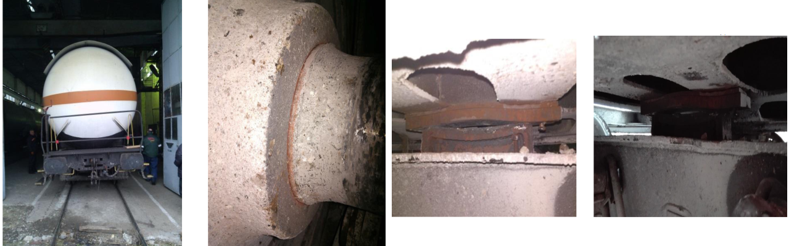Derailment of a tank wagon of train No 30582 at the Dalgopol–Komunari station-adjacent section, on road No 2, on 9 February 2017 (no employees or persons outside the railway system were injured in this accident).

Figure 5: On the front, buffer-side view of the wagon standing on a straight, level track, there is a visible tilt of the wagon body and undercarriage to the side (to the left, in this case). It was subsequently established that this was the side with the loosened wheel-axle press assembly at the first axle box of the first wheelset. The detailed inspection of the running gear of the wagon established that the side bearers (supporting the wagon body and undercarriage on the bogie frame) at the side of the loosened wheel were excessively worn out and chipped off, both on the first and the second bogie.

1. Derailment of electric locomotive No 86018.9 of freight train No 30690 entering the Pirdop station on 4 May 2017 (no employees or persons outside the railway system were injured in this accident).

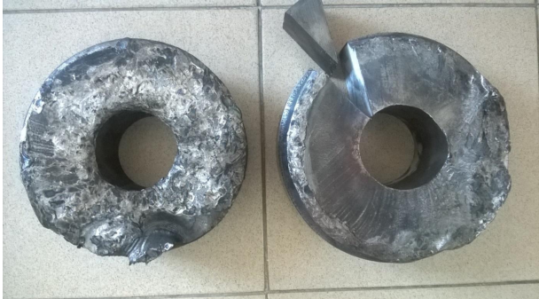

Figure 6: Parts chipped off while running, between the time of the axle break and the time of the locomotive stop

1. 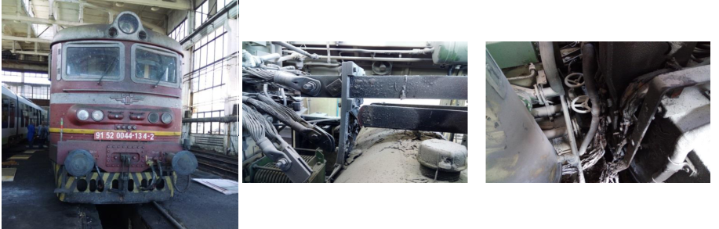Fire in electric locomotive No 44134.2 of intercity train No 8693, at the Dimitrovgrad station on 12 October 2017 (no employees or persons outside the railway system were injured in this accident).

Figure 7: The molten material of the copper bars dripped down to the cables beneath the bars, melted their insulation causing ignition and engine room fire.

|  |  |  |
| --- | --- | --- |
| Safety recommendations received from the NIB of Bulgaria in 2017 | Safety measures taken following the recommendations of Bulgaria’s NIB | Status of implementation |
| *1.*  After the derailment of a tank wagon of freight train No 30582 operated by the Bulgarian Railway Company AD, within the Dalgopol–Komunari station-adjacent section, on road No 2 on 9 February 2017*:* | | |
| 1. Refresh the knowledge and increase the alertness of the Bulgarian Railway Company AD personnel conducting technical inspections at the boundary transitions upon entry of the RS owned by foreign railway carriers operating on the railway infrastructure of the Republic of Bulgaria. 2. Train drivers should be alert for any irregularities occurring during the travel of their operated trains and, upon noticing any faults in the rolling stock, should take timely measures to stop and prevent accidents and incidents. 3. Implement an automated monitoring and control system for the rolling stock in motion to alert on any faults occurring in the running gear (wheelsets, axle boxes, suspension and unevenly loaded wagons). | By letter No 04-15-45/11 August 2017 from the Railway Administration Executive Agency to the Executive Director of the Bulgarian Railway Company AD, in accordance with recommendations 1 and 2 of the Report, and in relation to Article 7(1) and (2) of Ordinance No 56 on the requirements, conditions and procedure for the training of the candidates for the acquisition of qualifications required by the personnel responsible for the railway transport safety, or recognition of such qualifications, and the procedure for conducting examinations of personnel responsible for the transport safety, all persons occupying the following positions: train driver, locomotive; assistant train driver, locomotive, and technician-mechanic/wagon inspector at the Bulgarian Railway Company AD, shall appear at the RRI Sofia, Plovdiv and Gorna Oryahovitsa for a special examination of their knowledge.  By letter No 04-15-45/14 August 2017, the Railway Administration Executive Agency requested from the Chief Executive Officer of the NRIC SE information, by 20 October 2017, on the implementation of recommendation 3 of the Final Report.  For the implementation of recommendations 1 and 2 of the Report, in relation to Article 7(1) and (2) of Ordinance No 56, the RAEA requested all Bulgarian Railway Company AD personnel, occupying the positions of train driver, locomotive; assistant train driver, locomotive, and technician-mechanic/wagon inspector, to appear for a special examination of their knowledge.  By letter Reg. No 04-14-1-36/14 September 2017, the Managing Director of the Bulgarian Railway Company AD sent us a schedule with a list of the names of the personnel, occupying positions subject to special examination. The dates for the examinations to be held on site, in Burgas, Varna, Ruse and Sofia, were endorsed by the managers of the respective RRIs, with the additional option to appear for the examination on Mondays at the respective RRI. Special examinations were passed by a total of 180 employees whose duties were related to transportation safety.  By letter Reg. No RI-37336/24 October 2017, the Chief Executive Officer of the NRIC SE informed us on the action taken to implement recommendation No 3 of the Final Report to deploy, on the railway infrastructure, an automated monitoring and control system for the rolling stock in motion to alert on any faults occurring in the running gear (wheelsets, axle boxes, suspension and unevenly loaded wagons). | All recommendations were implemented. |
| 2. Following the derailment of electric locomotive No 86018.9 of freight train No 30690 operated by DB Cargo Bulgaria EOOD, entering the Pirdop station, on 4 May 2017: | | |
| 1. All technical personnel of DB Cargo Bulgaria EOOD involved in railway transport safety of non-tractive rolling stock must follow strictly and correctly the requirements laid down in Article 243(4) of Ordinance No 58/2006, Article 89(4) and Article 309(1) and (3) of the Rules for the Movement of Trains and Shunting Operations (RMTSO), as well as in the safety management system. 2. The railway carrier, DB Cargo Bulgaria EOOD, must organise training for the locomotive personnel operating the respective locomotive series, at a licensed educational institution, in accordance with the requirements of Article 18, Item 6 of the Vocational Education and Training Act and have new vocational training certificates issued to them, in accordance with Article 44(1), Item 1 of Ordinance No 56/2003. 3. The management of EXPRESS SERVICE LTD. must take measures to carry out thorough ultrasonic defectoscopy of the locomotive wheelsets and axles and ensure the strict application of the locomotive wheelset assembly process. | Sent by letter No 04-05-166/1 September 2017, from the Railway Administration Executive Agency to the Managing Director of DB Cargo Bulgaria EOOD, were recommendations 1 and 2 of the Report with the requirement, by 30 November 2017, to prepare and send to the Air, Water and Railway Transport Accident Investigation Unit (AWRTAIU) Directorate, with a copy to the RAEA, information on the implementation of the recommendations under Item 13 of the Final Report on the investigation of the railway accident.  Sent by letter No 04-05-166/1 September 2017, from the Railway Administration Executive Agency to the Managing Director of EXPRESS SERVICE LTD., was recommendation 3 of the Report with the requirement, by 30 November 2017, to prepare and send to the Air, Water and Railway Transport Accident Investigation Unit (AWRTAIU) Directorate, with a copy to the RAEA, information on the implementation of the recommendation under Item 13 of the Final Report on the investigation of the railway accident.  By letter Reg. No 04-05-166/4 December 2017, the Managing Director of DB Cargo Bulgaria EOOD informed us that:   * Under recommendation No 1, all employees, occupying the position of Wagon Inspector, received a special briefing and signed a statement for the strict adherence to the referenced rules. * Under recommendation No 2, all locomotive drivers at DB Cargo Bulgaria EOOD are employed upon completing a training at a licensed educational institution and obtaining a Locomotive Driver qualification certificate. They complete additional training and examinations for the specific locomotive series they will operate.   By letter Reg. No 04-05-166/8 December 2017, the Managing Director of EXPRESS SERVICE LTD. informed us that:   * Under recommendation No 3, an order was issued to have the personnel responsible for the Ultrasonic Control (USC) and wheelset assembly read the Final Report of the AWRTAIU and hold a special discussion on the adherence to the instructions. The USC instruction for the series 86 000 locomotive axles was reissued, specifically addressing the correct application of the Krautkramer Branson USN 50 Defectoscope Setting Instruction. | All recommendations were implemented. |
| 3. Following the fire in electric locomotive No 44134.2 of intercity train No 8693, at the Dimitrovgrad station, on 12 October 2017. | | |
| 1. Conduct an inspection of the fire-safety installations and main protection devices of all locomotives. | Under Item 1. To reduce the fire hazards caused by cables, cable connections and bars, a recommendation on the operation inspections of the locomotives was issued. | The recommendation was implemented. |
| 1. Following the derailment of freight train No 90570, at switch No 5, entering the Hitrino station, on 10 December 2016. | | |
| In relation to the requirements of Article 94(1) and (3) of Ordinance No 59 of 5 December 2006 on safety management of railway transport, aiming to improve the safety of railway transport, the Railway Administration Executive Agency, acting as National Safety Authority, should direct BULMARKET RAIL CARGO and the NRIC SE to implement the issued safety recommendations.   1. The Railway Administration Executive Agency should recommend to the managers of the railway carriers and to the Chief Executive Officer of the NRIC to conduct discussions with the personnel involved in transport safety and make sure they have read and understood the contents of the Final Report of the conducted investigation. 2. All tank wagons transporting liquified hydrocarbon gases must be equipped with crashworthy couplers and buffers under the requirements of BDS EN 15227:2008+A1:2010 and must have safety certificates. 3. The Railway Administration Executive Agency must issue an order eliminating the option for the owners of wagons for transport of dangerous goods to decide themselves on the intervals between the repairs of the running gear, undercarriage, couplers and buffers, which currently are 4 or 6 years, thereby setting the repair intervals at strictly 4 years, in line with the requirements for the tanks for transport of dangerous goods, as laid down in the RID Regulations. 4. At the border stations, wagons for transport of dangerous goods may be admitted to the country’s railway infrastructure only with documentary proof and guarantee of their good working order by the respective railway carrier. 5. The Railway Administration Executive Agency should organise control examinations for the operating personnel involved in transport safety, in relation to the requirements of Article 6(1) of Ordinance No 56 of 2003, on an ongoing, and not campaign, basis, with mandatory prior trainings, testing not only the theoretical knowledge but also the practical skills of the train drivers on simulators allowing to assess their responses in emergency and stress situations; 6. The Railway Administration Executive Agency must create the technical conditions to provide a recording device of an approved type and require all railway carriers, the Infrastructure Manager and all owners of tractive rolling stock (TRS) to install the device on their tractive vehicles. The device must be built in a way ensuring the recording of the most important travel parameters of the respective vehicle:   ⎫ Travel speed;  ⎫ Travel distance;  Astronomical time;  ⎫ Travel and stoppage times;  ⎫ Train emergency brake activation and whether it was activated by the train driver or from another location in the train;  ⎫ Additional (direct) brake activation;  ⎫ Activation of another type of brake installed on the vehicle and effective brake force values;  ⎫ Controller position (tractive force value);  ⎫ Traction motor currents;  ⎫ Contact network voltage;  ⎫ Diesel (or other) engine speed;  ⎫ Vigilance device readiness maintained by the train driver;  ⎫ Vigilance device state (on/off);  ⎫ Audible alerts activated using the whistle of the tractive vehicle;  ⎫ Personalised vehicle operation by means of an IC, magnetic card or other appropriate identification means and, respectively, preventing its operation without personal identification of the operating personnel;  ⎫ The devices must be designed in a way allowing the transport safety (NSA and institutional) authorities and the investigation bodies to download immediately the information they need without any required conversion or processing;   1. Before any rolling stock moves off to travel on the railway infrastructure, its good working order must be inspected by a wagon inspector, an employee of the railway infrastructure, and certified appropriately in the train records; 2. The Railway Administration Executive Agency must require all carriers to install, on their tractive rolling stock, vigilance devices with variable activation times to avoid monotony for the operating personnel; 3. The management of BULMARKET RAIL CARGO must organise training to obtain professional qualification, for a part of a profession, at a licensed organisation, pursuant to Article 9(5) of the Vocational Education and Training Act (VETA); 4. BULMARKET RAIL CARGO must strengthen its control over the issuance of the travel sheets for its locomotives, the pre-shift briefings to the personnel and the breaks provided under the requirements of the legislation. 5. BULMARKET RAIL CARGO must strengthen its control during the control authorities’ inspections of the good working order of the rolling stock and the personnel involved in transport safety; 6. BULMARKET RAIL CARGO must further detail the requirements for the employment at the company of locomotive drivers, entitled to pension based on social security service and age for the respective occupational category. 7. The NRIC must organise and conduct, for the station personnel at all stations, trainings on the required personnel response upon occurrence of railway accidents. 8. The train schedule for the freight trains carrying dangerous goods must be adjusted to allow transit on the main tracks at the stations, at speeds near the allowable speed for the respective railway sections, with the respective travel time allowances. 9. The NRIC must organise the urgent deployment of the monitoring system for the rolling stock in motion (Check Point) on the railway network of the Republic of Bulgaria. 39 10. The NRIC, jointly with the railway undertakings providing transport with own tractive rolling stock, must organise the urgent deployment of automatic locomotive signalling/road equipment on the main railway network of the Republic of Bulgaria and on-board equipment for the locomotives and multiple units. | Sent by letter No 04-05-292/11 September 2017, from the Railway Administration Executive Agency to the NRIC SE and all carriers, was recommendation No 1 of the Report with the requirement, by 29 December 2017, to prepare and send to the Air, Water and Railway Transport Accident Investigation Unit (AWRTAIU) Directorate, with a copy to the RAEA, information on the implementation of the recommendation under Item 16 of the Final Report of the investigation of the railway accident.  The NRIC SE and all carriers sent responses stating that their personnel involved in transport safety has been briefed, at company discussions, on the contents of the Final Report of the conducted investigation. | Recommendation No 16 was implemented. |

**Table 7: Measures taken by RUs and the IM in Bulgaria following safety recommendations made by the NIB to the NSA in 2017**

# Measures implemented not in relation to safety recommendations.

* + **Safety measures taken as a result of investigated railway accidents and incidents by the NSA and the District Investigation Committees (DICs).**

In 2017, employees of the Regional Rail Inspectorates (RRI) at the RAEA chaired meetings of the District Investigative Committees (DICs) in Sofia, Plovdiv and Gorna Oryahovitsa, where a total of 514 accidents and incidents (precursors of accidents) were investigated as required under Article 78 (3) of Ordinance No 59. For all investigations of accidents and incidents, final reports were created, wherein, as appropriate, instructions and recommendations were given to avoid any recurrence of the violations or invoking the liability of the officials for the train traffic safety violations they have allowed to occur.

**Instructions issued by the ED of the RAEA:**

In 2017, the ED of the RAEA issued eleven instructions, the most significant of which were 2 instructions to the BDZ Passengers and 3 instructions to the NRIC SE.

* The instructions to the BDZ Passengers, in 2017, were related to: 1) Providing information on passengers’ rights, in all stations and passenger wagons, including contact details of the carrier in an appropriate font and placement of stickers with the MTITC hotline; 2) Provision, at all stations, of the ‘Rules of action of the BDZ Passengers and NRIC SE officials in case of violation of the traffic schedule’; 3) Providing the passengers at the Sofia station with accessible information regarding the discontinuation of the services under the Contract for the Public Services Provided within the Railway Transport in Bulgaria.
* In 2017, the instructions to the NRIC SE were related to: 1) Removal of irregularities related to the flooded pedestrian underpass at the Skobelevo stop. Construction of platform shelters for passenger protection and temporary pedestrian bridges at both ends of the platforms to be used by the passengers to cross the tracks until the pedestrian underpass is drained and restored; 2) Providing access for the PRM at the Dragichevo station; 3) Creation of a procedure regulating the expedient introduction, cancellation and adjustment of a train schedule in the event of unforeseen situations occurring during the train travel or immediately prior to its departure, which is agreed with the railway carriers and included in the RD of the network, Annex 4, VII ‘Operational Interaction in Planning and Management of Transport and Operation of the Railway Infrastructure’.

**Instructions issued by RRI employees to the RAEA:**

The inspections conducted, in 2017, by employees (inspectors) of the RRI to the RAEA on sites of RUs and the IM, identified irregularities regarding the observance of the National Safety Rules (NSR) in accordance with the RTA, Ordinance No 58, Ordinance No 56[30], TOR[31], RMTSO[32], etc., whereon 36 statements of railway employee violations and 54 instructions were drawn up (including 27 by RRI Plovdiv, 14 by RRI Sofia and 13 by RRI Gorna Oryahovitsa).

**Safety measures taken by the NSA of Bulgaria as a result of inspections of the IM and RUs conducted in 2017:**

In 2017, employees of the RRI at the RAEA inspected a total of 837 sites and employees and conducted a total of 1224 inspections of the NRIC SE, BDZ Passenger Services Ltd., BDZ Freight Services, private carriers, railway stations, RS (trains, locomotives, DMUs[33]/EMUs[34], self-propelled specialised rail vehicles (SPSRVs), motor-powered draisines), WISs[35], level crossings, railway sections, contact network maintenance sub-areas, EPUs[36], SE[37] sections, passenger and freight centres, locomotive depots, intermodal terminals, construction companies performing RI repairs, licensed carriers and other employees (train and locomotive crews, train traffic controllers of the IM and traffic controllers of RUs).

In 2017, RAEA employees from the RRIs tested a total of 482 employees, occupying positions related to the safety of railway transport, for the use of alcohol and other intoxicating substances.

Implementing the requirements of Article 5 of Ordinance No 56, in 2017, RAEA employees conducted control examinations of 1310 IM and RU employees, occupying positions related to the safety of railway transport, including: RRI Sofia—520, RRI Plovdiv—559 and RRI Gorna Oryahovitsa—231.

## Supervision

## Strategy and Plan(s)

The essential safety requirements are defined in the Railway Transport Act and the statutory instruments. The requirements of the RSD are implemented mainly in Ordinance No 59 on safety management of railway transport, issued by the Minister for Transport, Information Technology and Communications. It introduces the principles of the CSM on the supervision exercised by the NSA after the issuance of the SCs and SAs to PCMs as provided for under Regulation (EU) No 1077/2012.

When defining the supervision strategy and supervision plans of the NSA of Bulgaria, at least the following sources of information are used:

* Monthly and annual information on the state of safety, submitted by the certified railway undertakings and the national RI manager (NRIC SE);
* Daily information from the bulletin on the irregularities on the railway network of Bulgaria, created by the national RI manager (NRIC SE)’s traffic controllers on duty;
* Review of the safety management system documentation and records of the RUs and the IM;
* Review of the system performance results observed during supervisory audits, checks and inspections or other similar activities;
* Results of the accident, incident and NM[38] investigations;
* Received signals and complaints from the IM, RUs, etc.

The annual inspection plans may be revised based on the information received from the monthly analyses, checks and inspections. The main inspection changes are related to the scope and purpose of the inspection in the presence of alarming safety-related information. They are approved by the Executive Director of RAEA and are sent for information to the respective railway undertakings and infrastructure managers. The Annual Supervision Schedule is developed by an Inspector General at the DGRI, endorsed by the Director General of DGRI and approved by the ED of the RAEA.

# Human Resources

The RAEA, through its Directorate General Railway Inspectorate (DGRI), performs its functions as the NSA for the railway transport of the Republic of Bulgaria. Some of its main functions are related to the supervision of the Safety Management Systems (SMSs) of the RUs and IM, as well as the control over the management systems for the PCMs/ECMs of freight wagons and other rail vehicles.

As of 31 December 2017, the DGRI had 30 employees, including 15 inspectors at its territorial units—Regional Railway Inspectorates in Sofia, Plovdiv and Gorna Oryahovitsa. The administrative, legal and financial services for the DGRI are provided, within the RAEA, by the Administrative-Legal and Financial-Economic Management Directorate having a staff of 7 employees.

In 2017, the NSA of Bulgaria conducted 27 SMS audits of RUs certified for freight (11) and passenger (1) transport in Bulgaria, as well as of the State IM (NRIC SE) (1 audit). Eleven of those were scheduled supervisory audits, four were related to safety certificate renewals, three were related to initial certifications, eight were unscheduled and one was related to an amendment. More information on the supervisory audits conducted, in 2017, by the NSA of Bulgaria of the IM and RUs for passenger or freight transport is provided in Table 8 below.

Table 8: Supervisory SMS audits of certified RUs and the IM conducted by the NSA of Bulgaria in 2017

|  |  |  |  |
| --- | --- | --- | --- |
| № | Name of the certified company (IM or RU) | Type of activity | Audit period |
|  | NRIC SE | Infrastructure Manager | between 16 January 2017 and 20 January 2017 |
|  | Bulgarian Railway Company AD (BRC) | RU for freight transport | between 13 February 2017 and 24 February 2017  between 21 August 2017 and 31 August 2017 |
|  | ‘BDZ Freight Services‘ Ltd. (BDZ-FS) | RU for freight transport | between 23 January 2017 and 3 February 2017  between 6 November 2017 and 30 November 2017 |
|  | PIMK Rail PLS | RU for freight transport | between 13 March 2017 and 24 March 2017  between 18 September 2017 and 21 September 2017 |
|  | DB Cargo Bulgaria EOOD | RU for freight transport | between 13 February 2017 and 24 February 2017  between 14 August 2017 and 18 August 2017 |
|  | BULMARKET RAIL CARGO | RU for freight transport | between 13 February 2017 and 24 February 2017  between 10 April 2017 and 21 April 2017  between 1 September 2017 and 8 September 2017 |
|  | Port Rail Ltd. | RU for freight transport | between 24 April 2017 and 28 April 2017  between 25 September 2017 and 29 September 2017 |
|  | TBD–TOVARNI PREVOZI JSC (TBD-TP) | RU for freight transport | between 13 February 2017 and 24 February 2017  between 11 September 2017 and 15 September 2017 |
|  | Rail Cargo Carrier–Bulgaria EOOD | RU for freight transport | between 28 August 2017 and 1 September 2017 |
|  | EXPRESS SERVICE LTD. | RU for freight transport | between 13 February 2017 and 24 February 2017 |
|  | ’BDZ Passenger Services’ Ltd. (BDZ-PS) | RU for passenger transport | between 14 November 2017 and 30 November 2017 |

The SMS audits of the NRIC SE, Bulgarian Railway Company AD, BDZ Freight Services, DB Cargo Bulgaria EOOD, BULMARKET RAIL CARGO, GASTRADE S.A., TBD–TOVARNI PREVOZI JSC, Rail Cargo Carrier–Bulgaria EOOD and BDZ Passenger Services, in 2017, were conducted implementing the 2017 Annual Supervision Plan of the NSA of Bulgaria, while those of SE TRANSPORT CONSTRUCTION AND REHABILITATION, Port Rail Ltd., CARGO TRANS VAGON BULGARIA and EXPRESS SERVICE LTD. were related to freight transport SC renewal applications. Of these, only the SE TRANSPORT CONSTRUCTION AND REHABILITATION was not transporting, and, respectively, did not apply for transport of, dangerous goods (the previous SC included transport of dangerous goods). Only the audit of PIMK Rail PLS was related to an application for the issue of a new SC *(for more information, please see****Section E.1****of the Report*).

In 2017, about 16–18 employees on the average took part in the supervisory SMS audits of the large and medium-sized RUs and the IM (NRIC SE) in Bulgaria, while, for the small RUs, between 6 and 12 RAEA DGRI employees were involved in this activity, for a total of about 3650 hours. So far, the NSA of Bulgaria has not used the services of external experts to exercise supervision of the SMSs of the certified RUs and the IM.

In 2017, the NSA of Bulgaria, as certification authority for the PCMs of freight wagons and tractive rail vehicles (locomotives, EMUs/DMUs, SPSRVs, etc.), conducted a total of 22 audits of RUs holding RS PCM or maintenance function (MF) certificates or applying for new such certificates. Of these, 5 initial certification audits were conducted, including 1 of persons certified to perform the MF and 4 of certified persons in charge of the maintenance.

4 certificate renewal audits were conducted, including 1 MF performance certificate renewal audit and 3 PCM certificate renewal audits. 1 certificate update audit was conducted—1 audit of a person performing a maintenance function and 0 audits of persons in charge of the maintenance.

In 2017, implementing the Annual Supervision Plan of the RAEA, as certification authority of PCMs, a total of 17 annual audits of PCMs of vehicles were conducted. Between 4 and 9 auditors (DGRI employees) took part in these audits and were involved in this activity for a total of about 2750 hours. So far, the NSA of Bulgaria, as certification authority of PCMs, has not used the services of external experts to exercise supervision of PCMs.

In 2017, checks and inspections of railway undertakings and the Infrastructure Manager, related to their transport safety activities, were conducted, involving 14 inspectors from the Regional Railway Inspectorates working for about 9100 hours.

# Competence

The employees of the NSA of Bulgaria exercising control and supervision of RUs and the IM must have the required qualifications, related to the railway transport safety, in accordance with the requirements of Ordinance No 56 of 14 February 2003 on the requirements, conditions and procedure for the training of the candidates for the acquisition of qualifications required by the personnel responsible for the railway transport safety, or recognition of such qualifications, and the procedure for conducting examinations of personnel responsible for the transport safety.

In 2017, no trainings to enhance the supervisory competence and qualifications of the employees of the NSA were conducted.

# Decision-making

Ordinance No 59 introduced the following supervision principles in accordance with Regulation (EU) No 1078/2012: 1) proportionality; 2) coordination; 3) purposefulness; 4) transparency; 5) priorities for efficient resource utilisation and 6) management responsibility and cooperation.

The audits conducted were focused on the verification of the operation of the Safety Management Systems of the railway undertakings and the Infrastructure Manager, as well as of rail vehicle maintenance management systems of the PCMs. For any identified non-conformities, recommendations are created with the respective time limits for implementation.

In the conducted checks/inspections of the railway infrastructure and carriers, the NSA issued instructions and actions were taken to bring sites of the railway infrastructure and rolling stock in conformity with the safety requirements. Upon identifying any faults endangering the transport safety, the NSA inspectors take the respective elements of the RI or RS out of service until the faults are cleared. The IM and the RUs were required to implement the instructions within the specified time limit. The implementation of the instructions and the removal of the non-conformities with the safety requirements are subject to follow-up control by the NSA.

Upon identifying any violations related to the transport safety, the NSA employees draw up administrative violation statements, in accordance with the Railway Transport Act. In 2017, 165 punitive orders were issued by the Executive Director of the RAEA, based on RTA violation statements drawn up by inspectors of the RAEA and employees of the Ministry of Interior.

In 2017, no complaints, submitted by RUs and the IM against decisions made by the NSA of Bulgaria in the course of its supervisory activities, were received.

# Coordination and Cooperation

In 2017, the NSA of Bulgaria did not execute any agreements with NSAs from other EU Member States for any joint supervision of RUs and the IM.

# Findings from Measures Taken

The results of the audits of the SMSs of RUs and the IM, holders of SCs and SAs, conducted in 2017, lead to the conclusion that they comply with the requirements of the European and the national legislation relating to the CSM and CST and maintain functioning SMSs. Certain gaps in the implementation of Regulation (EU) No 1078/2012 and Regulation (EU) No 402/2013 were identified. The railway undertakings, as a result of NSA’s recommendations and instructions, take timely action to remedy the identified non-conformities in their SMS implementations.

## Issuance of safety certificates and authorisations

# Guidance

The RAEA holds a quality management (QMS) certificate issued under the ISO 9001:2008 international standard. As part of the QMS of the RAEA, internal procedures (quality working instructions) were created regulating the procedure and method for the assessment of applications for the issuance of safety authorisations (SAs) to the IM and safety certificates (SCs) to RUs for passenger and/or freight transport. The procedures were issued based on the requirements of the applicable European and national legislation, published on the intranet page of the RAEA and are used by the employees of the NSA of Bulgaria involved in the assessment of the submitted applications. For the applicants, published in Bulgarian language, on the website of the RAEA are: the application, the cover sheet for annexes to the application form, instructions for completing the application form and the general requirements for the issuance of SC to a railway carrier.

In 2017, the following safety certificate (SCs) issuance applications were submitted to the RAEA:

* 3 applications for the issuance of new SCs (Part A and B) to a new RU not holding a licence for shunting within the area of a railway station (Traktsia JSC, Mondi Stambolijski EAD and SIEN 99 Ltd.);
* 1 application for the issuance of updated/amended freight transport (including transport of dangerous goods) SCs to RUs on all lines of the national RI (from TBD–TOVARNI PREVOZI JSC);
* 2 applications for SC (Part A and B) renewals to active RUs for freight transport on all lines of the national RI (BDZ Cargo and Port Rail Ltd.);
* 1 application for SC (Part A and B) renewal to an active RU for passenger transport on all lines of the national RI (BDZ Passengers).

Some details of the safety certificates issued in 2017 to RUs are provided in Table 10 below:

Table 10: SCs and SAs issued by the NSA of Bulgaria in 2017 to RUs and the IM

|  |  |  |  |  |  |  |  |
| --- | --- | --- | --- | --- | --- | --- | --- |
| Applicant  Name of the RU | Date of submission of the application | Date of issuance of the SC/SA | Type of SC/SA | | | Validity | |
| Autho-  risation | Certificate Part A | Certificate Part B | From | To |
| CARGO TRANS VAGON BULGARIA | 27 October 2016 | 11 April 2017 | - | Yes | Yes | 17 April 2017 | 16 April 2022 |
| Mini Maritsa Iztok EAD | 7 October 2016 | 19 April 2017 | - | Yes | Yes | 19 April 2017 | 18 April 2020 |
| TBD–TOVARNI PREVOZI JSC | 12 April 2017 | 20 April 2017 | - | Yes | Yes | 20 April 2017 | 26 August 2020 |
| Port Rail Ltd. | 29 December 2016 | 26 May 2017 | - | Yes | Yes | 29 May 2017 | 28 May 2022 |
| DMV CARGO RAIL LTD | 16 November 2016 | 3 July 2017 | - | Yes | Yes | 3 July 2017 | 2 July 2020 |
| TBD–TOVARNI PREVOZI JSC | 6 October 2017 | 16 November 2017 | - | Yes | Yes | 17 November 2017 | 26 August 2020 |
| Traktsia JSC | 24 August 2017 | 5 December 2017 | - | Yes | Yes | 6 December 2017 | 5 December 2019 |
| ‘BDZ-FS" Ltd. | 28 June 2016 | 21 December 2017 | - | Yes | Yes | 31 December 2017 | 30 December 2022 |
| BDZ Passengers | 28 June 2017 | 22 December 2017 | - | Yes | Yes | 31 December 2017 | 30 December 2022 |

In 2017, no applications for issuance, renewal or update of SAs of RUs were submitted to the RAEA, and no such certificates were issued or revoked.

# E.2. Contacts with Other NSAs

In 2017, there were no inquiries from other EU Member States’ NSAs for the provision of information regarding Safety Certificates Part A of railway undertakings certified by the NSA of Bulgaria applying for a Safety Certificate Part B in another Member State.

In 2017, the NSA of Bulgaria did not make any requests for the provision of information related to Safety Certificates Part A issued in other EU Member States.

# E.3. Procedural Issues

The observations of the NSA of Bulgaria during the implementation of the CSM for assessing conformity with the requirements for obtaining railway safety certificates (Regulation (EU) No 1158/2010/EU) and safety authorisations (Regulation (EU) No 1169/2010/EU), in 2017, show that the IM (NRIC SE) and the railway undertakings (RUs) have adapted their safety management systems (SMSs) to these requirements.

A main area for improvement of the operations of the railway sector in Bulgaria in the field of safety is the implementation of the CSM on risk evaluation and assessment in compliance with the requirements of Regulation No 352/2009/EC, repealed by Regulation No 402/2013.

Another main area for improvement of the operations of the railway sector in the field of safety is the raising of the criteria by the railway undertakings implementing the CSM for monitoring as required by Regulation No 1078/2012/EU.

# E.4. Feedback

The NSA of Bulgaria has good interaction and cooperation with the RUs and the IM. Regular workgroup meetings and sessions are held to discuss various issues relating to emerging problems in railway transport safety, the application of the TSIs and national rules, amendments to existing national technical and safety rules, etc.

The RAEA receives feedback from the businesses and citizens on the quality of the services it offers in the following ways:

1) using its own website and by e-mail;

2) in person, at the front office, or using the mailbox at the entrance of the RAEA;

3) using regular mail.

The instrument, which RAEA has created for the measurement of satisfaction of the citizens and businesses, is completing a feedback survey form by the consumers by electronic means or in person (at the front office). The feedback survey form contains questions relating to the general assessment of the work and competence of the RAEA employees, their interaction with the citizens and the existence of corruption practices.

The data received through the various communication channels are analysed and used to divide the consumers into target groups. Consumers, non-governmental organisations of citizens and businesses and the general public are informed of the action taken and the outcome via the website and on hard copies through the front office of the Railway Administration Executive Agency.

The information of interest to the citizens is available on the information board at the entrance of the MTITC, 7 Kuzman Shapkarev Str., Customer Charter and the RAEA website.

Since 2011, a direct telephone line (+359 2 940 9400) and a special website ([www.transportinfo.bg](http://www.transportinfo.bg/)) are in operation, where citizens and businesses can report irregularities in transport, including railway transport.

## Changes in legislation

# Railway Safety Directive (RSD)

In 2017, no changes were made in the Bulgarian railway legislation in relation to the transposition of the RSD (Directive 2004/49/EC). In the same year, a draft Act to Amend and Supplement the Railway Transport Act was prepared in relation to certain provision amendments with regard to the received reasoned opinion and additional letter of formal notice No C(2016) 2382 under European Commission infringement proceedings 2013/2076 with regard to the incorrect transposition and implementation of Directive 2004/49/EC of the European Parliament and of the Council of 29 April 2004 on safety on the Community’s railways and amending Council Directive 95/18/EC on the licensing of railway undertakings and Directive 2001/14/EC on the allocation of railway infrastructure capacity and the levying of charges for the use of railway infrastructure and safety certification.

***Table 1***, ***Annex C*** of this Report provides details about the changes made in the Bulgarian legislation in relation to the RSD.

# Legislative and regulatory amendments:

In the period between 1 January 2017 and 31 December 2017, in the State Gazette (SG) of the Republic of Bulgaria, the following legislative changes in the field of railway transport were published:

* *Railway Transport Act* (RTA) was amended 2 times in 2016 (SG No 19 and 58 of 2016)—these amendments were not related to railway safety.
* *Ordinance No 41 of 27 June 2001 for access and use of railway infrastructure* was amended and supplemented in SG No 36 of SG of 13 May 2016 on the transposition of the provisions of Directive 2012/34/EU of the European Parliament and of the Council of 21 November 2012 establishing a single European railway area. These amendments were not related to railway safety.
* *Ordinance No 44 of 10 October 2001 on the railway transport of goods* was amended and supplemented in SG No 76 of 30 September 2016. The amendments were related to the introduction of an electronic bill of lading for the railway transport of goods as a transport document having evidentiary force equal to that of the hard copy. The amendments were not related to railway safety.
* *Ordinance* *No 56 of 14 February 2003 on the requirements, conditions and procedure for the training of the candidates for the acquisition of qualifications required by the personnel responsible for the railway transport safety, or recognition of such qualifications, and the procedure for conducting examinations of personnel responsible for the transport safety* was amended in SG No 69 of SG of 2 September 2016, effective as of 1 July 2016, in relation to the transposition of the requirements of Commission Directive (EU) 2016/882 of 1 June 2016 amending Directive 2007/59/EC of the European Parliament and of the Council as regards language requirements. Directive (EU) 2016/882 amends Annex VI, item 8 to Directive 2007/59/EC of the European Parliament and of the Council of 23 October 2007 on the certification of train drivers operating locomotives and trains on the railway system in the Community (Directive 2007/59/EC). The amendment is related to the need of reducing the linguistic requirements for train drivers in respect of sections between the borders of the Member States of the European Union and the stations located near them and designated for carrying out cross-border operations by relieving the train drivers concerned of the linguistic B1 level requirements.
* *Ordinance No 57 of 9 June 2004 on the conditions and essential requirements for the railway infrastructure and rolling stock aimed at achieving interoperability of the national rail system with the rail system within the European Union* was amended in No 1 of SG of 5 January 2016, effective as of 1 January 2016, in relation to the introduction of the requirements of Directive 2014/106/EU[39]. These amendments were not related to railway safety.

Further details regarding the amendments to the Bulgarian legislation relating to the safety of railway transport in Bulgaria, which entered into force in 2016, are provided in ***Table 2*** of ***Annex B*** of this Report*.*

## APPLICATION OF THE CSM RELATED TO REA (RISK EVALUATION AND ASSESSMENT)

Regulation (EC) No 352/2009[40] and Regulation (EU) No 402/2013[41] were implemented in theory in the procedures related to the SMSs of the IM and RUs, which, effectively, are either rarely used or not used at all. During its supervisory activities, the NSA of Bulgaria controls the implementation of risk evaluation and assessment procedures, including assessment of ‘significant’ operational, organisational and other changes.

# NSA Experience.

According to the information received from the annual safety reports of the certified RUs and the IM in Bulgaria and the supervisory audits conducted in the reporting year 2017 in their organisation of work and the types of rolling stock they use, there have been no *‘significant’* changes within the meaning of Regulation (EC) No 402/2013.

# Feedback from Stakeholders.

The NSA of Bulgaria receives information about the application of the CSM on risk evaluation and assessment by RUs, the IM and PCMs/ECMs of vehicles through the supervision it exercises thereof, as required by Regulation (EC) 1077/2012[42], and their annual reports received each year, by 30 June, according to Article 12 and 12a of Ordinance No 59 on safety management in railway transport in the Republic of Bulgaria.

The sector stakeholders (RUs, IM, NoBo, DeBo, AsBo, construction companies, etc.) may express their opinions, comments, proposals, complaints, etc. on all matters relating to the RAEA operations, including on matters relating to the CSM on risk evaluation and assessment, by: electronic means (by e-mail or on the RAEA website), by regular mail or in person—at the front office or using the mailbox located at the entrance of the RAEA and MTITC.

**1. Information on the application of the RE-related CSM within the NRIC SE, in 2017:**

**1.1. General information**

In order to fulfil the requirements for the RE-related CSM, on 10 June 2013, safety procedure *SP 2.09. Risk evaluation, assessment and management methodology*, version 01, related to the SMS of the NRIC SE, entered into force. On 25 November 2015, implementing the requirements of Regulation (EU) No 402/2013, version 02 of the procedure entered into force. In 2017, version 03 entered into force, including the requirements of Regulation (EU) 2015/1136. And, in May 2018, version 04 entered into force.

With regard to the implementation of the RE-related CSM within the NRIC SE, in November 2017, the organisational structure of the Transport Operations Safety Inspectorate (TOSI) with the Safety Transport Inspector General at the Head Office of the NRIC SE was changed and a TSI and Risk Evaluation (RE) unit/sector was created with a staff of five employees: one sector manager and one expert for each of the following subsystems: Infrastructure (INF), Energy (ENE), Control, Management and Signalling (CMS) and Traffic Operation and Management (TOM).

**1.2. Decisions made pursuant to Article 4(1) and (2) of Regulation 402/2013 (whether the proposed change affects safety and whether it is ‘significant’ or not):**

Implementing NRIC SE safety procedure SP 2.09and orders of the Chief Executive Officer, in 2017, the Risk Evaluation Employees (REEs) appointed at the NRIC SE conducted significance assessments of the changes proposed for the following subsystems and projects:

1. for the upgraded INF and ENE subsystems under the project titled *Reconstruction and Electrification of the Dimitrovgrad–Svilengrad–Greek Border*, with regard to the issuance of the Authorisation for Placing into Service (APS) by the NSA of Bulgaria (RAEA) as required by Ordinance No 57 of 9 June 2004 on achieving interoperability of the national railway system with the railway system within the European Union and Directive 2008/57/EC of the European Parliament and of the Council of 17 June 2008 on the interoperability of the rail system within the Community. For the changes proposed in the project, the REE appointed by order No 2285/4 November 2016 of the Chief Executive Officer (CEO) of the NRIC SE decided that they affect safety and are ‘significant’. Thereupon, the procedure continued with the selection of an independent risk assessment body (AsBo), notified body (NoBo) and designated body (DeBo). In late February 2018, the RAEA issued new APSs for both subsystems. (No BG/62/2018/0001 for ENE and No BG/61/2018/0001 for INF).
2. for the upgraded CMS subsystem under the project titled *Reconstruction and Electrification of the Plovdiv–Svilengrad Railway Section*, with regard to its placing into service as required by Ordinance No 57 and Directive 2008/57/EC. For the changes proposed in the project, the REE appointed by order No 2285/4 November 2016 of the CEO of the NRIC SE decided that they affect safety and are ‘significant’. Thereupon, the procedure continued with the selection of AsBo, NoBo and DeBo. In 2017, an application for the issuance of an APS for this subsystem, as required by Ordinance No 57, was submitted to the RAEA and is still under review. In 2018, it is expected for the test operation of the subsystem to be completed successfully and a new APS for it to be issued.
3. for the upgraded INF and ENE subsystems under the project titled Rehabilitation of the Railway Infrastructure on Certain Sections of the Plovdiv–Burgas Railway Line, with regard to their placing into service, as required by Directive 2008/57/EC and Ordinance No 57. For the changes proposed in the project, the REE appointed by order No 2285/4 November 2016 of the CEO of the NRIC SE decided that they affect safety and identified them as ‘significant’. An application for the placing into service of the two subsystems, INF and ENE, as required by Ordinance No 57, was submitted to the RAEA and the respective APSs are expected to be issued in 2018.
4. for the upgraded INF, ENE and CMS subsystems under the project titled *Rehabilitation of the Stara Zagora–Zavoy Railway Section (to km 190+590 within the Yambol–Zavoy Station-adjacent Section) and the Zavoy–Zimnitsa (from km 192+706 to the Entry Switch at the Zimnitsa Station), Including the Main Tracks at the Stara Zagora and Yambol Stations, and All Stations and Stops between Them, with an Approximate Total Length of the Railway of 120 km.* For the changes proposed in the project, the REE appointed by order No 682/31 March 2016 of the CEO of the NRIC SE decided that they affect safety and identified them as ‘significant’. Thereupon, the procedure continued with the selection of the AsBo.
5. for the upgraded INF, ENE and CMS subsystems under the project titled *Rehabilitation of the Tserkovski–Karnobat Railway Section, Including the Main Tracks of the Tserkovski Station, with an Approximate Total Length of the Railway of 28 km, and Renewal of the Railway within the Karnobat–Burgas Section, Including the Main Tracks at the Karnobat and Burgas Stations, and All Stops and Stations between Them, with an Approximate Total Length of the Railway of 122 km*, for the changes proposed under the project, the REE appointed by order No 935/28 April 2016 of the CEO of the NRIC SE decided that they affect safety and identified them as ‘significant’. Thereupon, the procedure continued with the selection of the AsBo.
6. for the ENE subsystem under the project titled: *Rehabilitation of the Railway Infrastructure on Certain Sections of the Plovdiv–Burgas Railway Line—Restoration, Repair and Upgrade of the Stara Zagora and Nova Zagora Traction Substations (TSS) and Creation of a SCADA Remote Control System for the TSSs within the Central Traffic Control Centre (CTCC) Plovdiv*. For the changes proposed in the project, the REE appointed by order No 1773/30 August 2016 of the CEO of the NRIC SE decided that they affect safety and identified them as ‘significant’. Thereupon, the procedure continued with the selection of the AsBo.
7. risk assessment was conducted for the ENE subsystem under the project titled *Rehabilitation of the Railway Infrastructure on Certain Sections of the Plovdiv–Burgas Railway Line—Restoration, Repair and Upgrade of Burgas, Karnobat and Yambol Traction Substations*. For the changes proposed in the project, the REE appointed by order No 1773/30 August 2016 of the CEO of the NRIC SE decided that they affect safety and identified them as ‘significant’. Thereupon, the procedure continued with the selection of the AsBo.

**2. Information on the implementation of RE-related CSM by RUs certified by the NSA of Bulgaria for passenger and freight railway transport, and RS maintenance, in 2017:**

**In 2017, no decisions and no** ‘*significant*’ changes, within the meaning of Article 4 of the RE-related CSM, were made by Bulgarian RUs certified by the RAEA for passenger and freight railway transport, and RS maintenance.

# Revised National Safety Rules (NSR) as a Result of the Implementation of the EU Provisions regarding Risk Evaluation and Assessment.

In 2017, no national safety rules were revised as a result of the implementation of the European Union provisions regarding risk evaluation and assessment.

## DEROGATIONS IN CONNECTION WITH THE SCHEME FOR THE CERTIFICATION OF ENTITIES (PERSONS) IN CHARGE OF MAINTENANCE OF VEHICLES IN ACCORDANCE WITH ARTICLE 14a(8) of DIRECTIVE 2008/110/EC.

In 2017, the NSA of Bulgaria, in its capacity as certification authority of the entities in charge of the maintenance of rail vehicles, did not apply any derogations or alternative measures for their certification in accordance with Article 14a(8) of Directive 2008/110/EC of the European Parliament and of the Council of 16 December 2008 amending the RSD.

## ANNEX A. COMMON SAFETY INDICATORS (CSI)

Data/charts on the performance of the main CSI in the 2013–2017 period

**Data on the indicators related to ‘significant accidents’[43] and ‘precursors**

**of accidents’[44] (incidents) in the period between 2013 and 2017:**

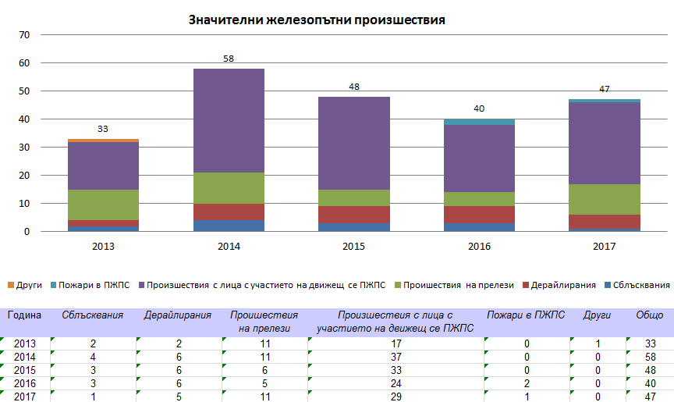

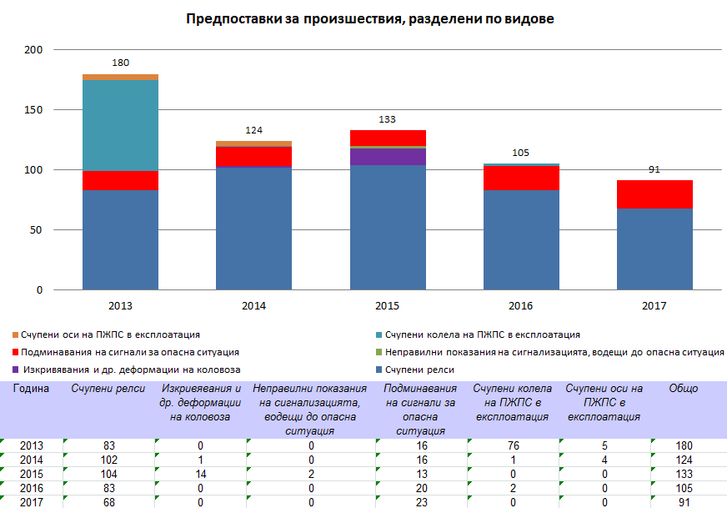

**Dead (killed) persons in railway accidents in Bulgaria, in the 2013–2017 period, divided by type of accident and risk category of the persons:**

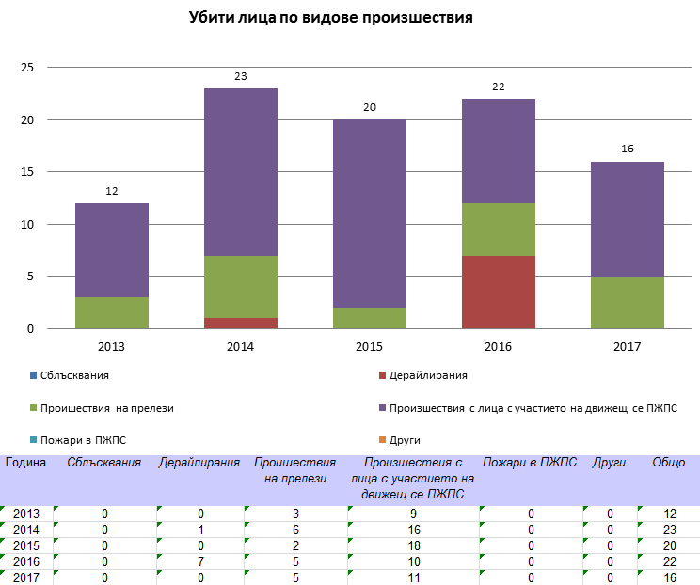

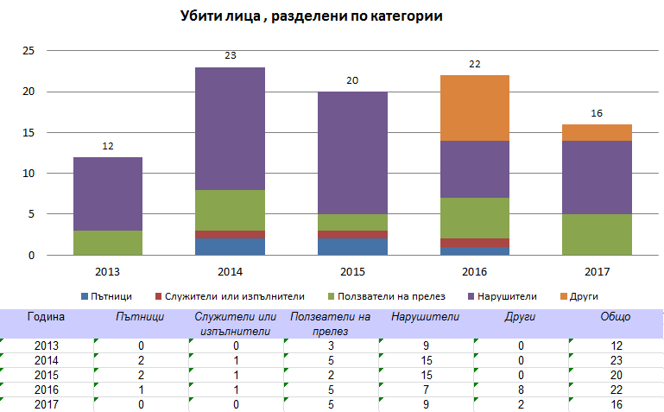

**Seriously injured persons in railway accidents in Bulgaria, in the 2013–2017 period, divided by type of accident and risk category of the persons:**

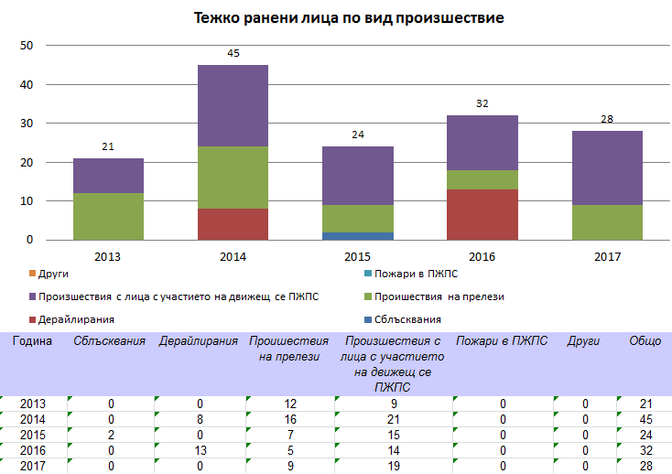

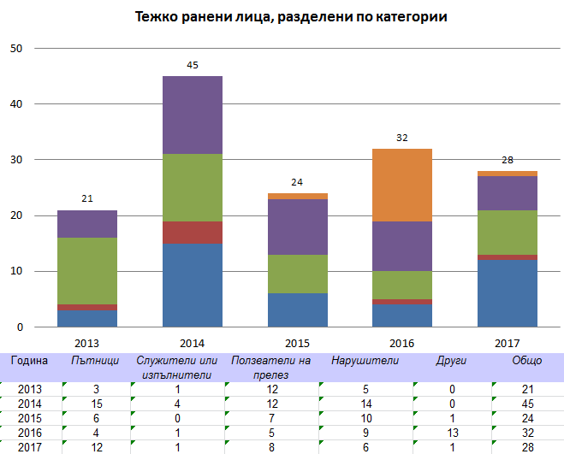

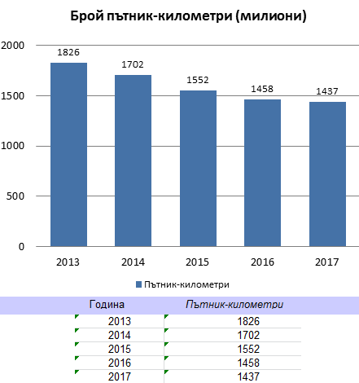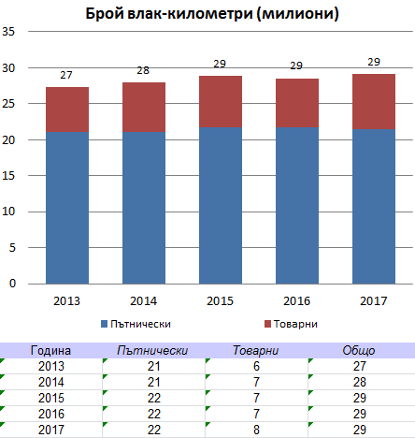**Data on the traffic[45]in Bulgaria in the 2013–2017 period:**

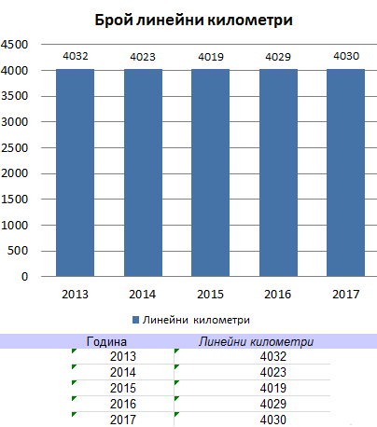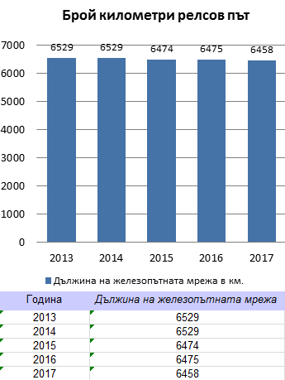

**Data on the technical safety of the railway infrastructure[46]**

**in Bulgaria, in the 2013–2017 period:**

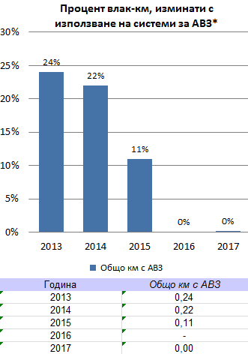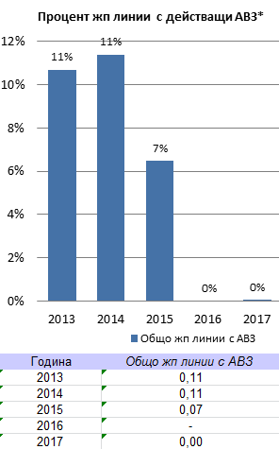

**Data on the total number of railway level crossings in Bulgaria, in the 2013–2017 period, divided into ‘active’ and ‘passive’ level crossings[47]**

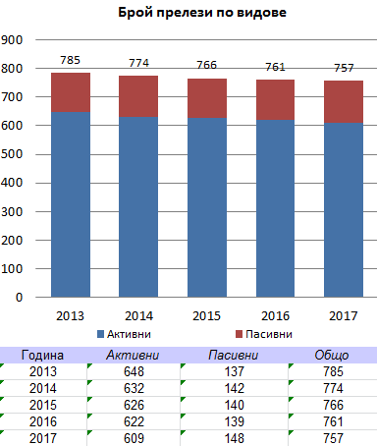

**Fatalities and weighted serious injuries (FWSIs)[48]of persons of the following risk categories: ‘Passengers,’ ‘Employees’ and ‘Level crossing users’ (CST 3.1), in the 2013–2017 period:**

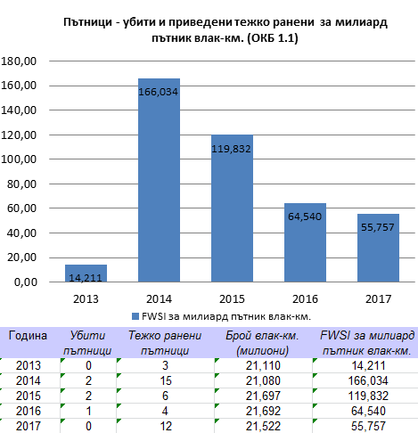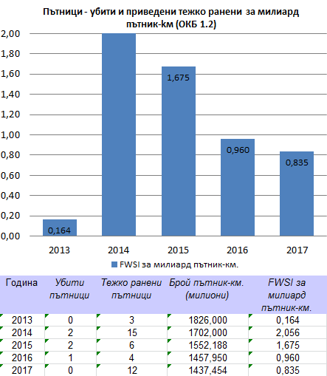

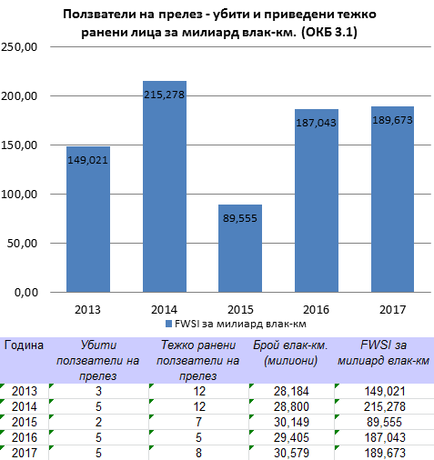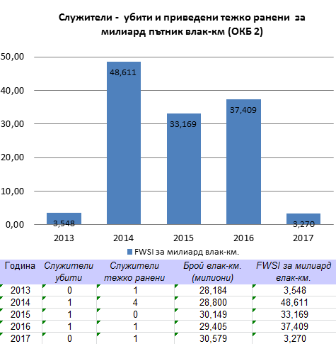

**Fatalities and weighted serious**

**injuries (FWSIs) of persons of the following RCs: ‘Level crossing users’ (CST 3.2), ‘Unauthorised persons,’ ‘Others’ and ‘All,’ in the 2013–2017 period:**

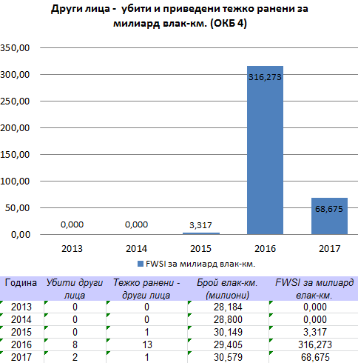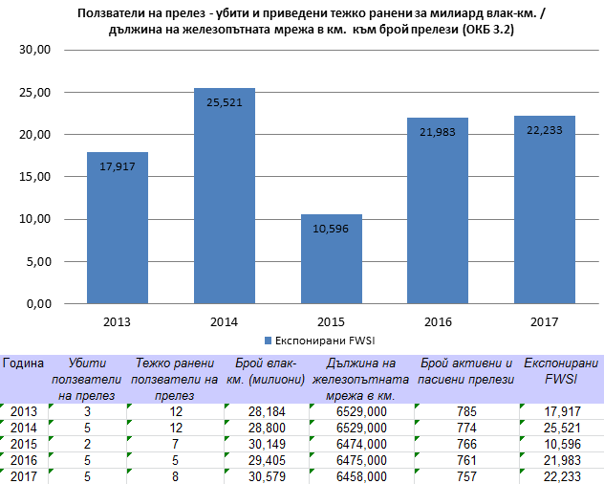

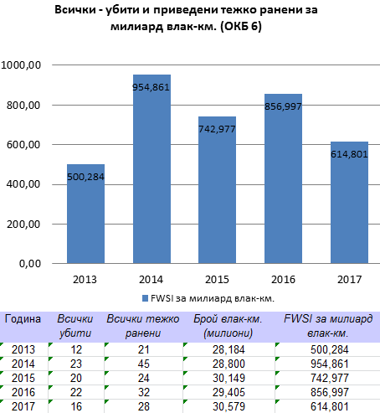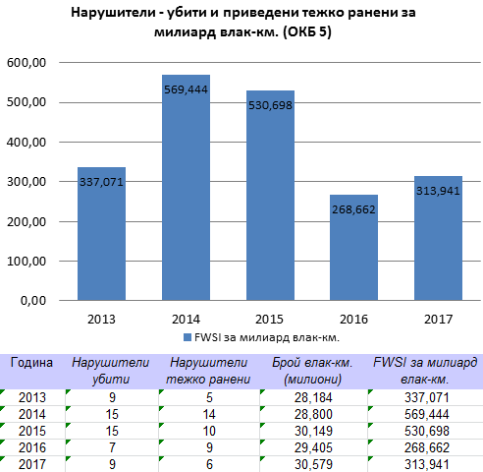

## Annex C. Changes in legislation

**(Annex to Section F of this Report)**

In 2017, in the Bulgarian railway legislation, no amendments were made related to the transposition of amendments to Directive 2004/49/EC of 29 April 2004 on safety on the Community’s railways.

Table 10. Status of the transposition of the amendments to Directive 2004/49/EC in the Bulgarian legislation as of 31 December 2017—Annex to Section F.1 of this Report.

Table 10: Status of the transposition of the amendments to Directive 2004/49/EC in the Bulgarian legislation as of 31 December 2016—Annex to Section F.1 of this Report.

|  |  |  |  |
| --- | --- | --- | --- |
| Amendments  to Directive 2004/49/EC | Transposed  (Yes/No) | Legal references | Date of entry  into force |
| Directive 2008/57/EC | Yes | Ordinance No 57 of 9 June 2004 on the conditions and essential requirements for the railway infrastructure and rolling stock aimed at achieving interoperability of the national railway system with the railway system within the European Union, Chapter V, Section IV ‘Authorisation for placing into service of a vehicle’. | 26 October 2010 |
| Directive 2008/110/EC | Yes | Ordinance No 59 of 5 December 2006 on safety management in railway transport. | 28 December 2010 |
| Directive 2009/149/EC | Yes | Ordinance No 59, Annex 1. | 22 June 2010 |
| Directive 2014/88/EU | Yes | Ordinance No 59, Annex 1. | 31 July 2015 |

# Table 11. Legislative and regulatory changes in the field of railway transport of Bulgaria, published in the State Gazette and entering into force in the period between 1 January 2017 and 31 December 2017 *(Annex to Section F.2 of this Report).*

|  |  |  |  |  |
| --- | --- | --- | --- | --- |
| LEGISLATION  AND REGULATION | Legal references | Entry into force, date | Description of the change | Reasons for the change |
| Concerning the NSA | - | - | - | - |
| Concerning NoBos, DeBos, Assessment Bodies, third parties of registration, examination, etc. | - | - | - | - |
| Concerning the RU/IM/ECM | - | - | - | - |
| Application of other requirements of the EU (relating to railway safety) | Ordinance No 56 of 14 February 2003 on the requirements, conditions and procedure for the training of the candidates for the acquisition of qualifications required by the personnel responsible for the railway transport safety, or recognition of such qualifications, and the procedure for conducting examinations of personnel responsible for the transport safety | amended State Gazette (SG), No 69 of 2 September 2016, effective as of 1 July 2016. | Directive (EU) 2016/882 amends Annex VI, item 8 of Directive 2007/59/EC of the European Parliament and of the Council of 23 October 2007 on the certification of train drivers operating locomotives and trains on the railway system in the Community. The amendment is related to the need of reducing the linguistic requirements for train drivers in respect of sections between the borders of the Member States of the European Union and the stations located near them and designated for carrying out cross-border operations by relieving the train drivers concerned of the linguistic B1 level requirements.  Language B1 level requirements for train drivers are an unnecessarily heavy burden in a number of specific cases where train drivers only reach the border station in the neighbouring Member State and this has an impact on the continuity of cross-border operations.  As a condition for the exemption from the level B1 language requirements, it is foreseen to introduce sufficient measures to ensure communication between the relevant train drivers and the infrastructure manager’s staff in routine, degraded and emergency conditions in order to avoid a possible negative impact on the safety of the railway system. | Transposition of the requirements of Commission Directive (EU) 2016/882 of 1 June 2016 amending Directive 2007/59/EC of the European Parliament and of the Council as regards language requirements |

1. AISIAS—Administrative Information System for Integrated Administrative Services
2. NSA & NIB reports: <https://eradis.era.europa.eu/safety_docs/AnnualReport/default.aspx>
3. <https://erail.era.europa.eu/safety-indicators.aspx>
4. ‘*Significant accident*’ means any accident involving at least one rail vehicle in motion, resulting in at least one killed or seriously injured person, or in significant damage to stock, track, other installations or environment, or extensive disruptions to traffic. Accidents in workshops, warehouses and depots are excluded (definition of Item 1.1 of the Appendix to Annex I of the RSD and Ordinance No 59).
5. *RS*—Rolling Stock
6. ‘*Death (killed person)*’ means any person killed immediately or dying within 30 days as a result of an accident, excluding any suicide (definition of Item 1.18 of the Appendix to Annex I of the RSD and Ordinance No 59).
7. ‘*Serious injury (seriously injured person)*’ means any person injured who was hospitalised for more than 24 hours as a result of an accident, excluding any attempted suicide (Item 1.19 of the Appendix to Annex I of the RSD and Ordinance No 59)
8. *Commission Decision 2009/460/EC* of 5 June 2009 on the adoption of a common safety method for assessment of achievement of safety targets, as referred to in Article 6 of Directive 2004/49/EC of the European Parliament and of the Council
9. ‘*Passenger*’ means any person, excluding a member of the train crew, who makes a trip by a rail vehicle. The accident statistics includes passengers trying to embark onto or disembark from a moving train (item 1.12 of the Appendix to Annex I of the RSD and Ordinance No 59).
10. ‘*Employee or contractor*’ means any person whose employment is in connection with a railway and is at work at the time of the accident, including the staff of contractors, self-employed contractors, the crew of the train and persons handling rolling stock and infrastructure installations (definition of Item 1.13 of the Appendix to Annex I of the RSD and Ordinance No 59).
11. ‘*Level crossing user*’ means any person using a level crossing to traverse the railway line by any means of transport or by foot (Item 1.14 of the Appendix to Annex I of the RSD and Ordinance No 59).
12. ‘*Unauthorised user*’ means any person present on railway premises where such presence is forbidden, with the exception of a level crossing user (definition of Item 1.15 of the Appendix to Annex I of the RSD and Ordinance No 59).
13. ‘*Other person on platform*’ means any person at a railway platform who is not defined as ‘passenger,’ ‘employee or contractor,’ ‘level crossing user,’ ‘unauthorised user’ or ‘other person not on platform’ (definition of Item 1.16 of the Appendix to Annex I of the RSD and Ordinance No 59).
14. ‘*Other person not on platform*’ means any person not at a railway platform who is not defined as ‘passenger,’ ‘employee or contractor,’ ‘level crossing user,’ ‘unauthorised user’ or ‘other person on platform’ (definition of Item 1.17 of the Appendix to Annex I of the RSD and Ordinance No 59).
15. *‘Serious railway accident’* means any train collision or derailment resulting in death of at least one person or serious injuries to at least five persons, or extensive damage to the rolling stock, infrastructure or environment, or any other such accident with apparent impact on railway transport safety regulation or safety management. ‘Extensive damage’ means damage that can immediately be assessed by the investigating body to cost at least EUR 2 million or BGN 4 million in total (definitions of Article 3(l) of the RSD and § 1, Item 16 and 17 of the Supplementary Provisions of Ordinance No 59).
16. ‘*Suicide*’ means an act of intentional self-injury that has resulted in death as registered and classified by the competent national authority (definition of Item 3.1 of the Appendix to Annex I to the RSD and Ordinance No 59). ‘*Attempted suicide*’ means an act to deliberately injure oneself resulting in serious injury (definition of Item 3.2 of the Appendix to Annex I to the RSD and Ordinance No 59).
17. ‘*Precursors of accidents*,’ also known as ‘*incidents*,’ are: 1) ‘*Broken rail*’; 2) ‘*Track buckle or other track misalignment*’; 3) ‘*Wrong-side signalling failure*’; 4) ‘*Signal Passed at Danger when passing a danger point*’;  
    I05) ‘*Signal Passed at Danger without passing a danger point*’;  
    I06) ‘*Broken wheel on rolling stock in service*’;  
    I07) ‘*Broken axle on rolling stock in service*’ (see the definitions given in Items 4.1 to 4.7 of the Appendix to Annex I to the RSD and Ordinance No 59, and Article 68(3) of Ordinance No 59).
18. ‘*Collision of train with obstacle within the clearance gauge*’ means a collision between a part of a train and objects secured or temporarily located on or near the track (excluding any objects on a level crossing lost by traversing vehicles or users), including collision with an overhead contact network.
19. *Commission Regulation (EU) No 1078/2012* of 16 November 2012 on a common safety method for monitoring to be applied by railway undertakings, infrastructure managers after receiving a safety certificate or safety authorisation and by entities in charge of maintenance.
20. *‘Track kilometre*’ means the length measured in kilometres of the railway network in the Republic of Bulgaria, with the exception of the railway lines under Article 2 of the RTA. Each track of a multiple-track railway line is to be counted (definition of Item 7.4 of the Appendix to Annex I to the RSD and Ordinance No 59).
21. ‘*Line kilometre*’ means the length measured in kilometres of the railway network in Bulgaria, with the exception of the railway lines under Article 2 under the RTA. For multiple-track railway lines, only the distance between origin and destination is to be counted.
22. ‘*Passive level crossing*’ means a level crossing without any form of warning system and/or protection activated when it is unsafe for the user to traverse the crossing.
23. ‘*Active level crossing*’ means a level crossing where the crossing users are protected from or warned of the approaching train by the activation of devices when it is unsafe for the user to traverse the crossing.
24. RI—Railway Infrastructure
25. PCM/ECM—Person (Entity) in Charge of the Maintenance of Rail vehicles
26. Regulation (EU) No 445/2011 of the Commission of 10 May 2011 on a system of certification of entities in charge of the maintenance for freight wagons and amending Regulation (EC) No 653/2007.
27. Ordinance No 59 of 5 December 2006 on safety management in railway transport
28. ‘*Train Protection System (TPS)*’ means a system that helps to enforce obedience to signals and speed restrictions;
29. ‘*Level crossing*’ means any level intersection between a road or passage and a railway, as recognised by the infrastructure manager and open to public or private users. Passages between platforms within stations are excluded, as well as passages over tracks for the sole use of employees. They are divided into: *passive and active level crossings*.  
    ‘*Passive level crossing*’ means a level crossing without any form of warning system and/or protection activated when it is unsafe for the user to traverse the crossing.  
    ‘*Active level crossing*’ means a level crossing where the crossing users are protected from or warned of the approaching train by the activation of devices when it is unsafe for the user to traverse the crossing.   
    *Active level crossings* are classified as follows:  
     a) *manual*: level crossings where user-side protection or warning is manually activated by a railway employee;  
    b) *automatic with user-side warning*: level crossings where the user-side warning is activated by the approaching train;  
    c) *automatic with user-side protection*: level crossings where the user-side protection is activated by the approaching train. This shall include level crossings with both user-side protection and warning;  
    d) *rail-side protected*: a level crossing where a signal or other train protection system permits a train to proceed once the level crossing is fully user-side protected and is free from incursion.
30. Ordinance No 58 of 2006 on the rules for technical operation, movement of trains and railway signalling;
31. TOR—Technical Operation Rules of the railway infrastructure, issued by the Chief Executive Officer of the NRIC in 2006
32. RMTSO—Rules on the Movement of Trains and Shunting Operations in the railway transport issued by the Chief Executive Officer of the NRIC in 2006
33. DMUs—Diesel multiple units
34. EMUs—Electric multiple units
35. WISs—Wagon Inspection Sections
36. EPUs—Electricity Public Utilities at the NRIC SE
37. SE—Security Equipment
38. NM—Near Miss
39. Commission Directive 2014/106/EU of 5 December 2014 amending Annexes V and VI to Directive 2008/57/EC of the European Parliament and of the Council on the interoperability of the rail system within the Community.
40. Commission Regulation (EC) No 352/2009 of 24 April 2009 on the adoption of a common safety method of risk evaluation and assessment as referred to in Article 6(3)(a) of Directive 2004/49/EC of the European Parliament and of the Council.
41. Commission Implementing Regulation (EU) No 402/2013 of 30 April 2013 on the common safety method for risk evaluation and assessment and repealing Regulation (EC) No 352/2009.
42. Commission Regulation (EU) No 1077/2012 of 16 November 2012 on a common safety method for supervision by national safety authorities after issuing a safety certificate or safety authorisation.
43. ‘*significant accident*’ means any accident involving at least one rail vehicle in motion, resulting in at least one killed or seriously injured person, or in significant damage to stock, track, other installations or environment, or extensive disruptions to traffic. Accidents in workshops, warehouses and depots are excluded;  
    ‘*significant damage to stock, track, other installations or environment*’ means damage that is equivalent to EUR 150 000 or more;  
    ‘*extensive disruptions to traffic*’ means that train services on a main railway line are suspended for six hours or more;
44. ‘*precursors of accidents*’ are the following types: 1) ‘Broken rail’; 2) ‘Track buckle and other track misalignment’; 3) ‘Wrong side signalling failure’; 4) ‘Signal passed at danger when passing a danger point’ and 5) ‘Signal passed at danger without passing a danger point’
45. ‘*train-km*’ means the unit of measure representing the movement of a train over one kilometre. The distance used is the distance actually run, if available, otherwise the standard network distance between the origin and destination shall be used. Only the distance on the national territory of the reporting country shall be taken into account (definitions of Directive 2014/88/EU amending Directive 2004/49/EC); ‘*passenger-km*’ means the unit of measure representing the transport of one passenger by rail over a distance of one kilometre. Only the distance on the national territory of the reporting country shall be taken into account;  
    * ‘*line km*’ means the length measured in kilometres of the railway network in Member States, whose scope is laid down in Article 2. For multiple-track railway lines, only the distance between origin and destination is to be counted.   
    ** *‘track km’* means the length measured in kilometres of the railway network in Member States, whose scope is laid down in Article 2. Each track of a multiple track railway line is to be counted.’ Official Journal of the European Union BG L 201/17 10.7.2014
46. *‘Automatic Train Protection (ATP)*’ means a system that helps to enforce obedience to signals and speed restrictions by speed control including automatic stop when passing signal at danger;
47. *‘Level crossing*’ means any level intersection between a road or passage and a railway, as recognised by the infrastructure manager and open to public or private users. Passages between platforms within stations are excluded, as well as passages over tracks for the sole use of employees (definitions of Directive 2004/49/EC);  
    ‘*Passive level crossing*’ means a level crossing without any form of warning system or protection activated when it is unsafe for the user to traverse the crossing.  
    ‘*Active level crossing*’ means a level crossing where the crossing users are protected from or warned of the approaching train by devices activated when it is unsafe for the user to traverse the crossing.  
    The ‘-’ *symbol* indicates that no data exist for the respective year.
48. ‘*Fatalities and weighted serious injuries (FWSIs)*’ means a measurement of the consequences of significant accidents combining fatalities and serious injuries, where 1 serious injury is considered statistically equivalent to 0,1 fatalities (letter (d) of Article 3 of Decision 2009/460/EC).