|  |  |
| --- | --- |
|  | REPUBLIC OF SLOVENIA MINISTRY OF INFRASTRUCTURE |

DEPARTMENT FOR THE INVESTIGATION OF AVIATION, MARITIME AND RAILWAY ACCIDENTS AND INCIDENTS

|  |  |
| --- | --- |
| Langusova ulica 4, 1535 Ljubljana | Tel: 01 478 88 51 |
|  | Email: gp.mzip@gov.si |
|  | www.mzip.gov.si |

|  |  |
| --- | --- |
| Ref no: | 010-18/2018/37 |
| ID code: | 00221736 |

**ANNUAL REPORT**

**BY THE RAILWAY INVESTIGATION BODY**

**OF THE REPUBLIC OF**

**SLOVENIA**

**2017**

|  |  |
| --- | --- |
| DSCF1613DSCF1792 |  |
| DSCF1966DSCF1417 |  |

**Ljubljana, 24/09/2018**

# INTRODUCTION

The railway investigating body conducts investigations of accidents and incidents with the aim of improving railway safety and preventing accidents from occurring in the future.

Pending the implementation of the new safety Directive 2016/798/EC of the European Parliament and of the Council of 11 May 2016, the investigating body was in 2017 still working under Safety Directive 2004/49/EC of the European Parliament and of the Council of 30 April 2016, which was transposed into Slovenian law by the adoption of the Railway Transport Act, published in the Republic of Slovenia’s (RS) Official Gazette No 44/2007 of 21 May 2007 and the Act on Safety of Rail Transport, published in the RS Official Gazette No 61/2007 of 10 July 2007.

The 2017 annual report on railway transport safety investigations in the Republic of Slovenia includes a presentation of the organisation of the body, the legal basis for its operation, an overview of the accidents and incidents investigated, and a review of the recommendations issued and accepted in the past year.

**TABLE OF CONTENTS**

|  |  |  |
| --- | --- | --- |
| **Point:** | **Title:** | **Page:** |

INTRODUCTION 1

1 PRESENTATION OF THE ORGANISATION OF SAFETY INVESTIGATIONS 3

1.1. Legal basis (or legal framework) 5

1.2. Application (description of mandate) and objective (or mission) 5

1.3. Internal organisation and subsections 5

1.4. Organisational flow where the national investigating body is within the diagram/scheme 6

1.5. Approach to behaviour in investigating an accident (philosophy and approach to determine investigation of accidents in the country and the level of mobility, readiness and timeliness) 8

2 INVESTIGATION PROCEDURE 10

2.1 Cases investigated: mandatory and non-mandatory under Articles 19 and 21 of the Railway Safety Directive 10

2.2 Institutions participating in the investigations (regularly or exceptionally) 10

2.3 Investigation procedure and the investigating body’s approach (as under point 1.5 but in greater detail) 11

3 INVESTIGATIONS 13

3.1 Overview of investigations completed in 2017 13

3.2 Investigations initiated and completed in 2017 14

3.3 Research (or safety studies in the case of serious accidents), commissioned and completed in 2017 15

3.4 Summary of investigations completed in 2017 Brief descriptions, photographs and diagrams and safety studies 16

3.5 Clarification and introduction or background of the investigations 33

3.6 Accidents and incidents investigated over the past five years (2013-2017) 34

4 RECOMMENDATIONS 36

1 PRESENTATION OF THE ORGANISATION OF SAFETY INVESTIGATIONS

The railway investigating body of the Republic of Slovenia is part of the Department for the Investigation of Aviation, Marine and Railway Accidents and Incidents within the Ministry of Infrastructure, which is directly subordinate to the Ministry’s senior management. Prior to 22 February 2017, since its establishment in 2008, the investigation body acted as a separate organisational unit called the Department for Investigation of Railway Accidents and Incidents.

Only one person is employed at the investigating body for railway accidents and incidents of the Department for the Investigation of Aviation, Marine and Railway Accidents and Incidents, who carries out all tasks identified in the participation in the network of EU investigating bodies under the auspices of the European Union Agency for Railway (ERA).

The railway investigating body is organisationally independent of the national safety and regulatory body for the railway sector. The financial resources for its operation are provided from the budget.

The headquarters of the Department for the Investigation of Aviation, Marine and Railway Accidents and Incident are at the Ministry of Infrastructure, Langusova ulica 4, Ljubljana.

**Project Unit — Office for**

**energy renovation of buildings**

**Department for policy on effective**

**use and renewable energy sources**

**Department for Sustainable Use**

**energy**

**MINISTER’S OFFICE**

**PUBLIC RELATIONS DEPARTMENT**

**INTERNAL AUDIT DEPARTMENT**

**SUSTAINABLE MOBILITY SERVICE**

**AND TRANSPORT POLICY**

**PROJECT UNIT FOR SETTING UP A COMPANY FOR PUBLIC PASSENGER TRAFFIC MANAGEMENT**

**National Centre for Traffic Management**

**Railways and Cableways Sector**

**Road Transport Sector and**

**Logistics**

**Roads Sector**

**Department for European Funds**

**MINISTRY OF INFRASTRUCTURE**

**Maritime Division**

**Aviation Division**

6

**ENERGY**

**DIRECTORATE**

**LAND TRANSPORT**

**DIRECTORATE**

**FINANCE DEPARTMENT**

**ENERGY DIRECTORATE**

**AND MARITIME TRANSPORT**

**STATE SECRETARY**

**MINISTER**

**Legal Department**

**SECRETARIAT**

**Administrative Operations Department**

**DEPARTMENT FOR INTERNATIONAL**

**AFFAIRS AND PROTOCOL**

**DEPARTMENT FOR THE INVESTIGATION OF AVIATION, MARITIME AND RAILWAY ACCIDENTS AND INCIDENTS**

**General Affairs and Informatics**

**Human Resources department**

**Public Procurement Department**

**Legal and International Energy Affairs Division**

**Energy Supply Division**

**Low-Carbon Society Division**

* 1. 1.1. Legal basis (or legal framework)

The legal basis for the operation of the railway investigating body for the year 2017 is laid down in Article 26 of the Railway Transport Act (ZZelP-UPB8), Official Gazette of the Republic of Slovenia No 99/2015 of 21 December 2015.

The railway investigating body is organisationally, financially and legally independent from the infrastructure manager, railway undertakings, the body responsible for setting infrastructure charges, the body for allocation of infrastructure capacity and the notified body.

The investigating body is also functionally independent from the safety and regulatory body.

* 1. 1.2. Application (description of mandate) and objective (or mission)

The principal investigator of railway accidents for the Ministry of Transport of Slovenia is appointed on contractual basis for an indefinite period of time and carries out safety investigations of serious accidents, accidents and incidents.

Investigations of serious accidents, accidents and incidents is carried out with the view to improving railway safety. The principal investigator for railway accidents and incidents of the Ministry of Transport of Slovenia cooperates with the investigative bodies of other railways from the EU, participating in the network of national investigating bodies under the auspices of the European Union Agency for Railways (ERA).

* 1. 1.3. Internal organisation and subsections

The Department for the Investigation of Aviation, Maritime and Railway Accidents and Incidents is part of the Ministry of Infrastructure, which is responsible for transport. The Department for the investigation of aviation, maritime and railway accidents and incidents has no subdivisions.

The Department for the investigation of aviation, maritime and railway accidents and incidents, as well as the internal systematisation within the Ministry, has one employment position, e.g. the chief railway accident investigator. When investigations into accidents and incidents are carried out, the chief investigator for railway accidents and incidents does not operate alone with financial resources earmarked under the budget for the needs of investigations of accidents and incidents, but instead the funds are managed by the budget line manager, a unit for the whole office.

The chief investigator is trained to carry out all necessary investigative functions in the event of an accident or a serious incident.

AVIATION

1 person serving as Head of Office/Chief Investigator

1 person serving as Coordinator/Administrator

1 Secretary

JOINT BODY

for the investigation of aircraft, maritime and railway accidents and accidents

MARITIME TRANSPORT

1 Chief investigator

RAIL TRANSPORT

1 Chief investigator

* 1. 1.4. Organisational flow where the national investigating body is within the diagram/scheme

The Department for the investigation of aviation, maritime and railway accidents and incidents of the Ministry of Transport conducts a safety investigation of accidents and incidents separately, according to various traffic branches, and acts independently.

The railway investigating body cooperates with other national investigating and judicial bodies, the railway safety body, the railway infrastructure manager, and all licensed railway undertakings in Slovenia.

**MINISTRY OF INFRASTRUCTURE**

**REPUBLIC OF SLOVENIA**

**Department for the investigation of aviation, maritime and railway accidents and incidents**

**Public Agency for Railway Transport of the Republic of Slovenia**

**Railway infrastructure manager (Slovenske železnice-Infrastruktura d.o.o.)**

**Slovenske železnice**‑**Vleka in tehnika, d.o.o. (SŽ**‑**VIT, d.o.o.)**

**Slovenian Ministry of the Interior**

**undertaking Slovenske železnice**‑**Tovorni promet d.o.o. (railway undertaking)**

**Ministry of Justice**

**REPUBLIC OF SLOVENIA**

**undertaking Slovenske železnice**‑**Potniški promet d.o.o.**

**undertaking RCC - Rail Cargo Carrier –**

**Slovenia, d.o.o.**

**undertaking Adria transport d.o.o.**

**Luka Koper d.d.**

**Primol-Rail, d.o.o.**

Where necessary, it also cooperates with the national investigating bodies of EU Member States operating within the network of national investigating bodies under the auspices of the European Union Agency for Railways (ERA).

It obtains necessary information from all the above mentioned entities for investigation procedures As railway accident investigations are conducted as openly as possible, all those involved and all interested parties are entitled to be heard and to make use of the results of investigations.

The Ministry of Transport, with jurisdiction over the Department for the investigation of aviation, maritime and railway accidents and incidents, ensures there is independence of operations and financial resources from the budget. The Ministry does not interfere with the investigating body’s independence.

Under the provisions of Article 35 of the Railway Safety Act (ZVZelP-UPB3, UL RS, No 56/2013, 2 July 2013), the railway infrastructure manager and railway undertakings must immediately notify the investigating body of all serious railway accidents, accidents and incidents.

The investigating body is notified by telephone, and subsequently also in writing on the prescribed ID-1 form.

* 1. 1.5. Approach to behaviour in investigating an accident (philosophy and approach to determine investigation of accidents in the country and the level of mobility, readiness and timeliness)

Under the provisions of Article 29 of the Railway Safety Act (ZVZelP-UPB3, UL RS, No 56/2013, 2 July 2013), the competent authorities, railway undertakings, the railway infrastructure manager and other entities involved must enable the investigating body to conduct its tasks efficiently, speedily and independently. In the light of past practice, it should be stressed that statutory provisions are consistently complied with.

Article 26 of the Railway Transport Act (ZZelP-UPB8, UL RS, No 99/2015, 21 December 2015) provides that the investigating body must investigate all serious accidents.

The investigating body may, at its own discretion, also decide to investigate accidents and incidents that could cause accidents in similar circumstances, including cases of technical malfunctions of structural subsystems or railway system interoperability components.

The investigating body complies with all the provisions of the relevant act. Due to a shortage of staff, the body charged with investigating railway accidents and incidents is obliged to consider, in particular, which accidents or incidents (in addition to serious accidents) will be investigated.

In addition to its normal working hours, the investigating body for the investigation of accidents and incidents is also on permanent standby.

The chief investigator has an official identity card that outlines his powers and proves his identity. The official card is prescribed by the Minister for Transport.

One of the Ministry of Infrastructure’s official cars is at the disposal of the chief investigator. Should a vehicle not be available, the chief investigator’s own vehicle is used.

The organisation of readiness and mobility as outlined above ensures that the investigator is able to inspect the scene of an event and launch investigative procedures in good time.

From his home and workplace, both located in central Slovenia, the chief investigator is two hours away from the furthest point of the railway network when travelling by car and in view of the roads available.

2 INVESTIGATION PROCEDURE

* 1. 2.1 Cases investigated: mandatory and non-mandatory under Articles 19 and 21 of the Railway Safety Directive

The investigating body investigates serious railway accidents, accidents and incidents. Under the Railway Transport Act (ZZelP-UPB8, UL RS, No 99/2015 of 21 December 2015), the investigating body investigates all serious accidents and may, at its own discretion as prescribed, also decide to investigate accidents, and incidents that could have caused serious accidents in similar circumstances, including cases of technical malfunctions of structural subsystems or railway system interoperability components.

A serious accident under the Railway Safety Act (ZVZelP-UPB3), Official Gazette of the Republic of Slovenia, No 56/2013 of 2 July 2013, means any train collision or derailment, resulting in the death of one or more persons or more serious injuries to five or more persons, or resulting in serious damage to rolling stock, infrastructure, or causing significant pollution of the environment, and any other similar accident with an obvious impact on safety or safety management. Significant damage means material damage that can be immediately assessed by the chief railway accident investigator at not less than EUR 2 million.

The Slovenian railway investigating body complies with the above legal provisions and investigates all serious accidents, as well as accidents and incidents that could cause serious accidents or accidents in similar circumstances. It conducts its own investigations as regards accidents and incidents.

* 1. 2.2 Institutions participating in the investigations (regularly or exceptionally)

The chief railway accident investigator at the Ministry of Transport regularly includes reports drawn up by officials at the Ministry of the Interior and, in exceptional circumstances, by judicial bodies.

Where a need arises for analysing chemical substances and other types of material, the investigating body engages competent independent and licensed organisations with laboratories for the investigation, e.g. the Jožef Stefan Institute, the Institute for Materials Research, the Institute for Metal Structures, etc.

If there is a need to examine the bodies of victims, the Institute of Forensic Medicine is also involved.

When the need arises to reproduce verbal communications, experts from the infrastructure manager who manage these devices are involved in the investigation. Experts from the infrastructure manager are also involved when analysing signalling safety component databases. Experts are also involved when an analysis of train movement databases is needed.

* 1. 2.3 Investigation procedure and the investigating body’s approach (as under point 1.5 but in greater detail)

Under Article 29 of the Railway Safety Act (ZVZelP-UPB3, UL RS, No 56/2013, 2 July 2013), the competent authorities, railway undertakings, the railway infrastructure manager and other bodies involved must enable the investigating body to conduct its tasks efficiently, speedily and independently, as has been the case so far.

Article 29 of the Railway Traffic Safety Act (ZVZeIP-UPB1, UL RS, No 56/2013, 2 July 2013) makes it obligatory for the competent authority, railway undertakings, the railway infrastructure manager and other entities involved to provide the investigating body with:

a) free access to the site of the accident, serious accident or incident, to the rolling stock and infrastructural facilities involved, and to traffic control and signalling facilities and devices;

b) an immediate listing of evidence and the controlled removal of wreckage, infrastructural facilities and devices, or their components, for examination or analysis;

c) access to and the use of the contents of on-board recorders of verbal messages and registration of signalling operations, traffic control and the traffic management system;

d) access to results of examinations of bodies of victims;

e) access to results of examinations of train staff and other persons involved in the accident;

f) questioning of railway staff involved and other witnesses;

g) access to all relevant information or records held by the infrastructure manager, railway undertakings involved and the safety authority.

Article 26 of the Railway Transport Act (ZZelP-UPB8, UL RS, No 99/2015 of 21 December 2015) provides that the investigating body must investigate serious accidents.

The investigating body may, following an assessment, also decide to investigate accidents, and incidents that could cause accidents in similar circumstances, including cases of technical malfunctions of structural subsystems or railway system interoperability components. It will take the following into consideration in its decision:

a) the seriousness of an accident or incident;

b) whether an accident or incident is part of a series of accidents or incidents affecting the entire system;

c) the impact on railway safety at European Union level, and

d) the requirements of infrastructure managers, railway undertakings, the safety authority or European Union Member States.

The railway investigating body complies with all the prescribed provisions applicable to investigative procedures. However, due to limitations of human resources, it must further assess which accidents and investigations is wishes to investigate.

3 INVESTIGATIONS

* 1. 3.1 Overview of investigations completed in 2017

The investigating body for railway accidents and incidents investigated six accidents in 2017:

* derailment of local passenger train No 2402 at points No 12, at 586 + 276 km, at Škofja Loka station, at 06:56 on 6 January 2017. The train derailed due to a failure to comply with the prescribed protocol. There was material damage;
* collision of local passenger train No 3516 with a road motor vehicle, at the established level crossing, equipped with road signs, between Celje and Žalec stations, 7 + 632 km, on 18 April 2017 at 20:02). The collision occurred due to a failure to comply with road traffic rules, and indirectly due to poor visibility at the level crossing. The passenger died from injuries at the site of the accident while the driver died at the hospital in Celje:
* collision of E-locomotive 541 + 008 with train No 38008 (empty passenger electric set), at points No 33 and 41 at Ljubljana station, 564 + 890 km, at 19:14 on 16 June 2017. The cause of collision was the failure to secure the vehicles to prevent them from moving. There was material damage;
* derailment of international freight train No 43601 of the Slovenian undertaking SŽ-Tovorni promet, d.o.o., on points No 25 at Zidani Most station, 502 + 771 km, at 18:13 on 19 June 2017. The cause of the accident was the broken points (No 25) at Zidani Most station. There was material damage;
* derailment of international freight train No 49485 by the Slovenian undertaking SŽ-Tovorni promet, d.o.o., at points No 6 of Kranj station, at 594 + 233 km, at 17:53 on 11 July 2017. The cause of the accident was blind sediment in the area of the points. There was material damage;
* collision of freight train No 55215 into a girl on a bicycle, at a regulated level crossing, equipped with road signs, between Jarše Mengeš and Domžale stations, at 14 + 117 km, at 15:52 on 16 August 2017. The cause of the accident was failure by the cyclist to comply with road traffic rules and, indirectly, poor visibility at the level crossing The cyclist died from injuries at the site of the accident;
* collision of train No 76311 (special purpose use track vehicle) with a passenger road motor vehicle, at the regulated level crossing, equipped with road signs, between Ruše and Maribor Studenci stations, at 8 + 824 km, at 9:06 on 17 August 2017. The cause of the accident was failure by the driver of the passenger road motor vehicle to comply with road traffic regulations as well as poor visibility at the level crossing. The driver of the passenger road motor vehicle died from injuries at the site of the accident.

|  |  |  |  |  |  |
| --- | --- | --- | --- | --- | --- |
| **Type of accident investigated** | **Number of incidents** | **Number of casualties** | | **Damage in EUR (estimated)** | **Trend in comparison with 2016** |
| **Number of fatalities** | **Seriously injured** |
| Train collision | 1 | 0 | 0 | 55 523.90 EUR | 1 > 0 |
| Train derailment | 2 | 0 | 0 | 850 000.00 EUR | 2 > 0 |
| Other | 4 | 5 | 2 | 5 500.00 EUR | 4 < 5 |

* 1. 3.2 Investigations initiated and completed in 2017

1. In 2017, eight accident investigations were initiated and seven were completed. The investigation of the derailment of the freight train is at the stage of the final report being issued.

|  |  |  |  |  |
| --- | --- | --- | --- | --- |
| **Investigations closed in 2017** | | | | |
| Date of accident or incident | Type of accident or incident | Place of accident or incident | Legal basis | Date of completion of investigation |
| 06.01.2017 | derailment of local passenger train 2402 | points No 12 at Škofja Loka station | Article 26 of the ZZelP | 12.08.2017 |
| 18.04.2017 | collision of local passenger train No 3516 with the passenger road motor vehicle | between Celje and Žalec stations — level crossing 7.6 | Article 26 of the ZZelP | 27.10.2017 |
| 16.06.2017 | collision of locomotive No 541-008 and train No 38008 | points No 42 at Ljubljana station | Article 26 of the ZZelP | 06.11.2017 |
| 19.06.2017 | derailment of international freight train No 43601 | points No 25 at Zidani Most station | Article 26 of the ZZelP | 20.11.2017 |
| 11.07.2017 | derailment of international freight train No 49485 | points No 6 at Kranj station | Article 26 of the ZZelP | 04.12.2017 |
| 16.08.2017 | collision between freight train No 55215 and a cyclist | between Domžale and Jarše Mengeš stations, level crossing 14.11 | Article 26 of the ZZelP | 14.12.2018 |
| 17.08.2017 | collision of special purpose railway train No 76311 with a passenger road motor vehicle | between Maribor Studenci and Ruše stations, level crossing 8.8 | Article 26 of the ZZelP | 18.12.2018 |
| 17.09.2017 | Derailment of freight train No | Right track between Logatec and Verd stations at 602 + 916 km | Article 26 of the ZZelP | The investigation is at the stage of the final report being issued. |

In 2017, the investigating body started an investigation of accidents and incidents for eight accidents, all on the basis of Article 19(2) of Directive 2004/49/EC of 29 April 2004.

* 2. 3.3 Research (or safety studies in the case of serious accidents), commissioned and completed in 2017

In the Republic of Slovenia’s railway network, eight accidents occurred in 2017, claiming five human lives, while two people suffered serious injuries. There were no serious railway accidents in 2017.

In the last 10 years there have been no railway accidents in the Slovenian railway network similar to railway accidents in the past.

The last serious accident, resulting from the collision of international passenger train No 314 with faulty electromotor passenger train set No 2405, on track No 3 (three) at Ljubljana Vižmarje station, occurred on 28 October 2012.

Before this serious accident occurred, there was a collision of freight and passenger trains at points No 3 at Jesenice station on 26 August 2011. Human factors were the cause of both accidents. On 28 October 2012 a passenger train collided with a static broken-down passenger train as a result of an error by an infrastructure worker (the train controller at Ljubljana Vižmarje station), while the collision between the passenger and goods trains at Jesenice station on 26 August 2011 was the result of an error by a railway undertaking worker (train driver).

It was not necessary to compile a research study on safety for these two cases as the cause in both cases was investigated and established in detail. Despite the similarity between the causes of the two accidents, additional research was not required, as it could in no way be claimed that the two cases raised wider concerns or that similar accidents could occur in the future.

All three accidents at level crossings occurred at passively protected level crossings. Two level crossings are for all types of road traffic and one crossing is for pedestrians and cyclists. All three level crossings are marked by road traffic signs.

In the accident on the passively protected level crossing between the stations Celje and Žalec, a younger driver of a passenger road motor vehicle drove the vehicle directly in front of the train. A young girl died from injuries at the site of the accident, and the driver died from injuries while being treated at Celje hospital.

In the accident on the passively protected level crossing at Rodica stop, between Domžale and Jarše Mengeš stations, a younger cyclist, cycling with a group of peers, cycled directly in front of the locomotive freight train while all other cyclists stopped before the crossing. The cyclist died from injuries at the scene of the accident.

In the accident at the passively protected level crossing between the stations Maribor Studenci and Ruše, a driver of a passenger road motor vehicle drove directly in front of a special railway purpose train. The driver suffered serious injuries and died while being transported to the University Clinical Hospital in Maribor.

After an in-depth investigation it was found that all three passive protected level crossings for road transport users were marked in accordance with the rules. The cyclist and the driver of the passenger road motor vehicle drove onto the track without first checking if rolling stock was approaching the level crossing. During the investigation it was also found that the visibility at level crossings was exceptionally poor at the time of the accident.

In 2017, four trains were derailed and one train collided with an operating locomotive. At Škofja Loka station, a local passenger train derailed due to a failure to observe the prescribed protocol for driving the train through points which were broken.

At Zidani Most station, the international freight train derailed due to a breakage on the points. The break was caused by wear and tear on the material of the points.

At Jesenice station, the international freight train derailed while departing from the station onto the exit points. The cause of derailment was blind blank sediment — hidden sediment on points No 6.

The investigation of the derailment of the closing wagon of the international freight train between Logatec and Verd stations is not yet completed.

The cause of collision of the operating locomotive in the train - an empty passenger electromotor train set - on points No 42, during the approach into the Ljubljana station, was that the locomotive was not secured to prevent it from moving.

* 1. 3.4 Summary of investigations completed in 2017 Brief descriptions, photographs and diagrams and safety studies

**Derailment of local passenger train No 2402 at points No 12 of the Škofja Loka station, at 06:56 on 6 January 2017.**

On 6 January 2017, on the Ljubljana - Jesenice route, local passenger train No 2402 was travelling. At Škofja Loka station, the train has a scheduled arrival of 06:37 and a departure time of 06:38. On 6 January 2017, the train was late according to the schedule and arrived at Škofja Loka station at 06:51:08 and continued at 06:55:55, as evidenced by the train running electronic record. While departing from the station, the train derailed with both front wheels of the first axle on points No 12, at a speed of 7 km/h, at 06:56:26.

The driver of train No 2402 received permission to run the train past departure signal SI-12 at Škofja Loka station from the line controller of the Ljubljana central management centre, giving the signal: 'Stop'.

During the visit at the scene of the incident, on the basis of the state of points elements and traces of derailment on the external right switch, it was found that points No 12 were not positioned correctly and accurately as prescribed by Article 20(12) and (13) of the Transport Regulation [OJ RS, No 50/2011 of 27 June 2011](http://www.uradni-list.si/1/index?edition=201150#!/Uradni-list-RS-st-50-2011-z-dne-27-6-2011).

Transport Regulation ([OJ RS No 50/2011 of 27 June 2011](http://www.uradni-list.si/1/index?edition=201150#!/Uradni-list-RS-st-50-2011-z-dne-27-6-2011)), Article 102(6)-(11) prescribes the handling if, at a station to which the main signals are handled by a controller from another station or by a line controller, the correct and accurate position of points is not notified. In this case, the railway line shall give the train driver a train, which has been stopped before the main signal, to inspect and secure points of contact that cannot be controlled in order to travel to a given track. The line controller gives orders to the train driver by a phonogram through communication means.

In case of the derailment of train No 2402 on 6 January 2017, on the basis of the electronic video of communication between the line controller at the Ljubljana traffic management centre and the driver of train No 2402 and, on the basis of the state of the points immediately following the derailment, it was established that the line controller did not give an order to the driver of train No 2402 to manually secure points No 12 with a lock, as prescribed by Article 115 of the Transport Regulation 2 [OJ RS No 50/2011 of 27 June 2011](http://www.uradni-list.si/1/index?edition=201150#!/Uradni-list-RS-st-50-2011-z-dne-27-6-2011)).

During the analysis of the records, looking at the method of derailment and the condition of the points immediately after derailment, it was established that two front wheels of the first axle of the bearing cart of train No 2402 derailed at points No 12 at Škofja Loka station at 06:56 on 6 January 2017, because the train moved through unsecured points which were not in the correct and accurate position for the intended journey. The order to run through unsecured points was given to the train driver by the line controller of the Ljubljana traffic management centre.

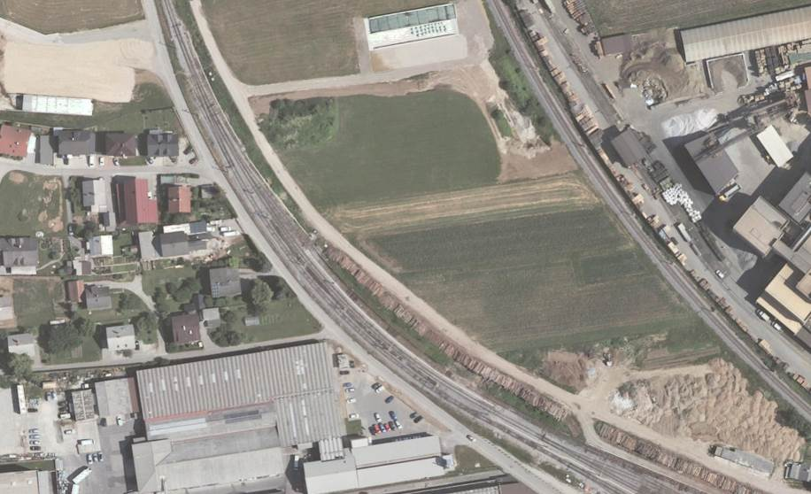

Figure 1: The derailment location is identified by the green cross; the running direction of the passenger train is identified by the red arrow.

**Causes:**

The direct cause of the derailment of local passenger train No 2404, at 06:56 on 6 January 2017, at points No 12 of Škofja Loka station, was a failure to comply with the protocol for train movement through points which do not have a control on the position, as a result of which the departure signal was: 'Stop'.

The indirect cause of the derailment was the irregular communication of the line controller of the Ljubljana transport management centre with the driver of train No 2402.

**Recommendations:**

In order to avoid similar accidents, two recommendations were issued.

A recommendation was issued to the infrastructure manager of SŽ — Infrastruktura d.o.o.:

1. it is recommended that, within the framework of the railway traffic safety management system, during the regular periodic training process of line controllers, training on how to act by line controllers is to be refreshed for cases when a safety device does not show the correct and exact position of points, as a result of which the main signals cannot indicate the signals allowing the run.

The recommendation has been issued to the operator of SŽ — owed):

1. It is recommended that within the safety management system for railway transport, there is a regular periodic training process for train drivers of SŽ – Vleka in tehnika d.o.o., training on how to act by line controllers is to be refreshed for cases when a safety device does not show the correct and exact position of points, as a result of which the main signals cannot indicate the signals allowing the run.

**Collision of local passenger train No 3516, on the established level crossing, equipped with road signs, between Celje and Žalec stations, at 20:24 on 18 April 2017.**

At 20:02 on 18 April 2017, passenger train No 3516, on the established level crossing, equipped with road signs, between Celje and Žalec stations, at 7 + 632 km, collided into a passenger road motor vehicle.

At the scene of the accident, a 16-year old passenger in the passenger road motor vehicle died from injuries. The 19-year old driver suffering a serious personal injury and a 20-year old passenger suffering lighter injuries were both taken by an ambulance to the hospital in Cele. The 19-year old driver succumbed to his injuries in the hospital in Celje on 24 November 2017.

Train No 3516, in the formation DMG 813/814-120, was running from Celje station towards Žalec station, on the single-track non-electrified line, Celje – Velenje. The head of the train had the unit DMG 813-120. Passenger road motor vehicle, Daewoo Kalos, reg. no. CE EF-254, was driving towards the level crossing from the direction Dobriša vas, towards regional road R-2 (category 2 regional road), designation 447, section 287 (section Petrovče — Žalec), from the house at the address Dobriška vas 21a, towards the house at the address Dobriška vas 17.

Train No 3516 last stopped at the Petrovče stop, at 7 + 000 km, to the point of collision at the level crossing at 7 + 632 km it had to run 632 m. The train then collided into the right side of the passenger road motor vehicle in such a way that the fender of the DMG cut through the glass of the front right door. The train then pushed the vehicle in front of it until it stopped at 7 + 711.8 km.

During the inspection, it was found that the glass of the right-hand headlamp was broken and the shadow headlamp on the DMB was not working after the collision.

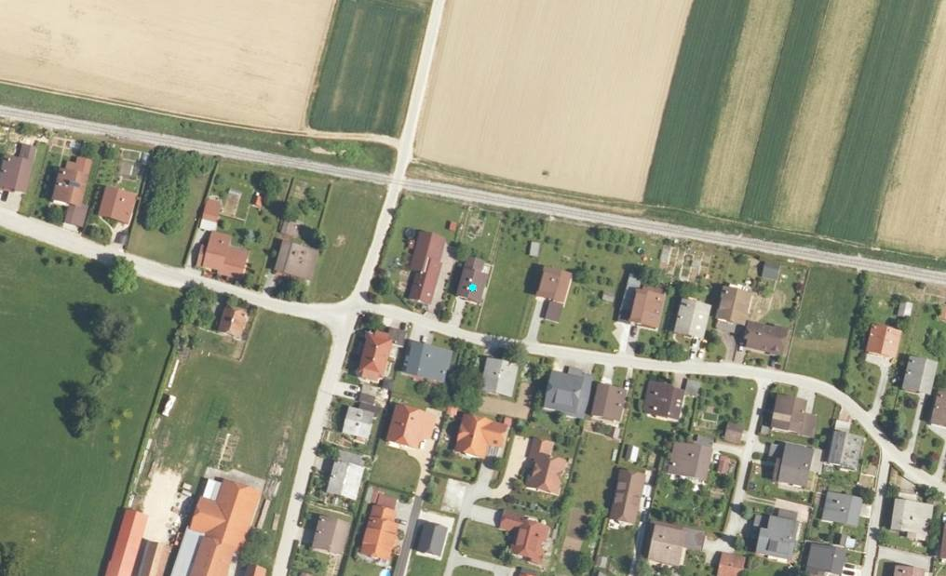

Figure: The point of collision is indicated by the black cross, the running direction of the local passenger train by the red arrow, the driving direction of the passenger motor vehicle by the blue arrow.

**Causes:**

The direct cause of the collision of local passenger train No 3516 at 20:24 on 18 April 2017 on the established level crossing, equipped with road signs, between Celje and Žalec stations at 7 636 km was the carelessness of the driver of the passenger road motor vehicle, who failed to check if a train was approaching along the railway towards the level crossing before driving the vehicle onto the level crossing.

The indirect cause of the collision was inadequate visibility for the road traffic passengers travelling in the direction from which the vehicle was coming.

**Recommendations:**

In order to prevent similar disasters in the future, it is recommended that the following measures are implemented.

To the road infrastructure manager:

1. it is recommended that the transverse warning lines are drawn across the whole road surface in both directions. There should be sound markings on the road surface that will warn road traffic users approaching the level crossing. This causes users to be more attentive when approaching a dangerous area. The transverse warning lines are to be plotted in such a way that those most further away are most distance from each other and come progressively closer to each other when approaching the level crossing.
2. It is recommended that, on the road surface from the direction Dobriška vas, towards regional road R-2 (category 2 regional road), designation 447, section 0287 (section Petroče — Žalec), from the house at the address Dobriška vas 21a towards the house at the address Dobriška vas 17, high vegetation is removed, which blocks road traffic users’ visibility of the track at the level crossing.

To the infrastructure manager of SŽ – Infrastruktura d.o.o.:

1. it is recommended that, alongside the railway line from the direction the Petrovče station, towards the direction žalec, high vegetation is removed, which blocks road traffic users’ visibility of the track at the level crossing.

To the undertaking SŽ – Potniški promet d.o.o.:

1. it is recommended that all classical headlamps of passenger vehicles are replaced with modern LED headlamps which give greater visibility of railway vehicles.

**Collision of operating unsecured locomotive 541-008 with train 38008 – empty passenger unit, at points No 33 and 41, during the arrival of the train to Ljubljana station on 16 June 2017 at 19:14.**

On 16 June 2017 at 19:14, on points No 33 and 41 at Ljubljana station, a running e-locomotive 541-008 collided with train No 38008 (empty passenger electric set).

Train 38008, an empty passenger electromotor unit, of the undertaking SŽ – Potniški promet d.o.o., was running from Zidani Most station to Ljubljana. During the approach to track No 29 at Ljubljana station, train 38008 collided with locomotive 541-008 of the carrier SŽ – Freight Transport d.o.o., at points No 33 and 41. The driver of train No 38008 was able to the stop the train at points 33 and 41 before the collision, after he had received a notification from the controller of the Ljubljana station that a locomotive was moving towards the train.

The electro locomotive No 541-008 was not occupied and was not secured on track No 28, somewhere before the opening of platforms of Ljubljana station. It was delivered by the train driver of the SŽ - VIT d.o.o. to track No 28 from the central workshop in Ljubljana Moste by SŽ - VIT d.o.o., together with two other electro locomotives 541-003 and 541-017, at around 16:00. At 19:11, two train drivers of SŽ VIT d.o.o., after separating it from locomotive 541-008, which remained on track No 28, moved locomotives 541-003 and 541-017 from track No 28. After about two minutes, unsecured locomotive 541-008 started to move without control along track 28 in the direction of Ljubljana Zalog Station. At this point in time, train No 38008 was approaching track No 29. When train No 38008 was approaching, the controller at Ljubljana station gave an order to the train driver to immediately stop and at the same time informed him that locomotive 541-008, on track No 28, was moving towards it. The driver of train No 38008 was able to stop the train at points No 33 and 41 before collision. After the train stopped, the train driver moved from cabin A into the middle of the passenger section for his own personal safety. Immediately afterwards cabin 2 of electro locomotive 541-008 collided with cabin A of the towing unit EMG 312-105.

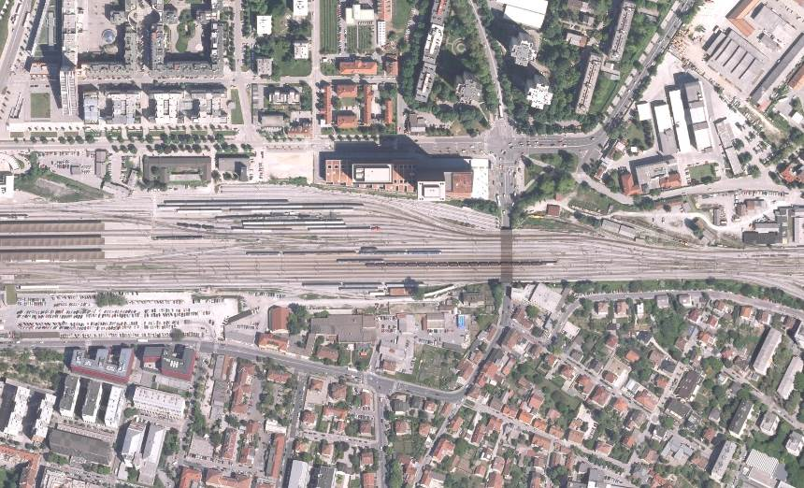

Figure: The point of collision is indicated by the black cross, the running direction of locomotive 541-008 by the red arrow, and the running direction of train No 38008 by the blue arrow.

**Causes:**

The direct cause of collision of electro locomotive No 541-008 with train No 38008 (empty passenger electromotor set) on 16 June 2017 at 19:14, at points No 33 and 41 of Ljubljana station, at 564 890 km, was locomotive 541-008 on track No 28 at Ljubljana station being inappropriately secured against movement.

The indirect cause could be due to irregular release of the main air connection of connected locomotives after receiving an order to join together unsecured locomotives into a group on track No 28.

Similarly, the indirect cause was irregular handling of brake handles by the driver of electro locomotive 541-008 before releasing the locomotive since the brake handle in cabin 1 was in position 2 ‘charge’, while the electro dynamic brake handle was in ‘break on’ position.

**Recommendation:**

In order to prevent similar disasters in the future, it is recommended to:

after each separation, on a locomotive or on one of the coupled locomotives which will remain unattended and unsecured on a particular track, one of front main brake pipes is to be opened. This would allow for emptying of the main brake pipe and consequent a locomotive or a group of locomotives would be in a break position that would prevent their movement.

**Derailment of international freight train No 43601 during departure from Zidani Most Station, at points No 25, at 502 + 771 km, on 19 June 2017 at 18:13**

At 18:32 on 19 June 2017, the main dispatcher of the Slovenian railways informed the investigating body for investigating railway accidents and incidents that freight train No 43601 had derailed at points No 25 at Zidani Most station at 18:13.

When inspecting the scene of the accident, it was established that the left switch of points No 25 was broken at the top, at 502+771 km. After the break, it was pushed during the train derailment onto the cover of the electrical points line drive, onto the external side of the track in the direction of Zidani Most towards Ljubljana.

Train No 43601 was travelling through Zidani Most station on track No 1 and derailed with the locomotive onto the exit side towards Hrastnik station, at points No 25, which in turn moved by itself and the first six carriages. The head of the train stopped at 502.923 km.

From the shavings on the external side of the right-hand wheels on the second, third, fourth, fifth and six axle of locomotive 363-024, it was possible to establish with certainty that the left point broke at 11 metres from where the points start (top of the point) after the first axle of the locomotive drove through it; after that the locomotive detailed with the left-hand wheels of the second, third, fourth, fifth and six axles, which then self-railed after moving for 15 metres.

While the train was running until it stopped, six more carriages were placed directly after the locomotive. After self-railing, the locomotive moved towards the direction of the left track along points No 26 and the first derailed carriage moved in the same direction, while the remaining five derailed carriages moved along points No 25 towards the extension of the right track of the station.

During the derailment of the train, contact wires and signal safety device were damaged as well as the superstructure of the track, the locomotive and six carriages.

Because of the accident, the track, the left and the right line were unexpectedly closed between Zidani Most and Hrastnik stations. Derailed carriages were re-railed by the intervention group of SŽ-VIT d.o.o. Re-railed carriages were moved onto track 25 at Zidani Most station where they stayed until inspection and preparation for their removal.

After the accident, the left track between Zidani Most and Hrastnik stations was in use again at 04:40 on 20 June 2017, and the right track at 19:50.

After the derailment, a slow speed of 20 km/h was introduced on track No 301.

From the shavings on the external side of right wheels on the second, third, fourth, fifth and six axle of locomotive 363-024, it was possible to establish with certainty that the left point after the first axle of the locomotive drove over it, which caused the locomotive to derail with the left wheels of the second, third, fourth, fifth and six axles, which then self-railed.

While the train was running and until it stopped, six more carriages were placed directly after the locomotive. After self-railing, the locomotive moved towards the direction of the left track along points No 26 and the first derailed carriage moved in the same direction, while the remaining five derailed carriages moved along points No 25 towards the extension of the right track of the station.

The train stopped with the head of the locomotive on the track section of the left track of the station at 502.923 km. The train stopped due to broken pipes of the main air connection between the third and fourth carriage.

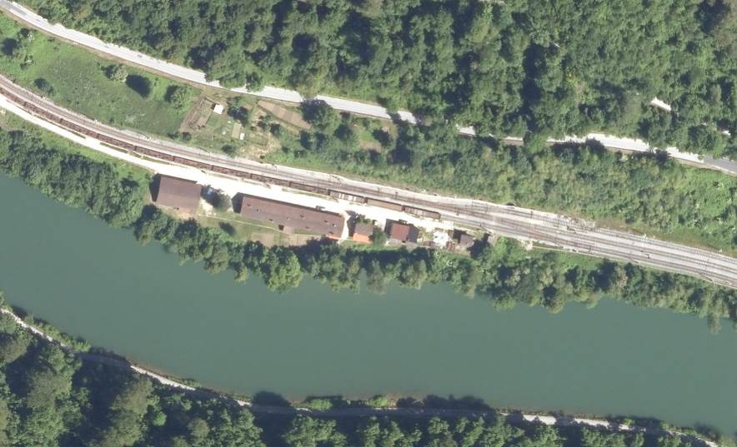

Figure: The derailment location is indicated by the black cross, the running direction of train No 43601 by the red arrow, and the running direction where the train should go through points No 25 by the blue arrow.

**Causes:**

The direct cause of the derailment of international freight train No 43601 at points No 25 at Zidani Most station, at 502 + 771 km, was the break of the left switch of the points, at 11 metres from the start of the points, after the first axle of the locomotive drove onto it, due to the wear and tear of the material of the points.

The indirect cause could be attributed to the subsidence of the upper structure of the track in the area of the points where they broke. Blind sediment cannot be detected with manual measuring devices without the point load of a track or points.

**Recommendations:**

In order to prevent similar accidents in the future, it is recommended to the infrastructure manager of SŽ-Infrastruktura:

1. the key elements of a track and track devices, such as most loaded points, are to be upgraded within a shorter time cycle;
2. load tests of a track with measuring trains are to take place also along points of the main station tracks in the deflection position which would allow for detection of blind sediments that cannot be detected with manual hand measuring device without a point load of the track.
3. areas of points on the main transport tracks are periodically tested with manual devices to find cracks in the material.

**Derailment of international freight train No 49485 during departure from Kranj station, at points No 6, at 594+233 km, on 11 July 2017 at 17:53**

At Kranj station at 17:53 on 11 July 2017, at points No 6 at 594+233 km, at the exit of track No 6, the train of the undertaking SZ - Tovorni promet d.o.o., No 49485 derailed.

Line No 20, Ljubljana – Jesenice state border is the single-track electrified track.

Upon the departure of train No 49485 from track No 6 at Kranj station, at points No 6, five carriages derailed from the train locomotive, positioned as the fourth, fifth, sixth, seventh and eighth carriages.

The accidents caused damage to carriages Nos 31545964294-0, 31545947773-5, 31545947749-5, 31545964235-3, 31545947392-4, to points No 6, 2 and 1, connecting tracks between points No 6, 2, 1, the end of track No 601, contact wires (extensive damage to the contact wires on side A of the station) and damage on the SV and TK devices of Kranj station.

International freight train No 49485, running from the direction of the state border towards Ljubljana, was moving along track No 6 because local passenger train No 2420 was crossing Kranj station on track No 6. During arrival onto track No 6, the train moved without any incident through the points on the B side of the station, alongside track No 6 until points No 6. After points No 6, the train’s right wheel on the one before last axle of the second bearing cart of the fourth carriage, climbed onto the point, in the direction of the train’s movement, in the channel between the primary rail and the point, due to which the second bearing cart derailed and then forcefully moved points No 6 from the position departure into the position toward. The points having moved caused the carriages after the fourth carriage to move towards the track in the Ljubljana direction to the end of the blind track, where four carriages toppled, piled up one against another and were completely destroyed.

The event was brought to the attention of all the competent authorities.

As a result of the event, the voltage of 3 KV in the Škofja Loka section of Škofja Loka was switched off. The Ljubljana – Jesenice national border was closed. The running time of the trains took place after the working timetable. Freight transport on the Ljubljana Vižmarje - Jesenice section was stopped. In the period of interrupted traffic, vehicles shall only be fitted with service trains for the purpose of remedying the consequences of the accident. The international passenger transport operation took place by means of replacement buses, with the exception of trains No 414 and 498, which are vehicles on the territory of Ljubljana – Sežana – Nova Gorica – Jesenice. Replacement uses for the Škofja Loka - Podnart section were also organised for the local passenger transport.

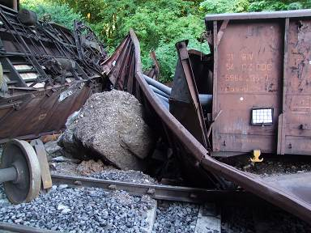

Figure: Destroyed carriages that piled up at the end of line No 601 at Kranj station.

**Causes:**

The direct cause of derailment of international freight train No 49485, at points No 6 at Kranj station, at 594 + 233 km, was significant sediment of the track at three points which means the area had ‘blind sediment’ that could not be detected by manual measuring devices. The sediment is distinguished by a sudden appearance and it is impossible to detect in a set of routine and main inspections. The consequences of a blind sediment is an error in the evenness of the track

Errors in the evenness of a track at the point of the maximum gradient of the ramp can cause a wheel rim to climb the head of the track and consequently, the carriage to derail.

The indirect cause of derailment can, with great certainty, be attributed to restrictions on the longitudinal carriage tilting during the journey over points No 6 because of the rigidity of the speed of the wagon loaded along the whole area of the derailed carriage. The carriage carried 16 full steel rods of Ø 200 mm in diameter, between 10013 and 10019 mm in length and 4 full steel rods of the Ø 200 mm, 5065 in 5078 mm in length, with the total joint mass of 44550 kg.

**Recommendations:**

In order to prevent similar accidents in the future, the infrastructure manager of SŽ-Infrastruktura has the following recommendations:

1. load tests of the track with measuring trains are to be carried out on points at main stations when in a departure position, in order to be able to detect ‘blind sediments which cannot be detected by manual devices without a point load of the track.
2. during regular monthly inspection of station tracks and the station points, internal rules are to be drawn up with a list of points elements that must be checked during the inspection.

**Collision of freight train No 55215, on the regulated level crossing, equipped with road signs, at the Rodica stop, 14 + 117 km, between Jarše Mengeš and Domžale stations, on 16 August 2017 at 15:52.**

At 15:52 on 16 August 2017, freight train No 55215 collided into a girl cyclist at the regulated level crossing, equipped with road signs, between Jašre Mengeš and Domžale stations, at 14 + 117 km.

The 13-year old girl died from injuries at the scene of the accident.

The freight train was running from the direction of Jarše Mardš station towards Domžale station, along the one-tier non-electrified regional Kamnik Graben – Ljubljana area, No 21. Parallel to the track there is a two-lane regional road (R3 644, road section No 1358) which, at the point of collision, is 13 metres away from the right-hand track.

At the impact point, the elevation is 307 m above sea level.

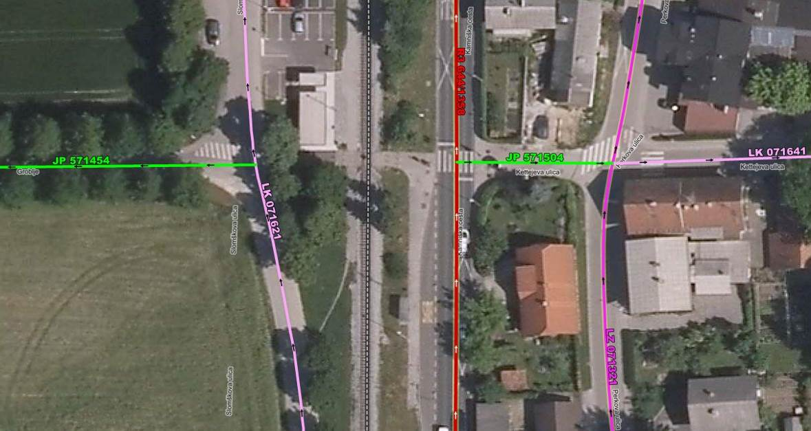

Figure: Traffic infrastructure in the area of the accident (green line Kettejev street, black and white railway line)

The girl was cycling with a group of friends along Kettejev street (public path No 571504) and at the pedestrian crossing crossed Kamniška street, in the direction of the Faculty of Biotechnology, Grobje 3. Kettjeva ulica runs en route towards the track at the angle of 90°. Immediately in front of the railway line, two metal pillars have been installed on the public path which prevent the crossing by vehicles or quadricycles.

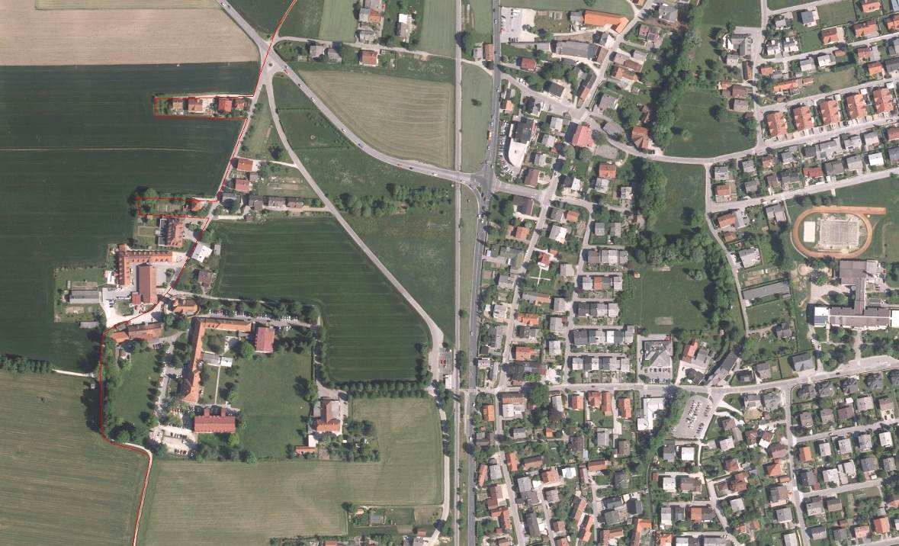

Figure: The location of the impact is indicated by the grey cross, the driving direction of the freight train by the red arrow, and the moving direction of the cyclist by the blue arrow.

The group of children, cycling with the victim, stopped on their bikes directly before the track. The girl who died cycled directly in front of train locomotive number No 55215. The train hit the victim with the front left side of locomotive No 644-005. The girl who died was thrown left along the line, 3.10 metres from the left-hand track, in the direction of travel of the train, 17.8 metres from the point of impact.

Train No 55215 had D-lok 644-005, 13 carriages, 933 t of mass, 50 axles and was 307 m in length.

**Causes:**

The direct cause of collision of freight train No 55215 at 16:52 on 16 August 2017, on the regulated level crossing, equipped with road signs, between Jarše and Domžale stations, at 14.117 km, was the carelessness of the young cyclist for failing to check if a train vehicle was approaching the level crossing before she cycled onto it.

The indirect cause of collision was thick vegetation along the track at the time of the accident which obscured the cyclist’s view of the track in the direction from which the train was coming.

**Recommendations:**

In order to prevent similar disasters in the future, it is recommended that the following measures are implemented.

To the road infrastructure manager:

1. It is recommended that at the pedestrian level crossing, crossing the railway at the Rodica stop, a maze and a fence are installed to prevent level crossing in the direction of Jarše Mengeš station and in the direction of Domžale station. This would prevent single-seat drivers from crossing the track.

To the infrastructure manager of SŽ – Infrastruktura d.o.o.:

1. It is recommended that alongside the railway track, towards the Rodica stop, the track in both direction in maintained by regularly removing vegetation which obscures road transport participant’s visibility of the track.

**Collision of train No 76311, at the regulated level crossing, equipped with road signs, at 8 + 824 km, between Ruše and Maribor Studenci stations at 09:06 on 17 August 2017**

On 17 August 2017 at 09:06, train No 76311 (special purpose track vehicle), collided with a passenger road motor vehicle at the regulated level crossing, equipped with road signs, between Ruše and Maribor Studenci stations, at 8 + 824 km, .

The driver of the passenger road motor vehicle succumbed to injuries and died in the ambulance on the way to the University Collage Hospital Maribor.

Train No 76311 (special railway track vehicle 915-202) was running from Ruše station towards Maribor Studenci station, on the single-track non-electrified track Maribor - Prevalje state border. The special railway track vehicle, driving towards the head of the steering cab, has the loading body and the loading arm.

The road vehicle was driving on public road No 86041, from the direction of Dravska street towards Dobrovo.



Figure 1: Transport infrastructure in the area of the accident: the brown line marks the railway track, the blue line marks routes and the red line marks the regional road.

The driver of the railway vehicle notified the controller at Ruše station at 09:08 that, between Ruše and Maribor Studenci stations, at 8 + 824 km, on the established level crossing, marked with the traffic road sign: ‘Double cross and Stop’ it had collided into the front left of the car. The vehicle was thrown on along the right side of the track, in the direction of the train.

The driver of the railway vehicle blew the whistle and gave the warning signal ‘Beware’ a number of times when approaching the level crossing. When the driver saw the road vehicle and realised its driver was not intending to stop before the crossing, the track driver activated the emergency brake. He was not able to prevent the collision with the passenger motor vehicle. Train No 76311 stopped 159 metres after the point of collision, at 8 + 665 km.

The section of the track between Ruše and Maribor Studenci stations was closed due to the accident until 11:45. During this closure, an alternative bus service was organised for passengers. The 28-year old driver of the Hyundai i20 passenger car, residing at Dobrova 30, Bistrica ob Dravi, died at the scene of the accident. The damaged vehicle for special track purposes, train No 76311, was taken by the track vehicle MPV-1 to Maribor Studenci station at 11:38.

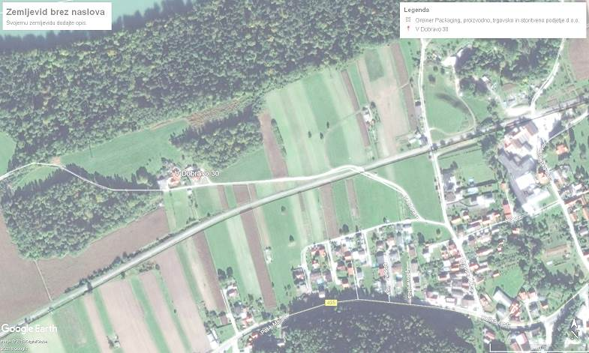

Figure: The location of the collision is marked by the black cross, the driving direction of the train (special track purpose vehicle) by the red arrow, the driving direction of the passenger motor vehicle by the blue arrow.

**Causes:**

1. The direct cause of the collision between train No 76311 (special railway vehicle) with the passenger road motor vehicle on at 09:06 on 17 August 2017 on the regulated level crossing, equipped with road signs, between Ruše and Maribor Studenci stations, at 8 + 824 km, was the carelessness of the driver of the road motor vehicle who, before driving onto the dangerous section of the level crossing, did not check if a train was approaching.
2. The indirect cause of the collision can be attributed to inadequate visibility of the track for road traffic users in the direction from which the vehicle was driving, because of the shed by the road and the colour of the special railway purpose vehicle which fitted into the surroundings at the level crossing.
3. However, the indirect cause of the accident could also be the lack of experience and fatigue of the driver of the road motor vehicle who was returning home after a night’s shift.

**Recommendations:**

In order to prevent similar disasters in the future, it is recommended that the following measures are implemented.

To the road infrastructure manager:

1. It is recommended that, on the road from the direction of Dravska street towards Dobrova, the facility by the electrical system ‘A’ pole is removed, as it obscures the visibility of the track for road traffic users at the level crossing.

To the infrastructure manager of SŽ – Infrastruktura d.o.o.:

1. it is recommended that high vegetation be regularly removed by the railway track in the direction from Ruše station towards Maribor Studenci station as it obscures the visibility of the track for road traffic users at the level crossing.

The investigations of the accidents described above did not require the compiling of special studies or drawings.

* 1. 3.5 Clarification and introduction or background of the investigations

The department charged with investigating railway accidents and incidents was not able to complete an investigation launched into an accident in 2013 by the prescribed deadline The investigation was concluded with a nine-month delay. In 2012, the investigation of a single accident – derailment of carriage owned by the Croatian Railways, freight train No 47502, was dropped due to a lack of cooperation by representatives of the carriage owners.

|  |  |  |  |  |  |
| --- | --- | --- | --- | --- | --- |
| Investigations started in 2017 but have not yet been resolved. | | | | | |
| Date of accident | Type of accident | Place of accident | Legal basis | Reason why investigation has not been completed or was abandoned | Who, why, when  (decision) |
| 17.09.2017 | derailment of international goods train 48414 | right track D-50 between the stations Verd and Logatec at 602 + 916 km | Article 26 of the ZZelP | the investigation was completed in 2018. | 17.09.2018 |

* 1. 3.6 Accidents and incidents investigated over the past five years (2013-2017)

[Table of investigations into railway accidents 2013‑2017 (serious accidents, accidents and incidents) and safety studies, with data from 2013 to 2017 and the types of accident/incident: collision of trains, collision with obstacles, derailments, accidents involving people and railway vehicles during travel, fires on railway vehicles, hazardous substances and other items] (Point 3.1 should be updated with the trends established by accident investigations.)

|  |  |  |  |  |  |  |  |
| --- | --- | --- | --- | --- | --- | --- | --- |
| Accidents investigated | | 2013 | 2014 | 2015 | 2016 | 2017 | Total |
| Serious accidents  Article 19(1) and (2) of the Railway Safety Directive | collision | 1 |  |  |  |  | 1 |
| derailment |  | 2 |  | 2 |  | 4 |
| level crossing |  |  |  |  |  |  |
| persons and railway vehicles during travel |  |  |  |  |  |  |
| fires on vehicles |  |  |  |  |  |  |
| Other |  |  |  |  |  |  |
| hazardous substances |  |  |  |  |  |  |
|  |  |  |  |  |  |  |  |
| other accidents  Article 21(6) of the Railway Safety Directive | collision |  |  | 1 |  | 1 | 2 |
| derailment | 2 |  |  |  | 3 | 5 |
| level crossing | 1 | 3 | 2 | 4 | 3 | 13 |
| persons and railway vehicles during travel |  |  |  |  |  |  |
| fires on vehicles |  |  |  |  |  |  |
| Other |  |  | 1 |  | 1 | 2 |
| hazardous substances |  |  |  |  |  |  |
| TOTAL |  | 4 | 5 | 4 | 6 | 8 | 27 |

In 2013, the investigating body investigated four incidents, in 2014 five, in 2015 four, in 2015 six and in 2017 seven incidents - serious accidents, accidents and incidents.

In the area covered by Slovenian railways, in the period from the time the investigative body started to operate on 01.06.2008 until the end of 2017, accidents with same or similar caused had not occurred. Given the above, there was therefore no need to carry out a more detailed study on railway safety in the period 2009 to 2017.

4 RECOMMENDATIONS

A table of outputs of the recommendations issued during the previous 10 annual period.

|  |  |  |  |  |  |  |  |
| --- | --- | --- | --- | --- | --- | --- | --- |
| Recommendations issued | | Situation regarding the implementation of recommendations | | | | | |
| implemented | | being implemented (or have been prepared) | | will not be implemented (rejected) | |
| YEAR | no. | no. | % | no. | % | no. | % |
| 2008 | 2 | 2 | 100 |  |  |  |  |
| 2009 | 16 | 15 | 94 |  |  | 1 | 6 |
| 2010 | 3 | 3 | 100 |  |  |  |  |
| 2011 | 6 | 5 | 83.3 |  |  | 1 | 16.7 |
| 2012 | 12 | 10 | 83.3 |  |  | 2 | 16.7 |
| 2013 | 5 | 4 | 80 |  |  | 1 | 20 |
| 2014 | 8 | 5 | 62.5 |  |  | 3 | 37.5 |
| 2015 | 4 | 4 | 100 |  |  |  |  |
| 2016 | 5 | 3 | 60 | 2 | 40 |  |  |
| 2017 | 16 | 13 | 81.3 | 3 | 18.77 |  |  |
| TOTAL | 77 | 64 | 83.1 | 5 | 6.5 | 8 | 10.4 |

In 2017, 16 recommendations relating to investigation of railway accidents were issued by the investigating authority for railway accidents:

- 5 on the maintenance process for maintaining public railway infrastructure;

- 2 on the educational process for regular periodic training of workers directly involved in managing traffic and train drivers;

- 1 on the technological process for the release of non-moving locomotives;

- 1 on installing traffic signals at a level crossing for road transport users;

- 1 on upgrading front lamps of diesel motor sets;

- 5 on ensuring visibility at regulated level crossings marked with road signs;

- 1 on installing additional safety device at a secured level crossing with a maze for pedestrians and cyclists.

|  |  |
| --- | --- |
|  | The chief investigator for railway accidents and incidents investigation:  Daniel Lenart, Secretary |