**RELATÓRIO ANUAL DE**

**ATIVIDADES DE INVESTIGAÇÃO**

**INVESTIGATION ACTIVITIES**

**ANUAL REPORT**

(includes summary and information

in English)

**Transporte Ferroviário**

**2017**

**Rail Transportation**

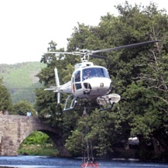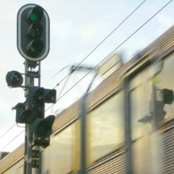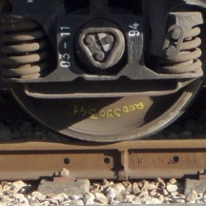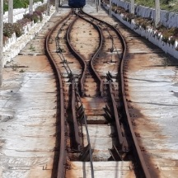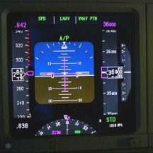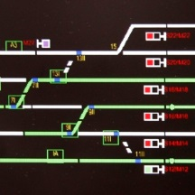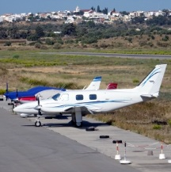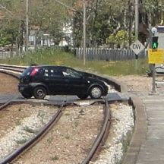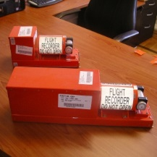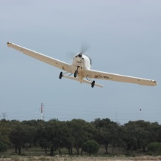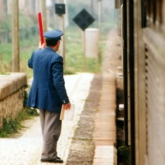

www.gpiaaf.gov.pt

**Imprint**

**Title |** Relatório Anual de Atividades de Investigação – Transporte Ferroviário – 2017

*Investigation Activities Annual Report – Rail Transportation – 2017*

**Publisher |** GPIAAF - Office for the Prevention and Investigation of Accidents in Civil Aviation and

Rail

Praça Duque de Saldanha, 31, 4.º – 1050-094 Lisbon – PORTUGAL

Phone: + 352 212 739 245 | Fax: + 351 217 911 959

Email: geral@gpiaaf.gov.pt

**Design and Composition |** GPIAAF

Under Council of Ministers Resolution No 8/2011, this document has been drafted in compliance with the Portuguese Language Orthographic Agreement of 1990, approved by Assembly of the Portuguese Republic Resolution No 26/91 and ratified by Presidential Decree No 43/91, both of 23 August 1991.

**© GPIAAF · Lisbon, Portugal · 2018**

With the exclusion of any materials whose rights belong to third parties, reproduction of the content of this document is authorised, except for commercial purposes, provided GPIAAF is cited as the author and the title, year of publication and reference ‘Lisbon-Portugal’ are given, and provided it is cited accurately and in the original context.

**This publication is also available at**[**http://www.gpiaaf.gov.pt**](http://www.gpiaaf.gov.pt/).

**Document check**

|  |  |  |  |  |
| --- | --- | --- | --- | --- |
| *Document No.* | *Date* | *Amendments* | *Drafting* | *Approval* |
| RAI-F2017.0 | 28-09-2018 | Original version |  | Nelson Oliveira |
|  |  |  |  |  |

Table of Contents

***English Summary*** ***5***

INTRODUCTORY NOTE 7

PART A 9

GENERAL AND MANAGEMENT INFORMATION 9

1. GPIAAF 10

1.1 Legal and organisational framework 10

1.2 Organisational structure 11

1.3 Mission 12

1.4 Vision 12

1.5 Duties and operating principles 13

1.6 Scope of work 13

2. RESOURCES 14

2.1 Principles applicable to managing human and financial resources and assets 14

2.2 Human resources 15

2.3 Financial resources 15

2.4 Assets 15

PART B 17

SAFETY RECOMMENDATIONS AND INVESTIGATIONS 17

1. ACCIDENT AND INCIDENT INVESTIGATION 18

1.1 Investigations begun in 2017 18

1.2 Completed investigations 22

1.3 Ongoing investigations 23

1.4 Investigations before 2011 24

2. SAFETY RECOMMENDATIONS 25

2.1 Recommendations issued in 2017 25

2.2 Monitoring of past recommendations 26

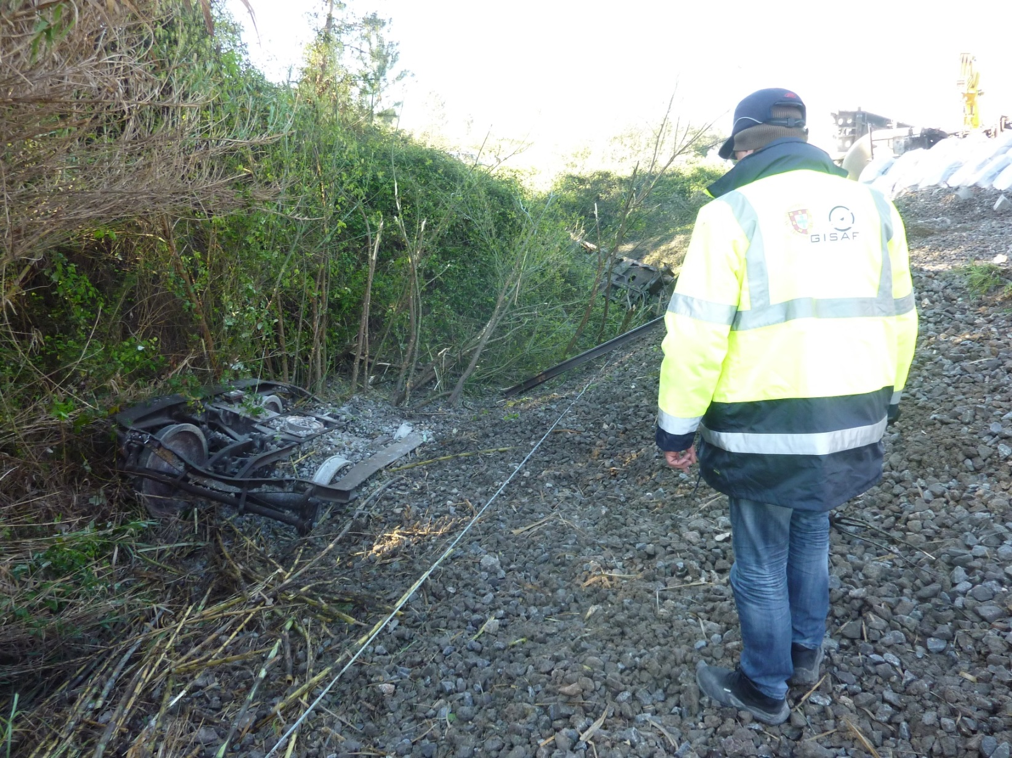

***English summary***

*This document is the Annual Report referred to in Article 23(3) of Directive 2004/49/EC of the European Parliament and of the Council, of 29 April 2004, relating to the investigation activities of GISAF as the Portuguese Rail Accidents National Investigation Body (NIB) during the year 2017.*

*It should be noted that from June 2017 GISAF was made extinct by the Portuguese Government and its duties and staff were integrated into a new bi-modal air/rail safety investigation body (GPIAAF), which is the entity responsible for publishing this report.*

*In 2017 GISAF/GPIAAF processed 516 safety occurrences notified by the Railway Undertakings and Infrastructure Managers and decided to start one safety investigation under article 19.1 (serious accidents) of the Railway Safety Directive and five safety investigations under article 19.2.*

*Due to the reorganization of the NIB and the effort devoted to the investigative work of the serious accident occurred on 01-04-2017, it was not possible to publish any final report during 2017. An action plan for the period 2018-2019 has been established to recover the delay in the publishing of reports and to decrease the average time to conclude the investigations.*

*Apart from the present summary, the text of this document is in Portuguese as the resources are not available to provide a full English translation. To facilitate immediate comprehension of the main information, the charts and tables containing the more relevant information are bilingual.*

*As required by legislation and the European Union Agency for Railways, this document has the following main content:*

* *General overview of the legal provisions for the NIB and its work [A1.1, page 10];*
* *Information concerning the relationship between the NIB and other Portuguese bodies, such as the National Safety Authority, Ministry of Transport and Investigation Bodies on other transport modes [Figure A.1 & A.2, pages 10 & 11];*
* *Information on the internal structure of the NIB [Figure A.3 & A.4, pages 11 & 12];*
* *Information about the NIB, its Role (description of the mandate), Aim and Mission [A1.3, A1.4, A1.5, pages 12 & 13];*
* *Information on the scope of the NIB on the rail system [A1.6, pages 13 & 14];*
* *Information on number of employees [A2.2, page 15];*
* *Information on budget [A2.3, page 16 and 17];*
* *Information on general management activities [A2.1, A2.4, pages 15 & 16];*
* *Information on investigation activities [section B, pages 17 to 23];*
* *Information on investigations opened in 2017 [table B.3 – page 21];*
* *Information on investigations concluded in 2017 [page 21];*
* *Information on investigations in progress [table B.4 – pages 22 & 23];*
* *Information on investigations opened prior to 2011, before the period when the NIB was inactive [tables B.5 – pages 23 & 24];*
* *Information on safety recommendations issued and their monitoring [tables B.7, B.8a and B.8b – pages 24 to 31].*

INTRODUCTORY NOTE

2017 was an unusual year in that the national body responsible for investigating railway safety and accidents underwent a major structural reorganisation.

On the basis of Decree-Law No 36/2017 of 28 March 2017, on 1 April the Portuguese Government created the Gabinete de Prevenção e Investigação de Acidentes com Aeronaves e de Acidentes Ferroviários (GPIAAF) [Office for the Prevention and Investigation of Accidents in Civil Aviation and Rail], a bimodal organisation which took over the responsibilities and personnel of the Gabinete de Investigação de Segurança e de Acidentes Ferroviários (GISAF) [Railway Safety and Accident Investigation Bureau], which was formally dissolved on 29 June.

This document contains the annual report required under Article 11(6) of Decree-Law No 394/2007 of 31 December 2007[1], which transfers to the national legal system the accident investigation provisions of Directive 2004/49/EC of the European Parliament and of the Council of 29 April 2004 on safety on the European Union's railways.

In accordance with Decree-Law No 394/2007 and the requirements laid down by the European Union Agency for Railways, this report includes information on the following:

* legal provisions covering the operation and work of the GPIAAF;
* institutional framework of the GPIAAF in relation to other relevant national bodies, particularly the sectoral authority and the Autoridade Nacional de Segurança Ferroviária [National Railway Safety Authority];
* information about the organisation: its duties and mission, organisational structure, number of employees and budget;
* information on investigations initiated and concluded in the reporting year, and a list of pending investigations;
* list of recommendations issued in the reporting year and information on action taken by the respective recipients in response to recommendations that have yet to be concluded by acceptance and implementation or rejection.

This information is organised into two separate parts, A and B. The first provides general management information while the second covers investigations and safety recommendations. Full information on the management component of the body is available in the 2017 Activity Report, in accordance with legal requirements.

Since it is not possible to produce a complete bilingual Portuguese/English version of this report, as preferred by the EU Agency for Railways, a summary in English has been provided instead, with a document map and bilingual tables containing the essential information.

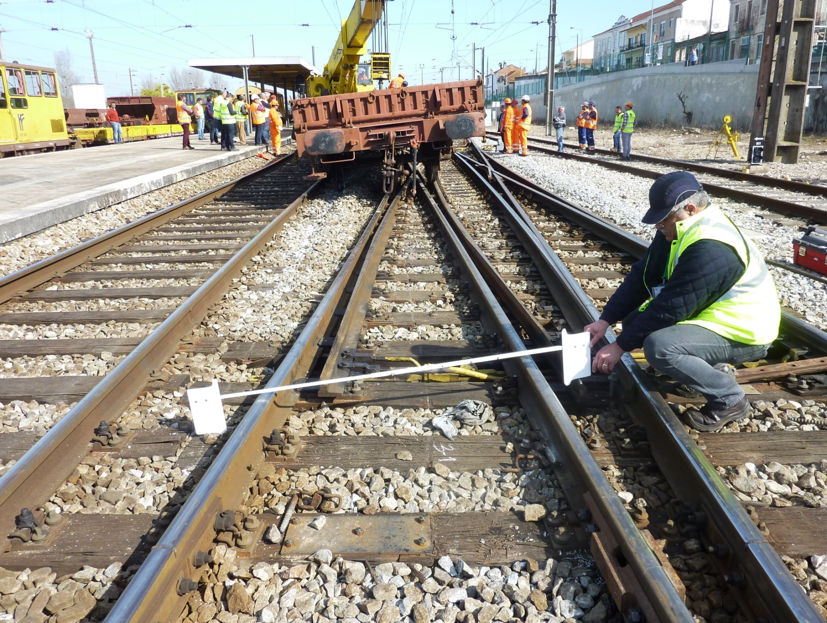

PART A

GENERAL AND MANAGEMENT INFORMATION

1. GPIAAF
   1. Legal and organisational framework

GISAF, the Railway Safety and Accident Investigation Bureau, was an administratively autonomous central government department under direct State administration.

It was established by Decree-Law No 210/2006 of 27 October 2006, though its original organisational structure was only defined subsequently by Decree-Law No 395/2007 of 31 December 2007. Decree-Law No 394/2007 of 31 December 2007 meanwhile stipulated the content of the technical investigation of railway incidents and accidents for which the Bureau was responsible, transposing into domestic legislation the relevant section of Directive No 2004/49/EC of the European Parliament and of the Council of 29 April 2004 on safety on the Community’s railways.

GISAF was organised in accordance with Decree-Law No 70/2012 of 21 March 2012, which repealed Decree-Law No 395/2007, under the Central Administration Reduction and Improvement Plan (PREMAC).

The position of GISAF in the structure of the Portuguese government and in relation to other national counterparts in the period from 1 January to 29 June is shown in the following organisational chart:

GISAF – Railway Safety and Accident Investigation Bureau

*NIB Railway*

**GPIAA** – Aircraft Accident Investigation and Prevention Bureau

*NIB Air*

**GPIAM** – Marine Accident Investigation and Prevention Bureau

*NIB Maritime*

**IMT** – Institute for Mobility and Transport [public enterprise]

(National Railway Safety Authority)

*NSA Railway*

**Ministério do Planeamento e das Infraestruturas**

**Secretaria de Estado das Infraestruturas**

*Ministry for Planning and Infrastructure*

*Secretary of State for Infrastructure*

**Ministério do Mar**

*Ministry for Sea*

**AMT** - Mobility and Transport Authority

(Rail Transport Regulator)

*Rail Regulator*

Figura A.1 – Enquadramento institucional do GISAF

*Figure A.1 – GISAF (NIB PT) institutional setting*

The Office for the Prevention and Investigation of Accidents in Civil Aviation and Rail (GPIAAF), set up on 1 April by Decree-Law No 36/2017 of 28 March 2017, is also an administratively autonomous central service under direct State administration.

This multimodal safety investigation body (aviation + railway) took over the Portuguese State’s obligations to investigate rail accidents and incidents laid down in Directive (EU) 2016/798 of 11 May 2016 on railway safety[2].

The GPIAAF operates under the Ministry for Planning and Infrastructure and reports directly to the Secretary of State for Infrastructure, within the following institutional framework:

**GPIAAF** - Office for the Prevention and Investigation of Accidents in Civil Aviation and Rail

**NIB Rail+Air**

**GAMA** – Maritime Accident Investigation and Aeronautical Meteorology Authority

**NIB Maritime**

**IMT** – Institute for Mobility and Transport [public enterprise]

**National Safety**

**Authority**

**Ministério do Planeamento e das Infraestruturas**

**Secretaria de Estado das Infraestruturas**

**Ministry for Planning and Infrastructure**

**Secretary of State for Infrastructure**

**Ministério do Mar**

**Ministry for Sea**

**AMT** - Mobility and Transport Authority

**Rail Regulator**

Figura A.2 – Enquadramento institucional do GPIAAF

*Figure A.2 – GPIAAF (NIB PT) institutional setting*

Supervision of the GPIAAF covers only its financing and the appointment of its senior official, with no influence on decisions regarding the activity of the Office, in accordance with its independent status.

The legal framework for rail accident and incident investigations ensured by GISAF and the GPIAAF is regulated by Decree-Law No 394/2007 of 31 December 2007.

* 1. Organisational structure

Under Articles 3 to 6 of Decree-Law No 70/2012 of 21 March 2012, the Railway Safety and Accident Investigation Bureau consisted of a Director and a team of investigators.

Until it was dissolved on 29 June, the organisational chart of GISAF was as follows:

**Director**

**Investigators**

Direct administrative support

Logistics and general administrative support

*(General Secretariat of the Presidency of the Council of Ministers)*

Figura A.3 – Organograma do GISAF

*Figure A.3 – GISAF (NIB PT) organizational structure*

With respect to the GPIAAF, under Articles 3, 5 and 6 of Decree-Law No 36/2012 of 28 March 2012, the Office is formed by a Director and two multidisciplinary investigation teams whose budget is approved by a ruling of the members of the government responsible for finance, public administration and transport. The logistical and administrative support needed for the GPIAAF to function is provided by the General Secretariat of the Presidency of the Council of Ministers.

The organisational chart of the GPIAAF is as follows:

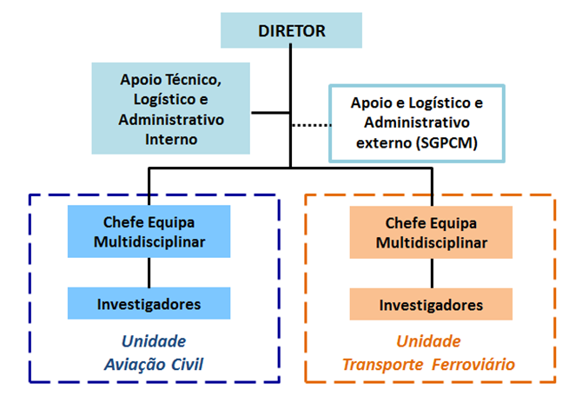

Figura A.4 – Organograma do GPIAAF

*Figure A.4 – GPIAAF (NIB PT) organizational structure*

|  |  |
| --- | --- |
| DIRETOR | DIRECTOR |
| Apoio Técnico, Logístico e  Administrativo Interno | Internal technical, logistic and  administrative support |
| Apoio e Logístico e Administrativo externo (SGPCM) | External logistic and administrative support (SGPCM) |
| Chefe Equipa Multidisciplinar | Multidisciplinary Team Leader |
| Investigadores | Investigators |
| Unidade Aviação Civil | Civil Aviation Unit |
| Chefe Equipa Multidisciplinar | Multidisciplinary Team Leader |
| Investigadores | Investigators |
| Unidade Transporte Ferroviário | Railway Transport Unit |

* 1. Mission

GISAF was the Portuguese government agency that was responsible for (*i*) investigating accidents, incidents and other events related to railway transport safety and identifying the respective causes, (*ii*) drawing up and sending out reports, (*iii*) carrying out studies, (*iv*) proposing prevention measures aimed at reducing rail accident rates and (*v*) ensuring participation in national or foreign committees or activities.

The GPIAAF is responsible for investigating accidents and incidents in connection with civil aviation and railway safety and identifying their causes in order to help to prevent future occurrences. In terms of its organisation, legal structure and decision-making process, the Office functions independently of the authorities responsible for safety, the bodies regulating civil aviation and railway transport, any infrastructure manager, civil aviation or rail company and any other party whose interests may clash with the tasks with which it is entrusted.

* 1. Vision

GISAF

To apply best practices in railway incident and accident investigations so as to contribute to continuous improvements in railway safety, in cooperation with other relevant bodies.

GPIAAF

To contribute actively to progress in civil aviation and railway safety, ensuring best practices in investigating accidents and incidents for the public good.

* 1. Duties and operating principles

The specific duties of GISAF and the GPIAAF in investigating railway safety are to:

1. investigate rail accidents and incidents, determine their causes and make recommendations;
2. analyse occurrences recorded in the railway infrastructure management body’s daily circulation report and propose the appropriate action according to how serious they are;
3. monitor compliance and implementation of recommendations made to the regulated entities.

In performing their duties, GISAF and the GPIAAF will operate independently of the safety authority and of any railway regulatory body, and their organisation, legal structure and decision-making will be independent of any infrastructure manager, railway undertaking, charging body, entity responsible for allocating capacity and notified body, and of any party whose interests could conflict with the tasks entrusted to them.

Under EU and national legislation, the investigations carried out by these organisations **are not intended or designed to apportion blame or determine liability**, but rather to **improve railway safety**.

**Portuguese legislation, however, does not guarantee that the reports produced by GISAF or the GPIAAF will not be used by third parties for the purposes of apportioning blame and liability, and protection of the identity of witnesses is not safeguarded in the event of a judicial investigation. The investigation reports nevertheless clearly state that their use for any purpose other than their intended use could lead to erroneous conclusions.**

* 1. Scope of work

Decree-Law No 394/2007, as amended by Decree-Law No 114/2009 of 18 May 2009, assigns GISAF and the GPIAAF a scope that is considerably broader than that set out in Directives 2004/49/EC and 2016/798 as mandatory for the national investigation bodies provided for therein.

The railway systems falling within the remit of GISAF and the GPIAA in 2017 were as follows:

* **National railway network**, managed by IP - Infraestruturas de Portugal, S.A., and railway operators licensed to operate on it:
  + COMSA Rail Transport,
  + [CP – Comboios de Portugal, E.P.E.](http://www.cp.pt/)
  + [Fertagus, S.A.](http://www.fertagus.pt/)
  + [MEDRAIL – Operador Ferroviário e Logístico de Mercadorias, S.A.,](http://www.cpcarga.pt/index.php/pt/)
  + [TAKARGO, Transporte de Mercadorias, S.A.](http://sinergia.mota-engil.pt/Detail.aspx?ParentId=42)
* **The Lisbon metro**, operated by Metropolitano de Lisboa, E.P.E.;
* **Metropolitano ligeiro da Área Metropolitana do Porto** (Porto light rail system), operated by Metro do Porto, S.A.;
* **Metropolitano ligeiro da margem sul do Tejo** (South Tagus light rail system), operated by MTS - Metro, Transportes do Sul, S.A.;
* [**Metropolitano ligeiro de Mirandela**](http://www.cm-mirandela.pt/index.php?oid=275)(Mirandela light rail system), operated by Metro Ligeiro de Mirandela, S.A.;
* **Caminho-de-ferro ligeiro Sintra – Praia das Maçãs** (Sintra-Praia das Maçãs light railway), operated by Sintra Municipal Council;
* [**Caminho-de-ferro ligeiro Costa da Caparica – Fonte da Telha**](http://transportesalmada.ageneal.pt/content.asp?startAt=2&categoryID=907)[Costa da Caparica-Fonte da Telha light railway], operated by Transpraia – Transportes Recreativos da Praia do Sol, Lda.;
* **Caminho-de-ferro ligeiro da praia do Barril (Praia do Barril light railway), operated by Gaprei - Gestão Aldeamento Pedras D’El Rei, S.A.;**
* [**Viana do Castelo funicular**](http://www.cm-viana-castelo.pt/pt/funicular-de-santa-luzia), operated by[Liftech](http://www.liftech.pt/)- Tecnologia para Elevadores, Lda.;
* [**Bom Jesus do Monte Funicular**](http://www.estanciadobomjesus.com/_elevador_2), operated by Confraria do Bom Jesus do Monte;
* [**Guindais Funicular**](http://www.metrodoporto.pt/PageGen.aspx?WMCM_PaginaId=10035), operated by Metro do Porto, S.A.;
* [**Nazaré Funicular**](http://www.cm-nazare.pt/custompages/showpage.aspx?pageid=67cd5fa6-cba0-43a8-981e-2906d7a4aee8&m=b149), operated by Serviços Municipalizados da Câmara Municipal da Nazaré;
* [**Sistema Automático de Transporte Urbano de Oeiras**](http://www.cm-oeiras.pt/amunicipal/Sustentabilidade/Transportes/Paginas/Satu.aspx)(Oeiras automated municipal transport system), operated by SATU – Sistema Automático de Transporte Urbano, E.M. (currently without a public service).

This corresponds to approximately 2 715 km of railway system and over 4 000 journeys per day.

1. RESOURCES
   1. Principles applicable to managing human and financial resources and assets

The forecast annual budget covers the allocation of human and financial resources and assets. Human resources are recorded on the personnel chart that must accompany the forecast budget submitted to the relevant ministry and the Ministry for Finance. As a general principle of good governance in public administration, this Office applies a results-driven management policy which ensures resource optimisation and rationalisation.

The resources of GISAF and the GPIAAF are managed by the General Secretariat of the Presidency of the Council of Ministers, namely:

1. budgetary control and implementation;
2. staff management: recruitment, processing of salaries and attendance management;
3. procurement of goods and services: via the UMC – Ministerial Procurement Unit of the General Secretariat of the Ministry for the Economy, with particular emphasis on procurement under the Framework Agreements of the Agência Nacional de Compras Públicas, E.P.E. (national public procurement agency);
4. asset management: vehicles, facilities and ICT.
   1. Human resources

On 1 January and 31 December 2017, the human resources of the Office allocated to railway transport in the staff chart and actual staff were as follows:

|  |  |  |  |  |
| --- | --- | --- | --- | --- |
|  | **01-Jan-2017** | | **31-Dec-2017** | |
| Designação  Title | Previstos  *Planned* | Reais  *Real* | Previstos  *Planned* | Reais  *Real* |
| ***Pessoal Dirigente / Managing Staff*** |  |  |  |  |
| Diretor / Director – Chefe de Unidade / Head of Unit | 1 | **1** | 1 | **1** |
| ***Estrutura Técnica / Technical Staff***  ***área ferroviária / rail area*** |  |  |  |  |
| Investigadores / Investigators | 2 | **2** | 3 | **2** |
| ***Estrutura Operacional / Operational Staff*** |  |  |  |  |
| Técnica superior / Senior officer | 0 | **0** | **2\*** | **1\*** |
| Assistente técnica / Technical assistant | 1 | **1** | 1* | **1\*** |
| **\*** Partilhadas com a Unidade de Aviação Civil / Shared with the Civil Aviation Unit | | | | |

Quadro A.1 – Recursos humanos

*Table A.1 – Human resources*

With the establishment of the GPIAAF, the staff chart provides for three railway investigators compared to two for GISAF, an increase which is essential for standardising research capacity in this area.

* 1. Financial resources

GISAF’s budget comes from the general government budget and includes operating and investment components.

In 2017 the initial budget of GISAF was EUR 325 000, of which EUR 287 231 were available for use, an increase of 16% compared to 2016.

Following the creation of the GPIAAF, at the end of the year EUR 530 522 had been applied, corresponding to the organisation as a whole.

* 1. Assets

In 2017 the assets of GISAF and the GPIAAF were generally speaking sufficient for their current administrative expenditure.

In 2017 GISAF and the GPIAAF’s Rail Transport Unit were accommodated on a temporary basis in five rooms at the headquarters of the Instituto da Mobilidade e dos Transportes, I.P..

It was not possible to achieve the aim of housing all the GPIAAF’s services at its Praça Duque de Saldanha headquarters because, for reasons beyond its control, the work necessary for that purpose was not carried out.

In 2017 the Office was very limited by the space it had to work in, not only for its normal operations but also for its future development, since a small laboratory/workshop as well as secure rooms for filing proceedings and storing evidence are needed, among other requirements.

Due to a lack of funds it was not possible to acquire specialised measuring and recording equipment, specifically for investigating derailments, an urgent need which had to be deferred once again to the following year.

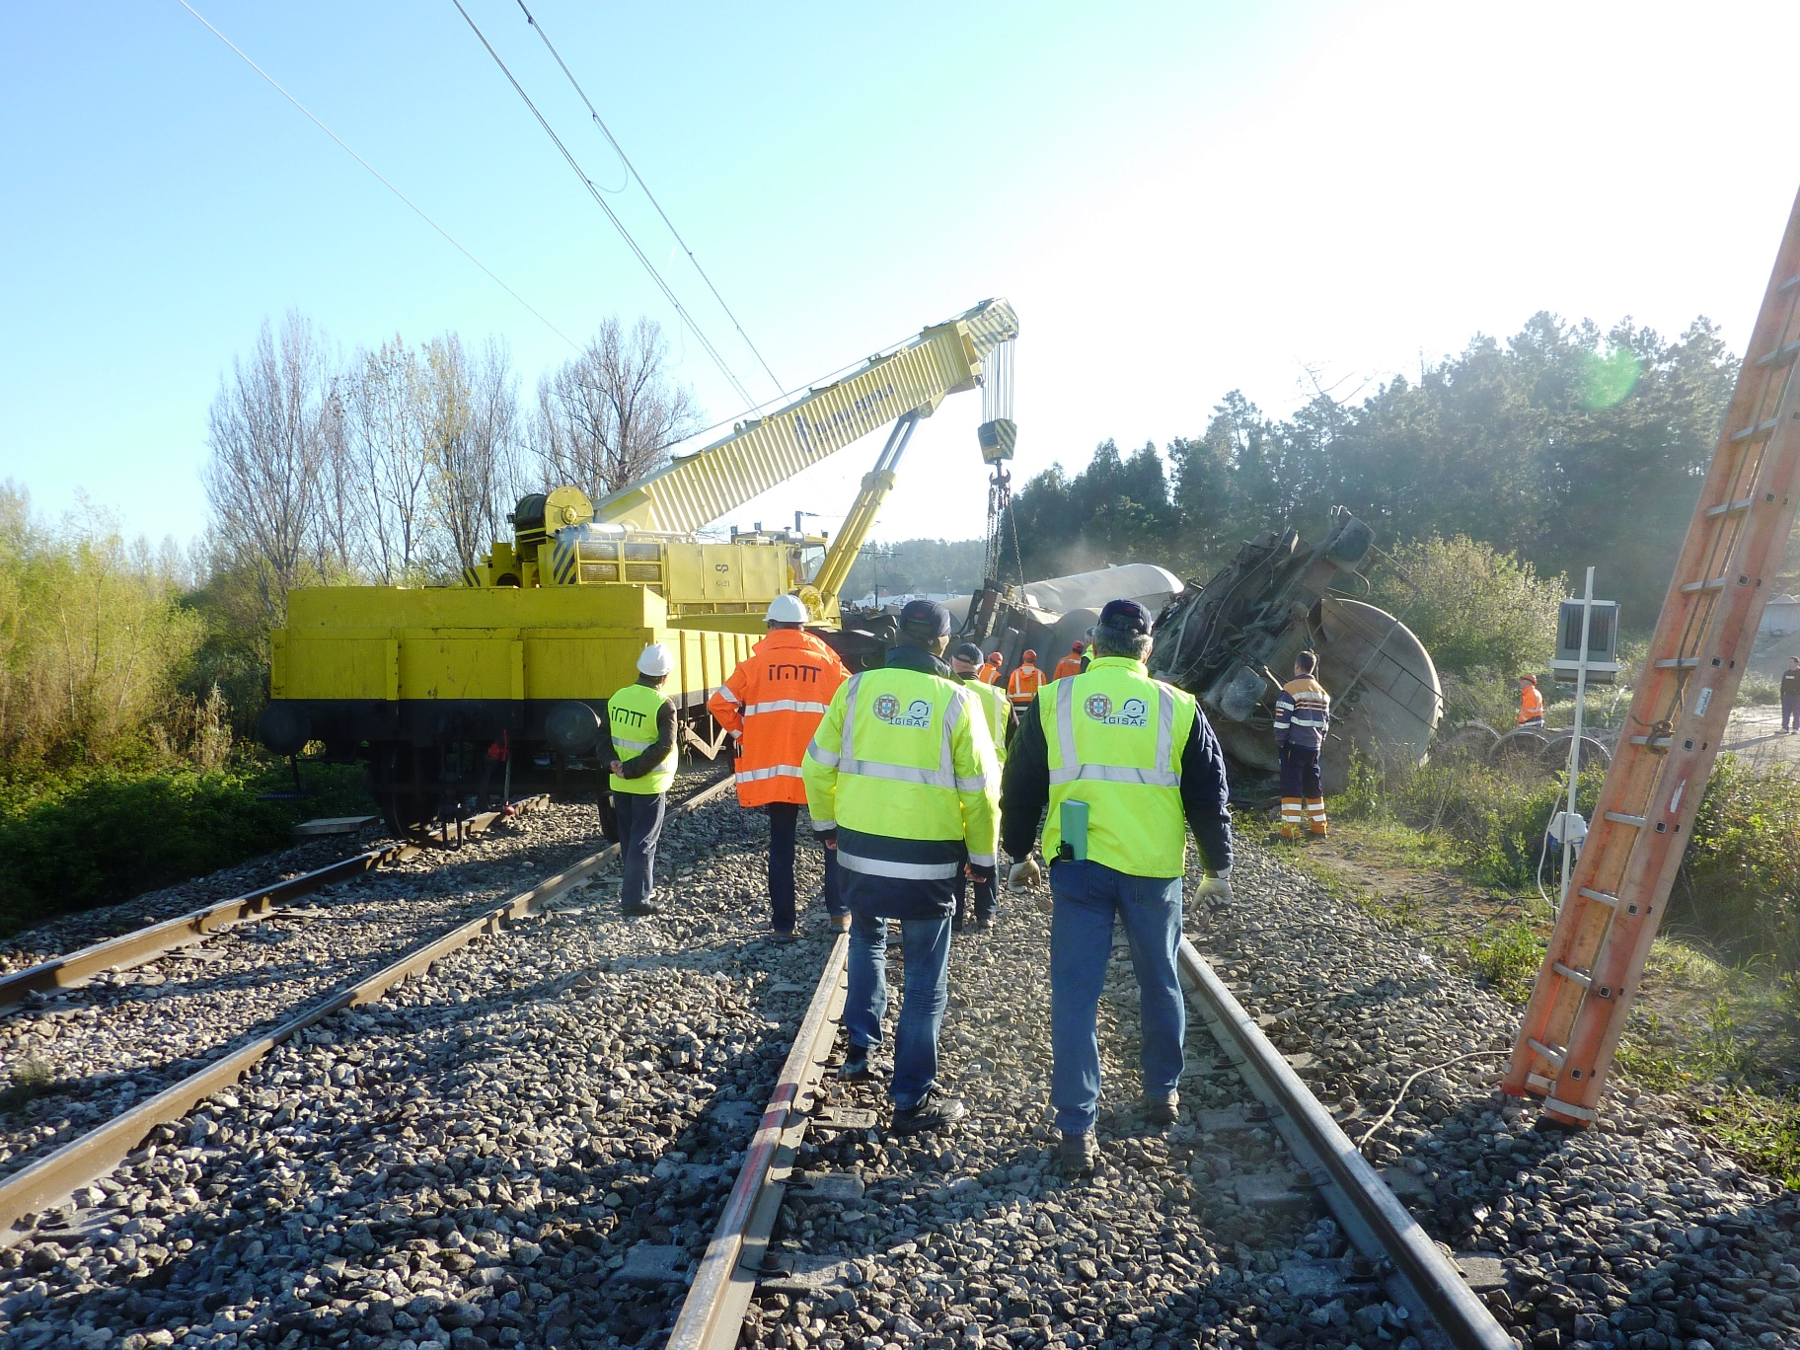

PART B

SAFETY RECOMMENDATIONS AND INVESTIGATIONS

1. ACCIDENT AND INCIDENT INVESTIGATION
   1. Investigations begun in 2017

Article 4(1) of Decree-Law No 394/2007 states that the Office must investigate serious railway accidents, which means any train collision or derailment of trains, resulting in the death of at least one person or serious injuries to five or more persons or extensive damage of at least EUR 2 million to rolling stock, the infrastructure or the environment, and any other similar accident with an obvious impact on railway safety regulation or the management of safety. The document ‘*Guidance on the decision to investigate*’, produced by the European Union Agency for Railways, provides guidelines for the decision to investigate with respect to the criterion ‘obvious impact on railway safety regulation or the management of safety’.

In 2017, only one accident was deemed by the Office to fall within the definition of ‘serious accident’, putting it under an obligation to investigate.

In addition, under Article 4(2) of the above-mentioned Decree-Law the Office may at its discretion also decide to investigate other accidents or incidents which, under different conditions, may have led to serious accidents, and the following must be taken into consideration in making its decision:

a) the seriousness of the accident or incident;

b) whether it is part of a series of accidents or incidents relevant to the system as a whole;

c) its impact on railway safety at EU level;

d) requests from infrastructure managers, railway undertakings, the safety authority or other Member States.

In relation to investigations of other accidents and incidents at the discretion of the GPIAAF, based on daily reports or equivalent forms of information provided by railway undertakings, 515 safety events were selected and recorded on the statistical database of GISAF and the GPIAAF, according to the Office’s internal criteria as defined in the respective Investigation Manual.

The distribution of events recorded by GISAF and the GPIAAF in accordance with their type and for all railway systems covered by the Office’s activity can be found in the following table, organised by decreasing order of frequency [3],[4].

|  |  |
| --- | --- |
| **Quadro B.1 – Ocorrências processadas pelo GISAF/GPIAAF em 2017**  ***Table B.1 – Occurrences processed by GISAF/GPIAAF in 2017*** | |
| **Natureza do Acidente / Incidente**  ***Category of Accident / Incident*** | **Quantidade**  ***Quantity*** |
| Deformação da via  *Track buckles and other track misalignment* | 145 |
| Aderência degradada - ICS 27/13  *Degraded adhesion* | 68 |
| Colisão com objeto - plena via  *Collision with object – plain line* | 42 |
| Colisão entre metro de superfície e veículo rodoviário em ambiente urbano  *Collision between surface metro and road vehicle in urban environment* | 34 |
| Carril partido  *Broken rails* | 27 |
| Colhida de pessoa não autorizada - plena via  *Accident to unauthorized person involving rolling stock in motion – plain line* | 21 |
| Ultrapassagem indevida de sinal de paragem (“ SPAD” ) – estação  Signal passed at danger - station | 17 |
| Descarrilamento – estação  *Derailment – station* | 12 |
| Colisão com objeto – PN  *Colision with object – Level crossing* | 11 |
| Colhida de pessoa não autorizada – estação  *Accident to unauthorized person involving rolling stock in motion – station* | 8 |
| Acidente de pessoa autorizada com material circulante em movimento – estação  *Accident to authorized person involving rolling stock in motion – station* | 7 |
| Colisão com objetos – estação  *Colision with object – station* | 7 |
| Colhida de pessoa não autorizada – PN  *Accident to unauthorized person involving rolling stock in motion – Level crossing* | 6 |
| Incêndio/explosão - plena via  *Fire/explosion – plain line* | 3 |
| Descarrilamento - plena via  *Derailment – plain line* | 2 |
| Incêndio/explosão – estação  *Fire/explo sion – station* | 2 |
| Falhas na sinalização lateral  *Wrong side signalling failure* | 1 |
| Acidente de pessoa autorizada com material circulante em movimento – plena via  *Accident to authorized person involving rolling stock in motion – plain line* | 0 |
| Ultrapassagem indevida de sinal de paragem (“ SPAD” ) - plena via  *Signal passed at danger – plain line* | 0 |
| Outras situações (inclui suicídios tentados e consumados)  *Other categories (includes atempted and consummate suicides)* | 103 |
| **TOTAL** | **516** |

The GPIAAF carried out a preliminary analysis on 29 of these events, selected for their characteristics or consequences, to determine whether they could be expected to yield important safety lessons that would justify opening an investigation under Article 4(2) of Decree-Law No 394/2007, while also considering the availability of the Office’s resources.

The preliminary analysis involves collecting basic data on the events from the companies involved, and usually also collecting and analysing evidence to obtain sufficient information on which to base a decision.

Based on the preliminary analyses carried out in 2017, GISAF decided to open **three** investigations and include the investigation of **two** events in an ongoing investigation. The remaining cases were dismissed either because there was no relevant evidence for conducting a safety investigation or because of a management decision, considering the ranking of priorities and availability of resources for carrying out an investigation in light of the expected benefit.

It should be noted, however, that records of accidents or incidents whose preliminary analyses were dismissed are stored for reference in the event of future occurrences, at which time an investigation may be opened if deemed appropriate.

In addition, the regular statistical processing of safety events makes it possible to compile relevant historical information when deciding whether or not to open an investigation into an event, or with a view to the possible opening of a series of investigations.

It should also be noted that the extraordinary events occurring in 2017, i.e. the restructuring of the Office and in particular the serious accident on 1 April 2017 close to Adémia, on the Northern line, plus the significant number of investigations opened in previous years which are still in progress, turned out‑to have a substantial impact on the decision to open investigations into events which do not give rise to an obligation to investigate, in line with European Union Agency for Railways recommendations.

The preliminary analyses carried out and investigations opened in 2017 are listed in the following tables.

|  |  |  |  |  |  |
| --- | --- | --- | --- | --- | --- |
| **Quadro B.2 – Análises preliminares realizadas em 2017**  ***Table B.2 – Preliminary examinations carried out in 2017*** | | | | | **Total: 29** |
| **GISAF GPIAAF**  **ID** | **Tipo de ocorrência**  ***Type of occurrence*** | **Data**  ***Date*** | **Linha**  ***Line*** | **Evento**  ***Event*** | **Sequência**  ***Sequence*** |
| AP_20170102 | Colisão em PN  *Collision at LX* | 02-01-2017 | West | Comboio 6453 embateu num veículo automóvel que se apresentou do lado direito da marcha na PN 112,098.  *Collision of train 6453 with road vehicle at LX* | ARQUIVADO  *DISMISSED* |
| AP_20170106 | Descarrilamento em Estação  *Derailment at station* | 06-01-2017 | Beira Alta | Descarrilamento do último vagão do comboio 47840 à passagem pela estação de Vila Franca das Naves.  *Derailment of the last wagon of train 47480 at Vila Franca das Naves station* | **INVESTIGAÇÃO**  ***INVESTIGATION*** |
| AP_20170115 | Descarrilamento em Estação  *Derailment at station* | 15-01-2017 | Douro | Descarrilamento parcial do comboio IR 868 à entrada da estação da Livração.  *Derailment of passenger train 868 at Livração station* | **INVESTIGAÇÃO**  ***INVESTIGATION*** |
| AP_20170126 | SPAD - Estação  *SPAD - Station* | 26-01-2017 | Cintura | Ultrapassagem indevida de sinal pela marcha 95243 na estação de Roma-Areeiro.  *SPAD by train 95243 at Roma-Areeiro station* | **INTEGRADO EM INVESTIGAÇÃO EM CURSO**  ***INTEGRATED IN ONGOING INVESTIGATION*** |
| AP_20170207 | Colisão em PN  *Collision at LX* | 07-02-2017 | Vouga | Colisão do comboio 5208 com veículo automóvel na PN 8,782.  *Collision of train 5208 with a road vehicle at LX 8,782.* | ARQUIVADO  *DISMISSED* |
| AP_20170217 | Descarrilamento em Estação  *Derailment at station* | 17-02-2017 | North | Descarrilamento de três vagões do comboio 50365 na estação de Alfarelos.  *Derailment of three wagons of train 50365 at Alfarelos station* | ARQUIVADO  *DISMISSED* |
| AP_20170218 | Outras ocorrências  *Other events* | 18-02-2017 | Beira Baixa | Comboio 5621 não efetuou paragem comercial no apeadeiro de Mouriscas por deficiente resposta do freio.  *Train missed scheduled stop at Mouriscas halt due to deficient brake response* | ARQUIVADO  *DISMISSED* |
| AP_20170414 | Colisão em PN  *Collision at LX* | 14-04-2017 | Cintura | Colisão de locomotiva em manobras com veículo automóvel.  *Collision of shunting locomotive with a road vehicle.* | ARQUIVADO  *DISMISSED* |
| AP_20170416 | SPAD - Estação  *SPAD - Station* | 16-04-2017 | Cintura | Ultrapassagem indevida de sinal pelo comboio 19103 na estação de Cais do Sodré.  *SPAD by train 19103 at Cais do Sodré station.* | ARQUIVADO  *DISMISSED* |
| AP_20170402 | SPAD - Estação  *SPAD - Station* | 02-04-2017 | Ramal da Lousã | Ultrapassagem indevida de sinal por composição em manobras na estação de Coimbra.  *SPAD by shunting movement at Coimbra station.* | ARQUIVADO  *DISMISSED* |
| AP_20170508 | Colisão em PN  *Collision at LX* | 08-05-2017 | Algarve | Colisão do comboio 5905 com veículo automóvel na PN 313,914.  *Collision of train 5905 with a road vehicle at LX 313,914.* | ARQUIVADO  *DISMISSED* |
| AP_20170516 | Colisão em PN  *Collision at LX* | 16-05-2017 | Sines | Colisão do comboio 81380 com veículo automóvel na PN 147,265.  *Collision of train 81380 with a road vehicle at LX 147,265.* | ARQUIVADO  *DISMISSED* |

|  |  |  |  |  |  |
| --- | --- | --- | --- | --- | --- |
| AP_20170524a | Colisão em PN  *Collision at LX* | 24-05-2017 | West | Colisão entre o comboio 806 e um veículo automóvel na PN ao PK 174,019.  *Collision of train 806 with a road vehicle at LX 174,019.* | ARQUIVADO  *DISMISSED* |
| AP_20170524b | Colhidas em PN  *Accident to persons at LX* | 24-05-2017 | Algarve | Colhida de utilizador da PN 339,241 pelo comboio 573  *Collision of train 573 with person at LX 339,241.* | ARQUIVADO  *DISMISSED* |
| AP_20170613 | Outras ocorrências  *Other events* | 13-06-2017 | Beira Alta | Derrame de vagão cisterna em composição estacionada na estação de Vilar Formoso.  *Release of gas from tank wagon at Vilar Formoso station* | ARQUIVADO  *DISMISSED* |
| AP_20170620 | Colhidas em Plena Via  *Accident to persons at PL* | 20-06-2017 | Metro Lisboa | Colhida mortal de utilizador que se introduziu no canal ferroviário, próximo da estação do Marquês de Pombal.  *Collision of Metro with unauthorized person in gallery.* | ARQUIVADO  *DISMISSED* |
| AP_20170714 | Colisão em PN  *Collision at LX* | 14-07-2017 | Vendas Novas | Colisão do comboio 81830 com veículo automóvel na PN 2,400.  *Collision of train 82830 with a road vehicle at LX 2,400.* | ARQUIVADO  *DISMISSED* |
| AP_20170725 | Descarrilamento em Plena Via  *Derailment at station* | 25-07-2017 | North | Descarrilamento de veículo de serviço ao PK 216,320.  *Derailment of maintenance vehicle at KM 216,320.* | ARQUIVADO  *DISMISSED* |
| AP_20170726 | SPAD - Estação  *SPAD - Station* | 26-07-2017 | North | Ultrapassagem indevida de sinal pela marcha 95220 na estação de Lamarosa.  *SPAD by train 95220 at Lamarosa station* | **INTEGRADO EM INVESTIGAÇÃO EM CURSO**  ***INTEGRATED IN ONGOING INVESTIGATION*** |
| AP_20170804 | SPAD - Estação  *SPAD - Station station* | 04-08-2017 | South | Ultrapassagem indevida de sinal na estação de Setúbal-Mar.  *SPAD by train at Setúbal-Mar station* | ARQUIVADO  *DISMISSED* |
| AP_20170807 | Colhidas em PN  *Accident to persons at LX* | 07-08-2017 | Minho | Colhida mortal de utilizador pelo comboio 851 na PN pedonal 117,897  *Fatal collision of train 851 with person at LX 117,897.* | ARQUIVADO  *DISMISSED* |
| AP_20170809 | Colhidas em Plena Via  *Accident to persons at PL* | 09-08-2017 | MTS | Colhida mortal de peão que se introduziu no canal dedicado ao Metro, na Avenida 25 de Abril, em Corroios.  *Collision of Metro with person in the dedicated right of way.* | ARQUIVADO  *DISMISSED* |
| AP_20170816 | SPAD - Estação  *SPAD - Station* | 16-08-2017 | Beira Baixa | Ultrapassagem indevida de sinal na estação de Rodão pelo comboio 542.  *SPAD by train 542 at Rodão station.* | ARQUIVADO  *DISMISSED* |
| AP_20170927 | Descarrilamento em Estação  *Derailment at station* | 27-09-2017 | Douro | Descarrilamento de locomotiva em manobras na placa giratória da estação da Régua.  *Derailment of shunting locomotive at Régua station.* | **INVESTIGAÇÃO**  ***INVESTIGATION*** |
| AP_20171015 | Outras ocorrências  *Other events* | 15-10-2017 | North | Ocorrências com comboio 135 em zona onde deflagrava um incêndio, perto de Oiã.  *Occurrences with train 135 during a forest fire, near Oiã.* | ARQUIVADO  *DISMISSED* |
| AP_20171025 | Falhas na sinalização lateral  *Wrong-side signalling failure* | 25-10-2017 | North | Irregularidade na sinalização à entrada de comboio 15730 na estação de Ovar.  *Wrong-side signal failure at Ovar station.* | ARQUIVADO  *DISMISSED* |
| AP_20171105 | Colhidas em PN  *Accident to persons at LX* | 05-11-2017 | North | Colhida mortal de utilizador na PN 29,887 pelo comboio 21610.  *Fatal collision of train 21610 with person at LX 29,887.* | ARQUIVADO  *DISMISSED* |
| AP_20171122 | Colisão em PN  *Collision at LX* | 22-11-2017 | Algarve | Colisão entre o comboio 5701 e um veículo automóvel na PN 349,197.  *Collision of train 5701 with a road vehicle at LX 349,197.* | ARQUIVADO  *DISMISSED* |
| AP_20171123 | Colhidas em PN  *Accident to persons at LX* | 23-11-2017 | North | Colhida mortal de utilizador na PN 325,417 pelo comboio 15726.  *Fatal collision of train 15726 with person at LX 325,471.* | ARQUIVADO  *DISMISSED* |

|  |  |  |  |  |
| --- | --- | --- | --- | --- |
| **Quadro B.3 - Investigações iniciadas em 2017**  ***Table B.3 - Investigations started in 2017*** | | | | **Total: 6** |
| **ERAIL ID** | **Designação**  ***Title*** | **Data da decisão**  ***Decision date*** | **Tipo de ocorrência**  ***Type of occurrence*** | **Base legal**  ***Legal basis*** |
| PT-4991 | Ultrapassagem indevida de sinal pela marcha 95243 na estação de Roma-Areeiro.  *SPAD by train 95243 at Roma-Areeiro station* | 09-03-2017 | Ultrapassagem indevida de sinal  *SPAD* | D-L 394/2007:  Art. 4.º-2  *Dir. 2004/49/CE: Art. 19.º-2* (a) |
| PT-5286 | *Descarrilamento do comboio de passageiros IR 868 na estação da Livração, na linha do Douro, em 15-01-2017.* | 27-02-2017 | Descarrilamento  *Derailment* | D-L 394/2007:  Art. 4.º-2  *Dir. 2004/49/CE: Art. 19.º-2* (a) |
| PT-5321 | *Descarrilamento do comboio de mercadorias n.º 95204 próximo de Adémia, na linha do Norte, em 01-04-2017.* | 07-04-2017 | Descarrilamento  *Derailment* | D-L 394/2007:  Art. 4.º-1  *Dir. 2004/49/CE: Art. 19.º-1* |
| PT-5474 | *Descarrilamento em comboio de mercadorias na estação de Vila Franca das Naves, na linha da Beira Alta, em 06-01-2017.* | 11-07-2017 | Descarrilamento  *Derailment* | D-L 394/2007:  Art. 4.º-2  *Dir. 2004/49/CE: Art. 19.º-2* (a) |
| PT-5759 | *Descarrilamento de locomotiva em manobras na placa giratória da estação da Régua, em 27-09-2017* | 04-12-2017 | Descarrilamento  *Derailment* | D-L 394/2007:  Art. 4.º-2  *Dir. 2004/49/CE: Art. 21.º* |
| PT-4991 | Ultrapassagem indevida de sinal pela marcha 95220 na estação de Lamarosa.  *SPAD by train 95220 at Lamarosa station* | 14-08-2017 | Ultrapassagem indevida de sinal  *SPAD* | D-L 394/2007:  Art. 4.º-2  *Dir. 2004/49/CE: Art. 19.º-2* (a) |

* 1. Completed investigations

No investigations were completed in 2017.

There were two principal reasons for this:

1. the process of setting up the GPIAAF and the merger and dissolving of GISAF and the Gabinete de Prevenção e Investigação de Acidentes com Aeronaves (GPIAA) [Aircraft Accident Investigation and Prevention Bureau], with the director of GISAF taking over all the functions of the director of the GPIAA from February 2017 and the functions of the director of the GPIAAF from April 2017. Although the merger and dissolving of GISAF and the GPIAA formally concluded in late July 2017, in practice the work on the merger and administrative and operational reorganisation of these bodies continued until the end of the year. This unusual circumstance occupied the director of GISAF (who was subsequently also responsible for the railway transport unit of the GPIAAF) on a virtually full-time basis, significantly limiting his availability to ensure due coordination and monitoring of the two investigators’ work and of the process of revising and approving the reports he was responsible for.

Aware of the need to take decisive measures to regulate the resulting situation, at the end of the year, with the reorganisation and administrative and functional standardisation of the GPIAAF virtually stabilised, an action plan was drawn up to recover the delay in publishing pending reports and reduce the average time for concluding investigations. This process will continue in 2018 and 2019, following which, on the basis of the resources envisaged for the Railway Transport Unit, the situation should be back to normal.

1. The accident on 1 April 2017 referred to above, the scale and importance of which required the total commitment of both investigators for some months in collecting and analysing the necessary information, in practice brought all other procedures to a halt during that time.
   1. Ongoing investigations

At the end of 2017, 16 investigations were ongoing.

It should also be noted that, in accordance with legal provisions and in close cooperation with other national investigation bodies, GISAF and the GPIAAF cooperated closely with their Spanish counterpart on a serious accident that took place on 9 September 2016 at O Porriño station, involving a stationary passenger train partially crewed by a Portuguese railway company.

As referred to in 1.2 above, an action plan was drawn up to recover the delay in concluding the investigations and significantly reduce their average duration, which with the resources planned for the Railway Transport Unit it is hoped will gradually come to fruition by the end of 2019.

The following table shows GISAF investigations that were ongoing as of 31 December 2017 and their respective status.

|  |  |  |  |  |
| --- | --- | --- | --- | --- |
| **Quadro B.4 - Investigações em curso no final de 2017**  ***Table B.4 - Investigations in progress at the end of 2017*** | | | | **Total: 16** |
| **ERAIL ID** | **Designação**  ***Title*** | **Data de abertura**  ***Opening date*** | **Tipo de ocorrência**  ***Type of occurrence*** | **Estado**  ***Status*** |
| PT-3865 | Descarrilamento de vagão integrado no comboio n.º 49817, ao PK 158,466 da linha da Beira Alta  *Derailment of wagon in train 49817, at KM 158,466 of Beira Alta Line* | 02-07-2014 | Descarrilamento  *Derailment* | Análise e ensaios complementares  *Analisys and aditional tests.* |
| PT-4771 | PN 106,202-Oeste (Caldas da Rainha) aberta aquando da passagem do comboio n.º 6450, em 17-04-2015  *Manned LX 106,202 – Oeste Line (Caldas da Rainha) open while train 6450 passed by, on 17-04-2015* | 22-04-2015 | Incidente de segurança  *Safety incident* | Relatório em revisão interna  *Report under internal review* |
| PT-4821 | Utilização de material circulante em percursos nos quais a série não estava regulamentarmente autorizada para o efeito  *Use of rolling stock on parts of the network for which it was not approved* | 07-06-2015 | Incidente de segurança  *Safety incident* | Relatório em revisão interna  *Report under internal review* |
| PT-4838 | Descarrilamento de vagões no comboio de mercadorias n.º 51232 cerca do PK 158+400 (apeadeiro do Vesúvio) da linha do Douro, em 21/07/2015  *Derailment of flat wagons on freight train 51232, at KM 158+400 - Douro line (Vesúvio halt), on 21-07-2015* | 03-08-2015 | Descarrilamento  *Derailment* | Análise e recolha de informação adicional  *Analysis and collection of additional evidence* |
| n/a | Descarrilamento de carro elétrico na linha Portela de Sintra – Praia das Maçãs, em 06-08-2015  *Derailment on Sintra tourist tram line, on 06-08-2015* | 14-09-2015 | Descarrilamento  *Derailment* | Relatório em revisão interna  *Report under internal review* |
| PT-4949 | Descarrilamento de vagão no comboio de mercadorias n.º 64132, entre Francelos e Miramar (linha do Norte), em 02-11-2015  *Derailment of a cement wagon on freight train 64132, between Francelos and Miramar halts - Norte line, on 02-11-2015* | 16-11-2015 | Descarrilamento  *Derailment* | Análise e ensaios complementares  *Analisys and aditional tests.* |
| PT-4991 | Ultrapassagem indevida de sinal no Areeiro por veículo de serviço, em 20-01-2016;  Ultrapassagem indevida de sinal pela marcha 95243 na estação de Roma-Areeiro;  Ultrapassagem indevida de sinal pela marcha 95220 na estação de Lamarosa.  *SPAD by service vehicle at Areeiro station, LIsboa, on 20-01-2016;*  *SPAD by train 95243 at Roma-Areeiro station;*  *SPAD by train 95220 at Lamarosa station.* | 15-02-2016  09-03-2017  14-08-2017 | Ultrapassagem indevida de sinal  *SPAD* | Relatório em revisão interna  *Report under internal review* |
| PT-5143 | Descarrilamento do comboio IR 805 na linha do Oeste, próximo do Louriçal, em 03-07-2016  *Derailment of passenger train 805 – Oeste Line (near Louriçal station), on 03-07-2016* | 25-07-2016 | Descarrilamento  *Derailment* | Análise e recolha de informação adicional  *Analysis and collection of additional evidence* |
| PT-5118 | Descarrilamento de três vagões na linha do Oeste, próximo de Regueira de Pontes, em 15-07-2016  *Derailment of wagons on freight train – Oeste line (near Regueira de Pontes halt), on 15-07-2016* | 18-07-2016 | Descarrilamento  *Derailment* | Análise e redação do relatório preliminar  *Analisys and report writing* |
| PT-5172 | Incêndio no comboio n.º 4100, na linha do Douro, em 10-10-2016  *Fire on train 4100 - Douro line, on 10-10-2016* | 12-10-2016 | Incêndio em material circulante  *Fire in rolling stock* | Análise e redação do relatório preliminar  *Analisys and report writing* |
| PT-5209 | Colisão de comboio de passageiros com veículo pesado na PN 69,474 da linha do Norte, em 08-11-2016  *Collision of passenger train with low-loader truck at level crossing – Norte line, on 08-11-2016* | 05-12-2016 | Colisão em PN  *Collision at level crossing* | Análise e redação do relatório preliminar  *Analisys and report writing* |
| PT-5235 | Percurso de veículo rail-route em via aberta à exploração, na linha do Norte, em 06-12-2016  *Unauthorized movement of maintenance vehicle from possession into open line - Norte line, on 06-12-2016* | 12-01-2017 | Ultrapassagem indevida de sinal  *SPAD* | Análise e redação do relatório preliminar  *Analisys and report writing* |
| PT-5286 | Descarrilamento do comboio de passageiros IR 868 na estação da Livração, na linha do Douro, em 15-01-2017. | 27-02-2017 | Descarrilamento  Derailment | Recolha de evidências e análise  *Evidence collection and analysis* |
| PT-5321 | Descarrilamento do comboio de mercadorias n.º 95204 próximo de Adémia, na linha do Norte, em 01-04-2017. | 07-04-2017 | Descarrilamento  Derailment | Recolha de evidências e análise  *Evidence collection and analysis* |
| PT-5474 | Descarrilamento em comboio de mercadorias na estação de Vila Franca das Naves, na linha da Beira Alta, em 06-01-2017. | 11-07-2017 | Descarrilamento  Derailment | Recolha de evidências e análise  *Evidence collection and analysis* |
| PT-5759 | Descarrilamento de locomotiva em manobras na placa giratória da estação da Régua, em 27-09-2017 | 04-12-2017 | Descarrilamento  Derailment | Recolha de evidências e análise  *Evidence collection and analysis* |

* 1. Investigations before 2011

When GISAF was reactivated in 2014, several investigations which had been reported to the European Union Agency for Railways prior to February 2011 were at different stages of completion.

For the reasons already stated, in 2017 it was not possible to finalise these processes, which are included in the above-mentioned 2018-2019 action plan. GISAF and the GPIAAF opted to prioritise investigations opened from 2014 because of their greater urgency and the likelihood that they will help to improve the system, taking the option to carry out work leading to the closure of these processes only as permitted by resource availability, and always bearing in mind the time already elapsed and the lack of relevant information in some cases.

Thus at the end of 2017, twenty pre-2011 investigations were still pending, as shown in the following table.

|  |  |  |  |  |
| --- | --- | --- | --- | --- |
| **Quadro B.5 - Investigações pendentes, anteriores ao período de inatividade do Gabinete de investigação (2011)**  ***Table B.5 - Pending investigations, opened prior to the inactivity period of the NIB (2011)*** | | | | **Total: 20** |
| **ERAIL ID** | **Designação**  ***Title*** | **Data da ocorrência**  ***Occurrence date*** | **Tipo de ocorrência**  ***Type of occurrence*** | **Base legal**  ***Legal basis*** |
| [PT-76](http://erail.era.europa.eu/occurrence/PT-76-38-1/Level-crossing-accident,-18-03-2006,-Level-crossing-is-located-in-the-) | Acidente em PN tipo B, na linha do Oeste próximo de Leiria, com veículo ligeiro  *Accident at level crossing Type B, on Oeste Line, near Leiria* | 18-03-2006 | Acidente em PN  *Accident at level crossing* | *Art. 22.º-6*  *Dir. 2004/49/CE* |
| [PT-77](http://erail.era.europa.eu/occurrence/PT-77-38-1/Other,-18-05-2006,-no-indication-(Portugal)) | Barreiras de PN não fecharam após aviso  *LC automatic gates didn’t close after activation* | 18-05-2006 | Outro  *Other* | *Art. 22.º-6*  *Dir. 2004/49/CE* |
| [PT-78](http://erail.era.europa.eu/occurrence/PT-78-38-1/Train-derailment,-04-07-2006,-Station-L-Norte-Pampilhosa-(Portugal)) | Descarrilamento na estação da Pampilhosa, linha do Norte  *Derailment at Pampilhosa station, Norte Line.* | 04-07-2006 | Descarrilamento  Derailment | *Art. 22.º-6*  *Dir. 2004/49/CE* |
| [PT-229](http://erail.era.europa.eu/occurrence/PT-229-38-1/Train-derailment,-15-07-2006,-Straight-Line-Path-with-good-visibility-) | Descarrilamento de 10 vagões na estação de Pegões, linha do Alentejo  *Derailment of 10 wagons at Pegões station (Alentejo Line)* | 15-07-2006 | Descarrilamento  *Derailment* | *Art. 19.º-1*  *Dir. 2004/49/CE* |
| [PT-222](http://erail.era.europa.eu/occurrence/PT-222-38-1/Level-crossing-accident,-10-08-2006,-Level-crossing-with-good-visibili) | Acidente em PN tipo B, ao PK 323,850 Norte, com veículo ligeiro  *Accident at level crossing Type B, at KM 323,850 (Norte Line)* | 10-08-2006 | Acidente em PN  *Accident at level crossing* | *Art. 19.º-1*  *Dir. 2004/49/CE* |
| [PT-240](http://erail.era.europa.eu/occurrence/PT-240-38-1/Broken-wheels-or-axles,-06-09-2006,-The-incident-ocurred-in-open-line-) | Quebra de eixo por avaria em caixa de eixo de vagão  *Broken axle at an axlebox of a wagon bogie* | 06-09-2006 | Quebra de rodas ou eixos  *Broken wheels or axles* | *Art. 19.º-2 (a)*  *Dir. 2004/49/CE* |
| [PT-225](http://erail.era.europa.eu/occurrence/PT-225-38-1/Level-crossing-accident,-28-10-2006,-Level-crossing-type-C-(without-ba) | Acidente em PN tipo C, na linha do Oeste, com veículo ligeiro  *Accident at level crossing Type C, on Oeste Line* | 28-10-2006 | Acidente em PN  *Accident at level crossing* | *Art. 19.º-1*  *Dir. 2004/49/CE* |
| [PT-226](http://erail.era.europa.eu/occurrence/PT-226-38-1/Level-crossing-accident,-07-11-2006,-Level-crossing-located-in-open-li) | Acidente em PN, na linha da Beira Baixa, com veículo ligeiro  *Accident at level crossing on Beira Baixa Line* | 07-11-2006 | Acidente em PN  *Accident at level crossing* | *Art. 19.º-1*  *Dir. 2004/49/CE* |
| [PT-239](http://erail.era.europa.eu/occurrence/PT-239-38-1/Train-derailment,-13-11-2006,-The-derailment-ocurred-as-the-train-was-) | Descarrilamento de vagão na estação de Oliveira do Bairro, linha do Norte  *Derailment of wagon at Oliveira do Bairro station (Norte Line)* | 13-11-2006 | Descarrilamento  *Derailment* | *Art. 19.º-1*  *Dir. 2004/49/CE* |
| [PT-228](http://erail.era.europa.eu/occurrence/PT-228-38-1/Level-crossing-accident,-15-12-2006,-Level-crossing-located-in-a-urban) | Acidente em PN, na linha do Oeste, com veículo ligeiro  *Accident at level crossing on Oeste Line* | 15-12-2006 | Acidente em PN  *Accident at level crossing* | *Art. 19.º-1*  *Dir. 2004/49/CE* |
| [PT-242](http://erail.era.europa.eu/occurrence/PT-242-38-1/Level-crossing-accident,-21-03-2007,-The-accident-ocurred-in-a-level-c) | Acidente em PN, na linha do Norte, com veículo pesado imobilizado  *Accident at level crossing on Norte Line* | 21-03-2007 | Acidente em PN  *Accident at level crossing* | *Art. 19.º-2 (a)*  *Dir. 2004/49/CE* |
| [PT-243](http://erail.era.europa.eu/occurrence/PT-243-38-1/Level-crossing-accident,-28-03-2007,-Bad-visibility-froom-the-left-sid) | Acidente em PN tipo A, na linha do Oeste, com veículo ligeiro  *Accident at level crossing Type A, on Oeste Line* | 28-03-2007 | Acidente em PN  *Accident at level crossing* | *Art. 19.º-1*  *Dir. 2004/49/CE* |
| [PT-244](http://erail.era.europa.eu/occurrence/PT-244-38-1/Level-crossing-accident,-04-04-2007,-Location-with-good-visibility--Le) | Acidente em PN de 5.ª categoria, na linha do Sul, com veículo ligeiro  *Accident at unprotected level crossing on Sul Line* | 04-04-2007 | Acidente em PN  *Accident at level crossing* | *Art. 19.º-1*  *Dir. 2004/49/CE* |
| [PT-313](http://erail.era.europa.eu/occurrence/PT-313-38-1/Level-crossing-accident,-12-05-2007,-Level-crossing-located-in-a-isola) | Acidente em PN tipo D, ao PK 143,998 Oeste, com motociclo  *Accident at level crossing Type D, at KM 143,998 (Oeste Line)* | 12-05-2007 | Acidente em PN  *Accident at level crossing* | *Art. 19.º-1*  *Dir. 2004/49/CE* |
| [PT-314](http://erail.era.europa.eu/occurrence/PT-314-38-1/Level-crossing-accident,-02-06-2007,-Level-crossing-located-in-a-area-) | Acidente em PN tipo A, ao PK 59,270 Douro, com veículo ligeiro  *Accident at level crossing Type A, at KM 59,270 (Douro Line)* | 02-06-2007 | Acidente em PN  *Accident at level crossing* | *Art. 19.º-1*  *Dir. 2004/49/CE* |
| [PT-315](http://erail.era.europa.eu/occurrence/PT-315-38-1/Level-crossing-accident,-05-08-2007,-Level-crossing-located-close-to-a) | Acidente em PN tipo B, ao PK 370,183 Algarve, com veículo ligeiro  *Accident at level crossing Type B, at KM 370,183 (Algarve Line)* | 05-08-2007 | Acidente em PN  *Accident at level crossing* | *Art. 19.º-1*  *Dir. 2004/49/CE* |
| [PT-317](http://erail.era.europa.eu/occurrence/PT-317-38-1/Train-derailment,-17-08-2007,-Derailment-in-Pampilhosa-station-(Portug) | Descarrilamento de três vagões na estação da Pampilhosa, linha do Norte  *Derailment of three wagons at Pampilhosa station (Norte Line)* | 17-08-2007 | Descarrilamento  *Derailment* | *Art. 19.º-1*  *Dir. 2004/49/CE* |
| [PT-316](http://erail.era.europa.eu/occurrence/PT-316-38-1/Level-crossing-accident,-18-08-2007,-Level-crossing-with-good-visibili) | Acidente em PN tipo D, ao PK 347,716 Algarve, com veículo ligeiro  *Accident at level crossing Type D, at KM 347,716 (Algarve Line)* | 18-08-2007 | Acidente em PN  *Accident at level crossing* | *Art. 19.º-1*  *Dir. 2004/49/CE* |
| [PT-962](http://erail.era.europa.eu/occurrence/PT-962-38-1/Train-derailment,-16-07-2010,-Site-of-Valega,-Km-297-200-of-the-main-l) | Descarrilamento de 9 vagões, em Válega, PK 297,200 Norte  *Derailment of 9 wagons at KM 297,200 (Norte Line)* | 16-07-2010 | Descarrilamento  *Derailment* | D-L 394/2007:  Art. 4.º-1  *Dir. 2004/49/CE: Art. 19.º-1* |
| [PT-1018](http://erail.era.europa.eu/occurrence/PT-1018-38-1/Train-derailment,-26-10-2010,-South-line,-Alcacer-do-Sal-village,-at-7) | Descarrilamento de 7 vagões, ao PK 78,247 Sul, sobre a ponte de Alcácer do Sal  *Derailment of 7 wagons at KM 78,247 (Sul Line), over Alcácer do Sal bridge* | 26-10-2010 | Descarrilamento  *Derailment* | D-L 394/2007:  Art. 4.º-1  *Dir. 2004/49/CE: Art. 19.º-1* |

1. SAFETY RECOMMENDATIONS
   1. Recommendations issued in 2017

For the reasons already stated, since no reports were published in 2017, GISAF and the GPIAAF did not issue any safety recommendations.

In compliance with railway safety legislation, it should be noted that the companies involved are under an obligation to carry out their own investigations into events and to ensure the immediate introduction of the appropriate corrective measures in accordance with the respective safety management systems. Supervision of the continued application of the latter is the responsibility of the National Railway Safety Authority, the Instituto da Mobilidade e dos Transportes, I.P. In addition, during their investigations GISAF and the GPIAAF continued to cooperate with the companies involved, sharing the information gathered.

International best practices, however, recommend that when national investigation bodies identify an issue that could represent a potential immediate safety risk, which existing control measures do not appear to cover adequately, this must be reported to the relevant authorities as soon as possible so that the appropriate measures can be taken.

In this respect and in connection with current investigations, in 2017 GISAF issued the safety alert shown in the table below.

|  |  |  |
| --- | --- | --- |
| **Quadro B.6 / *Table B.6*** | | |
| **Alertas de Segurança emitidos em 2017**  ***Safety Alerts issued during 2017*** | | |
| **Data**  ***Date*** | ***Destinatários***  ***Addressees*** | **Assunto**  ***Subject*** |
| 14-02-2017 | IP– Infraestruturas de Portugal, S.A. | **[Proc. Inv_20161108] – Colisão de comboio de passageiros com veículo pesado na PN 69,474 da linha do Norte, em 08-11-2016**  Controlo de risco identificado na PN 69,474 (linha do Norte)  ***[Proc. Inv_20161108] – Collision of passenger train with low-loader truck at level crossing – Norte line, on 08-11-2016***  *Control of risk identified at LX 69,474 (Norte line)* |

As usual, the IMT as the National Safety Authority is always informed of the alerts issued at the same time.

* 1. Monitoring of past recommendations

The GPIAAF monitored all recommendations issued up to 31 December 2017 which had not been closed by 31 December 2016.

Notwithstanding the responses received immediately after their issue, under Article 12(3) of Decree-Law No 394/2007 the addressees of safety recommendations must inform the GPIAAF at least once per year of the measures taken or envisaged in response to them.

The Office accordingly asked the various addressees for the updated information required so that it could be included in this report.

It should be noted that in legal terms, the authorities to which recommendations are addressed are responsible for deciding what action should be taken in response and whether they are considered to be closed or not, the GPIAAF alone being responsible for such monitoring and reporting.

The information collected is summarised below.

|  |  |
| --- | --- |
| **Quadro B.7 / *Table B.7*** | |
| **Estado das Recomendações de Segurança**  **emitidas até 31-12-2017 e não encerradas até 31-12-2016**  ***Safety Recommendations Status***  ***Issued before 31-12-2017 and not closed before 31-12-2016*** | |
| Implementadas e Encerradas  *Implemented and Closed* | **6** |
| Abertas, parcialmente implementadas  *Open, partly implemented* | **2** |
| Abertas, em implementação  *Open in implementation* | **5** |

The status of each safety recommendation is detailed in the following tables.

|  |  |  |  |  |
| --- | --- | --- | --- | --- |
| **Quadro B.8a / Table B.8a** | | | | |
| **Investigação:** | | Acidente com passageiro ao desembarcar do comboio n.º 18807 no apeadeiro de Algueirão-Mem Martins (Linha de Sintra) | | **ERAIL**  [PT-4418](https://erail.era.europa.eu/occurrence/PT-4418-38-1/Other-event,-10-11-2014,-Algueir%C3%A3o---Mem-Martins-(Portugal)) |
| ***Investigation:*** | | *Accident to passenger while stepping out of train 18807 at Algueirão-Mem Martins halt (Sintra Line)* | |
| **N.º / *ID*** | **Data / *Date*** | | **Destinatário / *Addressee*:**  Instituto da Mobilidade e dos Transportes, I.P. *(National Safety Authority)*  **Implementador final / *Final implementer:***  CP – Comboios de Portugal, E.P.E. *(Railway Undertaking)* | |
| 2016/01 | 14-11-2016 | | **Texto**  Recomenda-se ao IMT que garanta que, em prazo por si considerado aceitável, a CP avalia os riscos para os passageiros resultantes da abertura das portas automáticas do material circulante em local não seguro, e implementa as medidas consideradas adequadas para mitigar, tanto quanto razoável, os riscos identificados.  ***Text***  *IMT is recommended to ensure that, within a timeframe accepted by it, CP assesses the risks to passengers resulting from the opening of automatic doors at unsafe locations, and implements the measures considered adequate to mitigate, as far as reasonable, the identified risks.* | |
| **Situação**  **ENCERRADA – IMPLEMENTADA**  Recomendação aceite pelo IMT.  **Resposta do destinatário:**  Foi elaborada a análise de risco requerida, a qual propôs um conjunto de medidas mitigadoras que foram alvo de estudo interno.  Em 30-10-2017 a CP concluiu pela viabilidade técnica de implementação da inibição do automatismo de desbloqueio de portas nas séries UQE 2300/2400/3500, estando a aguardar orçamentação para a sua implementação. Relativamente às séries UME 3400 e UDD 9630, ainda se encontra em curso a análise técnica com vista à avaliação da exequibilidade da medida.  Tendo em conta a realização da análise de risco requerida e a implementação gradual das medidas propostas, o IMT considera cumprida a recomendação e continuará a acompanhar a implementação dessas medidas propostas no relatório.  ***Status***  ***CLOSED – IMPLEMENTED***  *Recommendation accepted by IMT.*  ***Addressee’s response:***  *The RU has undertaken the risk assessment, resulting in the proposal of several control measures that were subjected to an internal evaluation. On 30-10-2017 the RU considered that the implementation of a restriction for the automatic release of doors on EMUs of series 2300/2400/3500 was feasible, pending the evaluation of costs.*  *As for EMUs 3400 and DMUs 9630, the technical analysis is still being carried out.*  *Considering the conclusion of the risk analysis and gradual implementation of the proposal, the NSA considers that the recommendation is fulfilled and will keep accompanying its implementation.* | |
| **N.º / *ID*** | **Data / *Date*** | | **Destinatário / *Addressee*:**  Instituto da Mobilidade e dos Transportes, I.P. *(National Safety Authority)*  **Implementador final / *Final implementer:***  Instituto da Mobilidade e dos Transportes, I.P. *(National Safety Authority)* | |
| 2016/05 | 14-11-2016 | | **Texto**  Recomenda-se ao IMT que garanta que, no menor prazo possível, o quadro regulamentar aplicável a emergências em âmbito ferroviário é analisado e, caso necessário, revisto, no que respeite a minimizar o risco de erro dos utilizadores quanto às ações a tomar.  ***Text***  *IMT is recommended to ensure that, as soon as possible, the operating procedures’ framework applicable to emergencies is evaluated and, if necessary, reviewed, in order as to minimize the risk of error by the intended users regarding actions to be taken.* | |
| **Situação**  **ABERTA – EM IMPLEMENTAÇÃO**  Recomendação aceite pelo IMT.  **Resposta do destinatário:**  IET 110 foi integrada na ICET 196, Anexo 3. Falta integrar a IET 111.  Data de conclusão prevista: sem informação.  ***Status***  ***OPEN – IN IMPLEMENTATION***  *Recommendation accepted by IMT.*  ***Addressee’s response:***  *IET 110 was integrated into ICET 196, Annex 3. IET 111 integration is still pending.*  *Planned conclusion date: not available.* | |

|  |  |  |  |  |
| --- | --- | --- | --- | --- |
| **Quadro B.8b / Table B.8b** | | | | |
| **Investigação:** | | Acidente com ciclomotorista na PN 324,964 - linha do Algarve, Estômbar, em 28-01-2015 | | **ERAIL**  [PT-4739](javascript:fl(1,%20&apos;http://erail.era.europa.eu/occurrence/PT-4739-38-1/Level-crossing-accident,-28-01-2015,-Est%C3%B4mbar-(Portugal)&apos;,%20&apos;&apos;);) |
| ***Investigation:*** | | *Accident with motorcyclist at LX 324,964 – Algarve Line, Estômbar, on 28-01-2015* | |
| **N.º / *ID*** | **Data / *Date*** | | **Destinatário / *Addressee*:**  Instituto da Mobilidade e dos Transportes, I.P. *(National Safety Authority)*  **Implementador final / *Final implementer:***  Infraestruturas de Portugal, S.A. *(Infrastructure Manager)* | |
| 2016/08 | 14-11-2016 | | **Texto**  Recomenda-se ao IMT que, em prazo por si considerado aceitável, a Infraestruturas de Portugal, S.A. proceda ao estudo e implementação das soluções adequadas, conforme as melhores práticas internacionais e conhecimentos relevantes de engenharia rodoviária, com vista a maximizar a conspicuidade da PN 324,964 (Linha do Algarve – Estômbar) e da sua sinalização de proximidade ativa e passiva, especialmente em condições solares que possam conduzir ao encandeamento dos condutores ou à menor perceção visual da sinalização luminosa e das barreiras.  ***Text***  *IMT is recommended that, within a timeframe that it finds acceptable, the Infrastructure Manager Infraestruturas de Portugal, S.A. study and implements adequate improvements to level crossing 324,964 (Algarve line), based on good and best international practice on the subject, in order as to maximize the conspicuity to road users of the crossing and its road signals and signs, especially under adverse low sun conditions.* | |
| **Situação**  **ENCERRADA – IMPLEMENTADA**  Recomendação aceite pelo IMT.  **Resposta do destinatário:**  IP informou ter iniciado a implementação de duas medidas para melhoria da conspicuidade da PN: colocação de placas negras na parte posterior da sinalização luminosa e substituição das lâmpadas dos sinais por LED. A placa negra já está instalada e a substituição das lâmpadas por LED ocorrerá em simultâneo com a implementação de outras medidas da responsabilidade da C.M. de Lagoa, dado que os sinais serão reposicionados. Foi acordado com esta C.M. a implementação de um conjunto de medidas nas vias rodoviárias e pedonais de acesso à PN. As condições da envolvente da PN foram alteradas pela construção de uma ciclovia que será considerada nas ações de beneficiação da sua visibilidade e perceção.  O IMT considera a recomendação cumprida.  ***Status***  ***CLOSED – IMPLEMENTED***  *Recommendation accepted by IMT.*  ***Addressee’s response:***  *The IM has informed the NSA that it had installed black backplates behind the warning lights and that it intends to replace the light bulbs with LEDs, which will be done simultaneously with other actions under the responsibility pf the road manager, considering that the warning signals will be relocated. A set of actions on the roads and walkways leading to the LX was agreed with the road manager. The LX road approach was altered by the creation of a cycleway, which will be considered in the final solution for the improvement of the visibility and perception.*  *The NSA considers the recommendation fulfilled.* | |
| **N.º / *ID*** | **Data / *Date*** | | **Destinatário / *Addressee*:**  Instituto da Mobilidade e dos Transportes, I.P. *(National Safety Authority)*  **Implementador final / *Final implementer:***  Infraestruturas de Portugal, S.A. *(Infrastructure Manager)* | |
| 2016/09 | 14-11-2016 | | **Texto**  Recomenda-se ao IMT que, em prazo por si considerado aceitável, a Infraestruturas de Portugal, S.A. reforce os seus requisitos relativos à elaboração de projetos de PN, de forma a que fique garantido que na sua execução são explicitamente considerados os riscos identificados no atravessamento e que as soluções técnicas definidas evidenciam dar a resposta mais adequada ao seu controlo.  ***Text***  *IMT is recommended that, within a timeframe that it finds acceptable, the Infrastructure Manager Infraestruturas de Portugal, S.A. strengthens its requirements regarding the design procedure for level crossings, in order as to guarantee that the individual risks of each crossing under design are considered explicitly and that those risks are shown to be controlled by adequate technical solutions.* | |
| **Situação**  **ENCERRADA – IMPLEMENTADA**  Recomendação aceite pelo IMT.  **Resposta do destinatário:**  IP informou que os projetos em PN correspondem a processos de automatização das PN existentes e sua integração no controlo centralizado da PN, pelo que os mesmos não contemplam ações de mitigação ou eliminação de riscos. No entanto, desde 2016, a IP não executa qualquer ação de automatização de PN sem acordo prévio com o gestor da infraestrutura rodoviária para definição e implementação de medidas que mitiguem os riscos identificados no atravessamento. Foi ainda referido que, do ponto de vista ferroviário, o funcionamento de uma PN automatizada é seguro e, em situação de avaria, a PN fica fechada, pelo que os riscos existentes no seu atravessamento estão associados ao comportamento dos seus utilizadores (desrespeito da sinalização ou distração).  O IMT considera-se cumprida a recomendação e a sua aplicação será avaliada por este no âmbito do cumprimento da recomendação 2016/15.  ***Status***  ***CLOSED – IMPLEMENTED***  *Recommendation accepted by IMT.*  ***Addressee’s response:***  *The IM has informed that the level crossing projects correspond to existing level crossing automation processes and their integration in the LX centralized control, reason why they do not contemplate actions for risk mitigation or elimination. Nevertheless, from 2016 the IM does not automate any LX without a previous agreement with the road manager for the definition and implementation of the necessary measures to mitigate the risks identified on the LX. Furthermore, the IM states that, from the rail side, the working of a level crossing is safe and that, in case of malfunction, the LX reverts to closed position, any remaining risk being associated with user behaviour (signals’ disrespect or distraction).*  *The NSA considers the recommendation fulfilled and its implementation will be assessed by it under the scope of Recommendation 2016/15.* | |
| **N.º / *ID*** | **Data / *Date*** | | **Destinatário / *Addressee*:**  Instituto da Mobilidade e dos Transportes, I.P. *(National Safety Authority)*  **Implementador final / *Final implementer:***  Instituto da Mobilidade e dos Transportes, I.P. *(National Safety Authority)* | |
| 2016/10 | 14-11-2016 | | **Texto**  Recomenda-se ao IMT que, no prazo de um ano, proceda à elaboração de um normativo ou manual a aplicar na instalação, alteração e melhoria das componentes rodoviárias interessando às PN, o qual integre os conhecimentos relevantes da engenharia rodoviária e dê aos profissionais da área orientação para a aplicação das soluções técnicas comprovadas pelas melhores práticas internacionais na matéria, no que diz respeito, por exemplo, (i) à conceção integrada das PN com as suas vias de aproximação, (ii) à disposição e tipologia dos componentes e (iii) às medidas adequadas à mitigação de cada risco identificado, a ser utilizado como referência pelos gestores das infraestruturas ferroviária e rodoviária.  ***Text***  *IMT is recommended to produce, within one year, a code or guide to be used as reference by rail and road infrastructure managers in designing, changing or improving level crossings and its road approaches, taking into consideration the relevant knowledge of road engineering, in order as to give guidance on using best international practice regarding, as a minimum, (i) an integrated design of the level crossings considering their road approaches, (ii) the layout and type of its components, (iii) the technical solutions adequate to mitigate identified risks.* | |
| **Situação**  **ABERTA – EM IMPLEMENTAÇÃO**  Recomendação aceite pelo IMT.  **Resposta do destinatário:**  Em implementação.  Data de conclusão prevista: sem informação.  ***Status***  ***OPEN – IN IMPLEMENTATION***  *Recommendation accepted by IMT*  ***Addressee’s response:***  *In implementation.*  *Planned conclusion date: not available.* | |
| **N.º / *ID*** | **Data / *Date*** | | **Destinatário / *Addressee*:**  Instituto da Mobilidade e dos Transportes, I.P. *(National Safety Authority)*  **Implementador final / *Final implementer:***  Infraestruturas de Portugal, S.A. *(Infrastructure Manager)* | |
| 2016/11 | 14-11-2016 | | **Texto**  Recomenda-se ao IMT que, em prazo por si considerado aceitável, a Infraestruturas de Portugal, S.A. reforce os seus procedimentos de análise de risco nas PN, de forma a existirem procedimentos estruturados e evidenciáveis para análise sistemática dos riscos nas PN e definição das medidas de controlo de cada um dos riscos identificados.  ***Text***  *IMT is recommended that, within a timeframe that it finds acceptable, the Infrastructure Manager Infraestruturas de Portugal, S.A. strengthens their procedures regarding the risk analysis of level crossings, in order as to ensure that there are structured and documented procedures in the safety management system for the systematic analysis of risks at level crossings and the definition of the corresponding control measures.* | |
| **Situação**  **ABERTA – PARCIALMENTE IMPLEMENTADA**  Recomendação aceite pelo IMT.  **Resposta do destinatário:**  A IP esclareceu que efetua avaliações a todas as PN da RFN e análise às ocorrências em PN, resultando dessas ações a definição de medidas de implementação imediata, de médio e de longo prazo. Nas primeiras, normalmente associadas a visibilidade da PN ou reposicionamento de sinalização, a IP atua de imediato no canal ferroviário e nos acessos quando se trata de Estradas Nacionais. Em contexto municipal, a IP solicita ao respetivo gestor da infraestrutura rodoviária a execução dos trabalhos da sua responsabilidade. As medidas de médio e longo prazo, no âmbito ferroviário, configuram alterações das condições existentes através de ações de investimento, que são programadas no Plano de Investimento da Rede e sujeito à aprovação da Tutela.  Em paralelo, torna-se necessário que os gestores das vias de acesso rodoviário, pedonal ou ciclável implementem medidas de beneficiação desses acessos, pois verifica-se existir um desrespeito pela sinalização presente na aproximação da PN. A IP iniciou reuniões de trabalho com algumas Autarquias que visam não só obter os acordos para a supressão das PN, mas também a definição e implementação de planos de ação para mitigação dos riscos associados ao atravessamento. Esta metodologia de trabalho conjunto tem tido uma adesão muito favorável, pelo que a IP pretende dar continuidade à mesma nos próximos anos, de modo a abranger todos os municípios com PN na sua área geográfica.  O IMT considera adequadas as medidas implementadas pela IP, as quais devem constar de procedimentos estruturados e evidenciáveis como recomendado, o que será ainda avaliado.  O IMT considera a recomendação parcialmente cumprida.  ***Status***  ***OPEN – PARTLY IMPLEMENTED***  *Recommendation accepted by IMT.*  ***Addressee’s response:***  *The IM informed that it performs assessments to all LXs in the national rail network and analysis to occurrences, resulting in the definition of actions for immediate, medium or long-term implementation. The first kind are normally associated to LX visibility or signals relocation and the IM acts immediately on the rail premises and on the concurring road, if under its management as national road manager. If the roads are under the management of a municipality, the IM asks that the necessary interventions are performed. As for medium and long-term actions, on the rail side they require the change of pre-extant conditions through inclusion in the Network Investment Plan, subject to Governmental approval.*  *In parallel, it is required that the managers of the roads, walkways and cycleways where the LXs exist, implement the necessary improvements since there is a disregard of the approach signalling by the users. The IM has started a work stream with some municipalities for the suppression of LXs but also for the definition and implementation of action plans for the mitigation of the risks associated with the crossings. This joint work has been having a very favourable adhesion, leading IP to proceed with it in the next years so as to involve all municipalities with LXs in its domain.*  *The NSA considers adequate the measures implemented by the IM, which should be supported in structured and documented procedures, as recommended, which will be assessed.*  *The NSA considers the recommendation as partly implemented.* | |
| **N.º / *ID*** | **Data / *Date*** | | **Destinatário / *Addressee*:**  Instituto da Mobilidade e dos Transportes, I.P. *(National Safety Authority)*  **Implementador final / *Final implementer:***  Infraestruturas de Portugal, S.A. *(Infrastructure Manager)* | |
| 2016/12 | 14-11-2016 | | **Texto**  Recomenda-se ao IMT que, em prazo por si considerado aceitável, a Infraestruturas de Portugal, S.A. estabeleça procedimentos estruturados que garantam que o histórico das ocorrências de segurança em cada PN é analisado de forma sistemática e evidenciável, com uma periodicidade adequada, com vista à possível identificação de riscos que sejam demonstrados pelas caraterísticas das ocorrências.  ***Text***  *IMT is recommended that, within a timeframe that it finds acceptable, the Infrastructure Manager Infraestruturas de Portugal, S.A. establishes structured procedures in its safety management system for a systematic, regular and documented analysis of the history of safety occurrences at each level crossing, so as to identify evidenced potential safety risks.*  **Situação** | |
| **ENCERRADA – IMPLEMENTADA**  Recomendação aceite pelo IMT.  **Resposta do destinatário:**  IP referiu ter implementado procedimento autónomo de registo e análise de segurança nas PN, dispondo, a par da avaliação de risco, de mais um contributo sustentado na definição das prioridades de atuação em PN. Relativamente ao encandeamento solar, este pode ser um fator de risco numa importante parcela das PN da RFN, face à configuração Norte/Sul que a maioria das linhas apresenta. Da análise dos dados das ocorrências, resultantes da implementação do procedimento, foram identificadas pela IP as PN onde a orientação solar tem maior efeito sobre os condutores rodoviários e, como tal, apresentam prioridade de atuação pela IP/Autarquia, nos planos de ação referidos na recomendação 2016/11. O IMT considera cumprida a recomendação e a aplicação do procedimento referido será avaliada pelo IMT no âmbito do cumprimento da recomendação 2016/15.  ***Status***  ***CLOSED – IMPLEMENTED***  *Recommendation accepted by IMT.*  ***Addressee’s response:***  *The IM has informed of having implemented an autonomous procedure for the registry and safety analysis of LXs, thus having available, alongside the risk analysis, another supported contribution for defining priorities for action.*  *In what concerns the influence of the sun on the road drivers, this can be a risk factor on a considerable number of the network LXs, because of the North-South general alignment of most of the lines. From the analysis of occurrence data that resulted from the implementation of the procedure, the IM has identified the LXs where the sun’s orientation has the most significant effect on the road drivers and, as such, present a higher priority for intervention in the action plans referred to on recommendation 2016/11.*  *The NSA considers the recommendation fulfilled and the application of the procedure mentioned by IP will be assessed by the NSA under the scope of recommendation 2016/15.* | |
| **N.º / *ID*** | **Data / *Date*** | | **Destinatário / *Addressee*:**  Instituto da Mobilidade e dos Transportes, I.P. *(National Safety Authority)*  **Implementador final / *Final implementer:***  Infraestruturas de Portugal, S.A. *(Infrastructure Manager)* | |
| 2016/13 | 14-11-2016 | | **Texto**  Recomenda-se ao IMT que, em prazo por si considerado aceitável, a Infraestruturas de Portugal, S.A. reforça os seus procedimentos relativos à verificação da fiabilidade da informação que é registada na base de dados de ocorrências em PN, para minimizar o risco de que a classificação das ocorrências não corresponda com a sua causa direta.  ***Text***  *IMT is recommended that, within a timeframe that it finds acceptable, the Infrastructure Manager Infraestruturas de Portugal, S.A. strengthens the procedures in its safety management system to ensure the accuracy of the safety relevant information recorded in its data base as to the type of occurrences on level crossings.* | |
| **Situação**  **FECHADA**  Recomendação aceite pelo IMT.  **Resposta do destinatário:**  IP esclareceu que a base de dados de registo das ocorrências (eGOC) contém a informação conhecida no momento, não sendo possível a sua alteração posterior, apesar das ocorrências serem analisadas posteriormente. Questionada a possibilidade do resultado dessas análises posteriores serem registadas em base de dados com o mesmo número de ocorrência.  Em 19-10-2017 a IP complementou a informação previamente prestada, referindo que concordam que a informação inicial deva ser complementada e atualizada, embora reafirmem as dificuldades dessa operação no corrente sistema de registo. Esta possibilidade está a ser avaliada para futura atualização do sistema, não havendo contudo um calendário definido.  O IMT considera por isso fechada a recomendação, sendo que a IP será atempadamente questionada sobre a evolução dessa avaliação.  ***Status***  ***CLOSED***  *Recommendation accepted by IMT.*  ***Addressee’s response:***  *The IM explained that the database for registering occurrences contains the information as known at the moment, not being possible to change it later.*  *On 19-10-2017 the IM complemented the information, informing that it agrees that the initial registered information should be updated and complemented, although reaffirming the difficulty. This possibility is being assessed for a future database update, although there is no defined timescale.*  *The NSA considers the recommendation closed; IP will be prompted regularly for updates on the situation.* | |
| **N.º / *ID*** | **Data / *Date*** | | **Destinatário / *Addressee*:**  Instituto da Mobilidade e dos Transportes, I.P. *(National Safety Authority)*  **Implementador final / *Final implementer:***  Instituto da Mobilidade e dos Transportes, I.P. *(National Safety Authority)* | |
| 2016/15 | 14-11-2016 | | **Texto**  Recomenda-se ao IMT que reforce a sua ação de supervisão da aplicação contínua do Sistema de Gestão de Segurança por parte das empresas ferroviárias, dando prioridade à auditoria dos processos do SGS da Infraestruturas de Portugal, S.A. que interessam às PN e à monitorização interna da aplicação do Sistema e sua melhoria contínua.  ***Text***  *IMT is recommended to strengthen their supervision of the Infrastructure Manager and Railway Undertakings safety management systems, giving priority to the processes of the IM Infraestruturas de Portugal, S.A. relevant to level crossings and to their internal monitoring and continuous improvement.* | |
| **Situação**  **ABERTA – EM IMPLEMENTAÇÃO**  Recomendação aceite pelo IMT.  **Resposta do destinatário:**  Em implementação.  Data de conclusão prevista: sem informação.  ***Status***  ***OPEN – IN IMPLEMENTATION***  *Recommendation accepted by IMT.*  ***Addressee’s response:***  *In implementation.*  *Planned conclusion date: Not available* | |
| **N.º / *ID*** | **Data / *Date*** | | **Destinatário / *Addressee*:**  Câmara Municipal de Lagoa *(Road infrastructure manager)*  **Implementador final / *Final implementer:***  Câmara Municipal de Lagoa *(Road infrastructure manager)* | |
| 2016/18 | 14-11-2016 | | **Texto**  Recomenda-se à Câmara Municipal de Lagoa que, no menor prazo possível, proceda, em articulação com a Infraestruturas de Portugal, S.A., ao estudo e implementação das soluções adequadas, conforme as melhores práticas internacionais e conhecimentos relevantes de engenharia rodoviária, com vista a tornar a aproximação à PN 324,964 (Linha do Algarve – Estômbar) mais percetível para os condutores rodoviários e induzi-los ativamente a adotar a prudência adequada.  ***Text***  *Câmara Municipal de Lagoa is recommended to study and implement, within the shortest timeframe possible and in concertation with the rail Infrastructure Manager Infraestruturas de Portugal, S.A., adequate improvements to the road approaches to level crossing 324,964 (Algarve line), based on good and best international practice on the subject and relevant knowledge of road engineering, in order as to maximize to road users the conspicuity of the crossing and of its road signals, as well as to induce drivers to adopt the necessary precaution.* | |
| **Situação**  **ABERTA – EM IMPLEMENTAÇÃO**  Recomendação aceite pela C. M. Lagoa.  Em articulação com a IP, estão a ser desenvolvidas e introduzidas alterações nos acessos rodoviários e pedonais à PN, indo ser introduzida também uma via ciclável, com vista a resultar numa solução final integrada.  ***Status***  ***OPEN – IN IMPLEMENTATION***  *Recommendation accepted by Lagoa municipality.*  *In coordination with the IM, changes to the road and pathway approaches to the LX are being developed and introduced, so as to implement an integrated final solution.* | |
| **N.º / *ID*** | **Data / *Date*** | | **Destinatário / *Addressee*:**  Instituto da Mobilidade e dos Transportes, I.P. *(National Safety Authority)*  **Implementador final / *Final implementer:***  CP – Comboios de Portugal, E.P.E. *(Railway Undertaking)* | |
| 2016/20 | 14-11-2016 | | **Texto**  Recomenda-se ao IMT que, em prazo por si considerado aceitável, a CP – Comboios de Portugal, E.P.E. procede ao estudo do impacto para a segurança dos riscos que o efeito das ocorrências envolvendo colhidas de pessoas pode ter na saúde das tripulações dos seus comboios, quando estas prosseguem com o seu serviço, e, caso necessário, implementa as medidas mitigadoras adequadas.  ***Text***  *IMT is recommended that, within a timeframe that it finds acceptable, the Railway Undertaking CP – Comboios de Portugal, E.P.E. study the impact on safety of the risks that accidents involving persons hit by trains may have on their crews psychological health when they continue on duty, and, if necessary according to the results of the study, implement the adequate mitigating measures.* | |
| **Situação**  **ABERTA – PARCIALMENTE IMPLEMENTADA**  Recomendação aceite pelo IMT.  **Resposta do destinatário:**  A empresa apresentou as medidas implementadas para mitigar eventuais riscos para a segurança decorrentes do prosseguimento do serviço pelas tripulações envolvidas em ocorrência com colhidas de pessoas. Contudo, não foi apresentado o estudo requerido, que foi novamente solicitado.  Em 27-10-2017 a CP complementa a informação previamente prestada, evocando não entender esta recomendação como especifica de segurança, e dado que a análise de impacto não abrange apenas os agentes de condução da CP, entende esta, que o estudo deve ser conduzido pelo próprio IMT, com o objetivo de beneficiar todos os operadores ferroviários com as possíveis recomendações que essa análise produzir. Esta recomendação entende-se como fechada para a CP, estando o IMT a avaliar a pertinência dos argumentos apresentados pela empresa.  O IMT considera a recomendação parcialmente cumprida.  ***Status***  ***OPEN – PARTLY IMPLEMENTED***  *Recommendation accepted by IMT.*  ***Addressee’s response:***  *The RU has presented the actions implemented to mitigate the possible risks for safety resulting from keeping on duty the crews after an event of collision with persons. However, the recommended study was not undertaken and was again demanded.*  *On 27-10-2017, the RU informs that it considers the recommendation as not relating specifically to safety and that it does not concern solely to its agents, therefore, it considers that the study should be promoted by the NSA as it will benefit all RUs with the recommendation that may result from it. The RU considers that the recommendation in what concerns it has designated final implementer is closed, a position that the NSA is in the course of evaluating the presented arguments.*  *The NSA considers this recommendation as partly fulfilled.* | |
| **N.º / *ID*** | **Data / *Date*** | | **Destinatário / *Addressee*:**  Instituto da Mobilidade e dos Transportes, I.P. *(National Safety Authority)*  **Implementador final / *Final implementer:***  Instituto da Mobilidade e dos Transportes, I.P. *(National Safety Authority)* | |
| 2016/21 | 14-11-2016 | | **Texto**  Recomenda-se ao IMT que proceda a uma revisão do enquadramento legal das passagens de nível, no sentido de assegurar que estas e as suas aproximações rodoviárias são tratadas de uma forma integrada pelos gestores das infraestruturas ferroviária e rodoviária, no âmbito das respetivas competências e responsabilidades, e que, sem prejuízo da definição de níveis mínimos de equipamentos, fique consagrado que a composição de cada passagem de nível e suas aproximações rodoviárias resulta de uma análise aos riscos específicos identificados em cada uma, harmonizando assim o enquadramento legal das passagens de nível com os requisitos de segurança estabelecidos para o exercício da atividade de gestão das infraestruturas ferroviárias.  ***Text***  *IMT is recommended to make a general review of the legal and regulatory framework concerning level crossings, to ensure that the crossings and their road approaches are considered and managed in an integrated manner by the respective infrastructure managers, and that, without prejudice of the definition of minimum requirements, focus is made that the layout, equipments and signals of each level crossing and road approaches result from a safety risk assessment, thus harmonizing the legal framework regarding level crossings with the safety requirements legally established for the activity of infrastructure manager.* | |
| **Situação**  **ABERTA – EM IMPLEMENTAÇÃO**  Recomendação aceite pelo IMT.  **Resposta do destinatário:**  Em implementação.  Data final prevista: Não disponível.  ***Status***  ***OPEN – IN IMPLEMENTATION***  *Recommendation accepted by IMT.*  ***Addressee’s response:***  *In implementation.*  *Planned conclusion date: Not available.* | |
| **N.º / *ID*** | **Data / *Date*** | | **Destinatário / *Addressee*:**  Instituto da Mobilidade e dos Transportes, I.P. *(National Safety Authority)*  **Implementador final / *Final implementer:***  Infraestruturas de Portugal, S.A. *(Infrastructure Manager)* | |
| 2016/22 | 14-11-2016 | | **Texto**  Recomenda-se ao IMT que, em prazo por si considerado aceitável, a Infraestruturas de Portugal, S.A. uniformize a identificação das PN nos diversos documentos regulamentares e técnicos interessando à segurança, de forma a que a sua classificação seja inequívoca.  ***Text***  *IMT is recommended that, within a timeframe that it finds acceptable, the Infrastructure Manager Infraestruturas de Portugal, S.A. reviews its internal rules and technical documents concerning level crossings, so as to ensure that there is uniformity and clear identification of level crossings’ characteristics relevant to safety according to their defined types.* | |
| **Situação**  **ENCERRADA – IMPLEMENTADA**  Recomendação aceite pelo IMT.  **Resposta do destinatário:**  A identificação das PN é única (Linha e PK). Quanto à classificação das PN, os dois sistemas (DL 568/99 e IGS 7) têm âmbitos totalmente distintos e a sua uniformização terá de passar por uma revisão mais ampla de um dos sistemas referidos.  Em 19-10-2017 a IP complementa a informação previamente prestada, referindo que face ao exposto será seu compromisso assegurar a agregação de toda a informação técnica relativa a passagens de nível numa única instrução técnica (IT 02).  O IMT considera a recomendação fechada e irá acompanhar o desenvolvimento da IT 02.  Nota adicional do GPIAAF: Em 23-09-2018 entrou em vigor a ICET 150 - Relação de passagens de nível em linhas com exploração ferroviária, a qual também dá resposta à recomendação  ***Status***  ***CLOSED – IMPLEMENTED***  *Recommendation accepted by IMT.*  ***Addressee’s response:***  *The LX identification is unique (line and KM). As for its classification, both systems (DL 568/99 & IGS 7) have completely different scopes, which harmonization will require a broader revision of one of them.*  *On 19-10-2017 IP (the IM) informed that it undertakes to assure the compilation of all relevant technical information regarding LXs in a unique document (IT 02).*  *The NSA considers the recommendation closed and will accompany the development of IT 02.*  *Additional note by the NIB: On 23-09-2018 document ICET 150 came into force, which also gives response to the recommendation.* | |

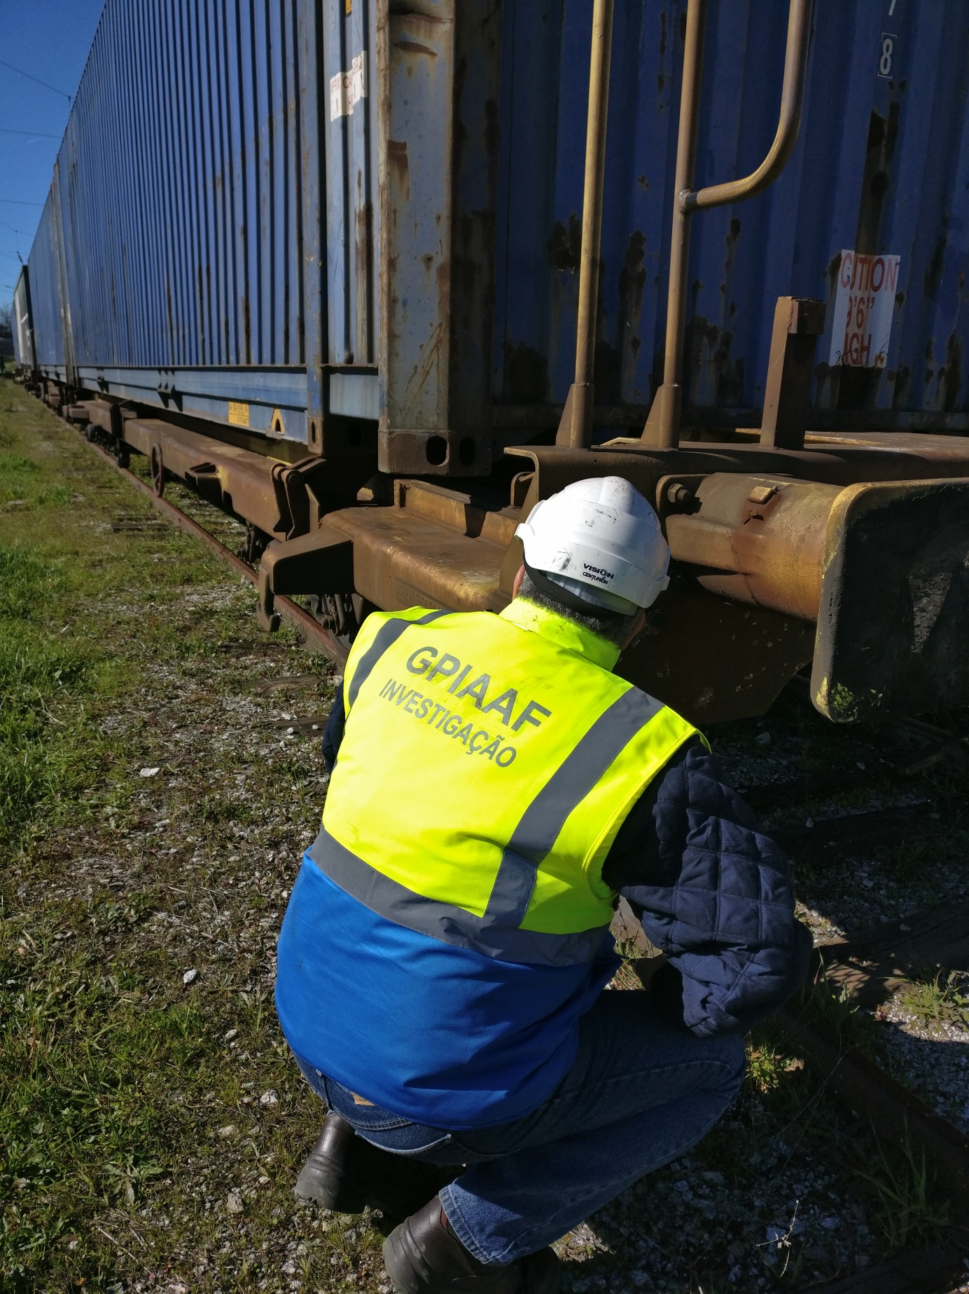

1. - As amended and republished by Decree-Law No 151/2014 of 13 October 2014.
2. - This repealed Directive 2004/49/EC.
3. - Includes serious accidents.
4. - The information in the table may not coincide with that indicated in the Annual Safety Report issued by the Institute for Mobility and Transport (IMT), since it corresponds to a selection of occurrences based on the criteria adopted by GISAF and the GPIAAF for their own use. For statistical purposes concerning national railway safety, only the data from the IMT Annual Safety Report is valid.