**Activity Report**

**2017**

September 2018

**Railway Sector**

**TECHNICAL INVESTIGATION ADMINISTRATION**

CIVIL AVIATION – MARITIME – INLAND WATERWAYS – RAILWAYS – ROADS

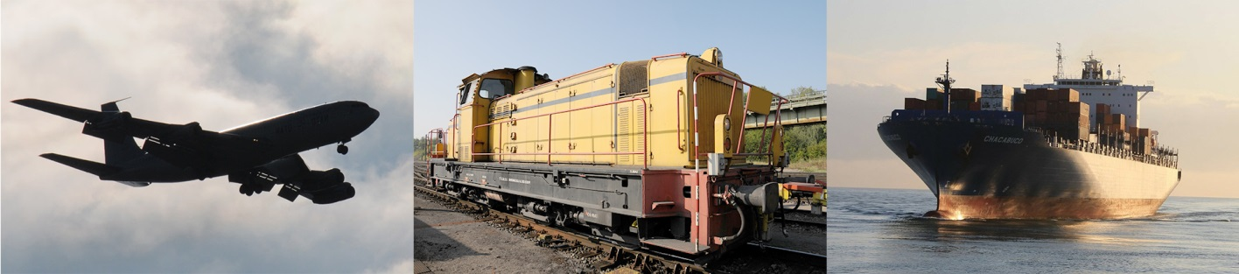

# Foreword

This activity report summarises the activities of the Technical Investigation Administration (Administration des enquêtes techniques – AET) in the railway sector in 2017, as well as the accidents and incidents that occurred on the Luxembourg rail network and that were notified by the infrastructure manager or railway undertakings in the same year.

This document has been prepared in accordance with Article 10(2) of the Grand-Ducal Regulation of 7 November 2008 laying down additional specifications for accidents and incidents occurring in the railway sector, and also in accordance with Article 24(3) of Directive (EU) 2016/798/EC.

**Technical Investigation Administration (AET)**

**1. General context**

The political initiative to improve road safety led to the decision to extend the AET's powers to fatal vehicle traffic accidents on public roads and to serious accidents on the tramway network.

It should be noted that in the road traffic sector, apart from the criminal investigations carried out following certain serious accidents, no technical investigations are currently carried out in Luxembourg.

In the vast majority of cases, the inappropriate individual behaviour of public road users is the cause of accidents (alcohol, speed, other non-compliance with traffic regulations, etc.). Therefore, the legislator’s intention is to limit technical investigations in this area solely to cases where a significant improvement in road safety can be expected. A draft law was drafted, tabled and adopted for this purpose. The law entered into force on 1 July 2017. The entry into service of the first section of the tramways in Luxembourg, between the ‘Luxexpo’ and ‘Pfaffenthal’ stops, took place on 10 December 2017.

As far as the civil aviation, maritime, inland waterway and railway transport sectors are concerned, new investigations were opened in 2017, while other investigations were still underway or were in the process of being completed. Two investigation reports in the civil aviation sector were completed and published in 2017.

Some of the AET’s time is spent on ensuring good relations and cooperation with other stakeholders in its areas of activity, at both national and international level.

**2. Functional context**

In August 2017, the AET was able to add to its staff an engineer whose activities are primarily focused on the area of vehicle traffic on public roads.

An engineer seconded from another administration who joined the AET in 2016 retired at the end of 2017.

The Administration’s staff currently consists of a director, three investigators and one person responsible for administration. However, it should be noted that, if necessary for a safety investigation, the amended Law of 30 April 2008 creating the Technical Investigation Administration provides for expert assistance to be sought from outside the AET.

The AET is an independent body under the authority of the member of the government who is responsible for transport.

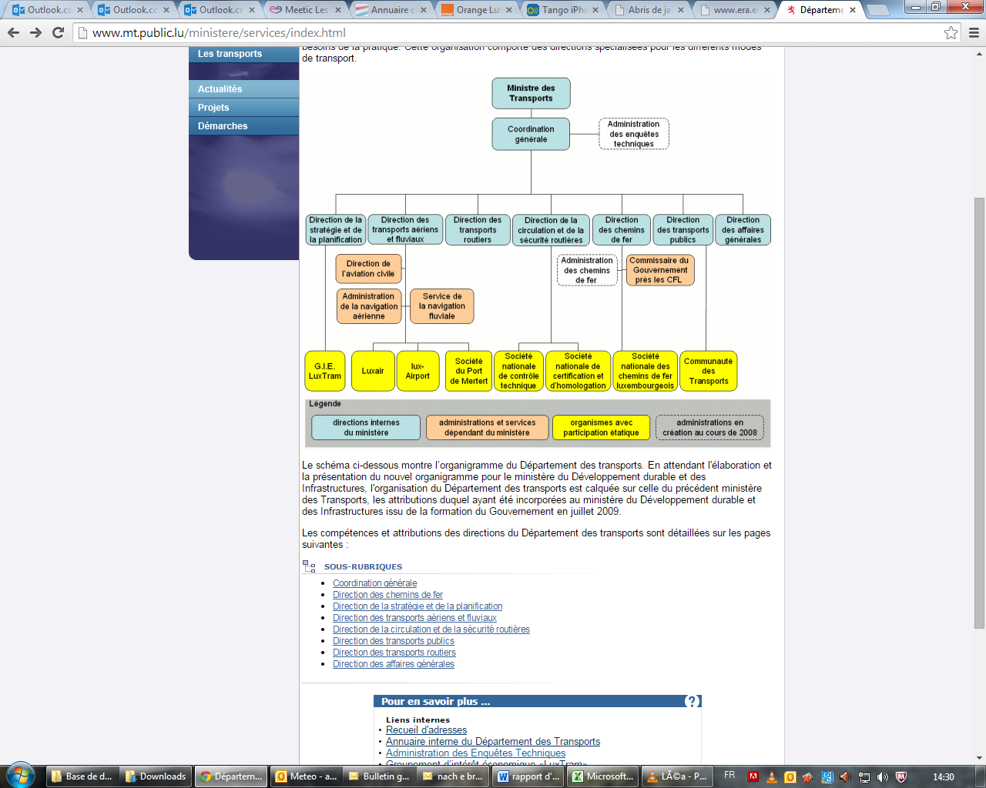

|  |  |
| --- | --- |
| Ministre des transports | Minister for Transport |
| Coordination générale | General Coordination Unit |
| Administration des enquêtes techniques | Technical Investigation Administration |
| Direction de la stratégie et de la planification | Strategy and Planning Directorate |
| Direction des transports aériens et fluviaux | Air and Inland Waterway Transport Directorate |
| Direction des transports routiers | Road Transport Directorate |
| Direction de la circulation et de la sécurité routières | Road Safety and Traffic Directorate |
| Direction des chemins de fer | Railway Directorate |
| Direction des transports publics | Public Transport Directorate |
| Direction des affaires générales | General Affairs Directorate |
| Direction de l’aviation civile | Civil Aviation Directorate |
| Administration de la navigation aérienne | Air Traffic Authority |
| Service de la navigation fluviale | Inland Waterway Traffic Service |
| Administration des chemins de fer | Railway Authority |
| Commissaire du Gouvernement près les CFL | Government Commissioner to the CFL (Luxembourg National Railway Company) |
| G.I.E. Luxtram | G.I.E. (Economic Interest Grouping) Luxtram |
| Luxair | Luxair |
| lux-Airport | lux-Airport |
| Société du Port de Mertert | Mertert Port Company |
| Société nationale de contrôle technique | National Agency for Technical Vehicle Inspection |
| Société nationale de certification et d’homologation | National Agency for Certification and Accreditation |
| Société nationale des chemins de fer luxembourgeois | Luxembourg National Railway Company |
| Communauté des Transports | Transport Federation |
| Légende | Key |
| directions internes du ministère | Ministry’s internal directorates |
| administrations et services dépendant du ministère | Authorities and services answerable to the Ministry |
| organismes avec participation étatique | Bodies with government involvement |
| administrations en création au cours de 2008 | Authorities created during 2008 |

The internal structure of the AET is represented in the diagram below.

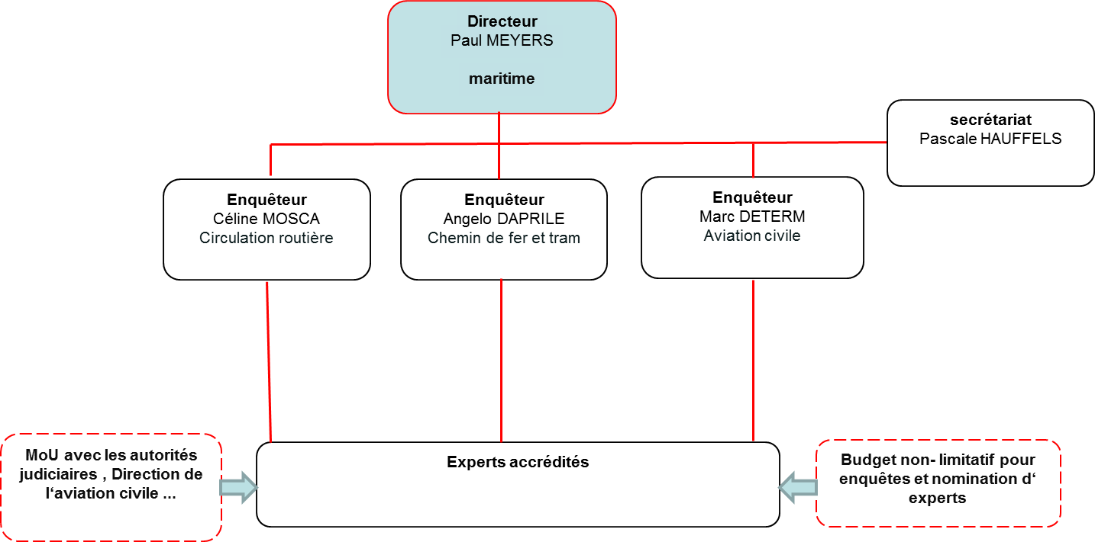

|  |  |
| --- | --- |
| **Directeur** Paul MEYERS **maritime** | **Director** Paul Meyers **maritime** |
| **Enquêteur** Céline MOSCA Circulation routière | **Investigator** Céline Mosca Road Traffic |
| **Enquêteur** Angelo DAPRILE Chemin de fer et tram | **Investigator** Angelo Daprile Railway and Tram |
| **Enquêteur** Marc DETERM Aviation civile | **Investigator** Marc Determ Civil Aviation |
| **secrétariat** Pascale HAUFFELS | **Secretariat** Pascale Hauffels |
| **MoU avec les autorités judiciaires, Direction de l’aviation civile…** | **MoU with the judicial authorities, Civil Aviation Directorate, etc.** |
| **Experts accrédités** | **Accredited experts** |
| **Budget non-limitatif pour enquêtes et nomination d’experts** | **Open-ended budget for investigations and appointment of experts** |

**3. Training**

The Community and international provisions on safety investigations in the transport sectors referred to by the Law of 30 April 2008 require the AET’s staff to have a core competency in the sectors concerned so they can effectively conduct a safety investigation. It is therefore important that there is regular attendance at continuous in-service training and other advanced training courses in the sectors of civil aviation, maritime and inland waterway transport, and railways.

In 2017, the Administration’s staff underwent a total of 38 days of training. This training was, for the most part, included in the continuous in-service training courses organised by the Institut national de formation publique (National Institute of Public Administration – INAP). Some training was organised by European agencies and other entities (ENCASIA, ECAC, ERA, EMSA) in the relevant means of transport with the aim of encouraging cooperation between safety investigation entities.

**4. Cooperation at national, European and international level**

Given the multiple means of transport under its responsibility, the AET is invited to take part in numerous meetings and other safety investigation activities at both European and international level. The contacts made and the information obtained at such events are particularly important as they enable the Administration, if necessary and in the absence of the appropriate resources in-house, quickly to seek external expert assistance and knowledge from foreign authorities and organisations.

**4.1 Cooperation in the railway sector**

In 2017, the European Union Agency for Railways (ERA) organised three meetings of the network of national investigation bodies (NIB Network). These meetings offer an opportunity to make decisions at European level in conjunction with the investigation bodies, analyse railway accidents, exchange information and experiences, and keep in touch with European counterparts.

**4.2 Cooperation between the AET and the judicial authority**

When offences are likely to have been committed in relation to accidents or serious incidents, the technical investigation is likely to compete with a criminal investigation. Of course, the purpose of the criminal investigation is very different from that of the technical investigation, in that it leads to the identification of any criminal liability, while the sole aim of the technical investigation is to improve safety. However, the two tasks partially overlap and the two bodies may find themselves in competition to investigate the same facts.

In that respect, a memorandum of understanding was signed in 2016 between the AET and the judicial authority represented by the various prosecutors’ offices and the investigating judges’ chambers. Its purpose is to consolidate cooperation, while taking into account the specific tasks of each of the parties involved. It was adapted in 2017 to take into account the AET’s new tasks in relation to vehicle traffic accidents on public roads.

The above-mentioned memorandum defines, among other things, the arrangements for cooperation in the following areas:

1. access to the accident site;
2. the preservation of evidence and access to it;
3. the initial and ongoing reports on the progress of each operation;
4. the exchange of information;
5. the appropriate use of safety information;
6. the resolution of conflicts.

In November 2017, the AET organised an information session with the judicial authority to present its specific tasks and responsibilities to the various prosecutors’ offices and investigating judges’ chambers.

**5. Railways**

In 2017, 44 safety events were notified to the AET by the infrastructure manager or by the railway undertakings involved.

There was a large number of signals passed at danger (21 events) and derailments (11 events).

On 14 February 2017, a serious accident took place in Dudelange, in which a regional express train (TER) and a goods train collided head-on at a set of points at kilometre point 1.481 of the ‘Bettembourg – Daereboesch’ section. The driver of the TER was killed instantly and the train guard suffered minor injuries. The driver of the goods train suffered serious injuries. No passengers were on board the TER at the time of the accident. However, there was major damage to the railway infrastructure and to the rolling stock.

Following this accident, a safety investigation was opened in accordance with the amended Law of 30 April 2008 on technical investigations relating to accidents and serious incidents occurring in civil aviation, maritime transport, railway and road traffic sectors, the Grand-Ducal Regulation of 7 November 2008 laying down additional specifications for accidents and incidents occurring in the railway sector, and Directive (EU) 2016/798 of the European Parliament and of the Council on railway safety.

The AET decided to issue safety recommendations immediately after the preliminary findings of the safety investigation in order to prevent the occurrence of a similar accident.

Without awaiting the investigation’s conclusions and in accordance with Article 9(2) of the Law of 30 April 2008 creating the AET, the following recommendations were submitted to the Administration des Chemins de Fer (Railway Authority – ACF):

* **Recommendation LU-CF-2017-001:** require railway undertakings to ensure that all rolling stock on the national rail network using the Memor II+ driver assistance system is uniformly equipped with an alert system informing the train driver of the position of the fixed repeater signal as it is passed.
* **Recommendation LU-CF-2017-002:** bring about as quickly as possible a shift from the use of the Memor II+ driver assistance system to the unified ETCS control-command system throughout the national rail network.
* **Recommendation LU-CF-2017-003:** make drivers aware that they must systematically communicate any irregularities and any damage observed in the railway infrastructure to the infrastructure manager as soon as possible and using the first available means.
* **Recommendation LU-CF-2017-004:** ensure that railway infrastructure users carry out systematic analysis of the driving data recorded in order to detect any anomalies.

The progress report was published on the AET’s website ([http://aet.gouvernement.lu/](http://aet.gouvernement.lu/en.html)) on 19 February 2018.

The following table summarises the events on the Luxembourg network that were notified to the AET in 2017:

|  |  |  |
| --- | --- | --- |
| **Item** | **Event type** | **Number** |
| 1 | signal passed at danger | 21 |
| 3 | derailment | 11 |
| 4 | collision with obstacle | 4 |
| 5 | suicide | 3 |
| 6 | collision | 2 |
| 7 | fire | 1 |
| 8 | danger | 1 |
| 9 | head-on collision of 2 trains | 1 |

**5.1 Breakdown by type of event in %**

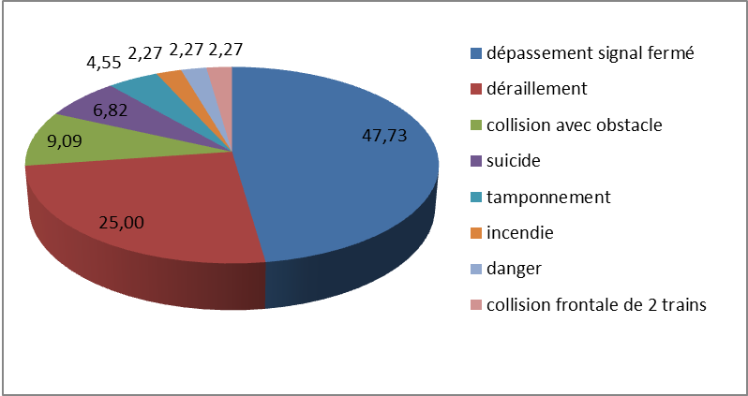

(Source: Notifications received by the AET)

|  |  |
| --- | --- |
| Dépassement signal fermé | Signal passed at danger |
| Déraillement | Derailment |
| Collision avec obstacle | Collision with obstacle |
| Suicide | Suicide |
| Tamponnement | Collision |
| Incendie | Fire |
| Danger | Danger |
| Collision frontale de 2 trains | Head-on collision of 2 trains |
| 47,73 | 47.73% |
| 25,00 | 25.00% |
| 9,09 | 9.09% |
| 6,82 | 6.82% |
| 4,55 | 4.55% |
| 2,27 | 2.27% |

**6. Tramways**

Since 10 December 2017, trams have been running in Luxembourg City between the ‘Luxexpo’ and ‘Pont Rouge’ stops. The AET is responsible for analysing any safety events and opening a safety investigation where appropriate.

The criteria for opening an investigation are similar to those for railways.

In 2017, two minor safety events were notified to the AET by the operating company Luxtram.