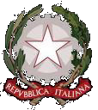

***Ministry of Infrastructure and Transport***

***Directorate General for Railway and Maritime Investigations***

|  |  |  |
| --- | --- | --- |
|  |  |  |
|  |  |  |
|  |  |  |
|  |  |  |
|  |  |  |

***ANNUAL REPORT 2017***

*It is permitted to use the contents of this Report, provided they are not altered and its reference context is unchanged.*

*If parts of this Report (sections, paragraphs, figures or tables or annexes) are used, the source must always be quoted: ‘Directorate General for Railway and Maritime Investigations– Annual report 2017’*

*This report is also available on the Directorate website at the following address* [***http://digifema.mit.gov.it***](http://digifema.mit.gov.it)*, in the section ‘Institutional relations’.*

|  |  |  |
| --- | --- | --- |
| ***1*** | ***2*** | ***3*** |
| ***4*** | ***5*** | ***6*** |
| ***7*** | ***8*** | ***9*** |

1. *Fire on board the motor vessel Sorrento, detail of a main deck, 2015 (source DIGIFEMA investigation)*
2. *DIGIFEMA [Directorate General for Railway and Maritime Investigations] Report on ‘Accidental events occurring from 01.01.2014 to 31.03.2015 with serious or fatal outcomes, characterised by collision with persons, mainly inside stations or their appurtenances’ , 2016 (source DIGIFEMA investigation)*
3. *Fire on board the motor vessel Sorrento, taken during rescue operations (source DIGIFEMA investigation)*
4. *DIGIFEMA report on collision between work vehicles, Fortezza-Bressanone section, 2017 (source DIGIFEMA investigation)*
5. *DIGIFEMA investigation report on an accident involving a collision between trains, which occurred on 12.07.2016 in the Corato-Andria section, 2017 (source National Fire Corps)*
6. *Detail of an accident involving a collision between trains, which occurred on 12.07.2016 in the Corato-Andria section, 2017 (source National Fire Corps)*
7. *Fire on board the motor vessel Norman Atlantic, taken during wreck recovery operations ( DIGIFEMA investigation)*
8. *DIGIFEMA investigation report on runaway of shunted empty wagons, collision with other wagons, derailment and collision with train, Piacenza-Bologna, Rubiera branch line, 2015 (source DIGIFEMA investigation)*
9. *DIGIFEMA investigation report on crash against pier in the port of Civitavecchia and damage to the vessel Sharden, 2016 (source DIGIFEMA investigation)*

|  |  |
| --- | --- |
|  | ***DIRECTORATE GENERAL FOR RAILWAY AND MARITIME INVESTIGATIONS*** |

# Annual report 2017

***NIB ANNUAL   
REPORT 2017***

#### Blank page

##### PREFACE

The year to which this annual Report refers, 2017, was extremely encouraging from the viewpoint of accidents for both the railway sector – which experienced no significant accidents with loss of human life – and the maritime sector.

But as we were forcefully reminded at the beginning of 2018, we must never allow ourselves to become complacent because, unfortunately, risk is just around the corner.

In 2017, the duties of DIGIFEMA were extended by Decree Law No 148 of 16 October 2017, converted by Law No 172 of 4 December 2017 expanding the Directorate’s scope to all transport systems with fixed installations and inland navigation.

This is a step toward the organisational methods adopted by the most advanced countries in terms of safety and prevention, where a single technical investigative body intervenes in all accidents, albeit with sector specialists, with the aim of pooling methods as well as investigative standards and attention to human factors.

However, as is often the case, the enormous expansion in the duties assigned went hand-in-hand with a reduction in human resources, creating a situation of overload that seriously risks impairing the quality of results in the future.

In 2017, we also began the process of signing a Memorandum of Understanding with the Public Prosecutors’ Offices, aimed at coordinating investigations pertaining to this Directorate with investigations carried out for judicial purposes in order not to cause procedural problems to the latter.

Unfortunately, to date only two thirds of the Public Prosecutors’ Offices have signed the protocol, even though it has been approved and issued by the Ministry of Justice, taking refuge behind formal statements that ignore the explicit and clear will of European and national laws decreeing that safety for all is a matter of overwhelming public interest.

The legislative tangle remains crucial: to avoid potentially difficult negotiations with other administrations, ministerial offices often offer the lawmaker confused, partial texts without any real organisation of the subject matter that would ensure (particularly in the transposition of European Directives) that the texts are not limited to a transliteration of standards but set out in a way that would make them actually implementable within the national regulatory framework.

The experience I have gained during full three years at the head of DIGIFEMA has taught me that until we rewrite the criminal code, the shipping code, the railways act and associated legislation, we will not be able to promote a culture of safety that is proactive and not reactive, that aims to manage and not comply with parameters and, in short, that makes the system safer and at the same time more efficient, accountable and transparent.

From now on, I am committed to ensuring that this Directorate increasingly makes its own small but significant contribution to ensuring the safety and health of the public.

**INTRODUCTION**

The Directorate General for Railway and Maritime Investigations performs the functions of the Investigating Body provided for by Directive 2004/49/EC of the European Parliament and of the Council as implemented by Legislative Decree No 162 of 10 August 2007 (railway accident investigations) and Directive 2009/18/EC of the European Parliament and of the Council as implemented by Legislative Decree No 165 of 6 September 2011 (marine casualty investigations).

According to the above Directives concerning investigations into railway and marine accidents, the priority objective of the activities of the Directorate General for Railway and Maritime Investigations is to improve railway safety and marine safety. This aim is pursued through activities involving identifying the causes of operating accidents or incidents and determining any ‘***Safety recommendations***’.

During 2017, the Directorate General worked generally on disseminating the results of investigations; this activity was carried out, in particular, by intervening in conventions, bilateral meetings and national and international working groups to clarify the nature, scope and broader aims of the recommendations.

In 2017, **one important aspect to highlight was the start of work on drawing up a Memorandum of Understanding with individual Public Prosecutors' Offices**, aimed at coordinating investigations pertaining to this Directorate with investigations carried out for legal purposes in order not to cause procedural problems to the latter.

Despite an ongoing lack of dedicated investigative staff, the Directorate General performed activities connected with its institutional duties in an effective and efficient manner, achieving the objectives specified below with regard to competences required by Ministerial Decree No 346 of 4 August 2014.

However, this lack of investigative staff will become an even greater concern in 2018 and in ensuing years because at present – as a result of the provisions laid down in Article 15(b)(4) of Law No 172 of 4 December 2017 – the Directorate’s area of competence has been significantly increased. Under the above law, the Directorate will also have to carry out investigations on accidents occurring:

* in all fixed installation systems (metros, trams and light rail vehicles, trolleybuses, escalators and cableways),
* in inland navigation and
* in all railway networks functionally isolated from the national railway network and used for local public transport,

without the law providing for a consequent and necessary increase in the workforce.

**DIRECTORATE GENERAL**

**Mr Fabio CROCCOLO**

**TABLE OF CONTENTS**

1. DIRECTORATE GENERAL FOR RAILWAY AND MARITIME INVESTIGATIONS 1

1.1Regulatory framework and implementation status of Directives 3

1.2Mission and role 8

1.3Organisation: structure and competences of the DIGIFEMA 11

1.4Information flow 13

2. THE INVESTIGATIVE PROCESS 15

2.1Procedure for opening an investigation 17

2.2.Institutions involved in investigative activities 24

2.3.The investigative process and the Directorate General’s approach 25

3. INVESTIGATIONS 33

3.1Overview of completed investigations and trends 35

3.2Investigations completed and launched in 2017 36

3.3Accidents and incidents investigated during the period 2012-2017 46

4. Safety recommendations 49

4.1Summary and presentation of recommendations 50

5. OTHER ACTIVITIES 57

5.1International and EU relations in the railway and maritime sector 58

5.2Relationships with network managers, railway undertakings and shipping companies 63

5.3Training and refresher courses for investigative staff 63

5.4Study and research 64

5.5List of Experts who can be commissioned to act as Investigators 65

**Annex No 1** List of relevant standards

*Drafting of Report by Division 1 International and institutional relations*

|  |  |  |  |
| --- | --- | --- | --- |
| - Mr | *Giuseppe* | *ALATI* | *Manager* |
| - Mr | *Wolmer* | *ZANELLA* | *Technical officer* |

*Printed at the Ministry of Infrastructure and Transport Printing Press Centre   
– EUR HEADQUARTERS*

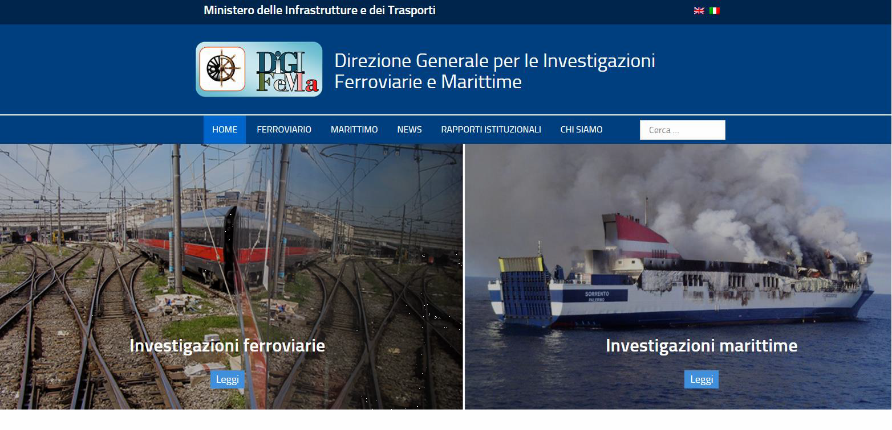

### DIRECTORATE GENERAL FOR RAILWAY AND MARITIME INVESTIGATIONS

#### Blank page

* 1. Regulatory framework and implementation status of Directives
     1. *Regulatory framework*

This Annual Report was prepared with reference to the provisions of Directive 2004/49/EC and Legislative Decree No 162/2007 (railway sector) as well as Directive 2009/18/EC and Legislative Decree No 165/2011 (maritime sector).

Details of EU regulatory instruments and/or guidelines as well as specific national rules on railway and maritime investigations and organisation of the activities of the Directorate-General are set out in **Annex No 1** to this report.

* + 1. *Update on implementation status of Directives 2004/49/EC, (EU) 2016/798 and 2009/18/EC*
* **Establishment and organisational principles of the Directorate General(as referred to in Article 21 of Directive 2004/49/EC, Article 22 of Directive (EU) 2016/798 and Article 8 of Directive 2009/18/EC)**

The 10th anniversary of the date when the national investigative body into railway accidents, known as the Directorate General for Railway Investigations was first set up falls in 2017.

This seems a good time to outline the main steps that led to the current organisational structure of the Directorate General in order to highlight changes in organisation and investigational expertise undergone by the investigative body during the period 2007-2017.

|  |  |  |
| --- | --- | --- |
| **YEAR** | **RELEVANT INVESTIGATIVE BODY** | **AREAS OF INVESTIGATION COVERED** |
| **2007** | Establishment of a permanent investigative body, set up by the ***Directorate General for Railway Investigation (DGIF)***, within the Ministry of Transport  (*See Article 18 of Legislative Decree No 162/2007*). | 1. Accidents and incidents occurring in the national railway system |
| **2011** | Establishment of the ***Marine Casualty Investigation Body* (OISM)**, within the Ministry of Infrastructure and Transport  (*See Article 4 of Legislative Decree No 165/2011)* | 1. Marine casualties and accidents involving national flag ships wherever they are located or occurring in State territorial sea or internal maritime waters |
| **2014** | Establishment of the ***Directorate General for Railway and Maritime Investigations (DIGIFEMA)*** within the Ministry of Infrastructure and Transport, with simultaneous merging of the former DGIF and the former OISM  (*see Article 15 of No 72/2014 and Article 4 of Ministerial Decree No 346/2014*) | a) + b) |
| **2017** | ***Directorate General for Railway and Maritime Investigations***  (See Article *15(b)(4) of Law No 172 of 4 December 1972)* **([1])** | 1. accidents on networks functionally isolated from the rest of the railway system and used only for local, urban or suburban passenger services; 2. accidents in domestic inland waterways; 3. accidents on all transport systems with fixed installations (metros, trams and other light rail transport systems). |

* **Principles of functional independence of the Directorate General from other ministerial organisations and from the National Railway and Maritime Safety Authority  
  (see Article 21 Directive 2004/49/EC, Article 22 of Directive (EU) 2016/798 and Article 8 of Directive 2009/18/CE)**

The principle of independence of the DIGIFEMA is mainly enshrined in the following provisions:

* Prime ministerial Decree No 72/2014 and Ministerial Decree No 346/2014, institutional and organisational decrees of the Directorate;
* Legislative Decrees No 162/2007 and No 165/2011 implementing Directives 2004/49/EC and 2009/18/EC;
* Directorial Decree No 352 of 24 March 2015 clearly setting out additional aspects of independence concerned with the employment of investigators external to DIGIFEMA to carry out investigative activities supporting the Directorate;
* Ministry of Infrastructure and Transport Directive No 26 of 25 January 2017 concerning ‘General guidelines for administrative and management activity for 2017’ (ref-Article 5 ‘Resource allocation’), which specifically states the ‘**organisational, functional and accounting independence**’ of this Directorate, implementing the principles laid down by the above EU legislation.

This principle has recently also been confirmed by Ministry of Infrastructure and Transport Directorate No 12 of 25.01.2018 concerning ‘General guidelines for administrative activities and management for 2018’, filed with the Court of Auditors on 9 February 2018 in register No 1, folio No 86, which conferred strategic and operational objectives for 2018 on those in charge of administrative responsibility centres and assigned the relevant financial, human and instrumental resources.

For this purpose, the Directorate is directly answerable to the Ministry and is not included among the direct cooperation offices or subject to ministerial departments or other organisations responsible for regulating and controlling the safety of national and/or regional railway networks as well as the safety of Maritime transport and for inland waterways.

* **Principles of investigative independence from the judicial authority  
  (see Article 20 of Directive 2004/49/EC, Article 21 of Directive (EU) No 2016/798 and Article 4 of Directive 2009/18/EC)**

In 2016, this Directorate received from the Prime Minister’s Office, Department for European Policies – Mission Structure for Infringement Procedures, a request for information on **EU PILOT CASE NO 8289/16/MOVE -** *Circumstances relating to the participation of BSU (German investigative body) investigators in safety investigations relating to the Norman Atlantic accident and the proper implementation by Italy of Directive 2009/18/EC on the investigation of casualties in the maritime transport sector*.

In particular, the European Commission requested details from the Directorate in the EU Pilot case regarding the following aspects of relations with the judicial authority:

1. Status of safety investigation;
2. Management of safety investigations and participation in the investigation;
3. Investigating bodies;
4. Protection of evidence.

Answers were given to the questions posed in **EU PILOT No 8289/16/MOVE** on the independence of technical investigations from judicial investigations, specifying that problems essentially derive from a discrepancy between court needs and the immediacy typical of technical safety enquiries.

In this regard, Article 28 of Italian Law No 97 of 6 August 2013 introduced a fundamental principle of necessary coordination between the two different types of investigations, judicial and technical.

In June 2017, based on this principle and regarding the investigative independence of DIGIFEMA from the judicial authority, individual Public Prosecutors' Offices began to sign the ‘***Cooperation agreement between DIGIFEMA and the Ministry of Justice***’, with the aim of implementing the provisions of Articles 20 and 21 of Legislative Decree No 162/2007 (as amended by Article 28 of Law No 97 of 6 August 2013), of article 21(2) and (4) and Directive (EU) 2016/798 and Articles 5 and 6 of Legislative Decree No 165/2011.

The outline Agreement with the above Public Prosecutors' Offices is available for consultation on the DIGIFEMA website at the following address [**http://digifema.mit.gov.it/?p=1120**](http://digifema.mit.gov.it/?p=1120)

|  |
| --- |
| For the sake of full disclosure, in 2017, according to information from the European Commission, **EU PILOT CASE No 8289/16/MOVE** has been shelved, but the Commission is still waiting to receive a copy of the agreement signed between the judicial authorities through the Ministry of Justice and DIGIFEMA, once the agreement has been finalised with individual Public Prosecutors' Offices. |

* **Principle of protecting the confidentiality of investigative activities performed by the Directorate General (see Article 21 Directive 2004/49/EC and Article 8 of Directive 2009/18/EC)**

Pursuant to the provisions of Legislative Decree No 196 of 30 June 2003**([2])** ‘Personal data protection code’ and subsequent amendments as well as Legislative Decree No 162/2007 and Legislative Decree 165/2011, DIGIFEMA investigative staff must observe obligations of confidentiality and secrecy with regard to any information, sensitive data, witness evidence, reports or other statement collected or received on the occasion of and for the purposes of the technical investigation of safety in railway accidents or marine casualties.

Furthermore, according to the above rules, the final report on a technical investigation or accident event, including factual findings contained therein and safety conclusions and recommendations set out constitutes a technical report independent of any other administrative or judicial procedure.

* 1. Mission and role

The main objective of activities performed by the Directorate General for Railway and Maritime Investigations is to improve railway and maritime safety and prevent accidents in accordance with the provisions of Directive (EU) 2016/798 and Legislative Decrees No 162/2007 and No 165/2011. **This strategic aim is pursued through investigative activities involving identifying the causes of operating accidents or incidents and determining any safety recommendations**.

Investigations launched as a result of railway accidents or incidents – that the Directorate General performs using its own staff or with the aid of external investigators – are aimed at identifying the direct, indirect and upstream causes of the event. This is done by analysing the technical aspects that caused the event as well as the procedural and regulatory aspects associated with the accidental event.

Final investigation reports contain safety recommendations proposed by the investigation commission or the investigator in charge.

The strategic mission of the Directorate General therefore consists of issuing **‘Safety recommendations’** which are used to start the process of improving railway safety and maritime safety in Italy; this process is also further developed by sharing the recommendations at EU level with our counterpart investigative bodies in other countries through the European Union Agency for Railways (ERA) and the European Maritime Safety Agency (EMSA).

|  |
| --- |
| **It is important to emphasise that the investigations do not set out in any way to identify civil or criminal liability because these are the exclusive competence of the judiciary.** |

In particular, **in the railway sector**, all events investigated by **DIGIFEMA** in its capacity as ***NIB - National Investigation Body***, are also subject to the obligation of notifying the opening of investigations to the European Union Agency for Railways (ERA) with inputting of the information into the **ERAIL (***European Railway Accident Information Links****)*** database.

The activity of entering both documents on the ERA website is carried out by Directorate staff directly in the ERAIL database, which can be found on the Agency website at the address [https://erail.era.europa.eu,](https://erail.era.europa.eu/) in order to ensure that all information connected with the investigations carried out is available and can be shared. The following table summarises the status of investigations started due to incidents occurring during 2017 and appearing in the ***ERAIL*** database (*Figure 1*).

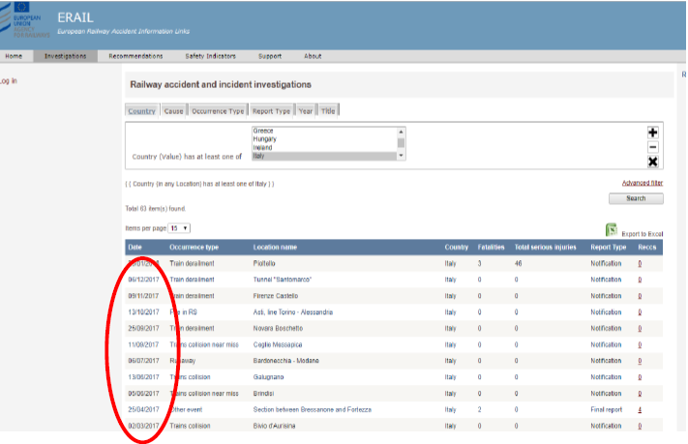

*Figure 1 - Chart showing notifications entered in the ERAIL database in 2017*

**In the maritime sector**, on the other hand, all events potentially subject to investigation by DIGIFEMA are reported to **EMSA**, as follows:

1. during the initial stage, reporting of an event that had occurred (very serious, serious, or less serious) by the Directorate General;
2. at the final stage, when the final report on the accident, following verification and validation by the Directorate, is sent to the European Commission (DG MOVE) by the agency EMSA, which operates as the technical and operational arm of the Commission.

Activities involved in entering both documents on the EMSA website are carried out by Directorate staff directly in the **EMCIP** (*European Maritime Casualty Information Platform*) database, which can be found on the Agency website at the address https://emsa- emcip.jrc.ec.europa.eu/emsa-emcip to ensure that all information connected with the investigations carried out is available and can be shared.

The following screenshot shows an excerpt from the most recent accident notifications, occurring during 2017, and entered in the above **EMCIP** database (*Figure 2*).

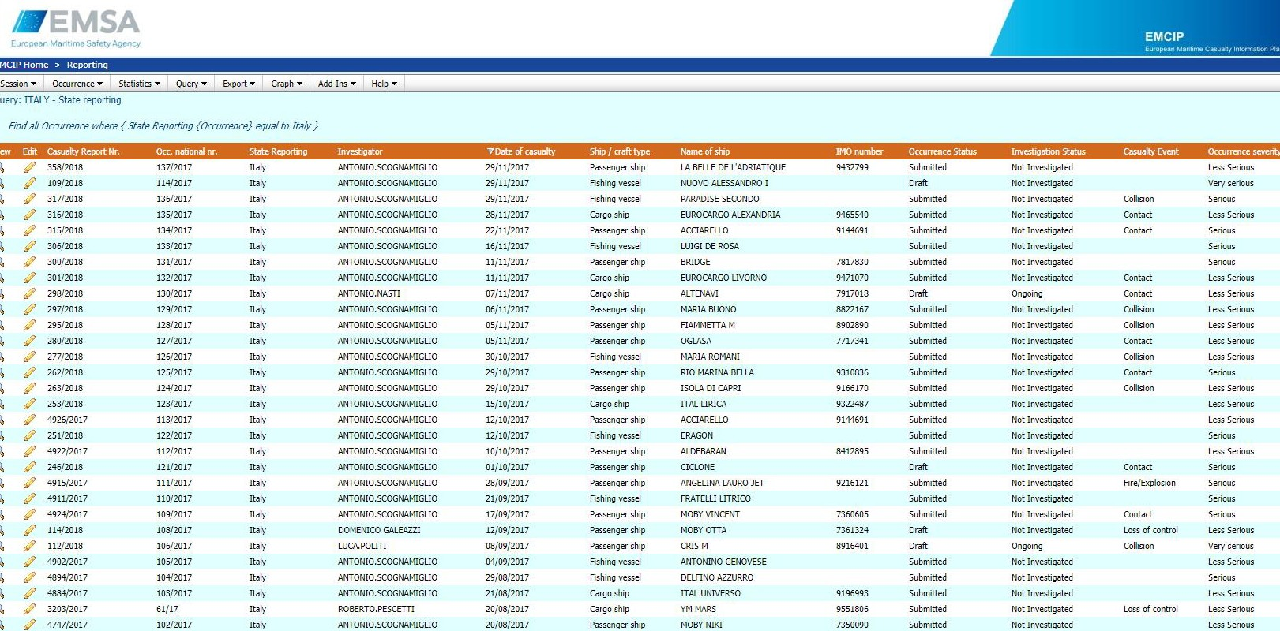

*Figure 2 - Chart showing part of the notifications entered in the EMCIP database for marine casualties occurring in 2017*

* 1. Organisation: structure and competences of the DIGIFEMA

Ministerial Decree No 346 of 4 August 2014 on the new organisation of ministerial offices defined the organisation of the Directorate General, which is now structured in accordance with the chart shown in *Figure* 3:

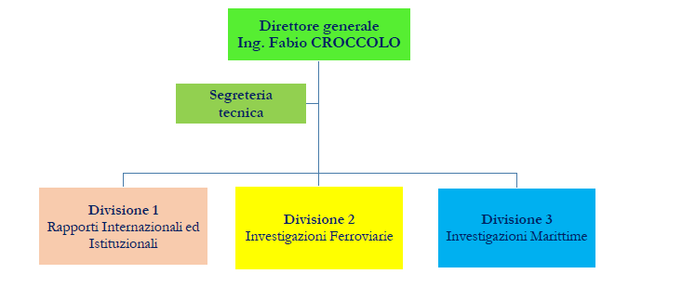

*Figure 3 - Organisational structure of DIGIFEMA*

|  |  |
| --- | --- |
| Direttore generale Ing. Fabio CROCCOLO | Director General Mr Fabio CROCCOLO |
| Segreteria tecnica | Technical Secretariat |
| Divisione 1 Rapporti Internazionali ed Instituzionali | Division 1 International and institutional relationships |
| Divisione 2 Investigazioni Ferroviarie | Division 2 Railway investigations |
| Divisione 3 Investigazioni Marittime | Division 3 Maritime investigations |

Detailed information on the competencies of individual Offices of the Directorate, established by Article 4 of the aforementioned Ministerial Decree No 346/2014, can be found on the new DIGIFEMA website at the address: [**http://digifema.mit.gov.it**](http://digifema.mit.gov.it/)

During 2017 - in order to plan its activities in line with the provisions of EU reference bodies concerning railway and maritime investigative activities – the Directorate considers it necessary to implement a voluntary quality management system compliant with ISO 9001:2015. To this end, it prepared a Quality Manual that describes its approach to institutional activity processes. The manual drawn up is also the outcome of cooperation and an exchange of experiences launched in 2016 with the Finnish investigative body SIA (OTKES), which has long carried out investigative activities in accordance with the principles of ISO 9001 and quality operating procedures.

In particular, the DIGIFEMA Manual fully maps all the main processes for which it is competent – such as notifying/reporting of accidents, investigative activities, safety recommendations – and related actions**([3])** to be started for each process, with reference to the applicable laws.

Table 1 below maps the Directorate’s main service processes.

*Table. 1 – DIGIFEMA process mapping*

|  |  |  |  |
| --- | --- | --- | --- |
| **PROCESS**  **(EX MINISTERIAL DECREE (MD 346/2014)** | **POSSIBLE INTERACTIONS WITH OTHER PROCESSES** | **INPUT** | **OUTPUT** |
| **1. Investigative activities** | 2, 3, 4, 6, 7 | Notification of accidents or incidents | Safety recommendations |
| **2. Notification of accidents or incidents** | 1, 4, 7 | External via accident event reporting on the DIGIFEMA SIGE web database | Investigative activities |
| **3. Safety recommendations** | 1, 4 | Investigative activities | Transmission to external stakeholders |
| Notification to ERAIL and EMCIP databases  Monitoring implementation of safety recommendations issued for the annual report |
| **4. Annual report** | 1, 2, 3, 7 | Investigative activities  Notification of accidents or incidents  Recommendations  Relations with international, EU and national institutions | Report on institutional activities carried out |
| **5. Implementation of changes to the regulatory framework** | 1, 2, 3, 4, 6 and 7 | Issue of legislative and regulatory changes at EU and national level | Investigative activities Recommendations Accident notification  Drawing up of reports / Annual reports  Procurement  Directorate's functional expense management |
| **6. Procurement of goods and services** | 1, 2, 4 | Need to acquire a supply of goods and services instrumental to the performance of institutional activities | Purchase of goods and services in accordance with government procurement procedures |
| **7. Operational expense management** | 1, 2, 3, 4, 6 | Investigative activities  Notification of accidents or incidents  Goods and services recommendations | Preparation of financial and accounting documents relating to the Directorate’s institutional activities by means of the SI.CO.GE. general accounting system |

* 1. Information flow

The final outcome of the DIGIFEMA investigation process - in addition to the outcome concerning public communication and information on results of investigations into the causes of accidents and incidents - is the issue of  **‘Safety recommendations’**, aimed at improving safety and avoiding the repetition of events. These are to be sent, together with the Investigation Report to the following stakeholders or end implementers of the required actions,

* **for railway matters, to:**
* European Union Agency for Railways (ERA)
* Italian National Railway Safety Agency (ANSF)
* Ministry of Infrastructure and Transport, as the authority responsible for regulatory control of the land transport sector;
* other State bodies or authorities;
* other European Union Member States.
* infrastructure managers;
* railway undertakings;
* local authorities;
* rescue services;
* **and for maritime matters to:**
* European Maritime Safety Agency (EMSA);
* General Command of the Corps of Port Captaincies, as the authority competent for marine safety;
* Ministry of Infrastructure and Transport, as the authority responsible for regulatory control of the maritime transport sector as well as for training crew members;
* other State bodies or authorities;
* other European Union Member States;
* ship owning, shipbuilding and naval industry companies;
* International Maritime Organisation (IMO).

**All the above entities must give due consideration to the safety recommendations they receive and must take steps to ensure that they are translated into specific measures.**

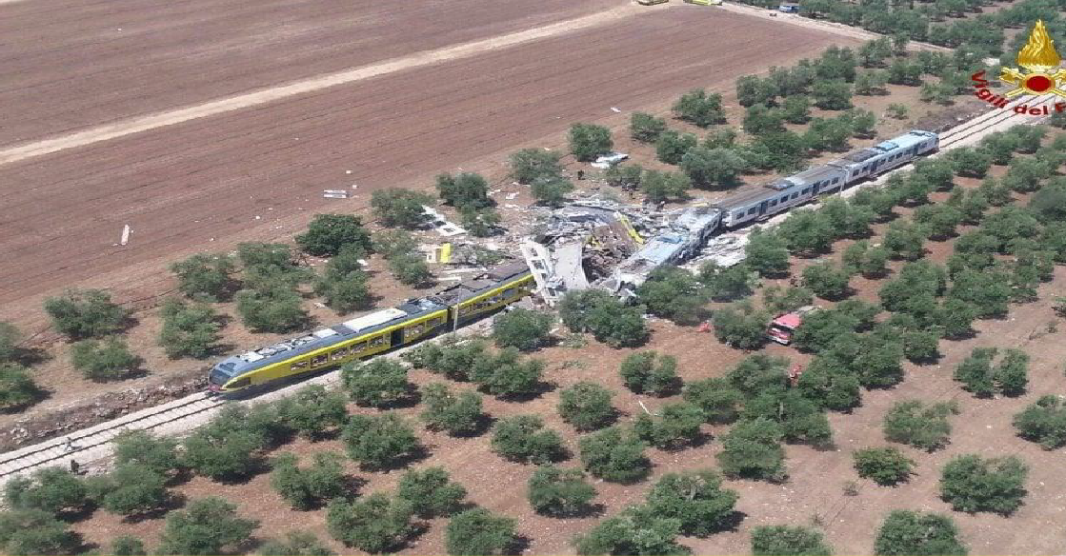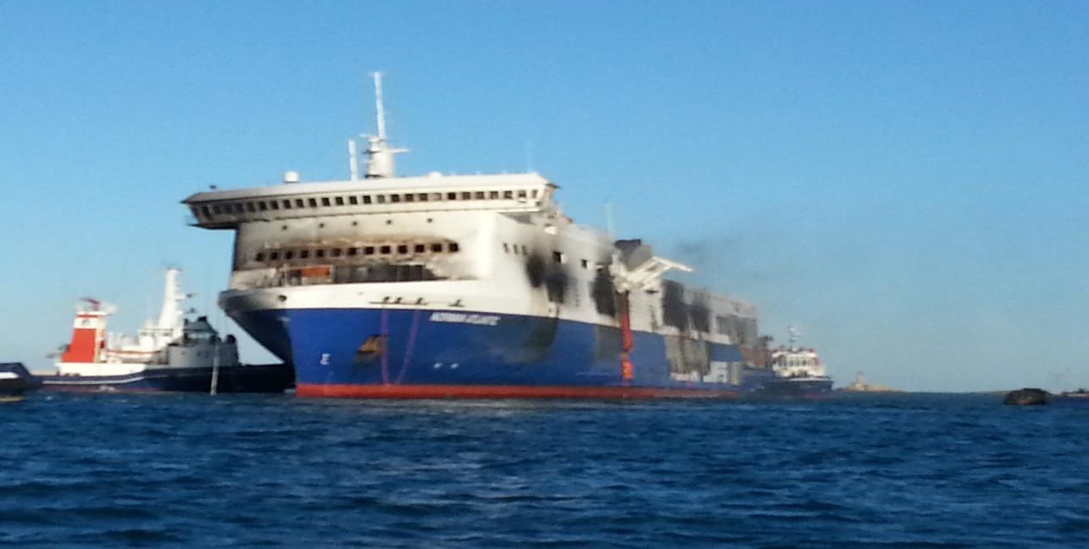

### THE INVESTIGATIVE PROCESS

#### Blank page

* 1. Procedure for opening an investigation
     1. *Procedures in the railway investigation sector*
  + Definition of accidents and incidents to be investigated

The following table defines the type of accident events that DIGIFEMA investigates, according to the provisions of Legislative Decree No 162/2007 and Directive 2004/49/EC.

*Table 2 – Definitions of the main types of accidental events in the railway sector*

|  |  |  |
| --- | --- | --- |
| **Legislative reference** | **Type of event** | **Definition** |
| Article 3(1) of Legislative Decree 162/2017  *Article 3(l) Directive 2004/49/EC and Article 3(12) of Directive EU 2016/798)* | *Serious accident* | *any railway collision or train derailment resulting in the death of at least one person or serious injuries to five or more people or serious damage to rolling stock, the infrastructure or the environment and any other similar accident with an obvious impact on the regulation of railway safety or the management thereof; serious damage: damage, the total cost of which can be immediately estimated by the investigating body as at least EUR 2 million* |
| Article 3(1) Legislative Decree 162/2017 | *accident* | *an unwanted and unintended sudden event or a specific chain of such events which have harmful consequences; accidents are divided into the following categories: collisions, derailments, level-crossing accidents, accidents to persons caused by rolling stock in motion, fires and others* |
| Article 3(1) of Legislative Decree 162/2017  *Article 3(m) Directive 2004/49/EC)* | *incident:* | *any occurrence, other than accident or serious accident, associated with the operation of trains and affecting or potentially affecting the operating safety* |

Pursuant to Article 19(1) of Legislative Decree No 162/2007, following serious accidents, **DIGIFEMA**, is obliged to carry out investigations ‘*with the aim of providing recommendations designed to improve railway safety and accident prevention’*.

In addition to serious accidents, in accordance with the provisions of Article 19(2) of Legislative Decree No 162/2007, **DIGIFEMA** can investigate accidents and incidents that could have caused serious accidents under different conditions, considering the risk level of the accidents and incidents and the possible impact of the investigated event on overall transport system railway safety.

* ***Method of classifying accidents and incidents and launching an investigation***

The following Table provides a classification of accidental events in force in 2017 for the railway sector, while the following diagram (*Figure* *4*) shows a block diagram for the choice of methods for opening an investigation **([4]).**

*Table 3 - Classification of accident events in the railway sector*

|  |  |  |  |
| --- | --- | --- | --- |
| **Code** | **Event** | **Event subset** | **Type** |
| **01** | **Collision** |  |  |
| 01.01 |  | Collision between trains | Accident |
| 01.02 |  | Collision with obstacles | Accident |
| 01.03 |  | Near miss | Incident |
| **02** | **Derailment** |  | Accident |
| **03** | **Level-crossing event** |  |  |
| 03.01 |  | Level-crossing accident | Accident |
| 03.02 |  | Near miss at level crossing, including improperly opened LC | Incident |
| **04** | **Accidents to persons caused by rolling stock in motion** |  |  |
| 04.01 |  | Accidents to persons | Accident |
| 04.02 |  | Suicide or attempted suicide | Accident |
| **05** | **Runaway rolling stock** |  | Incident |
| **06** | **Fire on rolling stock** |  | Accident |
| **07** | **Release of dangerous goods** |  | Accident/Incident |
| **08** | **Wheel or axle failure and other damage to rolling stock.** |  |  |
| 08.01 |  | Wheel failure | Incident |
| 08.02 |  | Axle failure | Incident |
| 08.03 |  | Other damage to rolling stock | Incident |
| **09** | **Malfunctioning of**  **technological systems** |  |  |
| 09.01 |  | Malfunctioning of signals | Incident |
| 09.02 |  | Malfunctioning of other systems | Incident |
| **10** | **Rail failure and buckling** |  |  |
| 10.01 |  | Rail failure | Incident |
| 10.02 |  | Buckling (sufficient to put the track out of operation) | Incident |
| **11** | **SPAD** |  | Incident |
| **12** | **Unauthorised train movements other than SPAD** |  | Incident |
| **13** | **Other** |  |  |
| 13.01 |  | Train collision/derailment shunting/maintenance | Accident |
| 13.02 |  | Collision/derailment of work vehicles | Accident |
| 13.03 |  | Serious accidents occurring at junctions or sheds (involving the railway system) | Accident |
| 13.04 |  | Fire in infrastructures | Accident |
| 13.05 |  | Electrocution | Accident/Incident |
| 13.06 |  | Act of vandalism | Accident/Incident |
| 13.07 |  | Division of trains | Incident |
| 13.08 |  | Hot Box and Hot Wheel Detection Alarm | Incident |
| 13.09 |  | Line break | Incident |
| 13.10 |  | Other event (specify) | Accident |

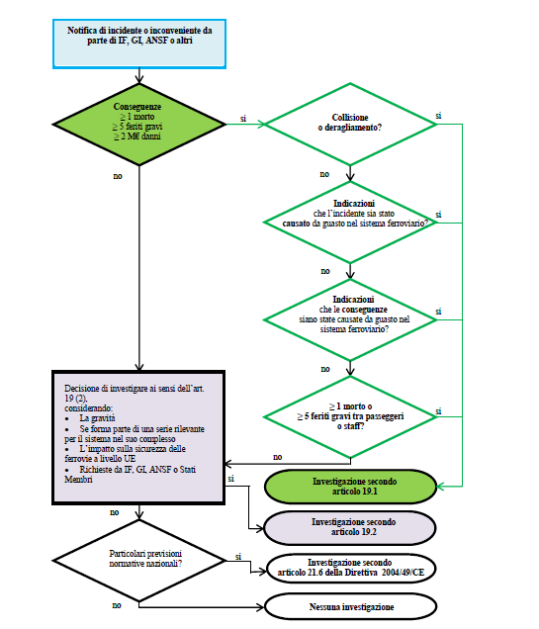

*Figure 4 - Process flowchart for decisions on investigations in the railway sector (ref. Directive 2004/49/EC)*

|  |  |
| --- | --- |
| Notifica di incidente da parte di IF, GI, ANSF o altri | Notification of accident or incident by IF, GI, ANSF or others |
| Conseguenze ≥ 1 morto ≥ 5 feriti gravi ≥ 2 M€ danni | Consequences ≥ 1 fatality ≥ 5 serious injuries ≥ EUR 2 million damages |
| si | yes |
| no | no |
| Collisione o deragliamento? | Collision or derailment? |
| Indicazioni che l’incidente sia stato causato da guasto nel sistema ferroviario? | Indications that the accident was caused by a fault in the railway system? |
| Indicazioni che le conseguenze siano state causate da guasto nel sistema ferroviario? | Indications that the consequences were caused by a fault in the railway system? |
| ≥ 1 morto o ≥ 5 feriti gravi tra passeggeri o staff? | ≥ 1 fatality or ≥ 5 serious injuries to passengers or staff? |
| Investigazione secondo articolo 19.1 | Investigation according to Article 19(1) |
| Investigazione secondo articolo 19.2 | Investigation according to Article 19(2) |
| Investigazione secondo articolo 21.6 della Direttiva 2004/49/C | Article 21.6 of Directive 2004/49/EC. |
| Nessuna investigazione | No investigation |
| Decisione di investigare ai sensi dell’art. 19 (2), considerando:   * La gravità * Se forma parte di una serie rilevante per il sistema nel suo complesso * L’impatto sulla sicurezza delle ferrovie a livello UE * Richieste da IF, GI, ANSF o Stati Membri | Decision to investigate pursuant to Article 19(2), considering:   * severity * whether it forms part of a series that is significant to the system as a whole * impact on railway safety at EU level * requests from IF, GI, ANSF or Member States |
| Particolari previsioni normative nazionali? | Particular national legislative provisions? |

* + 1. *Procedures in the maritime investigation sector*
* ***Definition of casualties and accidents to be investigated***

Article 2 of Legislative Decree 165/2011 states that the same Decree ‘**applies to marine casualties and incidents involving ships flying the Italian flag or that have occurred in State territorial or internal waters or have had an impact on significant Italian interests’**.

The following table defines the type of accident events that DIGIFEMA investigates, according to the provisions of Legislative Decree No 165/2011 and Directive 2009/18/EC.

*Table 4 – Definitions of the main types of accidental events in the maritime sector*

|  |  |  |
| --- | --- | --- |
| **Legislative reference** | **Event type** | **Definition** |
| IMO Resolution MSC.255(84) - IMO Code for the Investigation of Marine Casualties and Incidents | ***Very serious marine casualty***  *(very serious marine casualty)* | *marine incident on a ship that involves total loss of the ship, a fatality or serious damage to the environment* |
| IMO MSC-MEPC.3/Circ.3 | ***Serious marine casualty***  *(serious marine casualty)* | *marine incident other than a very serious marine accident, affecting a ship and relating to fire, collision, contact, grounding, damage to the hull and on-board equipment, flooding of ship compartments* |
| IMO Resolution MSC.255(84) | ***Marine incident***  *(marine incident)* | *event or sequence of events, other than a marine casualty, that occurred directly in connection with a ship’s operation, endangering its safety or, if not corrected, which could endanger the safety of the ship, its occupants or any other person or the environment* |
| IMO Resolution MSC.255(84) | ***Serious injury***  *(serious injury)* | *injury suffered by a person, resulting in that person being unable to work for more than 72 hours;*  *This event is taken into consideration if the injury coincides with a marine casualty affecting the ship* |

The Directorate General for Railway and Maritime Investigations - **DIGIFEMA** performs the role referred to in Directive 2009/18/EC and Legislative Decree No 165/2011 (see Article 5 ‘Obligation to investigate’, Directive 2009/18/EC and Article 7 of Legislative Decree No 165/2011), carrying out safety investigations in the maritime sector in accordance with the following outline:

* **obligatory investigations,** following a very serious marine casualty pursuant to Article 7(1) of Legislative Decree No 165/2011;
* **optional investigations**, in the event of a serious marine casualty: **DIGIFEMA,** in accordance with Article 7(2) of Legislative **Decree** No 165/2011, *‘carries out a preliminary evaluation of the facts and circumstances of the event with the aim of formally opening a safety investigation';*
* **optional investigations**: in the event of a less serious marine casualty, **DIGIFEMA** decides, in accordance with **Article** 7(2) of Legislative Decree No 165/2011 whether to open a safety investigation if it deems that the results of such an investigation could effectively prevent similar future casualties and accidents.
* ***Classification of accident events – maritime sector***

In the marine casualty sector, event reports take place in accordance with Circular Letter No 043/OISM [marine casualty investigative body] of 26 June 2014 *‘Obligation to notify and cooperate in the event of a marine casualty and associated technical safety enquiry’.*

The classification of accident events used in reports is as set out below.

*Table 5 - Classification of accident events in the maritime sector* **([5])**

|  |  |
| --- | --- |
|  | **Event type** |
| **1.** | **Capsizing/Listing** |
| **2.** | **Collision between ships or between a ship and other obstacles** |
| **3.** | **Contact** |
| **4.** | **Damage to ship or equipment** |
| **5.** | **Grounding/Stranding** |
| **6.** | **Fire/Explosion** |
| **7.** | **Flooding/Foundering** |
| **8.** | **Hull failure** |
| **9.** | **Loss of control** |
| **10.** | **Missing** |
| **11.** | **Non-accident events** |

For the sake of full disclosure, DIGIFEMA, in compliance with EMSA requirements, also analyses and conducts a technical investigation into ***serious injuries,*** i.e. accidents on board ship that do not affect the ship itself but only involve injury to crew members as a result of the accidental occurrence (referred to as ***occupational accident related to casualty of ship****).*

* + 1. *Accident event database management – ‘SIGE’ accident database*
* ***Procedure PR-SIGE-01: System for managing accidental events in the railway and maritime sector***

Under current legislation, DIGIFEMA must acquire data relating to railway and maritime accidents from all the responsible parties (infrastructure operators, transport undertakings, competent authorities in the field of railway and maritime safety and so on), and then draw up and analyse the data.

Independent conduct of the above institutional tasks allows responsible entities an opportunity to report new events occurring within the railway and maritime sectors with direct Internet access to the DIGIFEMA thematic section of the Ministry website by means of appropriate authentication and in accordance with technical rules for managing computerised documents (online forms).

As an example, a screenshot of the application relating to the railway and marine event data section is shown below.

*Figure 5 - Screenshots illustrating the* ***SIGE database*** *- Railway Accident and Marine Casualty Report Management System*

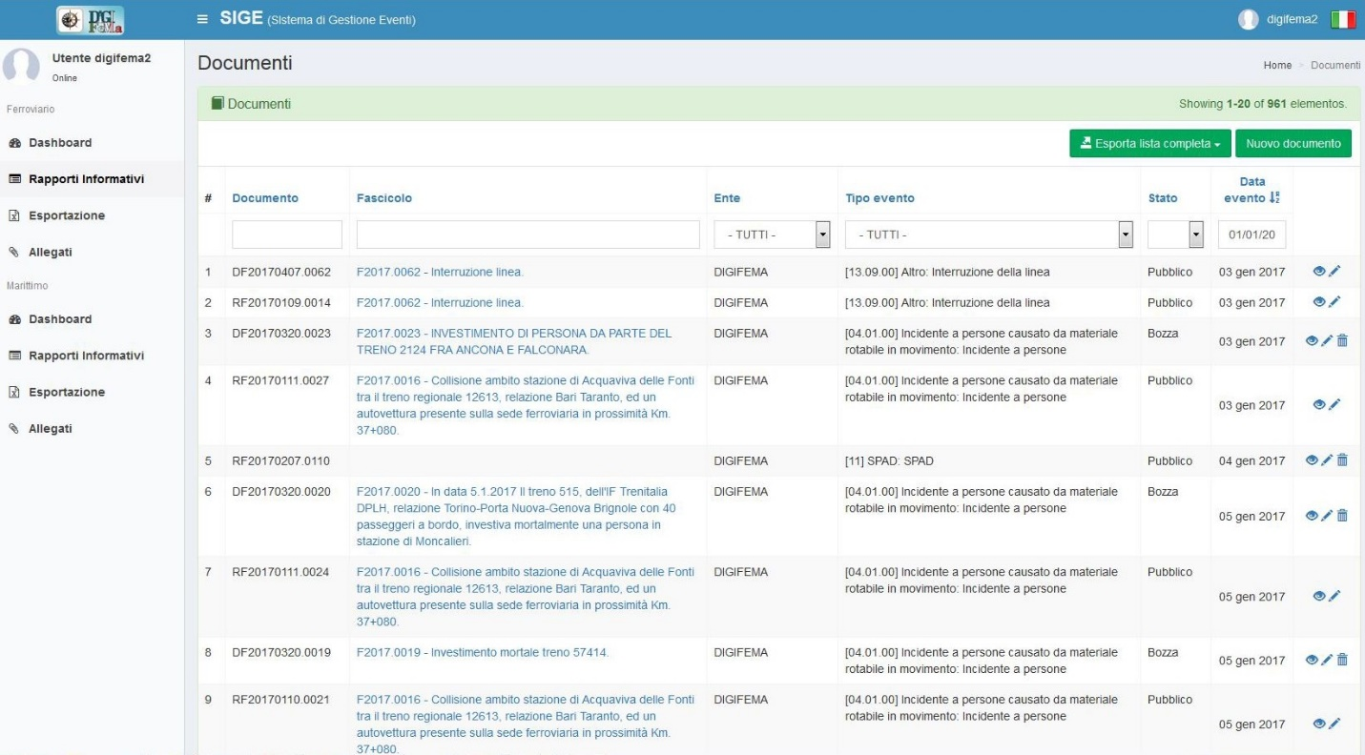

|  |
| --- |
| **Railway sector screenshot** |

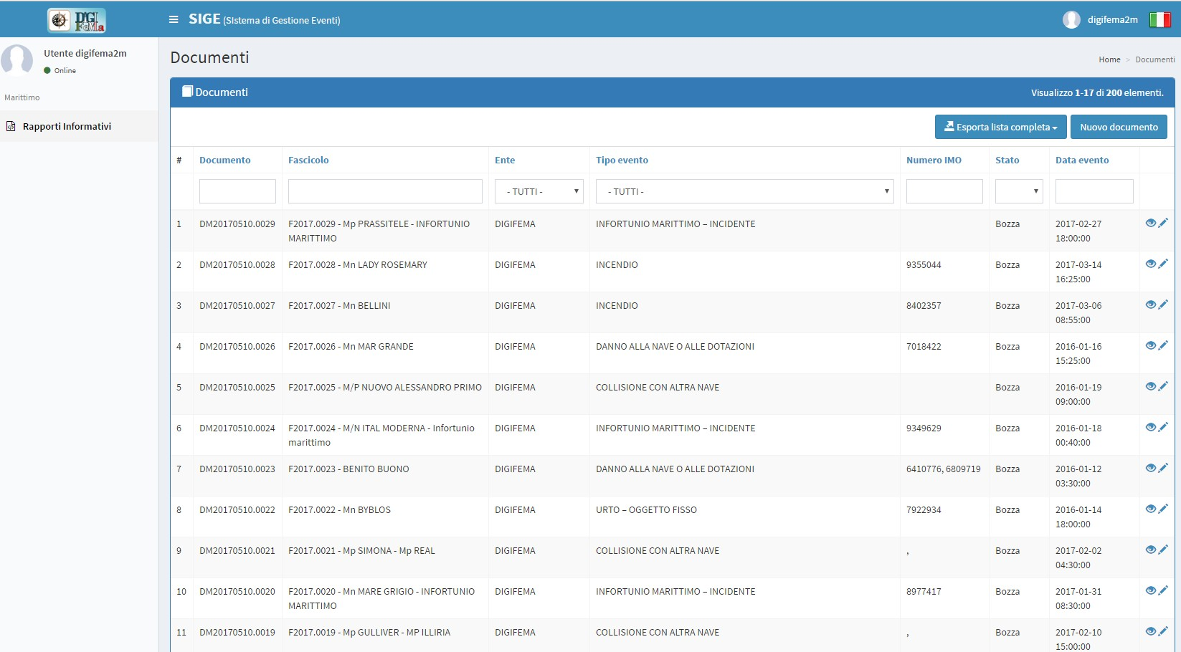

|  |
| --- |
| **Maritime sector screenshot** |

* 1. Institutions involved in investigative activities

The following institutional stakeholders were involved in various aspects of the investigative activities carried out during 2017:

* **Ministry of Infrastructure and Transport**, as the authority responsible for railway transport sector legal regulations (for aspects concerning level crossing interfaces) and for monitoring and statistical studies on marine casualties;
* **Ministry of Justice** as the authority responsible for coordinating judicial activities on railway accidents and marine casualties;
* **National Railway Safety Agency (ANSF),** national railway safety authority, as the natural target of the safety recommendations as provided by Article 24 of Legislative Decree No 162 of 10 August 2007;
* **European Union Agency for Railways (ERA)**, as the EU railway safety body informed of all investigations launched and because all recommendations issued by the DIGIFEMA are reported to ERA, as the EU body responsible for coordinating individual national agencies. We note in this regard that the list of recommendations issued by the DIGIFEMA in 2017 and sent to the ERA can be viewed on the ERA website at the following link: <http://erail.era.europa.eu/>
* **European Maritime Safety Agency (EMSA)**, as the EU maritime safety body informed of all investigations opened;
* **General Command of the Corps of Port Captaincies**, as the national authority competent for maritime safety;
* **National Fire Brigade,** as the state technical body with expertise in fire prevention supporting investigative activities in railway accident or marine casualty situations characterised by fire;
* **IMO** ( International Maritime Organisation) as the international body analysing the main types of maritime accidents at international level, including for the purpose of improving maritime safety regulations;
  1. The investigative process and the Directorate General’s approach
     1. *Accident event reporting – preliminary investigative actions*

In the railway investigation sector, following event notification in accordance with procedures set out in Circular No 1450 of 16 October 2015, where necessary, the Directorate General obtains further evidence of the event and decides whether or not to open an *in situ* investigation. The investigation then begins by conducting an initial verification of certain conditions:

* correct operation of all railway subsystems;
* adequacy and correct implementation of all safety measures.

Preliminary information is then gathered from the railway police, the infrastructure operator or the railway undertakings involved.

In the maritime investigation sector, accidents that occur, regardless of the consequences, must be reported as required in the Executive Directive issued in a document dated 26 June 2014.

In particular, after notification of the event, when necessary, DIGIFEMA obtains further evidence of the event and decides whether or not to start an investigation at the affected site, depending on the severity of the casualty reported and according to the event severity definition set out in the IMO Code, in Directive 2009/18/EC and in Legislative Decree No 165/2011.

At present, communication channels for immediate reporting of accident events occurring in the railway and maritime sectors are available 24 hours a day and, in particular, individual events are reported to Office telephone numbers dedicated to receiving event notifications.

* + 1. *Gathering evidence on accident events*

Having concluded the preliminary operations, the Directorate General gathers all the information necessary to help reconstruct the facts:

* witness statements (of people involved in the casualty or accident, eyewitnesses of the event, emergency service staff, competent police and safety authority staff, staff and/or technicians of the railway or shipbuilding companies involved in the event and technicians specialising in the examination of on-board equipment/systems or facilities);
* operating standards, rules and procedures;
* operation of vehicles involved in the railway accident or marine casualty, of equipment and of on-board and ground facilities;
* documentation relating to the circulation and/or traffic management system in the area involved in the event;
* man–machine interface;
* safety management system;
* any other information considered useful.

When the Directorate General decides to attend the site of the event, all interested parties are immediately informed and the action is agreed with the Judicial Authority, if involved, observing mutual independence of activities.

* + 1. *Analysis of the accident event – Human factor and safety culture*

At this point, the analysis stage begins, the aim of which is to clarify the reasons why the event occurred. During this stage, it may become necessary to obtain additional information, thus triggering an iterative process that generally depends on the complexity of the event.

During the analysis, it may be necessary to call in external experts for specific complex issues (for example, requesting the support of the National Fire Brigade for incidents when fires occurred).

The analysis stage concludes by reconstructing the chain of events that occurred and thus the direct, indirect and upstream causes that lead to the accident or incident.

The procedures used by **DIGIFEMA** investigators to conduct the investigation are performed in accordance with the following:

* for the railway sector, ERA/GUI/04/2010 guidelines as well as Directive 2004/49/EC;
* for the maritime sector, Regulation (EU) No 1286/2011 – issued for implementation of Article 5(4) of Directive 2009/18/EC – as well as Directive 2009/18/EC.

In 2017, the Directorate continued to use the specific study – prepared by this Office in 2016 entitled ‘Analysis of the human factor in railway and maritime sector accident events’- as the benchmark operational tool for conducting technical investigations. The above study was also presented nationally to all operators in both sectors during February 2017 and can be consulted and downloaded at the following website link [http://digifema.mit.gov.it/rapporti-istituzionali/](http://digifema.mit.gov.it/rapporti-istituzionali/%20)in the section **Studies & Research.**

In the field of investigations into railway accidents and marine casualties, DIGIFEMA also believes that more attention must be paid to the interrelationship between certain essential elements such as the safety management system, the human–machine interface, the human factor and human error as well as the new approach to safety and accident prevention issues that come under the heading of safety culture.

It is now a well-established principle in railway and maritime transport sectors that for safety and accident prevention purposes it is important to implement a smoothly-running Safety Management System (**SGS**). But it is equally important for the organisational and occupational areas of individual transport companies to disseminate a broad-ranging **safety culture**.

The general principle of the importance of promoting a safety culture and analysing the human element in the railway sector was also reiterated and reinforced in Directive (EU) No 2016/798 ([6]) on railway safety.

With specific regard to the investigative actions of this Directorate, we consider it appropriate to refer to the following principle enshrined in Recital 41 of the Directive:

|  |
| --- |
| *‘In the event that the direct cause of an accident or incident seems to be related to human actions, attention should be paid to the particular circumstances and the manner in which routine activities are performed by staff during normal operations, including the design of the man-machine interface, the suitability of procedures, conflicting objectives, workload and any other circumstances which may have influence on the occurrence, including physical and work-related stress, fatigue or psychological fitness’.* |

In view of this, the methodological outline for accident analysis currently used by DIGIFEMA investigators requires that the individual accident event should be described starting with a chronological description of non-compliant situations that occurred. The approach is broken down into six different levels involved in the overall system of activities associated with the event, namely:

|  |  |
| --- | --- |
| **ANALYSIS LEVEL** | **TYPE OF INVESTIGATIVE ACTION** |
| **1 - Event timeline** | Analysis of sequence/method of performing the different stages of the work activity involved in the accident (vehicle driving, on-board or ground traffic management and so on) |
| **2 - Technical aspects** | Analysis of behaviour, of the human factor and of the professional qualifications of the staff involved, of technical issues related to the event and technical characteristics of vehicles involved as well as problems related to the relevant infrastructures (rail or sea) |
| **3 - Managerial and operational aspects** | Analysis of procedures for managing the safety system of the means of transport (rolling stock or ship) and the infrastructural network involved in the accident. |
| **4 - Aspects connected with safety culture** | Analysis of the safety management policy of the entity involved (railway undertaking, shipbuilding company, national safety authority and so on) |
| **5 - Regulatory aspects** | Analysis of standards and regulations in force within the sector affected by the accidental event |
| **6 - Transport safety policies** | Analysis of transport safety (rail or maritime) with the aim of guiding policies and strategies and drawing up of proposed amendments. |

* + 1. *Safety recommendations*

All parties involved in the railway accident or marine casualty have the opportunity to contribute technical input prior to publication of the final report on the investigation and the recommendations.

All suggestions and observations made by the consultant parties are limited to factual content and, when deemed relevant, they are considered by the Directorate General prior to publication of the final investigation report.

At this point, the Directorate General may decide to issue a safety recommendation with the aim of increasing the safety of railway transport or maritime transport at national and international level, based on the causes that gave rise to the event.

* + 1. *SIGE – database of accident events in the railway and maritime sector*

With a view to sharing procedures for setting up the new accident event reporting system, in 2017 the Office launched the new reporting procedure by:

* organising meetings with main stakeholders in the railway and maritime sectors to introduce the new database and methods for managing accident event reporting;
* creating dedicated users to allow direct access to the database in order to assess the potential of the system and any problems with entering, processing or managing the data;
* use of the DB by Directorate staff, albeit in trial mode, with the aim of managing and reporting accident events in the railway sector received by email from railway undertakings and infrastructure managers.

This sharing activity enabled the SIGE database to be populated with data on railway and maritime accident events (accidents and incidents sent to this Directorate pursuant to the provisions of Legislative Decree No 162/2007 and Legislative Decree 165/2011), thus enabling us to enter approximately 1300 railway accident events and approximately 500 maritime events (reference period from 1 January 2016 to 31 December 2017).

In November 2017, the pre-operational test stage of the new SIGE Accident Data Base was completed

When the first trial stage was considered to have concluded, in December 2017 the second trial stage started to allow all the infrastructure managers and railway undertakings as well as all the peripheral maritime Offices to start becoming familiar with the new signalling system and with the application developed. They were allowed to use a test area at the following link <http://195.45.104.172/site/login> to access the opening screen for access to *SIGE – Marine and Railway Casualty Reporting Management System* and begin to enter data on accidents in their own part of the railway or maritime system in experimental test mode by means of the dedicated portal.

**SIGE database portal screen**

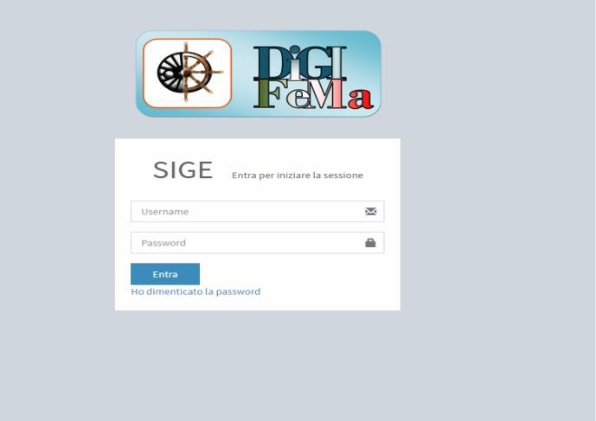

The new SIGE database for sector operators to enter notifications of railway accidents and marine casualties was due to become operational **by September 2018.**

As an example, during the period 1 January – 31 December 2017, 802 accident/incident reports were entered in the ‘Accident events – Railway’. These were distributed as follows:

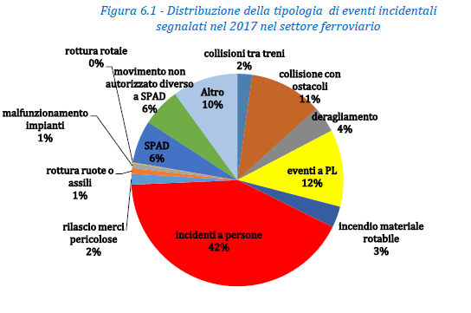

|  |  |
| --- | --- |
| ***Figura 6.1 - Distribuzione della tipologia di eventi incidentali segnalati nel 2017 nel settore ferroviario*** | ***Figure 6.1 - Distribution of type of accident events reported in 2017 in the railway sector*** |
| Rottura totale 0% | Total failure 0% |
| Malfunzionamento impianti 1% | System malfunction 1% |
| Rottura ruote o assili 19% | Wheel or axle failure 19% |
| Rilascio merci pericolose 2% | Dangerous goods release 2% |
| Incendio materiale rotabile 3% | Fire in rolling stock 3% |
| Deragliamento 4% | Derailment 4% |
| Collissione con ostacoli 11% | Collision with obstacles 11% |
| Collissione tra treni 2% | Collision between trains 2% |
| Movimento non autorizzato diverso a SPAD 6% | Unauthorised movement other than SPAD 6% |
| SPAD 6% | SPAD 6% |
| Incidenti a persone 42% | Accidents to persons 42% |
| Eventi a PL 12% | LC events 12% |
| Altro 10% | Other 10% |

For example, for Level Crossing Events – which are crucial for railway safety purposes – the following figure shows a geographical distribution of events occurring and reported to DIGIFEMA in 2017. The region of Puglia is highlighted in red as the geographical area most affected by such events.

*Figure 6.2 - Geographical distribution of LC accident events in 2017*

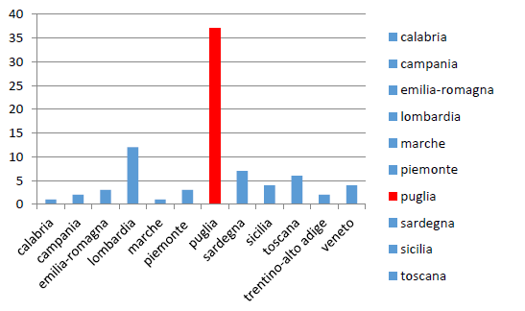

|  |  |
| --- | --- |
| calabria | Calabria |
| campania | Campania |
| emilia-romagna | Emilia-Romagna |
| lombardia | Lombardy |
| marche | Marche |
| piemonte | Piedmont |
| puglia | Puglia |
| sardegna | Sardinia |
| sicilia | Sicily |
| toscana | Tuscany |
| trentino-alto adige | Trentino-Alto Adige |
| veneto | Veneto |

**

### INVESTIGATIONS

#### Blank page

* 1. Overview of completed investigations and trends

The following table provides a summary of **railway investigations** completed in 2017.

*Table 6 – Summary of railway investigations completed in 2017*

|  |  |  |  |  |  |
| --- | --- | --- | --- | --- | --- |
| **Type of event investigated** | **Number of events** | **Number of casualties** | | **Material damage [€] (estimated)** | **Trend compared to 2016** |
| **Fatalities** | **Serious injuries** |
| Collisions between trains | 1 | 23 | 50 | > 9 000 000 | +1 (0) ([7]) |
| Collisions with obstacles | 0 | 0 | 0 | 0 | 0 (0) |
| Other events - collisions between work vehicles | 1 | 2 | 0 | > 2 000 000 | +1 (0) |
| Derailments | 0 | 0 | 0 | 0 | 0 (0) |
| Level-crossing accidents | 0 | 0 | 0 | 0 | 0 (0) |
| Accidents to persons caused by rolling stock in motion | 0 | 0 | 0 | 0 | -1 (1) ([8]) |
| Fires in rolling stock | 0 | 0 | 0 | 0 | 0 (0) |
| Hazardous goods | 0 | 0 | 0 | 0 | 0 (0) |
| Incidents | 0 | 0 | 0 | 0 | -2 (2) |

The following table provides a summary of **maritime investigations** completed in 2017.

*Table 7 – Summary of maritime investigations completed in 2017*

|  |  |  |
| --- | --- | --- |
| **Type of event investigated** | **Number of events 2017** | **Trend compared to 2016** |
| Capsizing/Listing | 0 | -1 (1) ([9]) |
| Collision between ships or between a ship and other obstacles | 0 | 0 (0) |
| Contact | 0 | 0 (0) |
| Damage to ship or equipment | 0 | -1 (1) |
| Grounding/Stranding | 0 | 0 (0) |
| Fire/Explosion | 1 | -1 (2) |
| Flooding/Foundering | 0 | -1 (1) |
| Missing | 0 | 0 (0) |
| Other types of events (marine incidents) | 1 | -1 (2) |

* 1. Investigations completed and launched in 2017

*Rail investigations completed and launched in 2017*

To *make* it easier to identify individual accidents, the following tables also provide the event ID Code in the ERAIL database as well as the legal basis for launching the investigation with reference to Directive 2004/49/EC (for more details, see also the list of investigations at this link: <http://erail.era.europa.eu/investigations.aspx>).

*Table 8 – Summary of railway investigations completed in 2017*

|  |  |  |  |  |  |
| --- | --- | --- | --- | --- | --- |
| **ERAIL ID event** | **Event date** | **Location** | **Investigation title** | **Legal basis** | **End date of investigation** |
| IT- 5134 | 12.07.2016 | Bari C.le – Barletta C.le line, Andria - Corato section | Head-on collision between passenger trains ET1016 and ET1021 | Article 19(1) | 06.12.2017 |
| IT- 5330 | 25.04.2017 | Verona – Brennero line, Fortezza – Bressanone section | Collision between work vehicles. | Article 19(2) | 14.12.2017 |

*Table 9 – Summary of railway investigations launched in 2017*

|  |  |  |  |  |
| --- | --- | --- | --- | --- |
| **ERAIL ID event** | **Event date** | **Location** | **Investigation title** | **Legal basis** |
| IT-5276 | 02.03.2017 | Bivio d’Aurisina station on the Portogruaro- Trieste line | Collision between a shunting locomotive and a goods train | Aricle 19(2) |
| IT-5442 | 05.06.2017 | Brinish - Squinzano line | Near miss between long-distance train and regional train | Article 19(2) |
| IT-5363 | 13.06.2017 | San Donato di Lecce – Galugnano section, Lecce - Zollino line | Collision between two passenger trains at low speed and with minor injuries | Article 19(2) |
| IT-5440 | 06.07.2017 | Turin - Modane line | Incident with runaway work vehicle when traffic on the line was suspended | Article 19(2) |
| IT-5439 | 11.09.2017 | Ceglie Messapica – Francavilla Fontana section, Martina Franca – Lecce line | Near miss between regional passenger trains | Article 19(2) |
| IT-5481 | 25.09.2017 | Novara Boschetto | Derailment of a wagon of shunting goods train 43631 | Article 19(2) |
| IT-5482 | 13.10.2017 | Asti station, Turin-Alessandria line | Fire in locomotive of goods train 70427 | Article 19(1) |
| IT-5510 | 09.11.2017 | Firenze Castello station | Derailment of one bogie on the penultimate vehicle of passenger train ES 8510 arriving at the station | Article 19(2) |
| IT-5551 | 06.12.2017 | Between PM Santomarco and Bivio Pantani in Santomarco tunnel | Derailment of three vehicles of regional passenger train 3742 in tunnel | Article 19(2) |

*Table 10 – Specification of railway investigations completed in 2017*

|  |  |  |  |  |
| --- | --- | --- | --- | --- |
| **ERAIL database – event ID** | **Accident date** | **Location** | **Event** | **Investigation end date** |
| **IT-5134** | **12.07.2016** | **Bari C.le - Barletta C.le line, Andria - Corato section** | **Head-on collision between passenger trains ET1016 and ET1021** | **06.12.2017** |
| **Event description** | The event occurred on 12.07.2016, at 11.05 a.m. At the 51 km marker on the Bari – Barletta line, in this section between the stations of Andria and Corato.  The event involved train ET 1016 from Bari C.le heading for Barletta C.le, and train ET 1021, from Barletta C.le and heading for Bari C.le, both owned by the railway undertaking Ferrotramviaria  S.p.A. An examination of the electronic speed according tapes of both trains showed that at the moment of impact, train ET 1016 was travelling at a speed of 94 km/h and train ET 1021 was travelling at 101 km/h, within the maximum speed limit allowed on that route (110 km/h).  The trains did not activate emergency braking, probably because the limited visibility at the collision point prevented the respective drivers from seeing the other train beforehand.  The collision took place on a bend with thick vegetation at the sides. The circumstances prevented the line being visible beyond the bend from the train driver’s cabin.  In addition to the four driving crew members (two drivers and two guards) on board the two trains involved in the collision, an approximate total of 80 passengers were present.  Traffic is controlled by a telephone block system in the part of the line where the event took place. | | | |
| **Direct cause of the accident** | **DIRECT CAUSE 1**  *Simultaneous occupation of the section between Andria and Corato by trains ET 1016 and ET 1021 due to incorrect traffic management by traffic controllers*  Trains ET 1021 departing from Andria in the direction of Corato, and ET 1016, departing from Corato in the direction of Andria, simultaneously occupied the route between Andria and Corato.  Train 1021 occupied the section after receiving an improper clearance for departure while in Andria station.  The movement authorisation for train 1021 should have been dependent on the arrival of train 1016 in Andria station, considering that the passing point between trains 1021 and 1016 in Corato station (due to a delay built up by train 1016) could not in any case be moved because an incident was in progress that prevented passings taking place in that station. | | | |
| **Direct cause of the accident** | **DIRECT CAUSE 2**  *Simultaneous occupation of the section between Andria and Corato by trains ET 1016 and ET 1021 due to an incorrect action in the management of passings by train crew.*  There is no documentary evidence of a written order to move the passing point between train ET 1021 and train ET 1016 and it is therefore considered that the checks involved in controlling the presence of passing trains in the station by the train crew, laid down by the Train Traffic regulation and Instructions for train drivers and crew, were not performed. | | | |
| **Indirect cause of the accident** | **INDIRECT CAUSE 1**  *Implementation of a procedure not covered by the Train Traffic Regulation aimed at adding a supplementary train.*  The regulation in force in Ferrotramviaria S.p.A. does not provide for the possibility of adding supplementary trains prior to the normal train. It is not therefore possible to send supplementary trains prior to normal trains.  Rolling stock from train 1642 from Andria heading in the direction of Barletta, numbered 1016 standard or 1016 bis, previously attached to train 1016, could not be forwarded by applying the procedure laid down in Article 12 of the Train Traffic Regulation.  Article 12(6) of train Traffic Regulation R 01 Rev. 1 of 16-4-2013 providing for the option of exchanging rolling stock between a normal train and its supplementary train to cater for train service needs seems to have been implemented in order to license a supplementary train prior to the normal train.  **INDIRECT CAUSE 2**  *Implementation of procedures differing from regulatory provisions for Traffic Protocol management*  An examination of documentation relating to the accident in question showed that the Traffic Protocol of the stations involved was partly pre-compiled on the basis of a normal operating programme. Based on interviews with company staff and an examination of documentation relating to a previous similar incident that took place in 21.10.2014, we cannot rule out that this has become an established informal procedure for some operators.  Precompilation of the Traffic Protocol, even partially, undermines a principle of the regulations whereby the request must be made when the departure or transit time of the train in question is imminent If the Traffic Protocol is improperly used in this way, it becomes a mere tool for recording movements and loses the safety function for which it was designed, thus undermining the effectiveness of the traffic regulation system. | | | |
| **Indirect cause of the accident** | **INDIRECT CAUSE 3**  *The conduct of the local manager was influenced by a request from the movements coordinator central manager to implement a procedure not covered by the Train Traffic Regulation aimed at adding a supplementary train.*  Interviews with company staff revealed that the movements coordinator central manager had suggested that the Andria local manager should make up a supplementary train from Andria to Barletta due to the delay of train ET 1016 from Corato in order to allow passengers waiting in Andria station to travel in the direction of Barletta to depart on time.  As already stated, this suggestion was not applicable to the case in question and this may have contributed to the implementation of the procedure actually carried out by the Andria local manager.  **INDIRECT CAUSE 4**  *Local manager working environment open to access by third parties*  The work environment in which local managers operate can have a significant impact on staff performance.  During inspections carried out after the event, the Commission noticed that the rooms of local managers were frequently and continuously accessed by unauthorised parties for the purpose of requesting information or by staff with duties not directly related to rail traffic. Staff interviewed confirmed that such accesses are customary. We therefore consider that measures designed to inhibit access by third parties (passengers and unauthorised staff) to rooms intended exclusively for staff working in the local manager’s room have not been properly implemented.  **INDIRECT CAUSE 5**  *Telephone block system safety level dependent on the human factor.*  An improper train running authorisation by the local manager is comparable to failure of a systems component and therefore the clearance granted by the local manager to train 1021 has the same characteristics as failure of a safety component. The system would have been foolproof in this case if regulations providing for the control of passing trains by train crew had been properly applied.  **INDIRECT CAUSE 6**  *Presence of line sections with different characteristics that could have caused train crew to become less alert and place too much trust in system safety.*  **INDIRECT CAUSE 7**  *Ineffective staff training*  **INDIRECT CAUSE 8**  *Limited effectiveness of controls on work performed by staff* | | | |

|  |  |  |  |  |
| --- | --- | --- | --- | --- |
| **ERAIL database – event ID** | **Accident date** | **Location** | **Event** | **Investigation end date** |
| **IT-5330** | **25.04.2017** | **Verona –Brennero line, Fortezza – Bressanone section** | **Collision between work vehicles.** | **14.12.2017** |
| **Event description** | On 25 April 2017 – renewing work was under way to improve the up line on the Fortezza-Bressanone section of the Verona-Brennero line. The gradient on this section is 22.5%  At 22.43, normal traffic having been suspended, the service train left Bressanone in the direction of Ponte Gardena and took up position on the up track of Bressanone station.  At 22.45, permission was given to suspend traffic on the up track from Fortezza to Bressanone in order to transfer the service train toward the working areas.  The normal formation of this train leaving Bressanone for Fortezza was generally made up of 49 parts (a ballast regulator at the Fortezza end of the train, and a locomotive at the tail end). This formation climbed up toward Fortezza to the point where the work sites started and then descended, breaking off into different sections at the different work sites.  On that evening, unlike the previous evenings, the track renewal train formation was shorter than usual because the ballast screener was only made up of 12 parts due to work site requirements.  Therefore, after the ballast screener train had been positioned at km 194+015, the track renewal train, in its shortened formation (one locomotive, 10 flatbed wagons loaded with sleepers, one container wagon, one item of work equipment – track renewal train – and a POZ wagon), were uncoupled to work at km 192+696 (in the direction of Bressanone).  Having received the OK for the cut-off, the track renewal train driver moved the brake valve to the first position to recharge the main brake-pipe. When the pressure in the brake-pipe reached 4.5-4.6 bars, the train began to move slowly and the train gained more and more speed even though the rapid-acting brake valve was operated after 30-40 m. At 23.44, after travelling for approximately 4 km, the train collided with a welding machine and a loader at approximately 189+900 m.  Speed at the moment of impact was calculated to be approximately 80 km/h, considering the ERS (event recorder system) track circuit occupation times. | | | |
| **Direct cause** | | Insufficient train braking action due to:   * excessive wear and anomalous working position of the brake blocks of some wagons; * isolation of four wagons (IT-RFI 170076-0, IT-RFI 170080-1, IT-RFI 170083-5, IT-RFI 170262-5) from the braking action; * wagon loads (to a marginal extent); * probable inadequacy of the locomotive brake, which was modified by adding ballast. | | | |
| **Indirect causes** | | No due importance was attached to the brake test, which is one of the cornerstones of operating safety (absence of the RFI agent or his failure to participate, incomplete and inaccurate compilation of the labour M40 form, report by one witness that sometimes the test was not even carried out, exclusion of vehicles from the braking action for reasons that were not always clear and sometimes even involved tail vehicles). A type A test would have made it possible to identify the anomalous situation and the failure to perform such a test is therefore an indirect cause of the event.  This highlights the need for more conscientious monitoring of the performance of brake tests and for staff to be forced to take greater responsibility. | | | |
| **Upstream causes** | | NA | | | |

*Maritime investigations completed and launched in 2017 or still in progress*

The event ID code used in the EMCIP database is also given for easier identification of individual accidents in the following table (for more details, see also the list of investigations available at the link [)https://emsa-emcip.jrc.ec.europa.eu/emsa-emcip/default.asp](https://emsa-emcip.jrc.ec.europa.eu/emsa-emcip/default.asp)).

*Table 11 – Summary of maritime investigations completed in 2017(****[10]****)*

|  |  |  |  |  |  |
| --- | --- | --- | --- | --- | --- |
| ***EMCIP database -***  ***Event ID*** | ***Accident date*** | ***Ship type*** | ***Ship name*** | ***Event type*** | ***Investigation end date*** |
| **1804/2016** | 02.05.2016 | **MV** | **LUCA S.** | FATALITY ON BOARD | **11.05.2017** |
| **04/2015** | 28.12.2014 | **RO-RO TP** | **NORMAN ATLANTIC** | FIRE ON BOARD | **22.12.2017** |

*Table 12 – Summary of maritime investigations launched or in process of completion in 2017 (****[11]****)*

|  |  |  |  |  |  |
| --- | --- | --- | --- | --- | --- |
| ***EMCIP database - Event ID*** | ***Accident date*** | ***Ship type*** | ***Ship name*** | ***Event type*** | ***Investigation status*** |
| **753/2014** | 09/02/2014 | **TP** | **COSTA NEORIVIERA** | FATALITY ON BOARD | **In process of completion** |
| **1328/2014** | 06/05/2014 | **RO-RO** | **ALTINIA** | FIRE | **In process of completion** |
| **1402/2015** | 13/12/2014 | **BC** | **GHETTY BOTTIGLIERI** | COLLISION BETWEEN SHIPS | **Interim Report 11.12.2015** |
| **3110/2015** | 30/03/2015 | **MP MV** | **S. ERASMO VECTOR QUINTO** | COLLISION | **Interim report 30.05.2016** |
| **1128/2016** | 02/04/2015 | **MP** | **SPARVIERO** | FOUNDERING | **In process of completion** |
| **675/2016** | 28/04/2015 | **RO-RO TP** | **SORRENTO** | FIRE ON BOARD | **Interim report 25.04.2016** |
| **1044/2016** | 08/03/2016 | **RO -RO** | **GRANDE BUENOS AIRES** | FATALITY ON BOARD | **Interim report 17.03.2017** |
| **1805/2016** | 16/05/2016 | **MP** | **NUOVA ANNAMARIA** | FATALITY ON BOARD | **In process of completion** |
| **182/2017** | 24/07/2016 | **RO-RO** | **ACCIARELLO** | FATALITY ON BOARD | **In process of completion** |
| **4019/2016** | 29/11/2016 | **RO-RO TP** | **SANSOVINO** | FATALITY ON BOARD | **In process of completion** |
| **982/2017** | 22/11/2016 | **MV** | **REPUBBLICA ARGENTINA** | FATALITY ON BOARD | **In process of completion** |
| **855/2017** | 12/11/2016 | **MV** | **MACAIVA** | COLLISION | **In process of completion** |
| **2012/2017** | 03/01/2017 | **MP** | **GIACOMO MARIA** | FOUNDERING | **In process of completion** |
| **4483/2017** | 23/07/2017 | **MP** | **GLADIUS** | FATALITY ON BOARD | **In process of completion** |
| **112/2018** | 08/09/2017 | **A/FO** | **CRIS** | COLLISION | **In process of completion** |

*Table 13 – Specification of maritime investigations completed in 2017*

|  |  |  |  |  |
| --- | --- | --- | --- | --- |
| **EMCIP database – event ID** | **Accident date** | **Ship name** | **Event type** | **Investigation end date** |
| **1804/2016** | **02/05/2016** | **LUCA S.** | **FATALITY ON BOARD** | **11/05/2017** |
| **Event description** | On 2 May 2016, the motor vessel “Luca S” was in the port of Taranto to perform commercial operations involving the embarkation of bulk sulphur.  At about 3.40 p.m. loading was halted due to rain and the first officer decided to go ahead with the closure of holds 1 and 2 – presumably to prevent damage to the cargo already loaded.  The holds are closed by overlying hatches manoeuvred by the overhead travelling crane installed on the hold coamings.  In order to handle each section of the hatch and position it correctly – as stated in the hatch operating manual and procedures issued by the company – the following are required to carry out the above closure operation:   * an officer to manoeuvre the overhead travelling crane; * a starboard crew member to perform duties of signalling to the officer; * a port crew member to perform duties of signalling to the officer.   As the overhead travelling crane moved from stern to bow, the crew member moved from the aftcastle toward the ships centre, ahead of the moving overhead travelling crane and as he was climbing up a ladder that was positioned insecurely, the overhead travelling crane came up behind him and crushed him against the hold ventilation structure in the centre of the ship on the starboard side, causing his death. | | | |
| **EMCIP database – event ID** | **Accident date** | **Ship name** | **Event type** | **Investigation end date** |
| **04/2015** | **28/12/2014** | **NORMAN ATLANTIC** | **FIRE** | **22/12/2017** |
| **Event description** | On the night between 27 and 28 December 2014, while sailing between Igoumenitsa and Ancona with 417 passengers, 55 crew members and at least three established stowaways on board, the motor vessel NORMAN ATLANTIC was affected by a very serious fire while passing through the Strait of Otranto, almost midway between the Italian, Greek and Albanian coasts.  The rescue operations involved three SAR authorities: initially Greek, then Italian (which took over command of the rescue operations after a few hours) and to a marginal extent also Albanian.  The unit, owned by the Italian shipping company ‘Visemar di Navigazione’, was chartered as part of a ‘deck & engine’ package by the Greek company Anek Lines for which it operated on the Italy-Greece and Greece-Italy routes. Essentially, Visemar was in charge of the on-board command, while crew in charge of room service and lashing were under contract with Anek.  The ship had started service on the new Patrasso – Igoumenitsa - Ancona route only a few days earlier on 20.12.2014, boarding crew from the charter company for commercial and lashing operations only a few days before the accident event.  A total of 452 people were rescued and the bodies of 11 casualties were recovered (nine casualties who died at sea due to drowning or hypothermia were recovered from the sea during rescue operations while two completely charred bodies were found on board the ship on 2 and 13 February 2015). Sixteen passengers and presumably six stowaways are considered missing.  Of the people rescued between 28 and 29 December, 88 were picked up by the numerous ships that came to help with the aid of lifeboats and rafts launched at sea and the remainder by helicopters and patrol boats sent to the site.  Following the fire, the ship suffered serious structural damage that affected:   * deformation and/or damage caused by fire/heat to the ship’s structures (deck and side planking and reinforcements) starting from Deck 3 (Main Deck) with consequent damage to the insulation. * Destruction of all bridge communication and navigation equipment, of accommodation areas for crew and passengers and communal spaces (reception, restaurant, lounge and so on), kitchen, galley and refrigerated chambers on Decks 5-6-7, including flooring, partitions, ceilings, doors, windows and portholes, furniture, fixtures and so on. * Evident damage to the main electrical panel, the vessel monitoring system (VMS) control console, sub-panels for powering sockets for refrigerators, ventilation and so on. * Damage caused by fire, heat and firefighting water to all electrical equipment (sub- panels, starters, uninterruptible power supply units, batteries and so on) and electrical cables, including the emergency electrical panel located on Deck 8. * Damage to the ventilation and air conditioning system. * Destruction of the service areas in the engine room on Deck 3. * Loss of life-saving equipment (lifeboats, rescue boats, self-inflating rafts, marine evacuation system (MES)) on the starboard side. * Damage to the following systems on decks 3-4-5-6-7-8-: * Firefighting water and sprinkler system in accommodation areas. * Drenchers in cargo decks 1-2-3-4 * CO2 for engine room and fire detection system (automatic and manual) * Hydraulic system for moving hatches, covers, internal ramps and so on * Damage to the windlass and warping winches and fairleads and mooring station equipment. | | | |

* 1. Accidents and incidents investigated during the period 2012-2017

The following Table provides a summary of the types of events investigated by the Directorate General from 2012.

*Table 14 –Summary of types of railway investigations completed in the period 2012-2017, broken down by type of accident event*

|  |  |  |  |  |  |  |  |  |
| --- | --- | --- | --- | --- | --- | --- | --- | --- |
| **Events investigated** | | **2012** | **2013** | **2014** | **2015** | **2016** | **2017** | **TOT** |
| **Serious accidents  (Article 19.1)** | Collisions between trains | 0 | 0 | 0 | 0 | 1 | 0 | **1** |
| Collisions with obstacles | 0 | 1 | 1 | 0 | 0 | 0 | **2** |
| Derailments | 2 | 1 | 0 | 0 | 0 | 0 | **3** |
| Level-crossing accidents | 1 | 1 | 0 | 0 | 0 | 0 | **2** |
| Accidents to persons caused by rolling stock in motion | 0 | 3 | 2 | 0 | 1 ([12]) | 0 | **6** |
| Fires in rolling stock | 0 | 0 | 0 | 0 | 0 | 1 | **1** |
| Hazardous goods | 0 | 0 | 0 | 0 | 0 | 0 | **0** |
| **Accidents  (Article 19(2))** | Collisions between trains | 0 | 0 | 2 | 1 | 0 | 2 | **5** |
| Collisions with obstacles | 0 | 0 | 1 | 0 | 0 | 0 | **1** |
| Derailments | 2 | 1 | 0 | 0 | 0 | 3 | **6** |
| Level-crossing accidents | 3 | 1 | 1 | 0 | 0 | 0 | **5** |
| Accidents to persons caused by rolling stock in motion | 0 | 0 | 2 | 0 | 0 | 0 | **2** |
| Fires in rolling stock | 0 | 2 | 0 | 0 | 0 | 0 | **2** |
| Hazardous goods | 0 | 0 | 0 | 0 | 0 | 0 | **0** |
| **Incidents (Article 19(2))** | | 1 | 0 | 0 | 2 | 0 | 4 | **7** |
| **Other accidents or incidents not included in Directive 2004/49  (Article 21(4))** | | 0 | 0 | 0 | 0 | 1 | 0 | **1** |
| **TOTAL** | | **9** | **10** | **9** | **3** | **3** | **10** | **44** |

Table 15 provides a summary of the types of very serious and serious marine casualties that occurred from 2014. In order to interpret the table properly, it must be considered that:

* the table only shows marine casualties reported to DIGIFEMA in accordance with the provisions of Legislative Decree No 165/2011;
* the data refer to the period 2014-2017, because the marine casualty investigative body was closed down and incorporated in the new DIGIFEMA only in May 2014, the date on which Prime Ministerial Decree No 72/2014 came into force.

*Table 15 – Very serious and serious marine casualties occurring during the period 2014-2017   
broken down by accident event type*

|  |  |  |  |  |  |  |  |  |
| --- | --- | --- | --- | --- | --- | --- | --- | --- |
| ***Type of event*** | ***Severity level*** | | | | | | | |
| ***Very serious*** | | | | ***Serious*** | | | |
| **2014** | **2015** | **2016** | **2017** | **2014** | **2015** | **2016** | **2017** |
| **Capsizing/Listing** | 0 | 1 | 0 | 0 | 0 | 1 | 0 | 0 |
| Collision between ships or between a ship and other obstacles | 2 | 2 | 0 | 1 | 2 | 2 | 6 | 3 |
| **Contact** | 1 | 0 | 0 | 0 | 7 | 5 | 1 | 6 |
| **Damage to ship or equipment** | 0 | 0 | 1 | 0 | 0 | 0 | 0 | 0 |
| **Grounding/Stranding** | 0 | 0 | 0 | 0 | 3 | 0 | 3 | 6 |
| **Fire/Explosion** | 3 | 1 | 0 | 0 | 6 | 5 | 4 | 6 |
| **Flooding/Foundering** | 1 | 2 | 1 | 2 | 4 | 4 | 2 | 6 |
| **Hull failure** | 0 | 0 | 0 | 0 | 0 | 0 | 0 | 0 |
| **Loss of control (electric/propulsion/steering equipment)** | 0 | 0 | 0 | 0 | 7 | 2 | 4 | 3 |
| **Missing** | 0 | 1 | 0 | 0 | 0 | 0 | 0 | 0 |
| **Other types of events (marine incidents)** | 4 | 7 | 7 | 3 | 28 | 27 | 28 | 23 |
| **SUBTOTAL** | **11** | **14** | **9** | **6** | **57** | **46** | **48** | **53** |
| **TOTAL** | **40** | | | | **204** | | | |

#### Blank page

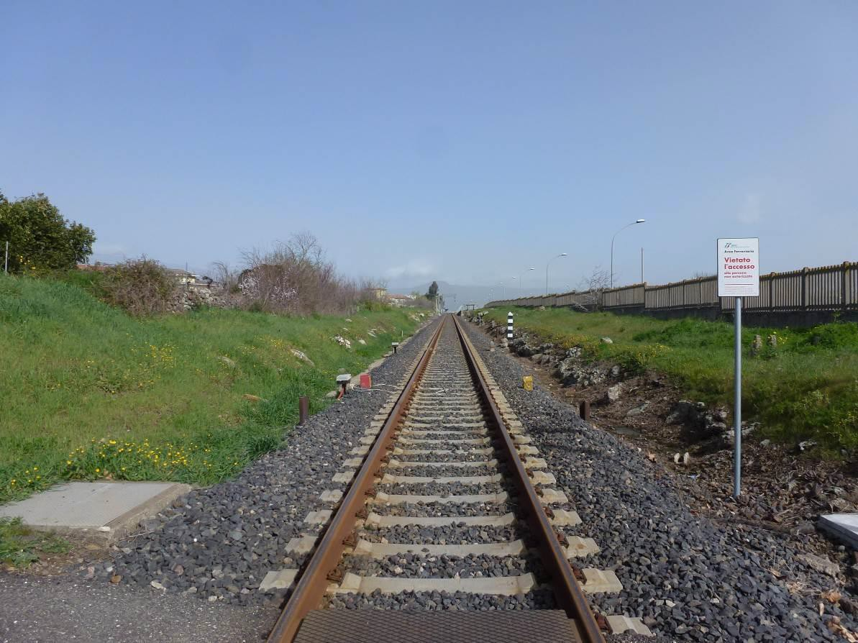

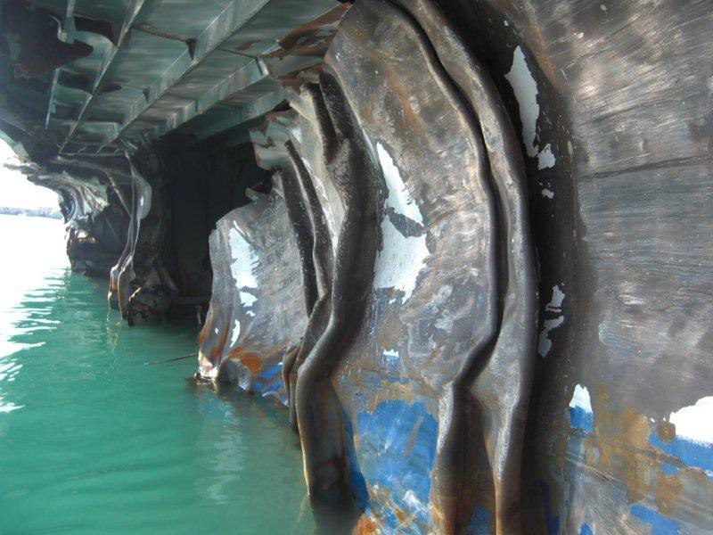

### Safety recommendations

* 1. Summary and presentation of recommendations

A summary of recommendations issued by DIGIFEMA is available on the Directorate website at the following link [http://digifema.mit.gov.it](http://digifema.mit.gov.it/)

* + 1. *Safety recommendations in the railway sector*

Under Legislative Decree 162/2007, the Directorate General defines recommendations on the basis of the causes identified, sends them to the parties concerned (ANSF, infrastructure operator, railway undertaking, etc.) and reports them to the ERA (European Union Agency for Railways).

*Table 16 - Implementation status of recommendations issued in the period 2014 –2017* **([13])**

|  |  |  |  |  |  |  |  |
| --- | --- | --- | --- | --- | --- | --- | --- |
| **Safety recommendations issued** | | **Status of recommendations issued** | | | | | |
| **Implemented** | | **Being implemented** | | **Not implemented** | |
| **Year** | [No] | [No] | [%] | [No] | [%] | [No] | [%] |
| **2017** | 11 | 0 | 0 | 0 | 0 | 11 | 100 |
| **2016** | 26 | 0 | 0 | 20 | 81 | 6 | 19 |
| **2015** | 26 | 10 | 38 | 15 | 58 | 1 | 4 |
| **2014** | 21 | 5 | 24 | 16 | 76 | 0 | 0 |
| **TOTAL** | **84** | **15** | **18** | **51** | **61** | **18** | **21** |

For quick reference, the following Table shows descriptions of safety recommendations issued in 2017 at the conclusion of technical investigations (see train collision Andria-Corato section; collision between work vehicles, Fortezza-Bressanone section).

*Table No 17 - Safety recommendations issued in 2017 – railway sector*

| ***ERAIL ID event*** | ***Accident date*** | ***Location*** | ***Event type*** | ***Safety recommendations*** | | | | ***Details of recommendation*** |
| --- | --- | --- | --- | --- | --- | --- | --- | --- |
| ***Date*** | ***Target*** | ***REC ID*** | ***No*** |
| **IT- 5134** | 12.07.16 | **Bari C.le – Barletta C.le line, Andria -**  **Corato section** | Head-on collision between passenger trains ET1016 and ET1021 | 06.12.17 | **MIT** | **000408** | **1.** | In order to develop and improve the safety of the railway system, the Ministry of Infrastructure and Transport is advised to bring Italian legislation into line with European legislation with regard to the proper identification of functionally isolated networks as set out in Article 2 (2) (b) of Directive 2004/49/EC of 29.04.2004 |
| **MIT** | **000409** | **2.** | The Ministry of Infrastructure and Transport is advised to take steps to ensure that Presidential Decree No 753 of 11 July 1980 is appropriately supplemented to ensure that the accident reporting provided for in Article 93 is extended to incidents, in other words any event other than an accident that affects or could affect operational safety |
| **MIT** | **000410** | **3.** | The Ministry of Infrastructure and Transport is advised to consider reporting accidents and incidents occurring in all collective public land transport services to an independent investigating body to allow, *inter alia*, an analysis of serious accident precursors with the aim of prevention |
| **DGTIF** | **000411** | **4.** | The Ministry of Infrastructure and Transport Directorate General for transport systems with fixed installations and local public transport is advised to take steps, for railways under its responsibility, to ensure that railway undertakings using the telephone block system check that the Train Traffic Regulations state that if a train is forwarded after another train, a direct third-party check is conducted on the safety operation to be performed by the Local Manager before the second train is sent, in the same way as passing trains must be controlled by the train crew. |
| **ANSF DGTIF** | **000412** | **5.** | The National Railway Safety Agency and the Ministry of Infrastructure and Transport Directorate General for transport systems with fixed installations and local public transport are advised to ensure, for railways under their responsibility, that railway undertakings using the |
|  |  |  |  |  |  |  |  | telephone block system check that the Traffic Protocols are completed in a manner consistent with the actual status of rolling stock managed by the Local Manager, avoiding the presence of incomplete register sections referring to vehicles no longer present within the station. |
| **IT- 5134** | 12.07.16 | **Bari C.le – Barletta C.le line, Andria**  **- Corato section** | Head-on collision between passenger trains ET1016 and ET1021 | 06.12.17 | **ANSF  FT** | **000413** | **6.** | The National Railway Safety Agency is advised to ensure that Ferrotramviaria S.p.A. adopts measures to prevent third parties (passengers and unauthorised personnel) from accessing premises designated for staff working in the Local Manager’s room. |
| **ANSF DGTIF** | **000415** | **7.** | The National Railway Safety Agency and the Ministry of Infrastructure and Transport Directorate General for transport systems with fixed installations and local public transport are advised to ensure, for railways for which they are competent, that infrastructure managers and railway undertakings implement appropriate audit/inspection activities on staff performing safety duties with the aim of maintaining skills. |
| **IT- 5330** | 25.04.17 | **Verona – Brennero line, Fortezza – Bressanone section** | Collision between work vehicles. | **14.12.17** | **ANSF DGTIF** | **000416** | **1.** | The National Railway Safety Agency and the Ministry of Infrastructure and Transport Directorate General for transport systems with fixed installations and local public transport are advised to ensure that Infrastructure Operators make staff in charge of carrying out brake tests on working equipment aware of the need to carry out a brake test and ensure that procedures to be carried out by the above staff are properly implemented.  In particular the Manager RFI S.p.A must consider including a specific reference to the IEFCA in the ICMO (Work Equipment Traffic Instruction) once checks have been carried out. |
| **ANSF DGTIF** | **000417** | **2.** | The National Railway Safety Agency and the Ministry of Infrastructure and Transport Directorate General for transport systems with fixed installations and local public transport are advised to ensure that Infrastructure Operators make staff in charge of checking work equipment permitted to travel on their networks aware of the importance of visual checks on vehicles, with particular reference to safety components. |
| **ANSF DGTIF** | **000418** | **3.** | The National Agency for Railway Safety and the Directorate General for Transport Systems with Fixed Installations and Local Public Transport, of the Ministry of Infrastructure and Transport are advised to ensure that Railway undertakings transferring work equipment in train formations check the prompt application of the relevant operating regulations |
| **ANSF**  **DGTIF** | **000419** | **4.** | The Italian National Railway Safety Agency and the Directorate General for Transport Systems with Fixed Installations and Local Public Transport, of the Ministry of Infrastructure and Transport are advised to ensure that Infrastructure Managers ensure that modifications to work vehicles are authorised in advance and properly registered in maintenance handbooks and manuals, stepping up the relevant checks to comply with procedures in force. |

Key

|  |  |
| --- | --- |
| *ANSF* | *National Railway Safety Agency* |
| *DGTIF* | *Directorate General for transport systems with fixed installations and local public transport* |
| *FT* | *Ferrotramviaria - Railway undertaking* |
| *MIT* | *Ministry of Infrastructure and Transport* |
| *RFI* | *National infrastructure manager (Rete Ferroviaria Italiana)* |

* + 1. *Safety recommendations in the maritime sector*

Under Legislative Decree No 165/2011, the Directorate General DIGIFEMA draws up recommendations based on the causes identified, sends them to interested parties and notifies EMSA (European Maritime Safety Agency).

*Table 18 - Implementation of recommendations 2015–2017* **([14])**

|  |  |  |  |  |  |  |  |
| --- | --- | --- | --- | --- | --- | --- | --- |
| **Safety recommendations issued** | | **Status of recommendations issued** | | | | | |
| **Implemented** | | **Being implemented** | | **Not implemented** | |
| **Year** | [No] | [No] | [%] | [No] | [%] | [No] | [%] |
| **2017** | 19 | 0 | 0 | 0 | 0 | 19 | 100 |
| **2016** | 15 | 0 | 0 | 0 | 0 | 15 | 100 |
| **2015** | 40 | 0 | 0 | 0 | 0 | 40 | 100 |
| **TOTAL** | **74** | **0** | **0** | **0** | **0** | **74** | **100** |

For quick reference, the following Table shows descriptions of safety recommendations issued in 2017 at the conclusion of technical investigations carried out (see very serious fire on board the motor vessel Norman Atlantic - ID EMCIP No 04/2015).

*Table No 19 - Safety recommendations issued in 2017 – Maritime sector*

|  |  |
| --- | --- |
| **No** | **Description of safety recommendation** |
| **04/2015-01** | Promote greater coordination between port security and ship security by providing for the implementation of procedures designed to carry out more effective control with the aim of avoiding safety incidents |
| **04/2015-02** | Supplement existing procedures to improve the efficiency and effectiveness of patrols on garage decks, particularly prior to the ship’s departure |

|  |  |
| --- | --- |
| **No** | **Description of safety recommendation** |
| **04/2015-03** | Reassess the timing of internal audits aimed at verifying exact compliance with regulations and procedures in force, particularly with regard to stowage, lashing and connection of reefer points. |
| **04/2015-04** | Implement measures to ensure that staff are properly aware of the working language and that it is actually used on board |
| **04/2015-05** | If staff with the same qualification (e.g. First Officer), are embarked, their respective duties must be established by means of a Captain’s service order to be issued at the time of boarding. |
| **04/2015-06** | It is advised to use the surname as it is set out on the identity document to register passengers |
| **04/2015-07** | Provide a detailed list of the cargo to be loaded including dimensions and weight and any additional technical requirements (e.g. on-board electrical connection and so on) in time to allow a load plan to be drawn up before departure. |
| **04/2015-08** | Provide a full list of passengers prior to departure, according to current legislation, to enable the Captain to establish that the number of passengers on board does not exceed the carrying capacity. |
| **04/2015-09** | Provide a study/analysis designed to eliminate existing solutions concerning the following structural/construction aspects and problems, or develop alternatives:   * garage deck fire detection systems that take into account any openings in the hull and are therefore positioned and calibrated with the openings in mind; * side openings of RO-RO Bessel open cargo decks to prevent/mitigating the devastating effects of an uncontrolled influx of external air currents; * passive protection of areas where collective rescue means are allocated (including the MES and evacuation station as defined by SOLAS) and their positioning must take into account any RO-RO area hull openings with the aim of preventing contact with naked flame in the event of fire; * reappraisal of fixed firefighting systems used to protect the ship’s garage decks, providing for the implementation of alternative extinguishing/containment systems (e.g.: water barriers/water mist etc.); * passive protection of cables and electrical circuits passing inside the garages must be stepped up in order to prolong the activity of emergency systems; * mandatory installation of an appropriate video surveillance system (also equipped with thermal detection) for garage areas to allow continuous, immediate remote control (bridge, VMS etc.); * for existing ships, evaluate the redundancy of power supply systems for pumps connected to the drencher fixed extinguishing system in order to ensure full system operation even under emergency conditions; |
| **04/2015-10** | The fire resistance of the VDR (DMM) must be improved on existing ships, providing for the implementation of heat/protection, particularly for mass memories designed for data recording |

|  |  |
| --- | --- |
| **No** | **Description of safety recommendation** |
| **04/2015-11** | Provide for the option of recording audio data from the VMS on the VDR and include a full set of alarms detected by the fire detection system among the recorded data |
| **04/2015-12** | Provide for the implementation of standard and open source VDR software and ensure data playback applications are updated |
| **04/2015-13** | Define the minimum distance between vehicles in the garage and the distance for the safe operational passage of the on-board firefighting team |
| **04/2015-14** | Provide simpler and more intuitive operating guidelines for safety equipment |
| **04/2015-15** | Provide for the option of feedback from the control bridge on valve status and drencher system operation |
| **04/2015-16** | Provide a detailed list of the cargo to be loaded including dimensions and weight and any additional technical requirements (e.g. on-board electrical connection and so on) in time to allow a load plan to be drawn up before departure. |
| **04/2015-17** | Arrange to synchronise the times of the on-board system monitoring devices (ECDIS, AUTRONICA, machine automation etc.) with the time provided by the GNSS. |
| **04/2015-18** | Perform a thorough review of PFSP with the aim of preventing unauthorised entry of people and vehicles to the terminals |
| **04/2015-19** | Perform a check on passenger registration systems |



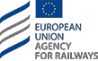



**ERAIL - *European Railways Accident Information Links***

### OTHER ACTIVITIES

1. **OTHER ACTIVITIES**

The following is a description of not purely investigative activities conducted by the Directorate in 2017, broken down by thematic area.

* 1. International and EU relations in the railway and maritime sector
     + 1. **Participation in the 33rd and 35th NIB National Investigation Body Plenary session at ERA** (March, Lille - November, Valenciennes)

During the above meetings, the following specific aspects were examined:

* information exchange methods and good investigative practices between bodies;
* analysis and progress of the proposal for a Commission Decision on the reporting structure of the accident and incident investigation report that will replace Annex 5 of Directive 2004/49/CE; the process of drawing up the new proposal should be completed by mid 2018;
* analysis of the Fourth Railway Package for aspects concerning obligations for accident investigations and an update of the Peer Review Programme;
* analysis of documents and results submitted by the Task Force regarding the **PRP**; (See Manual prepared to help NIBs to prepare preliminary documentation for implementing a **PRP)**
  + - 1. **Participation in the work of the Human Factor Network,** a technical body set up within ERA and specialising in analysis of the human factor in the railway sector

During the 13th session of the Human Factor Network **HFN**, ERA presented its future programme with initiatives that the Agency wishes to implement regarding the promotion of a safety culture in the railway sector. In particular, from 2018 ERA plans to carry out a series of actions to assess the degree of maturity of a safety culture within the entire railway sector of an individual Member State. Through these actions, ERA aims to be able to provide an initial report on the implementation status of safety culture principles within the railway transport sector of all Member States by 2024, as required by Directive 2016/798.

During the work, discussions were also held on ERA's proposal to develop **HFN** activities in order to extend their scope to the promotion of organisational aspects connected with the human factor (e.g. Human and Organisational Factor Network in the railway sector) by organising specific workshops/seminars/partnership with universities or research institutes dedicated to analysing and examining such aspects. In such initiatives, primary importance must be attached to integrating human factor analysis in safety management systems implemented by sector operators.

In this regard, back in 2016 DIGIFEMA launched a series of initiatives to take into account the importance of analysing the human factor and safety culture in investigative processes into railway and maritime accidents (see section 2.3.3 *Analysis of the accident event – Human factor and safety culture*).

* + - 1. **‘Common Occurrences Reporting - Procedure for indicating accidents and using data’, Workshop organised by ERA** (**February, Lille);**

The meeting was organised to update the NIBs on the ‘Common Occurrences Reporting’ project (see <https://extranet.era.europa.eu/safety/COR/Deliverables>) prepared by ERA with the aim of producing a platform as an alternative to the current accident reporting and notification system managed by individual NIBs by means of the ERAIL platform.

During the Workshop, ERA emphasised with regard to the role of NIBs in accident and incident investigations that future development of the **COR SMD** Common Occurrences Reporting - Safety Management Data should be seen as a useful support tool for investigative activities conducted by the NIBs and/or accident reporting.

In particular, according to ERA, the use of safety data obtained during investigations can help achieve the following improvements/benefits at EU level:

* + - * + better sharing of information that is useful to the various EU NIBs, particularly with regard to less frequent accidents, causes, etc.
        + improving accident type reporting taxonomy, for example regarding the causes of accidents that have not been previously screened or identified
        + potential use of **COR SMD** (after the phasing out of the ERAIL system) for more effective sharing of investigation reports and related safety recommendations between NIBs
        + use of data from **COR SMD** (frequency analysis, precursors, strategic priorities) to allow NIBs to define incident investigation priorities (see Article 20.3 of the Railway Safety Directive (RSD))
        + allowing all infrastructure managers and railway undertakings to promptly notify the NIB of all accidents and incidents occurring in the part of the system for which they are responsible to the NIB (see Article 22.3 of the RSD).
      1. **ITF – Transport Research Committee (TRC):** participation in the work of the second session at the OECD (November, Paris);

This committee work session involved examining a draft of the “***Safety Management Systems***” document drawn up by the TRC Secretariat concerning the importance of proactive use of safety management systems by operators for the purpose of improving accident prevention measures.

Particular emphasis was laid on the increasingly important principle of implementing an effectively operating Safety Management System (**SMS**) for safety purposes.

The TRC document also highlighted that in order to establish the existence of an effective SMS, it is necessary to identify and assess risks associated with transport activity operation within the SMS.

The Office contributed to this discussion, reporting to the Committee on the content and reasons that led DIGIFEMA to conduct a **study entitled “Analysis of the HUMAN FACTOR in railway and maritime sectors’ in 2016.** The Committee expressed its interest in obtaining a copy of this study, an English version of which was therefore sent to the Committee in December.

* + - 1. **HORIZON 2020 – IMPACT research project entitled ‘**Impact of Cultural Aspects in the management of Emergencies in Public Transport’

Participation in the project as a stakeholder and in partnership with the company Deep Blue, a consultancy firm expert in the field of risk analysis and management, to analyse the influence of social cultural aspects in the field of transport safety.

In this context, during September 2017, this Office took part in the project’s final event held in Rome entitled ‘*Managing socio-cultural factors during emergencies in public transport systems’*. The main documents drawn up as part of the Project are available at the following link: <http://www.impact-csa.eu/documents/>

* + - 1. **Fifth Convention on ‘RAILWAY SAFETY AND OPERATION’**

During the Convention, held in the Civil and Industrial Engineering Faculty of ‘La Sapienza’ University, Rome, as part of the session on “**Railway safety: methodological aspects**”, this Office presented a technical report on ‘*Human factor analysis methodologies in railway and maritime sector accident events’.*

The aim of the report is to highlight the fact that the Safety Management System (SMS) plays a long-established leading role in railway and maritime transport modalities. The report also supports the thesis that encouraging a widely disseminated safety culture within an organisation can help to positively influence staff behaviour and attitudes, which can help improve the overall performance of the entire organisation and the SMS adopted by the organisation with a view to ongoing improvement.

In this regard, this Office also reiterated the importance of identifying procedures – aimed at ensuring that cases of non-compliance, accidents and incidents (including near misses) are reported to the agency, investigated and analysed with the aim of improving safety – is an essential part of the agency’s SMS for the purpose of learning from operational and management errors and promoting a safety culture.

* + - 1. **Preparing information material on safety culture**

In 2017, the Office contributed to the drafting of an Italian language version of the following information leaflets prepared by ERA and the Human Factor Network on the subject of railway transport safety:

* + - * + Integrating the human factor into European railways: Safety management systems
        + Integrating the human factor into European railways: investigations into operating incidents and accidents
        + Integrating the human factor into European railways: Information for workers
        + Promoting a positive culture of rail safety: Safety culture.

The above documents are also available in a new section of the DIGIFEMA website entitled “**Promoting a safety culture**” at the following link <http://digifema.mit.gov.it/promozione-cultura-della-sicurezza/>

* + - 1. **Teaching activity at C.A.P.S. – Cesena State Police Training Centre**

concerning a training course on ‘intervention procedures and measurement techniques following railway accidents, resulting arrangements’, organised by the Railway Police Service with reference to the following topic ‘Intervention and role of the Directorate General for Railway and Maritime Investigations in the event of a railway disaster/accident’.

* + - 1. **Participation in EMSA workshops/workgroups and in the EMSA PCF 7 (Permanent Cooperation Framework)** (June, Lisbon)

Under Article 10 of Directive 2009/18/EC and Regulation (EU) No 651/2011, the PCF is a tool for implementing a system of permanent cooperation with corresponding bodies in other Member States in order to identify methods and procedures designed to improve investigative activities.

During PCF meetings, the following specific aspects were examined:

* + - * + methods of exchanging data between investigative bodies,
        + minimum content of interim reports,
        + criteria for following up safety recommendations,
        + guidelines for training investigators,
        + new methods for using the EMCIP Portal (EMSA portal used to enter data on marine casualties affecting ships flying the national flag);

In 2017, the Office also took part in the following works organised by EMSA:

* **Participation in PCF WG 9 and 11** (April – November, Lisbon);
* Participation in the second PCF Intersessional Seminar - Human element in accident investigation (November, Lisbon);
  + - 1. **Participation in the work of MAIIF** - **Marine Accident Investigators' International Forum,** held in Rotorua (New Zealand, November).

MAIIF is an international, non-profit organisation specialising in maritime safety and the prevention of marine pollution, made up of 45 member countries represented by their national marine casualty investigation bodies.

The priority aims of **MAIIF**, to be achieved through a continuous exchange of experiences and information between individual national investigative bodies present in the forum are:

* 1. to promote and improve marine casualty investigation procedures;
  2. to strengthen cooperation and communication procedures between investigative bodies.
     + 1. **Participation in the work of E-MAIIF European Marine Accident Investigators’ International Forum** (Stockholm, April),

The Directorate also continued to play an active role in the work of **E-MAIIF** which constitutes the European section of **MAIIF; in particular, this involved exploring aspects related to procedures for carrying out investigations on marine casualties and exchanging information and experiences on investigations carried out.**

* 1. Relationships with network managers, railway undertakings and shipping companies

During 2017, the usual relationships with railway network operators and railway undertakings continued, particularly through the examination of some accidental event reports received by the Office as well as other circumstances relating to accidental events or potentially hazardous situations that the Office became aware of through other sources (media outlets and so on). This activity was carried out through institutional examination of documentation requested and received as well as through specific dedicated inspections and meetings held in the Office and on the premises of the undertakings concerned.

During 2017, partnership activities were conducted with the Swiss investigative body with regard to an investigation conducted by the latter concerning a railway accident that occurred on 22/03/2017 in Lucerne involving the derailment of a Trenitalia tilting train.

With regard to the above investigation, some DIGIFEMA representatives attended - on 22/05/2017 and 20/06/2017 - activities conducted by Alstom of Savigliano concerning some components of rolling stock involved in the accident

* 1. Training and refresher courses for investigative staff

**Training plan for the three-year period 2016-2018**: following the new regulations introduced by Directive (EU) No 2016/798, a special training module was planned for DIGIFEMA investigators on the subject of ‘Analysing the human factor in accidents’.

The planning of the training of investigative staff working on behalf of the DIGIFEMA takes **into** account a significant development that recently involved the organisational structure of the Directorate General as well as specific regulatory provisions concerning investigations into maritime and railway accidents and incidents.

In 2017, a 24 hour long specialised course was therefore organised on ‘Human factors – Ergonomy’ aimed at all Directorate technical staff and to railway and maritime sector investigators in particular.

The aim of the course was to provide staff involved with training and information on the following aspects:

* + - Relationship between ergonomy and human factors,
    - Man-machine interface and interaction,
    - Incidence of fatigue and drowsiness,
    - Characteristics and functional status of an operator in transport systems,
    - Automation and management of procedures in transport systems,
    - Types of human error: characteristics and differences and organisational errors,
    - Design of operator-oriented systems and certification of ergonomic requirements.
  1. Study and research

The Directorate General also took part in specific international and EU study and research initiatives:

* **Participation in the Working Party on ‘Railway sector statistics’,** coordinated by Division 3 of DG IT and statistical systems and made up of representatives of the Ministry of Infrastructure and Transport, the Railway Safety Agency ANSF, the State Railways group and ISTAT. The activities of the Working Party, which was set up in 2013, concerned the following in particular:

1. analysis of the supply and demand of railway statistics;
2. optimisation of current data collection systems with the aim of harmonising data collection at national and EU level (RMMS Report and UNECE statistics)

Data relating to railway accidents still lack uniformity because the classification of accident events adopted by ISTAT and by the Ministry Statistical Office is different from the accident types referred to in Legislative Decree No 162/2007 as well as the taxonomic classification of accident events drawn up by ERA.

* **Transport safety work group**

Coordination of the transport safety work group set up within DIGIFEMA with the aim of:

* + identifying the most commonly used criteria for determining risk acceptance levels in the transport sector,
  + defining methodology to be used to assess risk in the transport sector,
  + determining individual risk and cumulative risk acceptability threshold levels in the public transport sector, comparing the levels with benchmark levels used at international and EU level in other industrial sectors (see also standard EN 61508 on functional safety).
  1. List of Experts who can be commissioned to act as Investigators

Article 18(4) of Legislative Decree No 162 of 10/08/2007 provides for the establishment of a list of experts in the field of railway technology and legislation who are independent of Infrastructure Managers, Railway Undertakings and the National Railway Safety Agency, and also external to the Administration, who can be called on to act as investigators in charge in the event of accidents, serious accidents and incidents.

This list is divided into two sections. The first relates to experts in Ministry of Infrastructure and Transport roles and the second relates to experts external to the Administration.

In 2017, some applicants were recognised as eligible for inclusion on the list of investigators and Directorate General for Railway and Maritime Investigations Decree Ref No 3210 of 02/11/2017 was issued entitled ‘Supplementation of list of railway technology and legislation experts pursuant to Article 18(4) of Legislative Decree No 162 of 10 August 2007’.

# Annex 1

**Organisational standards of the Directorate-General for Railway and Maritime Investigations**

###### Italian legislation

|  |  |
| --- | --- |
| **LAW No 172 of 4 December 2017** | Extending the investigative competences of DIGIFEMA |
| **Prime Ministerial Decree No 72 of 11 February 2014** | Organisational regulation of the Ministry of Infrastructure and Transport, pursuant to Article 2 of Decree-Law No 95 of 6 July 2012, transposed, with amendments, from Law No 135 of 7 August 2012 (published in Italian Official Gazette No 105 of 8 May 2014) |
| **Ministerial Decree No 346 of 4 August 2014** | Reorganisation, identification and definition of the number and duties of Ministry of Infrastructure and Transport non-general executive Offices |
| **Ministerial Decree No 352 of 24 March 2015** | Expert list – Criteria for the independence of railway investigators pursuant to Article 21(1) of Directive 2004/49/EC |
| **Executive Decree No 1237 of 23 May 2016** | Criteria for registration on the List – pursuant to Article 4(4) of Legislative Decree No 165 of 6 September 2011 – of maritime navigation technical and safety experts who can be called on to act as consultants to the Directorate General for Railway and Maritime Investigations in the event of marine casualties and incidents. |
| **Circular Letter No 1529 of 24 June 2016** | Procedure for carrying out technical investigations into railway and maritime accidents, implementing Legislative Decree No 162/2007, No 165/2011 and Directive (EU) 2016/798 |

***Railway investigation standards***

###### EU and Italian legislation

|  |  |
| --- | --- |
| **Directive (EU) No 2016/798** | of the European Parliament and of the Council of 11 May 2016 on railway safety (recasting Directive 2004/49/EC and successive amendments) in force since 15 June 2016; |
| **Regulation (EU) No 2016/796** | of the European Parliament and of the Council of 11 May 2016 on the European Union Agency for Railways and repealing Regulation (EC) No 881/2004. Pursuant to the provisions of Article 85 of Regulation (EU) No 2016/796, the Regulation entered into force on 15 June 2016 and Regulation (EC) No 881/2004 was repealed as of that date. |
| **Directive 2014/88/EC** | amending Directive 2004/49/EC of the European Parliament and of the Council as regards common safety indicators and common methods of calculating accident costs; |
| **Directive 2004/49/EC** | on safety on the Community’s railways (due to be repealed from 16 June 2020); |
| **Regulation (EC) No 881/2004** | establishing a European Union Agency for Railways; |

|  |  |
| --- | --- |
| **Legislative Decree No 162 of 10 August 2007** | Implementation of Directives 2004/49/EC and 2004/51/EC on the safety and development of the Community’s railways |
| **Ministry of Infrastructure and Transport Decree of 26 July 2015 (the Annex to the Decree replaces Annex No 1 of Legislative Decree 162/2007)** | transposing Commission Directive 2014/88/EC amending Annex 1 of Directive 2004/49/EC of the European Parliament and of the Council as regards common safety indicators and common methods of calculating accident costs; |
| **Law No 97 of 6 August 2013** | Provisions for the fulfilment of obligations arising from Italy’s membership of the European Union – European Law 2013; this law introduced a number of amendments to Articles 20 and 21 of Legislative Decree 162/2007 in the wake of EU Pilot Case 1254/10/MOVE. The aim of these changes is to adapt Italian law to ensure that the principle laid down in the Directive is implemented, namely an equal partnership between the investigative body and the judicial authority. |
| **Legislative Decree No 43 of 24 March 2011** | Implementation of Directive 2008/110/EC amending Directive 2004/49/EC on safety on the Community’s railways; this measure introduced changes to Article 19 of Legislative Decree No 162/2007, regarding aspects concerning railway investigations |
| **Presidential Decree No 753 of 11 July 1980** | concerning new rules on police, safety and regular operation of railways and other transport services |

***EU guidelines for railway sector investigative bodies***

|  |  |
| --- | --- |
| **ERA-20070524** | Communication Protocol between the European Union Agency for Railways and the competent national authorities and bodies relating to the exchange of information as described in Regulation (EC) No 881/2004 and Directives 96/48/EC, 2001/16/EC and 2004/49/EC |
| **ERA/GUI/02/2012** | Guidance for establishment and work of the national investigation bodies |
| **ERA/GUI/05/2010** | Guidance on good reporting practice |
| **ERA/GUI/04/2010** | Guidance on the decision to investigate accidents and incidents Articles 3(l), 19 and 21(6) |
| **ERA/GUI/03/2010** | Guidance on safety recommendations in terms of article 25 directive 2004/49/EC |

***National procedures and guidelines***

|  |  |
| --- | --- |
| **Circular No 1450 of 16 October 2015** | Method of notifying the Directorate-General for Railway and Maritime Investigations of accidents and incidents in accordance with Article 19 of Legislative Decree No 162 of 10 August 2007. |

***Maritime investigation standards***

###### International and EU legislation

|  |  |
| --- | --- |
| **International Convention on the Law of the Sea (Montego Bay 1982)** | **Article 2** establishes the right of a coastal State to investigate the causes of a casualty occurring in its own waters that has harmed its interests in any way. **Article 94** establishes that a flag State is obliged to investigate casualties involving its own vessels, even if they occur on the high seas, using appropriately qualified investigators. |
| **International Convention for the Safety of Life at Sea (SOLAS)** | **Regulation I/21** establishes that a flag administration must undertake to conduct an investigation of any casualty occurring to any of its ships when it judges that such an investigation may assist in determining what changes in the present regulations might be desirable and also provide the investigation results to the IMO.  **Chapter XI-1 – Special measures to enhance maritime safety.**  Regulation 6 – Introduces additional requirements for investigating marine casualties and accidents; in particular, Member States called on to investigate casualties taking into consideration the provisions of Resolution **MSC.255(84)** on a casualty investigation code. |
| **International Convention for the Prevention of Pollution from Ships (MARPOL)**  **International Maritime Labour Convention (ILO – MLC, 2006)** | **Article 12** obliges authorities to investigate casualties involving the vessels that have caused significant damage to the marine environment and also to provide the results of investigations to the IMO. **Regulation 5.1.6 of the MLC** obliges Member States to conduct an official investigation into all serious maritime casualties that result in injury or loss of life involving a ship flying their flag. The report on such investigations **must** normally be made public. |
| **Resolution MSC.255(84) adopted on 16 May 2008** | Code of the International Standards and Recommended Practices for a Safety Investigation into a Marine Casualty or Marine Incident, obligatory from 1 January 2010, the date of entry into force of the new SOLAS Regulation XI-1/6 ‘*Supplementary requirements for investigations into marine casualties*  ’. The IMO sets out to achieve a common approach by States when conducting investigations into casualties in order to **seek the technical causes of marine casualties in order to learn as much as possible with the aim of improving maritime safety**. |
| **Regulation (EC) No 1406 of 27 June 2002, as amended,** | establishing a European Maritime Safety Agency |

|  |  |  |
| --- | --- | --- |
| **Directive 2009/18/EC of 23 April 2009** | establishing the fundamental principles governing the investigation of accidents in the maritime transport sector and amending Council Directive 1999/35/EC and Directive 2002/59/EC of the European Parliament and of the Council. | |
| **Commission Implementing Regulation (EU) No 651 of 5 July 2011** | | adopting the rules of procedure of the permanent cooperation framework established by Member States in cooperation with the Commission pursuant to Article 10 of Directive 2009/18/EC |
| **Regulation No 1286/EU of 9 December 2011** | | adopting a common methodology for investigating marine casualties and incidents developed pursuant to Article 5(4) of Directive 2009/18/EC of the European Parliament and of the Council. |

###### Italian legislation and Circulars

|  |  |
| --- | --- |
| **Legislative Decree No 165 of 6 September 2011** | Implementation of Directive 2009/18/EC establishing the fundamental principles governing the investigation of accidents in the maritime transport sector and amending Directives 1999/35/EC and 2002/59/EC.  Article 3 of the Legislative Decree refers to the definitions in IMO Code Resolution MSC.255(84) with particular regard to the following expressions:   1. marine casualty; 2. very serious marine casualty; 3. marine incident; 4. marine safety investigation. |
| **LAW No 113 of 23 September 2013** | ratifying and implementing International Labour Organisation Convention No 186 on maritime labour (ILO MLC, 2006); |
| **Circular Letter No 043/ OISM of 26 June 2014,**  **supplemented by document no 270 of 03.02.2016** | Obligation of notification and cooperation in the event of a marine casualty and associated technical safety investigation. |

###### International and EU guidelines for maritime Investigation bodies

|  |  |
| --- | --- |
| **IMO Resolution A.1070(28) adopted on 4 December 2013** | IMO Instruments Implementation Code (III Code) |
| **IMO Resolution A.1075(28) adopted on 4 December 2013** | Guidelines to assist investigators in the implementation of the Casualty Investigation Code (resolution MSC.255(84) |
| **IMO Resolution A.987(24) adopted on 1 December 2005** | Guidelines on fair treatment of seafarers in the event of a marine casualty |
| **MSC-MEPC.3/Circ.4 –** Revised harmonised reporting procedures– Reports required under SOLAS Regulations I/21 and a XI-1/6, and MARPOL, Articles 8 and 12 | Circular MSC-MEPC.3/Circ.4 repeals MSCMEPC. 3/Circ.3 and contains amendments relating to the definition of a serious casualty and characteristics of reports on casualties and incidents at sea to be drawn up in accordance with MARPOL and SOLAS international conventions. |

1. ) For the sake of full disclosure, please note that the regulatory change introduced by Law No 172 of 2017 has effectively extended the scope of investigatory competence of this Directorate to systems that could be excluded from the scope of Directive (EU) 2016/798 through implementation of the derogation provided for in Article 2(4) of Directive (EU) 2016/798 on railway safety. This derogation states that Member States “*may decide to apply, where appropriate, provisions of this Directive to metros and other local systems in accordance with national law”.*
2. Decree implementing Directive 95/46/EC of the European Parliament and of the Council of 24 October 1995 on the protection of individuals with regard to the processing of personal data and on the free movement of such data. In this regard, **on 25 May 2018,** Regulation (UE) 2016/679 on the protection of natural persons with regard to the processing of personal data and on the free movement of such data, and repealing Directive 95/46/EC (General Data Protection Regulation) entered into force; and Directive 95/46/EC was repealed from that date.
3. ) In total, 56 actions have been identified relating to service processes for technical investigative activities and administrative and accounting management activities linked to the Directorate’s operating expenses
4. ) with reference to criteria set out in Article 19(1) and (2) and Article 21(6) of Directive 2004/49/EC as well as Article 19(1) and (2) of Legislative Decree No 162/2007.
5. ) The classification adopted complies with the most recent updated version of the EMCIP taxonomy, issued by EMSA in March 2017 (ref. doc. EMCIP Taxonomy – List of attributes).
6. The Directive was published in the Official Journal of the European Union No L 138/102 of 26 May 2016.
7. ) The number of events for which investigative activities ended in 2016 is shown in brackets
8. ) The type of event investigated and completed in 2016 concerns accident events occurring **from 01.01.2014 to 31.03.2015**, with serious or fatal outcomes, characterised by collision with persons, mainly inside stations or their outbuildings. As stated in the 2016 annual Report by convention, the number of events investigated is entered in the table as 1 because this was a framework investigation although a total of 306 events that occurred during the reference period were actually investigated. The collisions subject to this investigation (collision between trains and people) caused very severe damage to the people who were struck, and gave rise to injury or death. To sum up, 45 injuries, 57 deaths and 164 suicides. However, for methodological reasons, it was not considered appropriate to include these overall figures relating to death and injuries as well as suicides in the table because they do not refer to an individual event/day and cannot therefore be compared with aggregate data relating to previous years.
9. )The number of events for which investigative activities ended in 2016 is shown in brackets
10. ) For the sake of full disclosure, Table 11 shows investigations considered concluded in 2017 and for which the final report was issued in 2017, even though the EMSA acceptance procedure is still ongoing in the EMCIP system.
11. ) Table 12 uses the term ‘in process of completion’ to describe investigations for which the final report has been notified to EMSA, but EMSA has not yet validated and accepted the report in the EMCIP system, or cases where investigation is still ongoing and the final report has not yet been prepared
12. ) See also information in note 7)
13. ) From the time of entry into force of Prime Ministerial Decree No 72/ 2014 (23 May 2014) establishing the Directorate General for Railway and Maritime Investigations, the Directorate began monitoring the implementation status of all recommendations issued in the railway sector; this activity was also implemented in the maritime sector from 2016
14. ) From the time of entry into force of Prime Ministerial Decree No 72/ 2014 (23 May 2014) establishing the Directorate General for Railway and Maritime Investigations, the Directorate began monitoring the implementation status of all recommendations issued in the railway sector; this activity was also implemented in the maritime sector from 2016