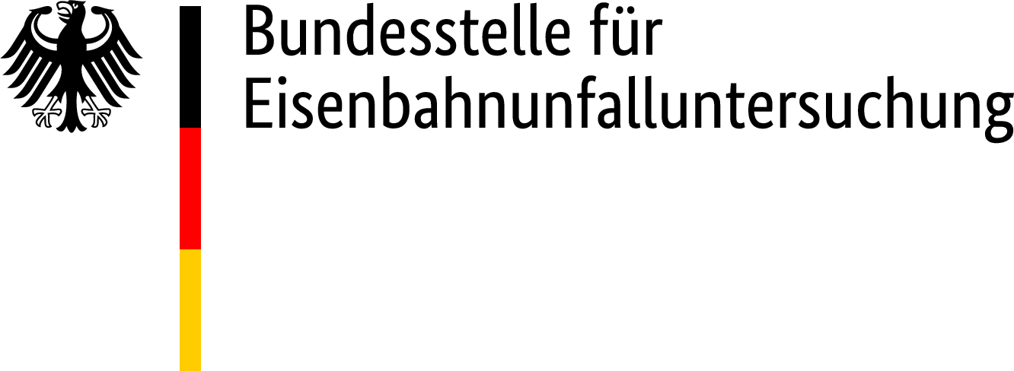

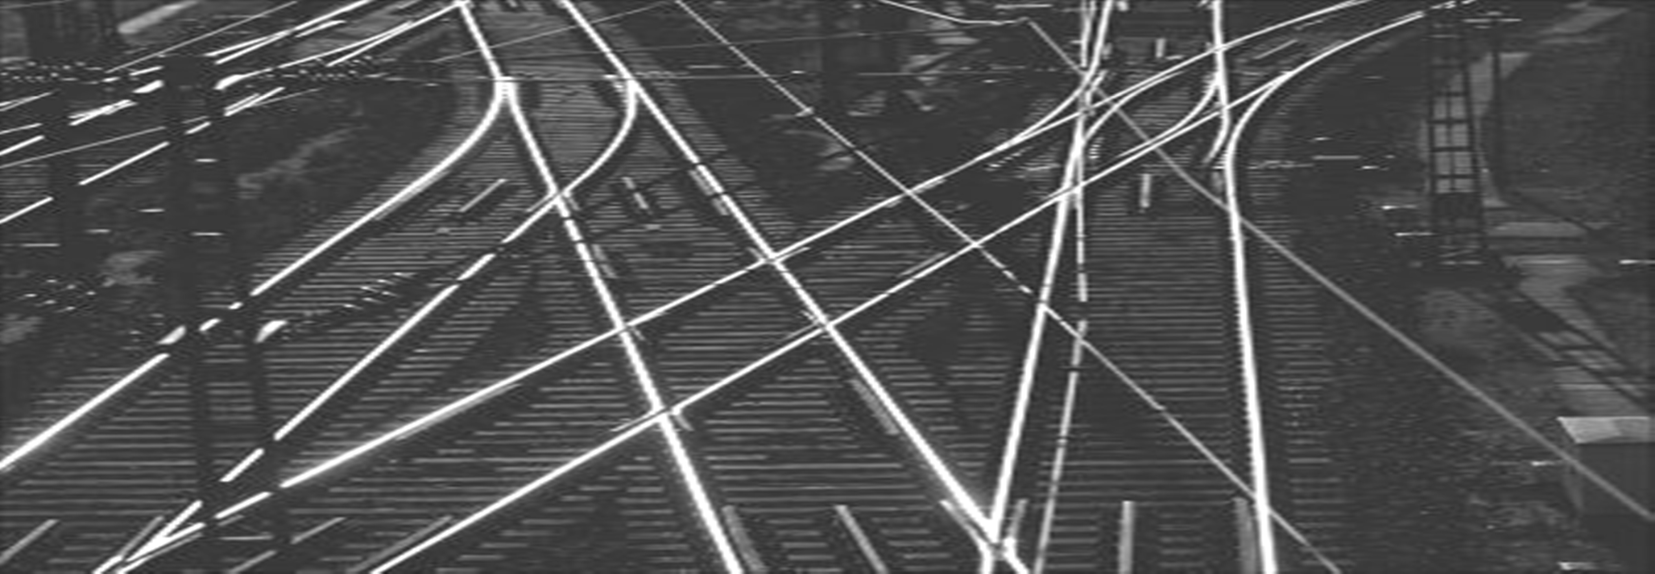



**ANNUAL REPORT**

**2017**

PUBLISHER:

**Federal Office for Railway Accident Investigation [Bundesstelle für Eisenbahnunfalluntersuchung]**

Heinemannstraße 6

53175 Bonn <www.beu.bund.de>

**Table of contents**

1 Investigation Office 6

1.1 Legal basis 6

1.2 Aim and purpose of the investigation 6

1.3 Reporting of dangerous events 7

1.3.1 Reports in 2017 8

1.4 Classification of dangerous events 9

1.4.1 Classifications in 2017 11

1.5 Investigation of dangerous events 15

2 Investigation 15

2.1 General 15

2.1.1 Train derailment in Mellenbach-Glasbach station on 6 January 2017 17

2.1.2 Unauthorised entry into an occupied section of track in Gruiten station on 1 February 2017 17

2.1.3 Train derailment in Munich-Riem transshipment station on 6 February 2017 18

2.1.4 Train collision in Frankfurt-Griesheim station on 17 February 2017 18

2.1.5 Accident involving people in Meppen station on 13 March 2017 19

2.1.6 Train derailment in Frankfurt (Oder) Oderbrücke station on 22 March 2017 19

2.1.7 Incident involving rolling stock in Merten (Sieg) station on 6 April 2017 20

2.1.8 Train derailment in Dortmund central station on 1 May 2017 20

2.1.9 Train derailment between Worms and Hofheim (Ried) on 5 May 2017 21

2.1.10 Level crossing accident (collision) between Neustadt am Rübenberge and Hagen (Han) on 15 May 2017 21

2.1.11 Train derailment between Papiermühle (Stadtroda junction) and Stadtroda on 19 May 2017 22

2.1.12 Train derailment between Gaildorf West and Schwäbisch Hall-Hessental on 15 June 2017 22

2.1.13 Train collision in Leese-Stolzenau station on 30 June 2017 23

2.1.14 Level crossing accident (collision) in Hohenlimburg station on 17 July 2017 23

2.1.15 Train collision in Augsburg central station on 18 September 2017 24

2.1.16 Train derailment in Mühlacker station on 14 November 2017 24

2.1.17 Train derailment in Elmshorn station on 15 November 2017 25

2.1.18 Train derailment in Bremen central station on 30 November 2017 25

2.1.19 Train collision between Weißenberg and Meerbusch-Osterath on 5 December 2017 26

3 Safety recommendations 27

3.1 Safety recommendations 2017 27

3.2 Safety recommendations 2006-2016 (sorted by date of event) 30

**List of figures:**

Figure 1: Accidents reported in 2017 8

Figure 2: Incidents reported in 2017 9

Figure 3: Classification and investigation of dangerous events 10

Figure 4: Categorisation of the dangerous events 12

Figure 5: Events as specified in Article 20(1) of Directive (EU) 2016/798 13

Figure 6: Events as specified in Article 20(2) of Directive (EU) 2016/798 14

Figure 7: Pre-investigations 14

**Foreword**

This annual report 2017 provides information on the activities of the Federal Office for Railway Accident Investigation (BEU) on the basis of Directive (EU) 2016/798 of 11 May 2016 on railway safety (the Railway Safety Directive).

The annual report contains information on investigations which were carried out in accordance with Section 5b of the General Railways Act (AEG).

In addition, the annual report provides information on the safety recommendations issued in the period covered by the report, as well as measures taken on the basis of earlier safety recommendations.

Further information is available on the BEU website under <http://www.beu.bund.de>.

# Investigation Office

## Legal basis

The provisions of Directive (EU) 2016/798 which concern accident investigation were transposed at national level with the Act on the Reorganisation of Railway Accident Investigation of 27 June 2017. For the investigation of dangerous events in railway operations, the Federal Office for Railway Accident Investigation (BEU) was set up as an independent higher federal authority in the domain of the Federal Ministry of Transport and Digital Infrastructure, and the Federal Railway Accident Investigation Office (EUB) was dissolved at the same time.

In the reporting period from 1 January 2017 to 31 December 2017, the task of the independent investigation office was performed by the BEU on the basis of the provisions under railway law

* + - of the General Railways Act (AEG),
    - of the Federal Railway Traffic Administration Act (BEVVG) and
    - of the Railway Accident Investigation Regulation (EUV) in the respectively valid versions.

## Aim and purpose of the investigation

The aim and purpose of the investigations is to establish the causes of dangerous events and hence to derive ways of improving safety. The investigations are not intended to establish fault or clarify questions of liability or other claims in civil law. They are carried out independently of any judicial investigation.

The investigation involves the collection and analysis of information, the preparation of conclusions including the determination of the causes and, if appropriate, the issuing of safety recommendations. The proposals of the Investigation Office for preventing accidents and improving railway traffic safety are sent to the safety authority and, if necessary, to other offices and authorities or other Member States of the EU in the form of safety recommendations.

## Reporting of dangerous events

The obligation to report and the format for reports were specified in the ‘General order for reporting dangerous events in railway operations’ [Allgemeinverfügung zum Melden von gefährlichen Ereignissen im Eisenbahnbetrieb] which supplements the second sentence of Section 2(3) EUV. A fundamental distinction is made between accidents and incidents when considering dangerous events within the meaning of this general order.

An accident is generally defined as an unwanted or unintended sudden event in railway operations or a chain of such events which has harmful consequences for people, property or the environment. Accidents are classified into the following types of event:

* + - collisions
    - derailments
    - accidents involving people
    - level crossing accidents (collisions)
    - rolling stock fires and
    - other railway operating accidents.

An incident is generally an occurrence in railway operations which compromises the safe operation of trains, without having immediate harmful consequences for people, property or the environment. Included in these are:

* + - signals passed at danger
    - unauthorised entry into an occupied section of track
    - incidents at level crossings
    - incidents involving rolling stock
    - incidents involving infrastructure and
    - incidents caused by operational error.

These events have to be reported by immediate, supplementary and daily reports to the Investigation Office by the Infrastructure Managers depending on the consequences of those events.

## 1.3.1 Reports in 2017

A total of 2 545 dangerous events were reported in reporting year 2017. Of these, 1 799 were accidents and 746 were incidents. The figures below show the classification into the relevant type of event.

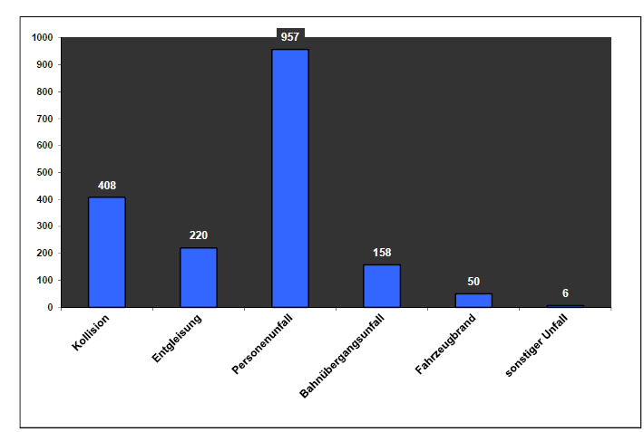

#### Figure 1: Accidents reported in 2017

|  |  |
| --- | --- |
| Kollision | Collisions |
| Entgleisung | Derailments |
| Personenunfall | Accidents involving people |
| Bahnübergangsunfall | Level crossing accidents |
| Fahrzeugbrand | Rolling stock fires |
| Sonstiger Unfall | Other accidents |

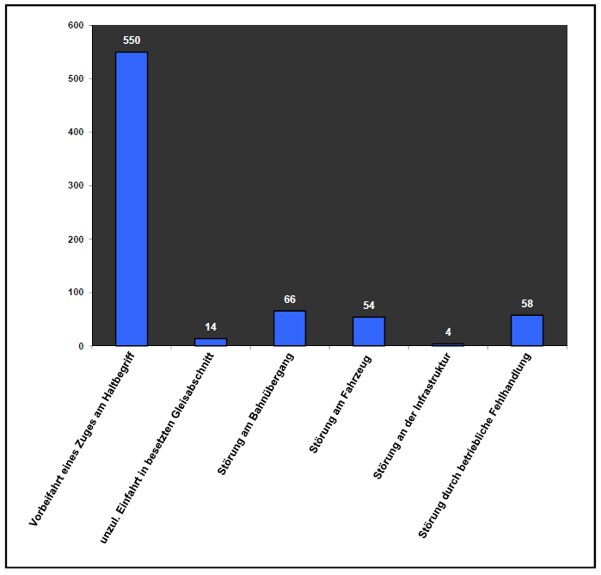

#### Figure 2: Incidents reported in 2017

|  |  |
| --- | --- |
| Vorbeifhrt eines Zuges am Haltbegriff | Signals passed at danger |
| Unzul. Einfahrt in besetzen Gleisabsschnitt | Unauthorised entry into an occupied section of track |
| Störung am Bahnübergang | Incidents at level crossings |
| Störung am Fahrzeug | Incidents involving rolling stock |
| Störung an der Infrastruktur | Incidents involving infrastructure |
| Störung durch betriebliche Fehlhandlung | Incidents caused by operational error |

## Classification of dangerous events

Following receipt of each report, the events are classified – in accordance with EU requirements – on the basis of the consequences in connection with the type of event. Serious accidents pursuant to Article 20(1) of Directive (EU) 2016/798 must be investigated and all other accidents and incidents pursuant to Article 20(2) of Directive (EU) 2016/798 may be investigated. The following figure shows the basic procedure for the classification of dangerous events.

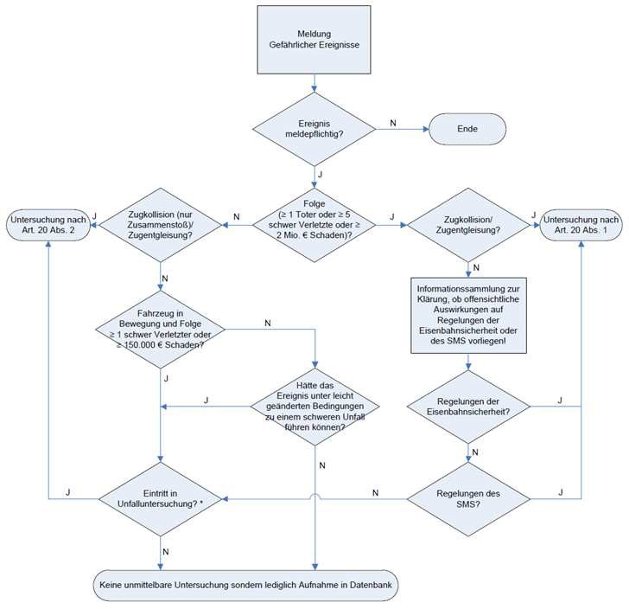

#### Figure 3: Classification and investigation of dangerous events

|  |  |
| --- | --- |
| Meldung Gefährlicher Ereignisse | Reporting of dangerous events |
| Ereignis meldepflichtig? | Is it necessary to report this event? |
| Ende | End |
| N | No |
| Untersuchung nach Art 20 Abs 2 | Investigation as specified in Article 20(2) |
| J | Yes |
| Zugkollision (nur Zusammenstoß Zugenlgleisung? | Train collision (impact only)/train derailment? |
| Folge (≥ Toter oder ≥ 5 schwer Verletzte oder ≥ 2 Mio, € Schanden)? | Consequence (≥ 1 death or ≥ 5 seriously injured people or ≥ EUR 2 million of damage)? |
| Zugkollision/ Zugentgleisung? | Train collision/train derailment? |
| Untersuchung nach Art. 20 Abs 1 | Investigation as specified in Article 20(1) |
| Fahrzeug in Bewegung und Folge ≥ 1 schwer Verletzter oder ≥ 150.000 € Schanden? | Vehicle moving and consequence ≥ 1 seriously injured person or ≥ EUR 150 000 of damage? |
| Hatte das Ereignis unter leicht geänderten Bedingungen zu einem schweren Unfall fuhren können? | Could the event have resulted in a serious accident under slightly different conditions? |
| Regelungen der Eisenbahnsicherheit? | Railway safety regulations? |
| Informationssammlung zur Klärung, ob offensichtliche Auswirkungen auf Regelungen der Eisenbahnsicherheit oder des SMS vorliegenl | Collection of information to clarify whether there are obvious effects for the railway safety or SMS regulations! |
| Eitritt in Unfalluntersuchung? | Entry into accident investigation? |
| Regelungen des SMS? | SMS regulations? |
| Keine unmittelbare Untersuchung sondem Aufnahme in Datenbank | No immediate investigation but entered into the database |

Since dangerous events cannot always be directly classified on the basis of the reports, pre‑investigations are also carried out. These serve, in particular, to clarify whether a serious accident is involved in the individual case and to what extent an overall improvement in rail safety could be achieved as a result of the investigations.

All events that must be reported are recorded internally with basic data regarding the type of event, and the place, date and consequences of the event. If separate, independent investigations were carried out, the causes determined are also included. The data are taken into account internally with the classification of dangerous events as specified in Article 20(2) of Directive (EU) 2016/798. These inquiries should not, however, be confused with the common safety indicators pursuant to Article 5 and Annex I of Directive (EU) 2016/798, which are published annually by the safety authorities in a report in accordance with Article 19 of Directive (EU) 2016/798 and also contain, inter alia, details regarding the development of railway safety.

## Classifications in 2017

Following receipt of the report, the dangerous events were categorised as follows:

|  |  |
| --- | --- |
| * Events as specified in Article 20(1) of Directive (EU) 2016/798: | 6 |
| * Events as specified in Article 20(2) of Directive (EU) 2016/798: | 13 |
| * Pre-investigations: | 107 |

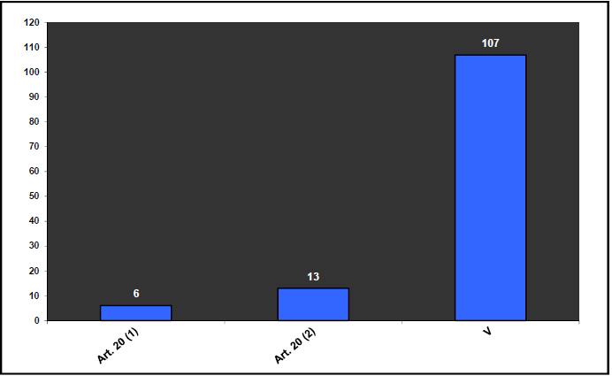

#### Figure 4: Categorisation of the dangerous events

|  |  |
| --- | --- |
| Art. 20 (1) | Article 20(1) |
| Art 20 (2) | Article 20(2) |
| V | Pre-investigations |

The following figures show how the type and number of events are distributed across the various categories.

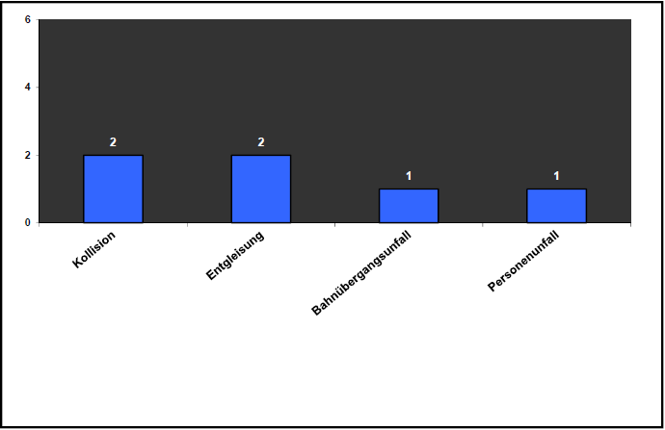

#### Figure 5: Events as specified in Article 20(1) of Directive (EU) 2016/798

|  |  |
| --- | --- |
| Kollision | Collisions |
| Entgleisung | Derailments |
| Personenunfall | Accidents involving people |
| Bahnübergangsunfall | Level crossing accidents |

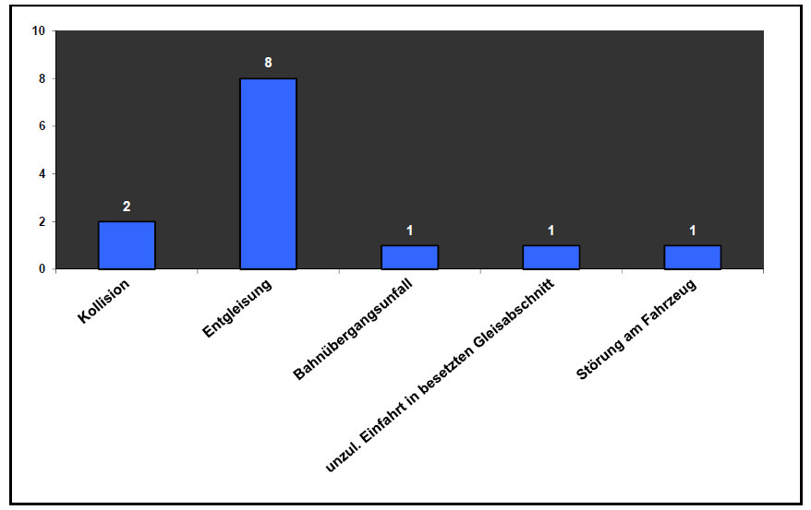

#### Figure 6: Events as specified in Article 20(2) of Directive (EU) 2016/798

|  |  |
| --- | --- |
| Kollision | Collisions |
| Entgleisung | Derailments |
| Bahnübergangsunfall | Level crossing accidents |
| Unzul. Einfahrt in besetzten Gleisabschnitt | Unauthorised entry into an occupied section of track |
| Störung am Fahrzeug | Incidents involving rolling stock |

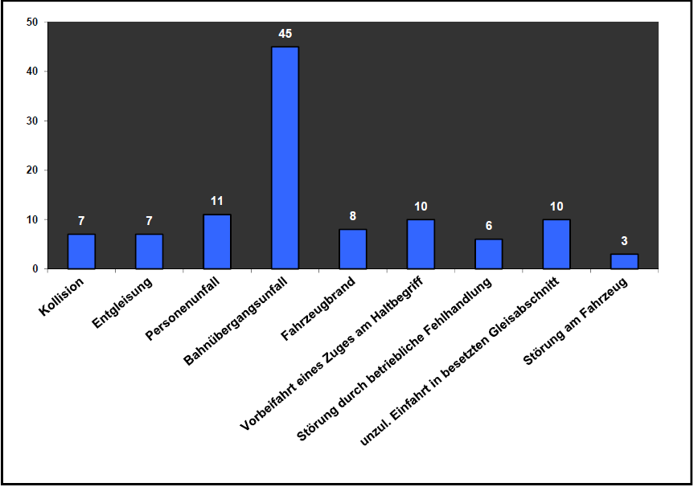

#### Figure 7: Pre-investigations

|  |  |
| --- | --- |
| Kollision | Collisions |
| Entgleisung | Derailments |
| Personenunfall | Accidents involving people |
| Bahnübergangsunfall | Level crossing accidents |
| Fahrzeugbrand | Rolling stock fires |
| Vorbeifahrt eines Zuges am Haltbegriff | Signals passed at danger |
| Störung durch betriebliche Fehlhandlung | Incidents caused by operational error |
| Unzul. Einfahrt in besetzten Gleisabschnitt | Unauthorised entry into an occupied section of track |
| Störung am Fahrzeug | Incidents involving rolling stock |

## Investigation of dangerous events

Dangerous events as specified in Article 20(1) and (2) of Directive (EU) 2016/798 are systematically investigated. The following four process steps are systematically performed in this regard:

1. First measures,
2. Launch of the accident investigation,
3. Establishment of the facts and
4. Analysis of the facts.

**First measures** comprise activities and agreements such as, for instance, putting together the investigation team and travelling to the accident site.

**Launch of the accident investigation** means that first all parties involved are recorded and initial enquires are made at the accident site. Evidence is taken and leads are determined and documented in all the disciplines involved. Following completion of these activities and internal agreement, the accident site can, in general, be cleared.

The third step, the **establishment of the facts**, comprises the investigation and assessment of all the evidence, including the statements and opinions obtained. This stage is completed with the reconstruction of the event (actual representation).

In the final step, the **analysis of the facts**, the Investigation Office reproduces the reconstructed event as it should have taken place (target representation) and carries out a target/actual comparison. The findings obtained in this way are assessed, conclusions are drawn and, if necessary, safety recommendations are developed.

The result of the investigation is summarised in an investigation report and published on the website.

# Investigation

## General

Fourteen ongoing investigations from previous years and two investigations from the reporting year were completed at the time of publication of the investigation report. Therefore, 16 investigations were completed overall. An interim report was also published on an investigation ongoing since February 2016. The individual dangerous events are set out in the following tables.

Published investigation reports:

|  |  |  |  |
| --- | --- | --- | --- |
| Serial  No | Type of event | Date of event | Location of event  (in / between) |
| 1 | Train derailment | 09/06/2013 | Kaub – Lorch |
| 2 | Train collision | 25/07/2015 | Himmelsthür (branch-off point) – Hildesheim central station |
| 3 | Train collision | 13/11/2014 | Dillingen (Saar) |
| 4 | Incident caused by operational error | 24/02/2016 | Hameln |
| 5 | Level crossing accident | 12/09/2015 | Kirn – Bad Sobernheim |
| 6 | Level crossing accident | 02/09/2014 | Schweinsberg junction – Kirchhein |
| 7 | Train derailment | 02/12/2014 | Borna (at Leipzig) |
| 8 | Unauthorised entry into  occupied track | 01/02/2017 | Gruiten |
| 9 | Train collision | 15/04/2015 | Karlsruhe freight yard |
| 10 | Train collision | 11/03/2013 | Hosena |
| 11 | Train collision | 16/11/2015 | Wustermark marshalling yard |
| 12 | Level crossing accident | 05/11/2015 | Vilseck – Freihung |
| 13 | Unauthorised entry into an occupied section of track | 23/02/2016 | Pinneberg – Hamburg-Eidelstedt |
| 14 | Accident involving people | 13/03/2017 | Meppen |
| 15 | Train collision | 28/10/2016 | Cologne-Eifeltor |
| 16 | Train derailment | 11/09/2015 | Duisburg-Wedau – Lintorf |

Table 1: Published investigation reports 2017

Published interim report:

|  |  |  |  |
| --- | --- | --- | --- |
| Serial  No | Type of event | Date of event | Location of event  (in / between) |
| 1 | Train collision | 09/02/2016 | Bad Aibling – Kolbermoor |

Table 2: Published interim reports 2017

Investigations pursuant to Article 20(1) and Article 20(2) of the Railway Safety Directive were launched into 19 events in the 2017 reporting year. These dangerous events are set out in the following sub-chapters (2.1.1 – 2.1.19).

## Train derailment in Mellenbach-Glasbach station on 6 January 2017

|  |  |
| --- | --- |
| At around 06:38 on 6 January 2017, passenger train 29870 travelling from Katzhütte to Rottenbach derailed with one bogie on trailable point 2 of Mellenbach‑Glasbach station. | Aufnahme an der Unfallstelle |
| No-one was killed or injured. The accident resulted in material damage. | |
| The investigation is at investigation step 4. | |

## Unauthorised entry into an occupied section of track in Gruiten station on 1 February 2017

|  |  |  |  |  |  |  |  |  |  |  |  |  |  |  |  |  |  |  |  |
| --- | --- | --- | --- | --- | --- | --- | --- | --- | --- | --- | --- | --- | --- | --- | --- | --- | --- | --- | --- |
| At around 22:35 on 1 February 2017, passenger train 1522 travelling from Munich central station to Dortmund entered the section of track occupied by passenger train 32490 in Gruiten station without authorisation. | Lageplan   |  |  |  | | --- | --- | --- | | Bf. Gruiten | Gruiten station |  | | Abzw Guiten | Gruiten junction |  | | Köln | Cologne |  | | Gleis 507 | Track 507 |  | | Wuppertal- Vohwinkel | Wuppertal- Vohwinkel |  | | Systemskizze ohne Maßstab | System sketch not to scale |  | |
| Nobody was fatally injured and one person was slightly injured. There was no material damage. | |
| The investigations have been completed. The investigation report has been published. | |

## Train derailment in Munich-Riem transshipment station on 6 February 2017

|  |  |  |  |  |  |  |  |  |  |  |  |  |  |  |  |  |  |  |  |
| --- | --- | --- | --- | --- | --- | --- | --- | --- | --- | --- | --- | --- | --- | --- | --- | --- | --- | --- | --- |
| At around 21:15 on 6 February 2017,  freight train 62902 travelling from Munich-Riem transshipment station to Hamburg‑Billwerder transshipment station derailed on points 236 of Munich-Riem transshipment station. | Lageplan   |  |  |  | | --- | --- | --- | | Anfahren des Zuges bei der Ausfahrt und Abrutschen des Rades mit dem Spurkranz an der äußeren Schienenkopfflanke  Erste erkennbare Entgleisungsspuren (ca. 80 m vor Grenzzeichen der Weiche W 237) | Start-up of the train upon departure and slipping of the wheel with the flange on the outer rail head flank  First visible evidence of derailment (approx. 80 m before boundary marker of points W 237) |  | | Zugentgleisung an der Weiche W 236 | Train derailment on points W 236 |  | | Portalkran Nr. 2 | Gantry crane No 2 |  | | Volle Bremsprobe der Wageneinheit KT 62902; Beladung der Wagen und vereinfachte Bremsprobe des Zuges | Full brake test of wagon unit KT 62902; loading of the wagons and simplified brake test of the train |  | | Entladestelle Zug KT 62903 | Unloading point of train KT 62903 |  | | Rangierbewegung der Wageneinheit bis zur Bremsprobeanlage (ca. 200 m) | Shunting movement of the wagon unit up to the brake testing equipment (approx. 200 m) |  | |
| No-one was killed or injured. The accident resulted in considerable material damage. | |
| The investigation is at investigation step 4. | |

## Train collision in Frankfurt-Griesheim station on 17 February 2017

|  |  |  |  |  |  |  |  |
| --- | --- | --- | --- | --- | --- | --- | --- |
| At around 01:39 on 17 February 2017, the empty passenger train 78730 travelling from Frankfurt central station to Frankfurt-Griesheim collided with the end of the platform on track 207 of Frankfurt‑Griesheim station. | |  |  |  | | --- | --- | --- | | FR | DT |  | | Bahnsteig | Platform |  | |
| Nobody was killed and one person was slightly injured. The accident resulted in material damage. | |
| The investigation is at investigation step 4. | |

## Accident involving people in Meppen station on 13 March 2017

|  |  |  |  |  |  |  |  |
| --- | --- | --- | --- | --- | --- | --- | --- |
| At around 09:51 on 13 March 2017, as passenger train 90275 was travelling from Emden central station to Münster (Westphalia) central station, an accident involving people took place with the moving rail vehicle on points 1 of Meppen station. | Aufnahme an der Unfallstelle   |  |  |  | | --- | --- | --- | | Weiche 1 | Points 1 |  | | Fahrtrichtung DPN 90275 | Direction of travel of DPN 90275 |  | |
| One person was fatally injured and three people were slightly injured. There was slight material damage. | |
| The investigations have been completed. The investigation report has been published. | |

## Train derailment in Frankfurt (Oder) Oderbrücke station on 22 March 2017

|  |  |
| --- | --- |
| At around 08:59 on 22 March 2017, freight train 49691 travelling from Frankfurt (Oder) container terminal to Frankfurt (Oder) Oderbrücke derailed with the first bogie of the last wagon in the points connection between points 115 and 116 in Frankfurt (Oder) Oderbrücke station. | Aufnahme an der Unfallstelle |
| No-one was killed or injured. The accident resulted in material damage. | |
| The investigation is at investigation step 4. | |

## Incident involving rolling stock in Merten (Sieg) station on 6 April 2017

|  |  |
| --- | --- |
| At around 14:45 on 6 April 2017, a wheelset journal of the seventh wheelset fractured due to a hot box on passenger train 33211 travelling from Düren to Au (Sieg) in Merten (Sieg) station. | Aufnahme an der Unfallstelle |
| No-one was killed or injured. The accident resulted in material damage. | |
| The investigation is at investigation step 4. | |

## Train derailment in Dortmund central station on 1 May 2017

|  |  |
| --- | --- |
| At around 18:46 on 1 May 2017, passenger train 945 travelling from Düsseldorf central station to Berlin-Ostbahnhof derailed with the last two wagons on double diamond points 36 of Dortmund central station. | Aufnahme an der Unfallstelle |
| Nobody was killed and two people were slightly injured. The accident resulted in material damage. | |
| The investigation is at investigation step 4. | |

## Train derailment between Worms and Hofheim (Ried) on 5 May 2017

|  |  |
| --- | --- |
| At around 20:35 on 5 May 2017, freight train 52789 travelling from Einsiedlerhof to Eisenach freight yard derailed with one bogie between Worms and Hofheim (Ried). |  |
| No-one was killed or injured. The accident resulted in material damage. | |
| The investigation is at investigation step 4. | |

## Level crossing accident (collision) between Neustadt am Rübenberge and Hagen (Han) on 15 May 2017

|  |  |
| --- | --- |
| At around 10:46 on 15 May 2017, passenger train 4412 travelling from Hanover central station to Bremerhaven-Lehe collided with an HGV on the level crossing at line kilometre 36.244 between Neustadt am Rüberberge and Hagen (Han). | Aufnahme an der Unfallstelle |
| One person was fatally injured and fifteen people were slightly injured. The accident resulted in material damage. | |
| The investigations have been completed. The investigation report was published in May 2018. | |

## Train derailment between Papiermühle (Stadtroda junction) and Stadtroda on 19 May 2017

|  |  |
| --- | --- |
| At around 19:29 on 19 May 2017, passenger train 3666 travelling from Glauchau (Saxony) to Göttingen derailed between the Papiermühle and Stadtroda crossovers. | Aufnahme an der Unfallstelle |
| Nobody was fatally injured and seven people were slightly injured. The accident resulted in considerable material damage. | |
| The investigation is at investigation step 4. | |

## Train derailment between Gaildorf West and Schwäbisch Hall-Hessental on 15 June 2017

|  |  |
| --- | --- |
| At around 16:45 on 15 June 2017, freight train 51894 travelling from Mannheim marshalling yard to Nuremberg marshalling yard derailed with three wagons between Gaildorf West and Schwäbisch Hall-Hessental. | Aufnahme an der Unfallstelle |
| No-one was killed or injured. The accident resulted in material damage. | |
| The investigation is at investigation step 4. | |

## Train collision in Leese-Stolzenau station on 30 June 2017

|  |  |
| --- | --- |
| At around 14:45 on 30 June 2017, freight train 42597 travelling from Antwerp to Maschen marshalling yard collided with freight train 42757 on track 1 of Leese‑Stolzenau station. | Source: Federal Police |
| No-one was fatally injured and two people were seriously injured. The accident resulted in considerable material damage. | |
| The investigations have been completed. The investigation report was published in February 2018. | |

## Level crossing accident (collision) in Hohenlimburg station on 17 July 2017

|  |  |
| --- | --- |
| At around 21:15 on 17 July 2017, freight train 93590 travelling from Hohenlimburg to Hagen freight yard collided with a car on the level crossing at track kilometre 17.335 in Hohenlimburg station. The rear part of the train then collided with the front part of train 93590 which had come to a standstill on track 1 of Hohenlimburg station. | Aufnahme an der Unfallstelle |
| No-one was fatally injured and three people were slightly injured. The accident resulted in material damage. | |
| The investigation is at investigation step 4. | |

## Train collision in Augsburg central station on 18 September 2017

|  |  |
| --- | --- |
| At around 12:50 on 18 September 2017, passenger train 42597 travelling from Augsburg-Oberhausen to Peißenberg collided with a shunting run travelling to the side on points 659 of Augsburg central station. | Aufnahme an der Unfallstelle |
| No-one was fatally injured and four people were slightly injured. The accident resulted in material damage. | |
| The investigation is at investigation step 4. | |

## Train derailment in Mühlacker station on 14 November 2017

|  |  |
| --- | --- |
| At around 13:25 on 14 November 2017, passenger train 85229 travelling from Bruchsal to Mühlacker derailed with one bogie on points 91 of Mühlacker station. | Aufnahme an der Unfallstelle |
| No-one was killed or injured. The accident resulted in material damage. | |
| The investigation is at investigation step 3. | |

## Train derailment in Elmshorn station on 15 November 2017

|  |  |
| --- | --- |
| At around 07:09 on 15 November 2017, passenger train 11004 travelling from Hamburg-Altona to Westerland (Sylt) derailed with three wagons on points 113 of Elmshorn station. |  |
| No-one was fatally injured, one person was seriously injured and two people were slightly injured. The accident resulted in material damage. | |
| The investigation is at investigation step 3. | |

## Train derailment in Bremen central station on 30 November 2017

|  |  |
| --- | --- |
| At around 01:16 on 30 November 2017, freight train 88963 travelling from Wilhelmshaven Ölweiche to Minden (Westphalia) derailed with two wagons in Bremen central station. | Aufnahme an der Unfallstelle |
| No-one was killed or injured. The accident resulted in considerable material damage. | |
| The investigation is at investigation step 3. | |

## Train collision between Weißenberg and Meerbusch-Osterath on 5 December 2017

|  |  |
| --- | --- |
| At around 19:27 on 5 December 2017, passenger train 32547 travelling from Rheine to Krefeld central station collided with freight train 48714 between Weißenberg (branch-off point) and Meerbusch-Osterath. |  |
| No-one was fatally injured, four people were seriously injured and 35 people were slightly injured. The accident resulted in considerable material damage. | |
| The investigation is at investigation step 4. | |

# 3 Safety recommendations

In accordance with Section 6 EUV, the body responsible for the investigation of serious accidents can issue safety recommendations at any time. The safety recommendations are sent to the safety authority and, if required, to other bodies or authorities or to other EU Member States. These are obliged to advise the investigating authority of the measures they have taken or plan to take as a consequence of safety recommendations. An assessment of these measures by the investigating authority is not required and does not take place.

In Chapter 3.1 ‘Safety recommendations 2017’, the safety recommendations issued regarding dangerous events in 2017 are listed and supplemented as applicable with information on the measures already taken. The following Chapter 3.2 ‘Safety recommendations 2006-2016’ contains a summary of all the safety recommendations, as well as current information on the measures taken. In this chapter, the dangerous events are ordered by date.

As of September 2018, the relevant safety authority, the Federal Railway Authority (Eisenbahn-Bundesamt, EBA), has provided information on measures taken regarding the following events:

* Train derailment between Korb and Lorch (Rhein) on 9 June 2013
* Train collision between Bad Aibling and Kolbermoor on 9 February 2016
* Unauthorised entry into an occupied section of track in Gruiten station on 1 February 2017
* Train derailment between Duisburg-Wedau and Lintorf on 11 September 2015
* Rolling stock fire in Wilhelmshaven station on 25 April 2015
* Train collision in Gladbeck West station on 26 October 2013
* Level crossing accident between Düsseldorf-Rath and Düsseldorf Eller on 19 December 2012

## Safety recommendations 2017

**Train derailment between Korb and Lorch (Rhein) on 9 June 2013**

**Safety recommendations:** (as of 31 January 2017)

(2/2017) In case of malfunctions, drainage systems on the track and near the track may result in the track substructure being penetrated by moisture which may lead to track geometry defects which pose a risk to operations. The staff used for the inspection of drainage systems lack the comprehensive register of the existing drainage systems required to be able to plan and carry out regular inspections. It is recommended that all drainage systems are recorded separately to be able to plan and promptly carry out regular inspections of the functionality of the respective drainage system.

The aim of this measure is the comprehensive and regular checking of the drainage systems on the track and near the track to prevent the development of track geometry defects which pose a risk to operations, which may result from the track substructure being penetrated by moisture.

(3/2017) Track geometry faults are evaluated in accordance with Guideline 821.2001 Section 5 based on individual defects, whereby individual defects occurring in combination are to be given particular attention. These individual defects occurring in combination also include longitudinal level defects occurring shortly after each other, that is to say cyclic longitudinal level defects. Guideline 821.1000 Section 2 and Guideline 821.2001 Table 2 include evaluation standards for individual defects defined according to the disturbance/reaction (SR) logic and in the following sections contain instructions to be applied by the person in control of an installation (PCI). There are no specific instructions for individual defects occurring in combination. The PCI is required in accordance with Guideline 821 to particularly consider track geometry defects occurring in combination and act at his own discretion. It is recommended to more precisely state the regulations regarding the individual defects occurring in combination.

**Measures:** (as of September 2018)

In relation to (2/2017): Due to the fact that track drainage systems have not yet been sufficiently recorded, the Infrastructure Manager responsible has arranged for the comprehensive recording of the corresponding systems. The Infrastructure Manager has also laid down standardised specifications for the inspection.

The procedure has therefore been substantively completed. The Federal Railway Authority will support and monitor the implementation.

In relation to (3/2017): With technical notice TM 1-2017-10135 supplementing Guideline 821.2001, the Infrastructure Manager concerned has stipulated that where there are three individual category SR100 errors in the longitudinal level within a 50 m section of track, the SRlim has been exceeded and the speed of travel must be reduced to 70 km/h. The procedure has been completed.

**Train collision between Bad Aibling and Kolbermoor on 9 February 2016**

**Safety recommendation:** (as of 7 February 2017)

(1/2017) It is recommended that the ‘Zugfunknotruf’ (train radio emergency call) and the ‘Notruf‑Strecke’ (trackside emergency call) in the Gefo menu be combined in one function button, after the emergency call button has been activated by the traffic controller.

**Measures:** (as of September 2018)

In relation to (1/2017): The control panel layout is currently being adapted. The measure should be completed by the end of 2018. The procedure has been substantively completed. The Federal Railway Authority will monitor the implementation.

**Unauthorised entry into an occupied section of track in Gruiten station on 1 February 2017**

**Safety recommendation:** (as of 12 September 2017)

(4/2017) The safety authority should review the operational regulations of DB Netz AG with regard to the topic of ‘section testing’ to ensure that they are safe to use and, if necessary, work towards amendments that rule out any misinterpretations by the user as far as possible.

**Measures:** (as of September 2018)

In relation to (4/2017): The Federal Railway Authority had already addressed the need for action to improve internal processes and the clarity of the work instructions before the accident report was made known to the undertaking concerned. This is a measure to be taken in the longer term. At the end of 2017, the undertaking had also already made its own amendments to the operational procedures concerned for traffic controllers. The procedure has not yet been completed.

**Train derailment between Duisburg Wedau and Lintorf on 11 September 2015**

**Safety recommendation:** (as of 20 December 2017)

(5/2017) In the context of regular further training and monitoring or by other suitable means, the train drivers should be made to strictly adhere to the rules relating to irregularities with vehicles and cargo and the measures in the case of imminent danger. With regard to train drivers recognising and repairing defective rail wagons, efforts should be made to considerably improve the workmanship. The train drivers should be made particularly aware of the importance of these activities, because unrecognised defects on vehicles almost inevitably lead to serious accidents, since fallback devices are often lacking.

(6/2017) Quality control for maintenance is to be optimised if necessary, in accordance with support process U7.2.4.2. It is to be ensured that only staff with the necessary qualifications are deployed for diagnostic inspections of wheelsets and DB Schenker Rail AG instruction IW‑C(W)2014/10 is strictly adhered to.

(7/2017) The traffic controllers should be made to strictly adhere to rules 408.0553 and 408.0581 through regular further training and monitoring.

**Measures:** (as of September 2018)

In relation to (5/2017): The Federal Railway Authority will monitor whether implementation is taking place in the context of regular further training. The procedure has not yet been completed.

In relation to (6/2017): After announcement of the safety recommendation in December 2017, the Federal Railway Authority discussed the circumstances with the railway undertaking concerned. The decisive factors for the safety recommendation were a report by RWTH Aachen of which the Federal Railway Authority was not aware and the assumption that an extensive loss of lubricant which had already been noticed in March 2015 had not resulted in the wheelset being replaced. The subsequent verification of the facts found deficiencies in the exchange of information between the railway undertaking concerned and the investigation office or the expert at RWTH Aachen. Not all of the required information and maintenance certificates regarding the wheelset inspection carried out in March were provided, which ultimately led to an incorrect description of the actual circumstances. Although there is no doubt that the derailment is to be traced back to an extensive loss of lubricant, it is unlikely that lubricant had been leaking since as far back as March 2015, that is to say six months before the event.

The instruction described has since been integrated into the maintenance regulations currently in force. The procedure has been completed.

In relation to (7/2017): The Federal Railway Authority will monitor whether implementation is taking place in the context of regular further training. The procedure has not yet been completed.

## Safety recommendations 2006-2016 (sorted by date of event)

**Rolling stock fire in Wilhelmshaven station on 25 April 2015**

**Safety recommendations:** (as of 7 June 2016)

1. Provide for use of non-flammable and wear-resistant material for the diesel leakage line with indication of a maximum period of use. Carry out fire-prevention measures on the turbocharger and exhaust gas pipe. Perform structural adaptation of the fuel return.
2. Retrofit fire detectors with automatic engine shut-off in all LINT diesel trains.

**Measures:** (as of September 2018)

In relation to point 1: The German Federal Railway Authority has extended the monitoring of the measures which the owners of the vehicles concerned had undertaken on the basis of this information to 2018. In doing so, findings from the reporting period 2017 are being taken into account. The procedure has not yet been completed. In relation to point 2: No measures were introduced in respect of this safety recommendation. (See in relation to point 1)

**Train collision in Mannheim central station on 1 August 2014**

**Safety recommendations:** (as of 23 September 2015)

1. Continuously strengthen the awareness and competence of traction vehicle crews when dealing with PZB (intermittent automatic train control) emergency braking of any kind by targeted training measures.
2. As a safety objective, check the retrofitting of the train control devices in the vehicles in order to ‘initiate contact after PZB emergency braking operations before starting up again’, and develop this further depending on the outcome.

**Measures:** (as of September 2016)

In relation to point 1: The Federal Railway Authority has set corresponding priorities on risk-oriented monitoring. Back in 2014, a priority check was instigated in the weeks following the accident in which over 200 train drivers were questioned regarding the correct conduct in the event of PZB emergency braking operations. This did not show up any structural shortcomings with regard to the knowledge of the operational staff.

In order to achieve the greatest possible effect and an awareness of dangers in the sector, in 2016, further monitoring is being targeted directly at the approximately 280 railway undertakings with safety certification. Carrying out and intensifying simulator training sessions for train drivers is covered by the regular audits of the undertakings. A further subject of the audits is the undertakings’ internal monitoring of staff on the basis of targeted evaluations of the PZB travel data storage devices. In this regard, there is also consideration of the procedural consistency for travel data that can be used for this purpose in hired locomotives; this data should still be available to the undertaking after the deployment of the vehicle.

In relation to point 2: To implement this safety recommendation, in the context of a request for information, selected railway undertakings and the VDV (Association of German Transport Undertakings) were asked to state their views, including all undertakings involved in the accident as well as large state-owned and private railway undertakings and DB Netz AG. The responses were classified and then the results of this request for information were evaluated. In this case, the examination of the safety recommendation revealed that retrofitting of the PZB for behaviour following an emergency braking operation does not make sense in a cost-benefit assessment against the background of the introduction of ETCS.

**Train collision in Gladbeck West station on 26 October 2013**

**Safety recommendations:** (as of 28 November 2014)

1. Reducing use of the current procedure ‘Staff authorised to carry out brake tests on trains’ as far as possible (in an emergency, e.g. after incident during a train journey, which makes a brake test necessary).
2. In the medium and long term, technical equipment should be used to safely carry out brake tests in freight traffic throughout Europe to minimise the human error rate.

**Measures:** (as of September 2018)

In relation to point 1: VDV Guideline 757 has been revised. The procedure has been completed.

In relation to point 2: Technical equipment for carrying out brake tests in freight traffic is not currently available. Such a development in European freight traffic can only be achieved via the corresponding European committees.

**Level crossing accident (collision) between Lübbecke (Westphalia) and Espelkamp on 9 January 2013**

**Safety recommendations:** (as of 21 June 2013)

1. The crossing keepers’ signals to stop the road traffic should also be given after auxiliary equipment is provided. This requirement should be specified in Guideline 456 and the clear use of the term ‘auxiliary equipment’ revised in the corresponding Annexes 2 and 5.
2. Where level crossing safety equipment is taken out of service for a period that is planned in advance or is relatively lengthy and protection by crossing keepers is put in place, the risk of a safety‑relevant operational error by the crossing keeper should be identified in order to determine an acceptable maximum duration for crossing keeper protection and to specify it in future.
3. Where the suspension from service is planned in advance or is relatively lengthy, there should be coordination with the traffic authorities (e.g. special level crossing inspection).
4. Where the suspension from service is planned in advance or is relatively lengthy, mobile barrier equipment with light signals and half barriers (e.g. technical auxiliary equipment for level crossing keepers), for better recognition of crossing keeper protection for road users, should be used more often. In this connection, the rules on the giving of signals should be adjusted.
5. For the purposes of protection and to make them easier to see, crossing keepers should wear high-visibility clothing that is easier to see (Class 3, at least vest and trousers).
6. Invalid light signals should only be covered up using means corresponding to the technical notice. The recognisability of the auxiliary equipment should be improved.
7. Where the suspension from service is planned in advance or is relatively lengthy, more mobile lighting should be used when it is dark if this makes the crossing area easier to see, even if the rules have not previously prescribed level crossing lighting.

**Measures:** (as of August 2015)

In relation to point 1: The Infrastructure Manager concerned has introduced measures for this – as far as is allowed in the context of the road traffic regulations – and made internal specifications. In this way, the visibility of the crossing keeper protection was further increased by improved recognisability of auxiliary equipment giving signals to stop the road traffic.

In relation to point 2: Basically, the measures under 1 are the decisive contribution towards controlling accident causes as in the event described here. On account of other frequently observed incidents in connection with crossing keeper error, an action plan has been developed by the undertaking as a result of the increased monitoring.

In relation to point 3: The road traffic authorities regularly issue invitations to traffic inspections. The crossing partner can, for example where there is lengthy suspension from service, apply for special traffic inspections.

In relation to point 4: The application of mobile safety equipment from an expected use time of more than seven days has in the meantime been internally regulated by the Infrastructure Manager concerned. Further associated operating measures are being introduced from December 2015 in an undertaking guideline.

In relation to point 5: The Infrastructure Manager concerned has introduced appropriate measures. Internal guidelines now regulate the minimum requirements for recognisable and high-visibility work clothing for crossing keeper visibility.

In relation to point 6: The regulation currently agreed with the safety authority on the covering of light signals is contained in an internal specification. An additional auxiliary appliance has in the meantime been developed by the Infrastructure Manager concerned, in the form of a mobile retro‑reflecting folding pyramid with red lamp attachment. It should be regularly used in future.

In relation to point 7: The implementation must in each individual case be decided by the organisation responsible for the equipment in discussion with the road maintenance authority.

**Level crossing accident (collision) between Düsseldorf-Rath and Düsseldorf-Eller on 19 December 2012**

**Safety recommendations:** (as of 7 April 2014)

As part of the planning and approval of level crossing safety equipment and as a result of a risk assessment, the application of the technical level crossing protection measures as specified in Section 11(6) EBO should be put into specific terms and modified, with the aim of minimising damage caused by broken-down vehicles in the danger area of the level crossing as far as possible.

**Measures:** (as of September 2018)

The issue is still being dealt with. The infrastructure operator concerned is currently revising the corresponding Guideline 815. Additionally, it is currently carrying out tests in the context of piloting various systems for monitoring danger zones. This was triggered by the fact that the tried-and-tested equipment for danger zone clearance signalling is no longer available at this time and so there is a need for comparable systems. Solutions may also arise from this for general recognition of vehicles which have broken down. The first findings are expected in Q3 of 2018. The procedure has not yet been completed.

**Train derailments in Stuttgart central station on 24 July 2012 and 29 September 2012**

**Safety recommendations:** (as of 8 April 2014)

1. Revision and finalisation of Guidelines 800.0110 and 800.0120 with the aim of more closely controlling layouts outside of basic values and target values.
2. Further investigations regarding the general examination of the unrestricted suitability of the type of buffer to long passenger coaches that are propelled with particular consideration of the twisting forces that occur and all possible conditions on the network. Should it not be possible to carry out this verification, it is recommended that this type of buffer should no longer be used on long passenger coaches that are propelled.

**Measures:** (as of September 2017)

In relation to point 1: On 1 December 2015, Guideline 800.0110 ‘Line layout’ was republished following an editorial and substantive revision. The recommendation was finally dealt with thereby. In detail: In section 9(4) ‘Avoidance of overriding of buffers’, this content was emphasised and reformulated. For the layout, comparison radii for the new speed ranges 25 km/h and 30 km/h were introduced, with a distinction being made between circular curves, basket curves and s-curves. The comparison radius is a geometric variable for the curvature difference in the case of a sudden discontinuity of curvature. With s-curves, in the case of a comparison radius rw < 90 m, a straight section length of greater than 8 m and, for rw < 110 m, greater than 6 m has to be complied with. The minimum length pursuant to TSI for newly planned stretches is likewise incorporated in the Guideline.

In relation to point 2: The undertaking concerned has, on the basis of the investigation results, checked the suitability of the previously used buffers for the specific scenario with negative results. A technical solution by substitution of the used buffers will be implemented after identification of suitable buffer types. Until then, safe operation is being guaranteed by operating regulations in connection with the withdrawal of the originally affected vehicles, including for comparable infrastructures. In addition, the Federal Railway Authority, in dialogue with the parties involved, has also started a discussion on the conditions required for safe operation, which also has to consider the permissible use of tolerances, both for vehicles and for infrastructure, for the intended operating system.

The consideration of the physical capacity of the vehicle components is also connected with the influences from the circumstances of the network. Findings of the Federal Railway Authority were therefore introduced in the working group of the Railway Agency of the EU regarding the Traffic Operation and Management TSI. The infrastructure register is of increased importance here for the future.

**Train collision between Hanau and Mühlheim East Crossover on 13 April 2012**

**Safety recommendations:** (as of 15 July 2014)

Finalising the regulations for the re-railing and re-roading of road-rail vehicles on/off the open track, especially the local induction training of those responsible.

**Measures:** (as of August 2015)

In an administrative procedure that was begun in 2013, an improvement of the local knowledge of the parties involved and the risk-based consideration of local details was picked out as a central theme. The Infrastructure Manager concerned is extrapolating internal procedures therefrom.

**Train collision in Bleicherode station on 21 September 2011**

**Safety recommendation:** (as of 17 April 2013)

Checking whether automatic track free reporting equipment should be provided in continuous main tracks of stations.

**Measures:** (as of August 2014)

There is a plan to subsequently equip Bleicherode station with ESTW [electronic control system] technology. The procedure has been completed.

**Train collision between Werlau and St. Goar on 11 September 2011**

**Safety recommendations:** (as of 12 June 2013)

1. The probability and the quantity of rainfall to be expected in future (heavy rainfall triggering an event) should be estimated in a risk assessment. After this, gutters/drainage devices together with accompanying catchment areas should be checked in order to identify and implement any further safety measures that may be required.
2. Creation of ‘another communication link’ as specified in Guideline 408.0581 to provide an emergency stop request by train staff on lines without telephones.

**Measures:** (as of August 2015)

In relation to point 1: Inspections of the hillside plots by the Infrastructure Manager in accordance with the internal guideline, reports by a subsoil institute, classification of the hillsides into danger classes. Detailed presentation of the measures already introduced in reporting year 2013.

In relation to point 2: The Infrastructure Manager concerned has established a corresponding rule relating to technical network access in the Network Usage Conditions 2014. For the railway undertaking concerned and in the scope of audits of other railway undertakings, the focus was directed at corporate requirements that all staff are able to properly make emergency calls quickly and directly.

**Rolling stock fire in Berlin Ostbahnhof [east station] on 26 July 2011**

**Safety recommendations:** (as of 25 November 2013)

Checking whether, for traction vehicles of the structurally identical series 112, 114 and 143, measures to increase the fire safety on the current rails and traction motor terminals (especially traction motor terminals 1 and 4) should be provided in order to prevent unacceptably high contact resistances and varying current distribution.

**Measures:** (as of August 2015)

The vehicle owner has provided for several measures to improve fire safety on the series of vehicles involved; these are based on the use of other materials and various precautions in the maintenance procedures.

**Train derailment between Gröbers and Großkugel on 11 February 2011**

**Safety recommendations:** (as of 24 June 2013)

Guideline 821.2001 does not specify any value for the standard deviation ‘s’ of the overall signal of the longitudinal level, the mutual altitude and the height of camber calculated over 250 m with an increment of 25 m, which, when reached, indicates that maintenance work needs to be done. A revision should take place so that for the standard deviation, likewise SR100, SRlim or limit values are specified.

**Measures:** (as of September 2016)

This safety recommendation was not taken into consideration. According to Guideline 821.2001, 5 (10), the standard deviation merely serves as an additional aid to decision‑making to assess the quality of the track geometry. The standard deviation makes a statement about the average quality of the track geometry and is used for planning maintenance works in larger sections. If the SRA [disturbance/reaction system A] value is exceeded, this must be examined on the basis of the local circumstances and maintenance measures may have to be initiated. An introduction of SR100 or SRlim is not considered to be necessary because, in Germany, the maintenance measures have for a long time depended on individual values and not on average values or the standard deviation. The consideration of the individual values is more important because, even in individual cases where SR100 or SRlim is exceeded, measures have to be taken. In the calculation of the average value or of the standard deviation, such individual cases where measured values exceed the specified limits can no longer be ascertained.

**Train collision in Hordorf station on 29 January 2011**

**Safety recommendations:** (as of 14 September 2011)

1. Retrofitting of all lines with automatic train control equipment so that a train which passes a signal at danger without authorisation can automatically be brought to a halt. Additionally, an unauthorised start on main lines when the signal is at danger can be automatically prevented.
2. Until the lines are retrofitted with automatic train control equipment as specified in point 1, additional measures should be taken which are capable in each individual case of reducing the likelihood of occurrence and/or the amount of damage caused by an unauthorised passing of a signal at danger.

**Measures:** (as of August 2015)

In relation to point 1: The sixth regulation amending the Statutory Provisions Governing Railways of 25 July 2012 amended the Railway Construction and Operation Order. The regulation came into force on 1 December 2012. Due to this amendment of the order, comprehensive retrofitting obligations are specified which are implemented to the greatest possible extent.

In relation to point 2: Until the retrofitting has been completed, the infrastructure operators have been encouraged by the safety authority to investigate and introduce suitable intermediate risk and operating measures. For this purpose, the infrastructure operators have undertaken various activities in conjunction with the railway undertakings and introduced appropriate measures.

**Train derailment in Bacharach station on 1 September 2010**

**Safety recommendation:** (as of 30 May 2012)

1. As part of their operational responsibility, railway undertakings should ensure that the load limits of freight wagons are not exceeded. In addition, it is necessary to ensure, among other things, that the braking properties of a train and, in particular, the sum of the braked weights are maintained in relation to the total weight of a train (braked weight percentage). An important safety-relevant factor of the total weight of a train is the actual payload weight. This needs to be determined and then put into the brake calculation.
2. The provisions of Guideline 408.0581 3 (5) ‘Emergency call’ of the Guideline ‘Train running and shunting’ have the following content:

*A train driver who cannot clearly hear or understand a message initiated by an emergency call must immediately reduce the speed of his train to a maximum of 40 km/h and drive on sight until it becomes clear from a following message that he is not affected or until the cause of the emergency call has been clarified with the traffic controller.*

The new text took effect on 31 December 2009 in notification No 8.

The electronic journey recorder of CS 47925 and the train driver’s statement verify that the driver of train CS 47925 after receiving the acoustic display with the pictogram ‘Emergency call connection’ on the GSM-R vehicle device could have brought his train to a halt significantly sooner than actually happened if he had immediately initiated an emergency brake application. As a result, the damage to the infrastructure would have been reduced and the potential danger of a collision with a train running on the opposite track would have been considerably reduced.

Bearing in mind the derailment consequences and also the potential danger to other trains, the provision of Guideline 408.0581 3 (5) amended on 13 December 2009 should be adapted accordingly.

**Measures:** (as of August 2013)

In relation to point 1: The recommendations were only sent to the undertakings involved in each case because it was considered to be a ‘one off’ case. Separate activities by the safety authority were therefore not provided.

In relation to point 2: The regulation issued is in accordance with a harmonised regulation of the operation TSI. A possible amendment was discussed in the relevant expert committee of the European Railway Agency but was not approved.

**Other accident in Bielefeld station on 10 July 2010**

**Safety recommendations:** (as of 20 October 2011)

Modify the working of the air-conditioning system, so that if a reset of the heating or cooling part of the air-conditioning system becomes necessary, or if it fails, the fresh air supply and air recirculation in the coach remains in service.

**Measures:** (as of July 2012)

The operator has justified his refusal to immediately implement the safety recommendation and compensated for this by technical and operating measures.

The procedure has been completed.

**Train collision between Leiferde and Braunschweig on 20 January 2010**

**Safety recommendations:** (as of 29 January 2010)

In order to ensure that passengers can be evacuated rapidly and safely in an emergency, the requirements concerning emergency entry and exit windows in component approval EBA 05 G 08A (10/05) as well as structurally identical emergency entry and exit windows regarding their functionality (marking, operation and risk of injury) should be reviewed.

**Measures:** (as of March 2010)

According to available information, the functionality of two emergency entry and exit windows from a series produced by the Scholl company was tested by the safety authority on a VT 628 on 24 March 2010. The impact test using the emergency hammer on both windows was carried out without problems and in both cases the window could be smashed and pushed out in 15-20 seconds.

Consultation on the need for a new or amended design for the pictogram showing how to use the emergency entry and exit windows has been completed. It was established that there was no need for action.

The procedure has been completed.

**Derailment between Nuremberg Stein and Nuremberg marshalling yard on 7 August 2009**

**Safety recommendations:** (as of 10 February 2011)

The design tension for the securing fittings is an important criterion for keeping permanent way to gauge and thus prevents derailments. It is recommended that DB Netz AG’s permanent way regulations for the inspection of track and points installations of type K-54-B58 are updated and supplemented in the near term.

1. Lay down a graduated inspection frequency for testing the tension of securing fittings on tracks and points. In deciding this frequency, line speed, traffic density and sensitive locations on the network (for example tight curves, track on timber sleepers that has been laid a long time, permanent way with ‘indirect fastenings’ and other constraints) should be considered.
2. Lay down a method of testing to check the tension of securing fittings and appropriate benchmarks. The measurement of design tension by means of a torque wrench, for example, is considered to be a suitable test.

**Measures:** (as of August 2014)

The matter has been discussed by the safety authority and the Infrastructure Manager concerned. A change to the regulations was seen as an appropriate measure. It is to come into effect in 2013 in the form of a technical civil engineering instruction. This change will set down maintenance periodicity, obligations to replace components and the need for special inspections when damage to fittings securing rails to B55 and B58 sleepers is noted. By the amendment/supplement to the regulations, damage that is gradually increasing can now be recognised and dealt with at an early stage.

The procedure has been completed.

**Derailment between Bünde (Westphalia) and Bruchmühlen on 17 July 2009**

**Safety recommendations:** (as of 8 February 2010)

The following rolling stock-related measures are currently recommended to avoid further wheelset axle failures caused by hot boxes:

1. replace riveted brass cages with plastic bearing cages;
2. investigate whether fitting further derailment detectors or sensors for hot box detection could make a measurable contribution to preventing derailments.

**Measures:** (as of July 2012)

In relation to point 1: Evaluation of the measure recommended has revealed that the replacement of riveted brass cages with plastic bearing cages to avoid further wheelset axle failures caused by hot boxes is inappropriate because it is only one of several causes. In a separate development, the issue has been dealt with further at European and international level.

In relation to point 2: The investigation of the effectiveness of derailment detectors or sensors for hot box detection is at present being pursued at European and international level.

The procedure has been completed.

**Other railway operating accident between Lövenich and Horrem on 27 June 2009**

**Safety recommendations:** (30 June 2009) At least investigate the following:

1. whether it is necessary to retrofit warning lights within the train driver’s field of vision which would indicate to him that the additional brake on the driving trailer had been applied or that it had not been completely released;
2. whether operational measures going as far as prohibiting the use of the additional brake when running with a driving trailer leading are to be initiated;
3. whether the air intake for the air conditioning should be moved to another suitable site, away from the braking equipment.

**Measures:** (as of July 2012)

In relation to point 1: The modification described in the safety recommendation has been ongoing since 2007. The retrofitting of warning lights has not yet been completed.

In relation to point 3: The study of whether the air intake for the air conditioning should be moved to another site has been completed with the result that there is no other suitable site.

The procedure has been completed.

**Train collision in Berlin Karow station on 16 April 2009**

**Safety recommendations:** (as of 8 December 2010)

1. Clarify the rules for return of signals to danger in (old) signal boxes without automatic means of indicating that the track is clear so as to make signals return to danger as soon as possible.
2. Investigate how the return of signals to danger is organised in comparable signal boxes on the existing network.
3. Investigate whether automatic means of indicating the track is clear should be provided in comparable stations.

**Measures:** (as of August 2011)

The infrastructure operator in question has drawn up a technical notice entitled ‘Rules for returning starting signals to danger and for equipping with means of indicating the track is clear’. This document contains clear guidelines for the automatic return of signals to danger in good time. The technical notice was introduced with immediate effect.

The complete network of the infrastructure operator in question was examined in order to identify comparable cases on the overall network with similar potential risks. For this, the infrastructure operator in question assembled comprehensive data and used it to make appropriate risk assessments. Local shortcomings have been remedied.

**Train collision in Recklinghausen on 25 November 2008**

**Safety recommendation:** (as of 28 November 2008)

Investigate, at least, whether drivers of light traction vehicles fitted with disc brakes should notify the traffic controller if sanding equipment has been used or initiated automatically and the traction vehicle has come to a halt, so as to avoid ‘wrong’ indications by track circuits indicating that the track is clear.

**Measures:** (as of August 2014)

The safety authority has issued instructions to Infrastructure Managers and railway undertakings on the basis of the safety recommendations.

The instructions issued to railway undertakings were tightened. In addition, the subject of ‘sanding equipment’ was dealt with further at authority and industry level via the ‘vehicles steering group’ regarding future arrangements on vehicle equipment.

The procedure has been completed.

**Derailment in Cologne central station on 9 July 2008**

**Safety recommendations:** (as of 4 March 2009)

Safety recommendation for ICE-3 multiple units with wheelset axles made of 34CrNiMo6 material is as follows:

Examine initial data for the materials for evidence of its fatigue strength when designing wheelset axles to take account of the structural inhomogeneity discovered in the course of the tests done by the Federal Institute for Materials Research and Testing [Bundesanstalt für Materialforschung und ‑prüfung (BAM)].

**Measures:** (as of August 2015)

All wheelset axles are regularly checked for freedom from cracks by non-destructive testing methods.

The powered wheelset axles made of 34CrNiMo6 are being replaced with wheelset axles made of EA4T. The approval procedure has been completed.

**Train collision of ICE 885 in the Landrücken tunnel on 26 April 2008**

**Safety recommendations:** (as of 14 May 2010)

1. Consider whether it is possible to continue to do without fencing of the line or parts of the line, or whether similar events can in future be prevented by other measures in order to improve the margin of safety against derailment for high speed trains.
2. Investigate and optimise the visibility of escape routes and emergency equipment in coaches.
3. Revise module 123.150 ‘Rescue by Third Parties’ of Guideline 123. In particular, there should be a clear separation of the responsibilities of the Emergency Manager/Emergency Management Office/Incident Officer.
4. Investigate the operating regulations regarding the behaviour of operating staff in the event of a collision with herd animals.
5. Refresh induction training and provide regular instruction of the staff responsible for rescue on local features and safety equipment and plan and carry out tunnel rescue practice.

**Measures:** (as of August 2015)

Regarding recommendation 1: The Infrastructure Manager concerned had already decided in August 2008 to determine the risks for train passengers and train staff arising from collisions with animals using a risk-based approach and to assess the appropriateness of fencing of high speed lines. An engineering company was commissioned to carry out a risk assessment on this matter. The following variants were investigated:

* complete fencing of the high speed lines,
* partial fencing of the high speed lines in critical places, and
* fencing of the high speed lines in the area of the north portal of the Landrücken tunnel.

Result of the risk assessment:

1. From the point of view of the individual risk, it is not necessary to build fences along high speed lines or on the remainder of the network.
2. From the point of view of the collective risk, complete fencing either of the high speed lines or of the remainder of the network is not considered to be a proportionate measure.
3. The differentiated investigation of the types of line on the high speed lines has shown that fencing only on the tunnel - tunnel type of line (connecting tunnel in both directions of travel) just about constitutes a proportionate measure.

As a result of the investigation of fencing of local sections of high speed lines on the basis of several risk-increasing factors, the sections of line concerned were identified.

With regard to recommendations 1, 3 and 5, the safety authority worked on getting the Infrastructure Manager to take the safety measures described below:

* checking the effectiveness of the regulations on raising the alarm by the emergency management offices as part of a practice which resulted in the following: the emergency folder was supplemented by a cover sheet on which all the required information can be seen in simple form – if this was not already available,
* intensifying the training in how to raise the alarm, and
* carrying out special inspections with regard to the tunnel safety equipment in different tunnels on high speed lines (v > 200 km/h).

In addition, the Infrastructure Manager analysed the need to fence high speed lines. The final assessment of the need for targeted fencing measures as well as, if necessary, their implementation is not yet completed.

With regard to recommendation 2, when requested, the operator of the rolling stock demonstrated that the train in question was equipped in accordance with the rules and furthermore showed that there is no requirement for improvement even on account of the accident.

When the Infrastructure Manager introduced organisational improvements, the safety authority closed the matter.

**Train derailment in Rotenburg / Wümme on 28 February 2007**

**Safety recommendations:** (as of 7 January 2008)

In view of the findings in the accident investigation and the results of the report on the metallurgical tests, ask specialist groups to consider whether and to what extent the distance between hot box detection installations can or must be optimised in order to be able to respond more effectively to a hot box which is developing relatively quickly.

**Measures:** (as of August 2011)

Potential improvements related to the spacing required, options for detection and basic assumptions for the temperature rise have been discussed with the infrastructure operator. A draft of a new specification was produced in conjunction with the infrastructure operator. The specification contains improved requirements for detection, options for evaluation and system stability. Improved requirements are also currently being tested or have already been implemented for the further development of hot box and dragging brake detectors already in operation.

**Collision in Berlin Südkreuz on 20 November 2006**

**Safety recommendations:** (as of 29 March 2007)

Send the expert report to S-Bahn Berlin GmbH. Issue a notice to S-Bahn Berlin GmbH which contains the requirement to ensure that the sanding equipment on series 480 and 481 S-Bahn trains works reliably and always contains enough operating materials.

Check the design of the brake system of series 480/481 vehicles in conjunction with the manufacturer and operator taking the points made by the expert into account.

Prepare a risk analysis as a means of preventively dealing with the probable cause of this accident, the combination of ‘dirty rail head and slight dampness’, and limiting the effect thereof by appropriate operational measures.

**Measures:** (as of July 2014)

The brake equipment and the sanding equipment of the vehicles were converted. The procedure has been completed as far as the vehicles are concerned.