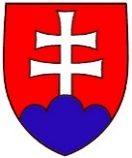
DOPRAVNÝ úrad

Letisko M. R. Štefánika, 823 05 Bratislava
TRANSPORT AUTHORITY

M. R. Stefanik airport, 823 05 Bratislava, slovak republic

Annual Report
on Railway Safety
in Slovakia
for 2015

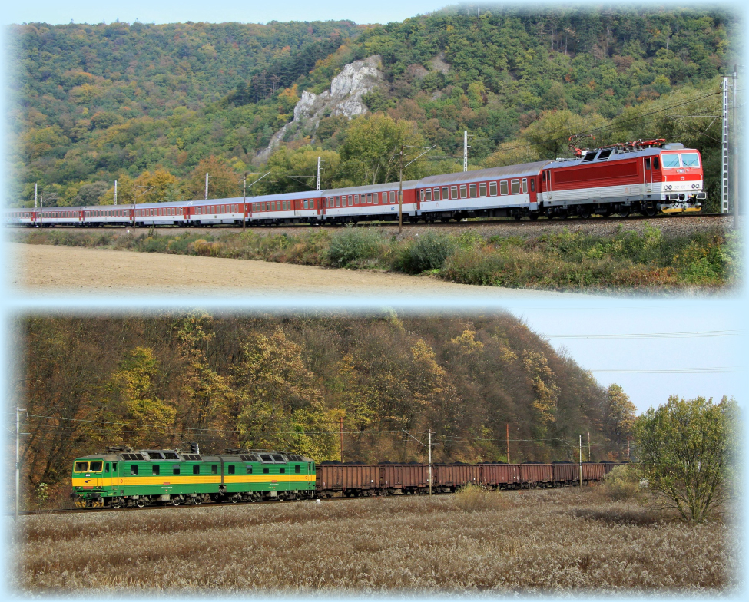
Report submitted by:
Ján Breja, Chairperson
September 2016

CONTENTS
List of abbreviations used 1
A. Scope of the Annual Report 2
B. Introductory section 2
1. Introduction to the report 2
2. Railway structure information 2
3. ŽSR railway network map 6
4. List of railway undertakings and infrastructure managers 6
5. Summary 6
6. Implementation of Railway Safety Directive 2004/49/EC 6
C. Organisation 6
1. Introduction 6
2. Organisation of the Authority 7
3. Organisational chart 8
D. The development of railway safety 8
1. Initiatives to maintain/improve safety performance 8
2. Detailed data trend analysis 9
3. Results of safety recommendations 9
E. Important changes in legislation and regulations 10
F. The development of safety certification and authorisation 10
1. National legislation 10
1.1 Issuing of safety certificates according to Article 10 of Railway Safety Directive 2004/49/EC. 10
1.2 Issuing of safety authorisations for infrastructure managers under Railway Safety Directive 2004/49/EC. 11
1.3 National safety rules. 11
2. Development of safety certification and authorisation – numerical data 11
3. Procedural aspects 12
3.1 Safety certificates part A 12
3.2 Safety certificates part B 13
3.3 Safety authorisations 13
4. Registration of vehicles 14
G. Supervision of railway undertakings and infrastructure managers 16
1. Description of supervision 16
1.1 Audits – inspections 16
1.2 The Authority’s findings from supervision, which need to be followed up on 17
2. Submission of safety reports 17
3. a 4. Inspections and audits by the Authority 17
5. Summary of relevant measures taken by the Authority 18
6. Summary description of complaints made by the infrastructure manager against railway undertakings in relation to the conditions under part A/B of the safety certificate 18
7. Summary description of complaints made by railway undertakings against the infrastructure manager in relation to conditions under the safety authorisation 18
H. Reporting on the application of the Common Safety Method on Risk Evaluation and Assessment 18
I. Alternative measures through derogations regarding the ECM certification scheme 19
J. The Authority’s conclusions on the reporting year – priorities 19
K. Sources of information 20
L. Annexes 21
Annex A 1 ŽSR network 22
Annex A 2 List of railway undertakings 23
Annex A 2.1 Infrastructure manager 26
Annex A 2.2 Railway undertakings – safety certificates issued 27
Annex B Organisational structure of the Authority 32
Annex B 1 Internal organisation (as at 31.12.2015) 32
B 1.1 Organisational chart of the Authority to the level of divisions 32
B 1.2 Organisational chart of the Railways and Railway Traffic Division 33
Annex B 2 Relationships with other national bodies 34
Annex C Common Safety Indicators data 35
Annex D Important changes in legislation and regulations 47
Annex E The development of safety certification and safety authorisation – numerical data 51
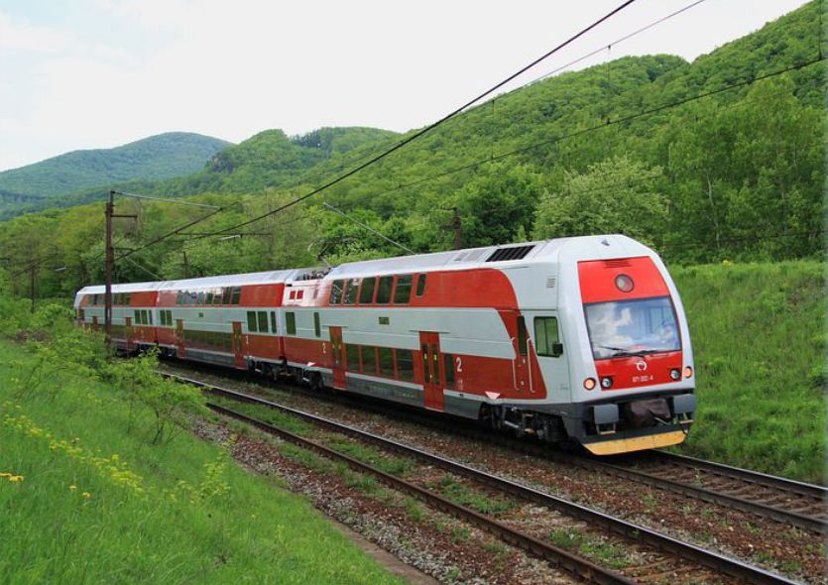
(photo: Pavel Chomjak, Prešov)

List of abbreviations used
CSM | common safety method
ERA | European Railway Agency
RTU | railway traction unit
Ministry | Ministry of Transport, Construction and Regional Development of the Slovak Republic
certificate | safety certificate of a railway undertaking
authorisation | safety authorisation of a railway infrastructure manager
BTS | border transit station
SR | Slovak Republic
SMS | safety management system
SPS | state professional supervision
SPTS | state professional technical supervision
TI | technical inspection
Authority | Transport Authority
OSMT SR | Office of Standards, Metrology and Testing of the Slovak Republic
VKM | Vehicle Keeper Marking
Railways Act | Act No 513/2009 Coll. on railways and amendments to certain acts, as amended
Railway Traffic Act | Act No 514/2009 Coll. on railway traffic, as amended
RS | rolling stock
ŽSR | Železnice Slovenskej republiky – the railway infrastructure manager

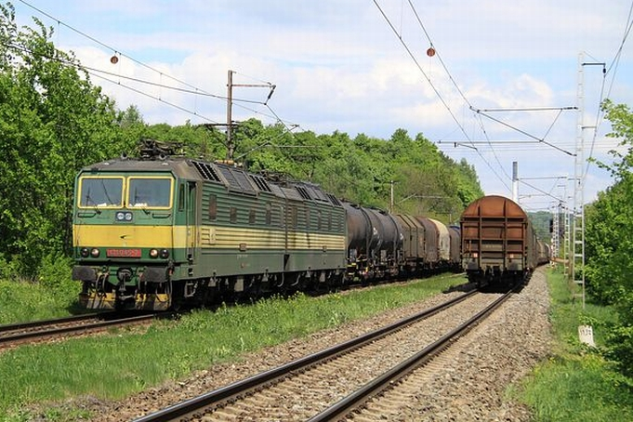

(photo: Pavel Chomjak, Prešov)

Scope of the Annual Report
The Annual Report on Railway Safety (‘the Report’) contains railway safety indicators for the railway infrastructure in the Slovak Republic for 2015 and information about the activities of the Transport Authority acting as the railway safety authority. This Report also contains data relating to marshalling yards and regional railway systems. Data on urban railways are not included in this Report.

Introductory section

Introduction to the report
The obligation to draw up the Report arises from the provisions of § 91(1) of the Railways Act and Article 18 of Directive 2004/49/EC of the European Parliament and of the Council of 29 April 2004 on safety on the Community’s railways and amending Council Directive 95/18/EC on the licensing of railway undertakings and Directive 2001/14/EC on allocation of railway infrastructure capacity and the levying of charges for the use of railway infrastructure and safety certification (‘Directive 2004/49/EC on railway safety’).
The purpose of this Report is to provide information on the level of railway safety and safety of railway transport within the railway infrastructure in the Slovak Republic.
The objective is to improve the level of railway safety continuously and inform stakeholders about how the level of safety is being improved.
The completed Report has been forwarded to the European Railway Agency and made available on the Authority’s website (http://nsat.sk/en/transport-authority-about-us/annual-reports).

Railway structure information
The railway infrastructure in Slovakia (except railway sidings) is owned by the State. The railway infrastructure is managed and operated by ŽSR. For the purposes of this Report, the railway infrastructure includes main and secondary railway lines in Slovakia.
Construction length of tracks
The total construction length of tracks is 6 871 km, of which 4 644 km are main tracks and 2 227 km are other station tracks. There are a total of 8 459 switches and 9 358 switch units.
Construction length of lines
The construction length of railway lines totals 3 626 km, of which 2 609 km are single-track and 1 017 km are double or multi-track lines. There are 3 481 km of standard-gauge lines, 99 km of broad-gauge lines and 46 km of narrow-gauge lines. Of the total construction length of railway lines, 2 039 km are non-electrified and 1 587 km are electrified.
Bridges
As part of the railway infrastructure, 2 297 bridges have been built, 438 being steel bridges and 1 859 solid bridges. The total length of bridges is 51 205 m.
Tunnels
The railway infrastructure also includes 76 tunnels. Of these, 68 are single-track and 8 are double-track tunnels. The total length of railway infrastructure tunnels is 45 004 m.

Level crossings
From the standpoint of railway safety, level crossings are the most critical part of the railway infrastructure. A total of 2 112 level crossings have been built as a part of the railway infrastructure. There are 1 071 secured and 1 041 unsecured level crossings. There are 51 level crossings secured with mechanical barriers and 41 crossings with permanently locked barriers. There are 9 level crossings secured with mechanical interlocking systems (PZM 0) and 970 crossings are secured with light signalling systems. In the context of modernisation large reconstructions of railway lines, level crossings are being replaced with grade-separated crossings.

Structure of level crossings (units)
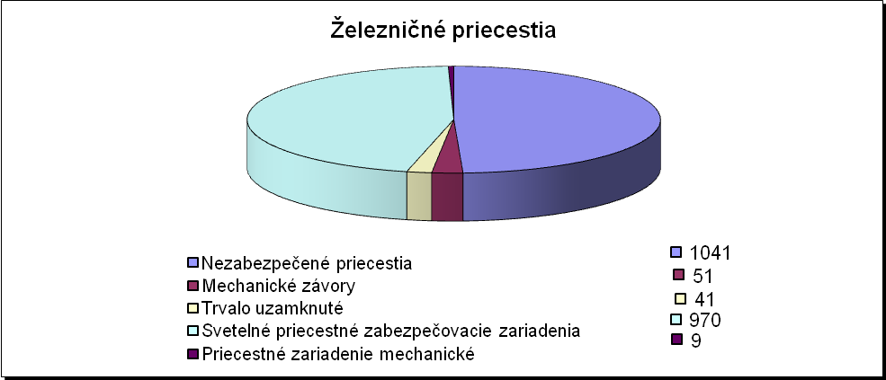

Železničné priecestia | Level crossings
Nezabezpečené priecestia | Unsecured crossings
Mechanické závory | Mechanical barriers
Trvalo uzamknuté | Permanently locked
Svetelné priecestné zabezpečovacie zariadenia | Light signalling system crossings
Priecestné zariadenie mechanické | Mechanical level crossing interlocking system

Track interlocking systems
Railway tracks protected with an automatic block signalling system have a total length of 541 km, of which 136 km are equipped with single direction ABS systems and 405 km use a bi-directional ABS system. Automatic block systems are used as track interlocking systems on 520 km of tracks. Semi-automatic blocks secure tracks with a total length of 585 km, of which 515 km are secured with a relay system and 70 km are secured with an electromechanical system. The total length of tracks using a telephone communication system for signalling is 1 580 km. Remote dispatcher-operated interlocking systems secure 377 km of tracks. In total, 762 km of tracks are equipped with a system enabling the transmission of information to trains.
Structure of track interlocking systems in km
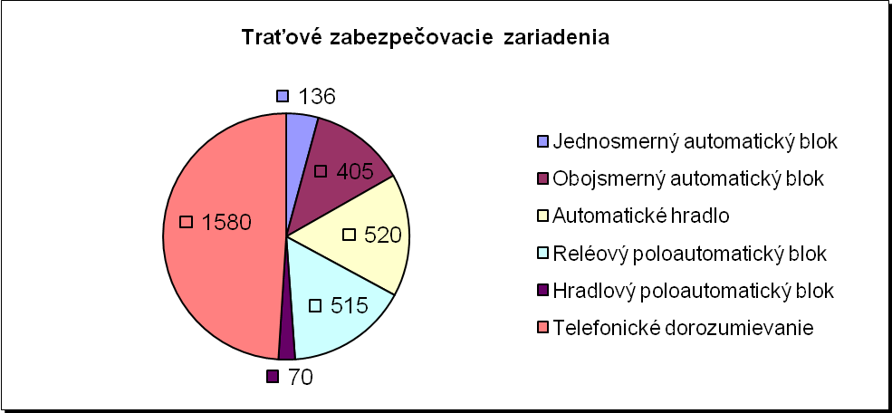

Traťové zabezpečovacie zariadenia | Track interlocking systems
Jednosmerný automatický blok | Single direction ABS
Automatické hradlo | Automatic block
Reléový poloautomatický blok | Relay semi-automatic block
Hradlový poloautomatický blok | Electromechanical semi-automatic block
Telefonické dorozumievanie | Telephone communication system

Station interlocking systems
A total of 149 railway stations in Slovakia are equipped with the simplest system – a mechanical station interlocking system. Electromechanical station signalling systems are employed at 61 railway stations. There are a total of 167 operating control points with a relay interlocking system, 40 operating control points use an electronic interlocking system, and 57 operating control points have other interlocking systems. Remote dispatcher-operated interlocking systems secure tracks with a length of 377 km.

Structure of station interlocking systems (units)
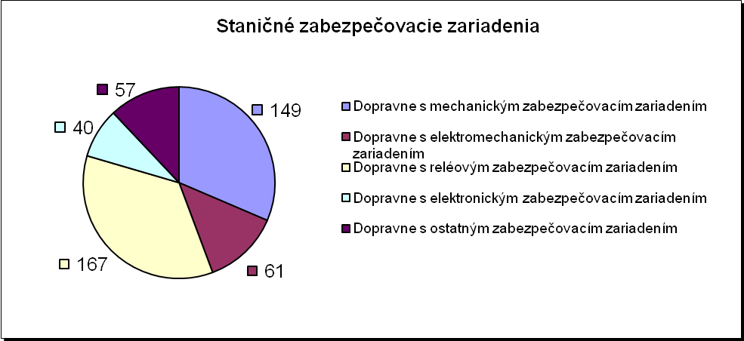

Marshalling yard interlocking systems
There are two automatic and six mechanical marshalling yards within the ŽSR network. The marshalling yard interlocking systems use retarders and compressor stations for their operation. There are 210 retarders and 15 compressor stations in total.
Electrified tracks
Of the total length of railway lines, 1,587.0 km are electrified using the following systems:
- AC 25,000 V/50 Hz | 762.0 km,
- DC 3,000 V (1,500 V, 600 V) | 825.0 km.
The extended length of overhead lines is 4 842 km, of which single-phase AC overhead lines total 2 193 km and DC overhead lines total 2 649 km.
Substations and switching stations
There are a total of 92 substations and switching stations within the railway infrastructure. Of these, 12 are single-phase substations and 36 are direct current substations. There are three auxiliary substations. The infrastructure includes 18 single-phase switching stations and 20 direct current switching stations. There are three mobile substations.
Operating control points
The railway infrastructure includes 1 020 operating control points in total. Of these, 379 are manned and 641 are unmanned. Of the total number of operating control points, 300 are railway stations,
22 are border stations and 698 are other operating control points (blocks, branch lines, exchange stations, operating control points with simplified traffic management, etc.).
Corridor routes within Slovakia’s railway infrastructure
The total length of ŽSR railway lines included in pan-European corridors is 939 km and consists of the following sections:

- the corridor in section: (CZ) – Kúty – Bratislava – Štúrovo – (HU) | (220 km)
- the corridor in section: Bratislava – Žilina – Košice – Čierna nad Tisou – (UA) | (544 km)
- the corridor in section: Žilina – Čadca – Skalité – (PL) | (57 km)
- the corridor in section: (HU) – Čaňa – Košice – Prešov – Plaveč – (PL) | (118 km)

Corridor routes within Slovakia’s railway infrastructure

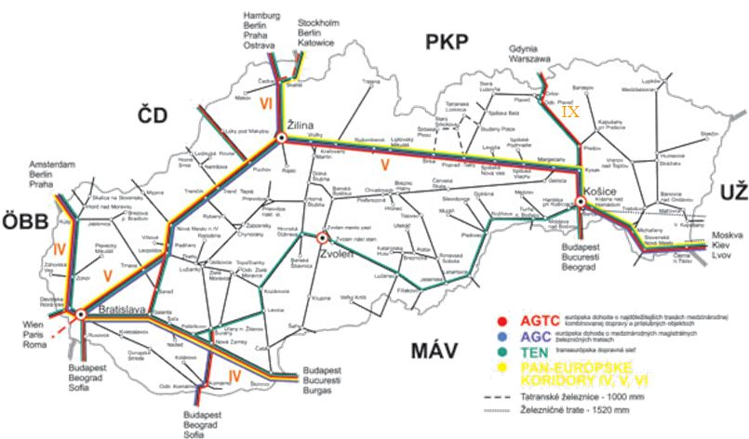

The total length of ŽSR railway lines included in pan-European railway freight corridors is 1 182 km and consists of the following sections:
RFC5: (CZ) – Žilina – Bratislava – (AT) | (281 km)
RFC7: (CZ) – Kúty – Bratislava – (HU) | (517 km)
RFC9: (CZ) – Žilina – Košice – (UA) | (496 km)

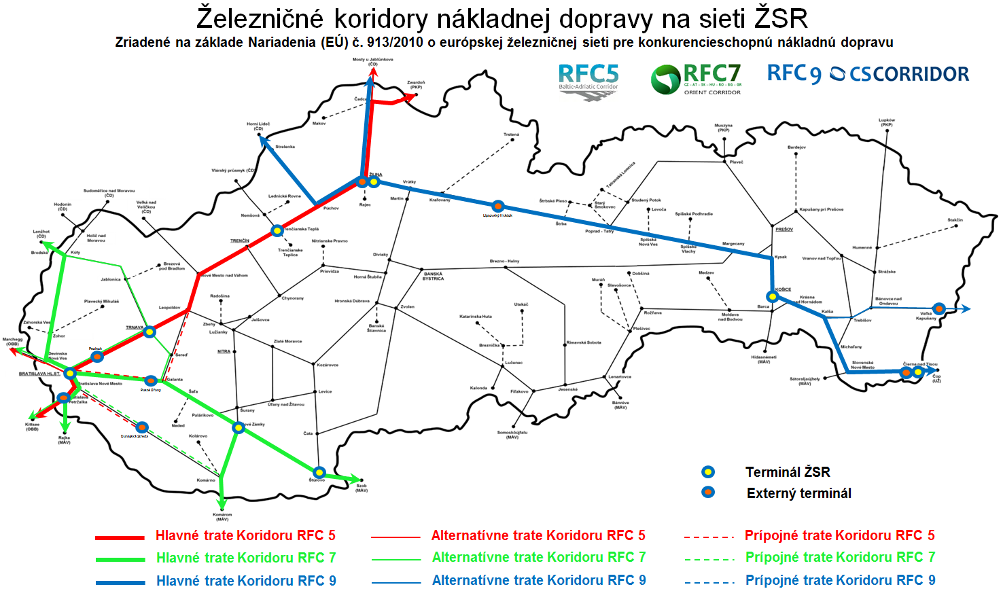

ŽSR railway network map
The map of the ŽSR railway network is provided in Annex A 1. The provided railway network information comes from the database of ŽSR.

List of railway undertakings and infrastructure managers
In 2015, a total of 54 railway undertakings operated transport services (held a valid safety certificate) within Slovakia’s railway infrastructure. These are listed in Annex A 2.
The sole railway infrastructure manager for main and secondary railway lines in Slovakia is ŽSR.

Summary
One of the fundamental roles of the SMS of the railway infrastructure manager and railway undertakings providing transport services on the railway infrastructure is to ensure and develop railway safety. This obligation also arises from the relevant provisions of the Railways Act and the Railway Traffic Act.
One of the Authority’s key tasks when exercising its competence as a safety authority is to oversee railway safety and railway traffic safety, accident prevention and the application of railway traffic safety legislation.
An analysis of the railway safety development trend can be derived from the statistics provided in the tables under Annex C.

Implementation of Railway Safety Directive 2004/49/EC
Railway Safety Directive 2004/49/EC has been fully transposed into the legislation of the Slovak Republic through the Railways Act and the related acts referred to in Annex D.
In 2015, the Authority’s activities in the field of railway safety were carried out in accordance with the applicable provisions of the Railways Act, the Railway Traffic Act and other national safety rules.
At the same time, procedures complying with Commission Regulation (EU) No 1077/2012 on a common safety method for supervision by national safety authorities after issuing a safety certificate or safety authorisation (‘Regulation No 1077/2012’) were applied in the context of exercising state professional supervision of railway undertakings.
When assessing railway undertakings’ applications for safety certificates, the Authority applied Commission Regulation (EU) No 1158/2010 of 9 December 2010 on a common safety method for assessing conformity with the requirements for obtaining railway safety certificates (‘Regulation No 1158/2010’). Applications for safety authorisations were assessed by the Authority applying Commission Regulation (EU) No 1169/2010 of 10 December 2010 on a common safety method for assessing conformity with the requirements for obtaining a railway safety authorisation (‘Regulation No 1169/2010’).

Organisation

Introduction
The Transport Authority was established through Act No 402/2013 Coll. on the Regulatory Authority for Electronic Communications and Postal Services and the Transport Authority, and on amendments to certain acts, effective from 1 January 2014, as the national state administration authority in the fields of
- railways and railway traffic,
- civil aviation, and
- inland waterway transport.
The Transport Authority, with its seat at Letisko M. R. Štefánika, 823 05 Bratislava, is the legal successor of authorities abolished by law, namely the Railway Regulatory Authority, the Civil Aviation Authority of the Slovak Republic and the State Navigation Administration.
The Transport Authority’s is to contribute effectively to ensuring safety in the area of railways and railway transport, civil aviation and inland navigation and create a regulatory framework in certain areas of transport by exercising supervision and oversight and setting the regulatory criteria.
In pursuing its mission, the Transport Authority follows generally applicable legislation of the Slovak Republic, legally binding acts of the European Union and international treaties binding on the Slovak Republic.
The Transport Authority is headed by a chairperson appointed and removed by the Slovak Government at the proposal of the Minister of Transport, Construction and Regional Development (‘the Minister’). The chairperson is deputised by the vice-chairperson of the Transport Authority, who is appointed and removed by the Slovak Government at the Minister’s proposal.
The Authority is internally divided into the headquarters and three divisions – Railways and Railway Traffic Division, Civil Aviation Division and Inland Waterway Transport Division. The divisions are subdivided into sections, departments and units.
The activities of the Authority are governed by its organisational rules approved by the chairperson of the Authority, which lay down its internal organisational structure, system and levels of management, as well as the scope of authorities and responsibilities of senior civil servants.
The activities of a safety authority in the field of railways, special transport systems, cableways and railway vehicles were carried out by the Railways and Railway Traffic Division.
In 2015, the planned number of employees at the Authority was 207. The registered number of employees as at 31 December 2015 was 190. Of these, 37 were employees of the Railways and Railway Traffic Division. Of the total number of employees performing state administration tasks, 178 were civil servants and 12 employees were performing work in the public interest.
The Authority is a budgetary organisation linked to the state budget by financial relations through the budget chapter administered by the Ministry.
In 2015, the Authority cooperated with safety authorities of other Member States as appropriate.

Organisation of the Authority
In 2015, in addition to other activities in the area of railway transport, the Authority acted as:
- the safety authority for railways, special transport systems, cableways and railway vehicles in accordance with § 103(1)(a) of the Railways Act,
- the regulatory authority for railways, special transport systems, cableways and railway vehicles in accordance with § 103(1)(b),
- railway licensing, safety and regulatory in accordance with § 34 and § 37(1)(a), (b) and (c) of the Railway Traffic Act,
- state professional supervision authority in matters of railways and railway transport, and state professional technical supervision authority in matters of designated technical equipment and designated activities on railways, and
- the safety authority in the field of designated technical equipment and designated activities under § 103(2)(c).
In compliance with the requirements of Railway Safety Directive 2004/49/EC, the Authority is independent of the railway infrastructure manager and railway undertakings when exercising its competence as a safety authority.
Compliance with the Authority’s responsibilities and obligations in the field of railway safety within the Railways and Railway Traffic Division was ensured, in particular, by the Safety and Interoperability Section; after the Authority’s Organisational Rules were amended effective from 15 July 2015, it was ensured by the Regulation and Interoperability Section and the
SPTS and Safety Section; since the amendment to the Authority’s Organisational Rules of 15 December 2015, it has been ensured by the Railway Interoperability, Licensing and Authorisation Section and the SPTS and Safety Section.
In the context of their obligations and responsibilities under the Authority’s Organisational Rules, in 2015 the above sections focused their activities on issues related to interoperability and safety of the railway system in Slovakia and on the execution of supervisory activities related to railway undertakings and the rail infrastructure manager ŽSR.
The sections also provided for:
  - issuing of authorisations for placing into service of interoperability subsystems,
- the performance of activities of a supervisory body in the area of interoperability of structural and functional subsystems and components of the existing railway system forming part of the European railway system within Slovakia,
- maintaining of the national vehicle register under Commission Decision No 2007/756/EC of 9 November 2007.
The area of issuing authorisations for the operation of railways and granting licences to railway undertakings for the provision of transport services on railways is also related to ensuring railway safety. These activities were carried out by the Authority's Railway Regulatory Section (until 15 July 2015) and the Regulation and Interoperability Section (from 15 July 2015).
In the area of activities related to State supervision within the meaning of § 106 of the Railways Act and § 40 of the Railway Traffic Act, state professional supervision and state professional technical supervision was performed by the individual sections in accordance with the scope of their competence in order to ensure supervision of the infrastructure manager, railway undertakings and railway operators with regard to general safety and technical safety and with regard to the operation of designated technical equipment, which is manufactured, intended or designed for ensuring the operation of railways and railway transport or forms part of railways.
The railway infrastructure manager regularly reported to the Authority on railway safety developments in the field of its activities and submitted to the Authority the relevant statistics and reports on the results of investigations into the causes of accidents. The Authority was also regularly informed about the sessions of operative committees convened to discuss the results of investigations into the causes of accidents and adopt measures to prevent accidents.

Organisational chart
The Authority’s organisational structure as at 31 December 2015 is shown in Annex B 1.

The development of railway safety

Initiatives to maintain/improve safety performance
Under the Railways Act effective from 1 January 2010, the responsibility to investigate accidents and incidents that have occurred on railways and, under the amendment effective from 1 January 2014, also within special transport systems and cableways, was passed from the Authority to the Ministry. In 2015, the Ministry, as the investigative authority, did not address directly to the Authority, as the safety authority, any safety recommendations arising from investigations into railway accidents, upon which the Authority should act as the safety authority.
In order to report on the state railway infrastructure safety, ŽSR prepares annual reports on railway traffic safety, occupational health and safety, and fire protection in the ŽSR network. The reports are presented to ŽSR employees and they also serve for managers as an input document for the assessment of the state of safety. ŽSR has also developed a ŽSR Strategy, which is regularly updated, especially based on legislative amendments relating to ŽSR infrastructure. The strategy also includes provisions on the safety and inspection management process.
The railway infrastructure manager and railway undertakings providing rail transport services within Slovakia’s railway infrastructure present to the Authority safety reports within the scope defined by § 85 of the Railways Act by 30 June every year.
In 2015, railway safety was monitored in line with the requirements of Railway Safety Directive 2004/49/EC, Regulation No 1077/2012 and the relevant provisions of the Railways Act. Indicators of railway safety developments and the statistics on monitored accidents are provided in Annex C.
The Authority informed operators of railway vehicles and other parties involved in railway operations in Slovakia of any safety alerts and recommendations from other national safety authorities in the EU through its website (http://nsat.sk/legislativa-legislativa-sk-a-eu/legislativa-v-oblasti-dopravy-na-drahach/).
Action-triggering accident precursors
Action-triggering accident precursors |  |  | Safety measure adopted
Date | Place | Description of the event | -
0 | 0 | 0 | 0

Detailed data trend analysis
Individual categories of accidents expressed in figures:
- Total number of serious accidents | 87
- Number of fatalities | 51
- Number of persons seriously injured | 36
- Number of possible accident precursors | 131
The technical safety of infrastructure is continuously improved, especially on the main lines, by modernising the corridor in the Bratislava – Žilina section, as well as by removing level crossings and placing into service of new components and subsystems that ensure a higher level of railway safety.
The information provided comes from ŽSR documents. Information on costs related to remedying the consequences of injuries and fatalities ha snot been provided.
Comparison with accidents in 2014:
A comparison of the above figures with 2014 shows a decrease in the number of serious accidents by 26 cases, i.e. by 23.0 % (113 in 2014 versus 87 in 2015) and a decrease in the number of fatalities by 25 cases, i.e. by 32.9 % (76 in 2014 versus 51 in 2015), as well as a decrease in the number of serious injuries by 10 cases, i.e. by 21.7 % (46 in 2014 versus 36 in 2015).
It can be concluded that, compared to the previous year, favourable developments in safety assessment parameters were observed in 2015. Nevertheless, in this context, it should be noted that the efforts made by the infrastructure manager and railway undertakings to achieve maximum safety are also affected by external factors, i.e. the above events are caused by civilians entering railway areas without authorisation or by irresponsible behaviour of users passing level crossings of railway lines and roads.
Based on documents obtained from ŽSR, the most serious issues surrounding the occurrence of accidents seem to be:
- frequent disregard of level crossing signalling system alarms or road traffic signs and road markings and failure to observe the applicable road traffic rules by road users,
- unauthorised entry of the rail yard by persons.
The accident rate statistics for 2015 are detailed in Annex C in accordance with the ERA template.

Results of safety recommendations
In 2015, the Ministry, as the investigative authority, continued to forward to the Authority information on final investigation reports issued, in particular for category A accidents. The safety recommendations given in final investigation reports delivered to the Authority were addressed to specific parties involved in the accident (especially the railway undertakings concerned). The Authority followed up on these recommendations and used them as far as possible in the planning of its control activities.
The infrastructure manager forwarded to the Authority reports on the completion of accident and incident investigations, which the Authority also monitored and, where appropriate, used in the planning of its control activities.
On the basis of accident investigation reports and reports on the completion of accident investigations, the Authority concludes that both railway undertakings and the infrastructure manager paid attention to enhancing railway safety in accordance with their SMS on the basis of analysing the causes of the incidents that occurred, while focusing, in particular, on regular training for staff conducting activities critical for the safety of railway operations and railway traffic, driving railway traction units, ensuring technical fitness and compliance of rolling stock, as well as the safe and functional operation of individual railway infrastructure installations. The conduct of internal audits was an important factor for complying with the rules arising from the SMS of the railway undertakings and the infrastructure manager.
ŽSR has implemented a system to control the functionality of railway infrastructure installations and the activities of railway undertakings.
The Authority will continue to pay special attention to test runs of RS. Within the scope of the Authority’s personnel capacity, the number of inspections in the form of exercising SPS will be increased and focused, in particular, on random checks of train crews, identification of the technical condition of rolling stock in service and technical condition and proper functioning of door closing and locking devices of passenger trains. Inspections will also focus on the technical condition of the infrastructure, in particular compliance with the prescribed parameters for unsecured level crossings by the infrastructure manager and administrator.
As part of the activities in the area of exercising SPTS, the Authority will continue to pay special attention to compliance with obligations by operators of designated technical equipment to ensure their prescribed technical fitness and the conduct of the specified activities in relation to designated technical equipment.

Important changes in legislation and regulations
An important change in the area of legislation was the adoption of Act No 402/2013 Coll. on the Regulatory Authority for Electronic Communications and Postal Services and the Transport Authority, and on amendments to certain acts, which abolished the Railway Regulatory Authority and, effective from 1 January 2014, established the Transport Authority as a national state administration body in the field of railways and railway transport, civil aviation and inland waterway transport. This Act laid down that, in the area of railways and railway transport:
  - the Transport Authority is the legal successor of the Railway Regulatory Authority abolished by the Act and assumes all rights and obligations of the institution,
  - the competence of the Railway Regulatory Authority as the Special Construction Authority is passed to the Ministry effective from 1 January 2014,
  - the competence of the Railway Regulatory Authority in the field of investigation of accidents and incidents that have occurred within special transport systems and cableways is passed to the Ministry from 1 January 2014.
The Railways Act and the Railway Traffic Act entered into force on 1 January 2010. In 2013, these acts were amended through the aforementioned Act No 402/2013 Coll. and Act No 432/2013 Coll. amending Act No 513/2009 Coll. on railways and on amendments to certain acts, as amended, amending certain acts effective from 1.2.2014.
Based on the Railways Act and the Railway Traffic Act, the following generally applicable legislation was issued and amended in the subsequent period:
- Decree of the Ministry of Transport, Posts and Telecommunications of the Slovak Republic (MTPT SR) No 205/2010 Coll. concerning designated technical equipment and designated activities and activities on designated technical equipment effective from 15 May 2010,
- Decree of the MTPT SR No 245/2010 Coll. concerning professional competence and medical and psychological fitness of persons operating railways and railway transport effective from 15.6.2010, as amended by Decree of the Ministry No 6/2012 Coll. effective from 15 January 2012 and Decree of the Ministry No 81/2014 Coll. effective from 1 April 2014,
- Decree of the MTPT SR No 350/2010 Coll. concerning the railway construction and technical code effective from 15 September 2010, amended by Decree of the Ministry No 502/2013 Coll. effective from 15 January 2014,
- Decree of the MTPT SR No 351/2010 Coll. concerning the code of railway traffic effective from 15 September 2010, amended by Decree of the Ministry No 12/2012 Coll. effective from 15 February 2012.
In 2015, Act No 259/2015 Coll., which amended Act No 513/2009 Coll. on railways (e.g. type approval of rolling stock was placed back under the competence of the Authority), entered into force on 1 December 2015.

The development of safety certification and authorisation

National legislation

Issuing of safety certificates according to Article 10 of Railway Safety Directive 2004/49/EC.
The requirements for applications, procedure and conditions for issuing of safety certificates to railway undertakings, the obligations of railway undertakings and the procedures for updating safety certificates are governed by the provisions of § 86, § 88 and Annex 11 to the Railways Act. The requirements for creating and implementing safety management systems are governed by the provisions of § 84 of the Railways Act. Details of the safety management system structure are set out in Annex 10 to the Railways Act. When assessing applications and issuing safety certificates to railway undertakings, the Authority followed the procedures arising from the Railways Act and from Regulation No 1158/2010 and Commission Regulation (EC) No 653/2007 of 13 June 2007 on the use of a common European format for safety certificates and application documents (‘Regulation No 653/2007’).

Issuing of safety authorisations for infrastructure managers under Railway Safety Directive 2004/49/EC.
The requirements for the submission of applications, procedure and conditions for issuing of safety authorisations, requirements for the railway infrastructure manager with regard to the management and operation of railways, the manager’s obligations, and procedures for updating the safety authorisation are governed by § 87 and § 88 of the Railways Act. The requirements for creating and implementing the safety management system by the railway infrastructure manager are governed by the provisions of § 84 of the Railways Act. Details of the safety management system structure are set out in Annex 10 to the Railways Act. When assessing applications and issuing safety authorisations, the Authority follows procedures arising from the Railways Act, as well as from Regulation No 1169/2010 and Regulation No 653/2007.

National safety rules.
According to § 83 of the Railways Act, it is the Ministry’s competence to determine which regulations represent the ‘national safety rules’ within the meaning of the requirement under Article 8 of Railway Safety Directive 2004/49/EC. The list of the national safety rules is published on the Ministry’s website (www.telecom.gov.sk). Notifications of any updates to the rules are also published on the Ministry’s website.
Generally applicable legislation falling into the category of national safety rules are registered in the collection of laws and are available to the general public via the relevant distribution network. Rules issued by the infrastructure manager are available through the manager’s distribution organisation – the Logistics and Procurement Centre. Other rules applicable to railway undertakings providing transport services within ŽSR’s railway infrastructure are also listed on ŽSR’s website (www.zsr.sk).

Development of safety certification and authorisation – numerical data
Information on the number of safety certificates issued under § 86 of the Railways Act and in accordance with Railway Safety Directive 2004/49/EC is provided in the following table:
Safety certificates issued under § 86 of the Railways Act in 2014
Number: |  | Of which:
Number: |  | part A+B | part B
- certificate applications submitted | 16 | 12 | 4
- certificate update applications submitted | 0 | 0 | 0
- proceedings on certificate applications | 18 | 13 | 5
- proceedings on certificate update applications | 0 | 0 | 0
- issued certificates | 13 | 9 | 4
- updated certificates | 0 | 0 | 0
- revoked certificates | 0 | 0 | 0
Note: Two proceedings were conducted on the basis of applications submitted in 2014
In 2015, the safety authorisation for the infrastructure manager Železnice Slovenskej republiky, Bratislava, under which it ensures the management and operation of railways, was renewed with validity until 21 April 2020.
The Authority started to issue safety certificates and safety authorisations under Railway Safety Directive 2004/49/EC since the entry into force of Act No 109/2007 Coll. (1 April 2007), which transposed the above Directive into Slovak legislation.
Safety certificates and authorisations issued and updated between 1 April 2007 and 31 December 2014
Number: | until 2014 | in 2015 | Total
- issued safety certificates part A | 45 | 9 | 54
- issued safety certificates part B | 83 | 13 | 96
- updated safety certificates | 8 | 0 | 8
- issued safety authorisations | 1 | 0 | 1

Procedural aspects

Safety certificates part A
The requirements and procedures for issuing and revoking of safety certificates divided into part ‘A’ and part ‘B’ within the meaning of Article 10 of Railway Safety Directive 2004/49/EC are governed by the Railways Act and Regulation No 1158/2010 as referred to in 1.1 of this Part.
The Railways Act, among other things, lays down that:
- the time limit for issuing a safety certificate is four months from the date of submission of all required documents,
- railway undertakings must notify the safety authority without delay of any changes to the conditions under which the safety certificate was issued.
3.1.1 Reasons for updating safety certificates included:
- extension of the scope of transport services provided to include carriage of dangerous goods,
- extension of the scope of transport services provided to include passenger transport,
- changes in data pertaining to the railway undertaking’s organisation (e.g. address or registered office).
3.1.2 Main reasons if the issuing time for part A certificates was more than four months.
All certificates were issued within the statutory period of four months from the date of submission of the required documents.
3.1.3 Overview of requests from other NSAs to verify/access information relating to the part A certificate of a railway undertaking that has been certified in your country, but applies for a Part B certificate in the other Member State.
No such requests were filed with the Authority in 2015.
3.1.4 Summary of problems with the mutual acceptance of the Community-wide valid part A certificate.
There were no issues with the mutual acceptance of the Community-wide valid part A certificate.
3.1.5 Charging fee for issuing a part A certificate.
Under the Administrative Fees Act, the issuing of part A together with part B safety certificate is subject to an administrative fee of EUR 99.50.
3.1.6 Summary of problems with using the harmonised formats for part B safety certificates, especially in connection with the type and scope of services.
There were no issues with using the harmonised formats of certificates in connection with the type and scope of services.
3.1.7 Summary of the common problems/difficulties for the NSA in application procedures for part A certificates.
In some cases problems occurred when submitting applications for part A and part B safety certificates in that the related documents submitted by applicants were incomplete.
3.1.8 Summary of the problems mentioned by railway undertakings when applying for a part A certificate.
No major problems of railway undertakings when filing applications for certificates were noted in 2015. Applicants usually request information about filing applications with the Authority in advance (by phone, by email or in person). Detailed information on filing of the applications is also available on the Authority’s website.
3.1.9 Feedback procedure (e.g. questionnaire) that allows railway undertakings to express their opinion on issuing procedures or to file complaint.
No complaints were received from applicants.

Safety certificates part B
    - Reasons for updating certificates:
The reasons were the same as referred to in 3.1.1.
    - Main reasons if the issuing time for a part B certificate was more than four months.
All certificates were issued within the statutory period of four months from the date of submission of the required documents.
    - Charging fee for issuing a part B certificate.
Under the Administrative Fees Act, the issuing of part B safety certificate is subject to an administrative fee of EUR 99.50.
    - Summary of problems with using the harmonised formats for part B safety certificates, specifically in relation to the categories for type and extent of service.
No problems were noted with using the harmonised formats for part B.
    - Summary of the common problems//difficulties for the NSA in application procedures for part B certificates.
Issues similar to those referred to under part A were noted when filing applications for part B certificates.
    - Summary of the problems mentioned by railway undertakings when applying for part B certificates.
No problems of railway undertakings when filing applications for certificates were noted in 2015. Most often, applicants request information about filing applications with the Authority in advance (by phone, by email or in person). Detailed information on filing of the applications is also available on the Authority’s website.
    - Feedback procedure (e.g. questionnaire) that allows railway undertakings to express their opinion on issuing procedures or to file complaint.
No complaints were received from applicants.

Safety authorisations
The requirements and procedures for issuing and revoking safety authorisations within the meaning of Article 11 of Railway Safety Directive 2004/49/EC are governed by the Railways Act and Regulation No 1169/2010, as referred to in 1.2 of this Part.
The Railways Act, among other things, lays down that:
- the time limit for issuing a safety authorisation is four months from the date of submission of the required documents,
- the railway infrastructure manager must notify the safety authority without delay of any changes to the conditions under which the safety authorisation was issued.
3.3.1 Reasons for updating/amending safety authorisations.
In 2015, the infrastructure manager filed with the Authority an application for renewal of the safety authorisation due to expiry of the previous one.
3.3.2 Main reasons if the issuing time for the safety authorisation exceeded four months.
The authorisation was issued within the statutory four-month period.
3.3.3 Summary of the issues/difficulties in the application procedure for safety authorisation.
No problems were noted with the filing of the application for the authorisation.
3.3.4 Summary of the issues mentioned by the infrastructure manager when applying for a safety authorisation.
The infrastructure manager did not mention any issues with the process of applying for the authorisation.
3.3.5 Feedback procedures (e.g. questionnaires) that allows the infrastructure manager to express his opinion on the issuing procedure or to file a complaint.
No complaints were received from the applicant.
3.3.6 Administrative fee for issuing a safety authorisation.
Under the Administrative Fees Act in force, the issue of a safety authorisation is subject to an administrative fee of EUR 200.
Detailed guidelines have been developed for all activities falling under the competence of the aforementioned organisational units of the Authority. These are available to applicants on the Authority’s website (www.nsat.sk) in the ‘Railway Transport’ section.
In the area of issuing safety certificates to railway undertakings on the main and secondary railway lines, the following guidelines applied in force in 2015:
- Transport Authority Procedure No 29/2014 of 25 June 2014 for applicants applying for safety certificates,
- Transport Authority Procedure No 30/2014 of 25 June 2014 for applicants applying for safety authorisations.
These documents contain detailed requirements for the content and method of filing applications, including requirements for creating a safety management system for the performance of activities related to the operation of railway traffic.

Registration of vehicles
The Authority, as the competent public body in matters related to railways within the meaning of Commission Decision 2007/756/EC of 9 November 2007 adopting a common specification of the national vehicle register, as amended, and in accordance with § 80 and § 103(2)(k) of Railways Act No 513/2009 Coll. maintained the national vehicle register.
The Slovak Republic is connected to the pan-European railway vehicle database via the Virtual Vehicle Register (VVR) using the standard National Vehicle Register (sNVR) system.
By the end of 2015, the Authority actively administered the following number of registrations in the national vehicle register:
Number of registrations in the national vehicle register in 2014
Type of railway vehicle | Number of valid registrations | Number of all registrations
Traction units | 1 465 | 1 617
Freight wagons | 29 208 | 31 979
Passenger coaches, electric- and diesel-motored units | 1 551 | 1 941
On-track machines, special vehicles and machinery | 836 | 857
TOTAL | 33 060 | 36 394
In 2015, the Authority processed and approved a total of 63 applications for modification of railway vehicle owner data registered in the national vehicle register.
Based on applications from railway vehicle keepers and in accordance with the user manual for the register of vehicle keeper markings (VKM) No IU-VKM-061128 of 1 April 2014, the Authority recommended the proposed vehicle keeper markings (‘VKM’) for approval of uniqueness.
Number of applications for a VKM filed in 2015
Number of applications filed for the allocation and approval of VKM: | 5
Number of VKMs approved by the agency: | 5
Number of VKMs not approved by the agency: | 0
Number of VKMs not recommended by the Safety Section: | 0
One of the main activities of the Authority was deciding on the granting of authorisations for putting railway vehicles into service under § 77(1) and § 78(1) of the Railways Act.

Overview of authorisations for placing railway vehicles into service in 2014
Type of railway vehicle | Number of applications submitted | Number of authorisations issued | Number of vehicles authorised
Traction units | 22 | 22 | 25
Freight wagons | 6 | 6 | 286
Passenger coaches, electric- and diesel-motored units | 75 | 75 | 105
On-track machines, special vehicles and machinery | 7 | 7 | 45
TOTAL | 110 | 110 | 460

In 2015, the Authority issued 3 decisions approving on-track testing of railway vehicles for a total of 7 railway vehicles.
Another major activity of the Authority in the area of interoperability was the granting of additional authorisations under § 77(4) and § 78(3) of the Railways Act for placing into service of railway vehicles first put into service in another EU Member State.
Overview of additional authorisations granted for placing into service of railway vehicles in 2015
Type of railway vehicle | Number of applications submitted | Number of additional authorisations granted | Number of vehicles authorised
Traction units | 48 | 48 | 160
Freight wagons | 6 | 6 | 412
Passenger coaches, electric- and diesel-motored units | 4 | 4 | 13
On-track machines, special vehicles and machinery | 33 | 33 | 47
TOTAL | 91 | 91 | 632
In the context of additional authorisation proceedings pertaining to railway vehicles, the Authority also made decisions on test runs of railway vehicles. Under this authority, it issued a total of 21 decisions of this kind for 47 railway vehicles in 2015.
Information about the additional authorisations granted is published and regularly updated on the Authority’s website (www.nsat.sk) in the ‘Railway Traffic’ section.
In relation to railway vehicles, the Authority allocated, modified and revoked European vehicle numbers in accordance with § 103(2)(l) of the Railways Act.

Overview of decisions concerning European vehicle numbers in 2015
Type of railway vehicle | Number of decisions to allocate a European number issued | Number of decisions to modify a European number issued | Number of decisions to revoke a European number issued
Traction units | 24 | 3 | 16
Freight wagons | 7 | 3 | 31
Passenger coaches, electric- and diesel-motored units | 78 | 1 | 35
On-track machines, special vehicles and machinery | 0 | 0 | 2
TOTAL | 109 | 7 | 84

Supervision of railway undertakings and infrastructure managers

Description of supervision

Audits – inspections
Audits and inspections were conducted by means of exercising State Professional Supervision (SPS) and State Professional Technical Supervision (SPTS) in accordance with § 106 and § 107 of the Railways Act and § 40 and § 41 of the Railway Traffic Act.
For the purposes of conducting state supervision on railways, the Authority has developed internal guidelines incorporating the rules for exercising SPS and SPTS in compliance with Slovak legislation.
The Authority’s supervisory activities in the context of exercising SPS focused, in particular, on:
- compliance with the conditions and obligations laid down in the Railways Act, Railway Traffic Act, generally applicable legislation issued on the basis of these acts, and the application by railway undertakings and the infrastructure manager of their own SMS,
- compliance by the infrastructure manager with the conditions for the proper and safe operation of railways in accordance with the safety authorisation issued,
- compliance by railway undertakings providing transport services within the railway infrastructure with the conditions for ensuring railway safety, in accordance with the safety certificate issued and the licence granted,
- identification of the technical condition of railway vehicles and other designated technical equipment,
- adherence to the management system with regard to the management and maintenance of level crossings, with an emphasis on compliance with the required field-of-vision conditions at unsecured level crossings,
- compliance with the requirements for the validity of professional competence and medical and psychological fitness of staff performing activities related to the operation of railways and railway traffic,
- performance by the infrastructure manager and railway undertakings of tasks relating to train driver certification.
SPTS activities were conducted on the basis of the relevant complaints and filings from the entities concerned and on its own initiative.
The exercise of SPTS in the area of designated technical equipment, which includes transport, gas, pressure, lifting and electrical equipment, equipment for protection against the effects of atmospheric and static electricity and for protection against the negative effects of return traction currents, containers and movable superstructures manufactured, designed or used to ensure the operation of railways or railway traffic or forming part of railways, focused on the verification of technical fitness of this equipment prior to placing it in service and when in service.
The Authority’s activities included the supervision of the performance of the specified activities in relation to designated technical equipment by authorised organisations in the fields of welding and non-destructive testing of railway vehicles, rails, steel bridges and bridge-like railway structures, filling with gas of metal pressure vessels used on railways, and filling with gas and other hazardous substances of tank wagons, tank containers and movable superstructures.
Based on MTPT SR authorisation No 5554/2010-SZDD/z-7619 dated 22 February 2010, the Authority carried out examination of technical competence and issued certificates to safety advisers for carriage of dangerous goods by rail. These activities were carried out within the meaning of § 23 and § 36 of the Railway Traffic Act and the provisions of section 1.8.3 RID, which forms Annex C to the Convention concerning International Carriage by Rail (COTIF - Convention Internationale concernant le transport par chemins de fer).

The Authority’s findings from supervision, which need to be followed up on
See points 3, 4 and 5 of this part of the Report

Submission of safety reports
According to § 85 of the Railways Act, ŽSR, as the railway infrastructure manager, and railway undertakings providing transport services within ŽSR’s railway infrastructure are required to submit to the Authority a safety report for the preceding calendar year by 30 June.
The infrastructure manager and the majority of railway undertakings complied with this obligation within the specified deadline. Slightly delayed submission of the report by some undertakings was caused by incorrect interpretation of the Act where carriers did not carry out transport operations on railways in the year concerned either due to a temporary restriction of transport operations or due to the fact that the first safety certificate was granted to them in the course of 2015, but they did not begin to carry out operations in that year. Therefore, they thought it unnecessary to submit a report. However, once notified by the Authority, they responded and submitted the report. The slight delay in submitting the report had no impact on the deadline for preparing it.
In order to achieve uniformity of the data provided in safety reports, the Authority published a safety report template in the ‘Railway Traffic’ section of its website (www.nsat.sk), along with other required information (for railway undertakings and infrastructure manager) to be included in the safety report.
The safety reports submitted by railway undertakings and the infrastructure manager were drawn up in accordance with legislative provisions and the above-mentioned instructions from the Authority, without any serious shortcomings.

a 4. Inspections and audits by the Authority
In 2015, the Authority exercised SPS and SPTS through its organisational units focusing, in particular, on the identification of the operational safety of railways and railway traffic safety.
As planned, a total of 72 SPS inspections were conducted in 2015. In connection with inspection findings from the exercise of SPS, a total of 35 measures and 2 fines totalling EUR 3 100 were imposed.
In 2015, a total of 2 728 SPTS inspections were conducted, 1 508 of which were inspections of pressure gas equipment and containers and inspections of welding and defectoscopy works; 1 220 were inspections of lifting, transport and electrical equipment.
The inspections revealed the following deficiencies, in particular:
- failures to meet the deadline for performing the TI of RTUs by railway undertakings, conduct of TIs by unauthorised persons and the absence of reports from the TIs conducted,
- railway undertakings’ failure to register RTUs in the national vehicle register, incomplete lists of railway undertakings’ RTUs,
- incorrect marking on the bodywork of vehicles in operation,
- failure to comply with the set mileage limits between individual inspections and repairs,
- deficiencies in internal rules for the maintenance of RTUs and insufficient record-keeping of repairs,
- insufficient equipment of the driver’s cab with the prescribed items,
- failure to update SMS and internal operating rules,
- inconsistency in documentation related to the certification of train drivers and issuing of harmonised complementary certificates,
- failure to comply with the prescribed field-of-vision conditions at unsecured level crossings,
- insufficient documentation of mutual responsibility in transport operations when using contracted vehicles and personnel.
Specific corrective measures and time limits for rectifying the deficiencies were imposed for all inspection findings in the appropriate reports from the SPS and SPTS conducted.
Each audited entity is required to notify the Authority in writing of compliance with the measures imposed to rectify the deficiencies and the adoption of appropriate measures for the future.
The Authority did not specifically monitor the cost of conducting SPS activities.

Summary of relevant measures taken by the Authority
Based on the results and findings from the exercise of SPS and SPTS focusing on the areas referred to in 1.1 of this part of the Report, the Authority’s activities in the next period will concentrate on similar activities of railway undertakings and the infrastructure manager, while making an effort to extend the scope of SPS and SPTS in order to achieve maximum compliance with measures affecting railway safety, i.e. in particular:
- supervision of the technical condition of railway vehicles in service, in particular within the scope of safety alerts from other NSAs,
- railway safety at unsecured level crossings,
- compliance with the SMS of the infrastructure manager and railway undertakings, the conditions of the licences issued and the conditions of the safety authorisation and safety certificates granted,
- compliance with legislative rules for the management and maintenance of designated technical equipment and lifting, transport, electrical, pressure and gas equipment, and for the performance of specified activities – welding of rails and vehicle components,
- compliance with the provisions of the Railways Act, the Railway Traffic Act and the related implementing legislation,
- compliance with the requirements for the validity of professional competence and medical and psychological fitness of employees performing activities related to the operation of railways and railway traffic, in particular the performance of the roles of the infrastructure manager and railway undertakings in the field of train driver certification.

Summary description of complaints made by the infrastructure manager against railway undertakings in relation to the conditions under part A/B of the safety certificate
No complaints of the infrastructure manager against railway undertakings in relation to the conditions of part A or part B safety certificates issued were delivered to the Authority in 2015.

Summary description of complaints made by railway undertakings against the infrastructure manager in relation to conditions under the safety authorisation
No complaints of railway undertakings against the infrastructure manager in relation to the conditions of the safety authorisation issued were delivered to the Authority in 2015.

Reporting on the application of the Common Safety Method on Risk Evaluation and Assessment
Commission Implementing Regulation (EU) No 402/2013 on the common safety method for risk evaluation and assessment and repealing Regulation (EC) No 352/2009 (‘Regulation (EC) No 402/2013’) established a revised common safety method (CSM) for risk evaluation and assessment as referred to in Article 6(3)(a) of Railway Safety Directive 2004/49/EC.
In accordance with Article 20, Regulation (EC) No 402/2013 applies from 21 May 2015 to all cases of significant changes of a technical, operational or organisational nature that relate to structural subsystems subject to Directive 2008/57/EC on the interoperability of the rail system within the Community, as required under Article 2(3) of the Regulation.
Under § 75 of the Railways Act, it is required to apply Regulation (EC) No 402/2013 when commissioning subsystems after they upgrading or renewing them. On the basis of applying the common safety method for risk evaluation and assessment, the Authority determines based on the scope of the planned work whether a new authorisation for commissioning of the subsystem is necessary due to the impact of technical changes of the subsystems on the overall level of safety of the railway system.
Under § 77(8) of the Railways Act, the application of Regulation (EC) No 402/2013 is required in the case of an additional authorisation of railway vehicles in full conformity with or when test runs of railway vehicles are performed.
According to § 78(9) of the Railways Act, the application of Regulation (EC) No 402/2013 is also required in the case of additional authorisation of railway vehicles that are not in full conformity with TSI or when test runs of railway vehicles are performed.
In 2015, the Authority applied an alternative procedure in the proceedings on additional authorisation of railway vehicles conducted – performance of test runs of railway vehicles within the existing railway system in Slovakia.
Risk assessment procedures in the event of significant changes are addressed in the SMS or internal rules of railway undertakings and the infrastructure manager. These are submitted to the Authority in the context of the process of obtaining safety certificates or safety authorisations within the meaning of Regulation No 1158/2010 or Regulation No 1169/2010.
1. Authority’s experience.
The Authority considers the processes implemented by railway undertakings and the infrastructure manager in relation to the application of the risk evaluation and assessment methods and the subsequent practical application of the methods as beneficial to railway safety.
2. As to the procedure (e.g. questionnaire) allowing railway undertakings and the infrastructure manager to comment on their experience with Regulation (EC) No 402/2013 on risk assessment:
No questionnaire has been developed for this purpose, railway undertakings and the infrastructure manager proceed in accordance with Regulation (EC) No 402/2013.
3. Revision of national safety rules to take account of Regulation (EC) No 402/2013 on risk assessment:
The requirements for the application of Regulation (EC) No 402/2013 have been incorporated into Slovak legislation in the relevant provisions of the Railways Act.

Alternative measures through derogations regarding the ECM certification scheme
In 2015, the Authority, as the ‘safety authority’, did not grant any derogations under Article 14a(8) of Directive 2004/49/EC from the requirement to comply with the rules laid down in Commission Regulation (EC) No 445/2011 of 10 May 2011 on a system of certification of entities in charge of maintenance for freight wagons and amending Regulation (EC) No 653/2007.

The Authority’s conclusions on the reporting year – priorities
In 2015, the Authority’s key priorities in the area of safety included:
- increased surveillance of safety at unsecured level crossings,
- railway traffic safety and passenger safety within the scope of the requirements under national safety regulations and internal rules of the infrastructure manager and railway undertakings.
After 2012, when the Authority started to issue licences for train drivers within the meaning of Directive No 2007/59/EC of the European Parliament and of the Council on the certification of train drivers and Commission Regulation (EU) No 36/2010, this process continued in 2015 and the Authority issued 308 new licences and 4 duplicates; one licence was updated. A total of 2 232 licences for train drivers were issued from 2012 to the end of 2015.
The Authority maintains the national vehicle register actively linked to the European Centralised Virtual Vehicle Register and continuously carries out the relevant activities to implement an infrastructure register in accordance with Commission Implementing Decision No 2014/880/EU of 26 November 2014 on the common specifications of the register of railway infrastructure and repealing Implementing Decision 2011/633/EU.
In the next period, the Authority will continue to focus, in particular:
- in the case of railway undertakings – on monitoring compliance with their SMS, performance of random (without prior notice) inspections of the technical condition of railway vehicles in service, compliance with the obligations of railway undertakings with regard to ensuring professional competence and medical and psychological fitness of employees performing activities relevant to the safety of operation of railways and railway traffic, and on the performance of activities carried out on railways by contractor organisations, while applying Regulation No 1077/2012,
- in the case of the infrastructure manager – on checking that safety is ensured at level crossings, in particular unsecured level crossings, and on the performance of activities in the management and maintenance of the railway infrastructure by contractor organisations, while applying Regulation No 1077/2012,
- in case of applicants for safety certificates or the safety authorisation – on thorough assessment of the applications received and compliance with the requirements of Regulation No 1158/2010 and Regulation No 1169/2010.

Sources of information
The 2015 Safety Report of the infrastructure manager ŽSR ref. no 20304/2016/O440-006 dated 27 June 2016 was used as the basic source of information and supporting document for the preparation of this Annual Report, together with the available statistical data and analyses of accidents that occurred within ŽSR infrastructure.
Another major source of information that has been used to draw up this report were the safety reports and data from individual railway undertakings that provided transport services within the railway infrastructure in 2015.
This report was drawn up by the Safety Department of the Railways and Railway Traffic Division of the Transport Authority using documents related to the activities of the department and documents supplied by other sections of the Railways and Railway Traffic Division.

Annexes
Annex A 1 ŽSR network 22
Annex A 2 List of railway undertakings 23
Annex A 2.1 Infrastructure manager 27
Annex A 2.2 Railway undertakings – safety certificates issued 28
Annex B Organisational structure of the Authority 33
Annex B 1 Internal organisation (as at 31.12.2015) 33
B 1.1 Organisational chart of the Authority to the level of divisions 33
B 1.2 Organisational chart of the Railways and Railway Traffic Division 34
Annex B 2 Relationships with other national bodies 35
Annex C Common Safety Indicators data 36
Annex D Important changes in legislation and regulations 49
Annex E The development of safety certification and safety authorisation – numerical data 53

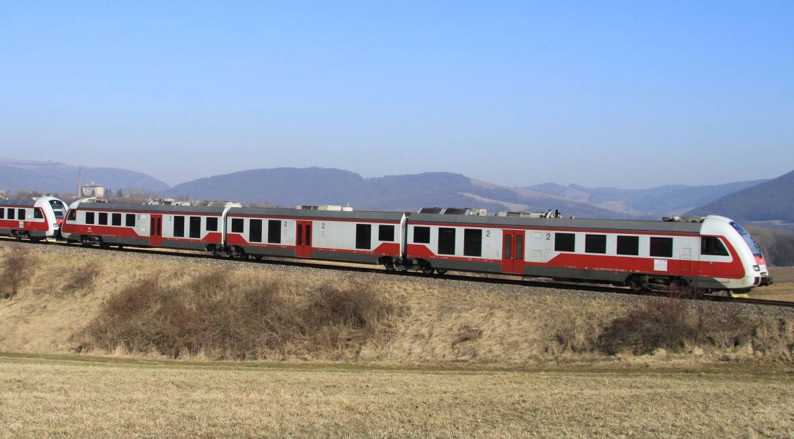

(photo: Pavel Chomjak, Prešov)

Annex A 1 ŽSR network

Annex A 2 List of railway undertakings
In 2015, the following railway undertakings provided transport services within the railway infrastructure of ŽSR:
Sequential number | Number | Name | Registered business no. | Contract number | Traffic type | Internal abbreviation | Street | City
 | 9001 | U. S. Steel Košice, s.r.o. | 36 199 222 | 1/2011 | Freight | USSK | Vstupný areál U.S.Steel | 044 54 Košice
 | 9002 | LOKO TRANS, s.r.o. | 60 731 796 | 2/2011 | Freight | LTB | Voříškova 2 | 623 00 Brno, Czech Republic
 | 9005 | Železničné stavby, a. s., Košice | 31 714 421 | 5/2011 | Freight | ZSKE | Južná trieda 66 | 040 01 Košice
 | 9006 | TSS GRÁDE, a.s. | 35 802 723 | 6/2011 | Freight | TSSTT | Dunajská 48 | 811 08 Bratislava
 | 9007 | LTE Logistik a Transport Slovakia, s.r.o. | 35 845 961 | 7/2012 | Freight/Passenger | LTESK | Kopčianska 1 | 851 01 Bratislava
 | 9009 | Prvá Slovenská železničná, a.s. | 35 858 664 | 9/2011 | Freight | PSZ | Ružová dolina 10 | 821 09 Bratislava
 | 9011 | HORNONITRIANSKE BANE zamestnanecká, a.s. | 36 002 887 | 11/2011 | Freight | HBZ | ul. Matice Slovenskej 10 | 971 01 Prievidza
 | 9012 | ELTRA, s.r.o. | 31 674 267 | 12/2011 | Freight | ELTRA | Rampová 4 | 040 01 Košice
 | 9014 | Železničné stavebníctvo Bratislava, a.s. | 31 365 701 | 14/2011 | Freight | ZSBA | Furmanská 8 | 841 03 Bratislava
 | 9015 | AWT Rail SK, a.s. | 35 864 974 | 15/2011 | Freight | AWTSK | Cukrová 14 | 811 08 Bratislava I
 | 9016 | Slovenská železničná dopravná spoločnosť, a.s. | 35 856 742 | 16/2011 | Freight | SZDS | Mostová 2 | 811 02 Bratislava
 | 9017 | Elektrizácia železníc Kysak, a.s. | 31 693 733 | 17/2011 | Freight | EZK | Rosinská cesta 1/8223 | 010 08 Žilina
 | 9019 | INVESTEX GROUP, s.r.o. | 36 034 665 | 19/2011 | Freight | INGR | Mostová 2 | 811 02 Bratislava
 | 9020 | Železničná spoločnosť Slovensko, a.s. | 35 914 939 | 20/2011 | Passenger | ZSSK | Rožňavská 1 | 832 72 Bratislava
 | 9021 | Železničná spoločnosť Cargo Slovakia, a. s. | 35 914 921 | 21/2011 | Freight/Passenger | ZSSKC | Drieňová 24 | 820 09 Bratislava
 | 9022 | LOKORAIL, a.s. | 36 564 443 | 22/2011 | Freight | LRL | Horárska 12 | 821 09 Bratislava
 | 9023 | GJW Praha, spol. s r. o. | 41 192 869 | 23/2011 | Freight | GJW | Mezitraťová 137/46 | 198 21 Praha 9, Czech Republic
 | 9024 | Advanced World Transport, a.s. | 47 675 977 | 24/2011 | Freight | AWT | Homopolní 3314/38 | 702 62 Ostrava - Moravská  Ostrava, Czech Republic
 | 9025 | OHL ŽS, a.s. | 46 342 796 | 25/2011 | Freight | OHL | Burešova 938/17 | 602 00 Brno, Veveří, Czech Republic
 | 9026 | METRANS Rail s.r.o. | 26 361 485 | 26/2011 | Freight | MTR | Podleská 926 | 104 00 Praha 10, Czech Republic
 | 9027 | Traťová strojní společnost, a.s. | 27 467 295 | 27/2012 | Freight | TSS | Na Valše 676/18 | 702 00 Ostrava-Přívoz, Czech Republic
 | 9028 | Ostravská dopravní společnost, a.s. | 60 793 171 | 28/2011 | Freight | ODO S | U Tiskárny 616/9 | 702 00 Ostrava-Přívoz, Czech Republic
 | 9031 | BF Logistics, s.r.o. | 27 406 911 | 31/2011 | Freight | BFL | Beranových 65 | 199 02 Praha 9, Czech Republic
 | 9034 | Slezskomoravská dráha, a.s. | 47 676 965 | 34/2011 | Freight | SMD | Poděbradova 3360/113 | 702 00 Ostrava - Moravská  Ostrava, Czech Republic
 | 9035 | Rail Cargo Carrier - Slovakia, s.r.o. | 44 453 949 | 35/2011 | Freight | WSSK | Čajakova 18 | 811 05 Bratislava 1
 | 9036 | SLOV - VAGÓN, a.s. | 36 673 196 | 36/2011 | Freight | SLVA | Andreja Žarnova 1 | 917 02 Trnava
 | 9038 | Central Railways, a.s. | 44 907 893 | 38/2011 | Freight/Passenger | CRW | Krivá 21 | 040 01 Košice
 | 9040 | PKP CARGO S. A. | 277 586 360 | 40/2011 | Freight | PKPC | Grójecka 17 | 020 21 Warszawa, Poland
 | 9041 | IDS CARGO, a.s. | 27 820 017 | 41/2011 | Freight | IDSC | Albertova 229/21 | 779 00 Olomouc - Nová Ulice, Czech Republic
 | 9042 | METRANS /Danubia/, a.s. | 36 380 032 | 42/2011 | Freight | MTD | Povodská cesta 18 | 929 01 Dunajská Streda
 | 9043 | CER Slovakia, a.s. | 44 616 791 | 43/2011 | Freight | CERS | Mýtna 15 | 811 07 Bratislava
 | 9044 | RegioJet, a.s. | 47 231 271 | 44/2011 | Passenger | RJSK | Obchodná 48 | 811 06 Bratislava
 | 9045 | Petrolsped Slovakia, s.r.o. | 46 247 211 | 45/2011 | Freight | PSP | L. Svobodu 2839/1 | 984 01 Lučenec
 | 9046 | MMV Magyar Magánvasút Zrt. | 01-10-045027 | 46/2011 | Freight | MMV | Kerék u. 80 | 1035 Budapest, Hungary
 | 9047 | BULK TRANSSHIPMENT SLOVAKIA, A.S. | 36 774 278 | 47/2011 | Freight | BTS | Železničná 1 | 076 43 Čierna nad Tisou
 | 9049 | Railtrans International, a.s. | 46 384 740 | 49/2012 | Freight | RTI | Trnavská cesta | 920 41 Leopoldov
 | 9050 | RTS Rail Transport Service, GmbH | FN252571d | 50/2012 | Freight | RTS | Puchstrape 184 b | 8055 Graz, Austria
 | 9052 | Generálne zastúpenie CD Cargo, s.r.o. | 44 349 793 | 52/2012 | Freight | GZCDC | Tomášikova 10/H | 821 03 Bratislava
 | 9053 | VIALTE, s.r.o. | 46 334 629 | 53/2013 | Passenger | VIALT | Kopčianska 1 | 851 01 Bratislava
 | 9054 | LOKOTRANS SERVIS, s.r.o. | 26 931 443 | 54/2014 | Freight | LTSB | Drážní 11 | 627 00 Brno - Slatina, Czech Republic
 | 9055 | OPTISPED, a.s. | 46 933 913 | - | Freight | OPTIS | Rusovská cesta 1 | 851 01 Bratislava
 |  | EURO VIA CS, a.s. | 45 274 924 | 54/2014 | Freight | ECS | Národní 138/10 | 110 00 Praha 1, Czech Republic
 | 9057 | Elektrizace železnic Praha, a.s. | 47 115 921 | 57/2014 | Freight | ELZEL | Nám. Hrdinů 1693/4a | 140 00 Praha 4 - Nusle, Czech Republic
 | 9058 | Express Group, a.s. | 35 795 123 | 58/2014 | Freight | EXSK | Plynárenská 7/B | 821 09 Bratislava
 | 9059 | LEO Express, a.s. | 29 016 002 | 59/2014 | Passenger | LE | Řehořova 908/4 | 130 00 Praha 3 - Žižkov, Czech Republic
 | 9060 | LokoTrain, s.r.o. | 28 903 811 | 60/2014 | Freight | LT | Školní 353 | 560 02 Česká Třebová, Czech Republic
 | 9061 | ARRIVA Service, s.r.o. | 35 846 526 | 61/204 | Passenger | ARVSK | Bratislavská cesta 1804 | 945 01 Komárno
 | 9062 | YOSARIA TRAINS, a.s. | 35 947 233 | 62/2041 | Passenger | YOSAR | Tomášikova 10/D | 821 03 Bratislava
 | 9063 | STRAVBAG Rail, a.s. | 25 429 949 | 63/2015 | Freight |  | Železničářská 1385/29 | 400 03 Ústi nad Labem – Střekov, Czech Republic
 | 9065 | INTERPORT spedition, s.r.o. | 01 484 494 | 65/2015 | Freight | IP | Nuselská 262/34 | 140 00 Praha 4 – Nulse, Czech Republic
 |  | ŽOS Vrútky, a.s. | 31 615 619 | - | Freight | ZOSVR | Dielenska Kružná 2 | 038 61 Vrútky
 |  | E-W Express, s.r.o. | 48 041 246 | - | Freight | EWEX | Kapitulská 21 | 974 01 Banská Bystrica
 |  | RegioJet, a.s. | 28 333 187 | - | Passenger | RJ | Náměstí Svobody 86/14 | 602 00 Brno, Czech Republic
 |  | Železnice Slovenskej republiky | 31 364 501 | - | Freight/Passenger | ŽSR | Klemensova | 813 61 Bratislava

Annex A 2.1 Infrastructure manager
Name | Address | Website/ Network statement link | Safety authorisation (number/date) | Start date of commercial activity | Total track length/gauge | Electrified track length/voltage | Total double/simple track length | Total high-speed track length (HSL) | ATP equipment used | Total number of level crossings | Number of signals
Železnice Slovenskej republiky (ŽSR) | Klemensova 8,  813 61 Bratislava | http://www.zsr.sk/slovensky/zeleznicna-dopravna-cesta/marketing/podmienky-pouzivania-zel.siete/podmienky-pouzivania-zel.siete-2015.html?page_id=2855 | SK 2120150001 of 13.04.2015 | 1.1.2002 | 3,482 km (1,435 mm)  99 km (1,520 mm)  46 km (1,000 mm/760 mm) | Total: 1,587 km  762 km: 25 kV/50 Hz  825 km: 3 kV, 1.5 kV, 600V | single track length – 2,610 km  double track length – 1,017 km | 0 | - automatic block signalling system  - semi-automatic block signalling system  - automatic block, electromechanical | 2 112 | 9 368

Annex A 2.2 Railway undertakings – safety certificates issued

.

.

Sequential number | Name | Address | Website | Safety Certificate A-B issued under Directive 2004/49/EC (number/date) | Start date of commercial activity | Traffic type (freight, passenger) | Number of locomotives | Number of railcars/multiple unit-sets | Number of coaches/freight wagons | Number of train drivers | Volume of passenger transport | Volume of freight transport
 | U.S. Steel Košice, s.r.o. | Vstupný areál U.S.Steel  044 54 Košice | 0 | SK 1120110002 part A of 4.2.2011  SK 1220110004 part B of 4.2.2011 | 1.2.2000 | freight | 3 | 0/0 | 0/38 | 9 | 0 | 508 278
 | LOKO TRANS, s.r.o. | Voŕíškova 2,  623 00 Bmo, Czech Republic | www.lokotrans.cz | CZ 1120120014 part A of 28.8.2012  SK 1220130003 part B of 18.3.2013 | 1.1.2009 | freight | 6 | 0/0 | 0/750 | 2 | 0 | 1 300
 | Železničné stavby, a.s. Košice | Južná trieda 66,  040 01 Košice | www.zeleznicnestavby.sk | SK 11201500014 part A of 12.5.2010  SK 1220150006 part B of 12.5.2010 | 1.5.2003 | freight | 5 | 0/0 | 41/126 | 3 | 0 | 0
 | TSS GRÁDE, a.s. | Dunajská 48,  811 08 Bratislava | www.tss.sk | SK 1120140005 part A of 18.8.2014  SK 1220140011 part B of 18.8.2014 | 23.4.2003 | freight | 6 | 0/0 | 0/141 | 5 | 0 | 406 177
 | LTE Logistik a Transport Slovakia, s.r.o. | Kopčianska 1,  851 01 Bratislava | www.lte.sk | SK 1120120001 part A of 13.6.2012  SK 1220120001 part B of 13.6.2012 | 1.1.2003 | freight, passenger | 4 | 0/0 | 0/24 | 10 | 0 | 662 239
 | Prvá Slovenská železničná, a.s. | Ružová dolina 10, 821 09 Bratislava | www.psz.sk | SK 1120130004 part A of 16.12.2013  SK 1220130013 part B of 16.12.2013 | 25.4.2008 | freight | 6 | 0/0 | 0/340 | 28 | 0 | 1 573 851
 | HORNONITRIANSKE BANE zamestnanecká, a.s. | Matice Slovenskej 10,  971 01 Prievidza | www.hbzam.sk | SK 1120130003 part A of 4.12.2013  SK 1220130011 part B of 4.12.2013 | 31.1.2005 | freight | 8 | 0/0 | 0/111 | 14 | 0 | 1 893 630
 | ELTRA, s.r.o. | Rampová 4,  040 01 Košice | http://www.eltra.biz/ | SK 1120150005 part A of 12.5.2015  SK 1220150007 part B of 12.5.2015 | 0 | freight | 2 | 5/0 | 0/27 | 6 | 0 | 0
 | Železničné stavebníctvo Bratislava, a.s. | Furmanská 8,  841 03 Bratislava | www.zs-ba-as.sk | SK 1120150007 part A of 30.8.2010  SK 1220150009 part B of 30.8.2010 | 18.1.1994 | freight | 1 | 0/0 | 0/5 | 2 | 0 | 0
 | AWT Rail SK, a.s. | Cukrová 14,  811 08 Bratislava I | www.awt.eu | SK 1120150008 part A of 12.10.2015  SK 1220150012 part B of 12.10.2015 | 26.7.2004 | freight | 0 | 0/0 | 0/0 | 0 | 0 | 306 963
 | Slovenská železničná dopravná spoločnosť, a. s | Mostová 2,  811 02 Bratislava | www.szds.sk | SK 1120130002 part A of 24.6.2013  SK 1220130004 part B of 24.6.2013 | 9.4.2004 | freight | 0 | 0/0 | 0/0 | 7 | 0 | 199 912
 | Elektrizácia Železníc Kysak, a.s. | Rosinská cesta 1/8223, 010 08 Žilina, | www.ezkvsak.sk | SK 1120130001 part A of 24.1.2013  SK 1220130001 part B of 24.1.2013 | 20.1.1998 | freight | 0 | 0/0 | 0/0 | 0 | 0 | 0
 | INVESTEX GROUP, s.r.o. | Mostová 2,  811 02 Bratislava | www.investex-group.sk | SK 1120110006 part A of 17.5.2011  SK 1220110011 part B of 17.5.2011 | 10.1.2006 | freight | 2 | 0/0 | 0/0 | 0 | 0 | 0
 | Železničná spoločnosť Slovensko, a.s. | Rožňavská 1,  832 72 Bratislava | www.slovakrail.sk | SK 1120150001 part A of 9.1.2015  SK 1220150001 part B of 9.1.2015 | 1.1.2005 | passenger | 180 | 231 | 965/0 | 1239 | 3 081 246 834 | 0
 | Železničná spoločnosť Cargo Slovakia, a.s. | Drieňová 24,  820 09 Bratislava | www.zscargo.sk | SK 1120150003 part A of 24.4.2015  SK 1220150005 part B of 24.4.2015 | 1.1.2005 | freight, passenger | 607 | 1/0 | 0/2211 | 937 | 105 120 | 34 728 645
 | LOKORAIL, a.s. | Horárska 12,  821 09 Bratislava | www.lokorail.eu | SK 1120130006 part A of 30.12.2013  SK 1220130015 part B of 30.12.2013 | 5.10.2004 | freight | 21 | 0/0 | 0/642 | 20 | 0 | 1 006 012
 | GJW Praha, spol. s r.o. | Medzitraťová 137,  198 21 Praha 9 – Hloubětín, Czech Republic | www.gjw-praha.cz | CZ 1120130005 part A of 6.3.2013  SK 1220130005 part B of 26.4.2013 | 1.3.2006 | freight | 4 HDV  14 SHV | 0/0 | 0/17 | 17 | 0 | 300
 | Advanced World Transport, a. s. | Poděbradova 3360/113, 702 00 Ostrava – Moravská Ostrava, Czech Republic | www.awt.eu | CZ 1120120024 part A of 22.3.2013  SK 1220140015 part B of 2.12.2014 | 19.12.2006 | freight | 108 | 0/0 | 0/239 | 38 | 0 | 335 878
 | OHL ŽS, a.s. | Burešova 938/17,  602 00 Brno - Veveří, Czech Republic | www.ohlzs.cz | CZ 1120130012 part A of 29.3..2013  SK 1220130006 part B of 20.9.2013 | 1.3.2006 | freight | 0 | 0/0 | 0/28 | 6 | 0 | 0
 | METRANS Rail, s.r.o. | Podleská 926,  104 00 Praha 10, Czech Republic | www.metransrail.eu | CZ 1120130043 part A of 30.9.2013  SK 1220140009 part B of 29.7.2014 | 22.10.2003 | freight. | 25 | 0/0 | 0/2 | 5 | 0 | 10 000
 | Traťová strojní společnost, a.s. | Na Valše 676/18,  702 00 Ostrava - Přívoz, Czech Republic | www.tssas.cz | CZ 1120130002 part A of 21.2.2013  SK 1220130012 part B of 5.12.2013 | 1.1.2006 | freight | 14 RTUs  40 STUs | 0/0 | 0/0 | 7 (RTUs)  28 (STUs) | 0 | 121 762
 | Ostravská dopravní společnost, a.s. | U Tiskárny 616/9,  702 00 Ostrava-Přívoz, Czech Republic | www.odos.cz | CZ 1120130015 part A of 18.4.2013  SK 1220130008 part B of 30.10.2013 | 0 | freight | 23 | 0/0 | 0/0 | 4 | 0 | 0
 | BF Logistics, s.r.o. | Beranových 65,  199 02 Praha 9, Czech Republic | www.bfl.cz | CZ 1120130041 part A of 18.9.2013  SK 1220130009 part B of 25.11.2013 | 1.9.2009 | freight | 12 | 0/0 | 0/0 | 2 | 0 | 0
 | Slezskomoravská dráha, a.s. | Poděbradová 3360/113,  702 00 Ostrava – Moravská Ostrava, Czech Republic | www.slezskomorav-skadraha.cz | CZ 1120130026 part A of 6.6.2013  SK 1220140008 part B of 8.7.2014 | 14.8.2009 | freight | 5 | 0/0 | 0/0 | 2 | 0 | 1 060
 | Rail Cargo Carrier - Slovakia, s.r.o. | Čajakova 18,  811 05 Bratislava | www.railcargocarrier.com | SK 1120140007 part A of 1.12.2014  SK 12200140014 part B of 1.12.2014 | 1.1.2012 | freight | 0 | 0/0 | 0/0 | 0 | 0 | 560124
 | SLOV - VAGÓN, a.s. | Andreja Žarnova 1,  917 02 Trnava | www.slovvagon.com | SK 1220100005 part A of 28.6.2010  SK 122010007 part B of 28.6.2010 | 1.4.2012 | freight | 4 | 0/0 | 0/399 | 0 | 0 | 0
 | Central Railways, a.s. | Krivá 21,  040 01Košice | www.crw.sk | SK 1120110003 part A of 30.3.2011 SK 1220110007 part B of 30.3.2011 | 8.9.2009 | passenger, freight | 20 | 0/0 | 0/50 | 12 | 0 | 1 212 253
 | PKP CARGO S.A. | Ul. Grójecka 17,  02 021 Warszawa, Poland | www.pkp-cargo.p/ | PL 1120140006 part A of 18.4.2014  SK 1220140005 part B of 22.5.2014 | 1.1.2011 | freight | 33 | 0/0 | 0/19867 | 10 | 0 | 697 228
 | IDS CARGO, a.s. | Albertova 229 / 21,  779 00 Olomouc - Nová Ulice, Czech Republic | www.ids-cargo.cz | CZ 1120130046 part A of 4.11.2013  SK 1220130010 part B of 26.11.2013 | 1.6.2011 | freight | 20 | 0/0 | 0/12 | 14 | 0 | 315 445
 | METRANS /Danubia/, a.s. | Povodská cesta 18,  929 01 Dunajská Streda | www.metrans.cz | SK 1120110005 part A of 23.5.2011 SK 1220110010 part B of 23.5.2011 | 1.7.2011 | freight | 8 | 0/0 | 0/0 | 26 | 0 | 3 194 874
 | CER Slovakia, a.s. | Mýtna 15,  811 07 Bratislava | www.cercargo.sk/index.php | SK 1120150009 part A of 16.12.2015  SK 1220150013 part B of 16.12.2015 | 1.4.2011 | freight | 2 | 0/0 | 0/0 | 2 | 0 | 315 485
 | RegioJet, a.s. | Obchodná č. 48,  811 06 Bratislava | www.regiojet.sk | SK 1120110007 part A of 22.8.2011  SK 1220110013 part B of 22.8.2011 | 4.3.2012 | passenger | 6 | 0/12 | 128/0 | 49 | 329 969 557 | 0
 | Petrolsped Slovakia, s.r.o. | L. Svobodu 2838/1,  984 01 Lučenec | www.petrolsped.sk | SK 1120110008 part A of 23.9.2011  SK 1220110015 part B of 23.9.2011 | 8.2.2012 | freight | 12 | 0/0 | 0/0 | 10 | 0 | 503 154
 | MMV Magyar Magánvasút Zrt. | Keréku. 80,  1035 Budapest, Hungary | www.mmv.hu | HU 1120120004 part A of 1.10.2012  SK 1220130002 part A of 15.2.2013 | 2.3.2012 | freight | 2 | 0/0 | 0/0 | 2 | 0 | 0
 | BULK TRANSSHIPMENT SLOVAKIA, A.S. | Železničná 1,  076 43 Čierna nad Tisou | www.btslovakia.sk | SK 1120120006 part A of 19.10.2012  SK 1220120007 part B of 19.10.2012 | 25.5.2009 | freight | 25 | 0/0 | 0/0 | 0 | 0 | 0
 | Railtrans International, a.s. | Trnavská cesta,  920 41 Leopoldov | www.railtrans.eu | SK 1120120002 part A of 19.6.2012  SK 1220120003 part B of 19.6.2012 | 2.6.2012 | freight | 2 | 0/0 | 0/0 | 12 | 0 | 287 432
 | RTS Rail Transport Service, GmbH | Puchstrape 184b,  8055 Graz, Austria | www.rts-rail.com | AT 1120140004 part A of 18.11.2014  SK 1220140016 part B of 16.12.2014 | 10.4.2013 | freight | 2 | 0/0 | 0/10 | 2 | 0 | 0
 | Generálne zastúpenie CD Cargo, s.r.o | Tomášikova 10/H,  821 03 Bratislava | www.cdcargo.sk | SK 1120120004 part A of 25.9.2012  SK 1220120005 part B of 25.9.2012 | 1.1.2013 | freight | 0 | 0/0 | 0/0 | 0 | 0 | 0
 | VIALTE, s.r.o. | Kopčianska 1,  851 01 Bratislava | - | SK 1120120005 part A of 15.10.2012  SK 1220120006 part B of 15.10.2012 | 14.5.2012 | passenger | 0 | 0/0 | 0/0 | 0 | 1300 | 0
 | LOKOTRANS SERVIS, s.r.o | Drážní 11,  627 00 Brno - Slatina, Czech Republic | www.lokotransservis.cz | CZ 1120140002 part A of 20.1.2014  SK 1220130007 part B of 29.5.2014 | 14.5.2013 | freight | 28 | 0/0 | 0/12 | 2 | 0 | 9 032
 | OPTISPED, a.s. | Rusovská cesta 1,  851 01 Bratislava | - | SK 1120140001 part A of 2.4.2014  SK 1220140001 part B of 2.4.2014 | 1.9.2013 | freight | 0 | 0/0 | 0/0 | 0 | 0 | 0
 | EURO VIA CS, a.s. | Národní 138/10,  110 00 Praha 1, Czech Republic | www.eurovia.cz | CZ 1120130003 part A of 22.1.2013  SK 1220140007 part B of 10.7.2014 | 27.5.2003 | freight | 3 | 0/0 | 0/0 | 3 | 0 | 0
 | Elektrizace železnic Praha, a.s. | Nám. Hrdinu 1693/4a, 140 00 Praha 4-Nusle, Czech Republic | www.elzel.cz | CZ 1120130006 part A of 6.3.2013  SK 1220140004 part B of 16.4.2014 | 16.4.2014 | freight | 22 | 0/0 | 0/208 | 18 | 0 | 21 851
 | Express Group, a.s. | Plynárenská 7/B,  821 09 Bratislava | www.expressgroup.sk | SK 1120140004 part A of 18.6.2014  SK 1220140006 part B of 18.6.2014 | 1.7.2014 | freight | 8 | 0/0 | 0/378 | 14 | 0 | 575 517
 | LEO Express, a.s. | Řehořova 908/4,  130 00 Praha 3-Žižkov, Czech Republic | www.le.sk | CZ 1120150004 part A of 26.3.2015  SK 1220150003 part B of 1.4.2015 | 12.12.2014 | passenger | 0 | 0/5 | 0/0 | 9 | 190 000 | 0
 | LokoTrain, s.r.o. | Školní 353,  560 02 Česká Třebová, Czech Republic | www.lokotrain.eu | CZ 1120120003 part A of 5.3.2012  SK 1220140010 part B of 14.8.2014 | 14.8.2014 | freight | 4 | 0/0 | 0/0 | 53 | 0 | 0
 | ARRIVA Service, s.r.o. | Bratislavská cesta 1804, 945 01 Komárno | www.arrivaservice.sk | SK 1120140003 part A of 8.4.2014  SK 1220140003 part B of 8.4.2014 | 20.1.2015 | passenger | 0 | 0/0 | 0/0 | 0 | 2 504 | 0
 | YOSARIA TRAINS, a.s. | Tomášikova 10/D,  821 03 Bratislava | www.yosaria-trains.trade.sk | SK 1120140006 part A of 7.10.2014  SK 1220140013 part B of 7.10.2014 | 11.11.2014 | passenger | 2 | 0/0 | 0/0 | 1 | 50 400 | 0
 | STRABAG Rail, a.s. | Železničařská 1385/29, 400 03 Ústi nad Labem – Střekov, Czech Republic | www.strabagrail.cz | CZ 1120150001 part A of 5.1.2015  SK 1220150002 part B of 23.3.2015 | - | freight | 17 | 0/0 | 0/70 | 35 | 0 | 0
 | INTERPORT spedition, s.r.o. | Nuselská 262/34,  140 00 Praha 4 – Nulse, Czech Republic | www.interport.cz | CZ 1120140030 part A of 5.12.2014  SK 1220150010 part B of 28.8.2015 | 1.1.2016 | freight | 4 | 0/0 | 0 | 0 | 0 | 0
 | ŽOS Vrútky, a.s. | Dielenská Kružná 2,  038 61 Vrútky | www.zosvrutky.sk | SK 1120150002 part A of 30.6.2015  SK 1220150004 part B of 20.4.2015 | - | freight | 2 | 0/0 | 0/0 | 3 | 0 | 0
 | E-W Express, s.r.o. | Kapitulská 21,  974 01 Banská Bystrica | www.ewex.sk | CZ 1120150006 part A of 7.10.2014  SK 1220150008 part B of 30.6.2014 | 30.6.2015 | freight | 0 | 0/0 | 0/0 | 0 | 0 | 0
 | Regio Jet | Náměstí Svobody 86/17,  602 00 Brno, Czech Republic | www.regiojet.cz | CZ 1120140022 part A of 8.10.2014  SK 1220150011 part B of 21.10.2015 | 11.12.2011 | passenger | 15 | 0/0 | 124/0 | 26 | 0 | 0
 | Železnice Slovenskej republiky, Bratislava | Klemensova 8,  813 61 Bratislava | www.zsr.sk | SK 1120130005 part A of 20.12.2013  SK 1220130014 part B of 20.12.2013 | 1.1.2002 | freight, passenger | 45 | 11/0 | 50/511 | 494 | 2 864 000 | 1 557 157

.

S

I

.

Annex B Organisational structure of the Authority

Annex B 1 Internal organisation (as at 31.12.2015)

B 1.1 Organisational chart of the Authority to the level of divisions
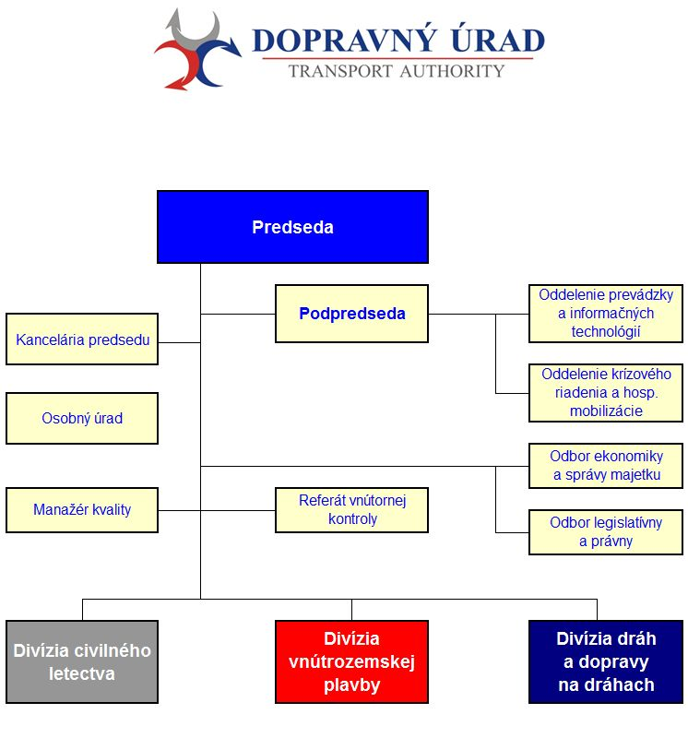
 | Chairperson
Chairperson’s Office | Vice-Chairperson | Operation and Information Technology Department
Human Resources | Internal Control Unit | Crisis Management and Economic Mobilisation Department
Quality Manager |  | Economy and Property Administration Department
 |  | Legislation and Legal Department
Civil Aviation Division | Inland Waterway Transport Division | Railways and Railway Traffic Division

B 1.2 Organisational chart of the Railways and Railway Traffic Division

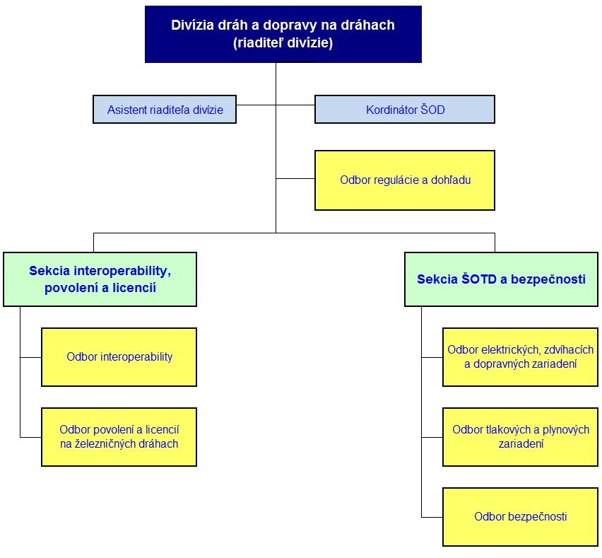

 | Railways and Railway Traffic Division
Assistant to the Head of the Division |  | SPS Coordinator
 |  | Regulation and Supervision Department
Interoperability, Authorisation and Licensing Section |  | SPTS and Safety Section
Interoperability Department |  | Electrical, Lifting and Transport Equipment Department
Railway Authorisation and Licensing Department |  | Pressure and Gas Equipment Department
 |  | Safety Department

Annex B 2 Relationships with other national bodies
NSA
Transport Authority
Safety, licensing and regulatory authority for railways and railway traffic
Ministry of Transport, Construction and Regional Development  The investigative authority for accidents and incidents on railways, special transport systems and cableways  The approval authority for the type approval of rolling stock for special transport systems |  |  | Slovak Office of Standards, Metrology and Testing (OSMT SR)
University of Žilina in Žilina  (certification of ECM) |  |  | Transport Research Institute – Notified Body

Key:

Authority – as a budget-funded organisation, it is linked to the state budget in terms of financial relations through the budget chapter administered by the Ministry. The Authority is headed by a Chairperson appointed and removed by the Government of the Slovak Republic at the proposal of the Minister of Transport, Construction and Regional Development of the SR.
OSMT SR – acts on matters of supervision relating to designated technical equipment and the relevant authorised and notified bodies active in the field of conformity assessment and certification.
Transport Research Institute, the Notified Body – based on OSMT SR Authorisation Decision No 2013/800/003896/01289 of 23.7.2013, with a view to Railways Act No 513/2009 Coll., it is the notified body for the assessment of conformity and suitability for use for interoperability subsystems of the European railway system.
University of Žilina – based on Decision of the Ministry No 12309/2012 - SŽDD/z.22119, it is the authorised legal entity for issuing certificates to persons in charge of maintenance of rail freight wagons under Commission Regulation (EU) No 445/2011 on a system of certification of entities in charge of maintenance for freight wagons.

Annex C Common Safety Indicators data
- Tables
* data processed in accordance with the amendment to Act 513/2009 Coll. on railways

Number of serious accidents and train*km (type of accident)
Year | Collisions | Derailments | Level crossing accidents | Accidents to persons caused by RS in motion | Fires in RS | Others | Total | train*km (MLN)
2006 | 7 | 8 | 68 | 53 | 8 | 55 | 199 | 51
2007 | 14 | 11 | 71 | 63 | 22 | 41 | 222 | 51
2008 | 12 | 6 | 63 | 78 | 8 | 50 | 217 | 49
2009 | 6 | 3 | 51 | 130 | 14 | 295 | 499 | 44
2010* | 2 | 1 | 11 | 70 | 0 | 1 | 85 | 47
2011* | 1 | 1 | 21 | 61 | 0 | 0 | 84 | 45
2012* | 1 | 2 | 27 | 65 | 0 | 1 | 96 | 46
2013* | 2 | 0 | 18 | 73 | 0 | 1 | 94 | 46
2014* | 0 | 1 | 20 | 92 | 0 | 0 | 113 | 46
2015 | 0 | 2 | 22 | 60 | 1 | 2 | 87 | 49

Number of fatalities, train*km and passenger*km (category of persons)
Year | Passengers | Employees | Level crossing users | Unauthorised persons | Others | Total | passenger*km (BLN) | train*km (MLN)
2006 | 4 | 0 | 16 | 81 | 0 | 101 | 2 | 51
2007 | 1 | 0 | 15 | 40 | 1 | 57 | 2 | 51
2008 | 2 | 0 | 11 | 41 | 2 | 56 | 2 | 49
2009 | 2 | 0 | 25 | 44 | 1 | 72 | 2 | 44
2010 | 0 | 2 | 9 | 44 | 3 | 58 | 2 | 47
2011 | 1 | 0 | 11 | 37 | 0 | 49 | 2 | 45
2012 | 1 | 1 | 21 | 45 | 0 | 68 | 2 | 46
2013 | 0 | 2 | 6 | 47 | 0 | 55 | 3 | 46
2014 | 0 | 0 | 9 | 67 | 0 | 76 | 3 | 46
2015 | 0 | 0 | 13 | 36 | 0 | 51 | 3 | 49

Number of injuries, train*km and passenger*km (category of persons)
Year | Passengers | Employees | Level crossing users | Unauthorised persons | Others | Total | passenger*km  (BLN) | train*km (MLN)
2006 | 6 | 3 | 12 | 13 | 0 | 34 | 2 | 51
2007 | 4 | 2 | 13 | 17 | 0 | 36 | 2 | 51
2008 | 5 | 1 | 15 | 15 | 2 | 38 | 2 | 49
2009 | 0 | 0 | 14 | 20 | 1 | 35 | 2 | 44
2010 | 17 | 3 | 2 | 17 | 6 | 45 | 2 | 47
2011 | 4 | 1 | 14 | 20 | 0 | 39 | 2 | 45
2012 | 12 | 2 | 15 | 12 | 0 | 41 | 2 | 46
2013 | 4 | 6 | 11 | 12 | 4 | 37 | 3 | 46
2014 | 12 | 2 | 12 | 19 | 1 | 46 | 3 | 46
2015 | 4 | 1 | 12 | 17 | 2 | 36 | 3 | 49

Number of causes/precursors to accidents and train*km (type of accident)
Year | Number of broken rails | Number of track buckles | Number of wrong-side signalling failures | Number of signals passed at danger | Number of broken wheels on rolling stock in service | Number of broken axles on rolling stock in service | Total | train*km (MLN)
2006 | 1 | 1 | 4 | 78 | 0 | 0 | 84 | 51
2007 | 5 | 2 | 6 | 79 | 1 | 0 | 93 | 51
2008 | 10 | 0 | 2 | 75 | 0 | 0 | 87 | 49
2009 | 15 | 1 | 1 | 75 | 0 | 0 | 92 | 44
2010 | 165 | 9 | 57 | 22 | 0 | 0 | 253 | 47
2011 | 133 | 8 | 28 | 25 | 0 | 0 | 194 | 45
2012 | 145 | 5 | 15 | 39 | 1 | 0 | 205 | 46
2013 | 74 | 9 | 9 | 33 | 0 | 0 | 125 | 46
2014 | 66 | 1 | 8 | 18 | 0 | 0 | 93 | 46
2015 | 98 | 5 | 5 | 23 | 0 | 0 | 131 | 49

Cost of all accidents, ‘safety hours’ (type of accident)
Year | Costs of deaths in EUR (million) | Costs of injuries in EUR (million) | Costs of replacement or repair of damaged rolling stock and railway installations in EUR (million) | Costs of delays, disturbances and re-routing of traffic, including extra costs for staff and loss of future revenue in EUR (million) | Total costs in EUR (million) | Total number of working hours of staff and contractors lost as a consequence of accidents | Total number of working hours | train*km (million)
2006 | 750 000 | 387 000 | 20 000 | 3 000 | 1 160 000 | 0 | 0 | 51
2007 | 0 | 0 | 1 890 000 | 100 000 | 1 990 000 | 0 | 0 | 51
2008 | 0 | 0 | 2 639 224 | 167 151 | 2 806 375 | 0 | 0 | 49
2009 | 0 | 0 | 2 124 167 | 0 | 2 124 167 | 0 | 0 | 44
2010 | 0 | 0 | 2 503 946 | 0 | 2 503 946 | 0 | 0 | 47
2011 | 0 | 0 | 1 884 516 | 0 | 0 | 0 | 0 | 45
2012 | 0 | 0 | 2 177 142 | 0 | 0 | 0 | 0 | 46
2013 | 0 | 0 | 2 498 757 | 0 | 0 | 0 | 0 | 46
2014 | 0 | 0 | 370 940 | 0 | 0 | 0 | 0 | 46
2015 | 0 | 0 | 4 787 565 | 0 | 0 | 0 | 0 | 49

Technical safety of infrastructure and its implementation, management of safety (type of accident)
Year | Percentage of tracks with Automatic Train Protection (ATP) in operation | Percentage of train*km using operational ATP systems | Total number of level crossings | Number of track km (double track lines are to be counted twice) | Total number of level crossings per track km | Percentage of level crossings with automatic or manual protection | Number of audits accomplished out of the number of audits required (and/or planned)
2006 | 15.14 % | 41.83 % | 2,322 | 4,678 | 0.496 | 46.98 % | 0.00 %
2007 | 15.14 % | 0.00 % | 2,307 | 3,629 | 0.636 | 47.03 % | 0.00 %
2008 | 18.49 % | 0.00 % | 2,265 | 3,659 | 0.625 | 48.65 % | 100.00 %
2009 | 18.49 % | 0.00 % | 2,220 | 4,638 | 0.478 | 48.46 % | 100.00 %
2010 | 21.04 % | 0.00 % | 2,219 | 4,638 | 0.478 | 48.72 % | 100.00 %
2011 | 21.03 % | 0.00 % | 2,205 | 4,641 | 0.475 | 48.93 % | 100.00 %
2012 | 21.03 % | 0.00 % | 2 160 | 4 648 | 0.464 | 50.37 % | 100.00 %
2013 | 23.44 % | 0.00 % | 2 149 | 4 648 | 0.462 | 50.63 % | 100.00 %
2014 | 20.62 % | 0.00 % | 2 131 | 4 644 | 0.459 | 50.63 % | 100.00 %
2015 | 21.01 % | 0.00 % | 2 112 | 4 644 | 0.455 | 50.71 % | 100.00 %

Number of serious accidents/train*km (type of accident)
Year | Collisions | Derailments | Level crossing accidents | Accidents to persons caused by RS in motion | Fires in RS | Others | Total
2006 | 0.14 | 0.16 | 1.33 | 1.04 | 0.16 | 1.08 | 3.90
2007 | 0.21 | 0.19 | 1.36 | 1.14 | 0.29 | 0.94 | 4.13
2008 | 0.22 | 0.17 | 1.34 | 1.28 | 0.25 | 0.97 | 4.23
2009 | 0.20 | 0.14 | 1.30 | 1.66 | 0.27 | 2.26 | 5.83
2010 | 0.21 | 0.12 | 1.25 | 1.82 | 0.25 | 1.99 | 5.65
2011 | 0.23 | 0.12 | 1.21 | 2.07 | 0.26 | 2.05 | 5.95
2012 | 0.09 | 0.05 | 0.74 | 1.75 | 0.09 | 1.5 | 4.25
2013 | 0.05 | 0.03 | 0.56 | 1.75 | 0.06 | 1.31 | 3.77
2014 | 0.03 | 0.02 | 0.42 | 1.57 | 0.00 | 0.01 | 2.05
2015 | 0.02 | 0.03 | 0.47 | 0.51 | 0.04 | 0.02 | 2.04

Number of fatalities/train*km and passenger*km (category of persons)
Year | Passengers | Passengers | Employees | Level crossing users | Unauthorised persons | Others | Total
2006 | 0.08 | 2.00 | 0.00 | 0.31 | 1.59 | 0.00 | 1.98
2007 | 0.05 | 1.25 | 0.00 | 0.30 | 1.19 | 0.01 | 1.55
2008 | 0.05 | 1.17 | 0.00 | 0.28 | 1.07 | 0.02 | 1.42
2009 | 0.05 | 1.13 | 0.00 | 0.34 | 1.06 | 0.02 | 1.47
2010 | 0.03 | 0.90 | 0.008 | 0.31 | 1.03 | 0.02 | 1.42
2011 | 0.02 | 0.60 | 0.008 | 0.30 | 0.87 | 0.02 | 1.24
2012 | 0.02 | 0.60 | 0.01 | 0.33 | 0.91 | 0.02 | 1.31
2013 | 0.02 | 0.40 | 0.02 | 0.32 | 0.95 | 0.02 | 1.33
2014 | 0.01 | 0.18 | 0.02 | 0.24 | 1.04 | 0.01 | 1.33
2015 | 0.01 | 0.15 | 0.02 | 0.26 | 1.00 | 0.00 | 1.29
- | related to train*km | related to passenger*km | related to train*km | related to train*km | related to train*km | related to train*km | related to train*km

Number of injuries/train*km and passenger*km (category of persons)
Year | Passengers | Passengers | Employees | Level crossing users | Unauthorised persons | Others | Total
2006 | 0.12 | 3.00 | 0.06 | 0.24 | 0.25 | 0.00 | 0.67
2007 | 0.10 | 2.50 | 0.05 | 0.25 | 0.29 | 0.00 | 0.69
2008 | 0.10 | 2.50 | 0.04 | 0.26 | 0.30 | 0.01 | 0.72
2009 | 0.08 | 1.88 | 0.03 | 0.28 | 0.33 | 0.02 | 0.73
2010 | 0.13 | 3.20 | 0.03 | 0.23 | 0.39 | 0.03 | 0.77
2011 | 0.12 | 3.00 | 0.02 | 0.24 | 0.37 | 0.03 | 0.81
2012 | 0.16 | 3.80 | 0.03 | 0.26 | 0.36 | 0.03 | 0.85
2013 | 0.16 | 3.41 | 0.05 | 0.25 | 0.36 | 0.05 | 0.87
2014 | 0.21 | 4.42 | 0.06 | 0.24 | 0.35 | 0.05 | 0.91
2015 | 0.16 | 0.72 | 0.05 | 0.28 | 0.35 | 0.03 | 0.86
- | related to train*km | related to passenger*km | related to train*km | related to train*km | related to train*km | related to train*km | related to train*km

Number of precursors to accidents/train*km (type of accident)
Year | Number of broken rails | Number of track buckles | Number of wrong-side signalling failures | Number of signals passed at danger | Number of broken wheels on rolling stock in service | Number of broken axles on rolling stock in service | Total
2006 | 0.020 | 0.020 | 0.078 | 1.529 | 0.000 | 0.000 | 1.647
2007 | 0.059 | 0.029 | 0.098 | 1.539 | 0.010 | 0.000 | 1.735
2008 | 0.106 | 0.020 | 0.079 | 1.536 | 0.007 | 0.000 | 1.748
2009 | 0.159 | 0.021 | 0.067 | 1.574 | 0.005 | 0.000 | 1.826
2010 | 0.81 | 0.053 | 0.289 | 1.36 | 0.004 | 0.000 | 2.52
2011 | 1.39 | 0.084 | 0.398 | 1.17 | 0.004 | 0.000 | 3.05
2012 | 2.03 | 0.09 | 0.44 | 1.02 | 0.004 | 0.000 | 3.60
2013 | 2.34 | 0.14 | 0.48 | 0.85 | 0.004 | 0.000 | 3.82
2014 | 2.54 | 0.14 | 0.51 | 0.60 | 0.004 | 0.000 | 3.78
2015 | 2.22 | 0.12 | 0.28 | 0 | 0.004 | 0.000 | 3.22

Cost of all accidents, ‘safety hours’: indicators (type of accident)
Year | Costs of deaths in EUR (million) | Costs of injuries in EUR (million) | Costs of replacement or repair of damaged rolling stock and railway installations in EUR (million) | Costs of delays, disturbances and re-routing of traffic, including extra costs for staff and loss of future revenue in EUR (million) | Total costs in EUR (million) | Number of working hours (MLN) of staff and contractors lost as a consequence of accidents /Number of working hours (MLN) of staff and contractors
2006 | 14 705.88 | 7 588.24 | 392.16 | 58.82 | 22 745.10 | 0
2007 | 7 352.94 | 3 794.12 | 18 725.49 | 1 009.80 | 30 882.35 | 0
2008 | 4 966.89 | 2 562.91 | 30 127.31 | 1 789.08 | 39 446.19 | 0
2009 | 3 846.15 | 1 984.62 | 34 222.52 | 1 385.39 | 41 438.68 | 0
2010 | 3 100.00 | 1 600.00 | 37 900.00 | 1 120.00 | 43 700.00 | 0
2011 | 0.00 | 0.00 | 4 680.00 | 1 130.00 | 3 990.00 | 0
2012 | 0.00 | 0.00 | 4 900.00 | 724.00 | 3 220.00 | 0
2013 | 0.00 | 0.00 | 4 910.00 | 0.00 | 2 030.00 | 0
2014 | 0.00 | 0.00 | 4 100.00 | 0.00 | 1 090.00 | 0
2015 | 0.00 | 0.00 | 5 050.00 | 0.00 | 0.00 | 0
- | related to train*km |  |  |  |  | -

Technical safety of infrastructure and its implementation, management of safety (type of accident)
Year | Percentage of tracks with Automatic Train Protection (ATP) in operation | Percentage of train*km using operational ATP systems | Total number of level crossings | Number of track km (double track lines are to be counted twice) | Total number of level crossings per track km | Percentage of level crossings with automatic or manual protection | Number of audits accomplished out of the number audits required (and/or planned)
2006 | 15.14 % | 41.83 % | 2 322 | 4,678 | 0.50 | 46.98 % | 0.00 %
2007 | 15.14 % | 20.92 % | 2 315 | 4 154 | 0.57 | 47.01 % | 0.00 %
2008 | 16.26 % | 13.94 % | 2 298 | 3 989 | 0.59 | 47.55 % | 33.33 %
2009 | 16.82 % | 10.46 % | 2 279 | 4 151 | 0.56 | 47.78 % | 50.00 %
2010 | 17.66 % | 8.37 % | 2 267 | 4 248 | 0.54 | 47.97 % | 60.00 %
2011 | 18.84 % | 0.00 % | 2 243 | 4 241 | 0.53 | 48.36 % | 80.00 %
2012 | 20.02 % | 0.00 % | 2 214 | 4 445 | 0.50 | 49.03 % | 100.00 %
2013 | 21.01 % | 0.00 % | 2 191 | 4 643 | 0.47 | 49.42 % | 100.00 %
2014 | 21.43 % | 0.00 % | 2 173 | 4 644 | 0.47 | 49.86 % | 100.00 %
2015 | 21.43 % | 0.00 % | 2 151 | 4 645 | 0.46 | 50.25 % | 100.00 %

- CSIs data - Performances at a glance

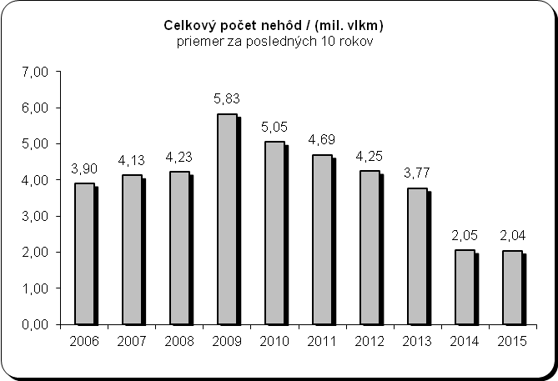 | 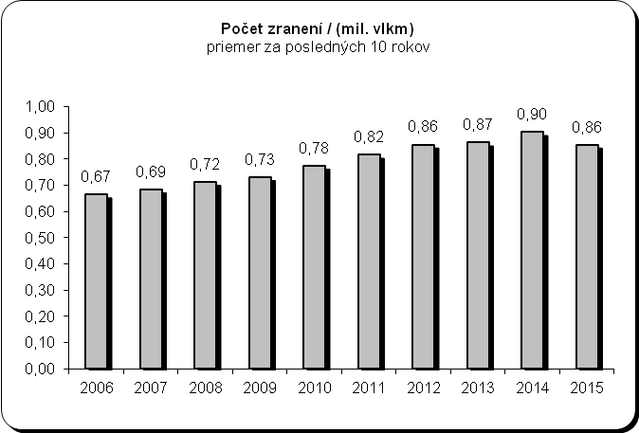

Total number of accidents/(MLN train*km)  last 10 years average | Number of injuries/(MLN train*km)  last 10 years average

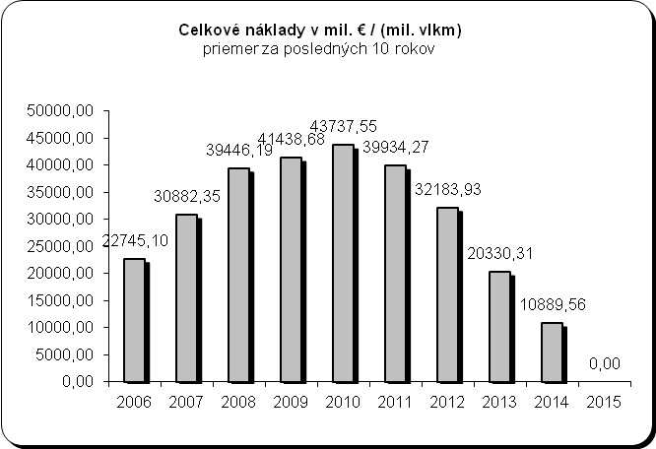 | 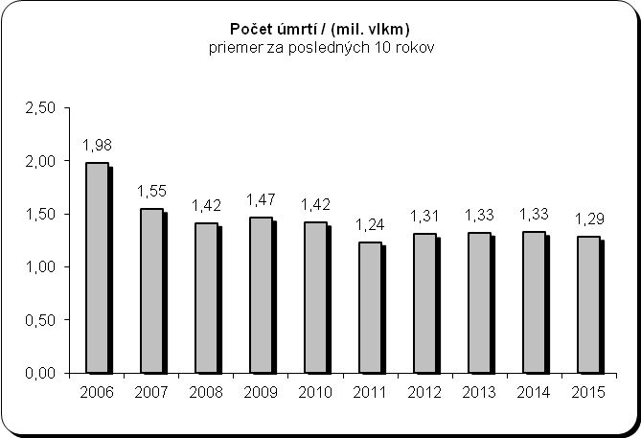

Total costs in MLN €/(MLN train*km)  last 10 years average | Number of fatalities/(MLN train*km)  last 10 years average

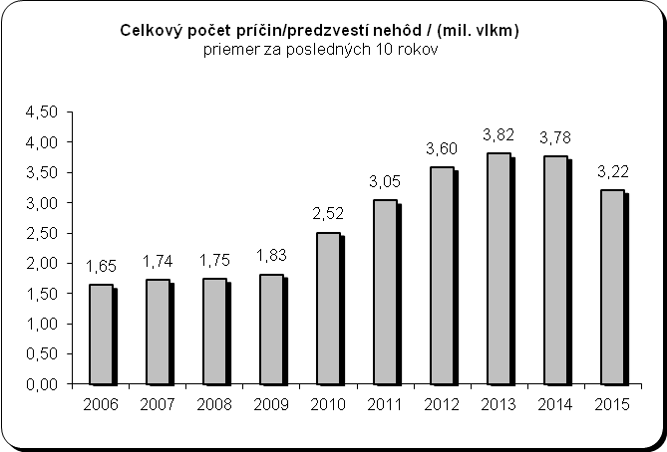
Total number of precursors/(MLN train*km)
last 10 years average

- Accidents divided by type

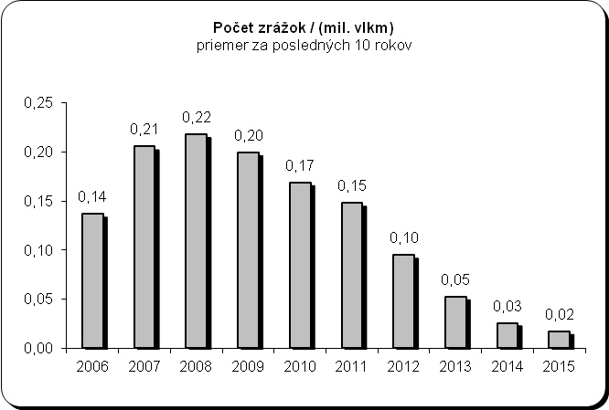 | 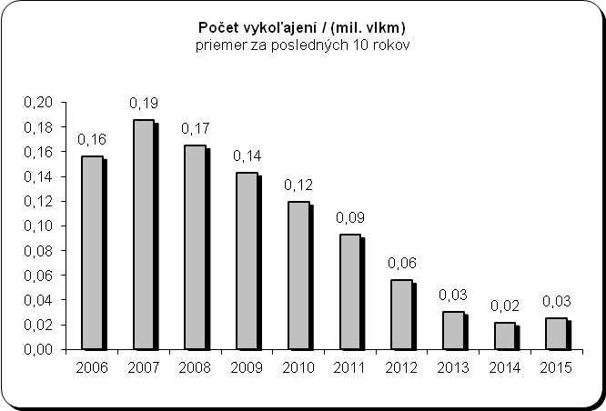
Number of collisions/(MLN train*km)  last 10 years average | Number of derailments/(MLN train*km)  last 10 years average

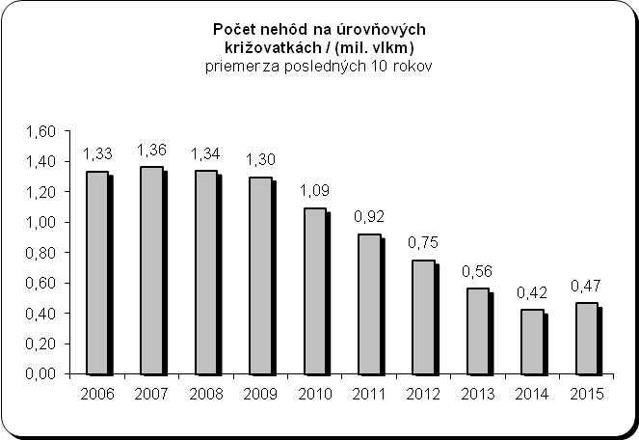 | 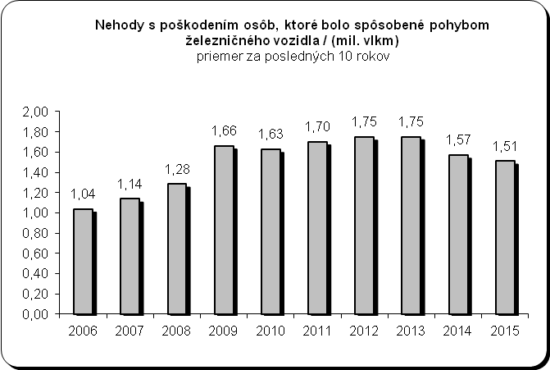
Number of level crossing accidents/(MLN train*km)  last 10 years average | Accidents to persons caused by rolling stock in motion/(MLN train*km)  last 10 years average

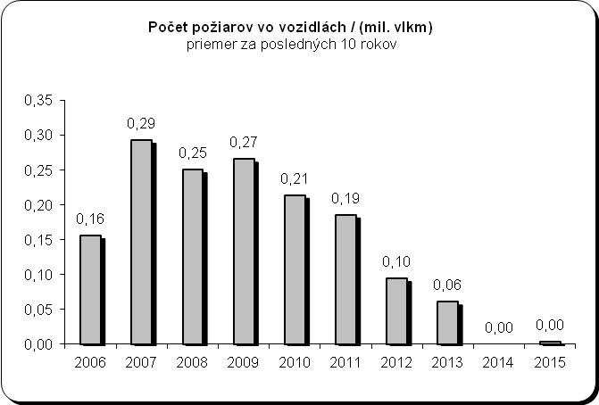 | 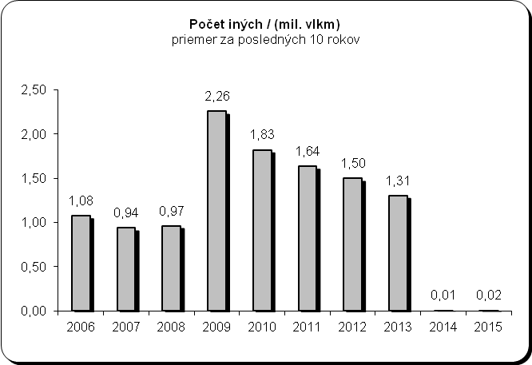
Number of fires in rolling stock /(MLN train*km)  last 10 years average | Others/(MLN train*km)  last 10 years average

- Fatalities divided by category of people involved

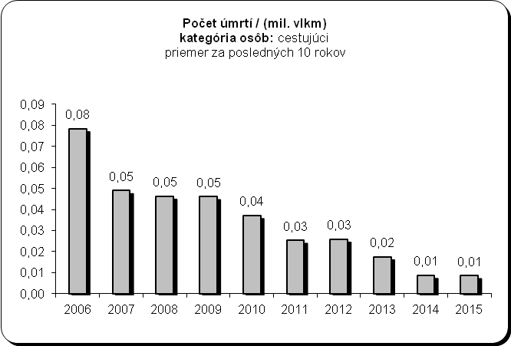 | 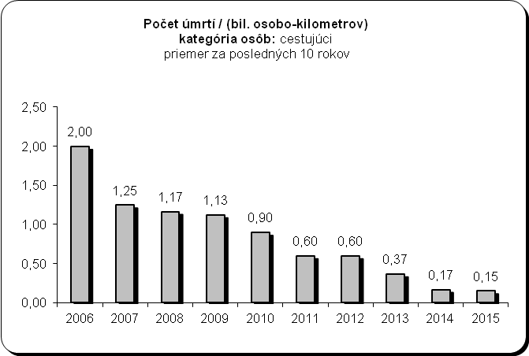
Number of fatalities/(MLN train*km), category of persons:  passengers, last 10 years average | Number of fatalities/(BLN passenger*km), category of persons:  passengers, last 10 years average

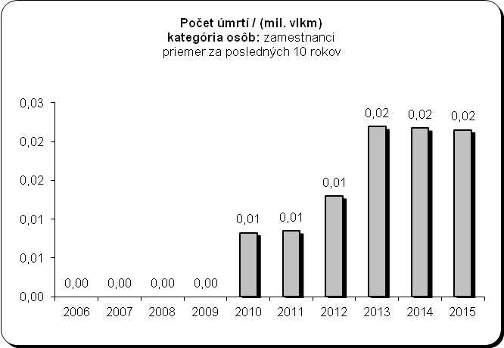 | 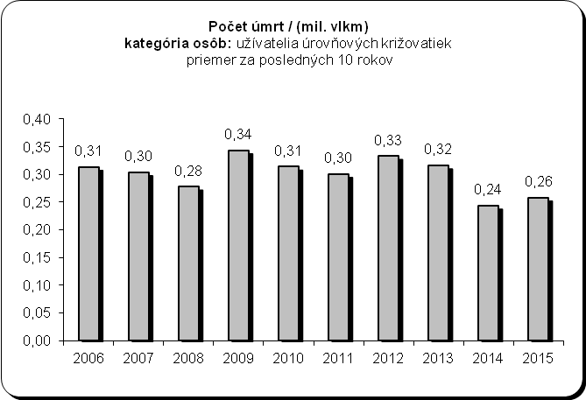
Number of injuries/(MLN train*km), category of persons:  employees, last 10 years average | Number of fatalities/(MLN train*km), category of persons:  others, last 10 years average

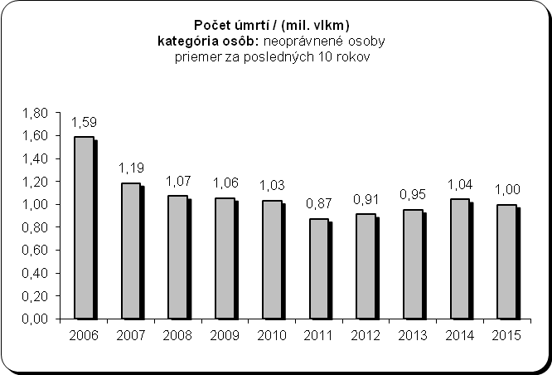 | 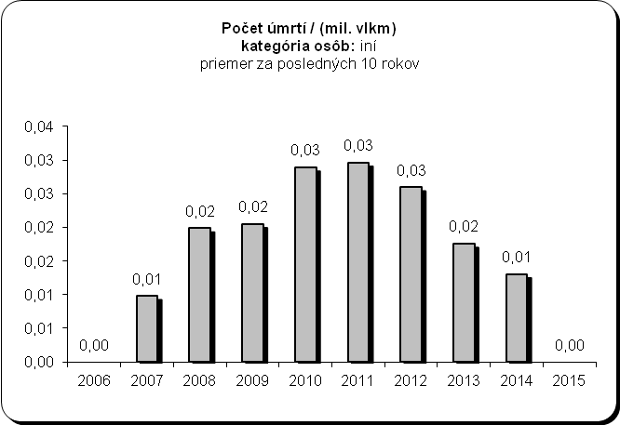
Number of fatalities/(MLN train*km), category of persons:  unauthorised persons, last 10 years average | Number of fatalities/(MLN train*km), category of persons:  others, last 10 years average

- Injuries divided by category of people involved

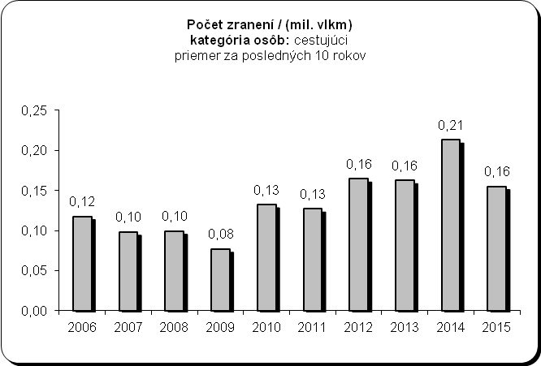 | 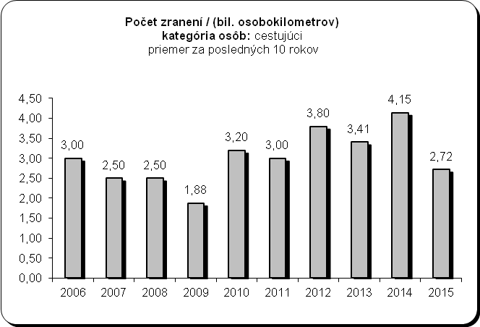
Number of injuries/(MLN train*km), category of persons:  passengers, last 10 years average | Number of injuries/(BLN passenger*km), category of persons:  passengers, last 10 years average

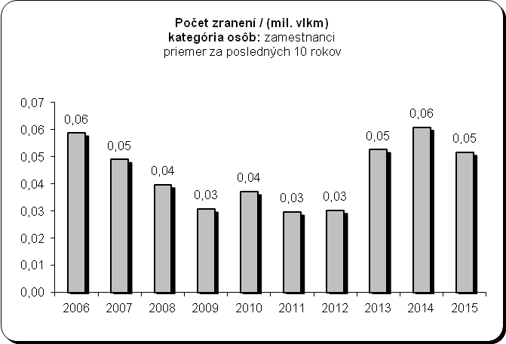 | 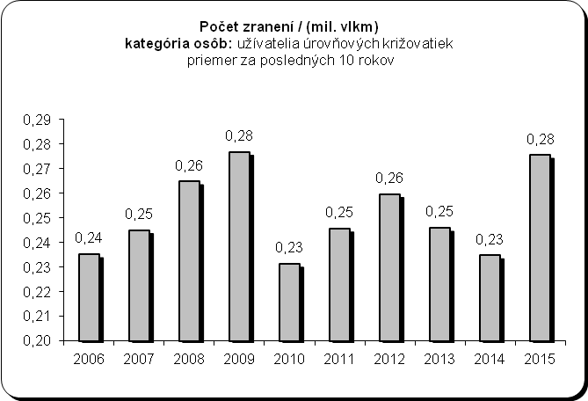
Number of injuries/(MLN train*km), category of persons:  employees, last 10 years average | Number of injuries/(MLN train*km), category of persons:  level crossing users, last 10 years average

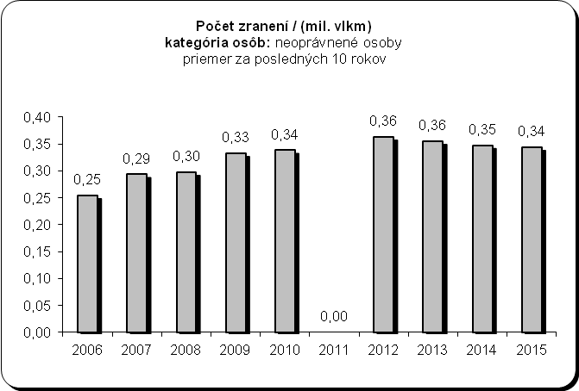 | 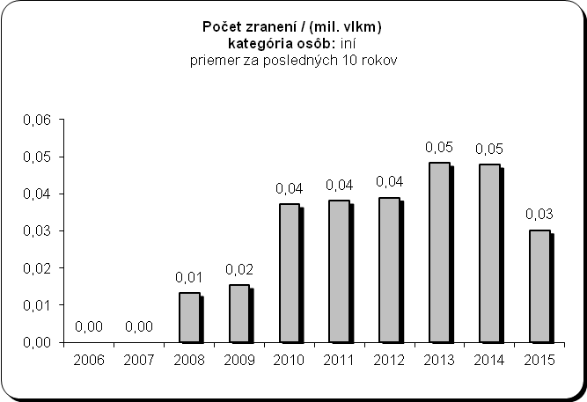
Number of injuries/(MLN train*km), category of persons:  unauthorised persons, last 10 years average | Number of injuries/(MLN train*km), category of persons:  others, last 10 years average

- Precursors to accidents

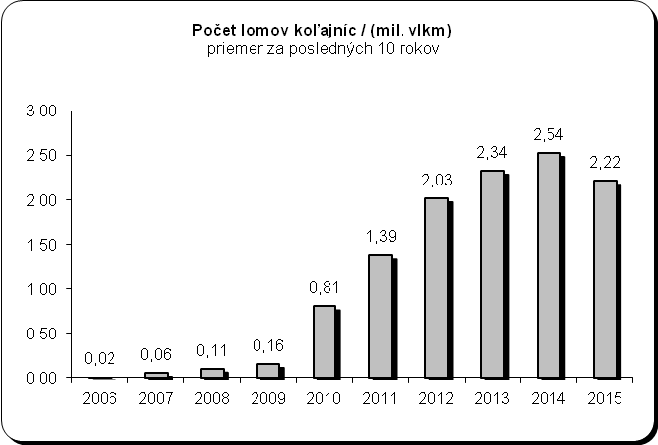 | 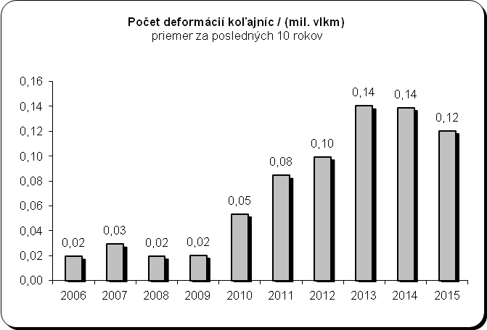
Number of broken rails/(MLN train*km)  last 10 years average | Number of track buckles/(MLN train*km)  last 10 years average

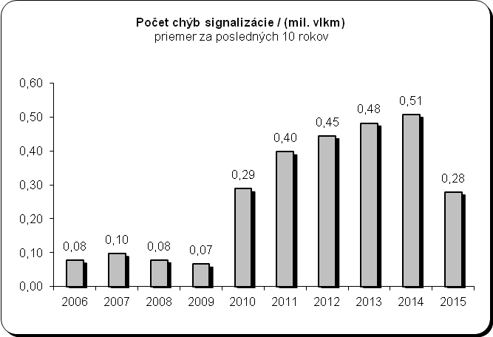 | 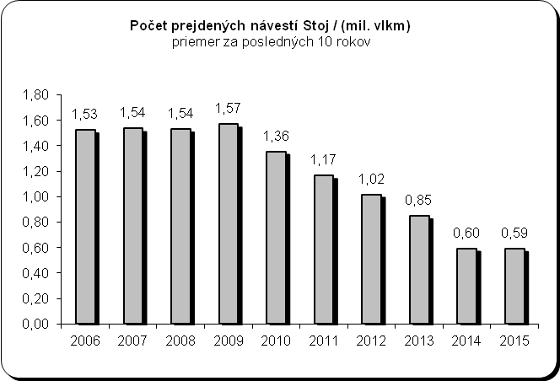
Number of wrong-side signalling failures/(MLN train*km)  last 10 years average | Number of signals passed at danger/(MLN train*km)  last 10 years average

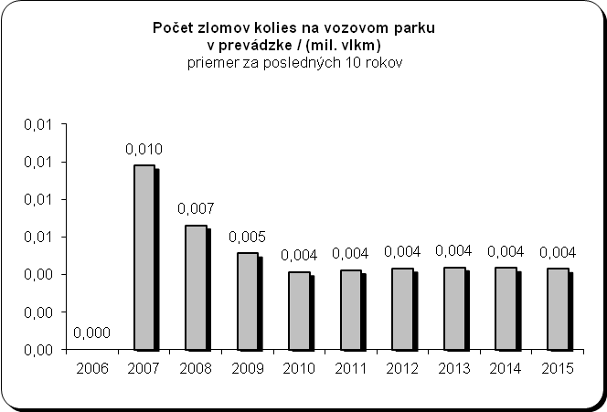 | 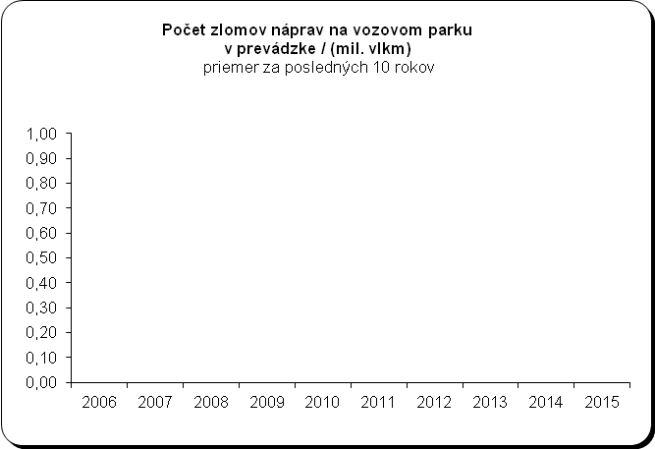
Number of broken wheels on rolling stock in service/(MLN train*km)  last 10 years average | Number of broken axles on rolling stock in service/(MLN train*km)  last 10 years average

- Cost of all accidents, number of working hours of staff and contractors lost as a consequence of accidents

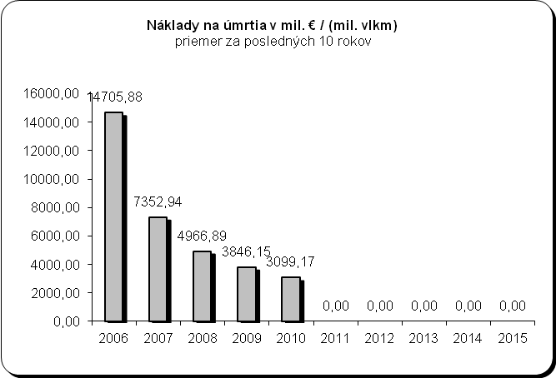 | 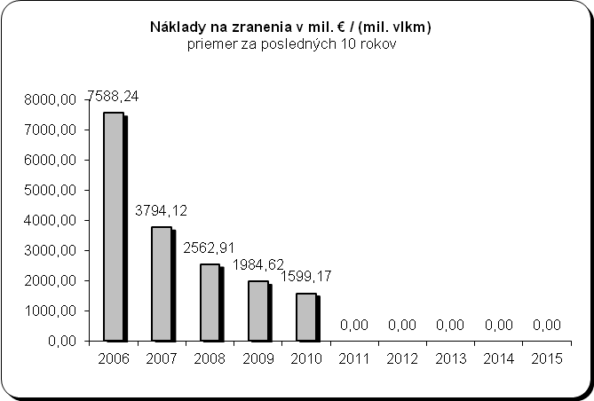
Costs of deaths in MLN €/(MLN train*km)  last 10 years average | Costs of injuries in MLN €/(MLN train*km)  last 10 years average

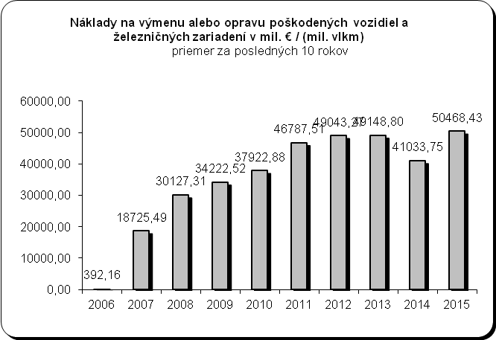 | 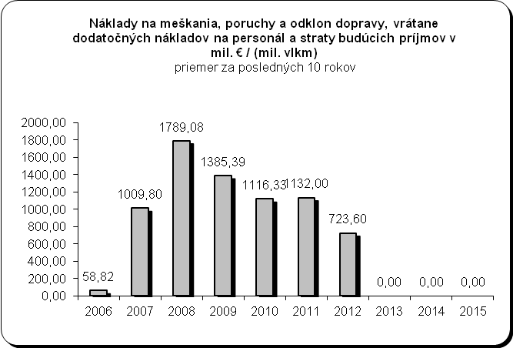
Costs of replacement or repair of damaged rolling stock and railway installations in MLN €/(MLN train*km)  last 10 years average | Costs of delays, disturbances and re-routing of traffic, including extra costs for staff and loss of future revenue in MLN €/(MLN train*km)  last 10 years average

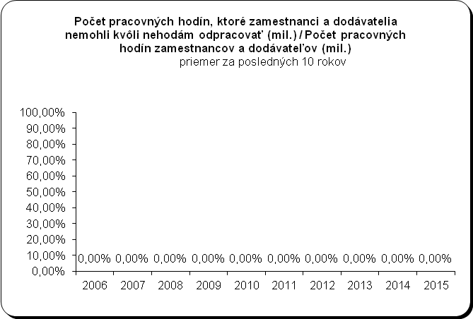
Number of working hours (MLN) of staff and contractors lost as a consequence of accidents /Number of working hours (MLN) of staff and contractors
last 10 years average

- Technical safety of infrastructure and its implementation, management of safety

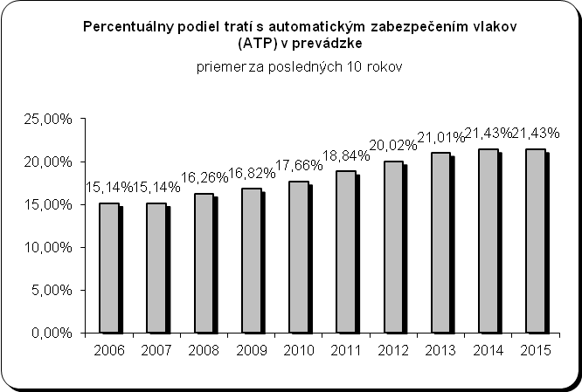 | 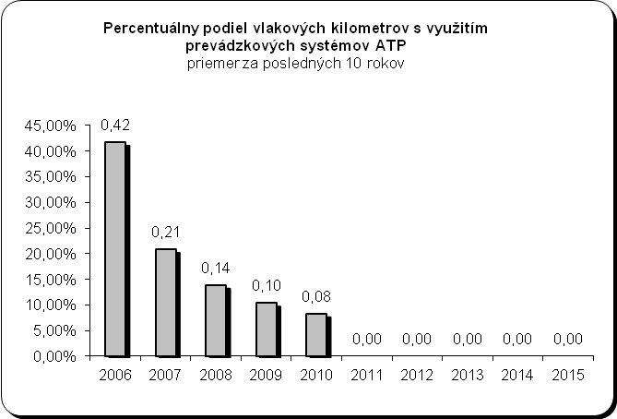
Percentage of tracks with automatic train protection (ATP) in operation  last 10 years average | Percentage of train*km using operational ATP systems  last 10 years average

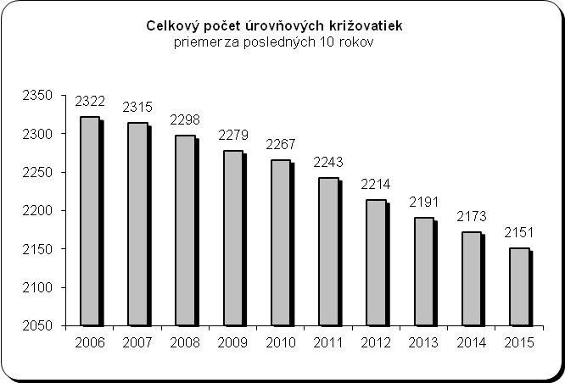 | 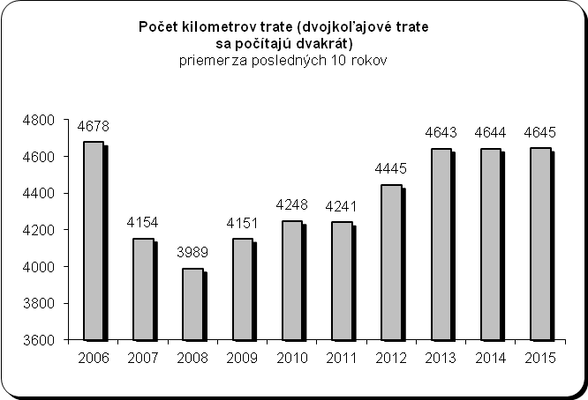
Total number of level crossings  last 10 years average | Number of track km (double track lines are to be counted twice)  last 10 years average

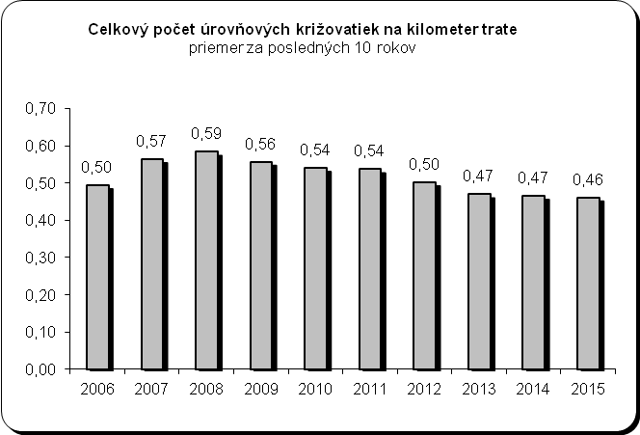 | 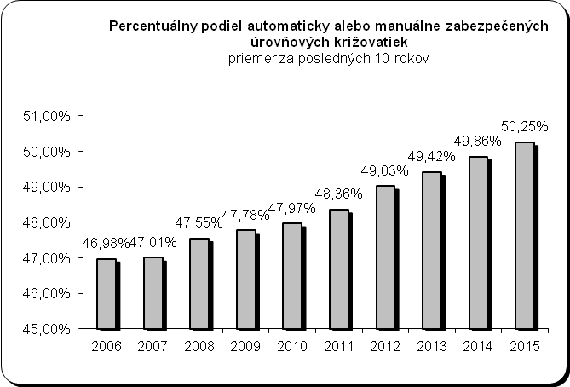
Total number of level crossings per track km  last 10 years average | Percentage of level crossings with automatic or manual protection  last 10 years average

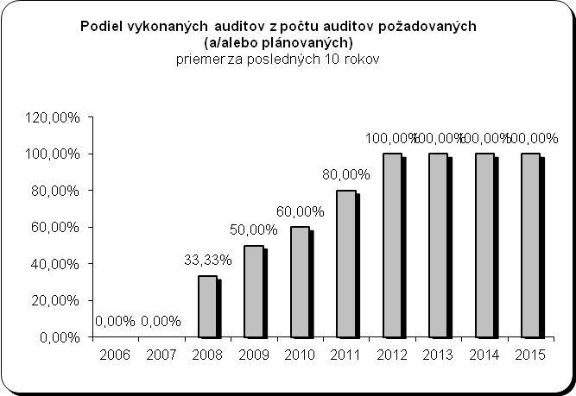
Number of audits accomplished out of the number of audits required (and/or planned)
last 10 years average

Annex D Important changes in legislation and regulations

Area | Legal reference | Date legislation came into force | Reasons for introduction (additionally specify new law or amendment to existing legislation) | Description
General national railway safety legislation
Legislation concerning the national safety authority | Act No 513/2009 Coll. on railways and on amendments to certain acts | 01.01.2010 | new law | Railway operating rules, responsibilities and obligations of the Authority, roles of the safety authority
Legislation concerning the national safety authority | Act No 514/2009 Coll. on railway traffic | 01.01.2010 | new law | Railway traffic operating rules, train driver certification, responsibilities and obligations of the Authority
Legislation concerning the national safety authority | Act No 402/2013 Coll. on the Regulatory Authority for Electronic Communications and Postal Services and the Transport Authority | 01.01.2014 | new law plus amendment to Act  No 513/2009 Coll. and Act No 514/2009 Coll. | Abolishment of the Railway Regulatory Authority and establishment of the Transport Authority, which, inter alia, acts as the safety authority (Directive 2004/49/EC).
Legislation concerning notified bodies, assessors, third-party bodies for registration, examination, etc. | Act No 513/2009 Coll. on railways and on amendments to certain acts | 01.01.2010 | new law | Railway operating rules, responsibilities and duties of notified bodies and authorised legal entities
 | Act No 393/2011 Coll. | 31.12.2011 | amendment to Act  No 513/2009 Coll. on railways | Subsystem verification procedures, authorisation of legal entities to verify railway vehicles, performance of technical and safety testing of railway vehicles
 | Act No 259/2015 Coll. | 15.12.2015 | amendment to Act  No 513/2009 Coll. on railways | Granting railway vehicle type authorisations
National rules concerning railway safety
Rules concerning national safety targets and methods | Act No 513/2009 Coll. on railways and on amendments to certain acts | 01.01.2010 | new law | Railway operating rules, responsibilities and obligations of the Authority, roles of the safety authority
Rules concerning national safety targets and methods | Act No 433/2010 Coll. | 01.12.2010 | amendment to Act  No 513/2009 Coll. on railways | Safety indicators, safety targets and safety methods
Rules concerning national safety targets and methods | Act No 514/2009 Coll. on railway traffic | 01.01.2010 | new law | Railway traffic operating rules
Rules concerning national safety targets and methods | Decree No 351/2010 Coll. on railway traffic regulations | 15.09.2010 | new decree of the Ministry | Details concerning the operation of railways and railway traffic, verification of technical fitness of railway vehicles, driving of RTUs
Rules concerning requirements on safety management systems and safety certification of railway undertakings | Act No 513/2009 Coll. on railways and on amendments to certain acts | 01.01.2010 | new law | Railway operating rules, responsibilities of the Authority, issuing of safety certificates, roles of the safety authority
 | Act No. 432/2013 Coll. | 01.02.2014 | amendment to Act  No 513/2009 Coll. on railways | Requirements on SMS, medical fitness requirements, authorisation for placing railway vehicles in service
 | Act No 514/2009 Coll. on railway traffic | 01.01.2010 | new law | Railway traffic operating rules, train driver certification, roles of the Authority as the safety authority
 | Decree No 351/2010 Coll. on railway traffic regulations | 15.09.2010 | new decree of the Ministry | Details concerning the operation of railways and railway traffic, operation of railway vehicles
Rules concerning requirements on safety management systems and safety authorisation of infrastructure managers | Act No 513/2009 Coll. on railways and on amendments to certain acts | 01.01.2010 | new law | Railway operating rules, issuing of safety authorisations, responsibilities and roles of the Authority as the safety authority
 | Act No. 432/2013 Coll. | 01.02.2014 | amendment to Act  No 513/2009 Coll. on railways | Requirements on SMS, medical fitness requirements, authorisation for placing railway vehicles in service
 | Act No 514/2009 Coll. on railway traffic | 01.01.2010 | new law | Railway traffic operating rules, train driver certification, roles of the Authority as the safety authority
 | Decree No 351/2010 Coll. on railway traffic regulations | 15.09.2010 | new decree of the Ministry | Requirements for the operation of railways and railway traffic, operation and tests of railway vehicles, organisation of railway traffic
Rules concerning requirements for wagon keepers | - | - | - | -
Rules concerning requirements for maintenance workshops | - | - | - | -
Rules concerning requirements for the authorisation of placing in service and maintenance of new and substantially altered rolling stock, including rules for exchange of rolling stock between railway undertakings, registration systems and requirements on testing procedures | Act No 513/2009 Coll. on railways and on amendments to certain acts | 01.01.2010 | new law | Railway operating rules, requirements for the authorisation of placing railway vehicles into service, tests and registration of railway vehicles, responsibilities and roles of the Authority as the safety authority
 | Decree No 351/2010 Coll. on railway traffic regulations | 15.09.2010 | new decree of the Ministry | Requirements for the operation of railways and railway traffic, verification of the technical condition of railway vehicles, technical and safety tests of railway vehicles
 | Decree No 12/2012 Coll. | 01.02.2012 | amendment to Decree  No 351/2010 Coll. | Authorisations for historical railway vehicles, conditions for performing technical and safety tests of railway vehicles, tests of railway vehicles, on-board signalling systems
Common operating rules of the railway network, including rules relating to the signalling and traffic procedures | ŽSR Regulation Z 1 – Railway traffic rules | 11.12.2011 | national safety regulation | Specifies the method, conditions and technological procedures for the operation of railways, performance of transport operations
 | Decree No 351/2010 Coll. on railway traffic regulations | 15.09.2010 | new decree of the Ministry | Requirements for the operation of railways and railway traffic, railway control, railway traffic management, methods of signalling and interlocking on railways
 | Decree No 12/2012 Coll. | 01.02.2012 | amendment to Decree  No 351/2010 Coll. | Requirements for railway traffic, running on sight, brake tests
Rules laying down requirements on additional internal operating rules (company rules) that must be established by the infrastructure managers and railway undertakings | Act No 513/2009 Coll. on railways and on amendments to certain acts | 01.01.2010 | new law | Railway operating rules, issuing of rules by the infrastructure manager and railway undertakings, responsibilities and roles of the Authority as the safety authority
 | Act No 514/2009 Coll. on railway traffic | 01.01.2010 | new law | Railway traffic operating rules, issuing of rules by the infrastructure manager and railway undertakings regarding train driver certification, roles of the Authority as the safety authority
 | Decree No 351/2010 Coll. on railway traffic regulations | 15.09.2010 | new decree of the Ministry | Requirements for the operation of railways and railway traffic, railway traffic management, issuing of operating rules and technological procedures by the infrastructure manager and railway undertakings
Rules concerning requirements on staff executing safety critical tasks, including selection criteria, medical fitness and vocational training and certification | Act No 513/2009 Coll. on railways and on amendments to certain acts | 01.01.2010 | new law | Requirements for professional competence and medical and psychological fitness, verification of professional competence and medical and psychological fitness
 | Act No 514/2009 Coll. on railway traffic | 01.01.2010 | new law | Requirements for professional competence and medical and psychological fitness, verification of professional competence and medical and psychological fitness of train drivers
 | Decree No 245/2010 concerning professional competence and medical and psychological fitness of persons operating railways and railway transport | 15.06.2010 | new decree of the Ministry | Details concerning professional training to obtain professional competence and the requirements for and verification of professional competence and medical and psychological fitness,
 | ŽSR Regulation Z 2 – Employee safety in the context of ŽSR | 01.01.2014 | national safety regulation | Safety of persons in premises within the railway infrastructure presenting potential risk
Rules concerning the investigation of accidents and incidents, including recommendations | Act No 513/2009 Coll. on railways and on amendments to certain acts | 01.01.2010 | new law | Obligations of the infrastructure manager and railway undertakings in the event of accidents, incidents and emergencies, investigation of their causes and taking of action
 | ŽSR Regulation Z 17 – Accidents and incidents | 09.12.2007 | national safety regulation, amended on 01.01.2010 and 01.01.2011 | Procedures in the event of accidents, incidents and emergencies and investigation of their causes
Rules concerning requirements for national safety indicators, including how to collect and analyse the indicators | Act No 513/2009 Coll. on railways and on amendments to certain acts | 01.01.2010 | new law | Obligations of the infrastructure manager and railway undertakings – collection and reporting of safety indicators to the NSA in safety reports
 | Act No 433/2010 Coll. | 01.12.2010 | amendment to Act  No 513/2009 Coll. on railways | Safety indicators – reporting, structure of the report
Rules concerning requirements for authorisation of placing into service infrastructure (tracks, bridges, tunnels, energy, ATC, radio, signalling, interlocking, level crossings, platforms, etc.) | Act No 513/2009 Coll. on railways and on amendments to certain acts | 01.01.2010 | new law | Rules on the construction and operation of railways, construction and technical requirements for the construction of railways and their parts, placing into service of railways
 | Decree No 350/2010 Coll. concerning the railway construction and technical code | 15.09.2010 | new law | Details of the construction and technical requirements for the design, construction and operation of railways

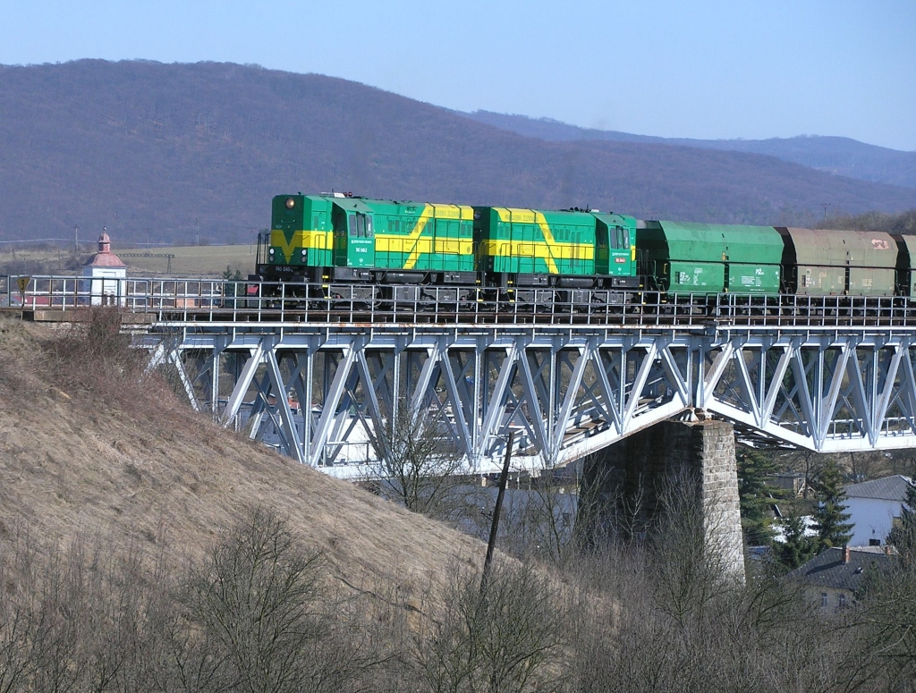
(photo: Pavel Chomjak, Prešov)

Annex E The development of safety certification and safety authorisation – numerical data

E.1. Safety Certificates according to Directive 2004/49/EC
E.1.1 Number of safety certificates part A issued in the reporting and in previous years and remain valid at the end of year 2015 | Total number of certificates: | Number of certificates Part A in ERADIS:
 | in the reporting year: 9
 | in previous years: 45 (until 2014)
 | valid at the end of 2015: 54

E.1.2 Number of safety certificates Part B issued in the reporting and in previous years by your member state and remain valid in the year 2015 | Total number of certificates: |  | Number of certificates Part B in ERADIS:
 | in the Slovak Republic: | in the reporting year: 9
 | in the Slovak Republic: | in previous years: 45
 | in the Slovak Republic: | valid at the end of 2015: 32
 | in another Member State:  (number of certificates Part B, for which the part A has been issued in another Member-State) | in the reporting year: 4
 |  | in previous years: 33
 |  | valid at the end of 2015: 22

E.1.3 Number of new applications for safety certificates Part A submitted by railway undertakings in year 2015 | Type of certificate | A | R | P
 | New certificates | 2 | 0 | 0
 | Updated/amended certificates | 0 | 0 | 0
 | Renewed certificates | 6 | 0 | 4

E.1.4 Number of new applications for safety certificates Part B submitted by railway undertakings in year 2015 | Where | Type of certificate | A | R | P
 | Part A has been issued in the Slovak Republic | New certificates | 2 | 0 | 0
 | Part A has been issued in the Slovak Republic | Updated/amended certificates | 0 | 0 | 0
 | Part A has been issued in the Slovak Republic | Renewed certificates | 6 | 0 | 4
 | Part A has been issued in another Member-State | New certificates | 2 | 0 | 1
 | Part A has been issued in another Member-State | Updated/amended certificates | 0 | 0 | 0
 | Part A has been issued in another Member-State | Renewed certificates | 1 | 0 | 0

A = accepted application, certificate is already issued
R = rejected applications, no certificate was issued
P = case is still pending, no certificate was issued so far

Revoked safety certificates | Total number of revoked certificates in the year 2015 | Number of revoked certificates in ERADIS (which were revoked in 2015)
E.1.5 number of certificates Part A revoked in the current reporting year 2015 | 0 | 0
E.1.6 number of certificates Part B revoked in the current reporting year 2015 | 0 | 0

E.1.7 List of countries where railway undertakings applying for a Safety Certificate Part B in your Member State have obtained their Safety Certificate Part A.
Name of railway undertaking | Member State where Safety Certificate Part A was issued
STRABAG Rail, a.s., Ústí nad Labem - Střekov,  LEO Express, a.s., Praha 3 – Žižkov,  INTERPORT spedition, s.r.o., Praha 4 | Czech Republic

E. 2 Safety authorisations according to Directive 2004/49/EC

E.2.1 Number of valid safety authorisations issued to infrastructure managers in the reporting year and in previous years and remain valid at the end of the year 2015 | Total number of safety authorisations: 1
 | in the reporting year: 1 (renewal for the infrastructure manager – ŽSR)
 | in previous years: 1
 | valid at the end of 2015: 1

E.2.2 Number of applications for safety authorisations submitted by infrastructure managers in year 2015 | Type of authorisation | A | R | P
 | New authorisations | 0 | 0 | 0
 | Updated/amended authorisations | 0 | 0 | 0
 | Renewed authorisations | 1 | 0 | 0
A = accepted application, certificate is already issued
R = rejected applications, no certificate was issued
P = case is still pending, no certificate was issued so far

E. 2.3 Number of safety authorisations revoked in the current reporting year 2015 | 0

E.3 Procedural aspects – safety certificates part A

The average time after receiving of the application with the required information and the final delivery of a safety certificate Part A in year 2015 for railway undertakings | New | Updated/amended | Renewed
 | 3 months | not applicable | 3 months

E.4 Procedural aspects – safety certificates part B

The average time after receiving the application with the required information and the final delivery of a safety certificate Part B in year 2015 for railway undertakings | Where | New | Updated/amended | Renewed
 | Part A has been issued in the Slovak Republic | 3 months | not applicable | 3 months
 | Part A has been issued in another Member-State | 3 months | not applicable | 3 months

E.5 Procedural aspects – safety authorisations

The average time after receiving the application with the required information and the final delivery of a Safety Authorisation in year 2015 for infrastructure managers | New | Updated/amended | Renewed
 | not applicable | not applicable | 1.5 months

