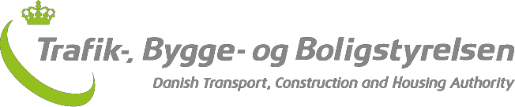

Safety report for the railways 2016

September 2017

Foreword
Each year, the Danish Transport, Construction and Housing Authority’s safety report for the railways presents a comprehensive analysis of the development in the number of accidents and incidents as well as a review of the Authority’s safety-related activities. The report thus provides a status report on railway safety in Denmark.
Safety remained at a high level on railways in Denmark in 2016. The number of significant accidents is on a par with previous years, and the Danish safety targets have been met.
In 2016, significant accidents involving people were at their lowest level for five years, and the number of suicides was at its lowest level in ten years.
The number of people killed in 2016 fell from ten to eight compared to 2015, while the number of people seriously injured rose from six to ten.
There has been an increase in reports of minor accidents and precursors to accidents, which is probably due to an improved reporting culture and the fact that the new Executive Order on reporting has introduced some new categories of incident.
The theme for this year’s safety report is passenger behaviour. Inappropriate passenger behaviour is a growing problem. The Authority has therefore used a number of initiatives to place greater focus on this area in 2016.
The Danish Transport, Construction and Housing Authority hopes that the report will contribute to the exchange of experiences and provide inspiration in the Danish railway sector.
The report will also be used to exchange experience among the EU Member States and will be submitted to the European Railway Agency (ERA).
Happy reading!
Kåre Clemmesen, Executive Manager

ABOUT THE DATA IN THE REPORT:
The data in the safety report are for 2016. The reason for the relatively late publication is that the Authority only receives the last data for 2016 from the undertakings in June 2017, and it is an extensive process to validate the information on incidents and accidents on the railways reported by the undertakings.
The Danish Transport, Construction and Housing Authority is required to publish the safety report and submit it to the European Railway Agency (ERA), but the Authority has chosen to design the report to also make it an interesting and relevant read for Danish stakeholders such as infrastructure managers, railway undertakings, the Danish Accident Investigation Board, politicians and the press.
The report therefore includes data from across the entire Danish rail network, including demarcated urban networks such as the metro and local railways, which would otherwise not be covered by the European reporting requirements. The reader must therefore be aware that the data in this report will be different from data reported for use in European statistics.

Contents
Summary 4
Summary 6
Chapter 1: Railway safety in Denmark in 2016 8
Reporting of data for the safety report 8
New Executive Order on reporting 8
Incident categories 9
Incidents on the railway 9
Significant accidents 10
Significant accidents involving persons 13
Minor accidents 20
Precursors to accidents 22
Suicides on the railway – the lowest number for ten years 25
Chapter 2: Follow-up of recommendations from the Accident Investigation Board and other incidents 27
The Accident Investigation Board’s role and responsibilities 27
Passenger train collided with excavator at Herfølge 28
Middelfart station, passenger's foot became caught in train step 29
Chapter 3: Safety certificates and safety authorisations 32
Safety certification 32
Safety authorisations 33
Enquiries to/from other countries concerning safety certificates 33
Changes to safety certificates and safety authorisations in 2016 33
The Authority's guidance of undertakings 34
Chapter 4: Monitoring of railway safety 36
The Danish Transport, Construction and Housing Authority as the supervisory authority 36
Supervision planning and prioritisation 36
General supervision results in 2016 37
Supervisory results and focus areas in 2016 38
Maturity assessment of the undertakings 39
Remedial measures implemented by the undertakings 41
The Authority's use of resources for supervision 41
Cooperation with other countries' authorities in relation to supervisory activities 43
Chapter 5: Experiences with the Risk Assessment Regulation (CSM-RA) 45
General information about the Authority's work on CSM-RA in 2016 45
Experiences in the area of infrastructure 46
Experiences in the area of vehicles 47
Experiences from the undertakings 48
Chapter 6: Implementation of the Railway Safety Directive 50
Harmonisation of regulations 50
The Executive Order on safety authorisations and safety certificates in the railways sector 51
The Executive Order amending the Executive Order on the certification of train drivers 51
The new Executive Order on the certification of train drivers 52
The Executive Order on health and skills requirements for certain safety-classified functions in the railways sector 52
The Executive Order on the technical compatibility of vehicles with the railway network 53
The Executive Order on fees and charges levied by the Danish Transport, Construction and Housing Authority in the railways sector 54
Chapter 7: Topic - passenger behaviour 56
Work done by the Authority on passenger behaviour 56
Dialogue with the railway industry 56
Inspections of passenger behaviour 56
Analysis of incidents during boarding and alighting 56
Regulation of passenger behaviour 58
Research on passenger behaviour 59
Annex A: The railways in figures 2016 62
Annex B: Safety indicators for 2016 64
Annex C: Definitions used 70

Summary

Denmark still has a high level of railway safety
Denmark's target is for no more than 0.3 people to be killed or seriously injured for every million train kilometres. Denmark has met this target every year since 2004, and the safety level remained well below 0.3 per million train kilometres in 2016 too. Over the 2012-16 period, there were 0.14 significant accidents involving people per million train kilometres. This puts Denmark among the best countries in Europe.
Number of significant accidents is at a stable level
The number of significant accidents in 2016 was on a par with recent years. People being hit by trains is still the main kind of significant accident on the railways.
Significant accidents involving people are at the lowest level since 2011. In 2016, eight people were killed and ten were seriously injured.
The lowest number of suicides on the railways for ten years
In 2016, there were 25 suicides on the railways in Denmark. This is the lowest level for ten years. Suicides are treated separately and are not included in the number of railway accidents.
Improved reporting culture
The number of reports of minor accidents and precursors to accidents has risen. This is probably due to an improved reporting culture and the fact that a new Executive Order on reporting has introduced some new categories of incident.
The Authority has complied with the Accident Investigation Board's recommendations
In 2016, the Accident Investigation Board published two reports with recommendations for the Danish Transport, Construction and Housing Authority. The Authority is of the view that all of the recommendations in those two reports have been complied with. A third report was published at the start of the year and will be followed up in 2017.
The undertakings still have some challenges in relation to safety management
The Danish Transport, Construction and Housing Authority is still of the view that some railway undertakings have not fully implemented risk-based safety management based on their individual risk profiles. The Authority is continuously following up these problems.
CSM-RA
The Authority and the railways industry have had a sharp common focus on CSM-RA in 2016. Among other things, the Authority has followed up on CSM-RA work from 2015 using a number of initiatives, including those based on the Authority's assessor survey in 2015.
Work continues on implementing the Railway Safety Directive
The Railway Safety Directive is the European legislation that provides a framework for the harmonisation of safety regulations in Europe. In 2016, the Authority has continued its work on implementing the Directive, among other things by producing six new Executive Orders.
Passenger behaviour
The thematic chapter in this year’s safety report discusses passenger behaviour. Inappropriate passenger behaviour is a growing problem. The Authority has therefore had a sharp focus on this area in 2016.

Summary
Denmark has a high level of railway safety
Denmark’s safety target is that the total number of fatalities or severely injured people per million train-km should not rise above 0.3. Since 2004, Denmark has met this target and in 2016 the safety level is once again considerably below the target. In the period 2012-2016, the number of fatalities and severely injured people is 0.14 per million train-km. This places Denmark among the best performing countries in Europe.
The number of significant accidents is at a stable level
In 2016, the number of significant accidents is at the same level as the previous years. Accidents to persons involving rolling stock in motion continues to be the primary type of significant accidents.
Significant accidents causing killed and seriously injured are at the lowest level since 2011. I 2016, 8 people were killed and 10 people were seriously injured.
The lowest number of suicides on the railway in 10 years
In 2016, 25 committed suicides on the railway in Denmark. It is the lowest number in 10 years. Suicides are not considered as railway accidents.
Improved safety reporting culture
The number of reported minor accidents and precursors to accidents have increased. This is most likely due to an improved safety reporting culture and a new executive order on safety reporting introducing new safety indicators.
The Authority complies with all recommendations of the Danish Accident Investigation Board
In 2016, the Danish Accident Investigation Board published two accounts and one report for follow-up for the Authority. All recommendations in the two accounts are considered to be complied by. The report is published at the end of the year and the follow-up will take place in 2017.
Safety management is still a challenge for the railway companies
Some railway companies still need to fully implement risk-based safety management starting with their own risk profile. The Authority will continuously follow up on these challenges.
CSM-RA
CSM-RA was a major joint focus point for the Authority and the railway industry in 2016. For example, the Authority has followed up on its work with CSM-RA in 2015 by introducing a number of initiatives, including initiatives based on the investigation of the assessor market made by the Authority in 2015.
The work on the implementation on the Railway Safety Directive continues
The Railway Safety Directive is the European legislation, which constitutes the framework within which the harmonization of the safety regulation in Europe takes place. In 2016, the Authority has continued the work of implementing the Directive. This includes issuing six executive orders.
Passenger behaviour
The theme chapter of this year’s safety performance report is about passenger behaviour. Undesirable behaviour is an increasing problem. Consequently, the Authority has made the topic a major focus point in 2016.

Chapter 1: Railway safety in Denmark in 2016
Denmark still has a very high level of railway safety. The number of significant accidents in 2016 was on a par with recent years, while the number of suicides is at the lowest level for ten years. There has been an increase in reports of minor accidents and precursors to accidents, which is probably due to the fact that some new categories of incident have been introduced, as well as an improved reporting culture. The Danish safety target for the number of significant accidents involving people was met in 2016.

Reporting of data for the safety report
There are approximately 2 700 km of railway line in Denmark. Large parts of it are equipped with effective train protection systems, the purpose of which is to reduce the risk of railway accidents in collaboration with the operational staff.
There are approximately 300 railway accidents a year in Denmark. The vast majority of these accidents have few, if any, harmful consequences. For example, a collision between a train and a deer or a shopping trolley left on the track will have minor consequences for rolling stock and only rarely any consequences for passengers.
Railway undertakings and infrastructure managers are responsible for following up on the incidents that have occurred in their areas. In the most serious cases, the Accident Investigation Board Denmark helps establish the chain of events and possible causes of the incidents (see Chapter 2).
Each year, infrastructure managers and railway undertakings report all safety-related incidents to the Danish Transport, Construction and Housing Authority.
Based on the data reported, the Authority analyses the development of railway safety and presents the results in this chapter of the annual safety report.

New Executive Order on reporting
Executive Order No 1340 of 26 November 2015 concerning the reporting of data on accidents and precursors to accidents etc. in the railways sector to the Danish Transport and Construction Agency entered into force on 1 January 2016.
The Executive Order implements the new and amended requirements in Annex 1 to the Railway Safety Directive, which primarily concerns the addition of new categories and the further subdivision of other categories.
In addition, the Authority has chosen to change and add two new national categories to provide for reporting of more valid data in cooperation with the industry.
The two new national categories:
- Boarding and alighting accidents, which are subdivided depending on whether the train is in motion or stationary;
- Accidents involving traction current, which are subdivided depending on whether the train is in motion or stationary/no train.
Finally, for the sake of clarity, the Authority has chosen to bring the categories of precursors to accidents and safety irregularities together under the heading of precursors to accidents.
This is because a precursor to an accident and a safety irregularity are both considered indicators of safety and are reported with a view to implementing preventive measures to avoid actual accidents.

Incident categories
Incidents on the railways are divided up into accidents and precursors to accidents, as mentioned above. Accidents are divided into significant accidents and minor accidents. Data relating to significant accidents involving people are also collected and evaluated under the heading of significant accidents (please see Figure 1.1 below).
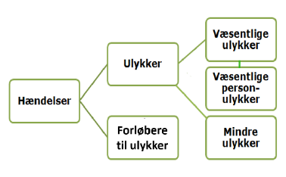
Figure 1.1: Incidents and definitions
Due to the low number of incidents per year, there is a certain degree of statistical uncertainty in the calculations. For this reason, the actual figures for 2016 are compared with the five-year average for 2012-16, which is based on a larger amount of data.
In order to find the five-year average, it has been necessary to compile incident data from 2016 using the broader categories that were used prior to the new Executive Order on reporting.
Furthermore, this chapter also contains calculations based on the new, smaller categories for which there is only data in relation to 2016.

Incidents on the railway
Figure 1.2 shows that only a small proportion of incidents reported in 2016 were decidedly accidents, and very few of them were serious accidents. The majority of reported incidents were precursors to accidents.
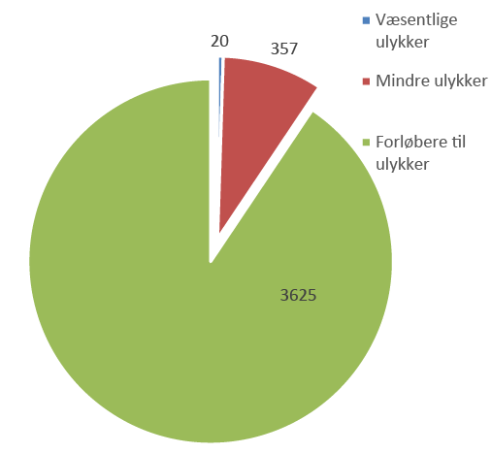
Figure 1.2: Number of incidents reported in 2016 according to incident type
Note: Suicides are not included.
Source: Danish Transport, Construction and Housing Authority incident database

Hændelser | Incidents
Ulykker | Accidents
Forløbere til ulykker | Precursors to accidents
Væsentlige ulykker | Significant accidents
Væsentlige person ulynkker | Significant accidents involving people
Mindre ulykker | Minor accidents

The incident database shows an increase in reported incidents from approximately 3 500 in recent years to 4 002 in 2016. It is particularly incidents in the categories of minor accidents and precursors to accidents that have seen an increase in comparison with previous years.
The larger number of incident categories that have been added by the new Executive Order on reporting may be a contributing factor for this increase. Nevertheless, the most probable cause for the increase is a better reporting culture within the undertakings in the face of a negative trend.

Significant accidents
In order to distinguish between accidents that do and do not have major consequences, accidents are divided into two groups: significant accidents and minor accidents.
Significant accidents are accidents that have caused serious personal injury, death, damage of more than DKK 1.2 million, or delays to train operations of more than six hours.
The new Executive Order on reporting now divides up accidents (both significant and minor accidents) into 14 types of incident. Please see Annex C for a description of the different types of incident. Suicides on the railways are not included in these categories, because they are not treated as railway accidents (you can read more about suicides on the railways later on in this chapter).
Twenty significant accidents were reported in 2016. This corresponds to 0.24 per million train kilometres. By way of comparison, there were 17 significant accidents in 2015. The five-year average for 2012-16 is on a par with this year's level (please see Figure 1.3).
Most of the significant accidents on the railways are collisions with a person or accidents at level crossings.

Figure 1.3: Significant accidents 1999 – 2016 (per million train kilometres)
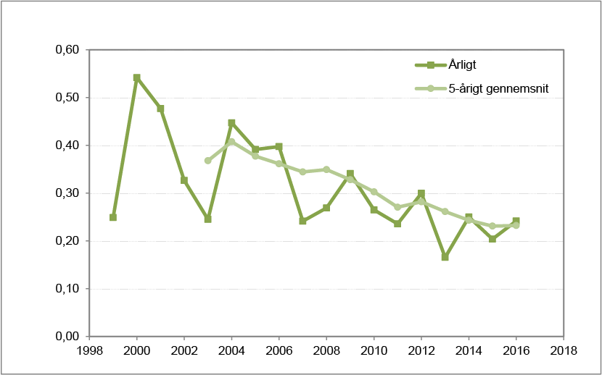
Note: Suicides are not included.
Arligt | Annually
5-årigt gennemsnit | 5-year average
Source: Danish Transport, Construction and Housing Authority incident database

Significant accidents are train accidents involving damage costing more than DKK 1.2 million, serious personal injury or death, or delays to train operations of more than six hours.

As Figure 1.4 shows, personal injuries involving rolling stock in motion are still the largest kind of significant accidents on the railways in Denmark. There were 11 incidents of this kind in 2016, which is on a par with the five-year average for 2012-16.
This figure includes ten collisions with people and one instance of a person being injured while on board a train in motion (please see Figure 1.5). The people who are hit by trains are mostly trespassers. There was one significant accident at a level crossing in 2016, which is considerably less than the five-year average. The accident is described below, under 'Significant accidents involving people'.
Collisions, fire or derailments, which are the accidents with the greatest potential for causing multiple injuries, are rare. There were no significant accidents involving collisions or derailments in 2016.
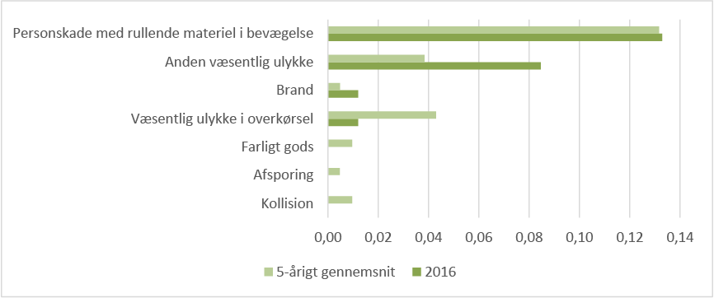
Figure 1.4: Significant accidents broken down by type of accident in 2016 (per million train kilometres).
Note: Suicides are not included. The category of 'personal injuries involving rolling stock in motion' has been designated as 'collision with a person' in the safety reports for previous years.
Personskade med rullende materiel I bevægelse | Personal injuries involving rolling stock in motion
Anden væsentlig ulykke | Other significant accidents
Brand | Fire
Væsentlig ulykke I overkørsel | Significant accidents at level crossings
Farligt gods | Dangerous goods
Afsporing | Derailment
Kollision | Collision
5-årigt gennemsnit | 5-year average
Source: Danish Transport, Construction and Housing Authority incident database

Figure 1.5: Significant accidents in 2016 under the new Executive Order on reporting.
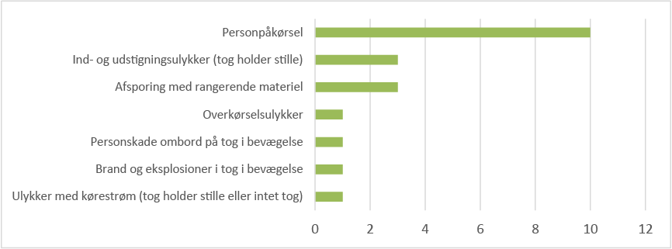
Note: Suicides are not included. Incident categories for which no incidents were reported in 2016 have not been included.
Personpåkørsel | Collisions involving people
Ind- og udstigningsulykker (tog holder stille) | Boarding and alighting accidents (train stationary)
Afsporing med rangerende materiel | Derailment involving slow-moving rolling stock
Overkørselsulykker | Accidents at level crossings
Personskade ombord på tog i bevægelse | Personal injury on board a train in motion
Brand og eksplosioner I tog i bevægelse | Fires and explosions on a train in motion
Ulykker med kørestrøm (tog holder stille eller intet tog) | Accidents involving traction current (train stationary or no train)
Source: Danish Transport, Construction and Housing Authority incident database

There was, however, a significant accident caused by fire in 2016. The fire occurred on 10 October in Odense. All passengers were evacuated from the train. Nobody was injured, but the material damage exceeded DKK 1.2 million.
There has also been a sharp increase in the category of other significant accidents (please see Figure 1.4). These incidents include three accidents involving the derailment of slow-moving rolling stock, three boarding and alighting accidents involving stationary trains, and one accident involving traction current (with a stationary or no train) (please see Figure 1.5).
Incidents involving dangerous goods
No accidents involving dangerous goods were reported in 2016.

Significant accidents involving persons
While 'significant accidents' is the term for accidents with major consequences, 'significant accidents involving people' designates accidents involving serious personal injury.
There is often incomplete information regarding the financial consequences of accidents, so information about significant accidents involving people is considered to be the best safety indicator.
Significant accidents involving people are the total number of people killed and the weighted number of people seriously injured (weighted 1/10) per million train kilometres on the railways over the year.

Figure 1.6: Significant accidents involving people 1999-2015 (people killed/injured per million train kilometres). The red line indicates the Danish safety target. Suicides are not included.
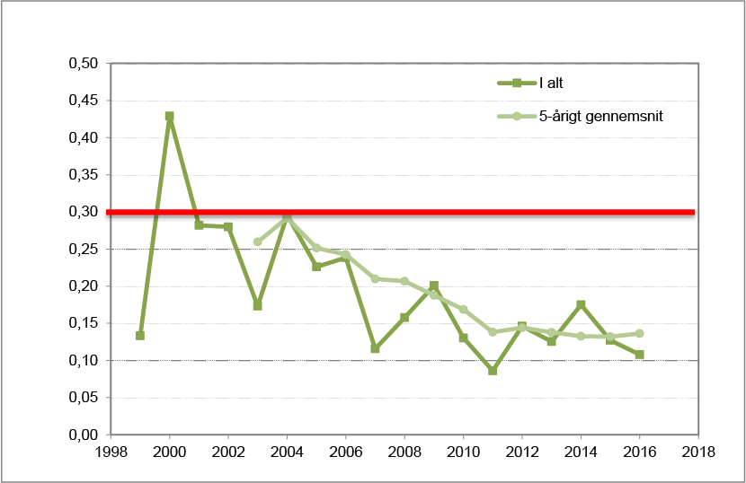
Note: Suicides are not included. Significant accidents involving people are the total number of people killed and the number of people seriously injured (weighted 1/10) per million train kilometres on the railways.
Source: Danish Transport, Construction and Housing Authority incident database
I alt | Total
5-årigt gennemsnit | 5-year average

The Danish safety target
Denmark’s target is to maintain the high level of safety (measured with 2004 as the reference year).
The Danish safety target is for the number of significant accidents involving people on the railways, calculated using the five-year average, to be under 0.3 per million train kilometres. The safety target is shown with a red line in Figure 1.6.
Compliance with the safety target is assessed on the basis of the number of significant accidents involving persons for all railway lines in Denmark.
Figure 1.6 shows that there were 0.14 significant accidents involving people per million train kilometres in 2012-16. This is slightly below the level of previous years and well below the Danish safety target.
The Danish safety target was thus met in 2016.
The Danish safety target is for the number of significant accidents involving people on the railways, calculated using the five-year average, to be under 0.3 per million train kilometres.
Denmark has met the safety target in 2016 and ranks favourably in relation to other European countries.
The EU’s safety target
The purpose of the European safety targets is to ensure a high level of safety for railways throughout the EU. The European Railway Agency publishes safety indicators and safety levels for EU Member States. The international comparison shows that Denmark is one of the European countries with the highest levels of railway safety.
Figure 1.7 on the next page shows the number of significant accidents involving people in the EU in 2011-15. The figure only contains data up to and including 2015, as the European figures will only be updated when the European countries have submitted their safety reports (this report) in September for the previous year.
As Figure 1.7 shows, the safety level for the Danish railway network for significant accidents involving people (excluding the metro and suburban railways) is 0.13 fatalities and weighted serious injuries per million train kilometres in 2011-15.
The European average for this reporting period is 0.29 significant accidents involving people per million train kilometres. This is more than twice as high as the average Danish level. Denmark is thus relatively low compared with the other European countries. Common safety targets for the whole EU were adopted in 2010 and revised in 2012. The safety targets are based on the first four years of data collected at Community level (2004-2009).

Figure 1.7: Significant accidents involving people in the EU 2011-15
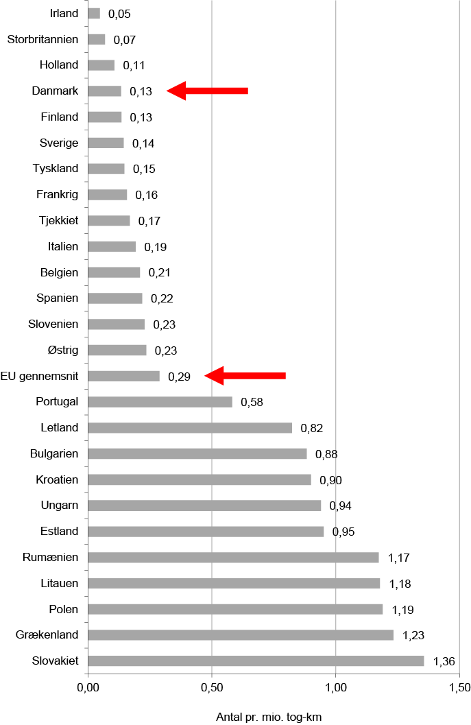
Note: The safety level is calculated as the number of deaths and serious injuries over a five-year period.
Source: The figures are based on calculations based on data from ERAIL (European Railway Accident Information Links), erail.era.europa.eu.
Irland | Ireland
Storbritannien | UK
Holland | Netherlands
Danmark | Denmark
Finland | Finland
Sverige | Sweden
Tyskland | Germany
Frankrig | France
Tjekkiet | Czech Republic
Italien | Italy
Belgien | Belgium
Spanien | Spain
Slovenien | Slovenia
Østrig | Austria
EU gennemsnit | EU average
Portugal | Portugal
Letland | Latvia
Bulgarien | Bulgaria
Kroatien | Croatia
Ungarn | Hungary
Estland | Estonia
Rumænien | Romania
Litauen | Lithuania
Polen | Poland
Grækenland | Greece
Slovakiet | Slovakia
Antal pr. mio. Tog-km | Number per million train kilometres

Deaths and serious injuries
In 2016, eight people were killed and ten were seriously injured on railways in Denmark.
Table 1.1 compares the number of deaths and serious injuries in 2015 and 2016 and shows both decreases and increases for the various categories during the last year.
The persons most vulnerable to railway accidents are trespassers. Table 1.1 shows that five of the eight people killed and three of the ten people seriously injured were trespassers on the railway.
Table 1.1: Number of fatalities and serious injuries in 2015 and 2016 broken down into categories of people
People killed | 2015 | 2016 | People seriously injured | 2015 | 2016
Passengers | 0 | 0 | Passengers | 2 | 4
Staff | 1 | 1 | Staff | 0 | 0
Level-crossing users | 1 | 1 | Level-crossing users | 0 | 0
Trespassers | 8 | 5 | Trespassers | 3 | 3
Other fatalities | 0 | 1 | Other serious injuries | 1 | 3
Total persons killed | 10 | 8 | Total serious injuries | 6 | 10
Note: Suicides are not included.
Source: Danish Transport, Construction and Housing Authority incident database

It is very rare for staff and passengers to be seriously injured in railway accidents in Denmark.
One employee of a railway undertaking was killed in 2016. The person in question died in an accident at Høje Taastrup during shunting operations.
From 2010 to 2016 inclusive, a total of two railway employees were killed. No employees were seriously injured in 2016.
Four passengers were seriously injured on four different occasions in 2016. One of them fell over on the train. The other three were injured in boarding and alighting accidents.
One level-crossing user was killed in 2016. The accident happened when a cyclist rode onto the level crossing despite the fact that the barrier was down. The cyclist was hit by the train and died.
Statistics from previous years show that many significant accidents involving people happen on level crossings.
In 2016, a foreign tourist died using a path across the tracks that did not have any warning equipment. The incident occurred at Kværndrup station on 23 May. This incident has been categorised as 'other fatalities' in the table above.
Figure 1.8 on the next page shows the number of people killed in railway accidents in the EU in 2014 and 2015. This shows that there is a relatively low number of deaths on Danish railways compared to other European countries. Please note that the figures in the table do not take account of the number of train kilometres in individual countries.

Figure 1.8: Number of fatalities in railway accidents in Europe in 2014 and 2015
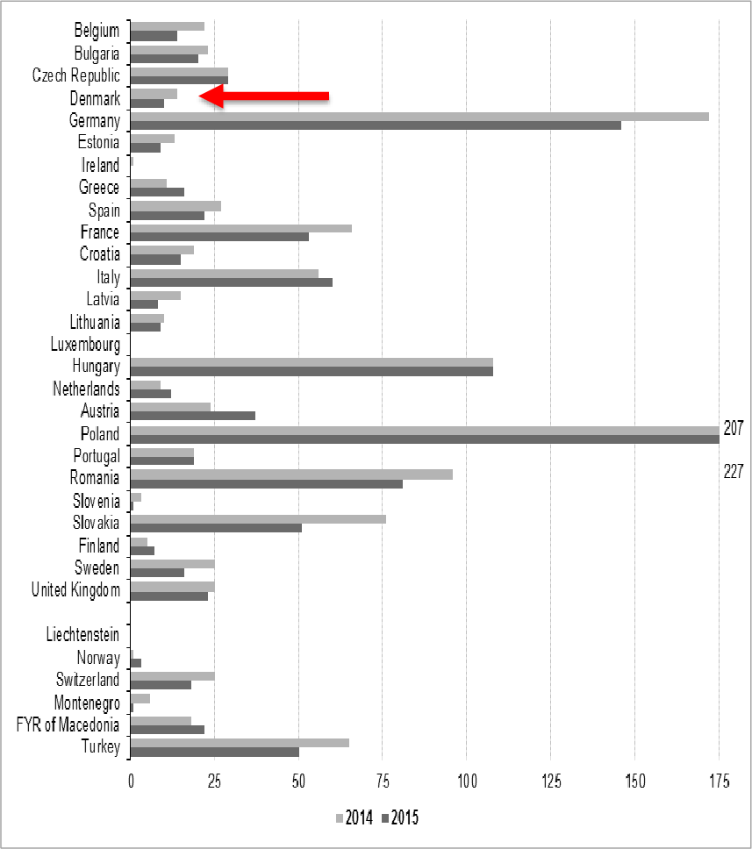
Source: http://ec.europa.eu/eurostat/statistics-explained/index.php/Railway_safety_statistics

Minor accidents
An accident is regarded as 'minor' if it has not resulted in death, serious injury, significant material damage or major delays.
Some 357 minor accidents were recorded in 2016. This is an increase of 35% compared to 2015, when 265 minor accidents were recorded. This number is slightly higher than the level in recent years, which has been approximately 300 minor accidents.
As has been mentioned above, the increase is probably due to the fact that some new categories of incident have been introduced and the undertakings have probably been better at reporting accidents.
Figure 1.9 compares the number of minor accidents per million train kilometres, broken down into the different types of accident for 2016, with the average for 2012-16.
The figure shows that there has been a sharp increase in the number of other minor accidents, a small increase in the number of fires, and a slight fall in the other types of accident, including collisions.
Figure 1.9: Minor accidents broken down according to accident type for 2016 and the five-year average for 2012-16 (number per million train kilometres).
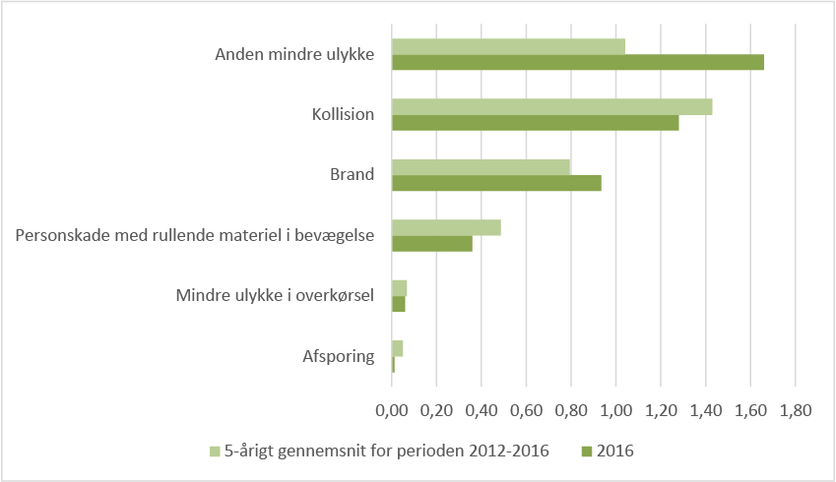
Note: Suicides are not included. The category of 'personal injuries involving rolling stock in motion' has been designated as 'collision with a person' in the safety reports for previous years.
Anden mindre ulykke | Other minor accidents
Kollision | Collision
Brand | Fire
Personskade med rullende materiel I bevægelse | Personal injuries involving rolling stock in motion
Mindre ulykke I overkørsel | Minor accidents at level crossings
Afsporing | Derailment
5-årigt gennemsnit for perioden 2012-2016 | Five-year average for 2012-16
Source: Danish Transport, Construction and Housing Authority incident database
Figure 1.10: Minor accidents in 2016 broken down according to incident category under the new Executive Order on reporting.
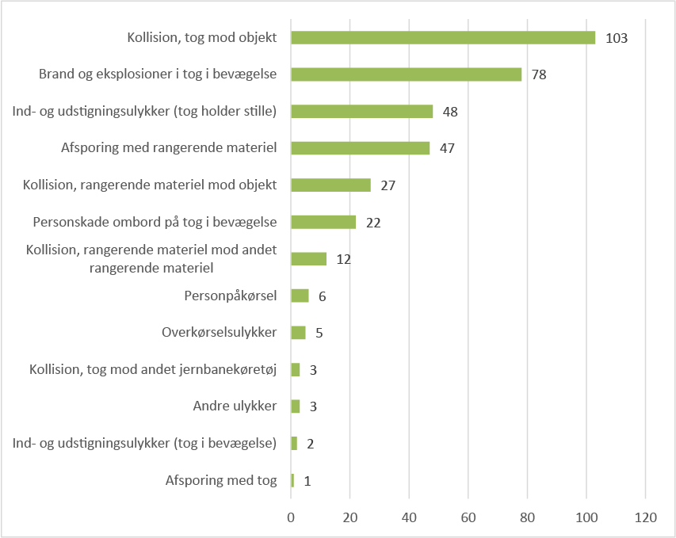
Note: Suicides are not included. Incident categories for which no incidents were reported in 2016 have not been included.
Kollision, tog mod objekt | Collision, train and object
Brand og eksplosioner I tog i bevægelse | Fires and explosions on a train in motion
Ind- og udstigningsulykker (tog holder stille) | Boarding and alighting accidents (train stationary)
Afsporing med rangerende materiel | Derailment involving slow-moving rolling stock
Kollision, rangerende materiel mod objekt | Collision, slow-moving rolling stock and object
Personskade ombord på tog i bevægelse | Personal injury on board a train in motion
Kollision, rangerende materiel mod andet rangerende materiel | Collision, slow-moving rolling stock and other slow-moving rolling stock
Personpåkørsel | Collisions involving people
Overkørselsulykker | Accidents at level crossings
Kollision, tog mod andet jernbanekøretøj | Collision, train and other railway vehicle
Andre ulykker | Other accidents
Ind- og udstigningsulykker (tog i bevægelse) | Boarding and alighting accidents (train in motion)
Afsporing med tog | Derailment of train
Source: Danish Transport, Construction and Housing Authority incident database

The 138 incidents involving other minor accidents in Figure 1.9 include the following types of incident in Figure 1.10:
- Boarding and alighting accidents (train stationary)
- Derailment involving slow-moving rolling stock
- Collision (slow-moving rolling stock and object)
- Collision (slow-moving rolling stock and other slow-moving rolling stock)
- Other minor accidents
Please also note that the 30 incidents of personal injuries involving rolling stock in motion in Figure 1.9 include the following types of incident in Figure 1.10:
- Personal injury on board a train in motion
- Collisions involving people
- Boarding and alighting accidents (train in motion)
Minor accidents are train accidents that may involve minor injuries or material damage of less than DKK 1.2 million.

Precursors to accidents
Precursors to accidents are events in the railways sector that have not resulted in an accident but which could have been significant for railway safety.
As has been mentioned above, the new Executive Order on reporting has grouped together the categories of precursors to accidents and safety irregularities under the heading of 'precursors to accidents', for the sake of transparency.
The new Executive Order on reporting has also further subdivided several categories of incident and/or given them a new name. Precursors to accidents are now divided up into a total of 19 types of incident. Please see Annex C for a list and description of the definitions used.
Some 3 625 precursors to accidents were reported in 2016. This is an increase of 336 in relation to 2015, equivalent to approximately 10%.
In 2016, there was a larger number of incidents of the risk of collision with a person type than the five-year average. Among other things, this increase can be explained by the fact that there were at least 50 incidents where people entered the Øresund tunnel.
There has also been an increase in the number of errors by station managers/traffic controllers and technical signalling faults in 2016 compared to 2012-16.
There were 280 incidents of signals passed at danger in 2016. This is lower than the five-year average.
In order to work in a more targeted way to limit the number of critical incidents where a signal is passed at danger, the new Executive Order on reporting has divided up the category of signals passed at danger into four categories (please see Figure 1.12).
Figure 1.11: Precursors to accidents broken down according to incident type for 2016 and the five-year average for 2012-16 (number per million train kilometres).
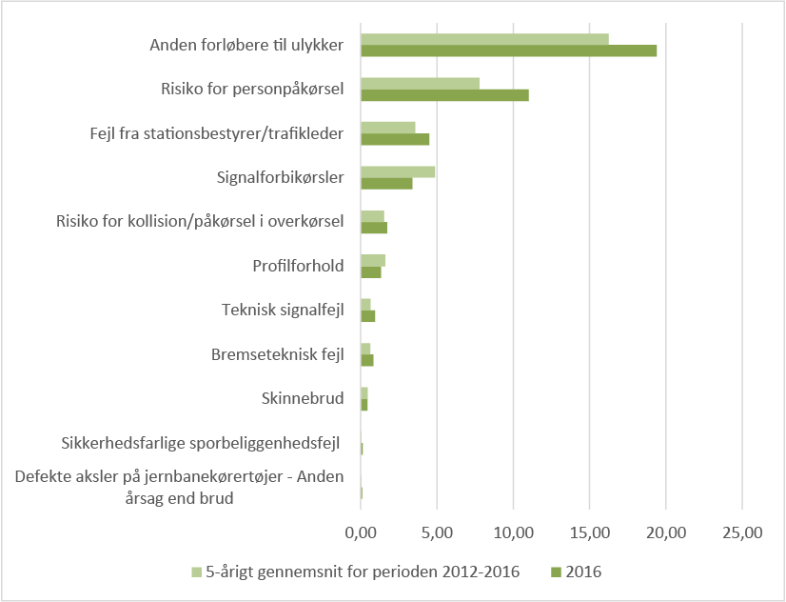
Note: Suicides are not included. This figure includes data and figures for precursors to accidents and safety irregularities in the safety reports for previous years. Where possible, the names of the categories have been changed so that they are comparable to the categories in the new Executive Order on reporting (please see Figure 1.12).
Anden forløbere til ulykker | Other precursors to accidents
Risiko for personpåkørsel | Risk of collision with person
Fejl fra stationsbestyrer/trafikleder | Error by station manager/traffic controller
Signalforbikørsler | Signals passed at danger
Risiko for kollision/påkørsel i overkørsel | Risk of collision/hitting someone at a level crossing
Profilforhold | Profiling
Teknisk signalfejl | Technical signalling fault
Bremseteknisk fejl | Braking-technology fault
Skinnebrud | Broken rails
Sikkerhedsfarlige sporbeliggenhedsfejl | Track-bed faults hazardous for safety
Defekte aksler på jernbanekørertøjer – Anden årsag end brud | Defective axles on railway vehicles – Reasons other than a break
5-årigt gennemsnit for perioden 2012-2016 | Five-year average for 2012-16
Source: Danish Transport, Construction and Housing Authority incident database

There has been a slight increase in the number of incidents of the risk of collision/hitting someone at a level crossing type in 2016 compared to the five-year average.
Figure 1.11 also shows an increase in the number of other precursors to accidents, equivalent to approximately 20%. This potentially reflects the total increase in the number of precursors reported in 2016 compared to previous years.
In 2016, there has also been a slight increase in the number of braking-technology faults, track-bed faults hazardous for safety and defective axles on railway vehicles (reasons other than a break) in comparison with previous years. On the other hand, there has been a slight fall in the number of profiling problems and broken rails.
Figure 1.12: Precursors to accidents in 2016 under the new Executive Order on reporting.
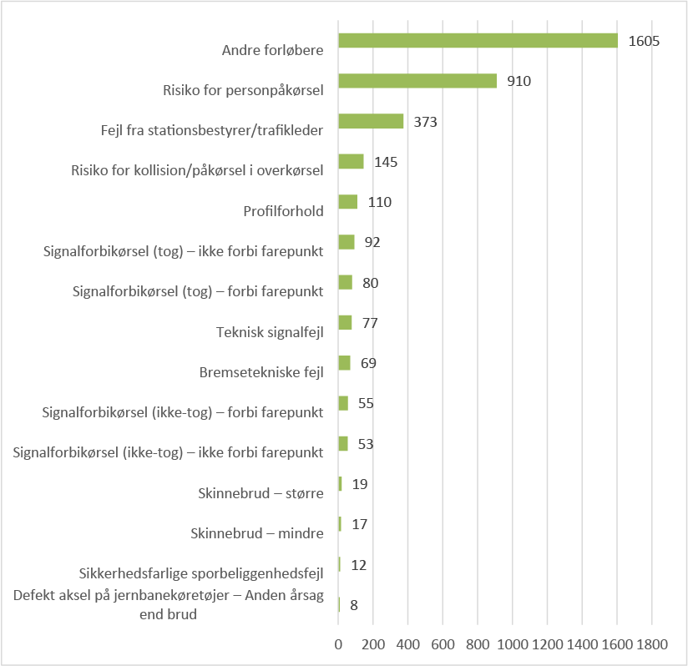
Note: Suicides are not included. Incident categories for which no incidents were reported in 2016 have not been included. For the categories relating to passing a signal at danger, 'train' is understood to mean a train movement with a train number (i.e. scheduled) on the through track and on an open line. 'No train' means moving slowly on or onto a through track with empty rolling stock that does not have a train number, and moving slowly in a secured shunting area (signals are controlled by a signal box).
Source: Danish Transport, Construction and Housing Authority incident database
Anden forløbere | Other precursors
Risiko for personpåkørsel | Risk of collision with person
Fejl fra stationsbestyrer/trafikleder | Error by station manager/traffic controller
Risiko for kollision/påkørsel i overkørsel | Risk of collision/hitting someone at a level crossing
Profilforhold | Profiling
Signalforbikørsler (tog) – ikke forbi farepunkt | Passing a signal at danger (train) – not passing a hazard
Signalforbikørsler (tog) – forbi farepunkt | Passing a signal at danger (train) – passing a hazard
Teknisk signalfejl | Technical signalling fault
Bremseteknisk fejl | Braking-technology fault
Signalforbikørsler (ikke-tog) – forbi farepunkt | Passing a signal at danger (no train) – passing a hazard
Signalforbikørsler (ikke-tog) – ikke forbi farepunkt | Passing a signal at danger (no train) – not passing a hazard
Skinnebrud – større | Broken rail – major
Skinnebrud - mindre | Broken rail – minor
Sikkerhedsfarlige sporbeliggenhedsfejl | Track-bed faults hazardous for safety
Defekte aksler på jernbanekørertøjer – Anden årsag end brud | Defective axles on railway vehicles – Reasons other than a break

Suicides on the railway – the lowest number for ten years
Suicide is not viewed as a railway accident in the traditional sense, because the causes of suicide are not directly related to the railway. The number of suicides and suicide attempts is therefore not included in the statistics on which the section above is based. Suicides on the railways should be considered and prevented on an equal basis with suicides in general.
It is, however, important to monitor the number of suicides on the railways and try to prevent them, because suicides and suicide attempts have serious consequences for the people involved and those near to them, for the train drivers and for any witnesses to the suicide; they also have a negative impact on timekeeping.
In 2016, there were 25 suicides on the railways in Denmark. This is the lowest level for ten years.
By way of comparison, in 2015 there were seven suicides in Norway, 48 in Finland and 86 in Sweden.
The number of suicides in the EU has been approximately 3 000 a year since 2010. This was also the case in 2015, when the number was 2 762. Of the EU Member States that have railways, the fewest suicides in 2015 were in Ireland, where there were two, and the most were in Germany, where there were 806.
Figure 1.10: Number of suicides on the railways in 1999-2016.
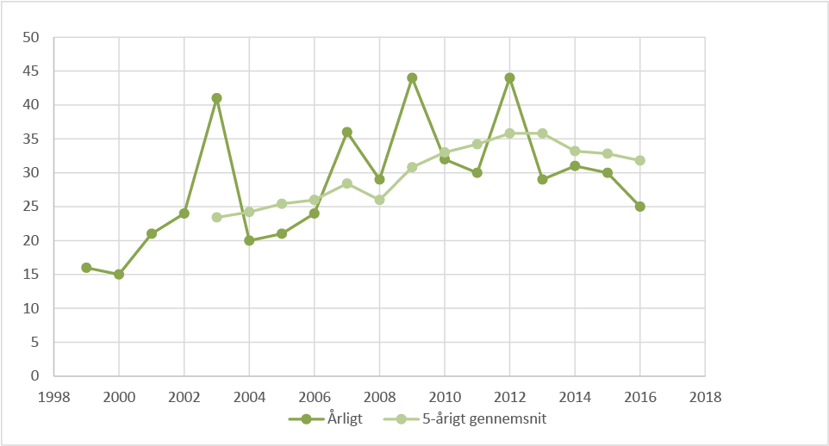
Note: The figure shows the number of suicides resulting in a fatality. Suicides are recorded on the basis of witness statements and police decisions.
Source: Danish Transport, Construction and Housing Authority incident database
Årligt | Annually
5-årigt gennemsnit | 5-year average

Chapter 2: Follow-up of recommendations from the Accident Investigation Board and other incidents
In 2016, the Accident Investigation Board published two statements and a report with recommendations for the Danish Transport, Construction and Housing Authority. The report was published at the start of the year and will be followed up in 2017. The Authority is of the view that all of the recommendations in the two statements have been complied with.

The Accident Investigation Board’s role and responsibilities
Through impartial investigations, the Accident Investigation Board (AIB) must make recommendations with a view to preventing damage, accidents and incidents and to improving railway safety.
Through its accident investigations, the AIB provides an independent assessment of the underlying causes of an accident, thus giving authorities and undertakings the opportunity to rectify any errors and discrepancies based on its suggestions (recommendations) for improvement.
As the recipient of a recommendation, the Authority must ensure that it is followed up. Any action takes place in cooperation with the relevant responsible actors.
The AIB and the Danish Transport, Construction and Housing Authority are in constant dialogue on accidents and incidents that require particular attention and follow-up and which may have an immediate impact on railway safety.
In 2016, the AIB published two statements and a report with recommendations for the Danish Transport, Construction and Housing Authority (please see Tables 2.1 and 2.2), the first two of which were followed up in 2016.
Table 2.1: Reports from the Accident Investigation Board that the Authority followed up on in 2016.
Date of report | Incident | Incident date
27 April 2016 | Passenger train collided with excavator at Herfølge | 28 April 2015
5 October 2016 | Middelfart station, passenger's foot became caught in train step | 22 October 2015

Table 2.2: Report from the Accident Investigation Board that the Authority will follow up in 2017
Date of report | Incident | Incident date
29 December 2016 | Passenger got wrist caught in doors and was dragged along by train at Vejle station | 23 February 2013

The Board’s recommendations and the Authority's follow-up on the two reports are reviewed below.
There were no other incidents in 2016 of such a kind that the Authority chose to follow up and explain them in the safety report.

Passenger train collided with excavator at Herfølge
The accident happened on 28 April 2015 at Herfølge. The train collided with an excavator that was crossing the tracks. The collision between the train and the excavator occurred because the train was signalled to run out onto the Køge-Herfølge section at the same time as a working party on the same section had permission to cross the track. The driver of one of the machines forming the working party sustained minor injuries. In addition to this, there was material damage to the excavator, train and infrastructure.
Recommendations by the AIB
The collision between the train and the excavator occurred because train 2475 was given permission (was signalled) to run out onto the Køge-Herfølge section at the same time as a working party on the same section had permission (brief track closure) to cross the track.
It is apparently possible for brief track closures to be established on sections of the line that do not have track isolation for detecting trains, without the possibility of location-specific cover, without prior agreement, and without clearly imposing requirements concerning the cover put in place by the station operator.
The Accident Investigation Board recommends that:
- The Danish Transport, Construction and Housing Authority ensure that Banedanmark clarify whether the requirements that apply to cover for closed tracks by the station operator (Section 73, paragraph 1.4 of the Railway Regulations) also apply to short-term track closures (Section 73, paragraph 1.8 of the Railway Regulations); and that
- The Transport, Construction and Housing Authority ensure that Banedanmark perform a risk assessment of whether short-term track closures should be permitted without prior agreement under Section 73 if, for example, sections with 1986 line blocks (signal blocks) cannot be given location-specific cover by means of a short-circuit loop.
The Accident Investigation Board’s report is available (in Danish) here.
Follow-up by the Danish Transport, Construction and Housing Authority
The Authority has, on its own initiative and based on a number of incidents indicating that mistakes had been made by the station operator, followed up on the way in which Banedanmark handled incidents and uncovered the reasons for these incidents. Follow-up on the recommendations made by the Accident Investigation Authority was therefore partly covered by the casework that has already been done. The Danish Transport, Construction and Housing Authority found that Banedanmark's procedures, methods and tools do not ensure to a high enough level that lessons are learned from incidents. This is still being followed up by monitoring Banedanmark's safety-management system.
On the basis of the two recommendations that have been made, Banedanmark has explained that the regulations do cover these situations, but that they were not followed in some individual cases.
Banedanmark nevertheless concludes that brief track closures may not be used without prior agreement, and that brief track closures are safe if the rules are followed.
The Authority regards the recommendations as having been complied with.

Middelfart station, passenger's foot became caught in train step
The accident occurred on 22 October 2015, when a passenger's foot became caught in the step by the external doors upon the train's departure. The passenger in question attempted to gain access to the train after the doors had closed, and after the visual check to ensure that there were no passengers or luggage caught in the external doors had been carried out. The person in question was dragged along by the train, since it started to move, and fell after the train had moved 8-10 metres. The passenger's foot came free of the step, but the passenger fell down between the train and the platform, and his foot was run over. The person in question was under the influence of alcohol.
Recommendations by the AIB
Since the technical systems and the safety instructions in force for ER-class multiple units do not cover situations where objects (less than 45 mm) become stuck in a step after the external doors are closed when a train starts, it should be assessed whether the current safety measures can be regarded as adequate.
The Accident Investigation Board recommends that the Danish Transport, Construction and Housing Authority ensure that it be assessed whether the current safety measures relating to driving with objects caught in an ER-class step or other similar step are adequate.
The AIB’s report is available (in Danish) here.
Follow-up by the Danish Transport, Construction and Housing Authority
The Danish Transport, Construction and Housing Authority has followed up with Danish State Railways (DSB) both the recommendations made by the Accident Investigation Board and other measures that DSB has taken on its own initiative.
- DSB has evaluated and revised the safety instructions and departure procedures for ER-class multiple units and has introduced some changes to the final checks for driver-only-operated trains so that once the doors have closed the driver must ensure that the doors are not obstructed before the train sets off.
The Danish Transport, Construction and Housing Authority considers the recommendation to have been complied with.
- DSB has investigated the options for further safeguarding the traction interlock for the closure of doors and steps, by means of its design. Since no cases of a step having caused a person to become caught have been recorded previously, DSB has decided not to change the design of the rolling stock.
On the basis of the investigation, the Authority is of the view that the current measures are adequate.
During 2016, DSB has carried out campaigns to raise customer awareness of the dangers associated with, for example, preventing the doors from closing or otherwise impeding departure. DSB has also, in collaboration with Banedanmark, launched an investigation into the options for additional preventative signs and painting of platforms.
Accident Investigation Board Denmark
The Accident Investigation Board Denmark is an independent safety investigation authority that investigates accidents and incidents in the Danish aviation and railway sectors.
The purpose of this is to prevent accidents by collecting and analysing information, drawing conclusions, including determining cause(s) and/or contributing factors, and preparing safety recommendations to improve safety.
The Accident Investigation Board does not attribute blame and responsibility.

Chapter 3: Safety certificates and safety authorisations
In 2016, 13 undertakings in Denmark had a valid safety certificate and/or valid safety authorisation. Two undertakings renewed their safety certificates during the year, and three undertakings had their safety certificates amended as a result of minor changes. There were no changes to safety authorisations in 2016.

Safety certification
All railway undertakings must have a safety certificate, parts A and B. In other words, this applies to all undertakings that are covered by Chapter 11 of the Railways Act and engage in traction on the railway infrastructure under their own responsibility.
Undertakings of this kind can be divided up into three main groups:
- Railway undertakings that carry goods, passengers and/or make tractive force available on the railways;
- Undertakings that engage in traction on the railways in connection with tasks carried out for railway undertakings or infrastructure managers;
- Undertakings that engage in traction on the railways in connection with installation and maintenance work carried out for an infrastructure manager.
The part A safety certificate includes general requirements for the undertaking, including requirements concerning the structure and implementation of a safety-management system. The undertaking must have a part A safety certificate in the country in which it has its main activities. It is valid throughout the EU for a maximum of five years.
Part B covers the specific infrastructure used by the undertaking in a given country. The undertaking must obtain a part B safety certificate for each country in which it wishes to carry out railway transport.
Safety certificates and safety authorisations
Safety certificates are issued to railway undertakings, and safety authorisations are issued to infrastructure managers.
A safety certificate is divided into part A and part B which cover a railway undertaking’s safety-related activities.
Before issuing part B, it must be established that the undertaking’s safety-management system meets all national requirements and conditions in relation to the infrastructure to be used.
All undertakings with a part A safety certificate in Denmark also receive a part B safety certificate for tractive operations in Denmark. The applications for part A and part B certificates are processed as part of the same case.
For undertakings with a part A safety certificate in another EU country, the application for a part B safety certificate is processed separately.
In Denmark, safety certificates are only issued to railway undertakings; please see group 1 above. Certificates are not issued to other undertakings, such as those in groups 2 and 3 above.
Table 3.1: Valid safety certificates as at 31 December 2016
Category | No.
Railway undertakings with safety certificates A and B | 9
Railway undertakings with safety certificate B in Denmark only | 2

Safety authorisations
A railway-infrastructure manager must always have a safety authorisation.
An undertaking may in fact install railway infrastructure without being an infrastructure manager. There must, however, be an approved infrastructure manager from the time when the infrastructure is made available for activities whereby a third party is involved in tractive operations on the infrastructure in question or could be affected by it. For example, this includes situations where the infrastructure is used with crossings for roads, paths, etc., or if tractive operations carrying passengers are involved, regardless of their scope.
A railway-infrastructure manager may engage in tractive operations as part of its safety authorisation in connection with installation and maintenance work on its own infrastructure. Such tractive operations may only be carried out on the manager's own infrastructure and only in connection with tasks relating to the installation or maintenance of that infrastructure. If these conditions are not fulfilled, the tractive operations must be carried out by an undertaking that holds a safety certificate.
It is a requirement for a safety authorisation that the infrastructure manager create and implement a safety-management system and demonstrate that it is able to control risks on the rail network.
The infrastructure manager is responsible for the coordination of the railway undertakings operating on its rail network.
Table 3.2: Valid safety authorisations as at 31 December 2016
Category | No.
Undertakings with safety authorisation | 7
There are five undertakings that have both part A and B safety certificates and a safety authorisation; in other words, they operate as both infrastructure managers and railway undertakings.

Enquiries to/from other countries concerning safety certificates
In 2016, Denmark did not receive any enquiries nor did it seek any information from other countries concerning part A certificates.
Denmark has, however, established a collaborative relationship with Sweden and Norway regarding work to monitor railway undertakings that also hold safety certificates in these countries. This collaborative relationship is described in more detail in chapter 4.

Changes to safety certificates and safety authorisations in 2016
Table 3.3 gives an overview of the changes that have been implemented in 2016.
To be specific, two railway undertakings had their safety certificates renewed when their existing safety certificates expired.
The Authority also issued three amended safety certificates in 2016. The amendments related to tractive operations on new infrastructure, the training of their own train drivers, and a change in name of a railway undertaking.
Table 3.3: Changes to safety certificates and authorisations in 2016
 | Number
New safety certificates/authorisations issued | 0
Renewals of safety certificates/authorisations | 2
Amendments to safety certificates/authorisations | 3
Expired safety certificates/authorisations | 0
Withdrawn safety certificates/authorisations | 0

The Authority's guidance of undertakings
The Authority emphasises guidance and dialogue with undertakings.
The Authority’s website includes guidelines on how to obtain a safety certificate and safety authorisation.
Here, undertakings can find forms with associated guidelines for applying for safety certificates and safety authorisations. The same form is used for new issues, renewals and amendments of safety certificates and authorisations respectively.
The Authority has also produced 'Safety-Management Guidelines', which can also be found on its website.
Preliminary meeting
When a new undertaking considers applying for a safety certificate or safety authorisation, the Authority offers to hold a preliminary meeting with that undertaking.
At the meeting, the undertaking is informed of the general requirements concerning documentation for the safety-management system and requirements for documentation for compliance with the other safety requirements.
It is also informed of the ensuing certification process, including the extent of monitoring.
When an undertaking has decided to apply for a safety certificate, it will also be offered an individual meeting.
Individual meeting on safety management
Since 2013, the Authority has offered undertakings individual meetings where the purpose and potential of the safety-management system are reviewed.
The purpose of these meetings is to balance expectations on the undertaking’s safety-management systems and also explain how a safety-management system is set up based on the undertaking’s specific activities and risk profile.
There will be a particular focus on the following areas:
- Structure/content of the safety-management system;
- Requirements for safety-management-system documentation;
- The undertaking's activities and risk profile;
- Safety targets;
- Monitoring and remedial measures, including internal audits and management evaluation.
Meetings with undertakings in 2016
A number of guidance meetings were held with undertakings in connection with new applications in 2016.
Meetings were also held with undertakings in the process of performing major reviews of their respective safety-management systems.
Complaints and rights of appeal
Undertakings cannot appeal against decisions made by the Danish Transport, Construction and Housing Authority to the Minister for Transport, Building and Housing or to any other administrative authority, but they may bring the case before the courts no later than eight weeks following receipt of a decision.
Undertakings may always ask the Danish Transport, Construction and Housing Authority to re-assess the case.
In 2016, the Authority did not receive any complaints from undertakings concerning safety certificates or safety authorisations.
In 2016, there were no major changes to the practices of the Danish Transport, Construction and Housing Authority concerning the issuing and supervision of safety certificates and safety authorisations.
Reporting to the police
There are a number of provisions in the Railways Act and in Executive Orders issued by the Danish Transport, Construction and Housing Authority that enable reporting to the police if some closely defined provisions are not complied with.
It does not often happen that the Danish Transport, Construction and Housing Authority feels compelled to apply these provisions, but it did happen in one case in 2016 where an undertaking used a number of vehicles without a valid certificate of release to service.

Chapter 4: Monitoring of railway safety
The low number of significant accidents in 2016 shows that Denmark has a high level of railway safety. The Danish Transport, Construction and Housing Authority is, however, of the opinion that several undertakings still face challenges in ensuring that they have adequate skills in place within their management systems.

The Danish Transport, Construction and Housing Authority as the supervisory authority
The Danish Transport, Construction and Housing Authority is the supervisory authority for the railways sector and thus supervises all railway undertakings and railway-infrastructure managers. There are a number of Executive Orders that place requirements on the undertakings within such areas as railway safety, preparedness, training and certificates of release to service.
Through its supervision of the undertakings, the Authority must ensure that they implement effective safety-management systems, and that the relevant safety requirements are being met.
The Authority usually employs dialogue-based supervision, where there is an opportunity to acquire experience from the undertakings, but where there is also an opportunity for providing guidance to the undertakings.
Supervision is planned on the basis of an annual assessment of the undertakings' circumstances and the impact on railway safety so that efforts are concentrated where the Authority deems there to be the most and greatest risks.

Supervision planning and prioritisation
Since 2010, the Authority’s annual planning of audits has been based on a comprehensive and systematic assessment of the undertakings' circumstances. The method is described in the Authority’s supervision strategy.
The assessments are based on a basic assessment of the nature of the undertaking, as well as the experience gained by the Authority with the undertakings over the previous year.
The number of audit days for the coming year is determined based on the overall assessment of the individual undertaking. The number of days may be increased when safety certificates and safety authorisations are renewed.
The Authority’s supervision schedule for the railways for 2016 was published on 29 January 2016.
The supervision schedule provides both an overview of the Authority's planned follow-up supervision during the validity of the safety certificates and safety authorisations respectively and the supervision that is to be carried out when safety certificates and safety authorisations respectively are renewed.
Changes to the supervision schedule
In 2016, a number of major changes were made to the supervision schedule.
The main reason for making the changes to the supervision schedule was that the undertakings' circumstances had changed. Among other things, the issuing of a new safety certificate and a safety authorisation was postponed until 2017.
In addition to this, two undertakings were subject to renewal-related supervision as a result of major reorganisations of their safety-management systems. These undertakings wanted to have the renewal-related supervision postponed until 2017, which the Authority accepted.
A number of instances of planned follow-up supervision were postponed until later in the year or until 2017 due to either internal changes at the undertakings in question or re-allocation of resources at the Danish Transport, Construction and Housing Authority.
In addition to this, some individual instances of supervision were allocated several days' of supervision, because the Authority has taken the view that there were more factors that needed to be followed up than had originally been planned.

General supervision results in 2016
The Authority is still of the view that, on the whole, the undertakings have challenges in exploiting the full potential of their management systems. Common problems are that the safety-management system often fails to cover the undertaking's activities fully, is not constantly updated, or is not implemented adequately. In addition to this, there are often deficient procedures for document management, the forms and diagrams used, etc.
Furthermore, it is often found in connection with supervision that the undertakings have difficulties with performing a root-cause analysis to uncover the underlying problem. In connection with the handling of incidents, for example, the feeling is that the analysis concludes that the train driver acted wrongly or was not paying attention, for instance. However, the investigation does not explain why he or she acted wrongly or was not paying attention in the situation in question. Nevertheless, some undertakings worked on implementing specific methods for root-cause analysis in 2016.
Similarly, the feeling is still that many undertakings have not followed up on remedial measures and ensure that they are implemented in full before the case is closed. Likewise, some undertakings also do not follow up (to a sufficient extent) whether the remedial measures have the intended effect.
In 2016, more than 50% of undertakings were found to have problems with fulfilling the skills-management requirements. Some of the undertakings have difficulties with setting skills requirements that actually relate to the safety-related work that is done. Among other things, there have been cases of skills requirements being set in relation to what the employee in question can already do and not what is actually required for the post. There have also been several examples of skills assessments not being carried out. Some of the undertakings have not been able to document the skills that their employees have achieved or that they have been assessed comprehensively.
With regard to internal audit, some undertakings are still not setting skills requirements for the employees responsible for the undertaking's internal audits. This is reflected in the fact that some undertakings do not have internal audits performed on their entire safety-management system or do not examine and follow up on whether remedial measures have been implemented effectively.
In 2016, failings and comments were recorded at approximately 35% of the undertakings with regard to:
- Failure to set safety targets that actually impose requirements for improvements to safety. Similarly, in many cases the undertakings fail to produce specific action plans addressing how the undertaking in question will achieve the target and criteria for determining when the target has been achieved;
- Failure to implement legal requirements. The undertakings have been better at identifying new legislation, but in many cases it has been found that the legislation has not been implemented properly at the undertaking in question. This is especially true of legislation relating to the management of train drivers' skills, locomotive certificates, and certificate records;
- Documentation of management evaluations has been found to be deficient in many cases. For example, the original input cannot be found or decisions made during the management evaluation cannot be documented. Likewise, some undertakings are still focusing on the processing of individual cases instead of assessing safety and the effectiveness of the safety-management system on the whole;
- In many cases, safety rules are sent for approval very late and/or are of poor quality. Some individual undertakings have also been unaware that certain kinds of safety rule must be approved by the Authority.
The Authority has found that the work being done on the undertakings' risk profiles has been strengthened.
Most undertakings are finishing the creation of their risk profiles and are working to make this the starting point and crux of their safety-management systems.
The Authority is of the view that adequate, relevant requirements for the safety manager are not being set within the management systems, but that this has only been singled out on the basis of experience of railways and railway safety. In this context, the Authority would like to draw attention to the fact that skills in management systems and skills in railway safety are not the same thing, and that direct requirements are imposed on the safety manager regarding knowledge of management systems.

Supervisory results and focus areas in 2016
Focus areas are topics that will be supervised at all undertakings during the year. These areas are selected on the basis of supervision in previous years. There are some areas where the Authority has found that several undertakings are having difficulty dealing with and implementing the requirements in force.
The following topics have been chosen as focus areas, based on the evaluation of the previous year's monitoring. They have also been communicated in the Authority's supervision schedule for 2016:
- The undertakings' change management;
- The undertakings' overall management processes.
The undertakings' change management
The supervision carried out by the Danish Transport, Construction and Housing Authority on change management by the undertakings is done in different contexts and takes different forms: inspections at the undertaking in question, desk inspections, and inspections resulting from the processing of applications.
The undertakings' change management processes are audited during inspections on their premises. All undertakings, bar three small ones, had their change management processes audited in 2016.
During inspections at the undertakings, the Danish Transport, Construction and Housing Authority found some examples of undertakings not having been completely precise and comprehensive in their definitions of the circumstances that are to be regarded and dealt with as changes. This often causes a discussion on the subject of 'changes', which is well received by the undertakings.
On the whole, the conclusions from inspections at the undertakings are entirely consistent with what the undertakings state in their safety reports concerning their experiences with CSM-RA (please see the section on 'The undertakings' experiences' in chapter 5). The conclusions are that experience of change management is gradually being reinforced, and that there is some upskilling of employees who are responsible for implementing changes.
The Danish Transport, Construction and Housing Authority is closely monitoring the change management of three undertakings. This is being done in the form of desk inspections of the undertakings' change planning and impact assessments; please see CSM-RA.
A large part of the experience that the Danish Transport, Construction and Housing Authority has gained from the undertakings' change management stems from the work done to approve the undertakings' applications for changes to infrastructure and vehicles. This experience is described in the sections on experience of CSM-RA in the areas of infrastructure and vehicles (please see chapter 5).
The undertakings' management of transportation of dangerous goods
The Authority has supervised goods operators' transportation of dangerous goods for a number of years. Accordingly, supervision relating to dangerous goods was carried out again in 2016. Physical checks were carried out to ascertain whether the wagon composition and signage were in accordance with the transport documents. Interviews were also conducted with train drivers from the relevant goods operators, and the drivers' certificates and licences, among other things, were checked as part of this.
On the basis of this supervision, the Authority is of the view that the difficulties encountered by the operators in previous years in relation to deficient locomotive certificates have generally been overcome. No new problem areas were identified in 2016.

Maturity assessment of the undertakings
Since 2013, the Authority has performed maturity assessments of railway undertakings and infrastructure managers in connection with inspection visits.
The maturity assessment evaluates the ability of the undertakings to deal with the risks associated with their activities by means of their safety-management system.
In 2016, the maturity assessment included an evaluation of all undertakings holding a part A certificate as a railway undertaking and/or a safety authorisation as an infrastructure manager. Undertakings that only have a part B safety certificate in Denmark are not included in the assessment (please see chapter 3 for more information on safety certificates and authorisations).

The maturity assessment model
In 2012 and 2013, the Authority devised and developed a method that aimed to measure the impact of the Authority's supervision. The starting point for this method is the fact that an undertaking’s ability to manage its own risks can be assessed by supervising compliance with regulations and through learning in the undertaking.
Based on this, the Authority has identified six key areas (indicators) in undertakings’ safety-management systems:
- Targets and action plans;
- Implementation of legal requirements;
- Recording of incidents;
- Management of remedial and preventive actions;
- Internal audits;
- Management evaluation.
For each area, the Authority has formulated five levels of maturity (levels 1 to 5), on the basis of which the undertakings are assessed. The lowest level (1) means the undertaking has not implemented safety management. However, for point 2, Implementation of legal requirements, the scale is 1-4.
The middle level (3) means the undertaking has implemented safety management that just meets the Authority’s requirements. A score of at least 3 is therefore the desired level.
The highest level (5) means that through its safety-management system, the undertaking is proactively improving safety throughout the organisation.
Through annual supervision, the Authority has thus assessed trends in undertakings' ability to manage their own risks since 2013, when the method was used for the first time. The assessment also indicates whether or not the Authority’s monitoring activities work and provides undertakings with information on their own development in relation to the industry.

Figure 4.1: Maturity assessment 2016 (all undertakings combined)
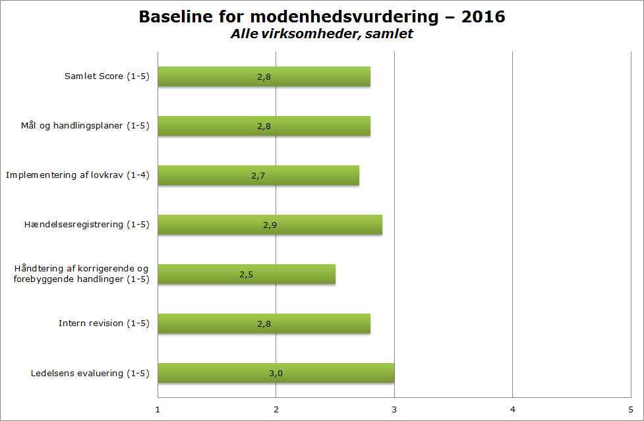
Baseline for modenhedsvurdering - 2016 | Baseline for maturity assessment - 2016
Alle virksomheder, samlet | All undertakings combined
Samlet Score (1-5) | Total Score (1-5)
Mål og handlingsplaner (1-5) | Targets and action plans (1-5)
Implementering af lovkrav (1-4) | Implementation of legal requirements (1-4)
Hændelsesregistrering (1-5) | Recording of incidents (1-5)
Håandtering af korrigerende og forebyggende handlinger (1-5) | Management of remedial and preventive actions (1-5)
Intern revision (1-5) | Internal audits (1-5)
Ledelsens evaluering (1-5) | Management evaluation (1-5)

Figure 4.1 shows the total scores for all of the undertakings included, where each undertaking is included only once, even if it is both a railway undertaking and an infrastructure manager. The scores include data for nine undertakings.
As has been mentioned above, maturity of level 3 means that the undertaking has implemented safety management that just meets the Authority's requirements. A score of at least 3 is therefore desirable.
As may be seen from Figure 4.1, the total maturity of the undertakings is not considered to be at the desired level, with the exception of a single area where level 3 was reached.
This is consistent with the general inspection results described earlier in this section.
Areas for follow-up
The results of the latest maturity assessment will still be used to follow up on those areas that generally present a challenge and the undertakings with a below-average result.
The maturity assessment for 2016 shows that four areas are 0.2 points or more below 3. This relates to:
- Targets and action plans;
- Implementation of legal requirements;
- Management of remedial and preventive actions;
- Internal audits.
The area of 'internal audits' has improved. There has been a sharp focus on implementing legal requirements, and several of the undertakings have activities in progress with the aim of improving this effort.
The Authority is of the view that 'targets and action plans' and 'management of remedial and preventive actions' are the areas where the undertakings currently face the greatest challenges. These topics have therefore been selected as focus areas for supervision in 2017.

Remedial measures implemented by the undertakings
The most significant remedial measures in 2016 are:
- Many of the undertakings are finishing their risk profiles and seeking to integrate them into their safety-management systems.
- A number of undertakings have developed, documented and implemented specific methods for root-cause analysis.
- A number of undertakings are still working on a root-and-branch review of their safety-management systems. Several of them have almost started from scratch with a new IT platform and a new way of describing the system.
- Finally, several undertakings have ensured that skills are enhanced in that their safety managers have taken courses as certified lead auditors.
On the whole, the undertakings have started to take a more targeted approach to working with a skills-management system that can help to comply with the requirements laid down in the Executive Order.

The Authority's use of resources for supervision
Time spent on supervision in 2016
In 2016, the Authority performed 158 audit days, relating to undertakings' safety-management systems in connection with safety certification and safety authorisation and their follow-up. By way of comparison, 127 audit days were performed in 2015 and 191 in 2014.
Table 4.1 shows the hours spent on supervision by the Authority. The number of hours shows the trend from 2013 to 2016 and it includes both time spent on audits and time spent on inspections. The table shows that the scope of supervision is generally on the rise, although 2014 was slightly unusual.
In 2014, an extraordinarily large amount of supervision was carried out when an infrastructure manager renewed its safety authorisation. Similarly, a large amount of supervision was carried out in 2016 when a large railway undertaking renewed its safety certificate.

Table 4.1: Time spent on supervision 2013-16 (in hours)
 | 2013 | 2014 | 2015 | 2016
System supervision (follow-up)* | 968 | 1683 | 3818 | 5435
Inspection | 1387 | 1381 | 743 | 1128
Certification/approval* | 1846 | 3982 | 1006 | **
Total hours spent | 4201 | 7046 | 5567 | 6563
Note: *In 2013-14, 'Certification/authorisation' includes both renewals and amendments. The method was changed in 2015, with renewals now being counted under 'System supervision'. This is because the undertakings are no longer charged a fee for renewals.
**In 2016, this figure has not been listed separately but comes under 'System supervision'.

In 2016, subject specialists were used for 25 % of system supervisions. This is equivalent to the 2015 level. In comparison, subject specialists were used for around 30% of system supervisions in 2014. The reason for this is that subject specialists were used to a particularly high degree in connection with the renewal supervision carried out for a major infrastructure manager.
Subject specialists were used for 37% of inspections. This is a fall in comparison with previous years, where they were used for approximately 50% of the inspections that were carried out. The proportion of subject specialists is still higher for inspections than for system supervisions.
The reason is that inspections are often a more in-depth evaluation of a particular area and are often of a more technical or railway-based nature.
The Authority expects that the scope of supervision will increase over the coming years as the number of stakeholders increases. A large part of this increase is expected to be due to Banedanmark's requirement for contractors to hold their own safety certificate in order to run under their own tractive force when carrying out work for Banedanmark.
Skills management
No changes were made to the Authority’s skills-management methods in 2016.
Staffing
As a rule, the Authority's supervision of the undertakings is carried out by two people with a background in auditing. One acts as lead auditor and the other as assistant auditor.
Where relevant, specialists in railway matters take part in implementing the supervision.
Supervision is therefore always carried out by at least two people from the Authority.
Lead auditor and assistant auditor
Lead auditor: The lead auditor is responsible for the preparation, implementation and follow-up of the supervision and is the Authority’s contact person for the undertaking. The lead auditor leads the individual supervision visit and decides on the composition of the supervision team to guarantee the necessary competencies in the team. The lead auditor administers and reviews the necessary documentation and ensures that the objective of the supervision is achieved.
Assistant auditor: It is the assistant auditor’s role to assist the lead auditor in all aspects of supervision. The assistant auditor helps administer and review documentation and assists with notes and supplementary questions.
Skills requirements
The Authority requires employees who are involved in supervisory activities to have been trained to perform the task. Employees' skills are assessed annually.
Employees who perform the role of lead auditor must have in-depth knowledge of and experience with management systems and have passed the examination at the end of an approved training course as a Certified Lead Auditor.
The Authority has also prepared a skills profile designed to ensure that lead auditors have sufficient knowledge of the railways as well as legal knowledge within the following areas:
- Movement on and near the railways;
- Standards and safety regulations;
- Basic infrastructure knowledge;
- Risk assessment;
- Administrative law and legislation.

Cooperation with other countries' authorities in relation to supervisory activities
Denmark has not concluded any formal written agreements with national safety authorities in other countries in 2016 concerning supervisory activities in the railways sector.
The Authority continuously exchanges experiences with the authorities in Sweden and Norway, and they provide each other with information about any problems with joint railway undertakings.
There were no supervisory activities with the other Nordic countries in 2016.
Annual Nordic supervisory meeting
Denmark holds an annual meeting with the supervisory authorities in Sweden and Norway. Information and knowledge are exchanged about current topics concerning railway undertakings and new legislation, for example.
The Nordic meeting in 2016 discussed the question of which undertakings needed collaborative supervision.
In addition to this, general problems and questions were exchanged, including:
- New forms of certification and skills requirements for safety managers;
- Experience of cross audit, which both Denmark and Norway had in 2015;
- Certification and supervision methods, and how these countries can best collaborate on supervision considering the points of intersection between the part A certificate and part B certificates issued in the other countries.
On the basis of the discussions concerning part A and part B certificates, it was established that, where an undertaking applies for a part B certificate in a given country, the authority in that country must contact the country in which the part A certificate was issued in order to start working together.
Similarly, the authority in the country in which the part B certificate is issued must report any deficiencies to the country in which the part A certificate was issued, since any deficiencies with regard to part B are symptomatic of deficiencies in the safety-management system and thus part A.
Cross audits
Cross audits are the (voluntary) supervision undertaken by ERA to ensure that the national safety authorities’ supervision of undertakings is in conformity with the CSM Supervision Regulation (Regulation No 1077/2012).

Chapter 5: Experiences with the Risk Assessment Regulation (CSM-RA)
The Danish Transport, Construction and Housing Authority, together with the rest of the railway industry, had a sharp focus on CSM-RA in 2016.

General information about the Authority's work on CSM-RA in 2016
In 2016, the Danish Transport, Construction and Housing Authority used a number of initiatives to follow up on the work done on CSM-RA in 2015. Among other things, these initiatives have been based on the Authority's assessor survey in 2015.
As part of this work, a workshop for the whole industry was held in 2016 concerning the challenges that the industry was experiencing with regard to the use of CSM-RA. The workshop and all the experience gleaned from it have resulted in an action plan for further work on CSM-RA.
The Authority has seen great interest from the industry in CSM-RA initiatives in 2016.
CSM-RA cafés
The Authority held CSM-RA cafés in 2016, in accordance with the targets and planned results, and the railway industry had the opportunity to attend.
The café initiative was launched as the result of a desire to reinforce the general understanding of CSM-RA and to create a forum where industry stakeholders can discuss challenges and opportunities for best practice in the sector without going into the detail of specific cases.
Four cafés were held in 2016, discussing the topics of identifying hazards and of CSM assessors' scope of work in relation to the undertakings' safety-management systems. The cafés were very well attended, with the railway industry widely represented. Participants expressed general satisfaction with the outcomes from these cafés.

Risk management
The aim of risk management is to prevent accidents and minor safety incidents from occurring in the future. When undertakings implement changes that can affect safety, they must first decide whether the change is significant. You can find more information about significance assessment and risk assessment on the Authority's website.
If the change appears to be significant, the undertakings must follow the risk-management process described in the common European method for risk assessment, CSM-RA. You can find more information about CSM-RA in the ERA’s guidelines.

CSM-RA and testing
Up until now, there have not been any provisions about tests on infrastructure. In 2016, therefore, the Authority issued an Executive Order amending the Executive Order on infrastructure with regard to tests on existing infrastructure.
The Executive Order lays down that, if an undertaking wishes to test subsystems such that the subsystems in question are used outside the terms of their valid certificate of release to service, it must be assessed prior to commencement of the tests in question whether the tests involve a significant change to the railway system according to CSM-RA or the Annexes to the Executive Order on infrastructure.
If a test involves a significant change to the railway system, the railway-infrastructure manager must use an assessor and apply to the Danish Transport, Construction and Housing Authority for permission to conduct the test in question.
New guidance on the approval of software
In spring 2016, the Danish Transport, Construction and Housing Authority published guidance on the approval of software systems on the railways, on the basis of the increasing use of software-based systems on the railways, especially the new signalling systems on the long-distance (fjernbane) and suburban (S-bane) railways.
Among other things, the guidance describes how the system definition must be designed in the event of software modifications and how the significance assessment can be performed. The Authority is of the view that the guidance has been well received by the industry, and the Authority can state that applications are increasingly referring to the guidance.

Experiences in the area of infrastructure
CSM-RA has been used for a number of years. In Denmark, the use of CSM-RA is linked to the application procedure for the issuing of certificates of release to service. Discussions are ongoing concerning the challenges in using CSM-RA during the application process, and it has been described a few times as being very costly.
On the whole, the application materials that the Authority receives are satisfactory, but there is a relatively large amount of variation from one case to another, depending among other things on the complexity of the project in question.
The Authority is of the view that there is a lack of CSM-RA skills in the industry, both in terms of having a core group of people with detailed knowledge of the use of CSM-RA and in terms of the general, basic knowledge of the principles applied in the CSM-RA and acceptance of those principles.
This lack of skills manifests itself in the organisation, execution and documentation of projects, in collaboration between the applicant and the assessor, and in the authorisation process.
The Authority is, however, of the view that challenges said to be CSM-RA challenges can also often be due to other factors, such as time pressure, resource pressure, communication challenges, and the complexity of installation projects.
In 2016, the Authority has had a focus on gathering knowledge, resolving differences of opinion, and providing guidance, with the aim of facilitating fact-based, forward-looking dialogue concerning how skills can be enhanced in the area of CSM-RA so as to reduce the challenges involved in using this method.
As part of this work, the Authority has identified a number of specific, key problems that could be addressed in a better way. The Authority is continuing to work on this.
Significance assessments
Since 2014, infrastructure managers have not had to send their significance assessments to the Authority unless it is explicitly stated in the terms of their safety authorisation.
The Authority monitors significance assessments. This monitoring covers a representative cross-section of cases, and can have a specific, thematic focus from time to time.
The aim of this monitoring is to ensure that assessments are performed properly and to maintain dialogue concerning how significance assessments are to be designed.
Small infrastructure managers are visited, among other things to provide an opportunity to give them guidance on significance assessments.
Visits to infrastructure managers
The Authority visited the small infrastructure managers in Denmark in 2016. The aim was to hold dialogue with them concerning their use of CSM-RA and TSIs in connection with changes to the railway infrastructure. The starting point for these visits was the current situation and specific challenges faced by each infrastructure manager individually.
The Authority is of the view that these visits have been positive for all parties. Both specific and general problems have been discussed.

Experiences in the area of vehicles
Several railway undertakings have a condition in their safety certificates to the effect that they must submit all changes to the Authority and not only significant changes.
There is still great variation in the quality of the preliminary system definitions submitted to the Authority. The Authority is of the view that the quality very much depends on the person who designed the preliminary system definition, despite the fact that the undertakings have designed templates and procedures to ensure both a consistent approach and better quality.
The main problem for the undertakings is to design system definitions so that they can actually be used for the right purpose in relation to CSM-RA, in other words to identify hazards and risk aspects.
Similarly, the undertakings' significance assessments have varied considerably in quality. Here again, the quality depends on the person who has designed them. In particular, expert assessments still clearly appear to have been developed by individuals at the undertakings and not by an expert assessment team. Furthermore, several undertakings are still having problems with designing significance assessments due to a lack of understanding of how the six assessment criteria are applied. The main challenge here is that only pre-existing barriers may be taken into consideration.
Some undertakings also feel that the significance criteria come 'too late' in the process, usually after the change in question is ready for implementation.
This contradicts the change management process, which requires an assessment of whether or not the change in question is significant before the change is set in motion. The undertakings therefore do not always apply the significance criteria as intended.
Based on the above, the Danish Transport, Construction and Housing Authority has maintained the requirement that all changes must be submitted to it in respect of those undertakings that were already covered by the requirement.
During 2016, the Danish Transport, Construction and Housing Authority has tried to give more detailed feedback on the undertakings’ significance assessments. This feedback includes general comments on the material submitted and any instances of non-compliance with the principles of the CSM-RA Regulation.
The Authority will continue this detailed feedback in 2017.

Experiences from the undertakings
In 2016, there were a total of 13 railway undertakings and infrastructure managers that had activities in Denmark, and all of them submitted a safety report to the Danish Transport, Construction and Housing Authority. All 13 undertakings made changes during the year that were significant in terms of railway safety, and they wrote about their experience of using the CSM-RA methods in their 2016 safety reports.
The vast majority of the undertakings reported that they were in a positive learning process whereby the use of the CSM-RA methods is being implemented in their organisations and they are gaining good experience in the use of these methods. The undertakings have also stated that they have a sharp focus on implementing solid CSM-RA processes for change management, and on using them properly.
Four of the undertakings reported that they have worked on reinforcing processes relating to changes and CSM-RA in their safety-management systems in 2016. One undertaking has produced a strategy for work on CSM risk management, and it will implement it in 2017 by updating processes and tools, among other things.
Four undertakings reported that work on CSM-RA is resulting in greater collaboration among departments within the undertakings in question, primarily between the safety department and various departments that have the task of implementation. One undertaking reported that it holds 'homework cafés' where internal 'safety experts' are available to provide guidance in relation to risk assessments.
The information contained in the safety reports is characterised by the fact that the undertakings are generally working to reinforce skills in CSM-RA. Five undertakings, including the largest undertakings in the industry, have implemented training activities, including in the form of courses run by external parties. The undertakings will continue their work on skills development in 2017.
According to their safety reports, five undertakings have had fewer than five changes in 2016. One undertaking stated that the CSM-RA process was not used at all in 2016.
Naturally enough, there have only been a limited number of changes for small undertakings in the industry. This means that the small undertakings have not had particularly great opportunities for reinforcing their skills through practical experience of using the CSM-RA methods.
Only one undertaking used external skills to perform significance assessments in 2016. The Authority regards this as an expression of the fact that many undertakings now consider their internal skills for performing significance assessments to be sufficient for ensuring that the risks associated with changes are managed in an acceptable way.
In the context of its supervision, the Danish Transport, Construction and Housing Authority has found that three undertakings still lack internal skills to such an extent that they must notify the Authority of various aspects of their change management. This extended supervision of the undertakings' change management can stop once the undertakings have implemented a number of changes in accordance with their own process and have thus demonstrated that they have the skills to ensure adequate risk management.
On the whole, the information contained in the undertakings' safety reports from 2016 gives the impression that their use of CSM-RA has increased. The experience that has been gained and the comprehensive training activities that are being carried out are supporting the undertakings' work to reinforce their skills in the use of the CSM-RA methods.

Chapter 6: Implementation of the Railway Safety Directive
The Railway Safety Directive is the European legislation that provides a framework for the harmonisation of safety regulations in Europe. The Danish Transport, Construction and Housing Authority has continued its work on implementing the Railway Safety Directive in 2016. This chapter reviews the rules issued by the Authority in 2016 as part of its implementation of the Railway Safety Directive.

Harmonisation of regulations
The purpose of the Railway Safety Directive is to ensure the development and improvement of safety on the EU’s railways and improved access to the market. The Directive provides a framework for the harmonisation of national safety regulations, safety certificates for railway undertakings, tasks and roles for the national safety authority and the national investigation authority. The purpose of harmonising these regulations is to alleviate the administrative burden for undertakings and make it easier and cheaper to travel across Europe by train.

The Danish Transport, Construction and Housing Authority has issued the following rules in 2016 as part of its implementation of the Railway Safety Directive:
Legal acts supplementing the implementation of the Railway Safety Directive:
- Executive Order No 147 of 30 January 2017 on safety authorisations and safety certificates in the railways sector.
National safety rules:
- Executive Order No 771 of 22 June 2016 amending the Executive Order on the certification of train drivers;
- Executive Order No 1378 of 22 November 2016 on the certification of train drivers;
- Executive Order No 1359 of 22 November 2016 on health and skills requirements for certain safety-classified functions in the railways sector.
New rules aimed at railway undertakings:
- Executive Order No 1465 of 5 December 2016 on the technical compatibility of vehicles with the railway network;
- Executive Order No 1498 of 2 December 2016 on fees and charges levied by the Danish Transport, Construction and Housing Authority in the railways sector.

The Executive Order on safety authorisations and safety certificates in the railways sector
This Executive Order was issued in 2017, but because most of the work done on it was carried out in 2016 the rules are already mentioned in this safety report.
This Executive Order updates and simplifies the regulatory structure for safety authorisations and safety certificates in the railways sector so that the rules are easier to understand and thus easier to comply with. At the same time, the current practices concerning safety-management systems, which are widely followed by the undertakings, have been written into the rules.
Among other things, the new Executive Order clarifies the requirements for:
- Risk-based safety management;
- Document management;
- Management of all kinds of irregularities, including analysis and remedial measures;
- Contract management;
- Monitoring, evaluation and improvement.

The new Executive Order is more consistent with the practices that have developed in recent years, not only in the railways sector but also in relation to all safety-management systems. The new rules therefore reflect to a great extent the understanding of safety management that certified undertakings now have. The new rules are also more transparent for new undertakings that have to establish a safety-management system.
To date, the rules governing safety certificates and safety authorisations have been regulated by four different Executive Orders. The rules have now been brought together in one Executive Order so that they are clearer for the industry and so that it is clear that the requirements for safety-management systems are the same for all kinds of undertakings.
There have not been any significant changes to the content in relation to the requirements hitherto in force.
The new Executive Order contains the following changes:
- The rules concerning the issuing of safety authorisations and certificates, and the conditions for obtaining them, have been updated;
- The requirements for safety-management systems have been updated and adapted to the trend in management standards, including the trend seen in the area of EU law. Please see the requirements in Annex 1 to the Executive Order;
- Modernisation of the rules governing applications for safety authorisations and certificates, including the addition of new annexes concerning application forms;
- Clarification of the provisions concerning amendments to safety authorisations and certificates;
- The deadline for submitting the undertaking's safety report has been changed from 30 June to 31 May.
The Executive Order may be found here.

The Executive Order amending the Executive Order on the certification of train drivers
The amendments to the Executive Order mean that train drivers may be exempted from the language requirements that they would otherwise have to fulfil. This exemption only applies in special cases where a train driver drives trains on sections of track that cross national borders and therefore only drives the train to the border station in a neighbouring Member State. To be specific, it is paragraph 8 of Annex 2 to the Executive Order, concerning language requirements, that has been amended.
A prerequisite for this exemption from the language requirements is that a detailed procedure must be followed. The procedure is designed to ensure that any negative impact for railway safety is avoided. According to this procedure, the railway undertakings must document that they have taken adequate measures to ensure communication between train drivers and infrastructure managers in routine, abnormal and emergency situations. The railway undertakings and infrastructure managers must ensure that the relevant staff are aware of these rules and measures and that they undergo the necessary training within the parameters of their safety-management systems.
The Executive Order containing these amendments implements the most recent amendments to the Train Drivers' Directive. This Directive was amended because it was found to be unnecessarily burdensome for train drivers who only drive to a border station in a neighbouring Member State to have to satisfy the language requirements in force.
The amended rules are not expected to have any practical significance for Danish railway undertakings, since up until this point it has not been problematic for the relevant train drivers to satisfy the language requirements that have been imposed in Denmark. Both Danish and German may be used at the most important border station, at Padborg. It is therefore not anticipated that the railway undertakings will need to apply the more lenient language requirements.
The Executive Order may be found here.

The new Executive Order on the certification of train drivers
The aim of the new Executive Order is to create a more user-friendly, holistic and easy-to-understand set of rules governing the requirements that apply to the certification of train drivers.
Before the new Executive Order, there were rules on the certification of train drivers in Executive Order No 985 of 11 October 2011 on the certification of train drivers, and rules concerning medical certificates in Executive Order No 986 of 11 October 2011 on health requirements in the railways sector.
The new Executive Order contains the following changes:
- The health requirements for train drivers and the professional qualifications required of train drivers are brought together in the Executive Order;
- Clarification of the fact that the medical certificate must remain valid in order to maintain a train driver's licence, and that the licence may be revoked if the medical certificate is revoked;
- Grounds for suspension of a medical certificate;
- The rules concerning the revocation of train drivers' licences have been specified more clearly than in the Executive Order in force.
- A provision has been inserted to the effect that the Authority may ask the issuing undertaking to suspend train drivers' certificates;
- There have also been some adjustments to the language used, and some changes in structure.
The Executive Order may be found here.

The Executive Order on health and skills requirements for certain safety-classified functions in the railways sector
The aim of the Executive Order is to create a harmonised set of rules for safety-classified functions. The Executive Order has been designed so that the health and training requirements for other safety-classified functions are consistent with those in the TSI-OPE.
The skills requirements that have been incorporated into the Executive Order are consistent with current practices in the sector. Including them in the Executive Order ensures that the requirements are clearer and more transparent for users.
The new Executive Order contains the following changes:
- Health requirements for train drivers have been removed from the Executive Order and moved across to the Executive Order on the certification of train drivers (as mentioned above);
- Metro stewards are not covered by the requirement for a medical certificate unless they perform functions defined in the Executive Order;
- The health and skills requirements correspond to those in the TSI-OPE;
- Grounds for suspending medical certificates have been introduced;
- Adjustments to the language used.
The Executive Order may be found here.

The Executive Order on the technical compatibility of vehicles with the railway network
The aim of this Executive Order is to create a national reference list of the overall requirements that apply to the compatibility of railway vehicles with the railway network.
In order to make things easier for the industry to understand, the Danish Transport, Construction and Housing Authority has chosen to bring all the requirements for the compatibility of railway vehicles together in one Executive Order. Previously, this aspect was also regulated by various railway standards.
In general terms, the Executive Order implements a simplification of the rules, whereby a number of national requirements have been abolished. There have also been some changes to EU regulations since the previous Executive Order entered into force, and this has rendered it necessary to update the rules so that the TSI requirements replace the special national rules previously in force.
This Executive Order abolishes the 'O requirements', because modern electric vehicles are built in a way that makes them less sensitive to interference current.
The testing requirements that have been imposed require an applicant to hire electrical equipment from other operators in order to perform the tests that were prescribed up to this point. This is a significant barrier both to modifications to existing vehicles and to the approval of new electric vehicles. It has also emerged that it is difficult in practice to implement the tests associated with this without serious consequences for day-to-day traffic.
The new Executive Order contains the following changes:
- The previous Banedanmark QN standards and BN2-74-1 have been incorporated. At the same time, a number of national requirements have been abolished, including in particular some of the requirements in QN 903 Q No 0779 (requirements L, N2, N4, O1 and O2);
- Diesel-powered vehicles that can run on both the railway network and the suburban railway (S-bane) are covered;
- The compatibility requirements under the ERTMS form part of Annex 1 under chapter 12;
- Update of instructions for the new TSIs in force;
- In the future, the compatibility tests will be designed on the basis of a type-approval certificate;
- Requirements for working vehicles on the railway network are based on standard EN 14033-1:2011 instead of Executive Order No 542 of 12 June 2012 on technical requirements for working vehicles on the railway network.
The Executive Order may be found here.

The Executive Order on fees and charges levied by the Danish Transport, Construction and Housing Authority in the railways sector
This Executive Order regulates fees and charges levied by the Authority and by the Danish Rail Regulatory Body in the railways sector. To be specific, the following fees and charges have been regulated:
- Charges in the railways sector; please see Section 109 of the Railways Act;
- Charges for the Danish Rail Regulatory Body; please see Section 111 of the Railways Act;
- Invoiced fees and fixed fees; please see Section 110 of the Railways Act.
The rates are set out in Table 6.1 (please see below). The rates for most fees will fall in 2017 compared to 2016. The Authority's overhead costs per hour have fallen in comparison with previous years owing to a number of economies of scale at the Authority resulting from reallocations of jurisdictional scope. A short review of the background to the regulation of the various fees and charges follows.
Fees
Invoiced fees
Invoiced fees cover the costs of the time that the Authority spends on the task described in Section 2(1) of the Executive Order. The invoiced fee was reduced in 2017 to DKK 850 per hour, because the Authority expects a balance in the area financed by invoiced fees at the end of 2018 with the rate at this level.
Fees for registering foreign licences in the NVR
The fee has been set at DKK 850. This fee has not been collected in recent years, since no foreign licences have been registered in the NVR. The fee is set so as to correspond to one hour's time spent processing cases. This amendment is not considered to be of significant importance for the industry.
Fees for entering and amending records in the NVR
This fee was reduced to DKK 30 in 2017. The cumulative saving for this fee in 2016 was paid out to undertakings that had paid in since this fee was established.
Fees for setting up access to the VVR
The fee has been set at DKK 850. This fee has not been collected in recent years, since no access to the VVR has been set up. The fee was set so as to correspond to one hour's time spent processing cases. This amendment is not considered to be of significant importance for the industry.
Fees for issuing medical certificates
This fee was reduced to DKK 500 in 2017 from DKK 560 in 2016. By reducing the rate, it is expected that the saving on this scheme will achieve a balance by the end of 2018.
Fees for issuing train drivers' licences
This fee has been maintained at DKK 800 in 2017. The Finance Act provides grounds for a ten-year balance on this fee, because these licences are issued en masse every ten years. The next mass issue is expected in 2023. Because the fee rate runs the risk of fluctuation from one year to another in the meantime when a few licences are issued each year, efforts have been made to keep the fee at DKK 800 in order to create stability for users.
Fees for issuing replacement train drivers' licences
This fee was reduced to DKK 400 in 2017 from DKK 600 in 2016, because the Authority's case-processing costs are lower than they were when the fee was last set. By reducing the rate, it is expected that the saving on this scheme will achieve a balance by the end of 2018.
Fees for lodging an appeal with the Danish Rail Regulatory Body
This fee has been maintained at DKK 4 000 in 2017; please see Section 111(8) of the Railways Act. This fee is only regulated by amendment to the legislation governing it.
Charges
Basic amounts and activity-related charges
In 2016, the basic amount was DKK 50 951 for each safety certificate or safety authorisation, and the activity-related charge was
DKK 0.0445 for every train kilometre run. These amounts have been regulated using the rate for the general price and wage index, which was 1.1% in the draft Finance Act for 2017. On this basis, the basic amount for 2017 has been amended to DKK 51 511 and the activity-related charge to DKK 0.0450.
The Danish Rail Regulatory Body
In 2016, the charge was DKK 0.0887 for every train kilometre run. This amount has been regulated for 2017 using the rate for the general price and wage index, which was 1.1% in the draft Finance Act for 2017. On this basis, the charge has been amended to DKK 0.0897.
The Executive Order on fees and charges levied by the Danish Transport, Construction and Housing Authority in the railways sector may be found here.
Table 6.1: Fees and charges in the railway sector in 2016 and 2017, in Danish kroner
 | Rate 2016 | Rate 2017
Invoiced fees (hourly rate) | 900 | 850
Registration of foreign licences (set-up/amendment) in the national vehicle register (NVR) | 900 | 850
Entering and amending records in the NVR | 60 | 30
Setting up access to the central virtual vehicle register (VVR) | 900 | 850
Medical certificate | 560 | 500
Train drivers' licence | 800 | 800
Issuing of replacement train drivers' licence | 600 | 400
Basic amount (charge) | 50 951 | 51 511
Activity-related charge, rate per km | 0.0445 | 0.0450
Charge for the Danish Rail Regulatory Body, rate per km | 0.0887 | 0.0897
Danish Rail Regulatory Body, fee for lodging an appeal | 4 000 | 4 000

Chapter 7: Topic - passenger behaviour
Inappropriate passenger behaviour is a growing problem that affects both the safety and the efficiency of passenger transport in the railways sector. In particular, passengers who try to board or alight a train following the departure signal can result in dangerous situations with a risk of serious personal injury.

Work done by the Authority on passenger behaviour
In order to have a better understanding of inappropriate passenger behaviour, the Danish Transport, Construction and Housing Authority has implemented a number of initiatives in this area in 2016.
These initiatives focus on analysing the extent of inappropriate passenger behaviour and on learning more about the factors that might explain it, as well as the measures that could have the best impact on behaviour in a positive direction. These initiatives include:
- Dialogue with the industry;
- Qualitative analysis based on inspections;
- Quantitative analysis of data on boarding and alighting;
- Regulation of this area;
- Examination of research on passenger behaviour.

Dialogue with the railway industry
The industry has confirmed to the Authority that it feels there is a growing problem with inappropriate passenger behaviour and serious accidents resulting from it. As a result of this growing problem, the Authority has placed passenger behaviour on the agenda on a number of occasions in 2016.
Passenger behaviour was one of the main topics at the Authority's safety conference in 2016 and was on the agenda for the Forum for Safety Managers and the Industry Panel in 2016. The Authority has raised this topic at these same fora again in 2017.
Some undertakings have pointed out that there is a fine line between nudging and the enforcement of penalties such as fines. Several undertakings have launched initiatives in this area, for example by tightening up the regulations and introducing campaigns such as DSB’s Hovedløselille and Lokaltog's SporRespekt (TrackRespect).

Inspections of passenger behaviour
In order to investigate the problem of inappropriate passenger behaviour more closely, the Danish Transport, Construction and Housing Authority chose to conduct three inspections with a focus on passenger safety in spring 2016.
The inspections took place at Nørreport Station, Copenhagen Airport Station and Copenhagen's Main Railway Station during the evening rush-hour. The observations covered long-distance and regional trains (including coastal lines), as well as suburban trains.
The observations showed that there is a general lack of respect regarding the signal for the train to depart. In the worst cases, as many as 50% of departures were affected by passengers' lack of respect for the departure signal. This illustrates the fact that there is probably a lack of awareness of the personal safety risks to which passengers are exposed by not staying a proper distance away from departing trains.

Analysis of incidents during boarding and alighting
In 2016, three significant accidents and 50 minor accidents were reported in relation to boarding and alighting, as has been mentioned in chapter 1.
Figure 7.1 gives an overview of incidents relating to boarding and alighting in 2016, broken down according to the cause.
The figure is based on the 123 reporting of incidents that have undergone a subsequent analysis based on the root-cause analysis for each incident.
The figure shows that the most serious injuries are caused by falling, particularly between the train and the platform. Nevertheless, most incidents occur when a person or object (such as a bicycle, walking frame or pushchair) becomes stuck, particularly as a result of boarding or alighting.

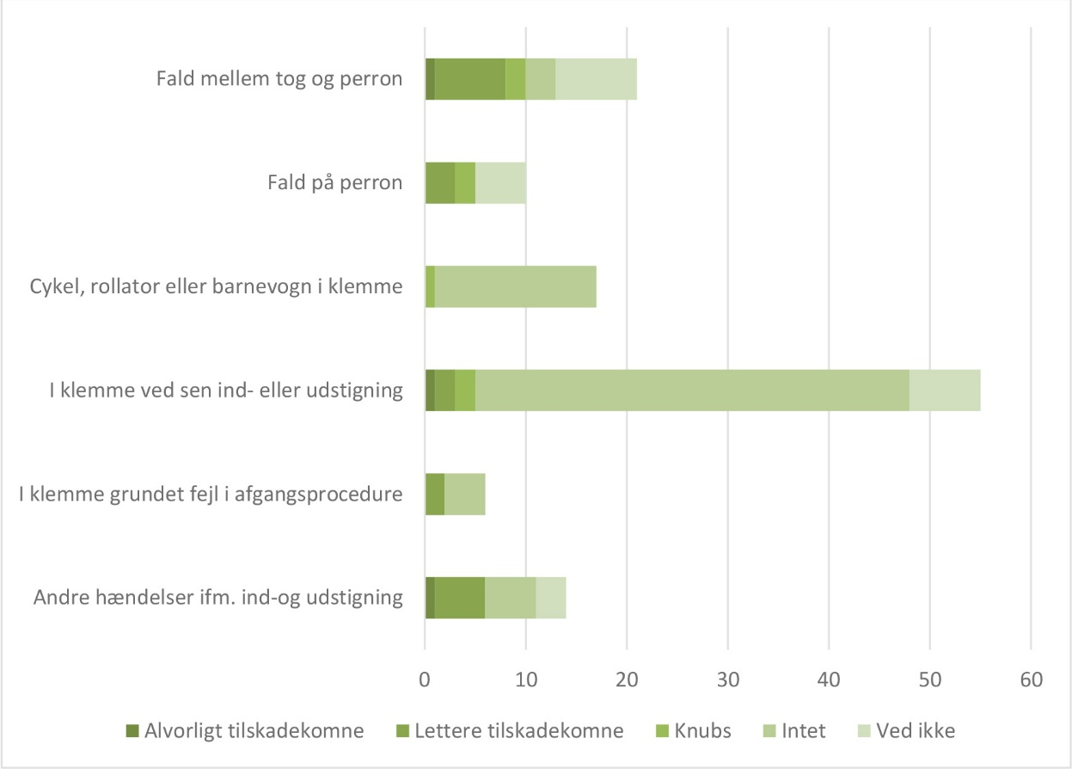

Fald mellem tog og perron | Falling between train and platform
Fald på perron | Falling on platform
Cykel, rollator eller barnevogn I klemme | Bicycle, walking frame or pushchair stuck
I klemme ved sen ind- eller udstigning | Stuck when boarding or alighting
I klemme grundet fejl I afgangsprocedure | Stuck because of error in departure procedure
Andre hændelser ifm. Ind- og udstigning | Other incidents relating to boarding and alighting
Alvorligt tilskadekomme | Serious injuries
Lettere tilskadekomne | Minor injuries
Knubs | Knocks
Intet | None
Ved ikke | Not known

Note: The definition of 'serious injuries' is one or more people who have been admitted to hospital for 24 hours or longer as a result of an accident. The definition of 'minor injuries' is people who have sustained injuries that require treatment (people who are killed, seriously injured and knocked are not included). 'Knocks' covers minor instances of being hit or caught that do not require hospital treatment.
'None' means that no injury was reported.
Source: Danish Transport, Construction and Housing Authority incident database

Regulation of passenger behaviour
Passenger behaviour is regulated by the Railways Act. On the whole, the Act states that passengers and other people who are in the open areas pertaining to the infrastructure manager and railway undertaking must act in accordance with the undertaking's rules and safety provisions.
The undertaking must make users aware of these provisions, and the police must assist with enforcement upon request (please see Section 42).
Furthermore, the Act lays down:
- various kinds of unlawful passenger behaviour (please see Sections 45 and 120);
- that gross negligence or premeditation contributing to an injury may affect any claim for compensation (please see Section 50); and
- penalties for unlawful behaviour (please see Sections 116(4) and 120).
Please see the most important sections relating to passenger behaviour in the green box below.

The most important sections of the Railways Act relating to passenger behaviour
Section 42. Anyone who seeks access to or remains in areas referred to in Section 41 and which are open to the general public must act in accordance with the regulations for maintaining order and safety, as issued by the undertaking's staff, or which are otherwise published by the undertaking on posters or in another appropriate manner.
(2). The police must, upon request, assist the railway undertaking or infrastructure manager with enforcement of the order and safety provisions applying to areas referred to in Section 41.
Section 45. It is prohibited to board a train when the doors are closing and to obstruct the train's automatic door-closure system.
(2). No refuse or other objects may be thrown out of a train.
(3). The emergency brake on the train and emergency stop on the platform may only be used in an emergency.
Section 50. Compensation for personal injury or loss of a wage-earner (please see Section 49(1)) may be reduced or refused if the injured or deceased party wilfully contributed to the damage. Compensation may also be reduced, and in special cases refused, if the injured or deceased party contributed to the damage through gross negligence.
(2). Compensation for damage to property (please see Section 49(2)) may be reduced or refused if the injured party wilfully or negligently contributed to the damage.
Section 116. Anyone who (...) shall be punished with a fine or imprisonment of up to four months:
4) infringes (…) Sections 42(1), 43-46 (…).
Section 120. Anyone who obtains or attempts to obtain carriage using an invalid ticket or invalid card shall be punished with a fine.

The amendment to the Executive Order on reporting that entered into force on 1 January 2016 introduced two new categories in order to focus on reporting boarding and alighting accidents and ensuring the quality of such reports.

The new Executive Order on reporting has a focus on boarding and alighting accidents
This Executive Order introduces two new categories of incident:
- Boarding and alighting accidents - train stationary;
- Boarding and alighting accidents - train in motion.
The quality of the data depends on whether the definitions of accidents and safety-related incidents are clear and easy to use. The new categories of incident are thus helping to ensure the quality of the data reported.

Research on passenger behaviour
Knowledge of the factors that respectively promote and prevent inappropriate passenger behaviour is key to preventing risky behaviour and improving the actual and perceived safety level for train passengers.
Memorandum on inappropriate passenger behaviour in the railways sector
In 2016, the Technical University of Denmark (DTU) produced a memorandum on inappropriate passenger behaviour. The memorandum investigates the psychological background to risky behaviour among train passengers, particularly in connection with boarding and alighting.
The memorandum is a review of selected literature in this area. The literature review shows a conspicuous lack of scientifically based literature with a focus on the underlying psychological factors that can contribute to understanding, clarifying and regulating the behaviour of passengers when boarding and alighting, with a view to preventing critical situations and definite accidents.
The memorandum identifies four themes that are indirectly related to the problem.
Among other things, the most important points for each of the four themes mentioned in the memorandum are summarised below.
Other research relating to passenger behaviour
On the basis of the memorandum from the DTU, the Authority has subsequently looked into other research on passenger behaviour, particularly in connection with boarding and alighting.
Inappropriate passenger behaviour in general
A British report shows that the most significant cause of accidents is inappropriate passenger behaviour, including where a passenger is affected or distracted by technology or does not understand the risk factors on the platform and when boarding and alighting.
Other reasons are that a passenger is too close to the platform edge or loses objects on the platform or track.
A Chinese study also shows that the most common forms of inappropriate passenger behaviour are: 1) lying down on/jumping down onto the rails; 2) falling down onto the tracks; and 3) forcing the doors open in order to board or alight. Another Chinese study shows that, whereas motorists are well aware of what behaviour is permitted, it is less clear for metro passengers.
Accidents in connection with boarding and alighting
A challenge in relation to analysing accidents and precursors to accidents relating to passenger behaviour is that they are often only reported to a limited extent.
A British study has, however, shown that passenger behaviour is the most significant cause of railway accidents resulting in fatalities and personal injuries. Some 20% of all accidents in the United Kingdom that result in people being killed or injured occur at the interface between the train and the platform. Accidents in connection with boarding and alighting account for 12% of all accidents. The extent of injuries is much greater in connection with boarding accidents than for alighting accidents.
Female passengers and passengers under 16 years of age and over 50 years of age are over-represented in statistics on boarding and alighting accidents, even when account is taken of how great a proportion of passengers they are.
Smartphones
Accidents relating to passenger behaviour can often be linked to passengers not paying attention, using their smartphones, etc. A new study by Patrick Crowley of Aalborg University confirms the fact that the combination of smartphones and walking challenges both our cognitive and motor abilities.
To be specific, the walking pattern becomes so unstable for people who are walking and writing messages on their mobile telephones simultaneously that, for example, they take shorter steps, risk falling, or forget to look where they are going. Young, fast people who are absorbed in their smartphones will walk as uncertainly as very old people.
Passengers' perception of risks and safety
Passengers' individual perceptions of safety are important for choosing trains and/or the metro as a mode of transport. Some of the factors that can result in a lack of safety are crowds, delays, accessibility, ease of finding the right train, and changing trains. The study did not see any link between these factors and behaviour when boarding and alighting.
Train design
Studies to optimise safety for boarding and alighting have not usually looked directly at psychological factors, but it does not appear to be surprising that train design plays a role, including the width of the train doors and the height of any doorsteps.
Conclusion
In general terms, other studies support the main conclusion of the memorandum produced by the DTU, namely that there is a lack of scientifically based literature with a focus on the underlying psychological factors that can help to understand, clarify and regulate inappropriate passenger behaviour.
In much of the existing literature, it is generally acknowledged that there are many facets of passenger behaviour that have not been researched adequately.
Much research on passenger behaviour is based on observations by passengers so as to devise technical solutions and other kinds of procedure to reinforce passenger safety. In other words, there is more research that investigates what describes passenger behaviour and what can affect it than there is research that can explain it.

Annex A: The railways in figures 2016
Table A.1. Information on railway infrastructure
Railway infrastructure | 2016
Number of infrastructure managers | 7
Total length of lines (km)* | 2 573
Total length of track (km) | 3 907
Length of electrified lines (km)* | 642
Lines with ATC, ATC train stopping/ACT equipment (km) | 1 434
Total number of level crossings | 1 289
- Automatic level crossing with warning signal system | 159
- Automatic level crossing with warning signal system and half or full barriers | 659
- Automatic level crossing with warning signal system, half or full barriers and track-side protection in the form of detection in the road or similar | 130
- Manually operated level crossing with warning signal system | 2
- Manually operated level crossing with barrier system | 1
- Level crossing without protection** | 338
Source: infrastructure managers' safety reports for 2016. However, data marked * are from table BANE41 from Statistics Denmark.
Note: ** all level crossings without protection in 2016 have been included here. The safety report for 2015 only includes Banedanmark's figures. There were a total of 380 level crossings without protection in 2015.
Table A.2. Information on railway undertakings
Railway undertaking | 2016
Number of railway undertakings | 11
Number of locomotives | 125
Number of units (passenger transport)* | 756
Number of train drivers | 2 346
Volume of passenger transport (million passenger km.)* | 6 653
Volume of freight transport (million tonne km.)* | 2 575
Volume of passenger transport (million train km)* | 79 100
Volume of freight transport (million train km)* | 3 638
Total number of kilometres travelled (million train km)* | 82 738
Source: railway undertakings' safety reports for 21016. However, data marked with * are from tables BANE1, BANE21, BANE31 and BANE51 from Statistics Denmark.

Annex B: Safety indicators for 2016

Data
The statistical data in the annex were recorded by railway undertakings and railway infrastructure managers in the period 2012-2016.
Some of the figures in the report are based on data that go back to 1999, but data for private and local lines is only available to a limited extent before 2003.
Data are reported in accordance with the Reporting Executive Order. On
1 January 2016, Executive Order No 1340 of 26 November 2015 concerning the reporting of data on accidents and precursors to accidents etc. in the railway sector to the Danish Transport and Construction Agency entered into force.
The new Executive Order on reporting introduced a number of changes to the incident categories. The definitions used can be found in Annex C and are described in greater detail in the guidelines on Executive Order on reporting, Executive Order No 1340 of 26 November 2015, which can be found on the Danish Transport and Construction Agency’s website.
Some categories of data contain relatively small quantities of data, and can give rise to big fluctuations in the statistics from year to year. This is why 5-year cumulative averages are calculated for comparison with annual figures.
In order to find the five-year average, it has been necessary to compile incident data from 2016 using the broader incident categories that were used prior to the new Executive Order on reporting. Nevertheless, the Annex does also contain data for the new, smaller categories for which there is only data in relation to 2016.

Overview of national safety indicators
Table B.1. Safety indicators for 2016
Indicators | Total in 2016 | Total in 2016/million train km | 5-year average/million train km
Significant accidents | 20 | 0.24 | 0.23
Minor accidents | 357 | 4.31 | 3.86
Precursors to accidents | 3 625 | 43.81 | 39.22
Persons killed* | 8 | 0.10 | 0.13
Serious injuries | 10 | 0.12 | 0.10
Suicides (deaths) | 25 | 0.30 | 0.38
Note: * The figures for ‘persons killed’ exclude suicides, as these are given separately.

Table B.2. Indicators relating to significant accidents
Significant accidents | Total in 2016 | Total in 2016/million train km | 5-year average/million train km
Collision | 0 | 0.00 | 0.01
Derailment | 0 | 0.00 | 0.00
Significant accidents at level crossings | 1 | 0.01 | 0.04
Fire | 1 | 0.01 | 0.00
Personal injuries involving rolling stock in motion | 11 | 0.13 | 0.13
Other significant accidents | 7 | 0.08 | 0.04
Dangerous goods | 0 | 0.00 | 0.01
Total significant accidents | 20
Note: The figures for number of significant accidents do not include suicides. *zero indicates that the 5-year average is extremely small (value < 0.01).
Table B.3. Indicators concerning significant accidents divided up into incident categories according to the new Executive Order on reporting
Significant accidents | Total in 2016
Collisions involving people | 10
Derailment involving slow-moving rolling stock | 3
Boarding and alighting accidents (train stationary) | 3
Accidents at level crossings | 1
Personal injury on board a train in motion | 1
Fires and explosions on a train in motion | 1
Accidents involving traction current (train stationary or no train) | 1
Collision, train and other railway vehicle | 0
Collision, train and object | 0
Collision, slow-moving rolling stock and other slow-moving rolling stock | 0
Collision, slow-moving rolling stock and object | 0
Derailment of train | 0
Boarding and alighting accidents (train in motion) | 0
Accidents involving tractive current (train in motion) | 0
Total significant accidents | 20
Note: The figures for number of significant accidents do not include suicides.

Table B.4. Indicators relating to persons killed
Persons killed | Total in 2016 | Total in 2016/million train km | 5-year average/million train km
Passengers | 0 | 0.00 | 0.00
Staff | 1 | 0.01 | 0.00
Level-crossing users | 1 | 0.01 | 0.04
Persons on railway property without permission | 5 | 0.06 | 0.07
Other | 1 | 0.01 | 0.01
Total persons killed | 8
Note: The figures for persons killed do not include suicides. *zero indicates that the 5-year average is extremely small (value < 0.01).
Table B.5. Indicators relating to serious injuries
Serious injuries | Total in 2016 | Total in 2016/million train km | 5-year average/million train km
Passengers | 4 | 0.05 | 0.02
Staff | 0 | 0.00 | 0.00
Level-crossing users | 0 | 0.00 | 0.01
Persons on railway property without permission | 3 | 0.04 | 0.04
Other | 3 | 0.04 | 0.02
Total serious injuries | 10
Note: The figures for serious injuries do not include attempted suicides.
Table B.6. Indicators relating to minor accidents
Minor accidents | Total in 2016 | Total in 2016/million train km | 5-year average/million train km
Collision | 106 | 1.28 | 1.43
Derailment | 1 | 0.01 | 0.05
Level-crossing accidents | 5 | 0.06 | 0.07
Collisions involving people | 30 | 0.36 | 0.49
Fire | 78 | 0.94 | 0.79
Other minor accidents | 137 | 1.66 | 1.04
Total minor accidents | 357
Note: The figures for serious injuries do not include attempted suicides.
Table B.7. Indicators concerning minor accidents divided up into incident categories according to the new Executive Order on reporting
Minor accidents | Total in 2016
Collision, train and object | 103
Fires and explosions on a train in motion | 78
Boarding and alighting accidents (train stationary) | 48
Derailment involving slow-moving rolling stock | 47
Collision, slow-moving rolling stock and object | 27
Personal injury on board a train in motion | 22
Collision, slow-moving rolling stock and other slow-moving rolling stock | 12
Collisions involving people | 6
Accidents at level crossings | 5
Collision, train and other railway vehicle | 3
Other minor accidents | 3
Boarding and alighting accidents (train in motion) | 2
Derailment of train | 1
Accidents involving tractive current (train in motion) | 0
Accidents involving traction current (train stationary or no train) | 0
Total minor accidents | 357
Note: The figures for serious injuries do not include attempted suicides.
Table B.8. Accidents and incidents involving dangerous goods
Accidents and incidents involving dangerous goods | Total in 2016 | Total in 2016/million train km | 5-year average/million train km
Accidents involving dangerous goods | 0 | 0.00 | 0.01
Incidents involving dangerous goods | 1 | 0.01 | 0.01
Note: Here is listed any incident or accident that must be reported in accordance with chapter 1.8.5 of the RID/ADR The one incident involving dangerous goods in 2016 is recorded in chapter 1 under the incident category of other precursors to accidents.

Table B.9. Indicators relating to precursors to accidents
Precursors to accidents | Total in 2016 | Total in 2016/million train km | 5-year average/million train km
Broken rails | 36 | 0.44 | 0.48
Track-bed faults hazardous for safety | 12 | 0.15 | 0.14
Technical signalling fault | 77 | 0.93 | 0.65
Signals passed at danger | 280 | 3.38 | 4.88
Defective axles on railway vehicles – reasons other than a break | 8 | 0.10 | 0.06
Risk of collision with person | 910 | 11.00 | 7.78
Braking-technology fault | 69 | 0.83 | 0.63
Risk of collision/hitting someone at a level crossing | 145 | 1.75 | 1.53
Error by station manager/traffic controller | 373 | 4.51 | 3.59
Profiling | 110 | 1.33 | 1.61
Other precursors to accidents | 1605 | 19.40 | 16.24
Total precursors to accidents | 3 625

Table B.10. Indicators concerning precursors to accidents divided up into incident categories according to the new Executive Order on reporting
Precursors to accidents | Total in 2016
Other precursors | 1 605
Risk of collision with person | 910
Error by station manager/traffic controller | 373
Risk of collision/hitting someone at a level crossing | 145
Profiling | 110
Passing a signal at danger (train) - not passing a hazard | 92
Passing a signal at danger (train) – passing a hazard | 80
Technical signalling fault | 77
Braking-technology fault | 69
Passing a signal at danger (no train) – passing a hazard | 55
Passing a signal at danger (no train) – not passing a hazard | 53
Broken rail – major | 19
Broken rail – minor | 17
Track-bed faults hazardous for safety | 12
Defective axles on railway vehicles – reasons other than a break | 8
Defective axles on railway vehicles – break | 0
Defective wheels on railway vehicles – reasons other than a break | 0
Defective wheels on railway vehicles – break | 0
Total precursors to accidents | 3 625

Annex C: Definitions used
Accidents
- Collision, train and other railway vehicle: Frontal collision between two trains or between the front and rear of two trains or a lateral collision between one part of a train and one part of another train or a railway vehicle or slow-moving rolling stock.
- Collision, train and object: Collision between one part of a train and an object permanently installed or temporarily located on or near the track, with the exception of level crossings, if the objects are lost by passing vehicles or users. This definition also covers collisions with overhead power lines.
- Collision, slow-moving rolling stock and other slow-moving rolling stock: Frontal collision between two pieces of slow-moving rolling stock or collision between the front and rear of two pieces of slow-moving rolling stock or a lateral collision between one part of a piece of slow-moving rolling stock and one part of another piece of slow-moving rolling stock.
- Collision, slow-moving rolling stock and object: Collision between one part of a piece of slow-moving rolling stock and an object permanently installed or temporarily located on or near the track. This definition also covers collisions with overhead power-line installations.
- Derailment of train: Any incident in which at least one of the train’s wheels comes off the rails.
- Derailment involving slow-moving rolling stock: Any incident in which at least one of the wheels of a slow-moving vehicle comes off the rails.
- Accidents at level crossings: These involve at least one railway vehicle and one or more crossing vehicles, other crossing users, such as pedestrians, or objects temporarily on or near the track if these have been lost by crossing vehicles or users.
- Collisions involving persons: Injury to one or more people who are either hit by a railway vehicle, part of a railway vehicle or an object attached to or detached from the vehicle.
- Personal injury on board a train in motion: Injury to one or more people who fall or are hit by loose objects during carriage on the train, as a result of the train's movement.
- Fires and explosions on a train in motion: Fires and explosions in railway vehicles, including their cargo, en route between the departure station and the destination - including where such vehicles are stationary at the departure station, have stopped, or are at the destination, as well as during shunting.
- Boarding and alighting accidents (train in motion): Accidents whereby a person falls while boarding or alighting a train, while the train is in motion.
- Boarding and alighting accidents (train stationary): Accidents whereby a person falls while boarding or alighting a train, while the train is stationary.
- Accidents involving tractive current (train in motion): Accidents where a person comes into contact with tractive current and where a train in motion is involved.
- Accidents involving traction current (train stationary or no train): Accidents where a person comes into contact with tractive current but where no train in motion is involved in the accident.
Significant accidents
- Significant accidents is understood to mean any accident involving at least one moving railway vehicle and which results in at least one person being killed or seriously injured, or in the extensive destruction of rolling stock, track, other parts of the infrastructure (installations), the environment, or in extensive disruption to traffic.
- Extensive destruction of rolling stock, track, other parts of the infrastructure (installations) or the environment is understood to mean destruction/damage valued as at least DKK 1.2 million.
- Extensive disruption to traffic is understood to mean that train traffic is at a standstill for six hours or more on a main line.
Suicide
- Suicide: An act whereby a person deliberately takes his or her own life, and which is recorded as such if it is known to be so.
- Suicide attempt: An act whereby a person deliberately attempts to take his or her own life, and which is recorded as such if it is known to be so or is recorded as such by the competent authorities.
Dangerous goods
- Dangerous goods: Substances and objects that may not be transported under the Regulation concerning the International Carriage of Dangerous Goods by Rail (RID), or may only be transported under conditions defined in the RID.
- Accidents in connection with the transportation of dangerous goods: Any accident or incident that must be reported under Chapter 1.8.5 of the RID/ADR.
- Accidents in connection with the transportation of dangerous goods with spillage: Any accident or incident that must be reported under Chapter 1.8.5 of the RID/ADR and where there has been a spillage of dangerous goods.
Precursors to accidents
- Precursors to accidents means an event in the railways sector that has not resulted in an accident but which could have been significant for railway safety.
- Broken rail – major: Any rail that has broken into two or more pieces, or any rail from which a piece of metal has broken away, leaving a hole more than 50 mm long and more than 10 mm deep on the running surface.
- Broken rail – minor: Any rail that constitutes a hazard and the hazardous periods of which can clearly be measured, for example by closing the track or reducing the speed.
- Track-bed faults hazardous for safety: Faults in the track layout and track geometry associated with sun kinks, track deformities and isolated defects in the height of the rails and track bed, which require immediate restrictions on operating conditions for safety reasons.
- Technical signalling fault: Any technical fault in the signalling system that results in a less restrictive signal than is required.
- Defective wheels on railway vehicles – Break: A break affecting the wheel and thus creating a risk of accidents in the form of derailments or collisions. The break must result in the railway vehicle in question being taken out of operation immediately.
- Defective axles on railway vehicles – Break: A break affecting the axle and thus creating a risk of accidents in the form of derailments or collisions. The break must result in the railway vehicle in question being taken out of operation immediately.
- Defective wheels on railway vehicles – Reasons other than a break: Reasons other than a break affecting the wheel and thus creating a risk of accidents in the form of derailments or collisions. The defect must result in the railway vehicle in question being taken out of operation immediately.
- Defective axles on railway vehicles – Reasons other than a break: Reasons other than a break affecting the axle and thus creating a risk of accidents in the form of derailments or collisions. The defect must result in the railway vehicle in question being taken out of operation immediately.
- Passing a signal at danger (train) – passing a hazard: Driving farther forward than permitted/driving past a given point without permission, so that the train will pose a danger of being involved in a railway accident. The hazard is often defined in the train-control system.
- Passing a signal at danger (train) - not passing a hazard: Driving farther forward than permitted/driving past a given point without permission, but where the hazard is not passed.
- Passing a signal at danger (no train) – passing a danger signal: Driving farther forward than permitted/driving past a given point without permission, so that the railway vehicle will pose a danger of being involved in a railway accident. The point in question is often defined in the train-control system.
- Passing a signal at danger (no train) – not passing a hazard: Driving farther forward than permitted/driving past a given point without permission, but where the hazard is not passed.
- Risk of collision with person: Any risk of one or more people being hit by railway vehicles in motion or by an object associated with the railway vehicle.
- Braking-technology fault: Any fault of the brakes that results in reduced braking power, including dragging brakes.
- Risk of collision/hitting someone at a level crossing: Any danger of users of level crossings or objects temporarily located on or near the track, if they are lost from passing vehicles or users are hit by rolling stock in motion.
- Error by station manager/traffic controller: An error connected to signal operation resulting in the erroneous dispatching of a train, including errors in uncovering a work site in the context of work on the track.
- Profiling: Loose parts of the train, or loss of parts of the rolling stock or goods, lost or displaced cargo.
- Other: Other precursors to accidents not covered by the other categories, such as serious maintenance errors or faults with railway vehicles above and beyond the categories mentioned above.
Personal injury
- Passengers: Anyone who undertakes a journey by railway, excluding train staff. In accident statistics this also includes persons who attempt to board or alight from a moving train.
- Staff - including contractor staff: Any person employed in connection with a railway and who is at work at the time of the accident. This definition covers contractors' staff, independent contractors, train personnel, and staff who operate railway vehicles and infrastructure installations.
- Level-crossing users: Anyone who uses a level crossing to cross the railway with the help of a vehicle or on foot.
- People on railway premises unlawfully (trespassers): Anyone who remains in a railway area where prohibited.
- People on the platform: Anyone not covered by the definition of passengers, staff, level-crossing users, or people on railway premises unlawfully, and who are on the platform.
- Other people: Anyone not covered by the definition of passengers, staff, level-crossing users, people on railway premises unlawfully, and people on the platform.
Injury types
- People killed: One or more people who are killed immediately or die within 30 days as a result of an accident.
- Serious injuries: One or more people who have been admitted to hospital for 24 hours or longer as a result of an accident.
- Minor injuries: People who have sustained injuries requiring treatment. Deaths and serious injuries are not included.
Costs
- Material damage to rolling stock or infrastructure: The costs of purchasing new rolling stock or constructing new infrastructure with the same functionality and technical parameters as the rolling stock or infrastructure damaged in the accident, as well as the costs of returning rolling stock or infrastructure that can be repaired to its condition prior to the accident. Both parts must be estimated by the railway undertakings and infrastructure managers on the basis of their experience. Costs of leasing rolling stock to replace damaged railway vehicles that are not available are also covered by this definition.
- Environmental damage: Costs that must be defrayed by the railway undertakings and infrastructure managers and other holders of safety certificates, estimated on the basis of their experience in restoring a damaged area to its condition prior to the railway accident.
Types of level crossing
- Unsecured level crossing: A level crossing without any safeguards, only a crossing sign and potentially a component or manual barrier operated by a pedestrian.
- Manually operated level crossing: A level crossing with warning equipment and/or barrier equipment activated by railway staff.
- Automatically secured level crossing with warning signal system: A level crossing with warning equipment, flashing light and audible signal that are activated automatically by the train or by a route-locking system.
- Automatically secured level crossing with half barrier but no clearance detection: A level crossing with a half barrier, flashing light, audible signal and barrier over the right-hand side of the road, possibly supplemented by a path barrier that is automatically activated by the train or by a route-locking system.
- Automatically secured level crossing with half barrier and clearance detection: A level crossing with a half barrier, a system to ensure the line is clear, flashing light, audible signal and barrier over the right-hand side of the road, possibly supplemented by a path barrier that is automatically activated by the train or by a route-locking system. When the barrier closes, a check is performed to see if there are any cars on the level crossing, for example by roadside poles.
- Automatically secured level crossing with full barrier but no clearance detection: A level crossing with a full barrier, flashing light, audible signal and barrier over whole road, that is automatically activated by the train or by a route-locking system.
- Automatically secured level crossing with full barrier and clearance detection: A level crossing with a full barrier, a system to ensure the line is clear, flashing light, audible signal and barrier over the whole road, that is automatically activated by the train or by a route-locking system. When the barrier closes, a check is performed to see if there are any cars on the level crossing, for example using roadside poles.

The Danish Transport, Construction and Housing Authority
Edvard Thomsens Vej 14
DK-2300 Copenhagen S

info@tbst.dk
www.tbst.dk

Safety report for the railways 2016

Executive Order No 1343 of 26 November 2015 concerning the reporting of data on accidents and precursors to accidents etc. in the railways sector to the Danish Transport and Construction Agency entered into force on 1 January 2016.
Executive Order No 1340 of 26 November 2015 concerning the reporting of data on accidents and precursors to accidents etc. in the railways sector to the Danish Transport and Construction Agency entered into force on 1 January 2016.
Executive Order No 1340 of 26 November 2015 concerning the reporting of data on accidents and precursors to accidents etc. in the railways sector to the Danish Transport and Construction Agency.
Please see Executive Order No 1340 of 26 November 2015 concerning the reporting of data on accidents and precursors to accidents etc. in the railways sector to the Danish Transport and Construction Agency.
See Annex C for definitions of terms used in this report.
Please note that suicides are not included in these figures. You can read more about suicides on the railways later on in this chapter.
Please note that these figures do not include incidents involving slow-moving rolling stock. Those incidents are included in the category of other significant accidents.
The unit 'number of deaths and weighted serious injuries' is abbreviated to FWSI, which stands for 'fatalities and weighted serious injuries'.
The Danish safety target and the definition of significant accidents involving people are laid down in The common European railway: A strategy for high safety levels and smooth implementation in Denmark. February 2009.
Railway Safety Performance in the European Union 2016 and ERAIL (European Railway Information).
Please note that whereas the figures in the rest of this chapter concern the entire Danish rail network, those given in Figure 1.7 relate to the Danish rail network excluding the metro and suburban railways. This is because metros and railways that are functionally distinct from the rest of the rail network, and that can only be used to transport passengers in local, urban or suburban areas, are not included in the official European statistics. The total safety level for the Danish railway (including the metro and suburban railways) in respect of the number of significant accidents involving people in 2012-16 stood at 0.14 fatalities and weighted serious injuries per million train kilometres, as shown in Figure 1.5.
The common safety indicators (CSIs) are reported; please see Annex I to the Safety Directive. Published in Denmark by Executive Order No 1293 of 23 November 2010 and Executive Order No 893 of 8 July 2015.
Please note that Figure 1.8 contains the figures for 2014-15, while the figures in this report are for 2015-16. This is because the European figures will only be updated when the European countries have submitted their reports (including this report). Please also note that the Danish figures reported to the European statistics do not include figures from the metro or the local railways, as they are not part of the European railway network and are thus not to be reported to ERA. Figure 1.7 is included here to show how Denmark compares with other European countries with regard to the number of fatalities on the railways.
The number for 2016 will be published following this report. You can find out more from ERAIL (European Railway Accident Information Links) at erail.era.europa.eu.
Source: www.havarikommissionen.dk
Act No 686 of 27 May 2015.
For railway infrastructure, please see Section 3(5) of the Railways Act.
A list of all undertakings that have been issued safety certificates and safety authorisations may be found on the Danish Transport, Construction and Housing Authority website.
The scores shown in the safety report for 2015 included ten undertakings. The difference is due to the fact that Lokalbanen and Regionstog have merged and therefore count as one undertaking as opposed to the two undertakings in the previous year. Furthermore, some undertakings have been excluded in previous years because they were not ready to be assessed, for various reasons. The maturity-level score for all undertakings in 2016 cannot therefore be compared directly to the maturity level in previous years.
Audit days are the number of days on which the Danish Transport, Construction and Housing Authority has performed audits. Days on which inspections were performed are not included in this figure.
Commission Implementing Regulation (EU) No 402/2013 of 30 April 2013 on the common safety method for risk evaluation and assessment, as amended.
The Danish Transport, Construction and Housing Authority published the 'Introduction to risk assessment' in 2016.
Executive Order No 523 of 30 May 2016 amending the Executive Order on certificates of release to service for subsystems in railway infrastructure.
The guidance can be accessed via the Authority's website.
TSIs (Technical Specifications for Interoperability) are the EU's harmonised technical requirements, which are designed to support an open, cross-border railway. You can read more about TSIs on the Authority's website.
In accordance with Articles 8, 16(2)(f) and 18(b) of the Railway Safety Directive. These do not implement nor supplement the Railway Safety Directive.
Commission Directive (EU) 2016/882 amending Directive 2007/59/EC of the European Parliament and of the Council as regards language requirements.
Act No 686 of 27 May 2015.
Figure 7.1 includes 123 incidents relating to boarding and alighting that were reported under the incident categories of boarding and alighting (train stationary); boarding and alighting (train in motion); risk of collision with person; personal injury on board a train in motion; other accidents; and other precursors. This is why the figure includes more incidents than the 53 boarding and alighting accidents mentioned in chapter 1 (please see Figures 1.5 and 1.10).
Act No 686 of 27 May 2015
Section 41 of the Railways Act states as follows: 'Areas pertaining to the infrastructure manager and the railway undertaking include station areas, railway lines and their associated embankments, berms and ditches, bridges, tunnels, elevated track, work sites and other installations, trains and other vehicles, fronts of stations and access routes to stations and rail ferries, where these are owned by the railway undertaking or are owned or managed by the infrastructure manager.'
Executive Order No 1340 of 26 November 2015 concerning the reporting of data on accidents and precursors to accidents etc. in the railways sector to the Danish Transport and Construction Agency entered into force on 1 January 2016.
The memorandum was produced for the Danish Transport, Construction and Housing Authority by Mette Møller and Sonja Haustein from the Transport DTU/DTU MAN Human Factors group.
It must be noted in general terms that some of the literature that has been identified originates from countries far away, and so the reader must be aware that any differences in traffic culture, etc. could be of significance for the extent to which the results can be extrapolated to Danish conditions. It should also be noted that this is not an exhaustive review of scientific literature on passenger behaviour.
RSSB (2015). Platform train interface strategy. Link to the report.
Calculated in relation to accidents per incident.
Wan, X., Li, Q., Yuan, J., & Schonfeld, P. M. (2015). Metro passenger behaviors and their relations to metro incident involvement. Accident Analysis & Prevention, 82, 90-100. Wan, X., Yuan, J., and Li, Q. (2015) An integrated framework for exploring the vulnerability due to passengers’ aberrant behaviors in an urban metro system. ICCREM 2015: 1124-1135
O’Neill, D. (2013). Accident patterns in the ageing population: non-collision injuries on public transport and injuries of single pedestrians. CONSOL Report WP 3.2.
Kyriakidis, M., Hursch, R., Majumdar, A. (2012). Matro railway safety: An analysis of accident precursors. Safety science, 50, 1535-1548. Carpenter, S. (2011). Passenger risk at the platform-train interface. Rail Safety and Standards Board 2011, United Kingdom.
You can read more about the study by Patrick Crowley of Aalborg University here.
Cheng, Y.H. (2010). Exploring passenger anxiety associated with train travel. Transportation, 37, 875-896.
Executive Order No 1343 of 26 November 2015 concerning the reporting of data on accidents and precursors to accidents etc. to the Danish Transport and Construction Agency
The definitions that have been used and which are listed in this Annex C have their legal basis in Annex 1 to Executive Order No 1340 of 26 November 2015 concerning the reporting of data on accidents and precursors to accidents etc. in the railways sector to the Danish Transport and Construction Agency, which entered into force on 1 January 2016.

