
APPROVED

Director A. Dunskis
28 February 2017

Safety Report
2016

Riepnieku iela 2, Rīga, LV-1050
vdzti@vdzti.gov.lv
www.vdzti.gov.lv

Table of Contents
1 Introduction 3
2 Summary 4
3 Summary in English 4
4 Railway Sector in Latvia 5
4.1 Railway Infrastructure 5
4.2 Railway Undertakings 6
5 State Administration 6
5.1 Supervision and Cooperation Structure 6
5.2 Authority of the State Railway Technical Inspectorate 7
6 Legislation 9
7 Traffic Safety 9
7.1 Accident Reporting System 9
7.2 Traffic Safety Improvement Measures 10
7.3 Traffic Safety Performance Evaluation 11
7.4 Safety Recommendations 16
8 Certification 17
8.1 Safety Certificate 17
8.2 Safety Permit 18
8.3 Entity Responsible for Maintenance of the Rolling Stock 19
9 Supervision 19
9.1. Inspections, audits and checks 20
9.2. Investigation and registration of railway traffic accidents 22
9.3. Putting into service of infrastructure facilities 22
9.4. Putting rolling stock into service 23
10 Risk Assessment 24
11 Analysis of Reports of Railway Undertakings and the Public Railway Infrastructure Manager 25
11.1. Report of the Public Railway Infrastructure Manager 25
11.2. Reports of Railway Undertakings 27
12 Priorities of the State Railway Technical Inspectorate for 2017 27
13 Annexes 29

Introduction
This report has been prepared by the State Railway Technical Inspectorate in accordance with paragraph 57 of Cabinet Regulation No 999 of 26 October 2010 ‘Procedures for the Classification, Investigation and Recording of Railway Traffic Accidents’ in order to disseminate information about the level of traffic safety and railway transport processes.
The report presents a compilation of data on traffic safety improvements, analysis of safety indicators and the enforcement of safety procedures by the State Railway Technical Inspectorate in the railway transport field. The report contains the following information:
  - Traffic safety tendencies;
  - Structure of supervision and cooperation;
  - Assessment of the traffic safety situation;
  - Amendments to laws;
  - Processes of supervision.
The report contains basic information about the State Railway Technical Inspectorate. It also contains an evaluation of the results achieved and reflects amendments to laws affecting the railway processes.
The following information sources were used in preparing the report:
  - Registers of the State Railway Technical Inspectorate;
  - State Railway Technical Inspectorate Action Plan 2016 (2 February 2016);
  - State Railway Technical Inspectorate Activity Strategy 2014 – 2016 (approved by Minister for Transport Order No 01-03/202 of 21 November 2014);
  - State Railway Technical Inspectorate Supervision Strategy 2014 – 2016 (approved by State Railway Technical Inspectorate Order No 1-4/1-83 of 21 November 2014);
  - Guidelines for the Development of Transport 2014-2020 (Cabinet Order No 683 of 27 December 2013);
  - Transport in Latvia 2016. Compilation of statistical data. (Central Statistical Bureau of the Republic of Latvia, Riga, 2017).
  - Basic Performance Indicators of the State Joint Stock Company Latvijas dzelzceļš [Latvian Railway] 2016. (Riga, 2017).
  - Safety Performance Report of the State Joint Stock Company Latvijas dzelzceļš 2016. (Riga, 2017).
  - Safety Performance Report 2016 of LDZ CARGO Ltd. (Riga, 2017).
  - Safety Performance Report of the Joint Stock Company Baltijas Ekspresis 2016. (Ventspils, 2017).
  - Safety Performance Report 2016 of Gulbenes–Alūksnes bānītis Ltd. (Gulbene, 2017).
  - Safety Performance Report 2016 of the State Joint Stock Company Pasažieru vilciens (Riga, 2017).
  - SAFETY PERFORMANCE REPORT 2014 OF THE JOINT STOCK COMPANY BALTIJAS TRANZĪTA SERVISS (Riga, 2017).
  - Annual Report 2016 of the State Railway Technical Inspectorate (Riga, 2017).
  - Annual Report 2016 of the State Railway Administration (Riga, 2017).

Summary
In 2016, volumes of rail freight transport decreased and the total turnover was 84% of that in 2015. Kopumā kravu apgrozība pārskata gadā sastādīja 15 871 milj. tonnkilometrus, 2015.gadā tie bija 18 906 milj.tonnkilometri. By contrast, volumes of passenger transport in 2016 grew by 1.17% in comparison to 2015, which is attributable to a new strategy implemented by JSC Pasažieru vilciens (zone-specific fares, ticket sales online and via an app, streamlined timetable, modernised diesel trains, etc.).
The number of accidents fell by 28% in 2016. Since 2004, the number of serious accidents has been decreasing, and it has not exceeded the average of the relative indicator 2,0E-06 since 2011. Per train-kilometre data shows that the proportion of casualties is gradually decreasing.
Table 2.1 Trend of casualties per train-kilometre
Year | Casualties (total number) | Train-kilometres | Relative indicator
2010 | 37 | 17843826 | 2,073E-06
2011 | 34 | 18471000 | 1,840E-06
2012 | 26 | 18851000 | 1,379E-06
2013 | 24 | 17576000 | 1,365E-06
2014 | 22 | 19029874 | 1,156E-06
2015 | 25 | 18577292 | 1,399E-06
2016 | 18 | 16515778 | 1,089E-06
The number of accidents to persons caused by rolling stock in motion has decreased, while the number of accidents at level crossings has increased. Pedestrians form the largest proportion of persons injured at level crossings.
The State Railway Technical Inspectorate conducted 161 inspections in 2016. Five safety certificates and 102 safety authorisations were issued to undertakings working in the railway sector. Within the scope of railway specialist certification, 198 traction vehicle drivers, 102 assistant drivers and 27 driver instructors, as well as 35 safety consultants responsible for the transport of dangerous goods and 200 railway specialists – members of the specialist certification committees of railway undertakings, were certified during the year. 29 railway traffic safety violations were investigated. Operation permits were issued to 8 new types of rolling stock, and 82 rolling stock units and 51 railway infrastructure facilities were accepted for placing in service. More than 350 decisions concerning building issues have been taken.

Summary in English
The present report has been prepared by the State Railway Technical Inspectorate in accordance with art. 57 of the Cabinet Regulations of 26 October 2010 No. 999 “Procedures for the Classification, Investigation and Recording of Railway Traffic Accidents” and its aim is to provide information on traffic safety level and on processes in railway traffic. The report contains summarised information about traffic safety development processes, safety indicators analysis and provision of safety procedures by the State Railway Technical Inspectorate. The report contains the following information:
  - Traffic safety tendencies;
  - Structure of supervision and cooperation;
  - Assessment of traffic safety situation;
  - Amendments in laws;
  - Processes of supervision;
  - Evaluation of activities of the State Railway Technical Inspectorate.
In the reporting year the number of serious accidents decreased by 28%. The total traffic volume decreased in 2016 due to economic impact to traffic to third countries. The overall tendency of serious accidents shows decrease. The number of accidents during the train movement leading to injuries to persons also dropped off, but increased accidents on level crossings due to pedestrians injuries. The collisions on level crossings are decreasing year by year. However the majority of all accidents are accidents during the train movement leading to injuries to persons. In the reporting year the number of fatalities shows that persons do not take into account the risks crossing railway lines, especially older people which are overestimating crossing time. Analysing data and comparing to train km volume it can be seen that the proportion of injured persons is going to decrease.
Within the scope of its functions determined by the Railway Law the Inspectorate has supervised an examination of 161 rail objects. Two safety certificates part A, three safety certificates part B and 102 safety permits (authorisations) for railway sector were issued. Within the framework of certification procedure 198 train drivers, 102 train driver assistants and 27 train driver instructors, as well as 35 safety consultants on dangerous goods deliveries and 200 railway sector experts – commission members for attestation specialists of railway undertakings were certified. 29 railway traffic safety accidents and incidents were investigated. Operation permits were issued to 8 new rolling stock types, 82 rolling stock units and 51 railway infrastructure facilities were placed into service. More than 350 decisions on building permits were taken.

Railway Sector in Latvia

Railway Infrastructure
Altogether, 392 privately owned sections of railway tracks with a total length of 615.2 km and 385 public sections of railway tracks with a total length of 3306.85 km were registered with the State Register as of 31 December 2016. 16% of private-use railway tracks and 84% of public-use railway tracks were registered in the State.
Table 4.1.1 Railway infrastructure indicators
Indices | 2011 | 2012 | 2013 | 2014 | 2015 | 2016
Total expanded length of railways, km | 3997.7 | 3908.5 | 3908.5 | 3915.0 | 3912.5 | 3922.1
Public railways, km, including | 3323.2 | 3246.3 | 3246.3 | 3290.9 | 3290.9 | 3306.9
main railways, km, of which | 2238.9 | 2160.9 | 2160.9 | 2214.0 | 2217.0 | 2251.7
double and more track railways, km | 316.2 | 316.2 | 300.0 | 363.0 | 367.0 | 1055.2
private railways, km | 674.5 | 662.2 | 662.2 | 624.14 | 621.64 | 615.2
Length of public main railways in use, km | 1864.7 | 1859.2 | 1859.2 | 1859.2 | 1860.0 | 1859.6
Length of electrified railways in use, km | 257.4 | 249.8 | 248.0 | 251.0 | 251.0 | 250.9
1229.2 km of public railway infrastructure are equipped with the continuous automatic train signalling system (ALSN).
Several measures for traffic safety improvement were implemented in 2016 in the public railway infrastructure:
    - installation of signalling systems at pedestrian crossings;
    - modernisation of level crossings and installation of surveillance systems;
    - installation of automatic cab signalling system at approach sections;
    - installation of the MAPS system (to count axles);
    - modernisation of overhead lines;
    - modernisation of power supply lines;
    - modernisation of substations;
    - overhaul of 56 km of railway tracks type A and B.

Railway Undertakings
In 2016 there were six commercial companies in Latvia, which, in accordance with the relevant safety regulations, had the right to provide railway transport services using the public railway infrastructure:
freight and passenger transport
4.2.1. LDZ Cargo Ltd.;
4.2.2. JSC Lietuvos geležinkeliai;
freight transport
4.2.3. JSC Baltijas ekspresis;
4.2.4. JSC BALTIJAS TRANZĪTA SERVISS.
passenger transport
4.2.5. Limited Liability Company Gulbenes-Alūksnes bānītis (narrow gauge railway);
4.2.6. JSC Pasažieru vilciens.
Freight transport services constitute a major part of the railway services in Latvia. The highest volume of transport services is provided by LDZ Cargo Ltd. (approximately 75% of the freight transport volume). The remaining volume of transport services is provided by JSC BALTIJAS TRANZĪTA SERVISS and JSC Baltijas Ekspresis. 90% of inland passenger transport services in Latvia are provided by JSC Pasažieru vilciens. LDZ Cargo Ltd. provides international passenger transport services.

State Administration

Supervision and Cooperation Structure
No substantial structural changes were made in 2016.

Authority of the State Railway Technical Inspectorate
Control and supervision of the railway technical operation in Latvia is performed by the State Railway Technical Inspectorate, which is independent of railway undertakings, railway infrastructure managers and railway public procurement performers in organisational, legal and decision-taking issues. Realisation of the Inspectorate functions is regulated by EU regulatory enactments.
The objective of the State Railway Technical Inspectorate is to ensure the appropriate traffic safety level, by ensuring traffic safety supervision. Sub-objectives of the Inspectorate:
- safe railway transport – to supervise the traffic safety level, in order for it not to be lower than the one specified in EU regulatory enactments;
- complete and safe information concerning the traffic safety situation in commercial companies;
- introduction of uniform requirements for all sector participants introduction of open and transparent requirements;
- protection of the interests of Latvia in the working groups of the EU institutions and qualitative system analysis;
- improvement of work capacity by introducing IT processes in its operation.
The functions of the State Railway Technical Inspectorate are prescribed by Section 33 of the Railway Law.
Pursuant to the provisions of Section 11 of the Law On the Movement of Dangerous Goods, the Inspectorate shall ensure control in the field of railway transport by performing inspections, in order to control the compliance with the law referred to, and shall request information from the persons participating in the movement of dangerous goods regarding the movement of dangerous goods.
In 2016 the functions and tasks of the State Railway Technical Inspectorate were adjusted with certain amendments to regulatory enactments.
Amendments to the Railway Law in 2016 (25 February 2016) prescribed new functions for the State Railway Technical Inspectorate:
3.2.1. | 25 February 2016 Amendments to the Railway Law | Section 33(3)  13) provision of information on responsibilities of parties involved in railway industry in connection with Commission Regulation (EU) No 1305/2014 of 11 December 2014 on the technical specification for interoperability relating to the telematics applications for freight subsystem of the rail system in the European Union and repealing the Regulation (EC) No 62/2006 and Commission Regulation (EU) No 454/2011 of 5 May 2011 on the technical specification for interoperability relating to the subsystem ‘telematics applications for passenger services’ of the trans-European rail system (new function);  14) to approve assessment bodies in the meaning of Commission Implementing Regulation (EU) No 402/2013 of 30 April 2013 on the common safety method for risk evaluation and assessment and repealing Regulation (EC) No 352/2009 (new function)
3.2.1. | 25 February 2016 Amendments to the Railway Law | Section 33(3) Protection of the rights of passengers  The State Railway Technical Inspectorate is responsible for ensuring accessibility of stations, platforms, rolling stock and other facilities for people with impaired mobility and taking necessary measures for ensuring personal safety of passengers at railway stations and in trains, as well as hazard management, aligning these measures with the safety level determined by state authorities (new function).
  - Structure of the State Railway Technical Inspectorate
As of 31 December 2016, there were 22 permanent jobs at the Inspectorate. During the reporting year, 21 persons were employed at the Inspectorate. No structural changes were made in 2016. The Inspectorate comprises four departments, of which three perform control and supervisory functions and one is responsible for the implementation of support functions.
  - Traffic Safety Department
The Department is responsible for the supervision and control of railway technical operations with the aim of ensuring that the requirements of railway regulations are observed and implemented. Each Department staff member is responsible for the monitoring of traffic safety issues and the provision of reports on a specific railway sector – repairs and upgrades of the rolling stock, rolling stock operation, infrastructure, transport of dangerous goods, railway technical operation, registration and control of railway accidents.
  - Building and Certification Department
The Department is responsible for the introduction, control and supervision of the railway certification process. Each Department staff member is responsible for a specific area – certification of railway specialists, certification of commercial companies or supervision of the construction process.
  - Development Department
The Department is responsible for the control of the safety management system, interoperability compliance matters, implementation of action policy and ensuring State administration principles at the Inspectorate. Each Department staff member is responsible for a specific field - transport of dangerous goods, risk assessment, interoperability issues, mutual recognition issues. The Department staff members are also responsible for maintaining cooperation with the European Railway Agency and representing the interests of Latvia in working groups.
  - Planning and Accounting Department
The Department is responsible for ensuring effective and transparent planning and utilisation of the State budget funds, accounting, and organisation of internal management processes at the Inspectorate.
In the State Railway Technical Inspectorate, 80% of the total number of personnel are railway sector specialists. Employees of the Inspectorate need to specialise in the railway sector in order to be able to independently make decisions in emergency situations and come up with proposals for the improvement of the traffic safety situation. Employees responsible for railway-related matters have graduate degrees in technical fields, i.e. engineer qualification. All employees of the Inspectorate have a higher education qualification.

Legislation
All national safety regulations are adopted by the Cabinet and published in the official newspaper Latvijas Vēstnesis (www.vestnesis.lv). All railway regulatory enactments are available on the home page www.likumi.lv, as well as on the website of the State Railway Technical Inspectorate in the section Normatīvie akti [Regulatory enactments]. Information in English is available on the website of the Inspectorate in the section Laws and Regulations.
All regulations and orders of the Cabinet are binding and mandatory for railway carriers and infrastructure managers. The same also refers to commercial companies involved in the building, repair, and maintenance of rolling stock or technical infrastructure equipment, as well as in the shunting service. Regulatory documents whose provisions also apply to railway undertakings and in which the State Joint Stock Company Latvijas dzelzceļš as the railway infrastructure manager determines the procedures for the use of the infrastructure under the management thereof, shall be issued pursuant to Section 5, Paragraph 2.¹ of the Railway Law. Binding directions issued by the manager of the public railway infrastructure that are binding to railway undertakings are updated and summarised in the Network Review published on the website of the infrastructure manager www.ldz.lv. The information is also available on the website of the Inspectorate.
Significant changes (amendments) to legislation related to railway transport in 2016:
  - Amendments to the Railway Law – adopted on 25 February 2016, came into force on 10 March 2016;
  - Cabinet Regulation No 569 of 23 August 2016 ‘Amendments to Cabinet Regulation No 873 of 14 September 2010 Regulation Regarding Obtaining a Traction Vehicle Driver’s (Train Driver’s) Qualification and Licence to Drive a Traction Vehicle’
  - Cabinet Regulation No 8 of 5 January 2016 ‘ Amendments to Cabinet Regulation No 1210 of 28 December 2010 ‘Regulations of interoperability of the European railway system’’.
More detailed analysis is provided in Annex 2.

Traffic Safety

Accident Reporting System
The accident reporting system is determined in Cabinet Regulation No 999 of 26 October 2010 ‘Procedures for the Classification, Investigation and Recording of Railway Traffic Accidents’. All accidents which have occurred on Latvian railways and which have been reported to the State Railway Technical Inspectorate are registered in the database. More than 5 000 reports are entered each year. On the basis of the data, risk limits are determined for each of the companies to make evaluation of the company safety level possible. Timely provision of information helps to evaluate shortcomings and to prevent the possibility of serious accidents in the future. Exact classification of data considerably simplifies retrieval and processing of any information.
Upon receiving reports, the State Railway Technical Inspectorate:

evaluates the information received and enters it in the register;

classifies accidents according to the classification system;

takes a decision as to which of the railway accidents need to be investigated and/or whether additional information is necessary;

examines if the parties involved are taking the necessary action to submit accurate reports and to eliminate or rectify the situations that are described in the reports;

analyses reports and information on the whole in order to identify problems and trends;

summarises information on railway traffic accidents;

performs risk analysis;

provides the data obtained and results of the analyses to parties that are associated with traffic provision;

provides recommendations or proposals, according to its competence, regarding opportunities for improving traffic safety performance;

participates in the exchange of reported data with other EU Member States and authorities.

Traffic Safety Improvement Measures
After issuing a safety certificate or safety permit, the State Railway Technical Inspectorate must verify whether operational results indicated in the safety certificate or safety permit have been attained, and whether all the relevant operation requirements are being constantly observed.
7.2.1. Table Decisions taken by the State Railway Technical Inspectorate
Description of causes | Measures implemented | 2013 | 2014 | 2015 | 2016
Failure to implement technical operation requirements on railway tracks | Prohibition of operations until the elimination of shortcomings | 53 | 161 | 178 | 147
Failure to ensure rolling stock maintenance and registration | Prohibition of operations | 5 | 10 | 24 | 22
Railway specialists failed to perform the knowledge test | Suspension of the specialists from work duties | 3 | 6 | 13 | 2
Failure to comply with technical operation requirements | Administrative fine | 2 | 1 | 8 | 10
The number of prohibitions which endanger traffic safety slightly decreased in 2016. The number of prohibitions to operate rolling stock also decreased. The decrease in the number of prohibitions is attributable to stronger supervision of the quality of performance of railtrack maintenance contracts (including subcontractors) and checks on railway track tests. The supervision resulted in private infrastructure managers becoming more attentive to technical condition of railway tracks. This trend continues also in 2017.
2016 saw a slight increase in the number of issued administrative fines. Most administrative fines (60%) were issued in connection with violations of technical operation requirements.
Several accidents in 2016 also called for implementing special measures, in order to eliminate risks and perform measures both for improving the infrastructure technical equipment and remedying the effects of errors caused by human error on traffic safety. The State Railway Technical Inspectorate carried out checks in specific cases as well as checks proposed for improving traffic safety.
Table 7.2.2. Measures taken to prevent accidents
Date, place of accident | Description of the accident | Measures implemented
11 May 2016  Grīva | Accident involving an individual caused by rolling stock (freight train) in motion | Fencing of railway tracks to prevent crossing the tracks where it is not allowed and restrict access of people to the railway area.
13 May 2016  Ķemeri-Tukums-1 | Accident to an individual on a crossing caused by rolling stock (electric train) in motion | Modernisation of the level crossing.
25 June 2016  Mangaļi | Accident to an individual on a crossing caused by rolling stock (electric train) in motion | Felling of trees and shrubs in the protection area to improve visibility.
Several accidents | Accident involving an individual during movement of rolling stock | Infrastructure manager must install warning signs in dangerous areas.

Traffic Safety Performance Evaluation
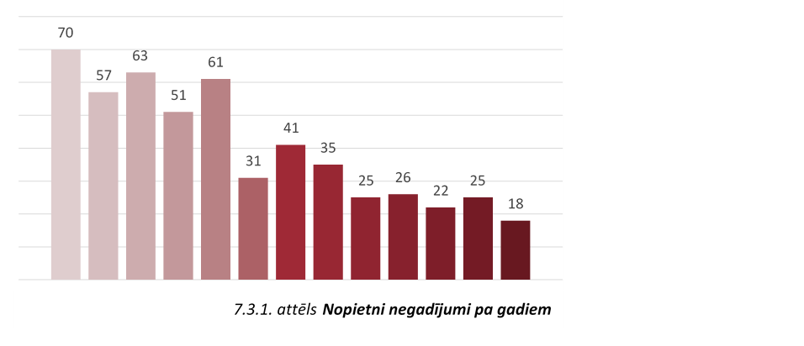
Railway traffic safety data is essential for the creation of data management strategy. The data allows identification of problems and causes. The more is known about security measures and possible improvements, the better the solutions that are being planned. Reliable and analysable data are necessary to ensure that the possible solutions are optimally prepared. This means that it is necessary to have information on many areas – general accident statistics, range of victims, identified places, range of security measures, etc. Data collection methods are very important for good documentation as well as for data structuring.
7.3.1. attēls Serious accidents by year

18 serious accidents were registered in Latvia in 2016. There were casualties in all accidents. The number of accidents decreased in the reporting year and reached the lowest level since 2004. The number of accidents fell threefold since 2004.
In terms of traffic safety performance (serious accidents) as far as the volume of transport is concerned (train-kilometres), the relative indicator is decreasing. The number of accidents where people were injured has decreased – the number of victims has decreased since 2008. Accidents to people caused by rolling stock in motion still make up the largest proportion (on average 80–90%) of the total volume of accidents. Such accidents cause serious consequences. Victims suffer fatal injuries in over 50% of accidents. Only in 2006 and 2011 was the number of fatal injuries less than the number of serious injuries. Average – 53.09% of accidents had fatal consequences.
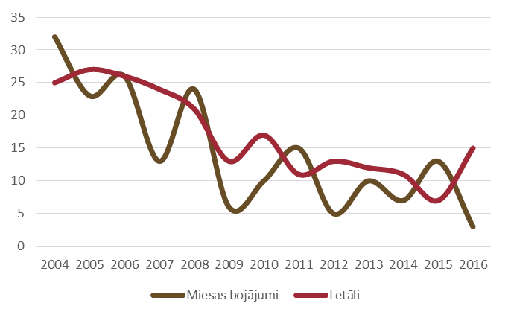
Miesas bojājumi | Injuries
Letāli | Fatalities

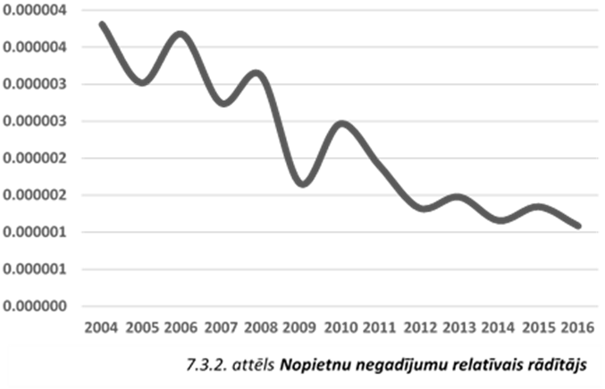
7.3.2. attēls Nopietnu negadījumu relatīvais rādītājs | 7.3.2. Figure Relative indicator of serious accidents
The State is losing people of employable age, since the average age of the victims is between 51 and 60.
Currently the highest risk is associated with stations and level crossings. It is important to reduce the risk for users of level crossings as well as at stations, where people violate safety regulations. Influence of alcohol is also a risk increasing factor at stations and level crossings. In more than 50% of accidents those injured had used alcohol. The number of fatal accidents significantly increased in 2016. Employees and people on platforms or crossing railtracks (also where it is not allowed) are the highest risk categories.
The highest proportion of accidents at level crossings are those involving people being driven over. The number of collisions with vehicles has decreased significantly since 2012 and reached an average of one collision a year, accounting for only 15% of the total number of accidents at level crossings. Most accidents at level crossings involve people violating safety requirements when crossing railtracks (pedestrians, cyclists). 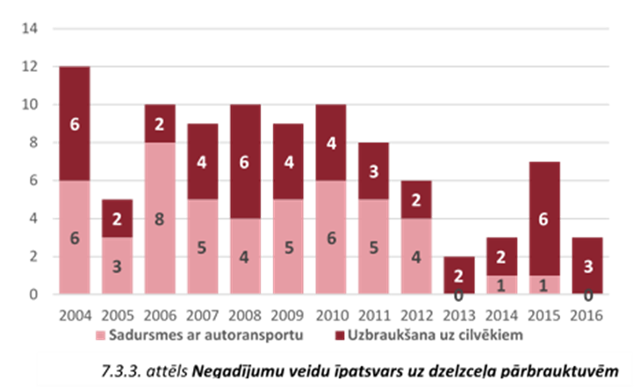
Sadursmes ar autoransportu | Collision with road vehicles
Uzbraukšana uz cilvēkiem | Driving over people
7.3.3. attēls Negadījumu veidu īpatsvars uz dzelzceļa pārbrauktuvēm | 7.3.3. attēls Proportion of various types of accidents at level crossings

Across the categories of injured people (between 2014 and 2016), the highest proportion was of unauthorised persons accessing dangerous areas and people on platforms not paying sufficient attention to train traffic or failing to judge timing correctly when crossing pedestrian crossings. The second biggest category of injured people are users of level crossings. The passenger category forms a small part of the total number of persons injured – it does not exceed 2% of the total number of the injured. There have been no accidents involving passengers since 2010.
There is still high level of risk for people working in the railway territory without paying due attention to railway operation requirements. Following investigations in connection with this risk category, additional requirements have been introduced to reduce the number of accidents: to consider the possibilities of reducing risks related to working environment when employees’ workloads and responsibilities change by training them to use special quick exercises to avoid drowsiness and tiredness. 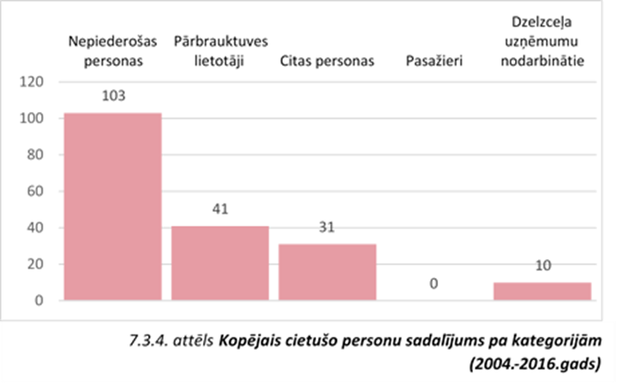
Nepiederošas personas | Unauthorised persons
Pārbrauktuves lietotāji | Level crossing users
Citas personas | Other persons
Pasažierī | Passengers
Dzelzceļa uzņēmumu nodarbinātie | Railway employees
7.3.4. attēls Kopējais cietušo personu sadalījums pa kategorijām | 7.3.4. attēls Total number of injured by category
(2004.-2016.gads) | (2004-2016)

 | 2011 | 2012 | 2013 | 2014 | 2015 | 2016
Unauthorised persons in high-risk areas | 21 | 10 | 17 | 15 | 9 | 11
Level crossing users | 8 | 8 | 2 | 4 | 6 | 3
Other persons outside the platform |  |  |  |  |  | 2
Other persons on the platform |  |  |  |  |  | 1
Other persons | 5 | 4 | 4 | 1 | 7
Passengers | 0 | 0 | 0 | 0 | 0 | 0
Railway employees | 1 | 1 | 1 | 2 | 4 | 1
Overall, the number of injured people is highest in May, October and December. The highest number of injured people in 2016 was also registered in May. Most accidents occur between 12:00 and 18:00 and in the evenings between 18:00 and 22:00. 50% of accidents involved passenger trains and 50% of accidents involved freight trains. The breakdown by accident location is similar: 47% of accidents occurred at stations and 53% of accidents occurred at railway sections. The largest proportion of casualties were registered in the Riga agglomeration, especially on the section between Zasulauks and Priedaine (suburban traffic) and on route Riga – Krustpils (34% of the total number of accidents), where the train traffic intensity is high. When specific stations are considered, the highest number of accidents occurred at Rēzekne 2 station which has heavy freight traffic.
The number of suicides in Latvia grew in 2016, reaching 35% of the total number of serious accidents. People dying from suicide are mostly men aged between 30 and 50.
In most EU Member States, suicides account for 80% of accidents involving individuals and they are excluded from statistics. In Latvia (between 2014 and 2016) suicides on average account for only 20% of accidents involving people. The proportion of suicides varies dramatically for each Member State. This means that it is necessary to work at the European level on a definition of common suicide criteria for statistical records and outline it for the EU institutions.
Kopa nopietni negadījumi | Significant incidents in total
Pašnāvības | Suicides
7.3.5. attēls Nopietnu negadījumu un pašnāvību īpatsvars pa gadiem | 7.3.5. attēls Proportion of serious accidents and suicides by year

No accidents involving hazardous freight and seriously affecting safety were registered in 2015 and 2016.
The number of violations of railway safety regulations is tending to decrease irrespective of fluctuations during the year. There has been a significant decrease since 2002. The number of cases of rolling stock passing the restrictive signal has significantly decreased as teams operating trains follow procedures and signals more carefully. Cases where a more permissive signal is switched on instead of a prohibitive one have not been registered since 2010. The number of cases of broken rails has slightly increased due to violation of welding procedures. Broken rails and geometric deviations of tracks are significantly influenced by climatic fluctuations. The number of violations of railway safety regulations is tending to decrease; however, some risks have been identified in connection with traffic safety problems in specific sections of public railway infrastructure, i.e. defects of signalling and communication equipment and violations of operational processes.
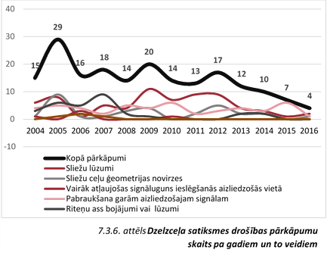
Kopā pārkāpumi | Total violations
Sliežu lūzumi | Broken rails
Sliežu ceļu ģeometrijas novirzes | Geometric deviations of tracks
Vairāk atļaujošas signāluguns ieslēgšanās aizliedzošas vietā | Cases when a more permissive signal is switched on instead of a prohibitive one
Pabraukšana garām aizliedzošajam signālam | Rolling stock passing the restrictive signal
Riteņu ass bojājumi vai lūzumi | Damaged or broken wheel axles
7.3.6. attēls Dzelzceļa satiksmes drošības pārkāpumu skaits pa gadiem un to veidiem | 7.3.6. Figure Number of traffic safety violations by year and type

Analysing the data for the period from 2006 to 2016, the total number of technical accidents does not exceed 20 cases per year.
Accurate data which provide information on how, where and how far people move and on the identity of these people is necessary for the development of railway traffic safety and understanding of security problems. Together with the information on accidents, it allows assessment of the risk to society as a whole or with regard to certain categories of risks or accident types. In order to assess the differences of risks and in development of risks, there is a need for regular evaluation. Therefore, in particular, the Inspectorate shall draw attention to accident data records. With the focus on specific topics, regular analysis of data shall be performed, such as on the nature of injuries and the causes underlying the behaviour.

Safety Recommendations
The Transport Accidents and Incidents Investigation Bureau did not address any safety recommendations for the prevention of accidents in 2016.

Certification
The State Railway Technical Inspectorate is responsible for issuing Parts A and B of Railway Safety Certificates and Safety Certificates, as well as for testing and certifying railway specialists. The procedure of verifying compliance is free of charge.
All information on the certification process is available on the website of the Inspectorate www.vdzti.gov.lv, section Certification/Safety certification or Certification/Safety permits or Certification of engine drivers. Information is updated continuously.

Safety Certificate
Cabinet Regulation No 168 of 10 March 2008 ‘Regulations Regarding the Procedures and Criteria for Issuing, Suspending and Revoking Part A and Part B of a Safety Certificate’ states that railway carriers should provide and maintain the safety management system, which shall include the risk assessment and control, competence and security management. A safety certificate shall be issued to railway undertakings that comply with the requirements for technical operations and meet the safety requirements regarding personnel, rolling stock and the internal structure of a commercial company.
There are six commercial companies in Latvia, which in accordance with the current safety regulations have the right to provide railway (freight, passenger) transport services using the public railway infrastructure: LDZ Cargo Ltd., JSC Baltijas Ekspresis, JSC BALTIJAS TRANZĪTA SERVISS, Gulbenes –Alūksnes bānītis Ltd. (narrow gauge railway), JSC Pasažieru vilciens, Euro Rail Cargo Ltd. and JSC Lietuvos geležinkeliai.
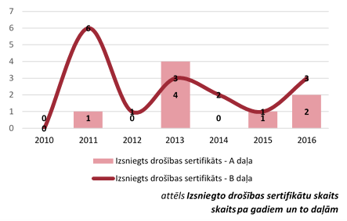
Izsniegts drosibas sertifikats – A dala | Safety certificate issued – Part A
Izsniegts drosibas sertifikats – B dala | Safety certificate issued – Part B
8.1.1. attēls Izsniegto drošības sertifikātu skaits | 8.1.1. Figure Number of safety certificates issued
skaits pa gadiem un to daļām | by year and part

The State Railway Technical Inspectorate issued five safety certificates in 2016. During the reporting year, two Part As of safety certificates and three adjusted/amended Part Bs of safety certificates were issued.
8.1.1.Table Number of safety certificates by year, type and part
 | 2011 | 2012 | 2013 | 2014 | 2015 | 2016
Safety certificate issued - Part A | 1 | 0 | 4 | 0 | 1 | 2
new safety certificate | 0 | 0 | 0 | 0 | 1 | 0
renewed safety certificate | 1 | 0 | 4 | 0 | 0 | 1
adjusted/amended safety certificate | 0 | 0 | 0 | 0 | 0 | 1
for passenger and freight transport | 0 | 0 | 1 | 0 | 0 | 0
for passenger transport | 1 | 0 | 1 | 0 | 0 | 2
for freight transport | 0 | 0 | 2 | 0 | 1 | 0
Safety certificate issued - Part B | 6 | 1 | 3 | 2 | 1 | 3
new safety certificate | 0 | 1 | 0 | 0 | 0 | 0
renewed safety certificate | 1 | 0 | 3 | 1 | 0 | 1
adjusted/amended safety certificate | 5 | 0 | 0 | 1 | 1 | 2
for passenger and freight transport | 2 | 1 | 0 | 1 | 0 | 0
for passenger transport | 2 | 0 | 1 | 0 | 1 | 2
for freight transport | 2 | 0 | 2 | 1 | 0 | 1
Total | 7 | 1 | 7 | 2 | 1 | 5

Safety Permit
Cabinet Regulation No 57 of 18 January 2011 ‘Regulations Regarding the Criteria and Procedure for the Issuance, Suspension and Revocation of a Safety Permit’ set out requirements for the issue of railway safety permits. Safety permits are issued for construction and repair of rolling stock, construction, repair and maintenance of equipment for railway infrastructure, management of railway infrastructure and shunting operations. During the reporting year, the Inspectorate issued 102 safety certificates, suspended 44 safety certificates and revoked 20 safety certificates. During the reporting year, safety certificates were revoked (issuing another safety certificate) on account of changes to the name and legal address of a company and changes to the field of a company’s commercial operations.
The largest number of applications (102) received during the reporting year was for the management of railway infrastructure.
8.2.1. Table Number of safety certificates by year and field
 | 2011 | 2012 | 2013 | 2014 | 2015 | 2016
Safety certificates issued | 85 * | 70* | 101* | 74* | 149* | 102*
Fields of operation
construction, repair and maintenance of rolling stock | 6 | 7 | 9 | 6 | 7 | 4
entity responsible for maintenance, including |  | 20 | 20 | 30 | 19 | 21
maintenance of freight wagons |  |  | 18 | 10 | 6 | 2
construction, repair and maintenance of equipment for railway infrastructure | 29 | 35 | 54 | 33 | 38 | 23
shunting operations | 3 | 4 | 7 | 12 | 6 | 18
railway infrastructure management | 56 | 14 | 39 | 39 | 102 | 101
Safety certificates issued | 85 | 70 | 101 | 74 | 149 | 102
new safety authorisation | 65 | 60 | 48 | 25 | 84 | 29
renewed safety authorisation | 10 | 6 | 29 | 25 | 42 | 46
adjusted/amended safety authorisation | 10 | 4 | 24 | 24 | 23 | 27
Safety certificates revoked | 3 | 10 | 17 | 12 | 27 | 20
Suspended safety certificates | 9 | 11 | 20 | 11 | 20 | 44
* More than one field of commercial operations may be specified in a safety certificate.

Entity Responsible for Maintenance of the Rolling Stock
The State Railway Technical Inspectorate is responsible for the certification of entities responsible for maintenance of the rolling stock and as alternative measures applies the provisions set out in Chapter VIII of Directive 2008/110/EC (16 December 2008) amending Directive 2004/49/EC on safety on the Community’s railways (Railway safety Directive). The requirements for certification are included in Paragraph 11 of Cabinet Regulation No 57 of 18 January 2011 ‘Regulations Regarding the Criteria and Procedures for the Issuance, Suspension and Revocation of a Safety Permit’.
If a railway undertaking indicates in a submission that the undertaking is also an entity responsible for technical maintenance of rolling stock, this information is included in the safety certificate. In this case certification shall be based on Cabinet Regulation No 168 of 10 March 2008 ‘Regulations Regarding the Procedures and Criteria for Issuing, Suspending and Revoking Part A and Part B of a Safety Certificate’
The whole certification process shall be completed within a month’s time, when a decision regarding the issuance of a certificate or authorisation is taken.

8.3.1. Table Indicators of certification process by year and field
 | 2013 | 2014 | 2015 | 2016
Carrier + entity responsible for the technical maintenance of freight wagons | 1
new safety certificate
renewed safety certificate | 1
adjusted/amended safety certificate
Infrastructure manager + entity responsible for the technical maintenance of freight wagons | 1
new authorisation
renewed authorisation | 1
adjusted/amended authorisation
Other entities responsible for the technical maintenance of the rolling stock (including freight wagons) | 20 | 30 | 19 | 21
new authorisation | 7 | 6 | 3 | 3
renewed authorisation | 5 | 6 | 3 | 17
adjusted/amended authorisation | 8 | 18 | 13 | 3
Total | 22 | 30 | 19 | 21

Supervision
After issuing a safety certificate or safety permit, the State Railway Technical Inspectorate must verify whether operational results indicated in the safety certificate or safety permit have been attained, and whether all the relevant operation requirements are being constantly observed. In performing supervision, the Inspectorate must comply with the key principles of the national safety authority in the field of supervision – proportionality, consistent approach, usefulness, transparency, accountability and cooperation – as referred to in Regulation (EU) No 1158/2010 and Regulation (EU) No 1169/2010.
The State Railway Technical Inspectorate is responsible for the supervision of the following areas:
8.1. supervision of technical operations;
8.2. evaluation of the efficiency of safety management systems;
8.3. checks of railway specialists’ competence;
8.4. rolling stock conformity assessment;
8.5. conformity assessment of railway facilities;
8.6. infrastructure conformity assessment;
8.7. supervision of transport of dangerous goods;
8.8. investigation of railway traffic accidents.

9.1. Inspections, audits and checks
The State Railway Technical Inspectorate conducted 161 inspections in 2016. The number of inspections in commercial enterprises has slightly decreased, which is due to gradual transition to audits of safety management systems where the audit of a single carrier requires at least a six-month assessment period. For that reason, the scope of inspections has been decreasing gradually over a five-year period by 5-10% a year on average. To schedule the inspections, the Inspectorate has defined clear criteria for the frequency and periodicity of checks in commercial enterprises. Audits of safety management systems are scheduled once every five years. The frequency of audits may be revised in the future on account of the transposition of the 4th Railway Package.
Scheduled inspections accounted for 70% of all inspections in the reporting year. The number of unscheduled inspections by year varies within 15-30% of the total number of inspections. The number of scheduled inspections decreased during the reporting year, which is due to specific inspections of private infrastructure managers where increased risk of traffic safety has been identified. 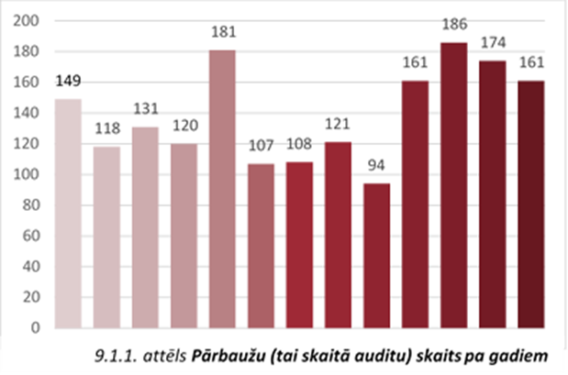
Figure 9.1.1. Number of inspections by year (including audits) | 9.1.1. Figure Number of inspections by year (including audits)

9.1.1. Table Indicators of monitoring process by year
 |  | 2011 | 2012 | 2013 | 2014 | 2015 | 2016
1. | Inspections | 121 | 94 | 161 | 186 | 174 | 161
1.1 | assessment of the efficiency of safety management systems/audits of safety management system elements | 6 | 7 | 6 | 2 | 1 | 1
1.2. | comprehensive inspections | 17 | 35 | 55 | 55 | 91 | 84
1.3. | specific inspections | 98 | 54 | 100 | 128 | 82 | 77
2. | Inspected objects and activities, including | 101 | 89 | 125 | 168 | 174 | 161
2.1. | railway undertakings | 5 | 5 | 5 | 5 | 2 | 1
2.2. | rolling stock maintenance companies | 17 | 13 | 15 | 17 | 15 | 3
2.3. | loading, unloading of dangerous goods | 20 | 9 | 36 | 34 | 34 | 33
2.4. | other | 2 | 2 | 2 | 3 | 12 | 2
2.5. | infrastructure management or maintenance and ensuring of shunting operations | 57 | 60 | 67 | 109 | 111 | 122
In approximately 45% of cases, the Inspectorate carried out comprehensive inspections in order to reduce the administrative burden for commercial enterprises and at the same time check all possible areas of work. In specific inspections, individual in-depth inspections are carried out, for example, standards for the maintenance of railway tracks or technical condition of rolling stock, or supervision of the transport of dangerous goods. In determining the overall scope of an inspection, the Inspectorate appraises information already available to the Inspectorate and analyses risks and information on the implementation of recommendations given during the last inspection. Complete and specific inspections are planned on a monthly basis.
The State Railway Technical Inspectorate also manages level crossings. Senior inspectors participated in 191 annual level crossing commission inspections in 2016. The inspections of level crossings are organised in accordance with Cabinet Regulation No 392 of 6 October 1998 ‘Regulations on constructing, equipping, servicing and closure of railway level crossings’. Apart from participating in the annual commission inspections, the senior inspectors also participated in the commission work on the construction, equipping or closure of railway level crossings.
9.1.1. Table Inspections of level crossings by year
 |  | 2011 | 2012 | 2013 | 2014 | 2015 | 2016
1. | Annual inspections of level crossings | 148 | 108 | 190 | 167 | 213 | 191
2. | Construction, equipping, or closure of level crossings | 17 | 9 | 24 | 15 | 9 | 1
 | Total | 165 | 117 | 214 | 131 | 222 | 192
As safety on railway level crossings is one of the priorities, the Inspectorate is focusing increasingly on the technical condition of level crossings.

9.2. Investigation and registration of railway traffic accidents
The State Railway Technical Inspectorate investigates and registers specific railway traffic accidents. Investigation and registration of railway traffic accidents are performed in accordance with Cabinet Regulation No 999 of 28 October 2010 ‘Procedures for the Classification, Investigation and Recording of Railway Traffic Accidents’.
The State Railway Technical Inspectorate investigated 29 railway traffic safety violations in 2016. In comparison with 2015, the number of investigated violations decreased, which would indicate an improvement in traffic safety by identifying risk areas and monitoring them. The State Railway Technical Inspectorate has not participated in investigations of serious accidents since 2013.
During the reporting year, railway traffic safety violations were investigated in the following instances:
4.4.2.1. Collision of the rolling stock with other rolling stock or a collision with an object of railway infrastructure, elements or objects of loading or unloading installations, thus endangering railway traffic safety (11 investigations);
4.4.2.2. Derailment of the rolling stock (13 investigations);
4.4.2.3. Acceptance or routing of a train along an unprepared route, including routing or acceptance of electric rolling stock if the route or its section has not been equipped with contact lines or there is no voltage (1 investigation).
4.4.2.4. Ignoring a signal at danger while part of the rolling stock performs an unauthorised movement (passing or not passing a danger point) contrary to the order – a signal at danger or an on-board device signal of an appropriately equipped train (1 investigation);
4.4.2.5. Failure to fence off work spaces on railway tracks (2 investigations);
4.4.2.6. Switching of a point if the railway rolling stock is located on it (1 investigation);
A summary of data indicates that the State Railway Technical Inspectorate investigates 30 to 45 accidents a year. The main reasons for these violations are maintenance shortcomings and failures to observe the relevant procedures. To a great extent, violations occur as a result of specialists acting incorrectly in normal operational and emergency situations, which can be attributed to insufficient knowledge, fatigue or inattentiveness. It is impossible to completely avoid these instances, however, such measures must be introduced that reduce the number thereof to a minimum.

9.3. Putting into service of infrastructure facilities
In 2016, the State Railway Technical Inspectorate put 51 infrastructure facilities into service. Putting into service of infrastructure facilities is carried out in accordance with Cabinet Regulation No 530 of 2 September 2014 ‘Railway Building Regulations’.
In putting the railway infrastructure facilities into service, compliance of the facilities with railway technical operation requirements shall be verified.
9.3.1. Table Putting into service of infrastructure facilities by year
 |  | 2011 | 2012 | 2013 | 2014 | 2015 | 2016
 | Infrastructure facilities put into service | 101 | 98 | 33 | 38 | 76 | 51
2.1. | renewal | 5 | 6 | 11 | 11 | 14 | 5
2.2. | newly erected building | 29 | 60 | 13 | 10 | 17 | 6
2.3. | rebuilding | 9 | 5 | 9 | 7 | 45 | 40
2.4. | modernisation | 58 | 27 | 0 | 0 | 0 | 0
3.1. | railway tracks | 9 | 6 | 17 | 23 | 67 | 11
3.2. | systems for automatic traffic management | 71 | 43 | 1 | 3 | 0 | 0
3.3. | optical cables | 0 | 36 | 0 | 0 | 0 | 0
3.4. | other infrastructure facilities | 21 | 13 | 14 | 11 | 9 | 40
The highest indicator was achieved in 2011 when 101 infrastructure facilities were put into service.

9.4. Putting rolling stock into service
On 28 December 2010, the Cabinet adopted Regulation No 1211 'Regulations on the Construction, Upgrading, Renewal, Conformity Assessment and Authorisation for Placing in Service of the Rolling Stock'. In 2011, new rules were defined for the placing into service of types and units of rolling stock. Before starting the operation, rolling stock shall be authorised for placing in service in Latvia.
In 2016, the State Railway Technical Inspectorate accepted 8 rolling stock types and 82 rolling stock units into service. The number of new types of rolling stock put into service has increased, whereas the number of units put into service has fallen significantly, which may be due to a decrease in freight transport volumes.
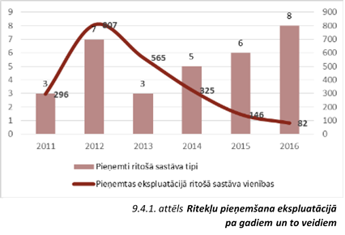
9.4.1. attēls Ritekļu pieņemšana ekspluatācijā | Figure 9.4.1 Vehicles put into service
Pienemti ritosa sastava tipi | Accepted types of rolling stock
Pienemtas ekspluatacija ritosa sastava vienibas | Units of the rolling stock accepted for placing in service
pa gadiem un to veidiem | by year and type

9.4.1. Table Vehicles put into service by year and type
 |  | 2011 | 2012 | 2013 | 2014 | 2015 | 2016
 | Accepted types of rolling stock | 3 | 7 | 3 | 5 | 6 | 8
1.1. | traction vehicle | 2 | 6 | 1 | 1 | 2 | 5
1.2. | freight wagon | 1 | 1 | 0 | 3 | 0 | 1
1.3. | special vehicle | 0 | 1 | 1 | 1 | 3 | 2
1.4. | passenger wagon | 0 | 0 | 0 | 0 | 1 | 0
 | Units of the rolling stock accepted for placing into service | 296 | 807 | 565 | 325 | 146 | 82
2.1. | freight wagon | 282 | 791 | 552 | 304 | 102 | 53
2.2. | special rolling stock | 1 | 1 | 5 | 6 | 14 | 4
2.3. | traction rolling stock | 13 | 15 | 8 | 15 | 20 | 25
2.4. | passenger wagon | 0 | 0 | 0 | 0 | 8 | 0
3.1. | after modernisation | 38 | 14 | 16 | 10 | 15 | 28
3.2. | newly built | 154 | 730 | 521 | 289 | 14 | 5
3.3. | used, placed on market for the first time | 104 | 63 | 28 | 26 | 117 | 49
Information on the types and units of rolling stock put into service can be found on the Inspectorate website www.vdzti.gov.lv, under Certification/Putting into service of rolling stock.

Risk Assessment
Any system change can affect traffic safety. It is therefore necessary to ensure there is a risk assessment. Railway undertakings, infrastructure managers, those carrying out repair work and construction companies shall comply with the requirements of European Commission Regulation (EC) No 352/2009 of 24 April 2009 on the adoption of a common safety method on risk evaluation and assessment as referred to in Article 6(3)(a) of Directive 2004/49/EC of the European Parliament and of the Council. Enterprises have adopted internal risk assessment procedures, which include registration of technical, technological and organisational changes and assessment of significance of the changes, identification and classification of the hazard thereof, determining the acceptability of the risk, the measures to be implemented, and responsibility so as to ensure the suitability of the system to fulfil its safety requirements and functionality.
Both carriers and the manager of public railway infrastructure prepared risk assessment processes. Internal risk assessment procedures have been prepared to set out the process of registration of technical, technological and organisational changes and assessment of significance of the changes, identification and classification of the hazard thereof, determining the acceptability of the risk, measures to be implemented, and responsibility so as to ensure compliance of the system with its safety requirements and functionality. Some parties involved in the process have established an information system for assessing risks.
In 2016, risk assessment was performed in several undertakings. The risk assessment process is applied to the following changes:
10.1. restructuring of regional centres of carriers;
10.2. tests of modernised diesel trains and diesel locomotives and putting them into operation;
10.3. installation of a wagon holder system;
10.4. a document management system for electronic circulation of telegrams of the public railway infrastructure manager;
10.5. enabling transportation processes at new railway sections;
10.6. changes to the vehicle maintenance system;
10.7. organisation and conducting of train traffic and shunting operations at stations.
10.1 .Table Risk assessment process by year
 |  | 2015 | 2016
 | Risk assessment | 10 | 17
1.1. | significant changes | 5 | 10
1.2. | insignificant changes | 5 | 7
Assessment authorities assessed compliance of the operation of the risk management process and have gained assurance that changes are implemented in accordance with the existing risk management plans.

Analysis of Reports of Railway Undertakings and the Public Railway Infrastructure Manager

11.1. Report of the Public Railway Infrastructure Manager
The report reflects the safety trends established, actions taken for railway safety and results achieved by the State JSC Latvijas dzelzceļš as the infrastructure manager. The report provides information regarding safety measures for improving the infrastructure and for reducing the number of accidents with casualties.
In order to ensure the system supervision and control, the State JSC Latvijas dzelzceļš has established an internal monitoring system for traffic safety. The system also provides schedules for technical audits and inspections.
11.1.1. Table Data of internal audits of the Public Railway Infrastructure Manager
 | Scheduled | Implemented | %
Technical audits | 105 | 105 | 100
The internal inspections examined procedures for signalling system maintenance and railway track supervision at stations and train wagon examination points. During the technical audits and inspections, several violations were revealed and recommendations were given to the responsible officials regarding the elimination of shortcomings and improvement of the overall traffic safety situation.
In 2016, the Safety management system was audited, with all elements of the system being audited simultaneously. The audit involved checks on internal regulations, procedures and processes describing aspects directly or indirectly concerned with safety. The audit of the Safety Management System provided assurance that types and scope of activities, as well as goals and principles of the traffic safety policy are relevant and consistent.
Several measures were taken in 2016 for preventing accidents and improving the safety of persons on the railway:

11.1.2. Table Measures taken by the Public Railway Infrastructure Manager
to reduce the number of accidents
reconstruction of railway tracks with pedestrian access points, crossings, access ramps and safety fences | 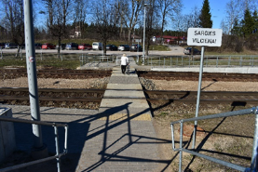
modernisation of pedestrian crossings | 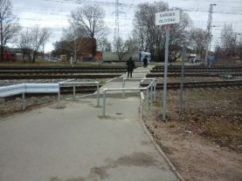
constructing pedestrian railway crossings controlled by light and sound signals | 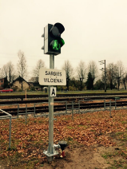
safety campaign related to the coming of the dark period, taking into consideration that the number of accidents increases when it’s darker and specific seasonal factors | 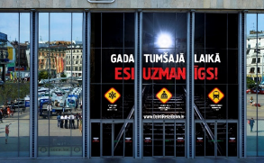
The report also includes information on risk assessment procedures.

11.2. Reports of Railway Undertakings
The State Railway Technical Inspectorate had received safety performance reports of all railway undertakings by 30 June 2016. The reports provided information regarding the implementation of safety measures, the structure of the internal monitoring system at an undertaking and general statistical information. Information on railway traffic accidents was provided in annexes.
In 2016, all railway undertakings audited their safety management systems to make sure that the systems ensured the safety of operations of the undertakings. All elements of the safety management systems were audited, including whether the internal regulations provided for traffic safety processes and procedures and whether the safety management systems were still efficient. After the reports on the audit results were received, it was concluded that:
11.2.1. The safety management system is efficient and guarantees safety. Documents, procedures and processes on operations comply with the requirements of regulatory enactments, technological processes and ensure the safe provision of services. The objectives and principles of the safety policy are up to date, and development priorities remain unchanged.
11.2.2. Improvements are needed in the safety management system by introducing relevant processes and responsibility levels, and by ensuring that internal regulations are revised pursuant to the requirements of external regulatory enactments;
Operational strategies and development plans have been developed for maintenance and improvements in the safety management system. Annual and long-term operational strategies have been developed. Operational strategies are developed according to proposals presented by the structural units of commercial companies.
More inspections were conducted at commercial companies pursuant to the internal monitoring system than originally anticipated. The internal traffic safety monitoring system regulates the procedures for the examination of issues, procedures for inspections, procedures for training, instruction and personnel management, the schedule of planned measures, and the drawing up and implementation of reports and documents regulating work of train crews. In total, more than 6 000 internal inspections and audits have been conducted. The monitoring system at commercial companies conforms to the provisions of the basic technical operation requirements.

Priorities of the State Railway Technical Inspectorate for 2017

Measures planned in 2017:
9.1. At the Inspectorate level: analysis, optimisation and development of internal systems.
9.2. Throughout Latvia:
9.2.1. work on the transposition of the Fourth Railway Package (until 31 May 2019);
9.2.2. implementation of the functions specified in the Railway Law
12.1.Table Operational areas of the Inspectorate in 2017
Operational result | Performance indicator | 2017
Audits of the elements of safety management systems (SMS) carried out | Audits of SMS elements performed per year | 14
Inspections carried out | Number of inspections per year | 100
Organisation of theoretical examinations for representatives of commercial companies | Number of examinations per year | 245
Operational result | Performance indicator | 2017
Issuance of safety certificates | Number of issued certificates per year | 3
Issuance of safety permits | Number of permits issued per year | 40
Conformity inspections of the rolling stock units | Units of the rolling stock accepted for placing in service per year | 60
Conformity inspections for the rolling stock types | Types of the rolling stock accepted for placing in service per year | 2
Inspections of level crossings | Annual inspections of level crossings | 120
Issuance of construction permits | Decisions taken per year | 25
Examination of compliance with the provisions included in the construction permit | Decisions taken per year | 10
Examination of provisions regarding construction works | Decisions taken per year | 15
Conformity inspections of railway infrastructure facilities | Infrastructure facilities accepted for placing in service per year | 35
Organisation of examination of drivers, driver assistants and driver instructors | Number of examinations per year | 275
Drafting EU legislation | Participation in working groups of EU bodies (number of meetings) | 30
9.2.2.Preparation of proposals in the course of drafting regulatory enactments.
9.3. At the EU level:
    - to provide feedback to the railway safety authorities of the Member States and the European Railway Agency with regard to railway-related issues, problems and possible solutions. The Inspectorate plans to:
      - take active part in the working groups of ERA, to the extent possible;
      - provide information regarding interoperability and traffic safety issues;
    - participate in meetings of the interoperability and safety committee;
9.3.3.participate in the analysis of technical specification parameters of interoperability (participation in ERA/OSJD working groups);

Annexes
Annex 1
Public Railway Infrastructure Manager
Name | Website | Safety certificate or safety permit number | Area of activity
State Joint Stock Company Latvijas dzelzceļš | www.ldz.lv. | LV2920130059 | Infrastructure Manager  Network report  http://www.ldz.lv/?object_id=3094
Railway Carriers
Name | Website | Safety certificate or safety permit number | Area of activity
JSC Baltijas ekspresis | www.asbe.lv | LV 1120130005 (Part A)  LV 1220130006 (Part B) | Carrier  (freight transport)
JSC Pasažieru vilciens | www.pv.lv | LV 1120160002 (Part A)  LV 1220160003 (Part B) | Carrier  (passenger transport)
JSC BALTIJAS TRANZĪTA SERVISS | N/A | LV 1120130003 (Part A)  LV1220160001 (Part B) | Carrier  (freight transport)
Gulbenes-Alūksnes bānītis Ltd. | www.banitis.lv | LV 1120160004 (Part A)  LV 1220160005 (Part B) | Carrier  (passenger transport)
LDZ Cargo Ltd. | www.ldz.lv | LV 1120130007 (Part A)  LV 1220140001 (Part B) | Carrier  (freight and passenger transport)
JSC Lietuvos geležinkeliai | www.litraill.lt | LV1220120001 (Part B) | Carrier  (freight and passenger transport)
JSC EURO RAIL CARGO | N/A | LV1120150002 (Part A) | Carrier (freight transport)

Annex 2
Changes in Legislation in the Reporting Year
 | Legal reference | Effective from | Description, amendment or new regulatory enactment
Functions and objectives
Legislation that sets out tasks for the authority responsible for control and monitoring of railway technical operations | Amendments to the Railway Law (No 48 (5620) of 9 March 2016) | 10 March 2016 | Amendments. Adjusted functions.  Section 33(2) System for exchange of information and cooperation between the State Railway Administration and the State Railway Technical Inspectorate  Section 33(3) Protection of the rights of passengers  Section 33(1) Recognition of assessment bodies and TAP TSI coordinator function
Regulations on assessment organisations, etc. | N/A | N/A | N/A
Safety Regulations
Regulations on safety objectives and methods | N/A | N/A | N/A
Regulations on safety management systems and safety certificates of railway transport undertakings | N/A | N/A | N/A
Regulations on safety management systems and safety permits of infrastructure managers | N/A | N/A | N/A
Regulations on requirements for wagon keepers | N/A | N/A | N/A
Regulations on technical maintenance for the structural units in charge | N/A | N/A | N/A
Regulations on railway repair undertakings | N/A | N/A | N/A
Regulations on uniform technical operations | N/A | N/A | N/A
Regulations on requirements for personnel performing tasks critical for safety, including personnel selection criteria, health status, vocational training and certification | Cabinet Regulation No 569 of 23 August 2016 ‘Amendments to Cabinet Regulation No 873 of 14 September 2010 Regulation Regarding Obtaining a Traction Vehicle Driver’s (Train Driver’s) Qualification and Licence to Drive a Traction Vehicle’ | 26 August 2016 | Amendments. Language requirements.  Language requirements for the infrastructure manager
Regulations on the investigation of railway traffic accidents | N/A | N/A | N/A
Regulations on registration and analysis of data on railway accidents | N/A | N/A | N/A
Regulations on registration and analysis of data on railway accidents | N/A | N/A | N/A
Regulations on permits to place in service and maintain new or overhauled infrastructure facilities | Cabinet Regulation No 8 of 5 January 2016 ‘Amendments to Cabinet Regulation No 1210 of 28 December 2010 ‘Regulations on interoperability of the European railway system’’ | 22 January 2016 | Amendments. Verification  Procedures and requirements for verification
Regulations with regard to rolling stock | Cabinet Regulation No 8 of 5 January 2016 ‘Amendments to Cabinet Regulation No 1210 of 28 December 2010 ‘Regulations on interoperability of the European railway system’’ | 22 January 2016 | Amendments. Verification  Procedures and requirements for verification

Annex 3

Documents Approved by the Public Railway Infrastructure Manager that Are Binding to Railway Carriers

Order number | Date of the document | Status | Name of the document
PP-40/387 | 8 December 2016 | new | Regulations on maintenance of freight wagons
DV-1.14./65-2016 | 24 January 2016 | new | On informing traction vehicle drivers
VL-37/120 | 8 December 2016 | new | Occupational Safety Policy
D-1.14./278-2016 | 19 December 2016 | new | Occupational Safety System
DT-1.15./101-2016 | 7 December 2016 | new | Handover of stations for back-up control in sections with ESTW L90 5 (Thales) centralised microprocessor control
D-1.14/238-2016 | 5 January 2016 | amendments | Determining the speed of trains
DV-1.14./29-2016 | 1 February 2016 | amendments | On transporting highly hazardous freight (the list of highly hazardous freight)
D-1.14./200-2016 | 23 August 2016 | amendments | Manual for control of the rolling stock technical condition during the train movement on public railway infrastructure tracks
DV-1.14./199-2016 | 3 October 2016 | amendments | On installing information signs at level crossings
DV-1.14./216-216 | 31 October 2016 | amendments | Rules on safety posts
DV-1.14./226-2016 | 11 November 2016 | amendments | Guidelines for the operation of rolling stock braking system
DV-1.14./236-2016 | 7 December 2016 | amendments | Wagon maintenance instructions

Appendix 4

Certification Process – Safety Certificates (statistical data)
4.1.
 | Total number of safety certificates | Number of safety certificates reported to ERADIS
Safety certificates Part A issued in
2016 | 2 | 2
Total number of valid safety certificates Part A in
2016 | 6 | 6
4.2.
 | Total number of safety certificates | Number of safety certificates reported to ERADIS
Total number of safety certificates Part B issued in
2015 | 3 | 3
safety certificate Part A issued in Latvia | 3 | 3
safety certificate Part A issued in another Member State | 0 | 0
Total number of safety certificates Part B valid in
2016 | 6 | 6
4.3.
Applications for safety certificates Part A |  | A | R | P
received in 2016, including | new certificates | 0 | 1 | 0
received in 2016, including | adjusted/amended certificates | 1 | 0 | 0
received in 2016, including | renewed certificates | 1 | 0 | 0
4.4.
Applications for Safety Certificates Part B |  |  | A | R | P
received in 2016, including | safety certificate Part A issued in Latvia | new certificates | 0 | 0 | 0
received in 2016, including | safety certificate Part A issued in Latvia | adjusted/amended certificates | 2 | 0 | 0
received in 2016, including | safety certificate Part A issued in Latvia | renewed certificates | 1 | 0 | 0
received in 2016, including | safety certificate Part A issued in another Member State | new certificates | 0 | 0 | 0
received in 2016, including | safety certificate Part A issued in another Member State | adjusted/amended certificates | 0 | 0 | 0
received in 2016, including |  | renewed certificates | 0 | 0 | 0
4.5.
Number of safety certificates cancelled/revoked in | Total number of safety certificates | Number of safety certificates reported to ERADIS in
2015 | 0 | 0
Part A | 0 | 0
Part B | 0 | 0

4.6.
 | Company name | Country where safety certificate Part A was issued | Year
List of countries where railway undertakings that applied for safety certificate Part B were issued safety certificate Part A | LDZ Cargo Ltd. | Latvia | 2013.
 | JSC BALTIJAS TRANZĪTA SERVISS | Latvia | 2013.
 | JSC Pasažieru vilciens | Latvia | 2016.
 | JSC Baltijas ekspresis | Latvia | 2013.
 | Gulbenes-Alūksnes bānītis Ltd. | Latvia | 2016.
 | JSC Lietuvos geležinkeliai | Lithuania | 2011.
 | JSC EURO RAIL CARGO | Latvia | 2015.

4.7. The period of time from submission of an application to issue of a certificate is one month (irrespective of the type of certificate)

Annual Public Report 2016 of the State Railway Administration.
Transport in Latvia 2016. Compilation of statistical data.
Annual Public Report 2016 of the State Railway Administration.
Basic Performance Indicators of the State Joint Stock Company Latvijas dzelzceļš [Latvian Railway] 2016.
Traffic Safety Report 2016 of SJSC Latvijas dzelzceļš.
Section 33, Paragraph one of the Railway Law.
Started in 2016, completed in 2017
SAFETY PERFORMANCE REPORT of the State JSC Latvijas dzelzceļš 2016
SAFETY PERFORMANCE REPORT of the State JSC Latvijas dzelzceļš 2016
A = Approved applications, safety certificates have been issued.
R = Rejected applications, safety certificates have not been issued.
P = Application has been submitted and is being considered, but safety certificate has not yet been issued.

