

2016 Annual Safety Report by the Luxembourg Railway Authority

**Table of contents**

A. INTRODUCTION 6

A.1 Purpose, scope and other recipients of this report 6

A.2 Significant organisational changes affecting the NSA 7

B. GENERAL SAFETY AND STRATEGY PERFORMANCE 8

B.1 Main conclusions for the year in question 8

B.2 Safety strategy, programmes and initiatives 9

B.3 Assessment of the past year 11

B.4 Areas of interest for next year (2017) 13

C. SAFETY PERFORMANCE TRENDS 14

C.1 Detailed analysis of the latest trends recorded 14

C.2 Results of safety recommendations 19

C.3 Implemented measures unrelated to the safety recommendations 21

D. SUPERVISION 25

D.1 Strategy and plan(s) 25

D.2 Human resources 25

D.3 Skills 26

D.4 Decision-making 27

D.5 Coordination and cooperation 29

D.6 Conclusions drawn from the action taken 29

E. CERTIFICATION AND AUTHORISATION 30

E.1 Guidance 30

E.2 Contacts with other NSAs 30

E.3 Procedural issues 31

E.4 Response 31

F. CHANGES TO THE LAW 32

F.1 Railway Safety Directive 32

F.2 Important changes to the law and regulations 33

G. APPLICATION OF THE COMMON SAFETY METHOD TO RISK EVALUATION AND ASSESSMENT 34

G.1 The National Safety Authority’s experience 34

G.2 Stakeholders’ reactions 34

G.3 Revision of the NSRs to take account of the EC Regulation on the CSM on risk evaluation and assessment 35

H. EXEMPTIONS FROM THE ECM CERTIFICATION SYSTEM 35

ANNEX A 36

COMMON SAFETY INDICATORS 36

ANNEX B 50

CHANGES TO LEGISLATION AND REGULATIONS – Table 1 50

CHANGES TO LEGISLATION AND REGULATIONS – Table 2 52

ANNEX C 54

ACF FUNCTIONAL ORGANISATION CHART 54

**Abbreviations**

|  |  |
| --- | --- |
| **ACF** | Luxembourg Railway Authority |
| **AET** | Technical Investigation Administration |
| **NSA** | National Safety Authority |
| **CEM** | Heavy equipment driver (train driver or shunting driver) |
| **RSD** | Railway Safety Directive |
| **ECM** | Entity in charge of maintenance |
| **RU** | Railway undertaking |
| **MS** | Member State |
| **ERA** | European Union Agency for Railways |
| **ERAIL** | European Railway Accident Information Links |
| **ETCS** | European Train Control System |
| **IM** | Infrastructure manager |
| **CSI** | Common safety indicator |
| **MSDI** | Ministry of Sustainable Development and Infrastructure |
| **CSM** | Common safety method |
| **DeBo** | Designated body (competent body in Luxembourg) |
| **AsBo** | Assessment body |
| **NIB** | Luxembourg National Investigation Body |
| **NoBo** | Notified body |
| **CST** | Common safety objective |
| **LC** | Level crossing |
| **MEMOR II+** | Luxembourg national automatic train protection system |
| **GRTO** | General Rules for Technical Operation |
| **IGR** | Infrastructure Manager’s Internal General Rules |
| **NSR** | Luxembourg National Safety Rules |
| **NRV** | National reference value set by Decision 2012/226/EU |
| **EPA** | Elementary Protection Area |

# INTRODUCTION

## Purpose, scope and other recipients of this report

This report covers the activities of the **ACF** (**A**dministration des **C**hemins de **F**er) [Luxembourg Railway Authority] in its capacity as **N**ational **S**afety **A**uthority (**NSA**) during the 2016 reporting year.

The objectives of the report are defined in Article 5 of the amended Law of 22 July 2009 on railway safety. The report must contain information on:

* + 1. progress with railway safety, including an inventory of the Common Safety Indicators (CSIs) defined in Annex I to Directive 2004/49/EC,
    2. important amendments made to the rules applicable to railway safety,
    3. changes in safety certification and authorisation,
    4. the results of the monitoring of the Infrastructure Manager (IM) and railway undertakings (RUs) and the lessons that have been learnt,
    5. the exemptions granted in accordance with Article 20(b) (see page 9, Article 20(b)(5)).

In accordance with Article 5 of the amended Law of 22 July 2009, the ACF reported to the Minister of Sustainable Development and Infrastructure on the performance of its responsibilities and is forwarding the report to the European Union Agency for Railways (ERA). The report may be consulted on the following websites:

[www.railinfra.lu](http://www.railinfra.lu/).

and

<https://pdb.era.europa.eu/safety_docs/AnnualReport/search_results.aspx>

The ACF also provides a hard copy version intended for restricted distribution to national stakeholders, such as the Technical Investigation Administration, the infrastructure manager, railway undertakings that hold a Luxembourg safety certificate, administrations, companies and persons interested.

## Significant organisational changes affecting the NSA

Having gained its ISO 9001:2008 certification in September 2015 through the certifying body ESCEM ASBL, the ACF underwent its first follow-up audit in 2016, which it passed.

The certificate of compliance with the requirements of the above-mentioned standard is valid for the following areas:

1. access to infrastructure;
2. safety certificates and authorisations;
3. authorisation for putting into service the structural subsystems constituting the railway system;
4. authorisation for putting vehicles into service;
5. national vehicle register;
6. train driver certification;
7. audits, checks and inspections for the purpose of supervision in the context of railway safety;
8. legislative monitoring.

Only one engineer was recruited in 2016. In the second half of the year, there was a new recruitment drive. As a result of this, four other technical staff were or will be recruited by the end of September 2017. With these new recruits, the precarious situation the ACF has been in since it was formed should improve significantly.

Pending the arrival and the external and internal training of these new personnel, the staff of the Interoperability and Safety Division must, on their own or with the help of other colleagues, perform the functions that the appointee is as yet unable to perform. In order to guarantee immediate fulfilment of the ACF’s obligations, a list of functions was drawn up in 2014 stating which staff member is responsible for each function, which staff member is actually performing the function and who is helping to fulfil the obligations related to this function.

# GENERAL SAFETY AND STRATEGY PERFORMANCE

## Main conclusions for the year in question

On the national network in 2016, there was one accident involving one serious injury, and one serious incident causing severe damage to a locomotive.

Sadly, there were three suicides and one suicide attempt in 2016.

The overall number of precursors, excluding signals passed at danger without authority, remains stable compared to previous reporting years and is still excellent.

The number of signals passed at danger without authority (two by trains and eight during shunting) was considerably lower than in 2015, when a worryingly high level was reached (15 by trains and 11 during shunting).

As regards infrastructure, the highlight of the year was the granting of authorisation for the ETCS equipment to go into service on the Kleinbettingen–Luxembourg and Luxembourg–Bettembourg Frontière lines and in all parts of Luxembourg station.

The following two observations:

* + - a considerable improvement in the number of signals passed at danger compared to 2015, bringing it back to the levels in the 2009-2014 period, and
    - stabilisation of all other indicators around the mean values (2009-2015),

allow us to conclude that the safety level remains very high.

However, caution must be maintained in view of the small size of the network (275 km of lines) and the few serious accidents that have occurred since 2009. The five signals passed at danger in 2015 could have had adverse consequences. Trends can change from one year to another.

All the railway stakeholders in Luxembourg, the two railway undertakings and the Luxembourg infrastructure manager, are certified in accordance with the amended Railway Safety Directive and with the Luxembourg laws transposing that Directive. The two RUs established in other Member States also have a B certificate in accordance with the regulatory framework. One of the certificates expired in mid-2016 and no application for renewal has yet been received by the ACF.

## Safety strategy, programmes and initiatives

Three processes underpin the ACF’s strategy:

* + - Performing a detailed assessment in line with the legal framework for requesting safety certificates and approvals, authorisations to put rolling stock and infrastructure subsystems into service. The opinions which the ACF gives to the supervising ministry in charge of issuing safety authorisations and certificates are accompanied by recommendations for improvements to be implemented by the entity concerned within a clearly defined deadline.
    - Performing audits, inspections and checks to satisfy the supervision obligations laid down in various legal acts.
    - Being in continuous contact with the stakeholders in the Luxembourg railway sector, the national and European institutions and the other safety authorities, particularly those in our neighbouring countries.

Given the high level of safety on the Luxembourg network, besides the plans for supervision the Luxembourg Railway Authority has thus far not drawn up an actual safety programme or plan. As stated below, the ACF issues recommendations to the relevant stakeholders after assessing applications for safety authorisations and certificates and also after audits.

In the light of the analyses carried out and the action plans put in place by the relevant stakeholders to counter the high increase in signals passed at danger, we are of the opinion that no further measures are necessary at present. However, we remain vigilant as regards changes in the safety indicators and in this precursor in particular.

On 16 February 2017, a head-on collision between a passenger train and a freight train occurred at the marshalling yard in Bettembourg, in which one person died and two were injured. This collision revealed failings in Luxembourg’s Class B system (MEMOR II+).

As a result of one of the four recommendations made by the Technical Investigation Administration based on the initial conclusions, the ACF brought forward the deadline for the mandatory installation of ETCS in rolling stock to 31 December 2019 (it was originally 30 June 2021).

The ACF has proposed that freight trains from Thionville (France) that have neither MEMOR II+ nor ETCS installed will have access to the Bettembourg marshalling yard, a few kilometres from the French border, only until 31 December 2017.

As regards supervision, the following aspects will be audited in 2017:

* + - Measures to manage all risks related to a railway undertaking’s activity.
    - Risks caused by the activities of parties outside the railway system.
    - Action, alert and information plans for emergencies, adopted in agreement with the competent public authorities.
    - Compliance with network-specific rules.
    - Compliance with network-specific rules regarding staff skills.
    - Compliance with specific rules on rolling stock management.

Following the discrepancies from the applicable references, the following subject will be included in the audit programme in 2017:

* + - Management of risks related to the use of contractors and control of suppliers.
    - Procedures to ensure that accidents or incidents and near-misses, as well as other dangerous occurrences, are reported, examined and analysed and that the necessary preventive measures are taken.

To ascertain whether structural, functional, operational and organisational changes by the different stakeholders are properly managed, the ACF has decided to include the correct application of Commission Implementing Regulation (EU) No 402/2013 on the common safety method for risk evaluation and assessment in the annual audit programmes to be carried out on stakeholders in the sector.

Nevertheless, it should be mentioned that a number of projects and programmes are currently being implemented by the Ministry of Sustainable Development, the IM and the RUs, along with awareness campaigns directly linked to safety, such as:

* installation of ETCS equipment in existing rolling stock or systematic replacement of rolling stock without ETCS, which is a much more effective system in terms of operational safety than the Class B equipment (MEMOR II+);
* the programme for the gradual elimination of level crossings;
* regular campaigns (including an annual campaign) on level crossing use by road users, to inform users of the dangers of crossing the tracks.

## Assessment of the past year

As already mentioned in point B1, the safety level as regards the Common Safety Targets (CST) laid down by the European Union is very high and remains stable. The indicators for 2016 are all below or at the National Reference Values (NRV) (for Luxembourg) set out in Commission Decision 2012/226/EU on the second set of common safety targets as regards the rail system. We would particularly like to highlight the fact that the situation concerning signals passed at danger, which had increased at an alarming rate, has markedly improved and the number recorded, involving two trains and eight shunting manoeuvres, is one of the lowest since the ACF was set up. Breakdowns of safety performance are given in Chapter C and Annex A.

We concentrated on the following issues in our audits of the RUs in 2016:

* + - *Management of all risks related to the railway undertaking’s activities;*
    - *Management of risks related to the use of contractors and control of suppliers;*
    - *Setting up of staff training programmes and systems for monitoring maintenance of their skills and for ensuring tasks are performed accordingly;*
    - *Qualitative and quantitative targets of the organisation as regards maintenance and improvement of safety, including plans and procedures for meeting those targets;*
    - *Procedures for meeting existing, new and modified technical and operational standards or other requirements;*
    - *Procedures and methods for assessing risks and taking risk control measures whenever a change in operating conditions or the introduction of new equipment produces new infrastructure or operational risks;*
    - *Procedures to ensure that accidents, incidents and near-misses and other dangerous occurrences are reported, examined and analysed and that the necessary preventive measures are taken.*

The main topics covered by IM audits are listed below:

* + - *Infrastructure Operations Service audited area – traffic management;*
    - *Safety management system documentation;*
    - *Allocation of responsibilities;*
    - *Ensuring that the different levels of management are making checks;*
    - *Setting up of staff training programmes and systems for monitoring skills maintenance and for ensuring tasks are performed accordingly;*
    - *Measures to ensure sufficient information is circulated within the organisation and, where appropriate, between organisations operating on the same infrastructure;*
    - *Planning of regular internal audits of the safety management system;*
    - *Operational safety of railway infrastructure;*
    - *Action, alert and information plans for emergencies, adopted in agreement with the competent public authorities.*

Given the risks posed by the IM’s signal boxes, especially during degraded operation or disrupted traffic conditions, the ACF would like to broaden its audits in this area, but because it has no experts on the subject, its ability to do so remains limited.

The findings of the audits carried out by the ACF were satisfactory. Nevertheless, as in the evaluation of applications for safety authorisations and certificates, several points were noted and recommendations for improvement with time scales for implementing them were sent to the entities concerned.

*Centralised control station covering, for example, a whole line and/or a whole station

## Areas of interest for next year (2017)

Future areas of interest are:

* increasing the number of audits;
* strengthening cooperation with other NSAs;
* as regards infrastructure, authorisation for putting the ETCS subsystem into service on all lines, which would allow the commercial test phase, not completed for reasons attributable to the RU CFL, to be closed and normal mode to commence;
* authorisation to put the ETCS subsystem into service on vehicles;
* active participation by the ACF in the working groups on transposition of the technical pillar of the fourth railway package within the Railway Interoperability and Safety Committee (RISC) and the European Union Agency for Railways;
* preparation by the ACF for the changes planned under the fourth railway package.

# SAFETY PERFORMANCE TRENDS

## Detailed analysis of the latest trends recorded

|  |  |  |  |  |  |  |
| --- | --- | --- | --- | --- | --- | --- |
| **Main indicators** |  | 2016 | 2015 | Average 11-16 | According to NRV | According to CST |
| Total number of persons seriously injured and killed (excluding suicides) | Number | 1 | 0 | 0.8 | 1.93 | 23.79 |
| Number/million train-km | 0.11 | 0 | 0.09 | 0.21 | 2.59 |
| Passengers seriously injured and killed | Number | 0 | 0 | 0 | 0.20 | 1.43 |
| Number/million passenger train-km | 0 | 0 | 0 | 0.02 | 0.17 |
| Staff including subcontractors seriously injured or killed | Number | 0 | 0 | 0 | 0.11 | 0.72 |
| Number/million train-km | 0 | 0 | 0 | 0.01 | 0.08 |
| People killed or seriously injured on level crossings including accidents involving pedestrians | Number | 1 | 0 | 0.40 | 0.88 | 6.52 |
| Number/million train-km | 0.11 | 0 | 0.04 | 0.10 | 0.71 |
| Unauthorised persons killed and injured on railway premises | Number | 0 | 0 | 0.4 | 0.73 | 18.83 |
| Number/million train-km | 0 | 0 | 0.04 | 0.08 | 2.05 |
| Suicides | Number | 3 | 3 | 5 |  |  |
| Number/million train-km | 0.34 | 0.33 | 0.56 |  |  |
| *Suicide attempts* | *Number* | *1* | *1* | *14)* |  |  |
| Number/million train-km | 0.11 | 0.11 | 0.114) |  |  |
| Broken rails | Number | 1 | 0 | 1.8 |  |  |
| Number/million train-km | 0.11 | 0 | 0.20 |  |  |
| Track buckling | Number | 1 | 4 | 1.6 |  |  |
| Number/million train-km | 0.11 | 0.44 | 0.18 |  |  |
| Wrong-side signalling failures | Number | 0 | 0 | 0.20 |  |  |
| Number/million train-km | 0 | 0 | 0.02 |  |  |
| Signals passed at danger without authority | Number3) | 24) | 15 | 6.40 |  |  |
| Number/million train-km3) | 0.25 | 1.63 | 0.71 |  |  |
| Signals passed at danger without authority during shunting | Number | 8 | 11 | 9.55) |  |  |
| Number/million train-km | 0.92 | 1.20 | 1.065) |  |  |
| Percentage of train kilometres using operational ATP systems | MEMOR II+ | 60% | 80% | 97%1) |  |  |
| ETCS | 40% | 20% | 2%2) |  |  |

1) and 2) not averages but the percentages for 2009

3) no signals passed at danger recorded

4) plus one signal passed at danger at Volmerange-les-Mines (France), a section of line managed and operated by the IM (CFL), not included in the statistics supplied to ERA

5) 2015 and 2016 average indicators added in 2015

**People seriously injured or killed** (including employees of railway stakeholders and their subcontractors)

Despite the fact that one person was seriously injured in the past reporting year, the average of 0.8 victims per year recorded for the 2011 to 2016 period is the same as the average in the report for 2015. This is well below the number of victims calculated on the basis of the latest National Reference Values (NRV) set out in Commission Decision 2012/226/EU, which is 1.93.

**Suicides**

The high number of suicides remains the main scourge that railways everywhere in Europe continue to face. They represent around 70% of deaths in the railway sector and this is a growing trend.

In the past reporting year, three suicides and one suicide attempt were recorded, which is exactly the same as the number recorded in 2016. Since 2009, there has been a downward trend in the average number of suicides. The average for the 2012 to 2016 period is 4.2 per year, compared to 5.00 between 2010 and 2014.

As the number of suicide attempts has only been recorded since 2015, it is not possible to state what the trend here is.

On this subject, we should mention the **‘Prevention of suicides is everyone’s responsibility’** campaign launched by the Luxembourg Ministry of Health. A National Suicide Prevention Plan for Luxembourg for the 2015 to 2019 period has also been drawn up.

For information purposes, the link is:

http://www.sante.public.lu/fr/publications/p/plan-national-suicide-lux-2015-2019/index.html

**Precursors to accidents – infrastructure, rolling stock**

The total number of precursors to accidents recorded in relation to infrastructure and rolling stock (excluding signals passed at danger) was three in 2016, which is its lowest level and was achieved once before in 2014. Overall these indicators are stable and at a very good level. This allows us to conclude that the general condition of the railway infrastructure and rolling stock is excellent, at least as regards the subsystems considered by the common safety indicators as precursors. However, the first cracked wheel was reported to us in 2016.

**Precursors to accidents – railway operations**

The number of signals passed at danger, which was on an upward trend in 2014 and reached very worrying levels in 2015, returned to much better levels in 2016 with two signals passed at danger (the one at Volmerange-les-Mines is not counted because the ACF’s figures are limited to Luxembourg only). The table below shows the signals passed at danger recorded by the ACF since its creation in 2009.

|  |  |  |  |  |  |  |  |  |
| --- | --- | --- | --- | --- | --- | --- | --- | --- |
|  | 2009 | 2010 | 2011 | 2012 | 2013 | 2014 | 2015 | 2016 |
| Signals passed at danger without authority (train) | **1** | 4 | **11** | 5 | 4 | 6 | **15** | **2** |

Average number of signals passed at danger by trains: 6.5/year

Average excluding the best and worst results: 5.3/year

In 2016, eight signals were passed at danger during shunting, compared to 11 in 2015, which is an improvement. As the ACF does not have figures for years prior to 2015, we cannot draw any more detailed conclusions.

After the catastrophic figures for 2015 for signals passed at danger, the action plans to remedy this worrying situation, which include no fewer than 68 measures agreed and implemented by stakeholders, have paid off.

These measures can be grouped into seven categories dealing with the following themes:

* + 1. training, communication with train drivers and feedback;
    2. coaching and awareness training for train drivers;
    3. increased frequency of controls of train drivers and improved controls of video and audio tapes;
    4. well-being at work, stress elimination as far as possible, and optimisation of rostering;
    5. adaptation of regulations on the use of mobile phones and cultivation of good workplace habits;
    6. optimisation of the visibility and clarity of signals (RU and IM working group);
    7. exchange of information and experience between RUs, partner RUs and IMs, as well as participation in the UIC’s ‘SPAD Task Force’.

On the basis of the results already recorded in the second half of 2015 and in 2016, the action taken by the different stakeholders has proved successful. The ACF is encouraging them to continue strict implementation of their actions.

Generally, we fully support the approaches taken by companies in the sector to improve safety culture internally.

**Infrastructure**

At the end of 2015, the entire national rail network, with the exception of the industrial rail network was equipped with ETCS. It was installed in nine lots, with the different lots each consisting of one or more complete or partial lines and one or more stations. The ACF issued the first authorisations in October 2016 and the final ones in July 2017, as the applications for authorisation to carry out the work were received. The table below shows the different lots and the date of issue by the ACF of authorisation for entry into service:

|  |  |  |
| --- | --- | --- |
| Authorisation for entry into service of groundside ETCS | | |
| Date | Lot description | Lot No |
| 05/10/2016 | Luxembourg – Kleinbettingen | Lot 8 |
| 13/10/2016 | Luxembourg station | Lot 4 |
| 14/10/2016 | Berchem – Bettembourg Frontière | Lot 5 |
| 02/06/2017 | Leudelange – Belval-Usines – Rodange Frontière | Lot 7 |
| 02/06/2017 | Noertzange – Esch-sur-Alzette | Lot 6 |
| 19/07/2017 | Ettelbrück – Diekirch and Ettelbrück – Bissen | Lot 1 |
| 19/07/2017 | Ettelbrück – Dommeldange | Lot 2 |
| 19/07/2017 | Ettelbrück – Troisvierges and Kautenbauch – Wiltz | Lot 3 |
| 20/07/2017 | Oetrange – Wasserbillig Frontière | Lot 9 |

The number of level crossings has been reduced by 18 since 2009, which represents a 13% reduction.

|  |  |  |  |  |
| --- | --- | --- | --- | --- |
| **Infrastructure characteristics** |  | 2016 | 2015 | 2009 |
| Km of lines equipped with the MEMOR II+ automatic train protection system | percentage | 100% | 100% | 100% |
| Main fixed signals and advanced fixed signals fitted with MEMOR II+ | percentage | 98.7%** | 100% | 100% |
| Km of lines fitted with ETCS level 1 | percentage | 100% | 100% | 59% |
| Main fixed signals and advanced fixed signals fitted with ETCS level 1 | percentage | 98.7%** | 99.6%* | 48% |
| Actively protected level crossings | number | 100 | 99 | 107 |
| Number/track-km | 0.16 | 0.16 | 0.17 |
| Passively protected level crossings | number | 24 | 25 | 35 |
| Number/track-km | 0.04 | 0.04 | 0.06 |

* The signals on the Tétange – Langegrund line leading to a particular branch are still to be fitted.

** The main fixed signals (SFP) at the new intermodal terminals are not equipped with either ETCS or MEMOR II+. In view of their location, the main fixed signals (SFP) will be replaced by fixed barred track signals (SFvb) which, depending on the principles applied by the IM, do not require a train protection system.

In principle, only barred track signals for flank protection towards line tracks and signals installed on station tracks for reception on occupied tracks are equipped with ETCS. The majority of fixed barred track signals installed at marshalling yards, sidings, junctions, etc. thus do not have ETCS or MEMOR II+ installed on the ground.

However, it should be noted that, for barred track signals without ETCS/MEMOR II+, the train travelling speed is very low compared to the maximum permissible speeds on the main line, so the risk of a serious accident/incident is greatly reduced.

## Results of safety recommendations

**Zoufftgen rail accident in 2006**

The Technical Investigation Administration was created by the Law of 30 April 2008. Together with the Land Transport Accidents Technical Investigations Bureau (BEA-TT France), it published its very first safety recommendations in 2009 as part of the technical report on the railway accident in Zoufftgen in 2006, which resulted in the death of six people.

As a result of that accident, 21 recommendations were made, of which:

* + - 14 have been implemented;
    - one is still being studied (recommendation R8);
    - five were rejected;
    - one does not concern Luxembourg railway operators.

All of these recommendations were included in the report for 2009.

The IM sent us the following information on the implementation of recommendation R8:

Recommendation R8 (CFL, SNCF, RFF): examine the feasibility of extending the SNCF Automatic Train Describer System [Système d’Annonce Automatique des Trains (SAAT)] to Bettembourg, displaying the first train described on the Optical Control Panel [Tableau de Contrôle Optique].

Automatic train describer systems such as CFL’s ZNL 800 or SNCF’s SAAT are simply operating aids and never play a role in rail traffic safety. They can therefore contribute only indirectly to improving safety.

The CFL and the SNCF have decided to develop an interconnection interface between the ZNL 800 and SAAT systems. This interface is currently being tested between Longwy (SNCF) and Rodange (CFL).

The entry into service of the interconnection installation for the CFL ZNL 800 and SNCF SAAT systems between Bettembourg and Thionville is suspended for the moment. For the SAAT installation to be commissioned, the new ZX 2000 installation at Bettembourg station must be operational. It was installed in December 2015. The studies for the creation of the interconnection between the ZN 2000 and SNCF SAAT systems could start in the second quarter of 2017, if the necessary resources are available.

**Occupational accident in Differdange in 2009**

In 2012, the AET made three recommendations in its final report on the occupational accident on 3 February 2009 on the former industrial network, which is now part of the National Railway Network. Only one is still pending (extracts from AET technical report):

R3: ensure that if the remote control box is tilted steeply, the interval before activation of rapid braking must be set so that emergency braking is applied as quickly as possible after the box is tilted.

Only one RU on the national rail network uses remote control. On the type of remote control used in this accident, the delay before activation of the emergency braking can be set at between three and five seconds (values given by the manufacturer and not modifiable by the user). This prevents the braking being triggered when the shunting driver has to bend down to enter or leave the Berne rectangle between two vehicles. The RU in question decided to set the delay to four seconds, which:

* + - firstly ensures that emergency braking is initiated within a safe period of time; and
    - secondly avoids emergency braking being initiated inappropriately because the time period is too short for coupling operations, as that would expose the staff to other safety hazards.

Concerning the other types of remote controls used on the national railway network, the RU in question has just informed us that harmonisation to four seconds has proved difficult as most of the equipment is leased. So a limit of no more than five seconds has been chosen. In view of the arguments presented by the RU, the ACF concludes that, from the point of view of recommendations, this accident can be considered closed.

## Implemented measures unrelated to the safety recommendations

**Safety measures taken following accidents/precursors to accidents**

|  |  |  |  |
| --- | --- | --- | --- |
| **Accidents/precursors prompting measures to be taken** | | | **Safety measures taken** |
| **Date** | **Place** | **Miscellaneous events** |  |
| 10/01 | Bettembourg station | Train path endangered by a secondary vehicle (SV) | * Detailed investigation by IM * New, more explicit regulations on measures to be taken in the case of a SV |
| 17/02 | Luxembourg station | SFHM* passed by an SV | * Detailed investigation by IM * New, more explicit regulations on measures to be taken in the case of a SV |
| 07/04 | Luxembourg station | Train diverted to line 7 (instead of line 6) | * Return of train and new departure towards line 6 |
| 04/05 | Manternach | Collision with a vehicle on a level crossing | * Tracks barred * Emergency shutdown of catenary power * Clearance of tracks * Repair of infrastructure * Removal of drivers from duty. * Accompaniment of drivers on their first service by a coach |
| 30/06 | Luxembourg – Troisvierges line | Slippage of a catenary post at kilometre post 37.300  3609 passenger train in distress due to power supply fault | * Track barred * Catenary installation power shut down * Passengers transferred to another train * Removal of catenary installations * Installation of a new block and a new catenary post * Restoration of catenary installations * Resumption of railway traffic. |
| 20/07 | Bettembourg station | Track deformation due to heat and route defect | * Track barred until makeshift repair completed * Replacement of rails and track straightening * Unbarring of rails |

* Fixed Halt for Shunting Signals

|  |  |  |  |
| --- | --- | --- | --- |
| **Accidents/precursors prompting measures to be taken** | | | **Safety measures taken** |
| **Date** | **Place** | **Miscellaneous events** |  |
| 01/08 | Mertert Port | Train started to move without authorisation from the traffic manager, train derailment at the first points, operated when the IM mapped the track | * Precautionary suspension of driver * Analysis of recordings * Refresher training on communication procedures |
| 27/08 | Schifflange | Near miss with a motor vehicle stopped on a level crossing  Emergency braking by driver and train stopped 60 metres before vehicle | * Psychological treatment for driver |
| 26/10 | Berchem –  Oetrange line | SV (rail-road vehicle) breaks down and blocks line | * Line barred * Repair of vehicle on-site failed * SV towed by traction unit to a passing place * Resumption of rail traffic * Removal of vehicle by crane |
| 16/12 | Pétange station | Weld break in track crossing | * Track crossing barred until semi-permanent repair by fish-plating * Replacement of centre of crossing and creation of aluminothermic welding |

|  |  |  |  |
| --- | --- | --- | --- |
| **Accidents/precursors prompting measures to be taken** | | | **Safety measures taken** |
| **Date** | **Place** | **Suicide and attempted suicide accidents** |  |
| 11/07 | Berchem | Suicide | * The drivers underwent a medical examination * On resumption of duty, the driver was accompanied on the first service by the CEM coach |
| 07/08 | Lintgen | Suicide |
| 08/09 | Bascharage | Suicide |
| 22/09 | Luxembourg | Suicide attempts |
| 06/10 | Diekirch – Ettelbrück | Accident involving person on level crossing |

|  |  |  |  |
| --- | --- | --- | --- |
| **Accidents/precursors prompting measures to be taken** | | | **Safety measures taken** |
| **Date** | **Place** | **Signal passed at danger** | The following measures were taken immediately:   * The drivers (CEM) were relieved of their duties. * The drivers underwent a medical examination or a psychological examination. The results of both examinations were positive. * The drivers underwent an examination on a driving simulator by a CEM coach * On resumption of duty, the driver was accompanied on the first service by the CEM coach. * The accompaniment was successful. * Signals passed at danger are mentioned in ongoing training courses |
| 17/02 | Luxembourg Hollerich | Shunting |
| 26/02 | Luxembourg | Shunting |
| 26/03 | Volmerange-les-Mines * | Train |
| 14/04 | Pétange sect. Rodange | Train |
| 11/07 | Berchem | Shunting |
| 11/08 | Bascharage | Shunting |
| 20/09 | Bettembourg station | Shunting |
| 25/10 | Bettembourg | Shunting |
| 17/11 | Bettembourg – marshalling yard | Shunting |
| 23/11 | Zoufftgen – Bettembourg | Shunting |
| 21/12 | Pétange sect. Rodange | Train |

*Incident on French territory, not counted in national statistics

**Safety measures taken for other reasons**

|  |  |  |
| --- | --- | --- |
| **Description of the cause** | **Description of the area concerned** | **Safety measures taken** |
| Feedback from IM 1/2016  Incident on 30/05/16 at Mersch/Cruchten | Slippage of a catenary post at kilometre post 37.300  3609 passenger train in distress due to power supply fault IM and RU report 2 uncertainties: | Regulatory uncertainty:  Clarification needs to be given of the moment when the track changes from ‘emergency track’ operation to  ‘working track’ mode |
| Feedback from IM 2/2016  Incident on 13/09/16 Repair/Maintenance Centre | Near derailment as a result of traffic on two divisions | Clarification of regulations to be applied in this type of situation |
| Feedback from IM 3/2016  Incident on 20/09/16 | Fixed barred track signal passed at Bettembourg station | Detailed joint analysis of the incident with necessary explanations by the investigators for the two staff members concerned   * Awareness training on communication during ongoing training (refresher courses) by EI and MI * Reminder of the reasons for the General Rules for Technical Operation (GRTO) provisions 02.32.04.06 (after stopping before the signal) |

# SUPERVISION

## Strategy and plan(s)

In accordance with Commission Regulation (EU) No 1077/2012 of 16 November 2012 on a common safety method for supervision by national safety authorities after issuing a safety certificate or safety authorisation, the development of a supervision strategy and a management procedure, dealing inter alia with the organisation and execution of audits, was finalised in 2014.

The sources of information and the main inputs used when conducting audits are those listed in that Regulation. Audit plans will be set up in accordance with that Regulation for future years.

## Human resources

Apart from the person in charge of supervision, who in principle participates as the main auditor in all audits, a large part of the audit work is distributed between several staff from the Interoperability and Rail Safety Division, who have confirmed knowledge in the areas in question.

In addition to being the main auditor, the person in charge organises and ensures the proper running of audit tasks and is responsible for preparing the reports in collaboration with the other auditors. Updating of the audit strategy and plans as well as cooperation with the authorities of other neighbouring countries are also part of the obligations.

In 2016, the amount of time spent by ACF officers on audit-related tasks is estimated at around 500 hours, which is similar to previous years (480 hours in 2014 and 544 in 2015).

A system audit of the IM and two system audits of the RUs were carried out. In short, three out of five audits were completed (one RU that had run only one train during the year could not be audited and nor could one RU whose B certificate had expired during the year).

No inspections were performed, due to the problem with recruiting enough staff.

However, five hauled freight rolling stock inspections were carried out after successive entries into service.

## Skills

Audits are carried out by an audit team consisting of a team leader (in principle, the person responsible for audits) and technical experts. If there is only one auditor, that auditor undertakes all the relevant activities, but that is clearly not the ideal solution.

The team leader is appointed from the qualified ACF auditors, in accordance with the requirements of the EN ISO 19011:2011 standard (certified in 2014).

The ACF ensures that everyone in the audit team is skilled either in carrying out audits or in the area being audited, or both.

The staff member in charge of performing the audit makes sure that each auditor and the audit team leaders continuously improve their skills. As required, the staff member in charge may propose ongoing training in order to maintain and improve the auditors’ know-how.

## Decision-making

During the audit, each audited element is evaluated by the ACF. The remarks made are classified into four levels of compliance:

|  |  |  |
| --- | --- | --- |
| Conclusion | Opinion on compliance | Explanation |
| **A** | Basis for a qualified opinion | Non-compliance that prevents maintenance of the safety certification or authorisation, authorisation for entry into service, or train driver’s licence.  Deficiency that does not satisfactorily meet the legal and/or regulatory requirements. |
| **B** | Major recommendation | Non-obstructing issue that requires compliance within a specific time limit. |
| **C** | Minor recommendation | Non-obstructing issue that may require improvement within a specific time limit. |
| D | No remarks | In compliance  Validated with no objections or recommendations. |

Any non-compliance is analysed with the representative of the entity being audited, who can then provide additional information or suggest immediate measures that could, in a wider context, make it possible to reclassify the remark into a different category.

* + - If the irregularity continues, the non-compliance is then formalised on a non-compliance sheet:
    - For obstructing issues, the ACF requires the audited entity to take immediate measures so that dangerous situations do not occur or continue to occur. The ACF may exceptionally allow a maximum period of 10 working days in which to eliminate the irregularity. If the ACF does not receive proof that corrective measures have been taken within this period, it can initiate procedures that may lead to the suspension of the safety certificate or authorisation.

In the case of non-obstructing issues, the ACF allows a period during which non-compliance must be corrected. If the ACF does not receive proof that corrective measures have been taken within this period, it can initiate procedures that may lead to the suspension of the safety certificate or authorisation.

Non-compliance classed as A, B or C with non-compliance sheets appended to the audit report must always meet the following three criteria:

* + - be objective and justified by non-compliance with a regulatory requirement or with a provision included in the railway undertaking or infrastructure manager’s safety management system;
    - be based on facts and never on presumptions;
    - be explained in the presence of the railway undertaking or infrastructure manager.

The non-compliance sheet is issued to the representative of the audited entity at the end of the audit. It is signed by the staff who carried out the audit and by the representative of the audited entity.

From this moment, RUs and IMs must take corrective action (action plans) to resolve the A, B or C issues.

At the request of the RUs or IM, the ACF’s auditors declare whether the corrective action that the audited entities are proposing is acceptable.

The ACF decides to what extent a railway undertaking or infrastructure manager has drawn up and implemented one or more action plans sufficient to correct the non-conformities within the deadline it has set.

The RU supplements the non-compliance records with its own action plans and returns them to the ACF. There are several types of corrective actions:

* + - corrective actions implemented during the audit;
    - corrective actions that may be covered by documentary evidence from the RU or IM. In this case, the non-conformity is closed by the ACF;
    - corrective actions for which implementation must be observed on-site.

An additional audit is proposed to the RU or IM. The person in charge of the audit checks the steps taken to resolve the deficiencies in the field before the non-compliance occurrence is closed.

The corrective action plan must be implemented by the railway undertaking or infrastructure manager within a time limit set by the ACF, which starts at the audit closure meeting. If this deadline is not met, the ACF initiates procedures that may lead to the suspension of the safety certificate or authorisation.

The report must include the following information:

* + - dates
    - auditors
    - scope of the supervisory activity
    - people audited
    - processes audited
    - key strengths and non-conformities

## Coordination and cooperation

On the basis of the protocol signed in February 2015, an agreement for putting the coordination into practice was drawn up and signed in June 2016.

In 2016, the three signatories (EPSF, SSICF and ACF) held four consultation meetings, which took place in the three Member States in turn.

As for the previous reporting years, the audit strategies and plans were exchanged, as were some of the audit reports.

A working group was set up to prepare documents of common interest and to work in detail on topics assigned to it.

For 2017, the decision was made to meet three times a year, with two meetings spread over two days to discuss:

* + - the results of the supervisory operations (audits);
    - joint audits carried out or coming up;
    - the progress of work related to transposition to the fourth railway package;
    - the work done by the working group and its future tasks;
    - specific topics such as future collaboration with the EBA.

The third meeting, a one-day meeting planned for the end of the year, will be used to coordinate and agree our audit plans for the following year.

Working group meetings will also be held according to the tasks assigned to the working group.

## Conclusions drawn from the action taken

The action plans submitted to us by the RUs or IM following the audits contain measures for complying with our recommendations. Most of the action plans are implemented within the deadlines set by the ACF. For some actions, extra time is requested by the entity, which the ACF grants if the request is justified.

# CERTIFICATION AND AUTHORISATION

## Guidance

As part of the ISO 9001 certification, the ACF finalised the related processes. They contain the details for issuing and publishing certificates and authorisations. Updating of the processes will be ensured by including a general revision process in the quality manual.

## Contacts with other NSAs

**Regarding safety certificates,** contacts with other NSAs on certification issues are rare for the following reasons:

* + - the very small number of certificates in Luxembourg (two A and two B certificates issued to RUs from Luxembourg (CFL and CFL cargo) and two B certificates issued to two foreign RUs (SNCB Logistics (now LINEAS) and SNCF, where the certificate had expired (on 9 July 2016) but a renewal application had not been received by the ACF;
    - the very small number of foreign B certificates held by Luxembourg RUs (two B certificates for CFL and two B certificates for CFL Cargo);
    - applicant RUs which, in the past, have shown significant expertise in rail transport;
    - the correct application of legal provisions on the recognition of A certificates by neighbouring NSAs and the ACF.

As already mentioned in Chapter D5, cooperation (EPSF/SSICF/ACF) on the audit of joint RUs (RUs with at least two B certificates in the three Member States) was introduced in 2015.

## Procedural issues

Since 2015, the ACF has been certified to ISO 9001 with clearly defined procedures communicated to the RUs. Because these processes are fully compliant with European and national legal contexts, the ACF is unaware of procedural issues for the RUs or the IM.

## Response

The certification process set up by the ACF allows RUs to express any difference of opinion they may have regarding the results of the assessment. It is then up to the Authority to analyse the arguments put forward by the RU and to make a decision on whether to review or maintain the assessment.

In practice, any differences of opinion are settled during meetings or in exchanges of correspondence or emails with the RU or IM concerned. Corrective measures taken, clarifying explanations or additional documents supplied by the applicant enable the ACF to reclassify the non-compliance, where necessary, into a different category.

The national regulations on certification allow the applicant to petition the Administrative Court.

# CHANGES TO THE LAW

## Railway Safety Directive

### Current legislation transposing the safety directives

The underlying DIRECTIVE **2004/49/EC** OF THE EUROPEAN PARLIAMENT AND OF THE COUNCIL

of 29 April 2004 on safety on the Community’s railways was transposed in the Grand-Duchy of Luxembourg by the following legal texts:

* + - Amended law of 30 April 2008 on the creation of the Technical Investigation Administration

Publication in the Official Gazette – Mémorial A No 65 of 19 May 2008;

* + - Grand-Ducal Regulation of 7 November 2008 on additional specifications with regard to accidents and incidents in the railway sector

Publication in the Official Gazette – [Mémorial A No 172](http://www.legilux.public.lu/leg/a/archives/2008/0172/index.html) of 28 November 2008;

* + - Amended law of 22 July 2009 on safety on the Community’s railways (Railway Safety Directive)

Publication in the Official Gazette – Mémorial A No 169 of 27 July 2009

amended by the law of 14 December 2011 – consolidated version  
Publication in the Official Gazette – Mémorial A No 273 of 27 December 2011 (see below) amended by the law of 23 December 2016 transposing the recast of the First Railway Package

Publication in the Official Gazette – Mémorial A No 294 of 27 December 2016;

* + - Grand-Ducal Regulation of 21 September 2009 on safety certification of railway undertakings

Publication in the Official Gazette – Mémorial A No 273 of 5 October 2009;

* + - Grand-Ducal Regulation of 21 September 2009 on safety certification of railway infrastructure managers

Publication in the Official Gazette – Mémorial A No 273 of 5 October 2009;

* + - Grand-Ducal Regulation of 1 June 2010 on the interoperability of the rail system:

amending the Grand-Ducal Regulation of 21 September 2009 on safety certification of railway undertakings (Article 36) Publication in the Official Gazette – Mémorial A No 91 of 14 June 2010

amending the Grand-Ducal Regulation of 21 September 2009 on safety certification of railway infrastructure managers (Article 37). Publication in the Official Gazette – Mémorial A No 91 of 14 June 2010.

DIRECTIVE **(EU) 2016/798** OF THE EUROPEAN PARLIAMENT AND OF THE COUNCIL of 11 May 2016 on railway safety is undergoing transposition.

Transposition is in progress.

### Progress made in transposing the amendments to the Railway Safety Directive 2004/49/EC

See ANNEX B, Table 1

## Important changes to the law and regulations

See ANNEX B, Table 2

# APPLICATION OF THE COMMON SAFETY METHOD TO RISK EVALUATION AND ASSESSMENT

## The National Safety Authority’s experience

The application of the Common Safety Method for risk evaluation and assessment, which is now much more frequent than in the 2010 to 2012 period, allows us to conclude that it has now become an accepted, valuable tool for the IM and the RUs that hold safety certificates for Luxembourg.

However, there is a problem with the independence of the evaluation bodies. On the one hand, there are very few competent organisations, especially for infrastructure projects, and on the other, the Luxembourg infrastructure manager and railway undertakings are small and have a very limited number of experts in each field, and they therefore have organisational difficulties when attempting to guarantee the independence of the staff carrying out the assessments required in the case of significant changes.

## Stakeholders’ reactions

Instances of the application of Commission Implementing Regulation (EU) No 402/2013 have increased compared to previous years, to 33, as reflected in the table below:

|  |  |  |  |  |  |  |  |  |
| --- | --- | --- | --- | --- | --- | --- | --- | --- |
|  | Types of changes | 2010 | 2011 | 2012 | 2013 | 2014 | 2015 | 2016 |
| Number of applications | Vehicles and Structural S-Systems | 0 | 1 | 3 | 11* | 12 | 15 | 16 |
| Operational and Organisational |  |  | 8 | 15 | 9 | 14 | 15 |
| Total | 0 | 1 | 11 | 26* | 21 | 29 | 33 |
| Number of applications considered significant | Vehicles and Structural S-Systems | 0 | 0 | 1 | 3 | 0 | 1 | 1 |
| Operational and Organisational | 0 | 0 | 0 | 0 | 0 | 0 | 1 |
| Total | 0 | 0 | 1 | 3 | 0 | 1 | 2 |

*the number recorded includes:

* one application started in 2012 and finished in the past year and one application that had just been started in 2013 and is currently being assessed.

## Revision of the NSRs to take account of the EC Regulation on the CSM on risk evaluation and assessment

The national safety rules are currently being revised. The process will take this EC regulation into account. A new edition of the General Regulations for Technical Operation (GRTO) was drawn up by the IM and a consultation of all RUs with a Luxembourg B certificate took place. The Minister for Sustainable Development and Infrastructure gave his approval on the advice of the ACF, which is responsible for checking that the rules have been drawn up correctly, in particular by checking that Commission Implementing Regulation (EU) No 402/2013 has been applied. Implementation took place on 1 April 2016.

Some rules are no longer included because they only apply to the IM’s staff and have been put into a new document called the ‘General Internal Regulations of the IM (IGR)’.

In accordance with the Traffic Operation and Management TSI (Technical Specifications for Interoperability), the IM has only specified the details of the operating conditions to be met. The rules for compliance with this, especially those related to train formation and braking, must be developed by the RUs, while respecting the legal framework and the regulatory framework established by the IM.

However, the IM has listed the rules relating to this in a new document called ‘Operational Document – Train Formation and Braking Rules’. This will allow RUs to choose themselves whether to use these ‘old’ rules or to develop their own, using the CSM on risk evaluation and assessment. The main reason for using the common safety method is to provide proof that the newly developed rules guarantee at least the current level of safety.

As already mentioned in Chapter B2 on page 9, as part of its role the ACF ensures that this regulation is also applied to the operational and organisational field.

A meeting with the ERA, MSDI, CFL-GI and ACF took place in Luxembourg on 31 May 2017. One of the objectives was a reduction in the number of national safety rules. The future work to be done by Luxembourg in relation to the revision of the NSRs was discussed and jointly agreed.

# EXEMPTIONS FROM THE ECM CERTIFICATION SYSTEM

No exemptions have been granted in respect of the certification of Entities in Charge of Maintenance (ECM) for freight wagons.

# ANNEX A

## COMMON SAFETY INDICATORS

* 1. CSI reference data

|  |  |
| --- | --- |
| 2015 reference data | |
| Number of millions of train-kilometres (million train-km) | 8.71 |
| Number of millions of passenger train-kilometres (million pt-km) | 7.97 |
| Number of millions of goods train-kilometres (million gt-km) | 0.53 |
| Number of millions of other train-kilometres (million ot-km)* | 0.21 |
|  |  |
| Number of millions of passenger kilometres (million p-km) | 417 |
| Number of millions of tonne kilometres (million t-km) | 246 |

*empty trains were included in other train-kilometres

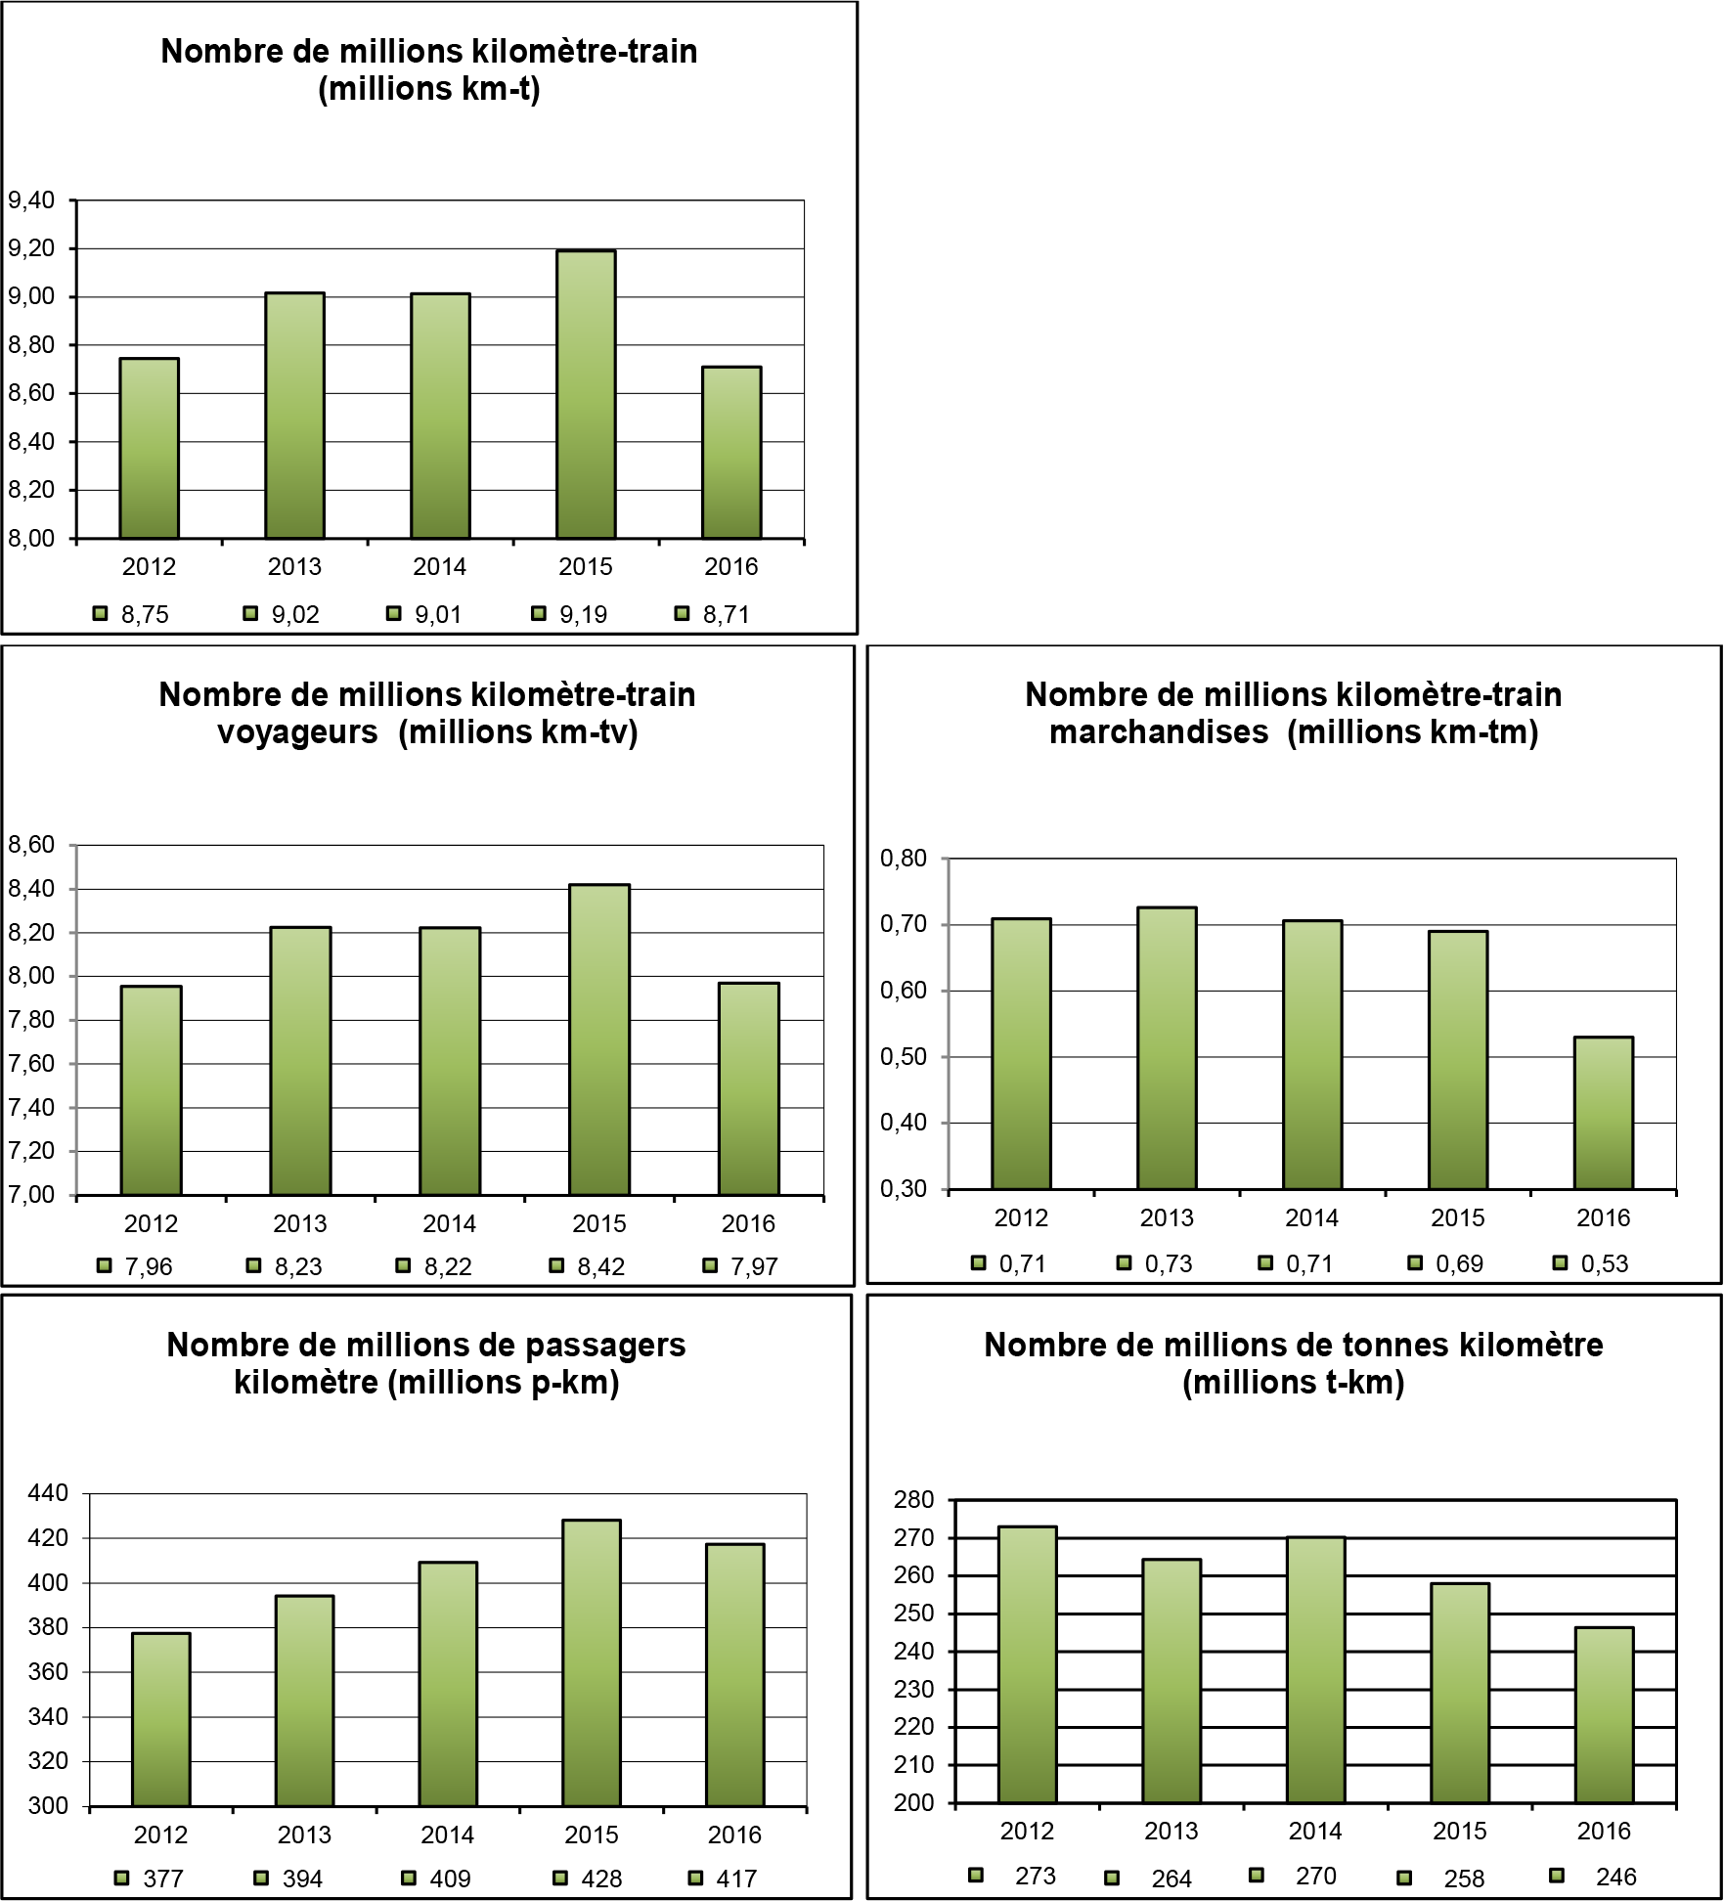

|  |  |
| --- | --- |
| Nombre de millions kilomètre-train (millions km-t) | Number of millions of train-kilometres (million train-km) |
| Nombre de millions kilomètre-train voyageurs (millions km-tv) | Number of millions of passenger train-kilometres (million pt-km) |
| Nombre de millions kilomètre-train marchandises (millions km-tm) | Number of millions of goods train-kilometres (million gt-km) |
| Nombre de millions de passagers kilomètre (millions p-km) | Number of millions of passenger kilometres (million p-km) |
| Nombre de millions de tonnes kilomètre (millions t-km) | Number of millions of tonne kilometres (million t-km) |

* + 1. Indicators relating to accidents
       1. Total and relative number of significant accidents per million train-kilometres (million train-km) and breakdown by accident type

|  |  |  |
| --- | --- | --- |
| 2016 accident types | Number | Number per million train-km |
| Collisions between trains, including collisions with obstacles within the clearance gauge | 1 | 0.11 |
| Derailments of trains | 0 | 0.00 |
| Level-crossing accidents, including those involving pedestrians | 1 | 0.11 |
| Accidents to persons caused by rolling stock in motion | 0 | 0.00 |
| Fires in rolling stock | 0 | 0.00 |
| Others | 0 | 0.00 |
| Total | 2 | 0.23 |

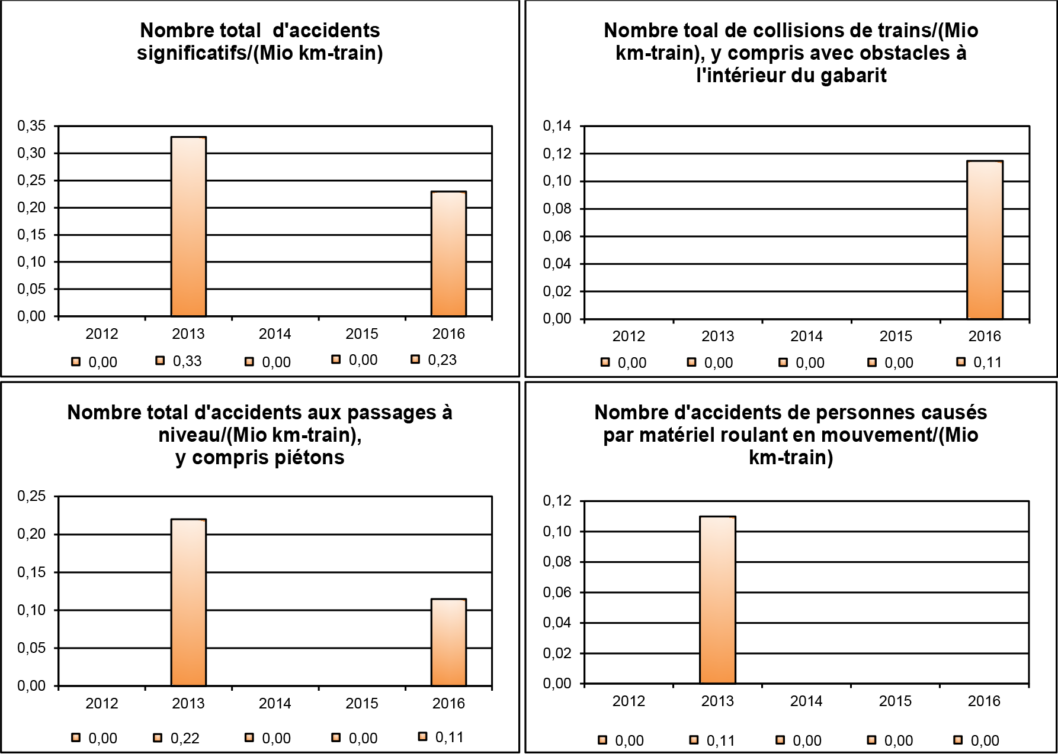

|  |  |
| --- | --- |
| Nombre total d'accidents significatifs/(Mio km-train) | Total number of significant accidents/(million train-km) |
| Nombre total de collisions de trains/(Mio km-train), y compris avec obstacles à l'intérieur du gabarit | Total number of train collisions/(million train-km), including collisions with obstacles within the clearance gauge |
| Nombre total d'accidents aux passages à niveau/(Mio km-train), y compris piétons | Total number of Accidents at level crossings, including those involving pedestrians/(million train-km) |
| Nombre d'accidents de personnes causés par matériel roulant en mouvement/(Mio km-train) | Accidents to persons caused by rolling stock in motion/(million train-km) |

Since the first annual report was drawn up in 2009, there have been no significant accidents in the ‘derailments of trains’, ‘fires in rolling stock’ and ‘others’ categories.

* + - 1. Total and relative number per million train-kilometres (million train-km) of persons seriously injured and of persons killed by type of person and type of accident

|  |  |  |  |  |
| --- | --- | --- | --- | --- |
| 2015 person types | Number | Number per million train-km | Number per million p-km | Number per million pt-km |
| Passengers | 0 | 0.00 | 0.00 | 0.00 |
| Employees, including subcontractors | 0 | 0.00 |  | |
| Users of level crossings | 1 | 0.11 |
| Unauthorised persons on railway premises | 0 | 0.00 |
| Others | 0 | 0.00 |
| Total | 1 | 0.11 |

Number per million p-km = Number per million passenger-km  
Number per million pt-km = Number per million passenger train-km

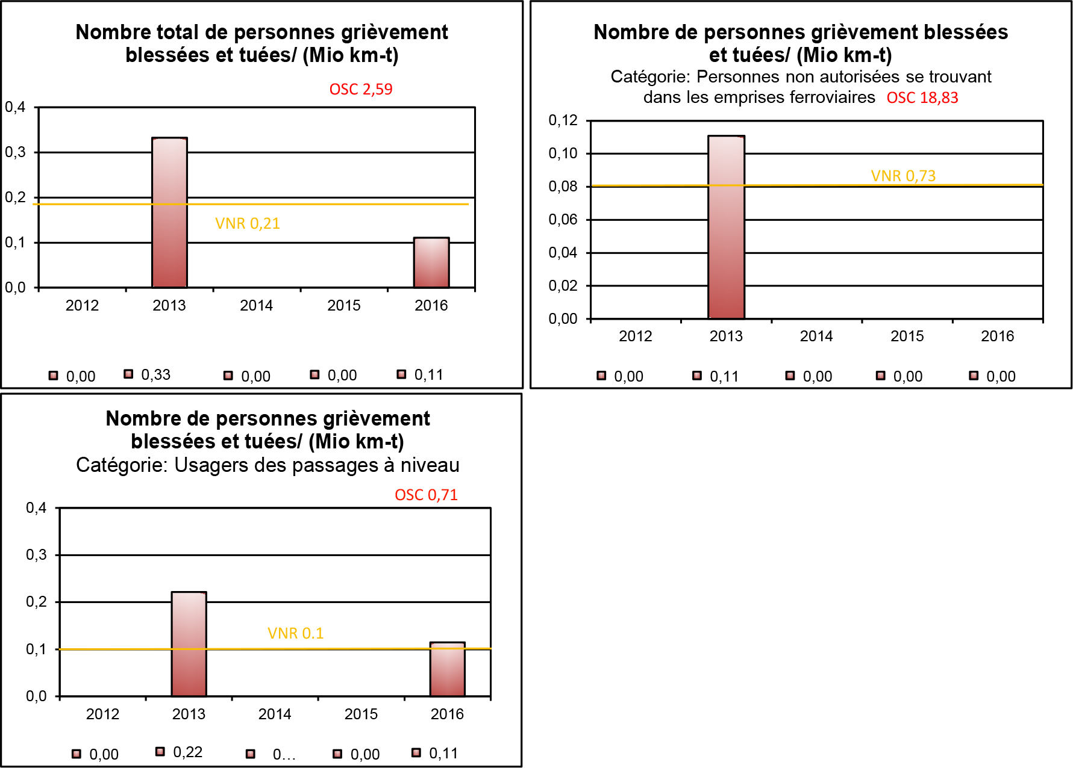

|  |  |
| --- | --- |
| Nombre total de personnes grièvement blessées et tuées/ (Mio km-t) | Total number of persons seriously injured or killed/(million train-km) |
| VNR 0,21 | NRV 0.21 |
| Nombre de personnes grièvement blessées et tuées/ (Mio km-t) | Number of persons seriously injured or killed/(million train-km) |
| Catégorie: Personnes non autorisées se trouvant dans les emprises ferroviaires | Category: Unauthorised persons on railway premises |
| OSC 18,83 | CST 18.83 |
| VNR 0,73  Nombre de personnes grièvement blessées et tuées/ (Mio km-t) | NRV 0.73  Number of persons seriously injured or killed/(million train-km) |
| Catégorie: Usagers des passages à niveau | Category: Users of level crossings |
| OSC 0,71 | CST 0.71 |
| VNR 0.1 | NRV 0.1 |

Since 2009, no serious passenger accidents have been recorded. The same applies to the employee/subcontractor category for the 2010-2016 period.

* + 1. Indicators relating to dangerous goods

Total and relative number per million train-kilometres (million train-km) of accidents relating to the transport of dangerous goods

|  |  |  |
| --- | --- | --- |
| Accidents involving dangerous goods in 2015 | Number | Number per million train-km |
| Accidents in which at least one rail vehicle carrying dangerous goods was involved | 0 | 0.00 |
| Accidents of this type in which hazardous substances were released | 0 | 0.00 |
| Total | 0 | 0.00 |

Since the first annual report was drawn up in 2009, there have been no accidents involving the carriage of dangerous goods.

* + 1. Indicators relating to suicides and suicide attempts

Total and relative number of suicides and suicide attempts per million train-kilometres (million train-km)

|  |  |  |
| --- | --- | --- |
| Suicides in 2016 | Number | Number per million train-km |
| Total | 3 | 0.33 |

|  |  |  |
| --- | --- | --- |
| Suicide attempts in 2016 | Number | Number per million train-km |
| Total | 1 | 0.11 |

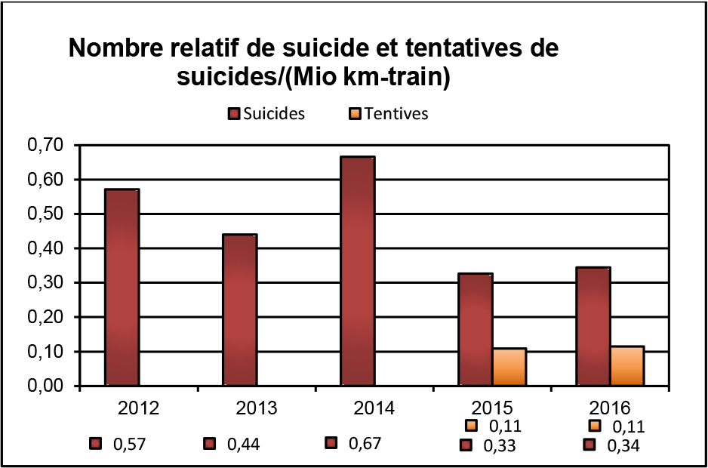

|  |  |
| --- | --- |
| Nombre relatif de suicide et tentatives de suicides/(Mio km-train) | Relative number of suicides and suicide attempts/(million train-km) |
| Suicides | Suicides |
| Tentives | Attempts |

* + 1. Indicators relating to precursors to accidents

Total and relative number per million train-kilometres (million train-km) by type of precursor

|  |  |  |
| --- | --- | --- |
| Standard precursors | Number | Number per million train-km |
| Broken rails | 1 | 0.11 |
| Track buckling | 1 | 0.11 |
| Wrong-side signalling failures | 0 | 0 |
| Signals passed at danger without authority (trains) | 2 | 0.22 |
| Broken wheels and axles on rolling stock in service | 1 | 0.11 |
| Total | 5 | 1.38 |
| Signals passed at danger without authority (shunting)* | 8 | 0.92 |

*Not included in the data sent to ERA or the totals

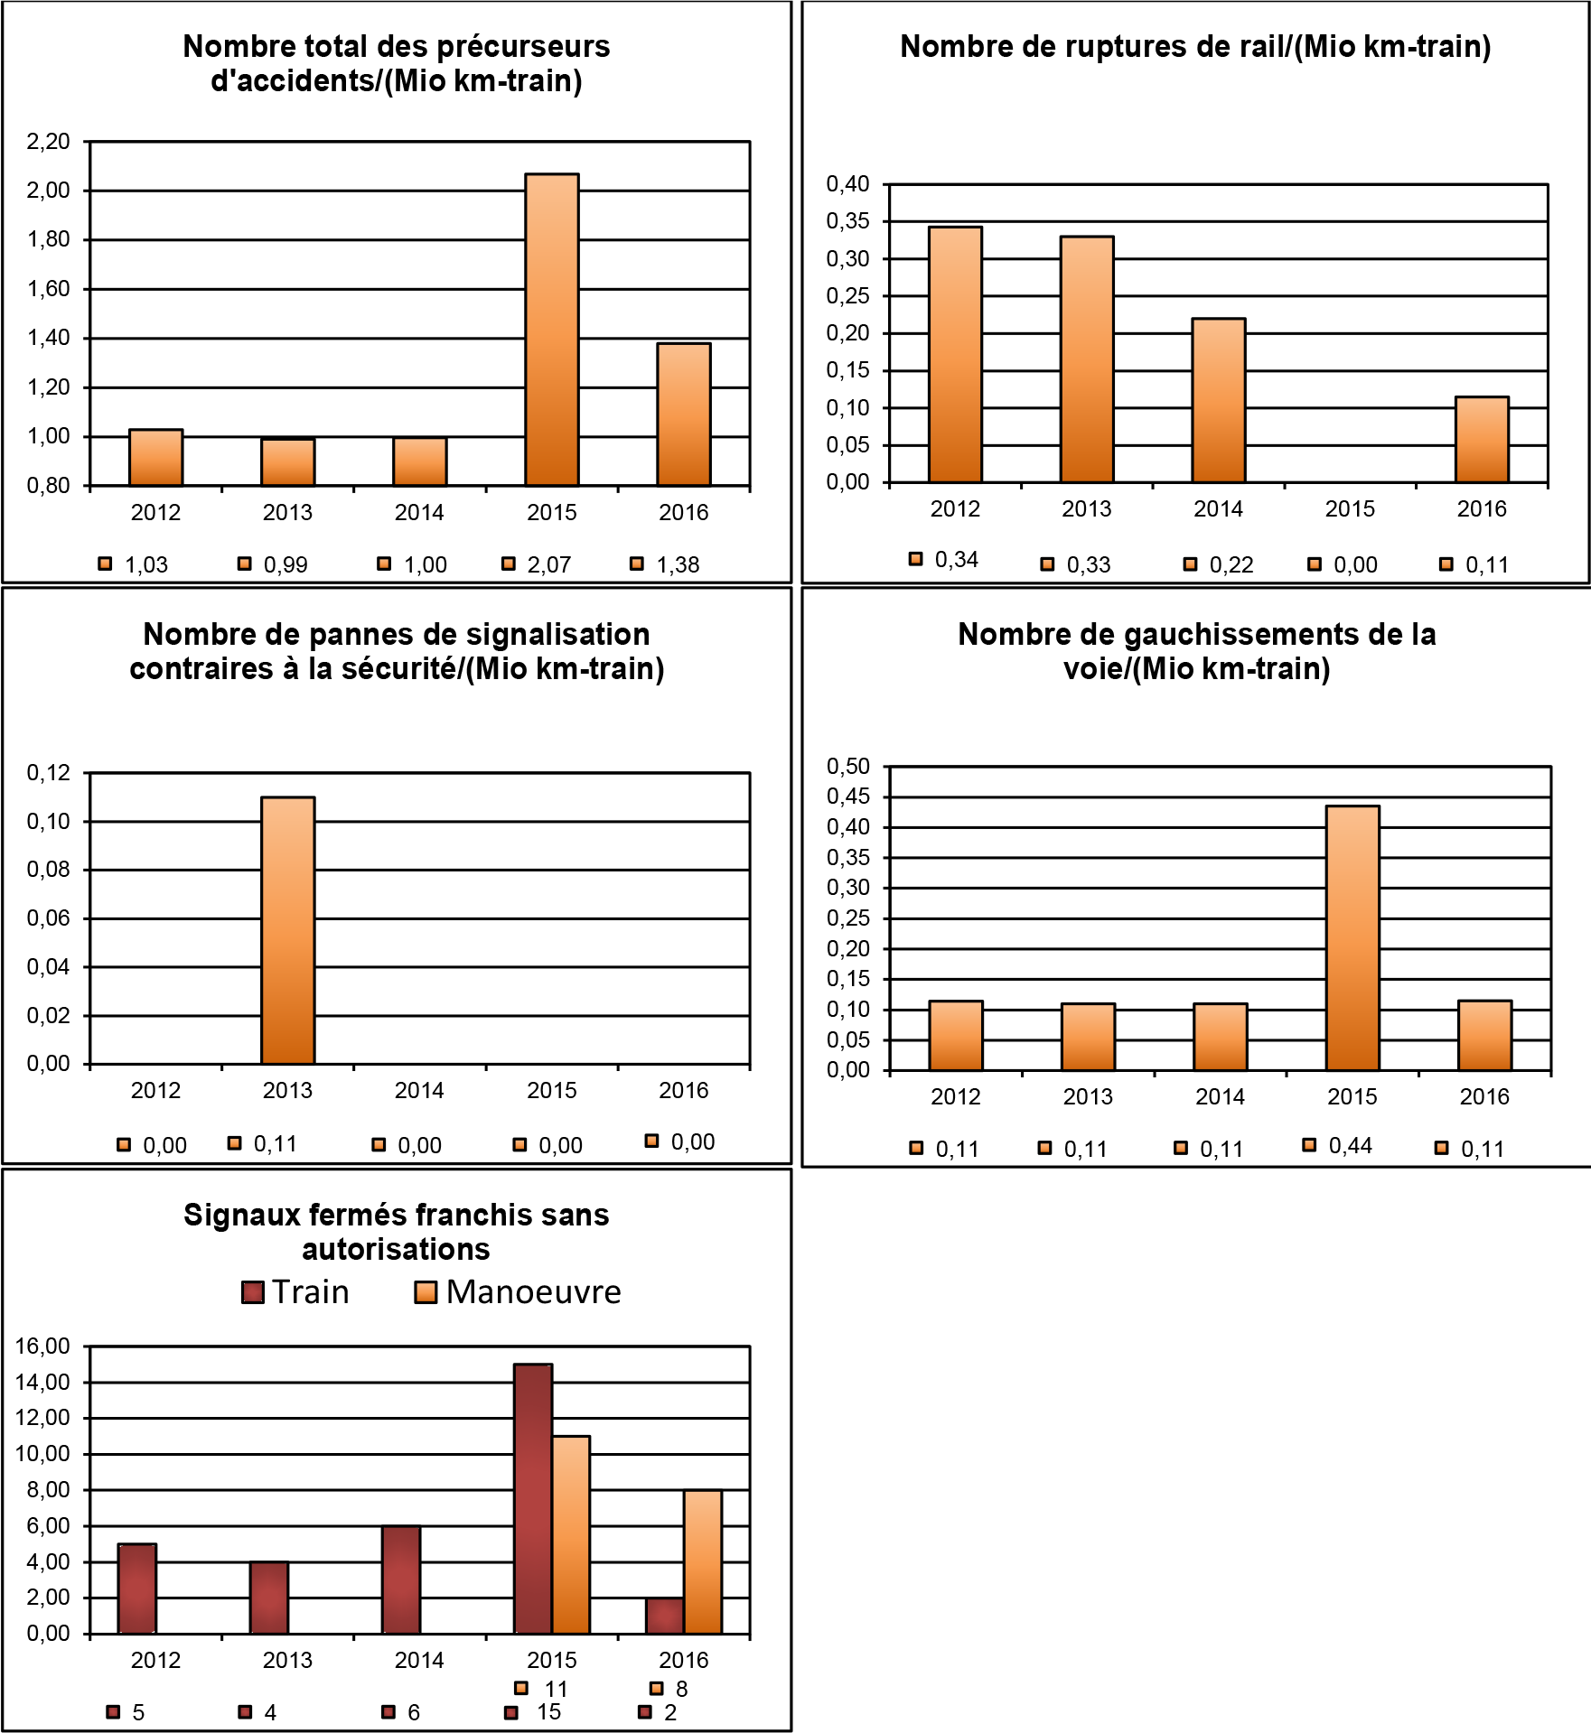

|  |  |
| --- | --- |
| Nombre total des précurseurs d'accidents/(Mio km-train) | Total number of precursors to accidents/(million train-km) |
| Nombre de ruptures de rail/(Mio km-train) | Number of broken rails/(million train-km) |
| Nombre de pannes de signalisation contraires à la sécurité/(Mio km-train) | Number of wrong-side signalling failures/(million train-km) |
| Nombre de gauchissements de la voie/(Mio km-train) | Number of track buckles/(million train-km) |
| Signaux fermés franchis sans autorisations | Signals passed at danger without authority |
| Train | Train |
| Manoeuvre | Shunting |

* + 1. Indicators relating to the economic impact of accidents

Total and relative costs per million train-kilometres (million train-km) in euros and by cost type.

|  |  |  |
| --- | --- | --- |
| Cost type | Thousands of € | Thousands of € per million train-km |
| Number of deaths and serious injuries multiplied by the value of preventing a death or serious injury. | 0.0 | 565 |
| Cost of damage caused to the environment | 0.0 | 0 |
| Cost of damage caused to rolling stock or infrastructure | 0.0 | 877 |
| Signals passed at danger without authority | 0.0 | 0 |
| Cost of delays following an accident | 0.0 | 398 |
| Total | 0.0 | 1841 |

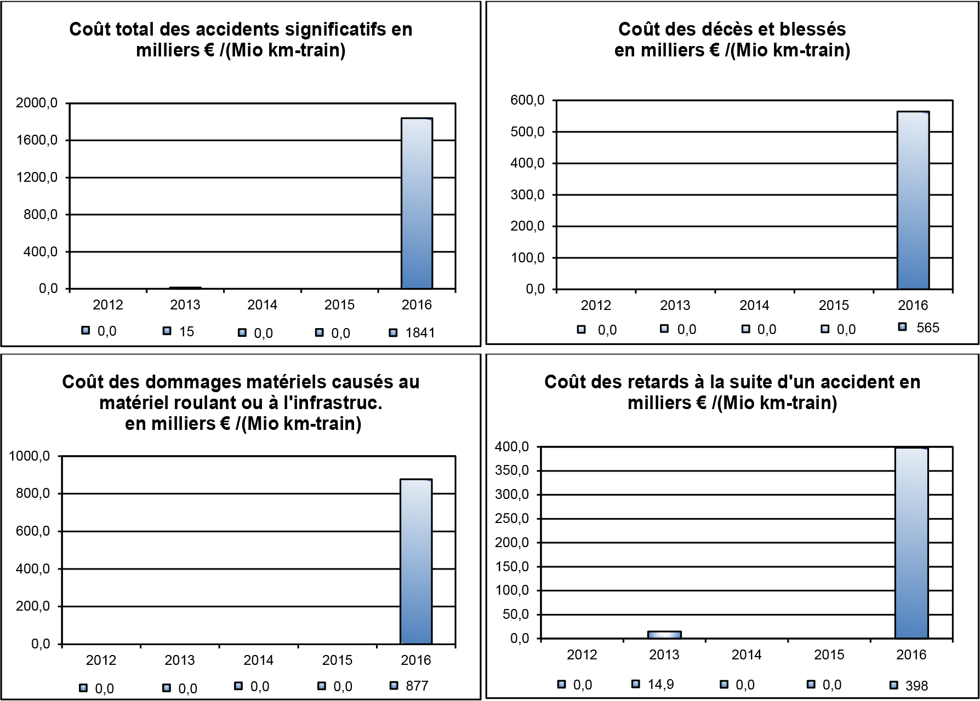

|  |  |
| --- | --- |
| Coût total des accidents significatifs en milliers € /(Mio km-train) | Total cost of significant accidents in thousands of €/(million train-km) |
| Coût des décès et blesses en milliers € /(Mio km-train) | Cost of deaths and injuries in thousands of €/(million train-km) |
| Coût des dommages matériels causés au matériel roulant ou à l'infrastruc. en milliers € /(Mio km-train) | Cost of material damage to rolling stock or infrastructure in thousands of €/(million train-km) |
| Coût des retards à la suite d'un accident en milliers € /(Mio km-train) | Cost of delays following an accident in thousands of €/(million train-km) |

*Note: the distribution rates were taken over the entire day by applying a rate of 70% for workers and 30% for non-workers. Students travelling by rail have been counted as workers.*

* + 1. Indicators relating to the technical safety of the infrastructure and its restoration
       1. Automatic Train Protection (ATP) system

|  |  |  |
| --- | --- | --- |
| 2015 indicators | MEMOR II+ | ETCS |
| Percentage of track fitted with an ATP system | 100% | 100% |
| Percentage of main fixed signals and advanced fixed signals fitted with an ATP system in service | 98.7* | 98.7* |
| Percentage of train-kilometres covered by operational ATP systems (estimate) | 60% | 40% |

* The main fixed signals (SFP) at the new intermodal terminals are not equipped with either ETCS or MEMOR II+. In view of their location, the main fixed signals (SFP) will be replaced by fixed barred track signals (SFvb) which, depending on the principles applied by the IM, do not require a train protection system.

In principle, only barred track signals for flank protection towards line tracks and signals installed on station tracks for reception on occupied tracks are equipped with ETCS. The majority of fixed barred track signals installed at marshalling yards, sidings, junctions, etc. thus do not have ETCS or MEMOR II+ installed on the ground.

However, it should be noted that for barred track signals without ETCS/MEMOR II+, the train travelling speed is very low compared to the maximum permissible speeds on the main line, so the risk of a serious accident/incident is greatly reduced.

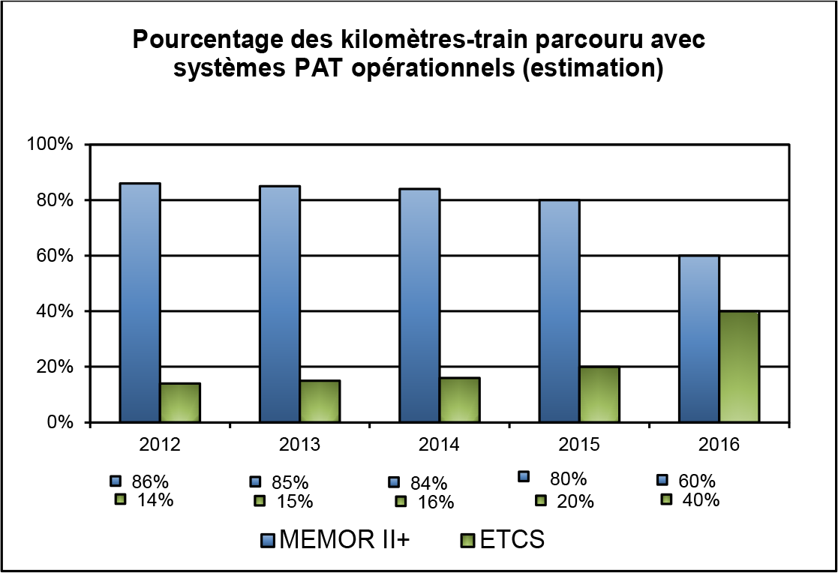

|  |  |
| --- | --- |
| Pourcentage des kilomètres-train parcouru avec systèmes PAT opérationnels (estimation) | Percentage of train-kilometres covered by operational ATP systems (estimate) |
| MEMOR II+ | MEMOR II+ |
| ETCS | ETCS |

* + - 1. Number of level crossings (total, per line-kilometre and per track-kilometre) and by type of level crossing

|  |  |  |  |
| --- | --- | --- | --- |
| a) Actively protected level crossings by type | Number | per km of line (275 km) | per km of track (621 km) |
| i) Manual | 20 | 0.072 | 0.032 |
| ii) Automatic with warning on user side | 2 | 0.007 | 0.003 |
| iii) Automatic with user protection (including level crossings with warning and protection) | 78 | 0.280 | 0.124 |
| iv) Rail-side protection | 0 | 0.000 | 0.000 |
| Total | 100 | 0.360 | 0.159 |
|  | | | |
| b) Passively protected level crossings | Number | per km of line (275 km) | per km of track (621 km) |
| Total | 24 | 0.091 | 0.040 |
|  | | | |
| c) Actively and passively protected level crossings | Number | per km of line (275 km) | per km of track (621 km) |
| Total | 124 | 0.451 | 0.200 |

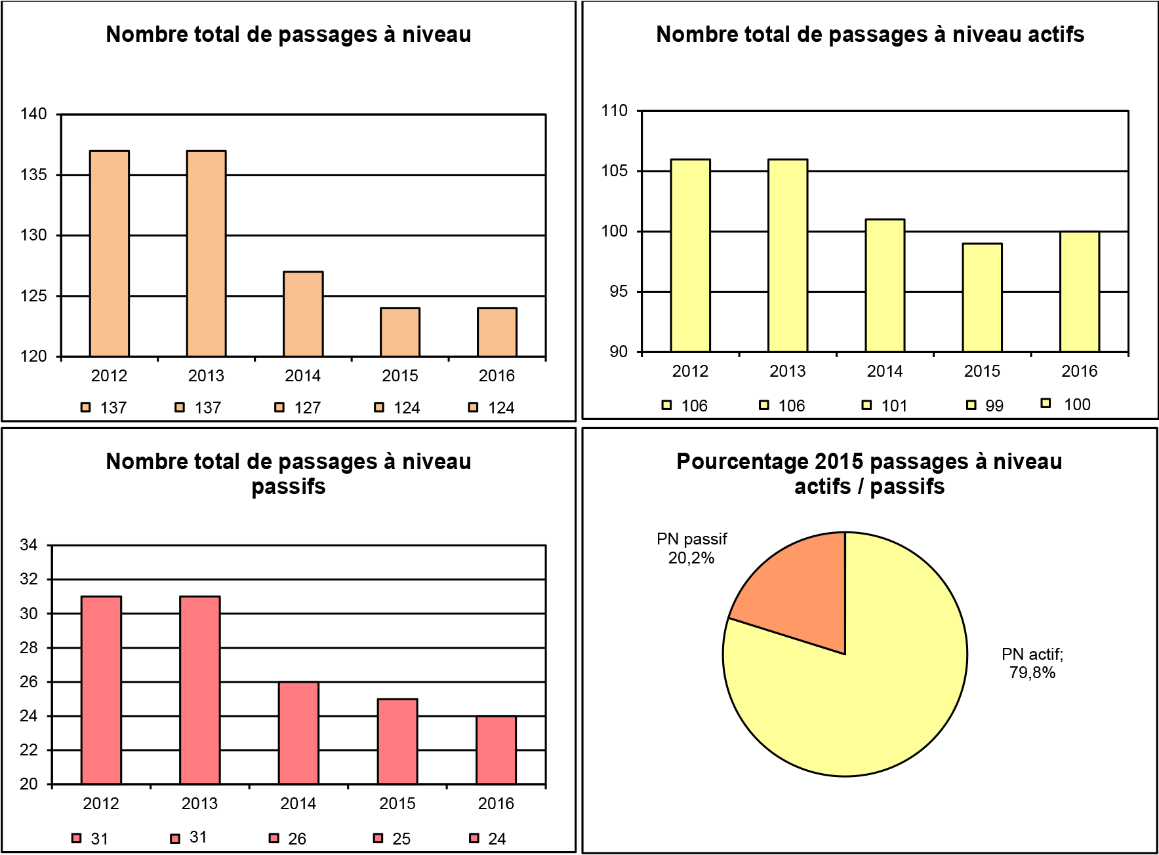

|  |  |
| --- | --- |
| Nombre total de passages à niveau | Total number of level crossings |
| Nombre total de passages à niveau actifs | Total number of actively protected level crossings |
| Nombre total de passages à niveau passifs | Total number of passively protected level crossings |
| Pourcentage 2015 passages à niveau actifs / passifs | Percentage of actively and passively protected level crossings in 2015 |
| PN passif 20,2% | Passively protected LCs 20.2% |
| PN actif; 79,8% | Actively protected LCs 79.8% |

* + 1. Indicators relating to safety management

Internal audits performed by infrastructure managers and railway undertakings, as defined in the safety management system documentation. Total number of audits performed and percentage with respect to the audits required (and/or planned).

|  |  |  |  |  |  |  |
| --- | --- | --- | --- | --- | --- | --- |
| Internal audits in 2015 | CFL infrastructure manager | CFL railway undertaking | CFLcargo | LINEAS | SNCF | Total |
| Number planned | 30 | 192 | 24 | 0 | 0 | 246 |
| Number performed | 53 | 237 | 24 | 0 | 0 | 314 |
| Percentage performed | 176% | 123% | 100% |  |  | 120% |

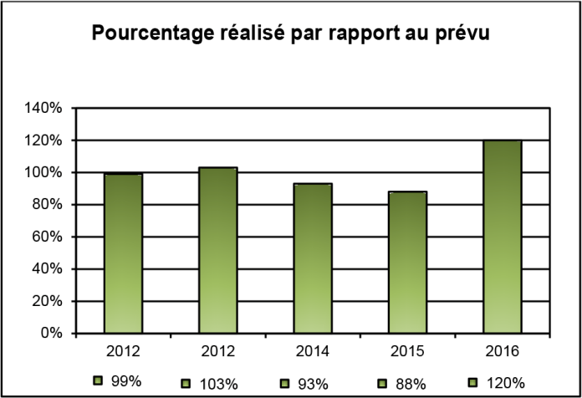

|  |  |
| --- | --- |
| Pourcentage réalisé par rapport au prévu | Percentage of planned audits performed |

# ANNEX B

## CHANGES TO LEGISLATION AND REGULATIONS – Table 1

|  |  |  |  |
| --- | --- | --- | --- |
| **AMENDMENTS TO THE RSD** | **Transposed (Y/N)** | **Legal reference** | **Date of entry into force** |
| Directive 2008/57/EC | Y | Act of 22 July 2009 on safety on the Community’s railways (Railway Safety Directive)  As the transposition of Directive 2004/49/EC was effective from 27 July 2009 (date of publication in Mémorial A No 269 of the law of 22 July 2009 on railway safety), the transposition took account of Article 40 of the Interoperability Directive, repealing Article 14 of Directive 2004/49/EC. | Publication in the Official Gazette – Mémorial A No 269 of 27 July 2009 |
| Directive 2008/110/EC | Y | Law of 14 December 2011 transposing Directive 2008/110/EC of the European Parliament and of the Council of 16 December 2008 amending Directive 2004/49/EC on safety on the Community’s railways | Publication in the Official Gazette – Mémorial A No 273 of 27 December 2011 |
| Commission Directive 2009/149/EC | Y | This Directive amends the annex and its appendix concerning the common safety indicators and the common methods for calculating the cost of accidents. Since Luxembourg’s transposition of the basic text just refers to the annexes of the Directive, without including them in the actual text, these amendments will apply automatically in Luxembourg once Directive 2009/149/EC comes into force. | The same as the Directive |

**ANNEX B**

CHANGES TO LEGISLATION AND REGULATIONS – Table 1 (continued)

|  |  |  |  |
| --- | --- | --- | --- |
| **AMENDMENTS TO THE RSD** | **Transposed (Y/N)** | **Legal reference** | **Date of entry into force** |
| Commission Directive 2014/88/EU amending Directive 2004/49/EC of the European Parliament and of the Council | Y | This Directive amends the annex and its appendix concerning the common safety indicators and the common methods for calculating the cost of accidents.  Since Luxembourg’s transposition of the basic text just refers to the annexes of the directive, without including them in the actual text, these amendments will apply automatically in Luxembourg once Directive 2014/88/EU comes into force. | The same as the Directive |

**ANNEX B**

## CHANGES TO LEGISLATION AND REGULATIONS – Table 2

|  |  |  |  |  |
| --- | --- | --- | --- | --- |
| **LEGISLATION** | **Legal reference** | **Entry into force** | **Description of the change** | **Reasons for the change** |
| Affects  RU/IM/ECM/NSA/DeBo/NoBo | Official Gazette – Mémorial A No 264 of 27 December 2016 | 27/12/2016 | Law of 23 December 2016 transposing the recast of the First Railway Package and amending   1. the amended law of 10 May 1995 on railway infrastructure management; 2. the amended law of 11 June 1999 on access to and use of railway infrastructure; 3. the amended law of 22 July 2009 on railway safety; and 4. the law of 3 August 2010 on railway market regulation | Transposition of the recast of the First Railway Package |

**ANNEX B**

CHANGES TO LEGISLATION AND REGULATIONS – Table 2 (continued)

|  |  |  |  |  |
| --- | --- | --- | --- | --- |
| **REGULATION** | **Legal reference** | **Entry into force** | **Description of the change** | **Reasons for the change** |
| General Rules for Technical Operation (GRTO). Ministerial approval on 1 October 2015 | Document issued by the IM | 03/04/2016 | New edition | The old edition was no longer compliant with the European and national legal framework |
| Appendix I – Supplementary information for the application of the provisions of the GRTO. Updated. | Document issued by the IM | 03/04/2016 | New edition | The old edition was no longer compliant with the European and national legal framework |
| Appendix II – Special instructions for the technical operation of the Tertiary Railway Network (TN). Ministerial approval on 1 October 2015 | Document issued by the IM | 03/04/2016 | New edition | The old edition was no longer compliant with the European and national legal framework |
| Appendix III – Additional provisions to the GRTO on the operation of the ETCS safety system. Ministerial approval on 1 October 2015 | Document issued by the IM | 03/04/2016 | New edition | The old edition was no longer compliant with the European and national legal framework |

# ANNEX C

## ACF FUNCTIONAL ORGANISATION CHART

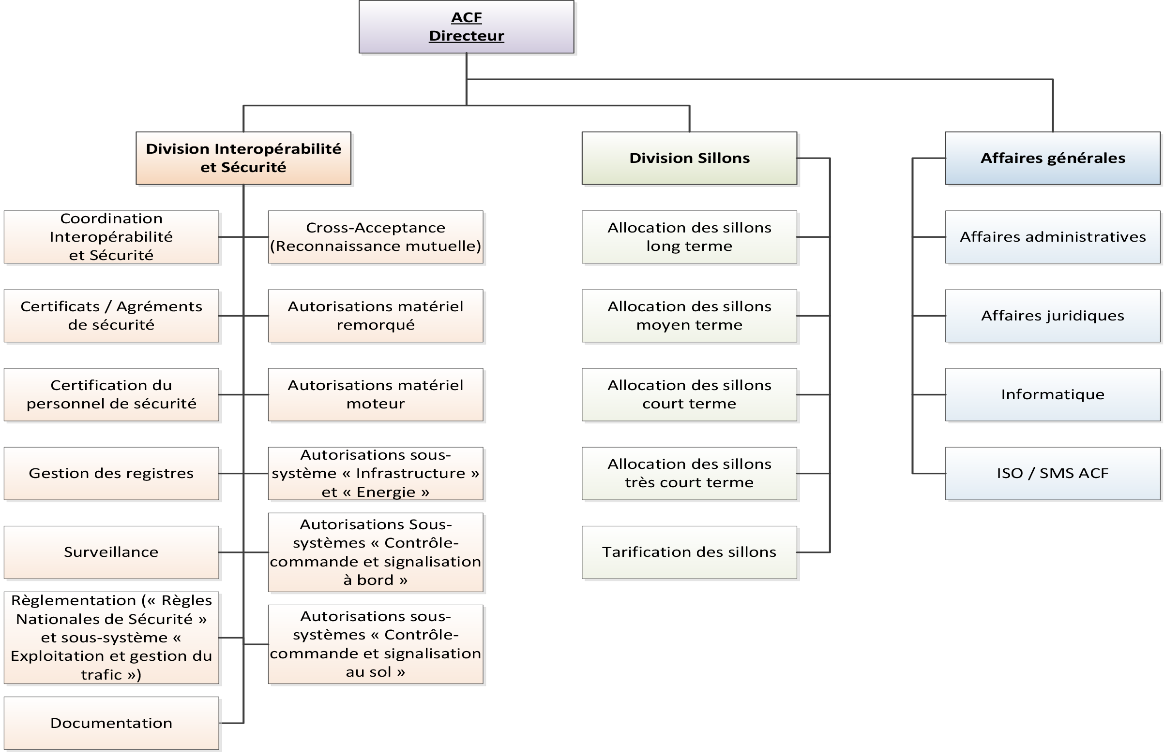

|  |  |
| --- | --- |
| ACF Directeur | Director of ACF |
| Division Interopérabilité et Sécurité | Interoperability and Security Division |
| Division Sillons | Train Paths Division |
| Affaires générales | General affairs |
| Coordination Interopérabilité et Sécurité | Interoperability and Safety Coordination |
| Certificats / Agrémentsde sécurité | Safety certificates/authorisations |
| Certification du personnel de sécurité | Safety personnel certification |
| Gestion des registres | Record management |
| Surveillance | Supervision |
| Règlementation («Règles Nationales de Sécurité» et sous-système «Exploitation et gestion du trafic») | Regulations (‘National Safety Rules’ and the ‘Traffic Operation and Management’ subsystem) |
| Documentation | Documentation |
| Cross-Acceptance (Reconnaissance mutuelle) | Cross-acceptance (Mutual recognition) |
| Autorisations matériel remorqué | Hauled stock authorisations |
| Autorisations matériel moteur | Traction stock authorisations |
| Autorisations sous-système «Infrastructure» et «Energie» | ‘Infrastructure’ and ‘Energy’ subsystem authorisations |
| Autorisations Sous-systèmes «Contrôle-commande et signalisation à bord» | ‘Instrumentation & control and on-board signalling’ subsystem authorisations |
| Autorisations sous-systèmes «Contrôle-commande et signalisation au sol» | ‘Instrumentation & control and ground signalling’ subsystem authorisations |
| Allocation des sillons long terme | Long-term train path allocation |
| Allocation des sillons court terme | Short-term train path allocation |
| Allocation des sillons très court terme | Allocation of very short-term train paths |
| Tarification des sillons | Train path pricing |
| Affaires administratives | Administrative affairs |
| Affaires juridiques | Legal affairs |
| Informatique | IT |
| ISO / SMS ACF | ACF ICO/SMS |