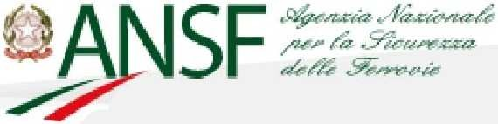

**ANNUAL SAFETY REPORT**

**for Italian railways regulated by the Italian National Railway Safety Agency**

**2016**

Piazza della Stazione, 45 50123 FLORENCE Italy

**Tel:** 0039 055 2356620 - 0039 06 41582379

**Fax:** 055 2356495

[**agenzia.sicurezza@ansf.gov.it**](mailto:agenzia.sicurezza@ansf.gov.it)

[www.ansf.it](https://www.ansf.it/)

## TABLE OF CONTENTS

|  |  |
| --- | --- |
| **PART A - INTRODUCTION** | |
| A.1 | Purpose and scope |
| A.2 | Organisational changes and staffing |
| **PART B – OVERALL RAILWAY SAFETY PERFORMANCE AND STRATEGY** | |
| B.1 | Main conclusions on the reporting year |
| B.1.1 | Accident analysis feedback |
| B.1.2 | Findings emerging from the railway system analysis |
| B.2 | National safety strategy, programmes and initiatives |
| B.2.1 | Initiatives to mitigate problems relating to the unauthorised presence of pedestrians on the track and for the protection of rail transport users |
| B.2.2 | Level crossing problem mitigation initiatives |
| B.2.3 | Maintenance problem mitigation initiatives |
| B.2.4 | Main strategies in ANSF's international activities |
| B.3 | Review of the previous year |
| B.3.1 | Monitoring of railway operator activities following regulatory reorganisation |
| B.3.2 | Training of staff with safety responsibilities |
| B.3.3 | Inspection and audit of infrastructure manager and railway undertaking activities |
| B.3.4 | Certification of entities in charge of railway freight wagon maintenance |
| B.4 | Focus areas for next year |
| **PART C – DEVELOPMENTS IN SAFETY PERFORMANCE** | |
| C.1 | Detailed analysis of the latest recorded trends |
| C.2 | Results of safety recommendations |
| C.3 | Measures implemented unrelated to safety recommendations |
| **PART D - SUPERVISION** | |
| D.1 | Strategy and plan |
| D.2 | Human Resources |
| D.3 | Competence |
| D.4 | Decision-making |
| D.4.1 | Decision-making criteria on how ANSF monitored, promoted and implemented compliance with the regulatory framework and procedure for establishing criteria |
| D.4.2 | Main complaints received by RUs and IMs |
| D.5 | Coordination and cooperation |
| D.6 | Results of measures taken |
| **PART E - CERTIFICATION AND AUTHORISATION** | |
| E.1 | Guidance for issuing a safety certificate |
| E.2 | Contacts with other National Safety Authorities |
| E.3 | Procedural issues |
| E.4 | Feedback |
| E.5 | Authorisations for the placing in service of vehicles |
| E.6 | Authorisation for the placing in service of fixed structural subsystems, general applications and general signalling products |
| E.7 | Accreditation of training centres |
| **PART F - CHANGES IN LEGISLATION** | |
| F.1 | Railway Safety Directive |
| F.2 | Changes in legislation and regulation |
| **PART G - APPLICATION OF THE COMMON SAFETY METHOD ON RISK EVALUATION AND ASSESSMENT** | |
| G.1 | Experience of the Italian National Railway Safety Agency |
| G.2 | Feedback from interested parties |
| G.3 | Revision of national safety regulations to take into account the EC regulation on the common safety method on risk evaluations and assessment |
| **PART H - DEROGATIONS FROM THE ECM CERTIFICATION SYSTEM** | |

**ANNEXES**

Annex A: Common Safety Indicators

Annex B: Changes in legislation

# PART A - INTRODUCTION

## Purpose and scope

This document has been prepared in accordance with Article 7 of Legislative Decree No 162 of 10 August 2007 ‘Implementation of Directives 2004/49/EC and 2004/51/EC on safety and on the development of the Community’s railways’, transposing Article 18 of Directive 2004/49/EC.

It describes the safety performance, recorded during 2016, in the part of the Italian railway system that falls within the competence of the Italian National Railway Safety Agency (hereafter ANSF) and over which ANSF therefore performs regulatory, authorisation and supervision activities.

In August 2016, ANSF’s remit was extended to cover regional networks interconnected with the national railway infrastructure and considered of strategic importance to the railway system, identified by Ministry of Infrastructure and Transport Decree of 5 August 2016 (hereafter Interconnected Regional Networks) as well as the network managed under licence by Rete Ferroviaria Italiana S.p.A. (hereafter RFI Network).

The Report is set out in accordance with the document ‘Annual Safety Report – Template – Network of national safety authorities’ (Version 1.2) issued by the European Railway Agency (ERA) on 5 September 2013. It is published on the ANSF website[www.ansf.it](http://www.ansf.it/) and has been sent to ERA and the Ministry of Infrastructure and Transport.

## Organisational changes and staffing

The Agency was established by Legislative Decree No 162 of 10 August 2007, which also defines the tasks for which it is responsible. It is a non-economic public entity independent of the railway operators and of the Directorate General for Railway and Maritime Investigations. It is supervised by the Ministry of Infrastructure and Transport.

The workforce recalculated following the last spending review (DPCM [Decree of the President of the Council of Ministers] of 22 January 2013, implementing Article 2 of Legislative Decree No 95/2012) provides for 265 staff instead of the 300 staff originally established.

During 2016, the number of staff was increased due to the addition of a manager working for the supervising Ministry and as a result of the mobility procedures implemented during 2015 under Article 30 of Legislative Decree No 165 of 30 March 2001, as amended. Once these were concluded, eight administrative staff and nine technical staff were transferred to ANSF positions. Due to the effect of the above intake, 118 staff members were employed by ANSF as of 31 December 2016.

# PART B – OVERALL RAILWAY SAFETY PERFORMANCE AND STRATEGY

## Main conclusions on the reporting year

* + 1. ***Accident analysis feedback***

The following table provides a preliminary overview of the number of significant accidents[1] and victims[2] recorded during the period 2007-2016 on the network that currently falls within the competence of ANSF, consisting of the RFI Network and the Interconnected Regional Networks, as specified previously.

|  |  |  |  |  |  |  |
| --- | --- | --- | --- | --- | --- | --- |
| **YEAR** | **[Interconnected Regional Networks]** | | **[RFI network]** | | **[Interconnected Regional Networks + RFI network]** | |
| **Significant ACCIDENTS** | **VICTIMS** | **Significant ACCIDENTS** | **VICTIMS** | **TOTAL significant ACCIDENTS** | **TOTAL VICTIMS** |
| **2007** | 5 | 5 | 121 | 104 | 126 | 109 |
| **2008** | 8 | 6 | 103 | 92 | 111 | 98 |
| **2009** | 2 | 2 | 93 | 126 | 95 | 128 |
| **2010** | 6 | 5 | 100 | 100 | 106 | 105 |
| **2011** | 7 | 22 | 106 | 98 | 113 | 120 |
| **2012** | 2 | 2 | 106 | 107 | 108 | 109 |
| **2013** | 13 | 29 | 98 | 94 | 111 | 123 |
| **2014** | 4 | 4 | 109 | 94 | 113 | 98 |
| **2015** | 4 | 4 | 98 | 83 | 102 | 87 |
| **2016** | 7 | 44 | 92 | 83 | 99 | 127 |

The number of accidents in relation to production data occurring on the RFI Network alone and total accidents occurring on the RFI Network and Interconnected Regional Networks show essentially the same trend over the years, as the following graph shows. However, a similar comparison for the number of victims shows discrepancies because this trend can be considerably influenced by a single railway accident.

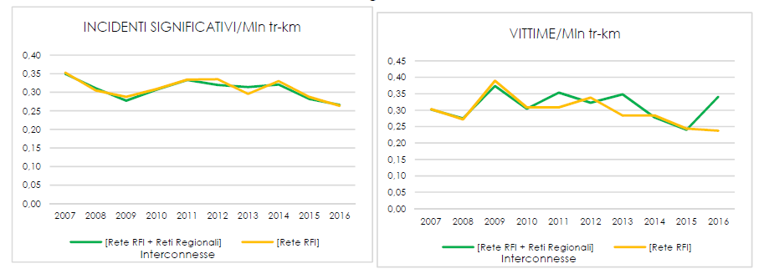

|  |  |  |  |  |
| --- | --- | --- | --- | --- |
| INCIDENTI SIGNIFICATIVI/Mln tr-km | SIGNIFICANT ACCIDENTS/million tr-km |  | VITTIME/Mln tr-km | VICTIMS/million tr-km |
| 0,40 | 0.40 |  | 0,45 | 0.45 |
| 0,35 | 0.35 |  | 0,40 | 0.40 |
| 0,30 | 0.30 |  | 0,35 | 0.35 |
| 0,25 | 0.25 |  | 0,30 | 0.30 |
| 0,20 | 0.20 |  | 0,25 | 0.25 |
| 0,15 | 0.15 |  | 0,20 | 0.20 |
| 0,10 | 0.10 |  | 0,00 | 0.00 |
| 0,05 | 0.05 |  | [Rete RFI + Reti Regionali] | [RFI network and Regional Networks] |
| 0,00 | 0.00 |  | [Rete RFI] | [RFI network] |
| [Rete RFI + Reti Regionali] | [RFI network and Regional Networks] |  |  |  |
| [Rete RFI] | [RFI network] |  |  |  |

The admittedly low level of sample data shows that the railway accident rate on Interconnected Regional Networks over the last decade shows consistent data dispersion around the individual types referred to in the Common Safety Indicators (CSI) shown in Annex 1 of Legislative Decree No 162 of 10 August 2007. The most critical conditions are associated with ‘level crossing accidents’ and ‘accidents to persons caused by rolling stock in motion’, as is the case for the RFI Network, but also with ‘train collisions with railway vehicles’. This condition reveals the need to take action on critical structural issues present in the regional network system. There is therefore a need to adopt an approach of technological upgrading and alignment with national and international regulations and standards in force for railway infrastructure managers. For example, only a minimal part of the traffic on such networks is covered by automatic train protection systems. There is therefore a need to focus on upgrading the equipment to ensure the results recorded on the RFI network where train running protection systems cover nearly 100 % of the traffic and have prevented significant accidents due to collision between trains since 2007.

The rest of this report will only analyse data relating to the RFI network due to the limited length of time since the interconnected regional networks came under the jurisdiction of ANSF.

During 2016, 92 significant accidents occurred on the RFI network. This represented a reduction of approximately 6 % compared to 2015 and approximately 31 % compared to 2005 while the number of train-kilometres travelled was essentially unchanged. The following table shows the trend in the number of significant accidents since 2005, the first year for which data collected in accordance with criteria set out in Annex 1 of Legislative Decree No 162 of 10 August 2007 are available.

|  |  |  |  |  |  |  |  |  |  |  |  |  |
| --- | --- | --- | --- | --- | --- | --- | --- | --- | --- | --- | --- | --- |
|  | **SIGNIFICANT ACCIDENTS under Annex I of Legislative Decree 162/2007, as amended [RFI network]** | | | | | | | | | | | |
|  | **2005** | **2006** | **2007** | **2008** | **2009** | **2010** | **2011** | **2012** | **2013** | **2014** | **2015** | **2016** |
| **Train collisions** | 5 | 4 | 4 | 2 | 3 | 2 | 6 | 7 | 4 | 9 | 5 | **3** |
| Train collisions with railway vehicles | 2 | 1 | 2 | 1 | 0 | 0 | 0 | 0 | 0 | 1 | 1 | **0** |
| Train collisions with obstacles within the clearance gauge | 3 | 3 | 2 | 1 | 3 | 2 | 6 | 7 | 4 | 8 | 4 | **3** |
| **Train derailments** | 6 | 11 | 8 | 8 | 5 | 3 | 3 | 5 | 6 | 4 | 3 | **2** |
| **Level-crossing accidents** | 25 | 32 | 19 | 9 | 5 | 15 | 18 | 13 | 14 | 16 | 19 | **11** |
| **Accidents to persons caused by rolling stock in motion** | 90 | 76 | 83 | 79 | 73 | 77 | 77 | 79 | 71 | 74 | 67 | **70** |
| **Fires in rolling stock** | 4 | 4 | 4 | 2 | 0 | 0 | 0 | 1 | 2 | 0 | 2 | **1** |
| **Other types of accident**(*) | 4 | 5 | 3 | 3 | 7 | 3 | 2 | 1 | 1 | 6 | 2 | **5** |
| **TOTAL** | **134** | **132** | **121** | **103** | **93** | **100** | **106** | **106** | **98** | **109** | **98** | **92** |
| (*) ‘other accidents’ means all accidents not covered by the previous cases such as derailments and impacts during shunting or by work equipment and hazardous goods spillages. | | | | | | | | | | | | |

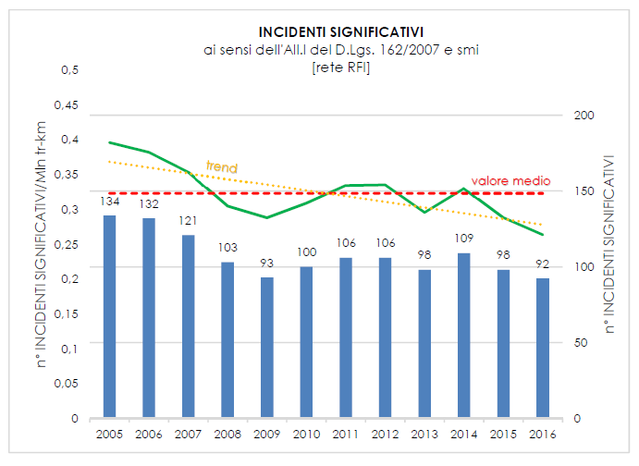

|  |  |
| --- | --- |
| **INCIDENTI SIGNIFICATIVI** | **SIGNIFICANT ACCIDENTS** |
| ai sensi dell’AII.I de D.Lgs. 162/2007 e smi | under Annex I of Legislative Decree 162/2007, as amended |
| [rete RFI] | [RFI network] |
| n° INCIDENTI SIGNIFICATIVI/Mln tr-km | NO OF SIGNIFICANT ACCIDENTS/million tr-km |
| n° INCIDENTI SIGNIFICATIVI | NO OF SIGNIFICANT ACCIDENTS |
| trend | trend |
| valore medio | average value |
| 0,5 | 0.5 |
| 0,45 | 0.45 |
| 0,4 | 0.4 |
| 0,35 | 0.35 |
| 0,3 | 0.3 |
| 0,25 | 0.25 |
| 0,2 | 0.2 |
| 0,15 | 0.15 |
| 0,1 | 0.1 |
| 0,05 | 0.05 |
| [Rete RFI + Reti Regionali] | [RFI network and Regional Networks] |
| [Rete RFI] | [RFI network] |

As the above graph shows, in 2016 the number of significant accidents per millions of train-km was below the average value recorded in the reference period and in line with the trend in recent years. It was noted in particular that:

* the most common accidents continue to be associated with the categories ‘accidents to persons caused by rolling stock in motion’, which accounts for a proportion of the total rising from 69 % in 2015 to 76 % in 2016 and relative growth of 4 % between 2015 and 2016;
* ‘level crossing accidents’ showed a percentage decrease, accounting for a proportion of the total falling from approximately 20 % in 2015 to 12 % in 2016;
* in 2016, accidents in the ‘other accident’ category more than doubled compared to 2015.

When the significant accidents occurring in 2016 are broken down based on the main cause, the vast majority, nearly 80 %, were associated with unauthorised presence on or crossing of the railway track by pedestrians, including cases occurring at level crossings.

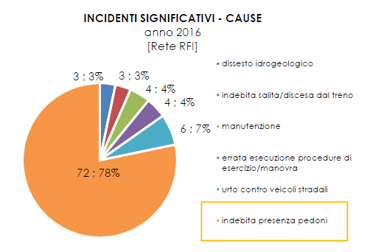

|  |  |
| --- | --- |
| **INCIDENTI SIGNIFICATIVI - CAUSE** | **SIGNIFICANT ACCIDENTS – CAUSES** |
| anno 2016 | 2016 |
| [Rete RFI] | [RFI network] |
| dissesto idrogeologico | hydrogeological disruption |
| indebita salita/discesa dal treno | unauthorised boarding/alighting from train |
| manutenzione | maintenance |
| errata esecuzione procedure di esercizio/manovra | incorrect execution of operation/shunting procedures |
| dissesto idrogeologico | hydrogeological disruption |
| urto contro veicoli stradali | striking road vehicles |
| indebita presenza pedoni | unauthorised presence of pedestrians |

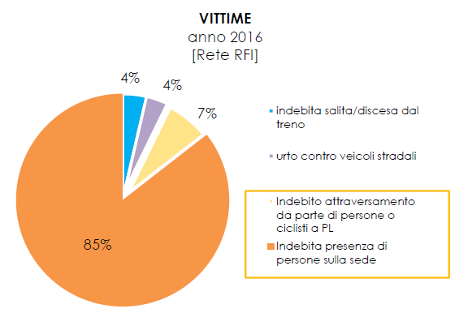

|  |  |
| --- | --- |
| **Vittime** | **Victims** |
| anno 2016 | 2016 |
| [Rete RFI] | [RFI network] |
| indebita salita/discesa dal treno | unauthorised boarding/alighting from train |
| urto contro veicoli stradali | collisions with road vehicles |
| Indebito attraversamento da parte di persone o ciclisti a PL | unauthorised persons or cyclists crossing LC |
| Indebita presenza di persone sulla sede | Unauthorised persons on railway premises |

|  |  |
| --- | --- |
| **92** | Significant accidents in 2016. The result was below the national average value during the period 2005-2016, marking a reduction of -31 % compared to 2005  **-6 compared to 2015** |
| **72** | caused by unauthorised presence of pedestrians on tracks. This was the main cause of fatalities on tracks, accounting for 93 % of victims overall in 2016  **unchanged compared to 2015** |
| **3** | caused by unauthorised boarding or alighting from a moving train. A reduction was recorded in absolute and percentage terms, accounting for 3 % of the total in 2016 compared to 9 % in 2015.  **-5 compared to 2015** |
| **4** | due to incorrect execution of railway procedures (operation and shunting). The finding is unchanged compared to 2015 and is still the same proportion of the total  **unchanged compared to 2015** |
| **4** | concerned with maintenance.  **-1 compared to 2015** |
| **6** | caused by road vehicles on the railway track  **+1 compared to 2015** |
| **3** | consequence of hydrogeological disruption  **unchanged compared to 2015** |

Overall, it was found that:

* + - * of the 92 accidents recorded as significant, 13 were classified based only on associated costs (over EUR 150 000) and therefore victimless, one stopped traffic for a period longer than six hours and 78 gave rise to victims;
      * the number of collisions with pedestrians, including those taking place at level crossings, was relatively constant over time during the period observed but represented approximately 64 % of the total in 2005, rising to 78 % in 2016. The overall number of victims corresponds to 93 % of the total, amounting to 58 fatalities and 19 injuries.
      * In 2016, apart from accidents caused by unauthorised presence of pedestrians, 20 accidents were due to ‘technical reasons’, in other words malfunction of railway subsystems (infrastructure, track equipment, signalling and safety systems). This was less than the 25 accidents recorded in 2015 and approximately -70 % compared to 2005.

Analysing the number of victims recorded in 2016 on the RFI network, there was an increase in the number of fatalities compared to 2015 (rising from 46 to 59) and a decrease in the number of injuries (falling from 37 to 24). The overall finding remained constant: 83 victims. The 2016 figure was the lowest during the reference period for all significant accident categories with the exception of the ‘accidents to persons caused by rolling stock in motion’ category.

|  |  |  |  |  |  |  |  |  |  |  |  |  |
| --- | --- | --- | --- | --- | --- | --- | --- | --- | --- | --- | --- | --- |
|  | **VICTIMS (fatalities and serious injuries) IN RAILWAY ACCIDENTS (1 fatality = 1 serious injury)**  **[RFI network]** | | | | | | | | | | | |
|  | **2005** | **2006** | **2007** | **2008** | **2009** | **2010** | **2011** | **2012** | **2013** | **2014** | **2015** | **2016** |
| Train collisions | 58 | 2 | 2 | 1 | 1 | 1 | 0 | 0 | 2 | 1 | 0 | 0 |
| Train derailment | 22 | 0 | 0 | 0 | 43 | 0 | 0 | 1 | 2 | 0 | 0 | 0 |
| LC accidents (including those involving pedestrians) | 23 | 31 | 18 | 8 | 5 | 15 | 18 | 22 | 17 | 16 | 16 | 9 |
| Accidents to persons caused by rolling stock in motion | 92 | 80 | 83 | 83 | 73 | 82 | 80 | 83 | 73 | 76 | 67 | 74 |
| Fires in rolling stock | 1 | 0 | 0 | 0 | 0 | 0 | 0 | 0 | 0 | 0 | 0 | 0 |
| Other | 6 | 4 | 1 | 0 | 4 | 2 | 0 | 1 | 0 | 1 | 0 | 0 |
| **TOTAL** | **202** | **117** | **104** | **92** | **126** | **100** | **98** | **107** | **94** | **94** | **83** | **83** |

A joint analysis of the frequency of significant accidents and their consequences in terms of victims shows the degree of achievement of the goal of 'aiming to achieve zero accident rates, taking into account changes in the legislation and technical and scientific progress and prioritising the prevention of serious accidents’, imposed on entities in charge of safety as a result of the ‘traffic safety powers’ (Point 2.1) conferred on them by ANSF in Decree 4/2012. This goal summarises the provisions:

* of Article 8 of Presidential Decree No 753 of 11 July 1980, which states that ‘During operation of the railways, measures and precautions suggested by technical and practical experience shall be adopted to prevent accidents’;
* of Article 1(1) of Legislative Decree No 162 of 9 August 2007, transposing Article 4(1) of Directive 2004/49/EC, which establishes ‘the goal of maintaining and, when reasonably practicable, continuously improving the safety of the Italian railway system, taking into account legal developments and technical and scientific progress, and giving priority to the prevention of serious accidents‘.

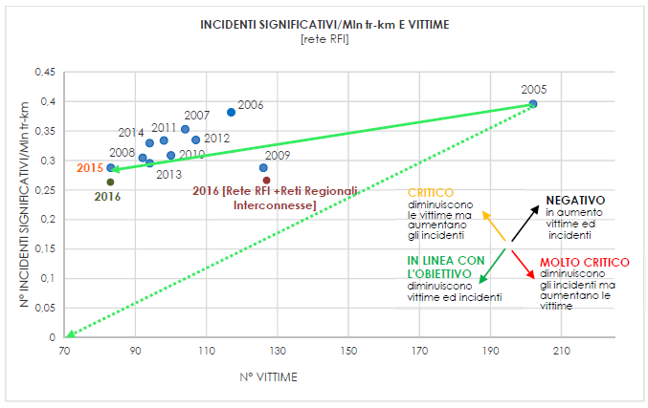

|  |  |
| --- | --- |
| **INCIDENTI SIGNIFICATIVI/Mln tr-km E VITTIME** | **SIGNIFICANT ACCIDENTS/million tr-km AND VICTIMS** |
| [rete RFI] | [RFI network] |
| N° INCIDENTI SIGNIFICATIVI/Mln tr-km | NO OF SIGNIFICANT ACCIDENTS/million tr-km |
| 0,45 | 0.45 |
| 0,4 | 0.4 |
| 0,35 | 0.35 |
| 0,3 | 0.3 |
| 0,25 | 0.25 |
| 0,2 | 0.2 |
| 0,15 | 0.15 |
| 0,1 | 0.1 |
| 0,05 | 0.05 |
| [Rete RFI +Reti Regionali Interconnesse] | [RFI Network + Interconnected Regional Networks] |
| CRITICO  diminuiscono le vittime ma aumentano gli incidenti | CRITICAL  fewer victims but more accidents |
| NEGATIVO  in aumento vittime ed incidenti | NEGATIVE  more victims and accidents |
| IN LINEA CON L'OBIETTIVO  diminuiscono vittime ed incidenti | IN LINE WITH TARGET  fewer victims and accidents |
| MOLTO CRITICO  diminuiscono gli incidenti ma aumentano le vittime | HIGHLY CRITICAL  fewer accidents but more victims |
| N° VITTIME | No VICTIMS |

The graph shows that over the period in question, the overall trend (continuous green arrow) is in line with the overall target (dashed green arrow). The trend was positive during the period 2005-2008 (effectiveness of train running protection systems) and also during the period 2009-2016 (reduction in accidents due to ‘technical reasons’). Despite a gradual reduction in the number of accidents, the number of victims was stable during the two-year period 2015-2016, although the finding indicated an approximately 25 % reduction compared to the average recorded during the decade (2005-2015).

The graph also shows the 2016 result for the entire network under the jurisdiction of ANSF (RFI Network + Interconnected Regional Networks) to indicate overall performance of the railway system to date. The figure is greatly influenced by the collision between trains that occurred in Corato in Puglia during July 2016. The technology of Interconnected Regional Networks must be upgraded to bring their performance into line.

An additional decrease in accidents and their consequences can be pursued by reducing accident levels associated with unauthorised crossing by pedestrians, including those occurring at level crossings, which caused nearly 93 % of victims in 2016, with 58 fatalities and 19 serious injuries.

## Findings emerging from the railway system analysis

The Ministry of Infrastructure and Transport Decree of 5 August 2016 extending ANSF’s responsibilities to the Interconnected Regional Networks provided for a transitional period to allow railway operators involved to reorganise their companies under Legislative Decree No 112 of 15 July 2015 and apply for the necessary safety certificates or authorisations from ANSF. During this period, ANSF prioritised contact with new entities in bilateral meetings and plenary meetings for topics common to several Operators.

Supervisory activity in 2016 was therefore addressed to the RFI Network and entities operating on that network.

There were still some shortcomings in safety management system (SMS) documentation by some operators. This generally applied to:

* + - * defining methods for implementing risk mitigation methods and evaluating their effectiveness;
      * implementing the common safety method set out in Regulation (EU) No 1078/2012 for monitoring aspects relevant to safety;
      * evaluating and implementing aspects related to the management of changes in the reference system under Regulation (EU) No 402/2013;

and with reference to specific areas:

* + - * organising checks on the operation of safety activity suppliers;
      * managing risks related to maintenance activities, whether carried out in-house or provided by external entities;
      * defining implementation and control stages for aspects related to the transport of hazardous goods and their complete traceability;
      * defining and guaranteeing the skills required by staff performing safety activities;
      * effectiveness of management appraisals;
      * impact of the role performed by the SMS Manager at corporate level.

In the case of the RFI Infrastructure Manager, the main deficiencies found in activities carried out concerned the following areas:

* Maintenance: there is no clear definition and implementation of the concept of safe maintenance in compliance with criteria V and W of Annex II of Regulation (EU) No. 1169/2010. In this regard:
  + - * there is no clear definition of the contribution of diagnostics to safe operation; there is no clear identification of procedures by which the results of this process are used to ensure the adoption of the necessary consequent actions, including traffic restriction measures, or of the criteria by which its effectiveness is evaluated;
      * outcomes and actions resulting from the management of visits to artworks are not properly managed and tracked.
* Hydrogeological risk management: there is no clear definition of criteria adopted to identify all sensitive points with regard to hydrogeological risk and to establish consequent mitigation measures to be implemented for railway operation based on a specific risk analysis. Initiatives provided following activation of ‘extraordinary monitoring in the event of adverse weather conditions’ are not always effective. There is also no evaluation of the appropriateness of traffic restriction measures in cases where these are established by driving staff and there is no definition of interim management measures pending full resolution of problems identified;
* Management of changes: management of changes to ground systems and subsystems has not always been compliant with relevant current legislation;
* Internal control: technical documentation is not always available at plants, updated or properly used; safety documentation is not always updated and managed in accordance with procedures in force; malfunctioning of equipment for recording the chronology of events at traffic management stations – and internal control activities are not always effective in highlighting management, operational and maintenance deficiencies present;
* Traffic management: it was found that recordings were incomplete and incorrect, including those relating to relationships between traffic and maintenance operators;
* Feedback management: incorrect application of procedures established for the management of investigations or surveys; failure to analyse the causes of non-conformity is identified, including for the purpose of adopting consequent actions; ineffective assessment of safety indicators and monitoring the execution of tasks assigned to staff, with particular reference to traffic operators.

The inspection activity revealed the persistence of problems, since 14 % (this data cannot be compared with previous years) of findings obtained during inspection activity on the infrastructure were found to be non-compliant as well as 11 % of those obtained from Railway Undertaking vehicles and activities.

Despite an improvement in compliance with deadlines arising out of commitments undertaken and generally more structured feedback, it was noted that evidence produced was limited in many cases to dealing with non-conformities identified without any proper analysis of the causes to ensure the problem did not recur: insufficient evidence was produced to show that the initiatives undertaken had been carried out effectively.

With regard to all other activities carried out on Railway Undertakings, shortcomings emerged with regard to:

* identification and implementation of risk control measures, completeness of related documentary content, verification of the effectiveness of measures;
* recording and management of non-conformities and consequent actions as well as of the internal audit system;
* application of Regulation (EU) No 1078/2012 with regard to monitoring of SMS processes and the adoption of appropriate safety performance evaluation indicators;
* vehicle maintenance management, whether carried out internally or outsourced to external suppliers. In particular, in many cases it was found that responsibilities were poorly defined among the various entities involved in vehicle maintenance management, the method of checking the effectiveness of maintenance carried out, completeness of the necessary formalities in contractual relationships with other operators involved (Holders, Entities in Charge of Maintenance);
* clarity of roles and responsibilities in relations between entities involved in hazardous good transport management.

## National safety strategy, programmes and initiatives

Every year, the Ministry of Infrastructure and Transport sets ANSF goals to be met when fulfilling tasks assigned by the applicable regulatory framework and their achievement is measured in a quantitative manner. In 2016, all the goals were met.

By 15 July each year, ANSF in turn notifies the infrastructure manager and the railway undertakings of objectives and critical areas within the railway system to allow the drawing up of an annual safety plan for the following year: priority areas that the railway operators must focus on are identified based on data from ANSF’s supervision activities and aspects notified by the railway operators in their annual safety report.

The actions do not usually resolve the problems in the short term but may require longer periods to implement and re-calibrate the measures. This is one of the reasons why critical areas sometimes persist year on year.

Objectives and critical areas for 2016 were also brought to the attention of Interconnected Regional Network railway operators although this was done at a later stage because these operators did not fall under the jurisdiction of ANSF until the first issue of the above document.

In 2016, ANSF asked the railway operators to ensure that their safety plans included projects and activities to resolve problems emerging from their own risk analyses or that were:

* indicated in documents on previous years relating to the identification of objectives and problem areas in the field of railway safety that have not yet been resolved based on the monitoring carried out;
* indicated in the ‘Preliminary report on railway safety’;
* reported by ANSF following an analysis of accidents or incidents, inspection activities or audits indicated in recommendations of the Directorate General for Railway and Maritime Investigations or stemming from international safety alerts.

In 2016, the same long-term objective of achieving zero accident and maintenance problem rates was pursued, together with an improvement in railway traffic safety, where feasible. In particular, the railway operators were required, each within their own field of competence, to:

1. reinforce railway safety (operation and maintenance);
2. reinforce monitoring of maintenance processes managed by external entities, both with regard to execution and support processes;
3. improve security procedures and guarantees for carrying out maintenance work that interferes with railway operation and track visits;
4. increase the number of professional refresher courses;
5. create and, where already present, optimise information flows between Infrastructure Manager and Railway Undertaking over technological device malfunctions;
6. pursue a synergistic and structured approach to deter pedestrians from trespassing on railway premises;
7. improve relations and contractual procedures with holders, builders and entities in charge of maintenance;
8. ensure that infrastructure managers improve the management of technical and administrative processes relating to the commissioning of new or amended structural ground subsystems;
9. ensure compliance with the provisions of ANSF Decree No 1/2015 relating to shunting locomotives;
10. improve the process of assessing and investigating railway accidents and problems;
11. complete the regulatory reorganisation.

Moreover, in view of the impact of technological equipment on reducing accident levels, ANSF has requested:

* + the Infrastructure Manager to continue the plan of equipping the railway infrastructure with devices to prevent accidents or limit their consequences;
  + Railway Undertakings to consider equipping trains with on-board devices that can detect, certify and promptly report any degradation or malfunctioning in components and mitigate the related risks.

With regard to the two main areas of intervention emerging from the analysis of significant accidents, the actions that ANSF has undertaken or called on the railway operators to adopt are set out below.

### Initiatives to mitigate problems relating to the unauthorised presence of pedestrians on the track and for the protection of rail transport users

During 2016, ANSF continued campaigns to spread the culture of railway safety, pursuing technical activities aimed at the world of railway operators and partnership activities with other institutions including the State Railway Police Service (POLFER), with which a specific memorandum of understanding has been activated.

To raise awareness among young people about the conscious, responsible and safe use of railway transport, ANSF developed a communications strategy with POLFER and with three Federations affiliated to CONI [Italian National Olympic Committee]: the Italian Basketball Federation (FIP), the Italian Rugby Federation (FIR) and the Italian Volleyball Federation (FIPAV). During 2016, five days of events were held with FIP, seven with FIR and seven with FIPAV, involving the participation of approximately 20 000 young people.

Partnerships have also been entered into with schools. During 2016, a competition (due for completion in 2017) was held in secondary schools to reward the best work produced on the subject of compliance with railway mobility rules. This was organised in conjunction with the Railway Police, the Regional Educational Office and the Region. In Tuscany, a cycle of direct campaigns was implemented together with the Regional Educational Office and the Region. These were addressed to the teaching body (one campaign) and school groups (three campaigns) with the involvement of approximately 400 teachers and students.

ANSF is also implementing appropriate synergies with universities to analyse the phenomenon of unauthorised crossing, funding specific scholarships for theses on railway safety.

In 2017, production was completed on an advert that will act as the basis for a broader communication campaign on railway safety issues to combat improper behaviour at stations, along tracks and on-board trains. The advert, launched at a press conference held on 19 September 2017 in the presence of the Minister of Infrastructure and Transport, will also be conveyed online and by means of billboards and posters. It will be broadcast as a public service advert on RAI networks. The video is aimed especially at young people: it is made in the style of a cartoon with characters from the world of sport who already feature in a TV series familiar to this audience.

These campaigns achieve positive medium and long-term effects and must therefore be associated with short-term measures for passive protection of railway premises. For this reason, Infrastructure Managers must offer further commitment and local Institutions and Administrations must be made more aware of their responsibilities. It would be appropriate to encourage partnerships between institutions to carry out:

* an analysis of railway area usability and permeability conditions;
* an assessment of the effectiveness of the pedestrian/vehicular road system present near railway areas.

In order to combat the phenomenon of the unauthorised presence of pedestrians, ANSF called on the infrastructure manager:

* + - * with the cooperation of railway undertakings, to update the mapping of areas where there is a high probability of people being struck and to adopt appropriate preventive safety measures in such areas;
      * to inform ANSF of any initiatives taken on the issue in question (cooperation with local authorities or with state police and launching of any informative, dissuasive or penalty campaigns).

Following these requests, RFI:

* + - * updated the mapping and, to make it more difficult to pass through unauthorised access points, ordered the planning of structural measures to mitigate the phenomenon (mobile barriers for the protection of construction sites, other actions aimed at the installation of fences, self-propelled barriers on station platforms and so on);
      * introduced a special procedure extending powers to RFI employees responsible for railway infrastructure running, caretaking and maintenance, for establishing offences under Presidential Decree 753/1980;
      * started a study with the aim of reviewing the system of penalties currently laid down with a view to a future change to the provisions of Presidential Decree 753/1980;
      * undertook information and training campaigns on the subject of safety at educational establishments and on-board the Green Train.

### Level crossing problem mitigation initiatives

State-funded level crossing (LC) removal activities have led to a decrease of almost 53 % in the number of LCs on the RFI network over the last 26 years (1990-2016). As of 31/12/2016, 4620 of the initial 9992 remain, with a reduction of 220 units compared to the previous year. On average, over the last 10 years, 3.5 % of total crossings have been removed, amounting to approximately 200 crossings per year.

The 32 % reduction in the number of LCs achieved between 2005 and 2016 was reflected by a 44 % fall in significant accidents occurring at level crossings between 2005 and 2016.

The technical and technological actions requested by ANSF are as follows:

* + - * equipping user-worked level crossings with a high-tech system that allows them to be opened on demand;
      * ensuring the efficiency of devices in use;
      * improving LC circuit layouts;
      * equipping LCs with systems for detecting obstacles between barriers (mainly cars stranded between barriers);
      * installing barriers that pedestrians cannot get around, that do not give rise to a risk of becoming entangled when raised;
      * resolving specific problems relating to parallelism between road and railway.

The effectiveness of technical or technological actions is subject to compliance with intervention completion times.

In order to implement the above, during 2016 RFI prioritised action on LCs handed over to private users. The estimated outcome is the removal of approximately 130 units and a financial commitment of approximately EUR 5.8 million.

This activity is limited by the cost and complexity of the work required for complete removal of LCs. The next step toward increasing the safety of existing LCs is therefore to equip them with technological devices and maintain the high professional standards of staff.

Given the accidents and problems occurring at LCs in private hands, in 2016 ANSF called on RFI to adopt measures over the entire Italian network (repeating a request made in 2015) with the aim of:

* imposing top speeds not exceeding 80 km/hour as imposed on sections equipped with LCs without barriers, notwithstanding the need to adopt lower speeds where, for example, there are specific situations concerning visibility and crossing times;
* adopting a system of opening on demand through telephone communications logged between the traffic regulator and LC user.

RFI has also initiated a project to convert LCs in private hands to ‘open on demand’ LCs, in other words equipped with a special technological system that temporarily suspends rail traffic when the user is operating the LC.

With regard to the public LC category, RFI equipped 220 of the 4620 LCs present with PAI-PL [level crossing supplementary automatic protection devices] and/or TV-PL [level crossing TV] devices. Testing has also started on an electronic pedal device for level crossings (PEPL). This system is designed to ensure that the barriers do not open for a set time after release pedal axle detection and then only when the train has left the appropriate binary circuit (BC). During 2016, the associated equipment plan was launched with the installation of 120 devices.

However, it should be stressed that most level crossing accidents are linked to road traffic offences or in any case to improper behaviour by road users. Road user awareness must therefore be improved through information and education campaigns, adding targeted campaigns for road users. We must also ensure that those approaching LCs are aware of the context and specific risks they are about to encounter and therefore:

* guarantee that the road-side signals are present and properly visible;
* change the local road system where possible;
* install rumble strips or speed-reduction devices.

Similar action must also be taken on LCs on Interconnected Regional Networks, given the density of crossings present. During bilateral meetings with regional railway operators, the need was stressed to prepare a plan to upgrade the technology of LCs and remove LCs.

### Maintenance problem mitigation initiatives

Although vehicle-side and infrastructure-side maintenance problems have fallen since last year in absolute terms, they still form the basis of at least 26 % of all accidents and accident ‘precursors’.

ANSF has made a check on the maintenance process and the training of maintenance staff a priority among its supervisory activities, organising targeted audits and inspections and requiring appropriate feedback following accidents and incidents.

The following areas of intervention have also been identified among the objectives and critical areas for 2016:

* + - * reinforcing control of maintenance processes by checking and monitoring maintenance processes whether carried out internally or outsourced to external entities, with particular reference to security operation traceability, defining and controlling the skills of staff involved, relationships between fleet management and operation and management of risks relating to these activities;
      * improving safety procedures and guarantees for carrying out maintenance work that interferes with railway operation and track visits;
      * increasing the number of professional refresher courses;
      * improving the process of assessing and investigating railway accidents and incidents and associated feedback, also ensuring that the condition of places and vehicles is not altered before the inspections.

These critical areas direct the strategy and action priorities of railway operators through projects set out in the Safety Plan.

By issuing "Guidelines for certifying Entities in Charge of Maintenance of railway vehicles (excluding freight wagons)", ANSF has created a tool to modulate the application of Regulation 445/2011 in settings not covered by the Regulation in order to ensure uniform application of operational standards and procedures. During 2016, ANSF monitored the application of the tool provided to operators and this led to the issue of one ECM certificate by the certified bodies.

ANSF also made use of warnings received from other NSAs using the Safety Alert tool to convey critical information regarding the life-cycle of components used in European settings. In 2016, 10 cases were processed and can be found in the appropriate section of the website ([www.ansf.it](https://www.ansf.it/)).

In particular, in 2016, ANSF received a Safety Alert from the Polish NSA concerning the identification of some defects in the trucks of ATR 220 and ATR 220Tr trains. It alerted the Italian railway companies that could potentially be involved and the manufacturer of these vehicles to allow them to take all the necessary measures.

Joint checks conducted by the manufacturer and the Railway Undertakings revealed defects in the trucks that could not be directly linked with those described in the safety alert. These were also identified on trains that were not yet in operation and could therefore probably be traced back to manufacturing problems. ANSF also asked the train certification body to analyse the problem. The timely intervention made it possible to implement extraordinary control measures and start work on repairing the trucks.

Given the usefulness and effectiveness of these tools, ANSF will continue to support the exchange of safety information between the various stakeholders in the European Union, supporting initiatives proposed to this effect by ERA.

Lastly, with regard to interface activities between infrastructure maintenance and rail operation, we are waiting for RFI to complete the framework of measures to mitigate risks associated with incorrect maintenance operations on safety systems and activities carried out in work sites.

### Main strategies in ANSF's international activities

In accordance with Ministry of Infrastructure and Transport (MIT) guidelines, in 2016 ANSF oversaw relationships with the European Railway Agency (ERA) in the field of railway safety and interoperability and participated in groups specially set up within ERA, by agreement with the Directorate General for Transport and Railway Infrastructure.

ANSF provided the Directorate General for Transport and Railway Infrastructure of the Ministry of Infrastructure and Transport with technical support:

* for participation and training of an Italian representation within the European Commission and the Railway Interoperability and Safety Committee (RISC) made up of Member State representatives, established under Article 27 of Directive 2004/49/EC and participation in the Tech Working Group within the OTIF;
* in groups established by the European Commission devoted to the implementation of the 4th Railway Package (Group of Experts on Implementation and Fees and Charges Group);
* for Rail Freight Corridors as set out in Regulation (EU) No 913/2010. In particular, ANSF experts participated directly in Corridors 1, 3 and 6 Executive Board and Corridors 1-3 Steering Committee as well as the ERTMS task force on Corridor 1 and drew up reports on all meetings.

With a view to applying the new regulatory framework, ANSF also played an active role in the working groups, taskforces and workshops set up by ERA and the ILGGRI (International Liaison Group of Government Railway Inspectorates).

ANSF took part in the ERA Group for the review of Regulations on CSMs, Conformity Assessment and Supervision, delivering questionnaires to evaluate the impact of the new regulations, links with human factor aspects and new Technical Specifications for Interoperability (TSI) on operation to be incorporated into the Safety Management System.

In all the committees in which it participated, ANSF encouraged the adoption of common harmonised measures by all national authorities, notwithstanding the possibility of adopting emergency measures in situations prejudicial to safety. The authority granted by the regulatory framework to individual entities and for support by the latter meant that they had little impact on the achievement of this goal.

ANSF also participated:

* in the instructions of the Ministry of Infrastructure and Transport, in the ‘Safety in Alpine railway tunnels’ Group (Zurich Process), which is responsible for safety in Alpine area railway tunnels;
* under the coordination of the Ministry of the Interior, in the IMI project by using the IMI (Internal Market Information) system routinely. This is a multilingual IT platform developed by the European Commission to exchange information on drivers’ licences between the safety authorities of the various Member States. The system makes it possible to receive requests for access (usually from Belgium and France) to information held in the RNL (Italian national driving licence registry) and also to send similar requests.

As part of European agency working groups for the review of TSI Operation and in a specific bilateral meeting with the European Agency held in Rome on 12 October 2016, ANSF representatives highlighted the following critical areas affecting the implementation of the current version of the TSI on operation within the Italian regulatory framework:

* replacing only some Italian standards with TSI Operation standards that often do not perfectly coincide with one another can undermine the internal consistency of the national regulatory framework with a possible impact on operating safety; this risk could be avoided only by ensuring that TSI Operation contains a complete and self-consistent set of operating standards with which to replace all Italian standards. At present this is not the case;
* European harmonisation of operating standards can only be achieved if the following safety principles are clearly defined in TSI OPE. In particular, among these principles, standards concerning safety functions performed by ground systems (interlocking, locking systems and protection systems) should be defined and harmonised; for example, it is impossible to harmonise operating rules between a network with a telephone lock and a network with an automatic lock, even if they are both equipped with ETCS (which is technically possible): the first network would require additional operating rules (such as control of crossings by train staff) to mitigate human error risks relating to the use of a telephone lock.

ANSF also participated actively in cross audits between national safety authorities with the aim of evaluating compliance by each NSA with the provisions of Directive 2004/49/EU, as well as in seminars and workshops held at ERA, where it shared problems arising while carrying out its activities and explained the solutions adopted.

In February 2016, the final report on the cross audit on ANSF (started in 2014 and completed in October 2015 with a close-out meeting) was shared with the ERA Cross Audit Team with authorisation for publication. In May 2016, at the end of the cross audit involving supervision and audit, safety certificate and authorisation, vehicle commissioning authorisation as well as the cross-cutting activity of organisational capacity, ANSF presented the final report at the NSA network meeting. During the presentation, strength and improvement actions were highlighted and the cross audit process was acknowledged to be a good opportunity for discussion and improvement. ERA also showed its great appreciation for ANSF's willingness to reveal its inner workings through interviews, submission of documents and on-site visits

Outside the sphere of ERA, ANSF played an active role in cross acceptance activities on trans-European corridors.

ANSF also played an active and regular role in European forums on rail transport organised by the Florence School of Regulation, which is part of the Fiesole European University Institute. In particular, on 2 May 2016, ANSF presented a report on the infrastructure register within the forum entitled: ‘How to define, measure, and improve the performance of the European railway system?’.

Together with other NSAs (NSA France and NSA Bulgaria) ANSF took part in the European HIPOPS Project coordinated by RINA, which completed work on WP2 and continued working on WP3 during 2016. In particular, Sector 2 followed administrative and reporting aspects.

Lastly, international events organised by ANSF included the Regional Workshop on TSI TAF (Telematic Applications for Freight) in partnership with ERA and the Slovenian and Croatian national contact points. The purpose of the event was to inform railway sector undertakings of the state of the art of TSI TAF, implementation tools, medium and long-term planning and how TSI TAF is becoming an established part of railway operations. The ANSF website includes a specific section on national contact point activities performed by ANSF.

## Review of the previous year

The activities that ANSF carried out during 2016 with regard to the established goals are set out below. See part E for a statement on safety certification and activities associated with the authorisation for placing in service. For accident and incident analysis details, see point B.1 above and part C below.

### Monitoring of railway operator activities following regulatory reorganisation

ANSF continued monitoring the operating provisions and specifications issued by entities operating on the RFI network to regulate their internal processes in accordance with the regulatory reorganisation implemented by ANSF decree No 4/2012 of 9 August 2012, which entered into force on 1 January 2013 as well as interface procedures with railway undertakings in the case of the infrastructure manager.

This activity, aimed at verifying the consistency of measures taken by Operators with safety principles, showed that most of the critical issues noted during 2015 had been overcome, but some remained outstanding, mainly relating to interface procedures. These specifically included procedures regulating traffic modalities between different systems (for example between stations and freight terminals, intermodal terminals, ports and interports (or between sidings in the same systems: although these movements should be carried out as train movements and therefore protected by safety systems and driving protection systems, sometimes they are carried out using different procedures (shunting, breaking) due to shortcomings in systems.

In 2016, all operating provisions and specifications (472) sent by the railway operators were examined. See part D for details of the activity.

### Training of staff with safety responsibilities

In accordance with the regulatory framework in force, ANSF provided for the issue of:

* + - * 6243 train driving licences;
      * 414 accreditation certificates for instructors and examiners of staff with safety responsibilities.

In 2016, ANSF:

* carried out 105 inspections on instructors/examiners and ANSF-accredited training centres;
* recognised one new training centre under Article 17(5) of Legislative Decree No 162 of 10 August 2007 and Article 20(5) and (6) of Legislative Decree No 247 of 30 December 2010.

### Inspection and audit of infrastructure managers and railway undertaking activities

ANSF’s inspection and audit activities conducted on railway undertakings and on the RFI Manager were carried out using the following instruments:

* inspection activities, meaning a specific non-reproducible check on individual elements of the railway system, subdivided into:
  + routine monitoring, carried out more or less continuously during the year through observation of predetermined elements (sample checks);
  + specific inspections, which consist of examinations following reports (including by the Railway Police), accidents and incidents, results of monitoring activity and in general as a result of requirements not covered by routine monitoring;
* audits, a systematic process carried out on certified operators to establish the extent to which policies, procedures and requirements have been met (documentary and on-the-spot audits);
* targeted checks on accidents and incidents considered most significant with the aim of promptly acquiring all information necessary to identify the cause of the event and make it possible for ANSF or Operators to adopt measures to help avoid the repetition of such events;
* monitoring and analysis of accidents and incidents;
* adoption of measures against the Operators involved following an analysis of recommendations issued by the Directorate General for railway investigations, and monitoring the implementation of such measures.

Specific inspection campaigns were also carried out in different areas. Some of the most relevant are listed below:

* + - * operations of train driving crew and other on-board crew;
      * notifications from foreign competent authorities (Swiss Confederation Federal Transport Office and NSA Germany – EBA), with particular regard to the transport of hazardous goods;
      * joint operations with the Swiss Confederation Federal Transport Office in the field of vehicle checks and maintenance;
      * overcrowding of local transport trains;
      * trains travelling on interconnected regional railways formerly operated under licence and entering station common to RFI;
      * effectiveness of corrective actions implemented by railway undertakings after audit;

|  |  |
| --- | --- |
| **ACTIVITIES CARRIED OUT IN 2016** | |
| **190** activities on Safety Management Systems and railway operator operating processes | 68 on-the-spot audits:   * 39 on the RFI Manager * 29 on railway undertakings (in seven cases, checks were carried out on hazardous goods transport) |
| 4 on-the-spot audits on accredited training centres |
| 65 documentary audits:   * 1 on the RFI Manager * 64 on 27 railway undertakings out of which   + 15 included checks on hazardous goods transport   + 5 included examination of the process of preparing safety plans and consistency of safety plans |
| 53 documentary follow-ups on evidence sent by railway operators for the processing and resolution of non-compliance cases emerging in previous on-the-spot operations:   * 22 on the RFI Manager * 29 on 19 Railway Undertakings. |
| **1331** inspection activities | 1198 inspection activities for a total of 7716 checks on 32 railway undertakings that carried out rail transport services |
| * 1166 elements checked with regard to the infrastructure manager (switches, binary circuits, level crossings, automatic locking stations, station and track equipment) for a total of 7243 measurements carried out * three tunnels and five works of art visited * 843 km of railway sections travelled on board a locomotive |
| **37** specific inspection activities |  |
| **120** targeted checks |  |

* + - * management of vehicle shunting and movement within terminals;
      * joint activities with Railway Police with the aim of hazardous goods transport inspection monitoring;
      * information declared by holders and/or owners of vehicles upon registration or amendment of the information in the national RIN Register;
      * performance of review commissions on staff involved in operational incidents, application of rules regarding training processes for staff with safety duties, work of instructors and examiners of staff performing safety duties, recognised by ANSF and training delivery entities.

See section B.1.2 for critical areas identified

The targeted checks conducted by ANSF focused on the most critical events by type of accident or by the seriousness of the possible consequences. The following data relate to the distribution of risk factors, highlighting the predominance of maintenance-related issues;

* 7 % of cases linked to the human factor ‘outside the railway system’;
* 34 % of cases linked to the incorrect execution of railway procedures (operation and shunting);
* 20 % of cases linked to infrastructure maintenance;
* 39 % of cases linked to rolling stock maintenance.

## Certification of entities in charge of railway freight wagon maintenance

In 2016 ANSF took part in inspection visits of the MIT [Ministry of Infrastructure and Transport]-ANSF Working Group, established by Decree of the Head of the Department for Transport, Navigation and IT Systems and Statistics, with operational functions connected with the activities of the Directorate General for Railway Transport for recognition, renewal, amendment and monitoring of Organisations certifying entities in charge of railway freight wagon maintenance.

Five monitoring activities were carried out in support of the Ministry of Infrastructure and Transport on the premises of entities who obtained Certification Body accreditation for Entities in Charge of Maintenance of railway freight trucks from the Ministry and one on-the-spot on-board checking activity.

## Focus areas for next year

The Agency’s primary objective is that the whole railway system should tend to achieve zero accident levels by means of maintenance and, where reasonably practicable, the continuous improvement of railway safety. In this context, ANSF will adopt a risk-based approach in a structured manner, identifying a priority scale of topics to be addressed. ANSF will continue:

* to encourage the railway undertakings and the network Manager to overcome the potential mismatch between production and commercial requirements on the one hand and safety protection on the other – and ensure effective control of their parts of the system;
* cross-border cooperation activities;
* supervision activities concerning purely railway-related aspects of dangerous goods transport;
* monitoring the proper conduct by railway operators of investigations into relevant railway accidents and incidents, aiming in particular to overcome failure to act or lack of co-operation between Operators and in relation to ANSF itself;
* verifying the internal control systems of railway operators (monitoring), the change management process and control and management of suppliers and the services they provide.

Activity arising out of the entry into force of Ministry of Infrastructure and Transport Decree of 8 August 2016 will be significant for ANSF. This decree identified Regional Networks interconnected with the national railway infrastructure that are deemed to be of strategic importance for the railway system included within the scope of ANSF. In order to guarantee the transition to the new regulatory context, ANSF:

* conducted a preliminary analysis of the main characteristics of organisations covered by the above decree to find out the organisational and technological state-of-the-art;
* offered its support and experience to railway operators, proposing explanatory and clarifying actions and setting up technical committees and workgroups within the sector association;
* identified measures to be implemented pending technological upgrading for each requirement to be complied with. This applies to operations that cannot be achieved quickly, stressing in particular that measures different from those indicated must be supported by a risk analysis demonstrating that they are equally effective. Such measures, which often require a reduction in travelling speed, have an impact on service while encouraging prompt implementation of the necessary technical measures;
* reminded companies of their obligations regarding vehicles used, including registration in the national vehicle register (RIN) and identification of entities in charge of maintenance;
* identified parts of Presidential Decree 753/1980 that are no longer in force following an extension of the scope of Legislative Decree 162/2007 and consequently requested clarification concerning the remaining tasks of ministerial offices concerning railway companies under Ministerial Decree 5/8/2016.

To avoid an impact on the regularity of regional services, the above Decree introduces a safeguarding rule that recognises the validity of authorisations previously issued by institutionally approved entities until the issue of the new authorising titles under Legislative Decree 162/2007. At the same time, the new railway operators will have to take steps to come into line with safety standards and management procedures that meet national and international regulatory standards. The time required to allocate public resources and the time required to implement the works will mean that the interventions are staggered in time. The necessary technical, organisational and technological upgrading will therefore take varying amounts of time depending on the availability of funding and the speed with which the new operators react. Technical and technological operations will be carried out under the responsibility of the new railway operators. During 2017, ANSF will therefore be strongly committed due to its own authorisation and certification functions in particular, as well as due to activities relating to the control and supervision of the new railway system.

Working in agreement with the Ministry of Infrastructure and Transport, ANSF started to check compliance with current safety and interoperability legislation by setting up a working committee. During the first stage, the reference area will be railway infrastructures linked to ports and will then be extended to interports and intermodal terminals. The aim is alignment of safety levels throughout the entire railway system. In order to apply this provision, ANSF considers it appropriate to set up a working group to increase the safety levels of port connections:

* harmonising them with national railway network connections;
* promoting improvement in technical aspects necessary to achieve the aim of strengthening port interchanges between maritime and rail transport.

ANSF is also preparing an implementation circular for railway safety standard and recommendation infringements, to be penalised under Article 18 of Law No 122/2016 and infringements of train driver certification requirements under Legislative Decree 247/2010, to be penalised under Article 26 of the Decree. Where the punishable behaviour is prejudicial to railway system safety, ANSF may adopt precautionary measures involving the total or partial suspension of the title’s effectiveness or prevent the circulation of vehicles or the use of staff.

During 2017, ANSF intends to focus its activities on verifying the effective incorporation of the human factor in safety management systems and constituent procedures. In particular, attention must be paid:

* + during the stage of planning working activities with a human element (duties, workload, shifts, motivation, working environments, available human resources and so on);
  + to identifying staff involved, who must have special skills and expertise and must be able to maintain these qualities over time.

In this context, it will also verify the adoption by railway operators of plans to equip railway lines and vehicles with technological systems designed to mitigate the consequences of possible front line staff errors.

# PART C – DEVELOPMENTS IN SAFETY PERFORMANCE

## Detailed analysis of the latest recorded trends

This part describes trends recorded in individual casualty and accident categories on the RFI network. Part B.1.1 reports the main accident analysis data obtained.

The following table shows the categories of persons employed in the Eurostat survey (passengers, railway employees and other persons). The ‘other persons’ category is detailed under ‘level crossing users’, ‘unauthorised persons on the railway track’ and ‘others’, as provided in Annex 1 of Legislative Decree 162/07.

|  |  |  |  |  |  |  |  |  |  |  |  |  |
| --- | --- | --- | --- | --- | --- | --- | --- | --- | --- | --- | --- | --- |
|  | **VICTIMS - CATEGORIES OF PERSONS**  **under ANNEX 1 of Legislative Decree 163/2007, as amended**  **[RFI network]** | | | | | | | | | | | |
| **2005** | **2006** | **2007** | **2008** | **2009** | **2010** | **2011** | **2012** | **2013** | **2014** | **2015** | **2016** |
| **PASSENGERS** | **88** | **19** | **14** | **9** | **15** | **13** | **4** | **8** | **5** | **2** | **9** | **3** |
| **RAILWAY EMPLOYEES** | **22** | **14** | **7** | **9** | **12** | **10** | **1** | **8** | **4** | **6** | **1** | **0** |
| **OTHER PERSONS:** | **92** | **84** | **83** | **74** | **99** | **77** | **93** | **91** | **85** | **86** | **73** | **80** |
| OTHER PERSONS ON PAVEMENTS | 0 | 0 | 0 | 0 | 0 | 0 | 0 | 0 | 2 | 0 | 1 | 0 |
| OTHER PERSONS NOT ON PAVEMENTS | 0 | 0 | 0 | 0 | 43 | 0 | 0 | 0 | 0 | 0 | 0 | 0 |
| LEVEL CROSSING USERS | 23 | 31 | 18 | 8 | 5 | 14 | 16 | 17 | 17 | 16 | 15 | 9 |
| UNAUTHORISED PERSONS ON THE RAILWAY TRACK | 69 | 53 | 65 | 66 | 51 | 63 | 77 | 74 | 66 | 70 | 57 | 71 |
| **TOTAL** | **202** | **117** | **104** | **92** | **126** | **100** | **98** | **107** | **94** | **94** | **83** | **83** |

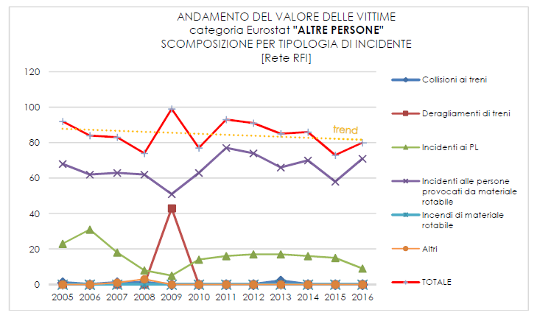

|  |  |
| --- | --- |
| ANDAMENTO DEL VALORE DELLE VITTIME  categoria Eurostat "**ALTRE PERSONE**" | TREND IN VICTIM NUMBERS  Eurostat category ‘**OTHER PERSONS**’ |
| SCOMPOSIZIONE PER TIPOLOGIA DI INCIDENTE | BREAKDOWN BY TYPE OF ACCIDENT |
| [Rete RFI] | [RFI network] |
| trend | trend |
| Collisioni ai treni | Train collisions |
| Deragliamenti di treni | Train derailments |
| Incidenti ai PL | LC accidents |
| Incidenti alle persone provocati da materiale rotabile | Accidents to persons caused by rolling stock |
| Incendi di materiale rotabile | Fires in rolling stock |
| Altri | Others |
| TOTALE | TOTAL |

All the categories used as a reference show a reduction for the last two-year period and an overall negative trend during the period 2005-2016, apart from the category of ‘unauthorised persons on railway premises’.

Between 2015 and 2016, the overall number of victims remained unchanged because a reduction in the number of serious injuries was offset by an increase in the number of fatalities: 24 serious injuries compared to 37 in 2015 and 59 deaths compared to 46 in 2015.

The ‘unauthorised persons on railway premises’ category had a negative impact on the data performance in terms of fatalities (rising from 36 in 2015 to 54 in 2016) because the number of serious injuries fell (from 22 in 2015 to 17 in 2016).

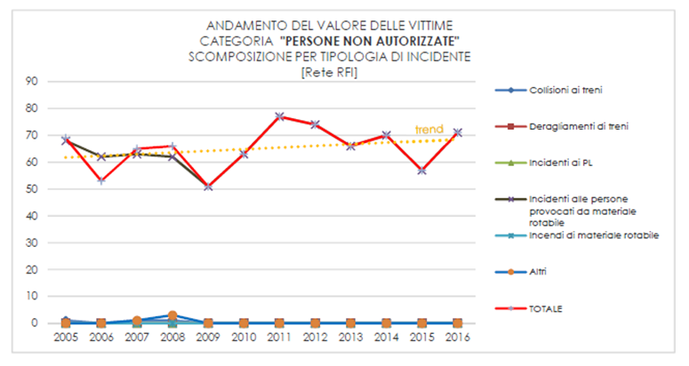‘Accidents caused by rolling stock in motion’ represented the main cause of victims in the ‘unauthorised persons on railway premises’ category as well as in the ‘passengers’ category. In particular, the former category showed a growing trend throughout the entire reference period.

|  |  |
| --- | --- |
| ANDAMENTO DEL VALORE DELLE VITTIME CATEGORIA "**PERSONE NON AUTORIZZATE**" | TREND IN THE NUMBER OF VICTIMS ‘**UNAUTHORISED PERSONS** ‘ CATEGORY |
| SCOMPOSIZIONE PER TIPOLOGIA DI INCIDENTE | BREAKDOWN BY TYPE OF ACCIDENT |
| [Rete RFI] | [RFI network] |
| trend | trend |
| Collisioni ai treni | Train collisions |
| Deragliamenti di treni | Train derailments |
| Incidenti ai PL | LC accidents |
| Incidenti alle persone provocati da materiale rotabile | Accidents to persons caused by rolling stock |
| Incendi di materiale rotabile | Fires in rolling stock |
| Altri | Others |
| TOTALE | TOTAL |

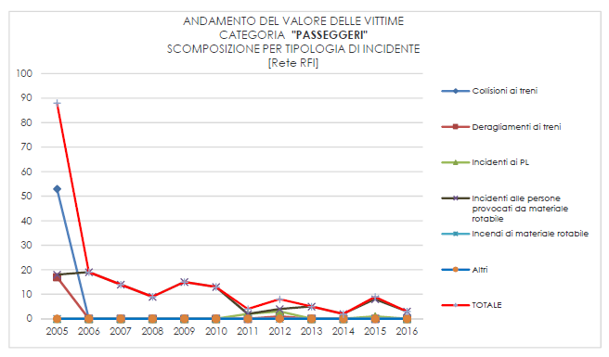

|  |  |
| --- | --- |
| ANDAMENTO DEL VALORE DELLE VITTIME CATEGORIA "**PASSEGGERI**" | TREND IN THE NUMBER OF VICTIMS ‘**PASSENGERS**‘ CATEGORY |
| SCOMPOSIZIONE PER TIPOLOGIA DI INCIDENTE | BREAKDOWN BY TYPE OF ACCIDENT |
| [Rete RFI] | [RFI network] |
| Collisioni ai treni | Train collisions |
| Deragliamenti di treni | Train derailments |
| Incidenti ai PL | LC accidents |
| Incidenti alle persone provocati da materiale rotabile | Accidents to persons caused by rolling stock |
| Incendi di materiale rotabile | Fires in rolling stock |
| Altri | Others |
| TOTALE | TOTAL |

The category ‘accidents caused by rolling stock in motion’ represented the main category during the relevant time window (2005-2016), even considering victims recorded among ‘staff’. In this case the trend was negative and fell to 0 in 2016 (next graph).

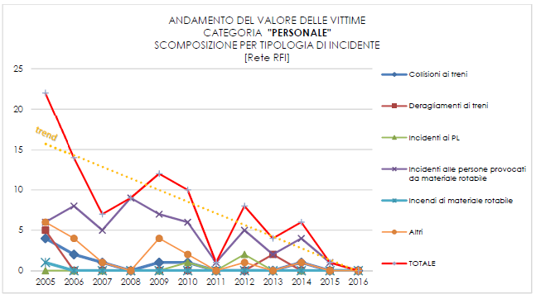

|  |  |
| --- | --- |
| ANDAMENTO DEL VALORE DELLE VITTIME CATEGORIA "**PERSONALE**" | TREND IN THE NUMBER OF VICTIMS ‘**STAFF**‘ CATEGORY |
| SCOMPOSIZIONE PER TIPOLOGIA DI INCIDENTE | BREAKDOWN BY TYPE OF ACCIDENT |
| [Rete RFI] | [RFI network] |
| trend | trend |
| Collisioni ai treni | Train collisions |
| Deragliamenti di treni | Train derailments |
| Incidenti ai PL | LC accidents |
| Incidenti alle persone provocati da materiale rotabile | Accidents to persons caused by rolling stock |
| Incendi di materiale rotabile | Fires in rolling stock |
| Altri | Others |
| TOTALE | TOTAL |

Analysing numbers of ‘accidents to persons caused by rolling stock in motion’ (next graph) in relation to traffic on the network shows a negative trend. In recent years, the performance for this category has been persistently below the period average (2005-2016). Despite a 22 % reduction compared to the 2005 figure, when the observation window is refined to the last decade, the figure shows very low fluctuation variance.

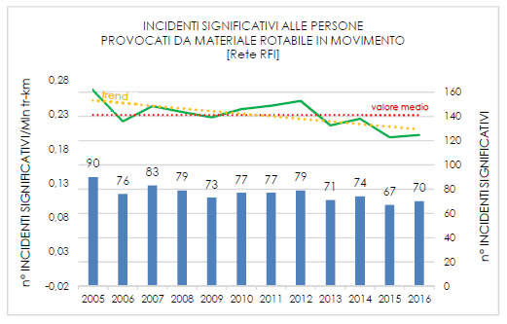

|  |  |
| --- | --- |
| INCIDENTI SIGNIFICATIVI ALLE PERSONE PROVOCATI DA MATERIALE ROTABILE IN MOVIMENTO | SIGNIFICANT ACCIDENTS TO PERSONS CAUSED BY ROLLING STOCK IN MOTION |
| [Rete RFI] | [RFI network] |
| trend | trend |
| valore medio | average value |
| n° INCIDENTI SIGNIFICATIVI/Mln tr-km | NO OF SIGNIFICANT ACCIDENTS/million tr-km |
| n° INCIDENTI SIGNIFICATIVI | NO OF SIGNIFICANT ACCIDENTS |
| 0,28 | 0.28 |
| 0,23 | 0.23 |
| 0,18 | 0.18 |
| 0,13 | 0.13 |
| 0,08 | 0.08 |
| 0,03 | 0.03 |
| -0,02 | -0.02 |

This category was still the most common and high-impact type of accident in 2016, just as it was in 2015. It represented approximately 76 % of significant accidents recorded and caused nearly 90 % of victims. However, in 2016 it was also identified as the type of accident with the highest number of victims associated with an individual event: 70 events caused 74 victims of which 54 were killed and 20 injured. During 2016, two accidents associated with ‘unauthorised presence on railway premises’ were recorded in the category of ‘unauthorised persons crossing railway premises’, which were associated with multiple victims.

The category of ‘unauthorised persons on railway premises’ still represents the category with the greatest impact on the overall number of victims; the number for 2016 increased at a higher rate than in recent years, giving rise to a positive trend throughout the reference period (2005-2016).

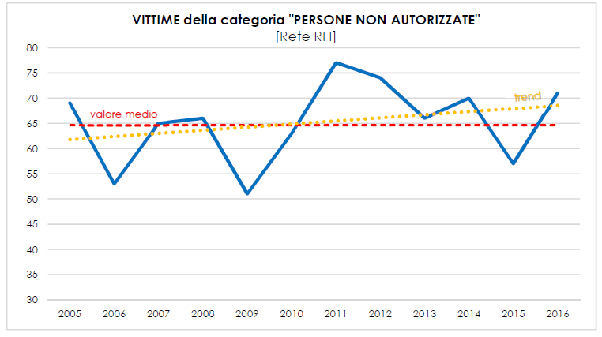

|  |  |
| --- | --- |
| **VITTIME della categoria "PERSONE NON AUTORIZZATE"** | **VICTIMS in the ‘UNAUTHORISED PERSONS’ category** |
| [Rete RFI] | [RFI network] |
| SCOMPOSIZIONE PER TIPOLOGIA DI INCIDENTE  [Rete RFI] | BREAKDOWN BY TYPE OF ACCIDENT  [RFI network] |
| trend | trend |
| valore medio | average value |

In 2016, the reference value (NRV) established for the category ‘unauthorised persons on railway premises (5)’ was again exceeded, which is clearly influenced by the unauthorised presence of pedestrians. The available evidence did not show any deterioration in the safety level during the period 2012-2016 for this category. Managers have been asked to increase passive measures to prevent unauthorised crossings as well as user prevention and information activities. Official 2016 statistics for the network under the jurisdiction of ANSF showed an increase after a falling trend for the five previous years. However, the data used to determine the National Reference Value (NRV) and any surplus refer to the entire Italian railway system (including isolated railways) and not only the part for which ANSF is responsible. The analyses and measures adopted by ANSF are currently of limited value. The main causes of the phenomenon may also lie in areas that are not exclusively railway-related.

We will now go on to analyse accidents at level crossings and associated casualties (‘level crossing users’). This indicator showed a fluctuating trend during the period in question, with values for the last five years close to the average value for the period.

In 2016, level crossing accidents accounted for about 12 % of significant accidents and caused about 10 % of victims, a reduction compared with 2015. The following graphs show the data trend during the reference period (2005-2016). The ‘LC victim’ component was made up exclusively of LC users in 2016. Events also involving ‘passenger’ and ‘staff’ categories have occurred only sporadically over the years.

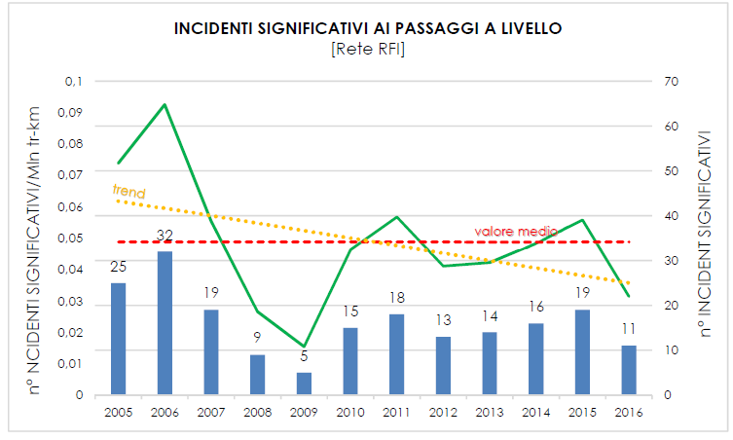

|  |  |
| --- | --- |
| **INCIDENTI SIGNIFICATIVI AI PASSAGGI A LIVELLO** | **SIGNIFICANT LEVEL-CROSSING ACCIDENTS** |
| [Rete RFI] | [RFI network] |
| trend | trend |
| valore medio | average value |
| n° INCIDENTI SIGNIFICATIVI/Mln tr-km | NO OF SIGNIFICANT ACCIDENTS/million tr-km |
| n° INCIDENTI SIGNIFICATIVI | NO OF SIGNIFICANT ACCIDENTS |
| 0,1 | 0.1 |
| 0,09 | 0.09 |
| 0,08 | 0.08 |
| 0,07 | 0.07 |
| 0,06 | 0.06 |
| 0,05 | 0.05 |
| 0,04 | 0.04 |
| 0,03 | 0.03 |
| 0,02 | 0.02 |
| 0,01 | 0.01 |

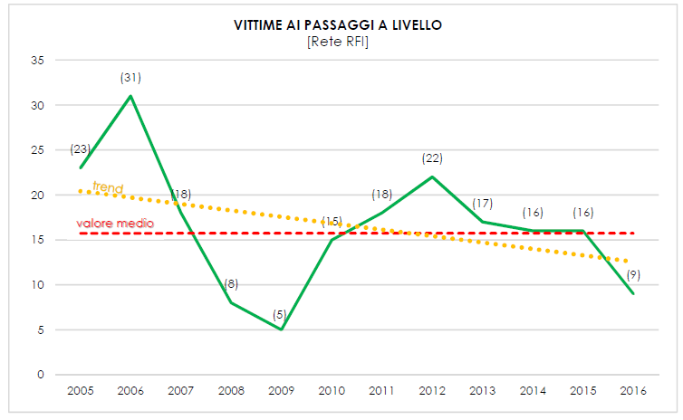

|  |  |
| --- | --- |
| **VITTIME AI PASSAGGI A LIVELLO** | **VICTIMS AT LEVEL CROSSINGS** |
| [Rete RFI] | [RFI network] |
| trend | trend |
| valore medio | average value |

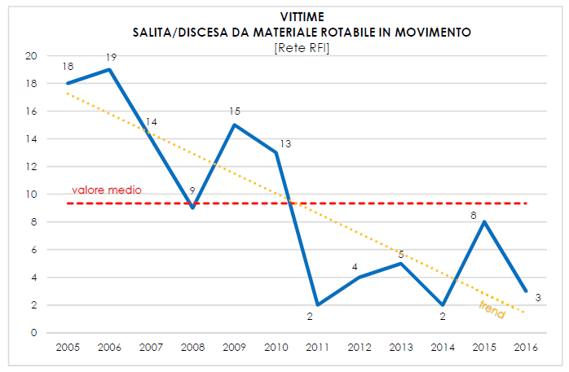

|  |  |
| --- | --- |
| **VITTIME SALITA/DISCESA DA MATERIALE ROTABILE IN MOVIMENTO** | **VICTIMS BOARDING/ALIGHTING FROM ROLLING STOCK IN MOTION** |
| [Rete RFI] | [RFI network] |
| trend | trend |
| valore medio | average value |

One additional factor to be analysed is the finding relating to ‘passengers’ involved in ‘accidents to persons caused by rolling stock in motion’, which essentially refers to events that involved personal injury while boarding and alighting from the doors of passenger trains.

In 2016, the number of victims among passengers boarding or alighting from trains fell; the figure fell by 80 % compared to 2009 and fell by nearly 70 % compared to the average value for the period. The accidents are mainly caused by improper behaviour but are sometimes also related to maintenance problems and incorrect application of operating procedures.

The long-term result can be mainly attributed to the introduction of high-tech systems on train doors preventing unauthorised opening, such as door locking and correct side door enablement devices. In order to further improve the values or limit the fluctuation that occurred in recent years, the above safety devices, which ANSF has progressively been making compulsory since 2009, must be maintained in proper working order by the railway undertakings. The undertakings must also consider opportunities to update existing material to the most recent standards (for example, traction cut-off if the door locks fail).

With reference to the cultural aspect affecting users in general, ANSF has embarked on significant cooperative ventures with the Railway Police (POLFER), educational establishments and sports federations as discussed above.

We will now go on to analyse significant accidents without any victims.

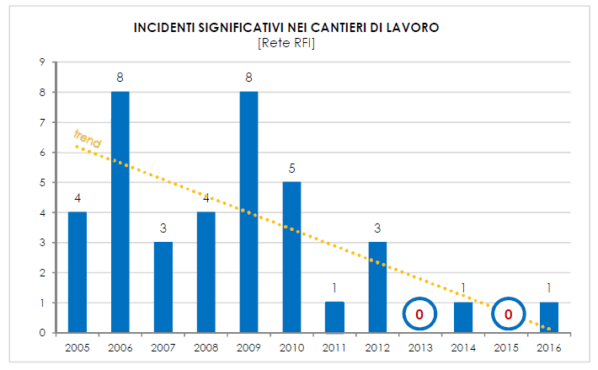In 2016 (as in 2015) railway construction sites caused no victims but a significant accident took place (collision between working vehicles). The values fell during the period but the trend fluctuates greatly, as shown in the following graphs. An analysis of past accidents showed that improvements must be made in work organisation, work execution and training of staff involved.

|  |  |
| --- | --- |
| **INCIDENTI SIGNIFICATIVI NEI CANTIERI DI LAVORO** | **SIGNIFICANT ACCIDENTS IN WORK SITES** |
| [Rete RFI] | [RFI network] |
| trend | trend |

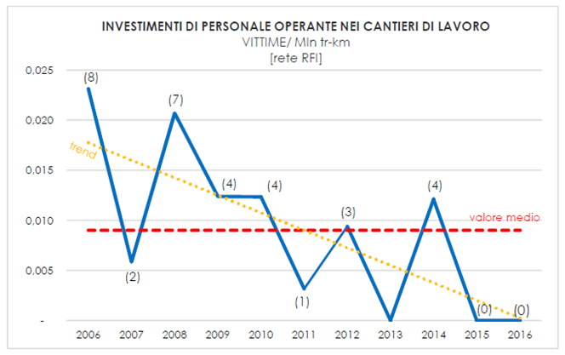

|  |  |
| --- | --- |
| **INVESTIMENTI DI PERSONALE OPERANTE NEI CANTIERI DI LAVORO** | **COLLISIONS WITH STAFF OPERATING IN WORKSITES** |
| VITTIME/ Mln tr-km | VICTIMS/million tr-km |
| [rete RFI] | [RFI network] |
| trend | trend |
| valore medio | average value |
| 0,025 | 0.025 |
| 0,020 | 0.020 |
| 0,015 | 0.015 |
| 0,010 | 0.010 |
| 0,005 | 0.005 |

For this reason, ANSF called for stricter application of detailed procedures by RFI as well as detailed verification of those procedures and of staff training in order to definitively eliminate protection of work sites by visual contact, adopting the necessary mitigating measures required for safe management of the transition.

Even though RFI has reduced the scope of work site protection by visual contact and also initiated significant staff training campaigns for this purpose, it has not fully complied with the requirements. The problem cannot therefore be considered resolved.

Although the statistics relating to the accidental events and their effects tend towards zero values, attention must be paid to effects potentially connected with work performance. One particularly relevant aspect concerns the safety system intervention procedures. During 2016, events were recorded that led to incorrect work on safety devices in connection with work on systems. In this regard, ANSF asked the RFI Manager to plan:

* automatic systems to guarantee traffic interruption to coincide with the performance of certain maintenance activities on safety systems;
* technical measures to ensure that it is physically impossible to connect cable connectors that are undergoing processing;
* automatic systems to check the correct functioning of system software and agreements between the actual physical state of siding entities and associated command and control by the system before putting a safety system that has undergone maintenance work into service.

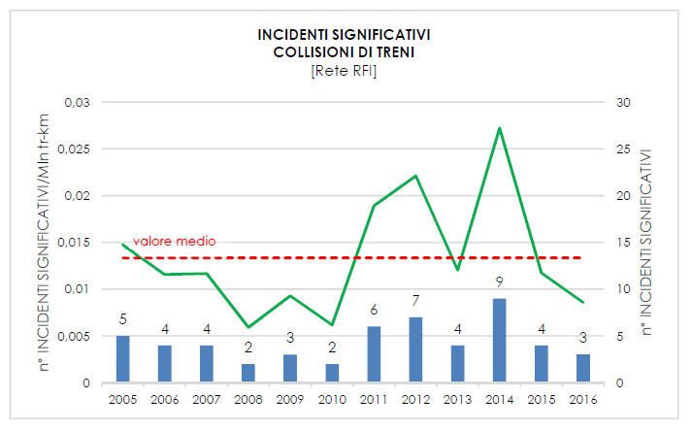During 2016, three accidents took place within the category of ‘train collisions’, which marked a slight reduction compared to 2015. These were ‘train collisions with obstacles within the clearance gauge’ due to hydrogeological disruption.

|  |  |
| --- | --- |
| **INCIDENTI SIGNIFICATIVI COLLISIONI DI TRENI** | **SIGNIFICANT ACCIDENTS TRAIN COLLISIONS** |
| [Rete RFI] | [RFI network] |
| valore medio | average value |
| n° INCIDENTI SIGNIFICATIVI/Mln tr-km | NO OF SIGNIFICANT ACCIDENTS/million tr-km |
| n° INCIDENTI SIGNIFICATIVI | NO OF SIGNIFICANT ACCIDENTS |
| 0,03 | 0.03 |
| 0,025 | 0.025 |
| 0,02 | 0.02 |
| 0,015 | 0.015 |
| 0,01 | 0.01 |
| 0,005 | 0.005 |

For problems relating to hydrogeological risk, in 2010 ANSF ordered the Manager to provide information about network points characterised by active or potential hydrogeological disruption phenomena with associated monitoring methods and the state of implementation of actions under way or planned.

During 2016, the RFI manager:

* + started to update network mapping to incorporate new data and implemented a new, dedicated IT application for geology and hydraulics;
  + funded an initial programme for the installation of alarmed networks for rock falls and, with regard to prevention (monitoring/warning) of high-speed phenomena (landslides, flowslides and subsidence), began installation of an experimental alarm system on the Salerno-Reggio Calabria line (at Favazzina station) as well as outsourcing the task for the design and testing of another four prototypes;
  + continued to implement an infrastructure intervention plan for risk management/mitigation.

However, areas for improvement emerged in the management of related aspects:

* + mapping of points subject to hydrogeological or hydraulic network problems aimed at specifically evaluating the route sector risk;
  + monitoring the areas most at risk, providing at least one plan for the installation of natural hazard sensors;
  + reviewing organisational procedures to support hydrogeological risk management and actions to be taken for intense weather events, including tracking restrictive measures adopted or reasons why it was not considered necessary to adopt them and procedures used to establish whether a train can travel in the presence of such phenomena.

Pending implementation of infrastructural measures for the mitigation or management of the problem, the Manager must adopt extraordinary monitoring actions and order train running limitations where necessary. The measures have not always been adopted with the necessary speed and the mitigation actions put in place, such as line monitoring (on foot, by train), have not always proved effective.

Moreover, considering the geomorphological characteristics of land crossed, hydrogeological instability has always been an issue addressed with Interconnected Regional Network Managers during bilateral meetings held to ensure that the topic is properly dealt with in the relevant Safety Management Systems.

During 2006, as in 2015, there were 19 unauthorised signal passings at danger. SPADs were divided into two categories, ‘starting against signal’ and those when the train ‘ran a red signal’. ‘Starting against signal’ SPADs are chiefly concerned with the interaction between train drivers and on-board staff, and represented the most numerous type in 2016 (12 events). ‘Running a red signal’ SPADs, on the other hand, occur on arriving at or passing through stations, and, on the basis of the outcomes of such incidents occurring during the period under review, were a greater cause for concern prior to the installation of train running protection systems. There was a reversal of the trend compared to 2015 because in 2016 the number of dynamic SPADs involving the train running a red signal fell but the number of starting against signal SPADs rose. Eight SPADs occurred while passing the danger point.

Over-reliance by driving crew members on high-tech train running protection systems again had an impact on the number of SPADs in 2016.

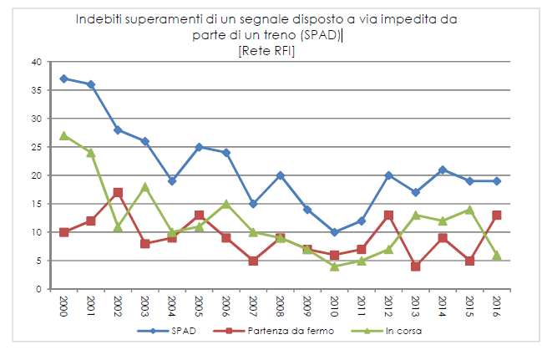

|  |  |
| --- | --- |
| Indebiti superamenti di un segnale disposto a via impedita da parte di un treno (SPAD) | Unauthorised signals passed at danger (SPAD) by a train |
| [Rete RFI] | [RFI network] |
| SPAD | SPAD |
| Partenza da fermon | Starting against signal |
| In corsa | Running a red signal |

An analysis of these incidents also revealed the following repeated problems:

* + - erroneous operation of the on-board subsystem ‘passing at red’ device;
    - inattention by drivers;
    - inadequate knowledge of service area characteristics.

Lastly, repeated infringements occurred following unauthorised signal passed at danger events, namely:

* + - failure by the train crew to report that the signal had been passed at danger;
    - failure of the traffic regulator to issue a complaint to the train crew;
    - reversing of trains without prior authorisation by the traffic regulator.

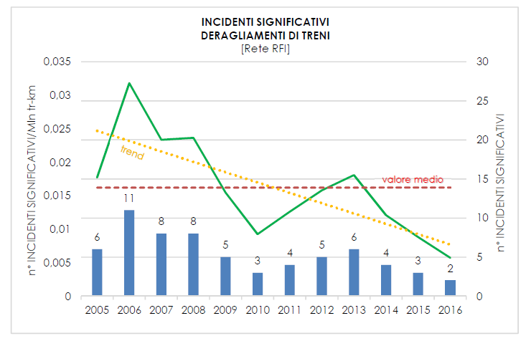The following figure shows the trend in ‘train derailments’. In 2016, the number of accidents fell to a level below the average for the period under review. In 2016, two derailments took place that did not result in casualties.

|  |  |
| --- | --- |
| **INCIDENTI SIGNIFICATIVI DERAGLIAMENTI DI TRENI** | **SIGNIFICANT ACCIDENTS TRAIN DERAILMENT** |
| [Rete RFI] | [RFI network] |
| trend | trend |
| valore medio | average value |
| n° INCIDENTI SIGNIFICATIVI/Mln tr-km | NO OF SIGNIFICANT ACCIDENTS/million tr-km |
| n° INCIDENTI SIGNIFICATIVI | NO OF SIGNIFICANT ACCIDENTS |
| 0,035 | 0.035 |
| 0,03 | 0.03 |
| 0,025 | 0.025 |
| 0,02 | 0.02 |
| 0,015 | 0.015 |
| 0,01 | 0.01 |
| 0,005 | 0.005 |

The available evidence shows that problems relating to infrastructural maintenance were identified in the two accidents.

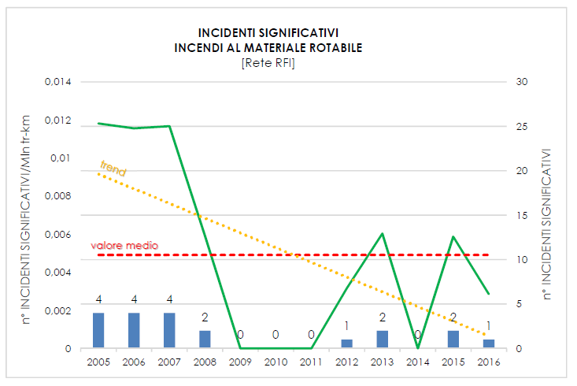The following figure then analyses accident categories due to ‘fires in rolling stock’. In 2016, one accident took place that did not result in casualties. As in the past, the accident was caused by maintenance problems and must be referred back to a significant number of minor events, reported last year, which revealed a need for an increased focus on railway vehicle maintenance activities.

|  |  |
| --- | --- |
| **INCIDENTI SIGNIFICATIVI**  **INCENDI AL MATERIALE ROTABILE** | **SIGNIFICANT ACCIDENTS**  **FIRES IN ROLLING STOCK** |
| [Rete RFI] | [RFI network] |
| trend | trend |
| valore medio | average value |
| n° INCIDENTI SIGNIFICATIVI/Mln tr-km | NO OF SIGNIFICANT ACCIDENTS/million tr-km |
| n° INCIDENTI SIGNIFICATIVI | NO OF SIGNIFICANT ACCIDENTS |
| 0,014 | 0.014 |
| 0,012 | 0.012 |
| 0,01 | 0.01 |
| 0,008 | 0.008 |
| 0,006 | 0.006 |
| 0,004 | 0.004 |
| 0,002 | 0.002 |

The category ‘other types of accidents’ included all railway accidents that are not covered by any of the other categories (e.g. derailment or collision of a work or shunting vehicle, spillage of dangerous goods). This category therefore also includes data relating to part of the events connected with worksite safety and shunting issues while the remainder come under the heading of ‘accidents to persons caused by rolling stock in motion’ involving ‘railway staff, including those working on behalf of contractors’.

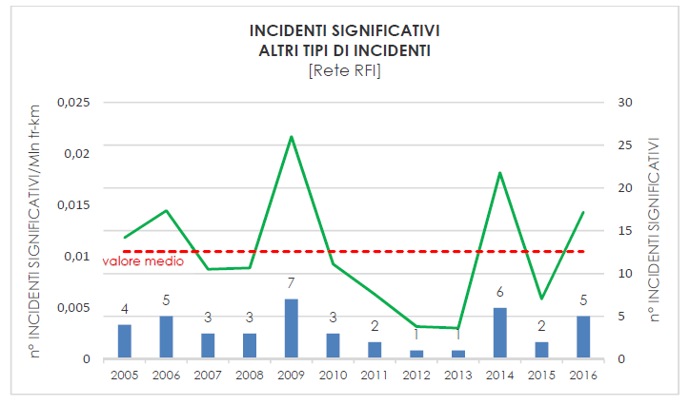

|  |  |
| --- | --- |
| **INCIDENTI SIGNIFICATIVI**  **ALTRI TIPI DI INCIDENTI** | **SIGNIFICANT ACCIDENTS**  **OTHER TYPES OF ACCIDENT** |
| [Rete RFI] | [RFI network] |
| valore medio | average value |
| n° INCIDENTI SIGNIFICATIVI/Mln tr-km | NO OF SIGNIFICANT ACCIDENTS/million tr-km |
| n° INCIDENTI SIGNIFICATIVI | NO OF SIGNIFICANT ACCIDENTS |
| 0,025 | 0.025 |
| 0,02 | 0.02 |
| 0,015 | 0.015 |
| 0,01 | 0.01 |
| 0,005 | 0.005 |

In 2016, four accidents took place while shunting. Of these, three were associated with incorrect implementation of operating procedures and one was associated with mechanical or electrical defects/wear in rolling stock/traction units. The figure rose compared to 2015 and is higher than the average for the period. With reference to this activity, ANSF's supervisory actions identified:

* staff incompetence;
* organisational and interface problems between operators;
* lack of control of activities;
* incorrect management of risks arising from the provision of safety-related activities.

The actions identified by ANSF that the Manager and railway undertakings must implement, each with their own area of competence, are as follows:

* move vehicles between systems as a train;
* equip shunting locomotives with a guard and running protection systems, gradually bringing safety devices into line with the requirements of ANSF Decree No 1/2015;
* ensure better staff training;
* regulate activities with a higher level of detail in order to limit the scope for discretional action by agents involved in shunting, defining the interfaces between the various actors involved;
* continuously monitor the performance of shunting activities, including those received in service by third parties;
* regulate methods for immobilising rolling stock and safekeeping of movable scotch blocks.

In 2016, no significant accidents were caused by spillage of dangerous goods. The 2016 value of all recorded events is therefore the lowest for the period under review (see graph below).

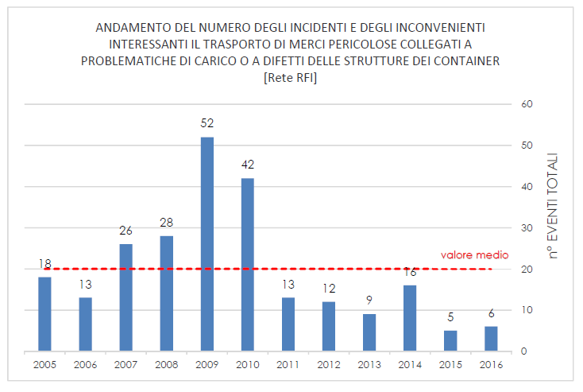

|  |  |
| --- | --- |
| ANDAMENTO DEL NUMERO DEGLI INCIDENTI E DEGLI INCONVENIENTI INTERESSANTI IL TRASPORTO DI MERCI PERICOLOSE COLLEGATI A PROBLEMATICHE DI CARICO O A DIFETTI DELLE STRUTTURE DEI CONTAINER | TREND IN THE NUMBER OF ACCIDENTS AND INCIDENTS INVOLVING DANGEROUS GOODS TRANSPORT CONNECTED WITH LOADING PROBLEMS OR CONTAINER STRUCTURAL DEFECTS. |
| [Rete RFI] | [RFI network] |
| valore medio | average value |
| n° EVENTI TOTALI | TOTAL NO OF EVENTS |
| n° INCIDENTI SIGNIFICATIVI | NO OF SIGNIFICANT ACCIDENTS |

ANSF follows this issue closely, particularly since 2009, when there was a historic peak. Since 2009, the number of dangerous goods spillages has gradually decreased due to checks carried out and the introduction of specific checklists. The rate for 2016 compared to 2009 is -90 %. The results obtained nationally led ANSF to support the use of checklists, making checks for the transport of liquids compulsory under the RID.

## Results of safety recommendations

In accordance with Article 24(2) of Legislative Decree No 162 of 10 August 2007, ANSF

takes due account of safety recommendations issued by the Italian investigative body (the Directorate General for Railway and Maritime Investigations established within the Ministry of Infrastructure and Transport) and takes steps to ensure they are translated into specific measures.

In accordance with paragraph 3 of the above Article, ANSF also notifies the investigative body at least once a year of measures adopted or planned with regard to the recommendations issued.

A list of recommendations received during 2016 is given below.

|  |  |
| --- | --- |
| **Safety recommendation** | **DIGIFEMA [Directorate General for Railway and Maritime Investigations] safety recommendation concerning ‘Accidental events occurring from 01.01.2014 to 31.03.2015 with serious or fatal outcomes, characterised by collision with persons, mainly inside stations or their appurtenances’ (Document Ref 11243/DGIFEMA/2016 of 24 May 2016).** |
| **Safety measure** | ANSF sent the above recommendation, accompanied by further specifications, to the RFI Infrastructure Manager and to the Railway Undertakings by means of Document Ref ANSF 6357/2016 of 10/06/2016.  As a result of recommendation No 2 concerning safety education activities, for years ANSF has been engaged in educational campaigns based on synergies with educational establishments, sports federations and POLFER.  Regarding recommendation No 4 on the monitoring of settlements near the railway network involving the competent institutions, ANSF issued document Ref ANSF 6367/2016 of 10/06/2016 requesting the cooperation of ANCI (National Association of Italian Municipalities) to involve local administrations with the aim of providing the necessary information to populate the specific risk map, prepared by RFI, with settlements (schools, hospitals, nursing homes, sports/recreational centres, reception centres, nomad camps, residential/commercial complexes, etc.) which constitute a potential risk because of the unauthorised presence of people on railway premises due to their features and proximity.  With regard to recommendation No 5 concerning the problem of unauthorised crossings of the Torre del Lago station, ANSF carried out specific inspection activities in the above station and in the railway sector between the station and Pisa station to check mitigation work carried out by the Manager. In partnership with the Prefectures of Lucca and Viareggio, it also sponsored a comparison and coordination meeting with the infrastructure manager and local competent authorities with the aim of analysing this problem jointly. |
| **Implementation status** | The Manager provided feedback in document RFI-SRQ\A0011\P\2016\0000422 of 26/07/2016 and subsequent document RFI-SRQ\A0011\P\2017\0000105 of 27/01/2017. The letter was sent following a request for additional information and clarification by ANSF set out in document ref ANSF 12074/2016 of 17/11/2016.  In general, there has been progressive compliance with recommendations issued, even if long intervention times or problem analysis shortcomings have been identified; for example, feedback provided on the analysis and evaluation of critical aspects present along railway tracks and in stations in order to identify areas where there is a high likelihood of occurrence is limited to providing the frequency of this phenomenon per route without any processing and without linking the finding to the adoption of mitigating measures.  Railway Undertakings generally provided feedback to recommendations No 8, 10 and 12, which are their own responsibility. With reference to recommendation No 10, some undertakings highlighted the need for a preliminary implementation of technical and functional specifications relating to frontal TV cameras to be installed on board locomotives in the relevant technical specifications of interoperability (TSI). |
|  | |
| **Safety recommendation** | **DIGIFEMA safety recommendation relating to “Incident Trenitalia train no 3950 of 30/06/2015, Cagliari – Olbia link, stopped on the line after a departure signal from Borore station due to the presence of a bus on the railway track at the km 140+487 LC”. (Document Ref 1776/DGIFEMA/2016 of 25 July 2016).** |
| **Safety measure** | ANSF sent the above recommendation to the railway Infrastructure Managers and to the Railway Undertakings by means of Document Ref ANSF 1944/2017 of 21/02/2017.  With regard to the problem of parallelism between road and railway as set out in recommendation No 4, ANSF issued document ANSF 5466/2015 of 06/05/2015 asking the RFI Manager to analyse the hazard level of crossings located in the above conditions and measures adopted to increase safety levels.  For the purposes of overall monitoring of interventions aimed at increasing safety levels of railway infrastructure level crossings managed by RFI, also including the provisions of recommendations No 5 and No 8, ANSF provided for the submission by the above Manager of a periodic report on the progress of actions undertaken and planned interventions. |
| **Implementation status** | The manager identified potentially critical level crossings as those for which the number of recorded accident events was ≥ 6 during the period 01.01.2011–31.12.2014. As a safety measure it was decided to equip these crossings with PAI-PL [level crossing supplementary automatic protection] devices (document RFI-SDR\A0011\P\2016\0003135 of 22/12/2014 and document RFI- SDR\A0011\P\2016\0000179 of 28/01/2016). Another measure identified has been to step up the detection of road-side offences by an amendment to the Highway Code.  With regard to actions taken against Managers and road owners, in the event of partial or total absence of road signs near LCs as required in the Highway Code, RFI issued notification RFI- DTC\A0011\P\2016\0000414 of 23/02/2016 indicating that checking activities for the upgrading of LC warning signs have been completed throughout the entire area and notifying road managers of cases of non-compliance with the standard when appropriate.  RFI also indicated that, in view of the above, it intends to carry out checks only within railway grounds delimited by barriers. |
|  | |
| **Safety recommendation** | **DIGIFEMA safety recommendation concerning ‘ Detachment of a door flap from Trenitalia train no 3171 while passing through the San Donato Tunnel (Florence SMN- Figline line) – 20.07.2015’ (Document Ref 2949/DGIFEMA/2016 of 22 December 2016)**  *Recommendations to ANSF:*   1. *with reference to conventional lines where the maximum permitted speed is higher than 200 km/h, as part of the check to ensure the technical characteristics of a vehicle are compatible with those of the infrastructure, an analysis is also carried out on the aerodynamic effects generated by the interaction of the vehicle with the infrastructure and with other types of vehicles allowed to run on it, considering the most difficult conditions expected.* 2. *With reference to conventional lines where the maximum permitted speed is higher than 200 km/h, provision should be made to ensure that:*    * *Railway Undertakings make available the characteristics of their vehicles (relevant for the purposes of aerodynamic effects) to interested parties and if necessary the vehicles themselves in order to allow checks and tests to be carried out concerning the interaction of a vehicle with the infrastructure and with other types of vehicles already permitted to travel on it under the most difficult conditions;*    * *infrastructure managers make available to interested parties information on the characteristics of their networks, necessary to analyse aerodynamic effects generated during interaction between infrastructure and vehicles and in the intersection between vehicles;*    * *in interface procedures between the Infrastructure Manager and Railway Undertakings, provision must be made for the aerodynamic effects generated in the interaction between infrastructure and vehicles and in the intersection between vehicles.* |
| **Safety measure** | With the aim of analysing the problem, ANSF suggested a discussion meeting with Undertakings, Infrastructure Manager, Independent Safety Inspectors and the manufacturers’ association. The following actions were identified during this meeting, which was held in April 2017:   * RFI will carry out a study on the most critical tunnels and will publish the ∆P values generated under the harshest operating conditions. The study will then be rolled out to all tunnels. * As part of the process of authorisation for placing into service, for vehicles with V < 200 km/h interested in being able to travel on AV [high speed] lines, manufacturers must declare the maximum pressure value for which the line has been designed and then provide a demonstration of the capacity of the doors (and other elements sensitive to pressure changes) to withstand preselected pressure values at the design stage and during type approval testing. Any fatigue resistance problems can be managed by appropriate maintenance requirements. This circumstance will be introduced in the NRD as a requirement for technical compatibility between the vehicle and network. The pressure surge value (+/-) compatible with the vehicle must be included amongst the vehicle characteristics set out in the authorisation for placing into service or associated documents. |
|  | - RFI will check whether a vehicle is in a condition enabling it to travel on certain lines when the railworthiness permit is issued. It is also necessary to provide these guidelines for trains that are already in circulation to enable RFI to send trains that are not specifically built for high speed on lines designed for top speeds greater than 200 km/h in accordance with ANSF’s provisions.  The analysis of this problem reveals a regulatory shortcoming for conventional vehicles, which are only covered by reference dossier UIC 566, as well as for AV trains for which there is no objective reference standard.  ANSF submitted a question to ERA about the correct interpretation of the 10 kPa parameter indicated in Regulation (EU) 1299/2014 as an absolute differential between two peaks. ERA also confirmed the genesis of the 10 KPa requirements set out in STI INFRA regarding the correlation with health reasons, but this does not rule out the fact that conventional trains must consequently withstand the same pressure gradients for all their constituent organs and devices. |
| **Implementation status** | It was not possible to follow through any activities in 2016 due to the recommendation submission date. |
|  | |

ANSF pressed for responses to the recommendations that have not yet been acted on. Recommendations for recent years have also been sent to Interconnected Regional Network Operators.

## Measures implemented unrelated to safety recommendations

The Agency continued to promote actions started in 2015 with regard to infrastructure maintenance, shunting, passenger train boarding and alighting doors, hydrogeological disruption, unauthorised crossing of tracks and level crossings.

These actions are supplemented by those given in the following table:

|  |  |  |  |
| --- | --- | --- | --- |
| **Sector of interest** | | Development of railway culture. | |
| **Description of reason** | | Increase awareness of the current regulatory context among railway operators. |
| **Safety measure introduced** | | A plenary meeting involving all railway operators was held on 19 December 2016 on regulatory reorganisation, SMS and supervision. |
|  | | |
| **Sector of interest** | | Development of railway culture. |
| **Description of reason** | | Increase awareness of the railway environment. |
| **Safety measure introduced** | | Three meetings with trade union organisations on the implementation status of regulatory reorganisation by operators and their additional notifications. |
|  | | |
| **Sector of interest** | | Development of railway culture. |
| **Description of reason** | | Increase awareness of the railway environment and improve control of associated problems. |
| **Safety measure introduced** | | Training of staff operating within POLFER. |
|  | | |
| **Sector of interest** | Authorisations for the placing in service of vehicles | |
| **Description of reason** | Define national technical requirements to be met by vehicles travelling on national railway system infrastructure – Issue of National Reference Document | |
| **Safety measure introduced** | Issue of ANSF Decree 1/2016 concerning ‘Regulatory reorganisation, technical standards, rolling stock and control-command subsystems and on-board signalling. National technical standards on subsystems making up railway vehicles regarding authorisations for the placing in service of vehicles’. | |
|  | | |
| **Sector of interest** | Development of railway culture. | |
| **Description of reason** | Increase awareness of the current regulatory context among railway operators and help entities | |
| **Safety measure introduced** | Twelve bilateral meetings were held with regional railway operators on regulatory organisation, SMS and supervision to cover specific problems: | |
|  | | |
| **Sector of interest** | Railway safety education, training and culture. | |
| **Description of reason** | To focus attention on problems associated with a new awareness of proper behaviour in a railway setting. | |
| **Safety measure introduced** | ANSF organised an international convention on the topic of ‘Railway safety education, training and culture’, held in Rome on 21-22 April 2016. | |
|  | | |
| **Sector of interest** | Alignment of all parts of the system with national railway standards. | |
| **Description of reason** | Interventions designed to bring technological systems governing Interconnected Regional Network traffic safety into line with national standards, identifying minimal measures to be adopted immediately. | |
| **Safety measure introduced** | Document ANSF 9956/2016 on urgent railway operation safety measures on Interconnected Regional Networks under Decree of 5 August 2016 | |
|  | | |

# PART D - SUPERVISION

Within the scope of the powers allocated to it by Legislative Decree No 162 of 10 August 2007, in accordance with the standards issued in ANSF Decree No 4 of 10 August 2012, ANSF carried out inspection, control and monitoring activities in 2016 in order to:

* monitor the implementation of technical standards and safety standards;
* monitor the application of technical provisions and specifications for the operation and maintenance of subsystems constituting the rail system in accordance with the relevant essential requirements;
* check the existence of conditions and fulfilment of requirements for the issue and maintenance of safety certificates, safety authorisation and accreditation of third-party bodies;
* monitor safety performance by railway operators;
* monitor training centre activity;
* monitor compliance with regard to the use of a safety management system by railway undertakings and the infrastructure manager;
* check compliance of the work done by the infrastructure manager and railway undertakings with requirements under Community and Italian law with regard to railway traffic safety issues.

The activities were carried out by means of inspections, audits, targeted checks on accidents and incidents, monitoring and analysis of accidents and incidents, adoption of measures against operators involved and meetings with railway operators, as described in detail in section B.3.3.

# Strategy and plan

As part of its functions and responsibilities, ANSF established activities to be carried out on the basis of specific guidelines, priorities and objectives supplied by the Ministry of Infrastructure and Transport in Directive ref no 0000021-02/02/2016 and notified to ANSF by the Ministry of Infrastructure and Transport Directorate General for Railway Transport.

In particular, the following priorities were identified for inspection, control and monitoring activities:

* monitoring to ensure proper application of safety management systems by means of sample checks among network infrastructure managers as set out in the Ministerial Decree implementing Legislative Decree No 112 of 15 July 2015;
* as part of supervision activities on infrastructure manager and railway undertaking safety management systems, monitoring of proper implementation of maintenance activities through sample checks in the form of audits, site visits and inspections;
* monitoring the proper implementation of safety management systems by means of sample checks on railway undertakings. The monitoring is carried out particularly on railway undertakings that carry out hazardous goods transport by rail;
* performance of sample or targeted checks to ensure compliance with hazardous goods transport provisions by railway undertakings and infrastructure managers, with particular regard to cross-border sectors.

The document ‘Inspection and Control Sector inspection activity, audit and documentary evaluation plan – 2016’ was thus issued on 11 March 2016.

The plan took into account the availability of qualified resources for carrying out the above activities with regard to the special competences required as well as the Three-Year Corruption Prevention Plan.

Planning was defined on the basis of an evaluation of activities conducted in 2015 and information relating to railway system safety, considering in particular:

* the results of supervision activities;
* outcomes of documentary compliance evaluations carried out for the issue and update of certificates and safety authorisations;
* analyses of accident data and the results of checks carried out following operating incidents occurring in 2015;
* validity of certificates and safety authorisation issued, with particular reference to those expiring in 2016;
* regulatory updates;
* notifications received from within and from outside ANSF.

Activities envisaged in the plan were subdivided into the following types:

* documentary, compliance and follow-up evaluations;
* on-the-spot system audits designed to check the implementation and effectiveness of the railway operators’ safety management system;
* process and product audits carried out on the spot at the premises of the railway operators with the aim of checking the implementation and effectiveness of operating processes relating to railway operating safety and their compliance with current standards;
* follow-up on previous audits;
* inspection of staff, vehicles and facilities for the purposes of monitoring and consequent analysis of any nonconformities recorded;
* specific inspections for the purposes of investigations deemed necessary.

The plan described intervention areas for conducting on-the-spot audit and inspection activities identified as part of a risk-based approach, ensuring priorities were defined based on the greatest risks associated with organisational activities within the scope of ANSF. As far as inspection activities were concerned, the plan ensured coverage that was as far as possible proportional to traffic volumes and, with regard to railway undertakings, to the extent of the main line, traffic volume, number of irregularities in track geometry and other abnormalities for which the manager was responsible and recorded in the latter’s database. The investigation topics were specified for RFI and railway undertakings.

The areas and processes identified for RFI activities were:

* assessing whether the safety organisation was fit for purpose and operational activities conducted by local structures met regulatory requirements;
* implementation of safety processes for safe design of infrastructure, safe operation, supply of maintenance and materials and maintenance and operation of the traffic and signalling control system;
* implementation of maintenance, involving checks on the functionality of points, track maintenance, track circuit functionality, control of curves and longer welded rail, functionality of level crossings.

For railway undertakings, interventions were carried out stemming from an analysis of priorities defined using a risk-based approach to maximise overall activity efficacy, with particular attention to maintenance management and hazardous goods transport. Continuous inspection activity on railway undertakings has been planned on vehicles for issues relating to technical checking and maintenance of vehicles, with particular regard to the transport of hazardous goods. Furthermore, activities were also carried out to check the consistency of statements made at the time of registration in the RIN, on accredited examiners and instructors and on shunting activities.

## Human Resources

The work took approximately 59 000 hours, divided into 8 115 man-days, for the conduct of audits and inspections in 2016, with an average commitment of approximately 1 450 hours of work per year for each agent.

These data stem from the fact that human resources in certain sectors are fully devoted to performing supervision activities, from the preparation stage to the execution or check stage. The commitment to the various supervision activities and stages may therefore be estimated at approximately 42 % of working hours and days by ANSF staff, where the workforce was equal to approximately 35 % of staff units present at 31 December 2016 in ANSF.

## Competence

In 2016, training activities continued for ANSF staff as planned in the two successive editions of the three-year training plan. The training action developed in many directions and involved a large number of employees. The total number of work person-days devoted to training activities was 579. The following are some of the main initiatives aimed at employees in technical sectors:

* + - training of nine new recruits in technical sectors on the ANSF operational model;
    - a total of [...] of internal training for inspection sector employees as well as staff who sporadically carry out this type of activity for various reasons.

The aim of this training is to maintain and enhance technical, methodological and procedural skills required for the role. Training took place in five sessions during 2016 in the Florence and Rome offices.

For specific aspects of supervision, staff acquired externally were trained in inspection activities and the implementation of audit activities through participation in in-house meetings when regulatory and procedural aspects were covered in depth.

The staff were also involved as support in on-the-spot audits aimed primarily at defining skills and knowledge gaps with training as a secondary aim.

During 2016, some training activities were also carried out with external teaching staff regarding knowledge of subsystems and railway system operating rules for staff transferred from other departments and employed in technical roles.

A consistent and specific in-house training activity was conducted for all staff involved in ANSF supervision activities in order to ensure their skills kept pace with technical and regulatory developments and ensure standard implementation of such activities. This activity was organised into five interventions specifically aimed at staff employed in audit activities and four training actions aimed at the technical operational side on subjects relating to vehicles and infrastructure, in particular:

A training session was also held on 13 December 2016 for all ANSF staff involved in inspections and audits to conclude the activities carried out and examine results obtained with the aim of planning activities for the following year.

In-house technical operational-oriented training sessions were also carried out on operating regulations in February, May, July and September 2016.

## Decision Making

### Decision-making criteria on how ANSF monitored, promoted and implemented compliance with the regulatory framework and procedure for establishing criteria.

With the change in organisation outlined by Ministry of Infrastructure and Transport Decree of 5 August 2016, numerous initiatives were undertaken with regard to undertakings included in the annex to the above Decree.

To facilitate the process of adaptation to the new regulatory framework, ANSF conducted an appraisal of the organisational and technological status of operators subject to the above Decree while also supervising traffic safety control over networks involved during the interim period in order to safeguard continuity of service as far as possible, as specifically required by the Decree.

In particular, immediately after the entry into force of the above Decree, ANSF identified urgent requirements to be met by regional railways for the purpose of protecting traffic safety and minimal measures to be taken immediately pending the adaptation.

These requirements are based on safety principles established in the ‘Railway Traffic Regulation’ issued by means of ANSF Decree No 4/2012 and essentially concern equipping of the line and trains with high-tech systems designed to mitigate the consequences of errors by front-line staff with traffic safety duties.

In particular, bilateral meetings were held with the companies managing these networks and with the railway undertakings carrying out transport on the networks in order to guide the regulatory adjustment process. The purpose of these bilateral meetings, held between November and December 2016, was to obtain general information on system, organisational and operational structure and provide initial assistance for the development of Safety Management Systems and preparation of minimum safety measures.

With regard to entities operating on the RFI network, during 2016 ANSF continued monitoring the operating provisions and specifications issued by those entities to regulate their internal processes in accordance with the regulatory reorganisation implemented by ANSF Decree No 4/2012 of 9 August 2012, which entered into force on 1 January 2013 as well as interface procedures with railway undertakings in the case of the infrastructure manager.

Still with the aim of monitoring the effects of the above Decree No 4/2012 on the activity of Operators, in 2016 work continued on activities begun in 2014 for conducting sample site visits and inspections on entities operating on the RFI network with the aim of ensuring the correct application of provisions and operating regulations adopted: five site visits were carried out on the RFI infrastructure manager. This provided a further opportunity for dialogue, which was useful for guiding the implementation of the regulatory reorganisation and providing the guidance and clarifications necessary for optimum development of the process.

During 2016, the following guidelines supporting the activity of railway operators were also revised:

* ‘Guideline for CCS Authorisation on Rail Freight Corridors’;
* ‘Guidelines for drawing up an annual safety report – Guideline data table’.

### Main complaints received by RUs and IMs

During 2016, some objections were received from the infrastructure manager (RFI) concerning the requirements imposed by ANSF with regard to:

* + - * abolition of the system of using lookout posts to protect work sites;
      * equipping of sections linking stations and sheds, workshops, ports and terminals with traffic signalling, block and protection systems;
      * pending installation of appropriate engineering devices, immediate adoption of measures designed to mitigate the risk of user-worked level crossings being crossed.

By means of specific documents and specially convened meetings, ANSF reiterated the need to comply with the above obligations urgently, highlighting the safety problems present in the current situation and referring to the regulatory references ordering their removal.

Companies operating regional railways under the competence of ANSF also sent in some complaints concerning mitigation measures imposed on them by ANSF pending the equipping of those railways with high-tech safety systems, with particular regard to limiting the speed to 50 km/h in the absence of driving protection systems.

In this regard ANSF replied that, as already set out in document 009956/2017 of 26/9/2016, the companies can adopt mitigation measures other than those indicated in the above document provided that their effectiveness is demonstrated to be at least equivalent based on an appropriate risk analysis conducted in accordance with Regulation (EU) No 402/2013.

No complaints were made against ANSF in the operators’ annual reports.

## Coordination and cooperation

With regard to supervision, during 2016 cooperation activities with the Federal Office of Transport (FOT) continued for the conduct of joint inspections.

Joint inspections were also carried out with the Railway Police. These were specifically aimed at the transport of dangerous goods and specific checks were carried out (always concerning the transport of dangerous goods to and from Germany), in response to reports received by the German competent authority (EBA) of repeated RID regulation infringements in this traffic.

In 2016, an agreement was also concluded with the Etabilissement Public de Securité Ferroviaire (EPSF) over the supervision of railway undertakings operating in Italy and France.

## Results of measures taken

During the activity to check the performance achieved by the infrastructure manager and railway undertakings, ANSF found that the provisions implemented had reduced the incidence of certain factors relating to accidents and incidents, including the following:

* a reduction in the trend of significant accidents, particularly those linked to technical aspects;
* supplementing of gear with train running protection systems;
* reduction in the impact of maintenance on accidents;
* reduction in problems relating to dangerous goods transport;
* greater awareness among railway operators of their role;
* a tendential reduction in problems relating to passenger boarding and alighting doors and worksites.

# PART E - CERTIFICATION AND AUTHORISATION

## Guidance for issuing a safety certificate

‘Guidance for issuing a Safety Certificate’ issued by ANSF in 2010 describes procedures, necessary requirements and documents that railway undertakings must submit to obtain a security certificate for access to the Italian railway infrastructure.

Following feedback arising out of the application of these guidelines in safety certificate issue/renewal/update/revocation processes and in the wake of developments in the European and Italian regulatory framework, work on revising the guide started in 2016 and it is due to be issued by the end of 2017.

To coincide with the issue of these revised guidelines, ANSF is also preparing guidelines for the issue of safety authorisation to infrastructure managers.

## Contacts with other National Safety Authorities

During 2016, there were no requests from other National Safety Authorities or requests by ANSF to other National Safety Authorities with regards to part A and part B of the certification processes.

## Procedural issues

As of 31 December 2016, a total of 36 railway undertakings held a safety certificate, of which 17 for goods transport alone, 10 for passengers alone and nine for passengers and goods, as shown in the graph indicating the value and percentage ratio.

The number of part A safety certificates issued in 2016 was the same as in 2015 (18); however, renewals (3) were issued for the first time in 2016 at the set five-year expiry date.

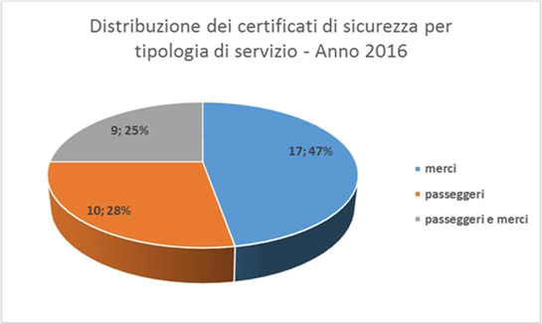

|  |  |
| --- | --- |
| Distribuzione die certificati di sicurezza per tipologia di servizio – Anno 2016 | Distribution of safety certificates by type of service – 2016 |
| merci | goods |
| passeggeri | passengers |
| passeggeri e merci | passengers and goods |

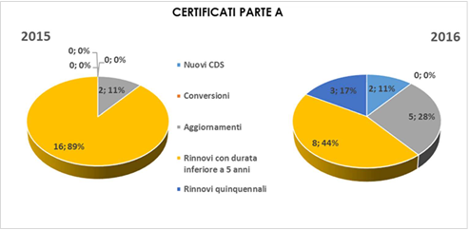

|  |  |
| --- | --- |
| **CERTIFICATI PARTE A** | **PART A CERTIFICATES** |
| Nuovi CDS | New SCs |
| Conversioni | Conversions |
| Aggiornamenti | Updates |
| Rinnovi con durata inferiore a 5 anni | Renewals for periods under 5 years |
| Rinnovi quinquennali | Five-year renewals |

For part B safety certificates in 2016, a slight reduction was also recorded in relation to 2015 (44 in 2014 as opposed to 35 in 2015). This decrease is mainly due to a reduction in update requests due to the effect of Document Ref ANSF 8014/2015 of 2 October 2015 in which ANSF stated that it is no longer necessary to apply for an update to the safety certificate when purchasing new types of vehicles.

One part B safety certificate for passenger transport was also revoked for Thello SaS (a railway undertaking with a Part A SC issued in France), because the undertaking stated that it would not offer a service in Italy and would therefore no longer carry out part B SMS maintenance and update activities for Italy.

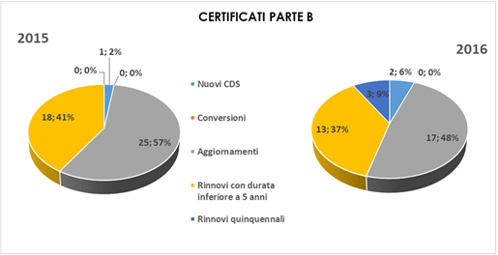

|  |  |
| --- | --- |
| **CERTIFICATI PARTE B** | **PART B CERTIFICATES** |
| Nuovi CDS | New SCs |
| Conversioni | Conversions |
| Aggiornamenti | Updates |
| Rinnovi con durata inferiore a 5 anni | Renewals for periods under 5 years |
| Rinnovi quinquennali | Five-year renewals |

During 2016, assessments carried out for SC issue/update/renewal procedures highlighted a set of aspects that gives rise to a number of observations on railway undertaking safety management systems. These aspects, also in 2016, particularly related to incomplete implementation of Regulation (EU) No 1078/2012 and inadequate coverage of the following criteria in Regulation (EU) No 1158/2010:

* Criterion B (Risk control related to the supply of maintenance and material);
* Criterion C (Risk control related to the use of contractors and control of suppliers);
* Criterion D (Risks arising from the activities of other parties external to the railway system);
* Criterion M (Procedures and methods for carrying out risk evaluation and implementing risk control measures whenever a change of the operating conditions or new material imposes new risks on the infrastructure or on operation).

Furthermore, with regard to assessments carried out on safety management systems to ensure compliance with national regulations (in other words, relating to the issue of part B SCs), there are still certain problems with:

* processes of training and maintaining staff competences in compliance with the new regulatory scenarios in force;
* processes of managing maintenance activities in the event that the railway undertaking performs the role of ECM as well as in the correct management of interfaces (maintainers, vehicle keepers, ECM) if the undertaking does not perform this role.

In 2016, ANSF verified safety management system documentation submitted by RFI SpA in January with the aim of assessing the removal of non-compliances reported in the specifications sent to coincide with issue of the safety authorisation on 30 June 2014 with an expiry date of 30 June 2019. The specifications considered compliance of the RFI SpA organisation and consequent upgrading of the safety management system to the criteria laid down in European Regulation 1169/2010 and relevant regulations in force. It was planned to complete the documentary analysis during the first few months of 2017.

Article 3 of Ministerial Decree of 5 August 2016 established the deadline when infrastructure managers and railway undertakings operating on interconnected regional networks must submit applications for safety authorisation or certification to ANSF. All companies involved have met the deadline for submitting safety certificate applications, i.e. 15 December 2016. Analyses carried out on the 15 cases showed general shortcomings in the amount of documentation required to activate the evaluation process defined by the CSMs in force. This led to a need to suspend the proceedings and request supplementary information in order to reactivate the evaluation procedure.

The deadline for safety authorisation applications by infrastructure managers was 15 March 2017. No applications were received in 2016.

## Feedback

ANSF used opportunities for meeting operators as a tool for exchanging information and gathering feedback on activities carried out and the operator's understanding of activities carried out by ANSF's internal structures with the aim of identifying operating and procedural areas that require improvement. These meetings take place individually with railway undertakings or in regularly scheduled plenary sessions on specific topics.

At present, no methods have been officially organised that operators can use to report problems/comments on procedures in force.

## Authorisations for the placing in service of vehicles

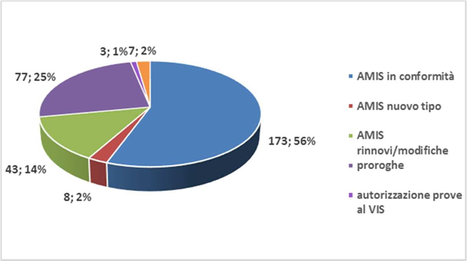Three hundred and eleven provisions have been issued relating to authorisations for the placing in service of vehicles. The following graph represents the distribution of activities in relation to the type of provision issued. The number of vehicles authorised was 509, of which 51 new type-approvals and 458 for compliance.

|  |  |
| --- | --- |
| AMIS in conformità | APIS for compliance |
| AMIS nuovo tipo | APIS new type approval |
| AMIS rinnovi/modifiche | APIS renewals/amendments |
| proroghe | extensions |
| autorizzazione prove al VIS | authorisation for testing ISV |

The following graphs show the distribution of the number of vehicles authorised in relation to type. The placing in service provision is very complex, particularly for vehicles, because the process is made up of several intermediate stages (authorisation to implement on-line tests, temporary authorisations and so on) with a substantial amount of supporting technical documentation. As a guide, each dossier contains 11 technical files on average, for a total of 750 technical files.

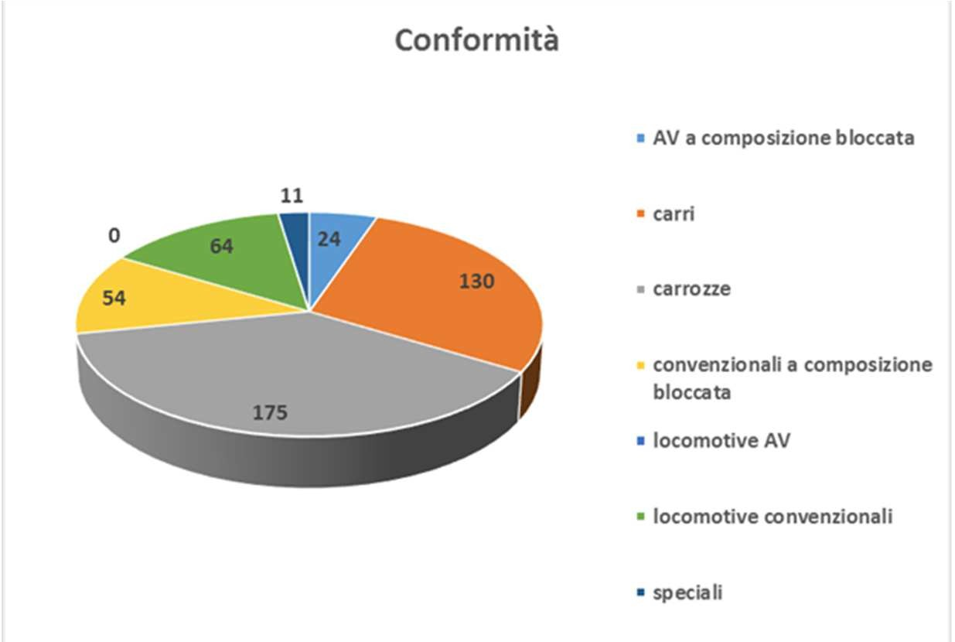

|  |  |
| --- | --- |
| **Conformità** | **Conformity** |
| AV a composizione bloccata | AV (high-speed) with fixed formation |
| carri | wagons |
| carrozze | carriages |
| convenzionali a composizione bloccata | conventional with fixed formation |
| locomotive AV | AV locomotives |
| locomotive convenzionali | conventional locomotives |
| speciali | special |

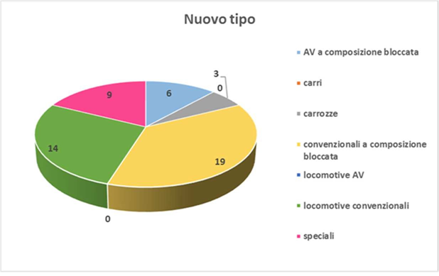The ‘Guidelines for issuing authorisation for placing in service of vehicles, structural subsystems or parts thereof’ are being revised. This document provides all stakeholders (railway vehicle manufacturers, railway undertakings, infrastructure managers and independent safety evaluators) with a tool covering all European decisions on Community railway system interoperability and national regulations. It also defines technical and administrative procedures to be implemented in order for an authorisation process to be fully effective.

|  |  |
| --- | --- |
| **Nuovo tipo** | **New type** |
| AV a composizione bloccata | AV (high-speed) with fixed formation |
| carri | wagons |
| carrozze | carriages |
| convenzionali a composizione bloccata | conventional with fixed formation |
| locomotive AV | AV locomotives |
| locomotive convenzionali | conventional locomotives |
| speciali | special |

## Authorisation for the placing into service of fixed structural subsystems, general applications and general signalling products

ANSF also issues APIS for trackside and on-board railway signalling general applications (GA) and general products (GP). Furthermore, under Article 19 of Legislative Decree 191/10, in the event of renewal or restructuring of operational systems, ANSF also issues an opinion on whether or not there is a need to start the authorisation for placing into service procedure, based on a technical dossier submitted by the applicant. A comparison between procedures carried out in 2013, 2014, 2015 and 2016 is given below.

|  |  |  |
| --- | --- | --- |
|  | **Authorisations for placing in service granted** | **Opinions issued (Article 19 of Legislative Decree 191/2010)** |
| **2013** | 19 (plus 6 extensions) | 18 |
| **2014** | 23 (plus 3 extensions) | 23 |
| **2015** | 25 | 30 |
| **2016** | 60 | 49 |

Issue of authorisation for infrastructural subsystems by ANSF does not allow systems to be effectively opened for operation. This must be carried out by the infrastructure manager after acquiring the remaining authorisations for safety matters that ANSF is not competent to grant.

## Accreditation of training centres

In 2016 there were five accredited training centres.

# PART F - CHANGES IN LEGISLATION

## Railway Safety Directive

In 2016, Ministry of Infrastructure and Transport Decree of 5 August 2016 ‘Identification of railway networks within the scope of Legislative Decree No 112 of 15 July 2015’ was issued. This attributes planning and administration duties to the Regions, which extend ANSF's competences to interconnected regional networks that are considered strategic.

## Changes in legislation and regulation

For information on changes, see Table 2 of Annex B.

# PART G - APPLICATION OF THE COMMON SAFETY METHOD ON RISK EVALUATION AND ASSESSMENT

## G.1 Experience of ANSF Italian National Railway Safety Agency

ANSF asked to supply data regarding the application of Regulation 402/2013 as described below:

* Description of the main changes deemed irrelevant by the proponent;
* Type of change (technical, operational or organisational);
* Decision-making criteria;
* Description of the main changes deemed relevant by the proponent;
* Type of change (technical, operational or organisational);
* Involvement of subcontractors and management of interfaces;
* Involvement of independent safety auditors (ISAs) in the role of CSM assessor;
* Brief description of the overall efficacy of the risk management process referred to in Regulation 352/2009;
* Hazardous event identification stage;
* Risk assessment stage and acceptance criteria used:
* Codes of good practice;
* Similar reference systems;
* Explicit risk assessment;
* Demonstration of conformity with safety requirements;
* Risk management process through the recording of hazardous events;
* Short description of audits performed by the proponent on the efficiency of its risk management process;
* Brief feedback by the proponent and, where applicable, its subcontractors and ISA, with regard to the application of Regulation 352/2009;
* Where applicable: proponent's experience with regard to the application of the CSM for risk determination and assessment, in cases where the application took place on a voluntary basis prior to the entry into force of the above Regulation.

During 2016 the necessary CSM application elements were supplied by nearly all railway undertakings (apart from two out of a total of

34 due to submit an annual report) by the RFI infrastructure manager and by a railway vehicle manufacturer (BOMBARDIER).

There is no immediate evidence of elements concerning the application of the CSM by operators in the role of entity in charge of maintenance. In general, apart from a few exceptions, the data provided were not complete and organised as required, with an almost total lack of the provisions set out under points 3 and 4 above. For this reason, there was deemed to be no significant feedback on the activities of CSM assessors involved or on the application of the Regulation in general.

One of the few significant items of feedback received was that provided by the manufacturer BOMBARDIER, which highlighted difficulties in dealings with its customers caused by 'a lack of awareness and knowledge of the matter' as well as a significant lack of uniformity in applying the CSM at national and international level, particularly for rolling stock subsystems. These factors had already been highlighted during the report for 2014.

The aggregate data show that the Regulation was applied to assess 480 changes deemed to have an impact on safety (412 overall for the undertakings and Manager and 68 for the manufacturer). Of these, 51 were identified as 'significant' changes under the Regulation – determining the application of the method referred to in Annex 1 thereof – amounting to approximately 11 % (same percentage recorded in 2015).

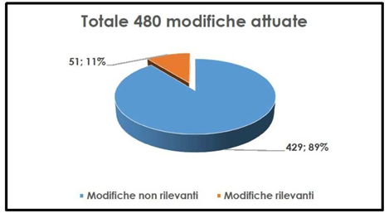

|  |  |
| --- | --- |
| **Totale 480 modifiche attuate** | **Total of 480 changes implemented** |
| Modifiche non rilevanti | Insignificant changes |
| Modifiche rilevanti | Significant changes |

As was the case last year, for railway undertakings and the infrastructure manager most of the changes were assessed to be of operational type (39 %) or technical type (33 %); organisational changes accounted for approximately 17 %, while no information was given on the type of the remaining 11 %. The changes assessed by the manufacturer, however, were entirely of a technical nature relating to changes in vehicles and checks on the integration of subsystems.

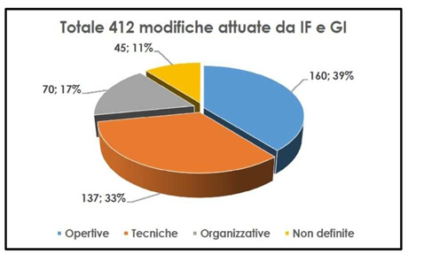

|  |  |
| --- | --- |
| **Totale 412 modifiche attuate da IF e GI** | **Total of 412 changes implemented by RU and IM** |
| Opertive | Operational |
| Tecniche | Technical |
| Organizzative | Organisational |
| Non definite | Not defined |

With regard to the number of changes reported, those relating to Trenitalia and the RFI Infrastructure Manager accounted for approximately 54 % of the total.

Considering only changes evaluated in accordance with the Regulation by the railway undertakings, 7 % related to SC update requests.

With regard to applications of the Regulation, no factors were recorded with regard to the application of corporate procedures governing risk assessment and management in the event of insignificant changes. In all cases, the undertakings applied the methodology laid down in Regulation (EU) No 402/2013 and the procedures contained in their safety management systems.

The overall finding based on the evidence provided confirms an improvement in risk assessment and management processes. However, given that a significant portion of operators did not provide information in this regard or that the information was incomplete, for full and effective implementation of the Regulation, all stakeholders involved must be made more aware, particularly entities in charge of maintenance and manufacturers.

As previously, in 2016 sample on-the-spot audits were carried out on management methods and evidence of application of the CSM by railway operators in the event of changes to the part of the system for which they were responsible. The CSM was found not to have been strictly applied, particularly with regard to the adoption of safety measures to combat the risks assessed and verification of their efficacy for risk control purposes.

## G.2 Feedback from stakeholders

Checks carried out on the application by railway undertakings of the definitive common safety method (CSM) established by Regulation (EC) No 402/2013 highlighted a set of frequent nonconformities that reveal an incomplete understanding by operators of the principles contained in the Regulation. Despite signs of improvement compared to the previous year, partly due to the evident interest in and greater awareness of the subject, there is still room for improvement in operational capacity for application of the Regulation.

Checks carried out on CSM application by railway undertakings showed a distinct improvement in standard application of the method, which has entered permanently into operational practice. Nevertheless, in many of the cases examined, it was not found to have been applied strictly, particularly in the examination of some assessment criteria (complementarity and consequences of the incident recurred in this context) and, in general, in the production of evidence supporting the assessments adopted.

### G.2.1 Application of Regulation (EU) No 1078/2012 on a common safety method for monitoring

The application of Regulation (EU) No 1078/2012 was verified in annual report submitted by 34 railway operators on the RFI Network and 13 operating on Interconnected Regional Networks.

With regard to Annual Reports submitted in 2015, the reporting paid greater attention to implementation of the Regulation, which was also implemented through specific projects in the Annual Safety Plan. However, the matter was dealt with at different levels of detail: some railway operators did not submit annual Reports with updated content and format as required by the European Regulation and guidelines issued by ANSF in Document Ref No 5841 of 25 May 2016.

It was reported that eight railway undertakings and two infrastructure managers submitted their Annual Report after the deadline set out in Article 13(4) of Legislative Decree No 162 of 10 August 2007 while another two sent in their Annual Report in the form of tabular reports without additional explanatory documents. In 14 cases, no adequate evidence of the results obtained was provided; two cases did not consider the application of Regulation 1078/2012.

Lastly, in 2016, a railway undertaking had to activate the notifications referred to in Article 4(2) of the Regulation in several instances.

Compliant implementation of the CSM was also the subject of on-the-spot checking activities. The results of these checks together with an analysis of the material submitted with the Annual Reports show that there is a need to continue making railway operators aware of the need to adopt a structured and effective system for monitoring safety processes and performances, in full compliance with Regulation (EU) No 1078/2012.

## G.3 Revision of national safety regulations to take into account the EC regulation on the common safety method on risk evaluations and assessment

Pro memoria

# PART H - DEROGATIONS FROM THE ECM CERTIFICATION SYSTEM

ANSF did not grant any derogations regarding the identification and certification of Entities in Charge of Maintenance as referred to in Article 14(a)(8) of Directive 2008/110/EC because none of the cases cited by the Directive arose in 2016.

1. In this report, ‘significant accident’ refers exclusively to an accident falling within the definition set out in the Appendix to Annex 1 of Legislative Decree No 162 of 10 August 2007, as amended by Ministry of Infrastructure and Transport Decree of 26 June 2015. A 'significant accident' is thus any accident involving at least one railway vehicle in motion, resulting in at least one fatality or serious injury or significant damage to rolling stock, tracks, other installations or the environment (or damage amounting to EUR 150 000 or more) or a prolonged interruption in traffic, excluding accidents in workshops, warehouses and depots.
2. If we break down the total number of fatalities and serious injuries, while seeking to provide as full a picture as possible, we assume 1 fatality = 1 serious injury, since we do not believe the statistical parameter of equivalent deaths (1 fatality = 10 serious injuries) set out in European Commission Decision 2009/460/EC to be fully representative.