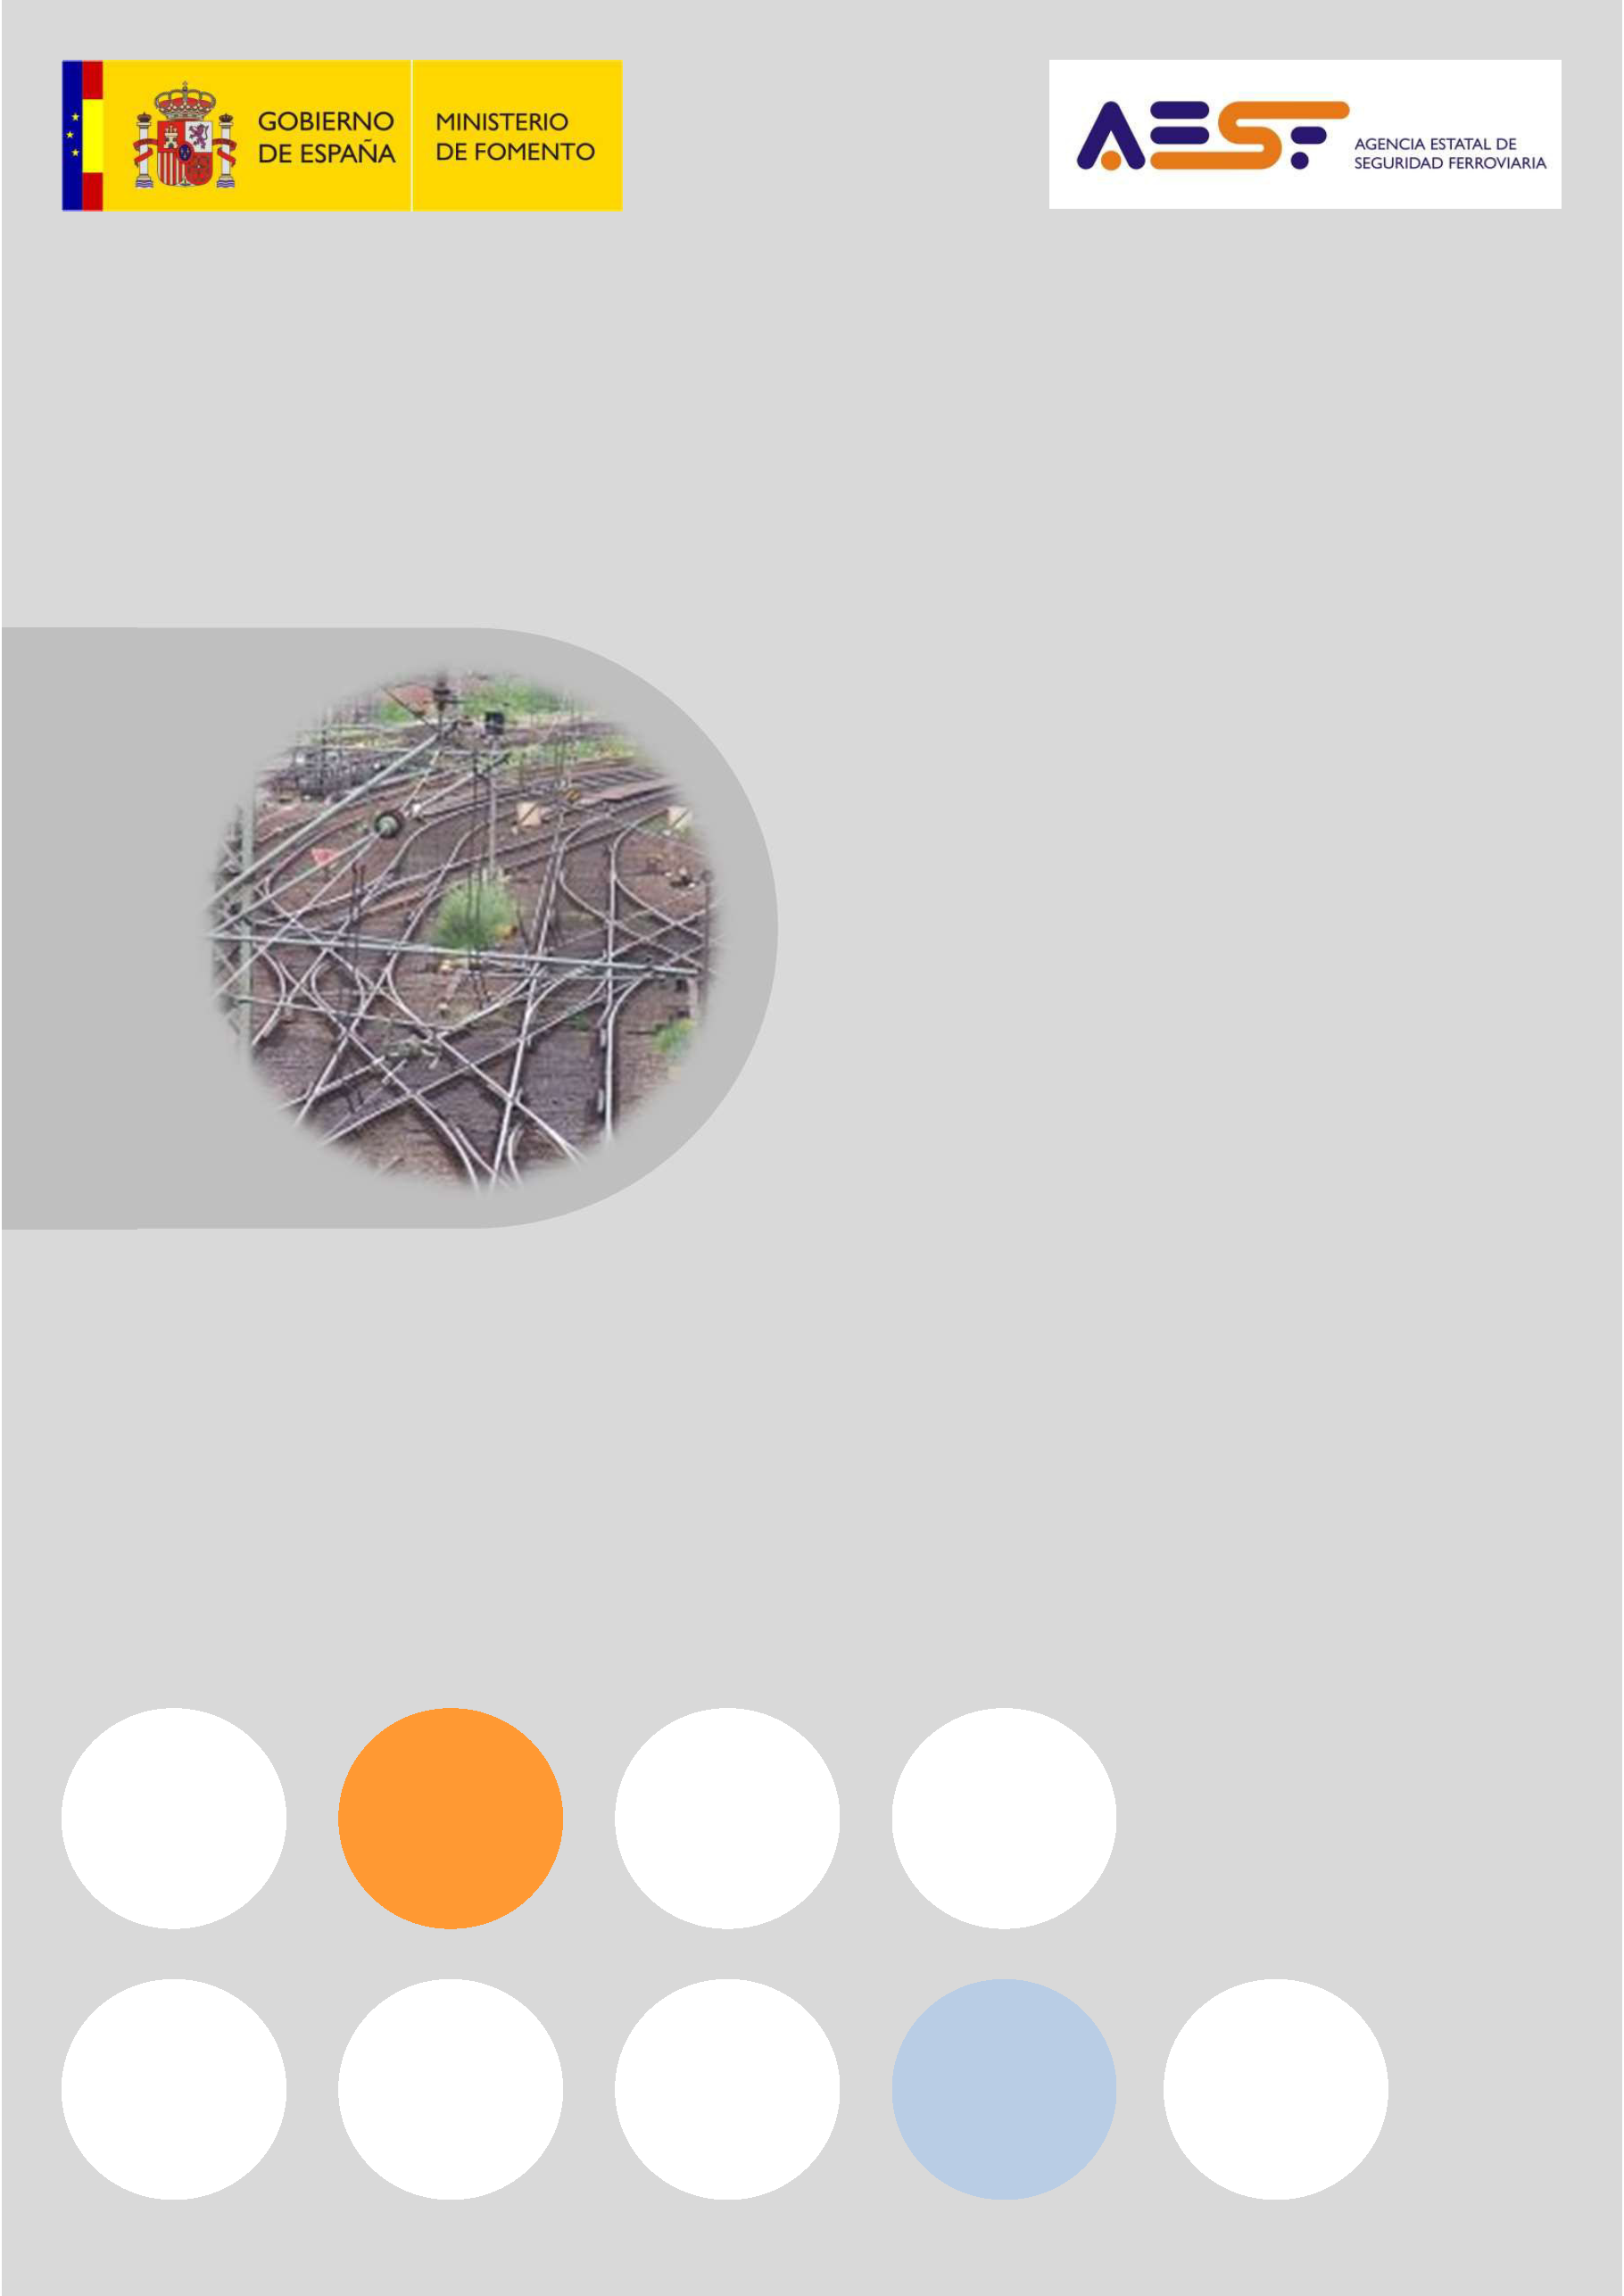

Annual Report

2017

Situation as at 31 December 2016



|  |  |
| --- | --- |
| GOBIERNO DE ESPAÑA | GOVERNMENT OF SPAIN |
| MINISTERIO DE FOMENTO | MINISTRY OF PUBLIC WORKS AND TRANSPORT |
| AGENCIA ESTATAL DE SEGURIDAD FERROVIARIA | NATIONAL RAILWAY SAFETY AGENCY |

National Railway Safety Agency

Annual Report

(Article 18, Directive 2004/49)

2017

(Actions up to  
31 December 2016)

Contents

A. INTRODUCTION 5

B. THE NATIONAL RAILWAY SAFETY AGENCY 8

C. POLICIES AND ACTION LINES REGARDING RAILWAY SAFETY 12

D. SAFETY EVOLUTION 25

E. SAFETY CERTIFICATES AND AUTHORISATIONS 39

F. CERTIFICATION OF ENTITIES IN CHARGE OF MAINTENANCE 42

G. SUPERVISION OF THE RAIL SYSTEM 44

H. MODIFICATION TO RAILWAY SAFETY LEGISLATION 51

I. APPLICATION OF REG. 402/2013 ON RISK EVALUATION AND ASSESSMENT 53

ANNEX: COMMON SAFETY INDICATORS 57

Abbreviations

|  |  |
| --- | --- |
| **AESF** | National Railway Safety Agency |
| **IM** | Infrastructure manager |
| **RSD** | Railway Safety Directive |
| **ECM** | Entity in charge of maintenance |
| **RU** | Railway Undertaking |
| **TSI** | Technical Specification of interoperability |
| **EUAR** | European Union Agency for Railways |
| **CSI** | Common Safety Indicators |
| **RI** | Railway Instruction |
| **RSA** | Railway Sector Act |
| **CSAP** | Traffic Safety Annual Plan (ADIF) |
| **MGN** | Metric gauge network |
| **RFIG** | Red Ferroviaria de Interés General (General Interest Railway Network) |
| **RCF** | Railway Traffic Regulation |
| **SMS** | Safety Management System |

|  |  |
| --- | --- |
|  | INTRODUCTION |

Article 18 of Directive 2004/49/EC on railway safety[1], states:

‘Each year the safety authority shall publish an annual report concerning its activities in the preceding year and send it to the Agency by 30 September at the latest. The report shall contain information on:

1. the development of railway safety, including, for each Member State, an inventory of the common safety indicators (CSIs) laid down in Annex I;
2. important changes in legislation and regulation concerning railway safety;
3. the development of safety certification and safety authorisation;
4. results of and experience relating to the supervision of infrastructure managers and railway undertakings'.

This report complies with this requirement. The information contained in the report reflects the situation at the end of 2016, i.e. **up to 31 December 2016**.

This report has been prepared by the National Railway Safety Agency (AESF) to be forwarded to the European Union Agency for Railways (EUAR), in accordance with the guidelines of this body, for the purposes of:

providing the Agency with basic information for drafting the biannual safety report.

publication by the Agency on its website.

The report is therefore directed at agents in the railway sector and at the general public, both through dissemination by the EUAR and by the AESF to national agents (railway undertakings and managers, entities in charge of maintenance, certification entities and the accident investigation committee).

For the preparation of this report, the Directive states that:

‘Each year all infrastructure managers and railway undertakings shall submit to the safety authority before 30 June an annual safety report concerning the preceding calendar year'.

Therefore, the agents of the national railway system must submit the information requested in Directive 2004/49/EC through these reports. As in previous years, to facilitate the compilation of data for the preparation of this report, a template of the annual report has been provided to undertakings, and the annual safety reports received from railway undertakings and infrastructure managers have been assessed to identify possible improvements for the preparation of subsequent reports.

This report **includes information on the General Interest Railway Network (RFIG) administered in 2016 by the Railway Infrastructure Manager (Adif), by Adif-Alta Velocidad and by the company Línea Figueras Perpignan[2]** (LFP), as well as information on the services and activities that are provided on it. The following are excluded from the scope of application of this report, as permitted by Directive 2004/49:

* 1. metros, trams and other light rail systems,
  2. networks that are functionally separate from the rest of the rail system and intended only for the operation of local, urban or suburban passenger services, as well as railway undertakings operating solely on these networks,
  3. privately owned railway infrastructure that exists solely for use by the infrastructure owner for their own freight operations,
  4. historical vehicles that travel on the RFIG, as long as they comply with specific safety rules to guarantee the safety of such vehicles,
  5. historical, museum and tourist railways that operate on their own networks, including workshops, vehicles and personnel.

This report covers the services and activities provided on the RFIG by railway undertakings that were providing commercial passenger services (Renfe Viajeros, SNCF, and FGC Rail) and freight services (Acciona Rail Services Comsa Rail Transport, Continental Rail, Ferrovial Railway, Logitren Ferroviaria, Renfe Mercancías, Tracción Rail, Transfesa Rail, and Transitia Rail) on that date.

|  |  |
| --- | --- |
|  | THE NATIONAL RAILWAY SAFETY AGENCY |

|  |
| --- |
| THE AGENCY’S COMPETENCIES |

The AESF is a public body regulated by Law 28/2006 of 18 July, on state Agencies for the improvement of public services, and is attached to the Ministry of Public Works and Transport through the General Secretariat of Infrastructure.

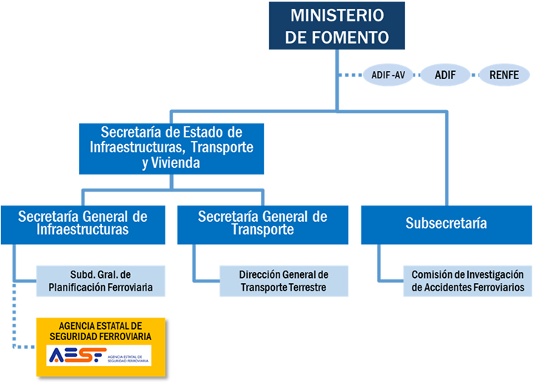

|  |  |
| --- | --- |
| MINISTERIO DE FOMENTO | MINISTRY OF PUBLIC WORKS AND TRANSPORT |
| ADIF -AV | ADIF -AV |
| ADIF | ADIF |
| RENFE | RENFE |
| Secretaría de Estado de Infraestructuras, Transporte y Vivienda | Secretariat of State for Infrastructure, Transport and Housing |
| Secretaría General de Infraestructuras | Secretariat General of Infrastructure |
| Subd, Gral. De Planificación Ferroviaria | General Under-secretariat of Railway Planning |
| AGENCIA ESTATAL DE SEGURIDAD FERROVIARIA | NATIONAL RAILWAY SAFETY AGENCY |
| Secretaría General de Transporte | Secretariat General of Transport |
| Dirección General de Transporte Terrestre | Directorate-General of Land Transport |
| Subsecretaría | Under-Secretariat |
| Comisión de Ivestigación de Accidentes Ferroviarios | Railway Accidents Investigation Commission |

Its by-laws were approved by Royal Decree 1072/2014 of 19 December, which established 1 April 2015 as the start date for its activities.

Within the scope of the Agency's jurisdiction (the RFIG), it is the **authority responsible for railway safety**, as set out in Law 38/2015 of 29 September, on the Railway Sector, organising and supervising the safety of all parts of the railway system: infrastructure, rolling stock, railway personnel and railway operations.

It carries out duties related to the **interoperability** of the railway system for which the state is responsible, and is likewise responsible for granting, suspending and revoking the **licences** of railway undertakings.

The Agency continues to exercise the powers on these matters that, prior to the start of its activities, were exercised by the Directorate-General of Railways of the Ministry of Public Works and Transport.

For more information about the Agency, visit its website: www.seguridadferroviaria.es

|  |
| --- |
| AGENCY’S PRINCIPLES OF ACTION |

The Agency is guided by the following action principles:

* 1. Independence in its actions with respect to the functions that it has been assigned regarding the safety of railway transport.
  2. Authority and responsibility for the development and application of national and international railway safety standards, and the control of procedures.
  3. Promotion and dissemination of a culture of railway safety in all areas of action.
  4. Quality, efficacy, efficiency and transparency in the exercise of its functions.

|  |
| --- |
| GOVERNING BODIES, EXECUTIVES BODIES, AND STRUCTURE OF THE AGENCY |

The Chairman’s Office and the Governing Board are the governing bodies of the AESF.

The Director of the Agency is the chief executive and is responsible for its direction and ordinary management. The Director is proposed by the Chairman and appointed by the Governing Board.

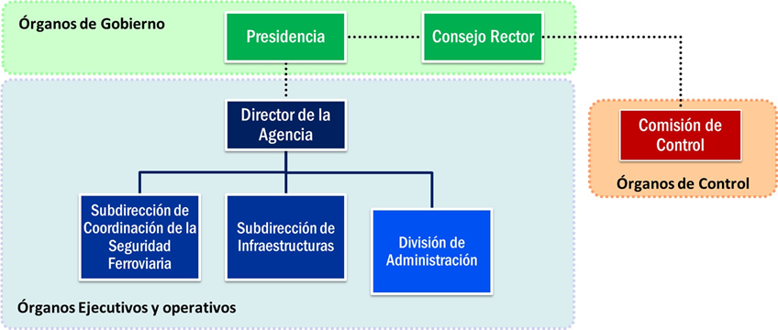

|  |  |
| --- | --- |
| Órganos de Gobierno | Governing Bodies |
| Presidencia | Chairman’s Office |
| Consejo Rector | Governing Board |
| Director de la Agencia | Director of the Agency |
| Subdirección de Coordinación de la Seguridad Ferreviaria | Sub-directorate of Coordination of Railway Safety |
| Subdirección de Infraestructuras | Sub-directorate of Infrastructure |
| División de Administración | Administrative Division |
| Comisión de Control | Control Commission |
| Órganos de Control | Control Bodies |

The Agency is composed of the following units:

* Sub-directorate General of Infrastructure

Responsible for exercising functions related to issuing safety authorisations for infrastructure managers and the subsequent supervision thereof, as well as all aspects related to infrastructure and fixed equipment.

* General Sub-directorate of Coordination of Railway Safety

Responsible for exercising functions related to issuing licences and safety certificates for railway undertakings and the subsequent supervision thereof, including authorisations for candidates other than railway undertakings and everything related to rolling stock, the maintenance thereof, railway personnel and associated centres.

Likewise, it is responsible for overall monitoring of the safety of the railway system, and coordinating the development of its technical operating procedures, as well as external representation of the Agency.

* Administrative Division

Reporting directly to the Director of the Agency, it carries out support tasks for management and the Governing Board, as well as the management functions entrusted to it.

|  |  |
| --- | --- |
|  | POLICIES AND ACTION LINES REGARDING RAILWAY SAFETY |

|  |
| --- |
| AESF’S STRATEGIC ACTION LINES |

AESF carries out many activities directly derived from its competencies as safety authority, especially regarding the issue of licences, certificates, authorisations, or approvals required by the system’s entities or elements to access the market, such as the following:

* Issue of railway undertakings’ licences.
* Issue of safety certificates to railway undertakings (new certificates, scope extensions, or renewals) after assessment of their safety management systems.
* Issue of infrastructure manager safety authorisations (new, scope extensions, or renewals).
* Certification of entities in charge of maintenance of coaches.
* Standard-approval of rolling stock maintenance centres.
* Standard-approval of railway staff centres: training and physical/psychological check-up centres.
* Authorisation for the placing in service of lines.
* Authorisation for the entry into service of vehicles and management of modification files.
* Authorisation for train driver training courses and examinations.
* Activities regarding issuance of train drivers’ licences.
* Examinations for Safety Advisers for the carriage of dangerous goods by rail.

In addition to these routine activities required by the sector, the AESF actions during the period subject matter of this report were articulated through five strategic lines, as stated in its **Action Plan 2016.**

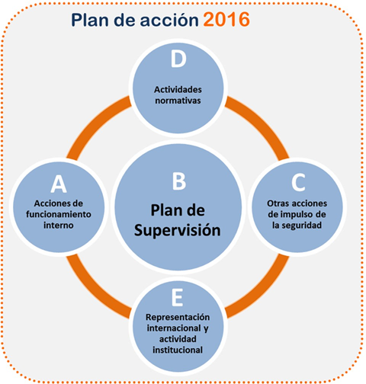

|  |  |
| --- | --- |
| Plan de acción 2016 | Action Plan 2016 |
| Actividades normativas | Regulatory activities |
| Acciones de funcionamiento interno | Internal operating actions |
| Plan de Supervisión | Supervision Plan |
| Representación internacional y actividad institucional | International representation and institutional activity: |
| Otras acciones de impulso de la seguridad | Other actions for promoting safety |

* 1. Internal operating actions:

This strategic line includes internal actions to improve the AESF personnel qualifications and its work procedures. The first Training Plan for AESF itself was approved in 2016, including specific training courses on railway subjects. Work procedures in different AESF activity areas were also formalised.

AESF internal activities to enable the progressive acquisition of greater management independence have continued.

The AESF dissemination and visibility actions have been notable, improving the Agency’s website and taking part in forums of different organisations to promote and present the Agency’s activity.

* 1. Supervision plan:

In accordance with the Railway Sector Act, traffic safety on the General Interest Railway Network is the responsibility of the infrastructure managers and the railway undertakings that operate on the network.

In turn, the authority that is responsible for safety must ensure compliance with the regulatory framework by system agents and ensure that they use an adequate safety management system.

Further details of the supervisory activities of the AESF are set out in Chapter G of this report.

* 1. Other actions for promoting safety:

Given its position in the sector, the AESF is responsible for the monitoring and coordination of the different agents involved in the initiatives that the Ministry of Public Works and Transport promotes to improve railway safety, such as the process of the Railway Traffic Regulations (RCF) coming into force.

* 1. Regulatory activities:

During 2016, a number of different regulatory activities have been carried out; these are described in Chapter H of this report.

* 1. International representation and institutional activity:

The AESF takes part in European working groups within different organisations, such as the European Union Agency for Railways (EUAR), the European Commission Shift2Rail, or the Intergovernmental Organisation for International Carriage by Rail (OTIF). This has meant attending more than 90 meetings.

One of the most important activities has been the participation in the Technical Pillar implementation meetings of the Fourth Railway Package. This technical pillar of the Fourth Railway Package involves changing the role of the European Union Agency for Railways in relation to national authorities and, therefore, to the AESF.

In future, the EUAR will have executive powers to issue authorisations for the placing on the market of vehicles, railway undertaking safety certificates and pre-approvals of track ERTMS. This will be managed via a ‘one-stop shop’ at the EUAR. It will be necessary to specify joint work procedures and enter into cooperation agreements between the EUAR and national authorities. For this purpose, working groups have been created to address these matters.

The AESF also takes part in the EU railway twinning programmes with other countries: Egypt and Ukraine.

|  |
| --- |
| SAFETY STRATEGIES, PROGRAMMES AND INITIATIVES OF THE MINISTRY OF PUBLIC WORKS AND TRANSPORT |

### GENERAL POLICIES TO IMPROVE SAFETY

The current policies of the Ministry of Public Works and Transport are included in the **Infrastructure, Transport and Housing Plan (PITVI)**. This Plan arises from the need to set a new framework for the strategic planning of infrastructures, with a time horizon running from 2012 to 2024.

The main **action points** for railway transport in this Plan are the following:

* + Rearranging the current organisational model of railway management in order to overcome existing inefficiencies and ensure effective coordination of the roles of the agents involved.
  + Giving a new boost to complete the deregulation of the sector, in line with European approaches, in order to ensure the development and improvement of railway transport efficiency.
  + Fostering the competitive opening-up of the Spanish network to new railway passenger operators.
  + Improving efficiency and competitiveness in freight transport by rail, as well as the effective integration thereof into logistics chains.
  + Integrating the high-speed and conventional networks, as well as linking with the networks of other countries.

**All these action points revolve around the basic focus of maintaining and improving the safety of railway transport.** Thus, all of the action programmes include action lines on safety. For example, the regulation, control and supervision programme includes the action line, 'Improvement of railway safety and passenger protection'.

In addition, the investment action programme includes investment to reduce the accident rate of the network through maintenance of the conventional network, investment to continue with the elimination of level crossings and investment in updating safety installations.

### IMPROVEMENT MEASURES FOR THE RAILWAY SYSTEM. THE NEW RCF.

Since August 2013, the Ministry of Public Works and Transport has been pursuing a series of measures covering various aspects of the railway sector to improve the sector and establish future action lines. Although in 2016 most of these measures were concluded, others, which are far-reaching and, therefore, medium-term, continued to be developed throughout that year.

The announced measures relate to the improvement of infrastructure (signalling), personnel (hiring, evaluation and training), rolling stock, passengers and regulations. They cover the entire national railway sector, therefore including the Ministry itself, the AESF and infrastructure managers and railway undertakings.

Within these measures, the most noteworthy during 2016 is the set of actions derived from **COMING INTO FORCE OF THE NEW GENERAL TRAFFIC REGULATIONS (RCF).** Approved by Royal Decree 664/2015, dated 17 July, the RCF has meant a complete overhaul of the regulations relating to railway operations that have in the past been applied in Spain.

The approval of the new RCF pursues the following objectives:

* The grouping and unification of previously diverse regulations:
* The General Traffic Regulation applicable to the Conventional Network, as well as successive modifications to the text since its publication in 1992.
* The Specific Traffic Standards (NEC) and the Technical-Operational Traffic and Safety Specifications (PTO) applied to High Speed.
* The Train Traffic Regulation (RCT) applicable to the narrow gauge network, in force since 1972.
* The Traffic Manual and some specific instructions.
* Adaptation of the content thereof to the Technical Specifications for Interoperability (TSIs – European reference standards).
* Improved adaptation to the legal framework, with the separation of jurisdiction and responsibilities between infrastructure managers and railway undertakings.
* The transfer of specific procedures to the safety management systems of railway undertakings.
* The improvement and modernisation of railway signalling and installations, therefore incorporating new technologies and more up-to-date work procedures.

It came into force in January 2017 to allow a training and adaptation transition period for the sector. Therefore, during 2016, the whole national railway sector has been focused on preparing for this date, with different actions:

1. Adaptation of the Safety Management Systems (SMS) of the infrastructure managers (IM) and railway undertakings (RU) to the new regulatory framework.

The drafting of the RCF according to the European regulations meant leaving out certain contents (included in the previous traffic regulations) which, given that they regulated processes internal to the IM or the RU, had to be incorporated in internal rules or procedures that were included in their SMS.

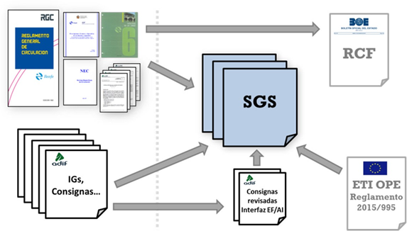

|  |  |
| --- | --- |
| RGC | RGC |
| Reglamento General de circulacion | General Traffic Regulation |
| IGs, consignas… | IGs, instructions… |
| SGS | SMS |
| Consignas revisadas Interfaz EF/AI | Reviewed instructions interface EF/AI |
| RCF | RCF |
| ETI OPE Reglamento 2015/995 | ETI OPE Regulations 2015/995 |

In order to help IMs and RUs identify which aspects they had to include in their SMS, optional good practices criteria were published to serve as guidance in embodying the new traffic regulations in their SMS (Technical recommendations 1/2016 and 5/2016 of AESF).

During 2016, frequent contact was kept with the Railway Undertakings, to guide them during the reworking of their SMS. They were also requested to provide regular information on the progress of their changes in the SMS, before the RCF entered into force in January 2017.

1. Adaptation of the RCF supplementary regulations to the new regulatory framework

The major changes resulting from the application of the RCF, especially regarding responsibilities between the different railways agents, required the review and update of most of the regulations published by the IMs (procedures, instructions, etc.) that were in accordance with the old traffic regulations.

A large part of these regulations was old and even dated from the time in which the whole network was operated and managed by a sole railway undertaking that combined the functions of RU and IM. This meant that both functions were intermingled in these documents, and has required the carrying out of a separation process so that, within the RCF framework, the regulations issued by the IMs cover only the interface aspects with RUs. The remaining aspects have to be the subject of internal rules or procedures of the IMs or RUs exclusively aimed at their own personnel, and be part of their SMS.

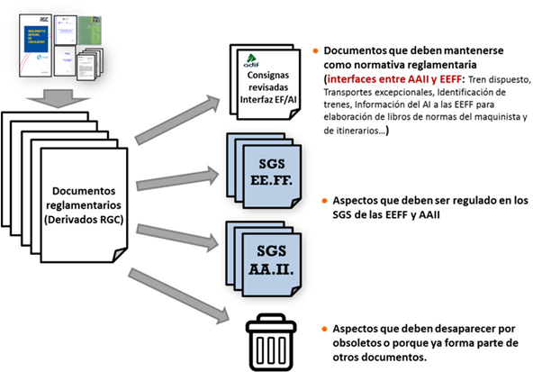

|  |  |
| --- | --- |
| Documentos reglamentarios (Derivados RGC) | Regulatory documents (derived from RGC) |
| Consignas revisadas Interfaz EF/AI | Reviewed instructions interface EF/AI |
| SGS EE.FF. | RUs SMS |
| SGS AA.II | IMs SMS |
| Documentos que deben mantenerse como normativa reglamentaria | Documents that shall be maintained as regulations |
| (interfaces entre AAII y EEFF: Tren dispuesto, Transportes excepcionales, Identificación de trenes, Información del AI a las EEFF para elaboración de libros de normas del maquinista y de itinerarios…) | (interfaces between IMs and RUs: established train, exceptional transports, train identification, information from IM to RUs to prepare train drivers’ and itineraries’ rule books, etc.) |
| Aspectos que deben ser regulado en los SGS de las EEFF y AAII | Aspects that shall be regulated in SMSs of RUs and IMs |
| Aspectos que deben desaparecer por obsoletos o porque ya forma parte de otros documentos. | Aspects that shall disappear because they are obsolete or because they are part of other documents. |

1. Clarification of doubts in the RCF implementation

During this transitional period, in order to help in applying the RCF, the AESF and different entities from the sector have had multiple contacts between themselves and with their personnel to resolve and clarify doubts regarding their interpretation until the final entry into force.

As a result of this process, it has been found necessary to correct RCF drafting errors, adding details, or clarifying contents that raised doubts in the reader. In order to that, a process to modify Royal Decree 664/2015 has been started.

1. Personnel training to adapt to the new regulations

During 2016, the IMs and RUs carried out training courses to adapt the personnel in charge of training to the new RCF, as well as train drivers and traffic personnel. This has meant an enormous training effort for the whole national sector, since the entire qualified personnel had to attend the training centres.

The minimum length of these adaptation courses was set by the “AESF Resolution of 23 December 2015, establishing the basic training requirements and minimum educational content of training programmes for railway staff qualifications, to be given at approved training centres for railway staff.”

1. Catalogue of signals

At the same time as the RCF, it was felt expedient to prepare an Official Catalogue of Railway Traffic Signals with definitions of the physical, location, and visual characteristics of the signals gathered in the RCF. This Catalogue was published in the Official Gazette as Order FOM/2015/2016, dated 30 December.

1. Track signalling of all maximum speeds

Until the RCF was published, it was not mandatory for the national railway systems to have signals (”signboards”) on the track to indicate the maximum speed at which trains might travel in each section of the line, except for certain stretches: temporary speed changes (TSL, temporary speed limits) or permanent limits.

The RCF introduces a very important criterion change in this regard, because, since its entry into force, it is mandatory to signpost each maximum speed change on the track.

All this has meant that it was mandatory for ADIF and ADIF AV to signpost all speed changes on track before January 2017, through a process that has included the following:

* 1. Signalling review and inventory of the entire railway network.
  2. Review of the Maximum Speed Charts to remove signals nesting.
  3. Gathering and manufacturing a very significant number of new signals throughout the whole network.
  4. Placement of signals, including taking off and removal of old signals in a phased process, ensuring that no human risks should be created because of changes in the environment due to different signalling criteria.
  5. Ongoing assessment of the process from the point of view of risks, with the participation of safety reviewers.

|  |
| --- |
| SAFETY STRATEGIES, PROGRAMMES, AND INITIATIVES OF THE MINISTRY OF PUBLIC WORKS AND TRANSPORT |

During 2016, all the other agents in the system carried out the specific actions set out in their safety plans, which focused on resolving specific problems derived from their accident rates and from investigations of events that occurred.

### ACTIONS CARRIED OUT BY THE RAILWAY INFRASTRUCTURE MANAGERS ADIF AND ADIF ALTA VELOCIDAD

Both Adif’s and Adif AV’s safety objectives, are established in the **ANNUAL SAFETY PLAN** (CSAP) in the form of target-indicators of accident/incident rates for traffic events considered as related to traffic safety, the cause of which is related to the activity of the infrastructure manager (events caused by Adif or Adif AV personnel in operations intrinsic to traffic, by rolling stock or Adif or Adif AV facilities, by their suppliers or customers, etc.). Events whose cause relates to actions or events unrelated to Adif or Adif AV activity are not taken into account (railway undertakings, third parties, etc.).

In the 2016 CSAP, target indicators of accident/incident rates were established per activity area, including the General Interest Railway Network managed by Adif.

Apart from the target indicators of accident/incident rates, the CSAP also includes a series of actions to detect and correct regulatory breaches, incorrect actions, and deficiencies in the facilities and rolling stock condition. In order to perform these activities, guides and instructions gathered in the procedures established in the Adif and Adif AV Traffic Safety Management System are followed.

The detection and correction actions are stated as follows:

Detection actions, made up of:

* + Inspections
  + Operational Audits

Proactive Safety Actions.

* + Risk detectors installed on the track.
  + Weighing carriages on dynamic scales.
  + Visual examination of trains.

Preventive Safety Actions (supervision and control).

* + Monitoring
  + Safety inspections:

Training being considered to be an essential element for any improvement process, the CSAP gathers a series of training and communicative actions for each of the Adif and Adif AV organisational areas with competencies in traffic safety.

Other objectives that have been taken into account through the action planning in the 2016 CSAP are as follows:

Promotion of a safety culture.

The Safety Culture is presented as a catalyst with a significant influence on the integration and evolution of the elements of the Safety Management System. In order to create a climate of prevention, certain actions have been carried out, including:

* + - Exchange and Feedback forums using a case study and workshop methodology
    - Dissemination of the Traffic Safety Management System
    - Information dissemination and awareness actions

Training of personnel related to Traffic.

Training actions to include retraining, safety and training courses and days targeting Adif personnel with traffic safety duties, to keep the qualifications in force and also to reinforce critical aspects detected during the performance of their activities.

Actions focused on human factors.

* + - Human Factor Workshops
    - Human Factor Training

Traffic Safety Management Participation Bodies

These Participation Bodies are made up of different safety commissions depending on their activity and territorial context, through which Adif and Adif AV (where appropriate) respond to the provisions of Royal Decree 810/2007 regarding participation and contribution to improving traffic safety.

‘#YoCruzoSeguro’ (I cross safely) Railway Education and Awareness Project

Adif, as part of its commitment to Corporate Social Responsibility, has developed a Railway Safety Pilot Project called ‘#YoCruzoSeguro’, whose starting point is the European Project “RESTRAIL”. This awareness and education programme is aimed at specific groups of society in order to make them aware and educate them about crossing tracks inappropriately.

### ACTIONS CARRIED OUT BY THE RAILWAY INFRASTRUCTURE MANAGER LFP PERTHUS

The Internal Safety Committee and the Operations Management meetings provide, among other things, the opportunity to develop and follow safety action plans, and to analyse accidents and/or incidents. During the course of 2016, the Internal Safety Committee has held six meetings in which, among other matters, the actions included in the Safety Action Plan 2016 have been monitored.

The closure of actions contained in the Safety Action Plan is a constant background activity that takes place over several months or years, due to the numerous interactions between procedures, organisations, real actions, and related documentation.

On the other hand, LFP Perthus has started two new actions to improve safety:

Implementation of an automatic control system to open and close the shutters of the RTA in the tunnel. The idea is to detect and measure, through sensors located at strategic points, the presence of a train and its direction of travel, as well as its speed. As a function of these parameters, the device starts (or doesn’t) the procedure of closing the shutters. The purpose is to preserve the ventilation shafts that are affected (and which lose their shape and break over time) due to the piston effect of high-speed trains.

Putting in place a device that opens and closes the redirection valve of dangerous materials in the tunnel's south entrance. Currently, the valve in question is manual. In the event of accidents involving dangerous goods, GPI Sur has to close this valve manually to redirect the polluted waters to the storage tank for dangerous goods and protect the environment. With this device, the control room will proceed to close the valve and the GPI will therefore not have to perform this task and can focus on assisting passengers.

### ACTIONS CARRIED OUT BY THE RAILWAY UNDERTAKINGS

In general, the railway undertakings in Spain coordinate safety through:

The preparation of annual safety plans setting out safety indicators and objectives on the following, among others:

* + Accident rates/incident rates.
  + Management of personnel training.
  + Internal monitoring plan (inspections of various types and audits to be conducted during the year).

Approved safety policy, endorsed by the undertaking's management bodies.

A strategic plan for traffic safety, designed to continuously reduce risk levels.

More specifically, the 2016 Safety Plan of the main operator in Spain – the **RENFE GROUP** (currently formed, among other segments, by the railway undertakings Renfe Viajeros and Renfe Mercancías) – established, in addition to its general and specific quantitative targets related to actual or potential accident rates, a set of Operational Objectives, which differ for each of the railway undertakings that form part of the Renfe Group.

In the case of **RENFE VIAJEROS**, in order to achieve the annual safety objectives**,** the Self-protection and Safety Management established Operational Objectives in order to:

Reduce the risk of technical failure

Reduce the risk of Human Error

Review and improve the Safety Management System

Strengthen the safety culture using feedback (REX)

As a result, the following activities were established in 2016:

* + 1. Actions to reduce risk.

Study of the viability of developing IT tools to avoid risks.

* + 1. SGS documentation for obtaining the Safety Certificate and inclusion of IT tools as a part of the SGS.

Documenting the SGS and preparing the technical specifications of the IT tool for the Safety Action Plan as a system tool.

* + 1. Management of the Operational Instruction No 1 in the follow-up and management of Human Error (feedback) for continuous improvement.

Development of the management of risks due to human error.

* + 1. Strengthening the safety culture by means of seminars, safety days and feedback.

Conducting training days and seminars aimed at all people concerned with the management of traffic safety in different business areas and different geographical locations

Establishing two-way communication actions and defining the lessons-learnt module for communication in qualifications refresher training.

* + 1. Evolutionary adaptation of Narrow Gauge Services to the culture of safety.

Extension of the SGS by applying the criteria of the action plan, compliance with procedures, lessons learnt, etc.

* + 1. Management and monitoring of new international traffic.

Incorporation into the SGS by applying Action Plan criteria and complying with the established procedures.

In addition to the above, in 2016 Renfe Viajeros established a set of Operational Objectives with the aim of reducing accidents and incidents caused by human and technical errors, through the introduction of management measures and the development of new technologies, especially in the driving of railway vehicles.

The reference framework related to the objectives and overall reach of the organisation in terms of safety considers:

Ongoing improvement of SMS

Reinforcement of safety culture

Risk management

Innovation

**RENFE MERCANCIAS**, for their part, established a set of strategic traffic safety lines. They are of a temporary, sliding nature and are accompanied by a set of actions aimed at continuously reducing risk levels, dealing with matters such as modernisation of safety facilities, improvement of rolling stock equipment, updating of training plans, and review and improvement of their internal management systems. These strategic lines are regularly reviewed.

In order to attain the objectives set for 2016, the strategic lines planned were as follows:

* + 1. Dissemination and correct application of the SMS
    2. GSA personnel follow-up
    3. Personnel training on safety aspects
    4. Process automation and control
    5. Surveillance of international traffic and maintenance of certificates in other countries
    6. SGA development and implementation
    7. Reduction of technical error
    8. Reduction of human error
    9. SAM integration
    10. Compliance with legislative changes

In connection with the strategic lines, through the Annual Safety Plan and in addition to the annual Safety Objectives, a set of Strategic and Operational Objectives was established, with the purpose of reducing accidents and incidents caused by human and technical errors.

|  |
| --- |
| AREAS OF PRIORITY ATTENTION FOR THE FUTURE |

The following will be areas of priority attention for the National Railway Safety Agency over the coming years:

Consolidating the Agency's position in the sector, therefore reinforcing its actions and visibility. To do this, it is considered essential to proceed with the tasks of issuing and dissemination of technical recommendations. Communication is one of the most effective tools to encourage a culture of safety across the sector. The AESF believes that communication is one of the most effective mechanisms to achieve compliance over the medium term with regulations and authorisation and supervision processes.

Continue to consolidate the sector’s supervision activities, incorporating new types of actions.

In the medium term, the AESF must be ready for the in-depth change that the application of the Fourth Railway Package will represent for the sector in the future, which, apart from regulatory and market changes, will change the relationships between the national agencies and the European Union Agency for Railways.

In the longer term, the AESF must take advantage of the fact that, due to its independent position in the sector, it is placed in an excellent position to collaborate with all those involved in achieving safety improvement objectives, coordinating and acting as the catalyst for strategic actions that affect multiple agents in the sector.

|  |  |
| --- | --- |
|  | SAFETY EVOLUTION |

This report includes statistics on the significant accidents that took place on the General Interest Railway Network managed by the infrastructure managers Adif and Adif Alta Velocidad in 2016. No accidents or precursors of accidents occurred on the network managed by LFP Perthus.

The charts below show two different geographic scopes of application: one for the RFIG managed by Adif and Adif AV, and one also including the Narrow Gauge Network (RAM), which was managed by the extinct company, FEVE.

Up until 1 January 2013, when the narrow gauge network was integrated into Adif with the disappearance of FEVE, the criteria for quantifying the accident rate on the RAM were not entirely comparable with those for the rest of the network. Therefore, it was deemed that the information should be separated into two series: a shorter series, from 2013, with information on the entire network to which Railway Safety Directive 2004/49/EC is applicable (including the RAM), and another, more extensive series excluding the RAM, in order to provide historical continuity.

In addition to the information included in this section, a series of charts have been prepared on the trend for each of the Common Safety Indicators, according to the criteria and the templates provided by the European Union Agency for Railways. The details of these statistics are included in the **Annex**.

|  |
| --- |
| DETAILED ANALYSIS OF THE LATEST RECORDED TRENDS |

As a general summary, during 2016 there were 121 accidents in the RFIG, a reduction compared with the previous year, thus establishing a decreasing trend and achieving a minimum in the historical series of accidents, both in absolute and relative values. The accident-frequency index (number of accidents per million train-kilometres travelled) was 0.610.

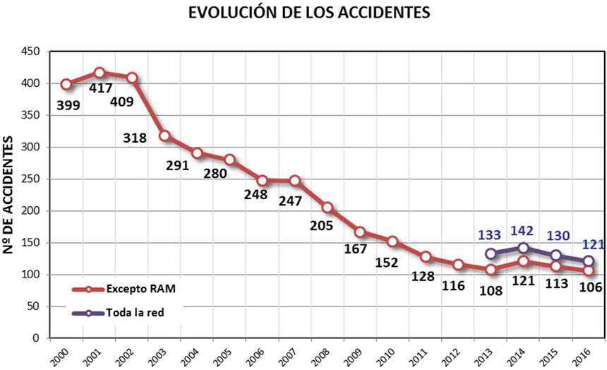

|  |  |
| --- | --- |
| EVOLUCIÓN DE LOS ACCIDENTES | ACCIDENTS |
| Nº DE ACCIDENTES | NUMBER OF ACCIDENTS |
| Excepto RAM | Excluding the RAM |
| Toda Ia red | Entire network |

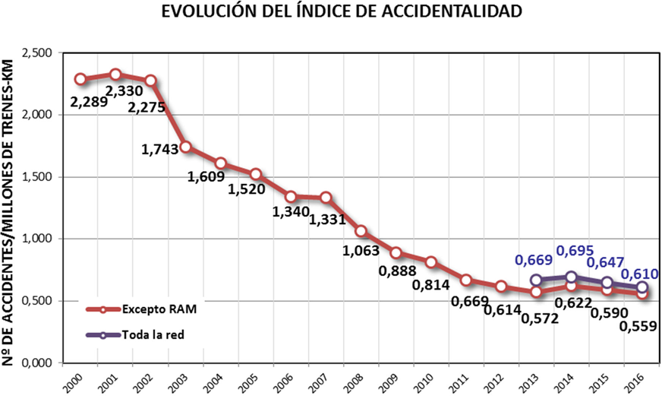

|  |  |
| --- | --- |
| EVOLUCIÓN DEL ÍNDICE DE ACCIDENTALIDAD | ACCIDENT RATE INDEX |
| Nº DE ACCIDENTES/MILLIONES DE TRENES-KM | NUMBER OF ACCIDENTS/MILLION OF TRAINS-KM |
| Excepto RAM | Excluding the RAM |
| Toda Ia red | Entire network |

The following chart shows that, in 2016, regarding the total number of significant accidents and serious accidents,[3] levels similar to the previous year are maintained.

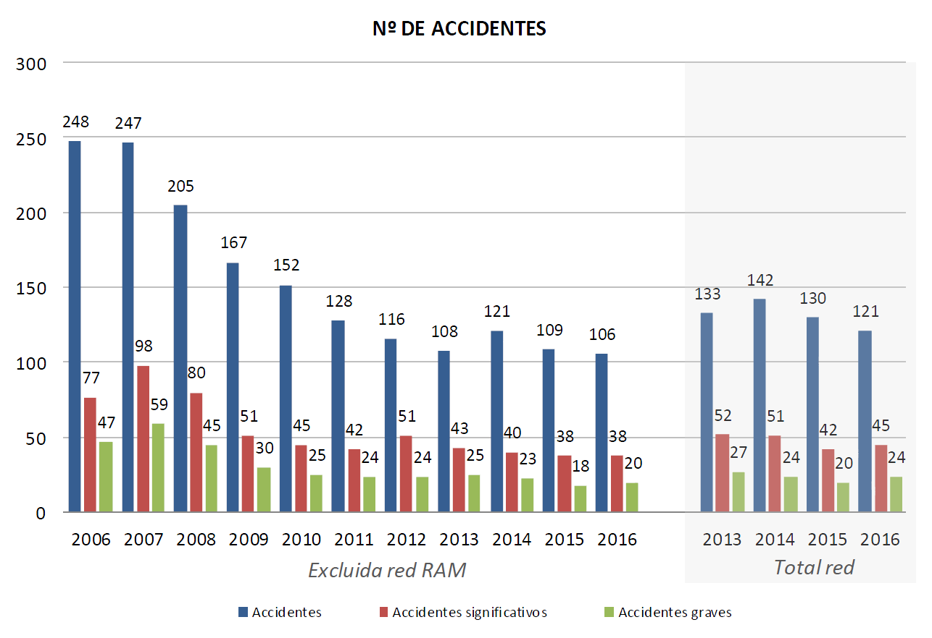

|  |  |
| --- | --- |
| Nº DE ACCIDENTES | NUMBER OF ACCIDENTS |
| Excluida red RAM | Excluding the RAM network |
| Total red | Total network |
| Accidentes | Accidents |
| Accidentes significativos | Significant accidents |
| Accidentes graves | Serious accidents |

**By type of accident[4]**, compared with the previous year, there is a decrease in the number of accidents in the main categories (derailments, collisions, and accidents to people). Accidents at level crossings are maintained at levels similar to 2015. Accidents in the fires and others categories increased (although none of these accidents will be considered as significant.)

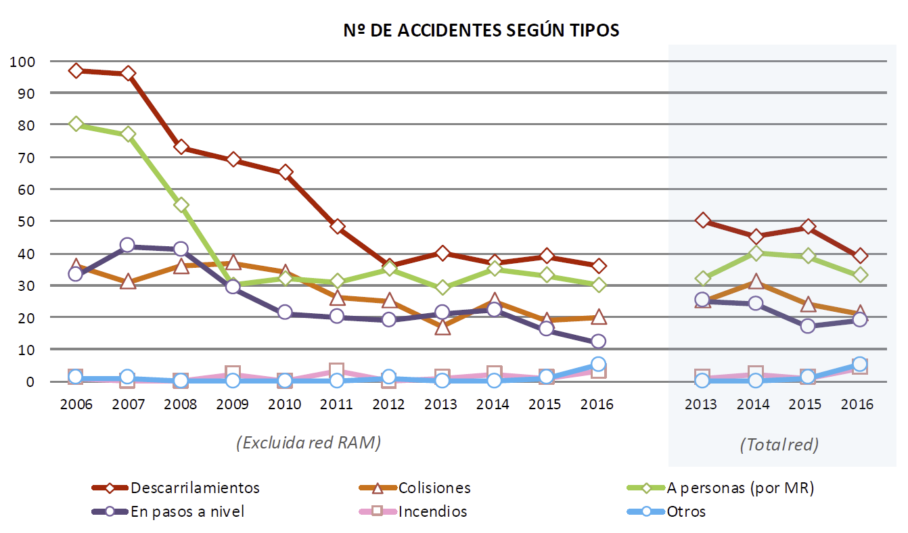

|  |  |
| --- | --- |
| Nº DE ACCIDENTES SEGÚN TIPOS | NUMBER OF ACCIDENTS BY TYPE |
| (Excluida red RAM) | (Excluding the RAM network) |
| (Totalred) | (Total network) |
| Descarrilamientos | Derailments |
| En pasos a nivel | At level crossings |
| Colisiones | Collisions |
| Incendios | Fires |
| A personas (por MR) | Involving people (by rolling stock) |
| Otros | Others |

|  |  |  |  |  |  |  |  |  |  |  |  |  |  |  |  |  |
| --- | --- | --- | --- | --- | --- | --- | --- | --- | --- | --- | --- | --- | --- | --- | --- | --- |
| **Accidents** | **RFIG (INCLUDING THE RAM NETWORK)** | | | | | | | | | | |  | **TOTAL NETWORK** | | | |
| **2006** | **2007** | **2008** | **2009** | **2010** | **2011** | **2012** | **2013** | **2014** | **2015** | **2016** |  | **2013** | **2014** | **2015** | **2016** |
| Derailments | 97 | 96 | 73 | 69 | 65 | 48 | 36 | 40 | 37 | 39 | 36 |  | 50 | 45 | 48 | 39 |
| Collisions[5] | 36 | 31 | 36 | 37 | 34 | 26 | 25 | 17 | 25 | 19 | 20 |  | 25 | 31 | 24 | 21 |
| Involving people (by rolling stock)[6] | 80 | 77 | 55 | 30 | 32 | 31 | 35 | 29 | 35 | 33 | 30 |  | 32 | 40 | 39 | 33 |
| At level crossings[7] | 33 | 42 | 41 | 29 | 21 | 20 | 19 | 21 | 22 | 16 | 12 |  | 25 | 24 | 17 | 19 |
| Fires | 1 | 0 | 0 | 2 | 0 | 3 | 0 | 1 | 2 | 1 | 3 |  | 1 | 2 | 1 | 4 |
| Others | 1 | 1 | 0 | 0 | 0 | 0 | 1 | 0 | 0 | 1 | 5 |  | 0 | 0 | 1 | 5 |
| **TOTAL** | **248** | **247** | **205** | **167** | **152** | **128** | **116** | **108** | **121** | **109** | **106** |  | **133** | **142** | **130** | **121** |

Regarding **significant accidents**, values in 2016 are very similar to those in 2015, which was the historically lowest year.

**Accidents classified by type** are shown below. As a general conclusion, we can say that the various types of accidents show a relatively stable trend.

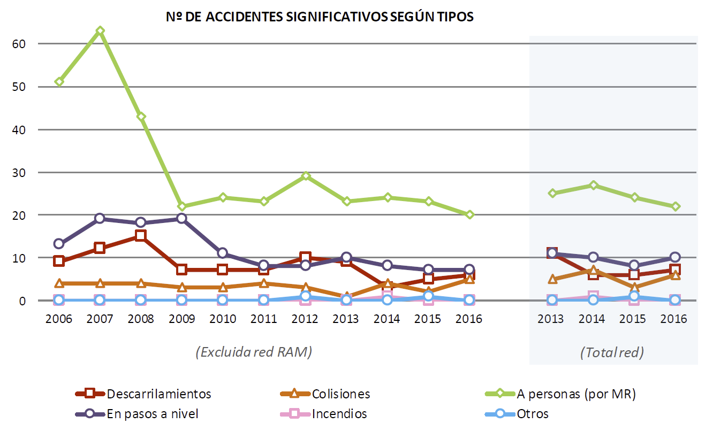

|  |  |
| --- | --- |
| NºDE ACCIDENTES SIGNIFICATIVOS SEGÚNTIPOS | NO. OF SIGNIFICANT ACCIDENTS BY TYPE |
| (Excluida red RAM) | (Excluding the RAM network) |
| (Totalred) | (Total network) |
| Descarrilamientos | Derailments |
| En pasos a nivel | At level crossings |
| Colisiones | Collisions |
| Incendios | Fires |
| A personas (por MR) | Involving people (by rolling stock) |
| Otros | Others |

|  |  |  |  |  |  |  |  |  |  |  |  |  |  |  |  |  |
| --- | --- | --- | --- | --- | --- | --- | --- | --- | --- | --- | --- | --- | --- | --- | --- | --- |
| **Significant accidents** | **RFIG (INCLUDING THE RAM NETWORK)** | | | | | | | | | | |  | **TOTAL NETWORK** | | | |
| **2006** | **2007** | **2008** | **2009** | **2010** | **2011** | **2012** | **2013** | **2014** | **2015** | **2016** |  | **2013** | **2014** | **2015** | **2016** |
| Derailments | 9 | 12 | 15 | 7 | 7 | 7 | 10 | 9 | 3 | 5 | 6 |  | 11 | 6 | 6 | 7 |
| Collisions[8] | 4 | 4 | 4 | 3 | 3 | 4 | 3 | 1 | 4 | 2 | 5 |  | 5 | 7 | 3 | 6 |
| Involving people (by rolling stock) | 51 | 63 | 43 | 22 | 24 | 23 | 29 | 23 | 24 | 23 | 20 |  | 25 | 27 | 24 | 22 |
| At level crossings | 13 | 19 | 18 | 19 | 11 | 8 | 8 | 10 | 8 | 7 | 7 |  | 11 | 10 | 8 | 10 |
| Fires | 0 | 0 | 0 | 0 | 0 | 0 | 0 | 0 | 1 | 0 | 0 |  | 0 | 1 | 0 | 0 |
| Others | 0 | 0 | 0 | 0 | 0 | 0 | 1 | 0 | 0 | 1 | 0 |  | 0 | 0 | 1 | 0 |
| **TOTAL** | **77** | **98** | **80** | **51** | **45** | **42** | **51** | **43** | **40** | **38** | **38** |  | **52** | **51** | **42** | **45** |

As for the number of **serious accidents**, this is similar when compared with recent years.

The most serious accident that occurred in 2016 was the derailment of a passenger train belonging to the company CP (Comboios de Portugal) travelling under a collaboration agreement between CP and Renfe Viajeros, which was travelling between Vigo and Porto (Portugal), on 9 September 2016. The derailment occurred when passing at excessive speed the entry to the siding of the O Porriño station, although its scheduled route was via the siding. As a result of this accident, 4 people died (the train driver, the supervisor, and two passengers) and 13 passengers were seriously injured. The event is being investigated by the Railway Accidents Investigation Commission (CIAF).

The following chart shows the accidents that have occurred in recent years and that could be classified as serious given their consequences (at least one fatality, five or more seriously injured people, or major damage.) We are still seeing the significant influence on the accident rates of the Spanish network that incidents involving third parties have: accidents involving people or at level crossings.

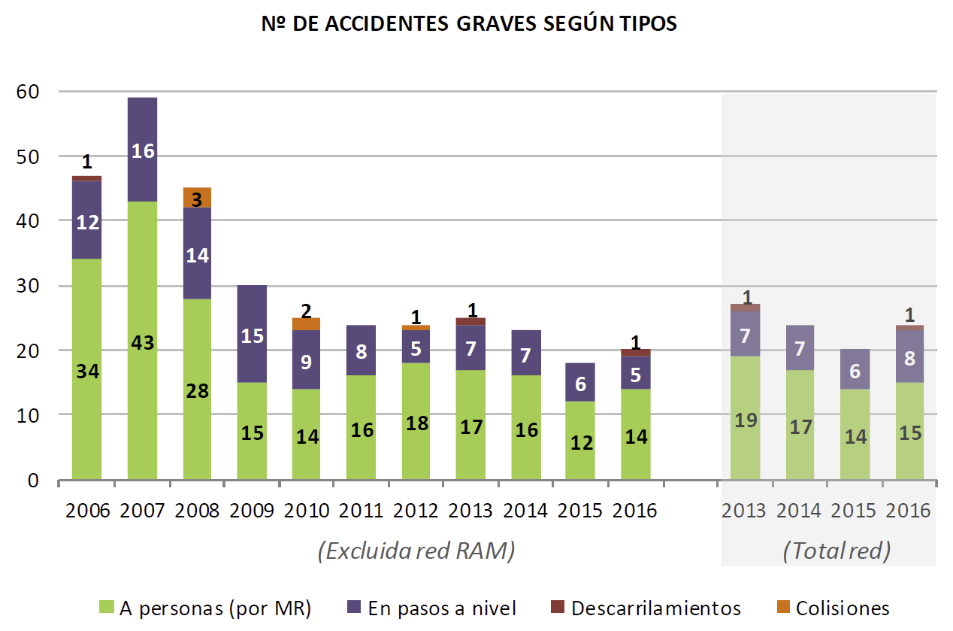

|  |  |
| --- | --- |
| Nº DE ACCIDENTES GRAVES SEGÚN TIPOS | NUMBER OF SERIOUS ACCIDENTS BY TYPE |
| (Excluida red RAM) | (Excluding the RAM network) |
| (Total red) | (Total network) |
| A personas (por MR) | Involving people (by rolling stock) |
| En pasos a nivel | At level crossings |
| Descarrilamientos | Derailments |
| Colisiones | Collisions |

|  |  |  |  |  |  |  |  |  |  |  |  |  |  |  |  |  |
| --- | --- | --- | --- | --- | --- | --- | --- | --- | --- | --- | --- | --- | --- | --- | --- | --- |
| **Significant accidents** | **RFIG (INCLUDING THE RAM NETWORK)** | | | | | | | | | | |  | **TOTAL NETWORK** | | | |
| **2006** | **2007** | **2008** | **2009** | **2010** | **2011** | **2012** | **2013** | **2014** | **2015** | **2016** |  | **2013** | **2014** | **2015** | **2016** |
| Derailments | 9 | 12 | 15 | 7 | 7 | 7 | 10 | 9 | 3 | 5 | 6 |  | 11 | 6 | 6 | 7 |
| Collisions[9] | 4 | 4 | 4 | 3 | 3 | 4 | 3 | 1 | 4 | 2 | 5 |  | 5 | 7 | 3 | 6 |
| Involving people (by rolling stock) | 51 | 63 | 43 | 22 | 24 | 23 | 29 | 23 | 24 | 23 | 20 |  | 25 | 27 | 24 | 22 |
| At level crossings | 13 | 19 | 18 | 19 | 11 | 8 | 8 | 10 | 8 | 7 | 7 |  | 11 | 10 | 8 | 10 |
| **TOTAL** | **77** | **98** | **80** | **51** | **45** | **42** | **51** | **43** | **40** | **38** | **38** |  | **52** | **51** | **42** | **45** |

Considering the **consequences of accidents[10]**, in 2016 the trend in the number of deaths is again altered by the consequences of an extraordinary event: the derailment at the O Porriño station. The remaining victims resulted from accidents involving people or at level crossings, in which elements unrelated to the railway system itself play a greater part.

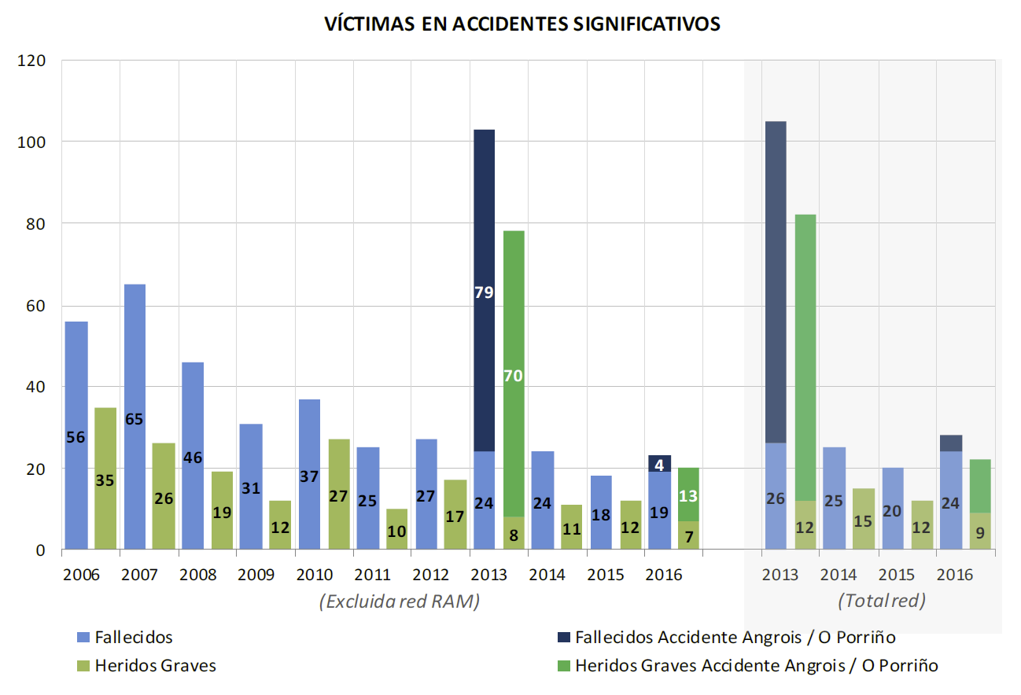

|  |  |
| --- | --- |
| VÍCTIMAS EN ACCIDENTES SIGNIFICATIVOS | VICTIMS IN SIGNIFICANT ACCIDENTS |
| (Excluida red RAM) | (Excluding the RAM network) |
| (Totalred) | (Total network) |
| Fallecidos | Deaths |
| Heridos Graves | Serious Injuries |
| Fallecidos Accidente Angrois / O Porriño | Deaths in the Angrois/O Porriño accidents |
| Heridos Graves Accidente Angrois / O Porriño | Seriously injured people in the Angrois/O Porriño accidents |

Below you will find a break-down of the number of **fatal victims by type of accident.**

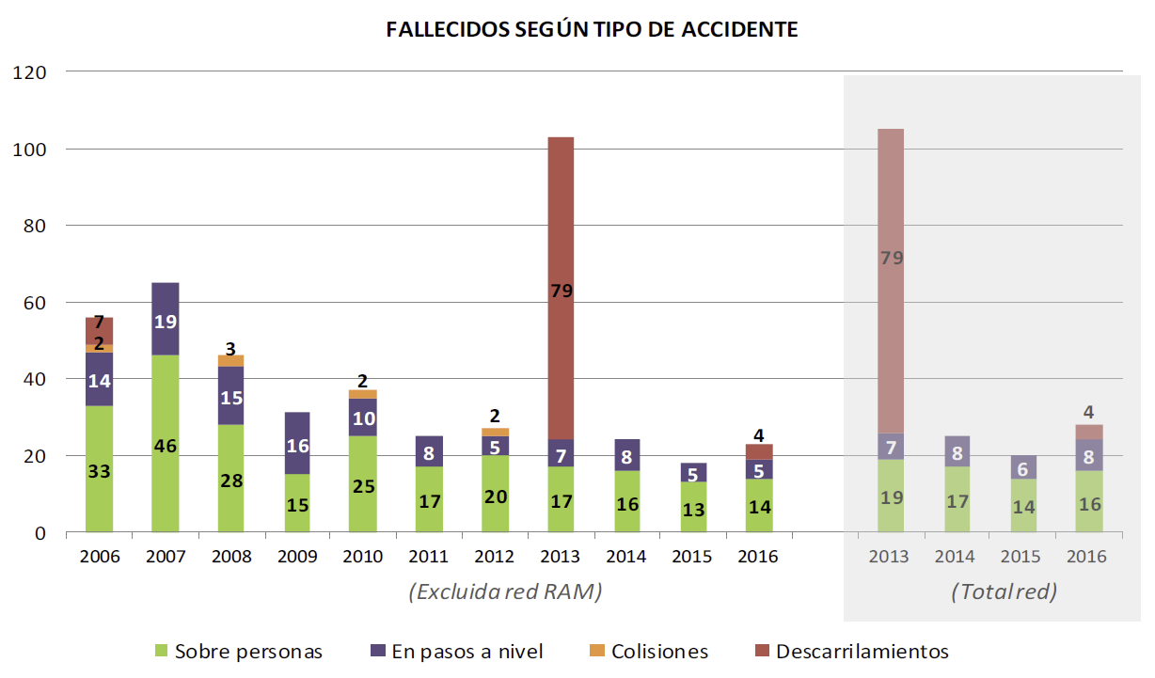

|  |  |
| --- | --- |
| FALLECIDOS SEGÚNTIPO DE ACCIDENTE | VICTIMS BY TYPE OF ACCIDENT |
| (Excluida red RAM) | (Excluding the RAM network) |
| (Totalred) | (Total network) |
| Sobre personas | Involving people |
| En pasos a nivel | At level crossings |
| Colisiones | Collisions |
| Descarrilamientos | Derailments |

There is a certain upturn compared with the previous year in the number of fatalities in the narrow gauge network (RAM) compared with the previous year, especially in the accidents that occurred at level crossings. Within this type of accidents, two accidents with fatalities occurred, one of them involving a train colliding with a road vehicle. As for accidents in the RAM network, two fatalities resulted from separate incidents involving trespassers, not at level crossings.

This final comparative chart shows the **precursors of accidents** recorded in recent years[11].

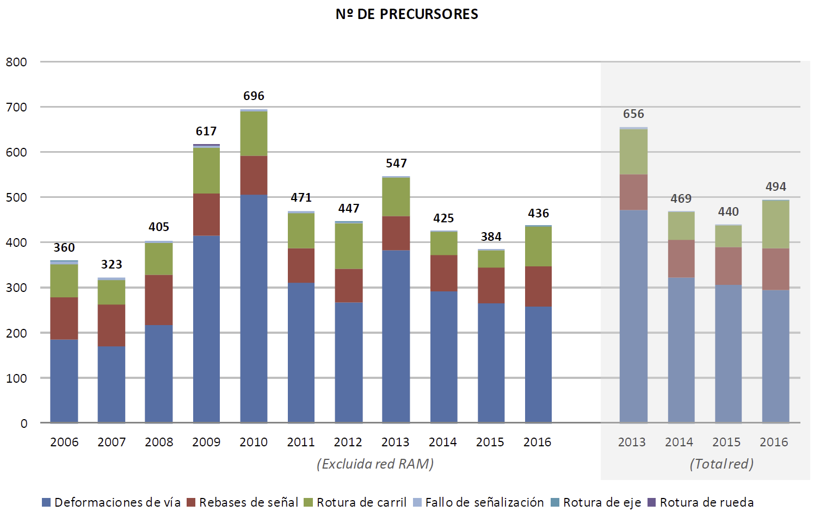

|  |  |
| --- | --- |
| Nº DE PRECURSORES | NUMBER OF PRECURSORS |
| (Excluida red RAM) | (Excluding the RAM network) |
| (Totalred) | (Total network) |
| Deformaciones de vía | Track warping |
| Rebases de señal | Signal overrun |
| Rotura de carril | Broken rail |
| Fallo de señalización | Signal failure |
| Rotura de eje | Broken axle |
| Rotura de rueda | Broken wheel |

In 2016, the number of signal overruns slightly increased from 85 to 93 (the danger point was exceeded only in 7 of them.)

As for **precursors related to infrastructure**, broken rails, and track warping, failure due to the condition of their components is very much influenced by the severity of the weather conditions; the more weakened the infrastructure is, the greater the impact. There has been an increase in broken rails compared with the very favourable trend of the last two years, which had achieved historical lows, and returning to figures similar to previous years.

Therefore, as a **general conclusion**, the analysis of the railway accident rate for 2016 shows that it is **a year in which the number of accidents has decreased overall**, although the consequences have been more serious than in the last two years, specifically due to the impact of the O Porriño derailment and slight rises in collisions involving people and at level crossings.

|  |
| --- |
| SAFETY RECOMMENDATIONS |

Investigating the accidents and incidents that occur on the network is a fundamental tool for detecting and preventing risks. This type of investigation must include all accidents and precursors of accidents with certain characteristics – such as repetition and when or where they occur, or where the causes can be attributed to railway management – irrespective of whether they have serious personal or financial repercussions.

Therefore, a report is prepared by an entity that is independent of the Agency for every accident investigated. These reports set out the causes identified and any recommendations for improving the railway installations, searching for patterns of behaviour in the people involved so as to prevent recurrence.

During 2016, the Railway Accidents Investigation Commission (CIAF) opened a total of 57 dossiers, of which a total of 7 accidents and 4 incidents were finally investigated. These involved 3 derailments, 3 collisions, 1 fire, and 4 near collisions (after the same number of signal overruns).

As a summary, the following are the **most important safety recommendations** resulting from CIAF's reports into events in 2016 (and including 2015) where investigations have been concluded[12] and implementation is already in progress by the appropriate bodies.

* Recipients: National Railway Safety Agency

Require a railway company to present a new standardisation and assembly plan for the new axle boxes for type 66 axles for Leks cars, and enforce compliance with these standards.

Make an assessment of a railway company in terms of how they treat their driving personnel after events that affect the safety of rail traffic.

* Recipients: Infrastructure managers

Fix the ends of the rail bars located next to the tracks in service, when it is foreseen that it will be stored for a considerable amount of time until its next use.

Prepare in greater detail the instructions that regulate works, describing at all times the conditions and situations that the works being carried out may have on the different elements of the safety installations and especially on signals and other components.

In the case of actions on installations on tracks that are in service, carry out a risk analysis and risk study in the stages prior to the project to ensure an adequate mitigation of the detected risks and their subsequent verification during the phases and stages of the project (design of the interlock, verification thereof, interlock tests, field tests, mitigating measures in the field tests, verification that the appropriate documents have been generated and verification that the associated risks have been correctly completed and closed, etc.) In the case of regulation of works by means of an Instruction, works must be done as per the content, scope, and fundamental development guidelines thereof. Traceability, communication and information exchange must be established between the preparation of the risk study and the instruction.

Insist on refresher courses being given to the staff involved in traffic movements, stress the need to communicate as soon as possible any incidents that may affect traffic safety.

Analyse the possibility of stabilising the cutting on a section of a line by applying an appropriate system.

* Recipients: Railway undertakings

Schedule an axle change when water is detected inside a grease box during the IM2, IM3, or IM4, to be made to vehicles of a certain series (599). Until this change is made, draw up a follow-up procedure and inspect during all preventive maintenance operations.

On changing an axle on a 599 vehicle, check that the kilometres travelled since the last complete overhaul of the axle and its bearings are less than or equal to those of the train it is mounted on, counting from the last R1 or R2 performed on it.

Intensify the maintenance of the current grease boxes arranged in the 66 axles of Leks carriages until their total replacement.

In the process of training and retraining driver personnel, stress to them that they must, wherever possible, drive from the front cab (in the direction of movement) when manoeuvring, in order to have a better overview of the operation.

In the refresher courses given to the driving staff, stress situations that are worse that normal or unusual such as the blocking of the supplementary telephone.

Use the training and refresher actions for the driving staff to stress the importance of transmitting information about an event to the traffic person in charge as soon as possible and using the established formal channels.

Develop and implement the appropriate mechanisms to ensure that, before carrying out their duties, train drivers receive the notices that involve them, from those responsible for documentation of the different organisational areas. Middle managers must brief the train drivers, reminding them of the application of the traffic conditions included in these documents before performing their duties.

Improve the safety management system procedures for the suspension, revocation and re-establishment of qualifications after a human error, depending on the severity thereof.

Prepare a procedure within the safety management system to establish the measures necessary to check compliance with driver working hours based on scheduled train services and, in the event of a deteriorated situation, to adjust driving times and to prevent non-compliance.

Incorporate into the safety management system Technical Recommendation 7/2014 from the Directorate-General of Railways on procedures to check maximum driving times.

The National Railway Safety Agency monitors the level of compliance with these recommendations by the parties involved. To do so, it makes periodic requests for information on the level of compliance from the body to which the recommendation is addressed. When it is deemed that a sufficient level of implementation of the recommendation has been reached, the Railway Accidents Investigation Commission is notified so that the issue may be closed.

The most noteworthy actions[13] taken by the agents responsible for complying with such recommendations are set out below. This list is not comprehensive. It only details the most significant actions, as it is working to achieve compliance with all of the recommendations issued by the CIAF.

|  |  |
| --- | --- |
| EVENT: DERAILMENT DUE TO TECHNICAL ERROR OF THE INFRASTRUCTURE | |
| Actions: | * Procedures for ensuring the adoption of corrective measures of track condition faults that are detected and classified as requiring urgent treatment have been established. * Track settlement reinforcement works have been completed, LTV has been removed, and inspections in the area have been scheduled. |

|  |  |
| --- | --- |
| EVENT: Derailment due to signal overrun | |
| Actions: | * All existing interlocks in the third rail have been analysed and directional slips are being introduced, in areas with sets of points that discriminate gauge, and interlocking the necessary switches and crossings. Moreover, the operating regulations for installations with third rail are being modified. |

|  |  |
| --- | --- |
| EVENT: Near collision due to signal overrun | |
| Actions: | * Peculiar characteristics of driving solo locomotives have been included in the training programmes of the refresher courses aimed at the driving staff. * **Technical recommendation 3/2016 of the National Railway Safety Agency** on several issues related to the training of railway staff and their qualifications has been drafted. * **Technical recommendation 4/2016 of the National Railway Safety Agency** on actions related to the qualification certificates of railway staff following events involving human error has been drafted. * A project to install ASFA standardised signals and beacons that would also improve the interlocking, signalling, and blocking systems, for stations with mechanical signals on non- electrified single-track lines with telephone blocking and mechanical interlocking, is being carried out. * A process to modify a specific interlock and be able to change the position of a signal to improve its visibility, has been established. |

|  |  |
| --- | --- |
| EVENT: ACCIDENTS AT LEVEL CROSSINGS | |
| Actions: | * Capability of protection B at a level crossing * A change in the current regulation is being drafted, on signalling and protection of level crossings. |

| EVENT: ACCIDENTS ON CROSSINGS BETWEEN PLATFORMS | |
| --- | --- |
| Actions: | * Technical regulations are being drafted to regulate the crossing between platforms. |

| EVENT: Collision due to human error by driving personnel | |
| --- | --- |
| Actions: | * In certain small stations where advanced signals show as permissive they have changed to absolute. |

| EVENT: Signal overrun due to human error by traffic personnel | |
| --- | --- |
| Actions: | * A new edition of the Experimental Procedure C No 58 to include the mandatory use of protection by short-circuit equipment (in lines with electrical track short-circuits) and signals (in lines without electrical track circuits) has been published. |

| EVENT: Derailment due to technical error of the rolling stock | |
| --- | --- |
| Actions: | * The lever support has been welded to the wheel box for the whole fleet equipped with Brava axles; this operation has been completed. Additionally, the carrying-out of the non-destructive tests (NDT) to verify the effectiveness of the solution adopted has been established. This type of verification will be incorporated into the Maintenance Plan for these vehicles. * A study to improve maintenance plans for the special self-propelled rolling stock (small open wagons, railway inspection trolleys, etc.) has been carried out. * The technical rule for the Brava axle maintenance has been modified to include the replacement of the scraper seal and the measurement of the backlash between cogs of the half-coupling as from service operation I3. In addition, the scraper of the variable gauge systems is replaced whenever the coupling system is dismounted. * A new scraper model has been produced and is being introduced, and the mechanical characteristics and surface treatment of the toothed couplings have been improved. |

| EVENT: Derailment due to excess speed | |
| --- | --- |
| Actions: | * With the Railway Traffic Regulations coming into force, the track signalling criteria have been modified, establishing an obligation to signal all speed changes, instead of traditional practice. * An improvement in the Digital ASFA is still being developed, which will allow the setting of more steps in speed control. Plans for the complete roll-out of this on all equipment have been speeded up. * The carrying-out continues of specific risk analyses that gather the identification and management of potential dangers derived from the interaction of different subsystems, both under normal and degraded operating conditions, within the process of commissioning new railway lines and variants or new commercial services. * The procedures of the SGSs have been reviewed and reinforced so that notifications of safety-related deficiencies detected at any stage are passed on to the functionally established channels for analysis and consideration, thereby ensuring efficient preventive management. * Systems that provide greater recording capacity in cabs are being installed to facilitate the investigation of events. |

|  |  |
| --- | --- |
|  | SAFETY CERTIFICATES AND AUTHORISATIONS |

|  |
| --- |
| REFERENCE FRAMEWORK FOR ISSUING CERTIFICATES AND AUTHORISATIONS |

Commission Regulation (EU) No 1158/2010 of 9 December 2010 has been used as the reference for the evaluation process prior to issuing safety certificates for railway companies. This Directive sets out a common safety method for assessing conformity with the requirements for obtaining railway safety certificates.

The AESF considers it essential that safety management systems be conceived from the outset taking into account Regulations 1158/2010 and 1169/2010, as well as Regulation 402/2013 on risk assessment, Regulation 445/2011 on a certification system for entities in charge of maintenance of freight wagons, and Regulation 1078/2012 on internal monitoring.

Therefore, and in order to facilitate the process of obtaining certificates, the AESF is carrying out advisory work directly with railway undertakings, or consultant companies that provide such undertakings with support, during the drafting phase of their SGSs, and even prior to submission of a formal application. This work procedure is facilitating subsequent assessment.

The annual safety reports that undertakings and managers submit offer an opportunity to express opinions about the procedures and practices for issuing safety certificates/authorisations, and other possible improvements to the system.

|  |
| --- |
| CERTIFICATES AND AUTHORISATIONS ISSUED DURING 2016 |

### PART A SAFETY CERTIFICATES

In 2016, six part A safety certificates were issued:

|  |  |  |
| --- | --- | --- |
| **RAILWAY UNDERTAKING** | **TYPE OF CERTIFICATE** | **DATE ISSUED** |
| **RENFE VIAJEROS** | New | 01/04/2016 |
| **NOGARTRAIN** | New | 18/04/2016 |
| **EUSKOTREN** | New | 25/04/2016 |
| **TRANSFESA RAIL** | Renewal | 24/06/2016 |
| **FGC RAIL** | New | 03/10/2016 |
| **TRANSFESA RAIL** | Update | 05/10/2016 |
| **TRANSFESA RAIL** | Update | 20/10/2016 |
| **CAF OPERADOR FERROVIARIO** | New | 30/11/2016 |

### PART B SAFETY CERTIFICATES

The part B safety certificates issued during 2015 are indicated below:

|  |  |  |  |
| --- | --- | --- | --- |
| **RAILWAY UNDERTAKING** | **TYPE OF CERTIFICATE** | **DATE ISSUED** | **REASONS FOR THE UPDATE** |
| **RENFE VIAJEROS** | New | 01/04/2016 | - |
| **NOGARTRAIN** | New | 18/04/2016 | - |
| **EUSKOTREN** | New | 25/04/2016 | - |
| **TRANSFESA RAIL** | Renewal | 24/06/2016 | - |
| **FGC RAIL** | New | 03/10/2016 | - |
| **TRANSFESA RAIL** | Update | 05/10/2016 | Error detected, corrected |
| **TRANSFESA RAIL** | Update | 20/10/2016 | Error detected, corrected |
| **CAF OPERADOR FERROVIARIO** | New | 30/11/2016 | - |

### SAFETY AUTHORISATIONS

Currently, there are three infrastructure managers with a safety authorisation in the RFIG.

In 2016, an authorisation for the new business organisation Línea Figueras-Perpiñan S.A., which manages the International Section in lieu of TP Ferro, was issued.

|  |  |
| --- | --- |
|  | CERTIFICATION OF ENTITIES IN CHARGE OF MAINTENANCE |

|  |
| --- |
| REFERENCE FRAMEWORK FOR ISSUING CERTIFICATES FOR ENTITIES IN CHARGE OF MAINTENANCE |

The National Railway Safety Agency is responsible for certifying entities in charge of maintenance (EEMs) for freight wagons registered in Spain, thereby complying with the provisions set out in the Railway Safety Directive and in Commission Regulation (EU) No 445/2011 of 10 May 2011, on a system of certification of entities in charge of the maintenance of freight wagons.

|  |
| --- |
| CERTIFICATES ISSUED DURING 2016 |

In 2016, three **entities in charge of maintenance** were certified:

|  |  |  |  |  |
| --- | --- | --- | --- | --- |
| **ENTITY IN CHARGE OF MAINTENANCE** | **TYPE OF COMPANY** | **DATE ISSUED** | **INCLUDES RAIL TANKERS FOR DANGEROUS GOODS** | **INCLUDES OTHER SPECIAL WAGONS FOR DANGEROUS GOODS** |
| **ADIF** | Infrastructure manager | 15/12/2016 | No | No |
| **CAF** | Manufacturer and maintenance service provider | 15/12/2016 | No | No |
| **ERION** | Maintenance service provider | 29/09/2016 | No | No |

Apart from the above-mentioned certificates, in 2016 the AESF has certified partial

functions of Entity in Charge of Maintenance, as indicated below:

|  |  |  |  |  |  |
| --- | --- | --- | --- | --- | --- |
| **UNDERTAKING** | **TYPE OF COMPANY** | **DATE ISSUED** | **INCLUDES RAIL TANKERS FOR DANGEROUS GOODS** | **INCLUDES OTHER SPECIAL WAGONS FOR DANGEROUS GOODS** | **ECM CERTIFIED DUTY** |
| **CAF** | Manufacturer and maintenance service provider | 15/12/2016 | No | No | Performance of maintenance |
| **CAF** | Manufacturer and maintenance service provider | 15/12/2016 | No | No | Management of fleet maintenance |
| **CAF** | Manufacturer and maintenance service provider | 15/12/2016 | No | No | Execution of maintenance |

It must be kept in mind that, in accordance with the provisions set out in Article 12.5 of Commission Regulation (EU) No 445/2011, **maintenance centres that are officially approved and qualified to perform maintenance on freight wagons in accordance with national laws[14]** are directly recognised as having an equivalent certificate for performing maintenance functions.

Finally, as in previous years, in 2016 the AESF did not issue any derogations based on Article 14 bis, paragraph 8, of Directive 2004/49/EC, in accordance with the modification introduced by Directive 2008/110/EC to certify alternative cases.

|  |  |
| --- | --- |
|  | SUPERVISION OF THE RAIL SYSTEM |

|  |
| --- |
| GENERAL LINES OF SUPERVISION |

As in previous years, supervision of the correct application of the regulatory framework regarding safety by responsible agents is carried out at various levels:

1. In general, the most important variables are monitored using the overall accident rate for the system through activities already described in this report, such as:

Continuous monitoring of accident rate statistics and indicators to detect significant deviations.

Drafting of the AESF annual report.

Review of the annual reports of railway undertakings and infrastructure managers.

1. It is also carried out through the certification and supervision of railway companies and infrastructure managers, as well as other agents involved in the railway sector and that provide services, such as entities in charge of wagon maintenance, rolling stock maintenance centres, railway personnel training centres and medical examination centres.
2. Through audits and inspections of the undertakings and managers themselves, especially for verifying application of the internal follow-up procedures of undertakings.
3. By issuing technical recommendations to sector entities regarding procedures for facilitating the implementation of requirements.
4. Through training measures and the dissemination of information to undertakings and managers, thereby assuring that they have adequate knowledge of the regulations they must apply.
5. Another field of supervision that has been the subject of attention was monitoring compliance with recommendations issued by the Railway Accidents Investigation Commission as a result of its investigations of accidents or incidents. This took place through systematic requests for information from the body to which the recommendation was addressed, relating to the level of compliance, until it is considered that implementation of the recommendation has been sufficiently achieved.
6. Follow-up on the safety recommendations issued by the CIAF to ensure compliance therewith.
7. Following-up complaints received on safety.
8. Finally, by advising entities on specific subjects at their request and through the coordination of work groups and information-sharing meetings.

|  |
| --- |
| SUPERVISION OF RAILWAY SYSTEM AGENTS |

The various agents of the system are subject to having previously obtained a certificate, authorisation or official approval from the national authority, thereby allowing them to exercise their activities. Once this qualifying certificate has been issued, **the objectives of supervision actions change:**

Periodic supervision, whether total or partial, of the conditions for granting the certificate/authorisation/approval.

Verification of implementation of the actions committed to when the certificate/authorisation/approval was granted (non-inhibiting qualifications or non-conformities).

Verification in the event of a change in the conditions for having granted the certificate/authorisation/approval.

Supervision derived from observation of a possible 'anomalous' situation that could be due to inadequate application of safety rules.

A revision or update, as applicable, of the safety management system in the event that circumstances arise that may represent added risks that must be adequately considered in procedures.

Specific supervision activities are planned considering the following aspects:

General supervision objectives and criteria.

All types of activities of the supervised agent and the size of the assessed undertaking.

Findings of the assessment process prior to obtaining the certificate/authorisation/approval.

Activities that are considered capable of generating more serious risks.

Other data or information not held by the AESF, such as: the results of previous supervisions, the annual safety report prepared by the undertaking/manager, accident rate reports, etc.

### INFRASTRUCTURE MANAGERS

In relation to **INFRASTRUCTURE MANAGERS**, a **programme of accompaniment and visits** was implemented in 2016, some 80 different visits and inspections of different kinds were carried out:

Accompaniment visits on the internal monitoring actions of Adif itself, to verify compliance with its internal monitoring actions, in accordance with European Regulation 1078/2012. Such visits also serve as training for AESF technicians for other, independent inspection actions.

Informative inspection visits for an overall examination or for examining particular aspects of one or several facilities of the RFIG, of its functioning and/or of its operation.

Informative visits for authorisations to bring lines into service, carrying out an overall examination or an examination of particular aspects of facilities before they come on stream.

Visit to port railway networks.

During 2016 the processes were initiated of seven **partial audits on the application of certain processes** of the management systems of infrastructure managers or specific activities.

There was continuing **follow-up on the processes of commissioning lines and new infrastructures and of changes in the operating conditions** by verifying the adequate application of Adif's internal procedures for start-up and for managing changes in safety installations.

### RAILWAY UNDERTAKINGS

In relation to **railway undertakings**, **audits of the application of the safety management systems** of six of the operating companies were conducted in 2016. These audits sought evidence of compliance with the undertakings' own procedures, and they concluded with reports being issued, in which the AESF made proposals for improvement and requested, where applicable, the presentation of action plans for implementing these improvements.

Two of the foregoing audits also included **aspects related to dangerous goods** within their scope.

**Compliance with requirements or the closing of points left open** by the AESF when the safety certificates were issued or renewed was also monitored.

As a result of anomalies detected, certain railway undertakings have been requested **to prepare specific action plans** to deal with recurrent failures (breakdowns of a certain type of equipment or loading failures.)

Another important supervision element developed during 2016 has been the establishment of **joint coordination mechanisms between AESF and ADIF** to exchange information between the AESF supervision activities and the ADIF inspection activities on the ground in developing policing competences in respect of activities that may damage infrastructure or traffic, which the railway legislation assigns to the manager. Under these mechanisms, the following inspections have been managed during 2016:

|  |  |  |  |
| --- | --- | --- | --- |
| ***TYPE OF INSPECTION*** | ***PERFORMED*** | ***INSPECTIONS WITH ANOMALIES*** | ***ANOMALIES*** |
| ***Wagons*** | *1 281* | *150* | *176* |
| ***Blood alcohol level*** | *155* | *-* | *-* |
| ***Dangerous goods*** | *92* | *13* | *26* |
| ***Freight*** | *265* | *28* | *153* |
| ***Cab inspection*** | *312* | *27* | *40* |
| ***Speed registrations*** | *270* | *32* | *46* |
| ***Total*** | ***2 375*** | ***250*** | ***441*** |

Likewise, the results of weighings on ADIF’s weighing tables (over 30,000 per year) were also taken into account to detect the origin of overloads.

### ENTITIES RELATED TO ROLLING STOCK MAINTENANCE

Adequate control of the maintenance of railway vehicles in accordance with the provisions set out in Spanish legislation is still considered a priority line. To do this, **maintenance centres** must be officially approved by the AESF, in accordance with the provisions of Order FOM/233/2006[15] for exercising such roles.

Total number of approved maintenance centres: 58

Number of maintenance centres approved in 2016: 1

Number of approved facilities: 192

The AESF conducts checks and inspections at least annually whenever there may be reasonable doubts about possible breaches of requirements. It may also do so randomly at any time to verify that compliance with the requirements for official approval is maintained.

Specifically, during 2016 a total of 75 inspections were carried out at the various facilities.

Turning to the supervision of **entities in charge of wagon maintenance,** which is entrusted to the AESF as the EEM certification body. Work continued to monitor execution of the improvement plans established for each of the EEMs already certified, to verify that any deficiencies detected in the auditing and inspection processes prior to issuing the certificates had been corrected. This action was complemented by the annual monitoring activities of the EEMs, the certification of which is issued for a period of 5 years, and by conducting audits and inspections for renewal of the certificate of EEMs classified as ‘new’, in accordance with the provisions set out in Commission Regulation (EU) No 445/2011.

In addition to the three initial audits conducted during the certification process, two renewal audits were conducted and ten follow-up audits were conducted during 2016 to close non-conformities and recommendations.

Three initial audits to undertakings that requested the certification for any of the duties defined in Regulation (EU) No 445/2011, in addition to one follow-up audit to those companies with a certified duty, have been made.

### CENTRES RELATED TO RAILWAY PERSONNEL

Another, complementary activity of vital importance to the sector is the training of personnel. Monitoring the centres that conduct such activities is, therefore, also a priority for the AESF.

Officially approved centres for the training of railway personnel are inspected in accordance with the provisions set out in Article 53 of Order FOM 2872/2010[16], Title IX, Chapter I, with respect to the inspection scheme for officially-approved centres for railway personnel and the functioning of all operations linked to the training of railway personnel for the various certificates established in that Order. During 2016, all approved training centres were inspected (8 of 10 approved centres.)

Similarly, inspection activities were also carried out on medical examination centres for railway personnel, which are also regulated under Order FOM/2872/2010. Eighteen inspection activities were conducted in 2016, and as of 31 December 2016, there were 20 officially-approved medical examination centres.

The AESF’s objective is to conduct at least one annual inspection of these centres, as indicated in Articles 58(3) and 71(3) of Order FOM/2872/2010 of 5 November.

In addition, when a training centre or medical examination centre submits an application to expand its facilities, the AESF visits the centre before issuing its decision.

|  |
| --- |
| ACTIVITIES FOR THE DISSEMINATION OF INFORMATION AND LESSONS LEARNT |

From the AESF's point of view, the dissemination of information to the sector is a support task that complements its supervision role. Its activities in this area include:

* Issuing technical recommendations, which are an effective means of disseminating information and ensuring the spread of best practices in the sector.

During 2016, the following recommendations aimed at different railway agents of the railway sector were issued:

1/2016. Criteria to implement the Railway Traffic Regulations and the Interoperability Technical Specification related to the “traffic management and operation” subsystem in the safety management systems.

2/2016. Criteria to draw up training programmes for driving personnel.

3/2016. Various issues concerning railway personnel training and their qualifications.

4/2016. Actions related to the qualification certificates of railway personnel after events involving human error.

5/2016. Criteria to draft and update the maintenance management systems of the entities in charge of maintenance following the implementation of the Railway Traffic Regulations and the Interoperability Technical Specification related to the “traffic management and operation” subsystem.

6/2016. Qualification of the Person in charge of Load Operations.

* Dissemination of safety alerts notified by the safety alerts system of the European Union Agency for Railways.
* Railway Traffic Regulation. In January 2017, the RCF enters into force; it was approved by Royal Decree No 664/2015, dated 17 July. For its commissioning, during 2016, implementation measures in connection with entities, railway safety personnel training programmes, process follow-up and signalling implementation, analysis of the regulatory documents derived from the RCF, and resolution of doubts arising from the interpretation of such RCF have been taken.

|  |
| --- |
| INTERNAL FOLLOW-UP BY UNDERTAKINGS AND MANAGERS |

During 2016, railway undertakings and infrastructure managers carried out the procedures provided for in their safety plans (application of Regulation No 1078/2012[17]), with satisfactory levels of compliance with such plans.

|  |  |  |
| --- | --- | --- |
| **INSPECTIONS** | | **RAILWAY UNDERTAKINGS:** |
| **Number of RU/IM inspections in 2016** | Inspection of loads | 2 526 |
| Technical Inspection of Rolling Stock in Service (ITMS) | 839 |
| Accompaniment of trains and switching | 17 415 |
| Train inspections before running | 2 691 |
| Switching inspections | 708 |
| Alcohol and drug testing | 9 898 |
| Visits to driving bases, residences, production and management centres | 441 |
| Check of driving times | 545 |
| Check of train safety records | 4 128 |
| **INFRASTRUCTURE MANAGERS:** | |
| A total of 5 010 safety inspections were conducted, 97 of which identified serious anomalies[18]. | |

Regarding entities in charge of maintenance, from the information gathered in their maintenance annual reports, it can be seen that there is a certain margin for improvement in the implementation of Regulation No 1078/2012 and its corresponding reflection in the reports.

|  |  |
| --- | --- |
|  | MODIFICATION TO RAILWAY SAFETY LEGISLATION |

|  |
| --- |
| TRANSPOSITION OF EUROPEAN LEGISLATION REGARDING RAILWAY SAFETY |

The basic document from the point of view of European legislation on railway safety, the Railway Safety Directive 2004/49 (RSD), was incorporated into the Spanish legal system through **Royal Decree 810/2007** of 22 June, thereby approving the Regulation on traffic safety in the General Interest Railway Network.

Subsequently, given the importance of railway safety in the system, it was deemed appropriate to elevate the main concepts of the RSD to the level of a regulation. These concepts were then incorporated into the Railway Sector Act, which is the highest-ranked standard on the subject.

Thus, **Law No 38/2015** of 29 September, on the railway sector, incorporated the main concepts of the RSD, such as the definitions of the safety authority, safety authorisation and certificates and management systems.

By publication of the Technical Pillar of the Fourth Package, which includes the new Directives No 2016/798/EU dated 11 May 2016, on railway safety, and No 2016/797/EU dated 11 May 2016, on interoperability, a comprehensive review process of the entire Spanish legislation on this matter has been started. It will be completed with the publication of the royal decrees that enable their incorporation to the national law in the following months.

|  |
| --- |
| AMENDMENTS OF LAWS AND REGULATIONS |

During 2016, the AESF has developed an important regulatory activity, pursuant to Article 9(1)(g) of its Statute. This has meant the processing and publication of several rules on railway safety and interoperability during the year that is the subject matter of this report:

* Royal Decree No 292/2016, dated 15 July, which modifies the sole transitional provision of Royal Decree No 664/2015, dated 17 July, approving the Regulation of Railway Traffic.
* Order FOM/2015/2016 of 30 December, adopting the Official Catalogue of Railway Traffic Signals on the General Interest Railway Network.
* Order FOM/1613/2016 of 4 October, amending Order FOM/2872/2010 of 5 November, which sets out the conditions for obtaining the qualifying certificates that allow railway personnel to perform their duties with respect to rail traffic safety, as well as the system of officially approved training centres and the medical examination centres of said personnel. (Transposition of Directive (EU) No 2016/882 of the Commission dated 1 June 2016 which modifies Directive No 2007/59/EC of the European Parliament and of the Council, regarding linguistic requirements.)

In addition, in 2016 the drafting of other regulations began; they are currently in different stages of preparation and processing:

* 1. Start the transposition of the new Safety Directive (2016/796/EU) and Interoperability Directive (2016/797/EU).
  2. Process the amendment of Royal Decree 412/2001 regulating certain matters relating to the transportation and movement of dangerous goods by rail.
  3. Continue the processing of the order for the maintenance rail vehicles, replacing the current part of Order FOM/233/2006, dated 31 January, which determines the approval system for rolling stock centres and their conditions of operation.
  4. Continue to process the Railway Instructions on Infrastructure (RII), Energy (RIE) and Rolling Stock (RI RM), these being the national regulatory supplement to applicable TSIs, by virtue of Order FOM/167/2015.

|  |  |
| --- | --- |
|  | APPLICATION OF REG. 402/2013 ON RISK EVALUATION AND ASSESSMENT |

This section responds to the requirement of Article 18.2 of Commission Implementing Regulation 402/2013 of 30 April 2013 on the common safety method for risk evaluation and assessment, which states that *'each national safety authority must, in its annual safety report referred to in Article 18 of Directive 2004/49/EC, report on the experience of the proposers with the application of this Regulation and, where appropriate, its own experience'.*

The generalised application of the methodology of Regulation No 402/2013 continued for **CHANGES IN ROLLING STOCK** throughout 2016.

Interesting information, from the 74 rolling stock files started in 2016, 45 belonged to modifications that do not require Commissioning Authorisation. The remaining files do require Commissioning Authorisation because they relate to new vehicles or modifications that require authorisation. Including the files started in previous years, during 2016 75 modification files that would not require a new Commissioning Authorisation were worked on.

Noteworthy are the high number of Software (SW) files, amounting to 28, and the establishment of a quota of modification files for trains to perform herbicide tasks, both temporary and permanent.

The examples[19] listed below correspond to practical applications of the legislation in the period covered by this report:

* Adaptation of national vehicles for international traffic

Modification of self-propelled vehicle for operation in traffic between Portugal and Spain

Adaptation of locomotives to the UIC gauge

* Modifications relating to the modernisation and installation of communications equipment:

Renewal of the ERTMS-ETCS equipment software of the control and signalling subsystem. Implementation of functionality Unisig 2.3.0d and national functions.

Update of Asfa Digital equipment.

Implementation of GSM-R in Cercanías vehicles.

Activation of ERTMS-ETCS equipment in passenger trains.

Installation of GPS module.

* Technical modifications for improving the operation of mechanical elements of vehicles:

Installation of new suspension base.

Modification of main shock absorption.

Modification of the wagon suspension mounting.

Modification of brake resistors on high-speed trains.

Assembly of 900-mm-diameter wheel on different series of trains.

* Modifications that have significantly affected the structure of the vehicle:

Replacement of the integral body on high-sided wagons.

Replacement of the hazardous goods hoppers with the same or greater capacity and replacement of the bogie for loads of 22.5 tons/axle.

Fitting of the electrical supply installation for Reefer containers in wagons.

Modification of height in XX wagons.

* Modifications to improve accessibility of trains for persons with reduced mobility (PRM):

Modification to adapt the transport of persons with reduced mobility in medium-range vehicles.

PRM management from Civia I, II, and III units, and enabling of door-opening sound.

* Modifications relating to the improvement of train processes.

Installation of new data recorder.

Functionality of the brake override button following operation of passenger alarm handles.

COSMOS protection against lowering of the pantograph under load and adjusting the swelling / shrinking of the door seal.

Implementation of the alert device for exit signals, DASS.

Improvement of heating equipment.

New version of PLC CCU 1.90.

Correction of covered distance calculation in the LZB recorder.

Implementation of the WIFI system on high-speed trains.

Pulsed sanding at low speed.

* Modifications of software on vehicles of different types, such as:

Modification of drive software.

Modification to change software in brake equipment.

Software modification of IRIS-D system.

Software change in AVCU equipment.

Improvement of SW PLC against Gateway failure.

Software to diagnose anti-locking equipment of coach brake.

* Temporary modifications and a permanent modification for adaptation to herbicide compositions.
* Remodelling of the interior design in electric self-propelled units.

In 2016, **Adif and Adif AV** railway infrastructure managers implemented **TRAINING ACTIONS ON METHODOLOGY FOR THE IDENTIFICATION AND DEVELOPMENT OF RISKS** (Regulation EU No 402/2013), contributing with general directives that shall be complied with in different activity areas. These training actions will continue during 2017 with the purpose of supporting the personnel who have the competence and duty to apply the procedures.

During 2016, attention is drawn to the application of the risk analysis methodology by infrastructure managers, in addition to the application on **new lines or facilities changes processes**, on **CHANGE PROCESSES DERIVED FROM THE RCF IMPLEMENTATION**, such as the following:

Implementation of significant speed changes.

Implementation of trackside signalling of maximum track speeds.

**Development of new ASFA v4.0 specifications.**

Within the guidelines for issuing the annual reports, the AESF is calling for information from railway undertakings **about the application of Regulation 402/2013 in other areas**, as a result of the application of risk management procedures under their safety management systems.

Evidence is also being requested of the application of the regulation's methodology to other

**ORGANISATIONAL OR OPERATIONAL CHANGES**, such as:

Extension of the Safety Management Systems of freight undertakings to apply to passengers or dangerous goods.

How Safety Management Systems are affected by organisational changes.

Analysis of the repercussions of expansion of the scope of operation, due to the start of operation of new lines or the bringing of new trains into operation.

The assessment of changes in vehicle maintenance plans.

Lastly, the AESF, as the certification body of **Entities in Charge of Maintenance**, has been able to assess compliance with Regulation (EU) No 402/2013 during audits. As a general rule, its application in most of the certified ECM could be verified, although focus was mainly on the management of technical changes. Progressively there is an improvement in the application in the management of other types of changes, such as those of procedures, organisation, personnel or interfaces. There is also room for improvement in the information included about their experiences in the annual maintenance reports.

|  |  |
| --- | --- |
|  | **AN**NEX:COMMON SAFETY INDICATORS |

* GENERAL SUMMARY

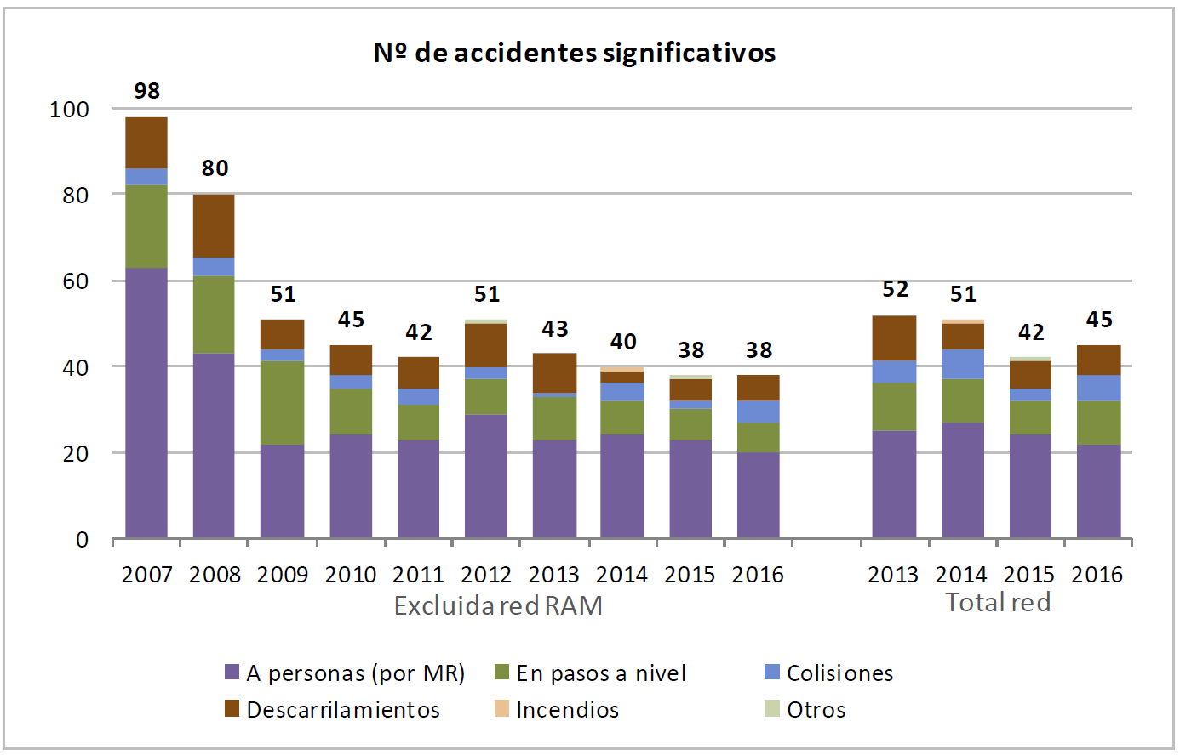

|  |  |
| --- | --- |
| Nº de accidentes significativos | No of significant accidents |
| Excluida red RAM | Excluding the RAM network |
| Total red | Total network |
| A personas (por MR) | Involving people (by rolling stock) |
| Descarrilamientos | Derailments |
| En pasos a nivel | At level crossings |
| Incendios | Fires |
| Colisiones | Collisions |
| Otros | Others |

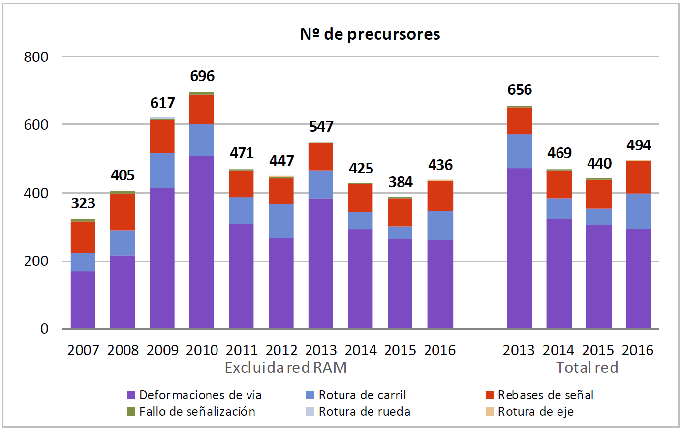

|  |  |
| --- | --- |
| Nº de precursores | Number of precursors |
| Excluida red RAM | Excluding the RAM network |
| Total red | Total network |
| Deformaciones de vía | Track warping |
| Fallo de señalización | Signal Failure |
| Rotura de carril | Broken rail |
| Rotura de rueda | Broken wheel |
| Rebases de señal | Signal overrun |
| Rotura de eje | Broken axle |

* FATALITIES

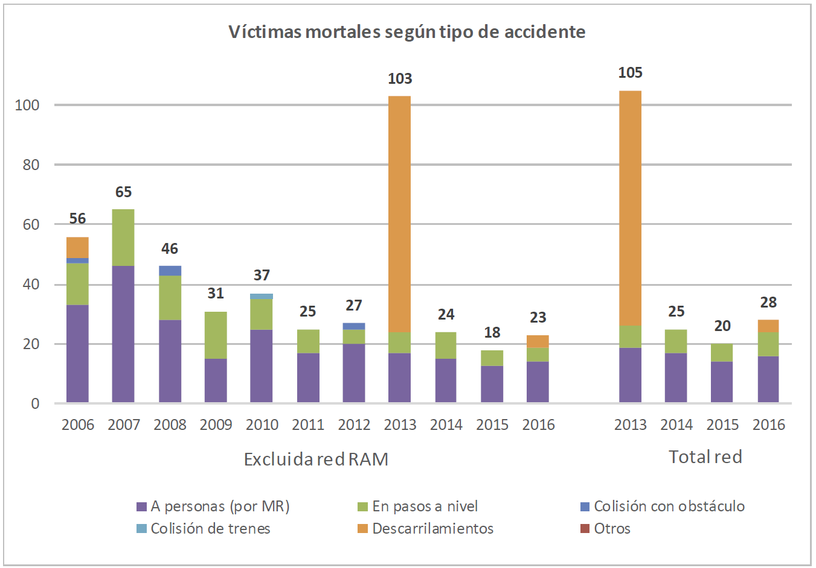

|  |  |
| --- | --- |
| Víctimas mortales según tipo de accidente | Fatalities by type of accident |
| Excluidared RAM | RAM network excluded |
| Total red | Total network |
| A personas (por MR) | Involving people (by rolling stock) |
| Colisión de trenes | Train crash |
| En pasos a nivel | At level crossings |
| Descarrilamientos | Derailments |
| Colisión con obstáculo | Collision with an obstacle |
| Otros | Others |

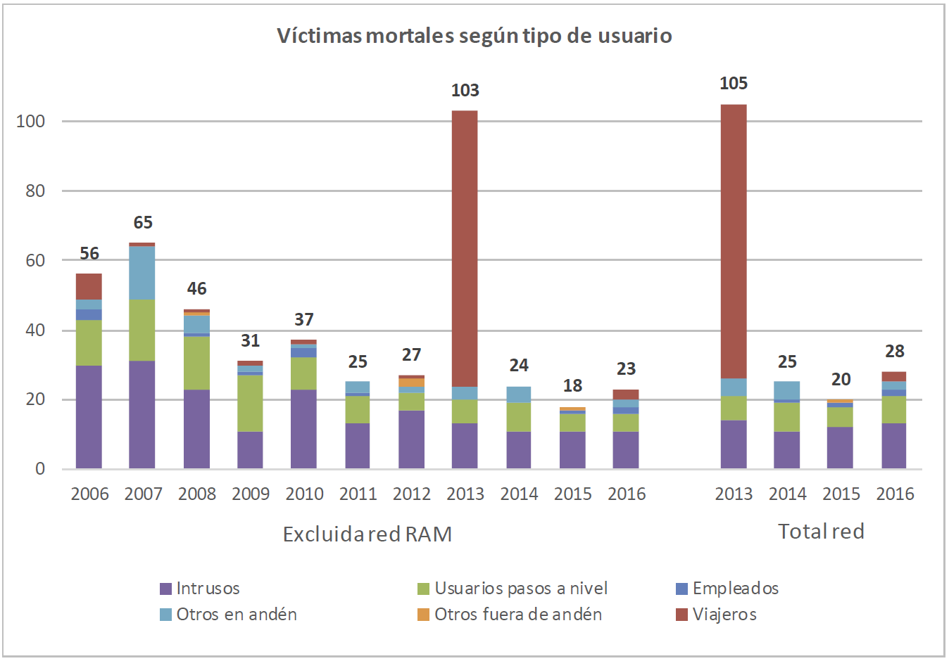

|  |  |
| --- | --- |
| Víctimas mortales según tipo de usuario | Fatalities by type of user |
| Excluida red RAM | Excluding the RAM network |
| Total red | Total network |
| Intrusos | Trespassers |
| Otros en andén | Other on platform |
| Usuarios pasos a nivel | Level crossing users |
| Otros fuera de andén | Other outside platform |
| Empleados | Employees |
| Viajeros | Passengers |

* SERIOUS INJURIES

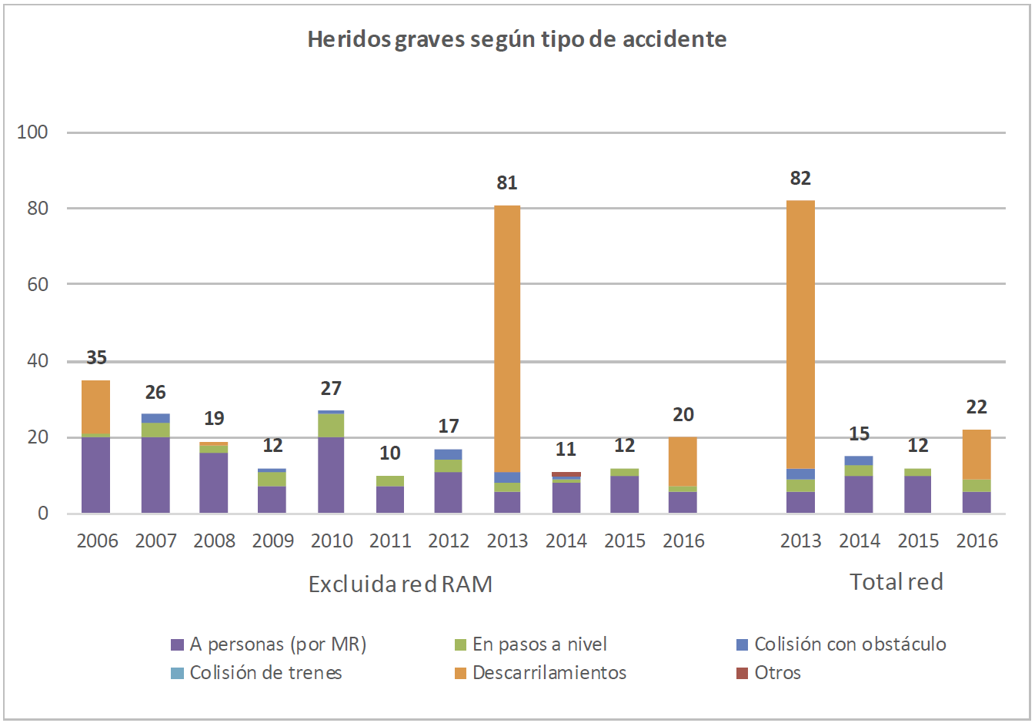

|  |  |
| --- | --- |
| Heridos graves según tipo de accidente | Serious injuries by type of accident |
| Excluida red RAM | Excluding the RAM network |
| Total red | Total network |
| A personas (por MR) | Involving people (by rolling stock) |
| Colisión de trenes | Train crash |
| En pasos a nivel | At level crossings |
| Descarrilamientos | Derailments |
| Colisión con obstáculo | Collision with an obstacle |
| Otros | Others |

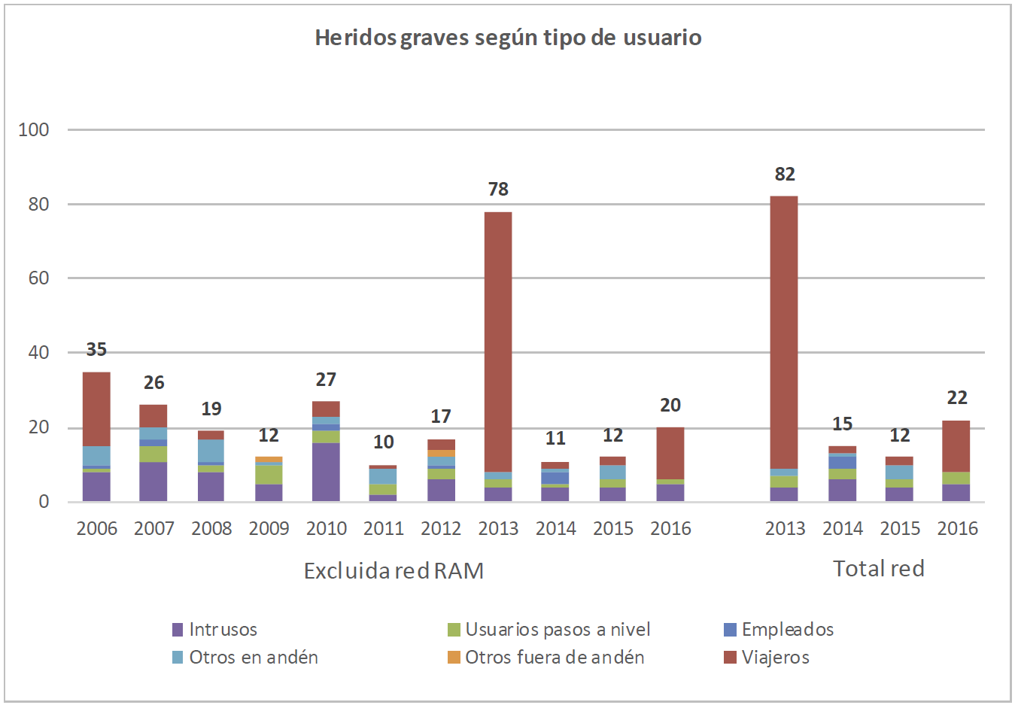

|  |  |
| --- | --- |
| Heridos graves según tipo de usuario | Serious injuries by type of user |
| Excluida red RAM | Excluding the RAM network |
| Total red | Total network |
| Intrusos | Trespassers |
| Otros en andén | Other on platform |
| Usuarios pasos a nivel | Level crossing users |
| Otros fuera de andén | Other outside platform |
| Empleados | Employees |
| Viajeros | Passengers |

* REFERENCE DATA

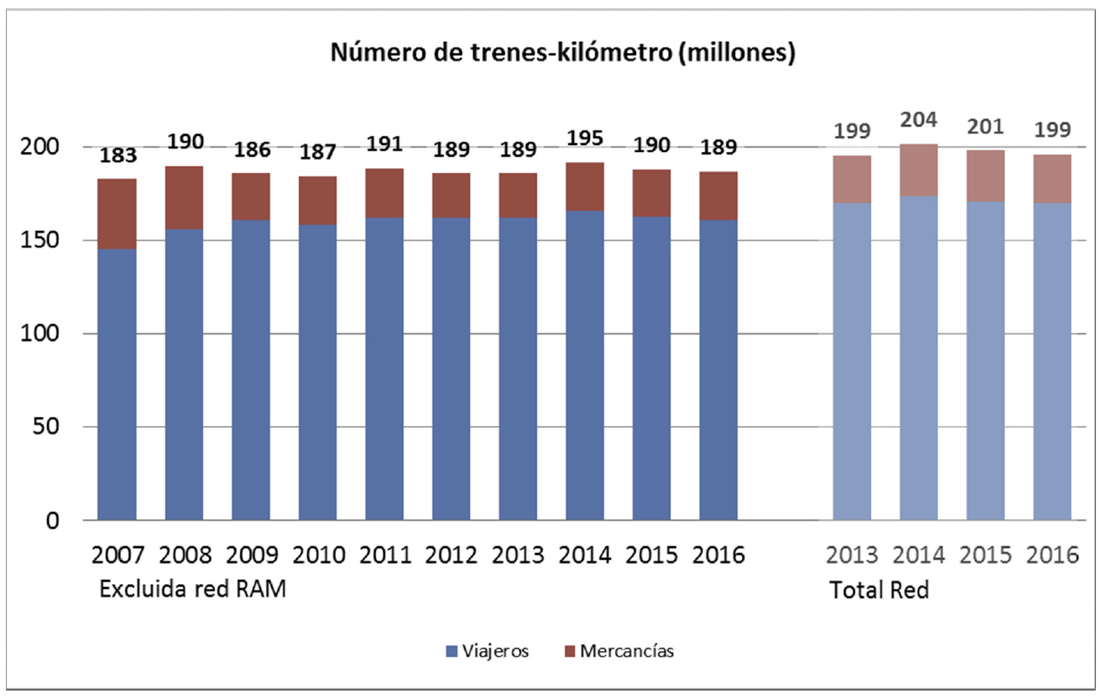

|  |  |
| --- | --- |
| Número de trenes - kilómetro(millones) | Number of train-kilometres (millions) |
| Excluida red RAM | Excluding the RAM network |
| Total Red | Total network |
| Viajeros | Passengers |
| Mercancías | Freight |

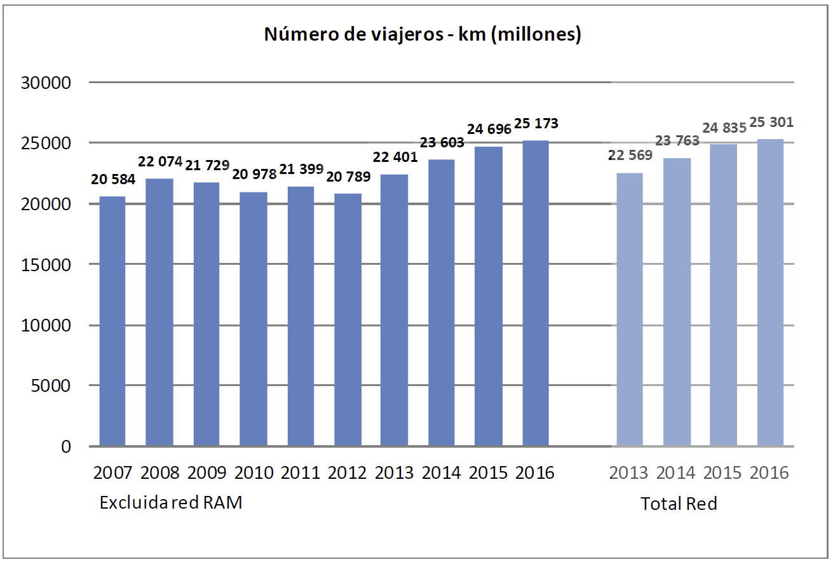

|  |  |
| --- | --- |
| Número de viajeros - km(millones) | Number of passenger-kilometres (millions) |
| Excluida red RAM | Excluding the RAM network |
| Total Red | Total network |

* RISK INDICATORS BY CATEGORY OF PERSONS INVOLVED
* TOTAL: ALL CATEGORIES OF PERSONS INVOLVED:

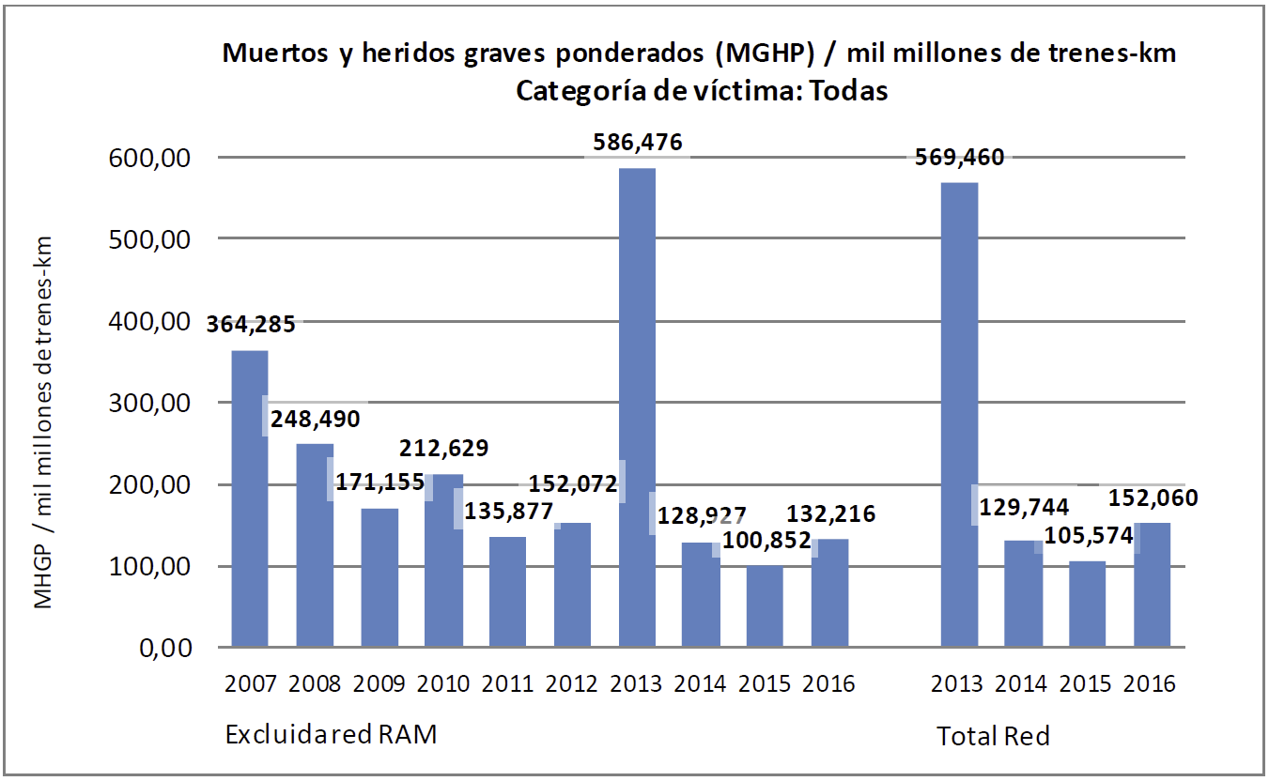

|  |  |
| --- | --- |
| Muertos y heridos graves ponderados (MGHP) / mil millones de trenes-km | Weighted fatalities and serious injuries (WFSI) / billion train-kilometres |
| Categoría de víctima: Todas | Victim category: All |
| Excluidared RAM | RAM network excluded |
| Total Red | Total network |
| MHGP / mil millones de trenes-km | FWI / billion train-km |

* EMPLOYEES

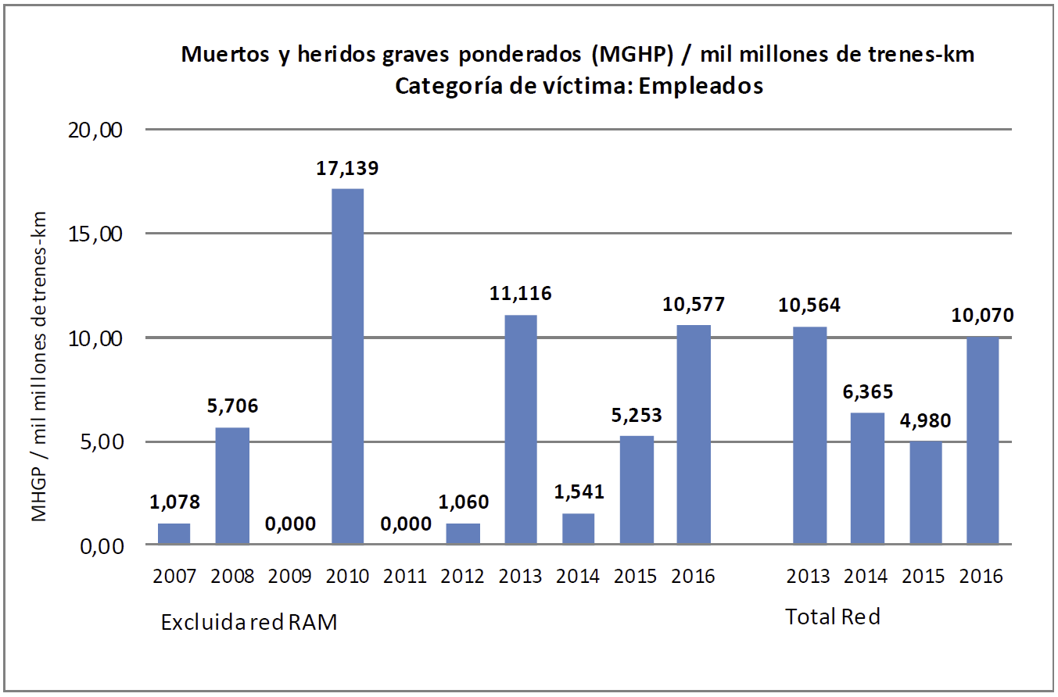

|  |  |
| --- | --- |
| Muertos y heridos graves ponderados (MGHP) / mil millones de trenes-km | Weighted fatalities and serious injuries (WFSI) / billion train-kilometres |
| Categoría de víctima: Empleados | Victim category: Employees |
| MHGP / mil millones de trenes-km | FWI / billion train-km |
| Excluida red RAM | Excluding the RAM network |
| Total Red | Total network |

* PASSENGERS

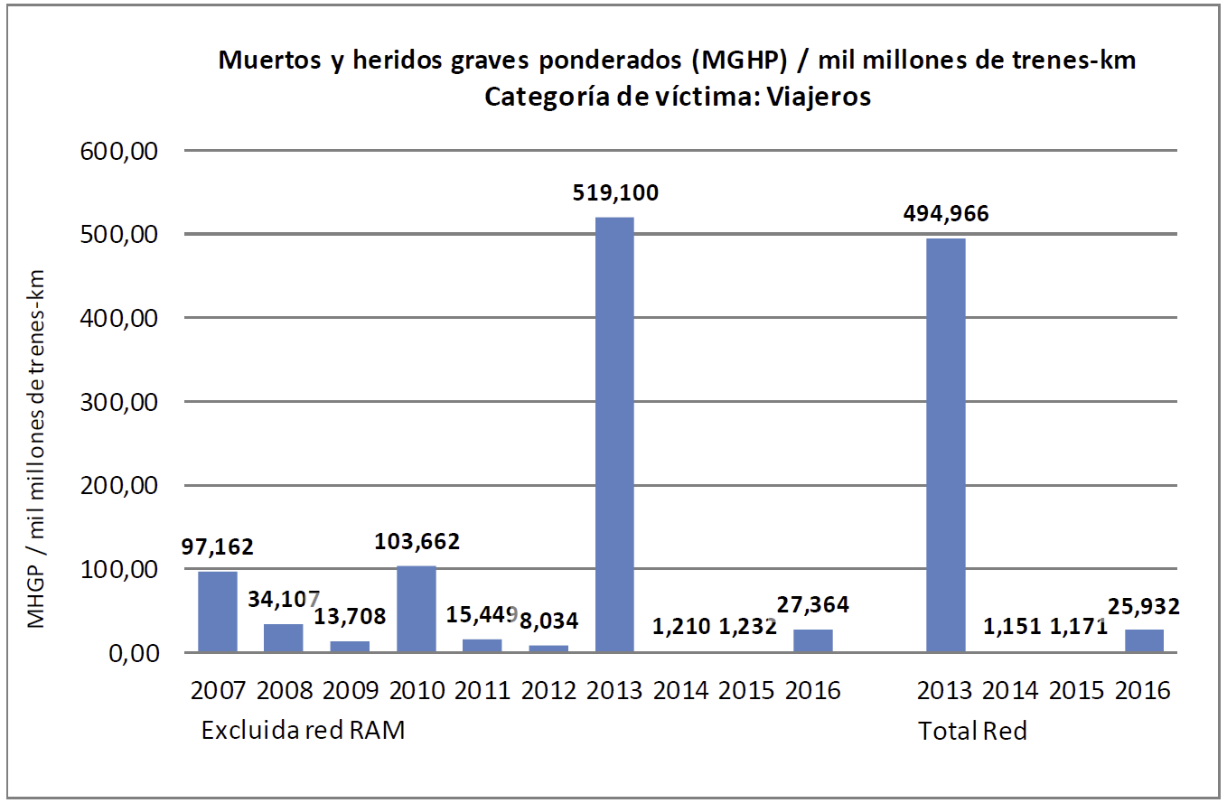

|  |  |
| --- | --- |
| Muertos y heridos graves ponderados (MGHP) / mil millones de trenes-km | Weighted fatalities and serious injuries (WFSI) / billion train-kilometres |
| Categoría de víctima: Viajeros | Victim category: Passengers |
| MHGP / mil millones de trenes-km | FWI / billion train-km |
| Excluida red RAM | Excluding the RAM network |
| Total Red | Total network |

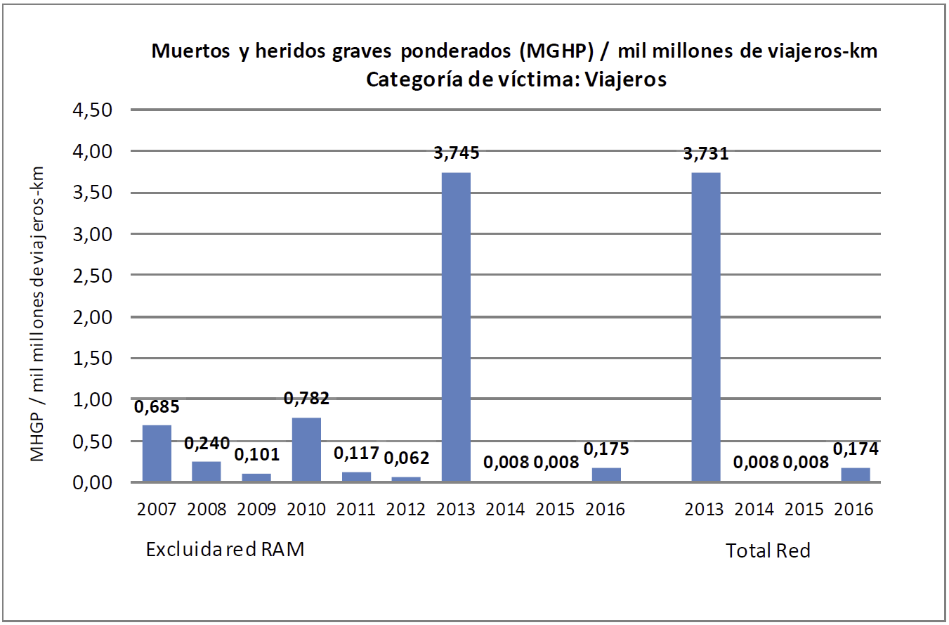

|  |  |
| --- | --- |
| Muertos y heridos graves ponderados (MGHP) / mil millones de viajeros-km | Weighted fatalities and serious injuries (WFSI) / billion passenger-kilometres |
| Categoría de víctima: Viajeros | Victim category: Passengers |
| MHGP / mil millones de viajeros-km | FWI / billion passenger-km |
| Excluida red RAM | Excluding the RAM network |
| Total Red | Total network |

* LEVEL CROSSING USERS

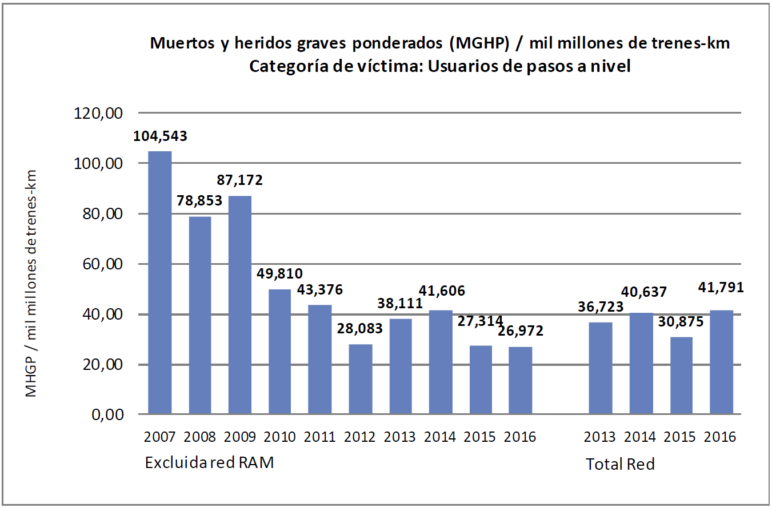

|  |  |
| --- | --- |
| Muertos y heridos graves ponderados (MGHP) / mil millones de trenes-km | Weighted fatalities and serious injuries (WFSI) / billion train-kilometres |
| Categoría de víctima: Usuarios de pasos a nivel | Victim category: Level crossing users |
| MHGP / mil millones de trenes-km | FWI / billion train-km |
| Excluida red RAM | Excluding the RAM network |
| Total Red | Total network |

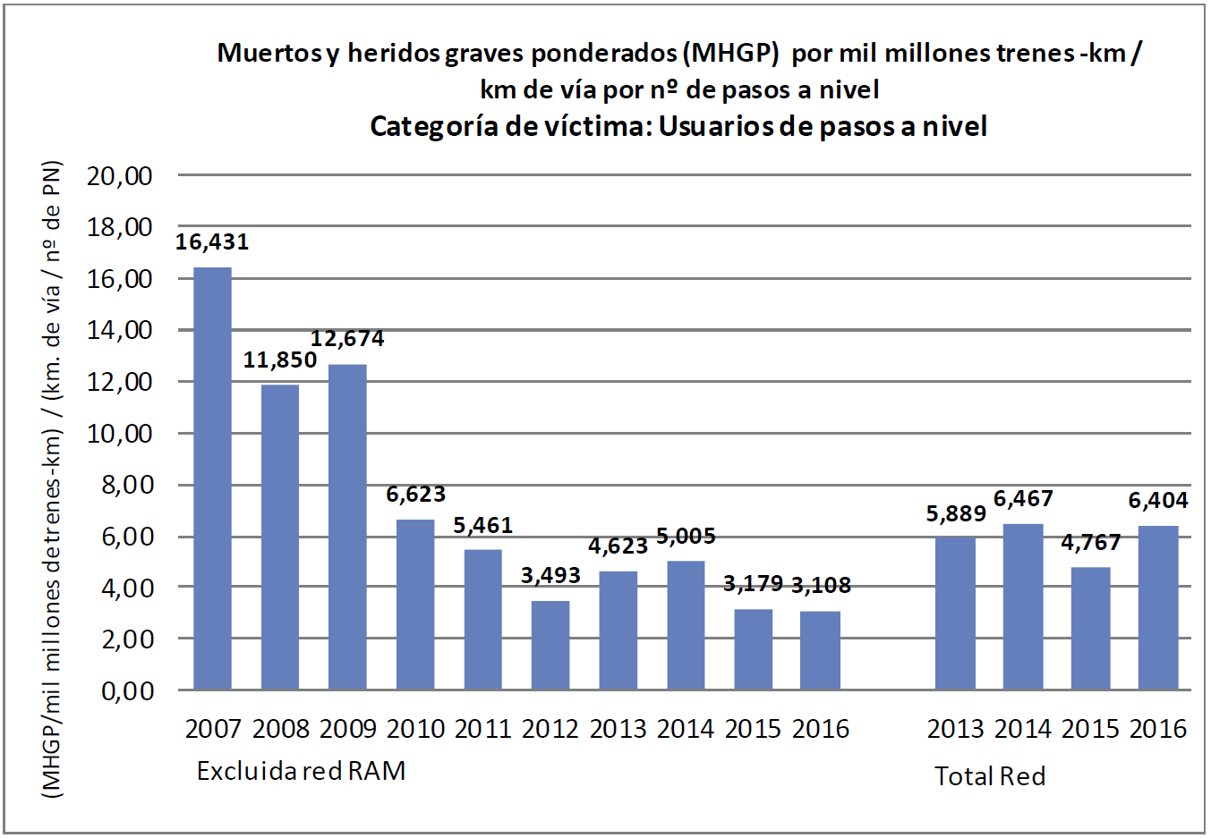

|  |  |
| --- | --- |
| Accidental weighted fatalities and serious injuries (WFSI) per billion train-kilometres / km of track per no. of level crossings | Accidental weighted fatalities and serious injuries (WFSI) per billion train-kilometres / km of track per no. of level crossings |
| Categoría de víctima: Usuarios de pasos a nivel | Victim category: Level crossing users |
| (MHGP/mil millones detrenes-km) / (km. de vía / nº de PN) | (FWI/billion trains-km) / (track km / PN no.) |
| Excluida red RAM | Excluding the RAM network |
| Total Red | Total network |

* UNAUTHORISED PERSONS

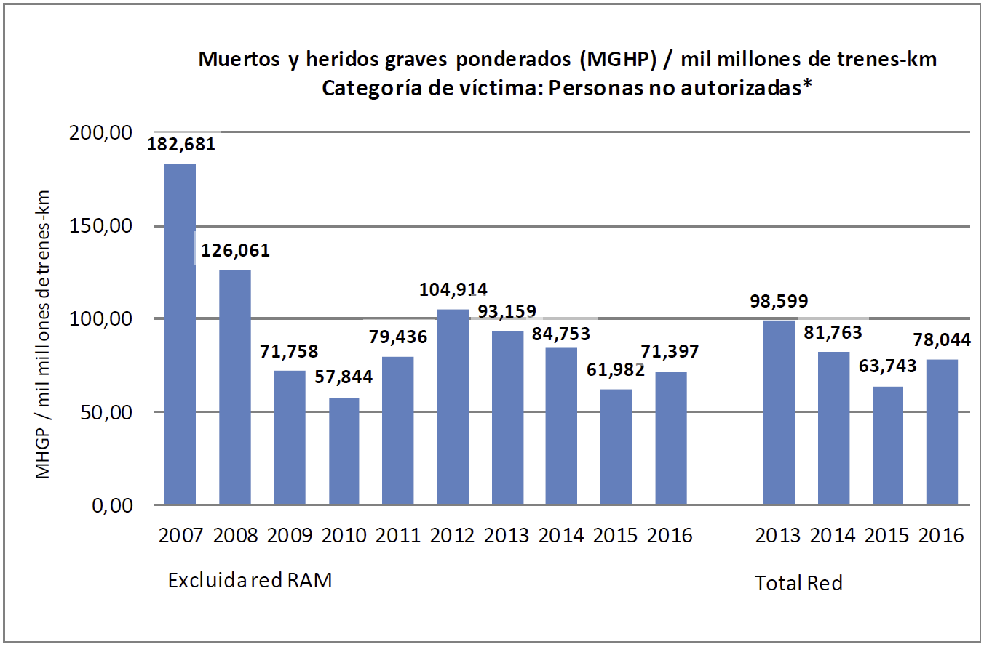

|  |  |
| --- | --- |
| Muertos y heridos graves ponderados (MGHP) / mil millones de trenes-km | Weighted fatalities and serious injuries (WFSI) / billion train-kilometres |
| Categoría de víctima: Personas no autorizadas* | Victim category: Unauthorised persons* |
| MHGP / mil millones detrenes-km | FWI / billion train-km |
| Excluida red RAM | Excluding the RAM network |
| Total Red | Total network |

To maintain the consistency of the historical series, the 2015 values for the '**Unauthorised persons**' category include victims from the '**Trespasser**' and '**Other person at a platform**' categories, in accordance with the definitions in Directive 2014/88.

* OTHERS

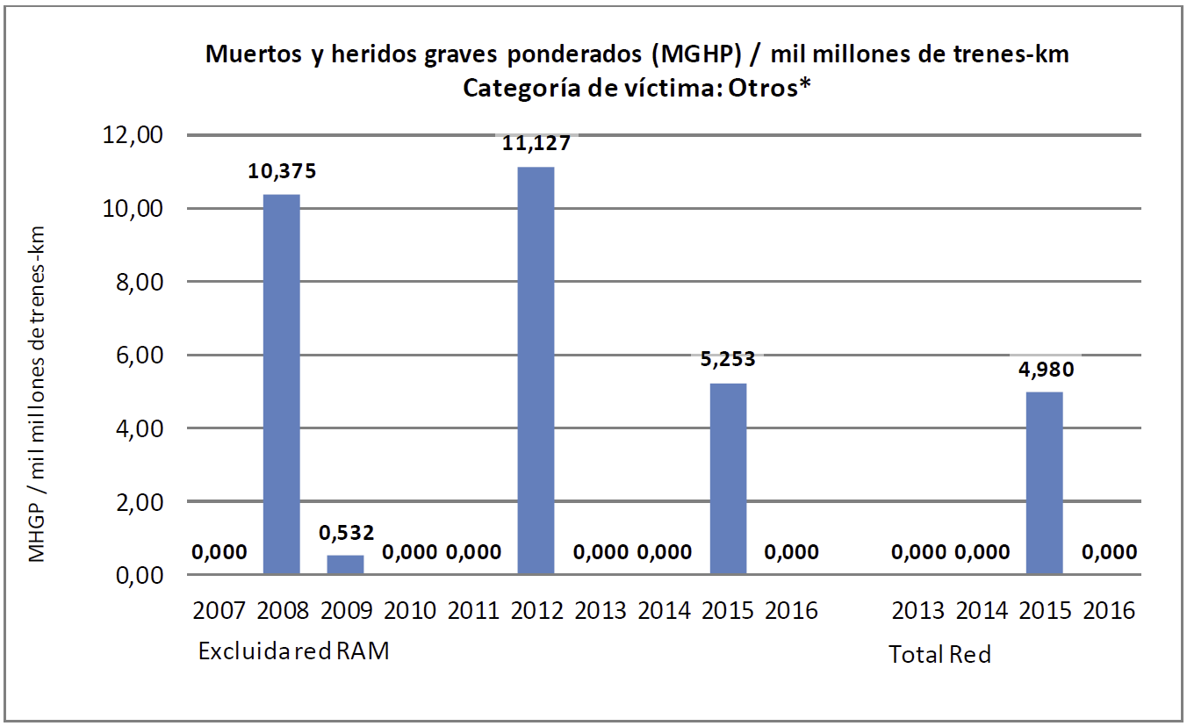

|  |  |
| --- | --- |
| Muertos y heridos graves ponderados (MGHP) / mil millones de trenes-km | Weighted fatalities and serious injuries (WFSI) / billion train-kilometres |
| Categoría de víctima: Otros* | Victim category: Others* |
| MHGP / mil millones detrenes-km | FWI / billion train-km |
| Excluida red RAM | Excluding the RAM network |
| Total Red | Total network |

(*) To maintain the consistency of the historical series, the 2015 values for the ‘**Others**’ category include victims from the ‘Other type of person at a platform’ category, in accordance with the definitions in Directive 2014/88.



1. Transposed into national legislation through Royal Decree 810/2007 of 22 June, approving the Regulation on traffic safety in the Public Railway Network.
2. On 21 December 2016, TP-FERRO concluded its activity as railway infrastructure manager. Instead, the whole activity was taken on by the new undertaking Línea Figueras Perpignan, S.A., created by agreement of the Spanish and French Ministries of Transport through the national infrastructure managers, ADIF and SNCF Réseau, respectively.
3. **Significant accident:** According to Article I of the Safety Regulations on railway traffic, approved by Royal Decree 810/2007 of 22 June: *‘any accident involving at least one railway vehicle in motion, with at least one fatality or serious injury or serious damage to the rolling stock, track, other installations or environments, or prolonged traffic disruptions. Accidents at workshops, warehouses and depots are excluded'*.

   'Serious damage to the rolling stock, track, other installations or environments' is understood as damage with a value equivalent to or greater than EUR 150 000, and 'prolonged traffic disruptions' are understood as railway services on a main railway line that are suspended for a minimum period of six hours.

   **Serious accident:** According to Article 2 of the Safety Regulations on railway traffic, approved by Royal Decree 810/2007 of 22 June: *‘any collision or derailment of trains with the result of at least one fatality or five or more serious injuries, or major damage to the rolling stock, to the infrastructure or to the environment, and any other, similar accident, with an evident effect on railway safety or on safety management. Major damage is understood as damage that can be immediately assessed by the investigation body to be worth at least two million euros in total'*.

   For consistency with the criteria used in the past, serious accidents (regardless of the type of accident) are considered to include all accidents in which there is at least one fatality or five or more serious injuries or major damage.
4. According to the definitions of types of accidents included in Article I of the Safety Regulations on railway traffic, approved by Royal Decree 810/2007 of 22 June.
5. Includes the following types of accidents: 'Collision of train with rail vehicle' and 'Collision of train with obstacle within the clearance gauge'.
6. Accidents involving people due to rolling stock in movement, not including suicides or suicide attempts.
7. Accidents at level crossings, including accidents involving pedestrians.
8. To give continuity to the statistical series, the following types of accidents are grouped together: 'Collision of train with rail vehicle' and 'Collision of train with obstacle within the clearance gauge'. There were no train collisions with a rail vehicle in 2015.
9. To give continuity to the statistical series, the following types of accidents are grouped together: 'Collision of train with rail vehicle' and 'Collision of train with obstacle within the clearance gauge'. There were no train collisions with a rail vehicle in 2016.
10. The statistical series is strongly influenced by the accident of 24 July 2013 in Angrois (Santiago de Compostela), as it significantly distorts the statistical series due to being an extraordinary event.
11. As from 2009, more restrictive criteria for quantifying track buckling began to be used, meaning the statistical series is not uniform.
12. Recommendations in final reports issued before the publication of this Annual Report (September 2017). Therefore, this report does not include any recommendations from reports on accidents in 2016 issued by the CIAF subsequent to its publication (between September and December 2017).
13. The actions relate to recommendations considered to be closed in 2016, as the AESF deemed compliance to be satisfactory. These originated from events in 2016 or earlier.
14. Order FOM 233/2006 of 31 January, regulating the conditions for the approval of railway rolling stock and maintenance centres and establishing the fees for the certification of such rolling stock.
15. Order FOM 233/2006 of 31 January, regulating the conditions for the approval of railway rolling stock and maintenance centres and establishing the fees for the certification of such rolling stock.
16. Order FOM/2872/2010 of 5 November, which sets out the conditions for obtaining the qualifying certificates that allow railway personnel to perform their duties with respect to rail traffic safety, as well as the system of officially approved training centres and the medical examination centres of said personnel. This rule was amended by Order FOM 679/2015 of 9 April.
17. Commission Regulation (EU) No 1078/2012 on a common safety method for monitoring to be applied by railway undertakings and infrastructure managers after receiving a safety certificate or safety authorisation and by entities in charge of maintenance.
18. Serious anomalies are defined as those that prevent any type of traffic if they involve infrastructure or rolling stock.
19. Modification files that have been managed during 2016 regardless of the year in which the file processing was started.