|  |  |
| --- | --- |
|  | **THE ESTONIAN TECHNICAL REGULATORY AUTHORITY** |

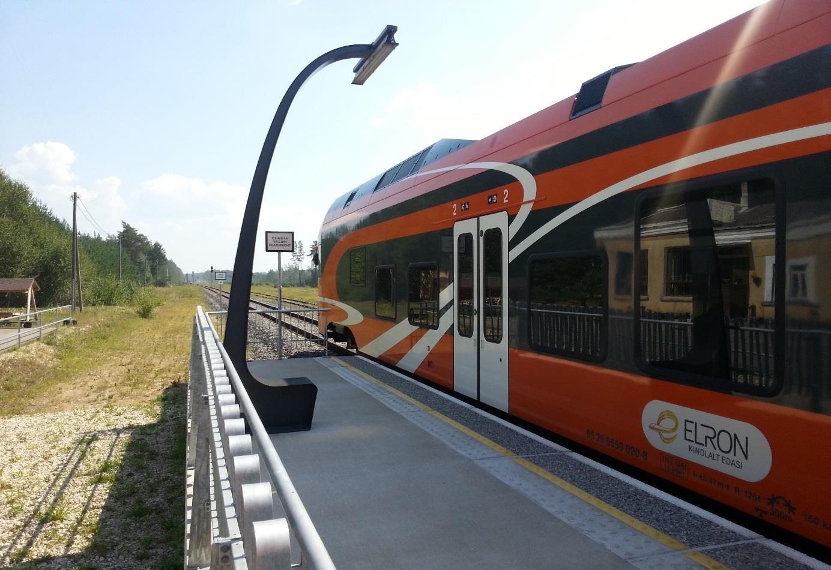

TEHNILISE JÄRELEVALVE AMETI 2016. AASTA ARUANNE

**ANNUAL REPORT OF TECHNICAL REGULATORY AUTHORITY OF ESTONIA 2016**

Table of contents

A.1 Summary 3

A.2 Summary 3

B. Introduction 4

B.1 General 4

B.2 Estonia’s railway sector 4

LISA A.1/ANNEX A.1 5

LISA A.2.1/ANNEX A.2.1 6

LISA A.2.2/ANNEX A.2.2 6

B.3 Summary – an analysis of general trends (railway safety development) 7

LISA B.3.1/ANNEX B.3.1 8

LISA B.3.2/ANNEX B.3.2 9

C. Organisation 10

C.1 The Estonian Technical Regulatory Authority 10

LISA B.1/ANNEX B.1 11

C.2 The division of responsibilities between organisations 11

LISA B.2/ANNEX B.2 12

D. The development of railway safety 12

D.1 The initiative for maintaining and improving railway safety 12

D.2 A detailed analysis of data 13

LISA C/ANNEX C – CSI data 13

D.3 Safety recommendations summary 14

E. Main amendments to legislation 15

F. The development and authorisation of safety certificates 15

F.1 National legal space – safety certificates and authorisations 15

F.2 Safety certificates issued (table) 15

F.3 Safety authorisations and safety certificates 15

G. Monitoring railway undertakings 16

H. Implementation of the Common Safety Methods (CSM) Regulation 17

I. Summary, conclusions, priorities 17

J. Primary information sources 17

# Summary

This annual report provides an overview of the Estonian railway sector and the development of railway safety in 2016. The report has been put together by the Technical Regulatory Authority (hereinafter referred to as the TRA).

In 2016, the TRA’s priority was to improve the efficiency of supervisory activities and safety-related preventive activities.

The supervision work that was carried out by the TRA’s Transportation Service in 2016 focused on checking the company’s safety activities in terms of issues related to rolling stock, infrastructure, safety documentation, and ensuring safety, as well as carrying out prevention activities. These supervisory activities demonstrated that the companies are aware of the safety risks, and employees who are responsible for managing safety issues are in possession of the required professional certificates and attend regular training courses. The company is sufficiently competent in the execution of its duties, and possesses the required skills to be able to properly operate under emergency conditions. In conclusion, the companies are operating under the umbrella of risk management, and preventive action is something that is constantly being taken.

In 2016, there were a total of 13 rail accidents, a significantly lower figure compared to the years 2015 and 2014 (in which there were nineteen and 20 accidents respectively). In 2016, there were five collisions with persons on the railway and eight collisions between trains and motor vehicles or all-terrain vehicles (ATVs). There were a total of seven persons injured, four of whom were injured during collisions and three upon impact. One person died during these accidents. This was a collision in which the individual’s premeditated action was established and therefore the case has been classified as suicide. The main cause of accidents is the lack of attention paid by road users and an underestimation of the risks related to interaction with the railway.

# Summary

This annual report provides an overview of the current situation in Estonia railway sector in 2016. The report has been composed by the Technical Regulatory Authority.

In 2016 our main priorities were related to making our surveillance activities more efficient and contributing to safety prevention activities. The auditing carried out by the Estonian NSA Railway Transport Department in 2016 focused on monitoring company's safety performance in terms of rolling stock, infrastructure, safety documentation and general safety and prevention. Surveillance activities showed that companies are aware of safety risks, the responsible employees have the corresponding qualifications and take part in regular trainings. Railway companies have sufficient competence and essential skills to be prepared to act in an emergency. All in all, companies have set a purpose to minimize risks and prevention is ongoing.

A total of 13 railway accidents were registered in 2016, which is significantly less than in 2015 (19 accidents) and 2014 (20 accidents). There were 5 accidents to persons caused by rolling stock in motion and 8 collisions between rolling stock and road vehicles. In 2016, 1 person was killed and 7 were injured in railway accidents – 3 of them in collisions and 4 of them in accidents to persons. Regarding the one accident where a person was killed, we can say that the road user planned the activity in advance and therefore the accidents is categorized as a suicide. The main reason for accidents is the inattentiveness of road users and the underestimation of rail-related hazards.

# Introduction

## General

This 2016 report is the eleventh report on railway safety to have been prepared by the TRA (earlier reports date from 2006 to 2015). Based on an analysis of the main safety indicators (accidents at level crossings, collisions, etc.), the safety report provides an overview of the developments in railway safety in Estonia. This report has been prepared for the European Union Agency for Railways (ERA) in order to provide an update on developments concerning railway safety in Estonia. The safety report is publicly available on the website [www.tja.ee](http://www.tja.ee/)

## Estonia’s railway sector

***Raudteede kaart / Railway infrastructure (public railway)***

### LISA A.1/ANNEX A.1

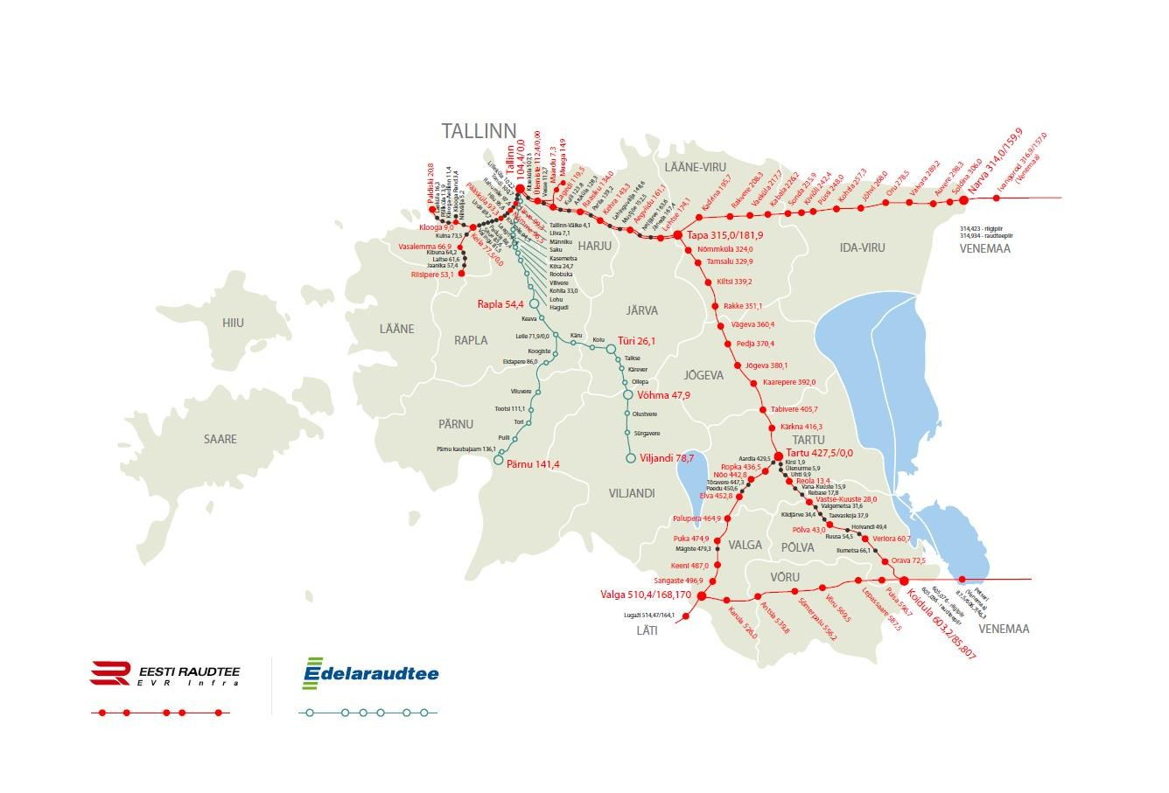

In 2016, the total length of the Estonian railways was 2 144 km, of which 1 508 km have been declared as public railways in accordance with Estonian legislation. Public railways are managed by AS Eesti Raudtee and Edelaraudtee Infrastruktuuri AS.

AS Eesti Raudtee (a state-owned company) owns and manages 1 285 km of the railway (including double-track railways and electrified lines). Edelaraudtee Infrastruktuuri AS, a private undertaking which is a subsidiary of Edelaraudtee AS, owns and manages 223 km of the railway.

A total of 916 km of the entire length of Estonia’s railways are primary tracks on public railways, and 132 km of railway has been electrified.

As of the end of 2016, the Estonian state railway traffic register included 281 locomotives, 19 electric and 49 diesel railcars, 276 passenger coaches, and 21 586 freight wagons. In 2016, one locomotive was commissioned from new, and 157 freight wagons were registered as new*.*

Over the course of the year, the number of passengers travelling by rail increased by 4% and the total number of railway passengers reached 6.9 million in 2016. There were a total of 6.8 million passengers who used domestic railways (a 3% increase over the previous year), and 102 800 passengers travelled on international railway lines (doubling the figure from the previous year). Railway passenger turnover increased by 11% within a year, reaching 315.9 million passenger kilometres in 2016.

### LISA A.2.1/ANNEX A.2.1

|  |  |
| --- | --- |
| **Avaliku raudteeinfrastruktuuri majandajad /** *Public Railway Infrastructure Managers* | |
| 1. AS Eesti Raudtee | TEN-T (except Valga-Koidula, Keila-Riisipere and Klooga-Klooga-Ranna) |
| 2. Edelaraudtee Infrastruktuuri AS | Non-TEN-T |

### LISA A.2.2/ANNEX A.2.2

In comparison with 2015, we have added to the table infrastructure managers operating in Estonia who have been granted safety certificates, Parts A and B, but who are operating primarily on a local basis at the various stations. During previous years, the table has shown the main infrastructure managers, ERS, operating on the Estonian public infrastructure. AS and EVR Cargo AS.

|  |  |
| --- | --- |
| **Railway undertakings (cargo transport on the public railway infrastructure in Estonia)**  *Railway Undertakings (cargo)* | |
| 1. ERS AS | Ohutustunnistus väljastatud 2013  *Safety certificate issued 2013* |
| 2. EVR Cargo AS | Ohutustunnistus väljastatud 2014  *Safety certificate issued 2014* |
| 3. Alexela Terminal AS | Ohutustunnistus väljastatud 2015  *Safety certificate issued 2015* |
| 4. Enefit Kaevandused AS | Ohutustunnistus väljastatud 2015  *Safety certificate issued 2015* |
| 5. Edelaraudtee AS | Ohutustunnistus väljastatud 2014  *Safety certificate issued 2014* |
| 6. AS Kunda Trans | Ohutustunnistus väljastatud 2013  *Safety certificate issued 2013* |

|  |  |
| --- | --- |
| 7. Vesta Terminal Tallinn OÜ | Ohutustunnistus väljastatud 2013  *Safety certificate issued 2013* |
| 8. Westgate Transport OÜ | Ohutustunnistus väljastatud 2013  *Safety certificate issued 2013* |
| 9. AS Maardu Raudtee | Ohutustunnistus väljastatud 2013  *Safety certificate issued 2013* |
| 10. Dekoil OÜ | Ohutustunnistus väljastatud 2013  *Safety certificate issued 2013* |
| 11. AS Railservis | Ohutustunnistus väljastatud 2013  *Safety certificate issued 2013* |
| 12. AS Sillamäe Sadam | Ohutustunnistus väljastatud 2013  *Safety certificate issued 2013* |
| 13. Leonhard Weiss RTE AS | Ohutustunnistus väljastatud 2012  *Safety certificate issued 2012* |
| **Railway companies involved in transporting passengers in Estonia**  *Railway undertakings (passenger)* | |
| 1. GoRail AS | Rahvusvaheline reisijatevedu veduriteenuse osutamisena Tallinn-Peterburg- Moskva  *Providing locomotive running service*  *in international passenger-train service Tallinn-St. Petersburg - Moscow* |
| 2. Eesti Liinirongid AS (Elron) | Riigisisene reisijatevedu diisel- ja elektrirongidega  *National passenger-train service by EMU-s and DMU-s* |
| 3. Edelaraudtee AS | Riigisisene reisijatevedu diiselrongidega  *National passenger-train service by DMU-s* |

## Summary – an analysis of general trends (railway safety development)

In order to assess the level of railway safety and the quality of train services, we have taken into account safety indicators related to accidents and incidents that have occurred during the year.

When calculating the level of railway safety, three indicators are used – the number of deaths, the number of injuries, and the number of suicides. In the case of railway traffic safety levels, cases that influence railway traffic safety (such as incidents involving signals passed at danger), technical incidents (such as rail breakages), and third party-related cases that include rolling stock collisions with obstacles in free dimensions, and road vehicle collisions involving rolling stock at level crossings. These three indicators each have a different share of safety indicators. In the case of both public railway safety levels and railway traffic safety levels, the result is a ratio which depends upon the number of train-kilometres travelled.

When compared to previous years, public railway safety levels have improved significantly (from 0.26 to 0.10), with the main reason being the fewer number of deaths. When compared to 2016, the railway traffic safety level has deteriorated somewhat (from 0.74 to 0.80), which can be explained by technical incidents and the higher total number of third party-related cases.

In 2016, processing of the 2030+ county plans was fully completed. In total, 12 county plans and seven comprehensive plans were processed. It should be noted the people responsible for drafting the plans have started to add issues to the explanatory notes for the plans where these are related to railway safety. In details which describe level crossings, attention is paid to visibility.

### LISA B.3.1/ANNEX B.3.1

Raudteeveeremi ja maanteesõiduki kokkupõrked raudteeületuskohtadel (2006-2016) / *Level crossing accidents (excluding accidents involving pedestrians at level crossings), collisions (2006-2016)*

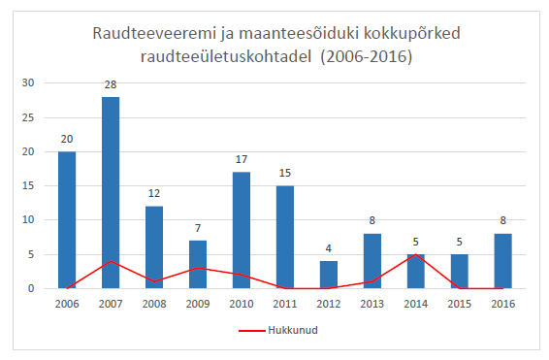

|  |  |
| --- | --- |
| Raudteeveeremi ja maanteesõiduki kokkupõrked raudteeületuskohtadel (2006-2016) | Level crossing accidents involving the railway and road vehicles (2006-2016) |
| Hukkunud | Deaths |

In 2016, there were a total of 13 railway accidents, a significantly lower number than in 2015 and 2014 (where there were 19 and 20 accidents respectively). There were eight collisions between motor or all-terrain vehicles (ATV) and trains. A total of seven persons were injured in accidents, three of them in collisions.

The main cause of accidents is the lack of attention paid by road users and an underestimation of the risks related to interaction with the railway.

An analysis of the causes of the accidents shows that, in order to be able to prevent dangerous situations and tragic consequences, road users need to improve their behaviour on the road and be aware that railways are a high risk area.

### LISA B.3.2/ANNEX B.3.2

Raudteeveeremi otsasõidud inimestele (2006-2016) / *Accidents to persons caused by rolling stock in motion 2006-2016*

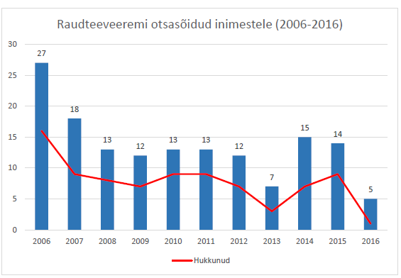

|  |  |
| --- | --- |
| Raudteeveeremi otsasõidud inimestele (2006-2016) | Collisions between railway vehicles and people (2006-2016) |
| Hukkunud | Deaths |

In 2016, there were a total of five collisions with people who were on the railway, in which four persons were injured and one person died. This was a collision in which the person’s premeditated action was established and therefore the case has been classified as suicide. In 2015, there were a total of 14 collisions with persons who were on the railway, in which nine persons died and five were injured. Compared to 2015, the situation has improved significantly – the number of collisions has more than halved and the number of injuries and deaths resulting from accidents has also dropped significantly. The main reason for collisions continues to be road users’ lack of attention and trespassing on the railway in unauthorised locations.

# Organisation

## The Estonian Technical Regulatory Authority

The TRA is a governmental authority operating within the Ministry of Economic Affairs and Communications (MoEAC). Its aim is to contribute to the implementation of Estonia’s economic policy through improved safety, organising the efficient use of limited resources, and improving the reliability of products in the fields of production, industrial equipment, railways and electronic communications.

The TRA’s Transportation Service has three departments: the railway infrastructure department, the railway transport department, and the transport investments department, which in 2016 employed a total of 18 people.

The Transportation Service is involved in activities that are provided for in national legislation (the Railways Act and legal acts adopted pursuant to that Act). As a national safety authority, it monitors the compliance of railway undertakings with EU legislation on interoperability and safety. In addition, the service participates in the practical implementation of the relevant legislation.

The TRA’s Transportation Service has the jurisdiction to issue safety certificates and process their renewal, check compliance of the railway infrastructure and the railway traffic management process with the requirements, approve detailed plans and the design criteria for railway civil engineering works, exercise state supervision over the performance of construction works on the railways, issue building permits and permits for use, issue train driving licences, operate within the capacity of recognising vocations, carry out activities related to the distribution of railway capacity, ensure that the Republic of Estonia's obligations are carried out in regard to the technical surveillance of the railways under international treaties, represent the Republic of Estonia with international railway organisations, if necessary, and carry out any other function defined by law. Furthermore, the Technical Regulatory Authority monitors the competency of those persons who are responsible for railway safety and the organisation of railway traffic, and it also oversees the observance of railway fire safety regulations and the organisation of the transportation of hazardous goods. We also carry out administrative proceedings concerning non-compliance with railway safety requirements.

By means of its activities, the TRA ensures the secure and safe development of the Estonian railway network through continuous surveillance in accordance with national legislation and European law. Furthermore, the TRA, together with the MoEAC, is responsible for harmonising and updating the legal basis of the Estonian railway sector.

Organisatsiooni struktuur / *Organization structure*

### LISA B.1/ANNEX B.1

## The division of responsibilities between organisations

The MoEAC includes a Road and Railways Department, which participates in drawing up national development plans for the road network, freight and passenger transport, railway infrastructure, railway transport logistics, railway passenger and freight transport, vehicles, railway vehicles, road and railway traffic, and also traffic and environmental safety issues, as well as ensuring the implementation of the development plans and preparing drafts of acts that regulate this area.

The Estonian Safety Investigation Bureau (the *National Investigation Body* or NIB) is an independent structural unit under the MoEAC, responsible for investigating railway accidents and conducting safety investigations.

The TRA (as a *National Safety Authority,* or NSA), exercises state supervision over the functions provided for by law and applies the state’s enforcement powers on the basis of and to the extent provided for by law. The Transportation Service also issues railway structure building permits and permits for the use of construction works, as well as safety certificates, Parts A and B, and operational safety certificates to railway infrastructure managers and railway undertakings. Train driver exams are organised and driving licences are issued in cooperation with the Regional Office of Road Administration.

Estonian railway undertakings are required to ensure compliance of their activities with requirements provided for by law, regarding the management of the railway infrastructure, provision of freight and passenger transport services, repairs to rolling stock, and the construction of railway facilities.

Organisatsiooni seos raudteevaldkonna teiste ettevõtete ja asutustega / *Organizational relationship chart*

### LISA B.2/ANNEX B.2

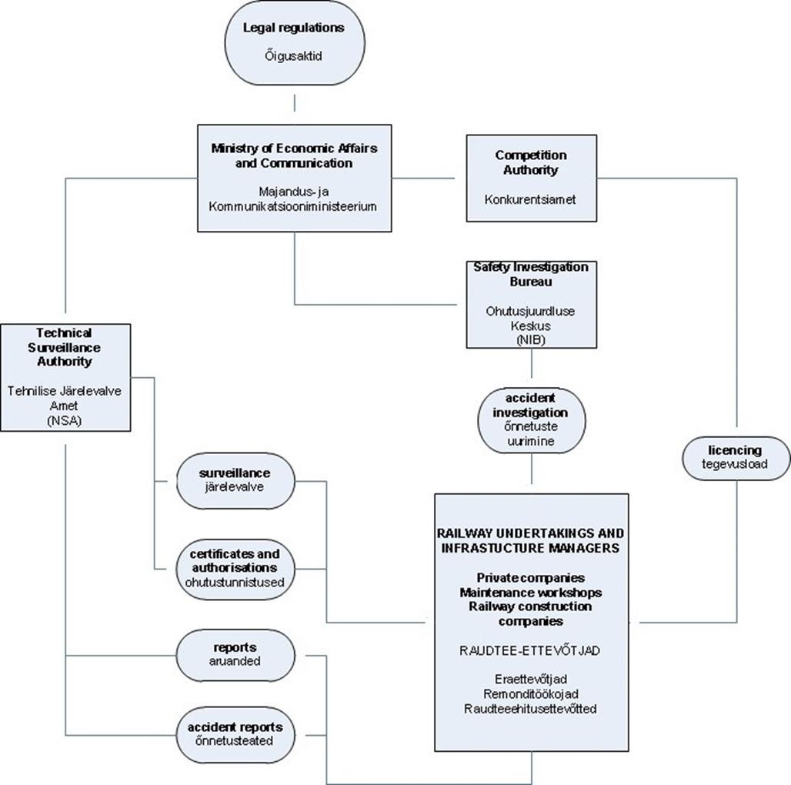

# The development of railway safety

## The initiative for maintaining and improving railway safety

In 2016, railway safety focused its attention on prevention in the field of safety, cooperation with entrepreneurs, being responsible for the preparation of educational materials in the field of safety and for cooperation between organisations in railway safety campaigns.

In 2016, a joint project between the TRA, the University of Tartu, and NPA Lifesaver Estonia (OLE) was completed. As a result, the study results for the railway safety sub-topic within the main subject of ‘Health and safety’, and the teacher’s railway safety book for the third school year were completed. The study material focuses on several important topics with regard to railway safety: risks involving unrelated activities when moving around near a railway, crossing the railway safely on foot and by bicycle, etc. There is some focus on following railway traffic rules and on accidents which may result from a violation of these rules, and also on preventing dangerous situations involving railways located on children’s routes to school. Photos and videos produced during the course of the project, which help to address the topic, bring added value to the study materials.

As a follow-up activity to this project, the TRA is participating in the cross-institutional safety taskforce during 2016-2018. The taskforce is involved in the wording of the common study results for the main subject of ‘Health and safety’, specifically for the first to fourth study stages, and in the preparation of teacher’s books. The aim is to achieve a common approach to the topic of safety among all institutions participating in the taskforce. The Ministry of the Interior and the University of Tartu are leading this taskforce. In addition, other national ministries and boards involved in safety issues are participating in the project.

The TRA continued its cooperation with NPA Operation Lifesaver Estonia in railway safety campaigns in 2016. In spring 2016, a national railway safety campaign was carried out in Estonia with the message ‘Being on the railway is prohibited’. One of the aims of this campaign was to remind people that railways can be crossed only at designated crossing points and that walking along the railway tracks or spending any time in their vicinity is dangerous and is therefore prohibited by law. The campaign was organised by NPA Operation Lifesaver Estonia, in collaboration with the TRA, the Police and Border Guard Board, and the Road Administration and Rescue Board. In addition, a Christmas campaign was conducted in December 2016 to remind road users to be extremely careful when crossing the railway and to make sure a train is not approaching before crossing. The slogan of the campaign was ‘They expect you to come home for Christmas’. This was the thirteenth time in which the Christmas campaign was organised by NPA Operation Lifesaver Estonia.

## A detailed analysis of data

### LISA C/ANNEX C – CSI data

Input from the TRA into the Common Safety Indicators (CSI) data table for 2016 has been uploaded to the ERAIL information system (<http://erail.era.europa.eu/>).

|  |  |  |  |
| --- | --- | --- | --- |
| ***aasta year*** | ***raudteeõnnetused railway accidents*** | ***surmajuhtumid fatalities*** | ***vigastatud injuries*** |
| ***2006*** | ***47*** | ***16*** | ***21*** |
| ***2007*** | ***46*** | ***13*** | ***19*** |
| ***2008*** | ***26*** | ***9*** | ***10*** |
| ***2009*** | ***19*** | ***10*** | ***7*** |
| ***2010*** | ***31*** | ***12*** | ***14*** |
| ***2011*** | ***28\**** | ***9*** | ***7*** |
| ***2012*** | ***20\**** | ***7*** | ***7*** |
| ***2013*** | ***15\**** | ***4*** | ***4*** |
| ***2014*** | ***20\**** | ***12*** | ***19*** |
| ***2015*** | ***19\**** | ***9*** | ***5*** |
| ***2016*** | ***13\**** | ***1*** | ***7*** |

*The railway accidents field includes both collisions between motor vehicles and rolling stock, and accidents to persons caused by rolling stock in motion, as well as derailments of and collisions between trains. In previous years, this field has reflected only collisions and accidents to persons caused by rolling stock in motion because collisions between trains during shunting operations were not classified as accidents involving rolling stock in motion. In recent years, the Estonian legal space has been brought into accordance with European law with the result that the total number of accidents also includes derailments of and collisions between trains during shunting operations.

One attempted suicide in which a person was injured was added to the number of persons injured in 2016.

## Safety recommendations summary

In 2016, the Safety Investigation Bureau submitted a report to the TRA on rail breakages in the railway infrastructure for AS Eesti Raudtee, investigated in 2015 and 2016. The Safety Investigation Bureau submitted its comments and opinions regarding rail breakages in thermite welding, concluding that the company had applied appropriate measures for operational activities when it came to preventing, identifying, and mending rail breakages. As no serious accidents had occurred, the Safety Investigation Bureau did not send any recommendations to the TRA in 2016.

All of the safety investigation reports and recommendations which had been prepared earlier are now in the public domain and are available from the Estonian Safety Investigation Bureau's website: <http://www.ojk.ee/>.

# Main amendments to legislation

In 2016, preparation of two national railway standards was completed. The first standard is called ‘EVS 930:2016 Railway applications. Requirements for railway vehicles with guided wheels’. This standard concerns railway vehicles with guided wheels on Estonian railways, requirements regarding the guided wheels of these vehicles and other equipment, driving onto and off the rails, and conditions for driving on the rails. The second standard has been named ‘EVS 931:2016 Railway applications. Written road and traffic permits, notices and book forms used for coordinating railway traffic’. This standard establishes the requirements for Estonian railway traffic (including shunting) in terms of negotiations, commands, orders, documents, and the description of and procedure for the use of traffic safety documents when coordinating railway traffic.

# The development and authorisation of safety certificates

## National legal space – safety certificates and authorisations

Regulations concerning safety certificates are laid down in Section 2: ‘Safety authorisation, safety certificate, and operational safety certificate’ in Chapter 2: ‘Operating licence, liability insurance contract, safety authorisation, safety certificate, and operational safety certificate’.

In order to regulate the issuing of safety authorisations, Commission Regulation (EU) No 1158/2010 of 9 December 2010 on a common safety method for assessing conformity with the requirements for obtaining railway safety certificates and Commission Regulation (EU) No 1077/2012 of 16 November 2012 on a common safety method for supervision by national safety authorities after issuing a safety certificate or safety authorisation were both adopted.

The national legislation that regulates the safety certificates process is Regulation No 24 of the Ministry of Economic Affairs and Communications: ‘The procedure for applying for and preparing safety certificates and operational safety certificates’, dated 24 March 2014. The legislation referred to above is available at [www.riigiteataja.ee](http://www.riigiteataja.ee/).

## Safety certificates issued (table)

No safety certificates were issued to operators in 2016.

## Safety authorisations and safety certificates

As of 2016, 16 operators hold safety certificates and two operators hold safety authorisations. There were no renewals of either Part A or B passenger safety certificates in 2016. In the same year, two freight operators started the process of renewing Parts A and B of their safety certificates. There were a total of 13 valid safety certificates for freight and three valid certificates for passengers. In addition there were two safety certificates covering the management of the public railway.

In 2016, two safety certificates were issued for operating on privately-owned railway infrastructure. One of them was for freight operations and the other was for traffic management.

# Monitoring railway undertakings

As regards supervision of railway safety, our main aim was to improve the efficiency of supervisory activities. In the course of supervisory activities, attention was paid to all the safety activities of the companies involved. We checked the rolling stock, infrastructure, safety documents, and other issues related to ensuring safety and carrying out preventive work.

In 2016, we carried out safety supervision activities with the biggest railway undertaking in Estonia, AS Eesti Raudtee. Furthermore, we checked 20 smaller undertakings. During the course of the supervisory process we checked safety documents, the safety management system, rolling stock and repair plans, awareness amongst employees, preventive activities, and assessed risk analyses and contingency plans for ensuring safety. The results of the supervisory work show that companies are aware of the safety risks and that employees hold the respective professional certificates and regularly undergo the requisite training. The risks are being managed for key areas and preventive work is ongoing.

In 2016, the focus of the checks carried out by the TRA’s Railway Infrastructure Department according to the working plan was on Tartu County and Harju County. The inspection committees checked the situation regarding level crossings in the county and city of Tartu, and the condition of level crossings in the city of Tallinn. A total of 47 level crossings were checked. The main issue for level crossings was ineffective barriers (users were able to cross the railway without passing through the barriers). Overall, it can be said that the number of problems is gradually decreasing, because railway operators are constantly improving the safety of level crossings. No infringement proceedings were initiated. In 2016, level crossings were checked during the inspection committee process, mainly in Harjumaa and Virumaa on 45 occasions. No cases where the use of a level crossing should be terminated immediately were detected.

A total of 60 level crossings and 59 other crossings (including non-public crossings) were checked in 2016. The results of the checks revealed that 70% of level crossings have some kind of deficiency. The main deficiencies involved the absence of traffic signs, missing marker posts and shrubs or high grass blocking visibility. All undertakings complied with the deadlines set for addressing safety deficiencies and no further infringement proceedings were initiated.

In 2016, several procedures were undertaken in regard to building permits and authorisations for use, as a result of which we issued building permits for building, reconstructing, or demolishing 52 railway civil engineering works. The most remarkable of these was the tram tunnel which passes under Ülemiste railway station, which in future will ensure a tram connection to Tallinn Airport. Authorisations for use were issued to 15 railway civil engineering works.

# Implementation of the Common Safety Methods (CSM) Regulation

In order to regulate the issuing of safety authorisations, Commission Regulation (EU) No 1158/2010 of 9 December 2010 on a common safety method for assessing conformity with the requirements for obtaining railway safety certificates and Commission Regulation (EU) No 1077/2012 of 16 November 2012 on a common safety method for supervision by national safety authorities after issuing a safety certificate or safety authorisation were both adopted. The TRA is implementing the aforementioned regulations in procedures which cover the issuing or renewal of safety certificates and authorisations.

Additionally, safety authorisations and safety certificates are assessed based on Regulation No 9 of the Minister of Economic Affairs and Communications: ‘Requirements for the safety management system of railway undertakings and its implementation’, dated 25 January 2008.

# Summary, conclusions, priorities

The 2015 safety report showed that focusing on activities related to preventing traffic safety violations continues to be a priority. The objective was to improve public safety level indicators.

In 2016, we managed to meet the goals set for key points. The goals set will also be taken into account in the future. In 2017, we will continue to undergo railway safety supervision duties and in our daily work we will focus on prevention activities.

# Primary information sources

* Reports and applications submitted by railway companies.
* Information collected by the TRA during supervision (based on common safety indicators).
* The Safety Investigation Bureau’s opinion: ‘Rail breakages on the AS Eesti Raudtee infrastructure during a one-year period between 2015 and 2016’.
* The official website of NPA Operation Lifesaver Estonia ([www.ole.ee](http://www.ole.ee/)).
* The Statistics Estonia database (source: https://[www.stat.ee/).](http://www.stat.ee/))