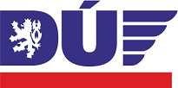
ANNUAL SAFETY REPORT 2016
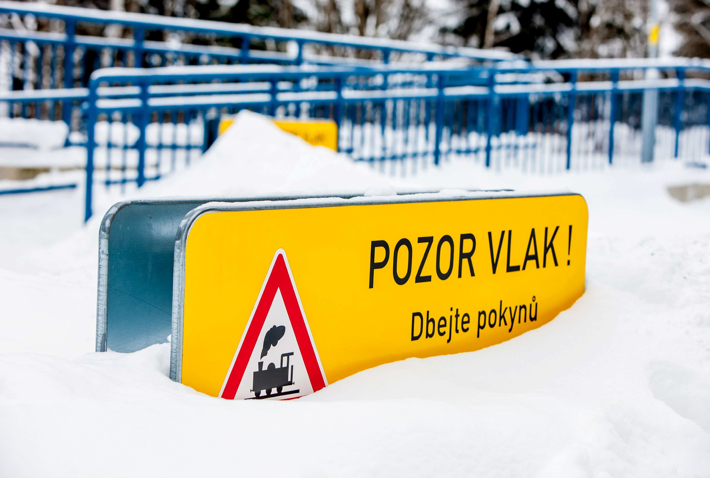

Imprint

Published by: | Rail Authority  Wilsonova 300/8, 121 06 Prague 2 – Vinohrady
Approved by: | Ing. Jiří Kolář, Ph.D., Rail Authority Director
Author: | Ing. Mgr. Petr Fleischman, Ing. Michaela Mácová, Ing. Dana Lelková, Bc. Tomáš Janák
Date: | 14 September 2017

INTRODUCTION BY THE DIRECTOR OF THE RAIL AUTHORITY

As with every year, we are releasing the Annual Safety Report. The purpose of this document is to provide infrastructure managers, carriers and other entities concerned with basic information about safety conditions on railways in the Czech Republic in 2016.

However, I believe that others will also come across this important document, whether railway enthusiasts or passengers who use railways for routine or occasional commuting to work, to school, for entertainment or recreation. I have a positive announcement which is not only for them. Based on this annual report and the long-term development observed, we can conclude that the railways continue to be safe, in particular compared to road transport. And this is information which I personally consider highly important.

Lastly, allow me to assure you that the Rail Authority will never ease up on its priority, which is unequivocally the safety of passengers and railway personnel.

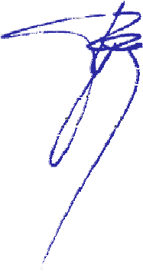
Wherever your journeys take you, may they always be safe.
Jiří Kolář

Reference documents

Ref. No | Document name | Reference to
(1) | Directive 2004/49/EC on safety on the Community's railways (the ‘Railway Safety Directive’) | OJ L 220, 21. 6. 2004, p. 16.
(2) | Directive 2008/110/EC on safety on the Community’s railways, amending Directive 2004/49/EC | OJ L 345, 23. 12. 2008, p. 62.
(3) | Regulation No 177/1995 Coll., stipulating construction and technical regulations of railways | Collection of Laws  No 8/1995, p. 2210
(4) | Commission Implementing Regulation (EU) No 402/2013 on the common safety method for risk evaluation and assessment and repealing Regulation (EC) No 352/2009 | OJ L 121/2003.  30. 4. 2013, p. 8.
(5) | Act No 500/2004 Coll., the Administrative Procedure Code | Collection of Laws No 174/2004,
(6) | Commission Directive 2009/149/EC amending the Railway Safety Directive as regards Common Safety Indicators and common methods to calculate accident costs | OJ L 313, 28. 11. 2009, p. 65.
(7) | Act No 266/1994 Coll. on railways | Collection of Laws  No 79/1994, p. 3041
(8) | Regulation No 376/2006 Coll. on the management system for rail operation safety and rail transport safety, and on procedures in the event of incidents on railways | Collection of Laws  No 19/2006, p. 937
(9) | Regulation No 183/2015 Coll. amending Regulation No 376/2006 Coll. on the management system for rail operation safety and rail transport safety, and on procedures in the event of incidents on railways, as amended by Regulation No 248/2010 Coll. | Collection of Laws  No 7/2015, p. 2221
(10) | Commission Regulation (EU) No 1078/2012 on a common safety method for monitoring to be applied by railway undertakings, infrastructure managers after receiving a safety certificate or safety authorisation and by entities in charge of maintenance | OJ  L 320/2012,  16. 11. 2012, p. 8.
(11) | Directive 2016/797/EC on the interoperability of the rail system within the European Union | OJ L 138
(12) | Directive 2016/798/EC on railway safety | OJ L 138,
(13) | Position (EU) No 3/2016 of the Council with a view to the adoption of a Directive of the European Parliament and of the Council  on railway safety
(14) | Act No 255/2012 Coll. on inspection (Inspection Code)

Contents

A. INTRODUCTION 7
B. GENERAL STATE OF SAFETY AND SAFETY STRATEGY 8
B.1 Main conclusions for the reporting year 8
B.2 National safety strategies, programmes and initiatives 8
B.3 Summary of major findings from inspection activities 9
B.4 Focus areas for the next year 9
C. DEVELOPMENTS IN SAFETY PERFORMANCE 10
C.1 Detailed analysis of the latest recorded trends 10
C.2 Results of safety recommendations 12
D. SUPERVISION 18
D.1 Strategy and plan 18
D.2 Coordination and cooperation 21
D.3 Competence 21
D.4 Feedback 21
E. GRANTING OF CERTIFICATES AND APPROVAL 23
E.1 A carrier's certificate issued to railway undertakings based in the Czech Republic 23
E.2 A carrier's certificate issued to railway undertakings of other EU Member States 23
E.3 An infrastructure manager's safety certificate 24
E.4 Communication with other national safety authorities 24
E.5 Procedural issues 24
E.6 Feedback 24
F. AMENDMENTS TO LEGAL REGULATIONS 25
F.1 Railway Safety Directive (RSD) (1) 25
G. APPLICATION OF A COMMON SAFETY METHOD FOR RISK EVALUATION AND ASSESSMENT 27
G.1 NSA experience 27
G.2 Feedback from stakeholders 28
G.3 Revision of National Safety Regulations (NSRs) to take into account the EC regulation on CSM for risk evaluations and assessment 28
H. EXCEPTIONS RELATING TO THE SYSTEM FOR GRANTING CERTIFICATES TO ENTITIES IN CHARGE OF MAINTENANCE 29
I. APPLICATION OF THE COMMISSION'S REGULATION ON A COMMON SAFETY METHOD FOR MONITORING 30
J. CONCLUSION 31
ANNEX A – COMMON SAFETY INDICATORS 32
ANNEX B – AMENDMENTS TO LEGAL REGULATIONS 36

Abbreviations

AsBo | Assessment Body
ACRI | Association of the Czech Railway Industry
CSI | Common Safety Indicator
CSM | Common Safety Method
ČD | Czech Railways
CAI | Czech Accreditation Institute
MS | Member State
DÚ | Rail Authority
RV | Railway Vehicle
EC | European Commission
ECM | Entities in Charge of Maintenance
ERAIL | European Railway Accident Information Links
ETCS | European Train Control System
EU | European Union
FTA | Fault Tree Analysis
FMEA | Failure Mode and Effects Analysis
GSM-R | Global System for Mobile Communications for Railway
DRV | Driving Railway Vehicle
NIB | National Investigation Body
NoBo | Notified Body
NRV | National Reference Value
NSA | National Safety Authority
NSR | National Safety Regulation
OPT | Operational Programme on Transport
IM | Infrastructure Manager
RID | Regulations concerning the International Carriage of Dangerous Goods by Rail
RSD | Railway Safety Directive
SS | State Supervision
SAsB | Safety Assessment Body
SŽDC | Railway Infrastructure Administration (state-owned company)
SFTI | State Fund for Transport Infrastructure
STE | Specified Technical Equipment

INTRODUCTION

The Rail Authority has prepared an annual report on its activities performed in 2016, containing information about:
- the development of railway safety, including a summary of common safety indicators ('CSI') in the territory of the Czech Republic;
- important changes in legislation and regulations concerning railway safety,
- development of the granting of safety certificates and safety approvals;
- results and experience relating to the supervision of infrastructure managers and railway undertakings, including the number and results of audits;
- experience of railway undertakings and infrastructure managers of applying applicable common safety methods (CSMs).

The report is based on Article 19 of Directive (EU) 2016/798 of the European Parliament and of the Council, which was integrated into Czech legislation by transposition into Section 49e(6) of Act No 266/1994 Coll., on railways (7), as amended (the 'Railways Act'), and further specified by Section 6 of Regulation No 376/2006 Coll., on the management system for rail operation safety and rail transport safety, and on procedures in the event of railway incidents (8), as amended.

The purpose of this report is to provide carriers, infrastructure managers and other parties concerned with information about the development of railway safety during 2016.

The details provided in the Annual Report on the Rail Authority's activities are based on the individual annual safety reports of the carriers and infrastructure managers of national and regional railways, and on the experience of the Rail Authority and other entities. All infrastructure managers pursuant to Section 22(2)(e) of the Railways Act (7) ensuring the operation of national railways and regional railways in 2016, and all carriers operating rail transport on national railways or regional railways pursuant to Section 35(2)(g) of the Railways Act submitted an Annual Safety Report within the specified time limit.

The Annual Safety Report has been drawn up in Czech and English and published on the Rail Authority's website www.ducr.cz

GENERAL STATE OF SAFETY AND SAFETY STRATEGY

Main conclusions for the reporting year

In 2016, the Rail Authority fulfilled its plan to conduct preventive inspection activities to verify the proper functioning of safety management, and it will continue to conduct these activities with other infrastructure managers and carriers in 2017.

National safety strategies, programmes and initiatives

In order to maintain and improve railway safety, efforts focus on upgrading and developing railway infrastructure in the long term, in particular in the following areas:
- Upgrading transit railway corridors and other tracks, in particular tracks of the TEN-T network, rail junctions, and other tracks of the European rail network. To ensure connectivity in the long term, interoperability of selected tracks is being ensured, in particular construction of a GSM-R digital radio system for transit corridor I. Significant amounts from the Operational Programme Transport, SFTI and European funds have been invested in railway infrastructure to ensure the development of suburban transport and integrated transport systems.
- GSM-R and ETCS systems are being implemented according to the ERTMS implementation plan in accordance with European standards. An ETCS has already been applied to several tracks and other track sections are under preparation. The pilot project of the ETCS interlocking plant in the Poříčany – Kolín track section has been completed.
- Investments made in repairs to railway infrastructure mainly included superstructure replacement, improved security of level crossings, repairs to platforms and station lighting, and bridge and culvert repairs.

Upgrades of transit railway corridors in the Czech Republic is the responsibility of the state-owned organisation SŽDC. The travelling time has been reduced on transit corridors IV in the Czech Republic, mainly on the Prague – Ostrava track branch. This link has one of the heaviest traffic flows across the Czech Republic. Upgrading work also continued to accelerate passability of some railway junctions and tracks of the TEN-T network. Other major investment elements included investments in the development of suburban transport and integrated transport systems. The investments were made with the use of grants from SFTI, OPT and EU funds. Great attention is paid to the issue of level crossing security and passenger safety during train journeys and at stops and stations.

Due to the higher number of incidents on level crossings in the long term emerging from analyses of incidents, certain infrastructure managers, carriers and independent state institutions (such as the Rail Safety Inspection Office) are continuing preventive programs in 2016 to ensure safe conduct of the public at level crossings. Here we should point out that the higher number of accidents on level crossings also needs to be perceived as a consequence of the constantly increasing volume of road traffic. And although occurrences of accidents are nearly always the responsibility of road vehicle drivers, infrastructure managers are paying significant attention to this issue with the aim of reducing the number of level crossings and fitting level crossings with higher standards of security systems.

Summary of major findings from inspection activities

State supervision and comprehensive supervision inspection activities conducted for carriers and infrastructure managers of national or regional railways did not find any major discrepancies with an immediate impact on railway operations and railway transport.

Focus areas for the next year

The general priority is mainly considered to be rail system safety itself, so that the transport of passengers and goods, particularly the carriage of dangerous goods, is safe, reliable and ecological. Therefore, the Rail Authority focuses on prevention and avoidance of sources of danger which could result in accidents and other incidents.

In 2017, the Rail Authority is continuing with intensive inspections of other infrastructure managers of national and regional railways and carriers, and in particular intends to:

- continuously analyse the conclusions of state supervision and safety recommendations issued by the Rail Safety Inspection Office as a result of incident investigations in order to generalise risk events and areas, and subsequently to arrange for the relevant modifications to regulations, standards and technological procedures;

- allow for a higher level of technical equipment within project preparation and approval for the reconstruction and upgrade of railway tracks, if financially feasible;

- focus its own inspection activities on verifying the provision of prescribed inspections and revisions of driving and towed rail vehicles of selected carriers.

DEVELOPMENTS IN SAFETY PERFORMANCE

Detailed analysis of the latest recorded trends

Pursuant to Commission Directive 2009/149/EC amending the Rail System Safety Directive as regards Common Safety Indicators and common methods to determine damage caused by accidents (6), transposed in the Czech Republic in Regulation No 376/2006 on the management system for rail operation safety and rail transport safety, and on procedures in the event of incidents on railways (8), the following figures were recorded in 2016:
- number of accidents: 86;
- number of deaths: 34;
- number of serious injuries: 61.

Table 1 below presents the most important indicators for the period under consideration.

 | 2009 | 2010 | 2011 | 2012 | 2013 | 2014 | 2015 | 2016
Number of accidents: | 113 | 125 | 99 | 97 | 91 | 104 | 94 | 86
Number of deaths: | 26 | 48 | 29 | 26 | 24 | 29 | 29 | 34
Number of serious injuries: | 92 | 107 | 74 | 66 | 52 | 60 | 53 | 61
Table 1 – Analysis of general trends

Note: The data has been obtained from annual reports submitted by infrastructure managers of national and regional railways pursuant to Section 22(2)(e) of the Railways Act as of 30 June 2017.
A detailed summary of accidents for 2016 is contained in a separate document that forms an integral part of this report.

The analysis indicates that the number of accidents has been slightly decreasing in the long term. The number of accidents decreased by 9% in 2016 as compared to the previous year. As per the definitions specified in the Commission Directive 2009/149/EC (6), 34 persons were killed (excluding suicides) and 61 persons were seriously injured.

For the sake of completeness, details of statistics of the Rail Safety Inspection Office are provided below. There were 4 142 incidents of all types on railways in the Czech Republic in 2016. This number expresses the quantity of all incidents, and not only serious accidents as defined in Commission Directive 2009/149/EC (6).

175 collisions occurred on level crossings. Collisions at level crossings with a person illegally entering the perimeter of the track significantly restrict and interrupt the regularity of railway transport. Most of the accidents on level crossings are caused by road users failing to respect or knowingly violating the provisions of Act No 361/2000 Coll. on road transport and Act No 266/1994 on railways (7).
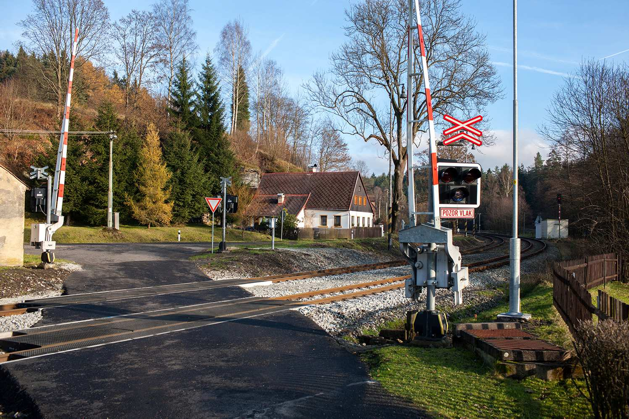

Results of safety recommendations

Table 2 lists the safety recommendations received from the national inspection authority, including information about the implementation status and description of the measures taken. Implementation of safety regulations is stipulated in Section 13(1) of Directive No 376/2006 Coll. on the management system for rail operation safety and rail transport safety, and on procedures in the event of incidents on railways (8).

Safety recommendations | Safety measures | Implementation status
21 March 2016  Golčův Jeníkov  Collision with a passenger car on level crossing P3706 during shunting between operating control points when driving along a closed track  Safety recommendation:  to the infrastructure manager Railway Infrastructure Administration (state-owned company):  - To order special training ending with a special test 'Specialised test for train control personnel'.  - For all personnel at a train control position performing operations during track closures, including externally hired personnel and contractors' employees, by 30 June 2017 at the latest  to the Rail Authority: to adopt its own measures leading to the implementation of the above mentioned safety recommendations by other infrastructure managers in the Czech Republic. | The Rail Authority issued its measure, ref. No DUCR-2833/17/Wo of 21 January 2017. Feedback is to be given by 31 August 2017. | Implemented on
19 April 2016  Suchdol nad Odrou  Collision of a pushed shunting operation with a carrier's employee  Safety recommendation:  to the infrastructure managers, Railway Infrastructure Administration (state-owned company):  - To modify existing technological procedures for shunting operations to determine whether railway vehicles can be pushed during shunting without a shunting crew, including special railway vehicles, and to ensure that the railway vehicle driver is not the only person to make decisions, but that every carrier establishes its uniform technological procedures for specific railway vehicles which can be pushed during shunting without a shunting crew to ensure that the safety of railway operations, railway transport and persons present within the perimeter of the track is always ensured by the view from the driver's station;  to the operators of the railway siding 'Olomouc RVF, Suchdol nad Odrou ODep', České dráhy, a.s.:  - To modify existing uniform technological procedures for shunting operations to determine whether special railway vehicles can be pushed during shunting without a shunting crew, and to ensure that the railway vehicle driver is not the only person to make decisions, but that every carrier establishes its own internal regulations for specific railway vehicles which can be pushed during shunting without a shunting crew to ensure that the safety of railway operations, railway transport and persons present within the perimeter of the track is always ensured by the view from the driver's station;  to the carriers, Railway Infrastructure Administration (state-owned company):  - To implement uniform technological procedures to determine which specific railway vehicles can be pushed during shunting without a shunting crew and under what conditions, so that the safety of railway operations, railway transport and persons present within the perimeter of the track is always ensured by the view from the driver's station;  - To carry out a physical check of railway vehicle drivers and a physical check of those persons performing other activities related to train driving or shunting during an internal safety inspection focused on the performance of railway transport operations .  to the Rail Authority: To adopt its own measure leading to the implementation of the above mentioned safety recommendations by other infrastructure managers and carriers on such railways in the Czech Republic. | The Rail Authority did not find it necessary to apply this safety recommendation to other carriers. | Not implemented. The RSIO did not identify a safety system violation.
26 May 2016  Dobronín – Jihlava  Derailment of two railway vehicles during the journey of train Pn 62800  Safety recommendation:  to the Rail Authority:  - To adopt its own measure towards the involved entities to ensure the following:  - A new inspection of bearings is always conducted after a railway vehicle shut-down exceeding six months;  - The life cycle of identified axle anti-friction bearings is limited to a maximum of 40 years and non-identified bearings are directly discarded and not used any more.  - To discuss fitting towed railways vehicles mainly designated for the transport of passengers and hazardous items with a pneumatic derailment detector with the vehicle owners.  - In cooperation with the Ministry of Transport of the Czech Republic, to adopt an efficient measure in relation to the national vehicle register:  - Valid registration of a condition for railway vehicle operation on the Czech railway network;  - Owners and holders of freight railway vehicles shall update and add any and all required details in the national railway vehicle register as soon as possible. | The Operational and Technical Section of the Rail Authority does not suggest that the safety recommendation be applied further. | Not implemented. The RSIO did not identify a safety system violation.
10 July 2016  Rotava  Collision of train Os 17016 with train Os 17007 at the Rotava operating control point  Safety recommendation:  to the railway owner in the Czech Republic and economic administrator, Railway Infrastructure Administration (state-owned company):  - To install technical equipment to eliminate the human error factor when driving railway vehicles on railways during the railway upgrading process.  to the infrastructure manager, PDV RAILWAY a.s.:  - To modify the REMOTE 98 interlocking plant so that loss of sight of the switch that is fitted with a self-reversing switch-point machine is indicated immediately after the loss of sight not only with a visual indication on a monitor, but also in an audible manner.  to the carrier, GW Train Regio a.s.:  - On railways where railway transport is operated with 'simplified control' and where the carrier operates railway transport, ensure that in the case of change of timetables, at least one train is charged with the reporting duty.  - All trains ordered to stop and wait according to the timetable must have details about request stops accessible to passengers in line with the details specified in the tabular time schedules of the respective trains.  - To provide infrastructure managers with maximum assistance in implementing and subsequently operating technical equipment to eliminate the possible human error factor when driving a railway vehicle.  to the Rail Authority: to adopt its own measure leading to the implementation of the above mentioned safety recommendations by other infrastructure managers and carriers in the Czech Republic. | Safety recommendation. To increase passive safety elements, it is proposed to accelerate implementation throughout the Czech Republic. The Rail Authority does not propose the implementation of a safety recommendation in this form and scope, as it is unrealistic with regard to the financial capacity of infrastructure managers and individual carriers. | Not implemented. The RSIO did not identify a safety system violation.
24 July 2016  Olomouc – Štěpánov  Fall of a child passenger out of the entrance door of a towed railway vehicle during the journey of train R 884  Safety recommendation:  to the carriers, České dráhy, a. s.:  - To modify uniform technological procedures so that the crews of trains comprising two or more coupled towed railway vehicles equipped with central entrance door locking are always obliged, as a matter of priority, to use the central lock to lock the entrance doors before checking their locking status and giving the 'Ready to depart' or 'Departure approved' signal;  - To provide training for employees – to train crew members operating central entrance door locking devices in all of its functions;  - On currently used towed railway vehicles with the Y-type vehicle body (according to standard UIC 567-1, i.e. also with the YB70 type) with outer hinged double-wing folding entrance doors, to install, refurbish or modify an existing entrance door central locking device controlled by a train crew member, so that once the device has been used, the doors cannot be manipulated from the interior of the towed railway vehicle and the entrance doors close/fully seal until the train departs and the doors are secured against opening during travel by a technical device, i.e. it is impossible to re-open, slightly open, or slightly close them, etc., unless subsequent opening of entrance doors is not provided by the conductor;  - Currently used towed railway vehicles with the Y-type vehicle body (according to standard UIC 567-1, i.e. also with the YB70 type) with outer hinged double-wing folding entrance doors, need to be fitted with a technical device detecting and signalling non-closed entrance doors so that:  - a train crew member of a towed railway vehicle without modifications to the central entrance door locking system undoubtedly identifies the status of the entrance doors, i.e. whether they are closed/fully sealed or only slightly closed, i.e. not closed/not fully sealed, when inspecting the closing/full sealing of the entrance doors before giving the 'Ready to depart' or 'Departure approved' signal, or until checking the situation on the platform after giving the 'Ready to depart' or 'Departure approved' signal, for the length of the assigned towed railway vehicles., however, on trains where all towed railway vehicles are fitted with the a central entrance door locking system, for the distance from the point of observing the situation on the platform prior to the departure of the train to the end entrance door of the first and last towed railway vehicle;  - passengers and other persons aboard the railway vehicle are warned about a non-closed entrance door with both a visual and an audible signal, and can (have the chance) to conduct themselves with adequate caution according to the nature of the railway transport with a non-closed entrance door, so as not to endanger their own safety, the safety of other persons, and the safety of smooth railway transport.  - Until all of the above mentioned safety recommendations have been implemented, to modify uniform technological procedures, in particular train departure procedures, in which the carrier ensures manning of the train with professionally qualified employees – a train crew, so that when checking that entrance doors of a train comprising towed railway vehicles with a Y-type vehicle body (according to standard UIC 567-1, i.e. including the YB70 type) are closed/fully sealed:  - prior to giving the 'Ready to depart' or 'Departure approved' signal from its position, the train crew is always able to unambiguously identify the status of the entrance doors, i.e. whether all entrance doors of the train's towed railway vehicles are closed/fully sealed, or only slightly closed, i.e. not closed/not fully sealed;  - having departed from the station or, as the case may be, after the train has left the platform area, the train crew is obliged, as a matter of priority, to check the status of the entrance doors from the interior of the towed railway vehicles.  to the Rail Authority: To adopt its own measure leading to the implementation of the above mentioned safety recommendations by other carriers using towed railway vehicles with similar entrance door designs for transport operations or, as the case may be, to adopt an adequate measure of its own as a national safety body under its international activities. | The Rail Authority checked the use of towed railway vehicles with the Y-type railway body by other carriers. These vehicles are only used for occasional nostalgic journeys.  Transport operator České dráhy, a.s. implements the safety recommendation. | Implemented on
13 September 2016  Vnorovy  Collision of train Os 2710 with a tractor on level crossing P8139  Safety recommendation:  to the Railway Infrastructure Administration (state-owned company):  - In connection with the already issued safety recommendations and the fitting of level crossing P8139, currently secured with warning lights, with barriers which, thanks to the visual obstruction, will reduce the probability of a driver entering the level crossing when not respecting the warning lights at the level crossing;  - Given the fact that most collisions on level crossings with the most severe consequences occur on level crossings secured with warning lights without barriers, in line with the wording of the previous safety recommendations of the Rail Safety Inspection Office, it is recommended to continue increasing security at level crossings in order to ensure the maximum level of safety of rail transport operations and road users, so that only level-crossing warning light equipment supplemented with whole barriers is designed and installed for two-way roads with opposing folding half barriers and a gradual folding barrier system when upgrading or reconstructing tracks and level crossings of the European rail system.  - to the Rail Authority: To adopt its own measure to ensure that the above mentioned safety recommendations for the infrastructure manager are also implemented by other infrastructure managers in the Czech Republic, or when discussing a request for a change in level crossing security and making a decision in the given matter.  - to tthe Ministry of Transport of the Czech Republic: to incorporate the above mentioned safety recommendation for the infrastructure manager of the Railways Act (7). | As part of the preparation of new and reconstructed level crossings, the Rail Authority requires the construction investor to fit level crossings with mechanical barriers – gate arms as a matter of priority, as is financially feasible for the investor. | Implemented
Table 2 – Implementation of safety measures adopted based on safety recommendations

SUPERVISION

Strategy and plan

In 2016, assigned Rail Authority personnel performed state supervision in railway matters with a focus on the performance of obligations by carriers, infrastructure managers and railway owners in line with applicable legislation.

D.1.1. Sources of information and main inputs used to establish the strategy and plan for supervision
Inspections are considered by the Rail Authority to be preventive measures with a major impact on the safety of rail operations and railway transport with the aim of ensuring a condition stipulated by legislation or, as the case may be, confirming the correctness of the supervised entity's actions.

The Rail Authority methodically proceeds pursuant to Act No 255/2012 Coll. on inspection (Inspection Code) (14). Inspections are conducted in the form of announced and unannounced state supervision. Any discrepancies discovered are stated in the respective reports on the performance of state supervision. Dates for their rectification are also determined along with a statement of any violations of laws, regulations and directives. The supervised entity has the opportunity to explain the causes of violations of correct procedures and to propose measures in writing for the attention of the Rail Authority. In cases where multiple discrepancies are identified during an inspection, the Rail Authority shall then perform subsequent state supervision, the purpose of which is to check the actual elimination of the discrepancies identified.

Besides ordinary state supervision, in 2016, the Rail Authority also started to apply a new method to carriers and national and regional infrastructure managers in the form of comprehensive supervision in order to examine all activities of a supervised entity. Several departments of the operational and technical section usually participate in comprehensive supervision, where such supervision can be considered multiple state acts of supervision due to its complexity and intensity.

Specific inspection activities

In 2016, inspections were conducted by both operational and technical sections which comprise several departments and offices based on their work focus. Specific inspections of individual departments and offices differ.

Assigned personnel of the Building Section performed 457 state supervision operations in 2016. State supervision in railway matters was focused on:
- rail system maintenance and repairs in the scope required for ensuring its operability by the national and regional infrastructure manager SŽDC pursuant to Section 20(1) of the Railways Act (7),
- verifying whether, in the course of the rail system operations and maintenance, structural and operational subsystems and individual parts thereof meet the basic requirements regarding structural and operational conditions, as well as the technical specifications for interoperability pursuant to Section 49e of the Railways Act (7),
- checking that activities considered business are not carried out within the perimeter of a railway without the infrastructure manager's permission, and that places not accessible to the public on or in the perimeter of a railway are not entered pursuant to Section 4a of the Railways Act,
- checking whether the constructions of a railway and constructions on the railway meet the technical conditions and requirements for railway operations and railway transport operations pursuant to Section 5(3) of the Railways Act,
- checking that there is no source of danger to a railway and no source of interruptions to railway operations pursuant to Section 10(2) of the Railways Act,
- checking that level crossings are identified and secured pursuant to Section 6(1) of the Railways Act.

Assigned personnel of the Operational and Technical Section performed 345 state supervision operations in 2016 including comprehensive state supervision operations.

  - The Safety and Licensing Department focused state supervision both on the performance of obligations of managers and owners of infrastructure – sidings and carriers operating railway transport on railways – sidings, and, in particular, on state supervision of carriers operating rail transport on the national rail network and regional rail networks with the focus on ensuring the safety of rail transport and safety systems pursuant to Regulation No 376/2006 Coll. on the management system for rail operation safety and rail transport safety, and on procedures in the event of incidents on railways, as amended (8), and the carrier's certification pursuant to Section 34h of the Railways Act (7). In 2016, the Safety and Licensing Department, in cooperation with the other departments of the Operational and Technical Section, implemented comprehensive supervision focused on safety systems, where more extensive and more detailed inspection of the performances of carriers on national (regional) railways was conducted with major and significant entities. There were 12 inspections of this kind altogether.

  - The Rolling Stock and ECM Department performed state supervision with the focus on the technical condition of railway vehicles and the management of railway vehicle documentation, such as vehicle repairs, change approvals, records in qualification certificates and technical inspections, while it also participated in 3 comprehensive state supervision operations.

  - The Selected Non-Electrical Technical Equipment Department performed state supervision with the focus on inspections of pressure and gas equipment specified in Section 1 of Regulation No 100/1995 Coll., stipulating conditions for the operation, design and production of selected technical equipment and specifications thereof (Regulations for Selected Technical Equipment), as amended.

  - The RID department performed state supervision with the focus on the performance of carriers' obligations pursuant to Article 1.4 of the RID Regulation. This mainly included inspections of rail yards of the national infrastructure manager Railway Infrastructure Administration (state-owned company) and in the periphery of larger railway stations. Inspections were also conducted in cooperation with the ECM office of the Railway Vehicles Department. Inspections of the transport of dangerous goods focused on the performance of obligations of operators and participants in the transport of dangerous goods according to Dangerous Goods Regulations (RID) and STE Regulations, on meeting requirements imposed on railway tankers and on the validity of tanker capacity certificates for such vehicles, and documents on the training of personnel participating in the transport of dangerous goods, the validity of a certificate of a safety consultant for the transport of dangerous goods, contracts entered into with safety consultants, recent annual reports on activities relating to the transport of dangerous goods, safety (emergency) plans, as well as reports on accidents and incidents relating to transport of dangerous goods.

  - The Selected Electrical Technical Equipment Department ('STE-E') performed state supervision with the focus on all types of electrical equipment specified in Section 1(4) of Regulation No 100/1995 Coll., stipulating conditions for the operation, design and production of selected technical equipment and specification thereof (Regulations for Selected Technical Equipment), as amended ('Regulation No 100/1995 Coll.'). The performance of state supervision in rail system matters focused mainly on compliance with Section 47 of the Railways Act (7), i.e. the operation of selected electrical technical equipment with a valid certificate of competence and in a technical condition corresponding to the approved competence, as well as on compliance with this report professional electrical engineering competences pursuant to Annex 4 of Regulation No 100/1995 Coll. As a part of state supervision in rail system matters, inspections of legal entities performing technical inspections and tests of selected electrical technical equipment were also performed according to the 'Conditions for Auditing Legal Entities', published in Transport Bulletin No 12/06, ref. No: 36/2006-130-SPR/2 of 18 May 2006.
  - The Independent Personnel Competence Department performed state supervision with the focus on professional and medical fitness of persons driving railway vehicles on national and regional rail networks and sidings. Attention was paid to the documents for the issue of an engine driver's certificate, completed training, professional qualification tests, register of issued driver's certificates and records of completed inspections pursuant to Section 46q of the Railways Act (7). The department also participated in 5 comprehensive state supervision operations of carriers.

D.1.2 Continuous upgrading of the supervision plan

Documents for performing state supervision are prepared based on suggestions from third parties, outputs of the Rail Safety Inspection Office or the findings of the Rail Authority. The Rail Authority has increased the number of state supervision operations in all sections of its competences for 2016 and in the forecast period of 2017.

Coordination and cooperation

Agreements on the coordination of inspection activities were not entered into with national safety authorities of other EU Member States in 2016. The Rail Authority cooperates with the Rail Safety Inspection Office as per Section 8(2) of Act No 500/2004 Coll., the Administrative Procedure Code, as amended (5).

Competence

Rail Authority employees participated in induction training sessions for newly hired employees in 2016, as well as advanced job training of employees focused on legislation of the Czech Republic and European Union to deepen their knowledge of this area. Training in railway transport legislation is expected to continue in the next year. Employees who perform state supervision are required to be medically fit in line with Regulation No 101/1995 Coll. on medical fitness of persons involved in railway operations and railway transport, as amended.

Feedback

The rectification of discrepancies has always been reported to the Rail Authority in writing and corrective measures have been described. The Rail Authority reviewed the rectification of discrepancies based on their severity and verified the correctness of the measures implemented. Infrastructure managers and operators did not file any complaints against the Rail Authority's performance.
We should emphasise that the majority of discrepancies and defects found did not directly endanger railway operations and railway transport.

GRANTING OF CERTIFICATES AND APPROVAL

The Rail Authority prepared a guideline for granting and approving a carrier's certificate and an infrastructure manager's safety certificate as per Article 12(2) of Directive 2004/49/EC of the European Parliament and of the Council on safety on the Community’s railways (1) and amending Council Directive 95/18/EC on the licensing of railway undertakings and Directive 2001/14/EC on the allocation of railway infrastructure capacity and the levying of charges for the use of railway infrastructure and safety certification (the Railway Safety Directive), as amended ('Directive 2004/49/EC'), Commission Regulation (EU) No 1158/2010 on a common safety method for assessing conformity with the requirements for obtaining railway safety certificates ('Regulation No 1158/2010') and Commission Regulation (EU) No 1169/2010 on a common safety method for assessing conformity with the requirements for obtaining a railway safety authorisation ('Regulation No 1169/2010'), aiming to make it more convenient for applicants – infrastructure managers and railway undertakings from the Czech Republic and other EU Member States to apply for:

A carrier's certificate issued to railway undertakings based in the Czech Republic

1 new certificate and 1 renewed carrier's certificate (parts A and B) were issued in 2016 pursuant to Section 34(h) of Act No 266/1994 on railways (7).
3 amendments to existing carrier's certificates were issued in the course of 2016. The amendments resulted from changes in carriers' organisations or changes to company names.

In 2016, no foreign safety authority requesting the issue of part B of the certificate in another Member State asked the Rail Authority about the correctness of issued part A of the carrier's certificate. In 2016, there were no problems relating to the mutual recognition of part A. The administrative fee for issue of certificate part A and B amounts to CZK 1 000, i.e. EUR 40.

A carrier's certificate issued to railway undertakings of other EU Member States

1 new certificate, 2 renewed carrier's certificates part B, and 1 revision of an already existing carrier's certificate part B were issued in 2016 pursuant to Section 34(h) of Act No 266/1994 on railways (7).

The law of the Czech Republic only defines a fee for renewing parts A and B of a carrier's certificate as a whole in a total amount of CZK 1 000, i.e. EUR 40.

An infrastructure manager's safety certificate

The safety certificate is issued pursuant to Section 23a of Act No 266/1994 on railways (7). 1 new infrastructure manager's safety certificate was issued in 2016.
1 revision of an already issued infrastructure manager's safety certificate was issued in 2016. This concerned a change arising from the infrastructure manager's organisational changes.
The administrative fee for issue of the safety certificate amounts to CZK 1,000, i.e. EUR 40.

Note: Please note that in general, Czech legislation requires that the management of relevant certificates be governed by the provisions of Act No 500/2004 Coll., the Administrative Procedure Code, as amended (5). The administrative procedure period has been fixed at 30 to 60 days based on complexity. In view of the fact that this period of time does not include an interruption of an administrative procedure, this instrument is used in practically all cases and serves for completing a submitted application.

Communication with other national safety authorities

The Rail Authority did not send or receive any requests for information relating to part A of a carrier's certificate that had been issued in another EU Member State.

Procedural issues

There were no major problems with issuing new or revised certificates.

Feedback

Assigned Rail Authority personnel provide consultancy to all applicants prior to the issue of a certificate. Over the following period, the Rail Authority will issue a methodical guideline with specific instructions for certificate applicants.

AMENDMENTS TO LEGAL REGULATIONS

Railway Safety Directive (RSD) (1)

Applicable legal regulations implementing the Railway Safety Directive (1)
- Act No 266/1994 Coll. on railways (7)
- Government Regulation No 589/2006 Coll. stipulating a different arrangement of working time and rest periods of employees working in the transport sector
- Regulation No 376/2006 Coll. on the management system for rail operation safety and rail transport safety, and on procedures in the event of incidents on railways (8)
- Regulation No 183/2015 Coll. amending Regulation No 376/2006 Coll. on the management system for rail operation safety and rail transport safety, and on procedures in the event of incidents on railways, as amended by Regulation No 248/2010 Coll.
- Government Regulation No 133/2005 Coll. on technical requirements for operational and technical interoperability of the European Rail System
- Act No 134/2011 Coll., amending Act No 266/1994 Coll. on railways, as amended (7), and Act No 634/2004 Coll. on administrative fees, as amended.
- Government Regulation No 353/2008 Coll. amending Government Regulation No 589/2006 Coll. stipulating a different arrangement of working time and rest periods of employees working in the transport sector
- Act No 181/2006 Coll., amending Act No 266/1994 Coll. on railways (7), as amended, and Act No 200/1990 Coll. on offences, as amended
- Act No 250/2016 Coll. on responsibility for offences and relating proceedings, repealing Act No 200/1990 Coll.
- Regulation No 248/2010 Coll. amending Regulation No 376/2006 Coll. on the management system for rail operation safety and rail transport safety, and on procedures in the event of incidents on railways
- Government Regulation No 289/2010 Coll. amending Government Regulation No 133/2005 Coll. on technical requirements for operational and technical interoperability of the European Rail System, as amended by Government Regulation No 371/2007 Coll.
- Directive No 2004/49/EC of the European Parliament and of the Council on safety on the Community's railways
- Commission Regulation (EC) No 352/2009 on the adoption of a common safety method on risk evaluation and assessment
- Directive (EC) 2016/797 on the interoperability of the rail system within the European Union
- Directive (EC) 2016/798 on railway safety
- 3/2016 Position of the EU Council with a view to the adoption of a Directive of the European Parliament and of the Council on railway safety
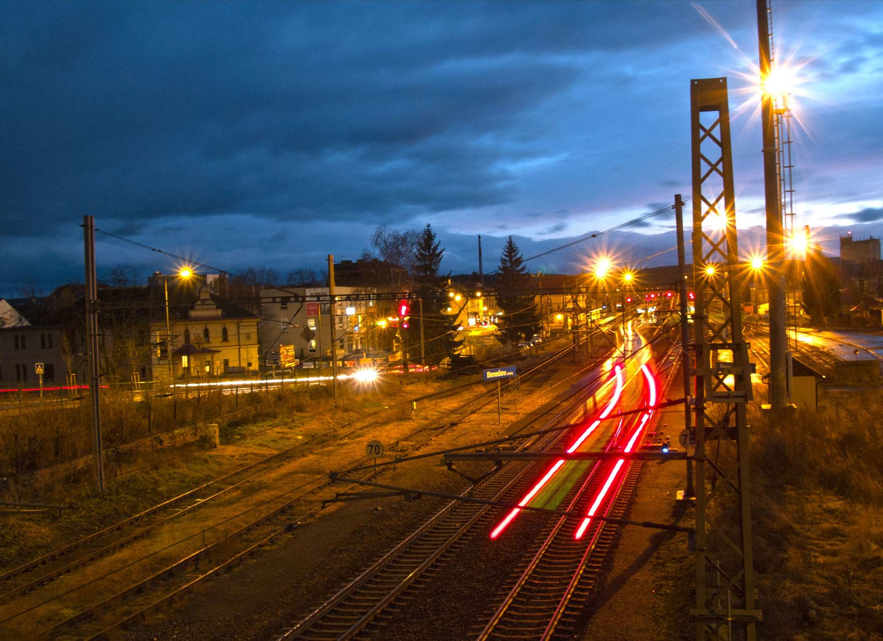
The status of implementation of amendments to the Railway Safety Directive (1) as of the end of the reporting year is given in Table 3 of Annex B.

APPLICATION OF A COMMON SAFETY METHOD FOR RISK EVALUATION AND ASSESSMENT

Transport operators use common safety methods to implement safety management in the form described in Annex III to the Railway Safety Directive (1). Common safety objectives and national reference values are used by carriers as reference data for determining their own safety objectives. Obtaining a safety certificate is governed by Commission Regulation (EU) No 1158/2010 of 9 December 2010 on a common safety method for assessing conformity with the requirements for obtaining railway safety certificates and by Commission Regulation (EU) No 1169/2010 of 10 December 2010 on a common safety method for assessing conformity with the requirements for obtaining a railway safety authorisation.
This area is governed by the measure relating to the enforcement of Commission Regulation No 402/2013 on the common safety method for risk evaluation and assessment and repealing Commission Regulation (EC) No 352/2009 (4) ('Regulation No 402/2013') and the Rail Authority's Guideline for enforcing Regulation No 402/2013.
The purpose of this Guideline is to establish procedures for the relevant employees of the Rail Authority, as well as for applicants in terms of applying Commission Regulation (EC) No 402/2013 (4), as stipulated in Article 6(3)(a) of the Railway Safety Directive (1).
This Guideline applies to putting structural sub-systems and vehicles into operation, their modifications and upgrades, as well as to organisational and operational changes. Commission Regulation No 352/2009 can be applied to vehicle systems and changes under the advanced development stage, as defined in Article 2(6) of Regulation No 402/2013 (4).
The good practices code is mainly preferred for the application of risk management, however, the applicants also use reference systems (both similar and deviating ones), methods of clear risk assessment (in particular FTA, FMEA) and various combinations of all stated principles of risk acceptability.

NSA experience

The Rail Authority requires applicants to attach a Safety Assessment Report to major changes to be evaluated, thus supervising the quality and level of outputs of safety assessment bodies, as has been designated by the Ministry of Transport, inter alia, as one of the acknowledging bodies. In the Czech Republic, it is also acceptable to request accreditation by safety assessment bodies to be conducted by the Czech Accreditation Institute (ČIA). Unlike accreditation of safety assessors by the Czech Accreditation Institute, acknowledgement of a safety assessment body by the Rail Authority is free of charge.

The Rail Authority received 104 safety assessment reports in 2016. As of 21 May 2015, the Rail Authority has requested a safety declaration from applicants for both operational and organisational changes.

In order to ensure better transparency of applicants' information about specific change classification, the Rail Authority utilised their obligation to elaborate such safety statements, differentiating them in the scope of the risk assessment requirement to:
    - safety statement type A, organisational changes do not influence operational and maintenance procedures;
    - safety statement type B, rail system change does not influence safety;
    - safety statement type C, rail system change influences safety, however, not seriously;
    - safety statement type D, rail system change is major (a safety assessment report must be attached to the request).

Feedback from stakeholders

Feedback from applicants and independent safety assessors is obtained via consultations with the Rail Authority’s employees authorised to evaluate safety assessment reports (safety assessors appointed directly by the Rail Authority director). The Rail Authority also participates in the ACRI’s workshops on the application of Regulation (EC) on a common safety method.

Revision of National Safety Regulations (NSRs) to take into account the EC regulation on CSM for risk evaluations and assessment

In 2016, no revision of NSRs were carried out.

EXCEPTIONS RELATING TO THE SYSTEM FOR GRANTING CERTIFICATES TO ENTITIES IN CHARGE OF MAINTENANCE

There was no case of the application of Article 14a(8) of Directive 2008/110/EC of the European Parliament and of the Council of 16 December 2008 (2), amending Directive 2004/49/EC on safety (1):
‘Member States may decide to fulfil the obligations to identify the entity in charge of maintenance and to certify it through alternative measures, in the following cases:

- vehicles registered in a third country and maintained according to the law of that country;

- vehicles which are used on networks or lines the track gauge of which is different from that of the main rail network within the Community and for which fulfilment of the requirements referred to in paragraph 3 are ensured by international agreements with third countries;

- vehicles identified in Article 2(2), and military equipment and special transport requiring an ad hoc national safety authority permit to be delivered prior to the service. In this case derogations shall be granted for periods not longer than five years.’
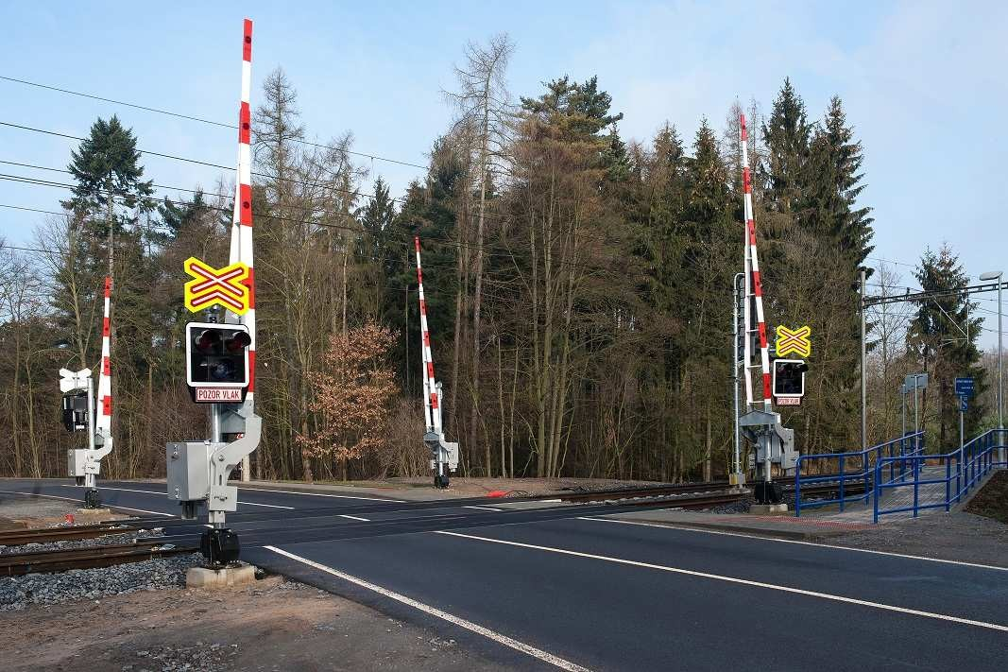

APPLICATION OF THE COMMISSION'S REGULATION ON A COMMON SAFETY METHOD FOR MONITORING

Infrastructure managers and carriers apply Commission Regulation (EU) No 1078/2012 on the CSM for monitoring ('Regulation No 1078/2012'). In practice, Regulation No 1078/2012 is mainly implemented by way of creating and performing plans for inspections of safe railway transport operation and incorporating knowledge arising from Regulation No 1078/2012 into internal regulations. In case of discrepancies found, by implementing corrective measures. Feedback is provided in individual annual reports.
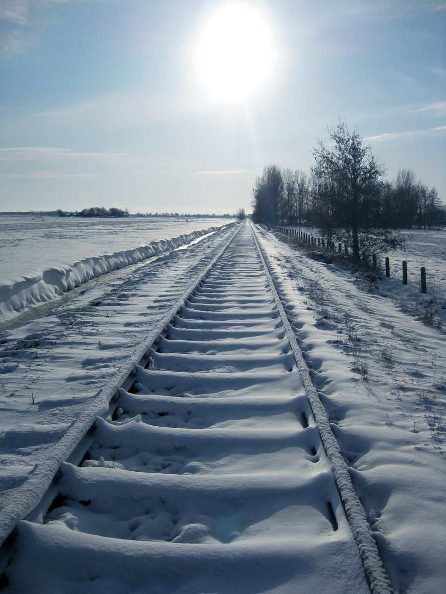

CONCLUSION

The Annual Report on the Rail Authority's performance generally evaluates the safety of railway transport and operations of railway infrastructure in the Czech Republic for 2016. It also provides information about the progress of the gradual performance and implementation of the safety directive into national statutory regulations.
The Rail Authority met its target in 2016 to perform state supervision to verify the proper functioning of safety management, and it will continue to conduct inspections of other infrastructure managers and carriers in 2017.
The main priority is given to railway safety and the safe transport of passengers and goods, especially dangerous goods, which might result in accidents and incidents.
List of annexes:
Annex A: Common Safety Indicators
Annex B: Amendments to legal regulations
Separate document: List of incidents in 2016

© Rail Authority 2017
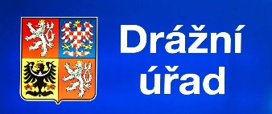
Wilsonova 300/8, 8,121 06 Prague 2 – Vinohrady
www.ducr.cz
www.facebook.com/drazni.urad

ANNEX A – COMMON SAFETY INDICATORS

Summary of incidents for 2016 – according to the definition of Commission Directive 2009/149/EC amending the Railway Safety Directive as regards Common Safety Indicators (CSI) and common methods to calculate the economic impact of accidents (5), saved in a separate file.

The common definitions for CSI and the common methods for assessing the economic impact of accidents are divided into the following areas:

- Indicators relating to accidents
- Indicators relating to dangerous goods
- Indicators relating to suicides
- Indicators relating to precursors of accidents

Definitions taken from Regulation No 2009/149/EC of the European Parliament and of the Council:

- Significant accident – means any accident involving at least one rail vehicle in motion, resulting in at least one killed or seriously injured person, or in significant damage to stock, track, other installations or environment, or extensive disruptions to traffic. Accidents in workshops, warehouses and depots are excluded.

- Significant damage to stock, track, other installations or environment – means damage that is equivalent to EUR 150 000 or more.

- Extensive disruptions to traffic – means that train services on a main railway line are suspended for six hours or more.

- Train – means one or more railway vehicles hauled by one or more locomotives or railcars, or one railcar travelling alone, running under a given number or specific designation from an initial fixed point to a terminal fixed point. A light engine, i.e. a locomotive travelling on its own, is considered to be a train.
- Collisions of trains, including collisions with obstacles within the clearance gauge – means a front to front, front to end or a side collision between a part of a train and a part of another train, or with:

  - shunting rolling stock,

  - objects fixed or temporarily present on or near the track (except at level crossings if lost by a crossing vehicle or user).

- Train derailment – means any case in which at least one wheel of a train leaves the rails.

- Level crossing accidents – means accidents at level crossings involving at least one railway vehicle and one or more crossing vehicles, other crossing users such as pedestrians or other objects temporarily present on or near the track if lost by a crossing vehicle/user.

- Accidents to persons caused by rolling stock in motion – means accidents to one or more persons who are either hit by a railway vehicle or by an object attached to, or that has become detached from, the vehicle. Persons who fall from railway vehicles are included, as well as persons who fall or are hit by loose objects when travelling on board vehicles.

- Fires in rolling stock – means fires and explosions that occur in railway vehicles (including their load) when they are running between the departure station and the destination, including when stopped at the departure station, the destination or intermediate stops, as well as during re-marshalling operations.

- Other types of accidents – means all accidents other than those already mentioned (train collisions, train derailments, at level crossing, to persons caused by rolling stock in motion and fires in rolling stock).

- Passenger – means any person, excluding members of the train crew, who makes a trip by rail. For accident statistics, passengers trying to embark/disembark onto/from a moving train are included..
- Employees (staff of contractors and self-employed contractors are included) – means any person whose employment is in connection with a railway and is at work at the time of the accident. It includes the crew of the train and persons handling rolling stock and infrastructure installations.

- Level crossing users – means all persons using a level crossing to cross the railway line by any mean of transport or by foot.

- Unauthorised persons on railway premises – means any person present on railway premises where such presence is forbidden, with the exception of level crossing users.

- Others (third parties) – means all persons not defined as
‘passengers', 'employees including the staff of contractors’, 'level crossing users' or 'unauthorised persons on railway premises’.

- Deaths (killed person) – means any person killed immediately or dying within 30 days as a result of an accident, excluding suicides.

- Injuries (seriously injured person) – means any person injured who was hospitalised for more than 24 hours as a result of an accident, excluding attempted suicides.

- Accident involving the transport of dangerous goods – means any accident or incident that is subject to reporting in accordance with
    - the RID/ADR.

- Dangerous goods – means those substances and articles the carriage of which is prohibited by RID, or authorised only under the conditions prescribed therein.

- Suicide – means an act to deliberately injure oneself resulting in death, as recorded and classified by the competent national authority.
- Broken rails – means any rail which is separated in two or more pieces, or any rail from which a piece of metal becomes detached, causing a gap of more than 50 mm in length and more than 10 mm in depth on the running surface..

- Track buckles – means faults related to the continuum and the geometry of track, requiring track obstruction or immediate reduction of permitted speed to maintain safety.

- Wrong side signalling failure – means any failure of a signalling system (either to infrastructure or to rolling stock), resulting in signalling information less restrictive than that demanded.

- Signal Passed at Danger (SPAD – means any occasion when any part of a train proceeds beyond its authorised
movement.

- Unauthorised movement – means to pass:

      - a trackside colour light signal or semaphore at danger, order to STOP, where an Automatic Train Control System (ATCS) or ATP system is not operational,
      - the end of a safety related movement authority provided in an ATCS or ATP system,
      - a point communicated by verbal or written authorisation laid down in regulations,
      - stop boards (buffer stops are not included) or hand signals.

- Broken wheels and broken axles – means a break affecting the essential parts of the wheel or the axle and creating a risk of accident (derailment or collision).

ANNEX B – AMENDMENTS TO LEGAL REGULATIONS

Amendments to Railway Safety Directive (1) | Completed under national law | Legal reference | Date of entry into force
Directive (EC) 2016/798 of the European Parliament and of the Council on safety on the Community's railways, substantially amending Directive 2004/49/EC | Yes | transposition 266/1994 Coll.  transposition 255/2012 Coll.  transposition 500/2004 Coll.  transposition 376/2006 Coll.  transposition 101/1995 Coll.  transposition 173/1995 Coll.  transposition 376/2006 Coll.  transposition 181/2006 Coll.  transposition 371/2007 Coll.  transposition 289/2010 Coll.  transposition 326/2011 Coll.  transposition 88/2012 Coll.  transposition 72/2016 Coll. | 11. May 2016
Table 3

