Railway Administration Executive Agency

2016 ANNUAL SAFETY REPORT

of the National Safety Authority of the Republic of Bulgaria

September 2017

Contents

ABBREVIATIONS USED IN THE REPORT 3

A. INTRODUCTION 4

A.1. Objective, Scope and Addressees of the Report 4

A.2. Significant Organisational Changes affecting the NSA 4

B. OVERALL SAFETY PERFORMANCE AND STRATEGY 5

B.1. Main Conclusions from the Reporting Year 5

B.2. National Safety Strategy, Programmes and Initiatives 10

B.3. Review of the Previous Year 13

B.4. Focus Areas for the Next Year 14

C. DEVELOPMENTS IN SAFETY PERFORMANCE 15

C.1. Detailed Analysis of the Latest Recorded Trends 15

C.2. Results of Safety Recommendations 17

C.3. Measures implemented not in relation to safety recommendations. 23

D. SUPERVISION 24

D.1. Strategy and Plan(s) 24

D.2. Human resources 25

D.3. Competence 27

D.4. Decision-making 27

D.5. Coordination and Cooperation 27

D.6. Findings from Measures Taken 27

E. SAFETY CERTIFICATION AND AUTHORISATION ISSUING 28

E.1. Guidance 28

E.2. Contacts with Other NSAs 29

E.3. Procedural Issues 29

E.4. Feedback 29

F. CHANGES IN LEGISLATION 30

F.1. Railway Safety Directive (RSD) 30

F.2. Legislative and regulatory amendments 30

G. APPLICATION OF THE CSM ON RISK EVALUATION AND ASSESSMENT 31

G.1. NSA Experience 31

G.2. Feedback from Stakeholders. 31

G.3. Revised National Safety Rules (NSRs) as a Result of the Implementation of the EU Provisions regarding Risk Evaluation and Assessment 31

H. DEROGATIONS IN CONNECTION WITH THE SCHEME FOR THE CERTIFICATION OF ENTITIES IN CHARGE OF MAINTENANCE OF VEHICLES IN ACCORDANCE WITH ARTICLE 14a(8) of DIRECTIVE 2008/110/EC 32

ANNEX A. COMMON SAFETY INDICATORS (CSIs) 33

Data/diagrams for the fulfilment of the main CSIs for the period 2012–2016. 33

ANNEX C. CHANGES IN LEGISLATION 40

**Table 11.** Legislative and regulatory changes in the field of railway transport of Bulgaria, published in the State Gazette and entering into force in the period from 1 January 2016 to 31 December 2016 **(Annex to Section F.2** of this report). 41

ABBREVIATIONS USED IN THE REPORT

|  |  |
| --- | --- |
| EUAR | European Union Agency for Railways (EUAR) |
| AsBo | Assessment Body |
| BDZ | Bulgarian State Railways |
| ASR | Annual Safety Report |
| DGRI | Directorate General ‘Railway Inspection’ at the RAEA |
| DeBo | Designated body |
| RSD | Railway Safety Directive 2004/49/EC |
| IOD | Railway Interoperability Directive 2008/57/EC |
| SOE NRIC | State Enterprise ‘National Railway  Infrastructure Company’ |
| EC | European Commission |
| ERADIS | ERA Database of Interoperability and Safety (ERADIS) |
| ERAIL | Register of safety and accidents on the railways of  European Union (European Railway Accident Information Links) |
| EU | European Union |
| RI | Railway Infrastructure |
| RU | Railway undertaking |
| RTA | Railway Transport Act of the Republic of Bulgaria |
| RAEA | Railway Administration Executive Agency |
| ED | Executive Director |
| PRM | Persons with reduced mobility |
| PCM/ECM | Person (Entity) in Charge of Maintenance of Vehicles |
| MTITC | Ministry of Transport, Information Technology and Communications |
| NRV | National Reference Value |
| NoBo | Notified Body |
| NSA | National Safety Authority |
| NIB | National Investigation Body |
| NSR | National Safety Rule |
| NVR | National Vehicle Register |
| CST | Common Safety Targets |
| CSM | Common Safety Methods |
| CSI | Common Safety Indicators |
| RS | Rolling Stock |
| RD | Network Reference Document |
| SC | Safety Certificate |
| SMS | Safety Management System |
| QMS | Quality Management System |
| TSI | Technical Specification for Interoperability |
| SA | Safety Authorisation |
| RIM | Railway Infrastructure Manager |

# INTRODUCTION

## Objective, Scope and Addressees of the Report

* + 1. This report aims to assess the achievement of Common Safety Indicators in 2016 and to present the overall development of railway safety in the Republic of Bulgaria in compliance with Article 5 of Directive 2004/49/EC of 29 April 2004 on safety on the Community’s railways (RSD).
    2. The scope of the report satisfies the requirements of Article 18 of RSD. It contains information on: the development of safety and Common Safety Indicators (CSIs) in railway transport in Bulgaria in 2016; the activity of issuing, renewal, amendment or revocation of safety certificates and safety authorisations; the experience gained from supervising the infrastructure managers (IMs) and railway undertakings (RUs), including the number and results from inspections and audits; the important changes in legislation and safety regulation; derogations that have been decided in compliance with Article 14(a), paragraph 8 of RSD; RUs and IMs experience gained from the application of the relevant Common Safety Methods (CSM).

This report was prepared using the model of the annual safety reports (ASR) of the National Safety Authorities (NSA), approved in 2013 by the Network of NSAs of the European Union Member States, which is in effect for the 2016 ASR.

* + 1. The Railway Administration Executive Agency (RAEA) is the national safety authority for railway transport pursuant to Article 6(3) of the Railway Transport Act (RT Act). The registered office of the RAEA is in Sofia, and of its regional structures – in Sofia, Plovdiv and Gorna Oryahovitsa.

The CSIs information has been prepared on the basis of data received from the ASR of the IM in Bulgaria (SE NRIC) and the RUs holding SCs for the carriage of freight or passengers in Bulgaria, as well as from the registers of railway accidents and incidents kept by the EUAR (ERAIL), RAEA (AISIAS[1]) and SOE NRIC (Smart Safety 2.1).

* + 1. This report is intended for: the railway sector in Bulgaria and Europe, European Union Agency for Railways (EUAR), the MTITC, the Bulgarian national investigation body (NIB) (RAIU), railway infrastructure managers, railway undertakings (including transport operators and entities in charge of maintenance of vehicles), notified bodies (NoBos), designated bodies (DeBos), assessment bodies (AsBos), specialised training institutions (universities, institutes, high schools, colleges, professional and qualification centres, schools, etc.), professional associations, unions and all legal entities and natural persons in the country and abroad, performing or intending to perform railway activities in the territory of Bulgaria.

This report is published online and is publicly available both in the ERADIS database of EUAR in the NSA & NIB reports[2] section, and on the RAEA website – in the National Safety Authority section, in the Annual Safety Reports category. The data with the CSIs for Bulgaria for 2016, as well as for the period 2006 – 2015, are published and are publicly available in the European Union ERAIL register on this link[3].

## Significant Organisational Changes affecting the NSA



In 2016, no significant organisational changes were made, and there were no significant legislative or external organisational changes that affected the RAEA’s responsibilities such as the NSA in the railway transport of Bulgaria.

# OVERALL SAFETY PERFORMANCE AND STRATEGY

## Main Conclusions from the Reporting Year

Common Safety Indicators (see also Annex A to the report):

* + 1. Common safety indicators data related to railway accidents:

In 2016, the positive trend for improvement of the common safety indicator (CSI) for railway accidents continued in Bulgaria, namely: total ‘significant accidents’[4] - 40 in 2016 compared with 48 in 2015 and 58 in 2014. The total number of railway accidents registered in Bulgaria in 2016 is 327, while in 2015 there were 305 and in 2014 – 304.

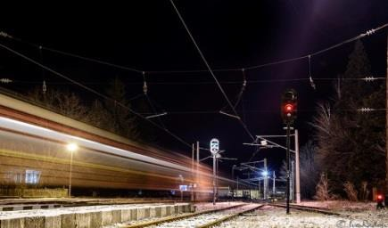

* + - 1. The value of indicator (N00) of total ‘significant accidents’ for 2016 is 40 accidents. The values of this indicator for the previous five years were as follows: 48 (2015), 58 (2014), 33 (2013), 48 (2012) and 74 (2011). In 2016 the trend of ‘accidents to persons involving rolling stock in motion (RSM)’[5] continues to be the highest. For 2016 they are: 24 (indicator with code N04). The next most serious significant accidents are: ‘derailments of trains’ – 6. (indicator NO2); ‘accidents at level crossings’ (indicator N03) – 5; ‘collision of train with obstruction within the building gauge’ – 3. (indicator N012) and ‘PWS fire’ – 2. (indicator N05). In 2016, there were no ‘significant accidents’ of the type of ‘collision of train with rail vehicle’ (index N011). For more information, see Table 2 and Table 3 on page 15 of the report.
      2. In 2016, the indicator total number of ‘deaths (killed persons)’[6] (TK00) reports deterioration compared to 2015. In 2016, a total of 22 people were killed in railway accidents, while in the previous five years they were as follows: 20 (2015), 23 (2014), 12 (2013), 21 (2012) and 37 (2011).
      3. In 2016, the total number of ‘seriously injured persons’[7] (TS00) in railway accidents also shows deterioration compared to 2015. In 2016, the seriously injured persons are 32, while in the previous five years they are as follows: 24 (2015), 45 (2014), 21 (2013), 32 (2012) and 42 (2011).
      4. Details of single railway accidents registered in 2016 in Bulgaria with the highest number of dead (killed) and seriously injured persons for each of the risk categories referred to in Art. 7(4)(a) and (b) of the RSD and Decision 2009/460/EC[8]:

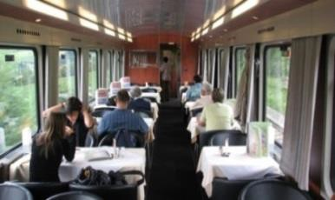

### For risk category (RC) ‘Passengers’[9]:

In 2016, the single accident with the most severe consequences with persons from RC ‘Passengers’ was an ‘accident to persons involving rolling stock in motion’, registered on 18 July 2016 at Zlatitsa station, where 1 passenger died (was killed) at the age of 63 when trying to get down from a passenger train after its regular stay at the station. He wore a backpack and a bag on his back, by which he was dragged by the train and trapped under the wagons.

### From RC ‘Employees or Contractors’[10]:

On 16 August 2016, an ‘Employee’ (locomotive driver of ‘TBD – Freight Transport’ EAD) was killed at the Raduil station in the intersection between Hrabarsko – Razmenna who served cargo train No 50537 (in the composition of 2 electric locomotives ahead and 22 full wagons) when attempting to descend during the movement from the leading locomotive to pass to the second locomotive of the train.

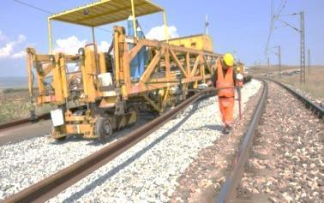

### Of RC ‘Level crossing users’[11]:

On 25 September 2016, at a level crossing at km 291 + 789 in the intersection between Polikraishte – Gorna Oryahovitsa passenger train No 2611, serviced by train brigade and locomotive No 44-114 of ‘BDZ – Passenger Transports’ EOOD (BDZ-PT), collided with a car. As a result of the crash, both persons who travelled in the vehicle (driver and passenger) from RC ‘Level crossing users’ were killed. For this accident to persons of RC ‘Level Crossing Users’, the FWSI indicator for killed and seriously injured persons is equal to 2.0.

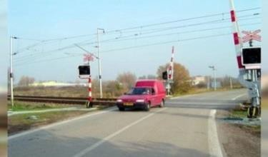

### Of RC ‘Trespassers’[12]:

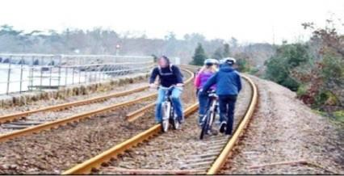

In 2016, in seven individual accidents seven persons of RC ‘Trespassers’ were killed. For all these cases for persons from RC *‘*Trespassers*’,* the value of the indicator FWSI = 1.0. In another eight single accidents, another eight seriously injured persons from RC ‘Trespassers’ were registered.

### For risk category ‘Other persons at a platform’[13]:

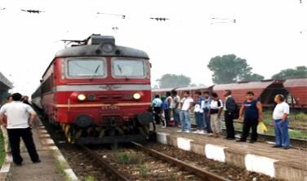

On 26 December 2016, a 70-year-old man from the RC ‘Other persons at a platform’ was killed at Dimitrovgrad station in an attempt to get down during a movement from the third wagon of passenger train No 1626 of ‘BDZ – Passenger Transport EOOD’. The man killed was seeing off his daughter, and, being aware that the train was moving, jumped and fell between the platform and the first track.

### For risk category ‘Other persons not at a platform’[14]:

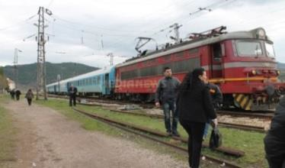

In 2016 in Bulgaria the most serious accident with persons from RC ‘Other persons not at a platform’ was the derailed freight train No 90570, registered on 10 December 2016 at Hitrino station, carrying dangerous goods, where there are registered: seven dead (killed) and 12 seriously injured persons of this risk category.

This is the most serious railway accident in the transport of dangerous goods in the history of the railway transport of Bulgaria since 1866.[15]

For this accident for RC ‘Other persons not at a platform’ the value of the FWSI indicator is 8.2. More information on the accident is provided on pages 7 and 8 of the report.

* + - 1. Total number of killed and seriously injured persons in all significant accidents registered in 2016 divided into the individual risk categories of persons defined in Art. 7(4)(a) and 7(4)(b) of the RSD and Decision 2009/460/EC.

### From RC ‘Passengers’:

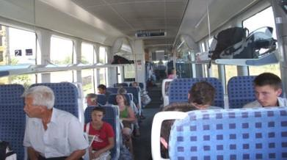

In 2016, one person from RC ‘Passengers’ lost his life (killed) in one single accident and in five other accidents five other passengers of RC ‘Passengers’ were seriously injured. All of them were injured when trying to get off a moving passenger train that was leaving after a regular stay at the station.

### From RC ‘Employees or Contractors’:

In 2016, two single significant accidents were registered with persons of the category ‘Employees or contractors’ where on 16 August 2016 one employee was killed (locomotive driver of the railway undertaking ‘TBD – Freight Transport EAD’) and on 10 December 2016 an employee of NRIC (post switchmen at Hitrino Station) was seriously injured. Details of these accidents are given above.

### Of RC ‘Level crossing users’:

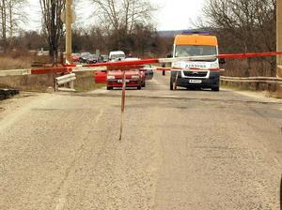

In 2016, a total of five significant individual accidents at level crossing, five people were killed and five other people were seriously injured from RC ‘Level crossing users’. Four of them are caused by unregulated trespassing through the level crossing of passenger cars with operated sound and light signalling. One of them was caused by the entry of a shepherd and herd in the area of the level crossing where the shepherd and one animal were killed.

### Of RC ‘Trespassers’:

In 2016, a total of 15 ‘significant’ individual accidents, 7 people were killed and 8 other people were severely injured from RC *‘*Trespassers*’*.

### For RC ‘Other persons not at a platform’:

In 2016, one serious accident was recorded with persons from RC ‘Other persons not at a platform’, in which seven people were seriously injured and 12 persons from RC ‘Other persons not at a platform’ were seriously injured. This accident was recorded on 10 December 2016 at Hitrino Station after a derailment and explosion of a freight train carrying dangerous goods. More details on the accident are given on the previous and following pages of this report.

### Of RC ‘Other persons at a platform’:

In 2016, in two significant accidents, from RC ‘Other persons not at a platform’ one person lost his life (was killed) and one person was seriously injured.

#### Safety indicators relating to dangerous goods (DG):

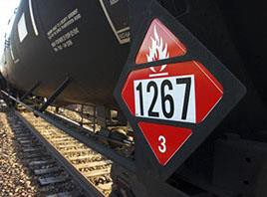

In Bulgaria, in 2016, one significant accident occurred in the transport of dangerous goods by rail was registered. The primary accident was ‘derailment of a train’, followed by a ‘RS fire’ and ‘a blast where dangerous goods were released’. The derailment was recorded at 5.37 a.m. on 10 December 2016 when a freight train No 90570 crossed Switch No 5 to track No 3 at Hitrino Station, where it was supposed to stop, to divert by passenger train No 90201. The gross mass of the train was 1 756 tons and in its composition there were 26 wagon-tanks (including 20 propylene-filled, three propane-butane-filled and three empty). The train was serviced by two locomotives ahead owned by Bulmarket Rail Cargo Ltd. – a Bulgarian RU certified for freight transport, incl. and dangerous goods, successor of Bulmarket DM Ltd – the first private railway carrier in Bulgaria, received from the RAEA in 2004 a regional and in 2005 a national license for the carriage of goods.

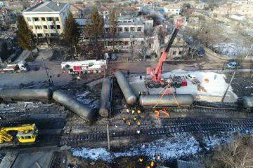As a result of the derailment, the tank of the 10th wagon in the train loaded with propylene was drilled, followed by a spill, spontaneous ignition of the load, strong blast, and shock wave. In the accident, seven local residents of the RC ‘Other persons not at a platform’ (living near the station) were killed; the severely injured were as follows: 12 local residents from RC ‘Other persons not at a platform’ (living near the station) and one ‘Employee’ (duty post switchman at Hitrino Station). In addition, 16 other local residents from RC ‘Other persons not at a platform’ were reported injured.

Photo of the serious railway accident at Hitrino Station on 10 December 2016

All residents of the village of Hitrino were evacuated and the trains on the High Line – Hitrino – Pliska railway line were stopped until all the wagons loaded with dangerous goods were fully withdrawn. On 21 December 2016, the movement was restored through a track at Hitrino station at a speed of up to 15 km/h.

As a result of the fire and a powerful explosion, many houses and public buildings in the village of Hitrino were completely destroyed. Significant damage to RI and RS has been caused.

* + 1. Safety Indicators relating to suicides[16]:



In 2016, 15 suicides were registered in Bulgaria’s railway transport. In the past five years, the number of suicides in the Bulgarian railways was as follows: 21 (2015), 29 (2014), 17 (2013), 33 (2012) and 27 (2011).

In 2016, only one suicide attempt was recorded. In 2015, one suicide attempt was also recorded. Statistical data on suicide attempts before 2015 were not collected.

* + 1. Safety indicators relating to ‘prerequisites for accidents’[17]:

In 2016, the indicator ‘Total Prerequisites for Accidents’ with code I00 decreased by 11% compared to the previous 2015. The value of the indicator I00 for 2016 is 120, in 2015 it is 133 and in 2014 is 124.

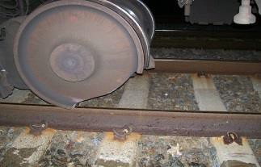

During the last three years, the positive tendency for accidents related to technical malfunctions of PPS has continued, of the type: ‘Broken wheel in rolling stock’ (I05) and ‘Broken axle of operating rolling stock’ (I06) to be equal to zero or close to zero. The value of the I05 indicator in 2016 is 2, in 2015 it is 0 and in 2014 it is 1. In 2016 and 2015 the I06 indicator is 0 and in 2014 it is 4.

In recent years, the number of accidents pertaining to technical failures of the track, respectively: ‘Broken Rail’ (I01) and ‘Track twisting and other deformations of the track’ (I02) is almost equal. In the year 2016, 83 cases of ‘broken rails’ were reposted and in the previous five years respectively: 104 (2015), 102 (2014), 83 (2013), 82 (2012) and 71 (2011). In 2016, 15 cases of ‘deformation of the railway’ (I02) were registered and investigated, and in 2015 – 14.

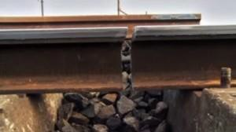

In 2016, as in 2013 and 2014, there were no cases of ‘incorrect indication of signalling leading to a hazardous situation’ (code I03). For the last time in 2015, two such cases were registered.

In 2016, the total number of registered ‘neglecting danger signals’ (with and without passing through a danger point) (I041 and I042) is 20, in 2015 it is 13 in 2014 and 2013 16, and in 2012 and 2011, four per each of both years.

* + 1. Indicators for calculation of the economic impact of accidents:

In 2016, the value of indicator C10 (Economic impact only from significant accidents) was BGN 38.6 million (EUR 19.736 million), while in 2015 it was BGN 29.496 million (EUR 15.081 million). The increase in 2016 is mainly due to: 1) the increased number of injured persons (22 killed and 32 seriously injured in 2016 against 20 killed and 24 in 2015) and 2) the serious accident involving dangerous goods at Hitrino Station on 10 December 2016, where seven people were killed and 13 people were seriously injured. In the preliminary report of the Bulgarian NIB, the technical investigation of this accident identified damage to the RI only: BGN 1.93 million (EUR 0.987 million). It lacks damages to the RS and the environment.

In 2016 the economic impact of the 22 deaths in railway accidents (indicator С01) was BGN 29.932 million (EUR 15.3 million), and out of the 32 most serious injuries (index CO2) was BGN 5.883 million (BGN 3.008 million) EUR). The ‘cost of material damage to rolling stock or infrastructure from significant accidents only’ (indicator C13) in 2016 is BGN 2.783 million (EUR 1.423 million), while in 2015 it is EUR 0.266 million (EUR 0.136 million). The increase is due to the serious accident involving dangerous goods registered on 10 December 2016 at Hitrino Station.

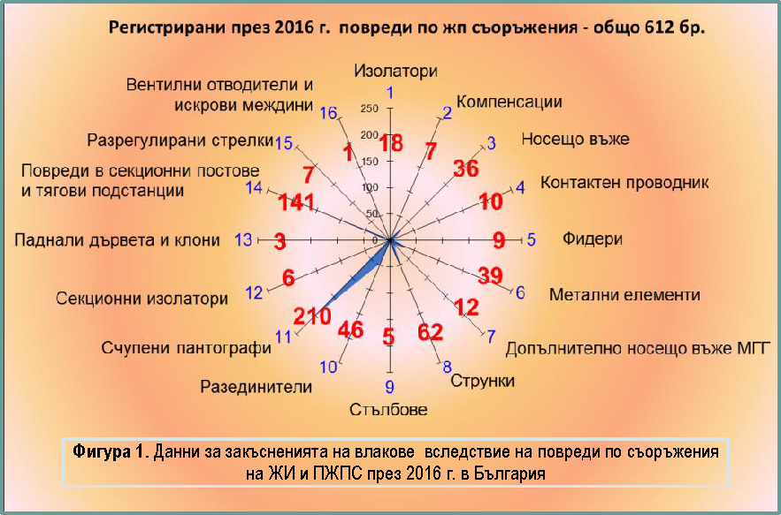

|  |  |
| --- | --- |
| Регистрирани през 2016 r. повреди по жn съоръжения - общо 612 бр. | Registered in 2016 damages on railway equipment – a total of 612 damages. |
| Изолатори | Isolators |
| Компенсации | Offsetting devices |
| Носещо въже | Messenger wire |
| Контактен проводник | Contact wire |
| Фидери | Feeders |
| Метални елементи | Metal elements |
| Допълнително носещо въже МГГ | Additional messenger wire MGG |
| Струнки | Cable dropper |
| Стълбове | Poles |
| Разединители | Disconnectors |
| Счупени пантографи | Broken pantographs |
| Секционни изолатори | Section insulators |
| Паднали дървета и клони | Fallen trees and branches |
| Повреди в секционни постове и тягови п подстанции | Damage to sectional posts and power substations |
| Разрегулирани стрелки | Disordered switches |
| Вентилни отводители и искрови междини | Surge arresters and impedance |
| Фигура 1. Данни за закъсненията на влаковете вследствие на повреди по съоръжения на ЖИ и ПЖПС през 2016 г. в България | Figure 1. Data on trains delays due to damage to facilities in the R and RSin 2016 in Bulgaria |

Minutes of delays of passenger trains (index C15) and freight trains (C16) in 2016 are 6 166 and 8 829 respectively. The values of indicator C15 in recent years are as follows: 12 833 minutes (2015); 10 882 (2014); 5 157 (2013); 7 583 (2012). The values of C16 in the past years are: 7 058 min (2015); 4 842 (2014); 7 012 (2013); 3 159 (2012).

Figure 1 shows a diagram of the damage to railway equipment in Bulgaria, calculating the longest delay of the trains in minutes, taken by the GDB of SOE NRIC for 2016. The diagram shows that the fault leading to the longest delay of trains in 2016 in Bulgaria is the breakage of pantographs (210 cases), which in Bulgaria is classed as an accident of the type of ‘crash of a train with an obstacle in the construction gauge’*[18]*. The reasons for breaking pantograph(s) are quite controversial and very often are the main cause of discord between RUs and IMs, as damage to the 25kV, 50Hz and PPS contact systems is, in most cases significant. In the following places, trains are delayed by damages to: 1) SP (sectional posts) and TPS (power substations); 2) messenger wires and contact wires/cable droppers/; 3) disconnectors; 4) metal elements; 5) messenger wire, etc.

In 2016, the delay of trains from broken pantographs in Bulgaria is 17 302 minutes in total, while in 2015 it is 12 650 minutes, which further hinders the implementation of the train schedule and leads to significant delays for passengers and freight (cf. Figure 2).

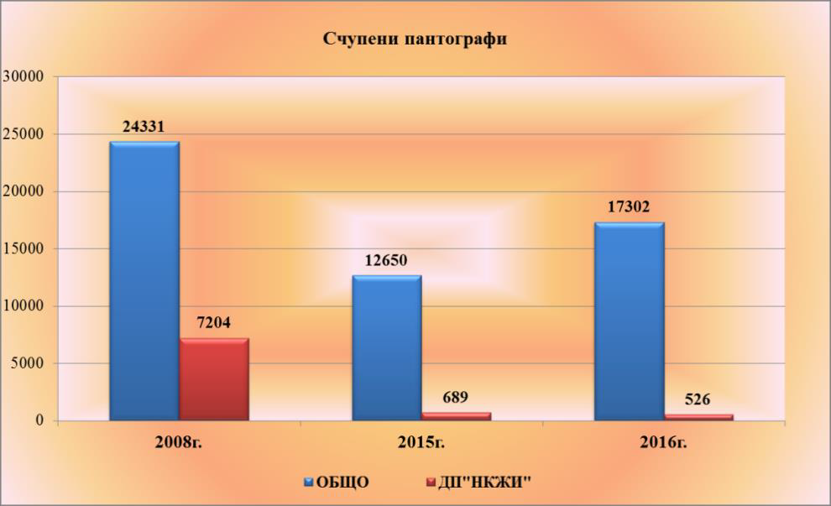



|  |  |
| --- | --- |
| Счупени паuтоrрафп | Broken pantographs |
| ОБЩО | TOTAL |
| ДП''НКЖП'' | SOE NRIC |
| Фигура 2. Данни за общото време на закъснение на влакове от счупени пантографи в България през годините 2008, 2015 и 2016 | Figure 2. Data on the total delay of trains due to broken pantographs in Bulgaria in 2008, 2015 and 2016. |

* + 1. Safety indicators relating to the technical safety of infrastructure and implementation thereof.

In 2016, the T03 indicator (total number of level crossings) in Bulgaria reports decrease by 1% compared to 2015. The values of T03 in the last five years are as follows: 761 (2016), 766 (2015), 774 (2014), 785 (2013), 783 (2012). The values of T06 indicator (total number of ‘active’ level crossings) over the last five years are the following: 622 (2016), 626 (2015), 632 (2014), 648 (2013), 646 (2012). The values of the T14 indicator (total number of ‘passive’ level crossings) over the last five years are as follows: 139 (2016), 140 (2015), 142 (2014), 137 (2013) and 137 (2012).

* + 1. Indicators relating to safety management.

In 2016, slight increase is reported in the number of conducted internal audits on the Safety Management Systems (SMS) of the IM (SE NRIC) and RUs pursuant to the requirements of Regulation (EC) No 1078/2012[19]. The observations of the NSA of Bulgaria show that the IM and the ‘old’ RUs plan and carry out audits of their SMS once per year. Most of them use the services of trained internal auditors and only one RU (Bulmarket Rail Cargo Ltd.) uses external auditors.

## National Safety Strategy, Programmes and Initiatives

The National Safety Strategy of the Republic of Bulgaria is included in the Strategy for Development of the transport system of the Republic of Bulgaria until 2020, issued by MTITC in 2010. It describes the obligations of the state regarding the development, coordination and implementation of a policy to increase safety and security in all modes of transport and of the transport system as a whole. The strategy emphasises the important role of the determination and the control of the application of technical standards for planning, design, construction, maintenance and operation of the transport infrastructure in order to ensure safety of consumers, uniformity and technical compatibility of the networks.

Operational Programme ‘Transport’ (OPT) 2007–2013 and Operational Programme ‘Transport and Transport Infrastructure’ (OPTTI) 2014–2020.

One of the main programmes for development of the Trans-European Transport Network to achieve sustainability of the Bulgarian transport system, part of which is the railway system, is OPT 2007–2013, continued with OPTTI 2014-2020. It is one of the seven operational programmes of the Republic of Bulgaria, financed from the EU Structural Funds and the Cohesion Fund. OPT is the Operational Programme with the largest budget in Bulgaria – over 2 billion EUR.



|  |  |
| --- | --- |
| ОПЕРАТИВНА ПРОГРАМА | OPERATIONAL PROGRAMME |
| ТРАНСПОРТ | TRANSPORT |

OPTTI 2014–2020 ensures continuity and logical continuation of investments from the 2007–2013 programming period, thus ensuring the completion of the routes in which investments have already been made. The following priority axes are formulated in the programme: 1) ‘Development of railway infrastructure along the “core” Trans-European Transport Network’; 2) ‘Development of road infrastructure along the “core” and “comprehensive” Trans-European Transport Network’; 3) ‘Improvement of intermodal transport services for passengers and freights and development of sustainable urban transport’; 4) ‘Innovation in Management and Services - Implementation of Modernised Traffic Management Infrastructure, Improvement of Transport Safety and Security’ and 5) Technical Assistance.

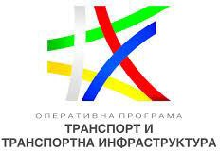

|  |  |
| --- | --- |
| ОПЕРАТИВНА ПРОГРАМА | OPERATIONAL PROGRAMME |
| ТРАНСПОРТ И ТРАНСПОРТНА ИНФРАСТРУРА | TRANSPORT AND TRANSPORT INFRASTRUCTURE |

Initiative with respect to the ILCAD (International Level Crossing Awareness Day) – 3 June

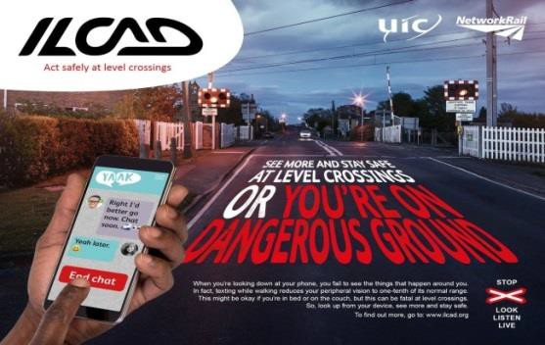

In 2016, for the eighth consecutive year, the infrastructure manager SE NRIC participated in the large-scale initiative of the international Level Crossing Awareness Day (ILCAD), which is held on the initiative of the International Union of Railways (UIC) jointly with the railway and the automobile sector in more than 50 countries around the world.

The first International Level Crossing Awareness Day (ILCAD) was held on 25 June 2009 in 27 countries.

The main purpose of the initiative is to show that accidents can be avoided by complying with traffic rules and by reducing the dangerous behaviour of traffic participants when crossing railway level crossings and the area around them.

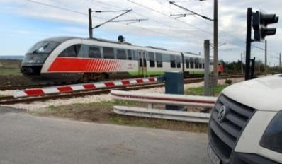

At the end of 2016, the total length of the railway network in Bulgaria is 6 475 ‘track kilometres’*[20]* and 3 904 ‘linear kilometres’[21]. At the end of 2016 in Bulgaria there are 766 level crosses, operated by the SOE NRIC, of which 139 are ‘passive’[22] and 622 are ‘active’[23].

The level crossings in Bulgaria in terms of their equipment and number are the following: 280, equipped with automatic level crossing alarms (sound and light); 119 equipped with automatic barriers; 119 equipped with electrical barriers; 108 equipped with manual barriers and 140 without technical means. Industrial level crossings, located in industrial railway branches, are total of 163.

##### One of the main priorities, as part of the overall activity of SE NRIC in Bulgaria, is ensuring security and safety when crossing railway level crossings.

In 2016, the positive trend of reducing accidents registered at level crossings continued. In 2016, the number of accidents at level crossings is 18 in total, of which 5 were ‘significant’. In 2015, they are 20, of which 6 are ‘significant’ and 21 in 2014, of which 11 are ‘significant’. The main reason for their occurrence is the violation of safety rules by drivers of motor vehicles and disregard of the signals prohibiting passage through the level crossing due to an approaching train.

The data regarding level-crossing accidents, registered in Bulgaria during the 5-year period 2012–2016, are presented in tabular format below:

|  |  |  |  |  |  |
| --- | --- | --- | --- | --- | --- |
| Year | Total number of accidents at level crossings | Total number of significant accidents at level crossings | Perished (killed) persons | Persons seriously injured | Total number of persons killed and seriously injured |
| 2012 | 36 | 15 | 7 | 15 | 22 |
| 2013 | 32 | 11 | 3 | 12 | 15 |
| 2014 | 21 | 11 | 6 | 16 | 22 |
| 2015 | 20 | 6 | 2 | 7 | 9 |
| 2016 | 18 | 5 | 5 | 5 | 10 |
| Table 1. Data for accidents at level crossings registered in Bulgaria in the period 2012 – 2016 (incl.) | | | | | |

The main objective of the implementation of the investment programme of NRIC SE for installing all required modern technical devices at level crossings is to reduce fatalities and serious injuries at railway level crossings. The financial strategy, implemented by the company in this respect, is based on the funds supplied both by the national budget of the Republic of Bulgaria and by the European funds – OPT 2007–2013 and OPTTI 2014–2020.

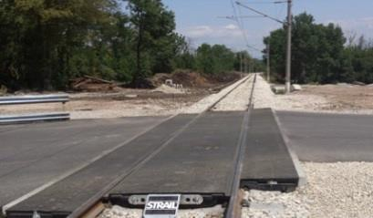

NRIC SE makes efforts to reduce the incidents at the railway level crossings in the country by intensively replacing the level-crossing devices and building elastic level-crossing pavements ensuring smooth and comfortable passage of motor vehicles in the area of the level crossings. In 2016, for rehabilitation and ongoing maintenance of railway crossings were invested: BGN 648 475 or EUR 331 560, and for elastic level crossing pavements: BGN 1 925 144 or EUR 984 310.

##### Educational safety campaign among children



In 2016 SOE NRIC together with the State Agency for Child Protection, Holding BDZ EAD and RAEA took part in a large-scale educational campaign to explain the dangers of widespread fashion among the teenagers of ‘selfies’ and youth gatherings in the area of stations and intersections. The campaign was launched in early 2016 after the school holiday. The initiative is launched to prevent accidents involving children. It is aimed at students in teenage age and emphasises the basic role of parents in their upbringing.

##### Campaign: ‘Railways are not a place to play and take pictures’ and ‘Is it worth risking your life for a single shot?’

With regard to the summer holidays and Children’s Day – 1 June, SOE NRIC and Holding BDZ EAD distributed hundreds of thousands of information brochures to the big stations in the country, as part of the ‘Railways are not a place to play and take pictures’ campaign. The initiative is carried out under the aegis of the State Agency for Child Protection, together with the Ombudsman of the Republic of Bulgaria, the Ministry of Interior (MoI) and other institutions dealing with cases of children injured by voltaic arc, as a consequence of illegal presence in sections of the RI.

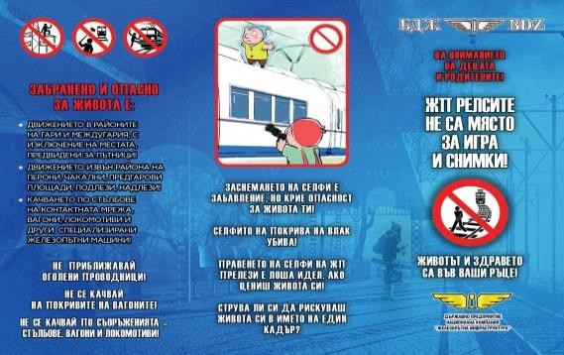

Fig. 3. Promotional brochure of the campaign ‘Railways are not a playground’ (face)

The information brochures of NRIC and BDZ are designed to increase the safety of children in areas of the railway infrastructure, as well as prevention of the phenomenon of ‘selfies in dangerous places’ which has become fashionable among teenagers.

Notwithstanding all the initiatives implemented over the years, the results of these initiatives related to rail infrastructure safety are generally unsatisfactory. Besides the problems with incorrect trespassing of the level crossings, the extreme selfies and dangerous behaviour in the areas of the National Railway Infrastructure, there is also a serious problem with non-observance of the rules for trespassing the railway routes using newly built facilities (underpasses, overpasses, lifts) doors are drilled in soundproofing walls to ‘shortcut’ over the tracks. Given the high speeds in these sections, this behaviour is an extreme danger to human life and health.

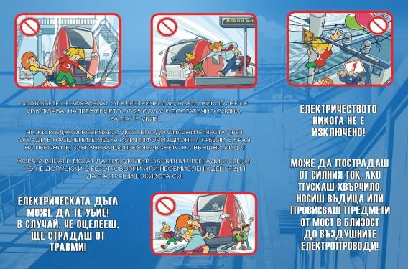

Fig. 4. Promotional brochure of the campaign ‘Railways are not a playground’ (back)

## Review of the Previous Year

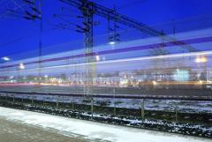

In 2016, as a whole, no lowering of the level of safety of the railway infrastructure and RS[24] was reported compared to 2015, based on the statutory criteria and safety indicators.

The safety management structures at the IM and the RUs provide full assistance to the RAEA in the monitoring and control of the overall development and improvement of safety. By the 10th day of each month they collect and process statistical information regarding the CSIs for the previous month and make it available to the RAEA and to the specialised unit for investigation of accidents and incidents in railway transport at the Ministry of Transport, Information Technology and Communications. The orders and prescriptions issued for this period and relating to the safety of transportation are enclosed with this information.

In 2016, the NIB of Bulgaria, applying the CSM for assessing conformity with the requirements for obtaining railway safety certificates established by Regulation (EU) No 1158/2010, issued a total of 11 SCs to the following RU for the rail carriage of goods: ‘PIMK Rail’ EAD (new SC part ‘A’ and ‘B’ on 3 June 2016 with validity 5 years), ‘TBD - Freight Transport’ EAD (updated SC part ‘A’ and part ‘B’ of 25 January 2016), ‘TBD - Freight Transport’ EAD (updated SC part ‘B’ on 11 April 2016), ‘DB Cargo Bulgaria’ EOOD (updated SC part ‘A’ and part ‘B’), SOE ‘TSV’ (renewed SC part ‘A’ and part ‘B’ on 30 September 2016 with validity 5 years) and Express Service OOD (renewed SC part ‘A’ and part ‘B’ on 9 December 2016 with a validity of 5 years).

The A & B Safety Certificates part ‘A’ and ‘B’ of TBD Freight EAD in 2016 were updated twice in relation to PCM/ECM[25] certificates issued to the same RU with numbers: BG/31/0015/0007 for freight wagons in accordance with Regulation (EU) No 445/2011[26] and BGRA/2016/0001 for railway vehicles in accordance with Ordinance No 59[27]. The Safety Certificates of DB Schenker Rail Bulgaria EOOD were updated on 30 May 2016 in connection with a change in the name of the Railway Undertaking to ‘DB Cargo Bulgaria’ EOOD.

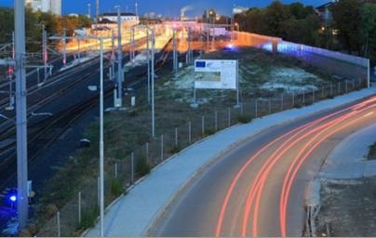

No SCs or SAs are issued, renewed, updated or withdrawn in 2016 to RU for passenger transport (in Bulgaria until now it is only ‘BDZ - Passenger Transport’ EOOD certified) and the IM (in Bulgaria only SOE NRIC is certified to date). Further details regarding the safety certificates and authorisations issued by the NIB of Bulgaria to RUs and the IM are presented in section E of this report.

## Focus Areas for the Next Year

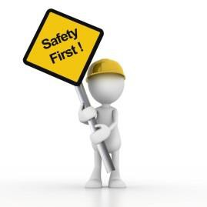

The key areas for action of the NIB of Bulgaria in the field of railway safety in the following year (2017) according to the requirements of Article 16(2) of the RSD are the following:

* Strengthening the control of RUs and IMs for strict compliance with the normative requirements for the transport of dangerous goods, RID Regulations and Ordinance No 46 after the serious accident with the release of dangerous goods, which occurred on 10 December 2016 at Hitrino Station in Bulgaria.
* Preparatory activities related to the transposition into Bulgarian legislation of the RSD and the other legal acts of the Fourth Rail Package (4RP).
* Issuance, renewal, amendment or revocation of safety certificates and safety authorisations of the RUs and the IM;
* Exercise of supervision as required by Regulation (EU) No 1077/2012;
* Issuing permits for commissioning the structural subsystems constituting the railway system and checking whether they are operated and maintained in compliance with the relevant essential requirements.
* Issuing permits for commissioning new and substantially altered rolling stock (RS);
* Control, support and development of the safety regulatory framework, including the system of national safety rules (NSRs);
* Registration of the vehicles in the National Vehicle Register (NVR) and timely update of the information in the register.
* Control over repairs, maintenance and operation of the railway infrastructure, traffic and transportation safety and the technical condition and serviceability of rolling stock.
* Controls and checks of the activities of persons authorised to assess and verify conformity of the constituents and subsystems with the TSIs (NoBo) and with the national safety regulations or technical rules (DeBo);

# DEVELOPMENTS IN SAFETY PERFORMANCE

## Detailed Analysis of the Latest Recorded Trends

Analysis of the data of the Common Safety Indicators (see also Annex A).

* + 1. Safety indicators relating to accidents, persons killed and seriously injured:

The values of safety indicators related to railway accidents, killed and seriously injured persons are shown in the table below for the period 2012 – 2016:

|  |  |  |  |  |
| --- | --- | --- | --- | --- |
| Year | Total number of accidents | Total number of significant accidents | Total number of persons killed | Total number of seriously injured persons |
| 2012 | 274 | 48 | 21 | 32 |
| 2013 | 266 | 33 | 12 | 21 |
| 2014 | 304 | 58 | 23 | 45 |
| 2015 | 305 | 48 | 20 | 24 |
| 2016 | 327 | 40 | 22 | 32 |
| Table 2. Data on the main safety indicators for Bulgaria for the period 2012 – 2016 (incl.) | | | | |

Table 3 below shows the total number of railway accidents, incl. significant, registered in 2016 in Bulgaria:

|  |  |  |  |  |  |
| --- | --- | --- | --- | --- | --- |
| Type of event | Region Sofia | Region Plovdiv | Region Gorna Oryahovitsa | Total number of accidents in 2016 | Significant accidents in 2016 |
| Train collision with railway vehicle train collision with obstruction within the construction gauge | 1 | 1 | 0 | 2 | 0 |
| 71 | 61 | 46 | 178 | 3 |
| Derailment of railway rolling stock | 24 | 18 | 11 | 53 | 6 |
| Level-crossing accident | 25 | 21 | 6 | 52 | 5 |
| Accidents to persons involving rolling stock in motion | 25 | 21 | 6 | 52 | 24 |
| Fires in rolling stock | 4 | 8 | 5 | 17 | 2 |
| Others | 1 | 3 | 3 | 7 | 0 |
| TOTAL | 130 | 119 | 78 | 327 | 40 |
| Table 3. Data on railway accidents registered in Bulgaria in 2016 (by region and total) | | | | | |

* + 1. Safety indicators relating to precursors for accidents:

The values of the indicators relating to precursors to accidents for the last five years are presented in table 4 below:

|  |  |  |  |  |  |  |  |
| --- | --- | --- | --- | --- | --- | --- | --- |
| Year | Number of broken rails | Number of track misalignments and other track deformations | Number of wrong side signalling failures leading to dangerous situations | Number of signals passed at danger | Number of broken wheels on rolling stock in service | Number of broken axles on rolling stock in service | TOTAL |
| CSI code | I01 | I02 | I03 | I041+I042 | I05 | I06 | I00 |
| 2012 | 82 | 0 | 0 | 4 | 27 | 14 | 127 |
| 2013 | 83 | 0 | 0 | 16 | 76 | 5 | 180 |
| 2014 | 102 | 1 | 0 | 16 | 1 | 4 | 124 |
| 2015 | 104 | 14 | 2 | 13 | 0 | 0 | 133 |
| 2016 | 83 | 11 | 0 | 20 | 2 | 0 | 116 |
| Table 4. Data on the CSIs related to precursors to accidents for the period 2012 – 2016 (incl.) | | | | | | | |

* + 1. Indicators for calculation of the economic impact of accidents:

In Bulgaria, in 2016, there is a 52% decrease in the C15 indicator ‘Minutes delay of passenger trains due to significant accidents’ compared to 2015 (2016 – 6 166 minutes, 2015 – 12 833 minutes, 2014 – 10 882 minutes). For C16 indicator ‘Minutes delay of freight trains only due to significant accidents’ an increase of 25% is observed, the values of which are: 2016 – 8 829 minutes; 2015 – 7 058 minutes; 2014 – 4 842 minutes).

* + 1. Safety indicators relating to the technical safety of railway infrastructure.

Data on some of the safety features related to the technical safety of the infrastructure and its implementation (‘Train Protection Systems (TPS)’[28] and ‘Level crossings’[29]) are presented in Table 5 below:

|  |  |  |  |  |  |  |  |  |  |
| --- | --- | --- | --- | --- | --- | --- | --- | --- | --- |
| Year | Percentage of railways in Bulgaria with active TPSs | Percentage of train–km with Train Protection Systems (TPSs) in operation | Total number of  active and passive level crossings* | Total number of active level crossings | Number of active level crossings – automatic, with a warning from the user side | Number of active level crossings – automatic, with user side protection | Total number of active level crossings – automatic with warnings and user-side protection and rail-side protection | Total number of active level crossings with manual user-side warning | Total number of passive level crossings |
|  | [ % ] | [ % ] | [ number ] | [ number ] | [ number ] | [ number ] | [ number ] | [ number ] | [ number ] |
| CSI | Т01 | Т02 | T03 | T06 | Т07 | Т081 | T10 | T12 | T14 |
| 2012 | 10.5 | 22 | 783 | 646 | -* | -* | -* | 171 | 137 |
| 2013 | 10.7 | 24 | 785 | 648 | -* | -* | -* | 139 | 137 |
| 2014 | 11.4 | 22 | 774 | 632 | -* | -* | -* | 126 | 142 |
| 2015 | 6.5 | 10.2 | 766 | 626 | 280 | 238 | 108 | 108 | 140 |
| 2016 | 6.5 | - | 761 | 622 | 278 | 172 | 64 | 108 | 139 |
| Table 5. CSIs related to technical safety of the railway infrastructure in Bulgaria for the period 2012 – 2016 (incl.) | | | | | | | | | |

* + 1. Indicators relating to safety management.

In 2016 there is an increase in the internal audits carried out by RUs in Bulgaria certified for the carriage of goods or passengers, and the monitoring of the SMS according to Regulation (EC) No 1078/2012. In 2016, they conducted a total of 11 internal audits on their SMS, while in 2015 and 2014, 7 IAs.

Observations by the NIB of Bulgaria show that the State Railway Infrastructure Manager (NRIC), the ‘large’ and the ‘medium’ RU hold a yearly IA on their SMS. Of these, only BJC AD (large RU) in 2016 conducted three IAs on certain topics of the SMS (one overall, one of the manoeuvre and transport activity and one of the maintenance of the RS). Of the 13 RUs with SC for freight or passenger transport in Bulgaria as at 31 December 2016, four of them still do not carry out internal audits and monitor their SMS as required by Regulation (EC) No 1078/2012 (Gastrade AD, Port Rail Ltd, PIMK Rail EAD and Cargo Trans Wagon Bulgaria AD).

|  |  |  |
| --- | --- | --- |
| Year | Total number of conducted audits of IM and RUs | Performed audits as a percentage of planned audits (%) |
| 2012 | 4 | 100 |
| 2013 | 5 | 100 |
| 2014 | 7 | 100 |
| 2015 | 7 | 87.5 |
| 2016 | 11 | 100 |
| Table 6. Total number of internal audits carried out in Bulgaria by RU and IM in the period 2012 – 2016 | | | | |

## Results of Safety Recommendations

The National Railway Accident Investigation Body in Bulgaria is the Special Investigation Unit for Accidents and Incidents in Railway Transport at the Directorate ‘Accident Investigation Unit in Air, Water and Railway transport’ of the Ministry of Transport, Information Technology and Communications (MTITC), which was established by Decree No 250 of 25 November 2005 of the Council of Ministers of the Republic of Bulgaria.

In 2016, safety recommendations from the RAEA of NIB of Bulgaria (RAIU) were received in connection with the following seven railway accidents:

* + 1. Fire at a locomotive No 44-169.1 on 13 October 2015 in the intersection Elin Pelin – Vakarel, serving passenger train No 1621 from Sofia to Svilengrad (no passengers or railway employees were injured in the accident).

|  |  |
| --- | --- |
|  |  |

* + 1. Derailing of freight train No 50601 on 23 January 2016 at Dupnitsa station (no victims and injured employees, but major damage to RS, RI and freight carried).

|  |  |
| --- | --- |
|  |  |

* + 1. Fire in locomotive No 44081.8 serving passenger train No 8626, in the intersection Aytos – Chernograd on 13 April 2016 (no victims and injured passengers and railway employees, but significant damage to the locomotive and railway infrastructure).

|  |  |
| --- | --- |
|  |  |

* + 1. Fire in locomotive No 44085.9, serving passenger train No 3622, in the intersection Dunavtsi – Sahrane on 16 June 2016 (no victims and injured passengers and railway employees, but significant damage to the locomotive in the accident).

|  |  |
| --- | --- |
|  |  |

* + 1. Fire in locomotive No 44141.0, serving passenger train No 3622, in the intersection Mihaylovo – Svoboda on 8 July 2016 (no victims and injured passengers and railway employees, but significant damage to the locomotive and RI).

|  |  |
| --- | --- |
|  |  |

* + 1. Derailment of freight train No 50505 at Petarch station on 28 August 2016 (no victims and injuries to railway employees, but significant damage to RS, RI and cargo).

|  |  |
| --- | --- |
|  |  |

* + 1. Fire in locomotive No 44096.6, serving passenger train No 80290, in the intersection Chernograd – Karnobat on 14 September 2016 (no injured passengers or employees, but significant damage was caused to the locomotive and RI in the accident).

|  |  |
| --- | --- |
|  |  |

|  |  |  |
| --- | --- | --- |
| Safety recommendations received from the NIB of Bulgaria in 2016 | Safety measures taken following the recommendations of Bulgaria’s NIB | Status of implementation |
| 1. After the fire, which occurred on 13 October 2015 in the intersection Elin Pelin – Vakarel, in electric locomotive No 44-169.1, serving passenger train No 1621 of BDZ - Passenger Services Ltd. | | |
| 1. BDZ Holding Ltd. and the railway carriers operating electric locomotives with an autotransformer switch (ATS) in the course of conducting 48-hour operational checks shall conduct a visual inspection of the collector unit of the ATS. 2. After an inspection and possible repair, an angular flowchart shall be prepared and captured, subject to the large periodic repair’s standards. 3. Technical requirements for the supply of contact bodies of material with parameters according to the technical requirements of the manufacturing plant shall be drafted. | On recommendation 1. The final report was sent to all divisions for familiarisation against the signatures of the repair and operations staff.  On recommendation 2. The ‘RRS’ and ‘Operations’ Directorates of BDZ-PS received orders from the divisions of the organisation created to implement the recommendations.  On recommendation 3. A public procurement contract for ATS contacts for electric locomotives series 44 and 45 was held. The contacts corresponding to the original drawing issued by the manufacturer's factory are prepared and delivered. | All recommendations are observed. |
| 1. After the derailment of passenger train No 50601 of BDZ – Freight Services Ltd. at railway station Dupnitsa on 23 January 2016. | | |
| 1. Vocational Training Centre (VTC) to Holding BDZ EAD to periodically organise refresher trainings on the current regulations of personnel directly related to the safety of transport. 2. Holding BDZ EAD to organise periodic inspections and tests of direct and train crane drivers and registering speedometers of locomotives from all series as well as to regularly monitor and monitor the speed bands of the locomotives by strictly monitoring the registration of all parameters. 3. Holding BDZ EAD to take action for designing, constructing and commissioning of electronic stands for testing the braking devices in the main locomotive depots of BDZ. 4. Holding BDZ EAD to design, construct and deploy a computer stand in the both companies for check and testing the registrar speedometer of the locomotives. 5. Holding BDZ EAD to organise the deployment of all locomotive devices, which will register in digital form and store all the data about the state of the locomotive. 6. Holding BDZ EAD to assign the construction of a simulator for training and testing of the practical skills of the locomotive drivers for the management of the braking systems. 7. It is proposed that SOE NRIC shall amend and supplement Art. 334 of the ‘Rules on the movement of trains and shunting activity in railways’ RMT and SA), as follows: 8. The current text in Art. 334 to become paragraph 1; 9. A new paragraph 2 to be created with the following text:   “(2) Upon departure of a freight train from a railway station, locomotive train drivers must obligatory check the effectiveness of the train brake at a temperature lower than minus 10o C." | 1. “BDZ-PS” and “BDZ-FT”, depending on the needs, shall prepare on a yearly basis periodic training requests for the staff involved in the safety of the transports, the training being conducted on approved curricula and programmes with a specific workload containing the theoretical and practical training completed with an examination. 2. The organisation and performance of periodic inspections and tests of the direct and train crane driver and the recording speedometers of all series of locomotives are to be carried out by “BDZ-PS” and “BDZ-FT” as the rolling stock PCW. After each check of the planned repairs, on-site samples and subsequent speed braking samples shall be carried out and a model card shall be filled in. For the operation of speedometer installations, speedometers and taho-switches shall be subject to periodic inspections and tests, proper reporting of the parameters and decryption of locomotives and multiple units (MU) shall be monitored. 3. The possibility of taking action for designing, constructing and commissioning of electronic stands for testing the braking devices in the main locomotive depots of Holding BDZ EAD is discussed. 4. Given the technically exhausted possibilities for upgrading, maintenance and securing supplies for the Hasler speedometer installation, an expert level is sought for a compatible modern and reliable speedometer system. 5. The MB series 10 000, 30 000, 31 000 and some of the electric locomotives series 44 001, 44 002 and 46 200 have electronic blocks that record all the data about their technical condition and the movement of the train where road equipment is built. 6. Given the diversity and differences of the braking systems used in all series of locomotives and MUs, it is difficult to determine the methodology and criteria to be followed for training and testing the simulator for the practical skills of locomotive drivers for braking systems management.   Upon delivery of new rolling stock under technical conditions, the manufacturer shall provide a training simulator for locomotive train drivers.   1. The General Director of SOE NRIC has issued Order No 1572/27.07.2016 amending the contents of Art. 334 according to the proposed texts. | All recommendations are observed. |
| 1. After the fire which occurred on 13 April 2016 in the intersection Aytos - Chernograd, in electric locomotive No 44-081.8, serving passenger train No 8626 of BDZ - Passenger Services Ltd. | | |
| 1. Carry out inspection of fire-fighting installations and basic protections of all locomotives. 2. Inspection of the operational examinations of the locomotives in the main and working depots and the operational points. 3. Installation of additional sensors to the fire alarm system and spray nozzles to the fire extinguishing system in the fire hazardous zones. 4. Upgrading of the 44000 and 45000 series locomotives with the construction of new fire-alerting and fire extinguishing systems of the locomotives. 5. Increasing the control over performing inspections and checks on the condition of the electrical equipment according to the ‘Regulations for the depot repair and maintenance of the electric locomotives of BDZ’. 6. Increasing the control over compliance with the norms for the commissioning of electrical machines and apparatus according to the ‘Regulations for the depot repair and maintenance of the electric locomotives of BDZ’. 7. Conducting periodic training of locomotive staff on the design and operation of the fire extinguishing locomotive installation and actions in the event of a fire occurring in rolling stock during operation. 8. Improvement of the coordination of the interaction of the individual operating services of SOE NRIC with the licensed carriers in the event of accidents and incidents in accordance with the requirements of Regulation No 59 on railway safety management and Ordinance No 58 on the rules for technical exploitation, train operation and signalling in rail transport. | 1. In order to reduce the prerequisites for the occurrence of fires caused by cables, cable connections and splints, an order No 287/03.05.2016 was issued. For the performed checks and measurements according to the order, the protocols with the results of the one-time inspection were sent and stored in the department ‘Repair’ of the RS Directorate. 2. The control over the operation of the locomotives in the main and operational depots and the operational points is increased. 3. A study was carried out on the options for mounting additional sensors or a new fire detection system (FDS) in 44000 and 45000 series locomotives, and a demonstration of the operation of the UniPOS fire detection system was carried out in this regard. An experiment was authorised to be carried out for the construction of FDS and FES of locomotive No 44179.0 in the Gorna Oryahovitsa locomotive depot, upon a proposed solution for complex fire protection with aerosol extinguishing of ANKOS-66 EOOD. 4. The manager of ‘BDZ-PP’ has approved reports for conducting an open procedure under the Public Procurement Act for carrying out capital repair and modernisation of 30 electric locomotives series 44000 and 45000 and carrying out 30 hoist repairs of electric locomotives series 44000 and 45000, where modernisation of the fire extinguishing installation of locomotives and replacement of the existing type of capacitors WK71021 and WK71020 from the protection of the rectifier blocks with new fireproof capacitors is provided. 5. and 6. The control over performing inspections and checks on the state of electrical equipment, electric machines and apparatuses according to the requirements of the repair regulations is increased. 6. and 8. Periodic trainings of the locomotive staff on the structure and operation of the fire-fighting installation of the locomotives and their operation in case of fire pursuant to Order No 397/15.06.2016 of the manager of ‘BDZ-PS’ EOOD are carried out on official mandatory lectures according to an validated schedule.   On 19 July 2016 the RAEA sent to SOE NRIC to recommendation No 8 on implementation, for which a reply was received on 21 October 2016 confirming its execution. | All recommendations are observed. |
| 1. After the fire which occurred on 16 June 2016 at Sahrane station in electric locomotive No 44-085.9, serving passenger train No 3622 of BDZ - Passenger Services Ltd. | | |
| 1. Audit on the performance of the Fire Extinguishing and Fire Detection Installations as well as the basic protection of the locomotives of Holding BDZ EAD. 2. Increasing control over operational reviews of locomotives in main and operational depots and service stations. 3. Conducting periodic trainings of locomotive staff with regard to the structure and operation of the fire-fighting installation of locomotives and their actions in case of fire. 4. Planning upgrade of 44000 and 45000 series locomotives through new fire detection and fire extinguishing systems of locomotives, with automatic action and more efficient fire-extinguishing agent. 5. Modification shall be planned of the existing fire-fighting installation of the locomotives and adding smoke and flame sensors in the hazardous areas. | In ‘BDZ – Freight Transports’ EOOD:  Under items 1 and 2. Order No 411/28.08.2015 stipulates for each planned repair in the locomotive depot locomotives to be checked against fire, as locomotives with available stationary fire-extinguishing systems shall be checked for their fitness. Locomotives shall be brought into service only after the said officials have certified with their signatures in the repair inventory that they are in fit for purpose fire-fighting situation. IQPPR[30] of ‘BDZ – FT’ before signing to add the text ‘The locomotive is fire-safe’.  Order No 12 / 07.01.2016 of the Manager of ‘BDZ – Freight Transports’ Ltd. Stipulates the electric locomotives with an autotransformer switch (ATS) to be subject to mandatory visual inspection of the ATS contactor block during the operation review every 48 hours .  After any necessary repairs, an oscillogram must be produced and removed, ensuring the correct operation of the elements in it, observing the Major Periodic Repairs (MPR) standards. Any repair of the ATS, regardless of the volume, should be entered into the passport of the unit and the record of the measurements made and a copy of the oscillogram shall be stored therein.  The technical requirements accompanying the initiation of public procurement for the supply of contact elements from the power train of the locomotives are overstated and with intended requirement to strictly observe the parameters, the material and the coverage of the enclosed drawings. Regarding the quality of their work, the definite requirement is that component joining shall be reliable and guaranteed, in line with standards and technology.  Under item 3. By order of the Director of ‘BDZ - Freight Transports’ EOOD, the directors of the RTP have been ordered to organise and carry out training with lecturers from the Regional Fire Safety Offices of all personnel twice a year on fire regulations and norms for the operation of locomotives.  On recommendations 4 and 5. A report was prepared on the necessity of spending on public procurement with the subject of: ‘Development of a Technical project for replacement of the currently used thermal sensors in order to increase the performance and efficiency of the fire detection installation and installation of additional sensors in the battery cabinets.’  In ‘BDZ – Passengers’ EOOD:  Under item 1. A check is being carried out on the fire-fighting installations and the basic protections of all locomotives operated by the respective depot.  Under item 2. The control over the operation of the locomotives in the main and operational depots and the operational points is increased.  Under item 3. Periodic training of locomotive staff on the structure and operation of the fire-fighting installation of locomotives and their actions in case of fire is carried out.  Under items 4 and 5. Experimenting of FDS and fire extinguishing system (FES) of electric locomotive No 44179.0 is carried out. | All recommendations are observed. |
| 1. After the fire which occurred on 08 July 2016 in the intersection Mihaylovo – Svoboda, in electric locomotive No 44-141.0, serving passenger train No 4681 of BDZ – Passenger Services Ltd. | | |
| 1. Analyse the risk assessment as a consequence of the frequent fires in the TCP and prepare risk mitigation measures. The ‘Methodology for analysis and assessment of safety risk’, which is an integral part of SMS, to be assessed as follows: the probabilities of a possible fire risk in the TCP at operation; the dangers associated with a ‘subjective factor’ (locomotive brigade and shipment brigade); the risks in the ‘technical factor’ part relating to the maintenance and repair of electric locomotives.   To supplement the ‘Record of hazards for maintenance activities in Annex No 2’, as the possible fire risks in operation in individual apparatuses and aggregates during the TCP repair are being assessed at the respective level.   1. To provide gas masks for locomotive brigades – two pieces per locomotive, as required by Art. 427, para. 1 of Ordinance No 13 on ensuring occupational health and safety in the railway transport. | 1. Order No 476/13.07.2016 instructed an expert council to carry out an analysis and risk assessment of the preconditions for the occurrence of the firing of the 44000 and 45000 series locomotives resulting from the discontinued medium and capital repairs (MR and CR ). Analysis and evaluation are performed in time and covers hazards and fire risks in the ‘technical factor’ section.   An analysis and assessment of the hazards related to the ‘subjective factor’ (locomotive brigade and transport brigade) has been carried out on the probability of a possible fire risk in the TCP at the time of movement for which a report has been prepared including measures for risk mitigation.  An addendum is drafted to the Danger Register - for maintenance of the TCP of BDZ – PS, an annex to the Methodology for analysis and risk assessment for the maintenance of the TCP.   1. With respect to the requirements of Art. 427, para. 1, item 7 of Ordinance No 13 the Fire Technique Ltd. company has supplied the necessary quantities of gas masks. They are located in the cabins of electric locomotives, multiple units, couchettes and sleeping carriages . | All recommendations are observed. |
| 1. After the derailment of passenger train No 50505 of BDZ - Freight Services Ltd. at railway station Petarch on 28 August 2016. | | |
| 1. ‘BDZ-FT’ to increase the control of the correct loading of the wagons in the bulk cargo areas. 2. To increase the quality of the freight wagon inspections carried out by BDZ-FT and the owner of the Bobov Dol HPP EAD wagons operated on the railway infrastructure. | ‘BDZ-TP’ has ordered all the divisions of the company to take measures for:   1. Carrying out thorough commercial and technical inspections of the wagons loaded by the shippers and especially the wagons loaded with bulk cargoes. 2. Strict performance of the technical inspections and samples of the automatic brakes of the train crews with strict compliance with the requirements of the ‘Instruction for Technician, Inspector Wagons’ (TIW) and Ordinance No 58. 3. Warning to all shippers to strictly observe the requirements for proper wagon loading and load distribution. | All recommendations are observed. |
| 1. After the fire which occurred on 14 September 2016 in the intersection Chernograd - Karnobat, in electric locomotive No 44-096.6, serving passenger train № 80290 of BDZ - Passenger Services Ltd: | | |
| 1. To investigate the behaviour during operation of the voltage transformer of the electric meters installed in the electric locomotives series 44000 and 45000 . To assess the risk of danger arising from malfunctions and the connection of the meters. 2. At each minor periodic repair (MAP), check the condition and density of the oil cooler's coolant loop, focusing on the bonding rubber compounds. | 1. The final report was sent for information to the managers of the locomotive depots Sofia, Gorna Oryahovitsa and Plovdiv and is to be signed by the repair and operating staff. An order was issued for observation of five locomotives, having an initial review of the voltage transformer, its strengthening, reliability of the connections. Observations have included reviews for: overheating of the power cables, removal of the cable terminal, loosened bolts to strengthen the transformer, degraded cable insulation. The result of the reviews of the five locomotives has shown that there is no change in the behaviour of the voltage transformer while operating. 2. Locomotive depots were instructed for each Small Periodic Repair (SPR) to check the oil cooler’s loop density, paying attention to the connecting rubber compounds.   The managers of depots have ordered an additional inspection, which is reflected in the Repair Inventory – Phase 3. | All recommendations are observed. |
| Table 7. Measures taken by RUs and IMs in Bulgaria following safety recommendations made by the NIB to the NSA in 2016 | | |

## Measures implemented not in relation to safety recommendations.

* Safety measures taken as a result of investigated railway accidents and incidents by the NSA and the District Investigation Committees (DICs).

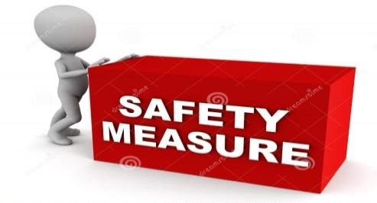In 2016, employees of the Regional Rail Inspectorates (RRI) at RAEA chaired meetings of the District Investigative Committees (DICs) in Sofia, Plovdiv and Gorna Oryahovitsa, where a total of 192 accidents and incidents were investigated (preconditions for accidents) according to the requirements of Art. 78, para. 3 of Ordinance No 59. For all investigations of accidents and incidents, final reports were drafted, in which, if necessary, instructions and recommendations were given in order to avoid any repetition of the admitted violations or searching for liability of employees for violations they had allowed on the safety of train movement.

#### Instructions issued by the RAEA ID:

The RAEA ID in 2016 issued seven instructions, of which four were to BDZ-PS and three to SOE NRIC. The instructions to BDZ-PS in 2016 were related to: 1) Providing information on passengers’ rights in all stations and passenger wagons, incl. contact details of the carrier in appropriate font and placement of stickers with the MTITC hotline; 2) Provision at all stations of ‘Rules of action of BDZ-PI and SOE NRIC officials in case of violation of the traffic schedule’; 3) Providing passengers at Sofia Station in an accessible manner with information regarding the discontinuation of the services provided under the Contract for Public Services Offering of Railway Transport in Bulgaria.

The instructions to SOE NRIC in 2016 were related to: 1) Removal of irregularities related to the flooded pedestrian underpass at the Skobelevo stop. Construction of platform sheds for passenger protection and temporary pedestrian bridges at both ends of the platforms to be used for crossing railways from passengers to the moment of drainage of the pedestrian underpass and its restoration; 2) Providing access to the PRM at Dragichevo Station; 3) Preparation of a procedure regulating the appointment, cancellation and correction of a train schedule in an operational order in the event of unforeseen situations occurring during the train movement or immediately prior to its departure, which is agreed with the railway carriers and included in the RD of the network , Annex 4, VII ‘Operational Interaction in Planning and Management of Transport and Operation of Railway Infrastructure’.

#### Instructions issued by RRI staff to RAEA:

In the inspections carried out in 2016 by officers (inspectors) of the RRI to the RAEA on sites of RU and IM, irregularities were observed regarding the observance of the national safety rules (NSR) according to RTA, Ordinance № 58, Ordinance № 58[31], TOR[32], RMTSA[33] and etc., for which 3 acts of violations of railway employees were drawn up and 58 instructions (including by RRI Plovdiv – 36, RRI Sofia – 13 and RRI Gorna Oryahovitsa – 9). The RRI’s instructions are addressed to: SOE NRIC (41), RUs for the carriage of passengers or freight (15) and owners of IRB[34] (2).

* Safety measures taken by the NSA of Bulgaria as a result of inspections of IM and RU carried out in 2016:

In 2016, RRI employees at RAEA have checked a total of 925 sites, including: 420 railway stations, 250 RS (trains, locomotives, DMU[35]/EMU[36], PCMC, motor handcars), 9 WRS[37], 43 level crossings, 19 railway sections, sub-regions for the maintenance of the contact grid, EDC[38], IE sections[39], passenger and freight centres, locomotive depots, intermodal terminals, construction companies, repairing railway infrastructure, licensed carriers, etc. staff (train and locomotive brigades, IM managers and RU dispatchers)

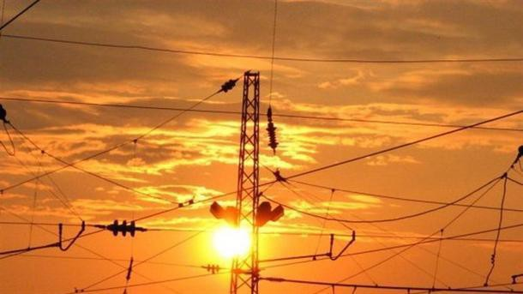

In 2016, RAEA employees from RRI have audited a total of 858 employees occupying positions related to the safety of rail transport for the use of alcohol and other narcotics.

In implementation of the requirements of Art. 5 of Ordinance No 56 in 2016, RAEA employees carried out control tests of 890 IM and RU staff occupying positions related to the safety of railway transport, including: RRI Sofia – 388, RRI Plovdiv – 293 and RRI Gorna Oryahovitsa – 199.

# SUPERVISION

## Strategy and Plan(s)

The essential safety requirements shall be determined in the Railway Transport Act and the statutory instruments. The requirements of the RSD are implemented mainly in Ordinance No 59 on safety management of railway transport, issued by the Minister for Transport, Information Technology and Communications. It introduces the principles of the CSM on supervision performed by the NSA after the issuance of the SC and SA and PCM certificates, stipulated in the provisions of Regulation (EU) No 1077/2012.

When defining the supervision strategy and supervision plans of the NSA of Bulgaria, at least the following sources of information are used:

* Monthly and annual information on the status of safety, presented by the certified railway undertakings and the national railway infrastructure manager (SOE NRIC);
* Daily information from the newsletter on the irregularities on the railway network of Bulgaria, prepared by the duty traffic controllers to the National Railway Infrastructure (SOE NRIC);
* Review of the documentation and records relating to the safety management system of RU and IM;
* Review of the performance results of the safety management system, established during supervisory audits, checks and inspections or other similar activities;
* Results of the investigation of accidents, incidents and NM[40];
* Received signals and complaints from IM, RU, etc.

The plans for the annual inspection may be revised based on the input information from the monthly analyses, checks and inspections. Major changes in revisions are related to the scope and purpose of the inspection in the presence of alarming information on safety. They shall be approved by the executive director of RAEA and shall be sent for information to the respective railway undertakings and the infrastructure managers. The Annual Surveillance Schedule is elaborated by a Chief Inspector at DGRI, coordinated by the Director General of DGRI and endorsed by the RAEA ED.

## Human resources

The RAEA, through its Directorate General ‘Railway inspectorate’, performs its functions of the National Safety Authority for the railway transport of the Republic of Bulgaria. Some of its main functions are related to the performance of supervision of the Safety Management (SMS) of the RU and IM, as well as control over the management of PCM/ECM of wagons and other railway vehicles.

As of 31 December 2016 DG ‘Railway Inspectorate’ consists of 31 employees, including 15 inspectors in territorial units – Regional Railway Inspectorates in Sofia, Plovdiv and Gorna Oryahovitsa. The administrative, legal and financial services for DG ‘Railway Inspectorate’ are delivered within the RAEA by the ‘Administrative-legal and Financial-economic Management’ Directorate comprising eight members of staff.

In 2016, the NSA of Bulgaria conducted 14 SMS audits of all certified RUs for cargo transportation (12) and passengers (1) in Bulgaria, as well as the State IM (SOE NRIC – 1). Nine of them are supervisory, four are for renewal of safety certificates and one is for initial certification. More information on the supervisory audits performed by the NSA of Bulgaria on IMs and RUs for passenger or freight transport in 2016 is provided in Table 8 below.

|  |  |  |  |
| --- | --- | --- | --- |
| No | Name of the certified company /IM or RU/ | Type of activity | Audit period |
| 1 | SOE NRIC | Infrastructure Manager | 23.02 - 02.03.2016 |
| 2 | ‘Bulgarian Railway Company’ AD (BRC) | RU for freight transport | 29.03 - 08.04.2016 |
| 3 | ‘BDZ – Freight Transport’ (BDZ-FT) Ltd. | RU for freight transport | 26.04 - 12.05.2016 |
| 4 | ‘PIMK Rail’ EAD (PIMK) | RU for freight transport | 19.05 – 26.05.2016 |
| 5 | ‘DB Cargo Bulgaria’ Ltd. (DBCBG) | RU for freight transport | 25.05 - 02.06.2016 |
| 6 | ‘Bulmarket Rail Cargo’ Ltd. (BMRC) | RU for freight transport | 07.06 - 10.06.2016 |
| 7 | ‘Cargo Trans Wagon Bulgaria’ AD (CTWB) | RU for freight transport | 21.07-22.07.2016 |
| 8 | ‘Port Rail’ Ltd. | RU for freight transport | 12.07 - 15.07.2016 |
| 9 | ‘Gastrade’ AD | RU for freight transport | 07.09 - 09.09.2016 |
| 10 | SOE ‘Transport Construction and Reconstruction’ (TCR) | RU for freight transport | 20.09 - 27.09.2016 |
| 11 | ‘TBD – Freight Transport’ EAD (TBD-FT ) | RU for freight transport | 12.10 - 14.10.2016 |
| 12 | ‘Rail Cargo Carrier – Bulgaria’ Ltd. (RCCBG) | RU for freight transport | 25.10 - 29.10.2016 |
| 13 | ‘Express Service’ Ltd | RU for freight transport | 08.11- 11.11.2016 |
| 14 | ‘BDZ - Passenger Services’ Ltd. (BDZ-PS) | RU for passenger transport | 06.12 - 15.12.2016 |
| Table 8. Supervisory audits of the RUs and IMs certified by SMS by the NSA of Bulgaria in 2016 | | | |

The audits of the SMS of SOE NRIC, BDZ, BDZ – Freight Transport, DB Cargo Bulgaria, Bulmarket Rail Cargo, Gastrade, TBD – Freight Transport, Rail Cargo Bulgaria, and “BDZ-Passenger Services” in 2016 were carried out in compliance with the annual surveillance plan for 2016 of the NSA of Bulgaria and those of SOE ‘TCR’, Port Rail, CTWB and Express Service Ltd in application for renewal of SC for freight. Of these, only SOE ‘TCR’ did not claim the transport of dangerous goods (the previous SC involved the transport of dangerous goods). Only the audit of ‘PIMK Rail’ EAD was conducted with regard to an application for issuing new SC (for more information seesection E.1of the report).

In 2016, the average of about 17-19 employees took part in the supervisory audits of the SMS and the large and medium-sized RUs and IMs (SOE NRIC) in Bulgaria, and for the small RUs between six and 12 DGRI employees at RAEA, who were engaged with this activity for about total 3600 hours. So far, the NSA of Bulgaria has not used the services of external experts to carry out surveillance activities on the SMS of the certified RUs and IMs.

In 2016, the NSA of Bulgaria as a certifying body of PCM of freight wagons and other railway vehicles (locomotives, EMU/DMU, PCMC, passenger wagons, etc.) carried out a total of 28 RU audits holders of certificate(s) of PCMs or a maintenance function (MF) of RS or applying for new such certificates. Of these, for initial certification a total number of two audits were performed, including entities certified to perform MF – 1, and certified entities in charge of maintenance – 1.

For the renewal of the certificates, six audits were carried out, incl. for renewal of certificates for performing MF – 3 and renewal of PCM certificates – 3.

In 2016, in implementation of the annual surveillance plan of RAEA as a certifying body of PCM, it has carried out a total of 20 annual audits of vehicle PCMs. Between four and 10 auditors (officials from DG ‘Railway Inspectorate’) participated in these audits and were engaged in this activity for a total of about 2 700 hours. So far NSA of Bulgaria as PCM’s certifying authority has not used the services of external auditors for performing its supervisory functions on PCMs.

In 2016, checks and inspections of railway undertakings and the infrastructure manager, related to their activities concerning the safety of transportation, were carried out, and 15 inspectors from the Regional Railway Inspectorates spent about 9 000 hours conducting them.

## Competence

Employees who carry out activities for the control and supervision of the RUs and IMs shall have the competence, related to the safety of transportation by railway transport in compliance with the requirements of Ordinance No 56 - 14.02.2003 on the requirements, conditions and procedure for training of the candidates for the acquisition of competence required by the personnel responsible for the safety of transportation by railway transport, or recognition of such a capacity, and the procedure for conducting examinations of persons of the staff responsible for the safety of transportation.

In 2016, no trainings of the employees of NSA of Bulgaria aimed at raising their competence and skills in the supervision activity were conducted.

## Decision-making

Ordinance No 59 introduces the following principles of supervision provided for in Regulation (EU) No 1078/2012: 1) proportionality; 2) coherence; 3) direction; 4) transparency; 5) priorities for resource efficiency and 6) management responsibility and cooperation.

The audits performed were targeted at checking the operation of the Safety Management Systems of the railway undertakings and the infrastructure manager, as well as the systems for the maintenance of vehicles of the PCMs. In case of established irregularities, recommendations shall be prepared within the appropriate deadlines.

In the conducted checks/inspections of the railway infrastructure and railway undertakings, the NSA has made prescriptions and actions have been undertaken to bring objects of railway infrastructure and rolling stock in compliance with the safety requirements. Upon finding deficiencies that threaten the safety of carriages, the inspectors of the NSA stop the service of elements of railway infrastructure or rolling stock until such deficiencies are eliminated. The RIM and the RUs are required to comply with the prescriptions within the specified time limit. Implementation of prescriptions and elimination of non-compliance with safety requirements are subject to follow-up by the NSA.

For established violations relating to the safety of carriages, the officials of the NSA compile acts of administrative violation, in accordance with the Railway Transport Act. In 2016, 103 penal decrees were issued by the Executive Director of the RAEA, based on acts of violations of the RTA, drawn up by inspectors of the Railway Administration Executive Agency and employees of the Ministry of Interior.

During the reporting 2016, there were no complaints filed by the RUs and the IM against decisions made by the NSA of Bulgaria in the course of supervisory activities.

## Coordination and Cooperation

During 2016, NSA of Bulgaria execute agreements with NSAs from other EU Member States for the common implementation of supervisory activities on RUs and the IMs.

## Findings from Measures Taken

The results of the audits carried out in 2016 of SMS of RUs and the IM, holders of SC and SA may lead to the conclusion that they comply with the requirements of the European and the national legislation relating to the Common Safety Methods and Common Safety Targets and maintain functioning SMS. Gaps in the implementation of Regulation (EU) No 1078/2012 and Regulation (EU) No 402/2013 were established. As a result of the recommendations and prescriptions of the NSA, railway undertakings take timely action to correct the discrepancies established in the implementation of SMSs.

# SAFETY CERTIFICATION AND AUTHORISATION ISSUING

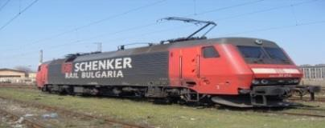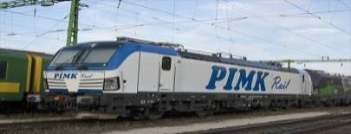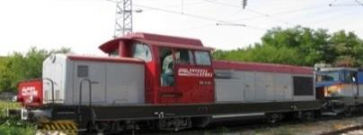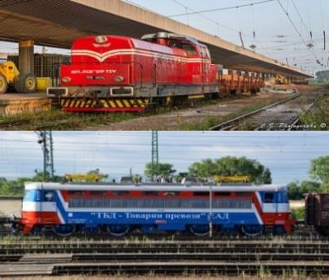

Fig. 5. Images of RU locomotives received SC from RAEA in 2016 (top-down): 1) Express Service; 2) PIMK Rail; 3) DB Cargo Bulgaria; 4) SOE TCR and 5) TBD-FT.

## Guidance

The RAEA holds a quality management certificate (QMS) issued under ISO 9001:2008. As part of the QMS of the RAEA, internal procedures (working quality instructions) are prepared regulating the procedure and method for the assessment of applications for the issuance of safety authorisations to the IM and safety certificates to RUs for the carriage of passengers and/or freight. The procedures are published on the intranet page of the RAEA and are used by employees of the NSA of Bulgaria involved in the assessment of the submitted applications, and are issued based on the requirements of the applicable European and national legislation. On the website of the RAEA for applicants in Bulgarian are published: the application, the home page for annexes to the application form, instructions for completing the application form and the basic requirements for the issuance of SC to a railway carrier.

In 2016, the following safety certification (SC) applications were deposited with RAEA:

* one for the issue of new SC (Part ‘A’ and ‘B’) of a new RU registered in Bulgaria for goods transport, incl. transportation of dangerous goods, on all lines of the National RI (‘PIMK Rail’ EAD, with headquarters in Plovdiv);
* three for issuing updated/amended SC of operating RUs for freight, incl. transport of dangerous goods, on all lines of the National RI (2 from ‘TBD - Freight Transport’ EAD and 1 from ‘BB Cargo Bulgaria’ Ltd.);
* two for the renewal of SC (Part ‘A’ and ‘B’) of operating RUs for the carriage of goods on all lines of the National Railway Infrastructure (SOE TCR and Express Service Ltd). In its application SOE TCR cancelled the transport of dangerous goods.

Some details of safety certificates issued in 2016 to RUs are presented in Table 9 below:

|  |  |  |  |  |  |  |  |
| --- | --- | --- | --- | --- | --- | --- | --- |
| Submitting entity / Name of the RU | Date of submission of the application | Date of issuance of SC/SA | Type of SC/SA | | | Validity | |
| Certificate | Certificate Part ‘A’ | Certificate Part ‘B’ | From | To |
| ‘TBD - Freight Transport’ EAD | 30.12.2015 | 25.01.2016 | - | Yes | Yes | 26.01.2016 | 26.08.2020 |
| ‘TBD - Freight Transport’ EAD | 07.04.2016 | 11.04.2016 | - | - | Yes | 11.04.2016 | 26.08.2020 |
| ‘DB Cargo Bulgaria’ Ltd. | 18.04.2016 | 30.05.2016 | - | Yes | Yes | 30.05.2016 | 26.05.2020 |
| ‘PIMK Rail’ EAD | 05.02.2016 | 03.06.2016 | - | Yes | Yes | 06.06.2016 | 05.06.2021 |
| SOE ‘TCR’ | 01.04.2016 | 30.09.2016 | - | Yes | Yes | 04.10.2016 | 03.10.2021 |
| ‘Express Service’ Ltd | 27.05.2016 | 09.12.2016 | - | Yes | Yes | 16.12.2016 | 15.12.2021 |
| Table 9. SC to RUs and SA to IM issued by the NSA of Bulgaria in 2016 | | | | | | | |

In 2016, by order No 14-00-130/05.12.2016 of the RAEA ED, a certificate of safety part ‘B’ was withdrawn from the Austrian Rail Company ‘Rail Cargo Austria’ AD with respect to a notification of termination of his activity in Bulgaria and its transfer to the newly created RU ‘Rail Cargo Carrier - Bulgaria’ Ltd (RCCBG) which is part of the RCG[41]. In 2015, the RCCBG was granted a license and safety certificates Part ‘A’ and Part ‘B’ for the performance of rail freight transport including the transport of dangerous goods for all railway lines of the Republic of Bulgaria.

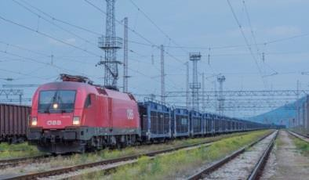

Fig. 6. Train of ‘Rail Cargo Carrier – Bulgaria’ (RCCBG)

In 2016, no applications for issuance, renewal or update of SA of M were submitted to RAEA, and no such certificates were issued or revoked.

## Contacts with Other NSAs

In 2016, there are no inquiries from other EU Member States’ NSAs for the provision of information regarding safety certificates Part ‘A’ of railway undertakings certified by the NSA of Bulgaria applying for a safety certificate Part ‘B’ in another Member State.

In 2016, the NSA of Bulgaria did not make any requests for the provision of information for Safety Certificates Part ‘A’ issued in other EU Member States.

## Procedural Issues

The observations of the NSA of Bulgaria in the implementation in 2016 of the CSMs for assessing conformity with the requirements for obtaining railway safety certificates (Regulation (EU) No 1158/2010/EU) and safety authorisations (Regulation (EU) No 1169/2010/EU) show that NRIC SE and the railway undertakings (RUs) have adapted their safety management systems (SMS) to these requirements.

A main area for improvement of operations in the railway sector in Bulgaria in the field of safety is the implementation of the CSM on risk evaluation and assessment in compliance with the requirements of Regulation No 352/2009/EC, repealed by Regulation No 402/2013.

Another major area to improve the performance of the railway sector in the field of safety is to improve the criteria set by railway undertakings in the application of the CSMs for monitoring pursuant to the requirements of Regulation (EC) No 1078/2012/EU.

## Feedback

The NSA of Bulgaria has good interaction and cooperation with the RUs and the IM. Regular meetings and meetings of working groups are held, where various issues relating to problems in the implementation of the safety of transportation by rail, the implementation of the TSIs and national rules, changes of existing national technical rules and safety rules, etc. are discussed.

RAEA obtains from businesses and citizens feedback on the quality of the services it offers in the following ways: 1) through its website and by e-mail; 2) on the spot – at the front office or via a post box located at the entrance of the RAEA, and 3) by ordinary mail.

The instrument, which RAEA has created for the measurement of satisfaction of the citizens and businesses, is completing a feedback questionnaire by the consumers by electronic means or on the spot (at the front office). The feedback questionnaire contains questions relating to an overall assessment of the performance and competence of the RAEA employees, their interaction with citizens and the existence of corruption practices.

The data obtained through various communication channels is analysed and used for dividing the consumers in target groups. Consumers, non-governmental organisations of citizens and businesses and the general public are informed of the action taken and the outcome via the website and through hard copies through the front office of the Railway Administration Executive Agency.

The information, in which citizens are interested, can be obtained from the information board at the entrance of the MTITC, at 7, ‘Kuzman Shapkarev’ str., Customer Charter and the RAEA website.

Since 2011, there has been an operating telephone number (+359 2 940 9400) on a special internet website (www.transportinfo.bg), where citizens and businesses can report irregularities in transport, including railway transport.

# CHANGES IN LEGISLATION



## Railway Safety Directive (RSD)

In 2016, in the Bulgarian railway legislation no changes have been made in relation to the transposition of the RSD (Directive 2004/49/EC).

Table 1 to Annex C of this report presents details about the changes made in the Bulgarian legislation in connection with the RSD.

## Legislative and regulatory amendments

In the period 1 January 2016 – 31 December 2016 in the State Gazette (SG) of the Republic of Bulgaria the following legislative changes in the field of railway transport in our country were published:

‘Railway Transport Act’ (RTA) in 2016 was amended twice: No 19 and No 58 of SG / 2016) – these amendments are not related to railway safety.

Ordinance No 41 of 27 June 2001 for access and use of railway infrastructure is amended and supplemented in No 36 of SG of 13 May 2016 on the transposition of the provisions of Directive 2012/34/EU of the European Parliament and of the Council of 21 November 2012 establishing a single European railway area. These amendments are not related to railway safety.

‘Ordinance No 44 of 10 October 2001 for the carriage of goods by rail’ is amended and supplemented in No 76 of SG of 30 September 2016. The amendments are related to the introduction of an electronic bill of lading for the transport of goods by rail as a transport document with a evidencing value equivalent to the paper form. These amendments are not related to railway safety.

‘Ordinance No 56 of 14 February 2003 on the requirements, conditions and procedure for training of the candidates for the acquisition of competence required by the personnel responsible for the safety of transportation by railway transport, or recognition of such a capacity, and the procedure for conducting examinations of persons of the staff responsible for the safety of transportation’ is amended in No 69 of SG of 2 September 2016, effective as of 1 July 2016, in relation to the transposition of the requirements of Commission Directive (EC) 2016/882 of 1 June 2016 amending Directive 2007/59/EC of the European Parliament and of the Council as regards language requirements Directive (EU) 2016/882 amends Annex VI, item 8 to Directive 2007/59/EC of the European Parliament and of the Council of 23 October 2007 on the certification of train drivers operating locomotives and trains on the railway system in the Community (Directive 2007/59/EC). The amendment is related to the need of reducing the linguistic requirements for train drivers in respect of sections between the borders of the Member States of the European Union and the stations located near them and designated for carrying out cross-border operations by relieving the train drivers concerned of the linguistic B1 level requirements.

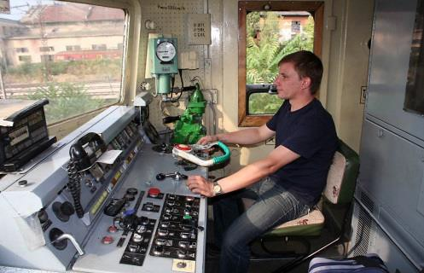

‘Ordinance No 57 of 9 June 2004 on the conditions and essential requirements for the railway infrastructure and rolling stock aimed at achieving interoperability of the national rail system with the rail system within the European Union’ is amended in No 1 of SG of 5 January 2016, effective as of 1 January 2016, related to the introduction of the requirements of Directive 2014/106/EU[42]. These amendments are not related to railway safety.

Further details regarding the amendments to the Bulgarian legislation relating to the safety of railway transport in Bulgaria, which entered into force in 2016, are presented inTable 2 of Annex B of this report.

# APPLICATION OF THE CSM ON RISK EVALUATION AND ASSESSMENT

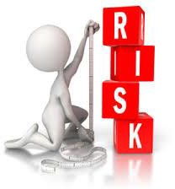Regulation (EC) No 352/2009[43] and Regulation (EU) No 402/2013[44] have been introduced in theory into IM and RU SMS procedures, which are very rarely or never used. During its supervisory activities, the NSA of Bulgaria controls the implementation of risk evaluation and assessment procedures, including assessment of ‘significant’ operational, organisational and other changes.

## NSA Experience

According to the information received from the annual safety reports of the certified RUs and IMs in Bulgaria and the supervisory audits carried out in the year 2016 in their organisation of work and the types of rolling stock they use, there have been no ‘significant’ changes within the meaning of Regulation (EC) No 402/2013.

## Feedback from Stakeholders.

The NSA of Bulgaria receives information about the application of the CSM on risk evaluation and assessment by RUs, IM and PCMs/ECMs of vehicles through supervision carried out on them in compliance with Regulation (EC) 1077/2012[45] and their annual reports received annually by 30 June according to Article 12 and 12a of Ordinance No 59 on safety management in railway transport in the Republic of Bulgaria.

Stakeholders (RUs, IMs, NoBo, DeBo, AsBo, construction companies, etc.) may express their opinions, comments, proposals, complaints, etc. on all matters relating to the RAEA operations, including on matters relating to the CSM on risk evaluation and assessment, by: electronic means (by e-mail or on the RAEA site), by regular mail or in person – in the front office or the mailbox located at the entrance of RAEA and MTITC.

## Revised National Safety Rules (NSRs) as a Result of the Implementation of the EU Provisions regarding Risk Evaluation and Assessment

In 2016, no national safety rules were revised as a result of the implementation of the European Union provisions regarding risk evaluation and assessment.

# DEROGATIONS IN CONNECTION WITH THE SCHEME FOR THE CERTIFICATION OF ENTITIES IN CHARGE OF MAINTENANCE OF VEHICLES IN ACCORDANCE WITH ARTICLE 14a(8) of DIRECTIVE 2008/110/EC

In 2016, the NSA of Bulgaria, in its capacity as certification body of entities in charge of the maintenance of railway vehicles, did not apply derogations or alternative measures for their certification in compliance with Article 14a(8) of Directive 2008/110/EC of the European Parliament and of the Council of 16 December 2008 amending RSD.

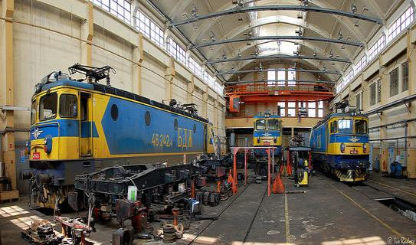

ANNEX A. COMMON SAFETY INDICATORS (CSIs)

Data/diagrams for the fulfilment of the main CSIs for the period 2012–2016.

Data for the indicators related to ‘significant accidents’[46] and ‘prerequisites for accidents’[47] (incidents) in the period 2012 – 2016:

|  |  |  |  |  |  |  |  |
| --- | --- | --- | --- | --- | --- | --- | --- |
| Significant railway accidents | | | | | | | |
|  | | | | | | | |
|  |  | Others | | | | | |
|  |  | Fires in rolling stock | | | | | |
|  |  | Accident to persons involving rolling stock in motion | | | | | |
|  |  | Level-crossing accidents | | | | | |
|  |  | Derailment | | | | | |
|  |  | Collisions | | | | | |
| Year | Collision | Derailment | Level-crossing accidents | Accident to persons involving rolling stock in motion | Fires in rolling stock | Others | Total |
| 2012 | 3 | 3 | 15 | 26 | 1 | 0 | 48 |
| 2013 | 2 | 2 | 11 | 17 | 0 | 1 | 33 |
| 2014 | 4 | 6 | 11 | 37 | 0 | 0 | 58 |
| 2015 | 3 | 6 | 6 | 33 | 0 | 0 | 48 |
| 2016 | 3 | 6 | 5 | 24 | 2 | 0 | 40 |

|  |  |  |  |  |  |  |  |  |
| --- | --- | --- | --- | --- | --- | --- | --- | --- |
| Prerequisites for accidents divided by types | | | | | | | | |
|  | | | | | | | |
| Broken axle on rolling stock in service | | | | | | | |
| Broken wheel on rolling stock in service | | | | | | | |
| Signal passed at danger | | | | | | | |
| Incorrect indication of signalling leading to a hazardous situation | | | | | | | |
| Track misalignments and other track deformations | | | | | | | |
| Broken rail | | | | | | | |
| Year | Broken rail | Track misalignments and other track deformations | Incorrect indication of signalling leading to a hazardous situation | Signal passed at danger | Broken wheel on rolling stock in service | Broken axle on rolling stock in service | Total |
| 2012 | 82 | 0 | 0 | 4 | 27 | 14 | 127 |
| 2013 | 83 | 0 | 0 | 16 | 76 | 5 | 180 |
| 2014 | 102 | 1 | 0 | 16 | 1 | 4 | 124 |
| 2015 | 104 | 14 | 2 | 13 | 0 | 0 | 133 |
| 2016 | 83 | 0 | 0 | 20 | 2 | 0 | 105 |

Dead (killed) persons in railway accidents in Bulgaria in the period 2012-2016, divided by type of accident and risk categories of persons:

|  |  |  |  |  |  |  |  |
| --- | --- | --- | --- | --- | --- | --- | --- |
| Dead (killed) persons in different types of accidents | | | | | | | |
|  | | | | | | | |
|  | Others | | | | | | |
|  | Fires in rolling stock | | | | | | |
|  | Accident to persons involving rolling stock in motion | | | | | | |
|  | Level-crossing accidents | | | | | | |
|  | Derailment | | | | | | |
|  | Collisions | | | | | | |
| Year | Collisions | Derailment | Level-crossing accidents | Accident to persons involving rolling stock in motion | Fires in rolling stock | Others | Total |
| 2012 | 1 | 0 | 7 | 13 | 0 | 0 | 21 |
| 2013 | 0 | 0 | 3 | 9 | 0 | 0 | 12 |
| 2014 | 0 | 1 | 6 | 16 | 0 | 0 | 23 |
| 2015 | 0 | 0 | 2 | 18 | 0 | 0 | 20 |
| 2016 | 0 | 7 | 5 | 10 | 0 | 0 | 22 |

|  |  |  |  |  |  |  |
| --- | --- | --- | --- | --- | --- | --- |
| Dead (killed) divided by categories | | | | | | |
|  | | | | | | |
|  | Passengers | Employees | Level crossing users | Trespassers | Others | |
| Year | Passengers | Employees | Level crossing users | Trespassers | Others | Total |
| 2012 | 1 | 2 | 7 | 11 | 0 | 21 |
| 2013 | 0 | 0 | 3 | 9 | 0 | 12 |
| 2014 | 2 | 1 | 5 | 15 | 0 | 23 |
| 2015 | 2 | 1 | 2 | 15 | 0 | 20 |
| 2016 | 1 | 1 | 5 | 7 | 8 | 22 |

Seriously injured persons in railway accidents in Bulgaria in the period 2012 – 2016, divided by type of accident and risk categories of persons:

|  |  |  |  |  |  |  |  |  |  |
| --- | --- | --- | --- | --- | --- | --- | --- | --- | --- |
| Seriously injured persons in different types of accidents | | | | | | | | | |
|  | | | | | | | | | |
|  | Others | | | | Fires in rolling stock | | |  | |
|  | Accident to persons involving rolling stock in motion | | | | Level-crossing accidents | | |  | |
|  | Derailment | | | | Collisions | | |  | |
| Year | Collision | Derailment | Level-crossing accidents | Accident to persons involving rolling stock in motion | | Fires in rolling stock | Others | | Total |
| 2012 | 3 | 0 | 15 | 14 | | 0 | 0 | | 32 |
| 2013 | 0 | 0 | 12 | 9 | | 0 | 0 | | 21 |
| 2014 | 0 | 8 | 16 | 21 | | 0 | 0 | | 45 |
| 2015 | 2 | 0 | 7 | 15 | | 0 | 0 | | 24 |
| 2016 | 0 | 13 | 5 | 14 | | 0 | 0 | | 32 |

Seriously injured persons in railway accidents in Bulgaria in the period 2012 – 2016, divided by type of accident and risk categories of persons:

|  |  |  |  |  |  |  |
| --- | --- | --- | --- | --- | --- | --- |
| Seriously injured persons in different types of accidents | | | | | | |
|  | | | | | | |
|  | Passengers | Employees | Level crossing users | Trespassers | Others | |
| Year | Passengers | Employees | Level crossing users | Trespassers | Others | Total |
| 2012 | 8 | 3 | 15 | 6 | 0 | 32 |
| 2013 | 3 | 1 | 12 | 5 | 0 | 21 |
| 2014 | 15 | 4 | 12 | 14 | 0 | 45 |
| 2015 | 6 | 0 | 7 | 10 | 1 | 24 |
| 2016 | 4 | 1 | 5 | 9 | 13 | 32 |

Data about the traffic[48] and the total length of the railway network in Bulgaria in the period 2012-2016:

|  |  |  |  |  |  |  |  |  |  |  |  |  |  |  |  |  |  |  |  |  |  |  |  |  |  |  |  |  |  |  |  |  |  |  |  |  |  |  |  |  |  |  |  |  |  |  |  |  |  |  |  |  |  |  |  |
| --- | --- | --- | --- | --- | --- | --- | --- | --- | --- | --- | --- | --- | --- | --- | --- | --- | --- | --- | --- | --- | --- | --- | --- | --- | --- | --- | --- | --- | --- | --- | --- | --- | --- | --- | --- | --- | --- | --- | --- | --- | --- | --- | --- | --- | --- | --- | --- | --- | --- | --- | --- | --- | --- | --- | --- |
| |  |  |  |  | | --- | --- | --- | --- | | Number of train-kilometres (millions) | | | | |  | | | | | Passenger train-km (million) | | Freight train km (million) | | | Year | Passenger train-km (million) | Freight train km (million) | Total | | 2012 | 20 | 7 | 27 | | 2013 | 21 | 6 | 27 | | 2014 | 21 | 7 | 28 | | 2015 | 22 | 7 | 29 | | 2016 | 22 | 7 | 29 | | |  |  | | --- | --- | | Number of passenger–kilometres (millions) | | |  | | | Passenger-kilometres (million) | | | Year | Passenger-kilometres (million) | | 2012 | 1876 | | 2013 | 1826 | | 2014 | 1702 | | 2015 | 1552 | | 2016 | 1458 | |
|  |  |
| |  |  | | --- | --- | | Total deployed length of the railway network of Bulgaria, measured in kilometres of railway | | |  | | | Track kilometres | | | Year | Track kilometres | | 2012 | 6635 | | 2013 | 6529 | | 2014 | 6481 | | 2015 | 6474 | | 2016 | 6475 | | |  |  | | --- | --- | | Total length of the railway network of Bulgaria, measured in linear kilometres | | |  | | | Linear kilometres | | | Year | Linear km | | 2012 | 3946 | | 2013 | 3896 | | 2014 | 3897 | | 2015 | 3894 | | 2016 | 3904 | |

Data on the technical safety of the railway infrastructure[49] in Bulgaria in the period 2012-2016:

|  |  |  |  |  |  |  |  |  |  |  |  |  |  |  |  |  |  |  |  |  |  |  |  |  |  |  |  |  |  |  |  |  |  |  |  |  |  |
| --- | --- | --- | --- | --- | --- | --- | --- | --- | --- | --- | --- | --- | --- | --- | --- | --- | --- | --- | --- | --- | --- | --- | --- | --- | --- | --- | --- | --- | --- | --- | --- | --- | --- | --- | --- | --- | --- |
| |  |  | | --- | --- | | Percentage of rail lines equipped with active ATS systems* | | |  | | | Total number of railway lines with ATS | | | Year | Total number of railway lines with ATS | | 2012 | 0.11 | | 2013 | 0.11 | | 2014 | 0.11 | | 2015 | 0.07 | | 2016 | - | | |  |  | | --- | --- | | Percentage of train kilometres travelled using ATS systems* | | |  | | | Total km with ATS | | | Year | Total km with ATS | | 2012 | 0.22 | | 2013 | 0.24 | | 2014 | 0.22 | | 2015 | 0.11 | | 2016 | - | |

Data on the total number of railway level crossings in Bulgaria in the period 2012-2016, divided into ‘active’ and ‘passive’ level crossing[50]

|  |  |  |  |
| --- | --- | --- | --- |
| Number of railway level crossings by types | | | |
|  | | | |
| Active level crossings | | Passive level crossings | |
| Year | Active level crossings | Passive level crossings | Total |
| 2012 | 646 | 137 | 783 |
| 2013 | 648 | 137 | 785 |
| 2014 | 632 | 142 | 774 |
| 2015 | 626 | 140 | 766 |
| 2016 | 622 | 139 | 761 |

Deaths and weighted Serious Injuries (FWSI)[51] of persons in risk categories: ‘Passengers’, ‘Employees’ and ‘Users of a level crossing’ (CST 3.1) for the period 2012-2016:

|  |  |  |  |  |  |  |  |  |  |  |  |  |  |  |  |  |  |  |  |  |  |  |  |  |  |  |  |  |  |  |  |  |  |  |  |  |  |  |  |  |  |  |  |  |  |  |  |  |  |  |  |  |  |  |  |  |  |  |  |  |  |  |  |  |  |  |  |  |  |  |  |  |  |  |  |  |  |  |  |  |  |  |  |  |  |  |  |  |  |  |  |
| --- | --- | --- | --- | --- | --- | --- | --- | --- | --- | --- | --- | --- | --- | --- | --- | --- | --- | --- | --- | --- | --- | --- | --- | --- | --- | --- | --- | --- | --- | --- | --- | --- | --- | --- | --- | --- | --- | --- | --- | --- | --- | --- | --- | --- | --- | --- | --- | --- | --- | --- | --- | --- | --- | --- | --- | --- | --- | --- | --- | --- | --- | --- | --- | --- | --- | --- | --- | --- | --- | --- | --- | --- | --- | --- | --- | --- | --- | --- | --- | --- | --- | --- | --- | --- | --- | --- | --- | --- | --- | --- | --- |
| |  |  |  |  |  | | --- | --- | --- | --- | --- | | Number of fatalities and weighted serious injuries to Passengers per billion passenger train-km (CST 1.1) | | | | | |  | | | | | | FWSI per billion passenger–km | | | | | | Year | Passengers killed | Passengers seriously injured | Number of passenger–kilometres (millions) | FWSI per billion passenger–km | | 2012 | 1 | 8 | 1 876.000 | 0.959 | | 2013 | 0 | 3 | 1 826.000 | 0.164 | | 2014 | 2 | 15 | 1 702.000 | 2.056 | | 2015 | 2 | 6 | 1 552.188 | 1.675 | | 2016 | 1 | 4 | 1 457.950 | 0.960 | | |  |  |  |  |  | | --- | --- | --- | --- | --- | | Number of fatalities and weighted serious injuries to Passengers per billion passenger-km (CST 1.2) | | | | | |  | | | | | | FWSI per billion passenger–km | | | | | | Year | Passengers killed | Passengers seriously injured | train-km (million) | FWSІ for a billion passenger train-km | | 2012 | 1 | 8 | 20.124 | 89.445 | | 2013 | 0 | 3 | 21.110 | 14.211 | | 2014 | 2 | 15 | 21.080 | 166.034 | | 2015 | 2 | 6 | 21.697 | 119.832 | | 2016 | 1 | 4 | 21.692 | 64.540 | |
|  |  |
| |  |  |  |  |  | | --- | --- | --- | --- | --- | | number of fatalities and weighted serious injuries to Employees per billion train km (CST 2) | | | | | |  | | | | | | FWSI per billion train-km | | | | | | Year | Employees killed | Employees seriously injured | number train-km (millions) | FWSI per billion train-km | | 2012 | 2 | 3 | 27.799 | 82.737 | | 2013 | 0 | 1 | 28.184 | 3.548 | | 2014 | 1 | 4 | 28.800 | 48.611 | | 2015 | 1 | 0 | 30.149 | 33.169 | | 2016 | 1 | 1 | 29.405 | 37.409 | | |  |  |  |  |  | | --- | --- | --- | --- | --- | | number of fatalities and weighted serious injuries to 'Level crossing users' per billion train-kilometres (CST 3.1) | | | | | |  | | | | | | FWSI per billion train-km | | | | | | Year | Level crossing users killed | Level crossing users seriously injured | Number of train–kilometres (millions) | FWSI per billion train-km | | 2012 | 7 | 15 | 27.799 | 305.766 | | 2013 | 3 | 12 | 28.184 | 149.021 | | 2014 | 5 | 12 | 28.800 | 215.278 | | 2015 | 2 | 7 | 30.149 | 89.555 | | 2016 | 5 | 5 | 29.405 | 187.043 | |

Fatalities and weighted serious injuries (FWSI) of RC persons: ‘Level crossing users’ (CST 3.2), ‘Trespassers’, ‘Others’ and ‘All’ in the period 2012 – 2016:

|  |  |  |  |  |  |  |  |  |  |  |  |  |  |  |  |  |  |  |  |  |  |  |  |  |  |  |  |  |  |  |  |  |  |  |  |  |  |  |  |  |  |  |  |  |  |  |  |  |  |  |  |  |  |  |  |  |  |  |  |  |  |  |  |  |  |  |  |  |  |  |  |  |  |  |  |  |  |  |  |  |  |  |  |  |  |  |  |  |  |  |  |  |  |  |  |  |  |  |  |  |  |  |  |  |  |  |  |  |  |
| --- | --- | --- | --- | --- | --- | --- | --- | --- | --- | --- | --- | --- | --- | --- | --- | --- | --- | --- | --- | --- | --- | --- | --- | --- | --- | --- | --- | --- | --- | --- | --- | --- | --- | --- | --- | --- | --- | --- | --- | --- | --- | --- | --- | --- | --- | --- | --- | --- | --- | --- | --- | --- | --- | --- | --- | --- | --- | --- | --- | --- | --- | --- | --- | --- | --- | --- | --- | --- | --- | --- | --- | --- | --- | --- | --- | --- | --- | --- | --- | --- | --- | --- | --- | --- | --- | --- | --- | --- | --- | --- | --- | --- | --- | --- | --- | --- | --- | --- | --- | --- | --- | --- | --- | --- | --- | --- | --- | --- | --- |
| |  |  |  |  |  |  |  | | --- | --- | --- | --- | --- | --- | --- | | number of fatalities and weighted serious injuries to ‘Level crossing users’ per billion train km/length of railway network in km rail track to number of railway level crossings (CST 3.2) | | | | | | | |  | | | | | | | | FWSI per exposure | | | | | | | | Year | Level crossing users killed | Level crossing users seriously injured | Number of train–kilometres (millions) | Number of track kilometres | Number of active and passive level crossings | FWSI per exposure | | 2012 | 7 | 15 | 27.799 | 6 635.000 | 783 | 49.452 | | 2013 | 3 | 12 | 28.184 | 6 529.000 | 785 | 23.947 | | 2014 | 5 | 12 | 28.800 | 6 481.000 | 774 | 34.103 | | 2015 | 2 | 7 | 30.149 | 6 474.000 | 766 | 14.051 | | 2016 | 5 | 5 | 29.405 | 6 475.000 | 761 | 22.515 | | |  |  |  |  |  | | --- | --- | --- | --- | --- | | Number of fatalities and weighted serious injuries to ‘Other’ persons per billion train km (CST 4) | | | | | |  | | | | | | FWSI per billion train-km | | | | | | Year | ‘Other’ persons killed | ‘Other’ persons seriously injured | Number of train-km (millions) | FWSI per billion train-km | | 2012 | 0 | 0 | 27.799 | 0.000 | | 2013 | 0 | 0 | 28.184 | 0.000 | | 2014 | 0 | 0 | 28.800 | 0.000 | | 2015 | 0 | 1 | 30.149 | 3.317 | | 2016 | 8 | 13 | 29.405 | 316.273 | |
|  |  |
| |  |  |  |  |  | | --- | --- | --- | --- | --- | | Number of fatalities and serious injuries of ‘Trespassers’ per billion train-km (CST 5) | | | | | |  | | | | | | FWSI per billion train-km | | | | | | Year | ‘Trespassers’ killed | ‘Trespassers’ seriously injured | Number of train-km (millions) | FWSI per billion train-km | | 2012 | 11 | 6 | 27.799 | 417.281 | | 2013 | 9 | 5 | 28.184 | 337.071 | | 2014 | 15 | 14 | 28.800 | 569.444 | | 2015 | 15 | 10 | 30.149 | 530.698 | | 2016 | 7 | 9 | 29.405 | 268.662 | | |  |  |  |  |  | | --- | --- | --- | --- | --- | | Number of fatalities and serious injuries from ‘All’ categories of persons per billion train-km (CST 6) | | | | | |  | | | | | | FWSI per billion train-km | | | | | | Year | Killed persons of all categories | Seriously injured persons of all categories | Number train-km (millions) | FWSI per billion train-km | | 2012 | 21 | 32 | 27.799 | 870.535 | | 2013 | 12 | 21 | 28.184 | 500.284 | | 2014 | 23 | 45 | 28.800 | 954.861 | | 2015 | 20 | 24 | 30.149 | 742.977 | | 2016 | 22 | 32 | 29.405 | 856.997 | |

###### ANNEX C. CHANGES IN LEGISLATION

(Annex to Section F of this report)

In 2016, in the Bulgarian railway legislation, no amendments were made related to the transposition of amendments to Directive 2004/49/EC of 29 April 2004 on safety on the Community’s railways.



Table 10. Status of the transposition of the amendments to Directive 2004/49/EC in the Bulgarian legislation as of 31 December 2016 – Annex to section F.1 of this Report.

|  |  |  |  |
| --- | --- | --- | --- |
| Amendments of Directive 2004/49/EC | Transposed (Yes/No) | Legal references | Date of entry into force |
| Directive 2008/57/EC | Yes | Ordinance No 57 of 9 June 2004 on the conditions and essential requirements for the railway infrastructure and rolling stock aimed at achieving interoperability of the national railway system with the railway system within the European Union, Chapter V, Section IV ‘Authorisation for placing into service of a vehicle’. | 26 October 2010 |
| Directive 2008/110/EC | Yes | Ordinance No 59 of 5 December 2006 on safety management in railway transport | 28 December 2010 |
| Directive 2009/149/EC | Yes | Ordinance No 59, Annex 1 | 22 June 2010 |
| Directive 2014/88/EU | Yes | Ordinance No 59, Annex 1 | 31 July 2015 |

|  |  |
| --- | --- |
| Table 11. Legislative and regulatory changes in the field of railway transport of Bulgaria, published in the State Gazette and entering into force in the period from 1 January 2016 to 31 December 2016 (Annex to Section F.2 of this report). |  |

|  |  |  |  |  |
| --- | --- | --- | --- | --- |
| LEGISLATION AND REGULATION | Legal references | Entry into force, date | Description of the change | Reasons for the change |
| Concerning the NSA | - | - | - | - |
| Concerning NoBos, DeBos, Assessment bodies, third parties of registration, examination, etc. | - | - | - | - |
| Concerning the RU/IM/ECM | - | - | - | - |
| Application of other requirements of the EU (relating to railway safety) | Ordinance No 56 of 14 February 2003 on the requirements, conditions and procedure for training of the candidates for the acquisition of competence required by the personnel responsible for the safety of transportation by railway transport, or recognition of such a capacity, and the procedure for conducting examinations of persons of the staff responsible for the safety of transportation | amended State Gazette (SG), No 69 of 2 September 2016, effective as of 1 July 2016. | Directive (EU) 2016/882 amends Annex VI, item 8 of Directive 2007/59/EC of the European Parliament and of the Council of 23 October 2007 on the certification of train drivers operating locomotives and trains on the railway system in the Community. The amendment is related to the need of reducing the linguistic requirements for train drivers in respect of sections between the borders of the Member States of the European Union and the stations located near them and designated for carrying out cross-border operations by relieving the train drivers concerned of the linguistic B1 level requirements.  Language B1 level requirements for train drivers are an unnecessarily heavy burden in a number of specific cases where train drivers only reach the border station in the neighbouring Member State and this has an impact on the continuity of cross-border operations.  As a condition for the exemption from the level B1 language requirements, it is foreseen to introduce sufficient measures to ensure communication between the relevant train drivers and the infrastructure manager’s staff in routine, degraded and emergency conditions in order to avoid a possible negative impact on the safety of the railway system. | Transposition of the requirements of Commission Directive (EU) 2016/882 of 1 June 2016 amending Directive 2007/59/EC of the European Parliament and of the Council on the language requirements |

This report used photos and figures from the following sources:

1. <http://flickrhivemind.net/> – photos on the cover page and pp. 5, 6, 7, 8, 12, 13, 21, 22, 29 and 30 (up);
2. <http://www.railpictures.net/> – photo on page 2 (table of contents);
3. [http://www.rail-infra.bg/](http://www.rail–infra.bg/) (official website of SOE NRIC) – photos on pp. 12 and 15 and figures 3 & 4 on page 13. Figures 1 & 2 on pp. 9 & 10 are from ASR for 2016 of SOE NRIC;
4. <http://lokomotiv.bg/>(Bulgarian locomotive forum)- photos on page 28;
5. [Https://www.mtitc.government.bg/page.php?category=390&id=9040](https://www.mtitc.government.bg/page.php?category=390&amp;amp;id=9040) – the 14 photos on p. 17 and p. 18 are of the final reports of the NIB of Bulgaria (RAIU).

1. AISIAS - Administrative Information System for Integrated Administrative Services
2. NSA & NIB reports <https://eradis.era.europa.eu/safety_docs/AnnualReport/default.aspx>
3. <https://erail.era.europa.eu/safety-indicators.aspx>
4. ‘Significant accident’ means any accident involving at least one rail vehicle in motion, resulting in at least one killed or seriously injured person, or in significant damage to stock, track, other installations or environment, or extensive disruptions to traffic. Accidents in workshops, warehouses and depots are excluded (definition of item 1.1 of the Addendum to Annex I of the RSD and Ordinance No 59).
5. PWS – Rolling Stock
6. ‘Death (killed person)’ means any person killed immediately or dying within 30 days as a result of an accident, excluding any suicide (definition of item 1.18 of the Addendum to Annex I of the RSD and Ordinance No 59).
7. ‘Serious injury (seriously injured person)’ means any person injured who was hospitalised for more than 24 hours as a result of an accident, excluding any attempted suicide (definition of item 1.19 of the Addendum to Annex I of the RSD and Ordinance No 59).
8. Commission Decision 2009/460/EC of 5 June 2009 on the adoption of a common safety method for assessment of achievement of safety targets, as referred to in Article 6 of Directive 2004/49/EC of the European Parliament and of the Council
9. ‘Passenger’ means any person, excluding a member of the train crew, who makes a trip with a rail vehicle. The accidents statistics includes passengers trying to embark onto or disembark from a moving train (item 1.12 of the Addendum to Annex I of the RSD and Ordinance No 59).
10. ‘Employee or contractor’ means any person whose employment is in connection with a railway and is at work at the time of the accident, including the staff of contractors, self-employed contractors, the crew of the train and persons handling rolling stock and infrastructure installations (definition of item 1.13 of the Addendum to Annex I of the RSD and Ordinance No 59).
11. ‘Level crossing user’ means any person using a level crossing to cross the railway line by any means of transport or by foot (item 1.14 of the Addendum to Annex I of the RSD and Ordinance No 59).
12. ‘Trespasser’ means any person present on railway premises where such presence is forbidden, with the exception of a level crossing user (definition of item 1.15 of the Addendum to Annex I of the RSD and Ordinance No 59).
13. ‘Other persons at a platform’ means any person at a railway platform who is not defined as ‘passenger’, ‘employee or contractor’, ‘level crossing user’, ‘trespasser’ or ‘other person not at a platform’ (definition of item 1.16 of the Addendum to Annex I of the RSD and Ordinance No 59).
14. ‘Other persons not at a platform’ means any person not at a railway platform who is not defined as ‘passenger’, ‘employee or contractor’, ‘level crossing user’, ‘trespasser’ or ‘other person at a platform’ (definition of item 1.17 of the Addendum to Annex I of the RSD and Ordinance No 59).
15. On 7 December 1866 the first railway line in Bulgaria Rousse – Varna, with a length of 223 km, was opened for operation, then part of the Ottoman Empire, which occupied territories in South-eastern Europe, the Middle East, Asia Minor (Anatolia) and North Africa between the 14th and 20th centuries.
16. ‘Suicide’ means an act of intentional self-injury that has resulted in death as registered and classified by the competent national authority (definition of item 3.1 of the Addendum to Annex I to the RSD and Ordinance No 59). ]Suicide attempt]means an act of deliberate self-injury that has resulted in serious injury (definition of item 3.2 of the Addendum to Annex I to the RSD and Ordinance No 59).
17. ‘Prerequisites for accidents’, called also ‘incidents’, are as follows: 1) ‘broken rail’; 2) ‘Track twisting and other deformations of the track’; 3) ‘Incorrect indication of signalling leading to a hazardous situation’; 4) ‘Neglecting a Danger Signal when Passing through a Danger Point’; 5) ‘Neglecting a Danger Signal when Not Passing through a Danger Point’; 6) ‘Broken wheel in rolling stock’; 7) ‘Broken axle of operating rolling stock’ (see the definitions given in items 4.1 to 4.7 of the Addendum to Annex I to the RSD and Ordinance No 59 and Article 68(3) of Ordinance No 59).
18. ‘Crash of a train with an obstacle in the construction gauge’ means a collision between a part of a train and objects secured or temporarily located on or near the track (excluding level crossing objects if they are lost by a crossing vehicle or user), including collision with an overhead contact grid.
19. Commission Regulation (EU) No 1078/2012 of 16 November 2012 on a common safety method for monitoring to be applied by railway undertakings, infrastructure managers after receiving a safety certificate or safety authorisation and by entities in charge of maintenance.
20. ‘Kilometre track’ means the length, measured in kilometres, of the railway network in the Republic of Bulgaria, with the exception of the railway lines under Art. 2 of the RTA. For multi-track rail lines the length of each current route is taken into account (definition in item 7.4 of the Addendum to Annex I to the RSD and Ordinance No 59).
21. ‘Linear kilometre’ means the length, measured in kilometres, of the railway network in Bulgaria, with the exception of railway lines under Art. 2 under the RTA. For multi-track railway lines, only the distance between the start and end points is taken into account.
22. ‘Passive level crossing’ means a level crossing without any form of warning system or protection activated when it is unsafe for the user to traverse the crossing.
23. ‘Active level crossing’ means a level crossing where the crossing users are protected from or warned of the approaching train by devices activated when it is unsafe for the user to traverse the crossing.
24. RI – Railway Infrastructure
25. PCM/ECM – person (entity) in charge of the maintenance of railway vehicles
26. Regulation (EU) No 445/2011 of the Commission of 10 May 2011 on a system of certification of entities in charge of the maintenance for freight wagons and amending Regulation (EC) No 653/2007.
27. Ordinance No 59 of 5 December 2006 on safety management in railway transport
28. ‘Train Protection System (TPS)’ means a system that assists in the compliance with signals and speed limits;
29. ‘Level crossing’ means any crossing at a level of a road or rail crossing, as recognised by the Infrastructure Manager and open to public or private use. Crossings between platforms within stations, as well as track passes that are intended for use by employees only are excluded. They are divided into: passive and active level crossings. ‘Passive level crossing’ means a level crossing without any form of warning system or protection activated when it is unsafe for the user to traverse the crossing. ‘Active level crossing’ means a level crossing where the crossing users are protected from or warned of the approaching train by devices activated when it is unsafe for the user to traverse the crossing. Active level crossings are classified as follows: (a) manual: level crossing where user-side protection or warning is manually activated by a railway employee.; (b) automatic with user-side warning; level crossing where the user-side alert is triggered by the approaching train; (c) automatic with user-side protection; level crossings where the user-side protection is triggered by the approaching train; this includes level crossings that have both protection and a warning on the user’s side; (d) rail-side protected; level crossing where a signal or other train protection system allows the train to continue as soon as the level crossing is completely protected by the user side and there are no obstacles thereon. * „-“ --- symbol showing lack of data for the respective year
30. IQPPR – Inspector of Quality of Production Processes, Receiver
31. Ordinance No 58 of 2006 on the rules for technical operation, movement of trains and railway signalling;
32. TOR – Technical operation rules of the railway infrastructure, issued by the Director General of NRIC in 2006
33. RMTSA – Rules on the movement of trains and shunting activity in railways issued by the Director General of NRIC in 2006
34. IRB – Industrial railway branch
35. DMU – Diesel multiple units
36. EMU – Electric multiple units
37. WRS – Wagon-revising section
38. EDC – Electrical Distribution Company at SE NRIC
39. IE – Interlocking equipment
40. NM– near misses
41. RCG – Rail Cargo Group
42. Commission Directive 2014/106/EU of 5 December 2014 amending Annexes V and VI to Directive 2008/57/EC of the European Parliament and of the Council on the interoperability of the rail system within the Community
43. Commission Regulation (EC) No 352/2009 of 24 April 2009 on the adoption of a common safety method of risk evaluation and assessment as referred to in Article 6(3)(a) of Directive 2004/49/EC of the European Parliament and of the Council.
44. Commission Implementing Regulation (EU) No 402/2013 of 30 April 2013 on the common safety method for risk evaluation and assessment and repealing Regulation (EC) No 352/2009.
45. Commission Regulation (EU) No 1077/2012 of 16 November 2012 on a common safety method for supervision by national safety authorities after issuing a safety certificate or safety authorisation.
46. ‘significant accident’ means any accident involving at least one moving railway vehicle resulting in at least one person killed or seriously injured or significant damage to rolling stock, track, other facilities or the environment or significant disruption of the movement, with the exception of accidents in repair plants, warehouses and depots, ‘significant damage to rolling stock, track, other facilities or the environment’ means damage equivalent to EUR 150 000 or more; ‘significant traffic disruption’ means that train traffic on a main line is interrupted for 6 hours or more;
47. ‘prerequisites for accidents’ are the following types: 1) ‘Broken rail’; 2) ‘Track misalignment and other deformations of the track’; 3) ‘Incorrect indication of signalling leading to a hazardous situation’; 4) ‘Signal passed at danger when crossing a dangerous point’ and 5) ‘Signal passed at danger when not passing a danger’
48. ‘train-km’ means the unit of measure representing the movement of a train over one kilometre. The distance used is the distance actually run, if available, otherwise the standard network distance between the origin and destination shall be used. Only the distance of the national territory of the reporting country shall be taken into account; ‘passenger-kilometre’ means the unit of measure representing the transport of one passenger by rail over a distance of one kilometre. Only the distance on the national territory of the reporting country shall be taken into account. * ‘line km’ means the length measured in kilometres of the railway network in Member States, whose scope is laid down in Article 2; For multiple-track railway lines, only the distance between origin and destination is to be taken into account. ** ‘track km’ means the length measured in kilometres of the railway network in Member States, whose scope is laid down in Article 2. Each track of a multiple-track railway line is to be counted’. (definitions of Directive 2014/88/EC amending Directive 2004/49/EC)
49. ‘Automatic Train protection (ATS)’ is a system, which requires compliance with signals and speed limits through supervision of the speed limits, including automatic braking on signal submitted for this;
50. ‘Level crossing’ means any level intersection between a road or passage and a railway, as recognised by the infrastructure manager and open to public or private users. Passages between platforms within the railway stations are excluded, as well as passages over tracks for the sole use of employees;‘Passive level crossing’ means a level crossing without any form of warning system or protection activated when it is unsafe for the user to traverse the crossing. ‘Active level crossing’ means a level crossing where the crossing users are protected from or warned of the approaching train by devices activated when it is unsafe for the user to traverse the crossing (definitions of Directive 2004/49/ЕC). ‘-’ --- symbol showing lack of data for the respective year
51. ‘fatalities and weighted serious injuries (FWSI)’ means a measurement of the consequences of significant accidents combining fatalities and serious injuries, where 1 serious injury is considered statistically equivalent to 0.1 fatalities (letter (d) of Article 3 of Decision 2009/460/EC)