

DEPARTMENT FOR THE INVESTIGATION OF AVIATION, MARITIME AND RAILWAY ACCIDENTS AND INCIDENTS

Langusova ulica 4, 1535 Ljubljana Tel: 01 478 88 51
E-mail:gp.mzip@gov.si
www.mzip.gov.si

Ref no: 010-19/2017/59
ID code: 00221736

ANNUAL REPORT
OF THE SLOVENIAN
RAILWAY INVESTIGATING BODY
2016
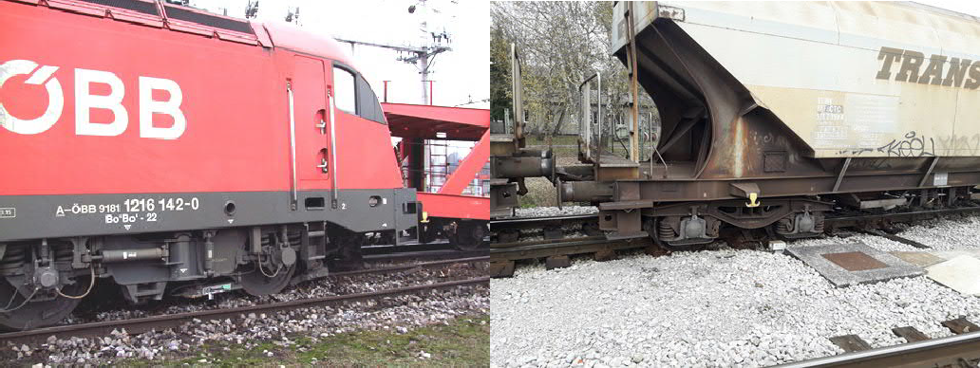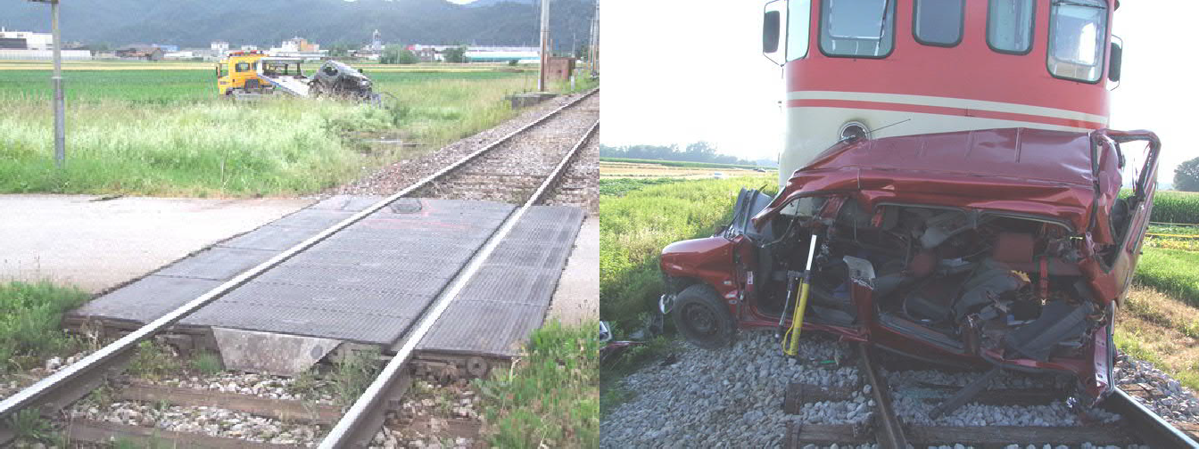

Ljubljana, 29 September 2017

INTRODUCTION
The railway investigating body conducts investigations of accidents and incidents with the aim of improving railway safety and preventing accidents from occurring in the future.
It operates in accordance with Railway Safety Directive 2004/49/EC of the European Parliament and of the Council of 29 April 2004, which was transposed into Slovenian law with the adoption of the Railway Transport Act (UL RS, No 44/2007, 21 May 2007) and the Railway Safety Act (UL RS, No 61/2007, 10 July 2007).
The 2016 annual report on the performance of railway safety investigations in Slovenia includes a presentation of the organisation of the body, the legislative basis for its operations, a review of the accidents and incidents investigated, and a review of recommendations issued and adopted in the past year.
TABLE OF CONTENTS

Point: Title: Page:

INTRODUCTION 1
1. PRESENTATION OF THE ORGANISATION OF SAFETY INVESTIGATIONS 3
1.1. Legal basis (or legal framework) 6
1.2. Role (description of mandate) and objective (or mission) 6
1.3. Internal organisation and sub-departments 6
1.4. Organisational flow and position of the national investigating body within the diagram/scheme 7
1.5. Approach to accident investigation (philosophy and approach when deciding whether to investigate an accident in the country, and the level of mobility, readiness and timeliness) 9
2 INVESTIGATION PROCEDURE 10
2.1 Cases investigated: mandatory and non-mandatory under Articles 19 and 21 of the Railway Safety Directive 10
2.2 Institutions participating in investigations (as a matter of course or in exceptional circumstances) 11
2.3 Investigation procedure and the investigating body’s approach (as under point 1.5 but in greater detail) 11
3 INVESTIGATIONS 14
3.1 Review of investigations completed in 2016 14
3.2 Investigations commenced and completed in 2016 15
3.3 Research studies (studies on safety involving serious accidents) commissioned and completed in 2016 17
3.4 Summary of investigations completed in 2016 Short descriptions, photographs, diagrams and safety studies 18
3.5 Explanation and introduction or background of investigations 24
3.6 Accidents and events investigated in the past five years (2012-2016) 25
4 RECOMMENDATIONS 27

PRESENTATION OF THE ORGANISATION OF SAFETY INVESTIGATIONS
Slovenia’s railway investigating body is part of the Ministry of Infrastructure as an independent and autonomous organisational unit: the Department for the Investigation of Railway Accidents and Incidents. It answers directly to the minister.
The Department for the Investigation of Railway Accidents and Incidents employs only one person. Along with managing and investigating, they perform other duties defined in cooperation within the network of the EU investigating bodies operating under the auspices of the European Railway Agency (ERA).
The railway investigating body operates independently and is organisationally autonomous. It is completely independent of the investigating bodies for other transport sectors, and from the national railway safety and regulatory body. The funds for the functioning of the investigating body are provided from the budget.
The headquarters of the Department for the Investigation of Railway Accidents and Incidents are based at the Ministry of Infrastructure, Langusova ulica 4, Ljubljana.

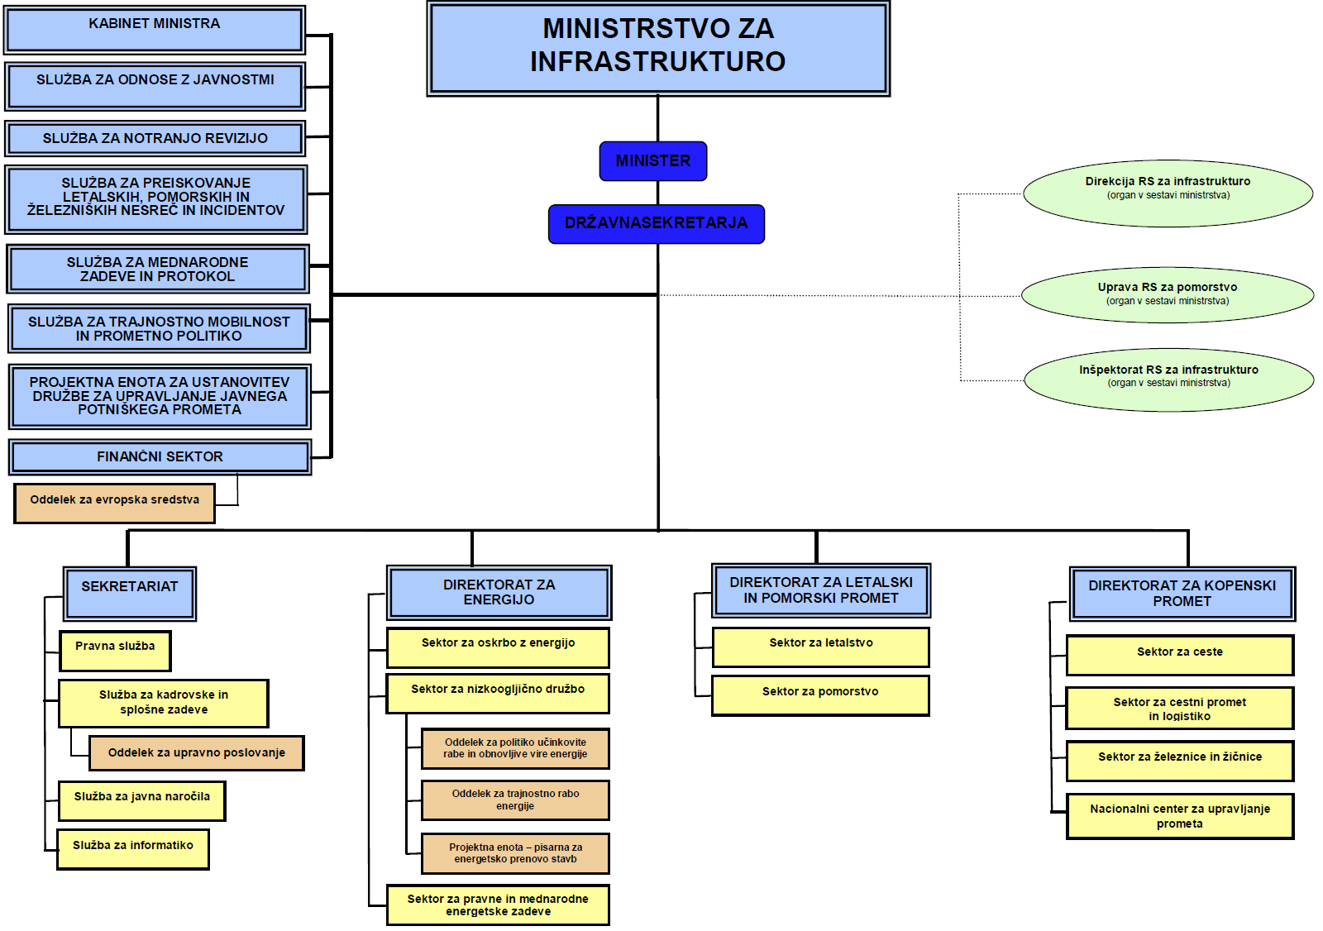

KABINET MINISTRA | OFFICE OF THE MINISTER
SLUŽBA ZA ODNOSE Z JAVNOSTMI | PUBLIC RELATIONS DEPARTMENT
SLUŽBA ZA NOTRANJO REVIZIJO | INTERNAL AUDIT DEPARTMENT
SLUŽBA ZA PREISKOVANJE LETALSKIH, POMORSKIH IN ŽELEZNIŠKIH NESREČ IN INCIDENTOV | DEPARTMENT FOR THE INVESTIGATION OF AVIATION, MARITIME AND RAILWAY ACCIDENTS AND INCIDENTS
SLUŽBA ZA MEDNARODNE ZADEVE IN PROTOKOL | INTERNATIONAL AFFAIRS AND PROTOCOL DEPARTMENT
SLUŽBA ZA TRAJNOSTNO MOBILNOST IN PROMETNO POLITIKO | SUSTAINABLE MOBILITY AND TRANSPORT POLICY DEPARTMENT
PROJEKTNA ENOTA ZA USTANOVITEV DRUŽBE ZA UPRAVLJANJE JAVNEGA POTNIŠKEGA PROMETA | PROJECT UNIT FOR THE ESTABLISHMENT OF A PUBLIC RAILWAY TRANSPORT MANAGEMENT DEPARTMENT
FINANČNI SEKTOR | FINANCIAL DEPARTMENT
Oddelek za evropska sredstva | Department for European Funds
MINISTRSTVO ZA INFRASTRUKTURO | MINISTRY OF INFRASTRUCTURE
MINISTER | MINISTER
RŽAVNASEKRETARJA | STATE SECRETARIES
Direkcija RS za infrastrukturo | Infrastructure Directorate of the Republic of Slovenia
(organ v sestavi ministrstva) | (body affiliated to the ministry)
Uprava RS za pomorstvo | Slovenian Maritime Administration
(organ v sestavi ministrstva) | (body affiliated to the ministry)
Inšpektorat RS za infrastrukturo | Infrastructure Inspectorate of the Republic of Slovenia
(organ v sestavi ministrstva) | (body affiliated to the ministry)
SEKRETARIAT | SECRETARIAT
Pravna služba | Legal Department
Služba za kadrovske in splošne zadeve | Human Resources and General Affairs Department
Oddelek za upravno poslovanje | Administrative Operations Department
Služba za javna naročila | Public Procurement Department
Služba za informatiko | IT Department
DIREKTORAT ZA ENERGIJO | ENERGY DIRECTORATE
Sektor za oskrbo z energijo | Energy Supply Division
Sektor za nizkoogljično družbo | Low-Carbon Society Division
Oddelek za politiko učinkovite rabe in obnovljive vire energije | Energy Efficiency and Renewable Energy Sources Department
Oddelek za trajnostno rabo energije | Sustainable Energy Consumption Department
Projektna enota – pisarna za energetsko prenovo stavb | Project Unit - Office for the Energy Renovation of Buildings
Sektor za pravne in mednarodne energetske zadeve | Legal and International Energy Affairs Division
DIREKTORAT ZA LETALSKI IN POMORSKI PROMET | AVIATION AND MARITIME TRANSPORT DIRECTORATE
Sektor za letalstvo | Aviation Division
Sektor za pomorstvo | Maritime Division
DIREKTORAT ZA KOPENSKI PROMET | LAND TRANSPORT DIRECTORATE
Sektor za ceste | Roads Division
Sektor za cestni promet in logistiko | Road Transport and Logistics Division
Sektor za železnice in žičnice | Railways and Cableways Division
Nacionalni center za upravljanje prometa | National Traffic Management Centre

Legal basis (or legal framework)
The legal basis for the operation of the railway investigating body is provided in Article 26 of the Railway Transport Act (ZZeIP-UPB8, UL RS, No 99/2015, 21 December 2015).
In organisational, financial and legal terms, the railway investigating body is independent of the railway infrastructure manager, railway undertakings, the body responsible for setting the infrastructure charge, the body responsible for allocating infrastructure capacities, and the notified body.
It is also functionally independent of the safety and regulatory body.

Role (description of mandate) and objective (or mission)
The chief railway accident investigator at the Slovenian ministry responsible for transport is appointed on the basis of a permanent contract, and conducts safety investigations into serious accidents, accidents and incidents.
Investigations are conducted into serious railway accidents, accidents and incidents with the aim of improving railway safety. The chief railway accident and incident investigator at the Slovenian ministry responsible for transport cooperates with investigating bodies from other railways within the network of national investigating bodies in the EU operating under the auspices of the European Railway Agency (ERA).

Internal organisation and sub-departments
The Department for the Investigation of Aviation, Maritime and Railway Accidents and Incidents is part of the Ministry of Infrastructure, which is responsible for transport, and has no sub-departments.
According to the ministry’s internal job classification system, there is one employed position at the Department for the Investigation of Aviation, Maritime and Railway Accidents and Incidents, that of the chief railway accident investigator. In conducting accident and incident investigations, the chief railway accident and incident investigator does not manage funds earmarked under the budget for the investigation of railway accidents and incidents; rather, these funds are managed by the budget item manager for the department as a whole.

The chief investigator is qualified to perform all necessary functions within the investigative procedure in the event of an accident or serious incident.

Organisational flow and position of the national investigating body within the diagram/scheme
The Department for the Investigation of Aviation, Maritime and Railway Accidents and Incidents at the Slovenian ministry responsible for transport conducts safety investigations of accidents and incidents separately by transport sector, and operates with complete autonomy.
The railway investigating body cooperates with other national investigating and judicial bodies, the railway safety body, the railway infrastructure manager, and all licensed railway undertakings in Slovenia.
Where necessary, it also cooperates with the national investigating bodies of EU Member States operating within the network of national investigating bodies under the auspices of the European Railway Agency (ERA).
It obtains the necessary information for its investigative procedures from all the above-mentioned entities. As railway accident investigations are conducted as openly as possible, all those involved and all interested parties are entitled to be heard and to make use of the results of investigations.
The Slovenian ministry responsible for transport ensures that the Department for the Investigation of Aviation, Maritime and Railway Accidents and Incidents operates independently, and provides it with funds from the budget. On no account does the ministry interfere with the investigating body’s independence.
Under the provisions of Article 35 of the Railway Safety Act (ZVZelP-UPB3, UL RS, No 56/2013, 2 July 2013), the railway infrastructure manager and railway undertakings are obliged to notify the investigating body of all serious railway accidents, accidents and incidents without delay.
The investigating body is notified by telephone, and subsequently also in writing on the prescribed ID-1 form.

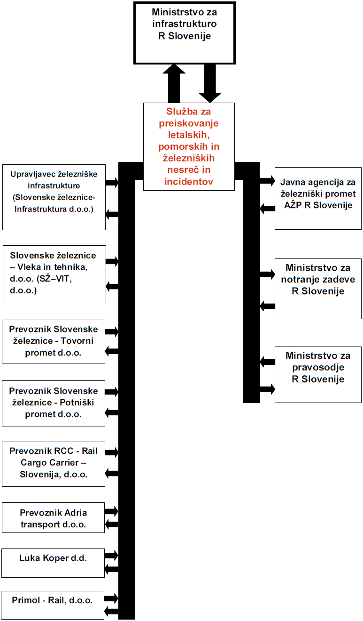

Ministrstvo za infrastrukturo R Slovenije | Ministry of Infrastructure of the Republic of Slovenia
Služba za preiskovanje letalskih, pomorskih in železniških nesreč in incidentov | Department for the Investigation of Aviation, Maritime and Railway Accidents and Incidents
Upravljavec železniške infrastructure (Slovenske železnice-Infrastruktura d.o.o.) | Railway infrastructure manager (Slovenske železnice-Infrastruktura d.o.o.)
Slovenske železnice – Vleka in tehnika, d.o.o. (SŽ–VIT, d.o.o.) | Slovenske železnice - Vleka in tehnika, d.o.o. (SŽ-VIT, d.o.o.)
Prevoznik Slovenske železnice – Tovorni promet d.o.o. | Slovenske železnice - Tovorni promet d.o.o. (railway undertaking)
Prevoznik Slovenske železnice – Potniški promet d.o.o. | Slovenske železnice - Potniški promet d.o.o. (railway undertaking)
Prevoznik RCC – Rail Cargo Carrier – Slovenija, d.o.o. | RCC (Rail Cargo Carrier - Slovenija, d.o.o.) (railway undertaking)
Prevoznik Adria transport d.o.o. | Adria transport d.o.o. (railway undertaking)
Luka Koper d.d. | Luka Koper d.d.
Primol - Rail, d.o.o. | Primol-Rail, d.o.o.
Javna agencija za železniški promet AŽP R Slovenije | Public Agency of the Republic of Slovenia for Railway Transport
Ministrstvo za notranje zadeve R Slovenije | Ministry of the Interior of the Republic of Slovenia
Ministrstvo za pravosodje R Slovenije | Ministry of Justice of the Republic of Slovenia

Approach to accident investigation (philosophy and approach when deciding whether to investigate an accident in the country, and the level of mobility, readiness and timeliness)
Under the provisions of Article 29 of the Railway Safety Act (ZVZelP-UPB3, UL RS, No 56/2013, 2 July 2013), the competent authorities, railway undertakings, the railway infrastructure manager and other entities involved are obliged to enable the investigating body to conduct its tasks efficiently, speedily and independently. Past practice demonstrates that there is complete compliance with the prescribed provisions.
Article 26 of the Railway Transport Act (ZZelP-UPB8, UL RS, No 99/2015, 21 December 2015) provides that the investigating body must investigate all serious accidents.
The investigating body may, at its own discretion, also decide to investigate accidents, and incidents that could cause accidents in similar circumstances, including cases of technical malfunctions of structural subsystems or railway system interoperability components.
The investigating body complies with all the provisions of the relevant act. Due to a shortage of staff, the body charged with investigating railway accidents and incidents is obliged to consider, in particular, which accidents or incidents (in addition to serious accidents) will be investigated.
In addition to its normal working hours, the body charged with investigating railway accidents and incidents is also on permanent standby.
The chief investigator has an official identity card that outlines his powers and proves his identity. The official identity card is prescribed by the minister responsible for transport.
One of the Ministry of Infrastructure’s official cars is at the disposal of the chief investigator. Should a vehicle not be available, the chief investigator’s own vehicle is used.
The organisation of readiness and mobility as outlined above ensures that the investigator is able to inspect the scene of an event and launch investigative procedures in good time.
From his home and workplace, which are both located in the middle of Slovenia in his case, the chief investigator is two hours away from the furthest point of the railway network when travelling by car and in view of the roads available.

INVESTIGATION PROCEDURE

Cases investigated: mandatory and non-mandatory under Articles 19 and 21 of the Railway Safety Directive
The investigating body investigates serious railway accidents, accidents and incidents. Under the Railway Transport Act (ZZelP-UPB8, UL RS, No 99/2015, 21 December 2015), the investigating body investigates all serious accidents and may, at its own discretion as prescribed, also decide to investigate accidents, and incidents that could cause serious accidents in similar circumstances, including cases of technical malfunctions of structural subsystems or railway system interoperability components.
Under the Railway Transport Act (ZZelP-UPB3, UL RS, No 56/2013, 2 July 2013), a ‘serious accident’ means any train collision or derailment of trains resulting in the death of at least one person, serious injuries to five or more persons or extensive damage to rolling stock, infrastructure or the environment, and any other similar accident with an obvious impact on railway safety regulation or safety management. ‘Extensive damage’ means damage that can be assessed on the spot by the chief railway accident investigator and that exceeds EUR 2 million.
The Slovenian railway investigating body complies with the above legal provisions and investigates all serious accidents, as well as accidents and incidents that could cause serious accidents or accidents in similar circumstances. It investigates accidents and incidents at its own discretion.

Institutions participating in investigations (as a matter of course or in exceptional circumstances)
The chief railway accident investigator at the Slovenian ministry responsible for transport ordinarily includes reports drawn up by officials at the Ministry of the Interior and, in exceptional circumstances, by judicial bodies.
Where the need arises for an analysis of chemical substances and other types of material, the investigating body involves in the investigation competent independent and licensed organisations with laboratories, e.g. the Jožef Stefan Institute, the Institute for Materials Research, the Institute for Metal Structures, etc.
If there is a need to examine the bodies of victims, the Institute for Forensic Medicine is also involved in the investigation.
When the need arises for reproductions of verbal communications, experts from the railway infrastructure operator that handle such equipment are involved in the investigation. Experts from the infrastructure operator are also involved if an analysis of the databases of signalling-safety devices is required. Experts from railway undertakings are involved if an analysis of train-driving databases is required.

Investigation procedure and the investigating body’s approach (as under point 1.5 but in greater detail)
Under Article 29 of the Railway Safety Act (ZVZelP-UPB3, UL RS, No 56/2013, 2 July 2013), the competent authorities, railway undertakings, the railway infrastructure manager and other entities involved are obliged to enable the investigating body to conduct its tasks efficiently, speedily and independently. This has been the case up to now.
Article 29 of the Railway Traffic Safety Act (ZVZeIP-UPB1, UL RS, No 56/2013, 2 July 2013) makes it obligatory for the competent authority, railway undertakings, the railway infrastructure manager and other entities involved to provide the investigating body with:
- free access to the site of the accident, serious accident or incident, to the rolling stock and infrastructural facilities involved, and to traffic control and signalling facilities and devices;
- an immediate listing of evidence and the controlled removal of wreckage, infrastructural facilities and devices, or their components, for examination or analysis;
- access to and the use of the contents of on-board recorders of verbal messages and registration of the operation of the signalling, traffic control and traffic management system;
- access to the results of examinations of the bodies of victims;
- access to the results of investigations of train staff and others involved in the accident;
- the opportunity to question the railway staff involved and other witnesses;
- access to all relevant information or records held by the infrastructure manager, the railway undertakings involved and the safety authority.
Article 26 of the Railway Transport Act (ZZelP-UPB8, UL RS, No 99/2015 of 21 December 2015) provides that the investigating body must investigate serious accidents.
The investigating body may, following an assessment, also decide to investigate accidents, and incidents that could cause accidents in similar circumstances, including cases of technical malfunctions of structural subsystems or railway system interoperability components. It shall take the following into consideration in its decision:
- the gravity of the accident or incident;
- whether the accident or incident was a part of a series of accidents or incidents affecting the entire system;
- the impact on railway safety at the level of the European Community;
- the requirements of infrastructure managers, railway undertakings, the safety authority or European Community Member States.
The railway investigating body complies with all the prescribed provisions applicable to investigative procedures. Staff shortages curtail the body’s activities and mean that it must make additional assessments if it wishes to investigate accidents and incidents.

INVESTIGATIONS

Review of investigations completed in 2016
The investigating body for railway accidents and incidents investigated six accidents in 2016:

    - derailment of international goods train 45440 at 7.23 am on 20 February 2016 at Points 205, Ljubljana railway station, km 565.934, operated by RCC (Rail Cargo Carrier) - train derailed on account of a broken tongue rail on Points 205;

    - collision between local passenger train 2425, operated by SŽ-Potniški promet, d.o.o., and an elderly pedestrian at a level crossing equipped with barriers at km 568.855 (Litostrojska cesta), between Ljubljana Vižmarje and Ljubljana Šiška stations, at 3.12 pm on 18 March 2016 - pedestrian died at the scene;

    - collision between international passenger train 151 operated by SŽ-Potniški promet, d.o.o. and a cyclist at a level crossing equipped with half-barriers at Šentjur railway station, km 538.260, at 12.36 pm on 5 June 2016 - cyclist died at the scene;

    - collision between international goods train 45445, operated by RCC (Rail Cargo Carrier), and a car at 5.58 pm on 14 June 2016 at a level crossing equipped with half-barriers at km 586.909, Škofja Loka railway station - the car driver was taken to Ljubljana University Medical Centre, where he died of his injuries;

    - collision between local passenger train 3830, operated by SŽ-Potniški promet, d.o.o., and a car at 4.05 pm on 11 July 2016 at a level crossing equipped with road traffic signs at km 48.250 between Ormož and Središče ob Dravi stations - a 63-year-old driver and his 60-year-old passenger died at the scene;

    - derailment of international goods train 45799, operated by RCC (Rail Cargo Carrier), at 9.47 am on 17 November 2016 while leaving Track 9 at km 453.840, Dobova station - wagon 33879332394-4 derailed.

Type of accident investigated | No of accidents | No of casualties |  | Damage in EUR (estimated) | Trend in comparison with 2014
Type of accident investigated | No of accidents | No of fatalities | Seriously injured | Damage in EUR (estimated) | Trend in comparison with 2014
Train collision | 0 | 0 | 0 | EUR 0 | 0 = 0
Train derailment | 2 | 0 | 0 | EUR 850,000 | 2 > 0
Other | 4 | 5 | 2 | EUR 5,500 | 4 < 5

Investigations commenced and completed in 2016
All six accident investigations commenced in 2016 were completed in the same year. Four accidents and one incident were investigated in 2015, with all investigations being completed in the same year.

Investigations completed in 2016
Date of accident | Type of accident | Place of accident | Legal basis | Date of completion
20 February 2016 | derailment of international goods train 45440 | Points 205, Ljubljana station, km 565+934 | Article 26 of the ZZelP | 27 October 2016
18 March 2016 | collision between local passenger train 2425 and elderly pedestrian | between Ljubljana Vižmarje and Ljubljana Šiška stations - level crossing 568+9 | Article 26 of the ZZelP | 4 November 2016
5 June 2016 | collision between international passenger train 151 and cyclist | Šentjur station - level crossing 538+3 | Article 26 of the ZZelP | 16 November 2016
14 June 2016 | collision between international goods train 45445 and car | Škofja Loka station - level crossing 586+9 | Article 26 of the ZZelP | 10 December 2016
11 July 2016 | collision between local passenger train 3830 and car | between Ormož and Središče ob Dravi stations - level crossing 048+2 | Article 26 of the ZZelP | 18 December 2016
17 November 2016 | derailment of international goods train 45799 | Track 9, Dobova station, km 453+840 | Article 26 of the ZZelP | 14 May 2017
In 2016 the body charged with investigating railway accidents and incidents launched investigations into six accidents, all pursuant to Article 19(2) of Directive 2004/59/EC of 29 April 2004.
Investigations launched in 2017
Date of accident or incident | Type of accident or incident | Place of accident or incident | Legal basis | Likely date of completion of investigation
6 January 2017 | derailment of local passenger train 2402 | Points 12, Škofja Loka station | Article 26 of the ZZelP | final report at the publication stage
18 April 2017 | collision between local passenger train 3516 and car | between Celje and Žalec stations - level crossing 7.6 | Article 26 of the ZZelP | final report at the publication stage
16 June 2017 | collision between locomotive 541-008 and train 38008 | Points 24, Ljubljana station | Article 26 of the ZZelP | at the investigation stage
19 June 2017 | derailment of international goods train 43601 | Points 25, Zidani Most station | Article 26 of the ZZelP | final report at the publication stage
11 July 2017 | derailment of international goods train 49485 | Points 6, Kranj station | Article 26 of the ZZelP | at the investigation stage
24 July 2017 | collision between local passenger train 2416 and pedestrian | between Ljubljana Šiška and Ljubljana Vižmarje stations, level crossing at km 570.5 | Article 26 of the ZZelP | at the investigation stage
16 August 2017 | collision between international goods train 55215 and young cyclist | between Jarše Mengeš and Domžale stations - level crossing 14.117 | Article 26 of the ZZelP | at the investigation stage
17 August 2017 | collision between track maintenance motor vehicle 76311 and car | between Ruše and Maribor Studenci stations - level crossing 8.924 | Article 26 of the ZZelP | at the investigation stage
17 September 2017 | derailment of international goods train 48414 | track rail L50 between Logatec and Verd stations at km 602+916 | Article 26 of the ZZelP | at the investigation stage

Research studies (studies on safety involving serious accidents) commissioned and completed in 2016
There were six accidents on the Slovenian railway network in 2016. These accidents claimed five lives. There were no serious railway accidents in 2016.
In the most recent ten-year period, there have been no railway accidents on the Slovenian railway network similar to an accident in the past.
The last serious accident, which involved a collision between international passenger train 314 and broken-down electrical engine set 2405 on Track 3 at Ljubljana Vižmarje station, occurred on 28 October 2012.
Prior to this serious accident, a goods train and a passenger train collided at Points 3 at Jesenice station on 26 August 2011. Human factors were the cause of both accidents. On 28 October 2012 a passenger train collided with a static broken-down passenger train as a result of an error by an infrastructure worker (the train controller at Ljubljana Vižmarje station), while the collision between the passenger and goods trains at Jesenice station on 26 August 2011 was the result of an error by a railway undertaking worker (train driver).
It was not necessary to compile a research study on safety for these two cases as the cause in both cases was investigated and established in detail. Despite the similarity between the causes of the two accidents, additional research was not required, as it could in no way be claimed that the two cases raised wider concerns or that similar accidents could occur in the future.
Three accidents occurred at level crossings equipped with half-barriers to stop road users from encroaching on the tracks, and one at a level crossing equipped with road traffic signs.
Regarding the accident at the level crossing between Ljubljana Vižmarje and Ljubljana Šiška stations, the elderly pedestrian stepped onto the tracks in front of the train despite the barriers being lowered. She died at the scene. Regarding the accident at the level crossing at Šentjur station, the cyclist rode around the lowered half-barrier in heavy storm conditions immediately after a passenger train had passed through the crossing. He rode onto the adjacent track (it is a two-track line), where he was struck by a passing international passenger train. The cyclist died at the scene. Regarding the accident at the level crossing at Škofja Loka station, the car driver drove around the lowered half-barrier into the path of a train. The driver sustained serious injuries and was taken to Ljubljana University Medical Centre, where he died. Regarding the accident at the level crossing equipped with road traffic signs between Ormož and Središče ob Dravi stations, the car driver drove onto the track directly into the path of a local passenger train. Driver and passenger died at the scene.
After a thorough investigation, it was found that the level crossing and its half-barriers met all the prescribed standards. The cyclist and car driver attempted to cross the track despite the half-barriers being lowered, and the pedestrian stepped onto the tracks by skirting the lowered barriers.
Two trains were derailed in 2016. In Ljubljana, an international goods train derailed as a result of a broken tongue rail at Points 205. A materials analysis of the tongue rail conducted by the Institute of Metals and Technology established that it had broken because of material fatigue. The cause of the derailment of the international goods train on Track 9 at Dobova station was the widening of the track resulting from worn-out/decayed sleepers that no longer held the rail baseplate fastening screws.

Summary of investigations completed in 2016 Short descriptions, photographs, diagrams and safety studies
Derailment of international goods train 45440 at Points 205, Ljubljana station (7.23 am, 20 February 2016)

At 7.23 am on 20 February 2016, international goods train 45440, operated by RCC (Rail Cargo Carrier), derailed at Ljubljana station (km 565.934) while switching tracks at Points 205. The train left Track 23 (the goods section of the station) and passed along Track 5 towards Track 111 in the direction of Ljubljana Šiška station. ÖBB locomotive 1216-142 and the first two wagons (25 80 437 1377-9 and 25 80 437 1413-2) derailed at Points 6. The weight of the train was 540 tons, it had 72 axles and was 558 m long. It was composed of 18 empty, two-tier car-transporting wagons (Laaers wagon series). All axles of the locomotive and both wagons were derailed. The derailment also caused the complete destruction of the next Points (206) in the direction of travel.
Points 205 are a single set of points, UIC 49, manufactured by VAE APCARON SA Buzau, Romania, sold by Voestalpine Schienen Gmbh, Austria.
The left tongue rail of the points had been incorporated into the structure in 2009.
The investigation established that the derailment was caused by a broken left tongue rail 7.2 m from the top.
An analysis conducted by the independent and accredited Institute of Metals and Technology (IMT) in Ljubljana indicated that it had broken because of material fatigue.
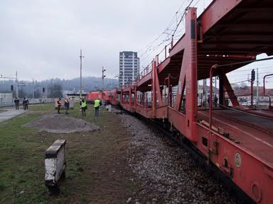
Figure 1: The red arrow shows the train’s intended direction of travel and the blue arrow shows where the derailment occurred.

Causes:
The direct cause of the derailment of the locomotive and two wagons of international goods train 45440 at Points 205 at Ljubljana station was the fracturing of the left tongue rail. The tongue rail broke because of material fatigue.

Recommendation:
As Points 205 is one of the busiest single set of points at Ljubljana station, it is recommended that the rails and tongue rails built into the points be made of materials that ensure greater flexibility, thereby reducing the risk of breakage.

Collision between local passenger train 2425 and a pedestrian at a level crossing equipped with barriers between Ljubljana Vižmarje and Ljubljana Šiška stations (3.12 pm, 18 March 2016)

At 3.12 pm on 18 March 2016, passenger train 2425, operated by SŽ-Potniški promet, d.o.o., struck an elderly pedestrian at a level crossing equipped with barriers at the Litostrojska cesta level crossing in Ljubljana (km 568.855). After colliding with the pedestrian, the head of the train came to a halt at km 568.702. The train driver had begun to brake prior to the collision, as the train was scheduled to stop at Litostroj station (km 568.680). The train travelled 153 m between striking the pedestrian and coming to a stop. It was composed of a series 311/315-209/210 electrical engine set. After the train, which was travelling between Jesenice and Ljubljana, struck her, the pedestrian was propelled from the track to the left-hand side of the track at km 568.843. She died at the scene.
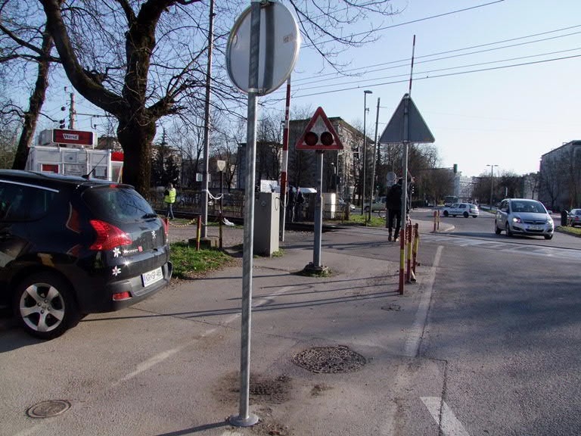

Figure 2: The red arrow shows the direction in which the pedestrian was walking and the point at which she stepped onto the area of the level crossing past the lowered half-barriers, the blue arrow shows the track and the train’s direction of travel, and the grey cross marks the spot where the collision occurred.

Cause:
The immediate cause of the collision between local passenger train 2425 and the pedestrian at a level crossing equipped with barriers on the Ljubljana-Jesenice single-track line was the victim’s carelessness; she circumvented the lowered half-barrier and stepped directly into the path of the train.

Recommendations:
It is recommended that level crossings be additionally secured, as part of the railway transport safety management system, by means of obstacles alongside the barrier area that make it impossible to bypass half-barriers that have already been lowered.

Collision between international passenger train 151 and a cyclist at a level crossing equipped with half-barriers at Šentjur station (12.36 pm, 5 June 2016)

At 12.36 pm on 5 June 2016, international passenger train 151, operated by SŽ-Potniški promet, d.o.o., struck a cyclist at a level crossing equipped with half-barriers at Šentjur station (km 538.260). The cyclist, who had ridden along Cesta Kozjanskega odreda in the direction of Cesta na kmetijsko šolo, stopped before the lowered half-barrier. As local passenger train 4436, which was travelling along the left-hand line from Celje towards Maribor, passed the level crossing, the cyclist rode around the lowered half-barrier and directly into the path of train 151, which was at the moment travelling along the adjacent right-hand Maribor-Celje line at 103 km/h. The cyclist died at the scene.
Immediately before he was struck, a storm arose in the area of the level crossing, carrying with it a large quantity of rainfall. It is therefore likely that, in his desire to withdraw as quickly as possible from the area of the storm, he concluded that the half-barriers would open immediately after the passenger train had passed along the adjacent track. In doing so, however, he failed to notice that another train was travelling in the opposite direction.
The head of train 151 came to a stop at km 537.900. Between colliding with the cyclist and coming to a stop, the train travelled 360 m.

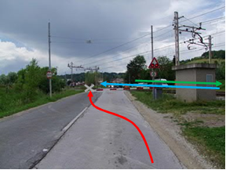
Figure 3: The red arrow shows the direction in which the cyclist was travelling and the point at which he entered the area of the level crossing past the lowered half-barrier, the blue arrow shows the track and the direction of travel of the international passenger train, the grey cross marks the spot where the collision occurred, and the green arrow indicates the direction of the local passenger train that passed the level crossing immediately prior to the collision.

Cause:
The immediate cause of the collision between international passenger train 151 and the cyclist at a level crossing equipped with half-barriers on the two-track Zidani Most-Maribor line was the carelessness of the cyclist, who rode around the lowered half-barrier in the centre of the roadway and directly into the path of the train.

Recommendations:
It is recommended that the level crossing be additionally secured, as part of the railway transport safety management system, by replacing the half-barrier with a barrier that covers the entire width of the roadway.
Collision between international goods train 45445 and a car at a level crossing equipped with half-barriers at Škofja Loka level crossing (5.58 pm, 14 June 2016)

At 5.58 pm on 14 June 2016, international goods train 45445, operated by RCC (Rail Cargo Carrier), collided with a car at a level crossing equipped with half-barriers at km 586.909, Škofja Loka station.
The investigation established that the driver of the car, who was travelling from Žabnica towards Dorfarje, drove around the lowered level crossing half-barrier and directly into the path of train 45445, which was travelling from Ljubljana towards Jesenice. After being struck by locomotive 1216 903, the car was propelled into a rainwater ditch on the left-hand side of the track at km 586.930.
The driver was taken to Ljubljana University Medical Centre, where he died of his injuries.
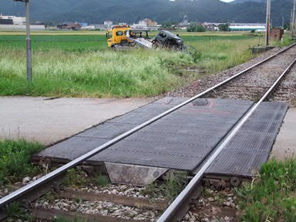

Figure 4: The red arrow shows the direction in which the car was travelling and the point at which the driver drove onto the area of the level crossing past the lowered half-barrier, the blue arrow shows the track and the direction of travel of the international goods train, and the white cross marks the spot where the collision occurred.

Cause:
The immediate cause of the collision between international goods train 45445 and the car at a level crossing equipped with half-barriers on the single-track Ljubljana-Jesenice line was the recklessness of the car driver, who drove around the lowered half-barrier on the other side of the roadway and directly into the path of the train.

Recommendation:
It is recommended that the level crossing be additionally secured, as part of the railway transport safety management system, by replacing the half-barrier with a barrier that covers the entire width of the roadway.

Collision between local passenger train 3830 and a car at a level crossing equipped with road traffic signs between Ormož and Središče ob Dravi stations (4.05 pm, 11 July 2016).

At 4.05 pm on 11 July 2016, train 3830 collided with a Citroen Berlingo at a level crossing marked with a ‘St Andrew’s Cross’ (km 048.250) between Ormož and Središče ob Dravi stations.
Passenger train 3830 was composed of traction unit 813-034 and engine unit 814-034. The front of the engine unit of train 3830 collided with the right-hand side of the car. The passenger compartment of the car was stuck to the buffers of engine unit DMG 814-034.
The 63-year-old driver and his 60-year-old passenger died of their injuries at the scene.
Ormož-Središče ob Dravi line 44 is single-track and sees an average of only 14 trains a day.
The gravel road that crosses the railway line at km 48.250 is a connecting road for areas of farmland.
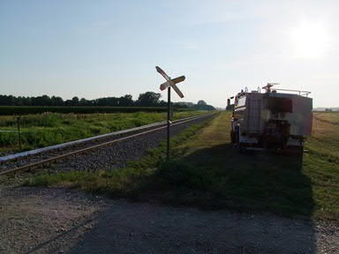

Figure 5: The red arrow shows the direction in which the local passenger train was travelling, the blue arrow shows the direction in which the car was travelling and the point at which the driver drove into the area of the level crossing, and the white cross marks the spot where the collision occurred.

Cause:
The immediate cause of the collision between local passenger train 3830 and the car at a level crossing equipped with road traffic signs on the single-track Ormož-Središče ob Dravi line was most likely the insufficient attention paid by the car driver, who did not see the train: at that time of year, the diesel engine set can blend into the vegetation because of the similarity of their colours.

Recommendation:
It is recommended that the road traffic signs be upgraded, as part of the railway transport safety management system, so that road users are more clearly warned that they are approaching a level crossing.

Derailment of international goods train 45799 while leaving Track 9 at Dobova station (9.47 am, 17 November 2016)

At 9.47 am on 17 November 2016, wagon 33879332394-4, operated by RCC (Rail Cargo Carrier), derailed as international goods train 45799 was leaving Dobova station in the direction of Zidani Most. The derailed vehicle was the eighth wagon from the front of the train. Train 45799 was composed of 20 wagons, had 80 axles, weighed a total of 1,575 tons and was 305 m in length.
The investigation established that the derailment was caused by the widening of Track 9 as a result of worn-out/completely decayed sleepers. At the location of the widening, the fastener of the rail baseplates had become completely loose and it was possible to remove the baseplate screws from the sleepers by hand.
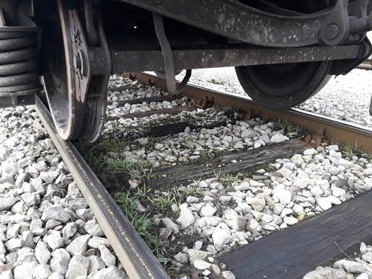
Figure 6: The red arrow shows the widened track at the point where traces of the derailment of the carriages are visible and the blue arrow shows the loosened screws of the rail baseplate fastener at this point.

Cause:
The immediate cause of the derailment of international goods train 45799 while leaving Track 9 at Dobova station was the widening of the track resulting from extremely poor maintenance, as the sleepers were completely weathered and decayed at the derailment point.

Recommendation:
It is recommended that adequate maintenance of the main station tracks be ensured, as part of the railway transport safety management system, so as to guarantee safe train and shunting driving.

The investigations of the accidents described above did not require the compiling of special studies or drawings.

Explanation and introduction or background of investigations
The department charged with investigating railway accidents and incidents was not able to complete an investigation launched into an accident in 2013 by the prescribed deadline (it was completed ten months after the deadline). In 2012 the department abandoned its investigation into one accident: the derailment of a wagon owned by Croatian railways (goods train 47502) because of lack of cooperation on the part of representatives of the wagon owners.

Investigations commenced in 2016 and not yet completed
Date of accident | Type of accident | Place of accident | Legal basis | Reason why investigation has not been completed or was abandoned | Who, why, when  (decision)
17 November 2016 | Derailment of international goods train 45799 | Track 9, Dobova station, km 453+840 | Article 26 of the ZZelP | investigation completed in 2017 | 14 May 2017

Accidents and events investigated in the past five years (2012-2016)
[Table of investigations into railway accidents 2012-2016 (serious accidents, accidents and incidents) and safety studies, with data from 2012 to 2016 and the types of accident/incident: collision of trains, collision with obstacles, derailments, accidents involving people and railway vehicles during travel, fires on railway vehicles, hazardous substances and other items] (Point 3.1 should be updated with the trends established by accident investigations.)

Accidents investigated |  | 2012 | 2013 | 2014 | 2015 | 2016 | Total
Serious accidents  Article 19(1) and (2) of the Railway Safety Directive | collision |  | 1 |  |  |  | 1
 | derailment | 1 |  | 2 |  | 2 | 5
 | Level crossing
 | persons and railway vehicles during travel
 | fires on vehicles
 | Other | 1 |  |  |  |  | 1
 | hazardous substances
Other accidents  Article 21(6) of the Railway Safety Directive | collision |  |  |  | 1 |  | 1
 | derailment |  | 2 |  |  |  | 2
 | Level crossing | 2 | 1 | 3 | 2 | 4 | 12
 | persons and railway vehicles during travel | 1 |  |  |  |  | 1
 | fires on vehicles
 | Other |  |  |  | 1 |  | 1
 | hazardous substances
TOTAL |  | 5 | 4 | 5 | 4 | 6 | 24

The investigating body investigated five events (serious accidents, accidents or incidents) in 2012, four events in 2013, five events in 2014, four events in 2015 and six events in 2016.
Between the time the investigating body began operating (1 June 2008) and the end of 2016, no accidents occurred in the area covered by Slovenian railways to which the same or similar causes as previous accidents could be attributed. Accordingly, there has been no requirement to produce a more detailed study of railway safety between 2009 and 2016.

RECOMMENDATIONS
The body charged with investigating railway accidents issued five safety recommendations in 2016:
- two related to maintenance processes for public railway infrastructure maintenance;
- one related to the upgrading of a level crossing equipped with road traffic signs for road users;
- one related to the upgrading of safety equipment for securing a level crossing and a recommendation that the amount of time taken to secure the crossing be reduced;
- one related to the upgrading of safety equipment for securing a level crossing by means of a maze for pedestrians and cyclists.

Recommendations issued |  | Situation regarding implementation of recommendations
 |  | implemented |  | being implemented (or have been prepared) |  | will not be implemented (rejected)
YEAR | no | no | % | no | % | no | %
2008 | 2 | 2 | 100
2009 | 16 | 15 | 94 |  |  | 1 | 6
2010 | 3 | 3 | 100
2011 | 6 | 5 | 83.3 |  |  | 1 | 16.7
2012 | 12 | 10 | 83.3 |  |  | 2 | 16.7
2013 | 5 | 4 | 80 | 1 | 20
2014 | 8 | 5 | 62.5 | 3 | 37.5
2015 | 4 | 4 | 100
2016 | 5 | 3 | 60 | 2 | 40
TOTAL | 61 | 51 | 83.6 | 6 | 9.8 | 4 | 6.6

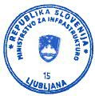 | Chief railway accident and incident investigator  Daniel Lenart, Secretary
 | Daniel  Lenart | Digitally signed by Daniel Lenart DN: c=si, o=state-institutions, ou=web-certificates, ou=government, cn=Daniel Lenart, serialNumber=1235613214020 Date: 2017.09.29 09:53:03 +02'00'

