**DOPRAVNÝ ÚRAD**

LETISKO M. R. ŠTEFÁNIKA, 823 05 BRATISLAVA

**TRANSPORT AUTHORITY**

M. R. ŠTEFÁNIK AIRPORT, 823 05 BRATISLAVA, SLOVAK REPUBLIC

**Annual Report on Railway Safety in the Slovak Republic for 2016**

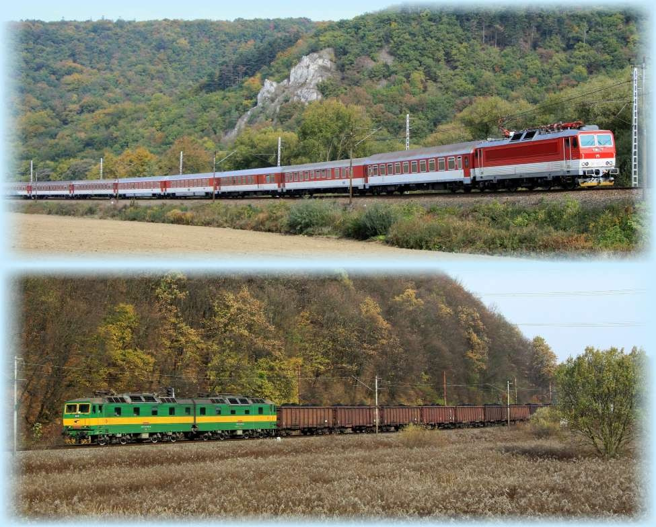

Signature:

**Report by:**

Ján Breja, Chairman

**Date:**

September 2017

**Contents**

List of abbreviations used 4

A. Scope of the annual report 5

B. Introductory section 5

1. Introduction to the report 5

2. Information on the railway infrastructure in the Slovak Republic 5

3. ŽSR railway network map 10

4. List of railway undertakings and infrastructure managers 10

5. Summary 10

6. Implementation of Railway Safety Directive 2004/49/EC 10

C. Organisation 10

1. Introduction 10

2. Organisation of the Authority 11

3. Organisation chart 12

D. The development of railway safety 12

1. Initiatives to maintain/improve safety performance 12

2. Detailed data trend analysis 13

3. Results of safety recommendations 13

E. Important changes in legislation and regulations 14

F. The development of safety certification and authorisation 15

1. National legislation 15

1.1 Issuing of safety certificates according to Article 10 of the Railway Safety Directive 2004/49/EC. 15

1.2 Issuing of safety authorisations for infrastructure managers under the Railway Safety Directive 2004/49/EC 15

1.3 National safety rules 15

2. The development of safety certification and authorisation – numerical data 16

3. Procedural aspects 17

3.1 Safety Certificates Part A 17

3.2 Safety Certificates Part B 18

3.3 Safety authorisations 18

4. Registration of vehicles 19

G. The supervision of railway undertakings and infrastructure managers 22

1. Description of the supervision 22

1.1 Audits – inspections 22

1.2 The Authority’s findings from supervision, which must be followed up 23

2. Submission of safety reports 23

3 and 4 Authority inspections and audits 23

5. Summary of relevant measures of the Authority 24

6. Summary of a description of complaints made by the infrastructure manager against railway undertakings in relation to the conditions referred to in Part A/B of the safety certificate 24

7. Summary of a description of complaints made by railway undertakings against the infrastructure manager in relation to conditions of the safety authorisation 24

H. Reporting on the application of the Common Safety Method on risk evaluation and assessment 25

I. Alternative measures through derogations regarding the ECM certification scheme 26

J. The Authority’s conclusions for the reporting year – priorities 26

K. Sources of information 26

L. Annexes 27

Annex A 1 – The ŽSR network 28

Annex A 2 – List of railway undertakings 29

Annex A 2.1 Infrastructure manager 32

Annex A 2.2 Railway undertakings – safety certificates issued 33

Annex B the Authority's Organisational chart 39

Annex B 1 – Internal organisation (as at 31/12/2014) 39

B 1.1 – Organisational setup to the level of Authority’s divisions 39

B 1.2 Organisational setup of the Railways and Railway Traffic Division 40

Annex B 2 – Relationship with other national bodies 41

Annex C – Statistics of accident rate and prescribed indicators – CSI data 42

Annex D – Important changes in legislation and regulations 68

Annex E – The development of safety certification and safety authorisations – numerical data 72

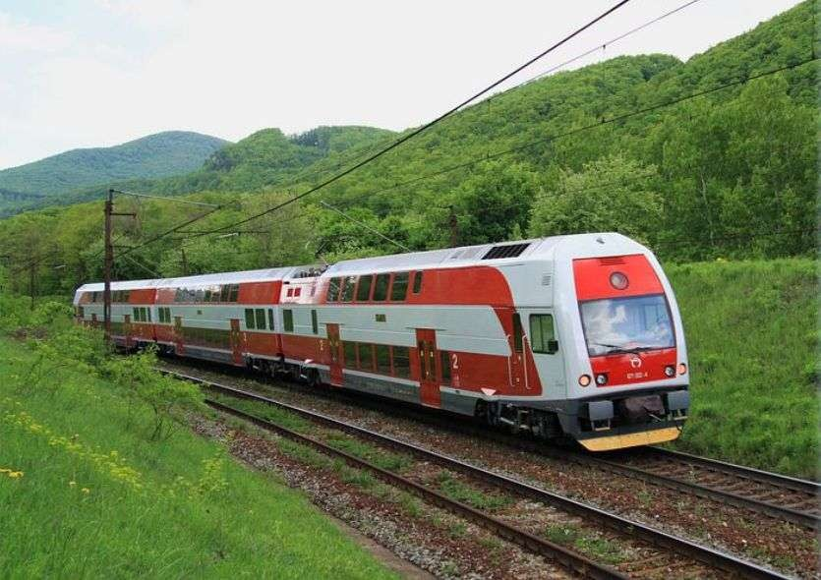

(Photo: Pavel Chomjak, Prešov)

## List of abbreviations used

|  |  |
| --- | --- |
| CSM | Common safety method |
| EUAR | EUROPEAN UNION AGENCY FOR RAILWAYS |
| RTU | Railway traction unit |
| Ministry | Ministry of Transport and Construction of the Slovak Republic |
| NSA | National Safety Authority |
| Safety certificate | Safety certificate of a railway undertaking |
| Safety authorisation | Safety authorisation of a railway infrastructure manager |
| BTS | Border transit station |
| SR | Slovak Republic |
| SMS | Safety management system |
| SPS | State professional supervision |
| SPTS | State professional technical supervision |
| TI | Technical inspection |
| Authority | Transport Authority |
| SOSMT | Slovak Office of Standards, Metrology and Testing |
| VKM | Vehicle Keeper Marking |
| Railways Act | Act No 513/2009 Coll. on Railways, to alter and to amend some other acts, as amended |
| ('the Railway Traffic Act') | Act No 514/2009 Coll. on Railway Traffic, as amended |
| RS | Rolling stock |
| ŽSR | Železnice Slovenskej republiky – the railway infrastructure manager |

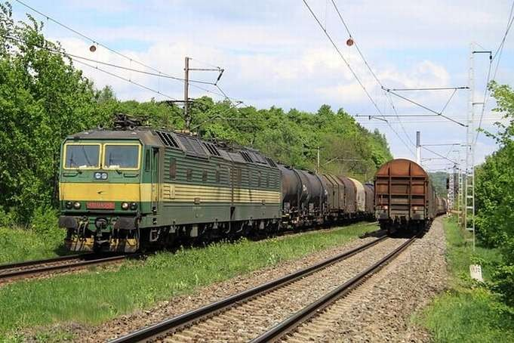

(Photo: Pavel Chomjak, Prešov)

# Scope of the annual report

The Annual Report on the Railway Safety ('the report') contains railway safety indicators for the railway infrastructure in the Slovak Republic for 2016 and information about the activities of the Transport Authority acting as the railway safety authority. The report also contains data relating to marshalling yards and railway systems. Data on urban railways are not included in this report.

# Introductory section

## Introduction to the report

The obligation to draw up the report arises from the provision of § 91(1) of the Railways Act and from Article 18 of Directive 2004/49/EC of the European Parliament and of the Council of 29 April 2004 on safety on the Community’s railways and amending Council Directive 95/18/EC on the licensing of railway undertakings and Directive 2001/14/EC on allocation of railway infrastructure capacity and the levying of charges for the use of railway infrastructure and safety certification ('Directive 2004/49/EC on Railway Safety').

The purpose of this report is to provide information about the level of safety on railways and on safety of railway traffic on the railway infrastructure of the Slovak Republic.

The goal is to continuously improve the level of railway traffic safety as well as to inform stakeholders on how the level of safety is being improved.

The report has been sent to the European Union Agency for Railways and, at the same time, published on the Transport Authority's website ([www.nsat.sk) v časti „](http://www.nsat.sk/)[O nás/Údaje a dokumenty/Výročné správy](http://nsat.sk/dopravny-urad-menu-udaje-a-dokumenty/vyrocne-spravy/)“.

## Information on the railway infrastructure in the Slovak Republic

The railway infrastructure in the Slovak Republic (with the exception of railway sidings) is owned by the State. The railway infrastructure is managed and operated by ŽSR. For the purposes of this report, the railway infrastructure includes the main and secondary railway lines of the Slovak Republic.

Construction length of tracks

The total construction length of tracks is 6,872 km, of which 4,645 km are main tracks and 2,227 km are other station tracks. There are a total of 8 448 switches and 9,363 switch units.

Construction length of railway lines

The total construction length of railway lines is 3,626 km, of which 2,609 km are single-track and 1,017 km are double or multi-track lines. There are 3,481 km of standard-gauge lines , 98 km of broad-gauge l and 46 km of narrow-gauge track lines. Of the total construction length of railway lines, 2 040 km are non-electrified and 1,586 km are electrified.

Bridges

As part of the railway infrastructure, 2,292 bridges have been built, 438 being steel bridges and 1,854 solid bridges. The total length of bridges is 51,272 m.

Tunnels

The railway infrastructure also includes 76 tunnels. Of these, 68 are single-track and 8 are double-track tunnels. The total length of trailway infrastructure tunnels is 45,004 m.

Level crossings

Level crossings are part of the railway infrastructure in terms of railway safety. A total of 2,131 level crossings have been built part of the railway infrastructure. There are 1,069 secured and 1,036 unsecured level crossings. There are 52 level crossings secured with mechanical barriers and 41 level crossings with permanently locked barriers, 8 level crossings secured with mechanical interlocking systems (PZM 0) and 968 level crossings are secured with light signalling systems. In the modernisation of railway tracks or in other large reconstructions respectively, the level crossings are replaced with grade-separated crossings.

**Structure of level crossings in pieces in 2016**

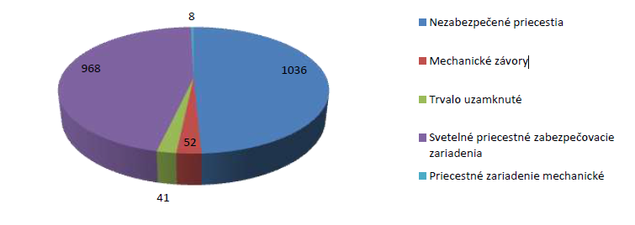**Level crossings 2016**

|  |  |
| --- | --- |
| Nezabezpečené priecestia | Unsecured crossings |
| Mechanické závory | Mechanical barriers |
| Trvalo uzamknuté | Permanently locked |
| Svetelné priecestné zabezpečovacie zariadenia | Light signalling system crossings |
| Priecestné zariadenie mechanické | Mechanical level crossing interlocking system |

Track interlocking systems

The total length of railway tracks secured with an automatic block is 541 km, of which 136 km are equipped with a single direction automatic block and 405 km are equipped with a bi-directional automatic block. Automatic block systems are used as the track interlocking systems on 520 km of tracks. Semi-automatic blocks secure tracks with a total length of 585 km, of which 515 km are secured with a relay system and 70 km are secured with a block system. The total length of tracks using a telephone communication system for signalling is 1,580 km. Remote dispatcher-operated interlocking systems secure 377 km of tracks. 762 km of tracks are equipped with a system enabling the transmission of information to trains.

**Structure of track interlocking systems in km in 2016**

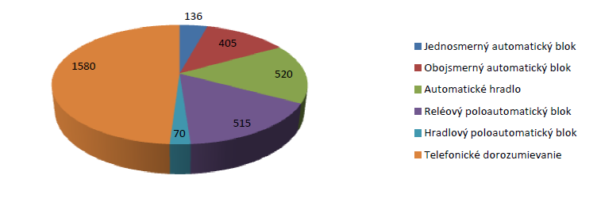**Track interlocking systems in 2016**

|  |  |
| --- | --- |
| Jednosmerný automatický blok | Single direction automatic block |
| Obojsmerný automatický blok | Bi-directional automatic block |
| Automatické hradlo | Automatic block system |
| Reléový poloautomatický blok | Relay semi-automatic block |
| Hradlový poloautomatický blok | Semi-automatic block system |
| Telefonické dorozumievanie | Telephone communication system |

Station interlocking systems

In total, 149 railway stations in Slovakia are equipped with the simplest system – a mechanical station interlocking system. Electromechanical interlocking systems are used at 61 railway stations. There are a total of 167 operating control points with a relay interlocking system, 40 operating control points use an electronic interlocking system, and 55 operating control points have another interlocking system. The remote dispatcher-operated interlocking systems are in the length of 377 km.

**Structure of station interlocking systems in pcs in 2016**

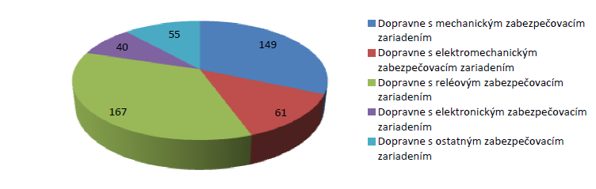**Station interlocking systems in 2016**

|  |  |
| --- | --- |
| Dopravne s mechanickým zabezpečovacím zariadením | Operating control points with mechanical interlocking system |
| Dopravne s elektromechanickým zabezpečovacím zariadením | Operating control points with electromechanical interlocking system |
| Dopravne s reléovým zabezpečovacím zariadením | Operating control points with relay interlocking system |
| Dopravne s elektronickým zabezpečovacím zariadením | Operating control points with electronic interlocking system |
| Dopravne s ostatným zabezpečovacím zariadením | Operating control points with other interlocking system |

Hump yard interlocking systems

On the ŽSR network, there are two automatic and 6 mechanical marshalling yards. The marshalling yard interlocking systems use track brakes and compressor stations for their operation. In total, there are 210 track brakes and 15 compressor stations.

Electrified tracks

Of the total length of railway lines; 1,586 km are electrified, especially with the following systems:

|  |  |
| --- | --- |
| * AC 25,000 V/50 Hz (15,000 V/ 16.7 Hz) | 762 km, |
| * DC 3,000 V (1,500V; 600 V) | 824 km. |

The developed length of the overhead lines is 4,839 km, of which single-phase AC overhead lines are in the total length of 2,192 km and DC overhead lines are in the total length of 2,647 km.

Substations and sectioning points

On the railway infrastructure, there is a total of 93 pc of such substations. Of these, 12 pc are single-phase traction substations and 36 are direct current traction substations (converter substations). There are three supporting substations. There are 19 pc of single-phase sectioning points and 20 direct current sectioning points. There are 3 mobile substations.

Operating control points

The railway infrastructure includes a total of 1,022 operating control points. Of these, 377 are manned and 643 are unmanned. Of the total number of operating control points, 300 are railway stations,

22 are border stations and 698 are other operating control points (blocks, branch lines, exchange stations, operating control points with simplified traffic management, etc.).

Corridor routes within the railway infrastructure of the Slovak Republic

The total length of the ŽSR railway lines **included in pan-European corridors is 939 km** and consists of the following sections:

|  |  |
| --- | --- |
| **IV. in the section**: (CZ) – **Kúty** – **Bratislava** – **Štúrovo** – (HU) | (220 km) |
| **V. in the section**: **Bratislava** – **Žilina** – **Košice** – **Čierna** **nad** **Tisou**- (UA) | (544 km) |
| **VI. in the section**: **Žilina** – **Čadca** – **Skalité** – (PL) | (57 km) |
| **IX. in the section**: (HU) – **Čaňa** – **Košice** – **Prešov** – **Plaveč** – (PL) | (118 km) |

**Corridor routes within the railway infrastructure of the Slovak Republic**

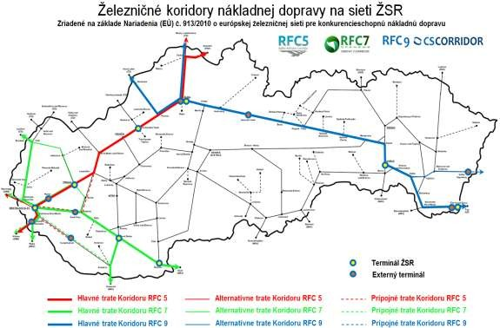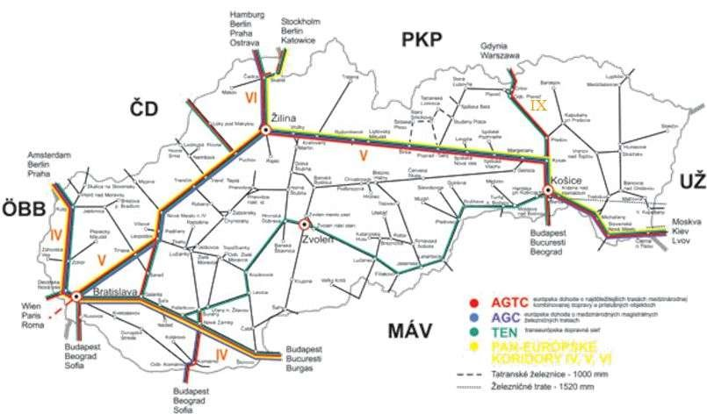The total length of ŽSR railway lines **included in pan-European railway freight corridors is 1,182 km** and consists of the following sections:

|  |  |
| --- | --- |
| **RFC5**: (CZ) – **Žilina** – **Bratislava** – (AT) | (281 km) |
| **RFC7**: (CZ) – **Kúty** – **Bratislava** – (HU) | (517 km) |
| **RFC9**: (CZ) – **Žilina** – **Košice** – (UA) | (496 km) |

## ŽSR railway network map

The map of the ŽSR railway network is shown in Annex A 1. The provided railway network information comes from the ŽSR database.

## List of railway undertakings and infrastructure managers

In 2016, a total of 49 railway undertakings operated transport on the railway infrastructure of the Slovak Republic (a valid safety certificate was issued), whereas 1 railway company terminated its activity in 2016. They are listed in Annex A 2.

The sole railway infrastructure manager for main and secondary railway lines in the Slovak Republic is ŽSR.

## Summary

One of the fundamental tasks of the SMS railway infrastructure manager and railway undertakings providing transport services on the railway infrastructure is to ensure and develop railway safety. They are also obliged to do so under the relevant provisions of the Railways Act and the Railway Traffic Act.

One of the Authority’s key tasks, as a safety authority, is the supervision of railway safety and railway traffic safety, accident prevention, and the enforcement of legal regulations in the field of railway traffic safety.

An analysis of the railway safety development trend may be derived from the statistics provided in the tables in Annex C.

## Implementation of Railway Safety Directive 2004/49/EC

The Railway Safety Directive 2004/49/EC has been fully transposed into the legislation of the Slovak Republic by the Railways Act and by the related acts referred to in Annex D.

In 2016, activities of the Authority in the field of railway safety were carried out under the applicable provisions of the Railways Act, the Railway Traffic Act, and other national safety rules.

At the same time, procedures in accordance with the Commission Regulation (EU) No 1077/2012 on a common safety method for supervision by national safety authorities after issuing a safety certificate or safety authorisation ('Regulation No 1077/2012') were applied as part of the execution of the state professional supervision by the national safety authorities over railway undertakings.

The Authority assessed applications for safety certificates for railway undertakings by applying Commission Regulation (EU) No 1158/2010 of 9 December 2010 on a common safety method for assessing conformity with the requirements for obtaining railway safety certificates ('Regulation No 1158/2010'), or in the assessment of the applications for safety authorisations, the Authority applied Commission Regulation (EU) No 1169/2010 of 10 December 2010 on a common safety method for assessing conformity with the requirements for obtaining a railway safety authorisation ('Regulation No 1169/2010').

# Organisation

## Introduction

The **Transport Authority was established** by Act No 402/2013 Coll. on Regulatory Authority for Electronic Communications and Postal Services and on the Transport Authority, to alter and to amend some other acts, **effective as of January 1, 2014**, as a state administration body with nationwide competence in the field of:

* + - railways and other guided transport;
    - civil aviation; and
    - inland waterway transport.

The Transport Authority, with its registered office at M. R. Štefánik Airport, 823 05 Bratislava, is the legal successor of the authorities cancelled by law, namely the Railway Regulatory Authority, the Civil Aviation Authority of the Slovak Republic and the State Navigation Administration.

The Transport Authority’s mission is to contribute effectively to ensuring safety in the area of railways and railway transport, civil aviation and inland navigation and create a regulatory framework in certain areas of transport by exercising supervision and oversight and setting the regulatory criteria.

In fulfilling its mission, the Transport Authority is governed by the generally binding legal regulations of the Slovak Republic, legally binding acts of the European Union and international treaties binding for the Slovak Republic.

The Authority is headed by the Chairperson of the Transport Authority, who is appointed to and removed from the office by the Government of the Slovak Republic at the proposal of the Minister of Transport and Construction of the Slovak Republic ('the Minister'). The Chairperson is deputised by the Vice-Chairperson of the Transport Authority, who is appointed and removed by the Government of the Slovak Republic at the proposal of the Minister.

The Authority is internally divided into a headquarters and three divisions – Railways and Railway Traffic Division, Civil Aviation Division and Inland Waterway Transport Division. The divisions are subdivided into sections, departments and units.

The activities of the Authority are governed by its organisational rules approved by the Authority's Chairperson, which lays down its internal organisational structure, system and levels of management, as well as the scope of authorities and responsibilities of senior civil servants.

The safety authority's activities in the field of railways, special transport systems, cableways and railway vehicles were provided by the Railways and Railway Traffic Division.

In 2016, the planned number of the Authority's employees was 207. The registered number of employees as per 31/12/2014 was 196, of which 39 were employed at the Railways and Railway Traffic Division. Out of the total number of employees, 184 employees were civil servants performing tasks of the state administration, and 12 employees performed work in a public interest.

The Authority is a budgetary organisation linked to the state budget by financial relations through a budget chapter managed by the Ministry.

In 2016, the Authority cooperated with safety authorities of other Member States, as appropriate.

## Organisation of the Authority

In 2016, in addition to other activities in the field of railway transport, the Authority performed the activities of:

1. the safety authority in the field of railways, special transport systems, cableways and railway vehicles under § 103(1)(a) of the Railways Act;
2. the regulatory authority in the field of railways, special transport systems, cableways and railway vehicles under § 103(1)(b) of the Railways Act;
3. the state professional supervision in the field of railways, except for the city tram and trolleybus lines, and the state professional technical supervision under § § 103(1)(c) of the Railways Act;
4. the safety authority in the field of designated technical equipment and specified activities under § 103(2)(c)
5. railway licensing, safety and regulatory authority under Articles 34 and 37(1)(a), (b) and (c) of the Railway Traffic Act of the Railways Act;

According to the requirements of the Railway Safety Directive 2004/49/EC on the railways safety, when exercising its competence as a safety authority, the Authority is independent of the railway infrastructure manager and railway undertakings.

In 2016, the competencies and compliance with the Railway Safety Agency's responsibilities in the field of the Railways and Railway Traffic Division were provided in particular by the Interoperability, Approval and Licensing Section and the SPTS and Safety Section. Since the amendment of the Organizational rules as of 01/10/2016, these activities are provided by the Safety Section and the Interoperability Section.

Within their responsibilities and competencies under the Authority's Organisational rules, in 2016, the above mentioned sections focused their activities on issues related to interoperability and safety of the railway system in the Slovak Republic and on the execution of supervisory activities related to railway undertakings and the rail infrastructure manager of the ŽSR and interoperability subsystems.

In the area of the activities related to the state supervision pursuant to § 106 of the Railways Act and § 40 of the Railway Traffic Act, the state professional supervision and state professional technical supervision were performed by the individual sections in accordance with the scope of their competence in order to ensure supervision of the infrastructure manager, railway undertakings and railway operators with regard to general safety and technical safety and with regard to the operation of designated technical equipment, which is manufactured, designed or serve for ensuring the operation of railways and railway transport or are a part of railways.

The railway infrastructure manager regularly reported to the Authority on the development of railway safety in the field of its activities and provided the Authority with relevant accident statistics and reports on the results of accident cause investigation. The Authority was also regularly informed of the performance of operative commissions, where results of accident cause investigation were discussed and preventive measures for accident prevention were taken.

## Organisation chart

The Authority's organisation chart updated as per 31/12/2016 is provided in Annex B 1.

# The development of railway safety

## Initiatives to maintain/improve safety performance

The Railways Act effective as of 01/01/2010 and its amendment effective as of 01/01/2014 the competence of investigating accidents and incidents that occurred on the railways, as well as on the special transport systems and cableways was passed from the Authority to the Ministry. In 2016, the Ministry as the investigative authority, did not notify directly the Authority, as the safety authority, of any safety recommendations arising from the investigation of railway accidents, during which the Authority should act as the safety authority.

In order to inform on the state of safety on the railway infrastructure, the 'Report on Railway Traffic Safety, Occupational Safety and Health and Fire Protection on the ŽSR network' is prepared by the ŽSR each year. Employees of ŽSR are acquainted with the report, which also serves for managers as an input document for the assessment of the state of safety. ŽSR has also developed a 'ŽSR Strategy', which is regularly updated, namely based on legislative amendments pertaining to the ŽSR infrastructure. The developed strategy also includes the 'Safety and Inspection Management Process'.

Each year as per June 30, the railway infrastructure manager and the railway undertakings providing rail transport services on the railway infrastructure of the Slovak Republic provide the Authority with a safety report within the scope defined by § 85 of the Railways Act.

In 2016, railway safety was monitored in accordance with the requirements of the Railway Safety Directive 2004/49/EC, Regulation No 1077/2012 and the relevant provisions of the Railways Act. Indicators of railway safety developments, as well as statistics of monitored accidents are provided in Annex C.

Using the Authority's website ([www.nsat.sk](http://nsat.sk/uvod/) ) in the part '[Doprava na dráhach](http://drahy.nsat.sk/uvod/)“, the Authority informed the railway operators and other parties involved in the operation of the railway operation in the Slovak Republic on issued safety warnings and recommendations of other national safety authorities in the EU.

**Precursors to accidents which triggered the measure**

|  |  |  |  |
| --- | --- | --- | --- |
| Precursors to accidents which triggered the measure | | | Safety measure decided |
| Date | Place | Description of the event | - |
| 0 | 0 | 0 | 0 |

## Detailed data trend analysis

Individual categories of accidents expressed in figures:

|  |  |
| --- | --- |
| * Total number of serious accidents | 60 |
| * Number of fatalities | 26 |
| * Number of persons seriously injured | 33 |
| * Number of precursors to accidents | 140 |

The technical safety of infrastructure is continuously improved mainly on the main track lines by the modernisation of the corridor in the section Bratislava – Žilina, as well as by the removal of level crossings and by implementing new components and subsystems that ensure a higher level of railway traffic safety.

The information provided comes from documents of ŽSR. Information on costs related to the remedy of consequences of injuries and fatalities was not provided.

Comparison of accidents with the year 2015:

In the comparison of the above figures with the period of 2015 we state decrease in the number of serious accidents by 27 cases, i.e., by 31.0% (87 in 2015 versus 60 in 2016), a decrease in the number of fatalities by 25 cases, i.e. by 49.0% (51 in 2015 versus 26 in 2016), and s decrease in the number of serious injuries by 3 cases, i.e. by 8.3% (36 in 2015 versus 33 in 2016).

It can be stated that compared to the previous year, favourable developments in safety assessment parameters were observed in 2016. Nevertheless, in this context, it should be noted that the efforts made by the infrastructure manager and railway undertakings to achieve maximum safety are also affected by so called external factors, i.e. the above events are caused by civilians entering railway areas without authorisation or by irresponsible behaviour of users passing level crossings of railway lines and roads.

Based on the documents obtained from ŽSR, the most serious issue in the field of occurrence of accidents seems to be:

* frequent disregard of level crossing signalling system alarms or road traffic signs and failure to observe the applicable road traffic regulations by road traffic users;
* unauthorised entry of persons into the railway yard.

The accident rate statistics for 2016 is detailed in Annex C according to the EUAR template.

## Results of safety recommendations

In 2016, the Ministry, as the investigative authority, continued to forward to the Authority information on final investigation reports issued, in particular for category A accidents. The safety recommendations given in final investigation reports delivered to the Authority were addressed to specific parties involved in the accident (especially the railway undertakings concerned). The Authority followed up on these recommendations and used them in the planning of its control activity as far as possible.

The infrastructure manager sent to the Authority reports on the conclusion of accident and incident investigation, which the Authority followed up on and, where appropriate, used in the planning of its control activity.

Pursuant to the submitted accident investigation reports and reports on the conclusion of accident investigation, the Authority concludes that the railway undertakings, as well as the infrastructure manager, paid attention to enhancing railway safety according to their SMSs, focusing particularly on the regular training of the staff conducting activities that are significant in terms of railway operation and railway traffic safety, drove railway traction units, ensured the technical capability of the rolling stock, and ensured the prescribed technical condition, as well as the safe and functional operation of individual railway infrastructure installations. Execution of internal audits was important to comply with the rules resulting from the SMSs of the railway undertakings and the infrastructure manager.

ŽSR has implemented a control system for the functionality of the railway infrastructure installations, as well as the control of activities of the railway undertakings.

The Authority will continue to pay special attention to test runs of RS. Within the scope of the staff capacity of the Authority, the number of inspections will be increased in form of SPS, which will be focused particularly on random inspections of train personnel, determination of the technical condition of rolling stock in operation, technical condition and proper functional operation of door closing and locking devices on passenger trains. The inspections will also be focused on the technical condition of the infrastructure, and particularly on ensuring compliance with the prescribed parameters of unsecured level crossings by the infrastructure manager.

As part of the activities in the field of SPTS conduct, the Authority will continue to pay particular attention to the performance of duties of designated technical equipment operators to ensure their prescribed technical capability and the carrying out of designated activities in relation to designated technical equipment.

# Important changes in legislation and regulations

An important change in the area of legislation was the adoption of Act No 402/2013 Coll. on Regulatory Authority for Electronic Communications and Postal Services and on the Transport Authority, to alter and to amend some other acts, through which the Railway Regulatory Authority was cancelled and the Transport Authority was established as a state administration body with nationwide competence in the field of railways and other guided transport, civil aviation and inland waterway transport, with effect from 1st January 2014. This act on railways and other guided transport stipulated that:

* the Transport Authority is the legal successor of the Railway Regulatory Authority cancelled by Act and assumed all its rights and obligations,
* the competence of the Railway Regulatory Authority in the field of Special Building Authority passed to the Ministry as of 1 January 2014;
* the competence of the Railway Regulatory Authority in the field of accident and incident investigation on the special transport systems and cableways passed to the Ministry as of 1 January 2014.

As of 1 January 2010, the Railways Act and Railway Traffic Act entered into force. In 2013, these acts were amended by the above Act No 402/2013 Coll. and Act No 432/2013 Coll. amending Act No 513/2009 Coll. on Railways, to alter and to amend some other acts, as amended, and to alter and to amend some acts with effect as of 01/02/2014.

Pursuant to the Railways Act and the Railway Traffic Act, the following generally binding regulations were issued and amended in the following period:

* the Decree of the Ministry of Transport, Posts and Telecommunications of the Slovak Republic (MTPT SR) No 205/2010 Coll. on Designated Technical Equipment and Specified Activities and Activities on Designated Technical Equipment effective as of 15/05/2010;
* the Decree of the MTPT SR No 245/2010 Coll. on Professional Competence, Medical and Psychological Fitness of Persons in the Operation of the Railway and Railway Traffic effective as of 15/06/2010, as amended by the Decree of the Ministry No 6/2012 Coll. effective as of 15/01/2012, the Decree of the Ministry No 81/2014 Coll. effective as of 01/04/2014 and the Decree of the Ministry No 108/2016 Coll. effective as of 01/03/2016,
* the Decree of the MTPT SR No 350/2010 Coll. on Building and Technical Regulations of Railways effective as of 15/09/2010, amended by the Decree of the Ministry No 502/2013 Coll. effective as of 15/01/2014;
* the Decree of the MTPT SR No 351/2010 Coll. on Railway Traffic Regulations effective as of 15/09/2010, amended by the Decree of the Ministry No 12/2012 Coll. effective as of 15/02/2012.

In 2015, Act No 259/2015 Coll., which amended Act no 513/2009 Coll. on Railways, entered into force as of 01/12/2015. This act was also amended by Act No 282/2015 Coll. effective as of 01/07/2016, by Act No 91/2016 Coll. effective as of 01/01/2017, by Act No 316/2016 Coll. effective as off 01/01/2017 and Act No 351/2016 Coll. effective as of 01/01/2017.

In 2016, the Railway Traffic Act was amended by Act No 91/2016 Coll. effective as of 01/01/2017 and Act No 351/2016 Coll. effective as of 01/10/2017.

# The development of safety certification and authorisation

## National legislation

1.1 Issuing of safety certificates according to Article 10 of the Railway Safety Directive 2004/49/EC.

Requirements for applications, procedure and conditions for issuing of the safety certificates to railway undertakings, obligations of railway undertakings, and procedures for updating the safety certificates are governed by the provisions of § 86, § 88 and in Annex 11 to the Railways Act. Requirements for the development and implementation of a safety management system are governed by the provisions of § 84 of the Railways Act. Details of the safety management system structure are set out by Annex 10 to the Railways Act. In the assessment of applications and issuing of safety certificates to the railway undertakings, the Authority applied the procedures arising from the Railways Act as well as from Regulation No 1158/2010 and Commission Regulation (EC) No 653/2007 of 13 June 2007 on the use of a common European format for safety certificates and application documents ('Regulation No 653/2007').

1.2 Issuing of safety authorisations for infrastructure managers under the Railway Safety Directive 2004/49/EC

Requirements for the submission of applications, procedure and conditions for issuing of safety authorisations, requirements for the management and operation of railways for the railway infrastructure managers, their responsibilities, and procedures for updating the safety authorisation are governed by § 87 and § 88 of the Railways Act. Requirements for the creation and implementation of the safety management system by the railway infrastructure manager are governed by the provisions of § 84 of the Railways Act. Details of the safety management system structure are set out by Annex 10 to the Railways Act. In the assessment of applications and issuing of safety authorisations, the Authority applies the procedures arising from the Railways Act as well as from Regulation No 1169/2010 and Regulation No 653/2007.

1.3 National safety rules

According to Sec. 83 of the Railways Act, it is the competence of the Ministry to stipulate which regulations represent the ‘national safety rules’ as required by Article 8 of Railway Safety Directive 2004/49/EC. The list of the national safety rules is published on the Ministry’s website ([www.mindop.sk](http://www.mindop.sk/)). A notification of their update is also published on the Ministry's website.

Generally binding legal regulations falling, at the same time, into the category of national safety rules are registered in the collection of laws and are available to the general public on the web portal slovlex.sk. Rules issued by the infrastructure manager are available through the distribution organisation – the Logistics and Procurement Centre. Other rules applicable to railway undertakings providing transport services within ŽSR’s railway infrastructure are also available on the ŽSR website ([www.zsr.sk](http://www.zsr.sk/)).

## The development of safety certification and authorisation – numerical data

Information on the number of safety certificates issued under Article 86 of the Railways Act and in accordance with Railway Safety Directive 2004/49/EC is set out in the following table:

**Safety certificates issued under § 86 of the Railways Act in 2016**

|  |  |  |  |
| --- | --- | --- | --- |
| **Number:** | **Total:** | **Thereof:** | |
| Part A+B | Part B |
| * submitted applications for a certificate | 13 | 8 | 5 |
| * submitted applications for a certificate update | 2 | 1 | 1 |
| * proceedings on applications for a certificate | 17 | 11 | 6 |
| * proceedings on applications for a certificate update | 1 | 0 | 1 |
| * issued certificates | 9 | 6 | 3 |
| * updated certificates | 2 | 1 | 1 |
| * revoked certificates | 1 | 1 | 0 |

Note: 4 proceedings were conducted on the basis of applications submitted in 2015.

The Authority began to issue the safety certificates and safety authorisations under Railway Safety Directive 2004/49/EC since the entry into force of Act No 109/2007 Coll. (1.4.2007), which transposed the above Directive into Slovak legislation.

**Issued and updated safety certificates and authorisations from 01/04/2007 to 31/12/2016**

|  |  |  |  |
| --- | --- | --- | --- |
| **Number:** | Until 2015 | In 2016 | Total |
| * issued safety certificates Part A | 54 | 6 | 60 |
| * issued safety certificates Part B | 96 | 9 | 105 |
| * updated safety certificates | 8 | 1 | 9 |
| * issued safety authorisations | 2 | 0 | 2 |

## Procedural aspects

### 3.1 Safety Certificates Part A

Requirements, procedures and division of issuing and revoking safety certificates Part A and Part B under Article 10 of Railway Safety Directive 2004/49/EC are governed by the Railways Act and Regulation No 1158/2010 as referred to in paragraph 1.1 of this part.

The Railways Act stipulates, inter alia, that:

* the deadline for issuing a safety certificate is within 4 months from the date of submission of all the required documents;
* a railway undertaking must notify the safety authority without delay of any change to the conditions under which the safety certificate was issued.

**3.1.1 The reasons for an update of the safety certificates were:**

* + - * + extension of the scope of transport services provided to include the transportation of dangerous goods;
        + extension of the scope of transport services provided to include passenger transport;
        + change in data pertaining to the organisation of a railway undertaking (e.g., address or registered office).

**3.1.2 The main reasons for the issuing of a Part A Certificate taking longer than 4 months**

On 2016 there was completed 1 application from2015, in which the time for issuing the Part A was longer than 4 months. The main reason was non-submitting of all required regulations and annexes necessary for issuing the Part A Safety Certificate.

**3.1.3 Overview of requirements of other NSAs for verification/disclosure of information related to the Part A Certificate of a railway undertaking that was certified in our country, but it applies for the Part B in another Member State**

In 2016, no such requests were filed with the Authority.

**3.1.4 Summary of issues in the mutual acceptance of a Part A Certificate valid in the whole territory of the Community**

No problems were registered in the mutual acceptance of a Part A Certificate valid in the whole territory of the Community.

**3.1.5 Administrative fee for issuing a Part A Certificate**

An administrative fee of € 99.50 is laid down in the Administrative Fees Act for issuing the Part A together with Part B Safety Certificate.

**3.1.6 Summary of problems with the application of harmonised formats for Part A Certificate, in particular in connection with the type and range of services.**

There were no problems in the application of harmonised formats of certificates in connection with the category of the type and scope of services.

**3.1.7 Summary of common problems/difficulties of the NSA in the process of application for the Part A Certificate**

In submitting applications for issuing the Part A and B Certificates, in some cases the applicants submitted incomplete related documents.

**3.1.8 Summary of problems stated by the railway undertakings when applying for a Part A Certificate**

In 2016, no major issues were experienced by railway undertakings when filing applications for certificates. Applicants usually request information about filing applications with the Authority in advance (by telephone, by email or in person). Detailed information on filing applications is also given on the website of the Authority.

**3.1.9 Feedback procedures (e.g. questionnaires) that enable railway undertakings to express their views on the process of certification or to file an objection or a complaint**

No complaints of applicants were registered.

### 3.2 Safety Certificates Part B

**3.2.1 Reasons for a certificate update:**

The reasons were the same as referred to in 3.1.1.

**3.2.2 The main reasons for the issuing of a Part B Certificate taking longer than 4 months**

On 2016 there was completed 2 application from 2015, in which the time for issuing the Part B was longer than 4 months. The main reason was non-submitting of all required regulations and annexes necessary for issuing the Part B Safety Certificate.

**3.2.3 Administrative fee for issuing a Part B Certificate**

An administrative fee of € 99.50 is laid down in the Administrative Fees Act for issuing a Part B safety certificate.

**3.2.4 Summary of problems in the application of harmonised formats for a Part B Certificate, mainly in connection with the type and scope of services**

No problems were noted in the application of harmonised formats for Part B.

**3.2.5 Summary of common problems/difficulties of the NSA in the process of applying for Part B Certificates.**

Issues similar to those for Part A were experienced in filing applications for issuing a Part B Certificate.

**3.2.6 Summary of problems noted by railway undertakings when applying for a Part B Certificate**

In 2016, no problems were registered by railway undertakings when filing applications for certificates. Most often, applicants request information on filing applications with the Authority in advance (by telephone, by email or in person). Detailed information on filing applications is also provided on the Authority's website.

**3.2.7 Feedback procedures (e.g. questionnaires) that enable railway undertakings to express their views on the process of certification or to file an objection or a complaint**

No complaints of applicants were registered.

### 3.3 Safety authorisations

Requirements, procedures and division of issuing and revoking safety authorisations under Article 11 of Railway Safety Directive 2004/49/EC are governed by the Railways Act and Regulation No 1169/2010 as referred to in 1.2 of this part.

The Railways Act stipulates, inter alia, that:

* the deadline for issuing a safety authorisation is within 4 months from the date of submission of all the required documents;
* a railway infrastructure manager must notify the safety authority without delay of any change to the conditions under which the safety authorisation was issued.

**3.3.1 The reasons for an update/change and amendment of safety authorisations**

In 2016, no application for update/change of a safety authorisation was delivered to the Authority.

**3.3.2 The main reasons for the issuing of a safety authorisation taking longer than 4 months**

Permission for the infrastructure manager was issued in 2015, within the 4-month period set by law.

**3.3.3 Summary of problems/difficulties in the safety authorisation application process**

No problems were registered with the filing of the application for the authorisation.

**3.3.4 Summary of problems registered by the infrastructure manager when applying for a safety authorisation**

The infrastructure manager did not mention any issues with the process of applying for the authorisation.

**3.3.5 Feedback procedures (e.g. questionnaires) that enable the infrastructure manager to express its view on the process of authorisation or to file an objection/complaint.**

No complaints of applicants were registered.

**3.3.6 Administrative fee for issuing a safety authorisation**

The administrative fee for issuing a safety authorisation under the Administrative Fees Act in force is €200.

Detailed procedures have been developed for all activities falling under the competence of the aforementioned organisational units of the Authority. These are available for applicants on the Authority's website ([www.nsat.sk](http://nsat.sk/uvod/)) in the part '[Doprava na dráhach/Bezpečnostné povolenia/Postup pre žiadateľov o bezpeč- nostné povolenie](http://drahy.nsat.sk/bezpecnost-na-zeleznicnych-specialnych-a-lanovych-drahach/bezpecnostne-povolenia/postup-pre-ziadatelov-o-bezpecnostne-povolenie/)'.

In the area of issuing safety certificates and safety permissions to railway undertakings and infrastructure managers on the main and secondary railway lines, the following procedures were in force in 2016:

* Procedure of the Transport Authority No 29/2014 of 25.6.2014 for applicants applying for safety certificates;
* Procedure of the Transport Authority No 30/2014 of 25.6.2014 for applicants applying for safety authorisations.

These procedures contain details of requirements for the content and method of filing applications, including requirements for the development of a safety management system for the performance of activities related to the operation of railways and operation of railway traffic.

## Registration of vehicles

The Authority, as the competent public body in matters related to railways, pursuant to the Commission Decision 2007/756/EC of 9 November 2007 adopting a common specification of the national vehicle register, as amended, and in accordance with the Sec. 80 and § 103(2)(k) of the Railways Act No 513/2009 Coll., kept the national vehicle register.

Using the Standard National Vehicle Register system, the Slovak Republic is connected to the pan-European railway vehicle database via a Virtual Vehicle Register (VVR).

By the end of 2016, the Authority actively managed the following number of registrations in the National Vehicle Register:

**Number of the registrations in the National Vehicle Register as at the end of 2016**

|  |  |  |
| --- | --- | --- |
| **Type of railway vehicle** | **Number of valid registrations** | **Number of all registrations** |
| Traction units | 1,455 | 1,624 |
| Freight wagons | 28,426 | 32,527 |
| Passenger carriages, electric and multiple units | 1,485 | 1,958 |
| On-track machines, special vehicles and machines | 832 | 862 |
| TOTAL | 32,198 | 36,971 |

Based on the hither-to registered data on railway vehicles in the National Vehicle Register, the Authority processed and granted a total of 81 applications for a change in owner of a railway vehicle in 2016.

Based on applications of railway vehicle keepers and in accordance with the user manual for the register of vehicle keeper markings (VKM) No IU-VKM-061128 of 1st April 2014, the Authority recommended the proposed vehicle keeper markings ('the VKM') for approval of their uniqueness.

**Number of applications for granting a vehicle keeper marking (VKM) in 2016**

|  |  |
| --- | --- |
| Number of applications filed for assigning and approval of VKM: | 10 |
| Number of VKMs approved by the agency: | 10 |
| Number of VKMs not approved by the agency: | 0 |
| Number of VKMs not recommended by the Safety Section: | 0 |

One of the main activities of the Authority was decision-making on granting authorisations for placing in service railway vehicles according to § 77(1) and § 78(1) of the Railways Act.

**Overview of authorisations for placing in service railway vehicles in 2016**

|  |  |  |  |
| --- | --- | --- | --- |
| **Type of railway vehicle** | **Number of applications submitted** | **Number of authorisations issued** | **Number of vehicles authorised** |
| Traction units | 25 | 25 | 25 |
| Freight wagons | 10 | 10 | 517 |
| Passenger carriages, electric and multiple units | 12 | 12 | 35 |
| On-track machines, special vehicles and machinery | 9 | 9 | 41 |
| TOTAL | 56 | 56 | 618 |

In 2016, the Authority issued 3 decisions on approval of rolling stock type for railways and 4 decisions on approval of modernisation or renewal of the type for self-propelled rail vehicles or for towed track vehicles with a speed of up to 160 km / h.

As part of the ordering test operation, the Authority issued 1 decision to carry out a test operation for a total of 4 railway vehicles in 2016.

Another major activity of the Authority in the field of interoperability, according to § 77(4) and § 78(3) of the Railways Act, is granting additional authorisations for putting into operation of railway vehicles that were first put into operation in any other EU Member State.

**Overview of additional authorisations granted for putting into operation railway vehicles within the year**

|  |  |  |  |
| --- | --- | --- | --- |
| **Type of railway vehicle** | **Number of applications submitted** | **Number of additional authorisations** | **Number of vehicles authorised** |
| Traction units | 56 | 56 | 179 |
| Freight wagons | 6 | 6 | 386 |
| Passenger carriages, electric and multiple units | 4 | 4 | 27 |
| On-track machines, special vehicles and machinery | 22 | 22 | 47 |
| **TOTAL** | 88 | 88 | 639 |

Within additional approving proceedings pertaining to railway vehicles, the Authority also made decisions on test operation of railway vehicles. Under this authority, the Authority issued a total of 14 decisions of this kind for 42 railway vehicles in 2016.

Under its authority, the Authority also decided to amend the additional permits, so deciding 18 times for a total of 374 rail vehicles in 2016.

Information about the granted additional authorisations is published on the Authority's website (<http://nsat.sk/uvod/>) in the part '[Doprava na dráhach/Interoperabilita železničných dráh/Dodatočné povoľovanie železničných vozidiel](http://drahy.nsat.sk/interoperabilita-zeleznicnych-drah/mobilne-subsystemy/dodatocne-povolovanie/)“ and they are regularly updated.

Under § 103(2)(l) of the Railways Act, in relation to railway vehicles, the Authority performed assigning, changing and revocations of European railway vehicle numbers.

**Overview of decisions concerning European railway vehicle numbers for 2016**

|  |  |  |  |
| --- | --- | --- | --- |
| **Type of railway vehicle** | **Number of decisions issued on assigning of a European number** | **Number of decisions issued on a change of the European number** | **Number of decisions issued on cancellation of the European number** |
| Traction units | 4 | 0 | 4 |
| Freight wagons | 15 | 10 | 15 |
| Passenger carriages, electric and multiple units | 14 | 0 | 14 |
| On-track machines, special vehicles and machinery | 1 | 0 | 12 |
| **TOTAL** | **34** | **10** | **45** |

# The supervision of railway undertakings and infrastructure managers

## Description of the supervision

### 1.1 Audits – inspections

Audits and inspections were carried out by the State Professional Supervision (SPS) and the State Professional Technical Supervision (SPTS) according to §§ 106 and 107 of the Railways Act and according to §§ 40 and 41 of the Railway Traffic Act.

For the purposes of conducting state supervision on railways, the Authority has developed internal regulations incorporating the rules for conduct of SPS and SPTS in compliance with the Slovak legislation.

The supervisory activity of the Authority within the competencies of the SPS was focused mainly on:

* compliance with the conditions and performance of obligations laid down by the Railways Act, the Railway Traffic Act, generally binding legal regulations issued thereunder, and the application of own SMSs by the railway undertakings and the infrastructure manager;
* compliance with the conditions for proper and safe operation of the railway in accordance with an issued security authorisation for railway operation by the infrastructure manager;
* compliance with the conditions to ensure railway safety in accordance with the granted Safety Certificate and a granted license for railway undertakings providing transport services on the railway infrastructure;
* determination of the technical condition of railway vehicles and other designated technical equipment;
* compliance with the management system in the field of level crossing administration and maintenance with an emphasis on compliance with the required visibility conditions at unsecured level crossings;
* compliance with the requirements for the validity of professional competence, medical and psychological fitness of staff performing activities related to the operation of the railway and railway traffic;
* performance of tasks of the infrastructure manager and the railway undertaking relating to train driver certification.

SPTS activities were conducted on the basis of the relevant complaints and filings from the entities concerned and on its own initiative.

Conduct of SPTS in the field of designated technical equipment, which includes transport equipment, gas equipment, pressure equipment, lifting equipment, electrical equipment, equipment for protection against effects of atmospheric and static electricity and for protection against negative effects of return traction currents, containers and interchangeable bodies that are manufactured, designed or used to ensure railway operation or railway traffic, or which form part of the railways, was focused on the verification of the technical capacity of this equipment prior to putting into operation and during the operation.

Another activity of the Authority was the supervision over specified activities in relation to designated technical equipment performed by authorised organisations in the field of welding and non-destructive testing of railway vehicles, rails, steel bridges and bridge-like railway structures, filling of metal pressure vessels used on the railways with gas, filling of tank wagons, tank containers and interchangeable bodies with gas and other hazardous substances.

Based on the authorisation of the Ministry of Transport and Construction of the Slovak Republic No 25380/2012-SŽDD/z.69482 of 04/12/2012 and the authorisation No 19648/2016/SŽDD/z.44623 of 06/10/2016, the Authority performed the professional competence tests and issued documents (certificates) of a safety adviser for the transport of dangerous goods in the railway transport. These activities were carried out pursuant to §§ 23 and 36 of the Railway Traffic Act and the provisions of the section 1.8.3 RID, which forms Annex C to the Convention on International Carriage by Rail (COTIF – Convention Internationale concernant le transport par chemins de fer).

### 1.2 The Authority’s findings from supervision, which must be followed up

See the paragraphs 3, 4 and 5 of this part of the Report.

## Submission of safety reports

According to Article 85 of the Railways Act, ŽSR as the railway infrastructure manager and railway undertakings providing transport services on the railway infrastructure of ŽSR are obligated to submit to the Authority a safety report for the preceding calendar year by 30 June.

The infrastructure manager and majority of railway undertakings fulfilled this obligation by the stipulated date. After 30/06 the Authority found that 8 railway undertakings did not submitted until 30/06 a safety report for the previous calendar year and 2 railway undertakings have submitted the security report for the previous calendar year after 30/06. The Authority initiated administrative procedures against all 10 railway undertakings in the case of imposition of a fine for failing to secure a safety report within the set deadline. During the on-going procedures, the Authority found that 3 railway undertakings had fulfilled their obligation, because they sent a safety report together with a financial competence designed for the licenses. In the case of these 3 railway undertakings, the Authority stopped the administrative proceedings. In the case of other 7 railway undertakings, there were separately imposed fines of EUR 2,000 for the failing to submit a security report within the set deadline.

In order to achieve uniformity of the data submitted in the safety reports, the Authority published a template of safety report contents on its website (<http://nsat.sk/uvod/>) in the part '[Doprava na dráhach/Bezpečnosť na drá- hach/Výročná správa o bezpečnosti](http://drahy.nsat.sk/bezpecnost-na-zeleznicnych-specialnych-a-lanovych-drahach/vyrocna-sprava-o-bezpecnosti/)’, as well as other required data (for railway undertakings and the infrastructure manager) that must be included in the safety report.

The safety reports submitted by railway undertakings and the infrastructure manager were prepared in accordance with legislative provisions and the above-mentioned instructions from the Authority, without any serious shortcomings.

## 3 and 4 Authority inspections and audits

In 2016, the Authority conducted SPS and SPTS through its organisational units focusing, in particular, on the identification of the operational safety of railways and railway traffic safety.

As planned, a total of 12 SPS inspections were conducted in 2016. In connection with the audit findings in the performance of the SPS, 33 measures were imposed.

In 2016, a total of 2,603 SPTS was carried out, of which 1,468 were for pressure and gas equipment, containers, welding and defectoscopy, and 1,135 for lifting, transport and electrical equipment and for cableway installations.

The following deficiencies in particular were determined during the SPTS:

* the incorrect marking of the operating railway vehicles by the European Vehicle Number,
* the incorrect marking of the railway vehicle holder's mark on the cabin of the operating railway vehicles,
* the incorrect data on the technical check carried out on the cabin of the railway vehicle and the non-conformity of the data contained in the technical inspection reports,
* missing and not updated registration of railway vehicles in the National Register of Railway Vehicles,
* deficiencies in internal regulations focused on the maintenance of power-driven railway vehicles.
* insufficient provision of the train driver’s position with the prescribed equipment;
* failure to update SMSs and internal operating rules;
* inconsistency in the agenda related to the certification of engine-drivers and issuing of harmonised, complementary certificates;
* failure to comply with the prescribed visibility conditions at unsecured level crossings;
* insufficient documentation of mutual responsibility in the conduct of transport operations using vehicles and staff in the contractual mode.

Particular corrective measures to rectify the deficiencies with the specified deadline for their remedy were assigned to all inspection findings.

Each audited entity is obligated to notify the Authority in writing of implementing the imposed measures for remedying the ascertained deficiencies, as well as of taking appropriate measures for the future.

The economic costs for the performance of the activity of SPS were not under particular scrutiny of the Authority.

## Summary of relevant measures of the Authority

Based on the results and findings obtained during the performance of the SPS and SPTS with the focus referred to in 1.1 of this part of the Report, the activity of the Authority in the following period will concentrate on a similar range of activities of railway undertakings and the infrastructure manager while endeavouring to extend the scope of the SPS and SPTS in order to achieve maximum compliance with measures that affect railway safety, i.e. in particular:

* supervision of the technical condition of railway vehicles in operation, in particular within the scope of safety alerts from other NSAs;
* ensuring railway safety at unsecured level crossings;
* compliance with the SMSs of the infrastructure manager and railway undertakings, conditions of issued licenses, and conditions of issued safety authorisation and safety certificates;
* compliance with the legislative rules in the management and maintenance of lifting, transport, electric, pressure and gas designated technical equipment (DTE) in the performance of specified activities, especially welding of rails and vehicle components;
* compliance with the provisions of the Railways Act, Railway Traffic Act and the related implementing rules;
* compliance with the requirements for the validity of professional competence, medical and psychological fitness of employees performing activities related to the operation of the railway and railway traffic, in particular performance of tasks of the infrastructure manager and railway undertakings in the field of engine-driver certification.

## Summary of a description of complaints made by the infrastructure manager against railway undertakings in relation to the conditions referred to in Part A/B of the safety certificate

No complaints made by the infrastructure manager against the railway undertakings in relation to the conditions of an issued Part A or Part B safety certificates were delivered to the Authority in 2016.

## Summary of a description of complaints made by railway undertakings against the infrastructure manager in relation to conditions of the safety authorisation

No complaints made by railway undertakings against the infrastructure manager in relation to the conditions of an issued safety authorisation were delivered to the Authority in 2016.

# Reporting on the application of the Common Safety Method on risk evaluation and assessment

Commission Implementing Regulation (EU) No 402/2013 on the common safety method for risk evaluation and assessment and repealing Regulation (EC) No 352/2009 ('Regulation (EU) No 402/2013') established a revised common safety method (CSM) for risk evaluation and assessment as referred to in Article 6(3)(a) of the Railway Safety Directive 2004/49/EC.

In accordance with Article 20, the Regulation (EC) No 402/2013 applies from 21 May 2015 to all cases of significant changes of a technical, operational or organisational nature that relate to structural subsystems subject to Directive 2008/57/EC on the interoperability of the rail system, as required under Article 2(3) of this Regulation.

Under § 75 of the Railways Act, it is required to apply Regulation (EU) No 402/2013, when commissioning subsystems after their upgrading or renovation. According to the application of the common safety method for risk evaluation and assessment, the Authority determines, whether it is necessary, with respect to the scope of the planned work, a new authorisation for commissioning of the subsystem, due to the impact of technical changes of the subsystems on the overall level of safety of the railway system.

According to § 77(8) of the Railways Act, the application of the EU Regulation No 402/2013 is required in the event of an additional authorisation of the railway vehicles, which are in full compliance with TSI or a test run of a railway vehicle must be performed.

According to § 78(9) of the Railways Act, application of the EC Regulation No 402/2013 is also required in the event of an additional authorisation of railway vehicles, which are not in full compliance with TSI or a test run of a railway vehicle must be performed.

In 2016, the Authority applied an alternative procedure in the proceedings carried out for additional authorisation of railway vehicles – performance of test runs of the railway vehicle on the existing railway system of the Slovak Republic.

The risk assessment procedures in the event of significant changes are governed in the SMSs or internal rules of railway undertakings as well as of the infrastructure manager, which are submitted to the Authority within the process of obtaining safety certificates or safety authorisations under Regulation No 1158/2010 or Regulation No 1169/2010.

1. **The Authority’s experience**

The Authority evaluates the processes implemented by the railway undertakings and the infrastructure manager relating to the application of the risk evaluation and assessment methods with the subsequent application in practice as being beneficial to railway safety.

1. **Is there any procedure (e.g. questionnaire) allowing railway undertakings and the infrastructure manager to express their experience with Regulation (EU) No 402/2013 on risk assessment?**

No questionnaire has been developed for this purpose, railway undertakings and the infrastructure manager proceed in accordance with Regulation (EU) No 402/2013.

1. **Revision of national safety rules to take account of Regulation (EU) No 402/2013 on risk assessment:**

The requirements for application of Regulation (EU) No 402/2013 are incorporated in the Slovak legislation in the relevant provisions of the Railways Act.

# Alternative measures through derogations regarding the ECM certification scheme

In 2016, the Authority, as the safety authority, under Article 14a(8) of Directive 2004/49/EC on safety, did not grant any entity a derogation from the requirement to comply with the rules laid down in Commission Regulation (EU) No 445/2011 of 10 May 2011 on the system of certification of entities in charge of maintenance for freight wagons and amending Regulation (EC) No 653/2007.

# The Authority’s conclusions for the reporting year – priorities

In 2016, the Authority’s key priorities in the field of safety included:

* increased surveillance over safety on the unsecured level crossings,
* railway traffic safety and passenger safety within the scope of the requirements under national safety regulations and internal rules of the infrastructure manager and railway undertakings.

After 2012, when the Authority started to issue licences for train drivers pursuant to Directive 2007/59/EC of the European Parliament and of the Council on the certification of train drivers and Commission Regulation (EU) No 36/2010, this process continued in 2016 and the Authority issued 219 new licences and 2 duplicates; one licence was updated. From 2012 to the end of 2016, there were issued a total of 2,455 engine-driver licenses.

The Authority kept the National Vehicle Register with an active link to the European Centralised Virtual Vehicle Register and it continuously carried out relevant activities in order to implement a register of infrastructure under Commission Implementing Decision No 2014/880/EU of 26/11/2014 on the common specifications of the register of railway infrastructure and repealing Implementing Decision 2011/633/EU.

In the next period, the Authority will continue to focus in particular:

* in railway undertakings – on monitoring of compliance with their SMSs, performance of random (without prior notice) inspections of the technical condition of railway vehicles in operation, fulfilment of obligations of railway undertakings in ensuring the professional competence, medical and psychological fitness of employees performing activities that are important in terms of safety in railway operation and railway traffic, and on the performance of activities carried out by contractor organisations on the railways, while applying EU Regulation No 1077/2012;
* for the infrastructure manager – on checking that safety is ensured at level crossings and in particular at unsecured crossings, and performance of activities in the management and maintenance of the railway infrastructure by contractor organisations, while applying EU Regulation No1077/2012;
* for the applicants for safety certificates or safety authorisations – on thorough assessment of applications received and compliance with the requirements of Regulation No 1158/2010 and Regulation No 1169/2010.

# Sources of information

The basic source of information and basis for the preparation of this annual report was the Safety Report of the ŽSR infrastructure manager for 2016, ref. no. 22359/2017/O440-1 of 22/05/2017, the Transport Authority 2016 Annual Report and provided statistical data and analyses of accidents that occurred on ŽSR infrastructure.

Another source of information used to draw up this report predominantly comprised safety reports and data from individual railway undertakings that provided transport services on the railway infrastructure in 2016.

This report was drawn up by the Safety Department of the Railways and Railway Traffic Division of the Transport Authority using documents related to the activity of the department and documents supplied by other sections of the Railways and Railway Traffic Division.

|  |  |
| --- | --- |
| Annexes |  |

Annex A 1 – The ŽSR network 28

Annex A 2 – List of railway undertakings 29

Annex A 2.1 Infrastructure manager 32

Annex A 2.2 Railway undertakings – safety certificates issued 33

Annex B the Authority's Organisational chart 39

Annex B 1 – Internal organisation (as at 31/12/2014) 39

B 1.1 – Organisational setup to the level of Authority’s divisions 39

B 1.2 Organisational setup of the Railways and Railway Traffic Division 40

Annex B 2 – Relationship with other national bodies 41

Annex C – Statistics of accident rate and prescribed indicators – CSI data 42

Annex D – Important changes in legislation and regulations 68

Annex E – The development of safety certification and safety authorisations – numerical data 72

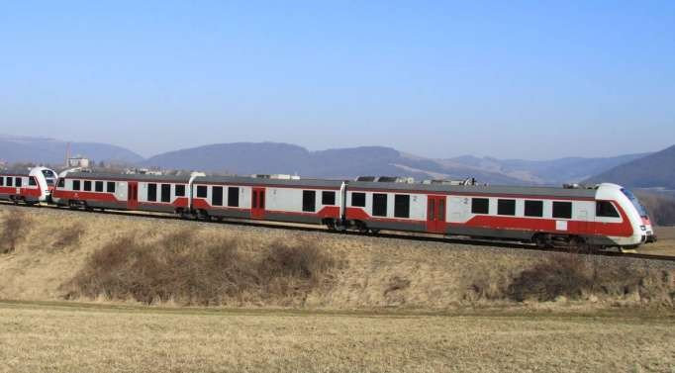

(Photo: Pavel Chomjak, Prešov)

Annex A 1 – The ŽSR network

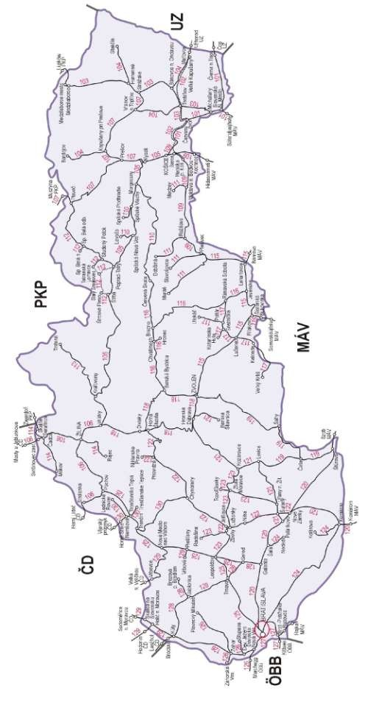

|  |  |
| --- | --- |
| Sieť Železníc Slovenskej republiky | ŽSR network |
| PKP | PKP |
| UZ | UZ |
| MÁV | MÁV |
| ÖBB | ÖBB |
| ČD | ČD |

Annex A 2 – List of railway undertakings

In 2016, the following railway undertakings provided transport services within the railway infrastructure of ŽSR:

|  |  |  |  |  |  |  |  |  |
| --- | --- | --- | --- | --- | --- | --- | --- | --- |
| ***Sequence number*** | ***Number*** | ***Name*** | ***CIN*** | ***Contract number*** | ***Type of transport*** | ***Internal abbreviation*** | ***Street*** | ***City*** |
| *1.* | 9001 | U. S. Steel Košice, s.r.o. | 36,199,222 | 1 / 2011 | Freight | USSK | Vstupný areál U.S.Steel | 044 54 Košice |
| *2.* | 9002 | LOKO TRANS, s.r.o. | 60,731,796 | 2 / 2011 | Freight | LTB | Voříškova 2 | 623 00 Brno, CR |
| *3.* | 9005 | Železničné stavby, a. s., Košice | 31,714,421 | 5 / 2011 | Freight | ZSKE | Južná trieda 66 | 040 01 Košice |
| *4.* | 9006 | TSS GRADE, a.s. | 35,802,723 | 6 / 2011 | Freight | TSSTT | Dunajská 48 | 811 08 Bratislava |
| *5.* | 9007 | LTE Logistik a Transport Slovakia, s.r.o. | 35,845,961 | 7 / 2012 | Freight/Passenger | LTESK | Kopčianska 1 | 851 01 Bratislava |
| *6.* | 9009 | Prvá Slovenská železničná, a.s. | 35,858,664 | 9 / 2011 | Freight | PSŽ: | Ružová dolina 10 | 821 09 Bratislava |
| *7.* | 9011 | HORNONITRIANSKE BANE zamestnanecká, a.s. | 36,002,887 | 11/2011 | Freight | HBP | Ul. Matice Slovenskej 10 | 971 01 Prievidza |
| *8.* | 9012 | ELTRA, s.r.o. | 31,674,267 | 12 / 2011 | Freight | ELTRA | Rampová 4 | 040 01 Košice |
| *9.* | 9014 | Železničné stavebníctvo Bratislava, a.s. | 31,365,701 | 14 / 2011 | Freight | ZSBA | Furmanská 6 | 841 03 Bratislava |
| *10.* | 9015 | AWT Rail SK,a.s. | 35,864,974 | 15 / 2011 | Freight | AWTSK | Cukrová 14 | 811 08 Bratislava |
| *11.* | 9016 | Slovenská železničná dopravná spoločnosť, a.s. | 35,856,742 | 16 / 2011 | Freight | SZDS | Mostová 2 | 811 02 Bratislava |
| *12.* | 9020 | Železničná spoločnosť Slovensko, a.s. | 35,914,939 | 20 / 2011 | Passenger | ZSSK | Rožňavská 1 | 832 72 Bratislava |
| *13.* | 9021 | Železničná spoločnosť Cargo Slovakia, a.s. | 35,914,921 | 21 / 2011 | Freight/Passenger | ZSSKC | Drieňová 24 | 820 09 Bratislava |
| *14.* | 9022 | LOKORAIL, a.s. | 36,564,443 | 22 / 2011 | Freight | LRL | Horárska 12 | 821 09 Bratislava |
| *15.* | 9023 | GJW Praha spol. s r.o. | 41,192,869 | 23 / 2011 | Freight | GJW | Mezitraťová 137/46 | 198 21 Praha 9 – Hloubětín, CR |
| *16.* | 9024 | Advanced World Transport, a. s. | 47,675,977 | 24 / 2011 | Freight | AWT | Hornopolní 3314 / 38 | 702 62 Ostrava-Moravská Ostrava, CR |
| *17.* | 9025 | OHL ŽS, a.s. | 46,342,796 | 25 / 2011 | Freight | ZSB | Burešova 938/17 | 602 00 Brno, Veveří, CR |
| *18.* | 9026 | METRANS Rail, s.r.o. | 26,361,485 | 26 / 2011 | Freight | MTR | Podleská 926 | 104 00 Praha 10, CR |
| *19.* | 9027 | Traťová strojní společnost, a.s. | 04,946,685 | 27 / 2016 | Freight | TSS | Na Valše 676/18 | 702 00 Ostrava – Přívoz, CR |
| *20.* | 9028 | Ostravská dopravní společnost, a.s. | 60,793,171 | 28 / 2011 | Freight | ODOS | U Tiskámy 616/9 | 702 00 Ostrava – Přívoz, CR |
| *21.* | 9034 | Slezskomoravská dráha, a.s. | 47,676,965 | 34 / 2011 | Freight | SMD | Poděbradova 3360/113 | 702 00 Ostrava – Moravská Ostrava, CR |
| *22.* | 9035 | Rail Cargo Carrier – Slovakia, s.r.o. | 44,453,949 | 35 / 2011 | Freight | WSSK | Lúčna 2 | 821 05 Bratislava |
| *23.* | 9038 | Central Railways, a.s. | 44,907,893 | 38 / 2016 | Freight/Passenger | CRW | Krivá 21 | 040 01 Košice |
| *24.* | 9040 | PKP CARGO S.A. | 277,586,360 | 40 / 2011 | Freight | PKPC | Grójecka 17 | 02 -021 Warsaw, Poland |
| *25.* | 9041 | IDS CARGO a.s. | 27,820,017 | 41 / 2011 | Freight | IDSC | Albertova 229/21 | 779 00 Olomouc – Nová Ulice, CR |
| *26.* | 9042 | METRANS /Danubia/, a.s. | 36,380,032 | 42 / 2016 | Freight | MTD | Povodská cesta 18 | 929 01 Dunajská Streda |
| *27.* | 9043 | CER Slovakia, a.s. | 44,616,791 | 43 / 2011 | Freight | CERSK | Mýtna 15 | 811 07 Bratislava |
| *29.* | 9045 | Petrolsped Slovakia, s.r.o. | 46,247,211 | 45 / 2016 | Freight | PSP | L. Svobodu 2839/1 | 984 01 Lučenec |
| *29.* | 9045 | Petrolsped Slovakia, s.r.o. | 46,247,211 | 45 / 2016 | Freight | PSP | L. Svobodu 2839/1 | 984 01 Lučenec |
| *30.* | 9046 | MMV Magyar Magánvasút Zrt. | 01-10-045027 | 46 / 2011 | Freight | MMV | Kerék u. 80 | 1035 Budapest, Hungary |
| *31.* | 9047 | BULK TRANSSHIPMENT SLOVAKIA, A.S. | 36,774,278 | 47 / 2011 | Freight | BTS | Železničná 1 | 076 43 Čierna nad Tisou |
| *32.* | 9049 | Railtrans International, a.s. | 46,384,740 | 49 / 2012 | Freight | RTI | Trnavská cesta | 920 41 Leopoldov |
| *33.* | 9050 | RTS Rail Transport Service GmbH | FN252571d | 50 / 2012 | Freight | RTS | Puchstrasse 184 b | 8055 Graz, Austria |
| *34.* | 9052 | Generálne zastúpenie ČD Cargo, s.r.o. | 44,349,793 | 52 / 2012 | Freight | GZCDC | Tomášikova 10/H | 821 03 Bratislava |
| *35.* | 9053 | VIALTE, s.r.o. | 46,334,629 | 53 / 2013 | Passenger | VIALT | Kopčianska 1 | 851 01 Bratislava |
| *36.* | 9054 | LOKOTRANS SERVIS s.r.o. | 26,931,443 | 54 / 2014 | Freight | LTSB | Drážní 11 | 627 00 Brno-Slatina, CR |
| *37.* | 9056 | EUROVIA CS, a.s. | 45,274,924 | 56 / 2014 | Freight | ECS | Národní 138/10 | 110 00 Praha 1, CR |
| *38.* | 9057 | Elektrizace železnic Praha, a.s. | 47,115,921 | 57 / 2014 | Freight | ELZEL | Nám. Hrdinů 1693/4a | 140 00 Praha 4-Nusle, CR |
| *39.* | 9058 | Express Group, a.s. | 35,795,123 | 58 / 2014 | Freight | EXSK | Plynárenská 7/B | 821 09 Bratislava |
| *40.* | 9059 | LEO Express, a.s. | 29,016,002 | 59 / 2014 | Passenger | LE | Poděbradova 908/4 | 130 00 Praha 3-Žižkov, CR |
| *41.* | 9060 | LokoTrain s.r.o. | 28,903,811 | 60 / 2014 | Freight | LT | Školní 353 | 560 02 Česká Třebová, CR |
| *42.* | 9061 | ARRIVA Service, s.r.o. | 35,846,526 | 61 / 2014 | Passenger | ARVSK | Bratislavská cesta 1804 | 945 01 Komárno |
| *43.* | 9062 | YOSARIA TRAINS, a.s. | 35,947,233 | 62 / 2014 | Passenger | YOSAR | Tomášikova 14/H | 821 03 Bratislava |
| *44.* | 9063 | STRABAG Rail, a.s. | 25,429,949 | 63 / 2015 | Freight | - | Železničářská 1385/29 | 400 03 Ústí nad Labem – Střekov, CR |
| *45.* | 9065 | MH – spedition, s.r.o. | 01,484,494 | 65 / 2015 | Freight | IP | Nuselská 262/34 | 140 00 Praha 4-Nusle, CR |
| *46.* | - | ŽOS Vrútky, a.s. | 31,615,619 | - | Freight | ZOSVR | Dielenska Kružná 2 | 038 61 Vrútky |
| *47.* | 9066 | ARRIVA Service, s.r.o. | 28,955,196 | 66 / 2016 | Passenger | ARR | Křížikova 148/34 | 186 00 Praha 8 – Karlín, CR |
| *48.* | 9067 | České dráhy, a.s. | 70,994,226 | - | Passenger | ČD | nábřeží Ludvíka Svobody 1222/12 | 110 15 Praha 1, CR |
| *49.* | - | RegioJet, a.s. | 28,333,187 | 69 / 2017 | Freight/Passenger | RJ | Náměstí Svobody 86/17 | 602 00 Brno, CR |
| *50.* | - | Železnice Slovenskej republiky | 31,364,501 | - | Freight/Passenger | ŽSR | Klemensova 8 | 813 61 Bratislava |
| *51.* | - | SLOV – VAGON, a.s. | 36,673,196 | - | Freight | SLVA | Andreja Žarnova 1 | 917 02 Trnava |
| *52.* | - | BF Logistics, s.r.o. | 27,406,911 | - | Freight | BFL | Beranových 65 | 199 02 Praha 9, CR |
| *53.* | - | E-W Express, s.r.o. | 48,041,246 | - | Freight | EWEX | Slnečné stráne 42 | 974 01 Banská Bystrica |
| *54.* | - | Elektrizácia železníc Kysak a. s. | 31,693,733 | - | Freight | EZK | Rosinská cesta 1/8223 | 010 08 Žilina |

Annex A 2.1 Infrastructure manager

|  |  |  |  |  |  |  |  |  |  |  |  |
| --- | --- | --- | --- | --- | --- | --- | --- | --- | --- | --- | --- |
| ***Name*** | ***Address*** | ***Internet reference to***  ***network statement*** | ***Safety authorisation (number/date)*** | ***Commercial activity commencement date*** | ***Total track length/gauge*** | ***Electrified track length / voltage*** | ***Total double/simple track length*** | ***Total length of high-speed track lines (HSL track)*** | ***ATP used***  ***equipment*** | ***Total number of level crossings*** | ***Number of signalling devices*** |
| Železnice Slovenskej  republiky  ŽSR | Klemensova 8  813 61 Bratislava | <http://www.zsr.sk/slovensky/zeleznicna-dopravna-ces-ta/marketing/podmienky-pouzivania-zel.siete/podmienky-pouzivania-zelezn.-infrastruktury-2017.html?page_id=4317> | SK 2120150001  of 13/04/2015 | 01/01/2002 | 3,626.297  km  (1,435 mm)  (1,520 mm)  >1,000 mm  /760 mm) | Total: 1,586.896  km  762 .303 km:  25 kV/50 Hz  15kV/16.67 Hz  824.593 km:  3 kV/1.5 kV  600V | single-tract  track line – 2,609.662  km  double-track  track line – 1,016.635  km | 0 | * automatic block, * semi-automatic block, * - automatic block system | 2,105 | 8,651 |

Annex A 2.2 Railway undertakings – safety certificates issued

|  |  |  |  |  |  |  |  |  |  |  |  |  |
| --- | --- | --- | --- | --- | --- | --- | --- | --- | --- | --- | --- | --- |
| ***Sequence number*** | ***Name*** | ***Address*** | ***Website*** | ***Safety Certificate A-B issued under Directive 2004/49/EC (number/date)*** | ***Commercial activity commencement date*** | ***Traffic type (freight, passenger)*** | ***Number of engines*** | ***Number: engine wagons and sets from an engine wagon*** | ***Number of coaches/ freight wagons*** | ***Number of engine drivers*** | ***Volume of passenger transport*** | ***Volume of freight transport*** |
| *1.* | U. S. Steel Košice, s.r.o. | Vstupný areál U.S.Steel 044 54 Košice | - | SK 1120160001 Part A of 28/01/2016  SK 1220160001 Part B of 28/01/2016 | 01/02/2000 | Freight | 3 | 0 / 0 | 0 / 38 | 9 | 0 | 579,742 |
| *2.* | LOKO TRANS, s.r.o. | Voříškova 2  623 00 Brno, CR | [www.lokotrans.eu](http://www.lokotrans.eu/) | CZ 1120120014 Part A of 28/08/2012  SK 1220130003 Part B of 18/03/2013 | 01/01/2009 | Freight | 4 | 0 / 0 | 0 / 750 | 2 | 0 | 500 |
| *3.* | Železničné stavby, a.s.  Košice | Južná trieda 66  040 01 Košice | [www.zeleznicnestavby.sk](http://www.zeleznicnestavby.sk/) | SK 1120150004 Part A of 12/05/2015  SK 1220150006 Part B of 12/05/2015 | 01/05/2003 | Freight | 5 | 0 / 0 | 41 / 126 | 3 | 0 | 0 |
| *4.* | TSS GRADE, a.s. | Dunajská 48  811 08 Bratislava | [*www.tss.sk*](http://www.tss.sk/) | SK 1120140005 Part A of 18/08/2014  SK 1220140011 Part B of 18/08/2014 | 23/04/2003 | Freight | 6 | 0 / 0 | 0 / 141 | 5 | 0 | 289,065 |
| *5.* | LTE Logistik a Transport Slovakia, s.r.o. | Kopčianska 1  851 01 Bratislava | [www.lte.sk](http://www.lte.sk/) | SK 1120120001 Part A of 13/06/2012  SK 1220120001 Part B of 13/06/2012 | 01/01/2003 | Freight, passenger | 4 | 0 / 0 | 0 / 24 | 10 | 0 | 599,725 |
| *6.* | Prvá Slovenská železničná, a.s. | Ružová dolina 10  821 09 Bratislava | [www.psz.sk](http://www.psz.sk/) | SK 1120130004 Part A of 16/12/2013  SK 1220130013 Part B of 16/12/2013 | 25/04/2008 | Freight | 7 | 0 / 0 | 0 / 342 | 24 | 0 | 1,675,480 |
| *7.* | HORNONITRIANSKE  BANE zamestnanecká, a.s. | Matice Slovenskej 10  971 01 Prievidza | [www.hbzam.sk](http://www.hbzam.sk/) | SK 1120130003 Part A of 04/12/2013  SK 1220130011 Part B of 04/12/2013 | 31/01/2005 | Freight | 8 | 0 / 0 | 0 / 111 | 15 | 0 | 1,760,655 |
| *8.* | ELTRA, s.r.o. | Rampová 4  040 01 Košice | [http://www.eltra.biz](http://www.eltra.biz/) | SK 1120150005 Part A of 12/05/2015  SK 1220150007 Part B of 12/05/2015 | - | Freight | 2 | 5 / 0 | 0 / 27 | 4 | 0 | 0 |
| *9.* | Železničné stavebníctvo Bratislava, a.s. | Furmanská 6  841 03 Bratislava | [www.zs-ba-as.sk/](http://www.zs-ba-as.sk/) | SK 1120150007 Part A of 27/08/2015  SK 1220150009 Part B of 27/08/2015 | 18/01/1994 | Freight | 0 | 0 / 0 | 0 / 5 | 1 | 0 | 0 |
| *10.* | AWT Rail SK, a.s. | Cukrová 14  811 08 Bratislava I | [www.awt.eu](http://www.awt.eu/cs) | SK 1120150008 Part A of 12/10/2015  SK 1220150012 Part B of 12/10/2015 | 26/07/2004 | Freight | 0 | 0 / 0 | 0 / 0 | 0 | 0 | 151,422 |
| *11.* | Slovenská železničná dopravná spoločnosť, a.s. | Mostová 2  811 02 Bratislava | [www.szds.sk](http://www.szds.sk/) | SK 1120130002 Part A of 24/06/2013  SK 1220130004 Part B of 24/06/2013 | 09/04/2004 | Freight | 0 | 0 / 0 | 0 / 0 | 7 | 0 | 311,875 |
| *12.* | Železničná spoločnosť Slovensko, a.s. | Rožňavská 1  832 72 Bratislava | [www.slovakrail.sk](http://www.slovakrail.sk/) | SK 1120150001 Part A of 09/01/2015  SK 1220150001 Part B of 09/01/2015 | 01/01/2005 | Passenger | 247 | 455 | 951 / 0 | 1,293 | 2,413,490  000 | 0 |
| *13.* | Železničná spoločnosť Cargo Slovakia, a.s. | Drieňová 24  820 09 Bratislava | [www.zscargo.sk](http://www.zscargo.sk/sk/) | SK 1120150003 Part A of 24/04/2015  SK 1220150005 Part B of 24/04/2015 | 01/01/2005 | Freight, passenger | 594 | 1 / 0 | 0 / 2208 | 927 | 58,560 | 35,637,263 |
| *14.* | LOKORAIL, a.s. | Horárska 12  821 09 Bratislava | [www.lokorail.sk](http://www.lokorail.sk/) | SK 1120130006 Part A of 30/12/2013  SK 1220130015 Part B of 30/12/2013 | 05/10/2004 | Freight | 21 | 0 / 0 | 0 / 642 | 20 | 0 | 2,104,370 |
| *15.* | GJW Praha spol. s r.o. | Mezitraťová 137/46  198 21 Praha 9 – Hloubětín, CR | [www.gjw-praha.cz](https://www.gjw-praha.cz/) | CZ 1120130005 Part A of 06/03/2013  SK 1220130005 Part B of 26/04/2013 | 01/03/2006 | Freight | 2 RTU  14 STU | 0 / 0 | 0 / 27 | 17 | 0 | 106 |
| *16.* | Advanced World Transport, a.s. | Hornopolní 3314/38, 702 62 Ostrava – Moravská Ostrava, CR | [*www.awt.eu*](http://www.awt.eu/) | CZ 1120120024 Part A of 22/03/2013  SK 1220140015 Part B of 02/12/2014 | 19/12/2006 | Freight | 107 | 0 / 0 | 0 / 236 | 46 | 0 | 349,402 |
| *17.* | OHL ŽS, a.s. | Burešova 938/17, 602 00 Brno – Veveří, CR | [www.ohlzs.cz](http://www.ohlzs.cz/) | CZ 1120130012 Part A of 29/03/2013  SK 1220130006 Part B of 20/09/2013 | 01/03/2006 | Freight | 0 | 0 / 0 | 0 / 28 | 6 | 0 | 0 |
| *18.* | METRANS Rail, s.r.o. | Podleská 926  104 00 Praha 10, CR | [www.metransrail.eu](http://metransrail.eu/en/) | CZ 1120130043 Part A of 30/09/2013  SK 1220140009 Part B of 29/07/2014 | 22/10/2003 | Freight | 46 | 0 / 0 | 0 / 0 | 11 | 0 | 70,000 |
| *19.* | Traťová strojní společnost, a.s. | Na Valše 676/18, 702 00 Ostrava – Přívoz,  CR | [www.tssas.cz](http://www.tssas.cz/) | CZ 1120160003 Part A of 29/06/2016  SK 1220160010 Part B of 14/09/2016 | 14/09/2016 | Freight | 14 RTU  40 STU | 0 / 0 | 0 / 0 | 8 (RTU)  24 (STU) | 0 | 0 |
| *20.* | Ostravská dopravní společnost, a.s. | U Tiskámy 616/9  702 00 Ostrava-Přívoz, CR | [www.odos.cz](http://www.odos.cz/cz/) | CZ 1120130015 Part A of 18/04/2013  SK 1220130008 Part B of 30/10/2013 | - | Freight | 23 | 0 / 0 | 0 / 0 | 4 | 0 | 0 |
| *21.* | Slezskomoravská dráha, a.s. | Poděbradova 3360/113 702 00 Ostrava – Moravská Ostrava, CR | [www.slezskomoravskadraha.cz](http://www.slezskomoravskadraha.cz/) | CZ 1120130026 Part A of 06/06/2013  SK 1220140008 Part B of 08/07/2014 | 14/08/2009 | Freight | 5 | 0 / 0 | 0 / 0 | 2 | 0 | 0 |
| *22.* | Rail Cargo Carrier – Slovakia, s.r.o. | Lúčna 2,  821 05 Bratislava | [www.railcargocarrier.com](http://www.railcargocarrier.com/hu/) | SK 1120140007 Part A of 01/12/2014  SK 12200140014 Part B of 01/12/2014 | 04/01/2016 | Freight | 0 | 0 / 0 | 0 / 0 | 9 | 0 | 448,362 |
| *23.* | Central Railways, a.s. | Krivá 21  040 01Košice | [www.crw.sk](http://www.crw.sk/) | SK 1120160002 Part A of 31/03/2016  SK 1220160002 Part B of 31/03/2016 | 08/09/2009 | Freight, passenger | 14 | 0 / 0 | 0 / 0 | 12 | 0 | 0 |
| *24.* | PKP CARGO S.A. | Ul. Grójecka 17  02 021 Warsaw, Poland | [www.pkpcargo.com](https://www.pkpcargo.com/pl/) | PL 1120140006 Part A of 18/04/2014  SK 1220140005 Part B of 22/05/2014 | 01/01/2011 | Freight | 50 | 50 / 0 | 0 / 16925 | 10 | 0 | 1,055,190 |
| *25.* | IDS CARGO a.s. | Albertova 229/21  779 00 Olomouc – Nová Ulice, CR | [www.ids-cargo.cz](http://ids-cargo.cz/cs/) | CZ 1120130046 Part A of 04/11/2013  SK 1220130010 Part B of 26/11/2013 | 01/06/2011 | Freight | 20 | 0 / 0 | 0 / 12 | 14 | 0 | 660,951 |
| *26.* | METRANS /Danubia/, a.s. | Povodská cesta 18  929 01 Dunajská Streda | [www.metrans.eu](https://www.metrans.eu/) | SK 1120160003 Part A of 16/05/2016  SK 1220160005 Part B of 16/05/2016 | 01/07/2011 | Freight | 8 | 0 / 0 | 0 / 0 | 27 | 0 | 3,521,221 |
| *27.* | CER Slovakia, a.s. | Mýtna 15  811 07 Bratislava | [www.cercargo.sk/index.php](http://www.cercargo.sk/index.php) | SK 1120150009 Part A of 16/12/2015  SK 1220150013 Part B of 16/12/2015 | 01/04/2011 | Freight | 2 | 0 / 0 | 0 / 0 | 7 | 0 | 125,578  079 |
| *28.* | RegioJet, a.s. | Obchodná No 48,  811 06 Bratislava | [www.regiojet.sk](https://www.regiojet.sk/) | SK 1120160005 Part A of 21/07/2016  SK 1220160007 Part B of 21/07/2016 | 01/12/2012 | Passenger | 14 | 0 / 15 | 156 / 0 | 46 | 375,816  729 | 0 |
| *29.* | Petrolsped Slovakia, s.r.o. | L. Svobodu 2839/1, 984 01 Lučenec | [www.petrolsped.sk](http://www.petrolsped.sk/) | SK 1120160006 Part A of 24/08/2016  SK 1220160008 Part B of 24/08/2016 | 08/02/2012 | Freight | 4 | 0 / 0 | 0 / 0 | 7 | 0 | 419,496 |
| *30.* | MMV Magyar Magánvasút Zrt. | Kerék u. 80,  1035 Budapest, Hungary | [www.mmv.hu](http://www.mmv.hu/) | HU 1120120004 Part A of 28/09/2012  SK 1220130002 Part A of 15/02/2013 | 02/03/2012 | Freight | 2 | 0 / 0 | 0 / 0 | 2 | 0 | 0 |
| *31.* | BULK TRANSSHIP- MENT SLOVAKIA, a.s. | Železničná 1  076 43 Čierna nad Tisou | [www.btslovakia.sk](http://www.btslovakia.sk/) | SK 1120120006 Part A of 19/10/2012  SK 1220120007 Part B of 19/10/2012 | 25/05/2009 | Freight | 29 | 0 / 0 | 0 / 0 | 0 | 0 | 64,150 |
| *32.* | Railtrans International, a.s. | Trnavská cesta, 920 41 Leopoldov | [www.railtrans.eu](http://www.railtrans.eu/) | SK 1120120002 Part A of 19/06/2012  SK 1220120003 Part B of 19/06/2012 | 02/06/2012 | Freight | 4 | 0 / 0 | 0 / 0 | 16 | 0 | 235,502 |
| *33.* | RTS Rail Transport Service GmbH | Puchstrasse 184b, 8055 Graz, Austria | [www.rts-rail.com](http://www.rts-rail.com/) | AT 1120140004 Part A of 18/11/2014  SK 1220140016 Part B of 16/12/2014 | 10/04/2013 | Freight | 2 | 0 / 0 | 0 / 10 | 2 | 0 | 0 |
| *34.* | Generálne zastúpenie CD Cargo, s.r.o | Tomášikova 10/D, 821 03 Bratislava | [www.cdcargo.sk](http://www.cdcargo.sk/) | SK 1120120004 Part A of 25/09/2012  SK 1220120005 Part B of 25/09/2012 | 01/01/2013 | Freight | 0 | 0 / 0 | 0 / 0 | 0 | 0 | 0 |
| *35.* | VIALTE, s.r.o. | Kopčianska 1  851 01 Bratislava | - | SK 1120120005 Part A of 15/10/2012  SK 1220120006 Part B of 15/10/2012 | 14/05/2012 | Passenger | 0 | 0 / 0 | 0 / 0 | 0 | 850 | 0 |
| *36.* | LOKOTRANS SERVIS,  s.r.o | Drážní 11,  627 00 Brno – Slatina, CR | [www.lokotransservis.cz](http://www.lokotransservis.cz/) | CZ 1120140002 Part A of 20/01/2014  SK 1220130007 Part B of 29/05/2014 | 14/05/2013 | Freight | 25 | 0 / 0 | 0 / 17 | 1 | 0 | 0 |
| *37.* | EUROVIA CS, a.s. | Národní 138/10, 110 00 Praha 1, CR | [www.eurovia.cz](http://www.eurovia.cz/cs/home) | CZ 1120130003 Part A of 21/02/2013  SK 1220140007 Part B of 10/07/2014 | 27/05/2003 | Freight | 4 | 0 / 0 | 0 / 0 | 4 | 0 | 0 |
| *38.* | Elektrizace železnic Praha, a.s. | Nám. Hrdinů 1693/4a, 140 00 Praha 4 – Nusle, CR | [www.elzel. cz](http://www.elzel.cz/) | CZ 1120130006 Part A of 06/03/2013  SK 1220140004 Part B of 16/04/2014 | 16/04/2014 | Freight | 29 | 0 / 0 | 0 / 194 | 18 | 0 | 23,844 |
| *39.* | Express Group, a.s. | Plynárenská 7/B, 821 09 Bratislava | [www.expressgroup.sk](http://www.expressgroup.sk/) | SK 1120140004 Part A of 18/06/2014  SK 1220140006 Part B of 18/06/2014 | 01/07/2014 | Freight | 9 | 0 / 0 | 0 / 378 | 16 | 0 | 801,124 |
| *40.* | LEO Express, a.s. | Řehořova 908/4, 130 00 Praha 3 – Žižkov,  CR | [www.le.cz](http://www.le.cz/) | CZ 1120150004 Part A of 26/03/2015  SK 1220150003 Part B of 01/04/2015 | 12/12/2014 | Passenger | 0 | 0 / 5 | 0 / 0 | 14 | 410,000 | 0 |
| *41.* | LokoTrain s.r.o. | Školní 353  560 02 Česká Třebová, CR | [www.lokotrain.eu](http://www.lokotrain.eu/) | CZ 1120120003 Part A of 05/03/2012  SK 1220140010 Part B of 14/08/2014 | 09/05/2012 | Freight | 6 | 0 / 0 | 0 / 0 | 65 | 0 | 371,000 |
| *42.* | ARRIVA Service, s.r.o. | Bratislavská cesta 1804  945 01 Komárno | [www.arriva.sk](https://arriva.sk/) | SK 1120140003 Part A of 08/04/2014  SK 1220140003 Part B of 08/04/2014 | 20/01/2015 | Passenger | 0 | 0 / 0 | 0 / 0 | 0 | 2,394 | 0 |
| *43.* | YOSARIA TRAINS, a.s. | Tomášikova 10/D, 821 03 Bratislava | www.yosariatra-ins.trade.sk | SK 1120140006 Part A of 07/10/2014  SK 1220140013 Part B of 07/10/2014 | 07/10/2014 | Passenger | 1 | 0 / 0 | 0 / 0 | 1 | 8,400 | 0 |
| *44.* | STRABAG Rail, a.s. | Železničářská 1385/29, 400 03 Ústí nad Labem – Střekov, CR | [www.strabagrail.cz](http://www.strabagrail.cz/) | CZ 1120150001 Part A of 05/01/2015  SK 1220150002 Part B of 23/03/2015 | - | Freight | 17 | 0 / 0 | 0 / 70 | 35 | 0 | 0 |
| *45.* | MH – spedition, s.r.o. | Nuselská 262/34, 140 00 Praha 4 – Nusle, CR | [www.interport.cz](http://www.interport.cz/) | CZ 1120140030 Part A of 05/12/2014  SK 1220150010 Part B of 28/08/2015 | 04/06/2016 | Freight | 4 | 0 / 0 | 0 / 0 | 20 | 0 | 34,629 |
| *46.* | ŽOS Vrútky, a.s. | Dielenska Kružná 2  038 61 Vrútky | [www.zos-vrutky.sk](http://www.zos-vrutky.sk/index_us.html) | SK 1120150002 part A of 20/04/2015  SK 1220150004 part B of 20/04/2015 | - | Freight | 2 | 0 / 0 | 0 / 0 | 3 | 0 | 0 |
| *47.* | ARRIVA vlaky, s.r.o. | Křižíkova 148/34, 186 00 Praha 8 – Karlín, CR | [www.arriva-vlaky.cz](http://www.arriva-vlaky.cz/) | CZ 1120150002 Part A of 05/02/2015  SK 1220160009 Part B of 12/09/2016 | 30/06/2015 | Freight, passenger | 6 | 0 / 0 | 0 / 0 | 25 | 0 | 0 |
| *48.* | České dráhy, a.s. | Nábřeží L. Svobody 1222, 110 15 Praha 1, CR | [www.cd.cz](http://www.cd.cz/) | CZ 1120130004 Part A of 28/02/2013  SK 1220160003 part B of 21/03/2016 | 01/05/2016 | Passenger | * | * | * | * | * | * |
| *49.* | RegioJet, a.s. | Náměstí Svobody 86/17, 602 00 Brno, CR | [www.regiojet.cz](https://www.regiojet.cz/) | CZ 1120160008 Part A of 01/11/2016  SK 1220150011 Part B of 21/10/2015 | 22/09/2011 | Passenger | 12 | 0 / 0 | 146 / 0 | 47 | 0 | 0 |
| *50.* | Železnice Slovenskej republiky | Klemensova 8  813 61 Bratislava | [www.zsr.sk](http://www.zsr.sk/) | SK 1120130005 Part A of 20/12/2013  SK 1220130014 Part B of 20/12/2013 | 01/01/2002 | Freight, passenger | 43 | 13 / 0 | 54 / 455 | 473 | 2,452,000 | 1,518,452 |
| *51.* | SLOV–VAGON, a.s. | Andreja Žarnova 1  917 02 Trnava | [www.slov-vagon.com](http://www.slov-vagon.com/) | SK 1120160004 Part A of 16/06/2016  SK 1220160006 Part B of 16/06/2016 | 01/04/2012 | Freight | 3 | 0 / 0 | 0 / 465 | 0 | 0 | 0 |
| *52.* | BF Logistics, s.r.o. | Beranových 65  199 02 Praha 9, CR | [www.bfl.cz](http://www.bfl.cz/) | CZ 1120130041 Part A of 18/09/2013  SK 1220130009 Part B of 25/11/2013 | 01/09/2009 | Freight | 12 | 12 / 0 | 0 / 0 | 2 | 0 | 0 |
| *53.* | E-W Express, s.r.o. | Slnečné stráne 42,  974 01 Banská Bystrica | [www.ewex.sk](http://www.ewex.sk/) | SK 11201500061Part A of 30/06/2015  SK 1220150008 Part B of 30/06/2015 | 30/06/2015 | Freight | 0 | 0 / 0 | 0 / 0 | 0 | 0 | 0 |
| *54.* | Elektrizácia železníc Kysak a. s. | Rosinská cesta 1 / 8223, 010 08 Žilina | - | SK 1120130001 Part A of 24/01/013  SK 1220130001 Part B of 24/01/2013 | 20/01/1998 | Freight | 0 | 0 / 0 | 0 / 0 | 0 | 0 | 0 |

Notes: * - the railway undertaking has not provided the required data

Annex B the Authority's Organisational chart

Railways and Railway Traffic Division

Civil Aviation Division

Inland Waterway Transport Division

Annex B 1 – Internal organisation (as at 31/12/2014)

B 1.1 – Organisational setup to the level of Authority’s divisions



**Chairperson and Head of Service Office**

Vice-Chairperson

Legislation and Legal Department

Information Systems and Technologies Department

Crisis Management and Economic Mobilisation Department

Legislation Department

Legal Department

Chairperson's Office, Authority's Spokeswoman

Economy and Asset Management Department

Human Resources

Internal Control Unit

Manager of Quality and Safety of Operation

Administration and Registration Unit

B 1.2 Organisational setup of the Railways and Railway Traffic Division

Designated Technical Equipment Department

Safety Department

Regulation and Supervision Unit

Fixed Subsystems Department

Mobile Subsystems Department

Approvals and Licences Department

Regulation Section

Safety Section

Interoperability Section

SPS Coordinator

Railways and Railway Traffic Division

Annex B 2 – Relationship with other national bodies

NSA

**Transport Authority**

Safety, licensing and regulatory authority for railways and railway traffic

Ministry of Transport and Construction – Investigation body for accidents and extraordinary events on railways, special transport systems and cable-ways.

The approval authority for the type approval of railway vehicles for special transport systems

Slovak Office of Standards, Metrology and Testing

University of Žilina in Žilina (ECM certification)

Transport Research Institute – Notified Body

**Key:**

**Authority** – as a budgetary organisation, with its financial relationships it is linked to the state budget through a budget chapter managed by the Ministry. The Authority is headed by a Chairperson, being appointed and removed by the Government of the Slovak Republic upon a proposal of the Minister of Transport and Construction of the Slovak Republic.

**SOSMT** - it acts in matters of supervision in the field of designated technical equipment, as well as relevant authorised and notified bodies acting in the field of conformity assessment and certification.

**Transport Research Institute** – based on the SOSMT Authorisation Decision No 2013/800/003896/01289 of 23/07/2013, with a view to the Railways Act No 513/2009 Coll. on Railways, it is the notified body for the assessment of conformity and suitability of use for interoperability subsystems of the European railway system.

**University of Žilina** – pursuant to the Decision of the Ministry No 12309/2012 – SŽDD/z.22119, it is an authorised legal entity for issuing certificates to persons in charge of maintenance of rail freight wagons under the Commission Regulation (EU) No 445/2011 on a system of certification of entities in charge of maintenance for freight wagons.

Annex C – Statistics of accident rate and prescribed indicators – CSI data

**C 1. Tables**

* Data processed under the amendment to Act 513/2009 Coll. on railways.

|  |  |  |  |  |  |  |  |  |
| --- | --- | --- | --- | --- | --- | --- | --- | --- |
| ***Number of serious accidents and Train*km (type of accident)*** | | | | | | | | |
| Year | Collisions | Derailemts | Accident on level crossings | Accidents to persons caused by RS in motion | Fires in railway vehicles | Others | Total | Train*km (MLN) |
| **2007** | 14 | 11 | 71 | 63 | 22 | 41 | 222 | 51 |
| **2008** | 12 | 6 | 63 | 78 | 8 | 50 | 217 | 49 |
| **2009** | 6 | 3 | 51 | 130 | 14 | 295 | 499 | 44 |
| **2010\*** | 2 | 1 | 11 | 70 | 0 | 1 | 85 | 47 |
| **2011\*** | 1 | 1 | 21 | 61 | 0 | 0 | 84 | 45 |
| **2012\*** | 1 | 2 | 27 | 65 | 0 | 1 | 96 | 46 |
| **2013\*** | 2 | 0 | 18 | 73 | 0 | 1 | 94 | 46 |
| **2014\*** | 0 | 1 | 20 | 92 | 0 | 0 | 113 | 46 |
| **2015\*** | 0 | 2 | 22 | 60 | 1 | 2 | 87 | 49 |
| **2016\*** | 2 | 1 | 12 | 42 | 2 | 1 | 60 | 49 |

|  |  |  |  |  |  |  |  |  |
| --- | --- | --- | --- | --- | --- | --- | --- | --- |
| ***No of Fatalities, Train*km and Passenger*km (category of persons)*** | | | | | | | | |
| Year | Passengers | Employees | Level crossing users | Unauthorised persons | Others | Total | Passenger*km (BLN) | Train*km (MLN) |
| **2007** | 1 | 0 | 15 | 40 | 1 | 57 | 2 | 51 |
| **2008** | 2 | 0 | 11 | 41 | 2 | 56 | 2 | 49 |
| **2009** | 2 | 0 | 25 | 44 | 1 | 72 | 2 | 44 |
| **2010** | 0 | 2 | 9 | 44 | 3 | 58 | 2 | 47 |
| **2011** | 1 | 0 | 11 | 37 | 0 | 49 | 2 | 45 |
| **2012** | 1 | 1 | 21 | 45 | 0 | 68 | 2 | 46 |
| **2013** | 0 | 2 | 6 | 47 | 0 | 55 | 3 | 46 |
| **2014** | 0 | 0 | 9 | 67 | 0 | 76 | 3 | 46 |
| **2015** | 0 | 2 | 13 | 36 | 0 | 51 | 3 | 49 |
| **2016** | 0 | 2 | 5 | 19 | 0 | 26 | 2 | 49 |

|  |  |  |  |  |  |  |  |  |
| --- | --- | --- | --- | --- | --- | --- | --- | --- |
| ***No of injures, Train*km and Passenger*km (category of persons)*** | | | | | | | | |
| Year | Passengers | Employees | Level crossing users | Unauthorised persons | Others | Total | Passenger*km (BLN) | Train*km (MLN) |
| **2007** | 4 | 2 | 13 | 17 | 0 | 36 | 2 | 51 |
| **2008** | 5 | 1 | 15 | 15 | 2 | 38 | 2 | 49 |
| **2009** | 0 | 0 | 14 | 20 | 1 | 35 | 2 | 44 |
| **2010** | 17 | 3 | 2 | 17 | 6 | 45 | 2 | 47 |
| **2011** | 4 | 1 | 14 | 20 | 0 | 39 | 2 | 45 |
| **2012** | 12 | 2 | 15 | 12 | 0 | 41 | 2 | 46 |
| **2013** | 4 | 6 | 11 | 12 | 4 | 37 | 3 | 46 |
| **2014** | 12 | 2 | 12 | 19 | 1 | 46 | 3 | 46 |
| **2015** | 4 | 1 | 12 | 17 | 2 | 36 | 3 | 49 |
| **2016** | 8 | 0 | 9 | 16 | 0 | 33 | 2 | 49 |

|  |  |  |  |  |  |  |  |  |
| --- | --- | --- | --- | --- | --- | --- | --- | --- |
| ***Number of precursors and Train*km (type of accident)*** | | | | | | | | |
| Year | Number of broken rails | Number of rail deformations | Number of wrong-side signalling failures | Number of 'Stop' signals passed | Number of broken wheels on rolling stock in service | Number of broken axles on rolling stock in service | Total | Train*km (MLN) |
| **2007** | 5 | 2 | 6 | 79 | 1 | 0 | 93 | 51 |
| **2008** | 10 | 0 | 2 | 75 | 0 | 0 | 87 | 49 |
| **2009** | 15 | 1 | 1 | 75 | 0 | 0 | 92 | 44 |
| **2010** | 165 | 9 | 57 | 22 | 0 | 0 | 253 | 47 |
| **2011** | 133 | 8 | 28 | 25 | 0 | 0 | 194 | 45 |
| **2012** | 145 | 5 | 15 | 39 | 1 | 0 | 205 | 46 |
| **2013** | 74 | 9 | 9 | 33 | 0 | 0 | 125 | 46 |
| **2014** | 66 | 1 | 8 | 18 | 0 | 0 | 93 | 46 |
| **2015** | 98 | 5 | 5 | 23 | 0 | 0 | 131 | 49 |
| **2016** | 107 | 4 | 4 | 25 | 0 | 0 | 140 | 49 |

|  |  |  |  |  |  |  |  |  |
| --- | --- | --- | --- | --- | --- | --- | --- | --- |
| ***Cost of all accidents, 'safety hours' (type of accident)*** | | | | | | | | |
| Year | Costs of deaths in mil. of € | Costs of injuries in MLN € | Costs of replacing or repairing damaged vehicles and railway installations in MLN € | Costs of delays, disturbances and re-routing of traffic, including extra costs for staff and loss of future revenue in in MLN € | Total costs in MLN € | Total number of working hours, which the employees and suppliers could not worked out due to accidents | Total number of working hours | Train*km (MLN) |
| **2007** | 0 | 0 | 1,890,000 | 100,000 | 1,990,000 | 0 | 0 | 51 |
| **2008** | 0 | 0 | 2,639,224 | 167,151 | 2,806,375 | 0 | 0 | 49 |
| **2009** | 0 | 0 | 2,124,167 | 0 | 2,124,167 | 0 | 0 | 44 |
| **2010** | 0 | 0 | 2,503,946 | 0 | 2,503,946 | 0 | 0 | 47 |
| **2011** | 0 | 0 | 1,884.516 | 0 | 0 | 0 | 0 | 45 |
| **2012** | 0 | 0 | 2,177.142 | 0 | 0 | 0 | 0 | 46 |
| **2013** | 0 | 0 | 2,498,757 | 0 | 0 | 0 | 0 | 46 |
| **2014** | 0 | 0 | 370,940 | 0 | 0 | 0 | 0 | 46 |
| **2015** | 0 | 0 | 4,787,565 | 0 | 0 | 0 | 0 | 49 |
| **2016** | 0 | 0 | 6,210,925 | 0 | 0 | 0 | 0 | 49 |

|  |  |  |  |  |  |  |  |
| --- | --- | --- | --- | --- | --- | --- | --- |
| ***Technical safety of infrastructure and its implementation, management of safety (type of accident)*** | | | | | | | |
| Year | Percentage of tracks Percentage of tracks with automatic train protection (ATP) in operation | Percentage of Train*km with use of ATP traffic systems | Total number of level crossings | Number of track km (double track lines are to be counted twice) | Total number of level crossings per track km | Percentage of level crossings with automatic or manual protection | Number of performed / number of required (and/or planned) audits |
| **2007** | 15.14 % | 0.00% | 2,307 | 3,629 | 0.636 | 47.03% | 0.00% |
| **2008** | 18.49% | 0.00% | 2,265 | 3,659 | 0.625 | 48.65% | 100.00% |
| **2009** | 18.49% | 0.00% | 2,220 | 4,638 | 0.478 | 48.46% | 100.00% |
| **2010** | 21.04% | 0.00% | 2,219 | 4,638 | 0.478 | 48.72% | 100.00% |
| **2011** | 21.03% | 0.00% | 2,205 | 4,641 | 0.475 | 48.93% | 100.00% |
| **2012** | 21.03% | 0.00% | 2,160 | 4,648 | 0.464 | 50.37% | 100.00% |
| **2013** | 23.44% | 0.00% | 2,149 | 4,648 | 0.462 | 50.63% | 100.00% |
| **2014** | 20.62% | 0.00% | 2,131 | 4,644 | 0.459 | 50.63% | 100.00% |
| **2015** | 21.01% | 0.00% | 2,112 | 4,644 | 0.455 | 50.71% | 100.00% |
| **2016** | 21.00% | 0.00% | 2,105 | 4,641 | 0.454 | 50.78% | 100.00% |

|  |  |  |  |  |  |  |  |
| --- | --- | --- | --- | --- | --- | --- | --- |
| ***Number of serious accidents/Train*km (type of accident)*** | | | | | | | |
| Year | Collisions | Derailments | Level crossing accidents | Accidents to persons caused by RS in motion | Fires in RS | Others | Total |
| **2007** | 0.27 | 0.21 | 1.39 | 1.24 | 0.43 | 0.80 | 4.35 |
| **2008** | 0.26 | 0.17 | 1.34 | 1.41 | 0.30 | 0.91 | 4.39 |
| **2009** | 0.22 | 0.13 | 1.28 | 1.88 | 0.30 | 2.68 | 6.51 |
| **2010** | 0.17 | 0.11 | 1.03 | 1.79 | 0.23 | 2.03 | 5.36 |
| **2011** | 0.14 | 0.09 | 0.91 | 1.70 | 0.18 | 1.64 | 4.69 |
| **2012** | 0.09 | 0.05 | 0.74 | 1.75 | 0.09 | 1.5 | 4.25 |
| **2013** | 0.05 | 0.03 | 0.56 | 1.75 | 0.06 | 1.31 | 3.77 |
| **2014** | 0.02 | 0.02 | 0.42 | 1.57 | 0.00 | 0.01 | 2.05 |
| **2015** | 0.01 | 0.02 | 0.46 | 1.51 | 0.00 | 0.01 | 2.04 |
| **2016** | 0.02 | 0.02 | 0.42 | 1.41 | 0.01 | 0.02 | 1.91 |

|  |  |  |  |  |  |  |  |
| --- | --- | --- | --- | --- | --- | --- | --- |
| ***Number of fatalities/Train*km and Passenger*km (category of persons)*** | | | | | | | |
| Year | Passengers | Passengers | Employees | Level crossing users | Unauthorised persons | Others | Total |
| **2007** | 0.01 | 0.50 | 0.00 | 0.29 | 0.78 | 0.01 | 1.12 |
| **2008** | 0.03 | 0.75 | 0.00 | 0.26 | 0.81 | 0.03 | 1.13 |
| **2009** | 0.03 | 0.83 | 0.00 | 0.35 | 0.86 | 0.02 | 1.28 |
| **2010** | 0.02 | 0.62 | 0.01 | 0.31 | 0.88 | 0.03 | 1.27 |
| **2011** | 0.02 | 0.60 | 0.008 | 0.30 | 0.87 | 0.02 | 1.24 |
| **2012** | 0.02 | 0.60 | 0.01 | 0.33 | 0.91 | 0.02 | 1.31 |
| **2013** | 0.17 | 0.36 | 0.02 | 0.31 | 0.95 | 0.01 | 1.33 |
| **2014** | 0.008 | 0.16 | 0.02 | 0.24 | 1.04 | 0.01 | 1.33 |
| **2015** | 0.008 | 0.15 | 0.02 | 0.25 | 1.00 | 0.00 | 1.29 |
| **2016** | 0.004 | 0.07 | 0.02 | 0.22 | 0.90 | 0.00 | 1.17 |
| **-** | Related to Train*km | Related to Passenger*km | Related to Train*km | Related to Train*km | Related to Train*km | Related to Train*km | Related to Train*km |

|  |  |  |  |  |  |  |  |
| --- | --- | --- | --- | --- | --- | --- | --- |
| ***Number of injures/Train*km and Passenger*km (category of persons)*** | | | | | | | |
| Year | Passengers | Passengers | Employees | Level crossing users | Unauthorised persons | Others | Total |
| **2007** | 0.07 | 2.00 | 0.03 | 0.25 | 0.33 | 0.00 | 0.70 |
| **2008** | 0.09 | 2.25 | 0.03 | 0.28 | 0.32 | 0.02 | 0.74 |
| **2009** | 0.06 | 1.50 | 0.02 | 0.29 | 0.36 | 0.02 | 0.75 |
| **2010** | 0.13 | 3.25 | 0.03 | 0.23 | 0.36 | 0.04 | 0.80 |
| **2011** | 0.12 | 3.00 | 0.02 | 0.24 | 0.00 | 0.03 | 0.81 |
| **2012** | 0.16 | 3.80 | 0.03 | 0.26 | 0.36 | 0.03 | 0.85 |
| **2013** | 0.16 | 3.41 | 0.05 | 0.24 | 0.35 | 0.04 | 0.86 |
| **2014** | 0.21 | 4.15 | 0.06 | 0.23 | 0.34 | 0.04 | 0.90 |
| **2015** | 0.15 | 2.82 | 0.05 | 0.27 | 0.34 | 0.03 | 0.85 |
| **2016** | 0.17 | 3.13 | 0.04 | 0.25 | 0.32 | 0.02 | 0.81 |
| **-** | Related to Train*km | Related to Passenger*km | Related to Train*km | Related to Train*km | Related to Train*km | Related to Train*km | Related to Train*km |

|  |  |  |  |  |  |  |  |
| --- | --- | --- | --- | --- | --- | --- | --- |
| ***Number of precursors/Train*km (type of accident)*** | | | | | | | |
| Year | Number of broken rails | Number of track buckles | Number of wrong-side signalling failures | Number of 'Stop' signals passed | Number of broken wheels on rolling stock in service | Number of broken axles on rolling stock in service | Total |
| **2007** | 0.09 | 0.03 | 0.11 | 1.55 | 0.01 | 0.00 | 1.82 |
| **2008** | 0.15 | 0.02 | 0.08 | 1.54 | 0.01 | 0.00 | 1.80 |
| **2009** | 0.20 | 0.02 | 0.06 | 1.59 | 0.006 | 0.00 | 1.89 |
| **2010** | 1.02 | 0.06 | 0.34 | 1.31 | 0.005 | 0.00 | 2.75 |
| **2011** | 1.39 | 0.08 | 0.39 | 1.17 | 0.004 | 0.00 | 3.05 |
| **2012** | 2.03 | 0.09 | 0.44 | 1.02 | 0.004 | 0.00 | 3.60 |
| **2013** | 2.34 | 0.14 | 0.48 | 0.85 | 0.004 | 0.00 | 3.82 |
| **2014** | 2.54 | 0.13 | 0.50 | 0.59 | 0.004 | 0.00 | 3.78 |
| **2015** | 2.22 | 0.12 | 0.28 | 0.59 | 0.004 | 0.00 | 3.22 |
| **2016** | 2.08 | 0.10 | 0.17 | 0.58 | 0.004 | 0.00 | 2.94 |

|  |  |  |  |  |  |  |
| --- | --- | --- | --- | --- | --- | --- |
| ***Cost of all accidents, 'safety hours' indicators (type of accident)*** | | | | | | |
| Year | Costs of deaths in mil. of € | Costs of injuries in MLN € | Costs of replacement or repair of damaged railway vehicles and railway installations in MLN € | Costs of delays, disturbances and re-routing of traffic, including extra costs for staff and loss of future revenue in MLN € | Total costs in MLN € | Number of working hours, which employees and suppliers could not worked out due to accidents (MLN) / number of working hours of employees and suppliers (MLN) |
| **2007** | 0.00 | 0.00 | 37,100.00 | 1,960.00 | 39,000.00 | 0 |
| **2008** | 0.00 | 0.00 | 45,300.00 | 2,670.00 | 48,000.00 | 0 |
| **2009** | 0.00 | 0.00 | 46,200.00 | 1,860.00 | 48,100.00 | 0 |
| **2010** | 0.00 | 0.00 | 47,900.00 | 1,400.00 | 49,300.00 | 0 |
| **2011** | 0.00 | 0.00 | 46,800.00 | 1,130.00 | 39,900.00 | 0 |
| **2012** | 0.00 | 0.00 | 49,000.00 | 724.00 | 32,200.00 | 0 |
| **2013** | 0.00 | 0.00 | 49,100.00 | 0.00 | 20,300.00 | 0 |
| **2014** | 0.00 | 0.00 | 41,000.00 | 0.00 | 10,900.00 | 0 |
| **2015** | 0.00 | 0.00 | 50,500.00 | 0.00 | 0.00 | 0 |
| **2016** | 0.00 | 0.00 | 68,000.00 | 0.00 | 0.00 | 0 |
| **-** | in relation to Train*km | | | | | - |

|  |  |  |  |  |  |  |  |
| --- | --- | --- | --- | --- | --- | --- | --- |
| ***Technical safety of infrastructure and its implementation, management of safety (type of accident)*** | | | | | | | |
| Year | Percentage of tracks  Percentage of tracks with automatic train protection (ATP) in operation | Percentage of Train*km with use of ATP traffic systems | Total number of level crossings | Number of track km (double track lines are to be counted twice) | Total number of level crossings per track km | Percentage of level crossings with automatic or manual protection | Number of performed / required (and/or planned audits) |
| **2007** | 15.14 % | 0.00% | 2,307 | 3,629 | 0.63 | 47.03% | 0.00% |
| **2008** | 16.82% | 0.00% | 2,286 | 3,644 | 0.63 | 47.84% | 50.00% |
| **2009** | 17.37% | 0.00% | 2,264 | 3,975 | 0.58 | 48.05% | 66.67% |
| **2010** | 18.29% | 0.00% | 2,253 | 4,141 | 0.55 | 48.22% | 75.00% |
| **2011** | 18.84% | 0.00% | 2,243 | 4,241 | 0.53 | 48.36% | 80.00% |
| **2012** | 20.02% | 0.00% | 2,214 | 4,445 | 0.50 | 49.03% | 100.00% |
| **2013** | 21.01% | 0.00% | 2,191 | 4,643 | 0.47 | 49.42% | 100.00% |
| **2014** | 21.43% | 0.00% | 2,173 | 4,644 | 0.46 | 49.86% | 100.00% |
| **2015** | 21.43% | 0.00% | 2,151 | 4,645 | 0.46 | 50.25% | 100.00% |
| **2016** | 21.42% | 0.00% | 2,131 | 4,645 | 0.45 | 50.62% | 100.00% |

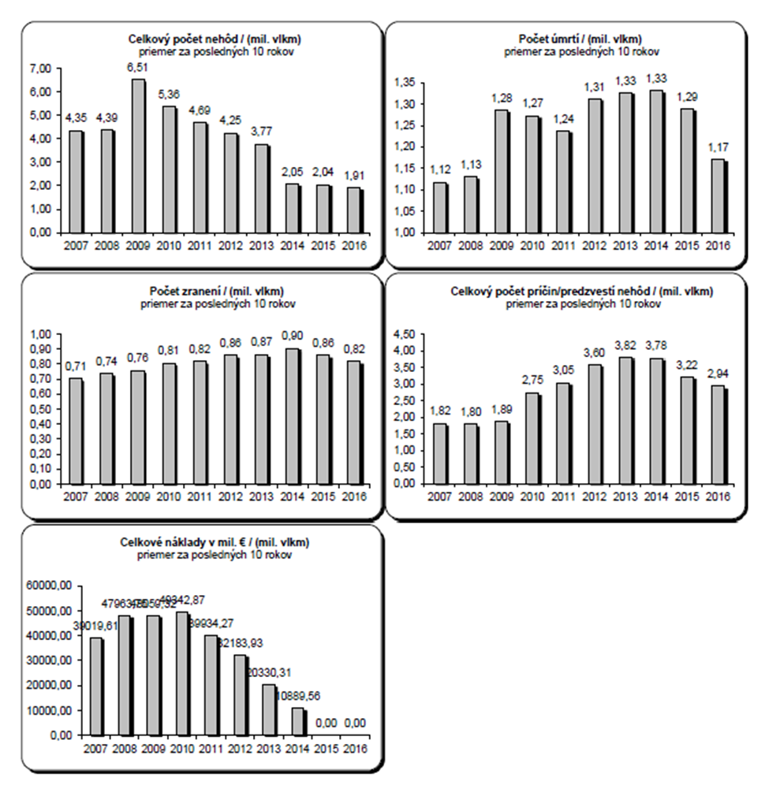**C 2. CSI data – Overview of safety results/level**

|  |  |
| --- | --- |
| Celkový počet nehôd / (mil. vlkm) | Total number of accidents / (MLN Train*km) |
| priemer za posledných 10 rokov | Average over the last 10 years |
| 7,00 | 7.00 |
| 6,00 | 6.00 |
| 5,00 | 5.00 |
| 4,00 | 4.00 |
| 3,00 | 3.00 |
| 2,00 | 2.00 |
| 1,00 | 1.00 |
| 0,00 | 0.00 |
| 4,35 | 4.35 |
| 4,39 | 4.39 |
| 6,51 | 6.51 |
| 5,36 | 5.36 |
| 4,69 | 4.69 |
| 4,25 | 4.25 |
| 3,77 | 3.77 |
| 2,05 | 2.05 |
| 2,04 | 2.04 |
| 1,91 | 1.91 |

|  |  |
| --- | --- |
| Počet úmrtí / (mil. vlkm) | Number of fatalities / (MLN Train*km) |
| priemer za posledných 10 rokov | Average over the last 10 years |
| 1,35 | 1.35 |
| 1,30 | 1.30 |
| 1,25 | 1.25 |
| 1,20 | 1.20 |
| 1,15 | 1.15 |
| 1,10 | 1.10 |
| 1,05 | 1.05 |
| 1,00 | 1.00 |
| 1,12 | 1.12 |
| 1,13 | 1.13 |
| 1,28 | 1.28 |
| 1,27 | 1.27 |
| 1,24 | 1.24 |
| 1,31 | 1.31 |
| 1,33 | 1.33 |
| 1,33 | 1.33 |
| 1,29 | 1.29 |
| 1,17 | 1.17 |

|  |  |
| --- | --- |
| Počet zranení / (mil. vlkm) | Number of injures/(MLN Train*km) |
| priemer za posledných 10 rokov | Average over the last 10 years |
| 1,00 | 1.00 |
| 0,90 | 0.90 |
| 0,80 | 0.80 |
| 0,70 | 0.70 |
| 0,60 | 0.60 |
| 0,50 | 0.50 |
| 0,40 | 0.40 |
| 0,30 | 0.30 |
| 0,20 | 0.20 |
| 0,10 | 0.10 |
| 0,00 | 0.00 |
| 0,71 | 0.71 |
| 0,74 | 0.74 |
| 0,76 | 0.76 |
| 0,81 | 0.81 |
| 0,82 | 0.82 |
| 0,86 | 0.86 |
| 0,87 | 0.87 |
| 0,90 | 0.90 |
| 0,86 | 0.86 |
| 0,82 | 0.82 |

|  |  |
| --- | --- |
| Celkový počet príčin/predzvestí nehôd / (mil. vlkm) | Total number of precursors / (MLN Train*km) |
| priemer za posledných 10 rokov | Average over the last 10 years |
| 4,50 | 4.50 |
| 4,00 | 4.00 |
| 3,50 | 3.50 |
| 3,00 | 3.00 |
| 2,50 | 2.50 |
| 2,00 | 2.00 |
| 1,50 | 1.50 |
| 1,00 | 1.00 |
| 0,50 | 0.50 |
| 0,00 | 0.00 |
| 1,82 | 1.82 |
| 1,80 | 1.80 |
| 1,89 | 1.89 |
| 2,75 | 2.75 |
| 3,05 | 3.05 |
| 3,60 | 3.60 |
| 3,82 | 3.82 |
| 3,78 | 3.78 |
| 3,22 | 3.22 |
| 2,94 | 2.94 |

|  |  |
| --- | --- |
| Celkové náklady v mil. € / (mil. vlkm) | Total costs in MLN € / (MLN Train*km) |
| priemer za posledných 10 rokov | Average over the last 10 years |
| 60000,00 | 60,000.00 |
| 50000,00 | 50,000.00 |
| 40000,00 | 40,000.00 |
| 30000,00 | 30,000.00 |
| 20000,00 | 20,000.00 |
| 10000,00 | 10,000.00 |
| 0,00 | 0.00 |
| 39019,61 | 39,019.61 |
| 47963,75 | 47,963.75 |
| 48059,32 | 48,059.32 |
| 49342,87 | 49,342.87 |
| 39934,27 | 39,934.27 |
| 32183,93 | 32,183.93 |
| 20330,31 | 20,330.31 |
| 10889,56 | 10,889.56 |
| 0,00 | 0.00 |
| 0,00 | 0.00 |

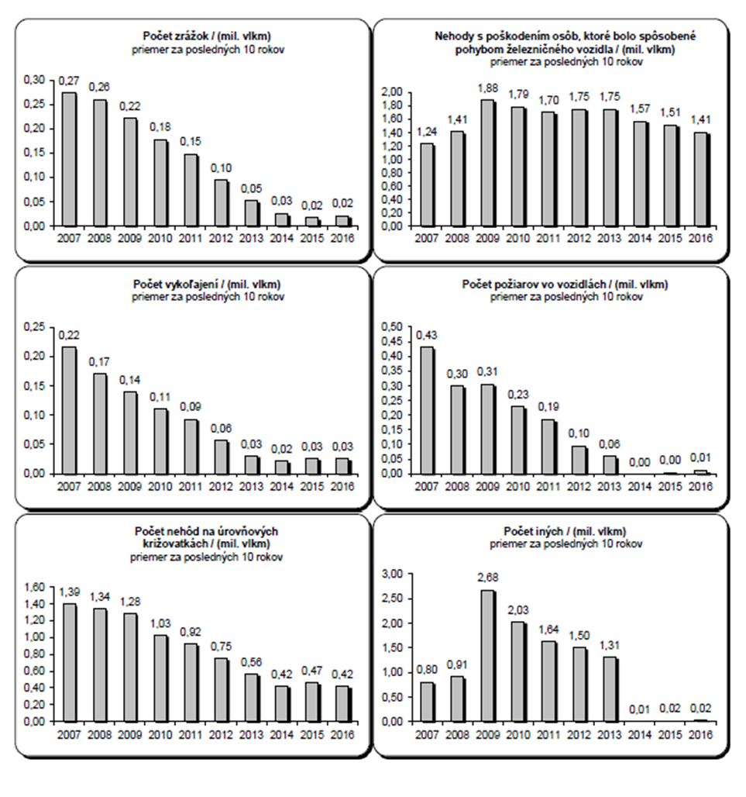**C 3. Accidents divided by type**

|  |  |
| --- | --- |
| Počet zrážok / (mil. vlkm) | Number of collisions / (MLN Train*km) |
| priemer za posledných 10 rokov | Average over the last 10 years |
| 0,30 | 0.30 |
| 0,25 | 0.25 |
| 0,20 | 0.20 |
| 0,15 | 0.15 |
| 0,10 | 0.10 |
| 0,05 | 0.05 |
| 0,00 | 0.00 |
| 0,27 | 0.27 |
| 0,26 | 0.26 |
| 0,22 | 0.22 |
| 0,18 | 0.18 |
| 0,15 | 0.15 |
| 0,10 | 0.10 |
| 0,05 | 0.05 |
| 0,03 | 0.03 |
| 0,02 | 0.02 |
| 0,02 | 0.02 |

|  |  |
| --- | --- |
| Nehody s poškodením osôb, ktoré bolo spôsobené pohybom železničného vozidla / (mil. vlkm) | Accidents to persons caused by RS in motion / (MLN Train*km) |
| priemer za posledných 10 rokov | Average over the last 10 years |
| 2,00 | 2.00 |
| 1,80 | 1.80 |
| 1,60 | 1.60 |
| 1,40 | 1.40 |
| 1,20 | 1.20 |
| 1,00 | 1.00 |
| 0,80 | 0.80 |
| 0,60 | 0.60 |
| 0,40 | 0.40 |
| 0,20 | 0.20 |
| 0,00 | 0.00 |
| 1,24 | 1.24 |
| 1,41 | 1.41 |
| 1,88 | 1.88 |
| 1,79 | 1.79 |
| 1,70 | 1.70 |
| 1,75 | 1.75 |
| 1,75 | 1.75 |
| 1,57 | 1.57 |
| 1,51 | 1.51 |
| 1,41 | 1.41 |

|  |  |
| --- | --- |
| Počet vykoľajení / (mil. vlkm) | Number of derailments / (MLN Train*km) |
| priemer za posledných 10 rokov | Average over the last 10 years |
| 0,25 | 0.25 |
| 0,20 | 0.20 |
| 0,15 | 0.15 |
| 0,10 | 0.10 |
| 0,05 | 0.05 |
| 0,00 | 0.00 |
| 0,22 | 0.22 |
| 0,17 | 0.17 |
| 0,14 | 0.14 |
| 0,11 | 0.11 |
| 0,09 | 0.09 |
| 0,06 | 0.06 |
| 0,03 | 0.03 |
| 0,02 | 0.02 |
| 0,03 | 0.03 |
| 0,03 | 0.03 |

|  |  |
| --- | --- |
| Počet požiarov vo vozidlách / (mil. vlkm) | Number of fires in vehicles / (MLN Train*km) |
| priemer za posledných 10 rokov | Average over the last 10 years |
| 0,50 | 0.50 |
| 0,45 | 0.45 |
| 0,40 | 0.40 |
| 0,35 | 0.35 |
| 0,30 | 0.30 |
| 0,25 | 0.25 |
| 0,20 | 0.20 |
| 0,15 | 0.15 |
| 0,10 | 0.10 |
| 0,05 | 0.05 |
| 0,00 | 0.00 |
| 0,43 | 0.43 |
| 0,30 | 0.30 |
| 0,31 | 0.31 |
| 0,23 | 0.23 |
| 0,19 | 0.19 |
| 0,10 | 0.10 |
| 0,06 | 0.06 |
| 0,00 | 0.00 |
| 0,00 | 0.00 |
| 0,01 | 0.01 |

|  |  |
| --- | --- |
| Počet nehôd na úrovňových križovatkách / (mil. vlkm) | Number of level crossing accidents / (MLN Train*km) |
| priemer za posledných 10 rokov | Average over the last 10 years |
| 1,60 | 1.60 |
| 1,40 | 1.40 |
| 1,20 | 1.20 |
| 1,00 | 1.00 |
| 0,80 | 0.80 |
| 0,60 | 0.60 |
| 0,40 | 0.40 |
| 0,20 | 0.20 |
| 0,00 | 0.00 |
| 1,39 | 1.39 |
| 1,34 | 1.34 |
| 1,28 | 1.28 |
| 1,03 | 1.03 |
| 0,92 | 0.92 |
| 0,75 | 0.75 |
| 0,56 | 0.56 |
| 0,42 | 0.42 |
| 0,47 | 0.47 |
| 0,42 | 0.42 |

|  |  |
| --- | --- |
| Počet iných / (mil. vlkm) | Number of others / (MLN Train*km) |
| priemer za posledných 10 rokov | Average over the last 10 years |
| 3,00 | 3.00 |
| 2,50 | 2.50 |
| 2,00 | 2.00 |
| 1,50 | 1.50 |
| 1,00 | 1.00 |
| 0,50 | 0.50 |
| 0,00 | 0.00 |
| 0,80 | 0.80 |
| 0,91 | 0.91 |
| 2,68 | 2.68 |
| 2,03 | 2.03 |
| 1,64 | 1.64 |
| 1,50 | 1.50 |
| 1,31 | 1.31 |
| 0,01 | 0.01 |
| 0,02 | 0.02 |
| 0,02 | 0.02 |

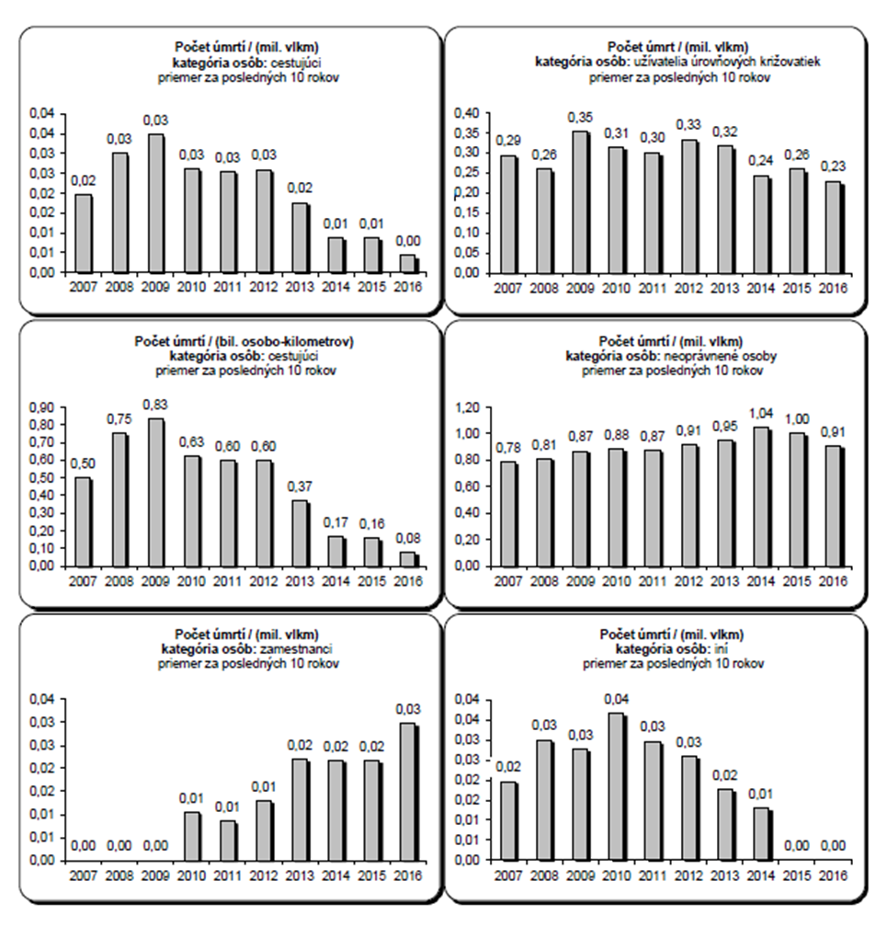**C 4. Fatalities divided by category of people involved**

|  |  |
| --- | --- |
| Počet úmrtí / (mil. vlkm) kategória osôb: cestujúc | Number of fatalities / (MLN train*km), category of persons: passengers |
| priemer za posledných 10 rokov | Average over the last 10 years |
| 0,04 | 0.04 |
| 0,04 | 0.04 |
| 0,03 | 0.03 |
| 0,03 | 0.03 |
| 0,02 | 0.02 |
| 0,02 | 0.02 |
| 0,01 | 0.01 |
| 0,01 | 0.01 |
| 0,00 | 0.00 |
| 0,02 | 0.02 |
| 0,03 | 0.03 |
| 0,03 | 0.03 |
| 0,03 | 0.03 |
| 0,03 | 0.03 |
| 0,03 | 0.03 |
| 0,02 | 0.02 |
| 0,01 | 0.01 |
| 0,01 | 0.01 |
| 0,00 | 0.00 |

|  |  |
| --- | --- |
| Počet úmrt / (mil. vlkm)  kategória osôb: užívatelia úrovňových križovatiek | Number of fatalities / (MLN Train*km)  category of persons: level crossing users |
| priemer za posledných 10 rokov | Average over the last 10 years |
| 0,40 | 0.40 |
| 0,35 | 0.35 |
| 0,30 | 0.30 |
| 0,25 | 0.25 |
| 0,20 | 0.20 |
| 0,15 | 0.15 |
| 0,10 | 0.10 |
| 0,05 | 0.05 |
| 0,00 | 0.00 |
| 0,29 | 0.29 |
| 0,26 | 0.26 |
| 0,35 | 0.35 |
| 0,31 | 0.31 |
| 0,30 | 0.30 |
| 0,33 | 0.33 |
| 0,32 | 0.32 |
| 0,24 | 0.24 |
| 0,26 | 0.26 |
| 0,23 | 0.23 |

|  |  |
| --- | --- |
| Počet úmrtí / (bil. osobo-kilometrov)  kategória osôb: cestujúci | Number of fatalities / (BLN Passenger*km)  category of persons: passengers |
| priemer za posledných 10 rokov | Average over the last 10 years |
| 0,90 | 0.90 |
| 0,80 | 0.80 |
| 0,70 | 0.70 |
| 0,60 | 0.60 |
| 0,50 | 0.50 |
| 0,40 | 0.40 |
| 0,30 | 0.30 |
| 0,20 | 0.20 |
| 0,10 | 0.10 |
| 0,00 | 0.00 |
| 0,50 | 0.50 |
| 0,75 | 0.75 |
| 0,83 | 0.83 |
| 0,63 | 0.63 |
| 0,60 | 0.60 |
| 0,60 | 0.60 |
| 0,37 | 0.37 |
| 0,17 | 0.17 |
| 0,16 | 0.16 |
| 0,08 | 0.08 |

|  |  |
| --- | --- |
| Počet úmrtí / (mil. vlkm)  kategória osôb: neoprávnené osoby | Number of fatalities / (MLN Train*km)  category of persons: unauthorised persons |
| priemer za posledných 10 rokov | Average over the last 10 years |
| 1,20 | 1.20 |
| 1,00 | 1.00 |
| 0,80 | 0.80 |
| 0,60 | 0.60 |
| 0,40 | 0.40 |
| 0,20 | 0.20 |
| 0,00 | 0.00 |
| 0,78 | 0.78 |
| 0,81 | 0.81 |
| 0,87 | 0.87 |
| 0,88 | 0.88 |
| 0,87 | 0.87 |
| 0,91 | 0.91 |
| 0,95 | 0.95 |
| 1,04 | 1.04 |
| 1,00 | 1.00 |
| 0,91 | 0.91 |

|  |  |
| --- | --- |
| Počet úmrtí / (mil. vlkm)  kategória osôb: zamestnanci | Number of fatalities / (MLN Train*km)  category of persons: employees |
| priemer za posledných 10 rokov | Average over the last 10 years |
| 0,04 | 0.04 |
| 0,03 | 0.03 |
| 0,03 | 0.03 |
| 0,02 | 0.02 |
| 0,02 | 0.02 |
| 0,01 | 0.01 |
| 0,01 | 0.01 |
| 0,00 | 0.00 |
| 0,00 | 0.00 |
| 0,00 | 0.00 |
| 0,00 | 0.00 |
| 0,01 | 0.01 |
| 0,01 | 0.01 |
| 0,01 | 0.01 |
| 0,02 | 0.02 |
| 0,02 | 0.02 |
| 0,02 | 0.02 |
| 0,03 | 0.03 |

|  |  |
| --- | --- |
| Počet úmrtí / (mil. vlkm)  kategória osôb: iní | Number of fatalities / (MLN Train*km)  category of persons: others |
| priemer za posledných 10 rokov | Average over the last 10 years |
| 0,04 | 0.04 |
| 0,04 | 0.04 |
| 0,03 | 0.03 |
| 0,03 | 0.03 |
| 0,02 | 0.02 |
| 0,02 | 0.02 |
| 0,01 | 0.01 |
| 0,01 | 0.01 |
| 0,00 | 0.00 |
| 0,02 | 0.02 |
| 0,03 | 0.03 |
| 0,03 | 0.03 |
| 0,04 | 0.04 |
| 0,03 | 0.03 |
| 0,03 | 0.03 |
| 0,02 | 0.02 |
| 0,01 | 0.01 |
| 0,00 | 0.00 |
| 0,00 | 0.00 |

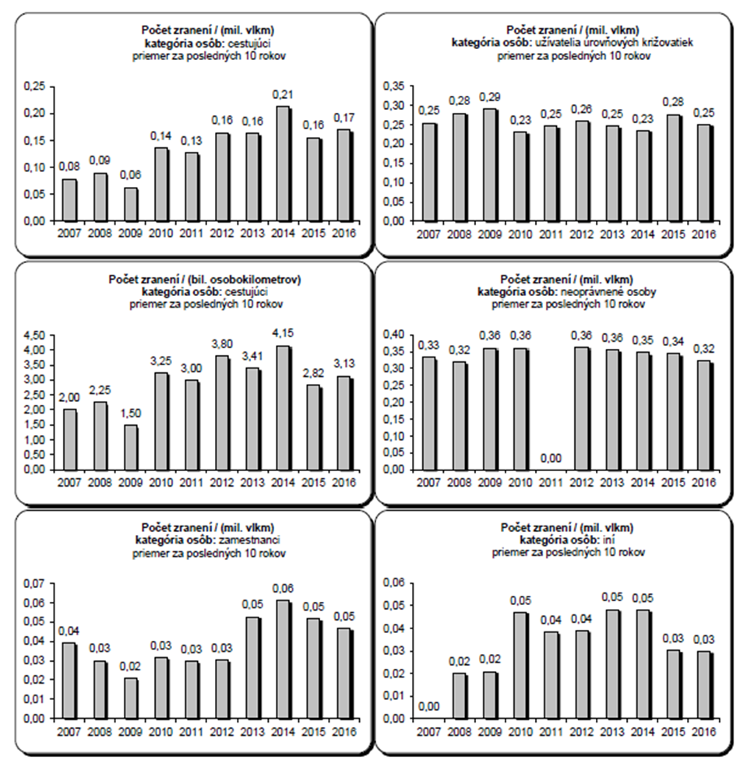**C 5. Injuries divided by category of people involved**

|  |  |
| --- | --- |
| Počet zranení / (mil. vlkm)  kategória osôb: cestujúci | Number of injures / (MLN Train*km)  category of persons: passengers |
| priemer za posledných 10 rokov | Average over the last 10 years |
| 0,25 | 0.25 |
| 0,20 | 0.20 |
| 0,15 | 0.15 |
| 0,10 | 0.10 |
| 0,05 | 0.05 |
| 0,00 | 0.00 |
| 0,08 | 0.08 |
| 0,09 | 0.09 |
| 0,06 | 0.06 |
| 0,14 | 0.14 |
| 0,13 | 0.13 |
| 0,16 | 0.16 |
| 0,16 | 0.16 |
| 0,21 | 0.21 |
| 0,16 | 0.16 |
| 0,17 | 0.17 |

|  |  |
| --- | --- |
| Počet zranení / (mil. vlkm)  kategória osôb: užívatelia úrovňových križovatiek | Number of injures / (MLN Train*km)  category of persons: level crossing users |
| priemer za posledných 10 rokov | Average over the last 10 years |
| 0,35 | 0.35 |
| 0,30 | 0.30 |
| 0,25 | 0.25 |
| 0,20 | 0.20 |
| 0,15 | 0.15 |
| 0,10 | 0.10 |
| 0,05 | 0.05 |
| 0,00 | 0.00 |
| 0,25 | 0.25 |
| 0,28 | 0.28 |
| 0,29 | 0.29 |
| 0,23 | 0.23 |
| 0,25 | 0.25 |
| 0,26 | 0.26 |
| 0,25 | 0.25 |
| 0,23 | 0.23 |
| 0,28 | 0.28 |
| 0,25 | 0.25 |

|  |  |
| --- | --- |
| Počet zranení / (bil. osobokilometrov)  kategória osôb: cestujúci | Number of injures / (BLN Passenger*km)  category of persons: passengers |
| priemer za posledných 10 rokov | Average over the last 10 years |
| 4,50 | 4.50 |
| 4,00 | 4.00 |
| 3,50 | 3.50 |
| 3,00 | 3.00 |
| 2,50 | 2.50 |
| 2,00 | 2.00 |
| 1,50 | 1.50 |
| 1,00 | 1.00 |
| 0,50 | 0.50 |
| 0,00 | 0.00 |
| 2,00 | 2.00 |
| 2,25 | 2.25 |
| 1,50 | 1.50 |
| 3,25 | 3.25 |
| 3,00 | 3.00 |
| 3,80 | 3.80 |
| 3,41 | 3.41 |
| 4,15 | 4.15 |
| 2,82 | 2.82 |
| 3,13 | 3.13 |

|  |  |
| --- | --- |
| Počet zranení / (mil. vlkm)  kategória osôb: neoprávnené osoby | Number of injures/(MLN Train*km)  category of persons: unauthorised persons |
| priemer za posledných 10 rokov | Average over the last 10 years |
| 0,40 | 0.40 |
| 0,35 | 0.35 |
| 0,30 | 0.30 |
| 0,25 | 0.25 |
| 0,20 | 0.20 |
| 0,15 | 0.15 |
| 0,10 | 0.10 |
| 0,05 | 0.05 |
| 0,00 | 0.00 |
| 0,33 | 0.33 |
| 0,32 | 0.32 |
| 0,36 | 0.36 |
| 0,36 | 0.36 |
| 0,00 | 0.00 |
| 0,36 | 0.36 |
| 0,36 | 0.36 |
| 0,35 | 0.35 |
| 0,34 | 0.34 |
| 0,32 | 0.32 |

|  |  |
| --- | --- |
| Počet zranení / (mil. vlkm)  kategória osôb: zamestnanci | Number of injures/(MLN Train*km)  category of persons: employees |
| priemer za posledných 10 rokov | Average over the last 10 years |
| 0,07 | 0.07 |
| 0,06 | 0.06 |
| 0,05 | 0.05 |
| 0,04 | 0.04 |
| 0,03 | 0.03 |
| 0,02 | 0.02 |
| 0,01 | 0.01 |
| 0,00 | 0.00 |
| 0,04 | 0.04 |
| 0,03 | 0.03 |
| 0,02 | 0.02 |
| 0,03 | 0.03 |
| 0,03 | 0.03 |
| 0,03 | 0.03 |
| 0,05 | 0.05 |
| 0,06 | 0.06 |
| 0,05 | 0.05 |
| 0,05 | 0.05 |

|  |  |
| --- | --- |
| Počet zranení / (mil. vlkm)  kategória osôb: iní | Number of injures / (MLN Train*km)  category of persons: others |
| priemer za posledných 10 rokov | Average over the last 10 years |
| 0,06 | 0.06 |
| 0,05 | 0.05 |
| 0,04 | 0.04 |
| 0,03 | 0.03 |
| 0,02 | 0.02 |
| 0,01 | 0.01 |
| 0,00 | 0.00 |
| 0,00 | 0.00 |
| 0,02 | 0.02 |
| 0,02 | 0.02 |
| 0,05 | 0.05 |
| 0,04 | 0.04 |
| 0,04 | 0.04 |
| 0,05 | 0.05 |
| 0,05 | 0.05 |
| 0,03 | 0.03 |
| 0,03 | 0.03 |

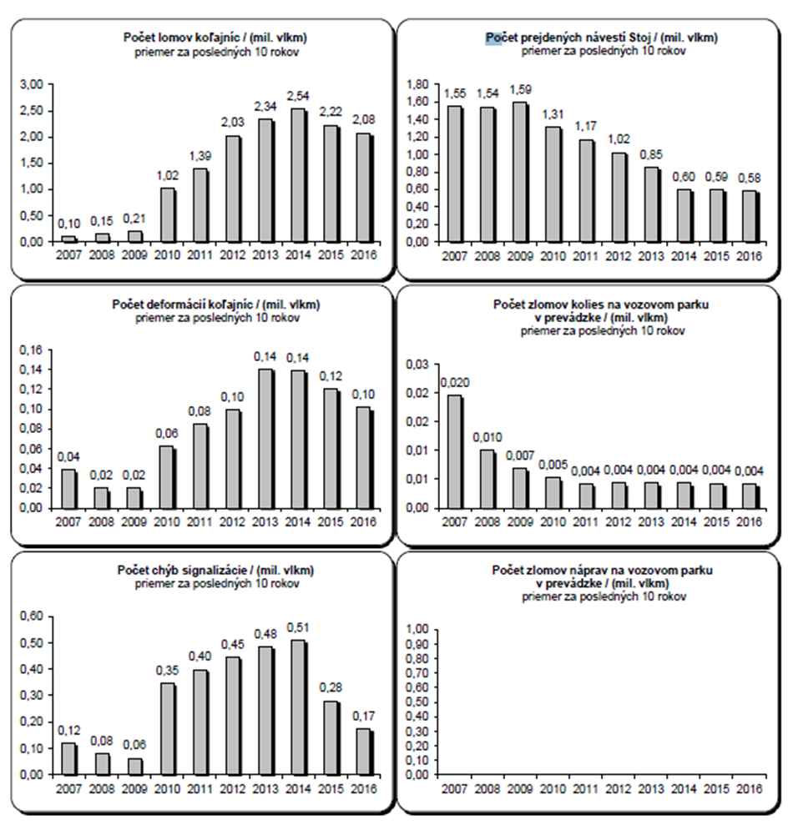**C 6. Precursors to accidents, which may cause an accident**

|  |  |
| --- | --- |
| Počet lomov koľajníc / (mil. vlkm) | Number of broken rails / (MLN Train*km) |
| priemer za posledných 10 rokov | Average over the last 10 years |
| 3,00 | 3.00 |
| 2,50 | 2.50 |
| 2,00 | 2.00 |
| 1,50 | 1.50 |
| 1,00 | 1.00 |
| 0,50 | 0.50 |
| 0,00 | 0.00 |
| 0,10 | 0.10 |
| 0,15 | 0.15 |
| 0,21 | 0.21 |
| 1,02 | 1.02 |
| 1,39 | 1.39 |
| 2,03 | 2.03 |
| 2,34 | 2.34 |
| 2,54 | 2.54 |
| 2,22 | 2.22 |
| 2,08 | 2.08 |

|  |  |
| --- | --- |
| Počet prejdených návestí Stoj / (mil. vlkm) | Number of 'Stop' signals passed / (MLN Train*km) |
| priemer za posledných 10 rokov | Average over the last 10 years |
| 1,80 | 1.80 |
| 1,60 | 1.60 |
| 1,40 | 1.40 |
| 1,20 | 1.20 |
| 1,00 | 1.00 |
| 0,80 | 0.80 |
| 0,60 | 0.60 |
| 0,40 | 0.40 |
| 0,20 | 0.20 |
| 0,00 | 0.00 |
| 1,55 | 1.55 |
| 1,54 | 1.54 |
| 1,59 | 1.59 |
| 1,31 | 1.31 |
| 1,17 | 1.17 |
| 1,02 | 1.02 |
| 0,85 | 0.85 |
| 0,60 | 0.60 |
| 0,59 | 0.59 |
| 0,58 | 0.58 |

|  |  |
| --- | --- |
| Počet deformácií koľajníc / (mil. vlkm) | Number of deformed tracks / (MLN Train*km) |
| priemer za posledných 10 rokov | Average over the last 10 years |
| 0,16 | 0.16 |
| 0,14 | 0.14 |
| 0,12 | 0.12 |
| 0,10 | 0.10 |
| 0,08 | 0.08 |
| 0,06 | 0.06 |
| 0,04 | 0.04 |
| 0,02 | 0.02 |
| 0,00 | 0.00 |
| 0,04 | 0.04 |
| 0,02 | 0.02 |
| 0,02 | 0.02 |
| 0,06 | 0.06 |
| 0,08 | 0.08 |
| 0,10 | 0.10 |
| 0,14 | 0.14 |
| 0,14 | 0.14 |
| 0,12 | 0.12 |
| 0,10 | 0.10 |

|  |  |
| --- | --- |
| Počet zlomov kolies na vozovom parku v prevádzke / (mil. vlkm) | Number of broken wheels on rolling stock  in service / (MLN Train*km) |
| priemer za posledných 10 rokov | Average over the last 10 years |
| 0,03 | 0.03 |
| 0,02 | 0.02 |
| 0,02 | 0.02 |
| 0,01 | 0.01 |
| 0,01 | 0.01 |
| 0,00 | 0.00 |
| 0,020 | 0.020 |
| 0,010 | 0.010 |
| 0,007 | 0.007 |
| 0,005 | 0.005 |
| 0,004 | 0.004 |
| 0,004 | 0.004 |
| 0,004 | 0.004 |
| 0,004 | 0.004 |
| 0,004 | 0.004 |
| 0,004 | 0.004 |

|  |  |
| --- | --- |
| Počet chýb signalizácie / (mil. vlkm) | Number of signalling errors / (MLN Train*km) |
| priemer za posledných 10 rokov | Average over the last 10 years |
| 0,60 | 0.60 |
| 0,50 | 0.50 |
| 0,40 | 0.40 |
| 0,30 | 0.30 |
| 0,20 | 0.20 |
| 0,10 | 0.10 |
| 0,00 | 0.00 |
| 0,12 | 0.12 |
| 0,08 | 0.08 |
| 0,06 | 0.06 |
| 0,35 | 0.35 |
| 0,40 | 0.40 |
| 0,45 | 0.45 |
| 0,48 | 0.48 |
| 0,51 | 0.51 |
| 0,28 | 0.28 |
| 0,17 | 0.17 |

|  |  |
| --- | --- |
| Počet zlomov náprav na vozovom parku v prevádzke / (mil. vlkm) | Number of signalling errors / (MLN Train*km) |
| priemer za posledných 10 rokov | Average over the last 10 years |
| 1,00 | 0.60 |
| 0,90 | 0.50 |
| 0,80 | 0.40 |
| 0,70 | 0.30 |
| 0,60 | 0.20 |
| 0,50 | 0.10 |
| 0,40 | 0.00 |
| 0,30 | 0.12 |
| 0,20 | 0.08 |
| 0,10 | 0.06 |
| 0,00 | 0.35 |

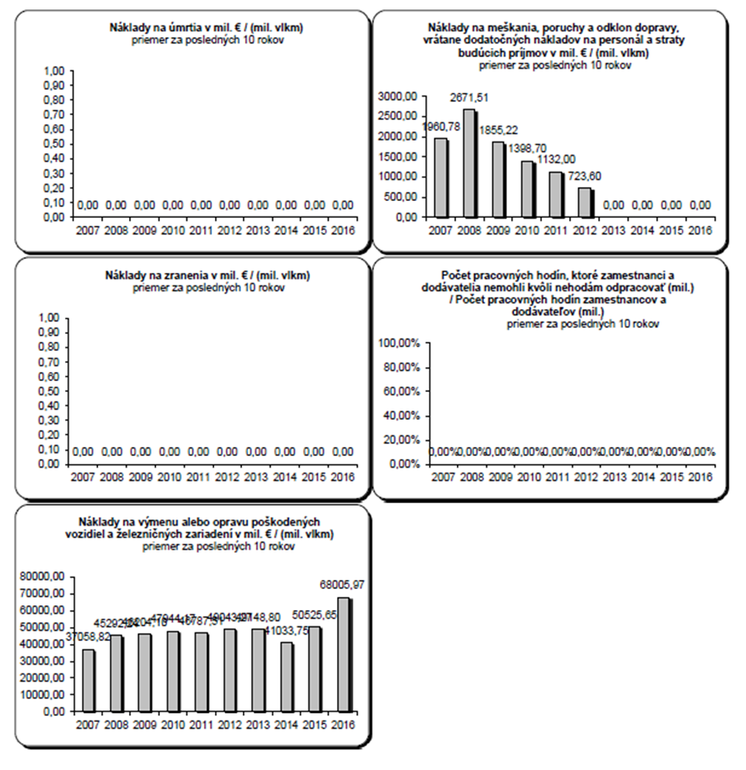**C 7. Cost of all accidents, number of working hours of staff and contractors lost as a consequence of accidents**

|  |  |
| --- | --- |
| Náklady na úmrtia v mil. € / (mil. vlkm) | Costs of fatalities in MLN € / (MLN Train*km) |
| priemer za posledných 10 rokov | Average over the last 10 years |
| 1,00 | 1.00 |
| 0,90 | 0.90 |
| 0,80 | 0.80 |
| 0,70 | 0.70 |
| 0,60 | 0.60 |
| 0,50 | 0.50 |
| 0,40 | 0.40 |
| 0,30 | 0.30 |
| 0,20 | 0.20 |
| 0,10 | 0.10 |
| 0,00 | 0.00 |
| 0,00 | 0.00 |
| 0,00 | 0.00 |
| 0,00 | 0.00 |
| 0,00 | 0.00 |
| 0,00 | 0.00 |
| 0,00 | 0.00 |
| 0,00 | 0.00 |
| 0,00 | 0.00 |
| 0,00 | 0.00 |
| 0,00 | 0.00 |

|  |  |
| --- | --- |
| Náklady na meškania, poruchy a odklon dopravy, vrátane dodatočných nákladov na personál a straty budúcich príjmov v mil. € / (mil. vlkm) | Costs of delays, disturbances and re-routing of traffic, including extra costs for staff and loss of future revenue in MLN € / (MLN Train*km) |
| priemer za posledných 10 rokov | Average over the last 10 years |
| 3000,00 | 3,000.00 |
| 2500,00 | 2,500.00 |
| 2000,00 | 2,000.00 |
| 1500,00 | 1,500.00 |
| 1000,00 | 1,000.00 |
| 500,00 | 500.00 |
| 0,00 | 0.00 |
| 1960,78 | 1,960.78 |
| 2671,51 | 2,671.51 |
| 1855,22 | 1,855.22 |
| 1398,70 | 1,398.70 |
| 1132,00 | 1,132.00 |
| 723,60 | 723.60 |
| 0,00 | 0.00 |
| 0,00 | 0.00 |
| 0,00 | 0.00 |
| 0,00 | 0.00 |

|  |  |
| --- | --- |
| Náklady na zranenia v mil. € / (mil. vlkm) | Costs of injuries in MLN € / (MLN Train*km) |
| priemer za posledných 10 rokov | Average over the last 10 years |
| 1,00 | 1.00 |
| 0,90 | 0.90 |
| 0,80 | 0.80 |
| 0,70 | 0.70 |
| 0,60 | 0.60 |
| 0,50 | 0.50 |
| 0,40 | 0.40 |
| 0,30 | 0.30 |
| 0,20 | 0.20 |
| 0,10 | 0.10 |
| 0,00 | 0.00 |
| 0,00 | 0.00 |
| 0,00 | 0.00 |
| 0,00 | 0.00 |
| 0,00 | 0.00 |
| 0,00 | 0.00 |
| 0,00 | 0.00 |
| 0,00 | 0.00 |
| 0,00 | 0.00 |
| 0,00 | 0.00 |
| 0,00 | 0.00 |

|  |  |
| --- | --- |
| Počet pracovných hodín, ktoré zamestnanci a  dodávatelia nemohli kvôli nehodám odpracovať (mil.)  / Počet pracovných hodín zamestnancov a dodávateľov (mil.) | Number of working hours, which employees and  and suppliers could not worked out due to accidents   / Number of working hours (MLN) of employees and suppliers (MLN) |
| priemer za posledných 10 rokov | Average over the last 10 years |
| 100,00% | 100.00% |
| 80,00% | 80.00% |
| 60,00% | 60.00% |
| 40,00% | 40.00% |
| 20,00% | 20.00% |
| 0,00% | 0.00% |
| 0,00% | 0.00% |
| 0,00% | 0.00% |
| 0,00% | 0.00% |
| 0,00% | 0.00% |
| 0,00% | 0.00% |
| 0,00% | 0.00% |
| 0,00% | 0.00% |
| 0,00% | 0.00% |
| 0,00% | 0.00% |
| 0,00% | 0.00% |

|  |  |
| --- | --- |
| Náklady na výmenu alebo opravu poškodených vozidiel a železničných zariadení v mil. € / (mil. vlkm) | Costs of replacement or repair of damaged vehicles and railway installations in MLN € / (MLN Train*km) |
| priemer za posledných 10 rokov | Average over the last 10 years |
| 80000,00 | 80,000.00 |
| 70000,00 | 70,000.00 |
| 60000,00 | 60,000.00 |
| 50000,00 | 50,000.00 |
| 40000,00 | 40,000.00 |
| 30000,00 | 30,000.00 |
| 20000,00 | 20,000.00 |
| 10000,00 | 10,000.00 |
| 0,00 | 0.00 |
| 37058,82 | 37,058.82 |
| 45292,24 | 45,292.24 |
| 46204,10 | 46,204.10 |
| 47944,17 | 47,944.17 |
| 46787,51 | 46,787.51 |
| 49043,27 | 49,043.27 |
| 49148,80 | 49,148.80 |
| 41033,75 | 41,033.75 |
| 50525,65 | 50,525.65 |
| 68005,97 | 68,005.97 |

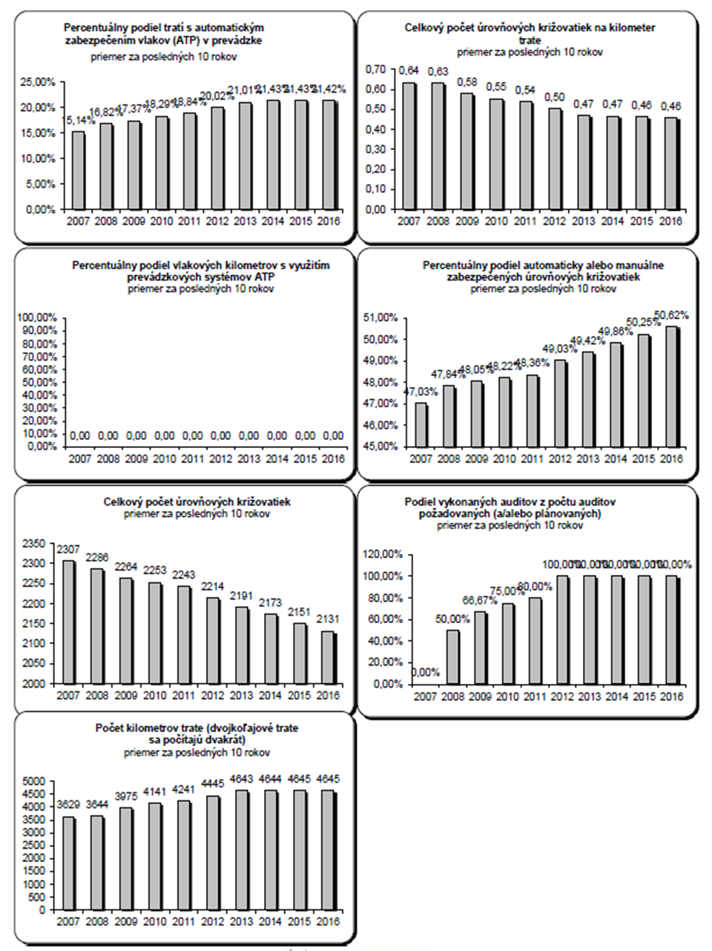**C 8. Technical safety of infrastructure and its implementation, safety management**

|  |  |
| --- | --- |
| Percentuálny podiel tratí s automatickým zabezpečením vlakov (ATP) v prevádzke | Percentage of tracks with automatic train protection (ATP) in operation |
| priemer za posledných 10 rokov | Average over the last 10 years |
| 25,00% | 25.00% |
| 20,00% | 20.00% |
| 15,00% | 15.00% |
| 10,00% | 10.00% |
| 05,00% | 05.00% |
| 0,00% | 0.00% |
| 15,14% | 15.14% |
| 16,82% | 16.82% |
| 17,37% | 17.37% |
| 18,29% | 18.29% |
| 18,84% | 18.84% |
| 20,02% | 20.02% |
| 21,01% | 21.01% |
| 21,43% | 21.43% |
| 21,43% | 21.43% |
| 21,42% | 21.42% |

|  |  |
| --- | --- |
| Celkový počet úrovňových križovatiek na kilometer trate | Total number of level crossings per track km |
| priemer za posledných 10 rokov | Average over the last 10 years |
| 0,70 | 0.70 |
| 0,60 | 0.60 |
| 0,50 | 0.50 |
| 0,40 | 0.40 |
| 0,30 | 0.30 |
| 0,20 | 0.20 |
| 0,10 | 0.10 |
| 0,00 | 0.00 |
| 0,64 | 0.64 |
| 0,63 | 0.63 |
| 0,58 | 0.58 |
| 0,55 | 0.55 |
| 0,54 | 0.54 |
| 0,50 | 0.50 |
| 0,47 | 0.47 |
| 0,47 | 0.47 |
| 0,46 | 0.46 |
| 0,46 | 0.46 |

|  |  |
| --- | --- |
| Percentuálny podiel vlakových kilometrov s využitím prevádzkových systémov ATPzamestnancov a dodávateľov (mil.) | Percentage of Train*km using operational ATP systems of employees and suppliers (MLN) |
| priemer za posledných 10 rokov | Average over the last 10 years |
| 100,00% | 100.00% |
| 90,00% | 90.00% |
| 80,00% | 80.00% |
| 70,00% | 70.00% |
| 60,00% | 60.00% |
| 50,00% | 50.00% |
| 40,00% | 40.00% |
| 30,00% | 30.00% |
| 20,00% | 20.00% |
| 10,00% | 10.00% |
| 0,00% | 0.00% |
| 0,00% | 0.00% |
| 0,00% | 0.00% |
| 0,00% | 0.00% |
| 0,00% | 0.00% |
| 0,00% | 0.00% |
| 0,00% | 0.00% |
| 0,00% | 0.00% |
| 0,00% | 0.00% |
| 0,00% | 0.00% |
| 0,00% | 0.00% |

|  |  |
| --- | --- |
| Percentuálny podiel automaticky alebo manuálne zabezpečených úrovňových križovatiek | Percentage of level crossings with automatic or manual protection |
| priemer za posledných 10 rokov | Average over the last 10 years |
| 51,00% | 51.00% |
| 50,00% | 50.00% |
| 49,00% | 49.00% |
| 48,00% | 48.00% |
| 47,00% | 47.00% |
| 46,00% | 46.00% |
| 45,00% | 45.00% |
| 47,03% | 47.03% |
| 47,84% | 47.84% |
| 48,05% | 48.05% |
| 48,22% | 48.22% |
| 48,36% | 48.36% |
| 49,03% | 49.03% |
| 49,42% | 49.42% |
| 49,86% | 49.86% |
| 50,25% | 50.25% |
| 50,62% | 50.62% |

|  |  |
| --- | --- |
| Celkový počet úrovňových križovatiek | Total number of level crossings |
| priemer za posledných 10 rokov | Average over the last 10 years |
| 2350 | 2,350 |
| 2300 | 2,300 |
| 2250 | 2,250 |
| 2200 | 2,200 |
| 2150 | 2,150 |
| 2100 | 2,100 |
| 2050 | 2,050 |
| 2000 | 2,000 |
| 2307 | 2,307 |
| 2286 | 2,286 |
| 2264 | 2,264 |
| 2253 | 2,253 |
| 2243 | 2,243 |
| 2214 | 2,214 |
| 2191 | 2,191 |
| 2173 | 2,173 |
| 2151 | 2,151 |
| 2131 | 2,131 |

|  |  |
| --- | --- |
| Podiel vykonaných auditov z počtu auditov požadovaných (a/alebo plánovaných | Rate of performed audits out of the number of required (and/or planned |
| priemer za posledných 10 rokov | Average over the last 10 years |
| 120,00% | 120.00% |
| 100,00% | 100.00% |
| 80,00% | 80.00% |
| 60,00% | 60.00% |
| 40,00% | 40.00% |
| 20,00% | 20.00% |
| 0,00% | 0.00% |
| 0,00% | 0.00% |
| 50,00% | 50.00% |
| 66,67% | 66.67% |
| 75,00% | 75.00% |
| 80,00% | 80.00% |
| 100,00% | 100.00% |
| 100,00% | 100.00% |
| 100,00% | 100.00% |
| 100,00% | 100.00% |
| 100,00% | 100.00% |

|  |  |
| --- | --- |
| Počet kilometrov trate (dvojkoľajové trate sa počítajú dvakrát) | Number of track km (double track lines are to be counted twice) |
| priemer za posledných 10 rokov | Average over the last 10 years |
| 5000 | 5,000 |
| 4500 | 4,500 |
| 4000 | 4,000 |
| 3500 | 3,500 |
| 3000 | 3,000 |
| 2500 | 2,500 |
| 2000 | 2,000 |
| 1500 | 1,500 |
| 1000 | 1,000 |
| 500 | 500 |
| 0 | 0 |
| 3629 | 3,629 |
| 3644 | 3,644 |
| 3975 | 3,975 |
| 4141 | 4,141 |
| 4241 | 4,241 |
| 4445 | 4,445 |
| 4643 | 4,643 |
| 4644 | 4,644 |
| 4645 | 4,645 |
| 4645 | 4,645 |

Annex D – Important changes in legislation and regulations

| **Area** | **Legal reference** | **Date legislation came into force** | **Reason for introduction (additionally, state if new law or amendment to existing legislation)** | **Description** |
| --- | --- | --- | --- | --- |
| **General national railway safety legislation** | | | | |
| Legislation concerning the national safety authority | Act No 513/2009 Coll. on Railways, to alter and to amend some other acts | 01/01/2010 | A new law | Railway operation rules, responsibilities and duties of the Authority, tasks of the safety authority |
| Act No 514/2009 Coll. on Railway Traffic | 01/01/2010 | a new law | Railway traffic operating rules, engine-driver certification, responsibilities and obligations of the Authority |
| Act No 402/2013 Coll. on Regulatory Authority for Electronic Communications and Postal Services and on the Transport Authority | 01/01/2014 | a new law and, at the same time, amendment to Act No 513/2009 Coll. and Act No 514/2009 Coll. | Cancellation of the Railway Regulatory Authority and establishment of the Transport Authority, which, inter alia, performs the tasks of the safety authority (Directive 2004/49/EC). |
| Legislation concerning notified bodies, assessors, third party bodies for registration, examination, etc. | Act No 513/2009 Coll. on Railways, to alter and to amend some other acts | 01/01/2010 | a new law | Railway operation rules, competencies and responsibilities of notified and authorised legal entities |
| Act No 393/2011 Coll. | 31/12/2011 | Amendment to Act No 513/2009 Coll. on Railways | Subsystem verification procedures, authorisation of legal entities for verification of RVs, performance of technical and safety tests on RVs |
| The Act No 259/2015 Coll. | 15/12/2015 | Amendment to Act No 513/2009 Coll. on Railways | Granting railway vehicle type authorisations |
| **National rules on railway safety** | | | | |
| Rules on national safety targets and methods | Act No 513/2009 Coll. on Railways, to alter and to amend some other acts | 01/01/2010 | a new law | Railway operation rules, responsibilities and duties of the Authority, tasks of the safety authority |
| Act No 433/2010 Coll. | 01/12/2010 | Amendment to Act No 513/2009 Coll. on Railways | Safety indicators, safety targets and safety methods |
| Act No 514/2009 Coll. on Railway Traffic | 01/01/2010 | a new law | Railway traffic operation rules |
| Decree No 351/2010 Coll. on Railway Traffic Regulations | 15/09/2010 | a new decree of the Ministry | Details concerning operation of railways and railway traffic, verification of technical capability of RVs, driving of RTUs |
| Rules concerning requirements on SMS and safety certification of RUs | Act No 513/2009 Coll. on railways, and amending certain acts | 1.1.2010 | New law | Railway operation rules, competencies of the Authority, issuing of safety certificates, tasks of the safety authority |
| Act No 432/2013 Coll. | 01/02/2014 | Amendment to Act no 513/2009 Coll. on Railways | Requirements on SMS, requirements for medical fitness, authorisation for placing in service of RVs |
| Act no 514/2009 Coll. on Railway Traffic | 01/01/2010 | a new law | Railway traffic operation rules, engine-driver certification, tasks of the Authority as the safety authority |
| Decree no.351/2010 Coll. on Railway Traffic Regulations | 15/09/2010 | a new decree of the Ministry | Details concerning operation of railways and railway traffic, operation of RVs |
| Rules concerning requirements on SMS and Safety Authorisation of IMs | Act No 513/2009 Coll. on Railways, to alter and to amend some other acts | 01/01/2010 | a new law | Railway operation rules, issuing of safety authorisations, competencies and tasks of the Authority as the safety authority |
| Act No 432/2013 Coll. | 01/02/2014 | Amendment to Act no.513/2009 Coll. on Railways | Requirements on SMS, requirements for medical fitness, authorisation for placing in service of RVs |
|  | Act No 514/2009 Coll. on Railway Traffic | 01/01/2010 | a new law | Railway traffic operation rules, engine-driver certification, tasks of the Authority as the safety authority |
| Decree No 351/2010 Coll. on Railway Traffic Regulations | 15/09/2010 | a new decree of the Ministry | Requirements for operation of the railway and railway traffic, operation and tests of RVs, organisation of railway traffic |
| Rules concerning requirements for wagon keepers | - | - | - | **-** |
| Rules concerning requirements for maintenance workshops | - | - | - | **-** |
| Rules concerning requirements on the authorisation for placing in service and maintenance of new and substantially altered rolling stock, including rules for exchange of rolling stock between RUs, registration systems and requirements for testing procedures | Act No 513/2009 Coll. on Railways, to alter and to amend some other acts | 01/01/2010 | a new law | Railway operation rules, requirements on the authorisation for placing in service of RVs, tests of RVs, registration of RVs, competencies and tasks of the Authority as the safety authority |
| Decree No 351/2010 Coll. on Railway Traffic Regulations | 15/09/2010 | a new decree of the Ministry | Requirements for operation of the railway and railway traffic, verification of the technical condition of RVs, TST, RVs |
| Decree No 12/2012 Coll. | 01/02/2012 | Amendment to the Decree No 351/2010 Coll. | Authorisations for historical RVs, conditions of performing RV TST, RVs tests, on-board signalling systems |
| Common operating rules of the railway network, including rules relating to the signalling and traffic procedures | Regulation of ŽSR Z 1 – Railways Traffic Rules | 11/12/2011 | National safety rule | It determines method, conditions and technological procedures in the railway operation, performance of transport activities |
| Decree No 351/2010 Coll. on Railway Traffic Regulations | 15/09/2010 | a new decree of the Ministry | Requirements for the operation of the railway and the railway traffic, attendance of the railway, railway traffic management, methods of signalling and securing the railway |
| Decree No 12/2012 Coll. | 01/02/2012 | Amendment to Decree No 351/2010 Coll. | Requirements for railway traffic, running based on visibility, brake tests |
| Rules laying down requirements for additional internal operating rules (company rules) that must be prepared by the infrastructure managers and railway undertakings | Act No 513/2009 Coll. on Railways, to alter and to amend of some other acts | 01/01/2010 | a new law | Railway operation rules, issuing of regulations by IMs and RUs, competencies and tasks of the Authority as the safety authority |
| Act No 514/2009 Coll. on Railway Traffic | 01/01/2010 | a new law | Railway traffic operation rules, issuing of regulations by IMs and RUs regarding certification of engine-drivers, tasks of the Authority as the safety authority |
| Decree No 351/2010 Coll. on Railway Traffic Regulations | 15/09/2010 | a new decree of the Ministry | Requirements for operation of the railway and railway traffic, railway traffic management, issuing of operating regulations and technological procedures by IMs and RUs |
| Rules concerning requirements on staff executing safety critical tasks, including selection criteria, medical fitness and vocational training and certification | Act No 513/2009 Coll. on Railways, to alter and to amend some other acts | 01/01/2010 | a new law | Requirements for professional competence, medical and psychological fitness, verification of professional competence, medical and psychological fitness |
| Act No 514/2009 Coll. on Railway Traffic | 01/01/2010 | a new law | Requirements for professional competence, medical and psychological fitness, verification of professional competence, medical and psychological fitness of engine-drivers |
| Decree No 245/2010 on professional competence, medical and psychological fitness of persons in the operation of the railway and railway traffic | 15/06/2010 | a new decree of the Ministry | Details concerning professional training for obtaining professional competence, requirement for professional competence, medical and psychological fitness, and their verification |
| Regulation of ŽSR Z 2 – Employee Safety in the Conditions of ŽSR | 01/01/2014 | National safety rule | Personal safety in the area with potential risk on the railway infrastructure |
| Rules concerning investigation of accidents and incidents, including recommendations | Act No 513/2009 Coll. on Railways, to alter and to amend some other acts | 01/01/2010 | a new law | Duties of IMs and RUs in the event of accidents, incidents and emergencies, investigation of their causes and taking of measures |
| Regulation of ŽSR Z 17 – Accidents and Incidents | 09/12/2007 | National safety rule, amended on 01/01/2010 and 01/01/2011 | Procedures in the event of accidents, incidents and emergencies and investigation of their causes |
| Rules concerning requirements for national safety indicators, including the method of their collection and analysis | Act No 513/2009 Coll. on Railways, to alter and to amend some other acts | 01/01/2010 | a new law | Duties of IMs and RUs – collection of safety indicators and their reporting to the NSA in a safety report |
| Act No 433/2010 Coll. | 01/12/2010 | Amendment to Act No 513/2009 Coll. on Railways | Safety indicators – reporting, report structure |
| Rules concerning requirements for authorisation of placing in service the infrastructure (tracks, bridges, tunnels, energy, ATC, radio, signalling, interlocking, level crossings, platforms, etc.) | Act No 513/2009 Coll. on Railways, to alter and to amend some other acts | 01/01/2010 | a new law | Rules concerning construction and operation of railways, construction and technical requirements for the construction of railways and their parts, putting railways into operation |
| Decree No 350/2010 Coll. on Construction and Technical Rules on Railways | 15/09/2010 | a new law | Details concerning construction and technical requirements for the design, construction and operation of railways |

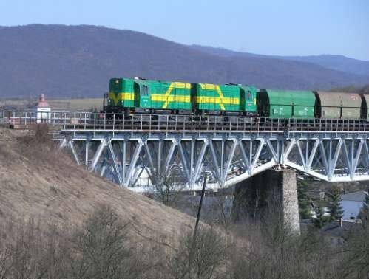

(Photo: Pavel Chomjak, Prešov)

Annex E – The development of safety certification and safety authorisations – numerical data

E.1. Safety Certificates according to Directive 2004/49/EC

|  |  |  |
| --- | --- | --- |
| E.1.1 Number of the Part A Safety Certificates issued in the reporting year and in previous years, and which remain valid at the end of year 2016 | Total number of certificates: | Number of certificates Part A in ERADIS: |
| in the reporting year: 7 | |
| in previous years: 21 | |
| valid at the end of 2016: 27 | |

|  |  |  |  |
| --- | --- | --- | --- |
| E.1.2 Number of the Part B Safety Certificates issued in the reporting year and in previous years by your Member State, and which remain valid at the end of 2016 | Total number of certificates: | | Number of certificates Part B in ERADIS: |
| in the Slovak Republic: | in the reporting year: 7 | |
| in previous years: 21 | |
| valid at the end of 2016: 27 | |
| in another Member State:  (number of Part B Certificates, for which the Part A has been issued in another Member State) | in the reporting year: 4 | |
| in previous years: 18 | |
| valid at the end of 2016: 21 | |

|  |  |  |  |  |
| --- | --- | --- | --- | --- |
| E.1.3 Number of new applications for the Part A Safety Certificates submitted by railway undertakings in 2016 | Type of certificate | A | R | P |
| New certificates | 0 | 0 | 1 |
| Updated/amended certificates | 1 | 0 | 0 |
| Renewed certificates | 3 | 0 | 1 |

|  |  |  |  |  |  |
| --- | --- | --- | --- | --- | --- |
| E.1.4 Number of new applications for the Part B Safety Certificates submitted by railway undertakings in 2016 | Where | Type of certificate | A | R | P |
| Part A has been issued in the Slovak Republic | New certificates | 0 | 0 | 1 |
| Updated/amended certificates | 1 | 0 | 0 |
| Renewed certificates | 3 | 0 | 1 |
| Part A has been issued in another Member-State | New certificates | 3 | 0 | 0 |
| Updated/amended certificates | 1 | 0 | 0 |
| Renewed certificates | 0 | 0 | 1 |

A = Accepted application, certificate is already issued

R = Rejected applications, no certificate was issued

P = Case is still pending, no certificate was issued so far

|  |  |  |
| --- | --- | --- |
| Revoked safety certificates | Total number of revoked certificates in 2016 | Number of revoked certificates in ERADIS (which were revoked in 2016) |
| E. 1.5 number of Part A certificates revoked in the relevant reporting year 2016 | 1 | 1 |
| E. 1.6 number of Part B certificates revoked in the relevant reporting year 2016 | 1 | 1 |

E.1.7 List of countries, where railway undertakings applying for a Part B Safety Certificate in your Member State have obtained their Part A Safety Certificate.

|  |  |
| --- | --- |
| Name of the railway undertaking | Member State where the Part A Safety Certificate was issued |
| České dráhy, a.s. ARRIVA vlaky, s.r.o.  Traťová strojní společnost, a.s. | Czech Republic |

E. 2 Safety authorisations according to Directive 2004/49/EC

|  |  |
| --- | --- |
| E.2.1 Number of valid safety authorisations issued to infrastructure managers within the reporting year and in previous years, and which remain valid at the end of 2016 | Total number of safety authorisations: 1 |
| in the reporting year: 0 |
| in previous years: 1 |
| valid at the end of 2016: 1 |

|  |  |  |  |  |
| --- | --- | --- | --- | --- |
| E.2.2 Number of applications for safety authorisations submitted by infrastructure managers in 2016 | Type of authorisation | A | R | P |
| New authorisations | 0 | 0 | 0 |
| Updated/amended authorisations | 0 | 0 | 0 |
| Renewed authorisations | 0 | 0 | 0 |

A = Accepted application, authorisation is already issued.

R = Rejected application, no authorisation was issued.

P = Case is still pending, no authorisation was issued so far.

|  |  |
| --- | --- |
| E. 2.3 Number of safety authorisations revoked in the relevant reporting year 2016 | 0 |

E.3 Procedural aspects – Part A Safety Certificates

|  |  |  |  |
| --- | --- | --- | --- |
| The average time after receiving an application with the required information and the final delivery of a Part A Safety Certificate in 2016 for railway undertakings | New | Updated/amended | Renewed |
| 3 months | 1 months | 3 months |

E.4 Procedural aspects – Part B Safety Certificates

|  |  |  |  |  |
| --- | --- | --- | --- | --- |
| The average time after receiving the application with the required information and the final delivery of a Part B Safety Certificate in 2016 for railway undertakings | Where | New | Updated/amended | Renewed |
| Part A has been issued in the Slovak Republic | 3 months | 1 months | 3 months |
| Part A has been issued in another Member-State | 3 months | 4 months | 3 months |

E.5 Procedural aspects – safety authorisations

|  |  |  |  |
| --- | --- | --- | --- |
| The average time after receiving the application with the required information and the final delivery of a safety authorisation in 2016 for infrastructure managers | New | Updated/amended | Renewed |
| Not applicable | Not applicable | Not applicable |