Annual report

of the National Safety Authority for the Year 2016 | Bundesministerium für Verkehr Innovation und Technologie Department IV, Rail Group, Section E 4

in accordance with Article 18 of Directive 2004/49/EC
'Directive on safety on the Community’s railways',
transposed by Section 13a Railway Act of 1957 (EisbG)

Contents:
A.1. Scope of the report 1
A.2. Summary 1
B. Introduction 3
C. Organisation 6
D. Development of railway safety 10
E. Changes in legislation and regulations 13
F. The development of safety certification and authorisation 13
G. Supervision of railway undertakings and infrastructure managers 18
H. The application of CSM to risk evaluation and assessment 20
I. Sources of information 22
J. Annexes 22
ANNEX A: Railway structure information 23
ANNEX B: Organisation chart 27
ANNEX C: CSI data – definitions applied 32
ANNEX D: The development of safety certification and authorisation – numerical data 42

- Scope of the report
This annual report has been drawn up in accordance with Section 13a Railways Act 1957, the Federal Act concerning railways, rail vehicles on railways and traffic on railways [Bundesgesetz über Eisenbahnen, Schienenfahrzeuge auf Eisenbahnen und den Verkehr auf Eisenbahnen (Eisenbahngesetz)] (EisbG), Federal Law Gazette [Bundesgesetzblatt (BGBl.)] No 60/1957 as most recently amended by BGBl. I. No. 137/2015 pursuant to Directive 2004/49/EC of 29 April 2004 on safety on the Community's railways, OJ L 164, 30 April 2004, as amended (on 11 May 2016 a recast directive on railway safety was announced, which repeals Directive 2004/49/EC as of 16 June 2020). The report covers the activities of the national safety authority in respect of the operation of main line railways and the secondary railways connected to them, the operation of rail vehicles on such railways and traffic on such railways in Austria in 2016.
- Summary
In Austria general duties for railway undertakings and infrastructure managers are laid down in the Austrian Railway Act: “Eisenbahngesetz 1957”, published in “Bundesgesetzblatt BGBl No 60/1957”, as last amended by “BGBl. I No 137/2015”. The detailed regulations of railway undertakings concerning the training, behaviour of staff concerned with safety critical tasks are subject of authorisation by the Railway Authority.
Beginning from 1 January 2006 the National Investigation Body – “Sicherheitsuntersuchungsstelle (SUB)” according to the regulations in the “Bundesgesetz über die unabhängige Sicherheitsuntersuchung von Unfällen und Störungen (Unfalluntersuchungsgesetz – UUG 2005)”, published in “Bundesgesetzblatt BGBl I No 123/2005” as last amended by “BGBl. I No 102/2017” started its work as an independent body according to Article 21 of the Safety Directive concerned with the investigation of accidents/incidents.
Safety indicators relating to accidents, incidents and near-misses, to technical safety of infrastructure and its implementation are collected by the SUB.
Safety performance on member state level is controlled on different levels e.g. by approval process of subsystems, maintenance rules, by accident and incident investigation. Railway undertakings and infrastructure managers have to fulfil obligations for periodical checking, reviewing and inspections. Furthermore safety performance is individually checked on the occasion of certain incidents.
Authorisation of subsystems for bringing into service, control of operation of railway undertakings and infrastructure managers, supervising of compliance of technical equipments, authorisation for placing into service of new or substantially altered rolling stock and monitoring, promoting and developing the safety regulatory framework are carried out by Federal Ministry of Transport, Innovation and Technology as NSA, notwithstanding the general responsibility of the railway undertakings and infrastructure managers themselves.
Publication of existing, new or updated national safety rules is managed on the website of the Federal Ministry of Transport, Innovation and Technology (www.bmvit.gv.at/en/verkehr/railway/notifications.html).
The annual report of the safety authority in Austria concerns its activities in the year 2016 according to the Directive on Safety on the Community’s railways (2004/49/EC, “Safety Directive”).
The report contains global information on the railway system in Austria shown in Parts A, B and C and also shown in the related annexes.
Safety recommendations as a result of investigation accidents, incidents and near-misses during the reporting year are enumerated in Part D.
The Part E reports important changes in legislation and regulation concerning railway safety in the year 2016.
The development of safety certification and safety authorisation is shown in Part F.
A description of results of and experience relating to the supervision of infrastructure managers and railway undertakings is given in part G.
Part H shows comments on the application of the CSM on risk evaluation and assessment.

Introduction

Introduction to the report
Article 18 of Directive 2004/49/EC, transposed by Section 13a Railway Act of 1957 (EisbG), provides the statutory basis for the preparation of the annual report:

Annual report
Section 13a. (1) The Federal Minister for Transport, Innovation and Technology shall prepare a report every year on his activities during the previous year in respect of the operation of main line railways and the secondary railways connected to them, the operation of rail vehicles on such railways and traffic on such railways. The annual report shall be published on the internet on the website of the Federal Minister for Transport, Innovation and Technology at the latest by 30 September of the calendar year following the year to which the report refers and shall also be submitted to the European Union Agency for Railways.
(2) The annual report shall contain the following information:
- an aggregation of the common safety indicators in accordance with Annex I to Directive 2004/49/EC;
- important changes in federal legislation and regulations made on the basis of federal law which relate to the construction or operation of the railways listed in paragraph 1, the operation of rail vehicles on such railways and traffic on railways;
- the development of safety certification and safety authorisation;
- results of and experience relating to the supervision of infrastructure managers and railway undertakings.’
In addition, the national safety authority had the obligation under Article 18 Paragraph 2 of Commission Implementing Regulation (EU) No 402/2013 of 30 April 2013 on the common safety method for risk evaluation and assessment, as last amended by Implementing Regulation (EU) No 2015/1136, to report on the experience of proposers with the application of the common safety method (CSM) on risk evaluation and assessment, and, where appropriate, its own experience.
The annual report pursuant to the directive is based on an evaluation of the Federal Safety Investigation Authority’s data in accordance with Section 13a (3) EisbG:
‘Section 13a (3) The Federal Safety Investigation Authority (Section 3 Investigation Bureau Act, BGBl.. I No 123/2005) shall make available the data necessary for aggregating the common safety indicators for the year to the Federal Minister for Transport, Innovation and Technology at the latest by 30 June of the calendar year following the year to which the report refers in an electronic form.’
together with the safety reports of the railway undertakings in accordance with Section 39d EisbG:

Safety report
Section 39d. Railway undertakings which have their registered office in Austria and infrastructure managers which have their registered office in Austria shall submit a safety report every year for the previous calendar year to the authorities before 30 June which shall contain the following:
- information on how the organisation's corporate safety targets are met;
- the Austrian and common safety indicators in so far as they are relevant to the railway undertaking in question;
- the results of internal safety auditing;
- observations on deficiencies and malfunctions which have compromised the safety of railway operations, the operation of rail vehicles on the railway or traffic on the railway.

The annual report is to be prepared in accordance with documents issued by the European Railway Agency:
- Template – Structure for the content of the NSA Annual safety Report
- Guideline for the use of the template – Structure for the content of the NSA Annual safety Report

Railway structure information
- A map of the rail network (see Annex A.1.);
- A list of the railway undertakings (RU) and infrastructure managers (IM) (see Annex A.2.).

Summary – general analysis
This report gives a summary of the development of the common safety indicators in accordance with Annex I of Directive 2004/49/EC, amended by Directive 2014/88/EU in 2016.
87 significant accidents were reported in 2016 within the scope of application of the Railway Safety Directive (these are essentially accidents involving a moving vehicle). The number of significant accidents rose from 77 in 2015 to 87, the number of significant accidents resulting in personal injury from 27 to 41. The other types of accidents 'collisions of trains' and 'derailments' mentioned in the annual report show a constant value, while 'accidents on level crossings', 'vehicle fires' and other accidents' show a decrease against 2015.
Overall, the two accident types, accidents at level crossings (at about 31%) and accidents to persons caused by rolling stock in motion (at about 41%), account for about 82% of the total number of major accidents.
The number of fatalities for all types of accidents combined was 31 (2015: 35), while the total number of seriously injured was 53 (2015: 45).
As regards the different groups of persons killed, the group of trespassers with 16 fatalities and users of level crossings with 13 fatalities give the great majority of accident victims. The great majority of seriously injured persons belongs to the categories of 'users of level crossings' (22 victims) and passengers (18 victims); a single train collision involving a runaway wagon resulted in four of these seriously injured passengers.
Data on the individual Common Safety Indicators (CSIs) for 2016 together with notes referring to the various common safety indicators are provided in Annex C.1.

Organisation

Introduction to the organisation
National safety authority for safety authorisation and safety certification:
(for railway infrastructure managers of main line railways and railway undertakings which are authorised to operate on main line railways and the secondary railways connected to them):
Federal Ministry of Transport, Innovation and Technology [Bundesministerium für
Verkehr, Innovation und Technologie] (bmvit)
Radetzkystraße 2
A-1030 Wien
Tel.: (+43)-1-71162-65-0
Fax: +43-1-71162-652298
Email: iv-sl@bmvit.gv.at
Website: www.bmvit.gv.at/verkehr/eisenbahn
Section 12(3) EisbG contains the provisions defining the competence of the Federal Minister of Transport, Innovation and Technology as a safety authority.
Other safety authorities:
(in every case, the Governor [Landeshauptmann] of the relevant one of the nine Federal Provinces is the railway safety authority for infrastructure managers who only manage connecting secondary railways):
Governor of Burgenland [Landeshauptmann von Burgenland]
Europaplatz 1
A-7000 Eisenstadt

Governor of Carinthia [Landeshauptmann von Kärnten]
Arnulfplatz 1
A-9020 Klagenfurt

Governor of Lower Austria [Landeshauptmann von Niederösterreich]
Landhausplatz 1
A-3109 St. Pölten

Governor of Upper Austria [Landeshauptmann von Oberösterreich]
Landhausplatz 1
A-4021 Linz

Governor of Salzburg [Landeshauptmann von Salzburg]
Chiemseehof
A-5010 Salzburg

Governor of Styria [Landeshauptmann der Steiermark]
Hofgasse 15
A-8010 Graz

Governor of the Tyrol [Landeshauptmann von Tirol]
Eduard-Wallnöfer-Platz 3
A-6020 Innsbruck

Governor of Vorarlberg [Landeshauptmann von Vorarlberg]
Landhaus
A-6900 Bregenz

Governor of Vienna [Landeshauptmann von Wien]
Lichtenfelsgasse 2
A-1010 Wien
Section 12(2) Railways Act contains the provisions defining the competence of governors as authorities.

Employee Protection Authority (Arbeitnehmerschutzbehörde):
Federal Minister of Labour, Social Affairs and Consumer Protection
[Bundesminister für Arbeit, Soziales und Konsumentenschutz] (bmask)
Department VII – Labour Law and Central Labour Inspectorate (Sektion VII – Arbeitsrecht und Zentral-Arbeitsinspektorat)
Competence Centre Labour Inspectorate for Transport (Kompetenzzentrum Verkehrs- Arbeitsinspektorat)
Stubenring 1 A-1010 Wien
Tel.: +43-1-71100-0
Fax: +43-1-7158258
Email: post@sozialministerium.at
Website: www.sozialministerium.at

Federal Safety Investigation Authority:
Accident investigating body within the meaning of Directive 2004/49/EC for the investigation of accidents and incidents in rail transport:
Federal Safety Investigation Authority, Rail Section [Sicherheitsuntersuchungsstelle des Bundes, Schiene]
Trauzlgasse 1
A-1210 Wien
Tel.: +43-1-71162-659000
Fax: +43-1-71162-659298
Email: sub@bmvit.gv.at
Website: www.bmvit.gv.at/verkehr/sub/schiene
The Accident Investigation Act (BGBl. I No 123/2005 as most recently amended by BGBl. I No 102/2017) and the Rail Accident Reporting Regulation 2006 (MeldeVO-Eisb 2006) (BGBl. II No 279/2006) define the statutory powers for the work.
The Reporting Regulation governs:
Section 1 … the scope and form of reports of accidents and incidents which arise during the operation of a main line or secondary railway (Section 4 Railways Act 1957, BGBl. No 60), a connecting railway (Section 7 Railways Act 1957, BGBl. No 60) or a tramway which operates exclusively on its own formation, such as underground railways (Section 5 Paragraph 1 Point 2, Railways Act 1957, BGBl. No 60), and the operation of rail vehicles on such railways.

Rail Regulator:
Rail Control Commission [Schienen-Control Kommission] (SCK)
Rail Control, Austrian Company for Rail Market Regulation [Schienen-Control]
Österreichische Gesellschaft für Schienenmarktregulierung mit beschränkter Haftung (Schienen-Control GmbH)
Praterstraße 62-64 A-1020 Wien
Tel.: +43-1-5050707-0
Fax: +43-1-5050707-180
Email: office@schienencontrol.gv.at
Website: www.schienencontrol.gv.at
The SCK is the Austrian railway regulator in accordance with Article 20 Directive 2001/14/EC. It was established by the Railways Act (EisbG) in 1999.

Organisation chart
The organisation of the national safety authority, the Federal Minister for Transport, Innovation and Technology is attached as Annex B.1.

Development of railway safety

Initiatives to maintain and improve safety
The following section lists the most important safety recommendations1) made in accident investigation reports in 2016:
Safety measures triggered by accidents and precursors to accidents:
Date of the event | Description of the event | Safety recommendation¹⁾
22 May 2015 | Train-car collision at level crossing | A-2016/008 (15.2.1)  Checking whether during the annual inspection of the crossing in accordance with Section 9 Paragraph 1 and applying Section 91 Paragraph 4 of the EisbKrV, all legally required equipment and danger signs should be inspected. If deficiencies are found, the body responsible for road construction and the Road Regulatory Authority (Straßenaufsichtsbehörde) should be informed.  A-2016/009 (15.2.2)  Examining whether from the time of the establishment of the crossing's non-compliant condition until the reinstatement of the appropriate conditions (e.g. by the body responsible for road construction, ...), the crossing should be closed for road traffic.  A-2016/010 (15.2.3)  Checking whether during the inspections in accordance with the EisbKrV more level crossings and non-public crossings can be replaced with level crossing equipped with technical protection.  A-2016/011 (15.2.4)  Conducting particular information events on site about the crossings in general and the correct behaviour of road users in particular (e.g. in municipalities, in schools, directly at the crossing, etc.).  A-2016/012 (15.2.5)  Repeated controls of key issues by the executive in relation to the behaviour of road users when using level crossings.  A-2016/013 (15.2.7)  Checking whether the behaviour of road users when using level crossings stipulated in the EisbKrV should be adopted in the StVO.  A-2016/014  Checking whether the DV B 6 of the ÖBB 'Service regulation on the protection of level crossings' should be adjusted to the provisions of the EisbKrV.
11 December 2015 | Train derailment | A-2015/021 urgent safety recommendation  Checking if 1000 Hz PZB magnets should be installed as technical support for the train driver at switching monitoring signals, which will become active with the signal is in the position RÜCKFALLWEICHEN BEFAHREN NICHT ERLAUBT (“do not drive on the spring switches”).
28 March 2016 | Train derailment | A-2016/001 urgent safety recommendation  It has to be ensured that all traction units of the 4020 series immediately undergo a technical inspection for comparable faults in a qualified procedure.  The technical inspections have to be concluded within four weeks from the date of receipt of the safety recommendation.  A report about the technical inspections performed has to be submitted to the NSA.  The defects established during the inspections also have to be recorded in the report with reference to the given vehicle.
6 May 2015 | Collision of two trains | A-2016/002  It has to be examined, whether the rules, which regulate the behaviour of staff (e.g. work requirements, instructions) should be approved without exception by the supreme railway authority.  A-2016/003  It has to be ensured that activities, which are not directly linked to normal operations, cannot be ordered. It has to be noted in this context that in accordance with the provisions of Section 132 Paragraph 8 of the EisBBv, staff employed in transport services are not allowed to use sound and video reception and reproduction equipment during operations for other than occupational purposes.  A-2016/004  It has to be ensured that changes or amendments to the current regulations on operations (e.g. update of work instructions) are appropriately updated and communicated.  A-2016/005  It has to be ensured that the provisions of MeldeVO-Eisb 2006 in relation to the appropriate reporting of accidents and disturbances to the SUB are observed.
31 May 2016 | Collision of a train with the part of a vehicle | A-2016/006 urgent safety recommendation  It has to be ensured by way of an appropriate procedure that after work is performed in the underfloor section of railjet models (e.g. water filling, toilet tank draining, and similar), the appropriate closing and locking of the covers to prevent unintentional opening before trips is checked.  It also has to be ensured that this inspection is performed by staff trained and authorised in accordance with Section 13 of ZSB 31.  A-2016/019  In accordance with the provisions of Section 42 Paragraph 8 of ZSB 31, an inspection concept has to be drawn up for the type, scope, location and frequency of technical management of wagons in accordance with Section 42 Paragraph 3 of ZSB 31. It has to be checked whether such inspection concepts are subject to a permit procedure of the authorities.  A-2016/020  In relation to the provisions of ZSB 31 on vehicle inspections, the obligations under Section 63 Paragraph 4 of service regulation DV V3 for train guards and train drivers have to be assessed to establish whether or to what extent these provisions have to be applied.  Later it should also be assessed whether for the activities described under Section 63 Paragraph 4 of service regulation DV V3 training in accordance with Section 13 of ZSB 31 is required.
15 July 2015 | Collision of two trains | A-2016/017  For the purpose of planned future rebuilding measures of safety equipment at the Leopoldau station, it is recommended to construct a signal gantry for the ES X005, the Z012 and the Y011.  A-2016/018  The signals 'Identification' (Kennzeichnung), which may only be installed to announce main signals are no longer clearly recognisable for the ES X005. The three signals installed on the catenary mast are partly very weather-beaten and unrecognisable, and should be replaced during the next inspection.
23 September 2016 | Collision of a train with the part of a vehicle | A-2016/015 urgent safety recommendation  Ensuring that the trains D 408 and D 409 undergo a vehicle inspection upon being handed over by the neighbouring states' railways (ČD and TI) in accordance with the provisions of ÖBB ZSB 31.  This vehicle inspection has to be carried out regularly for a period of four months, and after this four-month period randomly.  A-2016/016  Checking whether passenger carriages used in Austria have to be equipped with a side-selective door release mechanism and a central door locking mechanism controlled from the cab over the 12-core wiring (similarly to the regulations of the ANSF - see RIC, Appendix II - Special conditions for joining vehicles to passenger trains, country code 83)  A-2016/017  Ensuring that the settings of the side doors (upper guide roll and lower guide rail) are made and the side doors are maintained in line with the manufacturer's instructions in order to prevent malfunctioning when the doors close. As part of this, the settings of the locking mechanism have to be checked.  Safety recommendations to the preliminary inspection report –  Second comments procedure  15.2.1  Ensuring that passenger attendants not trained on the job receive a list of measures in relation to regulations, incidents and defects in their mother-tongue.  15.2.2  Checking whether in the medium term only passenger carriages bearing the RIC interoperability symbol equipped with side-selective door control may be used on the interoperable tracks of the EU in line with the requirements of ANSF.  15.2.3  Checking whether an entry in the European register of permitted vehicle types in accordance with Article 34 of Directive 2008/57/EC is required for vehicles from neighbouring countries within the community, which do not need a permit for being put into service under Article 21 Point 12 of Directive 2008/57/EC.  15.2.4  Checking whether vehicles, which are not entered into the European register of permitted vehicle types under Article 34 of Directive 2008/57/EC may only run as 'extraordinary consignment' (Außergewöhnliche Sendung) or with a speed limitation.  .  15.2.5  Checking whether regulations for the reporting of incidents should be revised for the improvement of the notification chain.
Safety recommendations and accident investigation reports from European Union Member States can also be found in the ERAIL (European Railway Accident Information Links) database maintained by the European Rail Agency.
Website: http://erail.era.europa.eu

Detailed data trend analysis
This section contains an analysis of the data in respect of all the CSI categories:
- Indicators relating to accidents
- Indicators relating to dangerous goods
- Indicators relating to suicides
- Indicators relating to the precursors of accidents
- Indicators to calculate the economic impact of accidents
- Indicators relating to technical safety of infrastructure and its implementation
Details of the coverage of the statistics, the definitions applied and data on the Common Safety Indicators (CSI) are listed in Annex C.

Results of safety recommendations
As a rule the safety recommendations made by the Safety Investigation Authority were implemented as recommended. Additional recommendations made by the national safety authority which have a more general application, i.e. are addressed to a whole group (such as for example, all infrastructure managers, all railway undertakings) can be found on the website: www.bmvit.gv.at/verkehr/eisenbahn/sicherheit/verfuegungen/index.html

Changes in legislation and regulations
There were no significant changes in national legislation and regulations in relation to rail safety in 2016.

The development of safety certification and authorisation

Availability of national safety rules and other national legislation to railway undertakings and infrastructure managers:
Federal Ministry of Transport, Innovation and Technology [Bundesministerium für
Verkehr, Innovation und Technologie] (bmvit)
Department IV
Radetzkystraße 2
A-1030 Wien
Tel.: (+43)-1-71162-65-0
Fax: +43-1-71162-652298
Websites:
www.bmvit.gv.at/verkehr/eisenbahn/recht/eu/normen/index.html
www.bmvit.gv.at/verkehr/eisenbahn/recht/downloads/notifizierung

The general federal legal information system contains national legislation and regulations:
Website: www.ris.bka.gv.at

To assist in the preparation of application documentations for safety certification pursuant to Article 12 of the Railway Safety Directive, the ‘Guide to applying for a safety certificate' [Leitfaden zum Antrag auf Ausstellung einer Sicherheitsbescheinigung] was drawn up.
This may be found on the following website: www.bmvit.gv.at/verkehr/eisenbahn/sicherheit/leitfaden_bescheinigung.html

To assist in the preparation of application documentations for safety certification pursuant to Article 11 of the Railway Safety Directive, the ‘Guide to applying for a safety certificate' [Leitfaden zur Ausstellung einer Sicherheitsgenehmigung] was drawn up:
Website: www.bmvit.gv.at/verkehr/eisenbahn/sicherheit/leitfaden_genehmigung.html

Numerical data
Numerical data on the development of safety certificates and licences are provided in Annex D.

Procedural aspects

Safety certificates – part A

Reasons for updating and amending part A certificates:
One reason for updating safety certificates was the expiry of their validity.

The main reasons for exceeding the average issuing time for part A certificates (restricted to those mentioned in Annex E and after having received all the information necessary) by more than the four months provided for in Article 12 Paragraph 1 of the Railway Safety Directive
Not applicable in 2016.

Overview of requests from other national safety authorities to verify or access information relating to the part A certificate of a railway undertaking which has been certified in your state, but which applies for a part B certificate in another Member State
No enquiries were made by other national safety authorities on this subject in 2016.

Summary of problems with the mutual recognition of the part A certificate which is valid in the whole of the European Community:
No problems with mutual recognition arose in 2016.

Fees charged by the national safety authority for issuing a part A certificate (yes/no – fees charged)
Fees are charged in accordance with the Fees Act 1957 [Gebührengesetz 1957] (BGBl. No 267/1957, as amended) for the submission of application documentation. These are based on the volume of the documents submitted with the application.

Summary of the problems with using harmonised formats for part A certificates, specifically in relation to the categories for type and extent of service
No major problems arose in connection with the use of the harmonised document.

Summary of the common problems and difficulties for the national safety authority in application procedures for part A certificates
No particular problems with the application procedures for part A certificates arose in 2016.

Summary of the problems reported by railway undertakings when applying for a part A certificate
No significant problems were reported in 2016.

Feedback procedure (e.g. questionnaires) that allows railway undertakings to express their opinion on issuing procedures and practices or to make complaints:
There was no formal feedback procedure in 2016.

Safety certificates – part B

Reasons for updating and amending part B certificates:
One reason for updating safety certificates part B was the expiry of their validity.

The main reasons for exceeding the average issuing time for part B certificates (restricted to those mentioned in Annex E and after having received all the information necessary) by more than the four months provided for in Article 12 Paragraph 1 of the Railway Safety Directive
Did not apply in 2016.

Fees charged by the national safety authority for issuing a part B certificate (yes/no – fees charged)
Fees are charged in accordance with the Fees Act 1957 [Gebührengesetz 1957] (BGBl. No 267/1957, as amended) for the submission of application documentation. These are based on the volume of the documents submitted with the application.

Summary of the problems with using harmonised formats for part B certificates, specifically in relation to the categories for type and extent of service
No major problems arose in connection with the use of the harmonised document.

Summary of the common problems and difficulties for the national safety authority in application procedures for part B certificates
No particular problems with the application procedures for part B certificates arose in year 2016.

Summary of the problems reported by railway undertakings when applying for a part B certificate
No major problems with applications for part B certification were reported in the year in question.

Feedback procedure (e.g. questionnaires) that allows railway undertakings to express their opinion on issuing procedures and practices or to make complaints
There was no formal feedback procedure in 2016.

Safety authorisations

Reasons for updating and amending safety authorisations
Not applicable in 2016.

The main reasons for exceeding the average issuing time for safety authorisations (restricted to those mentioned in Annex E and after having received all the information necessary) by more than the four months provided for in Article 12 Paragraph 1 of the Railway Safety Directive
Not applicable in 2016.

Summary of the problems and difficulties which arose regularly when applying for a safety authorisation
Not applicable in 2016.

Summary of the problems reported by infrastructure managers when applying for a safety authorisation
Not applicable in 2016.

Feedback procedure (e.g. questionnaires) that allows infrastructure managers to express their opinion on issuing procedures and practices or to make complaints
There was no formal feedback procedure in 2016.

Fees charged by the national safety authority for issuing safety authorisation (yes/no – fees charged)
Fees are charged in accordance with the Fees Act 1957 [Gebührengesetz 1957] (BGBl. No 267/1957, as amended) for the submission of application documentation. These are based on the volume of the documents submitted with the application.

Supervision of railway undertakings and infrastructure managers

Description of the means used to supervise railway undertakings and infrastructure managers
The general tasks of railway authorities and means they use for supervision are laid down comprehensively in Section 13 EisbG. The Railways Act, as amended, places firm responsibility on railway organisations to supervise their own construction and operation over the long term.
Amongst other methods, railway undertakings and infrastructure managers are supervised following exceptional events (see also point D.1.) e.g. by the authorities making sample inspections of operating documentation at the railway undertakings’ sites followed by documentation of the results and specifying measures to correct deficiencies (on-site supervisory activity).
As part of the supervisory process, sample on-site inspections using checklists were carried out on behalf of the national safety authority in connection with the issue of safety certificates and safety authorisations in 2016.
With view to the future supervision of rail undertakings and infrastructure managers, a new organisational structure was introduced at bmvit as of 4 August 2017, which involved the creation of the new department 'E 4 – Supreme Rail Authority Supervision' (see Annex B.1).

Submission of all annual safety reports produced by infrastructure managers and railway undertakings in accordance with Article 9 Paragraph 4 of the Railway Safety Directive within the statutory time limits
The reports listed below were submitted to the national safety authority (bmvit) for the year 2016. Bmvit also called for further statistical data:
9 safety reports from infrastructure managers, 29 safety reports from
railway undertakings, data from the Federal Office for Transport (Federal
Safety Investigation Authority; SUB),
along with supplementary data from railway undertakings.

Number of inspections (on-site inspections) of RU/IM in 2016
Inspections (on-site inspections) |  | Safety certificates part A issued | Safety certificates part B issued | Safety authorisations issued | Other activities
Number of inspections (on-site inspections) of RU/IM in 2016 | planned | *) | 4
Number of inspections (on-site inspections) of RU/IM in 2016 | unplanned | *)
Number of inspections (on-site inspections) of RU/IM in 2016 | carried out | *) | 4
*) The certification bodies audit the underlying management system periodically.

Summary of the relevant corrective measures/actions (e.g. amendment, revocation, suspension, serious warning) related to safety aspects following these audits/inspections
No relevant corrective measures in the year in question.

Complaints from IMs about RUs related to conditions in their part A or part B certificates
No known complaints in 2016.

Complaints from RUs about IMs related to conditions in their safety authorisation
No known complaints in 2016.

The application of CSM to risk evaluation and assessment
As an aid to help and support users of the ‘Common Safety Method on Risk Evaluation and Assessment’ and so that the use of these common safety methods should be to a single national standard, the Federal Ministry of Transport, Innovation and Technology (bmvit) drew up a ‘Guide to Regulation (EC) No 352/2009’ [Leitfaden zur Verordnung (EG) Nr. 352/2009]. The entry into force of Commission Implementing Regulation (EU) No 402/2013 of 30 April 2013 on the common safety method for risk evaluation and assessment (as last amended by Commission Implementing Regulation (EU) No 2015/1136) on 21 May 2015 repealed Regulation (EC) No 352/2009. More details may be found on the website: www.bmvit.gv.at/verkehr/eisenbahn/sicherheit/gmethoden/index.html

Description of the most important changes which were not regarded as significant by the proposers
In the year in question, railway organisations reported 89 changes which they did not regard as significant in their safety reports.
In making their assessment, railway organisations used the criteria of Article 4 Paragraph 2 of Commission Regulation (EC) No 402/2013 on common safety methods for risk evaluation and assessment supplemented by criteria internal to the organisation (for example, a comparison with internal safety targets).

Description of the most important changes
In relation to safety reports, one change considered to be significant was reported in the 2016 reporting year.

Short description of the audits undertaken by the proposers on the effectiveness of the risk management process
The railway organisations' risk management procedure is subject to a continuous audit programme as an integral part of the safety management system.
As of now, there are no significant findings as regards the effectiveness of the risk management procedure.

Reports from proposers and ultimately from their subcontractor(s) and assessment body/bodies on the application of Commission Regulation (EC) No 402/2013 on common safety methods for risk assessment
Amongst other issues, the costs of introducing a risk management procedure and the documentation (particularly to take account of changes that were not significant) were mentioned by railway undertakings.

Sources of information
Federal Safety Investigation Authority, accident statistics, safety recommendations, various publications
ERAIL database of the European Rail Agency, calculation templates, chart and table excerpts
The European Union Agency for Railways: various publications (particularly guides and templates for drawing up annual reports, ‘Implementation Guidance for CSIs, Annex 1 of Directive 2004/49/EC, as amended by Directive 2014/88/EC, V4’)
Federal Act concerning the Independent Safety Investigation of Accidents and Incidents (Accident Investigation Act) [Bundesgesetz über die unabhängige Sicherheitsuntersuchung von Unfällen und Störungen (Unfalluntersuchungsgesetz)] (UUG 2005) BGBl. I No 123/2005 as most recently amended by BGBl. I No 102/2017
Federal Act on High Capacity Railway Lines (High Capacity Line Act) [Bundesgesetz über Eisenbahn-Hochleistungsstrecken (Hochleistungsstreckengesetz)] – HlG, BGBl. No 135/1989 as most recently amended by BGBl. I No 154/2004
Federal Act on Railways, Railway Rolling Stock on Railways and Traffic on Railways (Railways Act 1957 – EisbG) [Bundesgesetz über Eisenbahnen, Schienenfahrzeuge auf Eisenbahnen und den Verkehr auf Eisenbahnen (Eisenbahngesetz 1957 – EisbG)], BGBl. No 60/1957 as most recently amended by BGBl. No 205/2013. I No 137/2015
Eurostat: various publications
Austrian railway organisations within the scope of the Railway Safety Directive, safety reports, various publications (for example, annual reports, network use conditions)
ÖBB-Infrastruktur AG: network map
Directive 2004/49/EC of the European Parliament and of the Council of 29 April 2004 on safety on the Community’s railways as amended.
Schienen-Control GmbH, Annual Report 2016
Austrian Statistics Office [Statistik Austria], various publications
Regulation of the Federal Minister for Transport, Innovation and Technology on the scope and form of reports of accidents and incidents involving railway organisations to the Federal Safety Investigation Authority (Railway Accident Reporting Regulation 2006 [MeldeVO-Eisb 2006]), BGBl. II No 279/2006

Annexes

ANNEX A: Railway structure information
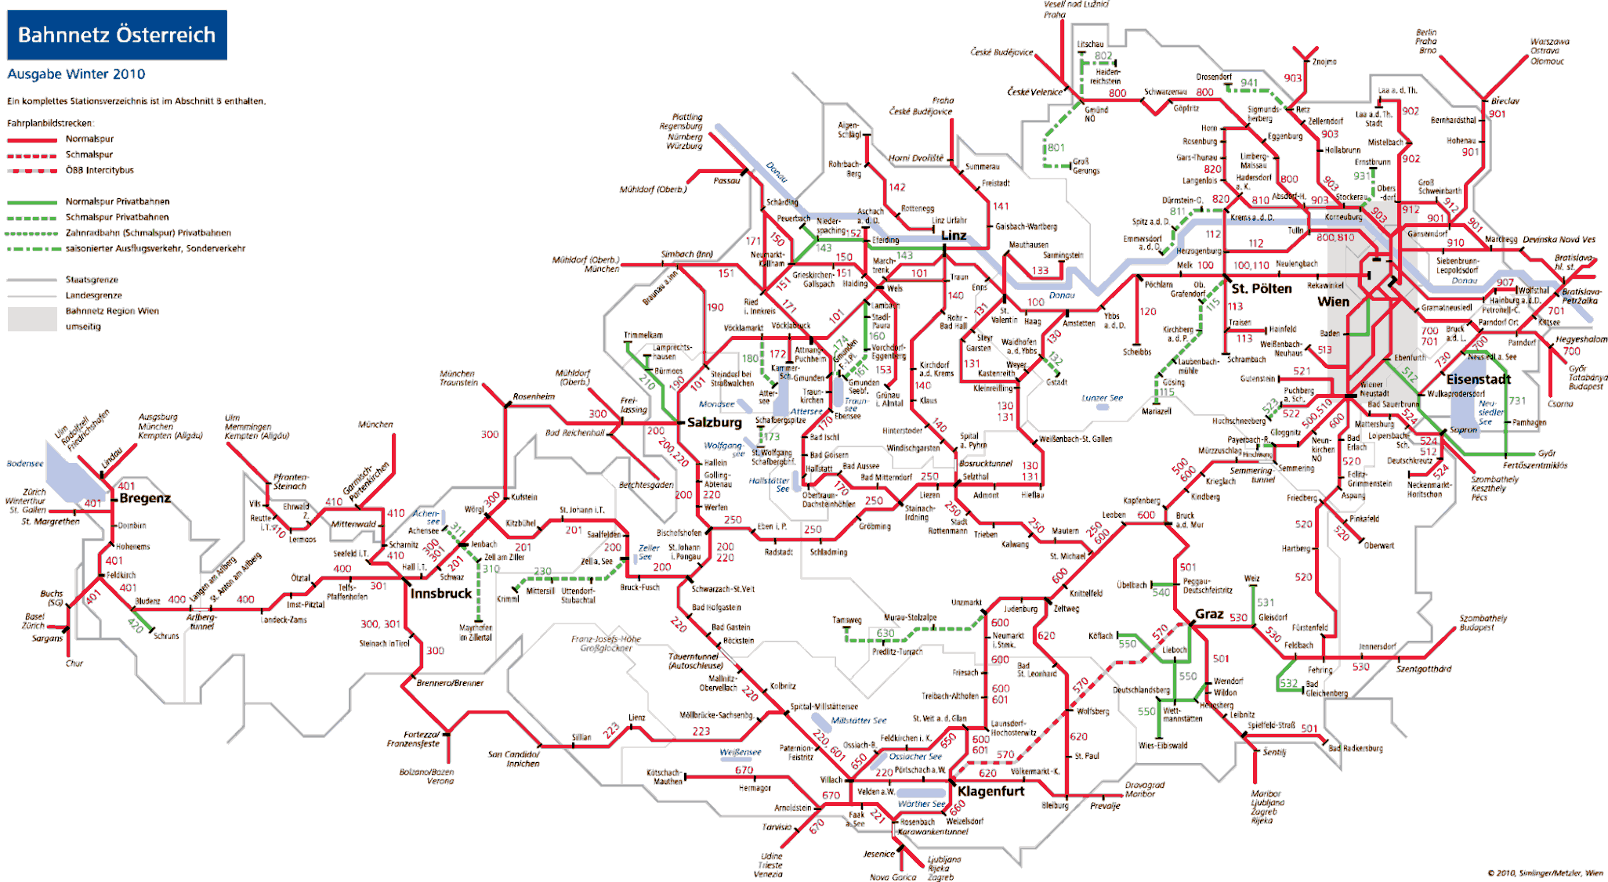
  - Network map

—— ÖBB Infrastruktur AG network
—— Other infrastructure managers’ networks
A network map for the ÖBB Infrastruktur AG network may be viewed on: http://www.oebb.at/infrastruktur/de/_p_3_0_fuer_Kunden_Partner/3_2_Schienennutzung/3_3_Schieneninfrastruktur/3_3_6_Karten/02_DMS_Dateien/Infrastrukturnetzuebersichtskarte.jsp
Bahnnetz Österreich | Austria's railway network
Ausgabe Winter 2010 | 2010 winter edition
Ein komplettes Stationsverzeichnis ist im Abschnitt B enthatten | A complete list of stations is contained in Section B
Fahrplanbildstrecken: | Map legend:
Normalspur | Standard gauge
Schmalapur | Narrow gauge
ÖBB Intercitybus | ÖBB Intercitybus
Normalspur Privatbahnen | Standard gauge private railways
Schmalspur Privatbahnen | Narrow gauge private railways
Zahnradbahn (Schmalspur) Privatbahnen | Cog railway (narrow gauge) private railways
saisonierter Ausflugsverkehr, Sonderverkehr | Seasonal excursion traffic, special traffic
Staatsgrenze | National border
Landesgrenze | Province border
Bahnnetz Region Wien | Railway network of the Vienna Region
umseitig | overleaf
  - List of railway organisations and infrastructure managers
    - Infrastructure managers with safety authorisations in accordance with Section 38 EisbG (infrastructure managers on main lines and the secondary lines connected to them as of 31 December 2016)
Name | Address | Website | Link to network statements [in German]
Aktiengesellschaft der Wiener Lokalbahnen | Eichenstraße 1  1120 Vienna | www.wlb.at | www.wlb.at/eportal/ep/channelView.do/pageTypeId/11128/channelId/-22413
Cargo-Center-Graz Betriebsgesellschft m.b.H. & Co KG | Terminal 1  8402 Werndorf | www.cargo-center-graz.at | www.stlb.at/terminal-graz-sued/
Graz-Köflacher Bahn und Busbetrieb GmbH | Köflacher Gasse 35-41  8020 Graz | www.gkb.at | www.gkb.at/index.php/infrastruktur-zugang
Land Steiermark/Steiermärkische Landesbahnen | Eggenberger Str. 20  8020 Graz | www.stlb.at | www.stlb.at/impressum-snnb/schienennetz- nutzungsbedingungen
Lokalbahn Lambach- Vorchdorf- Eggenberg AG (Betriebsführung: Stern & Hafferl Verkehrsgesellschaft mbH) | Kuferzeile 32  4810 Gmunden | www.stern-verkehr.at | www.lb-lve.at/index.php/infrastruktur
Linzer Lokalbahn AG  (managed by: Stern & Hafferl Verkehrsgesellschaft mbH) | Rathaus  4041 Linz | www.stern-verkehr.at | www.linzer-lokalbahn.at/index.php/infrastruktur
Montafonerbahn Aktiengesellschaft | Bahnhofstraße 15 a+b  6780 Schruns | www.montafonerbahn.at | www.montafonerbahn.at/verkehr/start.htm
Neusiedler Seebahn Gesellschaft mbH  (managed by: Raab-Oedenburg-Ebenfurter Eisenbahn AG) | Bahnhofplatz 5  7041 Wulkaprodersdorf | www.neusiedlerseebahn.at | www.neusiedlerseebahn.at/de/netzzugang/network-statement
ÖBB-Infrastruktur Aktiengesellschaft | Praterstern 3  1020 Vienna | www.oebb.at/infrastruktur | www.oebb.at/infrastruktur/de/_p_3_0_fuer_Kunden_Partner/3_2_Schieneninfrastruktur/3_2_2_Karten/index.jsp
Raab-Oedenburg-Ebenfurter Eisenbahn AG (Raaberbahn AG) | Bahnhofplatz 5  7041 Wulkaprodersdorf | www.raaberbahn.at | www.raaberbahn.at/schienennetznutzung.html
Salzburg AG für Energie, Verkehr und Telekommunikation | Plainstraße 70  5020 Salzburg | www.salzburg-ag.at | www.salzburg-ag.at/agb-schlichtungsstellen/
Stern & Hafferl Verkehrsgesellschaft mbH)  (as operating railway undertaking) | Kuferzeile 32  4810 Gmunden | www.stern-verkehr.at
    - Railway undertakings with a safety certificate part B in accordance with Section 37 EisbG (as of 31 December 2016)
Name | Address | Website
Aktiengesellschaft der Wiener Lokalbahnen | Eichenstraße 1, 1120 Wien | www.wlb.at
Bayerische Oberlandbahn GmbH | Bahnhofplatz 9, DE-83607 Holzkirchen | www.bayerischeoberlandbahn.de/
Cargo Service GmbH | Lunzer Straße 41, 4031 Linz | www.cargoserv.at
City Air Terminal Betriebsg.m.b.H. | Office Park, 1300 Wien Flughafen | www.cityairporttrain.com
DB Cargo Aktiengesellschaft | Rheinstraße 2, DE-55116 Mainz | www.dbcargo.com
DB Fernverkehr Aktiengesellschaft | Stephensonstraße 1, DE-60326 Frankfurt am Main | www.deutschebahn.com
DB Regio Aktiengesellschaft | Stephensonstraße 1, DE-60326 Frankfurt am Main | www.deutschebahn.com
ecco-rail GmbH | Haizingergasse 47/3, 1180 Wien | www.ecco-rail.at
ERS Railways B.V. | Waalhaven Zuidzijde 2, NL-3088 HH Rotterdam | www.ersrail.com
FLOYD Szolgáltató Zártkörűen Működő Részvénytársaság (FLOYD ZRt.) | Madarász Viktor u. 47-49, HU-1138 Budapest, | www.floyd.hu
FoxRail Zrt. | Árpád út 56, HU-1042 Budapest | www.foxrail.hu
Franz Plasser Dienstleistungsgesellschaft m.b.H. | Johannesgasse 3, 1010 Wien | www.plassertheurer.com
GEVD Gesellschaft für Eisenbahnverkehrsdienstleistungen mbH | Brunner Straße 33, 2700 Wiener Neustadt
Grampetcargo Austria GmbH | Ignaz-Köck-Straße 10 Top 4111, 1210 Wien | www.grampetcargo.at
Graz-Köflacher Bahn und Busbetrieb GmbH | Köflacher Gasse 35 – 41, 8020 Graz | www.gkb.at
Lokomotion- Gesellschaft für Schienentraktion mbH | Kastenbauerstraße 2, DE-81677 München | www.lokomotion-rail.de
LTE-Logistik- und Transport GmbH | Karlauer Gürtel 1, 8020 Graz | www.lte.at
METRANS Railprofi Austria GmbH | Karl Mierka Staße 7-9, 3500 Krems | www.railprofi.at
MEV Independent Railway Services GmbH | Hütteldorfer Straße 343-345, 1140 Wien | www.m-e-v.at
MMV Magyar Magánvasút Zártkörűen Működő Részvénytársaság MMV ZRt. | Kerék utca 80, HU-1035 Budapest | www.mmv.hu
Montafonerbahn AG | Bahnhofstraße 15 a+b, 6780 Schruns | www.montafonerbahn.at
ÖBB Personenverkehr AG | Am Hauptbahnhof 2, 1100 Wien | www.oebb.at/pv
ÖBB Produktion GmbH | Am Hauptbahnhof 2, 1100 Wien | produktion.oebb.at
ÖBB Technische Services GmbH | Grillgasse 48, 1110 Wien | www.oebb.at/ts
PKP CARGO SPÓŁKA AKCYJNA | ul. Grojecka 17, PL-02-021 Warszawa | www.pkp-cargo.pl
Raab-Oedenburg-Ebenfurter Eisenbahn AG) | Bahnhofplatz 5, 7041 Wulkaprodersdorf | www.raaberbahn.at
Raaberbahn Cargo GmbH | Bahnhofplatz 5, 7041 Wulkaprodersdorf | www.raaberbahncargo.at
Rail Cargo Austria AG | Am Hauptbahnhof 2, 1100 Wien | www.railcargo.com
Rhomberg Bahntechnik GmbH | Mariahilferstraße 29, 6900 Bregenz | www.rhombergrail.com
RTS Rail Transport Service GmbH | Puchstraße 184 b, 8055 Graz | www.rts-austria.at
Safety4you Baustellenlogistik GmbH | Bahnhofplatz 1, 4600 Wels | www.s4you.at
Salzburg AG für Energie, Verkehr und Telekommunikation | Plainstraße 70, 5020 Salzburg | www.salzburg-ag.at
Steiermarkbahn Transport und Logistik GmbH | Eggenberger Str. 20, 8020 Graz | www.steiermarkbahn.at
Stern & Hafferl Verkehrsgesellschaft mbH) | Kuferzeile 32, 4810 Gmunden | www.stern-verkehr.at
SŽ Tovorni promet d.o.o. | Kolodvorska 11, SI-1000 Ljubljana | www.slo-zeleznice.si/en/freight/
Transalpin Eisenbahn AG | Steinengraben 42, CH-4051 Basel
Trenitalia S.p.A. | Piazza della Croce Rossa 1, IT-00161 Roma | www.trenitalia.com
TX Logistik Austria GmbH | Am Concorde-Park E/13, 2320 Schwechat | www.txlogistik.eu
Walser Eisenbahn GmbH | Hütteldorfer Straße 37/20, 1080 Wien | www.walsereisenbahn.at
WESTbahn Management GmbH | Europaplatz 3/Stiege 5, 1150 Wien | www.westbahn.at
Wiener Lokalbahnen Cargo GmbH | Freudenauer Hafenstraße 8-10, 1020 Wien | www.wlb-cargo.at

- Organisation chart
  - Organisation chart for the national safety authority, the Federal Ministry of Transport, Innovation and Technology
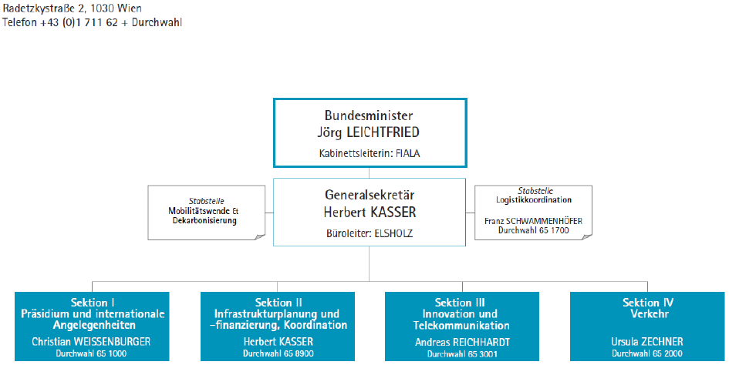
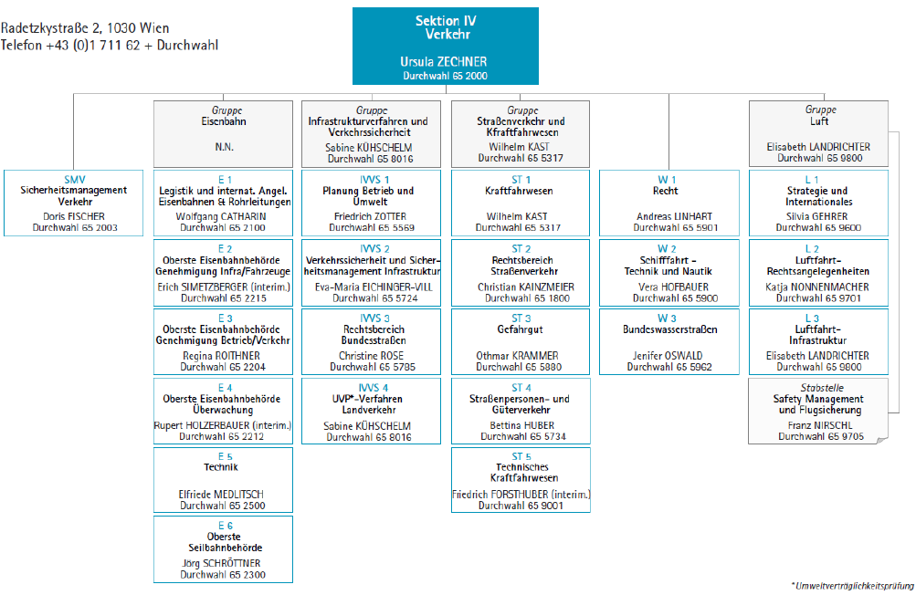
(as of 11 September 2017, Source: bmvit website)
Radetzkystraße 2, 1030 Wien | Radetzkystraße 2, 1030 Wien
Telefon +43 (0)1 711 62 + Durchwahl | Phone +43 (0)1 711 62 + extension
Bundesminister | Federal Minister
Jörg LEICHTFRIED | Jörg LEICHTFRIED
Kabinettsleiterin: FIALA | Head of cabinet: FIALA
Stabstelle | Staff unit
Mobilitätswende & Dekarbonisierung | Mobility change & decarbonisation (Mobilitätswende & Dekarbonisierung)
Generalsekretär | General Secretary
Herbert KASSER | Herbert KASSER
Büroleiter: ELSHOLZ | Office Manager ELSHOLZ
Stabstelle | Staff unit
Logistikkoordination | Logistics coordination
Franz SCHWAMMENHÖFER | Franz SCHWAMMENHÖFER
Durchwahl 65 1700 | Extension 65 1700
Sektion I | Department I
Präsidium und internationale Angelegenheiten | Steering committee and international affairs
Christian WEISSENBURGER | Christian WEISSENBURGER
Durchwahl 65 1000 | Extension 65 1000
Sektion II | Department II
Infrastrukturplanung und -finanzierung. Koordination | Infrastructure planning and financing Coordination
Herbert KASSER | Herbert KASSER
Durchwahl 65 8900 | Extension 65 8900
Sektion III | Department III
Innovation und Telekommunikation | Innovation and telecommunications
Andreas REICHHARDT | Andreas REICHHARDT
Durchwahl 65 3001 | Extension 65 3001
Sektion VI | Department VI
Verkehr | Transport
Ursula ZECHNER | Ursula ZECHNER
Durchwahl 65 2000 | Extension 65 2000
SMV | SMV
Sicherheitsmanagement Verkehr | Traffic safety management
Doris FISCHER | Doris FISCHER
Durchwahl 65 2003 | Extension 65 2003
Gruppe | Group
Eisenbahn | Railway
N.N. | Vacancy
E 1 | E 1
Legistik und internat. Angel. Eisenbahnen & Rohrleitungen | Logistics and international Angel. Railways & pipelines
Wolfgang CATHARIN | Wolfgang CATHARIN
Durchwahl 65 2100 | Extension 65 2100
E 2 | E 2
Oberste Eisenbahnbehörde Genehmigung Infra/Fahrzeuge | Supreme Rail Authority Permits Infra/vehicles
Erich SIMETZBERGER (interim.) | Erich SIMETZBERGER (interim)
Durchwahl 65 2215 | Extension 65 2215
E 3 | E 3
Oberste Eisenbahnbehörde Genehmigung Betrieb/Verkehr | Supreme Railway Authority Permits Operations/Traffic
Regina ROITHNER | Regina ROITHNER
Durchwahl 65 2204 | Extension 65 2204
E 4 | E 4
Oberste Eisenbahnbehörde Überwachung | Supreme Railway Authority Supervision
Rupert HOLZERBAUER (interim.) | Rupert HOLZERBAUER (interim)
Durchwahl 65 2212 | Extension 65 2212
E 5 | E 5
Technik | Technical
Elfriede MEDLITSCH | Elfriede MEDLITSCH
Durchwahl 65 2500 | Extension 65 2500
E 6 | E 6
Oberste Seilbahnbehörde | Supreme cableway authority
Jörg SCHRÖTTNER | Jörg SCHRÖTTNER
Durchwahl 65 2300 | Extension 65 2300
Gruppe | Group
Infrastrukturverfahren und Verkehrssicherheit | Infrastructure procedure and traffic safety
Sabine KÜHSCHELM | Sabine KÜHSCHELM
Durchwahl 65 8016 | Extension 65 8016
IVVS 1 | IVVS 1
Planung Betrieb und Umwelt | Planning operations and environment
Friedrich ZOTTER | Friedrich ZOTTER
Durchwahl 65 5569 | Extension 65 5569
IVVS 2 | IVVS 2
Verkehrssicherheit und Sicherheitsmanagement Infrastruktur | Transport safety and safety management, infrastructure
Eva-Maria EICHINGER-VILL | Eva-Maria EICHINGER-VILL
Durchwahl 65 5724 | Extension 65 5724
IVVS 3 | IVVS 3
Rechtsbereich Bundesstraßen | Legal area – Federal roads
Christine ROSE | Christine ROSE
Durchwahl 65 5785 | Extension 65 5785
IVVS 4 | IVVS 4
UVP*-Verfahren Landverkehr | EIA* procedures Land transport
Sabine KÜHSCHELM | Sabine KÜHSCHELM
Durchwahl 65 8016 | Extension 65 8016
Gruppe | Group
Straßenverkehr und Kraftfahrwesen | Road transport and road vehicles
Wilhelm KAST | Wilhelm KAST
Durchwahl 65 5317 | Extension 65 5317
ST 1 | ST 1
Kraftfahrwesen | Road vehicles
Wilhelm KAST | Wilhelm KAST
Durchwahl 65 5317 | Extension 65 5317
ST 2 | ST 2
Rechtsbereich Straßenverkehr | Legal area – road traffic
Christian KAINZMEIER | Christian KAINZMEIER
Durchwahl 65 1800 | Extension 65 1800
ST 3 | ST 3
Gefahrgut | Dangerous goods
Othmar KRAMMER | Othmar KRAMMER
Durchwahl 65 5880 | Extension 65 5880
ST 4 | ST 4
Straßenpersonen- und Güterverkehr | Passenger and freight traffic by road
Bettina HUBER | Bettina HUBER
Durchwahl 65 5734 | Extension 65 5734
ST 5 | ST 5
Technisches Kraftfahrwesen | Technical automotive engineering
Friedrich FORSTHUBER (interim.) | Friedrich FORSTHUBER (interim)
Durchwahl 65 9001 | Extension 65 9001
W 1 | W 1
Recht | Law
Andreas LINHART | Andreas LINHART
Durchwahl 65 5901 | Extension 65 5901
W 2 | W 2
Schifffahrt – Technik und Nautik | Shipping, technology and navigation
Vera HOFBAUER | Vera HOFBAUER
Durchwahl 65 5900 | Extension 65 5900
W 3 | W 3
Bundeswasserstraßen | Federal inland waterways
Jenifer OSWALD | Jenifer OSWALD
Durchwahl 65 5962 | Extension 65 5962
Gruppe | Group
Luft | Air
Elisabeth LANDRICHTER | Elisabeth LANDRICHTER
Durchwahl 65 9800 | Extension 65 9800
L 1 | L 1
Strategie und Internationales | Strategy and International
Silvia GEHRER | Silvia GEHRER
Durchwahl 65 9600 | Extension 65 9600
L 2 | L 2
Luftfahrt- Rechtsangelegenheiten | Aviation legal affairs
Katja NONNENMACHER | Katja NONNENMACHER
Durchwahl 65 9701 | Extension 65 9701
L 3 | L 3
Luftfahrt- Infrastruktur | Aviation infrastructure
Elisabeth LANDRICHTER | Elisabeth LANDRICHTER
Durchwahl 65 9800 | Extension 65 9800
Stabstelle | Staff unit
Safety Management und Flugsicherung | Safety Management and Flight Safety Unit
Franz NIRSCHL | Franz NIRSCHL
Durchwahl 65 9705 | Extension 65 9705
*Umweltverträglichkeitsprüfung | *environmental impact assessment
Extract from the organisation (with particular reference to the ‘Railway Safety Directive’):

Department IV – Transport

Authorities, Technical and legal area Rail/Road/Cableways/Pipelines and Water and Air Affairs

SMV Department – Safety Management Transport [Sicherheitsmanagement Verkehr]

Coordination and strategic management of safety-critical tasks of all Austrian road safety authorities within bmvit; Standardisation and quality management (including the monitoring the implementation) with regard to compliance by road safety authorities; processing of administrative files assigned to bmvit according to the Act on the Transport of Dangerous Goods [Gefahrgutbeförderungsgesetz] (GGBG)]; verification of financial capacity of transport companies during the authorisation procedure and supervisory activity; affairs of the traffic safety advisory council according to Section 25 of the Accident Investigation Act 2005, including management, risk and crisis management.

Section E 1 - Parliamentary drafting, EU & international affairs, railways and pipelines

Participation in the creation and implementation of Union law and of bilateral agreements in the area of railways and pipelines, including the representation of such matters within EU bodies and other bi- and multilateral bodies; national law-making in the railways and pipelines area (development, preparation and management of acts of law and regulations in cooperation with specialised departments) including notification; coordination of basic legal matters such as the regulation of the railway market; contributing to the representation in international technical working groups with Department E 5; implementation of Pipeline Act [Rohrleitungsgesetz].

Department E 2 – Supreme Railway Authority Permissions for Infrastructure and Vehicles

Exercising railway authority powers, in particular implementing regulations on construction approval, type approval including approval for operation of railway facilities (except for EIA procedures), including the protection, reconstruction and closing down of level crossings; lineside property regulations, non-applicability of TSI, expropriation, granting facilitation, permitting exceptions; type approval including approval for operation of vehicles; implementing the concession; closing down railways; declaring incorrect EC statements invalid; coordination and cooperation with the European Rail Authority and other (foreign) authorities in matters assigned to the department; institutional control over lower-level authorities in the department's own sphere of influence and also the SCHiG in its implementation of the EisbG.

Department E 3 – Supreme Railway Authority Permissions for Operation and Traffic

Exercising railway authority powers, in particular granting, extending, modifying and revoking traffic permits, safety certificates and safety authorisations, including the periodic control of the traffic permit. Approval of general orders to railways employees; railway staff matters (operations managers, railways supervisory body), appointing expert inspectors; approving training facilities; managing the register of technical areas within the railways; coordination and cooperation with the European Railway Authority and other (foreign) authorities in matters assigned to the department; institutional control over lower-level authorities in the department's own sphere of influence.

Department E 4 – Supreme Railway Authority Supervision

Performing ex officio railway authority duties, in particular the supervision of railway staff matters (operations managers, railway supervisory bodies), of the operation of vehicles (also in the case of foreign legislation), of matters relating to maintenance units; supervision in relation to safety permits and safety certificates; supervision of the construction and operation of facilities and level crossings; supervising general orders to railway employees; supervision strategy and supervision plans; coordination and cooperation with other (foreign) authorities in matters of supervision; institutional control over lower-level authorities in the department's own sphere of influence such as in relation to supervision of the infrastructure register; keeping contact with the federal safety research centre; reports and data analyses.

Department E 5 – Technology

General issues related to railway constructions, protection, crossings, telecommunication, electric and machine engineering; matters related to domestic and international technical standards and specifications and other regulations on technical standards; coordination, managing contents and general representation in international bodies, such as RISC, NSA (interoperability, safety and supervision) and technical working groups such as TSI including operation with the involvement of Department E 1; matters related to the ban of interoperability components; contributing to logistics, accreditations, research projects and the work of other departments managing procedures.

- CSI data – definitions applied
The CSI data evaluated relates to the operation of main lines and the secondary lines connected to them, the operation of rolling stock on such railways and traffic on such railways on Austrian sovereign territory in 2016.
  - CSI Data
    - Accident-related indicators (including the years 2012 – 2015)
Graphical presentation of accident-related indicators:
Significant accidents by type of accident:
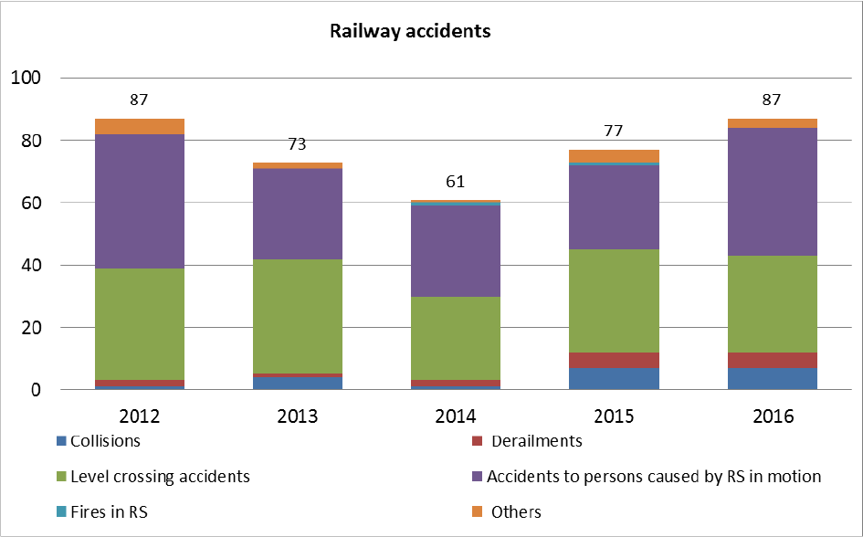
Fatalities by type of accident:
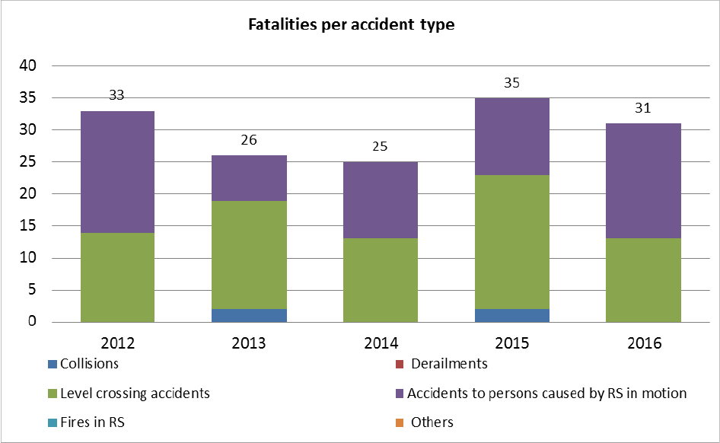

Serious injuries by type of accident:
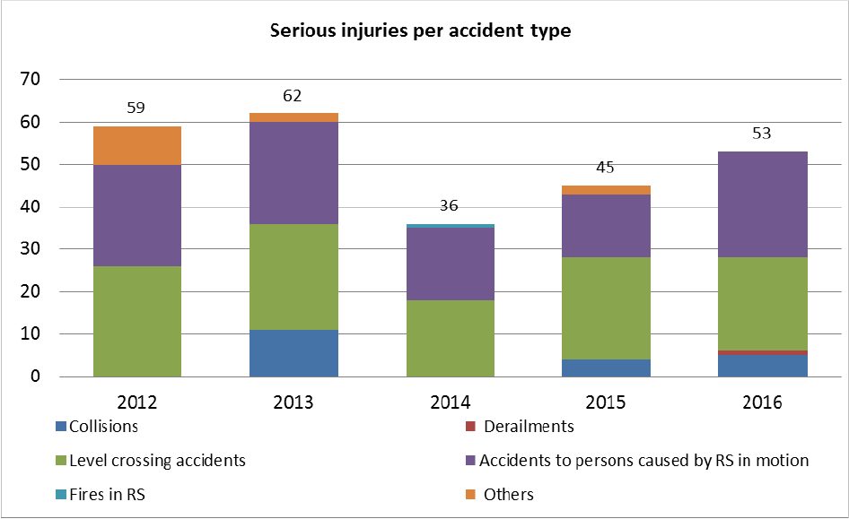

Fatalities by category of people involved:
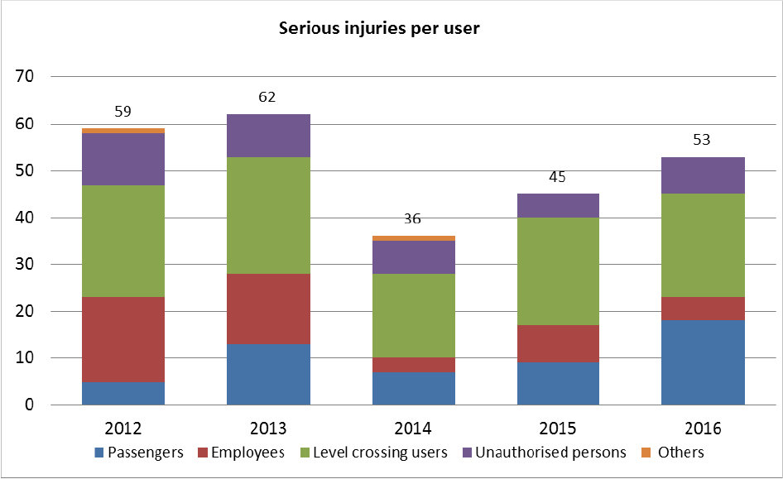

Serious injuries by category of people involved:
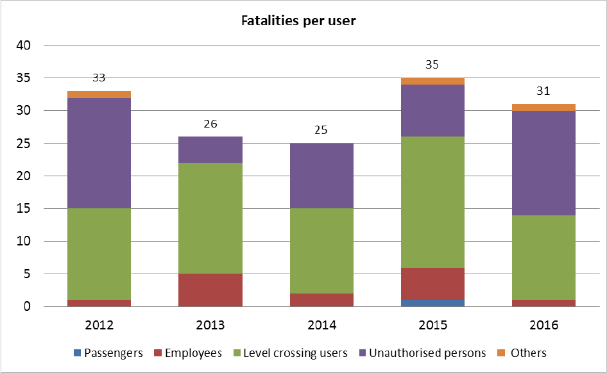

Tabular presentation of accident-related indicators:
Significant accidents by type of accident:
Year | Collisions | Derailments | Level crossing accidents | Accidents to persons caused by RS in motion | Fires in RS | Others | Total
2012 | 1 | 2 | 36 | 43 | 0 | 5 | 87
2013 | 4 | 1 | 37 | 29 | 0 | 2 | 73
2014 | 1 | 2 | 27 | 29 | 1 | 1 | 61
2015 | 7 | 5 | 33 | 27 | 1 | 4 | 77
2016 | 7 | 5 | 31 | 41 | 0 | 3 | 87
Fatalities by type of accident:
Year | Collisions | Derailments | Level crossing accidents | Accidents to persons caused by RS in motion | Fires in RS | Others | Total
2012 | 0 | 0 | 14 | 19 | 0 | 0 | 33
2013 | 2 | 0 | 17 | 7 | 0 | 0 | 26
2014 | 0 | 0 | 13 | 12 | 0 | 0 | 25
2015 | 2 | 0 | 21 | 12 | 0 | 0 | 35
2016 | 0 | 0 | 13 | 18 | 0 | 0 | 31
Serious injuries by type of accident:
Year | Collisions | Derailments | Level crossing accidents | Accidents to persons caused by RS in motion | Fires in RS | Others | Total
2012 | 0 | 0 | 26 | 24 | 0 | 9 | 59
2013 | 11 | 0 | 25 | 24 | 0 | 2 | 62
2014 | 0 | 0 | 18 | 17 | 1 | 0 | 36
2015 | 4 | 0 | 24 | 15 | 0 | 2 | 45
2016 | 5 | 1 | 22 | 25 | 0 | 0 | 53
Fatalities by category of people involved:
Year | Passengers | Employees | Level crossing users | Unauthorised persons | Others | Total
2012 | 0 | 1 | 14 | 17 | 1 | 33
2013 | 0 | 5 | 17 | 4 | 0 | 26
2014 | 0 | 2 | 13 | 10 | 0 | 25
2015 | 1 | 5 | 20 | 8 | 1 | 35
2016 | 0 | 1 | 13 | 16 | 1 | 31
Serious injuries by category of people involved:
Year | Passengers | Employees | Level crossing users | Unauthorised persons | Others | Total
2012 | 5 | 18 | 24 | 11 | 1 | 59
2013 | 13 | 15 | 25 | 9 | 0 | 62
2014 | 7 | 3 | 18 | 7 | 1 | 36
2015 | 9 | 8 | 23 | 5 | 0 | 45
2016 | 18 | 5 | 22 | 8 | 0 | 53
    - Indicators relating to dangerous goods
 | Total | Relative number (per million train km)
Accidents in which at least one rail vehicle carrying dangerous goods was involved (in accordance with the definition in the Annex to Directive 2014/88/EC) | 1 | 0.01
Number of this type of accidents in which dangerous goods are released. | 0 | 0.00
    - Indicators relating to suicides
 | Total | Relative number (per million train km)
Suicide | 99 | 0.65
Suicide attempt | 5 | 0.03
    - Indicators relating to the precursors of accidents
 | Total | Relative number (per million train km)
Broken rails | 99 | 0.65
Track buckles or other track geometry defects | 40 | 0.26
Wrong-side signalling failures | 1 | 0.01
Signal Passed at Danger reaching the danger point | 11 | 0.07
Signal Passed at Danger without reaching the danger point | 47 | 0.31
Broken wheels on vehicles in service | 0 | 0.00
Broken wheels and broken axles on a moving vehicle | 1 | 0.01
    - Indicators for the calculation of the economic impact of major accidents
 | Total | Relative amount (per million train km)
Total cost of all major accidents: | EUR 126 557 596 | EUR 825 555
Number of deaths and serious injuries multiplied by the value of preventing a casualty (VPC) | EUR 98 602 051 | EUR 643 197
Costs of damage to the environment | EUR 99 330 | EUR 648
Costs of damage to rolling stock and infrastructure | EUR 22 657 823 | EUR 147 801
Costs of delay caused by accidents | EUR 5 198 392 | EUR 33 910
    - Indicators relating to technical safety of infrastructure and its implementation
Percentage of lines operated with control-command systems (TPS) which include the following systems:
warning | 0%
warning and automatic stopping2) | 76%
warning and automatic stopping as well as speed monitoring in sections2) | 3%
Warning and automatic stopping as well as continuous speed supervision | 10%

Percentage of train kilometres using on-board TPS. These systems include the following:
warning | 0%
warning and automatic stopping2) | 35%
warning and automatic stopping as well as speed monitoring in sections2) | 48%
Warning and automatic stopping as well as continuous speed supervision | 13%

 | Total | Number per route kilometre | Number per track kilometre
Total number of level crossings by type: | 4086 | 0.788 | 0.555
active level crossing | 1877 | 0.362 | 0.255
manual | 145 | 0.028 | 0.020
automatic with user-side warning | 850 | 0.164 | 0.115
automatic with user-side protection | 882 | 0.170 | 0.120
with rail-side protection | 0 | 0.000 | 0.000
passive level crossing | 2209 | 0.426 | 0.300

Common safety indicators (CSI) from 2006 can also be found in the
ERAIL (European Railway Accident Information Links) database maintained by the European Railway Agency.
Website: http://erail.era.europa.eu/safety-indicators.aspx
The common safety indicators of European Union Member States are published on that site.

  - Definitions used in the annual report
    - Definitions to be adopted
The common definitions for the common safety indicators laid down in Directive 2014/88/EU of 9 July 2014 amending Directive 2004/49/EC have to be used with effect from 2015.
Further details on the various common safety indicators are provided in the guide entitled 'Implementation Guidance for CSIs', and produced by the European Railway Agency.
Website: www.era.europa.eu/Document-Register/Pages/Implementation_Guidance_for_use_of_Common_Safety_Indicators.aspx
    - National definitions
Further national definitions which have a particular relevance to the application of the Railway Safety Directive are set out below:
Main lines, secondary lines
In accordance with Section 4 Railways Act 1957, BGBl. No 60/1957, as amended:
Section 4 (1) Main lines are specific railway lines of greater traffic importance open for public traffic. Amongst them are those railway lines
1. which have been declared to be high capacity lines in accordance with Section 1 of the High Capacity Line Act (Hochleistungsstreckengesetz), BGBl. No 135/1989 as amended;
2. which the Federal Minister of Transport, Innovation and Technology has declared by means of a regulation to be main lines because a particular importance is attributed to them for high performance traffic or because they should be upgraded for such traffic – in particular for international services or for regional traffic.
(2) Secondary lines are railway lines open for public traffic provided they are not main lines or tramways.
Connected main and secondary lines
In accordance with Section 1a Railways Act 1957, BGBl. No 60/1957, as amended:
Main and secondary lines are connected if an exchange of vehicles can just take place over a local connection without a change of gauge and without technical aids (transporter wagon, for example). Main and secondary lines are also considered as connected if they are connected across a frontier with another railway of the same type in a neighbouring state.
High capacity lines
in accordance with the High Capacity Line Act, BGBl. No 135/1989, as amended:
Section 1 (1) The Federal Government may declare existing or planned railways (sections of lines or parts of sections of lines including the installations necessary) to be high capacity lines by regulation (High Capacity Line Regulation (Hochleistungsstreckenverordnung)). A precondition for this is that the line is considered to have a special importance for high performance with international connections or for local traffic.
(2) Existing or planned railways may also be declared to be parts of high capacity lines if the characteristics in paragraph 1 do not apply to them but they have a direct relationship with high capacity lines and are required for rational railway operation or rail traffic on high capacity lines.
Infrastructure manager
In accordance with Section 1a Railways Act 1957, BGBl. No 60/1957, as amended:
Section 1a. An infrastructure manager is a railway organisation which covers the construction and operation of main line and secondary railways excluding those secondary railways which are not connected to main lines or other secondary lines and is authorised to make them available.
Railway undertaking
In accordance with Section 1b Railways Act 1957, BGBl. No 60/1957, as amended:
Section 1b. A railway undertaking is a railway organisation which provides rail traffic services on main line or connected secondary line rail infrastructure and provides the traction, this also includes those which only provide traction, and to which a traffic authorisation, a traffic concession or an authorisation or approval which is equivalent to a traffic approval in accordance with Section 41 has been granted.
  - Abbreviations
BGBl | Federal Gazette [Bundesgesetzblatt]
Bf | Station
bmvit | Federal Ministry of Transport, Innovation and Technology [Bundesministerium für Verkehr, Innovation und Technologie]
CSI | Common Safety Indicators
CSM | Common Safety Methods
DV | Service regulations
EisbBBV | Railway Construction and Operation Regulations [Eisenbahnbau- und -betriebsverordnung]
EisbG | Railways Act 1957 [Eisenbahngesetz 1957]
EisbKrV | Railway Crossings Act [Eisenbahn-Kreuzungsverordnung 2012]
EIU | European Rail Infrastructure Manager
LC | Level Crossing
EUAR (ERA) | European Union Agency for Railways
ERAIL | European Railway Accident Information Links
EU | European Union
EVU | Railway undertaking [Eisenbahnverkehrsunternehmen]
Hz | Herz
IM | Infrastructure Manager  (Fahrwegbetreiber)
km | kilometre
MeldeVO | Rail Accident Reporting Regulation 2006 [Meldeverordnung Eisenbahn – Eisb 2006]
NSA | National Safety Authority
ÖBB | Austrian Federal Railways [Österreichische Bundesbahnen]
PKW | Passenger cars
PZB | Intermittent automatic train control [Punktförmige Zugbeeinflussung]
RIC | Agreement on the exchange and use of freight cars between rail transport companies
RU | Railway Undertaking
StVO | Road traffic regulations
SUB | Federal Safety Investigation Authority [Sicherheitsuntersuchungsstelle des Bundes]
VO | Regulation
ZSB | Additional provisions for signalling and operation regulations of the IM
- The development of safety certification and authorisation – numerical data
  - Safety certificates in accordance with Directive 2004/49/EC
 | Number of certificates
D.1.1. Number of valid safety certificates Part A issued in the reporting year and previous years | 28

 |  | Number of certificates
D.1.2. Number of safety certificates Part B issued in the reporting year and previous years that remain valid | Number of certificates Part B where Part A was issued in the given member state | 28
 | Number of certificates Part B where Part A was issued in another member state | 13

 |  | A | R | P
D.1.3. Number of new applications for safety certificates Part A submitted by railway undertakings in 2016 | New certificates | - | - | 1
 | Updated/amended certificates | - | - | -
 | Renewed certificates | 3 | - | -

 |  |  | A | R | P
D.1.4. Number of new applications for safety certificates part B submitted by railway undertakings in 2016 | Where the part A has been issued in your Member State | New certificates | - | - | 1
 | Where the part A has been issued in your Member State | Updated/amended certificates | - | - | -
 | Where the part A has been issued in your Member State | Renewed certificates | 3 | - | -
 | Where the part A has been issued in another Member State | New certificates | 1 | - | -
 | Where the part A has been issued in another Member State | Updated/amended certificates | - | - | -
 | Where the part A has been issued in another Member State | Renewed certificates | 2 | - | -

A = accepted: application accepted; certificate has already been issued
R = rejected: application rejected; no certificate has been issued
P = pending: case is still pending; no certificate has been issued in the reporting year
 | Number of certificates
D.1.5 Number of certificates Part A revoked in the reporting year | -
D.1.6 Number of certificates Part B revoked in the reporting year | -
    - List of states from which railway undertakings applying for a safety certificate part B in your Member State have obtained their safety certificate part A:
- Germany
- Italy
- Netherlands
- Poland
- Switzerland
- Slovenia
- Czech Republic
- Hungary
  - Safety authorisations in accordance with Directive 2004/49/EC
 | Number of authorisations
D.2.1. Number of valid safety authorisations issued to infrastructure managers in the reporting year and previous years | 9

 |  | A | R | P
D.2.2. Number of applications for safety authorisations submitted by infrastructure managers in 2016 | New authorisations | - | - | -
 | Updated/amended authorisations | - | - | -
 | Renewed authorisations | 2 | - | -

A = accepted: application accepted; authorisation has already been issued
R = rejected: application rejected; no authorisation has been issued
P = pending: case is still pending; no authorisation has been issued in the reporting year

D.2.3 Number of safety authorisations revoked in the reporting year | -

1) Safety recommendations which the Safety Investigation Authority (SUB) had made at the time the report went to press are shown, they do not yet represent commitments to take action on safety measures, however.
2) clear attribution to ‘warning and automatic stopping‘ or ‘warning and automatic stopping as well as section-by-section speed supervision’ is not available from all managers

