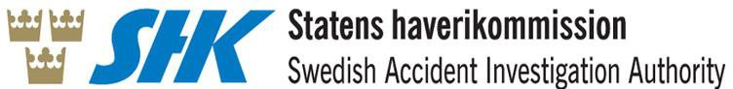

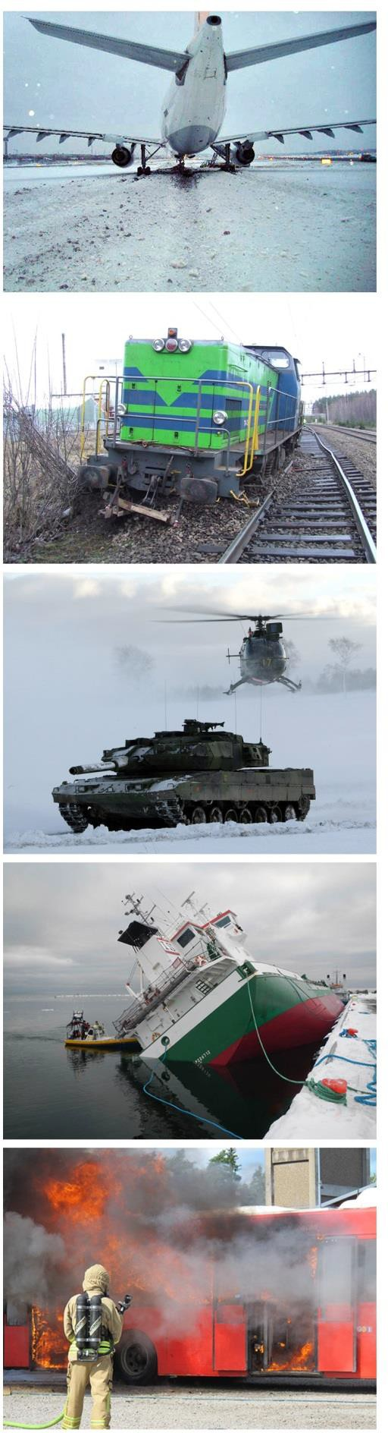NIB Annual Report 2016

Swedish Accident Investigation Authority

Ref. No A-125/17

15 September 2017

The Swedish Accident Investigation Authority (SHK) investigates accidents and incidents from a safety perspective. The purpose of the investigations is for similar incidents to be avoided in the future. SHK investigations do not, however, aim to assign liability or guilt or debt, whether criminal, civil or administrative.

This report is also available on the SHK website: [www.havkom.se](http://www.havkom.se/)

ISSN 1400-5743

Illustrations in SHK reports are protected by copyright. The SHK is the copyright holder, unless otherwise indicated.

With the exception of the SHK logo, and figures, images, and maps for which the copyright is held by a third party, the report is provided under the Creative Commons Attribution 2.5 Sweden. This means that it may be copied, disseminated, and edited, provided that the SHK is indicated as the copyright holder. For example, when using material from this document, indicate ʻSource: Swedish Accident Investigation Authority'.



In connection with figures, images, maps, or other material in the report for which a third party copyright holder is indicated, permission of the copyright holder is required for use of the material.

Third image on cover – Photo: Anders Sjödén/Swedish Armed Forces.

|  |  |  |  |  |  |
| --- | --- | --- | --- | --- | --- |
| *Postal address* | *Visitors* | *Telephone* | *Fax* | *Email* | *Website* |
| P.O. Box 6014 | Sveavägen 151 | +46 8 508 862 00 | +46 8 508 862 90 | [info@havkom.se](mailto:info@havkom.se) | [www.havkom.se](http://www.havkom.se/) |
| SE-102 31 Stockholm | Stockholm |  |  |  |  |
| Sweden |  |  |  |  |  |

**Contents**

1. INTRODUCTION 4

1.1 Legislation 4

1.2 Role and tasks 4

1.3 Organisation 5

2. INVESTIGATIONS 6

2.1 Investigations completed in 2016 6

2.2 Investigations completed in 2016 6

2.2.1 Investigations completed in 2016 6

2.3 Investigations launched in 2016 but not completed in 2016 6

2.4 Summaries of investigations completed in 2016 7

2.4.1 Final report RJ 2016:01 – Accident involving a person in part of the station at Pölsebo, Västra Götaland County, on 5 September 2015 7

2.5 Accidents and incidents investigated in the last five years 9

3. RECOMMENDATIONS 2016 10

# INTRODUCTION

## Legislation

The Swedish Accident Investigation Authority [Statens haverikommission, SHK] has independent status. Its activities are regulated, inter alia, by the Accident Investigation Act (1990:712), the Accident Investigations Ordinance (1990:717), and the Ordinance (2007:860) laying down instructions for the SHK.

Through these regulations, the Railway Safety Directive (Directive (EU) 2016/798) has been transposed into Swedish law.

## Role and tasks

The Swedish Accident Investigation Authority (SHK) investigates trackbound traffic accidents if they were caused by collisions between rail vehicles, derailments, or other incidents of significance to safety that resulted in at least one fatality or at least five serious injuries or which resulted in extensive damage to rail vehicles, track systems, property which was not being transported by the rail vehicle, or to the environment, and where the total costs of such damage are estimated at an amount equal to at least EUR 2 million.

An incident must be investigated if:

* + it involved a serious risk of an accident;
  + it suggests serious faults in rail vehicles or track systems, etc.; or
  + it suggests other significant shortcomings with regard to safety.

A coordinator from concerned supervisory bodies normally follows the investigation.

The purpose of an SHK investigation is to:

* + clarify, insofar as possible, the course of events and cause(s), as well as damages and other consequences;
  + provide a basis for decisions on measures to prevent a similar
  + incident from occurring, or to limit the impact of a similar incident;
  + provide a basis for an assessment of the emergency services' actions in connection with the incident and, if necessary, for improvements to the emergency services.

At the end of the fact-finding phase, the SHK convenes an incident meeting at which all the facts are presented. All parties affected by the incident are invited to participate in the meeting. Representatives from interest groups and labour unions are also usually invited.

Where necessary, the SHK must make safety recommendations to the respective supervisory body or safety authority or to other authorities or bodies on which to base decisions on suitable measures.

The role of the SHK does not include taking a position on matters of liability or damage claims. The investigations are aimed solely at improving safety.

## Organisation

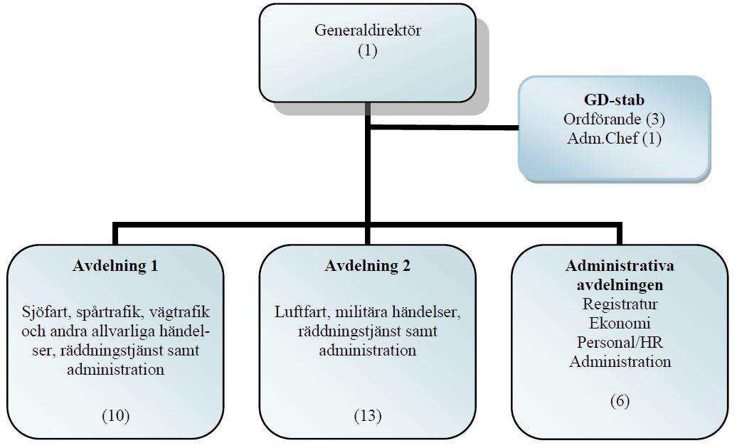

|  |  |
| --- | --- |
| Generaldirektör | Director-General |
| GD-stab | DG Secretariat |
| Ordförande | Chair |
| Adm.Chef | Head of Administration |
| Avdelning 1 | Department 1 |
| Sjöfart, spårtrafik, vägtrafik och andra allvarliga händelser, räddningstjänst samt administration | Maritime transport, rail traffic, road traffic and other serious incidents, civil protection and administration |
| Avdelning 2 | Department 2 |
| Luftfart, militära händelser, räddningstjänst samt administration | Aviation and military incidents, civil protection and administration |
| Administrativa avdelningen | Administration |
| Registratur | Registry |
| Ekonomi | Finance |
| Personal/HR | Personnel/HR |
| Administration | Administration |

Under current provisions, in an investigation the SHK must always consist of one Chair and at least one additional investigator.

Considering the wide range of incidents that may be subject to an accident investigation, the SHK must occasionally engage external experts who, using their respective expertise, work for the SHK by gathering facts and performing analyses. The SHK has contracted experts in various fields for the most common types of investigations.

# INVESTIGATIONS

## Investigations completed in 2016

|  |  |  |  |  |
| --- | --- | --- | --- | --- |
| Type of occurrence | Number of occurrences |  | | Property damage in EUR (estimate) |
| Fatalities | Seriously  injured |
| Accident | 1 | 0 | 1 | 0 |
| Incident |  |  |  |  |

## Investigations completed in 2016

Grounds for investigation:

1. In accordance with the Railway Safety Directive;
2. In accordance with national legislation (possible areas exempted in Article 2(2));
3. Voluntary investigations – other criteria (national laws not referenced in the Railway Safety Directive).

### Investigations completed in 2016

|  |  |  |  |
| --- | --- | --- | --- |
| **Date of occurrence** | **Title of investigation** | **Legal grounds** | **Completed** |
| 5 September 2015 | Accident involving a person at Pölsebo station, Västra Götaland County. | i | 31 May 2016 |

## Investigations launched in 2016 but not completed in 2016

|  |  |  |
| --- | --- | --- |
| **Event date** | **Title of investigation** | **Legal grounds** |
| 25 May 2016 | Two railway technicians hit at Markaryd, Kronoberg County. | i |
| 7 June 2016 | Near-miss between a train and shunting rolling stock at Västerås, Västmanland County. | i |
| 21 September 2016 | Collision between train 9207 and train 6032 on the Piteå – Arnemark section, Norrbotten County. | i |
| 30 September 2016 | Collision between a train on single-line working with an auxiliary vehicle and a stationary train on the Deje – Molkom section, Värmland County. | i |
| 11 October 2016 | Collision between train 34871 and train 26890 at Fångsjöbacken station, Jämtland County. | i |

## Summaries of investigations completed in 2016

### Final report RJ 2016:01 – Accident involving a person in part of the station at Pölsebo, Västra Götaland County, on 5 September 2015

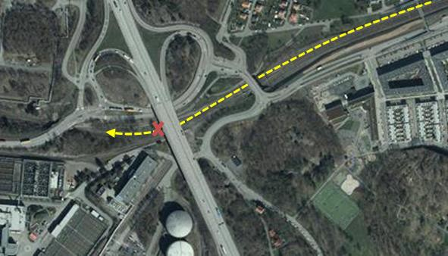

On 5 September 2015, a machine operator, who had been working on sleeper replacement and had then driven his excavator off the track, was hit by a train while on his way back to his colleagues to help with tidying up. The machine operator was seriously injured.

The working party to which the machine operator belonged had been replacing sleepers on the harbour line between Pölsebo and Skandia Harbour on the Gothenburg Harbour Line.

The working party included a supervisor who also acted as the health and safety manager, one machine operator, and two assistants. The sleeper-replacement work was carried out under work-site protection rules, which quite simply means that the track is closed to train traffic while the protection is in place.

When the sleeper-replacement work was finished for the day, the machine operator drove his excavator off the track. A short while later, the health and safety manager telephoned the machine operator and notified him that the work-site protection had been lifted, but that they needed to tidy up the work site. He asked the machine operator to join them and help, and the machine operator started to make his way back to his colleagues. Train 79012 was approaching Pölsebo at the same time.

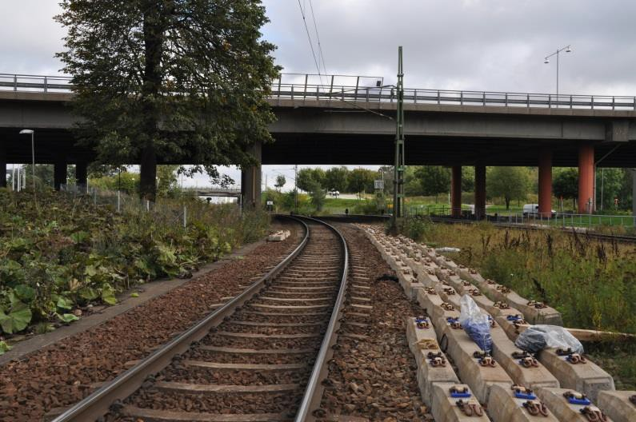

The driver of train 79012 noticed a group of people wearing high-visibility clothing standing at the left-hand side of the track. He felt that he had made eye contact with one of the people in the group and therefore did not need to give an audible signal. When the driver was near the group, a high-visibility jacket suddenly popped up into his field of vision and disappeared beneath him. Nobody in the working party noticed what happened until the collision had taken place.

It has not been possible to establish the precise reason for the machine operator having been so close to the track on which traffic was running, within the safety zone, to result in having been hit. What is known is that he was asked to the area by self-propulsion to assist with tidying up. One reason that is deemed likely is that the operator inspected the track on his way back, prior to the next day's work.

Possible contributing factors that it has been possible to identify are a relatively noisy environment at the site, which could have affected the opportunities for hearing the train, as well as the fact that the work-site protection rules under which the sleeper-replacement work had been carried out were lifted earlier than planned, so the circumstances changed from being a completely closed track to a track on which traffic was running, which could have led the machine operator to be confused by the circumstances.

An underlying factor for the risk having arisen at all was that some special safety measures for tidying up at the side of the track were not adopted. An underlying factor for this at the system level is that it is not self-explanatory from the rules and support documents in force that any safety measures need to be taken in such cases, and there is no systematic follow-up of how the rules are interpreted and applied in this respect.

## Accidents and incidents investigated in the last five years

Rail traffic investigations launched 2012-2016

|  |  |  |  |  |  |  |  |
| --- | --- | --- | --- | --- | --- | --- | --- |
| Investigations of accidents/incidents | | 2012 | 2013 | 2014 | 2015 | 2016 | Total |
| Serious accidents  (Article 19(1)-(2)) | Collision |  |  |  |  | 3 | 3 |
| Collision with an obstacle |  | 1 |  |  |  | 1 |
| Derailment | 1 |  | 1 |  |  | 2 |
| Level-crossing accident | 1 |  |  |  |  | 1 |
| Accident to person due to train movement |  |  |  | 1 | 1 | 2 |
| Fire in rolling stock |  |  |  |  |  | 0 |
| Large-scale release of dangerous goods |  |  |  |  |  | 0 |
| Fire |  |  |  |  |  | 0 |
|  | Incident | 3 |  | 3 | 0 | 1 | 7 |
| Total | | 5 | 1 | 4 | 1 | 5 | 16 |

# RECOMMENDATIONS 2016

|  |  |  |  |
| --- | --- | --- | --- |
| Date and time: | | 5 September 2015, 15:07 | |
| Location: | | Gothenburg station, Pölsebo section, Västra Götaland County. | |
| Type of occurrence: | | Accident to person | |
| Vehicle type and train number: | | Rc4 class locomotive, 1196  Train 79012 | |
|  | |  |  |
| Number on board: | | Personnel: | 1 |
| Passengers: | 0 |
| Number of fatalities: | | Personnel: | 0 |
| Passengers: | 0 |
| Number of seriously injured: | | Personnel: | 0 |
| Track workers | 1 |
| Number of slightly injured: | | Personnel: | 0 |
| Passengers: | 0 |
| Damage to rolling stock: | | None | |
| Damage to railway infrastructure: | | None | |
| Other damage: | | No | |
| Summary: please see section 2.4.1. | | | |
| Publication of final report: | | 31 May 2016 | |
| RJ 2016:01 R1 | The Swedish Transport Agency recommends, in consultation with the Swedish Work Environment Authority where required, that steps be taken to ensure that the Swedish Transport Administration and any other infrastructure managers affected carry out a review of their safety management systems to assess their effectiveness for creating safe activity in the context of work on the tracks.  Such reviews should, in particular, look at the following:   * The design of the rules, i.e. whether the rules are clear and easy to understand and apply for the people who have to use them; * The effectiveness of training in ensuring that track workers understand how the rules are expected to be applied and why; * How the current follow-up tools encapsulate the actual application of the rules in day-to-day work, i.e. whether the rules are applied as intended; | | |
|  | * Systematic feedback of experience from application, so that there is a basis for improving the rules or conditions for working safely, i.e. ensure that a functional system is implemented whereby individual workers, including those from contractors and subcontractors, report any deviations, failings and proposed improvements; * What kind of holistic perspective is applied to health and safety planning, for example how the risks associated with all the individual activities involved in a work initiative in the track environment, including preparatory work and clearing away, are dealt with. * The responsibility for health and safety management at a work site in the track environment, including the management of risks relating to entering the track area inadvertently, for example in the context of preparatory work and clearing away, i.e. it should be ensured that there is a specially designated person with overall responsibility for health and safety management, including outside the track area and safety zone, in the case of people working and otherwise being present in the track environment. | | |

1 (1)

|  |  |
| --- | --- |
| Date | Doc. No/Reference |
| 26 August 2016 | TSJ 2015-3785 |
| Your date | Your reference |
| 31 May 2016 | J-40/15 |
|  |  |
| Swedish Accident Investigation Authority | |
| Box 12538 | |
| 102 29 Stockholm | |

**Response of the Swedish Transport Agency to the safety recommendations made by the Swedish Accident Investigation Authority in consequence of the accident involving a person in part of the station at Pölsebo on 5 September 2015**

The Swedish Transport Agency has taken note of the Swedish Accident Investigation Authority's investigation report and the safety recommendation addressed to the Swedish Transport Agency. The response of the Swedish Transport Agency follows.

*The Swedish Accident Investigation Authority recommends to the Swedish Transport Agency, in consultation with the Swedish Work Environment Authority where required, that steps be taken to ensure that the Swedish Transport Administration and any other infrastructure managers affected carry out a review of their safety-management systems to assess their effectiveness for creating safe activity in the context of work on the tracks.*

The monitoring done by the Swedish Transport Agency on railway licence holders is carried out in order to check the effectiveness of the safety-management system, among other things. This work includes checking how the infrastructure managers ensure that operations on track facilities are safe.

In 2016, the Swedish Transport Agency has carried out continuous monitoring of the application of Commission Regulation (EU) No 1078/2012 on a common safety method for monitoring, in respect of the management systems at the Swedish Transport Administration, the Öresund Bridge Consortium and Inlandsbanan AB. The aim of this monitoring has been to check whether these licence holders have functional procedures in place for monitoring whether processes and procedures in the entire safety-management system are applied correctly and achieve the expected results.

|  |  |  |
| --- | --- | --- |
| **Swedish Transport Agency** | Telephone +46 (0)771-503 503 |  |
| Road and Rail Department | Fax +46 (0)243-23 66 77 | Unit: Information and systems support Section: Data collection and analysis  Eva.linmalm@transportstyrelsen.se |
| P.O. Box 267 |  |
| 781 23 Borlänge | www.transportstyrelsen.se |
| Visiting address | jarnvag@transportstyrelsen.se | +46 (0)10-495 55 05 |
| Jussi Björlings väg 19, Borlänge |  |  |

2 (2)

|  |  |
| --- | --- |
| Date | Doc. No/Reference |
| 26 August 2016 | TSJ 2015-3785 |

The Swedish Transport Agency intends to carry out further monitoring of the Swedish Transport Administration and other major infrastructure managers in 2017, and with a sharper focus on the areas specified by the Swedish Accident Investigation Authority in the safety recommendation set out in RJ 2016:01 R1.

The Swedish Transport Agency will also contact the Swedish Work Environment Authority for consultation in the areas falling within the area of the work environment and which are therefore not covered by the safety-management system but which could in practice affect traffic safety when work is carried out on or close to the track area.

This case was decided by Birgitta Hermansson, Head of Department. Claes Elgemyr, Bertil Karlsson and rapporteur Eva Linmalm participated in the final administration of the case.

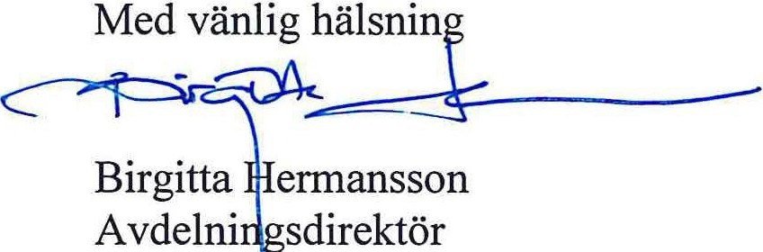

|  |  |
| --- | --- |
| Med vänlig hälsning | Yours faithfully, |
| Birgitta Hermansson | Birgitta Hermansson |
| Avdelningsdirektör | Head of Department |