Annex 1: Guidance for the technical offer
  - Development and maintenance of learning products for the EU Agency for Railways

Purpose of this annex
This annex provides background and contextual information to support tenderers in understanding the scope, objectives and context of the present call for tenders.
It explains the general expectations of the Agency regarding training activities and learning products, as well as the structure of the technical offer to be submitted.
This annex is provided for information purposes only and does not require any deliverable from tenderers.
Information contained in this annex shall not be interpreted as a request to reproduce, adapt or further develop existing training content at tender stage.
- Context
The European Union Agency for Railways develops and delivers training activities and learning materials for a wide range of stakeholders in the EU railway sector. These activities support the understanding and consistent application of the EU railway regulatory framework and related technical and organisational practices.
Training products may be delivered through different formats, including classroom training, e-learning and blended learning, and are intended for a multicultural and multilingual professional audience.
As part of the evaluation of technical offers under this call for tenders, the Agency seeks to assess the tenderers’ capacity to design, structure and adapt learning products, as well as their pedagogical and methodological approach.

Structure of the technical offer
The tenderer shall present a proposal explaining how they would adapt existing ERA materials (See section 5 “Basic Materials”) to create an improved training resource.
The technical offer shall consist of two distinct and complementary parts:
- Part 1 – Technical Offer Questionnaire (Annex 1a)
- Part 2 – Illustrative mock‑up (Annex 1b)
Each part serves a different purpose and is evaluated accordingly.

Part 1 – Technical Offer Questionnaire (Annex 1A)
The first part of the technical offer consists of a questionnaire to be completed by the tenderer.
Through this questionnaire, tenderers are requested to describe and explain:
- their pedagogical concept and approach;
- their methodology for structuring training courses and learning materials;
- their approach to adapting existing training content;
- their approach to localisation and multilingual deployment.
Responses are expected to be descriptive and analytical. No training materials, slides, storyboards or reusable content are expected under Annex 1A.

Part 2 – Illustrative mock-up (Annex 1B)
The second part of the technical offer consists of an illustrative mock-up.
The mock-up is intended solely to provide a visual illustration of the tenderer’s proposed pedagogical and design approach. It allows the Agency to better understand how the concepts described in the Annex 1A. could be translated into a concrete learning experience.
The mock-up is strictly non-functional, non-operational and non-reusable. It does not constitute a deliverable under the contract and shall not be used operationally by the Agency.
Detailed instructions and constraints applicable to the mock-up are described in Annex 1B.

Important clarification
At tender stage, the Agency is not procuring training products or learning content.
The objective of the technical offer is to assess the tenderers’ understanding, methodology and capacity to deliver the services described in the tender specifications during the execution of the contract.
Any reference to learning products, materials or deliverables in the tender documentation relates exclusively to the execution phase of the framework contract and not to the submission of the technical offer.

Basic material
The materials included in this annex are provided for background and contextual purposes only.
They do not constitute a request for tenderers to reproduce, redesign or further develop these materials at tender stage.

Slides of the presentation:
Link to the Quiz on EUSurvey: https://ec.europa.eu/eusurvey/runner/Quiz-Investigating-SMS-EU-Legislation_module
Approximate voice-over of the presentation:
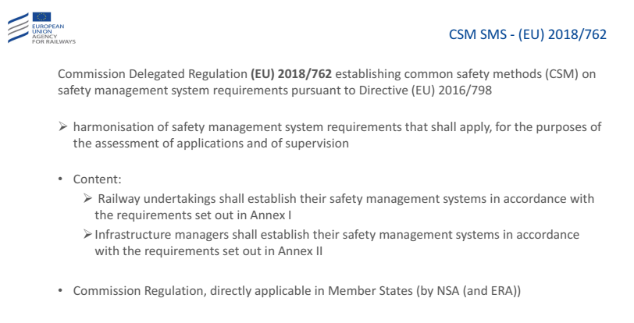 | The Commission Delegated Regulation (EU) 2018/762 of 8 March 2018 establishing common safety methods on safety management system requirements pursuant to Directive (EU) 2016/798 of the European Parliament and of the Council and repealing Commission Regulations (EU) No 1158/2010 and (EU) No 1169/2010.  Every actor in the Railway business must design its SMS in such a manner to comply with the requirements set out in Article 9 of Directive (EU) 2016/798 in order to ensure the safe management of its operations. To that end, it has to demonstrate compliance with the requirements set out in Annex I (RU) and II (IM) of Regulation (EU) 2018/762. These requirements are arranged to give a complete picture of the organisation’s safety management system following a Plan, Do, Check, Act (PDCA) cycle. The organisation will need to consider each individual requirement as well as how they fit together to form a coherent SMS which controls the relevant risks.
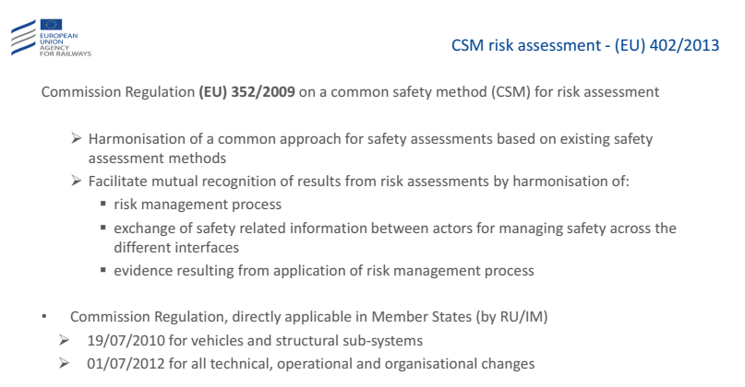 | The Commission Regulation (EU) 352/2009 establishes a common safety method on risk evaluation and assessment (CSM) as referred to in Article 6(3)(a) of Directive 2004/49/EC.  The purpose of this regulation was to harmonise a common approach for safety assessments, based on existing safety assessment methods and to facilitate mutual recognition of results from risk assessments by harmonising the risk management processes, through the exchange of safety related information between actors for managing safety across the different interfaces and by sharing the evidence resulting from the application of risk management process.  This Commission Regulation was directly applicable in Member States by the Railway Undertakings and Infrastructure Managers and had different deadlines for its application: 19/07/2010 for vehicles and structural sub-systems and 01/07/2012 for all technical, operational and organisational changes.
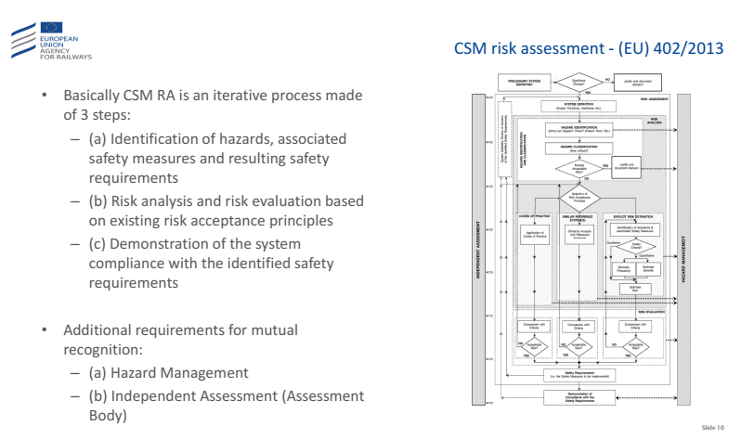 | The risk assessment and risk management processes, described by the Commission Regulation 352/2009, contains basically the following three steps:  1. identification of hazards;  2. risk analysis and risk evaluation based on existing risk acceptance principles, identification of safety measures and resulting safety requirements;  3. demonstration of the system compliance with the identified safety requirements.  In this process were included also some additional requirements for the mutual recognition, such as Hazard Management and independent assessment of the correct application and results of the CSM process performed by an Assessment Body. The process had to be applied in all Member States to any safety related change of the railway system considered to be significant.
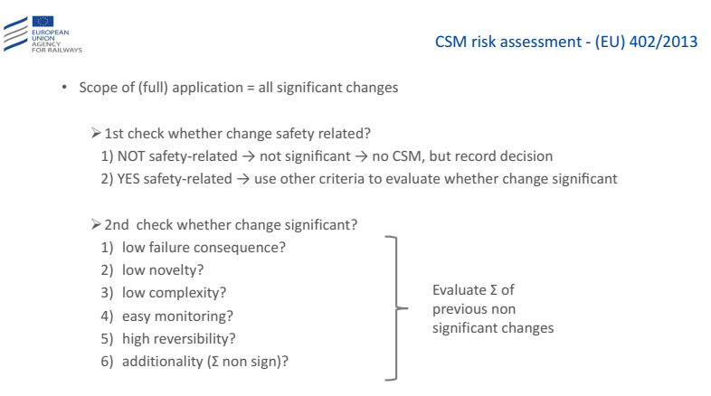 | The analysis is carried out based on the change significance for the safety.  If the change is not appreciated as safety-related, it is considered as not significant and there is no need to apply the CSM; nevertheless, the decision must be recorded.  Should the proposed change have an impact on safety, the applicant is to decide, based on expert judgement, about the significance of the following criteria:  - the effects of system failure: a reliable worst option scenario in the case of a failure of the system being investigated, acknowledging the existence of safety barriers beyond this system;  - the degree of innovation applied when introducing change: this includes innovation concerning both the railway industry as a whole, as well as exclusive to the entities introducing a change;  - the complexity of the change;  - extent of monitoring: difficulties in monitoring the introduced change during the complete life cycle of a system as well as in implementing appropriate interventions;  - the reversibility of the change: any difficulties in returning the system to the state it was in before the change has been introduced;  - additionality: assessment of the importance of change taking into account all recent safety related changes to the system under assessment, which were not at the time of their introduction assessed as significant.
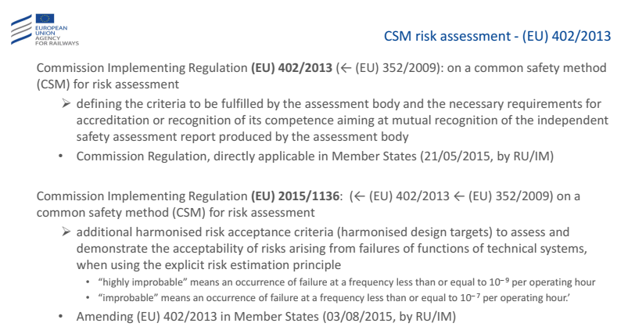 | Regulation (EC) N°352/2009 set up in Annex II the general criteria of "independence, competence, integrity and impartiality" to be fulfilled by the CSM assessment body. As Regulation (EC) N°352/2009 did not specify who shall check the compliance with these general criteria, it was difficult to get sufficient confidence in the CSM assessment body work and thus to mutually recognise its independent safety assessment.  This is made possible by Regulation (EU) N°402/2013 which revised Annex II and completed those general criteria with additional requirements, including the formal acknowledgement of the CSM assessment body competence. In addition to a full compliance with the ISO/IEC 17020:2012 standard, Annex II of the latest CSM for risk assessment requires the CSM assessment body also to demonstrate the following specific competence:  (a) competence in risk management, including the knowledge and experience of the standard safety analysis techniques and of the relevant risk assessment and risk management standards;  (b) all relevant technical competence for assessing the change under assessment and its safe integration into the railway system;  (c) competence in checking the correct application of safety and quality management systems or in auditing management systems. This requirement is crucial given that the CSM assessment body is not required to check all the activities and details of the risk assessment and risk management done by the proposer.  Moreover, the Commission Implementing Regulation (EU) 2015/1136 amends the Implementing Regulation (EU) No 402/2013 on the common safety method for risk evaluation and assessment by adding harmonised risk acceptance criteria (harmonised design targets) to assess and demonstrates the acceptability of risks arising from failures of functions of technical systems, when using the explicit risk estimation principle (“highly improbable” means an occurrence of failure at a frequency less than or equal to 10^{– 9} per operating hour and “improbable” means an occurrence of failure at a frequency less than or equal to 10^{– 7} per operating hour.)
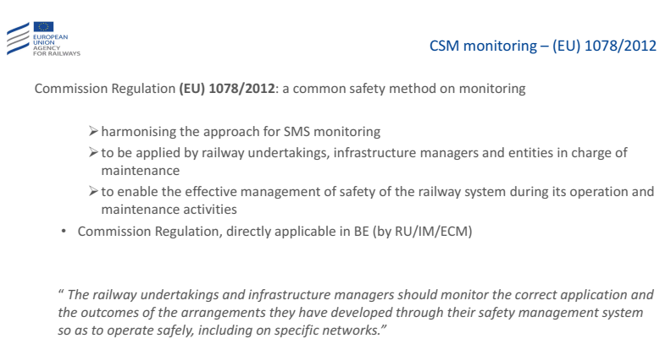 | Commission Regulation (EU) No 1078/2012 on the common safety assessment method related to monitoring is the current regulation regarding CSM. It stipulates techniques to enable railway operators to obtain verification during the assessment of the implementation of safety management systems. It is to be applied by railway undertakings and infrastructure managers after receiving a safety certificate or safety authorisation as well as by entities in charge of maintenance. Its implementation ensures the effective safety management of a railway system during its operation, maintenance, and its improvement where necessary and possible. It should also ensure the early identification of cases of non-compliance in the application of a management system, which could result in accidents, incidents, accident precursors or other dangerous events. It requires both railway undertakings and infrastructure managers to monitor the correctness of their application, and the results obtained from, solutions developed within the framework of their own safety management system in order to ensure the safe of operation of specific networks.
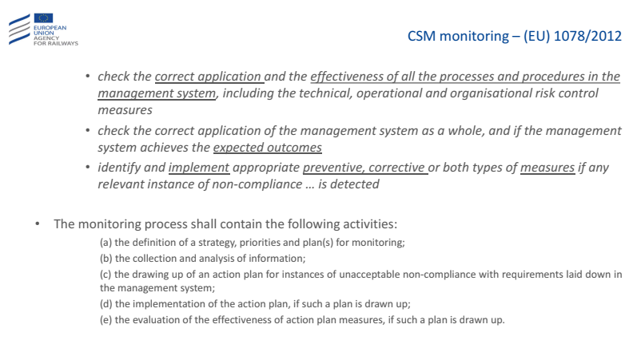 | Monitoring is to be understood as solutions introduced by railway undertakings, infrastructure managers, or entities responsible for maintenance in order to control the correct application and effectiveness of their own management system.  The regulation is to be applied in the following areas:  a) controlling the correct application and the effectiveness of all management system processes and procedures, including technical, operational and organisational risk control measures;  b) controlling the correct application of the management system as a whole and the achievement by this system of the expected results;  c) determining and implementing the correct preventive or corrective measures, or both kinds of measures, in the event of detecting appropriate cases of non-compliance with the requirements specified in points (a) and (b).  The monitoring process incorporates the following activities:  - defining the strategy, priorities and monitoring plan (plans);  - collecting and analysing information;  - developing an action plan in the event of detecting an unacceptable level of non- compliance with the requirements specified in the management system;  - implementing an action plan, if such a plan has been developed;  - assessing the effectiveness of the measures specified in the action plan, if such a plan was developed
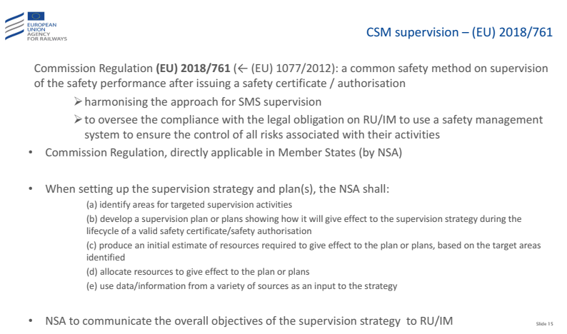 | The Commission Delegated Regulation (EU) 2018/761 of 16 February 2018 establishes common safety methods for supervision by national safety authorities after the issue of a single safety certificate or a safety authorisation pursuant to Directive (EU) 2016/798.  For the purposes of supervision, the national safety authorities shall accept the authorisations, recognitions or certificates of products or services provided by railway undertakings and infrastructure managers, or their contractors, partners or suppliers, granted in accordance with relevant Union law, as proof of the ability of railway undertakings and infrastructure managers to fulfil the corresponding requirements defined in Commission Delegated Regulation (EU) 2018/762.  To set up the supervision strategy and plans, the national safety authorities shall:  - collect and analyse data/information from a variety of sources as an input to the strategy and the plan or plans. Sources could include information gathered during the assessment of safety management systems, outcomes of previous supervision activities, information from authorisations of subsystems or vehicles, national investigation bodies accident reports/recommendations, other accident/incident reports or data, railway undertakings' or infrastructure managers' annual safety reports to the national safety authority, annual maintenance reports from entities in charge of maintenance, complaints from members of the public and other relevant sources;  - identify in the supervision strategy risk areas for targeted supervision activities, including those emerging from the integration and management of human and organisational factors, where relevant;  - develop a supervision plan or plans showing how it will give effect to the supervision strategy during the lifecycle of valid single safety certificates and safety authorisations;  - produce an initial estimate of resources required to give effect to the plan or plans, based on the target areas identified;  - allocate resources to give effect to the plan or plans;  - address in the supervision strategy and plan(s) any matters relating to cross-border operations or infrastructure(s) through coordination with other national safety authority (or authorities).
Quiz | 1 The RSD, (EU) 2004/49/EC, …  … introduced a barrier to the optimum functioning of rail transport FALSE  … has been transposed in national legislation TRUE  … imposes the establishment of a National Investigating Body TRUE  … puts Member States responsible for the safe operation of the railway system FALSE  2 Infrastructure Managers and Railway Undertakings …  … are responsible for the safe operation of the railway system TRUE  … need to implement necessary risk control measures, where appropriate in cooperation with each other TRUE  … need to apply national safety rules TRUE  … need to establish safety management systems (SMS) TRUE  3 The purpose of the safety certificate is to…  … provide evidence that the railway undertaking has established its SMS and can meet the requirements in order to operate safely on the network TRUE  … provide evidence that the railway undertaking has a good relationship with the NSA FALSE  … provide evidence that the railway undertaking has a zero accident policy FALSE  … provide evidence that the railway undertaking has very well documented how it wants its SMS to function. FALSE  4 An RU who's operation is limited to one Member State (MS)...  … does not need a Single Safety Certificate FALSE  … can apply for a Single Safety Certificate to ERA TRUE  … can apply for a Single Safety Certificate to the NSA in this MS TRUE  … can apply for a Single Safety Certificate to an NSA of choice FALSE  5 Commission Delegated Regulation (EU) 2018/762, establishing CSM on safety management system requirements, …  … has been transposed in national legislation FALSE  … has the same validity as the other ISO management system standards FALSE  … has the same structure as the other ISO management system standards TRUE  … is directly applicable in all Member States TRUE  6 Commission Regulation (EU) 352/2009 on a CSM for risk assessment…  … harmonises the process for risk assessment TRUE  … only applies for significant changes FALSE (golden false answer)  … requires the "not safety related" decision of changes to be documented TRUE  … requires the "not significant" decision of changes to be documented TRUE  7 Commission Regulation (EU) 1078/2012 on a CSM on monitoring…  … is only applicable for RU FALSE  … requires to check the correct application and the effectiveness of all the processes and procedures in the management system TRUE  … requires to report on the CSI FALSE  "… is only applicable for technical risk control measures" FALSE  8 Commission Regulation (EU) 1077/2012 on a CSM on supervision of the safety performance…  … harmonises the approach for SMS supervision TRUE  … requires RUs and IMs to develop a supervision strategy FALSE  … allows to use data/information from a variety of sources as an input to the supervision strategy TRUE  … allows the IM to supervise the performance of RU on its network FALSE

